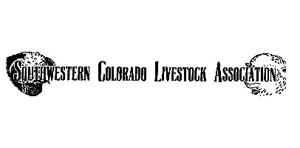
On behalf of the Southwestern Colorado Livestock Association board of directors. We would like to comment on the Draft Assessment for the Cimarron & Comanche Grasslands revised Management Plan. There are several concerning issues regarding the plan.

- The stakeholders did not engage any of the allotment owners in the development of the assessment plan. This clearly appears to display very biased intentions on part of the Grasslands revision team.
- The Taylor Grazing Act of 1934 was enacted to regulate livestock grazing on public lands. It created grazing districts and a permit system to control use, prevent overgrazing, and protect rangeland resources for long-term sustainability.

- The cattle on the land are an important part of the ecosystem. When managed responsibly, cattle grazing plays an important role in maintaining healthy rangelands. Grazing helps reduce excess grasses and invasive weeds that can fuel wildfires, while also encouraging new plant growth and diversity. Cattle naturally recycle nutrients back into the soil, improving its fertility and supporting the growth of native plants.

- Livestock and wildlife often use the same lands in complementary ways. Water sources, fences, and pastures developed for cattle also benefit deer, elk, and many smaller species. By keeping rangelands open and undeveloped, cattle operations preserve vital habitat and migration corridors that wildlife depend on.

- In Colorado as a whole, cattle ranching is one of the biggest agricultural sectors. Livestock contributes 6.4 billion of the value of agricultural production in Colorado for commodities like cattle. State‐wide, livestock and ranching play a large role in Colorado’s 9.2 billion agricultural/food production sector.

The Southwest Colorado Livestock Association board of directors would like the allotment owners to be included in any planning or revision of current grazing permits. The lack of transparency on behalf of the US Forest Service is very concerning.

Sincerely,
Southwest Colorado Livestock Association Board of Directors

