Comments due 9/24/25
I don’t understand why I did not receive a scoping packet when I have commented on SERAL and SERAL 2.
Fuels and Forest Health Emergency Situation Determination (ESD): Section 40807 of the Infrastructure Investment and Jobs Act of 2021 (Public Law 117-58) authorized the Secretary of Agriculture to determine that an emergency exists on National Forest System (NFS) lands and allows vegetation and other treatments to be carried out to address hazardous fuels on lands with high or very high wildfire risk and declining forest health. The Mokelumne Amador Calaveras Forest Health and Resilience Project received ESD authorization on May 1, 2025, by Region 5’s Acting Regional Forester, Jason Kuiken, as the delegated Authorizing Official on behalf of the Eldorado and Stanislaus National Forests. An environmental impact statement (EIS) prepared under an ESD requires analysis of only the proposed action and no action alternative and is not subject to the project-level pre-decisional administrative review (“objections”) or any processes set forth in 36 Code of Federal Regulations 218 (USDA Forest Service 2025a)

This emergency has been a long time in the making and will take a long time to resolve. Based on SERAL, the fuelbreaks and roadside clearing were what were implemented first. They are used in “fighting” fire and uncontrolled fire is the emergency. That is what should be included in the emergency determination. Tending the land with fire as a tool is quite different. It takes a very different set of knowledge and experience.
For a project that will be implemented over a large number of years and a very large area, it is important that other options (alternatives) be considered. It is particularly important to consider a tribal management alternative. They had managed it differently in a way that created the lush lands European explorers later found. If you are trying to get back to how it was when they were managing and if European best efforts got us to where we are, I suggest that working with Calaveras Band of Mi-Wuk f on management may be the most effective way to actually reach that goal.
You state that you are trying to return the land to the condition it was then they last managed it. All of your actions since then have not done this. Please allow their understanding into this process. On TEAMS Debra Grimes and Vanessa ______) of stated at the TEAMS meeting that they are interested in more than just the cultural sites. They care about the plants and animals and much larger areas. They asked to be more involved in the process. They are working on building capacity.
I am glad that you are including them with burns. I hope they can be included in other aspects too. Indigenous people were able to burn without fire lines in the past with their knowledge and the conditions they had created. They were able to burn in a patchy way based on very local conditions which would increase heterogeneity.
Allow for different approaches
Connie Millar (et al. 2007) advocate for flexibility in approaches due to rapidly changing and less predictable conditions in the years ahead. They mention the possibility of new conditions. This desired condition was in the Little Ice Age and may not be workable now. Climate Change and Forest of the Future: Managing in the Face of Uncertainty. I realize that you are introducing some heterogeneity with consideration of aspect, slope position, vegetation, and other management areas. Yet there is a tendency to keep using previous projects as a model (SERAL and SERAL 2.0), yet those have not been implemented very much and so have not been fully testing.

Weeds
I’m very concerned about weed control and effectively preventing weed spread in the project. The Calaveras side of the project has not had many weed surveys. Most of the mapped infestations are from 2004-2017. There are only a few mapped from 2023. The absence of weeds in other areas simply means there has not been mapping there.
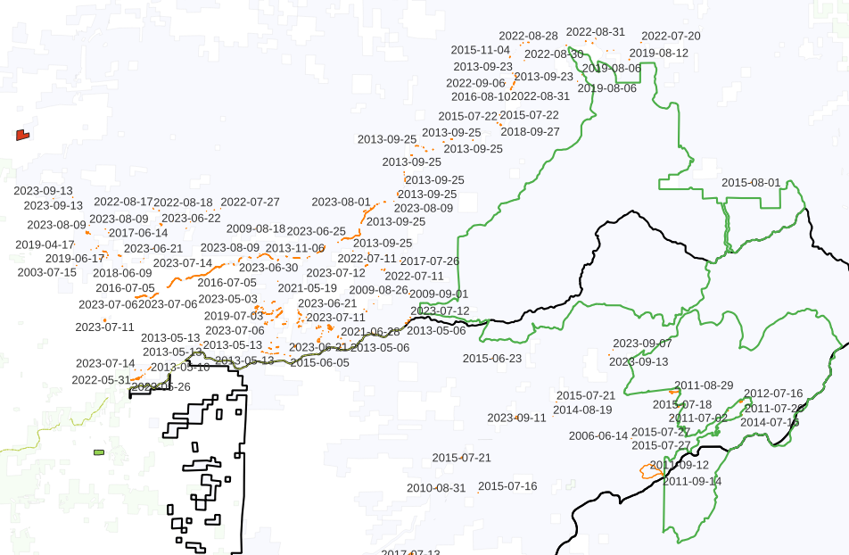
Making estimates of spread based on buffering has turned out to not be effective in Seral 2. Weeds are mostly spread by vectors including roads, wind, water, gravity (down slope), wildlife, cattle, and humans. So they spread far beyond any buffered estimates and are likely to continue to spread in that manner. The spread can differ by species due to different seed dispersal mechanisms and seed longevity.

The El Dorado Eradication and Control of Invasive Plants Project (USFS 2013) is a wonderful model of how to control and treat weeds when there is not enough current information. It is very effective because it relies on mapping done the year before the treatment. I am glad that you are using it. I do not know of any other way to meet forest plan and legal requirements on weed spread within the project
The lack of good information on weeds is a huge gap or problem with the analysis. The first step in a weed risk analysis is to determine what surveys were done and if they were adequate.
For the time I know from 1999 on , the person covering botany also covered wildlife and silviculture on Calaveras. She was spread thin. She had an assistant who covered the botany, but could not even identify a Clarkia. That person also covered wildlife surveys and called a red-tailed hawk a goshawk when I was out with her one day.
That was followed by someone who did well with botany but was put on ½ time when she wasn’t wiling to cover wildlife as well. So she did not have time to cover weeds. In addition, her crew leader could not key plants. I don’t really know the person who was reluctantly covering botany as an added duty after that, but again see no sign of covering weeds.
So the weeds from Darby, do not represent full surveys. They are only a few known sites that received treatment. I coordinated the surveys for sensitive plants for that project, but was not instructed to survey for weeds. Up in and near the wilderness the wilderness volunteers surveyed (bull thistle would come in dense after fires and slides) and was the major weed in the wilderness. The most recently dated entries are from treatments that county did that Jennie Haas entered. There is also the spurge at the workstation that they were treating for a long time. Most of the weeds except for the areas noted are fairly close to Highway 4.
So basically most of Calaveras has not been surveyed for weeds. There is no establish pattern of working on weeds or doing weed risk assessments on that district. It also likely has fewer weeds than other areas because much of the lower elevation belongs to SPI. Another factor was that the crews were far from the specialist, so the specialist had little idea what was going on with the crews on Calaveras.
There has never been a forest botanist on the Stanislaus, so each district was done differently.
From what I remember of the Eldorado weed management NEPA, it hinged on having a maximum area of treatment so there was something to base the NEPA on. Do not base that on existing known weeds.
I suggest making a better estimate using the acres in each 1,000’ band and how many acres of each species have been found on adjacent districts per 100 acres as a basis for estimating numbers on Calaveras. Since there has not been any weed mitigation there, I would suggest adding 50% to that estimate and possibly more since the weed information on other parts of the forest may also be old. What I’m proposing is not a great estimate, but is all that I think can be done given the extreme lack of data on that district.
I also know there was oblong spurge at a work station on Calaveras. It would be easy to spread out from there. So the amount of spurge already known should probably be doubled at least.
From the huge differences in weeds on the two districts (rush skeletonweed is only on Amador, medusahead seems to be only on Calaveras etc.), it should be mandatory to clean equipment when moving from one district to the other.
I will add other comments on specific weeds below
Tocalote is spread so rapidly by cattle and there is so much low elevation land that is private on the Calaveras District that It likely is not possible to control the spread.
Ox-eye daisy can be introduced in wildflower seed. They often include one weedy species to ensure that something will grow. It was introduced by that mechanism on the 108 corridor and has spread downstream at least 6 miles. It is important to control it before it spreads downstream.
French and scotch broom have very long-lived seeds. So consider any soil where they were growing to be infested.
Many of the weeds on Calaveras are close to private timber ground suggesting that infestation are likely on that land as well. The large sizes of some of these infestations suggest that they have been there for quite a while.
Bullthistle with its wind-born seeds has spread into the wilderness and greatly increased when there has been fire or landslides. This project proposes to burn the wilderness and roadless areas. There must be extensive yearly monitoring for several years after any burn to ensure that weeds do not expand and increase greatly. Italian thistle is increasing rapidly and will also expand after fire. Tragopogon dubius can also expend at high elevations.
Likewise, burn piles create an open rich substrate that amplifies any weeds seed that settles there, particularly that that are carried by wind (both those mentioned above as well as milk thistle, rush skeletonweed and others down lower. .
Melilotus officinalis and cheat grass were spread along Highway 108 when CalTrans spread contaminated sand during the winter months. If that is the case on the Amador District, then it may have happened on Calaveras along highway 4 as well.
I’m concerned about all the wiggle words used in reference to weeds. I understand the need for some flexibility and I also know that it can easily be over done. I suggesting some overall limits for the amount of flexibility as expressed as percentages of the overall project or some other method or else they may be to soft to be included in the weed risk analysis. Some examples are listed below:
“a qualified botanical resource specialist will be consulted” (what does this mean?) Weigh the amount of experience with the local resources not just someone with a title and little experience.
“Ultimately, it is up to the line officer to decide what to do with the botanical recommendations.” (What limitations need to be put on this so that the determination will still be valid?)
“Where possible,” ...”as appropriate”...”To the extent possible,”

Sensitive and rare plants
Yew trees are very sensitive to fire and to canopy removal. They can survive trees falling on them an many other impacts but even a backing broadcast burn that went into the riparian buffer killed them farther north when no other trees were affected. Canopy removal is the other place where I have seen yew trees die. The wood of yews was used for bows and digging sticks so there are cultural plants as well.
On the Calaveras District valid botanical surveys have also only taken place for a limited number of years. There are likely many more to be found.
Volcanic lahars (lava caps) are a large concern. There are a number of sensitive plants on them and other rare plants that have not been added to the sensitive list are also found in that habitat. The soild are very thin and are easily compacted and/or eroded. Occurrences have been eliminated by moving travel trailers onto lava caps for camping including late season use, late season sledding, late season snowmobiling, etc. A botanist should monitor to ensure that enough vegetation is preserved to prevent increased motor vehicle use of these areas by the actions of this project.

References
Millar, C.I, Stephenson, N.L>, and Stephens, S.L. 2007.

