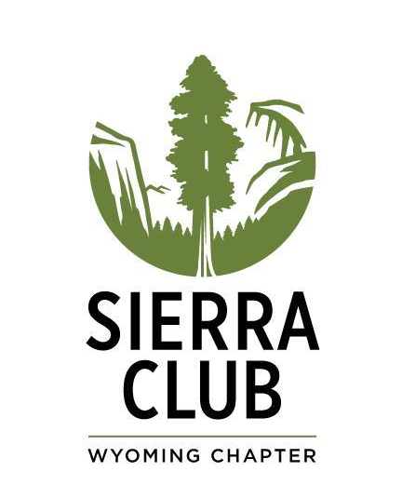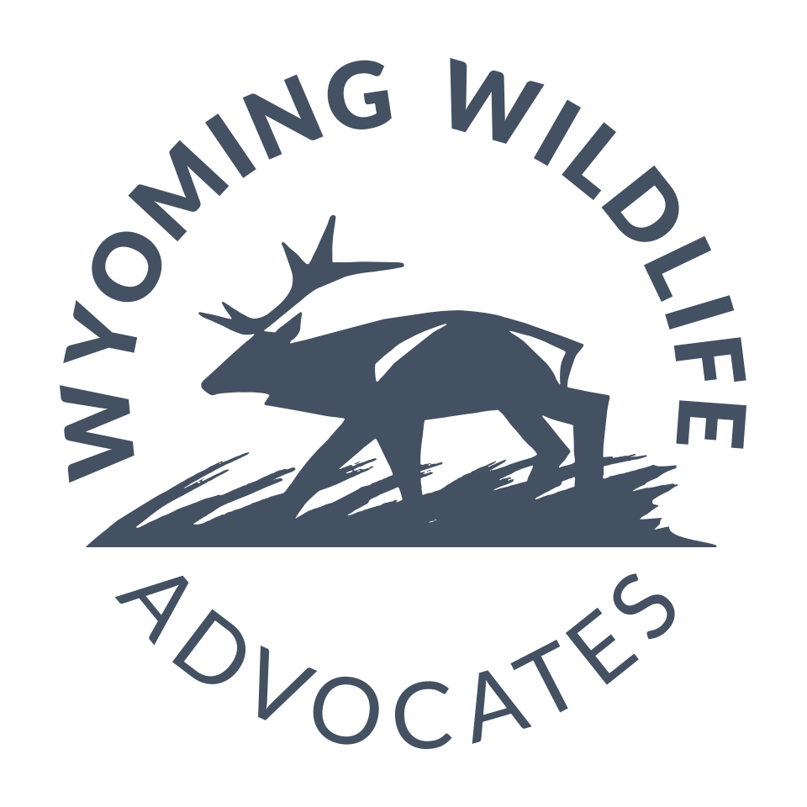
Management Alternatives for Elk Feedgrounds
in Wyoming and Surrounding States

A report prepared by Faith Williams for the
Sierra Club Wyoming Chapter and Wyoming Wildlife Advocates

Introduction
With chronic wasting disease (CWD) rapidly spreading, attention has focused on Wyoming’s winter feedgrounds and the potential consequences of intentionally congregating mass numbers of elk in small areas. In intermountain states adjacent to Wyoming, successful management strategies other than feedgrounds are used to reduce elk and livestock co-mingling, reduce private property damage, maintain healthy and abundant elk populations, and reduce disease risk. The Wyoming Game and Fish Department (WGFD) currently operates 22 artificial winter feeding grounds for elk (Figure 1), many of which are located on public lands. Elk are fed seven days a week, with most feeding starting in late November and ending in mid April. The 22 state-run feedgrounds are located in Teton, Lincoln, and Sublette counties on public land managed by the Bureau of Land Management (BLM) and the U.S. Forest Service (USFS), and on state and private land. The U.S. Fish and Wildlife Service operates the largest feedground in the state, the National Elk Refuge near Jackson Wyoming. The consequences of artificially feeding wildlife increasingly concern wildlife managers, neighboring states, and the general public. Consequently, the WGFD is drafting a long-term elk feedgrounds management plan to help guide elk management and determine the future of the state-run feedgrounds.

Figure 1. Wyoming Elk Feedground Locations. Map provided by WGFD 2022.
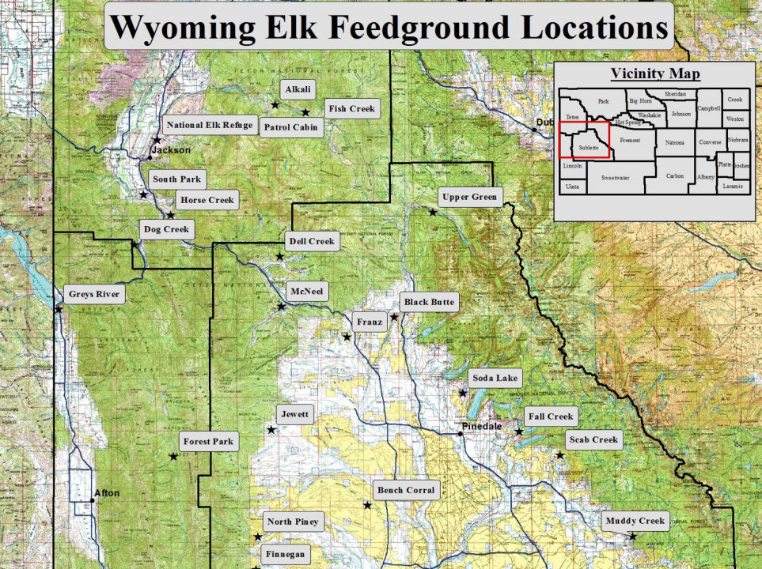
Wyoming justifies the annual feeding of elk by claiming that it maintains big game populations despite limited winter forage, ensures hunting opportunity, deters elk from causing property damage, and mitigates livestock conflict. Although all surrounding states have similar elk populations, climate, terrain, agriculture and livestock industries, and public land recreation, Wyoming is the only state in the western U.S to routinely utilize annual winter feeding despite the increased risk to elk herd health from numerous disease pathogens that more readily spread between animals on feedgrounds. Montana, Colorado, Utah, and Idaho have all implemented successful management policies to meet (and even exceed) big game population objectives, prevent and mitigate property damage, and minimize elk contact with livestock. This report takes a deeper look into habitat, population data, and alternative management strategies in Wyoming and surrounding states.

Elk Populations in Wyoming and Surrounding States
WGFD claims that the use of artificial feedgrounds is necessary to maintain adequate elk populations. Table 1 summarizes 2021 data provided from each state’s wildlife agency regarding the statewide elk population, population objectives, and population trends over the past 25 years.

Table 1. Statewide elk populations and objectives recorded in the year 2021. (Idaho does not utilize statewide population objectives.)
State | Statewide Population | Statewide Population Objective | Population Trends Over the Past 25 years
Wyoming | 117,000 | 85,300 | Increase
Idaho | 107,000 | N/A | Increase
Montana | 141,785 | 92,138 | Increase
Colorado | 308,901 | 233,000 | Increase
Utah | 84,390 | 78,990 | Increase

According to this information (gathered from public records and direct conversations with wildlife managers in each state), Colorado sustains 2.6 times more elk than Wyoming. All five states report positive population growth rates over the last 20 years and four states are exceeding their statewide elk population objectives (Idaho does not define statewide population objectives).
Maintaining substantial elk populations generates a considerable amount of revenue for local and state economies. States strive to maintain robust elk populations in part to allow for ample hunting and recreational opportunities. Table 2 displays data gathered from each state’s wildlife agency from 2021 describing elk hunting license numbers and success rates.
Table 2. Hunting licenses issued by state in 2021.
State | Non Resident Licenses Issued | Resident Licenses Issued | Total licenses Issued | Hunter Success Rate (%) | Hunting License Revenue ($)
Wyoming | 14,199 | 60,324 | 74,523 | 43 | 14,243,765
Idaho | 11,951 | 72,950 | 84,901 | 23 | 10,469,977
Montana | 18,621 | 15,807 | 32,428 | 20 | 15,380,529
Colorado | 26,406 | 59,082 | 85,488 | 23 | 25,456,509
Utah | 43,000 | 186,261 | 229,261 | 24 | 9,428,874

This information shows that successful elk hunts take place in all these states, with hunter success ranging from 20% in Montana to nearly 43% in Wyoming. License sales generate substantial revenue for managing agencies in all states. The states that identify population objectives (Wyoming, Montana, Colorado, and Utah) all have statewide elk populations above stated objectives, with Wyoming, Montana, and Colorado averaging 1.4 times more elk than their stated population objectives. States are able to maintain robust elk populations and sell sufficient hunting tags to support strong economic gains in each state.

When feedground proponents claim that winter feeding is necessary to support strong populations of elk in Wyoming, that suggests the state may lack suitable winter habitat or adequate natural forage in comparison to other states where supplemental feeding is not utilized. Below, we take a closer look at habitat in Wyoming and surrounding states.

Habitat and Winter Forage Availability
Wyoming, Idaho, Utah, Colorado, and Montana all have varying topography ranging from high elevation mountains to broad river basins and high plains. Western Wyoming is more mountainous with extensive forested areas while high-elevation prairie grasslands and shrublands are more dominant in the eastern regions of the state. The entire state is a large plateau intersected by mountain ranges and valleys. Similarly, Colorado, Idaho, Montana, and Utah terrain includes high elevation alpine areas, extensive forested mountain ranges, and basins with shrublands and grasslands. Most of the southern half of Utah consists of dry desert basins, canyonlands, and plateaus.
Elk typically migrate seasonally between higher elevation summer habitat to lower elevation grasslands and shrublands during winter months (Henderson, 1992). While grass and woody browse are all consumed by elk, grass species seem to be preferred where they are available. Across the western U.S., deep snow conditions can limit grass availability during the winter, causing elk to include more shrubs in their diet. According to the WGFD, winter diets for elk in Wyoming usually are dominated by antelope bitterbrush, mountain mahogany, serviceberry, and willow. When snow depth limits small shrub and grass availability, elk diets shift to include more aspen, conifers, sagebrush, willow, and other taller browse.
Table 3 lists the percentages of public and private land in Wyoming and surrounding states as well as the percentage of those public lands dominated by shrublands and grasslands (habitats containing preferred winter grazing and browse for elk).

Table 3. Percent of state occupied by public lands and percent of public lands occupied by specific habitat. Data gathered from BLM Public Land Statistics 2021.
State | Private Land | Public Land | Public Lands Occupied by Shrublands | Public Lands  Occupied by Grasslands
WY | 44.1% | 55.9% | 82% | .13%
MT | 62.5% | 37.5% | 38% | 55%
UT | 24.8% | 75.2% | 71% | .06%
ID | 29.6% | 70.4% | 61% | 34%
CO | 56.7% | 43.3% | 54% | .05%
Wyoming, Utah, and Idaho are all more than 50% public land, which is where natural food resources are expected to be most accessible with the least potential conflict for elk. However, Utah may not be a useful comparison in this regard because so much of that state’s public land is the dry desert canyonlands of the southern half (or more) of the state, terrain that provides less than ideal elk habitat. More of Wyoming’s public land is classified as shrubland than any of the other states. While many other characteristics including elevation, topography, aspect, slope, livestock grazing intensity, and other factors clearly influence winter forage availability, quality, and accessibility, this data suggests that Wyoming’s abundant public lands should offer reasonably abundant grass and shrublands for natural winter forage for elk, as much or more than surrounding states that have less public land (Montana and Colorado) and less shrublands on public lands (all four other states).

Livestock Management and Conflict Mitigation
Another frequently heard justification for the use of feedgrounds is the claim that winter feeding is necessary to prevent elk from co-mingling with livestock and to prevent damage to private property, primarily stored winter hay. The livestock industry in Wyoming strongly supports feedgrounds because of the perception that feedgrounds are the only effective way to prevent elk from eating hay meant for livestock, and to keep elk separated from livestock on haylines to reduce the risk of disease transmission (primarily brucellosis) from elk to cattle.
Wyoming ranks fourth out of the five states in abundance of cattle and sheep in the state (Table 4), suggesting that neighboring states such as Colorado, Montana, and Idaho probably face similar or even greater potential for interactions between elk and livestock, and unwelcome elk consumption of livestock feed. Again, Utah is a bit of an outlier given that so much of the state is desert canyonlands and as unsuitable for livestock as it is for large numbers of elk. These other states, plus northern Utah where most of the state’s elk and livestock are concentrated, successfully mitigate conflicts with livestock operations through appropriate fencing, hazing, livestock herding, and other strategies. No state other than Wyoming routinely uses season-long annual artificial feeding to mitigate wildlife conflicts with livestock or damage to private property, even though surrounding states face the same challenges including competition between cattle and ungulates for forage on public land, pressure from livestock owners to prioritize livestock use of public land forage over wildlife use, co-mingled public and private land, loss of winter range to private ownership, human-caused barriers to natural elk migration between summer and winter ranges, and the inherent attraction of artificial food sources like livestock feed lines and ranch haystacks.

Table 4. Number of cattle and sheep by state. Data from U.S. Dept. of Agriculture, 2021.
State | # Of Cattle | # Of Sheep
Wyoming | 1,320,000 | 340,000
Colorado | 2,620,000 | 425,000
Montana | 2,200,000 | 200,000
Idaho | 2,500,000 | 220,000
Utah | 740,000 | 280,000

In contrast to surrounding states, Wyoming does not have an official mitigation or prevention plan for livestock damage caused by elk. The WGFD considers compensation for damage or losses on a case by case basis. The WFGD routinely engages in hazing and additional feeding to lure elk away from livestock on private lands. While other states do sometimes use temporary feeding to deter elk from private property, Idaho, Utah, and Colorado all have formal prevention and mitigation plans in place that describe additional methods to prevent and treat damage caused by wildlife. Some strategies listed in these plans include:
- Provide materials to reduce or prevent wildlife impacts such as fencing, gates and panels
- Provide advice and assistance for hazing animals away from green or stored crops
- Authorize special hunts or issue permits to kill a certain number of animals on a property
- Work with landowners on crop agreements, such as paying landowners to allow wildlife to forage in their crops.
Although Montana does not have a written mitigation plan, Montana Fish, Wildlife and Parks does provide a mitigation program known as the Game Damage Program. Landowners may be eligible for game damage assistance if they allow public hunting during established hunting seasons. Assistance may include hazing, repellents, temporary or permanent stockyard fencing, damage hunts, kill permits, or supplemental game damage licenses.
Colorado not only has a written mitigation plan in place, but has a series of additional programs to compensate land owners, encourage hunting in problem areas, and establish long term preventative measures for damage caused by elk. For example, the Habitat Partnership Program (HPP) is a wildlife conflict resolution program administered by Colorado Parks and Wildlife (CPW) that aims “to reduce wildlife conflicts, especially those associated with fence and forage, and to help the Division meet game management objectives through duties deemed appropriate by the Director” (CPW, 2021). HPP is fully funded by big game hunting licenses and allocates these funds to projects regarding habitat manipulation, fencing, game damage, information/education, monitoring/research, equipment, conservation easement transaction costs and administrative necessities. Other programs in place to work with landowners to mitigate and prevent property damage caused by elk include the Landowner Preference Program and the Landowner Recognition Program.
Fundamentally, when elk use habitats on or near private land, landowners and agency personnel must work together to identify a suite of strategies to prevent problems to the greatest extent possible, and to mitigate problems that cannot be completely avoided through damage payments and the like. This is the approach taken by states surrounding Wyoming, and there is no apparent reason why it would not work in Wyoming as well. While some states like Utah and Idaho also use temporary baiting to draw elk away from private property, all surrounding states successfully use alternative measures and work with landowners to create incentives for coexistence with elk. Wyoming could choose to do the same.

Emergency Winter Feeding Policies
While some states use emergency winter feeding of ungulates when unprecedented winter weather conditions persist, Wyoming is the only state to routinely engage in supplemental feeding every year, regardless of winter severity. All surrounding intermountain states except Colorado and Wyoming have official winter feeding policies in place. Each state agency explicitly describes the consequences of feeding in their policy, as well as specific conditions under which feeding is permitted. Montana Fish, Wildlife, and Parks states the following in their winter feeding policy: “Past experience in Montana and elsewhere has shown that artificial feeding of game animals is not a sound game management program - neither economically nor biologically. It is expensive, is not good for the animals, and not good for the range upon which these animals are dependent. It can only be justified under extreme winter conditions which indicate a winter loss of major proportions is imminent.” (Emphasis added.)
Idaho shares similar objectives but focuses on restoration of winter habitat as a primary means of preparing populations for harsh winters. Idaho Fish and Game states the following in their winter feeding policy: “The Idaho Fish and Game Commission recognizes that big game populations should be maintained under natural conditions and by naturally available forage…The Department will work with appropriate land management agencies in an effort to maintain winter ranges in a condition suitable to meet big game management objectives, including the restoration of ranges...We, therefore, do not sanction any wide-spread supplemental winter feeding programs.” (Emphasis added.)

Utah only uses supplemental feeding under extreme conditions, and further states that, “the Division will not participate in any emergency big game feeding program that occurs within the known range or use area of any big game population where CWD, brucellosis or tuberculosis has been detected.” (Emphasis added.)

Although Colorado does not have an established winter feeding policy, the state explicitly acknowledges the harmful impacts of feedgrounds and does not engage in supplemental feeding. CPW states, “Concentrating deer by feeding them can increase stress on the deer and hasten the spread of disease.. as well as disrupt the natural behavior of elk and deer.” (Emphasis added.)

Some specific conditions under which emergency feeding is permitted in nearby states are: (a) snow depth 20 inches or more with crusts and/or ice forming, (b) weak adult cow elk forced to bottom lands along streams and highways, (c) adult cow elk not seeking cover after feeding, and (d) emergency food sources not available.

Table 5 describes how often Wyoming and surrounding states have used emergency winter feeding due to lack of natural resources over the past 13 years. Winter conditions which require supplemental feeding are relatively rare. While other state wildlife management agencies recognize the risks of winter feeding and use it with caution, Wyoming engages in artificial winter feeding every year.

Table 5. Emergency Winter Feeding Events by State Since 2010.
State | Year(s) State Has Engaged in Winter Feeding Since 2010
Wyoming | 2010 to 2023, every year (14 years total)
Utah | 2023 (1 year)
Colorado | None (0 years)
Idaho | 2017, 2023 (2 years)
Montana | Information Not Available

Chronic Wasting Disease
CWD is a fatal disease affecting the central nervous system of members of the deer family (Cervidae), including elk, deer, and moose. CWD can be transmitted from one cervid to another, mother to offspring, from all cervids to soil and plants, and from soil and plants back to cervids. Detectable levels of prions linked to chronic wasting disease have also been found to be stored in wintering ticks (Haley et al. 2021). Once present, CWD prions cannot be destroyed unless incinerated at extreme temperatures and prions can remain infectious and bio-available in the environment for at least 16 years (Almberg, et al. 2011). No cure or treatment is available for CWD-infected animals. Due to the severity of the disease, states are investing significant money and staff resources into learning more about the disease, monitoring its prevalence, and searching for effective ways to slow its spread.
CWD Prevalence
The map below demonstrates the prevalence of CWD throughout the United States in 2023.
Figure 2. Occurrence of CWD in free-ranging deer and elk in the United States as of March 2023. This map is based on the best-available information from multiple sources, including state wildlife agencies and the United States Geological Survey (USGS).
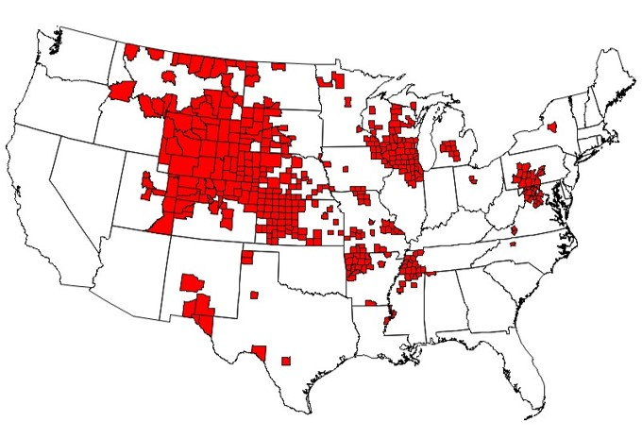
Relative to total land area, as of 2019 CWD was more prevalent in Wyoming than in any other state or province in North America (Table 5). As CWD continues to spread throughout North America and elsewhere, viable disease management strategies must be implemented for free-ranging cervid populations, given that eradication is currently impossible.

Table 5. Number of counties with reported positive CWD cases in free-ranging cervids by state.
State | # of Counties Where CWD has Been Detected | # of Counties total
WY | 22 | 23
CO | 27 | 64
ID | 1 | 44
MT | 23 | 56
UT | 7 | 29

A recent study evaluating the consequences of alternative management methods for artificial feedgrounds in Wyoming found that, “... median values of direct and indirect transmission of CWD are expected to be 1.9 and 4 times higher in fed elk populations compared to unfed elk”(Cook et al., 2023). This study included modeling that predicted a decrease in elk population if feedgrounds continue to be utilized. Recent modeling shows that the increase in CWD prevalence due to feedgrounds will actually lead to a greater population decline within a 20 year time period counterproductive in maintaining substantial big game populations (Cross et al., 2023).
Figure 3 visually depicts the inexorable spread of CWD across Wyoming from where it was first detected in southeastern Wyoming 20 years ago to its current documented presence in almost every part of the state. Of particular note is the overlay of hunt areas known to be infected with CWD (as of 2022) with the 23 feedgrounds in northwestern Wyoming.
Figure 3. Spread of CWD over time in relation to the artificial feedgrounds by deer hunt areas in Wyoming as of 2019. Map prepared by Sierra Club Wyoming using data provided by WGFD.
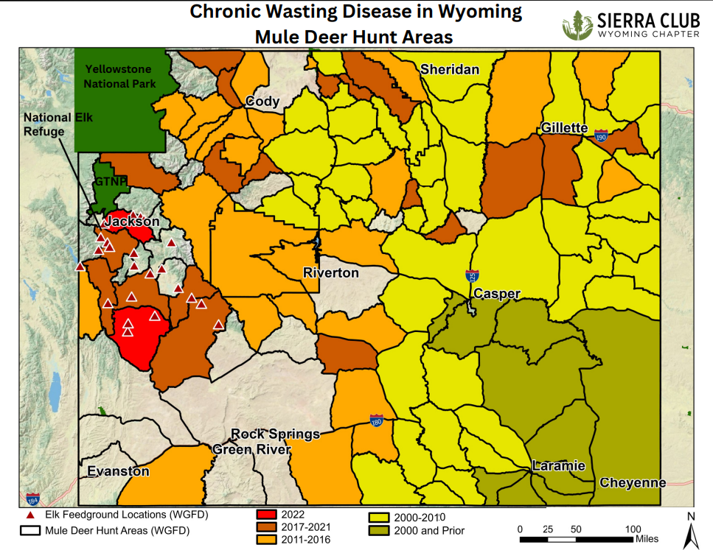
Hunt areas closest to feedgrounds have the greatest annual growth rate in the spread of CWD. Modeling software created by the Northern Rocky Mountain Science in Center in 2023 predicts that this trend will continue in areas where artificial feeding occurs. For example, the models predict that CWD prevalence in the Upper Green River hunt area will increase to 6.8 percent within three years if artificial feeding continues, which is more than four times higher than the initial expected prevalence of 1.5 percent.
Due to the current rapid spread of CWD, Wyoming plus the four surrounding intermountain states evaluated in this report all have CWD management plans that share a common explicitly stated objective to reduce the rate of spread and prevalence of CWD in infected areas. All five states’ plans identify management strategies to meet this objective including:
- Surveillance
- Harvest management
- Reducing risk of importing infected carcasses from other states by carcass import restrictions
- Providing guidelines for proper carcass disposal
- Limiting the translocation of wild cervids
- Prohibiting the rehabilitation of wild cervids
- Restricting baiting and feeding of wildlife
Wyoming’s CWD Management Plan states, “..To reduce artificial cervid concentrations, the Department pursues statewide or local feeding bans where possible, identify points or sources of concentration, and develop strategies to decrease cervid concentrations to minimize CWD transmission.” While all five states share objectives to reduce the impact of CWD and have actively practiced the listed strategies, Wyoming is the only state to continue routinely utilizing feedgrounds, even while acknowledging the implications such feedgrounds have on the spread of CWD and other common wildlife diseases.

Conclusion
In the past, supplemental winter feeding was used to improve overwinter elk survival, reduce the commingling of elk with cattle, and mitigate private property damage. Now, with rapidly spreading chronic wasting disease, economic risk to ranchers from brucellosis, increased harm from other wildlife diseases such as scabies and hoof rot, and far greater understanding of complex ecological systems, we know better. Other states have chosen to use effective elk management strategies that maintain robust elk populations in balance with available natural winter habitat, without jeopardizing state revenue, hunting opportunity, or their livestock industries Intermountain western states surrounding Wyoming have met or exceeded their defined elk population objectives without intentionally exacerbating disease spread by routine winter feeding of wild elk. Prompt controlled phase out of artificial feeding in Wyoming is imperative.

References:
Almberg, E. S., Cross, P. C., Johnson, C. J., Heisey, D. M., & Richards, B. J. (2011). Modeling routes of Chronic Wasting Disease Transmission: Environmental prion persistence promotes deer population decline and extinction. PLoS ONE, 6(5). https://doi.org/10.1371/journal.pone.0019896
Cook, J. D., Cross, P. C., Tomaszewski, E. M., Cole, E. K., Grant, E. H. C., Wilder, J. M., & Runge, M. C. (2023, March 9). Evaluating Management Alternatives for Wyoming Elk Feedgrounds in consideration of chronic wasting disease. Open-File Report. Retrieved April 11, 2023.
Driese, K. L., Reiners, W. A., Merrill, E. H., & Gerow, K. G. (n.d.). A Digital Land Cover Map of Wyoming, USA: A tool for vegetation ... Retrieved April 11, 2023, from https://onlinelibrary.wiley.com/doi/full/10.2307/3237251
Haley, N. J., Henderson, D. M., Senior, K., Miller, M., & Donner, R. (2021a). Evaluation of winter ticks (dermacentor albipictus) collected from North American elk (cervus canadensis) in an area of chronic wasting disease endemicity for evidence of PRP CWD amplification using real-time quaking-induced conversion assay. mSphere, 6(4). https://doi.org/10.1128/msphere.00515-21
Henderson, R.E. and A. O'Herren. (1992). Winter ranges of elk and deer: victims of uncontrolled subdivisions? Western Wildlands 18:20-25.
Idaho Department of Fish and Game (IDFG). (2014). Idaho Elk Management Plan 2014-2024. Idaho Department of Fish and Game, Boise, USA.
Mangus, D. (2009). Reducing reliance on supplemental winter feeding in elk: An applied management experiment at Deseret Land and Livestock Ranch. Thesis, Utah State University, Logan, Utah, USA.
Montana Fish, Wildlife and Parks. (2005). Montana Statewide Elk Management Plan. https://fwp.mt.gov/conservation/wildlife-management/elk
U.S Geological Survey, National Wildlife Health Center. (2023). Distribution of Chronic Wasting Disease in North America. https://www.usgs.gov/media/images/distribution-chronic-wasting-disease-north-america-0
Utah Department of Natural Resources, Division of Wildlife Resources. (2021). Utah Statewide Elk Management Plan. https://wildlife.utah.gov/pdf/bg/elk_plan.pdf
Wyoming Game and Fish Department. (2020b). Wyoming chronic wasting disease management plan: p. 73, accessed March 2023, at https://wgfd.wyo.gov/WGFD/media/ content/PDF/CWD/Final-WGFD-CWDManagement-Plan-7-2020-with-appendices.pdf

