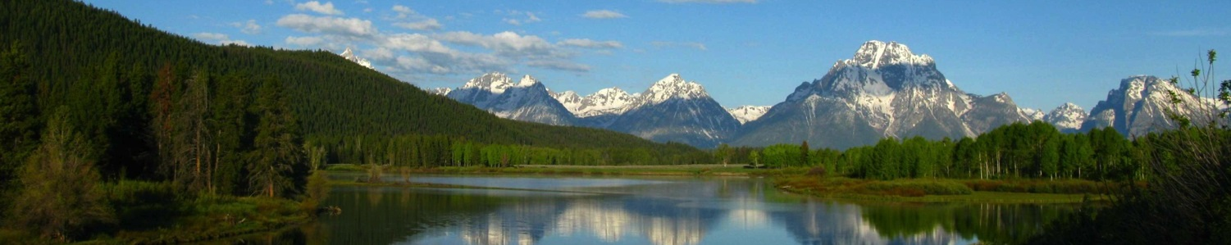

Our Mission: To promote, recommend and advocate for programs and projects within the Custer-Gallatin National Forest that will provide for the public health, safety and general welfare of our communities under the sustainable multiple-use management concept to meet the diverse needs of our communities through a transparent, collaborative and mutually supportive process within a diverse and committed stakeholder group.

Membership
County Commissions
Carbon Co.
Madison Co.
Park Co.
Gallatin Co.
Stillwater Co.
Big Horn Co.
Sweet Grass Co.
Powder River Co.
Rosebud Co.

Industry Representation
Skiing -
Red Lodge Mountain
Minerals/Mining –
Stillwater Mining Corp.
Multiple Use –
Citizens for Balanced Use
Recreational & Economic Dev. -
Big Sky Chamber
Agriculture/Ranching -
OPEN
Timber -
Sun Mtn. Lumber Co.
Motorized Recreation -
Montana Trail Vehicle Riders Assoc.
Quiet Recreation -
Winter Wildlands Alliance
SW Mont. Mtn.. Biking Advocates
Fishing and Hunting -
Montana Back Country Hunters & Anglers
Outfitters -
Montana Outfitters
& Guides Assn.
Montana University Extension
Conservation NGOs
Greater Yellowstone Coalition
The Wilderness Society
Society for Range Management,
Northern Great Plains Section
Trout Unlimited
Ttout Unlimited

Custer Gallatin Working Group

August 5, 2025
District Ranger Amy Haas
Beartooth Ranger District
6811 Highway 212 South
Red Lodge, MT 59068

Beartooth District Ranger Amy Haas,

The Custer Gallatin Working Group (CGWG) appreciates the opportunity to comment on the Burnt Mountain Project (CE). The CGWG is a collaborative that works to develop agreements around priority areas and approaches for project work on the Custer Gallatin National Forest. The CGWG represents a wide range of stakeholder interests including County Commissioners, representatives of conservation NGO’s, the ski industry, agriculture and ranching, recreation, hunters, anglers, outfitters, mining, and the timber industry.
The CGWG supports the purposes of the Burnt Mountain project to improve public and firefighter safety by reducing fire intensity in the WUI which extends from the East rosebud drainage area to the West Fork of Rock Creek and is adjacent to the City of Red Lodge and Red Lodge Mountain Ski Resort. This will also increase fire control probability and opportunities and improve the health and condition of the forest ecosystem.
Recent fires in the Beartooth Range in the West Fork drainage, along the US 212 Corridor, and more dramatically from Line Creek to the Main Rock Creek drainage are a clear indication of the need to address the ever-increasing fuel loads and extreme fire danger along the face of the Beartooth Range. Risks to infrastructure and responding firefighters should be addressed promptly.
The Custer Gallatin Working Group (CGWG) was effectively engaged in the Red Lodge Mountain Fuels Reduction Project which adjoins the Burnt Mountain project and has previously recommended in coordination with forest staff potential fuels reduction projects on the Beartooth Ranger District. Members of the CGWG serving on a committee for the purpose of reviewing the Burnt Mountain Project had the opportunity to review the scoping documents. We appreciate that the draft CE includes detailed information describing the treatments proposed for each unit and locations of temporary roads. This information is important for the public to fully understand the scope and purpose of the project.
The CGWG supports the intent of the Burnt Mountain Project while reserving the ability to recommend minor adjustments.
Sincerely,
John E Prinkki, Chair, Custer Gallatin Working Group
1662 Hwy 72, Bridger, Montana 59014

