7/30/2025
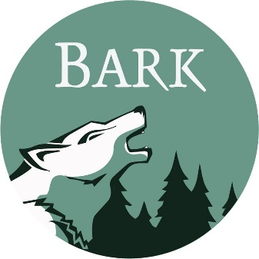
Bark
PO Box 12065
Portland, OR 97212
www.bark-out.org
503-331-0374

Kameron Sam, District Ranger
John Bowers, Deputy District Ranger
Barlow Ranger District
Mt. Hood National Forest
780 NE Court Street
Dufur, OR 97021

RE: Hootnanny CE
Dear Kameron and John,
As you are aware, Bark's mission is to transform the lands now known as Mt. Hood National Forest into a place where natural processes prevail, where wildlife thrives, and where local communities have a social, cultural, and economic investment in its restoration and stewardship. Our supporters live in the many communities surrounding Mt Hood National Forest. They rely on the Forest for drinking water, economic opportunities, recreation, forest products, spiritual renewal, connection to the land, and more. We submit these comments on behalf of our supporters.

TRIBAL INCLUSION

The Hootnanny project area is located within the ancestral homelands and ceded territories of The Confederated Tribes of Warm Springs. Though it is not our place to speak on behalf of Warm Springs members and their government, we encourage and support meaningful collaboration between the Tribe and the federal government that holds these lands in trust. Bark believes that incorporating Tribal perspectives and values into all aspects of project design and implementation will lead to better outcomes for the land and its people.

COLLABORATION

Bark wants to recognize and thank the IDT for introducing this project to the Wasco County Forest Collaborative (WCFC) and for planning/hosting field tours, fielding questions, and allowing time for discussions about proposed actions. Thank you.

CONTRACTING

Over the many years of Bark’s engagement in the planning and monitoring of vegetation projects on Mt Hood, we have documented discrepancies between project intent and contract implementation. Most recently, we saw this play out during the post-fire roadside hazard tree removal work on the Clackamas River Ranger District.

As I’m sure you are aware, poor project implementation can perpetuate public distrust in the Forest Service and lessen certainty that protections – as written in project PDCs – will actually protect resources as intended by the specialists.

In our opinion, discrepancies can be avoided by ensuring that strong PDCs are translated correctly into contract language, and that contracts are monitored during implementation. Further, we encourage the Mt Hood to award contracts to local, knowledgeable contractors with a demonstratable track record of successful Federal contract implementation.

FIRE

Bark appreciates and fully supports the proposal to conduct underburning after thinning and material removal. Bark requests that once these burn blocks are identified, information be shared that shows where underburning is likely to occur.

LARGE AND OLD TREES

One of the most critical components of dry forest resiliency is large, fire-adapted trees. We are lucky that there is still a large tree component in the Hootnanny project area (see photos below).
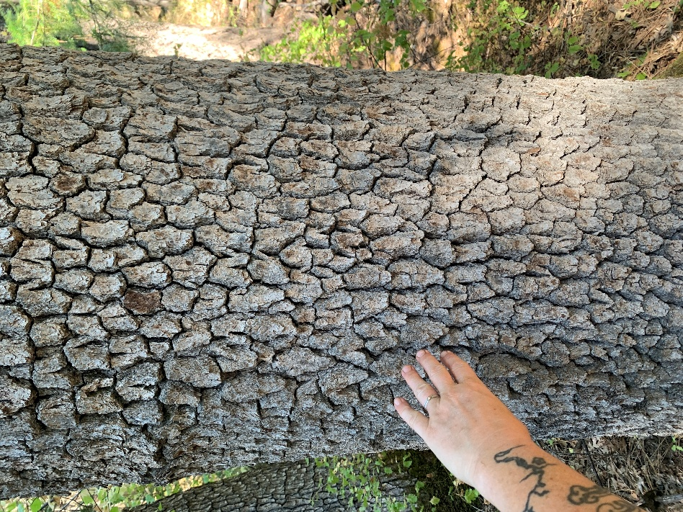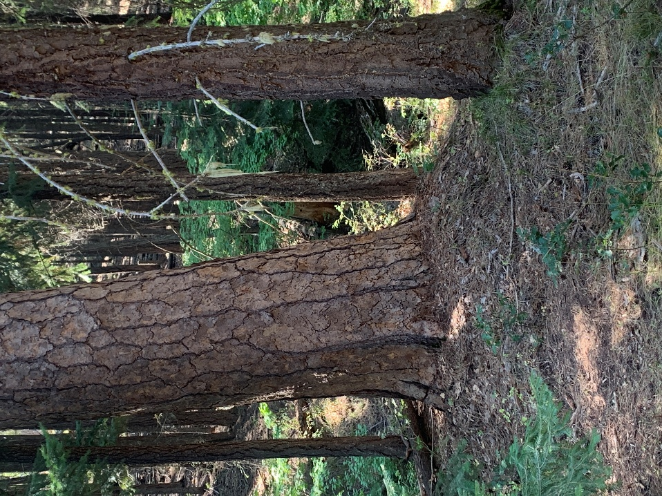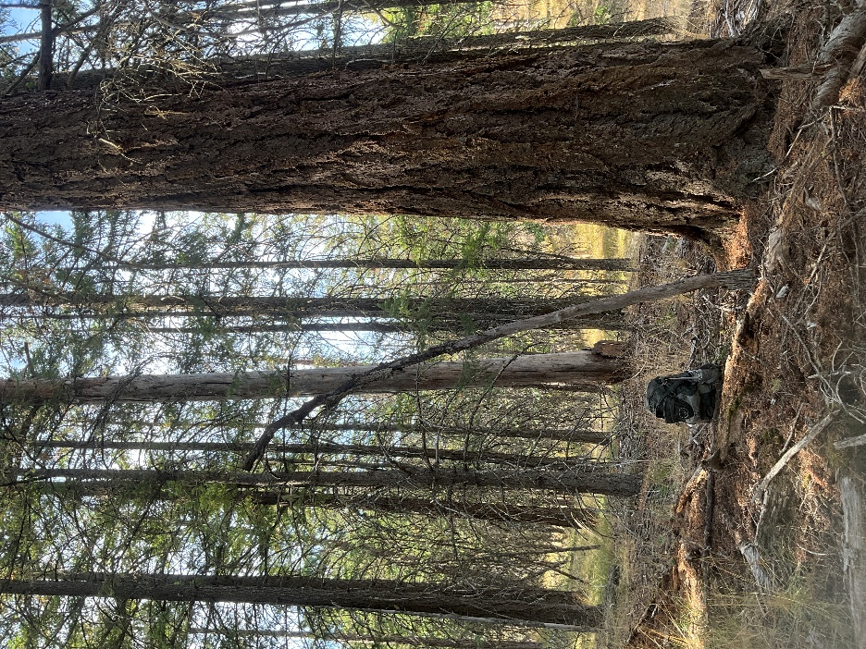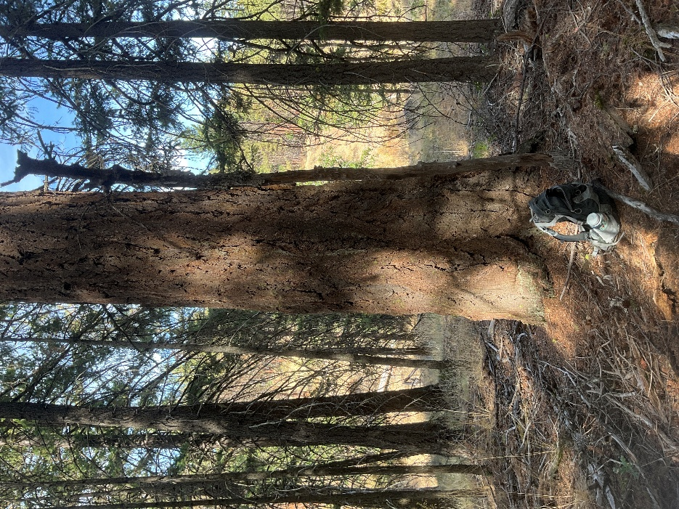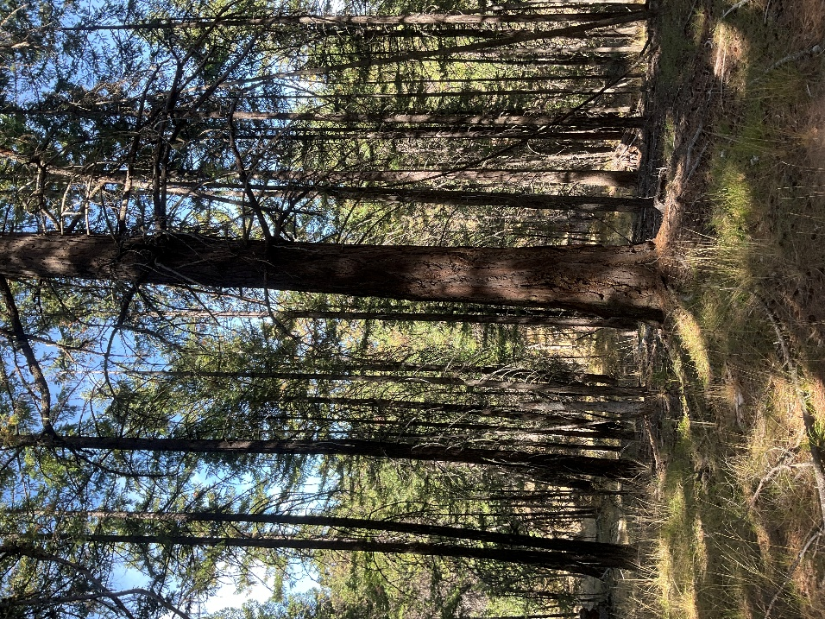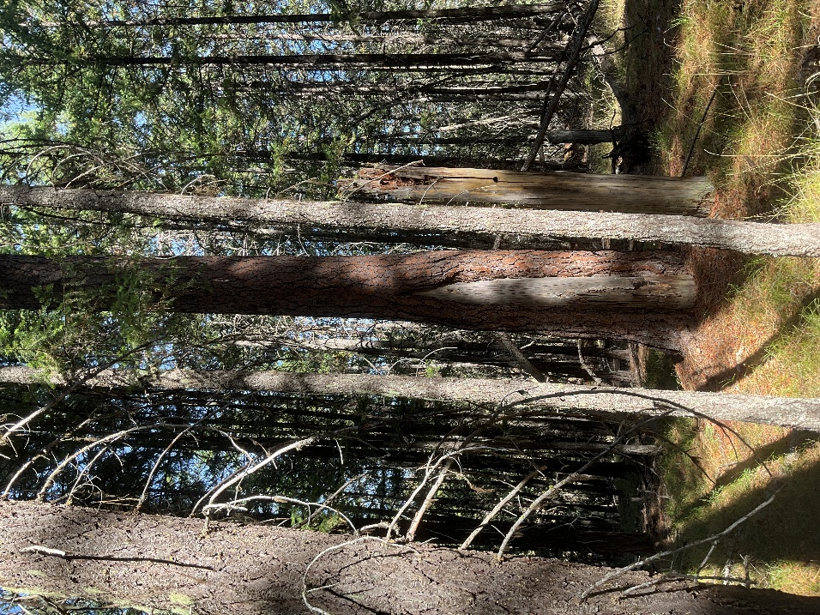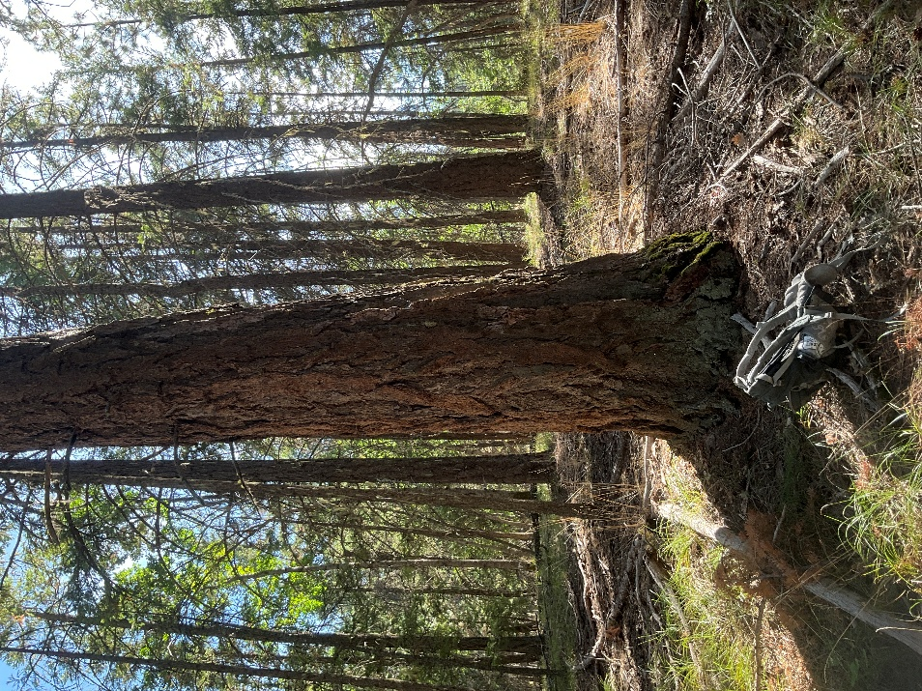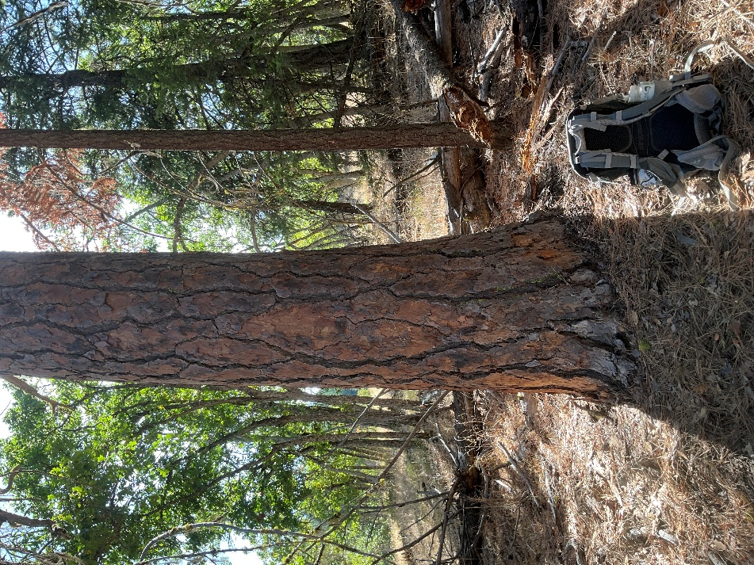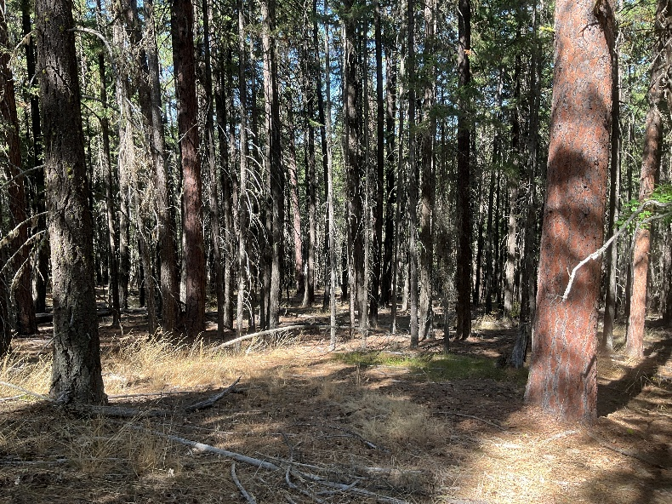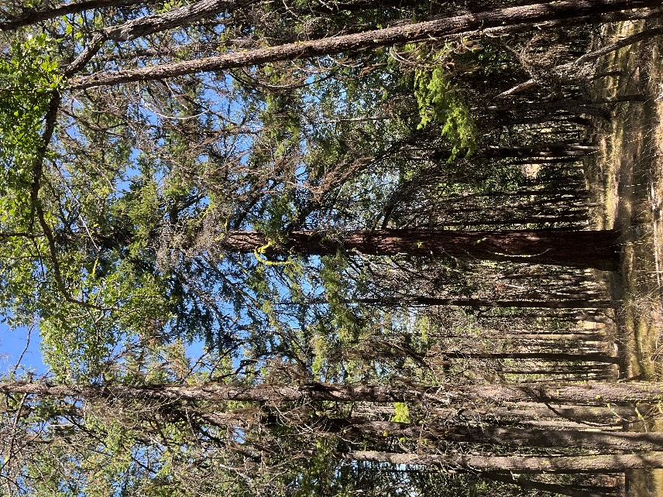

The scoping document states that this project is being considered under section 603 of the Healthy Forest Restoration Act (HRFA). Section 603 explicitly states: “Projects shall maximize the retention of old-growth and large trees, as appropriate for the forest type, to the extent that the purpose of the project is not impaired.”

There is only a single sentence in the scoping documents that references this critical requirement of section 603: “All treatment areas would use a mix of thinning from below and selective thinning, prioritizing the retention of the largest and healthiest trees available within the stands.” While this aligns with HFRA Section 603, this language is open-ended and subject to interpretation. Bark feels that this single sentence fails to provide reasonable assurance to the public that large trees within the project area will be retained to the maximum extent possible.

Further, some stand data are still being finalized with common stand exams (Appendix B), and unit-specific prescriptions are not yet public. This limits transparency about where large trees are, how they'll be retained, and how the project will comply with requirements for the Insect and Disease CE.

To provide reasonable assurance that the project maximizes the retention of old growth and large trees, Bark requests that, once completed, unit prescriptions for Hootnanny be shared with Bark and WCFC.

TEMPORARY ROADS
Please provide a map of potential temporary road alignments in the Decision documentation.
Bark is concerned about the potential for a high number of temporary road miles being needed for project implementation. Commercial unit 306 specifically may require construction of a very long new temporary road segment where no existing alignment exists (according to LiDAR).
More specifically, Bark is concerned about the unanalyzed long-term impact of temporary road construction. Short-term disturbance caused by temporary road construction can certainly be limited by reusing existing alignments and with appropriate PDCs for construction and closure. However, it seems to be common practice that road alignments, even when temporary, get reutilized by future projects or wildfire suppression operations, thus bringing into question how “temporary” the impacts of temp roads are.
Therefore, Bark strongly suggests that you limit the construction of temporary roads to the greatest extent possible.
Further, how will temporary roads be constructed? Will there be native surface roads? Will rock/gravel be used on temporary roads? We feel that the Temporary Road Closure PDC could be improved with more specific language. For example (taken from the Stone Draft EA PDCs):
“Native surfaced roads would be decompacted as needed with the jaws of a log loader or excavator. Roads or sections of roads that have rock surfacing may be decompacted where site-specific circumstances warrant. The technique known as “cratering,” which is a standard practice often used for system road decommissioning, may be used to decompact temporary roads or reused existing road alignments.”
Inclusion of language like the above would offer better assurance to the public that impacts from temporary roads will be mitigated by proper closure and rehabilitation.
SPECIFYING USE OF NATIVE PLANTS/SEED IN PDCs
Bark strongly encourages that relevant PDCs emphasize the use of native seed/plants for restoration/revegetation of temporary roads, landings, and other areas of bare soil caused by disturbance.

As an example, see the following PDCs included in the recent Draft EA for the Stone Creek Vegetation Management Project on the Clackamas River Ranger District:

A11. Bare soils would be covered by slash or other vegetative material or seeded and mulched. An effective ground cover of 60% will be installed on all disturbed surfaces. For restoration, revegetation, or erosion control on disturbed ground, use only locally adapted native plant materials e.g., seed, cuttings, divisions, corms, bulbs, and/or transplants that have been collected from the Mt. Hood National Forest. If native plant materials from the Forest are not available, materials from the west side of the Gifford Pinchot National Forest or the north side of the Willamette National Forest can substitute. The following would not be appropriate to use; materials from outside this sub-region, non-native plants, invasive plants, orchard grass (Dactylis glomerata), annual ryegrass (Lolium muliflorum; also known as L. perenne ssp. multiflorum) or the cultivar Madsen sterile wheat (Triticum aestivum). Locally collected native blue wildrye (Elymus glaucus) and California brome (Bromus carinatus]) are appropriate grasses to use as are locally collected native forbs (particularly broadleaf lupine [Lupinus latifolius], Canada goldenrod [Solidago elongata], pearly everlasting [Anaphalis margaritacea], and wild yarrow [Achillea millefolium]).

A12. Erosion-control measures would be implemented to prevent off-site movement of disturbed soils from logging activities, and other related actions. Areas of soil displacement on steep slopes resulting from yarding systems would be treated to prevent rill and gully erosion and possible sediment delivery to stream courses. Where appropriate, erosion control treatment on bare soils may include water bar placement, hillslope contouring, creating small ditches or diversions to redirect surface water movement, scattering slash on disturbed soils, placement of weed-free mulch, and application of approved native seed. Mulch may be used on slopes greater than 20%. An effective ground cover of 60% will be installed on operational surfaces (i.e. landings, skid trails, equipment tracks, etc.) prior to shutting down for an extended period (e.g., two weeks or more). When operations occur when it is likely to soon become too wet to operate, erosion-control work would stay current, and ground cover would be installed as soon as practicable.

N5. Plant seed used for erosion control or other reasons would be provided by the Government. Otherwise, outside sources would be certified by the State of Oregon to assure noxious weed-free status. A certificate, label, or other official documentation of noxious weed-free status must be provided. In certain cases, if approved by a FS botanist, non-certified seed may be used if it is deemed free of Oregon State Class A & B noxious weeds. The source of plant seed must be given before use. Species used must be native and genetically appropriate to the local area, sown at appropriate rates at the appropriate time (fall season after persistent rain or early spring), contain a diverse blend of forb and grass species, and incorporated with mulch when available.

Obviously, it would not be appropriate to copy the above PDCs directly, as they would need to be altered to better represent the different plant communities appropriate to the east-zone of Mt Hood. But we share the above because they better reflect our wish that contractors use the appropriate native plant mix to rehabilitate disturbed areas after implementation. The current PDCs listed in the scoping documentation do not mention native seed/plants.

SYSTEM ROADS
2700-121
During surveys in 2024, Bark staff found that this road had been reopened and bladed but then closed with large pits dug out in the road (see photos below). Mt Hood staff later confirmed that this occurred during the suppression response to the 2024 Larch Creek Fire.
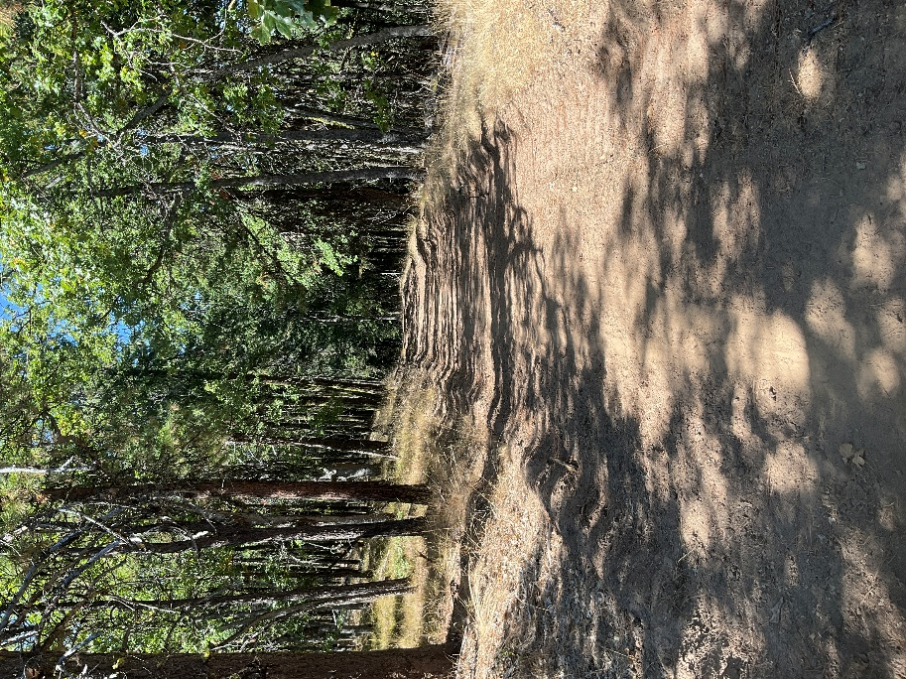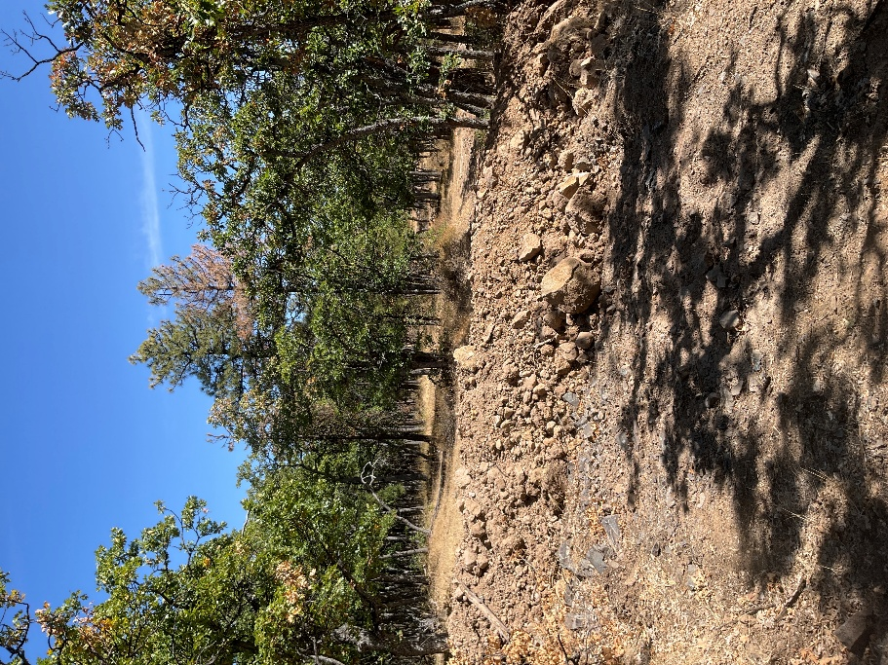
It appears that this road alignment may be used as a potential temporary road during project implementation. Can you please clarify the maintenance level of road 2700-121? If it is closed (ML-1), will it be returned to ML-1 post implementation? Will road closure follow Temporary Road Closure PDC #1 (and our suggested improvements)?
CONCLUSION
Bark has provided several suggestions for improving the Hootnanny CE. We appreciate you reading Bark's comments and finding ways to incorporate the above suggestions. If there is anything in this document that you have questions about or would like to discuss, please reach me at jordan@bark-out.org.

Thank you,



Jordan Latter
Forest Watch Program Manager, Bark

