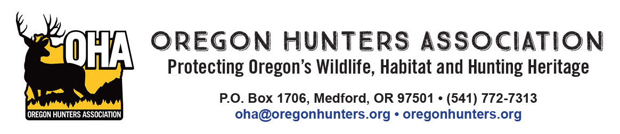
July 18, 2025

Middle Fork Ranger District
Attn: Dead Mountain EA
46375 Highway 58
Westfir, Oregon 97492

RE: Oregon Hunters Association input on the Dead Mountain project scoping

The Oregon Hunters Association (OHA) is a sportsmen’s conservation organization with over 12,000 members in 26 chapters across Oregon. OHA values our National Forests as a public place to hunt and recreate, and as a valuable asset providing habitat for the wildlife we care about. As such, the management and access of these lands are of critical importance to OHA. We have been engaged in numerous projects to improve and protect habitat conditions, and we value our partnership with the U.S. Forest Service (USFS) and the Willamette National Forest. We are providing comments and input on the Dead Mountain project scoping.

First and foremost, OHA supports active management for a variety of reasons that were articulated in the project proposal including improving/maintaining stand health, wildfire mitigation, and ensuring there is a well managed and appropriately sized transportation system. OHA’s primary interests in the project are specific to big game habitat and recreational access.

Elk populations on the Willamette National Forest (which includes the McKenzie Wildlife Management Unit) are below the management objectives set by the Oregon Department of Fish and Wildlife. This points to a need for work to develop or improve elk (and deer) habitat on the project area. While OHA believes that there is a very limited opportunity to improve habitat for ungulates with the proposed project, this may be the only opportunity to address some of these needs for quite some time. With that, we offer the following:

- OHA wants to encourage the USFS to use of the westside elk model when developing both stand specific and project wide stand prescriptions.
- Where using the creation of gaps in the stand treatment prescriptions, the USFS should favor using larger gaps and at an abundance to actually promote (temporarily at least) some semblance of early seral habitat.
- OHA strongly recommends that gaps be a minimum of three acres in size. Smaller gaps, in Douglas-fir stands, on high sites, will close in so rapidly that understory will be excluded within a decade.
- OHA would like to see the USFS employ heavier thinning prescriptions where possible to allow understory vegetation to develop and persist as long as possible before the stand closes in again. Once again, Douglas-fir stands on high sites will rapidly close in any openings in the overstory canopy. Using heavier thinning prescriptions on at least a portion of the project area will allow understory forage to persist longer.
- OHA supports the proposed actions related to roads. Specifically the proactive plan to decommission unneeded or poorly designed/placed roads, and using road closures where applicable, as well as other actions that will keep a well maintained, and appropriately sized road system in the project area. OHA recommends that the USFS consider at least seasonal road closures in areas where gaps are developed in the stands to avoid disturbance of elk.

Thank you for the opportunity to provide our input on this project.

Mike Totey
Conservation Director
Oregon Hunters Association

