7/17/2025

Bark
PO Box 12065
Portland, OR 97212
www.bark-out.org
503-331-0374

Phil Monsanto, District Ranger
Stone Creek EA ID Team
Clackamas River Ranger District
Mt. Hood National Forest
16400 Champion Way
Sandy, OR 97055
RE: Stone Creek Vegetation Management Project
Dear Phil,
As you are aware, Bark's mission is to transform the lands now known as Mt. Hood National Forest into a place where natural processes prevail, where wildlife thrives, and where local communities have a social, cultural, and economic investment in its restoration and stewardship. Our supporters live in the many communities surrounding Mt Hood National Forest. They rely on the Forest for drinking water, economic opportunities, recreation, forest products, spiritual renewal, connection to the land, and more. We submit these comments on behalf of our supporters.

TRIBAL INCLUSION

The Stone Creek project area is located within the ancestral homelands and ceded territories of The Confederated Tribes of Warm Springs. Though it is not our place to speak on behalf of Warm Springs members and their government, we encourage and support meaningful collaboration between the Tribe and the federal government that holds these lands in trust. Bark believes that incorporating Tribal perspectives and values into all aspects of project design and implementation will lead to better outcomes for the land and its people.

COLLABORATION

Bark wants to recognize and thank the IDT for introducing this project to Clackamas Stewardship Partners and for planning/hosting a field tour of the project area in September 2024. Further, we appreciated the continued project updates and responsiveness to questions/concerns from you, Phil, and the rest of the IDT. Thank you.

CONTRACTING

Over the many years of Bark’s engagement in the planning and monitoring of vegetation projects on Mt Hood, we have documented discrepancies between project intent and contract implementation. Most recently, we saw this play out during the post-fire roadside hazard tree removal work on the Clackamas River Ranger District.

As I’m sure you are aware, poor project implementation can perpetuate public distrust in the Forest Service and lessen certainty that protections – as written in project PDCs – will actually protect resources as intended by the specialists.

In our opinion, discrepancies can be avoided by ensuring that strong PDCs are translated correctly into contract language, and that contracts are monitored during implementation. Further, we encourage the Mt Hood to award contracts to local, knowledgeable contractors with a demonstratable track record of successful Federal contract implementation.

COMMERCIAL THIN UNITS

1356

This unit was cut in the early 1970s using a shelterwood logging method, therefore there is now a low density of larger mature trees scattered across the stand. In June and July of 2025, Bark staff and volunteers confirmed the presence of this mature tree component (see photos below). Most of these trees are western hemlock, and a few are Douglas-fir.

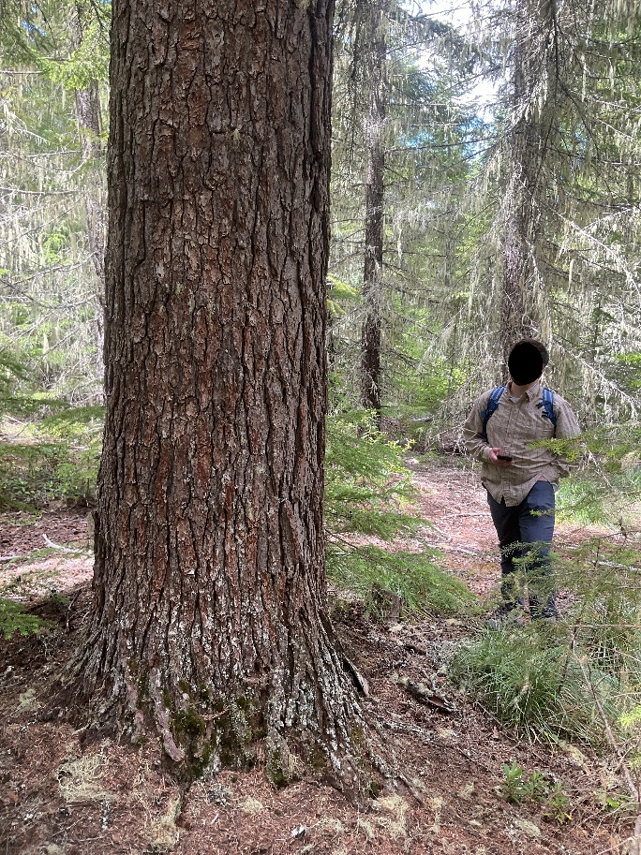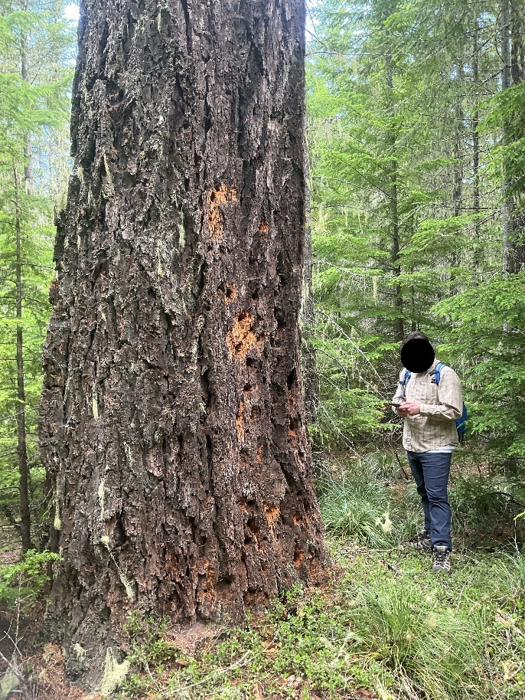

These larger mature trees should be retained during commercial harvest operations. Bark believes that retaining these trees is critical to maintaining structural complexity/diversity and improving fire resiliency. Retaining these trees is compatible with the general Desired Future Condition which states “… the planning area should consist of healthy forest ecosystems with habitat that will support populations of native species while maintaining a sustainable supply of timber and other forest products”. (Draft EA p. 10)

Further, many of the trees that were left during the 1970s logging operation have blown down and are now large logs (see photos below). Considering the lack of large downed logs in harvested stands (including unit 1356), these logs should be left on site and avoided during operations or incorporated into “skips” within the unit. Retaining these large logs will contribute to the overall health, structural diversity, and habitat quality of the stand.

ROAD CLOSURES AND DECOMMISSIONING

Bark appreciates and fully supports proposed actions to reduce road density in the project area. While decommissioning is preferred, we understand that it can be extremely costly. Road closure and storm proofing are positive steps in the right direction. That said, we would like to share a few road-related concerns that we discovered while surveying the project area.

5730-049 & 050

According to the transportation report, to access two past strip cuts (units 1377 and 1378), roads 5730-049 and 5730-050 will be used during implementation and then closed. While the units you will be accessing are young plantations, these roads pass through an older section of forest (see LiDAR imaging below).

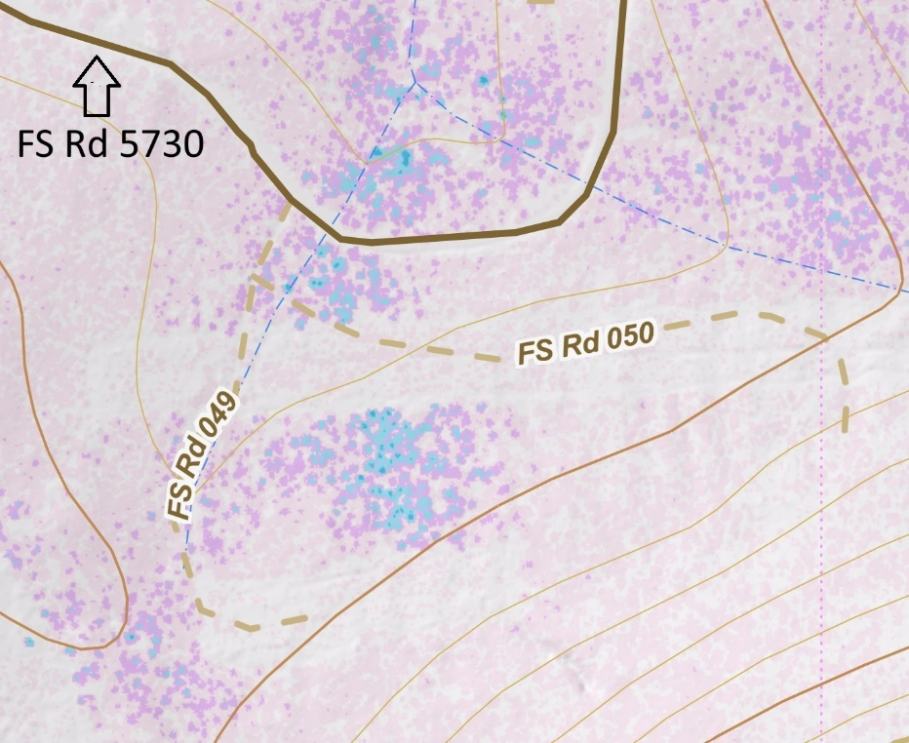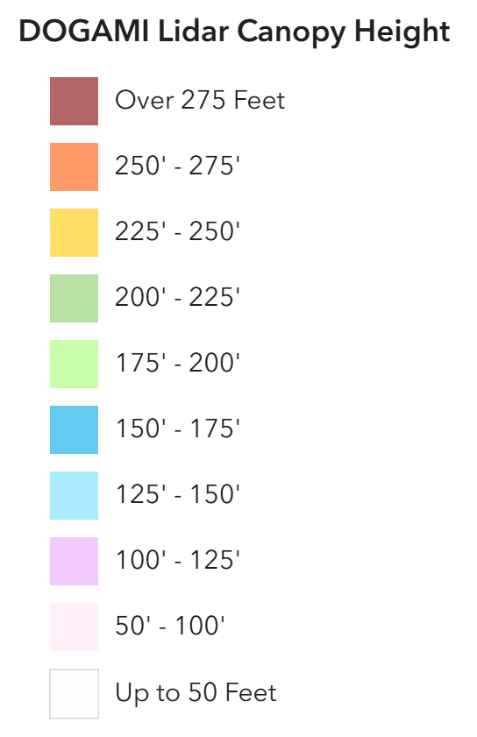

As an example, this clump of larger Douglas-fir trees (~40” DBH, see photo below) is next to the 050 road and may also be within the boundary of unit 1378. Please ensure that contract language protects these trees from being cut or damaged during operations.

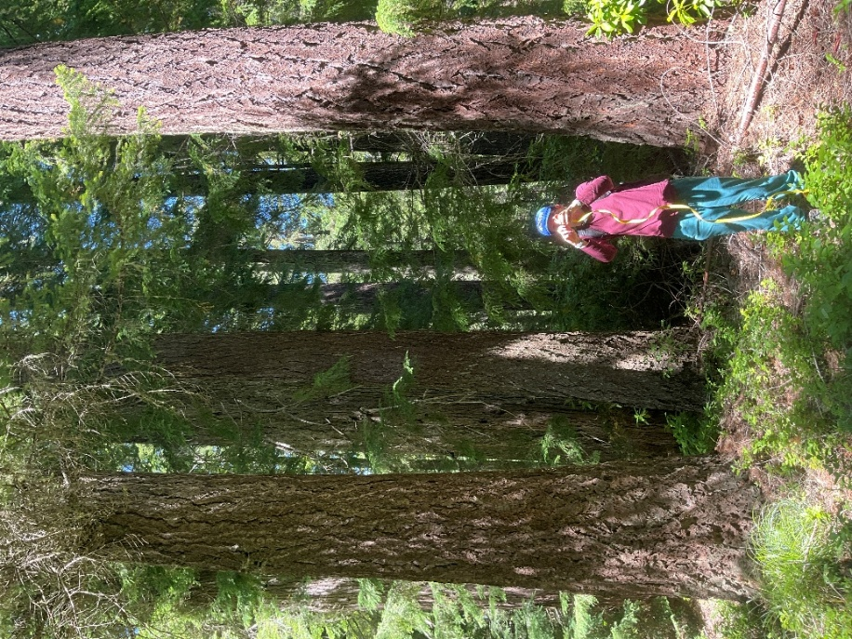
Additionally, near the junction of 5730-049 and 5730, there is a large Douglas-fir snag (45.073536, -121.832066, see photo below). This snag also appears to be within the roadside fuels reduction boundary.
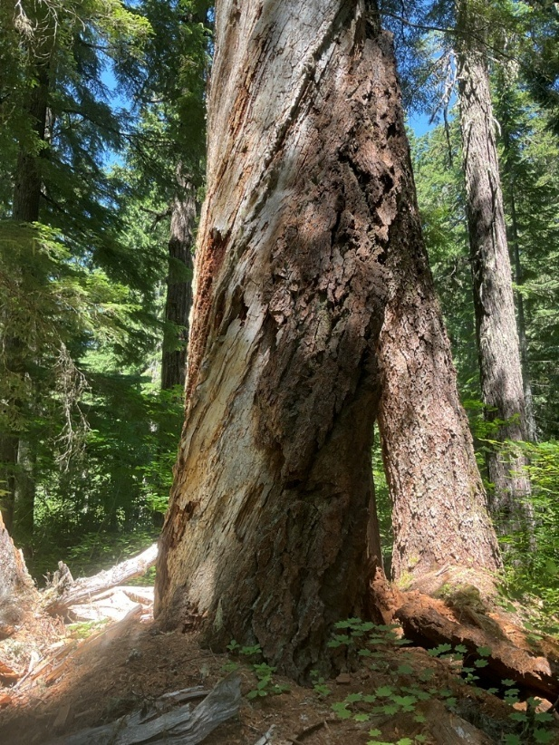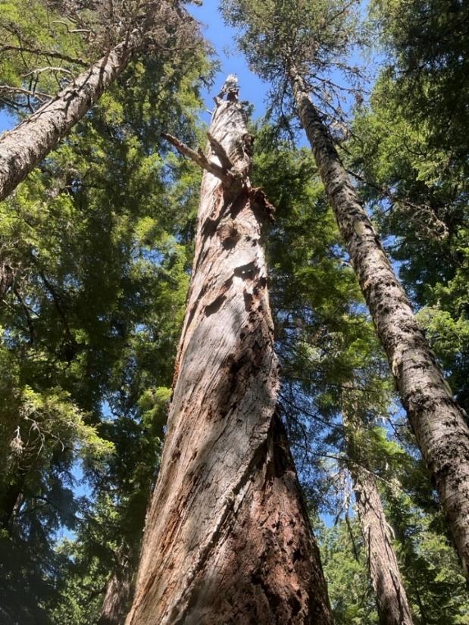

Draft PDCs allow snags to be cut for safety reasons. While we understand why this may be needed in some circumstances, we encourage you to ensure that high-quality snags like this one are retained on the landscape to provide long-term snag habitat.

5730-053/54

During a survey in July 2025, Bark staff and volunteers found that these road segments are in a condition well below the ML-2 designation (see photos below). The entrance/junction is not visible or accessible from road 5730, and there are spots along the mapped road alignment where the road doesn’t appear to exist except on a map.

View of junction with 5730 from 5730-053:
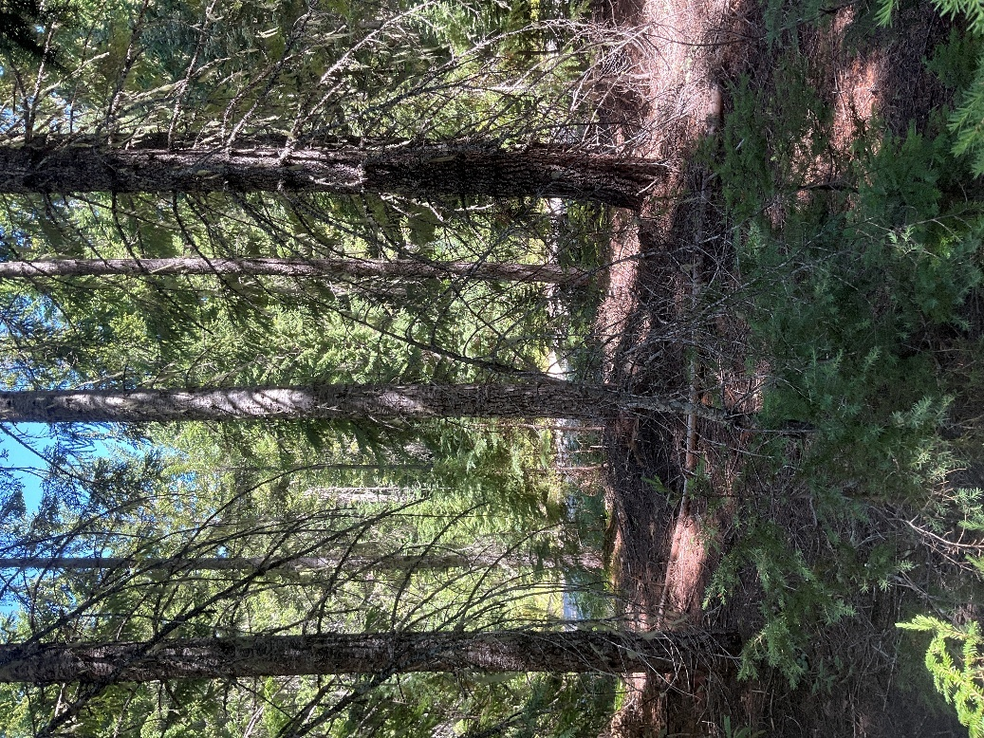

Current condition:
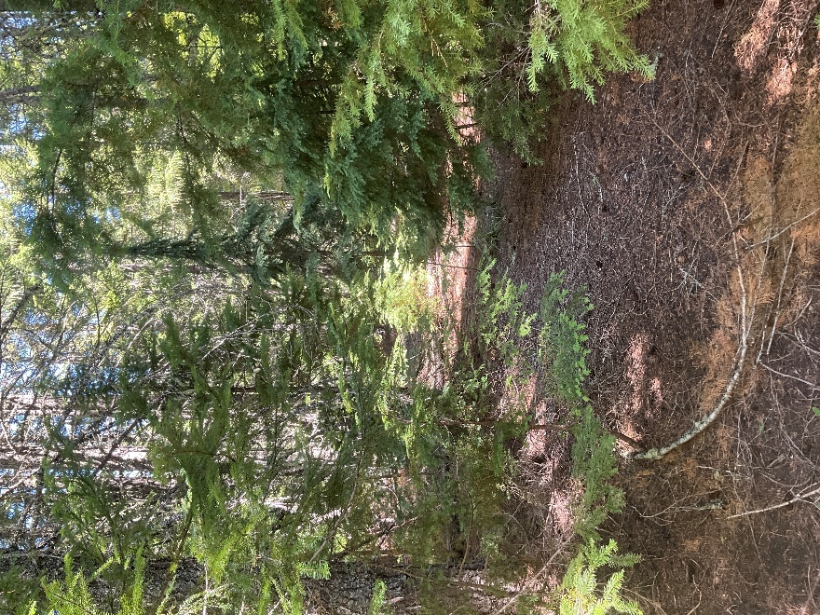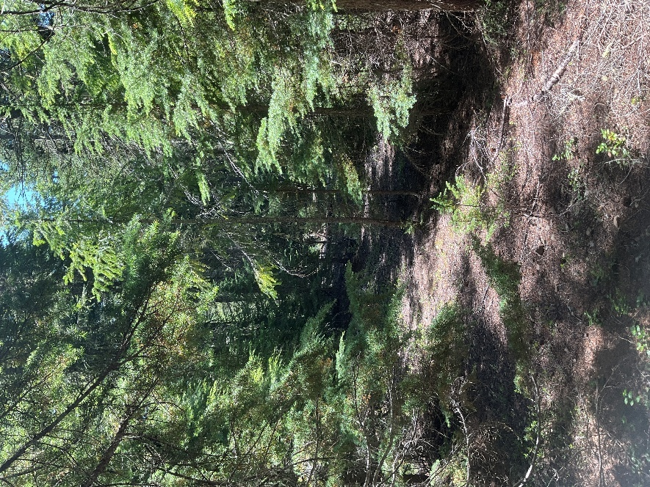
5730-053/54 junction:
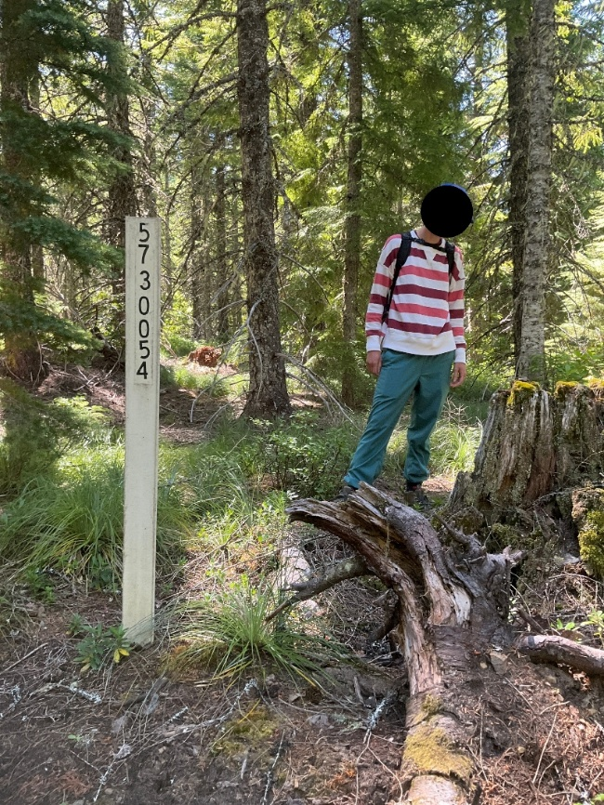
Considering the current condition of the road, Bark is wondering if it is operationally feasible to passively decommission this road (remove from transportation system), rather than reopen it for use and then close (ML-1) as is currently proposed in the EA documentation. This part of unit 1379 is within a bend in road 5730, providing access to most of the unit. Please analyze whether it would be possible and appropriate to passively decommission road 5730-053/54, rather than use during implementation.

5740-240

The following discrepancy was brought to my attention by Mia Pisano, who has also noted this in their comments on the Draft EA.

“The Transportation Report Table 3, Proposed Action Roads Table, identifies FR 5740-240 for closure, no stormproofing, change from ML2 to ML1. However, the map of Proposed Road Changes does not identify FR 5740-240 for closure.”

Please clarify the proposed action for road segment 5740-240.

5740-242

There is a dispersed campsite where road 5740-242 crosses a tributary of Stone Creek (45.094232, -121.811215). During surveys in June 2025, Bark staff and volunteers documented that the campsite contained trash and a camper-built wooden platform and toilet (see photos below). The trash and wooden structures should be cleaned up prior to or during activities related to the closure and storm proofing of this road. It may also be possible for Bark to partner with USFS to schedule a volunteer clean up day. We invite you to contact us regarding this issue.
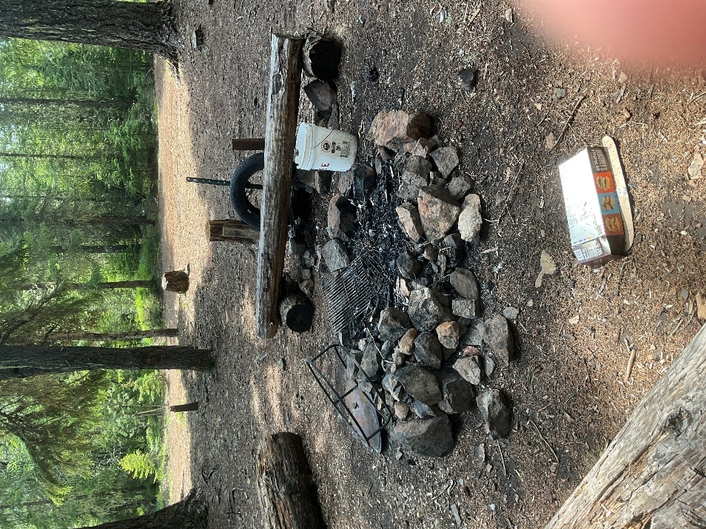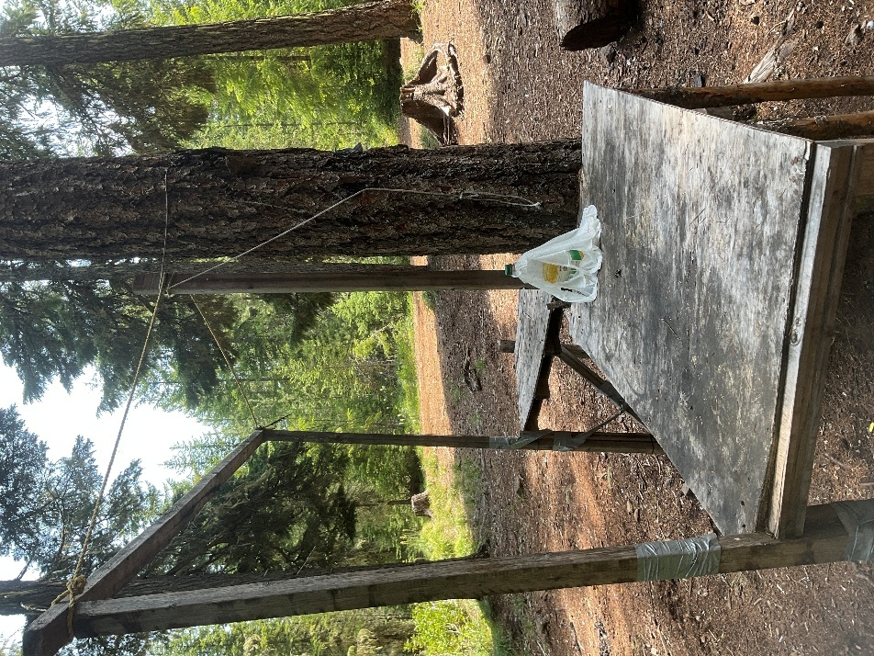
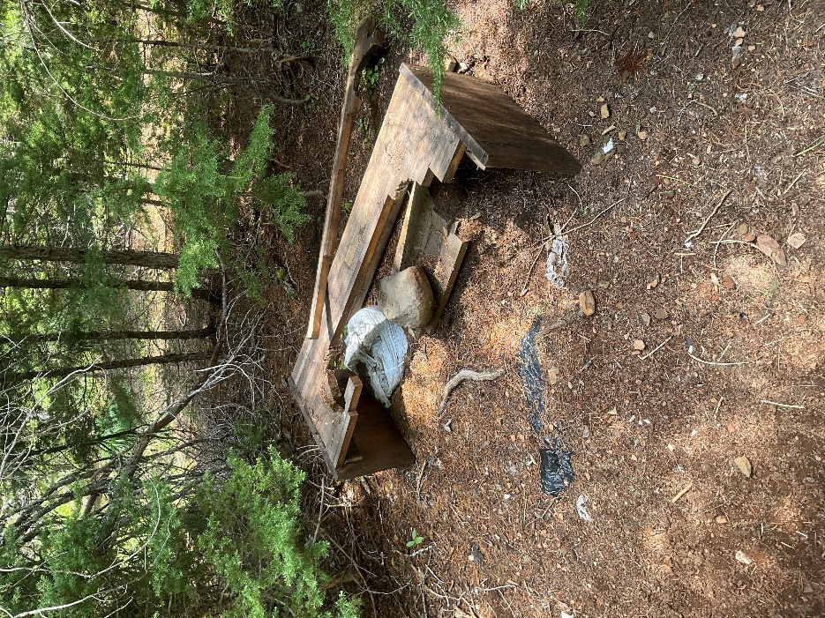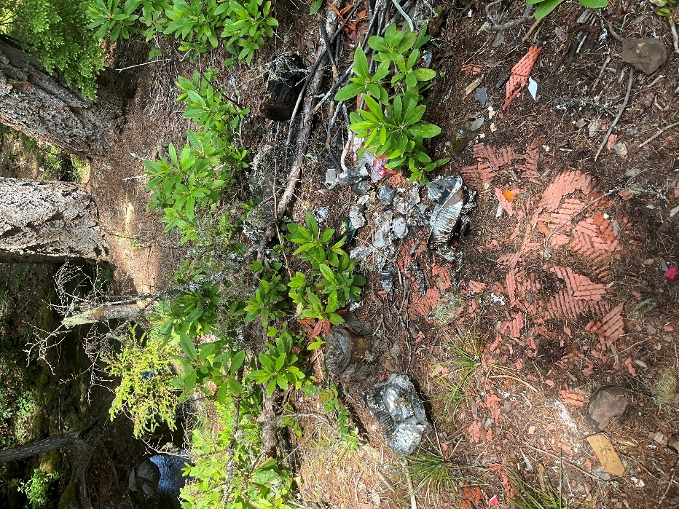
In addition, road 5740-242 contains a small culvert where it crosses a tributary of Stone Creek. In June 2025, Bark staff and volunteers documented that this culvert was already partially blocked on the upstream side as well as partially crushed (see photos below). This culvert should be removed and the original channel width restored during storm proofing activities.

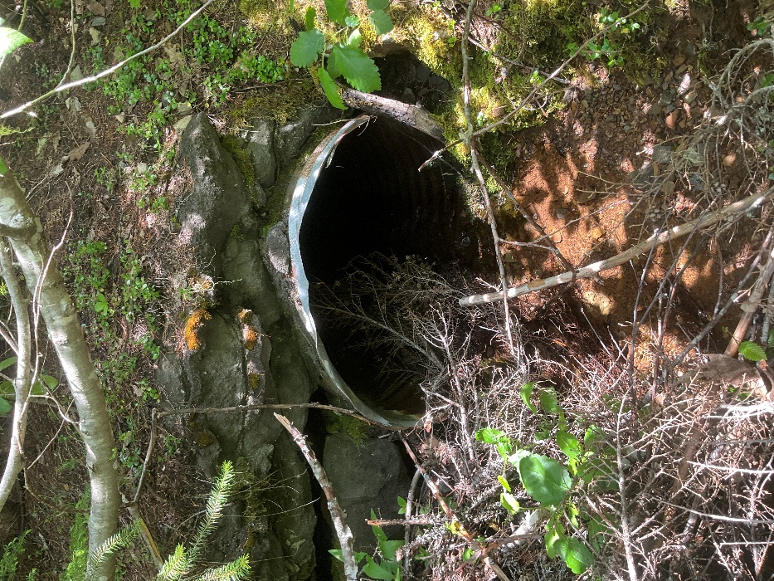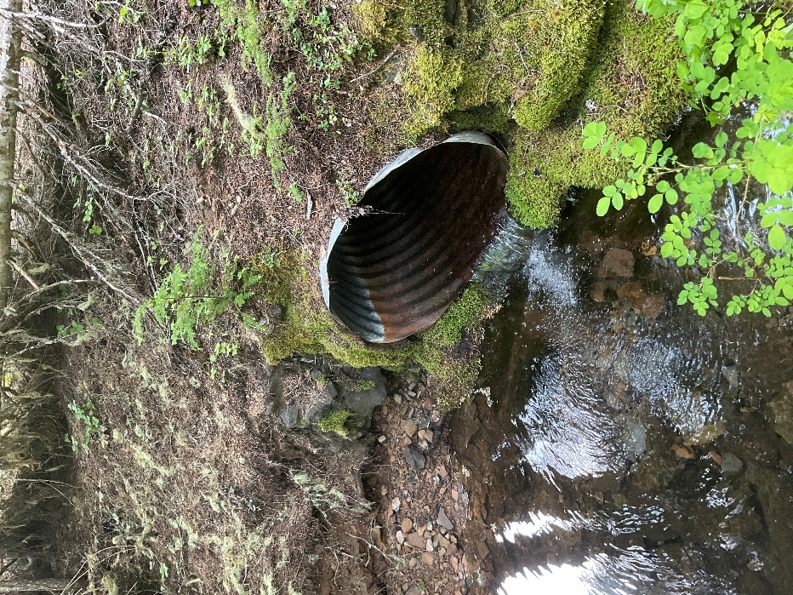

5740-285

During surveys of this road segment in June 2025, Bark staff documented two ditch relief culverts (see photos below). Both culverts were partially blocked on the downhill side from a buildup of gravel and sediment. These ditch relief culverts should be removed during storm proofing operations.

First culvert (located at 45.064843, -121.809072):
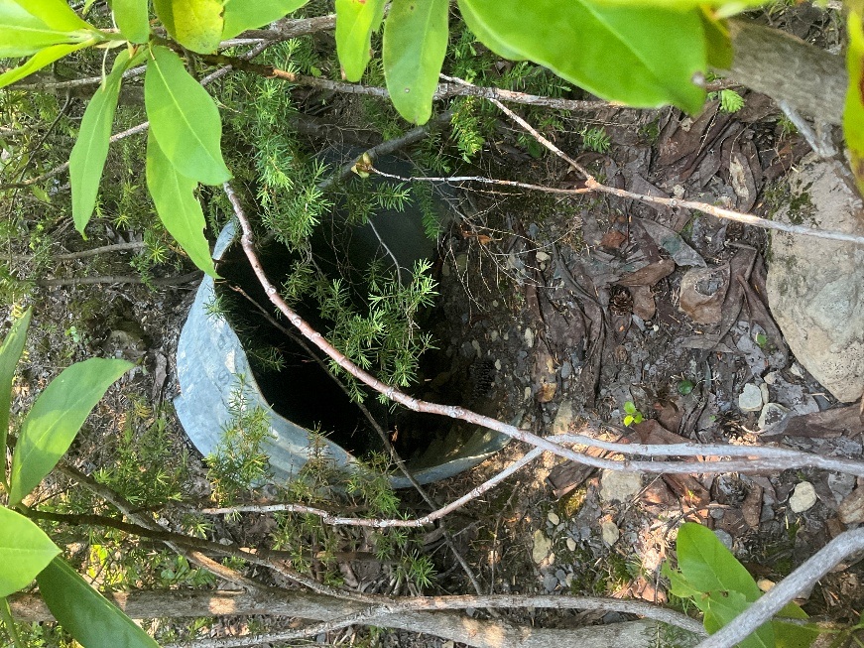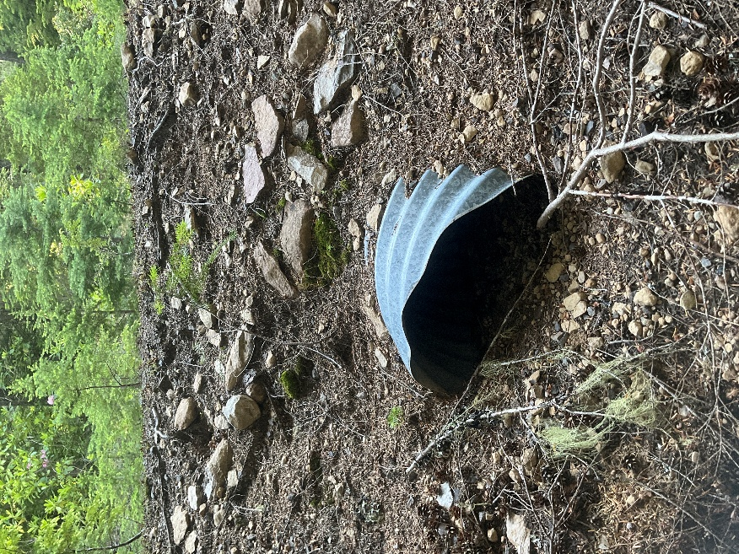
Second culvert (located at 45.063319, -121.807410):
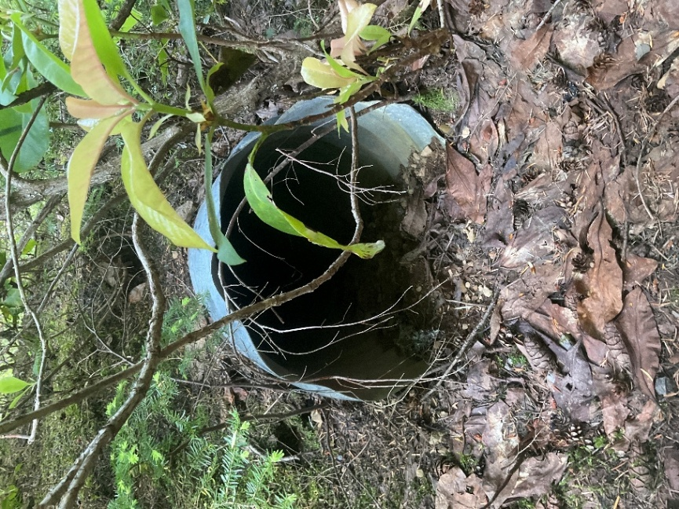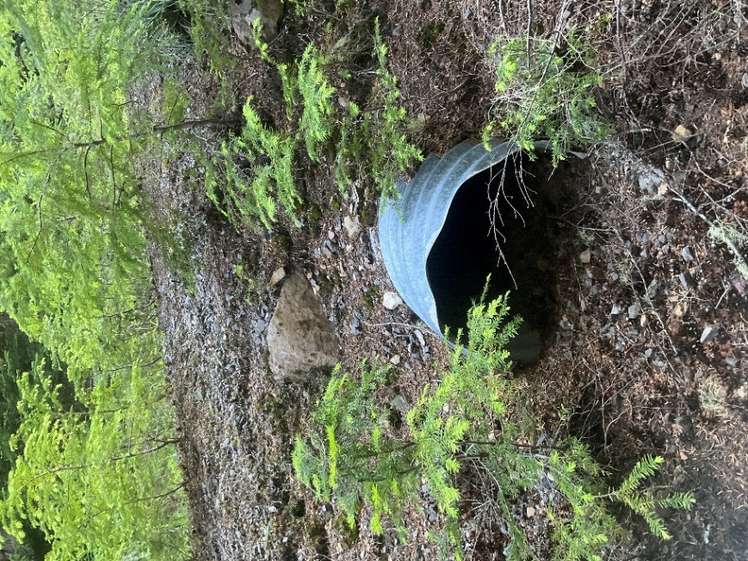
DISPERSED CAMPING

In our scoping letter, Bark noted the many dispersed camping locations in the project area in need of restoration and rehabilitation. It is unclear what the IDT’s response was to our concerns.

I want to repeat our concern about the most egregious example of a dispersed campsite causing damage to resources. The large and popular dispersed site located where road 5740 crosses Stone Creek (45.0893, -121.80368) allows vehicles to drive off road in a large area as well as into and across the adjacent creek.

Bark urges you to address the issues in this dispersed site. At the very least, prioritize protecting the creek by blocking vehicle access to the creek and closing off the small unofficial road connecting the campsite to 5740 on the north side of Stone Creek.

FIRE

Bark appreciates your recognition of the important role fire plays in shaping these forest ecosystems, and recognizing the harm caused by a strict suppression policy. We appreciate the inclusion of broadcast burning as a project component. Additionally, we appreciate the inclusion of actions to limit the impact of fire to large trees, such as burning tree wells during winter.

TEMPORARY ROADS

Thank you for including a map of potential temporary road alignments after Bark requested this information in our scoping comments.

ROADSIDE FUELS TREATMENTS

In Bark’s scoping comments, we expressed concern that roadside fuels treatments would allow heavy machinery to operate within stands over 80 years old.

While discussing roadside fuels treatments, the Silviculture report states, “Restrictions apply to this width in stands with mid-late seral characteristics (see PDCs).” PDC I10 states: “Where roadside fuels reduction would occur in stands exceeding 80 years of age, treatment widths will be restricted to the first 50 feet measured from the edge of the road.”

While we appreciate limiting the width of roadside treatments in stands over 80 to protect sensitive resources, this PDC language does not stop heavy machinery from operating within these stands while conducting roadside fuels treatments. Please ensure that PDCs eliminate or minimize heavy machinery from operating in stands over 80 years old.

ADDITIONAL INFORMATION

Bark noted the information below during scoping, but it is unclear what the response of the IDT was to our comment and whether this old bridge will be removed during project implementation.
There is an old wooden foot bridge spanning Rock Springs creek at 45.055094, -121.816578 (the SE boundary of unit 1368). This bridge is likely associated with a previous harvest and connects two old non-system roads. Bark requests this bridge be removed as part of the project.
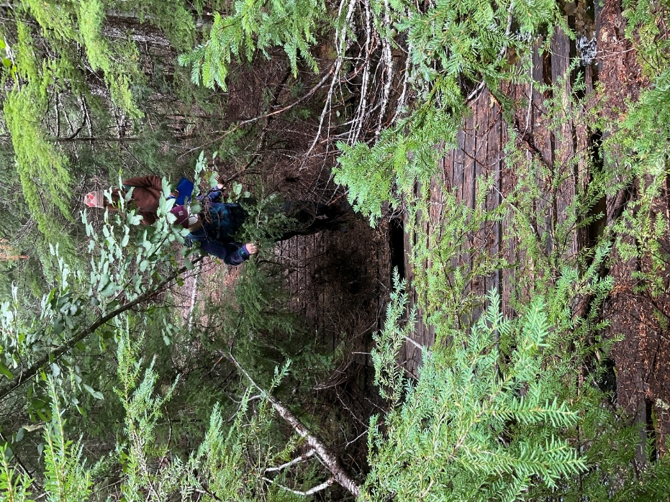

CONCLUSION
Bark has provided several suggestions for improving the Stone Creek Vegetation Management project. We appreciate you reading Bark's comments and finding ways to incorporate the above suggestions. If there is anything in this document that you have questions about or would like to discuss, please reach me at jordan@bark-out.org.

Thank you,



Jordan Latter
Forest Watch Program Manager, Bark

