17 July 2025

TO: Phil Monsanto, Clackamas River District Ranger
ATTN: Ashley Popham, Clackamas River Ranger District
VIA: https://cara.fs2c.usda.gov/Public/CommentInput?Project=65780

Subject: Stone Creek Vegetation Management draft EA/ESD — comments

Please accept the following comments from Oregon Wild concerning the Stone Creek Vegetation Management draft EA/ESD, https://www.fs.usda.gov/r06/mthood/projects/65780. Oregon Wild represents 20,000 members and supporters who share our mission to protect and restore Oregon’s wildlands, wildlife, and water as an enduring legacy. Our goal is to protect areas that remain intact while striving to restore areas that have been degraded. This can be accomplished by moving over-represented ecosystem elements (such as logged and roaded areas) toward characteristics that are currently under-represented (such as roadless areas and complex old forest).

This proposal involves 3,225 acres of treatments including over 2,000 acres of commercial logging:
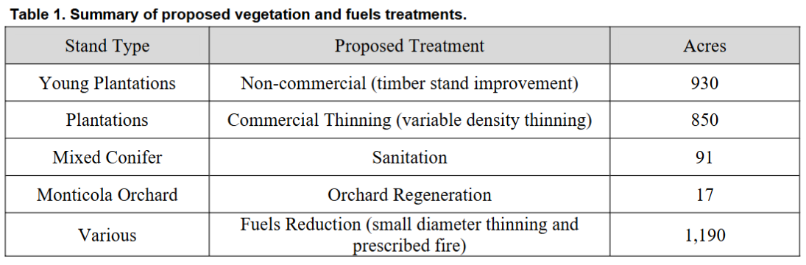
- Treatments are proposed in the Matrix and Riparian Reserve land use allocations.
- About 3 miles of temporary road construction
- close approximately 20 miles of open road

In general, we find that the analysis in the EA greatly oversimplifies the analysis found in the specialists reports and fails to adequately inform the public or the decision-maker. That said, the analysis in the specialists reports is often incomplete and misleading.

Young Stand Thinning
We are most comfortable with non-commercial thinning and prescribed fire because it has far fewer trade-offs normally associated with commercial logging, such as soil impacts for roads and heavy equipment, removal of significant biomass/habitat, and GHG emissions.

We appreciate this project’s focus on thinning young stands. We urge the Forest Service to design and implement this thinning increase beneficial effects and minimize trade-offs such as:
- Homogenizing spatial variability compared to natural stands,
- capturing mortality and reducing recruitment of snags and dead wood,
- adverse impacts to habitat and populations of spotted owl prey species,
- carbon storage that helps mitigate global climate change,
- microclimate refugia that helps wildlife exposed to climate extremes,
- adverse impacts from road construction and road use, etc.
Considering a range of alternatives that balance trade-offs in different ways would help the public and the decision-maker better understand this project and it’s effects.

We urge the Forest Service not to thin too heavy relying on relative density metrics that are based on agricultural models and intended to exclude natural processes like competition mortality, because retaining natural processes is essential to allowing these forest to continue developing and recruiting desired habitat qualities, like nags and structural complexity.

Please retain generous skips to mitigate some of the adverse effects of thinning on flying squirrels and snag habitat.

“Gaps” should be small patches of heavy thinning, NOT mini-clearcuts. We should be mimicking natural disturbance events that retain live trees and dead wood, not removing all the biomass from gaps.

We incorporate by reference our scoping comments dated 31 Dec 2024 which included detailed recommendations about optimizing beneficial effects from thinning.

Emergency Situation Determination
Neither the EA nor the Emergency Action Approval for this project provides adequate rationale for the emergency. https://usfs-public.app.box.com/v/PinyonPublic/file/1896611185722

USFS has never grounded the ESD for this particular area in any on-the-ground facts or a rational basis, and previous but very recent "emergency" or "priority" designations never identified this area as needing emergency treatment.

The Mt. Hood Strategic Action Plan did not appear to identify the Stone Creek Project area as a "priority area" for wildfire risk reduction (p. 16):
https://www.fs.usda.gov/sites/nfs/files/r06/mthood/publication/Mt.%20Hood%20Strategic%20Action%20Plan.pdf

The EA says the project need is based on excessive forest density due to fire exclusion, but this area is typified by moist mixed-conifer forests (western hemlock plant associations) that naturally build a lot of biomass in between relatively infrequent fire events. There is not a compelling need (let alone an emergency) to reduce fuels in forests like this. See more below.

The EA refers to “More recent studies2 indicate that moist Douglas- fir forests may have
experienced more frequent fire occurrences, with mixed fire severity.” But the EA cites a study from the Southern Oregon Cascades, not a study from the more moist forests of the Northern Oregon Cascades or the Mt Hood NF.

The EA also cites the need to address global climate change, but the agency has for years focused on the uncertainty of climate change and the uncertain effects of carbon emissions, and now it’s suddenly an emergency? It is highly suspicious that the agency wants to log forests to prepare forests for global climate change but unwilling to avoid GHG emissions by keeping carbon in these forests to help reduce the worst effects of global climate change that will affect these forests, and ecosystems around the world.

The EA never addresses contrary evidence showing that the proposed action (logging) may make the alleged emergency worse in several ways:
- Logging will open the canopy make the microclimate hotter, drier, and windier which makes fire effects worse;
- Logging will open the canopy and make more light water, and nutrients available to stimulate the growth of hazardous surface and ladder fuels, and making future maintenance treatments more frequent and more expensive;
- Logging will emit greenhouse gases and add to the cumulative excess of GHG in our atmosphere, which will make the global climate warmer, and increase drought stress, fire hazard, and other extreme weather events;
- Logging will open the canopy and allow penetration of warm dry air that increases evaporative demand, increases vapor pressure deficit, and makes trees more vulnerable to the drought stress caused by climate change;
- Logging will make the stand hotter and drier and degrade the microclimate refugia that many wildlife need to survive in a world with more climate extremes;
All these effects indicate a need for caution, not urgent action that could make the problems worse. The Climate Appendix to the EA claims that the proposed actions “generally align with recommended [climate] adaptation actions” but the EA fails to take a hard look at the contrary evidence.

Forests with infrequent, stand-replacing fire regimes are not good candidates for fuel reduction.
To date, most climate adaptation guidance has focused on recommendations for frequent-fire forests, leaving few published guidelines for forests that naturally experience infrequent, stand-replacing wildfires. Because most such forests are inherently resilient to stand-replacing disturbances, and burn severity mosaics are largely indifferent to manipulations of stand structure (i.e., weather-driven, rather than fuel-driven fire regimes), we posit that pre-fire climate adaptation options are generally fewer in these regimes relative to others. Outside of areas of high human value, stand-scale fuel treatments commonly emphasized for other forest types would undermine many of the functions, ecosystem services, and other values for which these forests are known.
Halofsky, J. S., D. C. Donato, J. F. Franklin, J. E. Halofsky, D. L. Peterson, and B. J. Harvey. 2018. The nature of the beast: examining climate adaptation options in forests with stand-replacing fire regimes. Ecosphere 9(3):e02140. DOI:10.1002/ecs2.2140. https://esajournals.onlinelibrary.wiley.com/doi/pdf/10.1002/ecs2.2140.

Fewer options exist for reducing fire severity in wetter, high-elevation and coastal forests of the Pacific Northwest, historically characterized by infrequent, stand-replacement fire regimes. In these ecosystems, thinning and hazardous fuel treatments are unlikely to significantly affect fire behavior, because fuels are abundant and fires typically occur under extreme weather conditions (i.e., during severe drought).
Joanne J. Ho, Robert A. Norheim, Jessica E. Halofsky, David L. Peterson, Brian J. Harvey 2019. Changing Wildfire, Changing Forests - How climate change is affecting fire regimes and vegetation in the Pacific Northwest (storymap) https://uw.maps.arcgis.com/apps/Cascade/index.html?appid=9c0f8668f47c4773b56c9b9ae6c301e3 based on Jessica E. Halofsky, David L. Peterson, and Brian J. Harvey. 2018. Changing Wildfire, Changing Forests: A Synthesis on the Effects of Climate Change on Fire Regimes and Vegetation in the Pacific Northwest. Seattle: Northwest Climate Adaptation Science Center. https://nwcasc.uw.edu/science/project/changing-fires-changing-forests-the-effects-of-climate-change-on-wildfire-patterns-and-forests-in-the-pacific-northwest/

“Uncharacteristic” fire is virtually non-existent in all of western Oregon.
In ​this study, we developed a model of expected area burned for the western US as a function of climate from 1984 to 2012. We then quantified departures from expected area burned to identify geographic regions with fire deficit or surplus. We developed our model of area burned as a function of several climatic variables from reference areas with low human influence; the relationship between climate and fire is strong in these areas. We then quantified the degree of fire deficit or surplus for all areas of the western US as the difference between expected (as predicted with the model) and observed area burned from 1984 to 2012. Results indicate that many forested areas in the western US experienced a fire deficit from 1984 to 2012, likely due to fire exclusion by human activities. …
... there were also large expanses that experienced no substantial departure from expected area burned. Such areas generally corresponded to two types of ecosystems that typically experience little fire: very dry ecosystems that are biomass limited (i.e., warm and cold deserts that have not been invaded by annual grasses) and wet ecosystems (temperate rainforest) that are rarely conducive to burning (Krawchuk and Moritz 2011, Parks et al. 2014).
Sean A. Parks, Carol Miller, Marc-Andre´ Parisien, Lisa M. Holsinger, Solomon Z. Dobrowski, And John Abatzoglou. 2015. ​Wildland fire deficit and surplus in the western United States, 1984–2012. Ecosphere. December 2015 v Volume 6(12) v Article 275. http://www.fs.usda.gov/rm/pubs_journals/2015/rmrs_2015_parks_s002.pdf. See ecoregions 8 (western Cascades) and 9 (Coast Range) in the map below. They show virtually no departure from expected fire occurrence.
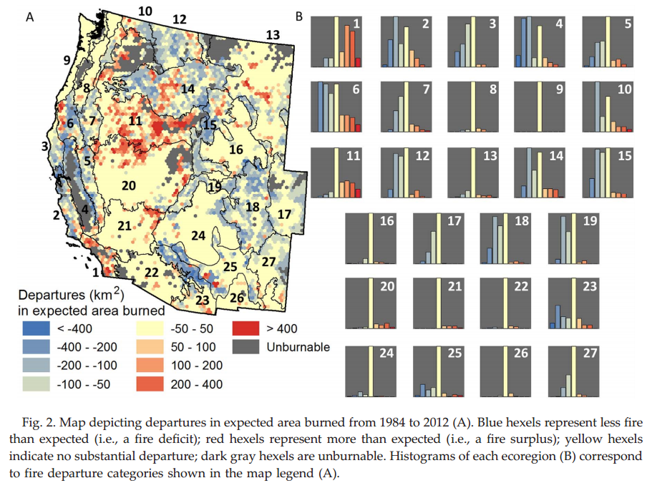

“In crown fire regimes … fuel accumulation has not been the cause of large fires, and ecosystems are often within their HRV; thus there is limited need for ecosystem restoration.” Keeley, J.E.; Aplet, G.H.; Christensen, N.L.; Conard, S.C.; Johnson, E.A.; Omi, P.N.; Peterson, D.L.; Swetnam, T.W. 2009. Ecological foundations for fire management in North American forest and shrubland ecosystems. Gen. Tech. Rep. PNW-GTR-779. Portland, OR: U.S. Department of Agriculture, Forest Service, Pacific Northwest Research Station. 92 p. https://www.fs.usda.gov/pnw/pubs/pnw_gtr779.pdf.

Appendix E of the Final Recovery Plan for the Northern Spotted Owl says “[S]ilvicultural activities designed to reduce fuels and alter fire behavior in forests naturally subject to stand-replacement disturbance regimes will result in unnatural ecosystems that have no historic precedent and are incapable of providing habitat for characteristic biodiversity or of carrying on the normal array of ecosystem processes.” U.S. Fish and Wildlife Service. 2008. Final Recovery Plan for the Northern Spotted Owl, Strix occidentalis caurina. U.S. Fish and Wildlife Service, Portland, Oregon.
“Contrary to claims by some commentators (e.g., National Association of Forest Industries 2009a,b,c), industrial logging is likely to make some kinds of forests more, not less, prone to an increased probability of ignition (Krawchuk & Cumming 2009) and increased fire severity and/or fire frequency (Uhl & Kauffman 1990; Thompson et al. 2007; Bradshaw et al. 2009; Malhi et al. 2009).” David B. Lindenmayer, Malcolm L. Hunter, Philip J. Burton, & Philip Gibbons. 2009. Effects of logging on fire regimes in moist forests. Conservation Letters xx (2009) 1–7. http://soln.org/wp-content/uploads/2010/01/effects-of-logging-on-fire-regimes-in-moist-forests.pdf.
Many of the stands where restoration of historical forest conditions is needed are open canopy and located on south facing slopes and at lower elevations. In contrast, many closed canopy stands are often located at higher elevations and on north-facing slopes where restoration of historical forest conditions is not needed.
R. V. Platt, T. T. Veblen, and R. L. Sherriff. 2008. Spatial Model of Forest Management Strategies and Outcomes in the Wildland–Urban Interface Natural Hazards Review, Vol. 9, No. 4, November 1, 2008. DOI:10.1061/(ASCE)1527-6988(2008)9:4(199) http://public.gettysburg.edu/~rplatt/Platt%20et%20al._NatHazReview08.pdf.

USFWS stated in the Biological Opinion for the Calapooya Divide Project:
In contrast to dry forests, short-term fire risk is generally lower in the moist forests that not only dominate on the west side of the Cascade Range, but also occur east of the Cascades as a higher elevation band or as peninsulas or inclusions in mesic forests. Disturbance based management for forests and spotted owls in moist forest areas should be different from that applied in dry forests. Efforts to alter either fuel loading or potential fire behavior in these sites could have undesirable ecological consequences as well (Johnson and Franklin 2009, p. 39; Mitchell et al. 2009, pp. 653–654; USDI FWS 2011, p. III–17).
USFWS 2019. Calapooya Divide BiOp, Project Code: 01EOFW00-2017-F-0326, https://www.fs.usda.gov/nfs/11558/www/nepa/100552_FSPLT3_4047426.pdf. [dead link. no cache]

Finally, “high overstory density can be resilient” when ladder fuel are absent and there is a gap between surface and canopy fuels. Terrie Jain (2009) Logic Paths for Approaching Restoration: A Scientist's Perspective, from Workshop: Restoring Westside Dry Forests - Planning and Analysis for Restoring Westside Cascade Dry Forest Ecosystems: A focus on Systems Dominated by Douglas-fir, Ponderosa Pine, Incense Cedar, and so on. May 28, 2009. http://ecoshare.info/projects/central-cascade-adaptive-management-partnership/workshops/restoring-westside-dry-forests/

Forest Plan Exceptions
The forest plan requirements are not optional. The National Forest Management Act (16 U.S.C. § 1604(i)) requires the agency to follow its Land and Resources Management Plan, including standards for soil conservation.

We are opposed to waiving critical forest plan requirement intended to protect soils from the adverse effects of logging. The EA failed to consider alternatives that would allow the Forest Service to meet soil standards, such a horse logging, non-commercial thinning, or no treatment in areas where heavy equipment will violate the forest plan.

The EA fails to disclose that logging in riparian reserves is likely to violate the Aquatic Conservation Strategy by reducing recruitment of dead wood and retarding attainment of aquatic objectives.

Road density may also be in violation if the road closures cannot be completed due to new Trump Admin policies.

All these violation indicate a need for a more careful NEPA analysis such as an EIS.

Wildlife Analysis
The EA fails to disclose or summarize important information from the Wildlife Report.

The Wildlife Report says “The proposed action would close approximately 20 miles of open road in the project area and another two miles proposed for passive decommissioning. Summer range open road density would be reduced from 2.9 to 2.3 miles per square mile which would satisfy the Forest Plan Standard FW-208 objective of 2.5 miles per square mile.” Is this analysis still accurate given the new direction from the regional forester about travel management?

The Wildlife Report admits that snag habitat is below reference conditions, but concludes that “sufficient quantities [of snags and down wood] across the landscape to provide for the needs of dependent species over time” in spite of the unacknowledged fact that logging will capture mortality and reduce the population of green trees available for future snag recruitment resulting in a long term reduction in snags, so there is no analytic basis for the conclusion that snag habitat would be sufficient. USDA Forest Service. 2007. Curran Junetta Thin EA. Cottage Grove Ranger District, Umpqua National Forest. June 2007. https://usfs-public.app.box.com/v/PinyonPublic/folder/158152590920.

The Wildlife Report erroneously asserts that logging would be beneficial to snag habitat saying “thinning is expected to result in increased growth, which would speed the ability of the stands to provide the size of snags and down wood.” This is highly misleading because thinning reduces the green tree population so much that there are fewer large trees available for recruitment after thinning. Garman, Steven L.; Cissel, John H.; Mayo, James H. 2003. Accelerating development of late-successional conditions in young managed Douglas-fir stands: a simulation study. Gen. Tech. Rep. PNW-GTR-557. Portland, OR: U.S. Department of Agriculture, Forest Service, Pacific Northwest Research Station. 57 p. http://andrewsforest.oregonstate.edu/pubs/pdf/pub2722.pdf. (“… treatments providing rapid development of live, late-successional attributes generally produced relatively lower densities of shade-tolerant stems, lower amounts of Douglas-fir basal area, and fewer snags and logs over a rotation compared to other treatments.”). Correcting this flaw in the analysis might reverse the finding that “there is an anticipated long-term beneficial effect on northern spotted owl habitat.”

The Wildlife Report fails to disclose that northern spotted owl may be better able to compete and co-exist with barred owls in high quality habitat.

We disagree with the No Effects determination for northern spotted owl given the adverse effects of thinning on prey species and dead wood habitat that are important features of owl habitat.

The Wildlife Report analysis of effects to marten and pileated woodpecker failed to account for the long-term adverse effects of logging on dead wood habitat. The graph below from the Curran Junetta Thin EA (on the Cottage Grove Ranger District of the Umpqua NF) shows that typical thinning prescriptions delays by more than 60 years the attainment of habitat objectives for large snags (i.e. mid-point of the gray band representing 30-80% tolerance level). Note: for reserve land allocations, the goal should be the top of the gray band representing 80% tolerance levels, which would mean that thinning virtually precludes attainment of snag habitat goals until a new cohort of understory trees grows large, e.g., 100+ years.

https://usfs-public.app.box.com/v/PinyonPublic/folder/158152590920. The EA should have provided an analysis like this to compare alternatives.

The Wildlife Report analysis of snag and down wood focused on comparing current and reference conditions, rather than disclosing and comparing the snag habitat development in logged and unlogged areas of this project. The report says that snag habitat would be lower in logged areas than unlogged areas in the short-term, but there would be more snags in logged than unlogged areas in the long-term. The analysis fails to disclose the uncertainty associated with realizing those snag habitat benefits in the long-term. These stands may be clearcut before those long-term snags ever have a chance to be realized.

Carbon and Climate Change Analysis
The EA’s carbon and climate analysis is incomplete and deeply flawed.

The EA says “Proposed actions would result in a loss of no more than 90,318 Mg carbon from the project area and would be recovered as growth in approximately 1.6 months.” This rate of carbon uptake is not possible on these sites, so the analysis is flawed to start with, but we assume the EA is claiming that the carbon uptake would occur somewhere else (not disclosed), but just not on the logged sites. This is vague, unaccountable, and not an appropriate method of carbon accounting. The analysis must account for the actual carbon emissions, the lag time between the logging and future carbon recapture at the logged sites, and the forgone opportunity to continue accumulating and storing more carbon on these sites if they are to logged.

The EA description of effects of the no action alternative fail to disclose the they would continue to grow and accumulate more carbon and help reduce the worst effects of global climate change.

The Climate Appendix to the EA is also flawed:
- The analysis bounces around from climate mitigation (carbon emissions/storage) and climate adaptation/resilience without ever providing a coherent framework to harmonize these competing goals. The agency need to rethink its focus on climate adaptation/ resilience actions (such as density reduction with commercial log removal) that will actually increase carbon emissions and exacerbate global climate change and reduce climate resilience, not just in the treated stands but around the world. The agencies instead need to design preferred alternatives that meaningfully harmonize climate change adaptation and climate change mitigation, such as non-commercial thinning + prescribed fire, increased riparian protection, conservation of mature, old-growth and unroaded areas, road system rescaling and storm-proofing. The agency should develop alternatives that harmonize potentially competing objectives of climate change mitigation, and climate change adaptation. Climate change mitigation involves keeping carbon in the forest and avoiding GHG emissions to the atmosphere from logging. Climate change adaptation may involve a variety of actions that range from reducing stand density to reduce water stress in a warming world to providing habitat redundancy and connectivity, and maintaining cool/moist habitat refugia for wildlife that thrive in dense forests. Addressing climate change requires the agency to both mitigate AND prepare for global climate change. This requires careful balancing of sometimes competing objectives, such as retaining trees to store carbon, and thinning to reduce climate stresses. The best harmony among these objectives is to retain medium and large trees that store the most carbon and provide the greatest ecosystem services, while thinning small trees removal of which will reduce climate stresses on the larger trees while emitting less carbon. Stein, B.A., P. Glick, N. Edelson, and A. Staudt (eds.). 2014. Climate-Smart Conservation: Putting Adaptation Principles into Practice. National Wildlife Federation, Washington, D.C. https://www.nwf.org/~/media/PDFs/Global-Warming/2014/Climate-Smart-Conservation-Final_06-06-2014.pdf

- The analysis never address the new information that trees may be more stressed by evaporative demand (which is made worse by thinning) compared to competition for soil moisture (which may be made better by thinning). Thinning will increase penetration of warm dry air into the stand and expose trees to greater vapor pressure deficit. There is new evidence that drought stress experienced by Douglas-fir trees is less a function of soil water availability, but is rather strongly related to atmospheric water availability, specifically vapor pressure deficit. Tree density and thinning may have some minor effect on soil water, but will have no beneficial effect on atmospheric water availability, so thinning is much less likely to provide beneficial effects on tree stress than previously believed. In fact, thinning likely increases drought stress on trees by increasing penetration of warm dry air within thinned forest stands. Lighter thinning would partially mitigate the effect compared to heavy thinning. The agency should consider and disclose these effects and consider a mitigating alternative with light non-commercial thinning of the understory. Atmospheric water demand, not soil moisture availability, appears to be the primary cause of tree water stress in the late summer. Temperature-driven increases in vapor pressure deficit from climate change are likely to reduce forest productivity regardless of soil moisture availability.
“How in the world can the trees be water stressed if they haven’t used all the water available in the soil?” Wondzell recalls pondering. “We spent a lot of time at the whiteboard asking ourselves, ‘Is this data actually correct?’” recalls Bladon.
…
In 2018, Jarecke read up on other studies that researched why trees might experience drought stress. What she learned was that the drought stress could be coming from aboveground. “New studies were emphasizing the impact of increasing vapor pressure deficit on tree water stress,” she explains. “And there’s a misconception in forest management on how we’ve been thinking about water stress being all about the belowground drought stress.”
Jarecke describes vapor pressure deficit (VPD) as the “drying power of the atmosphere” or phrased another way, how much water vapor or humidity is needed to saturate the air at a given temperature. Hot air can hold more moisture than cold air, which means as temperatures increase without a corresponding increase in humidity, VPD increases. So, how does VPD affect trees? “You can think of a tree as a cluster of tiny straws,” explains Wondzell. “As the soil dries out, the tree finds it harder and harder to pull soil water into the bottom of these straws. Conversely, aboveground it is the dryness of the air that does the pulling. And as the air gets drier, it pulls harder and harder on the water at the top of the straws.”
…
Latewood carbon isotope composition was most strongly correlated to mean daytime VPD between May and September and total rainfall between May and August. The researchers noticed that increased VPD during June, when there was still plenty of soil moisture, decreased the latewood growth, which lent weight to the hypothesis that VPD limits growth even when soil moisture is plentiful.
… Karla’s research strongly suggests that at her study site, these trees are highly sensitive to vapor pressure deficit,” Wondzell says. “Of course, they’re also sensitive to rainfall, but it’s actually vapor pressure deficit that is by far and away the bigger driver.”
…
If vapor pressure deficit is a primary cause of water stress and a primary limitation to tree growth during the long, dry summers typical of western Oregon, thinning could prove ineffective, or even counterproductive, for increasing drought resilience. Thinning a stand could allow penetration of hot, dry air deeper into the canopy, potentially increasing tree water stress.
Watts, Andrea; Wondzell, Steve; Jarecke, Karla; Bladon, Kevin. 2024. Hot air or dry dirt: Investigating the greater drought risk to forests in the Pacific Northwest. Science Findings 268. Portland, OR: U.S. Department of Agriculture, Forest Service, Pacific Northwest Research Station. 6 p. https://www.fs.usda.gov/pnw/sciencef/scifi268.pdf. See also, Karla M. Jarecke, Linnia R. Hawkins, Kevin D. Bladon, Steven M. Wondzell 2023. Carbon uptake by Douglas-fir is more sensitive to increased temperature and vapor pressure deficit than reduced rainfall in the western Cascade Mountains, Oregon, USA. Agricultural and Forest Meteorology, Volume 329, 15 February 2023, 109267. https://www.sciencedirect.com/science/article/abs/pii/S0168192322004543. See also, Watts, Andrea; Wondzell, Steve; Jarecke, Karla; Bladon, Kevin. 2024. Hot air or dry dirt: Investigating the greater drought risk to forests in the Pacific Northwest. Science Findings 268. Portland, OR: U.S. Department of Agriculture, Forest Service, Pacific Northwest Research Station. 6 p. https://www.fs.usda.gov/pnw/sciencef/scifi268.pdf. (“. Atmospheric water demand, not soil moisture availability, appears to be the primary cause of tree water stress in the late summer. … Management Implications … • The sensitivity of Dougals-fir water stress to vapor pressure deficit has critical implications to managing forests of western Oregon for drought resiliency in a changing climate. Hotter summer temperatures expected from climate change are likely to drive higher vapor pressure deficit and exacerbate water stress in the future. • If vapor pressure deficit is a primary cause of water stress and a primary limitation to tree growth during the long, dry summers typical of western Oregon, thinning could prove ineffective, or even counterproductive, for increasing drought resilience. Thinning a stand could allow penetration of hot, dry air deeper into the canopy, potentially increasing tree water stress.”).

- The cumulative effects analysis does not address the elephant in the room, i.e., the fact that logging will increase the cumulative overabundance of GHG in the atmosphere. This project is intended to make the forest more resilient to climate change but will make climate change worse at the same time. The analysis fails to disclose that the resilience benefits of logging are very local, while the resilience losses caused by more GHG emissions are global.

- The analysis of “Consistency with Management Direction” fails to explain how climate change will conflict with many of the fundamental goals and requirements of the FS Organic Act, the National Forest Management Act (and LRMP), and the Endangered Species Act, and Clean Water Act. Maintaining and increasing carbon storage is essential to meeting these requirements, but logging will make their attainment more challenging. This is why the Forest Service must make carbon storage and climate change mitigation part of the purpose and need for every vegetation management project.

Thinning and Sanitation Logging in Riparian Reserves
Logging in riparian reserves is likely to retard attainment of ACS objectives in violation of the Northwest Forest Plan Aquatic Conservation Strategy. Logging will both reduce cooling shade and capture mortality and reduce recruitment of valuable dead wood habitat trees (both instreams and in riparian uplands).

The EA does not provide a clear explanation of the need for sanitation harvest (which is of particular concern in riparian reserves where silviculture is prohibited). If the need is to address armillaria root disease by removing susceptible trees, the EA needs to disclose how many or which species will be removed, and if ACS objectives can be met when so many trees are removed from riparian reserves.

The EA failed to weigh the trade-offs associated with logging in riparian reserves.

Monitoring of the Aquatic Conservation Strategy shows that the natural abundance of large wood (>24” dbh) is still declining. This is because too many large and old trees were removed before the Northwest Forest Plan, large wood has a finite residence time, and tress grow slowly, so it will take a very long time to restore the conditions necessary to recruit natural levels of large wood necessary to support riparian and aquatic biodiversity.
Across the sampled sites in the AREMP area, overall survey results indicate that the density of wood pieces per length of stream consistently declined for the large size category, but they remained relatively constant for the intermediate and in some cases increased for the small size Across the AREMP area, the overall trend in wood piece density was -24.9 percent per decade (95-percent credibility intervals from -32.6 to -16.4 percent), and 83 percent of subwatershed-level trends were negative (95-percent credibility intervals from 71 to 95 percent) for the largest size class D. … All aquatic provinces experienced declines in density of the largest pieces of wood (class D) … Declines in density of larger sizes of wood (class D) were consistent across LUAs, with a 24-percent per decade decrease in LSRs, a 27-percent decrease in matrix, and a 29-percent decrease in congressional reserves. … Overall, trends indicating losses of larger instream wood are consistent with the concept of slow attrition of pieces derived from older, larger trees recruited to streams prior to widespread forest harvest in the region and subsequent protections imposed in accordance with the NWFP.
… For instream wood, we also observed declines in the quantity of the largest size class, presumably as recruitment of these largest pieces mainly occurred prior to the extensive removal of old-growth forests preceding the NWFP. Recovery of larger wood recruitment from older trees occurs on time scales that far exceed the 25-year period of this report.
Dunham, Jason; Hirsch, Christine; Gordon, Sean; Flitcroft, Rebecca; Chelgren, Nathan; Snyder, Marcia; Hockman-Wert, David; Reeves, Gordon; Andersen, Heidi; Anderson, Scott; Battaglin, William; Black, Tom; Brown, Jason; Claeson, Shannon; Hay, Lauren; Heaston, Emily; Luce, Charles; Nelson, Nathan; Penn, Colin; Raggon, Mark. 2023. Northwest Forest Plan the first 25 years (1994 2018): watershed condition status and trends. Gen. Tech. Rep. PNW-GTR-1010. Portland, OR: U.S. Department of Agriculture, Forest Service, Pacific Northwest Research Station. 163 p. https://doi.org/10.2737/PNW-GTR-1010. [Notably, the data also show a decline in wood 18-24” dbh in the Western Cascades Provinces]. The long-lasting adverse effect of past mismanagement can be mitigated or made worse depending on how riparian forests are managed going forward. More riparian logging will remove trees that would othersie grow and be recruited as riparian wood, thus making a bad situation worse. While strict conservation of riparian forests will allow those trees to grow and be recruited. Keep in mind that where there is a shortage of large wood, the presence of abundant small wood can partially mitigate that shortage.

Logging is a subtractive endeavor that is adverse to recruitment of dead wood. So, the agency often claims that logging in riparian reserves is necessary to improve attributes other than large wood. However, these benefits are often minor and transitory, and do not outweigh the significant long-term adverse effect of logging on recruitment of dead wood. The agency must focus on the most significant contributions of vegetation toward ACS objectives and the most significant effects of logging on the ACS objectives.

If the agency intends to log in riparian reserves to increase some nebulous goal like “vegetation diversity and complexity,” then please explain why the biophysical indicators for the ACS objectives (set forth below) do not include any mention of vegetation diversity or complexity. See the Jazz Thinning Preliminary Analysis, 2011. http://bark-out.org/sites/default/files/bark-docs/Jazz_PA_0.pdf.
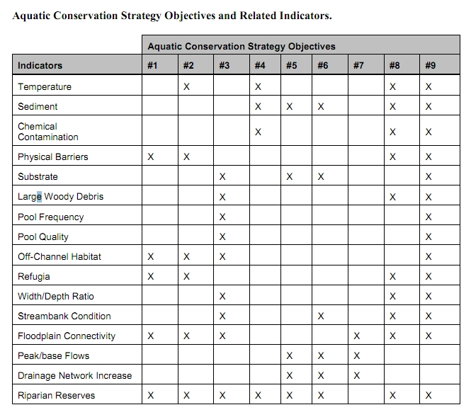
These ACS objectives and biophysical indicators are consistent throughout the Pacific Northwest and are not unique to the Mt Hood NF.

The Northwest Forest Plan and its supporting documentation make clear that the primary value of riparian vegetation is as a source of large wood and shade, not vegetation diversity and canopy layering, as often asserted by the agency to justify logging in riparian reserves. BLM admits “The primary function of Riparian Reserves is to provide shade and a source of large wood inputs to stream channels.” Medford BLM 2013. Pilot Thompson EA, p 3-76. http://www.blm.gov/or/districts/medford/plans/files/PT_EA_ForWeb.pdf

NEPA requires consideration of trade-offs. California v. Block, 690 F.2d 753, 771 (9th Cir. 1982) (NEPA was designed to “ensure that an agency is cognizant of all the environmental trade-offs that are implicit in a decision”). Stan Gregory notes the following trade-offs associated with logging riparian reserves to enhance early seral vegetation:
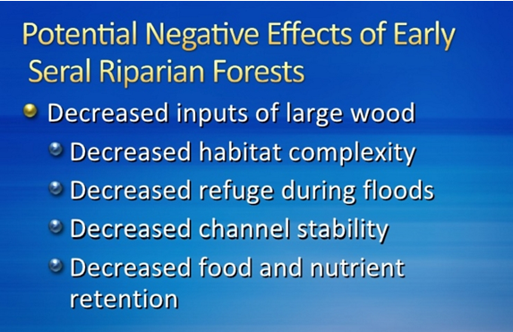
Gregory, Stan 2010. What About Riparian Systems: Who Benefits From an Early Seral Forest Condition. Workshop - Early Seral Forest - We know we need it -- How do we get it? Presentation sponsored by the Central Cascades Adaptive Management Partnership and NW Oregon Ecology Group http://ecoshare.info/2010/07/06/what-about-riparian-systems-who-benefits-from-an-early-seral-forest-condition-gregory/

The Northwest Forest Plan Aquatic Conservation Strategy Objectives (1994 ROD p B-11) enumerates specific purposes for “Maintain[ing] and restor[ing] the species composition and structural diversity of plant communities in riparian areas and wetlands” that is -
“to provide adequate summer and winter thermal regulation, nutrient filtering, appropriate rates of surface erosion, bank erosion, and channel migration and to supply amounts and distributions of coarse woody debris sufficient to sustain physical complexity and stability.”
All these values are provided as well or better by unthinned riparian stands.

The effects of logging on dead wood are significant and long term, adversely affecting a core function of the reserves, while the purported benefits to vegetation diversity are minor and transitory, and affect secondary purposes of the reserves.

Large Wood
Large quantities of downed trees are a functionally important component of many streams (Swanson et al. 1976; Sedell and Luchessa, 1982; Sedell and Froggat, 1984; Harmon et al. 1986; Bisson et al. 1987; Maser et al. 1988; Naiman et al. 1992). Large woody debris influences channel morphology by affecting longitudinal profile, pool formation, channel pattern and position, and channel geometry (Bisson et al. 1987). Downstream transport rates of sediment and organic matter are controlled in part by storage of this material behind large wood (Betscha 1979). Large wood affects the formation and distribution of habitat units, provides cover and complexity, and acts as a substrate for biological activity (Swanson et al. 1982; Bisson et al. 1987). Wood enters streams inhabited by fish either directly from the adjacent riparian zone from tributaries that may not be inhabited by fish, or hillslopes (Naiman et al. 1992).
Large wood in streams has been reduced due to a variety of past and present timber harvesting practices and associated activities. Many riparian management areas on federal lands are inadequate as long term sources of wood.
…
Riparian Ecosystem Components
…
Riparian vegetation regulates the exchange of nutrients and material from upland forests to streams (Swanson et al. 1982; Gregory et al. 1991). Fully functional riparian ecosystems have a suite of characteristics which are summarized below. Large conifers or a mixture of large conifers and hardwoods are found in riparian zones along all streams in the watershed, including those not inhabited by fish (Naiman et al. 1992). Riparian zone-stream interactions are a major determinant of large woody debris loading (House and Boehne 1987; Bisson et al. 1987; Sullivan et al. 1987). Stream temperatures and light levels that influence ecological processes are moderated by riparian vegetation (Agee 1988; Gregory et al. 1991). Streambanks are vegetated with shrubs and other low-growing woody vegetation. Root systems in streambanks of the active channel stabilize banks, allow development and maintenance of undercut banks, and protect banks during large storm flows (Sedell and Beschta 1991). Riparian vegetation contributes leaves, twigs, and other forms of fine litter that are an important component of the aquatic ecosystem food base (Vannote et al. 1980).
1993 FEMAT Report, pp V-13, V-25.

The effects of thinning on crown development are not very significant.

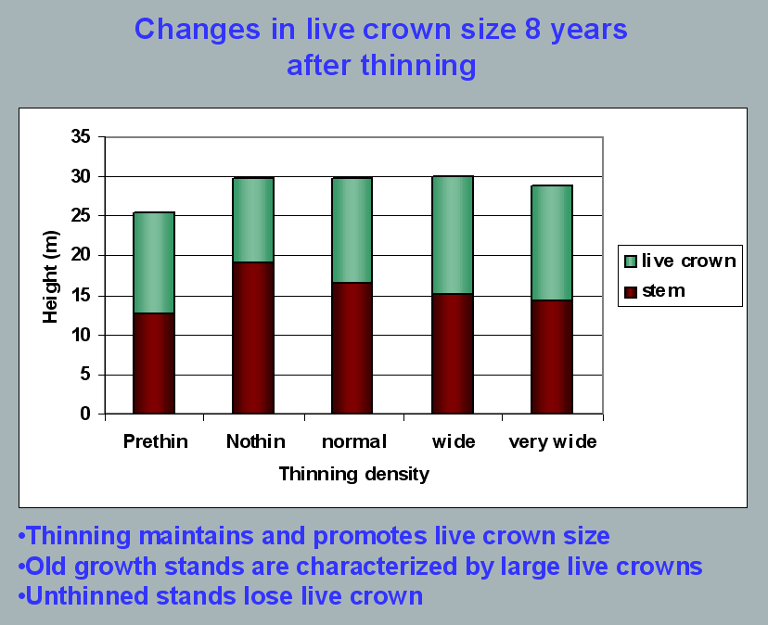
Aquatic/Riparian Ecosystem Dynamics and Associated Management Implications - Recent Findings. Powerpoint, 32.6M. This topic was presented at the Regional Interagency Executive Committee meeting on January 7, 2003. https://web.archive.org/web/20161221100307/http://www.reo.gov/library/presentations/Szaro_present_Aquatic_Rip_Final.ppt.

Stimulating the development of a diverse understory is often used as a justification for thinning, but this may not be justified in stands older than about 40 years. A systematic review of 917 Forest Inventory and Analysis (FIA) plots in western Oregon (mostly on non-federal lands) found,
Contrary to expectations of canopy closure, mean canopy cover by age class rarely exceeded 85 percent, even in unthinned productive young conifer forests. Possibly as a result, effects of stand age on understory vegetation were minimal, except for low levels of forbs found in 20- to 40-year-old wet conifer stands. … Although heavily thinned stands had lower total cover, canopy structure did not differ dramatically between thinned and unthinned stands. Our findings suggest potential limitations of simple stand succession models that may not account for the range of forest types, site conditions, and developmental mechanisms found across western Oregon.
McIntosh, Anne C.S.; Gray, Andrew N.; Garman, Steven L. 2009. Canopy structure on forest lands in western Oregon: differences among forest types and stand ages. Gen. Tech. Rep. PNW-GTR-794. Portland, OR: U.S. Department of Agriculture, Forest Service, Pacific Northwest Research Station. 35 p. http://www.fs.usda.gov/pnw/pubs/pnw_gtr794.pdf. This seems to indicate that the benefits of thinning may be best realized in dense stands younger than 40 years old. This study also showed that in wet conifer stands the mean Canopy Height Diversity Index and the mean Simpson’s Diversity Index of tree heights leveled off at about age 65. This study also looked at canopy conditions after three levels of thinning intensities (heavy, light, and none). “Mean cover of the lower canopy layer was nominal for all three thinning intensities. … There were no evident trends between understory cover and thinning history; both shrub and forb cover were fairly similar among the three thinning intensities. … The lack of a strong effect of crown closure on understory cover may be related to our finding that mean crown cover did not exceed 85 percent. … We expected greater cover of understory vegetation in thinned than in unthinned stands but did not detect significant differences in this analysis.”

While one can generalize that vegetation diversity is more likely to flourish when conifer density is lower, there are data showing a wide range of conifer density can support a wide range of deciduous shrub cover. Thinning is not always necessary. The NEPA analysis should carefully document the site-specific “need” for thinning.
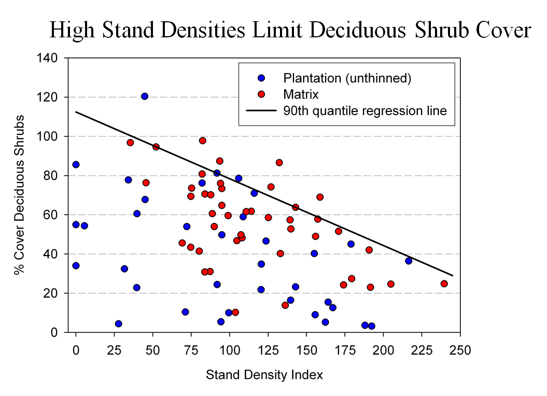
Spies, T. 2008. Powerpoint: Assumptions behind thinning young stands to create late successional riparian habitat. Presented at Riparian Thinning: Logic Paths for Silvicultural Prescriptions -- March 20, 2008. https://ecoshare.info/projects/central-cascade-adaptive-management-partnership/workshops/riparian-thinning-logic-paths/

It is also worth noting that where understories are well-stocked, midstory development can be enhanced by focusing on treating the understory itself rather than killing canopy trees.
[R]esults show that individual understory trees can be selectively favored for increased growth into the midstory by being released from competing saplings in the understory cohort. …Our results suggest that understory release treatments can be used to target individual saplings for increased growth, thereby recruiting a shade tolerant midstory cohort and accelerating the development of vertical foliar connectivity and a multi-layered stand structure. Abundance of non-coniferous understory vegetation is also augmented by this treatment. … [Note] The extent to which released understory trees collectively form a cohesive midstory canopy stratum is dependent on the density and horizontal arrangement of those released individuals. … . Inducing spatial variability within the midstory tree cohort would emulate the finescale disturbances of natural stands that create gaps and patches.
Taylor, Andrew 2016. Understory Vegetation Dynamics and Midstory Development Following Understory Release Treatments in Northwest Oregon Thinned Douglas-fir Stands. OSU MS Professional Paper.

Anderson (2007) looked at the effects of thinning in young Douglas fir forests and found –
[T]hinning treatments … had little impact on the abundance, size, or diversity of understory vegetation. Disturbance resulted in short-term decreases in understory vegetation cover, particularly tall shrubs. However, within five years of treatment, understory vegetation abundance returned to approximate pretreatment condition. … The general lack of understory vegetation response to the thinning treatments was likely due to the inherent resistance and resilience of the plant communities to disturbance, as well as the low intensity of disturbance attributable to the treatments.

/ / /

/ / /

/ / /
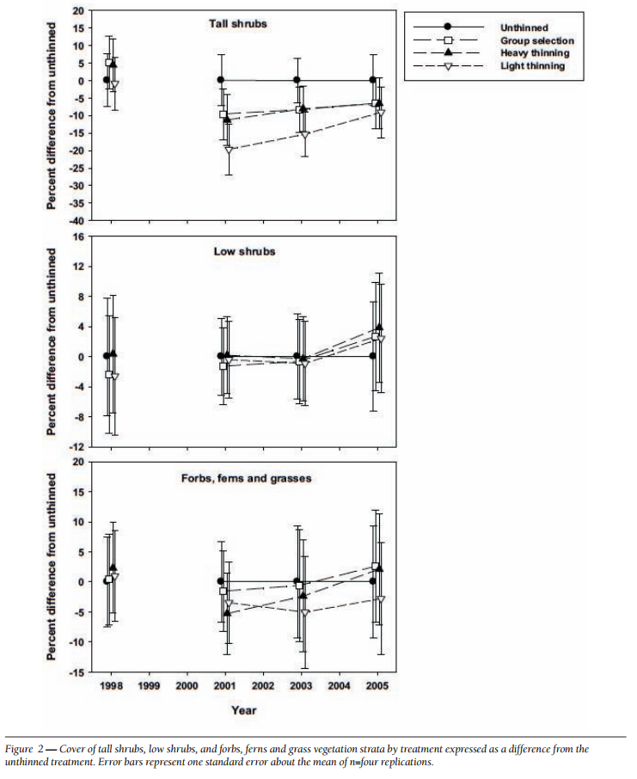
[Four years after thinning] tall shrub cover that was approximately four to nine percent less than the unthinned treatment … [C]over by low shrub species was unchanged by the harvest activity … Forbs, ferns, and grasses [experienced] little difference in cover between thinned and unthinned stands. … [F]ollowing treatment, the mean number of species declined somewhat, [then] return[ed] to pretreatment levels… [T]he evenness component of diversity did not differ among treatments or vary over time …. [T]here was little evidence of substantial alterations of understory shrub and herbaceous vegetation. This lack of strong understory vegetation response in terms of composition, abundance, or size is consistent with several studies of thinning in Douglas-fir. In a recent review of seven operational-scale silviculture experiments, Wilson and Puettmann (2007) report that percent cover by shrubs and percent cover by herbs, one to seven years following thinning showed little difference across a wide range of residual basal area.
Paul D. Anderson 2007. Understory Vegetation Responses to Initial Thinning of Douglas-fir Plantations Undergoing Conversion to Uneven-Age Management. Proceedings of the 2007 National Silviculture Workshop. http://www.fs.usda.gov/pnw/publications/gtr733/PNW_GTR_733_4.pdf This paper was published in: Deal, R.L., tech. ed. 2008. Integrated restoration of forested ecosystems to achieve multi-resource benefits: proceedings of the 2007 national silviculture workshop. Gen. Tech. Rep. PNW-GTR-733. Portland, OR: U.S. Department of Agriculture, Forest Service, Pacific Northwest Research Station. 306 p.

[W]hile specific structural attributes of forest ecosystems have been correlated with certain species, it is uncertain how such species will respond to treatments designed to recreate these features. There is always the possibility that in our attempt to create a structural attribute we think is important, we eliminate another attribute that is equally important, but unrecognized. One example is that attempts to restore spotted owl habitat by heavily thinning to accelerate the development of large diameter nesting trees could actually delay spotted owl recovery by reducing production of the large down wood utilized by the species it preys upon (Forsman et al., 1984; Carey, 1995; North et al., 1999). Similarly, heavily thinning stands to accelerate the development of marbled murrelet nesting trees also create open stands with a dense understory that is ideal habitat for a number of corvid species that prey on marbled murrelet nest eggs (USFWS, 2010). Riparian thinning efforts to create long-term supplies of very large diameter instream wood that can initiate complex wood jam formation (e.g., key pieces) are also likely to reduce the supply of large diameter wood that will create pools (Beechie and Sibley, 1997; Beechie et al., 2000; Fox and Bolton, 2007). Thus, we suggest that any efforts to actively restore riparian forests for the benefit of certain species should be treated as scientific experiments and proceed cautiously, skeptically, and with robust pre- and post-treatment data collection efforts. Hypothesized effects of thinning on riparian forest structure and the use of that structure by targeted species should be tested against empirical data.
Pollock, Michael M. and Timothy J. Beechie, 2014. Does Riparian Forest Restoration Thinning Enhance Biodiversity? The Ecological Importance of Large Wood. Journal of the American Water Resources Association (JAWRA) 50(3): 543-559. DOI: 10.1111/jawr.12206. http://oregon-stream-protection-coalition.com/wp-content/uploads/2014/07/Pollock-and-Beechie.-2014.-Riparian-thinning-and-biodiversity.pdf.

Climate change highlights an additional trade-off related to logging riparian buffers. New science shows that more frequent drought makes upland habitats less suitable, so increasing numbers of upland birds flock to riparian corridors, which become more crowded, with negative effects on riparian-dependent species. The agency should do more to increase space for wildlife that need moist streamside habitat during droughts. Gabrielsen, Paul 2021. In dry years, rivers become birds’ crowded corridors. University of Utah @THEU. https://attheu.utah.edu/uncategorized/in-dry-years-rivers-become-birds-crowded-corridors/ (“New research from the University of Utah and the Utah Division of Wildlife Resources (UDWR) finds that in dry years, birds funnel into the relative greenness of riparian (adjacent to river) environments. That increased diversity is accompanied by overcrowding that may cause increased competition for habitat and resources, the study finds, and an overall decrease in populations of birds who call the river home. … Neate-Clegg and his colleagues noticed that during particularly dry years they were finding more birds than usual in the mist nets near rivers. … The multi-year data showed that total bird captures and total species were higher in hotter and drier years, El Niño years, and less green years. The effect was strongest for non-riparian species, suggesting that in harsh conditions, birds from all over the landscape found their way to the rivers. “This suggests that the wider landscape is unable to support migrants and so they are forced to use greener areas,” Neate-Clegg says. But just as an influx of tourists can crowd out locals, the uptick in birds may have taken its toll on typically riparian species, especially those that breed on river banks…. In warmer years, population growth rates slowed for 47% of riparian bird species. The slowing, the researchers found, wasn’t due to more birds deaths, but rather to fewer new birds joining the population. There could be several reasons that bird breeding goes down in hotter years, but the authors suspect that more species in riparian habitats can mean more competition and fewer resources to go around. ‘This study shows how native bird populations utilize these habitats,’ Norvell says. ‘As droughts intensify, this becomes increasingly the refuge that everything’s relying on. And I don’t think humans are all that different in this case. We’re all increasingly relying on these very same areas.’ Neate-Clegg says that rivers provide connections for birds across the landscape, enabling them to transport nutrients or disperse seeds. A hotter, drier climate could affect those important functions that birds provide, called ‘ecosystem services.’”)

==

Each substantive issue discussed in these comments should be (i) incorporated into the purpose and need for the project, (ii) used to develop NEPA alternatives that balance tradeoffs in different ways, (iii) carefully analyzed and documented as part of the effects analysis, and (iv) considered for mitigation.

Please post to the project website, links to all relevant ESA and EFH consultation documents, RMPs, watershed analyses, and other supporting documents relied on in the NEPA analysis.

Please post to the project website before the public comment period, georeferenced maps of the proposed activity units that can be used to navigate in the field using apps such as Avenza.

Please provide Oregon Wild with timely notice of any forthcoming comment opportunities, and any draft and final decisions on this project. If the agency discovers new information or changed circumstance or modifies the project or the analysis after the decision, Oregon Wild requests to be notified and provided an opportunity to comment.

Note: If any of these web links in these comments are dead, they may be resurrected using the Wayback Machine at Archive.org. http://wayback.archive.org/web/

Sincerely,
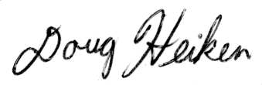
Doug Heiken (he/him)
dh@oregonwild.org

A.G. Merschel, M.A. Krawchuk, J.D. Johnston, T.A. Spies, Historical pyrodiversity in Douglas-fir forests of the southern Cascades of Oregon, USA, Forest Ecology and Management, Volume 572, 2024, 122306, ISSN 0378-1127, https://doi.org/10.1016/j.foreco.2024.122306.
Watts, Andrea; Wondzell, Steve; Jarecke, Karla; Bladon, Kevin. 2024. Hot air or dry dirt: Investigating the greater drought risk to forests in the Pacific Northwest. Science Findings 268. Portland, OR: U.S. Department of Agriculture, Forest Service, Pacific Northwest Research Station. 6 p. https://www.fs.usda.gov/pnw/sciencef/scifi268.pdf. See also, Karla M. Jarecke, Linnia R. Hawkins, Kevin D. Bladon, Steven M. Wondzell 2023. Carbon uptake by Douglas-fir is more sensitive to increased temperature and vapor pressure deficit than reduced rainfall in the western Cascade Mountains, Oregon, USA. Agricultural and Forest Meteorology, Volume 329, 15 February 2023, 109267. https://www.sciencedirect.com/science/article/abs/pii/S0168192322004543.

