5/15/2025
My name is Kate Kauffman, and I am a Portland resident, volunteer of Bark, and frequent explorer of the Clackamas watershed of Mt Hood forest. I have participated in several wetland surveys located in the southern reaches of the Clackamas River Range District to conduct longitudinal research on the effects on water tables, quality, and systems after the severe fires that occurred in this area. Areas of both parcels being considered in Consent for Geothermal Leasing #67700 were affected by the 2020 Lionshead fire, which provides us with unique and essential lands to conduct research on the effects of fire, and the long-term recovery of various species, including the northwestern spotted owl, coho salmon, and chinook salmon, within deeply disturbed watersheds. Current research on the effects of fire in and around identified spotted owl habitats is still emerging, and it is critical that these habitats be left to natural processes to ensure that our wildlife populations have opportunities for resilience and repopulation, and that researchers have the ability to conduct quality studies to direct future decisions by land managers and governments.
I am writing to implore the USFS to take Alternative 1-No Action for lease by BLM of OROR-70802 and strongly consider taking the same course of No Action for lease of OROR-70803, and for the USFS to fulfill their trust responsibilities by conducting meaningful consultation with relevant Tribes, specifically the Confederated Tribes of Warm Springs.
- 95% of parcel OROR-70802 contains designated northern spotted owl critical habitat, as does 41% of parcel OROR-70803 (see maps below). Many of these areas overlap with protected riparian habitat, scenic corridors, deer and elk summer range, and lake areas. Creating stipulations for each of these areas would result in significant overall limitations to the areas BLM would be able to develop in parcel OROR-70802, estimated around 5%. The confluence of various overlays of protected areas in OROR-70803 would also limit suitable development zones to under 20-30%, begging the question around feasibility and financial benefits to development.
- While current exploratory designations may have minimal impact, allowing the opportunity for exploration opens the door for more extractive and damaging practices to this sensitive habitat, that would likely impede recovery efforts of threatened species. There is high potential to spread invasive plant species through increased vehicle traffic and ground disturbance.
- There is designated critical habitat for coho salmon and steelhead trout within the project area, and just downstream of the project area there is designated critical habitat for Chinook salmon. The Fish and Wildlife Service recognizes that air and water pollution, toxic emissions, and localized fish and wildlife kills are all common environmental issues associated with geothermal energy development.
- Geothermal power plants require a large amount of water to operate, which could lead to conflicts over resource management. The latest enhanced geothermal technologies use similar fracking techniques currently used to extract oil and gas. They thus raise the same concerns about triggering earthquakes that have dogged oil and gas fracking operations and previous geothermal efforts.
- While there is demand to develop energy resources with less environmental impact on a national scale, there are also severe budget cuts, staffing layoffs, and governmental policies that will likely strip USFS of ability to adequately monitor and enforce diligent compliance with stipulations. I urge you to consider the department’s actual capacity to ensure the health and wellbeing of these recovering ecosystems in the current governmental context as you make your decisions, and enact responsible and ethical practices that ensure the long-term health of our lands.
  - 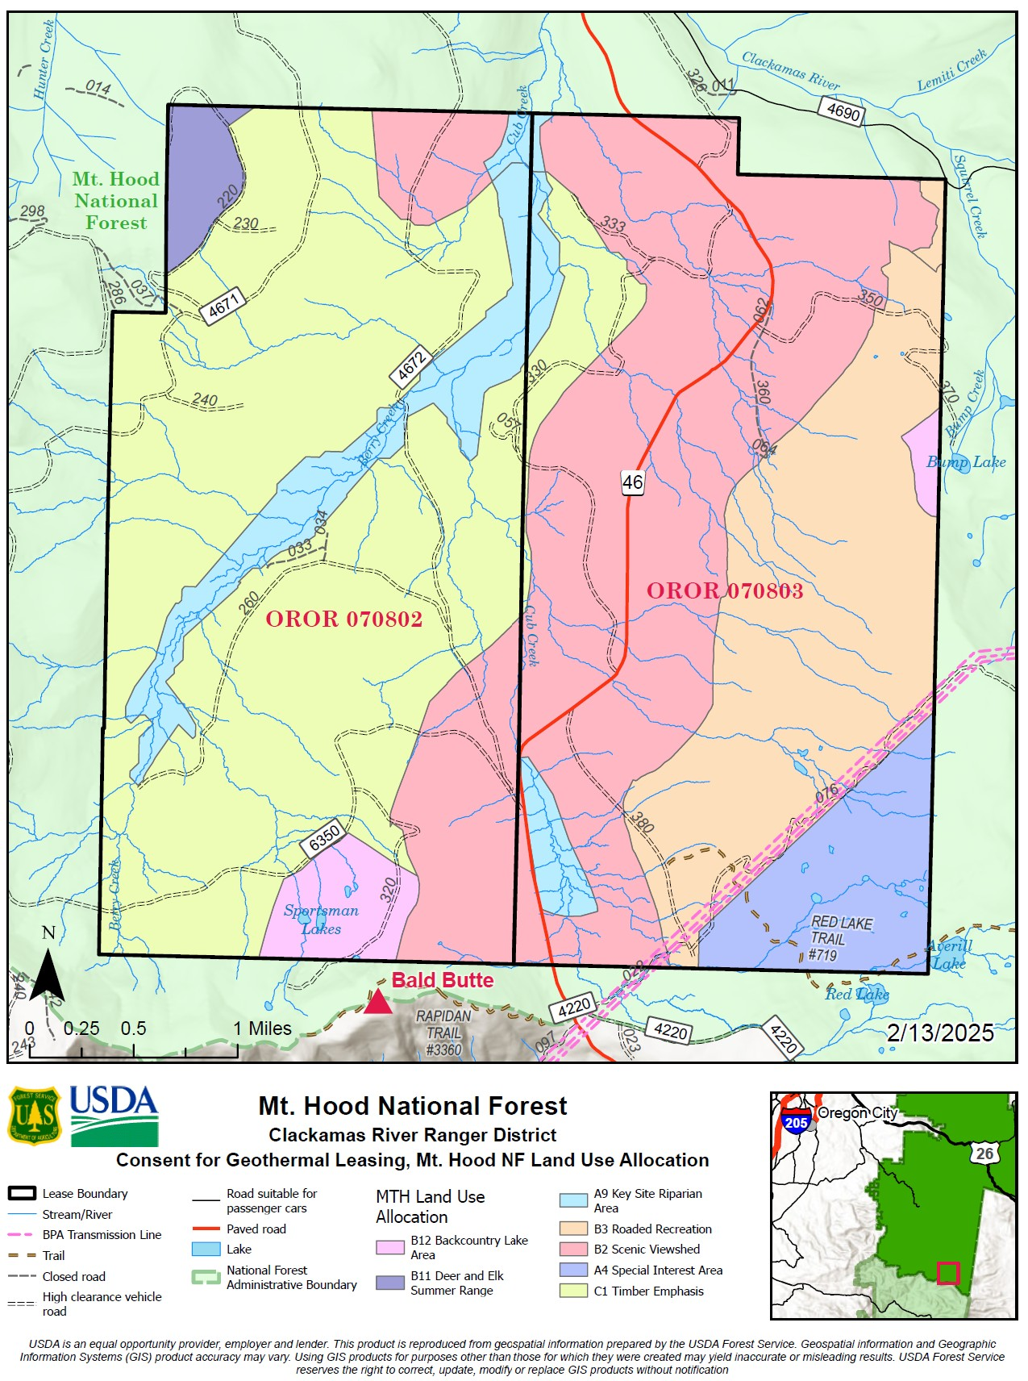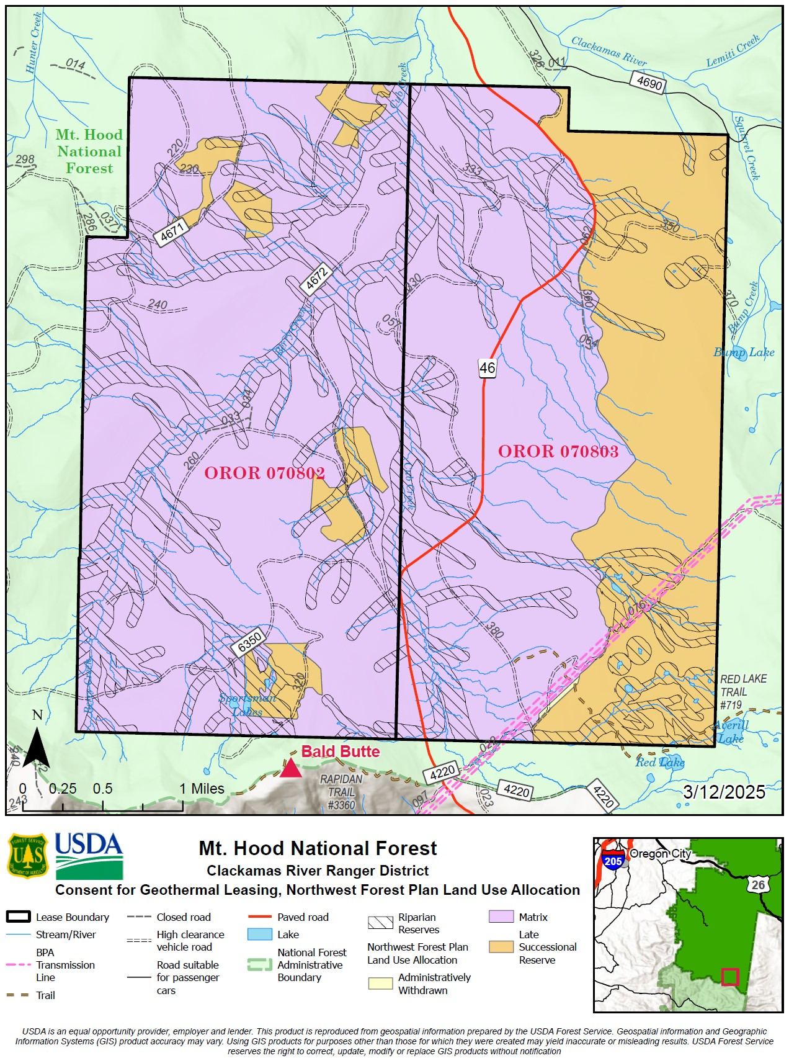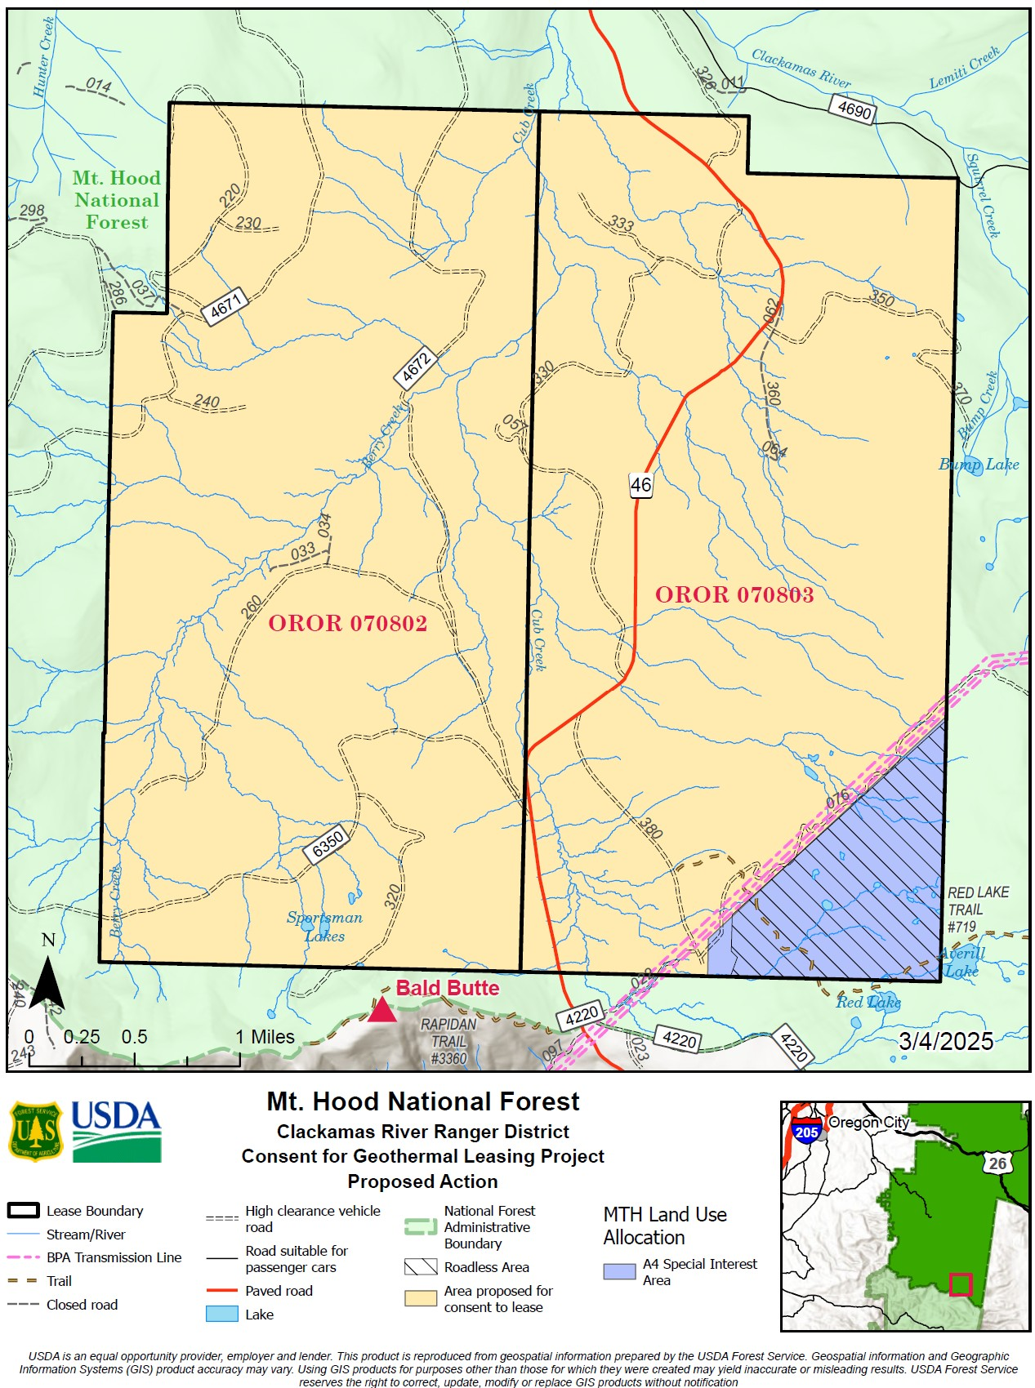
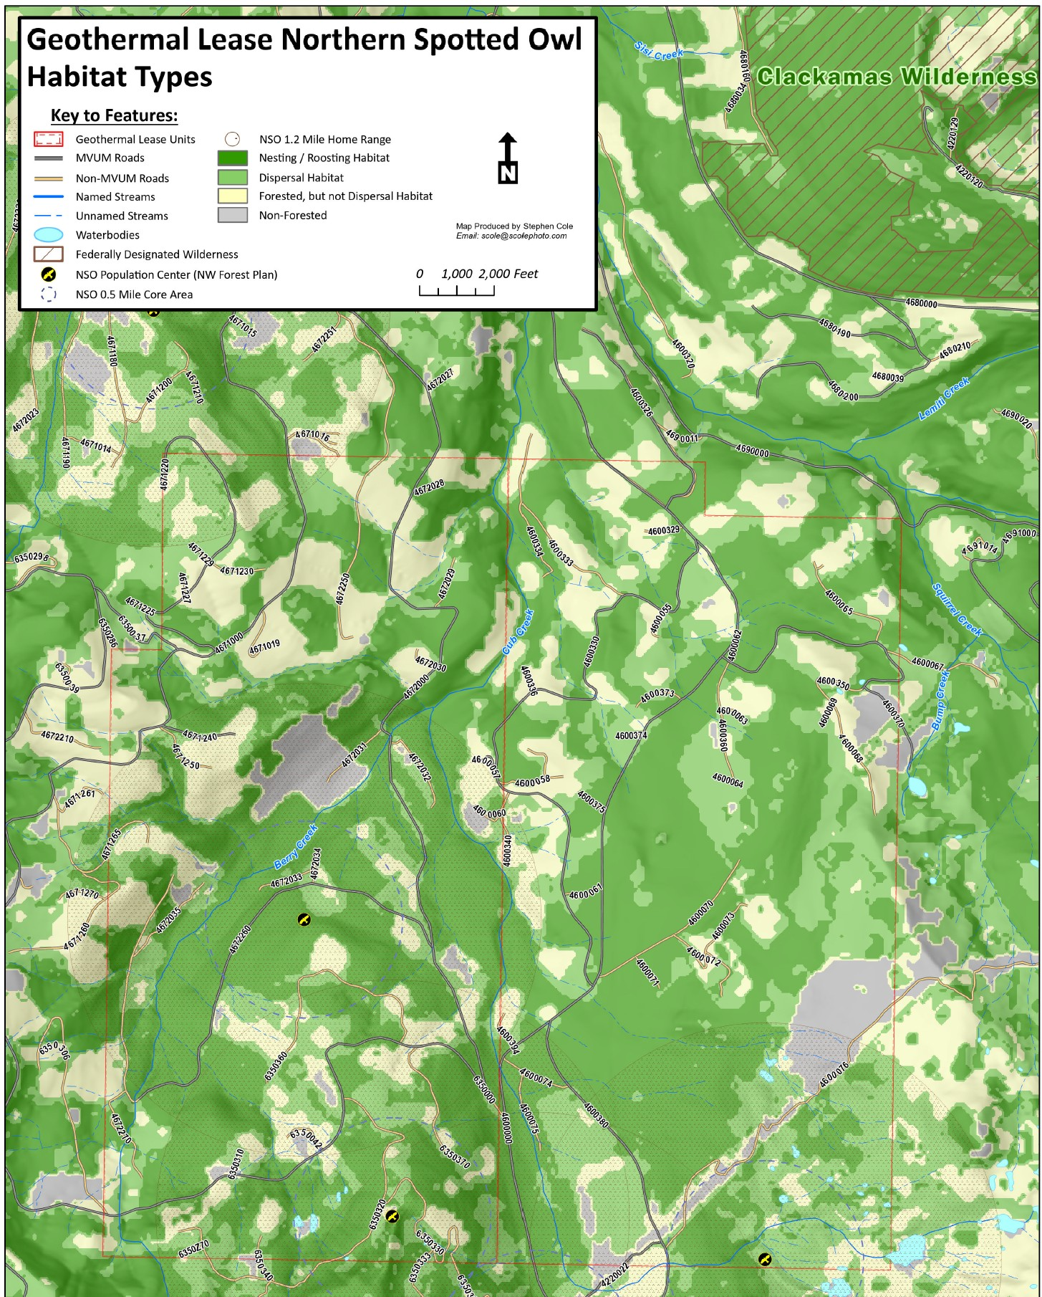Made by Steve Cole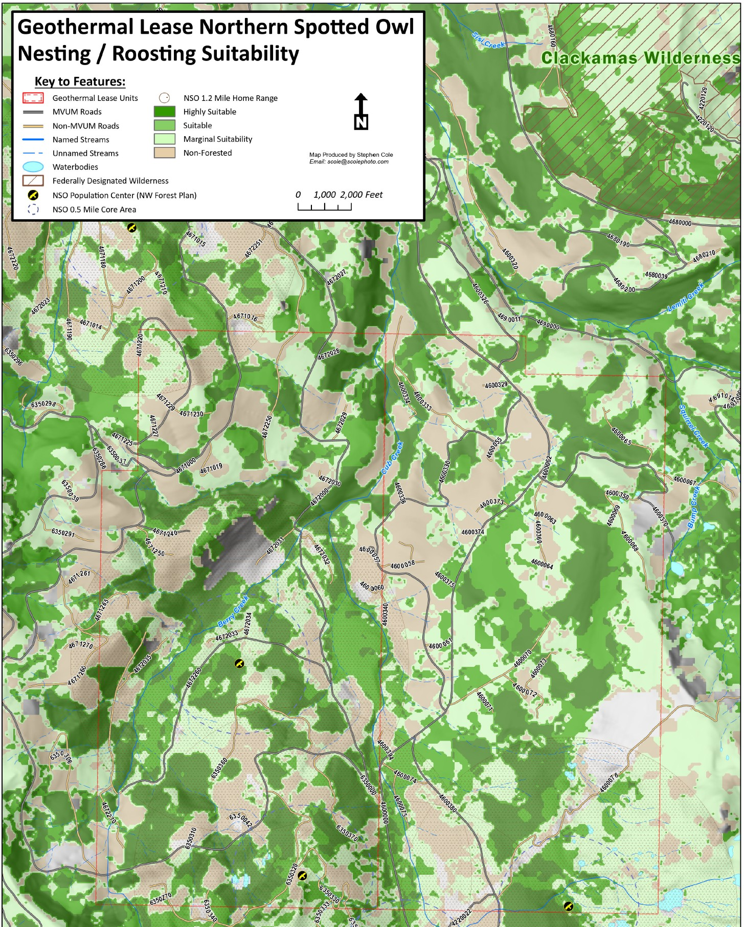Made by Steve Cole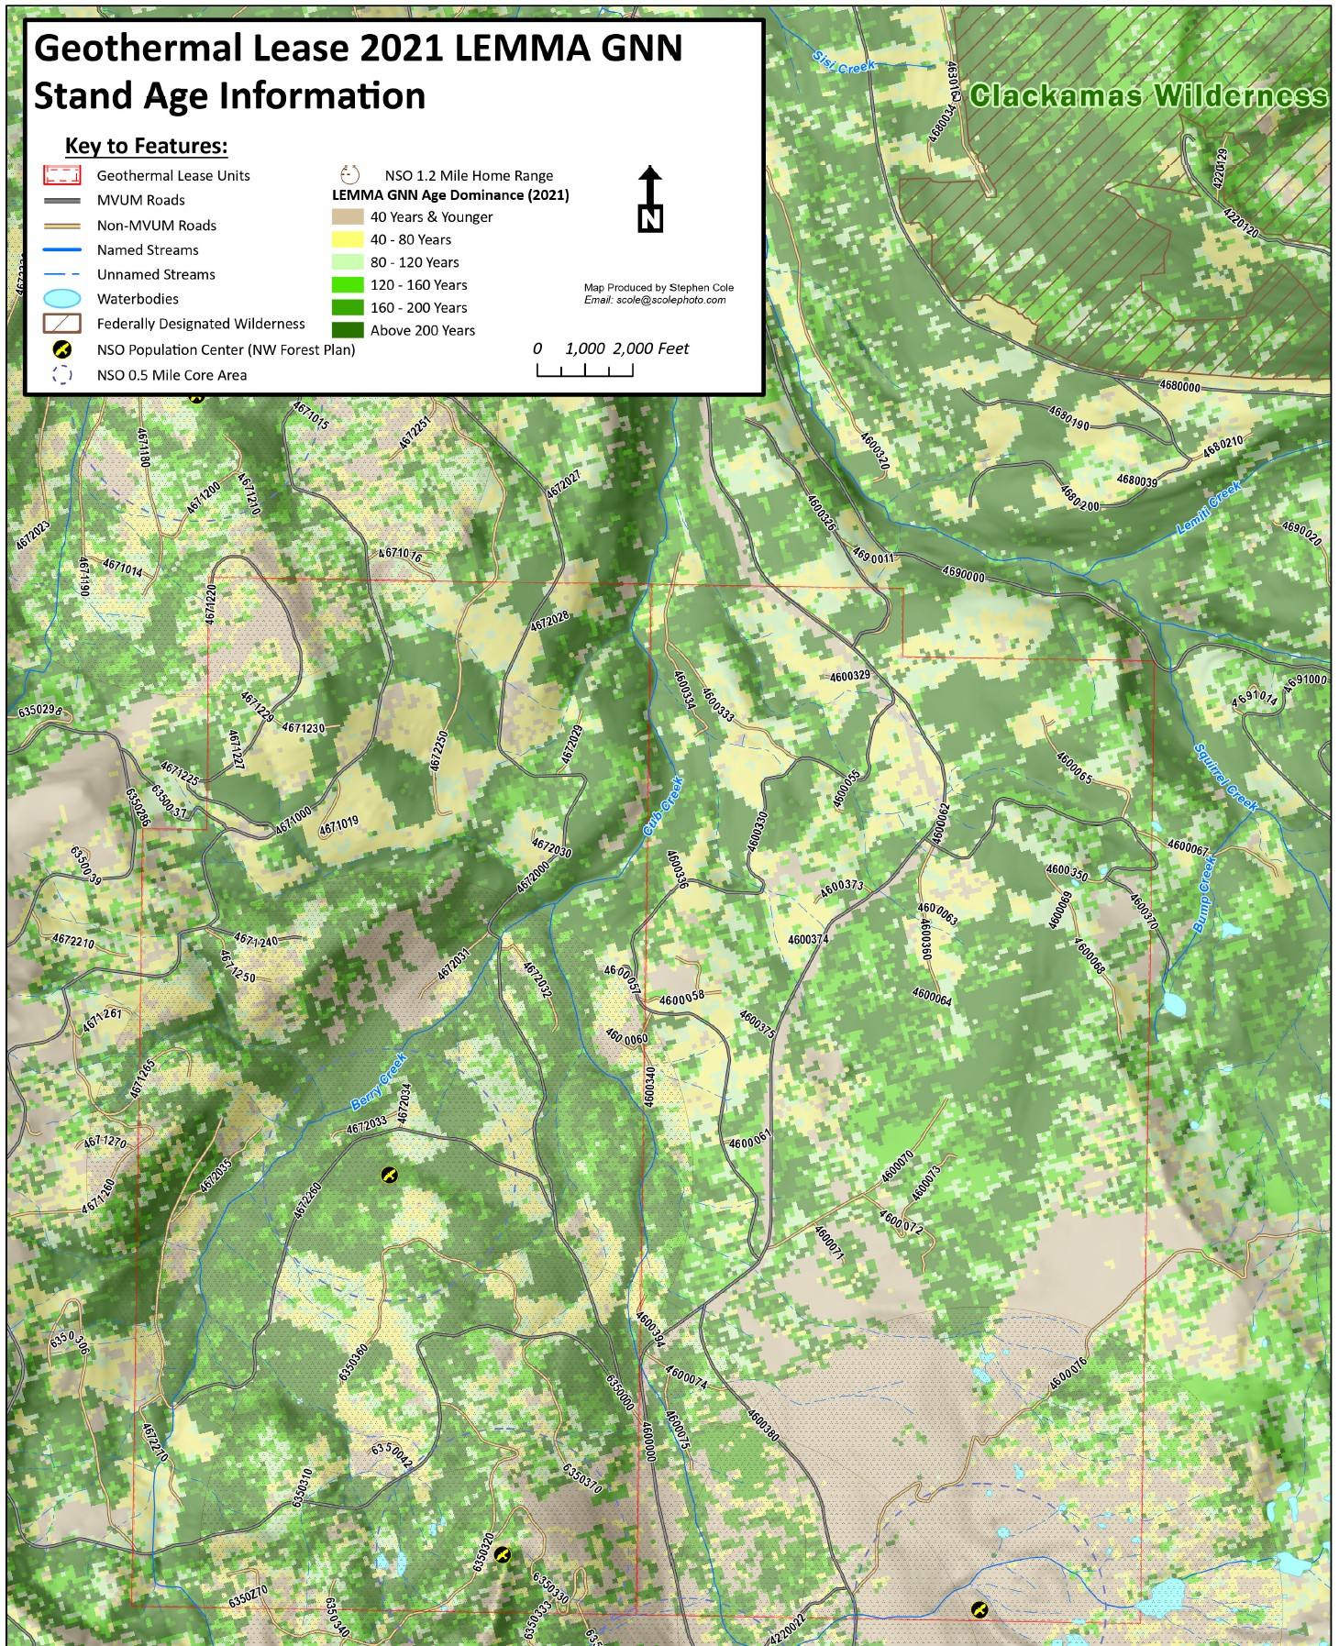

Background

