May 1, 2025
Comments on Boise Forest Snag and Nellie Fires Salvage Logging
Dear Boise Forest Service,
Here are comments from WildLands Defense, Alliance for the Wild Rockies, Native Ecosystems Council and Council for Fish and Wildlife regarding the Nellie and Snag Fires. Please also apply these concerns to the Lava Fire and any other post-2024 wild fire salvage logging and wood removal projects you are considering.
Our organizations and members use and enjoy the public lands, wildlife, waters, roadless areas and other irreplaceable values of the Boise Forest and its watershed lands and other Region 4 Forest lands – many of which are also threatened by massive USFS vegetation manipulation projects. We enjoy and appreciate, and work to preserve, the fish/wildlife/rare plant and other values that will be substantially harmed, destroyed and/or lost due to the USFS’s failure to establish a proper baseline, prepare an EIS to assess the full suite of environmental impacts of this mammoth cheatgrass-spreading project impacting a vital landscape for rare species conservation that has already been hit tremendously hard by past USFS logging, treatments, wildfires (including those that flashed right through heavily logged and thinned areas). Our organizations are very concerned about the biodiversity loss this massive deforestation and burning scheme will cause, and the project’s irreversible harms to species ranging from Northern Goshawk to Wolverine to rare aquatic species. Our organization missions are to protect and promote biodiversity, wildlife species preservation and biodiversity on western public lands.
After these 2024 fires removed even more essential habitat for sensitive species and migratory birds, we request that the FS reconsider the further logging and large-scale burning in projects that the USFS has already scoped or authorized but are not yet completed (“completed” referring to NEPA processes as well as parts of already approved multi-year projects)– More’s Creek, Clear Creek, SWIRL, Sagehen, etc. We also note that the Boise Forest just approved CuMo mining exploration - with significant multi-year mining exploration drilling and road expansion in an area of the forest that is rare plant habitat, Wolverine habitat, Northen Goshawk habitat and home to many other sensitive species. How many additional mining exploration projects are foreseeable in thnis region? Please provide detailed mapping and analysis of all claims on the Boise and Payette Forests. For example, we just received a scoping notice for mining exploration near Cuprum. Mining activity can pollute streams, dry up springs and surface waters, destroy wildlife habitat, displace sensitive and imperiled wildlife, etc. It poses a very large looming threat - especially under the drill, Baby, Mine policies (quoting Interior sec. Burgum) being announced for federal lands. Scalping off burned trees on the Forest facilitates mining exploration and ease of heavy equipment access, and reduces critical wildlife habitats and sensitive species occurrence – further facilitating ease of mining project approval by agencies.
Our organizations and members use and enjoy the public lands, wildlife, waters, roadless areas and other irreplaceable values of the Boise Forest and the Boise River and Mores Creek watershed lands and other Region 4 Forest lands – many of which are also threatened by massive USFS vegetation manipulation projects. We enjoy and appreciate, and work to preserve, the fish/wildlife/rare plant and other values that will be substantially harmed, destroyed and/or lost due to the USFS’s failure to establish a proper baseline, prepare an EIS to assess the full suite of environmental impacts of this mammoth cheatgrass-spreading project impacting a vital landscape for rare species conservation that has already been hit tremendously hard by past USFS logging, treatments, wildfires (including those that flashed right through heavily logged and thinned areas). Our organizations are greatly concerned about the biodiversity loss this massive deforestation and burning scheme will cause, and the project’s irreversible harms to species ranging from Northern Goshawk to Wolverine to rare aquatic species. Our organization missions are to protect and promote biodiversity, wildlife species preservation and biodiversity on western public lands.
Please prepare an EIS to take a current hard look under NEPA at the foreseeable devastating blow to migratory birds, Wolverine, big game, sensitive and MIS species, and aquatic species of concern including Bull Trout and other rare aquatic species, and sustainability of forest uses.
We were dismayed to read a recent Payette Forest news release stating the PNF were planning on burning in the Goose Creek and other drainages to the northwest of the Boise Forest salvage logging project areas. As part of the NEPA analysis of all these Boise and Payette “salvage” and also the alarming massive “precriobied fiere” and so-called “restoration” Forest projects, please review the scale of the existing loss of green tree cover across the Boise, Payette and Sawtooth Forests, as well as the foreseeable additional losses for all Fire, logging, restoration, thinning and other vegetation manipulation and treatments already authorized and/or foreseeable.
Salvage Logging imperils forest health by removing large, burned trees from recently burned forests, it turns out that “[s]uch trees are the most critical component of a biologically diverse post-fire ecosystem and that single component contributes significantly to the production of unique successional pathways and unique wildlife communities that we see after fire. In 2006, 540 independent Ph.D. scientists not associated with the Forest Service signed a letter to the United States Congress. They provided a long list of peer- reviewed studies supporting their conclusion that “no substantive evidence supports the idea that fire-adapted forests might be improved by logging after a fire.”
Generally speaking, “the impacts of salvage logging can be classified into three broad categories: (1) impacts on the physical structure of forest stands and aquatic systems; (2) impacts on key ecosystem processes (e.g., hydrological cycles, nutrient cycling, and soil formation); and (3) impacts on particular elements of the biota and species assemblages. These impacts, considered below, are often interrelated and cumulative... Although salvage logging removes wood from burned areas, such practices generally do not help regenerate or save ecosystems, communities, or species (but see Radeloff et al. 2000) and often have the opposite effect” (Franklin & Agee 2003, pp. 951, 954).
Impacts to Old Growth Biodiversity and Ecological Function
In a past major Boise Forest salvage logging scheme ---the North Pioneer Fire Project Decision Notice that authorized ogging more than 21,000 burned trees with greater than 20 inch diameters (measured at breast height), and cumulatively, it appears that as many as 50,000 trees in this larger category could be removed. This was an indication that what was being targeted is largely burned old- growth habitat, but also the most valuable habitat component in the shortest supply in our national forests; namely, large snags of the kind that were routinely removed from the forest for many decades in the 20th century - before their true value to wildlife could be appreciated. These large snags persist longer as standing habitat components for wildlife than smaller snags and are also more valuable for wildlife because their larger size serves wider habitat needs for a greater diversity of species.
They also persist longer as wildlife habitat after they fall, providing even greater and more valuable potential for wildlife diversity, and function to “reduce soil erosion, aid soil formation, and nourish streams as their leaves fall or their trunks decay
Has the Boise National Forest completed a comprehensive current inventory of old-growth habitat? Of mature Forest habitat? If so, please provide an up to date current detailed map and underlying supporting data and analysis. That includes the project area and surroundings lands. How many trees with 20 inch or greater diameter will each of the BNF and PNF proposed logging projects remove? How many trees of this diameter will remain – both live and dead – in the fire landscape? In the larger Forest landscape – for example, in each Ranger District?
Please provide mapping and analysis of all areas of unburned mature forest and unburned old growth forest across both Forests.
Concerns with Salvage Logging Abound
Salvage logging, large-scale “hazard tree removal, etc. would take place in heavily used areas close to Idaho’s largest population center. They are accessible to a large number of people seeking a forest camping, hiking, or natural experience. The Pioneer Fire resulted in large-scale alteration or loss of live forested lands and all the ecosystem values and amenities live trees provides – moderating the local climate by trapping windblown snow, shading the ground slowing down snow melt and holding precipitation moisture on site, blocking wind and reducing wind-blown soil loss, etc. The standing dead trees also serve these very same purposes. Extensive “salvage” logging is further reducing the standing dead tree cover (and an unknown amount of live trees damaged or cut) in these watersheds. Beyond the effects of the fire, the deforestation is removing trees that provide significant aesthetic value, help moderate local climate conditions and stabilize highly erodible soils in the burned watersheds thus helping to limit sedimentation of streams and aquatic habitats, and provide habitat needs for a wide diversity of species – from big game hiding cover to white-headed woodpecker habitat.
Salvage logging affects a broad range of recreational uses of the landscape. Visitors encounter a sea of stumps, reduced habitat and screening cover for wildlife species, loss of cavity and other habitat such as with loss of woodpecker habitat resulting from burned areas and the natural rotting of larger sized trees that occurs post-wildfire.
Logging further de-stabilizes the watershed through removal of stabilizing trees, heavy equipment travel, and roading disturbance of highly erodible Idaho batholith soils. Disturbed soils provide ideal sites for weed infestation and spread, etc. Historical mining and livestock grazing in portions of the burned watersheds have also taken place in the past – with resultant gullying, erosion and other processes that continue to impact the land to this day. There have been various wildfires and prescribed burns that have also substantially altered the landscape. The crumbling, coarse decomposing granite of the Idaho batholith soils are known for being quite poor in nutrients. Removal of the trees represents export and permanent loss of nutrients from the logged sites and these watersheds that have already suffered a long history of past human disturbance and nutrient loss and export in previous bouts of logging or treatments A considerable portion of the burned watersheds have experienced past treatment – extensive logging or fuels projects - following historical settlement era disturbances. Thus these 2024 fires landscape and affected watersheds, pre-fire, had already suffered nutrient loss and substantial loss of habitat characteristics and forested cover needed by a wide diversity of species in many areas. These impacts combined represent a significant concern for the health of the drainage networks and streams in the area. Bull trout and other native salmonids require cold, clean water. The fire bared steep slopes in the watersheds. The fire burned across streams, consuming protective riparian vegetation in many places. Sedimentation and lack of cooling shade in the wake of the fire are serious threats to the native fish that reside in these watersheds. Warmer waters also favor non-native fish species that compete with the native fish. The Forest’s own maps depict how steep these watersheds are, which heightens the need for stabilizing protective vegetation to hold soils in place. The salvage logging and other tree and wood removal will worsen all of these effects for native trout and other aquatic biota.
Bull trout and other native fish stream occupancy, at the time of the fire, had already been greatly reduced from historical habitat. The Payette and Boise River systems have lost their historical salmon and steelhead runs. Bull trout are reduced to a few drainages in the burn landscape. The goal is supposed to be restore and recover habitats. The salvage logging projects further reduce and strip standing shading vegetation that shades the soil, slows runoff and helps hold moisture on site. The expanded disturbance of the new logging and roading deals an additional blow. The tree removal destabilization, erosion, habitat loss, recreational losses.
Regrettably, the revised forest plan altered the definition of old-growth habitat, precluding the designation of old-growth habitat in Southwest Idaho - making it harder to track the catastrophic logging/treatment/fire losses of old growth.
The findings by scientists that a burned forest habitat, such as following the 2024 fires and the Pioneer Fire, contains as much diversity of plant and wildlife species, if not more, in the years following the fire as would be found in adjacent old-growth habitats, is significant. See Hutto (1995), “The composition of bird communities following stand-replacement fires in northern Rocky Mountain (U.S.A.) conifer forests,” Conservation Biology 9:1041-1058.
According to the independent scientists reporting in the paper Karr et al., (2004):
Fire-affected soils are especially vulnerable to additional disturbance (e.g., compaction or increased erosion). Soils deserve special care because soils and soil productivity are irreplaceable within human time scales and are crucial to forest recovery, stream conditions, and hydrologic processes... [H]igher-risk practices, such as logging with ground-based equipment, should not be used, and sensitive areas should be avoided to limit aquatic impacts. No logging should be done on moderately and severely burned areas and on other sites prone to soil damage and excessive sedimentation.
The foremost expert on salvage logging’s potential for significant impact to wildlife, Dr. Hutto, on the common practice of salvage logging following fires has stated: We need to change our thinking when it comes to logging after forest fires. With respect to birds, no species that is relatively restricted to burned-forest conditions has ever been shown to benefit from salvage harvesting. In fact, most timber-drilling and timber-gleaning bird species disappear altogether if a forest is salvage-logged.
Timber harvest (of live or dead trees in any place and road building in or close to riparian areas can immediately reduce stream shading and cover, channel stability, and large woody debris recruitment and increase sedimentation and peak stream flows (Chamberlin et al. 1991, p. 180; Ripley et al. 2005, p. 2436). These activities can, in turn, lead to increased stream temperatures, bank erosion, and decreased long-term stream productivity. The effects of road construction and associated maintenance account for a majority of sediment loads to streams in forested areas; in addition, stream crossings also can impede fish passage. (Shepard et al. 1984, p. 1; Cederholm and Reid 1987, p. 392; Furniss et al. 1991, p. 301).
Sedimentation affects streams by reducing pool depth, altering substrate composition, reducing interstitial space, and causing braiding of channels (Rieman and McIntyre 1993, p. 6), which reduce carrying capacity for aquatic species such as Bull trout. Sedimentation negatively affects bull trout embryo survival and juvenile bull trout rearing densities (Shepard et al. 1984, p. 6; Pratt 1992, p. 6). An assessment of the interior Columbia Basin ecosystem revealed that increasing road densities were associated with declines in four nonanadromous salmonid species (bull trout, Yellowstone cutthroat trout (Oncorhyncus clarkii bouvieri), westslope cutthroat trout (O. c. lewisi), and redband trout (O. mykiss spp.)) within the Columbia River basin, likely through a variety of factors associated with roads. Bull trout were less likely to use highly roaded basins for spawning and rearing and, if present in such areas, were likely to be at lower population levels (Quigley and Arbelbide 1997, p. 1183). These activities can directly and immediately threaten the integrity of the essential physical or biological features described in PCEs.
The USFS states:
“The project area includes a total of 82,090 acres of National Forest System (NFS) lands: all proposed actions are on NFS lands. The project area spans in elevation from 3,360 to 8,010 feet above sea level. Topography within both fire perimeters is bisected by multiple drainages, several providing critical habitat for Endangered Species Act (ESA) listed fish species such as bull trout, chinook salmon, and steelhead salmon. Portions of the Peace Rock, Stony Meadows, Deadwood, Whitehawk Mountain and the Needles Idaho Roadless areas are within the Snag and Nellie fire perimeters”.
What is the current ecological condition of the lands in between these fire areas, and surrounding areas? How much live tree cover is present? How much live tree cover was present in the burned areas before the fires?
It is our observation that there had already been a major loss of forested cover in this landscape – and indeed in all the land area between the Lava Fire and across Snag and Nellie and into the Sawtooth Forest areas burned in the 2024 fires. There had also been major and highly damaging salvage logging in the Pioneer Fire area.
Please provide mapping and detailed ecological analysis of all lands where salvage logging has taken place across the Boise Forest in the past decade. What are current ecological conditions? What does all ecological monitoring show – including aquatic/riparian and upland site condition monitoring? What sensitive species inventories have been conducted in this region? What migratory bird surveys? What native carnivore surveys?
Where are all records of Wolverine occurrence across this landscape? How much forested cover has been lost in Wolverine habitat in the past 20 years?
What is the current road and trail density in Wolverine hand other rare and sensitive species habitats? Please include both authoriz8ed and illegal routes including trails. What areas of the Forest are currently open to over-the-snow motorized travel? How will removing both burned trees as well as foreseeably many green trees injured in the logging, impact and fragment remaining habitats for Wolverine, for Forest MIS species? For sensitive species? For migratory birds?
The FS also states: “Most of the road network in the project area was created to support timber harvest activities and multiple uses including safe public access. Major public access routes impacted by the fire include NFS Roads 409, 555, and County Road 22. Post fire flooding has impacted roads and culverts in the project area. Forest roads could be subject to increased movement from sediment crossing the roadway from the increased erosion potential of the surrounding landscape, resulting in further road damage and/or impacts to the hydrology of the project area watersheds. What were the ecological conditions in these watersheds before the fire? Please conduct sediment, cobble embeddedness and monitoring to establish a baseline of conditions and compliance with Forest standards.
Most of the Snag and Nellie fires burned in a mosaic of intensity, with only a minor portion showing high soil burn severity. The density of fire-damaged trees varies throughout the project area. The level of vegetation burn severity generally correlates to the level of soil burn severity. Hazard trees are now present throughout the project area. The fires have resulted in a change of tree species composition and stand density. Desired vegetation attributes may no longer be present. Tree mortality associated with fire-injury, drought, and insect and disease infestation will continue …”.
If there’s only a minor portion of the burn with high intensity, doesn’t that mean there are likely many green trees and trees that will survive the fire left? So there’s no need to re-disturb lands with salvage logging. Please provide detailed mapping and analysis of all areas and stands of primarily live green trees across the project areas and landscape. These must be identified and left unaltered and undisturbed under any actin here – as they provide vital remnant habitat for forest biota reeling from large-scale recent fire, salvage logging like occurred in the Pioneer fire, and past logging losses. What is the age class of trees left alive, and what species are they? How much lives forest cover as present in 2024 pre-burn vs. now?
The Forest must not intrude into any roadless areas with logging and disturbance actions, but it appears you are planning to do so. Natural values, including natural ecological processes of burned wood nutrients and stored carbon returning to the soil in burned areas, and providing habitat for innumerable fungi, insects, small mammals and other wildlife, as ell as moister and protected microsites for vegetation recovery. Please provide enlarge detailed mapping of any “hazardous tree removal”, logging or other live and tree removal in roadless areas.
The FS states: “Moderate and high burn severity of vegetation and soils have created conditions for the increased risk of invasive botanical species to outcompete native plants. Low-elevation non- forested habitats may not be able to recover naturally following the fire, specifically, those areas historically supporting drought-adapted bitterbrush, sagebrush, Idaho fescue, and bluebunch wheatgrass. Portions of the project area are popular for recreation. Areas around Deadwood …”.
Cheatgrass and invasive species are likely to increase a lot faster with salvage logging, skidding “hazard trees” and other activities associated with all the wood removal proposed -including the excessively wide “hazardous tree” removal areas. Specifically – how does the USFS determine a “hazardous tree”?
We are concerned that the FS in previous logging projects may have left “beauty strips” by roads – and so larger trees remained in the areas now targeted for large-scale “hazardous tree” removals. What are the relative sizes and age classes of both remaining live and dead trees by roads vs. ½ mile distant from roads? How will the FS ensure sufficient large tree snags remain for cavity nesting birds and denning mammals?
The USFS states:
“Unauthorized roads and user-created trails that existed prior to the fire are now visible and accessible due to vegetative cover loss. Fire suppression activities, including repaired dozer lines, are also visible and at risk of becoming unauthorized routes”.
This is shows why salvage logging and cutting “hazardous” trees up to 200 ft. from small roads is a very bad and ecologically damaging activity. Removing woody vegetation makes it a lot easier for year-round motorized disturbance off roads, often increasing fire risk. AND it exposes why salvage logging -which causes “cover loss” is damaging. Removal of standing trees and heavy equipment driving around all over the pace and then “raking the forest” with burning “slash will aggravate vegetative cover loss, erosion, off-road use,
Please assess how much more soil erosion in both wind and water, vegetative cover loss, species habitat loss, etc., will result due to salvage logging vs. leaving the Forest alone.
Just how much “economic value” will be recovered? How much is the value of the increased soil erosion in wind and water, and losses in nutrients and Forest productivity? How much is the value of endangered aquatic and terrestrial species habitats? How much is the value of clean water vs. sediment-laden salmon spawning streams?
This is a huge amount of “hazard tree mitigation access” – it appears the Forest areas are laced with unauthorized and authorized trails and routes that don’t show up on mapping. Please identify all of these.
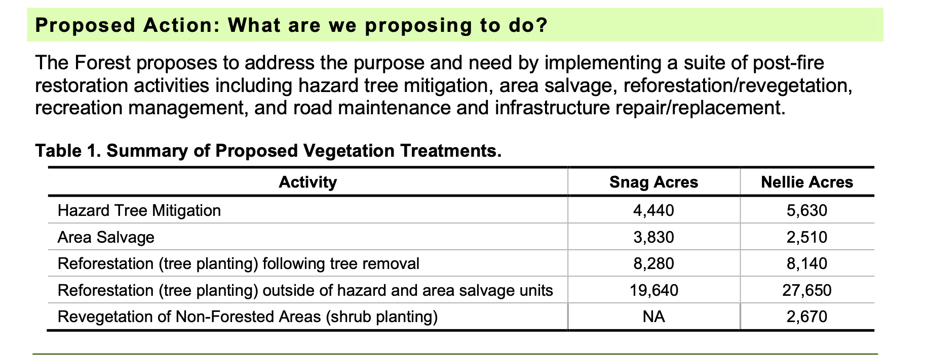
How much herbicide spraying, and using what specific chemicals does the USFS contemplate? Where were knapweed, rush skeleton weed, cheatgrass, bulbous bluegrass and any other flammable exotic species located pre-burn?
Where was intermediate wheatgrass, smooth brome of other aggressive biodiversity-destroying exotic rhizomatous grasses located before the fire? We urge the FS to not seed any more exotic species, especially rhizomatous grasses that choke out native species and prevent shrub and tree recovery.
The FS states:
“To facilitate tree removal approximately 16 miles of NFS roads currently classified as maintenance level 1 (ML1) would be reopened for project use then restored to their current state of storage upon project completion. In addition, approximately 4.7 miles of temporary road would be needed. Temporary roads would be decommissioned once harvest activities are complete and would not be added to the Forest Transportation System”.
What is the additive and cumulative erosion from all of these routes – both when they were bulldozed in, then supposedly “closed”, now bulldozed open again? We propose that the FS rip up any roadbeds and permanently close all these routes as an alternative, and that this be assessed as part of this process.
Is there any domestic livestock grazing taking place in any of the Snag-Nellie areas? If so, please apply our comments on grazing-caused ecological damage and impacts (attached) related to the Lava Fire.
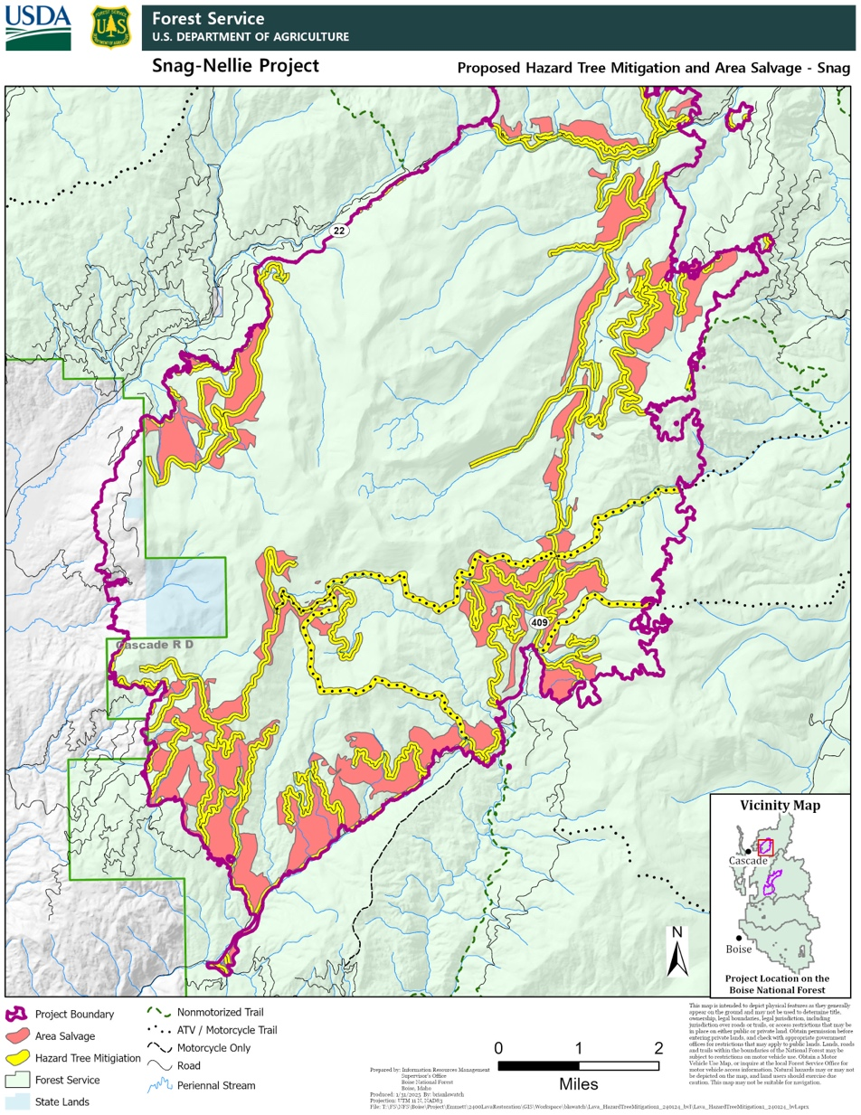
The map of the Snag fire shows extreme road networks in portions of the fire area, and lack of habitat security for wildlife. This will be made much worse by the combined effects of all the bulldozing and deforestation and “salvage” the FS proposes. The sharp twists and switchbacks also show rugged terrain. What forest tree species cover and age class was present in these areas – vs. in roadless areas? What is the elevation of the densely roaded areas vs. the unroaded areas, and where are all big game fawning/calving areas wintering areas, and other habitat types located in relation to the areas slated for salvage and hazardous tree logging?
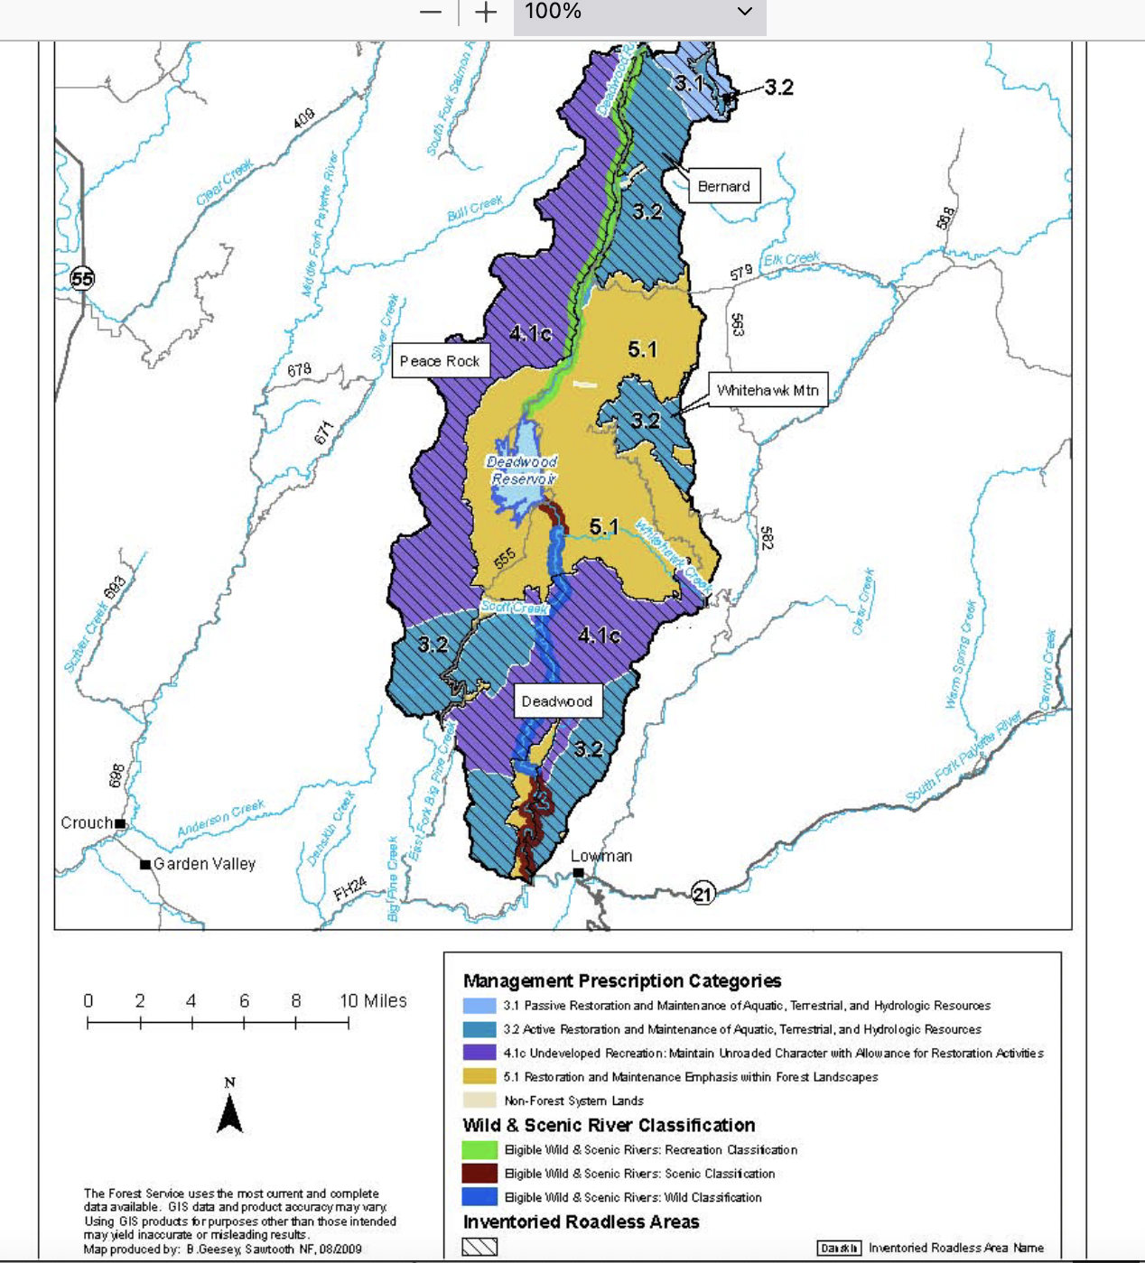
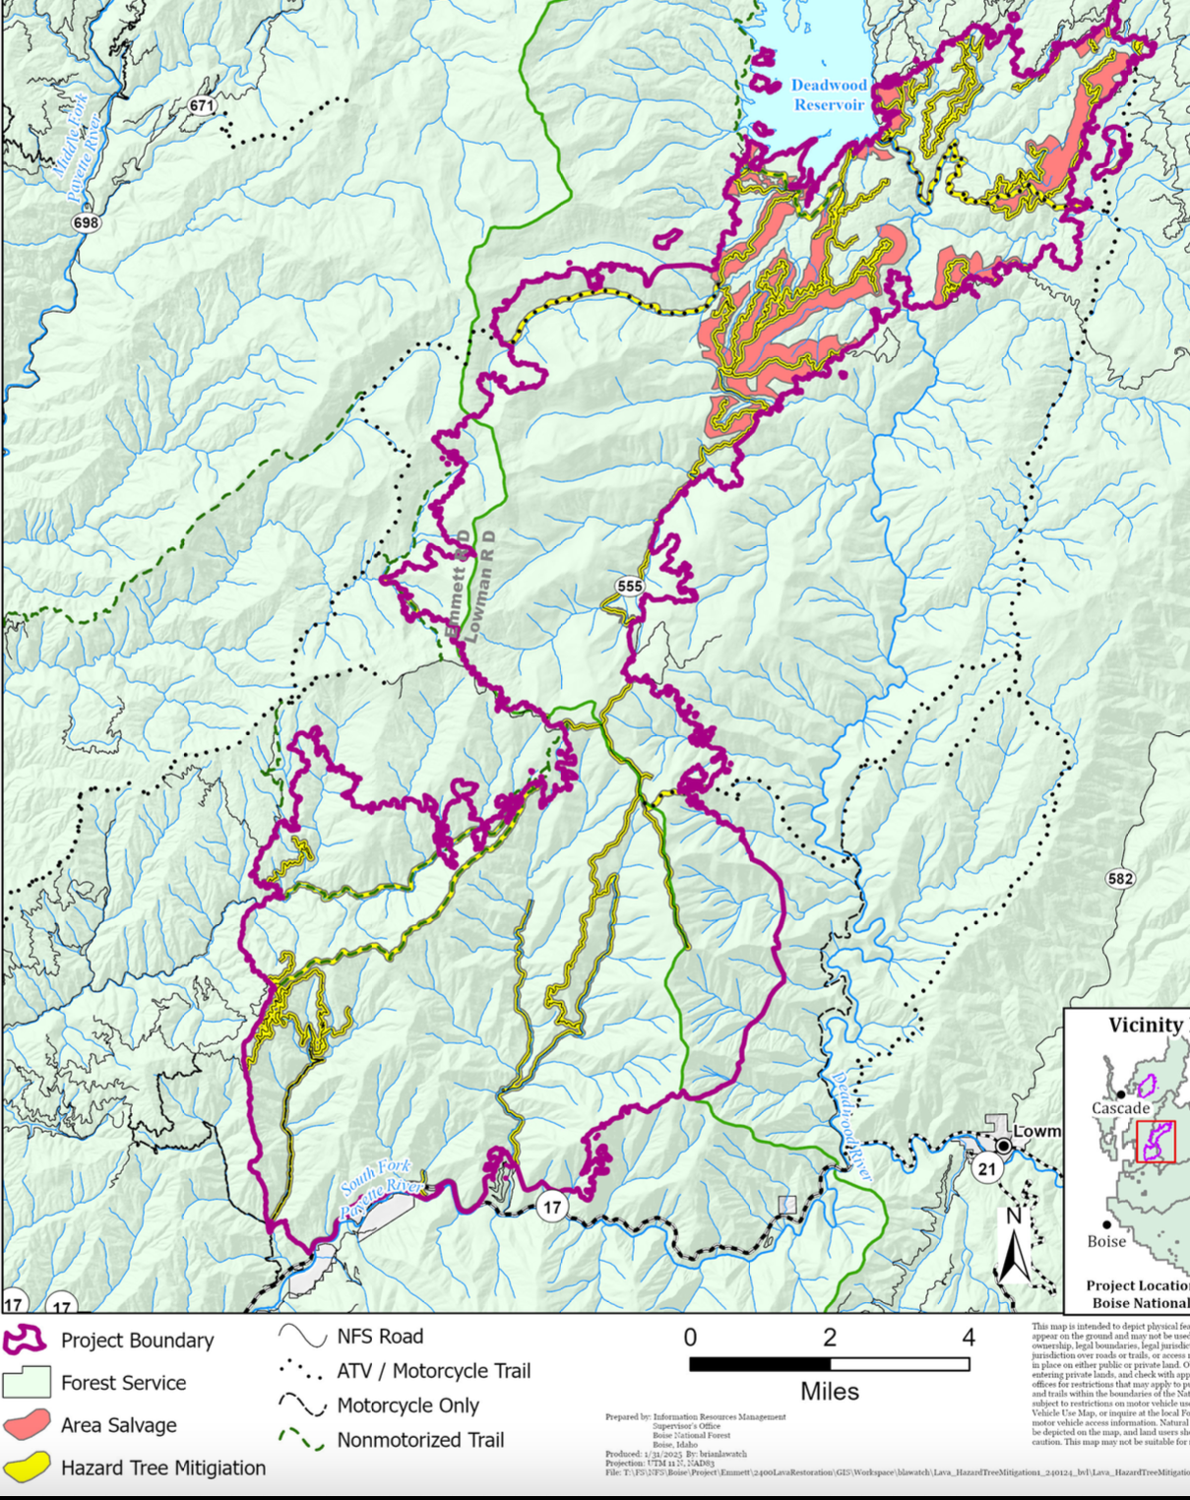

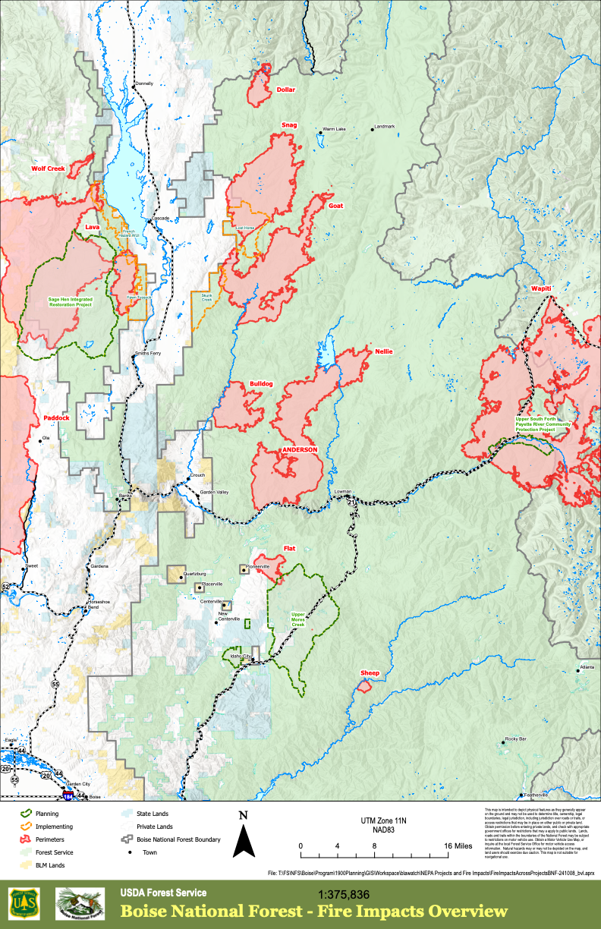
The above USFS map shows the extent of just the 2024 wildfires. Please provide mapping that shows all other burned areas in this landscape from the past 30 years.
These photos were from right before the Snag Nellie Fire burned. From up on a ridge above Bear Valley by the old White Hawk Lookout. There was already smoke in the air from other fires before the 2024 Snag, Nellie and other fires blew up blew up.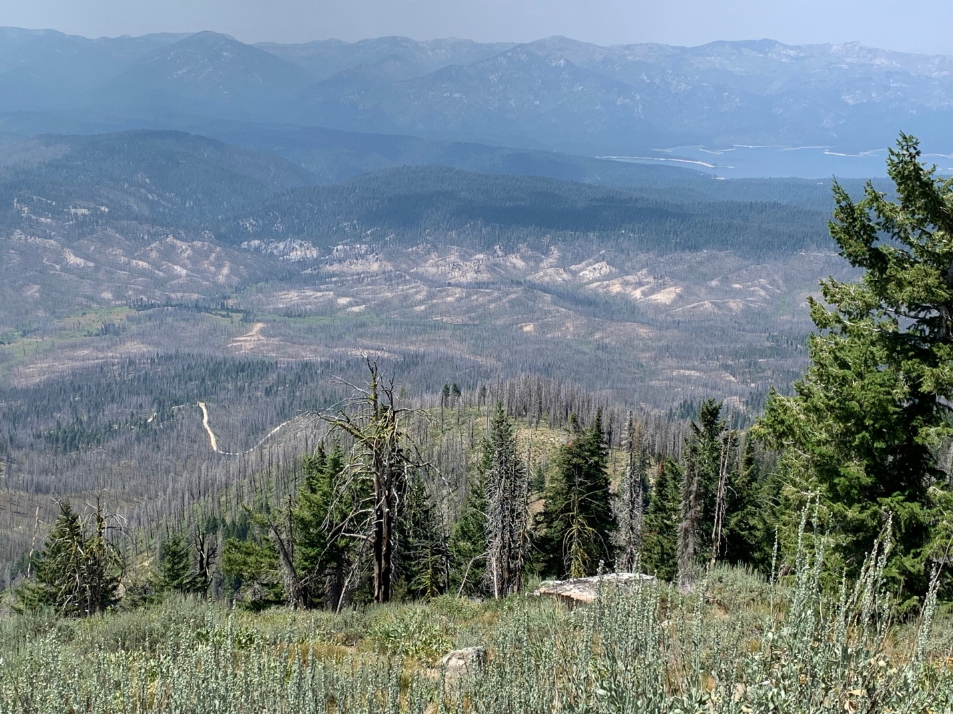In the first photo (above)- Deadwood Reservoir is in the upper right. There are only patches of darker green trees left. The fire took out many of them.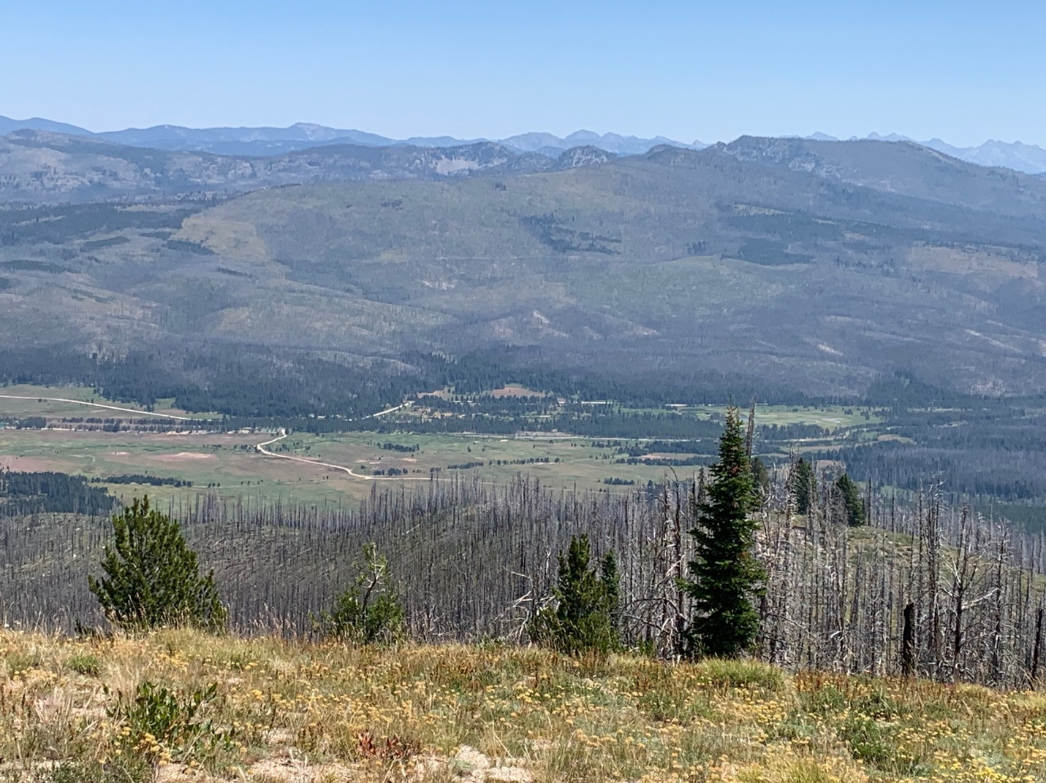
The second photo (above0 is typical of the country all around Bear Valley - to the east of the Ridge was on. To the south (out of sight) is the Northern Pioneer fire. You drive through Pioneer salvage-logged areas in accessing Bear Valley out of Lowman. To the north (out of sight) is the southern Frank Church Wilderness -nearly all burned too just like Bear Valley. There has clearly been huge wildfire loss of forested habitat – on top of incessant logging in much of this area of the Boise Forest. There certainly appears to be a habitat emergency for many avian and mammalian species across the Boise National Forest. Tanagers, Thrushes etc. These salvage logging proposals will make it worse. Please provide any past breeding bird survey information for this region.
In all project mapping of both fires, map what areas haven’t burned and/or been logged in the past 30 years? Are there logging, thinning or any form of vegetation removal/reduction projects proposed but not yet completed in the entire landscape areas shown in the project landscape mapping?
The USFS states:
“the Boise National Forest is proposing the Snag Nellie Project to mitigate hazard trees, reestablish forested conditions, protect the landscape from unauthorized access, and recover some economic value of fire killed trees. The USFS also proposes an “ESD”, claiming an emergency so that it can take environmental shortcuts and log vital woody protective cover that stabilizes watersheds and provides vital habitat for sensitive species, MIS species, migratory birds and ESA-listed species like Wolverine.
This major post-wildfire intentional new watershed and forest disturbance will also injure and often kill adjacent green trees and increase potential infestation by beetles and other insects due to injury from all the road blading, skidding, logging and other disturbance. It will also impair and harm natural recovery processes that are already underway.
Further, once these areas are logged, bulldozed, skidded, masticated, and have heavy equipment run over them as well as slash burned up and are purged of standing (and often downed wood), this will create an even hotter/drier/windier/weedier site with reduced post-fire recovery. This will also expand cheatgrass and other weed-causing livestock grazing and trampling damage, increase herbicide use and contamination, and increase all the many ecological problems caused by expanding livestock grazing into remnant previously less grazed areas – such as trampling-caused soil erosion, livestock eating and killing off “desirable” herbaceous vegetation, and damaging or killing woody seedlings.

We strongly oppose the FS seeding any non-native rhizomatous grasses including along bulldozed areas - like smooth brome and intermediate wheatgrass. These are aggressive species that choke out native herbaceous and woody species, and prevent native plant and soil biocrust recovery. Where have these species ben seeded in the past? The combination of fire and even more disturbance will make their impacts even worse.
How much winter recreational use does this area currently get? How many trees total - and of what age class and species -do you estimate will be removed under the proposed action? How many trees total (please tally both live and dead trees and provide info on both)– and of what age class and species – are actually now present in this much-manipulated landscape? How will the removal of the number of trees and age class proposed alter security and escape cover for big game? How much will it alter fawning/birthing cover – and where specifically are these habitat types located? How will this increase stress on, conflicts with, and jeopardize survival of local populations of larger native carnivores and their habitat use and survival? How will this impact nesting sites for migratory birds, and USFS sensitive and MIS avian species? Pre-decisional intensive inventories must be conducted across the project landscape, and info provided to the public for comment. How much are each of the project-affected species declining? Please review Rosenberg et al. 2019, describing the loss of 3 billion birds from North America. Matters have only worsened since the data used in that report.
What is the status of local Wolverine, Gray Wolf, fisher, Canada Lynx, and other native carnivore populations? How fragmented is habitat currently, and how much additional fragmentation will result?
We are dismayed at how deficient the project info is in relation to biological values. The FS actions appear to be loose, uncertain and serve to sacrifice watersheds, native biota, and recreational and wild land uses to the timber industry. The USFS apparently plans to use deficient baseline information and would allow piecemeal actions and “surveys” basically “in front of the bulldozer” or chainsaw – thus thwarting NEPA’s pre-decisional hard look analysis requirements
After the FS conducts the necessary nesting sensitive species, migratory bird, surveys for rare resident forest birds, and the ever-dwindling Blue Grouse native raptor surveys, native carnivore surveys, rare plant, aquatic species and Threat inventories and assessments, it may determine that a large-scale increase in forested cover and/or mature and old growth woody vegetation communities is what is actually needed to sustain forest values under NFMA. Complete actual baseline data on current ecological conditions and species occurrence, habitat needs and population viability - and a host of other values threatened by this project is necessary to prevent irreversible harms from occurring.
Climate crisis. The climate crisis heightens the risk of adverse outcomes of Treatments and Fire use. It also makes the FS outdated project scheme is to log, thin, “treat”, burn up remnant mature and old growth woody vegetation or any relatively denser woody vegetation resulting not only in tremendous habitat loss for sensitive species and migratory birds but also creating hot/dry/windy more fire prone sites and vegetation communities. This will also to release large amounts of carbon and other greenhouse gases into the atmosphere (how much?). It will also cause loss of carbon sequestering forests and older trees which are vital for addressing the climate crisis - making this out-dated project even more alarming. How much have conditions across the Forest changed since the Forest Plan (based on older scientific information) was adopted? What are the fire return and disturbance intervals the vegetation community modeling used in the Forest plan were based on? What are the fire return and disturbance intervals this project is based on?
Current science is showing rapid spread of fires in fragmented and grazed forests - hotter, drier, windier, weedier and changed local micro-climate including less retention of snow melt so sites dry out more rapidly. See Bradley et al. 2016 and much more recent research as well. Further, by removing forested vegetation, the local precipitation patterns may change and alter the precipitation regime. For example, numerous California and Oregon mega-fires have been sweeping right through heavily logged, thinned lands and old burns. This risk and uncertainty with this project scheme, and a host of new scientific and other information on the adverse consequences of the actions the USFS proposed, shows an EIS is needed.
Many areas of south and central Idaho Forest lands are now susceptible to cheatgrass invasion that is caused by cattle/sheep grazing disturbance and impacts and roading and other disturbance, as hotter temperatures under climate stress bear down. Beschta et al. 2012, 2014, Reisner et al. 2013, Williamson et al. 2019/2020. See also Fusco et al. 202, Kerns et al,. 2021 finding that climate stress reduces forest community resilience and recovery of forests, posing a threat that forested communities will not return.
Climate change stress makes lands less resistant to cheatgrass, rush skeleton weed and other weed infestations, increases loss of water flows, decreases resilience and the ability of arid lands and sensitive species habitats to recover or heal from grazing stress, increases risk of permanent desertification and aridification of remaining watered sites.
The FS must conduct adequate risk assessments of forest temperature increases, soil erosion and permanent increased site productivity loss, permanent weed infestation and dominance, increased aridification, increased fire risk, potential local population extirpation from all the combined effects of the battery of “treatment” actions along with the host of other threats facing this landscape that is highly valued by the public. A welter of disturbances will be imposed. The FS must take a systematic hard look at the many adverse effects of the cross-country heavy treatment/logging activities and slash burning types that will reduce microsite cooling shade and forest wind moderation, and reduce retention of moisture on-sites as more extreme runoff events are likely in burned watersheds.

How much hotter will soil temperatures be in project logged out areas? How much windier will the forest site be in project logged out areas? How much drier will the logged out sites be? How will logging impact snow retention?
How many trees large enough for native carnivore denning sites will remain in the burned areas following this salvage scalping off of burned forest areas?
Once the FS opens up currently closed routes, and smashes and bulldozes and smooths off bars/soil mounds in place to prevent motorized use and removes current downed wood or small to medium sized trees that have started to re-colonize old logging roads, this will greatly expand the human mechanized recreational disturbance footprint across the project area. Removing standing dead trees, injuring and likely logging injured green trees from the logging, and opening up routes will result in increasing ease of mechanized human activity – no matter if the FS tries to close routes after stripping supposed “hazard” trees.
What is the current condition of habitat security cover for big game across the project area? How much will all of these new post-fire disturbance and woody vegetation destruction and removal projects in the scoping notice increase vulnerability of big game species to human disturbance and poaching? How will you estimate the foreseeable combined effects of the fire plus, on top of past logging, on top of all the new disturbances and stripping of wood and cover the scoping letter seeks to impose? We have observed that numerous older routes had young trees growing up in road beds -now those that remain alive will be bulldozed off, and burned wood downed that would help impede mechanized access will be cleared away.
By removing standing dead trees, they won’t fall down onto the supposedly closed route and aid in preventing mechanized use? There appears to be no safety reason for logging trees on either side of closed routes.
What is the current condition of all closed routes? Please provide detailed mapping and analysis., and pre-fire aerial images.
The FS describes how roads were typically built for past logging – yet these 2024 fires and many other previous ones in Idaho have torn through much-logged country. Where are all past logged areas?
What is the treatment, manipulation, logging and history of all areas that burned with high intensity?
Please provide NEPA’s required baseline hard look at all the many past logging projects and vegetation “treatments” of any kind that have occurred across the burned area, and across the larger landscape.
Won’t bulldozing closed routes open so burned trees can be logged off will further jeopardize watershed stabilization and recovery?
Given that closed logging roads are in areas where the FS past logging has already removed a bunch of timber from their surroundings, and now much of the fires have burned up future loggable trees, there sure seems to be no need for retaining these roads, or for cutting so-called hazard trees. It will be a century of much longer until any logs of any size will be present. Please fully consider a range of alternatives under NEPA that would permanently obliterate the footprint of the closed old logging roads across the project area. Please conduct site-specific evaluation of area, and wildlife, sensitive species, watershed protection needs. Please also consider alternatives greatly reducing the distance from a road/trail any “hazard tree” would be cut. How tall are the standing dead trees, anyway?
How much more sedimentation, downcutting, gullying, erosion of stream banks will occur as a result of all the increased high intensity runoff from all the new post-fire disturbance that the scoping notice plans to inflict? From the “hazard tree” logging and slashing and burning; and from the logging: from freshly re-blading roads and trails? What is the existing footprint of routes – width and surfaces?
How much will all these activities impact the volume of flows, and erosive velocity of runoff in spring, as well as inn high intensity summer thunderstorm events?
Where are all springs streams, and drainage networks in relation to all roads/trails/sites where “hazardous tree” logging will take place? And in the salvage logging areas? What are the flows currently, and how might new logging, skidding, blading, burning and other disturbance impact them?
Forest roads with “hazardous trees” removed and roadbeds bulldozed off or opened up -including currently closed routes - would certainly be subject to increased high levels of erosion and sediment. What are the increased amounts? How many areas have highly erodible granitic Idaho batholith soils?
In addition, where are all the fire roads and bulldozing scars that have also disturbed watersheds?
The proposed actions will significantly increase forest soil loss in both wind and water. Removal of standing trees and burned wood that moderates site conditions, blocks wind, shades soil surface, and slows down runoff will all result in significant environmental impacts.
There will be increasing erosion from newly disturbed roadbeds/verges/water bars, etc. - on top of the increased erosion potential across the surrounding burned landscape, resulting in further road damage and/or impacts to the hydrology of the watershed, water quality, and sustainability of perennial flows, as well as new weed expansion areas.
Please take a hard look at where past USFS logging, thinning, treatments, roading, etc. may have resulted in high intensity fires.
Tree mortality associated with fire-injury, drought, and insect and disease infestations will continue for years after fires – and the logging will increase insect and disease risk to remaining live and recovering trees. Won’t tree mortality continued for years after the fire due to cut, crushed and wounded still-live trees being injured and producing sap that attracts beetles and other forest tree killing insects? Won’t all the new scoped disturbance increase the risk of forest pathogens that may kill still-live trees?
The FS states: Unauthorized roads and user-created trails that existed prior to the fire are now visible and accessible due to vegetative cover loss. Fire suppression activities, including repaired dozer lines, are also visible. Where fire impacts have left these routes visible, there is a need to deter access and prevent further damage to the landscape.
Where are all of these? Please provide detailed mapping and analysis of their location and any tree removal proposed for within 200 ft. of them, and any salvage logging. Please explain why the FS has not acted to effectively control use on them. The apparent abundance of these unauthorized routes highlights our concerns about the FS inability to effectively control mechanized use route proliferation in this landscape, including in the aftermath of all the scoped salvage logging, new bulldozing, skid trails, log decks, hazardous tree removal, including the proposed purging of trees from or near IRAs, and other scoped activities in this landscape.
Note that the scoping info is silent on foreseeable herbicide use. What herbicides will be used as a result of the logging and hazardous tree removal and bulldozing activity? Aasa result of livestock grazing resuming in this landscape? How will they be applied? What specific chemicals and chemical mixes? We note there are already significant weed problems in this landscape – greatly exacerbated by the high numbers of cattle and inadequate grazing standards the FS applies. Do these chemicals get transported in eroding wind? Do these herbicide mixtures include PFAS/Forever chemicals?
Riparian areas, including headwaters and seeps and springs previously protected by mature forested conifer and upland shrub, and riparian site mature willows, red osier dogwood, etc. are now all highly vulnerable to increased human and motorized damage. Resuming grazing will certainly slow and retard riparian area recovery, will increase sedimentation and water pollution, and likely lead to increased erosional gullying, loss of stream connectivity to floodplains, and reduced and altered surface water flows.
Hazard trees.
We are dismayed at the FS claiming a need to remove trees within 200 ft. of roads = a 400 ft. deforestation zone– when much of the forest trees have been 3rd growth heavily logged and manipulated areas with relatively short trees. How tall are trees at maturity here? Will trees be removed within 200 ft. of any- unauthorized routes and trails? If so, where? Please provide detailed current inventory-based mapping of all authorized and all unauthorized routes and trails, and the width and footprint of the road/trail. Didn’t the FS Sagehen project decisions expand the footprint of access routes – aggravating the substantial intensive motorized use and the “dispersed camping” that the FS now uses as an excuse for salvage logging of “hazardous trees”.
Is the FS going to log trees that are still alive after the fire? How many green trees will be removed in each salvage unit and 200 ft. area of each side of routes and any other area where trees will be cut down. What wood volume will this be? How will the FS determine which trees will survive? What are the criteria? Will the FS apply different criteria here than it does when evaluating the impacts of its own burning program?
Fuels Treatments
The FS states: Activity and existing fuels in hazard tree mitigation and area salvage units would be disposed of through hand or machine piling, pile burning, jackpot burning, lopping and scattering, mastication, chipping, biochar processing, or biomass removal”.
It is crazy to claim to treat “fuels” in the midst of a big burn – and this is just a big waste of taxpayer dollars and diesel fuel, equivalent to “raking” the forest.
The FS plans: Machine piling and mastication (mechanical chipping/grinding/shredding of fuels) would occur in hazard tree mitigation units where slash is too large or dense for hand piling. These are typically areas where the material that is greater than 3 inches diameter, has fuel loadings greater than 4 tons per acre, and the majority of the material is on the ground. Mastication is a treatment that can be used to remove smaller diameter trees or rearrange the ground fuel/slash into a size that will decompose more rapidly.
What determines if there’s too much slash? This is madness. It just means more heavy equipment tearing us soils and slopes, compacting soils, clearing areas of protective woody cover, and loss of carbon and nutrients from the site. There is no reason to do this. How much will this, and all aspects of this project, cost? This appears to be a make-work project for contractors.
All of this new post-fire disturbance and messing around with wood and vegetation will ultimately result in a hotter drier, weedier, harsher site than existed post-wildfire, and that is further stripped of woody cover critical to many forest animal species. These intensively grazed watersheds already suffer from a lack of protective cover, vulnerability to flammable weed infestation and dominance. The forest and shrublands suffer from a loss of nutrients, and significant loss of carbon storage ability. Yet the FS now wants to inflict even greater losses of nutrients, higher erosion, less shading and structural complexity that serves to slow down snowmelt runoff and helps retain moisture on the site as well as cooling the soils surface. All of these farming-type actions will strip-mine wood and structural complexity required for a host of small animal species and biodiversity. This will also result in lands being more severely exploited and trampled and grazed down by livestock. The FS should be leaving all possible wood on-site, rather than robbing the forest of nutrients, wildlife habitat, biodiversity, moisture retention capability, etc.
All of this logging, bulldozing, etc. will expand snowmobile disturbance of rare native carnivores, including Wolverine. The USFS has already created a significant disturbance problem by plowing routes for snowmobiles – and now there are motorized snow bikes and other devices further expanding winter disturbance. It of course will also further reduce and cause loss of prey species for Wolverine, Gray Wolf and other native carnivores. Please see Wolverine discussion in our Sagehen comments. It is likely to result in a range contraction.
The FS states: “To facilitate access to area salvage units, NFS roads currently classified as maintenance level 1 (ML1) would be reopened for project use then restored to their current state of storage upon project completion. In addition, approximately 2 miles of temporary road would be needed. Temporary roads would be decommissioned once harvest activities are complete and would not be added to the Forest Transportation System. No permanent roads will be constructed”.
Please provide detailed current on the ground inventory mapping of all routes in all categories.
The FS states: “This work includes repair and stabilization on drainage and structural trail features such as grade dips, water bars, retaining walls, and turnpikes. [What is a turnpike?]. Trail prisms would also be reestablished. This work would prevent trail tread and structure loss, soil erosion and runoff into streams, and prevent the cost of full reconstruction”.
The FS must consider and fully assess closure and removal of these trails and mechanized activity playgrounds - to provide for habitat security for big game and other wildlife in this newly burned landscape where it will take a century or longer to recover mature functioning forest habitats for migratory bird, sensitive species and a host of other wildlife.
Aren’t these nearly all motorized trails? Through what process Have all these been authorized? Are there also unauthorized trails leading off from the “authorized” ones? Where? Please provide mapping How have these trails been harming and displacing Elk, Mule Deer and other wildlife, intruding in sensitive species habitats including hawk and owl nesting habitats, as well as impacting riparian and wetland habitats and erodible soil areas? Were these purposefully constructed, or were they user created routes that the FS failed to close, and has now legitimized?
With the significant fire-caused loss of tree cover, the noise and visual and human harassment a poaching footprint of these trails will be seriously expanded – displacing and threatening big game, Wolverine, and many other species. How much has the firs expanded this for all trails and trail segments? How much worse will the FS salvage and hazard and other tree clearing make this? We request that you provide detailed analysis of the habitats impacted. (MIS, sensitive species, and fragile watershed or rare plant and other areas, and close trails with significant conflicts with other values of the Forest permanently – rather than rebuilding them. How significant are the habitat losses for all USFS sensitive, MIS and important species due to this and other recent fires? This fire and the Sagehen project logging and burning?
What is the current width and surface conditions of all of these? Will the FS keep any repairs to within that current footprint?
The FS says it will keep any repaired roads in the current footprint. WHAT is the footprint for each route to be repaired – please detail this for all segments.
We oppose winter intrusion and snowplowing for logging and other activity – as it will lead to an expanded human disturbance footprint, expanded hunting and poaching including of native predators – during a period of the year when wildlife need habitat security.
What does the FS Travel plan say about off-road snowmobile and other activity? Will this expand this use – including foreseeably to areas critical for wintering wildlife, make the grossly unethical pursuit of native predators by gunning and trapping even easier. There is Wolverine habitat in portions of the project area and surroundings. How much Wolverine habitat has burned in the Boise Forest in the past 25 years? How much in the Payette Forest - and area that has also suffered many recent fires, and is facing a battery of logging projects and burning projects – like Granite Goose and a cookie cutter burn EA similar to the Boise Forest SWIRL EA. Please provide detailed mapping ana analysis of the current condition of Wolverine habitat in this region, and the foreseeable further losses from a host of USFS “restoration” treatments.
We incorporate all concerns raised about Wolverine and other imperiled and sensitive species habitats in our Sagehen EA comment submissions, as well as the host of foreseeable and cumulative harms and threats to sustainability of Wolverine, migratory bird species populations, and other native species across the region.
The route depictions and other info on the scoping notice Map 2 are unclear., Please provide much better mapping.
We strongly oppose any tree cutting and route repair in the IRA, where the fire, a natural process, has affected the intrusive mechanized route network.
Please provide detailed current ecological analysis of conditions across the IRA. We are alarmed that the USFS apparently plans to burn up the remainder of the Boise Forest area Snowbank IRA under the Sagehen project. We request that the FS scrap any further burning and purposeful live forest cover loss in the still-forested areas of the IRA and this landscape.
Look at all the yellow logging areas in and/or along the border of the IRA. Please provide higher detail mapping showing where routes border the IRAs and if tree removal will occur there. How much damage will motorized logging, masticating, burning slash, etc. activity in the IRAs cause, and how will it be done?
Where are all currently de-commissioned routes? Have they been being used by motorized activity despite being theoretically closed? How has the FS monitored this
We strongly oppose plowing roads for this project. The FS states: Roads in the project area, including temporary roads, may be snowplowed to allow access for logging or reforestation activities.
The FS plans “commercial salvage” to strip mine wood from the forest – in the face of climate change stress that this already makes lands less able to recover from disturbances and more vulnerable to weeds and other ecological problem. Please provide inventory and analysis of the stand conditions and age of trees in and surrounding all areas targeted for commercial salvage. How does the tree size and age in these salvage areas compare to those in non-salvage sites? What is the number and age class of green unburned trees in these areas?
We oppose the FS not allowing for an Objection period and the “emergency” designation for this project – especially given the lack of sound justification for the salvage logging, the 200 ft on each sides of roads and even trails -including intruding into roadless areas - and using the 2024 fires as an excuse to spend federal funds further depleting and degrading this landscape by manicuring the forest through removing “fuels”.
We are alarmed at all the migratory bird nesting habitat loss that has taken place already across the Boise and neighboring Forests, and how much more damage will be done by salvage and other logging with this project- including impacts and further losses to pockets of remaining green trees, and mixed areas of green and dead trees. How will this, and all the other foreseeable projects, further eat into ever more scarce nesting habitat for species like Hermit Thrush, Western Tanager, and many other migratory birds?
Please conduct pre-decisional intensive inventories to determine the status of all sensitive Forest species in and surrounding the burned lands. What was the status and trend of populations prior to the fires? How will it affect viability of important, MIS, sensitive and ESA-listed species populations? Is the FS meeting all its Forest Plan goals for wildlife, watersheds, sensitive species, etc. Please provide the information from public comment and review as part of this process – before you tear up and destroy critical standing dead and alive trees and rip open closed roads as part of this 2025 proposal.
For each affected species through current baseline inventories must be conducted as part of this NEPA process and provided to the public for review. This is necessary to understand the severity of harms and full scale and significance of adverse effects. It is necessary to: Number of individuals impacted and the specific areas of occupied habitat in the project area and surrounding landscape (as many of these species are wide-ranging carnivores or otherwise linked to populations on state land, private land or USFS land.
-Acres of impacted habitat -Extent of impacts to individuals and habitat -Distance from specific locations (recreation sites, vegetation treatment locations, and so forth.
Please incorporate into the Snag Nellie NEPA process, and analyze, all relevant and applicable concerns raised in regards to the he Boise Lava Fire, and Sagehen and other project comments that we are attaching.
Sincerely,

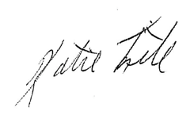
Katie Fite
Public Lands Director
WildLands Defense
PO Box 125
Boise, ID 83701
208-871-5738
katie@wildlandsdefense.org

/mg
Mike Garrity
Alliance for the Wild Rockies
PO Box 505
Helena, MT 59624
406-579-5986
wildrockies@gmail.com

/se
Sara Johnson
Native Ecosystems Council
PO Box 125
Willow Creek, MT 59760
406-579-3286
sjjohnsonkoa@gmail.com

