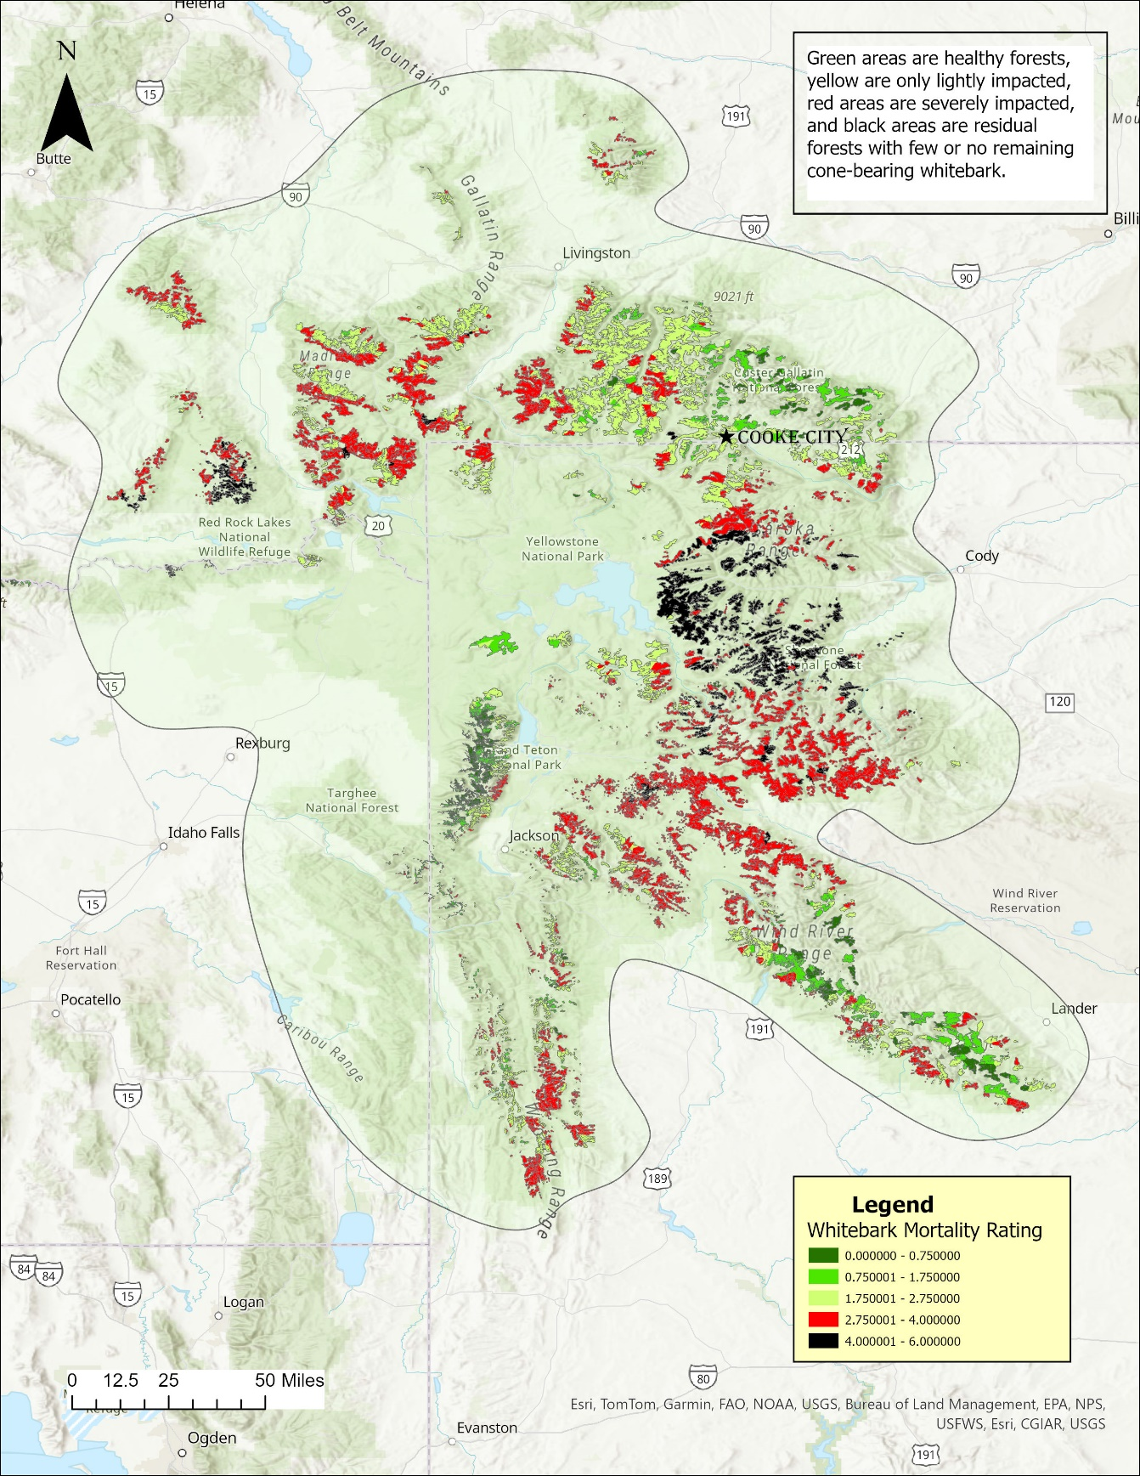
APPENDIX A. FIGURES
A.1. From Macfarlane et al. 2013

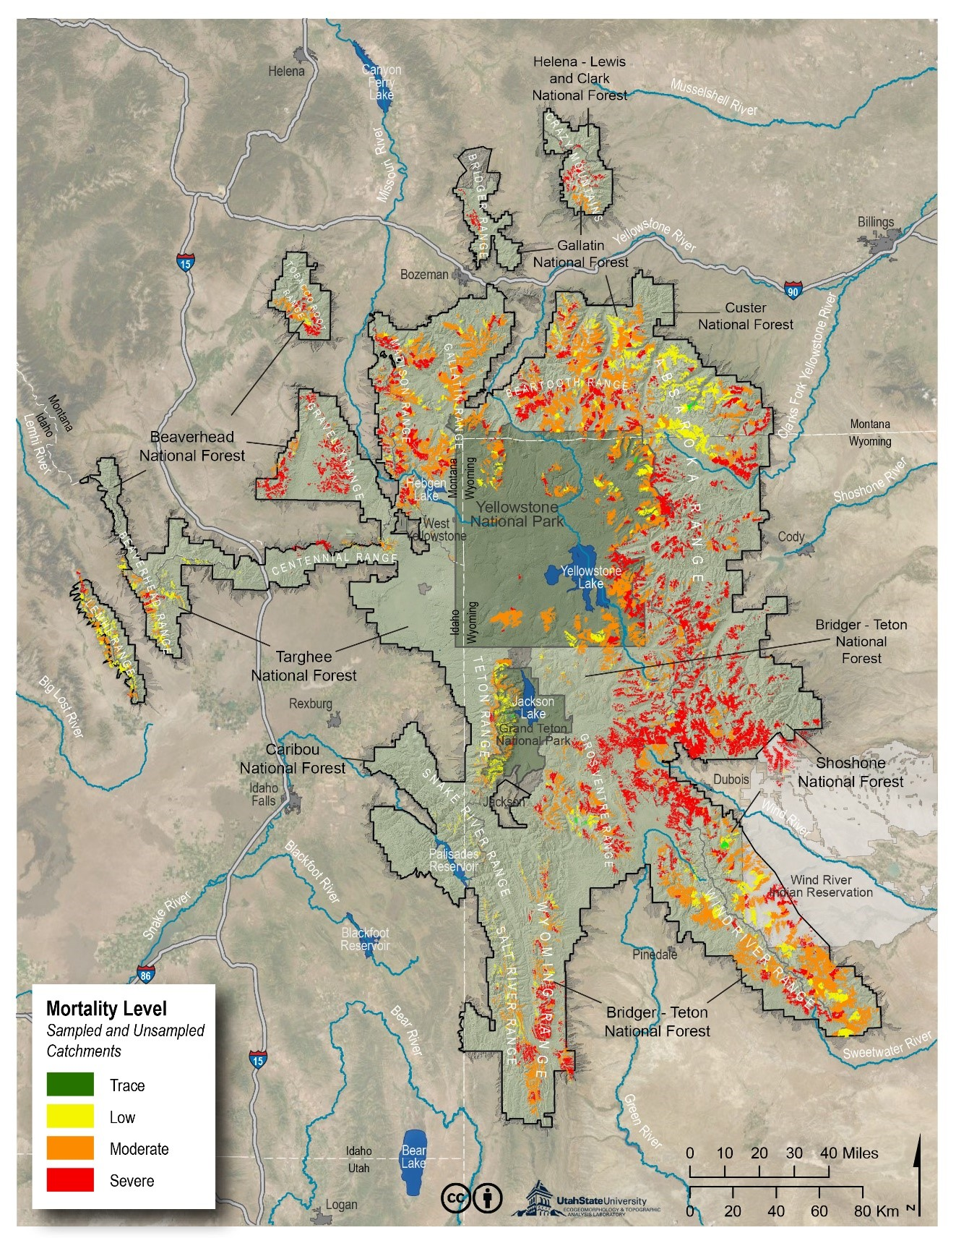
Fig. A.2. From Macfarlane et al. 2023

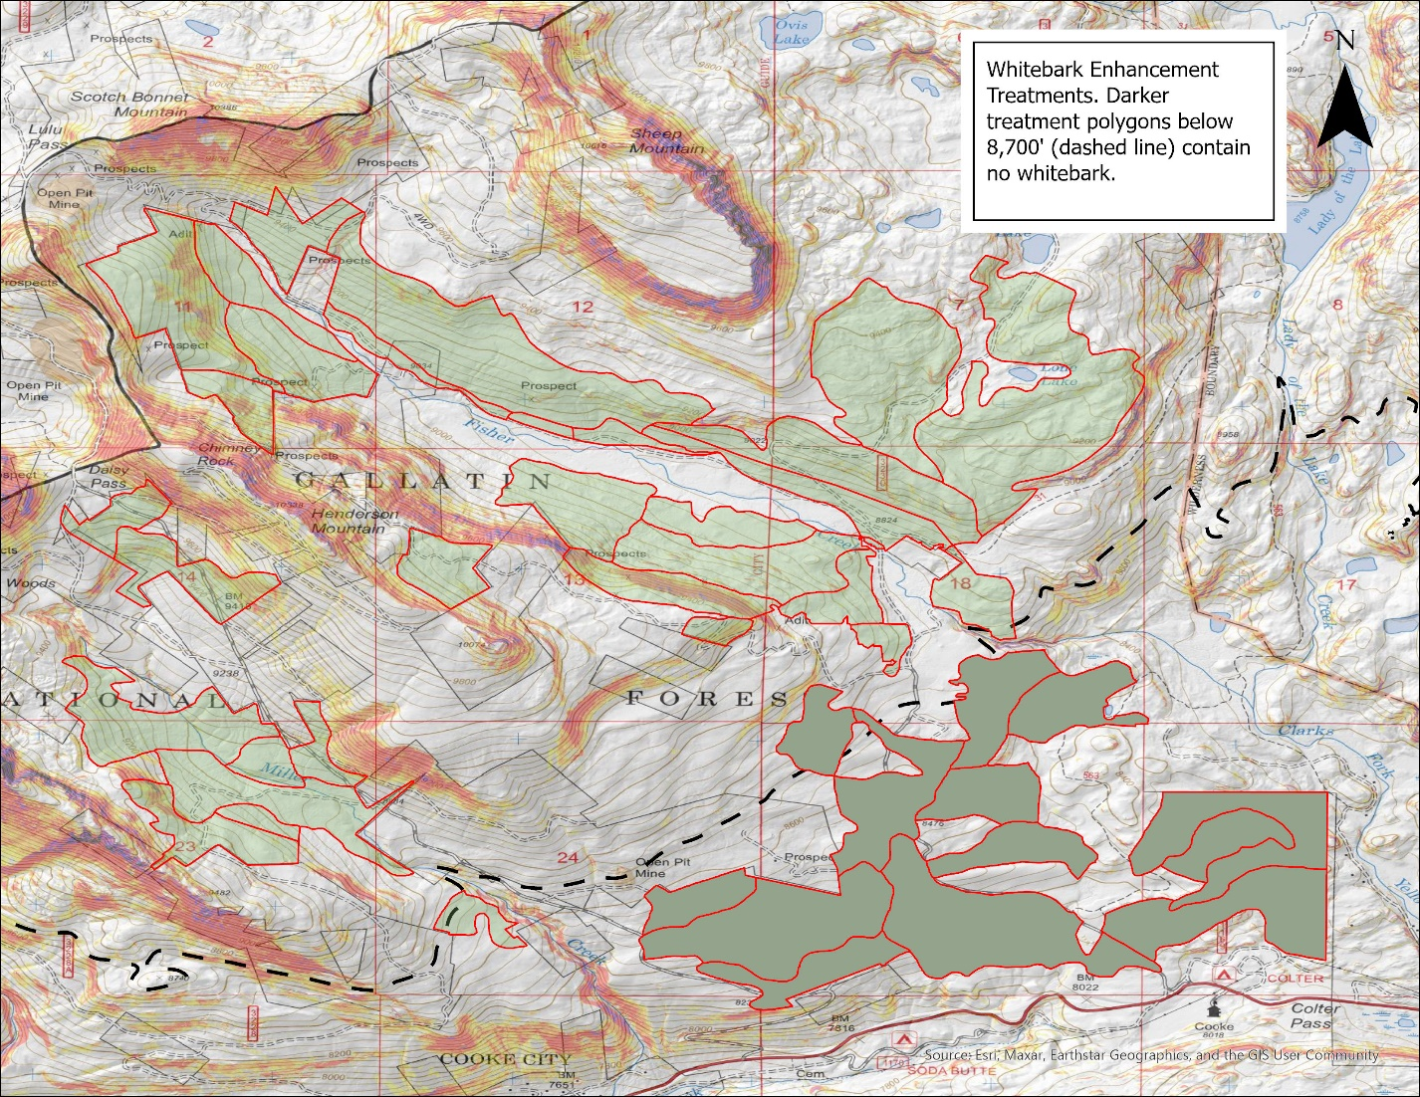
Fig. A.3 Whitebark enhancement treatments 3, 5-9, 11-13, 15, and 109 A, B contain no whitebark in either the overstory or understory.
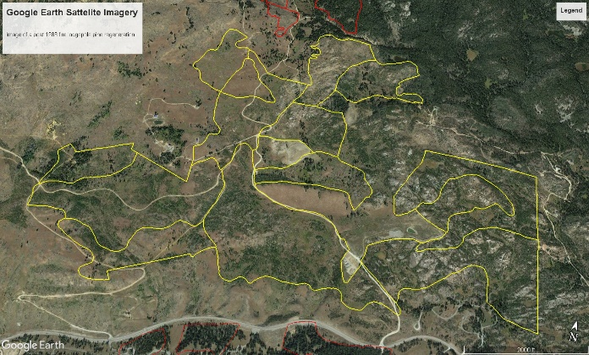
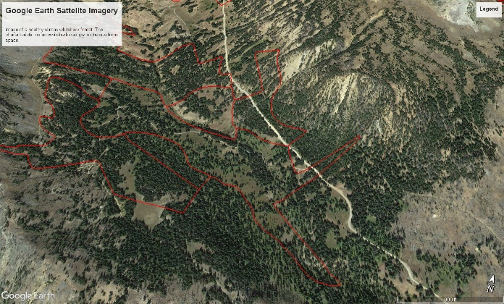
A. B.
Fig. A.4. Google Earth satellite imagery that shows the obvious difference in appearance between a healthy climax whitebark forest on the left (A) and a fire-regenerated dog-hair lodgepole forest on the right (B).

