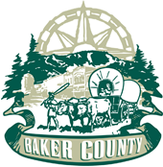
March 24, 2025
Shaun McKinney, Forest Supervisor
Attn: Objections
1550 Dewey Ave
Baker City, OR 97814

Submitted electronically: https://www.fs.usda.gov/project/project=58480

Baker County does not object to the authorization of the revised Environmental Assessment, Finding of No Significant Impact (FONSI), and draft Decision of Notice for the Baker City Watershed Fuels Management Project.

However, the County does object to the amount of time it took to get this project into the implementation phase. As a watershed that supplies municipal drinking water to 10,000 citizens plus visitors, it should have taken priority over other projects and had a 2 year start to finish, including NEPA and fieldwork. It’s not “if”, but “when” the watershed will suffer a catastrophic wildfire, and every delay puts it more at risk.

In addition, Baker County objects to the whittling away at project components because of the threat of litigation by environmental groups that do not reside in Baker County and will not suffer because of their actions. At the start of the project’s development, Marble Creek Road was to have a mile-wide buffer on each side and be passenger car assessable. Too, diseased and insect-infested trees, no matter the diameter, would be removed to lessen the likelihood of wildfire. Harvest would occur along the ridges and on steeper slopes by using approved methods of harvest such as tethered logging, allowing for more timber harvest. But all of these components were removed from the final EA, leaving the project a mere shell of its original conception and barely meeting the Needs and Purpose. The bending of the Forest Service to the environmental groups has been a huge disappointment to the County who believe that our community should come first.

As important as the diminished project, the fact that the County and the Forest Service went from monthly meetings to coordinate on the project to a more secretive Forest Service only internal discussions. There were a lot of months that the County did not know if the project was moving forward or not. Thankfully, in the last month or so, updates have once again started to be shared.

The County wants this project to be completed in a timely manner, including a timber sale and harvest that has a completion timeline of 2 years. We’ve waited long enough. It’s time to get the Baker City watershed healthy again.

Baker County does not want this project to stall again for any reason.

Sincerely, Thank you,
Doni 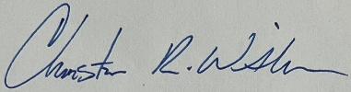
Baker Co Natural Res/Parks Commissioner
Coordinator
541-519-1719

Cc:
President Donald J. Trump
Rep. Cliff Bentz
Sen. Ron Wyden
Sen. Jeff Merkley
Sec. of Ag Brooke Rollins
FS Chief Tom Schultz
Assoc. Chief Chris French
Region 6 Forester Jacque Buchanan

