March 9, 2025
RE: Lava Fire Restoration Project proposed Salvage Logging, Hazardous Tree Removal, Livestock Projects and Management, Road/Trail and other Actions and other Post-Fire Disturbance Activity.
Dear Boise Forest and Brian Lawitch,
Here are comments from WildLands Defense, Alliance for the Wild Rockies and Native Ecosystems Council regarding the Lava Fire. Please also apply these concerns to Snag Nellie and any other 2024 projects you are considering.
After the 2024 fires, we request that the FS reconsider the further logging and large-scale burning in projects that the USFS has already scoped or authorized but are not yet completed – More’s Creek, Clear Creek, SWIRL, Sagehen, etc. – and take a current hard look under NEPA at the foreseeable devastating blow to migratory birds, Wolverine, big game, sensitive and MIS species, aquatic species of concern, and sustainability of forest uses.
The FS states “the purpose of the Lava Restoration Project is to address and mitigate the impacts to the landscape from the 2024 Lava Fire as described above in the Potentially Affected Environment section”. Salvage logging and removal of supposed “hazard” trees 200 ft. on both sides of roads, removal of “hazardous trees” from motorized routes/trails in the Snowbank IRA, removal of supposed “hazard trees” around completely unmapped “dispersed camping sites” (please map each of these sites ); removal of trees 200 ft on either side of even narrow closed former logging roads (of which an extensive network exists – and this will require extensive bulldozing further der-stabilizing watersheds and increasing sedimentation and erosion) does not mitigate fire impacts in any way, shape, or form. It very foreseeably increases. This will make everything much worse.
This major post-wildlife intentional new watershed and forest disturbance will also injure and often kill adjacent green trees and increase potential infestation by beetles and other insects due to injury from all the road blading, skidding, logging and other disturbance. It will also impair and harm natural recovery processes that are already underway.
Further, once these areas to be logged, bulldozed, have heavy equipment run over them are cleared of standing (and often downed wood), this will create an even hotter/drier/windier/weedier site with reduced post-fire recovery. This will also expand cheatgrass and other weed-causing livestock grazing and trampling damage, increase herbicide use and contamination, and increase all the many ecological problems caused by expanding livestock grazing into remnant previously less grazed areas – such as trampling-caused soil erosion, livestock eating and killing off “desirable” herbaceous vegetation, and damaging or killing woody seedlings.
We strongly oppose the FS seeding any non-native rhizomatous grasses -like smooth brome and intermediate wheatgrass, as these are aggressive species that choke out native herbaceous and woody species, and prevent biocrust recovery.
Once the FS opens up currently closed routes, and smashes and bulldozes and smooths off bars/soil mounds in place to prevent motorized use and removes current downed wood or small to medium sized trees that have started to re-colonize old logging roads, this will greatly expand the human mechanized recreational disturbance footprint across the project area. Removing standing dead trees, injuring and likely logging injured green trees from the logging, and opening up routes will result in increasing ease of mechanized human activity – no matter if the FS tries to close routes after stripping supposed “hazard” trees.
What is the current condition of habitat security cover for big game across the project area? How much will all of these new post-fire disturbance and woody vegetation destruction and removal projects in the scoping notice increase vulnerability of big game species to human disturbance and poaching? How will you estimate the foreseeable combined effects of the fire plus, on top of past logging, on top of all the new disturbances and stripping of wood and cover the scoping letter seeks to impose? We have observed that numerous older routes had young trees growing up in road beds -now those that remain alive will be bulldozed off, and burned wood downed that would help impede mechanized access will be cleared away.
By removing standing dead trees, they won’t fall down onto the supposedly. Closed route and aid in preventing mechanized use.
There is no possible safety reason for logging trees on either side of closed routes.
What is the current condition of all closed routes? Please provide detailed mapping and analysis.
The FS describes how roads were typically built for past logging – yet the fire tore threw much-logged country. “Although portions of the Lava Fire burned in a mosaic of intensity, a substantial portion of the fire burned at a high intensity; overall, the fire resulted in substantial tree mortality. Vegetation burn severity generally correlates to the level of soil burn severity. Hazard trees are now present throughout the project area. The fire has resulted in a change of tree species composition and stand density. Desired vegetation attributes”. What is the treatment, manipulation, logging and history of all areas that burned with high intensity?
Please provide NEPA’s required baseline hard look at all the many past logging projects and vegetation “treatments” of any kind that have occurred across the burned area, and across the Lava Fire and Sagehen Project area.
Please provide NEPA’s required baseline hard look at all the many still not completed 2024 Sagehen projects and “treatments” that have occurred across the burned area, and across the Lava fire and Sagehen Project area
The FS states: The project area consists of the 39,340 acres of the Lava Fire that burned into the Sage Hen Integrated Restoration Project area on the Emmett Ranger District.
The FS states: Most of the road network in the project area was created to support timber harvest activities and multiple uses including safe public access. Major public access routes impacted by the fire include NFS Roads 618, 625, and 624. Post fire flooding has already severely altered the Chief Eagle Eye drainage.
Doesn’t this show that bulldozing closed routes open so burned trees can be logged off will further jeopardize watershed stabilization and recovery?
Given that closed logging roads removed a bunch of timber from their surroundings, and now much of the Lava fire burned with high intensity killing future loggable trees, there’s no need for retaining these roads – as it will be a century of much longer until any logs of any size will be present. Please fully consider a range of alternatives under NEPA that would permanently obliterate the footprint of the closed old logging roads across the project area. Please conduct site-specific evaluation of area, and wildlife, sensitive species, watershed protection needs
How much more sedimentation, downcutting, gullying, erosion of stream banks will occur as a result of all the increased high intensity runoff from all the new post-fire disturbance the scoping notice plans to inflict?
How much will all these activities impact the volume and velocity of runoff in spring, as well as high intensity summer thunderstorm events?
Forest roads with “hazardous trees” removed and roadbeds bulldozed off on opened up currently closed routes would certainly be subject to increased high levels of erosion and sediment.
In addition, where are all the fire roads that and bulldozing scars that have also disturbed watersheds?
The proposed actions will significantly increase forest soil loss in both wind (removal standing trees and burned wood that moderates site conditions - blocking wind, shading soil surface, and slowing down runoff).
There will be increasing erosion from newly disturbed road beds and edges on top of the increased erosion potential across the surrounding burned landscape, resulting in further road damage and/or impacts to the hydrology of the watershed, water quality, and sustainability of perennial flows.
Please take a hard look at how all the past USFS logging, thinning, treatments, roading, etc. resulted in high intensity fires. The scoping notice states: “Although portions of the Lava Fire burned in a mosaic of intensity, a substantial portion of the fire burned at a high intensity; overall, the fire resulted in substantial tree mortality. Vegetation burn severity generally correlates to the level of soil burn severity. Hazard trees are now present throughout the project area. The fire has resulted in a change of tree species composition and stand density. Desired vegetation attributes …”.
may no longer be present. Tree mortality associated with fire-injury, drought, and insect and disease infestations will continue for years after the Lava Fire. Won’t tree mortality continued for years after the fire due to cut, crushed and wounded still-live trees being injured and producing sap that attracts beetles and other forest tree killing insects? Won’t all the new scoped disturbance increase the risk of forest pathogens that may kill still-live trees?
The FS states: “Moderate and high burn severity of vegetation and soils have created conditions for the increased risk of invasive botanical species to outcompete native plants. Low-elevation non-forested habitats may not be able to recover naturally following the fire, specifically, those areas historically supporting drought-adapted bitterbrush, sagebrush, Idaho fescue, and bluebunch wheatgrass”.
This soundly demonstrates that the FS should remove livestock grazing for decades, and develop a range of alternatives that closes cheatgrass-vulnerable pastures and/or allotments. Please identify these and provide a hard look alternatives analysis.
Grazing Damage
We incorporate by reference into these 2025 comments our discussion of livestock grazing degradation and threats, including as chronic and foreseeable and cumulative disturbance in our 2024 Sagehen project comments. Livestock -accessible area of the forest have been seriously degraded – with springs, seeps, streams grossly trampled, altered channel morphology, banks denuded of willow cover, etc. Past forest logged areas over the past decade are choked with thistles and other weeds. Trampling by cattle de-stabilizes ephemeral intermittent and perennial drainages. Trampling prevents the recovery of protective soil-stabilizing biocrusts, The 2 years of rest in the scoping notice is completely inadequate to allow for recovery of forest and shrub lands following wildfires – and now the scoped logging, road bulldozing, etc. on top of the fire.
The FS states: Approximately 34,980 acres of the Payette C&H and OLA-C C&H allotments were affected within the project area. Range improvements used to manage livestock were destroyed and/or damaged. Livestock grazing operations were impacted by wildfire and will require modification during recovery and rehabilitation efforts.
What has actual use been in all affected pastures and allotments? We are concerned that the “rest” of burned areas will result in the FS allowing intensified grazing in unburned areas. It is critical to understand actual use livestock numbers to determine this. Any partially burned pastures should be closed, and no new “temporary” fences built. Think of the impacts to wildlife – first the fire then the Forest salvage logging and other scoped disturbance, then the unburned habitat that serves a as a refuge gets hit with more concentrated livestock. Please provide current ecological health information for upland and riparian habitats across this landscape. It appears that the high levels of livestock grazing plus all the existing disturbance the USFS routinely allows here has wiped out or greatly reduced Bull trout in previously occupied stream areas. Is that the case?
Will any of these be used in the logging and other activities? Please provide detailed mapping and analysis of all unauthorized routes and trails.
The FS should use this an opportunity to reduce fencing and reduce very harmful livestock water developments.
What are all current flows at springs and areas that may be dug into deeper and essentially re-gutted? Have past spring “developments”’ reduced or altered surface water flows? What types of springs will be impacted? Please provide detailed mapping and analysis of all springs – developed and undeveloped across this landscape/
Who holds the water rights on springs that may re-gutted?
The FS states: The nearby Sage Hen Reservoir area did not burn. However, the fire affected several designated trails, used for both summer and winter recreation. Fire has resulted in damaged trees near and adjacent to designated trails and trailheads, as well as the Third Fork Cabin. The cabin itself was unharmed.
The FS states: Unauthorized roads and user-created trails that existed prior to the fire are now visible and accessible due to vegetative cover loss. Fire suppression activities, including repaired dozer lines, are also visible. Where fire impacts have left these routes visible, there is a need to deter access and prevent further damage to the landscape.
Where are all of these? Please provide detailed mapping and analysis of their location and any tree removal proposed for within 200 ft. of them, and any salvage logging. Please explain why the FS has not acted to effectively control use on them. The apparent abundance of these unauthorized routes highlights our concerns about the FS inability to effectively control mechanized use route proliferation in this landscape, including in the aftermath of all the scoped salvage logging, new bulldozing, skid trails, log decks, hazardous tree removal, including the purging of trees from ATV trails in Snowbank IRA, and other scoped activities in this landscape.
The USFS minimal grazing “rest” jeopardizes any “recovery” of native plants, including trees and shrubs. It jeopardizes the success of any post-fire seeding and tree and shrub planting.
Note that the scoping info is silent on foreseeable herbicide use. What herbicides will be used as a result of the logging and hazardous tree removal and bulldozing activity? Aasa result of livestock grazing resuming in this landscape? How will they be applied? What specific chemicals and chemical mixes? We note there are already significant weed problems in this landscape – greatly exacerbated by the high numbers of cattle and inadequate grazing standards the FS applies. Do these chemicals get transported in eroding wind? Do these herbicide mixtures include PFAS/Forever chemicals?
Riparian areas, including headwaters and seeps and springs previously protected by mature forested conifer and upland shrub, and riparian site mature willows, red osier dogwood, etc. are now all highly vulnerable to livestock access and trampling damage and destruction. Resuming grazing will certainly slow and retard riparian area recovery, will increase sedimentation and water pollution, and likely lead to increased erosional gullying, loss of stream connectivity to floodplains, and reduced and altered surface water flows.
Please evaluate a range of alternatives to remove ecologically harmful livestock projects across this landscape, and assess not rebuilding and rehabbing sites with projects that are harming or reducing surface flows of springs seeps, streams, cultural sites, causing weed proliferation, etc.
Hazard trees.
We are dismayed at the FS claiming a need to remove trees within 200 ft. of roads – when much of the forest trees have been 3rd growth heavily logged and manipulated areas with relatively short trees. How tall are trees at maturity here? Will trees be removed within 200 ft. of any- unauthorized routes and trails? If so, where? Please provide detailed current inventory-based mapping of all authorized and all unauthorized routes and trails, and the width and footprint of the road/trail. Didn’t the FS Sagehen project decisions expand the footprint of access routes – aggravating the substantial intensive motorized use and the “dispersed camping” that the FS now uses as an excuse for salvage logging of “hazardous trees”.
Please provide detailed mapping and analysis of the projects already conducted, and those not yet conducted, under the umbrella of the Sagehen project.
We are dismayed at the USFS plan to remove trees by “dispersed campsites”. Where are all dispersed campsites in and surrounding the burned area? How much volume of wood will this entail? Won’t this make many of them unattractive for camping, so the dispersed camping will take place in new areas?
The scoping photo of the so-called “hazard trees” look just like photos the USFS uses in publicity to try to say its prescribed burn program is benign and beneficial. Planning to log the Ponderosa pines in the photo looks like the FS is desperately trying to high grade any larger trees left in this landscape.
Is the FS going to log trees that are still alive after the fire? How many green trees will be removed in each salvage unit and 200 ft. area of each side of routes and at each “dispersed” camp site? What wood volume will this be? How will the FS determine which trees will survive? What are the criteria? Will the FS apply different criteria here than it does when evaluating the impacts of its own burning program?
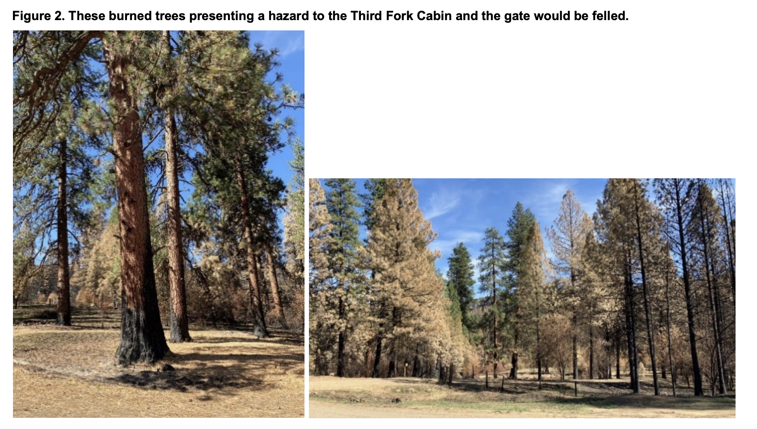
Fuels Treatments
The FS states: Activity and existing fuels in hazard tree mitigation and area salvage units would be disposed of through hand or machine piling, pile burning, jackpot burning, lopping and scattering, mastication, chipping, biochar processing, or biomass removal”.
It is crazy to claim to treat “fuels” in the midst of a big burn – and this is just a big waste of taxpayer dollars and diesel fuel, equivalent to “raking” the forest.
The FS plans: Machine piling and mastication (mechanical chipping/grinding/shredding of fuels) would occur in hazard tree mitigation units where slash is too large or dense for hand piling. These are typically areas where the material that is greater than 3 inches diameter, has fuel loadings greater than 4 tons per acre, and the majority of the material is on the ground. Mastication is a treatment that can be used to remove smaller diameter trees or rearrange the ground fuel/slash into a size that will decompose more rapidly.
What determines if there’s too much slash? This is madness. It just means more heavy equipment tearing us soils and slopes, compacting soils, clearing areas of protective woody cover, and loss of carbon and nutrients from the site. There is no reason to do this. How much will this, and all aspects of this project, cost? This appears to be a make-work project for contractors.
All of this new post-fire messing around with wood and vegetation will ultimately result in a hotter drier, weedier, harsher site than existed post-wildfire, and that is further stripped of woody cover critical to many forest animal species. These intensively grazed watersheds already suffer from a lack of protective cover, vulnerability to flammable weed infestation and dominance. The forest and shrublands suffer from a loss of nutrients, and significant loss of carbon storage ability. Yet the FS now wants to inflict even greater losses of nutrients, higher erosion, less shading and structural complexity that serves to slow down snowmelt runoff and helps retain moisture on the site as well as coloing the soils surface. All of these farming-type actions will strip-mine wood and structural complexity required for a host of small animal species and biodiversity. This will also result in lands being more severely exploited and trampled and grazed down by livestock. The FS should be leaving all possible wood on-site, rather than robbing the forest of nutrients, wildlife habitat, biodiversity, moisture retention capability, etc.
All of this logging, bulldozing, etc. will expand snowmobile disturbance of rare native carnivores, including Wolverine. The USFS has already created a significant disturbance problem by plowing routes for snowmobiles – and now there are motorized snowbikes and other devices further expanding winter disturbance. It of course will also further reduce and cause loss of prey species for Wolverine, Gray Wolf and other native carnivores. Please see Wolverine discussion in our Sagehen comments. It is likely to result in a range contraction.
The FS states: “To facilitate access to area salvage units, NFS roads currently classified as maintenance level 1 (ML1) would be reopened for project use then restored to their current state of storage upon project completion. In addition, approximately 2 miles of temporary road would be needed. Temporary roads would be decommissioned once harvest activities are complete and would not be added to the Forest Transportation System. No permanent roads will be constructed”.
Please provide detailed current on the ground inventory mapping of all routes in all categories.
The FS states: “This work includes repair and stabilization on drainage and structural trail features such as grade dips, water bars, retaining walls, and turnpikes. [What is a turnpike?]. Trail prisms would also be reestablished. This work would prevent trail tread and structure loss, soil erosion and runoff into streams, and prevent the cost of full reconstruction”.
The FS must consider and fully assess closure and removal of these trails and mechanized activity playgrounds - to provide for habitat security for big game and other wildlife in this newly burned landscape where it will take a century or longer to recover mature functioning forest habitats for migratory bird, sensitive species and a host of other wildlife.
Aren’t these nearly all motorized trails? Through what process Have all these been authorized? Are there also unauthorized trails leading off from the “authorized” ones? Where? Please provide mapping How have these trails been harming and displacing Elk, Mule Deer and other wildlife, intruding in sensitive species habitats including hawk and owl nesting habitats, as well as impacting riparian and wetland habitats and erodible soil areas? Were these purposefully constructed, or were they user created routes that the FS failed to close, and has now legitimized?
With the significant fire-caused loss of tree cover, the noise and visual and human harassment a poaching footprint of these trails will be seriously expanded – displacing and threatening big game, Wolverine, and many other species. How much has the firs expanded this for all trails and trail segments? How much worse will the FS salvage and hazard and other tree clearing make this? We request that you provide detailed analysis of the habitats impacted. (MIS, sensitive species, and fragile watershed or rare plant and other areas, and close trails with significant conflicts with other values of the Forest permanently – rather than rebuilding them. How significant are the habitat losses for all USFS sensitive, MIS and important species due to this and other recent fires? This fire and the Sagehen project logging and burning?
What is the current width and surface conditions of all of these? Will the FS keep any repairs to within that current footprint?
The FS says it will keep any repaired roads in the current footprint. WHAT is the footprint for each route to be repaired – please detail this for all segments.
We oppose winter intrusion and snowplowing for logging and other activity – as it will lead to an expanded human disturbance footprint, expanded hunting and poaching including of native predators – during a period of the year when wildlife need habitat security.
What does the FS Travel plan say about off-road snowmobile and other activity? Will this expand this use – including foreseeably to areas critical for wintering wildlife, make the grossly unethical pursuit of native predators by gunning and trapping even easier. There is Wolverine habitat in portions of the project area and surroundings. How much Wolverine habitat has burned in the Boise Forest in the past 25 years? How much in the Payette Forest - and area that has also suffered many recent fires, and is facing a battery of logging projects and burning projects – like Granite Goose and a cookie cutter burn EA similar to the Boise Forest SWIRL EA. Please provide detailed mapping ana analysis of the current condition of Wolverine habitat in this region, and the foreseeable further losses from a host of USFS “restoration” treatments.
We incorporate all concerns raised about Wolverine and other imperiled and sensitive species habitats in our Sagehen EA comment submissions, as well as the host of foreseeable and cumulative harms and threats to sustainability of Wolverine, migratory bird species populations, and other native species across the region.
The route depictions and other info on the scoping notice Map 2 are unclear., Please provide much better mapping.
We strongly oppose any tree cutting and route repair in the IRA, where the fire, a natural process, has affected the intrusive mechanized route network.
Please provide detailed current ecological analysis of conditions across the IRA. We are alarmed that the USFS apparently plans to burn up the remainder of the Boise Forest area Snowbank IRA under the Sagehen project. We request that the FS scrap any further burning and purposeful live forest cover loss in the still-forested areas of the IRA and Sagehen landscape.

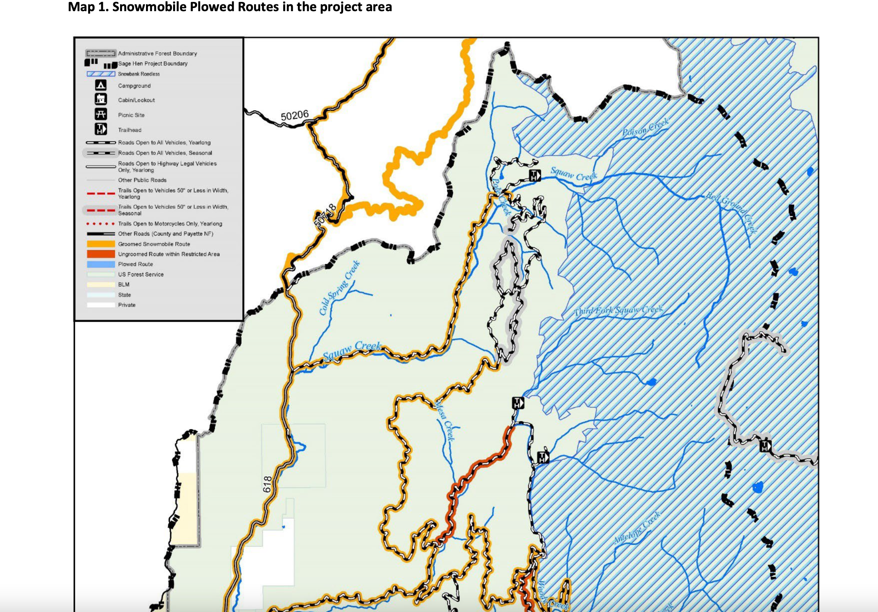
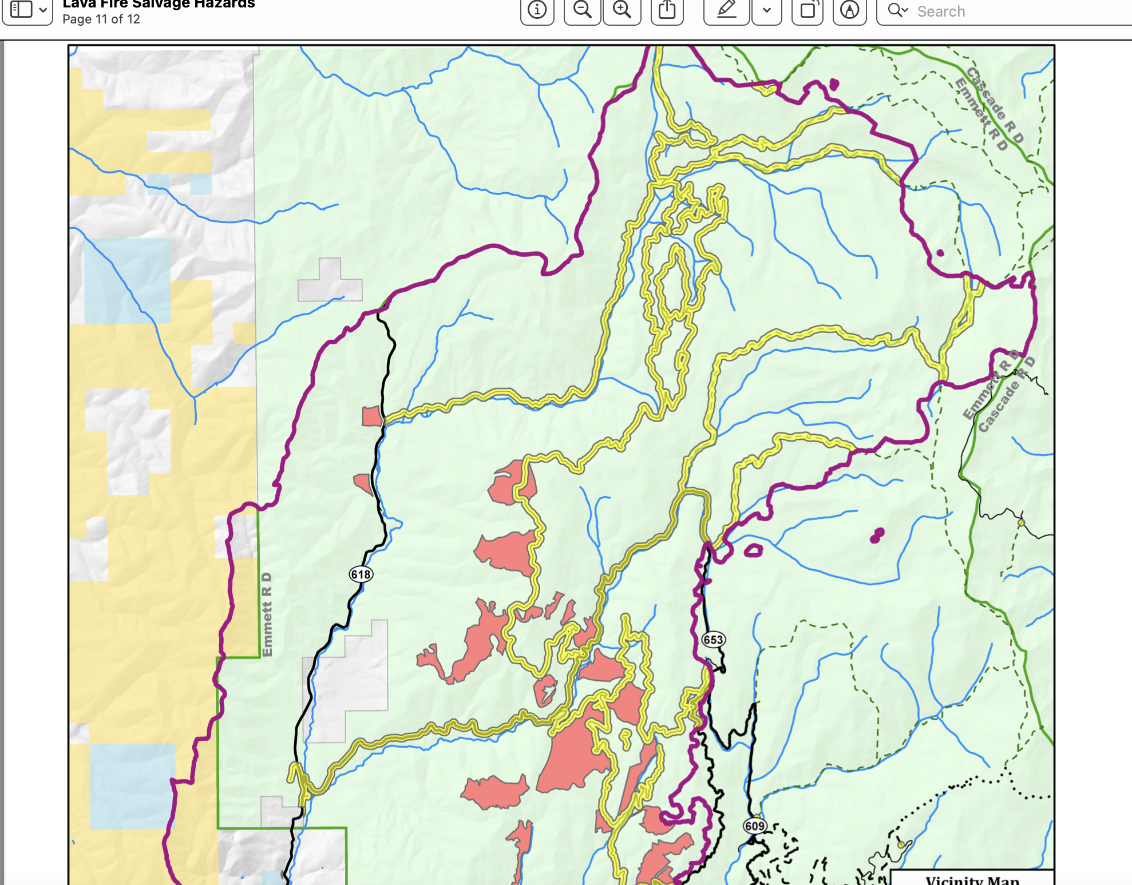
Look at all the yellow logging areas in and/or along the border of the IRA. Please provide higher detail mapping showing where routes border the IRA and if tree removal will occur there. How much damage will motorized logging activity in the IRA cause, and how will it be done?
Where are all currently de-commissioned routes? Have they been being used by motorized activity despite being theoretically closed? How has the FS monitored this
We strongly oppose plowing roads for this project. The FS states: Roads in the project area, including temporary roads, may be snowplowed to allow access for logging or reforestation activities.
The FS plans “commercial salvage” to strip mine wood from the forest – in the face of climate change stress that this already makes lands less able to recover from disturbances and more vulnerable to weeds and other ecological problem. Please provide inventory and analysis of the stand conditions and age of trees in and surrounding all areas targeted for commercial salvage. How does the tree size and age in these salvage areas compare to those in non-salvage sites? What is the number and age class of green unburned trees in these areas?
We oppose the FS not allowing for an Objection period and the “emergency” designation for this project – especially given the lack of sound justification for the salvage logging, the 200 ft on each sides of roads, and using the fire as an excuse to spend federal funds further depleting and degrading this landscape by manicuring the forest through removing “fuels”.
Note that the FS at this sane time has also scoped Snag Nellie post-fire tree salvage removal and wildlife habitat disturbance further eating into remnant less disturbed habitats and wild lands on the Boise Forest.
Again, please see Attached Sagehen comments and Objection, as well as pre-scoping comments we submitted, and fully assess all foreseeable additional logging and road building and other damage from the Sagehen project - and how much sensitive and important species and migratory bird habitat this includes. We are alarmed at all the migratory bird nesting habitat loss that has taken pace already across the Forest how much more damage will be done by salvage and other logging with this project- including impacts and further losses to pockets of remaining green trees, and mixed areas of green and dead trees. How will this, and all the other foreseeable projects across the Forest, further eat into ever more scarce nesting habitat for species like Hermit Thrush, Western Tanager, and many other migratory birds?
Sincerely,

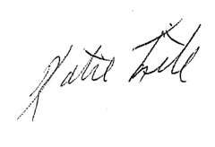
Katie Fite
Public Lands Director
WildLands Defense
PO Box 125
Boise, ID 83701
208-871-5738
katie@wildlandsdefense.org

/mg
Mike Garrity
Alliance for the Wild Rockies
PO Box 505
Helena, MT 59624
406-579-5986
wildrockies@gmail.com

/se
Sara Johnson
Native Ecosystems Council
PO Box 125
Willow Creek, MT 59760
406-579-3286
sjjohnsonkoa@gmail.com

