February 19, 2024

RE: Sagehen Integrated Vegetation Restoration Project

Dear Boise Forest Service Emmett Ranger District,

Here are comments of WildLands Defense, Alliance for the Wild Rockies, Native Ecosystems Council and Yellowstone to Uintas Connection on the “Sagehen Integrated Vegetation Restoration Project” Draft EA/FONSI and maps on the Emmett Ranger District of the Boise National Forest. We are alarmed at the scale and foreseeable adverse direct, indirect and cumulative impacts of this project on National Forest lands, and harms to waters, watersheds, biodiversity including sensitive and rare species habitats and populations and roadless area and wild lands values. All comments and alternative submissions we previously submitted on the first iteration of the massive Sagehen landscape disturbance project are incorporated by reference into these 2024 current comments.

The 2024 project continues with full bore massive manipulation of the Sagehen landscape. It has only small differences from the highly uncertain and risky “condition-based management” of the previous project, continues with a lack of integrated site-specific project area analysis, continues with almost identical alternatives, ignores the information on extensive cattle degradation and harmful ongoing grazing disturbance on ecological “resistance and resilience”, and the ability of lands to recover from this major uncertain logging, thinning, burning, roading project. We are veery concerned that the FS has never officially scoped this new EA with virtually identical “alternatives” attempting to ramming the same old massive devastation projects through.

The Sagehen EA includes the same massive agency treatment-caused loss and destruction of migratory bird, rare native carnivore (Wolverine, Gray Wolf, Fisher, Canada Lynx) , big game and other wildlife habitats and recovery potential. This project will further de-stabilize and reduce the viability of populations of wildlife and aquatic biota in this region of Idaho.

See: https://www.fs.usda.gov/project/boise/?project=56701

EA: https://usfs-public.app.box.com/v/PinyonPublic/file/1419513258354 .

The massive proposed assault on Boise NF lands in the McCall region with the Sagehen project includes two similar extremely unreasonable alternatives that will radically disrupt natural plant succession and ecological processes, and cause rampant weed spread and rare species habitat loss, as shown in 2024 EA Table 2:
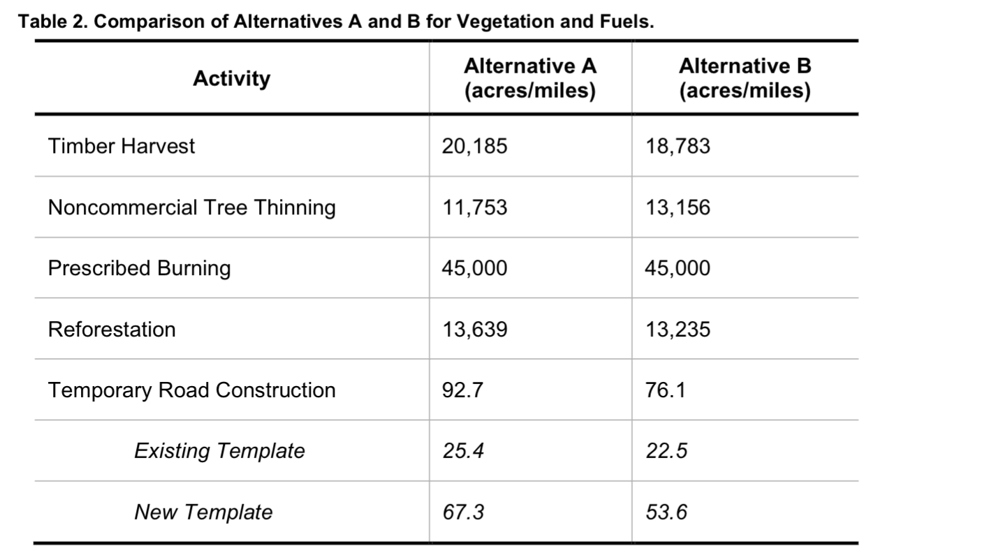

The Boise National Forest (BNF) Sagehen project is at the far northwestern edge of the Boise Forest, and Payette lands lie to the north and west. The revised Sagehen project represents one of many recent major treatment assaults on USFS lands, watersheds, biota and roadless areas - on top of all the existing USFS projects and wildfire impacts on forest habitats and processes in this landscape. It's as if the Region 4 Forest Service wants to get rid of nearly all mature forests and trees (see cumulative effects discussion throughout these comments). The FS appears to seek an artificial ideal in a tattered highly fragmented landscape of minimal tree or other woody vegetation cover. This will have devastating results for biodiversity and the persistence of sensitive and imperiled species.

The “new” 2024 Sagehen project continues its predecessor Sagehen project’s loose, uncertain, risky, lazy and NEPA-thwarting “condition-based management” (CBM) lacking adequate site-specific project area baseline sensitive and rare species inventories, roadless area integrity analyses, watershed and perennial flow function, and other baseline information necessary to take an integrated hard look at the project’s harms under a valid NEPA analysis. Once again, the new project is the result of a logging industry dominated “collaborative group” given undue weight and privileges in the NEPA process and alternative formulation by the USFS. Sagehen, like the major Granite Goose project to the north in the Payette Forest undergoing NEPA right now, will result in a hotter, drier, windier weedier and more fire prone forest environment that is less able to withstand climate stress – and more likely to burn in wildfires.

One thing that is certain is that the project in its current form will greatly alter, fragment and destroy most of the remaining mature forest in this landscape. It is also climate madness, and will also result in a significant loss of carbon sequestration and cause significant release of climate change gases like CO2 into the atmosphere with all manner of burning radically simplifying and depleting forest watersheds and habitats.

How much carbon is currently being sequestered in the forest sites the Sagehen project or the Payette Granite Goose project currently seek to radically “treat”, alter, fragment and/or destroy in both like live and dead trees and dead wood on the ground? How much CO2will be sequestered if the proposed action massive treatments are carried out? How much carbon and other greenhouse gases will be released by the project?

How much carbon sequestration ability will be lost across Region 4 forests if all the projects currently proposed and/or approved (including massive Fire EAs that often include much mechanical “treatment” under similar highly uncertain CBM schemes, and also lost in the scores of “restoration treatment” or logging projects”? How much carbon sequestration is currently occurring in these same Region 4 Forest areas?

See Humboldt-Toiyabe, Sawtooth, Salmon-Challis, Caribou-Targhee, Manti-LaSal, Dixie and other Region 4 CBM Prescribed Fire EAs, with many of these schemes described here.

The Boise Forest sweeping CBM Fire and manipulation EA is https://www.fs.usda.gov/project/?project=61880 . It is termed “SWIRL” - Southwest Idaho Resilient Landscape EA. https://usfs-public.app.box.com/v/PinyonPublic/file/1292373992921. It proposes to burn 77,000 acres per year of the BNF over the next 15-20 years.

The Payette Forest sweeping CBM Fire and manipulation EA is termed: Payette Forest Resilience and Fuels Reduction Prescribed Fire Project – with 3o,000 acres per year of burning and thinning.
https://www.fs.usda.gov/project/?project=63166

All of these projects (and Sagehen) are directly at odds with a FS effort claimed to be underway to effort to protect old growth:

https://www.fs.usda.gov/project/?project=65356.

As we describe in these comments, the massive CBM projects like Sagehen will destroy, kill and injure old growth (including through fostering insects and disease) as collateral damage – even if the FS claims old growth won’t be targeted.

These FS forest massive manipulation EAs have massive adverse implications for the sustainability of a host of native wildlife species – including migratory and resident birds, rare native carnivores, and many others.

Region 4 FS is planning to similarly burn over 6 or 7 million or more acres, including vast portions of Roadless Areas crucial for biodiversity protection across the regions’ forests. See following CBM NEPA documents for the Humboldt-Toiyabe, Sawtooth, Caribou-Targhee, Humboldt-Toiyabe, Fishlake and Dixie Forests Fire EAs. There are now similar pending CBM documents for the Payette and Boise Forest too. These massive risky “prescribed fire” projects are in addition to all the other “treatments” and logging that have taken place, are authorized, or foreseeable. The full range of indirect, cumulative and synergistic and additive adverse effects to migratory birds, native carnivores and all sensitive species and wild lands values and sustainability, and carbon sequestration and all other species of concern and impacted National Forest values impacted by these Region 4 infernos must be fully examined in assessing cumulative effects.
There is a looming intentional federal agency-causes epic scale of biodiversity and habitat loss and destruction from all the proposed treatments, and the permanent desertification and aridification and irreversible weeds these radical landscape-level manipulations schemes will cause. We Object to the failure to provide detailed site-specific and habitat -specific information on how long “recovery” to support species dependent on late seral stages of each habitat type will take under ideal plant successional processes.
Federal agency prescribed fire and treatment zealots across the Intermountain region will create conditions for massive migratory bird die-offs during continued drought and harsh weather conditions during migration. For localized resident species. Forest-inhabiting native carnivores and aquatic species struggling in the region’s tiny streams will face grave imperilment as watersheds are converted to hotter, drier, winder, weedier bleak burn-scapes - that also continue to be grazed by over-stocked cattle and sheep which cause cheatgrass expansion. Post-treatment, livestock would have even more ready access to areas previously less protected by woody vegetation. This Sagehen NEPA analysis failure to take a hard, science-based look at the at the adverse ecological impacts of this massive disturbance – including as it effects migratory and wide-ranging species population viability.
There is no baseline information provided on climate change effects, such as summer temperatures, in impacting fire control efforts. We Object to these EA analysis deficiencies.
See also:
“Forests are our only means for removing atmospheric carbon dioxide and storing the carbon long term at the needed scale. Burning wood in place of coal is accelerating global warming and decreasing the capacity of forests to counter the buildup of heat trapping carbon dioxide,” said Dr. William Moomaw of Tufts University. Dr. Chad Hanson, a forest ecologist with the John Muir Project, observed, “The dangerous excess CO2 that we’ve put into the atmosphere with fossil fuel consumption and logging will stay there for far too long if we don’t take serious steps to bring it down, and forest protection is our best and most effective way to do that.” Dr. Dominick DellaSala, Chief Scientist with the Geos Institute, added, “The vast majority of scientists warn that in order to avoid catastrophic climate impacts in the decades ahead, including new pandemics potentially linked to deforestation, we need to keep dinosaur-carbon in the ground and store atmospheric carbon in forests.”
https://forestlegacies.org/featured-projects/scientist-network/
How much carbon will be released into the atmosphere from this project? How much carbon sequestration ability will be lost for decades or centuries from this project? What is the current baseline of carbon sequestration taking place across the Forest in maturing, mature and old growth vegetation communities? We Object to the lack of baseline data and analysis.
Research shows forests are not regrowing following significant disturbance:
“New studies show drought and heat waves will cause massive die-offs, killing most trees alive today.” (Source: We Need to Hear These Poor Trees Scream: Unchecked Global Warming Means Big Trouble for Forests, Inside Climate News, April 25, 2020)
According to Bill Anderegg, a forest researcher at the University of Utah: “Global warming has pushed many of the world’s forests to a knife edge… in the West, you can’t drive on a mountain highway without seeing how global warming affects forests,”.

https://www.counterpunch.org/2021/12/03/burned-out-forests-are-not-re-growing/

So what does the MLNF propose to do? Create huge areas of new heavily disturbed and deforested/cleared hotter, drier, windier weedier sites that will fast-forward this process, destroy trees and shrubs that are sequestering carbon, release large amounts of carbon into the atmosphere through prescribed burns and mechanized activity and expand potential for motorized use in roadless areas. How prevalent are early successional areas? Where have fires burned since the underlying project info was collected and scoped?

Research and on the ground and on-line observations of how several recent mega-fires in CA, OR and elsewhere have burned are revealing this is the case. Large climate-driven wildfires have not been stopped by past agency treatments and grazing - which in fact have been singularly ineffective in stopping such fires, as the recent mega-blazes in CA and OR have shown.

See, also video with Dr. Chad Hanson describing Paradise Fire situation and GF claim that logging and tree thinning would protect them from fire, and that it was a “fuelbreak” Start at Video Minute 35. Yet the Paradise Fire that killed 85 people whipped right through the fuelbreaks which had given the Paradise residents a false sense of security. Minute 40. Beyond 100 ft. of structure, “treatments” make no difference. Defensible space is what matters. Minute 42. Emerging scientific evidence that thinned areas burn more intensely and fires move faster. Minute 47. Bond describes need for woody debris on the forest floor. It holds some water helping reduce fires and fire effects, is an important part of forest health, and downed logs are important wildlife habitat. Yet the Fire EA seeks to burn this up and destroy it – including with scorched earth pile burning manicuring the forest. Minute 49. Chad Hanson describes the importance of downed wood and wildlife habitat, and increased erosion in thinned areas. Winds whip through thinned areas and drive flames more rapidly there because there are fewer trees to act as windbreak. Denser stands of forests act as a wind break against winds that drive the fire. There is a cooler, moister, micro-microclimate because of higher canopy cover in non-thinned forests – emphasizes the value of intact forest canopy.
Listen to: https://wildearthguardians.org/brave-new-wild/news/wildearth-webinar-fire-and-forest-ecology-in-the-american-west/
Yet the whole current series of Region 4 Fire EAs are obsessed with manicuring the land surface and purging the Forest of downed woody debris, a further serious loss for biodiversity and micro-habitats associated with a large array of native species (pollinators, small mammals) and protecting soils from erosion - through pile burning and what is basically incineration by the severe heating that results from theburning methods the FS seeks to use in Sagehen. Thisis described in Fite “Bad Fire”
https://www.counterpunch.org/2022/03/11/bad-fire/
The Forest Service Intermountain Region 4 just released a barrage of cookie cutter NEPA documents aiming for a tremendous increase in Forest-wide prescribed burning across the Salmon-Challis, Sawtooth, Caribou-Targhee, Humboldt-Toiyabe, Manti-La Sal, Fishlake, Dixie and Ashley Forests.
The projects span millions of acres of rugged, dramatically beautiful arid forests and shrublands. It turns out these fire projects may be used as justification for pre-burn and post-burn logging under separate piecemeal NEPA decisions. Roadless Areas are primary targets. The Forest Service claims vast swaths of Roadless Areas are greatly “departed” from their modeled ideal, have “missed fires”, haven’t burned nearly enough, or trees are dense so there’s too much fuel. Being branded “departed” is the kiss of death. Claimed Roadless Area “departure” highlights the use of spurious USFS-BLM-Nature Conservancy LANDFIRE black box models with their purported pre-settlement fire intervals and broad brush fuel estimates. Roadless Areas are some of the least likely places for fire suppression to have occurred or been effective. Such models are being universally applied by agencies in support of the official narrative that fire suppression causes big western wildfires.
The Fire Environmental Assessments (EAs) march in lockstep in their mission to drastically alter mature and old growth woody communities across the Region, from Whitebark Pine to Ponderosa Pine to Greasewood. The Caribou-Targhee EA states that 84% of “departed” lands are late seral habitats, which are required by so many rare animal species across the Intermountain West. These communities are crucial for sequestering carbon, which will indeed depart into the atmosphere if the EAs stand.
Roadless Areas across the Salmon-Challis, Sawtooth and Caribou-Targhee Forests have long been proposed for wilderness designation in the Northern Rockies Ecosystem Protection Act (NREPA). The same questions must be asked about prescribed fire as any other agency project. What species habitats and wild areas will be harmed? Who profits? How bad will it turn out? We Object to the failure to take a hard look at the immense indirect and cumulative adverse habitat and population viability effects of all these projects on species ranging from Pinyon Jay to Brewer’s Sparrow to Sage-grouse.
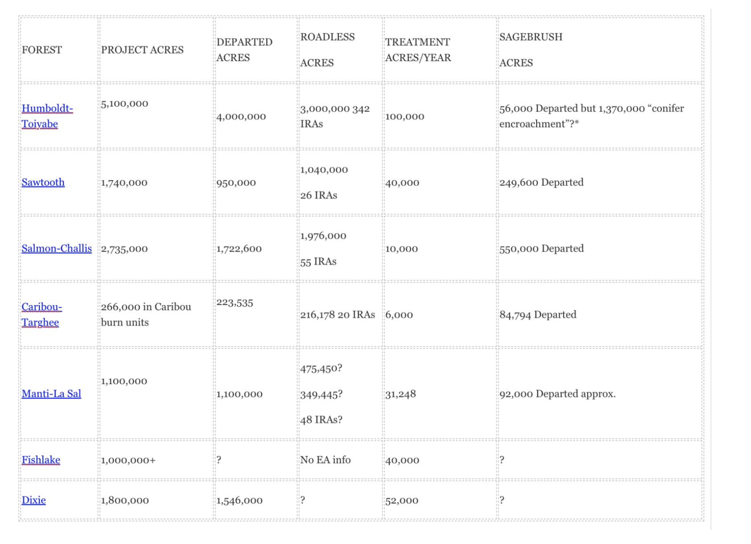
See also: https://grist.org/fix/forest-thinning-logging-makes-wildfires-worse/

Logging in disguise: How forest thinning is making wildfires worse

Additionally, how many older Forest Service CX/EA/EIS decisions that already approved projects not yet all completed does the Boise and Payette Forest have on their books? How many across Region 4? What rare and sensitive species habitats will these projects impact? How many acres do these projects entail? How many are there “on the books” across Region 4, and how many acres of each sensitive and rare species habitat type will be harmed as more acres are eaten up until completion? Where are these projects located, and if completed, how much carbon will be released into the atmosphere, how much carbon sequestration ability will be lost, and how much sensitive species habitat altered, fragmented and/or destroyed? We are dismayed that the Sagehen project even refers back to a circa 2007 project where a part (something to do with a road?) wasn’t completed – and folds this into this 2024 project.

How massive will the project’s habitat loss and fragmentation blow be to sensitive species (often many of the same species in different forests, rare native carnivores including Wolverine, Lynx, Gray Wolf, Fisher), including in the context of the cumulative e effects of similar massive manipulation schemes across BNF and PNF? Across the Region 4 Forests?

There has been extensive past logging, grazing and human disturbance in many portions of the Sagehen project area and surrounding landscape, causing substantial degradation of soils, waters, watersheds, sensitive and MIS and ESA species habitats and populations, forest health, natural forested vegetation composition and structure and harm to public recreational uses and enjoyment. Instead of allowing lands to continue to heal from these past and ongoing disturbances, by employing substantial passive restoration (and dealing with. The highly abusive grazing that is taking place – see Attached Photo Exhibits), and using careful active restoration to enhance watershed healing, the Boise Forest proposes to tear this landscape apart with expensive, very risky “treatment” disturbance of all types – including overlapping disturbances in the same land area/watershed/habitat.

The Boise Forest has repeatedly pushed forward major new Wolverine, Canada Lynx, Flammulated Owl, Great Gray Owl, Boreal Owl, Northern Goshawk, Fisher, Gray Wolf and other rare and endangered species habitat disturbance, destruction and fragmentation projects in this area that is very important to the public, and that is heavily used for a host of recreational purposes. For example, see the current More’s Creek project, yet another “product” of the same collaborative logging group.

The neighboring Payette Forest’s Granite Goose Project just admitted in an EA that the Forest Plan includes: “There is a need to maintain and promote dry, lower elevation, large and medium tree size class for the associated wildlife species (Forest Plan: WIOB07). This indicates a dearth of unlogged intact forests of this type across the landscape”. That project appears to have gotten even more destructive to wild land values and habitats on USFS lands after 2023 scoping (see 1.5.2), and this Sagehen project continues its previous massive uncertain habitat harms -including logging, thinning, burning, bulldozing roads into, and injuring trees across to dry, lower elevation large and medium size class trees and forest areas – further shrinking and reducing these vital sites, while strip mining vital dead trees and burning up that provides moisture wood retention and nutrients -and destroying habitat for a host of species, massive burning in the beautiful forests of the Snowbank roadless area -reducing this habitat critical for Wolverine survival here to ashes, dust and bulldozed firebreaks.

Please provide detailed analysis and mapping of past logging, thinning, manipulation “prescribed” fire and other agency intrusions for as long a time period as data is available.

The 2024 project would take place in a landscape where ecological conditions have deteriorated, and where radical and often overlapping aggressive logging/thinning/burning and other “treatments” only worsen fire risk and serve to expand insect “problems” by damaging and weakening remaining untreated vegetation and resulting in hotter, drier, windier and weedier conditions. The Forest plans here are old and out of step with current science and sensitive species needs. The USFS across region 4, in Idaho, in the Boise/Payette/Salmon-Challis forests has authorized many more deforestation and burning projects. There have also been many more wildfires in the western US – and in fire after fire it is revealed that fires flash right through logged thinned, treated and other areas AND that the “dense” vegetation that the USFS so seeks to destroy is actually more resistant to fire than the bleak hot, dry, windy, eroding stump-scapes that USFS treatments such as those here produce.

This 2024 Sagehen EA adds on to the many and often overlapping stresses described in the nearly identical earlier project. Now the 2024 EA with no scoping to such an already disturbed setting poses serious risk of irreparable harm and species losses. It is also likely to reduce the ability of natural processes to buffer climate change stress on Forest lands. This makes the USFS assault on the roadless areas even more relatively harmful. How many of the projects authorized or proposed by the Payette and Boise forests since the Forest plan have involved logging. thinning, burning or other “treatments” in roadless areas? How much more is foreseeable? In which roadless areas? Please provide detailed mapping and analysis.

Serious Sagehen and Significant Weed, Grazing and other Ecological Problems Long Known and Not Effectively Controlled

The Boise Forest Chapter III-2003-2010 integration document for Sagehen Hen Reservoir Management Area 16, reveals a host of rampant weed infestations, riparian habitat degradation, intensive motorized recreation where old logging roads are turned into motorized trails, and a flurry of winter disturbance from cross-country snowmobile and trail use that will worsen intrusions once the project burns up and logs the landscape. The Sagehen area’s fragile watersheds and sensitive species habitats.
https://www.fs.usda.gov/Internet/FSE_DOCUMENTS/stelprdb5394158.pdf

The Forest plan derived “Sagehen Unit” in Chapter III shows management here is to be for “restoration and maintenance”. How can a host of sensitive species, migratory birds and biodiversity values dependent on maturing, mature and later seral forests be adequately “maintained” if their habitat is already long known to have significant problems – and is now in 2024 targeted to be radically altered, simplified, fragmented and destroyed? How can there be “sustained yield” when many areas have already been highly degraded by past manipulation, logging and roading, and now the Forest seeks to radically burn and log and thin nearly the entire area? This is coupled with bulldozing in a plethora of “temporary” routes that are likely to become “trails” once “rehabbed” and that serve as sites for expanded and intensified human disturbance of wildlife across the landscape and weed, weeds, weeds? It is also coupled with massive burning that will carbon into the atmosphere, significant nutrient loss and create ideal sites for the further irreversible infestations of weeds in project-disturbed sites made worse by the extremely poor grazing management in this livestock-battered landscape.

How long does it take to recover mature and old growth trees of each vegetation type in this landscape, and thus critical habitat elements for nearly all sensitive and threatened species?

How much particulate matter and dust will be generated by all the Sagehen prescribed fire, logging and thinning activity?

How much MORE susceptible to wildfires will this project make Sagehen lands?

Plan Part III continues: "The dominant slope range is 35 to 65 percent in the fluvial lands, 30 to 50 percent in the structurally controlled basalt lands, and 15 to 40 percent in the frost-churned uplands. The surface geology is primarily Idaho batholith granitic soils [aren’t these soils highly erodible and low in nutrients?] in the east, and volcanic basalts in the west. Soils generally have moderate to high surface erosion potential, and moderate to high productivity. Subwatershed vulnerability ratings in this area are all low (see table below). Geomorphic Integrity ratings for the subwatersheds vary from moderate (functioning at risk) to low (not functioning appropriately), with the majority being low (see table below). In some locations, roads, timber harvest, livestock grazing, and recreation uses have resulted in accelerated erosion, stream channel modification, and streambank degradation”.
Some areas have impacts from roads, timber harvest, livestock grazing, and recreation that have increased sedimentation and nutrient levels. [And many more will have adverse impacts following this project].
Plan Part III also states "A good network of trails provides access to the roadless portion of the area". We are greatly concerned that the FS in2024 fails to map all of these “trails” and fails to describe and assess their human. Disturbance footprint.

Regarding Bull Trout, the FS states:
“Some areas have impacts from roads, timber harvest, livestock grazing, and recreation that have increased sedimentation and nutrient levels”.
“Bull trout occur within streams of the Squaw-Pole, Dodson, and Third Fork subwatersheds, with strong populations occurring in the latter subwatershed. Redband trout are presently found in streams within the Kennedy and Dodson subwatersheds. Sage Hen Reservoir is a popular fishery with both native and introduced fish species. Aquatic habitat is functioning at risk in some locations due to accelerated sediment from timber management, livestock grazing, and recreation use. Native fish populations are at risk due to the presence of
Native fish populations are at risk due to the presence of non-native fish species and habitat impacts noted above. The Third Fork and Squaw-Pole subwatersheds have been identified as important to the recovery of listed fish species, and as high-priority areas for active restoration.
[The aquatic species report presents a bleak picture of the current status of Bull Trout - yet the 2024 project will radically disturb cooling soil stabilizing and protective forest cover- including even mounting treatment forest cover removal assaults (thinning and burning) on RHCAs to an unknown and unassessed degree at unknown and unassessed locations,.
Also: An estimated 19 percent of the management area is comprised of rock, water, or shrubland and grassland vegetation groups, including Mountain Big Sage, Montane Shrub, Perennial Grass Slopes, and Perennial Grass Montane. The main forested vegetation groups in the area are Warm Dry Douglas-fir/Moist Ponderosa Pine (33 percent), Dry Grand Fir (7 percent), Cool Moist Grand Fir (26 percent), and Warm Dry Subalpine Fir 9 percent)
The Chapter III document admits that the impossible-to-effectively-control noxious weed with rush skeleton weed is increasing.
The Warm Dry Douglas-fir/Moist Ponderosa Pine, Dry Grand Fir, and Cool Moist Grand Fir groups are not functioning properly in some areas due primarily to timber management and fire exclusion [this is based on flawed claims of short fire return intervals] that have altered stand composition and structure. In managed areas, stands are dominantly young and mid-aged, with relatively few large trees, snags, and large woody debris. [As the attached photos show, the existing recent logging and treatment at Sagehen is resulting in loss of large trees, and exposing them to injury, windthrow and hot sun-scalded desiccation]. In unmanaged areas, stands have more late seral grand fir and less early seral ponderosa pine and western larch than is desirable, and moderate to high levels of insect and disease infestations … and weeds are increasing. [As the photos show, there is a weed nightmare at Sagehen, the FS is resorting to use of extremely tock chemical herbicides like Tordon while cows roam all over the place transporting weeds all over the place).
Also: “Riparian vegetation is functioning at risk due to localized impacts from timber harvest, roads, recreation, and livestock grazing. Noxious weeds and introduced plant species are increasing”.
The FS states: Non-native Plants - Dalmatian toadflax, rush skeletonweed, and diffuse knapweed occur in the area, particularly along the main road corridors. An estimated 51 percent of the management area is highly susceptible to invasion by noxious weeds and exotic plant species. The main weed of concern is Dalmatian toadflax, which occurs in scattered populations throughout the area. [What about the cheatgrass that is now moving into disturbed cow-beat sites and roadside areas especially in the basaltic soils???].
Subwatersheds in the table below have an inherently high risk of weed establishment and spread from activities identified with a “yes” in the various activity columns. This risk is due to the amount of drainage area that is highly susceptible to noxious weed invasion and the relatively high level of exposure from those identified vectors or carriers of weed seed.
[See attached photos showing “Vectors” and heavy impacts from cows, high use from all manner of motor and mechanized vehicles, and these will expand with the severe project disturbance lasting for 15+ years across this landscape – along with weed transport all across the landscape related to logging/treatment and the agency’s own vehicles - like FS 4 wheelers with drip torches used in lighting “prescribed” fires.

This Table below does not accurately reflect areas of heavy livestock use that we observed on site visits – including cows loafing on the receding water muck flats of Sagehen Reservoir and stream sites. Sagehen Reservoir area and its muck flats (the Reservoir appears to be filling with sediment) and camp sites were churned into dust bowls by loafing cows roaming all around near water and open areas. See attached photo Exhibits. Was this cow use authorized? Was it trespass use? If trespass, what FS action was taken?

What is the status of the Bald Eagle nest at Sagehen mentioned in Plan Chapter III? What is the status of the Wolves mentioned in the report? Are Wolves still present or has hunting wiped them out? Where has livestock grazing (turnout, areas grazed, grazing periods?) been altered to reduce conflicts?
The FS admits: “High road densities affect use of habitat by wildlife species negatively influenced by road-associated factors such as disturbance, spread of noxious weeds, vulnerability to poaching, and loss of snags. Terrestrial wildlife habitat is functioning at risk in some areas due to habitat changes from timber harvest and fire exclusion, fragmentation from roads and harvest, and disturbance from recreation uses. The Little Squaw (5th code HUC 1705012214) and Lower North Fork Payette (5th code HUC 1705012301) watersheds have been identified as important to the recovery of Forest sensitive species and other native wildlife utilizing late-seral forests with low canopy conditions and are identified as short-term high-priority areas for restoration”.
The FS also states: "The Snowbank IRA features undeveloped recreation with non- motorized trail opportunities and high visual sensitivity. Dispersed recreation in the rest of the area includes hunting, fishing, ATV use, snowmobiling, horseback riding, and hiking. Both trail and cross-country snowmobiling is very popular in the West Mountains area". [The FS fails to conduct adequate visual quality analysis, including through use of Key Observation points, on the baseline and on the outcome of project effects from the combined battery of treatment disturbance actions].
The FS refers to: “Rangeland Resources - This area has portions of nine cattle allotments and features a large number of range structural improvements. Management Area 16 provides an estimated 30,100 acres of capable rangeland. These acres represent about 8 percent of the capable rangeland on the Forest”. [What is the stocking rate per acre, and how was this calculated? What is actual use? What are the allotments? What happened to the grazing analysis that had been slated to take place?].
The FS must take an honest very hard look at how the Sagehen project seriously expands and often is maximizing recreational disturbance in the IRA and other areas - significantly harming and displacing Wolverine and other sensitive species - and how much worse the Sagehen project will make the human disturbance conflicts with biodiversity and native vegetation communities being infested with weeds associated with recreational use? Many of the goals sacrifice biodiversity and wildlife to recreation activities, and effective mitigation and minimization actions are lacking.
The FS planned to: "Continue cooperation with counties on grooming trails to maintain over-snow recreation opportunities”. Where is the Sagehen EA hard look analysis of this very significant disturbance? Groomed trails provide a conduit for recreation expanding outward across “treated” cleared and burned lands. How much has Sagehen recreational use increased since the Forest Plan was finalized?
The FS ius supposed to: “Maintain Snowbank Inventoried Roadless Area (IRA) as non-motorized use during the snow-free recreation season. Develop parking areas for access to Snowbank IRA”. The full deleterious footprint of heavy human disturbance and current incursion is simply not adequately assessed in the EA, nor is the dramatic change in access ease from the large-scale proposed burning activity.
We strongly object to treatments in roadless areas. The “treatments” will make the roadless areas hotter, drier, windier, weedier, with a longer fire season – and thus they will increase fire risk and the human recreational disturbance footprint. The landscape will be filled with ugly often charred stumps. They will result in biodiversity loss - as this project greatly destroys habitat for forest-dependent species in this landscape.
Given the many long-recognized weed and other problems here, as also shown by our site visits and observations of very significant cattle degradation, it is clear the weed situation is already put of control, and grazing is very serious and significant problem that the FS has failed to effectively control for many years.
Carbon Sequestration
A paper by Mildrexler et al. shows the tremendous value of older trees for carbon sequestration. See: https://www.frontiersin.org/articles/10.3389/ffgc.2020.594274/full

“Large Trees Dominate Carbon Storage in Forests East of the Cascade Crest in the United States Pacific Northwest”. “Large trees accounted for 2.0 to 3.7% of all stems (DBH ≥ 1” or 2.54 cm) among five tree species; but held 33 to 46% of the total AGC stored by each species. Pooled across the five dominant species, large trees accounted for 3% of the 636,520 trees occurring on the inventory plots but stored 42% of the total AGC”.

The Sagehen project’s massive amounts of logging, thinning and prescribed fire including aerial helicopter napalm ignitions, pile burning, few to no apparent limitations on season of fire use, and other disturbances associated with the project will injure and destroy mature or maturing, mature and old/”legacy” trees and forest stands across this landscape.

Mature trees will be injured or killed as collateral damage as the incessant logging, thinning and burning disturbance takes place, even if they are not specifically targeted in the project area. Insects attracted to wounded tree sap will infest “leave” trees and stands.

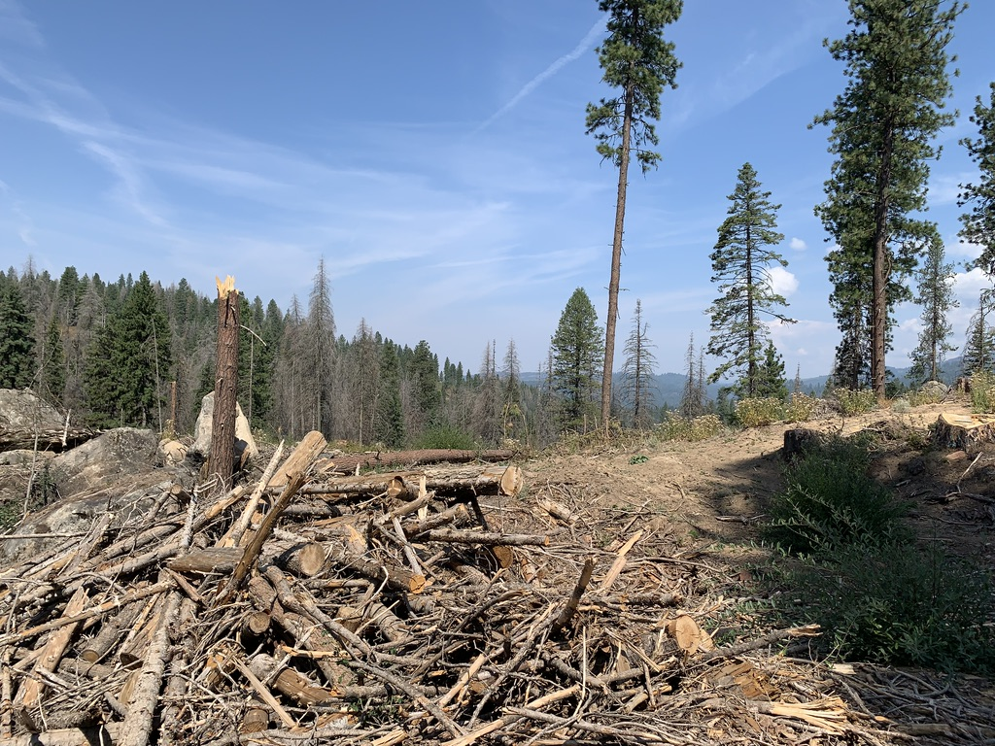

Note tree with most of its trunk obliterated. Note vulnerability of remnant standing trees where the forest has been radically thinned. How much WINDIER, HOTTER, DRIER and WEEDIER has this site become due to existing Sagehen “treatment”?

At the microclimate stand scale logging/thinning/burning, will result in changed wind patterns, more intense winds and site desiccation due to loss of forest will foreseeably injure and weaken “leave” trees.

Sites drying out quicker will increase “wildfire” season. As is now being revealed in fire after fire across the West – the more thinned, “treated”, logged out, manipulated the forest is, the more rapid fire spread is.

Given that weeds (see photos) are so pervasive across the heavily grazed Sagehen landscape where cows serve as a superlative weed seed vector, herbicide use to futilely try to control weeds post-“treatment” will further injure or kill remnant forest trees.
The so-called “temporary” roads to be built or existing roads bladed wider with a larger disturbance footprint will also result in older trees being injured and killed, and older stands fragmented.

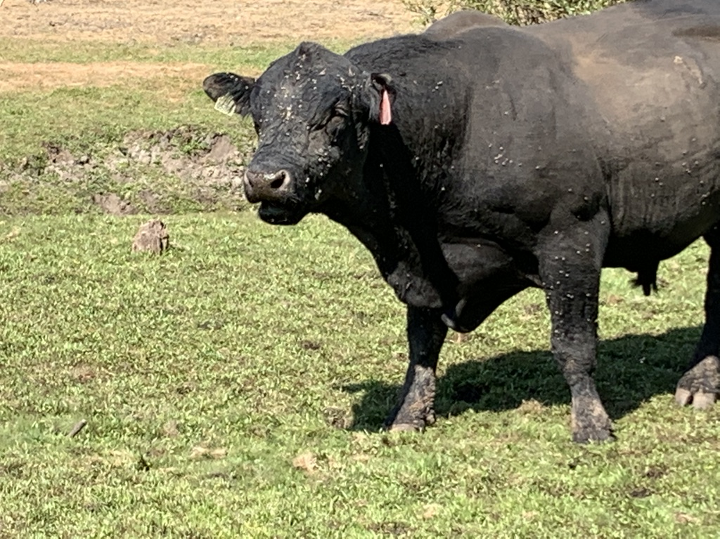
A bull – one of numerous cattle observed loafing and grazing near Sagehen. Reservoir (FS claims cows aren’t supposed to be in the “Sagehen Unit”). The animal is coated with dust from wallowing (likely from one of the scorched earth “prescribed fire” slash pile burns. All the little lumps on the bull are houndstongue weed seeds. The bull is a prime example of cows as a very effective dispersal agent for weed seeds. Plus there are often weed seeds in manure. And of course, the mud on the bull’s hoofs and extending up the animal’s legs, indicates the depth of trampling and tearing up of streambanks and moist areas that is allowed to take place here – without any limits or controls on the amount of trampling disturbance impacts.

Skidders, masticators or other mechanical equipment injury and skid trails will injure and bash remnant trees. This is so very common in logged/thinned sites. Huge “slash piles” (see attached photos), once set ablaze by the FS, will injure or kill adjacent “leave” trees. Sap from cut, thinned, or logged trees will lure in insects that then weaken or kill remaining “leave” trees. Further, photos of recent “treatments” at Sagehen show older trees cut down just like any others.

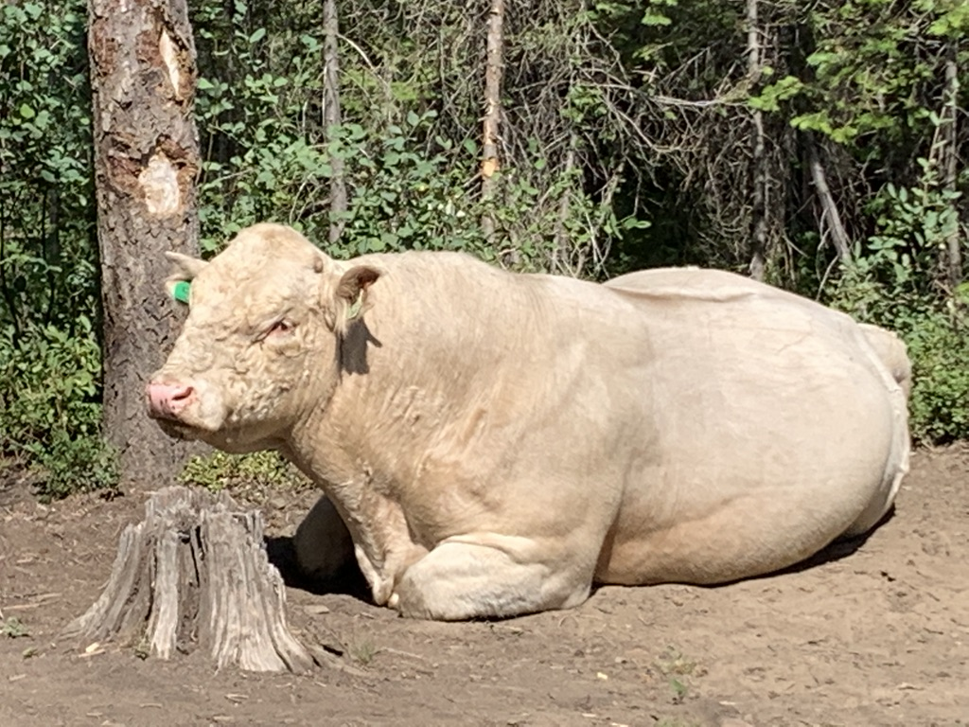

Flammable cheatgrass and other dense annual grasses are advancing. The ubiquitous high levels of grazing disturbance will facilitate cheatgrass expansion and site dominance, along with bulldozing vast lengths of new “temporary” roads and roads “improved” to facilitate/logging/burning “treatments”. Cheatgrass and other annual bromes and grasses are already expanding in the Sagehen landscape, especially on basalt soils.
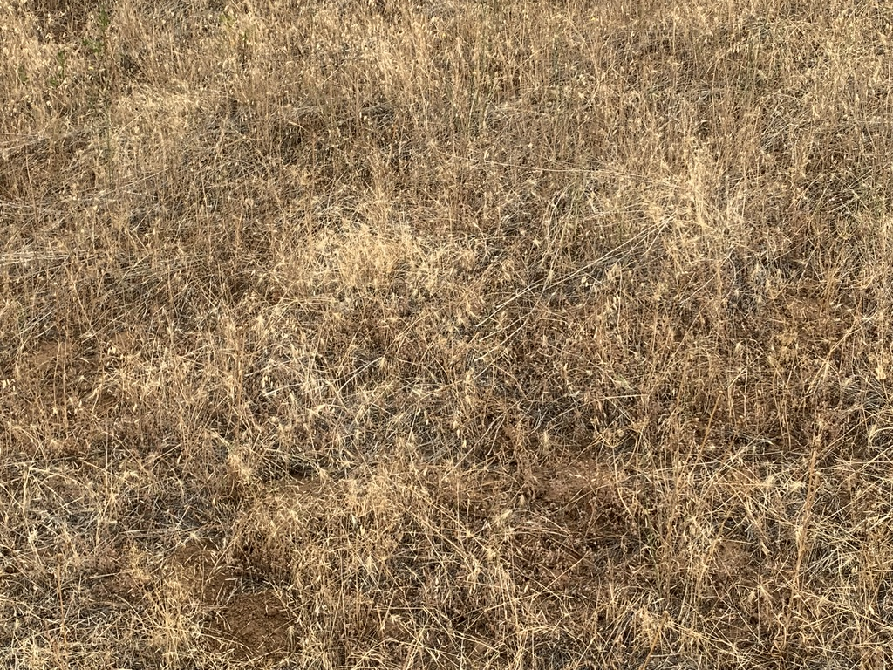

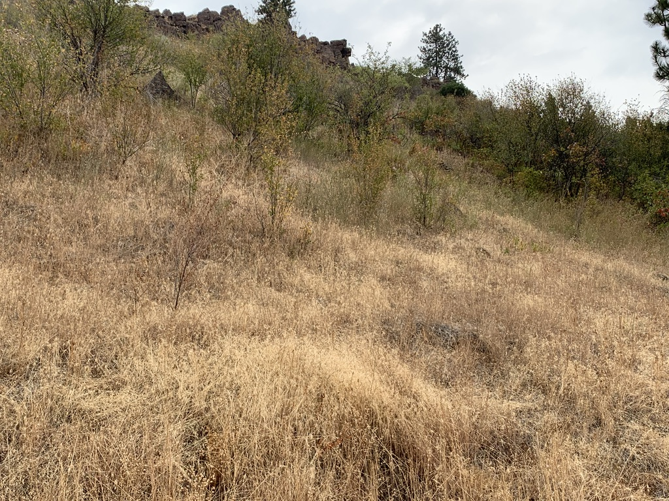

Here is one of many photos in the Photo Exhibits that show a combination of Sagehen logging forest damage.
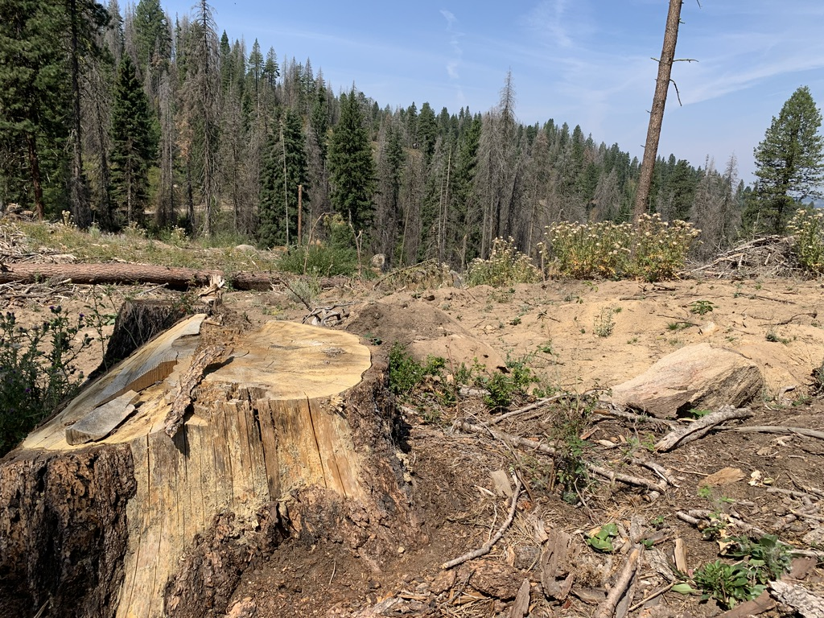

A “legacy” tree stump, a lone wind-vulnerable tree in the distance, multiple weeds, bare hot sun-bake soil (soon to be overrun with thistles, houndstongue, black henbane and other weeds) \. Note the standing dead trees in the background “unharvested” area, and how they shade the ground cooling the site, how they decrease wind speed, and how the site still functions as a forest.

Bulldozed fuelbreaks too will destroy mature trees and forest stands - and if this is supposed to be gentle, mild prescribed burning conducted during “safe” burning periods – why would fuelbreaks even be needed?

The FS fails to reveal if “leave” trees and stands will even be marked for saving.

And then there is the value of live and dead trees sequestering carbon – rather than the rampant soil-scalding burning the FS plans to inflict on the forest.

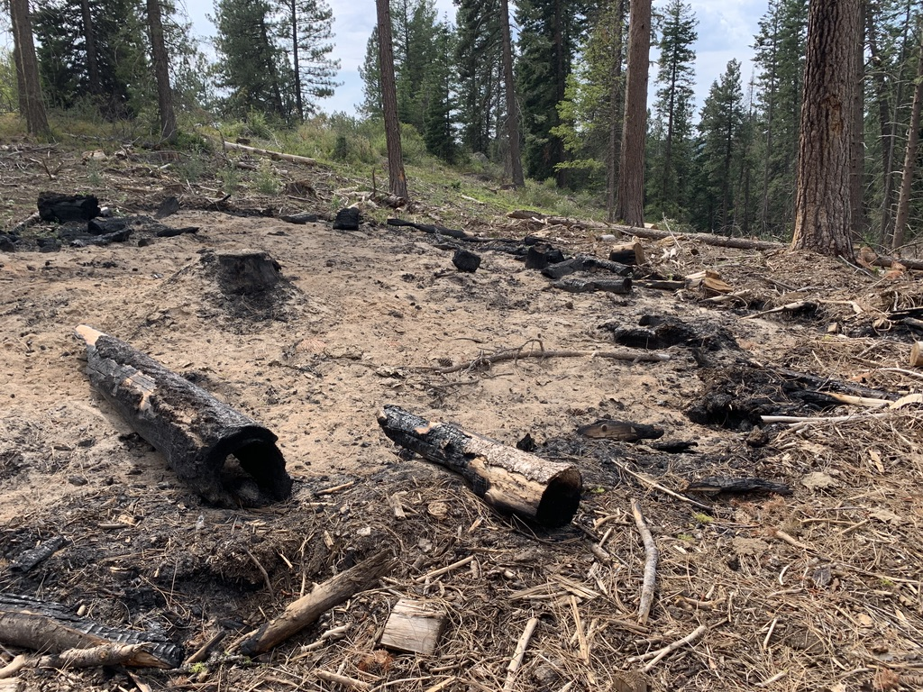
How UNNATURAL is it to cut down trees, pile slash into 5 to 30 ft. tall heaps and then torch the piler site using some flammable substance – thus releasing all the carbon into the atmosphere? Note that these slash pile burn sites at Sagehen turn out to be prime cattle wallow and loafing areas – ensuring maximum weed infestation and spread.

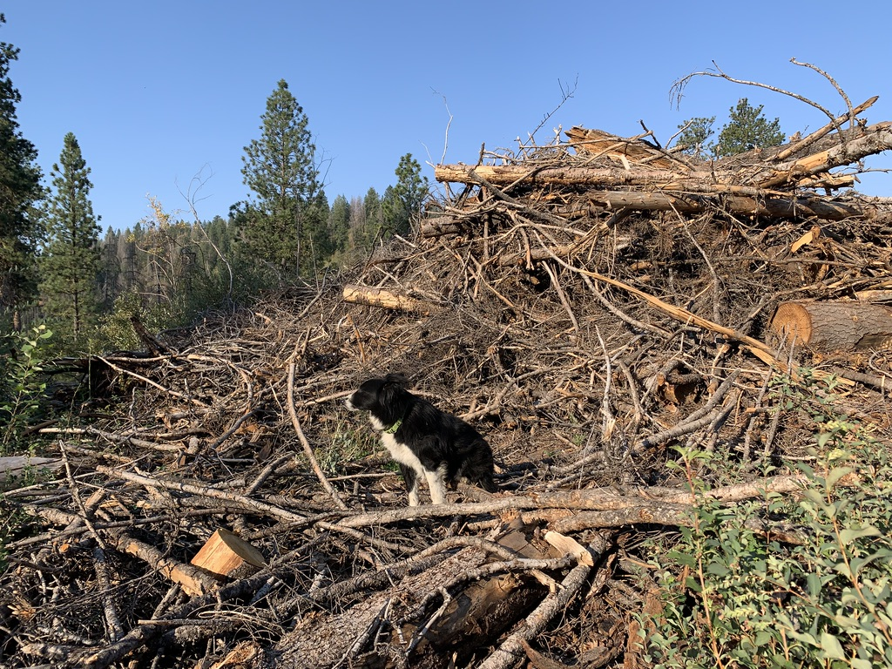
Sagehen “slash pile” pile waiting to be torched as the Emmett RD does its part to pollute the air and release copious amounts of carbon into the atmosphere and cook the planet. This is combined with the entire massive manipulation and forest manicuring project significantly reducing the forest caron sequestration. Note also that heavy equipment roamed around burning fossil fuels heaping carbon-sequestering wood into these huge piles to be torched.

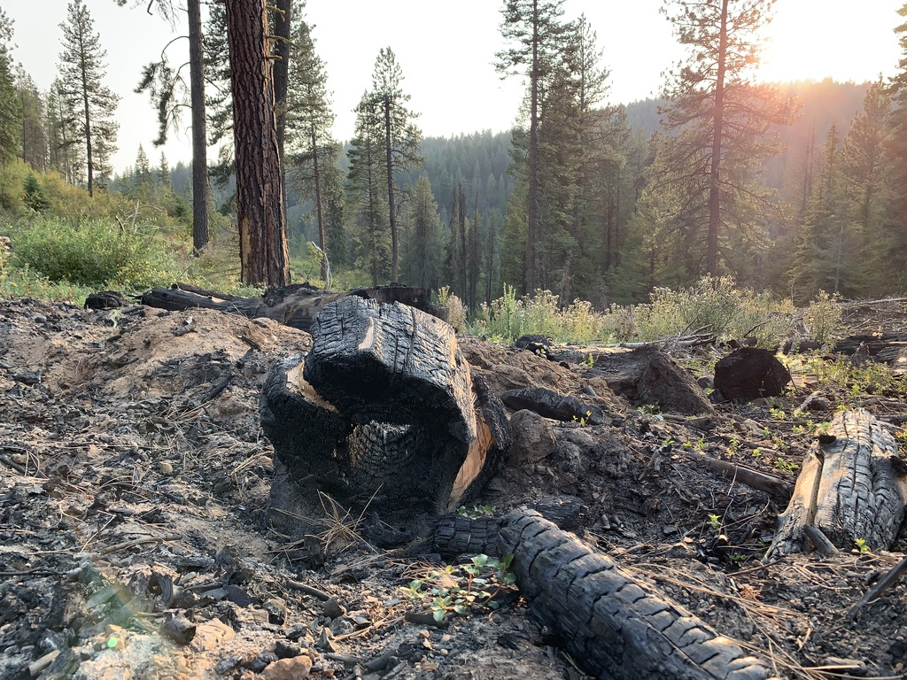
So much for assurances that the FS will let older trees develop cavities for cavity nesters. Just chop ‘em down, and burn ‘em up instead in a massive biodiversity-destroying heat increasing weed expansion project. Note also injured “leave” tree in background, and deep ash piles behind charred hollow cut tree.

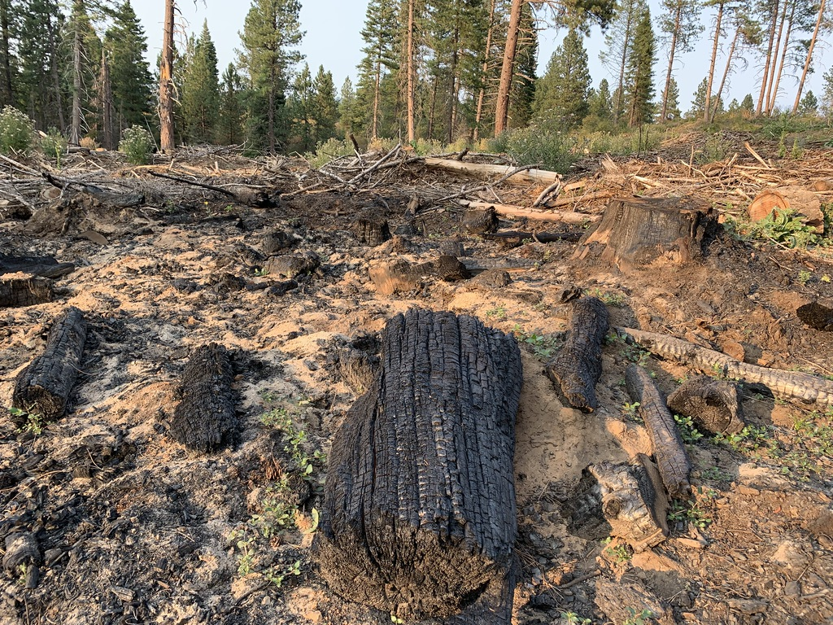
Current examination of wildfire after wildfire is showing that “thinning” results in hotter, drier, windier sites that fires whip readily through. The existing “treatments” at Sagehen illustrate such conditions.
Sagehen 2024 and 2020 Wildlife/Specialist Report and Addendum Are Deficient

The USFS fails to provide a current, hard look at the current status of habitats for MIS, sensitive and imperiled species and migratory birds n the Sagehen project area and across the Boise Forest and nearby Payette Forest landscape. What is current habitat quality? Or habitat quantity? What lands are actually occupied by sensitive species? What is the status and trends of the local and regional populations? What will be the foreseeable impacts of the battery of proposed “treatments” including a battery of mechanical deforestation/woody veg removal actions plus rampant “prescribed with bulldozed fuelbreaks and napalm burning on the quality and quantity of habitat fio these species and sustainability of viable populations in the project area and its surroundings? In the BNF and PNF? In the larger landscape encompassed by Region 4 forests and adjacent BLM and other lands? What is the scale and magnitude of threats currently in this landscape? Of threats that are foreseeable?

What current biological on the ground inventories are the 2024 Sagehen EA and its specialists reports based on, and how were any inventories and studies conducted?

What do current Forest monitoring reports, including monitoring of promises made in Forest Plans, from the BNF, PNF and Region 4 forests show about sensitive and rare species threats and habitat and population sustainability?
We also highlight that on top of the roads, trails, logging, burning, unassessed degrees of livestock grazing ecological impairment, degradation and harm - and impacts to hydrology, sediment, water quality and quantity - including harm erosion/pollution/perennial flow losses at fragile springs and seeps home to rare amphibians and that provide headwaters to stream systems, sensitive species habitats and population, Threatened Canada lynx and Wolverine, the sensitive horrifically persecuted Gray Wolf and other native carnivores that this project for which this project will provide greatly increased human harassment, disturbance, poaching, habitat loss, habitat fragmentation – and have significant adverse effects on population viability.
For each affected species, thorough current baseline inventories must be conducted as part of this NEPA process and provided to the public for review. This is necessary to understand the severity of harms and full scale and significance of adverse effects. It is necessary to understand:
The number of individuals impacted (and such impacts to population viability and sustainability) and the specific areas of occupied habitat in the project area and surrounding landscape (as many of these species are wide-ranging carnivores or otherwise linked to populations on state land, private land or USFS land. The acres of impacted habitat; the extent of impacts to individuals and habitat; the distance from specific locations (recreation sites, vegetation treatment locations, and so forth) all need to be carefully considered.
Note too that yet another Payette Forest effort at rampant forest logging, thinning and burning is likely to move forward in the Sagehen region just to north. Further, the Payette Forest has rammed through massive deforestation and “treatments” in the lands just west of New Meadows.
How many acres, of what age class, vegetation type, and stand attributes; what IRAs and IRA values; what impaired waters and degraded riparian areas; what identified Wolverine, Canada Lynx or other rare and native species and migratory bird habitats will (or are) all of these projects impacting? How much hotter, drier, harsher, windier, weedier, and more fire prone will these projects make this landscape? How many acres of each vegetation category - such as cool, moist or warm, dry forest of each conifer category the USFS imposes on the Sagehen and the lands of other similar projects in these forests will be impacted?
How many acres of undisturbed live forest will be present in the Sagehen landscape, and the Granite Goose project area, and where will they be located? What is the stand age, composition and structure of these areas? Please map and identify them. How many years does it take to achieve a mature forest of each vegetation type/category/pigeonhole the USFS uses? Which of these forest types may be successional communities - and transitional to late successional forest? We again stress that the Forest plan relies on long-outdated fire return and disturbance intervals that fail to take into account successional processes, fail to reflect the actual much longer fire return intervals of the various forest categories used in this EA, etc. the Forest also fails to consider papers by Kerns et al. 2020, Fusco 2019 that describe how forests may not be able to recover from significant disturbances under climate stress.
Minimal information is provided about the domestic livestock grazing that occurs across large portions of the Sagehen, Granite Goose and other massive deforestation project areas - including lands that may not be capable or suitable for supporting the levels of chronic livestock grazing disturbance and impacts. This is especially the case given the increased stresses of climate change, the human-altered landscape and increasing recreational uses and disturbance. Fleischner 1994, Catlin et al. 2011, Beschta et al. 2012. We are concerned that a significant element of this project is to kill trees to try to generate more grass for livestock on grazing-depleted range.
The Forest must fully identify, map, study baseline ecological conditions, study similar past project adverse effects on native biota, watershed and recreation of all such projects previously conducted in the targeted Project Area and surrounding landscape.
Please provide detailed assessment and analysis and baseline data on the current livestock grazing use levels and management schemes, permitted use HMs, actual use HMs, standards applied to protect Forest resources, current land health assessments, current capability and suitability analyses, detailed upland and aquatic/riparian monitoring of livestock impacts and the level of baseline existing degradation. Please provide detailed information on management schemes, unauthorized use or trespass, facility location and impacts, effects of salt supplement use, permittee motorized use, etc. on all Forest resources, and the degree to which grazing is causing weed infestations and spread and favoring exotic species that choke out native biota. Please fully investigate foreseeable ecological and other impacts of continued livestock grazing disturbance taking place in and surrounding the project area. See WLD old Sagehen EA comments Attachment A, Alternative and Mitigation actions regarding livestock grazing. Please review Belsky and Gelbard 2000, Choung et al. 2015 describing livestock transporting flammable weed seeds in mud on hoofs, Williamson et al. 2019 describing how livestock cause flammable weeds, Fusco et al. 2020 and Kerns et al. 2020 describing how trees in formerly forested lands are not recovering from disturbance – resulting in a loss of forest cover. This is likely to be a serious consequence of these massive and often overlapping disturbances.
This whole condition-based scheme is an effort to duck actually acquiring and integrating vital baseline site-specific information to try to duck an EIS. Not only will the Sagehen Project affect a very large land area for very long periods of time (and foreseeably forever when irreparable damage occurs and lands suffer irreversible weed infestations, excessive soil erosion, stream entrenchment and downcutting, loss of sustainable perennial flows, or steep declines or local extinction of rare species as crucial habitat elements are drastically reduced and habitats extensively fragmented.
Please provide a full explanation of federal legislation the 2024 project would be conducted under. Does it subsidize logging or treatment activity on private, or state lands? Does it subsidize logging or treatment activity on public lands? If so, how much will those subsidies be? Full analysis of the direct, indirect, additive, cumulative and synergistic effects of the proposal on these affected lands, waters, habitats and populations of wildlife and aquatic species, water quality, water quantity, sustainability of perennial flows, etc. must be provided. New current baseline studies must be conducted as a basis for formulating alternatives in an EIS for this project.
The USFS has clearly failed to develop and assess a suitable and reasonable range of alternative actions, including minimization and mitigation actions as well as any forest manipulation actions. The EA references a horror-show of heavy equipment soil/biocrust/native plant community mechanized” disturbance and forest destruction planned.
How many new and additional acres of insect infestation are likely to result from the large-scale logging/thinning/fire disturbances – for example sap from injure to unfold over 10-15 years or longer, with project-injured trees luring in tree killing or injuring insects? How much mechanical damage and/or burning and injury or death of “desirable” or “leave” trees and mature and old growth trees and forest areas will remain after all the mechanized activity and rampant burning? Please provide careful biologically valid estimates of these additional causes of mortality and “collateral damage” from these treatments.
This all demonstrates why much more detailed site-specific information needs to be amassed, and more reasonable range of alternatives that reduce and minimize ecological disturbance is needed. The maps with the project show blocks of land are targeted for various “silvicultural” forms of disturbance and forest destruction. It’s critical that there be thorough and detailed upfront mapping and analysis of all “leave:” tree areas and areas that will not eb disturbed, and their dispersion. This is also necessary to understand how much more fragmented the landscape will be, how little protective, screening and escape cover there will be for big game and rare native carnivores, and how visually scarred and marred the landscape will be. It’s also necessary to understand the degree of conflicts between different forms of recreational use. For example, standing forest helps hinder sound transmission, and would help prevent cross-country mechanized travel during all periods of the year – and the sights and sounds of such activity. EACH sensitive and imperiled species has different habitat needs, and unless a thorough baseline that honestly reveals how much forest and other habitat essential for their survival is now present vs. how much will remain is laid out in an EIS hard look analysis, it will be impossible to develop a truly reasonable range of alternatives and to require effective and necessary restrictions on forest and tree removal to minimize and mitigate any “treatment” impacts on MIS, sensitive, and imperiled terrestrial and aquatic species, big game, and migratory birds
Just as with Sagehen, the adjacent Payette lands the USFS has overwhelmingly ignored the concerns WLD et al. have repeatedly raised in scoping letters and comments – on Granite Goose scoping and now a flawed 2024 EA. See: https://www.fs.usda.gov/project/?project=54029
The Payette had initially scoped an EIS for the Granite project which would have harms similar to Sagehen, then back-pedaled. Federal Register link for that initiated EIS:

https://www.federalregister.gov/documents/2018/10/31/2018-23826/payette-national-forest-idaho-granite-meadows-project.

https://payetteforestcoalition.org/project-archive.html

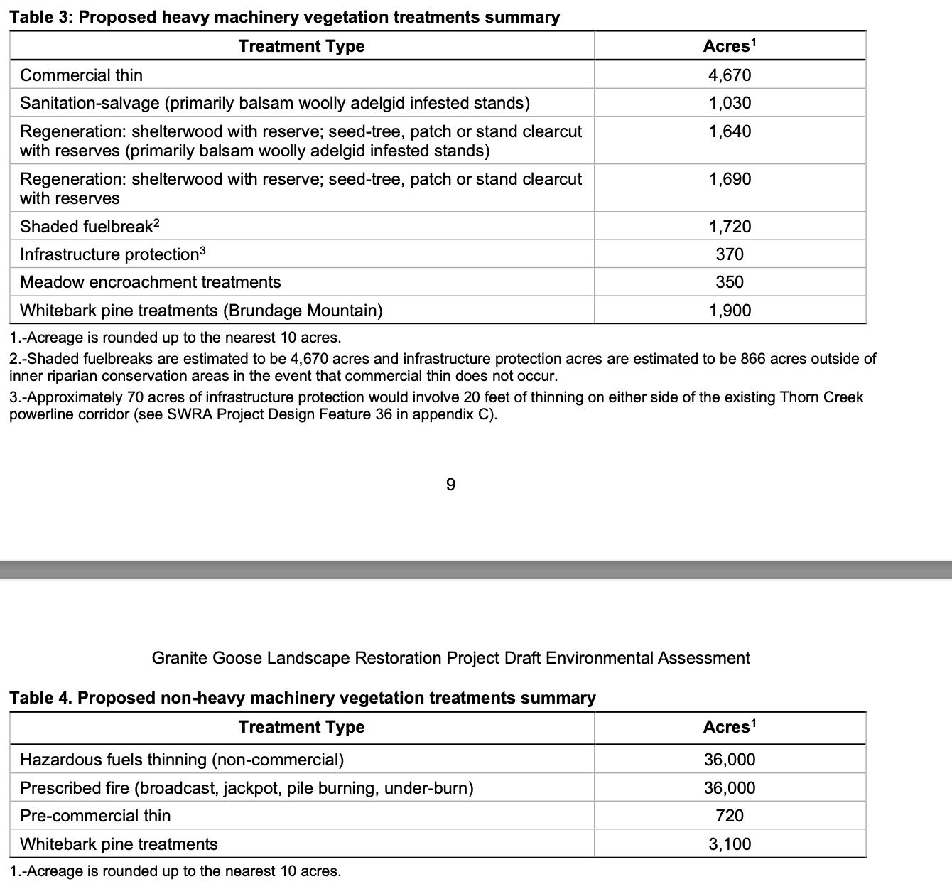
Similarly to the Payette Granite Goose project, the USFS in Sagehen is acting with significant bias, and ignoring any hard look at how damaging this massive disturbance will be. How does the Forest vet such “collaborative” logging group proposals, including applying current ecological science and data? We were concerned at the proposal being based on the desires of parties engaged in a loose and uncertain undemocratic process Such groups are often politicized, involve considerable “horse-trading” where one land area, vital habitat a beautiful old growth site or wildlife species habitat may be sacrificed to fulfill a wilderness, grazing or other agenda in another location. Such groups are largely dominated by extractive or commodity uses or intensive recreational interests.
Average citizens who use and enjoy the Forest lands for many aesthetic, recreational, scientific, spiritual and other interests and pursuits, such as our members, are at a significant disadvantage when such groups are given a stronger voice in federal agency processes. We are very concerned about the path this project is on – where snowmobiles being able to run all over the place trump Wolverines and other sensitive species habitats.
Please also provide information on whether members of the collaborative group have a financial interest in proposed project actions. For example, how many members listed in the vote tally are livestock grazing permittees on the Forest?
Clearly an EIS is required to take an honest hard look at this complex project with its large-scale manipulation disturbances to Wolverine and other rare species habitats, and the project’s increase to intensive recreational disturbances.

The USFS’s minimal self-serving Sagehen EA rehash seeks to burn, aggressively log and thin and clear vast areas of forest. Note that we just reviewed a Salmon-Challis Forest mining exploration EA where the USFS states that burns are poor habitat for Wolverines. The radical series of “treatments”: will facilitate greatly expanded human off-road activity and incremental development of new trails - including motorized and non-motorized/mountain bike – a use that has exploded since the now-outdated Payette and other Forest Plans. How much has pressure from mountain bike use increased in the McCall landscape since the old Forest plans were developed?

Old Forest Plan as Basis for Highly Uncertain CBM Extending 15-20 years into Future (Foreseeably Until 2044!)

The Boise and Payette Forest plans are around 20 years old (with the Boise plan amended on some matters in 2010). The data on which they relied and made allocations, is often older. The massive vegetation manipulation schemes and modeling that target maturing, mature and old growth trees and forest patches and blocks (where these even still exist) are based on very out-dated “pure” vegetation community models and assumptions, failed to adequately address climate stress on watersheds, flow sustainability, wild lands integrity and sensitive, important, rare and ESA-listed species.

Federal agencies are increasingly using modeling that create an alternate vegetation reality. The info in EA documents appears to be very similar to the Forest Service methodologies and models that critiqued in this article about a Pine Valley Utah Project https://www.counterpunch.org/2019/12/20/voodoo-vegetation-modeling-dooms-native-forests-and-wildlife-habitat/.

The Forest Plan does not follow current ecological science regarding the adverse impacts of grazing and livestock facilities in causing flammable weed proliferation, weeds, degrading watersheds and habitats, fostering diseases, making lands less resistant to climate change stress and less resilient and less able to recover from grazing disturbance and degradation. It was not based on current fire science showing how critical defensible space right by structures is, and how readily fires flash right through hotter, drier, windier, weedier “treated” and thinned” sites. It did not take into account biodiversity loss and the major and serious declines in migratory bird species in North America. See Rosenberg et al. 2019 describing the loss of 3 billion birds from North America. Fusco et al. 2020. Note that forest communities that are predicted are often not regenerating following fire or other disturbances,

Dr. Jack Cohen’s fire science - focusing on the actual area of habitations and interfaces is what is needed to address fire risk to communities and structures – not roaming all over the place radically simplifying and destroying forests. Cohen’s work was ignored in the old Forest plans and the current crop of Region 4 EAs. This further demonstrates why an EIS must be conducted here – to provide foundational updated scientific and other information relevant to the real world National Forest situation in 2024.

The predicted increases in summer temperatures as climate stress worsens will make the FS radical treatment disturbances and purposeful destruction of protective shading live and dead tree cover in these massive projects even more harmful to aquatic and terrestrial species. An ever-growing body of evidence from recent wildfires showing thing makes matters worse, and a host of other current ecological information.

The species significantly harmed by this large-scale disturbance now also face new and emerging disease threats – for example, migratory birds will suffer severe blow from this large-scale simplification, loss and fragmentation of habitats. Now they also face the emerging threat of avian bird flu or other diseases that may drastically reduce populations and exert serious new stress on local and regional species populations - especially the in degraded and fragmented habitats that will result from this massive loss of protective tree cover. There is also much new science on the harms caused by recreational activity disturbance on wildlife and wildlife displacement- from big game to Wolverine. Note that native carnivore leporid and ochotonid prey species face the grave new threat of quite lethal Rabbit Hemorrhagic Disease (RHD).

The Forest Plan also of course did not examine and assess the huge impacts of the huge direct, indirect and cumulative footprint of the massive vegetation and fuels “treatments” and logging that has occurred, is authorized, proposed, or is being planned or foreseeable across the Boise NF, the Payette NF and Region 4, as well as other nearby Forests.
Dr. Jack Cohen studies on hardening structures and other papers submitted in our scoping comments. What structures are actually present? Where? How have they been hardened? Only “treatments in close proximity to such areas will be effective in addressing fire risk here. Where specifically are all WUI areas located, and how was this land area of WUI determined? Please provide detailed analysis of how any WUI was defined and delineated here.
This project also appears to be aimed at intensifying recreational disturbance – by not closing roads but turning them into mechanized trails, expanding snowmobile parking lots, failing to close much larger areas to snowmobile use, relying on an out-dated forest travel plan, etc.
The Forest must fully consider an alternative that restricts OHV/snowmobile use over larger areas to protect Wolverine, (now recognized by USFWS as Threatened) Canada Lynx, Fisher, and Gray Wolf – the latter greatly threatened by the state of Idaho’s barbaric Gray Wolf persecution “management”. See:
https://news.yahoo.com/hunter-applied-receive-idaho-funds-110000618.html?guce_referrer=aHR0cHM6Ly93d3cuZ29vZ2xlLmNvbS8&guce_referrer_sig=AQAAACD8I3IFQvVjo-4tL7kBk_fvI9pIkUo362KZ5imkmTh_0kq_OFfXzhIUD581nOy10ap2zPob3GFqqRLRptw6UICmwAkCASdQsyXZIssaMqN0-2Rut9sg2VEy2E0wjAZCaITmpft0L3InAZ6E2QgvM5MXUY4yoV9Tj8Q4r9LB3-tr
The large-scale deforestation and tree removal and burning will make it much easier for snowmobiles, motor bikes, mountain bikes to run all over the place, and for year-round harassment, poaching and disturbance of native carnivores, big game and other wildlife in the project area including roadless lands.
The EA must detail the pre-project route condition and the effects of the proposed action in “improving” or constructing routes. The analysis must identify routes authorized in the current travel plan, routes with RS 2477 County claims on them, and must provide site-specific data and information on the width, condition and other aspects of each route to remain open vs, closed, and take a hard look at the effects of this welter of actions on sensitive and imperiled species, etc.
The FS must provide detailed mapping and analysis of “skid trails” and routes from past forest manipulation projects that now are motorized trails. Wasn’t the public told in previous logging/treatment projects that such sites would be rehabbed and “stabilized”? How successful has that been? How will this project reduce or kill mitigation claimed in past projects? Where will all new Sagehen skid trails and landing decks be located? These log deck areas suffer obliteration of surface vegetation, severe soil compaction, scalding pile burning - all priming sites for irreversible weed infestations.
How and where has the USFS in the Boise Forest monitored soil erosion rates on 50%? 60% 70% slopes in all soil types found in the project area? Slopes from 10 to 70? How much will the roads and the skid trails and logging and burning and thinning etc. affect the erosion rates? How will they change with slopes of 10%? 20%? 30%?, 40%? 50%? 60%? 70%? What is the natural undisturbed forest background rate of erosion. How are roads and skid trails and landing decks affecting soil erosion rates in both wind and water?
If part of the Region 4 and Boise Forest’s reckless logging/burning/massive forest disturbance treatments are claimed to boost water flows - recent Utah detailed watershed studies showing logging and thinning does NOT increase water flows.
https://greatsaltlakenews.org/latest-news/salt-lake-tribune/scientists-say-thinning-forests-wont-help-the-great-salt-lake-heres-how-they-know
https://www.fs.usda.gov/research/treesearch/64427, Goieking and Tarbuton 2022.
“Forest cover and streamflow are generally expected to vary inversely because reduced forest cover typically leads to less transpiration and interception. However, recent studies in the western U.S. have found no change or even decreased streamflow following forest disturbance due to drought and insect epidemics. We investigated streamflow response to forest cover change using hydrologic, climatic, and forest data for 159 watersheds in the western U.S …”.
Also: “Many watersheds exhibited decreased annual streamflow even as forest cover decreased. Time trend analysis identified decreased streamflow not attributable to precipitation and temperature changes in many disturbed watersheds, yet streamflow change was not consistently related to disturbance, suggesting drivers other than disturbance, precipitation, and temperature. Multiple regression analysis indicated that although change in streamflow is significantly related to tree mortality, the direction of this effect depends on aridity. Specifically, forest disturbances in wet, energy-limited watersheds (i.e., where annual potential evapotranspiration [PET] is less than annual precipitation) tended to increase streamflow, while post-disturbance streamflow more frequently decreased in dry water-limited watersheds (where the PET to precipitation ratio exceeds 2.35)”.
See: Goeking, Sara A.; Tarboton, David G. 2022. Variable streamflow response to forest disturbance in the western US: A large-sample hydrology approach. Water Resources Research. 58: e2021WR031575.
The project area is dominated by dry forests.
Additionally, how much Idaho Power cloud seeding is taking place in the Boise and Payette watersheds to try to eke out more moisture? Where is this taking place, and how and where does this futile effort alter snow and linked runoff? Where might this be making sites drier by taking moisture out of clouds? Are other cloud seeding efforts affecting precipitation across Idaho R4 Forests?
Full and detailed information on flow rate and water quality and habitat indicators for sediment/turbidity, temperature, bacterial pollution, etc. must all be provided for public review and comment. We are concerned that the importance of recovery these watershed areas for native aquatic and riparian species is being ignored in this major disturbance scheme.
Temperature and its impacts on sensitive and other aquatic biota, lack of recovery of native species, apparent declines in project-area watershed Bull Trout (note there is really no updated info on other aquatic species of concern -including native trout and amphibians)- are all matters of significant uncertainty and concern. Loss of other native salmonids is already a big problem across the project area and surrounding lands – as temperature and other degradation problems only worsen downstream and across lower elevations in the highly degraded watersheds at issue here. Mid and higher elevation deforestation/thinning /logging/treatment moves these problems upstream and upslope in watersheds.
Water temperature increases will result from both the deforestation across the watersheds and burning and thinning intrusions into the RHCAs. The project will worsen temperature and other existing ecological problems including substantial loss of carbon sequestration ability for long periods of time in these watersheds will certainly not bring about “resilience” or “climate adaptation”. This project will fast forward site drying and heating worsening climate stress. It will cause accelerating large-scale erosion in runoff events. It seems to be magical thinking and unreasonable to claim that removing shade in significant amounts and clearing woody vegetation near streams, springs, and drainage networks would not result in a hotter, drier, windier, weedier and more fire prone watershed, and these impacts would be made worse by increased temperatures.
For nearly all species of special concern, early seral forests are not an issue. Yet these are what the project will often result in, and it will take hundreds of years to ever recover a complex mature forest and longer for old growth forest. The USFS must take a hard and systematic look at whether sufficient mature and later seral forest will remain to provide for the needs of viable populations of sensitive species, MIS species, and species of concern.
Forest Service planning regulations pertaining to species of concern require consideration of all threats to the species persistence in the plan area, whether or not the threats occur within the plan area or are the result of national forest management. Significant threats to these at-risk species may also come from outside of the federal land. For example, nearly 100 square miles of Forest land (bought several years ago by Texas billionaires) are now up for sale for development.
A recent Payette Forest EA (Railroad Ridge) admitted that Fisher populations decrease with fire. Yet the USFS proposes substantial and large-scale “prescribed” fire in a highly uncertain manner – 36,000 acres or more. The logging, thinning and other treatments will also result in a loss of mature and maturing forests, and the habitat characteristics required by Fishers.
The massive new disturbance will increase Wolverine and Canada Lynx vulnerability with potential further reductions to snowpack -on top of those resulting from climate change The FS must take a critical and hard look at how this project will affect snowpack. Please see recent Utah watershed studies showing logging and thinning does NOT increase water flows.
The project not only impacts an immense area of highly diverse vegetation communities, it affects a host of headwaters areas, watersheds and riparian systems vital to many species of aquatic biota - with water quality and water flows jeopardized by the series of radical disturbances the Forest would inflict across the landscape. It will have very significant downstream effects waters that may already suffer a significant pollution or degradation burden. It includes highly controversial elements, including biomass removal and even more logging in a Forest land area that has already suffered considerable logging and loss of old and mature forests. Full and detailed aquatic habitat studies (sediment, cobble embeddedness, bacterial pollution, water temperatures) and exotic species inventories across terrestrial habitats must be conducted as a baseline, and the degree to which the EA proposed treatments and roads/trails and over-snow use and all other elements of this proposal in a chronically grazed landscape will increase degradation, exotic species, pollutants, worsen climate stresses and cause loss and fragmentation of sensitive, important and ESA species habitats and declines in population levels. How much more fragmentation and disturbance can the Wolverine, Fisher, Hermit Thrush, Bull Trout and other aquatic species including rare amphibians - and other declining species populations take? How much hotter will surface waters be from this deforestation “treatment”?
Small-diameter logging and thinning will remove essential habitat for Snowshoe Hare and Red Squirrels. These are primary food sources for numerous forest predators including bobcats, mountain lions, gray wolf, lynx, pine martins, fisher, wolverine, coyotes, goshawks, great grey owls, and boreal owls that all lose. What is the current status of the prey base for sensitive native carnivores, and its sustainability for all of these affected species? How much less secure will this project make any remaining carnivore habitats from human harassment, disturbance, displacement, trapping, shooting and other disturbance? Idaho hopes to slaughter 90% of its Gray Wolves.
This project will make it easier to shoot, trap, slaughter native carnivores, and make the population more vulnerable to stochastic events. The full ecological and social effects of this craven killing must be assessed in the direct, in direct and cumulative effects analysis of the project. Further, killing of Wolves will likely lead to increased big game mortality from CWD as well as vehicles, as wolves break up big game congregating in areas where disease transmission is maximized. Wolves also keep big game dispersed from roadsides where people die or are injured from vehicle accidents. Areas where big game concentrate too densely in winter also create ideal conditions for diseases like CWD to spread. Is there CWD in the big game herds in or near the project area at present? How has this disease expanded in Region 4 Forest landscape in the past decade?
Isn’t the Gray Wolf a forest sensitive species? Won’t this project make this greatly persecuted native carnivore even more vulnerable to being trapped, shot, poached and displaced. And more susceptible to the barbaric wolf killing now sanctioned by the state of Idaho? What is the current Gray Wolf population in the Boise Forest? Where is there protective forest cover and secure habitat in the project landscape? How will this project change that? How many more wolves are likely to die because of loss of forest cover protection? How viable will the population actually be? Won ‘t this project help push the species towards re-listing by destroying protective habitat and making wolf slaughter easier?
Note that within a few days after the USFWS rejected Gray Wolf ESA listing in 2024, environmental groups have again sued to seek listing sending USFWS 60-day Notice letters,
See: https://biologicaldiversity.org/species/mammals/Mexican_gray_wolf/pdfs/NRM-Wolf-Petition-Denial-NOI-2-7-24.pdf
“In Idaho, new legislation permits hunters, trappers, and private contractors to kill wolves using new—and highly effective—methods to do so.18 For example, Idaho now permits year- round trapping on private property; unlimited purchase of wolf tags; and baiting, hound-hunting, night hunting with night vision equipment, and the use of ATVs or snowmobiles to facilitate killing wolves”.
Inter-connected predator and prey species are part of the web of life that would be logged, thinned and burned and infested with weeds by the Sagehen project. The full scale of serious harms to their habitats and population persistence is glossed over in the deficient self-serving scoping in formation. All of these inter-connected species and the forest web of life and forest plan deficiencies in these watersheds that would be logged thinned, and burned by this project were also at stake in the past iterations of logging/treatment projects in the RD.
Collaborative Group Role in Rare Species Habitat Destruction
It is a concern that the FS is allowing collaborative group logging interests to direct significant elements of this large-scale logging and burning project disturbance to Wolverine, Gray Wolf, migratory bird, and a host of other native species habitats.

This all must undergo EIS-level analysis. What is driving this massive deforestation and disturbance crusade? We are concerned about the logging industry role in this project. The Region 4 projects fear-monger over dead trees. The FS claims a “need” to deal with insect killed trees by removing their protective cover and shade and habitat elements from the forest watersheds.The USFS in the adjacent PNF seeks to even destroy the higher elevation subalpine fire and the essential flying squirrel and rare avian species and native carnivore habitat it provides because of yet another forest insect - the hemlock wooly adelphid. Yet all the many BNF, PNF and Region 4 insect-killed tree projects haven’t made any effective dent in insect infestations and instead have helped them spread by injuring “leave” trees.

AND these insect killed trees are not a significant cause of wild fires. See: “Area burned in the western United States is unaffected by recent mountain pine beetle outbreaks”, Sarah J. Hart, Tania Schoennagel, Thomas T. Veblen, and Teresa B. Chapman
PNAS April 7, 2015 112 (14) 4375-4380; first published March 23, 2015 https://doi.org/10.1073/pnas.1424037112
Again, the proposed massive Sagehen ecological disturbance will take place in an area that is already stressed from past logging/treatments (and all of these must identified, mapped and monitoring of outcomes provided) and recreational uses and roads and mechanized trails.

Please also review the recent report on the 2023 Canadian wildfires showing that logging exacerbated the fire situation. See Wildfire Today 1/13/24 “Canada’s record-breaking wildfires have widespread logging partly to blame”.
https://wildfiretoday.com/2024/01/13/canadas-record-breaking-wildfires-have-widespread-logging-partly-to-blame/ .

https://www.mdpi.com/2073-445X/13/1/6
After massive logging, there was large-scale tree planting and uniformity.

2024 Sagehen Wildlife Report

The massive Sagehen mechanical and burning treatments will destroy the woody material and protective cover that characterizes much Wolverine habitat. It will aid in expanding and intensifying human disturbance including snowmobile and ATV habitat disruption and displacement of not only rare native carnivores, but also many other wildlife species. It will also increase vulnerability to trapping and poaching.

“Wolverine dens tend to be in areas of high structural diversity such as logs and boulders with deep snow (Magoun and Copeland 1998; Inman et al. 2007). Reproductive females dig deep snow tunnels to reach the protective structure of logs and boulders where they produce offspring. This behavior presumably protects the vulnerable kits from predation by large carnivores, including other wolverines (Pulliainen 1968; Zyryanov 1989), but may also have physiological benefits for kits by buffering them from extreme cold, wind, and desiccation (Pullianen 1968). All of the areas in the lower 48 States for which good evidence of persistent wolverine populations exists (i.e., Cascades, Sierra Nevada, northern and southern Rockies) contain large and well-distributed areas with deep snow cover that persists through
Alternative A and B may impact individuals or habitat but is not likely to cause a trend toward federal listing or loss of viability for the monarch butterfly. 1.5 Wolverine (Family 3-Threatened)1 Wolverines are a wide-ranging carnivore that occurs in relatively low densities, and occupies primarily high elevation habitats across the Northern Rockies of the lower 48 states of the U.S. They occupy large home range areas, anywhere from 15 to 300 mi2 (Ruggiero et al. 1994), and are known to travel substantial distances within that territory within a day. They tend to occupy habitats furthest from human development and activity (Ruggiero et al. 1994) and tend to be secretive and undetected”.

Wolverine do not appear to specialize on specific vegetation or geologic habitat features, instead select areas that are cold and reliably maintain deep persistent snow into the warm season. Spring snow cover (April 15 to May 14) is the best overall predictor of wolverine occurrence (Aubry et al. 2007; Copeland et al. 2010). Snow cover during the denning period is essential for successful wolverine reproduction range wide (Hatler 1989; Magoun and Copeland 1998; Inman et al. 2007). The persistent spring snow layer delineated by the Copeland and others (2010) MODIS model contained all known wolverine den sites in the conterminous United States.
Wolverine dens tend to be in areas of high structural diversity such as logs and boulders with deep snow (Magoun and Copeland 1998; Inman et al. 2007). Reproductive females dig deep snow tunnels to reach the protective structure of logs and boulders where they produce offspring”.

[It’s basic common sense that the Sagehen project’s rampant vegetation treatment, logging and burning -including massive use of fire in the Snowbank Roadless Area will simplify and destroy areas of high woody structural diversity]. These impacts will be very long lasting and irreparable, as it will take centuries for downed large logs to be present again. The effects are major, and unable to be mitigated effectively given the scale and great uncertainty of the “condition-based” proposed habitat manipulation and destruction actions].

“This behavior presumably protects the vulnerable kits from predation by large carnivores, including other wolverines (Pulliainen 1968; Zyryanov 1989), but may also have physiological benefits for kits by buffering them from extreme cold, wind, and desiccation (Pullianen 1968). All of the areas in the lower 48 States for which good evidence of persistent wolverine populations exists (i.e., Cascades, Sierra Nevada, northern and southern Rockies) contain large and well-distributed areas with deep snow cover that persists through the wolverine denning period (Brock et al. 2007, Aubry et al. 2007)”.

[The battery of Sagehen habitat disturbance and destruction treatment actions will result in hotter drier, less shaded sites where snow will melt more quickly, and where drifting of snow will increase].

The 2024 Sagehen Wildlife Report continues:

“Special habitat features include talus slopes, boulder fields, beaver lodges, old bear dens, fallen logs, root wads of fallen trees, large cavities used for den sites. Denning activities occur from February through early May until the natal and/or maternal den site is abandoned (Magoun and Copeland 1998). Denning habitat may be a factor limiting distribution and abundance (Copeland 1996), and wolverines may abandon dens in response to disturbance (Copeland 1996; Magoun and Copeland 1998)”.

[By drastically simplifying habitats logging removal and burning up wood plus clearing skid trails and other all the roading will removing impediments to cross-country snowmobile travel and ATV/motorized travel, areas of habitat previously with no or minimal human disturbance will become vulnerable to human disturbance].

“Projected habitat loss is linked to increasing temperatures and reduced late spring snowpack. As temperatures become warmer, more precipitation falls as rain, and snowmelt occurs earlier in the spring. As these changes continue, currently suitable habitat would become unsuitable, and wolverine habitat would contract, moving up mountain slopes. Habitat losses are likely to occur throughout the contiguous United States and are projected to be most severe in central Idaho (Federal Register Vol. 78, No. 23, February 4, 2013”).

[The massive Sagehen project and others (such as the Payette Granite Goose project deforestation and many huge burning projects) will cause accelerated habitat loss, will produce unsuitable habitat, will increase human disturbance and “take” and will aid and abet Wolverine extirpation in central Idaho, and cause species range contraction].

“McKelvey and others (2011) predict that 31 percent of current habitat will be lost due
to climate warming by 2045. The loss will increase to 63 percent by 2085. In conjunction with reduced area, habitat becomes more fragmented. The number of wolverines that could be supported by habitat”.

[How much Boise NF and Payette NF habitat with the woody features Wolverines and many other native carnivores use will be lost from the Sagehen project? From Granite Goose? How much will habitat security be reduced and human disturbance and displacement of rare and sensitive carnivores be increased by these projects? Note that the use of highly uncertain “condition-based” management (CBM) that does not delineate specific project activities in specific land areas (each site will have varying topography, snow deposition, aspect, wood density, rocks, etc.) makes it impossible to accurately assess the magnitude and scale of impacts and lost habitat that will persist for many decades and centuries due to the Sagehen Project, and the neighboring Payette “Granite Goose” project, and a host of other projects underway???

The 2024 Sagehen Report claims there is habitat elsewhere– yet the BNF is hellbent on destroying remnant habitats across the Forest in innumerable logging projects – Clear Creek and several others following after the massive strip mining of wood and nutrients and carbon sequestration from the lands of the Pioneer Fire. Right now, there is the Upper More’s Creek, and trying to ram a major project disturbing nearly all remaining partially intact forest areas between Idaho City and Pilot Peak. – even resorting to use of a contraption to log/mine trees from slopes up to 70% - in an area that has already suffered past logging and major post-fire “salvage” timber mining. As with the Sagehen and Granite Goose projects, these other BNF projects will push Wolverine closer to extirpation on the Forest, and a highly foreseeable northward range contraction caused first and foremost by incessant agency treatment and roading disturbances. There is also the sprawling massive BNF burning scheme:
Southwest Idaho Resilient landscape project.
https://www.fs.usda.gov/project/?project=61880 .

https://usfs-public.app.box.com/v/PinyonPublic/folder/159449957281

The massive BNF burn project is based on the bizarre “fire cycles missed” that use very out-dated and extremely short claims of fire return intervals.
“The Forest Service proposes to authorize multiple prescribed burns and associated treatments on up to 77,000 acres on National Forest System lands within the Boise National Forest each year over the next 20 years. his acreage is based on the median number of acres that burned through wildfire on the Boise National Forest using PVG and historical burn frequency for non-lethal and mixed fire regimes. These fire regimes ranged from burning 31,000-122,000 acres annually. Annual implementation of prescribed burning would not exceed 25 percent of the 5th level HUC in which the burn is taking place”.
And: “Prescribed fire activities would vary between fire regime groups and between forested and non-forested ecosystems. Timing of prescribed burning could take place during any time of the year while balancing resource objectives and concerns. The type and amount of fire applied would depend on the vegetation type, objectives, and conditions and would be determined in the burn plan. Primary focus areas would be the non-lethal-mixed 1 fire regimes and secondary focus areas would be mixed 2-lethal fire regimes”.
So this BNF mega-burn project too is CBM on steroids - with any specific “treatmeent” site all up in the air and not an acre of a specific project site is actually identified and analyzed. This massive annual burning under a highly uncertain and risky CBM scheme. 77,000 x 20 years = 1, 540,000 acres of BNF purposefully burned in the next 20 years!
It also includes not just the whole litany of “prescribed fire” burning – from helicopter napalm ping-pong balls, to soil scalding slash pile burns.
“These pre-treatments would include the non-commercial thinning of trees generally less than 15 inches at diameter breast height and cutting brush or other vegetation, with the occasional felling of a larger trees greater than 15 inches diameter breast height for safety of those working within the burn area or the public”. This also represents another massive assault on roadless areas, on all FS sensitive species habitats and population sustainability and viability, MIS species, bull trout, Wolverine habitat, and a host of other Forest values”.
We are dismayed at how the USFS 2024 Sagehen wildlife report tries to downplay the habitat importance for the Wolverine and other native carnivores, attempting to bury the need for habitat protections and NOT destroying key habitat elements. It states:
“39 wolverine observations have occurred between 1/4 to 25 miles from the project area dating between 1982 and 2022 (IFWIS 2023, USDA Forest Service 2023a). Of these observations only 6 occurred on the west side of the North Fork Payette River; everything else was in the mountains east of Long Valley and the river. The nearest observation to the project area occurred just a quarter mile outside of the project area’s southeast boundary in 2011. Wolverine have been documented throughout the Boise National Forest in modeled habitat (IFWIS 2023, USDA Forest Service 2023a) and this species is known to traverse great distances within and between home ranges. Modeled habitat for the species shows most habitat is in the Snowbank Inventoried Roadless Area. It is possible a wolverine may utilize habitat in the Sage Hen project area although they would most likely use the portion that is within the roadless area (Figure 1). Habitat in the Snowbank Inventoried Roadless Area is contiguous with extensive habitat patches running north on West Mountain and connecting to further extensive habitat patches on the
Payette National Forest. Few cirque bowls, talus slopes, or boulder fields are present in the Sage Hen project wolverine habitat, but large root wads or blowdown patches of trees could provide denning structure.
The only habitat patch outside the Snowbank Inventoried Roadless Area is in a cold pocket where can persist until late May on the ground, but it is a peninsula of habitat jutting out into a sea of non- habitat that extends from the project area all the way to the Blue Mountains of Oregon …”. [How has potential habitat been reduced by past logging, roading or other activity? What about forested areas for foraging? Aren’t there many prey species that require relatively intact and mature forests? Wolverines traverse vast areas in the course of a year. Moreover, the massive treatments will reduce, simplify and destroy habitat for potential prey species. It appears the only thing the FS is considering here is denning habitat in another effort to pretend the area does not have significance for Wolverines. The FS really is treating the habitat dismissively and as disposable.

Also, how much hotter, drier, windier, weedier – adverse to Wolverines and more susceptible to fire and disturbance will the forest simplification and destruction of forests in CBM “treatments” make the Sagehen project area?

We request that the FS conduct a multi-year study using cameras to properly delineate and understand Wolverine use in and around the project area].

While the FS provides a map of “roads”, it fails to consider how much the massive treatments and rampant burning of the Sagehen project will make the less roaded areas roadless lands susceptible to winter snowmobile and summer-fall-spring ATV intrusion, and increased trapping, hunting, bear baiting - , poaching, etc.– with resulting displacement of native carnivores and other wildlife from the pockets of habitats that would remain. There is no delineation of cleared skid trails and other linear features that are highly likely to get driven and provide access for human disturbance given the ever-increasing capabilities of motorized recreational vehicles. It also ignores detailing the loss of habitat security that will drive wildlife out of previously suitable areas – often into sub-optimal habitats].

The FS Wildlife report states:

“Increased motorized access from transportation management actions decreases habitat quality due to habitat avoidance. The portion of wolverine habitat where commercial harvest is proposed lies in a high road density area. Temporary road construction to access harvest units will increase motorized use for the duration of the activities; motorized use levels should return to the existing condition by the end of the sale contract or before. Temporary roads are closed to the public. This habitat patch is isolated and in a high road density area and is considered low quality. Any wolverine using this habitat would likely adjust its behavior and movement pattern to avoid being disturbed by implementation actions while traversing its territory. The majority of wolverine habitat in the action area is in the Snowbank Inventoried Roadless Area where only prescribed burn activities are proposed.

Increased motorized access from transportation management actions decreases habitat quality due to habitat avoidance. The portion of wolverine habitat where commercial harvest is proposed lies in a high road density area. Temporary road construction to access harvest units will increase motorized use for the duration of the activities; motorized use levels should return to the existing condition by the end of the sale contract or before. Temporary roads are closed to the public. This habitat patch is isolated and in a high road density area and is considered low quality. Any wolverine using this habitat would likely adjust its behavior and movement pattern to avoid being disturbed by implementation actions while … traversing its territory. The majority of wolverine habitat in the action area is in the Snowbank Inventoried Roadless Area where only prescribed burn activities are proposed …”.
[See preceding discussion of interacting and synergistic effects of treatment habitat simplification and increased human disturbance rendering habitat unsuitable, and displacing wildlife. The FS bizarrely tries to minimize consideration of the harms full effects of deforestation – at the same time that Sagehen project INCREASES the footprint and ease of travel of the road system with significant upgrades].

A viable alternative action that must be assessed in the EIS that must be prepared for this project must be to identify large blocks of forest where lands are NOT DISTURBED by “treatments” – and leave the forest alone to better recover as habitat for population persistence of the Wolverine and other sensitive native species. Instead, the agency tries to excuse away significant new logging activity harms. This demonstrates again how biased the agency analysis is towards collaborative logging group land exploitation desires. The 2024 Wildlife report (and its predecessor) expose the lengths the agency will go to in tying itself into knots trying to justify destruction of Wolverine and Wolverine prey species and other sensitive species habitats.

Further, the report using “only” for Wolverine Sagehen habitat– this diminishes the importance of large blocks of undisturbed open space.

If Wolverines are eliminated from the Sagehen area as a result of the catastrophic “treatments” Sagehen project- which includes burning up the Roadless area, this flies in the face of NFMA sustainability and species viability requirements, and Forest Plan standards and requirements for viable populations. AND it thumbs its nose at the ESA – doesn’t the USFS purport elsewhere that it “manages” national forest lands to help recover species listed under the ESA?

The Wildlife report also states:

“The Poison Creek, Gabe’s Bathtub, and Renwyck Creek burn blocks in the Snowbank Inventoried Roadless Area overlay wolverine habitat (Figure 1). Prescribed burns will be ignited using ground and/or aerial based ignitions. Equipment that may be used include helicopters, engines, trucks, utility- terrain vehicles, unmanned aircraft systems (drones), crews, aerial firing devices (plastic sphere dispensers), helitorches, drip torches, or terra-torches. Hand line will generally be used for containment lines. Placement will vary but natural and manmade features will be utilized, when possible, to minimize ground disturbance to soils, plants, and trails. Line will be rehabilitated seasonally as needed or after the burn is declared out. Hazard tree removal could occur along containment lines for safety. Machine line will typically not occur in the Snowbank Inventoried Roadless Area, but if used, is limited to existing roadbeds with slopes less than 45 percent. These lines would also be rehabilitated once the burn was declared out or when feasible to do so”.

[All of this “prescribed fire” large-scale disturbance sounds like a War on Trees being waged across the Sagehen forest.
Why is there any need for bulldozing fuelbreaks in the Snowbank roadless area, or anywhere else, if the FS is claiming use of controlled “prescribed” fire? If fuelbreaks are needed, that means the FS is planning reckless aerial ignitions using napalm-like substances and helicopters – and incinerating trees and the animals inhabiting them. Or that the FS is planning on burning when conditions are risky.

How wide will containment lines be? This appears to be another excuse for deforestation of wildlife habitat “hazardous trees”. How will hazardous trees be defined?

Where – specifically - will these firelines be? If the USFS actually conducted honest site-specific NEPA, it would be able to map out each burn area, and any bulldozed cleared areas. Instead, the whole Sagehen EA “condition-based management” (CBM) is designed to duck honest site-specific NEPA hard look analysis. The Sagehen EA agency hubris slams the door on concerned and knowledgeable public input on individual projects, and massive burning and treatment in the context of cumulative impacts and threats to species viability.

This bulldozing reveals what the results of this “prescribed” fire will be to the Snowbank or other land areas to be torched, and how much of the existing woody habitat elements and other cover that screens native carnivores, provides den sites, is home for prey species will be reduced – and lost at times for hundreds of years -if tree recovery ever actually happens - See Fusco et al. 2019 https://www.pnas.org/doi/full/10.1073/pnas.1908253116, Kerns et al. 2020 describing failure of forests to recover on disturbed sites – where flammable weeds proliferate.

“Our analysis of 12 invasive grasses documents regional-scale alteration of fire regimes for 8 species, which are already increasing fire occurrence by up to 230% and fire frequency by up to 150%”.

“Nonnative invasive grasses can promote fire, creating new fire regimes that are unsuitable for native species and lead to lower diversity and localized extinctions (1, 2). The altered fire regimes also create favorable conditions for the invasive grasses, which recover and spread quickly postfire, resulting in a “grass-fire cycle”.

“The presence of invasive grasses can increase fire size by creating horizontal and vertical fuel continuity, resulting in faster fire spread and the potential for crown fires (1, 2). Larger fuel loads from grass invasion can also lead to higher fire intensity (2), and hotter fires have been documented in areas occupied by grass species currently invading the United States (e.g., refs. 11–13). Finally, invasive grasses can increase fire frequency because they recover quickly postfire, providing renewed fuel sources and potentially resulting in shortened fire-return intervals (e.g., refs. 2, 11, 14, and 15)”. See attached photos of Sagehen cheatgrass.

Also see:

C. M. D’Antonio, P. M. Vitousek, Biological invasions by exotic grasses, the grass/fire cycle, and global change. Annu. Rev. Ecol. Syst. 23, 63–87 (1992).

B. A. Bradley et al., Cheatgrass (Bromus tectorum) distribution in the intermountain western United States and its relationship to fire frequency, seasonality, and ignitions. Biol. Invasions 20, 1493–1506 (2018).

J. K. Balch et al., Human-started wildfires expand the fire niche across the United States. Proc. Natl. Acad. Sci. U.S.A. 114, 2946–2951 (2017).

T. A. Fairman, L. T. Bennett, C. R. Nitschke, Short-interval wildfires increase likelihood of resprouting failure in fire-tolerant trees. J. Environ. Manage. 231, 59–65 (2019).

E. J. Fusco, J. T. Finn, J. K. Balch, R. C. Nagy, B. A. Bradley, Source data for “Invasive grasses increase fire occurrence and frequency across U.S. ecoregions.” Scholarworks. https://scholarworks.umass.edu/data/102.

Molvar, E.M., R. Rosentreter, D. Mansfield, and G.M. Anderson. 2024. Cheatgrass invasions: History, causes, consequences, and solutions. Hailey, ID: Western Watersheds Project, 128 pp. https://westernwatersheds.org/wp-content/uploads/2024/02/Cheatgrass-Literature-Review-final.pdf

The FS attempt at minimization of the major scale and harmful impacts of the large-scale fire disturbance are beyond the pale -including the risk of expansion of flammable exotic grasses such as cheatgrass and bulbous bluegrass.

The Sagehen burning scheme is:

“Approximately 500–10,000 acres of prescribed fire will be burned annually over a 20-year time frame. Given this plan it is expected that prescribed burning within the three burn blocks in the Snowbank Inventoried Roadless Area would be spaced out over time and disturbance would be present on only a portion of wolverine habitat in any one year. Approximately 45,000 acres could be treated with prescribed fire over the next 20 years. [This is nearly the entire roadless area! What is the age class structure of all forest stands of all vegetation types in the Roadless area?].

The FS hides behind an unproven and unassessed assertion that completely ignores the sustainability, population loss. The FS claims wildlife will move away and so all will be well. This implies there is a paradise of abundant habitat somewhere else -over the rainbow- the species can be crammed into. Where, specifically, is this magical habitat, with unoccupied territories where these species are to flee to? The FS must prove up on its brush off and cover up for the scale of habitat loss that will be caused by the project. It must identify and analyze the ecological conditions and “empty spaces” of this unidentified paradise of empty habitat) – since the FS uses this excuse ti This totally discounts the full range of harmful impacts of burning up mature and old growth forests, mountain shrubs and other diverse vegetation communities. What this really is appears mostly to be a massive livestock grazing subsidy.

Not only does the FS not identify what specific areas will be burned vs. left unburned and when, the public is not told where the empty habitat paradise is that the species displaced by the treatments are to flee to, nor the suitability of these sites as adequate habitat.

Specific locations, acreage and condition of the habitat displaced wildlife are to flee to must be carefully identified, and must be subjected to a hard look NEPA analysis now - with integrated pre-decisional baseline wildlife studies.

Instead, under the shoddy analysis and use of high risk CBM, the FS merely claims there will be some in-front-of-the-drip-torches or napalm helicoptered ping-pong balls surveys. Yet this massive landscape habitat destruction and simplification and deforestation scheme is planned to unfold over the next 15-20 years. There are no solid mandatory sideboards to protect the environment as piecemealed never assessed specifically under NE$PA project after project further eats into and destroys sensitive species, rare native carnivore, migratory bird and other habitats.

Big game impacts are also brushed aside. The FS “road density” analysis covers up the expanded snowmobile and 4-wheeler cross-country travel impacts that will take place across the logged and burned landscape full of supposedly “closed” roads and cleared skid trails. How much will wildlife habitat security be reduced and diminished by the project impacts?
Just think of how much these projects – and their combined effects will increase ease of detection and killing - especially with modern optics and weapons technology.

Given that the FS mantra is that the animals can move away – how much FURTHER will they have to move away while an area suffers large-scale “treatment” disturbance if the adjacent lands have already been “treated”?

It appears animals are expected to flee and manage to survive in some promised land of habitat – but the promised land is not identified and its ability to support MIS, sensitive species, big game, and migratory birds that rely on the vegetation types and age classes being reduced and/or destroyed by the project treatments is not studied or assessed in a hard look analysis. This is agency management negligence.

Just look at the lengths the FS goes too in claiming Wolverine aren’t a concern here. The report reveals in talking about all the “unsuitable” habitat to the West – all the way over to the Wallowas. Well, how many other species and animals “displaced” and in the Forest’s view able to move elsewhere to some promised land to flee the project habitat destruction, habitat loss and severe fragmentation will also find a lack of suitable habitat? How many species and animals in extant populations will the project significantly harm?

Common sense shows it’s impossible to accurately and scientifically assess impacts because the USFS embrace of highly uncertain “condition-based management” CBM makes it so there is no actual identification of WHAT specific land area will be treated within an identified area or habitat type block.

Both the old and the 2024 Wildlife Reports are self-serving agency cover-ups.

How much mature (older forest) and/or old growth of all vegetation community types are left in the project area? Across the Emmett RD? Across the Boise Forest? In the adjacent Payette lands? In IRAs? How much mature and/or old growth vegetation community area of all types remains in the project area and across the RD and Forest? Where are all these mature and old growth veg communities located? Please provide detailed mapping and analysis. How does the FS define mature vs old growth vs. earlier successional communities?

The Sagehen 2024 Wildlife report points backward to the deficient and similarly biased and self-serving common sense-defying 2020 document:

“Please refer to the Wildlife Technical Report for the analysis for Alternative A known in that document as the “proposed action”. See the Revised Environmental Assessment and Finding of No Significant Impact for the Sage Hen Integrated Restoration Project …”.

The link to the old Wildlife Technical Report:

https://usfs-public.app.box.com/v/PinyonPublic/file/935150632216

That report was deficient to begin with, lacking essential baseline site-specific inventories and a fair hard look assessment of threats and ecological impacts. First, the 2020 report is based on “PVGs” Potential Vegetation Groups from the out-dated Forest Plan, and relies on the concept of “pure” veg communities with extremely frequent fire return intervals.

If the modeled veg communities with the very short disturbance intervals actually existed, there would be minimal to no mature and old growth vegetation communities. The goal is simplification of structural diversity and thus major losses of biodiversity on Forest lands. It relies on out-dated claims of drastic thinning and clearing reducing fire risk – when in fact recent fires in the West have shown just the opposite.

Note that the FS includes BLM, state and private lands in this project area. Full and detailed analysis of weeds, forest stand conditions, habitats, vegetation community and stand age class and species composition, water quality and quantity and other essential information must be provided to understand habitat quality and quantity for MIS species, sensitive species, migratory birds, big game, and other species of concern on these lands.

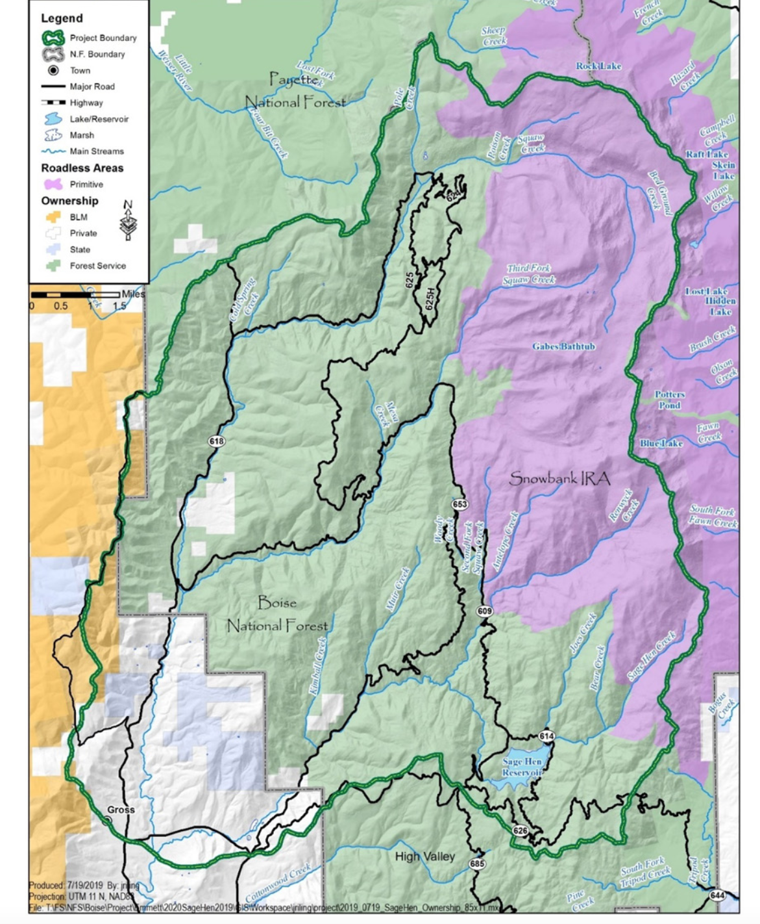

The purported Sagehen project goals are:
“Objective 1: Manage forest structure and species composition to develop and maintain a resilient landscape. Emulate disturbance processes to trend forested and non-forested vegetative communities toward desired amounts, patch sizes and patterns as described in the forest plan. [Hotter, drier, weedier, windier and disproportionate early-mid seral veg is not “emulating disturbance processes. Hauling off wood and pike burning and broadcast burning and jackpot burning, represents a massive loss of carbon sequestration feeding into the
The project’s radical liquidation and purging of woody habitat elements, nutrients and carbon is not “emulating disturbance processes”. Bulldozing huge lengths of new roading and “improving” lengths of existing roads is not either.
Objective 2a: “Manage towards a minimum road system that takes into consideration future management needs, impacts to aquatic and terrestrial habitat, and current and anticipated multiple uses”.
Objective 2b: “Restore unneeded roads to a more natural state to reduce fragmentation of landscapes and improve habitat quality for wildlife species”.
Objective 2c: “Improve access to habitat for bull trout in the Squaw Creek watershed”. The FS fails to effectively address the large-scale deleterious impacts of cattle grazing on the project area streams and aquatic species habitats, including in bull trout watersheds.
Objective 3a: Enhance recreational experiences while reducing potential for resource degradation. Please define and quantify “resource degradation”. How much will the radical removal of protective and screening cover lead to wildlife habitat and species sustainability and viability “degradation”?
Objective 3b: Manage dispersed and motorized recreation to reduce user conflicts. [How much will these massive treatments, cleared areas, road improvements, etc. increase user conflicts- specifically users who don’t seek an “industrial forest”, or heavily roaded manicured forest experience. Almost every bit of the Forest land area will be torn apart in various ways, with almost no area left to develop as natural forest/natural vegetation community].
Objective 4a: Reduce hazardous fuel loads and potential for undesirable wildfire effects. [The FS must conduct an honest assessment of how this project will make lands hotter, drier, windier, weedier, with a longer fire season, more susceptible to irreversible flammable grass expansion, more easily intruded on. By motorized vehicles and susceptible to human-caused fires, and the FS is already planning for bulldozing firelines as the FS proposes to conduct large-scale4 burning that could rage out of control.
Objective 4b: Utilize wood products from the suited timber base and invest in multiple-use opportunities to support local and regional economies, industries and livelihoods.” [How does this clash with agency climate goals and the need for carbon sequestration? Isn’t much of the local economy based on recreational uses of public lands, including wildlife on public lands?].
In 2020, the FS stated: “maximum of 20,700 acres could be treated with timber harvest. Approximately 13 to 18 timber sale contracts could be awarded within the project area. Sale areas have been delineated based on the existing transportation system and primary haul route locations. Implementation would occur over an approximate 10 to 15-year timeframe. Approximately 3,000 to 5,400 acres of commercial harvest could be implemented annually. The average contract would be 5 years in length. The first timber sale contracts will likely be awarded in 2021, with some roadwork and harvest beginning in Summer/Fall of 2021 …”.
Also in Sagehen 2020: A maximum of 92.4 miles of temporary roads could be needed to implement timber harvest activities. Approximately 27 percent would be located on an existing prism. Temporary roads for a harvest area could be in use for up to 3 to 5 years. Motorized public use is prohibited on temporary roads, with only administrative motorized use occurring as needed to implement management activities.
Almost every acre was slated for “treatment” – commercial (purple) and non-commercial (green).
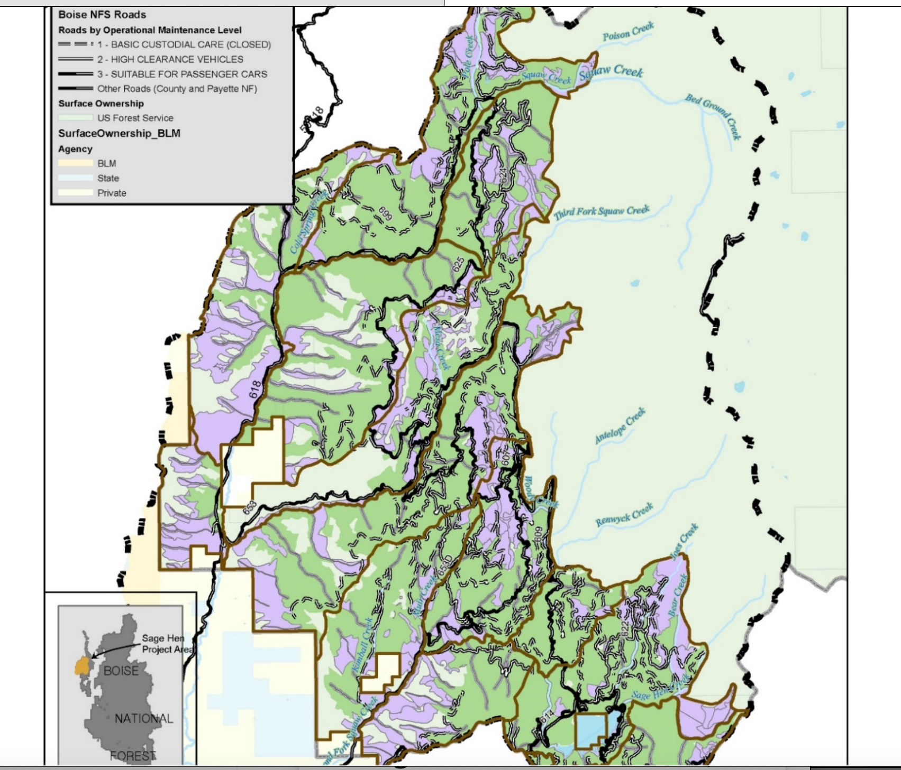
The above is from 2024. Boise NF Sagehen project is at the far northwestern edge of the Boise Forest, and Payette lands lie to the north and west.
It shows that once again there is no valid series of alternatives. The USFS is intent on forcing massive deforestation and burning that will destroy and fragment nearly all the existing wildlife habitat at Sagehen.
The 2024 Sagehen wildlife report claims:
“Alternative B was developed after the decision was rescinded and incorporates comments received through settlement negotiations”. This sure doesn’t seem accurate.
2024: “The Four Corners fire burned in a mosaic on the Emmett Ranger district with negligible effects due to most of the burn occurring on the Cascade Ranger district. [But what Forest types did it burn? And what are the cumulative effects of this? How much land outside the RD has since burned?
We found this map – is this the final fire perimeter?
https://inciweb.nwcg.gov/incident-maps-gallery/idpaf-four-corners-fire
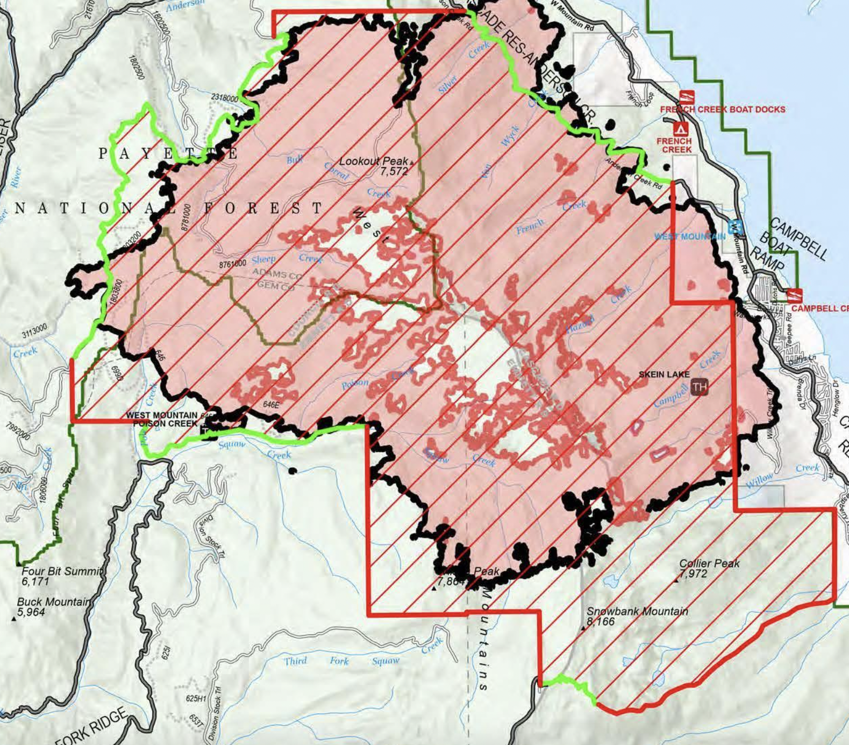
This map shows the Four Corners fire extended outside the Emmett RD on to the Payette Forest, and a significant area of lands burned was state and private land on the west side of Cascade reservoir. So please accurately analyze the full footprint of the fire, and the forest and other habitat loss, and impacts to the region’s sensitive and rare species and other values.
See also: https://www.ktvb.com/article/news/local/wildfire/four-corners-wildfire-burning-border-payette-boise-national-forests/277-8f0b6e46-8ca3-4932-9d6f-fb7d52274dde
KTVB TV station reported: “As of Monday, Sept. 26, the fire has burned 13,729 acres and is 96% contained”.
The massive Payette Fire EA Wildlife BE now pending shows plans to burn the lands immediately to the north of portions of the project area.
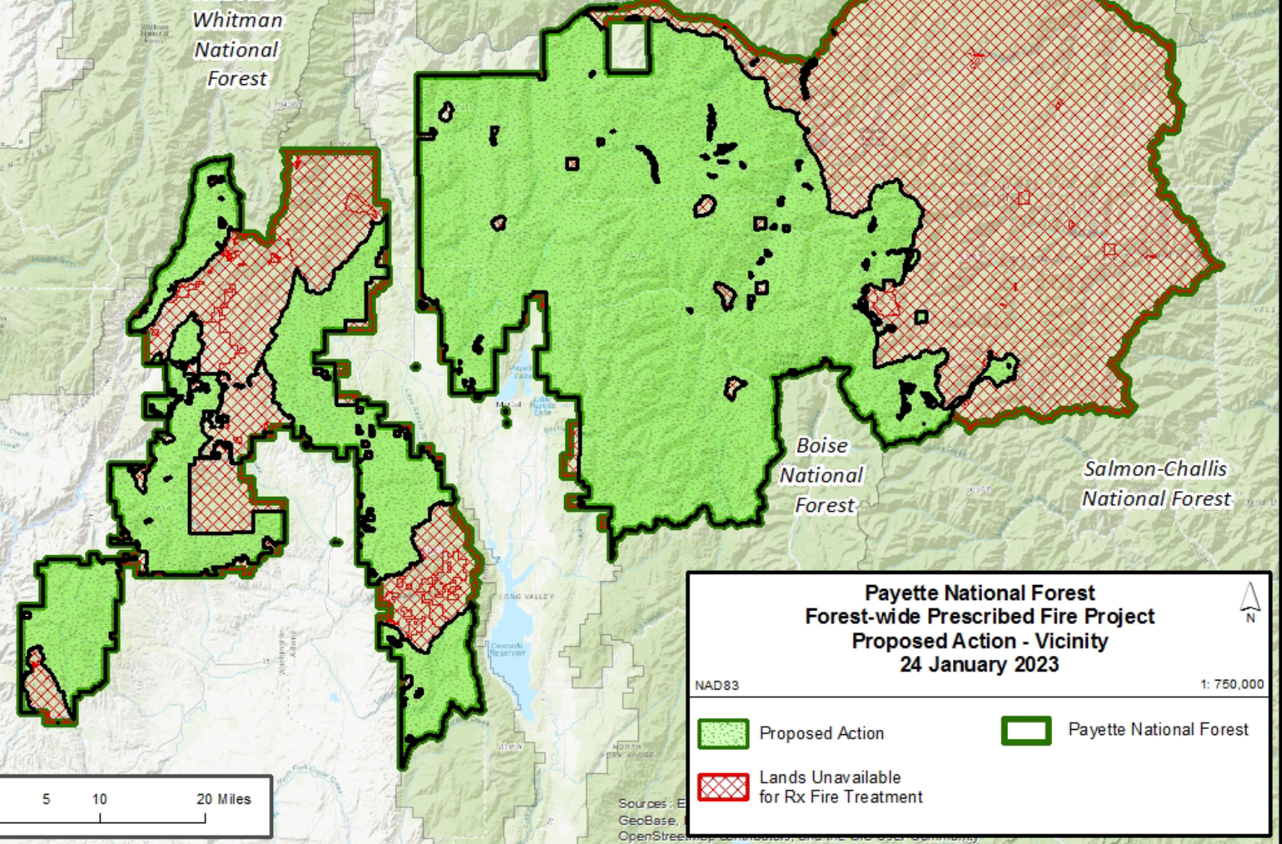
Note that nearly all areas proposed to not be burned (red on map) have burned in recent years. Thus the PNF scheme is to burn up nearly all the remaining mature forest sensitive species habitats, IRAs, etc.
The FS refers to: “Salvage sales have occurred within the proposed project area and were analyzed prior to implementation”. [This represents more strip mining of wood and nutrients and habitat elements for a host of native species– and more loss of carbon sequestration].
The old Sagehen DN is here:
file:///Users/pc/Downloads/20210414SageHenDN.pdf
The 2024 Sagehen project continues to rely on the same old myths of homogeneous veg and extremely short fire intervals from the extremely brief intervals the old DN, including:
“Nonlethal fire regimes have a fire return interval of 5 to 25 years, with fire intensity resulting in equal to or less than 10 percent mortality. The resulting vegetation patterns are relatively homogenous with small patches generally less than 1 acre of different seral stages, densities and compositions creation from mortality. Mixed 1 fire regimes have a fire return interval of 5 to 70 years, with fire intensity resulting in greater than 10 to 50 percent mortality. The resulting vegetation patterns are relatively homogenous with patches created from mortality ranging in size from less than 1 to 600 acres of different seral stages …”.
[Please provide scientific information for all vegetation communities in the project area that shows such extremely short fire return regimes. There is substantial scientific information that contradicts this FS assertion. These much too short intervals are used to justify logging. This forest mythology flies in the face of many species adaptations to mature and old growth forests]. See opposing information:
“Most plant communities of the West typically experience long fire rotations of many decades to hundreds of years without any significant fire. This includes spruce-fir, lodgepole pine, juniper-pinyon, sagebrush, chaparral, aspen, west-side Douglas fir, and many other plant group”.
https://www.thewildlifenews.com/2024/02/12/one-hundred-years-of-fire-suppression-narrative-challenged/
…before World War 11, fire suppression consisted of a few men riding mules around in remote wilderness areas armed with shovels and axes. Their influence on wildfire starts and spread was insignificant.
“Statistics bear this out. Between the early 1900s and late 1930s, tens of millions of acres of forest were charred by wildfire annually …”.
“What drives large blazes isn’t fuel. You can have all the fuel in the world, but you will not get a significant blaze if you don’t have the right climate-weather conditions. The conditions that create large fires include severe drought, low humidity, high temperatures, and, most importantly, high winds.
Wind-tossed embers are responsible for 90% of the structural losses across the West.
I have visited dozens upon dozens of large blazes across the West, and I know no exceptions to the generalization that climate/weather is the driving force behind significant wildfires”.
Higuera et al. 2021 (linked in the above Wuerthner article) describe:
“ … Therefore, the 21st century FRP of 117 y, largely because of the 2020 fire season, represents nearly a doubling of the average rate of burning over the past 2,000 y”.
“… the increasing magnitude and frequency of extreme moisture deficits in the 21st century (Fig. 1B), rather than increased fuel abundance, lacks precedent in recent millennia and has driven the 21st century shift in fire activity”.
… before World War 11, fire suppression consisted of a few men riding mules around in remote wilderness areas armed with shovels and axes. Their influence on wildfire starts and spread was insignificant.
Statistics bear this out. Between the early 1900s and late 1930s, tens of millions of acres of forest were charred by wildfire annually.
See also: https://cfri.colostate.edu/wp-content/uploads/sites/22/2021/01/FireEd-Infographic-Web_Print-1.pdf
Baker 2013 describes how fire regime studies are very often biased selection or inclusion of tress with obvious burn scars.
https://cdnsciencepub.com/doi/abs/10.1139/cjfr-2013-0176
See also;
Baker, William L.; Ehle, Donna S. 2003. Uncertainty in fire history and restoration of ponderosa pine forests in the western United States. Pages 319-333. In: Omi, Philip N.; Joyce, Linda A. (technical editors). Fire, Fuel Treatments, and Ecological Restoration: Conference Proceedings: 16-18 April 2002: Fort Collins, Colorado. Proceedings RMRS-P-29. Fort Collins, CO: USDA Forest Service, Rocky Mountain Research Station.

See also:
https://www.thewildlifenews.com/2023/04/09/fire-paper-challenging-traditional-wildfire-science/

Baker et al. 2023.

https://www.mdpi.com/2571-6255/6/4/146
“Two models of HRV, with different implications, have been debated since the 1990s in a complex series of papers, replies, and rebuttals. The “low-severity” model is that dry forests were relatively uniform, low in tree density, and dominated by low- to moderate-severity fires; the “mixed-severity” model is that dry forests were heterogeneous, with both low and high tree densities and a mixture of fire severities. Here, we simply rebut evidence in the low-severity model’s latest review, including its 37 critiques of the mixed-severity model. A central finding of high-severity fire recently exceeding its historical rates was not supported by evidence in the review itself. A large body of published evidence supporting the mixed-severity model was omitted. These included numerous direct observations by early scientists, early forest atlases, early newspaper accounts, early oblique and aerial photographs, seven paleo-charcoal reconstructions, ≥18 tree-ring reconstructions, 15 land survey reconstructions, and analysis of forest inventory data. Our rebuttal shows that evidence omitted in the review left a falsification of the scientific record, with significant land management implications.”
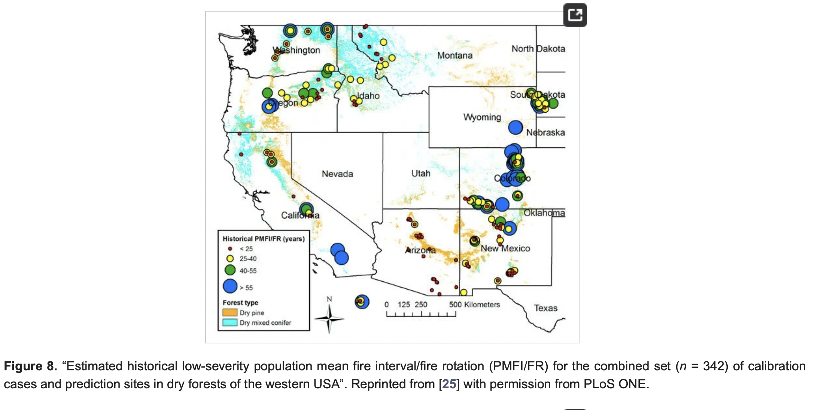
Figure 8 from Baker et al. 2023 shows 25-40 years is a far more accurate estimate of fire intervals in Ponderosa pine than the claimed 5-25 this project is based on.
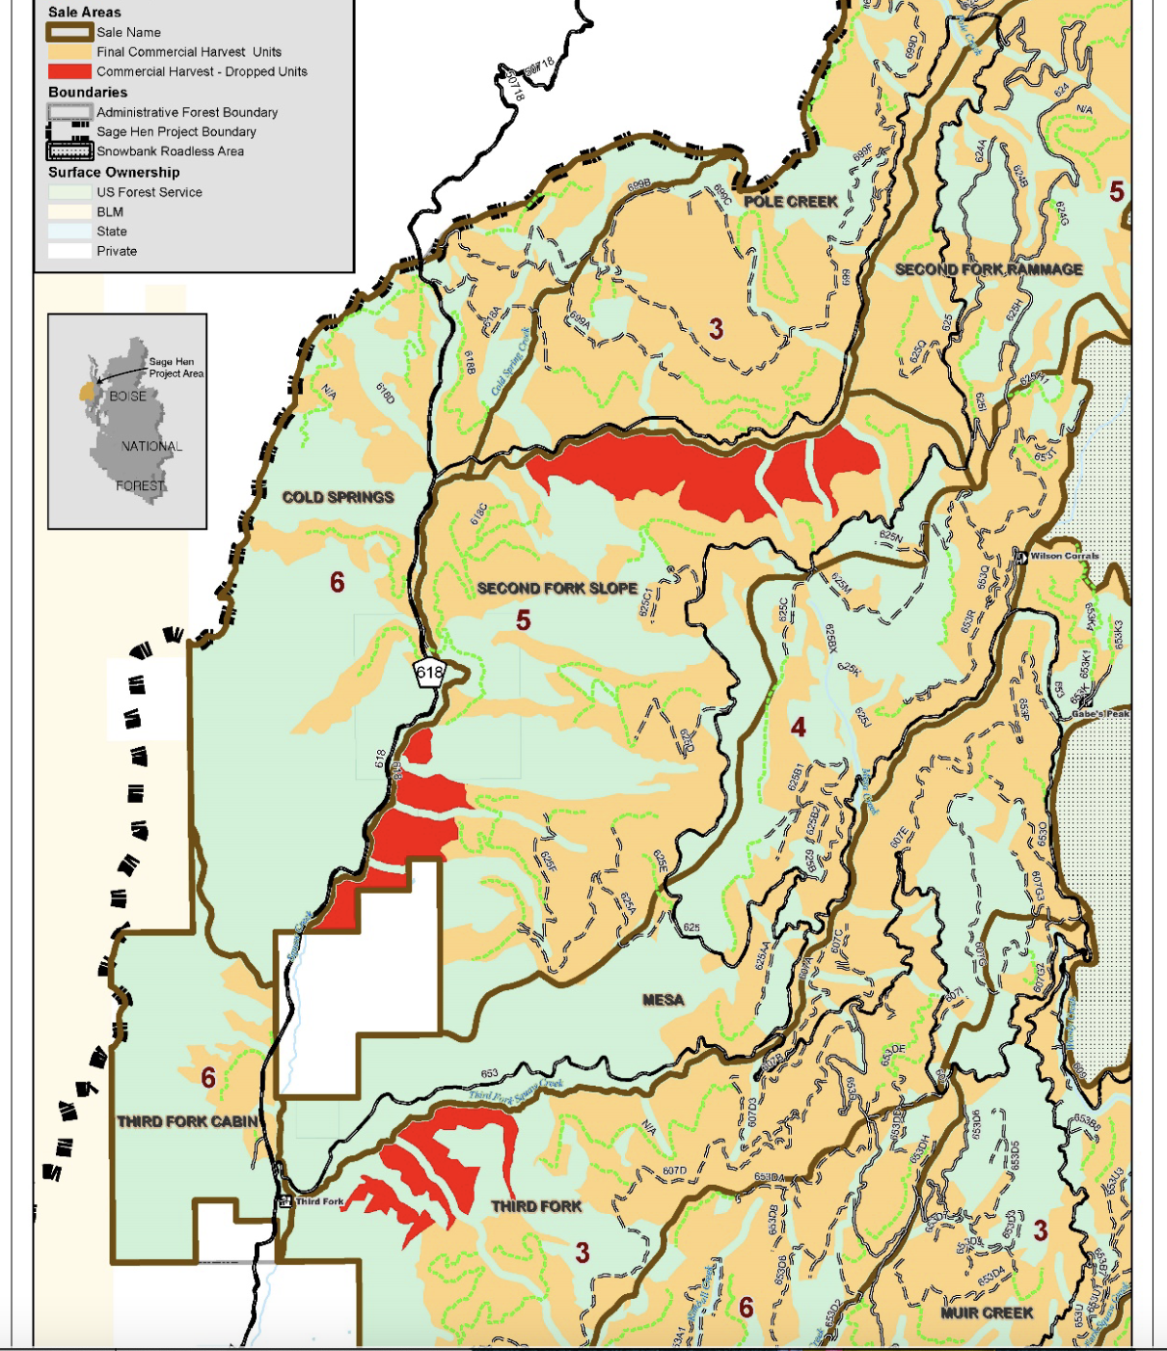Red in the above was dropped by the old Sagehen DN.
The FS failed to conduct scoping for the 2024 process, thus cutting out public information on alternative actions and the current scale and scope of threats to sensitive species persistence and other forest values that will be harmed by the project.
The 2024 EA states: “Since the original analysis that informed the Sage Hen EA in 2020, additional baseline surveys have been completed across portions of the project area. Botany surveys were completed in the Four Corners Fire perimeter and additional Sensitive Species surveys were completed in other parts of the Project Area. [please map, detail methods and times, and provide results of all of these]. Also, the fisheries crew collected additional eDNA surveys in various stream reaches of the project area”. EA p. 13
As the 2024 Sagehen EA Table 2 shows, there is almost no difference between the 2 alternatives. The FS refers to EA figure 18. And these alternatives certainly do not reflect the “settlement” discussions”. It appears the FS purposefully did not scope this project. Instead, the FS galloped ahead with a Draft EA and FONSI truncating public review, Has logging in one area been replaced with “pre-commercial thinning” in the 2 nearly identical alternatives? Alternatives are the heart of the NEPA process, and the FS did not scope this latest EA. The agency basically chopped off the public’s ability to submit alternatives. Instead, the FS again hid behind the logging collaborative.
Sagehen Figure 18 map
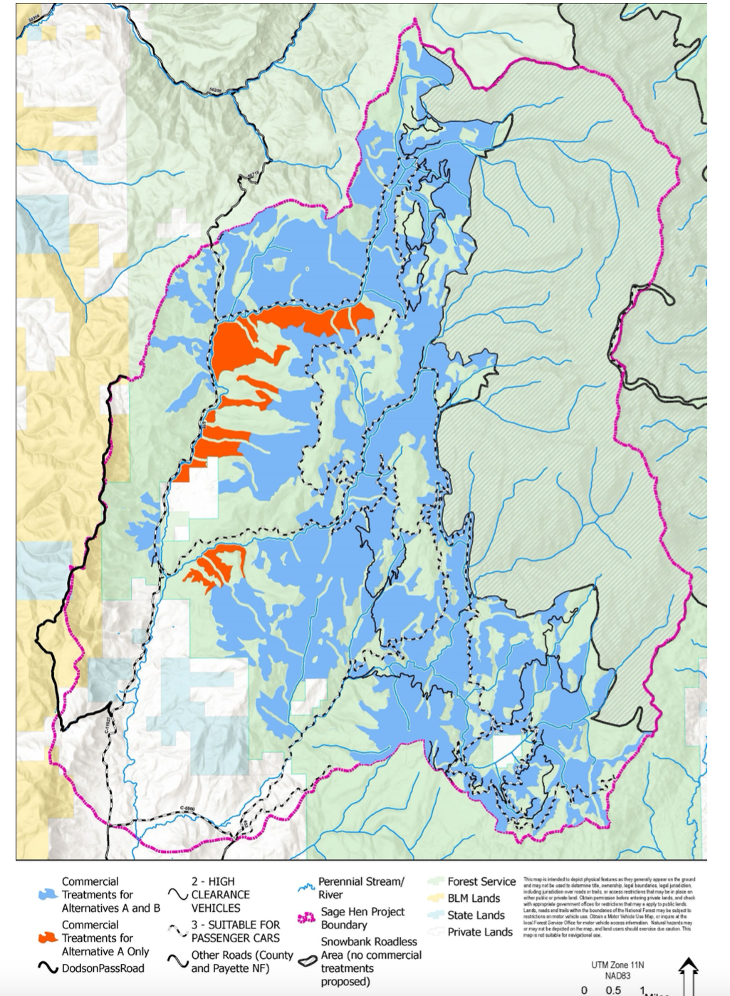

Note the red on this amp corresponds to the 2020 EA DN’s dropped logging shown in the old Sagehen DN map above.
So the 2024 EA “alternative A” appears to merely resurrect the old 2020 EA logging scheme.
However, it appears much of the acreage of the dropped logging areas has been folded into Other Treatments.
The FS states that in 2024 more acres have been killed by tussock moth– demonstrating the futility of the FS “treatments” to address insect issues - as the FS has already killed many trees already claiming to help control infestations (see photos) – and all for naught, and likely making insect infestations worse due to logging and burning disturbances as seen in photos. So WHY should more be killed? In fact, the incessant FS logging, burning and other manipulation disturbance will wound and kill “leave” trees and patches (and its really only little highly fragmented patches that will remain) trees and cause hot, dry, windy, weedy, conditions that will exacerbate insect problems. In reality, the severe Sagehen manipulation proposed for nearly every acre of the forest will only make matters worse.
How will the FS address continued insect forest live tree loss in its “prescriptions” for logging/thinning/burning/road building “leave tree” or “road leave path” claims? How many MORE trees are expected to die without logging/treatments, and where will they be located? How many more with logging/treatments?
Activity Cards – These are a loose laundry list series of possible actions that might be applied – without binding certainty. The FS uses the “card” description in CBM for what in the past were a similar set of loose uncertain BMPs – which were tied the actions to a specific land area. It’s ecological insanity to develop a project for 15-20 years that does not identify specific actions in a specific site with unique characteristics of aspect, slope, threatened species vital habitats, existing levels of water quality degradation, etc. Instead, with - no new public NEPA process, and no new integrated NEPA analysis, specific projects would occur and impacts never be assessed in a hard look NEPA analysis. That addresses ever-increasing and likely new and never analyzed threats. The wild card of climate change and a host of foreseeable threats makes this “condition-based” management approach even more of a loser for our forests and the preservation of sensitive and imperiled species.
Yet no new integrated NEPA analysis would occur for a project potentially 20 years from now (and the whole basis for this scheme is the collaborative logging group and old or limited inventories and a management scheme based on a circa 2003 wildly out-dated Forest Plan “PVG” scheme, and some inadequate surveys.
It is unclear when in the year any burning will take place.
This highly uncertain NEPA-violating massive any time of year burning would result in extreme levels of take under the migratory Bird treaty Act. Full and detailed multi-year surveys for all nesting, wintering and other migratory birds must take place as a baseline for this immense disturbance scheme.

Intensive surveys for all native carnivore dens and resident wildlife of concern must be conducted, and detailed studies on use of home ranges must take place for multiple years in advance of any decision here.

The year-round burning is made even riskier given the large-scale “prescribed fires” turned wildfires” Forest Service incidents in New Mexico in 2023 and other times.

THIS from the SWIRL project Scoping appears to be similar to the wildly short fire intervals the Sagehen project is based on:

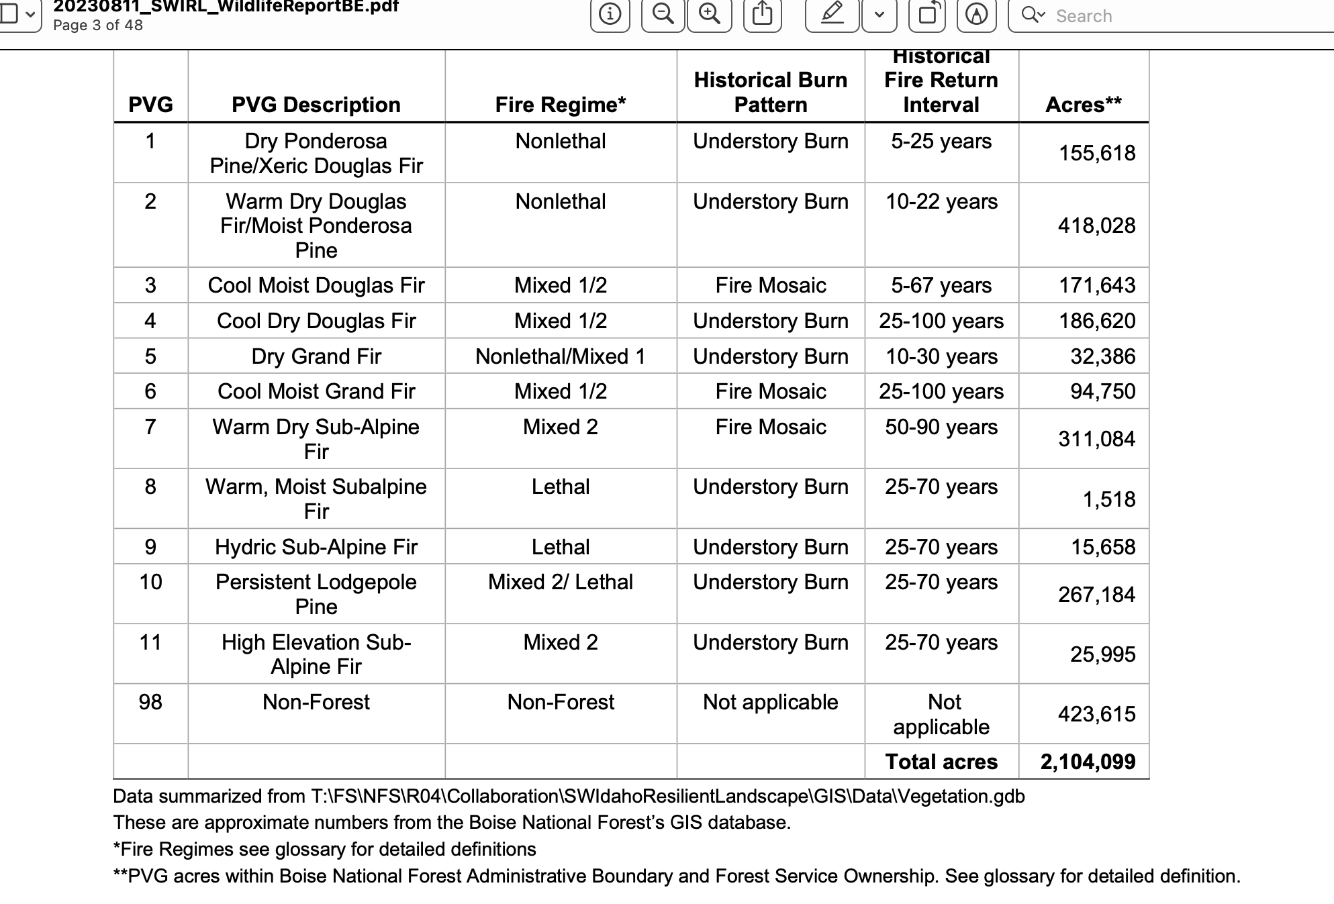

The 2024 Sagehen document is not adequate for fostering informed public comment on complex vegetation communities, wildlife habitats and populations, wild lands values and many other aspects of this sprawling project. A valid range of reasonable and current science-based alternatives is lacking The USFS must re-scope this very significant project as an EIS, and provide basic current systematic baseline biological inventories and other ecological information to the public to thoroughly detail the status and habitat condition of the animal species who currently occupy the native plant communities that the USFS deems unhealthy or uncharacteristic or deviant or having too many “fuels” or otherwise claimed in this document to be in need of large-scale disturbance and simplification from native tree and shrub removal and weed-causing “treatments”. We are very concerned about the FS use of the categories rigidly applied to complex habitats for rare native carnivores, rare owls, migratory birds, Mule Deer. Elk, Blue/Dusky grouse, and many others. How can sudden natural events (fires, insects) change how much land area is “surplus”? How can climate change stress change this “surplus”? What is the date when these categories were mapped? We are very concerned that the Forest’s artificial models with extremely short disturbance intervals and uniform “pure” veg types that do not reflect how natural plant successional processes play out in the real world, such as the intervals used in the out-dated Forest Plans or on the Landfire site are being used to justify radical manipulation that will result in a major Habitat loss and deficit of habitats for Wolverine, Canada Lynx, Fisher, Norther Goshawk, Great Gray Owl, migratory birds and a host of other species.

We are concerned about the FS use often by use of artificial categories and vegetation and fuels models that appear designed to justify extensive manipulation. After reading the Sagehen document, it appears that the Forest is not really satisfied with ANY existing vegetation community anywhere in the project landscape. How many unmanipulated /unlogged/untreated acres of all vegetation types remain at present across this project landscape? How many across the Emmett RD, which is very heavily logged, disturbed and weed-infested? How much will this change with the project? With ongoing or foreseeable projects in the RD and BNF? How fragmented has the landscape become in habitats necessary for each FS sensitive and MIS species of concern? How much will this change with the project? What is the current viability of all populations of species of concern? How will this project impact species numbers and persistence across the project area, the RD and the Forest? It is not possible for the FS to understand if current Forest plan goals are met for important and sensitive species and their habitats as monitoring has not been adeq1aute (see Monitoring discussion herein. Are they met for MIS species, and where is the monitoring data that shows this? Are they met for migratory birds and all other species of concern? Where is monitoring data that shows the current status of habitats and populations for these species, and that shows that Forest plan goals are currently met for these species? How will the massive manipulations affect attainment of FS goals for each sensitive species and other species of concern?

USFS lands here are suffering significant deleterious grazing impacts. See attached photos. No current NEPA and FRH or land health analyses related to grazing impacts have been conducted in many areas. The poorer condition that lands are in prior to a “treatment” disturbance, including the proposal’s massive burning disturbance, the greater risk of weed and other problems following vegetation treatment disturbance – especially these large-scale treatments that will result in hotter, drier windier weedier sites. The project actions are very likely resulted in significantly increased use of toxic chemical herbicides for which the FS does not appear to have adequate current risk assessments nor adequate current NEPA analysis of these chemicals toxic impacts on terrestrial and aquatic species (sensitive, rare, T&E) and on human users of the Forest in this area that is heavily used by the public for recreational purposes. Human exposure risks will be maximized by clearing away vegetation that helps filter runoff and lower wind speeds and thus reduce “drift”. Further, there is no hard look at information on foreseeable aerial toxic chemical herbicide applications or other methods of applications that are foreseeable and are prone to drift and contamination. What is the potential for runoff or contamination of surface waters highly used by aquatic biota and the recreational public? For collateral damage to non-target species? For harm to “leave” trees or patches?

There is significant concern for increased sedimentation and warmer temperatures of surface waters from this large-scale disturbance activity – including inside RHCAs. Please review phnotos attached showing how deghraded riparian areas accessible to cows are – and these will significantly increase with these massive treatments. Please provide detailed baseline analysis of current stream temperatures, cobble embeddedness, flow rates during all seasons of the year, etc. so that a baseline of aquatic habitat conditions can be established. This is necessary to serve as a basis for estimating the magnitude of change caused by the project, and to ensure water quality is met.

There are also significant areas in neighboring lands and across the RD, with large-scale habitat losses due to logging and projects very similar to this, and with significant biodiversity loss, watershed degradation and weed infestation risk as well. There has been many past logging and other treatments across land ownerships, and he USFS land condition is often highly degraded as result of past logging, thinning, burning, high densities of motorized trails and activity based on failed management paradigms. Nearly all these lands also suffer chronic high levels of livestock grazing disturbance. Please provide detailed mapping and analysis of all logging, thinning, vegetation treatment projects across the RD in the past 20 years, and monitoring of wildlife use, watershed condition and fish and wildlife populations in these treated areas. Please also provide weed inventories. Please provide similar detailed mapping and analysis for all ongoing and/or foreseeable projects.

There is a massive West-wide influx of funds for large-scale logging “treatments” dubbed “restoration”:

https://lmtribune.com/biden-administration-sending-funds-out-west-for-fire-reduction/article_58178e1c-9822-11ed-8ebd-27fe5f198a98.html

“Combined with another significant slug of funding from the Bipartisan Infrastructure Act that was announced last spring and targeted to 10 landscapes, Vilsack said the administration has made $930 million available to reduce fire risk on 45 million acres. Last year, the Boise and Payette national forests, part of the 1.7 million acre Southwest Idaho Landscape, were included in the initial phase of funding”. This manor funding will have massive adverse cumulative effects and harms to Wolverine, Northern Goshawk, and many other rare and declining species.
The highly uncertain intensive management actions here, with multiple overlapping disturbances are similar to intensive management actions on heavily cut and manipulated private lands.
See Baker and Bevington https://rewilding.org/myths-of-prescribed-fire-the-watering-can-that-pretends-to-be-a-river/ re: Problems with prescribed fire including smoke and risk of escape. In the project, lands could even suffer multiple bouts of fire depleting vegetative cover, exposing soils to erosion, adding carbon to the atmosphere, depleting nutrients – a real concern on the nutrient-deficient granitic soils of the Idaho batholith, and very cheatgrass-vulnerable basalt-derived soils. The “condition-based management” CBM scheme fails to specify and identify a specific treatment area and each type of treatment to be used in specific sites in that area makes any accurate science-based analysis impossible. This adds to the serious ecological risk of the project and increases uncertainty over its harms to plant communities and biodiversity including many sensitive species habitats and populations.
Also re: agency “prescribed fire:
“Another myth repeated by some prescribed fire advocates is the erroneous notion that forests that previously experienced Ore suppression will now “burn up” in all or mainly high-intensity fire when a wildfire occurs, unless those forests first get prescribed fire or other “fuel treatments.” But multiple studies have shown that areas that experience wildfire following long periods of fire
suppression still burn mainly at low and moderate intensity, along with some high-intensity
patches that provide the benefits described above (Odion and Hanson 2008, Miller et al. 2012). In fact, research has found that forests with the longest fire exclusion actually burn at somewhat lower intensity (Odion et al. 2010). This is exciting news for efforts at ecological restoration because it means that large-scale prescribed fire or other “treatments” are not needed as a precondition to allowing mixed-intensity wildfire back into forests”.

Downing et al. 2022 demonstrates the need to focus fuels efforts on private lands. The FS here fails to provide an adequate baseline of fuels situations, hardening of homes, etc. on private lands, and fails to consider a range of alternatives focused on treatments there.

An OSU news article describes the flawed paradigm that the FS embraces with this project:

“In the old framing, public agencies bear the primary responsibility for managing and mitigating cross-boundary risk and protecting our communities, with their efforts focused on prevention, fuel reduction and suppression,” Dunn said. “This has been the dominant management approach of years past, which is failing us.” The Findings, published today in Nature Scientific Reports, follow by a few weeks the Forest Service’s release of a new 10-year Year strategy, Confronting the Wildfire Crisis. The strategy aims for a change in paradigm within the agency, Dunn said. “We are long overdue for policies and actions that support a paradigm shift,” he said.

See also Chad Hanson (2021): Logging in disguise: How forest thinning is making wildfires worse. https://grist.org/fix/opinion/forest-thinning-logging-makes-wildfires-worse/

“The idea of felling trees and hauling them to lumber mills in the name of fire prevention has
many deceptive names: fuel reduction, forest health, ecological restoration, thinning,
and even reforestation. As I detail in my book, Smokescreen, the Forest Service began using these terms in the mid-1990s as the public became more aware of the horrific realities of widespread clearcutting of mature and old forests on public lands in the Pacific Northwest, and the northern spotted owl became a household name”. See also information on Bootleg and other fires discussed in the Hanson article.

Bradley et al. 2016 report: “We investigated the relationship between protected status and fire severity using the Random Forests algorithm applied to 1500 fires affecting 9.5 million hectares between 1984 and 2014 in pine (Pinus ponderosa, Pinus jeffreyi) and mixed‐conifer forests of western United States, accounting for key topographic and climate variables. We found forests with higher levels of protection had lower severity values even though they are generally identified as having the highest overall levels of biomass and fuel loading. Our results suggest a need to reconsider current overly simplistic assumptions about the relationship between forest protection and fire severity in fire management and policy …”.

Note that the SCNF Iron Creek mining exploration EA includes a 2011 fire as having harmful effects on Boreal Owl, Great Gray Owl, Flammulated Owl, Northern Goshawk, and Wolverine. Yet here in both Sagehen (and More’s Creek in the BNF) and Granite Goose large-scale logging/veg clearing “thinning”/fire, or a combination of fire and mechanical manipulation, will be unleashed across nearly the entire landscape.

This Sagehen project (and the huge number of additional projects already undertaken, proposed or foreseeable in the Boise Forest and in the Payette Forests and adjacent lands) would impact a large area of very weed-susceptible wild lands and fish and wildlife habitats. By drastically reducing protective maturing , mature and old growth forested vegetative cover (the latter harmed as collateral damage), this project (and the many others that are planned and/or foreseeable) will reduce the ability of the land to retain snow cover, and result in more extreme runoff events with higher erosive effects exposing vulnerable treatment-disturbed soils to elevated erosion rates. It would remove shading vegetation that helps retain moisture on the site so that water is slowly released from the system to provide sustainable perennial flows. Not only will forested cover shading and cooling moisture-trapping protection be greatly diminished by the project, site conditions will become harsher due to increased temperatures and other weather changes resulting from climate change stress. This will amplify and worsen the adverse effects of climate change stresses including erosive runoff and loss of essential elements of riparian and aquatic habitats.

We are very concerned that this project will result in much more erratic stream flows and flow losses. Please provide detailed stream and spring flow rate information and mapping of all perennial vs. intermittent vs. ephemeral water flow segments of streams. Full and detailed mapping and analysis of existing springs and moist areas must be provided. All RHCAs must be avoided. The FS must consider all areas surrounding springs to be RHCAs. Please provide detailed mapping and analysis of all springs, fens, boggy areas, meadows -and full and detailed assessment of the impacts of livestock grazing on the ecological conditions of all riparian sites.

Utah research shows flow losses. Note the author refers to beetle ifrestatoi9ons as “a natural thinning event”:

“That ‘natural thinning event,’ I have not used that phrase and I really like it,” said Sara Goeking, a biological scientist with the U.S. Forest Service Rocky Mountain Research Station, “... That’s what the mountain pine beetle epidemic really was. And there were a handful of studies that showed water yield didn’t increase, it didn’t change. Some of them found some decreased water yield.” Also: “It ran counter to prevailing beliefs at the time — forestry scientists had hypothesized since at least the 1960s that reduced forest cover would yield more water. While working on her Ph.D. in watershed sciences at Utah State University, Goeking wanted to explore why it wasn’t always the case in forests across the West.
“Most of the studies were done in wetter places,” she said. “No one ever really thought maybe that doesn’t hold true everywhere.”
Goeking collected data on forest disturbances like beetle outbreaks, wildfire and drought at 159 watersheds across the region, including some in the Uinta Mountains. She also analyzed streamflow measurements and climate information for those sites over a 20-year period”.
“the generally held hypothesis that forest cover and streamflow are inversely related is not universal in semi-arid western watersheds”.
“Thus, significantly decreased streamflow was more prevalent in disturbed than undisturbed watersheds, counter to commonly held expectations. Increased streamflow in 44% (8 of 18) of undisturbed watersheds coincided with higher precipitation overall in 2010–2019 compared to 2000–2009. Multiple regression analysis showed that mortality explains some variability in ΔQ that is not explained by climatic drivers, and that the direction of streamflow response to mortality (i.e., increase vs. decrease) is affected by aridity.”
https://www.sltrib.com/news/environment/2023/02/11/scientists-say-thinning-forests/.

Snowpack is essential to provide sustainable water flows, and climate change is reducing snow pack persistence. Drastic MLNF-caused reduction in shading forest and other woody watershed cover will also reduce snow persistence and result in a longer fire season, reduced aquifer recharge. See Hammond Dissertation 2018, describing
https://mountainscholar.org/bitstream/handle/10217/193128/Hammond_colostate_0053A_15153.pdf?sequence=1
“Loss of concentrated melt from persistent snowpacks may lead to lower streamflow and compromise deep drainage, and thus aquifer recharge, in semi-arid cold regions. The consequences of streamflow and groundwater recharge loss could be severe in regions already water-stressed, and this needs to be addressed in long-term water supply planning”.
Also see Biederman et al. 2015, “Recent tree die-off has little effect on streamflow in contrast to expected increases from historical studies”.
http://naes.agnt.unr.edu/PMS/Pubs/687_2015_04.pdf
“Time-trend analysis revealed post-die-off streamflow decreased in three catchments by 11–29%, with no change in the other five catchments. Although counter to initial expectations, these results are consistent with increased transpiration by surviving vegetation and the growing body of literature documenting increased snow sublimation and evaporation from the subcanopy following die-off in water-limited, snow-dominated forests. The observations presented here challenge the widespread expectation that streamflow will increase following beetle-induced forest die-off and highlight the need to better understand the processes driving hydrologic response to forest disturbance”.
Additionally, the Sagehen project will generate large amounts of ash during burning - with foreseeable deposition on snowpacks from FS winter-spring burns that have been increasingly conducted during, and following burns there will be soil erosion and dust for years following burning. Livestock grazing soil disturbance and trampling-caused destruction of microbiotic crusts is also a serious concern. The fire and other activity destroy crusts, the grazing prevents or retards crust recover, excessive dust is produced. We Object to the failure to quantify and take a hard look under NEPA at baseline and treatment-generated erosion in wind and water.

See for example, https://yaleclimateconnections.org/2018/03/dust-on-snowpack-a-gas-pedal-for-snowmelt/ , “Dust on snowpack a gas pedal for snowmelt”.

How much will the Fire EA activities increase ash deposition and also dust? What is the current baseline dust production? What is the erosion hazard for all project area soils? How is grazing currently impacting erosion rates? Please provide data and analysis - including of wind patterns and other information necessary to understand ash and dust deposition.

This all heightens the risk and uncertainty of this loose CBM scheme.

An EIS must be prepared to examine the host of adverse and other direct, indirect and cumulative impacts of this severe proposed project disturbance to the area watersheds, to streams and springs and their replenishment, to soils and protective microbiotic crusts (mosses, algae, lichens that help protect lands from weeds, sequester CO2, and prevent soil erosion), to diverse and complexly interspersed native vegetation communities, to sensitive and rare plant and animal communities and populations, to very important Inventoried Roadless Areas and other wild land natural and scenic values, irreplaceable cultural sites, and other values. Note that the unexamined levels of grazing, AMPs and management schemes, and stocking rates under actual use of livestock here will exacerbate and worsen the stresses of climate change and would hamper any recovery from the multiple disturbances being heaped in this landscape. See Beschta et al. 2012, 2014. Grazing makes lands LESS resilient and less able to recover from such severe vegetation disturbance stresses as the FS seeks to impose here – on top of watersheds already significantly damaged by logging, grazing and roading. The increased temperatures and extremes from climate change stress also make it less likely that forests will be able to recover in many areas. Fusco et al. 2019, Kerns et al. 2020.

There is currently serious livestock grazing degradation occurring across portions of the project area. This baseline level of degradation and impairment, and its impacts on biota of concern and other uses of the Forest, must be fully examined in an EIS for this project. A complete livestock current capability and suitability analysis must be provided including data on native perennial vegetation vs. annual and other weed infestations.

Not only is the USFS destroying protective cooling weather-moderating forested cover here, many other projects are underway in the Boise, Payette Forests and across Region 4 and also the Nez Perce Forest that will have cumulative adverse effects on sustainability of fish and wildlife habitats and populations, and recreational and wild land uses and enjoyment.

The cumulative and synergistic effects of all of these projects and impacts must be fully examined in an EIS that takes a hard look at the sustainability of forest vegetation types in a time of Climate Crisis, at irreversible weed invasion risks that may be caused by the severe project treatment disturbances, at the condition of sensitive wildlife species habitats and population viability and persistence, at migratory bird habitats and population viability and persistence, and at other important species habitats and population viability and persistence across this landscape.

Forest Tree Cutting Does Not Effectively Suppress Beetles or other Insect Outbreaks– Tree Injuries from Treatments Attract Insects, Weaken Injured Trees and Foster Pathogens

Timber harvest treatments do not effectively suppress bark beetles (a natural thinning event). The massive project treatments will weaken and injure remaining trees, increasing susceptibility. How many mores trees are likely to die because of “treatments” injuring them or neighbors? Outbreaks are dependent on temperature, differing tree defenses and beetle fluctuations. Salvage “treatments that log dead trees do not really reduce or impact beetle populations - as beetles are long gone from those trees. The project relies on unsupported assumption to clearcut and log both damaged and healthy trees, thus setting back regeneration, herbaceous production and wildlife habitat. Cutting trees will not control the beetle infestation or other forest “problems”. Instead, the Forest Service should be reducing the stresses on the health of these forests (like livestock grazing – as the grazing and trampling of livestock reduces water infiltration, compacts soils, dries out sites, and increases stress on the trees, making them more susceptible to disease and insects.

It makes no sense to respond to death of many forest trees by both removing the wood and carbon in the dead trees as well as injuring or killing even more trees in “treatment” disturbances.

Fire, Wildland Urban Interface, Treatments

Dr. Jack Cohen’s work has long reviewed scientific evidence on wildland/urban interface and fire, and found that the primary focus must be on structures and ignitability in the Home Ignition Zone, rather than extensive wildland fuel management. (Cohen, 1999, Cohen and Butler 2005).
Rhodes and Baker (2008) describe:
“Although some fuel-treatment methods could have lower impacts, ground-based mechanical treatments are often employed because other methods generate activity fuels [7] and are more costly. Ground-based methods and associated ma- chine piling, burning of activity fuels, construction and in- creased use of roads and landings can increase soil erosion, compact soils, and elevate surface runoff [8, 13, 14]. Al- though the effects of prescribed fire on watersheds are typically limited and fleeting, it can increase soil erosion and sediment delivery, sometimes significantly and persistently [15], especially if fires escape and burn larger and more severely than planned.
When impacts are extensive, proximate to streams, or in terrain with erosion hazards, treatments can increase runoff and sediment delivery to streams. Road activities that in- crease sediment production, such as elevated road traffic, of- ten affect stream crossings where sediment delivery is typically efficient and difficult to control [16]. Elevated sediment delivery to streams contributes to water quality degradation that impairs aquatic ecosystems [17].
Repeated treatments increase the potential for cumulative effects on aquatic ecosystems due to the persistence and additive nature of watershed impacts over time [19] and may increase the establishment of non-native plants [9]. The chronic watershed impacts from repeated treatments may be more deleterious to native fish than pulsed disturbances from wildfires [8]”.
NEPA analysis must place more burden on those who build within or by the Forest Boundary and interfaces, and should include in preferred alternatives no longer issuing rights of way in the forest for second home construction.
Further, the fire risk conditions will only increase as flammable weeds expand with chronic livestock grazing degradation plus Sagehen project “treatment” and roading disturbances.
Further, the FS has not conducted any current hard look NEPA analysis to address grazing-caused forest problems:
Baker et al., 2006 describe:
“Livestock grazing generally increases tree density in formerly open stands and thereby increases the fine fuels that contribute most to fire intensity and severity. Removal of grass reduces competition, allowing more trees to successfully regenerate, shown experimentally in the Southwest (Pearson, 1942), and also by paired comparisons in other parts of the West, in which mesas subject to livestock grazing have much higher tree density than do comparable nearby ungrazed mesas (Rummell, 1951; Madany & West, 1983). Grazing can also initially reduce the quantity of fine grass fuels needed for surface fires, and the onset of heavy grazing in south-western ponderosa pine landscapes is temporally associated with a marked reduction in surface fires (e.g. Savage & Swetnam, 1990). However, fine fuels are likely not to have remained low for long. Higher tree density increases fine fuels that lead to faster fire spread and increases ladder fuels that lead fire into the canopy (Zimmerman & Neuenschwander, 1984), together increasing the potential for more fires and more severe fires”.

Impacts of Federal Agency Actions Removing Environmental Protections with CBM Will Ripple Across Project Area – Causing New Harm to Native Biota and Watersheds

Migratory Birds at Risk. All of these treatments and road bulldozing will fragment and destroy migratory bird species and many other animal habitats, and migratory birds face a grave and growing crisis across the US. See Rosenberg et al 2019 describing the loss of 3 billion birds from North Americas, and will adversely impact biodiversity.

Forests across Region 4 - from the Dixie Forest in southern Utah to the Payette and Salmon-Challis Forest in the north - are proposing a huge amount of deforestation projects and “treatments” that will destroy and fragment forest habitat, and migratory bird habitats. These massive treatments are the dead opposite path a federal agency should be on as climate change stresses are bearing down on the land, waters, watersheds and habitats for native biota. Loss of forested cover must be considered cumulatively, as it will impact populations of precipitously declining migratory birds at a West-wide level, including during migration. An analysis of the loss of forested habitats for each of the vegetation habitat community types the USFS proposes to “treat” or deems to be unhealthy must be provided. The Forest must determine the amount of habitat loss that has taken place in recent decades, and that is foreseeable for species of concern/sensitive species, ESA-listed species. See: https://www.counterpunch.org/2022/03/11/bad-fire/

“The Forest Service Intermountain Region 4 just released a barrage of cookie cutter NEPA documents aiming for a tremendous increase in Forest-wide prescribed burning across the Salmon-Challis, Sawtooth, Caribou-Targhee, Humboldt-Toiyabe, Manti-La Sal, Fishlake, Dixie and Ashley Forests.
The projects span millions of acres of rugged, dramatically beautiful arid forests and shrublands. It turns out these fire projects may be used as justification for pre-burn and post-burn logging under separate piecemeal NEPA decisions. Roadless Areas are primary targets. The Forest Service claims vast swaths of Roadless Areas are greatly “departed” from their modeled ideal, have “missed fires”, haven’t burned nearly enough, or trees are dense so there’s too much fuel. Being branded “departed” is the kiss of death. Claimed Roadless Area “departure” highlights the use of spurious USFS-BLM-Nature Conservancy LANDFIRE black box models with their purported pre-settlement fire intervals and broad brush fuel estimates. Roadless Areas are some of the least likely places for fire suppression to have occurred or been effective. Such models are being universally applied by agencies in support of the official narrative that fire suppression causes big western wildfires”.

These massive fire EAs will greatly reduce mature and old growth vegetation communities just like many of the areas threatened here. This will result in a regional loss of habitats for many sensitive and important species and migratory birds that occur within this project area – and the full range of cumulative, additive and synergistic impacts of these massive treatments must be fully examined here.

See also attached objection to SCNF Prescribed Fire EA. Now the Payette Forest is proposing the same here – with massive highly uncertain “condition-based” prescribed fire that will deal a further blow to the species like Wolverine and Northern Goshawk and Great gray Owl and Boreal owl and Westslope cutthroat Trout and the quantity and quality of their habitats. See: https://usfs-public.app.box.com/v/PinyonPublic/file/1067076982714

The project spans 1.3 million acres, and the FS proposed to burn 30,000 acres a year in unknown sites without any integrated upfront analysis. This is another CBM EA, just as the Sagehen and Granite Goose projects are.

The adjacent Payette FS just authorized a major deforestation and burning project in the Railroad Saddle area. This will further reduce and fragment habitats for sensitive, MIS, migratory bird and other wildlife species – and lead to a loss of habitat connectivity -thus further isolating populations. Please provide detailed mapping and analysis of habitat connectivity vs. fragmentation for all species of concern affected by the current projects. What actions are necessary to increase and restore connectivity and key habitat features? It sure seems to use that in nearly all cases the primary action is to leave mature and maturing forests alone – as these are the habitats that are at a premium, are most essential to many declining species.

https://www.fs.usda.gov/project/?project=61229

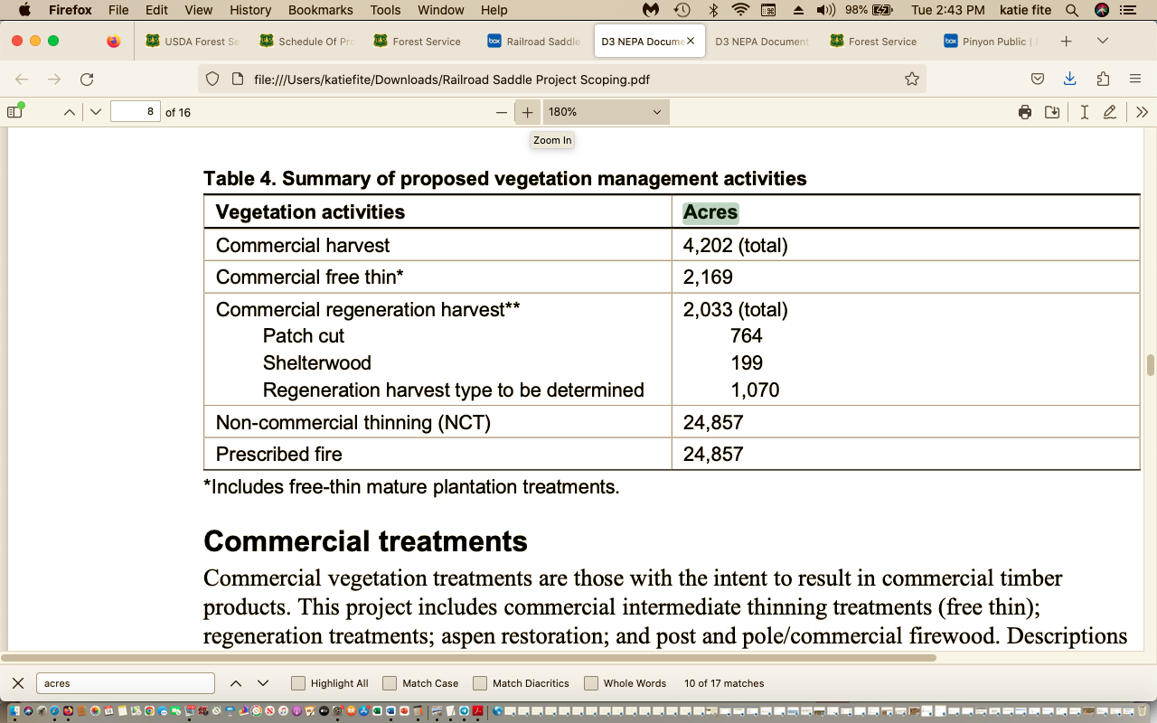

The FS must conduct thorough baseline inventories for all important and sensitive animals, rare plants and migratory bird species of concern across the project area and surrounding lands to serve as a necessary baseline for project impacts.

The FS must also conduct current detailed sediment bacteria and other aquatic habitat, water quality and quantity studies so that a solid environmental baseline and mitigation and minimization measures can be established for these large-scale treatments and expanded roading and erosion that will impact water quality, quantity and aquatic biota.

The aggressive USFS deforestation, logging and other treatment projects may drive serious population losses and/or may extirpate sensitive species across the region, along with cumulative impacts from BLM projects are also taking place.

Large fires have burned in many areas of the Region and in the Boise, Payette and other Forests - whipping right through intensively logged areas. This also represents significant loss of forested habitat cover for sensitive species of concern. Many lands also have suffered significant early settlement era human impacts including deforestation for wood products, and the use of promiscuous burning from livestock grazers setting the range afire, and other human deforestation and disturbance. Thus, in many areas, the forests are still recovering from significant past human disturbance, which the agency vegetation and fuels models and assumptions do not take into account. They may in fact have suffered much greater disturbance than the Forest claims has occurred, or that is used in disturbance interval models to justify the projects’ massive intervention and clearing.

Forest conditions are getting harsher and less resilient under climate change stress. Surface water is becoming more limited with reduced snowpacks that decrease sustainability of perennial flows. Snowpack is essential to provide water to springs and streams. Deforestation will result in hotter, drier sites prone to more rapid ad erosive runoff and resulting degradation. Ubiquitous livestock grazing further degrades and depletes springs and streams and riparian habitats. Belsky et al. 1999 describe the an y deleterious effects of livestock grazing on riparian areas – and these harms will be made worse and compounded by the massive native plant community disturbance and simplification treatments that are proposed.

Cheatgrass, bulbous bluegrass and other flammable invasive exotic weeds are already exploding across the lower elevations of this region. So too are aggressive often “seeded” bromes and intermediate wheatgrass that choke out native understories and thrive with fore and “treatment” disturbance to the detriment of native species. The Forest must carefully examine and map this landscape to determine the extent to which cheatgrass, bulbous bluegrass and other weeds are already present, or where they are likely to expand to – determining sites that may be dominated post-treatment. This project is made even more risky due to planned use of aerial fire ignitions. In these, ping pong balls with napalm-like highly flammable material are spit out of spinning device on helicopters. This type of ignition can have devastating impacts to forests. Please see photos in
https://www.counterpunch.org/2019/10/08/owyhee-ecocide-anatomy-of-blms-ancient-juniper-forest-destruction/

The photos illustrate the severe and highly damaging impacts of aerial ignitions in “prescribed” fires. This shows the damage caused by aerial ignition in rugged mountainous terrain in the Juniper Mountain area of Idaho. Ancient trees and groves of old growth arid forest were destroyed after the helicopter used napalm ping pong balls to ignite the forests. The Sagehen project’s rampant burning increases “leave’ tree and old growth loss risk, increases weed infestation risk, and cause elevated escaped wildfire risk.

The project will also irreversibly alter and degraded heavily used recreational areas and scenic wild lands. See attached photos. The essential migratory bird and wildlife habitats currently present in these forests and the currently often diverse vegetation communities will be harmed and simplified as the USFS attempt s to “groom” and manicure lands into an artificial state based on sketchy past disturbance “PVG” theories and models that ignore natural diverse forests and succesional processes.

This current proposal (and many of the other projects taking place or foreseeable) will alter this scenic and biodiverse area of Idaho for 150 years or longer – and that’s if cheatgrass or other weeds do not invade and truncate plant succession, which is a real possibility. Cheatgrass/flammable weeds/noxious weed invasion and ensuing site dominance is especially likely given the highly damaginglevels of livestock grazing the Forest and adjacent BLM management allows to take place here.
This proposal would inflict a huge battery of highly uncertain mechanical (heavy equipment and chain saw) treatment disturbances, and also impose prescribed burning, or burning in the aftermath of other treatments. There would be many opportunities for fire to escape, kill non-target vegetation, scald soils, and result in expanded weed problems.
This intensive treatment disturbance will injure or weaken trees, and result in hotter, drier, weedier less resilient sites. It is likely to result in expanding the insect/disease “problems” the agency cites in the scoping material (as a result of burned, cut, injured and otherwise damaged trees). It will result in large-scale loss of forested habitat complexity.
The insects are a natural part of the forest ecosystem. Standing dead trees are not a fire risk. They provide soil stabilization and structure to moderate site conditions as well as provide shade to cool the site. The deforestation project is likely to increase tree injury and disease, as sap from cut trees lures in insects, and as “leave” trees are injured. It will make matters worse, not better. They also serve as habitat for native woodpeckers, as den sites for rare forest mammals, store carbon and shade and cool sites and reduce wind speeds and moderate site conditions. Thus, we strongly oppose removal of dead trees as “salvage” or other types of logging/thinning “treatment”.
This project includes areas of steep, rugged terrain where control of fire may be difficult, and where spoils bared by treatment disturbances may be highly vulnerable to erosion. These risks will be increased by continued chronic high levels of livestock grazing pressure. Clearing trees may expand the areas of livestock impact and give livestock access to areas previously less impacted – further expanding weeds, erosion and degradation. How will the massive treatments alter grazing capability and stocking rates? Please provide detailed livestock monitoring information for riparian and upland sites, data on actual use, stocking per pasture or unit, grazing schemes, etc.
We are concerned the FS seeks to purge smaller age class native trees or native trees it considers the “wrong” species from sites to impose single-species type forest areas. Very often, mixed forest types contain vital structural diversity, and thus a high density and diversity of migratory birds and other biota – while treated purged forests represent a serious habitat loss. Denser tree cover also helps protect native carnivores and big game from human disturbance harassment, and poaching. Intact forests help protect migratory birds from nest and egg predators. Dense forest cover is critical in an area that receives such high intensity recreational disturbance and use. What wildlife use mixed species forests and forests that provide denser cover?
The USFS must provide full and detailed very site-specific mapping of tree age classes in all forested areas and adjacent vegetation communities of all types. Where are all old growth and mature forests (of all types – including mixed species assemblages)/sage/mountain shrub/aspen vegetation communities located? Detailed information on acreage, and on stand characteristics and wildlife habitat values and wildlife use of the site must be provided based on current site-specific inventories and inventories across this landscape. This further discussed below on comments.
Disruption of natural plant succession will convert forests to ashes and bare dirt. The FS often justifies massive conifer disturbance by saying there is as deficit of aspen. Aspen are a successional (seral) stage to the climax native Douglas fir community. The site could just as readily be termed a mid-seral Douglas fir community. The areas claimed to be mid-seral or other aspen are often actually a complex mix of forest species that naturally varies in composition depending on micro-site aspect, soils, slopes and past disturbance history. The USFS fails to provide scientific evidence for the artificial categories it imposes, and for its selection of these particular intact forest sites for the radical manipulation scheme.
Aspen is often complexly interspersed with conifers, and the combination of aspen and conifer habitat, including dense forested habitat, provides vital nesting habitat for many migratory birds. This includes Northern Goshawk, and many migratory birds and cavity nesting species.
Further, livestock browsing of young aspen and loafing and com0actiung soils and injuring trees in aspen stands can hinder or pre vent regeneration, and introduce disease into stands due to ramet injury.
Costs of Project

The USFS often fails to address the costs to the public of the welter of environmental damage and losses that would take place under the proposed actions. These will pose a significant drain to taxpayers, as well as harm or destroy recreational uses and enjoyment, and sustainability of clean water and other resources. Further, as the serious damage and destruction from the proposed activities is carried out, taxpayers will bear many uncalculated costs – from toxic chemical herbicide costs to costs to try to restore species whose populations are pushed to very low levels due to the project impacts.

This must also include the cost of potential escaped “prescribed fires”. This is a significant concern given the highly uncertain, non-specific and extensive “prescribed” burning” of the project. This recent investigation shows how the federal government is trying to avoid fully compensating victims of two smoldering pile burn escaped wildfires in New Mexico:
https://www.propublica.org/article/after-hermits-peak-calf-canyon-wildfire-quantifying-victims-suffering-becomes-legal-battle?utm_source=1500%20CWP%20List%20Daily%20Clips%20and%20Updates&utm_campaign=715f70c0c6-EMAIL_CAMPAIGN_2024_01_08_04_41&utm_medium=email&utm_term=0_-715f70c0c6-[LIST_EMAIL_ID]&fbclid=IwAR0VTsCZWwdabGzNutUnfGWF2D6DHAquPAOczQgcit6CNbeKuC7j3sL56kk
Also see:
https://www.governing.com/infrastructure/the-u-s-forest-service-accepts-fault-for-new-mexico-wildfire#:~:text=The%20forest%20service%20report%20described,packing%20or%20poised%20to%20flee
“The U.S. Forest Service sparked a wildfire last year that scorched more than 60 square miles and nearly reached the city of Los Alamos, N.M., and the national security laboratory, according to its own internal investigation.
The Cerro Pelado fire was a so-called holdover fire that smoldered secretly under the snow during winter, the forest service said, then burst into flame during a dry, drought-ridden spring.
“Despite being covered by wet snow, this holdover fire remained dormant for considerable time with no visible sign of smoke or heat,” .
Also: “It was the third prescribed burn gone rogue in the Santa Fe National Forest last year, after two others merged to create the largest wildfire in the state’s history.
The Calf Canyon Fire and Hermits Peak Fire, both products of out-of-control attempts to prevent massive fires, together destroyed at least 500 homes and torched 341,000 acres, or 532 square miles”.
The FS must honestly address the significant risks associated with the Sagehen project in arid forest lands in an EIS.
Alternative Actions for Land Health
This project must be analyzed in an Environmental Impact Statement, not an EA. Given the present degraded conditions, superimposing more roads and intensified human recreational disturbances of all types, widespread high levels of burning under this EA, Railroad Ridge project and many others, and the proposed Boise Forest and also Payette Prescribed Fire EAs in this landscape, and all manner of “treatment”, thinning, timber harvest - and other forest manipulations cannot result in a FONSI. A Draft EA/EIS should be provided for public comment prior to any objection period. A range of alternatives must be provided which address reduction in stressors to the ecosystem and its wildlife, rather than allowing or expanding (as in the case of roads) current uses, then superimposing these treatments and logging on top of these uses in this landscape suffering chronic grazing degradation.
Preventing expansion of ecosystem-dooming flammable annual grasses, exotic rhizomatous grasses, and other exotic weeds should be paramount for ensuring forest health. We are very concerned that weed infestations resulting from this action will result in excessive toxic chemical herbicide use by the Forest, and that the Forest does not currently have up to date risk assessments and hard look NEPA analysis of these dangerous chemicals and their impacts on humans, fish/aquatic biota, wildlife, rare plants, vegetation communities, and native. How much will this series of actions increase herbicide use? What chemicals will be used? What is the current scientific literature on these harmful effects of active and inert ingredients, carriers, adjuvants, breakdown products? What ecological risks does use of these toxics pose? The same applies to any insecticide pesticides that the FS may attempt to use under the guise of saving whitebarks. The number one most effective action for whitebark pines is to manually plant young trees - not torching or logging the forest See Keane and Parsons 2010 whitebark paper. This again demonstrates the USFS failure to take a hard look at ecological science throughout every aspect of this proposal under NEPA, and failure to consider a reasonable range of actions to protect habitats (for species ranging from Wolverine to migratory songbirds) and failure to prevent irreparable harm.
Herbicide Use, Risks, Contamination, Collateral Damage to Non-Target Vegetation
The project disturbance is highly likely to result in an expansion of herbicide use over significantly increased land areas, involving many kinds of toxic and polluting chemicals – often with multiple chemicals mixed together. These substances will be infiltrating and drifting into air, soils, water (water in small springs and streams that is vital for aquatic biota and waters used by recreationalists), infiltrating native pollinator habitat, wildlife food and water sources, aquatic species habitats), non-target vegetation, habitats of rare plants and animals and bodies of important and sensitive animals. There will now be more even more toxic chemicals and their polluting active ingredients, adjuvants, breakdown products and degradates in the Forest environment. The chemicals may also potentially be used in combination, or in overlapping areas in a manner that has never been adequately assessed.

What are the risk assessments, and environmental analyses that the Forest relies upon for the use of herbicides in this landscape? Much BLM and the USFS chemical use relies on risk assessments primarily from a long out-dated BLM Vegetation EIS from 2007 and some more recent flawed FS assessments. There is new scientific information on adverse and polluting effects of many these chemicals. It is also increasingly recognized that these chemicals have an adverse effect on human health, so extensive chemical use in the aftermath of treatments threatens agency staff or others applying chemicals, recreational users of the National Forest, especially those that may have chemical sensitivities. Please see Attached WLD comments on Boise and Sawtooth herbicide EIS.

What types and amounts of chemical herbicides have been used in the past in this landscape and across ther Forest? Where? How have they been applied? When, where and how has drift occurred? What have the effects been on non-target species? How has this been monitored? When, where and how much of each chemical has been used in the past? How does livestock grazing disturbance, and the road network, or recreational uses, contribute to the use of chemical herbicides? We are very concerned that although the Forest on paper claims to practice integrated weed/vegetation management, agency treatments rely overwhelmingly on herbicide applications without strong preventative actions and precautionary controls on disturbances that foster weed infestation and spread. This is a critical concern across the project area, because of the high levels of livestock grazing taking place with few to no mandatory actions to limit weed spread – plus the existing proliferation of roads and often high levels of recreational activities in many areas.

Differing allocations and provisions of the Forest Plan are often internally at odds with one another. The ramifications of inflicting large-scale ecological disturbance may be at odds with other promised management for watersheds, sensitive wildlife, recreation, protection of cultural sites, etc. to be achieved. Often, elements of the Plan do not adequately address climate change stress on ecological systems, making the uncertainty of the effects of the proposed project disturbances even greater.

We are concerned that the agency does not follow effective integrated weed prevention, or adequately assess and mitigate the adverse effects of what is largely a “Spray and Walk Away” approach. For example, livestock may be herded routinely from weed infested areas onto public lands without preventative quarantining or other measures. Livestock are turned out on lands with known weed infestations. Now proposed “Treatments” may take place in areas with known infestations highly likely to expand with this very large number of “condition-based” major disturbances to native vegetation communities and rare and sensitive species habitats. Please review our concerns regarding Payette grazing and linked herbicide use and toxic impacts in the Attached Sawtooth and Boise Forest herbicide processes (on cd).

The combined effects of large-scale domestic livestock grazing and other activities on the project lands, native vegetation, susceptibility to irreversible weed infestation and spread and a host of other ecological factors must be assessed.

The BNF grazing AOIs:

https://www.fs.usda.gov/detail/boise/landmanagement/resourcemanagement/?cid=stelprdb5336294

https://www.fs.usda.gov/Internet/FSE_DOCUMENTS/fseprd1112281.pdf

The grazing AOI for the “Ola C” - an affected allotment – shows that the FS may be applying different standards to different areas of bull trout habitat = referring to “patch” areas. The BNF provides no overall map, so it is unclear if other allotments also will be impacted. The AOI shows prolonged hot season use - known to be highly detrimental wot native trout -and a long grazing period. The FS also allows 50% use levels on meadows and areas adjacent to riparian zones – which is highly detrimental. There are also no browse limits and no bank trampling limits – even in Bull Trout habitat. It is unclear how standards are applied to springs. The EA provides no PFC or ecological spring condition information. There is not even EA mapping of springs, and no consideration of aquatic biota associated with them. Are standards applied to springs? Where is current ecological health information for project area springs? Where are all springs? How many are “developed” for livestock? What are flow rates of all springs?

Since livestock use m ay be shifted and intensified as a result of the project, it is critical to understand current riparian conditions and provide a firm baseline of ecological health.

Will treatment units be closed to grazing following treatments? If so, for how long? Will AUMs be reduced if areas are closed? If so, by how much, and how will hit be determined? What has actual use been in recent years in all units?

Where are all areas where 6 inches of stubble height vs 4 inches of stubble height will be applied? Where are all monitoring sites located? Where is analysis of monitoring data and compliance, and who conducts the monitoring? One simply cannot understand the significant impacts of grazing in the Sagehen watersheds that will be subjected to massive disturbances under the uncertain risky CBM scheme.

There appear to be no modern-day grazing plans in place. Did the FS abandon what it knew was a desperately needed grazing assessment of these Emmett RD lands at around the same time as it embarked on this disastrous mega-treatment Sagehen forest disturbance.

The FS refers to “patches” re: bull trout. Where are all these fish/BT patches?

Further, the Sagehen fisheries report fails to map “patches”, and the AOI makes clear that management decisions are made in closed door dealings with permittees. The door is slammed on public grazing involvement by the RD withdrawing its proposed grazing NEPA analysis, and deciding matters in a manner in which permittees dominate. From the OLA C grazing AOI:

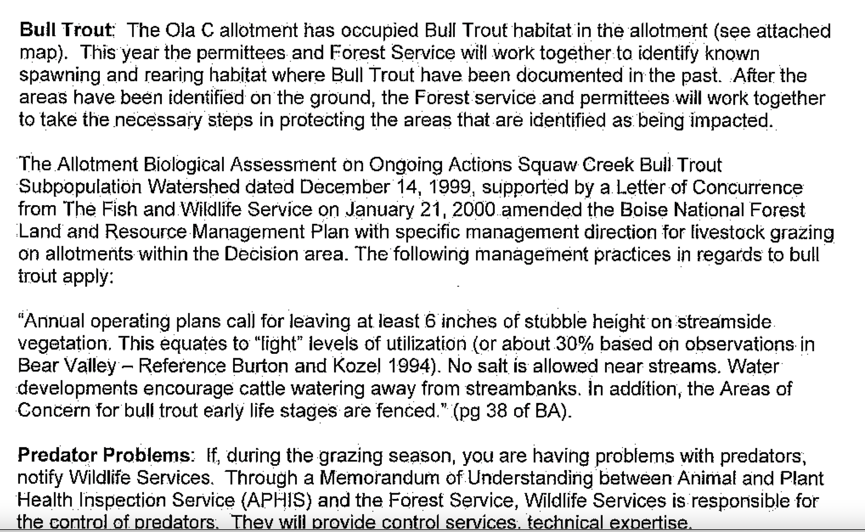

Please provide detailed mapping and analysis of all areas that have been systematically inventoried for BT spawning each year, and specific areas that have not. Please provide detailed information on where, specifically, on each stream and stream segment, 6 inches (vs. 4 inch) sacrifice zone standards are applied.).

Please provide detailed mapping and analysis of these “water developments” and all livestock facilities across the project area and surroundings.

What are the adverse ecological impacts of these developments? See Sada et al. 2001, BLM Tech. Report on sprjngs and seeps, and Sada and Lutz 2016. The FS will be burning up drainage headwaters where Bull Trout DNA was detected. This reduces protective cooling shading cover in the drainage network, increases risks of erosive runoff events, and decreases the ability of the system to absorb and slowly release water.

Sagehen Aquatic Report

From the 2024 Sagehen Fish Report
https://usfs-public.app.box.com/v/PinyonPublic/file/1419592199986

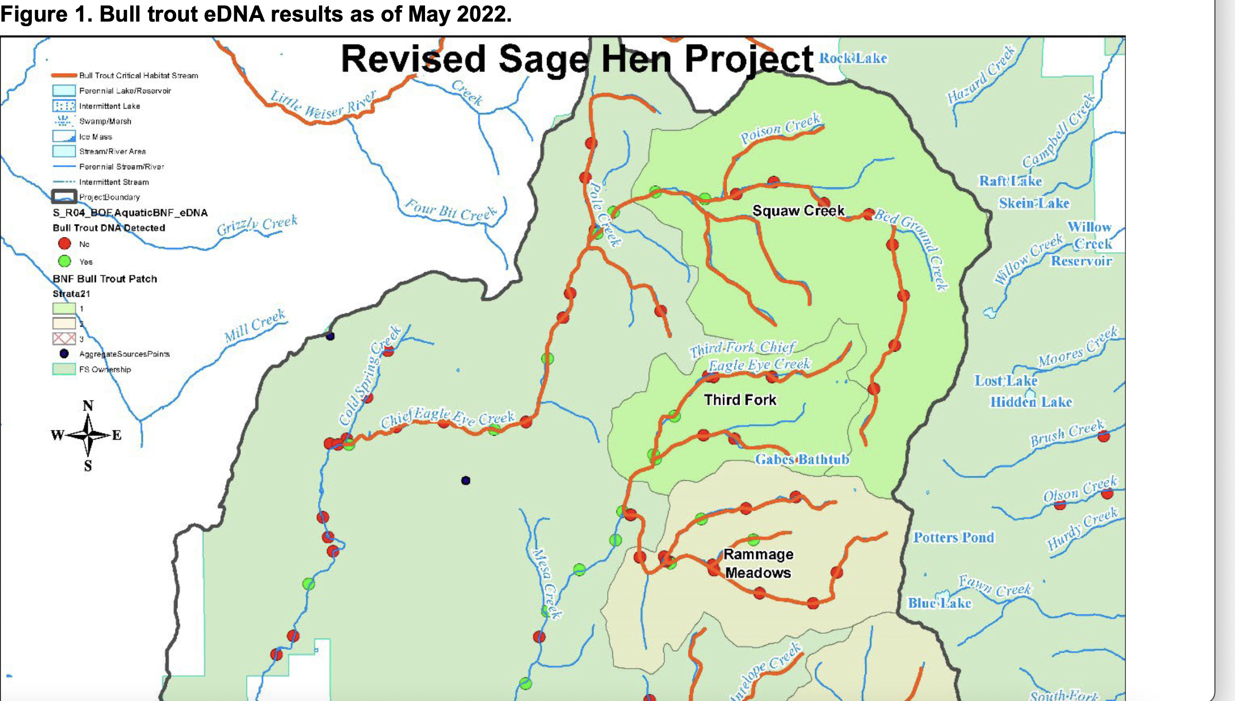

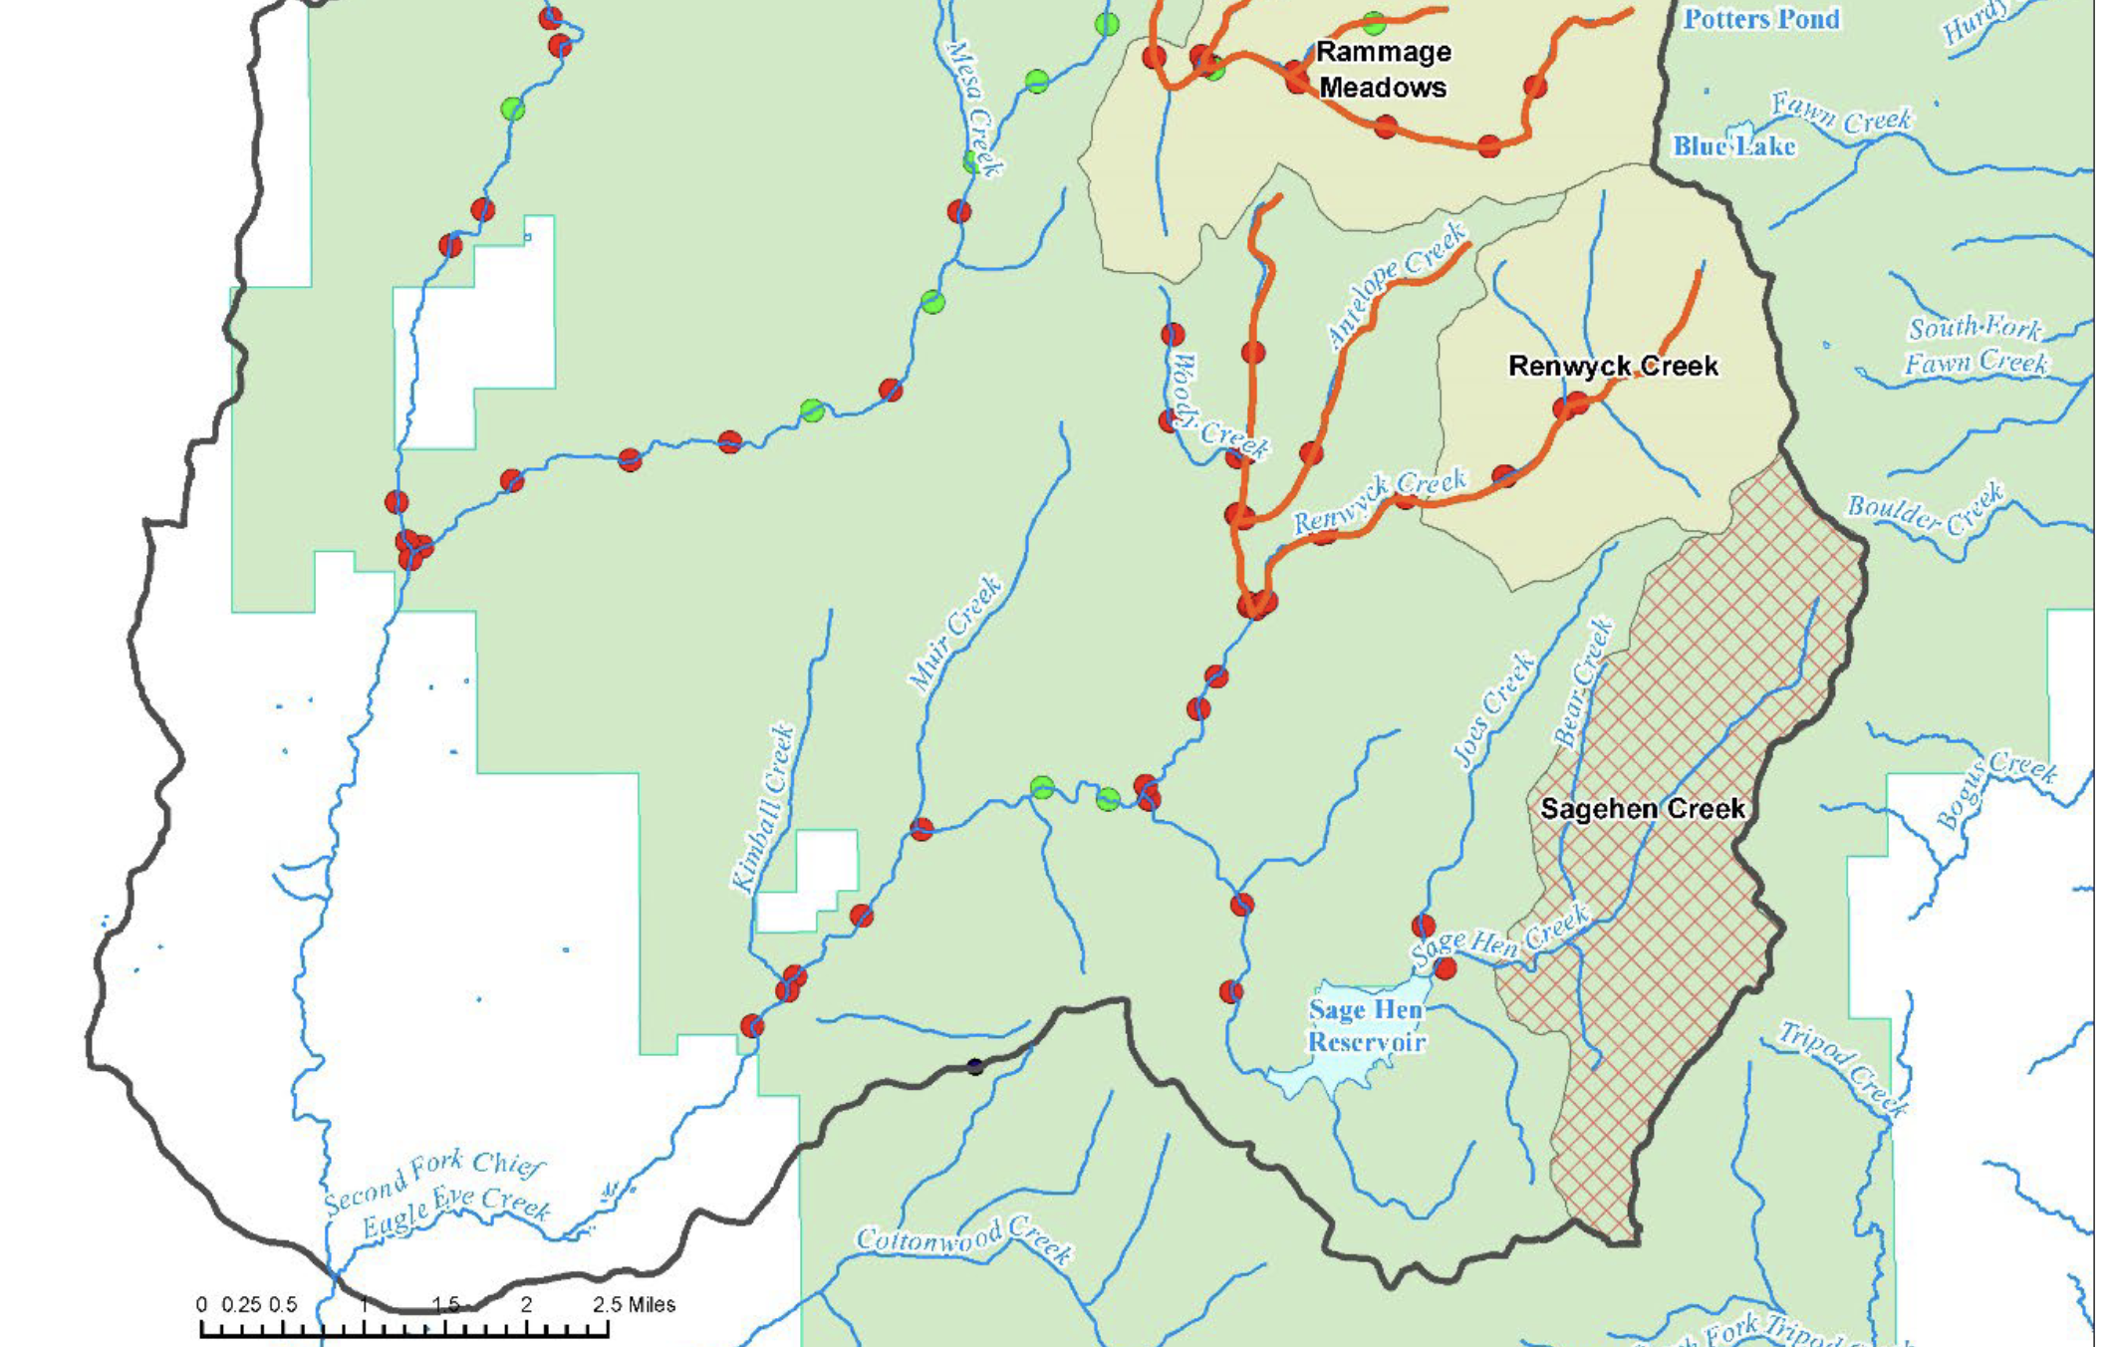

This description illustrates the lack of a reasonable range of alternatives: “This document covers those actions which may affect the Sediment/Turbidity WCI as well as other affected WCIs. Some WCIs, such as Temperature or Chemical Contaminants/Nutrients, are not analyzed here because Alternative B would not produce a measurable change in those indicators; the Alternative A analysis for those indicators is sufficient also for Alternative B” Aquatics report.

In order to understand how No Action vs. the nearly identical “alternatives” would impact water quality compliance, sustainability of perennial flows and beneficial uses – the FS must first provide a detailed hard look analysis at the impacts of livestock grazing and current systematic ecological health assessments, stocking rates, management schemes, impacts of denuding watersheds with burning and all the other “treatments” and the impacts of this massive treatment disturbance on the ability of the lands to withstand livestock grazjng, trampling and browsing impacts as well as bacterial pollution, weed risk and infestation irreversibility, ecosystem disturbance patterns, and loss of both “resistance” and “resilience” across the project area lands and waters. To do so, a thorough integrated hard look analysis must be undertaken.

Fish Report Table 1, “functionality” ratings show what very poor ecological health these systems are already in. This current degraded and impaired condition makes them even more susceptible to the severe ecological disturbance of the project’s massive burning, of all types, bulldozing of innumerable new roads, logging, thinning, mastication – and general radical manipulation and stripping of natural forests. Just look at the FRs and FURs! For example, it is perfectly reasonable to undertake removal of cows from the 2nd Fork of Chief Eagle Eye Creek watershed.

If the FS was really interested in addressing ecological health and integrity – it would conduct a full-scale grazing analysis and greatly reduce and/or remove livestock from some of these watersheds – such as the 2nd fork Chief Eagle Eye Creek. That, along with putting in in some culverts, and closing some routes, would be an appropriate ecological “treatment” for this landscape that would help reduce fire risk, protect carbon sequestration processes, not release unassessed levels of carbon and other greenhouse gases into the atmosphere, protect nutrient cycling, and sustain native carnivores and sensitive, rare, and MIS species.

We are dismayed that the FS lax management may have allowed the Bull Trout in 2nd Fork and other streams to be extirpated:

“Bull trout have previously been identified in the Second Fork subwatershed, electrofishing data from2004, 2011, and 2012, although recent eDNA surveys were negative in the subwatershed (see Sagehen Integrated Restoration Project BA Appendix D: Figure 8: Aquatics and Sagehen Integrated Restoration Project BA Addendum Appendix A) and the Rammage Creek and Renwyck Creek bull trout patches are currently listed as strata two: suitable, but unoccupied”.

Please provide all livestock grazing monitoring data for 2004 up to the present for the 2nd Fork and all other project area watersheds. Please provide specific information all actions taken by the FS where standards were shown to be exceeded.

This shows that the monitoring data the FS attempts to slide by with in 2024 are already 5 years old, and out-dated:

“the existing condition for Third Fork Chief Eagle Eye Creek subwatershed is presented in Table 1. Three reaches in Third Fork Chief Eagle Eye Creek subwatershed were surveyed between July and September 2019”. Please recall the prolonged mega-drought up through 2022 - demonstrating the need for current accurate inventory and analysis – not stale 2019 info.

Is it possible that the gross mis-management of livestock grazing habitat impairment here has almost wiped out – or actually wiped out – bull trout in 3rd Fork Eagle Eye Creek?
“A resident population of bull trout are believed to be present in the Third Fork Chief Eagle Eye Creek subwatershed. Recent eDNA surveys were primarily negative, but the surveys were not completed throughout the entire subwatershed (see Sagehen Integrated Restoration Project BA Appendix D: Figure 8: Aquatics and Sagehen Integrated Restoration Project BA Addendum Appendix A)”.

Please recall that at the time of the BNF 2003-2010 update, this appeared to be a stronghold for Bull Trout. What has gone wrong? Have grazing degradation and increased temperatures now wiped the fish out of many areas? Has the FS monitored increased in Brook Trout that can lout-compete Bull Trout and that survive in degraded conditions? Given what appear to be significant declines – can this watershed tolerate even more disturbance from “treatments”?

The 2024 Fish report includes:
"Harvest and road activities would degrade the sediment/turbidity watershed condition indicator (WCI) in the temporary time frame as delivered sediment routes through the drainage network and vegetation recovers. Beginning in the short-term as sale areas recover and roads are decommissioned, and continuing in the long-term, less sediment would be routed through the drainage network than in the current condition”.
Beneficial use for aquatic life in the mid- and lower reaches of Chief Eagle Eye-Pole and Third
Fork may be temporarily degraded as sediment is routed through the system; measures such as
embeddedness and pool tail fines could change during that time. Other beneficial uses are not likely to be changed from harvest activities. In the long-term, beneficial uses and the sediment/turbidity WCI would be improved over the current condition. Staggered actions and design features specific to reducing sediment delivery would minimize annual water quality impacts. The actions would produce a long-term trend (+15 years) towards less sediment input than the existing condition …”.

The FS simply has not addressed the potential adverse effects and impairment for the host of treatment disturbance impacts, herbiciding and other chemical use, large-scale chronic grazing degradation that increases with ease of cow access from treatments and cleared temporary routes where as a “forest” will not recover in any density for many decades or longer. Nor has the FS assessed the impacts of intensified and increased human recreational disturbance, camping, etc. – which the FS facilitates with its road upgrades, dust suppression, huge logging and treatment cleared areas, new road bulldozing, etc. There is no critical analysis of how much this all will further degrade and impair aquatic and terrestrial habitats, spread weeds, or disturb and displace – or wipe out - species from significant areas.
The Fish report claims benefits without any hard look at real world grazing disturbance impacts, weed and herbicide risk, interactions and synergistic effects of climate change stress (see Beschta et al. 2012 and 2014, Carter et al. 2014, Kaufman et al. 2023) etc. Such analysis jeopardizes the persistence of Bull Trout and other native fish and aquatic biota in the Sagehen region waters.
How does the wild card of grazing affect these self-serving rosy biased claims in what is supposed to be a scientific report:
The following illustrates how divorced from reality and common sense the report analysis is: “Alternative B is expected to have the lowest increase in sediment delivery in the temporary timeframe (see Table 3 and Table 4). Therefore, Alternative B would be expected to have the least negative effects to fisheries, specifically bull trout and bull trout critical habitat where present. Similarly, Alternative B would have the greatest reduction in sediment delivery once recovery is achieved (see Table 3 and Table 4). Although both Alternatives show a -103% in the Recovered Condition column, Alternative B has a much lower value (442%) in the Disturbed Condition column as a relative starting point, therefore this would result in a greater reduction in sediment delivery overall. See Section 4.5 for a more thorough explanation. These numbers are representative of the total increase in sediment delivery from all project activities by subwatershed in the project area. The Annualized Change column is representative of the annual change in sediment delivery with the assumption that approximately 8% of each subwatershed will be disturbed at any given time, thus the related increase in sediment delivered will have been routed thru the subwatershed in turn. This modeled short- and long-term reduction in sediment delivery would result in beneficial effects to the spawning success of salmonids”.

Does the FS biologist really believe its flawed modeling that “treated” subwatershed areas will sufficiently heal in the short gap between “treatments”? How does this take into account the treatments denuding and opening up the landscape -including the RHCAs - for more intensified livestock grazing?
“Stream-Connected Road Density: Both Alternative A and B would decrease stream-connected road density, although neither would change the overall functional rating of the sub-watersheds for this WCI. Skid trails and temporary roads could extend the length of the current drainage network in the temporary and short-term; however, in the long-term …”. This appears to ignore the extremes of climate change stress in eroding and blowing out roads and culverts ignores the likelihood vehicles will use supposedly closed routes; ignores how clearing woody vegetation will result in now cow trails- including on supposedly closed roads.

It's hard to believe that the Report stating the following is scientifically correct:
“SWST01/04/10 would be met in the short- and long-term timeframes. Water quality beneficial uses would be maintained. There are no measurable effects expected to stream temperature (bull trout) from the Sagehen Integrated Restoration Project, therefore no expected effects to salmonids from the stream temperature bull trout RCI”. What happens when logging, thinning and/or fire kill or remove standing 200 year old trees on slopes or near RHCAs that had been shading the streams or trub drainages? This too will vary from site to site, yet all hard look site-specific integrated analysis is forsaken with the FS lazy use of CBM. Please review the photos of how cattle grazing degrades these watersheds under Emmett RD management, and how poorly controlled grazing is.

It is also impossible to believe the flawed modeling that: “Based on this analysis, the Disturbance Regime WCI would likely be negatively affected in the temporary timeframe and then recover to a positive trend in the short- and long-term timeframes. Similarly, the WCIs 1) Disturbance History and 2) Persistence and Genetic Integrity could be expected to exhibit the same trends. Overall, the expected trends in these WCIs are not expected to have a significant effect on fish populations in the project area”. These are tiny streams. Bull Trout are already nearly wiped out. Degraded conditions favor Brook t=Trout and other aggressive competitors that also interbreed with native salmonids and brook trout tolerate hotter and poorer quality water than Bull Trout. Yet the FS would have the public believe that denuding watersheds with as combined battery of fire and mechanical treatments would not have significant, persistent and long-term harmful effects – especially when the FS definition of long-term throughout the Fish report appears to be very short – in comparison to the time frame for intact forest watershed development. Also, with climate stress the prospect for recovery of “desirable” forest types is reduced.

The FS also states:

“… would be temporarily moved from functioning appropriately to functioning at risk. This effect, based on the figures in Forest Hydrology (USDA 1974), would last fewer than two years before ECA recovered naturally to below the 15 percent threshold. Table 5. Equivalent Clear-Cut Area with Recovery by Sixth HU HU Name Existing ECA (%) ECA (%) with Proposed Action Percent ECA, 30 yr.*
*Based on ECA Recovery Curve (USDA, 1974).
Based on this analysis, the Disturbance Regime WCI would likely be negatively affected in the temporary timeframe and then recover to a positive trend in the short- and long-term timeframes. Similarly, the WCIs 1) Disturbance History and 2) Persistence and Genetic Integrity could be expected to exhibit the same trends. Overall, the expected trends in these WCIs are not expected to have a significant effect on
fish populations in the project area.
4.9. Large Woody Debris Recruitment. The recruitment of large wood into stream channels is the most important process that creates and maintains complex habitats, pools, and hiding cover for bull trout and other salmonids in the action area. The RCA buffer widths in the Sage Hen Integrated Restoration Project area would protect the woody debris recruitment, and would be wide enough to maintain essentially all of the woody debris recruitment to stream channels that naturally occurs in riparian corridors, wetlands, and landslide prone areas (Naimen
et al. 2000). Wait a minute – doesn’t this depend on the how dense and how large the riparian buffer woody veg is? Claims like this must be based upon thorough site-specific baseline inventory of structural composition and species present, age/maturity class and adequacy. data on the quality and quantity of vegetation. Something sure seems to be WRONG already with the RHCA vegetation adequacy – given all the degraded conditions, the Fish report lists, and the need for a TMDL}.
Manually thinning sub-merchantable conifers > 30 feet from streams and wetlands would be expected to have a negligible effect on present and future woody debris recruitment. The trees that would be cut would be too small and too far from water bodies to contribute woody debris”.

This ignores the effects of accelerated runoff events floodplains, hillslopes and water and gravity in moving wood. Plus 30 ft. tall trees grow taller if left unthinned, unsawed down, unburned. How old might a 30 ft. tall tree be – in all forest types? We strongly oppose this significant loss of protection, shade, structure and habitat in RHCAs, in violation of NFMA and NEPA hard look analysis. Please see Attached photos of how cow-beat significant areas of these watersheds are – they’re already damaged, and grazing is NOT being terminated – it synergistically and cumulatively degrade these waters, and thwart and muddy any claimed “recovery”. How is grazing factored into the models? What levels of grazing and trampling are factored in?

What are al inputs into all of the models used to arrive at this and other rosy conclusions – especially since Bull Trout already appear to almost be wiped out in drainages? “This WCI would not change functionality ratings as a result of the Sage Hen Integrated Restoration Project, although a positive trend would be expected in both the short- and long-term timeframe”. This ignores basic riparian geomorphological and ecological processes – as many of these sites are already in degraded condition to various degrees – and de-stabilizing watersheds with all the heaps of project disturbances can cause irreversible down-cutting, head-cutting erosion, loss of riparian potential, etc.
Fish Report Cumulative Effects states:
“Water quality impacts in the project area, if they are large enough, would accumulate in Chief Eagle Eye Creek and flow to Black Canyon Reservoir. The temporary and short-term water quality impacts from that project would overlap in the Second Fork sub-watershed. These impacts would then ultimately accumulate Sagehen Reservoir and the Black Canyon Reservoir. The most likely impact would be an increase in sediment accumulation in Sagehen and Black Canyon reservoirs. While both Reservoirs have fish populations, neither supports bull trout or is designated as bull trout critical habitat”.
This report serves as a replacement to the Sagehen Integrated Restoration Project Fisheries Effects analysis. It discusses the sediment-related consequences (effects) of the actions (cause) outlined in the environmental assessment (EA) of Alternatives A and B for the Sage Hen Integrated Restoration Project (Project) on the Boise National Forest. This report is meant to be read in conjunction with the Sagehen Integrated Restoration Biological Assessment and Amendment.

So is the FS using old EA BA?.

Also note from the Fish report:

Water quality (IDEQ) Beneficial Use Reconnaissance Program (BURP) data, 2010 Integrated Report database – so BURP data is 14 years old, or older;
IDEQs Final Total Maximum Daily Load Implementation Plan for the Chief Eagle Eye Creek
Watershed (State of Idaho, 2003; 1998) referred to as the (Sediment TMDL) and IDEQs Chief Eagle Eye Creek Temperature Total Maximum Daily Loads, (State of Idaho, 2007) referred to as the (Temperature TMDL) – this is also very old data;

the 2010 Forest Plan -old; the Watershed and Aquatic Recovery Strategy (USDA Forest Service, 2003a), -old;

the Ongoing BA for Actions in the Chief Eagle Eye Creek Subpopulation Watershed (Burton 2000), the Draft Bull Trout Recovery Plan (USFWS 2010) – old;
Emmett Ranger District Soil and Hydrologic Reconnaissance Report (Wendt, et al. 1973) -old – How does this old document and its reconnaissance report address quality and quantity of microbiotic crusts and grazing trampling impacts combined with effects of large-scale prescribed burns and logging?;

Sage Hen Road Inventory (GRAIP Lite) Report and associated data conducted by the Boise NF in 2020, 2010, and 2011(USDA Forest Service, 2011) – how much of the data is from 2010 and 2011?

The FS also refers to: the Boise NF Watershed and Fisheries data collected within the mainstem Chief Eagle Eye Creek, 3rd Fork Chief Eagle Eye Creek, 2nd Fork Chief Eagle Eye Creek, Rammage Creek, Renwyck Creek, and Antelope Creek (Emmett District -elsewhere the report describes some gaps in this data.

Other deficient cumulative impacts assessment includes:
“Because there are no foreseeable new impacts from grazing, and because the sediment impacts from the Sage Hen Recreation Area Hazard Tree Mitigation Project would not overlap in time, there is a very low likelihood that the cumulative effects from these actions within the project area would cause the project to be out of compliance with the soil and water standards outlined in this biological assessment …”.

Please see our discussion throughout these comments of the effects of clearing away vegetation resulting in concentrations of livestock in new areas. Please see photos of the ram-ant weed infestations that already exist, and the role of existing cattle grazing management in dispersing weed seeds across this landscape.

Fish Report p. 8:
“Evaluating data from the Climate Shield model by Isaak et al (2015) indicates that suitable habitat in 2040 will be present in all core areas in the Upper Snake Recovery Unit, though all core areas will have habitat that loses suitability. Some core areas are expected to have greatly reduced amounts of suitable habitat (Weiser, Chief Eagle Eye, NF Payette, MF Payette, and Jarbidge). The Jarbidge, MF Payette, and Chief Eagle Eye core areas appear to change the most (baseline to 2040) and potentially will contain the least possible habitat …”.

Why is the FS using a model protocol from 2015 – when the global heating is already blowing past 1.5 degrees centigrade temperature increase, and when there have been many intervening mega-drought years since then, and extensive new scientific information on climate stress, aridification, disturbance, etc.

And this doesn’t even take in to account the impacts of the project’s radical stripping away and simplification of wood and structure and loss of cooling shade from these watersheds with this project. Nor does it appear to factor in the adverse compounding and synergistically detrimental impacts of high levels of chronic livestock grazing disturbance acting in tandem with hotter temperatures and more extreme weather from climate change. Please detail what specific environmental and management factors were used in this climate model.

This Fish report conclusion appears to bedelusional:
“The same threats and factors that have effects on bull trout in the project area also have effect on the PBFs of critical habitat (see Table 2). Additionally, changes in hydrology and temperature caused by changing climate have the potential to negatively impact aquatic ecosystems in Idaho, with salmonid fishes being especially sensitive. Over a period of decades, climate change may directly threaten the integrity of the essential physical or biological features for bull trout critical habitat. No measurable effects from climate change are expected through the life of the Sagehen project”.

After fearmongering about climate change and fire– now the FS ties itself in knots claiming no measurable effects. The agency appears willing to resort to anything to make a claim of “no significant Impacts” so it can shirk its duty to conduct an EIS.

Does the FS Really expect us to believe there won’t be measurable water temperature increases? Or measurable irreversible shallow-rooted flammable grass expansion jeopardizing watershed stability? No measurable scouring, downcutting and bank erosion, sedimentation from more extreme weather events predicted to occur with climate change?

Please provide detailed scientific analysis supporting conclusion, and also detailed scientific analysis of regarding “functionality” no change ratings in the Fish Report Table 2: “Effects of management actions on WCI indicators”. Please conduct analyses of all the factors in these tables with No Action conditions factored in.

All this shows is the 2 action alternatives are nearly identical; there is an inadequate range of alternatives; that the FS abjectly fails to factor in the beneficial impacts of No Action alternative in a valid Alternatives analysis; BNF Emmett RD models and analysis are deeply flawed and relay on old stale models to make unbelievable claims.

Is there a “GRAIP-lite” modeling exercise for increased cow access to sensitive stream segments and drainage networks from the combined effects of all the project activities – blading “temporary” roads that will become cow trail travel corridors, burning and clearing off wood and trees that presently keep cows from accessing better condition areas of streams and springs, etc.

The whole Sagehen house of cards is built on models and ignoring common sense about the scale and magnitude of environmental effects and watershed degradation and biodiversity loss.

The FS also makes following claim:

“Beginning in the short- term as sale areas recover and roads are decommissioned, and continuing in the long-term, less sediment would be routed through the drainage network than in the current condition.” Has the FS ignored factoring in the more rapid and accelerated erosive runoff from deforested burned watersheds where the wood that slows down runoff and helps stabilize soils and moderate site conditions is stripped away or released as carbon into the atmosphere? The accelerated runoff from watersheds where wood has been stripped away will just blow out more culverts.

The Fish Report also claims:
“Estimated sediment production from prescribed fire is predicted to be lower than what would be expected should actual wildfire occur. Even though prescribed fire can increase the risk of sediment production in the temporary time frame: 1) delivery to streams is unlikely with the proposed RCA buffers and low burn severities typical of prescribed burns in the area; and 2) the potential sediment effects of prescribed burning are less than those of wildfire (Table 2). Thus, prescribed fire activities are not expected to measurably increase sediment delivery to streams. Burn piles generated from project activities would not likely contribute sediment to water bodies in the project area. Beneficial uses are not likely to be degraded from prescribed burning”. This ignores the current degraded conditions, the high levels of abusive cattle grazing taking place, and the vulnerability of burned watersheds so suffer serious erosion and sedimentation, the increasing shallow-rooted poor spoil stabilizing weeds, and many other impacts.

Also, the FS states:
The primary effects to fisheries in this report are from sediment/turbidity, fish handling during work area isolation, and short-term water quality impacts from any chemical application. Does this mean toxic herbicide use as Sagehen treatment and grazing-caused weeds proliferate?

Full and detailed site-specific analysis of herbicide and ingredients use, application methods in each “treated” site, and specific chemicals and current chemical risk assessments on all chemicals components of these toxic carcinogenic polluting substances must be provided.

The Fish Report continues to pretend that there won’t be harmful impacts by applying uncertain and flawed models that often defy common sense and ecological reality.
FS report claims of long-term beneficial impacts must be predicated on having any native species actually survive this massive assault – and ignoring the actual effects of large-scale denuding of the project watersheds.

Since the FS does not provide actual site-specific analysis of even a single one of the myriad “treatments” under CBM, it can’t predict outcomes in its various models.

Climate stress is likely to amplify and worsen the weed infestations that result from the massive treatment disturbance including extensive burning, all the recreational use, the sheep grazing and trailing all over the place – and these impacts will be dramatically worsened by the project clearing away forest impediments and burning up forest and downed wood that protects habitats areas by impeding livestock access to fragile upland areas, as well as to fragile springs, seeps, bogs, and stream headwaters. This also increases the threat of harmful runoff into downstream waters and other sensitive water bodies – with a worsening of water quality to already impaired streams where water quality is to be improved, not degraded. Placing some band-aid exclosures only serves to further degrade remaining unprotected sites and further concentrate livestock use thee – hastening degradation, erosion, flow loss and further concentrating pollution.

See Belsky and Gelbard 2000, also Molvar et al. 2024 describe a host of ways in which domestic livestock grazing both causes and spreads weeds. This will worsen under climate stress as native vegetation communities become less resistant to disturbance and less able to recover,

Please provide a current baseline and a predicted post-treatment grazing capability and suitability analysis. Where is forested vegetation density currently reducing or hindering livestock access to fragile springs, stream reaches, fens, meadows, rare plant sites and other fragile habitats? How will this change with this project? The project does not specify which specific areas will be burned - and uses other elements of “condition-based management” where the USFS ducks any future site-specific integrated NEPA analysis and fails to identify discrete project sites with their unique and specific slope, aspect, species composition, livestock degradation, watershed degradation and unraveling, old growth dependent species characteristics.

Agency lazy use of CBM results in agency failure to take a hard site-specific look at their impacts - instead the agency skates by using a programmatic or quasi-programmatic overview of what might happen across large land area – but NEVER providing specifics – including specifics and not conducting the upfront surveys necessary to understand impacts – instead pretending that in-front-of chainsaw or bulldozer wildlife piecemeal little wildlife “surveys” would suffice.– it appears highly uncertain and extremely difficult to understand the true scale of the effects. This uncertainty also necessitates an EIS.

From Belsky and Gelbard 2000:
First, livestock carry weed seeds on their coats and in their guts. Where
these seeds are brushed off the animals or excreted in dung, they can grow into mature plants capable of producing hundreds to thousands of seeds. One study in Alberta, for example, found that in a single growing season, one cow moved 270,000 viable weed seeds around a pasture. 3 It is clear that the millions of cattle and sheep now grazing our western public lands are annually moving tens of millions, if not hundreds of millions, of weed seeds from weed-infested communities into uninfested areas, even on our most remote public lands.
Second, livestock weaken many native plants by grazing them, thus removing their leaves and flowering stems - that is, their photosynthetic and reproductive organs. Grasses and other plants of the Intermountain West are especially vulnerable to grazing by large herbivores since they evolved in an environment that has not been home to many large grazers for the past ten thousand years. Bison are predominantly a Great Plains species, and only low densities of elk, deer, and pronghorn occupy the arid lands west of the Rocky Mountains. As a result, Great severely damaged by close and repeated grazing. In addition, livestock frequently prefer native plants to weeds, which are often covered with spines or contain toxic and distasteful compounds. Where they preferentially consume native grasses and wildflowers, they leave weeds to grow unharmed and with little competition for water and nutrients. Consequently, weedy species grow large and increase in number while native species decline.
Further, livestock significantly contribute to weed invasions by disturbing the soil surface. Several factors are involved: Livestock trample the soil, creating patches of bare ground that serve as natural seed beds for the germination of weed seeds, and ripping apart protective biocrusts. Trampling also compacts the soil, damaging the roots of native plants and preventing them from acquiring sufficient water and nutrients for vigorous growth.
By reducing plant cover through grazing and disturbing the soil surface with their hooves, livestock enhance wind and water erosion. Dislodged soil particles then bury the weed seeds, increasing their ability to germinate.
Livestock hooves destroy fragile biological crusts that blanket exposed soils in deserts, arid grasslands, and shrublands. These crusts, which are composed of algae, bacteria, lichens, and mosses, enrich the soil with nutrients, especially nitrogen, and increase the vigor of native plants. They also stabilize the soil and act as physical barriers to weed invasions. As the hooves of livestock pulverize the biological crusts, they remove an important defense against the invasion of weeds.
Livestock trampling also reduces the number of soil mycorrhizae, the microscopic fungi that benefit native plants by transporting nutrients and water from the soil into plant roots. Many exotic weeds, do not require or benefit from these fungi. As trampling reduces concentrations of mycorrhizae in the soil, the ability of native grasses to acquire nutrients and water is reduced, giving the exotic weeds a competitive advantage over the native plants.
Livestock deposit nitrogen on the ground in their urine and feces. These nitrogen "hot spots" are concentrated where livestock congregate, especially near streams, water tanks, and salt licks. They intensify invasions by nitrogen-loving weeds, such as cheatgrass and medusahead. Repeatedly, scientists have found that sites that are disturbed and also receive high concentrations of livestock waste are the most severely invaded.
By reducing plant and litter cover and compacting the soil, (thus decreasing water infiltration), livestock create warmer, drier and more erosion-prone soils, and impacts where plants are already highly stressed by lack of water. These drier soils reduce the vigor of herbaceous native plants, whereas annual weeds simply go dormant/produce seeds.
Most, but not all, exotic weed species require the type of disturbance and open space created by livestock to germinate and grow vigorously. A few species, however, are able to flourish in plant communities ungrazed by livestock, as can be seen in national parks and other natural areas. This is because vehicles, miners, native wildlife, hikers, wind, and flooding streams can also carry weed seeds into grasslands and disturb the soils. Rarely, however, are these other influences as numerous or as widely distributed as livestock. Studies have shown that in most cases, plant species that invade undisturbed natural areas are less dense inside the natural areas than outside with localized exceptions, such as sites near roads and trails, or sites disturbed by recreationists and wildlife.
The risk of livestock transporting weed seeds all over the place is made even greater – given the huge country these sheep roam all through. Not only may livestock spread weeds onto the project area – they may carry them all over the place onto other allotments far outside the project area as weeds increase in the wake of the disturbances. Further, grazing may be more concentrated with significantly greater disturbance impacts if “treated” lands are “rested” at all in association with the project.
Where do the cattle graze (in summer-fall) – and who knows what weed infestations may be present where they graze prior to entering the allotment. Where are these other sites? What weeds are present in those areas?
More Treatment Disturbance Concerns
The EA fails to provide past timber harvest, logging and treatments of all types, thinning activity, salvage wood removal prescribed fires, and wildfires must be mapped and current ecological conditions described in the project area and surrounding lands. Data showing tree stand statistics, recovery from disturbance and regeneration success or failure and current age class and tree species type, understory composition, production and trend including grasses, forbs and shrubs, basal cover, and bare ground must be provided. What were pre-project conditions? What were predicted project outcomes and recovery rate? How does that compare to what has taken place? Were objectives in NEPA documents and goals met? How did sensitive and MIS species respond? How did the USFS monitor and track populations – or were the projects like Sagehen where the agency simply does not have an adequate baseline to understand project outcomes and adverse habitat and population viability impacts?
Please provide detailed mapping and analysis of all projects aimed at controlling beetle, wooly adelphid or other insect populations or mistletoe across the BNF. Did any of these projects or “sanitation”? cuts stop the insects? And what are the effects of transporting exotic-insect killed trees or other associated logged/thinned trees that are “infested” but have not yet died to sawmills or other wood processing centers? Or their use for firewood? Is the FS in reality spreading infestations in its wood “harvest”?
What are current conditions – tree species/cover/age class/density/successional stage, etc. where insect “treatments” have occurred? They sure didn’t stop bark beetles in the Sawtooths, for example – but instead just injured “leave” trees making them more susceptible to insect-caused death. Beetle and other insect infestations have thinned the forest in many areas, and thus reduced supposed “fuels”. All of this must be fully assessed. How scarce are intact live uninfested tracts across the project area? The Emmett RD? The BNF? This region?
Authorized and unauthorized roads and trails, and their current status must be analyzed and compared to wildlife needs for security cover, the amount of security cover that exists today and what changes will occur due to this project. When was travel planning conducted? What has enforcement been? Where in the Emmett RD and the project area does the Forest allow cross-country travel by snowmobiles? How and where is winter or other recreational use impacting habitat for native carnivores and other wildlife? This includes habitat for Mule Deer, Elk, Black Bears, Lynx, Wolverine, Snowshoe Hare, Great Gray Owl, Boreal Owl, Northern Goshawk, Flammulated Owl and other rare species.
Home ranges of Goshawk and all other biota of concern must be carefully mapped, and the population status determined based on current thorough systematic surveys. How have existing deforestation, thinning, burning and other projects and fires impacted habitat integrity and connectivity? How much has habitat fragmentation of home ranges and/or important seasonal ranges impacted species at present? How much will fragmentation increase, and where, under the proposed action? How will this impact viability of local populations.
How will the projects increase the visual and noise disturbance footprint of human and recreational activity – visual disturbance, distances sound may travel, the combination of both? What are adequate buffers for roads, mountain biking, hiking, snowmobile use, etc. in the aftermath of the proposed actions? How do different weather conditions affect buffer distance? For example, noise travel distances in winter vs. summer? Please provide detailed adequate noise, visual and other disturbance avoidance distance studies to establish a baseline at present across the project area and its surroundings, then estimate how much the noise/visual/overall disturbance footprint will increase, and where this will occur.
How much additional road blading and forest protective cover removal will take place across logging/deforestation haul routes? How much will routes be widened or smoothed out and expanded travel ease and seasonal time periods result? How much will water bars provide new weed infestation sites? What are the slopes where all of these routes affected by the project occur or will be built? How permanent, effective and closely enforced will any route closures be? Why isn’t the FS conducting a new travel planning process? Will the FS need to do a travel plan amendment?
There are a large number of sensitive, rare, imperiled species that will be significantly harmed by the project. How many of these species rely on early seral conditions?
Further, since the EA analysis fear-mongers over insect-killed trees in the project area, there is no need for the USFS’s massive burning scheme to generate more habitat for species that rely on dead or dying trees.
Sagehen Expands Wolverine Harms and Endangerment
Another reason the USFS must prepare an EIS is the lack of regulatory standards to protect Wolverines and native carnivores in the old Forest Plan, and large-scale lack of other regulatory controls to protect the habitat and ecosystem on which Wolverines rely. The FS in this project using woefully out-dated modeling of veg communities to justify massive deforestation and burning in Wolverine habitat – right where recreation and recreational development is exploding – ensuring more human intrusion and disturbance into Wolverine habitats. Amid the maelstrom of disturbance – the UAFS fails to adequately curtail motorized, mechanized and other uses – and instead just approved a plan. For major expansion at Brundage, and only limits snowmobiles in some areas – which is greatly inadequate – especially given the rampant burning and other veg clearing.
Regarding the War on Wolves (a USFS sensitive species)– where Wolverines will be/are collateral trapping and poaching damage:
“In Idaho, legislation revised Idaho Codes in 2021 to: (1) authorize a year-round trapping season for wolves on private property (IC 36-201(3)); (2) authorize additional methods of take previously prohibited (inclusive of the use of snares in 97 out of 99 management units) (IC 36- 201(2)); (3) remove any limit to the number of wolf tags an individual may purchase (IC 36- 408(1)); (4) allow a livestock or domestic animal owner to use a private contractor to kill wolves (IC 36-1107(c)); (5) allow the Idaho Wolf Depredation Control Board to enter into agreements with private contractors, in addition to State and Federal agencies, to implement the provisions of SB 1211; and (6) direct wolf control assessments ($110,000 annually) collected from the Idaho livestock industry to be combined with $300,000 the State would transfer from the IDFG fund annually beginning on July 1, 2021”.
These regulation changes may increase the amount of wolf trapping and the risk of incidental trapping of wolverines because of the use of snares, extended trapping seasons, and financial incentives. The realized impact of these changes cannot yet be meaningfully measured due to the limited amount of time they have been in effect”.
And last, there is much discussion of the threat climate change poses to the Wolverine, and USFWS states habitats are projected to contract. Now the FS is engaged across the region in a battery of habitat disturbances that destroy key habitat attributes and make the species even more vulnerable to human recreational, trapping, and other disturbances and mortality.
Carnivore Killing and Trapping
USFWS 2023 states: “We present new information on incidental captures of wolverines in the contiguous U.S. where regulated wolverine trapping remains closed (USFWS 2018, pp. 70–72), and new information on the effects of trapping mortality on wolverine populations in southwestern Canada. New information suggests that wolverine trapping in southwestern Canada likely reduced populations in the Rocky Mountains, which may have impacted connectivity across the international border”.
“New published information shows that since 2012, there have been 10 non-target wolverine captures (average < 1/year) in Montana resulting in three mortalities; the remainder were released alive (MTFWP 2023, in litt., p.1). In Idaho, our 2018 SSA reported three wolverines incidentally trapped due to wolf control activities since 1995, with two released and one killed. Between November 2017 and August 2022, IDFG reported nine non-target captures, with two resulting in mortalities (IDFG 2022, in litt., pp. 5, 16–22). We are not aware of any recent incidental captures of wolverines in other western States”.
Long-time ex-Wildlife Services biologist Carter Niemeyer rebutted the belief that released wolverines fared well – or survived for any period of time. See: https://www.counterpunch.org/2023/12/05/wolverines-protected-under-the-esa-here-is-the-rest-of-the-story/
“Lose a foot”
Carter Niemeyer describes: “Assuming a trapper could even release an angry wolverine from a trap, most animals released after their blood circulation was cut off to a foot for several days in subzero weather end up with their frozen foot falling off, according to the Carter Niemeyer, a retired trapper for U.S.D.A.’s Wildlife Services. It is hard enough for a wolverine with four feet to survive. It is almost impossible for a wolverine to survive in the wild with only three feet. Therefore, the death toll on wolverines from accidental trapping is most likely higher”.
Boreal Owl, Canada Lynx, Columbia Spotted Frog, Gray Wolf, Great Gray Owl, Boreal Owl, Fisher, Pine Marten, Flammulated Owl, Northern Goshawk, Peregrine Falcon, rare bats, Wolverine are all at significant risk here.
It also appears Fishers may occur in proximity. IDFG records show occurrences in Valley County.
https://idfg.idaho.gov/species/taxa/18029 .
Also note Fisher range – and the project is located on the southern edge of the species range. Extirpation of the Fisher here and on the adjacent Boise Forest would foreseeably contribute to a range contraction northward for this species.

https://en.wikipedia.beta.wmflabs.org/wiki/Fisher_(animal)

https://digitalatlas.cose.isu.edu/bio/mammal/Carn/muste/fish/fishfrm.htm

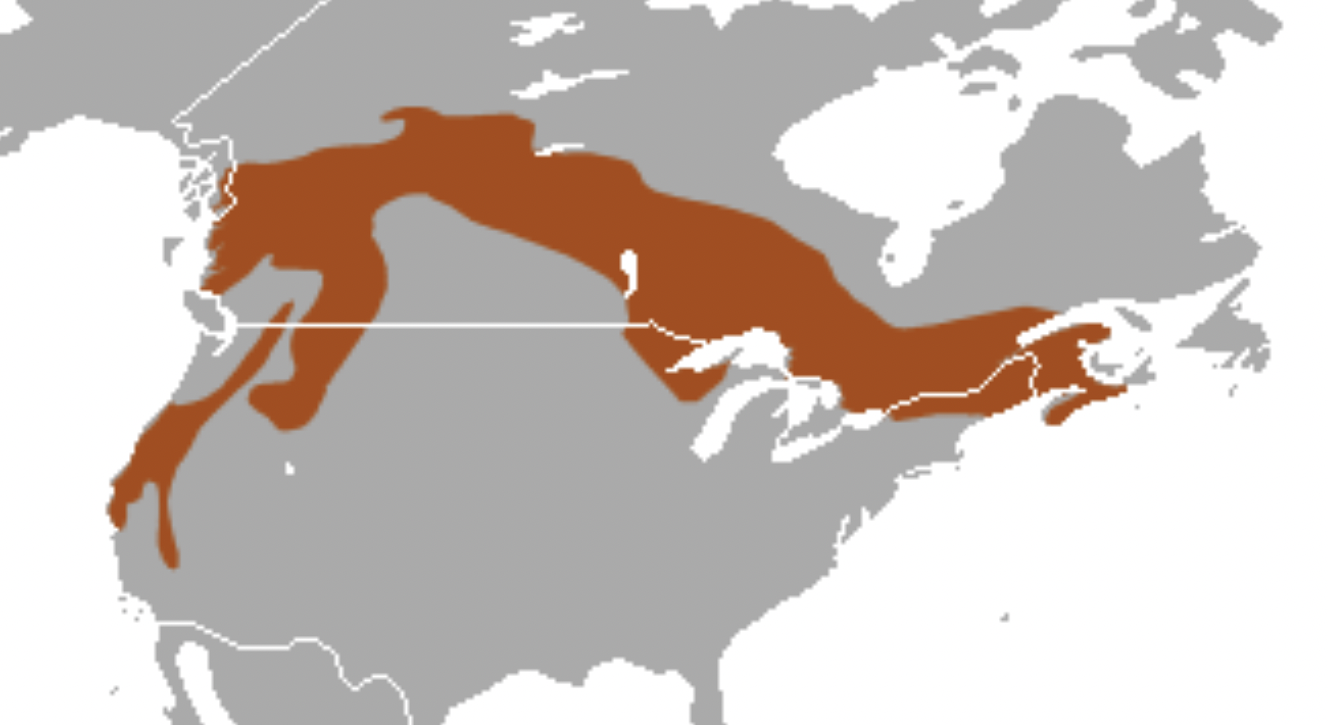

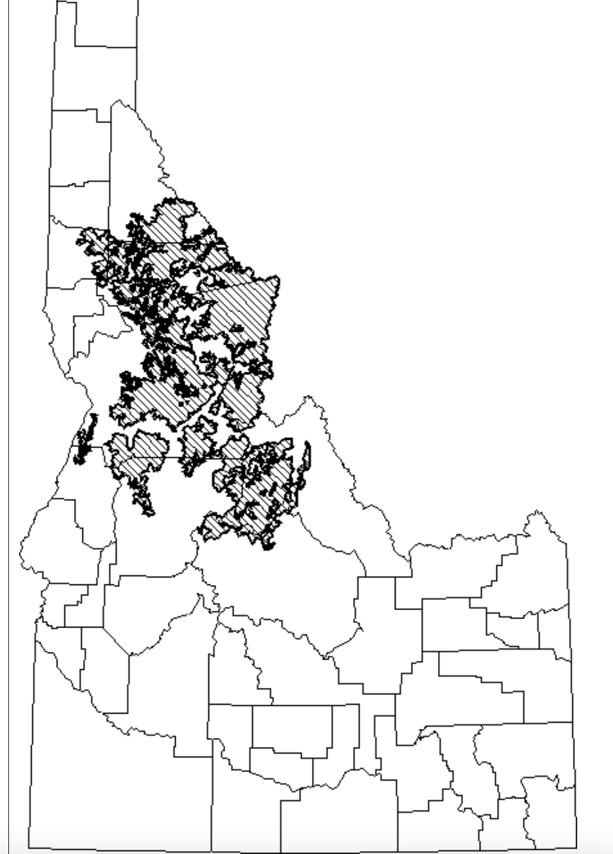

We cannot overemphasize the assault on higher elevation forests the Region 4 FS is currently engaged in – having logged out lower elevation Douglas fir and Ponderosa pine, in Idaho now the agency appears intent on mining timber from, or burning up, subalpine fir, grand for and other higher elevation forests – posing a significantly greater threat to the fisher and other rare native carnivores.
ADDITIONAL COMMENTS
Livestock grazing is a principle factor damaging forest and watershed health in the Payette Forest. It is the fundamental factor needing to be addressed in this Analysis and Cumulative Effect Area, as it degrades forest ecosystems, compacts soils, causes serious watershed harms, hampers the ability of sites to recover from the massive use of fire, thinning, logging, road blading, and other “treatments” in this project. Grazing has degraded this landscape, and the massive disturbances will only serve to worsen and expand its deleterious footprint. Grazing causes excessive amounts of bare soil, forest understory losing litter cover, soil carbon and nitrogen being depleted, conifer forest mycorrhizal fungi layer disrupted by livestock trampling, riparian area degradation, flow loss, spawning habitats filled with high levels of sediment from eroding watersheds and banks, native trout suffering mortality of their eggs and fry, etc. Grazing degradation creates conditions favoring non-native brook trout, which greatly out-compete native trout including bull trout. The hotter, more polluted water from these massive treatments will create conditions conducive to non-native Brook Trout expansion competing with native trout and preventing Bull Trout occupancy and increased loss of water flows, and seriously elevated temperatures in streams. As a baseline, the FS must carefully examine all areas of ephemeral, intermittent and perennial flows in watersheds – so that the foreseeable loss and reduction in flows from this project can be understood. Forest Allotments are often heavily overstocked, have never undergone any recent grazing analysis or NEPA assessment, and the native herbaceous plant community is greatly below potential and increasers dominate the community. Water developments and fencing create highly damaged areas as cattle and sheep congregate around them.
All this immense battery of Forest treatment disturbance requires even more ecosystem disturbance perturbation from commercial harvest-related and recreation-related road maintenance and use - Road maintenance includes road surface blading, ditch cleaning, installation of drainage features (e.g., rolling dips), hardening soft spots, replacing culverts, removing roadside woody vegetation. Even more areas would be cleared for roading. The Forest may also plan or expand quarries for road “improvement” materials. Please clarify – and provide detailed mapping and analysis of all areas that will permanently altered to “improve” roads – leading to increased human disturbances to wildlife and increased fire risk.
The Forest claims uncharacteristic and undesirable fire. Won’t the Forest’s proposed drastic manipulation and fragmentation of wild lands and watersheds result in the most uncharacteristic and undesirable fires of all? What are the scientific studies the Forest uses to define and assess these terms?
After reviewing the multitude of proposed Potential Veg groups: What is the scientific basis (literature, site-specific surveys and data, forest-wide and other data). After reviewing EA Tables, it appears to us that the Forest and the collaborative logging group want to turn these public lands into an artificial manicured tree and livestock farm.
The FS uses various fire categories, and assumptions about fire return intervals. What are the scientific and site-specific studies these are based on? How has the Forest determined that an individual site has “missed intervals”? Have you conducted fire scar and other studies, as described in work by William Baker and others? How do these assumptions take into account the natural patchy and variable patterns of wildfires? Have you reviewed General Land Office Records to try to understand historic vegetation communities in the region and project area? We request that you do so before making sweeping claims about Potential vegetation or that the majority of sites have missed two or more intervals. Further, the Forest only looks at the specific project area -ignoring the many large-scale fires and repeated fires that have burned in the West in recent decades. Full and detailed mapping and analysis of the scale and effects of recent fires on these communities at a landscape basis must be provided.
How is “restoration” defined? How is the watershed condition framework derived, and what current site-specific data has the Forest developed to support the various functioning claims?
We do not believe there is a need for treatment in RHCAs, and strongly oppose disturbance and degradation of RCAs in areas where not absolutely essential for human safety. We oppose all the project vegetation disturbance treatments in RHCAs. The Forest has not demonstrated a science-based need, and has not considered alternative measures, or the benefits of no action, and reliance on natural processes and not drastic human intervention.
Much larger scale maps must be provided to understand the complexity of vegetation types and ecological conditions and species habitats actually present in the project area, with specific treatment locations clearly identified] shows that fragile and vulnerable headwaters areas of important stream systems are targeted for this radical overlapping treatment disturbance. The Forest must fully examine the potential adverse effects of imposing such radical, overlapping and intensive disturbances on headwater springs and streams. See: Ellen Wohl. The significance of small streams. Frontiers of Earth Science, 2017; 11 (3): 447 DOI: 10.1007/s11707-017-0647-y
From reading the litany of human disturbances to be imposed, it appears the “desired condition” is a near-sterile grazed to dirt sparsely treed bio-engineered wasteland – devoid of natural vegetation community structure, diversity and complexity.
We are concerned that the Forest is relying on limited scientific studies that support a singular pro-project view, and has relied heavily on modeled and idealized vegetation communities underlain by inputs and data that may be out-dated, limited, flawed, or unsupported by current monitoring and surveys. These may use controversial, questionable or unproven fire return or disturbance intervals and other inputs that support what the agency wants to do - but not include other scientific studies and information that may run counter to fully supporting the artificially derived “desired” condition and project. They also may not give sufficient consideration to the many risks of imposing a battery of new disturbances on top of a landscape (many of which will interact cumulatively or synergistically with uncertain or unpredictable outcomes) that has already suffered significant relatively recent human-caused or other disturbance, and that is also facing a high degree of now-recognized risk and stresses from climate change effects.
What are the models of vegetation communities and their scientific basis that have been used to develop a desired condition? What is the difference between the desired vegetation on a site, and the current condition, and what is the scientific data and information used to study and identify both?
The Boise Forest plans immense disturbance to try to manipulate wild lands subject to many disturbance processes, stochastic events, and now climate change stress, into artificially manicured vegetation characteristics/conditions that do not reflect the natural biodiversity and complexity of wild landscapes and vegetation community development.
How do models and inputs used in determining the Forest’s desired conditions take into account the essential needs of indicator, sensitive, important and ESA-listed species habitat and population requirements for food, cover, high quality habitat, and freedom of human disturbance/poaching, etc.?
How do these models and desired condition assumptions, factor in consideration of the stresses posed by climate change? By both climate change and chronic livestock grazing disturbance impacts? See Beschta et al. 2012 and 2014.
Clearing or removing trees or naturally dense native vegetation, or prescribed fire make it easier for livestock to access areas previously inaccessible or less used. This is especially the case in areas of steep or rugged terrain in forested country where denser trees and downed wood may have served as impediments to livestock intensive use. Will lands that may suffer increased livestock use and disturbance following USFS treatments be capable of supporting this use? A current capability and suitability study must be conducted, and predicted changes must be assessed. How much are levels and/or areas of livestock use expected to change following project treatments?
What is the native climax forest type on each site in the project area, and what are the characteristics of climax forests as they have developed and transitioned over time? Where is each type naturally present? How many of the areas that the various models and site descriptions view negatively may represent forests in a state of development or transition/natural succession over time? How does removing trees through thinning, logging (under various methods) or other treatments potentially inhibit or retard forest stand site development and progression towards mature and old growth forest and/or late successional forest? How might it affect micro-site and local climate characteristics such as amount of soil moisture, length of periods of soil moisture availability, wind speeds, sustainability of perennial stream flows, etc.?
Recent scientific studies call into questions long held agency assumptions about the effects of logging, thinning and other treatments on forest health and fire frequency and effects.
An Op-Ed published by Dr. Chad Hanson describes how forest thinning treatments may cause a hotter, drier, windier and weedier and more fire prone project area.
“It is deeply troubling that Trump and his administration would support logging as a way to curb fires when studies have shown it's ineffective. In the most comprehensive scientific analysis conducted on the issue of forest management and fire intensity -- which looked at more than 1,500 fires on tens of millions of acres across the Western United States over three decades -- we found that forests with the fewest environmental protections and the most logging actually tend to burn much more intensely, not less.
This may seem counterintuitive, but logging leaves behind combustible twigs and branches on the forest floor, which can make fires spread faster. It also reduces the cooling shade of the forest canopy, which creates hotter and drier conditions, and the invasive weeds that take over readily burn. Denser forests buffer and reduce the winds that drive wildland fires, but this effect is largely eliminated by logging.

An increase in fire frequency would further retard or prevent development of mature and old growth forests, which are required by so many rare and important species. See also Bradley et al. 2016, Does increased forest protection correspond to higher fire severity in C. M Bradley, C.T. Hanson and D.A. Dellasala, 2016, Ecological Society of America.
https://doi.org/10.1002/ecs2.1492
The Forest references insect-killed trees as a problem - and proceeds to liquidate the wood. Forests have natural insect infestations that cause tree mortality dead trees. Avian and other species of wildlife rely on insects as food. Insect-caused tree mortality may be exacerbated by climate stress or other human disturbance. Logging, thinning and cutting results in wounded trees, abundant sap (that may attract some forest “pest” insects) and other factors that attract insects. So logging/thinning projects may unpredictably end up causing considerable harm to trees left standing, or adjacent patches of trees. Thus, there will be less live-tree habitat remaining for the many species that rely on it.
A review article in the Journal Forests addresses the mythology of forest health treatments aimed at suppressing beetle infestations or epidemics and does not support treatments. See Six D L, Biber E, Long E. 2014. Management for mountain pine beetle outbreak suppression: does relevant science support current policy? Forests 5:103-133. Doi:10.3390/f5010103.

- There are a lack of studies assessing the effects of timber harvest treatments for bark beetle suppression, yet policy is based on belief they work, not evidence. In fact, the evidence is they don’t work.
- Trees that are weakened by drought, disease or damage can be affected by smaller numbers of beetles, while vigorous trees may require very large numbers. Outbreaks occur when thresholds of temperature, tree defenses and beetle productivity are passed. Forests composed of large diameter trees can be at higher risk when thresholds are passed. Lower sapwood moisture results in higher susceptibility than higher sapwood moisture.
- Salvage harvests removing dead trees do not actually reduce or impact beetle populations as those trees are empty of beetles. These projects are more directed at economic (e.g. budgetary motives), or other reasons.
- There is a lack of post treatment monitoring to determine the efficacy of treatments.
- Stabilization of pine beetle populations requires a much higher detection accuracy and more intense level of treatment maintained over a very long timeframe. The consensus of studies is that suppression of a beetle outbreak would require killing of 97.5% of beetles in an area just to stabilize the population. Even removal of 100% of infested trees in an area would still not eliminate beetles.
- “The consensus of studies and retrospectives over the course of several outbreaks is that even after millions of dollars and massive efforts, suppression using direct controls has never been effectively achieved, and at best, the rate of mortality to trees was reduced only marginally.”
- Direct controls are aimed at reducing beetle numbers, whereas indirect controls, such as thinning are used to reduce susceptibility of stands to infestation by decreasing competition among trees for water, nutrients and light.
- Silvicultural treatments such as thinning have proven largely ineffective and once beetles invade a thinned stand, the probability of trees being killed there can be greater than in unthinned stands. These may be successful if combined with direct controls (removal of infested trees). “Although more trees were killed overall in control units during the outbreak, all controls still retained a greater number of residual trees than did thinned stands as they entered the post-outbreak phase.”
- Studies of lodgepole pine post-outbreak indicate that stocking density will be maintained in untreated stands. A study in Colorado found that even when beetles killed 60 – 92% of overstory lodgepole pine, the stands retained residual overstory as well as advance regeneration with untreated stands predicted to return to pre-outbreak stocking levels 25 years sooner than treated stands. Thinning is indiscriminate, taking trees of particular sizes without taking into account genetics, thereby undercutting natural selection, in which beetle-resistant trees would be selected for.
- “Outbreaks can result in strong natural selection against trees with phenotypes (and likely genotypes) favorable for the beetle and for those that possess unfavorable qualities. However, when humans thin forests, trees are removed according to size, species, and density, without consideration of genetics. Thus, trees best adapted to surviving beetle outbreaks are as likely to be removed as those that are not.”

A relevant paper reveals that advance regeneration in untreated beetle infected stands exceeded 1000 stems/ha on 76% of plots, “suggesting that in the absence of management intervention most future stands will be adequately stocked.” They found only half the shrub, grass and forb cover in treated stands compared to untreated stands. Using the Forest Vegetation Simulator (FVS) they determined that total forest basal area would return to pre-outbreak levels 25 years sooner in untreated stands than in treated stands (80 vs 105 yrs). It appears that leaving the stands untreated will result in greater and more rapid regeneration, greater herbaceous plant cover and more carbon storage than engaging in the proposed treatments.

Much of this (waste and futility of chainsaw medicine) very aptly applies to the huge recent rash of Region 4 massive “treatment” logging, thinning, burning and drastic forest simplification projects.
Many central Idaho forests (Frank Church area) are not recovering as normal following wildfires – under ungrazed and unlogged conditions. Here in this grazed and already partially logged area of the Payette, the situation is likely to be worse.
We gain emphasize that Sagehen is part of the Wolverine population landscape that includes the Frank Church.
Use of old flawed models continues here in Sagehen – just as in the Payette with Granite Goose, the massive Payette burning project. In both the BNF and PNF the FS relies on the same out-dated veg models, flawed fire models that do not reflect what happens with thinning and deforestation, and in the case of Granite Goose ignores that the Payette Forest approved major expansions at Brundage resort - further threatening the regions’ wildlife including now-threatened Wolverine and many other species. This is similar to proposed Tamarack expansion threat looming over FS lands and all the human disturbance that “resort” and remote trails have inflicted on the landscape closer to Sagehen. From the PNF Fire EA and draft FONSI just released:
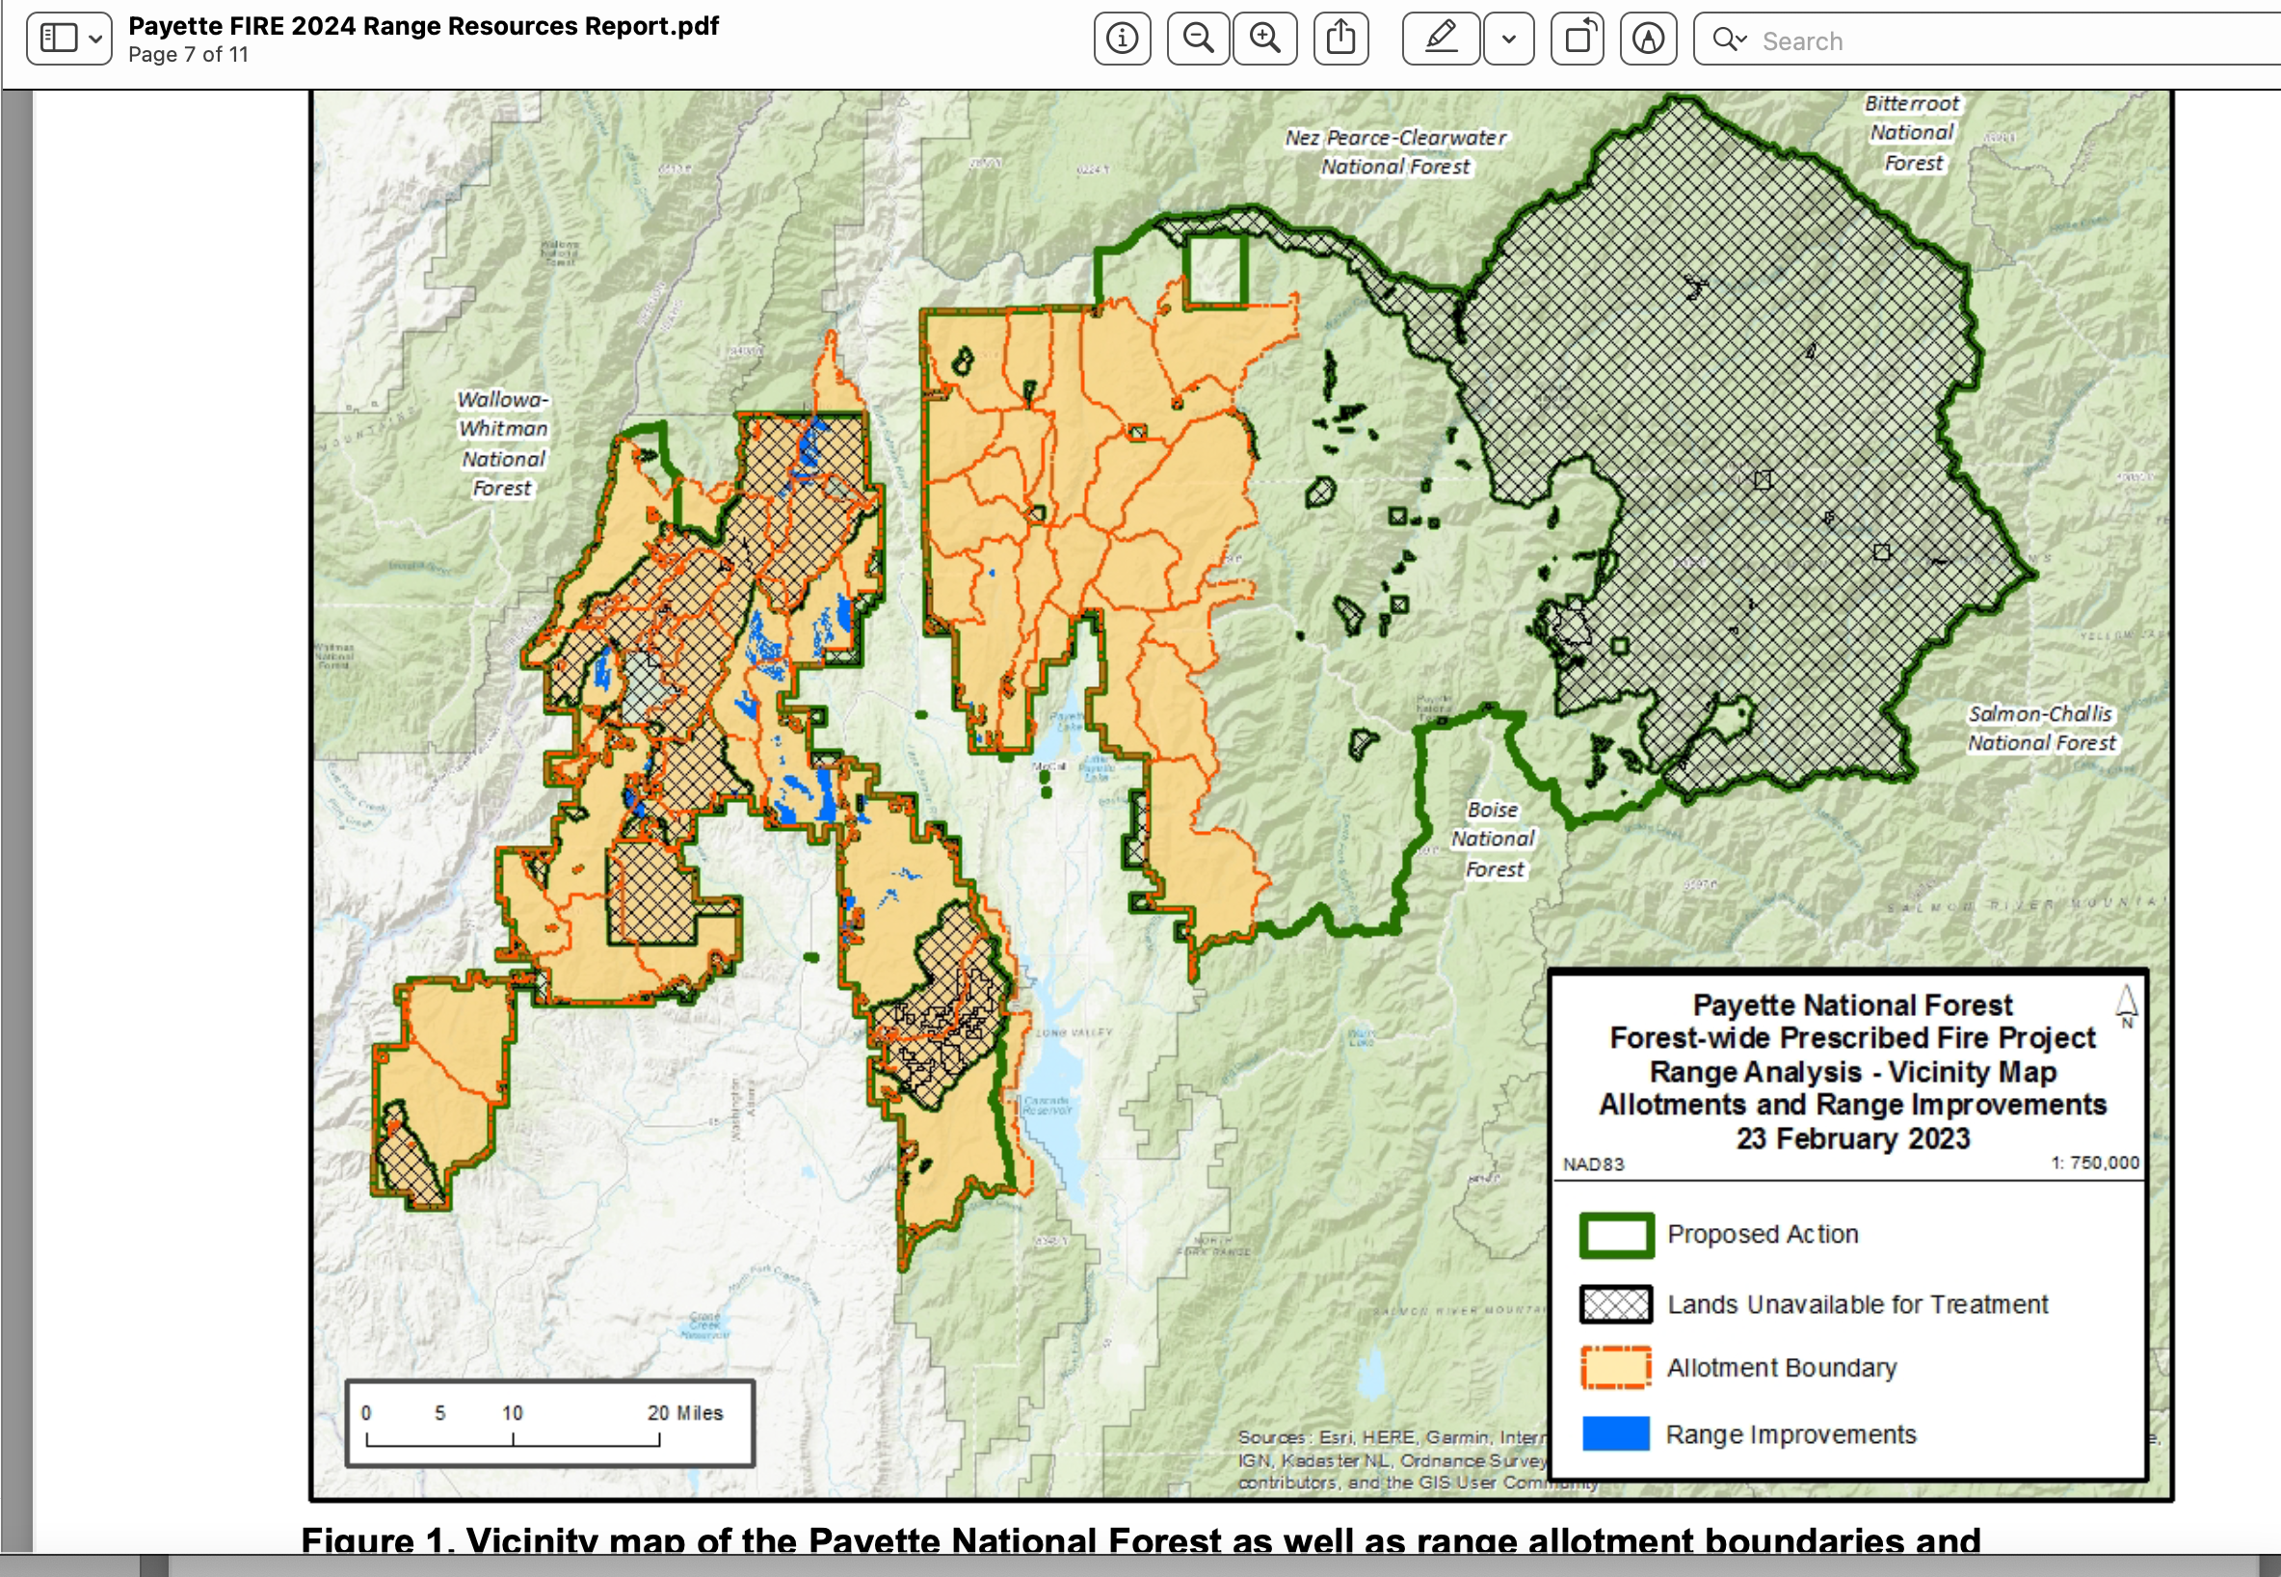
There has been much new scientific information and literature amassed since the time of the development of the desired conditions associated with Forest Plans across Idaho and much of Region 4. Climate change, and the stress that hotter temperatures for a more prolonged period, earlier or more extreme snowmelt runoff and other weather events have on forest ecosystems across Region 4 was only minimally considered. If lands are in poorer condition – or riparian areas and uplands disturbed from cattle or sheep grazing - these effects may be even more pronounced and severe.
Lands that are significantly altered or disturbed by livestock grazing are also likely to be less resilient when subjected to logging, thinning, fire and other treatments, more prone to excessive erosion, less shade which slows down snowmelt, etc. The risk is particularly great because the landscape and the project area receive a large amount of livestock grazing disturbance that alters site conditions and ecological processes at every level.
We are increasingly concerned that extensive forest tree or other woody vegetation removal projects may in fact be aimed at generating more livestock forage in areas with depleted “range” or limited “forage” or significant management problems – of which Sagehen iappears to be a superlative example. In a Washington state USFS project, clearing trees over many areas was promoted to disperse cows ostensibly to help limit wolf predation.
The project documents give the public the impression that the battery of radical new disturbances to be imposed on a system that has suffered extensive past logging/treatments of many types, and that has also been extensively grazed - will magically transform the landscape into asbestos-like ideal fire-resistant communities that will be “resilient” and “resistant”. These nebulous terms of resilience and resistance must be clearly defined, and solid scientific evidence provided to support the Forest’s claims.
What is the likelihood of areas to burn under various vegetation types and conditions in the models and estimates the Forests rely on for desired conditions? Burned largely grassy areas are often most likely to burn because they are hotter, drier, windier and have very short fire return intervals vs. shrub and forest lands. Forests are less likely to burn.
Will there be salvage or other logging or wood/tree removal in association with any prescribed fires? Will the Forest allow salvage logging in the event of a wildfire in or near the project area?
Sagehen and all of these massive treatment projects falsely claim they will increase diversity and resilience of the landscape with their overwhelming emphasis on promoting early seral species – destroying the essential habitats for nearly all Forest sensitive species.
Isn’t this counter to the Forest Plan and NFMA requirements for protection of sensitive, and also for MIS and ESA-listed species – none of which rely on early seral habitats that the avalanche of Region 4 treatment projects would massively result in?
The Forest Service references economic factors as part of the need. What will be the cost to recover the Wolverine population if they are driven out of the project area – due to intensified human disturbance in a burned and tree-stripped landscape heavily grazed landscape where recreational disturbance footprint also significantly expands? Doesn’t it violate NFMA to seek to destroy so much mid and late seral habitat -despite knowing from species habitat requirements that it will have a serious impact on rare biota? How much does livestock grazing cost the Forest just to administer? How much does it cost the forest to try to mitigate grazing damage – herbicide use, fencing, potential lack of forest regeneration, fencing degraded areas, etc.? How much will all elements of these projects cost taxpayers? What will be the costs to attempt restoration if the Forest’s treatments go awry -for example, herbicide costs if flammable grass or other weeds invade, re-planting of trees if burned or heavily logged areas do not regenerate – as is happening post-fire in areas of the Frank Church)? What is the economic value (recreational uses and enjoyment, carbon sequestration) associated with the Forest sites and attributes that will suffer short, mid and long-term loss and/or harms? What will it cost to restore species habitats and populations if projects cause their populations to significantly diminish or blink out altogether in the site? Or result in the larger local population not being viable any more? In order to understand this, the Forest must provide current baseline studies on the status of habitats, habitat loss and fragmentation and viability of populations of species of concern. How much will it cost to restore or stabilize a watershed that “blows out” as the result of effects of the often overlapping project treatments (including as exacerbated by grazing disturbance, roading etc.)?
Carbon sequestration concerns. Logging, burning or biomass production releases carbon dioxide and other gases into the atmosphere – and reduces the forest’s carbon sequestration. Livestock grazing also disrupts natural carbon sequestration processes.
What monitoring data does the FS have the degree of livestock browsing on aspen – and how may livestock browsing prevent natural regeneration? Does the Forest even monitor this highly detrimental grazing impact that impedes aspen regeneration and where the grazing injury may introduces diseases into clones? How are uncharacteristic or undesirable fires defined? When has fire “left the ecosystem” – does this just mean lightning has not struck recently? Note that in 2024, the FS claims areas have missed fire cycles – as if fires burn like clockwork – and the land is unhealthy if it has not burned. This is particularly absurd – given the mature and old growth deficits in the Boise, Payette and other Idaho Forests. How has the Forest factored the increase in human-caused fires due to improved “access” into its fire return and disturbance intervals, and projections of sufficient mature and old growth habitats and other values required to sustain MIS species, sensitive species, ESA species, and other forest attributes?
The project disturbances sprawl across the landscape. Logging and thinning that may make portions of the project area more vulnerable to fire spread, and may result in many more fires than the forest predicts. What science is the forest using to back up these claimed project benefits?
The Forest must provide a wide range of road removal and obliteration alternatives. But first it must take a systematic hard look at the impacts of the total road and trail system on all sensitive and rare species, and describe how trails and unauthorized routes keep expanding. Where is the Forest planning to keep roads in place so it can harvest more timber, for example - with the roads primary reason for existence being commodities/extraction. Where are roads kept open for grazing purposes when grazing activities such as salt distribution (salting primes sites for weeds) could be done on horseback?
Full ecological baseline data on existing site-specific conditions must be provided. All models, assumptions, inputs, science used to determine these desired conditions and to understand the direct, indirect and cumulative effects of imposing the project’s the battery of often overlapping disturbances on these resources must be provided. This is a very large land area, and there are many conflicts between competing resource uses that must be fully examined, and adverse impacts effectively minimized.
Please provide solid baseline inventory and assessment data of the Forest-required monitoring data effects of all livestock grazing disturbance, roads, trails, past logging/treatments, fires – on riparian areas – springs, seeps, wet meadows, bogs, streams, etc. See Belsky et al. 1999 Survey of livestock influences on stream and riparian ecosystems in the western United States riparian paper. Journal of Soil and Water Conservation, 1999, Vol. 54, pp. 419-431),
Full current data on riparian and aquatic habitat conditions must also be acquired as a baseline.
We are concerned that the Forest is improving roads and other recreational infrastructure. without minimizing and effectively mitigation adverse impacts to harms to wildlife, watersheds, roadless area lands, etc. of the combined effects of the “improvements” and massive treatments. How many of these are user-created? What specific use will trails be improved for? Many hikers, walkers and campers can get just fine with few and/or rudimentary trails. What is the existing winter recreation footprint - snowmobiling, or cross-country skiing? Is mountain bike use rapidly expanding in summer, resulting in trail proliferation and a considerable human disturbance footprint extending out considerable distances into wildlife habitats that were previously more secure? Other Forest project documents describe establishing User-created trails as part of a system. This is quite controversial, and rewards unauthorized use.
Please explain what this rosy statement really means. Aren’t some of these things mutually exclusive? It seems like the Forest has included contradictory elements in this statement. We are very concerned the Forest may be referring to the desires and agenda of Forest “Collaborative” group that cuts the vast majority of the public out of the process and decisions related to the group desires that may be at odds with the needs of rare species.
Non-Commercial Treatments: Non- commercial thinning (NCT) would occur on approximately 75,000 acres and would be completed in areas of commercial harvest as well as outside of commercial harvest. This would consist of trees generally less than ten inches diameter at breast height (DBH). Primary target acres for NCT consist of stands within 1⁄2 mile of structures; plantations; high-use recreation areas where vegetation management would maintain or enhance recreation objectives; areas with forest health concerns due to insect and disease; areas with undesirable competition to early seral species; areas where density related stress/mortality is
undesirable; and/or roadside treatments to improve ingress and egress routes.
Prescribed Fire Treatments:
Prescribed fire treatments would occur on approximately 83,000 acres. Nearly all of the project area (excluding the Bruin Mountain Reasearch Natural Area and additional areas deemed unsuited or critical) would be considered for prescribed fire over the next 20 years. Commercial activities would generally be completed prior to the application of fire, except where the application of fire prior to thinning does not affect commercial activities. Approximately 500 to 10,000 acres of prescribed fire would be applied annually.
This proposal amounts to a horrific disturbance footprint – often with multiple and overlapping treatment and other disturbance affecting the same site, watershed, populations of sensitive species, etc. – with logging/thinning (and linked roading), and fire taking place in the same constantly grazing disturbed area. EACH disturbance poses serious threats to the native ecosystem, sustainable native biota, sustainable and diverse recreational uses, and clean and abundant water including:
Irreversible and/or persistent weeds and chronic toxic herbicide use and drift, loss of sustainable perennial flows in tribs due to project-caused disturbance – associated erosion, downcutting rapid runoff, etc.
Levels and all types of impacts of all of these threats must be fully examined with an honest hard look NEPA analysis.
Associated Actions: Activities associated with implementing the above vegetative treatments include road maintenance and use; temporary roads, road relocation, rock pits, brush disposal, site preparation, and planting.
There should be no temporary road construction. The forest must honestly assess an alternative that relies on the existing road network. How ironic that the Forest claims it needs to close some roads for land/watershed health – yet at the same time proposes to bulldoze and blast new roads into remote or less disturbed areas. A mile of road in one area does not necessarily equate to a mile of road in another – the environmental context and values at risk and/or harmed must be critically examined.
Rock pits means new permanent destruction of Forest land areas for gravel for the massive ever-expanding road network. These areas are like little mines, and the sites they are located are irreversibly altered. What rock material will these pits be put into, and what potential pollutants or contaminants may it contain? Aren’t some crushed gravels contain significant amounts of arsenic or other pollutants?

Activities would include NFS road treatments, unauthorized route treatments, streambank and wetland restoration activities, and fish passage improvements. Road management actions for this project would utilize the McCall and New Meadows Ranger District Travel Analysis recommendations (completed in 2014 and 2015, respectively). Unauthorized routes not needed for future management would also be evaluated for some level of restoration treatment …
This all is quite nebulous and must be much better defined. The Forest must deal with all unauthorized routes first, before it builds more roads. Plus the many types of vegetation removal associated with this massive project will result in NEW unauthorized trails proliferating. How many miles of unauthorized trails currently exist, and where?
Why isn’t there a separate route closure process and EIS for that alone?
Where are all the unauthorized routes? When did they first show up (use aerial photography or other imagery to provide data). What has been the rate of new roading of all types in the project area and surrounding landscape? How many miles of roads have been built with past logging and/or treatment projects, and where are these located? Why didn’t the forest act to limit them? How many miles are there? How many may be related to livestock- fenceline routes, water development, etc. Please answer these questions for all roads –authorized or unauthorized.
Why is the Forest conducting such a huge sprawling project if it truly is concerned about interfaces with communities? This tear up a whole landscape approach is the dead opposite the direction public land management agency should be going. An agency should focus on protection of the actual interface with habitat – which means a dramatically reduced area.
Plus the battery of proposed treatments are likely to make the landscape MORE likely to burn in frequent fires.
Actions to improve stream channels, riparian habitat, and wetlands may include: Streambank stabilization, minor channel re- alignment, fence reconstruction, and planting native vegetation. These actions may also include placement of instream or streambank structures such as, but not limited to, rock, large woody debris, beaver dam analogs (BDAs), and barriers to prevent unauthorized motorized travel in sensitive areas.
What riparian and aquatic habitat condition studies have been conducted, and where? How many of these areas are grazed? What has been the role of livestock in causing or exacerbating riparian damage? Detailed data and analysis of the current livestock regime must be provided, as discussed below and in the Attached alternative. Are there spring developments or troughs? What has been the role of past treatments in impacting streams, springs, seeps, meadows and any other riparian habitats? Please provide detailed mapping and analysis of all past logging and other treatments for all periods of time in these watersheds. When and how is grazing inhibiting or retarding beaver recovery? In many instances, there is no need for artificial BDAs if habitat is allowed to improve by reducing or removing grazing degradation stress. In all areas where Streambank stabilization, minor channel re- alignment, fence reconstruction, and planting native vegetation and BDAs are proposed, detailed site-specific information must be provided, and a full range of alternatives must be provided. For example, we have seen the Humboldt-Toiyabe Forest in the Santa Rosa RD and some forests in California blade banks and then dump crushed gravel rocks in gullying headwater stream cuts caused by grazing, thus completely drying up all perennial surface flows. Meanwhile, no changes were made in cattle stocking, and the remaining stream and wetted areas suffered even worse cattle grazing and trampling degradation, promoting further loss of riparian habitats and flows.
WILDLIFE NEEDS MUST BE MET- YET PROJECT DRASTICALLY REDUCES AND FRAGMENTS AREA HABITATS
Under NFMA and the Forest Plan, the FS must maintain a diversity of wildlife species and must manage populations of wildlife for viable populations. Climate change stress amplifies the adverse effects of grazing on the ecosystem and native plants and animals as well as watershed processes.

Logging and thinning of other treatments will reduce existing cover of old growth and mature forests and disrupt recruitment of older trees. Many Forest sensitive species require old growth and mature forested cover. The Forest must identify these species, provide solid baseline data on the current habitat that exists and its ability to support these species, and provide detailed site data on how much the various treatment projects across the area will destroy, degrade and/or fragment habitat for sensitive and MIS species. How much has the availability of these habitats changed since the Forest Plan was adopted?

Levels of old growth, snag occurrence and abundance, and Old Growth replacement habitat across the project area and surrounding landscape and must be fully assessed in the EIS.

Please provide detailed site data and analysis of the current amount of nesting, young rearing, roosting, hiding, thermal, winter, snags, mistletoe (a beneficial habitat) and other cover and habitat that currently exists for important species, species of concern, MIS species, sensitive and ESA-listed species. Please provide detailed mapping depicting old growth and other habitats, and data and science-based analysis on how this type of habitat is necessary to fulfill species survival needs is dispersed across the landscape. Where are areas of higher quality habitat old growth or late successional habitat currently located. How large and inter-connected are they? How much fragmentation of this habitat is there? To what degree will the complicated series of project actions impact old growth and late successional habitat quality and quantity, and habitat connectivity or fragmentation? Please provide data and mapping.

The Forest must systematically determine how drastically essential habitat attributes (composition, function, structure, species composition – food, cover and space) for species nesting, birthing, fawning, etc. will change when the project is completed. Please also assess these conditions in the surrounding landscape.

Careful science-based consideration of the specific needs of sensitive and MIS species is required under NFMA and the Forest Plan. The Forest must also ensure a diversity of wildlife inhabit these lands -this includes food, cover, space, habitat security, carrying capacity and ability of animals to move across the landscape to fulfill seasonal needs must be analyzed.

Regarding Habitat quantity and quality, fragmentation/connectivity, availability:

How much suitable habitat will be left for each species of concern following the project activities, and where? Please provide detailed mapping and analysis How great a risk may stochastic events pose in what for some species will certainly be reduced habitat areas and increased fragmented and patchy habitat?

Please study and assess estimated direct, indirect and cumulative habitat loss, acreages, locations, forest type for all affected wildlife species.

Comprehensive thorough baseline inventories for all sensitive/rare species must be conducted. Old growth habitat types are particularly valuable to native wildlife species. See analysis in Hamilton (1993). Logging of old growth eliminates its value to wildlife, with impacts that ripple across the ecosystem. For example, several forest carnivores and some avian species prey on red squirrels - whose numbers are reduced by logging. It also reduces or eliminates snags with cavities essential for avian nesting and mammalian denning.

The number of birds increases with snags and mistletoe present. Mistletoe clumps provide essential habitat for flying squirrels and other small animals. Trees with mistletoe should be left standing uncut and unharvested including since they often have little economic value). Types of insects the Forest may consider pests are important food for birds. We stress that the insect species and populations are also impacted by livestock grazing taking place in the project area. Livestock consume native forbs/wildflowers, reducing insect availability (and thus food for avian and other species). Grazing of forbs and native bunchgrasses during their active or critical growing periods can result in plant injury or mortality, and ultimate changes in plant community composition. Anderson 1994 BLM Tech. Bull., Mack and Thompson 1982 This then reduces the abundance of the native plant species, resulting in replacement with early seral or exotic species. Belsky and Gelbard 2000.

White-headed Woodpecker and other Avian Habitat Concerns. Detailed site-specific data on canopy closure, canopy levels, understory conditions, topography exposure/aspect, etc. all must be provided. Canopy needs of various old growth forest and other sensitive species and migratory birds must be fully assessed. For example, see canopy closure needs reported for use for nesting, roosting, and foraging by the white-headed woodpecker as shown by Dixon’s (1995) research. Dixon describes the need for large diameter Ponderosa pine trees (27” dbh and >), canopy closure of 65%, Ligon (1973) reported on the need for ponderosa pine seed as winter food. Ponderosa pine are particularly important because of their larger sized seeds. The project will cause loss of these forest attributes will result in a loss of forest carrying capacity for dependent species. There will be many forms of loss associated with the complex project actions – logging, thinning burning, road blading clearing swaths of trees - for prolonged periods of time, etc.

https://sora.unm.edu/sites/default/files/journals/auk/v090n04/p0862-p0869.pdf

Birds of North America shows the relatively limited range of the white-headed woodpecker, found in only a few forests in Idaho, and describes:
Pine seeds are an important part of its diet through much of the year but especially in fall and winter. Individuals typically take pine seeds from open cones or by perching directly on an unopened cone and drilling into it. The species is closely associated with the ponderosa pine (Pinus ponderosa) over most of its range, but reaches greatest abundances where 2 or more species of pines with large, seed-laden cones occur. Its diverse foraging repertoire also includes flaking and gleaning of the trunk and branch surfaces of living conifers, as well as probing of needle clusters. These birds rarely, if ever, drill deeper into live, decaying, or dead wood.
… Modern forestry practices, including clear-cutting, even-age stand management, snag removal, fire suppression, and forest fragmentation have contributed to local declines of this species, particularly north of California.
https://birdsna.org/Species-Account/bna/species/whhwoo/introduction

Idaho winters are often long and severe, and abundant pine seeds would seem to be of much importance. Yet the project will significantly diminish this available food source.

The USFWS Conservation Assessment for the White-headed Woodpecker states:
White-headed woodpeckers are cavity nesting birds strongly associated with coniferous forests dominated by pines open ponderosa pine (Pinus ponderosa) or dry mixed-conifer forests dominated by ponderosa pine (Bull et al. 1986, Dixon 1995a, Frenzel 2004, Buchanan et al. 2003). They also use burned forests (Saab and Dudley 1988, Wightman et al. 2010). Nesting usually occurs in open ponderosa pine forests with higher number of large trees and snags than the surrounding forest (Buchanan et al. 2003, Frenzel 2004, Hollenbeck et al. 2011). The woodpeckers typically excavate nest cavities in large, moderately decayed, ponderosa pine snags (Buchanan et al. 2003, Dixon 1995a, Frenzel 2004). The birds forage in ponderosa pine trees in stands with higher canopy closure than nest stands (Dixon 1995a, Fredrick and Moore 1991). Large-seeded cone-producing trees and high canopy closure are vital, particularly outside the breeding season (Garrett et al. 1996).
White-headed woodpeckers lack strong excavating ability and rarely forage on completely dead trees. They typically feed on insects during the spring and early summer by gleaning and pecking (Garrett et al. 1996). The woodpeckers switch to ponderosa pine or sugar pine (Pinus lambertiana) seeds from late summer through the winter (Bull 1980, Dixon 1995a, Ligon 1973).
Habitat loss is the primary threat to White-headed woodpeckers (NatureServe 2008). Local population declines have occurred following loss of large open ponderosa pine forests from logging, and other threats.
http://www.fwspubs.org/doi/suppl/10.3996/052017-JFWM-039/suppl_file/10.3996052017-jfwm-039.s6.pdf

Bunnell 2013 describes how vital large trees are for many avian and sensitive species:

Pygmy Nuthatches, Flammulated Owls, White-headed Woodpeckers, and Pileated Woodpeckers all nest primarily in large ponderosa pine or Douglas-fir in at least some regions [57, 92, 192, 252].
Weak excavators include Mountain Chickadees, Nuthatches, and those Woodpeckers that forage primarily by probing and gleaning, extracting seeds, or capturing insects in flight (e.g., acorn (Melanerpes formicivorus), downy (Picoides pubescens), Lewis’s (M. lewis), Nuttall’s (P. nuttalli), and white-headed (P. albolarvatus) woodpeckers). Despite using cavities to nest, weak excavators are less well adapted to excavation than are species that drill into wood to forage, so often use cavities initiated by strong excavators. Strong excavators are generally large birds; weak excavators are mostly smaller species.
Larger species of strong primary excavators can act as keystone species, providing nest, den, and roost sites for other cavity-using species. If their requirements are lacking, secondary cavity users may be lost [7–11]. Similarly, Sapsucker foraging activity creates feeding opportunities for many other species. At least 23 bird species, 6 mammal species, and numerous arthropods (9 orders and 22 families) have been reported feeding at sapsucker holes [12–14]. Woodpeckers also can sometimes constrain the abundance of forest “pest” insects [15, 16]. Loss of strong excavators would seriously disrupt forest ecosystems. These holes may often be in species other than Aspen – such as the ofteninterspersed mature conifers in aspen stands that the FS seeks to destroy – seeking highly unnatural “pure” vegetation communities.

In the PNW, 67 vertebrate species use cavities more than 50% of the time, either generally or regionally; more species are opportunistic in their use of tree cavities. A small component of strong, primary excavators creates cavity sites for many more species (Figure 1). There are 22 primary cavity excavators and 45 secondary cavity users relying on hollows or cavities, not all of these excavated by birds. Only 9 species are strong excavators, affirming the role of strong excavators as keystone species. Most secondary users rely on holes excavated by primary excavators. The proportion of nest sites of secondary users excavated by other species ranged from 89 to 100% with one exception [7]; neither of two flammulated owl (Otus flammeolus) nest sites was excavated.

Birds (48 species) and bats (11 species) represent 88% of species consistently or commonly using cavities. More bird than mammal species use cavities; mammals using cavities or hollows range in size from bats to grizzly bears (Ursus arctos). Other than for some bats and squirrels, mammal use of cavities is more opportunistic than it is for birds. Amphibians and reptiles also use cavities in snags and stumps opportunistically …
Larger snags provide more room and are longer lived, so provide greater opportunities for cavity use. The number of cavity-using species thus decreases with decreasing diameter of the dominant tree species. In the north, where trees are small (Spruce Willow Birch of Figure 1), the numbers of cavity users is much reduced.

Of these species, only the White-headed and Lewis’s Woodpeckers are weak primary excavators, and several play keystone roles in particular regions. Three are candidates for designation or are designated “at risk” in portions of the PNW (Lewis’s, Pileated and White-headed Woodpeckers), and one has two subspecies designated (Williamson’s sapsucker).

Bunnell: https://www.hindawi.com/journals/isrn/2013/457698/ describes:
«Many bird and mammal species rely on cavities in trees to rear their young or roost. Favourable cavity sites are usually created by fungi, so they are more common in older, dying trees that are incompatible with intensive fiber production. Forestry has reduced amounts of such trees to the extent that many cavity-using vertebrates are now designated “at risk.”

Bunnell (2013) describes Flammulated Owl habitat needs:

Even relatively small secondary nesters select large trees when nesting in conifers, there apparently is no need to do that in hardwoods. Nest tree diameters must be large enough to accommodate a cavity with room for an adult bird and nestlings, but sizes in conifers usually exceed that requirement. The selection of trees much larger than the size of cavity required reflects not only pursuit of height above ground, but age and the size at which heart rot develops. That occurs at younger ages and smaller sizes in hardwoods. Collated diameters of conifer nest trees of tree swallows ranged from 18 to 78 cm. Flammulated owls are only slightly larger than a sparrow, but nested in ponderosa pine averaging 57.7 cm dbh on southern aspects and 71.7 cm on northern aspects (data of [194]). The difference reflects greater rates of growth on north aspects, thus size at the age when rot appears. Pygmy nuthatches, flammulated owls, white-headed woodpeckers, and pileated woodpeckers all nest primarily in large ponderosa pine or Douglas-fir in at least some regions [57, 92, 192, 252], showing little relationship between size of bird and diameter of tree during nest site selection in conifers …”.

Pileated Woodpecker. (Bunnell 2013): Even in forests dominated by conifers, large strong excavators (e.g., yellow-bellied sapsucker, Sphyrapicus varius, and pileated woodpecker, Dryocopus pileatus) preferentially nest in trembling aspen having decayed heartwood surrounded by sound sapwood [29, 55]. They use live and dead aspen relatively indiscriminately. Most pileated woodpecker nests in aspen are in live trees [68], affirming their ability to excavate live wood and the value of a sound sapwood shell. Bunnell 2013

The period that a snag remains firm enough to provide useful protection is shorter than the life of the snag. Analysis of preference for decay classes by comparing use to availability [46] showed the most strongly preferred decay classes were classes 3 and 4 (recently dead trees). How long a tree remains in these decay classes depends on cause of mortality, tree species, and site. Pileated woodpeckers used cavities in ponderosa pine (Pinus ponderosa) for 3–8 years after the trees were killed by fire…”.

Loss of snag habitat is a significant concern. See study of the loss of snag habitat due to logging measured by Holloway and Malcolm (2006).

Logging and other treatments that reduce or remove old growth and canopy protections and reduce or eliminate snags and future snag habitat will degrade habitat for these avian species and native carnivores like the fisher. Unavoidable adverse impacts must be considered in balance with any hypothesized beneficial impacts. Adverse impacts may include: a reduction in current and future snag habitat, and a reduction in both summer and winter food habitat for the white-headed woodpecker.

Northern Goshawk. Bunnell 2013 describes: Logging old growth forests adversely impacts foraging habitat for the northern goshawk. Forest thinning reduces prey habitat - red squirrel (key prey species) habitat as well as populations (Vahle and Patton 1983, Holloway and Malcolm 2006, and Herbers and Klenner 2007), (Salafsky et al. 2005, Salafsky et al. 2009). Reproductive success of the goshawk is believed to be driven by prey density (Salafsky et al. 2005, Salafsky et al. 2009, Reynolds et al. 2006).

Logging has been implicated in declining Northern Goshawk population trends. Patla (2005) reported that in the Greater Yellowstone Ecosystem that reoccupancy of goshawk territories average 45% in unlogged areas, and only 22% in logged habitat. On the heavily-logged Black Hills National Forest, a 2003 survey of 72 historic goshawk nests found only 8 of them occupied (Fauna West Wildlife Consultants 2003).

A Goshawk home range may be as large as 6000 acres. The Forest must manage consistent with the best science to protect nest stands, alternate nest stands, post-fledging areas, suitable prey habitat, and home ranges for the northern goshawk”.

“Like Canada lynx and wolverine, Northern goshawks also depend on mammals and birds for prey. Reynolds et al (1992) provide specific recommendations that livestock grazing utilization will average no more than 20% in goshawk home range of approximately 6,000 acres, which also includes nesting and post-fledging areas. They also specify forest stand structure needed for goshawk across its home range and the protection of mycorrhizal fungi in the forest floor to aid in nutrient cycling. There must be an analysis of the current state of habitat, forage productivity and livestock utilization of forage in the project area”. Reynolds, R.T., R.T. Graham, M.H. Reiser, R.L. Bassett, P.L. Kennedy, D.A. Boyce, Jr., G. Goodwin, R. Smith, and E.L. Fisher. 1992. Management Recommendations for the Northern Goshawk in the Southwestern United States. Gen. Tech. Rep. GTR-RM-217, Fort Collins, Colorado. U.S. Department of Agriculture, Rocky Mountain Forest and Range Experiment Station. 90p

Livestock grazing also compacts the soil, reduces infiltration, increases runoff, erosion and sediment yield. The effects of these activities on the nutrient cycle and soil conditions must be analyzed in connection with forest health in goshawk home ranges, habitats suitable for goshawk and these should be mapped. Northern goshawk, as an MIS, must have a determination of capable and suitable habitat.
Snowshoe hares are prey for lynx and goshawk. Their forage base is depleted by historic and current livestock grazing. The population data for snowshoe hare should be analyzed – what data has the FS collected on hares and other rare carnivore prey species in the project area?
Pileated woodpecker. This bird has been an MIS for the Boise and Payette Forests. This woodpecker relies on old growth habitat with at least a 60% canopy closure, or relatively dense forest, and it prefers unlogged forests. At least 40% of a pileated woodpecker territory should be unlogged. (Bull and Holthausen 1993). See also Hutto (1995).

The FS states: “The pileated woodpecker is a large tree cavity excavator that is ecologically tied to mature mixed-conifer stands. This association is predominantly a result of the species’ need for large dead trees for nesting, large hollow trees for roosting, and standing and down dead trees for foraging on carpenter ants. The pileated woodpecker is a long-lived and wide-ranging non-migratory resident species”.
The FS also states: “Fourteen other species of birds within the Ecogroup area are dependent on cavities that these woodpeckers excavate for nesting, because they are not able to excavate their own cavities. Cavities created by pileated woodpeckers are used by some of the large species that need cavities, but do not excavate them, e.g., barred owl, boreal owl, etc. In addition to cavity-nesting birds, mammals such as fisher, bats, and flying squirrels use cavities excavated by pileated woodpeckers for nesting, denning, and
roosting sites (Bull et al. 1997, ICBEMP 1996b, Thomas et. al. 1979, Wisdom et al. 2000). The pileated woodpecker is a species whose presence can be correlated with certain habitat characteristics important a number of other species (large diameter dead and downed wood, cavities)”. The FS admits these species in the Boise, Payette and Sawtooth Forests are impacted by forest management activities – and in the case of the proposed massive logging, thinning, burning, road bulldozing – are significantly by the Sagehen project wood and habitat liquidation.
https://www.fs.usda.gov/Internet/FSE_DOCUMENTS/stelprdb5196585.pdf

Logging old growth forests will also reduce forest “pests”, such as mistletoe, that are part of natural processes providing habitat for important biota. Bennetts et al. (1996) reported that the number of snags and mistletoe trees were positively correlated (mistletoe causing eventual tree mortality and thus snags). The number of forest birds and species richness was also positively correlated with the level of mistletoe in the stand. Mistletoe also provides essential Flying Squirrel habitat.

Species relying on seed production. Logging of old growth forests will also degrade songbird habitat (and red squirrel habitat) due to the reduction in conifer seed production. Smith and Balda (1970) identified many songbirds that feed heavily on conifer seeds, including more than a dozen species that occur in the project area. Conifer seed production reaches maximum potential when forest stands reach and exceed maturity (Reynolds et al. 1991).

Birds of conservation concern are highly associated with conifer seed crops, including the Clark’s nutcracker. Nutcrackers are suffering a calamitous loss of habitat due to West-wide die-off of the large-seeded whitebark pines. Preservation of the large-seeded pines is crucial. Yet the project proposes large-scale fire use – that wilk il surviving trees, including young ones. A variety of species of crossbills are highly dependent upon abundant conifer seed sources, and travel around the landscape to locate suitable areas (Benkman 1993). Conservation of this suite of species is tied to management of abundant cone crops across the landscape (Id., Wilcove 1992).

Species relying on old growth structural or food producing characteristics. There are also a number of songbirds in the northern Rocky Mountains that nest in relatively undisturbed older forest habitat (Hutto 1995). Approx. 25% of forest bird species rely on snag habitat.

The FS rosy Pileated Woodpecker claims are based on 1998 and older data from Idaho – i.e. extremely old ICBEMP info.

Canada Lynx. Has the project area or adjacent lands been identified as suitable Lynx habitat? The Lynx is an old growth dependent species. Squires et al. (2010) found that lynx depend upon older multistoried forests as winter habitat. If essential components of Lynx habitat are claimed not to be present, what are they and how can they be improved? Note that Snowshoe Hare use dense riparian areas, and this project will intrude on and destroy elements of RHCAs with “treatments” – and by clearing out woody impediments to livestock accessing many more areas of riparian zones.

The Forest must demonstrate consistency with applicable Lynx Conservation Assessment and Strategy (LCAS) Standards and Guidelines. Please provide adequate maps of LAUs and habitat components along with areas of human activity as the LCAS requires. This is necessary for the public and decision maker to understand the impacts of the many vegetation treatments and motorized travel. How will lynx habitat and connectivity of habitat be impacted? Livestock grazing may also result in herbivory and breakage of dense undergrowth affecting snowshoe hare habitat. This includes habitats adjacent to riparian willow areas. Please conduct full analysis of the range of cumulative impacts of the other human disturbance activities, including the cumulative effects of livestock grazing and motorized recreation in the project area. This must include the impacts of winter snowmobile use on native carnivore populations. How does the current Forest Travel plan address over-snow, and off-trail motorized use in winter across the project area and surrounding landscape? How does the snow grooming of trails mentioned in the Sagehen project documents impair and harm potential Lynx habitat use?

Please conduct detailed analysis of habitat elements for the Wolverine. Is there Wolverine habitat present in the project area? If so, where? Where are potential denning sites or winter use areas? How will climate change stress potentially increase threats to Canada Lynx and Wolverine habitats and populations? Lynx Analysis Units often fall below LCAS habitat percentages. Forest management in this EIS process must exceed the management status quo and strive to improve conditions of the LUAs. The latter is what led to Lynx listing under the ESA in the first place.

Has the Forest conducted track surveys, or used wildlife cameras to determine current status and habitat occupancy for native carnivores of concern? Please undertake a current scientifically sound survey for Lynx and Wolverine.

Loss or reduction of essential old growth and late successional forests, and loss of recruitment of these forest types and maturing forests as planned in this project, is likely to result in substantial population declines and loss of sustainability of existing populations. It will prevent recovery of populations and expansion into these habitats if these species are not already present. What would be considered a viable population of this species and other rare native carnivores? Note there are only estimated to be 300 Wolverines in western US.

Squires et al. (2010) stated that older, multi-storied forests are essential as winter lynx habitat, and viability of Lynx. The reduction of any of this key winter habitat may cause a risk to lynx viability. Lynx are already at a threshold level of survival in regards to winter hare populations; even minor reductions may result in winter starvations for lynx (Id.). It is currently recognized that there is a threshold of forest thinning and logging below which lynx may not persist (Squires et al. 2010; Squires 2010). The EIS must consider the connection between the historic loss of lynx winter habitat and the population decline of lynx in the Northern Rockies. Please detail the proposed management of snowshoe hare habitat, and potential impacts on viability of the lynx. Does the FS have winter hare surveys for this region and for the project area? Also note all leportids face the new serious RHD disease threat.

Elsewhere (for example in the Payette Forest’s Lost-Boulder Creek BA), the Forest has identified risk factors to Lynx in this geographic area:
- Timber harvest and precommercial thinning that reduce denning or foraging habitat or converts habitat to less desirable tree species;
- Fire exclusion that changes the vegetation mosaic maintained by natural disturbance processes;
- Grazing by domestic livestock that reduces forage for lynx prey;
- Roads and winter recreation trails that facilitate access to historical lynx habitat by competitors;
- Legal and incidental trapping and shooting;
- Being hit by vehicles;
- Obstructions to lynx movements such as highways and private land development

All of these factors must be fully examined in the current project.

Project Threats to Fisher and other Rare Native Carnivores

Here is mapping of the Fisher range in Idaho:

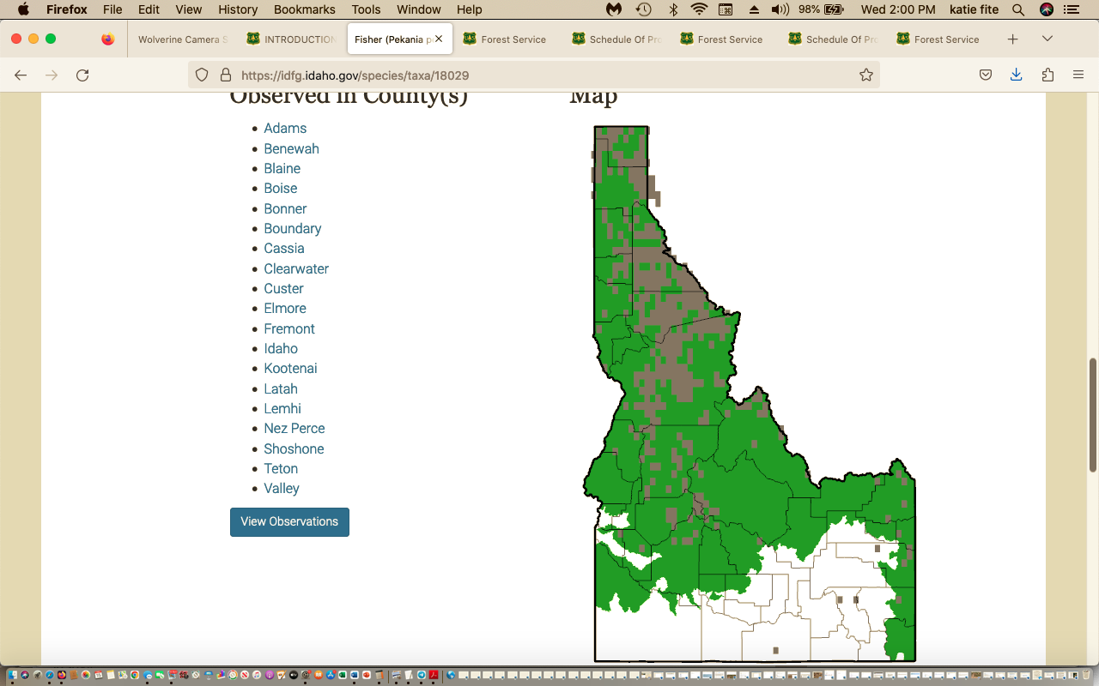

See: https://idfg.idaho.gov/sites/default/files/for_public_comment_draft_fisher_wolverine_and_canada_lynx_plan.pdf

Habitat Use. The distribution of fisher is broadly limited by three factors: abundance and structure of snow, availability of suitable forest structure (including resting and denning sites), and abundant prey (see Diet below). Unlike lynx and wolverine, fisher are not well adapted to deep, unconsolidated snow. For their size and weight, fishers have small feet, making them prone to sinking into snow rather than walking on top of it. This makes it energetically expensive for fishers to move and survive in areas characterized by deep, unconsolidated snowpack. Elsewhere in the range of fishers, snow depths are predictive in describing the range of fishers (Krohn et al. 2005). In Idaho and Montana, fishers are broadly associated with low to mid-elevation mixed-mesic forest types where snows consolidate, making their travel easier. In north-central
Idaho, regular occurrences of fishers taper off at >5,000ft of elevation, though some have been documented at much higher elevations.

“ … in the mid-elevation mixed-mesic forest types of north-central Idaho, fishers establish home ranges in landscapes with larger, more connected and contiguous patches of mature forest, with reduced amount of open areas (Sauder and Rachlow 2014). Within established home ranges, fisher core use areas have moderate amounts of high canopy cover forest and moderate amounts of forest edge (Sauder and Rachlow 2015). Heterogeneous forest patterns likely put preferred habitats for both hunting and resting in close proximity. Between foraging bouts, fishers regularly use resting sites in cavities of trees, platforms formed by witches' brooms, broken top trees, or tree forks. Specific data on resting site selection by fishers in Idaho are scarce, but consistent themes have been identified across other populations (Aubry et al. 2013). Resting sites typically have dense overhead cover, steeper slopes, cooler microclimate, and a greater prevalence of large trees and snags than are generally available in the surrounding landscape.
Zelinsnki et al. (2004) found that fisher resting sites were often in larger-than-average tree within stands of trees larger than the landscape average. In that study, resting sites were found principally in cavities in live conifer trees and snags averaging ~46 inches in diameter. Jones (1991) reported that the average diameter of resting site trees used by fishers in Idaho was ~22 inches (range 11 to 59 inches) and that 68% were on platforms composed of witches' broom.

Regarding federal candidate species Wolverine (now Threatened but with inadequate protections due to USFWS “exemptions”):

“Snow cover is a commonly used metric to project change in wolverine habitat resulting of a warming climate. Projections of increasing temperatures and a trend for more precipitation to fall as rain rather than snow represent a potential stress on wolverine based on elevation and latitude. However, the magnitude of projected change varies widely in time and space, and natural climate variability can reduce or amplify projected effects (e.g., Abatzoglou et al. 2014). Local climate conditions may continue to offer climate refugia (e.g., Moritz and Agudo 2013), and the complexity of terrain in Idaho represents a challenge for many climate models. All these factors lead to uncertainty about how climate change could influence wolverine persistence in Idaho over the next 50 years. Most projections for the Pacific Northwest predict progressively warmer and wetter conditions during the 21st century. Temperatures are predicted to increase in all seasons, with the largest increases in summer. Precipitation is predicted to increase during fall and winter, with little change or additional drying during summer. Much of the western U.S. is expected to transition from a snow-dominated system to one more rain-dominated; spring snowpack is expected to decline, especially at warmer low to mid-elevations; and existing snow is expected to continue melting earlier (Pierce and Cayan 2013). These changes are expected to become most pronounced beyond 2035 (Kunkel et al. 2013). Climate models provide credible estimates at global and continental scales under a given set of assumptions (IPCC 2007)”.

Information on Canada Lynx (IDFG 2023) includes:

https://idfg.idaho.gov/sites/default/files/for_public_comment_draft_fisher_wolverine_and_canada_lynx_plan.pdf

“Habitat Use. Suitable lynx habitat is forest structure that supports: (1) snowshoe hare density above 0.2 per acre (Berg et al. 2012), (2) enough horizontal cover to allow for efficient hunting (Vashon et al. 2008; Squires et al. 2010), and (3) winter conditions that promote unconsolidated snowpack to provide Canada lynx an adaptive advantage over other meso-carnivores due to their foot loading. In the Northern Rockies of the United States, these components tend to be found in mid- to high- elevation forest (i.e., 4,900 – 6,500 ft) composed of spruce-fir overstory with a midstory forming complex structure and high horizontal cover (Squires et al. 2010). This tends to be associated with late-seral stage forests. However, this is not the only forest structure needed by lynx. In an investigation of habitat use Holbrook et al. (2018) identified that a high-quality mosaic habitat for female lynx contains ≈50-60% mature forest and ≈18-19% advanced regenerating forest”.
“Habitat Use.
Suitable lynx habitat is forest structure that supports: (1) snowshoe hare density above 0.2 per acre (Berg et al. 2012), (2) enough horizontal cover to allow for efficient hunting (Vashon et al. 2008; Squires et al. 2010), and (3) winter conditions that promote unconsolidated snowpack to provide Canada lynx an adaptive advantage over other meso-carnivores due to their foot loading. In the Northern Rockies of the United States, these components tend to be found in mid- to high- elevation forest (i.e., 4,900 – 6,500 ft) composed of spruce-fir overstory with a midstory forming complex structure and high horizontal cover (Squires et al. 2010). This tends to be associated with late-seral stage
forests. However, this is not the only forest structure needed by lynx. In an investigation of habitat use of 32 female lynx over 94 lynx years, Holbrook et al. (2018) identified that a high-quality mosaic habitat for female lynx contains ≈50-60% mature forest and ≈18-19% advanced regenerating forest …”.
“Throughout the species’ range, snowshoe hare is the primary food item. In northwestern Montana, snowshoe hares account for 96% of winter prey biomass (Squires and Ruggiero 2007). Further south, in an introduced population of lynx in Colorado, Ivan and Shenk (2016) found that while snowshoe hares continued to be an important food source, red squirrels (Tamis hudsonicus) were also an important prey
item, accounting for more than 20% of diet by biomass in 7 of the 11 years of the study. While secondary prey items (i.e., prey other than snowshoe hare) may vary in rates of occurrence in food habitat studies, snowshoe hares remain the primary food item and suitable snowshoe hare densities are a requirement”.

We have observed that Snowshoe Hares are also associated with dense riparian willow habitats in central Idaho (for example, Trail Creek and the upper Big Lost). Livestock grazing degrades riparian areas. So will the “treatments” that impinge on RHCAs and that reduce woody vegetation across the watershed so livestock can access many more areas easily.

How will the project affect connectivity, habitat security, prey species habitats, and other key elements of habitats necessary for survival of native carnivores? Further, the removal of even more vegetation here will increase poaching and human harassment, and mortality of native carnivores from shooting and trapping- and that includes worsening the barbaric assault on Gray Wolves underway in Idaho. Note that 60-day notices have already been filed by environmental groups challenging USFWS recent not warranted Gray Wolf listing finding. See this article on shrinking snowpacks – and the massive logging, burning thinning :treatments” will exacerbate loss of snow cover.
https://www.ktvb.com/article/tech/science/environment/environment-northwest-shrinking-snowpack-pacific-northwest-impacts/281-41580cd0-3e1b-48b0-96d5-fcf73db9dd1a
“Looking forward, those trends continue. A University of Washington report projects that in the 4,000 to 5,000 foot range of the Cascades, the length of the snow season could decrease by nearly half by the end of the 21st century. This means that the historical 142 days of snow on the ground in the second half of the 20th century will drop to 87 days on average in the 2080s”.
“A map from the EPA shows the trends in April snowpack in the western U.S. from 1955 to 2022. In Washington, most areas’ snowpack is down between 20 to 30%, with some areas decreasing as much as 50 to 60%. Looking forward, those trends continue. A University of Washington report projects that in the 4,000 to 5,000 foot range of the Cascades, the length of the snow season could decrease by nearly half by the end of the 21st century”.

Major snowpack declines are predicted across Idaho – and this is certain to adversely impact the long-term project adverse impacts.
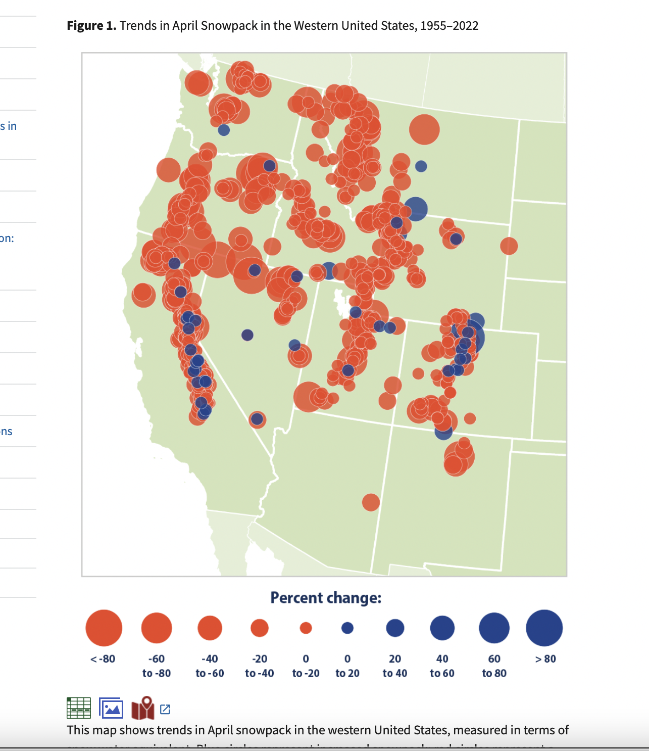

USFS Sagehen Project --- Wolverine Persistence and Survival Conflicts Abound
The extensive thinning, burning and other deforestation actions, and route/trail actions that expand access here will greatly expand the ability of snowmobiles, ATVs, mountain bikes, and domestic sheep to pierce previously in accessible or less accessible areas – generating even greater conflicts with Wolverine use of habitats and population viability.
These conflicts are already a major and highly controversial issue in the Payette NF in this very area.
What areas are currently impenetrable to snowmobile use in winter, or minimally used? To ATVs or bikes in summer? To sheep herding? How will this expand winter access? How can the FS possibly even make estimates on project outcomes when it uses the highly uncertain slipshod scheme of “condition-based management”? See for example:
https://www.theatlantic.com/science/archive/2020/03/snowmobiles-wolverines/608500/
The research—which was published in February 2019 and concluded that winter recreation displaces wolverines—has fueled an ongoing lawsuit regarding a proposed closure in the Sawtooth National Forest.

A Payette Forest Wolverine-Snowmobile study shows very significant recreational disturbance conflicts with this species:

https://esajournals.onlinelibrary.wiley.com/doi/full/10.1002/ecs2.2611

From the Heinemeyer et al. 2019 Abstract:
“Abstract. Outdoor recreation is increasingly recognized to impact nature and wildlife, yet few studies have examined recreation within large natural landscapes that are critical habitat to some of our most rare and potentially disturbance-sensitive species. Over six winters (2010–2015) and four study areas (>1.1 million ha) in Idaho, Wyoming, and Montana, we studied the responses of wolverines (Gulo gulo) to backcountry winter recreation. We fit Global Positioning System (GPS) collars to 24 individual wolverines and acquired >54,000 GPS locations over 39 animal-years during winter (January–April). Simultaneously, we monitored winter recreation, collecting ~6000 GPS tracks (~200,000 km) from backcountry recreationists. We combined the GPS tracks with trail use counts and aerial recreation surveys to map the extent and relative intensity of motorized and non-motorized recreation. We integrated our wolverine and backcountry recreation data to (1) assess patterns of wolverine habitat selection and (2) evaluate the effect of backcountry recreation on wolverine habitat relationships. We used resource selection functions to model habitat selection of male and female wolverines within their home ranges. We first modeled habitat selection for environmental covariates to understand male and female habitat use then incorporated winter recreation covariates. We assessed the potential for indirect habitat loss from winter recreation and tested for functional responses of wolverines to differing levels and types of recreation. Motorized recreation occurred at higher intensity across a larger footprint than non-motorized recreation in most wolverine home ranges. Wolverines avoided areas of both motorized and non-motorized winter recreation with off-road recreation eliciting a stronger response than road-based recreation. Female wolverines exhibited stronger avoidance of off-road motorized recreation and experienced higher indirect habitat loss than male wolverines. Wolverines showed negative functional responses to the level of recreation exposure within the home range, with female wolverines showing the strongest functional response to motorized winter recreation. We suggest indirect habitat loss, particularly to females, could be of concern in areas with higher recreation levels. We speculate that the potential for backcountry winter recreation to affect wolverines may increase under climate change if reduced snow pack concentrates winter recreationists and wolverines in the remaining areas of persistent snow cover”.
Species Status Assessment Addendum: FOR NORTH AMERICAN WOLVERINE (Gulo gulo luscus).
See discussion of “stressors” pps 30-47.

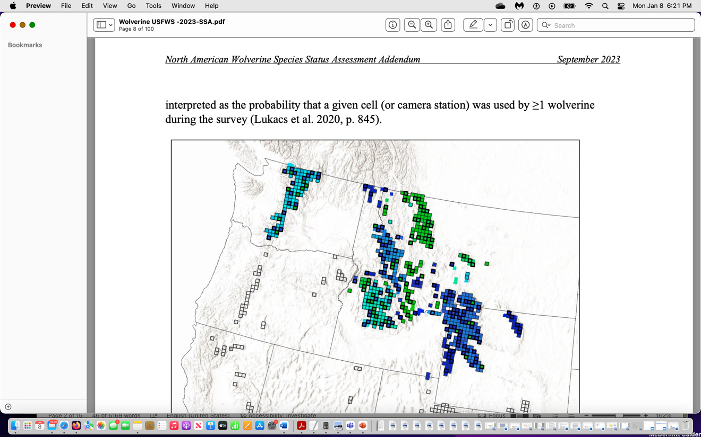
The BNF Sagehen project like the PNF Granite Goose project is near the very edge of the Wolverine’s current shrinking range and distribution – elevating concern that any loss or disturbance of habitat in both these projects may result in a range contraction.
As the USFWS makes very clear, this species is highly snow dependent. We are very concerned that the project will result in loss of snow retention and shortened periods of snow presence - as it will remove protective shading cover causing early and accelerated snow melt. This will of course be worsened by the effects of climate change and increased temperatures.
Instead of the Forest conducting much larger closures and NOT conducting these severe project treatments across distances far from structures/habitations, the agency semes intent on making much of the area uninhabitable for these rare carnivore species.
Here is what the USFWS said in 2023:
“Future Condition: We expect wolverine resiliency and redundancy in the contiguous U.S. to decline to some extent. Wolverine habitat in the contiguous U.S. is projected to decrease in areas that were modeled and become more fragmented because of climate changes that result in increasing temperatures, earlier spring snowmelt, and loss of deep, persistent spring snowpack, primarily at lower elevations (see Climate Change Effects section above). Winter recreation, which has been shown to negatively influence wolverine behavior, in these diminished habitats may increase as human populations increase (U.S. Forest Service 2016, pp. 12–13, 12–14). In addition, snow- dependent recreation that was formerly distributed over a wider elevation gradient will be constrained to that part of the gradient that contains quality snow into the future. Concurrently, human development may continue to expand in areas between core habitats that are important for maintaining wolverine population connectivity. While wolverines are capable of crossing areas with some human disturbance during dispersal, they also have shown some sensitivity to human development and other human impacts in rugged areas located between typical core wolverine habitats (Balkenhol et al. 2020, p. 799; Barrueto et al. 2022, p. 4). Increased human development, infrastructure and associated anthropogenic disturbance are expected to have direct and indirect effects to wolverine populations in the contiguous U.S. including reducing the number of wolverines that can be supported by available habitat and reducing the ability of wolverines to travel between patches of suitable habitat. A reduction in population size and connectivity may affect metapopulation dynamics, making it more difficult for subpopulations to recolonize currently extirpated areas and augment the genetics or demographics of adjacent subpopulations. Pp. 63-64.
“Salmon River Mountains: Results from a camera-trap and DNA survey in the McCall portion of the wolverine winter recreation study area (Heinemeyer et al. 2019, entire) within the Payette National Forest in central Idaho conducted in the winter of 2020–2021 found that previously documented territories appeared to be vacant (Mack and Hagen 2022, p. 13), which they consider to be supportive of a conclusion from Heinemeyer and Squires (2014, p. 7) of an incremental loss of resident wolverines from 2010 and 2011 to 2014. The 2020–2021 winter survey study results, from 9 captured animals in 2011 to just 4 animals confirmed in 2021 within the Payette National Forest study area, led the researchers to suggest “that what was considered to be a stable core subpopulation area could, in fact, be more tenuous” for this region (Mack and Hagen 2022, p. 13). The researchers noted that they were not always able to obtain high-quality DNA and/or diagnostic photographs to be positive of a wolverine’s identity; thus, the final number of individual wolverines contains a level of uncertainty and could be high or low (Mack and Hagen 2022, p. 12). In contrast, surveys of wolverine activity within the Boise National Forest in central Idaho appeared stable, with some differences noted in distribution (Mack and Hagen 2022, pp. 12–13). Overall, this 2020–2021 central Idaho survey detected 7 individual wolverines (likely at least 8) across 14 camera stations through a combination of DNA analyses and photographs (Mack and Hagen 2022, p. 6). Of the DNA samples collected in which a gender and individual profile could be completed, the study reported one new male wolverine not previously recorded in the Genomics Center database (Mack and Hagen 2022, pp. 7, Table 1)”.
Also: “Roads, human development, recreation, and other factors can influence wolverine habitat selection, movement, and mortality risk (Scrafford et al. 2018, entire; Heinemeyer et al. 2019a, entire, 2019b, entire; Balkenhol et al. 2020, entire). These factors, and their impact on wolverine distribution, population dynamics, effective dispersal, and population connectivity are discussed in greater detail in our Stressors section, below”.
Heinemeyer et al. (2019a, entire) modeled third-order (within home range) wolverine habitat selection in areas of the Northern Rocky Mountains with high amounts of winter backcountry recreation. They found significant differences in male and female habitat selection (Heinemeyer et al. 2019a, p. 9). The best model for male wolverines uniquely included distance to roads and proportion of lower-elevation grass and shrub cover, while the best model for female wolverines uniquely included talus, persistent spring snow cover (defined in the cited studies as snow cover present between 24 April and 15 May) and forest edge:area covariates (Heinemeyer et al. 2019a, p. 9). Best models for both sexes included covariates for topographic position index, quadratic form of slope, distance to forest edge, solar insulation and percentage cover of forest, riparian, and montane open cover types. Models indicated that wolverines avoided areas of both motorized and non-motorized winter recreation with off-road recreation eliciting a stronger response than road-based recreation (Heinemeyer et al. 2019a, pp. 11–13). Female wolverines exhibited stronger avoidance of off-road motorized recreation and experienced higher indirect habitat loss than did male wolverines (Heinemeyer et al. 2019a, pp. 16–17). Models further indicated that wolverines showed negative functional responses to the level of recreation exposure within home ranges, with female wolverines showing the strongest functional response to motorized winter recreation (Heinemeyer et al. 2019a, pp. 13–14; 17–18).
“… New studies in southwestern Canada and the western U.S. have found that wolverine distribution and density are negatively related to road density. In southwestern Canada, consistency of spring snow and road density are the two most important variables correlated with wolverine density (Clevenger 2019, p. 52; Mowat et al. 2020, p. 220). Wolverine population estimates derived from models based on snow and road density predicted that wolverine abundance would be 44% higher without the depressing effect of the road covariate (Clevenger 2019, p. 52; Mowat et al. 2020, p. 220). As most roads are concentrated in areas of human development at lower elevations with less snow, correlations between wolverine distribution and road density can be confounded by other collinear variables (Copeland et al. 2007, pp. 2210–2211). However, in southeastern British Columbia, the density of forestry roads that extended into high-elevation wolverine habitat was a strong negative predictor of wolverine distribution in winter, especially for females (Kortello et al. 2019, p. 10). The most likely explanation for this negative relationship is the use of these high-elevation forestry roads by snowmobilers, rather than predator avoidance or trapping pressure (Kortello et al. 2019, p. 10). Other possible explanations are increased trapping access or less abundant food resources near roads (Mowat et al. 2020, p. 224). While the statistical significance of the relationship between roads and wolverine densities has been demonstrated in some areas, the mechanisms behind this relationship are unclear and require further study (Mowat et al. 2020, p. 224)”.
“… Functional responses of wolverine space use to various levels of backcountry winter recreation (motorized and non-motorized) in four study areas in Idaho, Montana, and Wyoming has been tested (Heinemeyer et al. 2019a, p. 8). Although the study design precluded the ability to directly assess demographic or fitness effects on wolverines (Heinemeyer et al. 2019a, p. 17), within home ranges, wolverine avoided all forms of winter recreation (motorized and non-motorized) and increasingly avoided areas as the amount of off-road winter recreation increased, resulting in indirect habitat loss or functional degradation of moderate- or high-quality habitats in winter (Heinemeyer et al. 2019a, p. 16). Wolverines did demonstrate the ability maintain multi-year home ranges in areas with winter recreation activity. Some resident animals had over 40% of their home range within the footprint of winter recreation; suggesting that at some scale, wolverines tolerate winter recreation (Heinemeyer et al. 2019a, p. 16).
Dispersed or off-road winter recreation appears to elicit a stronger avoidance response than recreation along roads and groomed routes with females showing more sensitivity than males (Heinemeyer et al. 2019a, p. 15). Females exhibited the strongest negative response to motorized recreation, which occurred at higher intensity across a larger footprint than did non-motorized recreation”.
… The impacts of motorized and non-motorized backcountry winter recreation on wolverines in the Nez Perce-Clearwater, Sawtooth National Recreation Area, and Salmon-Challis National Forests of Idaho were evaluated by Regan et al. (2020, entire) using aerial survey methods of Heinemeyer et al. (2019b, pp. 6–10). Preliminary results showed that recreational impacts, in both area and intensity, are increasing over time. In the Sawtooth-Boulder White Cloud Mountains, researchers compared current extents of winter recreation with known historical wolverine home ranges and found that most of these home ranges contained little or no backcountry recreation (Regan et al. 2020, p. 4).
Camera-trap and DNA surveys on the Payette National Forest in central Idaho revisited a portion of a previous winter recreation study and affirmed that there had been an incremental loss of resident wolverines from 2010–2011 to 2014, and that previously documented territories appeared to be vacant (Mack and Hagen 2022, p. 13). The authors suggest that “what was considered to be a stable core subpopulation area could, in fact, be more tenuous” and “that the change in wolverine abundance in this area might be attributed to changes in habitat quality from direct or indirect influences” including dispersed recreation, although the precise cause for the apparent decline in wolverine abundance requires further study (Mack and Hagen 2022, p. 13).
“… As described above in Effects from Roads, forestry roads that are used by snowmobilers appear to have a strong negative correlation with wolverine distribution (Kortello 2019, p. 10). Non- motorized recreation can also impact wolverines. Remote camera-based surveys from 2011– 2020 in protected and non-protected habitat in southwestern Canada found that wolverine detection probability was strongly and negatively correlated with the amount of non-motorized human recreation (Barrueto et al. 2022, pp. 4–8). This pattern held for both winter and summer and was consistent with the findings of Heinemeyer et al. (2019a, p. 18). Data from winter occupancy surveys showed that 95% of all wolverine detections occurred during 2-week periods with three or fewer recreational user groups detected on remote cameras (Barrueto et al. 2022, p. 4). While this study also documented declines in density and occupancy of wolverine, further research is necessary to determine the specific causal mechanisms most responsible for these declines (Barrueto et al. 2022, p. 8)”.
Other Wolverine and human-caused habitat disturbance and displacement concerns in the 2023 USFWS Wolverine report:
“In our 2018 SSA, we concluded that human infrastructure may “affect individual wolverine behavior (e.g., avoidance) or loss or modification of wolverine habitat... but these effects are small or narrow in scope and scale and appear to represent a trade-off between foraging opportunities in areas that provide minimal risk of predation and avoidance of open areas and/or higher predation risk” (USFWS 2018, p. 62). Below, we discuss new information related to the impacts of human infrastructure on wolverine populations.
Wolverine density and detection probability in the Canadian Rocky Mountains declined with increased night light intensity, which is a measure for actively used human developments (Barrueto et al. 2022, p. 8). This pattern is consistent with telemetry-based findings …
Connectivity among wolverine habitats appears to be particularly sensitive to housing developments and other human impacts in rugged areas located between typical wolverine habitats (Balkenhol et al. 2020, p. 799). As the study population was small, habitat fragmentation and decreased population connectivity would increase the effects of demographic stochasticity (Barrueto et al. 2022, p. 8)”.
Also: “The extent of the impacts of human presence and actions on the landscape have been collectively called “the human footprint” (Janzen 1998, entire). In an analysis of the human footprint in the western U.S., Leu et al. (2008, p. 1125) found that the physical effect area of the 14 anthropogenic features they analyzed (human habitation, interstate highways, Federal and State highways, secondary roads, railroads, irrigation canals, powerlines, linear feature densities, agricultural land, campgrounds, highway rest stops, landfills, oil and gas development, and human induced fires) covered 13% of the land area in the western U.S, with agricultural land being the most dominant (9.8%) human use. Accounting for the indirect effects radiating out from the direct human footprint, Leu et al. (2008, p. 1125) categorized 52% of the western U.S. as having medium- or high-intensity impacts from the human footprint (both direct and indirect impacts), while low-intensity impact areas covered the remaining 48% of the landscape (Leu et al. 2008, pp. 1125–1127)”.
How much has the amount and footprint of motorized, mountain bike and other recreational use expanded in the past 25 years in this area of the Forest? Please provide detailed analysis. How much has summer recreation, and winter recreational activity – both motorized and non-motorized expanded in this region? How much has human habitation increased in areas surrounding McCall and New meadows? What logging/thinning projects have taken place - and where? These are all very important questions that must be assessed in a hard look NEPA analysis EIS – given that areas are showing a decline in Wolverines – and human disturbance and the human footprint is known to be expanding across this region. This hard look analysis is needed to understand the inter-twined effects of the logging, burning, road changes, closures, and controls on the large-scale domestic sheep grazing taking place – and if these factors – all of which will be made more harmful and result in more and expanded disturbance because of the project actions and will highly likely impact Wolverines, and if so, to what degree? Will increased areas of the project area be rendered uninhabitable? Or unsuitable for denning (of all types) and other activity, or will it harm prey species?
We do know there has been an in ever-increasing War on Wolves with year-round intensive hunting and trapping disturbance in areas of Idaho (and very likely unreported “by-catch” and/or poaching of other native carnivores like Wolverine). State policies and regulations have fanned the flames of Wolf and Predator hatred. Regs have become ever more lax, cruel and barbaric -fostering bloodlust for native carnivores. This must be fully considered here as a serious adverse indirect and cumulative threat as the project increases ease of human access and strips protective cover. The project will clear and remove vast areas of protective forest cover that currently hinders human access and disturbance and predator detection to various degrees.
How may the intensity of livestock grazing (time spent in area, turnout times, AUMs/HMs actually used vs. those permitted, etc.) result in more intensified livestock use and disturbance in more remote areas and Wolverine/native carnivore habitats.
“In addition to effects on wolverine density and connectivity, human infrastructure can also affect wolverines through shifts in community dynamics that precipitate from changes in the behavior and temporal use of habitats by apex predators. Wolverines and other carnivores may shift their daily behavior patterns in response to the presence of human landscape disturbance (Frey et al. 2020, pp. 1133–1138). By modeling the effects of human landscape features, linear (roads, rail, trails, seismic lines, transmission lines and pipelines) and polygonal (harvest cut-blocks, residential land, well-sites), researchers sought to determine if carnivore species change behavior in response to these disturbances, creating a potential shift in temporal niche portioning and leading to a potential increased interspecific competition in the Rocky Mountains of Alberta, Canada (Frey et al. 2020, entire). In response to increased human disturbance (proportion of linear and polygonal features) wolves (Canis lupus) showed a shift toward nocturnal activity while coyotes shifted toward cathemeral (i.e., sporadic and random intervals of activity at any time of the day or night) and marten (Martes americana) shifted toward diurnal activity (Frey et al. 2020, pp. 1133–1138). Although forest cover was shown to have a stronger influence on marten-wolverine activity overlap than did human infrastructure-associated landscape change (overlap decreased significantly with increasing forest cover) the results suggest that a shift in apex predator activity can lead to cascading shifts in mesocarnivores, in turn leading to increasing competition over resources and potential displacement of species (Frey et al. 2020, pp. 1133–1138).
Indirect effects to wolverines can also be caused by range expansion of other carnivores into wolverine habitat facilitated by human infrastructure. While wolverine and coyotes are generally segregated, the probability of co-occurrence increases with the proportion of linear disturbance features (Chow-Fraser et al. 2022, p. 4). Using the same study area in Alberta as Frey et al. (2020, p. 1130), the authors found that while wolverines favored areas of low disturbance (low proportion of linear features) and coyotes favored areas of high disturbance (high proportion of linear features), co-occurrence probability increased 3x for each increase of linear feature unit (Chow-Fraser et al. 2022, p. 4). Modeling showed that competition exhibited the strongest effect on wolverine distribution with wolverine occurrence best explained by coyote occurrence at the same sites (Chow-Fraser et al. 2022, p. 4). These results suggest that anthropogenic disturbance and resulting coyote range expansion may be contributing to wolverine population declines in the Canadian Rocky Mountains (Chow-Fraser et al. 2022, p. 6)”.
Frey et al 2020. https://nsojournals.onlinelibrary.wiley.com/doi/abs/10.1111/oik.07251
Chow-Fraser et al. 2022. https://www.sciencedirect.com/science/article/abs/pii/S0006320721004870

Landscape change shifts competitive dynamics between declining at-risk wolverines and range-expanding coyotes, compelling a new conservation focus.
“Wolverine were generally segregated from coyotes and avoided linear features; however if wolverine and coyotes did co-occur, they were twice as likely to co-occur at sites with linear features. Thus linear features increased opportunity for coyotes—a generalist species thriving in human disturbed landscapes – to compete with wolverines. We suggest this threat of increased competition is a mechanism potentially contributing to broad-scale wolverine range recessions from increasingly disturbed areas. Landscape change manifests as more than just physical disturbances: it alters the ecological processes that structure communities. These processes contribute to declines of species that cannot adapt to the novel disturbance features. We emphasize competition as an overlooked outcome of landscape change that could inform better conservation decisions to stem species declines”.
“In the Nearctic boreal forest, anthropogenic disturbance features can change resource availability and species' acquisition of resources by introducing forage subsidies (Fisher and Wilkinson, 2005), or creating travel corridors through otherwise complex habitat (Dickie et al., 2017). Some carnivores—such as wolverines—are “losers” and suffer range contractions from landscape change (Fisher et al., 2013; Heim et al., 2017), whereas other species–such as coyotes (Canis latrans)– are “winners” that can exploit novel resources (Fisher and Burton, 2018; Hody and Kays, 2018). The effects of landscape change on biodiversity are often understood through trends in habitat loss (Butchart et al., 2010), or changes in trophic relationships, such as apex predator declines (Estes et al., 2011). However, increased co-occurrence within a competing carnivore community may also adversely influence biodiversity”.
The Forest Service EA must grapple with both Tamarack and Brundage’s harmful and adverse footprint on Wolverines and overall escalating recreational disturbance facilitated by FS activities – and on other native wildlife and sensitive species - is only going to increase. See: https://brundage.com/brundage-mountain-maps-out-10-years-of-resort-upgrades/ . Just as with Sagehen, it is absurd for the FS to try to slide by with a mere EA for a project with large-scale significance for the persistence of Wolverine and many other rare species in the Granite Goose landscape. And in between Sagehen and Granite Goose project lies the sprawling Tamarack development exerting a major relatively recent and ever-expanding year-round human disturbance footprint (housing, ski resort, snowmobiles, mountain bike extensive trail system, etc. --- with development and recreation adversely fragmenting and harming habitats for MIS species, sensitive species, migratory birds and rare native carnivores
The Forest Service has approved immense expansions of Brundage resort’s adverse disturbance footprint in Wolverine habitat just north of McCall.
https://www.stormskiing.com/p/forest-service-accepts-brundage-master
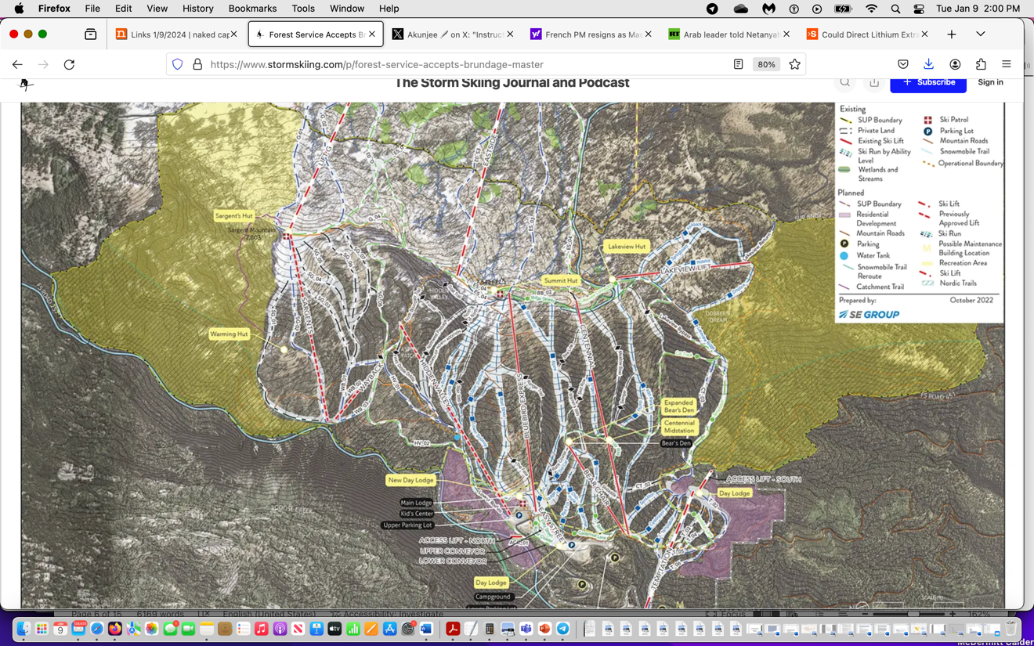
Ever-expanding trails in that project – include 30 miles plus 15 miles and potentially more spanning elevations and habitat types.
https://boisedev.com/2022/03/22/brundage-bear-basin-trail/
“This new multi-use trail will join the resort’s 30-mile trail system with Bear Basin’s 15-mile track. Mountain bikers and hikers will be able to enjoy views of Payette Lake, Salmon River Mountain peaks, and more. The trail descends 1,700 vertical feet from 6900 feet elevation on the Brundage Mountainside and 5,200 feet elevation on the Bear Basin half.
See also: https://boisedev.com/news/2022/03/09/brundage-housing-plan/ 88 new houses built -but this is only the beginning.
To the south West of Payette Lake, the West Mountain Area and Tamarack resort is adversely impacted by a ski resort, with expanding runs large amounts of bike trail summer trails. https://tamarackidaho.com/about/maps/summer-trails
https://tamarackidaho.com/about/maps/mountain-base
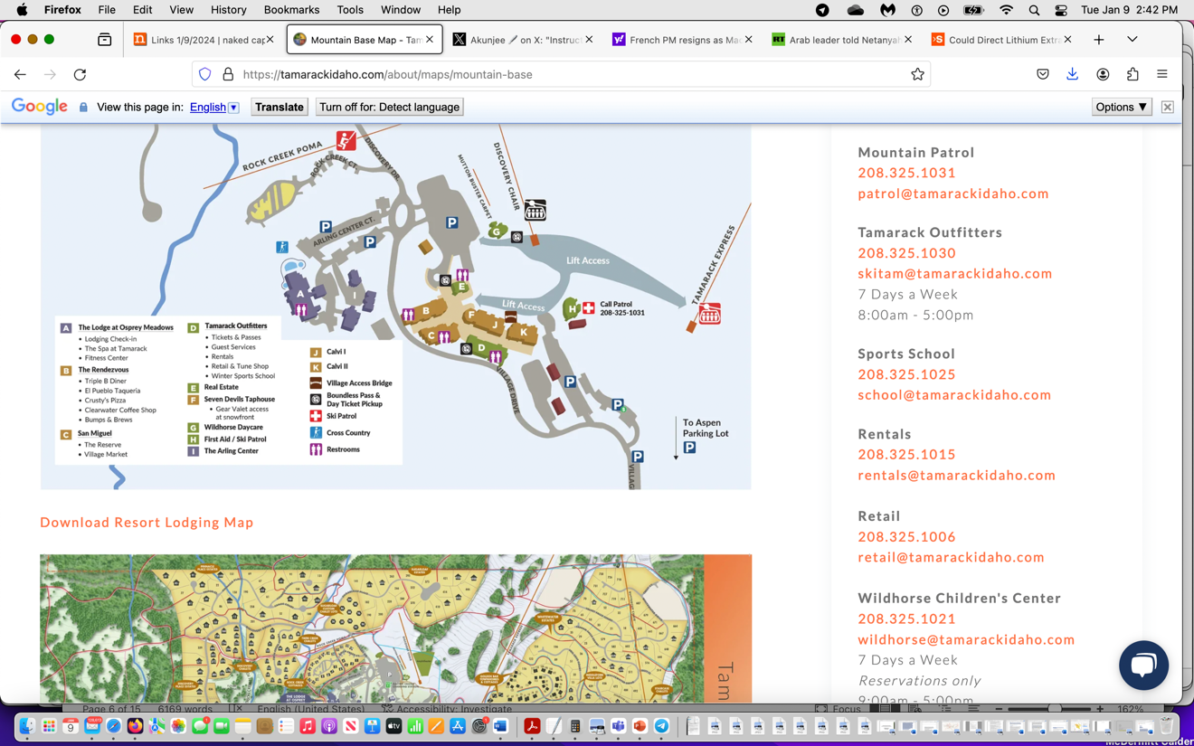
The Tamarack website on “future development”:
https://tamarackidaho.com/about/future
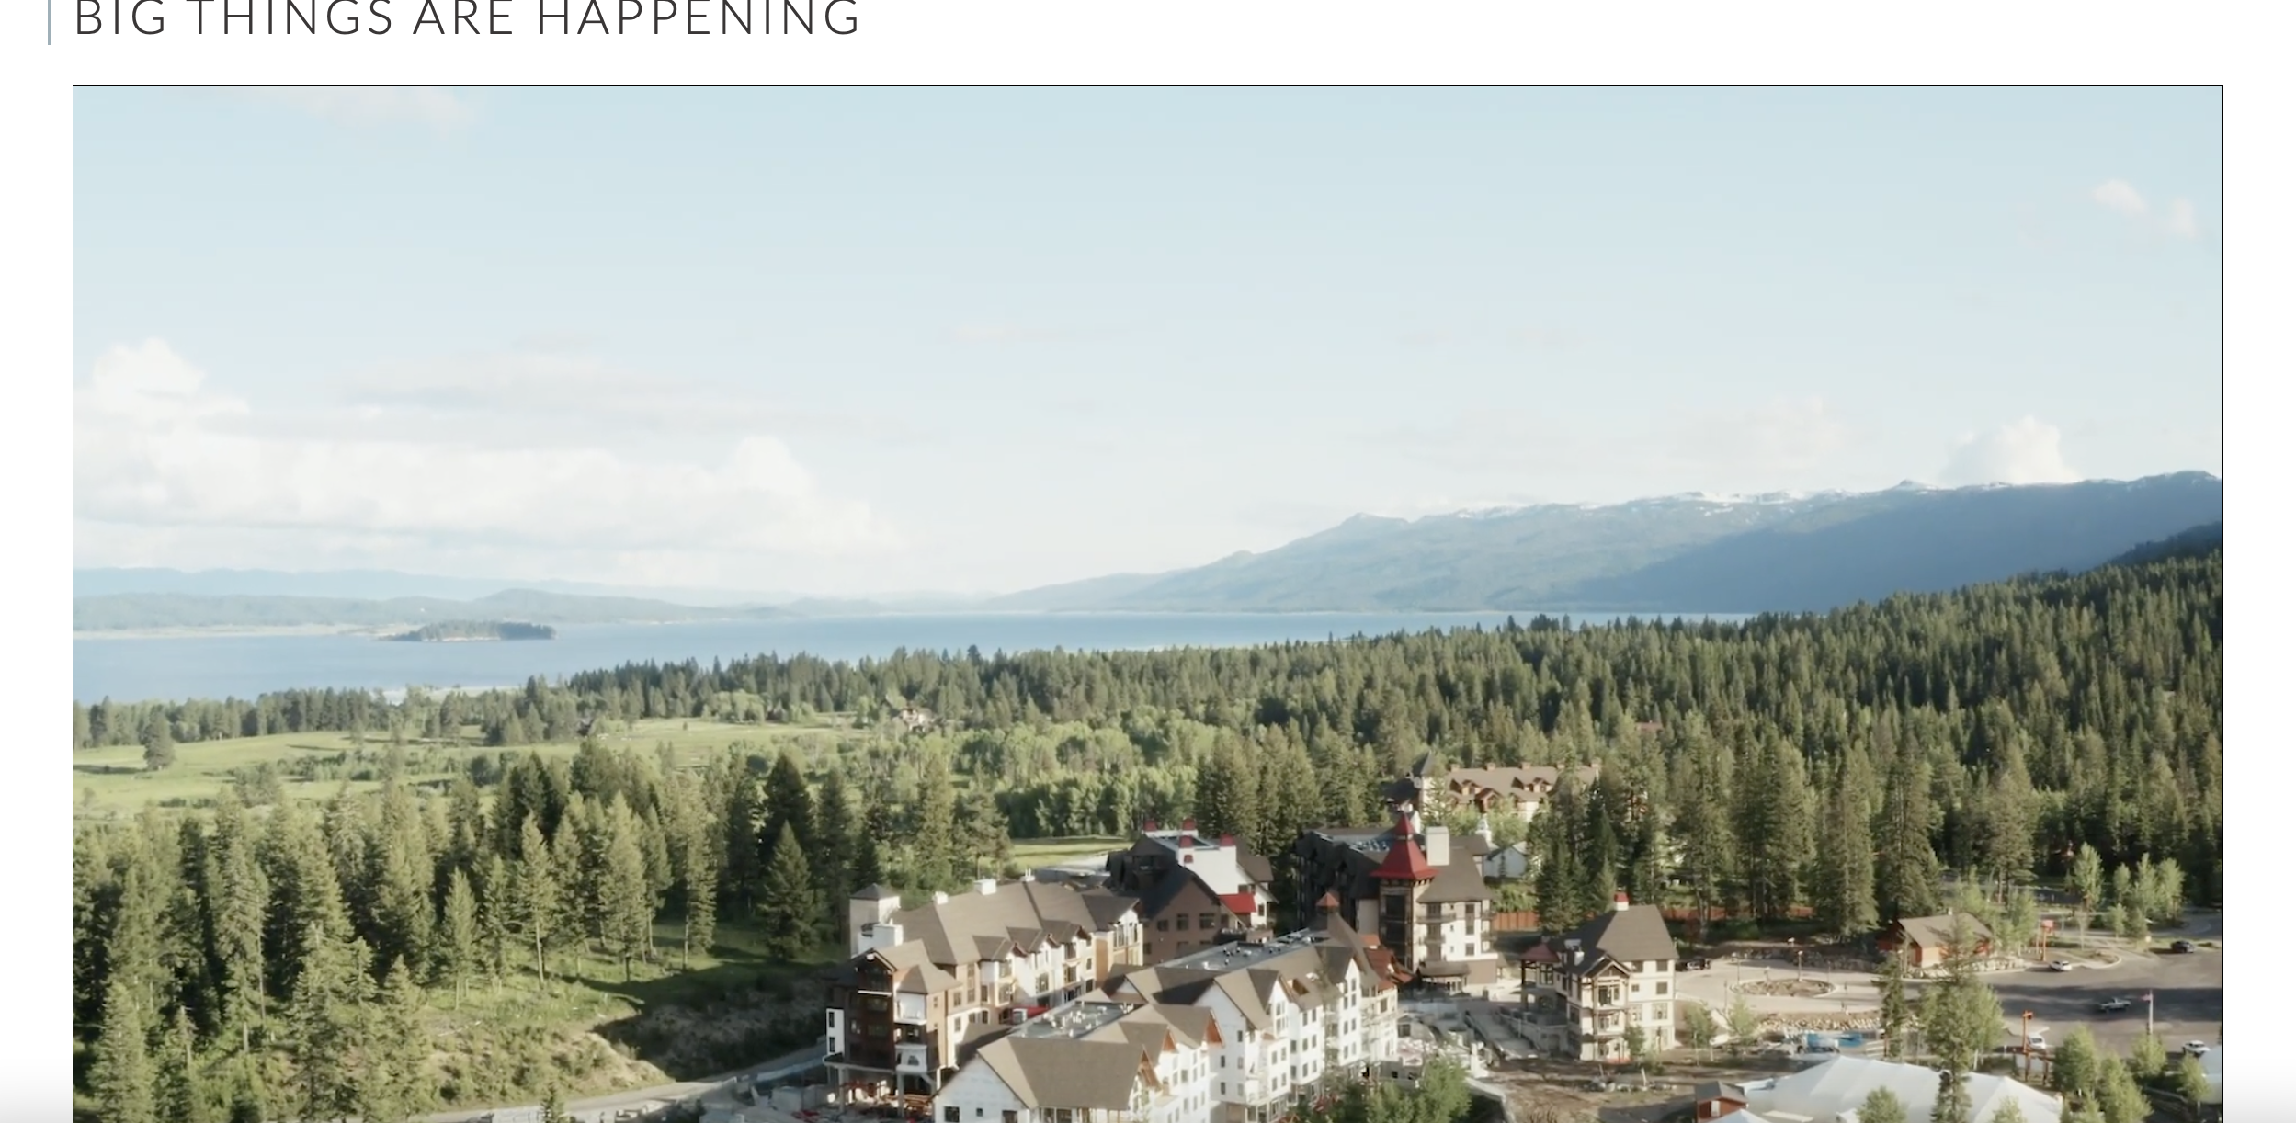
Tamarack promotional image – Photo appears to be looking South with Snowshoe Roadless area landscape in far distance.
See also “big things are happening” Tamarack youtube series:
https://tamarackidaho.com/about/future
There is a looming new Tamarack development scheme for USFS lands. Here’s a 2022 Boise NF press release describing Tamarack seeking to expand on thousands of acres of USFS lands (previously on state and private lands):
“Tamarack Resort currently operates exclusively on Idaho State Endowment and private lands. The proposed project would expand to 2,099 acres of NFS lands, primarily to the south of the existing resort, significantly increasing year-round recreation opportunities. The proposal includes the installation of several new ski lifts and a variety of expanded summer recreation activities.
“Due to the magnitude and complexity of the proposal, including a possible amendment of the Forest Plan, an Environmental Impact Statement (EIS) will be required. Next steps include developing a timeline and schedule for the NEPA process and decision”.
https://www.fs.usda.gov/detail/boise/news-events/?cid=FSEPRD1002680
Another reason the USFS must prepare an EIS is the lack of regulatory standards to protect Wolverines and native carnivores and other sensitive and rare species in the old Forest Plans in this region, where there is a large-scale lack of other regulatory controls to protect the ecosystem on which Wolverines rely. The FS in this project using woefully out-dated modeling with crazily short fire return intervals for vegetation communities to justify massive deforestation and burning in Wolverine habitat – right where recreation and recreational development and disturbance is exploding – ensuring more human intrusion and disturbance into Wolverine habitats. Amid the maelstrom of disturbance – the USFS fails to adequately describe the current human recreational disturbance footprint, or adequately control motorized, mechanized and other recreational disturbances in sensitive watersheds and habitats.
Regarding the ongoing War on Wolves – where Wolverines will be/are collateral trapping and poaching damage:
“In Idaho, legislation revised Idaho Codes in 2021 to: (1) authorize a year-round trapping season for wolves on private property (IC 36-201(3)); (2) authorize additional methods of take previously prohibited (inclusive of the use of snares in 97 out of 99 management units) (IC 36- 201(2)); (3) remove any limit to the number of wolf tags an individual may purchase (IC 36- 408(1)); (4) allow a livestock or domestic animal owner to use a private contractor to kill wolves (IC 36-1107(c)); (5) allow the Idaho Wolf Depredation Control Board to enter into agreements with private contractors, in addition to State and Federal agencies, to implement the provisions of SB 1211; and (6) direct wolf control assessments ($110,000 annually) collected from the Idaho livestock industry to be combined with $300,000 the State would transfer from the IDFG fund annually beginning on July 1, 2021.
These regulation changes may increase the amount of wolf trapping and the risk of incidental trapping of wolverines because of the use of snares, extended trapping seasons, and financial incentives. The realized impact of these changes cannot yet be meaningfully measured due to the limited amount of time they have been in effect”.
There is much discussion of the threat climate change poses to the Wolverine, and habitats are certainly projected to contract. Now the FS is engaged across the region in a battery of habitat disturbances and prolonged radical habitat simplification and fragmentation projects that destroy key habitat attributes and make the species even more vulnerable to climate stress harms, and opening lands up to expanded grazing degradation into remnant less grazed sites, and high levels of human recreational, trapping, and other disturbances and mortality.
Wolverine. The U.S. Fish & Wildlife Service over a decade ago stated that “Sources of human disturbance to wolverines include . . . road corridors, and extractive industry such as logging . . ..”. 75 Fed. Reg.78030 (Dec. 14, 2010.

The Ninth Circuit Court of Appeals had ruled that the Forest Service “must both describe the quantity and quality of habitat that is necessary to sustain the viability of the species in question and explain its methodology for measuring this habitat.” (Lands Council v. McNair). Assuring viability of most wildlife species is a forest-wide or landscape issue. The cumulative effects of carrying out multiple projects simultaneously across a national forest makes it imperative that population viability be assessed at least at the forest-wide scale (Marcot and Murphy, 1992; also see Ruggiero et al., 1994a).

We are concerned that the\ Forest Plan Standards are not based upon scientific research regarding the forest-wide amount and distribution of habitat needed to ensure viability of mature and old-growth forest associated wildlife.

McKelvey (2011) concluded that they expect, “the geographic extent and connective of suitable wolverine habitat in western North America to decline with continued global warming” and that “conservation efforts should focus on maintaining wolverine populations in the largest remaining areas of contiguous habitat and, to the extent possible, facilitating connectivity among habitat patches.”

The Sagehen project’s radical treatment and extreme forest disturbance does just the opposite.

Robert Inman, PhD, a biologist and Director of the Greater Yellowstone Wolverine Program at the Hornocker Institute/Wildlife Society in his Review of the United States Fish and Wildlife Service’s Proposed Rule to List Wolverines as a Threatened Species in the Contiguous United States, May 2013 noted that the FWS singled out a particular activity, fur trapping, that can cause mortality, while ignoring the full range of human activities such as road kill, infrastructure, transportation that can affect mortality. He also pointed out the extensive trapping that occurred in the US prior to records of wolverine and that they may well have been eliminated before records were kept. So delineating habitat based on these records can understate actual range for wolverines. He also provides evidence that wolverines can den in areas lacking the presumed snow cover and that conditions suitable for competing for food is also a limiting factor. He further argues that road density was found to be a factor in an earlier telemetry-based habitat analysis, particularly at higher elevations. Wolverines were observed to avoid or alter their travel when encountering housing developments and traffic.

The Forest must fully consider the role of habitat connectivity and genetic exchange in maintaining meta-populations and genetic diversity, vital to maintenance and recovery of the Wolverine and other native carnivores of concern.

Also, for all species, the Forest must Assess vulnerability of species and ecosystems to climate change, and strive to Connect habitats, restore important corridors for fish and wildlife, decrease fragmentation and remove impediments to species migration.

Fisher. The fisher also requires mature and old growth forested communities, and large tree cavities for survival -and these critical habitats will destroyed and decimated by the project over very large areas.

Owls. Where are Great Gray owls, Boreal Owls, Flammulated Owls or other strigiform species of concern present? How many nesting territories are there for each of these species, and what is the local population? How much of each species habitat will be treated? What is the population on the RD? On the Forest? How will the project impact their nesting, wintering or other habitats?

Protection of Predators to Promote Ecosystem Health
The Forest Service Manual 2323.33c - Predator Control states, “Predacious mammals and birds play a critical role in maintaining the integrity of natural ecosystems. Consider the benefits of a predator species in the ecosystem before approving control actions.” The NEPA analysis must address the role of predators and the killing of these important animals by livestock permittees, trappers, and Wildlife Services, disclosing the losses. It should also address the economics of this, and the risk to non-target animals, pets and the disruption of ecosystem processes such as depletion of spoke plant communities and cascading ecosystem effects that predator losses cause. Livestock grazing permits must be amended to minimize and prevent conflicts with native predators. Since the USFS project is radically altering, reducing and simplifying the veg communities in this landscape, the huge numbers of domestic sheep grazed here will further intrude on native predator and carnivore habitats – elevating conflicts. Thus, the FS must as part of this process, prohibit grazing disturbance in denning and assembly sites and high use areas for rare native carnivores, and no lethal control should be allowed.
We are very concerned that the FS essentially punts to WS in the grazing AOIs.
Are Wolves, Coyotes or other carnivores shot or trapped by Wildlife Services for the livestock permittees here? Please provide details on how many predators of what type have been killed in the project area because of grazing (sometimes Wildlife Services just flies overhead and guns down predators in advance grazing) and/or because of grazing conflicts or predation since the Forest Plan was adopted. How is the relentless persecution of native predators on USFS managed lands altering natural ecosystem processes?
The Forest should require permittees to use non-lethal controls only on USFS lands as a permit term.
Sound Habitat Inventory, Species Surveys and Population Analyses Are Essential for All Species of Concern and for Credible ESA Consultation

The Forest Plan and NFMA require protections of sensitive species habitats and populations. Trail et al. 2010 and Reed et al. 2003 are published, peer-reviewed scientific articles addressing determination of a “minimum viable population” and explain that minimum viable population size has often been drastically underestimated in past.

The poor approach of the FS in the 2024 Sagehen CBM and other projects is that instead of looking before the agency leaps – the FS plans for uncertain Condition-Based Management – leaving intensive surveys needed to understand sensitive and MIS species actual on the ground occurrence and population levels - until the bulldozers and chainsaws are revved up for various parts of the complicated actions that are generalized in the EA. The 2024 EA describes “pre-implementation” surveys for native biota. It is impossible to conduct an integrated hard look analysis at the actual population and availability of habitat, or gauge project outcomes and effects, without having solid pre-decisional site-specific species survey and population baseline at the project sites. It is impossible to understand the direct, indirect and cumulative impacts of an action without a current and honest integrated hard look analysis.

What population size does the Forest consider necessary to maintain viability of each species of concern – sensitive, MIS, T&E species, migratory birds, threatened Wolverine and others?

Won’t long-term persistent populations require thousands of individuals in inter-connected populations? See:

https://ase.tufts.edu/biology/labs/reed/documents/pub2014MVPcommentary.pdf .

Regarding conservation strategies, the Committee of Scientists (1999) state:

To ensure the development of scientifically credible conservation strategies, the Committee recommends a process that includes (1) scientific involvement in the selection of focal species, in the development of measures of species viability and ecological integrity, and in the definition of key elements of conservation strategies; (2) independent scientific review of proposed conservation strategies before plans are published; (3) scientific involvement in designing monitoring protocols and adaptive management; and (4) a national scientific committee to advise the Chief of the Forest Service on scientific issues in assessment and planning.

The Committee of Scientists (1999) emphasized the importance of inventories. The regulations required that in providing for diversity of plant and animal communities, “inventories shall include quantitative data making possible the evaluation of diversity in terms of its prior and present condition.” (36 C.F.R. Sec 219.26 (1984)) The Committee of Scientists (1999) explained, “No plan is better than the resource inventory data that support it. Each forest plan should be based on sound, detailed inventories of soils, vegetation, water resources, wildlife, and the other resources to be managed.” CBM ignores actual integrated site-specific current inventories. The FS instead wants us to believe a hodge podge of “activity card” actions and an in front of the bulldozer survey will adequately protect and sustain Forest lands, waters and biota 15 years from now - in an environment facing huge uncertainty from climate stress, new wildlife diseases, burgeoning human recreational and other use and disturbance, irreversible flammable weed expansion, etc.

The most recent Biennial Forest Plan Monitoring report exposes how the Forest is slacking off and postponing even critical biological monitoring essential to 2020-2021. See Monitoring discussion in these comments. As the biodiversity crisis worsens, the FS fails to conduct essential monitoring to determine how bad conditions are in the Forest. Boise Forest 2020-2021 Biennial Monitoring Report
https://www.fs.usda.gov/Internet/FSE_DOCUMENTS/fseprd1079962.pdf

An again, the Forest must conduct necessary inventories now to ensure:
- A scientifically peer-reviewed minimum amount of old growth on the Forest, which includes a buffer amount above what is considered the minimum to ensure viable populations of old-growth associated species, so that natural processes that result in loss of old growth do not result in threats to species’ viability.
- Scientifically peer-reviewed Standards for distribution of old growth.
- Scientifically peer-reviewed minimum size of blocks of effective (meeting all criteria) of old growth, below which existing block sizes do not contribute to the forest-wide minimum Standard or distribution Standard.
- Scientifically peer-reviewed conservation strategies for attaining those amounts and distribution of habitats.
- Follow the process recommended by the Committee of Scientists, 1999 in the above paragraph.
- Remove treatments in project units that adversely impact the MIS and TES species in a short or medium timeframe from project alternatives.
- Conduct updated scientifically sound surveys for the Northern Rockies Fisher, Northern Goshawk, Wolverine, Canada Lynx, rare owls, and others.
- Require that Project Monitoring includes mature and old-growth (or “legacy” or whatever current buzzword the FS is using) habitat monitoring which creates an internet-based map inventory with linked stand data including pre-decisional baseline data, updated annually with all changes fully explained, so the public can make informed judgments as to the accuracy of the inventory.
- Arrange for an independent scientific peer-review of the BNF’s mature and old-growth/legacy forest inventory prior to using its results as a valid estimate of old growth on the Forest.
- Provide an analysis that determines and discloses the quantity and quality of habitat necessary to insure viable populations of MIS TES wildlife species.
We note that it is difficult to comment on projects when basic data on actual species occurrence and population status, how fragmented and degraded the habitat currently is, and other critical information on species of great importance to the public is not provided in the agency documents. Instead of providing critical survey and monitoring data in the most recent Biennial report - the FS just greatly extended time periods for monitoring plan goal compliance from every 2 years to every 5 or 10 years – and then proceeds to issue flawed CBM NEPA for Sagehen and other projects without the data to understand actual forest-wide conditions. The FS used to endlessly use the phrase “adaptive management” -which on paper at least required monitoring. Now the FS is not even doing that, at the same time it issues wildly uncertain and risky CBM schemes -wiping out mature forests that will take hundreds of years to fully recover with the battery of combined logging/thinning/burning/roading schemes.

Project Big Game Habitat Impacts

An EIS must also be conducted to detail existing vs. altered conditions for: Big game hiding cover, escape cover, thermal cover, calving/fawning cover - all must be thoroughly examined - with a current baseline study and inventory. Then the magnitude and location of changes and potential adverse effects from the project treatments to these habitat components must be identified. Roads and other disturbances - including greatly expanded recreational disturbance resulting from project vegetation removal -must be factored in as well. How far from a trail with a clear sight line will mountain bikes displace big game? What is the current science showing? This includes a candid assessment of grazing disturbance impacts – livestock can displace elk from calving and rearing areas, coupled with causing longer term habitat degradation.

Stewart et al. 2002 describe disturbance displacement of elk by cattle:

Elk used lower elevations when cattle were absent and moved to higher elevations when cattle were present, indicating shifts in niche breadth and competitive displacement of elk by cattle. We demonstrated strong partitioning of resources among these 3 species, and presented evidence that competition likely has resulted in spatial displacement.

https://academic.oup.com/jmammal/article/83/1/229/2372874

Clearing of vegetation in treatments plus expanded road or trail access may expand both human use /disturbance and bovine use/disturbance into areas that were previously considered “secure” elk and other big game habitats. In the case of Sagehen, this also means areas where woody vegetation limited cattle fouling and degradation of spring and stream waters.

Ensuring big game habitat security cover is essential. Elk require 250 acres or more contiguous forest a half mile or more from open motorized vehicle routes/roads.

There is also increasing concern about mountain bike displacement of big game. The type of use trails, and the habitat that they traverse, and how the project will alter this, must be fully examined.

See: https://www.thewildlifenews.com/2019/06/18/impacts-of-mountain-biking/

“there is the tendency for some mountain bikers to create new “rogue” trails. Second, the increasing mechanization of mountain bikes, including now electric bikes, dramatically expands the terrain and distances that can be accessed by a bike. Third, there is a culture among many mountain bikers that glorifies thrills, speed, and the “conquest” of natural barriers. Fourth, there is a growing body of research that demonstrates that mountain bikes have significant impacts on wildlife”.
Although the research that explicitly targets mountain bikes is in its infancy, what we do know is disconcerting. https://www.lib.washington.edu/msd/norestriction/b67566091.pdf There is a “zone of influence” where recreational use can displace wildlife or reduce the habitat quality.
It is critical to note that even hiking can adversely impact wildlife. But the speed and greater distances that the mechanical advantage mountain bikes confer substantially increases those impacts. A good overview of mountain biking studies can be found here. http://www.culturechange.org/mountain_biking_impacts.htm
Although explicitly looking at the effects of roads on wildlife, many of the same conclusions would apply to trails. Effects of Roads on Animal Abundance: an Empirical Review and Synthesis https://www.ecologyandsociety.org/issues/view.php?sf=41Another study by biologist Barrie Gilbert– Motorized Access on Montana’s Rocky Mountain Front: A synthesis of scientific literature offers useful insights that apply equally to non-motorized mountain biking.
In a review of mountain biking and wildlife impacts, authors Jeff Marion and Jeremy Wimpey published an assessment, “Environmental Impacts of Mountain Biking: Science Review and Best Practices. In that paper they state: “Trails and trail uses can also affect wildlife. Trails may degrade or fragment wildlife habitat, and can also alter the activities of nearby animals, causing avoidance behavior in some and food-related attraction behavior in others. While most forms of trail impact are limited to a narrow trail corridor, disturbance of wildlife can extend considerably further into natural landscapes.”

Over 2 decades ago, the USFS admitted there were national forest system alone, there were 400,000 miles of roads. Now mountain bikes have expanded the mechanized human displacement footprint even more.
From The Wildlife News: “Mountain bikes pose a threat for four major reasons.
First, there is the tendency for some mountain bikers to create new “rogue” trails. Second, the increasing mechanization of mountain bikes, including now electric bikes, dramatically expands the terrain and distances that can be accessed by a bike. Third, there is a culture among many mountain bikers that glorifies thrills, speed, and the “conquest” of natural barriers. Fourth, there is a growing body of research that demonstrates that mountain bikes have significant impacts on wildlife”.
From TheWildlife News article:
All of this modification is creating more and more conflicts with other recreational users as well as wildlife. Although the research that explicitly targets mountain bikes is in its infancy, what we do know is disconcerting. https://www.lib.washington.edu/msd/norestriction/b67566091.pdf There is a “zone of influence” where recreational use can displace wildlife or reduce the habitat quality.
It is critical to note that even hiking can adversely impact wildlife. But the speed and greater distances that the mechanical advantage mountain bikes confer substantially increases those impacts. A good overview of mountain biking studies can be found here. http://www.culturechange.org/mountain_biking_impacts.htm
Although explicitly looking at the effects of roads on wildlife, many of the same conclusions would apply to trails. See: “Effects of Roads on Animal Abundance: an Empirical Review and Synthesis”. Another study by biologist Barrie Gilbert– Motorized Access on Montana’s Rocky Mountain Front: A synthesis of scientific literature offers useful insights that apply equally to non-motorized mountain biking.
In a review of mountain biking and wildlife impacts, authors Jeff Marion and Jeremy Wimpey published an assessment, “Environmental Impacts of Mountain Biking: Science Review and Best Practices. In that paper they state: “Trails and trail uses can also affect wildlife. Trails may degrade or fragment wildlife habitat, and can also alter the activities of nearby animals, causing avoidance behavior in some and food-related attraction behavior in others. While most forms of trail impact are limited to a narrow trail corridor, disturbance of wildlife can extend considerably further into natural landscapes.”
According to a recent report by the Colorado Backcountry Hunters and Anglers (BHA) “Impacts of Off-Road Recreation on Public Lands Habitat” “Wildlife habitat in Colorado is being significantly impacted by the proliferation of mechanized (i.e., mountain bike) and motorized (ATV/OHV) trails on public lands. Sportsmen and wildlife managers are finding that elk hunting opportunities, in particular, are being compromised by trail development in many parts of the state.”
Research comparing the effect of hikers, horse riders, and thrillcraft (mountain bikes and ORVs) on elk flight demonstrates significant differences in impact to wildlife. Hikers can clear a swath of disturbed animals 1/2-mile wide, especially if they have a dog. Equestrians may impact a swath 3/4th-to-1 mile wide, and ATV’s and mountain bikes clear a swath a full 2 miles wide! Grizzly bears show similar avoidance for roads and heavily used trails. https://calgaryherald.com/news/local-news/risk-of-bear-mortality-study-finds-people-not-roads-bug-grizzlies-the-most
Many mountain valleys are not more than two miles wide, so essentially if there is significant mountain biking activity, it can preclude wildlife usage of that area”.
Also: “In another study of human disturbance of elk calving grounds, found that an average of 10 disturbances/cow above ambient levels, the elk herd showed no growth. Their results support maintaining disturbance-free areas from all human entry for elk during parturitional periods”.
The Forest’s management strategy and “desired” conditions may be inadequate for elk goals – so the FS must not use older flawed “desired” conditions but must update them to ensure adequate protection.

Please fully disclose the current total post-project road density, including in habitat areas and locales considered to be of importance to Elk and Mule Deer at present. Please quantify how much removing screening protective woody cover may increases both road and trail and motorized and mechanized human caused displacement of big game. How will this impact important seasonal habitats – such as fawning area habitat? Where are all vital habitats located in the project area and surrounding landscape?

We are also concerned that the Forest is unable to effectively prevent illegal motorized and mechanized access in the project area.

In a previous Project analysis the Forest stated: “Unauthorized use of ATV/UTV use on non-system, closed roads will likely remain an issue for elk security. Reduction in funding for access management (e.g. gate maintenance) and law enforcement continue to exacerbate this ongoing problem.” This is the reality in forest lands in Idaho. All of these cumulative effects of the radical treatment disturbance – and how the project’s massive veg removal and/or burning will expand conflicts with big game and sensitive species – must be analyzed for wildlife species. It also must be considered aquatic species where road/trail crossings may be degrading streams.

Migratory Birds and the Biodiversity Crisis

The Migratory Bird Treaty Act requires the Forest protect and conserve habitats and populations of migratory birds. The USFS and FWS have signed an that details MOU protections that must be applied.

The Forest must clearly define mitigation measures and must rigorously evaluate the effectiveness of any mitigation measures to be applied. We are very concerned that the Forest will use loose, uncertain “adaptive” actions as a sort of mitigation under the highly uncertain CBM scheme, further increasing uncertainty of the project’s adverse impacts to biotic resources.

We can find no clear statement prohibiting all treatment activity during breeding and nesting periods – which guarantees the likelihood of take – such as “prescribed fire” burning up chicks in nests. What are the nesting periods for all native raptors here? For migratory birds?

How much land area and specific vegetation community and habitat type for all species of concern is currently present? How much will remain undisturbed by projects? How much greater will fragmentation be for all species of concern? Will fragmentation of migratory bird habitat is also highly likely to increase nest predation, and the prevalence of nest predators?

What is the status of the local and regional populations and trends in migratory birds in the Project area? What are various species particular habitat needs and how will the project impact the species? How will they be protected and populations sustained? No treatments, including burning, should take place during migratory bird nesting season. What is the migratory bird nesting season across the project area?
The EAs unknown specific number and amount of “treatments” and lack of info on specific sites burned - will clearly have disastrous impacts for migratory birds. The projects – alone and/or in combination - will be a violation of the Migratory Bird Treaty Act. There are likely greater than 30 bird species that will be harmed by the logging/fuels projects in forests, plus all the “collateral damage”. We are unaware of any effective FS plans for conservation of migratory birds and individual bird species being carried out in the Boise NF.
In “treatment (logging, burning) project after project, more and more maturing, mature and old forest is destroyed and/or fragmented, and activity avoidance periods that previously were in place are whittled down or jettisoned altogether. If no such plans exist, then please develop these plans based on current systematic surveys/inventories and best available science as part of the pre- decisional alternative development and public comment parts of the Batch project processes. The FS ignores the drastic declines for forest and other bird species as carefully documented in the Rosenberg et al. 2019 paper on the staggering loss of 3 billion birds in North America. https://science.sciencemag.org/content/366/6461/120 .
Many migratory bird species also face declines in insect populations – what has been termed an “insect apocalypse”. The project’s radical treatment disturbances – often heaped one on top of the other – will result in large-scale loss of insect habitat.
The FS must conduct complete and comprehensive surveys for migratory bird species across all of the affected landscapes so that a proper pre-decisional baseline inventory of bird occupancy, seasonal use, abundance, population viability and habitat restoration needs on the Forest can be established. This must be provided to the public during a public comment period for the projects, and it is also essential so that a reasonable range of alternatives can be developed.
Instead, it appears that the FS plans to forsake this integrated hard look science-based approach as required under NEPA, and instead use minimal piecemeal very small area post-decisional surveys, which will only serve to further sacrifice habitats and populations and cause new, expanding and rapid losses of bird habitats and populations. Mitigation for migratory birds and other sensitive species and biota is greatly deficient and will not comply with sustainability and other requirements of NFMA and the current Forest Plan. Please see discussion of the Boise NF Biennial Monitoring report doubling or quintupling the time between monitoring periods for species habitat elements. What would habitat restoration actually look like for species dependent on mature and/or old growth forests? What species actually use and rely upon the denser and maturing forests that the proposals would greatly thin, alter and reduce? How much habitat of similar types will be available outside any treatment areas, and where is it located? Where and how will the promised activities disrupt native forest successional processes? Where and how (to what degree) will the projects alter, degrade, impair, destroy and/or fragment mature forests and other mature shrub and mixed shrub/forest communities? When, where and how will the welter of treatment actions increase nest predation due to increasing fragmentation? When where and how will the projects affect Brown-headed Cowbird nest parasitism on migratory birds, and predation – as nest and egg predators often “work the edges”? What level of parasitism currently exist? Won’t the projects expand areas intensively used and disturbed by livestock further altering and degrading nesting habitats for avian species, or denning, fawning or other habitats for mammals - by burning, cutting, and thinning forests as well as “improving” roads? How will the projects change and alter land areas and acreages described and defined as capable and suitable for livestock grazing?
Examples of Baseline Studies Needs

Here are some examples of baseline studies and data that must be obtained to develop suitable alternatives, prevent excessive harm and apply proper mitigation, including mitigation by avoidance:
- Site-specific surveys for vegetative conditions in proposed treatment areas. The vegetation mapping is greatly generalized, and does not prov ide details on the specific composition and stand characteristics of any sites.
- Surveys of riparian areas – including springs, seeps, wetlands and current ecological conditions, flow rates, areal extent of wetted areas, changes in flow rates over time (if records are available), type and characteristics of springs, etc.
- Field surveys of soil and biocrust conditions
- Field surveys of vegetative productivity to ensure grazing is not adversely impacting non-capable lands.
- Current Capability and Suitability analyses – before and after treatments and project actions – for grazing and all other activities.
- Full analysis of Roads/Trails Analysis and Travel Planning survey results.
- Field surveys of aquatic habitat conditions and current level of habitat degradation and pollution. This must include dead trees and down wood, surveys for pathogens, etc. The project’s removal of forested areas or downed wood that may be limiting livestock movement or access to riparian areas will adversely alter grazing impacts to riparian sites. Belsky et al. 1999.
- Full current surveys to determine fish-bearing streams and their ecological condition, and occupied vs. unoccupied reaches.
- Full surveys to determine areas of perennial vs. intermittent flows and study of potential causes of flow loss. Survey of historical or other flow data to determine reductions or changes over time.
- Determination of which roads would be haul routes under action alternatives. Determination of location of skid trails and haul routes
- Full studies of conditions and indicators for determining effects of proposed vegetation treatments inside RCAs.
- Field surveys for highly erodible soils or unstable areas in proposed treatment units and proposed new road locations.
- A current inventory of unauthorized roads and trails (of all; types), and their restoration needs.
- Studies determining the expansion of the visual and noise disturbance footprint to habitats from the combined effects of the project activities.
- Studies and mapping of the expansion of habitat fragmentation caused by the project “treatments” for all species of concern.
- Studies of flammable annual grasses and risk of expansion under the treatment and domestic livestock grazing regimen.
- Studies of the current degree of ecological degradation of terrestrial and aquatic environments due to forest-managed livestock grazing impacts and disturbance.

Additional Roads and Trails Concerns

Many questions and concerns surround roads in the EA. Full current science-based analysis must undergird the project.

Will there be foreseeable road to OHV or mountain bike trail conversions in this area? If so, Where? How many miles? Will any roads converted to trails be used year-round vs. seasonal road closures at present?

What routes or trails currently have seasonal closures, and what are these closures for?

The Forest must answer: What is the minimum road system, necessary to manage the landscape? The Forest must conduct a science-based analysis to determine this. It must manage roads according to its Memorandum directives and Forest Service regulations, including 36 CFR 212, subpart A.

What is an appropriately sized and environmentally sustainable road system? In order to understand this and scientifically analyze it, the full site-specific impacts of Forest roads of different types/categories, and the adverse ecological or other harm (for example to quiet recreation) that these roads may be causing must be fully studied.

The Forest must determine all unneeded roads in the project area and develop plans for them to be decommissioned. Road management must be responsive to ecological, economic and social science concerns.

What will pre and post-project road and/or trail densities be in the project area? In the surrounding landscape? How does the proximity of roads, and/or road density impact forest species of concern/sensitive/important wildlife species? Will skid trails turn into de facto trails or routes– used by ATVs or mountain bikes?

How will all aspects of this project – including new temporary roads, expanded and “improved” existing roads, motorized or intensively used mountain bike or other trails, and all the motorized and other activity associated with logging, thinning, veg treatments affect the ability of livestock to move easily cross the landscape, and potentially access sites previously less disturbed?

Grazing-related concerns applicable to all components of the current project include:

In rugged forested terrain, denser patches of trees and/or slopes can prevent or limit livestock access to portions of grazing allotments, and serve to protect fragile springs/seeps headwaters from degradation, protect nesting sites for sensitive raptors and owls, or protect denning or fawning areas for mammals. The project has a likelihood of imposing new expanded harmful livestock impacts on lands, waters and habitats previously little used. With livestock come a host of negative impacts – they create ideal site conditions for weeds to take root, they are vectors of weed seed transport (manure, hair, mud on hooves) and spread, livestock manure and urine provides excessive nutrients not required in large amounts by native vegetation but in which weeds thrive, they cause excessive soil erosion, they trample and destroy microbiotic crusts, a frontline against weeds. Livestock also consume and trample protective herbaceous (and often shrub) plant cover that help protect and stabilize watersheds and result in shallow-rooted weedy species taking hold, impairing the slowing down erosive runoff. Livestock gravitate towards springs, seeps, and streams and expanded livestock impacts in headwaters or other areas may be particularly damaging – sedimentation, down-cutting, erosion, polluted water including bacterial contamination that may sicken recreationalists. They alter the composition of the native plant community, with result that “desirable” forage plants are replaced with undesirable ones. They trample small animal burrows, pollinator habitat, fish spawning substrates, redds, and bird nests and chicks, etc. Brown-headed cowbirds, which parasitize the nests of migratory songbirds, are attracted to areas with cattle present. Fleischner 1994, Ohmart 1996, Belsky et al 1999, Belsky and Gelbard 2000.

Livestock also conflict with recreational uses and enjoyment of Forest lands – destroying wildflower displays, spreading weeds, fouling waters and campsites, or the presence of dangerous bulls or cows with calves threaten the public – and here vicious sheep guard dogs or Wildlife Services traps and activity may threaten the public. Livestock are associated with stench, noise, dust, and pathogens. Grazing may drive wildlife out of critical or preferred habitat areas or deplete habitats making many species of fish and wildlife scarcer. Grazing causes overall degradation of the land, water and public wild lands experience.

Clearing of vegetation and roads/trails also expands the areas where grazing permittees would use 4 wheelers or other motorized vehicles or haul sheep camps, that may disturb wildlife, run over and crush vegetation animals, burrows, nests – and spread weeds. We increasingly see permittees riding ATVs rather than horses cross-country. Roads expand the ease of feeding livestock supplement – where one time placement can severely damage and deplete native plant communities at the site it is placed. Where are all these sites at present, and how infested with weeds are they? We have often seen new little routes spring up in areas of cleared vegetation in association with supplement/salt use siting on ridges or hills, and this is clearly evident in the project area.

Opening up more area for livestock also is likely to bring even more conflicts with wolves, black bears, mountain lions, wolverine, Canada lynx and other native carnivores who may use areas further from existing more intensively human (and cow/sheep) disturbed areas, too.

Current capability and suitability, and carrying capacity analyses must be conducted.

Forest Plan Monitoring Concerns

The Boise National Forest 2020-2021 Biennial Monitoring Plan

The Forest Plan really was only expected to have a shelf life of 10-15 years. Now that time is up. This buttresses the case for the need to conduct very robust analyses using current science and current site-specific data on ecological conditions and species needs for sustainability and persistence.

As Wolverine get listed, climate change stress bears down, and the FS across the Region begins a massive deforestation logging and burning crusade, the BNF’s most recent (2020-2021) Biennial Monitoring Report axes monitoring reporting on many critical biodiversity and habitat elements every 2 years – instead extending the time to report on compliance with the plan to every 5 or 10 years from 2 years. This is more lax and careless management and bureaucratic laziness, just like the use of CBM is. It of course favors the logging and “treatment” industry contractor profiteering.

Look at the “monitoring indicators” of Plan compliance:
“Indicator #1. Mix of size classes, canopy cover class, and species composition and their spatial patterns by forested Potential Vegetation Group (PVG) and non- forested cover types.
This indicator was addressed in the FY18-FY19 report. It was noted that for future Forest Plan
Monitoring, the Boise NF found it appropriate to answer this monitoring question either on a decadal basis, when improved datasets become available, or following large scale uncharacteristic disturbance events … of 250,000 acres”. This is delayed to a decadal basis! Yet massive projects like Sagehen may in the mean time can burn up and log forests that take hundreds of years to develop in the interim – resulting in major deficit that will take hundreds of years to make up for. There is no basis for understanding Sagehen cumualative effects as there is no current Indicator #1 monitoring compliance.
The FS report refers to other significant deforestation projects whose cumulative impacts to terrestrial and aquatic species habitats and populations must be assessed in the Sagehen NEPA analysis: :
2018-2019:South Fork Boise River Bark Beetle Mitigation (Mountain Home), Lost Horse (Cascade), Lowman Wildland Urban Interface Project (Lowman), Lower Feather Maintenance Burn (Mountain Boise NF Biennial Monitoring Evaluation Report
Home), Sinker Creek-Boise Ridge Forest Health Project (Idaho City), Fawn Tussock (Cascade).
The FS has no integrated current info on the critical elements for Biodiversity protection and meeting NFMA mandates. The FS should not have developed alternatives and new or revised projects until it takes a hard look based on integrated current baseline and monitoring info. The lack of adequate and required monitoring to determine current compliance across the BNF makes this project even more highly uncertain and risky.
Are Forest management actions maintaining and/or restoring the distribution, abundance, and
habitat quality of Threatened, Endangered, Proposed, Candidate and Sensitive (TEPCS) terrestrial species, or the occupied habitat of TEPCS and Watch plant species? Findings
The Boise NF defers addressing this monitoring question to the 2024 Forest Monitoring Report.
This too is Deferred until 2024: "Are Forest management actions affecting the distribution, abundance, and habitat quality of focal species and Species of Conservation Concern’.
Also deferred: “Have habitat restoration and conservation actions been prioritized in watersheds identified in the Forest Plan wildlife conservation Strategy as Priority watersheds? Deferred to 2024
Monitoring Question #2
Are restoration and conservation actions being implemented within Sage Grouse Priority Habitat
Management Area (PHMA), Important Habitat Management Area (IHMA), and General Habitat
Management Area (GMHA) to meet desired outcomes? Findings
The Boise NF defers addressing this monitoring question to the 2024 Forest Monitoring Report. The project may be finalized before this info is even synthesized.
Monitoring Question #3. Are Forest management actions maintaining and/or restoring the distribution, abundance, and
habitat quality of Threatened, Endangered, Proposed, Candidate and Sensitive (TEPCS) terrestrial species, or the occupied habitat of TEPCS and Watch plant species?
The Boise NF defers addressing this monitoring question to the 2024 Forest Monitoring Report.
Monitoring Question #4. Are Forest management actions affecting the distribution, abundance, and habitat quality of focal species and Species of Conservation Concern? Findings
The Boise NF defers addressing this monitoring question to the 2024 Forest Monitoring Report.
Monitoring
Question #5. Have habitat restoration and conservation actions been prioritized in watersheds identified in the Forest Plan Wildlife Conservation Strategy (WCS) as priority watersheds?
The Boise NF defers addressing this monitoring question to the 2024 Forest Monitoring Report.
Monitoring Question #6
Are special forest product gathering activities resulting in resource depletion (e.g., overharvest of
fungi, bear grass, berries)?Findings
The Boise NF defers addressing this monitoring question to the 2024 Forest Monitoring Report.
Monitoring Question #7
Has winter recreation affected source environments in priority watersheds identified in the Forest
Plan Source Environment Restoration Strategy?
AND even this: Fire
Monitoring Question #8
In Wildlife Conservation Strategy (WCS) priority watersheds, is wildland fire and or management-ignited fire moving landscapes towards desired conditions for resiliency and fire condition class? The Boise NF defers addressing this monitoring question. The previous monitoring report, which answered this monitoring question, stated this question is appropriate to answer on a five-year monitoring cycle.

Monitoring Question #9
Are high wildfire risk areas being identified within the Wildland Urban Interface (WUI)
The FS relied on its self-serving NEPA docs - rather than collecting current data in the field.

#10. Water Quality – Monitoring on a 4 year cycle.
Monitoring Question #11
Are management activities in riparian conservation areas (RCAs) designed to maintain or restore
riparian functions and ecological processes? The Boise NF found no need for changing management activities or the Forest Plan monitoring programs related to number one (above).
Data Source: NEPA decision documents, specialist reports and biological evaluations/assessments from fiscal years.

We also have significant concerns about much of the rest of the monitoring report, including soil condition monitoring.
https://www.fs.usda.gov/Internet/FSE_DOCUMENTS/fseprd1079962.pdf

To the north, the Payette Forest Plan Is Another Example of Monitoring deficiencies impacting. many of the same species as the Boise Forest Plan monitoring dereliction does.

We couldn’t find a 2020-2021 Payette plan, and the Forest never produced one after we repeatedly requested it. We did find 2018-2019.

“Have habitat restoration and conservation been prioritized in watersheds identified in the Forest Plan through such items as the Vegetation and Wildlife Habitat
Restoration Strategy?” The FS categorizes this as “Not available” , “uncertain”, and uses the word “after” – in “after completion of Wildlife Conservation Strategy, the
Monitoring Plan needs to be revised accordingly “.

https://www.fs.usda.gov/Internet/FSE_DOCUMENTS/fseprd814601.pdf

We were dismayed to discover while searching for this required strategy that the Payette forest had published a Notice in the Federal Register WITHDRAWING its scoped plans for an EIS for a Wildlife Conservation strategy. See: https://www.federalregister.gov/documents/2021/05/27/2021-11196/payette-national-forest-idaho-wildlife-conservation-strategy-forest-plan-amendment-withdrawal-of
“The Forest Supervisor in consultation with the Intermountain Regional Office has determined that the forest plan amendment proposed in 2011 cannot be completed as initiated per the provisions of 36 CFR 219.13 issued in 2016. Under the new regulations, the project would be required to be re-initiated in order to meet the public notification requirements. The withdrawal of the EIS could not proceed earlier because of pending litigation for another project that referenced the Draft EIS. Judgment in that case was issued in August 2020, and the litigation is no longer pending. Instead of proceeding with a new or re-initiated Plan Amendment at this time, individual projects are considering the need for project level amendments to address wildlife conservation needs on a project-by-project basis based on the best available science. The need for a plan level wildlife conservation strategy will be reassessed during forest plan revision in the future”.

The Payette Forest seems to have been floundering for 20 years now without any strategy - and after it had finally embarked on a planning effort many years before– withdrew it in 2021. In the meantime, in areas like this project, the FS has been in incrementally piecemealing away irreplaceable forest wildlife rare species habitats – to Brundage, to logging, to all manner of recreational intrusions and development. Now it has issued a plan that will radically disturb what’s left and wipe out habitat for many species over large areas – all without ever taking a hard look . This clearly demonstrates the need for an. EIS for this complicated and severe disturbance project. Note a KTVB news report says the County years ago had approved 1200 homes in association with Brundage. This would of course exert massive new pressure, and is incrementally proceeding – yet the FS has no credible wildlife conservation plan.
https://www.ktvb.com/article/sports/outdoors/mccalls-brundage-mountain-resort-growing-into-future/277-fbb5c8aa-bead-4a7e-a433-02a8fc9bb600

The 2018-2019 Payette Forest Monitoring report also shows uncertainty over stream-riparian conditions and BMP effectiveness.

“Are the distribution, abundance, and habitat quality of TEPC and sensitive terrestrial wildlife species being maintained and/or restored?” This too is “uncertain”.

What does the most recent plan show?

https://www.fs.usda.gov/Internet/FSE_DOCUMENTS/fseprd575779.pdf

The older Report Table 1 of MIS Species shows Pileated Woodpeckers require large tree size class in moderate to high canopy cover. White-headed woodpecker is described as large tree size in low canopy cover. However, a large body of science shows that this species actually requires denser canopy cover and has complex seasonal habitat needs. Bull trout habitat is described as “perennial streams”, and the Forest identifies sediment in spawning and rearing areas, water temperature, habitat connectivity, and hybridization with bull trout as management concerns.

Terrestrial and aquatic habitats are to support species diversity, with an emphasis on restoring and maintain TES species.

The Forest never really answered the question of whether its management was affecting habitat of globally rare plant species, as it could not find 16 of 39 project BEs.

The Forest is required to ensure that Watershed conditions are functioning properly. All Payette Forest watersheds are to be maintained in that condition, and others are to be moved towards it when planned activities occur. The Forest is also to improve priority watersheds to the next Watershed Condition Framework. The Forest lists road miles and density and other road-related factors - but provides no mention of livestock impacts on desired watershed conditions. Nor does it really determine if practices will restore and maintain stream channel integrity, flow regimes, and water quality. The Forest states road decommissioning has resulted in a positive trend – but it does not provide any data on the disturbances and stresses that may contribute to degradation and a downward trend – grazing, logging, vegetation treatments (alone or in combination) – and the added stresses of climate change.

Surface water quality is to meet or exceed state standards for aquatic biodiversity and beneficial downstream uses. A project must meet or exceed BMPs to mitigate non-point source pollution. No data is provided – the document refers to a BMP protocol being implemented.

Distribution of desired native and non-native fish and other aquatic species is to be maintained or increased into previously occupied habitat with inter-connectivity between and within populations. Which of the project watersheds are priority watersheds? They are to be maintained or restored to fully support beneficial uses and native and desired nonnative fish species and their habitat. The Forest provides no data, merely referencing “see above” where it listed some projects – including projects that had been found to be legally deficient.

Habitats for threatened and endangered aquatic species are to be managed consistent with established and approved recovery plans. Management actions ether contribute to or do not prevent recovery or delisting of species., Degrading effects from forest activities must be at levels that do not threaten the persistence of TEPC species. No data is provided – merely the statement that various recommendations are being implemented.

The “results” show that the Forest – 15 years after the Plan was finalized – still has not identified priority watersheds for habitat conservation. No data is provided.

The amount, distribution, and characteristics of source habitat are present at levels necessary to support persistence of native and desired nonnative wildlife species within their ranges. Has the FS yet identified priority watersheds for habitat conservation?

Habitats for TEPC and sensitive terrestrial wildlife species are to be managed consistent with recovery plans, and degrading effects form forest programs are at levels that do not threaten the persistence of TEPC and sensitive species populations. The monitoring question is – are the distribution, abundance and habitat quality of TEPC , and sensitive wildlife species being maintained and/or restored? The “indicator” is presence//absence data. There is only one TEPC species mentioned - Northern Idaho Ground Squirrel. The Forest provides minimal to no data at all on the many sensitive species terrestrial wildlife species and other species of importance.

Human activities do not prevent populations from maintaining desired distribution ad abundance during critical life stages. The Forest states that a winter recreation study and analysis to answer the monitoring question has not been completed. There is not even any reference to the exploding mountain bike use (including during longer periods of the year due to development of much wider tires), chronic ATV use, creation of new unauthorized trails and routes, and their impacts on soils, waters, watersheds and native biota.

Productivity, Recreation, Wildlife in Forest Plan Monitoring Report. The Forest is required to maintain productivity. Productivity is defined as the capacity of National Forest System lands and their ecosystems to provide various renewable resources in certain amounts in perpetuity (36 CFR 219.19). In this context, productivity is an ecological term, not an economic term.
Other Forest Plan Components: Soil protective cover, soil organic matter, and coarse woody material are at levels that maintain or restore soil productivity and soil-hydrologic functions where conditions are at risk or degraded. Soils also have adequate physical, biological, and chemical properties to support desired vegetation growth. The Forest refers amount of area in non-detrimentally disturbed condition.
Existing noxious weed populations are not expanding in size. New noxious weed outbreaks may occur temporarily or continue to exist as small, nonexpanding populations in areas of high susceptibility. Noxious weed populations in low susceptibility areas are small and scattered with low-to- moderate densities. New invader species to the Forest are not becoming established. Native plants are dominant on disturbed or recently restored sites.
But the FS appears to not be tracking invasive exotic flammable grasses that thrive in zones of disturbance in either the BNF or the PNF Biennial monitoring reports. There is no data on the presence of cheatgrass, bulbous bluegrass (poor soil stabilizer) – and no data on exotic seeded grasses that choke out native plants- like intermediate wheatgrass, smooth brome or other aggressive exotic and invasive species that choke out native plants or prevent recovery of a native component – especially in grazed habitats., or if annual exotic grasses are gaining a foothold at lower elevations.
Human uses and designations – this references roads and trails being “environmentally responsible management activities and being “environmentally compatible”
Under recreation, the Forest monitoring reports that UTV use has increased notably as portion of OHV recreation. The Forest is also to reduce conflicts between recreationists – yet the Sagehen project expands recreation ease and the recreational disturbance footprint without ever taking a hard look at deleterious impacts and effective mitigation and minimization measures.
Given the large-scale monitoring deficiencies, the BNF (and PNF in any projects) must provide comprehensive current baseline surveys, studies and effects analysis for development of sound science-based alternatives that comply NFMA’s diversity provisions for old growth, the Forest’s Management Indicator Species (MIS), Sensitive species, Threatened species, Endangered species, and species Warranted for listing under the ESA (Candidate species). Please ensure that viable populations of terrestrial wildlife are being maintained.

Please clarify wildlife habitat terms and methods. Please provide specific definitions and information on source habitat for species. The old PNF 2018 Monitoring report referred to:
“Many existing vegetation characteristics are associated with wildlife habitats, and meeting desired conditions in Appendix A, including patch size by PVG, is used as a mid-scale indicator for wildlife source habitat quality (USDA Forest Service 2003)”. What exactly does this mean?
Won’t 2024 projects greatly reduce patch size in the BNF and PNF? Re: the PNF to the north: Won’t the Railroad Saddle project, along with other projects west of New Meadows - Cold July, Lost Creek/Boulder – now being piecemealed in, also the Brush Mountain Burn and many other projects in the PNF. In the BNF, the sprawling Sagehen project follows on many other recent projects all across the more arid forest regions.

Where is source habitat for all species of concern located in the Boise Forest? In the project area? How much source habitat remains for all species of concern? Is all identified source habitat occupied by the species? Is the habitat providing for viable populations and meeting species seasonal and other habitat needs? What is its current ecological condition? What human-caused or natural stresses and threats are present? How much will the project alter the source habitat? Please do the same studies for other terms that may be used in the EIS, such as habitat family, and focal species, etc. many rare species have very specific habitat needs, and lumping them in with other species may not provide sufficient information and protections to ensure they are sustained in the project area and across the landscape. If the Forest plans to use different focal species to represent various habitat families, it appears that focal species should be treated as a management indicator species (MIS) for those habitat families.

Forest Wildlife Guidelines include that habitat should be determined for MIS or Sensitive wildlife species within or near the Project Area. Surveys to determine presence should be conducted for those species with suitable habitat.” Again, thorough baseline species presence and habitat quality, quantity, connectivity inventories, surveys, transects, etc. must be conducted early in the process as part of the pre-scoping and alternatives development stage. This data should be used throughout the analysis to explain project impacts and assess the degree of harm the project will cause and/or mitigation that may be required, including mitigation by avoidance. This should have been done already, and to determine the feasibility of a project with such an enormous forest and habitat disturbance footprint – and presented to the public to review for Scoping comments.

Other Forest plan Standards imply that the Forest Service will be thoroughly surveying for species’ presence in the project area, for the presence of big game calving/fawning areas. Is this correct? Have these surveys taken place – as they are necessary to develop a reasonable range of alternatives?

Please identify the best science that supports use of the proposed BNF Sagehen treatments for each of the MIS, Sensitive, Threatened, and Focal wildlife species habitats and populations. Please provide any post-project monitoring that verifies any habitat improvement—and therefore population increase—or other assumptions the Forest may make about treatment effects. Note that a previous environmental review of the Forest’s most recent LRMP Monitoring Report shows that often little to no actual on the ground environmental monitoring information has been collected. Please be sure to include if studies were conducted in areas grazed by livestock, and what levels of livestock use/stocking and monitoring of effects of livestock use had been taking place (if known). We often see that the very substantial role of grazing disturbance in de-stabilizing watersheds, spreading exotic invasive species, hindering site recovering (including of young trees in some instances), competing with and displacing native wildlife, polluting native trout streams with sediment and waste is overlooked when agencies make rosy predictions about project outcomes.

Mills (1994) states that certain population dynamics must be considered in making determinations about species viability, especially three factors: the growth rate of the population, the size of the population, and the connectivity of the population with surrounding populations of the same species.” This must be fully considered in EIS analyses for terrestrial and aquatic species for the Sagehen project..

Differing allocations and provisions of these old Forest Plans are often internally at odds with one another – and this has worsened over time as climate change stresses increase their grip, and more and more areas of previously intact forest have been fragmented, burned, treated, logged, or had trails punched into them. The ramifications of inflicting large-scale ecological disturbance may be at odds with other promised management for watersheds, sensitive wildlife, recreation, protection of cultural sites, etc. to be achieved. Often, elements of the Plan do not adequately address climate change stress on ecological systems, making the uncertainty of the effects of the proposed project disturbances even greater, and the weed risks greater.

IRAs, Uninventoried Roadless Lands

We are very concerned that the project activities will directly, indirectly or cumulatively impact the important Snowbank IRA and/or uninventoried roadless areas nearby. The Forest Service has a legal obligation to fully analyze and disclose impacts on such unroaded areas. Often these areas are significant enclaves important to persistence for wildlife and aquatic species and their populations adversely impacted by human disturbances.

Please fully analyze and disclose the impacts on unroaded areas and on the integrated IRA/unroaded lands as a whole, also considering the best scientific information on the importance of roadless areas for ecological integrity. Please pro ide and assess all monitoring data on ecological conditions and terrestrial and aquatic species habitats and populations in the Snowbank IRA for the past 20 years.

Are there RNAs, or RNA-worthy sites, in the Project area? If so, how will they be protected? Can the forest designate RNAs and/or Zoological Areas as part of this process?

Herbicide Use, Environmental Concerns, Toxicity, Drift, Non-Target Species and Herbivore Effects

The project disturbance is highly likely to result in a substantial expansion of herbicide use over increased land areas, involving several kinds of toxic and polluting chemicals. These substances will be contaminating and drifting into: Air, soils, water (water in small springs and streams that is vital for aquatic biota and waters used by recreationalists), native pollinator habitat, wildlife water sources, aquatic species habitats), non-target vegetation, habitats of rare plants and animals and bodies of important and sensitive animals. There will now be more even more toxic chemicals and their polluting active ingredients, adjuvants, breakdown products and degradates in the Forest environment. The chemicals may also potentially be used in combination, or in overlapping areas in a manner that has never been adequately assessed. Full and detailed analysis of all direct indirect and cumulative effects of herbicide type, risks, effects on non-target vegetation and pollinators, application methods, drift (in soils, air, water runoff into aquatic species habitats, volatilization), effects of consumption by herbivores, effects on neighboring land owners and recreationalists, and overall contamination must be provided. Given the substantial livestock grazing occurring in the project area, coupled with so much soil disturbance (skid trails, new roads, road or trail upgrades, heavy equipment traveling cross-country, pile burning, prescribed fire, etc.) herbicide use is of significant concern.

What are the risk assessments, and environmental analyses that the Forest relies upon for the use of herbicides in this landscape? Many agency chemical use analyses rely on risk assessments primarily from a long out-dated BLM Vegetation EIS from 2007 or other older information. Since the EIS was prepared, there is new scientific information on adverse and polluting effects of many these chemicals. It is also increasingly recognized that these chemicals have an adverse effect on human health, so extensive chemical use in the aftermath of treatments threatens recreational users, especially those that may have chemical sensitivities.

What types and amounts of chemical herbicides have been used in the past in this landscape and across the Forest? Where? How have they been applied? When, where and how has drift occurred? What have the effects been on non-target species? How have these effects been monitored? When, where and how much of each chemical has been used in the past? How have past treatments affected the need for herbicide use? How does livestock grazing disturbance, and the road network, or recreational uses, contribute to the use of chemical herbicides? See Belsky and Gelbard (2000), Chuong et al. 2015, Williamson et al. 2019 describing cattle causing cheatgrass. Also Belsky and Gelbard (2003) describing roads as conduits for exotic species, and cows walking roads and then moving cross-country in the forest exacerbate this risk, as do livestock facilities, salt/mineral sites and other areas of livestock concentration.

We are very concerned that although the Forest on paper claims to practice integrated weed/vegetation management, agency treatments rely overwhelmingly on herbicide applications without strong preventative actions, passive restoration practices such as reduced or curtailed grazing in disturbed areas susceptible to weed infestations to prevent infestations or allow lands to recover afterwards. The program operates overall without precautionary controls on disturbances that foster weed infestation and spread. This is a critical concern across the project area, because of the high levels of livestock grazing taking place with few mandatory actions and monitoring of actions to limit weed spread. The existing proliferation of roads and often high levels of recreational activities in many areas elevates weed risks and promotes herbicide use too.

We note that these toxic chemicals are typically used more in areas along roads (ease of spraying, and roads serve as conduits for weed infestations) - thus the recreational public including immune-sensitive individuals may be exposed to them. Will areas be posted for a sufficient period of time to alert the public to this use? We have seen Forest herbicide use create mile after mile of ugly and stinking dead vegetation. Odors of Round Up or other chemicals may persist for prolonged periods of time and be highly offensive to the public.

We are concerned that the agency does not follow effective integrated weed prevention, or adequately assess and mitigate the adverse effects of what is largely a “Spray and Walk Away” approach. For example, livestock are herded routinely from weed infested areas onto public lands without preventative quarantining or other measures. Livestock are turned out on lands with known weed infestations. Now proposed vegetation “Treatments” may take place in areas with known infestations highly likely to expand with added disturbances. And it is highly likely that treated areas will suffer non-stop annual grazing disturbance – exacerbating weed infestation risk.

The project will be very expensive. Current Forest management paradigms forsake common sense passive restoration and reductions in disturbances such as livestock grazing or letting dead trees stand and sequester carbon and stabilize soils. This will inevitably result in ever-expanding use of herbicides with potential for drift and contamination of soil and water, and harms to habitats and populations of important, rare and ESA-listed aquatic species as well as damage to scenic wild lands areas. How expensive will all aspects of the battery of proposed treatments be – when all costs are factored in?

More Riparian and Aquatic Habitat Concerns

The Forest must ensure population viability for native salmonid species and demonstrate that project activities will not contribute to the need to list species, and that actions help species move toward recovery.

The Watershed Condition Framework (WCF) and Watershed Condition Indicators (WCIs) the Forest plan relies upon appear to be a set of largely arbitrary and confusing categories of functionality and risk. Thus, claims that changes in categories will result in biologically meaningful improvement are often arbitrary. The Forest must validate claims with detailed baseline studies and then monitoring of project impacts. After reviewing the Payette Forest’s monitoring reports that we could find on-line, we are even more concerned that adequate data on projects and their impacts is not being collected. Plus, grazing adds additional stresses to watersheds and aquatic habitat that road densities and other Forest indicators do not adequately describe unless careful site-specific assessment is conducted.

The U.S. Fish and Wildlife Service states that “bull trout are absent when road densities exceed 1.71 mi./sq. mi.” (1998 Bull Trout Biological Opinion at p. 67.).

Fisheries analysis must include current project site-specific data on large woody debris, sediment cobble embeddedness, temperature, and other habitat and water quality indicators. All data on historic vs. current flows of streams and springs, and lengths of perennial stream reaches must also be provided. Is there data showing increased intermittent stream flows? Or reductions in spring flows? Have livestock water developments altered spring flows and spring site conditions? What type of springs feed into stream systems? Are they snow dependent? How might reduction in tree cover, or tree cover loss, reduce shading in watersheds promoting earlier snowmelt, or more extreme runoff events (which are also likely to be exacerbated by climate change)?

Proper delineation of RCAs entails detailed field surveys which the Forest must conduct with the project. We are very concerned at how the Forest may use proxy measurements.

Rain-on-snow events and chronically high annual peak flows cause stream channel aggradation, resulting in channel widening (Dose & Roper, 1994) and likely shallower streams which contribute to elevated water temperatures even in the absence of shade loss (Bartholow, 2000).

There is at least one TMDL on streams within the project area. Which project streams are tributaries? Impacts of the Sagehen project on attainment of TMDL goals and diligent monitoring must occur. Logging and burning are not compatible with achieving TMDL goals.

The Forest is proposing burning, logging or other treatments and disturbance within or right by RCAs. If so, how much, where and how is this being justified? Many RCA areas already suffer various levels of degradation from livestock grazing disturbance impacts, and removal of protective tree cover will only exacerbate this problem.

Native Salmonids

The Endangered Species Act (ESA) requires federal agencies to recover populations. If bull trout are absent from streams, what will the Forest use as a management indicator in those areas?

The U.S. Fish & Wildlife Service has found that four elements are necessary to assess long-term viability (extinction risk) of bull trout populations: 1) the number of local populations, 2) adult abundance, 3) productivity (reproductive rate), and 4) connectivity (presence of migratory life history form). Please fully address these parameters.

Please prepare an EIS with the following:

- Consider flood-prone width in RCA delineation, and all other elements necessary to properly identify habitat conditions and threats.
- Utilize detailed field surveys for proper delineation of RCAs.
- Provide monitoring of successful implementation of RCA logging and burning in the past and disclose measured outcomes.
- Disclose the scientific research basis for all riparian and habitat quality models, and for any proxy analysis.
- Avoidance of RCA logging and burning with this project.
- Provide an analysis that discloses the quantity and quality of habitat needed to maintain viable populations of native salmonid species.
- Provide current hard look analysis and ecological data on livestock grazing impacts to RCA and riparian stream and spring/seep/bog/wetland riparian habitats.

The Forest must retain adequate amounts of coarse and fine woody debris in areas proposed for logging/burning/blading/construction of roads/trails, and adequate herbaceous and ground cover across grazed areas.

Forest Plan desired conditions protect soils. Yet the project fails to take a critical hard look at soil conditions, erosion, nutrient loss, susceptibility to irreversible weed infestations, project-caused wind and water erosion, losses of biotic crusts that serve to protect soils from erosion, serve as a frontline defense against weeds, and sequester carbon.
Cattle grazing greatly harms biocrusts, a frontline defense against cheatgrass and other invasive species. See USDI BLM Belnap et al. 2001 BLM Tech Bull, Deines et al. 2007,Ponzetti et al. 2007, Serpe et al. 2007. This will also aid in reducing cheatgrass and other weed invasions and reducing fire risk, as part of an Integrated Vegetation/weed Management Plan that minimizes use of toxic chemical herbicides.
Belsky and Gelbard 2000, Reisner Dissertation 2010, Reisner et al. 2013, Chuong et al. 2015 demonstrate that grazing disturbance causes weeds. Summing up following analysis of various grazing scheme contortions, Manier et al. 2013, GRSG Baseline Ecological Report, finds that very often grazing systems do not work, and that removal of grazing stress is the most effective for preserving a species like sage-grouse. While sage-grouse may not occur in the Project area, Manier highlights problems with agency management that ignores need for livestock reductions.
Climate Stress and Grazing Stress

BOTH climate change stress and project stress impacts will be made worse by the chronic livestock grazing disturbance that the agency imposes across the landscape.
Beschta et al. 2012 describe:

Climate change is causing additional stress to already damaged western rangelands, and make management recommendations to address these implications.
• In the western U.S., climate change is expected to intensify even if greenhouse gas emissions are dramatically reduced.
• Among the threats facing ecosystems as a result of climate change are invasive species, elevated wildfire occurrence, and declining snowpack.
• Federal land managers have begun to adapt to climate-related impacts, but not the combined effects of climate and hooved mammals, or ungulates.
• Climate impacts are compounded from heavy use by livestock and other grazing ungulates, which cause soil erosion, compaction, and dust generation; stream degradation; higher water temperatures and pollution; loss of habitat for fish, birds and amphibians; and desertification.
• Livestock grazing and trampling degrades soil fertility, stability and hydrology, and makes it vulnerable to wind erosion. This in turn adds sediments, nutrients and pathogens to western streams.
• Water developments and diversion for livestock can reduce stream-flows and increase water temperatures, degrading habitat for fish and aquatic invertebrates.
These impacts are likely to be especially severe in fragile headwater areas with reduced flows.

Soil erosion form combined effects of “treatments” and livestock grazing degradation and disturbance at levels that aren’t even being monitored (there are no upland trampling standards and appear to be no soil disturbance and trampling standards on most of the riparian areas either). will certainly result in significant sediment concentration increases in headwater areas, potentially choking out habitats for aquatic biota and riparian species.

Livestock grazing will prevent recovery of shading cooling and protective vegetation, simplify channels, lead to further erosion and downcutting as the drainage networks become further divorced from floodplains. See Belsky et al. 1999 riparian paper.

Project Area Watershed Headwaters Vulnerability Concerns

We are very concerned about the serious adverse effects of this large-scale and long-lasting purposeful vegetation logging, burning, road bulldozing and other native plant community manipulation disturbance to native vegetation communities and watershed integrity and processes. The harmful adverse impacts of this project will be significantly amplified by the ecological stresses exerted by climate change.

Please fully review consider all information on this EPA Report on headwater and other stream systems, their importance and their significant vulnerability to disturbance.

https://www.epa.gov/water-research/headwater-streams-studies

https://nepis.epa.gov/Exe/ZyPDF.cgi/60000DA8.PDF?Dockey=60000DA8.PDF
EPA 600/R-06/126 October 2006 www.epa.gov
Field Operations Manual for Assessing the Hydrologic Permanence and Ecological Condition of Headwater Streams, Ken M. Fritz Brent R. Johnson David M. Walters
“This document provides methods specifically designed for assessing the hydrologic permanence and ecological condition of headwater streams”.
A firm ecological inventory and detailed baseline studies are needed to assess the current ecological conditions of the affected watersheds in, upstream of, and downstream of, the project.
Headwater streams are typically considered to be first- and second-order streams (Gomi et al. 2002, Meyer and Wallace 2001), meaning streams that have no upstream tributaries (i.e., “branches”) and those that have only first- order tributaries, respectively.
Assessments of headwater streams can provide better resolution to diagnose cause and effect because they drain smaller areas with less land use heterogeneity than their larger counterparts. Flow of water from land to headwater channels is relatively short compared to larger rivers; therefore responses to land changes may be more rapidly detected. Because headwater streams have narrower widths and shallower depths than larger streams and rivers, a larger proportion of water flowing through headwater channels is directly contacting (and exchanging water and solutes with) the stream bed and banks at a given moment. Biogeochemical processes (e.g., denitrification) and biotic densities are often higher in the saturated sediments of beds and banks than in the water column. This increased wetted area to water volume ratio therefore suggests that headwater channels may strongly influence downstream water quality. Lastly, because headwater streams represent the dominant interface between surrounding landscapes and downstream surface waters, further understanding of the structure and function of headwater streams will improve our ability to protect all water bodies.
Headwater Streams and Drying, Aridification Processes
One of the most distinctive and ecologically influential characteristics of many headwater streams is natural drying. In contrast to perennial or permanent streams that maintain continuous surface flow throughout most years, temporary streams (e.g., intermittent, ephemeral) have a recurrent dry phase(s) (Comín and Williams 1994, Uys and O’Keefe 1997, Williams 2006). Not to be confused with temporary waters are aestival water bodies (more commonly used to describe ponds than streams, but see Johansson and Nilsson 1994). Aestival habitats are characterized by being shallow and permanent, but freeze completely during the winter (Daborn and Clifford 1974). Temporary streams are the dominant form of running waters in arid and semiarid regions (Zale et al. 1989, Dodds 1997, Gasith and Resh 1999. Nanson et al. 2002), but are also common in temperate and tropical areas (e.g., Clifford 1966, Chapman and Kramer 1991, Delucchi 1988, Feminella 1996). Regardless of climatic region, headwater streams are more prone to drying than larger streams because they have smaller drainage areas for capturing recharge and generally have higher topographic elevation (McMahon and Finlayson 2003, Rivenbark and Jackson 2004, Svec et al. 2005). The rate of drying, and predictability, duration, and frequency of dry periods vary with geographic setting and annual precipitation. EPA pages 4 to 5.
Special considerations for headwater streams include:
Headwater streams are narrower, shallower, have higher drainage density, and are more likely to dry than larger streams and rivers. Their position in the network also makes many headwater streams more responsive to precipitation, so lag time is shorter between precipitation and peak discharge. Notable exceptions to this are spring-fed streams, where deep and more stable groundwater discharge can dominate the hydrologic regime. Depending upon the geographic location, headwater streams may have higher gradients and therefore the repeating habitat units are typically more closely spaced than wadable streams. Reach lengths for ecological assessment are typically scaled to the channel width (e.g., Barbour et al. 1999, Lazorchak et al. 1998, Moulton et al. 2002). Following this convention, reach lengths of headwaters are shorter than those needed for larger perennial streams and rivers. Multiple reaches or longer reaches may be required for studies using multiple indicators or assessment approaches (i.e. amphibian surveys, tracer additions, etc.).
The ecological disturbance being proposed in the project poses grave risk of unnaturally accelerating headwater drying and desiccation, and through erosion from elevated project runoff – of permanently altering and reducing the ability of systems to sustain flows, or in intermittent systems, to retain pools and flows for survival of aquatic biota, and to provide water for a broad variety of wildlife and other biota that inhabit this landscape.
The gradual change in environmental conditions (e.g., lower dissolved oxygen, higher temperatures) as temporary habitats dry can be as critical to understanding mechanisms influencing biotic response as the duration and frequency of drying. Disturbances (disrupting force) or perturbations (sequence of disrupting force and system response) have been classified as either pulse or press events (Bender et al. 1984, Glasby and Underwood 1996). A pulse disturbance is characterized by a short and sharply delineated event (relative to the time scale of the response measure, Figure 2-1a), whereas a press disturbance has a continuous and constant level that is relative long-lasting (Figure 2-1b). In contrast to pulse and press disturbances, environmental conditions for many organisms worsen over time as streams dry (Slack and Feltz 1968, Towns 1985, Ostrand and Wilde 2004). Lake (2000, 2003) characterized this difference by conceptualizing that drying or drought was a “ramp” disturbance (Figure 2-1c). As the sequence of physicochemical changes progresses, greater stress is placed upon inhabitants, causing more taxa to succumb or emigrate over time. Rather than a steady sequence of physicochemical changes of a “ramp”, Boulton (2003) argues that the sequence of changes may be better characterized as a series of “steps” (Figure 2 1d), wherein critical thresholds cause substantial shifts in wetted habitat (e.g., drying of riffles, subsurface habitat). EPA p. 14.
Headwater streams, particularly those that are spring-fed, often contain endemic taxa (Hubbs 1995, Ferrington 1995, Myers et al. 2001).
This EPA Report Diagram shows ephemeral, intermittent perennial flow areas. With added project disturbance stress (amplified by livestock degradation and ease of access to streams from the project’s vegetation destruction and disturbance, the lengths of ephemeral stream area likely to increase, and the length of perennial flow is likely to decrease (as upper portions of perennial areas become intermittent due to combined effects of loss of stabilizing protective vegetation across the watershed from the “treatment”, the added UNNATURAL stress of chronic grazing disturbance across the watershed, and likely intensification of grazing disturbance on streams and drainage network as the treatment removes impediments for livestock to access all areas of the drainage network and stream system.
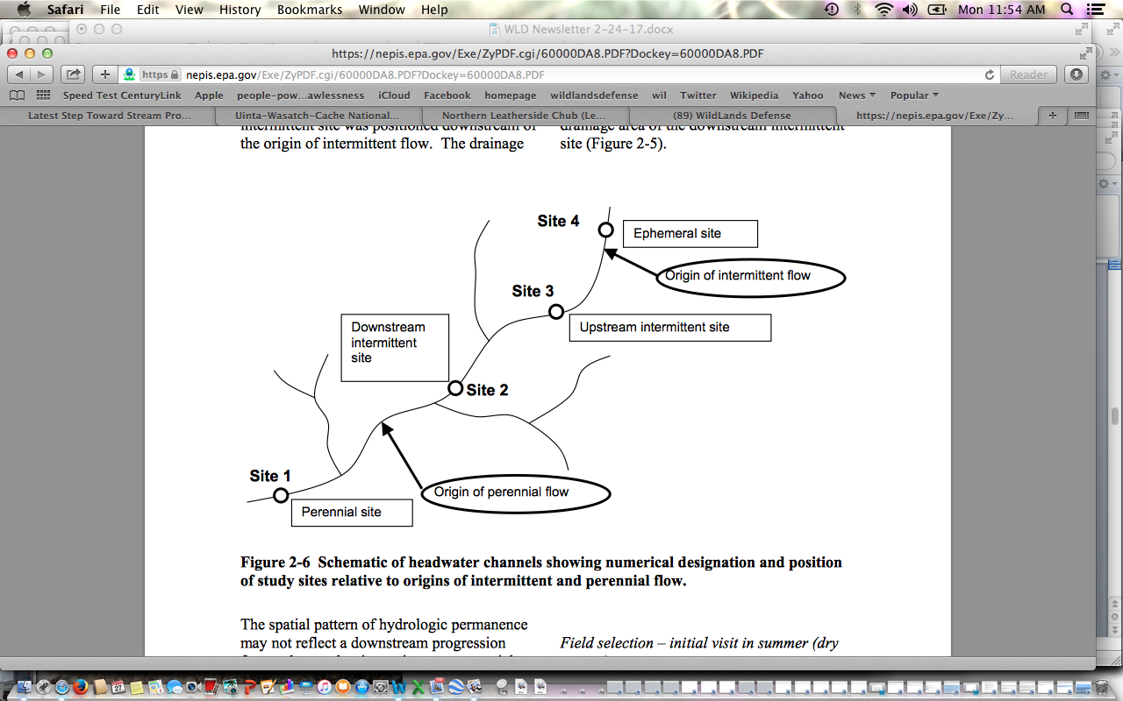
Foreseeable project-caused loss of perennial flows across the watershed headwaters significantly threatens biodiversity, aquatic species, and use of headwater areas by a broad array of wildlife as well as the recreational public. Thus, the spatial pattern of hydrological permanence may be adversely altered.
Full and detailed baseline information on physical habitat of streams and springbrooks must be obtained.
Physical habitat, typically refers to the structural attributes of the stream channel. For convenience of organization, we also discuss the measurement of physicochemical attributes of the stream water in this section. Habitat degradation from land-use change is the greatest threat to streams and their inhabitants (Allen and Flecker 1993, Sala et al. 2000, USEPA 2001).
The categories of hydrologic condition (discussed in detail below) represent the degree of departure from a spatially- continuous flow (or conversely, a completely dry condition) at a given point in time and space. These designations describe the level of connectivity or fragmentation of the aquatic phase in headwater streams (Boulton 2003). The degree of hydrologic connectivity is fundamental in controlling the structure and function of headwater streams because it affects physicochemical properties, biotic dispersal, and refuge availability (e.g., Boulton and Lake 1990, Dietrich and Anderson 1998, Maltchik et al. 1994).
Hydrology of headwater stream reaches may follow a predictable sequence of hydrologic conditions related to seasonal (and/or greater time frames) fluctuations in precipitation and evapotranspiration. Shannon et al. (2002) described hydrologic conditions in arid ephemeral channels that occur at lower frequencies than would occur in more humid regions. At a given time, the hydrologic condition also varies spatially within and among headwater streams associated with differences in distance to the groundwater table, watershed vegetation, groundwater storage capacity, etc.
Characteristics of Channel Headcuts. Headcuts are linked to erosion, often caused by grazing and/or road and logging or other deforestation disturbance impacts. Full and complete inventory of all existing headcuts across the watersheds to be disturbed must take place. The treatment disturbance combined with chronic disturbance seriously threatens expanded head-cutting, downcutting, stream entrenchment, and loss of sustainable water flows. [Note that headcuts and bank erosion are prevalent in areas impacted significantly by cattle, and this project will expand ease of cow access - including to Bull Trout headwaters. This will be combined with large-scale reductions in woody cover that serve to slow down and moderate erosive runoff].
Headcuts are abrupt changes in streambed elevation (i.e., knickpoint) that migrate in an upstream direction (Leopold et al. 1964). This migration is a natural geomorphic process that is often accelerated due to human modification of the channel and/or surrounding watershed (Patrick et al. 1994, Montgomery 1999). The upstream migration of headcuts results in downcutting (i.e., degradation) of the streambed and incised channel morphology (Galay 1983, Simon 1989). Among the ecological effects downstream of headcuts may be loss of streamside vegetation, scoured streambeds, decreased sinuosity, and temporary increase in downstream sedimentation (Patrick et al. 1994). Headcuts can also influence the connectivity along headwater streams by steep changes in streambed elevation and hydrology. Abrupt changes in summer baseflow hydrology (and water temperature) occur at headcuts and are related to differences in distance from the groundwater table. EPA P. 44.
Please survey for headcuts and other erosional features and measure length and measure surrounding conditions of ephemeral, intermittent and perennial stream segments, and assess effects. How much will erosion rates increase as a result of logging or thinning plus burning of various types in each affected watersheds?
Channel Dimensions and Geomorphology. Channel geomorphology influences many structural and functional aspects in streams, including streambed substrates, organic matter retention, and biotic response to floods. The scouring forces of floods are dissipated on the banks to greater extent in wide, shallow channels, whereas these forces are focused on the streambed in constrained or incised channels (Carling 1983). Geomorphology also governs the distribution of water as streams dry. Wetted widths will contract faster in wide, shallow channels than in incised channels. Wide, shallow channels may be more prone to surface water drying than incised channels because the summer groundwater table is more likely to be above the streambed (Stanley et al. 1997). However, where drying is severe, incised channels offer less interstitial refugia because the substrate layer above underlying bedrock may be thin. Habitat simplification reduces the biotic diversity directly, but also affects diversity indirectly through loss of refugia (Lake 2003). EPA 60—61.
Determine Risk of Habitat Simplification, Loss of Biodiversity and Sustainability. Concerns include: Changes in stream flow and water velocity. Depth to groundwater. Status of local and regional aquifers and changes over time. Are there past stream and spring flow measurements? If so where and when were they collected? How do current rates compare to past rates?
Benthic invertebrate surveys are widely used to evaluate the condition or health of water bodies (Hellawell 1986, Rosenberg and Resh 1993, Rader et al. 2001). Invertebrate assemblages are composed of a wide range of taxonomic and functional groups, many of which can be found in headwater streams. Furthermore, a diversity of life histories (e.g., voltinism, cohort production interval, dormancy stages) and physiological tolerances are found among aquatic invertebrates (Williams 1996, Frouz et al. 2003). Habitat characteristics (e.g., predictability, disturbance intensity, productivity) set the template governing the evolution of life histories and therefore the composition of assemblages (Southwood 1977, Townsend and Hildrew 1994). Flow is considered one of the ultimate drivers of lotic systems (Lytle and Poff 2004), and may be even more critical to temporary water bodies (Walker et al. 1995, Schwartz and Jenkins 2000). Thus, the composition of invertebrate assemblages should reflect the flow permanence in headwater streams. However, among past investigations there is no consensus regarding the distinctiveness of invertebrate communities among stream reaches of different flow permanence (Deluchi 1988, Feminella 1996, Dietrich and Anderson 2000, Fritz and Dodds 2002, Price et al. 2004). As is often the case in ecological systems, this disparity suggests that the relationship between flow permanence and assemblage organization may be complex. EPA P. 114.
Example of deforestation impacts on headwaters are described:
Kappesser, 1992 stresses the importance and sensitivity of headwater streams to Headwaters harvest. Headwaters harvest is known to have a disproportionately large influence on channel condition. The stability condition of a watershed may be broadly determined by evaluation the level of harvest activity (ECA), its special distribution with regard to headwater harvest and rain on snow risk, and the density of roading in the watershed with consideration of road location relative to geology and slope.
https://blog.epa.gov/blog/2016/07/intermittent-river-ecology/

“ … Intermittent waterways are interesting systems because they are fundamentally transformative in nature. While nearly all waterways expand and contract with pulses of water availability, these changes are particularly noticeable for intermittent waterways. They transition from flowing (even flooding,) to fragmented pools, to completely dry channels. This makes it more of a challenge in predicting patterns and processes compared to rivers which flow year-round. Recognition of the increasing prevalence of intermittent waterways across the globe has spurred greater interest in these systems, particularly in how they function and influence downstream waterbodies …”.

[Please provide all monitoring data of grazing use impacts - such as stubble heights recorded, browse use recorded for all riparian areas monitored for the past decade in the project area watersheds].

The EA fails to take a hard site-specific systematic look at the baseline, and the direct, indirect and cumulative impacts of the massive project disturbance on these environmental ecological and physical conditions described in the EPA report and cited literature above.

http://onlinelibrary.wiley.com/doi/10.1111/fwb.2016.61.issue-8/issuetoc
Storms: http://onlinelibrary.wiley.com/doi/10.1111/fwb.12734/full

Welter, J. R. and Fisher, S. G. (2016), The influence of storm characteristics on hydrological connectivity in intermittent channel networks: implications for nitrogen transport and denitrification. Freshw. Biol, 61: 1214–1227. doi:10.1111/fwb.12734

Abstract:

- Intermittent channel networks pose particular challenges for monitoring the extent of material transport and retention in arid river basins as a result of pulsed and highly variable rainfall-runoff dynamics. Here, we examine how rainfall characteristics influence hydrological connectivity along a terrestrial–aquatic flowpath from upland hillslopes to low order intermittent channel networks. In addition, we explore the implications for nitrogen loss via denitrification as a function of variable flowpath length and soil water conditions associated with intermittent flow.
- The size, timing and intensity of storms influenced the extent of hydrological connectivity and highest order channel flow. During summer monsoons, highest order channel flow increased most strongly with storm size, while in winter, the combination of days since last storm and storm intensity provided the best model; however, models containing storm size were also highly ranked.
- Riparian terrace and vegetated hillslope soils had the highest denitrification potential; however, rates in channel sediments also were appreciable. Deep channel sediments dried slowly and may therefore remain biologically active for longer periods, increasing the potential for N losses via denitrification.
- The extent of N transport, storage and denitrification is in large part driven by the frequency, intensity and duration of individual rainfall events. Individual storm characteristics influence the magnitude of vertical and horizontal hydrological connectivity in the catchment, and therefore, the magnitude of transport, solute storage and biogeochemical processing in intermittent channel basins.
http://onlinelibrary.wiley.com/doi/10.1111/fwb.12707/full

Marshall, J. C., Menke, N., Crook, D. A., Lobegeiger, J. S., Balcombe, S. R., Huey, J. A., Fawcett, J. H., Bond, N. R., Starkey, A. H., Sternberg, D., Linke, S. and Arthington, A. H. (2016), Go with the flow: the movement behaviour of fish from isolated waterhole refugia during connecting flow events in an intermittent dryland river. Freshw Biol, 61: 1242–1258. doi:10.1111/fwb.12707

- In many intermittent, dryland rivers, fish are confined to isolated waterholes for much of the year. It is only during brief flow events, which typify the hydrology of these systems, that fish are able to move between waterholes and explore surrounding habitat. Because most of the river channel will dry afterwards, there is a strong advantage for selection of persistent waterholes.
- Modifications to both flow regime and hydrological connectivity may reduce movement opportunities for fish in intermittent rivers. Our findings show that fish in intermittent systems use networks of waterholes and that management and conservation strategies should aim to maintain movement opportunities at large spatial scales to preserve population resilience.
http://onlinelibrary.wiley.com/doi/10.1111/fwb.12793/full

Rolls, R. J., Heino, J. and Chessman, B. C. (2016), Unravelling the joint effects of flow regime, climatic variability and dispersal mode on beta diversity of riverine communities. Freshw Biol, 61: 1350–1364. doi:10.1111/fwb.12793

Our findings suggest that maintenance of refuge pools will be critical to lessening drought impacts on river biodiversity at landscape scales, particularly if drought duration and intensity increase in the future.

https://academic.oup.com/bioscience/article/55/3/196/249658/Moving-Headwater-Streams-to-the-Head-of-the-Class

See also:
Moving Headwater Streams to the Head of the Class
Winsor H. Lowe Gene E. Likens
BioScience (2005) 55 (3): 196-197. DOI: https://doi.org/10.1641/0006-3568(2005)055[0196:MHSTTH]2.0.CO;2 2005

There is growing evidence that the water quality, biodiversity, and ecological health of freshwater systems depend on functions provided by headwater streams, which are similar in their importance to the fine branches of the human respiratory system in the lung. Among the functions of these streams are the maintenance of natural discharge regimes, the regulation of sediment export, the retention of nutrients, the processing of terrestrial organic matter, and the establishment of the chemical signature for water quality in the landscape. High levels of habitat diversity among and within these small streams create niches for diverse organisms, including headwater-specialist species of aquatic invertebrates, amphibians, and fish. Headwaters also act as refugia for riverine species during specific life-history stages and critical periods of the year, such as warm summer months.
Like the alveoli (the final branches of the respiratory tree that serve as the primary gas exchange units of the lungs), headwater streams are characterized by strong and vital interactions with the systems that surround them. Terrestrial inputs—dissolved nutrients, toxins, and particulate matter, for example—play a central role in determining the physical and chemical conditions of headwater streams (Likens and Bormann 1974) and in regulating the composition and productivity of biotic communities in these streams (Wallace et al. 1997). Because of this close terrestrial–aquatic linkage, the ecosystem services provided by head-waters and the species they support tend to be very sensitive to natural and anthropogenic disturbance of surrounding lands. Along with other distinctive qualities, this close connection creates a unique set of challenges and opportunities related to the protection of head-waters, and to research in these systems.
http://www.stroudcenter.org/research/PDF/ProtectingHeadwaters.pdf

In this paper we describe the special nature of headwater streams, their critical role in stream ecosystems, their fragility and vulnerability to human disturbance, and the benefits that ensue when headwaters are protected by forested riparian buffers. In particular, we argue that headwaters:
- support a biodiversity of communities including species of aquatic insects that are primarily restricted to spring seeps and first-order channels and communities of microorganisms that are selected for by the physical and chemical conditions found in headwaters;
- provide energy that helps support the life forms in larger downstream reaches and are largely responsible for establishing the chemical signature of the water downstream;
- can arise as permanently flowing streams from very small watershed areas and can include ecologically important intermittent streams that flow from even smaller watershed areas;
- are integrated into landscapes, which makes the quality of headwaters dependent upon land use conditions; and
- with intact forested riparian buffers have a physical form that influences the processing of nutrients and contaminants and reproduce the conditions under which their biological communities evolved.
- The health of downstream areas is only as good as the protection afforded to headwater streams, beginning as spring seeps and first-order stream channels in a steam and river network, have an immediate and intimate connection with the terrestrial environment, forming an extensive terrestrial/aquatic mosaic. However, the very attributes of headwaters that make them critical to the health of stream networks also make them exceedingly vulnerable to degradation when landscapes are altered.
This project greatly disturbs headwater region upland and riparian areas and drainage networks, and the EA fails to take a hard look at the direct, indirect, cumulative and synergistic impacts of the project’s massive disturbance to these fragile forest watershed systems and habitats.

Soil Erosion and Loss Vulnerability Assessment and Needed Protections

Soil analysis must provide data and measurements taken inside proposed project treatment units and also riparian areas. Please employ scientifically validated or monitoring validated methods for soil damage mitigation to ensure and restore the productivity of soils.

Please provide field surveys of existing detrimental disturbance (DD) and total soil resource commitment (TSRC). Mitigation and feasibility of proposed treatments hinge upon current soil conditions. These conditions are affected by past and ongoing management actions including logging, burning, livestock grazing, road building, and mechanized recreation.

Fire results in significant nutrient loss from soils– making the large-scale use of fire in this project even more harmful.

We are also concerned about logging/thinning/fire treatment and livestock trampling degradation of microbiotic crusts, such as the moss and lichens that cloak areas of forest floors – covering and stabilizing soils preventing erosion in wind and water. How does the Forest measure and monitor the health of microbiotic crusts, which provide a protective covering to soils, sequester carbon, provide nutrients, protect watersheds through promoting proper infiltration, and help exclude weeds. Belnap et al. 2000 BLM Tech. Bull. 2000.

See for example Glaser et al. 2022: https://www.ncbi.nlm.nih.gov/pmc/articles/PMC8966483/
Biological Soil Crust from Mesic Forests Promote a Specific Bacteria Community
“Bare soil at high vegetation climax sites is generated by animal activities and windfall, and by forest management, such as the removal of trees and the creation of skid trails or driving lanes for heavy equipment. The favorable climatic conditions in middle European temperate regions allow biocrusts to develop within weeks after disturbance, usually starting with a biofilm of eukaryotic algae, which are, besides mosses, the most dominant biocrust phototrophs in temperate forests and heaths (Gypser et al., 2015; Glaser et al., 2017, 2018). Biocrusts in temperate regions can sustain many years, but their activity is seasonal dependent (Dümig et al., 2014; Rieser et al., 2021). Even in well-developed European forest soils, biocrusts accumulate nutrients more strongly than surrounding bulk soils (Baumann et al., 2017; Drahorad et al., 2020) and also might counteract soil erosion as has been shown in other forest ecosystems (Seitz et al., 2017). Furthermore, temperate biocrusts impact the hydrological characteristics of the respective habitat (Gypser et al., 2016b).
Cyanobacteria and eukaryotic microalgae are crucial for the biocrust formation and development as major contributors to carbon fixation (Büdel et al., 2016; Szyja et al., 2018)”. Both the treatments, and livestock trampling, degrade, harm and/or destroy crusts – and there is no hard look at these impacts.
Please provide detailed information on methodologies used for measuring and protecting soil productivity and functional processes.

Forest Plan Standards require that soils be protected from detrimental disturbances. Example: Forest Plan Standard SWST02 states:

Management activities that may affect soil detrimental disturbance (DD) shall meet the
following requirements:
a) In an activity area where existing conditions of DD are below 15 percent of the
area, management activities shall leave the area in a condition of 15 percent or less detrimental disturbance following completion of the activities.
b) In an activity area where existing conditions of DD exceed 15 percent of the area, management activities shall include mitigation and restoration so that DD levels are moved back toward 15 percent or less following completion of the activities.

It is essential that the glossary definitions for the project area, detrimental soil disturbance and total soil resource commitment are clearly delineated. The Forest Plan Standard SWST02 and FSH 2509.18 DD use of 15% threshold is not based upon scientifically or publicly (i.e., NEPA) developed limitations on soil damage.

It is essential that the glossary definitions for the project area, detrimental soil disturbance and total soil resource commitment are clearly delineated. The Forest Plan Standard SWST02 and FSH 2509.18 DD use of 15% threshold is not based upon scientifically or publicly (i.e., NEPA) developed limitations on soil damage.

NFMA requires the Forest Service to “ensure that timber will be harvested from National Forest System lands only where—soil, slope, or other watershed conditions will not be irreversibly damaged.” [16 U.S.C. 1604 (g)(3)(E).] The FEIS thus violates NFMA and NEPA.

The Forest’s soil productivity proxy—such as the determination that management actions may permanently damage the soil covering 15% of an activity area and still meet NMFA and planning regulations—is arbitrary.

In responding to public comments on the Kootenai NF’s Brush Creek Environmental Assessment, the Forest Service stated:

Forest (“land”) productivity is “the summation of productivities of the individual landscape elements (stands) that comprise the forest and is the integration of soil productivity, species composition and stocking, and stand history (Grgal 2000)”. If soil productivity is adversely affected due to compaction, then this will have an impact on the overall productivity of the forest. Forest productivity is difficult to measure, so oftentimes, soil quality is used to estimate the potential productivity (Little et al., unknown year).

Soil compaction results from motorized activity in treatments, as well as livestock grazing trampling. How will both of these causes of compaction be measured, minimized/mitigated, and monitored? Fleischner (1994), Belsky et al. 1999. Treatment clearing and potential changes in roads/trails may alter how livestock use the landscape, and zones of soil disturbance, compaction and damage to microbiotic crusts.

If the Forest is using proxies, what is the scientific information based upon Payette data that correlates the proxy (areal extent of detrimental soil disturbance in activity areas) to metrics of long-term reductions in soil productivity, in order to validate the use of the proxy as a scientifically meaningful estimate of changes in soil productivity.

USDA Forest Service, 2007c states:

The Regional Soil Quality Standards (R-1 Supplement 2500-99-1) were revised in November 1999 (DEIS, A-11 (EIS Chapter 3). Manual direction recommends maintaining 85% of an activity area’s soils at an acceptable productivity potential with respect to detrimental impacts - including the effects of compaction, displacement, rutting, severe burning, surface erosion, loss of surface organic matter, and soil mass movement. This recommendation is based on research indicating that a decline in productivity would have to be at least 15% to be detectable (Powers, 1990).

The R-1 Supplement 2500-99-1 is almost identical to FSH 2509.18. It is important to note the separate and distinct thresholds in discussing 15% increases in bulk density, a threshold below which soil compaction is considered to be detectable, and 15% areal limit for detrimental disturbance, the Forest Plan and FSH upper limit on detrimental disturbance within “activity areas.” NFMA does not say that we can create up to 15% detrimental conditions, it says basically that we cannot create significant or permanent impairment.

This NEPA analysis must disclose internal controversies the agency fully recognizes surrounding its use scientific information for something as critical as standards for compliance with NFMA. NFMA requires that the Forest Service must “insure that timber will be harvested from National Forest System lands only where …soil, slope, or other watershed conditions will not be irreversibly damaged.” The Forest Service’s position is that its management may cause long-term harm or essentially irreversibly damage up to 15% of activity areas in disregard of NFMA—without any scientific basis.

The capability of Forest lands to support livestock grazing must consider the need to protect soils and determine the amount and levels of disturbance/degradation and other factors must also be considered.

More Weeds and Exotic Species Concerns

The Forest must fully disclose activities that will substantially cause or promote the introduction or spread of invasive species. This includes the agency’s own “rehab” actions associated with the project’s massive disturbance footprint – and any seeding or other activity. We are very concerned that the rehab may expand exotic and invasive species to the detriment of local native ecotypes, and harm the genetic integrity of native vegetation by failing to rely on local native ecotypes for any rehab efforts.
The direct indirect and cumulative effects of treatment disturbance, livestock grazing and roads/trails exacerbate the conditions for noxious weed and other invasive exotic species spread.
Noxious weeds and exotic invasive species like bulbous bluegrass or annual invasive grasses are one of the top threats to biodiversity on national forests. Please fully disclose the present level of noxious weed and exotic species infestations in the Project area, and the cause of those infestations.

Many weeds are poor soil stabilizers, resulting in invaded areas being more prone to accelerated soil erosion. Imposing grazing disturbance on treated areas promotes conditions where weeds thrive.

What are the impacts that noxious weed infestations, prevalence of invasive exotic grasses like bulbous bluegrass, or increase of rhizomatous aggressive exotic grasses like smooth brome or intermediate wheatgrass in understories cause to native plant communities? How does this affect the availability of livestock forage, stocking rates, and capability for livestock grazing?

We are very concerned that the project will greatly increase the amount of these aggressive exotic weedy rhizomatous grasses to the detriment of biodiversity, native forbs that are often critical to pollinators (which are completely ignored in analysis), and grasses and shrub recovery. Where are these grasses currently present across the project? How will fire expand them to the detriment of other species?

We strongly oppose any seeding of any exotic species or non-local ecotype of native species in this project and its huge disturbance footprint. Please specify each species that will be used, and under which specific conditions for all sites and habitats across the project landscape.

We are concerned that the Forest may provide laundry lists of effectiveness of BMPs/SOPs/ activity card grab bags of potential measures --- that do not effectively address prevention of new weed infestations following logging and related road operations, including in grazing-disturbed lands and watersheds. The Forest must disclose how this project may exacerbate existing weed infestations or cause new infestations.

Please quantify the project area extent of soils with impairment or experiencing detrimental impacts based upon the presence of noxious weeds and abundant exotic invasive shallow-rooted grasses.

Please develop project standards weed management which address the cause of the weed problems through prevention. See Appendix A, alternative and mitigation actions, and discussion of herbicide use concerns in these comments.

Fire and Fire Suppression Concerns

Documents for projects such as this fearmonger over fire, and rely on models and assumptions that assume often too short fire return interval, and uses terms like “catastrophic” or undesirable. The agency must come to grips with fire as a naturally functioning process.

The project analysis must fully disclose benefits of mixed severity and high severity fire. Even if all the “treatments” now proposed were to closely mimic the effects of a “characteristic” fire, there is no other plan for these newly “resilient” landscapes other than full on fire suppression where natural ignitions occur. What would the long-term ecological and economic costs of such a management regime be?

We support sound science-based fuel treatments located immediately adjacent to structures along private land/structure/national forest boundaries. Such treatments are supported by the scientific community as the most efficient and effective means to protect the values located on those private lands.

Cohen, 1999 reviewed current scientific evidence and policy directives on the issue of fire in the wildland/urban interface and recommend the focus be on structure ignitability in the Home Ignition Zone rather than extensive wildland fuel management. Cohen, 1999 also recognizes “the imperative to separate the problem of the wildland fire threat to homes from the problem of ecosystem sustainability due to changes in wildland fuels” (Id.). In regards to the latter—

How will the Forest study fire risk in a proper cumulative effects analysis area? Finney and Cohen (2003) discuss the concept of a “fireshed involving a wide area around the community (for many miles that include areas that fires can come from).” Please provide a thorough discussion and detailed disclosure of the current fuel situation within the fireshed within and outside the proposed treatment units, making it possible to assess the manner and degree to which most fire behavior would be changed by the project.
A major premise of the project is that the ecological impacts of fire suppression have been significant. How significant has logging, and promiscuous burning by livestock interests, been in the historical era? The Forest must adequately consider the spatial and temporal ecological cumulative impacts of the PNF’s fire suppression management regime for the area. The EIS must also consider the economic implications of the FS’s fire management.
Historic Fire Regimes

The fire analysis must include a temporal component, considering action alternative effects beyond immediate post-project conditions.

The FS must detail how it arrived at fire return ort disturbance intervals for all vegetation communities and must consider a broad range of sources – not just those that support very short fire return intervals.

Please perform a cumulative effects analysis of logging, treatments and fire suppression policies—how those effects play out across the Sagehen landscape and in the project area landscape. The many mechanical treatments will continue long-term adverse impact on the watersheds and terrestrial habitats. This leaves the door open to comprehensive restoration being subservient to timber volume production.

Habitat for the sensitive black-backed woodpecker is comprised predominately of insect infested or burned over stands. Insect infestations and recent wildfire provide key nesting and foraging habitats for the black-backed woodpecker and “populations are eruptive in response to these occurrences” (Wisdom et al. 2000). A purpose of the project is to eradicate or reduce insect infestations with large-scale removal amd purging of wood and burning wood along with a heap of other deforestation practices prevent the natural fire occurrence that the black-backed woodpecker requires – both within the project area and other sites across the Forest and landscape.

Viability of a species cannot be assured if habitat suppression is to be a forest-wide emphasis stemming from the forest plan. The FS will never be successful in “controlling” insects in this manner. All it will achieve is major new forest disturbance - including in Wolverine and a host of other rare species habitats, through removing nutrients, shade from standing dead and/or downed trees and carbon sequestration loss – a depauperate and simplified hotter, drier more fire prone vegetation community.

Cherry (1997) states:
The black-backed woodpecker appears to fill a niche that describes everything that foresters and fire fighters have attempted to eradicate. For about the last 50 years, disease and fire have been considered enemies of the ‘healthy’ forest and have been combated relatively successfully. We have recently (within the last 0 to 15 years) realized that disease and fire have their place on the landscape, but the landscape is badly out of balance with the fire suppression and insect and disease reduction activities (i.e. salvage logging) of the last 50 years. Therefore, the black-backed woodpecker is likely not to be abundant as it once was, and continued fire suppression and insect eradication is likely to cause further decline.”

Hutto, 1995 who studied forests burned in the1988 fire season, noted:
Fire is such an important creator of the ecological variety in Rocky Mountain landscapes that the conservation of biological diversity [required by NFMA] is likely to be accomplished only through the conservation of fire as a process…Efforts to meet legal mandates to maintain biodiversity should, therefore, be directed toward maintaining processes like fire, which create the variety of vegetative cover types upon which the great variety of wildlife species depend.

Hutto, 1995 states: “Fires are clearly beneficial to numerous bird species, and are apparently necessary for some.” (p. 1052, emphasis added.) Hutto, 1995 also noted:

USDA Forest Service 2011c describes some species needs for high severity burns:
Hutto (2008), in a study of bird use of habitats burned in the 2003 fires in northwest Montana, found that within burned forests, there was one variable that exerts an influence that outstrips the influence of any other variable on the distribution of birds, and that is fire severity. Some species, including the black-backed woodpecker, were relatively abundant only in the high-severity patches. Hutto’s preliminary results also suggested adverse effects of a legacy of past logging- as burned forests that were harvested fairly intensively (seed tree cuts, shelterwood cuts) within a decade or two prior to the fires of 2003 were much less suitable as post-fire forests to the black-backed woodpecker and other fire dependent bird species. Even forests that were harvested more selectively within a decade or two prior to fire were less likely to be occupied by black-backed woodpeckers.
Hutto, 2008 states, “severely burned forest conditions have probably occurred naturally across a broad range of forest types for millennia. These findings highlight the fact that severe fire provides an important ecological backdrop for fire specialists like the Black-backed Woodpecker, and that the presence and importance of severe fire may be much broader than commonly appreciated.” The Forest Service continues to manage against severely burned forests.

More Alternatives Deficiencies

There is no alternative that fully analyzes using natural processes as the primary method of vegetative restoration outside a wildland urban interface - using the best scientific information available. There is no adequate analysis of the environmental situation with the No Action alternative and effects cannot be properly understood with detailed current data; grazing impact and monitoring data; an honest look at the existing horrible effects (see attached Photo Exhibits) of the Forest’s past logging and thinning “treatments” right in this very landscape. Aa current baseline is woefully lacking. There is no real consideration of a range of alternative actions -including BMPs and SOPs and minimal tree removal, and not large-scale reduction n the project’s profligate use of fire. Further, the FS should have taken this opportunity to conduct large-scale winter disturbance closures across the project area – given the declines in the areas Wolverine population, as shown in USFWS 2023 Report.

Please incorporate livestock grazing Alternative and Mitigation actions, in a process-re-scoped as an EIS.

Full science-based analysis of No Action, and incorporation of components of No Action into alternatives must take place.

Comprehensive Cumulative Effects Analysis is Required to Comply with NEPA

We have discussed many threats to native biota and watersheds and other Forest values throughout these comments. An agency listing or mentioning past, ongoing, and reasonably foreseeable actions does not provide adequate analysis of those impacts for resources. It is important that the results of past monitoring be incorporated into cumulative effects analyses. The Forest Service must include the results of monitoring done in the project area as committed to in the NEPA documents of past projects or as a part of the Forest Plan monitoring and evaluation effort. We are very concerned that sufficient past monitoring may not have taken place.

Our review of the recent Forest Plan Monitoring Report discussed in these comments found large data gaps. What is the record of compliance with Forest plan-required monitoring?

What are the cumulative effects of the recreational uses, and foreseeable continuing increases in recreational disturbances, trail or other networks, motorized recreation and mountain biking disturbance on vegetation, soils, fish, wildlife habitats (over all seasons of the year) and water quality? What are the cumulative effects of past or foreseeable logging, wildfire, vegetation treatments on resources? What are the cumulative impacts of fire suppression?

What are the past and ongoing/chronic ecological damage effects from livestock grazing? The EIS include alternatives that adequately deals with the adverse cumulative effects of grazing.

How much do grazing allotments within the cumulative effects area contribute to loss of ground cover in RCAs and conversion of desirable native vegetation to less favorable weedy species or poor soil stabilizers? Wetlands that are at risk for compaction as well and possible effects to shallow water tables must be identified and damage addressed.

The Forest must identify “reference conditions” (and accurately describe departures from these reference conditions) for all Indicators and assessments of condition. Where are all BNF RNAs, and how do their conditions compare to the claimed “desired” conditions? Are there exclosures? If so, have they been trespassed, and if not, what insights into ecological conditions and grazing impacts do they provide?

We want to add additional new information the magnitude and scale of indirect and cumulative impacts and threats to biodiversity and wildlife in this Region and across the Region 4 forests landscape --- the disastrous potential impact of the proposed BLM Solar EIS that proposed industrial development on 22 million acres of the West, and that would harm and destroy lower elevation wintering or migration habitats for many migratory bird species and regional populations of wintering big game herds that also use National Forest lands.

If this massive industrialization of the interior West proceeds under that BLM Solar EIS, these populations even more vulnerable to extirpation - when combined with the host of deforestation and other actions of the Sagehen, Granite Goose project and a slew of other USFS logging “treatments” and massive burning schemes.

See Solar EIS Alternatives Mapping: https://blm-egis.maps.arcgis.com/apps/webappviewer/index.html?id=22df2b327e0c49c3a9afb67de5ca658d

We want to provide new information the magnitude and scale of indirect and cumulative impacts and threats to biodiversity and wildlife in this Region and across the Region 4 forests landscape --- the disastrous potential impact of the proposed BLM Solar EIS that proposed industrial development on 22 million acres of the West, and that would harm and destroy lower elevation wintering or migration habitats for many migratory bird species and regional populations of wintering big game herds that also use National Forest lands.

If this massive industrialization of the interior West proceeds under that BLM Solar EIS these populations even more vulnerable to extirpation - when combined with the host of deforestation and other actions of the Granite Goose project and a slew of other USFS “treatments” and massive burning schemes.

See Solar EIS Alternatives Mapping: https://blm-egis.maps.arcgis.com/apps/webappviewer/index.html?id=22df2b327e0c49c3a9afb67de5ca658d

We also note that there are several recent articles about significant harms that could be caused by the proposed Nez Perce-Clearwater Forest Plan and the treats it poses to roadless lands and the same rare native carnivores and other biota and to roadless area lands.

All manner of often overlapping and/or consecutive and cumulative disturbance are planned across this fragile Sagehen landscape and the regional forests. The EA fails to take a science-based hard look at the impacts, and the failure to specify where projects will occur and how large sites will be thwarts any science-based hard NEPA look – resulting in great uncertainty and a form of extremely risky “condition-based” management. Yet critical baseline information on soil condition , erosion susceptibility, watershed health, water quality and quantity, microbiotic crust condition, health and integrity of grazed native plant communities, areas actually occupied by sensitive species (see Dobkin and Sauder 2004) – describing how species may be much more limited in actual occurrence than gross habitat-typing mapping would indicate), whether migratory bird and TES species populations can withstand drastic FS-imposed loss of maturing, mature and old growth veg communities, the myriad harms to cultural sites, and myriad harms and losses recreational uses and enjoyment of these lands

Please keep us fully informed of all aspects of this major federal action where an EIS must be prepared.

Sincerely,

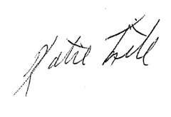

Katie Fite
Public Lands Director
WildLands Defense
PO Box 125
Boise, ID 83701
208-871-5738
katie@wildlandsdefense.org

/mg
Mike Garrity
Alliance for the Wild Rockies
PO Box 505
Helena, MT 59624
406-579-5986
wildrockies@gmail.com

/se
Sara Johnson
Native Ecosystems Council
PO Box 125
Willow Creek, MT 59760
406-579-3286
sjjohnsonkoa@gmail.com

Jason Christensen
Yellowstone to Uintas Connection
PO Box 363
Paris, ID 83261
435-881-6917
jason@yellowstoneuintas.org

.
Cohen, Jack 1999. Reducing the Wildland Fire Threat to Homes: where and how much? Jack D. Cohen, RMRS. Paper presented at the Fire Economics Symposium, San Diego, CA April 12, 1999. ecosystem sustainability—Cohen and Butler (2005) state: “Realizing that wildland fires are inevitable should urge us to recognize that excluding wildfire does not eliminate fire, it unintentionally selects for only those occurrences that defy our suppression capability—the extreme wildfires that are continuous over extensive areas. If we wish to avoid these extensive wildfires and restore fire to a more normal ecological condition, our only choice is to allow fire occurrence under conditions other than extremes. Our choices become ones of compatibility with the inevitable fire occurrences rather than ones of attempted exclusion”. “Rhodes, 2007 states: “The transient effects of treatments on forests, coupled with the relatively low probability of higher-severity fire, makes it unlikely that fire will affect treated areas while fuel levels are reduced.” (Internal citations omitted.) And Rhodes, 2007 also points out that management with mechanical fuel treatments to restore natural fire regimes must take into consideration the root causes of the alleged problems, which in this case may be related to the intensive livestock grazing that has occurred for several decades. The NEPA process here should take into account the effects of livestock grazing on forest conditions, in terms of various resources including soils, water, weeds, and forest composition. Baker et al., 2006 state: Livestock grazing generally increases tree density in formerly open stands and thereby increases the fine fuels that contribute most to fire intensity and severity. Removal of grass reduces competition, allowing more trees to successfully regenerate, shown experimentally in the Southwest (Pearson, 1942), and also by paired comparisons in other parts of the West, in which mesas subject to livestock grazing have much higher tree density than do comparable nearby ungrazed mesas (Rummell, 1951; Madany & West, 1983). Grazing can also initially reduce the quantity of fine grass fuels needed for surface fires, and the onset of heavy grazing in south-western ponderosa pine landscapes is temporally associated with a marked reduction in surface fires (e.g. Savage & Swetnam, 1990). However, fine fuels are likely not to have remained low for long. Higher tree density increases fine fuels that lead to faster fire spread and increases ladder fuels that lead fire into the canopy (Zimmerman & Neuenschwander, 1984), together increasing the potential for more fires and more severe fires. The allegation that thinning replicates natural fire is also contradicted by science (for example see Rhodes and Baker 2008, McRae et al 2001, and Rhodes 2007). DellaSala, et al. (1995) are skeptical about the efficacy of intensive fuels reductions as fire-proofing methods. Veblen (2003) states: The premise behind many projects aimed at wildfire hazard reduction and ecological restoration in forests of the western United States is the idea that unnatural fuel buildup has resulted from suppression of formerly frequent fires. This premise and its implications need to be critically evaluated by conducting area-specific research in the forest ecosystems targeted for fuels or ecological restoration projects. Fire regime researchers need to acknowledge the limitations of fire history methodology and avoid over-reliance on summary fire statistics such as mean fire interval and rotation period. Kauffman (2004) suggests that current FS fire suppression policies are what are actually “catastrophic”, and that fires are beneficia.:

