8 January 2025

TO: Sweet Home Ranger District
ATTN: Hilary Henry, Sweet Home Recreation Planner
VIA: https://cara.fs2c.usda.gov/Public//CommentInput?Project=64261
CC: Hilary.Henry@usda.gov

Subject: Upper Canyon EA — comments

Please accept the following comments from Oregon Wild and Cascadia Wildlands concerning the Upper Canyon EA, https://www.fs.usda.gov/project/willamette/?project=64261. Oregon Wild represents 20,000 members and supporters who share our mission to protect and restore Oregon’s wildlands, wildlife, and water as an enduring legacy. Our goal is to protect areas that remain intact while striving to restore areas that have been degraded. This can be accomplished by moving over-represented ecosystem elements (such as logged and roaded areas) toward characteristics that are currently under-represented (such as roadless areas and complex old forest). Cascadia Wildlands is part of a movement to protect and restore wild ecosystems of the Cascadia Bioregion, including vast old-growth forests, rivers full of wild salmon, wolves howling in the backcountry, and vibrant communities sustained by the unique landscapes. Cascadia Wildlands’ contact information is: P.O. Box 10455, Eugene, OR 97440 | Eugene, OR 97401 | 541-434-1463 | grace@cascwild.org.

This proposal involves
- treating 1,069 acres of under 80 stands using thinning, dominant tree release, 1-3 acre gaps, and skips
- No-harvest stream buffers are as follows: Class 1 streams: 120 feet, Class 2 streams: 100 feet ; Class 3: 60 feet; Class 4: 30 feet
- 8 stream crossing by non-system roads
- meadows would be restored
- fuels treated
- 5 miles of temporary road construction
- 0.75 miles Road closure
- 3 miles road decommissioning
- 85 miles of road maintenance
- 5 stream culverts replaced

We incorporate by reference our scoping comments dated Jan 22, 2024.

It’s disappointing that the FS website for this project was broken and unavailable on the day before comments are due. I hope that did not cause any public comments to be missed. The links at Box.com are generally more reliable. Maybe the Forest Service should put a link to those on the Willamette NF global project page.
Contents [hyperlinked]
Misc. Notes and Comments 2
Conserve Red Tree Vole Habitat Connectivity 6
Conserve the Special Values of Unroaded Areas 7
Weigh the Trade-offs Associated with Logging in Riparian Reserves. 13
Logging and Stream Temperature 25
Manage Matrix for Connectivity 26
Manage for Decadence – retain untreated “skips” for recruitment of mortality 30
Harmonize Climate Change Mitigation and Adaptation 41

Misc. Notes and Comments

- The EA says that part of the goal is to stimulate the growth of understory vegetation. This is a potential fuel hazard that should get greater attention in the EA. It might be better to maintain more canopy to mitigate effects on carbon, fire hazard, snags, and flying squirrels, while thinning heavy enough to stimulate understory in various sized patches that are not contiguous.

- It would help inform our comments to understand the management history of stands proposed for treatment, i.e., whether they were previously clearcut, replanted, thinned, whether they are natural regenerated, when they were last affected by wildfire, etc. The EA says that stands 30-80 years old are “older second growth plantations originating from early clearcut harvest treatments in the 1940s to the late 1980s. This stand type is characterized as dense, closed-canopied, and even-aged.” Is this universally true? Any exceptions in the stands to be treated.

- We appreciate that the EA acknowledges that are multiple pathways for stands to develop from young to old-growth condition, and the potential adverse effects of heavy equipment on the below-ground ecosystem.

- Gaps as mini-clearcuts do not mimic natural processes. Retaining 4 tpa is a start, but 10 tpa would be better. Gaps should be 1 acre or smaller, unless they retain significant live and dead tree structure (e.g., 10 tpa). Gaps should also not be randomly located. Variability is fine, but do not put gaps in places that have existing ecological features that should be retained, such as snag patches, large or legacy trees, rock piles, well-developed understory, etc. See EA Table 4, Special Habitats in Upper Canyon Units.

- We hope the Forest Service can be patient and allow time to natural regeneration of gaps and DTR patches.

- Natural forests are clumpy. We support dominant tree release that retains 5 or more trees, not just a single isolated tree. DTR trees are more vulnerable to blowdown, and retaining multiple trees helps spread the risk and retain some structure if 1 or 2 trees blow down.

- The EA repeatedly says that trees grow more slowly in unthinned areas, but the EA should add that at the stand level unthinned areas produce more wood, store more carbon, and provide more habitat such as snags and dead wood. Individual trees may slow down, but there are so many more trees that unthinned areas outperform thinned areas in many ways. This needs to be disclosed in the NEPA analysis.

- The cumulative effects analysis says that there are no effects from the no action alternative. This is not accurate. The no action alternative would result in incrementally (and cumulatively) more snags, dead wood, large trees, carbon storage, flying squirrel habitat, red tree vole habitat, etc.

- The EA lacks a credible analysis of how this project contributes to global climate change by emitting carbon. The EA suggests that logging is a climate adaptation action, but the EA does not disclose that logging accelerates the transfer of carbon from the forest to the atmosphere and emits greenhouse gas and makes global climate change worse (for this project area and the rest of the planet). The EA makes no attempt to harmonize the potentially competing goals of climate change adaptation, and climate change mitigation. See more on that below.
- The FS should develop a preferred alternative that minimizes and mitigates carbon emissions from logging by retaining more trees. This project area is moist, productive, and has an infrequent fire return, so it’s a great place to store carbon. In fact, carbon storage should be made part of the purpose and need, because the Forest Service cannot meet all of its legal mandates and LRMP requirements unless climate change is moderated by reduced emissions;
- Minimize and mitigate long-term adverse effects on snag recruitment by retaining more trees in unthinned “skips.” Also consider leaving 10-20 trees per acre in the seed orchard for future snag habitat;
- Thinning has adverse effects on a variety of spotted owl prey, including flying squirrels, red tree vole, red-backed voles, chipmunks, etc. Minimize and mitigate adverse effects on spotted owl prey by retaining more trees, more down wood, shrub cover, and “mid-canopy occlusion” that flying squirrels use for cover when gliding. The agency should design matrix thins to support abundant and diverse populations of owl prey species.
- The EA says that dispersal habitat is 11” dbh and 40% canopy cover. This is outdated. Spotted owl prefer to disperse through higher quality habitat (as close as possible to nesting, roosting habitat) that provides some foraging opportunities. See Stan G. Sovern, Eric D. Forsman, Katie M. Dugger, Margaret Taylor. 2015. Roosting Habitat Use and Selection By Northern Spotted Owls During Natal Dispersal. The Journal of Wildlife Management 79(2):254–262; 2015; DOI: 10.1002/jwmg.834. https://osu-wams-blogs-uploads.s3.amazonaws.com/blogs.dir/2742/files/2016/09/Sovern-et-al.-2015.pdf.
- Mimic natural patterns as much as possible. Strive for a high degree of spatial variability in the leave trees. Be sure to retain clumps of 2-5 trees which are common in natural forests, and leave some 1/4 acre unthinned skips embedded within thinned areas. Small structure-rich “gaps” are also recommended, 1/4 - 1/2 acre areas that are very heavily thinned with a few trees and snags retained within them;
- Retain existing elements of diversity, including wetlands, meadows, rocky outcrops, large trees, large snags, tall deciduous shrubs, hardwoods, and other minor tree species. Retain and protect under-represented conifer and non-conifer trees. Protect shrubs as much as possible, especially deciduous and tall shrubs, and those that produce insects, berries and mast. "Although usually classified as a shrub and not considered in discussions of forest composition or structure, A. circinatum [vine maple] dominated the angiosperm component, and although comprising only 0.9% of the basal area, it was the most abundant woody species in terms of stem count. This is important because A. circinatum makes a disproportionate contribution to biodiversity in this evergreen conifer forest, for example by providing food for folivore geometrid larvae that feed Neotropical migrant birds [26] and by providing substrate for epiphytic lichens and bryophytes [27]." Lutz JA, Larson AJ, Freund JA, Swanson ME, Bible KJ (2013) The Importance of Large-Diameter Trees to Forest Structural Heterogeneity. PLoS ONE 8(12): e82784. doi:10.1371/journal.pone.0082784. http://ctfs.arnarb.harvard.edu/Public/pdfs/LutzEtAl_PLoS2013.pdf
- Any yew trees that may be present should be excluded from the harvest contract and retained as much as possible within the stand. Yew trees are unique and under-represented. They provide a valuable ecological benefits, such as mid-canopy perches the help spotted owls tolerate weather extremes;
- Retain abundant snags and course wood both distributed and in clumps so that thinning mimics natural disturbance. Retention of dead wood should generally be proportional to the intensity of the thinning, e.g., heavy thinning should leave behind more snags not less. Retain wildlife trees such as hollows, forked tops, broken tops, leaning trees, etc. Keep in mind that the matrix is also expected to provide some late successional habitat values. See below comments under “Manage Matrix for Connectivity.” Thinning does not always accelerate development of late successional forests, in particular commercial thinning has an adverse effect on snags and dead wood that are defining characteristics of late successional habitat. Thinning might produce the first large trees, but those trees would be vigorous and less likely to experience mortality, so developing large snags is not a direct and immediate result of growing large trees. Thinning also dramatically reduces the pool from which future mortality can be recruited so thinning actually retards development of some attributes of late successional forest and spotted owl habitat including snags and down wood. NEPA analyses often assert that "As a result of thinning, growth of retained live trees would be accelerated, so larger trees would be available sooner for recruitment as snags and CWD than without thinning." This is only half the story and it is very misleading. The agency is not being fully honest about the effects of logging unless statements like this are followed by a loud and clear acknowledgement that accelerating development of a few larger live trees (that might become snags if a few of them happen to die) comes at the cost of a significant reduction in the number of medium and large snags over time. From an ecological perspective, the net result of commercial logging is undeniably adverse to snag habitat. The agency cannot present logging as a benefit to snag habitat when it is really a cost that needs to be mitigated.
- Avoid using heavy equipment on wet soils and wet weather log hauling that poses too great a risk of soil damage and water pollution. The EA says “roads that will be used year-round will be designed to meet engineering standards for wet season haul.” Our concerns are not alleviated by these words. We have seen muddy ditch water flowing into stream too often. The Willamette NF is too cozy with the timber industry and is known to waive requirements after the fact. Water quality is too important to compromise. To protect the public interest, heavy and equipment and log hauling should be limited to dry conditions.
- We are concerned about the 8 streams crossings by non-system roads. Are these just dirt track over streams, or are there culverts? The EA does not disclose the situation or the risks very well. The FS should do better than tolerate crude stream crossings.
- The Forest Service should design the preferred alternative to focuses on thinning areas near existing roads, and avoids temporary road construction, which in spite of its name, actually has long-term adverse effects on soil and vegetation;
- Agencies have a duty to consider habitat connectivity in their NEPA analyses. CEQ issued guidance saying “… agencies should consider and be transparent about the positive or negative impacts of proposed actions and alternatives on connectivity and corridors. Through the NEPA review process, Federal agencies can consider measures to advance corridors and connectivity as components of proposed actions, alternatives to proposed actions, or mitigation for proposed actions’ effects.” Mallory, B. 2023. CEQ Guidance for Federal Departments and Agencies on Ecological Connectivity and Wildlife Corridors. March 21, 2023. https://www.whitehouse.gov/wp-content/uploads/2023/03/230318-Corridors-connectivity-guidance-memo-final-draft-formatted.pdf.
- As noted in our scoping comments, young stands do not exist in isolation, so be sure to consider the effects of thinning on adjacent mature and old-growth habitat which may provide habitat for spotted owls, marbled murrelets, and other species. Spotted owls may use young stands for dispersal, foraging, and security from predators. It may be helpful to create a “risk map” that identifies areas that are more or less suitable for thinning based on criteria such as: existing habitat characteristics, proximity to occupied habitat or activity centers, proximity to suitable habitat, and proximity to recently thinned areas, non-habitat, and roads. The agency should also consider adjusting both the location and timing of thinning to minimize the cumulative effects of widespread thinning on the sensitive and listed species;
- The EA analysis of effects to Cavity Excavators, Pileated Woodpeckers, and Marten is inadequate. It fails to disclose the long-term adverse effects of logging on recruitment of snags and dead wood that is so important to all these species. Looking at recent stand simulation analyses the effects of thinning on recruitment of large wood, e.g. the Curran-Junetta and Holland Moonsalt Projects on the Cottage Grove Ranger District, it appears that thinned stands may not reach the 80% DecAID tolerance levels for large snags, not even in 100 years. If thinning really forecloses that opportunity, then we better set aside large areas of the landscape where thinning does not occur and large snag recruitment can occur at natural levels. These unthinned area need to be planned in advance and left unmanaged for very long periods so this process can operate without the interference of foresters who think they can improve on things with chainsaws. The lesson of the stand simulation models is that virtually any logging, reduces and delays recruitment of large snags. This is very significant and very under-appreciated new information. See “Manage for Decadence” below.
- As noted in our scoping comments, the EA should focus the NEPA analysis on “trade-offs” related to logging. All logging, including thinning stands of any age, include some adverse impacts and trade-offs. Some impacts of logging are unavoidable, so there is no such thing as a logging operation that is 100% beneficial. Depending on how thinning is done, it can have adverse impacts such as soil disturbance; habitat disturbance; damage to the shrub layer; carbon removal; spreading weeds; reduced populations of prey for carnivorous species; reduced recruitment of snags; road-related impacts on soil, water, site productivity, and habitat; moving fuels from the canopy to the ground, hotter-drier-windier microclimate that is favorable to greater flame lengths and rate of fire spread, etc. Some of these negative effects are fundamentally unavoidable, therefore all thinning has negative effects that must be compensated by beneficial effects such as reducing competition between trees so that some can grow larger faster, increased resistance drought stress and insects, possible increasing species and structural diversity, possible fire hazard reduction, etc. It is generally accepted that when thinning very young stands, the benefits outweigh the adverse impacts and net benefits are likely. It is also widely understood that thinning older stands tends to have greater impacts on soil, water, weeds, carbon, dead wood recruitment so the impacts very often outweigh the benefits, resulting in net negative outcome on the balance sheet. Thus, as we move from young forest to older forests, the net benefits turn into net negative impacts. See Klaus J. Puettmann, Adrian Ares, and Erich Dodson. 2011. Over- and understory vegetation responses to thinning treatments: Can we accelerate late successional stand structures? Symposium: Density Management In The 21st Century: West Side Story. http://oregonstate.edu/conferences/event/densitymanagement2011/agenda.pdf (“growth of large trees was less responsive to thinning and low mortality rates for larger trees resulted in little recruitment of large snags or coarse woody debris (down wood). In general, thinning increased abundance and diversity of early-seral understory species, with little effect on late-seral species. On sites where shrub cover was already high harvesting initially reduced the cover, but shrubs recovered over time. Exotic species slightly increased in response to treatment …”); and Erich K. Dodson, Adrian Ares, and Klaus J. Puettmann. 2011. Thinning effects on tree mortality and snag recruitment. Symposium: Density Management In The 21st Century: West Side Story. http://oregonstate.edu/conferences/event/densitymanagement2011/agenda.pdf (“…thinning did little to accelerate the development of large snags and coarse downed wood that provide critical wildlife habitat…”) These are some of the trade-offs that must be disclosed and weighed in the NEPA document.

Conserve Red Tree Vole Habitat Connectivity
Please strive to retain canopy connectivity between stands that may provide suitable habitat for red tree voles, which are an important prey species for the northern spotted owl. Reed Wilson provided some good suggestions where these unit adjustments to conserve RTV connectivity would make the most sense. Reed’s scoping comments said
“In Upper Canyon Creek, some old growth stands are surrounded closely by harvest units, impacting tree voles' ability to disperse, for example the old growth stand on 2032 bracketed by unit 41 and the road at 44.348790, -122.30608. Another area of concern is the old growth between units 99 and 101, at 44.29998, -122.294316. Withdrawing the narrow tongue of unit 41 that reaches NE to the road, and dropping tiny unit 42 would create an expanded, viable habitat area for tree voles along 2032. Designating an unharvested buffer strip in units 99 and 101 adjacent to old growth would allow tree voles to expand their population and improve their chances of surviving changing climate conditions.”

Conserve the Special Values of Unroaded Areas
Portions of this project area appear to be located within large unroaded that likely provide disproportionate ecosystem services and may be disproportionately degraded by logging. Unroaded areas are show in purple and lavender polygons below. They include Gordon Meadows Old Cascades, Two Girls, Tidbits Mountain – Owl Ridge, and Cook Creek.
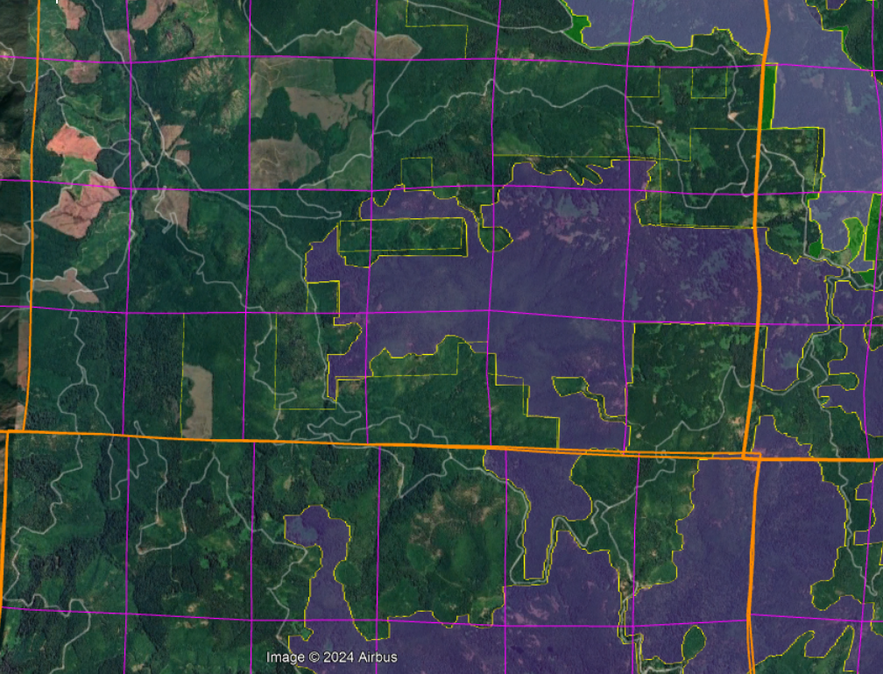

We cannot tell for sure which stands may be located within these unroaded polygons, and if they are plantations, they are likely on the edge which slightly alleviates our concerns, (if thinning can be done very carefully without roads). We urge the Forest Service to prepare and share an analysis to determine which units, if any, overlap with the unroaded areas.

This project is focused on stands under 80 years old, but were they all previously clearcut, or were any of natural origin?

We do not object to non-commercial thinning and removal of small trees for meadow restoration, but commercial logging and road construction should be avoided in unroaded areas, especially if any of the affected stands are naturally regenerated.

The EA should disclose any impacts on unroaded areas and develop alternatives that avoid impacting those areas with commercial logging and roads.

The agency cannot limit its analysis of roadless areas to inventoried areas >5,000 acres, because smaller roadless areas that were not inventoried are ecologically relevant and potentially significant. The NEPA analysis must reflect the growing scientific evidence (cited below) indicating the significant value of roadless areas smaller than 5,000 acres and larger than 1,000 acres. Recent scientific literature emphasizes the importance of unroaded areas greater than 1,000 acres as strongholds for the production of fish and other aquatic and terrestrial species, as well as sources of high quality water. Commercial logging and/or road building within large unroaded areas threatens these significant ecological values.

Large unroaded areas are important simply due to the fact that they better represent the historic condition that species evolved with but they are now rare on the landscape due to human activities that have degraded and fragmented the majority of the landscape. For instance, the mature and old-growth forests within these unroaded areas is likely much less fragmented than the mature and old-growth forests located outside these unroaded areas. The Northwest Forest Plan LSOG Effectiveness Monitoring Plan says that “perhaps 80 percent or more [of the historic late-successional old-growth forest] would probably have occurred as relatively large (greater than 1,000 acres) areas of connected forest.” Miles Hemstrom, Thomas Spies, Craig Palmer, Ross Kiester, John Teply, Phil McDonald, and Ralph Warbington; Late-Successional and Old-Growth Forest Effectiveness Monitoring Plan for the Northwest Forest Plan, USFS General Technical Report PNW-GTR-438; December 1998; http://www.fs.fed.us/pnw/pubs/gtr_438.pdf. Currently, these 1,000 acre and larger patches are rare on the landscape.

Boakes et al (2009) explained why it is important to retain large unroaded areas.
Abstract: Habitat clearance remains the major cause of biodiversity loss, with consequences for ecosystem services and for people. In response to this, many global conservation schemes direct funds to regions with high rates of recent habitat destruction, though some also emphasize the conservation of remaining large tracts of intact habitat. If the pattern of habitat clearance is highly contagious, the latter approach will help prevent destructive processes gaining a foothold in areas of contiguous intact habitat. Here, we test the strength of spatial contagion in the pattern of habitat clearance. Using a global dataset of land-cover change at 50x50 km resolution, we discover that intact habitat areas in grid cells are refractory to clearance only when all neighbouring cells are also intact. The likelihood of loss increases dramatically as soon as habitat is cleared in just one neighbouring cell, and remains high thereafter. This effect is consistent for forests and grassland, across biogeographic realms and over centuries, constituting a coherent global pattern. Our results show that landscapes become vulnerable to wholesale clearance as soon as threatening processes begin to penetrate, so actions to prevent any incursions into large, intact blocks of natural habitat are key to their long-term persistence.
Elizabeth H. Boakes, Georgina M. Mace, Philip J. K. McGowan and Richard A. Fuller 2009. Extreme contagion in global habitat clearance. Proceedings of the Royal Society B: Biological Sciences. November 25, 2009. doi: 10.1098/rspb.2009.1771, https://www.landscapepartnership.org/maps-data/climate-context/cc-resources/ClimateSciPDFs/ProcRSocB09How%20to%20save%20wilderness.pdf/app-download-file/file/ProcRSocB09How%20to%20save%20wilderness.pdf.

World Wildlife Fund and the Conservation Biology Institute summarized the important attributes of small roadless areas (1,000-5,000 acres).
Small roadless areas share many of attributes in common with larger ones, including:
• Essential habitat for species key to the recovery of forests following disturbance such as herbaceous plants, lichens, and mycorrhizal fungi
• Habitat refugia for threatened species and those with restricted distributions (endemics)
• Aquatic strongholds for salmonids
• Undisturbed habitats for mollusks and amphibians
• Remaining pockets of old-growth forests
• Overwintering habitat for resident birds and ungulates
• Dispersal “stepping stones” for wildlife movement across fragmented landscapes
DellaSala, Dominick and James Strittholt. 2002. Scientific Basis For Roadless Area Conservation. World Wildlife Fund. Ashland, OR; Conservation Biology Institute. (June 2002 - Updated October 2003) https://consbio.org/wp-content/uploads/2022/05/Scientific_Basis_For_Roadless_Area_Conservation.pdf.

In a 1997 letter to President Clinton, 136 scientists said:
There is a growing consensus among academic and agency scientists that existing roadless areas–irrespective of size–contribute substantially to maintaining biodiversity and ecological integrity on the national forests. The Eastside Forests Scientific Societies Panel, including representatives from the American Fisheries Society, American Ornithologists’ Union, Ecological Society of America, Society for Conservation Biology, and The Wildlife Society, recommended a prohibition on the construction of new roads and logging within existing (1) roadless regions larger than 1,000 acres, and (2) roadless regions smaller than 1,000 acres that are biologically significant…. Other scientists have also recommended protection of all roadless areas greater than 1,000 acres, at least until landscapes degraded by past management have recovered…. As you have acknowledged, a national policy prohibiting road building and other forms of development in roadless areas represents a major step towards balancing sustainable forest management with conserving environmental values on federal lands. In our view, a scientifically based policy for roadless areas on public lands should, at a minimum, protect from development all roadless areas larger than 1,000 acres and those smaller areas that have special ecological significance because of their contributions to regional landscapes.
Letter to President Clinton from 136 scientists (Dec. 10, 1997).
https://drive.google.com/file/d/0B4L_-RD-MJwrRzhFcm5QcFR0MHM/view?usp=sharing&resourcekey=0-2-sbGMN3bOUBQGGMDBQM1Q

To the list of special values found within unroaded areas must be added carbon storage. European policy leaders consider roadless areas effective for carbon storage and climate mitigation:
[T]he European Parliament has agreed to raise the issue of roadbuilding in intact forests at the UN Climate Change Conference to be held next month in Warsaw (Poland); it calls on parties to use the existence of roads in forest areas as an early negative performance indicator of REDD+ projects, and to prioritise the allocation of REDD+ funds towards road free forests.
Oct 24, 2013 Press release: EUROPEAN PARLIAMENT BACKS THE PROTECTION OF ROADFREE AREAS. http://kritonarsenis.gr/eng/actions/view/european-parliament-backs-the-protection. Federal land managers should recognize the tremendous carbon values in unroaded/unmanaged forests and avoid actions that would threaten these values. See also, William R. Moomaw, Susan A. Masino, and Edward K. Faison. 2019. Intact Forests in the United States: Proforestation Mitigates Climate Change and Serves the Greatest Good Front. For. Glob. Change, 11 June 2019 | https://doi.org/10.3389/ffgc.2019.00027; https://www.frontiersin.org/articles/10.3389/ffgc.2019.00027/full. See also, Kun, Z., DellaSala, D., Keith, H., Kormos, C., Mercer, B., Moomaw, W.R. and Wiezik, M. (2020), Recognising the importance of unmanaged forests to mitigate climate change. GCB Bioenergy. Accepted Author Manuscript. doi:10.1111/gcbb.12714 https://onlinelibrary.wiley.com/doi/pdfdirect/10.1111/gcbb.12714. (“The most effective means for keeping carbon out of the atmosphere to meet climate goals is to protect primary forests (Mackey et al. 2020) and continue growing secondary forests to accumulate additional carbon (proforestation) (Moomaw et al. 2019) while reducing emissions from all sources including bioenergy. … The importance of primary (unlogged) forests lies in the magnitude and longevity of their carbon stock. In order to reverse the decreasing forest carbon stocks in Europe (EEA, 2019), the largest forest carbon stores must be protected and additional forests must be allowed to continue accumulating carbon (proforestation).”).

“While primary forests of all extents have conservation value, areas of greater extent warrant particular attention where they persist, as they support more biodiversity, contain larger carbon stocks, provide more ecosystem services, encompass larger-scaled natural processes, and are more resilient to external stresses. The significance of large areas of primary forests has been highlighted by the global mapping of Intact Forest Landscapes (IFL) greater than 500 km2 in extent. While suitable for many purposes, other thresholds may be more suitable at regional and national levels that reflect local ecological factors.”
IUCN Policy Statement on Primary Forests, https://www.iucn.org/sites/dev/files/content/documents/iucn_pf-ifl_policy_2020_approved_version.pdf

There are tremendous co-benefits from conserving large blocks of unmanaged forests, such as climate mitigation and biodiversity conservation.
Based on the species–area relationship, regarded as one of ecology’s few universal laws, protection of [too] little habitat will condemn thousands of species to extinction if habitat outside them is converted, degraded or lost. It is this logic that underpins calls for ‘Nature Needs Half’ [26], together with an understanding that ecosystem processes and services of the scale needed to sustain the well-being of life on Earth require large wildlife populations and huge expanses of intact and restored habitat. ... Climate change adds a new dimension to the question of how much protected area coverage is needed to assure conservation of wild nature. Climate change is already reducing wildlife population sizes and forcing range shifts as conditions alter [28,29]. Protected areas counter such stresses by building up populations, and connectivity of populations and habitats is emerging as a key property in securing species persistence and resilience to rapid change [5]. Hence networked protected areas, especially where embedded within well-managed land or seascapes, provide crucial stepping stones to accommodate range shifts and, where no further movements are possible, refuges of last resort [5]. Analyses suggest that adequate levels of population viability and connectivity can be achieved only with marine protected area coverages of 30% or more [27]. ... [G]iven that many ecosystems are already degraded, ensuring continued provision of ecosystem services requires not only the precautionary protection of currently intact habitats, but also large-scale habitat restoration.
Providing greater space for recovery of intact, vibrant nature is not altruistic conservation, but is, we argue, an indispensable act of self- preservation, producing a cascade of benefits that will help maintain the habitability of the biosphere as the climate changes, thereby securing the well-being of generations to come.
Roberts CM, O’Leary BC, Hawkins JP. 2020 Climate change mitigation and nature conservation both require higher protected area targets. Phil. Trans. R. Soc. B 375: 20190121. https://royalsocietypublishing.org/doi/pdf/10.1098/rstb.2019.0121. See also, Soto-Navarro C et al. 2020 Mapping co-benefits for carbon storage and biodiversity to inform conservation policy and action. Phil. Trans. R. Soc. B 375: 20190128. http://dx.doi.org/10.1098/rstb.2019.0128 showing the congruence of high carbon value and high biodiversity value in PNW forests.

Law et al (2022) make a strong case that conservation of intact forests advances the twin goals of protecting the climate and biodiversity, and that broad-scale thinning to reduce fire severity conflicts with climate and biodiversity goals.
…
“While primary forests of all extents have conservation value, areas of greater extent warrant particular attention where they persist, as they support more biodiversity, contain larger carbon stocks, provide more ecosystem services, encompass larger-scaled natural processes, and are more resilient to external stresses. The significance of large areas of primary forests has been highlighted by the global mapping of Intact Forest Landscapes (IFL) greater than 500 km2 in extent. While suitable for many purposes, other thresholds may be more suitable at regional and national levels that reflect local ecological factors.” (IUCN Policy Statement on Primary Forests, https://www.iucn.org/sites/dev/files/content/documents/iucn_pf-ifl_policy_2020_approved_version.pdf, accessed on 22 April 2020).
…
Instead of regularly harvesting on all of the 70% of U.S. forest land designated as “timberlands” by the U.S. Forest Service, setting aside sufficient areas as Strategic Reserves would significantly increase the amount of carbon accumulated between now, 2050 and 2100, and reestablish greater ecosystem integrity, helping to slow climate change and restore biodiversity. The 2022 IPCC AR6 report stated that “Recent analyses, drawing on a range of lines of evidence, suggest that maintaining the resilience of biodiversity and ecosystem services at a global scale depends on effective and equitable conservation of approximately 30% to 50% of Earth’s land, freshwater and ocean areas, including currently near-natural ecosystems (high confidence).” Continuing commercial timber harvest on a portion of the remaining public lands and tens of millions of hectares of private lands would continue to adequately supply a sustainable forestry sector.
Preserving and protecting mature and old forests would not only increase carbon stocks and growing carbon accumulation, they would slow and potentially reverse accelerating species loss and ecosystem deterioration, and provide greater resilience to increasingly severe weather events such as intense precipitation and flooding.
…
Many of the existing forest management practices allegedly protect forests and homes from wildfire and are having severe adverse effects on forest ecosystem integrity and resilience, and are worsening climate change and diminishing biodiversity.
…
To summarize, harvest-related emissions from thinning are much higher than potential reduction in fire emissions. In west coast states, overall harvest-related emissions were about 5 times fire emissions …
Law, Beverly E., William R. Moomaw, Tara W. Hudiburg, William H. Schlesinger, John D. Sterman, and George M. Woodwell. 2022. Creating Strategic Reserves to Protect Forest Carbon and Reduce Biodiversity Losses in the United States. Land Vol. 11, no. 5: 721. https://doi.org/10.3390/land11050721, https://www.mdpi.com/2073-445X/11/5/721/htm.

Law et al (2022) describe a strategic reserve approach to protect water, biodiversity, and carbon in Oregon’s forests. Existing unroaded areas could make a significant contribution to such an approach.
Our study demonstrated that Oregon has high carbon density forests that also have high biodiversity and connectivity for species movement. When these characteristics were prioritized within each ecoregion, it identified sufficient forestland to meet both the 30% protection by 2030 and 50% by 2050 targets that are important nationally and internationally. … the climate resilience rank highlights large areas within the ecoregions with larger landscape features that are important for resilience (Figure 2D), such as the topography of mountain ranges in southwest Oregon, the Coast Range, Cascades, and Blue Mountains in the northeast. … Meeting the forest preservation targets would substantially increase protection of tree carbon stocks, animal and tree species’ habitat, and surface drinking water source areas. … Meeting these forest preservation targets would substantially increase forest habitat protection for threatened and endangered (T&E) species and other species of interest … Mitigation strategies need to explicitly protect existing oldgrowth forests, and allow mature secondary forests to regrow to their carbon capacity. For climate mitigation using natural climate solutions, effectiveness is based on the time that a unit of biomass carbon is resident in a forest ecosystem stock and thus kept out of the atmosphere (Körner, 2017; Mackey et al., 2020). … We also found that limiting harvest to half of current levels on public lands and doubling harvest cycles to 80 years on private lands was three times more effective as a land use strategy than replanting and reforestation after cutting within current forest boundaries in Oregon (Law et al., 2018). … There is concern that protecting areas that are vulnerable to increased drought and fire will be ineffective, however, species diversity, and threatened and endangered species still need habitat, refugia and connectivity with other protected areas. Wildfires tend to be patchy, and a majority of trees survive low to mixed-severity fires (Halofsky et al., 2011) that can be critical habitat, and burned forests still retain the vast majority of their carbon (Hudiburg et al., 2009; Law et al., 2018). … Older forests in Oregon’s watersheds exhibit greater water retention and improved late summer stream flows compared to managed plantations (Segura et al., 2020). Intact forests also tend to harbor more large and old trees, bolstering carbon stores and biodiversity services that large trees provide (Lutz et al., 2018; Plumtre et al., 2021). … The most important action Oregon can take to mitigate climate change, reduce biodiversity losses, and protect watersheds for drinking water is to set aside existing forests.
Law BE, Berner LT, Mildrexler DJ, Bloemers RO and Ripple WJ (2022) Strategic reserves in Oregon’s forests for biodiversity, water, and carbon to mitigate and adapt to climate change. Front. For. Glob. Change 5:1028401. doi: 10.3389/ffgc.2022.1028401. https://www.frontiersin.org/articles/10.3389/ffgc.2022.1028401/pdf.

Weigh the Trade-offs Associated with Logging in Riparian Reserves.

The EA says that logging would occur as close at 60 feet from perennial streams, which raises concerns about both shade and wood recruitment. The EA needs to take a hard look at these issues and acknowledge the trade-offs. The EA (p 40) says that “silvicultural treatments would promote the development of late successional forest structures, large conifers, and enhance biodiversity in the terrestrial portion of the Riparian Reserves including the enhancement of hardwood species. The proposed action’s project design features would abate impacts from logging activities and maintain or improve trends for the majority of the 13 habitat features over time.” This is not a hard look. Logging would remove more than half of the trees and would deplete dead wood habitat over the long term. Dead wood habitat is one of the key features of riparian reserves for both aquatic and terrestrial species.

The EA says that unthinned stands would cause a delay in the delivery of large wood to streams. This is misleading and inaccurate. Unthinned stands continue to grow and recruit more functional wood faster than thinned stands. Logging removes trees that would otherwise recruit to streams. The analysis must look at the stand level metrics, not tree levels metrics. Also, even if a thinned stand produces large trees more quickly, thinning enhances their vigor and delays their recruitment to the stream. In addition, large wood is not required to create habitat in small stream. Smaller trees can provide that function just fine, and most of the thinning in this project is along small streams, where smaller wood is functional. The NEPA analysis must reflect these realities, not wishful thinking that logging benefits fish habitat.

The effects of logging in riparian reserves should be described in terms of the number of pieces and the volume of wood, not just the size wood. Scientists recommend wood volume as a more meaningful measure of wood’s value instream. “Total volume of wood through time was reported for all simulations, which is a more conservative measure of wood abundance than the number of pieces.” Mark A. Meleason, Stanley V. Gregory, And John P. Bolte. 2003. Implications Of Riparian Management Strategies On Wood In Streams Of The Pacific Northwest. Ecological Applications, 13(5), 2003, pp. 1212–1221. http://www.geo.oregonstate.edu/classes/geo582/week_5_1_wood_movement/Meleasonetalstrategies.pdf.

Even when looking at the size and number of pieces, there is no long-term benefit from thinning. “Thinning accelerated the development of large diameter trees by about 20 years such that there were more live trees > 18” dbh in the two decades following thinning, relative to the unthinned stand, but this advantage was short-lived. Three decades after thinning, there were more live trees > 18” dbh in the unthinned stand and five decades after thinning there were twice as many live trees >18” dbh in the unthinned stand relative to the thinned stand. A similar trajectory was observed for the live trees > 24” dbh.” Kim Kratz, Ph.D., Issue Paper for Western Oregon. NMFS, Oregon State Habitat Office. 7-23-2010. Appendix 1. page 38. https://www.blm.gov/or/districts/medford/forestrypilot/files/kswildetal-attach4.pdf. The most notable effect of thinning is to reduce recruitment of larger wood. Even during the brief period that the thinned stand had more large trees, those trees are unlikely to be recruited to the stream, because they are more vigorous as a result of thinning.

Contrary to common assumptions, thinning is not a zero sum game, especially not in the years immediately following thinning. The wood that is captured and removed does not regrow for decades, and if a disturbance event comes along during that time, the absolute volume of wood recruited to streams WILL be adversely affected. “[T]he data have not supported early expectations of ‘bonus’ volume from thinned stands compared with unthinned. … [T]hinnings that are late or heavy can actually decrease harvest volume considerably.” Talbert and Marshall. 2005. Plantation Productivity in the Douglas-fir Region Under Intensive Silvicultural Practices: Results From Research And Operations. Journal of Forestry. March 2005. pp 65-70 citing Curtis and Marshall. 1997. LOGS: A Pioneering Example of Silvicultural Research in Coastal Douglas-fir. Journal of Forestry 95(7):19-25. “In this as in other LOGS installations, the unthinned plots have consistently produced more total volume (CVTS) than any of the thinning treatments.” Curtis, Robert O.; Marshall, David D. 2009. Levels-of-growing-stock cooperative study in Douglas-fir: report no. 18—Rocky Brook, 1963–2006. Res. Pap. PNW-RP-578. Portland, OR: U.S. Department of Agriculture, Forest Service, Pacific Northwest Research Station. 91 p. http://www.fs.fed.us/pnw/pubs/pnw_rp578.pdf.
The NEPA analysis must reflect accurate scientific analysis such as that presented by the NMFS:
A strategy of thinning to accelerate the development of a few healthy, large-diameter trees does not translate into more large wood in streams. … Overall, an unthinned stand will produce a higher number of both live and dead trees across a range of diameter classes and will produce far more dead wood over a much longer time frame relative to a heavily thinned stand. … The tradeoff of getting a few more large standing live trees sooner at the expense of a continuous supply of both large and small trees over the long term period always needs to be considered.
…
Numerous studies suggest that all organic matter, including the various sizes of wood, has functional value in streams (and riparian areas), and that these functions vary with size (Bilby and Likens 1980, Beechie and Sibley 1997, Gurnell et al. 2002). Of particular note is that large wood that cannot singly form pools will form pools in combination with other pieces of wood and other obstructions by forming “wood jams.” Wood jams are common feature of natural streams of all sizes, and contain a distribution of wood sizes that, in concert, can form a semipermeable structure that can retain sediment (such as that used for spawning), nutrients and organic material, as well as form pools upstream and downstream of the obstruction (Bilby and Likens 1980, Bilby 1981, Bilby and Ward 1991).
…
Reid and Hilton (1998) found that 30% of the trees falling into streams were triggered by trees falling from farther upslope. More research on this subject is needed, but it speaks to the indirect importance of trees in the outer portion of the riparian zone for wood delivery to streams.
…
Managing for large instream wood also results in the creation of large riparian wood and large snags, both of which are beneficial to numerous species other than salmonids, such as cavity nesting birds and certain amphibians.
…
[NMFS’s Northwest Fisheries Science Center’s quantitative analysis of the East Alsea Landscape Management Project, Pollock, M.M.] (Appendix 1) suggests that typical riparian thinning regimes will result in a mature forest with fewer large diameter trees, fewer large diameter snags, and fewer large diameter pieces of wood on the riparian forest floor and in streams, relative to natural conditions. This largely stems from excessive thinning. In regards to stream habitat, many of the negative impacts created by the existing riparian thinning proposals could be largely avoided with wider no-thin buffers (e.g., see Appendix 1) and removing far fewer trees during thinning operations.
…
The exclusive use of the 24-inch/50-ft wood indicator by the USFS and BLM does not satisfy the requirement in 50 CFR 402.14 that both the action agency and NMFS use the best available scientific and commercial data, or (2) the requirement in 50 CFR 402.02 that the action agencies and NMFS analyze all effects of the proposed action … which would mean consideration of a broader range of sizes of wood.
…
Recommendations
- The USFS and BLM should include all sizes of wood in describing environmental baseline conditions and in analyzing the effects of its proposed actions, not just pieces of wood that are greater than 24 inches in diameter and greater than 50 ft in length.
- The USFS and BLM should adjust their tree diameter targets based on stream size. Databased curves are available for both functional-sized and key pieces of wood (e.g., Fox and Bolton 2007).
- The USFS and BLM should leave more thinned trees on the ground in riparian areas, particularly close to streams, on floodplains, and on steep sideslopes where some trees are likely to slide down into streams, than are required to meet wildlife needs.
- In order to better portray environmental baseline conditions and to understand the likely effects of thinning proposals, the USFS and BLM should develop stand data separately for riparian and upland forests.
- In order to insure adequate recruitment of conifer wood to streams, the USFS and BLM should measure riparian buffers from the outer edge of streamside hardwood forests, where present.
- The USFS and BLM should work with NMFS to develop reliable methods of wood recruitment modeling and procedures that could be used routinely in ESA section 7 consultations to promote decisions based on data instead of concepts and generalizations from the scientific literature.
…
Kratz, K.W. 2010. Response to April 1, 2010, Request by the Interagency Coordinating Subgroup for Position Paper to Support the February 23, 2010 Elevation of Two Northwest Forest Plan Issues to the Regional Executives. NOAA/NMFS July 23, 2010.

From Appendix 1 of the NMFS Memo quoted above:
Thinning did accelerate the development of large diameter trees by about 20 years relative to the unthinned stand, but this benefit was short-lived because the higher number of trees in the unthinned stand allowed it to produce far more large diameter live and dead trees in the long run. A century after thinning, a 60 foot no cut buffer between a stream and the thinned forest provided 56% of the stream wood relative to an unthinned stand, while a 150 foot no cut buffer provided 91% of the stream wood relative to an unthinned stand. Our results suggest that the thinning regimes proposed by the Siuslaw National Forest will delay the development of key structural elements of forest and stream habitat by more than a century. The delay in stream habitat recovery can be minimized by creating a no cut buffer of 150 feet or more in width between streams and any forest thinning operations. Some of the delay in forest structure development caused by thinning might also be reduced by removing far fewer trees.
…
[Analysis based on a 37 year old Douglas-fir stand thinned to 55 TPA]

MORTALITY TREES — … Trees in the thinned stand increased diameter rapidly, and in 20 years following thinning, had a greater number of > 18” diameter trees relative to the unthinned stand. However, from 30-100 years after thinning, the unthinned stand had more > 18” dbh trees, and by year 135 had over 5 [dead]TPA, compared to just 0.6 [dead]TPA in the thinned stand. Neither stand produced many trees > 24” dbh by year 135. The thinned stand produced slightly more > 24” [dead]TPA for each decade following thinning through year 115 (e.g. 0.5 v. 0.4 > 24” [dead]TPA at year 115), but by year 135 the unthinned stand was producing more large trees (0.7 v. 0.5 > 24” [dead]TPA). Further, at year 135, the trend of the > 24” dbh [dead]TPA in the unthinned stand was increasing, while in the thinned stand the > 24” dbh class had leveled off, suggesting that beyond year 135 the unthinned stand would continue to produce a greater number of large dead trees. … Comparison of the thinned and unthinned mortality curves graphically illustrates that thinning greatly reduced riparian tree mortality and thus reduces the potential for snags, forest wood and instream wood. It is noteworthy that the proposed thinning reduces tree mortality during the period of stand development when tree mortality and thus snag and wood loading, is at its’ highest. For example, for an unthinned stand at age 135, about 50 years past peak mortality, will still be producing about 10 trees per acre per decade. In contrast, a thinned stand will have about 0.5 [dead]TPA for the same time period. … The 30 foot no cut buffer, which approximates what the Siuslaw National Forest proposed …, would provide less than 30% of the in stream wood relative to a 250 foot no cut buffer at year 135.
…
[T]he vast majority of stands likely grew at densities higher than 55 TPA, and there is no evidence that such low density conifer stands were found in riparian environments. For example, Poage and Tappeiner (2002) estimated growth rates from the stumps of 505 large diameter Douglas-fir on upland sites and concluded that at age 50, about 75% of them were growing at tree densities higher than 53 TPA Since riparian forests generally are more productive and have higher tree densities than upland forests (Pollock et al., in review), we expect that the occurrence of young, low density riparian stands would be even less than in upland environments.
…
Even if the uncut buffer is 150 feet wide and the thinning is confined to the outer 100 feet of the Riparian Reserve, a century after thinning, the recovery rate of instream wood will still be lowered by about 10%. This is a significant decrease for a program that is ostensibly designed to improve riparian function. We conclude that the thinning of riparian forests to the degree contemplated in the Siuslaw National Forest will delay creation of late successional forest structure by more than a century. … Thinning treatments may exist which will accelerate the
development of late successional forest structure in Riparian Reserves and that are consistent with the goals of the Northwest Forest Plan Aquatic Conservation Strategy, but they most assuredly will involve the removal of far fewer trees. … Future research should more comprehensively assess the conditions under which thinning accelerates or retards the development of key structural attributes of riparian forests.
Michael M. Pollock and co-authors to be determined. [in review 2010] Effects of Riparian Thinning on Development of Late-Successional Forest Structure in the Alsea Watershed, Oregon, USA. NOAA Fisheries, Northwest Fisheries Science Center, Seattle, Washington.

Monitoring of the Aquatic Conservation Strategy shows that the natural abundance of large wood (>24” dbh) is still declining. This is because too many large and old trees were removed before the Northwest Forest Plan, large wood has a finite residence time, and tress grow slowly, so it will take a very long time to restore the conditions necessary to recruit natural levels of large wood necessary to support riparian and aquatic biodiversity.
Across the sampled sites in the AREMP area, overall survey results indicate that the density of wood pieces per length of stream consistently declined for the large size category, but they remained relatively constant for the intermediate and in some cases increased for the small size Across the AREMP area, the overall trend in wood piece density was -24.9 percent per decade (95-percent credibility intervals from -32.6 to -16.4 percent), and 83 percent of subwatershed-level trends were negative (95-percent credibility intervals from 71 to 95 percent) for the largest size class D. … All aquatic provinces experienced declines in density of the largest pieces of wood (class D) … Declines in density of larger sizes of wood (class D) were consistent across LUAs, with a 24-percent per decade decrease in LSRs, a 27-percent decrease in matrix, and a 29-percent decrease in congressional reserves. … Overall, trends indicating losses of larger instream wood are consistent with the concept of slow attrition of pieces derived from older, larger trees recruited to streams prior to widespread forest harvest in the region and subsequent protections imposed in accordance with the NWFP.
… For instream wood, we also observed declines in the quantity of the largest size class, presumably as recruitment of these largest pieces mainly occurred prior to the extensive removal of old-growth forests preceding the NWFP. Recovery of larger wood recruitment from older trees occurs on time scales that far exceed the 25-year period of this report.
Dunham, Jason; Hirsch, Christine; Gordon, Sean; Flitcroft, Rebecca; Chelgren, Nathan; Snyder, Marcia; Hockman-Wert, David; Reeves, Gordon; Andersen, Heidi; Anderson, Scott; Battaglin, William; Black, Tom; Brown, Jason; Claeson, Shannon; Hay, Lauren; Heaston, Emily; Luce, Charles; Nelson, Nathan; Penn, Colin; Raggon, Mark. 2023. Northwest Forest Plan the first 25 years (1994 2018): watershed condition status and trends. Gen. Tech. Rep. PNW-GTR-1010. Portland, OR: U.S. Department of Agriculture, Forest Service, Pacific Northwest Research Station. 163 p. https://doi.org/10.2737/PNW-GTR-1010. [Notably, the data also show a decline in wood 18-24” dbh in the Western Cascades Provinces]. The long-lasting adverse effect of past mismanagement can be mitigated or made worse depending on how riparian forests are managed going forward. More riparian logging will remove trees that would othersie grow and be recruited as riparian wood, thus making a bad situation worse. While strict conservation of riparian forests will allow those trees to grow and be recruited. Keep in mind that where there is a shortage of large wood, the presence of abundant small wood can partially mitigate that shortage.

Logging is a subtractive endeavor that is adverse to recruitment of dead wood. So, the agency often claims that logging in riparian reserves is necessary to improve attributes other than large wood. However, these benefits are often minor and transitory, and do not outweigh the significant long-term adverse effect of logging on recruitment of dead wood. The agency must focus on the most significant contributions of vegetation toward ACS objectives and the most significant effects of logging on the ACS objectives.

If the agency intends to log in riparian reserves to increase some nebulous goal like “vegetation diversity and complexity,” then please explain why the biophysical indicators for the ACS objectives (set forth below) do not include any mention of vegetation diversity or complexity. See the Jazz Thinning Preliminary Analysis, 2011. http://bark-out.org/sites/default/files/bark-docs/Jazz_PA_0.pdf.
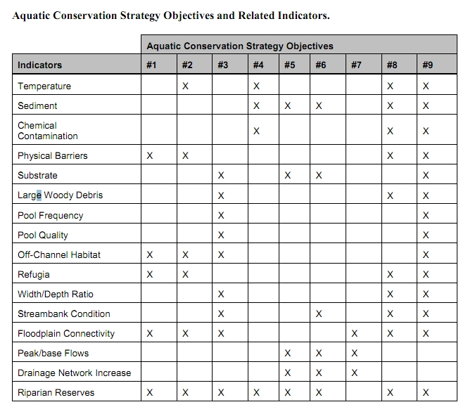
These ACS objectives and biophysical indicators are consistent throughout the Pacific Northwest and are not unique to the Mt Hood NF.

The Northwest Forest Plan and its supporting documentation make clear that the primary value of riparian vegetation is as a source of large wood and shade, not vegetation diversity and canopy layering, as often asserted by the agency to justify logging in riparian reserves. BLM admits “The primary function of Riparian Reserves is to provide shade and a source of large wood inputs to stream channels.” Medford BLM 2013. Pilot Thompson EA, p 3-76. http://www.blm.gov/or/districts/medford/plans/files/PT_EA_ForWeb.pdf

NEPA requires consideration of trade-offs. California v. Block, 690 F.2d 753, 771 (9th Cir. 1982) (NEPA was designed to “ensure that an agency is cognizant of all the environmental trade-offs that are implicit in a decision”). Stan Gregory notes the following trade-offs associated with logging riparian reserves to enhance early seral vegetation:
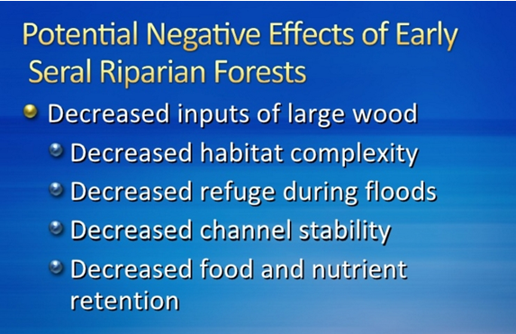
Gregory, Stan 2010. What About Riparian Systems: Who Benefits From an Early Seral Forest Condition. Workshop - Early Seral Forest - We know we need it -- How do we get it? Presentation sponsored by the Central Cascades Adaptive Management Partnership and NW Oregon Ecology Group http://ecoshare.info/2010/07/06/what-about-riparian-systems-who-benefits-from-an-early-seral-forest-condition-gregory/

The Northwest Forest Plan Aquatic Conservation Strategy Objectives (1994 ROD p B-11) enumerates specific purposes for “Maintain[ing] and restor[ing] the species composition and structural diversity of plant communities in riparian areas and wetlands” that is -
“to provide adequate summer and winter thermal regulation, nutrient filtering, appropriate rates of surface erosion, bank erosion, and channel migration and to supply amounts and distributions of coarse woody debris sufficient to sustain physical complexity and stability.”
All these values are provided as well or better by unthinned riparian stands.

The effects of logging on dead wood are significant and long term, adversely affecting a core function of the reserves, while the purported benefits to vegetation diversity are minor and transitory, and affect secondary purposes of the reserves.

Large Wood
Large quantities of downed trees are a functionally important component of many streams (Swanson et al. 1976; Sedell and Luchessa, 1982; Sedell and Froggat, 1984; Harmon et al. 1986; Bisson et al. 1987; Maser et al. 1988; Naiman et al. 1992). Large woody debris influences channel morphology by affecting longitudinal profile, pool formation, channel pattern and position, and channel geometry (Bisson et al. 1987). Downstream transport rates of sediment and organic matter are controlled in part by storage of this material behind large wood (Betscha 1979). Large wood affects the formation and distribution of habitat units, provides cover and complexity, and acts as a substrate for biological activity (Swanson et al. 1982; Bisson et al. 1987). Wood enters streams inhabited by fish either directly from the adjacent riparian zone from tributaries that may not be inhabited by fish, or hillslopes (Naiman et al. 1992).
Large wood in streams has been reduced due to a variety of past and present timber harvesting practices and associated activities. Many riparian management areas on federal lands are inadequate as long term sources of wood.
…
Riparian Ecosystem Components
…
Riparian vegetation regulates the exchange of nutrients and material from upland forests to streams (Swanson et al. 1982; Gregory et al. 1991). Fully functional riparian ecosystems have a suite of characteristics which are summarized below. Large conifers or a mixture of large conifers and hardwoods are found in riparian zones along all streams in the watershed, including those not inhabited by fish (Naiman et al. 1992). Riparian zone-stream interactions are a major determinant of large woody debris loading (House and Boehne 1987; Bisson et al. 1987; Sullivan et al. 1987). Stream temperatures and light levels that influence ecological processes are moderated by riparian vegetation (Agee 1988; Gregory et al. 1991). Streambanks are vegetated with shrubs and other low-growing woody vegetation. Root systems in streambanks of the active channel stabilize banks, allow development and maintenance of undercut banks, and protect banks during large storm flows (Sedell and Beschta 1991). Riparian vegetation contributes leaves, twigs, and other forms of fine litter that are an important component of the aquatic ecosystem food base (Vannote et al. 1980).
1993 FEMAT Report, pp V-13, V-25.

The effects of thinning on crown development are not very significant.

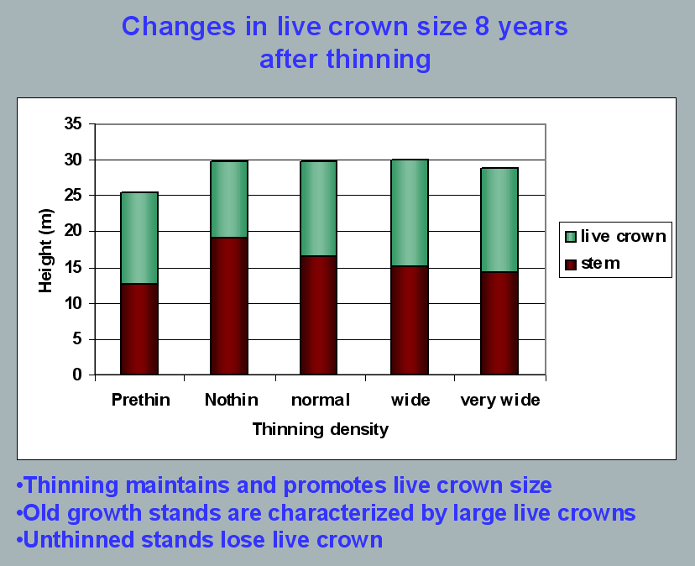
Aquatic/Riparian Ecosystem Dynamics and Associated Management Implications - Recent Findings. Powerpoint, 32.6M. This topic was presented at the Regional Interagency Executive Committee meeting on January 7, 2003. https://web.archive.org/web/20161221100307/http://www.reo.gov/library/presentations/Szaro_present_Aquatic_Rip_Final.ppt.

Stimulating the development of a diverse understory is often used as a justification for thinning, but this may not be justified in stands older than about 40 years. A systematic review of 917 Forest Inventory and Analysis (FIA) plots in western Oregon (mostly on non-federal lands) found,
Contrary to expectations of canopy closure, mean canopy cover by age class rarely exceeded 85 percent, even in unthinned productive young conifer forests. Possibly as a result, effects of stand age on understory vegetation were minimal, except for low levels of forbs found in 20- to 40-year-old wet conifer stands. … Although heavily thinned stands had lower total cover, canopy structure did not differ dramatically between thinned and unthinned stands. Our findings suggest potential limitations of simple stand succession models that may not account for the range of forest types, site conditions, and developmental mechanisms found across western Oregon.
McIntosh, Anne C.S.; Gray, Andrew N.; Garman, Steven L. 2009. Canopy structure on forest lands in western Oregon: differences among forest types and stand ages. Gen. Tech. Rep. PNW-GTR-794. Portland, OR: U.S. Department of Agriculture, Forest Service, Pacific Northwest Research Station. 35 p. http://www.fs.fed.us/pnw/pubs/pnw_gtr794.pdf. This seems to indicate that the benefits of thinning may be best realized in dense stands younger than 40 years old. This study also showed that in wet conifer stands the mean Canopy Height Diversity Index and the mean Simpson’s Diversity Index of tree heights leveled off at about age 65. This study also looked at canopy conditions after three levels of thinning intensities (heavy, light, and none). “Mean cover of the lower canopy layer was nominal for all three thinning intensities. … There were no evident trends between understory cover and thinning history; both shrub and forb cover were fairly similar among the three thinning intensities. … The lack of a strong effect of crown closure on understory cover may be related to our finding that mean crown cover did not exceed 85 percent. … We expected greater cover of understory vegetation in thinned than in unthinned stands but did not detect significant differences in this analysis.”

While one can generalize that vegetation diversity is more likely to flourish when conifer density is lower, there are data showing a wide range of conifer density can support a wide range of deciduous shrub cover. Thinning is not always necessary. The NEPA analysis should carefully document the site-specific “need” for thinning.
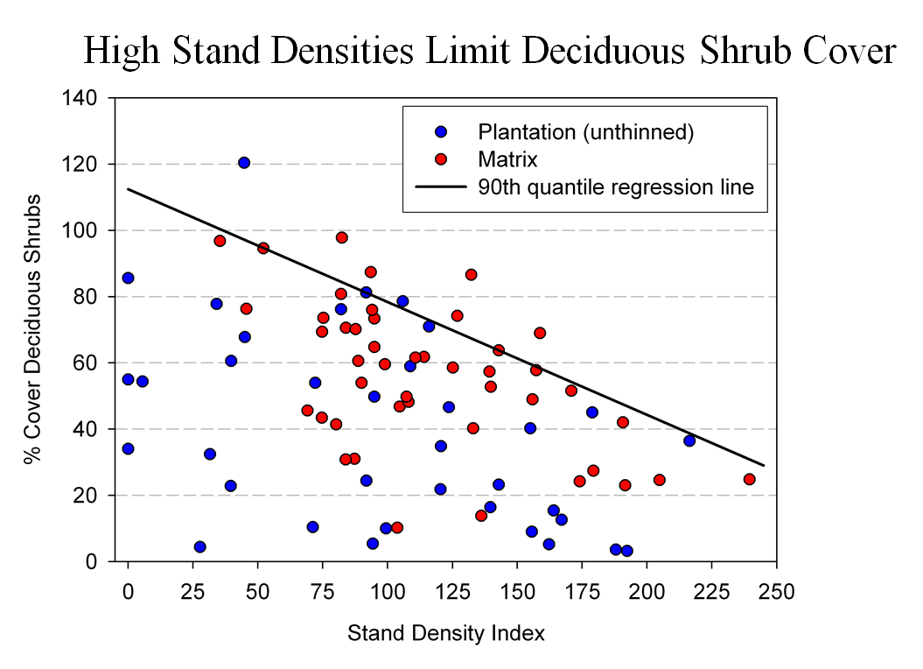
Spies, T. 2008. Powerpoint: Assumptions behind thinning young stands to create late successional riparian habitat. Presented at Riparian Thinning: Logic Paths for Silvicultural Prescriptions -- March 20, 2008. https://ecoshare.info/projects/central-cascade-adaptive-management-partnership/workshops/riparian-thinning-logic-paths/

It is also worth noting that where understories are well-stocked, midstory development can be enhanced by focusing on treating the understory itself rather than killing canopy trees.
[R]esults show that individual understory trees can be selectively favored for increased growth into the midstory by being released from competing saplings in the understory cohort. …Our results suggest that understory release treatments can be used to target individual saplings for increased growth, thereby recruiting a shade tolerant midstory cohort and accelerating the development of vertical foliar connectivity and a multi-layered stand structure. Abundance of non-coniferous understory vegetation is also augmented by this treatment. … [Note] The extent to which released understory trees collectively form a cohesive midstory canopy stratum is dependent on the density and horizontal arrangement of those released individuals. … . Inducing spatial variability within the midstory tree cohort would emulate the finescale disturbances of natural stands that create gaps and patches.
Taylor, Andrew 2016. Understory Vegetation Dynamics and Midstory Development Following Understory Release Treatments in Northwest Oregon Thinned Douglas-fir Stands. OSU MS Professional Paper.

Anderson (2007) looked at the effects of thinning in young Douglas fir forests and found –
[T]hinning treatments … had little impact on the abundance, size, or diversity of understory vegetation. Disturbance resulted in short-term decreases in understory vegetation cover, particularly tall shrubs. However, within five years of treatment, understory vegetation abundance returned to approximate pretreatment condition. … The general lack of understory vegetation response to the thinning treatments was likely due to the inherent resistance and resilience of the plant communities to disturbance, as well as the low intensity of disturbance attributable to the treatments.
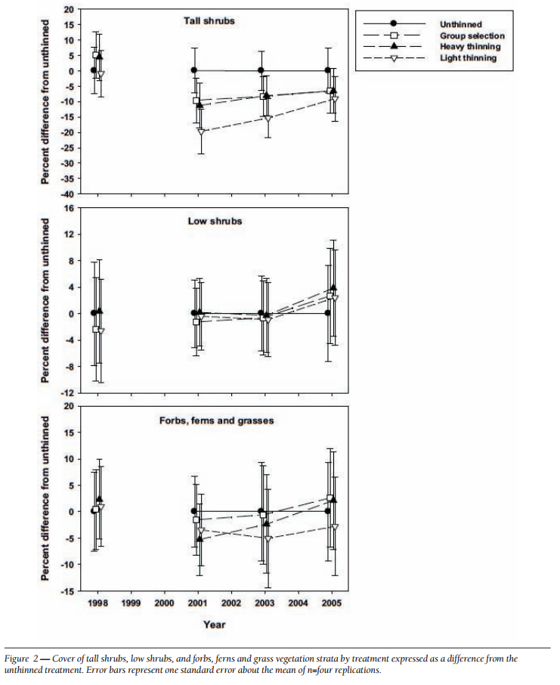
[Four years after thinning] tall shrub cover that was approximately four to nine percent less than the unthinned treatment … [C]over by low shrub species was unchanged by the harvest activity … Forbs, ferns, and grasses [experienced] little difference in cover between thinned and unthinned stands. … [F]ollowing treatment, the mean number of species declined somewhat, [then] return[ed] to pretreatment levels… [T]he evenness component of diversity did not differ among treatments or vary over time …. [T]here was little evidence of substantial alterations of understory shrub and herbaceous vegetation. This lack of strong understory vegetation response in terms of composition, abundance, or size is consistent with several studies of thinning in Douglas-fir. In a recent review of seven operational-scale silviculture experiments, Wilson and Puettmann (2007) report that percent cover by shrubs and percent cover by herbs, one to seven years following thinning showed little difference across a wide range of residual basal area.
Paul D. Anderson 2007. Understory Vegetation Responses to Initial Thinning of Douglas-fir Plantations Undergoing Conversion to Uneven-Age Management. Proceedings of the 2007 National Silviculture Workshop. http://www.fs.fed.us/pnw/publications/gtr733/PNW_GTR_733_4.pdf This paper was published in: Deal, R.L., tech. ed. 2008. Integrated restoration of forested ecosystems to achieve multi-resource benefits: proceedings of the 2007 national silviculture workshop. Gen. Tech. Rep. PNW-GTR-733. Portland, OR: U.S. Department of Agriculture, Forest Service, Pacific Northwest Research Station. 306 p.

[W]hile specific structural attributes of forest ecosystems have been correlated with certain species, it is uncertain how such species will respond to treatments designed to recreate these features. There is always the possibility that in our attempt to create a structural attribute we think is important, we eliminate another attribute that is equally important, but unrecognized. One example is that attempts to restore spotted owl habitat by heavily thinning to accelerate the development of large diameter nesting trees could actually delay spotted owl recovery by reducing production of the large down wood utilized by the species it preys upon (Forsman et al., 1984; Carey, 1995; North et al., 1999). Similarly, heavily thinning stands to accelerate the development of marbled murrelet nesting trees also create open stands with a dense understory that is ideal habitat for a number of corvid species that prey on marbled murrelet nest eggs (USFWS, 2010). Riparian thinning efforts to create long-term supplies of very large diameter instream wood that can initiate complex wood jam formation (e.g., key pieces) are also likely to reduce the supply of large diameter wood that will create pools (Beechie and Sibley, 1997; Beechie et al., 2000; Fox and Bolton, 2007). Thus, we suggest that any efforts to actively restore riparian forests for the benefit of certain species should be treated as scientific experiments and proceed cautiously, skeptically, and with robust pre- and post-treatment data collection efforts. Hypothesized effects of thinning on riparian forest structure and the use of that structure by targeted species should be tested against empirical data.
Pollock, Michael M. and Timothy J. Beechie, 2014. Does Riparian Forest Restoration Thinning Enhance Biodiversity? The Ecological Importance of Large Wood. Journal of the American Water Resources Association (JAWRA) 50(3): 543-559. DOI: 10.1111/jawr.12206. http://oregon-stream-protection-coalition.com/wp-content/uploads/2014/07/Pollock-and-Beechie.-2014.-Riparian-thinning-and-biodiversity.pdf.

Climate change highlights an additional trade-off related to logging riparian buffers. New science shows that more frequent drought makes upland habitats less suitable, so increasing numbers of upland birds flock to riparian corridors, which become more crowded, with negative effects on riparian-dependent species. The agency should do more to increase space for wildlife that need moist streamside habitat during droughts. Gabrielsen, Paul 2021. In dry years, rivers become birds’ crowded corridors. University of Utah @THEU. https://attheu.utah.edu/uncategorized/in-dry-years-rivers-become-birds-crowded-corridors/ (“New research from the University of Utah and the Utah Division of Wildlife Resources (UDWR) finds that in dry years, birds funnel into the relative greenness of riparian (adjacent to river) environments. That increased diversity is accompanied by overcrowding that may cause increased competition for habitat and resources, the study finds, and an overall decrease in populations of birds who call the river home. … Neate-Clegg and his colleagues noticed that during particularly dry years they were finding more birds than usual in the mist nets near rivers. … The multi-year data showed that total bird captures and total species were higher in hotter and drier years, El Niño years, and less green years. The effect was strongest for non-riparian species, suggesting that in harsh conditions, birds from all over the landscape found their way to the rivers. “This suggests that the wider landscape is unable to support migrants and so they are forced to use greener areas,” Neate-Clegg says. But just as an influx of tourists can crowd out locals, the uptick in birds may have taken its toll on typically riparian species, especially those that breed on river banks…. In warmer years, population growth rates slowed for 47% of riparian bird species. The slowing, the researchers found, wasn’t due to more birds deaths, but rather to fewer new birds joining the population. There could be several reasons that bird breeding goes down in hotter years, but the authors suspect that more species in riparian habitats can mean more competition and fewer resources to go around. ‘This study shows how native bird populations utilize these habitats,’ Norvell says. ‘As droughts intensify, this becomes increasingly the refuge that everything’s relying on. And I don’t think humans are all that different in this case. We’re all increasingly relying on these very same areas.’ Neate-Clegg says that rivers provide connections for birds across the landscape, enabling them to transport nutrients or disperse seeds. A hotter, drier climate could affect those important functions that birds provide, called ‘ecosystem services.’”)

Logging and Stream Temperature

Removing trees near streams will degrade water quality. Riparian vegetation is important in several ways: (a) it shades the water surface from direct solar insolation, (b) it shades soils and shallow groundwater before it is discharged to surface streams; (c) it reduces wind penetration and air mass mixing over the water surface, insulating the stream from summer daytime warming or winter night time cooling, and (d) it stabilizes streambanks and floodplain surfaces and provides a supply of downed wood that helps keep channels narrow and establishes and maintains internal hydrologic complexity (vertical and lateral flow exchange between surface water and hyporheic waters) that buffers stream temperature against the effects of solar insolation and airmass mixing.

Thinning in riparian reserves does in fact raise ambient air temperatures that the microclimate effects must be accounted for. Anderson, Paul D.; Larson, David J.; Chan, Samuel S. 2007. Riparian Buffer and Density Management Influences on Microclimate of Young Headwater Forests of Western Oregon. Forest Science, Volume 53, Number 2, April 2007 , pp. 254-269(16). http://www.ingentaconnect.com/content/saf/fs/2007/00000053/00000002/art00012.

... concern about cumulative effects of thinning, which involves an understanding of the spatial and temporal dimensions of the issue in whole-stream networks. To address these cumulative effects we are studying experimental riparian thinning treatments in adjacent stream networks and forests managed by the Green Diamond Resource Company and the National Park Service (Redwood National Park) in northern California. Thinning was implemented in multiple locations, allowing us to evaluate effects of these local treatments in the context of larger stream networks. To track local treatments, we followed a before-after-control-impact approach to quantify spatial and temporal patterns of riparian shade, light, and stream temperatures as possible responses to riparian thinning. To evaluate how the potential effects of these local treatments resonate at broader extents, we have quantified shade, light, and stream temperatures across entire networks. Spatial statistical models were applied to these data to determine the spatial extent to which localized thinning propagated through stream networks. Preliminary results from tracking local treatments indicate an immediate response in stream temperature associated with the reductions in shade and increases in light associated with riparian thinning. At the network extent this resulted in variable downstream propagation of the effects of upstream thinning.
David Roon, Jason Dunham. 2018. Spatial Patterns of Riparian Shade, Light, and Stream Temperature in Response to Riparian Thinning in Redwood Headwater Streams. Speed Talks. 2018 Oregon Chapter of the American Fisheries Society 54th Annual Meeting.
http://orafs.org/wp-content/uploads/2017/10/2018-Annual-Meeting-Abstracts.pdf

Climate change is expected to increase stream temperatures and reduce fish habitat quality and quantity. “Riparian vegetation can potentially off-set future increases in water temperature [related to global climate change].” Gordy Reeves, 4-22-2020 Presentation to the Oregon Board of Forestry. https://www.oregon.gov/odf/board/bof/20200422-bof-handouts.pdf (p 63/132).

Manage Matrix for Connectivity
The matrix is not a free-for-all logging zone. It is intended to support dispersal of late successional species, including spotted owls that prefer to disperse through high quality habitat.

The NWFP conservation scheme has its origins in the 1990 report of the Interagency Scientific Committee (ISC Report) which explained that matrix lands are intended for several conservation purposes:
- To provide connectivity for dispersal and interaction of owls among HCAs. ….
- To maintain options for returning owls to the forest matrix by retaining older forest structures in the managed landscape.
- To develop and apply experimental silvicultural treatments that may support a viable owl population in the forest matrix.
- To contribute toward a short-term viable population (less than 50 years).
1990 ISC Report, p 318. (Thomas, J.W.; Forsman, E.D.; Lint, J.B. et al. 1990. A conservation strategy for the northern spotted owl: a report of the Interagency Scientific Committee to address the conservation of the northern spotted owl. Portland, OR. https://www.fws.gov/sites/default/files/documents/ConservationStrategyForTheNorthernSpottedOw_May1990.pdf).

The quality of matrix lands for meeting these objectives is directly related to the extent that it resembles nesting, roosting, and foraging habitat. If structurally simple stands in the matrix can be modified to be more complex in terms of species diversity, niche diversity, and dead wood abundance, they will support better foraging opportunities which will greatly improve the quality of dispersal habitat.

The agency should not rely on outdated science suggesting that 40% canopy cover represents owl dispersal habitat. New information indicates that spotted owl dispersal habitat should be managed for “at least 80%” canopy cover. See Stan G. Sovern, Eric D. Forsman, Katie M. Dugger, Margaret Taylor. 2015. Roosting Habitat Use and Selection By Northern Spotted Owls During Natal Dispersal. The Journal of Wildlife Management 79(2):254–262; 2015; DOI: 10.1002/jwmg.834. https://osu-wams-blogs-uploads.s3.amazonaws.com/blogs.dir/2742/files/2016/09/Sovern-et-al.-2015.pdf (“Roost Site Selection. In contrast to the assumption that stands with relatively open canopies provide suitable dispersal habitat for spotted owls, our results suggest that dispersing juveniles selected stands for roosting that had relatively high canopy closure (x = 66 + 2%). … Two hypotheses could explain why dispersing owls selected closed-canopy stands. First, several researchers (Barrows 1981, Forsman et al. 1984, Weathers et al. 2001) have shown that temperature and precipitation appear to influence selection for roost trees and attributes within a roost tree, such as perch height and percent overhead cover. … Second, juvenile northern spotted owls may have selected for closed-canopy forest because their preferred prey were most abundant … Landscape Scale Selection. … [O]ur mean estimate of canopy closure from plots at roosts (66%), which was likely an underestimate of canopy cover, was considerably higher than the minimum values recommended by Thomas et al. (1990) [i.e. 50-11-40]. … Management Implications. … Based on our study, we recommend that managers should pursue a strategy that exceeds the canopy cover guidelines recommended by Thomas et al. (1990) when managing dispersal habitat for spotted owls. Based on our estimate of mean canopy closure (66%), and our estimate of mean canopy cover from overlaying a dot grid on the same areas (approx. 14% larger), we recommend that the target for canopy cover in stands managed for dispersing spotted owls should be at least 80%.”)

Owl habitat is characterized by large trees, high canopy closure, abundant dead wood, well-developed understories. A few of these qualities can be attained with traditional uniform thinning (large trees and canopy closure), but all of them are more likely to be attained with variable density thinning and managing for decadence. In particular, canopy closure and well-developed understories are best achieved with variable density thinning.

The agency should design matrix thins to support abundant and diverse populations of owl prey species. “[H]abitat elements that support prey [include] (mistletoe, snags, down wood, forage lichens, truffles abundance)” NSO FRP p 114. Where owl prey base is diverse and abundant spotted owl home ranges tend to be smaller which is energetically advantageous and enhances owl survival rates. Carey, A. 2004 Relationship of Prey and Forest Management. Appendix 5 pp 3-24, 3-25 in Courtney, SP; J A Blakesley. 2004. Scientific evaluation of the status of the Northern Spotted Owl. http://www.sei.org/owl/finalreport/finalreport.htm. “Numerous patches of low foraging quality can have negative impacts on owl demography and behavior (Carey et al 1992).” id. and this is precisely what uniform thinning that “captures mortality” will do to current and future spotted owl home ranges. A large number of owl prey species have some association with snags and down wood either as sites for denning or as a source of fungal food supplies. Traditional thinning will reduce the recruitment of dead trees and down wood and further simplify the forest structure for many decades. Establishing diverse micro-habitats and creating and retaining large numbers of snags and down wood will help the spotted owl through the habitat bottleneck that it is now going through.

Small mammal populations also appear to increase with understory cover which can follow some forms of thinning. Waldien and Hayes. 2006. Influence of Alternative Silviculture on Small Mammals. USGS/CFER Fact Sheet. July 2006. http://www.fsl.orst.edu/cfer/pdfs/CFERFS05.pdf.

North et al. (1999) noted in a study of foraging habitat selection by northern spotted owls, “In our study area, stands with high use by owls typically included many ‘legacies’ (large trees and snags) that survived a fire or windstorm that destroyed much of the previous stand. They found that “stands with 142 m³/ha of intact snags and a high diversity of tree heights had medium or high foraging use by spotted owls. In these old-growth stands, biological legacies (e.g., large trees and snags) produced by past disturbance provide important forest structures associated with spotted owl foraging.” North, Franklin, Carey, Forsman, Hamer. 1999. Forest Stand Structure of the Northern Spotted Owl’s Foraging Habitat. For. Sci. 45(4):520-527. https://andrewsforest.oregonstate.edu/sites/default/files/lter/pubs/pdf/pub3549.pdf.

Some have concluded that light, uniform thinnings in young stands are unlikely to attain biodiversity conservation objectives. See Duncan S. Wilson, and Klaus J. Puettmann. Density management and biodiversity in young Douglas-fir forests: challenges of managing across scales. DRAFT submitted to Forest Ecology and Management. August 2006.

Given all the new information on the risks and uncertainties faced by spotted owls, thinning projects in the Matrix should apply variable density thinning techniques because variable density thinning and managing for decadence will help increase the complexity of the forest (structural complexity and plant species diversity) thereby increasing populations of owl prey species and enhancing owl foraging opportunities within owl dispersal/foraging habitat.
VDT will not conflict with matrix objectives. Matrix objectives include timber production as well as habitat and species diversity. Variable thinning will produce potentially more wood products in the short-term as well as significant wood products in the long-term. There is absolutely no requirement that the agencies MAXIMIZE timber production. The ecological benefits of variable density thinning are significant and should not be forgone. There are operational challenges with implementing effective variable thinning prescriptions but the agencies must embrace the challenges and instead of retreating from the ecological objectives of the matrix, the agencies must apply their best thinking and creativity to the objective of creating species-diverse and structurally rich and complex mid-seral forest habitat.

The matrix is supposed to provide wildlife habitat and connectivity and VDT will help the matrix achieve these objectives while also improving the growth of favored commercial tree species. Matrix is not a tree farm. It still has a role to play in providing diverse habitats, so don’t just grow trees, grow forests.
The matrix is an integral part of the management direction included in these standards and guidelines. Production of timber and other commodities is an important objective for the matrix. However, forests in the matrix function as connectivity between Late-Successional Reserves and provide habitat for a variety of organisms associated with both late-successional and younger forests. Standards and guidelines for the matrix are designed to provide for important ecological functions such as dispersal of organisms, carryover of some species from one stand to the next, and maintenance of ecologically valuable structural components such as down logs, snags, and large trees. The matrix will also add ecological diversity by providing early-successional habitat.
…
Matrix objectives for silviculture should include: (1) production of commercial yields of wood, including those species such as Pacific yew and western red cedar that require extended rotations, (2) retention of moderate levels of ecologically valuable old-growth components such as snags, logs, and relatively large green trees, and (3) increasing ecological diversity by providing early-successional habitat.
…
Stands in the matrix can be managed for timber and other commodity production, and to perform an important role in maintaining biodiversity. Silvicultural treatments of forest stands in the matrix can provide for retention of old-growth ecosystem components such as large green trees, snags and down logs, and depending on site and forest type, can provide for a diversity of species. Retention of green trees following timber harvest in the matrix provides a legacy that bridges past and future forests. Retaining green trees serves several important functions including snag recruitment, promoting multistoried canopies, and providing shade and suitable habitat for many organisms in the matrix.
1994 NWFP ROD pp B-1 to B-6 (emphasis added) https://web.archive.org/web/20170214000554/https://www.blm.gov/or/plans/nwfpnepa/FSEIS-2000/ROD-SandG.pdf. Clearly VDT, will meet matrix objectives by providing wood products, and by promoting multistoried canopies, providing diversity of species, creating and maintaining structural features such as snags, logs, and large trees, and providing opportunities for early-seral species to persist in mid-seral stands.

According to the 2003 Draft SEIS for survey and manage, “Matrix was also expected to provide for ecologically diverse early-successional conditions and planned timber harvest.” (DSEIS page 68). Variable density thinning is appropriate in the matrix because VDT expands future options for multiple-use/sustained yield in its fullest dimension and VDT does not foreclose any matrix objectives.

Variable Density prescriptions will also improve connectivity by enhancing foraging opportunities for dispersing predators such as spotted owls (and other raptors), marten, fisher, etc. Young and mid-seral forest may not provide ideal nesting/denning conditions but they often do provide for important dispersal functions. If these young and mid-seral forests are species-diverse and structural complex, they are more likely to have healthy populations of small mammals, birds, and other prey species relied upon by predator species of concern.

Variable density thinning can create a variety of micro-habitats that may be suitable for different species. Andy Carey found that VDT could establish patchy habitat patterns that could lead to the development of small mammal populations that are not only more dense but more diverse compared to uniformly thinned stands.

Our results support hypotheses that: (1) biocomplexity resulting from interactions of decadence, understory development, and overstory composition provides pre-interactive niche diversification with predictable, diverse, small mammal communities; (2) these communities incorporate numerous species and multiple trophic pathways, and thus, their integrity measures resiliency and sustainability.

Thus, increasing complexity of the environment through increasing horizontal and vertical heterogeneity in vegetation structure, species diversity in vascular plant composition, and forest-floor structure with coarse woody debris may simultaneously (1) increase multidimensional habitat space (Carey et al., 1999a), (2) reduce frequencies and intensities of interspecies interactions (Grant, 1972; Carey et al., 1980), (3) increase or maintain the already high abundance and diversity of seed fall, fungal fruiting bodies, and invertebrates characteristic of mesic, temperate coniferous forests (Church field, 1990), and (4) allow not only coexistence, but abundance of potentially competing species within communities (Carey and Johnson, 1995, this study). As a result of this complexity, Pacific Northwest forests support the greatest diversity of shrews in North America (Rose, 1994) …
…
These studies do suggest that management can homogenize and simplify (reduce decadence, amounts of coarse woody debris, variety of tree species, diversity and abundance of understory vegetation, and spatial heterogeneity) forest ecosystems. We found local extirpations of a number of species and particularly absence of G. sabrinus and T. townsendii in multiple plots. These absences raise questions about long-term viability of these species in managed landscapes. Management-induced homogeneity and simplification (1) is a real danger to diversity, resiliency, and susceptibility to invasions of exotic plants (Carey, 1998; Carey et al., 2000; Halpern et al., 1999; Heckman, 1999; Thysell and Carey, 2000), (2) may result in small-mammal communities non-supportive of predators populations (Carey et al., 1992; Carey and Peeler, 1995), …
Andrew B. Carey, Constance A. Harrington; Small mammals in young forests: implications for management for sustainability; Forest Ecology and Management (2001) 154(1-2): 289-309; http://www.fs.fed.us/pnw/pubs/journals/pnw_2001_carey003.pdf.

High density and diversity of prey species is clearly advantageous for spotted owls. Dense populations of prey allow for smaller home ranges which is energetically advantageous, while diverse populations reduces the risk that any one species population will decline and leave the owl vulnerable. “[E]xperiments in both terrestrial and aquatic microcosms have tended to find that increasing the number of prey items enhances stability.” Kevin Shear Mccann, The diversity–stability debate. Nature 405, 228 - 233 (11 May 2000). http://www.iterations.com/protected/dwnload_files/diversity_stability_debate.pdf. Thinning variably will enhance the habitat for more than one prey species. If one species declines, the owl has other options so diverse prey base tends to have a stabilizing effect on owl populations. The agency can have all these ecological benefits from restoration silviculture and still support some jobs and produce some wood products.

Manage for Decadence – retain untreated “skips” for recruitment of mortality

The analysis in the EA should reflect a more ecological view of forest ecosystems, including the beneficial role of natural mortality processes. We caution against tools like Stand Density Index (SDI) which is biased in favor of vigorous tree growth and biased against natural processes that create high quality habitat with a mix of live and dead trees.

“Two common consequences of conventional thinning practices have been increased uniformity of forest structure and composition, and removal or delay in the development of dead wood as snags or down wood to meet decadence and habitat functions. … Over the past several decades our ecological understanding of decadence and its importance to habitat and biogeochemical processes has increased substantially, but translation of the fundamental knowledge into coherent goals is lagging.”
Paul D. Anderson 2013. Two Decades of Learning about Thinning in the Ecosystem Management Era. https://www.fs.usda.gov/pnw/pubs/pnw_gtr880/pnw_gtr880_001.pdf in Density Management in the 21st Century: West Side Story PNW-GTR-880. http://www.treesearch.fs.fed.us/pubs/44695

“Many species in the Pacific Northwest evolved to use large snags and logs that were historically abundant in the landscape. If snags and logs are lost, biodiversity can be affected and potentially cause a loss of some function in the landscape such as control of forest insects.”
Mt Hood NF 2011. Huckleberry Thin EA. https://usfs-public.app.box.com/v/PinyonPublic/folder/158150413008.

Many animals in Douglas fir forests are strongly associated with habitat features that are best developed in natural forest, such as large trees, snags, and downed logs. The diversity and density of cavity-nesting birds, for example, are positively correlated with the abundance of snags, especially tall and/or large-diameter snags (Nelson 1988, Zarnowitz and Manuwal 1985).
…
It is the cycle of structural development through plant growth, and the retention of structural complexity via legacy, that characterizes natural forests in the Coastal Northwest. Intensive wood production practices may alter this cycle both by truncating succession before large structures develop and by removing most existing structures during harvest. Planting and thinning may further promote uniformity in tree species, size, and spacing.
…
Studies in unmanaged forests teach us that natural disturbance maintains structural complexity within stands and that this complexity promotes plant and animal diversity.
…
Until it is clear that forests managed for wood production can be made suitable for native species, managers should consider retaining within managed forests representative tracts of all natural forest stages, not just old growth.
Hansen, A. J.; Spies, T. A.; Swanson, F. J.; Ohmann, T. L. 1991. Conserving biodiversity in managed forests - Lessons from natural forests. BioScience 41(6):382- 392. http://www.montana.edu/hansen/documents/downloadables/hansenetal1991.pdf.

“Dead wood in the form of snags and downed logs is generally common or abundant. Although a notable part of old-growth stands, such material is actually common in unmanaged stands in all successional stages in the Douglas-fir region.” Franklin & Spies 1983. CHARACTERISTICS OF OLD-GROWTH DOUGLAS-FIR FORESTS. Reprinted New Forests for a Changing World. Proceedings of the 1983 SAF National Convention http://andrewsforest.oregonstate.edu/pubs/pdf/pub120.pdf

Many natural young and mature stands have some of the attributes of old-growth stands that may not be present in young, managed stands. Perhaps the greatest difference between natural and managed stands is the lower number and volume of large snags and logs in managed plantations (Spies and Cline 1988). Many young natural forests less than 80 years old have high amounts of carry-over of woody debris...
Thomas A. Spies and Jerry F. Franklin 1991. The Structure of Natural Young, Mature, and Old-Growth Douglas-Fir Forests in Oregon and Washington in Leonard F. Ruggiero, Keith B. Aubry, Andrew B. Carey, and Mark H. Huff, technical editors 1991. Wildlife and Vegetation of Unmanaged Douglas-Fir Forests. General Technical Report PNW-GTR-285. http://www.fs.fed.us/pnw/pubs/gtr285/.

The NEPA analysis should help illuminate trade-off between snag quality (snag size) and snag quantity (number of snags) that follows from the choice between thinning and not thinning. This critically important trade-off may be amenable to quantitative analysis if the agency would conduct a stand simulation model. This is one of the key functions of NEPA to illuminate the consequences of alternative management approaches. With respect to dead wood habitat, what mix of treated and untreated areas will result in the best mix of thinned areas with later-fewer-larger snags, and unlogged areas where dead wood recruitment is more rapid, more abundant, only slightly smaller?

Thinning is often presumed to accelerate attainment of multiple attributes of mature and old-growth forests. This is partially true. Thinning does accelerate the growth rate of the trees that are retained, but thinning has limited effects on canopy structure and generally has adverse effects on snags and dead wood. The NWFP ROD highlighted the importance of dead wood accumulation as young forests develop into mature & old-growth: “Desired late-successional and old-growth characteristics that will be created as younger stands change through successional development include: (1) multispecies and multilayered assemblages of trees, (2) moderate-to-high accumulations of large logs and snags, (3) moderate-to-high canopy closure, (4) moderate-to-high numbers of trees with physical imperfections such as cavities, broken tops, and large deformed limbs, and (5) moderate-to-high accumulations of fungi, lichens, and bryophytes.” 1994 ROD p B-5. Thinning will truncate this important ecological process and degrade the quality of future late-successional habitat. When the logs are removed from the site, this adverse effect can be long-lasting.

“Natural processes and disturbances such as windthrow fire and the effects of pathogens and insects are also part of old forest development that thinning does not mimic.” http://www.fsl.orst.edu/Oldgrowthworkshop/statements/Tappeiner.pdf.

Mid-seral stands that result from past clearcutting leave few if any legacies from the previous stand. Natural young stands tend to have abundant snags and dead wood, but clearcut stands are artificially deprived of dead wood several decades. At the age of thinning, such stands are starting to experience suppression mortality and will tend to accumulate snags and dead wood over time if left unthinned. However, thinning will perpetuate the artificial shortage of snags and dead wood for another several decades. This is a long-term cumulative impacts that needs to be addressed in the NEPA analysis.

There is a widely held belief that growing big trees faster by thinning, also benefits snag associated wildlife and fish because if there are bigger trees, there must also be bigger snags faster. This assumption does not hold up under scrutiny. Thinning captures mortality and removes it from the forest to the mill. It also increases the vigor of trees and delays mortality. BLM says “Thinning ‘captures’ much of the snag recruitment that results from inter-tree competition and very little density mortality … is expected to occur for 25 years after treatment.” Salem BLM, South Scappoose EA. http://www.blm.gov/or/districts/salem/plans/files/SSC_EA.pdf. See this online slideshow which shows the modeled effects of thinning on dead wood habitat. http://www.slideshare.net/dougoh/effects-of-logging-on-dead-wood-habitat. Stand simulation models clearly show that we need to count the effects of thinning on dead wood as a “cost” instead of the “benefit”, so we need to consider appropriate methods to avoid and mitigate impacts. Avoidance is just to leave stands unthinned and let them naturally grow and recruit mortality over time. Mitigation can come in several forms. Here are a few ideas:
a) truly mimic natural disturbance by thinning with prescribed fire that creates a pulse of dead trees and does not build roads. This could be combined with light thinning;
b) retain abundant untreated areas such as riparian areas and other “skips” within thinning areas where natural mortality can proceed without interference, and make sure these areas do not get salvaged or thinned in subsequent entries so that mortality gets recruited to the stands, not to the mill;
c) identify which portions of the landscape will remain unthinned in perpetuity and keep the loggers out. Use tools like DecAID determine the appropriate portion of the landscape must be managed to meet the each different tolerance levels in order to attain desired objectives over time for viable populations, carbon storage, soil stability/sediment storage and routing, nutrient cycling, site productivity, water storage, and other ecological services.
NOTE: simply protecting existing snags or artificially creating a few snags during logging has a very short-term effect that does not address the more fundamental issue of continuous snag recruitment over time.

One of the big challenges of any restoration thinning regime, is that virtually all logging tends to “capture mortality,” yet the trees that are removed represent future snags and down logs and are valuable (even essential) components of any complex forest. “Carey et al. (1999) found that coarse woody debris amounts declined significantly as a result of variable density thinning, especially the higher decay classes, despite the intent of the treatment to leave all existing debris in place.” The agency cannot use “average” snag levels as a management objective within treatment areas, because treatments are essentially displacing natural disturbance events which would normally create and retain large numbers of snags, so disturbance areas should have abundant snags, not average levels of snags. Managing for decadence in young stands is not a trivial issue because among the many other valuable attributes of dead wood, it is strongly associated with healthy populations of many small animals species that in turn help support populations of at-risk predators such as spotted owls, goshawk, fisher, marten, etc.

Small logs provide escape cover or shelter for small species. … Tallmon and Mills (1994) have shown that red-backed voles, a primary prey species for the spotted owl, are highly associated with large down material in more advanced decay stages. Truffles, a dietary staple of the northern flying squirrel, have also been loosely associated with down material.
Gregg, M. 2013. Wildlife Report for Management Indicator Species, Species of Concern from the Northwest Forest Plan, and Landbirds - Pole Creek Fire Timber Salvage. http://a123.g.akamai.net/7/123/11558/abc123/forestservic.download.akamai.com/11558/www/nepa/94141_FSPLT3_1451590.pdf

The snag dynamics white paper on the DecAID website indicates that timber harvest typically results in the loss of a majority of the standing snags (62% of snags within a variety of timber harvest areas were cut down.) http://web.archive.org/web/20060520051245/http://wwwnotes.fs.fed.us:81/pnw/DecAID/DecAID.nsf/HomePageLinks/863EEA66F39752C088256C02007DF2C0?OpenDocument. Also, in the Windjammer EA the Siuslaw NF noted that at least six times more coarse wood carries over from old-growth forests after wildfire compared to after timber harvest, and the CWD left after logging is smaller and decays faster (citing Spies & Cline 1988) so young stands are already deprived of dead wood. This is very troubling. The agency must start by carefully designing the project to keep workers away from existing snags. The agency must then consciously and very deliberately manage for decadence in the design of all thinning efforts. One way to think of this is to figure out how many trees the agency thinks they want to kill and remove a small portion of those while leaving the remainder as standing snags or down wood.

Harmon (1999) said:
Linking Live and Dead Trees - Although developing a viable morticulture will require new knowledge, in many cases it will require that we apply what we already know. For example, we already know that live trees eventually form dead trees, but it is amazing that this dynamic is often missing from current forest management thinking. … Forest management in the past century has focused on how to lower mortality rates via thinning, fire protection, etc. Ironically, the next century of forest management may be occupied with how to increase mortality when and where we want it. … [H]ow might this new paradigm of morticulture work? It would probably start by answering the question of which species or processes are to be maintained, restored, or otherwise managed (fig. 5). Then the target levels for these functions should be determined. Before assessing the amount of woody detritus to be maintained or added to meet this functional target, the landscape context for the management action should be assessed. Are there limitations of populations or processes that would limit the desired response? If not, a plan to add wood would be designed to maintain the desired level. But if there are landscape limitations, then these should be addressed before planning at the stand-level proceeds.”)
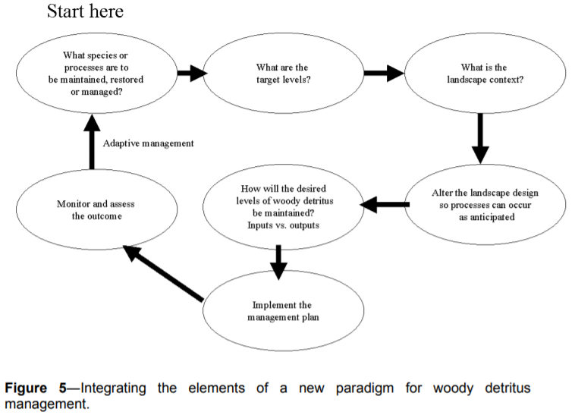
See Harmon, Mark 1999. Moving towards a New Paradigm for Woody Detritus Management. in Proceedings of the Symposium on the Ecology and Management of Dead Wood in Western Forests. PSW-GTR-181. http://www.fs.fed.us/psw/publications/documents/gtr-181/
https://www.fs.fed.us/psw/publications/documents/gtr-181/071_Harm.pdf. Using DecAID or other tools, the agency needs to identify appropriate goals for snags and dead wood habitat based on the needs of wildlife that are most sensitive to the absence of such habitat features. The agency needs to analyze how to achieve those goals by retaining an adequate population of green trees and maintaining natural mortality processes that can act on those trees.

This graphic from the Microsoft Teams public meeting held Feb 1, 2023 to discuss the draft report of the “2nd Annual Adaptive Management Workgroup: Management Direction for Large Diameter Trees” clearly shows the close association between the abundance of large live trees and large snags. This makes perfect sense because all snags are a product of large live trees. The NEPA analysis must provide an honest and accurate disclosure of the adverse effects of commercial removal of medium and large trees on the future recruitment of large snags.

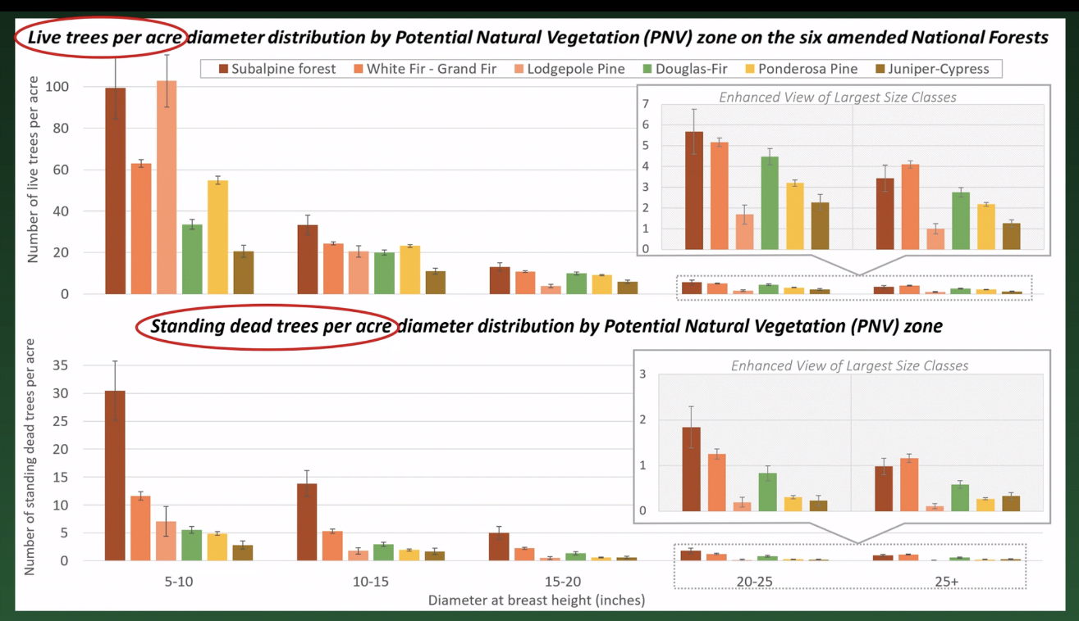
https://www.fs.usda.gov/project/?project=58050

The agency should recognize the long-term effects of captured mortality on the habitat needs of small mammals and spotted owls.
Several small mammals, such as the northern flying squirrel form the prey base for the Endangered Species Act (ESA) listed spotted owl and are among the species associated with abundant large dead standing and down wood. This presumably, is why spotted owls prefer to forage in stands with abundant standing and fallen dead wood (Table 2, North et al. 1999). The fruiting bodies of hypogeous fungi are a food source of northern flying squirrels and are also associated with down logs, suggesting that there are complex, indirect paths through which dead wood supports spotted owls (Amaranthus et al. 1994, Carey 2000).
Thomas Spies, Michael Pollock, Gordon Reeves, and Tim Beechie 2013. Effects of Riparian Thinning on Wood Recruitment: A Scientific Synthesis - Science Review Team Wood Recruitment Subgroup. Jan 28, 2013, p 36. http://www.mediate.com/DSConsulting/docs/FINAL%20wood%20recruitment%20document.pdf

The National Science Foundation thinks morticulture is important and so should our land management agencies. Dybas 2015. Research News - Morticulture: Forests of the living dead. Scientists unearth importance of dead wood to forest ecosystems. https://www.nsf.gov/discoveries/disc_summ.jsp?cntn_id=136524

North et al. (1999) noted in a study of foraging habitat selection by northern spotted owls, “In our study area, stands with high use by owls typically included many ‘legacies’ (large trees and snags) that survived a fire or windstorm that destroyed much of the previous stand. They found that “stands with 142 m³/ha of intact snags and a high diversity of tree heights had medium or high foraging use by spotted owls. In these old-growth stands, biological legacies (e.g., large trees and snags) produced by past disturbance provide important forest structures associated with spotted owl foraging.” North, Franklin, Carey, Forsman, Hamer. 1999. Forest Stand Structure of the Northern Spotted Owl’s Foraging Habitat. For. Sci. 45(4):520-527. https://andrewsforest.oregonstate.edu/sites/default/files/lter/pubs/pdf/pub3549.pdf.

Techniques for enhancing decadence may include:
- Retaining all large snags and large dead wood by keeping workers out of the hazard zone if necessary,
- Intentionally retaining leaning trees, and trees with defects, broken tops, forked tops, etc.
- Leaving some untreated skips where future mortality can be expected,
- Mimic natural disturbance processes by killing and leaving some trees.
- When determined to be necessary, snag creation must be a creative endeavor. Trees killed in different way will die and decay in different ways. A variety of techniques should be used within and between stands: high-cutting stumps, girdling, topping, burning, infecting with heart rot fungus or other native pathogens, etc. See for instance, James W. Rivers, Fungal inoculations and mechanical wounding of trees have limited efficacy for snag creation two decades after treatment, Forest Ecology and Management, Volume 553, 2024, 121651, ISSN 0378-1127, https://doi.org/10.1016/j.foreco.2023.121651.

Artificial snag creation is often proposed as a mitigation, but this has very short-term benefits. Since logging has long-term adverse effects on snag recruitment, it is necessary to adopt mitigation with long-term effects, such as retaining untreated skips embedded within treatments areas where natural mortality processes can flourish.

The Mt Hood National Forest has made an effort to manage for decadence in the Cloak Thinning EA, 11/2004 http://web.archive.org/web/20090116060045/http://www.fs.fed.us/r6/mthood/projects/cloak-thinning/CloakEA.pdf. Design Criteria #6 (p 23) indicates that “live trees would also be selected as leave trees that have the ‘elements of wood decay’ as described in the DecAID advisor. This may include trees with features such as dead tops, broken tops and heart rot.” This technique will be applied not only in thinning native second growth but also in thinning dense young plantations. The agency should incorporate this design element in all projects and instruct marking crews and cutting crews to “look up” so they can retain key elements of structural complexity such as broken tops, forked trees, etc.

The Regional Ecosystem office recommends managing dead wood in young stands within reserves to attain biologically optimal levels, not just average or reference levels. REO said “CWD objectives should be based on research that shows optimum levels of habitat for late-successional forest-related species, and not be based simply on measurements within natural stands.” REO 7-9-1996 Criteria to Exempt Specific Silvicultural Activities in Late-Successional Reserves, http://www.reo.gov/library/policy/REO-694_comm_thin_criteria.doc. This means that information from DecAID reference stands should be supplemented with DecAID >80% tolerance levels to determine management objectives for dead wood in LSRs.

The agencies often claim (erroneously) that thinning increases dead wood or improves dead wood habitat, but the laws of conservation of mass prevent the agencies from claiming that they can simultaneously send millions of board feet of wood to the mill and still increase wood in the forest over the long term. The agencies often present the issue of dead wood as if the objective is to produce the first large tree (aka “the hare”), rather than to produce a continuous flow of large trees over the long-term (aka “the tortoise”). By focusing on the treatment that produces a few big trees fast, the agencies ignore important aspects of the decision, including (a) the fact that recruiting dead wood requires two things large trees AND mortality. Logging produces vigorous trees that are less likely to die and produce snags in the near term, and thinning removes less vigorous trees that are more likely to be recruited as forest structure in the near term, and (b) the fact that thinning reduces the absolute number of trees that can ever be recruited as snags and dead wood. Every tree that leaves the forest on a log truck has an alternate future as a snag and dead wood. The agency ignores this opportunity cost of logging. When forest scenarios are put through an accurate model of stand growth and mortality, in almost all cases thinning will result in a reduced flow of large wood over the long-term. For instance, in a thinning project on the Siuslaw National Forest “modeling stand #502073 over a 100-year cycle [using ORGANON] predicts a total stand mortality of 202 trees (>10 inches dbh) for the unthinned stand, while mortality for the thinned stand was two trees. Therefore, thinning will reduce density-dependent mortality within the stand by 99%.” NOAA 2006. Magnuson Act consultation on Essential Fish Habitat and Response to Siuslaw NF Lobster Project BA. April 4, 2006.

If the agency asserts that commercial logging benefits snags and dead wood, they must provide quantitative analysis and state their assumptions.
Zelig modeling by Pabst et. al (figure below, unpublished 2003) has shown no difference in the cumulative number of large snags (>19.7” dbh) in un-thinned vs. thinned + snag creation treatments for the first 35 years. From 35 to 100 years post-treatment, there are slightly more large snags in the thinned +snag creation stands than in the un-thinned. But with review including error bars, the difference is negligible. After 100 years, large snags accumulated at a much higher rate in the un-thinned stands. Since most silvicultural prescriptions on the WNF include only one thinning entry, with plans for regeneration harvest between 40-80 years after treatment (~80-120 year rotations), thinning + snag creation at the densities modeled does provide a small benefit to large snag availability within that time frame.
Cheryl Friesen 2009. THINNING AND DEAD WOOD: “BEST AVAILABLE SCIENCE” December 15, 2009. http://ecoshare.info/projects/central-cascade-adaptive-management-partnership/synthesis-papers-tools/ In this analysis, the agency assumes that the stand will be regenerated before the long-term benefits of passive management can be realized. It is not proper to rely on this assumption when planning thinning projects in young stands. The future regen is not part of the proposed action, and in reserve allocations regen is not part of the desired future condition.

We are very concerned that heavy thinning “captures mortality” and increases vigor thereby delaying recruitment of snags and delaying development of critical components of old growth forests. This is especially critical in riparian reserves where recruitment of large wood is important. It is often asserted that thinning grows big trees faster and therefore results in more rapid recruitment of large snags faster, but FVS and other tools show this NOT to be true. Thinning both reduces and delays snag recruitment, by removing trees that would otherwise suffer suppression mortality, and by increasing vigor and delaying overall mortality. Thinning may increase growth of individual trees but the alternative to thinning (i.e. natural growth and succession) does NOT result in NO growth. Unthinned stand continue to grow and actually result in more large snags sooner. The effects of this fact must be reflected in the NEPA analysis. The implications are that heavy thinning should be used sparingly and generous unthinned patches should be retained WITHIN thinned stands in order to continue the snag recruitment process and mitigate for captured mortality.

The vast majority of agency NEPA analyses make erroneous conclusions about the effects of logging on snags and dead wood, claiming that logging is beneficial when available evidence indicates the opposite is true. This is not an error about the degree of effect (small versus large effects), but an error on the character and direction of effects (detrimental versus beneficial). See Heiken, D. 2010. Dead Wood Response to Thinning: Some Examples from Modeling Work. https://www.dropbox.com/s/m4671mhsstg61ss/dead_wood_slides_2.pdf?dl=0. First, the agencies have put too much faith in professional opinion, which can be fallible. “Models provide a basis but lack variables in the program. Only on-the-ground work of an experienced forester can take in all the variables. Years of experience cannot be replaced by a computer.” Wallowa-Whitman National Forest. 2011. Muddy Sled DN, Appendix E. Second, the agencies appear to suffer from a malady called “belief perseverance.”
“People tend to hold on to their beliefs even when it appears that they shouldn't. Belief perseverance is the tendency to cling to one's initial belief even after receiving new information that contradicts or disconfirms the basis of that belief. … The third type involves naive theories, beliefs about how the world works. … At least three psychological processes underlie belief perseverance. One involves use of the “availability heuristic” to decide what is most likely to happen. … A second process concerns “illusory correlation,” in which one sees or remembers more confirming cases and fewer disconfirming cases than really exists. A third process involves “data distortions,” in which confirming cases are inadvertently created and disconfirming cases are ignored. … Research also has investigated ways to reduce belief perseverance. The most obvious solution, asking people to be unbiased, doesn't work. However, several techniques do reduce the problem. The most successful is to get the person to imagine or explain how the opposite belief might be true. This de-biasing technique is known as counterexplanation.”
Anderson, C.A. (2007). Belief perseverance (pp. 109-110). In R. F. Baumeister & K. D. Vohs (Eds.), Encyclopedia of Social Psychology. Thousand Oaks, CA: Sage. http://www.psychology.iastate.edu/faculty/caa/abstracts/2005-2009/07a.pdf.

Looking at recent stand simulation analyses the effects of thinning on recruitment of large wood, e.g. the Curran-Junetta and Holland Moonsalt Projects on the Cottage Grove Ranger District, it appears that thinned stands may not reach the 80% DecAID tolerance levels for large snags, not even in 100 years. If thinning really forecloses that opportunity, then we better set aside large areas of the landscape where thinning does not occur and large snag recruitment can occur at natural levels. These unthinned area need to be planned in advance and left unmanaged for very long periods so this process can operate without the interference of foresters who think they can improve on things with chainsaws. The lesson of the stand simulation models is that virtually any logging, reduces and delays recruitment of large snags. This is very significant and very under-appreciated new information.

Using data from stand exams modeled through FVS-FFE (West Cascades variant) the Umpqua NF found that the actual effect of thinning 40-60 year old stands is to capture mortality and delay recruitment of large wood for up to 60 years. Other NEPA analyses should emulate the honest disclosure of thinning impacts on snag habitat found in the Cottage Grove District’s Curran Junetta Thin EA:

There is currently an excess of forested land in this area without snags (roughly 5 times higher than what DecAID recommends) and a deficiency in areas with high snag densities (roughly 12% of what DecAID recommends). Management prescriptions should allow for these extremes because they are ecologically important (White et al. 2002, Mellen et al. 2005). Common natural disturbances that produce areas with high levels of dead wood include wildfire, insects and disease, and wind (blow down) events.
…
The action alternatives cause a decrease in stand levels of snags and down wood caused by incidental falling of snags for logging or safety reasons, and consumption of down wood during the fuels reduction treatments. Thinning would then reduce the amount of suppression mortality within the thinned portions of stands, indirectly affecting future recruitment of CWD. Existing snags and logs would be protected to the extent practical and safe. However, it is probable that the action alternatives would lower levels of these structures (to approximately one to two snags per acre) through mechanical disturbance from tree falling and harvesting. … To mitigate for effect on large snags, the action alternatives would include the inoculation of two trees per acre on 857 acres and five snags per acre on 379 acres (within CHU OR-20) with locally collected native heart rot fungus. Inoculated trees begin to develop heart rot within five years as they continue to grow (Duncan, 1999), eventually producing larger trees with cavities and future snags that remain standing longer than if girdled. Inoculation is a management tool being used to offset the reduction of suppression mortality caused by thinning and to maintain a component of decadence within these managed stands. Additional snag mitigation would occur within CHU OR-20; six snags per acre would be created by fire during fuels reduction activities. In unit seven, mitigation would occur by girdling trees (>15 inch dbh or largest trees available) to achieve six snags per acre within the thinned portions of the unit.
…
Large snag (≥20” DBH) densities within the stands are currently below the levels advised for in DecAID (4.7 snags/acre – 30% tolerance level). Under the no action alternative this level of snags would not be achieved for another two decades (Figure 15). The action alternatives would delay reaching this level by an additional 10 to 30 years (10 years for units thinned to 70 to 90 trees per acre, 30 years for units thinned to 40 to 60 trees per acre).
…
Cumulative impacts
Substantial adverse impacts to levels of CWD at both the stand and landscape-scale have resulted from past clearcut timber harvesting, road building, roadside salvage and fire exclusion. The Layng Creek inventory showed an overabundance of land area with no snags, and a deficit of land area with high snag densities (caused by fire exclusion). It would take several decades to restore snag and log conditions to within the ranges advised for in DecAID at these two extreme ends of the range of CWD.
USDA Forest Service. 2007. Curran Junetta Thin EA. Cottage Grove Ranger District, Umpqua National Forest. June 2007. https://usfs-public.app.box.com/v/PinyonPublic/folder/158152590920.

This graph from the Curran Junetta Thin EA shows that heavy thinning delays by more than 60 years the attainment of habitat objectives for large snags (i.e. mid-point of the gray band representing 30-80% tolerance level).

https://usfs-public.app.box.com/v/PinyonPublic/folder/158152590920.
The figure below, from Pollock et al (2012), shows that tree removal through thinning can lead to stand development trajectories that miss the reference condition for dead wood. We point this out to highlight one of the trade-offs involved in thinning, and to encourage careful thinking about mitigation. Leaving the cut trees in the woods is a good short-term mitigation, but the small trees do not last long enough to fill the temporal gap between now and when the stand begins recruiting more dead wood on its own. Leaving unthinned patches within treated stands is a good mid-to-long-term mitigation.
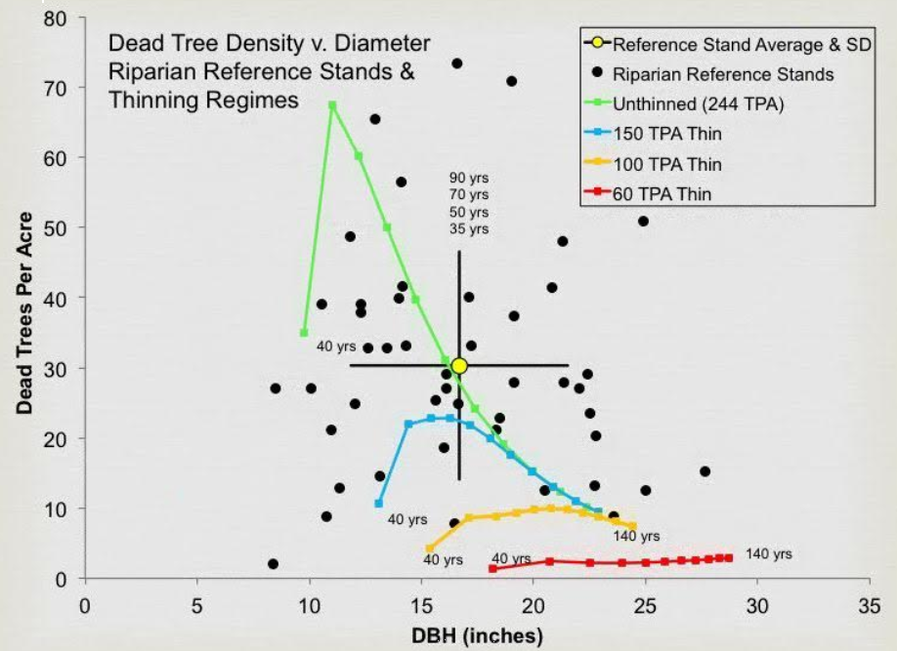
Pollock, M. M., T. J. Beechie, and H. Imaki. 2012. Using reference conditions in ecosystem restoration: an example for riparian conifer forests in the Pacific Northwest. Ecosphere 3(11):98. http://dx.doi.org/10.1890/ES12-00175.1

Harmonize Climate Change Mitigation and Adaptation
The agency has decided that meeting the purpose of this project requires logging that will emit greenhouse gases to the atmosphere and which will exacerbate global climate change (and ironically increase the climate stress imposed on the forest). These are very significant effects that require an EIS and consideration of mitigating alternatives. The agency can mitigate the effects of logging-related GHG emissions by retaining more trees, thinning less aggressively, forgoing logging in some areas, etc.

NEPA mandates that an agency “shall to the fullest extent possible: use the NEPA process to identify and assess the reasonable alternatives to proposed actions that will avoid or minimize adverse effects of these action upon the quality of the human environment.” 40 C.F.R. § 1500.2(e). NEPA also requires the agency to “study, develop, and describe appropriate alternatives to the recommended courses of action in any proposal which involves unresolved conflicts concerning alternative uses of available resources as provided by section 102(2)(E) of the Act [NEPA].”40 C.F.R. § 1501.2 (c). All reasonable alternatives must receive a “rigorous exploration and objective evaluation ..., particularly those that might enhance environmental quality or avoid some or all of the adverse environmental effects.” Id. § 1500.8(a)(4).

The agency need to rethink its focus on climate adaptation/resilience actions (such as density reduction with commercial log removal) that will actually increase carbon emissions and exacerbate global climate change and reduce climate resilience, not just in the treated stands but around the world. The agencies instead need to design preferred alternaitves that meaningfully harmonize climate change adaptation and climate change mitigation, such as non-commercial thinning + prescribed fire, increased riparian protection, conservation of mature, old-growth and unroaded areas, road system rescaling and storm-proofing.

The agency should develop alternatives that harmonize potentially competing objectives of climate change mitigation, and climate change adaptation. Climate change mitigation involves keeping carbon in the forest and avoiding GHG emissions to the atmosphere from logging. Climate change adaptation may involve a variety of actions that range from reducing stand density to reduce water stress in a warming world to providing habitat redundancy and connectivity, and maintaining cool/moist habitat refugia for wildlife that thrive in dense forests.

The Biden Administration has adopted a policy to both mitigate AND prepare for global climate change.
“It is, therefore, the policy of [the Biden] Administration to listen to the science; to improve public health and protect our environment; to ensure access to clean air and water; … to reduce greenhouse gas emissions; to bolster resilience to the impacts of climate change; … To that end, this order directs all executive departments and agencies (agencies) to immediately review and, as appropriate and consistent with applicable law, take action to address the promulgation of Federal regulations and other actions during the last 4 years that conflict with these important national objectives, and to immediately commence work to confront the climate crisis.”
Executive Order on Protecting Public Health and the Environment and Restoring Science to Tackle the Climate Crisis. JANUARY 20, 2021 https://www.whitehouse.gov/briefing-room/presidential-actions/2021/01/20/executive-order-protecting-public-health-and-environment-and-restoring-science-to-tackle-climate-crisis/. This requires careful balancing of sometimes competing objectives, such as retaining trees to store carbon, and thinning to reduce climate stresses. The best harmony among these objectives is to retain medium and large trees that store the most carbon and provide the greatest ecosystem services, while thinning small trees removal of which will reduce climate stresses on the larger trees while emitting less carbon.

President Obama established a clear policy mandate to avoid, minimize, and rectify impacts of federal land use:
Section 1. Policy. It shall be the policy of the Departments of Defense, the Interior, and Agriculture; the Environmental Protection Agency; and the National Oceanic and Atmospheric Administration; and all bureaus or agencies within them (agencies); to avoid and then minimize harmful effects to land, water, wildlife, and other ecological resources (natural resources) caused by land- or water-disturbing activities, and to ensure that any remaining harmful effects are effectively addressed, consistent with existing mission and legal authorities. Agencies shall each adopt a clear and consistent approach for avoidance and minimization of, and compensatory mitigation for, the impacts of their activities and the projects they approve.
… Sec 2. Definitions … (f) "Mitigation" means avoiding, minimizing, rectifying, reducing over time, and compensating for impacts on natural resources. As a practical matter, all of these actions are captured in the terms avoidance, minimization, and compensation. These three actions are generally applied sequentially, and therefore compensatory measures should normally not be considered until after all appropriate and practicable avoidance and minimization measures have been considered.
…
Sec. 3. Establishing Federal Principles for Mitigation. … (b) Agencies' mitigation policies should establish a net benefit goal or, at a minimum, a no net loss goal for natural resources the agency manages that are important, scarce, or sensitive, or wherever doing so is consistent with agency mission and established natural resource objectives. When a resource's value is determined to be irreplaceable, the preferred means of achieving either of these goals is through avoidance, consistent with applicable legal authorities. Agencies should explicitly consider the extent to which the beneficial environmental outcomes that will be achieved are demonstrably new and would not have occurred in the absence of mitigation (i.e. additionality) when determining whether those measures adequately address impacts to natural resources.
Presidential Memorandum: Mitigating Impacts on Natural Resources from Development and Encouraging Related Private Investment. Nov 3, 2015. https://www.whitehouse.gov/the-press-office/2015/11/03/mitigating-impacts-natural-resources-development-and-encouraging-related In the context of climate change this means that greenhouse gas emissions should be avoided and that the climate forcing effects of any emissions that do occur must be mitigated.

Stein et al (2014) make the distinction between climate change mitigation and adaptation and the potential conflict between the two.
Climate change adaptation is the discipline that focuses on addressing these impacts. In contrast, climate change mitigation addresses the underlying causes of climate change, through a focus on reductions in greenhouse gas concentrations in the atmosphere. Confronting the climate crisis requires that we both address the underlying causes of climate change and simultaneously prepare for and adapt to current and future impacts. Accordingly, adaptation and mitigation must be viewed as essential complements, rather than as alternative approaches. Because greenhouse gas emissions and concentrations will dictate the type and magnitude of impacts to which we will need to adapt, the ability to successfully accomplish adaptation over the long term will be linked to the success of climate mitigation efforts (Warren et al. 2013).
…
Climate-smart conservation strategies must also take climate mitigation considerations into account. Although adaptation is about addressing the impacts of rapid climate change, adaptation actions should not aggravate the underlying problem of global warming. Indeed, minimizing the carbon footprint of adaptation actions can help society avoid the “worst-case” scenarios for climate change, which would make successful adaptation in human and natural systems difficult, if not impossible, to achieve. Ideally, adaptation efforts should contribute to meeting climate mitigation goals both by minimizing or reducing the greenhouse gas emissions from project operations, including from any construction and ongoing maintenance, as well as by managing natural systems in ways that sustain or enhance their ability to cycle, sequester, and store carbon.
…
Some of the most obvious synergies between adaptation and mitigation are those aimed at enhancing carbon stocks in natural forests, … Strategies for increasing the capture and storage of forest carbon include: avoiding deforestation; afforestation (i.e., establishment of trees in areas have not been forests or where forests have not been present for some time); decreasing forest harvest; and increasing forest growth (McKinley et al. 2011). Managing natural systems to provide carbon benefits must be carefully balanced, however, with other conservation and adaptation goals. … Recent research, however, indicates that old trees “do not act simply as senescent carbon reservoirs” but actively fix larger amounts of carbon than smaller trees (Stephensen et al. 2014). This recognition highlights the important role that biodiversity-rich old-growth forests can play in sequestering carbon.
…
It is not always obvious, however, when conservation and climate mitigation efforts might be in alignment or in conflict. … Although there are clear synergies between adaptation and mitigation focused activities, managers will also need to carefully consider any trade-offs.
Stein, B.A., P. Glick, N. Edelson, and A. Staudt (eds.). 2014. Climate-Smart Conservation: Putting Adaptation Principles into Practice. National Wildlife Federation, Washington, D.C. https://www.nwf.org/~/media/PDFs/Global-Warming/2014/Climate-Smart-Conservation-Final_06-06-2014.pdf.

Sometimes climate change mitigation and adaptation are in complete harmony, such as protecting riparian forests that both store carbon and buffer streams from hydrological extremes caused by climate change. See Justice et al. 2017. Can stream and riparian restoration offset climate change impacts to salmon populations? Journal of Environmental Management 188 (2017) 212e227 https://www.critfc.org/wp-content/uploads/2017/01/JournalPost_Justice_etal2017.pdf. However, there are also times when efforts directed at climate change adaptation conflict with climate change mitigation goals. For instance, some people argue that we should reduce the density of federal forests so they are more resilient to soil-water stress caused by global warming. However, forest density reduction will accelerate the transfer of carbon from the forest to the atmosphere where it will contribute to global climate change.

Logging and the entire wood products supply chain causes significant emissions of CO2, this makes fire worse in several ways. It not only warms the atmosphere and extends the fire season, CO2 is also a “floating fertilizer” that stimulates the growth of hazardous fuels. When the agency says they are logging to make the forest more resilient to climate change, they must address these countervailing risks, and consider alternatives that better harmonize climate change resilience/adaptation and climate change mitigation (emissions avoidance). Allen, R. J., Gomez, J., Horowitz, L. W., & Shevliakova, E. (2024). Enhanced future vegetation growth with elevated carbon dioxide concentrations could increase fire activity. Communications Earth & Environment, 5(1), 1-15. https://doi.org/10.1038/s43247-024-01228-7. (“… the spatial pattern of the NPP response is quite similar to the corresponding spatial pattern of the fFire response (Fig. 2)-not only for 1% per year CO₂ and 1% per year CO₂-bgc, but interestingly also for 1% per year CO₂-rad. This is also the case for other vegetation parameters, including leaf area index (LAI; Supplementary Figs. 10–11 and Supplementary Note 4). This implies that the increase in fFire is largely due to the increase in biomass production (i.e., more fuel to burn) and likewise for decreases. The corresponding correlations (between the NPP and fFire responses) across grid boxes yield significant positive MMM correlations at 0.34, 0.26 and 0.17 for 1% per year CO₂, 1% per year CO₂-bgc, and 1% per year CO₂-rad, respectively. ”).

Federal agencies must strive to harmonize climate change mitigation (carbon storage or avoided emissions) and climate change adaptation (making ecosystems more resilient to climate change). For example, if the agency uses climate change adaptation as a rationale for forest thinning, they must not only fully disclose the increased GHG emissions caused by their proposal, they must also consider alternatives that harmonize these competing goals, such as by thinning very lightly and retaining all of the medium and large trees that store most of the carbon.

The Forest Service recognizes the need to optimize, rather than maximize, objectives on the National Forests.
Climate adaptation
Actions that provide adaptation benefits through reduced risk of unintended climate impacts can provide carbon benefits through avoided carbon emissions. Some disturbances or forest health issues may also decrease carbon uptake through plant growth. While not all adaptation actions provide carbon benefits, there are many actions that address risks to ecosystem health that sustain or improve the capacity of systems to sequester carbon.
Carbon optimization
While national forests and grasslands can play an important role in climate change mitigation through land management, balancing the numerous environmental benefits provided by healthy ecosystems is paramount to achieving our mission. Carbon stewardship aims to optimize carbon benefits on the landscape in a way that recognizes the importance of achieving other management objectives. Maximizing ecosystem carbon stocks can create undesirable tradeoffs with other environmental benefits, and in some landscapes may result in lower carbon benefits where carbon stability is compromised. Maximizing carbon is therefore not necessary, and is often counter to, achieving effective carbon stewardship.
USDA Forest Service 2024. Sustainability and Climate website. https://www.fs.usda.gov/managing-land/sustainability-and-climate/carbon. The NEPA anlysis needs to reflect these nuances by harmonizing competing objectives. For instance, climate adaptation can be advanced in various ways, some of whcich emit more carbon (such as commercial logging), while others emit less carbon (such as non-commercial thinning and prescribed fire). The NEPA analysis should consider and weigh alternatives that highlight and resolve these trade-offs.

There may be climate benefits from thinning but there will also be climate trade-offs in the form of carbon emissions, unless thinning is done very early in stand development. Schaedel et al (2017) said --
Thinning in second growth forests is often suggested as a climate change adaptation strategy (Bradford and D’Amato, 2012; Churchill et al., 2013), because thinning can be used to promote the development of complex stand structures resilient to disturbances and drought. However, these climate change adaptation outcomes attainable with thinning generally require a tradeoff with climate change mitigation objectives: most studies have shown decreased forest C storage in thinned stands (Bradford and D’Amato, 2012).
...
We found that: (1) fifty-four years after PCT total aboveground C is similar across treatments, due primarily to the increase in mean tree C of trees grown at lower stand densities; (2) deadwood legacies from the pre-disturbance forest still play an important role in long-term C storage 62 years after current stand initiation, accounting for approximately 20–25% of aboveground C stores; and (3) given enough time since early thinning, there is no trade-off between managing stands to promote individual tree growth and development of understory vegetation, and maximizing stand level accumulation of aboveground C over the long term. We infer that early PCT can be used to simultaneously achieve climate change mitigation and adaptation objectives, provided treatments are implemented early in stand development before canopy closure and the onset of intense intertree competition.
Michael S. Schaedel, Andrew J. Larson, David L.R. Affleck, R. Travis Belote, John M. Goodburn, Deborah S. Page-Dumroese. 2017. Early forest thinning changes aboveground carbon distribution among pools, but not total amount. Forest Ecology and Management 389 (2017) 187–198. https://www.fs.fed.us/rm/pubs_journals/2017/rmrs_2017_schaedel_m001.pdf.

The Forest Service’s 2022 Climate Adaptation Strategy says that harmonizing climate change mitigation and climate change adaption is “complex problem” that requires “frank discussions.” This indicates a need for an EIS that carefully weighs and balances trade-offs:
Many forests with old-growth characteristics have a combination of higher carbon density and biodiversity that contributes to both carbon storage and climate resilience. They are often viewed as ideal candidates for increased conservation efforts, … Even so, as climate continues to deviate from historical norms, many of these forests are expected to be at increasing risk from acute and chronic disturbances such as drought, wildfires, and insect and disease outbreaks. As a result, climate-amplified disturbances like these have become the primary threat to old-growth stands on national forests. In response, Executive Order 14072 Strengthening the Nation’s Forests, Communities, and Local Economies emphasizes the climate-informed stewardship of mature and old-growth forests on Federal lands, as part of a science-based approach to maintain valued characteristics and reduce wildfire risk. There is no single “right answer” in addressing the complex problem, but the spirit and practice of shared stewardship can help us generate the frank discussions necessary to consider values and risks as we find the best paths forward.
…
Unfortunately, many forests are increasingly vulnerable to climate-amplified impacts and stressors. If a forest is vulnerable, so is its carbon. Thoughtful carbon stewardship does not seek to maximize carbon at the expense of forest health but rather to optimize carbon within the context of ecosystem integrity and climate adaptation. Some forests, such as those at risk for high severity wildfire, might require hazardous fuels treatments and other forest health interventions that reduce carbon storage in the short term …
USDA FOREST SERVICE CLIMATE ADAPTATION PLAN. FS-1196 | July 2022. https://www.usda.gov/sites/default/files/documents/4_NRE_FS_ClimateAdaptationPlan_2022.pdf. Any effort to optimize requires weighing the competing values. The NEPA analysis must document this process. The last sentence suggests that carbon emissions from fuel reduction are justified, but it can also be said that forgoing fuel reduction is justified in order to retain carbon and avoid GHG emissions. The Strategy offers no tools to resolve these competing views. Weighing these issues is an appropriate subject for a hard look under NEPA.

The agencies often claim that density reduction treatments are expected to increase the resiliency of treated stands to the projected effects of climate change. But this small increase in resiliency comes at a tremendous cost. The NEPA analysis needs to disclose and consider the fact that logging will result in greenhouse gas emissions that make climate change worse. Think about that trade-off. Logging might make a small area more resilient to climate change while making climate conditions (and ocean acidification) worse for ecosystems all over the rest of the world. This significant trade-off needs to be carefully evaluated in the NEPA document.

There is evidence that tree mortality is controlled more by low humidity than soil water availability, so thinning to increase soil water availability and drought resilience won’t do much good. Karla M. Jarecke, Linnia R. Hawkins, Kevin D. Bladon, Steven M. Wondzell 2023. Carbon uptake by Douglas-fir is more sensitive to increased temperature and vapor pressure deficit than reduced rainfall in the western Cascade Mountains, Oregon, USA. Agricultural and Forest Meteorology, Volume 329, 15 February 2023, 109267. https://www.sciencedirect.com/science/article/abs/pii/S0168192322004543. This undercuts the idea that logging is useful to increase forest resilience and adaptation to climate change. Such logging just emits a lot of carbon and exacerbates climate change without actually increasing forests resilience. This is a highly unfavorable trade-off.

Even well-intentioned logging also has impacts that make ecosystems less resilient to climate change. For instance, (i) roads and soil degradation make watershed less resilient to the expected effects of the amplified hydrologic cycle; (ii) reduction of complex forest structure and dense forest conditions makes certain species populations less resilient to climate change, including species associated with relatively dense forests and species associated with snags and dead wood. These species are already stressed by the cumulative effects of non-federal land management and fragmentation caused by past and ongoing management on federal lands; (iii) Also, “High overstory density can be resilient” when ladder fuel are absent and there is a gap between surface and canopy fuels. Terrie Jain (2009) Logic Paths for Approaching Restoration: A Scientist’s Perspective, from Workshop: Restoring Westside Dry Forests - Planning and Analysis for Restoring Westside Cascade Dry Forest Ecosystems: A focus on Systems Dominated by Douglas-fir, Ponderosa Pine, Incense Cedar, and so on. May 28, 2009. http://ecoshare.info/projects/central-cascade- adaptive-management-partnership/workshops/restoring-westside- dry-forests/. New information indicates that El Ninos will likely become stronger even if we are able to limited warming to 1.5 degrees C. Guojian Wang, et al. 2016. Continued increase of extreme El Niño frequency long after 1.5 °C warming stabilization. Nature Climate Change (2017). doi:10.1038/nclimate3351. https://www.nature.com/nclimate/journal/vaop/ncurrent/full/nclimate3351.html. A bet-hedging strategy should retain trees of all sizes and stands of various densities. “Removal of most small trees to reduce wildfire risk may compromise the bet-hedging resilience, provided by small trees and diverse tree sizes and species, against a broad array of unpredictable future disturbances.” William L. Baker and Mark A. Williams. 2015. Bet-hedging dry-forest resilience to climate-change threats in the western USA based on historical forest structure. Front. Ecol. Evol., 13 January 2015 | doi: 10.3389/fevo.2014.00088. http://journal.frontiersin.org/Journal/10.3389/fevo.2014.00088/full.

==

Each substantive issue discussed in these comments should be (i) incorporated into the purpose and need for the project, (ii) used to develop NEPA alternatives that balance tradeoffs in different ways, (iii) carefully analyzed and documented as part of the effects analysis, and (iv) considered for mitigation.

Please post to the project website, links to all relevant ESA and EFH consultation documents, RMPs, watershed analyses, and other supporting documents relied on in the NEPA analysis.

Please post to the project website before the public comment period, georeferenced maps of the proposed activity units that can be used to navigate in the field using apps such as Avenza.

Please provide Oregon Wild with timely notice of any forthcoming comment opportunities, and any draft and final decisions on this project. If the agency discovers new information or changed circumstance or modifies the project or the analysis after the decision, Oregon Wild requests to be notified and provided an opportunity to comment.

Note: If any of these web links in these comments are dead, they may be resurrected using the Wayback Machine at Archive.org. http://wayback.archive.org/web/

Sincerely,
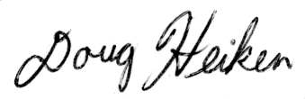
Doug Heiken (he/him)
dh@oregonwild.org

Sincerely,
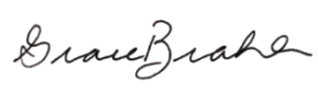
Grace Brahler
Cascadia Wildlands
grace@cascwild.org

In young Douglas-fir stands “canopy structure did not differ dramatically between thinned and unthinned stands. … There were no evident trends between understory cover and thinning history; both shrub and forb cover were fairly similar among the three thinning intensities [including the unthinned control stands]. The difference in mean shade-tolerant canopy cover was not significantly lower in LT [light thin] and HT [heavy thin] than in ND [undisturbed] stands … We expected greater cover of understory vegetation in thinned than in unthinned stands but did not detect significant differences in this analysis.” McIntosh, Anne C.S.; Gray, Andrew N.; Garman, Steven L. 2009. Canopy structure on forest lands in western Oregon: differences among forest types and stand ages. Gen. Tech. Rep. PNW-GTR-794. Portland, OR: U.S. Department of Agriculture, Forest Service, Pacific Northwest Research Station. 35 p. http://www.fs.fed.us/pnw/pubs/pnw_gtr794.pdf
Jan 2004 SEIS for Removing Survey and Manage Mitigation, page 189. citing Carey, A.B., D.R. Thysell, and A. Brodie. 1999. The forest ecosystem study: background, rationale, implementation, baseline conditions, and silvicultural assessment. USDA Forest Service. General Technical Report PNW-GTR-457. Pacific Northwest Research Station. Portland, Oregon. http://www.treesearch.fs.fed.us/pubs/2984
Spies, T. A., and S. P. Cline. 1988. Coarse woody debris in forests and plantations of coastal Oregon. Pp. 5-23 in: C. Maser, R. F. Tarrant, J. M. Trappe, and J. F. Franklin, ed. From the forest to the sea: a story of fallen trees. Gen. Tech. Rpt. PNW- GTR-229. USDA Forest Service, Portland OR. http://www.fs.fed.us/pnw/pubs/229chpt1.pdf.

