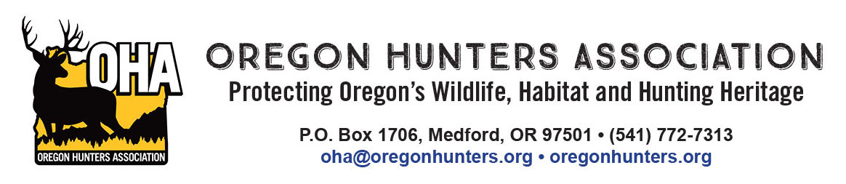

January 6, 2025

Hilary Henry
Sweet Home Recreation Planner
4431 Highway 20
Sweet Home, OR 97386

RE: Oregon Hunters Association comments on the draft Upper Canyon Environmental Assessment

The Oregon Hunters Association (OHA) is a sportsmen’s conservation organization with over 12,000 members in 26 chapters across Oregon. OHA values our National Forests as a public place to hunt and recreate, and as a valuable asset providing habitat for the wildlife we care about. As such, the management and access of these lands are of critical importance to OHA. We have been engaged in numerous projects to improve and protect habitat conditions, and we value our partnership with the U.S. Forest Service (USFS) and the Willamette National Forest. We are providing comments and input on the draft Upper Canyon Environmental Assessment (EA).

“The purposes of this project are to: 1) provide a sustainable supply of timber products; 2) actively manage timber plantations and the landscape to promote growth, diversity, and structural complexity; 3) manage riparian reserves to control stocking and acquire desired vegetation characteristics needed to obtain the Aquatic Conservation Strategy objectives; and 4) sustainably manage the network of roads in the project area by identifying a minimum road system.”
OHA is supportive of the project proposal and proactive management on the forest. With that, we have the following comments to consider.

OHA supports active management for a variety of reasons that were articulated in the draft EA. Of specific note was the acknowledgement of the USFS that they “do not anticipate any future significant timber sale or public works projects in the Upper Canyon project area”. While the term “significant” is not well defined, OHA will assume that there is room for some level of future active management and normal maintenance. With that, OHA interprets this to mean that if the USFS can execute projects for a variety of benefits in the near future, those opportunities may not exist in the more distant future.

In the draft EA Wildlife section, Cumulative Effects on elk and deer it states “There are no other ongoing or reasonably foreseeable activities on National Forest System lands in the big game analysis area that would meaningfully improve forage habitat for deer and elk.” Given this, OHA sees the Upper Canyon project as a very limited opportunity to address certain management needs in the project area.

OHA first wants to recognize the USFS for its use of the westside elk model during its analysis and development of the draft EA. We have also included information from the Oregon Department of Fish and Wildlife (ODFW) on the current status of Roosevelt elk in western Oregon, including the McKenzie Wildlife Management Unit (separate attachment). While the draft EA states that “Viable populations of deer and elk are expected to persist at the project and Forest levels” OHA believes that the USFS should take opportunities like the Upper Canyon project to improve habitat conditions for wild ungulates to work towards meeting the management objectives of ODFW, rather than simply hoping the species can persist.

All of this information points to a need for work to develop or improve elk and deer habitat on the project area. Relying on catastrophic, stand replacement level wildfires, such as those on the Labor Day weekend of 2020, to potentially provide habitat is not a desirable approach. OHA believes that there is a very limited opportunity to improve habitat for ungulates with the proposed project. This leads us to specific recommendations where stand treatments are being planned.

First, where using the creation of gaps in the stand treatment prescriptions, the USFS should favor using larger gaps and at an abundance to actually promote (temporarily at least) some semblance of early seral habitat. Alternative 2 prescriptions detail the creation of gaps that are one to three acres in size, with leave trees. OHA strongly recommends that gaps be a minimum of three acres in size. Smaller gaps, in Douglas-fir stands, on high sites, will close in so rapidly that understory will be excluded within a decade.

Second, OHA recommends that the USFS employ heavier thinning prescriptions where possible to allow understory vegetation to develop and persist as long as possible before the stand closes in again. Once again, Douglas-fir stands on high sites will rapidly close in any openings in the overstory canopy. Using heavier thinning prescriptions on at least a portion of the project area will allow understory forage to persist longer.

Other management actions can benefit both elk and deer. OHA supports the meadow restoration included in the project. Our experience tells us that enhancing and maintaining natural meadows is not something that can typically be done with a single management entry. OHA encourages the USFS to use on-going maintenance of this work.

OHA supports the actions in the “Transportation” section of the draft EA. Specifically the statement that “Temporary spur roads would be built to facilitate logging operations and removed after logging is
completed.” and other actions outlined in the draft EA that will keep a well maintained, and appropriately sized road system in the project area. OHA recommends that the USFS consider at least seasonal road closures in areas where gaps are developed in the stands to avoid disturbance of elk.

Thank you for the opportunity to comment.

Mike Totey
Conservation Director
Oregon Hunters Association

