24 Dec 2024

TO: Donna Mickley, Acting Forest Supervisor, Willamette NF
VIA: https://cara.fs2c.usda.gov/Public/CommentInput?Project=67147
CC: elspeth.gustavson@usda.gov

Subject: 2020 Roadside Salvage, Supplemental EA — comments

Please accept the following comments from Oregon Wild, Cascadia Wildlands, and Willamette River Keeper concerning the 2020 Roadside Salvage, Supplemental EA, https://www.fs.usda.gov/project/?project=67147&exp=overview.
- Oregon Wild represents 20,000 members and supporters who share our mission to protect and restore Oregon’s wildlands, wildlife, and water as an enduring legacy. Our goal is to protect areas that remain intact while striving to restore areas that have been degraded. This can be accomplished by moving over-represented ecosystem elements (such as logged and roaded areas) toward characteristics that are currently under-represented (such as roadless areas and complex old forest). Oregon Wild’s contact information is on the letterhead above.
- Cascadia Wildlands is part of a movement to protect and restore wild ecosystems of the Cascadia Bioregion, including vast old-growth forests, rivers full of wild salmon, wolves howling in the backcountry, and vibrant communities sustained by the unique landscapes. Cascadia Wildlands’ contact information is: P.O. Box 10455, Eugene, OR 97440 | Eugene, OR 97401 | 541-434-1463 | grace@cascwild.org.
- Willamette Riverkeeper has approximately 2,500 members who live, work, visit, recreate, and enjoy the Willamette River Basin, including in the waters of the Holiday Farm Fire, Beachie Creek Fire, and Lions Head Fire areas. They believe a river with excellent water quality, abundant natural habitat, safe for fishing and recreation is a basic public right. Willamette River Keeper’s contact information is 454 Willamette Street #218, Eugene, OR 97401 | 503.223.6418 | lindsey@willametteriverkeeper.org.

This proposal involves modifying the original 4,450-acre roadside salvage project within the perimeters of the Beachie Creek and Lionshead Fires to allow heavy equipment to operate off road on 1,450 acres of slopes less than 30% adjacent to roads (for safety). Heavy equipment will be allowed to operate on 341 acres of riparian reserves on all stream classes with minimal no entry buffers. Approximately 87 acres of Riparian Reserves associated with fish-bearing streams and 56 acres of Riparian Reserves associated with ESA-listed fish habitat are included in the area of the proposed action change and may see ground-based equipment operations.

The link provided in the November 2024 project notification letter leads to an almost empty webpage, shown below. This is confusing to the public. See below.

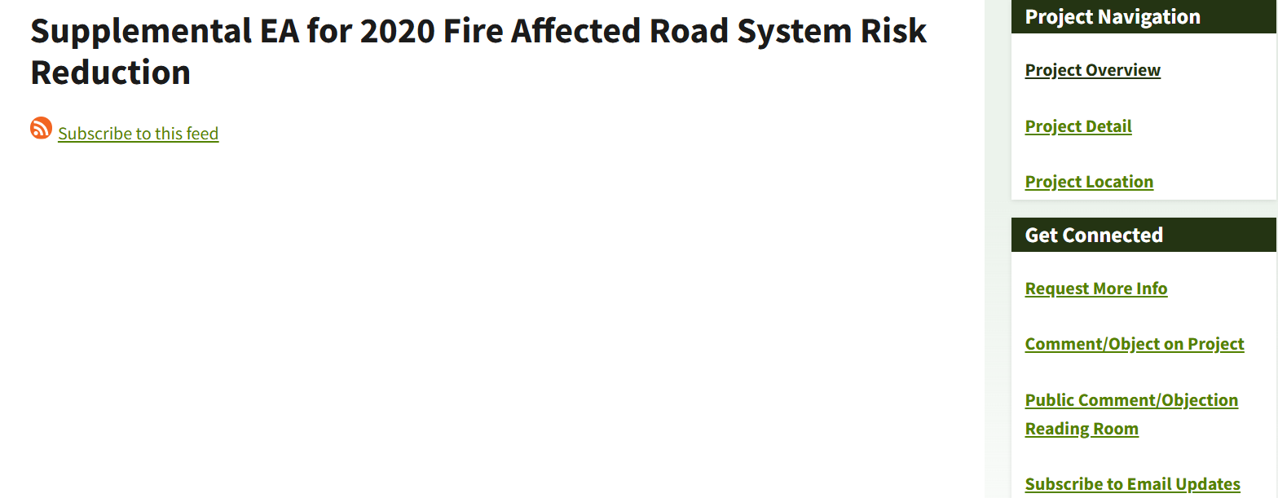
We were eventually able to access the Supplemental EA, but we were not as lucky finding the original EA.

The documents supporting the original 2020 Roadside Project were unavailable during the comment period.
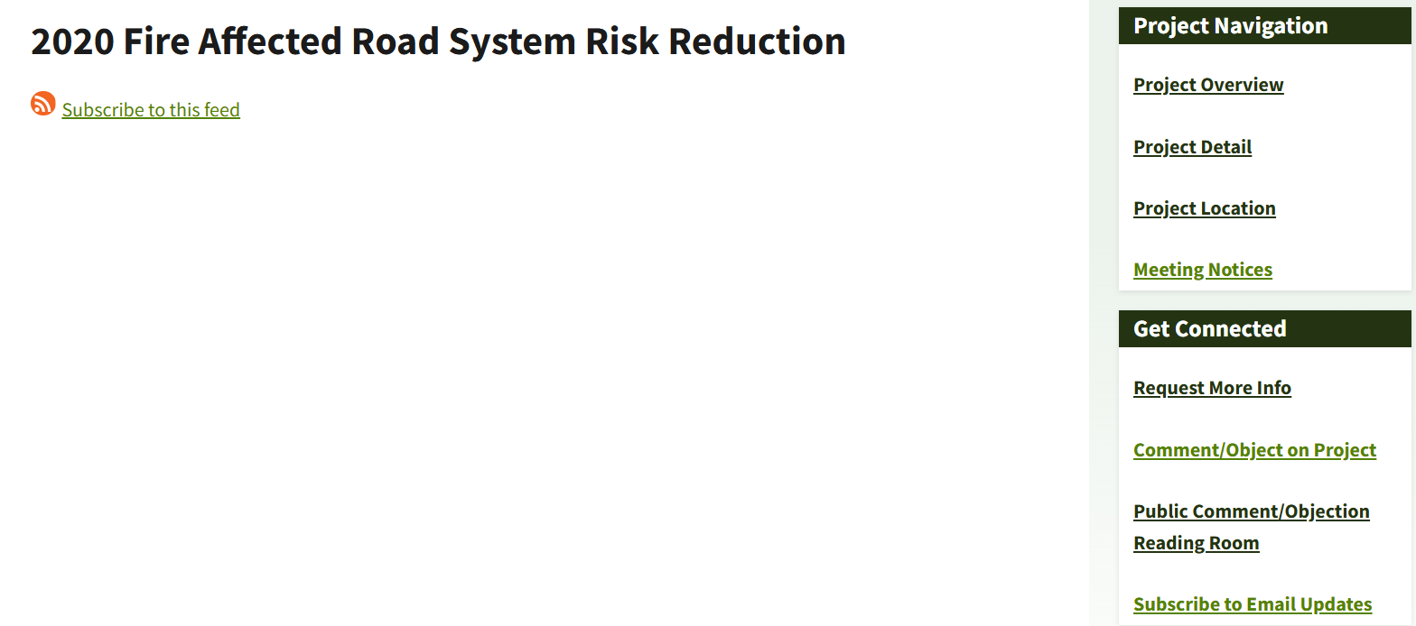
The Supplemental EA says: “previous analysis and decision documents are available for review on the project website:
https://www.fs.usda.gov/project/willamette/?project=61749” and “the impacts of this [no action] alternative are considered and presented in the original EA for the 2020 Fire Affected Road System Risk Reduction project which is here incorporated by reference.” And “impacts and activities are unchanged and the original Environmental Assessment is incorporated by reference, these issues will not be discussed further in this Supplemental EA.” However, the website for the 2020 Roadside EA is broken and unavailable.

Finally, the person listed on the notice letter to request more information, returned this:

It appears the email is spelled incorrectly in the notice letter, but that subtle error is not obvious to the general public.

The lack of access to the original EA makes it far more difficult to provide informed comment. We would like to see what the EA said about why implementation via hand crews was selected over heavy equipment, but the FS lack of transparency prevents that. This is another reason to prepare an EIS.

Changed Conditions Require Consideration of More Alternatives.
This modified project is an unfair broken promise, or bait-and-switch. The Forest Service originally planned to implement this project without using heavy equipment, and they knew that trees would decay over time, and that implementation would take time. The alleged changed conditions are so predictable that the FS should not rely on them to change the decision.

The public relied on the mitigations adopted in the original decision. In Cascadia Wildlands’ et al. July 2022 comments on the original 2020 Roadside EA we said—
“We appreciate that modifications were made to the project design in response to our input to … minimize unnecessary damage from heavy equipment … The Forest Service must exercise great care in project planning and implementation to ensure impacts to aquatic resources and Riparian Reserves are minimized. … Please ensure that the management directions to mitigate sediment introduction as much as possible remain in the final project design ...”
This project modification undermines public confidence in the Forest Service sincerity toward protecting soil and water quality.

After finally getting a copy of the original 2020 Roadside EA and having a chance to review it on the Christmas eve holiday, we found a variety of very good reasons to restrict heavy equipment to roadways, and prohibit off-road use of heavy equipment in the fragile post-fire landscape:
- Operating heavy equipment only within the road prism was a key scoping issue. 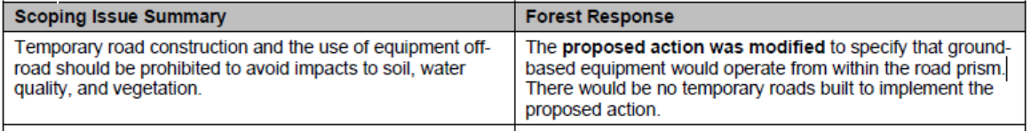 (Original EA p 7)
- “Use of heavy equipment to conduct treatments may result in ground disturbing activities that have the potential to affect cultural resources. … Use of heavy equipment may impact sites through disturbance and artifact breakage. However, equipment is expected to operate from within the road prism, so these impacts are unlikely to occur. … The direct effects of ground disturbing activities using heavy equipment may impact archaeological artifacts, features, or structures which may cause breakage, loss, displacement, or compaction. … Project design measures of previous and currently proposed actions provide mitigations of possible adverse effects to cultural resources.” (Original EA pp 28, 30, 31). The Forest Service needs to be sure that cultural resource surveys are conducted by qualified personnel before implementation.
- “The use of logging equipment would reduce the number of natural seedling regeneration during this short period (Donato et al. 2006) around landings and adjacent to roads, however equipment would operate from within the road prism where few if any trees are expected to sprout.” (Original EA p 36)
- “The Forest Plan has standards for the protection of forest soils in project areas. Potential soil impacts from the proposed action include displacement, compaction, nutrient loss, and instability. To protect soils during risk reduction treatments, ground-based operations would occur within existing road prisms and previously impacted areas … Fire-killed and injured trees within reach of the road would be hand felled and pulled to the road by ground-based equipment. As equipment would primarily operate from within the already compacted confines of the road prism, displacement and compaction of adjacent forest soils would be limited. … [U]sing the existing road network to the greatest extent practicable are paramount to staying within the thresholds for soils compaction and sediment mobilization.” (Original EA p 60)
- Project Design Features necessary to minimize water pollution and protect botany resources:
…
(Original EA p 98, 101)
- Aquatic Conservation Strategy Analysis-
“Objective #5 – Maintain and restore the sediment regime under which aquatic ecosystems evolved. Elements of the sediment regime include the timing, volume, rate, and character of sediment input, storage, and transport.
Post-fire timing, volume, rate, and character of sediment delivery will be at the high end of the natural range of variability and will remain so for years to a decade.
…
With regard to treatment effects from this project, the goal of the interdisciplinary team was to design a project using Best Management Practices to prevent additional effects above and beyond the fire effects. Project design features such as fall and leave within Riparian Reserves, limiting ground-based equipment to the road prism, applying erosion control measures in freshly cleaned ditches and assuring that haul of woody material only occurs in dry conditions throughout the year will assure that risk reduction operations do not exacerbate sedimentation.” (Original EA p 113-114)
- “Concern Statement: There was a concern for the impacts of operating heavy logging equipment to sensitive post-fire soils. Forest Service Response: … Heavy equipment would stay on roadways to the maximum extent practicable (PDF Aquatics 3).” (Original EA p 138)
The Supplemental EA does not adequately address all the compelling rationales for limiting heavy equipment to roadways. The original plan to implement via hand felling was based in part on minimizing and mitigating environmental effects. These amplified effects of the modified project are potentially significant and require preparation of an EIS. The original EA and the Supp EA makes many admissions that need to be carefully considered in the finding of significance.

Our biggest concern is that the Forest Service is not changing anything about this proposal except to allow heavy equipment to operate off road, including in riparian reserves. This is not in the public interest. The Forest Service designed this project with hand felling in mind, which mitigates some of the inherent adverse effects of removing danger trees. Other aspects of the project design should change when another more impactful logging method is adopted.

We understand the importance of public and worker safety, but there are many ways to achieve. This project failed to consider mitigating alternatives that would better harmonize safety, soil integrity, post-fire recovery, water quality, carbon storage, fish & wildlife, etc. We have provided below a range of potential mitigations that should be considered by the Forest Service, preferably in an EIS.

The Forest Service should take steps to minimize and mitigate the increase adverse effects by making other modifications to the project, such as:
- Dropping treatments along little-used roads that are not essential to forest management. The supplemental EA says that heavy equipment is more safe than hand felling trees, but this is misleading. Workers are still very much at risk when inside those cages. It would be better to keep workers out of the way of harm altogether, by forgoing treatment and temporarily closing roads until the hazards have abated.;
- Gating roads to allow natural post-fire ecological processes to flourish, then when the road is actually needed in the future removing trees after they have fallen instead of before;
- Narrowing the width of the treatment area to reduce the footprint of adverse effects. All things being equal, a tree directly adjacent to the road has less than 50% chance of hitting the road, and as distance from the road increases, the probability of hitting the road decreases;
- Retaining more trees that are not clearly dead, e.g., tighten the criteria for dying trees in order to avoid falsely identifying trees likely to die. Retaining green trees will help restore the below-ground ecosystem, and provide much needed green tree and snag habitat during the “snag gap” created by fire;
- Avoid or reduce treatments in Late Successional Reserves and riparian reserves;
As a side-benefit, many of these mitigations would actually reduce workers exposure to hazards even more than implementation with heavy machinery. NEPA requires agencies to consider mitigation alternatives. “... To determine the scope of environmental impact statements, agencies shall consider ... 3 types of alternatives, .... They include: ... (b) Alternatives, which include: (1) No action alternative. (2) Other reasonable courses of actions. (3) Mitigation measures (not in the proposed action).” 40 CFR §1508.25.

Unacceptable Effects from Heavy Equipment in a Burned Landscape
Allowing tree removal via heavy equipment on almost 1/3 of the acres proposed for treatment is a major modification to the project which will dramatically increase environmental effects. Effects include:
- Increased soil disturbance, compaction, displacement, loss of gas exchange, etc. Allowing skid trails as close at 50 ft apart will cause unacceptable cumulative effects on soil and water. The Supp EA admits “Ground-based equipment operations within Riparian Reserves can cause considerable disturbance to forest vegetation and soils in riparian areas. Ground disturbance associated with ground-based equipment operations in riparian and upslope areas can also lead to increased levels of soil erosion and downslope transport of sediment to stream channels during storm events (USDA, 2018).”;
- Increased risk of erosion and water pollution, with potential adverse effects on ESA-listed fish. Heavy equipment and tree removal will be allowed in all stream classes with small no entry buffers. This is likely to violate standards & guidelines that prohibit logging in riparian reserves, and prohibit actions that will retard attainment of ACS objectives. Skid trails near roads are a big risk for sedimentation because they are likely to move sediment to ditches and many ditches are connected to streams. The modified decision seems to ignore the fact that riparian reserves are a separate land allocation with separate goals and standards & guidelines. The Supp EA calls for work to be done in the dry season, but should also specify that work be done when conditions are in fact dry because it can rain during dry season). The Supp EA admits “Operating ground-based equipment off-road could potentially increase sedimentation in a number of ways, including off-road tree felling and yarding operations, the designation and use of off-road skid trails, and ground disturbance resulting from ground-based equipment use on fire affected soils.” This represents a likely violation of the Aquatic Conservation Strategy and a trigger for an EIS. The Supp EA says “The use of riparian buffers is a long-standing management practice used to reduce sediment transport to streams,” however, the effectiveness of stream buffers is based on an assumption that they are unburned. The post-fire condition of soils and vegetation significantly reduces the effectiveness of stream buffers to intercept and hold mobile sediment. By repeatedly using qualifying words (“largely” and “generally”) regarding the prohibition on heavy equipment on steep slopes, the Supp EA appears to in fact allow heavy equipment to operate on steep slopes. The effects of this are not disclosed in the EA;
- Increased risk of weeds due to more soil disturbance and more vectors;
- Increased damage to important habitat features such as standing snags and down wood. Big machines are not as light and agile as people. Many non-target trees will be impacted. The plan is to run equipment over thick beds of slash, which might mitigate soil effects, but it adversely effects other values provided by down wood;
- Increased damage to recovery plant communities including tree seedlings, shrubs, forbs, grass, etc. Killing these plants will delay recovery of the above and below ground ecosystems. The EA admits “Ground-based equipment operations within Riparian Reserves can cause considerable disturbance to forest vegetation …” This is also true outside riparian reserves.;
- Increased fragmentation of habitat, so that wildlife will find it harder to safely cross treated roads without exposing themselves to predation, etc.
- The Supp EA lacks nuance. The Supp EA says “The overall determination of impacts to fish from the original EA are unchanged by the proposed action change. For ESA listed fish species, the project still “may affect, and is likely to adversely affect” these species and their Critical Habitat.” The Supp EA should better disclose how much worse this is for fish, even within the broader category of LAA.

We continue to be concerned that several of the guidance documents that form the basis of this proposal (Region 6 Danger Tree Policy Guidelines, Filip, Hood, and the Willamette Road Investment Strategy) have not undergone National Environmental Policy Act (NEPA) analysis. Though apparently unaddressed in the draft EA, our concerns remain that members of the public, Tribes, other agencies, and other interested parties never had the opportunity to review and provide feedback on the danger tree criteria that forms the basis for the proposal.

Additional Considerations Related to Removal of Danger Trees.

- The objective of public safety is laudable, but there are gradations of risk based on characteristics of the site and the tree and the type and amount of public exposure, so felling of hazard trees must be balanced against other important objectives such as wildlife habitat, carbon storage, water quality/stream shade, etc.
- Clearing large areas along an extensive road system can have significant negative cumulative impacts such as: soil degradation from heavy equipment operating off roads and biomass removal, water quality degradation from heavy equipment affecting ditches that convey water to streams; cumulative loss of habitat associated with snags, down wood, and diverse early seral vegetation; accelerated carbon emissions; increased fire hazard associated with fire ignition risks, and plantation fuel structure; habitat fragmentation and loss of habitat connectivity caused by increasing the width of non-habitat associated with roads; etc.
- The agency should be more risk tolerant and retain more trees in sensitive areas, such as unroaded areas, riparian areas, and mature and old-growth stands and conservation areas.
- The agency can also be more risk tolerant because some agents of tree decay such as heart rot can coexist in living trees for hundreds of years. By Katherine Latham 2021. The Lost Generation of Ancient Trees. 8th September 2021. https://www.bbc.com/future/article/20210908-the-lost-generation-of-ancient-trees;
- To protect soil and water quality and vegetation diversity, heavy equipment should not be allowed off of roads.
- USFS Roads Policy requires the agency to use an open, public roads analysis process to balance competing interests involved in roads management including public safety and environmental values, and the policy urges the agency to focus maintenance work on the roads that get the most use, and emphasizes decommissioning of roads where environmental conservation should take priority, and “If necessary for environmental protection and due to lack of funding, travel on classified roads may need to be restricted or closed.” USFS Road Management Policy. https://www.fs.usda.gov/nfs/11558/www/nepa/115185_FSPLT3_5597368.pdf. The careful weighing of interests required to perform careful roads analysis means that it is not appropriate to categorically exclude danger tree removal projects from NEPA.
- The agency should consider alternative means of managing hazards from falling trees:
  - Minimize human activities near hazard trees (e.g., closing roads). This may not work where a hazard trees is adjacent to a high traffic road, but some little used roads can be closed. Analyze whether spurs or overgrown roads truly receive public use that justifies hazard tree removal;
  - Temporarily limit the use of roads that cannot be permanently closed until the risk of falling trees is naturally reduced;
  - Top trees, rather than kill them, if shortening them would reduce the chance they would reach the road if they fell;
  - Place signage warning people of post-fire hazards, particularly on roads that are infrequently used. This way people can evaluate the risks for themselves;
  - Often the hazard is not from the tree falling directly on people, but from cars colliding with trees that have previously fallen. This hazard can be mitigated with signage and speed limits, while allowing valuable wildlife trees to persist;
  - Prohibit cutting live, green trees, since all surviving trees are helping to rebuild the below-ground ecosystem, stabilize soils, and serve a valuable role as legacy structure and a recruitment pool for future large trees and snags;
  - Focus tree removal on imminent danger or hazard trees located within striking distance of high use areas, such as developed sites, parking lots, and paved roads. Wherever possible, use hazard trees for restoration of streams and placement in nearby stands that lack large wood;
  - Where they do not pose an immediate threat to safety, all trees presumed to be dying should be treated as live until they are dead, so as to not lose the ecological benefits of those trees that may survive;
  - Take measures to stabilize impacted slopes in areas where roadside logging is unavoidable; and
  - Analyze the cumulative impacts of all post-fire sales and roadside logging projects across agency jurisdictions.
- The agency should only fall trees that pose an imminent hazard to the public. There is little need to fell trees that lean away from the road. Even if a tree is directly on the edge of the road, a tree falling in a random direction has only a 50% chance of hitting the road, and the likelihood diminishes as the distance from the road increases. Trees more than 100 feet from the road have a low probability of falling on the road, even if they are taller than 100 feet. This is because of all the directions these trees could fall, only a small subset would reach the road. For instance, in the figure below, if a tree located at point (E) is close to a road (represented by line G-H) there is a much higher risk of it hitting the road compared to a tree at the location of point (C). The sum of the angles from the tree to the road (in the blue shaded areas) represent either broad or narrow risk of a tree falling and hitting the road depending on its distance from the road.

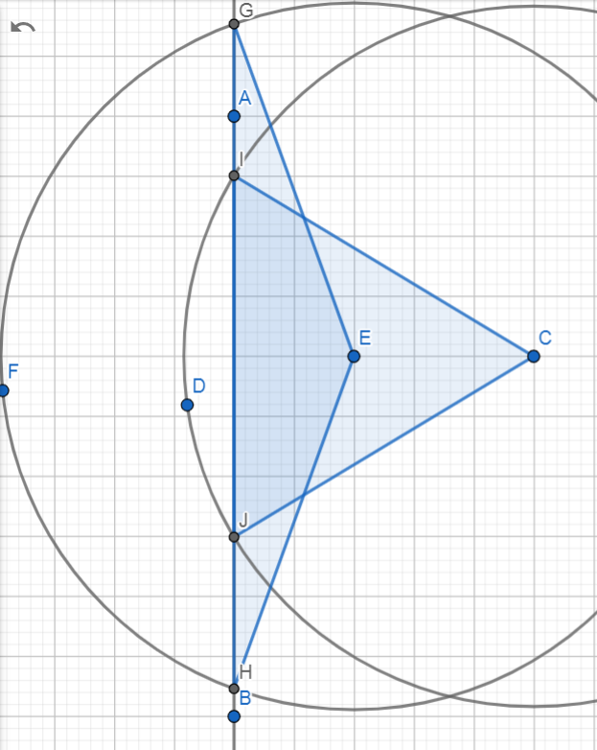
https://www.geogebra.org/geometry?lang=en
- There are several reasons that danger tree felling should be limited to 100 feet from roads. The chance of trees more than 100 feet from roads impacting the road are not very high because the tree would have to fall in precisely the right direction toward the road. And there is a much higher chance it will fall in numerous directions that do not threaten the road. In addition, many dead tree tops break off and fall close to the base of the tree, leaving a shorter snag with a more limited zone of hazard. Felling trees more than 100 feet from roads is unnecessarily risk averse, and unjustifiably sacrifices environmental values (such as snag habitat, dead wood habitat, and soil health).
- The agency should focus on roads that are heavily used by the public and workers. There is a trade-off between safety and habitat, and the agency should conserve defective trees and snag habitat in areas that receive little public use.
- The agency should fell trees as absolutely necessary, but wherever possible leave the trees on-site to provide down wood habitat. When tree removal is necessary use the wood to restore stream habitat or to add down wood to previously clearcut plantations where down wood habitat is severely lacking.
- We object to commercial sale of hazard trees, because there are economic conflicts of interest that could lead to ecologically important large trees being removed for the wrong reasons. And the need for large trees for restoration purposes far outstrips the supply.
- The cumulative impact of hazard tree removal needs to be carefully considered. There is a dense road network across the federal/non-federal landscape and if all the hazard trees are removed a certain distance from all those roads, then the area of the forest that can support large snags become greatly diminished. See, for instance, these roadside danger tree removal plans from Eugene BLM’s McKenzie watershed:
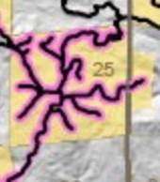 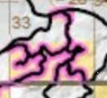 https://eplanning.blm.gov/eplanning-ui/project/2009923/570. In their danger tree CX BLM said "Effects to potential spotted owl foraging in moderately and severely burned areas would not be significant because hazard tree removal would affect a linear corridor rather than entire forest stands" But they did not appear to account for these situations where is a dense road network and the linear corridors affect a large fraction of the stand. The cumulative effects analysis must also account for the lost potential for high quality large snag habitat caused by past regeneration harvest and salvage logging. The NEPA analysis should disclose how the forest can meet DecAID 50-80% tolerance objectives given the cumulative loss of large snag habitat.

The risk of a dead trees actually falling and hitting someone is extremely remote and must be put in perspective. For instance, the agency allows the public to use thousands of miles of roads where the risk of death or injury from collisions or other accidents is far far higher than the risk of being hit by a falling tree. The agency also allows boating and swimming in dangerous waterbodies, winter camping, mountain climbing, off-road vehicle use, and hunting with dangerous weapons. The agency also promotes dangerous occupations such as logging and firefighting, and piloting aircraft used for a variety of forest management activities. Furthermore, public use of public lands is skewed toward the summer months, while the extreme weather that tends to cause trees to fall is skewed toward the winter months. If the purpose of this project is to increase public safety please consider all the alternative ways that safety might be enhanced.

The hazards from trees falling is also mitigated by time. These are not high use roads. The chance that an employee or member of the public will be there when the tree falls is very low. To put things in perspective, there are almost 16 million seconds in a year. How many seconds are there vehicles on the road under these trees during the course of a year, and what fraction 16 million is that?

There are multiple options for managing safety, (a) manage the physical feature presenting the hazard, or (b) mange public use so that the public is less likely to be subject to the physical hazard. We strongly support retention of large snags while educating the public and managing public use to keep the public out of harm’s way as much as possible. Truly hazardous trees (i.e., imminent risk of falling in very high use areas) may need to be felled (often leaving a high stump for wildlife) but the boles of such trees should generally be left to provide for wildlife and soil needs.

Here is a good example of signage that may improve safety awareness in burned landscapes:
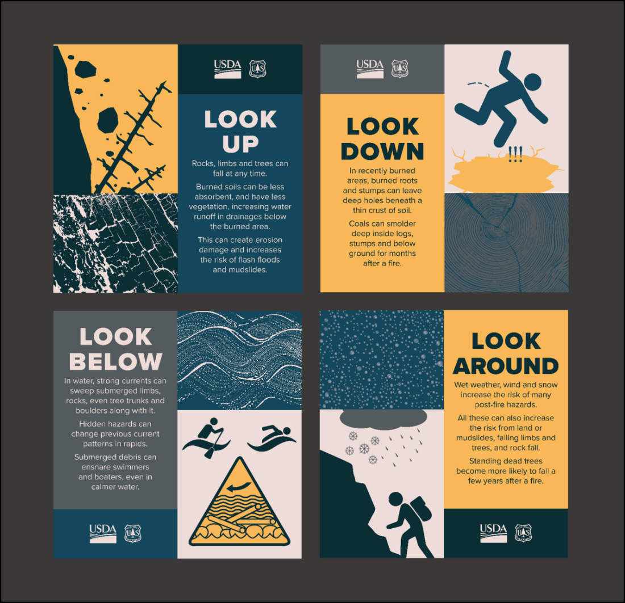
Situational awareness is critically important for staying safe in burned areas. Practice the Four Steps for Safety to improve your awareness of natural hazards:
LOOK UP for upland burned areas, snags, and exposed rocks that may fall.
LOOK DOWN for debris from falling rocks, erosion – especially at road and trail edges, and ash pits (which may form from root pockets or stumps of burned trees),
LOOK AROUND Be situationally aware. Check the weather before you travel, including at higher elevations. Wind, rain, ice and snow can increase the risk of tree fall, rock fall, slides and other hazards. Flash floods and landslide risks are elevated below severely burned areas.
LOOK BELOW the surface of standing water and moving water for floating logs, submerged trees and other debris, which can strike or entangle swimmers and boaters and damage other infrastructure.
Willamette National Forest 2022. 2020 Fire Affected Road System Risk Reduction Project Storymap. https://storymaps.arcgis.com/stories/841b9854be5346638c3c34291913fe31

The agencies’ field guide for danger tree identification indicates that little-used logging roads are a low priority for danger tree removal because of intermittent and infrequent hazard exposure.
There are many miles of roads that may have danger trees adjacent to them. It is not possible to correct the danger tree problem immediately, so it is necessary to prioritize the danger tree treatment workload. The treatment priority should be highest where people are most likely to be impacted by danger trees. Consideration of exposure level and traffic frequency provides a way to prioritize the workload.
…
Another aspect of exposure along roads is traffic frequency. Roads that have a higher traffic frequency expose more people to a danger tree than roads with a lower traffic frequency.
The longer people are exposed to a tree, the more opportunity there is for the failed tree to impact them. If exposure duration and traffic frequency are reduced, the opportunity for the tree to impact people is also reduced. The qualified person should consider traffic frequency and exposure duration when determining whether a tree poses a danger to people.
Toupin, Filip, Erkert & Barger. 2008. Field Guide for Danger Tree Identification and Response. USDA FS, USDI BLM, Oregon OSHA. http://www.blm.gov/or/districts/medford/plans/files/fieldguidedangertree.pdf

Sometimes the motivation for eliminating hazards is based on a misunderstanding of legal liabilities. The NEPA analysis needs to acknowledge that the public assumes certain risk when recreating on public lands, so not every hazardous tree on every dead end spur road needs to be felled and removed. See ORS §§ 105.672(3), 105.682(1) and Brewer v. ODFW, 2 P.3d 418, 167 Or.App. 173. http://www.publications.ojd.state.or.us/A103245.htm.

ORS 105.682(1) provides:
Except as provided by subsection (2) of this section [pertaining to intentional injuries], and subject to the provisions of ORS 105.688 [limiting immunity to those who do not charge for use of the land or who charge no more than $20 per cord for woodcutting on the land], an owner of land is not liable in contract or tort for any personal injury, death or property damage that arises out of the use of the land for recreational purposes, woodcutting or the harvest of special forest products when the owner of land either directly or indirectly permits any person to use the land for recreational purposes, woodcutting or the harvest of special forest products. The limitation on liability provided by this section applies if the principal purpose for entry upon the land is for recreational purposes, woodcutting or the harvest of special forest products, and is not affected if the injury, death or damage occurs while the person entering land is engaging in activities other than the use of the land for recreational purposes, woodcutting or the harvest of special forest products.

ORS 105.676 provides:
The Legislative Assembly hereby declares it is the public policy of the State of Oregon to encourage owners of land to make their land available to the public for recreational purposes, for woodcutting and for the harvest of special forest products by limiting their liability toward persons entering thereon for such purposes...
"Land" is defined by ORS 105.672(3) as including "all real property, whether publicly or privately owned." "Owner" is defined by ORS 105.672(4) as "the possessor of any interest in any land, including but not limited to possession of a fee title. 'Owner' includes a tenant, lessee, occupant or other person in possession of the land."

The Oregon Court of Appeals in Brewer said,
The trade-off represented by this policy is manifest. The owner of land opened for recreational use in accordance with the Act gives up exclusive enjoyment of the land and, in return, is insulated from certain types of liability for injuries that may occur there. The users of recreational lands opened in accordance with the Act give up their rights to sue land owners for certain types of injuries but gain the benefit of using land for recreation that otherwise would not be available to them."
Brewer v. ODFW, 2 P.3d 418, 167 Or.App. 173. http://www.publications.ojd.state.or.us/A103245.htm

Also, the Federal Tort Liability Act provides the government some degree of immunity in exercising their discretionary functions like hazard tree management. For instance, the National Park Service was found not liable for failing to remove a tree weakened by root rot that fell and killed a recreational motorist at Great Smokey Mountains National Park, even when the road involved was a high use paved road near a visitor center, and when the tree species at issue (Black Locust) was known by the Park Service to be prone to fall down. AUTERY v. UNITED STATES 992 F.2d 1523 (11th Cir. 1993). https://web.archive.org/web/20051203012108/http://classweb.gmu.edu/erodger1/prls560/content/autery.htm. The appeal court overturned the district court and held that the agency’s balancing of public safety and preserving natural areas prevented judicial second guessing and gave them immunity from liability for the death of the motorist.
Based upon the evidence in this case, the appeals court held that "the decisions made by GSMNP personnel in designing and implementing its unwritten tree inspection program fall within the ambit of the discretionary function exception."
Although the district court may have disagreed with the balance struck by the Park Service, or believed that some other policy would have been better, the discretionary function exception is designed to protect against just this type of "judicial 'second-guessing"...
To decide on a method of inspecting potentially hazardous trees, and in carrying out the plan, the Park Service likely had to determine and weigh the risk of harm from trees in various locations, the need for other safety programs, the extent to which the natural state of the forest should be preserved, and the limited financial and human resources available. Indeed, the district court recognized this when it criticized the Park Service for elevating he overriding policy considerations of protecting the trees and the natural state of the area over the safety of humans using the park roadway.
This means that the agency is free to weigh the value of snags for wildlife and other ecosystem services and need not reflexively cut down every hazard tree. The agency’s proposal in the present case is not consistent with applicable law or conservation principles.

29 CFR § 1910.266
(c) Danger tree. A standing tree that presents a hazard to employees due to conditions such as, but not limited to, deterioration or physical damage to the root system, trunk, stem or limbs, and the direction and lean of the tree.
…
(d)(vi) Each danger tree shall be felled, removed or avoided. Each danger tree, including lodged trees and snags, shall be felled or removed using mechanical or other techniques that minimize employee exposure before work is commenced in the area of the danger tree. If the danger tree is not felled or removed, it shall be marked and no work shall be conducted within two tree lengths of the danger tree unless the employer demonstrates that a shorter distance will not create a hazard for an employee.
(vii) Each danger tree shall be carefully checked for signs of loose bark, broken branches and limbs or other damage before they are felled or removed. Accessible loose bark and other damage that may create a hazard for an employee shall be removed or held in place before felling or removing the tree.
http://www.osha.gov/pls/oshaweb/owadisp.show_document?p_table=STANDARDS&p_id=9862.

==
Each substantive issue discussed in these comments should be (i) incorporated into the purpose and need for the project, (ii) used to develop NEPA alternatives that balance tradeoffs in different ways, (iii) carefully analyzed and documented as part of the effects analysis, and (iv) considered for mitigation.

Please post to the project website, links to all relevant ESA and EFH consultation documents, RMPs, watershed analyses, and other supporting documents relied on in the NEPA analysis.

Please post to the project website before the public comment period, georeferenced maps of the proposed activity units that can be used to navigate in the field using apps such as Avenza.

Please provide Oregon Wild with timely notice of any forthcoming comment opportunities, and any draft and final decisions on this project. If the agency discovers new information or changed circumstance or modifies the project or the analysis after the decision, Oregon Wild requests to be notified and provided an opportunity to comment.

Note: If any of these web links in this document are dead, they may be resurrected using the Wayback Machine at Archive.org. http://wayback.archive.org/web/

Sincerely,
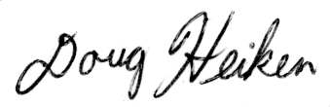
Doug Heiken (he/him)
dh@oregonwild.org

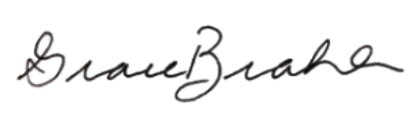
Grace Brahler
Cascadia Wildlands
grace@cascwild.org

/s/
Lindsey Hutchison
Staff Attorney
Willamette RiverKeeper
lindsey@willametteriverkeeper.org

