General Comments on MAC Project:
I strongly support the proposed project to reduce the overgrown forests and the likely devasting effects of megawildfire on forest stands, local communities, critical infrastructure, drinking water, watershed resources, and wildlife habitat from the increasing size and intensity of megawildfires, and to make forests resilient to fire and mortality over the long-range from the warming and long droughts. I support the use of prescribed fire, hazard tree removal, commercial and non-commercial mechanical thinning, mechanical and hand treatments, invasive plant treatments, meadow and aspen restoration, and other ecological restoration objectives.
Specific Comments:
- No Project Alternative -- NEPA documentation must address in detail a “No Project Alternative” to thoroughly disclose the probable Effects on the Watershed and the Wild and Mokelumne Scenic River Designation if the proposed project is not implemented.
- Climate Change Impacts -- Address the potential Climate change worst-case warm-dry scenario over the next 50 years, to 2075 in published scientific literature. Specifically, please address the increasing risk of mega wildfires and long droughts on tree mortality, structure, and wildfire risk from the forecasts such as in Siirila-Woodburn, 2021 (1), “A low-to-no snow future and its impacts on water resources in the western United States.” Snow water equivalent declines of ~25% are expected by 2050.
- Debris Flow Potential of No Project -- Please address the debris flow potential and potential impacts on Mokelumne Wild & Scenic River of a no project alternative. The North Fork of the Feather River was heavily damaged with logs and sediment after the 2021 Dixie Fire, an example of what can happen to the Mokelumne River (2). In October 2021, the USGS studied a watershed in Colorado (3) and concluded: a wildfire can transform a watershed with no recent history of debris flows into a substantial hazard for residents, communities, infrastructure, aquatic habitat, and water supply. Other USGS show the debris flow potential after fires (https://www.usgs.gov/search?keywords=Landslide%20and%20Debris-Flow%20Event%20Summaries). These examples show the potential impacts from debris flows that can significantly degrade the Wild and Scenic sections of the Mokelumne River and impact other values. Eldorado National Forest and Lake Tahoe Basin Mgt Unit Pacific Southwest Region USDA Forest Service forecasted potential debris flows in the 2021 Caldor Fire just north of the Mokelumne WS. The published report is the Burned Area Emergency Response (BAER) Assessment Report Summary of the 2021 Caldor Fire (4). The Agency’s conclusion is there are potential post-fire effects from the Caldor Fire including debris flows, increased flooding, ash and sediment input that can impact water quality flowing into Jenkinson Reservoir and Lake Tahoe.
- Wildfire Size & Severity -- Address the trend of wildfire size and severity over the last 20 years and the risk to the Upper Mokelumne WS, and values including Wildland Urban Interface Communities, powerlines, drinking water, and the Mokelumne Wild & Scenic River Segments.
- Domestic Water Supply -- The NEPA should disclose that Upper Mokelumne River Watershed is a domestic water supply for over 1.4 million people from East Bay MUD, Amador and Calaveras Counties and other lower river users.
- Shaded Fuel Break Priority, Design and Maintenance – Make Fuel Breaks the top priority in project scheduling and funding to help protect Communities, WUI’s, power, drinking water and road infrastructure. The USFS POD (Potential Operational Delineation) strategy should be addressed and used in locating Fuel Breaks for firefighter safety and to assist with wildfire control. Make construction of 1,000 foot-wide Shaded Fuel Breaks a high priority. Provide for maintenance of them every 5 years. Use prescriptions that will reduce the threat of fire. Provide maintenance by mechanical, prescribed fire, and non-herbicide maintenance like grazing. Direct Foliar application of herbicides can be used on up to 300 acres per year per Ranger District. Broadcast application should not be permitted. All slash should be removed from fuel breaks. Lop & Scatter should be prohibited. FB’s should be maintained every 5-8 years. There should be relatively little use of herbicides used to maintain fuel breaks. Where used for FB maintenance, herbicides should only be applied directly on shrubs. Broadcast application by machine or hand should be prohibited.
- Prescribed Fire emphasis – I support the ACCG adopted Shared Vision of shifting to a policy of Pyrosilviculture (2021): using fire in combination with mechanical thinning to prevent catastrophic wildfires in forests over large areas. This vision includes:
(1) Anchor treatments – treating fuels in strategic locations using thinning to control prescribed and managed wildfire and resist severe fire,
2) Ecosystem asset treatments – pre-treating riparian corridors, spotted owl territories, or large-tree area assets prior to introducing fire, and
3) Revenue treatments -- removing timber and biomass to provide a revenue stream to fund prescribed and managed fire.
- CASPO -- Address and include in the Proposed Action standards that can protect Ca Spotted Owl’s from severe mega wildfires. Address the long-term benefits of treating the forest to protect against mega fires to benefit CSOs and other wildlife versus the short-term effects of forest treatments. CSO PAC’s have been eliminated by severe wildfires in the last 15 years, including the Caldor, Rim, King, Dixie Fires to name a few. Short-term impacts on owls & their PACS and habitats should be accepted to ensure long-term survival and protection of the CASPO. Allow Exceptions to the standard protection measures of PACs in Fuel Breaks and WUI zones to allow thinning and removal of ground and ladder fuels to make them resist canopy fires.
- Strategic Fire Zones (SFZ) -- Create and reintroduce beneficial fire in Strategic Fire Zones (SFZ) of over 5,000 ac. away from WUI’s and located adjacent to fuel breaks. In the SFZs, allow lightning ignitions, as well as prescribed and cultural burns to reduce fuels and restore ecosystem services.
- Noxious weeds – Control by very limited use of herbicides as a last resort when other alternatives are not practical.
- Bulk Density & Thinning – Brodie, et. al., Forest thinning and prescribed burning treatments reduce wildfire severity and buffer the impacts of severe fire weather (5), has shown that canopy bulk density is directly related to the risk of severe canopy mega wildfire. Please address and use bulk density in standards and prescriptions to lower wildfire risk by thinning. Prohibit Lop & Scatter in thinning to reduce the threat of ground fuel build-up.

Thank you,
Rich Farrington
Amador Water Agency Director, D-3

REFERENCES:
(1) A low-to-no snow future and its impacts on water resources in the western United States, Erica R. Siirila-Woodburn, Alan M. Rhoades, Benjamin J. Hatchett, Laurie S. Huning, Julia Szinai, Christina Tague, Peter S. Nico, Daniel R. Feldman, Andrew D. Jones, William D. Collins & Laurna Kaatz Nature Reviews Earth & Environment volume 2, pages, 800–819 (2021)
(2) Dixie Fire Post-Fire Debris Flows: A Tale of Two Storms, US Geological Survey, Kostelnik, J., Thomas, M., Lindsay, D. September 25, 2023.
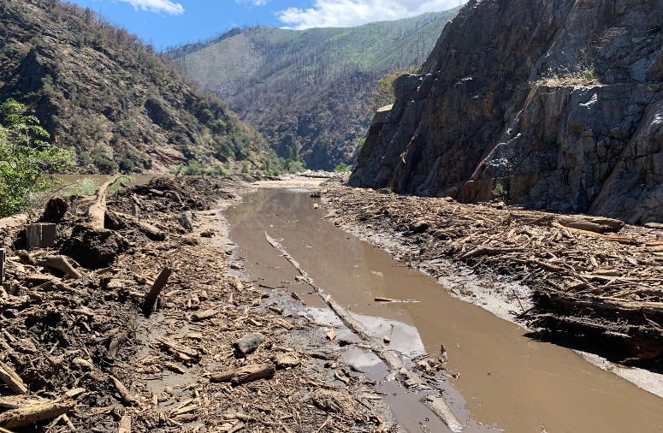
Woody debris in the North Fork Feather River following the 2021 Dixie Fire and June 12, 2022, storm.
(3) Estimated probability of post-wildfire debris-flow occurrence and estimated volume of debris flows from a pre-fire analysis in the Three Lakes Watershed, Grand County, Colorado, By Michael R. Stevens, Clifford R. Bossong, Davi d W. Litke, Roland J. Viger, Michael G. Rupert, and Stephen J. Char (2008)
(4) 2021 CALDOR FIRE CA-ENF-023040, Burned Area Emergency Response (BAER) Assessment Report Summary, Eldorado National Forest and Lake Tahoe Basin Mgt Unit Pacific Southwest Region USDA Forest Service, (October 2021)
(5) Forest thinning and prescribed burning treatments reduce wildfire severity and buffer the impacts of severe fire weather, Brodie, et. al., Fire Ecology (2024) 20:17

