10/22/24

RE: WildLands Defense CuMo Mine EA OBJECTION
2023 CuMo Exploration Project #64920

https://www.fs.usda.gov/project/boise/?project=64920

Objection submitted electronically.

Dear Forest Service,

Here is an Objection from WildLands Defense related to the significant ecological degradation that will be caused by the CuMo mine EA, Boise National Forest, Idaho City Ranger District with its lack of adequate alternatives and balanced hard look impacts analysis required under NEPA and its violations of NFMA in failing to portect hbaitats, species and watersheds, and of the ESA – including the project assault on ESA-listed Wolverine and Canda Lynx habitat.

The Responsible USFS Official is Brant Petersen, Forest Supervisor, and the Objection Reviewing Officer is the Intermountain (R4) Regional Forester.

WildLands Defense is a 501c3 environmental group based in Hailey, Idaho. WLD focuses on biodiversity and wild lands protection – and the CuMO project is a major assault on terrestrial and aquatic species habitats and public uses and enjoyment of USFS lands/waters/biodiversity and sustainability of native carnivores, rare plants, and other imperiled biota. in opposition to the public interest for sustainable clean water in the region of Idaho’s burgeoning major population center. WLD’s members view and enjoy wildlife species and the watersheds in these impacted lands. We enjoy wildflower displays, and untrammeled wild places on the Boise Forest, as well as enjoy and appreciate and find solace in the waters of the Boise River system that are under threat of depletion and/or pollution from this proposed mining activity. Further, heavy equipment operating in remote areas like this increases the risk of human-caused wildfire and even more sensitive species, migratory bird, Wolverine and other rare species habitat loss in this Boise Forest region already suffering enormous fire and USFS “treatment” impacts already.

This Objection is submitted under the following “predecisional administrative review process outlined in Title 36 of the Code of Federal Regulations (CFR), Part 218, Subparts A and B. A final decision will not be made until after the requirements of 36 CFR 218.12, 36 CFR 218.5(a), and any other applicable regulations.

WLD has previously submitted comments on the CuMo project about the harms and damage to Forest lands, waters, wildlife, biodiversity and public recreational and other uses. There are serious threats to ground and surface waters and to wildlife habitat and rare plant as well as aquatic species habitats from drilling, roads, noise and other actions the FS embraces under the inadequate EA. We Object that the FS has not addressed significant noise and other project activity concerns.

We Object that the FS has not taken a hard look at significantly changed circumstances and dramatic large-scale new wildlife habitat land other FS land values losses. Now since the Objection period started – there has been even more fire loss of crucial and irreplaceable habitat in the Boise “Valley” fire There are now dramatically changed circumstances for wildlife impacted by this project – as well as portions of Boise River and other watersheds due to the massive 2024 wildfires. These alone necessitate and new and supplemental NEPA analysis and EIS. Species ware already reeling from both past and now new massive fires. Now this project will drastically disturb other large areas of remaining unburned forest habitat– which is an increasing rarity in Idaho in the region following the unprecedented 2024 wildfires, and ever-increasing climate change stress. This stress reduces and worsens any “remediation” effectiveness and the impacts of project-caused water loss, degradation and to important, sensitive and ESA-listed species habitat damage. And this is on top of a slew of already proposed and/or foreseeable logging/treatment and “prescribed burning” project decisions that the FS has already planned for the region – on the Boise, Payette, and Sawtooth forests, Wildlife will soon have no place to live.
From Watch Duty 2024 fire mapping https://app.watchduty.org/

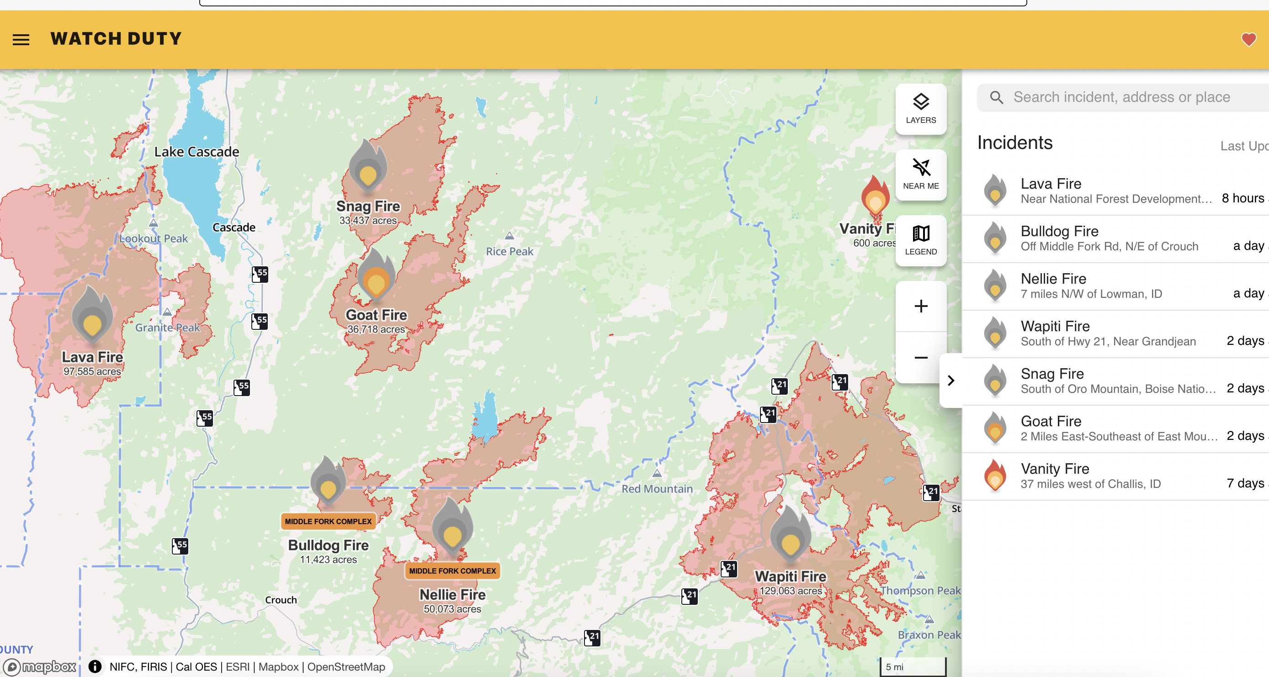

We Object that the Forest Service continues to try to shove this project through under a mere EA with greatly inadequate minimization and mitigation measures, and with massive public opposition that demonstrates the controversy and significance of this action in the fragile Boise River headwaters region.

We Object that the USFS is shirking its duty to prepare an EIS, and to conduct supplemental NEPA analysis that addresses all the new existing, planned and foreseeable losses affecting the same populations of species, forest habitats and other FS land values greatly impacted by 2024 fires and vegetation habitat removal or loss. Moreover, it is highly foreseeable that the FS may propose and push through more horrid “salvage logging” like the FS did with the Pioneer Fire – increasing even more the post-fire soil erosion, water pollution, habitat loss and climate change stress on Boise Forest and other surrounding national FS lands, waters, watersheds and important/sensitive/migratory bird and ESA-listed species – including wide-ranging species like Wolverine. Note that these fires will also further stress native carnivores by removing forested impediments to winter recreational and snowmobile and ither uses.

The FS must re-initiate consultation with USFWS over Bull Trout, Wolverine and other ESA-listed species now that their habitat across this region of Idaho has taken a massive new forest habitat loss wildfire hit in 2024. We Object that the FS is plowing ahead with authorizing the multi-year significant habitat drilling disturbance without addressing the scale and scope of habitat loss and harms to ESA-listed, sensitive species, and migratory bird habitats, and without a new consultation process that is based on scientific analysis of the scale of the new 2024 habitat losses as well as the mammoth new habitat loss from all the USFS proposed vegetation and logging and burning “treatments”.

WildLands Defense carries forward all comments and concerns about the adverse direct, indirect and cumulative impacts of this mining activity found in our scoping comments.

We Object that the FS did not take a serious and hard look at the environmental issues that WLD raised in our comments that we made on the EA with the attached Salmon-Challis Iron Creek Mine Forest Objection. Issues raised there -effects of drilling and other project activity on water flows, sustainability, disturbance to wolverine and other sensitive and imperiled species, noise and wildlife seasonal range disturbance and human intrusion, etc. correspond to the many issues and deficiencies of shared with the CuMo EA.

We Object that the FS has not adequately addressed significant potential water quantity and quality harms from this drilling project that will jeopardize designated Bull Trout Critical habitat with erosion of highly vulnerable Idaho batholith material in wind and water runoff. Bull Trout Populations in other Boise and neighboring Forest habitat will now be suffering in the aftermath of the serious 2024 fires as well as the stack of longing/thinning/burning EAs the Boise/Payette/Sawtooth have authorized. This is on top of potential CuMo activity harming stream flows due to drilling. Sustainable flows in the Boise and Payette River systems will be further jeopardized by erosional wildfire runoff including “blowouts” such as happen frequently in the aftermath of such events in unstable granitic or other soils – with likely future extreme runoff events resulting from the large-scale loss of tree cover and bare soils and slopes.

We Object to carefully consider and provide essential baseline data and analysis of spring characteristics – type, connectivity with ground water, extent of current degradation at spring, and the potential impacts of all of this drilling puncturing freshwater lenses or strata, and the potential drilling result killing or reducing water surface flows. Are springs in the local area the result of groundwater upwelling? What is the direction of flow in the spring areas?

We also Object that the FS project design features and proposed mitigation measures to protect public health and safety, such as using “non-toxic” drilling fluids and biodegradable synthetic polymer and bentonite are greatly inadequate. The agency has not taken a hard look at potential PFAS and other contamination in all materials used in the drilling process. The EA is bereft of such analysis. We also Object to the inadequate and deficient spill avoidance and control plan, and restricting access to the project area and fuel transportation.

We Object to the failure to address these significantly changed baseline conditions for all terrestrial and aquatic biota impacted by the drilling and these fires – and this includes the big game herds that now have suffered the further habitat loss of winter range with the Boise WMA area “Valley” fire of 2024.

We Object that the FS fails to adequately control this project that will drill holes in fragile aquifer areas without adequate analysis of the project effects on sustainability of perennial surface water flows, and foreseeable connected harms to surface expression of flows in springs, seeps and streams in the area. There has been inadequate EA analysis of the hydrology of the project area and its surroundings – and much more detailed studies of the type of springs and underground water connectivity with surface flows must be provided. Further, we Object that there is no adequate way to know if the drill holes are properly sealed after drilling or as part of this process. For example, we have recently been told by local parties that exploratory drillers associated with the Thacker Pass Lithium mine in Nevada did not properly cement drill holes after they were finished drilling. This can have severe negative impacts to ground and surface waters – like resulting in surrounding springs drying up, which is what the local parties are observing. Potential for such errors/oversight lapses/downright agency and driller negligence must be fully considered as potential significant adverse impacts causing long-term and irreparable harm to water and to aquatic species and to terrestrial biota that also rely on the affected waters. This is indeed a highly uncertain risk disregarded by the USFS, and it imperils critically important waters for the region. What is the connectivity between underground waters in and surrounding the project area with surface waters in the local and regional area? Are there lenses of freshwater under the project area that will be punctured by drilling? This all is a particular concern given what a shady and potentially insolvent operation this is.

How much would it cost to replace water flows and underground structures damaged or lost due to drilling, potential negligence unanticipated events? We Object that the FS has not conducted necessary analysis to understand the enormity of a bond that must be posted for this major drilling assault on the watershed.

In a new article recently on the Objection period, the Idaho Capitol Sun reported:

The planned project area is 2,917 acres …proposed test drill project would affect 72 acres … 122 drill pads and construction of 8.9 miles of temporary roads. Within two years after the project is completed, all drill pads and temporary roads created would be removed and restored.
Afterward, the company plans to close off and cap up to 250 drill holes, “so that there can’t be any contamination,”.

This is a very large number of holes punched into the aquifer and underlying geological structures of this area (2,917 acres = approx. 4.6 sq. miles). Climate change stress and highly erodible soils make any promised rehab. We Object that the proposed decision lacks adequate measures to ensure accountability and adequacy of any sealing off of drill holes.

We Object that the FS brushes aside that this project will harm, fragment and jeopardize Wolverine habitat and habitat security on the southern edge of the species range – potentially resulting in a range contraction. The roads will result in a new disruption of hoiabtat – and the cleared vegetation will provide a longer-term access point for snowmobile and other human disturbances, Wolf hunters/killers, as well as for big game poachers and other human intrusions. There is no hard look NEPA analysis, and no inadequate info for consultation in the EA.

We Object that the FS has not addressed the highly significant past, ongoing and foreseeable severe adverse impacts of a host of vegetation manipulation and treatments that have been authorized on the Boise, Payette and Sawtooth Forests. WLD attached to our comments were recent Objections to Boise Forest, Payette Forest etc. logging “restoration” projects and alarming year-round “prescribed” burning to be done under weed-promoting CBM (Condition-Based Management) and highly uncertain fire EAs. These other projects show how threatened and stressed and degraded - including for decades into the future - the Boise River and other southern Idaho watersheds will be as these projects are conducted. This all will be amplified by climate change stress and potential livestock grazing.

All of the discussed harmful impacts to aquatic and terrestrial species, sustainable water flows, wildlands recreation that are discussed as Objection points in the attached Objections must be adequately addressed in an EIS.

We Object that the FS has not considered the cumulative effects on Wolverine and other impacted species and public uses of FS lands from recent approval of the Stibnite Gold mine, a whole series of “exploration” drilling projects in Wolverine habitat, recent approval of the Sagehen project, and much else all greatly harmful to sustainable habitats and populations for wild native carnivores and other rare biota.

We Object that this project will fragment and tear apart essential habitat areas of the largest remaining extant population of Sacajawea bitterroot in the world. This will expose this rare plant to soil erosion and instability and runoff in water as well wind erosion, becoming coated with dust due to project soil disturbance-caused soil wind erosion, loss of pollinator habitat, irreversible weed expansion, potential mining-activity-caused weed herbicide use and drift - and other harmful effects. It will also expose the habitat to downslope and other erosion that could result in mixing of soils and unsuitable habitat for this beautiful diminutive wildflower. We Object that the FS has failed to take a hard look at the wide spectrum of habitat damage that will result. For example, what will the dust fall rate caused by project disturbance to rare plant habitats be? How will such impacts be adequately monitored? There appears to be no mechanism to do so.

We Object that the USFS is tearing up much of the remaining relatively mature and less disturbed areas of the BNF with massive prescribed burning/logging/”restoration” projects - often using highly uncertain and injurious “condition-based” style management. This all elevates the risk of wildfires – and further significant losses of vital habitat for the viability and persistence of rare terrestrial and aquatic species. The EA fails to take a hard look under NEPA at these cumulative adverse impacts to the same species impacted by this mining project. The FS fails to ensure rare species population viability.

Additional Consultation Necessary
Full and adequate consultation on Bull Trout, Wolverine and potentially Canada Lynx. USFWS must determine whether the action, taken together with cumulative effects, is “likely to jeopardize the continued existence of listed species.” 50 C.F.R. § 402.14(g)(4). An activity must not jeopardize the continued existence of a listed species or result in the destruction or adverse modification of critical habitat, lies with the action agency.
This requires the USFS to produce much more detailed baseline environmental information on direct, indirect and cumulative effects to aquatic and terrestrial species habitats and populations. See Boise and Payette Fire WLD Objections attached to WLD EA comments. It also requires a hard look analysis that fully considers the adverse impacts of this project, as well as the foreseeable cumulative impacts of the future mine. We Object to these analysis deficiencies.
Largest Sacajawea Bitterroot Population in the World to Be Torn Up
We Object that the mitigation/minimization measures, and proposed actions or plans for protecting rare or ESA-lasted species, including the largest remaining population of Sacajawea bitterroot are not adequate. There is no critical hard look at whether the proposed mitigation measures will be effective, as required by the NEPA, NFMA, and the ESA.
New Alternatives and EIS/Supplemental Analysis Needed – FS Arbitrarily Rejected a Reasonable Alternatives Range
We Object that the USFS has not prepared an EIS to take and honest hard look at both helicopter drilling as well as use of portable drill rigs that don’t require nearly as much road building, soil disturbance and watershed and soil erosion harms.
Sincerely,

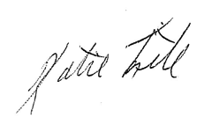

Katie Fite
Public Lands Director
WildLands Defense
PO Box 125
Boise, ID 83701
208-871-573
katie@wildlandsdefense.org

Attachments: WildLands Defense SCNF, Boise, Payette Forest mining and fuels/veg EA Objections

