Clearcuts on national forests in R-6
Analyzed and Approved by the USFS
Attempting to Serve the Public
By “restoring” the Forest

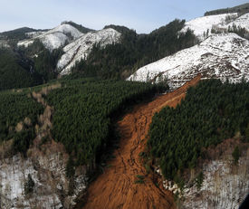

This landslide caused by the “temporary” road failure at the bottom of the clearcut is so large it blocks the stream at the bottom just out of the picture. These clearcuts were part of a so-called “restoration” timber sale in a forest in western Oregon that the EIS P&N claimed would create a healthy forest.

What was “restored’ here besides the financial bottom line for the purchaser?

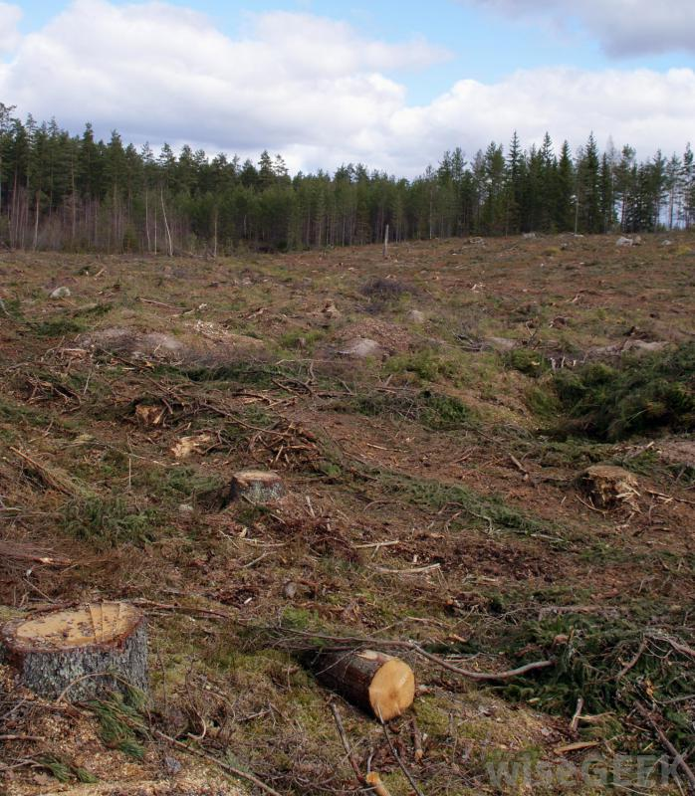
A unit on the Gifford Pinchot National Forest

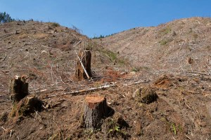
What was “restored” here?

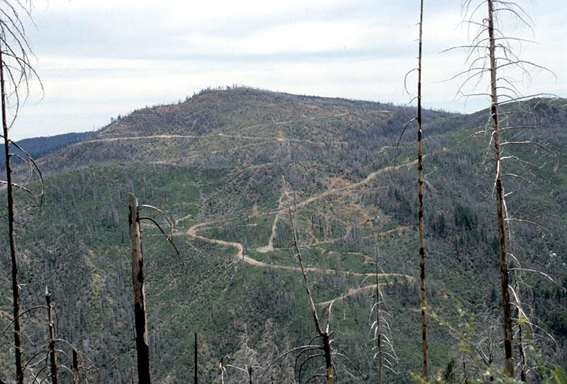
A spiderweb of sediment producing skid trails and temporary roads.

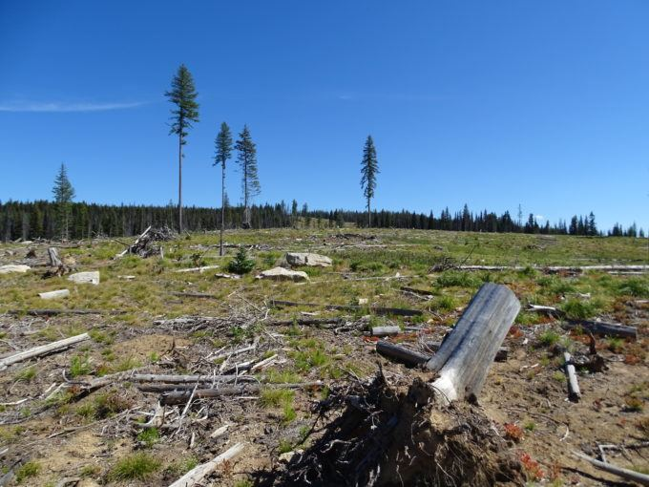

The Ranger received RO approval for this created opening larger than 40 acres and the DEIS did not tell the public why this clearcut with reserves was needed.

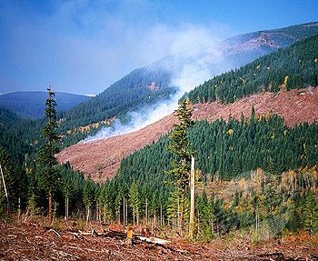
The Siuslaw National Forest

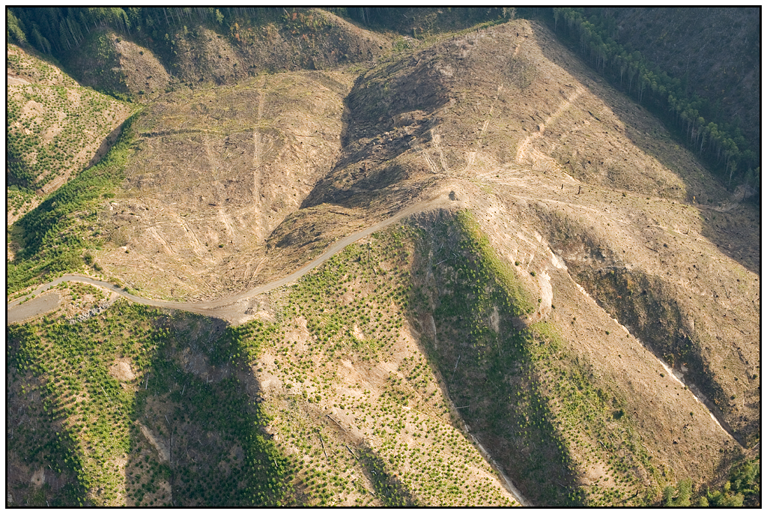
This landscape was criminally assaulted

What can I say?

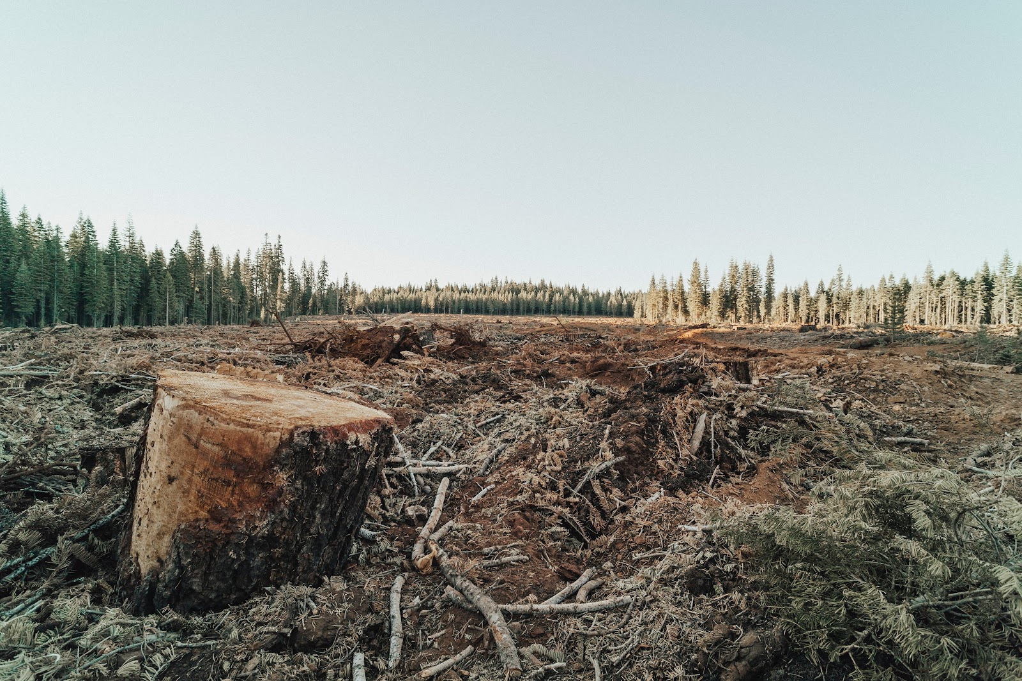
The EA gives no reason why this opening greater than 40 acres is needed.

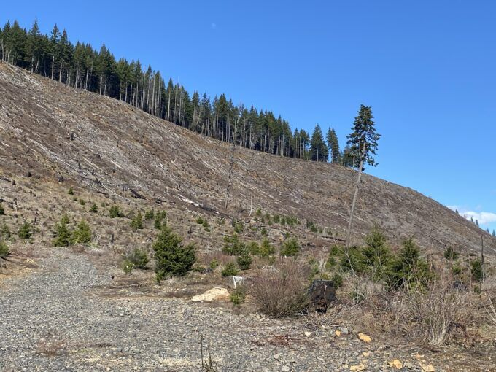
A clearcut with a reserve tree intended to make this look like it is not a clearcut.

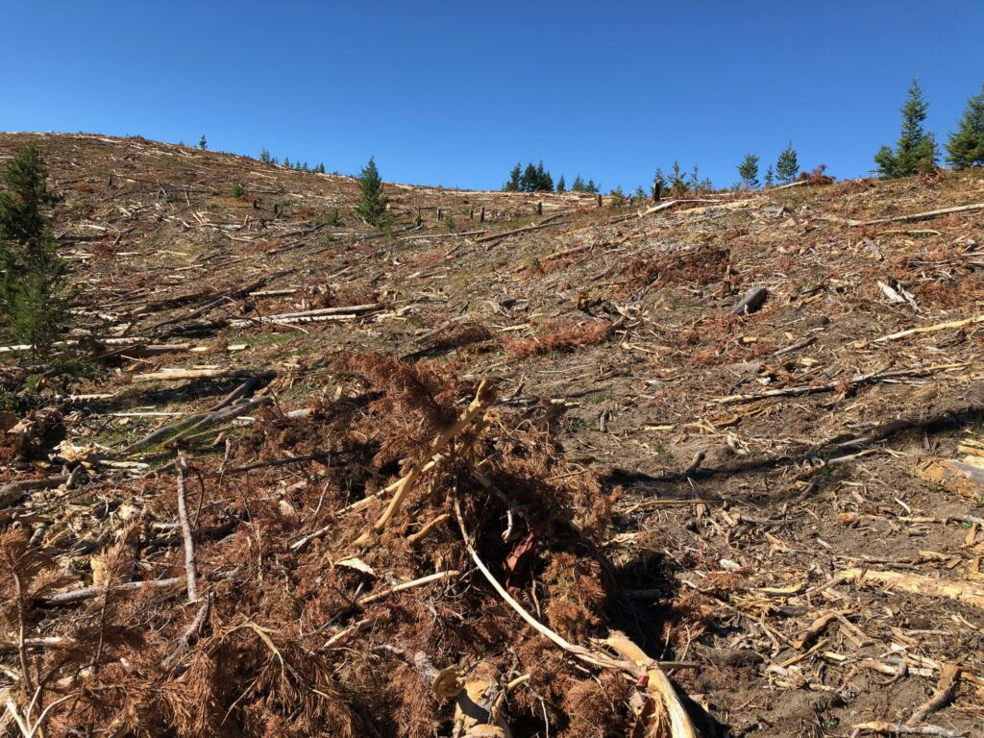
Another reserve tree.

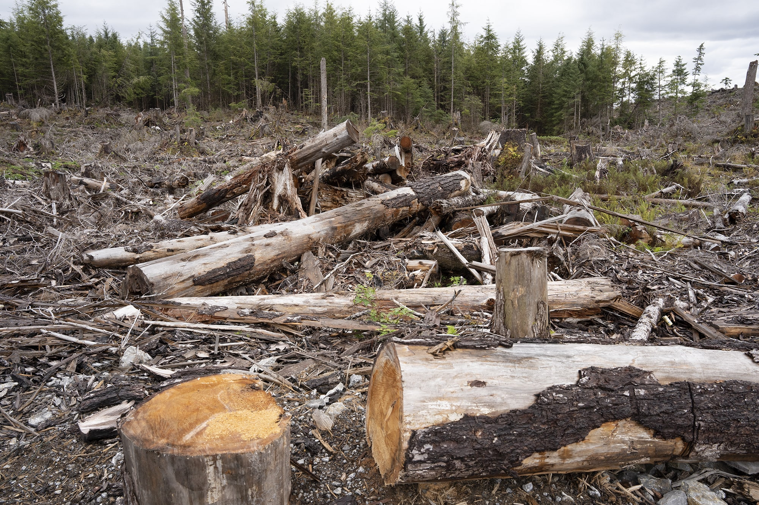

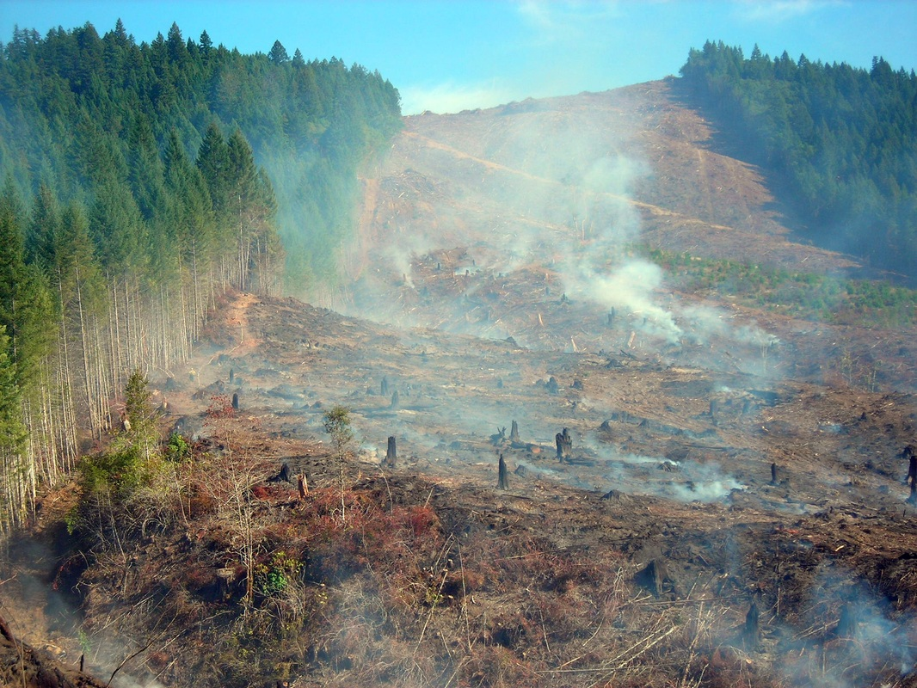

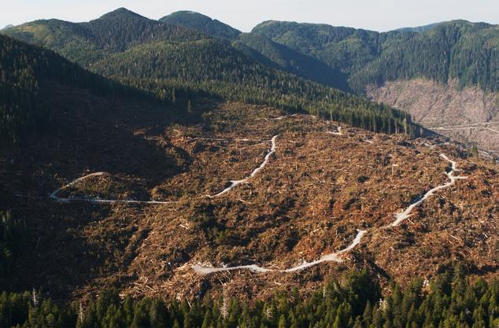

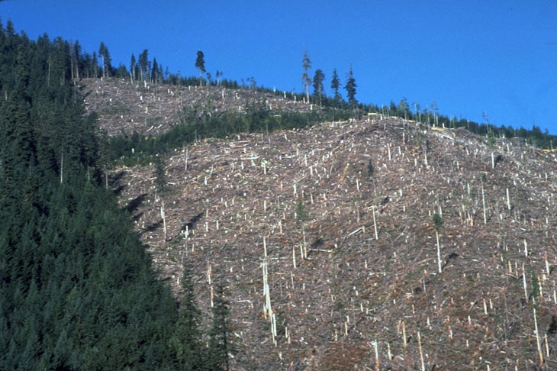
More reserve trees

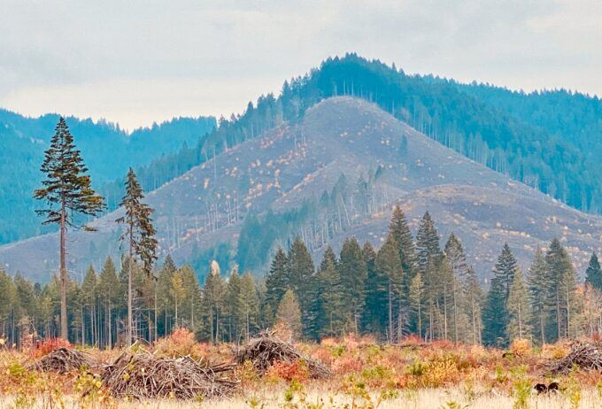
Logging operations on the Mt. Baker National Forest, Washington Cascades … lots of reserve trees.

Logging adjacent to the Gospel-Hump Wilderness that was done under the guise of fire-prevention. This is what the USFS wants in every corner of the forest. FOC file photo.

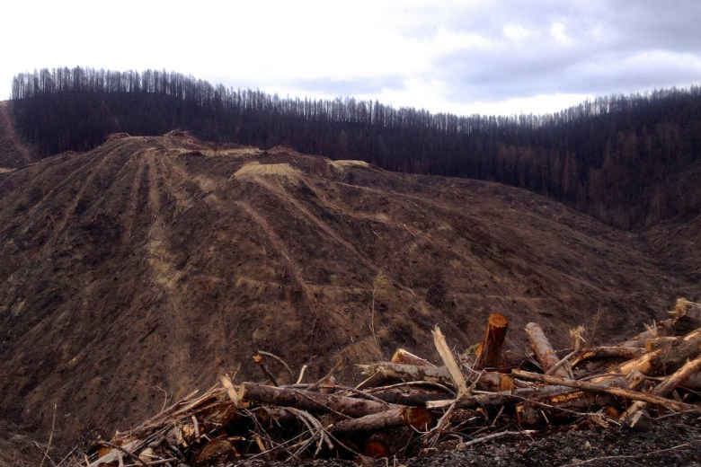

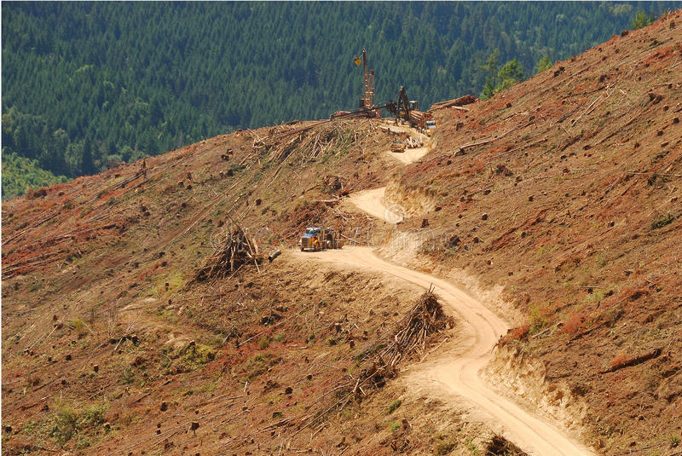

z

