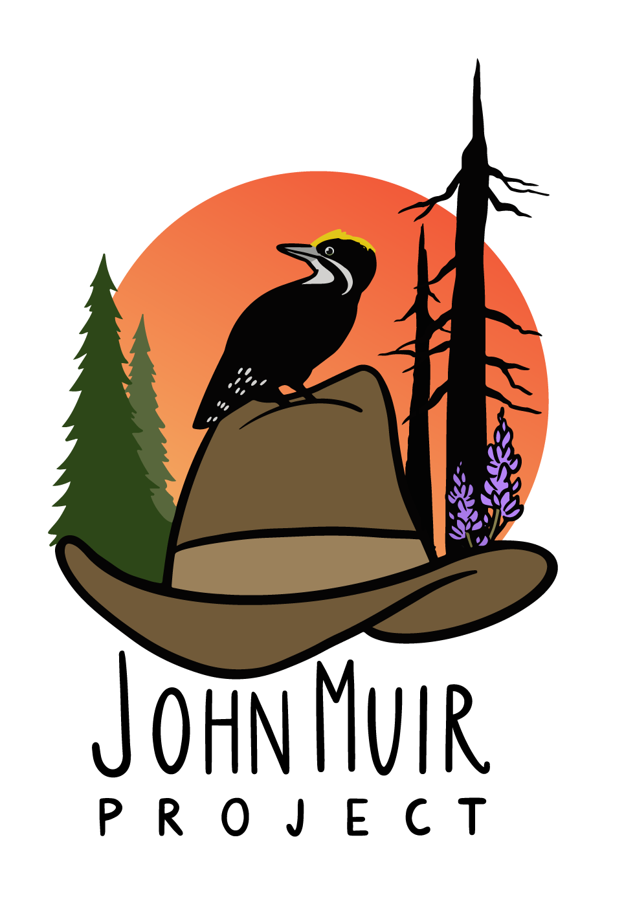

_____________________________________________________________________________________

15 July 2024

Jennifer Eberlein, Regional Forester
U.S. Forest Service, Region 5

Submitted through: https://www.fs.usda.gov/project/inyo/?project=61827

Re: “ESCCRP Objection”

Dear Ms. Eberlein,

On behalf of the John Muir Project of Earth Island Institute (Lead Objector), we are submitting this Objection on the Eastern Sierra Climate and Community Resilience Project (Project) on the Inyo National Forest. The responsible official is Fred Wong, District Ranger, Mammoth Lakes Ranger District, Inyo National Forest. This Objection generally follows the substantive content of our scoping comments, given that the draft decision and EA do not meaningfully address or mitigate the concerns and legal violations that we raised.

For the reasons expressed below, we urge you to withdraw this project and redesign it to focus on defensible space pruning immediately adjacent to homes and key evacuation routes, while allowing prescribed fire and managed wildfire in forest wildlands instead of mechanical thinning. At a minimum, a project of this magnitude and gravity, with public safety at stake due to highly uncertain and highly controversial effects regarding wildfire, an EIS must be prepared, not an EA. Moreover, an alternative that would involve (a) defensible space pruning within 200 feet or less from homes and other human structures, along with providing information to homeowners about simple steps they can take to make their homes more fireproof (e.g., ember-proof vents), and (b) prescribed burning and managed wildfire, with no prior tree removal, in the remainder of the Project area (if the Forest Service identifies some areas that are exceptions, and where the Forest Service’s data and models indicate that prescribed fire alone, even in mild fire weather, would not result in overwhelmingly lower-intensity fire effects, then hand thinning could occur in such areas prior to prescribed burning). The Forest Service recently admitted, in the Response to Comments (p. 37) in the Community Protection Project—Central and Western Slope on the Plumas National Forest (attached), that prescribed fire can be applied without prior thinning, and that prescribed fire alone is far less expensive than mechanical thinning plus slash burning. As we explain below, serious matters of public safety are at issue here, and the project as proposed would pursue an approach that will increase, not decrease, threats to communities from wildfires.

Our Objection could be resolved if the Forest Service modified the project decision to include only the following: (a) defensible space pruning within 200 feet or less from homes and other human structures, along with providing information to homeowners about simple steps they can take to make their homes more fireproof (e.g., ember-proof vents); and (b) prescribed burning and managed wildfire alone, with no thinning or other tree removal, in the remainder of the Project area. If the Forest Service identifies some areas that are exceptions, and where the Forest Service’s data and models indicate that prescribed fire alone, even in mild fire weather, would not result in overwhelmingly lower-intensity fire effects, then hand thinning could occur in such areas prior to prescribed burning.

An EIS Must Be Prepared Due to Potential Significant Effects

NEPA regulations indicate preparation of an EIS is warranted when there are likely to be significant effects to the environment and/or public safety. 40 CFR 1501.3(b).

The approach of this Project is the same approach that the Forest Service has pursued for many years, except this Project promotes this approach on a much bigger scale. In brief, it involves mechanical thinning and post-fire logging of vast forest areas distant from communities based on the claim that this will either directly stop fires from reaching towns or indirectly stop fires by making fires burn much more slowly and so much less intensely that fire suppression crews can easily halt the fire before it reaches a community. This approach is a proven failure, as we have seen in Paradise (Camp fire of 2018), Greenville (Dixie fire of 2021), Grizzly Flats (Caldor fire of 2021), and Berry Creek and Feather Falls (North Complex fire of 2020), among others. Please see the maps below showing large areas of thinning and other so-called fuel-reduction logging around towns that were largely destroyed by the Camp fire, Dixie fire, and Caldor fire, respectively.

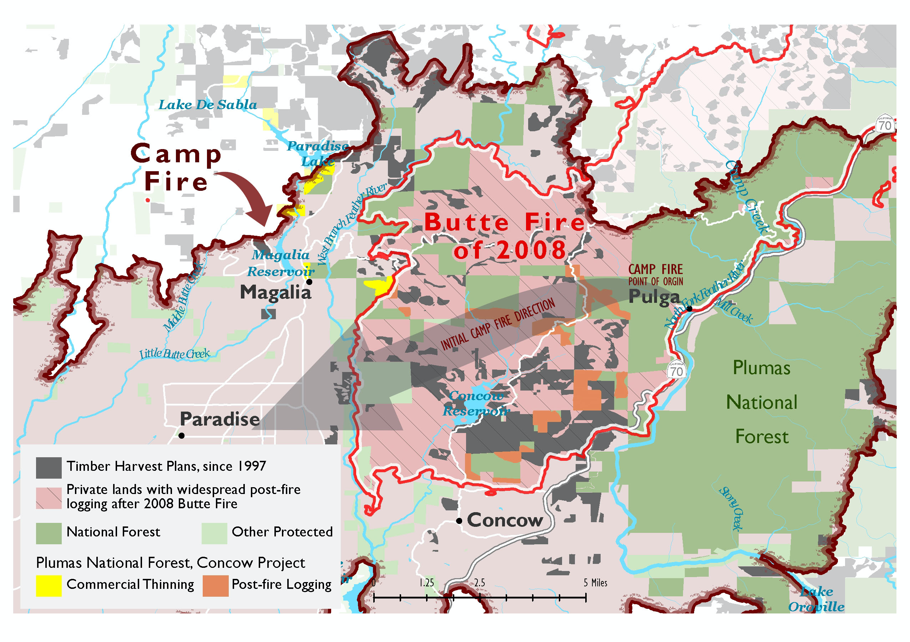

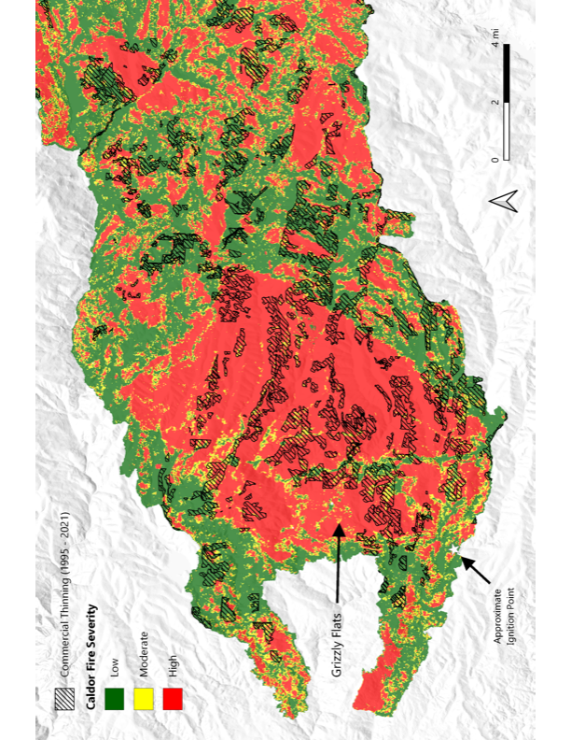

An EIS must be prepared, given the highly controversial and highly uncertain nature of this project, in terms of potential fire effects to the forest and adjacent communities due to mechanical thinning that includes widespread removal of thousands of mature trees, and the potential for “thinning” and other logging to increase, not decrease, fire severity, based on science submitted here and as recognized by the Ninth Circuit Court of Appeals in the 2020 BARK v. U.S. Forest Service case, which was highly similar to the case here (https://scholar.google.com/scholar_case?case=8163889612711152072&q=BARK+v+forest+service&hl=en&as_sdt=2006). The Ninth Circuit’s reasoning is included here:
First, the effects of the Project are highly controversial and uncertain, thus mandating the creation of an EIS. See 40 C.F.R. § 1508.27(b)(4) & (5) (listing relevant factors for whether an EIS is required, including if the project's effects are "highly controversial" and "highly uncertain"). The stated primary purpose of the CCR Project is to reduce the risk of wildfires and promote safe fire-suppression activities, but Appellants identify considerable scientific evidence showing that variable density thinning will not achieve this purpose. Considering both context and intensity, as required by 40 C.F.R. § 1508.27, this evidence raises substantial questions about the Project's environmental impact, and an EIS is required. See, e.g., Blackwood, 161 F.3d at 1212; Native Ecosystems Council, 428 F.3d at 1238-39.
"A project is `highly controversial' if there is a `substantial dispute [about] the size, nature, or effect of the major Federal action rather than the existence of opposition to a use.'" Native Ecosystems Council, 428 F.3d at 1240 (alteration in original) (quoting Blackwood, 161 F.3d at 1212). "A substantial dispute exists when evidence ... casts serious doubt upon the reasonableness of an agency's conclusions." In Def. of Animals, 751 F.3d at 1069 (quoting Babbitt, 241 F.3d at 736). "[M]ere opposition alone is insufficient to support a finding of controversy." WildEarth Guardians v. Provencio, 923 F.3d 655, 673 (9th Cir. 2019).
The EA explained that the CCR Project will use "variable density thinning" to address wildfire concerns. "In variable density thinning, selected trees of all sizes ... would be removed." This process would assertedly make the treated areas "more resilient to perturbations such as ... large-scale high-intensity fire occurrence because of the reductions in total stand density." Variable density thinning will occur in the entire Project area.
Substantial expert opinion presented by the Appellants during the administrative process disputes the USFS's conclusion that thinning is helpful for fire suppression and safety. For example, Oregon Wild pointed out in its EA comments that "[f]uel treatments have a modest effect on fire behavior, and could even make fire worse instead of better." It averred that removing mature trees is especially likely to have a net negative effect on fire suppression. Importantly, the organization pointed to expert studies and research reviews that support this assertion.
Bark also raised this issue: "It is becoming more and more commonly accepted that reducing fuels does not consistently prevent large forest fires, and seldom significantly 871*871 reduces the outcome of these large fires," citing an article from Forest Ecology and Management. Bark also directed the USFS to a recent study published in The Open Forest Science Journal, which concluded that fuel treatments are unlikely to reduce fire severity and consequent impacts, because often the treated area is not affected by fire before the fuels return to normal levels. Bark further noted that, while "Bark discussed [during the scoping process] the studies that have found that fuel reduction may actually exacerbate fire severity in some cases as such projects leave behind combustible slash, open the forest canopy to create more ground-level biomass, and increase solar radiation which dries out the understory[,] [t]he EA did not discuss this information."
Oregon Wild also pointed out in its EA comments that fuel reduction does not necessarily suppress fire. Indeed, it asserted that "[s]ome fuel can actually help reduce fire, such as deciduous hardwoods that act as heat sinks (under some conditions), and dense canopy fuels that keep the forest cool and moist and help suppress the growth of surface and ladder fuels...." Oregon Wild cited more than ten expert sources supporting this view. Importantly, even the Fuels Specialist Report produced by the USFS itself noted that "reducing canopy cover can also have the effect of increasing [a fire's rate of spread] by allowing solar radiation to dry surface fuels, allowing finer fuels to grow on ... the forest floor, and reducing the impact of sheltering from wind the canopy provides."
The effects analysis in the EA did not engage with the considerable contrary scientific and expert opinion; it instead drew general conclusions such as that "[t]here are no negative effects to fuels from the Proposed Action treatments." Appellants thus have shown a substantial dispute about the effect of variable density thinning on fire suppression. Although it is not our role to assess the merits of whether variable density thinning is indeed effective in the project area to prevent fires, or to take sides in a battle of the experts, see Greenpeace Action v. Franklin, 14 F.3d 1324, 1333 (9th Cir. 1992), NEPA requires agencies to consider all important aspects of a problem. See WildEarth Guardians, 759 F.3d at 1069-70. Throughout the USFS's investigative process, Appellants pointed to numerous expert sources concluding that thinning activities do not improve fire outcomes. In its responses to these comments and in its finding of no significant impact, the USFS reiterated its conclusions about vegetation management but did not engage with the substantial body of research cited by Appellants. This dispute is of substantial consequence because variable density thinning is planned in the entire Project area, and fire management is a crucial issue that has wide-ranging ecological impacts and affects human life. When one factor alone raises "substantial questions" about whether an agency action will have a significant environmental effect, an EIS is warranted. See Ocean Advocates v. U.S. Army Corps of Eng'rs, 402 F.3d 846, 865 (9th Cir. 2005) ("We have held that one of [the NEPA intensity] factors may be sufficient to require preparation of an EIS in appropriate circumstances."). Thus, the USFS's decision not to prepare an EIS was arbitrary and capricious. See Blackwood, 161 F.3d at 1213 (holding that conflicting evidence on the effects of ecological intervention in post-fire landscapes made a proposed project highly uncertain, thus requiring an EIS).
What about the effect of mechanical thinning on wildfire severity in mixed-conifer and ponderosa pine forests? The Forest Service’s own scientists (Lesmeister et al. 2021) recently conducted a massive, landmark 30-year study—a substantial portion of which was conducted in such forests—and found that, in these forest types (most frequent fire regime), the densest forests with the highest biomass, highest canopy cover, and highest tree densities, on average had lower wildfire severities when fires occurred when compared to more open, lower-density forests resulting from mechanical thinning and other logging operations (see Figure 4b from Lesmeister et al. 2021 below). The Forest Service scientists concluded that more open forests with lower biomass had higher fire severity, because the type of open, lower-biomass forests resulting from thinning and other logging activities have “hotter, drier, and windier microclimates, and those conditions decrease dramatically over relatively short distances into the interior of older forests with multi-layer canopies and high tree density...”

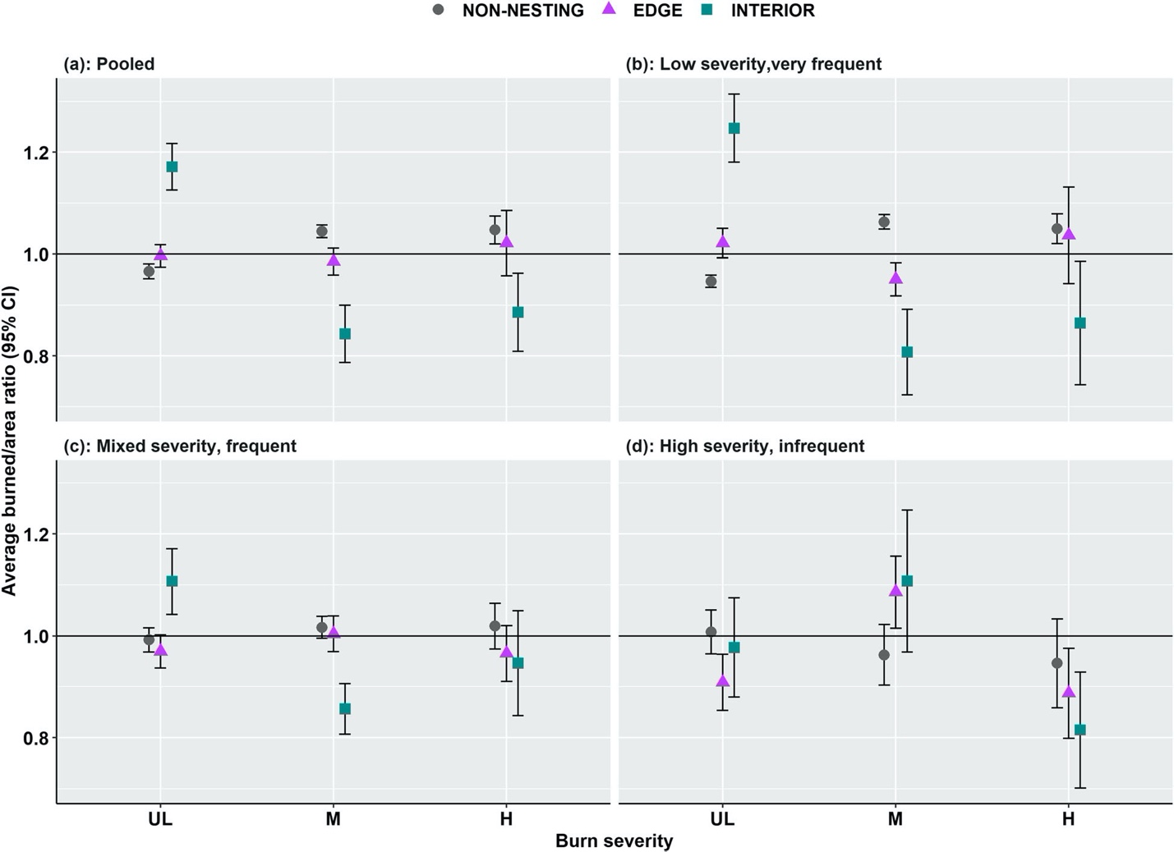

(Figure 4 from Lesmeister et al. 2021—values above 1.0 are relatively more likely, and values below 1.0 are relatively less likely)

Notably, Lesmeister et al. (2021) made the same finding in their analysis of more mesic forests, including mesic mixed-conifer forests.
Other Forest Service scientists, in Lydersen et al. (2014), reported the following finding in the 257,000-acre Rim fire of 2013:
“Density of small to intermediate size trees (20–40 cm dbh in the analysis with all plots and both 40–60 cm and 60–80 cm dbh in the analysis excluding plots burned on a plume-dominated day) were also related to Rim Fire severity, with plots with a greater small tree density tending to burn with lower severity.”
The very largest scientific analysis ever conducted in dry forests on the subject of tree removal and wildfire severity, Bradley et al. (2016), found that forests completely protected from tree removal had the lowest fire severity, while forests with some limited tree removal allowed had higher levels of fire severity, and forests with the fewest environmental protections and the most tree removal had the highest fire severity. The authors concluded the following:
“We found forests with higher levels of protection [from tree removal] had lower severity values even though they are generally identified as having the highest overall levels of biomass and fuel loading. Our results suggest a need to reconsider current overly simplistic assumptions about the relationship between forest protection and fire severity in fire management and policy.”
Hanson (2021) made similar findings in dry forests in the approximately 380,000-acre Creek fire of 2020 in the southern Sierra Nevada, reporting that, based on the Forest Service’s own data, forests with previous logging under the rubric of “fuel reduction”—specifically, mechanical thinning and post-fire logging—had overall higher fire severity than unmanaged forests.

More recently, scientists have begun looking at another key question regarding mechanical thinning and wildfire severity in dry forests, related to overall combined tree mortality from thinning itself and subsequent wildfire. These studies have consistently found that mechanical thinning kills more trees than it prevents from being killed in mature and old dry forests, including Baker and Hanson (2022) (pertaining to the Caldor fire of 2021 in the northern Sierra Nevada), and DellaSala et al. (2022) (pertaining to the Wallow fire of 2011 in Arizona). Baker and Hanson (2022) explained why some studies have erroneously reported that mechanical thinning is effective as a wildfire management approach:
“Despite controversy regarding thinning, there is a body of scientific literature that suggests commercial thinning should be scaled up across western US forest landscapes as a wildfire management strategy. This raises an important question: what accounts for the discrepancy on this issue in the scientific literature? We believe several factors are likely to largely explain this discrepancy. First and foremost, because most previous research has not accounted for tree mortality from thinning itself, prior to the wildfire-related mortality, such research has underreported tree mortality in commercial thinning areas relative to unthinned forests. Second, some prior studies have not controlled for vegetation type, which can lead to a mismatch when comparing severity in thinned areas to the rest of the fire area given that thinning necessarily occurs in conifer forests but unthinned areas can include large expanses of non-conifer vegetation types that burn almost exclusively at high severity, such as grasslands and chaparral. Third, some research reporting effectiveness of commercial thinning in terms of reducing fire severity has been based on the subjective location of comparison sample points between thinned and adjacent unthinned forests. Fourth, reported results have often been based on theoretical models, which subsequent research has found to overestimate the effectiveness of thinning. Last, several case studies draw conclusions about the effectiveness of thinning as a wildfire management strategy when the results of those studies do not support such a conclusion, as reviewed in DellaSala et al. (2022).” (internal citations omitted)
Finally, with regard to the common misconception that mature and old-growth stands are “overgrown”, and have too many smaller trees relative to historical forests, Baker et al. (2023) meticulously documented the fact that this notion stems from a pattern of scientific omissions in studies funded by the Forest Service. This pattern of omissions of peer-reviewed, published reply articles, which refuted and discredited U.S. Forest Service response articles, created a “falsification” of the scientific record regarding historical forest density and fire regimes. The corrected record shows that historical forests were much denser on average than assumed by the Forest Service and were shaped by mixed-severity fire, not merely low-severity fire.

Below is a summary of numerous scientific sources, in chronological order, in key subject areas that implicate both the impacted environment as well as public safety. Key findings are quoted and/or summarized, and sources authored or co-authored by U.S. Forest Service scientists are indicated in bold.

A large body of scientific evidence and opinion, including from a growing group of U.S. Forest Service scientists, concludes that thinning—including thinning-plus-burning—and post-fire logging/clearcutting increase overall tree mortality and carbon emissions, make wildfires spread faster and/or burn more severely, and our current funding and management focus on tree cutting and removal in wildland forests is putting nearby communities at greater risk.

Calkin, D.E., Barrett, K., Cohen, J.D., Finney, M.A., Pyne, S.J., and Quarles, S.L. (co-authored by U.S. Forest Service). 2023. Wildland-urban fire disasters aren’t actually a wildfire problem. Proceedings of the National Academy of Sciences of the United States of America. 120: e2315797120.

The authors criticized the current federal management approach embodied in the 2022 Wildfire Crisis Strategy, and in the 2021 Infrastructure Act and 2022 Inflation Reduction Act, that is focused on thinning tens of millions of acres of public, private, and Tribal forests in the western U.S. The authors concluded that we must recognize that wildfire in forests and other wildlands is not only inevitable, but also there is an “ecological necessity” that wildfires occur for native biodiversity benefits. The scientists concluded that the “best way” to protect homes and lives is to focus attention and resources directly on communities, using proven methods to make them fire safe, noting that the current approach is leading to more, not fewer, losses of homes and lives. They promoted “direct funding and technical assistance to communities”, instead of spending many billions of dollars managing forests distant from homes.
USFS (U.S. Forest Service) (2022). Gallinas-Las Dispensas Prescribed Fire Declared Wildfire Review. U.S. Forest Service, Office of the Chief, Washington, D.C.
Thinning followed by burning caused a massive fire that destroyed communities.

Thinning reduced canopy cover, increasing growth of combustible grasses; associated pile burning caused a huge wildfire, spreading rapidly through thinned areas, burning many homes.

Lesmeister, D.B., et al. (co-authored by U.S. Forest Service). 2019. Mixed-severity wildfire and habitat of an old-forest obligate. Ecosphere10: Article e02696.

Denser, older forests with high canopy cover had lower fire severity.

“Thinned forests have more open conditions, which are associated with higher temperatures,
lower relative humidity, higher wind speeds, and increasing fire intensity. Furthermore, live and dead fuels in young forest or thinned stands with dense saplings or shrub understory will be drier, making ignition and high heat more likely, and the rate of spread higher because of the relative lack of wind breaks provided by closed canopies with large trees.”

Lesmeister, D.B., et al. (co-authored by U.S. Forest Service). 2021. Northern spotted owl nesting forests as fire refugia: a 30-year synthesis of large wildfires. Fire Ecology 17: Article 32.

More open forests with lower biomass had higher fire severity, because the type of open, lower-biomass forests resulting from thinning and other logging activities have “hotter, drier, and windier microclimates, and those conditions decrease dramatically over relatively short distances into the interior of older forests with multi-layer canopies and high tree density…”

Reilly, M.J., et al. (co-authored by U.S. Forest Service). 2022. Cascadia Burning: The historic, but not historically unprecedented, 2020 wildfires in the Pacific Northwest, USA. Ecosphere 13: e4070.

Weather conditions primarily determined fire severity, and forest density was not a factor.

“We found minimal difference in burn severity among stand structural types related to previous management in the 2020 fires. Adaptation strategies for similar fires in the future could benefit by focusing on ignition prevention, fire suppression, and community preparedness, as opposed to fuel treatments that are unlikely to mitigate fire severity during extreme weather.”
North, M.P., S.L. Stephens, B.M. Collins, J.K. Agee, G. Aplet, J.F. Franklin, and P.Z. Fule (co-authored by U.S. Forest Service). 2015. Reform forest fire management. Science 349: 1280-1281.
“…fire is usually more efficient, cost-effective, and ecologically beneficial than mechanical treatments.”
Meigs, G.W., et al. (co-authored by U.S. Forest Service). 2020. Influence of topography and fuels on fire refugia probability under varying fire weather in forests of the US Pacific Northwest. Canadian Journal of Forest Research 50: 636-647.

Forests with higher pre-fire biomass are more likely to experience low-severity fire.

Thompson, J.R., Spies, T.A., Ganio, L.M. (co-authored by U.S. Forest Service). 2007. Reburn severity in managed and unmanaged vegetation in a large wildfire. Proceedings of the National Academy of Sciences of the United States of America 104: 10743–10748.
“Areas that were salvage-logged and planted after the initial fire burned more severely than comparable unmanaged areas.”
Thompson, J.R., Spies, T.A. (co-authored by U.S. Forest Service). 2009. Vegetation and weather explain variation in crown damage within a large mixed-severity wildfire. Forest Ecology and Management 258: 1684-1694.

Mature forests with higher canopy cover had lower fire severity.
Thompson, J., and T.A. Spies (co-authored by U.S. Forest Service). 2010. Exploring Patterns of Burn Severity in the Biscuit Fire in Southwestern Oregon. Fire Science Brief 88: 1-6.

“Areas that burned with high severity…in a previous wildfire (in 1987, 15 years prior) were more likely to burn with high severity again in the 2002 Biscuit Fire. Areas that were salvage-logged and planted following the 1987 fire burned with somewhat higher fire severity than equivalent areas that had not been logged and planted.”
Graham, R., et al. (U.S. Forest Service). 2012. Fourmile Canyon Fire Findings. Gen. Tech. Rep. RMRS-GTR-289. Fort Collins, CO: U.S. Department of Agriculture, Forest Service, Rocky Mountain Research Station. 110 p.

Thinned forests “were burned more severely than neighboring areas where the fuels were not treated”, and 162 homes were destroyed by the Fourmile Canyon Fire (see Figs. 45 and 46).
Morris, W.G. (U.S. Forest Service). 1940. Fire weather on clearcut, partly cut, and virgin timber areas at Westfir, Oregon. Timberman 42: 20-28.

“This study is concerned with one of these factors - the fire-weather conditions near ground level - on a single operation during the first summer following logging. These conditions were found to be more severe in the clear-cut area than in either the heavy or light partial cutting areas and more severe in the latter areas than in virgin timber.”

Countryman, C.M. (U.S. Forest Service). 1956. Old-growth conversion also converts fire climate. Fire Control Notes 17: 15-19.

Partial cutting (thinning) increases wildfire severity, due to microclimate impacts, regardless of whether or how the slash debris is treated.
“Although the general relations between weather factors, fuel moisture, and fire behavior are fairly well known, the importance of these changes following conversion and their combined effect on fire behavior and control is not generally recognized. The term ‘fireclimate,’ as used here, designates the environmental conditions of weather and fuel moisture that affect fire behavior. It does not consider fuel created by slash because regardless of what forest managers do with slash, they still have to deal with the new fireclimate. In fact, the changes in wind, temperature, humidity, air structure, and fuel moisture may result in greater changes in fire behavior and size of control job than does the addition of more fuel in the form of slash.”
“Conversion which opens up the canopy by removal of trees permits freer air movement and more sunlight to reach the ground. The increased solar radiation in turn results in higher temperatures, lower humidity, and lower fuel moisture. The magnitude of these changes can be illustrated by comparing the fireclimate in the open with that in a dense stand.”
“A mature, closed stand has a fireclimate strikingly different from that in the open. Here nearly all of the solar radiation is intercepted by the crowns. Some is reflected back to space and the rest is converted to heat and distributed in depth through the crowns. Air within the stand is warmed by contact with the crowns, and the ground fuels are in turn warmed only by contact with the air. The temperature of fuels on the ground thus usually approximates air temperature within the stand.”
“Temperature profiles in a dense, mixed conifer stand illustrate this process (fig. 2). By 8 o'clock in the morning, air within the crowns had warmed to 68° F. Air temperature near the ground was only 50°. By 10 o'clock temperatures within the crowns had reached 82° and, although the heat had penetrated to lower levels, air near the surface at 77° was still cooler than at any other level. At 2:00 p.m., air temperature within the stand had become virtually uniform at 87°. In the open less than one-half mile away, however, the temperature at the surface of pine litter reached 153° at 2:00 p.m.”
“Because of the lower temperature and higher humidity, fuels within the closed stand are more moist than those in the open under ordinary weather conditions. Typically, when moisture content is 3 percent in the open, 8 percent can be expected in the stand.”
“Moisture and temperature differences between open and closed stands have a great effect on both the inception and the behavior of fire. For example, fine fuel at 8-percent moisture content will require nearly one-third more heat for ignition than will the same fuel at 3-percent moisture content. Thus, firebrands that do not contain enough heat to start a fire in a closed stand may readily start one in the open.”
“When a standard fire weather station in the open indicates a temperature of 85° F., fuel moisture of 4 percent, and a wind velocity of 15 m.p.h.--not unusual burning conditions in the West--a fire starting on a moderate slope will spread 4.5 times as fast in the open as in a closed stand. The size of the suppression job, however, increases even more drastically.”
“Greater rate of spread and intensity of burning require control lines farther from the actual fire, increasing the length of fireline. Line width also must be increased to contain the hotter fire. Less production per man and delays in getting additional crews complicate the control problem on a fast-moving fire. It has been estimated that the size of the suppression job increases nearly as the square of the rate of forward spread. Thus, fire in the open will require 20 times more suppression effort. In other words, for each man required to control a surface fire in a mature stand burning under these conditions, 20 men will be required if the area is clear cut.”
“Methods other than clear cutting, of course, may bring a less drastic change in fireclimate. Nevertheless, the change resulting from partial cutting can have important effects on fire. The moderating effect that a dense stand has on the fireclimate usually results in slow-burning fires. Ordinarily, in dense timber only a few days a year have the extreme burning conditions under which surface fires produce heat rapidly enough to carry the fire into the crowns. Partial cutting can increase the severity of the fireclimate enough to materially increase the number of days when disastrous crown fires can occur.”
SNEP (co-authored by U.S. Forest Service). 1996. Sierra Nevada Ecosystem Project, Final Report to Congress: Status of the Sierra Nevada. Vol. I: Assessment summaries and management strategies. Davis, CA: University of California, Davis, Center for Water and Wildland Resources.
“Timber harvest, through its effects on forest structure, local microclimate, and fuel accumulation, has increased fire severity more than any other recent human activity.”
Chen, J., et al. (co-authored by U.S. Forest Service). 1999. Microclimate in forest ecosystem and landscape ecology: Variations in local climate can be used to monitor and compare the effects of different management regimes. BioScience 49: 288–297.

When moving from open forest areas, resulting from logging, and into dense forests with high canopy cover, “there is generally a decrease in daytime summer temperatures but an increase in humidity…”

The authors reported a 5° C difference in ambient air temperature between a closed-canopy mature forest and a forest with partial cutting, like a commercial thinning unit (Fig. 4b), and noted that such differences are even greater than the increases in temperature predicted due to anthropogenic climate change.

Dombeck, M. (U.S. Forest Service Chief). 2001. How Can We Reduce the Fire Danger in the Interior West. Fire Management Today 61: 5-13.

“Some argue that more commercial timber harvest is needed to remove small-diameter trees and brush that are fueling our worst wildlands fires in the interior West. However, small-diameter trees and brush typically have little or no commercial value. To offset losses from their removal, a commercial operator would have to remove large, merchantable trees in the overstory. Overstory removal lets more light reach the forest floor, promoting vigorous forest regeneration. Where the overstory has been entirely removed, regeneration produces thickets of 2,000 to 10,000 small trees per acre, precisely the small-diameter materials that are causing our worst fire problems. In fact, many large fires in 2000 burned in previously logged areas laced with roads. It seems unlikely that commercial timber harvest can solve our forest health problems.”

Hanson, C.T. 2021. Is “Fuel Reduction” Justified as Fire Management in Spotted Owl Habitat? Birds 2: 395-403.

Thinning followed by burning and post-fire logged areas had higher overall fire
severity.

“Within the forest types inhabited by California Spotted Owls, high-severity fire occurrence was not higher overall in unmanaged forests and was not associated with the density of pre-fire snags from recent drought in the Creek Fire, contrary to expectations under the fuel reduction hypothesis. Moreover, fuel-reduction logging in California Spotted Owl habitats was associated with higher fire severity in most cases. The highest levels of high-severity fire were in the categories with commercial logging (post-fire logging, private commercial timberlands, and commercial thinning), while the three categories with lower levels of high-severity fire were in forests with no recent forest management or wildfire, less intensive noncommercial management, and unmanaged forests with re-burning of mixed-severity wildfire, respectively.”

Baker, B.C., and C.T. Hanson. 2022. Cumulative tree mortality from commercial thinning and a large wildfire in the Sierra Nevada, California. Land 11: Article 995.

Thinning followed by burning increases overall fire severity.

“Similar to the findings of Hanson (2022) in the Antelope Fire of 2021 in northern California, in our investigation of the Caldor Fire of 2021 we found significantly higher cumulative severity in forests with commercial thinning than in unthinned forests, indicating that commercial thinning killed significantly more trees than it prevented from being killed in the Caldor Fire…Despite controversy regarding thinning, there is a body of scientific literature that suggests commercial thinning should be scaled up across western US forest landscapes as a wildfire management strategy. This raises an important question: what accounts for the discrepancy on this issue in the scientific literature? We believe several factors are likely to largely explain this discrepancy. First and foremost, because most previous research has not accounted for tree mortality from thinning itself, prior to the wildfire-related mortality, such research has underreported tree mortality in commercial thinning areas relative to unthinned forests. Second, some prior studies have not controlled for vegetation type, which can lead to a mismatch when comparing severity in thinned areas to the rest of the fire area given that thinning necessarily occurs in conifer forests but unthinned areas can include large expanses of non-conifer vegetation types that burn almost exclusively at high severity, such as grasslands and chaparral. Third, some research reporting effectiveness of commercial thinning in terms of reducing fire severity has been based on the subjective location of comparison sample points between thinned and adjacent unthinned forests. Fourth, reported results have often been based on theoretical models, which subsequent research has found to overestimate the effectiveness of thinning. Last, several case studies draw conclusions about the effectiveness of thinning as a wildfire management strategy when the results of those studies do not support such a conclusion, as reviewed in DellaSala et al. (2022).” (internal citations omitted)

DellaSala, D.A., B.C. Baker, C.T. Hanson, L. Ruediger, and W.L. Baker. 2022. Have western USA fire suppression and megafire active management approaches become a contemporary Sisyphus? Biological Conservation 268: Article 109499.

Thinning followed by burning increases overall fire severity.

With regard to a previous U.S. Forest Service study claiming that commercial thinning effectively reduced fire severity in the large Wallow fire of 2011 in Arizona, DellaSala et al. (2022, Section 5.1) conducted a detailed accuracy check and found that the previous analysis had dramatically underreported high-severity fire in commercial thinning units, and forests with commercial thinning in fact had higher fire severity, overall.

DellaSala et al. (2022, Section 5.2) also reviewed several U.S. Forest Service studies relied upon by Prichard et al. (2021) for the claim that commercial thinning is an effective fire management approach and found that the actual results of these cited studies did not support that conclusion.

Beschta, R.L.; Frissell, C.A.; Gresswell, R.; Hauer, R.; Karr, J.R.; Minshall, G.W.; Perry, D.A.; Rhodes, J.J. 1995. Wildfire and salvage logging. Eugene, OR: Pacific Rivers Council.
“We also need to accept that in many drier forest types throughout the region, forest management may have set the stage for fires larger and more intense than have occurred in at least the last few hundred years.”
“With respect to the need for management treatments after fires, there is generally no need for urgency, nor is there a universal, ecologically-based need to act at all. By acting quickly, we run the risk of creating new problems before we solve the old ones.”
“[S]ome argue that salvage logging is needed because of the perceived increased likelihood that an area may reburn. It is the fine fuels that carry fire, not the large dead woody material. We are aware of no evidence supporting the contention that leaving large dead woody material significantly increases the probability of reburn.”

Morrison, P.H. and K.J. Harma. 2002. Analysis of Land Ownership and Prior Land Management Activities Within the Rodeo & Chediski Fires, Arizona. Pacific Biodiversity Institute, Winthrop, WA. 13 pp.

Previous logging was associated with higher fire severity.
Donato DC, Fontaine JB, Campbell JL, Robinson WD, Kauffman JB, Law BE. 2006. Science 311: 352.
“In terms of short-term fire risk, a reburn in [postfire] logged stands would likely exhibit elevated rates of fire spread, fireline intensity, and soil heating impacts…Postfire logging alone was notably incongruent with fuel reduction goals.”
Hanson, C.T., Odion, D.C. 2006. Fire Severity in mechanically thinned versus unthinned forests of the Sierra Nevada, California. In: Proceedings of the 3rd International Fire Ecology and Management Congress, November 13-17, 2006, San Diego, CA.
“In all seven sites, combined mortality [thinning and fire] was higher in thinned than in unthinned units. In six of seven sites, fire-induced mortality was higher in thinned than in unthinned units…Mechanical thinning increased fire severity on the sites currently available for study on national forests of the Sierra Nevada.”
Platt, R.V., et al. 2006. Are wildfire mitigation and restoration of historic forest structure compatible? A spatial modeling assessment. Annals of the Assoc. Amer. Geographers 96: 455-470.

“Compared with the original conditions, a closed canopy would result in a 10 percent reduction in the area of high or extreme fireline intensity. In contrast, an open canopy [from thinning] has the opposite effect, increasing the area exposed to high or extreme fireline intensity by 36 percent. Though it may appear counterintuitive, when all else is equal open canopies lead to reduced fuel moisture and increased midflame windspeed, which increase potential fireline intensity.”

Cruz, M.G, and M.E. Alexander. 2010. Assessing crown fire potential in coniferous forests of western North America: A critique of current approaches and recent simulation studies. Int. J. Wildl. Fire. 19: 377–398.

The fire models used by the U.S. Forest Service falsely predict effective reduction in crown fire potential from thinning:
“Simulation studies that use certain fire modelling systems (i.e. NEXUS, FlamMap, FARSITE, FFE-FVS (Fire and Fuels Extension to the Forest Vegetation Simulator), Fuel Management Analyst (FMAPlus), BehavePlus) based on separate implementations or direct integration of Rothermel’s surface and crown rate of fire spread models with Van Wagner’s crown fire transition and propagation models are shown to have a significant underprediction bias when used in assessing potential crown fire behaviour in conifer forests of western North America. The principal sources of this underprediction bias are shown to include: (i) incompatible model linkages; (ii) use of surface and crown fire rate of spread models that have an inherent underprediction bias; and (iii) reduction in crown fire rate of spread based on the use of unsubstantiated crown fraction burned functions. The use of uncalibrated custom fuel models to represent surface fuelbeds is a fourth potential source of bias.”
DellaSala et al. (2013) (letter from over 200 scientists):

“Numerous studies also document the cumulative impacts of post-fire logging on natural ecosystems, including…accumulation of logging slash that can add to future fire risks…”

DellaSala et al. (2015) (letter from over 200 scientists):
“Post-fire logging has been shown to eliminate habitat for many bird species that depend on snags, compact soils, remove biological legacies (snags and downed logs) that are essential in supporting new forest growth, and spread invasive species that outcompete native vegetation and, in some cases, increase the flammability of the new forest. While it is often claimed that such logging is needed to restore conifer growth and lower fuel hazards after a fire, many studies have shown that logging tractors often kill most conifer seedlings and other important re-establishing vegetation and actually increases flammable logging slash left on site. Increased chronic sedimentation to streams due to the extensive road network and runoff from logging on steep slopes degrades aquatic organisms and water quality.”
Bradley, C.M. C.T. Hanson, and D.A. DellaSala. 2016. Does increased forest protection correspond to higher fire severity in frequent-fire forests of the western USA? Ecosphere 7: article e01492.
In the largest study on this subject ever conducted in western North American, the authors found that the more trees that are removed from forests through logging, the higher the fire severity overall:
“We investigated the relationship between protected status and fire severity using the Random Forests algorithm applied to 1500 fires affecting 9.5 million hectares between 1984 and 2014 in pine (Pinus ponderosa, Pinus jeffreyi) and mixed-conifer forests of western United States, accounting for key topographic and climate variables. We found forests with higher levels of protection [from logging] had lower severity values even though they are generally identified as having the highest overall levels of biomass and fuel loading.”
Dunn, C.J., et al. 2020. How does tree regeneration respond to mixed-severity fire in the western Oregon Cascades, USA? Ecosphere 11: Article e03003.

Forests that burned at high-severity had lower, not higher, overall pre-fire tree densities.

Moomaw et al. (2020) (letter from over 200 scientists: https://johnmuirproject.org/2020/05/breaking-news-over-200-top-u-s-climate-and-forest-scientists-urge-congress-protect-forests-to-mitigate-climate-crisis/):
“Troublingly, to make thinning operations economically attractive to logging companies, commercial logging of larger, more fire-resistant trees often occurs across large areas. Importantly, mechanical thinning results in a substantial net loss of forest carbon storage, and a net increase in carbon emissions that can substantially exceed those of wildfire emissions (Hudiburg et al. 2013, Campbell et al. 2012). Reduced forest protections and increased logging tend to make wildland fires burn more intensely (Bradley et al. 2016). This can also occur with commercial thinning, where mature trees are removed (Cruz et al. 2008, Cruz et al. 2014). As an example, logging in U.S. forests emits 10 times more carbon than fire and native insects combined (Harris et al. 2016). And, unlike logging, fire cycles nutrients and helps increase new forest growth.”
Moomaw et al. (2021) (letter from over 200 scientists: https://bit.ly/3BFtIAg):
“[C]ommercial logging conducted under the guise of “thinning” and “fuel reduction” typically removes mature, fire-resistant trees that are needed for forest resilience. We have watched as one large wildfire after another has swept through tens of thousands of acres where commercial thinning had previously occurred due to extreme fire weather driven by climate change. Removing trees can alter a forest’s microclimate, and can often increase fire intensity. In contrast, forests protected from logging, and those with high carbon biomass and carbon storage, more often burn at equal or lower intensities when fires do occur.
Bartowitz, K.J., et al. 2022. Forest Carbon Emission Sources Are Not Equal: Putting Fire, Harvest, and Fossil Fuel Emissions in Context. Front. For. Glob. Change 5: Article 867112.

The authors found that logging conducted as commercial thinning, which involves removal of some mature trees, substantially increases carbon emissions relative to wildfire alone, and commercial thinning “causes a higher rate of tree mortality than wildfire.”
Evers, C., et al. 2022. Extreme Winds Alter Influence of Fuels and Topography on Megafire Burn Severity in Seasonal Temperate Rainforests under Record Fuel Aridity. Fire 5: Article 41.
The authors found that dense, mature/old forests with high biomass and canopy cover tended to have lower fire severity, while more open forests with lower canopy cover and less biomass burned more severely.
Baker, W.L., C.T. Hanson, M.A. Williams, and D.A. DellaSala. 2023. Countering Omitted Evidence of Variable Historical Forests and Fire Regime in Western USA Dry Forests: The Low-Severity-Fire Model Rejected. Fire 6: Article 146.
A pattern of omissions of peer-reviewed, published reply articles, which refuted and discredited U.S. Forest Service response articles, created a “falsification” of the scientific record regarding historical forest density and fire regimes. The corrected record shows that historical forests were much denser on average than assumed by the Forest Service and were shaped by mixed-severity fire, not merely low-severity fire.

The only effective way to protect homes from fire is home-hardening and defensible space pruning within 100 to 200 feet of homes or less.

Cohen, J.D. (U.S. Forest Service). 2000. Preventing disaster: home ignitability in the wildland-urban interface. Journal of Forestry 98: 15-21.

The only relevant zone to protect homes from wildland fire is within approximately 135 feet or less from each home—not out in wildland forests.

Gibbons P, van Bommel L, Gill MA, Cary GJ, Driscoll DA, Bradstock RA, Knight E, Moritz MA, Stephens SL, Lindenmayer DB (2012) Land management practices associated with house loss in wildfires. PLoS ONE 7: Article e29212.

Defensible space pruning within less than 130 feet from homes was effective at protecting homes from wildfires, while vegetation management in remote wildlands was not. A modest additional benefit for home safety was provided by prescribed burning less than 500 meters (less than 1641 feet) from homes.

Syphard, A.D., T.J. Brennan, and J.E. Keeley. 2014. The role of defensible space for residential structure protection during wildfires. Intl. J. Wildland Fire 23: 1165-1175.

Vegetation management and removal beyond approximately 100 feet from homes provides no additional benefit in terms of protecting homes from wildfires.

Tree removal is not necessary prior to conducting prescribed fire as an additional community safety buffer.

Decades of scientific studies have proven that, even in the densest forests that have not experienced fire in many decades, prescribed fire can be applied without prior tree removal, as demonstrated in the following studies:
Knapp EE, Keeley JE, Ballenger EA, Brennan TJ. 2005. Fuel reduction and coarse woody debris dynamics with early season and late season prescribed fire in a Sierra Nevada mixed conifer forest. Forest Ecology and Management 208: 383–397.
Knapp, E.E., and Keeley, J.E. 2006. Heterogeneity in fire severity within early season and late season prescribed burns in a mixed-conifer forest. Int. J. Wildland Fire 15: 37–45.
Knapp, E.E., Schwilk, D.W., Kane, J.M., Keeley, J.E., 2007. Role of burning on initial understory vegetation response to prescribed fire in a mixed conifer forest. Canadian Journal of Forest Research 37: 11–22.
van Mantgem, P.J., A.C. Caprio, N.L. Stephenson, and A.J. Das. 2016. Does prescribed fire promote resistance to drought in low elevation forests of the Sierra Nevada, California, USA? Fire Ecology 12: 13-25.
van Mantgem, P.J., N.L. Stephenson, J.J. Battles, E.K. Knapp, and J.E. Keeley. 2011. Long-term effects of prescribed fire on mixed conifer forest structure in the Sierra Nevada, California. Forest Ecology and Management 261: 989−994.

An EIS Must Be Prepared to Address the Increased Tree Mortality Caused by Thinning

The Forest Service fails to meaningfully address or analyze dissenting science that contradicts the Forest Service’s claim that mechanical thinning effectively curbs climate-driven wildfires and protects community safety. The agency must fully consider alternatives that could better accomplish the primary stated objectives of community protection from wildfires, based on the evidence presented above.

Moreover, the Forest Service has recently improperly relied on a Forest Service study, North et al. (2022), that has been thoroughly discredited and has been found to represent a “falsification of the scientific record” (Baker et al. 2023).

First, North et al. (2022) relies on previous studies by Collins and Stephens, which reported that there were only 20 to 30 trees per acre in historical Sierra Nevada forests, based on circa 1911 Forest Service field surveys. However, as we found in Baker et al. (2018), the Collins and Stephens work omitted the small-tree data in those historical datasets and failed to use correction factors that the Forest Service itself, a century ago, repeatedly stated were needed to avoid severe underestimations of forest density. The surveys were based on visually estimated distance from the transect line, but surveyors consistently overestimated distance (e.g., they would see 30 or 40 feet to their left and right but would assume they were seeing 66 feet left and right), causing a huge underestimation of forest density. Our findings in Baker et al. (2018) are uncontested by the Forest Service.

Second, North et al. (2022) misleadingly claimed that "current" forests have 150 to 200 trees per acre, but inexplicably used data from 2011 to represent supposed "current" conditions, and failed to mention that over 90% of their study areas have burned in mixed-intensity wildfires since 2011, and that a large portion of the live trees that existed a decade ago are now snags and downed logs.

The bottom line is that North et al. (2022) severely underreported historical forest density by using previous historical density estimates that have been discredited and superseded, and overreported current live tree forest density by using 2011 as their "current" condition, despite the fact that fire and drought since 2011 have dramatically reduced live tree density in their study areas.

Further, studies that have claimed success of such projects on reducing bark beetle mortality generally do not consider the treatment-caused mortality when considering the concept of a successful treatment. For instance, Fettig et al (2012) examined the effect on bark beetle-induced tree mortality of various levels of thinning in comparison to unthinned areas in mixed-conifer forests in the Sierra Nevada. While they stated that “[i]n the present study, bark beetle-caused tree mortality was relatively low the decade after thinning, never reaching a level that would be considered epidemic for either P. jeffreyi or P. ponderosa...” the authors did not consider the initial mortality event caused by the thinning treatment itself. Their measure of success was whether the level of tree mortality in thinned stands was less than that in the unthinned stands, but apparently mortality was only significant to success if caused by bark beetles. When analyzing the data they present, it is actually quite simple to glean that the overall mortality (i.e. mortality from thinning plus mortality from subsequent bark beetles) in the three thinning treatments was substantial (109 – 289 trees killed per hectare on average) compared to the overall mortality in the unthinned stands (approximately 13 trees killed per hectare on average). Granted, the number of trees killed by bark beetles was slightly lower in the thinning units (3 – 11 trees killed per hectare on average) compared to the unthinned stand (13 trees killed per hectare on average), but this pales in comparison to overall number of trees killed due to the thinning itself (see Figure 1). Another way to view this is, approximately 289 trees per hectare were killed in the most intensive treatment by the thinning itself in order to prevent 10 trees from being killed in the future by bark beetles.
Six et al. (2014) notes a similar pattern:
“Although more trees were killed overall in control units during the outbreak, all controls still retained a greater number of residual mature trees than did thinned stands as they entered the post-outbreak phase.”
And a separate study in ponderosa pine forests in the Black Hills similarly demonstrated that far more trees were killed through the actual thinning process than through a subsequent bark beetle outbreak that was more severe than that experienced in the study by Fettig et al. (2012). Negron et al (2017) examined stands in which the overall mortality (again, mortality caused by thinning plus mortality caused by bark beetles) was 242.6 trees killed per acre on average in thinned stands compared to 87.7 trees killed per acre in unthinned stands. As with other similar studies, the treatment was the primary source of mortality in the stand rather than bark beetles. By the end of the outbreak, not only were there more trees in the unthinned stands (203.2 trees per acre on average) compared to the thinned stands (55 trees per acre on average) as well as more basal area (which could be considered a proxy for both biomass and carbon storage; 67.8 square fee per acre compared to 32.3 square feet per acre).
In Sierra Nevada mixed-conifer and ponderosa pine forests after the major drought occurring approximately 2012-2017, Restaino et al. (2019) reported, in Figures 3 and 4, mixed effects of increasing forest basal area on tree mortality from drought and native bark beetles, with no clear relationship. Restaino et al. (2019), in Figure 5, reported that thinned forests had approximately the same or higher tree mortality from drought/beetles compared to unthinned forests for three of the four conifer species studied. Only one of the four conifer species studied, ponderosa pine, had slightly lower probability of mortality in thinned forests than in unthinned forests, but the difference was only 15% on average, while Figure 2a of the study showed that thinning itself killed about 35% of the forest basal area before the drought occurred; thus thinning once again killed more trees than it prevented from being killed, even for the one conifer species out of four for which the thinned areas had somewhat lower probability of tree mortality.
North et al. (2022) fails to divulge or disclose the fact that mechanical thinning, conducted ostensibly to reduce stand densities and reduce competition-related tree mortality, kills far more trees than it prevents from being killed.

The EA Fails to Consider a Reasonable Range of Alternatives

Based on the foregoing, the EA failed to fully and meaningfully consider a reasonable range of alternatives, including an alternative that would focus on defensible space pruning on national forest lands within 100 feet of private properties abutting the national forest boundary (as well as providing information to property owners about home hardening to increase the fire safety of their homes), while conducting prescribed fire and allowing managed wildfire—without pre-fire or post-fire mechanical thinning or other tree removal—instead of various forms of mechanical thinning in the remainder of the project.

Sincerely,
Chad Hanson, Ph.D., Ecologist
John Muir Project (Lead Objector)
P.O. Box 897
Ridgecrest, CA 93556
530-273-9290
cthanson1@gmail.com

