November 22nd , 2021

Terry De Lay
Escalante District Ranger
Dixie National Forest

RE: Hungry Creek Vegetation Improvement Project

Comments submitted electronically through the project webpage comment portal

Center for Biological Diversity ⦁ Grand Canyon Trust
Grand Staircase Escalante Partners ⦁ Southern Utah Wilderness Alliance
Western Watersheds Project

District Ranger De Lay,

These comments are submitted on behalf of the Center for Biological Diversity, Grand Canyon Trust, Southern Utah Wilderness Alliance, and Western Watersheds Project regarding the Hungry Creek Vegetation Improvement Project. We appreciate the opportunity to participate in this project.

COMMENTS

- Purpose & Need

The first purpose listed in the Scoping Notice includes to “promote mature and old-forest characteristics” (p. 2). However, the Scoping Notice does not describe how this purpose will be met, or how old-growth trees will be retained amidst the project activities. Large old trees are important in all forest types, but are particularly so in pinyon-juniper, ponderosa, and mixed conifer forest types. We believe that every effort should be made to retain large old trees as the ecological backbone of these communities, and to design treatments to maximize their retention. Within the section on riparian treatments mention is made of fuels thinning specifications for species, diameter, and spacing (p. 4). These specifications should be provided and discussed by species in the Forest’s subsequent analysis. We discuss old tree retention in more detail in the context of specific vegetation types below.

The purpose and need section of the Scoping Notice describes general goals for each vegetation community and indicates the actions that will be taken. For example, to improve stand density, structure, and composition, increase resiliency to fire, improve species composition, improve riparian habitat, etc. These are important and worthy goals, but please be more explicit about the desired future conditions for each vegetation type. In addition, please address understory conditions in these vegetation types as appropriate, which receive little attention in the Scoping Notice. We recommend that the Forest strive to achieve conditions described in ecological site descriptions, including percent cover of biological soil crust and upper limits on percent cover of bare ground.

II. Proposed Action, by Vegetation Type

- Mixed Conifer

We recognize and support the need for vegetation treatment prescriptions to be site-specific. In addition, we believe that it is useful to specify general treatment prescriptions by vegetation type. We propose the following as general treatment prescriptions for dry mixed conifer forests:

- overall goal: Aim to reduce stand density and increase mean diameter to more closely approximate historical conditions, and to increase resilience to fire and insect outbreaks. Accomplish this goal both by retaining existing old tree populations, and where old trees are not present, by managing to restore old tree structure to forests in the future.
- old trees (>150 years old)
  - All old trees of all species should be retained, including old but small trees, and large snags and downed wood.
  - Remove younger trees (<150 years old) and other competing vegetation for twice the canopy drip line around old trees to reduce competition, eliminate ladder fuels, and reduce the likelihood of crown fire.
  - Do not remove old trees from clumps.
- younger trees
  - Do not remove all younger trees. Allow for multi-storied areas and future recruitment of old trees. Leave at least 10 square feet (in basal area) of younger trees per acre.
  - For younger Douglas fir and white fir (<150 years old), prioritize retention of some individuals that are not threatening old ponderosa pines.
- openings: Include larger openings of irregular shape up to 2 acres in size.
- skips
  - Include strategic untreated areas (skips) in prescriptions, including around biologically unique attributes and some seedling/sapling patches, and to retain areas with shade, wildlife hiding cover, and decadence/deadwood.
  - Leave denser patches in less fire-prone areas, such as north-facing slopes and in cooler/moister draws, and manage for multi-storied habitat in these areas.
- future mortality: Increase stand density targets (by 5-20%) to account for future tree mortality from prescribed or natural fire, insect mortality, and windthrow.
- understory: Ensure post-treatment understory management of native species (e.g., conservative grazing levels) allows for the regular reintroduction of lower intensity fires.

- Aspen

We request that the Forest provide more clarity regarding the acreage and location of aspen restoration treatments. Table 1 provides a specific section on Aspen Restoration (AR), described as: “generally removal of competing conifer trees from within and surrounding aspen” (p. 4). Then the T – Thinning section includes “removal of conifer for aspen” (p. 4). We request that all acres involving removal of conifer to restore aspen be included in a single category and mapped as such. Currently, the location of aspen restoration as part of the T – Thinning category is not clear.

Quaking aspen forests are an important part of the landscape of southern Utah and the Dixie National Forest in particular. Aspen communities are among the most biodiverse communities in the western US. Wildlife (cavity nesting birds, raptors, mammals, and pollinators, among others) depend on aspen trees and the understory vegetation that can be so lush and diverse in aspen forests. But aspen forests are also among the most heavily invaded by non-native plant species. Therefore, good management is essential to maintain healthy aspen forests and to avoid their conversion to non-native understory vegetation, the loss of aspen due to browse of young stems and/or the conversion to conifer forests.

The Forest Service “Guidelines for Aspen Restoration in Utah” recommends “a minimum density of 500 recruits per acre”. In order to get that number of recruits (stems over 6-feet tall) there needs to be regeneration of at least 1,000 stems per acre. The Monroe Mountain Aspen Ecosystems Restoration Project has that criterion of 1,000 saplings per acre to achieve successful restoration.

We support the goal to “utilize prescribed fire to promote aspen recruitment and stand resiliency” but the role of ungulate herbivory must also be considered. The greatest factor that impedes the recruitment of aspen is browsing of young stems by ungulates, both native (elk and deer) and domestic (cattle and sheep). Vegetation treatments in aspen forest result in an abundance of aspen stems (regeneration) but often the small aspen suckers are eaten by ungulates year after year, preventing them from growing over 6-feet tall (recruits). Ungulate browse levels on Monroe Mountain (Fishlake National Forest) averaged 67% of meristems in a study from 2013 to 2017. A Monroe Mountain study found that browsing of more than 30% of meristems impairs aspen recruitment and that recruitment failure occurs above 60% meristem loss.

With the proposed vegetation treatments of the Hungry Creek project it will be essential to reduce livestock grazing post-treatment until there are at least 500 recruits per acre. This will require rest from livestock grazing, at least two years and maybe longer, to allow recruits to reach the threshold of 500 recruits per acre. Monitoring of the number of aspen recruits per acre will be needed for the Forest Service to know when there are sufficient aspen recruits to allow livestock back onto treated areas. Monitoring of understory vegetation is also important to make sure that native grasses and forbs re-establish, rather than non-native plants. The effect of livestock grazing on aspen communities in the project area, both in the past and associated with proposed treatments, should be addressed in the EA, and any necessary management changes identified.

The proposal to “perform thinning to improve species composition, stand density and structure, promote aspen regeneration, limit mortality and growth loss due to stem decay promoting VSS 1 and reduce the risk of large-scale fire” needs to be considered in light of other similar efforts in the region. Research on Monroe Mountain documented the problems of small mechanical treatments in producing sufficient aspen recruits due to ungulate browsing post-treatment. For a variety of reasons the mechanical treatments were followed by excessive browsing by ungulates, which will prevent the aspen forest from persisting. On the other hand, relatively large prescribed fires on Monroe Mountain have resulted in higher levels of aspen recruitment that can support a new generation of aspen trees and the persistence of these important forests. The fate of the understory vegetation is not yet clear (it is currently being studied by BYU researchers) but the understory vegetation will presumably fare better under aspen trees than in areas so heavily browsed that that aspen cannot recruit.

Based on nearby experience on Monroe Mountain, and the pervasive pressure from ungulate browsing, we feel that mechanical vegetation treatments should not be conducted in aspen forests in the Hungry Creek Project aside from very specific circumstances, such as adjacent to private property. Mechanical treatments increase the likelihood of introducing non-native species on machinery, as well as creating soil disturbance that can facilitate establishment of invasive plants.

We support prescribed fire, especially large and higher severity fire in aspen forests, which seems to “improve aspen regeneration by increasing tolerance and chemical resistance to ungulate herbivores”. We also support allowing natural fires to burn, where they do not affect private property.

In addition, we request that the Forest clarify which species of conifer trees will be subject to removal from within and surrounding aspen. The Escalante Ranger District is unique in having substantial stands of aspen intermixed with ponderosa pine. While we recognize that overtopping and shading out of aspen by spruce and fir is an issue, we have not observed places where this is the case with ponderosa pine. Aspen/ponderosa pine communities were likely historically heavily dependent on frequent fire, to which mature ponderosa pine is resistant, and which would have promoted aspen regeneration. We recommend not mechanically removing ponderosa pine from the ponderosa/aspen vegetation type, and instead relying on fire as the primary treatment method.

We propose the following as general treatment prescriptions for aspen/mixed conifer forests:

- overall goal: Restore aspen communities at risk of being lost due to overtopping by conifers, including multi-aged stands and a diverse, native, intact understory.
- fire: Wherever possible, use large-scale fire, both prescribed and managed natural fire, to remove conifers. Large-scale fires are desirable to combat the risk of treatment failure due to excessive ungulate browsing of aspen sprouts post-fire.
- mechanical treatment: Undertake mechanical removal of conifers sparingly, when the use of fire is not feasible (e.g., adjacent to private property), and preferably in conjunction with large-scale fire in the vicinity. Prevent ungulate use of mechanically treated areas either through jackstrawing of cut conifers (preventing ungulate access) or through fencing until the majority of new aspen sprouts are taller than six feet.
- post-treatment management: Ensure post-treatment management of ungulate use allows for the continued, regular recruitment of aspen sprouts above 6 feet in height, resulting in a self-sustaining multi-aged aspen stand.

- Ponderosa Pine

We propose the following as general treatment prescriptions for ponderosa pine forests:

- overall goal: Aim to reduce stand density and increase mean diameter to more closely approximate historical conditions, and to increase resilience to fire and insect outbreaks. Accomplish this goal both by retaining existing old tree populations, and where old trees are not present, by managing to restore old tree structure to forests in the future.
- old trees (>150 years old)
  - All old trees should be retained, including old but small trees, and large snags and downed wood.
  - Remove younger trees (<150 years old) and other competing vegetation for twice the canopy drip line around old trees to reduce competition, eliminate ladder fuels, and reduce the likelihood of crown fire.
  - Do not remove old trees from clumps.
- younger trees: Do not remove all younger trees. Allow for multi-storied areas and future recruitment of old trees. Leave at least 10 square feet (in basal area) of younger trees per acre.
- openings: Include larger openings of irregular shape up to 2 acres in size.
- skips: Include strategic untreated areas (skips) in prescriptions, including around biologically unique attributes and some seedling/sapling patches, and to retain areas with shade, wildlife hiding cover, and decadence/deadwood.
- future mortality: Increase stand density targets (by 5-20%) to account for future tree mortality from prescribed or natural fire, insect mortality, and windthrow.
- understory
  - Ensure post-treatment understory management of native species (e.g., conservative grazing levels) allows for the regular reintroduction of low-intensity ground fires every 5-15 years.
  - In areas with significant cheatgrass presence, minimize ground disturbance in treatments (by favoring hand-treatment over large machinery) and suppress fire. These areas will likely require more active management and regular maintenance into the future.

In addition, we refer the Forest to the Old Growth Protection & Large Tree Retention Strategy developed as part of the Four-Forest Restoration Initiative in northern Arizona. This Strategy is referred to in the 2015 Record of Decision for the Four-Forest Restoration Initiative, and we include the Strategy as an attachment to our comments. This Strategy was developed with broad agreement from a variety of stakeholders and provides a common-sense approach to protecting and retaining large old trees. We suggest the Forest use this document as a starting point for proposed treatments in ponderosa pine and take a similar collaborative approach in order to achieve broad agreement regarding large old tree retention in all forest types.

- Pinyon/Juniper

We propose the following as general treatment prescriptions for pinyon-juniper forests:

- overall goal: Aim to approximate historical conditions, and to prevent conversion of pinyon-juniper forests to cheatgrass monocultures resulting from high-intensity fire.
- old trees (>150 years old)
  - All old trees should be retained, including old but small trees, and large snags and downed wood.
  - Where there is a risk of uncharacteristic fire intensity resulting in a cheatgrass monoculture, younger trees (<150 years old) and other competing vegetation may be selectively removed from the immediate vicinity of old trees to reduce the risk of a crown fire carrying.
- younger trees: Do not remove all younger trees. Allow for multi-storied areas and future recruitment of old trees.
- future mortality: Assess the possibility for future mortality due to drought and insect mortality and retain a range of age classes to ensure future resilience.
- understory
  - Ensure post-treatment understory management of native species (e.g., conservative grazing levels) allows for the restoration of this component of pinyon-juniper forests.
  - In areas with significant cheatgrass presence, minimize ground disturbance in treatments (by favoring hand-treatment over large machinery) and suppress fire. These areas will likely require more active management and regular maintenance into the future.

To ensure the retention of old-growth pinyon and juniper trees, the Forest should core trees in each stand to establish an age-size relationship based on the samples.

- Sagebrush/Grassland

The need for sagebrush/grassland restoration in the project area is evident. These former treatments exhibit the typical degraded conditions (low functional, structural, and species diversity, abundant bare ground, and high percent cover of exotics, for example) we see in treatments throughout the west. Rangeland health evaluations in nearby vegetation projects show that treatments often exhibit higher than average utilization by livestock and wildlife and have low scores for soils and hydrological function. Yet the Forest Service proposes to conduct the methods of vegetation manipulation for these areas (i.e., mechanical treatment, prescribed fire) that have failed to achieve sustainable sagebrush/grassland systems in the past.

Retreating these areas without investigating the causes of declining land health condition is likely to result in treatment failure again in the future, necessitating even more treatments. The Forest Service must evaluate and analyze the cause of these conditions in the EA and disclose them to the public, including the role that livestock management may have had. To that end, please provide information on rangeland health assessments, utilization, trespass, and allotment management plans for each grazing allotment in the project area.

We also question the use of prescribed fire in sagebrush communities and would like more detail on where this method would be used and under what conditions. Sagebrush communities are not fire dependent, and post-fire recovery periods can be long. Historic fire return intervals for this community varied in the past, but they were on the order of decades or centuries, especially in the case of mountain big sagebrush. This affects the many wildlife species that depend on this vegetation type for food and shelter. Researchers recommend that prescribed fire only be conducted in communities that have enough perennial native grasses and forbs to outcompete cheatgrass and other invasive exotic species (Kitchen and MacArthur 2007). Will this be part of the pre-treatment assessment determining where to use prescribed fire in sagebrush grassland? Please also consider including passive restoration as one of the methods in this vegetation type if the seed bank is adequate to allow for recovery.

- Riparian Areas

The goal to “reduce road to stream hydrologic percent connectivity” (page 2, second item #6) is good, but the Proposed Action does not include a description of how that would occur. We also support the effort to “increase stream channel complexity” (p. 2). As cut trees are placed in the channel or on streambanks, care should be made to minimize disturbance to soil and streambanks. Vehicles should not drive in streams or on streambanks (or hydric riparian soils as noted below).

There should be no removal, destruction or mastication of riparian woody plants such as cottonwood, willow or birch. No vehicles should be driven on hydric vegetation or moist/wet soil which is very vulnerable to compaction and displacement by tires of machines.

There is little if any benefit of removing conifers in riparian areas on active floodplains. It would be better to leave those trees for the habitat they provide to wildlife and for the streambank and soil stabilization their roots provide. The wet conditions and periodic flooding will cause those trees to fall relatively frequently, and at that point the fallen logs can add large wood to the stream which has stream habitat benefits. If and when natural fire occurs in riparian areas the vegetation will generally recover quickly as long as it is rested from livestock grazing post-fire. On terraces that are not connected to the stream (through overbank flooding) it could make sense to cut conifers in order to reduce the spread of fire, but that should be done in a way that minimizes damage to soil, such as through hand-cutting.

We suggest referring to cottonwoods as riparian woody plants, or deciduous trees, rather than “hardwoods” even if that is an accepted term. Because cottonwoods are such soft wood, the term hardwoods can be confusing in the western US (in contrast to the eastern US with oak and maple hardwoods).

Chips from masticated trees should not be placed in riparian areas. Wood piles should not be stacked in riparian areas. Burning of wood piles should not occur in riparian areas where that would damage soils, especially soils that have organic matter which could be burned.

Natural fire in riparian areas should be accepted. The only reason to stop a natural fire in a riparian area would be to prevent the spread of fire that could destroy private property.
If riparian areas burn due to prescribed or natural fire, they need to be rested from livestock grazing at least two years, and until any riparian woody vegetation is over six feet tall so that it can recruit into the overstory.

We suggest that the Proposed Action include the ability to create riparian pastures and exclosures to allow for post-fire recovery of riparian areas. Places where riparian pastures or exclosures could be useful are Pine Creek, Hobie Bottoms, Tule Lake, North Creek, and areas with old beaver ponds. In addition, cut trees could be used to create barriers that block ungulates from certain riparian areas, which could foster a mosaic of riparian conditions.

There is reference to “Plant/interplant understocked stands” (page 2, item 5) but it is not clear what vegetation types that would occur in or what species would be planted. No non-natives should be planted. Even planting of native seedlings could be biologically problematic if the seeds were from a different region and have genetic variability.

The distinction between the various riparian treatment types listed in Table 1 is not clear. For treatment types RIP 1 to RIP 5-T, the intention is clear. However, 316 acres are listed for Riparian Restoration, with the description: “Improvement of stream corridor characteristics through vegetation treatments” (p. 5). It appears that these 316 acres are not included in the RIP 1 to RIP 5-T treatments, but it is not clear. In addition, given the vague description of this treatment type compared to those provided in RIP 1 to RIP 5-T, it is unclear what actions will be taken in this acreage. This must be clarified in the Forest’s subsequent analysis.

Table 1 also lists 12 acres under Meadow Restoration. However, meadow restoration is also listed as a treatment activity within Map Symbol T - Thinning, which is described as “Thinning, density reduction, including sanitation for mistletoe control, removal of conifer for aspen and meadow restoration” (p. 3). We suggest including all meadow restoration in a single category, and specifically mapping where this activity will take place. Based on the maps we were not able to discern where the 12 acres of MR – Meadow Restoration treatment are planned, and it appears that any meadow restoration planned in the T – Thinning area were not specifically mapped. We suggest that the Proposed Action include the ability to create exclosures in meadow restoration areas to allow for full restoration and to help prevent the recolonization by conifers due to reduced competition from understory vegetation as a result of grazing.

III. Timber Stand Improvement Treatments

The Proposed Action includes 19,166 acres of Timber Stand Improvement, described as: “Density reduction of sub-merchantable conifer, can include P/J removal” (p. 5). We have significant concerns about the specificity of this proposal. Based on a visit to the project area, many areas mapped for Timber Stand Improvement treatments appear to be inappropriate settings for such treatments. Many of these areas are on steep slopes with rocky soils (See Photos 1-5 in Appendix A). These areas, based on topography and soil type, seem to be mostly persistent pinyon-juniper forests. Absent an identified departure from natural conditions, these areas should not be subject to tree removal. In addition, extremely steep slopes should be removed from treatment polygons. We request that the polygons for this treatment type, along with associated acreages, be modified to reflect on-the-ground conditions and where such treatments might actually be appropriate. Based on the maps provided and our site visit, it appears that many areas mapped for Timber Stand Improvement are not appropriate for such treatments.

IV. Chaining Retreatments & Expansion

Th proposal to retreat and expand previous chainings is concerning to us. Previously chained areas exhibit depauperate understory conditions (See Photo 6) and significant re-growth of pinyon-juniper trees (See Photo 7). The underlying cause of pinyon-juniper re-growth must be addressed. It appears that the chained area included removal of old trees, based on the size of tree skeletons (see Photo 8) and old-growth trees growing directly adjacent to the chained area (Photo 9). This was likely a pinyon-juniper/shrubland community. If previous chainings occurred in pinyon-juniper ecological sites, proposing to retreat them amounts to continuing to attempt to force an ecological community to be something that it is not, despite a previous attempt and failure. What reason does the Forest have to expect a different outcome upon retreatment? We believe that pursuing this approach is both ecologically unfounded, and not a responsible use of taxpayer funds.

The proposal to expand these previous chainings seems equally unfounded. Proposed chaining expansion areas mapped in Figure 3 (p. 10) include old pinyon and juniper trees (see Photos 10-12). In addition, these areas contain significant amounts of ponderosa pine, including old-growth trees (see Photos 13-17). Chaining Expansion, as distinguished from Timber Stand Improvement, implies complete overstory tree removal. Due to the presence of old growth pinyon, juniper, and ponderosa pine, we do not think this is appropriate in any of the proposed chaining expansion areas that we visited, and perhaps not anywhere in the project area. If the Forest is not proposing complete overstory tree removal in these areas, they should not be categorized as Chaining Expansion, but instead as Timber Stand Improvement, or some other treatment type. Either way, the Forest should refine its maps regarding these treatments to reflect on-the-ground conditions. Complete overstory removal should only be contemplated in areas that are documented to be ecological sites that would not naturally include any pinyon or juniper as a component.

V. Seeding

The Scoping Notice says that the Forest will seed in the Upper Spring and Whites Flat chaining retreatments, as well as on/around the temporary roads associated with the project. However, it does not indicate what the seed mix will be composed of, either generally or specifically. We propose that, in order to further the goal of ecosystem and vegetation restoration, only native species should be used. Please include a list of species that could potentially be used in seeding associated with this project in subsequent analysis for this project.

VI. Proposed Prescribed Fire Treatments

The reintroduction of fire is needed due to the altering of fire regimes as a result of fire suppression that has occurred over the past century and the continued excessive removal of fine fuels by cattle and sheep. The goal should be to facilitate a return to a natural fire regime in light of the current climatic regime. Prescribed fire can do that by creating a mosaic of burned and unburned areas, which is the natural pattern. That will create natural fire breaks. In general, large-scale burning has the potential to create dense even-aged stands that will be vulnerable to large-scale fires in the future. We believe that it is more prudent to attempt to restore a natural fire regime rather than undertake treatments in a way that require the continual application of prescribed fire, particularly given the resource constraints of the agency.

The Scoping Notice identifies “Maximum Manageable Areas” which would be allowed to burn should prescribed fire carry into them (p. 6). We request that the Forest clarify whether this would also be the management approach in these areas in the case of natural ignitions. We are generally supportive of allowing these areas to burn in the proper circumstances, either due to prescribed or natural fire. However, one concern we have in the lower elevation areas designated as Maximum Manageable Areas is the potential for post-fire cheatgrass proliferation. We believe this concern is shared by the Forest. We request that the Forest provide more guidance with respect to low-elevation Maximum Manageable Areas and the potential for post-fire cheatgrass proliferation. In general, we recommend avoiding uncharacteristically high fire intensities in these areas and preventing fire from burning into areas where cheatgrass is established and likely to expand post-fire.

VII. The Proposed Action Threatens to Violate the Roadless Rule

The national Roadless Area Conservation Rule, adopted in 2001, generally prohibits the cutting, sale or removal of timber from National Forest Service inventoried roadless areas (IRAs) in Utah. For the Hungry Creek Vegetation Improvement Project, the Forest Service proposes logging or removal of trees via thinning, timber stand removal, mastication, lopping and scattering, “whole tree yarding,” and other means across more than 10,000 roadless acres.
Because these treatments will occur within IRAs, the Forest Service can only authorize them if they comply with the Roadless Rule. As proposed in the Scoping Notice, the Forest Service does not demonstrate that the proposed action will comply with that law. Further, the potential impact to roadless area values and characteristics requires preparation of a full environmental impact statement, or at the absolute minimum, an environmental assessment.
A. Proposed Actions within Roadless Areas
The project area includes nearly all of the 17,118-acre Hog Ranch IRA, nearly all of the 15,135-acre Jake Hollow IRA, and more than half of the 8,328-acre McGrath Lake-Auger Hole IRA.
According to the Figures 2, 3, and 4 contained in Scoping and Proposed Action notice, the Forest Service proposes the following vegetation treatments in the Hog Ranch IRA:
- Timber stand improvement, described as “[d]ensity reduction of sub-merchantable conifer, can include P/J removal.”
- Riparian restoration, described as “[i]mprovement of stream corridor characteristics through vegetation treatments.”
- Thinning, described as “density reduction including sanitation for mistletoe control, removal of conifer for aspen and meadow restoration.”
- “Chaining Expansion,” described as “[r]emov[ing] P/J and diversify[ing] age class structure in sagebrush using a combination of mastication, prescribed fire and seeding.”
- “Upper Spring Chaining,” described as the same as “Chaining Expansion.”
- Meadow restoration, described as “removal of conifer tree regeneration.”
Nearly all of the Hog Ranch IRA will be directly impacted by these treatments. The project will also authorize the following “fuels treatments” within most of the IRA:
- Broadcast burning
- Lop and scatter
- Lop and scatter/Pile Burn/Mastication
- Whole Tree Yarding/Pile Burn/Under Burn
The Forest Service proposes the following “vegetation treatment” actions in the Jake Hollow IRA:
- Timber stand improvement
- Riparian restoration
- Aspen restoration treatments, described as “generally removal of competing conifer trees from within and surrounding aspen.”
Approximately one-third of the Jake Hollow IRA will be directly subject to these treatments. The project will also authorize the following “fuels treatments” within roughly the same area of the IRA:
- Broadcast burning
- Lop and scatter
- Lop and scatter/Pile Burn/Mastication
- Whole Tree Yarding/Pile Burn/Under Burn
- Under Burn
In the McGrath Lake-Auger Hole IRA, the Forest Service proposes vegetation treatments including:
- Timber stand improvement
- Riparian restoration
- Thinning
- Aspen restoration treatments.
The proposed action will also authorize the following fuels treatments within the McGrath Lake-Auger Hole IRA:
- Broadcast burning
- Lop and scatter/Pile Burn/Mastication
- Whole Tree Yarding/Pile Burn/Under Burn
- Under Burn
B. Legal Framework: The Roadless Rule
The Roadless Rule provides that, in general, “[t]imber may not be cut, sold, or removed in inventoried roadless areas of the National Forest System.” One exception to this general provision states:
timber may be cut, sold, or removed in inventoried roadless areas if the Responsible Official determines that one of the following circumstances exists. The cutting, sale, or removal of timber in these areas is expected to be infrequent.
(1) The cutting, sale, or removal of generally small diameter timber is needed for one of the following purposes and will maintain or improve one or more of the roadless area characteristics as defined in § 294.11.
(i) To improve threatened, endangered, proposed, or sensitive species habitat; or
(ii) To maintain or restore the characteristics of ecosystem composition and structure, such as to reduce the risk of uncharacteristic wildfire effects, within the range of variability that would be expected to occur under natural disturbance regimes of the current climatic period.
The Roadless Rule defines roadless area characteristics as:
Resources or features that are often present in and characterize inventoried roadless areas, including:
(1) High quality or undisturbed soil, water, and air;
(2) Sources of public drinking water;
(3) Diversity of plant and animal communities;
(4) Habitat for threatened, endangered, proposed, candidate, and sensitive species and for those species dependent on large, undisturbed areas of land;
(5) Primitive, semi-primitive nonmotorized and semi-primitive motorized classes of dispersed recreation;
(6) Reference landscapes;
(7) Natural appearing landscapes with high scenic quality;
(8) Traditional cultural properties and sacred sites; and
(9) Other locally identified unique characteristics.
The rule requires a highly site-specific analysis, given the regulation’s emphasis on “locally identified unique characteristics.”
The Roadless Rule’s preamble reinforces the need for such a site-specific analysis.
Because of the great variation in stand characteristics between vegetation types in different areas, a description of what constitutes “generally small diameter timber” is not specifically included in this rule. Such determinations are best made through project specific or land and resource management plan NEPA analyses, as guided by ecological considerations such as those described below.
The intent of the rule is to limit the cutting, sale, or removal of timber to those areas that have become overgrown with smaller diameter trees….
[A]ll such determinations of what constitutes “generally small diameter timber” will consider how the cutting or removal of various size classes of trees would affect the potential for future development of the stand, and the characteristics and interrelationships of plant and animal communities associated with the site and the overall landscape. Site productivity due to factors such as moisture and elevational gradients, site aspect, and soil types will be considered, as well as how such cutting or removal of various size classes of standing or down timber would mimic the role and legacies of natural disturbance regimes in providing the habitat patches, connectivity, and structural diversity critical to maintaining biological diversity. In all cases, the cutting, sale, or removal of small diameter timber will be consistent with maintaining or improving one or more of the roadless area characteristics as defined in § 294.11. ….
Vegetative management would focus on removing generally small diameter trees while leaving the overstory trees intact. The cutting, sale, or removal of trees pursuant to 294.13(b)(1) must be clearly shown through project level analysis to contribute to the ecological objectives described. Such management activities are expected to be rare and to focus on small diameter trees.
In adopting the Roadless Rule, the Forest Service thus anticipated that logging in IRAs under this specific exception would only occur following a project-level NEPA analysis that evaluated stand-specific conditions.
C. Absent an Exception to the Roadless Rule, Removal of Pinyon and Juniper Trees for This Project Would Violate the Rule.
The Forest Service cannot argue that the Roadless Rule’s prohibition on tree removal (which reads “[t]imber may not be cut, sold, or removed in inventoried roadless areas of the National Forest System”) does not apply to pinyon and juniper trees because trees are not “timber.” Such an interpretation of the Rule would be precedent-setting, and thus would require preparation of an EIS. The preamble to the rule uses the terms “timber” and “trees” interchangeably, indicating that the ban on tree removal applies to all trees and not just those generally sold for wood products. In any event, the Dixie National Forest Plan identifies “pinyon-juniper” as a “Timber Management” issue requiring further research, indicating the Forest considers pinyon and juniper to fit under the definition of “timber.” If an exception to the rule is claimed, removal of pinyon and juniper must be infrequent and limited to small diameter trees.
D. The Forest Service Must Address the “Frequency” of Roadless Area Logging.
The Roadless Rule “expects” that logging (tree removal) in roadless areas for any purpose will “be infrequent.” The Scoping Notice fails to address or identify the frequency of logging in roadless areas, or the duration of the project. At an absolute minimum, the Forest Service must explain how this project will not violate the Roadless Rule’s provision that logging should be “infrequent” in any subsequently prepared NEPA document.
E. The Forest Service Must Ensure that Logging Will Be Limited to “Generally Small Diameter Timber.”
The Forest Service’s Scoping Notice fails to explain how it can approve “thinning,” “whole tree yarding,” “timber stand improvement,” or other logging and tree removal within individual stands, much less across the entire planning area. While the Scoping Notice is careful to assert that “[a]ll proposed activities will be consistent with the Forest Plan,” the Scoping Notice fails to even mention the Roadless Rule, let alone address whether the project will comply with the Rule. This is a significant omission. In any subsequently prepared NEPA document, the Forest Service must explain why and how, for each stand within each IRA, the proposed action complies with the Roadless Rule.
The Forest Service may contend that it can authorize logging within IRAs under the Roadless Rule exception for logging of “generally small diameter timber.” The information provided in the Scoping Notice fails make that case. In fact, it appears that the logging proposed for this project will likely violate this provision of the Roadless Rule.
In adopting the Roadless Rule, the Department of Agriculture explained that “[t]he intent of the rule is to limit the cutting, sale, or removal of timber to those areas that have become overgrown with smaller diameter trees.” The Forest Service provides little evidence that the proposed action would do so.
Several of the specific types of logging the Scoping Notice identifies appear to target larger trees or contain no limits on the size of tree to be logged. For example, “aspen restoration” will involve “generally removal of competing conifer trees from within and surrounding aspen.” If logging is necessary to remove conifers as competition, these are likely to be larger trees. The brief descriptions of “thinning” and “whole tree yarding” fail to include any description or limits on the type or size of trees that can be cut down. The Scoping Notice defines thinning as “density reduction including sanitation for mistletoe control, removal of conifer for aspen and meadow restoration.” These treatments would appear to allow the removal of any size of tree, not favoring the retention of generally larger trees. In pinyon-juniper habitat, the Scoping Notice describes “timber stand improvement” (or “TSI”) to include “reduc[ing] PJ encroachment into meadows, sagebrush sites, mountain brush sites and riparian corridors,” which would appear to involve the elimination of P-J from those sites, regardless of size.
The Forest Service could have clarified the issue by providing explicit design features that limit logging and tree removal to comply with the Roadless Rule. As noted above, the Roadless Rule preamble indicates that before the agency can use the exception permitting logging within IRAs, it must undertake a site-specific analysis to determine the nature of individual stands to be logged. The Scoping Notice does not reflect that the Forest Service undertook such analysis. In any subsequently prepared NEPA document, the Forest Service must describe, specifically, whether and how each treatment type and unit will comply with the Roadless Rule requirement that permits removal of only “generally small diameter trees.” Without this information, neither the Forest Service nor the public can be assured that Forest Service will limit logging within Roadless Areas to that allowed by law.
F. The Forest Service Must Ensure that Logging Will Maintain or Improve One or More Roadless Area Characteristic.
The exception the Forest Service is likely to invoke to allow logging in IRAs requires that logging “will maintain or improve one or more of the roadless area characteristics.” The Scoping Notice asserts that the purpose of the project is to “facilitate landscape-scale forest vegetation management to promote resiliency of the ecosystem while maintaining the aesthetics and character of the landscape,” but nowhere asserts whether or how the project will “maintain or improve one or more roadless characteristics.”
Virtually all roadless area characteristics identified in the Roadless Rule could be degraded by logging, the use of heavy equipment and skid trails, and pile burning. Further, the analysis concerning impacts to roadless characteristics requires a highly site-specific analysis, given the regulation’s emphasis on “locally identified unique characteristics.” Thus, the only way to determine whether a project may comply with these provisions is for the Forest Service to undertake a site-specific analysis that maps the roadless areas at issues, reviews the values of each roadless area to be impacted by specific logging treatments at specific locations, and evaluates the impacts of the proposed action at the stand-specific level, with stands broken down by vegetation type, at a minimum. Because the Hungry Creek project would approve numerous, ill-defined tree removal and other actions across multiple roadless areas over an indeterminate number of years, the Forest Service must demonstrate how it can ensure compliance with this Roadless Rule exception.
Further, the proposed logging projects will likely degrade, or at least are unlikely to “maintain or improve,” most of the roadless area characteristics. For example, the use of heavy equipment, including masticators, and the use of pile burning, which can scarify soil, is incompatible with maintaining or improving “[h]igh quality or undisturbed soil, water, and air.” Logging and burning would also likely degrade scenic values for years, a potentially significant impact.
The Scoping Notice does not disclose the nature of non-motorized recreation, reference landscapes, or natural appearing landscapes with high scenic quality within the project’s roadless areas or assert whether or how the activities proposed over thousands of acres will “maintain or improve” such values.
Unless and until the Forest Service undertakes a specific analysis of each stand-specific treatment within each specific roadless area, and how each treatment will impact each IRA’s roadless characteristics, it cannot ensure that it will comply with the Roadless Rule.
The Roadless Rule exception further provides that logging may be authorized in IRAs if the removal of small diameter trees is necessary “[t]o maintain or restore the characteristics of ecosystem composition and structure, such as to reduce the risk of uncharacteristic wildfire effects, within the range of variability that would be expected to occur under natural disturbance regimes of the current climatic period.” Any subsequently-prepared NEPA document should disclose what an “uncharacteristic wildfire” would entail in the impacted ecosystem, and analyze the “range of variability that would be expected to occur under natural disturbance regimes of the current climatic period” for each IRA at issue.
G. The Forest Service Must Take a “Hard Look” at the Project’s Impacts to Roadless Area Characteristics.
As part of its review of the project, the Forest Service must disclose impacts to IRAs and roadless area characteristics.
For example, any subsequently-prepared NEPA document should provide maps displaying roadless area boundaries overlaying plant and animal communities, soil types, wildlife habitat, and treatments proposed so that the public can better understand both the values of each IRA and the potential for proposed treatments to degrade or improve those values. For example, while the Scoping Notice maps disclose where a certain category of treatments may occur, the Forest Service provides no information about the type of trees that may be thinned, lopped, or burned. This despite the fact that the treatments appear to vary by whether the forest involved is spruce-fir, mixed conifer, aspen, ponderosa, pinyon-juniper, blue spruce, or riparian. Any subsequently prepared NEPA analysis should also address habitat for threatened, endangered, proposed, candidate, and sensitive species and for those species dependent on large, undisturbed areas of land within the roadless areas.
Roadless areas are beloved and staunchly protected by forest advocates because they include the last remnants of undisturbed ecosystems, pure water, critical wildlife habitat and quiet recreation. The Forest Service should tread particularly carefully when proposing management in these areas, and carefully ensure compliance with the law that protects those areas. This is not to say that the Forest Service cannot demonstrate that some treatments in some roadless areas may be necessary and helpful, but the Scoping Notice has failed to do so. Any subsequently prepared analysis or NEPA document must address, and ensure compliance with, the Roadless Rule and disclose how the proposed action will impact and protect roadless area values.
H. The Forest Service Should Analyze an Alternative that Limits Logging in IRAs.
We request that the Forest Service analyze an alternative that protects roadless characteristics by limiting the manner, method, and scale of proposed treatments in IRAs. For example, the Forest Service should consider an alternative that permits TSI, thinning, and mastication treatments outside roadless areas, but prohibits those treatments inside IRAs and instead opts for hand-thinning and low-impact prescribed burning with no or minimal pre-treatment clearing activities. This would still allow the agency to utilize those treatments over a significant area and could allow the Forest Service to use less damaging and surface-disturbing tools inside the IRAs.

VIII. Temporary Road Construction

The Forest Service has long recognized the damaging impacts of roads to a variety of natural resources. Further, the FS has long explicitly recognized the damaging impacts of temporary roads. See, e.g., Final EIS for the Roadless Area Conservation Rule (2000) at 2-18 (“The use of temporary roads may have the same long lasting and significant ecological effects as permanent roads, such as the introduction of nonnative vegetation and degradation of stream channels”); id. at 3-30 (“in general, temporary roads are not designed or constructed to the same standards as classified roads and are not intended to be part of the National Forest System Transportation System. The results can be a higher risk of environmental impacts over the short run.”); id. at 3-150 (“temporary roads present most of the same risks posed by permanent roads, although some may be of shorter duration. Many of these roads are designed to lower standards than permanent roads, are typically not maintained to the same standards, and are associated with additional ground disturbance during their removal. Also, use of temporary roads in an area to support timber harvest or other activities often involves construction of multiple roads over time, providing a more continuous disturbance to the area than a single, well-designed, maintained, and use-regulated road. While temporary roads may be used for periods ranging up to ten years, and are then decommissioned, their short- and long-term effects can be extensive to terrestrial species and habitats.”), id. at 164 (“While temporary roads may be used temporarily, for periods ranging up to 10 years before decommissioning, their short- and long-term effects on aquatic species and habitats can be extensive.”). id. at 3-176 (“Rare plant populations can be lost during road construction, whether roads are temporary or permanent. While temporary roads may be used temporarily, for periods ranging up to 10 years, and are then decommissioned, their short and long-term effects can be extensive to rare plant populations.”)

The location of temporary roads can determine their impacts, and so the Forest must disclose the location of temporary roads, both re-opened and new roads, in any subsequently prepared NEPA analysis. The Forest should also provide a plan for decommissioning and rehabilitating of non-system roads in the project area, including both temporary roads created for project purposes and others that may be discovered in the project area. In addition, the Forest should discuss the effectiveness of road closure in this watershed – has it actually worked, what has it consisted of, and whether there is any monitoring for illegal off-road use in the area.

IX. Wilderness

    - Visual Resource Management

The USFS is not at present proposing treatments in the Box Death Hollow Wilderness, but they will be visible from there. The Forest must analyze the effects of project implementation on viewsheds in the Wilderness.

B. Project Boundary

The Scoping Notice states: “Although the project boundary includes a portion of the Box Death Hollow Wilderness, no treatments are planned in the wilderness. The project boundary was in part chosen to facilitate the NEPA effects analysis which encompasses the North Creek and Pine Creek watersheds” (p. 6). However, based on Figure 4 on p. 11 of the Scoping Notice, the Forest is proposing to include the portion of the Wilderness within the project area within the Maximum Manageable Areas Fuels Treatment category, which would be allowed to burn should prescribed fire carry into them (p. 6). It thus appears that treatments could potentially occur within the Box Death Hollow Wilderness. We request clarification on this point. If the Forest is in fact proposing to authorize treatments within the Wilderness, this would require extensive analysis. Wilderness is listed as a “unique characteristic” amongst the Council on Environmental Quality’s criteria for significance. Thus treatments within wilderness may require the preparation of an Environmental Impact Statement. If no project activities are being proposed in the Box Death Hollow Wilderness, the project area boundary should be adjusted to exclude the entirety of the Wilderness, and transparently reflect the boundaries of the area the Forest Service is actually proposing to treat.

X. Assessment & Monitoring

A robust plan for assessment and monitoring is necessary to ensure that proposed actions are meeting project goals and to determine if adaptive management changes should be implemented. The typical methods of assessment, such as utilization or trend, may be helpful but are not adequate to determine if progress is being made. This requires more detailed quantitative data over time. Please address this in the subsequent analysis by developing a monitoring plan that outlines protocols and establishes specific, objective, quantitative goals for all the expected outcomes, including triggers for adaptive management. Important indicators of landscape health should be included, such as vegetation diversity (species, functional and structural groups), percent cover of exotics, and percent cover of bare ground.

XI. Elements of an Alternative

We submit the following components to be considered in the Forest’s analysis of alternatives, preferably to be incorporated into the preferred alternative in subsequent analysis. If they are not incorporated into the Forest’s preferred alternative, we request that they be analyzed as part of a separate alternative alongside the preferred alternative. We believe that these are reasonable and fall within the scope of the purpose and need of the project:

- Large old trees will be retained as much as possible, and treatments will be designed to accomplish this goal. Particular care will be taken to preserve large old pinyon pine, juniper, ponderosa, and Douglas fir trees.
- In general, mechanical treatments in aspen will be limited to specific circumstances, such as adjacent to private property, and fire will be the primary treatment in aspen communities.
- Riparian pastures and exclosures may be constructed to allow for post-fire recovery of riparian areas.
- Exclosures may be constructed in meadow restoration areas.
- Timber Stand Improvement areas will not include tree removal in areas without an identified departure from natural conditions, or on steep slopes. Where this treatment is utilized, large old trees will not be removed, nor will all younger trees. Any “density reduction” will involve leaving a full suite of age classes as would be naturally expected for the stand type.
- Previously chained areas that took place in pinyon-juniper ecological sites will not be subject to tree removal but will attempt to re-establish the natural vegetation community over time, which may have included a small but important component of pinyon-juniper trees interspersed in shrubland.
- Chaining Expansion treatment will not take place where old-growth trees of any species occur. In addition, ponderosa pine will not be removed as part of these treatments. Complete overstory removal will only be considered in areas that are documented to be ecological sites that would not naturally include any pinyon or juniper as a component.
- Uncharacteristically high fire intensities in low-elevation Maximum Manageable Areas will be avoided, and fire will be prevented from burning into areas where cheatgrass is established and likely to expand post-fire.
- Any seeding undertaken as part of the project will be consist only of native species.
- Uncharacteristically high fire intensities in low-elevation Maximum Manageable Areas will be avoided, and fire will be prevented from burning into areas where cheatgrass is established and likely to expand post-fire.
- TSI, thinning, and mastication treatments will not take place inside Inventoried Roadless Areas. Roadless Area treatments may include hand-thinning and low-impact prescribed burning with no or minimal pre-treatment clearing activities.
- Non-system roads found in the project area may be decommissioned and rehabilitated.
- To avoid duplication, we also include here by reference the general treatment prescriptions for pinyon-juniper, ponderosa pine, aspen, and dry mixed conifer forests provided above.

XII. Conclusion

We are grateful for the opportunity to provide scoping comments on this Proposed Action. Please let us know if you have any questions about anything contained in this set of comments.

We believe that there are many topics worthy of further discussion associated with this project, and that such discussions are generally most productive out in the field with everyone looking at the same conditions on the ground. Thus, we suggest that before the Forest begins the process of preparing its subsequent analysis, a field tour should be planned to visit a variety of areas within the project area. Please let us know if this could be arranged, and how we might help in facilitating such a field tour taking place.

Sincerely,


Mike Popejoy
Utah Public Lands Director
Grand Canyon Trust
(928) 707-1419
mpopejoy@grandcanyontrust.org

Laura Welp
Ecosystems Specialist
Western Watersheds Project
15 Overlake Lane
McCleary, WA 98557
435-899-0204
laura@westernwatersheds.org

Edward B. Zukoski, Senior Attorney
Center for Biological Diversity
1536 Wynkoop Street, Suite 421
Denver, CO 80202
303-641-3149
tzukoski@biologicaldiversity.org

Kya Marienfeld
Wildlands Attorney
Southern Utah Wilderness Alliance
435-259-5440
kya@suwa.org

Sarah Bauman
Executive Director
Grand Staircase Escalante Partners
435-260-9440
sarah@gsenm.org

Appendix A
Photos

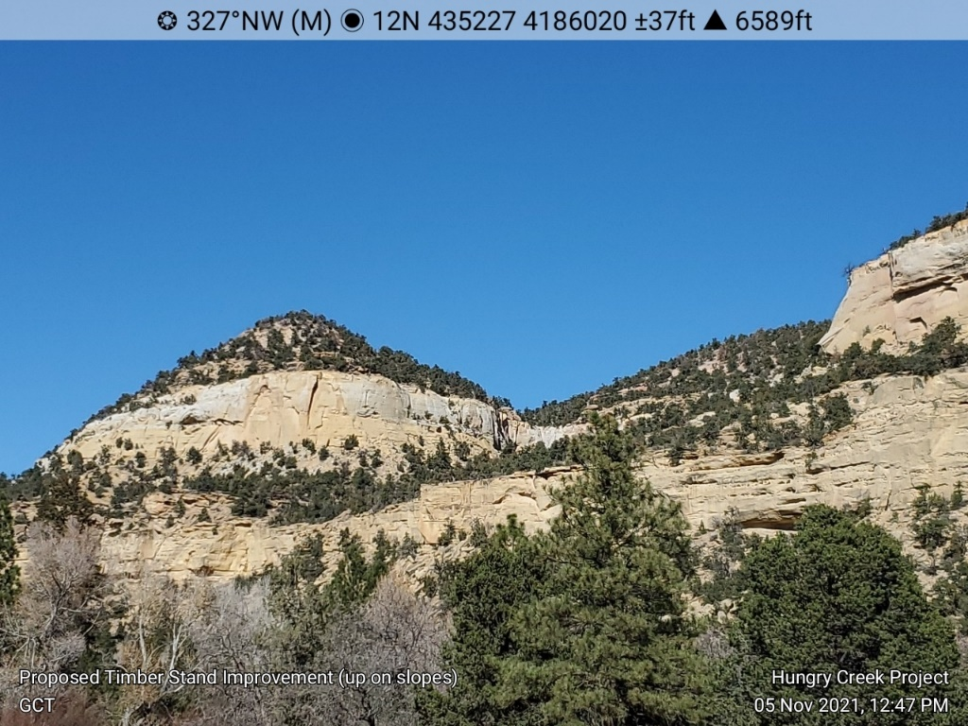
Photo 1. Proposed Timber Stand Improvement (up on slopes)

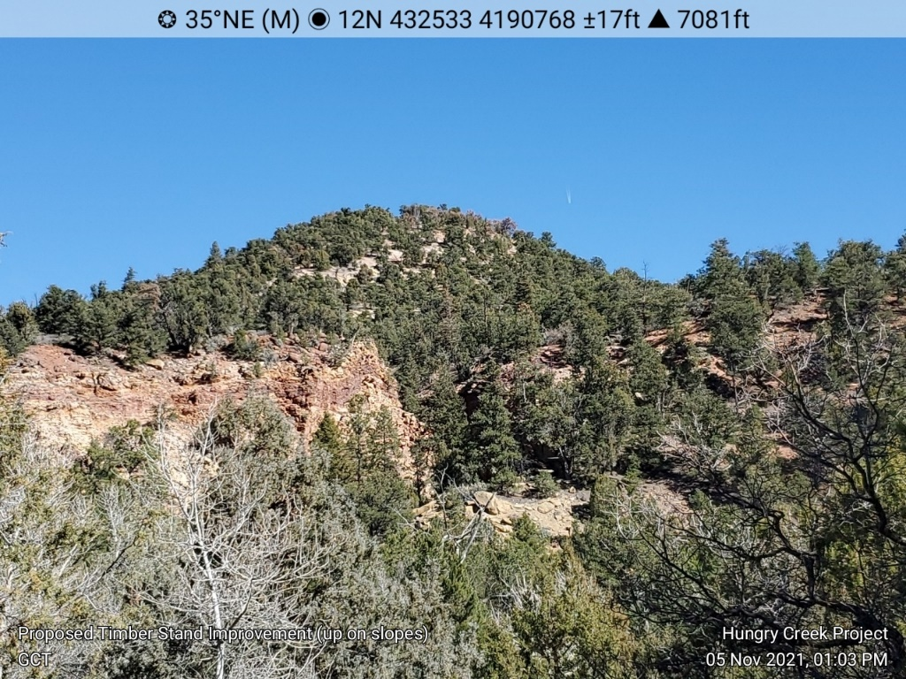
Photo 2. Proposed Timber Stand Improvement (up on slopes)
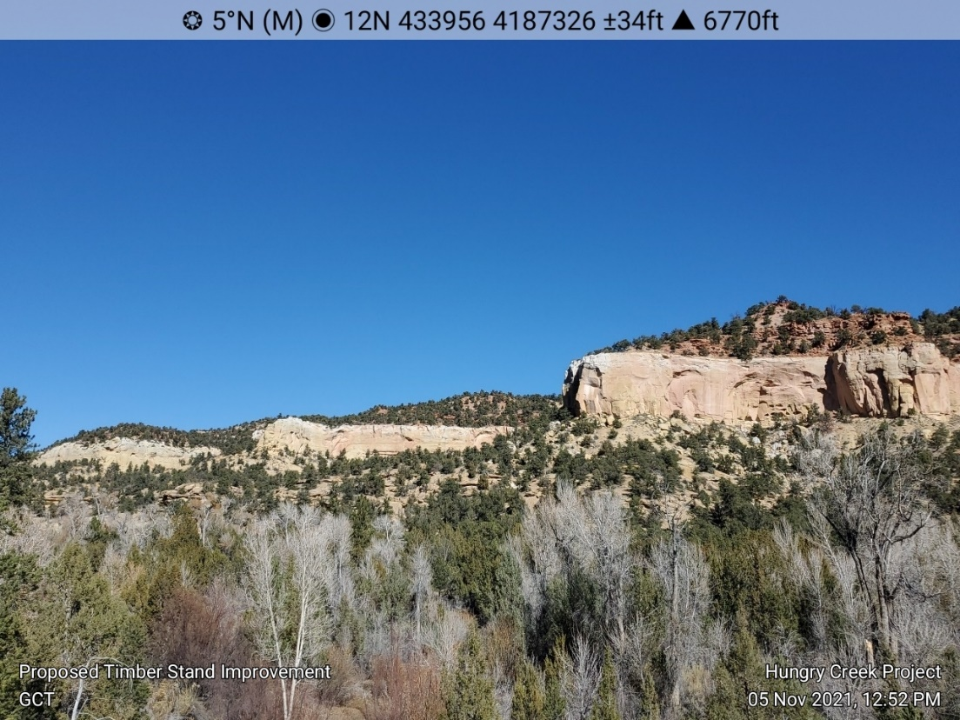
Photo 3. Proposed Timber Stand Improvement

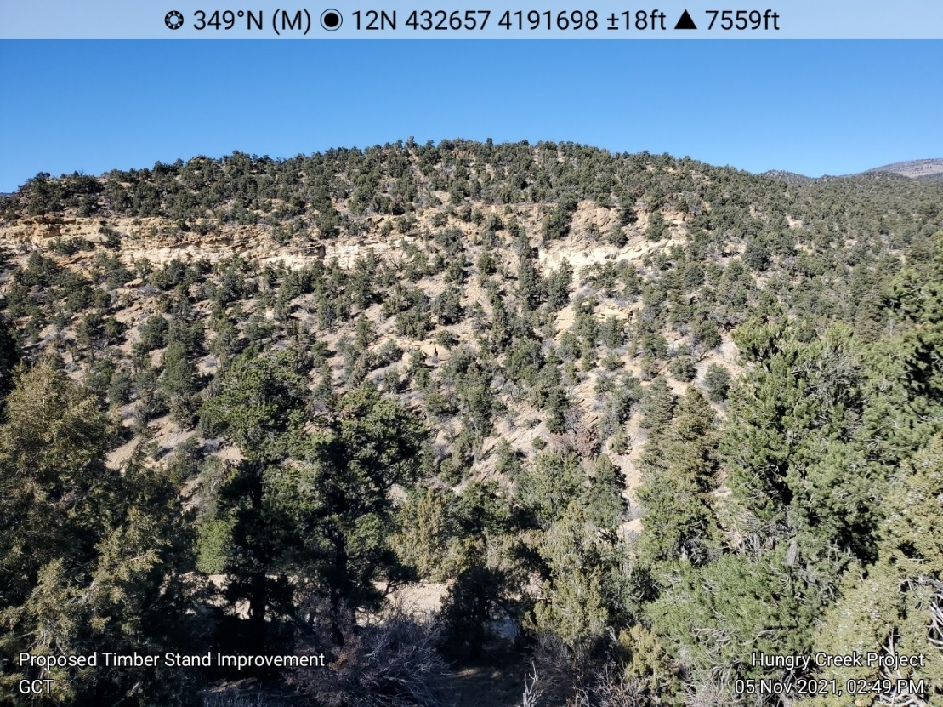
Photo 4. Proposed Timber Stand Improvement
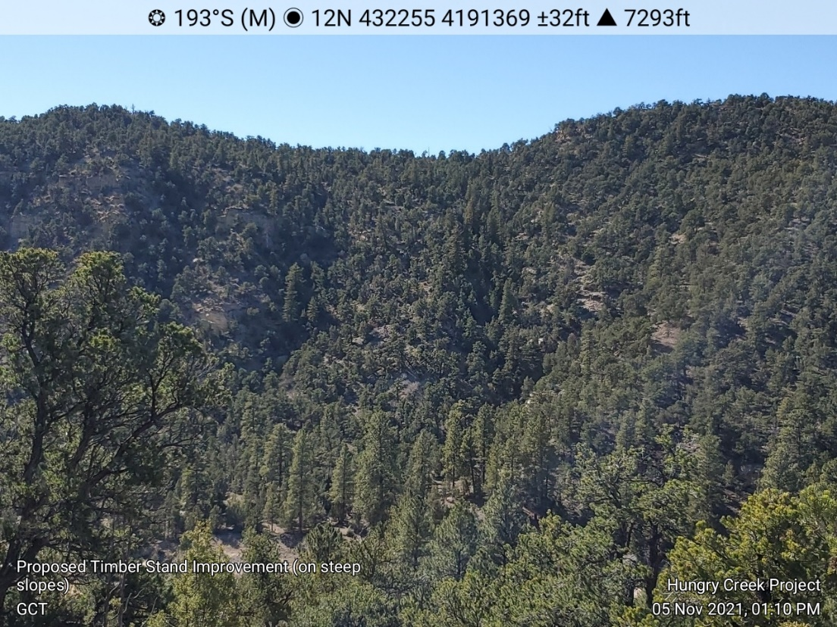
Photo 5. Proposed Timber Stand Improvement (on steep slopes)

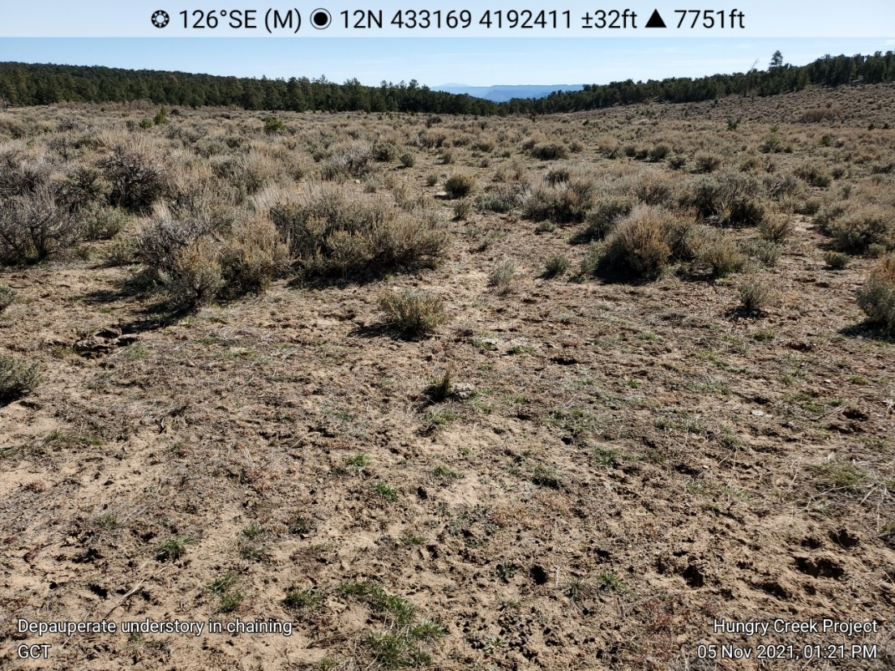
Photo 6. Depauperate understory in old chaining
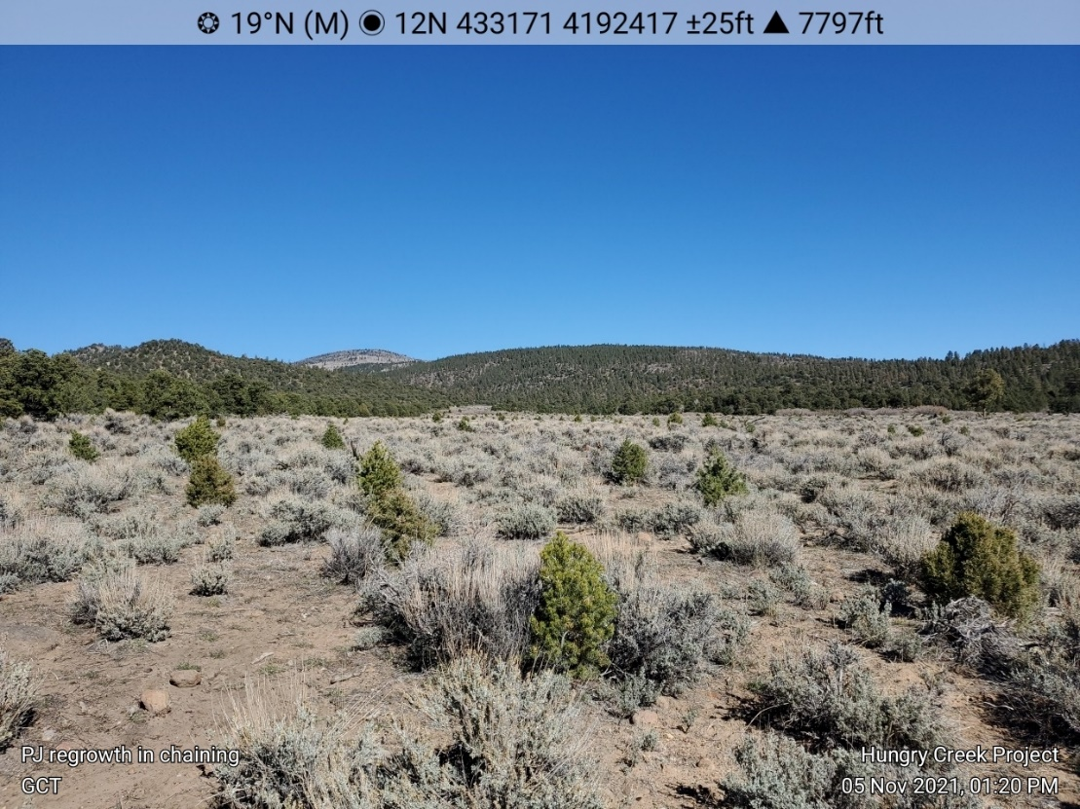
Photo 7. PJ Regrowth in old chaining

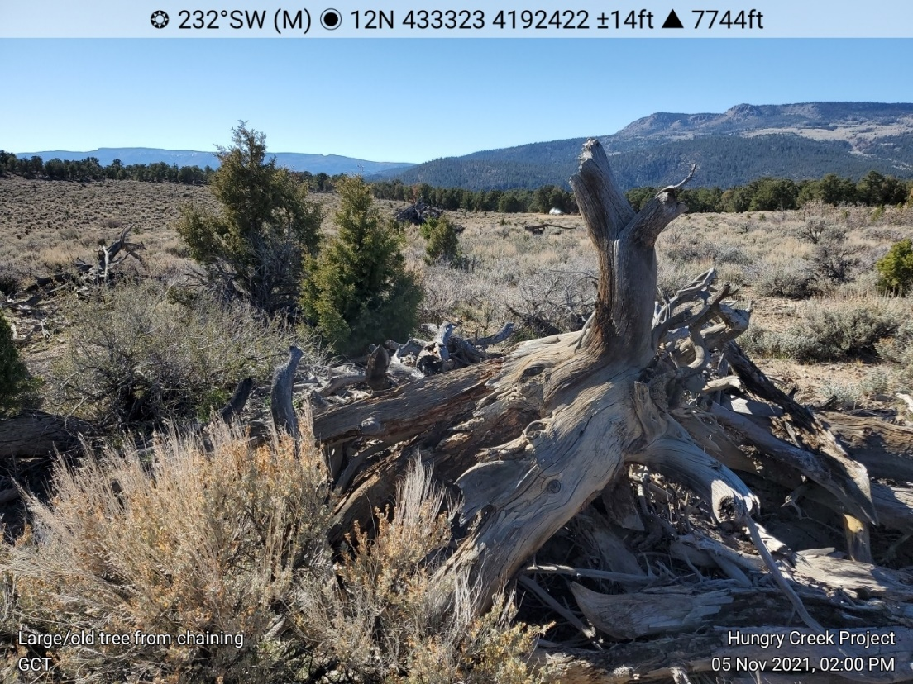
Photo 8. Large/old tree from chaining
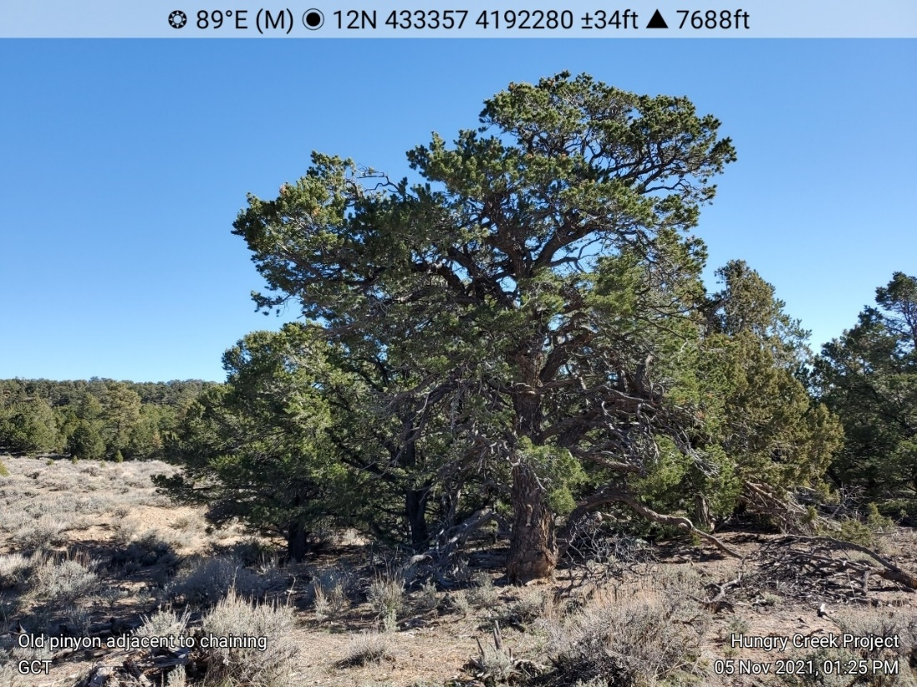
Photo 9. Old pinyon adjacent to chaining

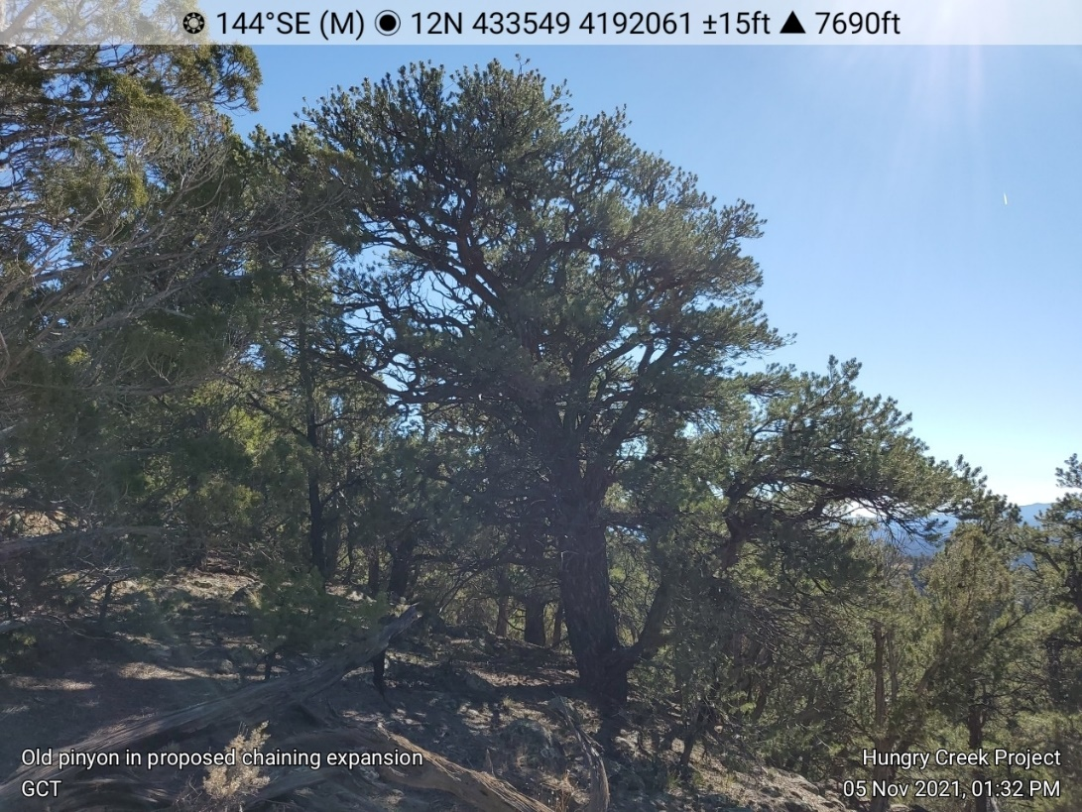
Photo 10. Old pinyon in proposed chaining expansion
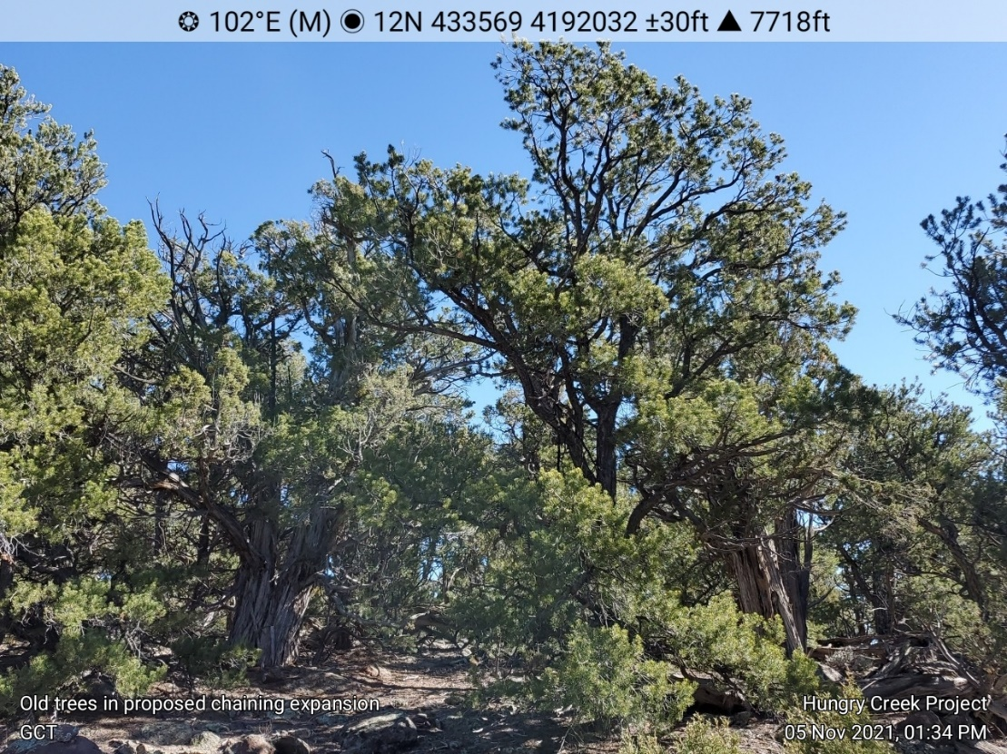
Photo 11. Old trees in proposed chaining expansion

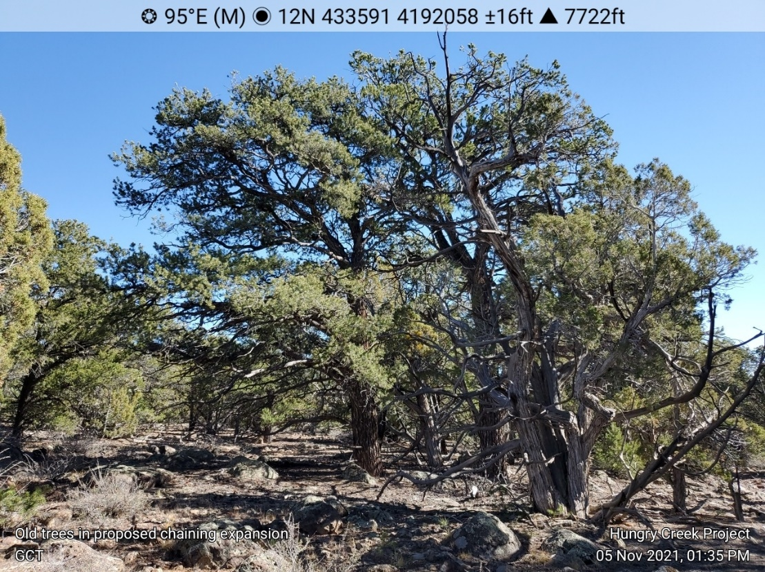
Photo 12. Old trees in proposed chaining expansion
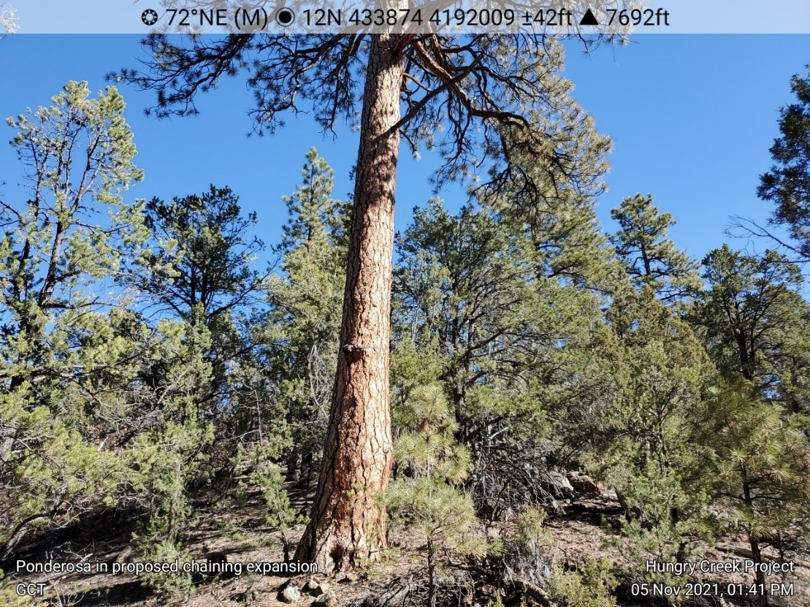
Photo 13. Ponderosa in proposed chaining expansion.

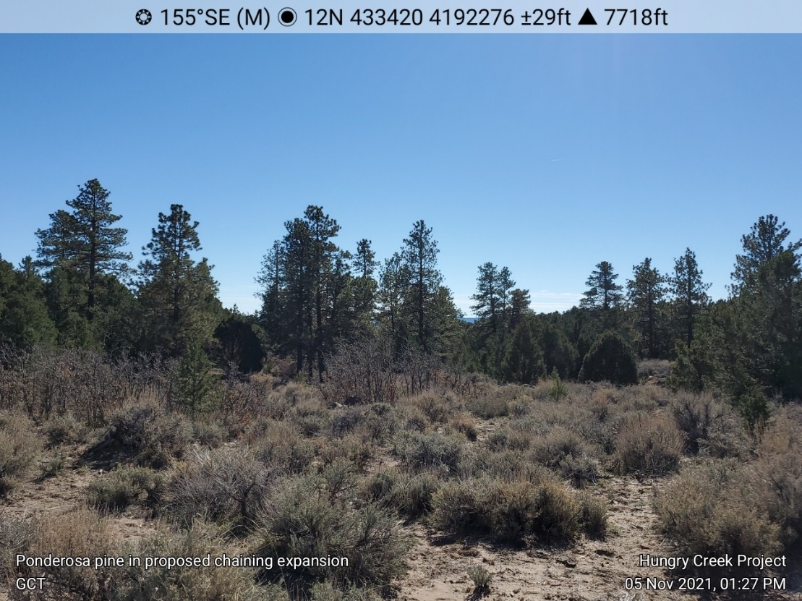
Photo 14. Ponderosa pine in proposed chaining expansion
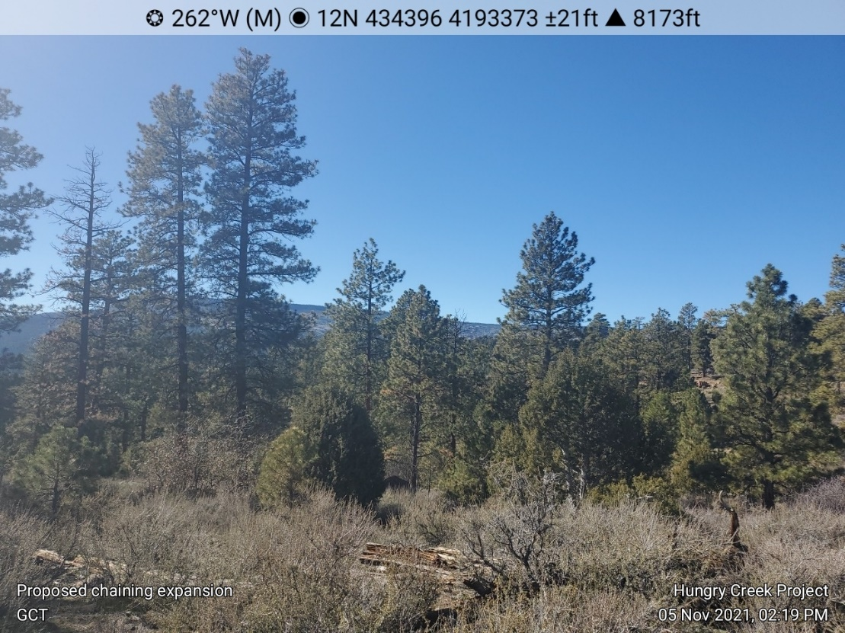
Photo 15. Proposed chaining expansion

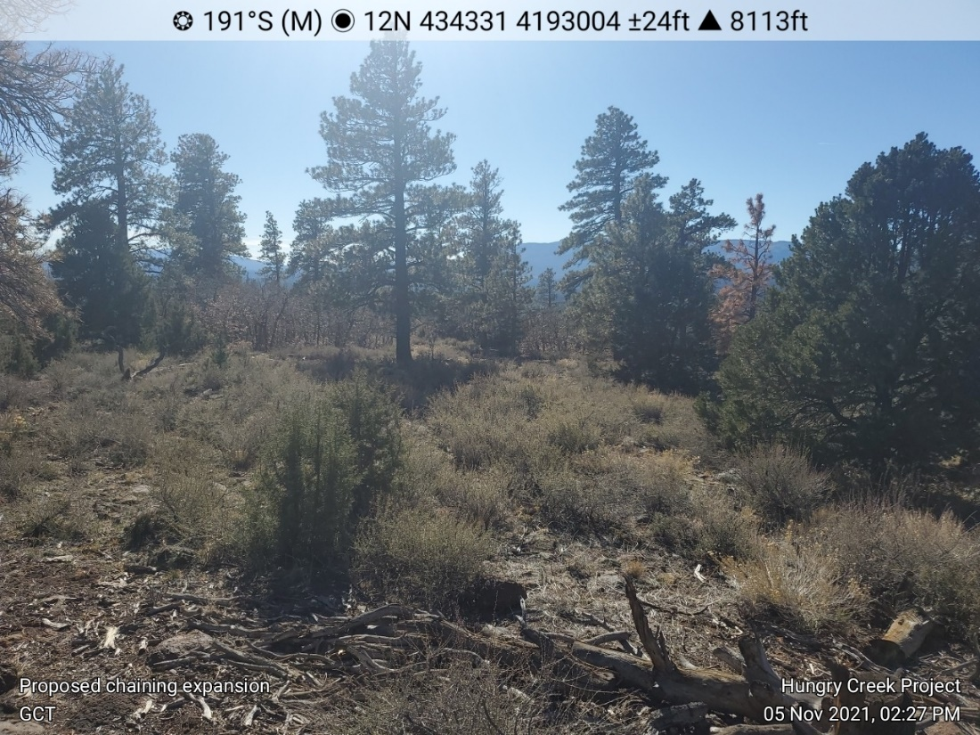
Photo 16. Proposed chaining expansion
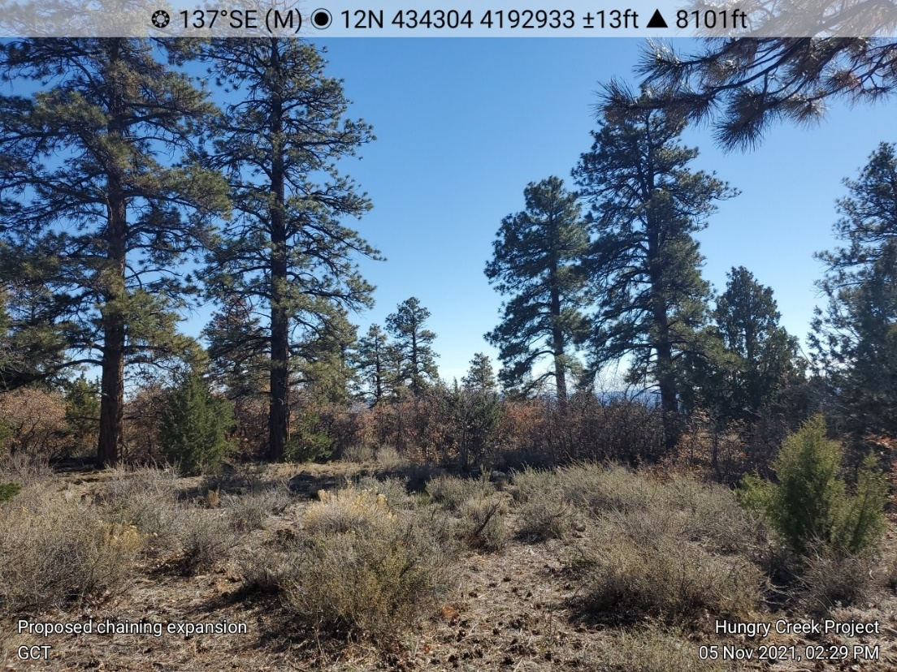
Photo 17. Proposed chaining expansion

Chong GW, SE Simonson, TJ Stohlgren and MA Kalkhan 2001. Biodiversity: Aspen Stands Have the Lead, But Will Nonnative Species Take Over? USDA Forest Service Proceedings RMRS-P-18. 2001.
Chong et al. 2001.
Kitchen, SG, PN Behrens, SK Goodrich, A Green, J Guyon, M O’Brien, D Tart 2019. Guidelines for aspen restoration in Utah with applicability to the Intermountain West. Gen. Tech. Rep. RMRS-GTR-390. Fort Collins CO: U.S. Department of Agriculture, Forest Service, Rocky Mountain Research Station. 55 p.
USDA Forest Service 2015. Final Record of Decision, Monroe Mountain Aspen Ecosystems Restoration Project, Richfield Ranger District, Fishlake National Forest Sevier and Piute Counties, Utah. 90 p.
Rhodes, AC, and SB St Clair 2018. Final Report: Monroe Mountain Stable Aspen Monitoring 2013-2017.
Rhodes, AC, RT Larsen, SB St. Clair 2018. Differential effects of cattle, mule deer, and elk herbivory on aspen forest regeneration and recruitment. Forest Ecology and Management, 422: 273–280.
Rhodes et al. 2018
https://www.fs.usda.gov/Internet/FSE_DOCUMENTS/stelprd3836454.pdf
Miller, M.E 2008. Broad-Scale Assessment of Rangeland Health, Grand Staircase–Escalante National Monument, USA Rangeland Ecol Manage 61:249–262.
Innes, Robin J.; Zouhar, Kris. 2018. Fire regimes of mountain big sagebrush communities. In: Fire Effects Information System, [Online]. U.S. Department of Agriculture, Forest Service, Rocky Mountain Research Station, Missoula Fire Sciences Laboratory (Producer). Available: https://www.fs.fed.us/database/feis/fire_regimes/mountain_big_sagebrush/all.html [2019, June 7].
36 C.F.R. § 294.13(a), published at 66 Fed. Reg. 3244 (Jan. 12, 2001) (“Timber may not be cut, sold, or removed in inventoried roadless areas of the National Forest System, except as provided in paragraph (b) of this section.”).
Scoping Notice at Figure 2 (IRA and Project map). See also Dixie NF, Motorized Travel Plan, Inventoried Roadless Areas and Unroaded and Undeveloped Areas Specialist Report (March 2009) (identifying acreage of Dixie NF IRAs), available at https://www.fs.usda.gov/Internet/FSE_DOCUMENTS/stelprdb5220839.pdf (last viewed Nov. 16, 2021). The project area also includes roughly a third 3,171-acre Box-Death Hollow 3,171 IRA, but the agency proposes no treatments in this IRA.
Scoping Notice at 5.
Id. at 5.
Id. at 4.
Id. at 6.
Id.
Id. at 4.
The Scoping Notice (at 6) declines to define any of these terms.
Scoping Notice at 4.
36 C.F.R. § 294.13(a).
36 C.F.R. § 294.13(b)(1) (emphasis added).
36 C.F.R. § 294.11.
Id. (emphasis added).
Forest Service, Roadless Area Conservation Rule, 66 Fed. Reg. 3244, 3257 (Jan. 12, 2001) (emphasis added).
Id. at 3258 (emphasis added).
36 C.F.R. § 294.13(a).
Roadless Area Conservation Rule, 66 Fed. Reg. at 3257, 3258 (e.g., “Vegetative management would focus on removing generally small diameter trees while leaving the overstory trees intact.”)
Dixie National Forest, Land and Resource Management Plan (1986) at II-61.
36 C.F.R. § 294.13(b).
Forest Service, Roadless Area Conservation Rule, 66 Fed. Reg. 3244, 3257 (Jan. 12, 2001) (emphasis added).
Scoping Notice at 4.
Id. at 4.
Scoping Notice at 3. Elsewhere, the Forest Service describes TSI as involving “[d]ensity reduction of sub-merchantable conifer.” Id. at 5. The Forest Service fails to describe what “sub-merchantable” means in terms of size, or whether or why that is the same as “generally small diameter.”
36 C.F.R. § 294.13(b)(1).
36 C.F.R. § 294.11.
Id.
36 C.F.R. § 294.13(b)(1)(ii) (emphasis added).
See Scoping Notice at 2-3.
See, e.g., Trombulak (https://conbio.onlinelibrary.wiley.com/doi/pdfdirect/10.1046/j.1523-1739.2000.99084.x); Gucinski et al., Forest Roads: A Synthesis of Scientific Information (May 2001), available at https://www.fs.fed.us/pnw/pubs/gtr509.pdf.
Available at https://www.fs.usda.gov/Internet/FSE_DOCUMENTS/stelprdb5057895.pdf

