April 19, 2024

RE: Monitor-Toquima Range Vacant Allotment Livestock Grazing EA

To: Lance Brown, Responsible Official and Humboldt-Toiyabe Forest Service Supervisor Jon M. Stansfield, Objection Reviewing Officer
Pursuant to 36 CFR Part 218, WildLands Defense (WLD) Lead Objector and Alliance for the Wild Rockies (AWR) are submitting this Objection to the Austin-Toiyabe Ranger District Monitor-Toquima Vacant Allotments EA.
Here is an Objection from Wildlands Defense, lead Objector and Alliance for the Wild Rockies of the Humboldt-Toiyabe National Forest (HTNF) Monitor-Toquima (M-T) Range Vacant Allotment EA and Draft Decision Notice (DDN) to authorize livestock grazing on the McKinney, Meadow Canyon, Monitor Valley East, Monitor Valley West, Silver Creek, and Table Mountain allotments. This is a weed-vulnerable rugged arid mountainous landscape. This biodiversity rich landscape is targeted for significant livestock grazing disturbance and degradation across more than 200,000 acres. This scheme is much more than simply “re-stocking”. The world has changed dramatically since the ancient 1986 (38-year old) Toiyabe Forest Plan, which itself relies on even older data, was compiled.
Objector Organizational Interests: The following Objection is based on WLD and AWR concerns about the significant and short, mid and long-term (including irreversible) cattle-grazing caused impacts and losses to biodiversity, essential and irreplaceable wildlife habitats, major biodiversity values - including USFS MIS species, sensitive species and state species of concern, and trammeling of spectacular biodiverse wild lands and Wilderness. It has been shown irrefutably that cattle grazing causes irreversible flammable weed infestation and spread (Belsky and Gelbard 2000, Reisner 2013 Dissertation, Reisner et al, 203, Chuong et al, 2015, Williamson et al 2019, Kauffman et sl. 2022, Molvar et al. 2024.
Pursuant to 36 CFR Part 218, WildLands Defense (WLD) Lead Objector, and Alliance for the Wild Rockies (AWR) Object to the Monitor-Toquima Range Vacant Allotment grazing EA.
Wildlands Defense is a 501c3 public interest organization dedicated to protecting and improving the ecological and aesthetic qualities of the wildlands and wildlife communities of the western United States for present and future generations. WLD does so by fostering the natural enjoyment and appreciation for wildlands habitats and wildlife by means of legal and administrative advocacy, wildland and wildlife habitat protection and scientific research, and by supporting and empowering active public engagement. Wildlands Defense has offices in Boise and Hailey, Idaho.
WLD works to protect and improve the ecological and aesthetic qualities of the wildlands and wildlife communities of the western United States for present and future generations. WLD does so by fostering the natural enjoyment and appreciation for wildlands habitats and wildlife by means of legal and administrative advocacy, wildland and wildlife monitoring and scientific research, and by supporting and empowering active public engagement. Wildlands Defense has offices in Boise and Hailey, Idaho.
Alliance for the Wild Rockies is a 501c3 public interest organization whose mission is to secure the ecological integrity of the Wild Rockies Bioregion through citizen empowerment and the application of conservation biology, sustainable economic models, and environmental law. Alliance for the Wild Rockies is headquartered in Helena, Montana. While AWR did not comment, during scoping, there was no EA, and our Objection is based on new significant information on climate stress effects, massive foreseeable proposed new threats and habitat losses for sensitive species, the use of Forest lands in the sole alternative as a sacrifice zone with ever-shifting grazers from unknown and unspecified sites and at any time of the year. Permittees may have degraded their “regular” allotments so the land is being “rested”, or use of these lands may be linked to a gargantuan weed-causing habitat destroying forest-wide prescribed fire and mechanical treatment EA. There is also new scientific information (such as new cheatgrass publications). Sensitive Species of significant concern to AWR are also suffering new habitat loss, and USFWS has found species like Pygmy Rabbit may warrant ESA listing.
Our organizations staff and members would be directly affected by this project and past and ongoing actions by the Forest Service on these lands and watersheds that are vital for biodiversity protection and wild lands preservation, for the viability of species like migratory birds and rare native carnivores. The Monitor-Toquima project would directly and significantly harm us and our members, who use this National Forest, other Region 4 Forests, and our interests in biodiversity and natural wild land ecosystems in project area lands in question - enjoyment of the natural world, quiet recreation, bird watching, nature photography, scientific pursuits, aesthetic and spiritual purposes.
Objector Organizational Interests: The following Objection is based on our concerns about the significant and short, mid and long-term (including irreversible) losses to biodiversity, wildlife, wild lands, weed risk, site heating and drying/desertification/aridification effects, unassessed grazing and other stresses and impacts acting synergistically to harm project-threatened values, climate change impacts, biodiversity loss, sensitive and imperiled species and other concerns raised in our comments on this project. It also based on grave concerns about the relentless Region 4 Forest-wide assault on sensitive and rare species habitats, and wild and Roadless areas with a huge battery of “treatment” disturbances coupled with the FS failure to honestly evaluate livestock grazing impacts in a modern day ecological analysis across the Region. Re-imposing grazing will harm the Forest environmental values that it is our organization mission to protect, and harm our members recreational, spiritual, aesthetic and other uses and enjoyment of National Forest lands.
Relation Between Objection Points and Comments
We base this Objection on comments submitted with the NOPA. NOPA comments previously submitted are included in significant part herein, and they serve as the basis for the Objection, along with new information relevant to unknown and unrevealed information on project components that were not discussed by the FS or in the NOPA. We also incorporate new and current information on emerging threats and agency projects and also scientific information that has arisen since the NOPA ,such as Greenlink North, BLM Solar DEIS massive proposed industrial development of BLM lands in the region, new mining threats, ever-mounting scientific information on the grave threat of cheatgrass and exotic bromes caused by cattle grazing disturbance, the fact that climate change is exceeding predicted heating rates, threats of new wildlife diseases decimating sensitive and important species, a huge number of new lithium mining claims devouring lands in the region and threatening ground and surface water, new petitions for ESA listing of species impacted by this project and inhabiting these lands, continued declines in Sage-grouse habitats and populations, etc. Objector WLD joins in this Objection based on the significant new information and events.
Overview of Objection Points
Preparation of an EIS is essential, and we Object to the failure to prepare an EIS. The Humboldt-Toiyabe Forest shirked informed public involvement and forsook even providing the public with a draft EA so that comments, concerns and observations on FS analysis assertions – including public comments that might prevent significant new harm to Sage-grouse and other rare species habitats - could be evaluated. The FS ignored the huge number of public scoping comments opposing this grazing project. The FS never considered anything other than a single highly damaging grazing and livestock facility construction alternative.
The No Action alternative suffers from a very inadequate ecological condition and threat baseline. EA at 3 states: “The no-action alternative represents the current management and conditions as described in the LRMP, which would persist if the proposal were not approved.” What does this even mean? The LRMP current conditions were those of 1986 when allotments were grazed. The on the ground current conditions is the allotments aren’t being grazed.
The Forest must take a hard look at the cumulative environmental impacts of this Project. A court will enjoin a project where the agency has failed to demonstrate compliance with binding legal standards. Native Ecosystems Council v. U.S. Forest Service, 418 F.3d 953, 961 (9th Cir. 2005). A court will also enjoin a project if the agency fails to discuss an important issue. Oregon Nat-ural Desert Ass'n v. Bureau of Land Management, 531 F.3d 1114, 1142 (9th Cir. 2008).
Here is an example showing the FS does not have sufficient data to make any decision: “Reconstruction of improvements will require additional site-specific clearances and approvals. Cattle distribution can be more effectively managed through controlling their access to water”. The “improvements” are a significant part of claims that the lands are grazable and cows can be somewhat controlled.
The USFS forsook consideration of a broad body of current ecological science, and glossed over serious harms to the outstanding wild lands values in and outside designated Wilderness that will suffer irreparable harm if grazing is re-imposed, if small springs are re-gutted, if fences injurious and lethal to wildlife are rebuilt.

Cows will be hauled in from unknown land areas and allotments with unknown noxious and flammable weed infestations. The cows will be grazed in what are tantamount to 5 “sacrifice zone” allotments. There do not appear to be fences and/or sufficient natural barriers between many of the allotments, and adjacent BLM lands. So grazing these sacrifice allotments is likely to result in unintentional and/or intentional cow trespass onto BLM lands where grazing is not currently authorized. Hage trespass was a significant part of what caused these allotments to be “Vacant” in the first place.
Worsening heat with climate change, and more extreme weather events, and drought – all are exerting new levels of stresses on wild land vegetation communities - making them even more susceptible to irreversible flammable weeds, less able to recover from grazing disturbance, more at risk of spring and tiny stream flow loss - especially combined with uncontrolled and unmonitored levels of cattle trampling impacts and out-dated excessive use standards, harmful periods of use, and many uncertain grazing elements. No AMPs are provided for public review. Site heating and drying/desertification/aridification effects as the lands and waters are increasingly stressed by climate change, unassessed grazing and other stresses and impacts acting synergistically to harm project-threatened values, climate change impacts, biodiversity loss – to sensitive and imperiled species viable populations - and many other concerns raised in our comments on this project to date are simply not examined in a hard look NEPA analysis violating NEPA.
We Object to the failure to take a hard look at each of these preceding significant issues.
We Object to the failure to take a hard look at the cumulative, additive and synergistic threats facing native biota (sensitive species, MIS species, migratory birds, ESA species and many others) in the Monitor-Toquima landscape, Austin-Tonopah RDs, and Great Basin.
Threats to this beautiful biodiverse landscape abound in 2024. There are proposed relentless Region 4 and Humboldt-Toiyabe Forest-wide “treatment” assaults on sensitive and rare species native vegetation habitats, in wild lands and roadless areas and important public recreational sites and impacting cultural values. The HTNF is proposing a highly uncertain and controversial Condition-Based Management (CBM) Prescribed Fire EA, and a host of other projects that will doom species like Pinyon Jay and also sagebrush species including Sage-grouse. The magnitude and cumulative effects of habitat disturbance and extreme weed expansion risk from large-scale use of fire (and also mechanical manipulation) must be fully assessed. This harms the Forest land environmental values of biodiversity that it is our group missions to protect, and harms our group members recreational (hiking, camping, birdwatching, nature photography), and spiritual, aesthetic and other uses and enjoyment of National Forest lands.
Very significant new information and major new threats to this landscape’s undeveloped lands and, watersheds and sensitive and MIS species and migratory bird habitats, and recreational uses and cultural sites have emerged since the M-T scoping notice in 2021. The Forest did not prepare a draft M-T EA with a public comment period. We Object to this, as it thwarts fully informed public comment and processes. Now in 2024, there are significant environmental changes and new information and threats (rapidity of climate stress changes, ever-increasing cheatgrass/flammable weed risk with hotter temperatures and flammable annual weeds moving upward in elevation; a Pinyon Jay ESA petition and USFWS positive 90-day finding; a Pygmy Rabbit petition and USFWS positive 90-day finding; new wildlife diseases like very lethal and highly transmissible RHD - a very lethal leporid disease. Jackrabbits are primary prey species for the Golden Eagle and many other native species. These is also the new specter of avian flu with a potential not only to impact bird populations, but also mammal transmission that foreseeably could significantly impact both bird and mammal populations. There are also major new development threats.
Industrial Solar Development Threat. There is very likely looming massive foreseeable habitat loss of migratory birds and other sensitive species in the Austin-Tonopah landscape due to the major push for remote-sited industrial solar development as laid out in the BLM Solar EIS - greatly expanding solar in the sagebrush and other arid lands biomes, and its potentially designation 22 million acres as potential for industrial solar, expanding geothermal destruction of Nevada wild land habitats and waters. Here is the situation under 22 million acres (Alt. 1 map checked):
https://blm-egis.maps.arcgis.com/apps/webappviewer/index.html?id=22df2b327e0c49c3a9afb67de5ca658d
Dark green is solar-targeted lands.
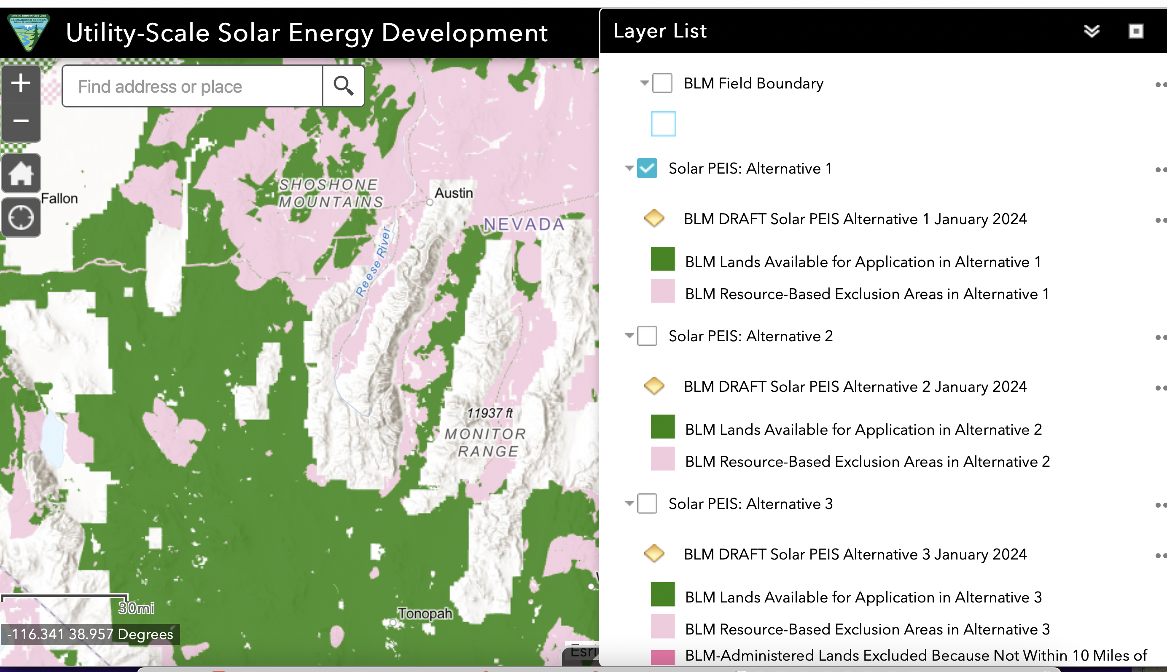
The most likely alternative to be adopted is 8 million acres allocated for industrial solar. (Alt. 3 in the EIS site map checked). The solar project sprawl all along the Sage-grouse, Pygmy Rabbit, Burrowing Owl, Kit Fox, sensitive migratory songbird, Pinyon Jay habitat on the west side of the Toquima Range and around the southern area of Monitor Range. The dark pink areas are identified for solar sprawl and green energy colonialism if transmission is built. There is currently a major push for even more mega-transmission line to turn remote areas of Nevada and the Interior West into energy colonies for distant areas, rather than focus on rooftop solar, distributed energy, conservation measures, etc.
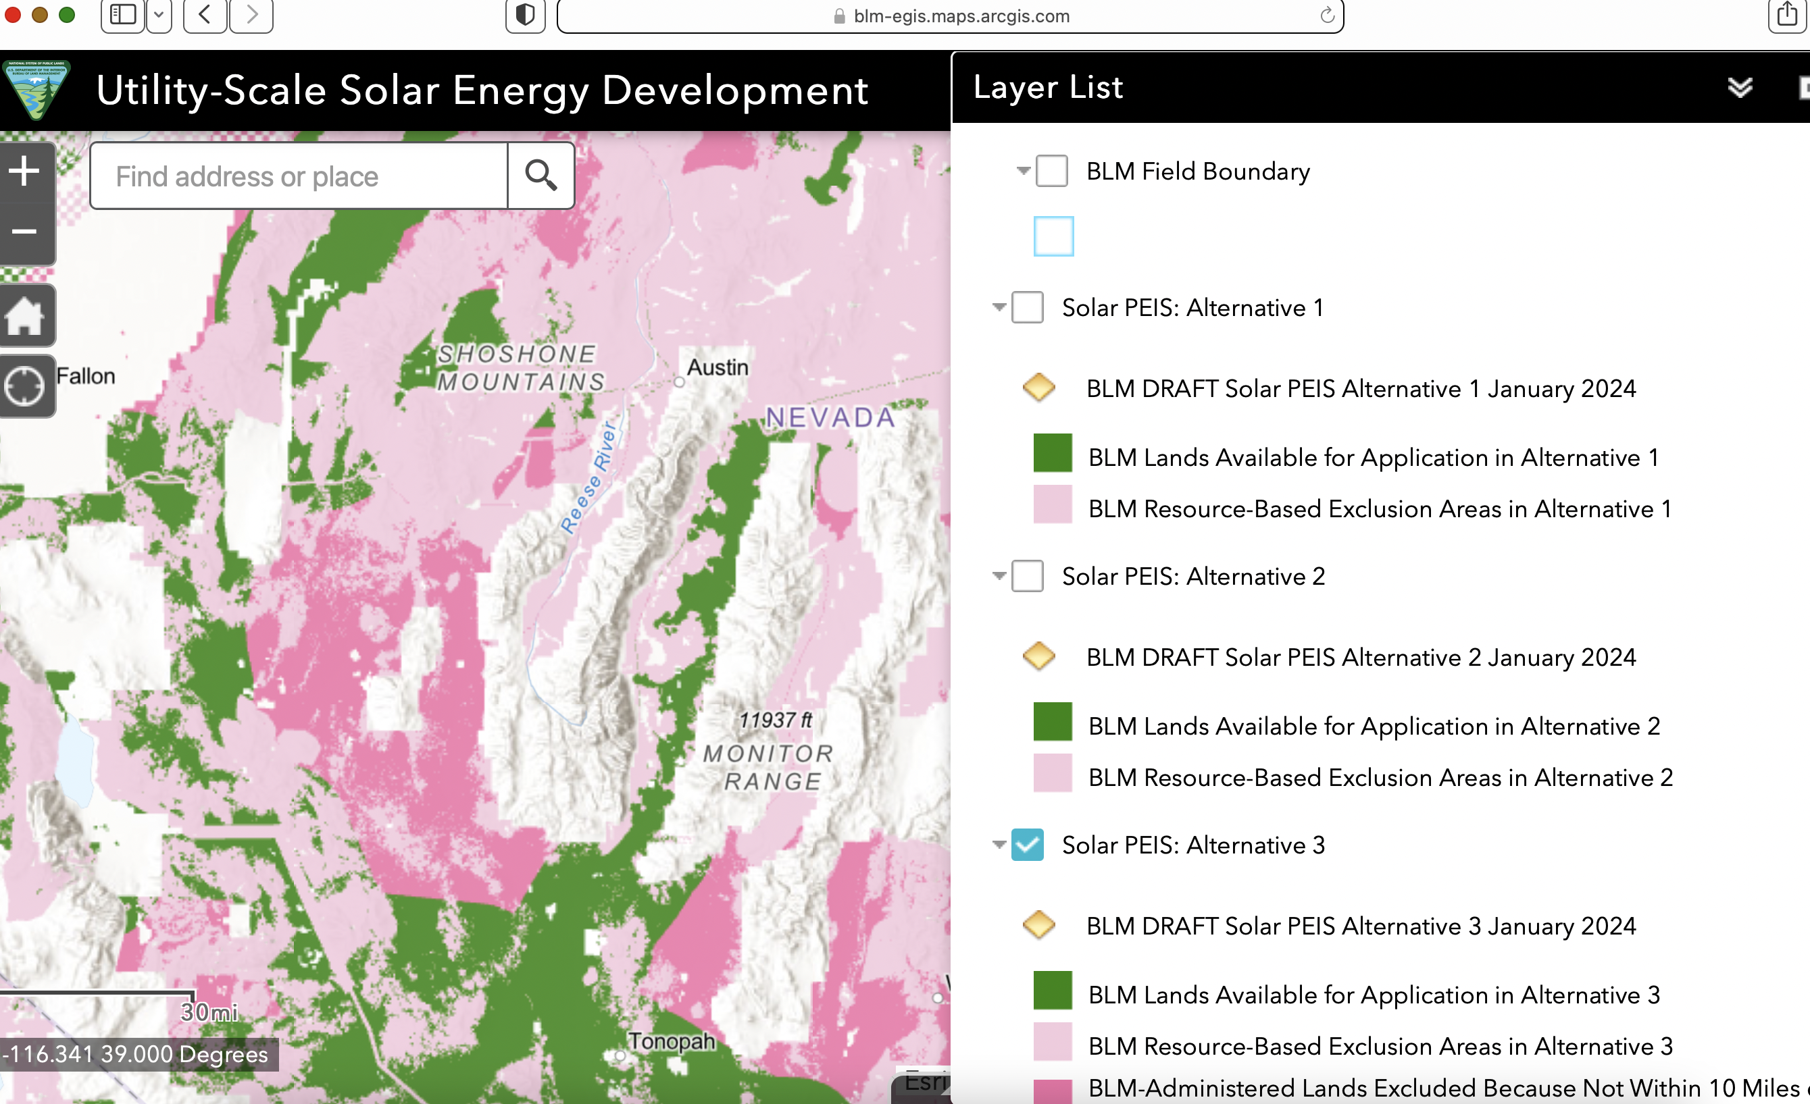
Comparing the BLM 2024 Solar DEIS maps to the M-T project mapping at https://www.fs.usda.gov/project/?project=59389, we see that the solar DEIS Alt 3oindicates lands “excluded because not within 10 miles of a transmission line” – but that could change with construction of additional transmission line, which is being strongly pushed by industry at present. If that is the case, the Pine Valley and

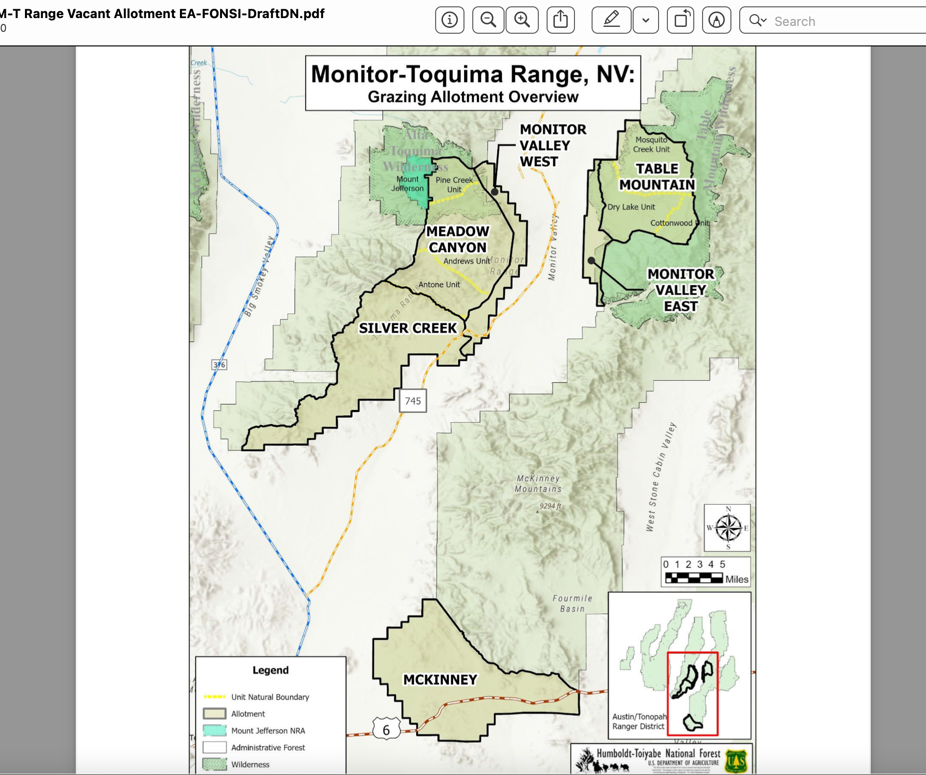
Silver Creek and Monitor Valley West, and adjacent Meadow Canyon allotments in the Toquima Range are located right by BLM lands targeted for industrial solar under the BLM 2024 DEIS likely alternative action. So is McKinney Creek allotment in the southern Monitor Range – and if transmission lines were to be built, the dark pink BLM lands in the Solar DEIS Alt. 3 map would be right by Table Mountain and Monitor Valley East allotments. Note that the sacrifice/reserve allotments under the M-T EA proposal are already very questionably grazable due to the lack of fencing between adjacent BLM land. Development of industrial solar in this region - besides having a drastic impact on many sensitive and MIS/important species habitats, could also hamper wild horse free roaming ability and displace horses from portions of HMA lands - resulting in intensified conflicts with any FS grazing cattle grazing schemes and the WHT lands. It could also result in BLM not grazing the lands adjacent to sacrifice allotments, making any FS grazing there even more unrealistic and ecologically damaging. Industrial solar could be accompanied by new transmission lines to projects and new access routes and increased use and depletion of local area waters.
Proposed New Major-Transmission Line Project.
The Greenlink North proposed mega-transmission line crosses portion of HTNF land north between Austin-Eurkea-Ely. This line is being built to promote massive remote-sited solar and potentially geothermal and wind projects to be built in the surrounding landscape and power exported in a form of green colonialism. Greenlink North would rip large areas of Nevada sagebrush and PJ habitats apart – as these projects are aimed to drastically increase remote-sited industrial renewal energy projects all over the surrounding landscape. The eastern portion of these lands currently have less cheatgrass/flammable weeds – but disturbance from this project across grazed lands threatens expanded flammable weeds in salt desert, sagebrush and PJ habitats.
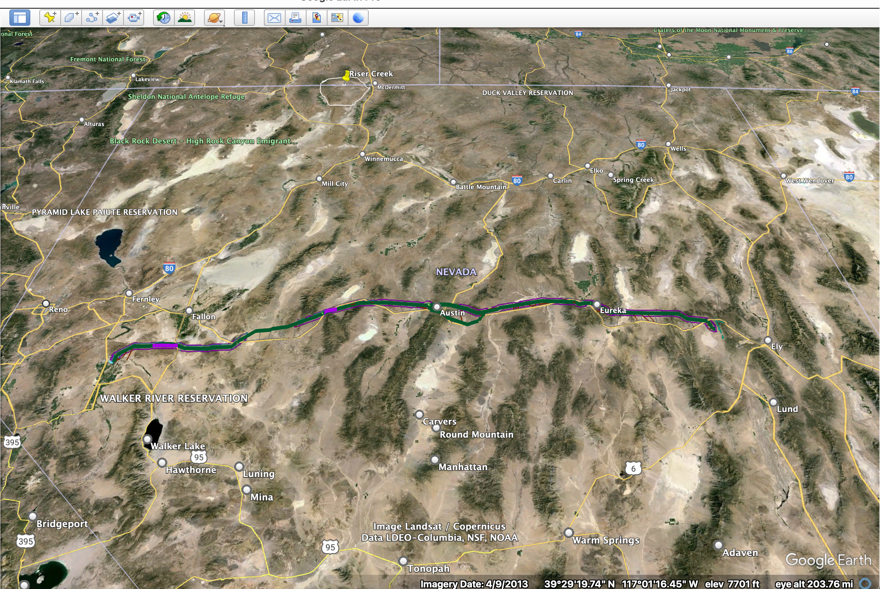
Greenlink North path cutting through critical sagebrush and Pinyon-Juniper habitats on BLM and some USFS lands. See: https://www.fs.usda.gov/project/?project=64198. Map of the ecologically and scenically disastrous Greenlink North transmission line project has just been re-scoped. Now BLM is making the project worse in re-scoping, proposing a 3-mile wide “utility corridor” around the line route – likely leading to a slew of additional future utility developments that will similarly devastate the region. The BLM solar DEIS schemes to sprawl industrial solar projects 10 miles north and south of this line. BLM refuses to examine less harmful alternative of siting the project further north along I-80 in part. It will affect some FS lands and much additional BLM land in this region that is critical for wintering wildlife and for sensitive species survival. The massive industrial solar (and foreseeably geothermal projects or wind projects too) to which it is linked will sprawl outwards under BLM’s scheme 10 miles from the actual path of the line on either side of line. So that’s basically a 20-mile wide industrial zone - devastating sagebrush and PJ habitats for Sage-grouse, Pygmy Rabbit, Pinyon Jay, migratory songbirds, and big game. BLM now intends for this to be a “utility corridor” 3 miles wide. This facilitates more powerlines, gas lines, water or other lines or who knows what future development actions in the “utility corridor” – and these may then cause further sprawl of development to the north and south of the line eating into even more habitat.
Lithium and other Hard Rock Mining Threats
. There is also greatly expanded lithium mining claims and exploration proposals and other hard rock mining claims, exploration and mining including for other critical minerals, and gold mining -with demand for the latter driven by warmongering and global insecurity. The Center for Biological Diversity (CBD) has mapped active lithium projects in the West. See CBD Lithium Claims Tracker website.
https://www.google.com/maps/d/viewer?mid=1kq8TRUSMR97kg-XQ22kdQpE4lUT0Rj49&ll=38.52747840473932%2C-111.43918045000001&z=5
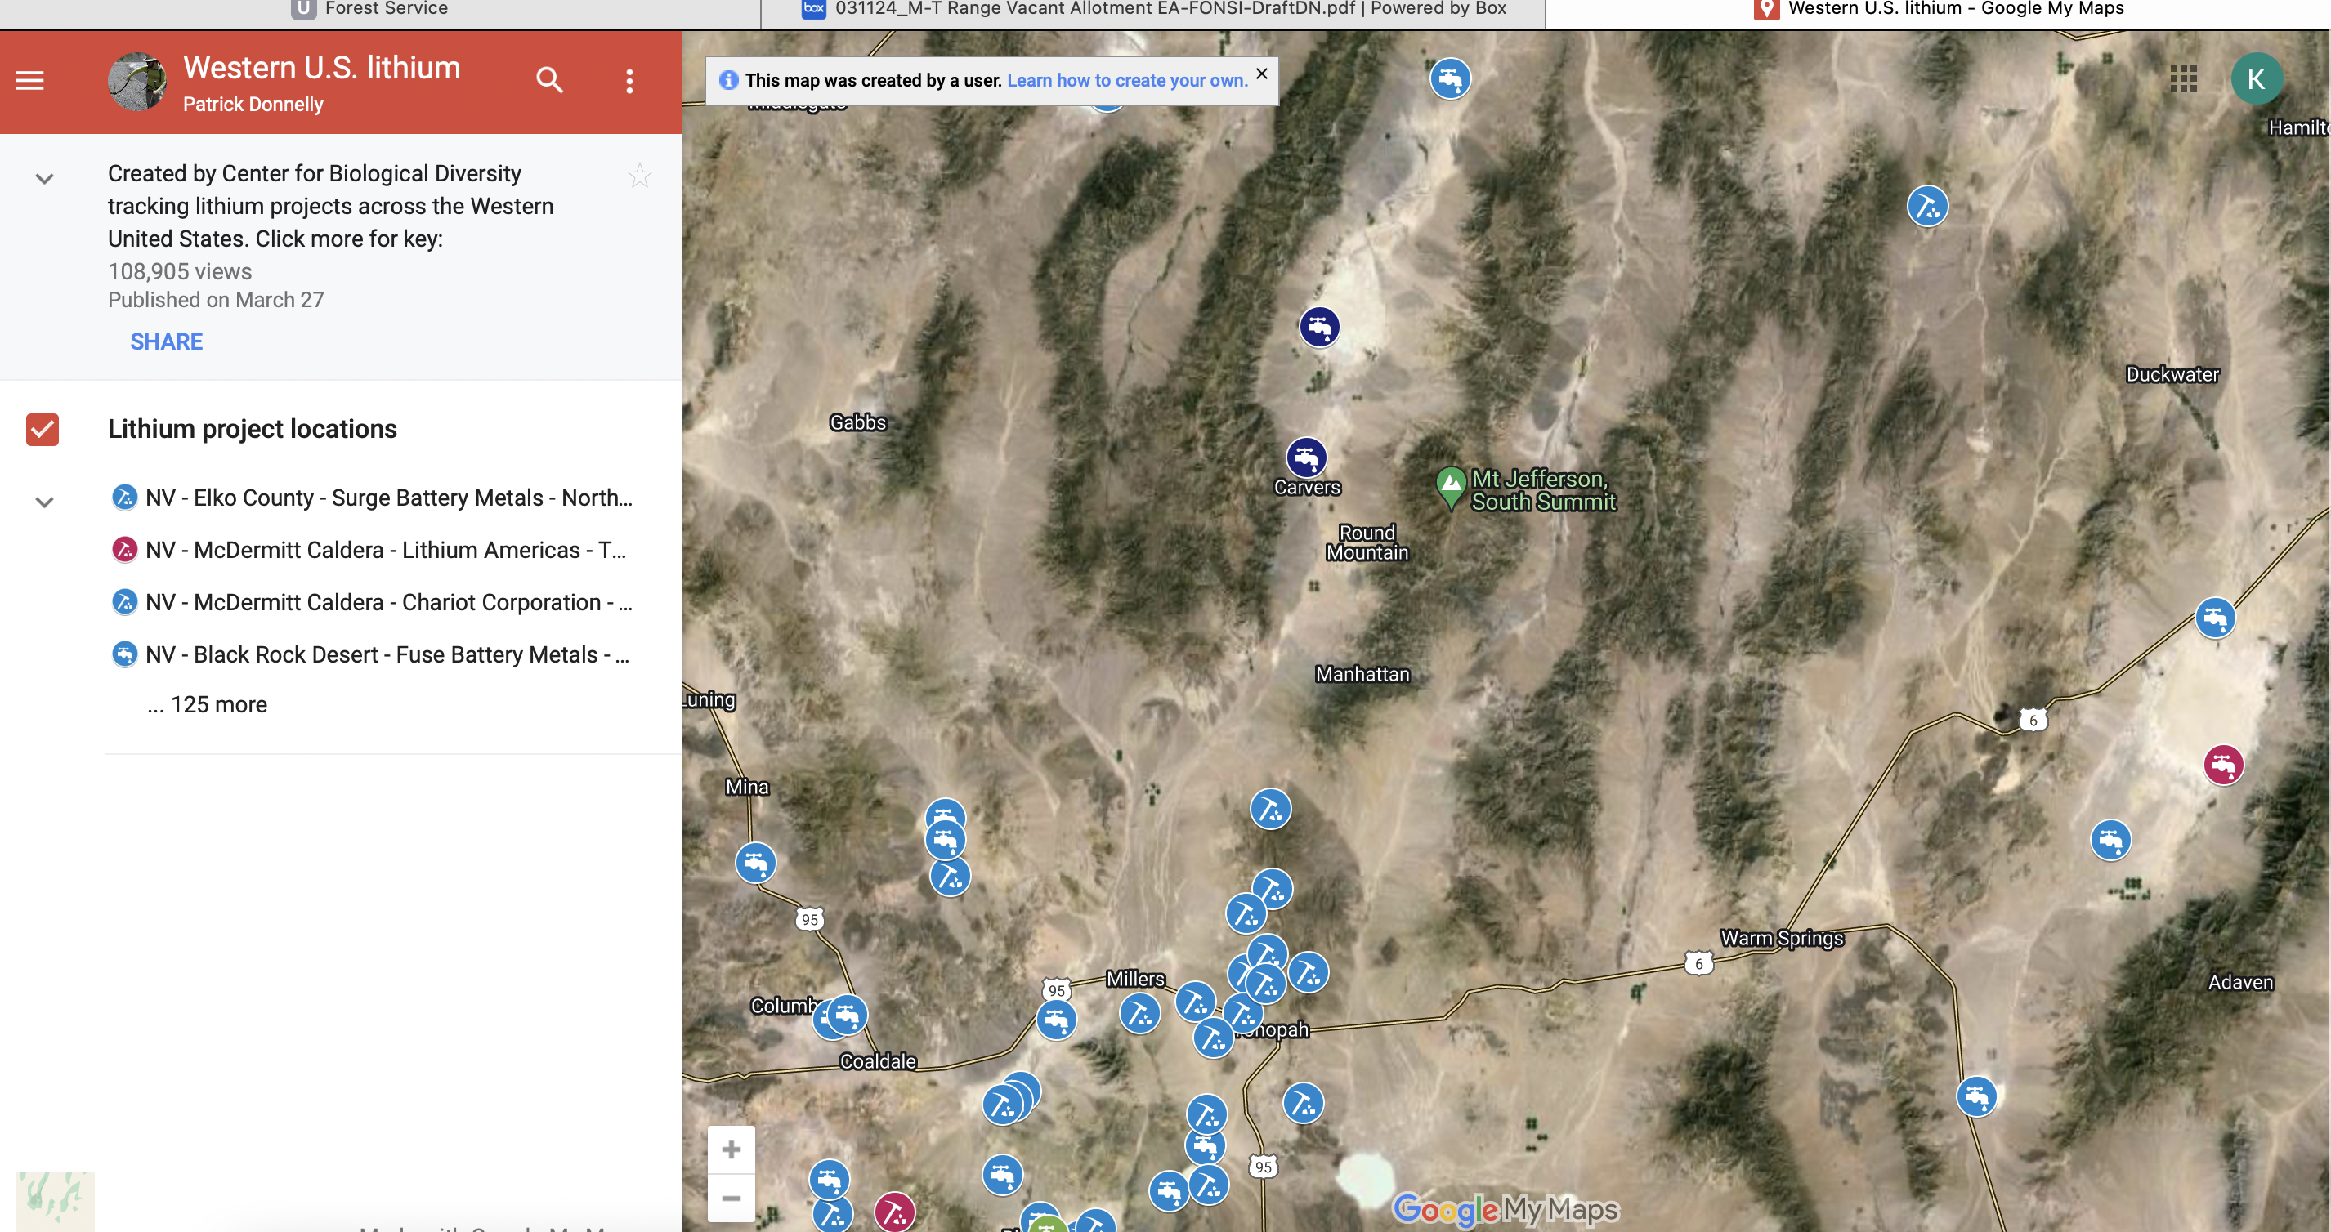
There is no EA assessment of high value habitats, cultural locales or other values vs. degraded habitats and few values – instead western public lands face lithium claims chaos – just as they do gold, copper and other mining claims threats. The FS has not specified if there are mine claims (of any type) in these allotments or adjacent BLM lands. We Object to the lack of such mine claim information, as it represents a foreseeable exploration and mining threat.
Sage-grouse Persistence Concerns Have Increased
In late 2021 (11/22/21), after the HTNF scoped the M-T project, the BLM announced it was amending its Sage-grouse RMP amendments. https://eplanning.blm.gov/eplanning-ui/project/2016719/510 . This is due to continued sagebrush species habitat loss and population declines, which indicates the current BLM and USFS plan amendments are failing to sufficiently “conserve, enhance and restore” sagebrush habitats. The M-T project is a prime example of a federal agency’s failure to conserve, enhance and restore” sagebrush – instead proposing to “disturb, degrade and harm” higher quality sagebrush habitat, including Sage-grouse Priority and General habitats.
The EA admits:
ix greater sage-grouse leks have been identified in the project area; four in the Meadow Canyon allotment (Antone Creek, Jefferson Summit Aerial, Meadow Creek, and Rattlesnake Butte), one in Silver Creek allotment (Belmont South), and one in Table Mountain allotment (Table Mountain 1) (BLM GIS, 2021b). Further, the greater sage-grouse has PHMA, GHMA, and OHMA designation within the project area; these total approximately 93,424 acres (BE, Figure 4, Table 22). Error! Reference source not found.Error! Reference source not found.These designations provide a landscape-level reference of relative greater sage-grouse habitat suitability.
A significant element of the latest BLM ARMPA process is that ACECs are being considered. The currently ungrazed BLM allotments - including the BLM lands that the sacrifice/reserve allotments are not fenced separately from -will be proposed for inclusion in an ACEC. This FS M-T project – with the high potential for drift or trespass into the BLM lands. The impracticality of grazing just the FS lands without the BLM land (as shown by the narrow slivers of allotments) would potentially serve to degrade proposed ACEC lands.
Climate Change Stress.
Record global heat in 2023 further demonstrates the significance and cumulative impacts of climate threats – and the threat to waters, wild lands, biodiversity, sensitive species, and any chances of site recovery from large-scale re-imposition of cattle grazing - and the FS using allotments as dumping grounds for cows displaced from other areas.
Cheatgrass/Flammable Weed Threats Increase and New Information
There is significant new scientific info including on cheatgrass threat and risk, see Kauffman et asl. 2022, Molvar et al. 2024.
New BLM Geothermal CX Cuts Out Informed Decision-making Process and Public Input
There is also a new geothermal CX that thwarts a legitimate NEPA process, at the same time that new advances in deep geothermal exploitation is embracing fracking to great, depths. https://www.blm.gov/press-release/blm-adopts-categorical-exclusions-expedite-geothermal-energy-permitting
All of these significant new changed environmental circumstances and new information relevant to the project lands and species and wild land threats were not known at the time the project was scoped. Thus, the FS regulations allow AWR to join in this Objection.
The selected (and only) alternative in the M-T DDN would authorize a new 10 year grazing permit and AMP in Table Mountain allotment (but the FS failed to provide an AMP for public review and comment), while the other allotments suffer as sacrifice zones – with grazing by cows from un know areas – increasing disease risks, weed risks, and general degradation. They will be significantly exploited by cattle displaced from other u known areas – will they be trucked in from Colorado? Or Jarbidge? There is also the risk and uncertainty of what BLM will do in regards to grazing the old Hage allotments. The FS EA refers to re-imposing permanent grazing on the other allotments if BLM decides to graze its lands.
Scoping comments at the Forest website show that grazing permittee Colvin seeks to graze on these lands. See: https://www.rgj.com/videos/news/2014/05/03/8666369/ The Colvin operation is currently suing BLM in this same area over wild horses in the Stone Cabin HMA, lands linked to the Forest Wild Horse Territory. A wild horse advocacy group has filed a separate lawsuit. The horses at issue span a very large area, and include seasonal and permanent use within the WHT of the FS lands in the M-T EA landscape. We Object to the failure to adequately assess how re-imposing grazing disturbance and reconstruction of a battery of livestock facilities may shift, alter and intensify conflicts with wild horse free roaming ability and the “thriving natural ecological balance” in the WHT. There may be significant changes on the BLM lands hampering or impacting wild horse use and free roaming ability. We Object to the failure to provide current hard look analysis of the bassline and foreseeable conditions if the FS proposed action goes forward.
Re-imposing significant amounts of domestic livestock grazing and a battery of harmful livestock facilities on these ever more fragile climate-stressed lands also runs counter to the Biden administration 30X 30 claims. The M-T grazing is the antithesis of “conservation” and basically treats these lands as primarily valuable for a single use. We Object to the FS failing to take a hard look at the grazing and facility battery conflicts, and sacrificing 5 of the allotments to a reserve status to be grazed by cows hauled in from unknown lands - with conservation of biodiversity and wild lands. It threatens soils, biocrusts, water quality and water quantity/flow sustainability, integrity of native vegetation communities, and jeopardizes the lad’s high biodiversity values and the will degraded and impair irreplaceable habitats for sensitive and MIS species and migratory birds. It harms a broad spectrum of public lands recreational use boith inside and outside of Wilderness areas, reduces carbon sequestration, makes the lands LESS resilient in the face of climate change stress.
The FS refers to there being 40 vacant allotments on the HTNF. There is a reason many of the allotments are designated vacant – the landscape is often very rugged, steep, has tiny fragile springs/meadows/seeps/headwater streams, and is too hard to control livestock in, tiny springs and streams are readily highly damaged by cattle grazing and trampling disturbance. There is often minimal “forage”, and significant risk of irreversible flammable weed expansion, and as a result significant degradation and conflicts with many public values of the National Forest lands results from imposing livestock grazing. The harmful effects have only gotten much worse since the 38 year old Toiyabe Forest Plan was finalized. These areas – including the M-T allotments – currently serve as refugia for and as remnant minimally disturbed areas for sustaining viable populations of declining and rare native biota. Which of the 40 Vacant allotments are or aren’t being periodically grazed under the radar? How many Closed allotments are there? Please provide this info across the HTNF. There seems to be a great imbalance between non-grazed lands (few) and grazed allotments (many) across the HTNF. We Object to the FS failing to provide the full story here, and take a hard look at the full range of effects under NEPA.
It is particularly alarming that the HTNF’s pending Prescribed Fire EA categorizes natural wild biodiverse forests, sagebrush and mixed shrub and other habitats that provide the habitat necessary for survival of almost all Forest sensitive species in a category that leaves them wide open for large-scale manipulation. This is based on these deeply flawed models, that claim lands that support nearly all the Forest sensitive animal species are in undesired, or uncharacteristic condition. Several pejorative terms are applied to help justify major manipulation of forest veg communities that are currently high in biodiversity. The flawed veg and “fuels” models the FS generated and relies upon result in an alternative reality that ignores how natural plant succession works, how fires naturally burn, the old age of native arid communities that did not suffer frequent fires, etc. These models are designed to help promote serve the interests of the logging/treatment industry and highly subsidized public lands ranchers – as they are the basis the FS uses to justify often radically reduce carbon-sequestering structurally diverse native forests, and create open, hot, dry, windy, fire-prone, weedier sites that are more readily grazable. These Landfire and other out-dated models and assumptions, and the old Forest plan is based on are also used to purge mixed-species stands of what the FS “undesired” or another pejorative term tree species. There are also a slew of other “treatments” and Region 4 projects with this same cookie cutter template. See attached comments on literature CD. We apply all these overview concerns to all Objection concerns below. These projects will drastically impact many of the same sensitive species across this region of the West – and certainly all the region 4 forests that are finalizing these cookie cutter CBM Fire “treatment” EAs, and other mis-named “restoration” EAs and vegetation manipulation projects. We Object to the lack of a hard look NE$PA analysis at these matters
Wher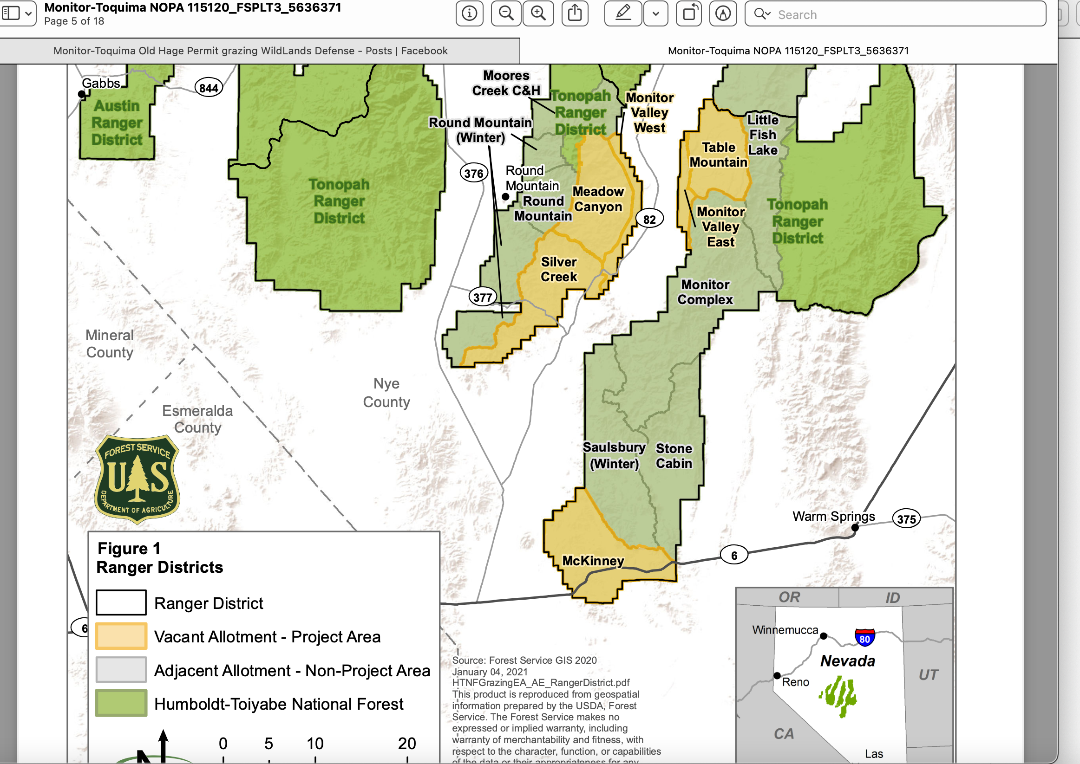Where are the other 40 vacant allotments? What is the permitted use vs. actual use on the “grazed” allotments in the Austin-Tonopah RD? Is there a current analysis of ecological conditions in any of the grazed allotments? We are not aware of anything being done ion recent years, or decades, here. The full cumulative effects of grazing and facilities in this landscape must be provided, based on current monitoring of riparian and upland conditions and sensitive and MIS habitat quality and quantity, as well as population status. We Object to the lack of adequate EA baseline information and NEPA analysis necessary to understand compliance with NFMA.

The M-T project includes 200,000 acres of USFS lands. We Object that the FS has not taken a systematic hard 2024 look at how much the project may harm wildlife over a much greater area – as the allotments are not contiguous, and critical seasonal habitats for native biota from across the region may be impacted significantly. Where do the Elk, Pronghorn, Sage-grouse, Mule Deer and other mobile native wildlife move and use seasonally, and what are their migration corridors and movements that may be hindered by the FS “rebuilding” an endless number of lethal and injurious habitat fragmenting barbed wire and other fences – plus all the additional fences that may be ”rebuilt” (despite never taking any hard look at how the old fences to be re-imposed may conflict with GRSG habitats, Pygmy Rabbit habitats, Mule Deer, Elk, Pronghorn, rare plants, scenic values and if they were located in ecologically harmful sites areas to begin with, or how they and foreseeable reconstructed and/or new facilities on BLM lands harm these same species use of habitats and the facilities may be outright lethal to animals like Sage-grouse. The EA greatly lacks hard look integrated habitat use and project conflicts data, and other crucial baseline analysis.

No Draft EA for Public Comment Provided

We again Object to the FS failing to provide a draft EA for public comment, and the callous disregard for public input and concern that is reflected in the M-T EA’s sole NEPA alternative that exposes Table Mountain to permanent long-term grazing as well as using other allotments as a sacrifice zone “forage reserve” for cows from unknown areas potentially serving as vectors for importing unknown weeds and diseases. Even portions of Alta-Toquima Wilderness lands may be used as a sacrifice area for cows displaced from who knows where - bringing in new noxious and other weeds and diseases on their coats, in their manure, in mud on hoofs, on rancher vehicles from afar, etc.
The public needs to be able to review and comment on a full NEPA analysis prior to the objection stage. Anderson v. Evans, 314 F.3d 1006, 1016 (9th Cir. 2002) (interpreting NEPA’s public notice requirement to mean that the “public must be given an opportunity to comment on draft EAs and EISs”); see also Citizens for Better Forestry v. U.S. Dep’t of Ag., 341 F.3d 961 (9th Cir. 2003). The Forest Service’s planning regulations also require that “[t]he responsible official shall provide opportunities to the public for . . . commenting on the proposal and the disclosure of its environmental impacts in accompanying National Environmental Policy Act (NEPA) documents.” 36 C.F.R. § 219.4(a) (emphasis added).
The NEPA analysis should include a detailed description of the environmental baseline conditions because “[w]ithout establishing the baseline conditions . . . there is simply no way to determine what effect the [action] will have on the environment, and consequently, no way to comply with NEPA.” Half Moon Bay Fisherman’s Marketing Ass’n v. Carlucci, 857 F.2d 505, 510 (9th Cir. 1988). “The establishment of a ‘baseline is not an independent legal requirement, but rather, a practical requirement in environmental analysis often employed to identify the environmental consequences of a proposed agency action.’” Or. Natural Desert Ass’n v. Jewell, 840 F.3d 562, 568 (9th Cir. 2016) (quoting Am. Rivers v. FERC, 201 F.3d 1186, 1195, n.15 (9th Cir. 1999)).
We Object that the public has been severely handicapped in effective comment by not having a draft EA. The FS throws new proposed management information into the mix (the sacrificing of allotments – terming them “Forage Reserves”), and since the public does not have a crystal ball to foretell the future, is left at a severe handicap. This is made even worse when one considers the very large number of comments the FS received in scoping this project, demonstrating significant public interest and significant controversy. We Object to the FS arbitrarily shutting the public out of the ability to make informed comments on NEPA processes.
We Object that the Forest Service has not conducted necessary baseline site-specific surveys to not know the trends and population status of all sensitive species, including Pygmy Rabbit (last surveys were in 2016) migratory birds, Sage-grouse, Elk, Mule Deer and other big game seasonal habitats, on the allotments. The Forest Service must adequately establish a baseline because they do not know the full extent of the species present and their habitat use patterns and actual quality, quantity and fragmentation/connectivity of habitats. The current and projected degree of habitat loss and fragmentation due to the project must also be assessed. Lacking this crucial data and on the ground science-based information and analysis, the Forest Service cannot properly assess the serious harms of the grazing and cow facility reconstruction, and levels and periods of cow use. Dobkin and Sauder 2004 describe how many birds and small mammals are not present in what superficially looks like adequate habitat.
Forage Reserve Allotments Sacrifice Forest Lands Species and Other Values
The FS fails to define use any specific livestock use periods in the sacrifice/reserve allotments. The FS fails to identify important critical habitat areas for several sensitive, MIS, and other important species including migratory bird populations that use these lands that could be grazed at any time of year - as well as adjacent BLM lands that may also suffer intensified grazing disturbance from drift or trespass and significant new habitat alteration - so the agency can’t really effectively analyze any alternatives under NEPA, and certainly not in the superficial self-serving EA analysis.

Further - what is the No Action – the FS appears to blend No Grazing with the management in place before Hage startedy defying the FS and BLM?

There no “No Grazing” alternative that closes the allotments, and no alternative that reduces acreage grazed to protect rare and imperiled species, cultural sites, recreational uses, biodiversity.
How can it be that exactly the same facilities are now needed, or are ecologically appropriate in 2024? Or that inadequate grazing use standards – including lack of trampling protections – are proposed with no alternatives.

We Object to the FS failing to take a hard look at the innumerable conflicts and highly foreseeable and irreversible environmental damage and harms that will stem from “forage reserve” allotments hauling in frequently changing livestock from unspecified lands.

The BE at 4, the FS states: “Forage reserve allotments may be used in conjunction with authorized livestock use when there is a loss of forage availability or to resolve short-term resource concerns arising from a variety of factors including but not limited to:
- Drought, [If there’s a “drought” then grazing these sacrifice allotments with highly unnatural large herds of domestic cattle that loaf by water and whose trampling demolishes protective weed-preventing biocrusts and that devour native forbs, bunchgrasses and shrubs – will amplify grazing damage and harm in these critical areas – including irreplaceable Sage-grouse habitats, Wilderness areas, Bighorn sheep habitats (conflicts with use of space, water, meadows), Elk critical seasonal habitats – food/ “forage”, cover space, habitat security and survival, Mule Deer critical seasonal habitats food/ “forage”, cover space, habitat security, Pronghorn food/ “forage”, cover space, habitat security].
- (2) Fire - either prescribed or wild. [If there’s a significant fire in this region, then the local Sage-grouse PMU, Mule Deer Elk, Flammulated Owl population, migratory birds and rare aquatic species habitats may take a serious hit - reducing the viability of sensitive, important and FS MIS species populations. Grazing cows in this context on the fragile M-T allotments will adversely impact and harm a critical habitat refugia for species suffering habitat losses or degradation (including where Sage-grouse habitat triggers may have been tripped by fires or other habitat loss and/or population declines). Grazing the allotments in this context would have highly significant adverse impacts on remaining habitats and on population viability. This may end up violating NFMA and potentially the ESA as Pygmy Rabbits, Sage-grouse, Pinyon Jay all face ESA listing and declining populations. The sagebrush species here occupy the southern margin of the species range. These species are already experiencing accelerated habitat loss from proposed massive mining exploration, solar projects, near-universal grazing of BLM lands, massive PJ deforestation and sagebrush “treatments”, new transmission lines, etc. Migratory birds face extreme habitat loss and devastation in US wintering areas under the BLM industrial solar development schemes.
The LCT and Paiute trout restoration habitats here and watersheds may be seriously degraded by the intensive new cow degradation. This will also degrade and impair Wilderness, visual quality and other barriers, and facilitate potential spread of numerous livestock vector disease and pathogens. The EA greatly lacks any substantial baseline and the current species habitat and population and trend inventories for this landscape needed to understand even the current status of all species of concern – and thus violates both NEPA and NFMA and potentially will result in future violations of the ESA. There is also no hard look at the welter of cumulative threats facing species of concern, water sustainability, and other environmental elements either in the M-T allotments or across the affected landscape. Further, the FS places no limits on where the cows to be dumped out here would come from – and that must be part of any valid NEPA analysis]. The effects of the appalling number and high density of fences and water developments that are extremely harmful to Sage-grouse and other birds, big game and other wildlife - all to be “reconstructed” newly fragmenting habitats in construction and as they concentrate large herds of cows, and also often accompanied by motorized use and soil disturbance – form both the reconstruction as well as the high levels of intensified cattle trampling and grazing activity associated with these facilities) makes this even worse. These facilities also represent a grotesque subsidy to the livestock industry. How much will this cost, and what vital wildlife seasonal habitats will be harmed?].
- Rangeland restoration activities. [These “activities” must be specifically defined – what exactly constitutes “restoration” – is it any place burned, masticated , or deforested under the massive scorched earth HTNF Fire EA? It is extremely important to understand that if the “range” is degraded enough somewhere else to need “restored” – then the FS is basically rewarding the same abusive permittees that degraded it – by giving them non-stop virtually free forage for an indeterminate period in this tragic sacrifice of the wealth of biological values contained in these allotments].
- Litigation or consultation needs. [If there is litigation over grazing damage, and grazing is enjoined, there is no reason to reward a rancher who is damaging the land. Near-free grazing on USFS land is a privilege, and not a right].
- Short-term resolution of resource concerns on other NFS allotments. [As above, if ranchers are damaging habitats, watersheds, cultural sites, upland and riparian areas somewhere else – it is unconscionable to reward them with near-free grazing in these beautiful M-T wild land allotments that are high in biodiversity in significant part because they have not been intensively grazed for 20-25 years. And where are the cows to come from – Bridgeport? Jarbidge? What are the weeds, cattle and wildlife disease ticks and other insect pests that may be introduced into the sacrifice zone allotment lands. There are new and emerging tick threats all the time - species, diseases caused, etc.].
We Object to the failure to take a hard look under NEPA at the significant questions raised in brackets above, and failure to ensure compliance with NFMA sustainability requirements. This is all made worse by FS repeatedly brushing off pre-decisional data gathering so understanding actual impacts is not possible, and also relies on limited, often old and deficient information. See EA at
Further, hauling cows all over the place may spread avian flu. Concentrating cows at squalid upland water developments, highly degraded salt-supplement sites (which are not mapped or limited as to number and that treat upland unresilient sites as sacrifice zones to feeding supplement on lands with minimal palatable forage”) and other areas under the proposed action may lead to increased cow-vectored disease transmission and spread into wild animal populations.
Just look at what is taking place now in 2024 with cows and avian flu. There is potential cow to cow transmission. Cats are dying from bird flu. See: https://www.youtube.com/watch?v=4Ov6xWosl4k A person working in a Texas dairy has contracted this disease.
https://www.cdc.gov/media/releases/2024/p0401-avian-flu.html?fbclid=IwAR18LFY1Byi14Vz98hjwbYpBeArwm4je0qYPN0CYIsuBTZ3PUQ5fr2lfS5Q_aem_Aea_BeDr2CDL8RqqIq7saIUC-ds0LSNqH8gMutGYdfn_N-WvaHR1tlttn-FxhPkxYuYp7lQD3R0QonQK425fbqvB
Avian flu effects on wild birds include:
“This particular strain of avian influenza virus affects a wide variety of wild birds, including raptors such as Red-tailed Hawks, owls, crows, vultures, and waterfowl such as Canada Geese and Mallards (see details below). The virus is shed in the saliva, mucus, and feces of infected birds and is transmitted to other birds via ingestion or inhalation. There have been reports of mammals, such as red foxes, skunks, bobcats, fishers, and bears, also infected with avian influenza, likely from eating infected birds”.
https://www.allaboutbirds.org/news/avian-influenza-outbreak-should-you-take-down-your-bird-feeders/#
We Object to the failure of the USFS to take a science, climate, economics (the cow projects alone will cost large sums, irreplaceable wild land qualities will be impaired or lost), rare and important species habitat quality/quantity/population viability/sustainability reduced and/or lost, water quality and quantity and flow sustainability lost and/or impaired, Wilderness natural and other values including clean water will be significantly impaired without even any coe trampling standards. Yet no hard look under NEPA is taken at any of the above bracketed concerns. Instead, the USFS treats these lands as a sacrifice area - including potentially for ranchers who have damaged other USFS or BLM lands.
We Object to the failure to detail how many cows were trespass grazing on these FS lands during the Hage years, and the failure to fully address the whole background to grazing in this landscape. How many cows was Hage trespassing? When was the last time actual use was reported, and what were the cow numbers by pasture/unit and allotment? How does the actual use compare to the proposed new stocking on each allotment? What was the actual use in each allotment that was reported during the years before the major trespass hit? We Object to the failure to provide this information, and the failure to address if some trespass by various parties (perhaps perspective permittees) might currently be taking place.
We Object to the FS failing to provide the weight of the cattle used in the capability and any associated forage allocations and HMs proposed– both in the past at the time of adjudication, at the time of the Toiyabe Forest Plan, at the time of any previous AMP (was there one) and present? We recently reviewed an agency document stating cows were 1200 lbs. + and 1200 lbs. is now pretty much the norm. This, and whether cows have calves, has major implications for how much they eat, how much they drink, how much they defecate and urinate and pollute water, and how seriously they compact soils, or deeply trample soils, how much they degrade and impair Wilderness values, etc. We Object to the lack of clarity on how the “capability”, capacity, and any productivity or forage analysis relied on here was arrived at.
The FS EA states:
“According to the current LRMP, livestock trampling can be tolerated on slopes less than 5 percent and on slopes from 11 to 30 percent with soils having high clay content (Forest Service, 1986). Slopes greater than 30 percent are not capable of grazing livestock. Within the project area, the acres of greater than 30% slope varies by allotment but remains a relatively small percentage of the landscape throughout”.
But there is no information on whether the soil clay info and the amount of “forage” under the Region 4 capability criteria and other cow grazing “capability” factors were applied -including based on current vegetation and soil condition data. We Object to this lack of clarity.

We Object to the lack of a detailed hard look analysis at the basic “demand” cows will place on this landscape. Plus, the negligent FS use of allotments as dumping grounds for cows, has no limits on what actually constitutes the age class, weight, cows with or without calves, etc. that would be grazed here. And in the sacrifice allotments, use could vary tremendously.
We Object to the failure of the FS to assess the site-specific deleterious impacts of grazing non-capable lands. For example, cows entering and loafing in scarce waters in canyons whose sides are considered largely non-capable. Excessive and accelerated soil erosion is another common significant harm – as cow trails in non-capable terrain turn into eroding gullies as the bovines lumber towards water.
We Object that the FS fails to provide factual information on all the location and acreage and type of “restoration” it has planned, is planning or is foreseeable, and mapping of project location and extent. Where is current site-specific Forest data of degraded lands and their extent and need for “restoration” across the Forest areas where cows may originate from? Note that it makes no sense for the FS to say some of these allotments are primarily winter use suitability – when there is no information on just how many winter grazing use permit the HTNF has. Will the cows be imported from Arizona Forests? Will BLM cows be grazed here?
The FS also states: “Reserves may also be used as an opportunity to achieve various rangeland management objectives by making use of the unobligated forage as a temporary supplement to, or replacement for, forage resources on active allotments. This use would be considered for existing Forest Service permittees who are being required to temporarily rest a portion or all of their existing allotments. If no use is scheduled for a forage reserve, it would remain unoccupied until needed”. [As Objected to above, there is much more to FS landscapes than “forage”- such as the whole unassessed dimension of habitat security, and disturbance displacing animals to sub-optimal habitats where they succumb to mortality – combined with cows spreading irreversible flammable and other weeds, cows and “reconstructed” projects killing flows at fragile springs and seeps, etc. and the FS is imposing not multiple use – but a dominant use that will greatly disrupt, degrade and cause proliferation of irreversible flammable weeds across Wilderness and non-Wilderness lands especially under the ever-hotter conditions of climate change stress, Sage-grouse irreplaceable habitats here at the very southern edge of the species’ range, and a host of disrupt and disturb wintering, birthing, kidding, lambing and all types of wildlife and big game critical seasonal habitat areas.]
WLD strongly Objects to and opposes any effort to re-impose highly damaging livestock grazing in this beautiful wild land area that is so vital to biodiversity preservation. Pinyon Jays (suffering declines of 85%), Sage-grouse (suffering declines of 80%), migratory birds undergoing sweeping declines, with North America losing 3 billion birds (Rosenberg et all 2019 Pygmy Rabbits (facing grave new threat of rabbit hemorrhagic Disease which is highly likely to be able to be spread cross-country by livestock in mud on hoofs), rare amphibians (which also may suffer from chytrid which is also may be spread cross-country in mud on livestock hoofs) and many other rare species are greatly struggling in Nevada and West-wide.

We Object (as described below) to the flawed Capability analysis and the huge failure to conduct any current livestock grazing Suitability analysis that takes a hard look at, and balances and mitigates and minimizes ALL the other values harmed by grazing with re-imposing grazing. EVERY other element of the environment displayed in EA tables is significantly harmed by this grazing disturbance scheme.

We Object to continued reliance on a wildly out-dated Forest plan that does not reflect current climate stress, flammable weed risk, the reduced populations ss and habitats of sensitive and MIS species, heavier cows, looming industrial solar eating up the valleys and benches of West, expanding mining that is greatly plaguing the Tonopah region including now lithium mining, etc,. It is absurd to claim that the 1986 Toiyabe Plan somehow is adequate to address all the threats and ecological and development concerns that are present now in 2024 and into the foreseeable future when this grazing scheme including in Table Mountain the 5 sacrifice allotments. would be in place. There is also no site-specific analysis of the host of lethal and degradation causing livestock-concentrating potential weed and disease spreading zones associated with the battery of projects to rebuilt without any real site-specific hard look analysis. The public is not even told if any of these projects are pre-NEPA, what the promises were made about controlling livestock effectively or reducing harm in any NEPA for them that exist, what the derelict “developments” look like, the project impacts on sustainability of surface flows and the current flow levels of the springs that are to be re-gutted/re-developed with potentially new and worse damage to spring water flows, who holds water rights on all projects affected, and the project visual impacts, the materials used, in the past how these projects may conflict with big game movement and use of seasonal habitats, sage-grouse and other avian species needs, may shift and intensify impacts onto other vulnerable or fragile sites, archaeological sites, cultural uses with these projects including potential impacts ot indigenous food sources, etc. There is also no adequate site-specific analysis if the road network and cross-country travel and vegetation killing and weed spread and expansion risk associated with each project. BLM and the USFS have simply not been able to control flammable and many other types of weed spread once they become established in livestock-grazed lands. There are endless media reports on federal agency inability to re-establish native arid land shrubs like sagebrush that are crucial for many sensitive species survival and population sustainability.

We Object that the FS has not conducted a hard look NEPA analysis at direct, indirect, cumulative and inter-twined impacts - including with BLM land that is often not fenced separately from USFS land – a fact that the EA conceals. Mapping does not show existing FS land boundary fence lines with BLM and with private lands.

There is also no hard look at the effect of existing and foreseeable private land barrier fencig with BL and if lands are fenced seoparatyely or not, and no look at if irrigation ditches taking water now or opotneitally abloe to ibe used for water in the future are currently unmaintained or maintained. The impacts of these water diversions that may be present in association with private land as they may impact USFS and/or BLM lands and sensitive sopeciues, recreational uses, sutinability of spring and stream flows, cutlrual sites and uses, etc. is not provided.

Has the FS completely forgotten that a primary jsutification used by Hage and his supporters for the prolonged trespass (and his supporters prominently included the Bundy clan and associates including ag., interests that were present at Malheur during the Refuge takeover) had ot with “ditch rights”. See attached documents – including Angus McIntosh, Hage’s own writing, Hage court proceedings, etc. Hage was a significant part of the “sagebrush Rebellion”:. As were

The USFWS BO mentions the impacts of “water diversions” in the context of LCT – yet the EA fails to provide the necessary site-specific hard look at just what goes on with diversion here, water rights, lands and values directly/indirectly/cumulative impacted, etc.. But the same applies ot adverse impacts to other aquatic biota and to terrestrial species as well – especially if lands used by GRSG for brood rearing or oither pruposes face reductions due to irrigation – or use of irrigaiton ditches where they run through FS or BLM land. Where are all diversions? Where is mapping and what uill be the impacts on flows, wildfire, aquatic biota, recreation, and other vl;aues substantially harmed by garzing and infrastuture and herb icide use and other related el;emenbts of re-imposoing large herds of cows on the M-T landscape. if the diversions are operative?

“If there's a poster boy for the Sagebrush Rebellion, it's arguably Wayne Hage, a Nevada rancher who, along with his survivors, waged a legal battle with the federal government that spanned more than 20 years. His story began in 1991 after the government, contending Hage had defied grazing regulations in Humboldt-Toiyabe National Forest and refused to pay fines for violations, impounded some of his cattle.
Hage sued, insisting the government had violated his right to freely graze on public land and thus had threatened his livelihood. The case wound its way through the courts and, in 2008, two years after Hage's death, U.S. Claims Court Judge Loren Smith agreed, concluding Hage's rights had been violated. The judge ordered the government to pay the rancher's family $4.4 million in what was heralded by many as a major victory for the Sagebrush Rebellion.
That victory, however, was shot down in July 2012 when a three-judge panel of the Federal Circuit Court of Appeals in Washington, D.C., overturned the ruling. Hage's attorneys are now attempting a new appeal in the case”.
https://www.rgj.com/story/news/2014/05/04/bundy-standoff-roots-conflict-decades-old/8665725/

Note mention of a Colvin rancher.

The FS and BLM spent many years trying to address the Hage trespass and efforts to essentially grab public lands.

https://cdn.ca9.uscourts.gov/datastore/opinions/2016/01/15/13-16974.pdf
Prior to this – and remember the trespass began around 1993 - the USFS and BLM legal efforts were variously held up for many years in a lower Court that dealt primarily with financial claims, and it had been was in front of a notorious Judge - Robert Clive Jones who was very biased towards Hage’s interests.
“The panel held that the Hages violated applicable federal statutes and regulations, as well as the Nevada state law of trespass because between 2004 and 2008, the Hages’ cattle grazed frequently on lands owned by the United States and the Hages did not hold a grazing permit or other grazing authorization during that time. The panel also held that the district court erred in concluding that, because of their water rights, the Hages had an “easement of necessity” to access water sources. The panel held that the Hages’ counterclaim under the Administrative Procedure Act was barred by the statute of limitations”.
“The panel held that the district judge {Robert Clive Jones] was biased against the government agencies, and directed that on remand the case be assigned to a different district judge”.
“The United States brought this action for damages and injunctive relief against E. Wayne Hage (now deceased) and his son, Wayne N. Hage, alleging that they grazed cattle on federal lands without a permit or other authorization. The district court found that, in fact, the Hages had grazed cattle on federal lands without a permit or other authorization. The court nevertheless ruled almost entirely against the government by holding—contrary to longstanding binding precedent—that the Hages’ water rights provided a defense to the government’s claims of trespass. The district court also ruled against the government on a counterclaim—filed at the district court’s invitation—even though the counterclaim plainly was barred by the statute of limitations. Finally, the district court held two federal agency officials in contempt of court for their ordinary actions, lawfully carried out within the scope of their regulatory and statutory duties, despite the fact that the actions had no effect whatsoever on this case. In this opinion, we vacate in part and reverse in part the judgment on the merits, and we remand for further proceedings before a different district judge. In a separate disposition filed today, we reverse the findings of contempt against the government officials”.

This is posted right now on the HTNF website – the FS clearly knows how woefully oput-dated in addressing current ecological threats it 198 Forest Plan is: Forest Plans
“Work on Forest Plan revision has been suspended as resources and personnel are devoted to travel management, environmental analysis of grazing, fire and fuels management, and implementation of the American Recovery and Reinvestment Act. The Humboldt-Toiyabe National Forest will make a public announcement when Forest Plan revision is re-initiated. Humboldt-Toiyabe National Forest Forest Plan Revision Team”.
https://www.fs.usda.gov/detail/htnf/landmanagement/planning/?cid=fsm9_026859
The FS is supposed to conduct regular monitoring of Forest conditions – and the EA fails to include current info on whether Forest goals for Sage-grouse and a host of other values are being met. In the meantime, as the FS kicks the can down the road, it is churning out massive landscape manipulation schemes and extremely show ineffective “wilderness” plans such as those in the M-T record, and as described herein, the FS knew circa 1999, and scoped an EIS, for specific management of this world class landscape. We Object to the failure to provide honest analysis of the pressing need to conduct current analysis of the severe conflicts, damage and threats caused by grazing in 2024. The last time the FS systematically examined whether these allotments should be Open Closed or Vacant. Also, there is no allocation for “forage reserves” - with all the problems of using these precious FS lands as “forage reserves”, or failing to. Clearly an EIS is needed for major amendments to the Toiyabe Plan.
We Object to the FS failing to take a hard look at all of these significant management shortcomings- and the resultant environmental risk of irreversible harm from such old, shallow, out-dated management. Just scrolling through the blurry ono-line Toiyabe plan appendices shows that at the time it was finalized the FS only had one Wilderness. We also Object ot the failure to prepare any current hard look at significant blocks of roadless lands, including in association with contiguous BLM lands. Re-building old projects could result in bulldozers damaging portions of current blocks of roadless lands, and there is noth8ing to prevent road “improvements” to “reconstructed” project sites – the scale of which may be far more damaging, more de-watering, and more injurious than past projects.
1986 Toiyabe Forest Plan:
https://www.fs.usda.gov/Internet/FSE_DOCUMENTS/stelprdb5143054.pdf
Management Area 10 is Toiyabe.
Management Area 9 is Toquima. See Toiyabe Plan at IV-129. At this time, it appears that elk were expanding ad just getting established here.
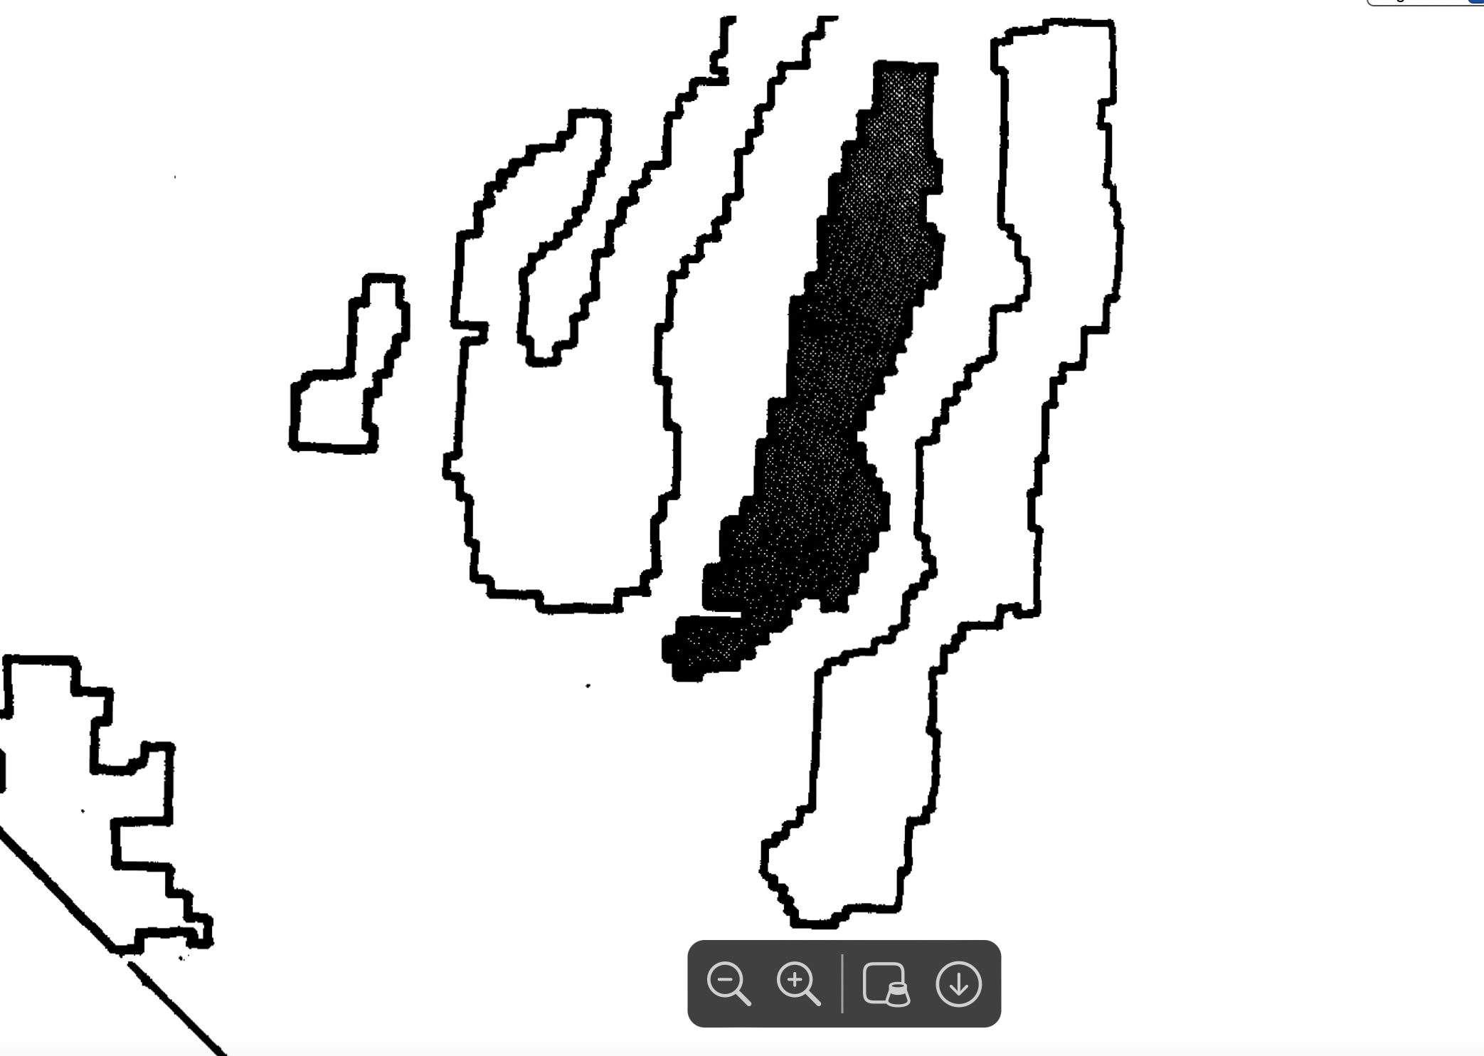
Key wildlife and fisheries habitat w i l l be maintained and improved.
The Forest will cooperate with the American Museum of Natural History t o develop an interpretive program for Toquima Range archaeological resources. [This highlights how landscape’s cultural values are – and the FS has greatly failed to examine the loss an degradation that will result from re-imposing grazing as lands and waters faced with climate stress (exacerbated by the m myriad harmful impacts of grazing and trampling degradation, erosional loss, re-construction of cow projects digging and excavating more, concentrating livestock, thus setting up a situation where trespass onto, and unauthorized use of, BLM land may be likely. The FS also never took a hard site-specific look at, or examined, or disclosed the cultural values both within and outside the Wilderness areas targeted for grazing disturbance, or the effects of potentially shifted and intensified use by other ungulates (elk, wild horses) potentially displaced by cattle herds and rancher motorized and other uses, or that move away from degraded and impaired habitats, from water grossly polluted with livestock waste to severely trampled meadows and broken artifact and sites with scientific value lost due to trampling, to grazing of non-capable land areas causing accelerated and excessive soil erosion in wind and water – exposing cultural materials to the surface. There is no assessment of the impacts of this grazing, trailing, facilities development, or salting and supplement feeding on irreplaceable cultural materials and landscapes.
Requirements of bighorn sheep will be provided for in currently occupied areas. Pioneering of bighorn sheep in other suitable habitat will be encouraged. Note the EA admits that Bighorn sheep are present in McKinney and Meadow Canyon, and some presence in Silver Creek and Monitor Valley West].
Noxious farm weeds will be controlled. New infestations and areas where noxious weeds are spreading will receive first priority for treatment. [The Toiyabe Pl ani ignored flammable invasive weeds. This alone shows the need for a new EIS].
Also: 377, 000 acres are to be managed for wildlife and recreation. [There is no mention of “range”].
31,000 acres wilderness have a Wilderness emphasis, and only 27,300 acres had range considered or important in management. Note the 1986 Forest Plan was finalized before the 1989 Wilderness designations. Plan at Iv 130.
The FS is also supposed to maintain the Pine Creek campground, but there is no hard look analysis of significant harmful cattle impacts in and around the campground, exposure of the public to high loads of cow manure and urine, cow-harbored diseases, etc.
Also: “Enhance sage grouse habitat in Stoneberger and Meadow Canyon”. [There is NOT going to be “enhancement” of Sage-grouse habitat with the FS re-imposing cattle grazing disturbance in Meadow Canyon. There is going to be accelerated loss and substantial new degradation of Sage-grouse habitat and reduced site productivity, reduced nesting cover, higher predation risk, reduced sustainability of viable populations, seriously increased riparian area erosion risk and more downcutting and new flow reductions or losses - reducing riparian and mesic areas and the vegetation required in suitable sites for late brood rearing. Construction of lethal and injurious range projects without current site-specific NEPA analysis, is not “enhancing” habitat. Grazing in spring – or on top of wintering birds – is not conserving, enhancing and restoring sagebrush habitats, Impacts will be significant and highly uncertain. There are now ever-escalating new sagebrush habitat threats. Yet the FS proposes significant new grazing in high quality habitats, and importin large herds of cattle from unknown sites to be grazed at any time of the year under extreme flexibility – all while the FS lands face threats from climate change of water flow loss that will be compounded by cattle grazing impacts, flammable weeds caused by cattle, new diseases that can be moved around by cows/rancher vehicles, etc., the persistent effects of the megadrought, and many cumulative threats
It is extremely hard to understand how allowing grazing at any unspecified time of the year in the sacrifice/reserve allotments complies with Toiyabe Plan, such as the emphasis on improvement of deer winter range.
There is no EA mapping and no hard look analysis of how this all overlays the project landscape.
Noxious farm weeds will be controlled. New infestations and areas where noxious weeds are spreading will receive first priority for treatment. Thus, the HTNF plan greatly ignores the spread, and risk of, flammable exotic invasive species- recognized as a graver environmental threat in 2024. See Molvar et al. 2024.
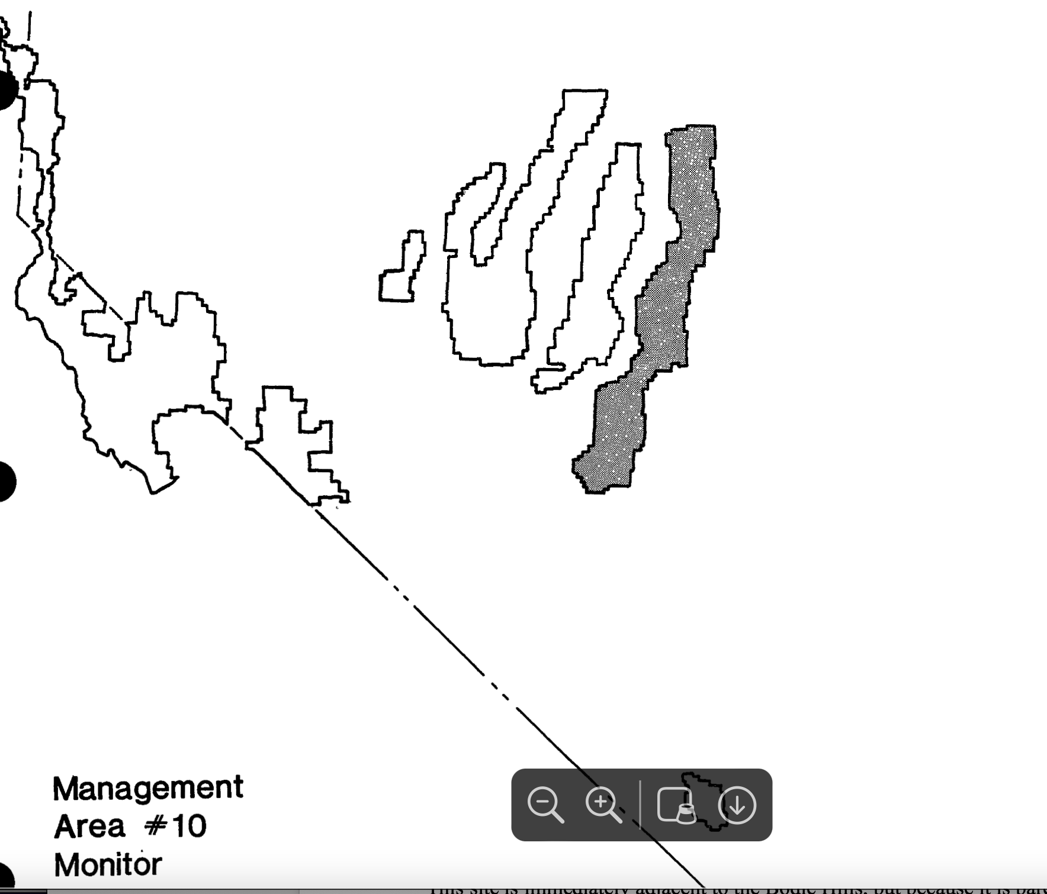
Area 10 – Monitor management area is 728,500 acres.
A healthy, diverse wildlife habitat will be provided with emphasis on deer, elk, and upland birds, while also emphasizing livestock grazing. Management will provide for requirements of wild horses.
Key habitats will be maintained and improved through management of wild horses and livestock. Wildlife habitat improvement projects will be conducted in key areas such as riparian habitats.
Wild horse herds willl be managed cooperatively with the BLM t o provide sufficient forage and water for wildlife and domestic livestock, and to
maintain soil and vegetation in satisfactory condition. Noxious farm weeds w i l l be controlled.
Forage for livestock and forage production will be maximized by maintaining intensive grazing systems.
Intensive Wildlife and Dispersed Recreation. 496,900 Acres
Wild Horses, Wildlife, and Dispersed Recreation. 177,600 acres.
Cultural resources. Conduct programmatic inventory and evaluation in the following areas: McCann Canyon, Savory Creek, Table Mountain, Hannapah, Georges Canyon, Clear Creek, Morgan Basin, Butler Basin, and House Canyon.
Manage the following areas to meet nonmotorized recreation objectives, but allow for designated routes, snowmobiles, special uses, and valid mineral and protection activities where applicable: Dagget, Reynolds, Bald
Horse Heaven-Butler Basin, Morgan Basin, Table Mountain.
Improve sage grouse habitat throughout the unit with emphasis on Table Mountain, Charnac Basin, Butler Basin, Willow Creek, Kelly Creek, and Allison Creek drainages.
Elk management – under Monitor Elk management plan.
The plan elements also describes improved fisheries management, and a trail system.
Enhance fishery habitat primarily through improvement structures and improved livestock management.
Implement prescriptions to reestablish aspen on suitable sites on Table Mountain.
Design the grazing system in Barley Creek to minimize conflicts between grazing and recreation. [The grazing system appears maximize conflict with cows being present throughout summer and into fall – the peak visitor use times].
Resolve conflicts between cattle and horses on South Monitor Wild Horse Territory.
Eliminate head cutting in meadows through management of livestock and/or installation of head cut structures.
Rehabilitate roads that exist in the vehicle closure area on Table Mountain. Continue implementation of the Table Mountain meadow restoration plan
Process 46 water claims.
We Object to the failure of the FS to take a hard look at how the self-serving EA analysis does not effectively address the Toiyabe Plan specific management sideboards in these terms:
The Toiyabe Plan describes Capability as:-The potential of an area of land to produce resources, supply goods and services, and allow resource uses under an assumed set of management practices and a t a given level of management intensity. Capability depends upon current conditions and site conditions such as climate, slope, landform, soils and geology, as well as the application of management practices, such as silviculture or protection from fire, insects, and disease. Plan at VI-4. Then HOW can the FS rely on the Toiyabe Plan when such factors have changed under climate stress impacts now known in 2024? How absurd is it to inflict season-long hot season grazing on Table Mountain or [potentially in Meadow Creek or other sacrifice/reserve allotments – and not even apply cow trampling standards on all the climate -stressed tiny springs and streams in 2024? And making matters worse, the FS proposes to “redevelop” = dig into and gut the springs with new excavation, in order to try to eke out climate-stressed flows to cow troughs, when sustainability of flows are much more threatened under 2024 climate – and ever hotter temperatures. There is no information on whether even a drop of water will actually remain at any “redeveloped” spring site, and no scientific analysis of spring type and characteristics. Also, the uplands under 2024 climate stress are much less resistant to grazing damage/exotic flammable weeds taking over – and much less “resilient” – i.e. have reduced ability to recover from grazing, unmeasured and uncontrolled trampling damage by 1200 lb.+ weight cows, and browse stress.
Recreation goal emphasizes ensuring visual quality protections - with analysis of VQOs and visual planning in all EAs.
Also from the Plan: Carrying capacity -The maximum stocking rate possible without inducing - damage to vegetation or related resource. As used in the determination of elk habitat effectiveness, carrying capacity is the estimated (expressed as the number of elk per square mile) of the elk herd subunit to provide quality elk habitat. VI-4 and 5.
Characteristic landscape - The overall impression created by a landscape's unique combination of visual features (land, vegetation, water structures), as seen in terms of form, line, color and texture; synonymous with "visual landscape c
Critical habitat -Key land areas used by wildlife for forage and reproduction.
Cultural resource -The remains of sites, structures, or objects used by humans in the past--historical or archaeological.
Cultural sensitivity -Refers to the likelihood of encountering significant cultural volumes (quantity and/or quality) which may affect and be affected by ground-disturbing activities.
The many outstanding values of the M-T lands are not evaluated in the Draft EA based on carrying capacity, capability and other management definitions and goals of the M-T plan. We Object to this.
Forest Service GRSG Amendment Violated by EA Harmful Management
Sage-grouse concerns were a critical part of NOPA comments, and now BM is preparing a new plan amendment in addition to the 2015 amendment, The 2015 Sage-grouse plan is Toiyabe Plan Amendment 17.
https://www.fs.usda.gov/Internet/FSE_DOCUMENTS/fseprd649477.pdf .
This amendment Plan includes:
GRSG-GEN-DC-001-Desired Condition – The landscape for greater sage-grouse encompasses large contiguous areas of native vegetation, approximately 6 to 62 square miles in area, to provide for multiple aspects of species life requirements. Within these landscapes, a variety of sagebrush- community compositions exist without invasive species, which have variations in subspecies composition, co-dominant vegetation, shrub cover, herbaceous cover, and stand structure, to meet seasonal requirements for food, cover, and nesting for greater sage-grouse. [Tis project will result in proliferation of exotic specu8es from cattle grazing disturbance, and these risks are worsened by the rampant project disturbance and “reconstruction”, the lack of any controls at all on 1200+ lb. cow trampling, the total lack of data on current health and quality of biocrust cover (front line defense against exotic weeds), the creation of sacrifice zone allotments that can be grazed at any time during the year – including when soils are extremely muddy and subject to major trampling displacement. Further, there is no effective way to “de-weed” cows that will be hauled in from all over the place to the sacrifice zone allotments, no mandatory rancher washing their ATVs and trucks each time they enter the allotment to “manage” cows, etc. The salt/supplement feeding allowed across uplands is not limited in amount and creates endless new sites for exotic weed infestation and spread. Large volumes of toxic herbicide m ay be used as a result of resumed grazing and this is not assessed in a hard look analysis.
The upland utilization standard can result in killing or weakening of native vegetation and fails to provide adequate residual cover for Sage-grouse nesting, We Object to the failure of the FS to address these significant concerns in a hard look analysis, and the lack of reasonable alternative and effectiveness analysis. There are numerous other goals, objectives and management actions of the GRSG amendment that the EA violates. We Object to the failure to comply with the 2015 GRSG plans and failure to effectively conserve Sage-grouse habitats.
Grazing the M-T allotments under the high utilization and other use standards and uncertain “flexibility” - including unknown time periods and herd sizes in 5 allotments will result in inadequate residual nesting cover and other crucial GRSG habitat elements:
GRSG-GEN-DC-003-Desired Condition – In greater sage-grouse habitats, including all seasonal habitats, 70% or more of lands capable of producing sagebrush have 10 to 30% sagebrush canopy cover and less than 10% conifer canopy cover. In addition, within breeding and nesting habitat, sufficient herbaceous vegetation structure and height provides overhead and lateral concealment for nesting and early brood rearing life stages. Within brood rearing habitat, wet meadows and riparian areas sustain a rich diversity of perennial grass and forb species relative to site potential. Within winter habitat, sufficient sagebrush height and density provides food and cover for greater sage-grouse during this seasonal period. [Cows break down and simplify diverse complex protective shrub cover on winter range, and the FS utilization levels do not provide for necessary residual cover height].
The FS year-round period when grazing would be allowed in the sacrifice allotments would result in prolonged spring grazing in the sacrifice allotments. The presence of cattle lures ravens and mesopredators that eat Sage-grouse eggs and chicks in. All the reconstructed cow projects prov ide elevated perches, sites for West Nile virus mosquitoes, and a host of other conflicts with quality Sage-grouse habitats and viable populations.
GRSG-LG-DC-039-Desired Condition – In priority and general habitat management areas, sagebrush focal areas, and within lek buffers, livestock grazing is managed to maintain or move towards desired conditions. (tables 1a and 1b). [We Object that the FS has not taken. A hard look at the range of adverse effects of the grazing schemes on these habitat areas].
GRSG-LG-ST-040-Standard – In priority and general management areas and sagebrush focal areas, do not approve construction of water developments unless beneficial to greater sage-grouse habitat and consistent with State approved water rights. [We Object that the FS has not shown that re-constructing the M-T water developments is beneficial to GRSG – especially due to damage to spring flows and potential total loss of flows from gutting springs even worse. This will reduce or destroy altogether the mesic vegetation brood rearing habitat. Further, there is no data on ecological conditions and characteristics of all affected springs, or on how much flows are, or who holds the water right, or if development would ensure flows for wildlife. See Sada et al. 2001, BLM Tech. Report on springs, Sada and Lutz 2016. We emphasize there is a great lack of baseline site-specific data and this may end up wrecking brood habitat. There is no site-specific data – for example, will troughs with re-gutted springs be 50 ft. or 500 ft from the spring? What threshold of surface flow will be too mini al to undertake re-gutting?].
GRSG-LG-ST-041-Standard – When vertical embankments in water troughs or open water facilities pose a drowning risk to birds, wildlife escape ramps should be installed and maintained. {we Object that the FS fails to identify that birds still drown in tanks because often multiple ladders are needed, and tanks become choked with scummy algae masses that prevent swimmingGRSG-LG-DC-039-Desired Condition – In priority and general habitat management areas, sagebrush focal areas, and within lek buffers, livestock grazing is managed to maintain or move towards desired conditions. (tables 1a and 1b)
GRSG-LG-ST-040-Standard – In priority and general management areas and sagebrush focal areas, do not approve construction of water developments unless beneficial to greater sage-grouse habitat and consistent with State approved water rights.
GRSG-LG-ST-041-Standard – When vertical embankments in water troughs or open water facilities pose a drowning risk to birds, wildlife escape ramps should be installed and maintained.
GRSG-LG-GL-042-Guideline – Grazing guidelines should be applied in each of the seasonal habitats in table 3. If values in table 3 guidelines cannot be achieved based upon a site-specific analysis using Ecological Site Descriptions, long-term ecological site potential analysis, or other similar analysis, adjust grazing management to move towards desired habitat conditions in table 1a or 1b consistent with the ecological site potential. Do not use drought and degraded habitat condition to adjust values. Grazing guidelines in table 3 would not apply to isolated parcels of National Forest System lands that have less than 200 acres of greater sage-grouse habitat.
GRSG-LG-GL-042-Guideline – Grazing guidelines should be applied in each of the seasonal habitats in table 3. If values in table 3 guidelines cannot be achieved based upon a site-specific analysis using Ecological Site Descriptions, long-term ecological site potential analysis, or other similar analysis, adjust grazing management to move towards desired habitat conditions in table 1a or 1b consistent with the ecological site potential. Do not use drought and degraded habitat condition to adjust values. Grazing guidelines in table 3 would not apply to isolated parcels of National Forest System lands that have less than 200 acres of greater sage-grouse habitat.
See also:
GRSG-LG-GL-043-Guideline – In priority and general habitat management areas and sagebrush focal areas, when grazing permits are waived without preference or obtained through permit cancellation, consider the agency’s full range of administrative authorities for future allotment management, including, but not limited to allotment closure, vacancy status for resource protection, establishment of forage reserve, re-stocking, or livestock conversion as management options. The FS DID NOT take a hard look at allotment closure, and never evaluated that as a reasonable alternative (including through applying a current Suitability analysis) given the host of threats this population at the very southern edge of the range, faces. A range contraction is foreseeable].
GRSG-LG-GL-046-Guideline – Fences should not be constructed or reconstructed within 1.2 miles from the perimeter of occupied leks, unless the collision risk can be mitigated through design features or markings (e.g., mark, laydown fences, or other design features).
GRSG-LG-GL-047-Guideline – New permanent livestock facilities (e.g., windmills, water tanks, corrals) should not be constructed within 1.2 miles from the perimeter of occupied leks.
We Object that that the FS fails to provide adequate hard look analysis at the impacts of the proposed grazing and facility EA scheme in relation to these sagebrush habitat management elements of the plan and has not even mapped of leks in this local population, and provided current lek attendance numbers, nor provided trends for all leks periods of time for which data is available in the local population and the Monitor PMU, as well as failing to identify where documented leks formerly occurred but are no longer active.
GRSG-RT-DC-078-Desired Condition – In priority and general habitat management areas and sagebrush focal areas, within the forest transportation system and on roads and trails authorized under a special use authorization, greater sage-grouse experience minimal disturbance during breeding and nesting (March 1 to June 30) and wintering (November 1 to February 28) periods. Year-round and conflict significantly with this, and we Object to the FS allowing grazing during these harmful periods.

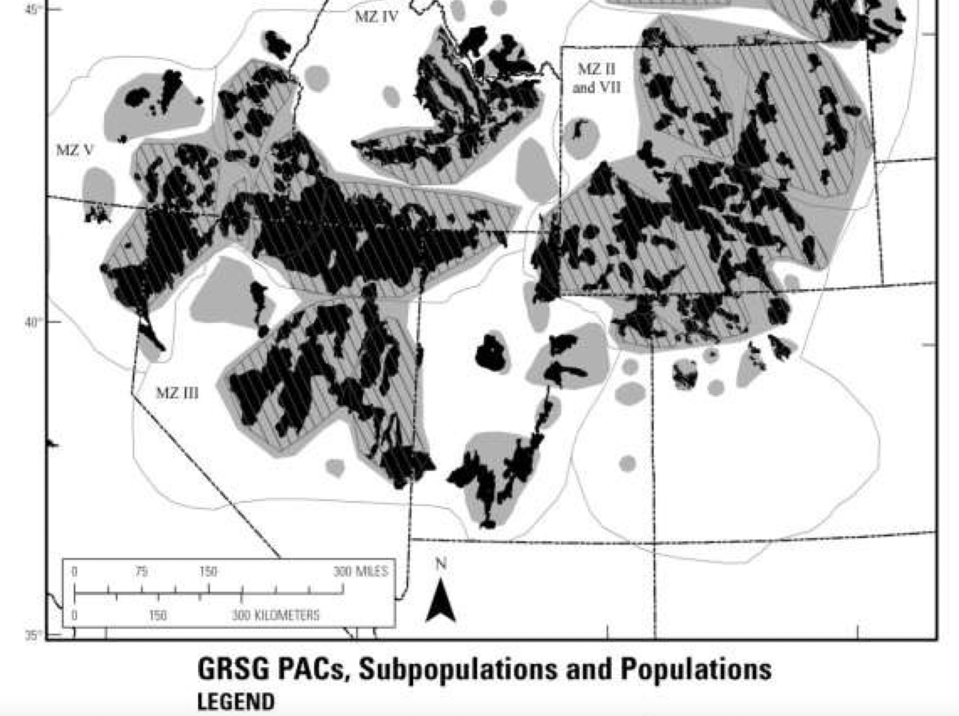

A hard 2024 look is necessary to ensure compliance with NFMA, even the elements of the old Forest Plan that the FS relies on (even the range elements). As an example, the EA violation and lack of credible hard look NEPA analysis at the Toiyabe Plan’s wildlife mandate:
“4.2.3 Wildlife and Fish Standards and Guidelines: 4—Manage ecosystems containing sensitive plant and animal and threatened and endangered animal populations to maintain or increase these populations and to achieve recovery.
There is no hard look at actual current ecological conditions including whether conditions can be maintained – let alone improved with cattle grazing permanently imposed. There are new unassessed and unaddressed and inadequately minimized or mitigated impacts:
We Object that no hard look has been taken at Elk “forage”, and how cows and rancher management and facilities will conflict with elk and other wildlife use of food, cover space including seasonal calving and other habitat security cover and needs, and clean water. Conditions have significantly changed with burgeoning elk populations since 1986. How many elk were present in this population and this landscape at the time of the 1986 Tonopah Forest Plan (elk were introduced in Monitor region in 1979 vs. now in 2024? Where are all important seasonal ranges?
The NDOW elk plan at “Nevada elk Species Management Plan” 12-13 describes livestock potentially infecting elk with diseases, and that areas where elk and livestock may concentrate – as on winter range - are a concern. The highly uncertain year-round grazing period, and potential winter grazing conflicts in the 5 sacrifice allotments are not adequately assessed in a hard look analysis. It also discusses the high value of elk to the public and their positive economic impact.
https://www.ndow.org/wp-content/uploads/2021/10/NDOW-Elk-Species-Management-Plan-02-08-97-ADA-Compliant.pdf
Note that large numbers of Elk are not believed to have been present pre-white settlement in central NV. Further, Wolves and Grizzly Bears have been eliminated, so native predator-prey relations and the presence of large native predators to prevent big game concentrations has been disrupted. Grazing cattle here may result in taxpayer subsidized Wildlife Services killing of Coyotes, Mountain Lions and other extant native predators – further disrupting natural ecological processes.
NDOW documents show the importance of this area and these allotments to elk populations:
https://www.ndow.org/wp-content/uploads/2022/01/Elk-161-164171-173.pdf
“Recommended Hunting Areas: Although elk occur in all units of the management area, many of the animals are found in the Monitor Range in Unit 162. Densities are highest in the Table Mountain area, but hunter numbers are also higher, particularly during the early season hunts. The Dobbin Summit, Butler Basin/Willow Creek area is more accessible than the Table Mountain Wilderness to the hunter who does not have horses. Typically, elk have moved off Table Mountain and out of Butler Basin by the late season hunts. The Table Mountain herd winters primarily on the southeast side of the Monitors in Haystack Canyon to Sheep Mountain. The Butler Basin herd typically winters in the Butler/Willow Creek and Blackrock areas. Mature bulls usually winter away from the large cow-calf groups in more difficult to reach areas. Lone bulls and bachelor groups may be encountered in many canyons throughout the Monitors and can be difficult to locate at times. Some good places to start looking for bulls would be the higher country …”.
Cows grazed in these allotments may displace Elk from preferred habitat areas – as elk avoid areas significantly disturbed by cows in summer - early fall. Hunter blogs discuss elk in the Monitor region concentrating near water in Septembe – and the FS grazing scheme inflicts cows during that period. It has been our observation over the years that in late summer, Elk often avoid the most cow-fouled waters and lands.
http://www.nevadadventures.com/Hunting/hunterinfo/16area/elk162.html
We Object to the FS authorizing a new grazing permit on the very land area (Table Mountain) with the most elk conflicts without first conducting a valid hard look analysis carefully weighing a host of conflicts and problems that will arise, and also without first conducting a current grazing Suitability analysis under NFMA. The elk population has increased substantially since the few animals present when the old Forest Plan (the last time grazing Suitability was considered) was being developed. The elk are certainly worth much more to the public and to many more people than the cows. Cows imposed on Table Mountain benefit a sole single ranching operation with nearly free grazing and no responsibility to pay for the large-scale habitat degradation and loss that would take place – such as irreversible weed expansion, permanent loss of spring flows from grazing and facility impacts, introduction and/or spread of new wildlife diseases, etc., which the FS fails to take a science-based hard look at even identify. There are already concerns about big game herd population declines. See: https://www.ndow.org/wp-content/uploads/2023/08/2022-23-Big-Game-Status-Book-1.pdf with any private lands in the area, too. Further, NDOW records show Mule Deer populations across this region are currently low. Where are all elk calving ad deer fawning areas impacted by grazing under the EA schemes for these allotments?
We Object to the failure to consider a broad range of climate stress impacts to the host of wildlife, watershed and wild land values here. Accelerated climate change stress making lands and water hotter and habitats less resistant and less resilient to domestic cattle grazing and 1200 lb.+ cows lumbering around obliterating protective biocrust and causing and spreading irreversible flammable weeds in a landscape that historically did not have large herds of hoofed grazers. What was the average temperature here and in the West in 1986 vs. 2024? What were flow rates of springs and streams across these allotments in 1986 vs. 2024? How many flammable weeds were present in 1986 vs. 2024?
New or Increased Threats Increase Cumulative Impact Harms in Allotments
We Object that the FS has not conducted hard look NEPA analysis of all direct indirect, cumulative and synergistic stresses and threats to important native animals and plant, including sensitive and MIS species, that inhabit the EA-targeted land .
New disease threats make sensitive wildlife even more vulnerable to population declines and losses – and the further degradation and disturbance of livestock grazing will exacerbate this. Further, many of the new diseases – that did not exist at the time of the ancient Forest Plan – can be spread all over the place by cows – with disease organisms in soil and mud on hoofs, or hair on coats, Examples: Chytrid, RHD. The large number of livestock water developments and fence lines that the FS proposes to “reconstruct” – without a hard look at baseline characteristics (terrain, current flows, veg present, extent of riparian/mesic zones that are unique to each site, so that the actual species/habitat/population conflicts, watershed integrity and condition impacts, the extent of marring of Recreation/Wilderness/visual values, the impacts to cultural sites and materials in the vicinity of the project, and severity of cow congregation disturbance and weed spread that is foreseeable– can be fully examined in a hard look NEPA analysis.
Additionally, the fences and potentially cow water development materials will provide elevated perches for Sage-grouse and small mammal and bird predators to scan for eggs/nests/chicks/young. Connelly et al. 2004 Sage-grouse Conservation Assessment describe fences as areas of habitat fragmentation, predator travel corridors, and sites for weed infestation too.
Deep cow hoof pocks will result in ideal conditions for water developments for West Nile virus, and potential transmission of avian flu. Diseases that can be spread all around by soil on cow hoofs or coats include chytrid that decimates native amphibian populations. RHD (Rabbit Hemorrhagic Disease) gravely threatens Pygmy Rabbit and all other native leporids, including Pika, Jackrabbits and Cottontails. These species are essential food sources for Golden Eagle and other rare and declining native raptors. We Object to the failure to consider the role of cattle in spreading diseases to wildlife.
Migratory bird populations are in serious decline. See Rosenberg et al. 2019, Remington et al. USGS report 2022. Also: https://news.cornell.edu/stories/2019/09/nearly-30-birds-us-canada-have-vanished-1970 .Cattle facilities not only provide elevated predator perches, they provide perches for brown-headed cowbirds that parasitize nests, and are a collision hazard for migratory birds - including even if marked. Van Lanen 2016 describes Sage-grouse collision mortality from marked fences, and WLD has observed this in the field, too
The 2019 Rosenberg et al paper Decline of the North American Avifauna describes the great declines in the North American avifauna including forest and grassland birds, and billions of birds lost in bird populations in North America. The HTNF Fire EA will worsen the plight of many already declining migratory birds.

See also: https://news.cornell.edu/stories/2019/09/nearly-30-birds-us-canada-have-vanished-1970
Numerous sagebrush species migratory bird and other declines are described in the Remington et al. late 2021 report: https://pubs.usgs.gov/of/2022/1081/ofr20221081.pdf
Cheatgrass and other flammable weed expansion is driven in significant part by cattle grazing disturbance in arid western lands. See Belsky and Gelbard 2000 http://www.alamedacreek.org/take-action/pdf/Belsky%20and%20Gelbard%202000.pdf describing grazing disturbance and the fact that livestock are vectors for weed seed spread in mud on hoofs, in guts and deposited as manure, and seeds lodged in hair.
See Reisner Dissertation, Reisner et al. 2013 and Williamson et al. 209 (on cd) all describe cattle grazing causing cheatgrass. The word “cheatgrass” or bulbous bluegrass (another densely growing arid annual grass) isn’t even found in the M-T EA. Yet there is now overwhelming evidence that cattle grazing causes cheatgrass and other flammable weed spread.
New information is summarized in Kauffman et al. 2022. https://link.springer.com/article/10.1007/s00267-022-01633-8 describing how livestock grazing in arid western lands exacerbates and interacts with climate change, loss of resilience and resistance, and grazing disturbance causing cheatgrass.
New information in Molvar et al. 2024 review of extensive evidence of grazing causing cheatgrass. https://westernwatersheds.org/wp-content/uploads/2024/02/Cheatgrass-Literature-Review-final.pdf
The latter two papers provide significant new information since scoping on this short-sighted damaging M-T grazing scheme.

See also:
https://www.usgs.gov/news/new-research-highlights-decline-greater-sage-grouse-american-west-provides-roadmap-aid?qt-news_science_products=1#qt-news_science_products .

https://pubs.er.usgs.gov/publication/ofr20201154 “Range-wide Greater Sage-Grouse Hierarchical Monitoring Framework: Implications for Defining Population Boundaries, Trend Estimation, and a Targeted Annual Warning System”.
Greater Sage-grouse populations have declined significantly over the last six decades, with an 80% range-wide decline since 1965 and a nearly 40% decline since 2002, according to a new report by the U.S. Geological Survey.

Remington et. al. 2021. https://pubs.usgs.gov/publication/ofr20201125

Pinyon Jay: https://birdsoftheworld.org/bow/species/pinjay/cur/introduction

Pinyon Jays are increasingly rare and their populations declined by 85% between 1970 and 2014, according to Partners in Flight. Since we submitted scoping comments, a petition has been filed seeking Pinyon Jay listing.
USFWS subsequently determined that Listing may be warranted.
Cattle may impact pinyon pine forest regeneration and growth in many ways. This includes trampling damage that destroys seedlings, and the major threat of cattle grazing causing expansion and subsequent dominance of cheatgrass which chokes the ground surface, and prevents native plant and Pinyon Pine restoration. Further, there is no adequate mapping and site-specific information of vegetation condition and habitat quality and quantity in the areas where the multitude of projects may be” “rebuilt”: and trees may be cut down, or injured. Pinyon injuries expose tree sap that attracts insects that kill injured trees and the insects often expand into surrounding areas – thus threatening the integrity of the forest and quality and quantity of Pinyon Jay habitat. We Object to the failure to take a hard science-based look under NEPA at the current occurrence and populations levels of Pinyon Jays in this landscape, as a basis for developing a reasonable range of alternatives and to be able to effectively assess, minimize and mitigate impacts – including mitigation by avoidance of cattle grazing/trampling damage to young pinyon, and protection of understories from cattle damage that causes cheatgrass – leading to fast-moving wildfires. The ancient Tonopah Plan has no MIS species that represents the ever-diminishing PJ forest.
Moreover the FS may plan to use the M-T allotments as locations for grazing cattle that may be “displaced” due to the HTNF’s own major PJ and sagebrush vegetation manipulation treatments. These “treatments” are often the opposite of “restoration”, and instead include large-scale landscape burning and piled up vegetation burns (both cause cheatgrass invasion), heavy equipment cross country travel harming plant/soil/biocrust damaging mastication, drastic chaining disturbance, cutting or other deforestation projects that promote irreversible flammable weeds, and that are destroying Pinyon Jay and often sagebrush habitat too as collateral damage. There are currently huge projects proposed or being authorized across across Region 4 Forests. Critical habitats and forest lands biodiversity and wild lands values are in the crosshairs of numerous HTNF projects. The Prescribed Fire EA,
The East Humboldt-South Ruby (EHSR) EA https://www.fs.usda.gov/project/?project=65063 .
There are many recent HTNF Bridgeport RD forest manipulation and tree killing projects, innumerable Ely BLM and other Nevada BLM office deforestation projects and Ely Forest and Austin-Tonopah Indian Valley projects threatening Pinyon Jay survival.
Further purposeful destruction of forests, as the HTNF is proposing, under the guise of “restoration could thus result in cows being grazed for years in the M-T EA sacrifice/reserve allotments. These massive treatments pose a grave risk - and will only make ecological matters much worse.

The HTNF Prescribed Fire EA or other future forest and sage manipulation projects could burn up or “treat” much of the irreplaceable existing very high quality sensitive and MIS species habitat on the Table Mountain and other project allotments, and move permitted cows onto a sacrifice forage allotments. The HTNF has been failing to assess alternatives of reforestation and sagebrush replanting, or passive restoration by removing grazing from significant land areas to promote ecological integrity and land health in all of these supposed restoration projects, and only providing the most minimal “rest” period an only ibn some circumstances. The M-T project abandons de facto passive restoration and is a big step backwards. The sole EA alternative has failed to address cheatgrass/bulbous bluegrass/medusahead and other serious invasive weed problems the proposed actions will cause. Chronic livestock grazing disturbance and “treatments”, including so-called “restoration” projects, are making weeds much worse. Both result in hotter, direr, windier, weedier sites. We Object to this lack of analysis of vegetation manipulation harms to HTNF lands and biota, and to public recreational and other uses, and of potential links between re-imposing grazing here and the manjor treatment projects in the pipeline.

The Boone et al. 2021 paper on Pinyon Jays describe that the birds have undergone an 85% population reduction, and finds that Pinyon jays use forests over a wide range of elevations. See also : https://www.allaboutbirds.org/guide/Pinyon_Jay/lifehistory. Pinyon Jay populations declined by 85% between 1970 and 2014, according to Partners in Flight. They are a Yellow Watch List species, and have a Continental Concern Score of 14 out of 20.

In 2022, Defenders of Wildlife filed an ESA petition:
https://defenders.org/sites/default/files/inline-files/2022.4.25_FWS_Listing%20petition_Pinyon%20Jay.pdf .

USFWS positive finding Pinyon Jay 90-day finding:
https://www.federalregister.gov/documents/2023/08/17/2023-17726/endangered-and-threatened-wildlife-and-plants-90-day-findings-for-five-species

Often when BLM or the FS proposed killing more PJ that is claimed to be “invading” especially at lower elevations, the FS destroying forests in areas where PJ naturally occurs and was historically present. This again points to the need to reforest areas currently lacking PJ because of fires, or agency deforestation "treatments” to enhance Pinyon Jay and migratory bird habitat. Cattle grazing can destroy and kill young trees through trampling and breakage, and cattle grazing disturbance promotes irreversible flammable weeds choking the ground surface also preventing PJ forest regeneration.

Despite the USFWS issuing a positive 90-day finding on the Pinyon Jay petition, https://www.federalregister.gov/documents/2023/08/17/2023-17726/endangered-and-threatened-wildlife-and-plants-90-day-findings-for-five-species the HTNF just scoped the East Humboldt-South Ruby (ESHR) EA that will include significantly expanded new destruction of Pinyon Jay and many other avian species habitats. The HTNF SOPA shows the ecologically disastrous HTNF Prescribed Fire EA is still moving forward. The HTNF Indian valley PJ deforestation was authorized prior to the petition, but project components may still be taking place - in the Austin-Tonopah landscape.
https://www.fs.usda.gov/project/htnf/?project=52200 . The Indian Valley project area sprawls across 22,500 acres or more, and within this site the Forest proposal is to radically deforest 17,000 acres, yet the FS conducted a mere rubber-stamp CX with no actual analysis of harmful environmental impacts.

The large-scale destruction of sagebrush and other shrub and forest veg communities proposed in a series of HTNF EAs (including sage/mahogany/aspen mature veg community destruction) and unassessed collateral damage. Burn piles and other “treatment” actions will fast forward flammable irreversible cheatgrass across this landscape. High levels of livestock grazing are chronically inflicted on Open HTNF allotments are certain to escalate weed risk. Where will flammable weeds take over in the wake of these treatments? Please provide detailed soil, biocrusts, and other baseline information – and take a hard look at the severity of weed dominance risk that treatments will spawn.
The HTNF and BLM “restoration” projects target the mature and old growth native veg communities - from sagebrush to limber pine -that are sensitive and MIS avian species and other rare species vital habitats necessary to support viable populations. out-dated flawed models and do not reveal the specific inputs for each vegetation community and for wildlife habitats that it used.
In addition, pending HTNF projects like Deer Creek destroy Goshawk, Flammulated owl, migratory songbird, forest and sagebrush habitat in Nevada.
The FS in this series of HTNF projects affecting both forest and shrubland sensitive species relies on long-disproven extremely short fire return and disturbance intervals in “range” papers by Miller 2008 and Tausch 2009, and Landfire info and modeling from 7 or more years ago in order to arrive at its astonishing forest destruction targets: in its prescribed Fire EA and deeply flawed East Humboldt-South Ruby project now scoped – and many of the same migratory bird, forest sensitive raptors and other species oof concern would also be significantly impacted by this project. From the EHSR project:
“LANDFIRE data were also used to compare historic range mean fire return interval as well as approximate acres burned for each vegetation type (LANDFIRE 2014). This information provides an approximation of how many acres should be targeted for burning on an annual basis to move towards and then maintain the historic fire return interval to restore a more resilient stand composition and structure. Based on the natural fire regime, the analysis supports an annual prescribed fire objective of up to 80,000 to 100,000 acres per year on the Humboldt-Toiyabe National Forest.

https://www.fs.usda.gov/project/?project=57860

The “resilient” structure sought ends up being grass and dirt. Claiming the HTNF arid veg communities are “fire-dependent ecosystems” is nonsense. There are very long fire return intervals of hundreds of years. See Bauer and Weisberg 2010, for example. This project will make the Forest lands much more uniform and full of early successional and highly flammable cheatgrass, bulbous bluegrass, and other weedy vegetation. It will result in hotter, drier, weedier, windier mountain ranges with greatly simplified vegetation communities and large-scale losses in biodiversity - lacking complex woody vegetation structure required by so many rare and declining species and that protects and cools the ground surface and allows slower snow melt and moisture retention on site.

The HTNF also asserts it will alter how forests burn. But isn’t this “unnatural”? Don’t nearly all these forests and sage historically burn in stand replacing fires and with fire intervals of several hundred years– if one consults the ecological literature, and not “range” advocate papers the FS relies on. Lanner and Frazier 2011 have described the historical stability of Nevada Pinyon-Juniper forests. http://www.phytologia.org/uploads/2/3/4/2/23422706/933360-387lannerpinyonjunipernevada.pdf

Fire kills sagebrush of all types – and all of these HTNF treatments will further endanger local and regional populaitons of Nevada’s Sage-grouse, Pygmy Rabbit, Sage Thrasher and other sagebrush dependent species habitats and populations. These plant communities targeted by the EHSR and the immense sprawling HTNF Fire EA are not “fire-dependent”!

The HTNF native vegetation “treatment is so extreme right now that agency claims about one major project contradict the other, as in the Fire EA vs. EHRM EA.
The HTNF Prescribed Fire EA claims these are fire-dependent ecosystems - yet in the sprawling EHRM EA that was recently scoped, the HTNF claims it is trying to stamp out fires.

We incorporate by reference into this M-T Vacant Allotment Objection and are submitting on cd HTNF Prescribed Fire EA and HTNF EHSR EA comments, comments on the BLM Restoration PEIS, BLM Fuelbreaks PEIS and Pinyon Juniper Categorical Exclusion CX. These comments detail biases and ecological risks from the HTNF “restoration” and “fuels” treatments currently proposed. These projects represent major new and long-term threats to the regional FS sensitive and MIS species populations that will also be harmed by this grazing imposition EA. The flawed FS models targeting PJ and mature native vegetation communities in the Great Basin for massive alteration ignore natural arid land forest and shrubland ecological and successional processes; the importance of mid and later seral habitats to survival of nearly all Forest sensitive species and their importance to biodiversity; the high risk of irreversible weed infestation that will be exacerbated by chronic grazing disturbance and hotter temperatures under climate change stress; and the great value of these habitats and aesthetic and natural settings they provide to the public – and that these manor manipulation schemes will significantly harm. These HTNF large-scale treatment schemes appear to be a key part of any claimed “need” for grazing of the sacrifice/reserve or 40 other vacant allotments. We Object to the failure of the EA analysis to: 1) Assess significant adverse effects of proposed HTNF and BLM massive vegetation manipulation projects on sensitive and MIS species and migratory birds - species also impacted by the M-T EA project: 2) squarely address if livestock from HTNF “treatment” disturbed Forest treated lands are going to be grazed in the sacrifice/reserve M-T allotments; 3) disclose the potential for the M-T allotments to be “treated” under the HTNF Fire EA or other manipulation projects.
Bauer and Weisberg – showing how the FS modeling is severely flawed – as fire return and disturbance intervals in PJ are extremely long (here 427 years) -compared to the very short time periods used by the FS models used to justify massive manipulation. See also Connelly et al. 2011, Studies in Avian Biology, William Baker chapter sagebrush fire return intervals.

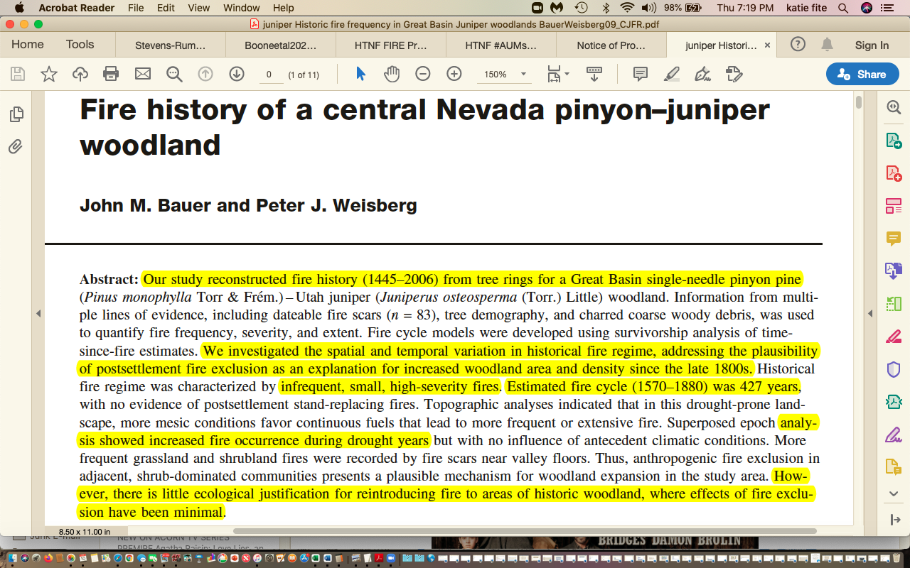
The USFS must fully analyze the highly significant adverse footprint of the vast and destructive agency and other vegetation treatments as a cumulative impact and threat to M-T EA FS sensitive and MIS species and persistence of sustainable habitats and populations at the local and regional level.
Both USFS and BLM ignore the major role of historical mining era deforestation and settler burning and wood use in removing native forests from lands. Then the agencies use claims of “encroachment”, “expansion” for areas where trees are re-occupying forests to doom these forests to clearing for livestock forage under claims of saving sage-grouse or reducing “fuels”. These radical vegetation manipulation projects make the arid forest lands bleaker, hotter, drier, windier, weedier thus changing the site micro-climate. They also make lands more likely to burn and prolong the fire season. These projects are also causing significant adverse impacts to sagebrush – including as collateral damage – including pile and other burning which produces tens of thousands of sites for cheatgrass and other flammable weeds to get a toehold to infest forest lands and then. Proliferate outward, with impacts worsened by cattle grazing disturbance and depletion and the cows are weed vectors Also, the FS and BLM PJ killing projects end up killing many more trees than are actually “treated” – as treatment-wounded trees and masticated or piled wood pitch lures in insects that then infest “leave” tree areas and patches.
We are greatly concerned about the lack of an EA baseline of forest, sagebrush, or other native vegetation disturbance, loss and fragmentation in the project area and adjacent landscape. Where are all existing USFS and BLM “treatments over the past 25 years? Where are proposed or foreseeable treatments? How disturbed are the species habitats that will be significantly harmed, disturbed and fragmented by this M-T grazing proposal? The resumption of grazing in the M-T allotments is highly likely to lead to “treatments” as lands become depleted. We Object to the failure to provide baseline ecological information on all existing treatments conducted for all periods of time – cuts, chainings, prescribed fire, seedings, etc. -in the affected landscape, and any foreseeable ones. We Object that the EA fails to look at the scale of habitat alteration and impacts from existing projects, and/or that may authorized by projects already finalized - but where all treatments under the NEPA document umbrella have not yet been carried out.
The HTNF Fire EA mapping sets the stage for massive burning and mechanical “treatment” of all vegetation communities in these allotments outside of designated Wilderness. The FS mapping shows nearly everything except rocks and ice (green low departure) as “moderate” departure: https://www.fs.usda.gov/project/?project=57860
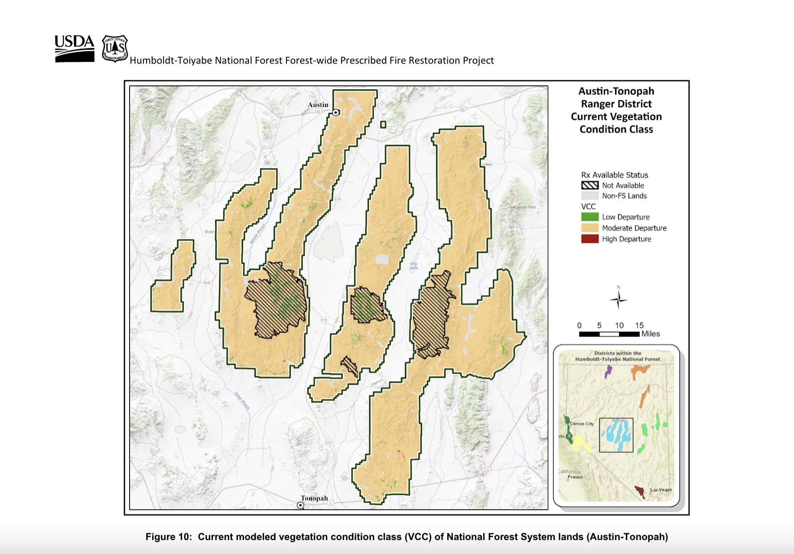
All the “moderate” (dull yellow color) lands including the project area allotments could foreseeably be “treated” - burned, masticated, cut down, piled and burned, etc. under the HTNF Prescribed Fire EA – with the FS veg manipulation and fire use spawning irreversible weeds, and weed risks elevated by made worse by the M-T projects cows.
The HTNF Prescribed Fire EA maps these lands at “moderate risk” because there are actually many mature native veg communities (critical sensitive species habitats) present, Yet the crazed HTNF fuels models seek to reduce these to an early seral state dirt and grass state where sensitive species are not able to live. We Object to the failure to conduct hard look analysis of how devastating such highly foreseeable large-scale disturbance treatments aimed at destroying the mature and old growth communities characteristics and complexity required by nearly all FS sensitive species and MIS species like sage-grouse would be for these species, and for the public lands recreational, cultural, aesthetic and spiritual uses of M-T lands and surrounding areas. We Object to the failure to consider cumulative impacts from all the manor manipulation projects the HTNF is now embarking on. We Object to the failure to address potential links between the M-T EA scheme’s major sacrifice zone allotments and these massive treatments.
Biodiversity Baseline and Basic Current Species Inventories Baseline Is Lacking
We Object that the USFS has not conducted intensive on the ground surveys for many species of growing conservation concern so an informed NEPA document with a reasonable range of alternatives can be developed, and the full range of the projects harmful direct, indirect and cumulative impacts to their habitats and populations can be assessed. The FS cannot merely use existing databases or habitat models. The EA actions will deprive our members of enjoying, viewing, studying, photographing, seeking solace in, beautiful wild landscapes and a diversity of native wildlife like Sage-grouse, Pygmy Rabbit, Pinyon Jay and many others, as well as native vegetation. These animals rely on natural minimally fragmented wild and undeveloped habitats. The dense cheatgrass/flammable annual weeds and habitat fragmentation from cattle facilities and concentrations of livestock will substantially harm these sensitive species habitats, and their ability to recover from natural disturbance.
Even critical elements of arid western shrub and forest lands are ignored entirely. For example, the EA is dead silent on the condition, presence and integrity of biotic crusts, and there is no look at how the EA grazing or potential massive treatments will harm them.
Regarding cutting/thinning/fire treatment and/or livestock trampling degradation of microbiotic crusts. The EA has not analysis of how the Forest measures and monitor the health of microbiotic crusts in the M-T lands. Crusts provide a protective covering to help prevent soil erosion in wind and water, sequester carbon, provide nutrients to other vegetation, protect watersheds through promoting proper infiltration, and help exclude weeds. Belnap et al. 2000 BLM Tech. Bull. 2000. Microbiotic crusts are a very important component of sage/shrub and PJ communities that the project will harm. The crusts in forests and western arid lands stabilize soils, protect them from erosion, and are a frontline defense against cheatgrass and other invasive species. See analysis examples:
Beymer et al 1992. Effects of cattle grazing on microbiotic crusts. Vegetation manipulation or clearing fence lines for fences gives cows access to previously ungrazable sites protected by tree limbs or shrub structure. Protected sites in grazed landscapes are very often covered in mosses, lichens or native grasses.
Bowker et al. 2008. Crusts as soil function indicators. Yet the project ignores and crusts – the massive foreseeable “treatments” in the region involve heavy equipment, pile burning, wood chips smothering them, and deforestation exposing sites to even more intensive cow impacts such as weed-causing soil/crust trampling, deposition of weed-causing manure, eating fragile native plants previously protected.
Brotherson et al. 1984. This describes adverse effects of long-term grazing on crusts.
Concostrino-Zubiri et al. describe effects of exposure and grazing - example bryophytes (mosses).
Deines et al. 2007. Greater lichen cover resulted in an observed significant decrease in cheatgrass.
Evans and Belnap 1999. Effects of loss of nitrogen from soils in arid communities.
Fernandez et al. 2007. Results show that areas used by domestic livestock have 20% less plant cover and 100% less soil organic carbon and nitrogen compared to relict sites browsed by native ungulates. In actively grazed sites, domestic livestock grazing also appears to lead to clustered, rather than random, spatial distribution of soil resources.
Kettering 2009. Soil crusts were not totally recovered 40 years after disturbance. Also impacts carbon sequestration.
NRCS 2007. This describes microbiotic crusts and disturbance impacts. It’s too bad NRCS veg models (such as those used in the Ecosites, disturbance intervals, and other info the FS relies on) today greatly ignore the natural occurrence of, and role, of crusts.
Ponzetti and McCune 2007. This describes effects of soil disturbance, and of increased incident radiation, increased heat load, and topographic position in crust recovery.
Rosentreter 1992. Describes cheatgrass harms to rare plants, and grazing harming crusts causing cheatgrass/annuals.
Rosentreter et al. Field Guide. Lichens and mosses typical of the region.
Serpe et al. 2008. Crusts tend to reduce the spread of invasive species. The project will harm and/or destroy or lead to the cow-caused destruction of crusts – over vast areas, and the Forest ignores this harm.
USDI BLM Belnap et al. 2001. Tech. Ref. on Biological Crusts. Describes grazing and harmful mechanical disturbance impacts to crusts, and their vital role in the ecosystem protecting soils from erosion in wind and water and other ecological functions.
NDOW’s new wildlife action plan, released after the M-T scoping, lists many species of conservation concern in Nevada, and entire groups of species are ignored completely in the M-T EA’s minimal baseline and analysis of impacts.

See: https://www.ndow.org/wp-content/uploads/2023/11/2022-SWAP-Full-Doc-FINAL-print.pdf

The M-T grazing project impacts will cause extensive degradation of HTNF and surrounding BLM habitats and ecological processes. They will be cumulatively harmful with the consequences of other connected and cumulative actions the USFS and BLM are authorizing on federal lands in this region. This includes depleting weed-causing livestock grazing disturbance across the hundreds (how many are there?) of grazed HTNF allotments impacting wildlife and aquatic species habitats and populations, watersheds, wild lands; a host of mining exploration projects in this landscape amid both a gold and lithium mining “boom”; relentless agency vegetation disturbance “treatments” and habitat destruction and manipulation based on spurious Landfire, FRCC and other modeling; foreseeable expansion of geothermal exploration and development with minimal environmental review; foreseeable expansion of remote-sited industrial scale solar projects and all the powerline and infrastructure development that accompanies industrial renewable energy in remote areas – along with expanding roading and motorized intrusions, and other significant habitat disturbance and habitat loss. This includes the loss of potentially 8 to 22 million acres of largely arid lands and sage brush and PJ habitats to industrial solar developments, as is proposed in alternatives of the BLM new solar DEIS – all with significant very harmful impacts to essential habitats for Pronghorn and other big game, migratory birds, Pygmy Rabbit, Sage-grouse and a host of other species.
We Object to the FS failure to take a hard, science- based look at the threats to biodiverist and species of conservation concern that will be harmed by imposing significant levels of chronic cattle grazing disturbance on these beautiful and biodiverse M-T wild lands, and the failure to adequately and address and minimize harmful impacts.
Major Avian Conflicts with M-T Grazing Schemes
Cattle grazing and herding disturbance flushes and displaces ground nesting birds like Sage-grouse and migratory birds that nesting in the ground or in shrubs. Flushing increases chances of predator detection of nests.
Cattle and water facility subsidies in uplands promotes Raven presence and risk of nest, egg and young chick predation. Dead cattle, manure, and grain in supplement, and other elements of grazing also lure in subsidize avian and mammalian predators. Despite all the adverse impacts of imposing grazing disturbance, the sacrifice allotments can be grazed at any time of year -including on top of nesting birds.
The proposed FS utilization standard fails to provide sufficient 7 to 9 inches of residual herbaceous cover required for Sage-grouse nesting. Standing herbaceous residual grass cover provides visual and scent screening for nests. The FS considers no alternative standards for any grazing that occurs that would provide for increased residual herbaceous cover. See Connelly et al. 2004, Braun 2006, Coates 2016.
Migratory bird declines are of great and growing concern across North American and western public lands.
“According to research published Sept. 19 by the journal Science, the total breeding bird population in the continental U.S. and Canada has dropped by 29 percent since that year”.
“We were astounded by this result … the loss of billions of birds,” said the study’s lead author, Ken Rosenberg, an applied conservation scientist at the Cornell Lab of Ornithology and a leader of research and planning on joint initiatives by the Lab and the American Bird Conservancy
It’s a strong signal that our human-altered landscapes are losing their ability to support birdlife,” he said. “And that is an indicator of a coming collapse of the overall environment.”
All told, the U.S. and Canadian continental avifauna population is down by 2.9 billion breeding adult birds, with devastating losses among birds in every biome. Forests alone have lost 1 billion birds. Grassland bird populations collectively have declined by more than 50 percent, or another 700 million birds. https://news.cornell.edu/stories/2019/09/nearly-30-birds-us-canada-have-vanished-1970. Based on the findings of Rosenberg et al. 2019.
Besides cattle increasing potential avian nest, egg, chick predation, nest loss, stripping or breaking off protective vegetation – the presence of cows also draws in Brown-headed Cowbirds that parasitize migratory songbird nests. Livestock facilities like fences provide elevated perches for cowbirds to scan for nests to parasitize.
We Object to the failure of the EA to take a hard look at the significant adverse impacts of the loose and highly uncertain potential grazing at any of time of year in the sacrifice/reserve allotments and the harmful late spring and summer hot season Table Mountain proposed grazing period on Sage-grouse brood rearing and the latter part of the nesting period for some species, the conflicts of potential use at any time of year in the sacrifice allotments, and the FS failure to develop a range of alternatives to avoid this obvious harmful cattle grazing use conflict.
Rabbit Hemorrhagic Disease

The M-T EA ignores the great disease threats all native rabbits, foundational prey species in arid sage and shrubland communities, now face. The California Game Dept. describes the serious threats:

https://nrm.dfg.ca.gov/FileHandler.ashx?DocumentID=179037&inline

RHDV2 is highly contagious and lethal to both wild and domestic rabbits, hares and pikas.
The virus is transmitted between rabbits through contact with other infected rabbits or carcas-es, their meat or their fur, contaminated food or water, or materials coming into contact with them. People can also inadvertently spread the virus to new areas. The virus can persist in the environment for a very long time, making disease control efforts extremely challenging once it is in wild rabbit populations.
If you’ve been recreating outdoors, please take care to wash your clothing and disinfect your foot- wear and equipment before traveling to other areas or interacting with domestic rabbits. Footwear and equipment should be disinfected by washing in household bleach diluted 1:10 with water for at least 10 minutes before rinsing.
Hunters should wear gloves when field dressing rabbits, bury any remains onsite deep enough to prevent scavenging and wash their hands thoroughly when finished. Meat from healthy rabbits harvested by hunters is safe to consume when cooked thoroughly. Falconers should avoid flying birds in areas with known RHDV2 outbreaks, pre- vent their birds from consuming dead or diseased rabbits, and take precautions to sanitize gear between outings.

If humans can track the RHD virus around on hiking boots – imagine what large cattle herds hauled in from who knows where to the sacrifice allotments can do – and how much disease-spread risk these cattle herds pose. We Object to the failure to take a hard look at livestock disease spread risk to Pygmy Rabbits, Pika, Black-tailed Jackrabbits, Cottontail rabbits and Pika -species which serve as a vital prey base for avian and mammalian predators -including Golden Eagle, rare forest owls, Northern Goshawk, and others. We Object to the failure of the EA to consider such significant harmful impacts, and to consider the large-scale recent documented declines in Pygmy Rabbits in Nevada. See Petition discussion of earliier surveys vs. current surveys.

The ecologically beneficial absence of domestic livestock grazing here in recent decades has greatly helped to protect and sustain the essential and irreplaceable Monitor-Toquima region’s wildlife habitats, waters and biodiversity. See Belsky et sl. 1999 riparian paper describing livestock degradation and harm to riparian systems in arid western lands, Earnst et al. 2012 describing aspen community and other vegetative recovery at Hart Mountain following removal of livestock https://www.researchgate.net/publication/267288546_Aspen_recovery_following_livestock_removal_A_landscape-scale_natural_experiment_on_Hart_Mountain_National_Antelope_Refuge . The region is facing unprecedented stress from the interlocking adverse effects of climate change and drought. Grazing amplifies and makes worse the effects of these grave stresses on Great Basin ecosystems and wildlife including sensitive species population .

It is ecological madness to re-impose grazing on the Sage-grouse, Pygmy Rabbit, aquatic species, and other wildlife, aquatic species, rare plants, and undescribed native pollinator populations here. Protection of the Monitor-Toquima Sage-grouse and Pygmy Rabbit and other wildlife populations exist in the Monitor-Toquima lands on the southern margin of the species ranges already face serious threats. Protections of these habitats – especially such a high quality habitat area as Table Mountain and portions of the other allotments is essential - as such populations are often highly vulnerable to extirpation. These species loss here could result in range contraction. The ecosystem-wide disturbance harms from domestic livestock grazing in the arid West are laid out in Fleischner 1994, Ohmart 1996, Belsky and et al. 1999 riparian paper, Sada et al. 2001 BLM Tech. Report on Great Basin Springs, Sda and Lutz 2016, Belsky and Gelbard 2000 weed paper, Connelly et al. 2004 Greatre Sage-grouse Conservation Assessment, Steinfeld et al. 2006, Knick and Connelly 2011, eds. Studies in Avian Biology, Beschta al. 2012 and 2014, Sada and Lutz 2016, Williamson et al. 2019/2020, Fusco et al. 2019, Poessel et al., 2019, Kerns et al. 2020, McInturff et al. 2021, Kauffman et al. 2022, Molvar et al. 2024, and many papers on livestock harm to protective biocrusts that prevent soil erosion in wind and water, , help exclude cheatgrass/flammable weeds, and sequester carbon. The M-T EA’s increased grazing disturbance and damaging livestock facilities would jeopardize the persistence of sensitive species in these arid lands. ALL of this scientific information was not yet published at the time pof the 1986 Forest Plan, the last time land use allocations were made, and grazing Suitability was assessed. We Object to the failure to take a hard look at the grave sensitive species population decline and foreseeable extirpation risk.

We were dismayed in reading the shallow 2021 NOPA now followed in 2024 with an EA and Objection period and no draft for comment. Thus, we did not have an opportunity to understand the FS proposed alternative and offer comment elements in this Objection. The NOPA appeared aimed at as single action alternative, based on a backwards 1950s era range exploitation management paradigm, and reliance on a 1986 forest plan to determine the Suitability for grazing now 38 years later in 2024 – in a changed environmental setting of new ever-increasing rising threats. The NOPA did not even mention the status of the Sage-grouse habitats and population and high quality and biodiversity values of Forest lands here, and their vulnerability to grazing disturbance. The EA now proposes “flexible” chaotic any of time year grazing schemes and sacrifices lands as “forage reserves”. The sacrifice/reserve scheme was never mentioned in the NOPA. The public never had a chance to comment on a NEPA document that included this – due to the FS forsaking preparation of a draft EA/EIS The FS must re-scope this project, and/or provide a draft EA/EIS for public comment. We Object to the failure to disclose this scheme and allow public comment on it prior to the Objection period.

Alarmingly, the FS developed a 1950s era chaos-based grazing scheme EA with a sole alternative- and is on a path to reaching a fore-ordained conclusion. It would be a travesty to re-impose highly destructive livestock grazing disturbance to these lands that are also facing unprecedented climate stress, that just experienced a devastating mega-drought, and where the local and regional populations of sensitive animals and plants and species of concern are greatly threatened by large-scale new energy and mining development and veg manipulation threats.
https://www.nationalgeographic.com/environment/article/megadrought-persists-in-western-us-as-another-extremely-dry-year-develops.

The FS must scrap the severely flawed narrow EA and conduct an EIS. This is a critically important nationally significant landscape; it is rich in biodiversity that is threatened by grazing; it is sagebrush and other habitat that is not yet overrun with flammable weeds – and this is gravely threatened by the FS EA actions; it contains the southern edge of Sage-grouse and Pygmy Rabbit range and loss of birds and Pygmy Rabbits here could lead to permanent range contraction; contains portions of 2 outstanding Wilderness areas designated after the Forest Plan; contains at least 3 species proposed for ESA listing – GRSG, Pygmy Rabbits, Pinyon Jay; it contains a vulnerable population of out-of-basin LCT, tiny springs and streams - with many stream segments or lengths already going dry – from climate change stress and over a century and a half of chronic livestock grazing (and also perhaps water diversion which is unassessed in the EA). WHTs comprise 57% of the project lands, and highly controversial BLM actions that also impact ther WHT herds are hte subject of a series of current litigation actions. All of this makes the proposed FS grazing impacts far worse; the large-scale uncertainty with the “forage reserve” sacrifice allotments on top of critical wildlife habitats, tiny fragile riparian areas and wild lands areas – including even portions of the Alta Toquima Wilderness; the uncertainty lack of actual grazing plans and the “first-ever” HTNF sacrifice allotments here cows harboring weeds and diseases of all types can be dumped out in this remote beautiful area; the lack of fencing and barriers to keep FS land grazed cows from trespassing onto BLM lands; prolonged hot season grazing in Table Mountain and all the rest, winter grazing – are there even any FS winter grazing permits anywhere?, the controversial setting where sagebrush rebel sentiments and government defiance still persist – resuming grazing here could lead to a repeat of something similar to the Hage episode that hamstrung federal agencies for 15+ years; reliance on a 1986 grazing “suitability” determination and land use plan to authorize grazing in fragile biodiverse arid sagebrush, PJ, aspen and other wildlands in 2024. A host of current scientific information shows the innumerable harms caused by livestock grazing in this arid landscape.

WLD suggested an alternative to Close the allotments - yet the FS never considered closing even a single allotment. The 1986 FS Plan has allotment categories Open, Closed and Vacant, and the last time they were “reviewed” as appropriate for this landscape was in 1986.

WLD also suggested the FS designate a Zoological Area here, and work in coordination with BLM in developing an ACEC on the contiguous BLM lands where allotments are currently ungrazed as well. The FS ignored that – despite the high values long being known - including. a circa 2010 “Heart of the Great Basin” Monume t proposal for this very landscape. The FS failed to incorporate information and documents relevant to a “Heart of the Great Basin” monument proposal in this same landscape – see 2010 comment excerpts submitted by the public in past efforts to inflict new grazing on these and other HTNF lands.

Any reasonable alternatives range here should be aimed at closing all or some of these these Vacant HTNF allotments, and this must be fully considered in alternatives in a Supplemental EIS if the FS proceeds with this current flawed NOPA.
This also demonstrates the need for the FS to re-scope this project as an EIS, and to conduct new and Supplemental NEPA on the proposal.

The NOPA described the rugged, and highly biodiverse area, where it is readily apparent that livestock grazing will greatly damage fragile native communities and cause irreversible flammable weeds to invade, trample and churn soil causing accelerated erosion, trample and destroy protective microbiotic crusts, and greatly disturb and ruin sensitive species habitats faced with huge stresses from climate change and drought, and major riparian habitat and upland soil losses from impacts of “historical” grazing that resulted in desertification and loss of permanent flows in streams and springs.

https://www.historiaagraria.com/ARTICULO/77/RHA77_saitua.htm

“The proposed Monitor Forest Reserve was located in Eureka and Nye Counties, comprising roughly 450,000 acres. Nonetheless, only one-fourth to one-third of the area was surveyed²³. The Monitor Range was one of a number of parallel mountain ranges that extend north to south in central Nevada. The valley basins between these mountain ranges were at high elevations between 5,000 and 6,500 feet. According to Stabler, the scarcity of water resources prevailed, but there was an exception in the Reese River Valley, where there was, in his own words, a continuous stream of water. He also noted the persistence of a severe drought that affected and altered dramatically the ecological and agricultural situation. The condition accelerated the process of range degradation in Nevada’s marginal lands: In the other valleys the creeks that flow into them are soon dried up and lost because the soil is very sandy and the gradient slight. In terms of climatic concerns, Stabler stressed that these valleys were characterized by the scarcity of rains and very low temperatures, with considerable snowfalls. He observed that the extremely cold winter temperatures often caused great losses of cattle to the ranchers²⁴. .”

Flows were greatly impacted and lost in many areas over a century ago. Chronic continued grazing has worsened the situation. Now climate change stress and increased heat, more extreme weather events, etc. is only making this worse. All of this combines to make these S lands non-Suitable for grazing in 2024.

The effects of the 20 year recent mega-drought alone are a reason to scrap this entire proposal, and designate protection for this landscape. See also Comer et al. 2012 Rapid Ecological Assessment, Beschta et al. 2012, 2014, Kauffman et al. 2022.

The FS states: “The McKinney, Meadow Canyon, Monitor Valley East, Monitor Valley West, Silver Creek, and Table Mountain allotments are located in the Monitor and Toquima Ranges of the Humboldt-Toiyabe National Forest … The Monitor Range is a rugged and remote mountain range that runs north to south at elevations varying from 7,500 feet to its highest point at 10,461 feet on Summit Mountain. The topography is diverse and can be roughly described in five zones or geographic units. In the middle of the range lies the Table Mountain Geographic Unit, a slope-topped plateau, with lower plateaus on either side. This unit has some deep canyons that incise the plateau. Table Mountain and the area south of it have significant faulting along the edges but are essentially one large block. South of Table Mountain is a region of rocky terraces and canyons. This area is dominated by the McKinney Mountains, a subpart of the Monitor Range, which lend their name to this geographic unit. Wide, gently sloping, dry valleys, separated by low, uninterrupted ridges, characterize the South Monitor Geographic Unit.
The Toquima Range is a similarly rugged and remote mountain range that trends north-northeast at elevations varying from 7,500 feet to its highest point at 11,941 feet on Mount Jefferson. The topography is diverse and can be roughly described in five zones or geographic units …”.

This demonstrates the area’s rugged terrain highly unsuited to domestic cattle grazing this landscape is, and also the area’s great importance to biodiversity conservation. Significant populations of rare and declining native biota will be harmed by the HTNF imposing large-scale livestock grazing disturbance during a period of unprecedented climate change stress.

We Object that the HTNF failed to conduct full multi-year baseline inventories for all the region’s migratory birds, resident animals, rare plants, and sensitive, important, and ESA-listed species to determine the current extent of habitat occupancy- what species are found where? Where has species habitat been degraded or fragmented? What can be done to restore upland and riparian areas still suffering from past grazing abuse – and now faced with added risk of M-T EA grazing-caused highly flammable invasive weeds, desertification, watershed unraveling, and loss of sustainable native vegetation communities and loss of sustainable water flows if grazing were to be re-imposed?
After the FS (and BLM on adjacent lands because it is clear the M-T allotments are not fenced off from BLM lands in many areas – WLD confirmed this with Tonopah BLM) completes these inventories, the agencies must determine the current status of species of concern populations present. What is the population number of Pygmy Rabbits or Sage Thrashers or Sage-grouse currently found in the local area? On all project area and nearby leks and for the affected BSU, for all periods of time records have been kept? and regional population of birds? How do more recent lek counts within the local area here (which has not been receiving intensive grazing) compare to the numbers across broader area? To the region? To the range-wide trend?
The NOPA states “These allotments have generally been used by cattle. Term grazing permits were originally issued in 1956, and Pine Creek Ranch acquired the permits in 1976”. We Object to the lack of a hard look at this oinformation, and that the FS has failed to explain if there is a history of sheep to cow HM/AUM conversions here, and how any such past conversions and grazing allocations were made (i.e. the ratio of sheep HMs to cows HMs that resulted). Please provide all actual use data for all periods available, and all upland and riparian monitoring data.

The FS makes clear that this EA is part of a larger harmful connected action - a scheme to re-impose grazing Forest-wide that will have immense adverse impacts across the entire Forest Region. The FS plans to impose highly destructive grazing anew on many other vacant allotments, stating:
“There are more than 40 vacant allotments across the HTNF. The Forest Service is considering these allotments for authorization of livestock grazing. The Forest Service has developed a phased approach for performing the analysis of vacant allotments for authorization of livestock grazing. This project is the first phase of that approach”.

How many allotments in habitat for this Sage-grouse BSU are NOT being grazed at present? Or are vacant allotments? How many vacant allotments across the Forest are not being grazed? The HTNF has actually been grazing vacant Jarbidge RD and Santa Rosa RD allotments in northern NV.
An effort to re-impose grazing over apparently all of these 40 allotments also vividly illustrates that an EIS is essential and the full direct, indirect and cumulative effects must be assessed comprehensively. The full adverse effects of re-imposing significant grazing impacts on 40 allotments must be assessed in a valid cumulative effects analysis, which the M-T EA lacks. We Object to the failure to address these significant issues. Note that the FS had embarked on such a process over a decade ago, and never finalized it.

Excerpted below are 2010 public comments that very harmfully cementing in high levels of grazing in the Hot Creek country is potentially the next shoe to drop.
The HTNF is managing lands under woefully out-dated land use Plans (Humboldt Plan and Toiyabe Plan. There must be a comprehensive intensive look at the serious adverse ecological impacts of grazing across this landscape, and the dire ecological consequences of continuing grazing in currently Open allotments, as well as any scheme re-imposing grazing on Vacant or Closed allotments allotments.

Nearly all the HTNF vacant allotments are Vacant because they are in significant part ungrazable – due to the damage that grazing in remote, rugged steep terrain with limited and tiny amounts of water inflicts, and the inability or purposeful failure of ranchers to effectively control livestock under such conditions.

This (from the NOPA) shows how woefully out-dated the 1986 Toiyabe Forest Plan, which never addressed climate change stress, the mega-drought, or the severe threat posed by flammable invasive grasses that livestock grazing causes (Fleischner 1994, Belksy and Gelbard 2000, Connelly et al. 2004, Steinfeld et al. 2006, Beschta et al. 2012 and 2014, Reisner et al 2013, Williamson et al. 2019, Fusco et al. 2020, Kauffman et al. 2022, Molvar et al. 2024.
- Maintain livestock use at preexisting levels (Forest Service 1986, p. IV-4). [So the world and threats to wild lands and biodiversity remain frozen in 1986 and prior? This is a travesty, and demonstrates why an EIS must be prepared, amending the Toiyabe Plan if necessary. We note that it took environmental groups suing the HT Forest to get a modicum of improved protection for riparian areas in Amendment 2 on the Humboldt p[art of the Forest. Sadly, the Toiyabe has lesser protections. We also note the HTNF has already rolled back elements of Humboldt Forest Amendment 2 in critical Sage-grouse, Pygmy Rabbit and aquatic species habitats in the Santa Rosa Range RD]. These HT plans serve as no legitimate basis for addressing the climate, biodiversity, weed, migratory bird losses, sage-grouse declines and other threats to NV lands in 2021. The HTNF abandons science if it adheres to the grazing allocations as part of the 1986 commodity-driven plan.
- Strive to achieve or maintain a minimum of 60 percent ground cover on upland rangelands with the exceptions of low sagebrush types, Wyoming big sagebrush types, crested wheatgrass seedings, pinyon/juniper types, and south-facing sagebrush types on granitic slopes of the Sierra Nevada (Forest Service 1986, p. IV-26). The 1986 plan does not even consider the importance of microbiotic crusts in preventing weeds, sequestering carbon, preventing erosion. Cattle grazing demolishes protective biocrusts, creating inroads for irreversible flammable weed invasions, increases dust due to loss of crusts (and dust causes early snow-melt aggravating the climate crisis).
- Achieve or maintain rangeland in satisfactory condition, which is defined as (1) having a resource value rating of 50 or above for vegetation or other features, or (2) being in a mid-succession or higher class of ecological status, and (3) having a stable or upward trend in soil and vegetation (Forest Service 1986, pp. IV-26, 27). Imposing cattle grazing and a battery of reconstructed facilities will result in downward trends. Has the FS systematically conducted the necessary studies for these attributes under the Forest Plan methodologies? If so, what has it found? Again, there is no consideration given to biocrusts, to climate stress, to cheatgrass and other irreversible weed invasion risk, to species-specific habitat needs].
- Implement noncontinuous-use management systems on all livestock grazing allotments. When feasible, use a rest rotation system when significant range is in unsatisfactory condition (Forest Service 1986, p. IV-27). [Ha! The chaos-based system of the NOPA here relies on use any time of the year. The flexibility here represents grazing uncertainty and chaos, divorced from sustainable use of lands and actual hard look NEPA analysis of any specific grazing management scheme. The plan is for no concrete grazing system so as to allow maximum harmful rancher exploitation – sacrificing 5 allotments to being temporary parking places for cows from somewhere else].
- Use forage utilization standards obtained from the 1986 forest plan as maximum standards for the development of proper use criteria (Forest Service 1986, pp. IV-28, 29). Proper use criteria will be established, in writing, for each unit of each grazing allotment. [What were they previously? How has the FS determined that the standards applied are adequate - including the absence of any upland and riparian trampling standards? What is this based on? How are the needs of Sage-grouse for 9 inches of residual cover for nesting are taken into account?].
- Use proper use criteria as a mandatory part of each allotment management plan (AMP). Long-term trend studies are also mandatory to determine if proper use criteria are correct and to determine what is occurring in regard to range condition. Establishing proper use criteria requires interdisciplinary team involvement. Proper use criteria define the permissible grazing level in the range unit or pasture (Forest Service 1986, p. IV-30). [The “criteria” the FS proposes are far too excessive to protect the health of crusts, native vegetation in upland and riparian areas, and water quality and quantity in drought-stricken, climate-stressed NV. The FS failed to provide AMPs for public comment and review, and any AMPs for the sacrifice/reserve allotments won’t contain use periods. If lads are grazed when herbaceous vegetation is growing, use can very readily exceed the standard, and then grow before it ever gets measured by the agency].
We Object to the failure to take NEPA’s required hard analysis look at, and to address, the significant concerns in brackets above.
The FS provides this definition of capability:
- Capability is the potential of an area of land to produce resources and supply goods and services (Forest Service Manual 1905; 36 CFR: 219.3). In the case of livestock grazing, “goods and services” equates to the availability of the forage for livestock, and the ability of the landscape to support sustainable long- term grazing by livestock. While some lands may not meet the capability definition, this does not mean those rangelands cannot be crossed by livestock or that some forage cannot be removed by livestock without causing an unacceptable impact. Rather, it means the area was not deemed to have enough forage production to be used as a base for determining grazing capacity. Lands that were not identified as capable can be grazed and would be managed under the same standards as lands that were identified as capable.
As we describe elsewhere, the Toiyabe forest plan has a different definition of Capability – and Cap[ability can be applied to many more things than grazing cows. The FS’s range claims here are not substantiated with a hard look at the EA’s adverse foreseeable harms to “goods and services” which must include clean water, sustainable flows, abundant wildlife, protection of biodiversity and conservation of rare species, etc., not merely cows and rancher profits. The Region 4 FS capability methods do not address climate change stress making the lands less able to withstand exotic domestic livestock grazing and damaging facility construction impacts - such as re-gutting and diverting spring flows, drought, the lack of resilience and resistance caused by combined effects of grazing/drought/hotter temperatures, the risk of irreversible cheatgrass and other flammable weed dominance and thus loss of any sustainable perennial forage, less snow and less replenishment of springs, etc. Thus, there is not sufficient valid science-based capability info provided. We Object to this.

The FS states: “In 2007, a capability assessment was completed for all allotments in the Austin-Tonopah Ranger District. The analysis process followed the most recent capability analysis direction, and a narrative describing the process is in the project record (Forest Service 2008). Since 2008, little has changed that would prevent the rangelands on these allotments from meeting the capability criteria used”. We Object that this old capability analysis failed to address climate stress, megadrought, lack of resilience and resistance, species declines -with GRSG now known to have declined 80%, migratory bird populations collapsing (Rosenberg et al. 2019), etc. A tremendous amount has changed – the FS just is using long-outdated blindered range claims to justify destroying irreplaceable wildland habitats with large herds of loosely controlled cows.

The FS, based on woefully inadequate and vague mapping and analyses claims: All six of the allotments have acreage capable of supporting domestic cattle grazing. Table 2 and Figure 2 show the capable acres for cattle grazing. The current forage conditions and availability of capable acreage suitability is defined at 36 CFR 219.3. For the practice of livestock grazing, suitable areas generally include those areas within grazing allotment boundaries that do not conflict with other resources (for example, designated campgrounds, administrative areas, and municipal watersheds). We Object the FS did not consider and take a hard, science-based look at Sage-grouse nesting habitats, Pygmy Rabbit habitats, sensitive sagebrush migratory bird habitats – are all threatened with substantial degradation and harm including irreversible flammable weed spread and depletion of key habitat elements including sustainable spring flows, etc. that are all values jeopardized by that must be considered in any science-based ‘suitability” determination.
The “proposed action” ignores current ecological science and realworld threats to sustainability in 2024. It shows the bias of the HTNF leadership towards the livestock industry – and management that is antithetical to NFMA and the public interest, in stating:
“Initial occupancy rates have been determined, but those rates and other aspects of the grazing management strategy may need to be adjusted as both the permittee(s) and the Forest Service learn the most effective and appropriate way to manage cattle grazing on these allotments. As a result, the proposed action would authorize flexible occupancy rates, seasons of use, and grazing management strategies, as described below …”.
This “flexibility” sounds very similar to the chaos-based “management” that was part of the failed Trump admin. effort to radically revise and gut the BLM grazing regulations – now being imposed here by the FS, with the added uncertainty of grazing cows from unknown areas.

We Object to the failure to address all of these significant ecological concerns, and to conduct a valid current carrying capacity and sustainability analysis.

FS Is Proposing Significant HM Numbers for Lands at High Risk of Climate Stress, Flammable Weed Expansion, Loss of Crusts Due to Grazing, Loss of Species Like Pygmy Rabbit Due to Grazing Impacts and Flammable Weeds

We Object to the failure to specify in detail how these stocking numbers were determined. This also shows the FS reverting to 1950s style potential use at any time of the year – maximizing disturbance and conflicts nesting birds including raptors like Golden Eagle, wintering wildlife wildlife, recreational uses, the need to avoid grazing during the active and critical growing periods for native vegetation when grasses can be injured or killed by grazing at the levels the FS would impose – and also when it is impossible to actually monitor additively how much utilization has actually occurred. This period is also when soils may be moist from rain and./or snowmelt – and thus pocked deeply by trampling tearing up protective biocrust,

The FS states: The initial occupancy rate for Table Mountain will help reduce the risk for noncompliance situations and effects on range conditions as the permittee(s) and Forest Service learn the best way to successfully graze livestock on the allotment. We Object to the fact that the FS leaves the door open to significantly increase grazing numbers without any public comment and NEPA review, or hard look condition analysis.
This approach to restocking the allotments will not be used on the Monitor Valley East, Monitor Valley West, or Silver Creek allotments. The Silver Creek allotment is meeting LRMP desired conditions at all monitoring sites. The proposed permitted use on these three allotments is low to begin with; any reduced rate would make management difficult with the need to manage these allotments in conjunction with other adjacent and nearby allotments. We Object to the failure to provide an explanation of what the last sentence really means – is that it is impossible to graze these lands without trespassing on the BLM lands that are not fenced separately. Statements like this show the high degree of uncertainty further confirming an EIS is required:
The HTNF 1950s era “range” mindset is causing highly negligent management across the Forest – as shown by the harmful grazing now authorized in the Santa Rosa Range area, the Ely RD allotments, and the overstocked Mountain City RD lands.
The full cumulative impacts of the ecological footprint and damage to Sage-grouse and Pygmy Rabbit habitats, and impacts to sustainable water flows and water quality as a result of the 1950s era “range” mindset must be fully assessed in an EIS here. We Object that the out-dated EA alternative analysis management foundation violates Executive Order 13990 of utilizing best available science, improving public health and protecting the environment, and bolstering resilience to the impacts of climate change. Grazing makes lands less resilient and less resistant to weed infestation. https://www.whitehouse.gov/briefing-room/presidential-actions/2021/01/20/executive-order-protecting-public-health-and-environment-and-restoring-science-to-tackle-climate-crisis/

The EA proposed actions heighten and increase conflicts with the needs of myriad wildlife species for food, cover, and undisturbed space. See 2013 USFWS Sage-grouse COT report.
COT p. 12: Species are likely to be more resilient if large populations exist in large blocks of high quality habitat across the full breadth of environmental variability to which the species is adapted (Redford et al. 2011).
COT report p. 13. We defined our conservation goal as the long-term conservation of sage-grouse and healthy sagebrush shrub and native perennial grass and forb communities by maintaining viable, connected, and well-distributed populations and habitats across their range, through threat amelioration, conservation of key habitats, and restoration activities.
USFWS COT Report p. 12 identified livestock grazing as a threat to the southern Great Basin Sage-grouse population, of which these allotments lie at its southern current extent in an ever-shrinking current range.
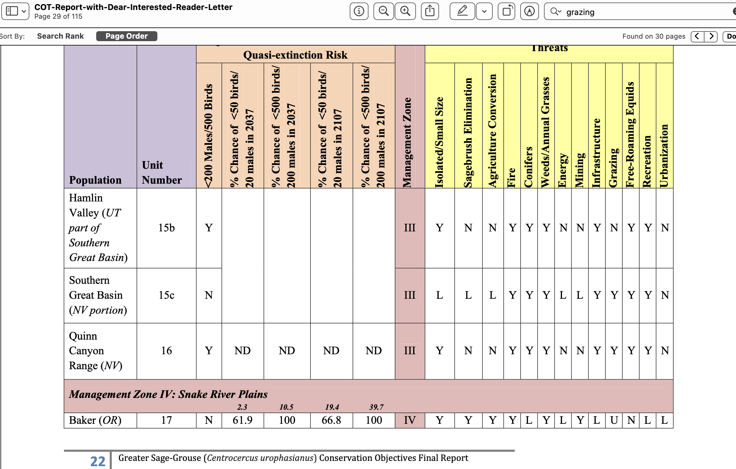
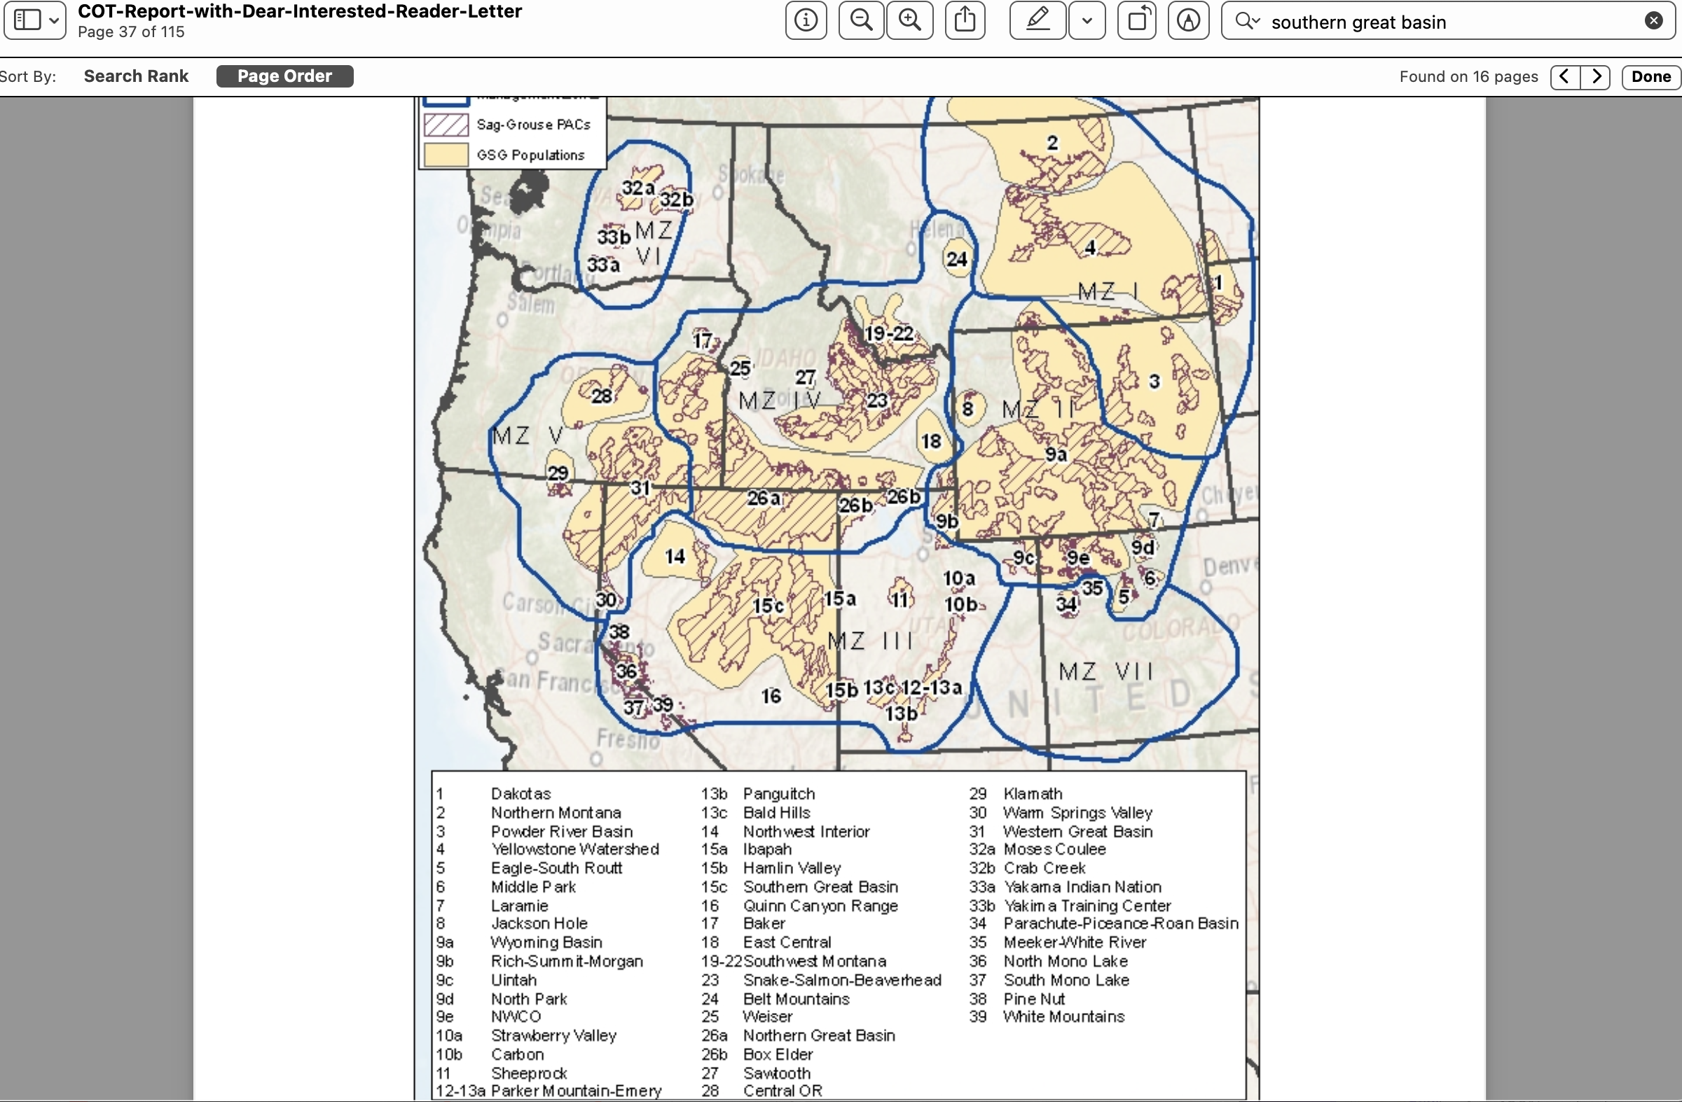

Grazing-Caused Land Damage Still Not Healed - As Admitted in EA– Showing Importance of Retaining No Grazing in Monito-Toquima Allotments and Lack of Resilience and Resistance

The NOPA stated:
Currently, two-thirds of monitoring sites in the McKinney allotment and half of the monitoring sites in the Meadow Canyon allotment are not meeting desired conditions. Many of these sites have shown improvement since grazing was last permitted. The Forest Service wants to ensure that reauthorization of grazing does not hinder recovery of the sites or cause a downward trend in conditions.
This demonstrates the significant long-lasting damage caused by grazing here – and now ecological science demonstrates the grave and growing risks of livestock grazing disturbance.
WLD submitted numerous scientific documents about grazing harms and fragility of this landscape with comments on the NOPA, and these appear to have been ignored. We Object to the FS failing to ensure NFMA compliance and sustainability of Forest land, water and biodiversity values in its attempts to re-impose large amounts of cattle grazing disturbance and injurious grazing facility developments. How very long has it been since there was any significant number of cattle were trespass grazing here - yet sites still have not recovered.

NEW Capability and Suitability Analyses Must be Conducted - Climate Change Threat, Flammable Weed Dominance Risk, Watershed Damage, Sustainable Flow Loss, Biodiversity Loss Caused by Grazing and Facility NOPA Schemes – ALL Must Be Assessed Scientifically in Any Valid 2021 Analysis

We Object to the FS dismissive statements about the adequacy of the out-dated capability and ancient suitability analyses - this further shows the 1950’s style head-in-the-sand industry bias of the HTNF range program, as applied in this project – and the “flexibility” thwarts
Flexibility would be incorporated into the authorized seasons of use. The overall permitted seasons would range from 4 months to 12 months, depending on the allotment (Table 3). Authorized use may be for only a portion of the permitted use and would be adaptable based on range readiness at the beginning of the season, precipitation, drought conditions, forage production, fires, elk and wild horse use, or other permitted activities. Flexible seasons also provide the ability to authorize more cattle for a shorter season, or fewer cattle for a longer season, provided the permitted number of head-months and end-of-season utilization standards are not exceeded.
Proposed use standards do not provide for inches of residual protective cover for nesting Sage-grouse, They do not control highly damaging livestock trampling impacts to the fragile uplands and the tiny drought and climate change-stressed riparian and mesic areas.
Horrifying HTNF Plans to Further Trench and Gut Springs and Alter Natural Flows -Destroying Wildlife and Aquatic Species Habitats by Further Industrializing Lands for Rancher Profit
The NOPA states:
These allotments contain existing fences and water developments; some of these are operational, and some are nonoperational. Under the proposed action, the existing infrastructure would either be kept and maintained, reconstructed, or removed.
Water developments will be designed to ensure some water flow [WHAT does that mean? How much will each wetted area shrink? How much flow and wetted area is at each site? Multiple years of data are necessary to understand flow and wetted area levels. HOW will the FS be able to ensure that the additional water loss from hotter temperatures with climate stress does not dry up every drop at the gutted springs? This massive digging around springs is highly significant – from a wildlife, aquatic biota, cultural and aesthetic/recreational perspective – and necessitates an EIS-level analysis. WHAT have been the adverse effects of all the existing facilities on water flows, wetted areas, biota, and water sustainability and cultural sites?]. … remains in the source area while still providing water for livestock. A hydrologic analysis will be performed at each development to determine the proper diversion rate necessary to sustain the spring ecosystem. [THIS must be prepared as part of this current EIS effort!] Shut-off valves will be used to keep water from being diverted outside of the annual grazing period. Float valves will be used to keep troughs full while preventing excess flow away from the spring. [Cattle routinely wreck these – and water overflows, trampled muck that provides sites for mosquitoes that may harbor West Nile virus result]. If additional water is needed at the troughs during high-use periods, tanks may be installed to store water. Depending on the spring type, water developments will be designed so that the water table does not drop below the threshold identified …”. Just how will the FS factor in climate change stress? Please detail the water ‘rights’ situation here – given that was a huge part of some of the Hage claims to begin with. Who holds the water rights? How much water is allocated? Are there springs that no linger have flows? Are there water rights on those springs? How does water for wildlife and wild horses enter into this?
Where is a map of each and every spring, seep, meadow, stream and data on current baseline flow volumes and conditions during all seasons of the year? This should have been provided with the NOPA so that the FS could show that the actions are even feasible and “reasonable”. Note that we believe they are not in climate and drought-stressed lands with irreplaceable essential Sage-grouse and other wildlife habitats,
This all runs counter to sustaining flows in lands facing unprecedented climate stress. See Sada 2001 and Sada and Lutz 2016 in Comment attachments describing in the serious harms in excavating springs, including killing sustainable perennial flows. What type of spring is each spring? How dependent are springs on snow fall? What is the status of the local and regional aquifers? How is mining and other demands on water affecting aquifer levels?
Fences are lethal to wildlife, fragment habitats, concentrate livestock and this intensive use results in flammable and other irreversible wed infestations. Fences also kill birds that collide with them. Here too removing fencing is crucial ot protect the area’s biodiversity and buffer lands from climate change stress.
Year-Round Chaos-Based Grazing
The NOPA has a laundry list of uncertain grazing actions that might maybe perhaps could happen – with no integrated clear effective actions to protect public values threatened by gra8ng imposition here. This further shows how lose and uncertain this scheme is, with minimal controls and limits on grazing use very similar to that the livestock industry got included in BLM’s scoping for the Trump admin. efforts to gut the BLM grazing regulations. Now this is what we are seeing in the HTNF proposal for this beautiful area, as the FS has succumbed to the same livestock industry demands.

See: https://www.federalregister.gov/documents/2020/01/21/2020-00849/notice-of-intent-to-prepare-an-environmental-impact-statement-for-the-proposed-revision-of-grazing

https://eplanning.blm.gov/eplanning-ui/project/1500093/510

https://eplanning.blm.gov/public_projects/1500093/200323207/20019408/250025612/BLM%20Grazing%20Regs_ScopingReport_Final_508%20(1).pdf

It further demonstrates the 1950s-era mindset of the HTNF grazing program, and the scheme the NOPA is based on.
Strategies would be designed to incorporate the following guidelines:
- Do not graze any one pasture twice in the same grazing season
- Vary the time of year livestock are in any one unit over several years
- Provide periodic season-long rest when possible
- Limit the amount of time cattle are in any area to minimize impacts of grazing regrowth
- Provide adequate time for growth prior to grazing or for regrowth after livestock have been removed
- Do not allow for multiple entries into a given pasture within a season, unless necessary for trailing
- Key areas would be established in allotments to monitor changes as a result of livestock and horse management
Bottom line: The NOPA grazing system is that there would be no grazing system.
Vague and Minimal Cherry-Pocked Site Monitoring System Uncertainty
We are greatly concerned at the bias in both monitoring site selection, the limited sites, the HTNF abandoning the detailed information that the previous forest botanist had helped developed.
We are dismayed at this, as well as the very limited attributes being monitored, and the very high utilization monitored at sites distant from more intensive livestock use – and the lack of controls on trampling damage to upland and/or riparian areas.
NOPA P. 11 states: “Monitoring could occur at any of the following key areas. These key areas were selected because they are areas that are sensitive to changes in livestock management and/or elk and wild horse impacts, have been used in the past and existing data are available, and represent a variety of important habitats/plant community types on the allotments. If necessary, new key areas may be added. If a key area no longer provides useful information about the effects of livestock grazing on an allotment, it would no longer be used.
The intent of identifying these key areas is not to commit to monitoring every one of them. Rather, it is to disclose the areas that may be monitored. Monitoring efforts will focus on obtaining enough short- and long-term information to justify a decision on whether to change occupancy rates”.
Just like every other part of this scheme, there is no certainty, and no effectiveness and certain action to prevent irreparable injury to the lands, waters and native biota as well as wild lands values and cultural sites. The latter are readily damaged by cattle trampling, cattle-caused erosion, digging around springs and other project activities.
Wild Lands Values Threatened
The NOPA states: The allotments include portions of the Alta Toquima Wilderness and the Table Mountain Wilderness, respectively, which were established in 1989.
Are there Roadless Areas as well? If so, where are they located? Are unroaded areas contiguous with BLM WSAs or Lands with Wilderness Characteristics? Have agencies done inventories that look at blocks of unroaded land spanning agency boundaries? Please conduct these as part of this process.
Please provide full and detailed information on current road networks and please provide a current travel plan that would control livestock/grazing -related roading and/or road footprint expansion. The livestock facility construction binge will doubtless expand roading - as ranchers drive in roads, and then the FS just allows thee roads to remain.
Recreation and Cultural Concerns
The FS states it is preparing a mere EA, and it is clear an EIS is essential for this vast, biodiverse and beautiful landscape with a wealth of natural values greatly threatened by the 1950s era-flexibility and grazing chaos, of the HTNF range mindset. Public lands are of great and ever-increasing value to the recreational public, including our members, and now the HTNF is proposing for a single livestock operation to harm and destroy these values.

Further, the FS cannot continue to base allocation for grazing here on a woefully out-dated 35 year old 1986 Forest plan that never considered the effects of climate change stress, cheatgrass moving up in elevation under climate stress and hotter temperatures,and other flammable weed risk, the western mega-drought – and the current plight of so many rare and declining species – including the Pinyon Jay whose numbers have declined by 85% and that we fear will be threatened by hideous “treatments” and deforestation ot facilitate expanded grazing here if a permit is used. Note that the HTNF has scoped a proposal for massive new burning destruction of mature and old growth native vegetation communities, and this will also spawn highly flammable cheatgrass and wed infestations in sensitive species habitats across the Forest – impacting the viability of many sensitive animal and plant species on the Forest.
We have pasted below comments from an earlier FS effort to impose damaging grazing here as well in some other allotments (prepared by WLD’s Fite). There, the FS recognized an EIS was essential, and it is here too -especially with the grave threats this landscape and its biota are now known to face. Comer et al. 2012 REA, Beschta et al. 2012 and 2014, Reisner et al. 2013 9cows cause cheatgrass) Williamson et al. 2019 (cows cause cheatgrass) , Fusco et al. 2019, kerns et al. 2020.
We ask that all comments and concerns raised in the info below carried forward into the 2021 comments on this disastrous HTNF proposal.
There was not adequate biological and other info in the NOPA for the public to be able to provide informed comments about Sage-grouse and many other issues of great importance. The NOPA was so lacking in basic information that it does not even map the existing projects, the proposed projects, the locations of all springs, seeps, meadows, streams --- and the areas of perennial, intermittent and ephemeral flows. This crucial information on water flows is not provided in the EA, either, yet the EA would authorize permanent new facility reconstruction further impairing - or killing flows and greatly inadequate use standards and harmful hot season use periods.

Map from 2015 GRSG ARMPA. Dark purple = Priority habitat, paler purple = Important habitat. It shows the vital importance of these and other vacant allotments in this region.

________________________________________________________

WLD submitted significant ecological and other concerns from older comments on the FS scoping of an EIS for grazing HTNF vacant allotments in the Monitor-Hot Creek region to the FS as part of our comment submissions on the NOPA. This further demonstrates the need to prepare an EIS for the current grazing scheme – due to significant environ mental impacts, and the controversial nature of inflicting cattle grazing here again when arid lands are facing great climate change and other stresses.
We Object to continued failure to take a hard look at a hist of unresolved ecological concerns.

Purpose and Need

The Purpose and Need is defined far too narrowly. It pre-determines woefully sacrificing these lands to livestock interests. [Just like in 2021! And continuing in 2024]. We Object that this was not modified.

The Federal Register Scoping Notice stated:

The purpose and need for the proposed Federal action is to provide livestock grazing opportunities to permittees in a way that sustains the health of the land and protects essential ecosystem functions and values.

For goodness sake: There are NO permittees on the Vacant allotments. There is absolutely no need, no requirement, and it is in defiance of all current conservation science to impose permittees and livestock disturbance in these lands. This is especially the case given all the conflicts of domestic livestock grazing with sage-grouse, pygmy rabbits, watersheds, water quality and quantity, recreation, cultural values, or healthy forest communities.

The Forest must use this process to Close these allotments, and re-do Scoping with an expanded, science based purpose and need that complies with NFMA, the Wilderness Act, protection of roadless areas and recreational uses and enjoyment of the public lands, scientific uses of the Vacant allotments as reference areas – critical for understanding persistence of the sage-grouse population at the southern margin of the species range, and the agency’s sensitive and T&E policies.

The Forest needs to define a new and greatly expanded Purpose and Need. The Forest must also supply the public with much more information so that informed Scoping input can occur.

In its Purpose and Need, the Forest must recognize that keeping Vacant allotments closed prevents desertification-causing and weed-spreading livestock grazing is essential to protect “at risk” biological values. Removing grazing would buffer Forest lands and the sensitive and threatened species that inhabit them from the adverse effects of invasive species, weeds, and other negative impacts of imposing domestic livestock grazing. The Need should be greatly expanded to maximize production of goods and services like clean air, clean and abundant water, vibrant wild and ecosystems free of livestock stench, manure, diseases, weeds, barbed wires, etc.

The money that the Forest saves from analyzing re-imposing livestock grazing here should be applied to removal of harmful barbed wire or other facilities.

The Purpose and Need as set forth violates the Forest Plan, which requires the Forest address a spectrum of values – not just desires of one or two unspecifed and unknown livestock men. There are No permittees on the Vacant allotments. All current science shows the severe incompatibility of grazing with these harsh arid lands facing climate change.

The Forest Service needs to analyze livestock grazing disturbance on these allotments in an Environmental Impact Statement that relies on current ecological and conservation science.

The purpose and need for the NEPA analysis should be to analyze whether livestock grazing is economically and environmentally appropriate on these allotments in order to improve the conditions of public lands, sustain the health of the land and its biological communities, and must protect essential ecosystem functions under threats from climate change, provide for growing recreational values, and services such as production of abundant clear cold water and viable species populations.

The Federal Register Notice stated:

The Forest will prepare an environmental impact statement (EIS) on a proposal to authorize continued livestock grazing [[Page 8037]] within the Monitor-Hot Creek Rangeland Project area. The analysis will determine if a change in management direction for livestock grazing is needed to move existing resource conditions within the Monitor-Hot Creek Rangeland Project area towards desired conditions. The project area comprises approximately 952,234 acres and is located on the Monitor and Hot Creek Mountain Ranges in Eureka, Nye and Lander Counties, Nevada.

If this is the reason for this EIS, then how in the world could the Forest contemplate Opening Vacant or currently ungrazed allotments? The only direction ecological conditions will move with the Forest re-imposing grazing disturbance is downward. Please see Mack and Thompson (1982), Fleischner (1994), Belsky and Gelbard (2000), Fleischner (2009), USWFW March 2010 Twelve Month Finding for greater sage-grouse.

There is minimal economic value to the mutton or beef that could be produced on these harsh rugged, arid lands - lands that are also highly vulnerable to weed invasions. Mining and recreation are far more important to the economy than grazing. As it is, a reader of the scoping statement doesn’t know if the Forest is currently grazing 5 cows, or 50,000 sheep on Open allotments, or what may contemplated for the Vacant ones.

The magnificent pinyon-juniper and other conifer forests, and sagebrush plateaus and expanses of the Monitor-Hot Creek area in their current ungrazed state provide very valuable ecological functions to the public. These include storing and slowly releasing clear unpolluted waters, sequestering carbon to combat climate change, providing remote Wilderness lands recreational experiences free of noise, diseases, smells, and ecological damage of livestock. The provide a valuable scientific reference area, and an opportunity to study sage-grouse in an ungrazed land area. The microbiotic crusts in the understories of the sagebrush and pinyon-juniper communities serve to stabilize soils, protect them from wind and water erosion – including downwind dust depletion that contributes to earlier snowmelt, and also help to absorb Carbon.

Thus, it seems that the most reasonable range of alternatives in the 2010 context would NOT include opening currently ungrazed lands to subsidized private livestock herds of a couple of ranchers. A reasonable range of alternatives would be additional closures and increasingly conservative use levels in any allotments that remained Open. It would also include a range of Active Restoration of areas currently with invasive species present as a result of grazing or facility disturbances. Active removal of livestock facilities (such as harmful fences and spring-gutting/de-watering developments) should also be examined under a range of alternatives.

Native vegetation communities should not be subjected to intensive tree or shrub killing, as has been the path of some public lands agencies in Nevada. These lands are too vulnerable to weeds, soil erosion, loss of sensitive and imperiled species, and other adverse effects if large-scale treatments were to be imposed. In fact, it seems that the primary purpose of some of the Nevada agency treatments has been to provide off-fire season activity and/or hire a couple of big contractors with heavy equipment. Instead, a range of alternatives that examines selective hand thinning of trees in some sagebrush areas should be the basis for precautionary and prudent science-based management of these lands.

Didn’t the Forest previously prepare a detailed Monitor-Hot Creek Study of some or all of this area - a decade or so ago? If so, please post this previous info on the Forest Website so that it will be available for public review as part of this process.

The Project area included lands at the southern periphery of the sage-grouse range, just north a bit from the Mojave region. Native vegetation and animal populations here are very much threatened by the host of deleterious effects of livestock grazing and ill-conceived highly disturbing vegetation “treatments”, plus mining and energy projects that are increasing all the time.

BLM lands in this very area are now greatly threatened by solar or other “renewable” development under agencies destructive current energy policies, making the Forest lands even more important to ecosystem, watershed and species conservation. A full and complete assessment of all the proposed or foreseeable solar, geothermal, wind, transmission, or other development on Tonopah and Battle Mountain BLM lands must be provided.

Comments had requested that the Forest use a Hot Creek Monitor EIS to conduct Forest Plan amendments that place lands off-limits to such development (energy of all kinds).

It is widely known that there are irreplaceable biological values on Forest and BLM lands in the region –ranging from the greatly threatened Pika habitats to Sage-grouse on the southern periphery of the species range.

Back in 2010, the FS proposed closing the arid McKinney allotment:

“The Austin/Tonopah Ranger Districts proposal to authorize continued domestic livestock grazing … The Kelly Creek/North Monitor, White Rock, South Monitor, Table Mountain and Monitor Valley East allotments are currently vacant. Livestock grazing would be authorized in these allotments and they would be used to reduce conflicts on allotments that are currently grazed or as forage reserve allotments. These allotments comprise approximately 259,232 acres. Monitor Winter, Horse Heaven, North Monitor Winter, Hicks Station, Wagon Johnnie, Little Fish Lake, Monitor Complex, Saulsbury and Stone Cabin allotments have active term grazing permits and would continue to have authorized grazing. These allotments comprise approximately 557,201 acres. Morey, Hot Creek and McKinney allotments are currently vacant and would be closed. These allotments comprise approximately 135,801 acres”.

It is ecological madness to propose increasing grazed lands in 2010 [and now in 2024] in this arid “at risk” region. The only range of alternatives that should be considered is decreasing HTNF grazed land areas, while updating analysis of climate change effects, and identifying areas where active restoration may be needed to treat annual grasses, remove facilities and rehab areas, cut some junipers in sagebrush - and otherwise minimally intrude n the area. Once livestock facilities are removed, some roading may be closed, too – since livestock facilities or management are often the cause of roading in grazed landscapes.

We Object that the Forest has not provided provide much more substantial information on ecological conditions, biological values threatened by resuming grazing, monitoring of livestock effects (far too few sites), current capability, current suitability, condtiion of livestock facilities, areas of weed infestation, areas at risk of weed infestation if grazing occurs, detailed surveys of the conditions of microbiotic crusts, current ecological vegetation condition and production inventories.

Detailed biological surveys must be conducted for all sensitive, petitioned, candidate, Threatened or imperiled species for a period of two years to provide a Baseline. These must serve as the basis for understanding effects of grazed vs. ungrazed settings.

FS in 2010 scoping that included these allotments admitted that: Continued livestock grazing has the potential to affect vegetation, which may result in a decline in the long-term productivity of the land base.

How has the Forest considered the adverse effects on the land’s “productivity” for pygmy rabbit, sage-grouse, migratory songbirds, nesting raptors (whose prey base may be disrupted), native pollinators, and other very important biota here? Or pikas –a species threatened by climate change – but that also may be impacted by grazing removing vegetation from the limited areas near rocks where pikas live. Imposing grazing on their habitats will amplify any adverse effects of climate change.

In 2010, the FS admitted: Continued livestock grazing has the potential to affect heritage resources within the project area.

Not only “to effect’ but also to alter site stratigraphy, break and damage artifacts, and destroy integrity of cultural sites and materials.

Around 3 years before scoping grazing here in 2010, the H-T had scoped a Forest Plan revision (that appears to have been supplanted by Travel Planning in some areas – but we are not aware of that even occurred in the M-T lands.

Public comment on the 2010 proposal included
“We ask that Ranger Williams incorporate the full record for that Savory-Sevenmile proposal, and Appeal, into this current EIS Project Record. There is a clear and ongoing link between burning, chopping and reducing native woody vegetation in central Nevada, and efforts to expand livestock grazing … there has been much more evidence of the natural role of large or catastrophic fires in pinyon-juniper systems. See various papers by Baker and Baker and Shinneman”.

2010 comments also included: “There are large areas of roadless and/or wilderness quality lands here. This is an area of great scenic beauty and growing recreational importance. Livestock grazing adversely affects recreational uses and enjoyment – from polluted waters, springs dried up by piping for cattle troughs, flies, stock ponds harboring West Nile virus, stench of livestock, noise of livestock, marred vistas and viewsheds from livestock facilities, weeds, etc”. All of this in relevant and no hard look was taken in the 2024 EA.

The very important context of the grazing-targeted lands was raised in 2010: “Why isn’t extreme vulnerability of sagebrush habitats at the southern periphery of sage-grouse and pygmy rabbits range a significant Issue? Or the great fragility of springs, seeps, small streams that characterize the area?

In the 2010 era, the FS was using complicated Matrices that attempted to fit complex and often highly varied plant communities into a cookie cutter model of “perfection” that rarely exists in the natural world.

2010 comments included reference to a “leaked” Heart of the Great Basin BLM Monument memo describing just some of the values of the general Toiyabe-Monitor landscape. This describes the “Heart of the Great Basin” – A globally unique assemblage of cultural, wildlife, and historical values. It describes petroglyphs, varied ecosystems, and rare wildlife like the pika.

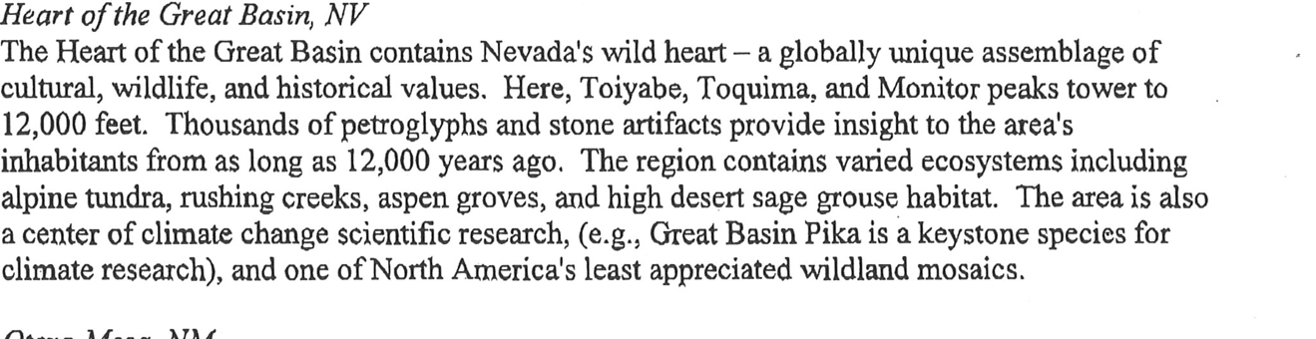

We Object that the FS has failed to consider these many continuing and often ever-greater ecological concerns including those raised in 2010 for these same lands, and the great importance of this landscape. These values that would be significantly harmed by re-imposing cattle grazing and a battery of destructive facilities for cow grazing.

We also call to your attention a 1999 Federal Register Notice - where the Forest Service recognized long ago in 1999 that it needed updated management protections for the Monitor region. Here is what the Forest Proposed to do in 1999:

“Based on the analysis of the existing direction, monitoring and evaluation of resource conditions, and public comments, the following topics have been identified as having a need for change in management direction: Heritage Resources, American Indian Religious and Cultural Use, Watershed Protection, Species and Ecosystem Viability, Wilderness Management, Roadless Areas, Access, Transportation Systems, Recreation, Visual Resources, Forest Products Management, Livestock Grazing, Wild Horses, Wildlife, and Mining”.

In more detail:

Forest Service Long Ago Recognized Need for Significant Monitor/Hot Creek Plan Amendment

The FS in 1999 scoped a significant amendment to the Toiyabe Forest Plan.

http://www.epa.gov/fedrgstr/EPA-IMPACT/1999/July/Day-19/i18010.htm

“Monitor/Hot Creek Forest Plan Amendment EIS; Humboldt-Toiyabe National Forest; Nye, Eureka and Lander Counties, NV”

Federal Register: July 19, 1999 (Volume 64, Number 137). SUMMARY: The Humboldt-Toiyabe National Forest will prepare an environmental impact statement (EIS) to consider amending the Toiyabe National Forest Land and Resource Management Plan (Forest Plan). The amendment will be comprehensive, covering a wide variety of issues needed to update the Forest Plan for the Monitor and Hot Creek Mountain Ranges. DECISION TO BE MADE: The Forest Service will decide whether or not to amend the Forest Plan for the Monitor and Hot Creek Mountain Ranges of the Austin and Tonopah Ranger Districts. The amendment will consider improving the management direction of portions of the Forest Plan and affirm continuation of other aspects of the Forest Plan's management direction for the next 10-15 years. … The agency expects to file the draft EIS with the Environmental Protection Agency and make it available for public comment in January, 2000. The proposed amendment will address management of National Forest System lands in the Monitor and Hot Creek Mountain Ranges, which includes portions of Nye, Eureka and Lander Counties, Nevada. This area is part of the Austin and Tonopah Ranger Districts. The substantive changes that will be addressed in the amendment of the Forest Plan are described in the regulations implementing the National Forest Management Act (NFMA). The amendment process begins with monitoring and evaluation of Forest Plan implementation (36 CFR 219.12(k)). It includes public involvement in monitoring and identification of opportunities for improvements to improve management. This NOI signals the development of an EIS for the amendment of the Forest Plan. Based upon monitoring and evaluation results and the information obtained in the Analysis of the Management Situation (AMS), Humboldt-Toiyabe National Forest is proposing to make several improvements to the long-term management direction for the Monitor and Hot Creek Mountain Ranges. The public is invited to comment on the preliminary alternatives which have been identified. Proposed Action. The proposed action is to amend the Toiyabe Land and Resource Management Plan to improve management direction. The purpose of the proposed action is to provide long term management direction for the Monitor and Hot Creek Mountain Ranges. The proposed action is needed because existing guidance is more than a decade old. That guidance does not reflect the substantial additions to the National Forest System in the area, the rapidly growing and diversifying population, or the advances in science that have occurred over the last decade. Four alternatives have been prepared to address the topics outlined below. A preferred alternative will be selected during the preparation of the draft EIS based on public comments from this scoping process and the analysis of environmental impacts of the alternatives. Amendment Topics: Based on the analysis of the existing direction, monitoring and evaluation of resource conditions, and public comments, the following topics have been identified as having a need for change in management direction: Heritage Resources, American Indian Religious and Cultural Use, Watershed Protection, Species and Ecosystem Viability, Wilderness Management, Roadless Areas, Access, Transportation Systems, Recreation, Visual Resources, Forest Products Management, Livestock Grazing, Wild Horses, Wildlife, and Mining. Public Comments on the Draft EIS

The Forest Service decades ago recognized that many very important issues to the public needed updating in 1999! To this day, these values have not been adequately protected and conserved – and now face significant new threats. We Object to the FS seeking to impose grazing and facilities on currently vacant allotment lands without an integrated hard look at all direct, indirect and cumulative to their world class values values in 2024.This further demonstrates the need for an EIS to address the host of pressing conservation issues in the M-T lands.

Even if the Forest wrongly refuses to do so, the adverse indirect and cumulative impacts of continuing to manage lands under a 1986 worldview must be fully analyzed in this EIS. We Object that this is not taking place prior to imposing major new cow grazing and a major facility construction project.

Additional Capability Concerns

The FS must analyze, in a site-specific way. This analysis needs to assess the availability of forage, the distances to water, and slopes not to exceed a certain limit depending on soil types. While the Forest Plan may have carried out a large-scale assessment of capability, and then a circa 2008 general assessment often without collecting on the ground soil, veg cover and perennial veg production data, which needs to be verified at this site-specific level of analysis. We are concerned that data on which the FP analysis relied is very old – especially vegetation, soils, and production figures. There are many veg and soils elements FS capability analyses ignore scientific awareness of the importance biotic crusts in stabilizing soils, fixing nitrogen, absorbing CO2, and keeping out weeds like cheatgrass. Only a current site-specific analysis can determine the actual percentage of capable acres in each allotment. We Object this has not been done, and that sufficient biotic crusts and other critical elements have not been considered in any capability assessment. Climate change stress, cheatgrass expansion risk under current ad foreseeable climate stress exacerbated by grazing disturbance (note that cheatgrass expansion results in decreased sustainable forage), and other pertinent data must also be incorporated into a 2024 capability analysis. Kauffman et al. 2022 (climate and cheatgrass), Molvar et al. 2024.

Capability [as the FS has been applying it] involves the four major issues of slope, distance to water, highly erodible soils and availability of palatable forage, and the Forest needs to assess at a site specific level whether the more general GIS livestock capability maps typically formulated in Region 4 are accurate considering the specific slopes, forage availability, and distances to water sources on the allotment. This analysis must also ground-truth the Forest Plan assessment of capability especially in regard to erodibility of soils in both wind and water. What is the current production figure? Is the FS still using a minimal 50 lb. production figure, when a figure of 200 lbs. or more per acre should be applied.

Suitability

The Forest Service must complete a suitability analysis for the M-T allotments. This process needs to include analysis of a variety of impacts and conflicts that will occur at differing levels of livestock grazing which need to be considered in the alternatives of the EIS. Analysis of suitability necessarily will vary by alternative in the EIS as differing assumptions need to be used with regard to defining protocols for suitability of “capable” lands for livestock grazing according to the level of livestock grazing impacts and conflicts which are deemed to be unsuitable when they conflict with other values such as wilderness, wildlife habitat, wildlife displacement, and negative impacts on special status plants and animals including but not limited to Management Indicator Species (MIS) and species listed under the Endangered Species Act (ESA).

For example, even if lands are determined to be capable of supporting livestock grazing under out-dated Region 4 criteria, they may be unsuitable for that use if soils are at risk of compaction or accelerated erosion, if water quality will be unacceptably degraded, if spring and seep water flows significantly reduced or lost altogether from unmitigated trampling and cow facility excavation and water removal, if recreational activities will be compromised unacceptably, if climate change effects place stresses on resources such as wildlife habitat --- such as Sage-grouse nesting cover, cow trampling collapse of Pygmy Rabbit burrows; conflicts with Elk calving grounds or wintering areas with livestock displacing big game into sub-optimal habitats; simplification of dense big sagebrush structure essential for Sage Thrashers and other migratory songbird nesting; contraction or perforation of the Sage-grouse or other sensitive species range due to grazing impacts including cheatgrass proliferation from cattle grazing and trampling impacts, etc. If myriad other values of Forest lands will be significantly damaged or degraded, if native plant ecosystems and rare or sensitive plant species cannot sustain livestock use under 2024 and worse foreseeable climate stress and flourish; if predators will be routinely killed to protect livestock; if hikers and other users of these lands will face widespread polluted water and expanses of cheatgrass or other weeds in Wilderness and other wild lands areas; if bighorn sheep are displaced from optimal habitat or from water sources by cows, or because of the reduced wildlife carrying capacity/productivity given competition with livestock for food, water, spatial use, or if livestock serve as unacceptable vectors of weed seeds or disease spread. ALL of these factors must be considered in a 2024 Suitability analysis that looks, at a minimum, at the next 10 years as a 10-year permit is to be issued. These conflicts and others also need to be analyzed within a range of levels of livestock grazing as well as in a no- grazing alternative and allotment Closure. We Object to the failure to conduct a valid hard look NEPA process that includes a curret analysis under NFMA of grazing suitability.

For example, the EA even admits there may be “competition” with Bighorn sheep – but proceeds to propose allocating the habitat to the livestock industry as a sacrifice/reserve allotment.

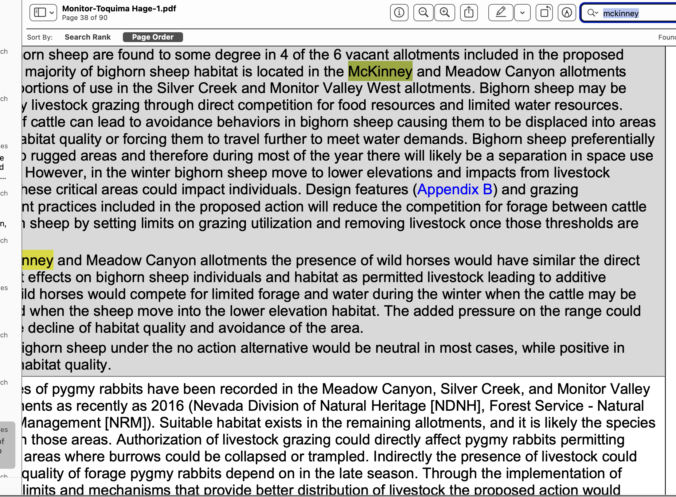

The EA doesn’t “reduce competition” with bighorns – the EA increases competition.

The suitability analysis also needs to reveal the impacts of grazing and trailing on lands deemed non-capable even under the Region 4 methods, but that are within the areas proposed for grazing, and the scattered distribution of capable lands. This is especially important for cumulative effects analysis of grazing and trampling on the soils found on these allotments, and impacts of livestock on many of the water sources, such as those in canyons or by steep slopes. .

A suitability anlaysismust also needs to take a hard look at the serious conflicts of the host of cow projects that the FS seeks to rebuild – with no valid site-specific analysis of visual, cultural, sensitive species habitat, or information on who holds water rights or assurances that water will be provided for wildlife if lands are grazed or springs gutted/excavated under current and foreseeable conditions of climate stress. We Object to all of these EA, NFMA, MUSYA and APA violations. The severe damage that will result to the habitats and declines in populations of sensitive species must be fully assessed.
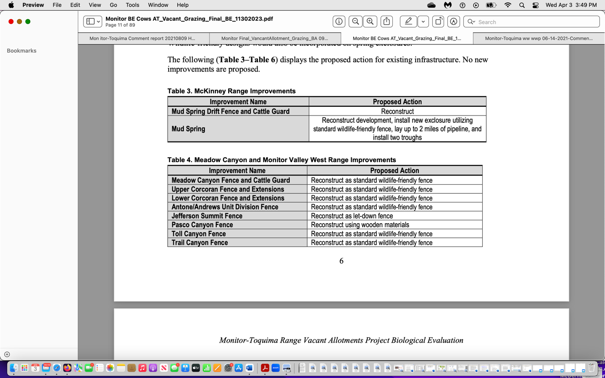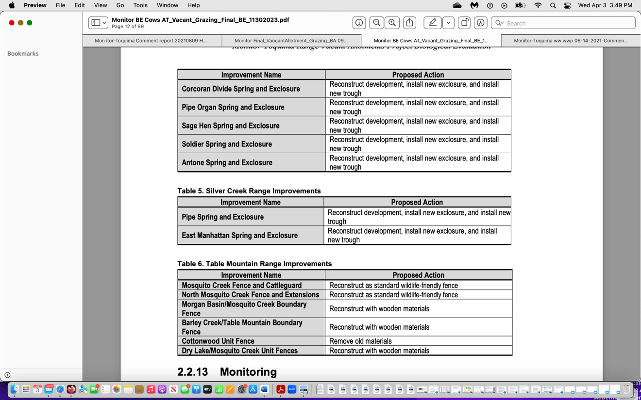

Key aspects of the suitability analysis needs to address the likelihood of negative impacts of livestock on bighorn sheep and all other big game species including potential displacement, and the cow disturbance increasing conflicts with wild horses dispersing to, using or moving through the allotments; harmful impacts and habitat damage and fragmentation from the battery of proposed facilities; of significant serious competition between cows and elk and other big game for necessary habitat elements; how grazing may conflict with the seasonal use area and other needs of wild horses in the WHT and contiguous BLM HMA lands. Using allotments as sacrifice/reserve areas may result in shifting and intensifying wild horse use onto other areas of sensitive wild lands and rare and important species habitats – including those that will also suffer extensive cattle trampling, grazing and browsing impacts. We Object to all of these these EA analysis deficiencies, and failure to ensure compliance with the Wild Horse and Burro Act and NFMA sustainability, sensitive species, and other values.

This is a brief list of potential issues of suitability which apply generally to the allotments; however, it is not inclusive, and it is the duty of the Forest Service to fully assess criteria for suitability by developing a protocol for determining whether the impacts from livestock grazing at any level is incompatible and therefore unsuitable for lands which may be designated capable of supporting livestock grazing.

Steep, rugged, forested, weed-susceptible lands should not be considered capable or suitable - nor should lands distant from water. The full magnitude of harm to such lands and to the fragile small streams/springs/drainage networks that are damaged by the reality of grazing so-called “capable” lands must be fully assessed. It appears the capability analysis here is old – from 2007 or so – before the once in a blue moon very prolonged western mega-drought, before the relentless increases in climate stress including higher and higher temperatures that may result in natural vegetation changes, etc.

The EA has not taken a hard look at how projected climate change stress, flammable weed expansion caused by intensified grazing disturbance, will not provide sustainable “forage” as weeds expand. This is also necessary to look at effects of the decision if grazing is re-imposed – and any validity of signing a FONSI.

Any allotment areas or units with narrow stringers or patches of Capable lands should not be considered capable and certainly not suitable. If only limited capable lands are present, or cows must traverse areas of non-capable lands, the livestock are very likely to degrade the same flatter areas year after year, so they never heal. The FS has not revealed if the capability analysis was based systematic on the ground sampling and data collection, or if it was a modeling exerciser. Plus cow trailing in mountainous areas will occur on steep, unstable slope soils or other areas that cannot withstand 1200 lb. bovine trampling and grazing impacts Conflicts with wildlife and recreation will also be heightened if non-capable areas are grazed.

We Object to the failure to provide detailed information and take a hard current look at both capability and suitability.

Grazing and Wild Horse Territory Conflicts and Uncertainty

WLD had provided comments on the 2022 BLM Stone Cabin wild horse round up EA, including:

“This huge and significant land area clearly necessitates preparation of an EIS. The Stone Cabin HMA is 407,706 acres and Saulsbury HMA includes 135,018 acres. The proposed gather area represents 542,724 acres within the Stone Cabin Complex HMAs, and 343,457 acres outside of designated HMAs, in areas adjacent to HMAs where wild horses have moved or may move to during gather activities including the Monitor WHT. The Monitor USFS WHT is 380,000 acres. We note that both BLM and the USFS are separately attempting to re-impose destructive domestic livestock grazing under the old Wayne Hage permits in portions of the Monitor area”.

BLM never prepared an EIS to examine the current complexities of wildlife, wild horses, and livestock grazing in this inter-connected landscape. BLM proceeded with its usual cookie cutter round up process. Now the FS is re-imposing grazing on Vacant allotments that include portions of the WHT and has prepared a minimal EA that fails to address the impacts of turning portions of the WHT into a sacrifice/reserve allotments that could be grazed at any time of year and re-imposing cattle facility projects - without any hard look at the impacts to the thriving natural ecological balance that must be maintained, or conflicts with wild horse seasonal use and movement. There is also large-scale uncertainty as the FS lands are often not fenced separately from BLM lands. Further, there is no integrated current analysis of wild horse use in this landscape. We Object to all of these deficiencies.

Wild Horse Education describes:

https://wildhorseeducation.org/2023/05/10/breaking-taking-a-stand-at-stone-cabin-on-file/
“The Stone Cabin HMA is located approximately 30 miles east of Tonopah in Nye County directly off Highway 6, both north and south. Saulsbury is just to the West, a couple of miles off the highway both north and south. The Monitor USFS WHT is located in between the Saulsbury and Stone Cabin HMAs (and it is worth noting that no studies have been done to show which populations spend more time on BLM or USFS land denoting jurisdiction for removal or population growth suppression tools). The total approved target area represents 542,724 acres within the Stone Cabin Complex HMAs, and 343,457 acres outside of designated HMAs, in areas primarily adjacent to HMAs where wild horses have moved or may move to during gather activities. (If you note the observation about the Monitor WHT, this language also means wild horses that call USFS Monitor “Home Range” and may flee back home. The Monitor WHT is 380,000 acres (and we know USFS has not done much monitoring out there for 50 years, instead relying on BLM to remove Monitor horses each time a Stone Cabin roundup takes place.) BLM notes that any gather inside Monitor would require a decision from USFS… but we know from documenting roundups at Stone Cabin for over a decade, that this is not “how the chopper flies.”
Not only are there clear multi-jurisdictional issues with this approved plan, there are serious deficits involving a lack of actual data, failures to follow-through on underlying approved plans and so much more”.
We Object to the failure of the EA to take a hard science-based look at all the serious HMA/WHT wild horse movement, use, monitoring, seasonal areas, livestock facility impacts, etc. of BLM and HTNF management - including all direct, indirect, cumulative, synergistic impacts.

The BLM admits that 57% of the allotment land area is located in WHTs, and claims it “coordinates” management with BLM.

We Object to the failure to provide a current WHT plan that incorporates and addresses scientific and on the ground factual information about the impacts of the megadrought, climate change stresses, competition with cattle grazing under the HTNF proposed sacrifice/reserve allotment scheme, potential cattle and rancher activity displacement of horses from essential seasonal habitats under the 2024 EA’s potential use at any time of the year in the sacrifice/reserve allotments, and at the elevated weed, potential disease, and other risks of the EA grazing scheme. The EA lands include portions of both the Toquima and Monitor WHTs – and there is no current systematic data provided on other non-EA Forest allotments included in these WHTs -current ecological conditions, grazed vs. ungrazed, numbers of livestock and actual use, use standards, season of use, monitoring of grazing impacts, livestock facility impacts, sustainability of spring and stream flows, current forage production and carrying capacity, weed presence and grazing-related weed risks, capability, suitability, cultural values and grazing conflicts, big game winter use and seasonal ranges, water availability, etc.

And again, a much more in depth analysis is necessary in part because of the significant uncertainty of when and how the sacrifice/reserve allotments will actually be grazed – all the HMs in a single day, or a few cows straggled out for many months, livestock facility effects, ability to effectively control cows ion unfenced lands, and a host of wildlife livestock effects and displacement concerns that may affect the WHTs. The FS ducks any hard look analysis of cow and facility impacts with EA claims management of the WHTs is “outside the scope” of the M-T EA cow grazing project. But this EA directly affects and changes how grazing occurs, on those same lands and will have real world impacts and conflicts with wild horse use and the TNEB.

Sage Grouse – Absence of Grazing in Monitor PMU Forest Lands Noted in NDOW Report

An NDOW Sage-grouse planning team report describes:

Back in 2016, when FWS looked at re-imposing significant levels of livestock grazing disturbance here, the Monitor PMU had a large number of leks and robust population, extensive acreage of existing habitat, with over 70 known leks. How many active leks are present now? What are lek counts for all times, including the counts in thisd PMU up top the present? Where haver leks blinked out?

The majority of the core sage grouse summer habitat within the Monitor PMU and
portions of the Reese River PMU are within USFS vacant or closed allotments and receive no permitted livestock use. NDOW South Central Planning Team, Sage Grouse Conservation Strategy, p. 13.

Further, the Monitor PMU has long been one of the most important Nevada PMUs. It is among the 8 largest breeding populations of Nevada PMUs (which comprise half or more of the Sage-grouse in Nevada).

The most recent information we can find from NDOW is:
https://www.ndow.org/wp-content/uploads/2023/06/18-FY24_Upland-Game-Bird-Stamp-Report.pdf

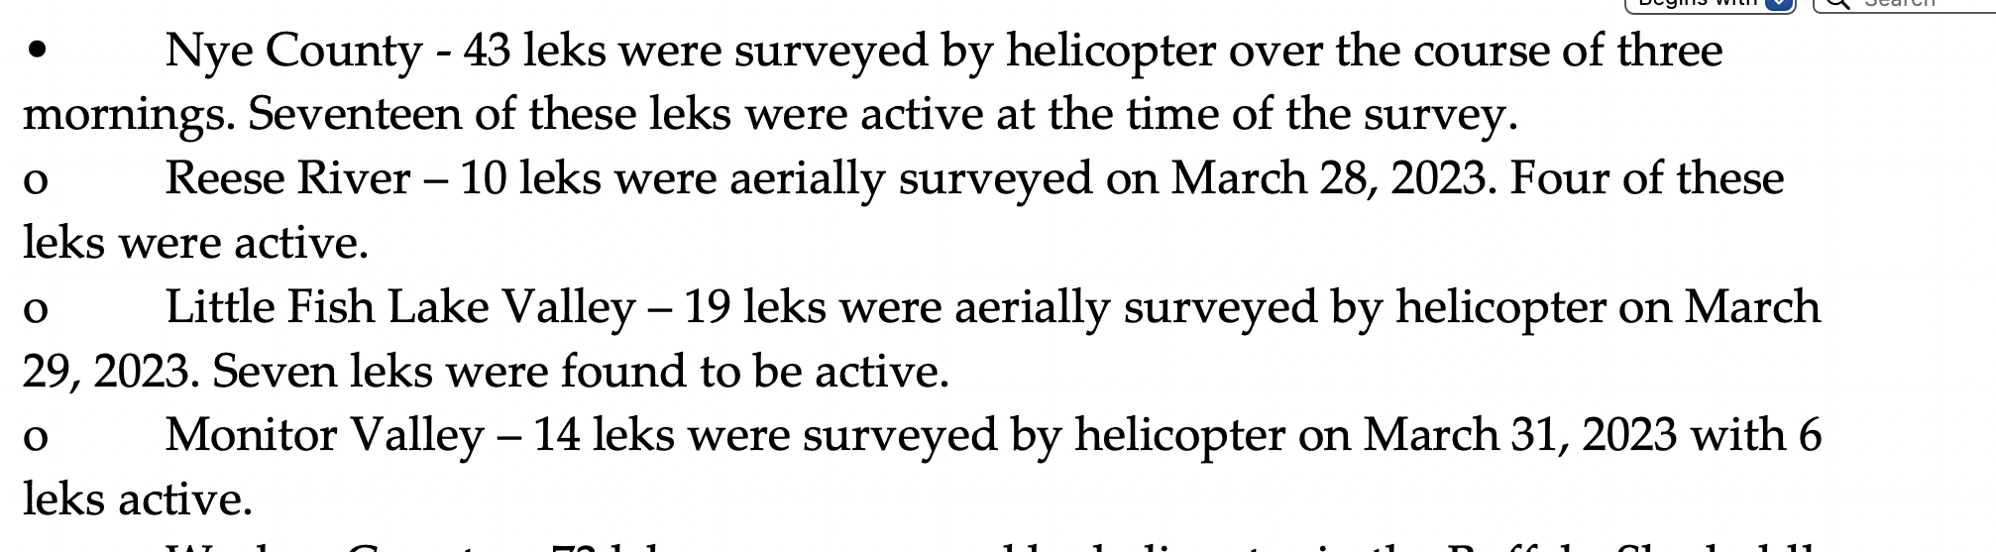

We are not certain how many of these leks are within the area that was laid out as the Monitor PMU in the foundational 2004 NV Sage-grouse plan, but there appears to be a significant decrease in occupied/active leks.
https://www.ndow.org/wp-content/uploads/2023/02/FY21_22_SRA_LegislativeReport.pdf .

We Object to the failure to consider that the primary reason leks and bird numbers may have been (at the time of the 2016 USFS “Vacant allotments” scoping somewhat stable here - note there adequate hard look at the current status of the Monitor and other affected PMUs – that must be assessed under cumulative impacts).

The Monitor PMU is at the southern periphery of the Sage-grouse range, and the persistence and relatively robust nature of the population may be due in significant part to the absence of livestock grazing.

The critical and irreplaceable values of the M-T allotments in the project landscape – and the rest of the 40 vacant allotments that the FS appears to threaten re-imposing significant levels of grazing disturbance in. So why in the world is the Forest considering re-opening nearly all allotments and not doing an EIS to permanently Close them– as climate stress bears down, weed risk escalates, elk populations significantly expand, wild land recreational uses expand, etc.?

The Monitor BSU encompasses 3.6 million acres.

https://sagebrusheco.nv.gov/uploadedFiles/sagebrusheconvgov/content/Resources/Nevada%20Strategic%20Action%20Plan%20Final.pdf

Also, in see NDOW’s initial GRSG plan,

https://water.nv.gov/hearings/past/Spring%20Valley%202006/exhibits/USFWS/FWS-2060/FWS-2060.pdf . This recognized the Reese River and Monitor PMUs had relatively high densities of Sage-grouse.

We Object to the failure of the FS to take a hard look at the context and intensity and national significance of the GRSG habitats and other outstanding wildlife and wild lands values that that will be seriously and irreversibly harm ed by imposing large-scale grazing treating allotments as sacrifice zones ,and reconstruction of a plethora of lethal and injurious cattle facility projects. This is also the heart of a current suitability analysis.

The proposed action is contradictory to the FS sensitive species policy in many ways, and these issues must be fully examined in an EIS. Domestic livestock grazing very much impacts lands, and cattle herds and grazing degradation and permittee disturbance may displace wildlife or wild horses into sub-optimal areas, or increase competition with other biota such as elk as cows and rancher disturbance alters animal. We Object that the FS EA has not teased out impacts of foreseeable competition between cows, elk, wild horses, potential undue degradation to Sage-grouse habitats from now adding cows under these uncertain grazing schemes back into the mix, and has not conducted a hard look NEPA analysis at these complexly interwoven elements.

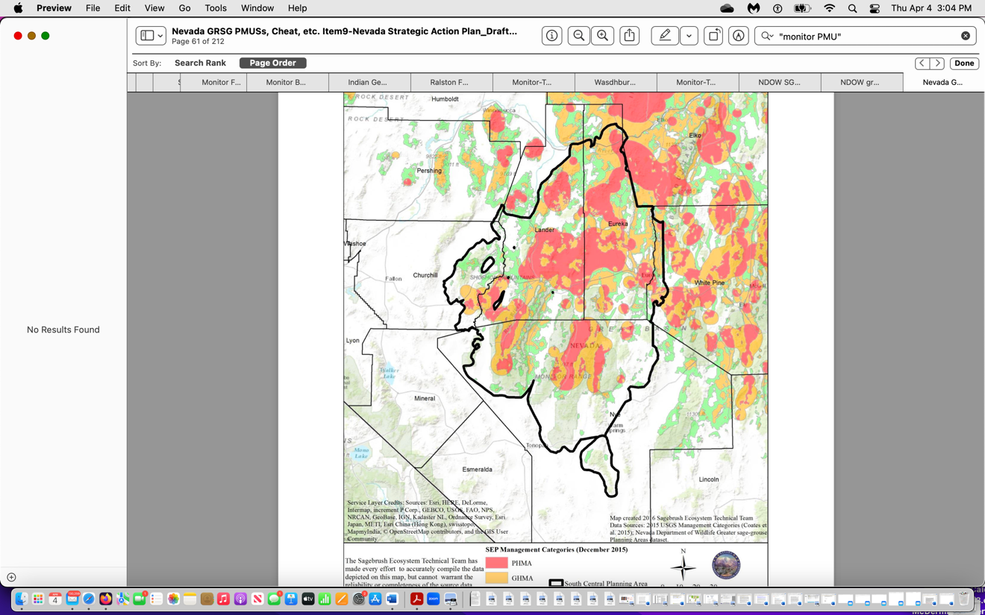

Full and Detailed Baseline Inventories for All Rare Plant and Animal Species Required

In Center for Biological Diversity (“CBD”) v. BLM, the court held that agency’s approval of a management plan for a recreational sand dunes area was arbitrary and capricious because it was prepared in the absence of current inventories of sensitive species known and likely to occur in the project area. CBD v. BLM, 422 F.2d 1115, 1167-1168 (N.D. Ca. 2006). (Despite the court’s acknowledgement that “directives in management plans, such as directives to monitor and study species, are not legally enforceable” it nevertheless held BLM‟s decision was arbitrary and capricious because its NEPA analysis was based on “such obviously outdated and inadequate inventories.”).

We Object to the failure to provide adequate current sensitive and important species inventories across the affected landscape, and failure to conduct such surveys and analysis prior to preparing this EA, draft FONSI and DDN.

We Object that the FS has not identified potential conflicts with Pika herbaceous foods This sensitive species is threatened by climate change, but USFWS failed to list it.

http://www.lvrj.com/news/american-pika-wont-get-protection-despite-climate-change-risk-83749602.html
ADDITIONAL ECOLOGICAL CONSIDERATIONS

Grazing Impacts Overview
We Object that the FS did not take a hard look at the interaction of grazing disturbance stress on arid land systems with climate change including vulnerability to irreversible soil loss, and flammable weed infestations permanently dooming native system etc. See Reisner Dissertation 2010, Reisner et al. 203, Williamson et al. 209, Molvar al. 2024 Cheatgrass review.
Livestock use affects a far greater proportion of BLM and Forest Service lands than do roads, timber harvest and wildfires combined. But efforts to mitigate the pervasive effects of livestock has been comparatively minor, they said, even as climatic impacts intensify.
It is very rare to have ungrazed Forest allotments in the Interior West, and the actions of the HTNF to re-impose grazing use on potentially 40 vacant allotments including these M-T lands is highly controversial. This is made even more so given the unprecedented climate, irreversibility of flammable weed expansion caused by cattle grazing disturbance, cattle waste, novel exotic disease s decimating the wealth of native sensitive biota present in the M-T landscape. The FS has not revealed the grazing situation with other allotments in the Monitor-Toquima-Hot Creek area, nor provide details on the stated agency effort to graze 40 vacant allotments – nearly all of which are “vacant” because of being largely ungrazable - with steep, rugged terrain, aridity, or conflicts such as with Bighorn Sheep -and domestic-sheep caused diseases to bighorn herds. Note that Cattle may also transmit various diseases, though not as well known or as deadly as domestic sheep pneumonia transmissions, to Bighorns. This is yet another conflict with grazing the EA ignores.
Climate change has significantly added to historic and contemporary problems that result from cattle grazing. If livestock use on public lands continues at current levels, its interaction with anticipated changes in climate will likely worsen soil erosion, dust generation, and stream pollution. Soils whose moisture retention capacity has been reduced will undergo further drying by warming temperatures and/or drought and become even more susceptible to wind erosion (Sankey and others 2009).
Ohmart and Anderson (1986) suggested that livestock grazing may be the major factor negatively affecting wildlife in eleven western states. Such effects will compound the problems of adaptation of these ecosystems to the dynamics of climate change (Joyce and others 2008, 2009). The many major declines of many North American bird populations that use grassland and grass–shrub habitats affected by grazing are ‘‘on track to become a prominent wildlife conservation crisis of the 21st century’’ (Knick et al. 2003, Teetering paper, Brennan and Kuvlesky 2005, Rosenberg et al. 2019 describing 3 billion birds disappearing from North America, USGS Remington et al. 2022)
Climate change and ungulates, singly and in concert, influence ecosystems at the most fundamental levels by affecting soils, protective erosion-limiting weed-inhibiting and erosion preventing biocrust cover, and hydrologic processes, vegetative cover and biodiversity. These effects, in turn, influence many other ecosystem components and processes—nutrient and energy cycles; reproduction, survival, and abundance of terrestrial and aquatic species; and community structure and composition. By altering so many factors crucial to ecosystem functioning, the combined effects of a changing climate and ungulate use can affect biodiversity at scales ranging from species to ecosystems.
Livestock use effects, exacerbated by climate change, often have severe impacts on upland plant communities. Areas severely affected include the northern Great Basin and interior Columbia River Basin (Middleton and Thomas 1997, series of ICBEMP reports which also included extensive information on the imperilment of the sagebrush ecosystem).
Livestock grazing disrupts hydrologic processes and harms water quality and quantity/perennial flows. Cattle (now with weights significantly exceeding cow eight when HMs were allocated) have profound effects on soils, -trampling pocking and churning soils creating extensive disturbance that provides ideal sites for weed infestation and spread – and also impacting productivity, infiltration, and water storage.
Soil compaction from livestock has been identified as an extensive problem on public lands (CWWR 1996; FS and BLM 1997). Compaction is inevitable because the hoof of a 450-kg cow exerts more than five times the pressure of heavy earthmoving machinery (Cowley 2002). Soil compaction significantly reduces infiltration rates and the ability of soils to store water, both of which affect runoff processes (Branson and others 1981; Blackburn 1984). Compaction of wet meadow soil can significantly decrease soil water storage (Kauffman and others 2004), thus contributing to reduced summer base flows. Plus trampling churns riparian soils and makes them more susceptible to erosion as well asz site drying (large unvegetated surface areas rapidly dry out). Also, increases in infiltration and soil water storage of compacted soils during periods of high-intensity rainfall contribute to increased surface runoff and soil erosion (Branson and others 1981). These fundamental alterations in hydrologic processes from livestock use are likely to be exacerbated by climate change.
The combined effects of elevated soil loss and compaction caused by grazing reduce soil productivity. This harms the capability of grazed areas to support native plant communities (CWWR 1996; FS and BLM 1997). Erosion triggered by livestock use continues to represent a major source of sediment, nutrients, and pathogens in western streams (WSWC 1989; EPA 2009). The FS relies on an outdated capability assessment that did not take into account the changes and reduction in “capable” areas over the course of the sacrifice area grazing or 10 year permit grazing.
Contemporary grazing effects take place on top of massive historical losses of riparian potential downcutting, erosion, and desertification processes from “historical” livestock grazing and trampling along stream channels can destabilize streambanks, thus contributing to widened and/or incised channels (NRC 2002). Accelerated streambank erosion and channel incision are pervasive on western public lands used by livestock (Fig. 4). Stream incision contributes to desiccation of floodplains and wet meadows, loss of floodwater detention storage, and reductions in baseflow (Ponce and Lindquist 1990; Trimble and Mendel 1995). Grazing and trampling of riparian plant communities also contribute to elevated water temperatures—directly, by reducing stream shading and, indirectly, by damaging streambanks and increasing channel widths (NRC 2002). Livestock use of riparian plant communities can also decrease the availability of food and construction materials for keystone species such as beaver (Castor canadensis).
Livestock production impacts energy and carbon cycles and globally contributes an estimated 18% to the total anthropogenic greenhouse gas (GHG) emissions (Steinfeld and others 2006). Livestock grazing and trampling can reduce the capacity of rangeland vegetation and soils to sequester carbon and contribute to the loss of above- and below- ground carbon pools (e.g., Lal 2001b; Bowker and others 2012).
Controlling livestock on public lands also involves extensive harmful and injurious fence systems – and this M-T project reimposes many miles of new harmful fences that kill or injure Sage-grouse, migratory birds, raptors, owl, bats, big game animals. Between 1962 and 1997, over 51,000 km of fence were constructed on BLM lands with resident sage- grouse populations (Connelly et al. 2004, FWS 2010), Knick and Connelly, eds. 2011 Studies in Avian Biology., Van Lanen 2016 (significant Sage-grouse deaths even if fences are marked- which also supports our field observations of fence collisions with marked fences. Fences can significantly impact wildlife species. For example, 146 sage-grouse died in less than three years from collisions with fences along a 7.6-km BLM range fence in Wyoming (FWS 2010). Fences can also restrict the movements of wild ungulates and increase the risk of injury and death by entanglement or impalement (Harrington and Conover 2006; FWS 2010). Fences and roads for livestock access can fragment and isolate segments of natural ecological mosaics thus influencing the capability of wildlife to adapt to a changing climate.
We Object that the analysis greatly failed to take NEPA’s required hard look at the all of these significant grazing impacts and the impacts of infrastructure associated with increased grazing. New water developments facilitate sage-grouse predators and predation, and attract ravens and other Sage-grouse egg and chick predators. They are visual foragers and use man-made structures (like all the livestock facilities – fences, upright posts at water developments, etc.) as perch sites to increase their visual fields. Brown-headed cowbirds There is published and observational evidence that ravens show a preference for developed livestock waters rather than natural springs as a water source (Knight et al. 1998, Coates et al. 2016 abstract --- finding that the odds of raven occurrence increased 45.8% if cattle were present.
Livestock presence in wild land areas also benefits ravens, coyotes, and other subsidized predators and mesopredators by providing carcasses and disturbances that facilitate raven presence and foraging. There is also the risk that adding new developed waters may encourage raven use of the allotment and thus facilitate the distribution of West Nile Virus across the allotment carried by affected ravens. Livestock infrastructure and livestock themselves also promote increases in ravens (Coates et al. 2016). See also Connelly et al. 2004 Sage-grouse Conservation Assessment describing harmful impacts of livestock fences and water developments.
Livestock use on arid western lands (particularly cattle) exert disturbances without evolutionary parallel (Mack and Thompson 1982, Milchunas and Lauenroth 1993). The combined effects of ungulates (domestic, wild, and feral) and a changing climate present a pervasive set of stressors on public lands, which are significantly different from those encountered during the evolutionary history of the region’s native species.
To preserve biodiversity, public lands management must focus on restoring and maintaining structure, function, and integrity of ecosystems to improve their resilience to climate change (Rieman and Isaak 2010, Kauffman et al. 2022 “Forum: Climate, Ecological, and Social Costs of Livestock Grazing on Western Public Lands”.
“Cessation of public lands grazing is an environmentally and economically sound mitigation and adaptation approach to addressing the climate crisis; an approach that will also facilitate restoration of the myriad of ecosystem services provided by intact wildland ecosystems”.
We Object that the FS has failed to take a hard look at all of this scientific and common sense information about the significant adverse effects of climate change stress and cattle grazing disturbance, and the very harmful effects of structural range facilities – fences, water developments, and also the serious soil/biocrust/native veg/habitat disturbance resulting from industry practices of salting and supplement feeding (the latter is an indicator of insufficient desirable “forage”) that result in intensive new areas of concentration of livestock disturbance and epicenters for flammable invasive weed infestation and spread.
Vulnerability of Tiny Nevada Riparian Streams, Springs, Meadow Systems

There is no “freeboard” room for error in addressing the dire conditions of many Nevada springs, seeps and springbrooks and tiny streams. Climate change will bring hotter temperatures, early snowmelt and runoff, less precip failing as snow. Thus, sustainability of perennial flows will be further jeopardized – on top of the effects of the potential mining aquifer drawdown, irrigation withdrawals depleting aquifer, and the general significant existing desertification across these watersheds.

Watersheds may exhibit extensive signs of past human alteration, and/or degradation/down-cutting due to 150+ years of livestock grazing and trampling impacts, and the desertification processes that have taken place, and continue to play out across the landscape.

We are attaching links and/or various studies by Don Sada and others related to Nevada springs and springbrooks, including information on different spring types.

https://www.dri.edu/images/stories/conferences_and_workshops/spring-fed-wetlands/spring-fed-wetlands-sada-pohlmann-protocol.pdf

Although discharge rates, aquifer sources, and the presence of rare species (e.g., fishes, aquatic macroinvertebrates, rare plants, etc.) have been assessed at some springs, basic information describing physical and biological characteristics of arid land springs is very limited. This paucity of knowledge has often resulted in permitting activities that adversely affect spring aquatic and riparian biota (Shepard 1993). Management is challenged to respond to these issues because many uses and management activities have adversely affected biodiversity and resulted in status declines of rare species (Sada and Vinyard 2002). At this time, assessing the efficacy of management is often difficult because springs are unique systems, spring survey and monitoring methods are largely unknown, and spring resources are often unknown to most resource managers.
Also: Springs are relatively small aquatic and riparian systems that are maintained by groundwater flowing onto the land surface through natural processes (Meizner 1923, Hynes 1970). They are distinct from other aquatic systems because their water temperature is relatively constant (at least near their source), they depend on subterranean flow through aquifers, they provide the only water over vast areas and are therefore “biodiversity hotspots” (Myers and Resch 1999), and many support obligatory, spring-dwelling species (crenobiontic species) (Hynes 1970, Erman and Erman 1995, Myers and Resch 1999).
Springs are supported by precipitation that seeps into the soil and accumulates in aquifers where it is stored. They occur where subterranean water reaches the earth’s surface through fault zones, rock cracks, or orifices that occur when water creates a passage by dissolving rock. Spring hydrology is influenced by characteristics of regional and local geology, and how water moves through an aquifer. The size of an aquifer depends on regional and local geology and climate, and water chemistry is strongly influenced by aquifer geology. Perched, local, and regional aquifers are the basic types of aquifers in the western U.S.
A number of anthropogenic stress factors also disturb springs. These include diversion, ground water pumping, spring box capture and piping to troughs, channelization, etc.), impoundment, nutrient pollution, introduction of non-native plants and animals, and trampling by humans and non-native ungulates (Shepard 1993, Minckley and Unmack 2000, Sada 2001, Sada and Vinyard 2002). In a survey of 505 springs throughout northern Nevada, Sada et al. (1992) found greater than 85 percent of springs were moderately or highly disturbed by livestock and diversion. Less than five percent of springs were unaffected by human disturbances …
Sada et al. (2005) and Fleishman et al. (in press) also qualitatively assessed stress levels in relation to functional characteristics of aquatic and riparian communities at springs. They observed biotic characteristics varying along a gradient of disturbance. As stress increased, the richness in aquatic and riparian communities declined, the abundance of tolerant macroinvertebrates increased. Obligatory and facultative wetland vegetation declined and was replaced by upland species.
Sada et al. 2001. BLM Tech. Bull. http://gaiavisions.org/deiSHerb/FOIA-comments/Public%20Comment%20809%20Attachment/Riparian-Springs/Sada,%20TR%201737-17%20_A%20Guide%20to%20Managing,%20Restoring,%20and%20Conser.pdf
NOTE the different types of springs:
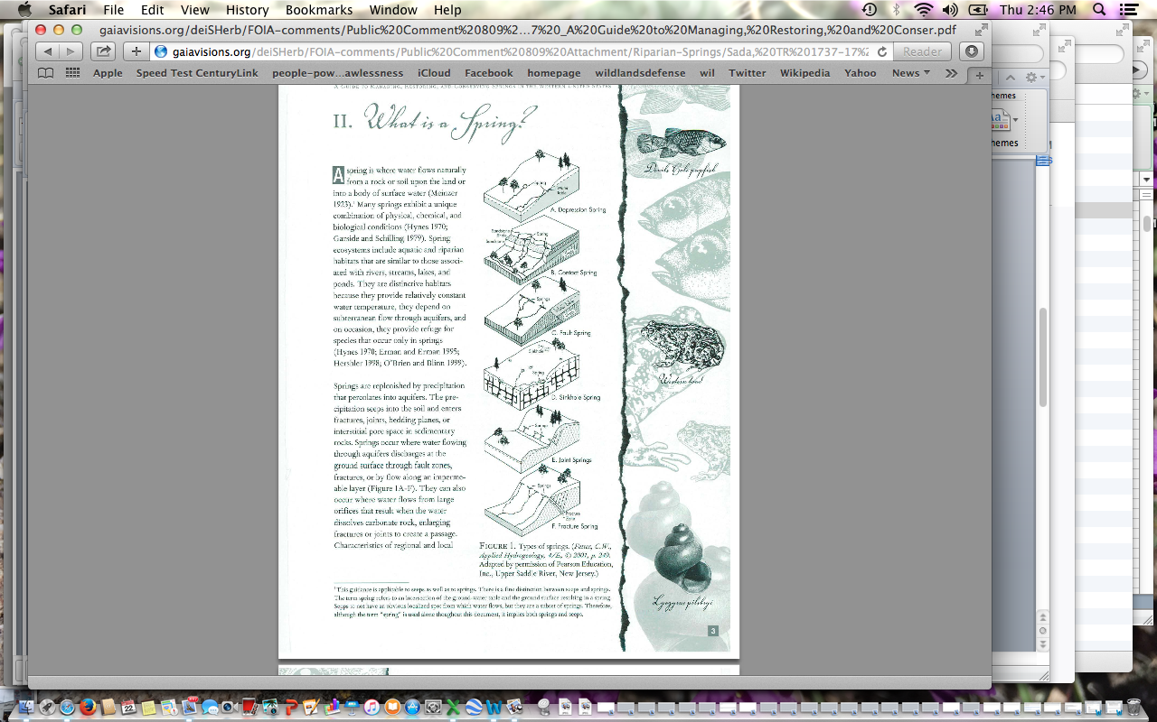

https://greatbasinlcc.blob.core.windows.net/media/Default/Updates/EnvironmentalCharacteristics_of_GreatBasin&MojaveDesert_SpringSystems_Final.pdf
This describes holocrene, hillslope, rheocrene, from “Spring Stewardship Institute”.
Approximately 3 percent the springs were disturbed by natural factors, and evidence of human disturbance was at approximately 83 percent of springs. Approximately 65 percent were moderately or highly disturbed by either diversion, horse, burro, or cattle use, recreation, or dredging, and many springs were degraded by several of these uses. Recent studies by Keleher and Radar (2008) and Sada et al. (2015) show that these levels of disturbance represent highly degraded, unhealthy ecosystems. Moderately or highly degraded springs were most common on Bureau of Land Management land, followed by private lands, U.S. Forest Service, and finally U.S. Fish and Wildlife Service lands. P. iii
This mapping shows there should be at least some data on some Argenta and Buffalo springs:
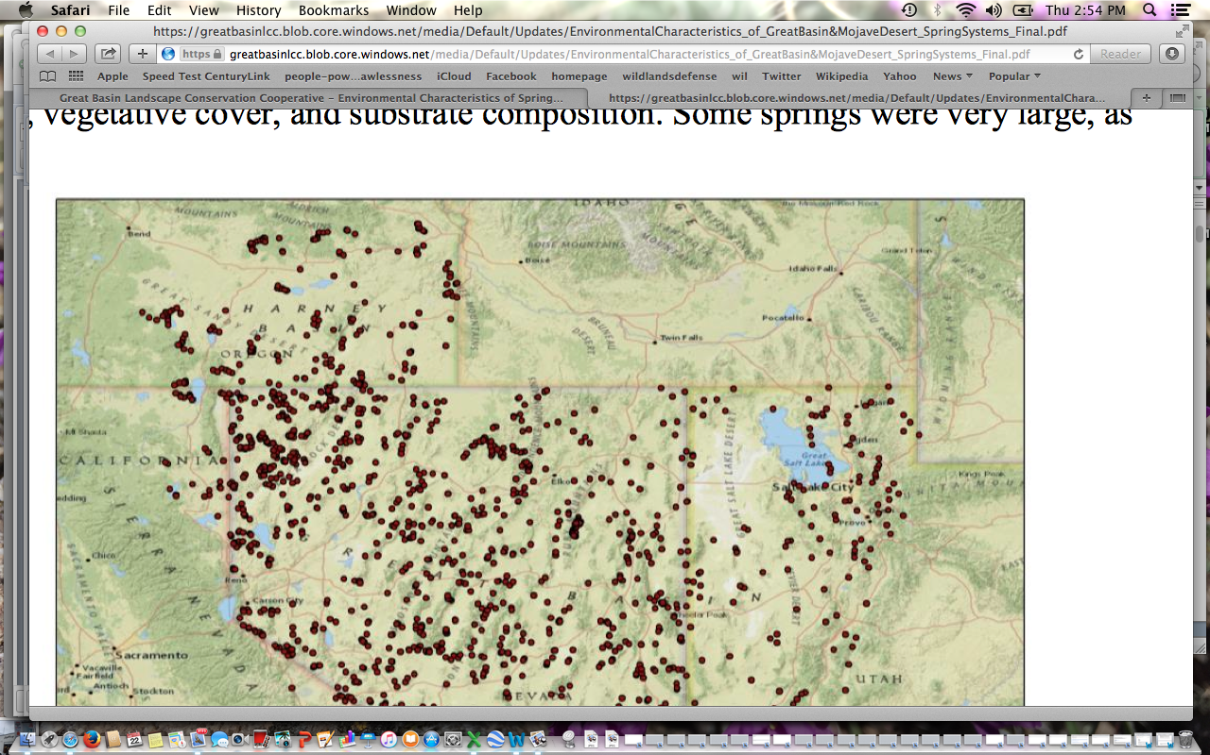
Limited discharge, limited width, limited wetted length …
Rheocrene, helocrene, limnocrene.
Relatively few of the springs were disturbed by natural factors, and cattle use and diversions (mostly for cattle use) were the most common human factors influencing condition (Table 6). Human use was evident at approximately 83 percent of springs, and 65 percent of springs were either moderately or highly disturbed by human uses (Table 7). Most springs had been disturbed by more than one activity (Table 7). Approximately 57 percent of springs were affected by a single type of disturbance, and 34 percent, 8 percent were altered by two or three factors, respectively. Six moderately or highly disturbed springs had been altered by four or more factors. The highest frequency of disturbance was observed on BLM land (73 percent), followed by private land (69 percent) the miscellaneous lands (military, state, etc. ownerships). The lowest frequency of disturbance was on lands managed by the USFWS.

Has the Forest Service obtained information on characteristics of spring sites, or determined if there is pre-existing info on springs? What are all recorded flow rates for all periods of time? Please obtain comprehensive year-round flow, temperature and other data for all affected waters, and provide this in an EIS for this project. How will increased temperatures and other impacts of climate change affect flow sustainability?

We Object that the FS has not taken a hard, look at, nor provided essential baseline data and analysis of the type, characteristics, water temperatures and water quality and flow sustainability of the springs, seeps and tiny streams in this landscape, and their sustainability under climate stress + grazing disturbance stress, and the magnitude of new and often irreversible damage and harm (flammable weeds invasion and dominance in uplands, trampled to death springs that lose flows, further stream downcutting, eroding meadows and flow loss, that will take place if grazing is imposed.

We Object ot the failure of the FS to

BESCHTA et al. Excerpts Relevant to Proposal

We Object that the FS has failed to take a hard look at, and minimize and mitigate impacts, under the significant climate stress and grazing-caused ecological disturbance and harm impacts that we raised, including information from:

Beschta 2012 Excerpts – Climate Ecological Stress, Water Loss, Water Development Impacts https://www.ncbi.nlm.nih.gov/pubmed/23151970
http://ir.library.oregonstate.edu/xmlui/bitstream/handle/1957/50113/BeschtaRobertForestryReducingLivestockEffects.pdf;sequence=1

Climate-related changes can not only affect public-land ecosystems directly, but may exacerbate the aggregate effects of non-climatic stressors, such as habitat modification and pollution caused by logging, mining, grazing, roads, water diversions, and recre- ation (Root and others 2003 ; CEQ 20 10; Bamosky and others 2012).
One effective means of ameliorating the effects of climate change on ecosystems is to reduce environmental stressors under management control, such as land and water uses (Julius and others 2008; Heller and Zavaleta 2009; Prato 2011). Public lands in the American West provide important opportunities to implement such a strategy for three reasons: (l) despite a history of degradation, public lands still offer the best available opportunities for ecosystem restoration (CWWR 1996; FS and BLM 1997; Karr 2004); (2) two-thirds of the runoff in the West originates on public lands (Coggins and others 2007); and (3) ecosystem protection and restoration are consistent with laws governing public lands. To be effective, resto- ration measures should address management practices that prevent public lands from providing the full array of eco- system services and/or are likely to accentuate the effects of climate change (Hunter and others 2010). We Object that instead of ameliorating impacts, the FS M-T grazing scheme imposes major new harmful impacts, and fails to consider reasonable action alternatives such as Closing the allotments, and fails to ensure compliance with the sensitive species management requirements].
Climate change and ungulates, singly and in concert, influence ecosystems at the most fundamental levels by affecting soils and hydrologic processes. These effects, in tum, influence many other ecosystem components and processes- nutrient and energy cycles; reproduction, survival, and abundance of terrestrial and aquatic species; and community structure and composition.
Climate Change in the Western US
Anticipated changes in atmospheric carbon dioxide (C02), temperature, and precipitation (IPCC 2007a) are likely to have major repercussions for upland plant communities in western ecosystems (e.g., Backlund and others 2008), eventually affecting the distribution of major vegetation types.
Future decreases in soil moisture and vegetative cover due to elevated temperatures will reduce soil stability (Karl and others 2009). Wind erosion is likely to increase dra- matically in some ecosystems such as the Colorado Plateau (Munson and others 2011 ) because biological soil crusts- a complex mosaic of algae, lichens, mosses, microfungi, cyanobacteria, and other bacteria-may be less drought tolerant than many desert vascular plant species (Belnap and others 2006). Higher air temperatures may also lead to elevated surface-level concentrations of ozone (Karl and others 2009), which can reduce the capacity of vegetation to grow under elevated C02 levels and sequester carbon (Kamosky and others 2003).
Air temperature increases and altered precipitation regimes will affect wildfire behavior and interact with insect outbreaks (Joyce and others 2009).
Climate induced increases in wildfire occurrence may aggravate the expansion of cheatgrass (Bromus tec- torum), an exotic annual that has invaded millions of hectares of sagebrush (Artemisia spp.) steppe, a widespread yet threatened ecosystem. In turn, elevated wildfire occurrence facilitates the conversion of sagebrush and other native shrub-perennial grass communities to those dominated by alien grasses (D'Antonio and Vitousek 1992; Brooks 2008), resulting in habitat loss for imperiled greater sage-grouse (Centrocercus urophasianus) and other sage- brush-dependent species (Welch 2005). The US Fish and Wildlife Service (FWS 2010) recently concluded climate change effects can exacerbate many of the multiple threats to sagebrush habitats, including wildfire, invasive plants, and heavy ungulate use.
By the mid-21st century, Bates and others (2008) indicate that warming in western mountains is very likely to cause large decreases in snowpack, earlier snowmelt, more winter rain events, increased peak winter flows and flooding, and reduced summer flows. Annual runoff is predicted to decrease by 10-30 % in mid-latitude western North America by 2050 (Milly and others 2005) and up to 40 % in Arizona (Milly and others 2008; ITF 2011). Drought periods are expected to become more frequent and longer throughout the West (Bates and others 2008). Summertime decreases in streamflow (Luce and Holden 2009) and increased water temperatures already have been documented for some western rivers (Kaushal and others 2010; Isaak and others 2012).
High water temperatures, acknowledged as one of the most prevalent water quality problems in the West, will likely be further elevated and may render one-third of the current coldwater fish habitat in the Pacific Northwest unsuitable by this century's end (Karl and others 2009). Resulting impacts on salmonids include increases in virulence of disease, loss of suitable habitat, and mortality as well as increased competition and predation by warmwater species (EPA 1999). Increased water temperatures and changes in snowmelt timing can also affect amphibians adversely (Field and others 2007). In sum, climate change will have increasingly significant effects on public-land terrestrial and aquatic ecosystems, including plant and animal communities, soils, hydrologic processes, and water quality.
Livestock use affects a far greater proportion of BLM and FS lands than do roads, timber harvest, and wildfires combined. Yet attempts to mitigate the pervasive effects of livestock have been minor compared with those aimed at reducing threats to ecosystem diversity and productivity that these other land uses pose …
Livestock use effects, exacerbated by climate change, often have severe impacts on upland plant communities. For example, many former grasslands in the Southwest are now dominated by one or a few woody shrub species, such as creosote bush (Larrea tridentata) and mesquite (Prosopis g/andulosa), with little herbaceous cover (Grover and Musick 1990; Asner and others 2004; but see Allington and Valone 2010). Other areas severely affected include the northern Great Basin and interior Columbia River Basin (Middleton and Thomas 1997). Livestock effects have also contributed to severe degradation of sagebrush-grass ecosystems (Connelly and others 2004; FWS 2010) and widespread desertification, particularly in the Southwest (Asner and others 2004; Karl and others …
Simplified plant communities combine with loss of vegetation mosaics across landscapes to affect pollinators, birds, small mammals, amphibians, wild ungulates, and other native wildlife (Bock and others 1993; Fleischner 1994; Saab and others 1995; Ohmart 1996). Ohmart and Anderson (1986) suggested that livestock grazing may be the major factor negatively affecting wildlife in eleven western states. Such effects will compound the problems of adaptation of these ecosystems to the dynamics of climate change (Joyce and others 2008, 2009).
Soils and Biological Soil Crusts
Livestock grazing and trampling can damage or eliminate biological soil crusts characteristic of many arid and semiarid regions (Belnap and Lange 2003; Asner and others 2004). These complex crusts are important for fertility, soil stability, and hydrology (Belnap and Lange 2003). In arid and semiarid regions they provide the major barrier against wind erosion and dust emission (Munson and others 2011) …
If livestock use on public lands continues at current levels, its interaction with anticipated changes in climate will likely worsen soil erosion, dust generation, and stream pollution. Soils whose moisture retention capacity has been reduced will undergo further drying by warming temperatures and/or drought and become even more susceptible to wind erosion (Sankey and others 2009). Increased aeolian deposition on snowpack will hasten runoff, accentuating climate-induced hydrological changes on many public lands (Neff and others 2008) …
Livestock grazing has numerous consequences for hydrologic processes and water resources. Livestock can have profound effects on soils, including their productivity, infiltration, and water storage, and these properties drive many other ecosystem changes. Soil compaction from livestock has been identified as an extensive problem on public lands (CWWR 1996; FS and BLM 1997). Such compaction is inevitable because the hoof of a 450-kg cow exerts more than five times the pressure of heavy earth- moving machinery (Cowley 2002). Soil compaction significantly reduces infiltration rates and the ability of soils to store water, both of which affect runoff processes (Branson and others 1981; Blackburn 1984). Compaction of wet meadow soils by livestock can significantly decrease soil water storage (Kauffman and others 2004), thus contributing to reduced summer base flows. Concomitantly, decreases in infiltration and soil water storage of com- pacted soils during periods of high-intensity rainfall con- tribute to increased surface runoff and soil erosion (Branson and others 1981). These fundamental alterations in hydrologic processes from livestock use are likely to be exacerbated by climate change …
The combined effects of elevated soil loss and compaction caused by grazing reduce soil productivity, further compromising the capability of grazed areas to support native plant communities (CWWR 1996; FS and BLM 1997). Erosion triggered by livestock use continues to represent a major source of sediment, nutrients, and pathogens in western streams (WSWC 1989; EPA 2009). Conversely, the absence of grazing results in increased litter accumulation, which can reduce runoff and erosion and retard desertification (Asner and others 2004) …
Water Developments
Water developments and diversions for livestock are common on public lands (Connelly and others 2004). For example, approximately 3,700 km of pipeline and 2,300 water developments were installed on just 17 % of the B L M ' s land base from 1961 to 1999 in support of livestock operations (Rich and others 2005). Such developments can reduce streamflows thus contributing to warmer stream temperatures and reduced fish habitat, both serious problems for native coldwater fish (Platts 1991; Richter and others 1997). Reduced flows and higher temperatures are also risk factors for many terrestrial and aquatic vertebrates (Wilcove and others 1998). Water developments can also create mosquito (e.g., Culex tarsalis) breeding habitat, potentially facilitating the spread of West Nile virus, which poses a significant threat to sage grouse (FWS 20 I0). Such developments also tend to concentrate livestock and other ungulate use, thus locally intensifying grazing and trampling impacts.
SAGE-GROUSE HABITAT NEEDS - Cover, Structural Complexity, Forbs
Sage-grouse Needs Not Addressed in Integrated Manner by Piecemeal Development.
Gregg et al. 1994, Connelly et al. 2000, Connelly et al. 2004, the Braun Blueprint 2006, Knick and Connelly 2011, USFWS WBP Finding, Manier et al. 2013.
Adequate residual cover is vital to protect nests and hens in early spring from the start – from early April on - which is before grass has even started to grow in many areas. The residual cover is the dry grass left over from the previous year. But BLM clearly does not care if any grass is left over, as it does not even bother to require that sufficient residual cover be present, and allows repeated harmful use with additive damage to fragile native plants, especially since the decision authorizes active and critical growing period use, as well as repeated use that harms and weakens plants, resulting in stunted plants that lack vigor. It repeatedly disturbs soils and crusts, and the habitats that sage-grouse and other wildlife need their food, cover space and other requirements met. It allows grazing to be imposed on top of breeding season habitats.
The flexible chaos-based year round loose and uncertain grazing proposal ensures that many of these crucial sage-grouse needs will not be met.
Nests must be adequately concealed and protected throughout the nesting period. By failing to apply any measurable use standard whatsoever (and also failing to even analyze any use standard sufficient to provide this amount of cover in the depleted exotic species-infested landscape), The proposal has turned a blind eye to sage-grouse, pygmy rabbit and many other sensitive species needs. See Manier Summary Attachment about problems with many grazing systems, and the need for residual cover. This is the Baseline Ecological Report associated with the GRSG EIS process.
Across this landscape, the native Indian ricegrass, bluebunch wheatgrass and other native grasses have been greatly depleted. The agency is proposing allowing very damaging grazing that will kill and weaken many of the remaining bunchgrasses. This has also turned a blind eye to the profusion of unproductive weedy exotic species that provide minimal vegetation height and cover - and the very serious risk that they will invade and come to dominate crucial nesting ad other habitat areas as a result of this grazing abuse during drought.
Grass height is essential for protective vegetative screening in the area of the nest to better conceal nests from visual and scent predators.
Grass height and cover also are important components of sage grouse nest sites (Table 1). Grass associated with nest sites and with the stand of vegetation containing the nest was taller and denser than grass at random sites (Wakkinen 1990, Gregg 1991, Sveum et al. 1998a). Grass height at nests under non-sagebrush plants was greater (P < 0.01) than that associated with nests under sagebrush, further suggesting that grass height is an important habitat component for nesting sage grouse (Connelly et al. 1991). Moreover, in Oregon, grass cover was greater at successful nests than at unsuc cessful nests (Gregg 1991). Grass >18 cm in height occurring in stands of sagebrush 40–80 cm tall resulted in lesser nest predation rates than in stands with lesser grass heights (Gregg et al. 1994). Herbaceous cover associated with nest sites may provide scent, visual, and physical barriers to potential predators (DeLong et al. 1995). Connelly et al. 2000.
The NEPA Process must critically assess the adequacy of cover - and cannot ignore alternative actions such as not grazing watersheds and areas with vulnerable species to provide freedom from disturbance and adequate cover. It violates NEPA’s requirements for an agency not to use high quality science, and take a hard look at competing points of view and scientific information, and not just engage in self-serving analyses.
The upland use that is proposed typically provides only a few inches inches of cover– both due to the way it is measured at remote flat cherry-picked “monitoring” sites, and due to the depletion of larger statured bunchgrasses in the landscape. See Catlin Report on cd describing manner in which agencies measures utilization.
http://sagemap.wr.usgs.gov/Docs/Sage_Grouse_Guidelines.PDF
Connelly et al. 2000.

The highly flexible chaos-based year-round grazing scheme proposed greatly fails to apply mandatory triggers of conservative measurable use level controls to limit cattle impacts, including impacts shifted and intensified due to livestock facilities, and continued high numbers of livestock being grazed likely far above actual use - to soils, crusts, native vegetation (trampling of crusts and soil displacement, browse of shrubs, utilization of grasses and forbs) that provide protective residual cover for sage-grouse nesting in early spring.
Connelly et al. 2000: Grass height and cover also are important components of sage grouse nest sites (Table 1). Grass associated with nest sites and with the stand of veg-etation containing the nest was taller and denser than grass at random sites (Wakkinen 1990, Gregg 1991, Sveum et al. 1998a). Grass height at nests under non-sagebrush plants was greater (P < 0.01) than that associated with nests under sagebrush, further suggesting that grass height is an important habitat component for nesting sage grouse (Connelly et al. 1991). In Oregon, grass cover was greater at successful nests than at unsuccessful nests (Gregg 1991). Grass >18 cm in height occurring in stands of sagebrush 40–80 cm tall resulted in lesser nest predation rates than in stands with lesser grass heights (Gregg et al. 1994). Herbaceous cover associated with nest sites may provide scent, visual, and physical barriers to potential predators (DeLong et al. 1995). Braun (2006) stresses the importance of undisturbed nesting habitat and adequate cover.
ALTERNATIVE Standards and Mitigations Not Examined
The EA failed to consider a reasonable range of alternatives and mitigation actions and use standards that would provide protective residual cover for watersheds, riparian areas, and uplands, buffer climate change stress and provide many other protections.. This represents a grave threat to the critical sensitive species habitats that these areas provide, and sustainability of use. An EIS must take a hard look at the site-specific, and how the action is highly likely to increase use precisely in very vulnerable riparian and upland habitats for rare species and push them to further declines and/or extirpation.
BLM also has not shown that it is complying with the GRSG Forest Plan Amendments. See also Connelly et al 2006. Setting the Record Straight.
Herbaceous vegetation characteristics that were consistently higher at successful versus unsuccessful sage-grouse nests throughout the range of studied populations included live and residual grass height (Wakkinen 1990, Sveum et al. 1998b, Aldridge and Brigham 2002, Hausleitner 2003), residual vegetative cover (Gregg et al. 1994, Sveum et al. 1998b), forb cover (Holloran 1999, Hausleitner 2003) and visual obstruction (Wakkinen 1990, Popham 2000, Slater 2003). Successful nests in southern Canada had taller grasses and palatable forbs, and less grass cover compared to unsuccessful nests (Aldridge and Brigham 2002). In California, percent rock cover (rocks >10 cm in diameter; 27.7 vs. 14.5%), total shrub height (65.5 cm vs. 49.2 cm), and visual obstruction (40.2 vs. 32.5 cm) were greater at successful than unsuccessful nest sites (Popham and Gutiérrez 2000). Nests destroyed by avian predators in southwestern Wyoming consistently had less overhead cover (live sagebrush and total shrub canopy cover) within 15 m
of the nest and increased lateral cover (herbaceous cover and height) within 2.5 m of the nest compared to nests in general and mammalian-destroyed nests (Slater 2003). Hausleitner (2003) reported that successful nests in northwestern Colorado had higher average forb (9.3 vs. 7.2%) and grass cover (4.8 vs. 3.9%) within 10 m of the nest, and taller grasses at the nest (15.4 vs. 11.7 cm) and at 1 m from the nest (18.2 vs. 13.5 cm) compared to unsuccessful nests. Additionally, in southeastern Idaho, successful nests tended to have taller grass and more lateral
obstructing cover within 2.5 m of the nest compared to unsuccessful nests (Wakkinen 1990). In central Wyoming, food-forb cover within 2.5 m tended to be higher at successful nests relative to unsuccessful nests (2.1 vs. 1.3%; Holloran 1999). Successful artificial nests placed between 800 and 1440 m from active and inactive sagegrouse leks in southern Canada consistently had more forb and total sagebrush canopy cover, taller grasses, and lower numbers of sagebrush plants within 0.5 m compared to unsuccessful artificial nests (Watters et al. 2002). DeLong et al. (1995) reported that a combination of greater
amounts of tall (>18 cm) grass and medium height (40-80 cm) shrub cover within 1 m of artificial sage-grouse nests in southeastern Oregon increased the probability of success. There have been numerous explanations for these low rates of nest success
and/or low rates of annual reproductive success. These include the lack of adequate forbs and low residual herbaceous cover (Barnett and Crawford 1994, Gregg et al. 1994, Hanf et al 1994, DeLong et al. 1995, Coggins 1998).

The Connelly Guidelines also state:

Wallestad and Pyrah (1974) also indicated that successful nests were in sagebrush stands with greater average canopy coverage (27%) than those of unsuccessful nests (20%). Gregg (1991) reported that sage grouse nest success varied by cover type. The greatest nest success occurred in a mountain big sagebrush (A. t. tridentata vaseyana) cover type where shrubs 40–80 cm in height had greater canopy cover at the site of successful nests than at unsuccessful nests (Gregg 1991). These observations were consistent with the results of an artificial nest study showing greater coverage of medium-height shrubs improved success of artificial nests (DeLong 1993, DeLong et al. 1995).

Grass height and cover also are important components of sage grouse nest sites (Table 1). Grass associated with nest sites and with the stand of vegetation containing the nest was taller and denser than grass at random sites (Wakkinen 1990, Gregg 1991, Sveum et al. 1998a). Grass height at nests under non-sagebrush plants was greater(P < 0.01) than that associated with nests under sagebrush, further suggesting that grass height is an important habitat component for nesting sage grouse (Connelly et al. 1991). Moreover, in Oregon, grass cover was greater at successful nests than at unsuccessful nests (Gregg 1991). Grass >18 cm in height occurring in stands of sagebrush 40–80 cm tall resulted in lesser nest predation rates than in stands with lesser grass heights (Gregg et al. 1994). Herbaceous cover associated with nest sites may provide scent, visual, and physical barriers to potential predators (DeLong et al. 1995).

SEE Also Sage-Grouse RMP Amendment Information and Fence/Project Harms

SAGE-GROUSE Populations Are in Deep Trouble – Agencies Must Conserve, Enhance and Restore Populations

Seee Knick and Connelly 2009/2011 Garton et al. Chapter population analysis, 2015 PEW Garton et al. analysis. Greater Sage-Grouse Population Dynamics and Probability of Persistence. http://www.pewtrusts.org/~/media/assets/2015/04/garton-et-al-2015-greater-sagegrouse-population-dynamics-and-persistence-31815.pdf
Crist et al. 2015 highlights the perils of the fragmentation of occupied habitats, and agency habitat mapping/delineation coupled with habitat loss resulting in sage-grouse being confined to “zoos” and becoming increasingly vulnerable to stochastic events and population losses. Yet the aggressive projects may increase fragmentation through expanded development, Please also review current sage-grouse literature. Knick and Connelly 2009/2011 Garton et al. Chapter population analysis, 2015 PEW Garton et al. analysis. Greater Sage-Grouse Population Dynamics and Probability of Persistence. http://www.pewtrusts.org/~/media/assets/2015/04/garton-et-al-2015-greater-sagegrouse-population-dynamics-and-persistence-31815.pdf
Crist et al. 2015, Crist et al -2016 highlight the perils of the fragmentation of occupied habitats. Yet the aggressive treatment projects may increase fragmentation through collateral damage and other loss of sagebrush.

Connelly et al 2019 describe serious continuing Sage-grouse declines, and agencies being in denial. This project is a stellar example of such agency denial.
https://www.researchgate.net/publication/337818762_CONSERVATION_NEWS_Sage-Grouse_Population_Declines_Species_in_Crisis_and_Agencies_in_Denial

FENCE IMPACTS, HABITAT FRAGMENTATION, HARMS

There are long-known significant ecological concerns with fences and sage-grouse habitats.
Relevant Excerpts from Connelly et al. 2004, Conservation Assessment illustrate concerns:

Fences provide perches for raptors, and modify access and movements by humans and
livestock, thus exerting a new mosaic of disturbance and use on the landscape. ES-3.

The increased edge in landscapes fragmented by roads, power-lines, fences, and other
linear features promote spread of exotic invasive species (Gelbard and Belnap 2003), facilitates predator movements (Tewksbury et al. 2002), and isolates wildlife populations (Saunders et al.1991, Trombulak and Frissell 2000). Changes in quantity, composition, and configuration ofsagebrush habitats have consequences on the ecological processes within the sagebrush ecosystem and the resources available to support wildlife (Wisdom et al. 2002). Few pristineand intact sagebrush ecosystems remain (Noss and Peters 1995, Noss et al. 1995, West 1996,Mac et al. 1998). 1-6.

Livestock grazing has altered sagebrush habitats; the effects of overgrazing combined with drought on plant communities in the late 1880s and early 1900s still influences current habitats. Management of
livestock grazing has influenced sagebrush ecosystems by habitat treatments to increase forage and
reduce sagebrush and other plant species unpalatable to livestock. Fences, roads, and water
developments to manage livestock movements have further influenced the landscape and increased
access into sagebrush habitats. Energy development also influenced sagebrush landscapes by
construction of wells, access roads, and pipelines. Treatments to restore sagebrush are becoming a
major emphasis of land management agencies. However, revegetation and rehabilitation treatments
are limited by the financial, biological, and technological resources needed to restore sagebrush
landscapes that function at the spatial and temporal scales used by sage-grouse (Centrocercus
urophasianus). 7-2

For example, 1,258 km of fences were constructed in year 2000 on lands
managed by the U.S. Bureau of Land Management (U.S. Bureau of Land Management, Public Lands Statistics 2001). Fences control livestock, modify habitats, and influence movement of predators, invasive plants, or vehicular travel. In the absence of spatial information, such as linear distance/unit area, and other regional characteristics, our ability to quantify the area over which fences might influence habitats and increase mortality rates is limited. For example, fences can increase mortality directly when sage-grouse fly into fences or indirectly because of increased predation by raptors. 7-3.

The primary habitat treatments on lands managed by the U.S. Bureau of Land Management include construction of fences, development or control of water, and habitat modifications (Table 7.8). More than 1,000 km of fences were constructed each year from 1996 through 2002; most fences were constructed in Montana, Nevada, Oregon, and Wyoming. Linear density of fences exceeds 2 km/km2 in some regions of the Conservation Assessment study area (Fig. 7.22; Chapter 13 presents
additional information on fences and sage-grouse). In addition to influencing livestock and predator movements, facilitating spread of exotic plants, and providing additional travel and access for human activities, fences potentially increase mortality of sage-grouse due to direct collisions or indirectly by increasing predation rates by increasing the number of perches for raptors. Fences used to control grazing management among allotments further modify the landscape by creating an artificial mosaic among separate pastures (Freilich et al. 2003).
Water developments were widespread throughout public lands (Fig. 7.23). Water
developments and distribution of water sources substantially influence movements and distribution of livestock in arid western habitats (Valentine 1947, Freilich et al. 2003). Consequently, grazing pressure can be unevenly distributed and influence the composition and relative abundance of the plant relative to water sources. 7-34 and 7-35.

The density of fences exceeds >2 km/km2 of habitat in some regions and influence movements of livestock, vehicles, predators, and exotic plants (Chapter 7). 13-7.

Others factors, such as fences, influence sagebrush ecosystems across the entire biome but at lower intensities. The cumulative impacts of the disturbances, rather than any single source, may be the most significant influence on the trajectory of sagebrush ecosystems. 13-8.

Sage-grouse are adapted to a landscape with few
vertical obstructions but now occupy areas that commonly have many kilometers of fences and powerlines. From 1962 to 1997, >51,000 km of fence were constructed on land administered by the U.S. Bureau of Land Management in states supporting sage-grouse populations (Connelly et al. 2000b); >1,000 km of fences were constructed each year from 1996 through 2002 (Chapter 7) and density of fences exceeds 2 km/km2 in some regions of the sage-grouse range. Structures such as powerlines and fences pose hazards to sage-grouse because they provide perch sites for raptors. However, predator control is rarely recommended for sage-grouse and other species of
prairie grouse for a variety of reasons including long-term consequences, relatively high cost, and public attitudes (Messmer et al. 1999, Schroeder and Baydack 2001). Grouse may also be injured or killed when they fly into these structures. In further support of this concern, an informal report was provided by the Bureau of Land Management documenting (with GPS locations and photographs) 21 incidents of sage-grouse striking a barbed wire fence in Sublette County Wyoming during spring 2003 (T. Rinkes, U.S. Bureau of Land Management, Lander, WY) …
(2003) assessed the impact of energy development on sage-grouse and reported that traffic
disturbance associated with natural gas developments may reduce nest initiation rates and increase distances moved from leks to nest sites. 13-13.

We Object to the failure of the FS to take a hard science-based look at the Manier et al 2013 grazing information we provided in 2021 NOPA comments, based on Manier, D.J., Wood, D.J.A., Bowen, Z.H., Donovan, R.M., Holloran, M.J., Juliusson, L.M., Mayne, K.S., Oyler-McCance, S.J., Quamen, F.R., Saher, D.J., and Titolo, A.J., 2013, Summary of science, activities, programs, and policies that influence the rangewide conservation of Greater Sage-Grouse (Centrocercus urophasianus): U.S. Geological Survey Open-File Report 2013–1098, 170 p., http://pubs.usgs.gov/of/2013/1098/

This summary includes much long known scientific information in Connelly et al. 2004, Conservation Assessment , and Knick and Connelly 2011, Eds. Studies in Avian Biology, and additional information

We Object that the FS has failed to provide a current baseline, evaluation, and controls on and monitoring of M-T livestock grazing damage to microbiotic crusts, with this trampling damage promoting invasive weeds. These essential crusts have long been recognized as a critical factor in degradation of arid lands in the Interior Columbia Basin. In order to understand the inter-connected processes of livestock degradation that, with chronic continued grazing disturbance, are converting the sagebrush landscape of the arid Great Basin and other sage-grouse population landscapes into a desertified weedland, A hard look NEPA analysis must not only address all of these concerns, but also trampling impacts, microbiotic crust loss and destruction, and the cumulative effects of all of this, which is also amplified by climate change effects.

Various failed/ineffective range schemes discussed below have not in any way halted flammable annual grass and weed expansion, and are in a large way responsible for it – by giving false legitimacy to continued unsustainable high levels of domestic livestock grazing disturbance across the landscape.

We submitted NOPA comments on the great need to minimize disturbance within remnant better condition sagebrush communities deemed important for Sage-grouse conservation might include a combination of wildfire control as well as adjusting use standards (for example, grazing, energy development, and recreation and avoid management actions, treatments or activities that remove sagebrush, or degrade native herbaceous species, and/or promote cheatgrass expansion.
… the invasion by exotic annuals has resulted in dramatic increases in number and frequency of fires with widespread, detrimental effects on habitat conditions (Young and Evans, 1978; West and Young, 2000; West and Yorks, 2002; Connelly and others, 2004). For example, big sagebrush communities invaded by cheatgrass have estimated mean fire-return intervals of less than 10 years in many areas (Connelly and others, 2004), whereas the natural regime is estimated (conservatively) to be 10 to 20 times longer. Increased fire frequency or intense fire behavior typically results in removal of the sagebrush canopy in affected areas and often with replacement by annual species that provide little, to no, habitat value (Knapp, 1996; Epanchin-Niell and others, 2009; Rowland and others, 2010; Baker, 2011; Condon and others, 2011). Presumably cheatgrass (Bromus tectorum) was able to thrive in this region, in part because there was no pre-existing (native) dominant annual plant species. As this optimal colonist species established, chronic grazing by cattle, sheep, and horses combined with drought and fire to increase the distribution and frequency of disturbance and further optimize this region for dominance by an annual grass (Knapp, 1996). Importantly, research in sagebrush ecosystems has revealed an inverse relation between cheatgrass dominance and native perennial herbs, especially grasses (West and Yorks, 2002). Further, the post-disturbance response of sagebrush communities to fire and similar disturbances is strongly affected by the condition and composition before disturbance, the presence of propagules, and sprouting of native species (West and Yorks, 2002; Beck and others, 2009; Epanchin-Niell and others, 2009; Condon and others, 2011). Cheatgrass competes with native grasses and forbs that are important components of sage-grouse habitat. Cheatgrass abundance is negatively correlated with habitat selection by sage-grouse (Kirol and others, 2012) indicating that changes in composition and structure associated with cheatgrass specifically degrade sage-grouse habitat. Invasion by Medusahead (Taeniatherum caput-medusae), which can replace cheatgrass in some circumstances, may be even worse as it also reduces perennial productivity, degrades wildlife habitat, supports high-frequency fire-return intervals, and requires intensive treatment for restoration (Davies, 2010). Infestation of these species, and others, cause direct degradation of sagebrush habitats resulting in (indirect) effects on local sage-grouse populations by affecting forage and cover quality with potential to cause complete avoidance (functional habitat loss).
In southern habitats (MZs III, IV, V, and VII), cheatgrass … Manier et al. p. 88.

Large-scale restoration is needed in many areas, making minimally invaded areas highly valuable for habitat conservation. In the sagebrush-steppe of northern habitats (all or parts of MZs I, II, IV, V, and VI), cheatgrass is less ubiquitous but demonstrates increased dominance, productivity, and elevation range on south-facing slopes (Connelly and others, 2004), which indicates the need for careful local considerations and best-practices that minimize disturbance in areas with a threat (presence) of cheatgrass expansion. Potential for cheatgrass occurrence has been modeled in the Great Basin region based on environmental correlations, which can help discern locations and habitats that have the greatest risk, either because cheatgrass is already on those landscapes (some of the risk has been realized) or the conditions are right to support cheatgrass (fig. 27A). Summary data indicate that invasion potential is widespread and similar among assessed MZs (table 20). Although the distribution of cheatgrass, and other annual invaders such as Japanese brome (Bromus arvensis), has been documented across shrub and grasslands of Colorado, Wyoming, and Montana, the currently available model was only parameterized for the Great Basin, therefore only MZs III, IV and V are described here (table 20, fig. 27A). Manier et al. p. 88

The Connelly et al. 2004 info that appears to have been used in Manier is extremely out-dated, and conditions are much worse due to continued loss of habitats.

As this optimal colonist species established, chronic grazing by cattle, sheep, and horses combined with drought and fire to increase the distribution and frequency of disturbance and further optimize this region for dominance by an annual grass (Knapp, 1996). Importantly, research in sagebrush ecosystems has revealed an inverse relation between cheatgrass dominance and native perennial herbs, especially grasses (West and Yorks, 2002). Further, the post-disturbance response of sagebrush communities to fire and similar disturbances is strongly affected by the condition and composition before disturbance, the presence of propagules, and sprouting of native species (West and Yorks, 2002; Beck and others, 2009; Epanchin-Niell and others, 2009; Condon and others, 2011). Cheatgrass competes with native grasses and forbs that are important components of sage-grouse habitat. Cheatgrass abundance is negatively correlated with habitat selection by sage-grouse (Kirol and others, 2012) indicating that changes in composition and structure associated with cheatgrass specifically degrade sage-grouse habitat. Invasion by Medusahead (Taeniatherum caput-medusae), which can replace cheatgrass in some circumstances, may be even worse as it also reduces perennial productivity, degrades wildlife habitat, supports high-frequency fire-return intervals, and requires intensive treatment for restoration (Davies, 2010). Infestation of these species, and others, cause direct degradation of sagebrush habitats resulting in (indirect) effects on local sage-grouse populations by affecting forage and cover quality with potential to cause complete avoidance (functional habitat loss).

Livestock grazing has been described as a diffuse form of biotic disturbance that exerts repeated pressure over many years on a system; unlike point-sources of disturbance (for example, fires that have acute perturbations from well-defined origins), livestock grazing is characterized as a “press” form of disturbance because it exerts repeated pressure across the landscape (Knick and Connelly, 2011b). Thus, effects of grazing are not likely to be detected as disruptions—except in extreme cases as around water sources or mineral-nutrient blocks—but rather as differences in the processes and functioning of the sagebrush system (Knick and Connelly, 2011b). Importantly, effects of grazing are not distributed evenly, because historic practices, management plans and agreements, and animal behavior all dictate differential use and therefore different effects.

The grazing-caused cheatgrass expansion threat is a testimony to why the FS can’t sign a FONSI for the M-T grazing EA , and we Object to the FS proposing to do so.

Native perennial grasses and forbs … were not adapted to heavy grazing … Livestock grazing can affect soils, vegetation, water, and nutrient availability by consuming or altering vegetation, redistributing nutrients and plant seeds, trampling soils and vegetation, and disrupting microbiotic crusts (Connelly and others, 2004). At unsustainable levels of grazing, these impacts can lead to loss of vegetative cover, reduced water infiltration rates, decreased plant litter on soil surface, increased bare ground, reduced nutrient cycling, decreased water quality, increased soil erosion, and reduced overall habitat quality for wildlife including sage-grouse (Wisdom and others, 2002; Knick and others, 2011). Ultimately, livestock function as keystone species; domestic grazing does not preclude native wildlife and vegetation, but it influences ecological pathways and can influence which plant and animal species persist (Knick and others, 2011). Thus there are two important influences of detrimental grazing on sage-grouse habitat: the influence on annual conditions in the near-term and the accumulation of selective pressure resulting in altered vegetation dominance over time. Prolonged selective pressure can affect condition of individual plants, abundance of species, inter-specific competition, and ultimately, community composition (Miller and others, 1994; Beck and Mitchell, 2000; Wisdom and others, 2002; Erichsen-Arychuk and others, 2002; Holechek and others, 2003; Connelly and others, 2004; and Pyke, 2011). Although specific effects and conditions are localized in most cases, the cumulative effect of these transitions across the species’ range may affect the regional condition of sage-grouse habitats.

… heavy grazing in wet meadows deteriorated hydrology and reduced the extent of habitats suitable for summer—these sites were avoided by sage-grouse, and (4) sheep and cattle trampled nests and caused nest desertions (Beck and Mitchell, 2000). P. 96.

Sage-grouse population persistence has been linked to the availability and condition of sagebrush habitat; the dependence of the species on sagebrush through all seasonal periods has been well documented and cannot be overemphasized (Connelly and others, 2004). Nesting sage-grouse consistently select areas with more sagebrush canopy cover and taller grasses compared to available habitats (Hagen and others, 2007); tall, dense herbaceous cover—including residual grasses—in selected dense sagebrush stands increases the probability of a successful hatch. Thermal cover, predator protection, and food availability are important for chick survival during the early brood-rearing period with tall (>30cm) grasses and sagebrush creating this habitat structure. Grazing intensity—including stocking rate, duration, and frequency—has consistently been identified as having impacts on ecosystem and rangeland health (Vallentine, 1990; Briske and others, 2008; Veblen and others, 2011) including the structure required by sage-grouse. Similarly, the timing of grazing relative to plant phenology in particular can influence the sustainability of grazing (Briske and Hendrickson, 1998; Briske and others, 2003; Veblen and others, 2011) and compatibility with wildlife requirements. Resting pastures from livestock grazing during periods of fastest growth of dominant grasses and forbs in intermountain sagebrush-steppe generally enhances herbaceous plant growth and reproduction and increases culm height, long-term tiller production, and flower and seed production (Pyke, 2011) improving range conditions and habitat. Repeated grazing during this time tends to favor sagebrush growth (Pyke, 2011) through reduced competitive ability of grasses. Seasonal monitoring of range conditions could enable removal of livestock when stubble heights required to protect nests and broods are reached; however, this information is difficult to attain accurately in a timely way across large regions; therefore, surrogate measures or indices of condition would likely benefit this effort.
Heavy fall utilization of sagebrush habitats by livestock has been deemed detrimental to sagebrush overstories and thus may negatively influence sage-grouse habitat suitability (Wright, 1970; Owens and Norton, 1990; Angell, 1997; Beck and Mitchell, 2000). Trampling by livestock under short-duration or season-long grazing may kill sagebrush, particularly seedlings growing in interstitial spaces (Beck and Mitchell, p. 97).

… (Van Poolen and Lacey, 1979), compiling results from 18 western grazing-system studies reported that adjustments in livestock numbers resulted in increased herbage production of approximately 35 percent and 28 percent when grazing-use levels were reduced from heavy (60–80 percent) to moderate (40–60 percent) and from moderate to light (20–40 percent), respectively. The authors concluded that livestock stocking intensity was more important than grazing system for herbage production (Van Poolen and Lacey, 1979), a key habitat feature associated with hatching success of sage-grouse nests and chick survival during early brood-rearing. In contrast, others found season of use to influence production: grazing heavily during the spring or during spring and fall was detrimental to herbaceous understories (Mueggler, 1950; Laycock, 1978; Owens and Norton, 1990). Insect diversity and density were positively correlated with herbaceous density and diversity (Hull and others, 1996; Jamison and others, 2002); thus, spring or spring-fall grazing could negatively impact nesting sage-grouse and young chick survival during early brood-rearing, and avoidance through rotation or rest may benefit nesting or brood-rearing success. P. 97

However, grazing during the dormant season (late summer through winter) may influence residual-grass-stubble height (Pyke, 2011), which could influence nesting habitat quality for sage-grouse the following spring.
… High stocking rates in areas with limited water availability were particularly detrimental to forage productivity on lands immediately surrounding water sources (Hall and Bryant, 1995; Dobkin and others, 1998). Similarly, summer grazing on riparian habitats concentrated livestock on riparian corridors resulting in decreased low-vegetative growth (typically the forb communities essential in sage-grouse summer diets) and reduced lateral extent of succulent vegetation associated with the riparian corridor due to a reduction in the hyporheic zone (that is, the region beneath and alongside a water body where there is mixing of groundwater and surface water). p. 99.

Therefore, the most significant long-term influence of grazing on sage-grouse habitat is the potential for transition from an ecological state dominated by sagebrush and early (cool) season grasses to a site dominated by sagebrush, grazing-tolerant grasses (increasers), invasive annual grasses and forbs, or woodlands (Pyke, 2011) driven by persistent, selective herbivory that can affect composition, dominance, and community structure (Manier and Hobbs, 2007).

.. Thus, though the northern sagebrush-steppe has proven similar in response to disturbance and management to semiarid grasslands, Great Basin types are more similar to deserts with islands of fertility surrounding shrubs, increased potential for erosion due to limited cover (soil exposure), and seasonal drought and precipitation patterns (West, 1988). Thus, it is probable that the impacts of overgrazing are more severe in these arid regions compared to northern wetter regions. Further impacts of drought and prolonged shifts in precipitation patterns may trigger shifts in systemic condition, productivity, and resilience in areas that were previously more robust, and this may cause significant differences in effects of local grazing practices. P. 99.

… Ensuring adequate residual herbaceous cover through the nesting season (through June in most areas) will provide for long-term resilience with plant communities that include healthy bunchgrass understories and adequate residual grass cover and height to support annual objectives (Pyke, 2011).
rate of accumulation of effects. Importantly, environmental patterns, historic and current uses … Manier et al. p. 100.

Passive restoration is typically the most affordable approach to restoration treatment because it does not require directed human activities but rather depends on adjustments in processes and management structure that can be imparted through revised use strategies (Connelly and others, 2004, p.320). “The greatest land-use adjustment within the sage-grouse region that might bring about passive restoration is to change livestock management, largely because of the prevalence of livestock grazing as a land use” (Pyke, 2011, p. 537). Manier et al. p. 107.

SPRINGS - Characteristics and Disturbance/Development Threats
We Object that the FS did not take a hard look at, pr provide essential baseline information on springs, seeps and grazing and facility impacts as described in the series of Sada et al. research articles we provided and issues we raised about serious adverse impacts to springs, seeps, tiny mountain streams and adjacent meadows.
The FS also has not adequately minimize and mitigate address the serious impacts of grazing and facility “reconstruction” and spring draining and re-gutting.
Environmental Characteristics of Great Basin and Mojave Desert Spring SystemsDonald W. Sada Alexandra D. Lutz Division of Hydrologic Sciences
Environmental conditions recorded at 2,256 Great Basin and Mojave Desert springs that were inventoried from the late 1980s into 2013 are summarized. These records provide information about individual springs and their spatial variability across the landscape. Insight into their changing condition is provided by records compiled at springs visited several times over more than 20 years. Although this summary considers a small proportion of springs in this region, it provides broad insight into their size, basic water chemistry, and conditions that are indicative of springs over a large portion of the southwestern US.
This assessment examines physicochemical characteristics of all of the springs surveyed, and by segregating them by land manager or owner (e.g., U.S. Bureau of Land Management, U.S. Forest Service, U.S. Fish and Wildlife Service, and private). Springs ranged widely in size, water chemistry, vegetative cover, and substrate composition. Some springs were very large, as indicated by discharge, springbrook length, water depth, and wetted width. However, median estimated discharged from all springs was less than 10 l/min, springbrook length was less than 50 m, water depth was less than 3 cm, and median springbrook width was less than 100 cm. There was also a wide diversity in water chemistry, from cold to very hot springs, from low to very high electrical conductance (EC), moderately low to moderately high pH, and low to very high dissolved oxygen (DO) concentrations. Most were relatively moderate environments, however. Median temperature was near ambient, EC was relatively high, pH was slightly higher than neutral, and DO was moderate. Emergent and bank cover generally exceeded 50 and 68 percent, respectively, and fines dominated substrate composition in most springs. Sand, gravel, cobbles, and boulders were relatively scarce.

Very harmful spring disturbance such spring piping/gutting/excavation is precisely what is to be expanded under the M-T proposed action:
Approximately 3 percent the springs were disturbed by natural factors, and evidence of human disturbance was at approximately 83 percent of springs. Approximately 65 percent were moderately or highly disturbed by either diversion, horse, burro, or cattle use, recreation, or dredging, and many springs were degraded by several of these uses. Recent studies by Keleher and Radar (2008) and Sada et al. (2015) show that these levels of disturbance represent highly degraded, unhealthy ecosystems. Moderately or highly degraded springs were most common on Bureau of Land Management land, followed by private lands, U.S. Forest Service, and finally U.S. Fish and Wildlife Service lands.
“… Changes in the condition of 265 springs that were surveyed several times over 20 years found that condition improved in 16 percent of springs, were unchanged in 40 percent, but degraded in 44 percent of springs. Many Great Basin and Mojave Desert springs are occupied by rare aquatic life that occurs only in this region. Further evidence of degrading condition is exhibited by extirpation of 27 populations of these taxa between the late 1980s into 2013. Two extinctions were also documented over this period. All of this information shows that springs in this region are degraded, that degradation is continuing, and that current management is not providing for their ecological health.
Springs provide much of the aquatic environment in arid lands as well as a substantial portion of regional aquatic and riparian biodiversity, and water for rural economies. Springs were also highly symbolic and sacred places for Native Americans who believed that landscapes and homelands are often more important than events and time. New strategies are needed to manage and restore these systems, improve ecological health, and stop the extirpation of rare aquatic life that occurs only in Great Basin and Mojave Desert springs …
Springs are small aquatic systems that occur where groundwater reaches the surface (Meinzer 1923). In deserts, they range widely in size, water chemistry, morphology, landscape setting, and persistence. Some springs dry each year, some dry only during extended droughts, while some persist for millennia. Desert springs are distinct from springs in more temperate or humid regions because they are typically isolated from other waters, some are more susceptible to drought, and aquifers in these regions are strongly influenced by high elevations, rugged topography, diverse lithology, and aridity (Thomas et al. 1996, Hershey et al. 2010). Geology, aquifer size, geography, climate, persistence of water, and the flow path of groundwater movement constitute the hydrologic context for each spring. These factors also provide the fundamental natural elements that influence spring environments and structure biotic communities. Sada and Thomas (draft manuscript) examined hydrogeology and ecology of reference Great Basin and Mojave Desert springs and found that the characteristics of benthic macroinvertebrate (BMI) communities were associated with aquifer characteristics and groundwater flow pathways”.
We Object that this very important baseline and assessment information necessary to understand spring characteristics and vulnerability to the EA grazing and facility schemes must be assessed and taken into account in developing a suitable range of alternatives – as well as in a realistic science-based approach to carrying capacity, capability and suitability. We Object that these fragile sites have not been assessed with solid baseline data and hard look analysis and the proposed grazing infrastructure projects have not been developed with site-specific current information.
Also: As a consequence of their lengthy isolation and long-term persistence, many Great Basin and Mojave Desert springs also support a crenophilic (obligate spring dwelling) and endemic fauna and flora (e.g., Sada 1990, Erman and Erman 1995, Hershler 1998, Baldinger et al. 2000, Polhemus and Polhemus 2002, Keleher and Sada 2012). When they are persistent, and unaffected by human activity, springs are generally more stable than lotic systems because they are not exposed to variability in temperature, discharge, and water chemistry (McCabe 1998). Variability in population size and assemblage structure of aquatic life in persistent springs is low compared to other aquatic systems, and springs are often occupied by animals unable to survive highly variable environments (van der Kamp 1995).
The EA’s proposed large-scale re-development of numerous spring-gutting projects is highly destructive. New excavation and piping of water is a diversion from addressing the extremely significant and harmful practice of digging into fragile springs - and disrupting the underlying clay layers that support spring flows. Puncturing those layers can cause and can cause spring flows to dry up. We Object that the FS failed to conduct the necessary basic studies to determine the severity of EA risks of EA actions seriously reducing or killing surface water flows.
“Many authors have noted the degraded condition of desert springs caused by diversion, non-native ungulate use, excessive groundwater pumping, non-native aquatic species, etc. (e.g., Shepard 1993, Sada et al. 2001, Unmack and Minckley 2008). Effects of these activities have been reported mostly as extirpations, extinctions, or declines in abundance of crenophiles (e.g., Miller 1961, Williams et al. 1985, Minckley and Deacon 1968, Sada and Vinyard 2002, Abele 2011).
Several studies provide insight into the ecological effects of disturbance on springs. Sada et al. (2005) and Fleishman et al. (2006) found that BMI and riparian communities in 63 Mojave Desert and southern Great Basin springs generally differed along an environmental stress gradient where highly disturbed springs supported depauperate communities composed of animals and plants that are more tolerant of harsh physicochemical environments than less disturbed springs. Statistical differences could not be detected between BMI and riparian communities in undisturbed and slightly disturbed springs, but differences between springs with these levels of disturbance significantly differed from communities in springs that were moderately or highly disturbed (Sada and Nachlinger 1998).
Sada et al. (2015) examined 115 Nevada springs to assess the influence of natural and human disturbances and other physicochemical metrics on the BMI communities. They found that their structure was less affected by natural factors (e.g., water temperature, elevation, electrical conductance, etc.) than they were to the level of disturbance that was qualitatively categorized as undisturbed, slightly, moderately, or highly disturbed by avalanches, fire, floods, drying, livestock, horses or burros, diversion, dredging, or recreation.
Rheocrenes were the most common springs, followed by helocrenes and limnocrenes (Table 5). Helocrenes were scarce on USFS lands, due to steep slopes and mountainous terrain where flat areas that are necessary for helocrenes are uncommon. Dry springs were most common on BLM land, due to their low elevation and drier climates.
Our assessment of temporal changes in spring condition also found that the condition of some springs improved, others had not changed, but, contrary to Abele (2011), conditions had deteriorated in more than 44 percent of 265 springs that had been visited more than once since the late1980s.
The degraded condition of more than 65 percent of Great Basin and Mojave Desert springs, extirpation, extinction, or severe declines of 34 crenophilic taxa from the late 1980s into 2013, and continued declines in spring condition show that these systems may be one of the most endangered ecosystems in North America. p. 22
These findings also show current and past management have not protected the ecological health of these systems, and the focus to improve the health of streams, rivers, and lakes has not been applied to springs. New strategies are necessary to prevent additional declines in the quality of isolated wetlands in this arid environment. Continued extirpations also begs two questions, 1—‘What has been lost that was never recorded from these systems?’, and 2—‘What will disappear next?’
Springs are distinctive aquatic and riparian systems that function differently from other lentic and lotic environments (see McCabe 1998). Due to these differences, it is inappropriate to manage and restore springs using many of the tools that effectively manage lentic and lotic habitats. Unfortunately, many springs have been degraded, their functional characteristics altered, and invasive species habitats have been created by practitioners employing incompatible methods. Springs appear to be very sensitive to disturbance but Keleher and Radar (2008) and Sada et al. (2015) also observed that their ecological health is minimally affected with minimal levels of disturbance. In contrast, Morrison et al. (2013) found tipping points where springbrook environments were most severely altered when discharge was reduced less than 20 percent. Sada et al. (2015) found the structure and functional characteristics of a BMI community also changed when discharge was reduced by 20 percent.
We Object to the large-scale failure of the M-T EA analysis to take a hard science-based look t the fragility and site characteristics (type of spring, snbow0mneklt dependence, flow rates and any flow changes over time, presence of existing developments and impacts of that development and whether previous NEPA Has been done on the development, potential for presence of clay layers that m y be punctured by development, etc. Also there is no hard EA look at the vulnerability of springs to permanent irreversible damage – including due to no trampling standards from cows that now weigh a lot more than at the time of the old HTNF Toiyabe Forest Plan.
We Object to the failure of the FS to conduct current baseline analysis of cheatgrass and ohter flammable weed existing presence and foreseeable project-caused cheatgrass risk and expansion under the grazing scheme as described in the Reisner 2010 Dissertatioomn and the 2013 Reisner et al. 2013 paper summarizing cattle causing cheatgrass in the Great Basin landscape.
As the Reisner Dissertation described at p. 50:

“Cattle herbivory is a novel type of stress compared to the stress regimes under which native bunchgrasses recently evolved (10,000-12,000yr) in the Northern Great Basin (Mack and Thompson
1982; Adler et al. 2004). Consequently, many bunchgrasses, including P. spicata, P.
secunda, A. thurberianum, S. comata, A. thurberianum, are highly sensitive to intense
grazing (Blaisdell and Pechanec 1949; Mueggler 1975; Rickard et al. 1975; Mack and
Thompson 1982; Ganskopp 1988). Cattle herbivory and associated disturbances are
predicted to be important drivers of Artemisia community composition and structure
(Miller et al. 1994; Briske and Richards 1995). Interactions between herbivory and
water stress would not be surprising because defoliation during water stress reduces
bunchgrass recovery (Busso et al. 1989; Brown 1995).
Cattle herbivory stress overlapped with heat stress to form the first stress
gradient. The increasing heat stress was driven by changes in landscape orientation
(aspect and slope). Our findings confirm the prediction of Davies et al. (2007) that
heat stress is an important driver of shifts in the spatial patterns of association between
Artemisia and herbaceous species and others that landscape orientation is an important
determinant of Artemisia community structure (Passey et al. 1982; Hironaka et al.
1983; Jensen 1990).
… In striking contrast to natives, the non-native focal species, B. tectorum and L.
perfoliatum, exhibited the strongest competition at the highest stress levels, which
coincided with their ecological optima (Liancourt et al. 2005). Because of their strong
herbivory tolerance and avoidance of water stress, both species may derive few
benefits from facilitation but incur the costs of competition (Reichenberger and Pyke
1990).
The strikingly different patterns of interaction outcomes between Artemisia
and the non-natives, L. perfoliatum and B. tectorum, compared to the native
bunchgrasses strongly suggest that a shift in the relative importance of selective forces
has fundamentally altered the structure of Artemisia interactions with herbaceous
species. We contend that prior to cattle introduction negative interactions between
Artemisia and bunchgrasses for water and nutrients were likely one of the most
important selective forces (Caldwell et al. 1987; Caldwell et al. 1991; Miller et al.
1991). Positive interactions were probably limited to Artemisia amelioration of heat
stress and water stress. Competition and neutral outcomes were probably most
frequent, i.e. similar to the interaction outcomes at the lowest levels of stress in this
study. The competition between Artemisia and the non-natives, B. tectorum and L.
perfoliatum, observed in this study evidences these past interactions and forces. …

Screen 71:

With the introduction of cattle, Artemisia protection from herbivory increased
in importance as an underlying positive interaction because of the sensitivity of most
bunchgrasses to such grazing (Mack and Thompson 1982). Under this novel selective
force, facilitation and neutral outcomes increased in frequency and strength, i.e.
similar to the interaction outcomes at the intermediate and high stress levels. The
consistent Artemisia facilitation of native bunchgrasses provided evidence for the
strength of this selective force. We contend that these changes fundamentally altered
the structure of interactions between Artemisia and many bunchgrass species”. P. 57.

Valiente-Banuet et al. (2006) found that many species lineages that evolved
under more mesic climatic conditions than those of the current Mediterranean are now
dependent on positive interactions from nurse plants for their persistence. Similarly,
57
many native bunchgrass species may now be dependent on Artemisia facilitation for
their continued persistence under otherwise unsuitable levels of herbivory, heat, and
water stress (Valiente-Banuet et al. 2006; Callaway 2007; Brooker et al. 2008). In
contrast, the highly invasive B. tectorum dominates the interspace microsites where its
collective avoidance and tolerance mechanisms minimize stress impacts, but is also
present under shrubs where Artemisia competition limits its dominance.
In Artemisia communities characterized by intermediate to high combined
levels of heat, water, and cattle herbivory stress levels, sagebrush removal will
simultaneously eliminate Artemisia competition and facilitation. Released from
Artemisia competition, B. tectorum community composition is likely to increase
(Reichenberger and Pyke 1990; Chambers et al. 2007), whereas native bunchgrass
cover is likely to decrease without Artemisia protection from herbivory and
amelioration of heat and water stress. If removal is fire-driven, then the higher fire
intensity beneath shrubs may result in bunchgrass mortality (Pyke et al. 2010).

Ongoing global climate change may increase heat stress and potentially increase water stress by altering precipitation regimes in these Artemisia communities (Neilson et al. 2005; Chambers et al. 2009; Chambers and Wisdom 2009). Reducing cumulative cattle grazing intensities may be the only effective means of reducing cumulative stress levels to avoid these fire-triggered catastrophic regime shifts

Reisner’s painstaking research focuses primarily on herbivory. There are other harmful dimensions of livestock impacts that promote cheatgrass, too. Especially the effects of trampling and disturbance of microbiotic crusts and weed invasion due to crust disturbance, and compaction of soils, erosion and other significant impacts of livestock cover reduction and trampling impacts combined.. The current NRCS Ecosites embraced by federal agencies minimize and largely ignore the great importance of cursts. See Mack and Thompson 1982, Fleischner 1994, Belnap et al. 2001, BLM Tech. Bull. Another important element not included here is the importance of the structural complexity – not mere flat one-dimensional canopy cover – in understanding the sagebrush community processes.

Management Implications : Conserving and restoring the stability of these communities will require significantly reducing cumulative stress levels. Cattle grazing in combination with heat and water stress has fundamentally altered the role of Artemisia as a driver of
community stability. Ongoing climate change will likely increase heat stress and
potentially water stress within this region by altering precipitation regimes (Neilson et
al. 2005; Chambers et al. 2009). Cattle grazing is the predominate land use of these
landscapes (Knick et al. 2010) and ongoing dispersal of watering locations to optimize
cattle utilization of forage (Holechek 1988; Holechek et al. 2003) may inadvertently
increase cumulative herbivory stress levels across Artemisia landscapes. These stress
increases may drive communities currently characterized by intermediate stress levels
where “facultative” Artemisia facilitation of bunchgrasses increases community
stability to high stress levels where “obligate” Artemisia facilitation decreases
community stability (Bradley 2009). Of the three stresses, management can only
adjust cattle grazing. Consequently, reducing cumulative cattle grazing levels by
adjusting utilization rates and/or seasons of use may be the only effective means of
reducing cumulative stress levels.

Screen 153: Invasional Meltdown

Consistent with the invasional meltdown hypothesis, increasing levels of cattle
grazing facilitated B. tectorum invasions by reducing native bunchgrass abundance,
shifting bunchgrass community composition, and reducing BSC abundance, which in
turn reduced community resilience. This invasional meltdown was likely the result of
differences in grazing avoidance and tolerance attributes between native and nonnative
species. Most native bunchgrass species lack strong grazing resistance and
tolerance strategies compared to B. tectorum. We found no evidence that cattle
increased B. tectorum propagule pressure, or that cattle grazing increased resilience by
directly reducing B. tectorum abundance. These findings provided important insight
into the role of cattle grazing as potential determinant of community resilience and
place it in the context of the resilience causal network.

[So GRAZING cheatgrass won't decrease cheatgrass, despite the livestock industry push for so-called “targeted” grazing].

“Using a priori knowledge from a panel of ecologists with expertise in
Artemisia ecosystems, previous work in these ecosystems, and ecological theories, we
developed a multivariate hypothesis of the causal network for a regime shift to occur.
The causal network incorporates the predicted relationships between and among all
controlling factors based on processes thought to operate in regime shifts within this
ecosystem (Fig. 4.1, Table 4.1). The conceptual model was based on an a priori
assumption that cattle grazing influences ecosystem invasibility through four primary
processes: (1) Cattle grazing directly decreases invasibility by reducing B. tectorum
abundance; (2) Cattle directly increases invasibility by serving as a dispersal vector
and increasing propagule pressure; (3) Cattle grazing indirectly increases invasibility
by decreasing biotic resistance because grazing reduces bunchgrass abundance and/or
shifts bunchgrass community composition, which in turn increase resource
availability; and (4) Cattle trampling indirectly increases invasibility by decreasing
biotic resistance because trampling reduces biological soil crust (BSC) abundance and
thereby creates safe sites for B. tectorum establishment”.

“ … Cattle grazing had a positive association with B. tectorum cover through three
independent processes. Because distance from water is inversely related to cattle
grazing levels, positive path coefficients indicate a negative relationship between
cattle grazing and the response variable. Thus, cattle grazing had three indirect effects
on B. tectorum cover through its direct negative effects on bunchgrass abundance
161 (0.34), BSC abundance (0.29), and bunchgrass community composition (Axis 2)

We found no evidence that cattle
grazing, even at the highest intensities near livestock watering developments, reduced
B. tectorum abundance (non-significant pathway #1).
To the contrary, increasing intensity of cattle grazing and disturbances was associated with a decrease in ecosystem resilience and increase in
the magnitude of B. tectorum invasions. Increasing intensity of cattle grazing
decreased ecosystem resilience by reducing native bunchgrass abundance, shifting the
composition of the bunchgrass community, and increasing the aggregation of
bunchgrasses beneath Artemisia canopies. As cattle grazing increased, P. spicata, A.
thurberianum, and P. secunda cover decreased, E. elymoides cover did not change,
and B. tectorum cover increased.
Management Implications
These collective findings raise serious red flags regarding proposals to use
cattle grazing to control B. tectorum in Artemisia ecosystems where remnant
bunchgrass communities persist (Miller et al. 1994; Mosely 1996; Olson 1999). In
contrast, numerous studies have recommended reducing cumulative livestock grazing
levels as one of the most effective means of passively restoring Artemisia ecosystem
resilience (McIver and Starr 2001; Suring et al. 2005; Wisdom and Chambers 2009;
Pyke 2010).

…If the management goal is sustaining and restoring ecosystem resilience, our
findings suggest that cumulative cattle grazing levels must match levels that maintain
resilience and resistance and prevent the most susceptible communities within a
grazing management unit from crossing these thresholds (Bestelmeyer et al. 2009).
Otherwise, the resilience of more vulnerable communities will likely be compromised
and B. tectorum will dominate them. Once B. tectorum begins to expand in gaps
between perennial bunchgrasses, these communities will become at risk for fires
(Knick et al. 2010) and may serve as foci for subsequent spread to surrounding
Communities”.

Thus, we believe the FS must start over, scope an EIS an consider a broad range of alternatives that protect the biodiversity, recreational, cultural and other values of the Monitor-Toquima lands.

Sincerely,

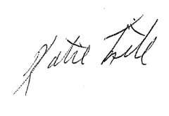

Katie Fite
Public Lands Director
WildLands Defense
PO Box 125
Boise, ID 83701
208-871-5738
katie@wildlandsdefense.org

/mg
Mike Garrity
Alliance for the Wild Rockies
PO Box 505
Helena, MT 59624
406-579-5986
wildrockies@gmail.com

Sincerely,
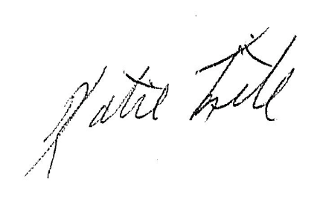

Katie Fite
WildLands Defense
PO Box 125
Boise, ID 83701
208-871-5738

