
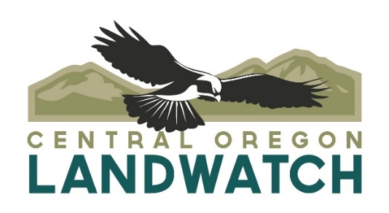

12 April 2024

TO: Ochoco National Forest
VIA: https://cara.fs2c.usda.gov/Public//CommentInput?Project=62771

Subject: Corral Flat Endurance Trails Project draft EA— comments

Please accept the following comments from Oregon Wild, Central Oregon LandWatch, and Great Old Broads for Wilderness Bitterbrush Broadband concerning the Corral Flat Endurance Trails Project draft EA, https://www.fs.usda.gov/project/?project=62771. Oregon Wild represents 20,000 members and supporters who share our mission to protect and restore Oregon’s wildlands, wildlife, and water as an enduring legacy. Our goal is to protect areas that remain intact while striving to restore areas that have been degraded. The mission of the Great Old Broads for Wilderness, including the Bitterbrush Broadband, is to preserve and protect wilderness and wild lands and give voice to the millions of Americans who want to protect their public lands and wilderness for now and future generations. Central Oregon LandWatch (“LandWatch”) is an Oregon non-profit, public interest organization with over 700 members. Its offices are located in Bend, Oregon. LandWatch’s mission is to defend and plan for Central Oregon’s livable future, and it has advocated for the preservation of natural resources in Central Oregon for over 30 years.

This proposal involves designating an extensive network of 51 miles of existing trails and open and closed roads for an equestrian endurance trail system, fence the trailhead area, rehabilitate areas damaged by off-highway vehicles and reinforce road closures to prevent future damage, 53 trail crossings of RHCA areas, with up to 17 sites not associated with existing FS system road, install drainage features, construct appropriate water crossings, including homemade bridges placed on two stream crossings will be replaced with hardened rock crossings. The proposed trail runs through and/or impacts every patch of core habitat over 100 acres within the project area and thus fragments these patches into smaller blocks.

We appreciate that most of this project is on existing impacted areas which should somewhat mitigate effects, but this does represent a commitment by the Forest Service to continue and expand equestrian use across a large area, so the effects must be carefully considered. The draft EA does not yet provide a complete or informative review of potential effects from increased use of this trail system.

The EA buries the fact that this project involves new impacts to core habitat areas. Approximately 60% (or 30 miles) of the proposed trail system falls within areas of existing disturbance (e.g., existing roads and trails) and the remaining 40% (or 20 miles) traverses through blocks of unfragmented core habitat larger than 100 acres. We are concerned about the overall reduction in core habitat of approximately 1,263 acres. Much of the analysis in the EA makes it sound like this project is just approving ongoing activities, but the fresh impacts to core habitat are potentially significant.

The EA says that there are no foreseeable cumulative effects on core habitat. Does that mean none of the ongoing and proposed logging projects listed in Table 3 or Table E-1 have any overlap with the core habitat affected by this project?

Increased use of this trail system is likely to require increased expenditure on trail maintenance. Does the FS have funds for that? What if maintenance is not done? The EA also indicates that avoiding stream sedimentation requires monitoring (“Monitoring trail use would address
erosion caused by wet weather use or other problems identified from the construction to minimize sedimentation downstream”). Is monitoring funded? What if it’s not done?

If this trail designation is expected to reduce recreation conflicts around Lookout Mountain, that would seem to confirm that increased equestrian use can be expected here. And, does that also mean increased mountain bike use can be expected around Lookout? What are the effects of that? It should be part of the NEPA analysis.

We are doubtful that the FS will be willing to restrain future equestrian use here, so the effects analysis must consider long-term effects more than 5 years out.

The EA does not evaluate a reasonable range of alternatives. NEPA requires the agency’s environmental analysis documents to “[r]igorously explore and objectively evaluate all reasonable alternatives” to the Project. For example, the EA does not consider alternatives that might mitigate effects on soil, water, weeds, fish & wildlife, connectivity, potential recreation conflicts, etc.

The EA says the trail system was refined between the scoping and the EA. When there are no alternatives considered in the EA, it kind of sounds like the decision was made during the scoping process. This is not how NEPA is supposed to work. What refinements were made? Which were rejected? Why? This is supposed to be a transparent process, not a negotiated pre-decisional agreement with the equestrian community.

The EA says implementation would involve “Install[ing] drainage features, construct[ing] appropriate water crossings” and at least 17 stream crossings that are not associated with existing roads. But the EA does not say where these crossings occur, nor what the potentially affected stream resources are involved, such as stream size/category, fish presence, stream gradient, floodplain character, etc. The final EA should provide more detail on the trail/stream crossings, especially any particular crossings that may raise concern related to erosion, fish, and water quality. The FS can’t just generalize and PDCs magically fix all problems. The EA says “There is the potential for the creation and operation of trails to increase the amount of sediment that reaches the stream network.” Where is this risk highest? What streams are impacted? What mitigating alternatives are available?

Significant stretches of the trail system are adjacent and parallel to streams. This raises concerns about erosion and water quality, that need to be more thoroughly addressed in the final EA.

The Inland Native Fish Strategy (“INFISH”) “defines RHCAs as portions of watersheds where riparian-dependent resources receive primary emphasis and management activities are subject to specific standards and guidelines. Riparian Management Objectives (“RMOs”), which are to be considered at a landscape scale, contribute to optimum habitat for fish and serve as indicators of watershed health. The FS must analyze and document how the project will impact RMOs within RHCAs and whether actions will retard progress towards meeting RMOs where they are currently not being met, and/or cause an area to no longer meet RMOs where they are currently being met.

The EA needs to consider effects on soil, water, weeds, wildlife from horses riding parallel to the existing road tread, instead of on the road tread. The EA needs to account for the fact that some road surfaces are not favored by equestrians, and they may be tempted to ride on roadsides that are not designed to accommodate that use, with unintended adverse effects.

The analysis of effects to big game relies on the HEI methodology, and concludes “HEI values would not change with the Corral Flat Trails project.” We are concerned that this analysis may not account for the effects of increased use of closed roads as equestrian trails. We cannot find documentation in the record to answer this question.

To protect elk calving, the EA relies on a seasonal restriction on trail maintenance within 0.25 miles of identified calving sites from May 15-June 30. We are concerned that the EA fails to account for the effects of increased trail use during elk calving seasons. The EA also fails to disclose the likelihood and effects when elk caving sites are not identified and protected.

To protect elk during the rut, there are seasonal restrictions near some elk wallows, but only for trail maintenance, not trail use, and the concern remains that elk wallows may not be properly identified and therefore not protected. The effects analysis does not address these risks.

The EA is confusing as to when seasonal restrictions are triggered because the Resource Protection Measures say “Seasonal restrictions may be waived, with approval of District Ranger, in a particular year if surveys determine calving elk are not present.” If seasonal restrictions are triggered by the affirmative presence of active wallows, why do the need to be waived by the affirmative absence of active wallows?

As mentioned above, the FS does not appear to have collected important data to establish an accurate baseline on current conditions for special elk habitat. In other words, the EA fails to provide specific information about the current locations and distributions of elk calving, wallowing, and rutting sites within the project area. Without this information the analysis is based on an inadequate baseline; the lack of information paired with inadequate protections measures for special elk habitat makes it impossible to show the project’s compliance with forest plan standards and guidelines for elk.

Under the Ochoco Foret Plan, the FS is obligated to manage habitat for mule deer to meet ODFW’s population management objectives to the extent practicable. The scale of this project seems to be in opposition to this commitment.
The EA predicts limited effects on big game, in part because there is little expected seasonal overlap between equestrian use and big game winter use. Is this finding still valid under a changing climate regime? Equestrian riding season might extend and overlap with big game use. Big game use might shift due to the changing patterns of snow and phenology.

The EA describes seasonal restrictions for raptor nests but does not specify whether it applies to trail maintenance, trail use, or both, nor does the EA disclose the consequences if trail use is excluded from the seasonal restriction.

The EA says no snags will be affected by the project. This seems unlikely. The removal of danger trees and snags along the road/trail system is increasingly likely with increased human use of the trail system. This will impact habitat for many species associated with snags and dead wood. This is not addressed in the EA.

The Forest Service should take into consideration the public concerns raised in the Ochoco Summit OHV Trails Project and the relevant results of subsequent litigation.

The transportation analysis says that there are no cumulative effects, but there are numerous planned logging projects that will involve log hauling and setting up landings on or near roads. This could cause user conflicts or trail closures. Is it true that none of these activities overlap with the equestrian trails? This seems unlikely.

The EA says that roads have been evaluated for mixed use, and a number of the roads have been designed as highway legal only, such as 2610 and 2630 Road, and that the potential conflicts can be resolved with signage. We are concerned that these conflicts might be more significant, and more detailed analysis is required, along with consideration of mitigating alternatives.

The planning and analysis for this project should be informed by this report about harmonizing recreation uses. Miller, A.B.; King, D.; Rowland, M.; Chapman, J.; Tomosy, M.; Liang, C.; Abelson, E.S.; Truex, R. 2020. Sustaining wildlife with recreation on public lands: a synthesis of research findings, management practices, and research needs. Gen. Tech. Rep. PNW-GTR-993. Portland, OR: U.S. Department of Agriculture, Forest Service, Pacific Northwest Research Station. 226 p. https://www.fs.usda.gov/pnw/pubs/pnw_gtr993.pdf.

The EA lists several projects that may contribute to cumulative effects, but the EA does not disclose those cumulative effects, or where and how they might manifest. The analysis of cumulative effects on wildlife habitat (on EA page 23) is confusing and fails to take a hard look.

There appear to be a lot of invasive species overlapping the northwest portion of the trail system. Increased equestrian use risks spreading those to the relatively uninfected south and east portions of the trail system. The NEPA analysis needs to consider effects and mitigating alternatives.

Did the Forest Service consider the possibility that some equestrian users might return to this familiar area in winter with snow machines and bring unexpected off-season impacts to the area?

There is a lot of site-specific information in the Appendices that need to be put in the body of the EA, such as information about effects to core habitat, invasive species, road use conflicts, etc. Important parts of the NEPA analysis cannot be buried in specialists reports and appendices:
“The EA's cursory and inconsistent treatment of sedimentation issues, alone, raises substantial questions about the project's effects on the environment and the unknown risks to the area's renowned fish populations. We do not find adequate support for the Forest Service's decision in its argument that the 3,000 page administrative record contains supporting data. The EA contains virtually no references to any material in support of or in opposition to its conclusions. That is where the Forest Service's defense of its position must be found. See 40 C.F.R. § 1508.9(a) (an environmental assessment is "a concise public document" that "briefly provide[s] sufficient evidence and analysis for determining whether to prepare an environmental impact statement or a finding of no significant impact").”
Blue Mountains Biodiversity Project v. Blackwood, 161 F.3d 1208 (9th Cir. 1998), https://caselaw.findlaw.com/us-9th-circuit/1180061.html.

Connectivity
Agencies have a duty to consider connectivity in their NEPA analyses. In 2023 CEQ issued guidance saying “… agencies should consider and be transparent about the positive or negative impacts of proposed actions and alternatives on connectivity and corridors. Through the NEPA review process, Federal agencies can consider measures to advance corridors and connectivity as components of proposed actions, alternatives to proposed actions, or mitigation for proposed actions’ effects.” The CEQ Guidance says:
“Connectivity is the degree to which landscapes, waterscapes, and seascapes allow species to move freely and ecological processes to function unimpeded. Corridors are distinct components of a landscape, waterscape, or seascape that provide connectivity. Corridors have policy relevance because they facilitate movement of species between blocks of intact habitat, notably during seasonal migrations or in response to changing conditions… Increasing connectivity is one of the most frequently recommended climate adaptation strategies for biodiversity management.”

“To the maximum extent practicable, Federal agencies are expected to advance the objectives of this guidance by developing policies, through regulations, guidance, or other means, to consider how to conserve, enhance, protect, and restore corridors and connectivity during planning and decision-making, and to encourage collaborative processes across management and ownership boundaries. Any existing corridor and connectivity policies or related policies should be updated as needed to align with the objectives in this guidance. Federal agencies should have new or updated policies ready to implement by the first quarter of 2024 and make their policies publicly available. Federal agencies should also actively identify and prioritize actions that advance the objectives set forth in this guidance.”

“Federal agencies should not limit engagement in restoration activities only to circumstances when restoration serves as a mitigation strategy to compensate for adverse impacts from projects or actions. Instead, Federal agencies should consider where there are opportunities in their programs and policies to carry out restoration with the objective of promoting greater connectivity.”
Mallory, B. 2023. CEQ Guidance for Federal Departments and Agencies on Ecological Connectivity and Wildlife Corridors. https://www.whitehouse.gov/wp-content/uploads/2023/03/230318-Corridors-connectivity-guidance-memo-final-draft-formatted.pdf.

The agency’s analysis of connectivity should consider the State of Oregon’s Priority Wildlife Connectivity Areas (PWCAs) developed by ODFW’s Oregon Connectivity Assessment and Mapping Project (OCAMP) described here: https://oregonconservationstrategy.org/success-story/priority-wildlife-connectivity-areas-pwcas/; and displayed here: https://experience.arcgis.com/experience/6979b6598f904951bd0af1821e1595f1/ (Note: the habitat thresholds in OCAMP are set to minimize the extent of connectivity areas. These thresholds should be adjusted, especially on federal lands, to recognize wildlife’s broader use of the landscape for movement and connectivity.)
/ / /

/ / /

/ / /
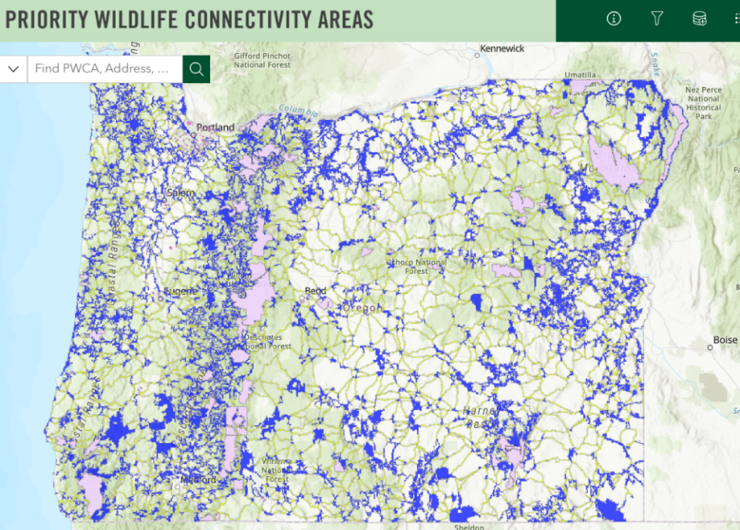

Each substantive issue discussed in these comments should be (i) incorporated into the purpose and need for the project, (ii) used to develop NEPA alternatives that balance tradeoffs in different ways, (iii) carefully analyzed and documented as part of the effects analysis, and (iv) considered for mitigation.

Please post to the project website, links to all relevant ESA and EFH consultation documents, RMPs, watershed analyses, and other supporting documents relied on in the NEPA analysis.

Please post to the project website, georeferenced maps of the proposed activity units that can be used to navigate in the field using apps such as Avenza.

Note: If any of these web links in this document are dead, they may be resurrected using the Wayback Machine at Archive.org. http://wayback.archive.org/web/

Sincerely,
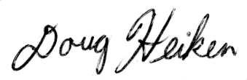
Doug Heiken (he/him)
dh@oregonwild.org

/Amy M. Stuart/Electronic signature
Amy M. Stuart, Co-leader
Great Old Broads for Wilderness, Bitterbrush Broadband
amystuart63@gmail.com

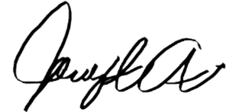
Jeremy Austin
Wild Lands & Water Program Director
Central Oregon LandWatch
2843 NW Lolo Dr St. 200
Bend, OR 97703

40 C.F.R. § 1502.14(a); Please be explicit about which version of the CEQ’s NEPA regulations are being applied. We request that you apply the spirit, if not the letter, of the 1979 version of the regulations, given the legal and regulatory uncertainty surrounding the 2020 version

