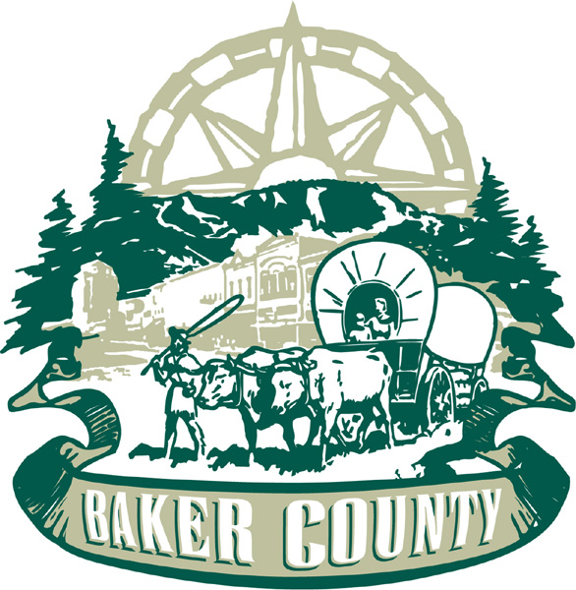

April 6, 2024

US Forest Service
Wallowa-Whitman National Forest
Stephaney Kerley, Acting District Supervisor
1550 Dewey Ave, Ste A
Baker City, OR 97814

Submitted online via: https://cara.fs2c.usda.gov/Public//CommentInput?Project=58480

Dear Ms. Kerley:

Baker County appreciates the opportunity to comment on the Baker City Watershed Fuels Management Project (BCW), Draft Environmental Assessment (DEA). The County has worked closely with the WWNF in coordination until very recently, when we were no longer included by the local WWNF leadership. The County is requesting to be included in discussions with the WWNF Staff as this project moves forward.

The County supports the BCW project with the below recommendations.

The Baker County Board of Commissioners (Commission) is charged with governing the County in the best interests of its citizens, their health, safety, and welfare, its economic base, and the natural environment. The economic sustainability of the County relies on both private and public lands for use of natural resources. The Wallowa-Whitman National Forest (WWNF) comprises approximately 33% of the County’s landmass, therefore, all decisions on land management on the WWNF will directly affect Baker County’s economy, customs, and cultures.

Baker City is the largest of the cities within the County, with a little over 10,000 citizens. The County Court and Courthouse are within the City boundaries, as well as the majority of businesses outside of agriculture. The success of the County relies on the success of Baker City.

Marble Creek Road

Marble Creek Road has provided historic access to the Baker City Watershed, mining claims, homesteads, and has allowed for many generations of citizens and visitors to enjoy the magnificent scenic views from the top of the Elkhorn Mountains. Unfortunately, topography, geology, and insufficient federal funding for road maintenance has created a road that does not promote multiple forest use. Currently, only the very adventurous off-roaders use the road at their own risk. In addition, Marble Creek Road does not provide access to the area for emergency services, will not withstand travel of fuels reduction equipment or allow for multiple forest use.

It is very important that Marble Creek Road be improved as soon as possible for many reasons, including, but not limited to:

- The Baker City Watershed is in desperate need of immediate fuels reduction. The road provides access through the middle of the Watershed, which, with improvement, will create a buffer and allow for the movement of emergency and logging equipment to and from the area.

Should a wildfire move through the watershed, over 10,000 community members and an unknown number of visitors/recreationists will be without drinking water. The cost of a treatment plant has been estimated at over $20M. A cost that neither Baker City nor its citizens can afford.

- Economically, an improved road will provide access to public lands for many diverse recreationalists. Businesses in Baker City rely on recreation and tourism dollars to maintain their economic viability. Gas stations, bike rentals, restaurants, grocery stores, and other locally owned businesses will all reap the rewards of increased usage.

- Local customs and culture are very strong. As a community, we are a people who live on the land and appreciate natural resources and use them wisely. Marble Creek Road can be excellent access onto public lands for big game hunting, fishing in the high-mountain lakes, or just stopping for a picnic and view to gather thoughts and enjoy time with friends and family.

- Marble Creek Road must be brought to state and federal standards expected of all roads that are to be used for hauling, firefighting equipment, emergency vehicles and safe for the general public to travel without fear of road caused accidents.

In 2019, there was an accident in the Marble Creek area, and because of the poor road conditions, it was very difficult to access the individual that had been in distress. It’s only a matter of time before a similar situation occurs.

The Elkhorn Crest Trail #1611 from Marble Creek Trailhead to Forest Road 7220 is a trail that is increasing in popularity, thus increasing the number of visitors and road users each year. It is accessed off Marble Creek Road. The WWNF encourages the use of the Elkhorn Crest Trail and needs to ensure safe travel to the trailhead and emergency extraction for recreationists in need.

Starting at Marble Creek Pass, the trailhead which allows vehicles such as bicycles and dirt bikes to the trail, intersects with other roads and trails such as the FR 5505 to Cracker Saddle before heading into Wilderness as it winds down to FR 7220. Marble Creek Pass and the 5505 road must be accessible to emergency vehicles due to the frequency of recreation users, mining, and grazing permittees and visitors to the Elkhorn Crest Trail.

Marble Creek Pass is one of the very few roads that allows for travel from Baker Valley to Sumpter Valley. The road on each side of the pass is difficult and requires high clearance vehicles to traverse the road. A Baker City water supply pipeline runs under the road at one point and access to the pipeline as well as the water source is mandatory for Baker City as well as the County.

Every year, the Elkhorn 50-mile race happens from Bourne to Cracker Saddle, Marble Creek Pass, and ending in Sumpter after multiple aid station loops along the trail. The participants in this event come from all over the nation to run the 50-miles. This is a large economic boost for Sumpter and Baker County. The last aid station is on Marble Creek Pass at the trailhead where access must be available for HAM Radio operators, the aid station, and emergency vehicles.

Marble Creek Road is a historic treasure and offers priceless views of both Baker and Sumpter Valleys, highlighted by a glimpse into the lime quarry mining on the Pass and an overhead view of the Sumpter Valley Dredge Tailings above Phillips Reservoir.

Defensible Fuel Profile Zone (DFPZ)
The County would like the DFPZ to be expanded from 300’ or less to 1-mile on each side of the roads. Most spot fires happen less than 1/2 mile away from the parent fire, but it is still common for them to spot up to 2 miles away. Anything beyond 2 miles is very rare but has occurred recently during fires in California and Australia. Embers/Firebrands have been witnessed to ignite forests and homes up to 24-miles away. The establishment of a 600’ fuel break within the BCW is irresponsible knowing the economic and environmental losses that a wildfire will cause.

Eastside Screens
Baker County encourages the WWNF to remove as many of the trees 21” dbh or greater in an effort to reduce insect and invasive species spread, such as mistletoe. Leaving mistletoe infected trees for “biodiversity” reasons is not good forest management and is a part of the lack of management that has gotten the WWNF into the fire-hazard state it is in.

Roads
The County has a “no loss of roads” policy as indicated in the 2016 Baker County Natural Resources Plan. The County encourages the WWNF to leave temporary roads created for the project that are not in the IRAs, open to the public for firewood gathering for a period up to (10) years. In addition, the County’s Natural Resources Plan requires the federal government to discuss any road closures prior to them being closed or decommissioned.

Thusly, no existing road closures should occur after harvest and all dispersed campsites must remain open and mining and grazing permits be kept in place.

Project Timeline
Baker County wants to see groundwork and securing of harvest contracts in 2024. Because of the small window of opportunity for prescribed burns, and the potential for uncontrolled fire, fire line construction before burns to reduce potential catastrophic “got away” fires must be adhered to. The County encourages the WWNF to advertise on the radio, online, and in the newspapers when prescribed burns are going to occur so the public doesn’t panic when they see smoke coming out of the BCW.

The County understands that the preparation of the DEA was daunting. However, the inclusion of “The habitat types…” on pages 21 and 22 from a completely different area shows poor proof-reading and lends to the thoughts of how many more non-project numbers or tasks were included.

The Baker City Watershed Project is very important. The County does not want to create roadblocks to its implementation. It is also equally important though to conduct the project in a way that makes it successful in its goal to protect the watershed and increase forest resiliency.

Please, include Baker County in future discussions as the project moves forward under the Coordination statute.

Thank you,
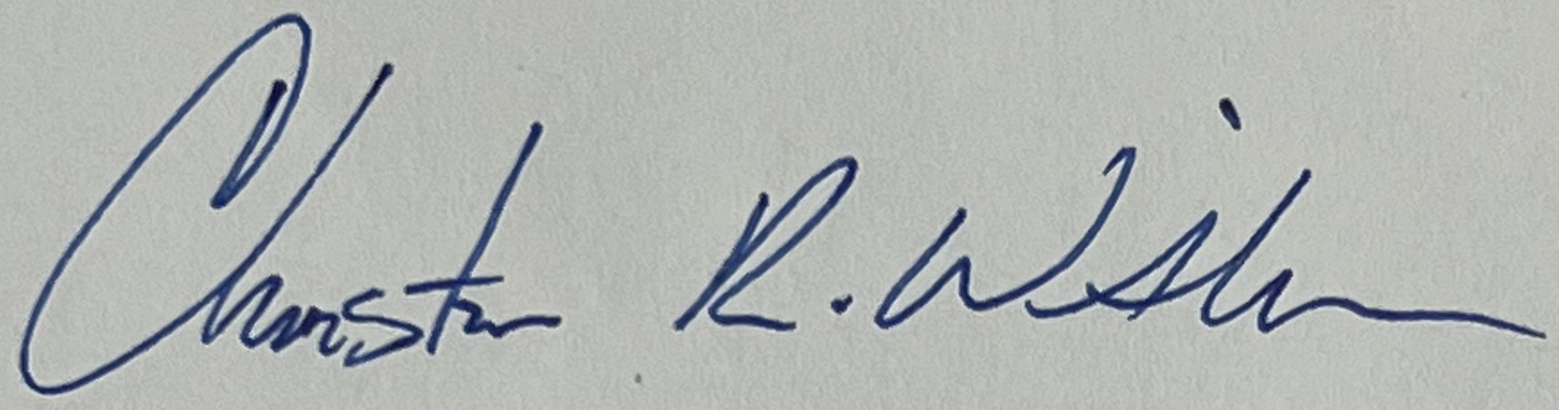
Commissioner Christina Witham
Baker County Commission

Thank you,
Doni
Natural Resources/Parks Coordinator

