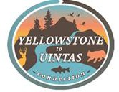
January 25, 2023

Jim Zelenak Adam Zerrenner Ben Conrad
US Fish and Wildlife Service
Ecological Services, Montana Field Office 585 Shephard Way, Suite 1
Helena, MT 59601.

Re: Canada lynx Species Status Assessment – Comment Submittal

Sent VIA Email to: jim_zelenak@fws.gov; Adam_zerrenner@fws.gov and Ben_conard@fws.gov

Dear Jim, Adam, and Ben:

Yellowstone to Uintas Connection is providing these comments as input to your current species status assessment for Canada lynx. Yellowstone to Uintas Connection is a 501c3 non-profit entity working to restore fish and wildlife habitat including the Regionally Significant Wildlife Corridor connecting the Greater Yellowstone Ecosystem to the Uinta Mountains and Colorado through the application of science, education, and advocacy. We named our organization and the Corridor from the Greater Yellowstone Area that passes through SE Idaho and SW Wyoming into NE Utah, the Yellowstone to Uintas Connection (Y2UConn) in order to bring attention to it across the West.
Y2U has been working to correct habitat fragmentation and degradation in the Y2UConn. Over the decades, we have documented the destruction and degradation of the natural character, water quality, and wildlife habitat integrity of the National Forests and BLM managed lands in this region, including the Y2UConn. Human developments including energy development, mining, livestock grazing, motorized recreation, and logging on public and private land have contributed to an apparent loss of function in this connection for Canada lynx. Our focus has been on restoring this corridor to function as a linkage for Canada lynx and wolverine. We review the literature, analyze and comment on agency actions such as phosphate mining and timber projects which fragment the habitat. Motorized recreation is a massive presence and largely unregulated and uncontrolled.
In recent years, we have been addressing the phosphate mining industry in SE Idaho on lands managed by the Caribou National Forest (CNF) and identified by the CNF as linkage habitat.¹ The phosphate mines typically dig up and destroy thousands of acres for each mine plus ancillary haul roads, powerlines, pipelines, and rail lines. To date, over 20,000 acres of forested habitats that are important to many wildlife species have been lost. Wildlife and habitat studies are minimal with no population data or trend analysis for viability assessments. Monitoring of project impacts on wildlife are scarce to non-existent. The typical outcome for lynx analysis is

¹ Caribou National Forest. 2003. Revised Forest Plan and FEIS. https://www.fs.usda.gov/detail/ctnf/landmanagement/planning/?cid=stelprdb5228906 Accessed January 21, 2023.

for the project proponents to acknowledge they may occasionally travel through the project or analysis area but will move around the periphery of the disturbance by way of other available habitat. While the project proponents, including the agencies, also acknowledge this area is part of the linkage area designated by the CNF and FWS, the habitat integrity of that area lynx are supposed to be able to access is never analyzed in terms of functionality for lynx. The CNF RFP linkage criteria lack any force or definition related to lynx habitat components, connectivity, or snowshoe hare needs.
What is lacking are adequate regulatory and land use planning criteria that require agencies such as the Forest Service and BLM to fully analyze and correct habitat fragmentation. In the following comments, we provide a summation of this Y2UConn as linkage habitat and an analysis of the failure of data interpretation, regulation and planning criteria to provide habitat and connectivity for lynx.
After years of providing input and analysis, the CNF remains unable or unwilling to fully analyze and implement habitat protection criteria for this linkage area, while consultations with
U.S. Fish and Wildlife Service (FWS) are lacking in detail with FWS approving project after project without requiring any systematic and detailed analysis of lynx habitat functionality or connectivity. The 2017 FWS Species Status Assessment (SSA) continues to deflect to Forest Planning as protective of lynx and its habitat without providing any evidence this is the case.² While we expect the FWS is familiar with the principal documents relating to protection of lynx habitat, in the following, we briefly outline and comment on these as it is a good reminder of the state of knowledge and absence of effective regulation pertaining to lynx and its protection.
Dr. John Carter, Ecologist, and founder of the Yellowstone to Uintas Connection and Kiesha’s Preserve, a wildlife preserve in the Y2UConn in SE Idaho, prepared these comments for input to the current Canada Lynx Species Status Assessment. Dr. Kirk Robinson, founder of the Western Wildlife Conservancy, has worked on this Regional Corridor and carnivore ecology for many years and assisted with input on the logic of lynx occupancy in Colorado and Utah.³ The comments were reviewed by Dr. Barrie Gilbert, (retired) Utah State University.⁴
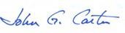
Respectfully,
John Carter, PhD Ecology Yellowstone to Uintas Connection Kiesha’s Preserve
PO Box 363
Paris, Idaho 83261

² U.S. Fish and Wildlife Service. 2017. Species Status Assessment for the Canada lynx (Lynx canadensis) Contiguous United States Distinct Population Segment. Version 1.0, October, 2017. Lakewood, Colorado.
³ Kirk Robinson, J.D., PhD Philosophy. Founder and current Executive Director of Western Wildlife Conservancy. https://westernwildlifeconservancy.org/mission-vision/ Accessed on January 24, 2023.
⁴ Barrie K. Gilbert PhD, Department of Wildland Resources, (senior scientist retired), Utah State University, Logan Utah. Dr. Gilbert is a behavioral ecologist and recent author of One of Us: A Biologist’s Walk Among Bears.

ABSTRACT

These comments provide a brief review of the regulatory history and science involved in the ESA listing for Canada lynx and subsequent land management on National Forests. The review reveals that much of the science is misinterpreted to favor human activities that degrade and fragment lynx habitat, while absence of evidence due to lack of studies is used to claim these activities either have little effect or in the case of timber manipulations, can even be beneficial. A review of the NRLMD and its application in linkage and peripheral areas as incorporated into Forest planning uses the Caribou NF as an example. The NRLMD provides limited guidance and protection to the Caribou NF as it is deemed “unoccupied” by lynx. This is in spite of evidence that lynx persisted in the area of the CNF over historical times. This “unoccupied” status results from failing to find current evidence of lynx long after habitats have been fragmented by mines, high road density, an explosion in motorized recreation accessing nearly every acre of land, timber projects and including habitat alteration by livestock grazing. The CNF Forest Plan includes recognition of lynx linkage, but the provisions in that plan for linkage habitat lack adequate quantification and standards.

Noting that there is a lack of emphasis on landscape connections between core areas of the DPS, analysis and mapping is provided showing the existence of long recognized regional wildlife corridors. A principal corridor is the Yellowstone to Uintas Connection linking the GYA to the Uinta Mountains and Colorado by passing through SE Idaho from lynx critical habitat in Wyoming. This is the most continuous high elevation, forested corridor making these connections. It also aligns with the CNF linkage to other areas. Protection and restoration of this and other corridors is essential to promote lynx connectivity and sustain meta- populations.

This review shows that regulatory mechanisms are inadequate to protect lynx habitat and connectivity. Monitoring of snowshoe hare habitat and populations as well as lynx presence in these southern areas of the DPS is lacking. While some habitat mapping and modeling has been done, it is not being applied or expanded to identify and describe in sufficient detail the habitats and migration corridors needed for lynx to persist. Land management plans must be updated and amended to provide data-based criteria and quantitative standards to ensure habitat for lynx and snowshoe hare are connected and functional.

REGULATORY ISSUES

The Programmatic Lynx BA. Canada lynx were listed as a Threatened species under the Endangered Species Act (ESA). In December 1999, the Forest Service and Bureau of Land Management completed their “Biological Assessment of The Effects of National Forest Land and Resource Management Plans and Bureau of Land Management Land Use Plans on Canada

Lynx” (Programmatic Lynx BA).⁵ The Programmatic Lynx BA concluded that the current programmatic land management plans “may affect, and are likely to adversely affect, the subject population of Canada lynx.” The Lynx BA team recommended amending or revising Forest Plans to incorporate conservation measures that would reduce or eliminate the identified adverse effects on lynx. The Programmatic Lynx BA’s determination means that Forest Plan implementation is a “taking” of lynx and makes Section 7 formal consultation on the land management plans (LMPs) mandatory, before actions are approved. The Lynx BA “likely to adversely affect” conclusion was based on the rationale that land use plans within the Northern Rockies have inadequacies, including:

- Aggressive fire suppression may limit the availability of foraging habitat.
- Allow levels of human access via forest roads that may risk incidental trapping, shooting, or access by competing carnivores.
- Weak in guidance for new or existing recreation developments.
- Allow mechanized and non-mechanized recreation that may pose a risk, by allowing compacted snow trails and plowed roads that facilitate competitors and predators.
- Weak direction for maintaining habitat connectivity.
- Weak in direction for coordinating management activities with adjacent ownerships to assure consistent management of lynx habitat across the landscape.
- Fail to provide monitoring of lynx, snowshoe hares, and their habitats, making the detection and assessment of adverse effects from other management activities difficult or impossible to attain.
- Forest management has resulted in a reduction of the area in which natural ecological processes were historically allowed to operate, thereby increasing the area potentially affected by known risk factors to lynx. The Plans have continued this trend. The Plans have also continued the process of fragmenting habitat and reducing its quality and quantity. Consequently, plans may risk adversely affecting lynx by potentially contributing to a reduction in the geographic range of the species.
- Plan revisions are needed to incorporate conservation measures included in the Canada Lynx Conservation Assessment and Strategy.6
The LCAS “was developed to provide a consistent and effective approach to conserve Canada lynx on federal lands in the conterminous United States. The USDA Forest Service, USDI Bureau of Land Management, and USDI Fish and Wildlife Service initiated the Lynx Conservation Strategy Action Plan in spring of 1998.” The LCAS was published shortly after the Canada lynx was listed as Threatened under the ESA. Risk Factors from the LCAS (2000) include:

⁵USDA Forest Service and DOI Bureau of Land Management.1999. Biological Assessment of the Effects of National Forest Land and Resource Management Plans and Bureau of Land Management Land Use Plans on Canada lynx.
⁶Ruediger et al. 2000. Canada Lynx Conservation Assessment and Strategy. USDA Forest Service, USDI Fish and Wildlife Service, USDI Bureau of Land Management, and USDI National Park Service. Forest Service Publication #R1-00-53, Missoula, MT. 142 pp.

- Timber harvest and pre-commercial thinning that reduce denning or foraging habitat or convert habitat to less desirable tree species.
- Fire exclusion changing the vegetation mosaic maintained by natural disturbance processes.
- Grazing by livestock that reduces forage for prey.
- Roads and winter recreation trails that facilitate access to historical lynx habitat by competitors.
- Incidental trapping and shooting.
- Predation.
- Being hit by vehicles.
- Obstructions to movement such as highways and private land developments.

All of these factors continue to operate within the National Forests and BLM lands within and surrounding the Y2UConn. They are not effectively addressed while degradation and fragmentation of habitat continues. Monitoring of these activities is minimal to non-existent.

Northern Rockies Lynx Management Direction. We reviewed the Northern Rockies Lynx Management Direction (NRLMD).⁷ This direction “applies to mapped lynx habitat on National Forest System land presently occupied by lynx, as defined by the Amended Lynx Conservation Agreement (CA)⁸ between the Forest Service and FWS…When National Forests are designing management actions in unoccupied mapped lynx habitat they should consider the lynx direction, especially the direction regarding linkage habitat.” (NRMLD p1). [Emphasis added]. The FEIS for the NRLMD provided a map for the Northern Rockies Lynx Planning Area which is inserted as Figure 1. The CA provided this, “As recommended in the LCAS, appropriate actions, including research, administrative studies, or monitoring, will be taken to verify the effectiveness of the lynx conservation measures.” (CA p7). We have seen none of these monitoring or other studies that have addressed effectiveness of lynx conservation measures, while monitoring of lynx and snowshoe hare occurrence and populations in the DPS is lacking.

In the NRMLD (p3) there is reference to a FWS “Clarification of Findings” in a Remand Notice which basically explains away most forest activities as impacting lynx or lynx habitat, i.e. a “threat” to lynx. The NRMLD puts it this way:

After the LCAS was issued the FWS published a Clarification of Findings in the Federal Register (FEIS, Vol. 1, Appendix P), commonly referred to as the Remand Notice. In the Remand Notice the FWS states, “We found no evidence that some activities, such as forest roads, pose a threat to lynx. Some of the activities suggested, such as mining and grazing, were not specifically addressed [in the Remand Notice] because we have no information to indicate they pose threats to lynx” (p. 40083).

Further on in the Remand Notice they state, “Because no evidence has been provided that packed snowtrails facilitate competition to a level that negatively

⁷ USDA Forest Service. 2007. National Forests in Montana, and parts of Idaho, Wyoming, and Utah. Northern Rockies Lynx Management Direction Record of Decision.
⁸ USDA Forest Service and USDOI Fish and Wildlife Service. 2006. Canada Lynx Conservation Agreement. USFS Agreement #OO-MU-11015600-0 13.

affects lynx, we do not consider packed snowtrails to be a threat to lynx at this time” (p. 40098).

In regards to timber harvest the FWS states, “Timber harvesting can be beneficial, benign, or detrimental to lynx depending on harvest methods, spatial and temporal specifications, and the inherent vegetation potential of the site.
Forest practices in lynx habitat that result in or retain a dense understory provide good snowshoe hare habitat that in turn provides good foraging habitat for lynx” (p. 40083).

These findings by FWS narrow the focus from the concerns first published in the LCAS (discussed above) about what management direction is needed to maintain or improve Canada lynx habitat. We considered this information in the development of the selected alternative, and in our decision.

So, in one fell swoop, FWS and then the USFS thru the NRMLD adopted guidance that removes the majority of Forest Service actions or permitted activities from consideration as impacting lynx. We are to believe that lack of evidence is proof these activities have no impact on lynx or their habitat. Yet, the scientists who published the Science Report⁹ which was used as the basis for the NRLMD had determined these activities adversely affect lynx and lynx habitat.

What we have observed is a gradual easing of requirements and population status of lynx over the years. Absence of lynx in SE Idaho is a foregone conclusion if you manage them out of existence by denying their presence thru history then deny impacts from logging, snowmobiles across the landscape, off road vehicles speeding thru forest roads, and that “mining and grazing, because they were not specifically addressed … because we have no information to indicate they pose threats to lynx.” In this way, the agencies have relieved themselves of most responsibility to maintain or restore lynx, its habitat, and connectivity. We have reviewed the Science Report and find that the information in that report does not say roads, snowmobiles, timber harvest, mines and grazing do not impact lynx or lynx habitat. We discuss these as part of the narrative below.

Further in the NRLMD there are clarifying statements such as that standards and guidelines only apply to occupied habitat, while they can be considered for unoccupied habitats. (NRLMD p6). Regarding vegetation management direction, it “conserves the most important component of lynx habitat: a mosaic of early, mature, and late successional stage forests, with high levels of horizontal cover and structure.” (NRLMD p21). The objectives, standards and guidelines do not “apply to linkage areas”. (NRLMD Att 1 p2). Livestock grazing “may reduce or eliminate foraging habitat in areas that grow quaking aspen and willow in riparian areas….These localized changes in habitat may affect individual lynx; however, no information indicates grazing poses a threat to overall lynx populations…” (NRLMD p21). Livestock management

⁹ Ruggiero, Leonard F.; Aubry, Keith B.; Buskirk, Steven W.; Koehler, Gary M.; Krebs, Charles J.;McKelvey, Kevin S.; Squires, John R. 2000.. Ecology and conservation of lynx in the United States. General Technical Report RMRS-GTR-30WWW. Fort Collins, CO: U.S. Department of Agriculture, Forest Service, Rocky Mountain Research Station. https://www.fs.usda.gov/research/treesearch/50623 Accessed on January 21, 2023.

objectives and guidelines do not apply to linkage areas. ( NRLMD Att 1 p5). Over snow recreation “Emphasizes not expanding snow compacting human uses into non-compacted areas.” Guideline G11 “discourages the expansion of designated over-the-snow routes and play areas into uncompacted areas.” “An alternative to drop all direction limiting snow compaction was not developed in detail because there is evidence competing predators use packed trails, suggesting a potential effect on individual lynx.” (NRLMD p23). Mineral and Energy Standard does not apply to linkage habitat. (NRMLD Att1 p5).

As these statements make clear, lynx habitat, including linkage areas have virtually no protections, standards, or guidelines under the NRLMD. While it does acknowledge that there is evidence of lynx competitors using packed snow trails it does not address landscape level snow machine access, the increase in motorized recreation with fast, high-powered machines, and landscape-level use such as occurs in 97% of the CNF since the Science Report data and information was assembled. A recent paper by Olson et al (2018)¹⁰ acknowledges that lynx avoid areas of ski resort development and they altered their behavior to spend less time in areas of motorized recreation or used them at night when there was less use. The Forest Service Rocky Mountain Research Station has said, “Lynx appear to have an upper threshold of recreation intensity which they can tolerate, and above this level, lynx may be less able to coexist. Managers, then, should keep in mind that developed or dispersed areas with very high use may displace lynx from habitat.”¹¹ We note that the phosphate mines in SE Idaho operate 24 hours per day, 7 days per week for up to 30 years at an individual mine with some 400 blasts of explosives each week at each mine.¹² Haul roads further fragment the habitat, operating continuously.

Since these studies used in the Science Report, three decades have passed with ever increasing snowmobile and off-road vehicle use. A report by Winter Wildlands Alliance for USDA noted that snowmobile use more than doubled between the early 1980s and 2004.¹³ Cross-country skiing and snowshoeing experienced a similar increase. In the 1990s more powerful snow machines made access available to “dominate terrain only accessible by backcountry skis or snowshoes.” High-marking and acrobatics are common in areas previously inaccessible.
Highmarking is the “recreational maneuver of attempting to reach the highest point of a snow- covered feature such as a mountain, on a snowmobile.”¹⁴ Groomed trails now are over 20,000 miles in the 11 Western Snow Belt States. Today, there are 1.3 million registered snowmobiles in the US and 601,000 in Canada.¹⁵ As acknowledged above, this increased access allows

¹⁰ Olson, L.E.; Squires, J.R.; Roberts, E.K.; Ivan, J.S.; Hebblewhite, M. 2018. Sharing the same slope: Behavioral responses of Canada lynx to winter recreation. Ecology and Evolution. 1-18.
¹¹ USDA RMRS. 2023. Winter Sports and wildlife: Can Canada lynx and winter recreation share the same slope? https://www.fs.usda.gov/rmrs/winter-sports-and-wildlife-can-canada-lynx-and-winter-recreation-share-same-slope Accessed on January 16, 2023.
¹² USDA and DOI. 2019. Final Environmental Impact Statement Proposed Dairy Syncline Mine and Reclamation Plan. https://app.box.com/s/jmod5pcq1txhv4wmply3oxuazlm16tau Accessed on January 16, 2023.
¹³ Winter Wildlands Alliance. 2006. Winter Recreation on Western National Forest Lands. https://www.fs.usda.gov/Internet/FSE_DOCUMENTS/fseprd528883.pdf Accessed on January 16, 2023
¹⁴https://en.wikipedia.org/wiki/Highmarking
¹⁵ ISMA. 2022. Snowmobiling Fact Book. https://www.snowmobile.org/docs/isma-snowmobiling-fact-book.pdf Accessed on January 17, 2023.

trapping and hound hunting to occur across the landscape. In Idaho there were 1,830 trapping licenses issued for the 2017 - 2018 season¹⁶, up from 638 in the 1995-1996 season.¹⁷

We looked up some brief history of ATV and UTVs. These come from industry websites. The first four wheeled atv was produced in 1982 by Suzuki.¹⁸ This quickly turned to an emphasis on speed in 1987 with a model that could attain almost 80 mph. “Naturally, as high-performance ATVs gained popularity, Quad Racing and ATV Motocross enjoyed massive growth and exposure in the late 1980s.” The first UTV, the Kawasaki Mule was introduced in the late 1980s.¹⁹ A racing emphasis came about with the introduction of the Polaris RZR in 2007.
Today, sales of these vehicles are around 800,000 annually with about half in the US. This is an estimate, since in many states they are not registered.²⁰

The point of this is that there are millions of snowmobiles, atvs, utvs, and dirt bikes in the US today. Add to this the pickup truck and SUV market with their TV commercials emphasizing the backcountry and off-roading. These were present only minimally during the time of most of the studies in the Science Report. The implication of this is that conclusions about forest roads and snowtrails are out the window today since these are loud, fast, and powerful machines capable of accessing most terrain and are present in large numbers. For instance, in 2017, we funded a research project at Kiesha’s Preserve to evaluate traffic on a CNF Forest access road in SE Idaho. Over 300 vehicles per day were using the road with many traveling at high rates of speed.²¹ Sound levels were over 100 DbC. In winter, snowmobiles were creating noise levels of over 100 DbC. These roads today are not quiet, low frequency roads, but as we like to say, they have become an analog to a motocross where there is no enforcement of speed, noise or even checking registrations. How are lynx to occupy an area with this level of disturbance?

The Conservation Agreement (CA). addresses its scientific basis as:

In March of 1998, an interagency lynx coordination effort was initiated in response to the emerging awareness of the uncertain status of lynx populations and habitat in the conterminous United States and the onset of the listing process. The U.S. Fish and Wildlife Service (FWS), USDA Forest Service (FS), Bureau of Land Management (BLM), and the National Park Service (NPS) have participated in this effort. Three products important to the conservation of lynx on federally managed lands have been produced through this effort: (1) "The

¹⁶ IDFG. 2018. Idaho Department of Fish and Game Furbearer. https://collaboration.idfg.idaho.gov/WildlifeTechnicalReports/Furbearer%20Statewide%20FY2018.pdf Accessed on January 16, 2023.
¹⁷ Melquist, W.E. 1997. Idaho Department of Fish and Game Furbearers Study III, Job 1. https://collaboration.idfg.idaho.gov/WildlifeTechnicalReports/Furbearer%20PR94.pdf Accessed on January 16, 2023.
¹⁸ https://www.hqpowersports.com/blog/history-of-the-modern-atv-and-utv/ Accessed on January 17, 2023.
¹⁹ https://shocktherapyst.com/blog/a-brief-history-of-utvs/ Accessed on January 17, 2023.
20 https://www.motorcyclesdata.com/2022/12/27/all-terrain-vehicles/ Accessed on January 17,2023.
²¹ Unpublished data. 2017. Utah State University in Association with Kiesha’s Preserve.

Scientific Basis for Lynx Conservation" (Ruggiero et. al. 2000)²², hereafter referred to as the "Science Report"; the Lynx Conservation Assessment and Strategy (LCAS); and this Lynx Conservation Agreement (CA). Several States within the range of the lynx have contributed to this effort through interactions with participants and review of draft products.

The Science Report, prepared by an international team of experts in lynx biology and ecology, is a compendium and interpretation of current scientific knowledge about the Canada lynx, its primary prey and habitat relationships. This document serves as an important scientific reference for the various lynx activities of the cooperating Federal Agencies.

The LCAS builds upon this scientific base and identifies the risks to the species that may occur as a result of federal land management. It recommends conservation measures that could be taken to remove or minimize the identified risks. It was developed to provide a consistent and effective approach to conservation of Canada lynx on federal lands in the conterminous United States.

The LCAS and Science Report constituted the best available knowledge and were incorporated into the CA. The Science Report (p12) addressed uncertainty by suggesting that “the burden of proof be shifted so that uncertainty favors, or at least is not destructive to conservation…”. As we pointed out above, the LCAS identified risk factors, which are now excluded by the NRLMD and Remand Notice. These exclusions have arbitrarily discounted nearly all activities as affecting lynx and lynx habitat. Lack of regulatory mechanisms was identified as a cause in the listing notice (FR Vol 65 No 58 p16052) stated as,

The contiguous U.S. Distinct Population Segment of the lynx is threatened by the inadequacy of existing regulatory mechanisms. Current U.S. Forest Service Land and Resource Management Plans include programs, practices, and activities within the authority and jurisdiction of Federal land management agencies that may threaten lynx or lynx habitat. The lack of protection for lynx in these Plans render them inadequate to protect the species.

²² Ruggiero, Leonard F.; Aubry, Keith B.; Buskirk, Steven W.; Koehler, Gary M.; Krebs, Charles J.;McKelvey, Kevin S.; Squires, John R. 2000.. Ecology and conservation of lynx in the United States. General Technical Report RMRS-GTR-30WWW. Fort Collins, CO: U.S. Department of Agriculture, Forest Service, Rocky Mountain Research Station. Available at: http://www.fs.fed.us/rm/pubs/rmrs_gtr030.html

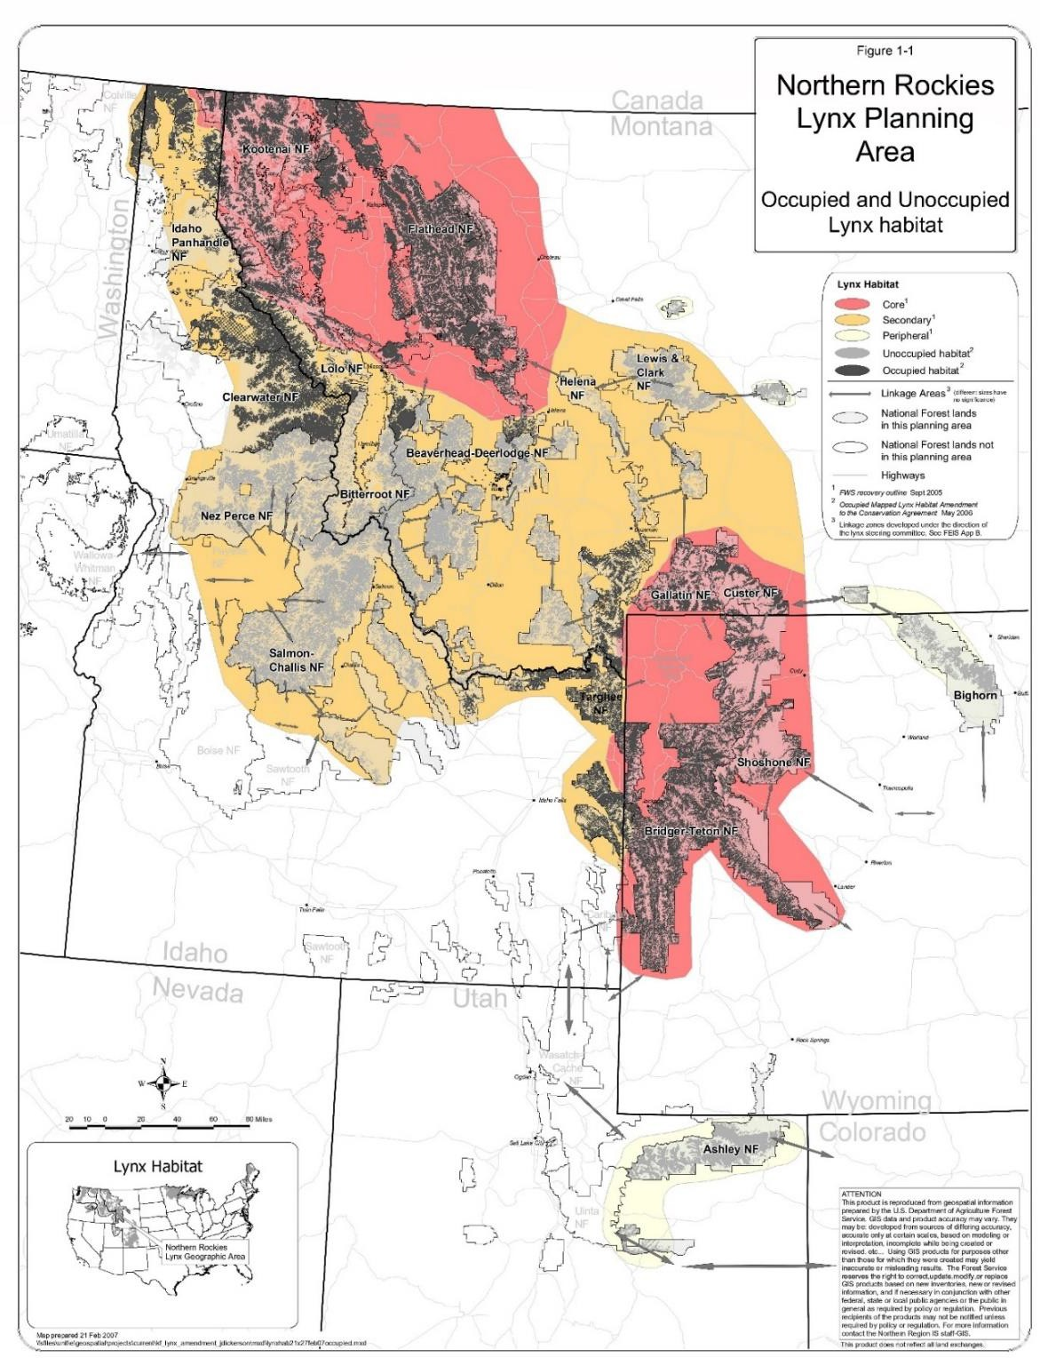
Figure 1. Map of Lynx Habitats from the FEIS for the NRLMD

The Science Report (SR) addresses fragmentation as “reduction of total area, increased isolation of patches, and reduced connectedness among patches or natural vegetation…” (SR p84). “habitat fragmentation is the most serious threat to biological diversity and is the primary cause of the present extinction crisis.” (SR p85). “rare species associated with wilderness, such as the lynx, generally are considered most susceptible to fragmentation.” (SR p86). “generalist predators tend to dominate the predator guild in fragmented landscapes.” (SR p86). Coyotes and lynxes are separated by snow conditions, but “this separation may break down where human modifications to the environment increase access by coyotes to deep snow areas. Such modifications include expanded forest openings throughout the range of lynx in which snow may be drifted, and increased snowmobile use in western mountains. Recreational snowmobile use has expanded dramatically in the United States in the past 25 years, with hundreds of thousands of km of trails (>19,000 km of groomed trails in Maine alone) within the pre-settlement range of the lynx…” (SR p94). “Fragmentation of habitats occupied by lynx (including increased openings, higher road densities, exurban residential development, and wider use of snowmobiles and devices that compact snow in areas with deep, soft snow) is a plausible mechanism for the questionable conservation status of the lynx in the contiguous United States.” (SR p95).

The data and information included in the Science Report had mostly been generated by the early 1990s, much in the 1970s and 1980s. The studies describing road density and snowmobile effects were very limited. The single study in the Science Report (p308) was based on data from the 1980s and stated that “Road densities had no significant effect on habitat selection, and lynx crossed roads at frequencies that did not differ from expectation.” There was no data on use of these roads by vehicles in summer or snowmobiles in winter. Road density averaged 1.28 miles/sq.mi. As noted above, snowmobile use was expanding. The Science Report (p391) noted that “Roads in the study area were of primitive standards that received little use in summer but were frequently used by snowmobilers in winter.” The Science Report (p295) said, “Snowmobiles became readily available in the late 1950s and early 1960s, likely influencing trapper coverage, access, and attitudes.” Science Report (p391), “Although legal harvest is no longer a conservation concern, human-caused mortality is believed to be additive in the low- density lynx populations characteristic of southern boreal forests (Koehler 1990; Table 13.3). If so, illegal or incidental harvest could significantly reduce population numbers of lynx in southern regions.”

2017 Species Status Assessment (SSA). The USFWS published a species status assessment (SSA)²³ for Canada lynx in 2017. The SSA recognized the lack of regulatory mechanisms was the reason for listing. (SSA p1). It stated:

Factors affecting lynx that were evaluated in the SSA “include the adequacy of existing regulatory mechanisms (the factor for which the DPS was listed); climate change, vegetation management, wildland fire management, and habitat loss and fragmentation (the factors considered by the Interagency Lynx Biology Team [ILBT] to have the potential to exert population-level effects on the DPS); and other factors that could influence the continued ability of particular geographic units to support resident lynx.” (SSA p3).

²³ U.S. Fish and Wildlife Service. 2017. Species Status Assessment for the Canada lynx (Lynx canadensis) Contiguous United States Distinct Population Segment. Version 1.0, October, 2017. Lakewood, Colorado.

“The lack of regulations protecting lynx habitat from potential threats on Federal lands at the time of listing has been largely addressed by formal and binding amendments or revisions to most Federal land management plans within the DPS range. Although uncertainty remains about the efficacy of this improved regulatory framework, Federal lands are now being managed specifically to protect and restore lynx habitats, with the goal of supporting continued lynx presence on these lands.” (SSA p231).

This last statement is incredibly dismissive of the main cause of lynx habitat degradation, lack of adequate regulation, and instead, dismisses almost all actions that the Science Report acknowledged adversely affect lynx and lynx habitat. We searched online for evidence that the CNF has adopted the NRLMD or provided any Forest Plan amendments for lynx protection.
There were none to be found. Y2U sent a letter to Mel Bolling, Forest Supervisor of the Caribou Targhee NF (CTNF) requesting updated analysis of the lynx status in the CTNF, including its historical occurrence, migration corridors and connections between habitats. The letter outlined our desired analysis and mapping to include human fragmentation and historical lynx habitat use.²⁴ The response from Mr. Bolling explained the current situation in the CTNF.²⁵

Mr. Bolling explained some of the history of the lynx listing, the Science Report, LCAS and the 2013 revision of the LCAS which is now considered the primary guidance for land management agencies. His letter pointed out that the Targhee NF RFP was amended by the NRLMD in 2007. A National Lynx Survey was conducted on both the Forests in 1999 and determined that the Targhee NF met criteria for management as an occupied forest, but the Caribou did not.
Therefore, the Caribou NF was not subject to the NRLMD and “No LAU’s or lynx habitat is mapped on the Caribou due to the designation of the Caribou NF as an unoccupied forest in 2002.” (p2). The conservation measures in the CNF RFP were “deemed sufficient: by the USFWS through consultation on the RFP Biological Assessment to address threats to Canada lynx and provide regulatory mechanisms to ensure the continued persistence of Canada lynx on the Caribou National Forest.” Under this arrangement, therefore it appears that the provisions of the CNF RFP would be central to analysis of lynx habitat because other protections are dismissed due to what appears to be an arbitrarily determined occupancy status that ignored historical lynx observations and only relied on absence determined by the National Lynx Survey in 1999 which occurred long after historical reported occupancy. We address this further on.

Mr. Bolling’s response included reference to a paper by Olson et al (2021)²⁶ which used lynx observations in the west, climate, and human induced factors to model lynx habitat. Using lynx GPS and tracking data from Idaho, Wyoming, Montana, Washington, and British Columbia, the study found that lynx habitat is made up of a complex array of environmental conditions, not primarily vegetation type and elevations as currently mapped. They included an index of

²⁴ Carter, J., Garrity, M., Johnson, S., and Fite, K. 2021. Request for Response on Lynx Analysis in the CTNF. Letter on behalf of Yellowstone to Uintas Connection, Native Ecosystems Council, Alliance for the Wild Rockies, and Wildlands Defense. Dated August 15, 2021.
²⁵ Bolling, M. 2021. Response to letter requesting information on Canada lynx. Dated September 13, 2021.
26 Olson et al. 2021. Improved prediction of Canada lynx distribution through regional model transferability and data efficiency. Ecology and Evolution 11:1667 – 1690.

summer vegetation production, percentage of tree cover, road density and night light intensity as indices of anthropogenic influences. One confounding issue is their assumption of boreal forest soil pH as a factor due to the wetter conditions in boreal forests. However, we know lynx use a variety of forested types and this factor might disqualify habitats unnecessarily. The model provides insight and a basis for more detailed analysis of lynx potential habitat and its fragmentation within the linkage in SE Idaho in the CTNF. We have included an Olson et al map from that paper as Figure 2 below. It illustrates a high probability of suitable lynx habitat in SE Idaho and the CNF. So, by this model, lynx habitat is present in SE Idaho. Why are there no lynx here? It is up to the FWS in its current Species Status Assessment and review to determine this.

Our review of the 2017 SSA finds a tenor of finding continued habitat fragmentation and degradation as unimportant to persistence of lynx, while only implicating climate change as problematic. But climate change is superimposed on all the existing insults to habitat and heightens their importance in the decline of lynx and lynx habitat. For example, the SSA contends that lynx only occurred in Colorado during “irruptions from Canada…in the early 1960s and 1970s” concluding that there is doubt that the population in Colorado “will receive the demographic and genetic support from the north that is thought to be important to the DPS populations.” (p227).

There are two competing hypotheses operating regarding lynx presence in Colorado.

H1. Lynx had been present in the Southern Rockies (south of Idaho-Wyoming) in a self-sustaining population for millennia but were slowly extirpated as a result of human activities, including trapping and livestock grazing, from early 19th century through mid-20th century.

H2. The presence of lynx in the Southern Rockies in the 19th and 20th centuries prior to lynx reintroduction into the San Juan Mountains, was due mostly or entirely to periodic influxes of lynx from Canada.

Two bodies of evidence (I & II) support H1 as the correct hypothesis.
  - There is a general lack of evidence of lynx population cycles in Canada being correlated with lynx population dynamics in the U.S., let alone in Colorado. The Science Report (p242) comments on the immigration hypothesis.
“In the Canadian provinces, Alaska, Montana, and Washington, we know that there are local reproductive populations, knowledge that invalidates a pure immigration hypothesis. For these areas, we can only state that they appear to be a part of a population in which lagged synchronous dynamics occur. Because we do not know why these dynamics occur, we cannot say to what extent they are affected by changes in local dynamics and the role that immigration might play.

. . . the lack of lynx occurrence records associated with a large population peak occurring in the central provinces during the early 1980s. This population peak

was higher than any recorded in the 20th century prior to 1959, but there was no evidence from museum specimens, verified mortality records, or anecdotal observations that unusual numbers of lynx occurred in any portion of its range in the contiguous United States.”

  - Since lynx reintroductions in Colorado, lynx have reproduced and become established there. Prognostications of the eventual disappearance of lynx from Colorado are speculative and have nothing to do with whether Colorado was or is capable of supporting a self-sustaining population of lynx.

The Science Report in describing the population cycles made this observation regarding the Minnesota population: “a three-year lag with data from the south-central Canadian provinces resulted in a strong correlation for the most recent period (r = 0.73, 1960-1983) but the pattern is out of phase in the previous 26 years… .” (SR p238). We note that lynx were present in the DPS during large blocks of time other than in the 1960s and 1970s.

The 2013 LCAS. We reviewed the 2013 LCAS.²⁷ It emphasizes protection of core areas which support persistent lynx populations and “less stringent protection and greater flexibility in secondary/peripheral areas…” (p2). The only conservation measures provided for these peripheral areas were for vegetation management, which are general and unenforceable statements such as “Vegetation treatments should be designed with consideration of historical landscape patterns and disturbance processes. Design timber harvest, planting, and thinning to include some representation of young densely stocked regenerating stands in the mosaic for snowshoe hare production areas” (p95). The 2013 LCAS provided conservation measures for core areas and stated that projects “must be consistent with the management direction contained in the forest plan.” (p89). This would mean the analysis would be consistent with the CNF RFP and its FEIS. Conservation measures for core areas included (only examples cited, for full list see the LCAS):

- Delineate LAUs (p89)
- Vegetation management (includes several measures including landscape evaluation to identify opportunities for adaptation to climate change). (p89)
- Wildland fire management (p93)
- Habitat fragmentation (promote or retain large contiguous blocks of lynx habitat, identify linkage areas to maintain connectivity, minimize large scale development, and others (p93)
- Recreation management (direct recreational activities away from identified linkage areas (p94).
- Minerals and energy (locate facilities and roads outside of lynx habitat and linkage areas where possible) (p95)
- Backcountry roads and trails (Avoid Road reconstruction and upgrades that substantially increase speeds) (p95).
- Livestock grazing (manage in riparian areas to maintain snowshoe hares) (p95).

27 Interagency Lynx Biology Team. 2013. Canada lynx conservation assessment and strategy. 3rd edition. USDA Forest Service, USDI Fish and Wildlife Service, USDI Bureau of Land Management, and USDI National Park Service. Forest Service Publication R1-13-19, Missoula, MT. 128 pp.

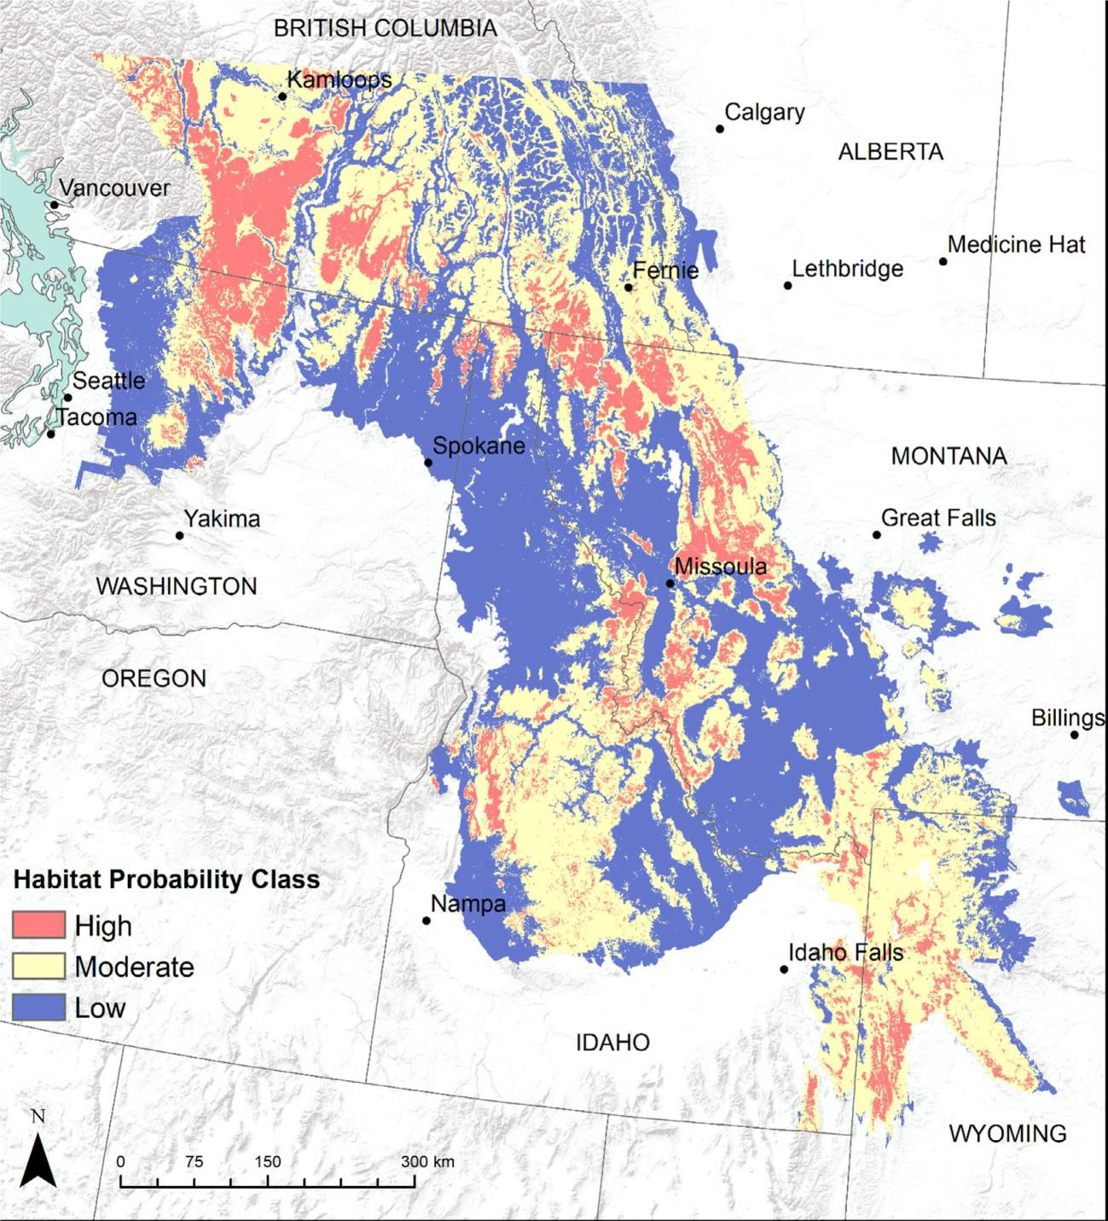

Figure 2. Prediction of Canada Lynx Habitat Probability from Olson et al 2021.

In the past two years we have seen several National Forests, the Caribou Targhee NF, the Ashley NF come out with prescribed fire and other forest manipulations that cover most, if not all, of the acreage within those Forests. These add up to nearly 2 million acres. This is happening across the West.

We have included Figure 3.1 from the 2013 LCAS here as Figure 3. That map does not show any linkage habitat. While it refers to the USFWS Recovery outline, there is no analysis of how to recover lynx. The 2013 LCAS does address factors that compromise lynx habitat and movement under the umbrella of “anthropogenic influences”(p68). It admits that not every human activity has been examined, but groups the activities into two tiers that can negatively affect lynx populations and habitat. The specialization of lynx on snowshoe hares and lynx “low densities and in small populations throughout their range in the contiguous United States .. increase their susceptibility to local extirpations.” (p68). First tier factors include climate change, vegetation management, wildland fire and habitat fragmentation “can directly effect (sic) both snowshoe hare and lynx population dynamics.” (p68).

“Federal agencies have amended or revised land management plans across much of the range of the lynx to provide direction to conserve lynx and lynx habitat. Thus, the impacts of anthropogenic influences have been substantially reduced.” (LCAS p68). The Caribou NF has not demonstrated that its RFP has “conserved lynx and lynx habitat” or reduced “anthropogenic influences” while continuing to propose and approve projects across the CNF, including phosphate mines, timber and prescribed fire, and off-road vehicle trails. In no case have lynx protections or criteria been invoked or analyzed and no habitat analysis of the linkage capability has been performed, and in every case when consulted, the FWS has signed off on these projects. FWS must do a better review of these projects and their implications to lynx habitat, including requiring that land management agencies conduct the proper monitoring, quantitative habitat descriptions and analysis of habitat structure and function prior to approving future projects.
The 2013 LCAS describes how these first-tier factors affect lynx and lynx habitat. Climate change is a factor which is overriding other impacts and can cause shifts in distribution, changes in snowshoe hare cycles, reduction in lynx habitat and population, among other outcomes. (LCAS p69). Vegetation management alters stand structure, composition and arrangement and occurs across the range of the lynx. (LCAS p71). Wildland fire management can result in similar alterations. (LCAS p76). Habitat fragmentation, “accentuates the viability risk inherent in a small population and increases its vulnerability to local extirpation.” (LCAS p76). Examples of fragmentation include, “removal of forest cover, development of highways and associated infrastructure, and intensive minerals or energy development…” (LCAS p77). Vehicle collisions are a factor in mortality. Here, the LCAS admits these activities have inherent risk to viability for small populations. In a direct contradiction to the Remand Notice, here “intensive minerals development” is a factor fragmenting habitats, yet this is excluded from any standards in the NRLMD for linkage habitats.

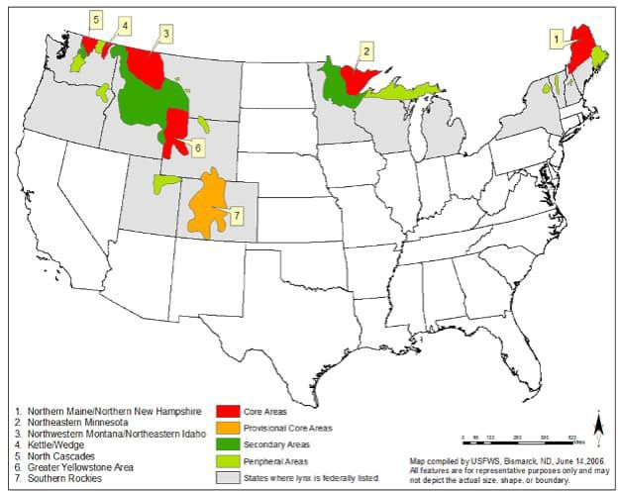

Figure 3. Taken from the LCAS Figure 3.1. Areas identified as core, secondary, and peripheral as depicted in the Canada Lynx Recovery Outline across the states where the lynx is listed (U.S. Fish and Wildlife Service 2005)

The second tier of anthropogenic influences include incidental trapping with rates of trapping “positively related to average pelt value and appeared additive to nontrapping mortality.” (LCAS p79). It “can occur in areas where regulated trapping for other species…overlaps with lynx habitats.” (LCAS p79). “No conservation measures to address incidental trapping are included … because trapping is regulated by the states.” (LCAS p80). Idaho allows trapping of numerous species, hound pursuit and with snowmobile access and groomed trails, winter access is available throughout the CNF. Previously we have noted the increase in trapping licenses in Idaho. This effect is dismissed from consideration.

Recreation is noted to be increasing with millions of participants. (LCAS p80). The data reported in the LCAS is pre-2009. Recreation effects include habitat loss from construction of developed areas, disturbance from human presence with examples of den abandonment, use of

compacted trails in the snow by competitors. (LCAS p80). Minerals and energy development “could affect lynx habitat by changing or eliminating the native vegetation and contributing to habitat fragmentation. … development of associated roads, powerlines, and pipelines.. could also result in a loss of lynx habitat and contribute to fragmentation.” (LCAS p83).

An illegal shooting example from Colorado is provided, showing over 14% of reintroduced lynx were shot in the first 10 years. (LCAS p84). Forest/backcountry roads and trails with low vehicular or snowmobile traffic “had little effect on lynx seasonal resource-selection patterns” and lynx traveled on roads “unplowed during winter”. “Squires et al (2008) reported that lynx denned farther from all roads compared to random expectation. … occupy dens in early May when many forest roads are still impassable… snowmobiles no longer use the roads because of intermittent and unpredictable availability of sufficient snow.” Finally, “fewer roads were located in denning habitat and higher road density occurred along forest edges and in managed stands, which lynx avoided….” (LCAS p84). But these factors are all dismissed as affecting lynx in the Remand Notice and we find no regulatory standards regarding these activities relating to lynx and lynx habitat in the CNF.

Regarding livestock grazing, LCAS (p85) notes the summer diet of snowshoe hares is dominated by herbaceous food including “forbs, grasses, and shrubs”. Then claims that “The habitats used by snowshoe hare that are most likely to be affected by livestock grazing are riparian willow and aspen communities.” The conclusion is that grazing by domestic livestock is “unlikely to reduce the snowshoe hare prey base…” This statement can only be produced by those who have never studied the impacts of livestock grazing on ecosystems in the Rocky Mountains. We have studied the effects of livestock grazing in SE Idaho and NE Utah and found extensive habitat degradation, over-utilization of forage, and overstocking. See Appendix 1 for a brief review with photographs showing some of the degraded conditions. Habitats in many of the National Forests in the southern portion of the DPS are terribly degraded by livestock grazing. Riparian areas and other snowshoe hare foraging areas are included.

By laying out these first and second tier anthropogenic effects for core areas, the 2013 LCAS inadvertently explains why lynx may not be found today in southern areas where they existed in earlier times. Lynx have “low densities and in small populations throughout their range in the contiguous United States .. increase their susceptibility to local extirpations.” (LCAS p68).
Almost every anthropogenic activity does have an adverse effect on lynx and lynx habitat as the science provided by the Forest Service and FWS have described in the preceding paragraphs. It is the omission of current monitoring and analysis along with the absence of adequate Forest Service standards that logic dictates is responsible for absence of lynx in places where it was observed in years gone by. We can find no monitoring or analysis of the effects of these activities to comply with the RFP and Travel Management Plan in the CNF. Lack of current data enables the CNF to deny impacts. Since our research has found an absence of recent monitoring and studies on Canada lynx habitat, populations and snowshoe hare habitats and populations across these southern Forests, it is incumbent on the current SSA effort to address this lack of information. FWS must press for meaningful, ecological based standards, define linkages and corridors, and require they be addressed with detailed habitat, lynx, and snowshoe hare studies. Models such as we discuss later in these comments must be consolidated, evaluated, and applied to define and update core and linkage areas.

Lynx Observations. The 2013 LCAS briefly describes lynx occurrences in the Northern Rockies. In Wyoming, lynx is a species of “greatest conservation concern” and “has been documented historically and currently in western Wyoming…” In Idaho lynx “are classified as an S1 species of greatest conservation need.” Most of the 35 verified records in Idaho came from north of the Snake River with 2 from Caribou and Bonneville Counties along the Wyoming border. Recent snow tracking surveys have detected no lynx. (LCAS p57). Two lynxes were captured in traps in 2012 and 2013, one was released alive, and the other was shot due to being misidentified as a bobcat. In Utah, the LCAS reports only a few historical records from the early 1900s with later records all from northwestern Utah near the borders with Wyoming and Idaho. (LCAS p58).

Lynx observations were summarized in McKelvey et al (2000)²⁸. McElvey et al used “written accounts, trapping records, and spatially referenced occurrence data…” (SR p207). They limited consideration of trapping records due to lack of constant effort and confusion with bobcats and where high reliability is needed, “we used a subset of these data we call ‘verified records”. Verified records were those “only if it was represented by a museum specimen, or a written account in which a lynx was either in someone’s possession or observed closely….neither tracks nor sighting reports were considered to be a verified record.” (SR p209). Yet, today tracking surveys are used.

We have extracted McKelvey’s data from Table 8.1 of their chapter and summarized the percent of observations that are “verified” and “reliable”. An extremely low percentage of total spatially referenced occurrences were “verified”. (Table 1). Hundreds to thousands of observations are not counted when determining lynx historical occupancy. Are we to believe they were all wrong? An example of this comes from a BLM report.²⁹ Of interest is an account by Harold Wadley, who was a Forester working for the U.S. Forest Service in Idaho and in the Uinta Mountains in Utah. Harold worked in the Uinta Mountains in 1957 and 1958. He used dogs and traveled by snowshoe to track and tree lynx. His records show he treed 20 Canada lynx in those two years. Harold encountered Canada lynx along the entire north slope of the Uinta Mountains. He estimated that there were 15 Canada lynx on the north slope of the Uinta Mountains between the West Fork of the Bear River and the Little East Fork of the Black Fork River. This essentially was the area within his ranger district. Was his report even considered? It is hard to tell. Do we just discount this as unreliable? After all, Harold worked for the U.S. Forest Service and knew lynx as do most trappers are likely to be able to do. His observations in the 1950s indicate a resident population occurred on a portion of the north slope of the Uinta Mountains at that time. This was prior to the irruptions from Canada in the 60s and 70s.

In the following paragraphs, we use an example of how one should approach these arguments surrounding whether lynx ever resided in the Uinta Mountains that was provided by Dr. Kirk

²⁸ McKelvey, K.S., K.B. Aubry, and Y.K. Ortega. 2000. History and distribution of lynx in the contiguous United States. Pages 207-264. Chapter 8. In Ruggiero, L.F., K.B. Aubry, S.W. Buskirk, G.M. Koehler, C.J. Krebs, K.S. McKelvey, and J.R. Squires (Tech Eds). Ecology and conservation of lynx in the United States. Univ. Press of Colorado. Boulder, CO. 480 p.
²⁹ Lewis, L. and Wenger, C.R. 1998. Idaho's Canada Lynx: Pieces of the Puzzle. Idaho Bureau of Land Management Technical Bulletin No. 98 - 11 in cooperation with the U.S. Forest Service.

Robinson in one of our joint efforts to address domestic sheep grazing in the Uinta Mountains of Northwest Utah.³⁰

Table 1. Spatially Referenced Occurrence Data from McElvey et al 2000.
State and time span | Total Spatially Referenced Occurrences | Verified Records | Verified as Percent of Total/Reliable
Colorado 1878 - 1974 | 196 Total  84 Reliable | 17 | 8.7/20.2
Idaho  1874 - 1991 | 234 Total  228 Reliable | 74 | 31.6/32.4
Utah  1916 - 1991 | 27 Total  17 Reliable | 10 | 37.0/58.8
Montana 1887 - 1999 | 1,542 Total  1,169 Reliable* | 84 | 5.5/7.1
Washington 1896 - 1999 | 765 Total  571 Reliable** | 134 | 17.5/23.4
Wyoming 1856 - 1991 | 361 Total  288 Reliable | 30 | 8.3/10.4
*Note that trapping records showed 3,012 reported between 1950 – 1997
**Trapping records show 215 between 1960 - 1989

Dr. Robinson’s logical analysis examines the use of verified vs reliable accounts, or observations. He puts it this way:

There may have only been 10 verified records of lynx occurrence in the Uintas in the 20th century, but there have been an additional 17 reliable reports of lynx in Utah in the 20th century, based on physical remains (including photographs), visual sightings and track identifications, plus another 10 of unknown reliability. The total number of records is 37. Most of these lynx occurrences were on the north slope of the Uintas, in or near the West Fork of Blacks Fork. Even if we discount the 10 reports of unknown reliability, we still have 17 reliable reports and 10 verified records of lynx, for a total of 27, most of which located the lynx in the Uintas! In other words, the historical evidence indicates a minimum of 10-37 lynxes in the Uinta Mountains over the last 103 years (not counting dispersers from Colorado). Thus, there can be little doubt that the actual number of “sightings” was greater than 10. 30 would be much more probable.

Why arbitrarily exclude the “reliable” sightings? What does “reliable” mean if you can’t rely on what is reliable? Yet the FS chooses not to rely on them for the purpose of the DEIS—a decision that would seem to be based not so much on a desire for accuracy as a desire to minimize the presence of lynx in Utah in order to make room for Alternative 2.

³⁰ Coalition comments on the High Uintas Domestic Sheep Analysis Project. 2019. Provided to the Uinta Wasatch Cache National Forest. August 5, 2019. Access at: https://app.box.com/s/797x21rggtx1t6yayr0gi9kpbouis4sr

At this point we should ask ourselves how many records—verified records, if you like—it would take to establish that there was a resident population of lynxes in the Uintas during some part of the 20th century. Does anyone have even the slightest clue? Of course not. And the reason is that there are no empirical data for establishing a baseline on which to base a prediction. Surely all we can reliably say is that the more records (verified + reliable), the higher the probability. Thus, this premise commits the fallacy of begging the question by presupposing what is to be proved.

As we review the table 8.1 from McKelvey, it is apparent that most historical observations and accounts are dismissed out of hand and have become the basis of today’s claims by FWS and the Forest Service that there are not (and perhaps never were) resident lynx in Utah and Idaho, or Colorado for that matter even though the reintroduced population survives there today and appears stable or increasing according to the Forest Service website cited earlier.

McKelvey et al (2000) also provide a narrative describing lynx records in Idaho, totaling 73 records. Some records such as reported in Lewis and Wenger (1998), are apparently not included. The following are extracted from McElvey et al:

From 1874 – 1917, there are 22 museum specimens from areas north of the Snake River Plain. In 1939 and 1940 specimens were collected in central Idaho in Valley County and Idaho County. In 1954 and 1955 specimens were located from Bonner and Shoshone Counties. Other verified records include one from Shoshone County in 1901, one from Boundary County in 1919, one from Idaho County in 1936, one from northwest Idaho in 1939, one from Clearwater County in1942, five from Caribou County in 1947, two from Bonneville County in 1955. (SR p225 - 226).

“There are 35 verified records from 1960 to 1991: four from 1962 to 1969, 18
from 1970 to 1979, 10 from 1982 to 1989, and three from 1990 to 1991; there are no verified records of lynx in Idaho since 1991 (Anonymous 1999, unpublished). Although most of these records are from the northern and central regions of Idaho where lynx occurred historically, six are from counties in the Snake River Plain, in areas where forest types occupied by lynx are absent or very fragmentary in extent (see “Lynx Associations with Broad Cover Types”). These include records from Blaine, Butte, Jerome, and Twin Falls Counties in 1972; one from Blaine County in 1984; and one from Power County in 1990”. (SR p227).

The Lewis and Wenger (1998) report provided numerous accounts of lynx and lynx tracks in Idaho. They noted that little is known about Canada lynx in Idaho and that “the lack of Canada lynx studies…only adds to the puzzling nature of the species”. It was based on interviews with individuals “familiar with Canada lynx habitat and local fauna in general.” (pi). These were individuals documented by Idaho Fish and Game as “having harvested Canada lynx”. While the report covers several areas of Idaho, it also includes Eastern Idaho accounts by 18 individuals. These are provided here for the SE Idaho area. They included accounts from residents in Island Park, St. Anthony, Rexburg, Georgetown, Ashton, Preston, Swan Valley,

Paris, Montpelier, and Alta, Wy. The reports included those who observed lynx in SE Idaho in Georgetown Canyon, Tincup Creek, and Henry’s Fork, many of whom killed lynx or observed their tracks. The report paints a broad picture of lynx across much of Eastern Idaho as well as other areas of the state. Here is one from Oliver Peterson of Montpelier who was trapping prior to the 70s when lynx sightings were claimed to be due to movement from Canada due to hare cycle lows. It appears very convenient today to claim there were never resident lynx in these areas.

Oliver Peterson, Montpelier, ID —Oliver began trapping in 1945 and did most of his trapping in the 1950s and 1960s. During a one-week period in 1947 or 1948, he caught five Canada lynx ten miles northeast of Soda Springs. He trapped four Canada lynx in the 1950s and 1960s, one in the same area where he caught the five Canada lynx. He caught three Canada lynx farther east near Georgetown.
Except for one Canada lynx trapped near timberline, the remaining Canada lynx were caught in areas with a mosaic of aspen, conifer, and mountain brush. (p8). He speculated that during those years there were no snowmobiles and atvs and that the demise of lynx was due to increased access and by snowmobiles, atvs, and the lack of snowshoe hares. Traplines were accessed by snowshoe or skis and now (the 1990s) there is “intensive snowmobile and atv use”. He believed this was a primary factor in the demise of lynx since the 1970s. (p17).

The interviews provided information on lynx prey including jackrabbits, grouse, red squirrels, voles in addition to snowshoe hares indicating the use of alternate prey appears greater than in Canada and Alaska. The authors suggest scenarios relating lynx behavior to jackrabbit populations by lynx following jackrabbits into shrub steppe far from typical coniferous forest habitats and end up near other habitats occupied by snowshoe hares and/or may exploit jackrabbit population highs without leaving traditional habitats resulting from jackrabbits dispersing into those habitats.

They also discuss livestock grazing, noting that studies show that livestock reduce forage availability, that elk and livestock eat many of the same species as do black-tailed jackrabbits and reduce forage to the point it limits jackrabbit densities. “Grazing of the same areas by both species may have cumulative effects on both snowshoe hare and jackrabbit habitats.” (p17). “Utilization of forage by both elk and livestock may thus have a significant impact on hare habitats. This may be particularly true in the southern-most portions of the Canada lynx range where grazing becomes a more dominant use.” (p18).

In conclusion, Lewis and Wenger (p19) state, “there is no ‘smoking gun’ factor in the decline of Canada lynx in Idaho. Many variables appear to limit Canada lynx numbers in this state. The most important of these appear to be timber harvest practices; high numbers of coyotes, mountain lions, and elk; increasing motorized and nonmotorized recreational use; incidental trapping; and reduced numbers of alternate prey, including species that are not documented as Canada lynx prey in existing research. These include jackrabbits, beavers, and porcupines.”

Lynx, the ESA and Forest Service Manual. The ESA promulgated regulations at 50 CFR §
402.12 delineate the purpose of a Biological Assessment (BA) as to “evaluate the potential effects of the action on listed and proposed species and designated and proposed critical habitat…”. It describes the contents as “discretionary” and depends on the nature of the federal action with consideration for including (1) results of on-site inspections; (2) views of recognized experts; (3) review of the literature; (4) analysis of the effects of the action on species and habitat, including cumulative effects and the results of related studies; and (5) analysis of alternate actions considered by the Federal agency.

In a recent typical example in the CNF in a Decision for a phosphate mine, the Husky 1 North Dry Ridge mine, the BA only based its brief analysis on the proposed action, not the suite of alternatives contained in the FEIS.³¹ It included minimal analysis. The intent of the ESA was avoided and if one applied the NEPA standard for a hard look or cumulative effects to this aspect of the analysis, the analysis would fail. “Discretionary” cannot be used to avoid taking a hard look in the analysis. This project, combined with other projects that are listed in the FEIS for H1NBR in addition to roads, timber harvest, and recreation, occurs within a linkage area connecting to critical habitat for lynx immediately east of the project. Figure 4 illustrates this and shows some of the phosphate leases in the CNF lynx linkage for illustration. The loss of this connection due to habitat fragmentation means the loss of the genetic connection between the critical habitat and other peripheral habitat such as in the Uinta Mountains which then connect to the current Colorado population. How can regulations or land use plans be effective when they are “discretionary” for the project proponents? This must be addressed.

The Forest Service Manual³² cites the ESA as “the Act directs federal departments and agencies to ensure that actions authorized, funded, or carried out by them are not likely to jeopardize the continued existence of any threatened or endangered species or result in the destruction or adverse modification of their critical habitats.” (FSM 2670.11). The FSM (2679.12) cites Departmental Regulation 9500-4 as (1) “Manage ‘habitats for all existing native and desired nonnative plants, fish and wildlife species in order to maintain at least viable populations of such species.’” (2) “Conduct activities and programs ‘to assist in the identification and recovery of threatened and endangered plant and animal species.’” (3) “Avoid actions ‘which may cause a species to become threatened or endangered’”. The CNF provided guidance in its RFP FEIS to address this connectivity but has ignored its own guidance in approving the H1NDR and all the other projects we have reviewed. How can the CNF dismiss impacts to Canada lynx without actually conducting an analysis? The current analysis for H1NDR and other projects does not “ensure” that actions do not further endanger or adversely modify habitat. Only in the industry bias world of today’s Forest Service could total destruction of habitat not be considered an “adverse” impact. Degrading and fragmenting this linkage habitat compromises lynx migration and habitat adjacent to and bordering lynx critical habitat and must be considered in that context.

FSM 2670.31 provides additional guidance for T&E species.

31 https://www.fs.usda.gov/project/?project=37878 Accessed on January 17, 2023.
32 USDA Forest Service. 2005. Forest Service Manual National Headquarters (WO) Washington DC. FSM 2600 – Wildlife, Fish, and Sensitive Plan Habitat Management Chapter 2670 – Threatened, Endangered and Sensitive Plants and Animals (September 23,2005).

(1) “Place top priority on conservation and recovery of endangered, threatened, and proposed species and their habitats.” (2) “Establish, through the Forest planning process, objectives for habitat management and/or recovery of populations.” (4) “Avoid all adverse impacts on threatened and endangered species and their habitats, except when it is possible to compensate adverse effects totally through alternatives identified in a biological opinion.” (6) “Identify and prescribe measures to prevent adverse modification or destruction of critical habitat and other habitats essential for the conservation of endangered, threatened, and proposed species. Protect individual organisms or populations from harm or harassment as appropriate.”

Once again, the CNF has not placed top priority on conservation and recovery, has not established meaningful objectives with enforceable standards for lynx habitat, has not designated LAUs with standards to protect preferred habitats and linkages, has ignored the effect of this linkage area on the adjacent critical habitat, thus compromising the integrity of that critical habitat and what remains of the core population in the DPS. The CNF by allowing snowmobile use on 97% of the Forest is not preventing harm or harassment of lynx, wolverines or other species which are affected by snowmobile use and the associated trapping, shooting and harassment. We have witnessed multiple snowmobiles trespassing on Kiesha’s Preserve chasing and harassing a coyote and deer in an effort to “whack” the coyote and at other times, releasing dogs carried in their sleds to chase mountain lions while trespassing. With the groomed trails throughout the mountains, one hunter can cover a hundred miles in one day looking for tracks to turn out his dogs.

The FSM 2670.5 provides definitions of terms that are useful in interpreting the efficacy of the agency analysis. An adverse effect includes “Any action that directly alters, modifies, or destroys, critical or essential habitats or renders occupied habitat unsuitable for use by a listed species, or that otherwise affects its productivity, survival, or mortality.” Essential habitat is defined as “Those areas designated by a regional forester as possessing the same characteristics as critical habitat without having been declared as critical habitat by the Secretary of the Interior or Commerce. The term includes habitats necessary to meet recovery objectives for endangered, threatened, and proposed species and those necessary to maintain viable populations of sensitive species.” A viable population is defined as “A population that has the estimated numbers and distribution of reproductive individuals to ensure the continued existence of the species throughout its existing range (or range required to meet recovery for listed species) within the planning area.”

The CNF has not designated Essential Habitat, but it has designated linkage for lynx. It has not identified recovery objectives or evaluated how a project leads to recovery of lynx. The analysis we have provided shows actions by the Forest Service have had an “adverse effect” as demonstrated by the lack of lynx observations and presence in SE Idaho. Given the lack of lynx observations in the recent decades, it is apparent that human activity is occurring in such a manner that lynx populations are being affected. Otherwise, why are lynx not being found here today? This example is illustrative of failures by both the Forest Service to comply with the intent of its RFP and FWS failure to require detailed analysis and protections in its role of consultation.

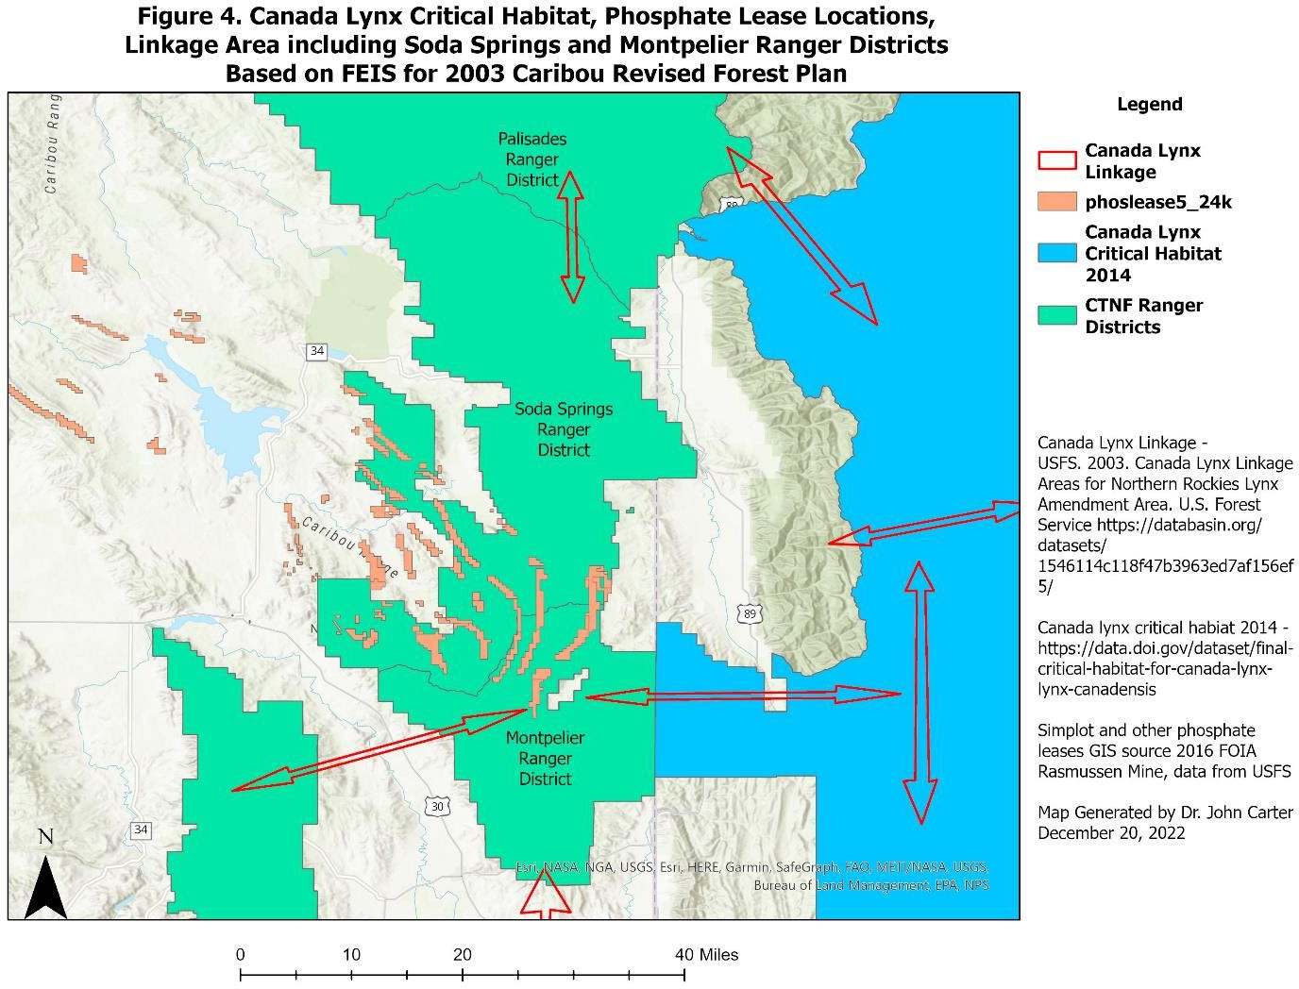

FSM 2671.44 describes determination of the effects on listed species. Biological evaluations are to “conduct and document the program and activities review necessary to ensure that any action
… is not likely to jeopardize the continued existence of any listed or proposed species or to result in the destruction or adverse modification of critical or proposed critical habitat.” Internal “biological expertise” and “informal consultation” are to be used to reach “supportable determinations of effect”. Finally, “Consider effects on suitable unoccupied habitat essential to recovery of the species when doing the biological evaluation.” We do not see CNF analysis of the linkage, or “suitable unoccupied habitat” or any effort to address its current vs historical condition as delineated in the CNF RFP FEIS. FWS is not addressing failures such as these.

The lack of adequate regulatory mechanisms to protect lynx habitat and connectivity has been implicated as a central issue for lynx being able to maintain populations.³³ (FR p16052). The FSM described above makes the point that the Forest Service should establish through planning,

³³DOI USFWS. 2000. Endangered and Threatened Wildlife and Plants; Determination of Threatened Status for the Contiguous U.S. Distinct Population Segment of the Canada Lynx and Related Rule. Fed. Register Vol. 65, No. 58.

objectives for habitat management and/or recovery of populations and prescribe measures to prevent adverse modification of habitat essential to the conservation of T&E species. This remains to be done and the FWS should ensure that not only the CNF, but all Forests and BLM land management plans are quantitatively addressing lynx habitat and connectivity needs.

What the CNF provides for lynx linkage in its RFP is summarized below.

Caribou NF Direction for Canada Lynx. The Caribou RFP FEIS laid out a process for addressing connectivity. We have reviewed the RFP for standards or objectives relating to lynx and its habitat. Overall, these are quite generic and not specific to the habitat of lynx. The direction specified to maintain linkages for Canada lynx is found in (1) Vegetation Desired Future Conditions, (2) Vegetation Goals 1 – 4, (3) Vegetation Standard 2, (4) Wildlife Goals 2,
3, and 5, (5) Vegetation Goal 7, (6)Lands Objective 1, and (7) Lands Standard 1. (RFP 3-28) We reviewed each of these for specifics regarding lynx habitat. They are summarized below:

- Vegetation DFC (RFP 3-17) to retain diversity of structure and composition, 30 – 40% of conifers in mature and old classes (FEIS notes this will not be attained), functional corridors are present, aspen managed to 20 – 30% mature and old, non- forested vegetation within site potential and within HRV, restoration of native shrub communities accomplished, woodland types are multi aged with balanced shrub/herbaceous understory and within HRV.

- Vegetation Goals 1 – 4, 7 (RFP p3-17 – 3-18) to have diverse forested and non- forested ecosystems within HRV and/or restored through time, aspen managed to reduce or halt decline, forested ecosystems moving towards a balance of age and size classes in each forested type on a watershed or landscape scale, sage-steppe and mountain brush moving towards a balance of age, canopy cover, and size class on a watershed or landscape scale and within HRV, biodiversity maintained or enhanced.

- Vegetation Standard 2 (RFP 3- 19) “In each 5th code HUC which has the ecological capability to produce forested vegetation, the combination of mature and old age classes (including old growth) shall be at least 20 percent of the forested acres. At least 15 percent of all the forested acres in the HUC are to meet or be actively managed to attain old growth characteristics.”

- Wildlife Objective (RFP 3-24) “The Forest provides habitat that contributes to state wildlife management plans; Forest management contributes to the recovery of federally listed threatened, endangered, and proposed species and provides for conditions, which help preclude sensitive species from being proposed for federal listing.”

- Wildlife Goals 2, 3, and 5 (RFP 3-24) states that wildlife biodiversity is maintained or enhanced by managing for vegetation and plant communities within their HRV, maintain multiple vegetation layers in woody riparian habitats, maintain, and “where necessary and feasible, provide for habitat connectivity across forested and non-forested landscapes.”

- Lands Objective 1 (RFP 3-8) “Identify land adjustments and rights-of-way to improve management, public access, and/or wildlife connectivity annually.”

- Lands Standard 1 (RFP 3-9) “Priority shall be given to acquiring lands having special importance or unique characteristics such as riparian areas, historic sites, habitat for federally listed species, recreation sites, etc.”

There is no specific direction and no enforceable standards regarding lynx habitat and linkage (which the Forest Plan itself mapped). These appear as mere afterthoughts with no relation to research on lynx or hare habitat. We have seen no evaluation in any project as to whether these have any relation to the habitat needs of lynx. In our example, the H1NDR NEPA process did not analyze these provisions or reveal how they have been applied across the affected watersheds and landscape where lynx formerly have been found, or in the linkage shown in the CNF RFP FEIS. In our example of the H1NDR FEIS, the analysis did not use the guidance in the CNF RFP FEIS on connectivity and how to analyze it. It did not analyze the risk factors described in the LCAS and the combined impact of all the various uses and projects on this linkage area. A review of IRAs in the CNF finds they are rarely different in management than other forest lands, with many user-created roads and trails, past timber harvest, mining, and livestock grazing. For example in our comments on the Dairy Syncline DEIS (p43) we cited the Idaho roadless rule description of the Huckelberry Basin IRA which was to be fragmented for a tailings pond.³⁴ "Remoteness and solitude rate as low, because of development." .. "Manageability of the area is considered poor, due to road intrusions and timber harvest activities." (Idaho roadless rule FEIS C5-46). This is typical of the characterization of IRAs under the Idaho Roadless Rule. So, if IRAs are fragmented by all these activities, where are the intact habitats for lynx and other special status species in IRAs and other habitats presumed to have lower levels of protection? A thorough review of the science on lynx habitat characteristics needed for recovery and connectivity should be completed and used to compare current conditions in the CTNF to those needed for lynx.

LYNX REGIONALLY SIGNFICANT WILDLIFE CORRIDOR (Y2UConn)

The following discussion is about the need to define, protect and restore a corridor or corridors, and provide standards for habitat to provide connectivity to the southern population of lynx.
This is focused on the Y2UConn (higher elevation) corridor passing through SE Idaho and NE Utah to connect critical habitat in the GYA to the Colorado lynx population.

The Colorado Division of Wildlife tracked radio-collared lynx released in Colorado. ³⁵ According to the Rocky Mountain Research Station, “By 2010, all indications were that the vast majority of animals relocated there had stayed in the state and they seemed to be surviving and reproducing well enough that the population was on a slight upward trajectory.”³⁶ That

³⁴ USDA. 2008. Roadless Area Conservation National Forest System Lands in Idaho Final Environmental Impact Statement Appendix C.
³⁵ Devineau P, Shenk T.M., White, G.C., Doherty Jr., P.M. and R.H. Kahn. 2010. Evaluating the Canada lynx reintroduction programme in Colorado: patterns in mortality. Journal of Applied Ecology. doi: 10.1111/j.1365- 2664.2010.01805.x 8 p.
³⁶ USDA RMRS. 2023. Winter Sports and wildlife: Can Canada lynx and winter recreation share the same slope?

link also noted that lynx were extirpated or greatly reduced in Colorado by the 1970s. The web report noted that “managers really understand the need to provide for connectivity in these critical areas we’ve identified.” Do they? Are they? Where is the evidence? FWS should require evidence.

Devineau et al (2010) show that lynx telemetry records confirm that there is a “hot spot” of lynx occurrences at the western end of the Uinta Mountains, where collared lynx from Colorado remain for a time before moving on. As of 2009, at least 22 individuals had made at least 27 visits to the state of Utah, recorded by air telemetry and satellite.³⁷ The highest concentration of lynx locations in Utah, as identified by telemetry, is in the Uinta Mountains. “The use-density surface for lynx use in Utah indicates the primary area of use being located in the Uinta Mountains.”³⁸ A recent report by Colorado Parks and Wildlife (CPW) using information from the tracking devices found that 19 males and 10 females reintroduced into Colorado between 1999 - 2006 were located in Utah.³⁹ Because some of these were single data points, CPW chose to evaluate 11 males and 6 females that were located in Utah between 2000 and 2010. Most of the individuals “entered and exited Utah via the Uinta Mountains in the northeast, Abajo Mountains in the southeast, or the East Tavaputs Plateau in the east- central part of the state… .” The report points out that a male and female occupied the same area in the Uinta Mountains for >200 days, but it is not known if there was denning or reproduction. “Those that spent a considerable amount of time in Utah tended to find and traverse the high country running north – south through the central portion of the state.” “There were likely other individuals who made the trip. Also, CPW stopped monitoring collared lynx in April, 2011. Movements into Utah may or may not have continued since then, but we have no documentation.” (p3).

The Science Report (Chapter 10) discusses the history of lynx occurrence in Colorado. “… boreal forest habitat in Colorado is insular in nature and isolated from similar habitat in Utah and Wyoming by more than 150 km of lower elevation habitats in the Green River Valley and Wyoming Basin (Findley and Anderson 1956). All but a few specimen records are from the center of this island of boreal forest habitat in west-central Colorado.” (SR p230). There were 15 specimens found between the 1800’s and 1936 with none thereafter until 1969, 1972, and 1974 when four additional specimens were identified. Despite snow tracking efforts, there have been no verified records in Colorado since 1974. (SR p231). As we summarized in Table 2, out of 196 records in Colorado between 1878 – 1974, there were 17 verified records, but 84 reliable records.

Figures 8.19 and 8.20 in the Science Report (p247) depicts lynx occurrences overlaid on Kuchler (1964) vegetation classes in the western U.S. It is noted that Rocky Mountain Conifer cover type enclosed 82% of lynx occurrences. Those Figures and Figure 8.17 show dense patterns of lynx occurrence in Colorado, western Wyoming and the GYA, western Montana, northern Idaho, and Washington bordering Canada. A pattern of occurrence also is shown in northeast Utah and

https://www.fs.usda.gov/rmrs/winter-sports-and-wildlife-can-canada-lynx-and-winter-recreation-share-same-slope Accessed on January 19, 2023.
³⁷ Colorado Department of Wildlife (CDOW) Report, 2006-7, Tables 4 and 6, pages 23 and 24.
38 Ibid. page 10; see also Figure 2, page 29.
³⁹ Ivan, J. 2019. Summary of movements of Colorado lynx in Utah. Colorado Parks and Wildlife, Fort Collins.

along the border between Idaho and Wyoming. Connecting these populations is critical for the DPS to recover and maintain gene flow.

We have been addressing connectivity in the Yellowstone to Uintas Connection since our organization was founded. The Y2UConn leg of the Regionally Significant Corridor is the high elevation, conifer dominated link needed to connect the GYA and northern Rockies to the Uinta Mountains and Southern Rockies. The CNF Forest Plan FEIS (pD-5)⁴⁰ summarizes the history/knowledge of this corridor through SE Idaho into NE Utah.

Most of the efforts to date to map corridors have focused on large-scale dispersal corridors generally from the Northern Rockies (Glacier NP) to the Greater Yellowstone Ecosystem. The USFWS, in efforts to conserve large carnivores in the Northern Rocky Mountains, has developed the concept of linkage zones. The linkage zone is an area between habitat fragments able to support both movement and low-density occupancy. The distinction between linkage zone and corridor is the width of habitat—that is the ability to support low density occupancy by species (Samson et al, 1997).

Ruediger, et al, 2000 drafted a map titled “IGBC Wildlife Habitat Linkage in the Northern Rocky Mountains.” This map also includes the northeastern portion of the Caribou in the mapped north-south linkage zone. Other agencies and groups have done mapping as well.

In May 2000, a meeting was held with several state and federal agencies as well as other interested groups, to discuss developing common criteria to help identify linkages of highest importance (Ruediger, 2000). They recommended factors to consider when identifying wildlife habitat linkages; 1) consider all scales, 2) landforms and topography are important, mountain passes, river bottoms and major ridges are often natural movement corridors, 3) vegetation is important, many species use forested areas for cover, 4) quality of habitat is important, 5) areas with low road densities and low levels of human use are important, 6) need data and 7) maintain large intact blocks of habitat (Ruediger, 2000)

The Wasatch-Cache National Forest in Utah looked at a north-south corridor passing through the Forest. They used McNab, et al, (1994) to identify Province M331 “Southern Rocky Mountain Steppe” as main north-south corridor (Williams, Forest Biologist pers. comm.) Part of this province (M331) passes through part of the Caribou NF in the Caribou/Webster/Preuss subsections. This same area has been mapped as part of the Greater Yellowstone Ecosystem and was included on Ruediger’s “IGBC Wildlife Habitat Linkages” map.

The 2003 Revised Forest Plan and FEIS for the Wasatch Cache National Forest provides this map along with a map of LAUs in the Wasatch-Cache NF, Uinta NF, and Ashley NF on its

⁴⁰ USDA Forest Service. 2003. Final Environmental Statement for the Caribou National Forest Revised Forest Plan.

website.⁴¹ Figure 5 illustrates this Regional Corridor and its connections. Figure 6 illustrates the Kuchler RMC type, and Figure 7 the topography. These maps show that the Science Report ignored this conifer dominated, high elevation connection in its claim that the Colorado boreal forest (Kuchler?) is “isolated from similar habitat in Utah and Wyoming by more than 150 km of lower elevation habitats in the Green River Valley and Wyoming Basin.” Distances between higher elevation forested areas are much less in the western leg (Y2UConn) than across the Green River Valley and other northern areas from Colorado.

Colorado Parks and Wildlife summarized lynx movements from the reintroductions in Colorado to Wyoming.⁴² Locations from 16 male and 15 female lynx that were released in Colorado between 1999 -2006 and were located in Wyoming between 1999 – 2010. (p2). It is interesting to note that the reintroduced lynx came from Canada populations to the north. Inspection of the maps in the report give the impression these lynx are attempting to find their way back north. As the report describes, “Most of these individuals entered and exited Wyoming via the Medicine Bow Mountains or the Park Range and traveled no farther into the state than the northern extent of these ranges… . At least 8 lynx made it to the Greater Yellowstone Area and beyond. A few entered/exited via the Uinta Mountains in Utah… .” The report notes that there were likely other individuals that made the trip, but there is no documentation since that time. (p3). Inspection of the figures in the report shows that some lynx apparently did cross the wide lower elevation valleys between the Medicine Bow Mountains and GYA, but there was no consistent path being followed and there were few conifer or high elevation areas. (Figure 6).

A least-cost path analysis of lynx connectivity between the San Juan Mountains in Colorado and the Greater Yellowstone Area reviewed the negative effects of habitat loss and fragmentation on wildlife populations and the resulting isolation of those populations.⁴³ The role of landscape linkages in providing connections and gene flow was addressed. Using GIS, current spatial data for habitats, human factors affecting lynx movement, and potential travel corridors between core patches of lynx habitat in the southern and northern Rockies were identified. Habitat suitability analysis identified the best core areas for lynx based on vegetation type and road density.
Habitat types suitable for lynx were identified and scored. We have provided a general overview map in Figure 8 showing these core and corridor areas of the least cost path overlaid with the Y2UConn leg of the Regional Corridor. These are well aligned with each other. Detailed maps of vegetation classes, road densities, core areas, housing density, slope, habitat permeability, and least cost corridors are provided in the report. The analysis provides an assessment of the probability of successful dispersal for lynx as it assessed the entire landscape, while “an animal traveling on the ground may not have prior knowledge of the territory it is crossing or obstacles it may come upon.” (p21). The model is suitable for making conservation and management decisions.

41 https://www.fs.usda.gov/detailfull/uwcnf/landmanagement/planning/?cid=stelprdb5076923&width=full
⁴² Ivan, J. 2017. Summary of movements of Colorado lynx in Wyoming. Colorado Parks and Wildlife.
⁴³ Bates, W. and Jones, A. 2007. Least-Cost Corridor Analysis for Evaluation of Lynx Habitat Connectivity in the Middle Rockies. Report to the Nature Conservancy by the Wild Utah Project, Salt Lake City. https://app.box.com/s/0g8b1ryqg1iz6r1fd61rdkc8fso97oh5

Figure 5.

Regionally Significant Wildlife Corridor, Lynx Linkage and Colorado Potential Habitat

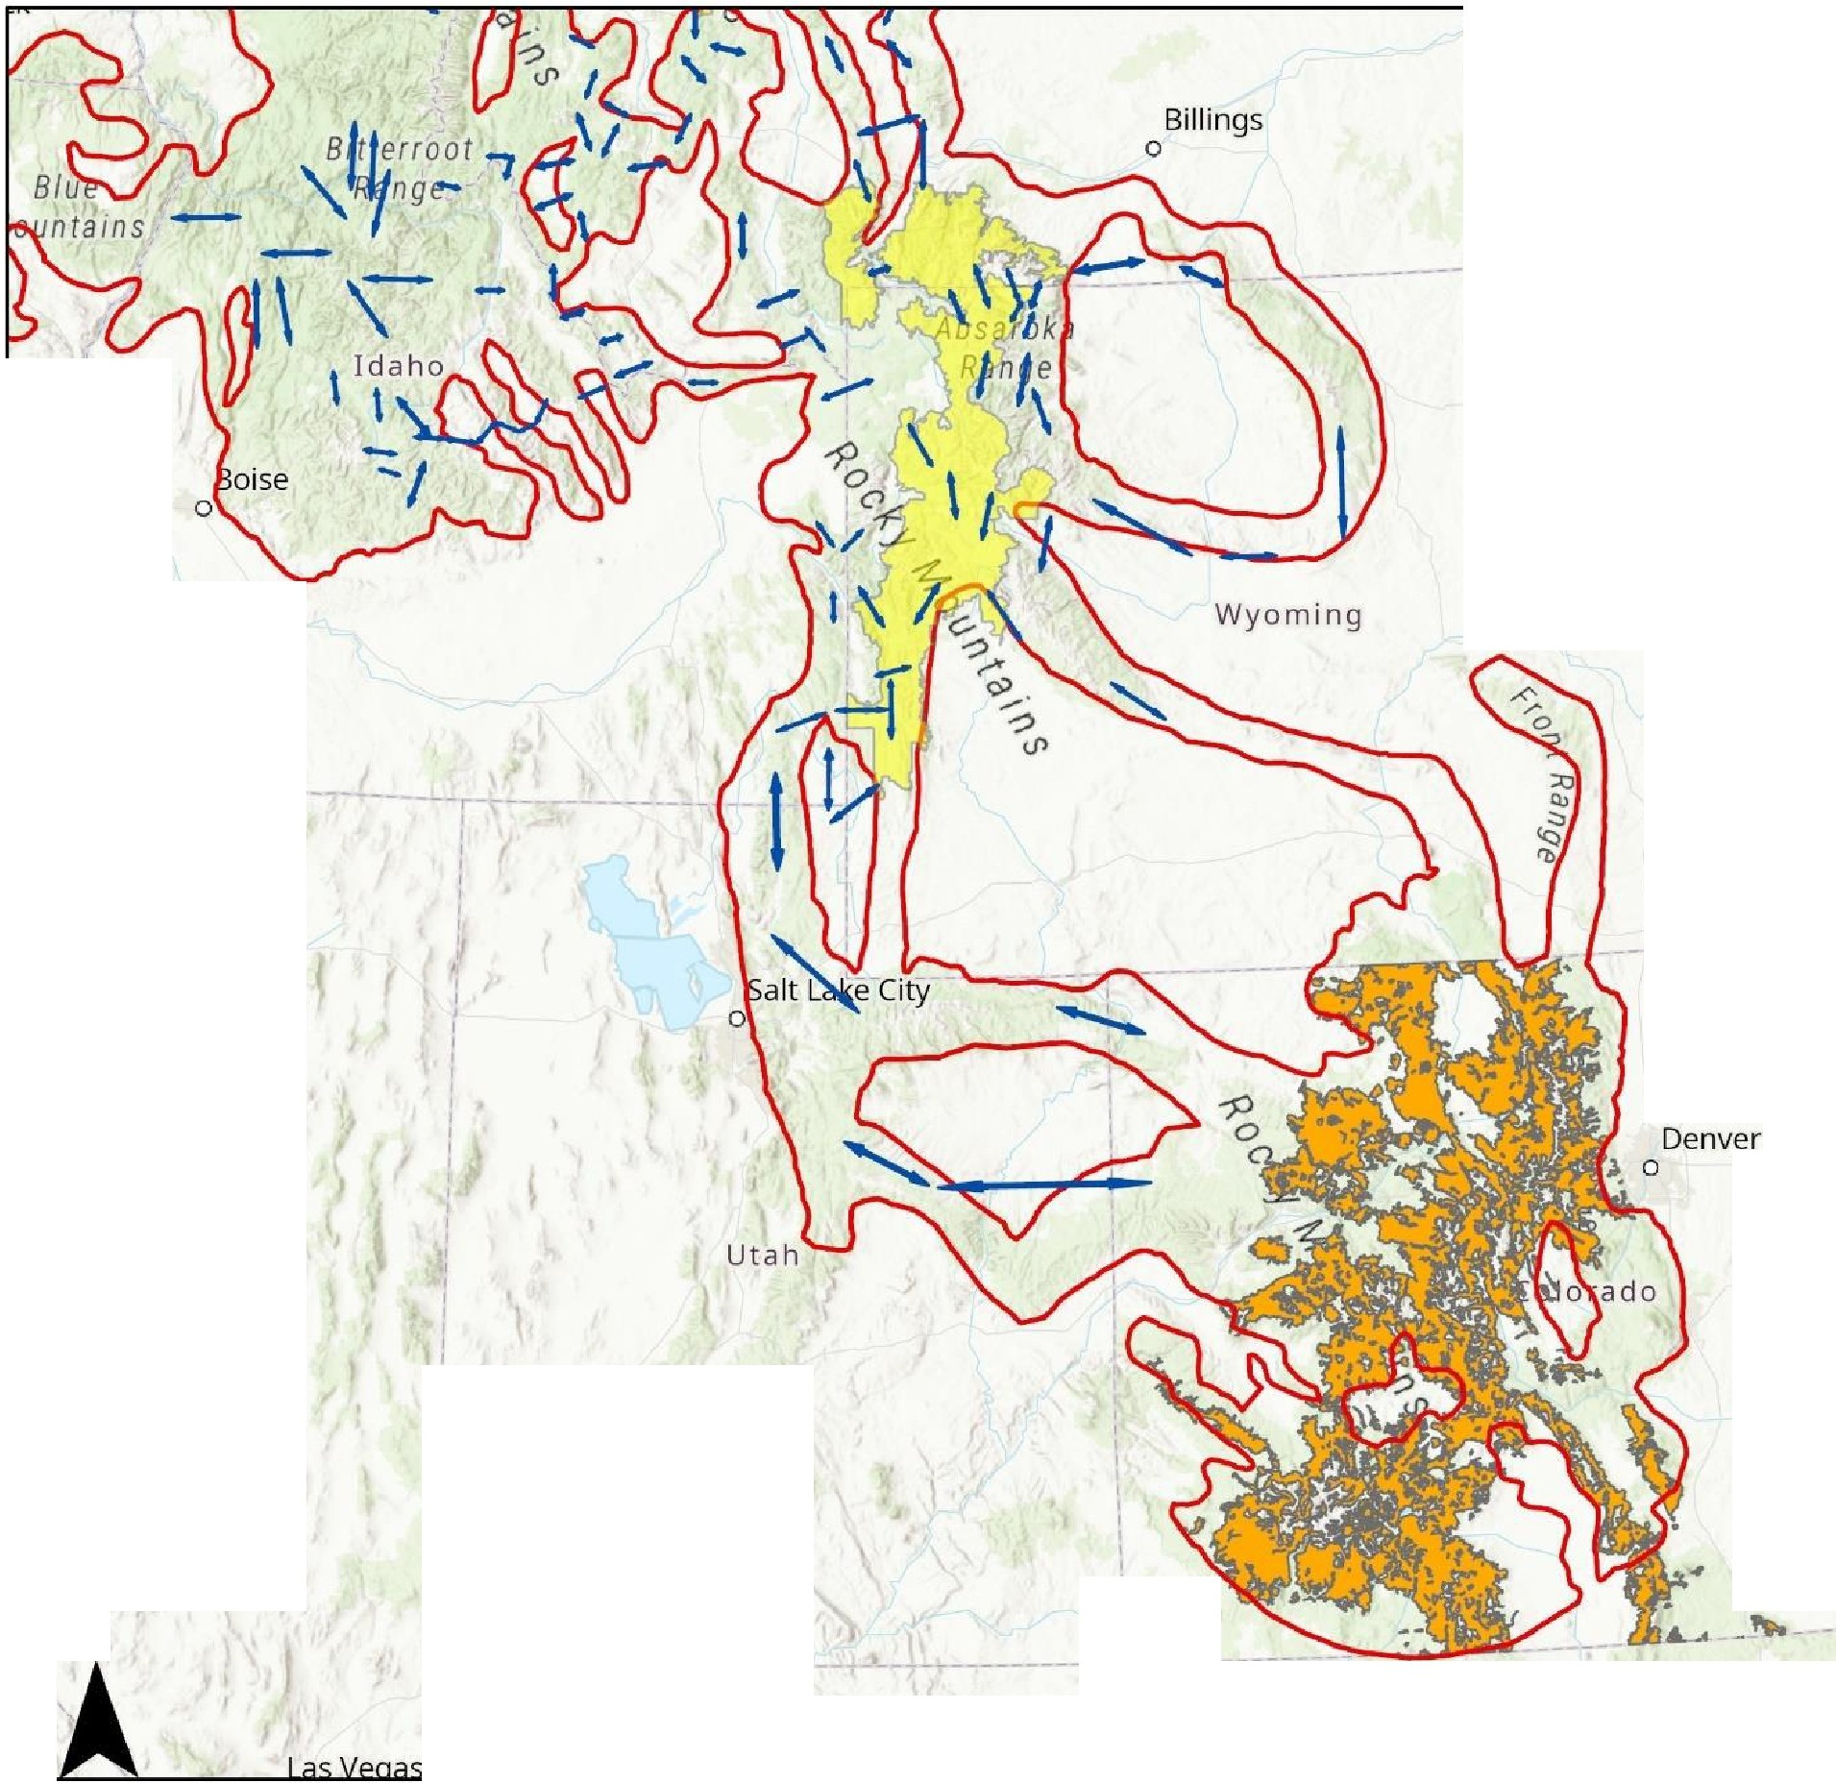
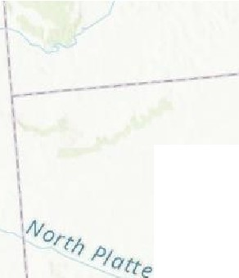
- Lynx Critical Habitat
�
'
-
­
South
- 1
I
I
I
I
,'
,j.
I
- _.IJ ---
I
--
I
Cheyenne
0 - J
I
Great Basin
I
I
'I
L.-----
1
I
I
Arkansas
\
\
I
N
I
--r---- - _I.,_
t
'
Esn, HERE, Garmin, FAO, NOAA, USGS, EPN-Esn, tJSGS
I
I
D Regional Corridor
- Canada Lynx Linkage Lynx Potential Habitat

Regional Corridor - Referenced in USDA. 2003. Revised Forest Plan Wasatch-Cache NF.

https:/ /www.fs.usda.gov/ detailfull/uwcnf/ landmanagement/ planning/? cid=stelprdb5076923&width
=full
Canada Lynx Linkage - USDA Forest Service Northern Region. November 13, 2003. Canada lynx linkage areas for the Northern Rockies Lynx Amendment.
Lynx Potential Habitat - Colorado Parks and Wildlife

Critical Habitat - Fish and Wildlife Service designation. See Federal Register Citation Number 79 FR 54782, published 20140912 for the legal critical habitat information.

Figure 6

Regionally Significant Wildlife Corridor and
Kuchler Rocky Mountain Conifer

1-- --- --

- Kuchler Rocky Mtn Conifer
D Regional Corridor

'
1r
I South
I
I
I

Great Basin a
, .,
_, .,.
\ \ --- --- --- -----

I
I
I
:'110,.,4
\,_ P/Otte
I
I
I
Cheyenne
0 - _J 1
I
I

I
I
I
-
I
I
I
Denver

I
I
I I I I
I
\
I
Regional Corridor - Referenced in USDA. 2003. Revised Forest Plan Wasatch-Cache NF.

https://www.fs.usda.gov/ detailfull/uwcnf/ landmanagement/ planning/?
cid=stelprdb5076923&width
=full
Kuchler type GIS files from Data Basin. http:// app.databasin.org/ app/ pages/datasetPage.jsp?
id= 1c7a301c8e6843f2b4fe63

N 7 ' '
L.
I I I I
--t--
I
I
Arkansos ^{I}

I I

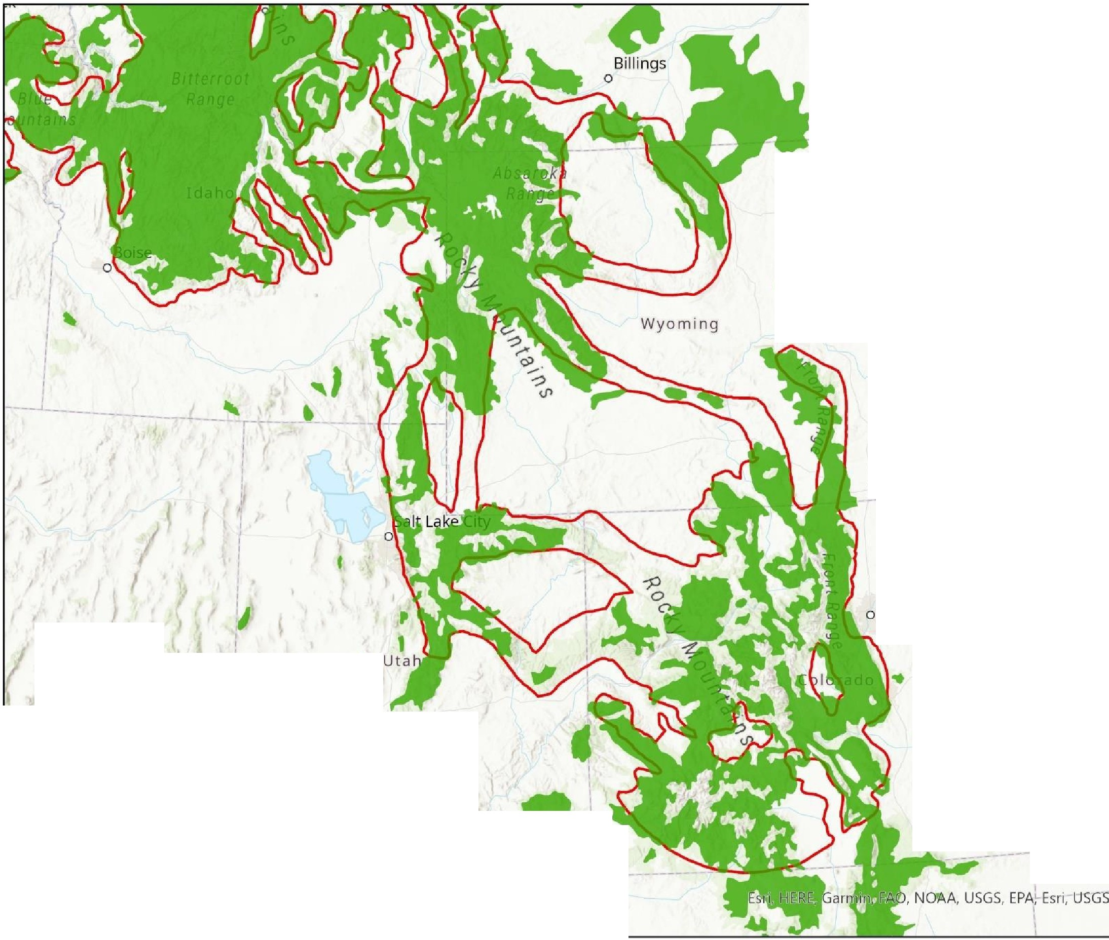
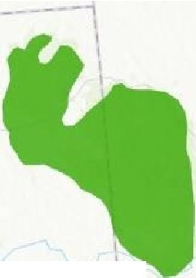
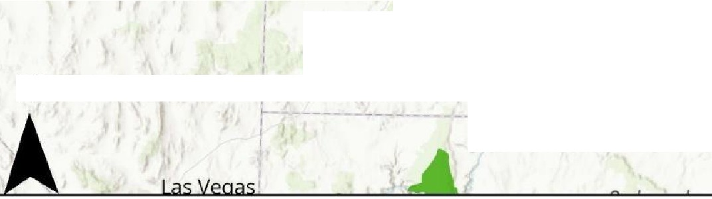
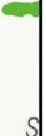
I r --- - -
) •

Figure 7

Regionally Significant Wildlife Corridor Topographic Relief

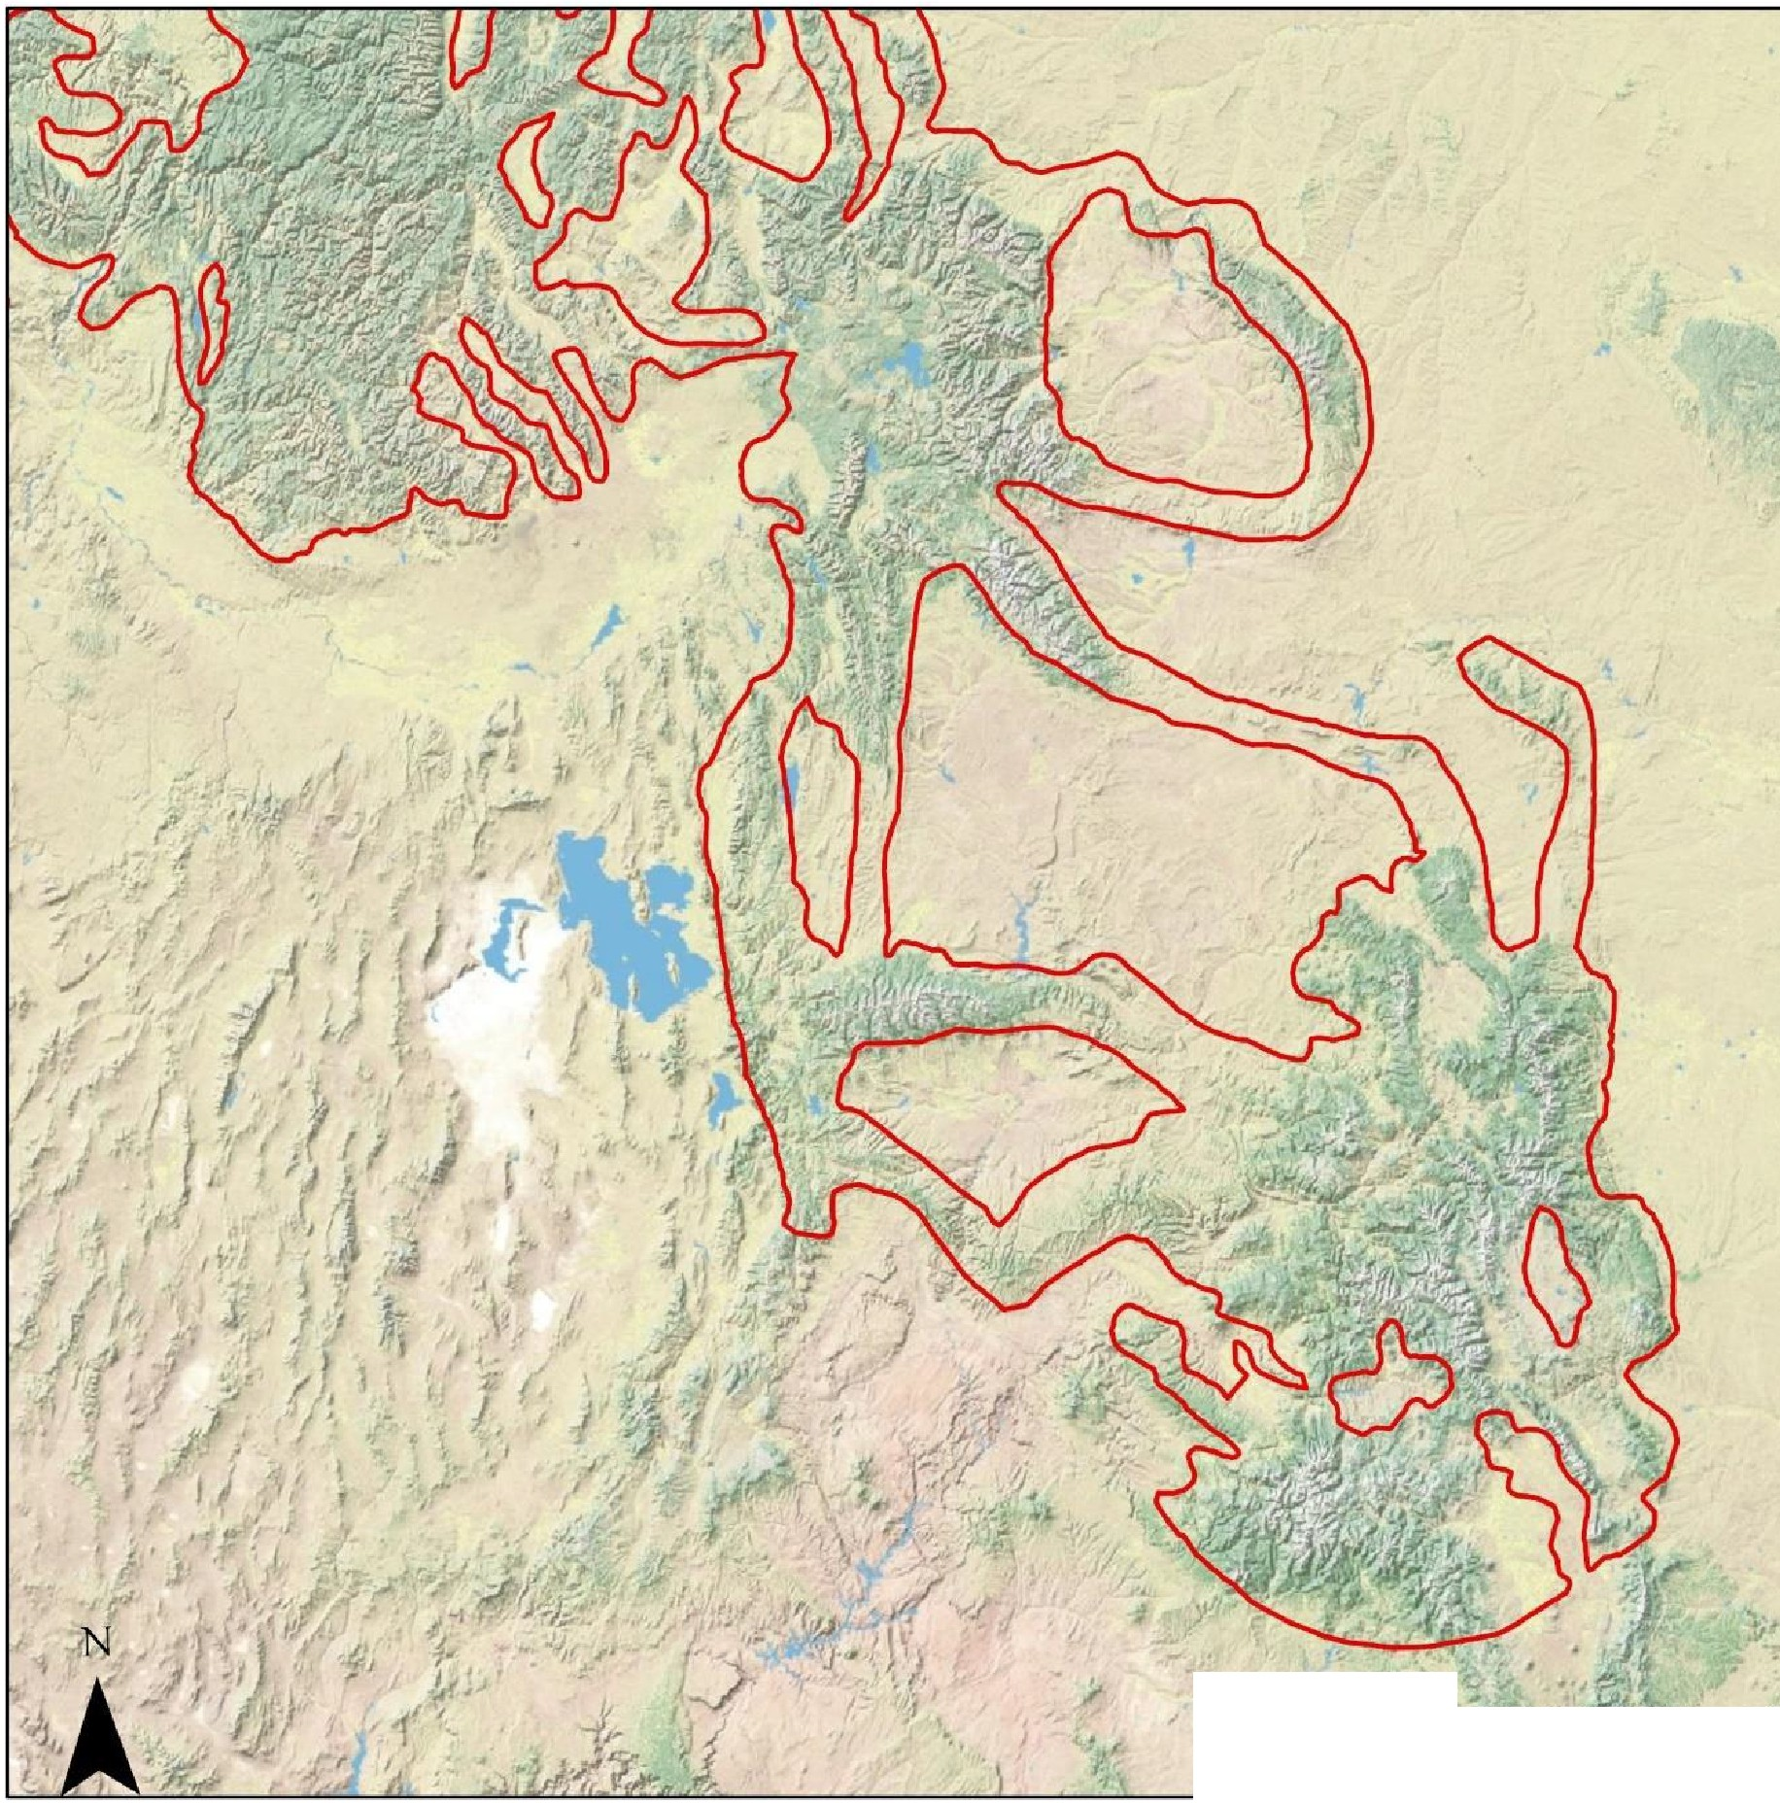
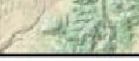
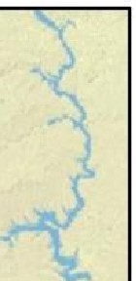

D Regional Corridor

Regional Corridor - Referenced in USDA. 2003. Revised Forest Plan Wasatch-Cache NF.

https://www.fs.usda.gov/ detailfull/ uwcnf / landmanagement/planning/? cid=stelprdb5076923&width
=full

Topographic Map
ESRI land cover imagery for the world and detailed topographic maps for the United States

C nal Geographic Society, i-cubed
;,f,.,,,

Colorado Parks and Wildlife engaged in a similar effort to map predicted use areas in Colorado.⁴⁴ They used location data from reintroduced lynx fitted with transmitters, filtered those data to remove locations for the first six months to account for habituation, considered elevations above 8,000 feet, and included factors for housing and road density, slope, distance to forest patches and vegetation types. Summer and winter data were used to generate models for both seasons. Figures 9 and 10 are reproduced from that report.

A map of the predicted distribution for Canada lynx in the 2050's based on modeled climatic conditions is provided in Figure 11.⁴⁵ This dataset represents the predicted distribution for Canada Lynx (Lynx canadensis) for the 2050's (ten year period average), based on the agreement (spatial average) of 5 niche modeling techniques (BIOCLIM, Climate Space Model, Envelope Score, Environmental Distance, SMV) and monthly precipitation and average temperature from 12 GCM's from the A2 emission scenario. Localities used to produce the model were resampled from the core area (highest probability) of the predicted distribution based on 48 Worldclim 1.4 climatic variables and BIOCLIM. CPW (Ivan) have also produced maps of summer and winter predicted habitat above 8,000 ft in Colorado.

Modeling and analysis such as these examples provide should be used to delineate the final configurations for regional corridors needed to maintain connectivity for these lynx populations. The Y2UConn leg of the corridor is a viable option for the higher elevations and snow cover needed by lynx. It also includes the potential core area of the Uinta Mountains where historical observations indicate a lynx population existed there in the early 1800’s prior to trapping and exploitation by people. It connects to Critical Habitat in Western Wyoming where studies documented lynx present in 2004/2005 along with populations of snowshoe hares.⁴⁶ A follow-up effort in the winter of 2008/2009 also detected lynx in the Greater Yellowstone Area.⁴⁷

44 Ivan, J., Rice, M., Shenk, T., Theobald, D., and Odell, E. Undated. Predictive Map of Canada Lynx Habitat Use in Colorado. Colorado Parks and Wildlife. Accessed on January 20, 2023. https://cpw.state.co.us/Documents/Research/Mammals/Publications/CPWPredictiveLynxMapReport.pdf
⁴⁵ Hamilton, H. 2008. Predicted Distribution of Canada Lynx (Lynx canadensis) - A2 emissions scenario - 2050's. California Academy of Sciences 07.29.2008. Map data from https://databasin.org/datasets/3674ed71-f5b7-45a3- a778-dfc2f0990235/ Accessed on January 20, 2023.
⁴⁶ Berg, N.D., Burghardt, J., Gray, R., and Smith, B. 2005. The Greater Yellowstone Lynx Study 2004/2005 Annual Report. The Endeavor Wildlife Research Foundation.
⁴⁷ Holmes, M. and Berg, N. 2009. Greater Yellowstone Ecosystem Lynx Study. Endeavor Wildlife Research Foundation. https://yellowstone.co/pdfs/lynxstudy2009.pdf Accessed on January 22, 2023.
34

Figure 8

Regionally Significant Wildlife Corridor, Lynx Linkage and Colorado Potential Habitat

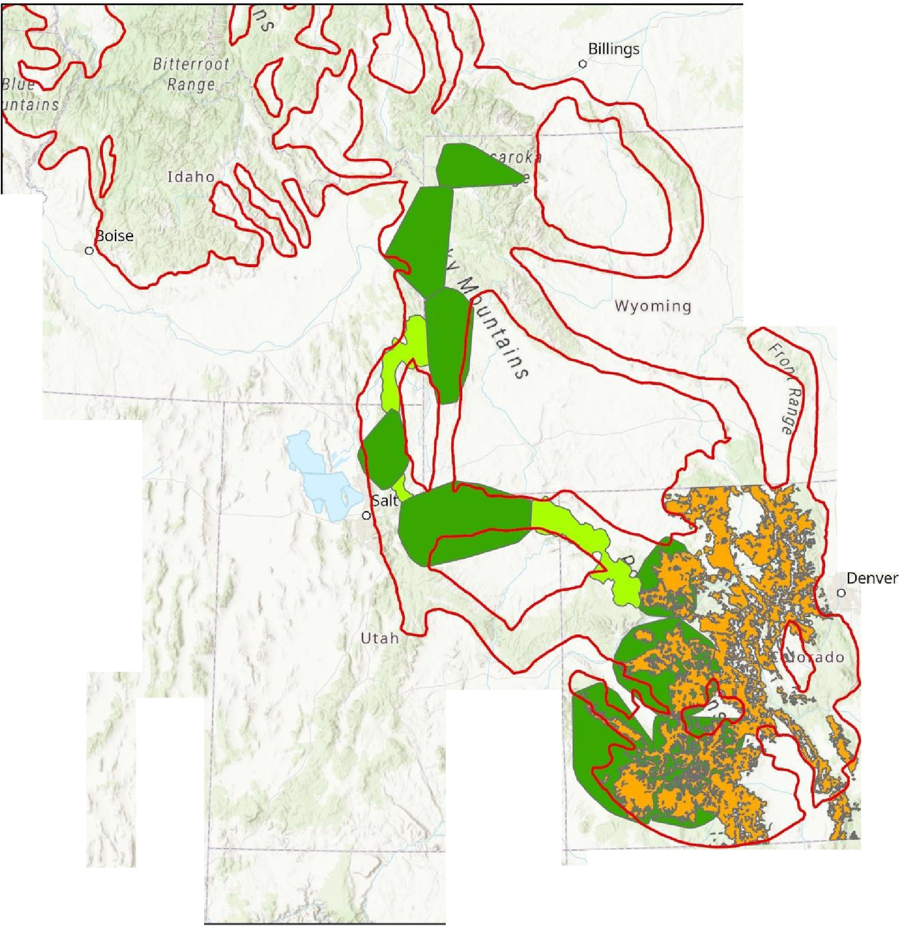
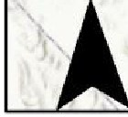
D Regional Corridor
'
\
- 1
I
\
I�--------
South Da
-- --
p
0
{
'I
------- - -
I
I
I
I
I
I
I
-- J
I
\
\'11ort;,
, "latte
Sa
0
Cheyenne
-- -- -- ---
----,
I
I
Great Basin
L-- ----
I
I I I I I
I I I I I
I
I
\
I I I I
L - --
N
- - r
I
L. - -- -
Esri, HERE, Garmin, FAO, NOAA, USGS, EPA, Esri, USGS
Las Vegas
Colorado
- Lynx Potential Habitat
D CanadaLynxCorridors
- CanadalynxCores

Regional Corridor - Referenced in USDA. 2003. Revised Forest Plan Wasatch-Cache NF.

https://www.fs.usda.gov/ detailfull/uwcnf/ landmanagement/planning/? cid=stelprdb5076923&width
=full

Canada Lynx Linkage - USDA Forest Service Northern Region. November 13, 2003. Canada lynx linkage areas for the Northern Rockies Lynx Amendment.
Lynx Potential Habitat - Colorado Parks and Wildlife
Bates and Jones (2007) Least­ Cost Corridor Analysis for Evaluation of Lynx Habitat Connectivity in the Middle Rockies.

0 75 150 300 Miles

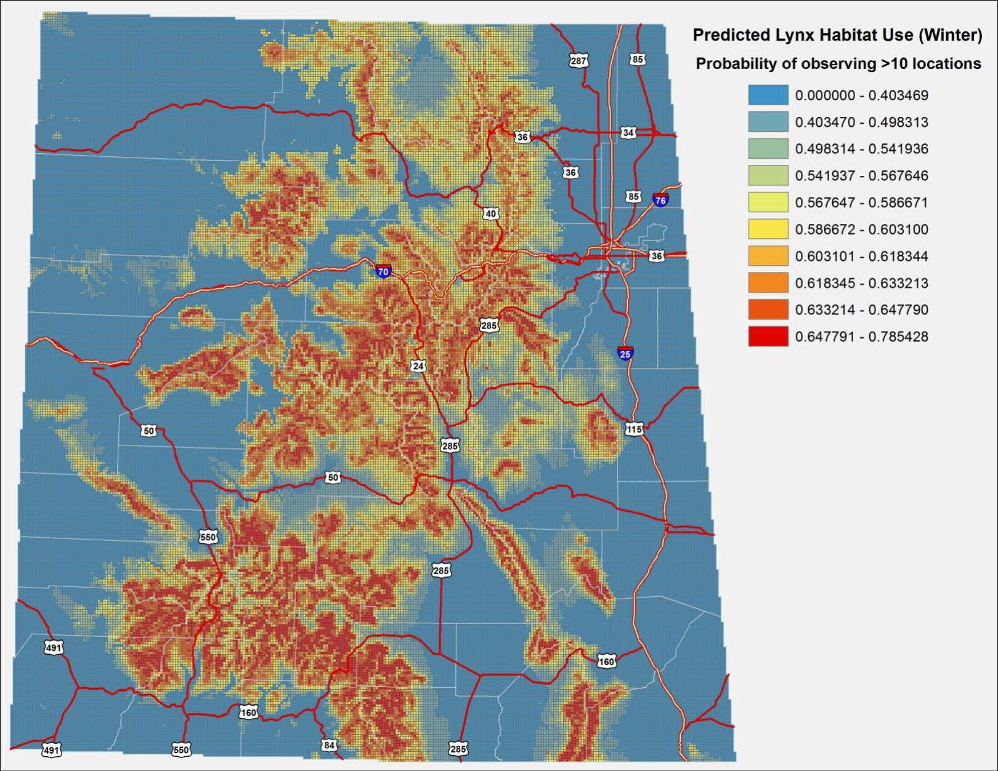
Figure 9 . Predicted winter use by Canada lynx in western Colorado. (From Ivan et al Figure 2) 36

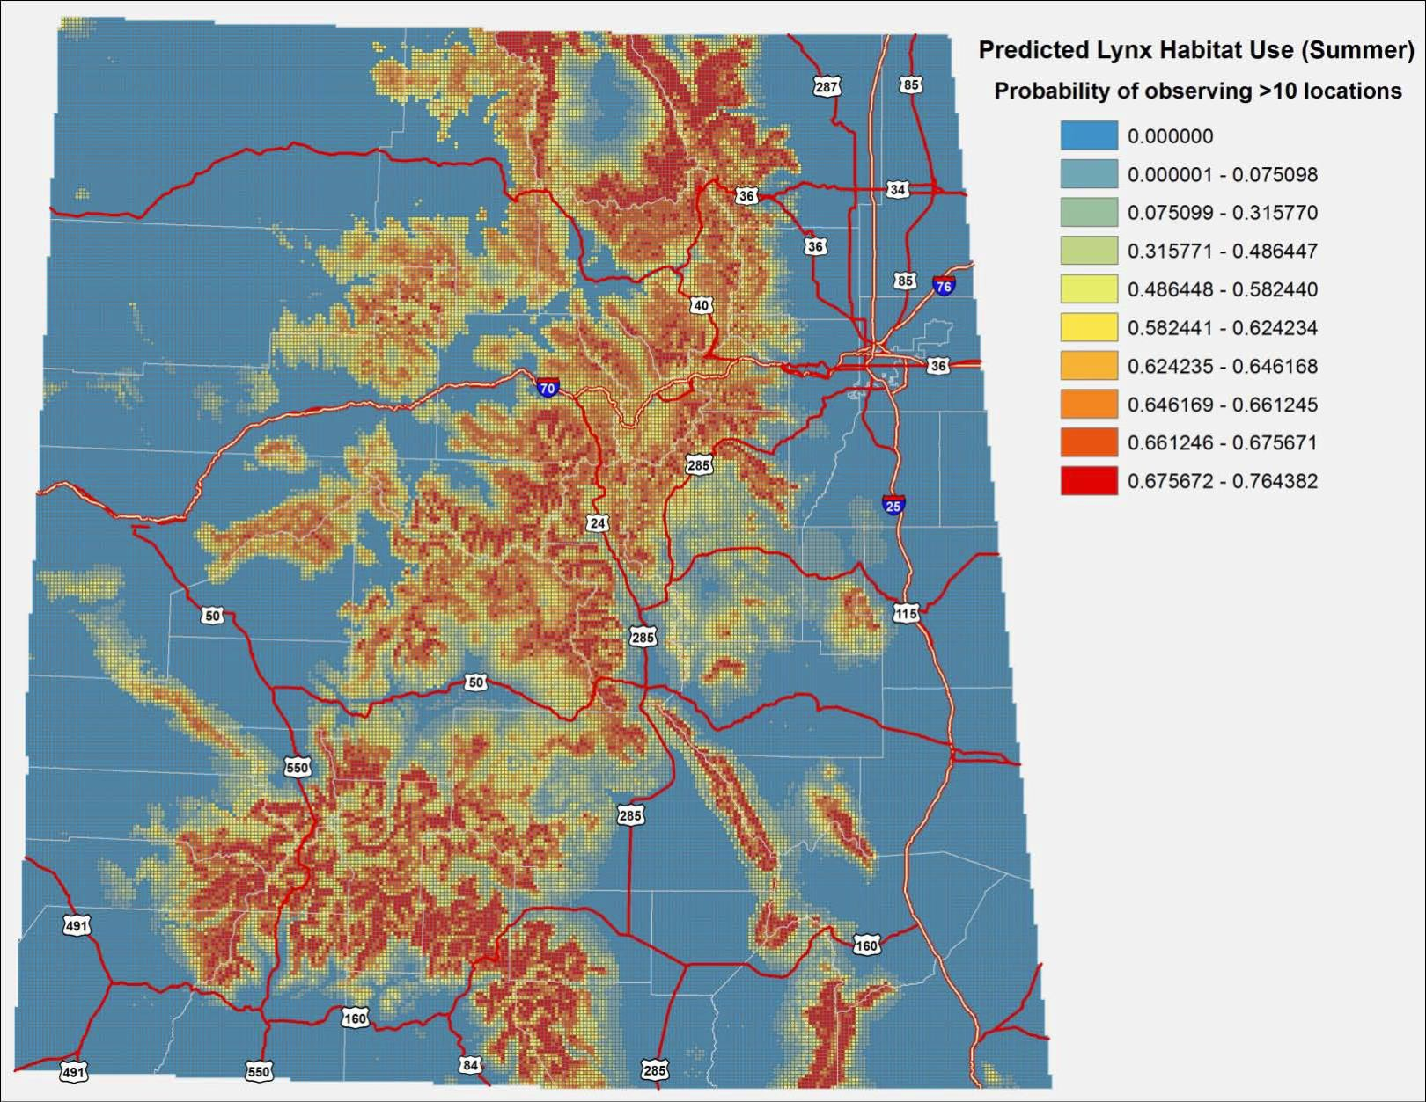
Figure 10. Predicted summer use by Canada lynx in western Colorado. (From Ivan et al Figure 3) 37

Figure 11 Regionally Significant Wildlife Corridor
Predicted Lynx Distribution in 2050s Using Climate Model

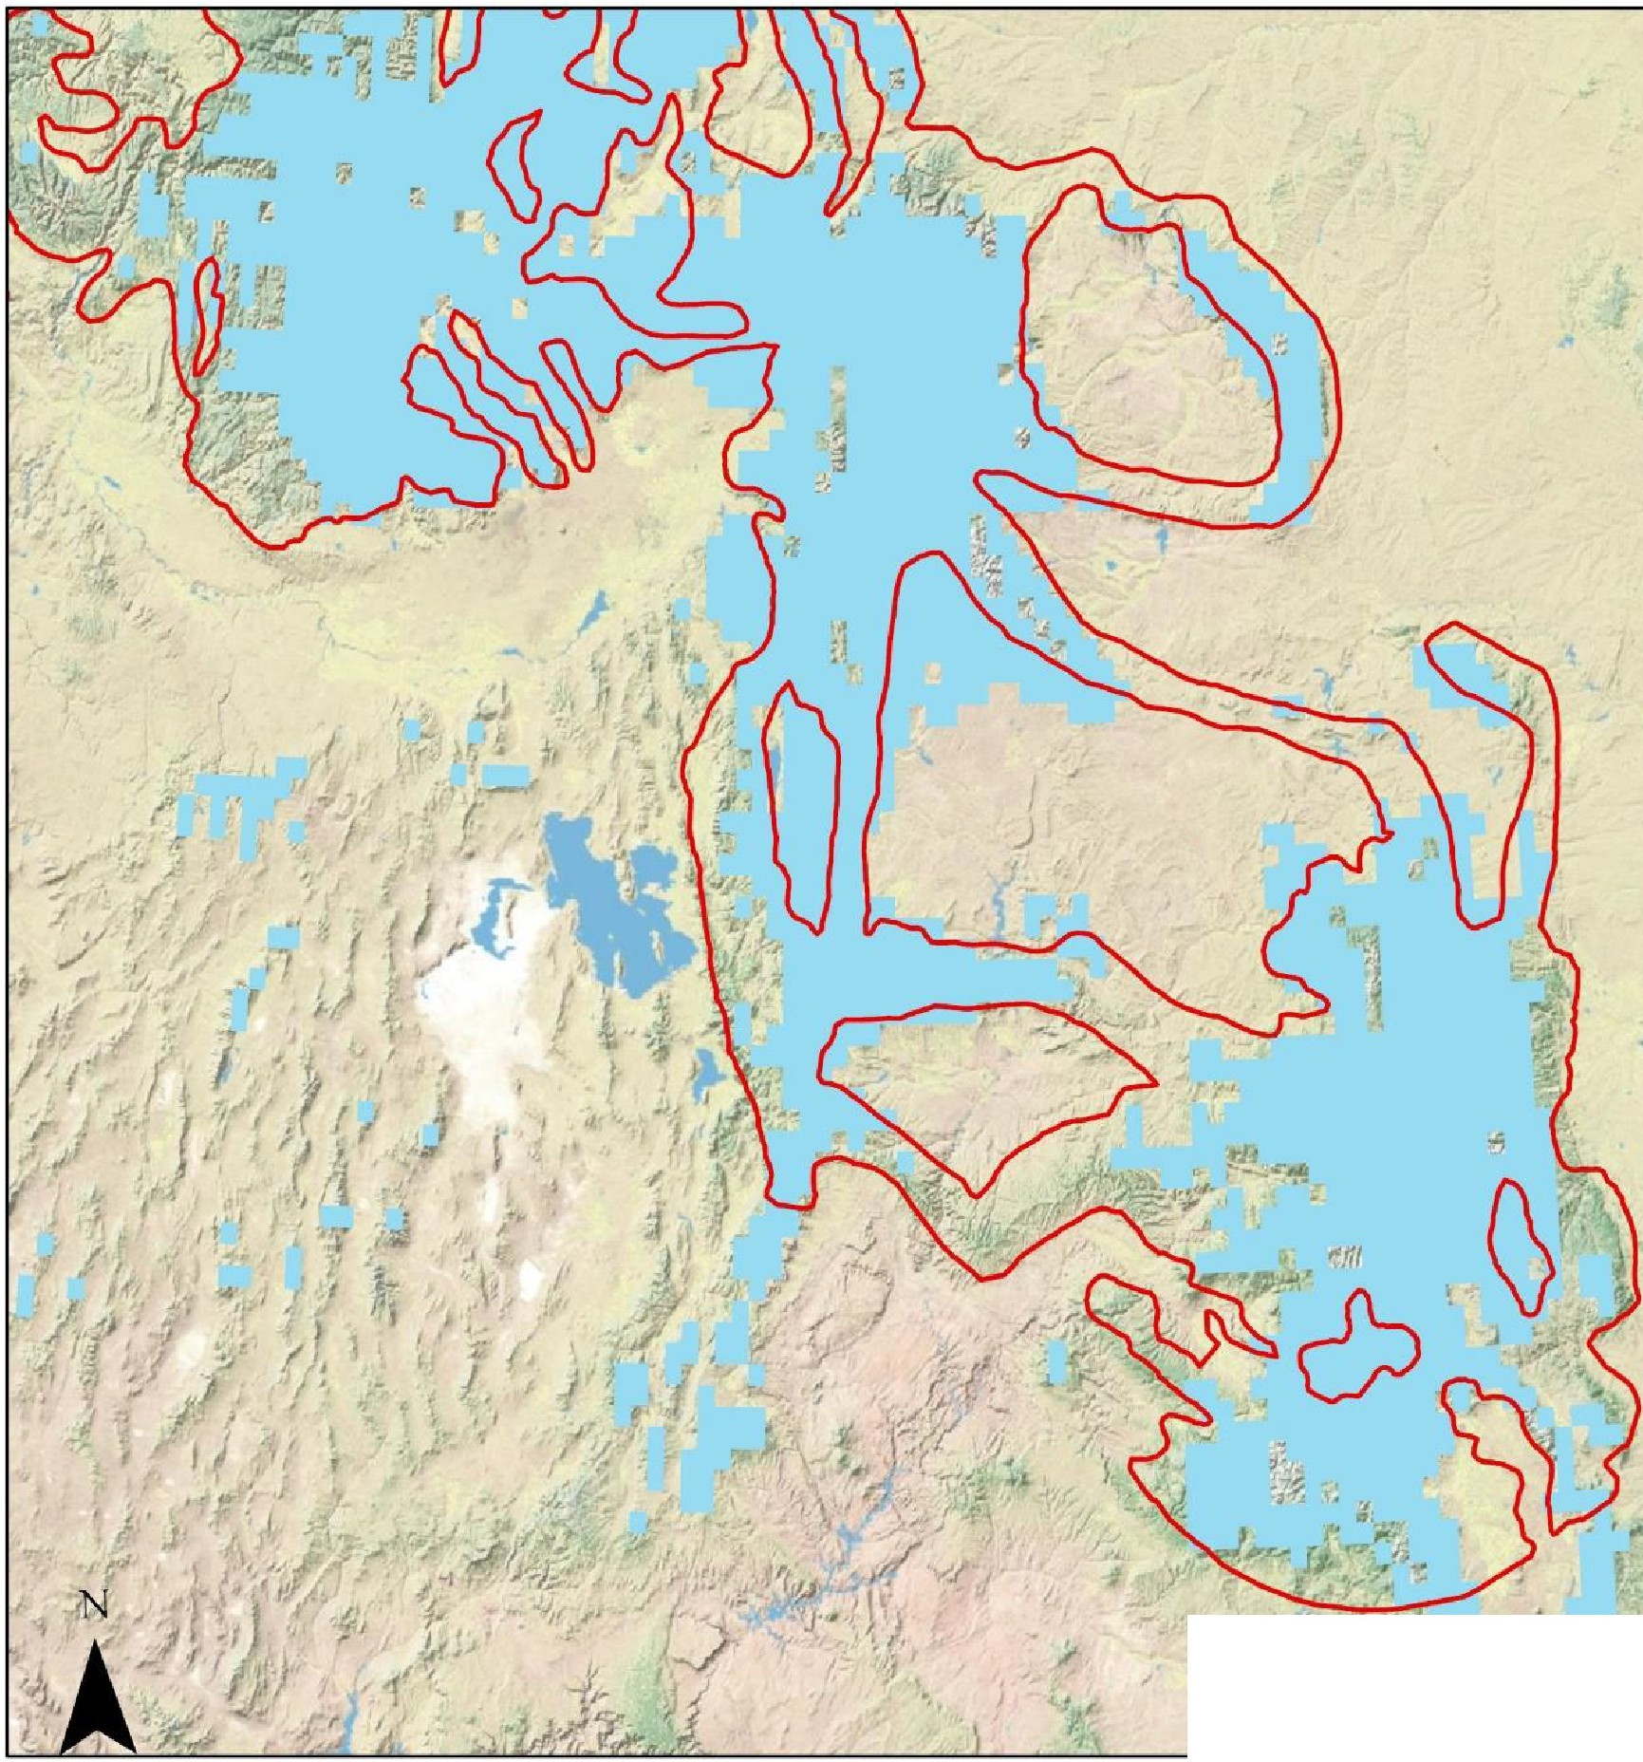
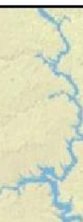
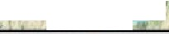
D Regional Corridor Predicted Lynx 2050
d
· . .,.,
Copyright:© 2d13 National Geographic Society, i-cubed
v I"
- ,.
- '

Regional Corridor - Referenced in USDA. 2003. Revised Forest Plan Wasatch-Cache NF.

https://www.fs.usda.gov/ detailfull/uwcnf/ landmanagement/planning/? cid=stelprdb5076923&width
=full

Predicted Lynx Distribution 2050

https://databasin.org/ datasets/3674ed71-f5b7-45a3- a778-dfc2f0990235/



0 75 150 300 Miles

PROVIDING FOR CANADA LYNX IN IDAHO, UTAH, WYOMING, AND COLORADO
These four states are those historically used or occupied by Canada lynx that do not border the Canadian Provinces (excluding northern Idaho) and the forested habitats where the larger populations of lynx have survived. Ensuring connectivity and habitat protection in these southern core and corridor areas that are disconnected from habitats in Canada is critical to maintain the isolated meta-populations in the south. The Colorado reintroductions show lynx can survive in this southern portion of the DPS, yet research and monitoring are lacking for these areas. The Science Report (SR p338) reported only seven studies with two of those being for bobcats. In the following, we just touch on a few parameters to place some degree of definition on lynx habitat, prey, and demographics for context to illustrate some of the quantitative parameters that need to be incorporated into agency requirements.

The Science Report Chapter 13 reviewed the ecology of lynx in these southern areas and compared them to the taiga in Canada. In both regions, lynx occurred where snowshoe hares were abundant. In the southern region, lynx were known to make exploratory movements prior to dispersal. The Colorado tracking data clearly illustrate these exploratory movements.
Habitats in the southern region are patchier and lynx make more use of alternate prey. For instance, lynx scats collected in north-central Washington contained 79% snowshoe hare and 24% red squirrel. (SR p376 - 377). Snow tracking studies in the southern Canadian Rocky Mountains found prey consisted of 52% snowshoe hare, 30% red squirrels, and the rest were flying squirrels, martens, voles, and grouse plus unknowns. Snowshoe hare densities were estimated to range from 0.01 - 0.47 hares/ha. (SR p377). “In southern boreal forests, limited data suggest that because snowshoe hares typically occur at low densities (Chapter 7), alternative prey may always be important components of lynx diets, especially in the western mountains.” (SR p378).

We previously referenced the association between lynx locations and habitat. The predominant association was with Rocky Mountain Conifer in these western interior states. Lynx use a variety of habitats and elevations between summer and winter. Generally, they use higher elevations in more southerly locations and between summer and winter. Most conifer types are included in areas used by lynx and can include Douglas-fir, western larch, lodgepole pine, subalpine fir, whitebark pine, and Engelmann spruce. Occasionally, they will occur in non- forested areas such as shrub-steppe. (SR p379). Snow tracking in Washington found that lynx traveled around meadows and used thinned stands that contained several hundred trees per ha. (SR p381).

Home ranges in these southern areas are larger than in the north. The average for males is 151 km² and females, 72 km². In west-central Wyoming they were smaller at 90 and 66 km². (SR p383 – 384). In Washington, home ranges were bounded by rivers, ridges, and major highways. (SR p385). Exploratory movements in Montana ranged from 17 to 38 km. (SR p386). Dispersal can take place over larger distances of several hundred km. (SR p386 -387). In the north-central Washington study, 8 kittens were documented in a population of 23 lynx during the three-year study. Estimates of total lynx density for the 1,161 km² area was 2.4 lynx/100 km². (SR p387). Comparisons are made to northern populations during the lows in hare cycles, indicating similar demographics occur in the southern populations compared to these lows. (SR p389).

Because lynx are highly dependent on snowshoe hares, we have looked for information on hare density in these southern states. Chapter 11 of the Science Report summarizes densities in Montana as well as the Wyoming Range. (SR p346). These ranged from 0.6/ha to 1.4/ha. Two studies cited from Utah gave densities ranging from lows in aspen with dense understory of 0.22/ha to 2.7/ha in spruce-fir habitat. Intermediate numbers occurred in Douglas-fir (0.57/ha and subalpine fir of 0.99/ha). These were estimated from pellet counts while the higher numbers from spruce-fir were from live trapping. Pellet plots in Colorado ranged from 0.26/ha in aspen, to 0.46 in Engelmann spruce. (p185).

These southern hare densities compare to population lows in areas of Canada with persistent lynx populations. For example, from the Science Report (SR p362), “Hare densities in the southwest Yukon declined from 8.0 to 10.7/ha to 0.2 to 0.5/ha during one cycle (Ward and Krebs 1985), and another population fell from 7.5/ha to 1.3/ha during the next cycle (Slough and Mowat 1996). Similarly, a population in the Northwest Territories fell from 7 to 9/ha to 0.4 to 1.0/ha during the early 1990s (Poole 1994), and a northern Alberta population declined drastically from about 17/ha to 0.34/ha during the early 1970s (Brand et al. 1976).” Apparently hare densities in these studies were sufficient to support lynx populations in the DPS, but the absence of recent hare studies leaves open the question as to the status and extent of current hare densities in the southern portion of the DPS. Whether snowshoe hares exist in sufficient numbers in these southern regions needs to be determined along with factors (deforestation, livestock grazing, predation, etc.) driving their population density.

A recent study looked at forest characteristics centered around lynx reproductive success.⁴⁸ Concerns were habitat fragmentation and loss of connectivity. In particular, the natural patchiness of lynx habitat at the southern extent of its range is “subject to loss and fragmentation by some forest management practices (i.e. regeneration harvests, pre-commercial and commercial thins, prescribed burns), wildfires and insect infestations, and climate change… .” (p2). There are data gaps on the abundance and arrangement of lynx habitat and how these relate to reproductive success. The research was conducted in the Swan, Mission, and Purcell Mountains in Montana and included low to mid-elevation ponderosa pine and Douglas-fir to high-elevation subalpine fir, spruce and lodgepole pine. (p3 - 4). Thirty - six female lynx were radio collared and monitored and produced 36 litters with an average of 2.46 kittens during the 14 year period 1998 – 2012. (p12 – 13). Mature forest was the dominant structure in core areas and home ranges with 49 and 50% of core and home ranges with young regenerating forest averaging 13 and 11% of core and home ranges, respectively. (p13). When the proportion of young regenerating forest reached 10 – 15% of the core area, the probability of producing a litter declines. (p14). Females with larger surviving litters “had less fragmented home ranges, lower moisture variance, young regenerating forest patches with low perimeter-area ratio, and lower percent composition of old regenerating forest than home ranges of females with smaller surviving litter sizes”. (p15). “…connectivity of mature forest, percent composition of young regenerating forest and young regenerating forest patches with low perimeter-area ratio, and adjacency of mature to young regenerating forest types were the most important predictors for overall lynx reproductive success in our study areas.” (p16).

⁴⁸Kosterman, Megan K., "Correlates of Canada Lynx Reproductive Success in Northwestern Montana" (2014). Theses, Dissertations, Professional Papers. Paper 4363.

The Northern Rockies Lynx Management Direction Record of Decision (NRLMD ROD) and its standards and guidelines provided no adequate standard for levels of mature forest habitat within LAUs and provided nothing for habitat not designated in LAUs. While it states that habitat connectivity will be maintained, there is no definition of what constitutes connected habitat, even though this can be defined by current science. The NRLMD ROD does not clearly define what qualifies as unsuitable lynx habitat, which is limited to no more than 30% of an LAU (VEG S1) with no more than 15% unsuitable habitat created in 10 years (VEG S2). The glossary at 12 also defines lynx habitat in an unsuitable condition as the stand initiation structural stage but notes that unsuitable habitat can also be created by shelterwood cuts and commercial thinning depending on the resulting stand composition and structure. The ROD at 9 defines lynx habitat in an unsuitable condition as those forests in a stand initiation structural stage that are too short to provide winter snowshoe hare habitat; these conditions are created by stand-replacing wildfires, prescribed burns that remove all vegetation, or regeneration timber harvest. The ROD at 10 states that the definition of VEG S2 was changed to clarify that it only applies to timber management practices that regenerate a forest, as clear-cut, seed tree, shelterwood, and group selection. The VEG S2 standard applies to all timber management projects that regenerate forests, including clear-cuts, seed tree, shelterwood and groups selective cuts. The NRLMD does not ensure persistence of lynx, since there are no restrictions on the amount of an LAU that can be converted to habitats that are avoided by lynx, and to habitats that reduce habitat connectivity via mature forests.

The 30% clear-cut standard for lynx habitat in the NRLMD is based on habitat recommendations published in 1989, while other key recommendations were ignored. Although these recommendations noted that monitoring was required to determine if they would be effective, we found no evidence such monitoring was ever done before they were partially included in the LCAS and the NRLMD. Currently, the best available science demonstrates that the 33% opening level allowed by these recommendations are invalid, while the unused recommendations of maintaining a high level of forest cover of 69% has been validated. The 1989 Brittell recommendations for lynx habitat defined a level of habitat connectivity for lynx, which included denning, travel, and stalking habitat as 66% of each square mile of lynx habitat, not an entire LAU of many square miles with no guidance as to where within that LAU habitat should be maintained.⁴⁹

While clear-cuts and sparse forests may receive some lynx use, their suitability for lynx is significantly reduced for a significant amount of time. It has been shown not only that those clear-cuts and sparse forest are strongly avoided by lynx but that restoration of lynx habitat use in these logging areas to 50% of previous use takes 20 years in forest thinnings, and 34-40 years for selection cuts and clear-cuts. Also, all logging treatments are avoided by lynx for at least 10 years.⁵⁰ Predictors for lynx reproductive success within occupied female home ranges were the connectivity of mature forest, intermediate (10 - 15%) amounts of young regenerating forest, young regenerating forest patches with low perimeter - area ratios, and the adjacency of mature

⁴⁹ Brittell, J.D., R.J. Poelker, S.J. Sweeney, G.M. Koehler. 1989. Native cats of Washington. Washington Department of Wildlife, Olympia.
⁵⁰ Holbrook, J.D., Squires, J.R., Bollenbacher, B., Graham, R., Olson, L.E., Hanvey, G., Jackson, S., Lawrence, R.L., 2018. Spatio-temporal responses of Canada lynx to silvicultural treatments within the Northern Rockies, U.S. For. Ecol. Manage. 422, 114–124.

forest to young regenerating types. Female lynx home ranges with greater than 50% mature forest and 10 - 15% young regenerating forest appear to be the optimum. ⁵¹

More recent work has characterized habitat quality of Canada lynx at their "range periphery".

Our results indicated that the probability of a female producing kittens was most associated with the connectivity of mature, multistoried forests (composed of mostly spruce-fir). However, the variation among female lynx accounted for
≈62% of the total variation explained in litter production, suggesting substantial individual-level variation. Thus, managers can contribute to increased reproductive success of female Canada lynx by facilitating the development of mature forests but measuring that success will be difficult given the individual variation. In core areas of high-quality females (i.e., produced kittens frequently), mature forest was 17% more abundant (i.e., ≈60% of the total core area), more connected, less clumpy, and exhibited 2.25-times larger patch sizes than the core areas of low-quality females. At the home-range extent, patterns were less pronounced while the abundance of mature forests remained high (≈50%) for high quality females. Additionally, we demonstrated that the relative density of snowshoe hares was ≥2.8 times higher in advanced regenerating forests compared to all other structural classes, including mature forest. Advanced regenerating forests accounted for ≈18–19% of the core area and home range of high-quality female lynx. Combined, our results suggest that a high-quality mosaic for female Canada lynx contains ≈50–60% mature forest and ≈18–19% advanced regenerating forest. Furthermore, we used Forest Inventory and Analysis data to characterize the approximate age distribution of advanced regeneration and mature forest, which was relevant for rotation schedules of forest silviculture. Results indicated that advanced regeneration was ≈20 to 80 years old while mature forest was ≈50 to ≥200 years old. ⁵²

In addition, lynx spend a significant amount of time at the interface between mature and advanced regeneration forest. This is likely because advanced regeneration forest provides the most hares, but mature forest habitat makes these hares more accessible. This indicates that advanced regeneration forest subsidizes the occurrence of hares in adjacent mature forest where they are more accessible to lynx.⁵³

What is lacking today is the inclusion of current knowledge of what is known about lynx, snowshoe hare, red squirrels and their habitats into quantitative criteria that define these

⁵¹ Kosterman, M.K. 2014. Correlates of Canada Lynx Reproductive Success in Northwestern Montana.Graduate Student Theses, Dissertations, & Professional Papers. 4363. https://scholarworks.umt.edu/etd/4363 Accessed on January 22, 2023.
⁵² Holbrook, J.D., Squires, J. R., Bollenbacher, B., Graham, R. O., Lucretia E., Hanvey, G., J, S., Lawrence, R.L., Savage, S. L. 2019. Management of forests and forest carnivores: Relating landscape mosaics to habitat quality of Canada lynx at their range periphery. Forest Ecology and Management. 437: 411-425. https://doi.org/10.1016/j.foreco.2019.01.011 Accessed on January 22, 2023.
⁵³ Holbrook, J.D., Squires, J.S., Olson, L.E., Lawrence, R.L., Savage, S., 2017. Multi-scale habitat relationships of snowshoe hares (Lepus americanus) in the mixed conifer landscape of the Northern Rockies, USA: cross-scale effects of horizontal cover with implications for forest management. Ecol. Evol. 7, 125–144.

habitats and their overlap in the southern DPS. The NRLMD and current Forest Plans are badly out of date and based on the omission of critical information. This is especially true in those areas not bordering the Canadian populations. While the Science Report has pointed out study and research needs, there has been a lack of definitive work in the southern-most states, particularly in SE Idaho, NE Utah, Colorado and the linkages or connections between these areas. Since these areas are heavily used by livestock as opposed to the situation further north, the effects of livestock on habitats important for cover and forage for snowshoe hares, and cover for lynx need to be determined. Also, the effects of over-snow travel, cross-country skiing, summer recreation and road density must be studied because the earlier data in the Science Report and the conclusions represented in the NRLMD, both LCAS, the 2017 SSA and the Remand Notice were based on earlier times in the absence of the levels of activity currently flooding throughout the western National Forests and BLM lands. We have regularly asked for data and maps of old growth forest residuals in these forests without success, apparently because these have not been developed. We have regularly asked for identification of the status of mined land reclamation, forest and vegetation manipulations, mapping of non-system roads and trails, temporary roads on National Forests without result.

It is in this vacuum of current data and information that the FWS must evaluate the status of Canada lynx in the DPS. Continuing to cast doubt on the historical presence of lynx in these southern areas cannot be used as a mechanism to reduce the area of potential lynx habitat, the habitat connections needed, or regulatory requirements. Instead, the current existing database and science must be applied to map and describe these areas of historical observations (not just verified records), their current habitat status and fragmentation by human uses as compared to what is known about the habitat needs of lynx. Studies and data collection need to happen to answer the questions and fill the data needs.

The criteria for identifying and managing LAUs needs to change to more specific, quantitative limitations on timber harvest, road density, mining, recreation use, perhaps using blocks of contiguous habitat and connections. Currently “unoccupied” or “peripheral” areas that had historical lynx observations must have potential lynx habitat mapped into LAUs, watershed areas, or blocks of habitat with definitive and quantitative criteria and standards reflecting what is known about lynx habitat. The parameters defining lynx habitat in places such as those studies we have cited in the contiguous states could be used to define current standards. Forest Plans and BLM Resource Management Plans must be amended with new standards to correct the current lack of regulatory requirements we have identified in our example of the Caribou NF. Corridors must be mapped and defined following the examples cited herein in which models have been used to identify lynx habitat, corridors, and connections. Those should have the same standards as occupied habitat.

Until these things are done, the Status Assessment for lynx must be that they are not only “threatened” in the western states DPS, but “endangered” and a recovery plan put in place to retain lynx in its historical habitat.

APPENDIX 1 -LIVESTOCK GRAZING STUDIES IN LINKAGE AND PERIPHERAL AREAS IN SE IDAHO AND NE UTAH BY DR. JOHN CARTER & ASSOCIATES

Since the late 1980s we have been engaged in collecting data on habitat in NE Utah and SE Idaho, particularly focused on the Bear River Range and Uinta Mountains. These are areas located in the linkage and peripheral habitat described for lynx in the CNF RFP and WCNF RFP. The 2013 LCAS (p68) stated that, “Federal agencies have amended or revised land management plans across much of the range of the lynx to provide direction to conserve lynx and lynx habitat. Thus, the impacts of anthropogenic influences have been substantially reduced.” The presumption is that putting it in a forest plan means it will be so. The data and observations we have made over the past four decades and even earlier as we have backpacked and explored the national forests in Idaho, Utah, and Wyoming refute that presumption. Following are descriptions of some of our reports and data showing that livestock grazing management in this linkage habitat is abysmal. Figure A1 shows the National Forests occurring in the high elevation Regionally Significant Wildlife Corridor,
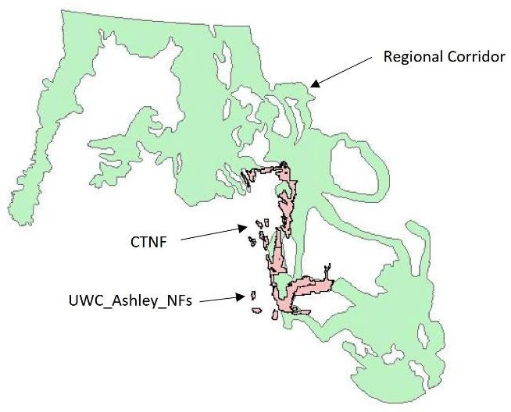
which are where much of this data and observations have occurred. This corresponds to the linkage habitat and peripheral habitat.

We completed a survey in the Caribou NF in 2001 with a report (Report) issued in 2002.¹. This study showed tremendous degradation of plant communities and riparian areas.
Monitoring in this and other areas in the Caribou and Targhee Zones and in NE Utah in the Uinta Wasatch Cache NF and Ashley NF since that time has shown no progress. When we measure use by livestock it is typically higher than sustainable levels and livestock are the base of the pyramid of damaging actions the Forest Service allows to continue. The photos in Figures A2-A6 below were taken during the 2001 survey and are from the Report. They show examples of the (a) impact

Figure A1. Forests in Which Livestock Grazing Studies Occurred

of livestock grazing and water developments on vegetation, soils and aspen understory and recruitment, (b) conifer understory, and (c) riparian areas. Photo links are provided in the referenced Report for all locations surveyed.

In preparing this survey, we relied on Forest Service monitoring reports, the Draft EIS for the Revised Caribou Forest Plan² and literature characterizing livestock impacts on upland and riparian habitats. In the late 1990's, the Forest Service had prepared Regional and Sub-Regional

¹ Carter, J., Chard,B. and J. Chard. 2002. Assessment of Habitat Conditions Bear River Range Caribou National Forest, Idaho. https://app.box.com/shared/5q2hazcnfu
² USDA. 2001. Draft Environmental Impact Statement for the Caribou National Forest Revised Forest Plan Draft Revised Forest Plan. Caribou-Targhee National Forest.

Reports characterizing departures from Proper Functioning Condition (PFC) for aspen, conifer, tall forb, sagebrush/grasslands, riparian, and wetland areas. They found livestock grazing and past timber harvest in conifer forest were fundamental issues leading to loss of PFC in these communities.³ ⁴ Our Report (p18) described the structure and compositional characteristics of these habitats needed for PFC.

We assessed 86 locations for PFC in the Bear River Range including uplands, riparian areas, open basins/meadows, aspen and conifer stands. These were within one mile of water sources in areas considered "capable" for livestock based on slope and distance to water. Mapping analysis predetermined the locations at which we surveyed each habitat type present. We compared observable conditions to the Caribou RFP Draft EIS PFC guidelines. Table A1 below is reproduced from the Report and shows the number of locations of each habitat type assessed. A total of 310 individual habitats were assessed. As shown, a small percentage met the Forest Service guidelines for PFC, most did not.
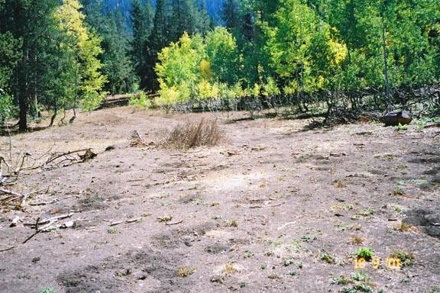
Figure A2. Sheep watering and bedding area showing complete loss of understory, loss of aspen recruitment and high-lined aspen. The soil is completely exposed. Sheep are bedded in a different location each day throughout the season, leading to widespread damage that is not documented by the Forest Service.

³ USDA. 1996. Intermountain Regional Assessment: Properly Functioning Condition. USDA Forest Service, Region IV, Ogden, Utah.
⁴ USDA. 1998b. Draft Sub-regional Assessment of Properly Functioning Condition for Areas Encompassing the National Forests of Northern Utah. USDA Forest Service, Region IV, Ogden, Utah

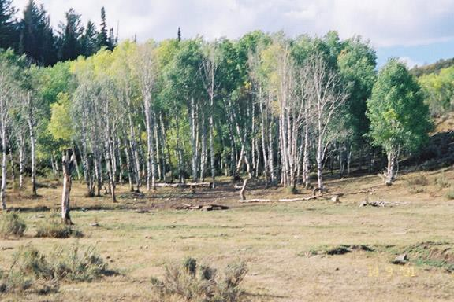

Figure A3. Aspen stand in valley bottom. Cattle have denuded the area, browsed suckers and essentially created a single aged stand that will die out unless livestock are excluded and recruitment allowed to occur. No understory cover or herbaceous vegetation is left.

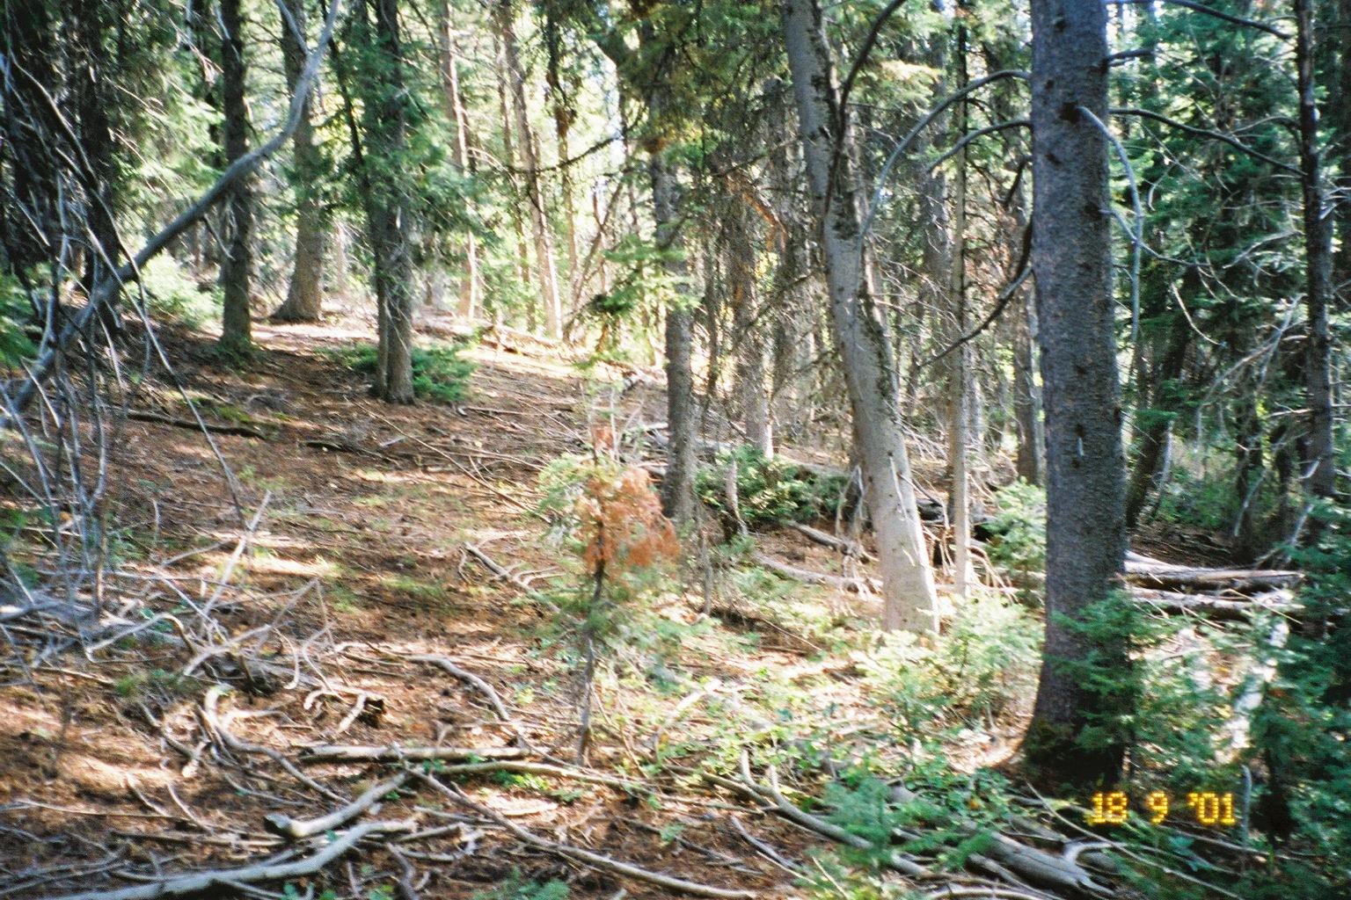
Figure A4. Grazed conifer stand with little herbaceous vegetation present
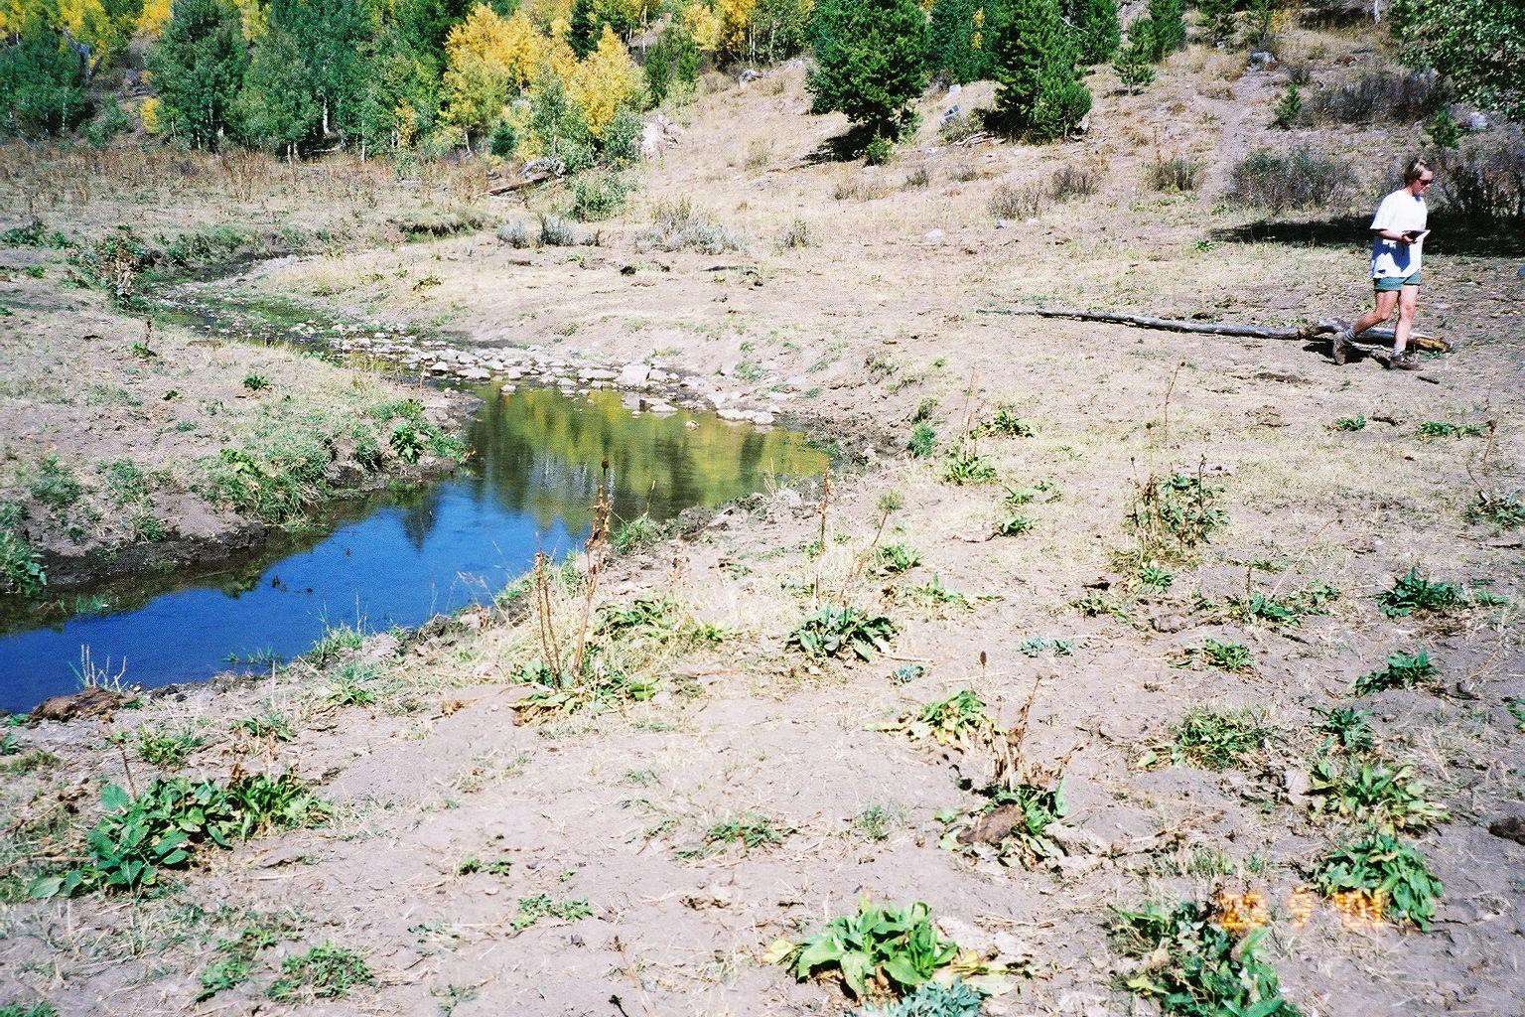
Figure A5. Grazed riparian area with barren banks, little vegetation left in riparian zone

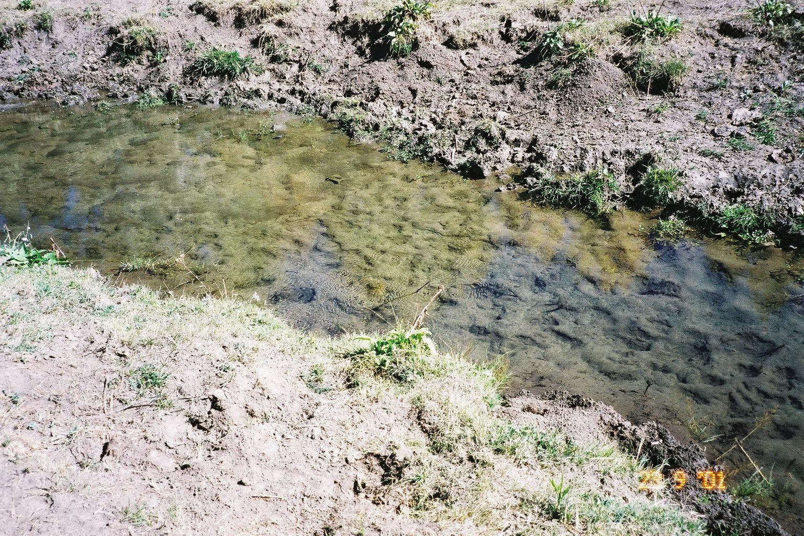

Figure A6. Sediment-laden stream substrate from trampled and eroding banks, adjacent roads

Table A1. Results of Bear River Range PFC Assessments
Habitat type | Number of locations | Number in PFC | Percent in PFC
Aspen forest | 71 | 17 | 24%
Conifer forest | 68 | 14 | 21%
Forb meadow | 44 | 2 | 4.5%
Sage – grass | 73 | 8 | 11%
Riparian | 54 | 12 | 22%

We measured ground and canopy cover along transects at 55 locations in sagebrush-grassland and tall forb habitats. Tables A2 and A3 below are reproduced from that report. Bare soil averages above 50% show ground cover is well below potential. These averages included some ungrazed exclosures, which if omitted from the analysis, would have resulted in even lower soil cover values. The Sub-Regional Assessment by the Forest Service indicated ground cover potential ranges between 80 - 95%. In our surveys of un-grazed areas in the Bear River Range and on Kiesha's Preserve, potential ground cover is near 100% in all habitats. See our Kiesha's Preserve website for photographs of these ungrazed conditions.

Table A2. Cover Data for 45 Sagebrush Locations
Cover type | Range | Average | Standard Deviation
Bare Ground | 86.2 – 10.7 | 51.6 | 19.0
Litter | 68.2 – 2.0 | 31.5 | 15.2
Grass | 23.2 – 0.3 | 5.1 | 5.3
Forb | 14.7 – 0.5 | 4.5 | 3.4
Shrub | 16.7 – 0 | 4.7 | 3.6
Rock | 11.9 – 0 | 2.2 | 2.8
Crust/moss | 10.4 – 0 | 0.4 | 1.6
Shrub Canopy | 43.0 - 0 | 12.4 | 9.0

Table A3. Cover Data for 10 Locations in Tall Forb
Cover type | Range | Average | Standard Deviation
Bare Ground | 78.8 – 5.5 | 54.1 | 22.6
Litter | 55.0 – 4.9 | 24.2 | 15.5
Grass | 16.5 – 1.0 | 6.0 | 5.6
Forb | 21.1 – 2.8 | 11.6 | 5.2
Shrub | 10.3 - 0 | 3.0 | 3.4
Rock | 3.6 - 0 | 0.8 | 1.2
Crust/moss | 1.9 - 0 | 0.3 | 0.6

Data collected in this 2001 study as well as other surveys we have conducted in the area demonstrate that all Forest habitats grazed by livestock are well below potential. Compared to the Draft Caribou RFP EIS and other PFC manuals for Riparian Areas the best we could say is they are functioning at risk with many in non-functioning condition

We have measured utilization by livestock in numerous locations in the Bear River Range and adjacent public lands such as BLM. Compared to Forest Plan or BLM land use plan standards allowing 30 – 50% use in upland and riparian areas, universally we find utilization in riparian areas and meadows near 100% and in uplands 70 – 80%. A summary of studies is listed:

- Unpublished data for Bear River Range riparian areas (12) using paired plots found utilization rates averaging 81%.⁵

5 Carter, J. 2009. Unpublished utilization data for Riparian Areas in the Bear River Range.

- 2011 Monitoring Report 1st Hollows and Paris Canyon Allotments.⁶ I found utilization ranges from 75 – 92% in meadows, riparian area use was 63 and 82.6% at two locations monitored, upland low sagebrush sites ranged from 49 to 69%, and upland big sagebrush sites ranged from 85 to 88%.
- Multiyear study in the Bear River Range in northern Utah looked at livestock grazing effects on plant production, soil nitrogen and carbon.⁷ That study documented losses in plant cover, plant production, soil carbon and nitrogen in areas grazed by livestock compared to long term ungrazed areas.
- Summary of utilization data for riparian areas on the North Rich Allotment in the Bear River Range.⁸ Over a four-year period these remained nearly constant at 83 – 93%.
- A multiyear study on a BLM managed allotment (Duck Creek) in the lower elevation foothills adjacent to the Bear River Range in Utah. We evaluated government monitoring by collecting data on grazed and ungrazed paired plots and critiqued the government monitoring effort. We found the BLM understated utilization and native plant production was greatly reduced by decades of improper management.⁹
- A paper illustrating upland and riparian outcomes from BLM management of the Duck Creek allotment showed the installation of upland water and a deferred rotation grazing system resulted in increased use on the riparian greenline, bank alteration by trampling remained at 80%, riparian utilization remained near 100%, and upland utilization increased to near 80%.¹⁰
- A report summarizing multiple years of data collection in the High Uintas Wilderness.¹¹ This study documented depleted alpine ground cover in grazed areas compared to those that had been excluded from sheep grazing for decades. Grazed areas had over 50% bare soil compared to 0.2% in long term rested areas. Streambanks were scoured by high runoff events due to loss of stabilizing vegetation in the watershed and stream banks. Most of the soils in the allotment are considered as high to extremely high in erosion potential, resulting in loss of the productive upper horizon.
- A paper on livestock grazing impacts in the High Uintas Wilderness which is in designated LAUs and Peripheral habitat.¹² While all lands in this 160,000 acre set of domestic sheep allotments are grazed by domestic sheep, we determined that only a small fraction of the area

⁶ Carter, J. 2012. 2011 Monitoring Report 1st Hollows and Paris Canyon Allotments. Report prepared for Western Watersheds Project and Yellowstone to Uintas Connection. Dated March 1,2012.
⁷ Carter, J., Chard, B., and Chard, J. 2011. Moderating livestock grazing effects on plant productivity, nitrogen and carbon storage. In Monaco, T.A. et al. comps. 2011. Proceedings – Threats to Shrubland Ecosystem Integrity; 2010 May 18-20; Logan, UT. Natural Resources and Environmental Issues, Volume XVII. S.J. and Jessie E. Quinney Natural Resources Research Library, Logan Utah, USA.
⁸ Carter, J. 2009. Allotment Summary North Rich Allotment Riparian Areas.
⁹ Catlin, J., Carter, J., and Jones, A. 2011. Range management in the face of climate change. In Monaco, T.A. et al. comps. 2011. Proceedings – Threats to Shrubland Ecosystem Integrity; 2010 May 18-20; Logan, UT. Natural Resources and Environmental Issues, Volume XVII. S.J. and Jessie E. Quinney Natural Resources Research Library,
Logan Utah, USA.
¹⁰ Carter, J., Catlin, J., Hurwitz, N., Jones, A., and Ratner, J. 2017. Upland water and deferred rotation effects on cattle use in riparian and upland areas. Rangelands 39(4):112-118.
¹¹ Carter, J. 2006. Watershed Conditions Uinta’s Wilderness, Utah. Report for Western Watersheds Project. https://app.box.com/s/944957604b8618539585 Accessed on January 21, 2023.
¹² Carter, J., Vasquez, E. and Jones, A. (2020) Spatial Analysis of Livestock Grazing and Forest Service Management in the High Uintas Wilderness, Utah. Journal of Geographic Information System, 12, 45-69. https://doi.org/10.4236/jgis.2020.122003

(6%) is capable for grazing when we applied the Forest Service criteria for determining capable acres. The current forage on the allotments provides only 10% of the demand. The result of this is accelerated erosion, sedimentation of lakes and streams, depletion of the native plant community to below its potential. Based on the two scenarios we evaluated, the stocking rate would need to be reduced between 90 – 97%.

There were other surveys and reports with data provided to the Forest Service and BLM. No management changes have resulted from this input now decades after we first began monitoring and submitting data to the agencies. The habitats are depleted of the forage and horizontal cover needed by snowshoe hares and other wildlife. The Desired Future Conditions and Standards provided in the Forest Plans for these places have resulted in no positive change. Yet, the FWS and Forest Service claim that provisions in Forest Plans protect lynx habitat.

