February 15, 2024

CanadaLynxRPComments@fws.gov jim_zelenak@fws.gov
Re: Supplemental Comments on the Draft Recovery Plan (DRP) for the Contiguous United States Distinct Population Segment of Canada lynx (Lynx canadensis)
=============================================
These comments supplementing our January 29 2024 comments are submitted on behalf of Yellowstone to Uintas Connection (Y2U), Alliance for the Wild Rockies, Conservation Congress, Council on Wildlife and Fish, Gallatin Wildlife Association, Native
Ecosystems Council, Sage Steppe Wild, and Swan View Coalition.

The purpose of these comments is to call attention to the extremely narrow focus of the SSA Appendix and Draft Recovery Plan and designated SSA 5 Focal Unit (FU) and SSA 5 Focal Area (FA). These omit large areas of suitable modeled lynx habitat in Central
and SE Idaho, Southwestern Montana, and Western Wyoming. It is our contention that the boundaries for the FU and FA are arbitrarily drawn and thereby eliminate
consideration of habitat and linkages (current and potential) occurring in these wider areas. We have used the Olson et al 2021 Model for this analysis.1 The Olson Model was relied upon for the FWS analysis and conclusions in the Draft Recovery Plan. We critiqued its application in our prior comments.

The Olson et al 2021 paper described the habitat model output in this way:

Our best-performing SDM generated predictions consistent with known lynx habitat use (Mckelvey, 2000), with Canada lynx patchily distributed in mountainous areas throughout the Pacific Northwest and the Greater Yellowstone Area (see Figure 8 for details).
Categorical predictions created by 90% and 85% threshold values when applied to the “WA Equal” model delineated the location of habitat most likely to be selected by lynx in a reproductive popula- tion (“high” probability habitat) and habitat that was less favorable
but potentially still used by lynx (“moderate” probability habitat), par- ticularly for connectivity or as part of a matrix with “high” and “low” probability habitat (Figure 8).

1 Olson et al. 2021. Improved prediction of Canada lynx distribution through regional model transferability and data efficiency. Ecology and Evolution 11:1667 – 1690.

We have reproduced the Olson Model Figure 8 below as Figure 1 for these comments. Figure 2 illustrates the extent of the Olson Model output we received. It is overlain with state boundaries and lynx linkage as agreed upon by the Forest Service and Fish and Wildlife Service. 2
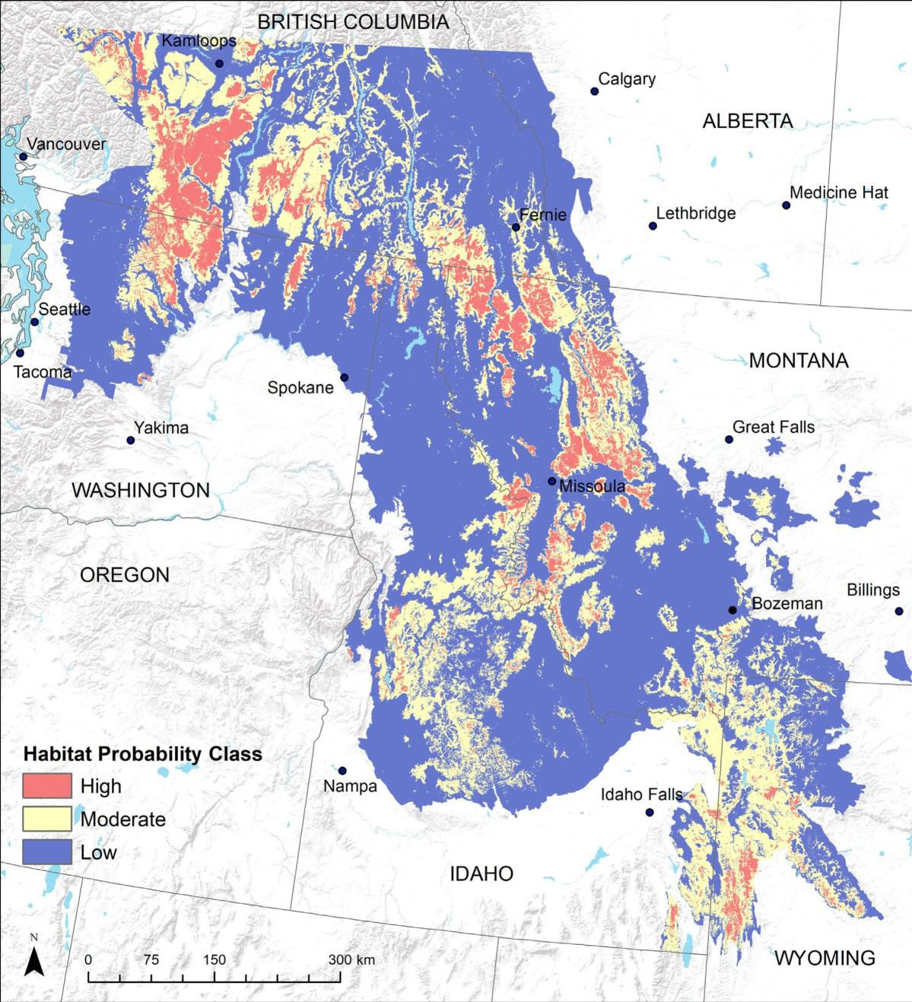

Figure 1. Lynx Habitat Probability Model Output. (Olson et al 2021 Figure 8).

2 USDA Forest Service. 2003. Canada Lynx Linkage Areasfor Northern Rockies Lynx Amendment Area. https://databasin.org/datasets/1546114c118f47b3963ed7af156efb55/ Accessed February 9, 2024.

Figure 2

Olson et al 2021 Habitat Probability, Linkage
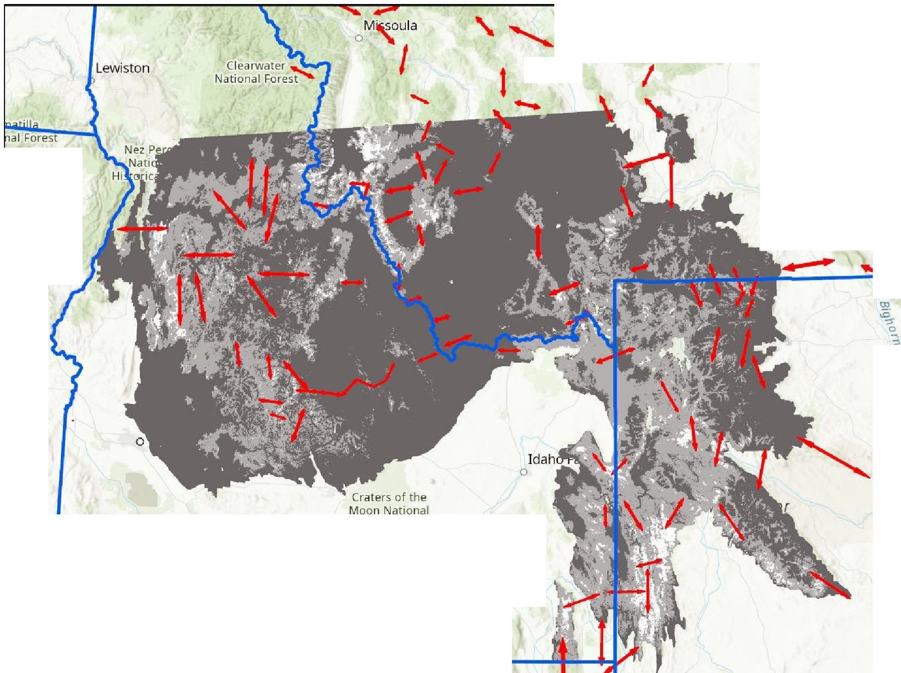
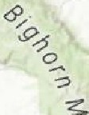

Central and Eastern Idaho, SW Montana, and Western Wyoming
0
----._
-Montana

Ye11aw;to0•
Billings
0
Blue ountains
- ;
0
C
Preserve
Wyoming
0
Pocatello
0
Twin Falls
0
Lo an
0
Helena
Ogden
Hill Air Force
Base
Great Salt
Lake Desert
Grear
Salt
Lake
0
Rock Springs
-• ,.,...,..,. , ,
Land M-IIJ r
Forest
, , ureau o
WS, Esri, CGIAR, USGS
Humboldt
NationalJForest
Co
Sal
O

0
Elko

Legend
RegModVeg908S_GYA.tif
Value
1.001- 1
1.001 - 2
2.001- 3
- Canada Lynx Linkage
c:J cb_2018_us_state_Sm

N
A

0 50 100 200 Miles
3

As can be seen in Figures 1 and 2, there are large areas of High and Moderate probability habitat predicted in Central and SE Idaho, Western Wyoming, and
Southwestern Montana. The lynx linkages in Figure 2 also illustrate the importance of addressing these to maintain connectivity. The majority of this entire region is omitted from analysis and discussion in the Draft Recovery Plan or its SSA Appendix.
We obtained the Olson Model output for what they delineated for the Greater
Yellowstone Area.3 Using ArcGIS Pro 3.2 we overlaid various land management units (National Parks, National Forests, Ranger Districts, the Critical Habitat, SSA Focal Unit and Focal Area for the GYA) and summarized the habitat probability levels (1, 2, or 3)
from the Olson Model that were contained within the bounds of each land management unit. In these comments, we refer to Category 1 which corresponds to the Low habitat probability, Category 2 to the Moderate habitat probability, and Category 3 to the High habitat probability. The Summarize Categorical Raster function in ArcGIS Pro was
used. The TIFF image resolution was determined by ArcGIS Pro to be 250 meters x 250 meters, resulting in a pixel equating to 15.625 acres. Pixel counts for each Category were totaled and converted to acres.
The analysis in our prior comments (January 29, 2024) focused on the National Forests and National Parks in what we determined to be the Greater Yellowstone Ecosystem delineated by the National Park Service. This included Yellowstone National Park, Grand Teton National Park, Beaverhead-Deerlodge NF, Bridger-Teton NF, Caribou- Targhee NF, Custer-Gallatin National Forest, and the Shoshone NF. These comprised over 16 million acres with approximately 9.1 million forested acres. Those were underestimates as explained in those comments. 4

The Olson Model GYA file we received included those areas and in addition, all or parts of the Bitterroot NF, Boise NF, Nez Perce NF, Payette NF, Salmon-Challis NF, and the Sawtooth NF. (Figure 3). We summarized the areas of these within the bounds of the Olson GYA Model. (Table 1 – all tables are at the end). The total area is 30,888,094
acres of which the moderate and high probability classes are 14,632,406 acres, or 47%. Table 2 provides the acreage of Lynx Critical Habitat, SSA 5 Focal Unit and SSA 5 Focal Area. Critical habitat is 19% of the total area of National Forest and Park acreage, SSA 5 FU is 24% and SSA 5 FA is 2.3%. To visualize the relative importance of these land management units to the designated CH, FU, and FA, these are charted in Figure 4.
Category 2 and 3, or Moderate and High probability habitats are combined to represent available or potential habitat and connections.

3 Filename = RegModVeg9085_GYA.tif
4 See Figure 2 of our January 29, 2024 comments, page 6 - 8.
4

ue
rains

1' Lewiston-
0

St. Joe National
!=□rest
Figure 3
National Forests and National Parks Within
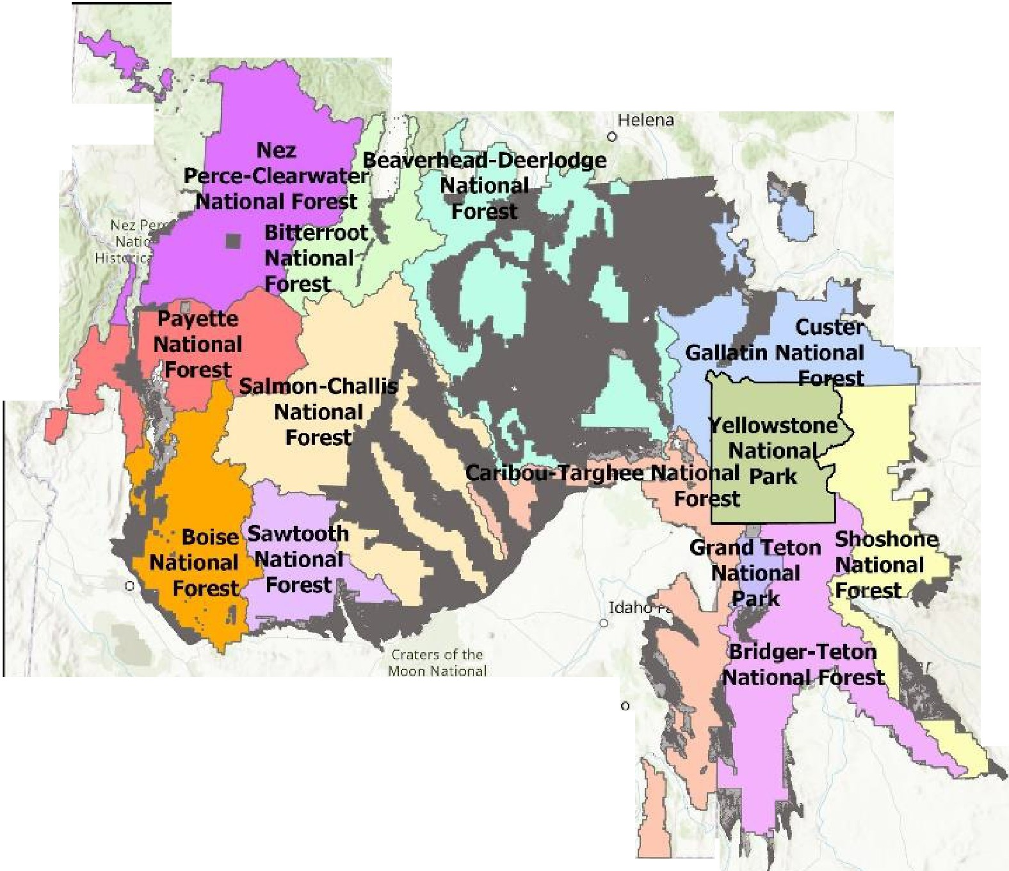
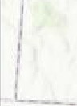
Olson GYA Model Area

Montana
Missoula
0

Billings
0
Ye11ow.;1on<2-

Legend
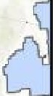
RegModVeg9085_GYA.tif Value
- 1.001-1
- 1.001-2
2.001- 3
GTNP
D
YNP

D
FORESTNAME

Twin Falls
0

Preserve

0t:r
0
-9
':is.,.,
s-
o
C
:;>
..-+
"'
:,
"'

Wyoming
D Beaverhead-Deerlodge National Forest
D Bridger-Teton National
Forest
CJ Caribou-Targhee
National Forest
D Custer Gallatin National
Forest
D Shoshone National
Forest
- <all other values>
Boise NF
- NezPerce Clearwater
NF
t - Payette NF
0 Salmon Challis NF
D Sawtooth NF
D Bitteroot NF

Humboldt
National Forest
D ··· I'
, Logan I
'.q
'
I
' 0 'I
I
I

Rock Springs N
0 A

N

Elko
0

Hill Air Force Bs1 e
Great Salt

Grear Sale lake
: Me_d
0 Ogde r,, To Tom, Garmin, FAO, NOAA, USG$, Bweau of Land Management. EPA,Nat,
1 NPS, USFWS, Esri, CGIAR, USGS
I - -
'-----------

0 50 100 200 Miles

5

Percent

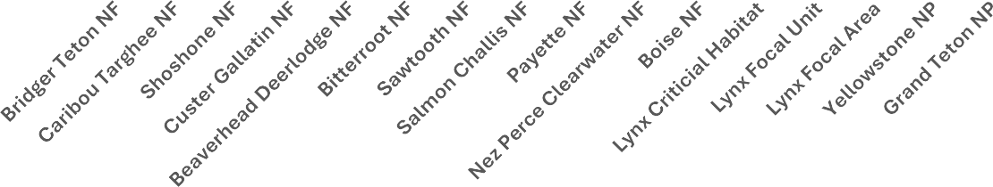
National Forests exceeding the combined Category 2 and 3 probability of the FU include the Bridger-Teton, Caribou-Targhee, and Bitterroot, with the Sawtooth at a similar amount as the FU. Yellowstone National Park exceeded the FU, while Grand Teton NP was similar. Lynx Critical Habitat combined Category 2 and 3 probability was exceeded in the Bridger-Teton, Caribou-Targhee, Bitterroot NFs with the Sawtooth being similar. Yellowstone NP was slightly below the CH in combined probability. The FA is very narrowly drawn, and no large land management unit (National Forest or Park) is at that level, although the entire Bridger-Teton NF and Caribou-Targhee NF exceed all others in approaching that high threshold. The tabulation of the habitat probabilities is provided in Table 3.
Figure 4. High + Moderate Habitat Probability
120.0%
100.0%
80.0%
60.0%
40.0%
20.0%
0.0%

Management Unit
Given the Bridger-Teton and Caribou-Targhee NFs are higher than others at the major land management unit level, we looked at smaller land management units (Ranger Districts) within those NFs. Figure 5 illustrates the RDs for these NFs and also the FU and FA. The BTNF contains most of the FU outside Yellowstone and Grand Teton NPs with a small area in the Shoshone NF. We summarized the areas of these RDs, the CH, FU, and FA to provide
comparisons in Tables 4 and 5 and Figures 5 and 6.

6

Figure 5
Ranger Districts within
Bridger-Teton and Caribou Targhee National Forests

Cody
a

Legend
RegModVeg9085_GYA.tif
Value
1.001- 1
1.001- 2
2.001- 3
Lynx2023SSA_GYA_Foca1Ar Lynx2023SSA_GYA_FU

0

Fon Hall Reserva(ion ,rnd Off-Res Natton Trust Lar1d

Pocatello

Resen.iati
Off-Rese Trust L'
BTNF_KemmererRD D BTNF_GreysRiverRD D BTNF_BlackRocksRD D BTNF_JacksonRD
D BTNF_PinedaleRD
D CTNF_SodaSpringsRD CTNF_MontpelierRD
D CTNF_AshtonislandParkRD
D CTNF_TetonBasinRD D CTNF_PalisadesRD D CTNF_DuboisRD

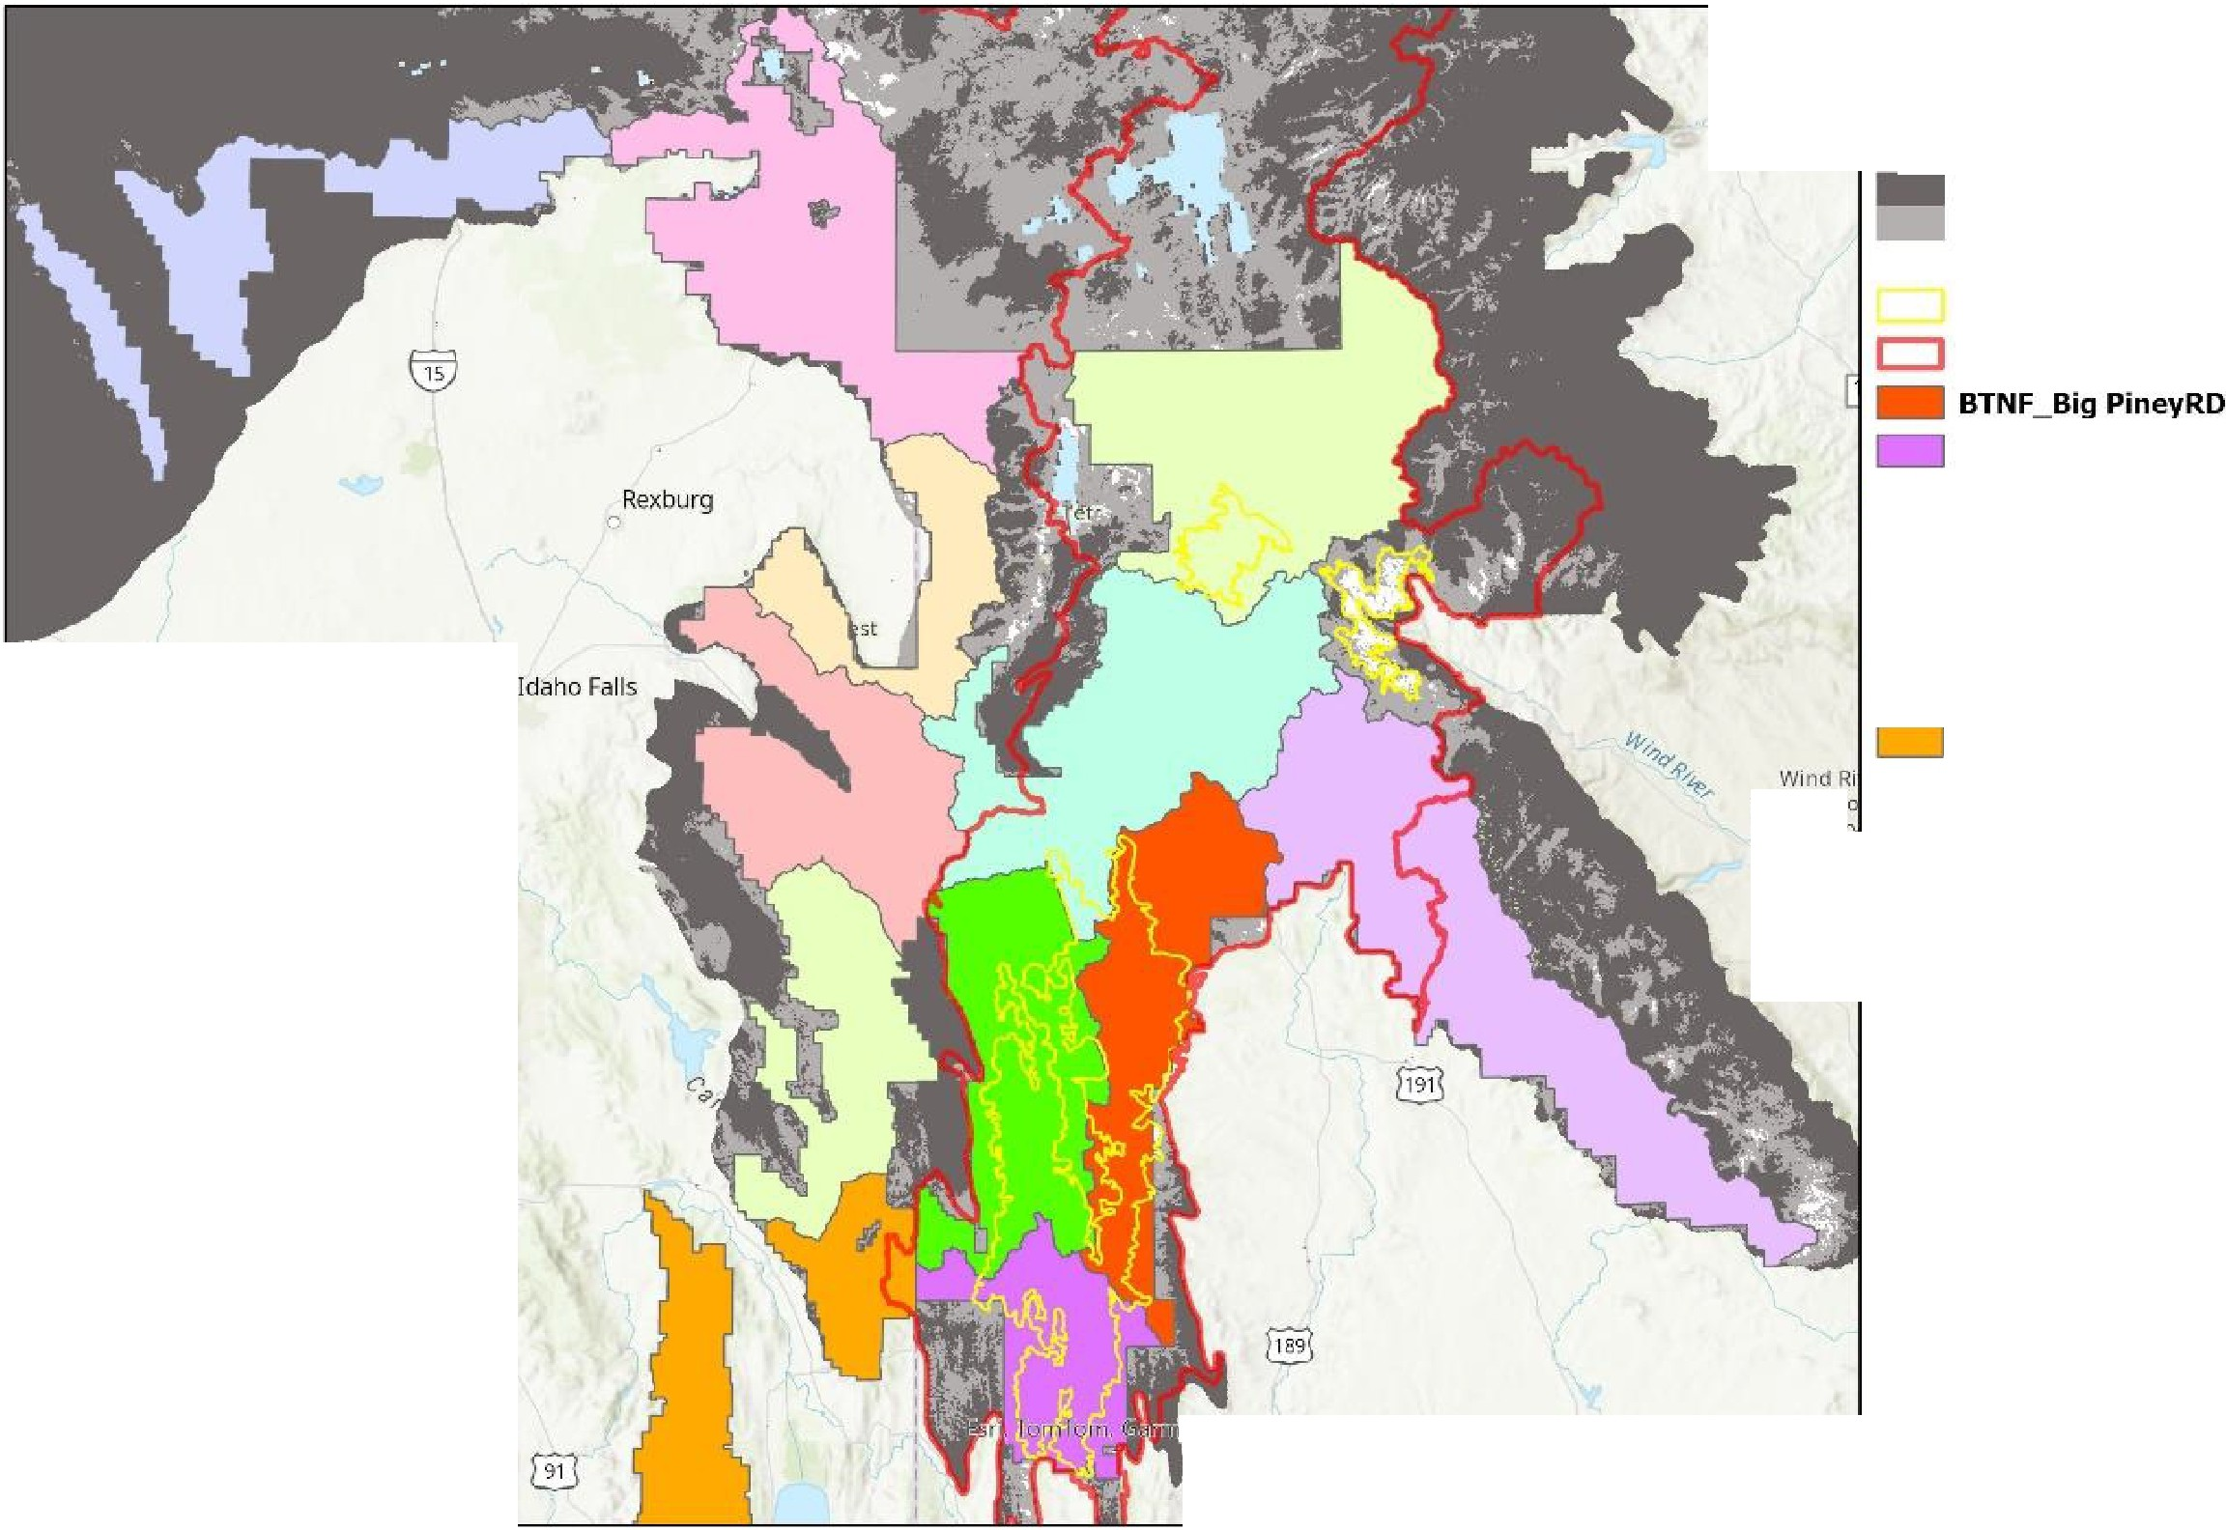
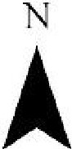
0

N
in, FAO, NOAA, USGS, Bureau of Land Management. EPA,
NPS, us Esri, CGIAR, USGS

0 20 40 80 Miles

7

Percent

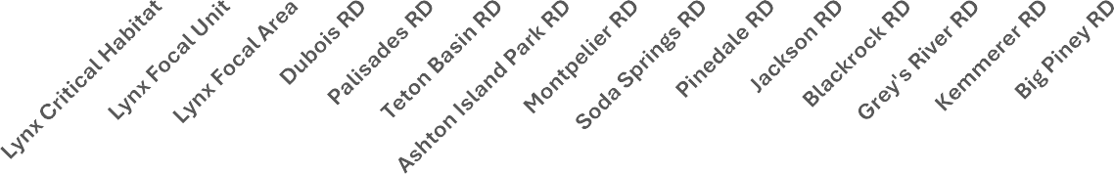
Table 4 provides the total acreage in these RDs of 6.2 million acres. Category 2 and 3 acreage within these RDs totals 4,623,531 acres, or overall, 74.8% moderate and high probability habitat. Table 5 breaks down the percentage of these for each RD and Lynx CH, FU, and FA. Figure 6 provides a side-by-side comparison. None of the RDs reach the high of the FA, but 8 of them are at 80% or higher. Eleven RDs are higher than the CH, and 11 also exceed the FU.
Figure 6. High + Moderate Habitat Probability
120.0%

100.0%

80.0%

60.0%

40.0%

20.0%

0.0%

Management Unit
We ranked the land management units by percent Category 2 + Category 3. Table 6 provides the summary and rankings for the major land management units such as Parks or National
Forests. The BTNF, CTNF, Bitterroot NF and YNP all exceed the FU in percent high and
moderate habitat probability. Some of the NFs that were below the FU still have large areas of the high and moderate habitat probability categories. An example is the Beaverhead-Deerlodge NF, which is 45.7%, but contains 1.4 million acres of these higher probability habitats. These are large patches of habitat separated by the lower probability habitat, but which Olson et al also describe as potential connections, “particularly for connectivity or as part of a matrix with ‘high’ and ‘low’ probability habitat (Figure 8).

When we focused on the RDs, we see many are very high in these high and moderate habitat probabilities. (Table 7). While none were as high as the FA at 98.8%, that FA was tightly drawn around only the highest category. The RDs include all the lands in each RD so by necessity all categories are included. Yet still, all but one RD exceeded the habitat probability of the FU and CH as pointed out above, but 8 RDs exceed 80% with four at 90% or higher.

Conclusion
The SSA Addendum summarized its major points in the Executive Summary. These included the following statements.
In this addendum, we evaluate the current and potential future resiliency of lynx populations in focal areas (areas of known or modeled high quality habitat capable of supporting resident lynx) within six SSA Units that have been modified based on recent verified occurrence data to represent the current distribution of lynx in the contiguous U.S.

Our definition of a verified lynx record is based on McKelvey et al. (2000a, p. 209): (1) an animal (live or dead) in hand or observed closely by a person knowledgeable in lynx identification, (2) genetic (DNA) confirmation, (3) snow tracks only when confirmed by genetic analysis (e.g., McKelvey et al. 2006, entire), or (4) location data from radio or GPS-collared lynx (79 FR 54816).
Focal areas support resident lynx populations and/or have habitat modeled as being capable of doing so.

By drawing the Focal Areas within arbitrarily drawn SSA boundaries, FWS has excluded large areas of high and moderate quality habitat. We have pointed out in our prior comments that the SSA 5 FAs in the BTNF have high percentages of logged areas. The lack of analysis of current and potential forest cover along with areas degraded by timber and mining projects has led to selection of FAs that may not currently be high or even moderate quality habitat. Our analysis has identified millions of acres at the National Forest and National Park level that contain this high and moderate probability modeled habitat. We have also previously argued that the Draft Recovery Plan and its SSA Appendix have selectively claimed to use reliable observations while excluding thousands of reliable observations from McKelvey et al 2006. The habitat model by Olson et al 2021 show that much of the habitat that could be used by lynx has been excluded from the DRP and SSA Appendix by arbitrarily drawing the SSA boundary and ignoring your own definition of FAs as described above, i.e. containing modeled, high-quality habitat.
We modeled prevailing temperature conditions in the focal areas of each SSA unit during 2001–2020 and in 20-year timesteps (2021–2040, 2041–2060, 2061–2080, and 2081–2100) through the end of this century under three future climate scenarios.

Declines occurred most quickly in the Northeast (Unit 1) and Northwest (Unit 4),
with prevailing temperatures persisting longest in the Greater Yellowstone Area (GYA, Unit 5) and Southern Rockies (Unit 6).

Since the GYA and Colorado populations have predicted temperatures to persist longest, greater attention to the entire region surrounding each of these Units is needed. The SSA Unit 5 must be expanded to also include the National Forests we have identified here that are in SW Montana, Central and SE Idaho, and Western Wyoming. (Figure 3). These and other land management units contain millions of acres of potential lynx habitat that will remain without adequate analysis and regulatory protection if this DRP goes ahead under its current, limited focus.

In our prior comments and in Figure 2 of these supplemental comments, we have focused on connectivity and linkage for lynx. These linkages tend to follow the higher elevation areas and the least cost path between those. The Bates and Jones (2007) model we provided in our initial
comments did a detailed map of the connection between YNP and the Uinta Mountains in Utah. That effort needs to be expanded to identify connections within and from the Greater Yellowstone Ecosystem to both the northern and southern Rockies. This connection has
already been mapped as the Regionally Significant Wildlife Corridor5 which includes the higher elevation areas. Now, the detailed look at current and potential forest cover needs to happen and FWS needs to produce this map along with effective, quantitative criteria for maintaining and restoring these connections and core areas. It must map additional FAs and FUs.

Finally, we reiterate that no evidence has been provided that demonstrates the current Northern Rockies Lynx Management Direction has been effective. The statement from the SSA Appendix that, “SSA Units that have been modified based on recent verified occurrence data to represent the current distribution of lynx in the contiguous U.S.” indicates continued shrinkage of lynx occupancy without an actual analysis or summary of where the monitoring occurred and what was found. Were the NFs and Parks we identify herein included in a monitoring effort? Our look at this indicates that monitoring is patchy and recent observations are subject to ongoing habitat modification which then feeds back to less area used by lynx.
Suggested next steps.
- Conduct a mapping analysis to expand the SSA 5 FU by including the additional areas we have identified that are overlain by the Olson Model. The Olson model identified precipitation and temperature as major drivers and shows these areas (Id, Mt, Wy) as containing predicted habitat based upon these drivers. It is, therefore, consistent with the SSA Appendix finding that the GYA temperatures will persist thru this century to then focus on retaining the maximum possible habitat across this region and ensuring connectivity to the adjacent SSA 3 and SSA 6 Focal Units.
- Identify land management units such as Forest Service Ranger Districts, Bureau of Land Management Field Offices, National Parks, National Wildlife Refuges, State and Tribal lands.

5 https://www.fs.usda.gov/detailfull/uwcnf/landmanagement/planning/?cid=stelprdb5076923&width=full

- Rank these according to their composition of Category 1, 2 and 3 areas provided by the Olson Model.
- Delineate Focal Areas that correspond to land management units at the Ranger District,
BLM Field Office, State and Tribal areas. These should be ranked by their Category 2 and 3 areas and be connected by additional units that are also prioritized by their rankings.
- Wilderness and other protected areas should be included for their inherently higher levels of habitat protection. An example would be the Frank Church River of No Return Wilderness in Central Idaho.
- Delineate connections between these FAs. These could be delineated by an analysis such as Bates and Jones 2007 or Ivan et al we cited in our January 25 2023 comments. (These looked at forest cover, roads, and habitat fragmentation, among other factors). Connection identification should consider surface disturbance such as timber projects, mining and the age and recovery status of these disturbed areas, including their potential upon recovery.
- Once these have been identified and mapped, set specific criteria such as we have cited previously (Brittell, Holbrook, Kosterman, and others) that would retain large patches of mature forest and minimum distance between patches. Our January 25 2023 comments summarized habitat requirements for lynx. See pp 40 - 42 of those comments.
- Monitoring of the effectiveness of any criteria needs to be specific and uniform across land management units.
- It is this and specific criteria that must be the outcome of the Recovery Plan, otherwise there will be a chaotic situation such as we have today where each land management unit is able to deflect around addressing lynx habitat and connectivity and there is no assessment of effectiveness of regulatory mechanisms. Meanwhile habitat will continue to be degraded and lost. The current Draft Recovery Plan essentially postpones effective action for another two decades.
Sincerely,
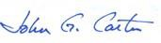
John Carter, Ecologist
Yellowstone to Uintas Connection PO Box 464
Bondurant, Wyoming 82922
435-881-5404
Jcoyote23@gmail.com
And also for the following:

Mike Garrity, Director Alliance for the Wild Rockies PO Box 505
Helena, Montana 59624 wildrockies@gmail.com
Jonathan Ratner, Director Sage Steppe Wild
31 Old Tie Hack Rd
Cora, Wyoming 82925 jonathan@wild-sage.org

Denise Boggs, Director Conservation Congress 1604 1st Ave S
Great Falls, MT 59401
denise@conservationcongress-ca.org
Kieth Hammer, Director Swan View Coalition 3165 Foothill Road
Kalispell, Montana keith@swanview.org

Steve Kelly, Director
Council on Wildlife and Fish PO Box 4641
Bozeman, Montana 59722 troutcheeks@gmail.com
Clint Nagel, President Gallatin Wildlife Association
P. O. Box 5317
Bozeman, MT 59717 www.gallatinwildlife.org

Sara Johnson, Director Native Ecosystems Council PO Box 125
Willow Creek, Montana 59760 sjjohnsonkoa@yahoo.com

Table 1. Areas by Habitat Probability in Parks and National Forests within Olson Model GYA

Unit | Total Acres | Category 1 Acres | Category 2 Acres | Category 3 Acres
Bridger Teton NF | 3,498,328 | 758,578 | 2,233,422 | 506,328
Caribou Targhee NF | 2,685,922 | 802,063 | 1,743,922 | 139,938
Shoshone NF | 2,493,781 | 1,959,000 | 483,703 | 51,078
Custer Gallatin NF | 2,678,234 | 1,731,563 | 909,641 | 37,031
Beaverhead Deerlodge NF | 3,148,766 | 1,708,359 | 1,288,641 | 151,766
Bitterroot NF | 1,334,359 | 482,906 | 661,375 | 190,078
Sawtooth NF | 1,574,391 | 684,594 | 856,969 | 32,828
Salmon Challis NF | 4,448,000 | 3,122,609 | 1,244,469 | 80,922
Payette NF | 2,312,531 | 1,155,672 | 1,064,375 | 92,484
Nez Perce Clearwater NF | 1,733,094 | 1,090,422 | 639,656 | 3,016
Boise NF | 2,553,813 | 1,752,781 | 755,891 | 45,141
Yellowstone NP | 2,137,141 | 875,531 | 1,242,031 | 19,578
Grand Teton NP | 289,734 | 131,609 | 147,391 | 10,734
Totals | 30,888,094 | 16,255,688 | 13,271,484 | 1,360,922

Table 2. Lynx Critical Habitat, SSA 5 Focal Unit and SSA 5 Focal Area
Unit | Total  Acres | Category 1  Acres | Category 2  Acres | Category 3  Acres
Lynx Critical Habitat | 5,915,688 | 2,285,781 | 3,118,094 | 511,813
Lynx Focal Unit | 7,516,500 | 3,224,938 | 3,749,031 | 542,531
Lynx Focal Area | 725,141 | 8,750 | 290,344 | 426,047

Table 3. Comparison of Habitat Probabilities Across Major Land Management Units

Unit | Category 1 Percent of  Total | Category 2 Percent of  Total | Category 3 Percent of  Total | Category 2 +  3 Percent of  Total
Bridger Teton NF | 21.7% | 63.8% | 14.5% | 78.3%
Caribou Targhee NF | 29.9% | 64.9% | 5.2% | 70.1%
Shoshone NF | 78.6% | 19.4% | 2.0% | 21.4%
Custer Gallatin NF | 64.7% | 34.0% | 1.4% | 35.3%
Beaverhead Deerlodge NF | 54.3% | 40.9% | 4.8% | 45.7%
Bitterroot NF | 36.2% | 49.6% | 14.2% | 63.8%
Sawtooth NF | 43.5% | 54.4% | 2.1% | 56.5%
Salmon Challis NF | 70.2% | 28.0% | 1.8% | 29.8%
Payette NF | 50.0% | 46.0% | 4.0% | 50.0%
Nez Perce Clearwater NF | 62.9% | 36.9% | 0.2% | 37.1%
Boise NF | 68.6% | 29.6% | 1.8% | 31.4%
Yellowstone NP | 41.0% | 58.1% | 0.9% | 59.0%
Grand Teton NP | 45.4% | 50.9% | 3.7% | 54.6%
Lynx Critical Habitat | 38.6% | 52.7% | 8.7% | 61.4%
Lynx Focal Unit | 42.9% | 49.9% | 7.2% | 57.1%
Lynx Focal Area | 1.2% | 40.0% | 58.8% | 98.8%
Table 4. Areas by Habitat Probability in Ranger Districts in the BTNF and CTNF

Unit | Total Acres | Category 1 Acres | Category 2 Acres | Category 3 Acres
Dubois RD | 463,781 | 370,000 | 93,563 | 219
Palisades RD | 473,703 | 137,641 | 298,844 | 37,219
Teton Basin RD | 271,047 | 49,203 | 199,094 | 22,750
Ashton Island Park RD | 675,250 | 126,781 | 539,406 | 9,063
Montpelier RD | 433,094 | 80,609 | 305,953 | 46,531
Soda Springs RD | 369,563 | 38,391 | 306,984 | 24,188
Pinedale RD | 829,031 | 267,969 | 499,984 | 61,078
Jackson RD | 703,250 | 139,359 | 543,938 | 19,953
Blackrock RD | 730,672 | 249,391 | 430,203 | 51,078
Grey's River RD | 490,797 | 43,422 | 333,313 | 114,063
Kemmerer RD | 289,344 | 21,609 | 150,313 | 117,422
Big Piney RD | 455,234 | 36,859 | 275,578 | 142,797
Totals | 6,184,766 | 1,561,234 | 3,977,172 | 646,359

Table 5. Comparison of Habitat Probabilities Across Ranger Districts in the BTNF and CTNF with CH, FU, and FA

Unit | Category 1 Percent of  Total | Category 2 Percent of  Total | Category 3 Percent of  Total | Category 2 + 3 Percent of  Total
Lynx Critical Habitat | 38.6% | 52.7% | 8.7% | 61.4%
Lynx Focal Unit | 42.9% | 49.9% | 7.2% | 57.1%
Lynx Focal Area | 1.2% | 40.0% | 58.8% | 98.8%
Dubois RD | 79.8% | 20.2% | 0.0% | 20.2%
Palisades RD | 29.1% | 63.1% | 7.9% | 70.9%
Teton Basin RD | 18.2% | 73.5% | 8.4% | 81.8%
Ashton Island Park RD | 18.8% | 79.9% | 1.3% | 81.2%
Montpelier RD | 18.6% | 70.6% | 10.7% | 81.4%
Soda Springs RD | 10.4% | 83.1% | 6.5% | 89.6%
Pinedale RD | 32.3% | 60.3% | 7.4% | 67.7%
Jackson RD | 19.8% | 77.3% | 2.8% | 80.2%
Blackrock RD | 34.1% | 58.9% | 7.0% | 65.9%
Grey's River RD | 8.8% | 67.9% | 23.2% | 91.2%
Kemmerer RD | 7.5% | 51.9% | 40.6% | 92.5%
Big Piney RD | 8.1% | 60.5% | 31.4% | 91.9%
Table 6. Rank of Major Land Management Units (Parks and NFs)

Unit | Rank | Category 2 + 3 Percent of Total
Lynx Focal Area | 1 | 98.8%
Bridger Teton NF | 2 | 78.3%
Caribou Targhee NF | 3 | 70.1%
Bitterroot NF | 4 | 63.8%
Lynx Critical Habitat | 5 | 61.4%
Yellowstone NP | 6 | 59.0%
Lynx Focal Unit | 7 | 57.1%
Sawtooth NF | 8 | 56.5%
Grand Teton NP | 9 | 54.6%
Payette NF | 10 | 50.0%
Beaverhead Deerlodge NF | 11 | 45.7%
Nez Perce Clearwater NF | 12 | 37.1%
Custer Gallatin NF | 13 | 35.3%
Boise NF | 14 | 31.4%
Salmon Challis NF | 15 | 29.8%
Shoshone NF | 16 | 21.4%

Table 7. Rank of Ranger Districts in the BTNF and CTNF

Unit | Rank | Category 2 + 3 Percent of Total
Lynx Focal Area | 1 | 98.8%
Kemmerer RD | 2 | 92.5%
Big Piney RD | 3 | 91.9%
Grey's River RD | 4 | 91.2%
Soda Springs RD | 5 | 89.6%
Teton Basin RD | 6 | 81.8%
Montpelier RD | 7 | 81.4%
Ashton Island Park RD | 8 | 81.2%
Jackson RD | 9 | 80.2%
Palisades RD | 10 | 70.9%
Pinedale RD | 11 | 67.7%
Blackrock RD | 12 | 65.9%
Lynx Critical Habitat | 13 | 61.4%
Lynx Focal Unit | 14 | 57.1%
Dubois RD | 15 | 20.2%

