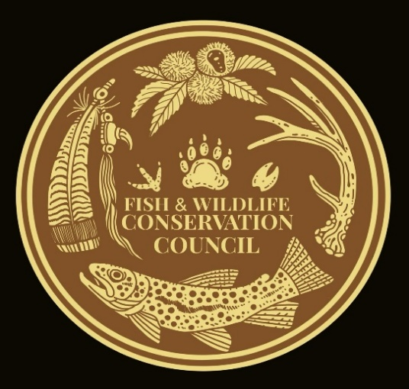
David Whitmire
Fish and Wildlife Conservation Council
Lake Toxaway, NC 28747
avery@citcom.net

February 20, 2024

National Forest in North Carolina
Objection Coordinator
160 Zillicoa St.
Asheville, NC 28801

Re: Nantahala Mountains Project Objection

Dear Coordinator:

The Fish and Wildlife Conservation Council would like to take this time in the project process to object to the final Environmental Assessment draft decision notice. Thank you for this opportunity.

The Fish and Wildlife Conservation Council is a grassroots network of sportsmen and women thru-out the ranger districts across the Nantahala and Pisgah National Forest. We advocate for quality habitat for wildlife on these public game lands. These two national forests consist of over half of NC’s game lands. Our council was a collaborator on the recently released management plan.

We fully support the project. Our objection is now having the new plan released and seeing the directives, we feel the young forest habitat objectives fall short on this project.

Requested relief: To increase the 1.6 percent of the project area young forest creation to levels more consist with the forest plan. Use NCWRC and other partners in tier two opportunities that would increase young forest habitat.

We realize and appreciate the amount of work that goes into this project. Objections only extend that work. We also know the advantages of projects that include as much habitat improvement that moves the forest toward the desired conditions under one project. Our wildlife that depends on young forests are directly affected by these projects.
Thank you again for this opportunity,

David Whitmire
FWCC Chair
.

