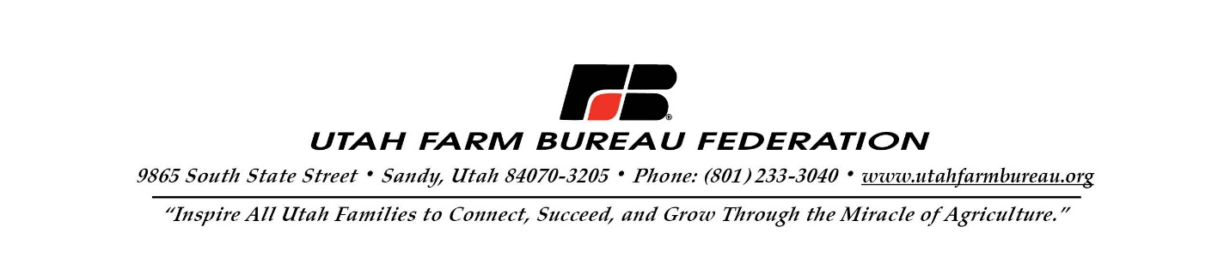

February 12, 2024
SUBMITTED ELECTRONICALLY VIA: https://www.fs.usda.gov/project/?project=64356
ATTN: Mike Elson
Forest Supervisor
Objection Reviewing Officer
Fishlake National Forest
U.S. Forest Service
Intermountain Regional Office
324 25th Street
Ogden, UT 84401

Subject: Objection to the Flat Canyon Allotment Management – Environmental Assessment, Finding of No Significant Impact, and Draft Decision Notice #64356

Dear Supervisor Elson:

The Utah Farm Bureau Federation reviewed the U.S. Forest Service’s (USFS) Final Environmental Assessment (EA) and the Draft Decision Notice and Finding of No Significant Impact (FONSI) for the Flat Canyon Allotment Management project. We hope you will accept our comments on behalf of our 35,000 members throughout the state of Utah and in particular our ranchers that will be directly affected by the USFS decision on this allotment.
In the FONSI, the USFS considered three alternatives: Alternative 1 (Winter Sheep Grazing), Alternative 2 (Conversion to Cattle Grazing), and Alternative 3 (No Grazing). Included in the FONSI is USFS’s intent to implement Alternative 2. Utah Farm Bureau policy supports government agencies working in a coordinated effort to promote and enhance livestock grazing as an integral part of multiple use and management of natural resources, as outlined in county and state resource management plans, the National Environmental Policy Act, and the National Forest Management Act (NFMA). Our policy also supports livestock grazing as a viable fire suppression tool to reduce burnable fuels.
The state of Utah is rapidly urbanizing, and the Utah Farm Bureau is increasingly concerned about the rate at which we are losing both farmland and grazing acreage. The Kem C. Gardner Policy Institute recently projected growth in Utah will result in population increasing from 3,284,823 in 2020 to 5,450,598 in 2060, a 66% increase. As growth continues, public lands grazing, especially on federal lands that make up more than 63% of our state, will be more important to our ranchers than ever before. As most livestock grazing in Utah takes place on federal lands, it is vital to the economic viability of ranchers that as many grazing opportunities as possible remain open.
Utah Farm Bureau objects to the FONSI as Alternative 2, as proposed, as it would result in a loss of HMs on the Flat Canyon Allotment. According to the FONSI, Alternative 1 would allocate 2,687 sheep HMs, while Alternative 2 would allocate 334 cattle HMs. Current USFS conversion regulations state that “for fee purposes 5 sheep or goats, weaned or adult, are equivalent to one cow, bull, steer, heifer, horse, or mule.” Utah Farm Bureau recognizes that the USFS conducted an assessment of “range suitability and capability.” Presumably, this assessment is what the USFS used as the justification for offering 334 HMs instead of the 5:1 conversion that would result in 537 HMs. Utah Farm Bureau disagrees with the 203 HM decrease proposed by the FONSI. We also question why, if the USFS found that the allotment is more suitable for cattle instead of sheep, this would not result in more forage being usable resulting in an increase of HMs rather than a reduction. We respectfully request that USFS increase HMs to at least 537 in its final decision.
The Utah Farm Bureau is also concerned that the FONSI contains incomplete information regarding the interest from sheep producers in the Flat Canyon Allotment. Specifically, the FONSI states: “Due to the recognized challenges of grazing the allotment under the current management scenario, there were no parties interested in acquiring the permit. Thus, in 2019 the permit was waived without a preferred applicant.”
In April 2019, Annabella Land and Livestock accepted payment from two wildlife-related NGOs, Sportsmen for Fish and Wildlife and the Utah Wild Sheep Foundation to purchase the allotment. However, instead of a typical purchase of a grazing allotment with base property and/or livestock where the seller waives the permit to the USFS in favor of the buyer as the applicant, Annabella Land and Livestock waived the permit back to the USFS without a preferred applicant after accepting payment. After the waiver without a preferred applicant, it is our understanding that at least two Utah sheep producers approached the USFS about utilizing the permit and both written applications were rejected. Therefore, we reject Alternative 2 on the grounds that it is somewhat misleading to state that no sheep producers were interested in acquiring the permit.
It is our hope that the USFS will reassess its Draft Decision Notice and at the very least increase HMs to 537. Please feel free to contact me if you have any questions about our comments.

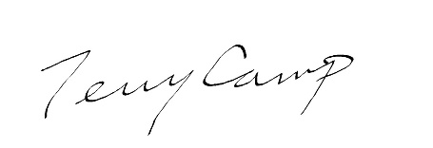
Sincerely,

Terry Camp
VP, Public Policy
Utah Farm Bureau Federation
Terry.Camp@fbfs.com

FONSI at 36.
Kem C. Gardner Policy Institute, “Utah Long-Term Planning Projections,” January 2022, https://gardner.utah.edu/wp-content/uploads/LongTermProj-Jan2022.pdf?x71849&x71849
Congressional Research Service, “Federal Land Ownership: Overview and Data,” R42345, February 21, 2020, https://crsreports.congress.gov
36 CFR §222.50(c).
FONSI at 37.
This information appears in the comment letters submitted by SFW and UWSF, available to the public at https://cara.fs2c.usda.gov/Public//ReadingRoom?Project=64356.
FSM 2200 – Range Management, Chapter 2231.8.
FONSI at 37.

