February 2, 2024

Forest Supervisor
Payette National Forest
500 Mission Street Building 2
McCall, ID 83638

Dear Payette Forest Supervisor and New Meadows District Ranger,

Here are comments of WildLands Defense, Alliance for the Wild Rockies, Native Ecosystems Council and Yellowstone to Uintas Connection on the Granite Goose project Draft EA and maps on the New Meadows Ranger Districts of the Payette National Forest. We are alarmed at the scale and foreseeable adverse direct, indirect and cumulative impacts of this project on National Forest lands, and harms to waters, watersheds, biodiversity and wild lands. All comments we previously submitted on the Granite EIS Project scoping must be included here, as these Granite Goose lands are a major part of that past effort, and this project is a derivative of that.

The current project is at this link:
https://www.fs.usda.gov/project/?project=63507
Maps: https://usfs-public.app.box.com/v/PinyonPublic/folder/192983328706
EA: https://usfs-public.app.box.com/v/PinyonPublic/file/1406452076880

There has been extensive past logging, grazing and human disturbance in many portions of the project area and surrounding landscape, causing substantial degradation of soils, waters, watersheds, sensitive and MIS and ESA species habitats and populations, forest health, natural forested vegetation composition and structure and harm to public recreational uses and enjoyment. Instead of allowing lands to continue to heal from these past and ongoing disturbances, by employing substantial passive restoration, and using careful active restoration to enhance healing, the forest proposes to tear this landscape apart with expensive, very risky “treatment” disturbance of all types – including overlapping disturbances in the same land area/watershed/habitat.

The Forest has repeatedly tried to spin off major new Wolverine, Canada Lynx, Great Gray Owl, Boreal Owl, Northern Goshawk, Fisher, Gray Wolf and other rare and endangered species habitat disturbance, destruction and/or fragmentation projects in this already very heavily used important Forest landscape.

The Forest in 2018 stated:
Decades of fire suppression, forest management (e.g. logging), livestock management (e.g. grazing), insect and disease outbreaks, and other factors have substantially altered forest structure, composition and spatial pattern (Stine et al. 2014, Franklin et al. 2013, Belsky and Blumenthal 1997; Perry et al. 2011; Keane et al. 2017; Perkins et al. 2016) in the western United States and in the project area. Within the project area, these altered conditions have led to: increased susceptibility of undesired and uncharacteristic wildfires; species composition, structure, density that have departed from desired conditions; and an increased insect and disease susceptibility”.
The Forest is describing an ecosystem, plant and animal communities and watersheds that are already highly disturbed by too much human activity – including the ever-expanding habitat disturbance footprint of Brundage resort. Studies on Wolverines have found harmful human recreational activity disturbance effects. The USFS in the Granite Goose EA seeks to burn, aggressively log and thin and clear vast areas of forest. Note that we just reviewed a Salmon-Challis Forest mining exploration EA where the USFS states that burns are poor habitat for Wolverines. The radical series of “treatments”: will facilitate greatly expanded human off-road activity and incremental development of new trail - including motorized and non-0moptoiriuzed/mountain bike – a use that has exploded since the now-outdated Payette and other Forest Plans. How much has pressure from mountain bike use increased in the McCall landscape since the old Forest plans were developed?

The EA admits: the Forest Plan includes: “There is a need to maintain and promote dry, lower elevation, large and medium tree size class for the associated wildlife species (Forest Plan: WIOB07). The project appears to have gotten even more destructive to wild land values and habitats on USFS lands after 2023 scoping (see 1.5.2):
1.5.1 Vegetation and Fuels Management Changes
In consultation with the Idaho Department of Lands, shaded fuelbreaks and infrastructure protection treatments were removed from state lands as they do not align with the state’s management objectives. [WHY did these treatments not align?].
1.5.2 Vegetation Treatments in Idaho Roadless Areas
Incidental timber removal was proposed during scoping for the implementation of whitebark pine restoration treatments, non-commercial thinning, shaded fuelbreaks, meadow encroachment, aspen treatments, and prescribed fire. Non-incidental timber removal in Idaho roadless areas was added to the proposed action to maintain or restore the characteristics of ecosystem composition, structure, and processes by addressing the insect and disease outbreaks in the Idaho roadless areas and to reduce the risk of uncharacteristic wildland fire effects to an at-risk community and municipal water supply system. [We strongly object to treatments in roadless areas. The “treatments” will make the roadless areas hotter, drier, windier, weedier, with a longer fire season – and thus they will increase fire risk. The landscape will be filled with ugly often charred stumps stumps. They will result in biodiversity loss -as this project greatly destroys habitat for forest-dependent species in this landscape. The use of heavy equipment to log these lands will create extensive new openings skid trails, landings and other clearings that will lead to expanded motorized use, further destroying the roadless character. Full and detailed analyses of the severity of roadless value loss must be provided.
The timber cutting activities proposed within Idaho roadless areas in the project area have been reviewed by the regional forester to ensure consistency with the implementation of the 2008 Idaho Roadless Area Conservation Rule. The regional forester has the delegated authority to approve exceptions for prohibited actions within Idaho roadless areas. On June 9, 2023, the Intermountain Region acting deputy regional forester concurred that the activities proposed as part of the Granite Goose Landscape Restoration Project qualify for a Roadless Rule exception. The concurrence and approval of the exception is documented separately in the project record. {we urge the USFS to reconsider this, and to take NEPA’s required hard look at the increased long-term motorized penetration and use of this landscape that will result.
There has also been extensive past logging, treatments, fire and other habitat disturbances and past manipulation in many portions of the project area. Please provide detailed analysis and mapping of past logging, thinning, manipulation “prescribed” fire and other agency intrusions for as long a time period as data is available.

The 2024 project would take place in a landscape where ecological conditions have deteriorated, and where radical and often overlapping aggressive logging/thinning/burning and other “treatments” only worsen fire risk and serve to expand insect “problems” by damaging and weakening remaining untreated vegetation and resulting in hotter, drier, windier and weedier conditions. The USFS across region 4, in Idaho, in the Boise/Payette and Nez Perce forests has since that time authorized many more deforestation and burning projects. There have also been many more wildfires in the western US – and in fire after fire it is revealed that fires flash right through logged thinned, treated and other areas AND that the “dense” vegetation that the USFS so seeks to destroy is actually more resistant to fire than the bleak hot, dry, windy, eroding stumpscapes that USFS treatments such as those here produce.

Adding the many and often overlapping stresses described in the 2018 DOPAA pages 3-5 and the 2023 Scoping Notice and now the 2024 EA to such an already disturbed setting poses serious risk of irreparable harm and species losses. It is also likely to reduce the ability of natural processes to buffer climate change stress on Forest lands. This makes the USFS assault on the roadless areas even more relatively harmful. How many of the projects authorized or proposed by the Payette and Boise forests since the Forest plan have involved logging. thinning, burning or other “treatments” in roadless areas? How much more is foreseeable? In which roadless areas? Please provide detailed mapping and analysis.

What is the age class of trees of all types inside the roadless areas vs. outside the roadless areas?

What is the current age class of all trees of each species on the block of state lands near Payette Lake? What types of logging and other treatments have taken place there?

How has the Brundage ski resort and associated facilities, lifts, trails and recreational use intensified in this landscape in the project area expanded over time? We were dismayed in looking at the USFS winter use map, at the huge disturbance footprint the FS has allowed Brundage to exert.
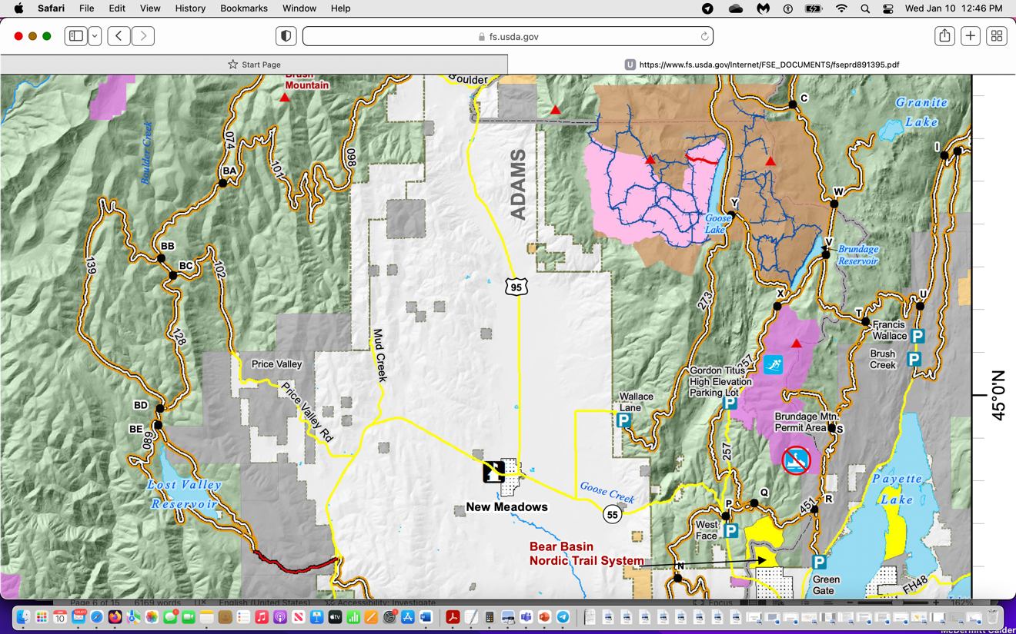
The legend reveals routes in the project area in the north colored brown are Brundage Cat ski routes. Do they extend into IRAs? This shows how major the disturbance footprint, which needs to be greatly rolled back, is in Wolverine habitat. It appears that the brown area is wide open to motorized and non-motorized winter-long disturbance? Is that correct? It is unclear what trails/routes are groomed.
Pale pink is existing snowmobile closure for 3 months. – only from Jan. 15-March 31. The regular green color appears to mean the land is wide open to snowmobile use.
Dark pink is

The USFS has also changed the following that further increase and expand intensive motorized and other recreation activity in Wolverine and other sensitive, important and rare species habitats. This represents a further blow to biodiversity, to watershed protection, and to sensitive and ESA-listed species. the EA states:
“… a modification to the Bear Basin winter over- snow motorized closure to make the closure easier to identify while preserving access to areas currently used for over-snow motorized recreation and modified geographic boundaries to the proposed Bear Basin motorized closure. In response, the proposed Bear Basin over-snow motorized boundary has been shifted north to the snowmobile groomed route and does not include lands east of National Forest System Road 50451. Removing the closure east of Road 50451 would maintain motorized over-snow access in an area that is outside the Nordic ski area permit boundary. The proposed modification creates a defined geographic boundary that is easier to sign and more obvious to snowmobilers, which is expected to reduce snowmobile incursion into the permitted Nordic ski area boundary and meet the purpose and need for reduced recreation conflicts.
Additional changes to the recreation proposed action in response to scoping comments include:
- Removed the proposed closure of National Forest System Road 51913 in Ecks Flat.
- Included a proposal for a pedestrian bridge over Goose Creek near Last Chance Campground.
- Trails in Ecks Flat: Reduced mileage, as a portion of the original proposal is now proposed as a road.
- Added an additional 7 miles of non-motorized trail in the Bear Basin Area.
- Modified the location of the proposed Bear Basin East Trailhead.
- Removed the proposed northern Brundage Reservoir boat ramp.
EA Table 2 shows project impacts to vegetation “Change in species composition, tree class size, and canopy cover class.” This all further diverges from the dearth of mature and old growth forested and other vegetation communities across the Forest and this region.
EA Table 2 re: fuels states “Change in flame length, rate of spread, and crown fire activity”. Yet there is not hard look candid analyi8ss of the effects of the often overlapping massive and severe disturbance “treatments” will change the fire risk and fire spread situation.
The FS fails to consider the shading and moisture retention value of forested vegetation, including of standing dead trees in moderating site conditions – as climate change stress bears down.
For botany, soils, hydrology – the FS fails to provide the site-specific baseline data and analysis necessary to assess the project harms, nor to effectively minimize and mitigate risks. The FS also fails to reveal how the deforestation and “treatments” will increase livestock access to previously less accessible or used area – jeopardizing native vegetation communities, hydrology (including sedimentation, water pollution, algal growth from excess livestock nutrients, and trampling of egg masses and redds as well as adverse modification of cooling and shading riparian vegetation, and impacting any post-treatment recovery or effective stabilization. Thus, rare plants, and sensitive terrestrial and aquatic species habitats – and forest recovery are all threatened by livestock grazing disturbance expansion.
This continues throughout Table 2. We also highlight that on top of the roads, trails, logging, burning, unassessed degrees of livestock grazing ecological impairment, degradation and harm impact hydrology, sediment, water quality and quantity - including fragile springs and seeps home t rare amphibians and that provide headwaters to stream systems, sensitive species habitats and population, Threatened Canada lynx and Wolverine, the sensitive horrifically persecuted Gray Wolf and other native carnivores that this project for which this project will provide greatly increased human harassment, disturbance, poaching, habitat loss, habitat fragmentation – and have significant adverse effects on population viability.
For each affected species through current baseline inventories must be conducted as part of this NEPA process and provided to the public for review. This is necessary to understand the severity of harms and full scale and significance of adverse effects. It is necessary to: Number of individuals impacted and the specific areas of occupied habitat in the project area and surrounding landscape (as many of these species are wide-ranging carnivores or otherwise linked to populations on state land, private land or USFS land.
-Acres of impacted habitat -Extent of impacts to individuals and habitat -Distance from specific locations (recreation sites, vegetation treatment locations, and so fort
Note too that yet another Boise Forest effort at rm pant forest logging, thinning and burning is likely to move forward in the Sagehen region just to the south. Further, the Payette Forest has rammed through massive deforestation and “treatments” in the lands just west of new meadows – in the Clear Creek and other areas. The USFS is silent on the lands in the West that were initially part of the Granite Goose project and what fate is to befall them.
How many acres, of what age class, vegetation type, and stand attributes; what IRAs; what impaired waters and degraded riparian areas; what identified Wolverine, Canada Lynx or other rare and native species and migratory bird habitats will (or are) all of these projects impacting? How much hotter, drier, harsher, windier, weedier, and more fire prone will these projects make this landscape? How many acres of EACH veg category -= such as cool, moist or warm, dry forest of each conifer category the USFS imposes on the Granite Goose forests will be impacted?
How many acres of undisturbed live forest will be present in the Granite Goose project area, and where will they be located? What is the stand age, composition and structure of these areas? Please map and identify them. How many years does it take to achieve a mature forest of each vegetation type/category/pigeonhole the USFS uses? Which of these forest types may be successional communities - and transitional to late successional forest? We again stress that the Forest plan relies on long-outdated fire return and disturbance intervals that fail to take into account successional processes, fail to reflect the actual much longer fire return intervals of the various forest categories used in this EA, etc. the Forest also fails to consider papers by Kerns et al. 2020, Fusco 2019 that describe how forests may not be able to recover from significant disturbances under climate stress.
Minimal information is provided about the domestic livestock grazing that occurs across large portions of the project area including lands that may not be capable or suitable for supporting this use – especially given the increased stresses of climate change, the human-altered landscape and increasing recreational uses and disturbance. Fleischner 1994, Catlin et al. 2011, Beschta et al. 2012. We are concerned that a significant element of this project is to kill trees to try to generate more grass for livestock on grazing-depleted range.

The Federal Register Scoping Notice included:
Proposed treatments include timber harvest, thinning, prescribed fire, road treatments and road decommissioning, watershed improvement and restoration treatments, and recreation improvements.
This corresponds to the 2023 Granite Goose scheme. The Forest must fully identify, map, study baseline ecological conditions, study similar past project adverse effects on native biota, watershed and recreation of all such projects previously conducted in the targeted Project Area and surrounding landscape.
Coordination with existing permittees on grazing schedules would also be included to meet the purpose and need related to fuels reduction.
Please provide detailed assessment and analysis and baseline data on the current livestock grazing use levels and management schemes, permitted use HMs, actual use HMs, standards applied to protect Forest resources, current land health assessments, current capability and suitability analyses, detailed upland and aquatic/riparian monitoring of livestock impacts and the level of baseline existing degradation. Please provide detailed information on management schemes, unauthorized use or trespass, facility location and impacts, effects of salt supplement use, permittee motorized use, etc. on all Forest resources, and the degree to which grazing is causing weed infestations and spread and favoring exotic species that choke out native biota. Please fully investigate foreseeable ecological and other impacts of continued livestock grazing disturbance taking place in and surrounding the project area. See WLD comments Attachment A, Alternative and Mitigation actions regarding livestock grazing. Please review Belsky and Gelbard 2000, Choung et al. 2015 describing livestock transporting flammable weed seeds in mud on hoofs, Williamson et al. 2019 describing how livestock cause flammable weeds, Fusco et al. 2020 and Kerns et al. 2020 describing how lands are not recovering from disturbance – resulting in a loss of forest cover. This is likely to be a serious consequence of these massive and often overlapping disturbances.
The 2018 Fed Reg EIS Notice described an immense and complex Project sprawling across 130 square miles:
The Granite Meadows Project area totals approximately 83,000 acres, and includes approximately 70,000 acres of National Forest System (NFS) lands within the New Meadows and McCall Ranger Districts on the Payette National Forest. Additionally, the project area includes approximately 7,000 acres of state land and 6,000 acres of private land, where proposed treatments would be covered under the Wyden Authority (Wyden Amendment, Section 323(A) of the Department of Interior and Related Agencies Appropriations Act, 1999 as included in Pub. L. 105–277, Div. A, Section 101(e) as amended by Pub. L. 111–11, Section 3001).
This 2023 project appears to include a major part of that proposal, which we fear will be segmented in – and the Granite Goose proposal is just an effort to segment that larger project into multiple projects to try to duck an EIS. Not only will the 2023 Project affect a very large land area for very long periods of time (and potentially forever if irreparable damage occurs and lands suffer irreversible weed infestations, excessive soil erosion, stream entrenchment and downcutting, loss of sustainable perennial flows, or steep declines or local extinction of rare species as crucial habitat elements are drastically reduced and habitats extensively fragmented.
Please provide a full explanation of the Wyden Act and any acts the 2024 project would be conducted under. Does it subsidize logging or treatment activity on private or state lands? Does it subsidize logging or treatment activity on public lands? If so, how much will those subsidies be? Full analysis of the direct, indirect, additive, cumulative and synergistic effects of the proposal on these all affected lands, waters, habitats and populations of wildlife and aquatic species, water quality, water quantity, sustainability of perennial flows, etc. must be provided. New current baseline studies must be conducted as a basis for formulating alternatives in an EIS for this project.
The USFS has clearly failed to develop and assess a suitable and reasonable range of alternative actions, including minimization and mitigation actions as well as any forest manipulation actions. EA Table 3 contains the horror-show of heavy equipment soil/biocrust/native plant community mechanized” disturbance and forest destruction planned, and EA Table 4 shows non -heavy equipment including chainsaw cutting and fire.
How many new and additional acres of insect infestation are likely to result from the large-scale logging/thinning/fire disturbances – for example sap from injured trees luring in tree killing or injuring insects? How much mechanical damage and/or burning and injury or death of “desirable” or “leave” trees and mature and old growth trees and forest areas will remain after all the mechanized activity and rampant burning? Please provide careful biologically valid estimates of these additional causes of mortality and “collateral damage” from these treatments.
This all demonstrates why much more detailed site-specific information needs to be amassed, and more reasonable range of alternatives that reduce and minimize ecological disturbance is needed. The maps with the project show blocks of land are targeted for various “silvicultural” forms of disturbance and forest destruction. It’s critical that there be thorough and detailed upfront mapping and analysis of all “leave:”” tree areas and areas that will not eb disturbed, and their dispersion. This is also necessary to understand how much more fragmented the landscape will be, how little protective, screening and escape cover there will be for big game and rare native carnivores, and how visually scarred and marred the landscape will be. It’s also necessary to understand the degree of conflicts between different forms of recreational use. For example, standing forest helps hinder sound transmission, and would help prevent cross-country mechanized travel during all periods of the year – and the sights and sounds of such activity. EACH sensitive and imperiled species has different habitat needs, and unless a thorough baseline that honestly reveals how much forest and other habitat essential for their survival is now present vs. how much will remain is laid out in an EIS hard look analysis, it will be impossible to develop a truly reasonable range of alternatives and to require effective and necessary restrictions on forest and tree removal to minimize and mitigate any “treatment” impacts on MIS, sensitive, and imperiled terrestrial and aquatic species species, big game, and migratory birds.
The USFS has overwhelmingly ignored the concerns WLD et la. have repeatedly raised in scoping letters and comments - on Granite Creek, and Granite Goose scoping and now this flawed EA.

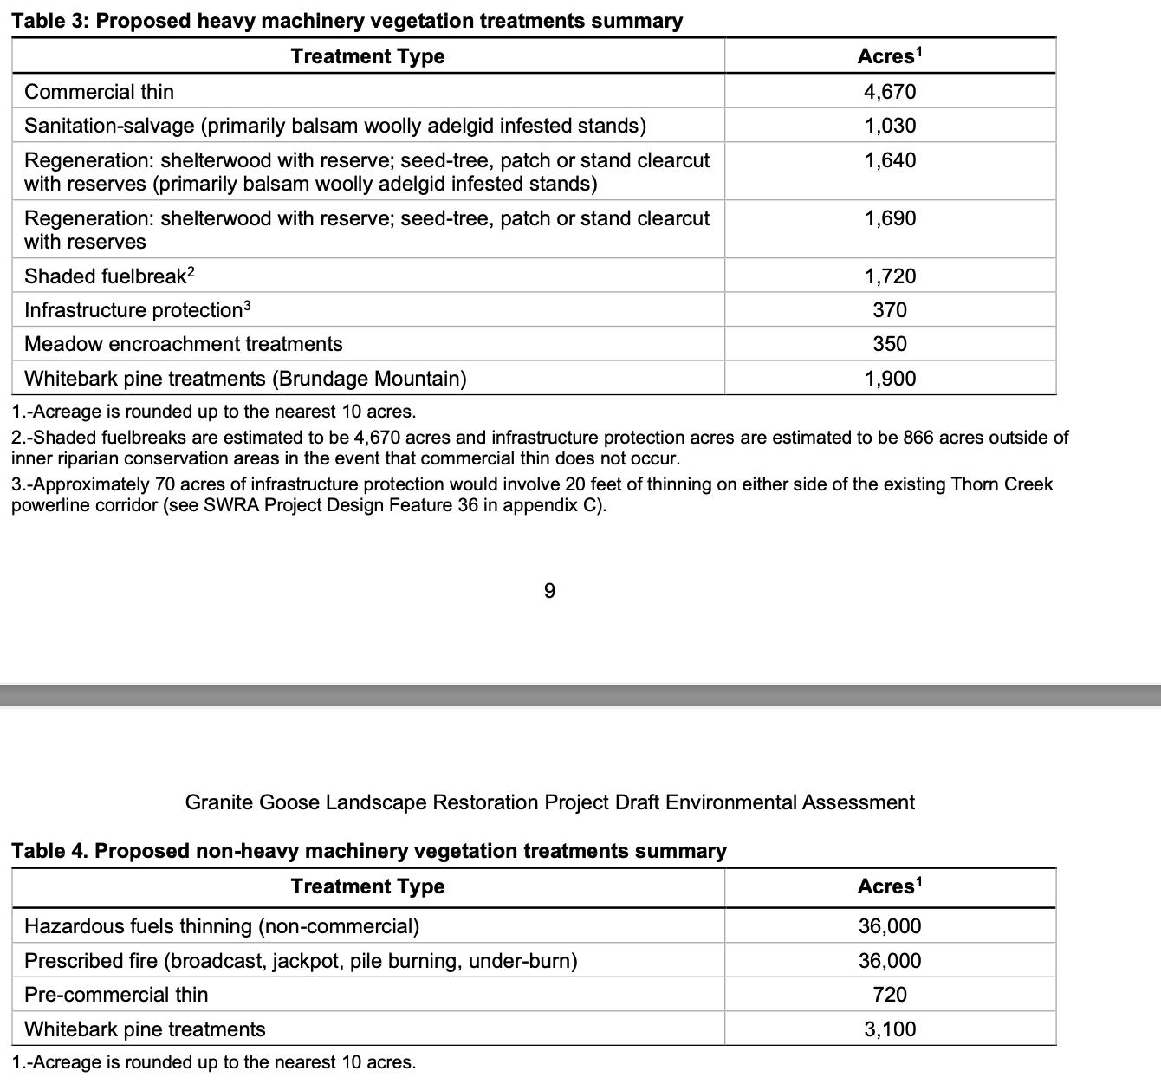
The Forest in 2018 mentioned a collaborative group. The Forest Webpage contained a document showing a vote tally from this group. Most of vote shows even the collaborative members were not happy with the huge mishmash of patched together expensive disturbance actions put forth in the Granite Meadows proposal. “I can live with it” is not a ringing endorsement. Here in 2024, as the changes made show, the USFS is acting with significant bias, and ignoring any hard look at how damaging this massive disturbance will be. How does the Forest vet such proposals, using current ecological science and data? We were concerned at the proposal being based on the desires of parties engaged in a loose and uncertain undemocratic process that the Forest is advanced in the 2018 DOPAA document, and now we are seeing the very same thing in this 2024 process. Such groups are often politicized, involve considerable “horse-trading” where one land area, vital habitat, beautiful old growth site or wildlife species habitat may be sacrificed to fulfill a wilderness, grazing or other agenda in another location. Such groups are largely dominated by extractive or commodity uses or intensive recreational interests. Average citizens who use and enjoy the Forest lands for many aesthetic, recreational, scientific, spiritual and other interests and pursuits, such as our members, are at a significant disadvantage when such groups are given a stronger voice in federal agency processes. We are very concerned about the path this project is on – where snowmobiles being able to run all over the place trump Wolverines and other sensitive species habitats.
Please also provide information on whether members of the collaborative group have a financial interest in proposed project actions. For example, how many members listed in the vote tally are livestock grazing permittees on the Forest?
This current project must be analyzed in an EIS. This is directly derived from, and includes much of the land area, of Granite Meadows. We have previously submitted our comments on Granite Meadows, and asked that you address all matters of ecological concern that we raise in them with this latest project Granite Goose Project.

One of the collaborative group members posted this about the 2023-24 project

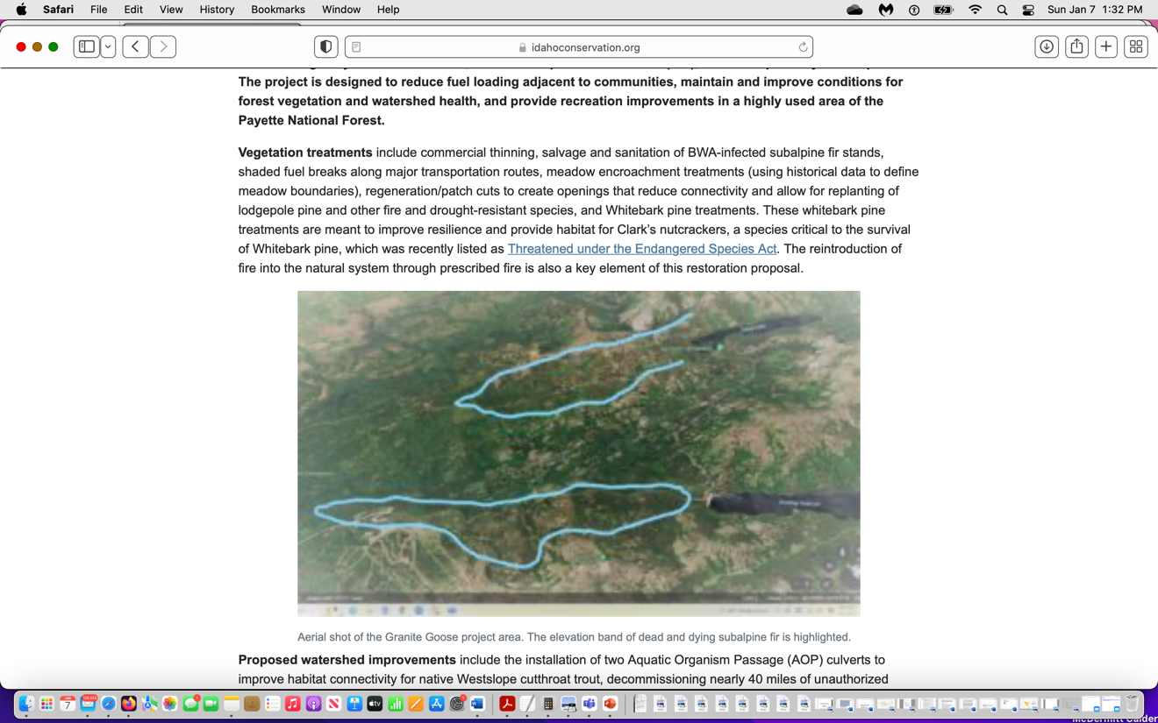

It appears the USFS plans on replacing subalpine fir with handplanted lodgepole pine. Is that the case? What species is the climax species on all ecological sites in this landscape, and how has the Forest Service determined this?

The Forest Service 2023-2024 project remains very large and complex in this very heavily used landscape that also includes inflicting major unnatural disturbance on Roadless Areas now states:

The project area is approximately 39,918 acres and contains 33,346 acres of National Forest
System (NFS) lands, 5,371 acres of State of Idaho lands and 1,195 acres of private lands.
Through Wyden Amendment (P.L. 109-54, Section 434) agreements between the PNF, the Idaho
Department of Lands, and willing private landowners, some proposed treatment activities may
occur on State and private lands within the project area boundary.

This total 39,982 acres = 62.3 square miles.The full indirect and cumulative effects of treatments, roading, logging, burning, developments, intensive recreational activity on state and private lands must be fully assessed as well.

A 2022 letter from the logging collaborative group still includes the larger acreage, and this may indicate that the USFS is planning on piecemealing and segmenting it in.

The FS states:
“The PNF is proposing to implement a variety of vegetation treatments including thinning (of all class sizes), regeneration harvest, and prescribed fire to address hazardous fuels and reduce fuel loading to counter catastrophic wildfire risk, respond to insect and disease outbreaks, and promote whitebark pine (Pinus albicaulis) conservation in the project area. Other actions proposed include watershed restoration, recreation management, and travel management to enhance streams, wetlands, and meadows, promote safe and efficient recreation access, reduce recreation conflicts, and reduce impacts of no longer needed roads and trails on resource conditions”.

Clearly an EIS is required to take an honest hard look at this complex project with its large-scale manipulation disturbances to Wolverine and other rare species habitats, and the project’s increase to intensive recreational disturbances.

Concerns About Project Basis

The Payette Forest plan is 20 years old, and the data on which it relied is much older. It is based on very out-dated vegetation community models and assumptions, failed to adequately address climate stress on watersheds, flow sustainability, wild lands processes and sensitive, important, rare and ESA-listed species. The Forest Plan does not follow current ecological science regarding the adverse impacts of grazing and livestock facilities in causing flammable weed proliferation, weeds, degrading watersheds and habitats, fostering diseases, making lands less resistant to climate change stress and less resilient and less able to recover from grazing disturbance and degradation. It was not based on current fire science showing how critical defensible space right by structures is, and how readily fires flash right through hotter, drier, windier, weedier “treated” and thinned” sites. It did not take into account biodiversity loss and the major and serious declines in migratory bird species in North America (see Rosenberg et al. 2019 describing the loss of 3 billion birds from North America, Fusco 2020 describing forests not regenerating following fire or other disturbances, Dr. Jack Cohen’s fire science where focus on the actual area of habitats is what is needed to address fire risk in interfaces was ignored in the Forest plan; the degree of large-scale increase in summer temperatures that will make the radical treatment disturbances and purposeful destruction of protective shading live and dead tree cover here very harmful to aquatic and terrestrial species, an ever-growing body of evidence form recent wildfires showing thing makes matters worse, and a host of other current ecological information.

The species significantly harmed by this large-scale disturbance now also face new and emerging disease threats – for example, migratory birds will suffer severe blow from this large-scale simplification, loss and fragmentation of habitats – and now the now they also face the emerging threat of avian bird flu or other diseases that may drastically reduce populations and exert serious new stress on local and regional species populations - especially those in degraded and fragmented habitats that will result from this massive loss of protective tree cover. There is also much new science on the harms caused by recreational activity disturbance on wildlife and wildlife displacement- from big game to Wolverine.

The Forest Plan also of course did not examine and assess the huge impacts of the huge direct, indirect and cumulative footprint of the massive vegetation and fuels “treatments” and logging that has occurred, is authorized, proposed, or is being planned or foreseeable across the Payette NF and Region 4, as well as the Boise and Nez Perce and other nearby Forests.

The Forest Service must explain why it has apparently abandoned conducting an EIS for the Granite Meadows Project. The FS must detail all ways in which that past proposal has now apparently morphed, at least in part, into the Granite Goose Project – especially given the ever-escalating threats to biodiversity. This all must undergo EIS-level analysis. Have any piecemealed project actions that were to be under the umbrella of Granite Meadows been conducted under separate CXs, EAs? Are any remaining elements of Granite Meadows likely to foreseeably be piece-mealed in – under separate NEPA analyses in the future?

Information on the Granite Meadows project is here:

https://www.fs.usda.gov/project/?project=54029

The Federal Register link for that initiated EIS:

https://www.federalregister.gov/documents/2018/10/31/2018-23826/payette-national-forest-idaho-granite-meadows-project.

https://payetteforestcoalition.org/project-archive.html

“The Granite Meadows Project … approximately 83,000 acres,and includes approximately 70,000 acres of National Forest System (NFS) lands within the New Meadows and McCall Ranger Districts on the Payette National Forest. Additionally, the project area includes approximately 7,000 acres of state land and 6,000 acres of private land, where proposed treatments would be covered under the Wyden Authority …”.

What is driving this massive deforestation and disturbance crusade? We are concerned about the logging industry role in this project. The previous project fear-mongered over dead trees. Now the USFS seeks to even destroy the higher elevation subalpine fire and the essential flying squirrel and rare avian species and native carnivore habitat it provides because of yet another forest insect - the hemlock wooly adelphid.

We are concerned that this 2023-2024 Granite Goose process is biased towards logging interests, and thwarts a legitimate public process. A USFS Power point preferentially provided to a logging “collaborative” group in late 2022 is posted on the group’s website.

https://0201.nccdn.net/1_2/000/000/13e/c0b/pfc-august-2022-granite-meadows-recommendations.pdf#RDAM39327032

"Based on the departure of current stand conditions from the desired conditions contained in the Forest Plan as provided to the PFC, and the information contained in the proposed action for the previous Granite Meadows project, the PFC recommends commercial treatments on approximately 25,000 acres, non-commercial mechanical treatments of approximately 40,000 acres (some within stands also commercially treated to remove ladder fuels, thin sapling and pole stands and reduce ground fuels) and utilizing prescribed fire on an undetermined number of acres to treat reduce ground and ladder fuel loading and raise the base canopy height on mechanically treated areas as well as outside those treatment units”.

This sounds like an even larger area than Granite Goose. Does this mean that Granite Goose is only the first step in inflicting massive ecological disturbance in an area that is already stressed from past logging/treatments (and all of these must identified, mapped and monitoring of outcomes provided) and very high winter and summer recreational uses and roads and mechanized trails. Is this acreage as high or higher than the total 2018 project “treatment”??? This group knows what the forest is planning – and this demonstrates that NEPA appears to be being purposefully segmented to try to duck a credible EIS analysis.
“Studies have shown that changing wildfire intensity and severity requires restoring fire-adapted stand conditions on at least 1/3 of the overall landscape/fireshed. For the Granite Meadows project area that equates to treating over 28,000 acres”. What are these studies, and what is the current science that conflicts with these claims? Please see Dr. Jack Cohen studies on hardening structures and other papers submitted in our scoping comments.
What structures are actually present? Where? How have they been hardened? Only “treatments in close proximity to such areas will be effective in addressing fire risk here.
Where specifically are all WUI areas located, and how was this land area of WUI determined?
This project also appears to be aimed at intensifying recreational disturbance – by not closing roads but turning them into mechanized trails, expanding snowmobile parking lots, failing to close much larger areas to snowmobile use, relying on an out-dated forest travel plan, etc.
While snowmobile use may be controlled in the Patrick Butte area, the Forest must fully consider an alternative that restricts OHV use over a much larger area to protect Wolverine, (now recognized by USFWS as Threatened) Canada Lynx, Fisher, and Gray Wolf – the latter greatly threatened by the state of Idaho’s barbaric Gray Wolf persecution. See:
https://news.yahoo.com/hunter-applied-receive-idaho-funds-110000618.html?guce_referrer=aHR0cHM6Ly93d3cuZ29vZ2xlLmNvbS8&guce_referrer_sig=AQAAACD8I3IFQvVjo-4tL7kBk_fvI9pIkUo362KZ5imkmTh_0kq_OFfXzhIUD581nOy10ap2zPob3GFqqRLRptw6UICmwAkCASdQsyXZIssaMqN0-2Rut9sg2VEy2E0wjAZCaITmpft0L3InAZ6E2QgvM5MXUY4yoV9Tj8Q4r9LB3-tr
The large-scale deforestation and tree removal and burning will make it much easier for snowmobiles, motor bikes, mountain bikes to run all over the place, and for year-round harassment, poaching and disturbance of native carnivores, big game and other wildlife in the project area including roadless lands.
Small-diameter logging and thinning will remove essential habitat for Snowshoe Hare and Red Squirrels. These are primary food sources for numerous forest predators including bobcats, mountain lions, gray wolf, lynx, pine martins, fisher, wolverine, coyotes, goshawks, great grey owls, and boreal owls that all lose. What is the current status of the prey base for sensitive native carnivores, and its sustainability for all of these affected species? How much less secure will this project make any remaining carnivore habitats from human harassment, disturbance, displacement, trapping, shooting and other disturbance? Idaho hopes to slaughter 90% of its Gray Wolves.
This project will make it easier to shoot, trap, slaughter native carnivores, and make the population more vulnerable to stochastic events. The full ecological and social effects of this craven killing must be assessed in the direct, in direct and cumulative effects analysis of the project. Further, killing of Wolves will likely lead to increased big game mortality from CWD as well as vehicles, as wolves keep big game dispersed from road sides where people die or are injured from vehicle accidents. Areas where big game concentrate too densely in winter also create ideal conditions for diseases like CWD to spread. Is there CWD in the big game herds in or near the project area at present? How has this disease expanded in Region 4 Forest landscape in the past decade?
Isn’t the Gray Wolf a forest sensitive species? Won’t this project make this greatly persecuted native carnivore even. More susceptible to the barbaric wolf killing now sanctioned by the state of Idaho? What is the current Gray Wolf population? Where is there protective forest cover and secure habitat in the project landscape? How will this project change that? How many more wolves are likely to die because of loss of forest cover protection? How viable will the population actually be? Won ‘t this project help push the species towards re-listing by destroying protective habitat and making wolf slaughter easier?
All of these inter-connected species are part of the web of life that would be logged thinned and burned by this project. The full scale of serious harms to their habitats and population persistence is glossed over in the deficient self-serving scoping in formation. All of these inter-connected species and the forest web of life and forest plan deficiencies in these watersheds that would be logged thinned, and burned by this project were also at stake in the past iterations of logging/treatment projects in the RD.
Collaborative Group Role
It is a concern that the FS is allowing logging interests and others to direct significant elements of this large-scale disturbance to Wolverine, Gray Wolf, migratory bird, and a host of other native species habitats. Here is what the “PFC” logging group wants:
TREATMENT TYPES: The PFC supports a mix of commercial and non-commercial treatments to restore vegetation structures within the project area. Some treatment types will move the project area towards the desired condition and at the same time generate revenue from stumpage value. Other treatments represent a restoration investment (cost) that will modify stand structure or composition in order to achieve the desired forest condition in future silvicultural prescriptions and will vary based upon actual sites due forest conditions; however, they can generally be lumped into six groups of treatment types:
Commercial Thin/Free Thin (CT/FT) – This prescription is a mechanical thinning and will be applied to medium and tree size class stands that generally have a desirable species composition with an objective of reducing tree densities, promoting and/or retaining a large tree character and promoting and/or retaining early seral species. These treatments are expected to provide a positive economic return. In general, the prescription will thin from below or be combined with crown thinning to retain desired species and vigorous, healthy trees.
Commercial Thin / Patch Cut (CT/PC) - This prescription is a mechanical treatment and will be applied to medium and large tree size class stands that have a component of desirable species but are losing or have lost the desired species in portions of the stand. The objective is to regenerate early seral species in up to 25% of the total stand area. These areas (patch cuts) would range from 3-10 acres in size and would have 5 or more target species reserve trees per acre retained in the patches where available. In the remainder of the stand Free Thinning (as described above) will be applied to areas with desirable species composition or deferred from treatment if the desired species are not present.
Early Commercial Thin / Mature Plantation (ECT/MP) – This prescription is a mechanical treatment applied to small and medium tree size class plantations that are generally greater than 35 years of age. Although some commodities (small logs and woody biomass) would be removed, the value of the timber would not generally be expected to pay for the entire treatment.
Pre-Commercial Thin (PCT) – This prescription will be applied to sapling and small tree sized plantations where no commodity would be removed. The objective would be to promote growth of early seral species into the larger size class to create trees capable of surviving prescribed fire, while promoting the desired large tree species composition. This treatment is a restoration investment.
Sanitation-Salvage - Balsam Wooly Adelgid (BWA) impacts – Near complete removal of sub- alpine fir (SAF) and grand fir trees in areas heavily infected by BWA combined with thinning all age classes, burning, and regenerating other tree species including Douglas-fir, lodgepole pine, Engelmann spruce, western larch and quaking aspen.
Targeted Prescribed burning (Rx Fire) – This prescription will be recommended in treated stands as well as other medium and large tree size class stands that are currently in their desired canopy closure class (i.e. Low and Moderate Canopy Closure Classes). The objective of burning is to reduce fuel loads, restore ecological function and increase the resiliency of the landscape.
The PFC also recommends timing livestock grazing in existing allotments and using targeted grazing within the wildland-urban interface to manage fine fuels within treated areas in close coordination with permittees”.
See also:
"The Payette Forest Coalition (PFC) is pleased to forward the attached Landscape Restoration Priorities and Recommendations for the design of restoration projects within the Granite Meadows Landscape. The recommendations were adopted at the PFC’s August 18, 2022 meeting with one dissenting vote. This meets the PFC’s bar for consensus (unanimous support with no more than one dissenting vote). The minority opinion expressed that the recommended Coppit Creek Trail from the Warren Wagon Road to the Brundage Overlook will threaten elk security …”.

Also, the logging group is pushing to keep even unauthorized roads open – for vehicles 70 inches wide! This would include the very large very fast traveling “Razrs” and other ATVs that have just as big a disturbance footprint as a regular truck: "Where it is possible to do so while still moving towards wildlife habitat and watershed improvement objectives described above, evaluate authorized and unauthorized roads identified for decommissioning for possible conversion to either non-motorized or motorized trails. Include in this assessment the potential benefits and impacts of designating some trails for OHVs < 70 inches wide.
“The group is also raising RS 2477 issues to push maintaining and/or expanding motorized disturbances. Please provide detailed mapping and analysis of all supposed RS 2477 routes across the project area and surrounding landscape. “Coordinate with Adams and Valley counties before obliterating any roads or trails that have been asserted as historic routes under RS2477. System roads that access trailheads should be improved and maintained. Develop or improve trailheads that are sufficient in size to accommodate several vehicles and allow for a stock truck and trailer turn-around at the trailhead".
The EA must detail the pre-project route condition and the effects of the proposed action in “improving” or constructing routes. The fails to identify routes authorized in the trave, plan, routes with RS 2477 claims on them, fails to provide site-specific data and information on the width, condition and other aspects of each route to remain open vs, closed, fails to take a hard look at the effects of this welter of actions on sensitive and imperiled species, etc.
The FS must provide detailed mapping and analysis of “skid trails” and the like from past forest manipulation projects, as well as all clearing associated with the Brundage resort. Wasn’t the public told in previous logging/treatment projects that such sites would be rehabbed and “stabilized”? How successful has that been? How will this project reduce or kill mitigation claimed in past projects?
How and where has the USFS in the Payette Forest monitored soil erosion rates on 50%? 60% 70% slopes in granitic soils and all soil types found in the project area? Slopes from 10 to 70? How much will the roads and the skid trails and logging and burning and thinning etc. affect the erosion rates? How will they change with slopes of 10%? 20%? 30%?, 40%? 50%? 60%? 70%? What is the natural undisturbed forest background d rate of erosion on How are roads and skid trails and landing decks affecting soil erosion rates in both wind and water?
If part of the Region 4 and Boise Forest’s reckless logging/burning/massive forest disturbance treatments are claimed to boost flows - recent Utah detailed watershed studies showing logging and thinning does NOT increase water flows.
How much Idaho Power cloud seeding is taking place in the Boise and Payette watersheds? Where is this taking place, and how and where does it increase snow and linked runoff? Where might this be making sites drier by taking moisture out of clouds? Are other cloud seeding affecting precipitation across Idaho R4 Forests?
Full and detailed flow rate and water quality and habitat indicators for sediment/turbidity, temperature, bacterial pollution, etc. must all be provided for public review and comment. We are concerned that the importance of recovery these watershed areas for native aquatic and riparian species is being ignored in this major disturbance scheme.
Temperature and its impacts on sensitive and other aquatic biota and lack of recovery of native species and further loss of other native salmonids is already a big problem across the project area and surrounding lands – as temperature and other degradation problems only worsen downstream and across lower elevations in the highly degraded watersheds at issue here. Mid and higher elevation deforestation/thinning /logging/treatment moves these problems upstream and upslope in watersheds. Temperature increases will result from both the deforestation and burning intrusions into the RHCAs as well as adjacent areas. The project – which worsens temperature and other existing ecological problems including substantial loss of carbon sequestration ability for long periods of time in these watersheds will ccrtainly not bring about “resilience” or ”climate adaptation”. This project will fast forward site drying and heating worsening climate stress. It will cause accelerating large-scale erosion in runoff events. It seems to be magical thinking and unreasonable to claim that removing shade in significant amounts and clearing woody vegetation near streams, springs, and drainage networks would not result in a hotter, drier, windier, weedier and more fire prone watershed, and these impacts would be made worse by increased temperatures.
For nearly all species of special concern, early seral forests are not an issue – yet these are what the project will produce, and it will take hundreds of years to ever recover a mature forest and longer for old forest. The USFS must take a hard and systematic look at whether sufficient mature and later seral forest will remain to provide for the needs of viable populations of sensitive species, MIS species, and species of concern.
A recent Payette Forest EA (Railroad Ridge) admitted that Fisher populations decrease with fire. Yet the USFS proposes substantial and large-scale “prescribed” fire in a highly uncertain manner – 36,000 acres or more. The logging, thinning and other treatments will also result in a loss of mature and maturing forests, and the habitat characteristics required by Fishers. The massive new disturbance will increase Wolverine and Canada Lynx vulnerability with reduced snowpack, The FS must take a critical and hard look at how this project will affect snowpack. Please see recent Utah watershed studies showing logging and thinning does NOT increase water flows.
The project not only impacts an immense area of highly diverse vegetation communities, it affects a host of headwaters areas, watersheds and riparian systems vital to many species of aquatic biota - with water quality and water flows jeopardized by the series of radical disturbances the Forest would inflict across the landscape. It will have very significant downstream effects waters that may already suffer a significant pollution or degradation burden. It includes highly controversial elements, including biomass removal and even more logging in a Forest land area that has already suffered considerable logging and loss of old and mature forests. Full and detailed aquatic habitat studies (sediment, cobble embeddedness, bacterial pollution, water temperatures) and exotic species inventories across terrestrial habitats must be conducted as a baseline, and the degree to which the EA proposed treatments and roads/trails and over-snow use and all other elements of this proposal in a chronically grazed landscape will increase degradation, exotic species, pollutants, worsen climate stresses and cause loss and fragmentation of sensitive, important and ESA species habitats and declines in population levels. How much more fragmentation and disturbance can the Wolverine, Fisher, Hermit Thrush, native Trout like West Slope Cutthroat trout, and other species populations take? How much hotter will surface waters be from this deforestation “treatment”?
The Scoping Notice p. 12 stated:
“Vegetation management treatments would be evaluated before implementation to ensure that the appropriate treatment is aligned with conditions on the ground at the time of implementation. This would allow for treatments to be implemented more effectively and accurately on an as-needed basis in response to changing conditions. This approach provides flexibility and encourages the application of the appropriate treatment to achieve the desired conditions”.

This certainly appears to be more of the highly controversial “condition-based management” that the USFS attempted to use in its Sagehen project. The specific areas where these actions would take place are NOT specified, not revealed, and not able to be adequately assessed in a hard look analysis. This means no one can tell if there will be 1 one-acre patch of mature or old growth subalpine fire or Grand fir remaining, or 100 patches, or their adequacy for providing essential habitat elements to support rare and declining wildlife.

See:
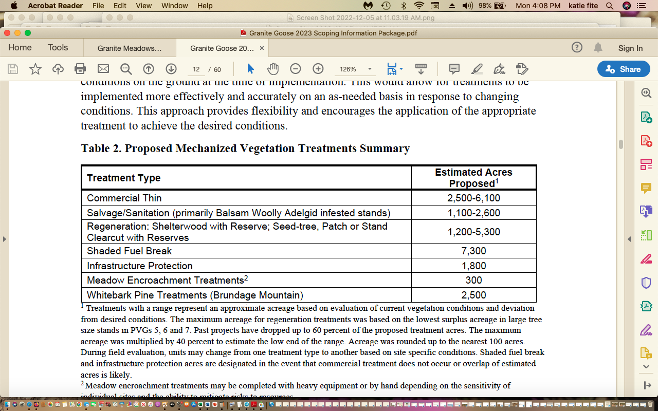
Table 2.

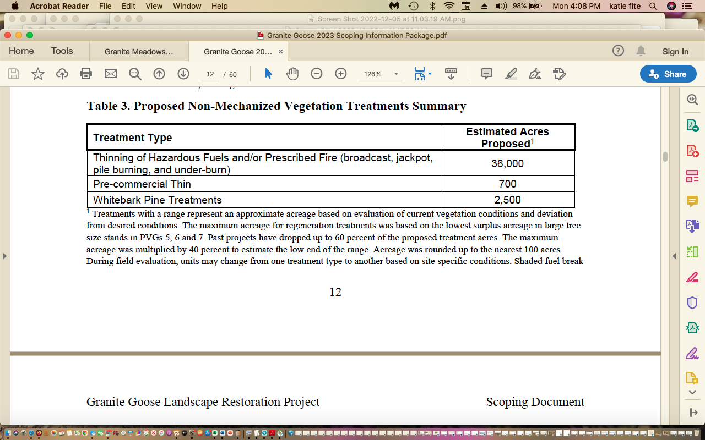
The 2018 project was located in the Hard Creek, Hartsell Creek-North Fork Payette River, Elk Creek-Little Salmon River, Lower Meadows Valley-Little Salmon River, Round Valley Creek-Little Salmon River, Sixmile Creek-Little Salmon River, Box Creek-North Fork Payette River, Fisher Creek, and Payette Lake subwatersheds with the Little Salmon and North Fork of the Payette subbasins. Were riparian ecological health studies conducted in all of these watershed areas? If so, what were the effects of existing logging/treatments/roads/fires (wild and prescribed) livestock grazing and climate stress studied, and separated out, or cumulative effects considered? Distinguishing the relative effects contribution of these several ecosystem and site disturbance factors is necessary to arrive at a solid understanding of specific restoration actions to take.
The 2018 DOPAA described 25,000 acres of commercial treatments, logging/cutting and multiple disturbances and treatments occurring in the same land area/watershed/habitat.
Commercial Treatments: This would include intermediate treatments (e.g. commercial thin), group selection with reserves, and regeneration treatments (e.g. modified shelterwood with reserves and patch cuts with reserves) depending on stand conditions and species composition. All commercial treatment areas may also have non- commercial thinning and prescribed fire treatments occur …”
Radical site, habitat and watershed disturbance is proposed: Trees would be removed for sawlogs, biomass, firewood or other forest products. Trees would generally be removed with the limbs and tops attached (i.e., whole tree yarding logging method) or could be processed in place. Where not needed to meet coarse woody debris requirements, limbs and tops of harvested trees may be used as biomass, or other products, where practical. Harvest systems may include ground-based, skyline, tethered, and helicopter.
Non-Commercial treatments will rip apart, cut, and grind up even more sites, habitats, and watersheds:
40,000 acres of NFS lands and up to 8,000 acres of non-NFS lands using cooperative agreements (i.e. the Wyden Authority). This would consist of cutting or masticating trees generally less than eight to ten inches DBH and pruning of residual trees where appropriate. Mastication may be used within plantations, commercially harvested areas, and within the WUI.
The Forest must clearly define the WUI in the 2023 project, how it was identified and defined, where all structures are located in relation to the host of proposed project actions, what measures have been taken to ‘harden” existing structures and private land areas, and basically explain the on-the-ground current baseline. Then it must identify additional actions that may be taken in the WUI, and describe the characteristics of all plant communities, topography, terrain, etc. in the WUI, and concentrate its logging, thinning, pruning, grinding, burning and other activities in the WUI in areas near human habitation.
The Forest planned to burn vast portions of the project area in 2018, and now in 2023 proposes highly uncertain “condition-based” projects of all kinds including multiple types of potentially overlapping burning activities. In 2018:
Up to 78,000 acres of NFS and non-FS lands would be treated with prescribed fire over the next 20 years to restore vegetation and fuel conditions, improve wildlife habitat, and promote the development of fire-adapted communities ... Approximately 500 to 10,000 acres of fire would be applied annually. Ignitions would be by hand or helicopter.
Now in the 2023 Scoping proposal, all treatment areas (every acre) could suffer burning:
“All treatment areas may also have small diameter (5.0-11.9” Diameter at breast height (DBH)) thinning, prescribed fire (pile, jackpot or underburn), and reforestation (planting or natural regeneration) treatments occur as described in regeneration treatments”. 2023 Scoping p. 13.

2023 Scoping p. 16: “Up to 36,000 acres would be treated with prescribed fire over the next 25 years to restore vegetation and fuel conditions, improve wildlife habitat, and promote the development of fire-adapted communities. Approximately 500 to 10,000 acres of fire would be applied annually, depending on conditions”.

2023 also includes just around every logging thinning disturbance known to exist:
Sanitation, salvage logging (after the FS burns things up???), commercial thinning, sed-tree, clearcut, shaded fuelbreak.

Crazily, this 2023 proposal also authorizes burning at any time of the year, and there is no specificity to when, where and now burning will take place. Please see Attached Objection to Salmon-Challis NF “condition-based” Prescribed Fire EA that this 2023 Granite Goose document mirrors:
“To achieve desired conditions for tree class sapling, small, medium, and large tree size (Appendix 1, Tables 13-15) could require multiple applications. Maintenance burning (burning after reaching desired conditions) could occur as necessary to maintain desired percentage of saplings, small and medium tree size classes and shrub canopy cover and as appropriate for the given fire regime (forest plan, table A-11).
Prescribed burning operations would occur any time of year when conditions permit, typically spring (April, May, June) and fall (August, September, October). Prescribed fire may be applied prior to commercial activities. Burn treatments would be implemented in accordance with Montana/Idaho Airshed Group and follow an approved prescribed fire burn plan. Active ignition within RCAs would not occur”.

This highly uncertain NEPA-violating massive any time of year burning would result in extreme levels of take under the migratory Bird treaty Act. Full and detailed multi-year surveys for all nesting, wintering and other migratory birds must take place as a baseline for this immense disturbance scheme.

Intensive surveys for all native carnivore dens and resident wildlife of concern must be conducted, and detailed studies on use of home ranges must take place for multiple years in advance of any decision here.

The year-round burning is made even riskier given the large-scale “prescribed fires” turned wildfires” Forest Service incidents in New Mexico in 2023 and other times.

We stress that the Payette Forest SOPA contains a link to the Payette undertaking “prescribed fire EA” nearly identical to the Salmon-Challis Prescribed Fire EA, so all issues raised in the SCNF Objection (on cd) apply here.

The 2023 action proposes use of toxic insecticides, sneaking this in under the guise of “saving” whitebark pines – this alone necessitates and EIS: “Whitebark Pine Restoration Treatments
Whitebark pine restoration treatments would use strategies and methods identified by current and recommended management practices (Tomback et al., 2022) for the restoration of whitebark pine (Pinus albicaulis Engelm.), a western North American tree listed as threatened under the Endangered Species Act. Treatments may include stand-level thinning, selection cutting, tree-level thinning (daylighting), spot fuels treatments, girdling, nutcracker openings, and insecticide and pheromone applications. Restoration of whitebark pine, including preservation of whitebark pine trees, is the primary objective of these treatments. Table 4 presents the different whitebark pine restoration treatment types”.

Please review the Attached Herman and Bulger Wildlife Monograph of the devastating impacts of insecticide applications to Forest birds, shrews and other biota. It is madness to consider this in an area so heavily used by the recreational public as well. The Payette Forest has no current analysis for use of toxic pesticides on Forest lands – exposing the public, migratory birds and other biota including native pollinators to dangerous chemicals.

How much mature (older forest) and/or old growth of all vegetation community types are left in the project area? Across the New Meadows RD? Across the Payette Forest? In the adjacent Nez Perce District lands? In the affected IRAs? How much mature and/or old growth vegetation community area of all types remains in the project area and across the RD and Payette Forest? Where are all these old growth veg communities located? Please provide detailed mapping and analysis. How does the FS define mature vs old growth vs. earlier successional communities?

The scoping document provides insufficient information on the very heavy recreational winter and summer use much of this area gets, which already places a significant strain on Forest watersheds, ecological conditions, and habitats and populations of native animals. It also provides almost no information on the adverse ecological footprint of the heavy livestock grazing burden and livestock-caused watershed and habitat impairment of these watersheds and habitats.

The document is not adequate for fostering informed public comment on complex vegetation communities, wildlife habitats and populations, wild lands values and many other aspects of this sprawling project. The USFS must re-scope this very significant project as an EIS, and provide basic current systematic baseline biological inventories and other ecological information to the public to thoroughly detail the status and habitat condition of the animal species who currently occupy the native plant communities that the USFS deems unhealthy or uncharacteristic or deviant or having too many “fuels” or otherwise claimed in this document to be in need of large-scale disturbance and simplification from native tree and shrub removal and weed-causing “treatments”. We are very concerned about the FS use of the categories “surplus” and “deficit” applied to complex habitats for rare native carnivores, rare owls, migratory birds, Mule Deer. Elk and Moose are termed “surplus. Over what land area is this category used? How can sudden natural events (fires, insects) change how much land area is “surplus”? How can climate change stress change this “surplus”? What is the date when these categories were mapped? There appears to be significant out-dated information in the Scoping Notice, regarding Wolverines and other native species. We are very concerned that the Forest’sd artificial models with extremely short disturbance intervals such as those used on the Landfire site are being used to justify radical manipulation that will result in a major loss and deficit of habitats for Wolverine, Canada Lynx, Fisher, Norther Goshawk, Great Gray Owl, migratory birds and a host of other species.

We are concerned about the FS use often by use of artificial categories and vegetation and fuels models that appear designed to justify extensive manipulation. After reading the document, it appears that the Forest is not really satisfied with ANY existing vegetation community anywhere. How many unmanipulated acres of all vegetation types remain at present across this landscape? How many across the New Meadows Ranger District, which is very heavily logged and disturbed? How much will this change with the project? With the Railroad Saddle project? With ongoing or foreseeable projects in the McCall RD? How fragmented has the landscape become from all FS sensitive and MIS species? How much will this change with the project? What is the current viability of all populations of species of concern, and how will this project impact species numbers and persistence across the project, area, RD and Forest? Are current Forest plan goals met for important and sensitive species, and where is the monitoring data that shows this? Are they met for MIS species, and where is the monitoring data that shows this? Are they met for migratory birds and all other species of concern? Where is monitoring data that shows the current status of habitats and populations for these species, and that shows that Forest plan goals are currently met for these species? How will the massive manipulations affect attainment of FS goals for each sensitive species and other species of concern?

USFS lands here are suffering significant deleterious grazing impacts. No current NEPA and FRH or land health analyses related to grazing impacts have been conducted in many areas. The poorer condition that lands are in prior to a “treatment” disturbance including the proposal’s massive burning disturbances, the greater risk of weed and other problems following vegetation treatment disturbance – especially these large-scale treatments that will result in hotter, drier windier weedier sites. The project actions are very likely resulted in significantly increased use of toxic chemical herbicides for which the FS does not appear to have adequate current risk assessments nor adequate current NEPA analysis of these chemicals toxic impacts on terrestrial and aquatic species (sensitive, rare, T&E) and on human users of the Forest in this area that is heavily used by the public for recreational purposes. Human exposure risks will be maximized by clearing away vegetation that helps filter runoff and lower wind speeds and thus reduce “drift”. Further, there is no information on whether aerial toxic chemical herbicide applications or other methods of applications will take place, and potential for runoff or contamination of surface waters highly used by aquatic biota and the recreational public.

There is also significant concern for increased sedimentation and warmer temperatures of surface waters from this large-scale disturbance activity. Please provide detailed baseline analysis of current stream temperatures, cobble embeddedness, flow rates during all seasons of the year, etc. so that a baseline of aquatic habitat conditions can be established. This is necessary to serve as a basis for estimating the magnitude of change caused by the project, and to ensure water quality is met.

There are also significant areas in neighboring lands and across the RD, with large-scale habitat losses due to logging and projects very similar to this, and with significant biodiversity loss, watershed degradation and weed infestation risk as well. There have been many past logging, and other treatments across land ownerships, and he USFS land condition is often highly degraded as result of past logging, thinning, burning, high densities of motorized trails and activity based on failed management paradigms. Nearly all these lands also suffer chronic high levels of cattle and/or sheep livestock grazing disturbance. Please provide detailed mapping and analysis of all logging, thinning, vegetation treatment projects across the New Meadows RD in the past 20 years, and monitoring of wildlife use, watershed condition and fish and wildlife populations in these treated areas. Please also provide weed inventories. Please provide similar detailed mapping and analysis for all ongoing and/or foreseeable projects.

For example, there is a massive influx of funds for logging “treatments”:

https://lmtribune.com/biden-administration-sending-funds-out-west-for-fire-reduction/article_58178e1c-9822-11ed-8ebd-27fe5f198a98.html

“Combined with another significant slug of funding from the Bipartisan Infrastructure Act that was announced last spring and targeted to 10 landscapes, Vilsack said the administration has made $930 million available to reduce fire risk on 45 million acres. Last year, the Boise and Payette national forests, part of the 1.7 million acre Southwest Idaho Landscape, were included in the initial phase of funding”. Is this Granite Goose project tied to that? Did the FS merely carve off a big part of its old 2018 project and outdated information, and issue this scoping notice, with fed $$$ “burning a hole” in its pocket, so to speak??

Now the adjacent Nez Perce forest is to receive a massive funding influx:
“The Nez Perce-Clearwater National Forest will receive a share of $490 million the Biden administration is sending to 11 national forests across the West, it was announced this morning”
This project with its host of intensive and often unpredictably overlapping disturbances and disruption of natural forest processes is likely to increase and intensify fire dangers.
See for example, Levine et al. 2022, “Higher incidence of high-severity fire in and near industrially managed forests”.
https://forestpolicypub.com/wp-content/uploads/2022/04/Frontiers-in-Ecol-Environ-2022-Levine-Higher-incidence-of-high%E2%80%90severity-fire-in-and-near-industrially-managed.pdf .
The highly uncertain intensive management actions here, with multiple overlapping disturbances ,are similar to intensive management actions on heavily cut and manipulated private lands.
See Baker and Bevington re: Problems with prescribed fire including smoke and risk of escape. In the project, lands could even suffer multiple bouts of fire depleting vegetative cover, exposing soils to erosion, adding carbon to the atmosphere, depleting nutrients – a real concern on the nutrient-deficient granitic soils of the Idaho batholith. The “condition-based management” where the project would fail to specific y and identify a specific treatment area for each type of treatment makes any accurate science-based analysis impossible - adding to the serious ecological risk of the project and its harms to plant communities and biodiversity including many sensitive species habitats and populations. Also:
“Another myth repeated by some prescribed advocates is the erroneous notion that forests that previously experienced Ore suppression will now “burn up” in all or mainly high-intensity fire when a wildfire occurs, unless those forests first get prescribed fire or other “fuel treatments.” But multiple studies have shown that areas that experience wildfire following long periods of fire
suppression still burn mainly at low and moderate intensity, along with some high-intensity
patches that provide the benefits described above (Odion and Hanson 2008, Miller et al. 2012). In fact, research has found that forests with the longest fire exclusion actually burn at somewhat lower intensity (Odion et al. 2010). This is exciting news for efforts at ecological restoration because it means that large-scale prescribed fire or other “treatments” are not needed as a precondition to allowing mixed-intensity wildfire back into forests”.

Downing et al. 2022 demonstrates the need to focus fuels efforts on private lands, and the FS here fails to provide an adequate baseline of fuels situations, hardening of homes, etc. on private lands, and fails to consider a range of alternatives focused on treatments there.

An OSU news article describes:
“In the old framing, public agencies bear the primary responsibility for managing and mitigating cross-boundary Ere risk and protecting our communities, with their
e\orts focused on prevention, fuel reduction and suppression,” Dunn said.
“This has been the dominant management approach of years past, which is failing us.” The Endings, published today in Nature Scientific Reports, follow by a few weeks the Forest Service’s release of a new 10-year Ere strategy, Confronting the Wildfire Crisis. The strategy aims for a change in paradigm within the agency, Dunn said. “We are long overdue for policies and actions that support a paradigm shift,” he said.

See also Chad Hanson (2021)
Logging in disguise: How forest thinning is making wildfires worse

“The idea of felling trees and hauling them to lumber mills in the name of fire prevention has
many deceptive names: fuel reduction, forest health, ecological restoration, thinning,
and even reforestation. As I detail in my book, Smokescreen, the Forest Service began using these terms in the mid-1990s as the public became more aware of the horrific realities of widespread clearcutting of mature and old forests on public lands in the Pacific Northwest, and the northern spotted owl became a household name”. See also information on Bootleg and other fires discussed in the Hanson article.

Bradley et al. 2016 report: “We investigated the relationship between protected status and fire severity using the Random Forests algorithm applied to 1500 fires affecting 9.5 million hectares between 1984 and 2014 in pine (Pinus ponderosa, Pinus jeffreyi) and mixed‐conifer forests of western United States, accounting for key topographic and climate variables. We found forests with higher levels of protection had lower severity values even though they are generally identified as having the highest overall levels of biomass and fuel loading. Our results suggest a need to reconsider current overly simplistic assumptions about the relationship between forest protection and fire severity in fire management and policy …”.

Note that the SCNF Iron Creek mining exploration EA includes a 2011 fire as having harmful effects on Boreal Owl, Great Gray Owl, Flammulated owl, Northern Goshawk, and Wolverine. Yet herein Granite Goose large-scale logging and veg clearing and fire, or a combination of fire and mechanical manipulation, will be unleashed across nearly the entire landscape.

This Granite Goose project (and the huge number of additional projects already undertaken, proposed or foreseeable in the Payette Forest and adjacent lands) would impact a large area of very weed-susceptible wild lands and fish and wildlife habitats. By drastically reducing protective forested vegetative cover, this project (and the many others that are planned and/or foreseeable) will reduce the ability of the land to retain snow cover, and result in more extreme runoff events with higher erosive effects exposing vulnerable treatment-disturbed soils to elevated erosion rates. It would remove shading vegetation that helps retain moisture on the site so that water is slowly released from the system to provide sustainable perennial flows. Not only will forested cover shading and cooling moisture-trapping protection be greatly diminished by the project, conditions may become even harsher due to increased temperatures and other weather changes resulting from climate change stress. This will amplify and worsen the adverse effects of climate change stresses including erosive runoff and loss of essential elements of riparian and aquatic habitats. We are concerned that this project will result in much more erratic stream flows and flow losses. Please provide detailed stream and spring flow rate information and mapping of all perennial vs. intermittent vs. ephemeral water flow segments of streams. Full and detailed mapping and analysis of existing springs and moist areas must be provided. All RHCAs must be avoided. The FS must consider all areas surrounding springs to be RHCAs. Please provide detailed mapping and analysis of all springs, fens, boggy areas, meadows

“That ‘natural thinning event,’ I have not used that phrase and I really like it,” said Sara Goeking, a biological scientist with the U.S. Forest Service Rocky Mountain Research Station, “... That’s what the mountain pine beetle epidemic really was. And there were a handful of studies that showed water yield didn’t increase, it didn’t change. Some of them found some decreased water yield.” Also: “It ran counter to prevailing beliefs at the time — forestry scientists had hypothesized since at least the 1960s that reduced forest cover would yield more water. While working on her Ph.D. in watershed sciences at Utah State University, Goeking wanted to explore why it wasn’t always the case in forests across the West.
“Most of the studies were done in wetter places,” she said. “No one ever really thought maybe that doesn’t hold true everywhere.”
Goeking collected data on forest disturbances like beetle outbreaks, wildfire and drought at 159 watersheds across the region, including some in the Uinta Mountains. She also analyzed streamflow measurements and climate information for those sites over a 20-year period”.
“the generally held hypothesis that forest cover and streamflow are inversely related is not universal in semi-arid western watersheds”.
“Thus, significantly decreased streamflow was more prevalent in disturbed than undisturbed watersheds, counter to commonly held expectations. Increased streamflow in 44% (8 of 18) of undisturbed watersheds coincided with higher precipitation overall in 2010–2019 compared to 2000–2009. Multiple regression analysis showed that mortality explains some variability in ΔQ that is not explained by climatic drivers, and that the direction of streamflow response to mortality (i.e., increase vs. decrease) is affected by aridity.”
https://www.sltrib.com/news/environment/2023/02/11/scientists-say-thinning-forests/

An EIS must be prepared to examine the host of adverse and other direct, indirect and cumulative impacts of this severe proposed project disturbance to the area watersheds, to streams and springs and their replenishment, to soils and protective microbiotic crusts (mosses, algae, lichens that help protect lands from weeds, sequester CO2, and prevent soil erosion), to diverse and complexly interspersed native vegetation communities, to sensitive and rare plant and animal communities and populations, to very important Inventoried Roadless Areas and other wild land natural and scenic values, irreplaceable cultural sites, and other values. Note that the unexamined levels of grazing, AMPs and management schemes, and stocking rates under actual use of livestock here will exacerbate and worsen the stresses of climate change and would hamper any recovery from the multiple disturbances being heaped in this landscape. See Beschta et al. 2012, 2014. Grazing makes lands LESS resilient and less able to recover from such severe vegetation disturbance stresses as the FS seeks to impose here – on top of already damaged watersheds. The increased temperatures and extremes from climate change stress also make it less likely that forests will be able to recover in many areas. Fusco et al. 2019, Kerns et al. 2020.

There is currently serious livestock grazing degradation occurring across portions of the project area, and the level of degradation and impairment must be fully examined in an EIS for this project. A complete livestock current capability and suitability analysis must be provided including data on native perennial vs. annual weed production.

Not only is the USFS destroying protective cooling weather-moderating forested cover here, many other projects are underway in the Boise, Payette Forests and across Region 4 and also the Nez Perce Forest that will have cumulative adverse effects on sustainability of fish and wildlife habitats and populations, and recreational and wild land uses and enjoyment.

The cumulative and synergistic effects of all of these projects must be fully examined in an EIS that takes a hard look at the sustainability of forest vegetation types in a time of Climate Crisis, at irreversible weed invasion risks that may be caused by the severe project treatment disturbances, at the condition of sensitive wildlife species habitats and population viability and persistence, at migratory bird habitats and population viability and persistence, and at other important species habitats and population viability and persistence across this landscape.

Tree Cutting Does Not Effectively Suppress Beetles – Tree Injuries from Treatments Entice Insects, Foster Pathogens.

Timber harvest treatments do not effectively suppress bark beetles. The massive treatments will weaken and injure remaining trees, increasing susceptibility. How many mores trees are likely to die because of “treatments” injuring them or neighbors? Outbreaks are dependent on temperature, differing tree defenses and beetle fluctuations. Salvage “treatments that log dead trees don not really reduce or impact beetle populations - as beetles are long gone from those trees. The project relies on unsupported assumption to clearcut and log both damaged and healthy trees, thus setting back regeneration, herbaceous production and wildlife habitat. Cutting trees will not control the beetle infestation or other forest “problems”.. Instead, the Forest Service should be reducing the stresses on the health of these forests (like livestock grazing – as the grazing and trampling of livestock reduces water infiltration, compacts soils, dries out sites, and increases stress on the trees, making them more susceptible to disease and insects.

Fire, Wildland Urban Interface, Treatments

NEPA analysis must place more burden on those who build within the Forest Boundary, and should include in its preferred alternative no longer issuing rights of way in the forest for second home construction.

Cohen’s work has long reviewed scientific evidence on wildland/urban interface and fire, and found that the primary focus must be on structures and ignitability in the Home Ignition Zone, rather than extensive wildland fuel management. (Cohen, 1999, Cohen and Butler 2005).
Rhodes and Baker (2008) describe:
“Although some fuel-treatment methods could have lower impacts, ground-based mechanical treatments are often employed because other methods generate activity fuels [7] and are more costly. Ground-based methods and associated ma- chine piling, burning of activity fuels, construction and in- creased use of roads and landings can increase soil erosion, compact soils, and elevate surface runoff [8, 13, 14]. Al- though the effects of prescribed fire on watersheds are typically limited and fleeting, it can increase soil erosion and sediment delivery, sometimes significantly and persistently [15], especially if fires escape and burn larger and more severely than planned.
When impacts are extensive, proximate to streams, or in terrain with erosion hazards, treatments can increase runoff and sediment delivery to streams. Road activities that in- crease sediment production, such as elevated road traffic, of- ten affect stream crossings where sediment delivery is typically efficient and difficult to control [16]. Elevated sediment delivery to streams contributes to water quality degradation that impairs aquatic ecosystems [17].
Repeated treatments increase the potential for cumulative effects on aquatic ecosystems due to the persistence and additive nature of watershed impacts over time [19] and may increase the establishment of non-native plants [9]. The chronic watershed impacts from repeated treatments may be more deleterious to native fish than pulsed disturbances from wildfires [8]”.
Baker et al., 2006 state:

“Livestock grazing generally increases tree density in formerly open stands and thereby increases the fine fuels that contribute most to fire intensity and severity. Removal of grass reduces competition, allowing more trees to successfully regenerate, shown experimentally in the Southwest (Pearson, 1942), and also by paired comparisons in other parts of the West, in which mesas subject to livestock grazing have much higher tree density than do comparable nearby ungrazed mesas (Rummell, 1951; Madany & West, 1983). Grazing can also initially reduce the quantity of fine grass fuels needed for surface fires, and the onset of heavy grazing in south-western ponderosa pine landscapes is temporally associated with a marked reduction in surface fires (e.g. Savage & Swetnam, 1990). However, fine fuels are likely not to have remained low for long. Higher tree density increases fine fuels that lead to faster fire spread and increases ladder fuels that lead fire into the canopy (Zimmerman & Neuenschwander, 1984), together increasing the potential for more fires and more severe fires”.

Impacts of Federal Agency Actions removing Environmental Protections Will Ripple Across Project Area – Causing New Harm to Native Biota and Watersheds

All of these treatments and road network will fragment and destroy migratory bird species and many other animal habitats, and migratory birds face a grave and growing crisis across the US. See Rosenberg et al 2019 describing the loss of 3 billion birds from North Americas, and will adversely impact biodiversity.

Forests across Region 4 - from the Dixie Forest in southern Utah to the Payette and Salmon-Challis Forest in the north - are proposing a huge amount of deforestation projects and “treatments” that will destroy and fragment forest habitat, and migratory bird habitats. These massive treatments are the dead opposite path a federal agency should be on as climate change stresses are bearing down on the land, waters, watersheds and habitats for native biota. Loss of forested cover must be considered cumulatively, as it will impact populations of precipitously declining migratory birds at a West-wide level, including during migration. An analysis of the loss of forested habitats for each of the vegetation habitat community types the USFS proposes to “treat” or deems to be unhealthy must be provided. The Forest must determine the amount of habitat loss that has taken place in recent decades, and that is foreseeable for species of concern/sensitive species, ESA-listed species. See: https://www.counterpunch.org/2022/03/11/bad-fire/

“The Forest Service Intermountain Region 4 just released a barrage of cookie cutter NEPA documents aiming for a tremendous increase in Forest-wide prescribed burning across the Salmon-Challis, Sawtooth, Caribou-Targhee, Humboldt-Toiyabe, Manti-La Sal, Fishlake, Dixie and Ashley Forests.
The projects span millions of acres of rugged, dramatically beautiful arid forests and shrublands. It turns out these fire projects may be used as justification for pre-burn and post-burn logging under separate piecemeal NEPA decisions. Roadless Areas are primary targets. The Forest Service claims vast swaths of Roadless Areas are greatly “departed” from their modeled ideal, have “missed fires”, haven’t burned nearly enough, or trees are dense so there’s too much fuel. Being branded “departed” is the kiss of death. Claimed Roadless Area “departure” highlights the use of spurious USFS-BLM-Nature Conservancy LANDFIRE black box models with their purported pre-settlement fire intervals and broad brush fuel estimates. Roadless Areas are some of the least likely places for fire suppression to have occurred or been effective. Such models are being universally applied by agencies in support of the official narrative that fire suppression causes big western wildfires”.

These massive fire EAs will greatly reduce mature and old growth vegetation communities just like many of the areas threatened here. This will result in a regional loss of habitats for many sensitive and important species and migratory birds that occur within this project area – and the full range of cumulative, additive and synergistic impacts of these massive treatments must be fully examined here.

See also attached objection to SCNF Prescribed Fire EA. Now the Payette Forest is proposing the same here – with massive highly uncertain “condition-based” prescribed fire that will deal a further blow to the species like Wolverine and Northern Goshawk and Great gray Owl and Boreal owl and Westslope cutthroat Trout and the quantity and quality of their habitats. See: https://usfs-public.app.box.com/v/PinyonPublic/file/1067076982714

The project spans 1.3 million acres, and the FS proposed to burn 30,000 acres a year in unknown sites without any integrated upfront analysis. This is another “condition-based” EA, just as the Granite Goose project is.

Right now, the FS is also planning a major deforestation and burning project in the Railroad Saddle area. Tis will further reduce and fragment habitats for sensitive, MIS, migratory bird and other wildlife species – and lead to a loss of habitat connectivity -thus further isolating populations. Please provide detailed mapping and analysis of habitat connectivity vs. fragmentation for all species of concern affected by the current projects. What actions are necessary to increase and restore connectivity and key habitat features? It sure seems to use that in nearly all cases the primary action is to leave mature and maturing forests alone – as these are the habitats that are at a premium, are most essential to many declining species.

https://www.fs.usda.gov/project/?project=61229

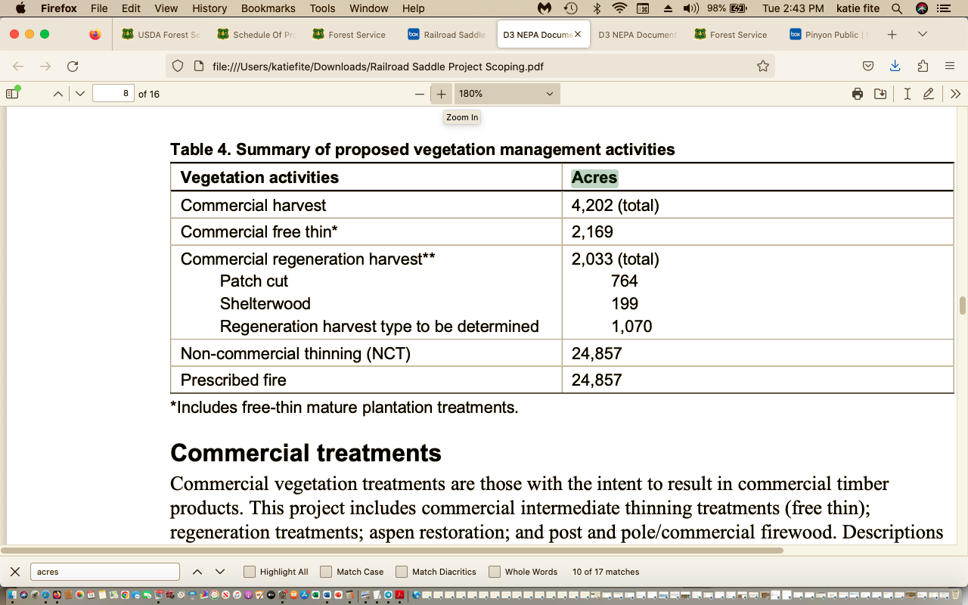

Please conduct full and thorough baseline inventories for all important and sensitive animals, rare plants and migratory bird species of concern across the project area and surrounding lands to serve as a necessary baseline for project impacts.

Please conduct current detailed sediment bacteria and other aquatic habitat, water quality and quantity studies so that a solid environmental baseline and mitigation and minimization measures can be established for these large-scale treatments and expanded roading and erosion that will impact water quality, quantity and aquatic biota.

The aggressive USFS deforestation, logging and other treatment projects may drive serious population losses and/or may extirpate sensitive species across the region, along with cumulative impacts from BLM projects are also taking place.

Large fires have burned in many areas of the Region and in the Payette Forest - whipping right through intensively logged areas. This also represents significant loss of forested habitat cover for sensitive species of concern. Many lands also have suffered significant early settlement era human impacts including deforestation for wood products, and the use of promiscuous burning from livestock grazers setting the range afire, and other human deforestation and disturbance. Thus, in many areas, the forests are still recovering from significant past human disturbance, which the agency vegetation and fuels models and assumptions do not take into account. They may in fact have suffered much greater disturbance than the Forest claims has occurred, or that is used in disturbance interval models to justify the projects’ massive intervention and clearing.

Forest conditions are getting harsher and less resilient under climate change stress. Surface water is becoming more limited with reduced snowpacks that decrease sustainability of perennial flows. Snowpack is essential to provide water to springs and streams. Deforestation will result in hotter, drier sites prone to more rapid ad erosive runoff and resulting degradation. Ubiquitous livestock grazing further degrades and depletes springs and streams and riparian habitats. Belsky et al. 1999 describe the an y deleterious effects of livestock grazing on riparian areas – and these harms will be made worse and compounded by the massive native plant community disturbance and simplification treatments that are proposed.

Cheatgrass, bulbous bluegrass and other flammable invasive exotic weeds are already exploding across the lower elevations of this region. So too are aggressive often “seeded” bromes and intermediate wheatgrass that choke out native understories and thrive with fore and “treatment” disturbance to the detriment of native species. The Forest must carefully examine and map this landscape to determine the extent to which cheatgrass, bulbous bluegrass and other weeds are already present, or where they are likely to expand to – determining sites that may be dominated post-treatment. This project is made even more risky due to planned use of aerial fire ignitions. In these, ping pong balls with napalm-like highly flammable material are spit out of spinning device on helicopters. This type of ignition can have devastating impacts to forests. Please see:
https://www.counterpunch.org/2019/10/08/owyhee-ecocide-anatomy-of-blms-ancient-juniper-forest-destruction/

photos illustrating the severe and highly damaging impacts of aerial ignitions in “prescribed” fires. This shows the damage caused by aerial ignition in rugged mountainous terrain in the Juniper Mountain area of Idaho. Ancient trees and groves of old growth arid forest were destroyed after the napalm ping pong balls ignited the forest. Many of the logging and other projects also include burning, increasing weed infestation risk, and cause elevated wildfire risk.

The Granite Goose project will also irreversibly alter heavily used recreational areas and scenic wild lands. The essential migratory bird and wildlife habitats currently present in these forests and the currently often diverse vegetation communities will be harmed and simplified as the USFS attempt s to “groom” and manicure lands into an artificial state based on sketchy models.

This current proposal (and many of the other projects taking place or foreseeable) will alter this scenic and biodiverse area of Idaho for 150 years or much longer – and that’s if cheatgrass or other weeds do not invade and truncate plant succession, which is a very real possibility. Cheatgrass/flammable weeds/noxious weed invasion and ensuing site dominance is especially likely given the highly damaging large levels of livestock grazing the Forest and adjacent BLM management allows to take place here.
This proposal would inflict a huge battery of highly uncertain mechanical (heavy equipment and chain saw) treatment disturbances, and also impose prescribed burning, or burning in the aftermath of other treatments. There would be many opportunities for fire to escape, kill non-target vegetation, scald soils, and result in expanded weed problems.
This intensive treatment disturbance will injure or weaken trees, and result in hotter, drier, weedier less resilient sites. It is likely to result in expanding the insect/disease “problems” the agency cites in the scoping material (as a result of burned, cut, injured and otherwise damaged trees). It will result in large-scale loss of forested habitat.
The insects are a natural part of the forest ecosystem. Standing dead trees are not a fire risk. They provide soil stabilization and structure to moderate site conditions as well as provide shade to cool the site. The deforestation project is likely to increase tree injury and disease, as sap from cut trees lures in insects, and as “leave” trees are injured. It will make matters worse, not better. They also serve as habitat for native woodpeckers, as den sites for rare forest mammals, store carbon and shade and cool sites and reduce wind speeds and moderate site conditions. Thus, we strongly oppose removal of dead trees as “salvage” or other types of logging/thinning “treatment”.
This project includes areas of steep, rugged terrain where control of fire may be difficult, and where spoils bared by treatment disturbances may be highly vulnerable to erosion. These risks will be increased by continued chronic high levels of livestock grazing pressure. Clearing trees may expand the areas of livestock impact and give livestock access to areas previously less impacted – further expanding weeds, erosion and degradation. How will the massive treatments alter grazing capability and stocking rates? Please provide detailed livestock monitoring information for riparian and upland sites, data on actual use, stocking per pasture or unit, grazing schemes, etc
We also very concerned the FS seeks to purge smaller age class native trees or native trees it considers the “wrong” species from sites. Very often, mixed forest types contain a high density and diversity of migratory birds and other biota- and a purged forests represent a serious habitat loss. Denser tree cover also helps protect native carnivores and big game from human disturbance harassment, poaching. This dense cover is critical in an area that receives such high intensity recreational disturbance and use. What wildlife use mixed species forests and forests that provide denser cover?
The USFS must provide full and detailed very site-specific mapping of tree age classes in all forested areas and adjacent vegetation communities of all types. Where are all old growth and mature forests (of all types – including mixed species assemblages)/sage/mountain shrub/aspen vegetation communities located? Detailed information on stand characteristics and wildlife habitat values and wildlife use of the site must be provided based on current site-specific inventories and inventories across this landscape. This further discussed below on comments.
Disruption of natural plant succession will convert forests to ashes and bare dirt. Aspen are a successional (seral) stage to the climax native Douglas fir community. The site could just as readily be termed a mid-seral Douglas fir community. The areas claimed to be mid-seral or other aspen are often actually a complex mix of forest species that naturally varies in composition depending on micro-site aspect, soils, slopes and past disturbance history. The USFS fails to provide scientific evidence for the artificial categories it imposes, and for its selection of these particular intact forest sites for the radical manipulation scheme.
Further, aspen is often complexly interspersed with conifers, and the combination of aspen and conifer habitat, including dense forested habitat, provides vital nesting habitat for many migratory birds. This includes Northern Goshawk, and many cavity nesting species.
Costs of Project

The USFS often fails to address the costs to the public of the welter of environmental damage and losses that would take place under the proposed actions. These will pose a significant drain to taxpayers, as well as harm or destroy recreational uses and enjoyment, and sustainability of clean water and other resources. Further, as the serious damage and destruction from the proposed activities is carried out, taxpayers will bear many uncalculated costs – from toxic chemical herbicide costs to costs to try to restore species whose populations are pushed to very low levels due to the project impacts.

This must also include the cost of potential escaped “prescribed fires”. This is a significant concern given the highly uncertain, non-specific and extensive “prescribed” burning” of the project. This recent investigation shows how the federal government is trying to avoid fully compensating victims of two smoldering pile burn escaped wildfires in New Mexico:
https://www.propublica.org/article/after-hermits-peak-calf-canyon-wildfire-quantifying-victims-suffering-becomes-legal-battle?utm_source=1500%20CWP%20List%20Daily%20Clips%20and%20Updates&utm_campaign=715f70c0c6-EMAIL_CAMPAIGN_2024_01_08_04_41&utm_medium=email&utm_term=0_-715f70c0c6-[LIST_EMAIL_ID]&fbclid=IwAR0VTsCZWwdabGzNutUnfGWF2D6DHAquPAOczQgcit6CNbeKuC7j3sL56kk

Alternative Actions for Land Health
This project must be analyzed in an Environmental Impact Statement, not an EA. Given the present degraded conditions, superimposing more roads and intensified human recreational disturbances of all types, widespread high levels of burning under this EA, Railroad Ridge project and many others, and the proposed Payette Prescribed Fire EA in this project area alone, all manner of “treatment”, thinning, timber harvest - and other forest manipulations cannot result in a FONSI. A Draft EA/EIS should be provided for public comment prior to any objection period. A range of alternatives should be provided which address reduction in stressors to the ecosystem and its wildlife, rather than allowing or expanding (as in the case of roads) current uses, then superimposing these treatments and logging on top of these uses in this landscape suffering chronic grazing degradation.
Preventing expansion of ecosystem-dooming flammable annual grasses, exotic rhizomatous grasses, and other exotic weeds should be paramount for ensuring forest health. We are very concerned that weed infestations resulting from this action will result in excessive toxic chemical herbicide use by the Forest, and that the Forest does not currently have up to date risk assessments and hard look NEPA analysis of these dangerous chemicals and their impacts on humans, fish/aquatic biota, wildlife, rare plants, vegetation communities, and native. How much will this series of actions increase herbicide use? What chemicals will be used? What is the current scientific literature on these harmful effects of active and inert ingredients, carriers, adjuvants, breakdown products? What ecological risks does use of these toxics pose? The same applies to any insecticide pesticides that the FS may attempt to use under the guise of saving whitebarks. The number one most effective action for whitebark pines is to manually plant young trees - not torching or logging the forest See Keane and Parsons 2010 whitebark paper. This again demonstrates the USFS failure to take a hard look at ecological science throughout every aspect of this proposal under NEPA, and failure to consider a reasonable range of actions to protect habitats (for species ranging from Wolverine to migratory songbirds) and failure to prevent irreparable harm.
Herbicide Use, Risks, Contamination, Collateral Damage
The project disturbance is highly likely to result in an expansion of herbicide use over significantly increased land areas, involving many kinds of toxic and polluting chemicals. These substances will be infiltrating and drifting into air, soils, water (water in small springs and streams that is vital for aquatic biota and waters used by recreationalists), native pollinator habitat, wildlife water sources, aquatic species habitats), non-target vegetation, habitats of rare plants and animals and bodies of important and sensitive animals. There will now be more even more toxic chemicals and their polluting active ingredients, adjuvants, breakdown products and degradates in the Forest environment. The chemicals may also potentially be used in combination, or in overlapping areas in a manner that has never been adequately assessed.

What are the risk assessments, and environmental analyses that the Forest relies upon for the use of herbicides in this landscape? Much BLM and the USFS chemical use relies on risk assessments primarily from a long out-dated BLM Vegetation EIS from 2007. Since the EIS was prepared, there is new scientific information on adverse and polluting effects of many these chemicals. It is also increasingly recognized that these chemicals have an adverse effect on human health, so extensive chemical use in the aftermath of treatments threatens recreational users, especially those that may have chemical sensitivities. Please see Attached WLD comments on Boise and Sawtooth herbicide EIS.

What types and amounts of chemical herbicides have been used in the past in this landscape Forest? Where? How have they been applied? When, where and how has drift occurred? What have the effects been on non-target species? How has this been monitored? When, where and how much of each chemical has been used in the past? How does livestock grazing disturbance, and the road network, or recreational uses, contribute to the use of chemical herbicides? We are very concerned that although the Forest on paper claims to practice integrated weed/vegetation management, agency treatments rely overwhelmingly on herbicide applications without strong preventative actions and precautionary controls on disturbances that foster weed infestation and spread. This is a critical concern across the project area, because of the high levels of livestock grazing taking place with few to no mandatory actions to limit weed spread – plus the existing proliferation of roads and often high levels of recreational activities in many areas.

Differing allocations and provisions of the Forest Plan are often internally at odds with one another. The ramifications of inflicting large-scale ecological disturbance may be at odds with other promised management for watersheds, sensitive wildlife, recreation, protection of cultural sites, etc. to be achieved. Often, elements of the Plan do not adequately address climate change stress on ecological systems, making the uncertainty of the effects of the proposed project disturbances even greater.

We are concerned that the agency does not follow effective integrated weed prevention, or adequately assess and mitigate the adverse effects of what is largely a “Spray and Walk Away” approach. For example, livestock may be herded routinely from weed infested areas onto public lands without preventative quarantining or other measures. Livestock are turned out on lands with known weed infestations. Now proposed “Treatments” may take place in areas with known infestations highly likely to expand with this very large number of “condition-based” major disturbances to native vegetation communities and rare and sensitive species habitats. Please review our concerns regarding Payette grazing and linked herbicide use and toxic impacts in the Attached Sawtooth and Boise Forest herbicide processes (on cd).

The combined effects of large-scale domestic sheep grazing and other activities on the project lands, native vegetation, susceptibility to irreversible weed infestation and spread and a host of other ecologcal factors must be assessed.

The USFS website shows a map of the allotments:
https://www.fs.usda.gov/Internet/FSE_DOCUMENTS/fseprd704405.pdf
This shows Brundage Sheep and Goat allotment -and the FS fails to post the AOI on-line.

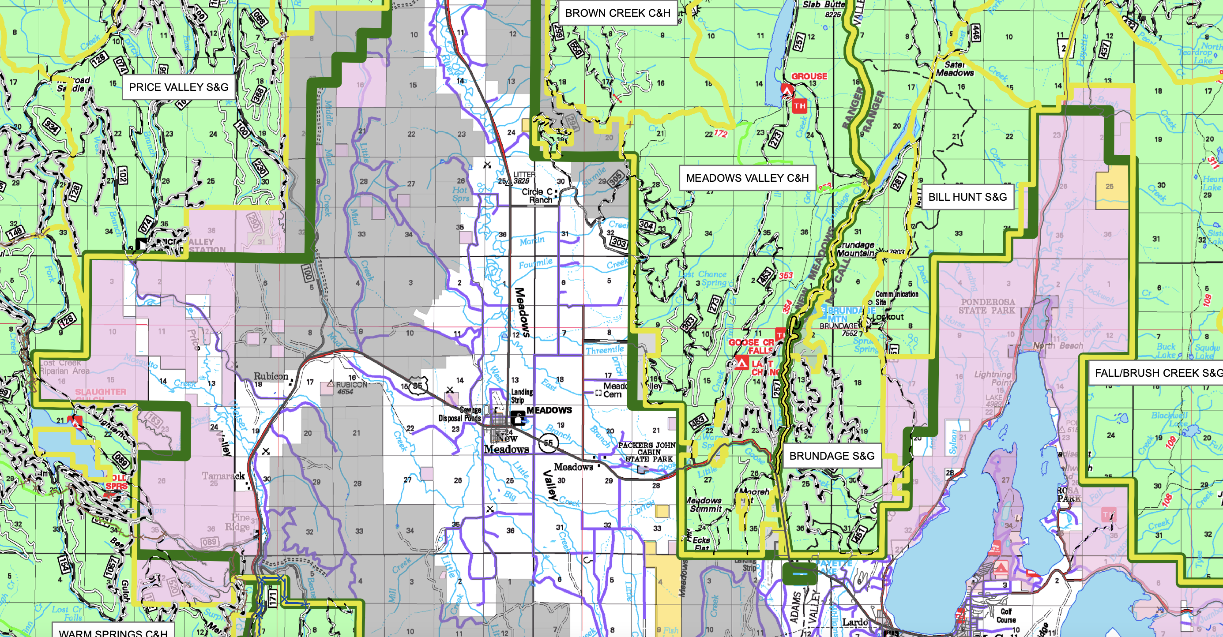

Climate stress is likely to amplify and worsen the weed infestations that result from the massive treatment disturbance including extensive burning, all the recreational use, the sheep grazing and trailing all over the place – and these impacts will be dramatically worsened by the project clearing away forest impediments and burning up forest and downed wood that may impeded sheep access to uplands as well as to fragile springs, seeps, bogs, and stream headwaters. This also increases the threat of harmful runoff into Payette Lake and other sensitive water bodies – with a worsening of water quality.
See Belsky and Gelbard 2000, describing a host of ways in which domestic livestock grazing both causes and spreads weeds. This will worsen under climate stress as native vegetation communities become less resistant to disturbance and less able to recover,

Please provide a current and predicted grazing capability and suitability analysis. Where is forested vegetation density currently reducing or hindering livestock access to fragile springs, stream reaches, fens, meadows, rare plant sites and other fragile habitats? How will this change with this project? Since the project dies not specify which specific areas will be burned - and uses other elements of “condition-based management” where the USFS fails to identify discrete projects, and take a hard site-specific look at their impacts - instead the agency skates by using a programmatic or quasi-programmatic overview of what might happen across large land area – but NEWVER providing specifics – including specifics and not conducting the upfront surveys necessary to understand impacts – instead pretending that in-front-of chainsaw or bulldozer wildlife piecemeal little wildlife “surveys” would suffice.– it appears highly uncertain and extremely difficult to understand the true scale of the effects. This uncertainty also necessitates an EIS.

From Belsky and Gelbard:
First, livestock carry weed seeds on their coats and in their guts. Where
these seeds are brushed off the animals or excreted in dung, they can grow into mature plants capable of producing hundreds to thousands of seeds. One study in Alberta, for example, found that in a single growing season, one cow moved 270,000 viable weed seeds around a pasture. 3 It is clear that the millions of cattle and sheep now grazing our western public lands are annually moving tens of millions, if not hundreds of millions, of weed seeds from weed-infested communities into uninfested areas, even on our most remote public lands.
Second, livestock weaken many native plants by grazing them, thus removing their leaves and flowering stems - that is, their photosynthetic and reproductive organs. Grasses and other plants of the Intermountain West are especially vulnerable to grazing by large herbivores since they evolved in an environment that has not been home to many large grazers for the past ten thousand years. Bison are predominantly a Great Plains species, and only low densities of elk, deer, and pronghorn occupy the arid lands west of the Rocky Mountains. As a result, Great severely damaged by close and repeated grazing. In addition, livestock frequently prefer native plants to weeds, which are often covered with spines or contain toxic and distasteful compounds. Where they preferentially consume native grasses and wildflowers, they leave weeds to grow unharmed and with little competition for water and nutrients. Consequently, weedy species grow large and increase in number while native species decline.
Finally, livestock contribute to weed invasions by disturbing the soil surface. Several factors are involved: Livestock trample the soil, creating patches of bare ground that serve as natural seed beds for the germination of weed seeds. Trampling also compacts the soil, damaging the roots of native plants and preventing them from acquiring sufficient water and nutrients for vigorous growth.
By reducing plant cover through grazing and disturbing the soil surface with their hooves, livestock enhance wind and water erosion. Dislodged soil particles then bury the weed seeds, increasing their ability to germinate.
Livestock hooves destroy fragile biological crusts that blanket exposed soils in deserts, arid grasslands, and shrublands. These crusts, which are composed of algae, bacteria, lichens, and mosses, enrich the soil with nutrients, especially nitrogen, and increase the vigor of native plants. They also stabilize the soil and act as physical barriers to weed invasions. As the hooves of livestock pulverize the biological crusts, they remove an important defense against the invasion of weeds.
Livestock trampling also reduces the number of soil mycorrhizae, the microscopic fungi that benefit native plants by transporting nutrients and water from the soil into plant roots. Many exotic weeds, such as Russian thistle and halogeton, do not require or benefit from these fungi. As trampling reduces concentrations of mycorrhizae in the soil, the ability of native grasses to acquire nutrients and water is reduced, giving the exotic weeds a competitive advantage over the native plants.
Livestock deposit nitrogen on the ground in their urine and feces. These nitrogen "hot spots" are concentrated where livestock congregate, especially near streams, water tanks, and salt licks. They intensify invasions by nitrogen-loving weeds, such as cheatgrass and medusahead. Repeatedly, scientists have found that sites that are disturbed and also receive high concentrations of livestock waste are the most severely invaded.
By reducing plant and litter cover and compacting the soil, livestock create warmer and drier soils, an impact especially severe in parched deserts, where plants are already highly stressed by lack of water. These drier soils reduce the vigor of native plants, whereas annual weeds simply go dormant.
Most, but not all, exotic weed species require the type of disturbance and open space created by livestock to germinate and grow vigorously. A few species, however, are able to flourish in plant communities ungrazed by livestock, as can be seen in national parks and other natural areas. This is because vehicles, miners, native wildlife, hikers, wind, and flooding streams can also carry weed seeds into grasslands and disturb the soils. Rarely, however, are these other influences as numerous or as widely distributed as livestock. Studies have shown that in most cases, plant species that invade undisturbed natural areas are less dense inside the natural areas than outside with localized exceptions, such as sites near roads and trails, or sites disturbed by recreationists and wildlife.
The risk of sheep transporting weed seeds all over the place is made even greater – given the huge country these sheep roam all through. Not only may sheep spread weeds onto the project area – they may carry them all over the place onto other allotments far outside the project area as weeds increase in the wake of the disturbances. Further, sheep grazing may be more concentrated with significantly greater disturbance impacts if lands are “rested” at all in association with the project.

As the AOI info below shows, sheep are no longer supposed to graze in several allotments – due to risk of disease transmission to bighorn sheep. By clearing vegetation with the massive project treatment disturbance, the USFS will increase ease of bighorn movement across the landscape, and we are concerned this may increase risk of disease transmission.
We could not find the 2023 AOI, but the 2022 AOI includes the following – note Wildlife Services (killers of native carnivores) are included on the AOI.

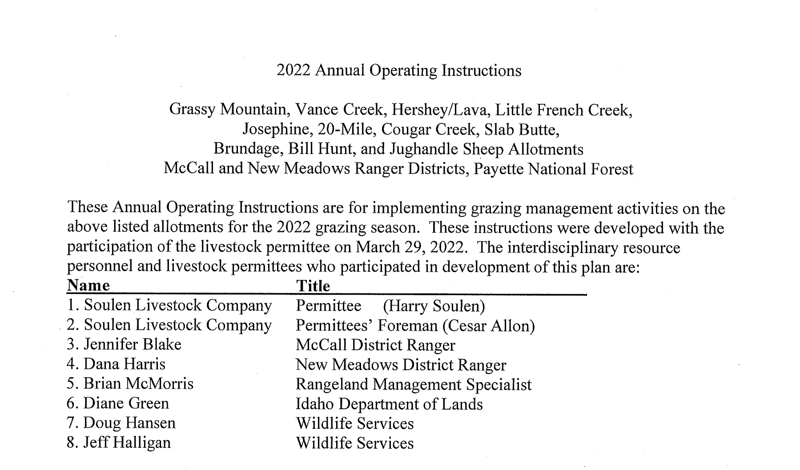
Where the sheep graze (in summer-fall) – and who knows what weed infestations may be present where they graze prior to entering the allotment. Where are these other sites? What weeds are present in thoise areas?
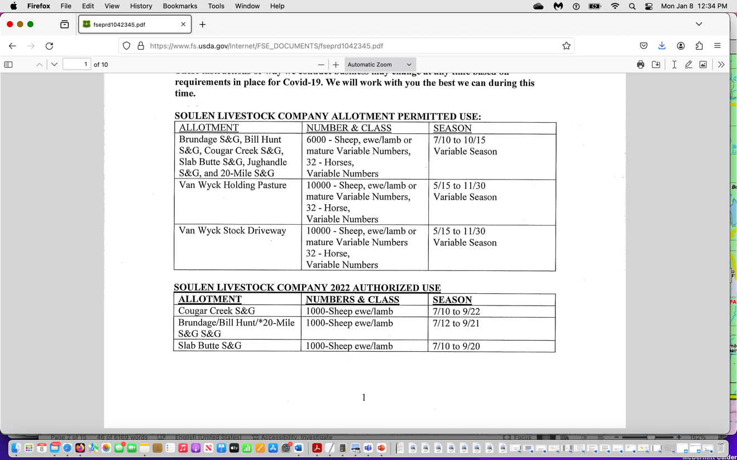
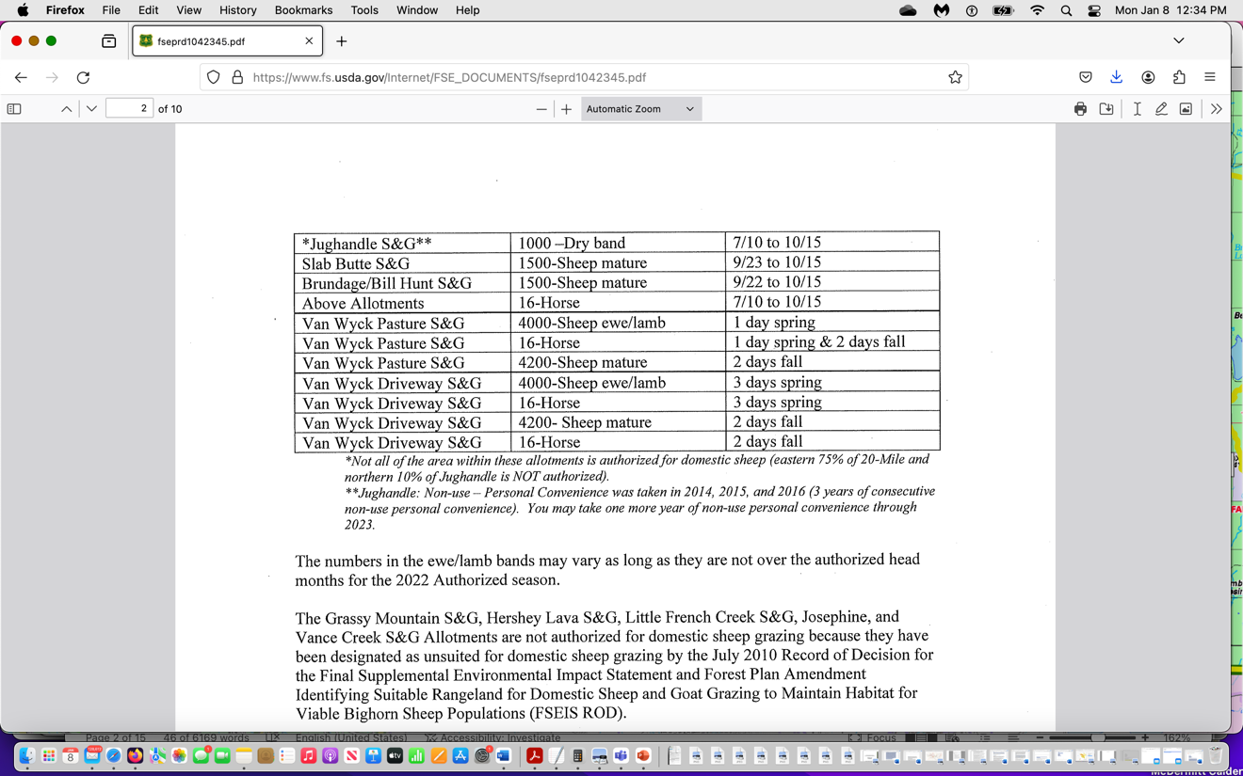

We also note the AOI includes mwentionof numerous disrtyrbvnace projects, trails etc.Where are al of these projects? Are any now subsumed in this EA, or has there been piecemeal analhyiss?

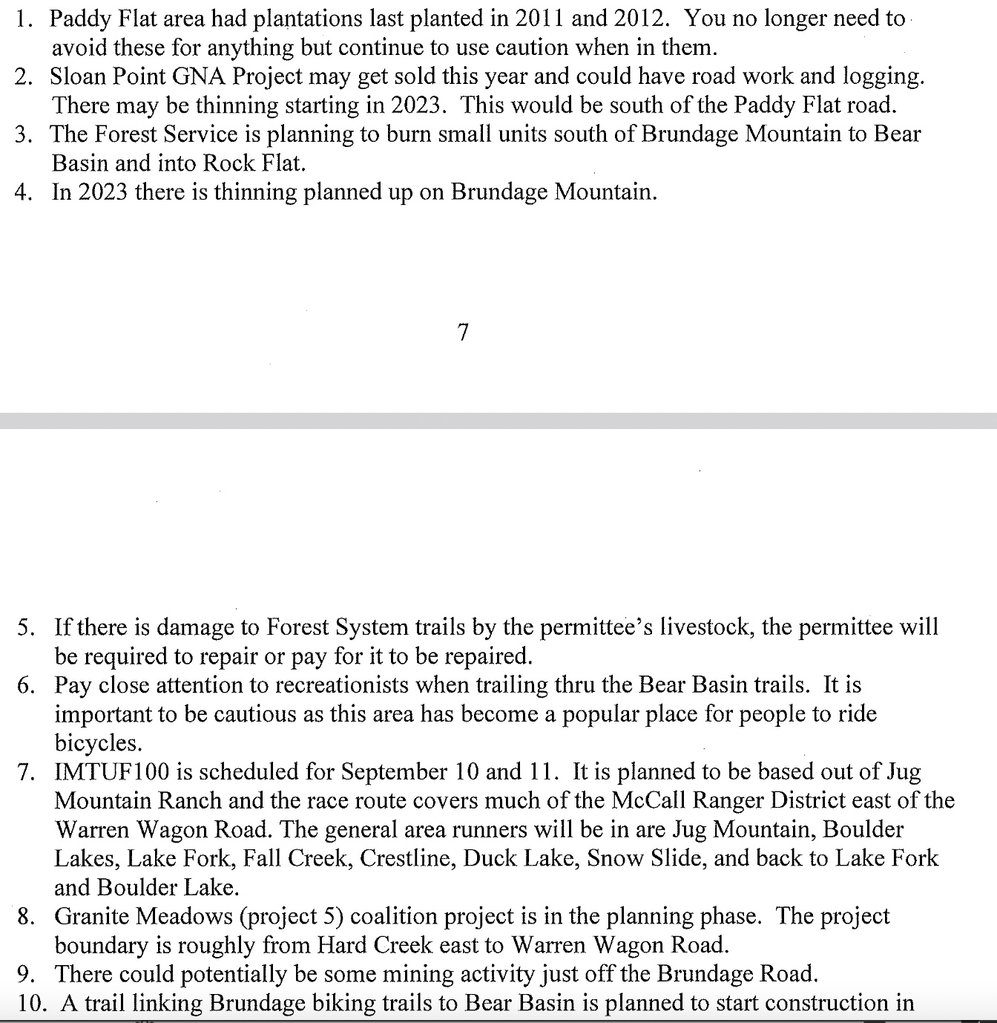

Please provide detailed information on al trail networks associated with Brundage mountain bike, cross-country, others). When were they built or expanded? Is further trail expansion foreseeable?

Where are all project area riparian areas – including springs? Is there an RHCA zone associated with springs? If so, how big is it? Where are all current PFC and ecological condition ratings for all riparian areas? Since this project will both make sheep access to many riparian areas easier as well as increase sedimentation from slopes, as well as drainage networks, and also will all various forms of new riparian area disturbance, and also will continue grazing sheep-[ but apparently will intensify heavy levels of trampling (which is not even monitored) and other use in “untreated” areas for periods of time – much more detailed analysis of all of these factors, must be provided.

Where are all sheep bedding sites? We have seen these areas serve as epicenters for weed infestations – including cheatgrass because of the severe sheepo damage to veg/soils/biocrusts and all the urine and manure concentrated in these sites.

This project is also likely to increase recreationalist conflicts with vicious sheep guard dogs that imprint on the sheep and view humans as threats – with the severe treatments and other project actions removing woody vegetation that serves to screen bikers, hikers, trail users from dogs. Note that in USFS Sawtooth Cape Horn sheep allotment there were repeated biker injuries due to these dogs. Has the Payette FS identified such conflicts?

The project will be very expensive, and its impacts are likely to be irretrievable including significant expansion in weeds. It will increase use of chemical herbicide mixtures that include not only active ingredients but also adjuvants, carriers and other unknown substances that could include use PFAS and PFOS as well. And many of the other substances in these chemical brews have no risk assessments conducted. Further, there often are not risk assessments on combinations of active ingredients that may be used.

Many of these chemicals have significant potential for drift in wind and water and also volatilization, and may result in contamination of soil and ground and surface water, and harms to food for native herbivores and the animals themselves, rare plants, and habitats and populations of important, rare and TES species as well as damage to scenic wild lands areas. How expensive will the battery of proposed treatments be? What amounts of what herbicides will the USFS be using? Do the risk assessments account for their carcinogenicity? When was use of these chemicals assessed in the Payette? This project has a high risk of weed infestation and spread – given the high levels of recreational use and recreational vehicles transporting weeds, and the large-scale soil/biocrust/native vegetation disturbance actions proposed. Along, of course, with unassessed levels and effects of livestock grazing disturbance across the “treated” landscape.
The USFS proposed action ignores passive restoration to protect native vegetation communities and to recover native understories, shrubs and microbiotic crusts, a primary and essential element of preventing flammable weeds from choking public lands and reducing future fires. Passive restoration, (letting lands naturally heal from disturbance instead of trampling them with huge herds of sheep), helps ensure that public lands are in good condition and better able to withstand fires, insects and other disturbance and able to recover from disturbance an d fire events. It also helps to buffer ever-growing climate change stress. As cheatgrass and other weeds spread due to continued harmful levels of livestock grazing exacerbated by climate change stress (see Beschta et al. 2012), all sagebrush communities are extremely sensitive to grazing and other exploitive disturbance.
Please provide comprehensive current mapping of current bulbous bluegrass/cheatgrass/annual grass and of smooth brome/intermediate wheatgrass and all exotic rhizomatous grasses (these are highly likely to increase in density and choke out recovery of natives with the USFS major use of fire int his project), and noxious weeds and infestation areas at all percentages of infestation so the enormity of the problem can be understood.

The EA fails to provide past timber harvest, logging and treatments of all types, thinning activity, salvage wood removal prescribed fires, and wildfires must be mapped and current ecological conditions described in the project area and surrounding lands. Data showing tree stand statistics, recovery from disturbance and regeneration success or failure and current age class and tree species type, understory composition, production and trend including grasses, forbs and shrubs, basal cover, and bare ground must be provided. What were pre-project conditions? What were predicted project outcomes and recovery rate? How does that compare to what has taken place? Were objectives in NEPA documents and goals met? How did sensitive and MIS species respond? How did the USFS monitor and track populations – or were the projects like Granite-Goose where the agency simply does not have an adequate baseline to understand project outcomes and adverse habitat and population viability impacts?
Please provide detailed mapping and analysis of all projects aimed at controlling beetle, wooly adelphid or other insect populations across the PNF. Did any of these projects or “sanitation”? cuts stop the insects? And what are the effects of transporting exotic-insect killed trees or other associated logged/thinned trees that are “infested” but have not yet died to sawmills or other wood processing centers? Or their use for firewood? Is the FS in reality spreading infestations in its wood “harvest”?
What are current conditions – tree species/cover/age class/density/successional stage, etc. where insect “treatments” have occurred? They sure didn’t stop bark beetles in the Sawtooths, for example – but instead just injured ”leave” trees making them more susceptible. Beetle and other insect infestations have thinned the forest in many areas, reduced supposed “fuels”, and all of this must be fully assessed. How scarce are intact live uninfested tracts across the PNF and tis region?
Authorized and unauthorized roads and trails, and their current status must be analyzed and compared to wildlife needs for security cover, the amount of security cover that exists today and what changes will occur due to this project. When was trave, planning conducted? What has enforcement been? Where does the Forest allow cross-country travel by snowmobiles? How and where is this impacting habitat for native carnivores and other wildlife? This includes habitat for Mule Deer, Elk, Bears, Lynx, Wolverine, Snowshoe Hare, Great Gray Owl, Boreal Owl, Northern Goshawk and other rare species. Home ranges of Goshawk and all other biota of concern home must be mapped, and the population status determined. How have existing deforestation, thinning, burning and other projects and fires impacted habitat integrity and connectivity? How much has habitat fragmentation of home ranges and/or important seasonal ranges impacted species at present? How much will fragmentation increase, and where, under the proposed action? How will this impact viability of local populations. How will the projects increase the disturbance footprint of human and recreational activity – visual disturbance, noises, combination? What are adequate buffers in the aftermath of the proposed actions? How do different weather conditions affect buffer distance? For example, noise travel distances in winter vs. summer? Please provide detailed adequate noise studies to establish a baseline at present across the project area and its surroundings, then estimate how much noise/visual/overall disturbance will increase, and where this will occur, with the project’s extensive disturbance footprint.
How much additional road blading and forest protective cover removal will take place across logging/deforestation haul routes? How much will routes be widened/ How much will water bars provide new weed infestation sites? What are the slopes where all of these routes affected by the project occur or will be built? How permanent will any route closures be? Why isn’t the FS conducting a new travel planning process? Will the FS need to do a travel plan amendment?
There are a large number of sensitive, rare, imperiled species that will be significantly harmed by the project. How many of these species rely on early seral conditions?
Further, since the EA has fear-mongered over insect-killed trees over project areas, there is no need for the USFS’s massive burning scheme to generate more habitat for species that rely on dead or dying trees.

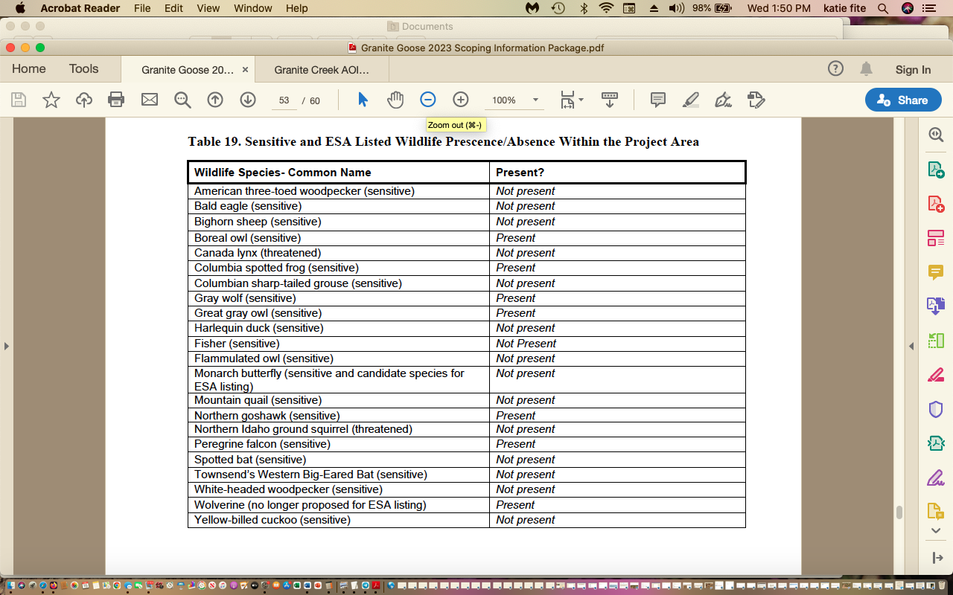

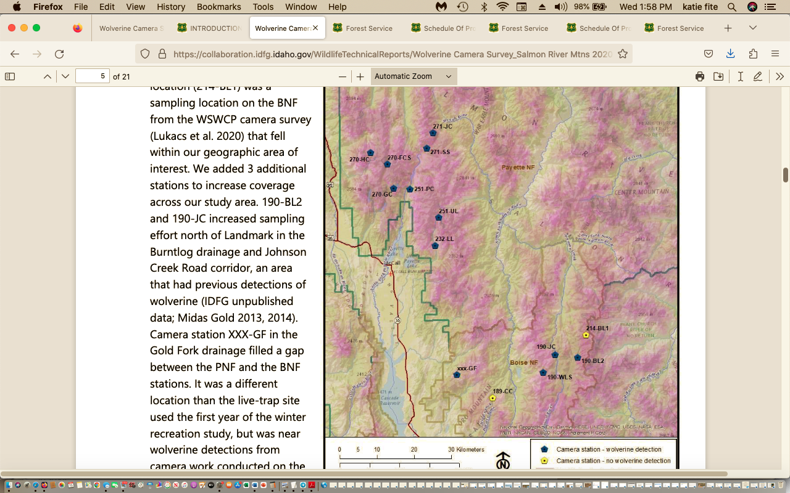

USFS Proposal Wolverine Conflicts Abound
The extensive thinning, burning and other deforestation actions, and route/trail actions that expand access here will greatly expand the ability of snowmobiles, ATVs, mountain bikes, and domestic sheep to pierce previously in accessible or less accessible areas – generating even greater conflicts with Wolverine use of habitats and population viability.
These conflicts are already a major and highly controversial issue in the Payette NF in this very area.
What areas are currently impenetrable to snowmobile use in winter, or minimally used? To ATVs or bikes in summer? To sheep herding? How will this expand winter access? How can the FS possibly even make estimates on project outcomes when it uses the highly uncertain slipshod scheme of “condition-based management”? See for example:
https://www.theatlantic.com/science/archive/2020/03/snowmobiles-wolverines/608500/
The research—which was published in February 2019 and concluded that winter recreation displaces wolverines—has fueled an ongoing lawsuit regarding a proposed closure in the Sawtooth National Forest.

A Payette Forest Wolverine-Snowmobile study shows significant conflicts:

https://esajournals.onlinelibrary.wiley.com/doi/full/10.1002/ecs2.2611

Heinemeyer et al. 2019 Abstract:
“Abstract. Outdoor recreation is increasingly recognized to impact nature and wildlife, yet few studies have examined recreation within large natural landscapes that are critical habitat to some of our most rare and potentially disturbance-sensitive species. Over six winters (2010–2015) and four study areas (>1.1 million ha) in Idaho, Wyoming, and Montana, we studied the responses of wolverines (Gulo gulo) to backcountry winter recreation. We fit Global Positioning System (GPS) collars to 24 individual wolverines and acquired >54,000 GPS locations over 39 animal-years during winter (January–April). Simultaneously, we monitored winter recreation, collecting ~6000 GPS tracks (~200,000 km) from backcountry recreationists. We combined the GPS tracks with trail use counts and aerial recreation surveys to map the extent and relative intensity of motorized and non-motorized recreation. We integrated our wolverine and backcountry recreation data to (1) assess patterns of wolverine habitat selection and (2) evaluate the effect of backcountry recreation on wolverine habitat relationships. We used resource selection functions to model habitat selection of male and female wolverines within their home ranges. We first modeled habitat selection for environmental covariates to understand male and female habitat use then incorporated winter recreation covariates. We assessed the potential for indirect habitat loss from winter recreation and tested for functional responses of wolverines to differing levels and types of recreation. Motorized recreation occurred at higher intensity across a larger footprint than non-motorized recreation in most wolverine home ranges. Wolverines avoided areas of both motorized and non-motorized winter recreation with off-road recreation eliciting a stronger response than road-based recreation. Female wolverines exhibited stronger avoidance of off-road motorized recreation and experienced higher indirect habitat loss than male wolverines. Wolverines showed negative functional responses to the level of recreation exposure within the home range, with female wolverines showing the strongest functional response to motorized winter recreation. We suggest indirect habitat loss, particularly to females, could be of concern in areas with higher recreation levels. We speculate that the potential for backcountry winter recreation to affect wolverines may increase under climate change if reduced snow pack concentrates winter recreationists and wolverines in the remaining areas of persistent snow cover”.
Species Status Assessment Addendum: FOR NORTH AMERICAN WOLVERINE (Gulo gulo luscus).
See discussion of “stressors” pps 30-47.

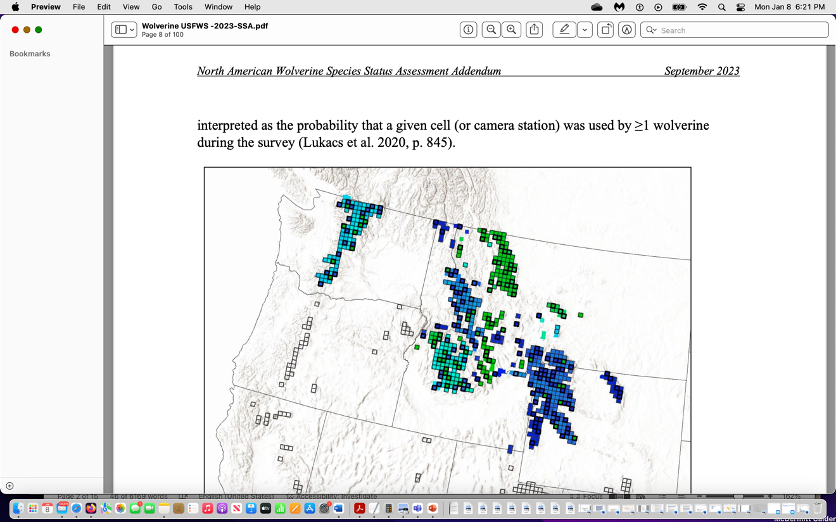
The project is near the very edge of the wolverine distribution – elevating concern that any loss or disturbance of habitat may result in a range contraction.
As the USFWS makes very clear, this species is highly snow dependent. We are very concerned that the project will result in loss of snow retention and shortened periods of snow presence - as it will remove protective shading cover causing early and accelerated snow melt. This will of course be worsened by the effects of climate change and increased temperatures.
Instead of the Forest conducting much larger closures and NOT conducting these severe treatments across distances far from structures/habitations, the agency semes intent on making much of the area uninhabitable for this species.
Here is what the USFWS said in 2023:
“Salmon River Mountains: Results from a camera-trap and DNA survey in the McCall portion of the wolverine winter recreation study area (Heinemeyer et al. 2019, entire) within the Payette National Forest in central Idaho conducted in the winter of 2020–2021 found that previously documented territories appeared to be vacant (Mack and Hagen 2022, p. 13), which they consider to be supportive of a conclusion from Heinemeyer and Squires (2014, p. 7) of an incremental loss of resident wolverines from 2010 and 2011 to 2014. The 2020–2021 winter survey study results, from 9 captured animals in 2011 to just 4 animals confirmed in 2021 within the Payette National Forest study area, led the researchers to suggest “that what was considered to be a stable core subpopulation area could, in fact, be more tenuous” for this region (Mack and Hagen 2022, p. 13). The researchers noted that they were not always able to obtain high-quality DNA and/or diagnostic photographs to be positive of a wolverine’s identity; thus, the final number of individual wolverines contains a level of uncertainty and could be high or low (Mack and Hagen 2022, p. 12). In contrast, surveys of wolverine activity within the Boise National Forest in central Idaho appeared stable, with some differences noted in distribution (Mack and Hagen 2022, pp. 12–13). Overall, this 2020–2021 central Idaho survey detected 7 individual wolverines (likely at least 8) across 14 camera stations through a combination of DNA analyses and photographs (Mack and Hagen 2022, p. 6). Of the DNA samples collected in which a gender and individual profile could be completed, the study reported one new male wolverine not previously recorded in the Genomics Center database (Mack and Hagen 2022, pp. 7, Table 1).
Also: “Roads, human development, recreation, and other factors can influence wolverine habitat selection, movement, and mortality risk (Scrafford et al. 2018, entire; Heinemeyer et al. 2019a, entire, 2019b, entire; Balkenhol et al. 2020, entire). These factors, and their impact on wolverine distribution, population dynamics, effective dispersal, and population connectivity are discussed in greater detail in our Stressors section, below”.
Heinemeyer et al. (2019a, entire) modeled third-order (within home range) wolverine habitat selection in areas of the Northern Rocky Mountains with high amounts of winter backcountry recreation. They found significant differences in male and female habitat selection (Heinemeyer et al. 2019a, p. 9). The best model for male wolverines uniquely included distance to roads and proportion of lower-elevation grass and shrub cover, while the best model for female wolverines uniquely included talus, persistent spring snow cover (defined in the cited studies as snow cover present between 24 April and 15 May) and forest edge:area covariates (Heinemeyer et al. 2019a, p. 9). Best models for both sexes included covariates for topographic position index, quadratic form of slope, distance to forest edge, solar insulation and percentage cover of forest, riparian, and montane open cover types. Models indicated that wolverines avoided areas of both motorized and non-motorized winter recreation with off-road recreation eliciting a stronger response than road-based recreation (Heinemeyer et al. 2019a, pp. 11–13). Female wolverines exhibited stronger avoidance of off-road motorized recreation and experienced higher indirect habitat loss than did male wolverines (Heinemeyer et al. 2019a, pp. 16–17). Models further indicated that wolverines showed negative functional responses to the level of recreation exposure within home ranges, with female wolverines showing the strongest functional response to motorized winter recreation (Heinemeyer et al. 2019a, pp. 13–14; 17–18).
… New studies in southwestern Canada and the western U.S. have found that wolverine distribution and density are negatively related to road density. In southwestern Canada, consistency of spring snow and road density are the two most important variables correlated with wolverine density (Clevenger 2019, p. 52; Mowat et al. 2020, p. 220). Wolverine population estimates derived from models based on snow and road density predicted that wolverine abundance would be 44% higher without the depressing effect of the road covariate (Clevenger 2019, p. 52; Mowat et al. 2020, p. 220). As most roads are concentrated in areas of human development at lower elevations with less snow, correlations between wolverine distribution and road density can be confounded by other collinear variables (Copeland et al. 2007, pp. 2210–2211). However, in southeastern British Columbia, the density of forestry roads that extended into high-elevation wolverine habitat was a strong negative predictor of wolverine distribution in winter, especially for females (Kortello et al. 2019, p. 10). The most likely explanation for this negative relationship is the use of these high-elevation forestry roads by snowmobilers, rather than predator avoidance or trapping pressure (Kortello et al. 2019, p. 10). Other possible explanations are increased trapping access or less abundant food resources near roads (Mowat et al. 2020, p. 224). While the statistical significance of the relationship between roads and wolverine densities has been demonstrated in some areas, the mechanisms behind this relationship are unclear and require further study (Mowat et al. 2020, p. 224).
… Functional responses of wolverine space use to various levels of backcountry winter recreation (motorized and non-motorized) in four study areas in Idaho, Montana, and Wyoming has been tested (Heinemeyer et al. 2019a, p. 8). Although the study design precluded the ability to directly assess demographic or fitness effects on wolverines (Heinemeyer et al. 2019a, p. 17), within home ranges, wolverine avoided all forms of winter recreation (motorized and non-motorized) and increasingly avoided areas as the amount of off-road winter recreation increased, resulting in indirect habitat loss or functional degradation of moderate- or high-quality habitats in winter (Heinemeyer et al. 2019a, p. 16). Wolverines did demonstrate the ability maintain multi-year home ranges in areas with winter recreation activity. Some resident animals had over 40% of their home range within the footprint of winter recreation; suggesting that at some scale, wolverines tolerate winter recreation (Heinemeyer et al. 2019a, p. 16).
Dispersed or off-road winter recreation appears to elicit a stronger avoidance response than recreation along roads and groomed routes with females showing more sensitivity than males (Heinemeyer et al. 2019a, p. 15). Females exhibited the strongest negative response to motorized recreation, which occurred at higher intensity across a larger footprint than did non-motorized recreation.
… The impacts of motorized and non-motorized backcountry winter recreation on wolverines in the Nez Perce-Clearwater, Sawtooth National Recreation Area, and Salmon-Challis National Forests of Idaho were evaluated by Regan et al. (2020, entire) using aerial survey methods of Heinemeyer et al. (2019b, pp. 6–10). Preliminary results showed that recreational impacts, in both area and intensity, are increasing over time. In the Sawtooth-Boulder White Cloud Mountains, researchers compared current extents of winter recreation with known historical wolverine home ranges and found that most of these home ranges contained little or no backcountry recreation (Regan et al. 2020, p. 4).
Camera-trap and DNA surveys on the Payette National Forest in central Idaho revisited a portion of a previous winter recreation study and affirmed that there had been an incremental loss of resident wolverines from 2010–2011 to 2014, and that previously documented territories appeared to be vacant (Mack and Hagen 2022, p. 13). The authors suggest that “what was considered to be a stable core subpopulation area could, in fact, be more tenuous” and “that the change in wolverine abundance in this area might be attributed to changes in habitat quality from direct or indirect influences” including dispersed recreation, although the precise cause for the apparent decline in wolverine abundance requires further study (Mack and Hagen 2022, p. 13).
… As described above in Effects from Roads, forestry roads that are used by snowmobilers appear to have a strong negative correlation with wolverine distribution (Kortello 2019, p. 10). Non- motorized recreation can also impact wolverines. Remote camera-based surveys from 2011– 2020 in protected and non-protected habitat in southwestern Canada found that wolverine detection probability was strongly and negatively correlated with the amount of non-motorized human recreation (Barrueto et al. 2022, pp. 4–8). This pattern held for both winter and summer and was consistent with the findings of Heinemeyer et al. (2019a, p. 18). Data from winter occupancy surveys showed that 95% of all wolverine detections occurred during 2-week periods with three or fewer recreational user groups detected on remote cameras (Barrueto et al. 2022, p. 4). While this study also documented declines in density and occupancy of wolverine, further research is necessary to determine the specific causal mechanisms most responsible for these declines (Barrueto et al. 2022, p. 8).
Other Human Disturbance concerns in the 2023 Wolverine report:
In our 2018 SSA, we concluded that human infrastructure may “affect individual wolverine behavior (e.g., avoidance) or loss or modification of wolverine habitat... but these effects are small or narrow in scope and scale and appear to represent a trade-off between foraging opportunities in areas that provide minimal risk of predation and avoidance of open areas and/or higher predation risk” (USFWS 2018, p. 62). Below, we discuss new information related to the impacts of human infrastructure on wolverine populations.
Wolverine density and detection probability in the Canadian Rocky Mountains declined with increased night light intensity, which is a measure for actively used human developments (Barrueto et al. 2022, p. 8). This pattern is consistent with telemetry-based findings …
Connectivity among wolverine habitats appears to be particularly sensitive to housing developments and other human impacts in rugged areas located between typical wolverine habitats (Balkenhol et al. 2020, p. 799). As the study population was small, habitat fragmentation and decreased population connectivity would increase the effects of demographic stochasticity (Barrueto et al. 2022, p. 8).
Also: “The extent of the impacts of human presence and actions on the landscape have been collectively called “the human footprint” (Janzen 1998, entire). In an analysis of the human footprint in the western U.S., Leu et al. (2008, p. 1125) found that the physical effect area of the 14 anthropogenic features they analyzed (human habitation, interstate highways, Federal and State highways, secondary roads, railroads, irrigation canals, powerlines, linear feature densities, agricultural land, campgrounds, highway rest stops, landfills, oil and gas development, and human induced fires) covered 13% of the land area in the western U.S, with agricultural land being the most dominant (9.8%) human use. Accounting for the indirect effects radiating out from the direct human footprint, Leu et al. (2008, p. 1125) categorized 52% of the western U.S. as having medium- or high-intensity impacts from the human footprint (both direct and indirect impacts), while low-intensity impact areas covered the remaining 48% of the landscape (Leu et al. 2008, pp. 1125–1127)”.
How much has the footprint of Brundage and associated trails expanded in the past 25 years? Please provide detailed analysis. How much has summer recreation, and winter recreational activity – both motorized and non-motorized expanded in this region? How much has human habitation increased in areas surrounding McCall and New meadows? What logging/thinning projects have taken place - and where? These are all very important questions that must be assessed in a hard look NEPA analysis EIS – given that this area has shown a DECLINE in Wolverines – and human disturbance and the human footprint is known to be expanding across this region. This hard look analysis is needed to understand the inter-twined effects of the logging, burning, road changes, closures, and controls on the large-scale domestic sheep grazing taking place – and if these factors – all of which will be made more harmful and result in more and expanded disturbance because of the project actions and will highly likely impact Wolverines, and if so, to what degree? Will increased areas of the project area be rendered uninhabitable? Or unsuitable for denning (of all types) and other activity, or will it harm prey species?
We do know there has been an in ever-increasing War on Wolves with year-round hunting and trapping in Idaho (and very likely poaching of other native carnivores like Wolverine), as the state regulations have become more and more cruel and barbaric. This must be fully considered here, as the project will clear and remove vast areas of protective forest cover that hinders human access to various degrees.
Was the intensity of grazing (time spent in area, turnout times, AUMs/HMs actually used vs. those permitted, etc.) shifted because of the Payette Forest plan adoption and the recognized conflicts with Bighorn sheep and disease contagion carried by domestic sheep herds? We note the Brundage Soulen AOI states that the sheep are to avoid pretty much everything associated with Brundage – and as mountain bike trail networks, ski slope areas, and other expansion has played out – that “avoidance” zone has likely expanded – resulting in more intensified sheep use and disturbance in more remote areas and Wolverine/native carnivore habitats.
“In addition to effects on wolverine density and connectivity, human infrastructure can also affect wolverines through shifts in community dynamics that precipitate from changes in the behavior and temporal use of habitats by apex predators. Wolverines and other carnivores may shift their daily behavior patterns in response to the presence of human landscape disturbance (Frey et al. 2020, pp. 1133–1138). By modeling the effects of human landscape features, linear (roads, rail, trails, seismic lines, transmission lines and pipelines) and polygonal (harvest cut-blocks, residential land, well-sites), researchers sought to determine if carnivore species change behavior in response to these disturbances, creating a potential shift in temporal niche portioning and leading to a potential increased interspecific competition in the Rocky Mountains of Alberta, Canada (Frey et al. 2020, entire). In response to increased human disturbance (proportion of linear and polygonal features) wolves (Canis lupus) showed a shift toward nocturnal activity while coyotes shifted toward cathemeral (i.e., sporadic and random intervals of activity at any time of the day or night) and marten (Martes americana) shifted toward diurnal activity (Frey et al. 2020, pp. 1133–1138). Although forest cover was shown to have a stronger influence on marten-wolverine activity overlap than did human infrastructure-associated landscape change (overlap decreased significantly with increasing forest cover) the results suggest that a shift in apex predator activity can lead to cascading shifts in mesocarnivores, in turn leading to increasing competition over resources and potential displacement of species (Frey et al. 2020, pp. 1133–1138).
Indirect effects to wolverines can also be caused by range expansion of other carnivores into wolverine habitat facilitated by human infrastructure. While wolverine and coyotes are generally segregated, the probability of co-occurrence increases with the proportion of linear disturbance features (Chow-Fraser et al. 2022, p. 4). Using the same study area in Alberta as Frey et al. (2020, p. 1130), the authors found that while wolverines favored areas of low disturbance (low proportion of linear features) and coyotes favored areas of high disturbance (high proportion of linear features), co-occurrence probability increased 3x for each increase of linear feature unit (Chow-Fraser et al. 2022, p. 4). Modeling showed that competition exhibited the strongest effect on wolverine distribution with wolverine occurrence best explained by coyote occurrence at the same sites (Chow-Fraser et al. 2022, p. 4). These results suggest that anthropogenic disturbance and resulting coyote range expansion may be contributing to wolverine population declines in the Canadian Rocky Mountains (Chow-Fraser et al. 2022, p. 6)”.
Frey et al 2020. https://nsojournals.onlinelibrary.wiley.com/doi/abs/10.1111/oik.07251
Chow-Fraser et al. 2022. https://www.sciencedirect.com/science/article/abs/pii/S0006320721004870

Landscape change shifts competitive dynamics between declining at-risk wolverines and range-expanding coyotes, compelling a new conservation focus
“Wolverine were generally segregated from coyotes and avoided linear features; however if wolverine and coyotes did co-occur, they were twice as likely to co-occur at sites with linear features. Thus linear features increased opportunity for coyotes—a generalist species thriving in human disturbed landscapes – to compete with wolverines. We suggest this threat of increased competition is a mechanism potentially contributing to broad-scale wolverine range recessions from increasingly disturbed areas. Landscape change manifests as more than just physical disturbances: it alters the ecological processes that structure communities. These processes contribute to declines of species that cannot adapt to the novel disturbance features. We emphasize competition as an overlooked outcome of landscape change that could inform better conservation decisions to stem species declines”.
“In the Nearctic boreal forest, anthropogenic disturbance features can change resource availability and species' acquisition of resources by introducing forage subsidies (Fisher and Wilkinson, 2005), or creating travel corridors through otherwise complex habitat (Dickie et al., 2017). Some carnivores—such as wolverines—are “losers” and suffer range contractions from landscape change (Fisher et al., 2013; Heim et al., 2017), whereas other species–such as coyotes (Canis latrans)– are “winners” that can exploit novel resources (Fisher and Burton, 2018; Hody and Kays, 2018). The effects of landscape change on biodiversity are often understood through trends in habitat loss (Butchart et al., 2010), or changes in trophic relationships, such as apex predator declines (Estes et al., 2011). However, increased co-occurrence within a competing carnivore community may also adversely influence biodiversity”.
Brundage’s harmful and adverse footprint on Wolverines and other native wildlife and sensitive species is only going to increase. See: https://brundage.com/brundage-mountain-maps-out-10-years-of-resort-upgrades/
IN 2021, Brundage “resort” proclaimed: “The ownership group that acquired Brundage Mountain in November of 2020 has been working diligently to craft a 10-year plan to build on the resort’s established skiing legacy by introducing new ski-in/ski-out accommodations, a revitalized base village and an array of new recreation and mountain amenities.
As part of this process, Brundage leaders are envisioning the entire resort experience with a focus on creating a vibrant multi-season destination resort. Priorities include enhancing the overall guest experience on the mountain and in the base area, expanding seasonal offerings to create a year-round destination and introducing resort property opportunities with overnight accommodations, all while preserving the classic Brundage Mountain vibe”.
The “vibe” and expanded facilities, amenities and the gross human disturbance footprint – including new “resort properties” poses a grave threat to Wolverine persistence- and the USFS Granite Goose project - makes it all worse.
The Forest Service has approved immense expansions of Brundage’s footprint.
https://www.stormskiing.com/p/forest-service-accepts-brundage-master
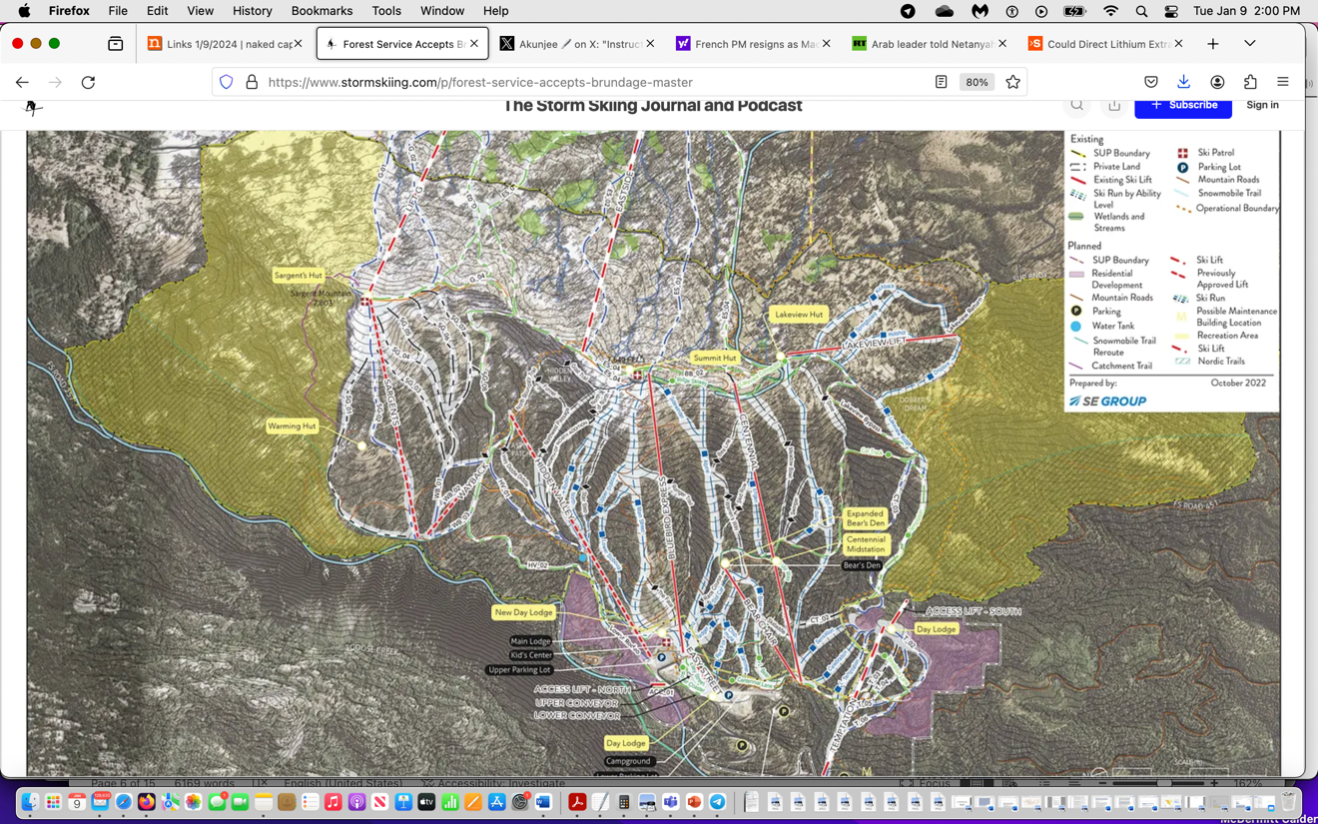
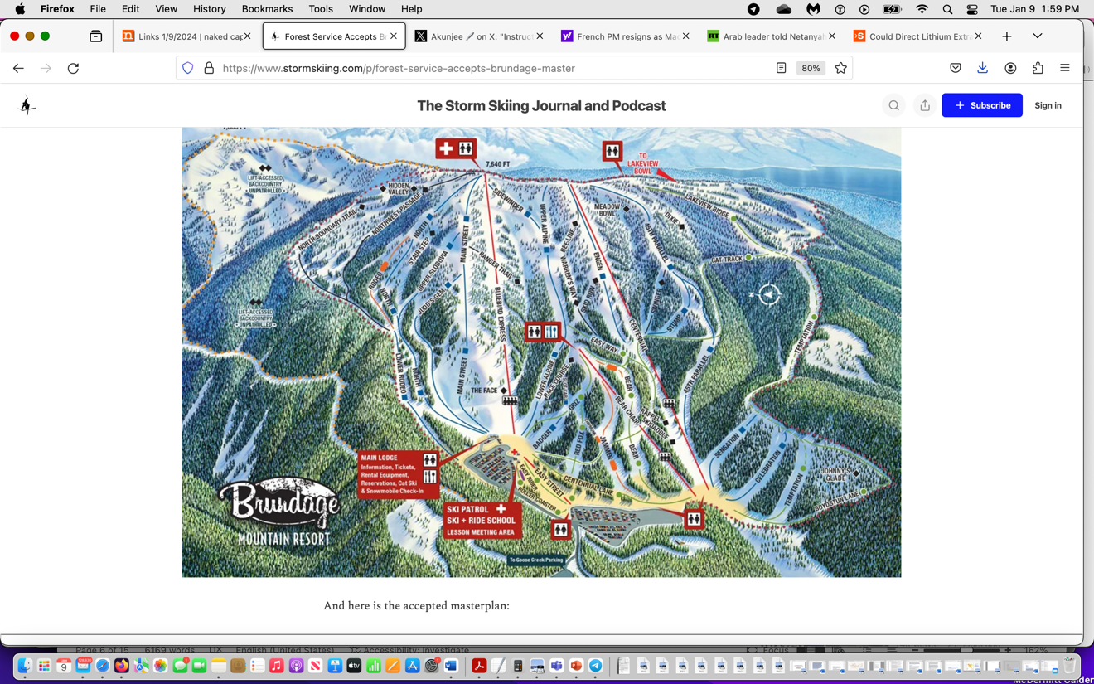
Regarding the ever-ep0xanding trails:
https://boisedev.com/2022/03/22/brundage-bear-basin-trail/
This new multi-use trail will join the resort’s 30-mile trail system with Bear Basin’s 15-mile track. Mountain bikers and hikers will be able to enjoy views of Payette Lake, Salmon River Mountain peaks, and more. The trail descends 1,700 vertical feet from 6900 feet elevation on the Brundage Mountainside and 5,200 feet elevation on the Bear Basin half.
Construction on the lower portion of the trail is planned for June, while the entire project is expected to be complete by late October and open to the public in the spring of 2023.
Central Idaho Mountain Bike Association, or CIMBA, is teaming up with the Brundage Mountain Trail crew to get the project done. There will also be various bike trail builders from across the country coming in to help, including Progressive Trail Design and Dirt Candy Designs.
See also: https://boisedev.com/news/2022/03/09/brundage-housing-plan/ 88 new houses built -but this is only the beginning.
Note that to the south, The West Mountain Area and Tamarack resort is massively impacted by a ski resort, extreme amounts of bike trails.
Summer trails. https://tamarackidaho.com/about/maps/summer-trails
Tamarack development: https://tamarackidaho.com/about/maps/mountain-base
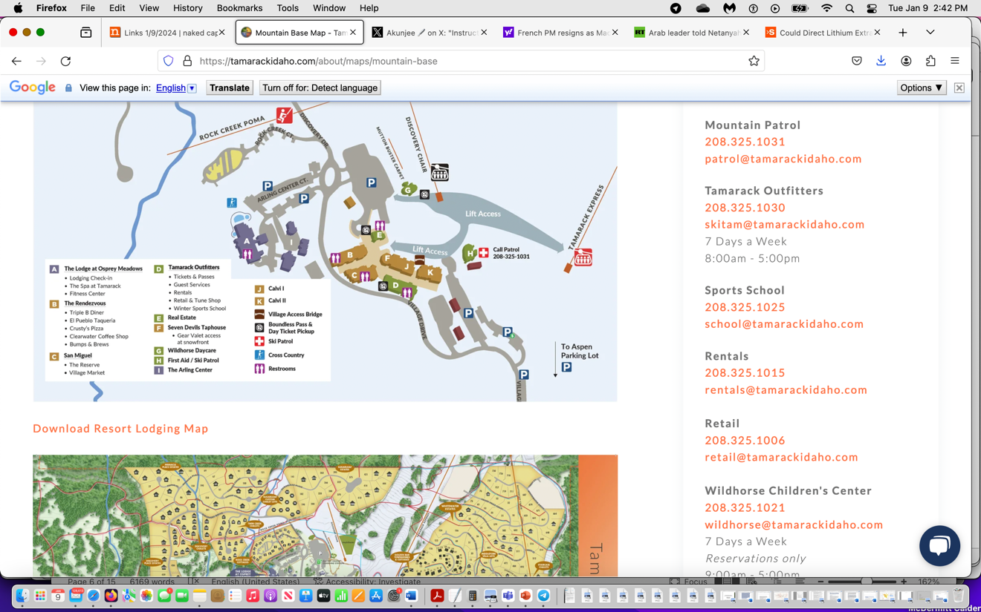
Another reason the USFS must prepare an EIS is the lack of regulatory standards to protect Wolverines and native carnivores in the old Forest Plan, and large-scale lack of other regulatory controls to protect the ecosystem on which Wolverines rely. The FS in this project using woefully out-dated modeling of veg communities to justify massive deforestation and burning in Wolverine habitat – right where recreation and recreational development is exploding – ensuring more human intrusion and disturbance into Wolverine habitats. Amid the maelstrom of disturbance – the UAFS fails to adequately curtail motorized, mechanized and other uses – and instead just approved a plan. For major expansion at Brundage, and only limits snowmobiles in some areas – which is greatly inadequate – especially given the rampant burning and other veg clearing.
Regarding the War on Wolves – where Wolverines will be/are collateral trapping and poaching damage:
““In Idaho, legislation revised Idaho Codes in 2021 to: (1) authorize a year-round trapping season for wolves on private property (IC 36-201(3)); (2) authorize additional methods of take previously prohibited (inclusive of the use of snares in 97 out of 99 management units) (IC 36- 201(2)); (3) remove any limit to the number of wolf tags an individual may purchase (IC 36- 408(1)); (4) allow a livestock or domestic animal owner to use a private contractor to kill wolves (IC 36-1107(c)); (5) allow the Idaho Wolf Depredation Control Board to enter into agreements with private contractors, in addition to State and Federal agencies, to implement the provisions of SB 1211; and (6) direct wolf control assessments ($110,000 annually) collected from the Idaho livestock industry to be combined with $300,000 the State would transfer from the IDFG fund annually beginning on July 1, 2021.
These regulation changes may increase the amount of wolf trapping and the risk of incidental trapping of wolverines because of the use of snares, extended trapping seasons, and financial incentives. The realized impact of these changes cannot yet be meaningfully measured due to the limited amount of time they have been in effect”.
And last, there is much discussion of the threat climate change poses to the Wolverine, and USFWS states habitats are projected to contract. Now the FS is engaged across the region in a battery of habitat disturbances that destroy key habitat attributes and make the species even more vulnerable to human recreational, trapping, and other disturbances and mortality.
Killing and Trapping
USFWS 2023 states: “We present new information on incidental captures of wolverines in the contiguous U.S. where regulated wolverine trapping remains closed (USFWS 2018, pp. 70–72), and new information on the effects of trapping mortality on wolverine populations in southwestern Canada. New information suggests that wolverine trapping in southwestern Canada likely reduced populations in the Rocky Mountains, which may have impacted connectivity across the international border”.
“New published information shows that since 2012, there have been 10 non-target wolverine captures (average < 1/year) in Montana resulting in three mortalities; the remainder were released alive (MTFWP 2023, in litt., p.1). In Idaho, our 2018 SSA reported three wolverines incidentally trapped due to wolf control activities since 1995, with two released and one killed. Between November 2017 and August 2022, IDFG reported nine non-target captures, with two resulting in mortalities (IDFG 2022, in litt., pp. 5, 16–22). We are not aware of any recent incidental captures of wolverines in other western States”.
Long-time Wildlife Services biologist Carter Niemeyer rebutted the belief that released wolverines fared well – or survived for any period of time. See: https://www.counterpunch.org/2023/12/05/wolverines-protected-under-the-esa-here-is-the-rest-of-the-story/
“Lose a foot”
Assuming a trapper could even release an angry wolverine from a trap, most animals released after their blood circulation was cut off to a foot for several days in subzero weather end up with their frozen foot falling off, according to the Carter Niemeyer, a retired trapper for U.S.D.A.’s Wildlife Services. It is hard enough for a wolverine with four feet to survive. It is almost impossible for a wolverine to survive in the wild with only three feet. Therefore, the death toll on wolverines from accidental trapping is most likely higher”.
Boreal Owl, Canada Lynx, Columbia Spotted Frog, Gray Wolf, Great Gray Owl, Boreal Owl, Fisher, Pine Marten, Flammulated Owl, Northern Goshawk, Peregrine Falcon, rare bats, Wolverine are all at significant risk here.
It also appears Fishers may occur in proximity. IDFG records show occurrences in Valley County.
https://idfg.idaho.gov/species/taxa/18029

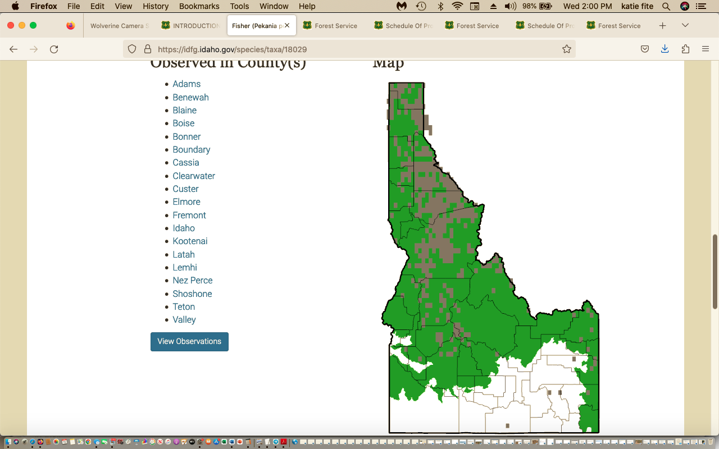

Fisher:

Habitat Use. The distribution of fisher is broadly limited by three factors: abundance and structure of snow, availability of suitable forest structure (including resting and denning sites), and abundant prey (see Diet below). Unlike lynx and wolverine, fisher are not well adapted to deep, unconsolidated snow. For their size and weight, fishers have small feet, making them prone to sinking into snow rather than walking on top of it. This makes it energetically expensive for fishers to move and survive in areas characterized by deep, unconsolidated snowpack. Elsewhere in the range of fishers, snow depths are predictive in describing the range of fishers (Krohn et al. 2005). In Idaho and Montana, fishers are broadly associated with low to mid-elevation mixed-mesic forest types where snows consolidate, making their travel easier. In north-central
Idaho, regular occurrences of fishers taper off at >5,000ft of elevation, though some have been documented at much higher elevations.

“ … in the mid-elevation mixed-mesic forest types of north-central Idaho, fishers establish home ranges in landscapes with larger, more connected and contiguous patches of mature forest, with reduced amount of open areas (Sauder and Rachlow 2014). Within established home ranges, fisher core use areas have moderate amounts of high canopy cover forest and moderate amounts of forest edge (Sauder and Rachlow 2015). Heterogeneous forest patterns likely put preferred habitats for both hunting and resting in close proximity. Between foraging bouts, fishers regularly use resting sites in cavities of trees, platforms formed by witches' brooms, broken top trees, or tree forks. Specific data on resting site selection by fishers in Idaho are scarce, but consistent themes have been identified across other populations (Aubry et al. 2013). Resting sites typically have dense overhead cover, steeper slopes, cooler microclimate, and a greater prevalence of large trees and snags than are generally available in the surrounding landscape.
Zelinsnki et al. (2004) found that fisher resting sites were often in larger-than-average tree within stands of trees larger than the landscape average. In that study, resting sites were found principally in cavities in live conifer trees and snags averaging ~46 inches in diameter. Jones (1991) reported that the average diameter of resting site trees used by fishers in Idaho was ~22 inches (range 11 to 59 inches) and that 68% were on platforms composed of witches' broom.

From: https://idfg.idaho.gov/sites/default/files/for_public_comment_draft_fisher_wolverine_and_canada_lynx_plan.pdf
Regarding federal candidate species Wolverine (now Threatened but with inadequate protections due to USFWS “exemptions”):

“Snow cover is a commonly used metric to project change in wolverine habitat resulting of a warming climate. Projections of increasing temperatures and a trend for more precipitation to fall as rain rather than snow represent a potential stress on wolverine based on elevation and latitude. However, the magnitude of projected change varies widely in time and space, and natural climate variability can reduce or amplify projected effects (e.g., Abatzoglou et al. 2014). Local climate conditions may continue to offer climate refugia (e.g., Moritz and Agudo 2013), and the complexity of terrain in Idaho represents a challenge for many climate models. All these factors lead to uncertainty about how climate change could influence wolverine persistence in Idaho over the next 50 years. Most projections for the Pacific Northwest predict progressively warmer and wetter conditions during the 21st century. Temperatures are predicted to increase in all seasons, with the largest increases in summer. Precipitation is predicted to increase during fall and winter, with little change or additional drying during summer. Much of the western U.S. is expected to transition from a snow-dominated system to one more rain-dominated; spring snowpack is expected to decline, especially at warmer low to mid-elevations; and existing snow is expected to continue melting earlier (Pierce and Cayan 2013). These changes are expected to become most pronounced beyond 2035 (Kunkel et al. 2013). Climate models provide credible estimates at global and continental scales under a given set of assumptions (IPCC 2007)”.

Information on Canada Lynx (IDFG 2023) includes:

https://idfg.idaho.gov/sites/default/files/for_public_comment_draft_fisher_wolverine_and_canada_lynx_plan.pdf

“Habitat Use. Suitable lynx habitat is forest structure that supports: (1) snowshoe hare density above 0.2 per acre (Berg et al. 2012), (2) enough horizontal cover to allow for efficient hunting (Vashon et al. 2008; Squires et al. 2010), and (3) winter conditions that promote unconsolidated snowpack to provide Canada lynx an adaptive advantage over other meso-carnivores due to their foot loading. In the Northern Rockies of the United States, these components tend to be found in mid- to high- elevation forest (i.e., 4,900 – 6,500 ft) composed of spruce-fir overstory with a midstory forming complex structure and high horizontal cover (Squires et al. 2010). This tends to be associated with late-seral stage forests. However, this is not the only forest structure needed by lynx. In an investigation of habitat use Holbrook et al. (2018) identified that a high-quality mosaic habitat for female lynx contains ≈50-60% mature forest and ≈18-19% advanced regenerating forest”.
“Habitat Use.
Suitable lynx habitat is forest structure that supports: (1) snowshoe hare density above 0.2 per acre (Berg et al. 2012), (2) enough horizontal cover to allow for efficient hunting (Vashon et al. 2008; Squires et al. 2010), and (3) winter conditions that promote unconsolidated snowpack to provide Canada lynx an adaptive advantage over other meso-carnivores due to their foot loading. In the Northern Rockies of the United States, these components tend to be found in mid- to high- elevation forest (i.e., 4,900 – 6,500 ft) composed of spruce-fir overstory with a midstory forming complex structure and high horizontal cover (Squires et al. 2010). This tends to be associated with late-seral stage
forests. However, this is not the only forest structure needed by lynx. In an investigation of habitat use of 32 female lynx over 94 lynx years, Holbrook et al. (2018) identified that a high-quality mosaic habitat for female lynx contains ≈50-60% mature forest and ≈18-19% advanced regenerating forest …”.
“Throughout the species’ range, snowshoe hare is the primary food item. In northwestern Montana, snowshoe hares account for 96% of winter prey biomass (Squires and Ruggiero 2007). Further south, in an introduced population of lynx in Colorado, Ivan and Shenk (2016) found that while snowshoe hares continued to be an important food source, red squirrels (Tamis hudsonicus) were also an important prey
item, accounting for more than 20% of diet by biomass in 7 of the 11 years of the study. While secondary prey items (i.e., prey other than snowshoe hare) may vary in rates of occurrence in food habitat studies, snowshoe hares remain the primary food item and suitable snowshoe hare densities are a requirement”.

We stress that snowshoe hares are also associated with dense riparian willow habitats in central Idaho, and livestock grazing degrades riparian areas. So too will “treatments” that impinge on RHCAs.

How will the project affect connectivity, habitat security, and other key elements of habitats necessary for survival of native carnivores? Further, the removal of even more vegetation here will increase poaching and human harassment, and mortality of native carnivores from shooting and trapping- and that includes worsening the barbaric assault on Gray Wolves underway in Idaho.
ADDITIONAL COMMENTS
Livestock grazing is a principle factor damaging forest and watershed health in the Payette Forest. It is the fundamental factor needing to be addressed in this Analysis and Cumulative Effect Area, as it degrades forest ecosystems, compacts soils, causes serious watershed harms, hampers the ability of sites to recover from the massive use of fire and other “treatments” in this 2023 Granite Goose project. Grazing has degraded this landscape, and the massive disturbances will only serve to worsen and expand its deleterious footprint. Grazing causes excessive amounts of bare soil, forest understory losing litter cover, soil carbon and nitrogen being depleted, conifer forest mycorrhizal fungi layer disrupted by livestock trampling, riparian area degradation, flow loss, spawning habitats filled with high levels of sediment from eroding watersheds and banks, native trout suffering mortality of their eggs and fry, etc. Grazing degradation creates conditions favoring non-native brook trout, which greatly out-compete native trout including bull trout. The hotter, more polluted water from these massive treatments will create conditions conducive to non-native Brook Trout expansion competing with native trout and preventing Bull Trout occupancy and increased loss of water flows, and seriously elevated temperatures in streams. As a baseline, the FS must carefully examine all areas of ephemeral, intermittent and perennial flows in watersheds – so that the foreseeable loss and reduction in flows from this project can be understood. Allotments are often grossly overstocked, have never undergone any recent grazing analysis or NEPA assessment, and the native herbaceous plant community is greatly below potential and increasers dominate the community. Water developments and fencing create highly damaged areas as cattle and sheep congregate around them.
All this immense battery of Forest treatment disturbance requires even more ecosystem disturbance perturbation from:
Commercial harvest-related road maintenance and use - Road maintenance includes road surface blading, ditch cleaning, installation of drainage features (e.g., rolling dips), hardening soft spots, replacing culverts, realignment of short road segments to minimize resource impacts, and removing roadside brush to improve visibility and safety for hauling forest products.
Coordination with existing permittees planned would result in shifted and intensified grazing disturbance in many areas that currently receive less grazing disturbance: Coordination with existing grazing permittees on grazing programs would occur within the project area to meet the purpose and need of reducing the risk of uncharacteristic and undesirable wildland fire (e.g. resting/rotating pastures to allow for prescribed burning).
Even more areas would be cleared for roading: Temporary roads - Authorized roads needed to complete vegetation treatments that are identified during sale layout, approved by the Forest Service prior to construction, and decommissioned after project use.
The Forest may also plans rock pits (quarries?), soil-scalding and weed promoting slash burning and other understory manicuring. Please clarify – and if these are include – provide detailed mapping and analysis of all areas that will permanently altered to “improve” roads – leading to increased human disturbances to wildlife and increased fire risk.
The Forest claims uncharacteristic and undesirable fire. Won’t the Forest’s proposed drastic manipulation and fragmentation of wild lands and watersheds result in the most uncharacteristic and undesirable fires of all? What are the scientific studies the Forest uses to define and assess these terms?
SD Appendices Tables A-1, A-2, A-3, A-4 have categories for Potential Veg groups. Then the forest defines tree sizes classes, and uses terms deficit, surplus, on target, etc. What is the scientific basis (literature, site-specific surveys and data, forest-wide and other data) for these many categories, and the category assumptions of deficit, surplus, etc.? After reviewing these Tables, it appears to us that the Forest and the collaborative group want to turn these public lands into an artificial manicured tree and livestock farm.
Table A-6 contains various fire categories, and assumptions about fire return intervals, and “missed intervals”. What are the scientific and site-specific studies these are based on? How has the Forest determined that an individual site has “missed intervals”? Have you conducted fire scar and other studies, as described in work by William Baker and others? How do these assumptions take into account the natural patchy and variable patterns of wildfires? Have you reviewed General Land Office Records to try to understand historic vegetation communities in the region and project area? We request that you do so before making sweeping claims about Potential vegetation or that the majority of sites have missed two or more intervals. Further, the Forest only looks at the specific project area -ignoring the many large-scale fires and repeated fires that have burned in the Payette and adjacent Salmon-Challis and Boise Forest in recent decades. Full and detailed mapping and analysis of the scale and effects of recent fires on these communities at a landscape basis must be provided.
Table A-7 lists watersheds and various restoration categories. How is restoration defined? How is the watershed condition framework derived, and what current site-specific data has the Forest developed to support the various functioning claims?
We do not believe there is a need for treatment in RCAs, and strongly oppose disturbance and degradation of RCAs in areas where not absolutely essential for human safety. Initial project area analysis indicates vegetative treatments (i.e. thinning and prescribed burning) in the RCAs would be needed to maintain or move towards the desired vegetative conditions as specified in Appendix A of the Forest Plan and minimize potential fire behavior among values at risk, and also where necessary to meet forest user safety objectives (e.g. on Brundage Ski Resort).
We oppose all the other project vegetation disturbance treatments in RCAs. The Forest has not demonstrated a science-based need, and has not considered alternative measures, or the benefits of no action, and reliance on natural processes and not drastic human intervention.
Mapping (much larger scale m[as must be provided to understand this project, with specific treatment locations clearly identified] shows that fragile and vulnerable headwaters areas of important stream systems are targeted for this radical overlapping treatment disturbance. The Forest must fully examine the potential adverse effects of imposing such radical, overlapping and intensive disturbances on headwater springs and streams. See: Ellen Wohl. The significance of small streams. Frontiers of Earth Science, 2017; 11 (3): 447 DOI: 10.1007/s11707-017-0647-y
The Fed Reg stated the need for the project is because of the difference between the existing and the desired condition. Well, from reading the litany of human disturbances to be imposed, it appears the “desired condition” is a near-sterile grazed to dirt sparsely treed bio-engineered wasteland – devoid of natural vegetation community diversity and complexity.
We are very concerned that the Forest is relying on limited scientific studies that support a singular pro-project view, and has relied heavily on modeled and idealized vegetation communities underlain by inputs and data that may be out-dated, limited, flawed, or unsupported by current monitoring and surveys. These may use controversial, questionable or unproven fire return or disturbance intervals and other inputs that support what the agency wants to do - but not include other scientific studies and information that may run counter to fully supporting the artificially derived “desired” condition and project. They also may not give sufficient consideration to the many risks of imposing a battery of new disturbances on top of a landscape (many of which will interact cumulatively or synergistically with uncertain or unpredictable outcomes) that has already suffered significant relatively recent human-caused or other disturbance, and that is also facing a high degree of now-recognized risk and stresses from climate change effects.
What are the models of vegetation communities and their scientific basis that have been used to develop a desired condition? What is the difference between the desired vegetation on a site, and the current condition, and what is the scientific data and information used to study and identify both?
The 2018 project SD Purpose and Need (SD 3-5) showed the Forest plans immense disturbance to try to manipulate wild lands subject to many disturbance processes, stochastic events, and now climate change stress, into artificially manicured vegetation characteristics/conditions that do not reflect the natural biodiversity and complexity of wild landscapes and vegetation community development.
How do models and inputs used in determining the Forest’s desired conditions take into account the essential needs of indicator, sensitive, important and ESA-listed species habitat and population requirements for food, cover, high quality habitat, and freedom of human disturbance/poaching, etc.?
How do these models and desired condition assumptions, factor in consideration of the stresses posed by climate change? By both climate change and chronic livestock grazing disturbance impacts? See Beschta et al. 2012 and 2014.
Clearing or removing trees or naturally dense native vegetation, or prescribed fire make it easier for livestock to access areas previously inaccessible or less used. This is especially the case in areas of steep or rugged terrain in forested country where denser trees and downed wood may have served as impediments to livestock intensive use. Will lands that may suffer increased livestock use and disturbance following USFS treatments be capable of supporting this use? A current capability and suitability study must be conducted, and predicted changes must be assessed. How much are levels and/or areas of livestock use expected to change following project treatments?
What is the native climax forest type on each area, and what are the characteristics of climax forests as they have developed and transitioned over time? Where is each type naturally present? How many of the areas that the various models and site descriptions view negatively may represent forests in a state of development or transition/natural succession over time? How does removing trees through thinning, logging (under various methods) or other treatments potentially inhibit or retard forest stand site development and progression towards mature and old growth forest and/or late successional forest? How might it affect micro-site and local climate characteristics such as amount of soil moisture, length of periods of soil moisture availability, wind speeds, sustainability of perennial stream flows, etc.?
Recent scientific studies call into questions long held agency assumptions about the effects of logging, thinning and other treatments on forest health and fire frequency and effects.
An Op-Ed published by Dr. Chad Hanson describes how forest thinning treatments may cause a hotter, drier, windier and weedier and more fire prone project area.
“It is deeply troubling that Trump and his administration would support logging as a way to curb fires when studies have shown it's ineffective. In the most comprehensive scientific analysis conducted on the issue of forest management and fire intensity -- which looked at more than 1,500 fires on tens of millions of acres across the Western United States over three decades -- we found that forests with the fewest environmental protections and the most logging actually tend to burn much more intensely, not less.
This may seem counterintuitive, but logging leaves behind combustible twigs and branches on the forest floor, which can make fires spread faster. It also reduces the cooling shade of the forest canopy, which creates hotter and drier conditions, and the invasive weeds that take over readily burn. Denser forests buffer and reduce the winds that drive wildland fires, but this effect is largely eliminated by logging.

An increase in fire frequency would further retard or prevent development of mature and old growth forests, which are required by so many rare and important species. See also Bradley et al. 2016, Does increased forest protection correspond to higher fire severity in C. M Bradley, C.T. Hanson and D.A. Dellasala, 2016, Ecological Society of America.
https://doi.org/10.1002/ecs2.1492
The Forest references insects. Forests have natural insect infestations that cause tree mortality dead trees. Avian and other species of wildlife rely on insects as food. Insect-caused tree mortality may be exacerbated by climate stress or other human disturbance. Logging, thinning and cutting results in wounded trees, abundant sap (that may attract some forest “pest” insects) and other factors that attract insects. So logging/thinning projects may unpredictably end up causing considerable harm to trees left standing, or adjacent patches of trees. Thus, there will be less live-tree habitat remaining for the many species that rely on it.
A review article in the Journal Forests addresses the mythology of forest health treatments aimed at suppressing beetle infestations or epidemics and does not support treatments. See Six D L, Biber E, Long E. 2014. Management for mountain pine beetle outbreak suppression: does relevant science support current policy? Forests 5:103-133. Doi:10.3390/f5010103.

- There is a lack of studies assessing the effects of timber harvest treatments for bark beetle suppression, yet policy is based on belief they work, not evidence. In fact, the evidence is they don’t work.
- Trees that are weakened by drought, disease or damage can be affected by smaller numbers of beetles, while vigorous trees may require very large numbers. Outbreaks occur when thresholds of temperature, tree defenses and beetle productivity are passed. Forests composed of large diameter trees can be at higher risk when thresholds are passed. Lower sapwood moisture results in higher susceptibility than higher sapwood moisture.
- Salvage harvests removing dead trees do not actually reduce or impact beetle populations as those trees are empty of beetles. These projects are more directed at economic (e.g. budgetary motives), or other reasons.
- There is a lack of post treatment monitoring to determine the efficacy of treatments.
- Stabilization of pine beetle populations requires a much higher detection accuracy and more intense level of treatment maintained over a very long timeframe. The consensus of studies is that suppression of a beetle outbreak would require killing of 97.5% of beetles in an areas just to stabilize the population. Even removal of 100% of infested trees in an area would still not eliminate beetles.
- “The consensus of studies and retrospectives over the course of several outbreaks is that even after millions of dollars and massive efforts, suppression using direct controls has never been effectively achieved, and at best, the rate of mortality to trees was reduced only marginally.”
- Direct controls are aimed at reducing beetle numbers, whereas indirect controls, such as thinning are used to reduce susceptibility of stands to infestation by decreasing competition among trees for water, nutrients and light.
- Silvicultural treatments such as thinning have proven largely ineffective and once beetles invade a thinned stand, the probability of trees being killed there can be greater than in unthinned stands. These may be successful if combined with direct controls (removal of infested trees). “Although more trees were killed overall in control units during the outbreak, all controls still retained a greater number of residual trees than did thinned stands as they entered the post-outbreak phase.”
- Studies of lodgepole pine post-outbreak indicate that stocking density will be maintained in untreated stands. A study in Colorado found that even when beetles killed 60 – 92% of overstory lodgepole pine, the stands retained residual overstory as well as advance regeneration with untreated stands predicted to return to pre-outbreak stocking levels 25 years sooner than treated stands. Thinning is indiscriminate, taking trees of particular sizes without taking into account genetics, thereby undercutting natural selection, in which beetle-resistant trees would be selected for.
- “Outbreaks can result in strong natural selection against trees with phenotypes (and likely genotypes) favorable for the beetle and for those that possess unfavorable qualities. However, when humans thin forests, trees are removed according to size, species, and density, without consideration of genetics. Thus, trees best adapted to surviving beetle outbreaks are as likely to be removed as those that are not.”

A relevant paper reveals that advance regeneration in untreated beetle infected stands exceeded 1000 stems/ha on 76% of plots, “suggesting that in the absence of management intervention most future stands will be adequately stocked.” They found only half the shrub, grass and forb cover in treated stands compared to untreated stands. Using the Forest Vegetation Simulator (FVS) they determined that total forest basal area would return to pre-outbreak levels 25 years sooner in untreated stands than in treated stands (80 vs 105 yrs). It appears that leaving the stands untreated will result in greater and more rapid regeneration, greater herbaceous plant cover and more carbon storage than engaging in the proposed treatments.

Much of this (waste and futility of chainsaw medicine) applies to the Woolly Adelphid, too.
Many central Idaho forests (Frank Church area) are not recovering as normal following wildfires – under ungrazed and unlogged conditions. Here in this grazed and already partially logged area of the Payette, the situation is likely to be worse. We gain emphasize that Granite-Goose is part of the Salmon-Selway Wolverine population landscape that includes the Frank Church.
The 2018 Granite Creek project Fed Reg notice stated:
The Granite Meadows project is a landscape-scale effort to improve conditions across multiple resource areas. The need for the project is based on the difference between the existing and desired conditions.
Now 5 years later, the FS relies on the same out-dated veg models, flawed fire models that do not reflect what happens with thing and deforestation and ignores that the Payette forest approved major expansions at Brundage - further threatening the regions’ wildlife including now-threatened Wolverine and many other species. There has been much new scientific information and literature amassed since the time of the development of the desired conditions associated with the Payette Forest Plan. Climate change, and the stress that hotter temperatures for a more prolonged period, earlier or more extreme snowmelt runoff and other weather events have on forest ecosystems was only minimally considered. If lands are in poorer condition – or riparian areas and uplands disturbed from cattle or sheep grazing - these effects may be even more pronounced and severe.
Lands that are significantly altered or disturbed by livestock grazing are also likely to be less resilient when subjected to logging, thinning, fire and other treatments, more prone to excessive erosion, less shade which slows down snowmelt, etc. The risk is particularly great because the landscape and the project area receive a large amount of livestock grazing disturbance that alters site conditions and ecological processes at every level.
We are increasingly concerned that extensive forest tree or other woody vegetation removal projects may in fact be aimed at generating more livestock forage in areas with depleted “range” or limited “forage”. In a Washington state USFS project, clearing trees over many areas was promoted to disperse cows ostensibly to help limit wolf predation.
The Forest’s project documents give the public the impression that the battery of radical new disturbances to be imposed on a system that has suffered extensive past logging/treatments of many types, and that has also been extensively grazed - will magically transform the landscape into asbestos-like ideal fire-resistant communities that will be “resilient” and “resistant”. These nebulous terms of resilience and resistance must be clearly defined, and solid scientific evidence provided to support the Forest’s claims.
What is the likelihood of areas to burn under various vegetation types and conditions in the models and estimates the Forests rely on for desired conditions? Burned largely grassy areas are often most likely to burn because they are hotter, drier, windier. Forests are less likely to burn.
Will there be salvage or other logging or wood/tree removal in association with any prescribed fires? Will the Forest allow salvage logging in the event of a wildfire in or near the project area?
The Fed Reg Notice also stated:
There is a need to increase the diversity and resilience of the landscape with an emphasis on promoting early seral and fire resistant species (e.g., ponderosa pine and western larch), and improving watershed function and integrity. There is also a need to reduce the threat of unnaturally high wildfire intensity, especially in areas adjacent to communities. Additionally, there is a need to address the potential for user conflict and improve forest user safety, and effectively manage areas experiencing detrimental impacts from dispersed or unauthorized recreation.
Isn’t this counter to the Forest Plan and NFMA requirements for protection of sensitive, MIS and ESA-listed species – none of which rely on early seral habitats that the 2018 and current project would massively result in?
The Fed Reg also references economic factors as part of the need. What will be the cost to recover the Wolverine population if they are driven out of the project area – due to intensified human disturbance in a burned and tree-stripped landscape where recreational disturbance footprint significantly expands -including as a result of the Brundage expansion, housing development, trails networks, etc. that the FS approved -despite knowing the serious impact on rare biota? How much does livestock grazing cost the Forest just to administer? How much does it cost the forest to try to mitigate grazing damage – herbicide use, fencing, potential lack of forest regeneration, fencing degraded areas, etc.? How much will all elements of these projects cost taxpayers? What will be the costs to attempt restoration if the Forest’s treatments go awry -for example, herbicide costs if flammable grass or other weeds invade, re-planting of trees if burned or heavily logged areas do not regenerate – as is happening post-fire in areas of the Frank Church)? What is the economic value (recreational uses and enjoyment, carbon sequestration) associated with the Forest sites and attributes that will suffer short, mid and long-term loss and/or harms? What will it cost to restore species habitats and populations if projects cause their populations to significantly diminish or blink out altogether in the site? Or result in the larger local population not being viable any more? In order to understand this, the Forest must provide current baseline studies on the status of habitats, habitat loss and fragmentation and viability of populations of species of concern. How much will it cost to restore or stabilize a watershed that “blows out” as the result of effects of project treatments (including as exacerbated by grazing disturbance, roading etc.)?
Carbon sequestration concerns. Logging, burning or biomass production releases carbon dioxide and other gases into the atmosphere – and reduces carbon sequestration. Livestock grazing also disrupts carbon sequestration processes.
The Fed Reg Notice claimed the Project (and this wishful thinking continues in the 2024 project) will:
Move vegetation toward desired conditions defined in the Forest Plan with an emphasis on improving wildlife habitat; reducing the risk of uncharacteristic and undesirable wildland fire; returning fire to the ecosystem; promoting the development of large tree forest structures mixed with a mosaic of size classes; improving growth, maintaining and promoting seral species composition (e.g., quaking aspen, whitebark pine, western larch, ponderosa pine, and Douglas-fir), and increasing resiliency to insects, disease, and fire.
Where is data monitoring the degree of sheep browsing on aspen – and how it may prevent regeneration? How are uncharacteristic or undesirable fires defined? When has fire “left the ecosystem” – does this just mean lightning has not struck recently? Note that in 2024, the FS claims areas have missed fire cycles – as if fires burn like clockwork – and the land is unhealthy if it has not burned, This is particularly absurd – given the mature and old growth deficits ion the Payette Forest. How has the Forest factored the increase in human-caused fires into its fire return and disturbance intervals, and projections of sufficient mature and old growth habitats and other values required to sustain MIS species, sensitive species, ESA species, and other forest attributes?
The project disturbances sprawl across the landscape. Logging and thinning that may make portions of the project area more vulnerable to fire spread, and may result in many more fires than the forest predicts. What science is the forest using to back up these claimed project benefits?
Support the development of fire- adapted rural communities.
This is a laudable goal. If the Forest truly wants to do this, then please focus at the community/structure interface – the actual WUI – and do not conduct wide-ranging vegetation clearing projects miles away from where the homes, infrastructure and community are located. Torching and logging the French Creek IRA is incompatible with this goal.
What is the distance to habitations from all areas of each treatment unit? What is the fuel loading and the characteristics of the fuels in the area targeted vs. not targeted for radical disturbance and habitat simplification in the project? Please provide detailed mapping of WUIs.
Also, there is certainly increasing recreational or second home or other development currently expanding in the WUI – as the FS approved the Brundage resort houses If so- where and what will the effects be? Expanded housing (and linked roading or other development) on private lands in the project area will also place more pressure on wildlife populations that require areas of lower disturbance – making the existing less disturbed areas of the Forest in their current condition -with more screening and protective vegetative cover - be even more valuable to these species. Provide for a safe, sustainable and efficient NFS transportation network for administration, utilization, and protection of NFS lands, and reduce road-related negative effects to resources.
The Forest must provide a wide range of road removal and obliteration alternatives. But first it must critically examine the impacts of the total road and trail system, and describe how trails and unauthorized routes keep expanding.
Where is the Forest planning to keep roads in place so it can harvest more timber, for example - with the roads primary reason for existence being commodities/extraction. Where are roads kept open for grazing purposes when grazing activities such as salt distribution (salting primes sites for weeds) could be done on horseback?
Move subwatersheds within the project area toward the desired conditions for soil, water, riparian, and aquatic resources.
See above re: full ecological baseline data on existing site-specific conditions must be provided. All models, assumptions, inputs, science used to determine these desired conditions and to understand the direct, indirect and cumulative effects of imposing the project’s the battery of often overlapping disturbances on these resources must be provided. This is an immense area, and there are many conflicts between competing resource uses that must be fully examined, and adverse impacts minimized.
Implement site-specific streambank and wetland restoration activities where stream channels, wetlands, or riparian areas are in a degraded condition.
Please provide solid baseline inventory and assessment data of the effects of all livestock grazing disturbance, roads, trails, past logging/treatments, fires – on riparian areas – springs, seeps, wet meadows, bogs, streams, etc. See Belsky et al. 1999 Survey of livestock influences on stream ands riparian ecosystems in the western United States riparian paper. Journal of Soil and Water Conservation, 1999, Vol. 54, pp. 419-431),
Full current data on riparian and aquatic habitat conditions must also be acquired as a baseline.
Manage recreation use by improving trails, addressing unauthorized trails, improving other recreation infrastructure, and thus improve soil and water conditions while also minimizing the potential for conflicts between users, and addressing the risk to forest users.
We are concerned about just what the Forest means by improving trails and other recreational infrastructure. How many of these are user-created? What specific use will trails be improved for? Many hikers, walkers and campers can get just fine with few and/or rudimentary trails. What is the existing winter recreation footprint -Brundage, snowmobiling, cross-country skiing? Is mountain bike rapidly expanding in summer, resulting in trail proliferation and considerable human disturbance extending into wildlife habitats that were previously more secure? Other Forest project documents describe establishing User-created trails as part of a system. This is quite controversial, and rewards unauthorized use.
G. Contribute to the economic vitality of the communities adjacent to the Payette National Forest through improvements to recreational opportunities, timber sales, and other removals of forest products, which also fosters a resilient, adaptive ecosystem to mitigate wildfire risk and strengthen …
Please explain what this rosy statement really means. Aren’t some of these things mutually exclusive? It seems like the Forest has included contradictory elements in this statement. We are very concerned the Forest may be referring to the desires and agenda of Forest “Collaborative” group that cuts the vast majority of the public out of the process and decisions related to the group desires that may be at odds with the needs of rare species.
Non-Commercial Treatments: Non- commercial thinning (NCT) would occur on approximately 75,000 acres and would be completed in areas of commercial harvest as well as outside of commercial harvest. This would consist of trees generally less than ten inches diameter at breast height (DBH). Primary target acres for NCT consist of stands within 1⁄2 mile of structures; plantations; high-use recreation areas where vegetation management would maintain or enhance recreation objectives; areas with forest health concerns due to insect and disease; areas with undesirable competition to early seral species; areas where density related stress/mortality is
undesirable; and/or roadside treatments to improve ingress and egress routes.
Prescribed Fire Treatments:
Prescribed fire treatments would occur on approximately 83,000 acres. Nearly all of the project area (excluding the Bruin Mountain Reasearch Natural Area and additional areas deemed unsuited or critical) would be considered for prescribed fire over the next 20 years. Commercial activities would generally be completed prior to the application of fire, except where the application of fire prior to thinning does not affect commercial activities. Approximately 500 to 10,000 acres of prescribed fire would be applied annually.
This proposal amounts to a horrific disturbance footprint – often with multiple and overlapping treatment and other disturbance affecting the same site, watershed, populations of sensitive species, etc. – with logging/thinning (and linked roading), and fire taking place in the same constantly grazing disturbed area. EACH disturbance poses serious threats to the native ecosystem, sustainable native biota, sustainable and diverse recreational uses, and clean and abundant water including:
Irreversible and/or persistent weeds and chronic toxic herbicide use and drift, loss of sustainable perennial flows in tribs due to project-caused disturbance – associated erosion, downcutting rapid runoff, etc.
Levels and all types of impacts of all of these threats must be fully examined with an honest hard look NEPA analysis.
Associated Actions: Activities associated with implementing the above vegetative treatments include road maintenance and use; temporary roads, road relocation, rock pits, brush disposal, site preparation, and planting.
There should be no temporary road construction. The forest must honestly assess an alternative that relies on the existing road network. How ironic that the Forest claims it needs to close some roads for land/watershed health – yet at the same time proposes to bulldoze and blast new roads into remote or less disturbed areas. A mile of road in one area does not necessarily equate to a mile of road in another – the environmental context and values at risk and/or harmed must be critically examined.
Rock pits means new permanent destruction of Forest land areas for gravel for the massive ever-expanding road network. These areas are like little mines, and the sites they are located are irreversibly altered. What rock material will these pits be put into, and what potential pollutants or contaminants may it contain? Aren’t some crushed gravels contain significant amounts of arsenic or other pollutants?

Activities would include NFS road treatments, unauthorized route treatments, streambank and wetland restoration activities, and fish passage improvements. Road management actions for this project would utilize the McCall and New Meadows Ranger District Travel Analysis recommendations (completed in 2014 and 2015, respectively). Unauthorized routes not needed for future management would also be evaluated for some level of restoration treatment …
This all is quite nebulous and must be much better defined. The Forest must deal with all unauthorized routes first, before it builds more roads. Plus the many types of vegetation removal associated with this massive project will result in NEW unauthorized trails proliferating. How many miles of unauthorized trails currently exist, and where?
Why isn’t there a separate route closure process and EIS for that alone?
Where are all the unauthorized routes? When did they first show up (use aerial photography or other imagery to provide data). What has been the rate of new roading of all types in the project area and surrounding landscape? How many miles of roads have been built with past logging and/or treatment projects, and where are these located? Why didn’t the forest act to limit them? How many miles are there? How many may be related to livestock- fenceline routes, water development, etc. Please answer these questions for all roads –authorized or unauthorized.
Why is the Forest conducting such a huge sprawling project if it truly is concerned about interfaces with communities? This tear up a whole landscape approach is the dead opposite the direction public land management agency should be going. An agency should focus on protection of the actual interface with habitat – which means a dramatically reduced area.
Plus the battery of proposed treatments are likely to make the landscape MORE likely to burn in frequent fires.
Actions to improve stream channels, riparian habitat, and wetlands may include: Streambank stabilization, minor channel re- alignment, fence reconstruction, and planting native vegetation. These actions may also include placement of instream or streambank structures such as, but not limited to, rock, large woody debris, beaver dam analogs (BDAs), and barriers to prevent unauthorized motorized travel in sensitive areas.
What riparian and aquatic habitat condition studies have been conducted, and where? How many of these areas are grazed? What has been the role of livestock in causing or exacerbating riparian damage? Detailed data and analysis of the current livestock regime must be provided, as discussed below and in the Attached alternative. Are there spring developments or troughs? What has been the role of past treatments in impacting streams, springs, seeps, meadows and any other riparian habitats? Please provide detailed mapping and analysis of all past logging and other treatments for all periods of time in these watersheds. When and how is grazing inhibiting or retarding beaver recovery? In many instances, there is no need for artificial BDAs if habitat is allowed to improve by reducing or removing grazing degradation stress. In all areas where Streambank stabilization, minor channel re- alignment, fence reconstruction, and planting native vegetation and BDAs are proposed, detailed site-specific information must be provided, and a full range of alternatives must be provided. For example, we have seen the Humboldt-Toiyabe Forest in the Santa Rosa RD and some forests in California blade banks and then dump crushed gravel rocks in gullying headwater stream cuts caused by grazing, thus completely drying up all perennial surface flows. Meanwhile, no changes were made in cattle stocking, and the remaining stream and wetted areas suffered even worse cattle grazing and trampling degradation, promoting further loss of riparian habitats and flows.
Note that all of these above concerns in our comments on the 2018 process are relevant and must be considered in this derivative and segmented 2024 Granite Goose proposal.
WILDLIFE NEEDS MUST BE MET
The Forest must maintain a diversity of wildlife species and must manage populations of wildlife for viable populations. Climate change stress amplifies the adverse effects of grazing on the ecosystem and native plants and animals as well as watershed processes.

Logging and thinning of other treatments will reduce existing cover of old growth and mature forests, and disrupt recruitment of older trees. Many Forest sensitive species require old growth and mature forested cover. The Forest must identify these species, provide solid baseline data on the current habitat that exists and its ability to support these species, and provide detailed site data on how much the various treatment projects across the area will destroy, degrade and/or fragment habitat for sensitive and MIS species. How much has the availability of these habitats changed since the Forest Plan was adopted?

Levels of old growth, snag occurrence and abundance, and Old Growth replacement habitat across the project area and surrounding landscape and Payette Forest must be fully assessed in the EIS.

Please provide detailed site data and analysis of the current amount of nesting, young rearing, roosting, hiding, thermal, winter, snags, mistletoe (a beneficial habitat ) and other cover and habitat that currently exists for important species, species of concern, MIS species, sensitive and ESA-listed species. Please provide detailed mapping depicting old growth and other habitats, and data and science-based analysis on how this type of habitat is necessary to fulfill species survival needs is dispersed across the landscape. Where are areas of higher quality habitat old growth or late successional habitat currently located. How large and inter-connected are they? How much fragmentation of this habitat is there? To what degree will the complicated series of project actions impact old growth and late successional habitat quality and quantity, and habitat connectivity or fragmentation? Please provide data and mapping.

The Forest must determine how essential habitat attributes will change when the project is completed. Please also assess these conditions in the surrounding landscape.

Careful science-based consideration of the specific needs of sensitive and MIS species is required under NFMA and the Forest Plan. The Forest must also ensure a diversity of wildlife inhabit these lands -this includes food, cover, space, habitat security, carrying capacity and ability of animals to move across the landscape to fulfill seasonal needs must be analyzed.

Regarding Habitat quantity and quality, fragmentation/connectivity, availability:

How much suitable habitat will be left for each species of concern following the project activities, and where? Please provide detailed mapping and analysis How great a risk may stochastic events pose in what for some species will certainly be reduced habitat areas and increased fragmented and patchy habitat?

Please study and assess estimated direct, indirect and cumulative habitat loss, acreages, locations, forest type for all affected wildlife species.

Comprehensive thorough baseline inventories for all sensitive/rare species must be conducted. Old growth habitat types are particularly valuable to native wildlife species. See analysis in Hamilton (1993). Logging of old growth eliminates its value to wildlife, with impacts that ripple across the ecosystem. For example, several forest carnivores and some avian species prey on red squirrels - whose numbers are reduced by logging. It also reduces or eliminates snags with cavities essential for avian nesting and mammalian denning.

The number of birds increases with snags and mistletoe. Mistletoe clumps provide essential habitat for flying squirrels and other small animals. Trees with mistletoe should be left standing uncut and unharvested including since they often have little economic value). Types of insects the Forest may consider pests are important food for birds. We stress that the insect species and populations are also impacted by livestock grazing taking place in the project area. Cattle and sheep consume native forbs/wildflowers, reducing insect availability (and thus food for avian and other species). Grazing of forbs and native bunchgrasses during their active or critical growing periods can result in plant injury or mortality, and ultimate changes in plant community composition. Anderson 1994 BLM Tech. Bull., Mack and Thompson 1982 This then reduces the abundance of the native plant species, resulting in replacement with early seral or exotic species. Belsky and Gelbard 2000.

White-headed Woodpecker and other Avian Habitat Concerns. Detailed site-specific data on canopy closure, canopy levels, understory conditions, topography exposure/aspect, etc. all must be provided. Canopy needs of various old growth forest and other sensitive species and migratory birds must be fully assessed. For example, see canopy closure needs reported for use for nesting, roosting, and foraging by the white-headed woodpecker as shown by Dixon’s (1995) research. Dixon describes the need for large diameter Ponderosa pine trees (27” dbh and >), canopy closure of 65%,
Ligon (1973) reported on the need for ponderosa pine seed as winter food. Ponderosa pine are particularly important because of their larger sized seeds. Loss of these forest attributes will result in a loss of forest carrying capacity for dependent species. There will be many forms of loss associated with the complex project actions – logging, thinning burning, road blading clearing swaths of trees - for prolonged periods of time, etc.

https://sora.unm.edu/sites/default/files/journals/auk/v090n04/p0862-p0869.pdf

Birds of North America shows the relatively limited range of the white-headed woodpecker, found in only a few forests in Idaho, and describes:
Pine seeds are an important part of its diet through much of the year but especially in fall and winter. Individuals typically take pine seeds from open cones or by perching directly on an unopened cone and drilling into it. The species is closely associated with the ponderosa pine (Pinus ponderosa) over most of its range, but reaches greatest abundances where 2 or more species of pines with large, seed-laden cones occur. Its diverse foraging repertoire also includes flaking and gleaning of the trunk and branch surfaces of living conifers, as well as probing of needle clusters. These birds rarely, if ever, drill deeper into live, decaying, or dead wood.
… Modern forestry practices, including clear-cutting, even-age stand management, snag removal, fire suppression, and forest fragmentation have contributed to local declines of this species, particularly north of California.
https://birdsna.org/Species-Account/bna/species/whhwoo/introduction

Idaho winters are long and severe, and abundant pine seeds would seem to be of much importance.

The USFWS Conservation Assessment for the white-headed woodpecker states:
White-headed woodpeckers are cavity nesting birds strongly associated with coniferous forests dominated by pines open ponderosa pine (Pinus ponderosa) or dry mixed-conifer forests dominated by ponderosa pine (Bull et al. 1986, Dixon 1995a, Frenzel 2004, Buchanan et al. 2003). They also use burned forests (Saab and Dudley 1988, Wightman et al. 2010). Nesting usually occurs in open ponderosa pine forests with higher number of large trees and snags than the surrounding forest (Buchanan et al. 2003, Frenzel 2004, Hollenbeck et al. 2011). The woodpeckers typically excavate nest cavities in large, moderately decayed, ponderosa pine snags (Buchanan et al. 2003, Dixon 1995a, Frenzel 2004). The birds forage in ponderosa pine trees in stands with higher canopy closure than nest stands (Dixon 1995a, Fredrick and Moore 1991). Large-seeded cone-producing trees and high canopy closure are vital, particularly outside the breeding season (Garrett et al. 1996).
White-headed woodpeckers lack strong excavating ability and rarely forage on completely dead trees. They typically feed on insects during the spring and early summer by gleaning and pecking (Garrett et al. 1996). The woodpeckers switch to ponderosa pine or sugar pine (Pinus lambertiana) seeds from late summer through the winter (Bull 1980, Dixon 1995a, Ligon 1973).
Habitat loss is the primary threat to White-headed woodpeckers (NatureServe 2008). Local population declines have occurred following loss of large open ponderosa pine forests from logging, and other threats.
http://www.fwspubs.org/doi/suppl/10.3996/052017-JFWM-039/suppl_file/10.3996052017-jfwm-039.s6.pdf

Bunnell 2013 describes how vital large trees are for many avian and sensitive species:

Pygmy nuthatches, flammulated owls, white-headed woodpeckers, and pileated woodpeckers all nest primarily in large ponderosa pine or Douglas-fir in at least some regions [57, 92, 192, 252], showing little relationship between size of bird and diameter of tree during nest site selection in conifers...
Weak excavators include chickadees, nuthatches, and those woodpeckers that forage primarily by probing and gleaning, extracting seeds, or capturing insects in flight (e.g., acorn (Melanerpes formicivorus), downy (Picoides pubescens), Lewis’s (M. lewis), Nuttall’s (P. nuttalli), and white-headed (P. albolarvatus) woodpeckers). Despite using cavities to nest, weak excavators are less well adapted to excavation than are species that drill into wood to forage, so often use cavities initiated by strong excavators. Strong excavators are generally large birds; weak excavators are mostly smaller species.
The larger species of strong primary excavators can act as keystone species, providing nest, den, and roost sites for other cavity-using species. If their requirements are lacking, secondary cavity users may be lost [7–11]. Similarly, sapsucker foraging activity creates feeding opportunities for many other species. At least 23 bird species, 6 mammal species, and numerous arthropods (9 orders and 22 families) have been reported feeding at sapsucker holes [12–14]. Woodpeckers also can sometimes constrain the abundance of forest “pest” insects [15, 16]. Loss of strong excavators would seriously disrupt forest ecosystems.

In the PNW, 67 vertebrate species use cavities more than 50% of the time, either generally or regionally; more species are opportunistic in their use of tree cavities. A small component of strong, primary excavators creates cavity sites for many more species (Figure 1). There are 22 primary cavity excavators and 45 secondary cavity users relying on hollows or cavities, not all of these excavated by birds. Only 9 species are strong excavators, affirming the role of strong excavators as keystone species. Most secondary users rely on holes excavated by primary excavators. The proportion of nest sites of secondary users excavated by other species ranged from 89 to 100% with one exception [7]; neither of two flammulated owl (Otus flammeolus) nest sites was excavated.

Birds (48 species) and bats (11 species) represent 88% of species consistently or commonly using cavities. More bird than mammal species use cavities; mammals using cavities or hollows range in size from bats to grizzly bears (Ursus arctos). Other than for some bats and squirrels, mammal use of cavities is more opportunistic than it is for birds. Amphibians and reptiles also use cavities in snags and stumps opportunistically …
Larger snags provide more room and are longer lived, so provide greater opportunities for cavity use. The number of cavity-using species thus decreases with decreasing diameter of the dominant tree species. In the north, where trees are small (Spruce Willow Birch of Figure 1), the numbers of cavity users is much reduced.

Of these species, only the white-headed and Lewis’s woodpeckers are weak primary excavators, and several play keystone roles in particular regions. Three are candidates for designation or are designated “at risk” in portions of the PNW (Lewis’s, pileated and white-headed woodpeckers), and one has two subspecies designated (Williamson’s sapsucker).

Bunnell: https://www.hindawi.com/journals/isrn/2013/457698/

Bunnell (2013) describes Flammulated Owl habitat needs:

Even relatively small secondary nesters select large trees when nesting in conifers, there apparently is no need to do that in hardwoods. Nest tree diameters must be large enough to accommodate a cavity with room for an adult bird and nestlings, but sizes in conifers usually exceed that requirement. The selection of trees much larger than the size of cavity required reflects not only pursuit of height above ground, but age and the size at which heart rot develops. That occurs at younger ages and smaller sizes in hardwoods. Collated diameters of conifer nest trees of tree swallows ranged from 18 to 78 cm. Flammulated owls are only slightly larger than a sparrow, but nested in ponderosa pine averaging 57.7 cm dbh on southern aspects and 71.7 cm on northern aspects (data of [194]). The difference reflects greater rates of growth on north aspects, thus size at the age when rot appears. Pygmy nuthatches, flammulated owls, white-headed woodpeckers, and pileated woodpeckers all nest primarily in large ponderosa pine or Douglas-fir in at least some regions [57, 92, 192, 252], showing little relationship between size of bird and diameter of tree during nest site selection in conifers …”.

Pileated Woodpecker. (Bunnell 2013): Even in forests dominated by conifers, large strong excavators (e.g., yellow-bellied sapsucker, Sphyrapicus varius, and pileated woodpecker, Dryocopus pileatus) preferentially nest in trembling aspen having decayed heartwood surrounded by sound sapwood [29, 55]. They use live and dead aspen relatively indiscriminately. Most pileated woodpecker nests in aspen are in live trees [68], affirming their ability to excavate live wood and the value of a sound sapwood shell. Bunnell 2013

The period that a snag remains firm enough to provide useful protection is shorter than the life of the snag. Analysis of preference for decay classes by comparing use to availability [46] showed the most strongly preferred decay classes were classes 3 and 4 (recently dead trees). How long a tree remains in these decay classes depends on cause of mortality, tree species, and site. Pileated woodpeckers used cavities in ponderosa pine (Pinus ponderosa) for 3–8 years after the trees were killed by fire…”.

Loss of snag habitat is a significant concern. See study of the loss of snag habitat due to logging measured by Holloway and Malcolm (2006).

Logging and other treatments that reduce or remove old growth and canopy protections and reduce or eliminate snags and future snag habitat will degrade habitat for these avian species and native carnivores like the fisher. Unavoidable adverse impacts must be considered in balance with any hypothesized beneficial impacts. Adverse impacts may include: a reduction in current and future snag habitat, and a reduction in both summer and winter food habitat for the white-headed woodpecker.

Northern goshawk. Bunnell 2013 describes: Logging old growth forests adversely impacts foraging habitat for the northern goshawk. Forest thinning reduces prey habitat - red squirrel (key prey species) habitat as well as populations (Vahle and Patton 1983, Holloway and Malcolm 2006, and Herbers and Klenner 2007), (Salafsky et al. 2005, Salafsky et al. 2009). Reproductive success of the goshawk is believed to be driven by prey density (Salafsky et al. 2005, Salafsky et al. 2009, Reynolds et al. 2006).

Logging has been implicated in declining northern goshawk population trends. Patla (2005) reported that in the Greater Yellowstone Ecosystem that reoccupancy of goshawk territories average 45% in unlogged areas, and only 22% in logged habitat. On the heavily-logged Black Hills National Forest, a 2003 survey of 72 historic goshawk nests found only 8 of them occupied (Fauna West Wildlife Consultants 2003).

Goshawk home range may be as large as 6000 acres. The Forest must manage consistent with the best science to protect nest stands, alternate nest stands, post-fledging areas, suitable prey habitat, and home ranges for the northern goshawk.

Like Canada lynx and wolverine, Northern goshawks also depend on mammals and birds for prey. Reynolds et al (1992) provide specific recommendations that livestock grazing utilization will average no more than 20% in goshawk home range of approximately 6,000 acres, which also includes nesting and post-fledging areas. They also specify forest stand structure needed for goshawk across its home range and the protection of mycorrhizal fungi in the forest floor to aid in nutrient cycling. There must be an analysis of the current state of habitat, forage productivity and livestock utilization of forage in the project area. Reynolds, R.T., R.T. Graham, M.H. Reiser, R.L. Bassett, P.L. Kennedy, D.A. Boyce, Jr., G. Goodwin, R. Smith, and E.L. Fisher. 1992. Management Recommendations for the Northern Goshawk in the Southwestern United States. Gen. Tech. Rep. GTR-RM-217, Fort Collins, Colorado. U.S. Department of Agriculture, Rocky Mountain Forest and Range Experiment Station. 90p

Livestock grazing also compacts the soil, reduces infiltration, increases runoff, erosion and sediment yield. The effects of these activities on the nutrient cycle and soil conditions must be analyzed in connection with forest health in goshawk home ranges, habitats suitable for goshawk and these should be mapped. Northern goshawk, as an MIS, must have a determination of capable and suitable habitat.
Snowshoe hares are prey for lynx and goshawk. Their forage base is depleted by historic and current livestock grazing. The population data for snowshoe hare should be analyzed and compared to the level of activities occurring here.

Pileated woodpecker. This bird is an MIS for the Payette Forest. This woodpecker relies on old growth habitat with at least a 60% canopy closure, or relatively dense forest, and it prefers unlogged forests. At least 40% of a pileated woodpecker territory should be unlogged. (Bull and Holthausen 1993). See also Hutto (1995).

Logging old growth forests will also reduce forest pests, such as mistletoe, that are part of natural processes providing habitat for important biota. Bennetts et al. (1996) reported that the number of snags and mistletoe trees were positively correlated (mistletoe causing eventual tree mortality and thus snags). The number of forest birds and species richness was also positively correlated with the level of mistletoe in the stand.

Species relying on seed production. Logging of old growth forests will also degrade songbird habitat (and red squirrel habitat) due to the reduction in conifer seed production. Smith and Balda (1970) identified many songbirds that feed heavily on conifer seeds, including more than a dozen species that occur in the Granite Creek project area. Conifer seed production reaches maximum potential when forest stands reach and exceed maturity (Reynolds et al. 1991).

A number of birds of conservation concern are highly associated with conifer seed crops, including the Clark’s nutcracker. Nutcrackers are suffering a calamitous loss of habitat due to West-wide die-off of the large-seeded whitebark pines. Preservation of the large-seeded pines is crucial. Yet the project proposes large-scale fire use – that wilk il surviving trees, including young ones. A variety of species of crossbills are highly dependent upon abundant conifer seed sources, and travel around the landscape to locate suitable areas (Benkman 1993). Conservation of this suite of species is tied to management of abundant cone crops across the landscape (Id., Wilcove 1992).

Species relying on old growth structural or food producing characteristics. There are also a number of songbirds in the northern Rocky Mountains that nest in relatively undisturbed older forest habitat (Hutto 1995). Approx. 25% of forest bird species rely on snag habitat.

Canada Lynx. Has the project area or adjacent lands been identified as suitable Lynx habitat? The Lynx is an old growth dependent species. Squires et al. (2010) found that lynx depend upon older multistoried forests as winter habitat.

The Forest must demonstrate consistency with applicable Lynx Conservation Assessment and Strategy (LCAS) Standards and Guidelines. Please provide adequate maps of LAUs and habitat components along with areas of human activity as the LCAS requires. This is necessary for the public and decision maker to understand the impacts of the many vegetation treatments and motorized travel. How will lynx habitat and connectivity of habitat be impacted? Livestock grazing may also result in herbivory and breakage of dense undergrowth affecting snowshoe hare habitat. This includes habitats adjacent to riparian willow areas. Please conduct full analysis of the range of cumulative impacts of the other human disturbance activities, including the cumulative effects of livestock grazing and motorized recreation in the project area. This must include the impacts of winter snowmobile use on native carnivore population. How does the current Forest Travel plan address over-snow, and off-trail motorized use in winter?

Please conduct a similar analysis of habitat elements for the wolverine. Is there wolverine habitat present in the project area? If so, where? Where are potential denning sites or winter use areas? How will climate change stress potentially increase threats to Canada Lynx and Wolverine habitats and populations?

Lynx Analysis Units often fall below LCAS habitat percentages. Forest management in this EIS process must exceed the management status quo and strive to improve conditions of the LUAs. The latter is what led to Lynx listing under the ESA in the first place.

Has the Forest conducted track surveys, or used wildlife cameras to determine current status and habitat occupancy for native carnivores of concern? Please undertake a current scientifically sound survey for Lynx and Wolverine.

Loss or reduction of essential old growth and late successional forests, and loss of recruitment of these forest types, is likely to result in substantial population declines and loss of sustainability of existing populations. It will prevent recovery of populations and expansion into these habitats if these species are not already present. What would be considered a viable population?

Squires et al. (2010) stated that older, multi-storied forests are essential as winter lynx habitat, and viability of Lynx. The reduction of any of this key winter habitat may cause a risk to lynx viability. Lynx are already at a threshold level of survival in regards to winter hare populations; even minor reductions may result in winter starvations for lynx (Id.). It is currently recognized that there is a threshold of forest thinning and logging below which lynx may not persist (Squires et al. 2010; Squires 2010). The EIS must consider the connection between the historic loss of lynx winter habitat and the population decline of lynx in the Northern Rockies. Please detail the proposed management of snowshoe hare habitat, and potential impacts on viability of the lynx. Does the FS have winter hare surveys for this region and for the project area?

Elsewhere (for example in the Payette Forest’s Lost-Boulder Creek BA), the Forest has identified risk factors to Lynx in this geographic area:
- Timber harvest and precommercial thinning that reduce denning or foraging habitat or converts habitat to less desirable tree species;
- Fire exclusion that changes the vegetation mosaic maintained by natural disturbance processes;
- Grazing by domestic livestock that reduces forage for lynx prey;
- Roads and winter recreation trails that facilitate access to historical lynx habitat by competitors;
- Legal and incidental trapping and shooting;
- Being hit by vehicles;
- Obstructions to lynx movements such as highways and private land development

All of these factors must be fully examined in the current project.

Wolverine. The U.S. Fish & Wildlife Service over a decade ago stated that “Sources of human disturbance to wolverines include . . . road corridors, and extractive industry such as logging . . ..”. 75 Fed. Reg.78030 (Dec. 14, 2010.

The Ninth Circuit Court of Appeals had ruled that the Forest Service “must both describe the quantity and quality of habitat that is necessary to sustain the viability of the species in question and explain its methodology for measuring this habitat.” (Lands Council v. McNair). Assuring viability of most wildlife species is a forest-wide or landscape issue. The cumulative effects of carrying out multiple projects simultaneously across a national forest makes it imperative that population viability be assessed at least at the forest-wide scale (Marcot and Murphy, 1992; also see Ruggiero et al., 1994a).

We are concerned that the PNF Forest Plan Standards are not based upon scientific research regarding the forest-wide amount and distribution of habitat needed to ensure viability of old-growth associated wildlife.

McKelvey (2011) concluded that they expect, “the geographic extent and connective of suitable wolverine habitat in western North America to decline with continued global warming” and that “conservation efforts should focus on maintaining wolverine populations in the largest remaining areas of contiguous habitat and, to the extent possible, facilitating connectivity among habitat patches.”

The Granite project’s radical treatment and extreme forest disturbance disturbance does just the opposite.

Robert Inman, PhD, a biologist and Director of the Greater Yellowstone Wolverine Program at the Hornocker Institute/Wildlife Society in his Review of the United States Fish and Wildlife Service’s Proposed Rule to List Wolverines as a Threatened Species in the Contiguous United States, May 2013 noted that the FWS singled out a particular activity, fur trapping, that can cause mortality, while ignoring the full range of human activities such as road kill, infrastructure, transportation that can affect mortality. He also pointed out the extensive trapping that occurred in the US prior to records of wolverine and that they may well have been eliminated before records were kept. So delineating habitat based on these records can understate actual range for wolverines. He also provides evidence that wolverines can den in areas lacking the presumed snow cover and that conditions suitable for competing for food is also a limiting factor. He further argues that road density was found to be a factor in an earlier telemetry based habitat analysis, particularly at higher elevations. Wolverines were observed to avoid or alter their travel when encountering housing developments and traffic.

The Forest must fully consider the role of habitat connectivity and genetic exchange in maintaining meta-populations and genetic diversity, vital to maintenance and recovery of the Wolverine and other native carnivores of concern.

Also, for all species, the Forest must Assess vulnerability of species and ecosystems to climate change, and strive to Connect habitats, restore important corridors for fish and wildlife, decrease fragmentation and remove impediments to species migration.

Fisher. The fisher also requires mature and old growth forested communities, and large tree cavities for survival.

Owls. Are Great Gray owls, Boreal Owls, Flammulated Owls or other strigiform species of concern present? How many nesting territories are there for each of these species, and what is the local population? What is the population on the Forest? How will the project impact their nesting, wintering or other habitats?

Protection of Predators to Promote Ecosystem Health
The Forest Service Manual 2323.33c - Predator Control states, “Predacious mammals and birds play a critical role in maintaining the integrity of natural ecosystems. Consider the benefits of a predator species in the ecosystem before approving control actions.” The NEPA analysis must address the role of predators and the killing of these important animals by livestock permittees, trappers, and Wildlife Services, disclosing the losses. It should also address the economics of this, and the risk to non-target animals, pets and the disruption of ecosystem processes such as depletion of spoke plant communities and cascading ecosystem effects that predator losses cause. Livestock grazing permits must be amended to minimize and prevent conflicts with native predators. Since the USFS project is radically altering, reducing and simplifying the veg communities in this landscape, the huge numbers of domestic sheep grazed here will further intrude on native predator and carnivore habitats – elevating conflicts. Thus, the FS must as part of this process, prohibit grazing disturbance in denning and assembly sites and high use areas for rare native carnivores, and no lethal control should be allowed.
Are Wolves, Coyotes or other carnivores shot or trapped by Wildlife Services for the Soulen operation here? Please provide details on how many predators of what type have been killed in the project area because of grazing (sometimes Wildlife Services just flies overhead and guns down predators in advance of sheep grazing) and/or grazing conflicts or predation since the Forest Plan was adopted.
Sound Habitat Inventory, Species Surveys and Population Analyses Are Essential for All Species of Concern and for Credible ESA Consultation

The Forest Plan and NFMA require protections of sensitive species habitats and populations. Trail et al. 2010 and Reed et al. 2003 are published, peer-reviewed scientific articles addressing determination of a “minimum viable population” and explain that minimum viable population size has often been drastically underestimated in past.

The terribly poor approach of the FS in the 2024 project is instead of looking before the agency leaps – the FS is planning on doing what is essentially condition-based management – leaving intensive surveys needed to understand species actual; on the ground occurrence and population levels - until the bulldozers and chainsaws are revved up for various parts of the complicated actions that are generalized in the EA. The 2024 EA describes “pre-implementation” surveys for native biota. It is impossible to conduct an integrated hard look analysis, or gauge project outcomes and effects, without having solid pre-decisional site-specific species survey and population baseline at project sites.

What population size does the Forest consider necessary to maintain viability of each particular species – sensitive, MIS, T&E, migratory birds – jncluding Wolverine?

Won’t long-term persistent populations require thousands of individuals in inter-connected populations? See:

https://ase.tufts.edu/biology/labs/reed/documents/pub2014MVPcommentary.pdf

Regarding conservation strategies, the Committee of Scientists (1999) state:

To ensure the development of scientifically credible conservation strategies, the Committee recommends a process that includes (1) scientific involvement in the selection of focal species, in the development of measures of species viability and ecological integrity, and in the definition of key elements of conservation strategies; (2) independent scientific review of proposed conservation strategies before plans are published; (3) scientific involvement in designing monitoring protocols and adaptive management; and (4) a national scientific committee to advise the Chief of the Forest Service on scientific issues in assessment and planning.

The Committee of Scientists (1999) emphasized the importance of inventories. The regulations required that in providing for diversity of plant and animal communities, “inventories shall include quantitative data making possible the evaluation of diversity in terms of its prior and present condition.” (36 C.F.R. Sec 219.26 (1984)) The Committee of Scientists (1999) explained, “No plan is better than the resource inventory data that support it. Each forest plan should be based on sound, detailed inventories of soils, vegetation, water resources, wildlife, and the other resources to be managed.”

The Forest must conduct necessary inventories to ensure:
- A scientifically peer-reviewed minimum amount of old growth on the Forest, which includes a buffer amount above what is considered the minimum to ensure viable populations of old-growth associated species, so that natural processes that result in loss of old growth do not result in threats to species’ viability.
- Scientifically peer-reviewed Standards for distribution of old growth.
- Scientifically peer-reviewed minimum size of blocks of effective (meeting all criteria) of old growth, below which existing block sizes do not contribute to the forest-wide minimum Standard or distribution Standard.
- Scientifically peer-reviewed conservation strategies for attaining those amounts and distribution of habitats.
- Follow the process recommended by the Committee of Scientists, 1999 in the above paragraph.
- Remove treatments in project units that adversely impact the MIS and TES species in a short or medium timeframe from project alternatives.
- Conduct updated scientifically sound surveys for the Northern Rockies Fisher, Northern Goshawk, Wolverine, Canada Lynx, rare owls, and others.
- Require that Project Monitoring includes mature and old-growth (or “legacy” or whatever current buzzword the FS is using) habitat monitoring which creates an internet-based map inventory with linked stand data including pre-decisional baseline data, updated annually with all changes fully explained, so the public can make informed judgments as to the accuracy of the inventory.
- Arrange for an independent scientific peer-review of the PNF’s mature and old-growth/legacy forest inventory prior to using its results as a valid estimate of old growth on the Forest.
- Provide an analysis that determines and discloses the quantity and quality of habitat necessary to insure viable populations of MIS TES wildlife species.
We note that it is difficult to comment on projects when basic data on actual occurrence and population status, how fragmented and degraded the habitat currently is, and other critical information on species of great importance to the public is not provided in the agency documents.

Project Big Game Habitat Impacts

An EIS must detail existing vs. altered conditions for: Big game hiding cover, escape cover, thermal cover, calving/fawning cover, must all be thoroughly examined - with a current baseline study and inventory. Then the magnitude and location of changes and potential adverse effects from the project treatments to these habitat components must be identified. Roads and other disturbances - including greatly expanded recreational disturbance resulting from project vegetation removal -must be factored in as well. How far from a trail with a clear sight line will mountain bikes displace big game? What is the current science showing? This includes a candid assessment of grazing disturbance impacts – livestock can displace elk from calving and rearing areas, coupled with causing longer term habitat degradation.

Stewart et al. 2002 describe:

Elk used lower elevations when cattle were absent and moved to higher elevations when cattle were present, indicating shifts in niche breadth and competitive displacement of elk by cattle. We demonstrated strong partitioning of resources among these 3 species, and presented evidence that competition likely has resulted in spatial displacement.

https://academic.oup.com/jmammal/article/83/1/229/2372874

Clearing of vegetation in treatments plus expanded road or trail access may expand human use and bovine use into areas that were previously considered “secure” elk and other big game habitats.

Ensuring big game habitat security cover is essential. Elk require 250 acres or more contiguous forest a half mile or more from open motorized vehicle routes/roads.

There is also increasing concern about mountain bike displacement of big game. The type of use trails, and the habitat that they traverse, and how the project will alter this, must be fully examined.

See: https://www.thewildlifenews.com/2019/06/18/impacts-of-mountain-biking/

“On our national forest system alone, there are more than 400,000 miles of roads. https://www.fs.fed.us/eng/road_mgt/qanda.shtml”.

“Mountain bikes pose a threat for four major reasons.
First, there is the tendency for some mountain bikers to create new “rogue” trails. Second, the increasing mechanization of mountain bikes, including now electric bikes, dramatically expands the terrain and distances that can be accessed by a bike. Third, there is a culture among many mountain bikers that glorifies thrills, speed, and the “conquest” of natural barriers. Fourth, there is a growing body of research that demonstrates that mountain bikes have significant impacts on wildlife”.
From the Wildlife News” article:
“WILDLIFE IMPACTS
All of this modification is creating more and more conflicts with other recreational users as well as wildlife. Although the research that explicitly targets mountain bikes is in its infancy, what we do know is disconcerting. https://www.lib.washington.edu/msd/norestriction/b67566091.pdf There is a “zone of influence” where recreational use can displace wildlife or reduce the habitat quality.
It is critical to note that even hiking can adversely impact wildlife. But the speed and greater distances that the mechanical advantage mountain bikes confer substantially increases those impacts. A good overview of mountain biking studies can be found here. http://www.culturechange.org/mountain_biking_impacts.htm
Although explicitly looking at the effects of roads on wildlife, many of the same conclusions would apply to trails. Effects of Roads on Animal Abundance: an Empirical Review and Synthesis https://www.ecologyandsociety.org/issues/view.php?sf=41 Another study by biologist Barrie Gilbert– Motorized Access on Montana’s Rocky Mountain Front: A synthesis of scientific literature offers useful insights that apply equally to non-motorized mountain biking.
In a review of mountain biking and wildlife impacts, authors Jeff Marion and Jeremy Wimpey published an assessment, “Environmental Impacts of Mountain Biking: Science Review and Best Practices. In that paper they state: “Trails and trail uses can also affect wildlife. Trails may degrade or fragment wildlife habitat, and can also alter the activities of nearby animals, causing avoidance behavior in some and food-related attraction behavior in others. While most forms of trail impact are limited to a narrow trail corridor, disturbance of wildlife can extend considerably further into natural landscapes.”
According to a recent report by the Colorado Backcountry Hunters and Anglers (BHA) “Impacts of Off-Road Recreation on Public Lands Habitat” “Wildlife habitat in Colorado is being significantly impacted by the proliferation of mechanized (i.e., mountain bike) and motorized (ATV/OHV) trails on public lands. Sportsmen and wildlife managers are finding that elk hunting opportunities, in particular, are being compromised by trail development in many parts of the state.”
Research comparing the effect of hikers, horse riders, and thrillcraft (mountain bikes and ORVs) on elk flight demonstrates significant differences in impact to wildlife. Hikers can clear a swath of disturbed animals 1/2-mile wide, especially if they have a dog. Equestrians may impact a swath 3/4th-to-1 mile wide, and ATV’s and mountain bikes clear a swath a full 2 miles wide! Grizzly bears show similar avoidance for roads and heavily used trails. https://calgaryherald.com/news/local-news/risk-of-bear-mortality-study-finds-people-not-roads-bug-grizzlies-the-most
Many mountain valleys are not more than two miles wide, so essentially if there is significant mountain biking activity, it can preclude wildlife usage of that area”.
Also: In another study of human disturbance of elk calving grounds, found that an average of 10 disturbances/cow above ambient levels, the elk herd showed no growth. Their results support maintaining disturbance-free areas from all human entry for elk during parturitional periods”. The Forest’s management strategy and “desired” conditions may be inadequate for elk goals – so the FS must not use older flawed “desired” conditions but must update them to ensure adequate protection.

Please fully disclose the current total post-project road density, including in habitat areas and locales considered to be of importance to elk and mukle deer at present.

We are also concerned that the Forest is unable to effectively prevent illegal motorized and mechanized access in the project area.

In a previous Project analysis the Forest stated: “Unauthorized use of ATV/UTV use on non-system, closed roads will likely remain an issue for elk security. Reduction in funding for access management (e.g. gate maintenance) and law enforcement continue to exacerbate this ongoing problem.” These cumulative effects of disturbance – and how the project’s massive veg removal and/or burning will change this – must be analyzed for wildlife species, and aquatic species where road/trail crossings may be degrading streams.

Migratory Birds

The Migratory Bird Treaty Act requires the Forest protect and conserve habitats and populations of migratory birds. The USFS and FWS have signed an that details MOU protections that must be applied.

The Forest must clearly define mitigation measures and must rigorously evaluate the effectiveness of any mitigation measures to be applied. We are very concerned that the Forest will use loose, uncertain “adaptive management” as a sort of mitigation, further increasing uncertainty of the project’s adverse impacts to biotic resources.

How much land area and specific vegetation community and habitat type will remain undisturbed by projects? What is the status of the local and regional populations and trends in migratory birds in the Project area? What are various species particular habitat needs and how ill the project impact the species? How will they be protected and populations sustained? No treatments, including burning, should take place during migratory bird nesting season.
The EAs unknown specific number and amount of “treatments” and lack of info on specific sites burned - will clearly have disastrous impacts for migratory birds. The projects – alone and/or in combination - will be a violation of the Migratory Bird Treaty Act. There are likely greater than 30 bird species that will be harmed by the logging/fuels projects in forests, plus all the “collateral damage”. We are unaware of FS plans for conservation of migratory birds and individual bird species being carried out in the Payette. IN project after project, more and more maturing, mature and old forest is destroyed and/or fragmented. If no such plans exist, then please develop these plans based on current systematic surveys/inventories and best available science as part of the pre- decisional alternative development and public comment parts of the Batch project processes. The FS ignores the drastic declines for forest and other bird species as carefully documented in the Rosenberg et al. 2019 paper on the staggering loss of 3 billion birds in North America. https://science.sciencemag.org/content/366/6461/120
The FS must conduct complete and comprehensive surveys for migratory bird species across all of the affected landscapes so that a proper pre-decisional baseline inventory of bird occupancy, seasonal use, abundance, population viability and habitat restoration needs on the Forest can be established. This must be provided to the public during a public comment period for the projects, and it is also essential so that a reasonable range of alternatives can be developed.
Instead, it appears that the FS plans to forsake this integrated hard look science-based approach as required under NEPA, and instead use minimal piecemeal very small area post-decisional surveys, which will only serve to further sacrifice habitats and populations and cause new, expanding and rapid losses of bird habitats and populations. Mitigation for migratory birds and other sensitive species and biota is greatly deficient and will not comply with sustainability and other requirements of NFMA and the current Forest Plan. What would habitat restoration actually look like for species dependent on mature and/or old growth forests? What species actually use and rely upon the denser and maturing forests that the proposals would greatly thin, alter and reduce? How much habitat of similar types will be available outside any treatment areas, and where is it located? Where and how will the promised activities disrupt native forest successional processes? Where and how (to what degree) will the projects alter, degrade, impair, destroy and/or fragment mature forests and other mature shrub and mixed shrub/forest communities? When, where and how will the welter of treatment actions increase nest predation due to increasing fragmentation? When where and how will the projects affect Brown-headed Cowbird nest parasitism on migratory birds, and predation – as nest and egg predators often “work the edges”? What level of parasitism currently exist? Won’t the projects expand areas intensively used and disturbed by livestock further altering and degrading nesting habitats for avian species, or denning, fawning or other habitats for mammals - by burning, cutting, and thinning forests as well as “improving” roads? How will the projects change and alter land areas and acreages described and defined as capable and suitable for livestock grazing?
Examples of Baseline Studies Needs

Here are some examples of baseline studies and data that must be obtained to develop suitable alternatives, prevent excessive harm and apply proper mitigation, including mitigation by avoidance:
- Site-specific surveys for vegetative conditions in proposed treatment areas. The vegetation mapping is greatly generalized, and does not prov ide details on the specific composition and stand characteristics of any sites.
- Surveys of riparian areas – including springs, seeps, wetlands and current ecological conditions, flow rates, areal extent of wetted areas, changes in flow rates over time (if records are available), type and characteristics of springs, etc.
- Field surveys of soil conditions
- Field surveys of vegetative productivity to ensure grazing is not adversely impacting non-capable lands.
- Current Capability and Suitability analyses – before and after treatments and project actions.
- Full analysis of Roads/Trails Analysis and Travel Planning survey results.
- Field surveys of aquatic habitat conditions and current level of habitat degradation and pollution. This must include dead trees and down wood, surveys for pathogens, etc. The project’s removal of forested areas or downed wood that may be limiting livestock movement or access to riparian areas will adversely alter grazing impacts to riparian sites. Belsky et al. 1999.
- Full current surveys to determine fish-bearing streams and their ecological condition, and occupied vs. unoccupied reaches.
- Full surveys to determine areas of perennial vs. intermittent flows and study of potential causes of flow loss. Survey of historical or other flow data to determine reductions or changes over time.
- Determination of which roads would be haul routes under action alternatives. Determination of location of skid trails and haul routes
- Full studies of conditions and indicators for determining effects of proposed vegetation treatments inside RCAs
- Field surveys for highly erodible soils or unstable areas in proposed treatment units and proposed new road locations.
- A current inventory of unauthorized roads and trails (of all; types), and their restoration needs.

Roads and Trails Concerns

Many questions and concerns surround roads. Full current science-based analysis must undergird the project.

Will there be road to OHV or mountain bike trail conversions? If so, how many miles? Will any roads converted to trails be used year-round vs. seasonal road closures at present?

What routes or trails currently have seasonal closures, and what are these closures for?

The Forest must answer: What is the minimum road system, necessary to manage the landscape? The Forest must conduct a science-based analysis to determine this. It must manage roads according to its Memorandum directives and Forest Service regulations, including 36 CFR 212, subpart A.

What is an appropriately sized and environmentally sustainable road system? In order to understand this and scientifically analyze it, the full site-specific impacts of Forest roads of different types/categories, and the adverse ecological or other harm (for example to quiet recreation) that these roads may be causing must be fully studied.

The Forest must determine all unneeded roads in the project area and develop plans for them to be decommissioned. Road management must be responsive to ecological, economic and social science concerns.

What will pre and post-project road and/or trail densities be in the project area? In the surrounding landscape? How does the proximity of roads, and/or road density impact forest species of concern/sensitive/important wildlife species?

How will all aspects of this project – including new temporary roads, expanded and “improved” existing roads, motorized or intensively used mountain bike or other trails, and all the motorized and other activity associated with logging, thinning, veg treatments affect the ability of livestock to move easily cross the landscape, and potentially access sites previously less disturbed?

Grazing-related concerns applicable to all components of the current project include:

In rugged forested terrain, denser patches of trees and/or slopes can prevent or limit livestock access to portions of grazing allotments, an d protect fragile springs/seeps headwaters from degradation, protect nesting sites for sensitive raptios and owls, or protect denning or fawning areas for mammals. The project has a likelihood of imposing new expanded harmful livestock impacts on lands, waters and habitats previously little used. With livestock come a host of negative impacts – they create ideal site conditions for weeds to take root, they are vectors of weed seed transport (manure, hair, mud on hooves) and spread, livestock manure and urine provides excessive nutrients not required in large amounts by native vegetation but in which weeds thrive, they cause excessive soil erosion, they trample and destroy microbiotic crusts, a frontline against weeds. They consume and trample protective herbaceous (and often shrub) plant cover that help protect and stabilize watersheds., slowing down erosive runoff. They gravitate towards springs, seeps, and streams and expanded livestock impacts in headwaters or other areas may be particularly damaging – sedimentation, down-cutting, erosion, polluted water including bacterial contamination that may sicken recreationalists. They alter the composition of the native plant community, with result that “desirable” forage pants are replaced with undesirable ones. They trample small animal burrows, pollinator habitat, fish spawning substrates, redds, and bird nests and chicks, etc. Brown-headed cowbirds, which parasitize the nests of migratory songbirds, are attracted to areas with cattle. Fleischner 1994, Ohmart 1996, Belsky et al 1999, Belsky and Gelbard 2000.

Livestock also conflict with recreational uses and enjoyment of Forest lands – destroying wildflower displays, spreading weeds, fouling waters and campsites, or the presence of dangerous bulls or cows with calves threaten the public – and here vicious sheep guard dogs or Wildlife Services traps may threaten the public. Livestock are associated with stench, noise, dust, and pathogens. Grazing may drive wildlife out of critical or preferred habitat areas or deplete habitats making many species of fish and wildlife scarcer. Grazing causes overall degradation of the land, water and public wild lands experience.

Clearing of vegetation and roads/trails also expands the areas where grazing permittees would use 4 wheelers or other motorized vehicles or haul sheep camps, that may disturb wildlife, run over and crush vegetation animals, burrows, nests – and spread weeds. We increasingly see permittees riding ATVs rather than horses cross-country. Roads expand the ease of feeding livestock supplement – where one time placement can severely damage and deplete native plant communities at the site it is placed. Where are all sheep camp sites at present, and how infested are they? Does the FS limit these locations in any way? We have often seen new little routes spring up in areas of cleared vegetation in association with sheep camp trailer siting on ridges or hills.

Opening up more area for livestock also is likely to bring even more conflicts with wolves, black bears, mountain lions, wolverine, Canada lynx and other native carnivores who may use areas further from existing more intensively human (and cow/sheep) disturbed areas, too.

Forest Plan Monitoring Concerns

The 2018 Payette Biennial Monitoring Report showed that, despite the Forest Plan having been in place since 2003, the Forest has still never identified priority watersheds for terrestrial wildlife habitat improvement. Further, the Forest Plan really was only expected to have a shelf life of 10-15 years. Now that time is up. This buttresses the case for the need to conduct very robust analyses using current science and current site-specific data on ecological conditions and species needs for sustainability and persistence.

We couldn’t find 2020-2021 plan. We did find 2018-2019, which appears to be similar to 2018.

“Have habitat restoration and conservation been prioritized in watersheds identified in the Forest Plan through such items as the Vegetation and Wildlife Habitat
Restoration Strategy?” The FS categorizes this as “Not available” , “uncertain”, and uses the word “after” – in “after completion of Wildlife Conservation Strategy, the
Monitoring Plan needs to be revised accordingly “.

https://www.fs.usda.gov/Internet/FSE_DOCUMENTS/fseprd814601.pdf

We were dismayed to discover while search8ing for this required strategy that the Payette forest had published a Notice in the Federal Register WITHDRAWING its scoped plans for an EIS for a Wildlife Conservation strategy. See: https://www.federalregister.gov/documents/2021/05/27/2021-11196/payette-national-forest-idaho-wildlife-conservation-strategy-forest-plan-amendment-withdrawal-of

“The Forest Supervisor in consultation with the Intermountain Regional Office has determined that the forest plan amendment proposed in 2011 cannot be completed as initiated per the provisions of 36 CFR 219.13 issued in 2016. Under the new regulations, the project would be required to be re-initiated in order to meet the public notification requirements. The withdrawal of the EIS could not proceed earlier because of pending litigation for another project that referenced the Draft EIS. Judgment in that case was issued in August 2020, and the litigation is no longer pending. Instead of proceeding with a new or re-initiated Plan Amendment at this time, individual projects are considering the need for project level amendments to address wildlife conservation needs on a project-by-project basis based on the best available science. The need for a plan level wildlife conservation strategy will be reassessed during forest plan revision in the future”.

The Payette Forest seems to have been floundering for 20 years now without any strategy - and after it had finally embarked on a planning effort many years before– withdrew it in 2021. In the meantime, in areas like this project, the FS has been in incrementally piecemealing away irreplaceable forest wildlife rare species habitats – to Brundage, to logging, to all manner of recreational intrusions and development. Now it has issued a plan that will radically disturb what’s left and wipe out habitat for many species over large areas – all without ever taking a hard look . This clearly demonstrates the need for an. EIS for this complicated and severe disturbance project. Note a KTVB news report says the County years ago had approved 1200 homes in association with Brundage. This would of course exert massive new pressure, and is incrementally proceeding – yet the FS has no credible wildlife conservation plan.
https://www.ktvb.com/article/sports/outdoors/mccalls-brundage-mountain-resort-growing-into-future/277-fbb5c8aa-bead-4a7e-a433-02a8fc9bb600

The 2018-2019 Payette Forest Monitoring report also shows uncertainty over stream-riparian conditions and BMP effectiveness.

“Are the distribution, abundance, and habitat quality of TEPC and sensitive terrestrial wildlife species being maintained and/or restored?” This too is “uncertain”.

What does the most recent plan show?

https://www.fs.usda.gov/Internet/FSE_DOCUMENTS/fseprd575779.pdf

The older Report Table 1 of MIS Species shows pileated Woodpeckers require large tree size class in moderate to high canopy cover. White-headed woodpecker is described as large tree size in low canopy cover. However, a large body of science shows that this species actually requires denser canopy cover and has complex seasonal habitat needs. Bull trout habitat is described as “perennial streams”, and the Forest identifies sediment in spawning and rearing areas, water temperature, habitat connectivity, and hybridization with bull trout as management concerns.

Terrestrial and aquatic habitats are to support species diversity, with an emphasis on restoring and maintain TES species.

The Forest never really answered the question of whether its management was affecting habitat of globally rare plant species, as it could not find 16 of 39 project BEs.

The Forest is required to ensure that Watershed conditions are functioning properly. All Payette Forest watersheds are to be maintained in that condition, and others are to be moved towards it when planned activities occur. The Forest is also to improve priority watersheds to the next Watershed Condition Framework. The Forest lists road miles and density and other road-related factors - but provides no mention of livestock impacts on desired watershed conditions. Nor does it really determine if practices will restore and maintain stream channel integrity, flow regimes, and water quality. The Forest states road decommissioning has resulted in a positive trend – but it does not provide any data on the disturbances and stresses that may contribute to degradation and a downward trend – grazing, logging, vegetation treatments (alone or in combination) – and the added stresses of climate change.

Surface water quality is to meet or exceed state standards for aquatic biodiversity and beneficial downstream uses. A project must meet or exceed BMPs to mitigate non-point source pollution. No data is provided – the document refers to a BMP protocol being implemented.

Distribution of desired native and non-native fish and other aquatic species is to be maintained or increased into previously occupied habitat with inter-connectivity between and within populations. Which of the project watersheds are priority watersheds? They are to be maintained or restored to fully support beneficial uses and native and desired nonnative fish species and their habitat. The Forest provides no data, merely referencing “see above” where it listed some projects – including projects that had been found to be legally deficient.

Habitats for threatened and endangered aquatic species are to be managed consistent with established and approved recovery plans. Management actions ether contribute to or do not prevent recovery or delisting of species., Degrading effects from forest activities must be at levels that do not threaten the persistence of TEPC species. No data is provided – merely the statement that various recommendations are being implemented.

The “results” show that the Forest – 15 years after the Plan was finalized – still has not identified priority watersheds for habitat conservation. No data is provided.

The amount, distribution, and characteristics of source habitat are present at levels necessary to support persistence of native and desired nonnative wildlife species within their ranges. Has the FS yet identified priority watersheds for habitat conservation?

Habitats for TEPC and sensitive terrestrial wildlife species are to be managed consistent with recovery plans, and degrading effects form forest programs are at levels that do not threaten the persistence of TEPC and sensitive species populations. The monitoring question is – are the distribution, abundance and habitat quality of TEPC , and sensitive wildlife species being maintained and/or restored? The “indicator” is presence//absence data. There is only one TEPC species mentioned - Northern Idaho Ground Squirrel. The Forest provides minimal to no data at all on the many sensitive species terrestrial wildlife species and other species of importance.

Human activities do not prevent populations from maintaining desired distribution ad abundance during critical life stages. The Forest states that a winter recreation study and analysis to answer the monitoring question has not been completed. There is not even any reference to the exploding mountain bike use (including during longer periods of the year due to development of much wider tires), chronic ATV use, creation of new unauthorized trails and routes, and their impacts on soils, waters, watersheds and native biota.

Productivity, Recreation, Wildlife in Forest Plan Monitoring Report. The Forest is required to maintain productivity. Productivity is defined as the capacity of National Forest System lands and their ecosystems to provide various renewable resources in certain amounts in perpetuity (36 CFR 219.19). In this context, productivity is an ecological term, not an economic term. Specific productivity indicators that would be monitored for key ecosystem characteristics on the Forest are identified and described in Payette LRMP Table IV-2 below.
Other Forest Plan Components: Soil protective cover, soil organic matter, and coarse woody material are at levels that maintain or restore soil productivity and soil-hydrologic functions where conditions are at risk or degraded. Soils also have adequate physical, biological, and chemical properties to support desired vegetation growth. The Forest refers amount of area in non-detrimentally disturbed condition.
Existing noxious weed populations are not expanding in size. New noxious weed outbreaks may occur temporarily or continue to exist as small, nonexpanding populations in areas of high susceptibility. Noxious weed populations in low susceptibility areas are small and scattered with low-to- moderate densities. New invader species to the Forest are not becoming established. Native plants are dominant on disturbed or recently restored sites.
But the FS appears to not be tracking invasive exotic flammable grasses that thrive in zones of disturbance. There is no data on the presence of cheatgrass, bulbous bluegrass (poor soil stabilizer) – and no data on exotic seeded grasses that choke out native plants- like intermediate wheatgrass, smooth brome or other aggressive exotic and invasive species that choke out native plants or prevent recovery of a native component – especially in grazed habitats., or if annual exotic grasses are gaining a foothold at lower elevations.
Human uses and designations – this references roads and trails being “environmentally responsible management activities and being “environmentally compatible”
Under recreation, the Forest monitoring reports that UTV use has increased notably as portion of OHV recreation. The Forest is also to reduce conflicts between recreationists.
Past Payette Biennial Monitoring Reports The Forest Wildlife Conservation Strategy, still appears to be in Draft form (now withdrawn) – as priority watersheds have not been identified. A Draft generally assessed effects to species of concern (particularly species associated with large tree and old forest habitats) at the broad forest-wide scale. Because population viability analyses are difficult at any scale, the analysis focused on effects to sustainability of wildlife species of concern (including the northern goshawk, flammulated owl, pileated woodpecker, fisher, Canada lynx, and wolverine at a broad scale. Many other species of concern /sensitive species received minimal attention. Site-specific analysis is essential.

Given the large-scale monitoring deficiencies, the Forest in the Granite Creek Project and now this segmented Granite Goose portion, must provide baseline studies and effects analysis for development of sound science-based alternatives that comply NFMA’s diversity provisions for old growth, the Forest’s Management Indicator Species (MIS), Sensitive species, Threatened species, Endangered species, and species Warranted for listing under the ESA (Candidate species). Please ensure that viable populations of terrestrial wildlife are being maintained.

Please clarify and Study wildlife habitat terms and methods. Please provide specific definitions and information on source habitat for species. The old 2018 Monitoring report referred to:
“Many existing vegetation characteristics are associated with wildlife habitats, and meeting desired conditions in Appendix A, including patch size by PVG, is used as a mid-scale indicator for wildlife source habitat quality (USDA Forest Service 2003)”. What exactly does this mean?
Won’t this 2024 project greatly reduce patch size? Won’t the Railroad Saddle project? And the other projects west of New Meadows - Cold July, Lost Creek/Boulder – now being piecemealed in, also the Brush Mountain Burn and many other projects.

Where is source habitat for all species of concern located in the Forest? In the project area? How much source habitat remains for all species of concern? Is all identified source habitat occupied by the species? Is the habitat providing for viable populations and meeting species seasonal and other habitat needs? What is its current ecological condition? What human-caused or natural stresses and threats are present? How much will the project alter the source habitat? Please do the same studies for other terms that may be used in the EIS, such as habitat family, and focal species, etc. many rare species have very specific habitat needs, and lumping them in with other species may not provide sufficient information and protections to ensure they are sustained in the project area and across the landscape. If the Forest plans to use different focal species to represent various habitat families, it appears that focal species should be treated as a management indicator species (MIS) for those habitat families.

Forest Wildlife Guideline WIGU05 requires that “Habitat should be determined for MIS or Sensitive wildlife species within or near the Project Area. Surveys to determine presence should be conducted for those species with suitable habitat.” Again, thorough baseline species presence and habitat quality, quantity, connectivity inventories, surveys, transects, etc. must be conducted early in the process as part of the pre-scoping and alternatives development stage. This data should be used throughout the analysis to explain project impacts and assess the degree of harm the project will cause and/or mitigation that may be required, including mitigation by avoidance. This should have been done already, and to determine the feasibility of a project with such an enormous forest and habitat disturbance footprint – and presented to the public to review for Scoping comments.

Forest plan Standards WIST02, WIST03, WIST04 and others, imply that the Forest Service will be thoroughly surveying for species’ presence in the project area. Guideline WIGU12 contains a similar implication for the presence of big game calving/fawning areas. Is this correct? Have these surveys taken place – as they are necessary to develop a reasonable range of alternatives?

Please identify the best science that supports use of the proposed Granite Goose treatments for each of the MIS, Sensitive, Threatened, and Focal wildlife species habitats and populations. Please provide any post-project monitoring that verifies any habitat improvement—and therefore population increase—or other assumptions the Forest may make about treatment effects. Note that a previous environmental review of the Forest’s most recent LRMP Monitoring Report shows that often little actual information has been collected. Please be sure to include if studies were conducted in areas grazed by livestock, and what levels of livestock use/stocking and monitoring of effects of livestock use had been taking place (if known). We often see that the very substantial role of grazing disturbance in de-stabilizing watersheds, spreading exotic invasive species, hindering site recovering (including of young trees in some instances), competing with and displacing native wildlife, polluting native trout streams with sediment and waste is overlooked when agencies make rosy predictions about project outcomes.

Mills (1994) states that certain population dynamics must be considered in making determinations about species viability, especially three factors: the growth rate of the population, the size of the population, and the connectivity of the population with surrounding populations of the same species.” This must be fully considered in EIS analyses for wildlife and aquatic species.

IRAs, Uninventoried Roadless Lands

We are very concerned that the project activities will directly, indirectly or cumulatively impact IRAs and/or uninventoried roadless areas adjacent to the IRA boundary. The Forest Service has a legal obligation to fully analyze and disclose impacts on such unroaded areas. Often these areas are significant enclaves important to persistence for wildlife and aquatic species and their populations adversely impacted by human disturbances.

Please fully analyze and disclose the impacts on unroaded areas and on the integrated IRA/unroaded lands as a whole, also considering the best scientific information on the importance of roadless areas for ecological integrity.

Are there RNAs, or RNA-worthy sites, in the Project area? If so, how will they be protected? Can the forest designate Zoological Areas as part of this process?

Herbicide Use, Environmental Concerns, Toxicity, Drift, Non-Target Species and Herbivore Effects

The project disturbance is highly likely to result in a substantial expansion of herbicide use over increased land areas, involving several kinds of toxic and polluting chemicals. These substances will be contaminating and drifting into: Air, soils, water (water in small springs and streams that is vital for aquatic biota and waters used by recreationalists), native pollinator habitat, wildlife water sources, aquatic species habitats), non-target vegetation, habitats of rare plants and animals and bodies of important and sensitive animals. There will now be more even more toxic chemicals and their polluting active ingredients, adjuvants, breakdown products and degradates in the Forest environment. The chemicals may also potentially be used in combination, or in overlapping areas in a manner that has never been adequately assessed. Full and detailed analysis of all direct indirect and cumulative effects of herbicide type, risks, effects on non-target vegetation and pollinators, application methods, drift (in soils, air, water runoff into aquatic species habitats, volatilization), effects of consumption by herbivores, effects on neighboring land owners and recreationalists, and overall contamination must be provided. Given the substantial livestock grazing occurring in the project area, coupled with so much soil disturbance (skid trails, new roads, road or trail upgrades, heavy equipment traveling cross-country, pile burning, prescribed fire, etc.) herbicide use is of significant concern.

What are the risk assessments, and environmental analyses that the Forest relies upon for the use of herbicides in this landscape? Many agency chemical use analyses rely on risk assessments primarily from a long out-dated BLM Vegetation EIS from 2007 or other older information. Since the EIS was prepared, there is new scientific information on adverse and polluting effects of many these chemicals. It is also increasingly recognized that these chemicals have an adverse effect on human health, so extensive chemical use in the aftermath of treatments threatens recreational users, especially those that may have chemical sensitivities.

What types and amounts of chemical herbicides have been used in the past in this landscape and across the Forest? Where? How have they been applied? When, where and how has drift occurred? What have the effects been on non-target species? How have these effects been monitored? When, where and how much of each chemical has been used in the past? How have past treatments affected the need for herbicide use? How does livestock grazing disturbance, and the road network, or recreational uses, contribute to the use of chemical herbicides? See Belsky and Gelbard (2000), Chuong et al. 2015. Also Belsky and Gelbard (2003) describing roads as conduits for exotic species, and cows walking roads and then moving cross-country in the forest exacerbate this risk, as do livestock facilities, salt/mineral sites and other areas of livestock concentration. We are very concerned that although the Forest on paper claims to practice integrated weed/vegetation management, agency treatments rely overwhelmingly on herbicide applications without strong preventative actions, passive restoration practices such as reduced or curtailed grazing in disturbed areas susceptible to weed infestations to prevent infestations or allow lands to recover afterwards. The program operates overall without precautionary controls on disturbances that foster weed infestation and spread. This is a critical concern across the project area, because of the high levels of livestock grazing taking place with few mandatory actions and monitoring of actions to limit weed spread. The existing proliferation of roads and often high levels of recreational activities in many areas elevates weed risks and promotes herbicide use too.

We note that these toxic chemicals are typically used more in areas along roads (ease of spraying, and roads serve as conduits for weed infestations) - thus the recreational public including immune-sensitive individuals may be exposed to them. Will areas be posted for a sufficient period of time to alert the public to this use? We have seen Forest herbicide use create mile after mile of ugly and stinking dead vegetation. Odors of Round Up or other chemicals may persist for prolonged periods of time and be highly offensive to the public.

Differing allocations and provisions of the Forest Plan are often internally at odds with one another – and this has worsened over time as climate change stresses increase their grip, and more and more areas of previously intact forest have been fragmented, burned, treated, logged, or had trails punched into them. The ramifications of inflicting large-scale ecological disturbance may be at odds with other promised management for watersheds, sensitive wildlife, recreation, protection of cultural sites, etc. to be achieved. Often, elements of the Plan do not adequately address climate change stress on ecological systems, making the uncertainty of the effects of the proposed project disturbances even greater, and the weed risks greater.

We are concerned that the agency does not follow effective integrated weed prevention, or adequately assess and mitigate the adverse effects of what is largely a “Spray and Walk Away” approach. For example, livestock are herded routinely from weed infested areas onto public lands without preventative quarantining or other measures. Livestock are turned out on lands with known weed infestations. Now proposed vegetation “Treatments” may take place in areas with known infestations highly likely to expand with added disturbances. And it is highly likely that treated areas will suffer non-stop annual grazing disturbance – exacerbating weed infestation risk.

The project will be very expensive. Under current Forest management paradigms that forsake passive restoration and alternatives to chemical use, It will inevitably result in use of herbicides with potential for drift and contamination of soil and water, and harms to habitats and populations of important, rare and ESA-listed aquatic species as well as damage to scenic wild lands areas. How expensive will tall aspects of the battery of proposed treatments be – when all costs are factored in?

Riparian and Aquatic Habitat Concerns

The Forest must ensure population viability for native salmonid species and demonstrate that project activities will not contribute to the need to list species, and helps species move toward recovery.

The Watershed Condition Framework (WCF) and Watershed Condition Indicators (WCIs) the Forest plan relies upon appear to be a set of largely arbitrary and confusing categories of functionality and risk. Thus, claims that changes in categories will result in biologically meaningful improvement are often arbitrary. The Forest must validate claims with detailed baseline studies and then monitoring of project impacts. After reviewing the Payette Forest’s monitoring reports that we could find on-line, we are even more concerned that adequate data on projects and their impacts is not being collected. Plus, grazing adds additional stresses to watersheds and aquatic habitat that road densities and other Forest indicators do not adequately describe unless careful site-specific assessment is conducted.

The U.S. Fish and Wildlife Service states that “bull trout are absent when road densities exceed 1.71 mi./sq. mi.” (1998 Bull Trout Biological Opinion at p. 67.). The USFS claims there are no bull trout present – but are project area streams tributary to Bull Trout or other ESA-listed species waters?

Fisheries analysis must include current project site-specific data on large woody debris, sediment cobble embeddedness, temperature, and other habitat and water quality indicators. All data on historic vs. current flows of streams and springs, and lengths of perennial stream reaches must also be provided. Is there data showing increased intermittent stream flows? Or reductions in spring flows? Have livestock water developments altered spring flows and spring site conditions? What type of springs feed into stream systems? Are they snow dependent? How might reduction in tree cover, or tree cover loss, reduce shading in watersheds promoting earlier snowmelt, or more extreme runoff events (which are also likely to be exacerbated by climate change)?

Proper delineation of RCAs entails detailed field surveys which the Forest must conduct with the project. We are very concerned at how the Forest may use proxy measurements.

Rain-on-snow events and chronically high annual peak flows cause stream channel aggradation, resulting in channel widening (Dose & Roper, 1994) and likely shallower streams which contribute to elevated water temperatures even in the absence of shade loss (Bartholow, 2000).

Are there TMDLs on any streams within the project area, or to which project streams are tributaries? Impacts of the project on attainment of TMDL goals and diligent monitoring must occur. Logging and burning are not compatible with achieving TMDL goals.

The Forest is proposing burning, logging or other treatments and disturbance within or right by RCAs. If so, how much, where and how is this being justified? Many RCA areas already suffer various levels of degradation from livestock grazing disturbance impacts, and removal of protective tree cover will only exacerbate this problem.

Native Salmonids

\The Endangered Species Act (ESA) requires federal agencies to recover populations. If bull trout are absent from streams, what will the Forest use as a management indicator in those areas?

The U.S. Fish & Wildlife Service has found that four elements are necessary to assess long-term viability (extinction risk) of bull trout populations: 1) the number of local populations, 2) adult abundance, 3) productivity (reproductive rate), and 4) connectivity (presence of migratory life history form). Please fully address these parameters.

Please prepare an EIS with the following:

- Consider flood-prone width in RCA delineation, and all other elements necessary to properly identify habitat conditions and threats.
- Utilize detailed field surveys for proper delineation of RCAs.
- Provide monitoring of successful implementation of RCA logging and burning in the past and disclose measured outcomes.
- Disclose the scientific research basis for all riparian and habitat quality models, and for any proxy analysis.
- Avoidance of RCA logging and burning with this project.
- Provide an analysis that discloses the quantity and quality of habitat needed to maintain viable populations of native salmonid species.
- Provide current hard look analysis and ecological data on livestock grazing impacts to RCA and riparian stream and spring/seep/bog/wetland riparian habitats.

The Forest must retain adequate amounts of coarse and fine woody debris in areas proposed for logging/burning/blading/construction of roads/trails, and adequate herbaceous and ground cover across grazed areas.

A Forest Plan desired condition is, “Soil protective cover, soil organic matter, and coarse woody material are at levels that maintain or restore soil productivity and soil-hydrologic functions where conditions are at risk or degraded.” The Forest Plan also states: “Forest Service Manual and Handbook management direction for snags and coarse woody debris is in FSM 5150 – Fuels, FSM 2550 - Soil Management, and FSH 2509.18 - Soil Management Handbook.” .

Climate Stress and Grazing Stress

BOTH climate change stress and project stress impacts will be made worse by the chronic livestock grazing disturbance that the agency imposes across the landscape.
Beschta et al. 2012 describe:

Climate change is causing additional stress to already damaged western rangelands, and make management recommendations to address these implications.
• In the western U.S., climate change is expected to intensify even if greenhouse gas emissions are dramatically reduced.
• Among the threats facing ecosystems as a result of climate change are invasive species, elevated wildfire occurrence, and declining snowpack.
• Federal land managers have begun to adapt to climate-related impacts, but not the combined effects of climate and hooved mammals, or ungulates.
• Climate impacts are compounded from heavy use by livestock and other grazing ungulates, which cause soil erosion, compaction, and dust generation; stream degradation; higher water temperatures and pollution; loss of habitat for fish, birds and amphibians; and desertification.
• Livestock grazing and trampling degrades soil fertility, stability and hydrology, and makes it vulnerable to wind erosion. This in turn adds sediments, nutrients and pathogens to western streams.
• Water developments and diversion for livestock can reduce stream-flows and increase water temperatures, degrading habitat for fish and aquatic invertebrates.
These impacts are likely to be especially severe in fragile headwater areas with reduced flows.

Soil erosion form combined effects of “treatments” and grazing will certainly result in significant sediment concentration increases in headwater areas, potentially choking out habitats for aquatic biota and riparian species.

Livestock grazing will prevent recovery of shading vegetation, simplify channels, lead to further erosion and downcutting as the drainage networks become further divorced from floodplains. See Belsky et al. 1999 riparian paper.

Headwaters Vulnerability Concerns

We are very concerned about the serious adverse effects of this large-scale and long-lasting purposeful vegetation logging, burning, and other native plant community manipulation disturbance to native vegetation communities and watershed integrity and processes. The harmful adverse impacts of this project will be significantly amplified by the ecological stresses exerted by climate change.

Please fully review consider all information on this EPA Report on headwater and other stream systems, their importance and their significant vulnerability to disturbance.

https://www.epa.gov/water-research/headwater-streams-studies

https://nepis.epa.gov/Exe/ZyPDF.cgi/60000DA8.PDF?Dockey=60000DA8.PDF
EPA 600/R-06/126 October 2006 www.epa.gov
Field Operations Manual for Assessing the Hydrologic Permanence and Ecological Condition of Headwater Streams, Ken M. Fritz Brent R. Johnson David M. Walters
“This document provides methods specifically designed for assessing the hydrologic permanence and ecological condition of headwater streams”.
A firm ecological inventory and detailed baseline studies are needed to assess the current ecological conditions of the affected watersheds in, upstream of, and downstream of, the project.
Headwater streams are typically considered to be first- and second-order streams (Gomi et al. 2002, Meyer and Wallace 2001), meaning streams that have no upstream tributaries (i.e., “branches”) and those that have only first- order tributaries, respectively.
Assessments of headwater streams can provide better resolution to diagnose cause and effect because they drain smaller areas with less land use heterogeneity than their larger counterparts. Flow of water from land to headwater channels is relatively short compared to larger rivers; therefore responses to land changes may be more rapidly detected. Because headwater streams have narrower widths and shallower depths than larger streams and rivers, a larger proportion of water flowing through headwater channels is directly contacting (and exchanging water and solutes with) the stream bed and banks at a given moment. Biogeochemical processes (e.g., denitrification) and biotic densities are often higher in the saturated sediments of beds and banks than in the water column. This increased wetted area to water volume ratio therefore suggests that headwater channels may strongly influence downstream water quality. Lastly, because headwater streams represent the dominant interface between surrounding landscapes and downstream surface waters, further understanding of the structure and function of headwater streams will improve our ability to protect all water bodies.
Headwater Streams and Drying, Aridification Processes.

One of the most distinctive and ecologically influential characteristics of many headwater streams is natural drying. In contrast to perennial or permanent streams that maintain continuous surface flow throughout most years, temporary streams (e.g., intermittent, ephemeral) have a recurrent dry phase(s) (Comín and Williams 1994, Uys and O’Keefe 1997, Williams 2006). Not to be confused with temporary waters are aestival water bodies (more commonly used to describe ponds than streams, but see Johansson and Nilsson 1994). Aestival habitats are characterized by being shallow and permanent, but freeze completely during the winter (Daborn and Clifford 1974). Temporary streams are the dominant form of running waters in arid and semiarid regions (Zale et al. 1989, Dodds 1997, Gasith and Resh 1999. Nanson et al. 2002), but are also common in temperate and tropical areas (e.g., Clifford 1966, Chapman and Kramer 1991, Delucchi 1988, Feminella 1996). Regardless of climatic region, headwater streams are more prone to drying than larger streams because they have smaller drainage areas for capturing recharge and generally have higher topographic elevation (McMahon and Finlayson 2003, Rivenbark and Jackson 2004, Svec et al. 2005). The rate of drying, and predictability, duration, and frequency of dry periods vary with geographic setting and annual precipitation. EPA pages 4 to 5.
Special considerations for headwater streams include:
Headwater streams are narrower, shallower, have higher drainage density, and are more likely to dry than larger streams and rivers. Their position in the network also makes many headwater streams more responsive to precipitation, so lag time is shorter between precipitation and peak discharge. Notable exceptions to this are spring-fed streams, where deep and more stable groundwater discharge can dominate the hydrologic regime. Depending upon the geographic location, headwater streams may have higher gradients and therefore the repeating habitat units are typically more closely spaced than wadable streams. Reach lengths for ecological assessment are typically scaled to the channel width (e.g., Barbour et al. 1999, Lazorchak et al. 1998, Moulton et al. 2002). Following this convention, reach lengths of headwaters are shorter than those needed for larger perennial streams and rivers. Multiple reaches or longer reaches may be required for studies using multiple indicators or assessment approaches (i.e. amphibian surveys, tracer additions, etc.).
The ecological disturbance being proposed in the project poses grave risk of unnaturally accelerating headwater drying and desiccation, and through erosion from elevated project runoff – of permanently altering and reducing the ability of systems to sustain flows, or in intermittent systems, to retain pools and flows for survival of aquatic biota, and to provide water for a broad variety of wildlife and other biota that inhabit this landscape.
The gradual change in environmental conditions (e.g., lower dissolved oxygen, higher temperatures) as temporary habitats dry can be as critical to understanding mechanisms influencing biotic response as the duration and frequency of drying. Disturbances (disrupting force) or perturbations (sequence of disrupting force and system response) have been classified as either pulse or press events (Bender et al. 1984, Glasby and Underwood 1996). A pulse disturbance is characterized by a short and sharply delineated event (relative to the time scale of the response measure, Figure 2-1a), whereas a press disturbance has a continuous and constant level that is relative long-lasting (Figure 2-1b). In contrast to pulse and press disturbances, environmental conditions for many organisms worsen over time as streams dry (Slack and Feltz 1968, Towns 1985, Ostrand and Wilde 2004). Lake (2000, 2003) characterized this difference by conceptualizing that drying or drought was a “ramp” disturbance (Figure 2-1c). As the sequence of physicochemical changes progresses, greater stress is placed upon inhabitants, causing more taxa to succumb or emigrate over time. Rather than a steady sequence of physicochemical changes of a “ramp”, Boulton (2003) argues that the sequence of changes may be better characterized as a series of “steps” (Figure 2 1d), wherein critical thresholds cause substantial shifts in wetted habitat (e.g., drying of riffles, subsurface habitat). EPA p. 14.
Headwater streams, particularly those that are spring-fed, often contain endemic taxa (Hubbs 1995, Ferrington 1995, Myers et al. 2001).
This EPA Report Diagram shows ephemeral, intermittent perennial flow areas. With added project disturbance stress (amplified by livestock degradation and ease of access to streams from the project’s vegetation destruction and disturbance, the lengths of ephemeral stream area likely to increase, and the length of perennial flow is likely to decrease (as upper portions of perennial areas become intermittent due to combined effects of loss of stabilizing protective vegetation across the watershed from the “treatment”, the added UNNATURAL stress of chronic grazing disturbance across the watershed, and likely intensification of grazing disturbance on streams and drainage network as the treatment removes impediments for livestock to access all areas of the drainage network and stream system.
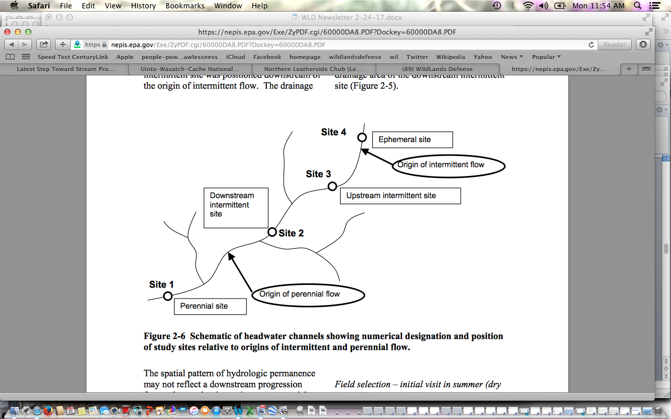
Foreseeable project-caused loss of perennial flows across the watershed headwaters significantly threatens biodiversity, aquatic species, and use of headwater areas by a broad array of wildlife as well as the recreational public. Thus, the spatial pattern of hydrological permanence may be adversely altered.
Full and detailed baseline information on physical habitat of streams and springbrooks must be obtained.
Physical habitat, typically refers to the structural attributes of the stream channel. For convenience of organization, we also discuss the measurement of physicochemical attributes of the stream water in this section. Habitat degradation from land-use change is the greatest threat to streams and their inhabitants (Allen and Flecker 1993, Sala et al. 2000, USEPA 2001).
The categories of hydrologic condition (discussed in detail below) represent the degree of departure from a spatially- continuous flow (or conversely, a completely dry condition) at a given point in time and space. These designations describe the level of connectivity or fragmentation of the aquatic phase in headwater streams (Boulton 2003). The degree of hydrologic connectivity is fundamental in controlling the structure and function of headwater streams because it affects physicochemical properties, biotic dispersal, and refuge availability (e.g., Boulton and Lake 1990, Dietrich and Anderson 1998, Maltchik et al. 1994).
Hydrology of headwater stream reaches may follow a predictable sequence of hydrologic conditions related to seasonal (and/or greater time frames) fluctuations in precipitation and evapotranspiration. Shannon et al. (2002) described hydrologic conditions in arid ephemeral channels that occur at lower frequencies than would occur in more humid regions. At a given time, the hydrologic condition also varies spatially within and among headwater streams associated with differences in distance to the groundwater table, watershed vegetation, groundwater storage capacity, etc.
Characteristics of Channel Headcuts. Headcuts are linked to erosion, often caused by grazing and/or road and logging or other deforestation disturbance impacts. Full and complete inventory of all existing headcuts across the watersheds to be disturbed must take place. The treatment disturbance combined with chronic disturbance seriously threatens expanded head-cutting, downcutting, stream entrenchment, and loss of sustainable water flows.
Headcuts are abrupt changes in streambed elevation (i.e., knickpoint) that migrate in an upstream direction (Leopold et al. 1964). This migration is a natural geomorphic process that is often accelerated due to human modification of the channel and/or surrounding watershed (Patrick et al. 1994, Montgomery 1999). The upstream migration of headcuts results in downcutting (i.e., degradation) of the streambed and incised channel morphology (Galay 1983, Simon 1989). Among the ecological effects downstream of headcuts may be loss of streamside vegetation, scoured streambeds, decreased sinuosity, and temporary increase in downstream sedimentation (Patrick et al. 1994). Headcuts can also influence the connectivity along headwater streams by steep changes in streambed elevation and hydrology. Abrupt changes in summer baseflow hydrology (and water temperature) occur at headcuts and are related to differences in distance from the groundwater table. EPA P. 44.
Please survey for headcuts and other erosional features and measure length and measure surrounding conditions of ephemeral, intermittent and perennial stream segments, and assess effects.
Channel Dimensions and Geomorphology. Channel geomorphology influences many structural and functional aspects in streams, including streambed substrates, organic matter retention, and biotic response to floods. The scouring forces of floods are dissipated on the banks to greater extent in wide, shallow channels, whereas these forces are focused on the streambed in constrained or incised channels (Carling 1983). Geomorphology also governs the distribution of water as streams dry. Wetted widths will contract faster in wide, shallow channels than in incised channels. Wide, shallow channels may be more prone to surface water drying than incised channels because the summer groundwater table is more likely to be above the streambed (Stanley et al. 1997). However, where drying is severe, incised channels offer less interstitial refugia because the substrate layer above underlying bedrock may be thin. Habitat simplification reduces the biotic diversity directly, but also affects diversity indirectly through loss of refugia (Lake 2003). EPA 60—61.
Determine Risk of Habitat Simplification, Loss of Biodiversity and Sustainability. Concerns include: Changes in stream flow and water velocity. Depth to groundwater. Status of local and regional aquifers and changes over time. Are there past stream and spring flow measurements? If so where and when were they collected? How do current rates compare to past rates?
Benthic invertebrate surveys are widely used to evaluate the condition or health of water bodies (Hellawell 1986, Rosenberg and Resh 1993, Rader et al. 2001). Invertebrate assemblages are composed of a wide range of taxonomic and functional groups, many of which can be found in headwater streams. Furthermore, a diversity of life histories (e.g., voltinism, cohort production interval, dormancy stages) and physiological tolerances are found among aquatic invertebrates (Williams 1996, Frouz et al. 2003). Habitat characteristics (e.g., predictability, disturbance intensity, productivity) set the template governing the evolution of life histories and therefore the composition of assemblages (Southwood 1977, Townsend and Hildrew 1994). Flow is considered one of the ultimate drivers of lotic systems (Lytle and Poff 2004), and may be even more critical to temporary water bodies (Walker et al. 1995, Schwartz and Jenkins 2000). Thus, the composition of invertebrate assemblages should reflect the flow permanence in headwater streams. However, among past investigations there is no consensus regarding the distinctiveness of invertebrate communities among stream reaches of different flow permanence (Deluchi 1988, Feminella 1996, Dietrich and Anderson 2000, Fritz and Dodds 2002, Price et al. 2004). As is often the case in ecological systems, this disparity suggests that the relationship between flow permanence and assemblage organization may be complex. EPA P. 114.
Example of deforestation impacts on headwaters are described:
Kappesser, 1992 stresses the importance and sensitivity of headwater streams to Headwaters harvest. Headwaters harvest is known to have a disproportionately large influence on channel condition. The stability condition of a watershed may be broadly determined by evaluation the level of harvest activity (ECA), its special distribution with regard to headwater harvest and rain on snow risk, and the density of roading in the watershed with consideration of road location relative to geology and slope.
https://blog.epa.gov/blog/2016/07/intermittent-river-ecology/

“ … Intermittent waterways are interesting systems because they are fundamentally transformative in nature. While nearly all waterways expand and contract with pulses of water availability, these changes are particularly noticeable for intermittent waterways. They transition from flowing (even flooding,) to fragmented pools, to completely dry channels. This makes it more of a challenge in predicting patterns and processes compared to rivers which flow year-round. Recognition of the increasing prevalence of intermittent waterways across the globe has spurred greater interest in these systems, particularly in how they function and influence downstream waterbodies …”.

The EA fails to take a hard site-specific systematic look at the baseline, and the direct, indirect and cumulative impacts of the massive project disturbance on these environmental ecological and physical conditions described in the EPA report and cited literature above.

http://onlinelibrary.wiley.com/doi/10.1111/fwb.2016.61.issue-8/issuetoc
Storms: http://onlinelibrary.wiley.com/doi/10.1111/fwb.12734/full

Welter, J. R. and Fisher, S. G. (2016), The influence of storm characteristics on hydrological connectivity in intermittent channel networks: implications for nitrogen transport and denitrification. Freshw. Biol, 61: 1214–1227. doi:10.1111/fwb.12734

Abstract:

- Intermittent channel networks pose particular challenges for monitoring the extent of material transport and retention in arid river basins as a result of pulsed and highly variable rainfall-runoff dynamics. Here, we examine how rainfall characteristics influence hydrological connectivity along a terrestrial–aquatic flowpath from upland hillslopes to low order intermittent channel networks. In addition, we explore the implications for nitrogen loss via denitrification as a function of variable flowpath length and soil water conditions associated with intermittent flow.
- The size, timing and intensity of storms influenced the extent of hydrological connectivity and highest order channel flow. During summer monsoons, highest order channel flow increased most strongly with storm size, while in winter, the combination of days since last storm and storm intensity provided the best model; however, models containing storm size were also highly ranked.
- Riparian terrace and vegetated hillslope soils had the highest denitrification potential; however, rates in channel sediments also were appreciable. Deep channel sediments dried slowly and may therefore remain biologically active for longer periods, increasing the potential for N losses via denitrification.
- The extent of N transport, storage and denitrification is in large part driven by the frequency, intensity and duration of individual rainfall events. Individual storm characteristics influence the magnitude of vertical and horizontal hydrological connectivity in the catchment, and therefore, the magnitude of transport, solute storage and biogeochemical processing in intermittent channel basins.
http://onlinelibrary.wiley.com/doi/10.1111/fwb.12707/full

Marshall, J. C., Menke, N., Crook, D. A., Lobegeiger, J. S., Balcombe, S. R., Huey, J. A., Fawcett, J. H., Bond, N. R., Starkey, A. H., Sternberg, D., Linke, S. and Arthington, A. H. (2016), Go with the flow: the movement behaviour of fish from isolated waterhole refugia during connecting flow events in an intermittent dryland river. Freshw Biol, 61: 1242–1258. doi:10.1111/fwb.12707

- In many intermittent, dryland rivers, fish are confined to isolated waterholes for much of the year. It is only during brief flow events, which typify the hydrology of these systems, that fish are able to move between waterholes and explore surrounding habitat. Because most of the river channel will dry afterwards, there is a strong advantage for selection of persistent waterholes.
- Modifications to both flow regime and hydrological connectivity may reduce movement opportunities for fish in intermittent rivers. Our findings show that fish in intermittent systems use networks of waterholes and that management and conservation strategies should aim to maintain movement opportunities at large spatial scales to preserve population resilience.
http://onlinelibrary.wiley.com/doi/10.1111/fwb.12793/full

Rolls, R. J., Heino, J. and Chessman, B. C. (2016), Unravelling the joint effects of flow regime, climatic variability and dispersal mode on beta diversity of riverine communities. Freshw Biol, 61: 1350–1364. doi:10.1111/fwb.12793

Our findings suggest that maintenance of refuge pools will be critical to lessening drought impacts on river biodiversity at landscape scales, particularly if drought duration and intensity increase in the future.

https://academic.oup.com/bioscience/article/55/3/196/249658/Moving-Headwater-Streams-to-the-Head-of-the-Class

Moving Headwater Streams to the Head of the Class
Winsor H. Lowe Gene E. Likens
BioScience (2005) 55 (3): 196-197. DOI: https://doi.org/10.1641/0006-3568(2005)055[0196:MHSTTH]2.0.CO;2 2005

There is growing evidence that the water quality, biodiversity, and ecological health of freshwater systems depend on functions provided by headwater streams, which are similar in their importance to the fine branches of the human respiratory system in the lung. Among the functions of these streams are the maintenance of natural discharge regimes, the regulation of sediment export, the retention of nutrients, the processing of terrestrial organic matter, and the establishment of the chemical signature for water quality in the landscape. High levels of habitat diversity among and within these small streams create niches for diverse organisms, including headwater-specialist species of aquatic invertebrates, amphibians, and fish. Headwaters also act as refugia for riverine species during specific life-history stages and critical periods of the year, such as warm summer months.
Like the alveoli (the final branches of the respiratory tree that serve as the primary gas exchange units of the lungs), headwater streams are characterized by strong and vital interactions with the systems that surround them. Terrestrial inputs—dissolved nutrients, toxins, and particulate matter, for example—play a central role in determining the physical and chemical conditions of headwater streams (Likens and Bormann 1974) and in regulating the composition and productivity of biotic communities in these streams (Wallace et al. 1997). Because of this close terrestrial–aquatic linkage, the ecosystem services provided by head-waters and the species they support tend to be very sensitive to natural and anthropogenic disturbance of surrounding lands. Along with other distinctive qualities, this close connection creates a unique set of challenges and opportunities related to the protection of head-waters, and to research in these systems.
http://www.stroudcenter.org/research/PDF/ProtectingHeadwaters.pdf

In this paper we describe the special nature of headwater streams, their critical role in stream ecosystems, their fragility and vulnerability to human disturbance, and the benefits that ensue when headwaters are protected by forested riparian buffers. In particular, we argue that headwaters:
- support a biodiversity of communities including species of aquatic insects that are primarily restricted to spring seeps and first-order channels and communities of microorganisms that are selected for by the physical and chemical conditions found in headwaters;
- provide energy that helps support the life forms in larger downstream reaches and are largely responsible for establishing the chemical signature of the water downstream;
- can arise as permanently flowing streams from very small watershed areas and can include ecologically important intermittent streams that flow from even smaller watershed areas;
- are integrated into landscapes, which makes the quality of headwaters dependent upon land use conditions; and
- with intact forested riparian buffers have a physical form that influences the processing of nutrients and contaminants and reproduce the conditions under which their biological communities evolved.
- The health of downstream areas is only as good as the protection afforded to headwater streams, beginning as spring seeps and first-order stream channels in a steam and river network, have an immediate and intimate connection with the terrestrial environment, forming an extensive terrestrial/aquatic mosaic. However, the very attributes of headwaters that make them critical to the health of stream networks also make them exceedingly vulnerable to degradation when landscapes are altered.
This project greatly disturbs headwater region upland and riparian areas and drainage networks, and the EA fails to take a hard look at the direct, indirect, cumulative and synergistic impacts of the project’s massive disturbance. This is especially the case because

Soil Assessment and Needed Protections

Soil analysis must provide data and measurements taken inside proposed project treatment units or riparian areas.

Please employ scientifically validated or monitoring validated methods for soil damage mitigation to ensure and restore the productivity of soils.

Please provide field surveys of existing detrimental disturbance (DD) and total soil resource commitment (TSRC). Mitigation and feasibility of proposed treatments hinge upon current soil conditions. These conditions are affected by past and ongoing management actions including logging, burning, livestock grazing, road building, and mechanized recreation.

Fire results in significant nutrient loss from soils– making the large-scale use of fire in this project even more harmful.

We are also concerned about logging/thinning/fire treatment and livestock trampling degradation of microbiotic crusts, such as the moss and lichens that cloak areas of forest floors – covering and stabilizing soils preventing erosion in wind and water. How does the Forest measure and monitor the health of microbiotic crusts, which provide a protective covering to soils, sequester carbon, provide nutrients, protect watersheds through promoting proper infiltration, and help exclude weeds. Belnap et al. 2000 BLM Tech. Bull. 2000.

See for example Glaser et al. 2022: https://www.ncbi.nlm.nih.gov/pmc/articles/PMC8966483/

Biological Soil Crust From Mesic Forests Promote a Specific Bacteria Community
“Bare soil at high vegetation climax sites is generated by animal activities and windfall, and by forest management, such as the removal of trees and the creation of skid trails or driving lanes for heavy equipment. The favorable climatic conditions in middle European temperate regions allow biocrusts to develop within weeks after disturbance, usually starting with a biofilm of eukaryotic algae, which are, besides mosses, the most dominant biocrust phototrophs in temperate forests and heaths (Gypser et al., 2015; Glaser et al., 2017, 2018). Biocrusts in temperate regions can sustain many years, but their activity is seasonal dependent (Dümig et al., 2014; Rieser et al., 2021). Even in well-developed European forest soils, biocrusts accumulate nutrients more strongly than surrounding bulk soils (Baumann et al., 2017; Drahorad et al., 2020) and also might counteract soil erosion as has been shown in other forest ecosystems (Seitz et al., 2017). Furthermore, temperate biocrusts impact the hydrological characteristics of the respective habitat (Gypser et al., 2016b).
Cyanobacteria and eukaryotic microalgae are crucial for the biocrust formation and development as major contributors to carbon fixation (Büdel et al., 2016; Szyja et al., 2018)”. Both the treatments, and livestock trampling, degrade, harm and/or destroy crusts – and there is no hard look at these impacts.
Please provide detailed information on methodologies used for measuring and protecting soil productivity and functional processes.

Forest Plan Standard SWST02 states:

Management activities that may affect soil detrimental disturbance (DD) shall meet the
following requirements:
a) In an activity area where existing conditions of DD are below 15 percent of the
area, management activities shall leave the area in a condition of 15 percent or less detrimental disturbance following completion of the activities.
b) In an activity area where existing conditions of DD exceed 15 percent of the area, management activities shall include mitigation and restoration so that DD levels are moved back toward 15 percent or less following completion of the activities.

It is essential that the glossary definitions for the project area, detrimental soil disturbance and total soil resource commitment are clearly delineated. The Forest Plan Standard SWST02 and FSH 2509.18 DD use of 15% threshold is not based upon scientifically or publicly (i.e., NEPA) developed limitations on soil damage.

NFMA requires the Forest Service to “ensure that timber will be harvested from National Forest System lands only where—soil, slope, or other watershed conditions will not be irreversibly damaged.” [16 U.S.C. 1604 (g)(3)(E).] The FEIS thus violates NFMA and NEPA.

The Payette Forest’s soil productivity proxy—such as the determination that management actions may permanently damage the soil covering 15% of an activity area and still meet NMFA and planning regulations—is arbitrary.

In responding to public comments on the Kootenai NF’s Brush Creek Environmental Assessment, the Forest Service stated:
Forest (“land”) productivity is “the summation of productivities of the individual landscape elements (stands) that comprise the forest and is the integration of soil productivity, species composition and stocking, and stand history (Grgal 2000)”. If soil productivity is adversely affected due to compaction, then this will have an impact on the overall productivity of the forest. Forest productivity is difficult to measure, so oftentimes, soil quality is used to estimate the potential productivity (Little et al., unknown year).

Soil compaction results from motorized activity in treatments, as well as livestock grazing trampling. How will both of these causes of compaction be measured, minimized/mitigated, and monitored? Fleischner (1994), Belsky et al. 1999. Treatment clearing and potential changes in roads/trails may alter how livestock use the landscape, and zones of soil disturbance, compaction and damage to microbiotic crusts.

If the Forest is using proxies, what is the scientific information based upon Payette data that correlates the proxy (areal extent of detrimental soil disturbance in activity areas) to metrics of long-term reductions in soil productivity, in order to validate the use of the proxy as a scientifically meaningful estimate of changes in soil productivity.

USDA Forest Service, 2007c states:

The Regional Soil Quality Standards (R-1 Supplement 2500-99-1) were revised in November 1999 (DEIS, A-11 (EIS Chapter 3). Manual direction recommends maintaining 85% of an activity area’s soils at an acceptable productivity potential with respect to detrimental impacts - including the effects of compaction, displacement, rutting, severe burning, surface erosion, loss of surface organic matter, and soil mass movement. This recommendation is based on research indicating that a decline in productivity would have to be at least 15% to be detectable (Powers, 1990).

The R-1 Supplement 2500-99-1 is almost identical to FSH 2509.18. It is important to note the separate and distinct thresholds in discussing 15% increases in bulk density, a threshold below which soil compaction is considered to be detectable, and 15% areal limit for detrimental disturbance, the Forest Plan and FSH upper limit on detrimental disturbance within “activity areas.” NFMA does not say that we can create up to 15% detrimental conditions, it says basically that we cannot create significant or permanent impairment.

This NEPA analysis must disclose internal controversies the agency fully recognizes surrounding its use scientific information for something as critical as standards for compliance with NFMA. NFMA requires that the Forest Service must “insure that timber will be harvested from National Forest System lands only where …soil, slope, or other watershed conditions will not be irreversibly damaged.” The Forest Service’s position is that its management may cause long-term harm or essentially irreversibly damage up to 15% of activity areas in disregard of NFMA—without any scientific basis.

The capability of Forest lands to support livestock grazing must consider the need to protect soils and determine the amount and levels of disturbance/degradation and other factors must also be considered .

Weeds/Exotic Species

The Forest must fully disclose activities that will substantially cause or promote the introduction or spread of invasive species. The direct indirect and cumulative effects of treatment disturbance, livestock grazing and roads/trails exacerbate the conditions for noxious weed and other invasive exotic species spread.
Noxious weeds and exotic invasive species like bulbous bluegrass or annual invasive grasses are one of the top threats to biodiversity on national forests. Please fully disclose the present level of noxious weed and exotic species infestations in the Project area, and the cause of those infestations.

Many weeds are poor soil stabilizers, resulting in invaded areas being more prone to accelerated soil erosion. Imposing grazing disturbance on treated areas promotes conditions where weeds thrive.

What are the impacts that noxious weed infestations, prevalence of invasive exotic grasses like bulbous bluegrass, or increase of rhizomatous aggressive extic grasses like smooth brome or intermediate wheatgrass in understories cause to native plant communities? How does this affect the availability of livestock forage, stocking rates, and capability for livestock grazing?

We are concerned that the Forest may provide laundry lists of effectiveness of BMPs that do not effectively address prevention of new weed infestations following logging and related road operations, including in grazing-disturbed lands and watersheds. The Forest must disclose how this project may exacerbate existing weed infestations or cause new infestations.

Please quantify the project area extent of soils with impairment or experiencing detrimental impacts based upon the presence of noxious weeds and abundant exotic invasive shallow-rooted grasses.

Please develop project standards weed management which address the cause of the weed problems through prevention. See Appendix A, alternative and mitigation actions, and discussion of herbicide use concerns in these comments.

Fire and Fire Suppression Concerns

Documents for projects such as this fearmonger over fire, and rely on models and assumptions that assume often too short fire return interval, and uses terms like “catastrophic” or undesirable. The agency must come to grips with fire as a naturally functioning process.

The project analysis must fully disclose benefits of mixed severity and high severity fire. Even if all the “treatments” now proposed were to closely mimic the effects of a “characteristic” fire, there is no other plan for these newly “resilient” landscapes other than full on fire suppression where natural ignitions occur. What would the long-term ecological and economic costs of such a management regime be?

We support sound science-based fuel treatments located immediately adjacent to structures along private land/structure/national forest boundaries. Such treatments are supported by the scientific community as the most efficient and effective means to protect the values located on those private lands.

Cohen, 1999 reviewed current scientific evidence and policy directives on the issue of fire in the wildland/urban interface and recommend the focus be on structure ignitability in the Home Ignition Zone rather than extensive wildland fuel management. Cohen, 1999 also recognizes “the imperative to separate the problem of the wildland fire threat to homes from the problem of ecosystem sustainability due to changes in wildland fuels” (Id.). In regards to the latter—

How will the Forest study fire risk in a proper cumulative effects analysis area? Finney and Cohen (2003) discuss the concept of a “fireshed involving a wide area around the community (for many miles that include areas that fires can come from).” Please provide a thorough discussion and detailed disclosure of the current fuel situation within the fireshed within and outside the proposed treatment units, making it possible to assess the manner and degree to which most fire behavior would be changed by the project.
A major premise of the project is that the ecological impacts of fire suppression have been significant. How significant has logging, and promiscuous burning by livestock interests been in the historical era? The Forest must adequately consider the spatial and temporal ecological cumulative impacts of the PNF’s fire suppression management regime for the area. The EIS must also consider the economic implications of the FS’s fire management.
Historic Fire Regimes

The fire analysis must include a temporal component, considering action alternative effects beyond immediate post-project conditions.

The FS must detail how it arrived at fire return ort disturbance intervals for all vegetation communities and must consider a broad range of sources – not just those that support very short fire return intervals.

Please perform a cumulative effects analysis of logging, treatments and fire suppression policies—how those effects play out on the Payette NF and in the project area landscape. The many mechanical treatments will continue long-term adverse impact on the watersheds and terrestrial habitats. This leaves the door open to comprehensive restoration being subservient to timber volume production.

Habitat for the sensitive black-backed woodpecker is comprised predominately of insect infested or burned over stands. Insect infestations and recent wildfire provide key nesting and foraging habitats for the black-backed woodpecker and “populations are eruptive in response to these occurrences” (Wisdom et al. 2000). A purpose of the Granite Goose (and its predecessor Granite Creek) project is to “eradicate” insect infestations with the “sanitation cuts” and large-scale removal of wood and burning of wood and the heap of other deforestation practices prevent the natural fire occurrence that the black-backed woodpecker requires – both within the project area and other sites across the Forest and landscape. Viability of a species cannot be assured if habitat suppression is to be a forest-wide emphasis stemming from the forest plan. The FS will never be successful in “controlling” insects in this manner. All it will achieve is major new forest disturbance - including in Wolverine and a host of other rare species habitats, and through removing nutrients, shade from standing dead and/or downed trees and carbon sequestration loss – a depauperate and simplified hotter, drier more fire prone vegetation community.

Cherry (1997) states:
The black-backed woodpecker appears to fill a niche that describes everything that foresters and fire fighters have attempted to eradicate. For about the last 50 years, disease and fire have been considered enemies of the ‘healthy’ forest and have been combated relatively successfully. We have recently (within the last 0 to 15 years) realized that disease and fire have their place on the landscape, but the landscape is badly out of balance with the fire suppression and insect and disease reduction activities (i.e. salvage logging) of the last 50 years. Therefore, the black-backed woodpecker is likely not to be abundant as it once was, and continued fire suppression and insect eradication is likely to cause further decline.”

Hutto, 1995 who studied forests burned in the the 1988 fire season, noted:
Fire is such an important creator of the ecological variety in Rocky Mountain landscapes that the conservation of biological diversity [required by NFMA] is likely to be accomplished only through the conservation of fire as a process…Efforts to meet legal mandates to maintain biodiversity should, therefore, be directed toward maintaining processes like fire, which create the variety of vegetative cover types upon which the great variety of wildlife species depend.

Hutto, 1995 states: “Fires are clearly beneficial to numerous bird species, and are apparently necessary for some.” (p. 1052, emphasis added.) Hutto, 1995 also noted:

USDA Forest Service 2011c describes some species needs for high severity burns:
Hutto (2008), in a study of bird use of habitats burned in the 2003 fires in northwest Montana, found that within burned forests, there was one variable that exerts an influence that outstrips the influence of any other variable on the distribution of birds, and that is fire severity. Some species, including the black-backed woodpecker, were relatively abundant only in the high-severity patches. Hutto’s preliminary results also suggested adverse effects of a legacy of past logging- as burned forests that were harvested fairly intensively (seed tree cuts, shelterwood cuts) within a decade or two prior to the fires of 2003 were much less suitable as post-fire forests to the black-backed woodpecker and other fire dependent bird species. Even forests that were harvested more selectively within a decade or two prior to fire were less likely to be occupied by black-backed woodpeckers.
Hutto, 2008 states, “severely burned forest conditions have probably occurred naturally across a broad range of forest types for millennia. These findings highlight the fact that severe fire provides an important ecological backdrop for fire specialists like the Black-backed Woodpecker, and that the presence and importance of severe fire may be much broader than commonly appreciated.” The Forest Service continues to manage against severely burned forests.

Alternatives

There is no alternative that fully analyzes using natural processes as the primary method of vegetative restoration outside a wildland urban interface - using the best scientific information available. There is no consideration of a range of alternative actions -including BMPs and SOPs and minimal tree removal, and not large-scale reduction n the project’s profligate use of fire. Further, the FS should have taken this opportunity to conduct large-scale winter disturbance closures across the project area – given the declines in the areas Wolverine population, as shown in USFWS 2023 Report. We are extremely concerned that the FS is allowing Brundage resort profiteering on national forest lands- such as snow cat skiing and the ever-expanding resort activity and trails and housing to eat a huge hole into irreplaceable native carnivore habitat.

Please incorporate livestock grazing Alternative and Mitigation actions in Appendix A, in a process-re-scoped as an EIS.

Full science-based analysis of No Action, and incorporation of components of No Action into alternatives must take place.

Comprehensive Cumulative Effects Analysis is Required to Comply with NEPA.

Listing or mentioning past, ongoing, and reasonably foreseeable actions does not provide adequate analysis of those impacts for resources. It is important that the results of past monitoring be incorporated into cumulative effects analyses. The Forest Service must include the results of monitoring done in the project area as committed to in the NEPA documents of past projects or as a part of the Forest Plan monitoring and evaluation effort. We are very concerned that sufficient past monitoring may not have taken place.

Has the Forest performed all of monitoring and mitigation required or recommended in any NEPA documents? Our review of the recent Forest Plan Monitoring Report discussed in these comments found large data gaps. What is the record of compliance with Forest plan-required monitoring?

What are the cumulative effects of the Brundage Resort and associated ski developments, trail or other networks, motorized recreation and mountain biking disturbance on vegetation, soils, fish, wildlife habitats (over all seasons of the year) and water quality? What are the cumulative effects of past or foreseeable logging, wildfire, vegetation treatments on resources? What are the cumulative impacts of fire suppression?

What are the past and ongoing/chronic ecological damage effects from livestock grazing? The EIS include alternatives that adequately deals with the adverse cumulative effects of grazing.

How much do grazing allotments within the cumulative effects area contribute to loss of ground cover in RCAs and conversion of desirable native vegetation to less favorable weedy species or poor soil stabilizers? Wetlands are at risk for compaction as well and possible effects to shallow water tables must be identified and damage addressed.

The Forest must identify “reference conditions” (and accurately describe departures from these reference conditions) for all Indicators and assessments of condition. Where are all PNF RNAs, and how do their conditions compare to the claimed “desired” conditions? Are there exclosures? If so, have they been trespassed, and if not, what insights into ecological conditions and grazing impacts do they provide?

Additional Concerns

We had requested the most recent 2-year Forest monitoring reports from your office around 3 weeks ago. While we received one phone call back, the staff had not yet found these required reports. Without adequate montoring and the status of habitats and populations of species and other Forest biological, roadless area, native vegetation community, and other values across the Forest, a valid NEPA process can’t take place.

We have corrected the date on our previously submitted comments and re-submitting them.

We also want to add additional new information the magnitude and scale of indirect and cumulative impacts and threats to biodiversity and wildlife in this Region and across the Region 4 forests landscape --- the disastrous potential impact of the proposed BLM Solar EIS that proposed industrial development on 22 million acres of the West, and that would harm and destroy lower elevation wintering or migration habitats for many migratory bird species and regional populations of wintering big game herds that also use National Forest lands.

If this massive industrialization of the interior West proceeds under that BLM Solar EIS,these populations even more vulnerable to extirpation - when combined with the host of deforestation and other actions of the Granite Goose project and a slew of other USFS “treatments” and massive burning schemes.

See Solar EIS Alternatives Mapping: https://blm-egis.maps.arcgis.com/apps/webappviewer/index.html?id=22df2b327e0c49c3a9afb67de5ca658d

We also are including links and information on the Boise Forest release of the Sagehen EA that includes the same massive agency treatment-caused loss and destruction of migratory bird, rare native carnivore, big game and other wildlife habitats. This will further de-stabilize and reduce the viability of populations of wildlife and aquatic biota in this region of Idaho. See:

https://usfs-public.app.box.com/v/PinyonPublic/folder/158226337006

EA: https://usfs-public.app.box.com/v/PinyonPublic/file/1419513258354 .

The massive proposed assault on Boise NF lands in the McCall region with the Sagehen project includes:
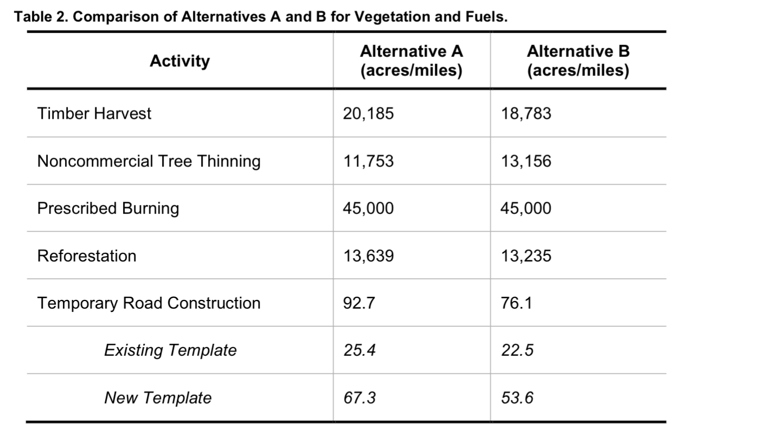

The Boise NF Sagehen project is at the far northwestern edge of the Boise Forest, and Payette lands lie to the north and west. 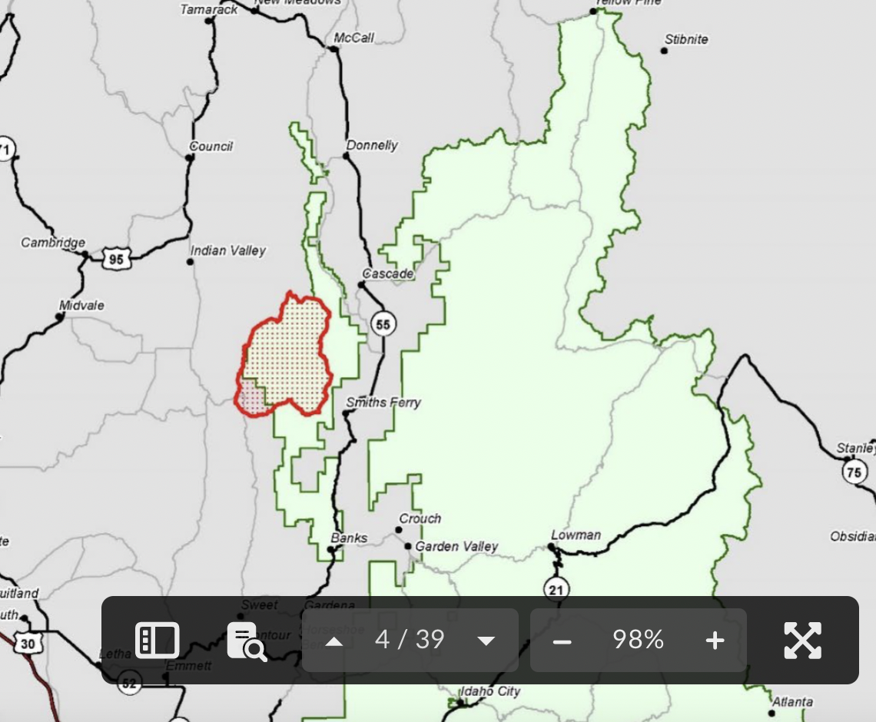

The revised Sagehen project represents another major treatment assault on USFS lands, watersheds, biota and roadless areas - on top of all the existing USFS projects and wildfire impacts on forest habitats and processes in this McCall region landscape. It's as if the Region 4 Forest Service wants to get rid of nearly all mature forests and trees - seeking an ideal of a tattered landscape of minimal tree or other woody vegetation cover - with devastating results for biodiversity and the persistence of sensitive and imperiled species.

Further, the Sagehen project continues the predecessor Sagehen project’s loose, uncertain “condition-based” management lacking adequate baseline species inventories, roadless area analyses, watershed and other data and information necessary data and analysis to take an integrated hard look at the project’s harms under a valid NEPA analysis. This project is the result of a logging industry “collaborative” given undue weight and privileges in the NEPA process by the USFS. Sagehen, like Granite Goose, will result in a hotter, drier, windier weedier and more fire prone forest environment that is less able to withstand climate stress. The one thing that is certain is that it attacks and will greatly alter, fragment and destroy most of the remaining mature forest in this landscaper, and also result in a significant loss of carbon sequestration and release of climate change gases like CO2 into the atmosphere.

How much carbon is currently being sequestered in the forest sites the Granite Goose project seeks to radically “treat”, alter, fragment and/or destroy – in both like trees and dead wood? How much will be sequestered if the proposed action takes place? How much carbon and other greenhouse gases will be released?

How much carbon sequestration ability will be lost across Region 4 forests if all the projects currently proposed and/or approved (massive Fire EAs that often include much mechanical “treatment”, and scores of “restoration treatment”/logging projects”) are carried out? How much carbon sequestration is currently occurring in these same Region 4 Forest areas?

Additionally, how many older “approved” long-term projects does the Payette Forest have on its books? Where are these project located, and if completed, how much carbon will be released and sensitive species habitat altered, fragmented and/or destroyed?

Similarly, how massive will the habitat loss and fragmentation blow be to sensitive species (often many of the same species in different forests, rare native carnivores including Wolverine, Lynx, Gray Wolf, Fisher, Marten) across the Region 4 Forests?

Also note Fisher range – and the project is located on the southern edge of the species range. Extirpation of the Fisher here and on the adjacent Boise Forest would foreseeably contribute to a range contraction northward for this species.

https://en.wikipedia.beta.wmflabs.org/wiki/Fisher_(animal)

https://digitalatlas.cose.isu.edu/bio/mammal/Carn/muste/fish/fishfrm.htm

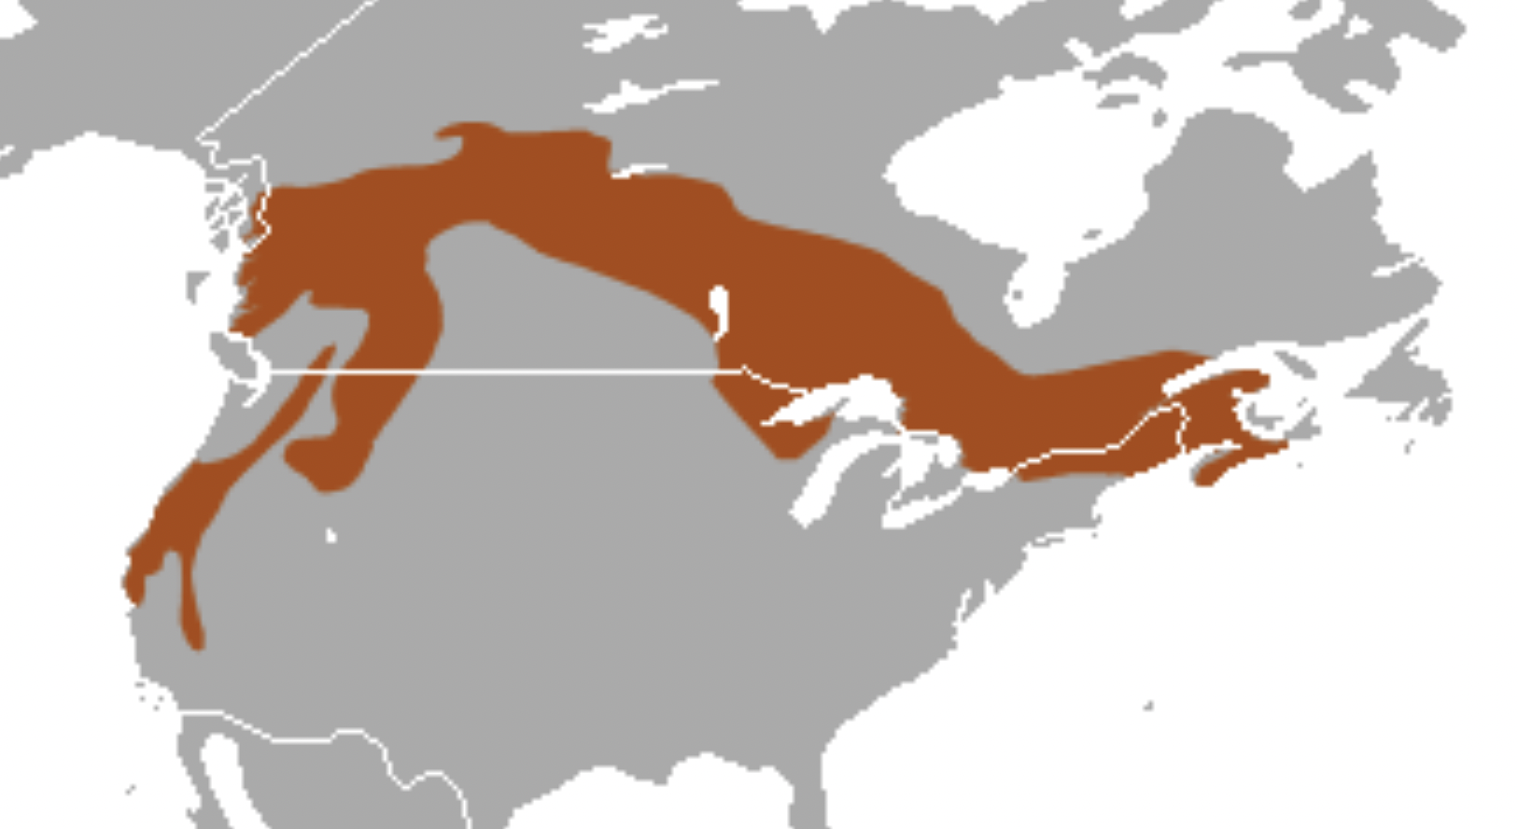

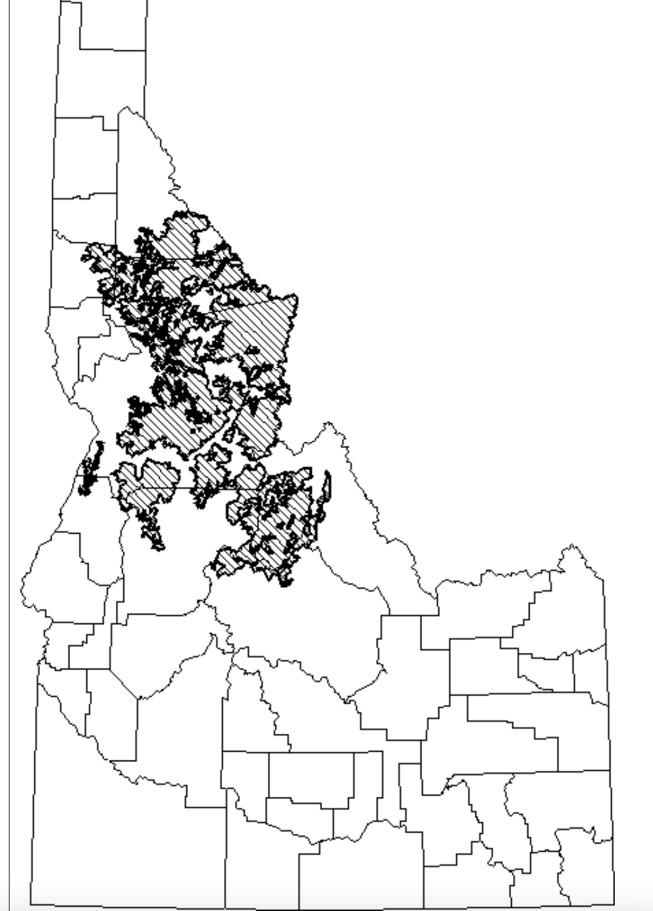

We cannot overemphasize the assault on higher elevation forests the Region 4 FS is currently engaged in – having logged out lower elevation Douglas fir and Ponderosa pine, in Idaho now the agency appears intent on mining timber from, or burning up, subalpine fir, grand for and other higher elevation forests – posing a significantly greater threat to the fisher and other rare native carnivores.

We also note that there are several recent articles about significant harms that could be caused by the proposed Nez Perce-Clearwater Forest Plan and the treats it poses to roadless lands and the same rare native carnivores and other biota and to roadless area lands.

Please keep us fully informed of all aspects of this major federal action where an EIS must be prepared.

Sincerely,

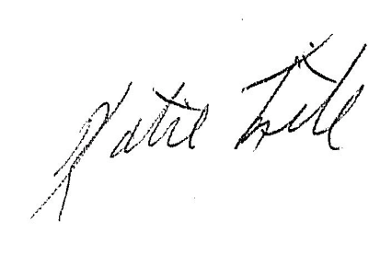

Katie Fite
Public Lands Director
WildLands Defense
PO Box 125
Boise, ID 83701
208-871-5738
katie@wildlandsdefense.org

/mg
Mike Garrity
Alliance for the Wild Rockies
PO Box 505
Helena, MT 59624
406-579-5986
wildrockies@gmail.com

/se
Sara Johnson
Native Ecosystems Council
PO Box 125
Willow Creek, MT 59760
406-579-3286
sjjohnsonkoa@gmail.com

Jason Christensen
Yellowstone to Uintas Connection
PO Box 363
Paris, ID 83261
435-881-6917
jason@yellowstoneuintas.org

.
Cohen, Jack 1999. Reducing the Wildland Fire Threat to Homes: where and how much? Jack D. Cohen, RMRS. Paper presented at the Fire Economics Symposium, San Diego, CA April 12, 1999. ecosystem sustainability—Cohen and Butler (2005) state: Realizing that wildland fires are inevitable should urge us to recognize that excluding wildfire does not eliminate fire, it unintentionally selects for only those occurrences that defy our suppression capability—the extreme wildfires that are continuous over extensive areas. If we wish to avoid these extensive wildfires and restore fire to a more normal ecological condition, our only choice is to allow fire occurrence under conditions other than extremes. Our choices become ones of compatibility with the inevitable fire occurrences rather than ones of attempted exclusion. Rhodes, 2007 states: “The transient effects of treatments on forests, coupled with the relatively low probability of higher-severity fire, makes it unlikely that fire will affect treated areas while fuel levels are reduced.” (Internal citations omitted.) And Rhodes, 2007 also points out that management with mechanical fuel treatments to restore natural fire regimes must take into consideration the root causes of the alleged problems, which in this case may be related to the intensive livestock grazing that has occurred for several decades. The NEPA process here should take into account the effects of livestock grazing on forest conditions, in terms of various resources including soils, water, weeds, and forest composition. Baker et al., 2006 state: Livestock grazing generally increases tree density in formerly open stands and thereby increases the fine fuels that contribute most to fire intensity and severity. Removal of grass reduces competition, allowing more trees to successfully regenerate, shown experimentally in the Southwest (Pearson, 1942), and also by paired comparisons in other parts of the West, in which mesas subject to livestock grazing have much higher tree density than do comparable nearby ungrazed mesas (Rummell, 1951; Madany & West, 1983). Grazing can also initially reduce the quantity of fine grass fuels needed for surface fires, and the onset of heavy grazing in south-western ponderosa pine landscapes is temporally associated with a marked reduction in surface fires (e.g. Savage & Swetnam, 1990). However, fine fuels are likely not to have remained low for long. Higher tree density increases fine fuels that lead to faster fire spread and increases ladder fuels that lead fire into the canopy (Zimmerman & Neuenschwander, 1984), together increasing the potential for more fires and more severe fires. The allegation that thinning replicates natural fire is also contradicted by science (for example see Rhodes and Baker 2008, McRae et al 2001, and Rhodes 2007). DellaSala, et al. (1995) are skeptical about the efficacy of intensive fuels reductions as fire-proofing methods. Veblen (2003) states: The premise behind many projects aimed at wildfire hazard reduction and ecological restoration in forests of the western United States is the idea that unnatural fuel buildup has resulted from suppression of formerly frequent fires. This premise and its implications need to be critically evaluated by conducting area-specific research in the forest ecosystems targeted for fuels or ecological restoration projects. Fire regime researchers need to acknowledge the limitations of fire history methodology and avoid over-reliance on summary fire statistics such as mean fire interval and rotation period. Kauffman (2004) suggests that current FS fire suppression policies are what is catastrophic, and that fires are beneficial:

