Reasonable and Foreseeable Development of the Thompson Divide

By Ken Kreckel

Findings

In late 2022, the Biden administration proposed the withdrawal of 225,000 acres of public land in the Thompson Divide area in western Colorado, from new mining and oil and gas leases for 20 years. Several reports exist assessing the likelihood of drilling within the Thompson Divide. The purpose of this paper is provide an update of those studies, expand on their findings, and provide an assessment of “reasonable and foreseeable development” within the area proposed for withdrawal.

This acreage lies on the extreme eastern edge of the prolific gas producing Piceance Basin. The USGS has estimated the basin holds an unproduced resource of 4.7 trillion cubic feet (TCF) of gas from the Mesaverde formation and 66 TCF from the Niobrara/Mancos formation, a very large resource indeed. But these estimates only define a resource. How much of this resource becomes actual reserves depends on the economics of developing them. Thus far, the economics of this play has been very questionable, and very little has been developed.

Moreover, this paper is concerned with the prospect for developing this resource on only a portion of the basin, specifically the Thompson Divide acreage.

My assessment of the prospect for developing oil and gas from under the Thompson Divide acreage under any reasonable and foreseeable timeline is essentially zero. Drilling in the Thompson Divide, lies at a considerable competitive disadvantage when compared to the middle of the Piceance Basin where formations are deeper and prospects have been proven. Broadly speaking, the reasons for this are as follows:

- The vast majority of drilling in the Piceance Basin (more than 99% from 2020-2023) is in the Williams Fork formation, and that is centralized in the middle of the Basin – not near the proposed withdrawal area.
- These locations are all in very low risk locations, either in-filling current production or testing the field edges, seeking to extend production to the next adjacent locations. Any drilling in the Thompson Divide would involve much greater risk, which thus far industry has not accepted.
- The Mesaverde, the major existing gas play in the basin, is not prospective here. The formation is too thin, too close to the outcrop to be a reasonable target for the drill bit. Much of formation actually outcrops on the acreage, leaving large areas to the east where it does not exist at all. Where it does exist, it tends to produce low amounts of gas, or only water.
- The economics of the large Niobrara/Mancos resource was the subject of much excitement years ago, but it has not lived up to expectations. Few wells have been drilled to the Niobrara/Mancos. In any case, the most prospective area for the formation is in the basin center where the source rock potential is highest, and the formation is at its thickest.
- Oil and gas operations in the Thompson Divide will be difficult and much more expensive than in the basin itself, where there is ample infrastructure and operations are relatively easy. Drilling in the Piceance Basin is, and has been for a decade, depressed. The drilling that continues is concentrated almost exclusively on the major gas fields in the deeper portion in the center, well away from the Thompson Divide.

The following discussion provides the details behind these conclusions.

Qualifications

I am a professional geo-scientist with over forty years’ experience in the exploration and development of oil and gas reserves in North America and Europe. For much of my career, I initiated and managed the exploration and development efforts of Marathon Oil Company in various producing basins, including many years in the Rocky Mountain region. I was in a decision-making role in evaluating the technical and economic merits of horizontal and directional drilling, 3D seismic surveys, and so on. Of particular note are my years as Exploitation Manager in Tyler, Texas where I directly managed the development of several Cretaceous tight gas sand fields in formations very similar to the Mesaverde. I also led the company's development of the fractured Austin Chalk, a formation much like the Niobrara/Mancos. This development pioneered the use of horizontal wells. In addition, I have ten years’ experience as an instructor and department head at Casper College, where I developed and taught several courses in oil and gas technology, including petroleum geology, and well drilling. I continue to maintain an active consulting business, much of it devoted to analyzing the geologic and environmental issues surrounding federal and state lease sales. Most recently I was the supervising geophysicist in a major international oil play in the Bahamas. For more information, I refer you to my Curriculum Vitae (CV) [attached].

Piceance Basin

The Piceance Basin is an asymmetrical sedimentary basin in the northeast part of the Colorado Plateau. [see Figure 1] ² The basin is highly asymmetric with steeply dipping strata on the eastern flank and gently dipping strata on the southern, western, and northeastern portions. The basin’s synclinal axis trends northwest to southeast close to the eastern edge of the basin. Currently, 38 oil and gas fields have been discovered, and of these, 21 produce partially or completely from basin-centered gas accumulations. ¹

The Thompson Divide acreage lies in the extreme eastern portion of the basin, generally in a poor position for major hydrocarbon accumulations. Much of this acreage is adjacent to igneous intrusions, shown in red on the map. Heat from these intrusions can degrade any hydrocarbons present. Structurally [see Figure 2] ³ the northern portion of the acreage lies in an area of especially steep dip on the edge of the basin. The more southerly acreage lies in the more gently dipping southeast edge of the basin. However, all the acreage lies on the edge of the basin where the rocks that produce in the basin center become much shallower, thinner and actually outcrop on the surface nearby. [See Figure 3] ⁴ This makes the presence of economic hydrocarbons much less likely for a variety of reasons:

- Leakage of hydrocarbons into the atmosphere at the outcrop.
- Degradation of any hydrocarbons due to an influx of meteoric waters [fresh, oxidated water] from those outcrops.
- Lack of trapping mechanism.
- Reduction of reservoir pressures.
- Distance from the source rocks which lie in the deeper portion of the basin.

Figure 6 is an east-west cross section across the basin.⁵ Two points are evident here:

- The extreme steep dips on the east side of the basin where much of the Thompson acreage lies.
- There is a line illustrating the top of known gas in the Mesaverde, at a depth of approximately 0' sub sea, or sea level. Much of the Mesaverde under the Thompson acreage is considerably above this line, thereby rendering the Mesaverde non-prospective for commercial gas in this area.

In addition, the Thompson Divide acreage has not been generally drilled by industry. [See Figure 4] ⁶ There are only abandoned locations and a few unsuccessful tests, outside of the Wolf Creek structure, which is a gas storage facility. The area directly adjacent to the acreage has likewise been only sparsely drilled, outside of the Bull Mountain coal bed and Mancos wells [to be discussed later in this report]. Exclusive of these exceptions, industry has shown little to no interest in actually drilling in the Thompson Divide.

Surface Considerations

The Thompson Divide comprises nearly 224,794 acres across Pitkin, Garfield and Gunnison counties. The vast majority of land, 200,518 acres, is administered by the U.S. Forest Service. The proposed administrative withdrawal would apply to 78,000 acres of the White River National Forest and about 122,000 acres on the Grand Mesa, Uncompahgre, and Gunnison National Forests. The BLM manages 15,465 acres and 8,700 acres are privately owned land with federal minerals underground, according to the Forest Service. [See Figure 5] ⁷

This rugged terrain presents problems to oil and gas production. Wright characterizes it as: "very rugged terrain, much of which is located in roadless areas. Access to the area with wheeled vehicles is restricted to a summer window.... Because of the restricted access the operating costs will probably be much higher than those used in the analysis.” ⁸

Both Wright and others have commented on the lack of infrastructure on the Thompson Divide acreage. This includes the lack of roads, as well as oil and gas infrastructure, such as pipelines, well pads, etc. For example, MHA Petroleum Consultants pointed out: “Expenses aside, the logistics involving the ‘roadless area’, wetlands, wildlife, recreation, public opposition, and multiple other obstacles, makes this area extremely unattractive to drill and operate wells.” ⁹ Indeed, Forest Service designated “Inventoried Roadless Areas” occupy the majority of land within the proposed administrative withdrawal.

The main point to remember is that both initial pre-drill costs and subsequent operating costs will be considerably higher for any future drilling on the acreage. Thus oil and gas operations on the Thompson Divide are at a competitive disadvantage compared to the Piceance Basin proper, where the vast majority of wells are currently being drilled.

Natural Gas Production in the Piceance

Mesaverde

According to Natural Gas Intel: “Much of the current production in the Piceance comes from the Williams Fork Formation within the Mesaverde Group in general [See Figure 7], and from four major fields in particular: Grand Valley, Mamm Creek, Parachute, and Rulison.” [See Figure 4] Although a developed play, the Piceance certainly has seen efficiency gains over the last twenty years. For example, WPX drilled an average of 42.2 wells per rig in 2012, nearly double the 22.2 wells per rig it was able to drill in 2006. But as an older, more developed play, the Piceance is also no longer the fast grower it was in the early 2000s. At the start of 2015, WPX delayed completions on at least 20 drilled wells waiting for "economics to improve." As we will see in following pages, this decline has continued to the present day. 10

The USGS has recently assessed the major gas play in the Unita-Piceance, the Mesaverde Total Petroleum system. This system makes up the bulk of the production in the basin. “The Piceance Mesaverde Tight Gas AU lies within the Piceance Basin part of the Uinta-Piceance Province in northwest Colorado. Mesaverde Group and Wasatch Formation tight gas—more than 7.7 TCF—has been produced from over 12,000 wells in the Piceance Basin, mostly from the central part of the basin (IHS Markit, 2017).” 11

The USGS summed up its remaining potential in the following two tables: 11

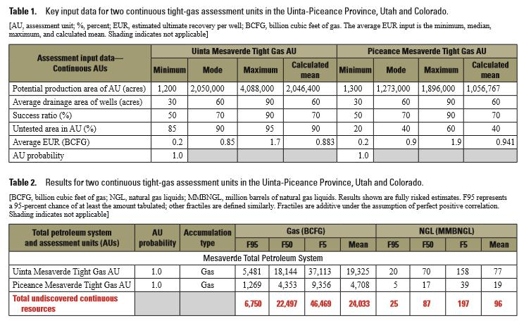

Note the following:

- The USGS considers the Piceance Basin to be fairly mature, with its mean calculated untested area of only 40%. Thus 60% of the basin has been tested by the drill bit.
- Total undiscovered, or undeveloped, gas is much lower than the Uinta Basin, comprising a mean of 4.7 TCF. This volume is still quite large, however.
- Average drainage area of wells is 60 acres. As we will see in the following pages, however, this average is likely to decline. Infill drilling in many fields is being conducted on a 10 acre spacing.

Drilling for Mesaverde Gas

During the drilling boom of the 2000's, which saw infill drilling greatly increase the number of wells per section, the use of multiple directional wells drilled from a single pad became the 'best practice'. This provided not only a reduced footprint by replacing multiple wells with a single pad, but in also unlocking economies of scale. A glance at the well bores in the main fields [see Figure 4] reveals the number of wells drilled in this way, particularly since 2008. It is now standard practice for both infill wells and field extensions.

To do this, most of the wells must be directional. An S-curve is utilized for two major reasons:

- It allows the well bore to get significantly away from the surface location when it intersects the target pay zone. The cross section below reflects a drilling plan with a 4600' lateral from the surface location to access targeted minerals in the Williams Fork. See Figure 8. ¹²
- The well bore returns to vertical as it passes through the pay zone, thereby facilitating the subsequent artificial fracturing.

This configuration allows the drilling of multiple wells from a single location. Figure 9 ¹³ is a close-up view of well pads (marked by red dots) and downhole targets (marked by gray dots) in Section 21 of the Mamm Creek Field.

Note the number of directional wells drilled to develop this section. There are essentially 16 bottom hole locations per each of the four surface locations. Thus, there are 64 wells drilled in this section. This section is therefore developed on a 10-acre spacing. This is common practice in the major fields and accounts for almost all of the drilling over the past several years.

A careful examination [see Figure 4] of the drilling patterns in the Piceance, especially the directional wells from multi-well pads, which are easily identified on the map, will reveal:

- The majority of wells were drilled to infill the established fields on a much tighter basis, down to 10 acres per well.
- The balance of the drilling was done to extend such fields, usually by drilling the lands immediately adjacent to the producing fields.

The reason drilling was confined to purely in-fill and step out development wells is the nature of oil and gas plays based on the use of artificial fracturing. The fundamental difference between these plays and traditional oil and gas development is that one is no longer seeking to find a productive reservoir, instead the reservoir is created by artificial fracturing. Thus, the productive limits of such a reservoir are difficult to define geologically. These limits are now more defined by the effectiveness of the 'frack'. Oil and gas bearing formations remain the target, but the limits become more defined by economics. Nevertheless, broad geological principles still apply to limit potential productivity of wells, as discussed throughout this report. Fracking does not enable production from 'just anywhere' in a given formation.

The main indicators of success become initial production [IP] and the estimated ultimate recovery [EUR] which are engineering, not geologic, parameters. These are much more difficult to predict, so wells are drilled in the least risky locations, usually directly adjacent to another productive well. This is simple enough for infill drilling, which is performed in the midst of successful wells, but becomes more difficult for extending fields. Even in this instance, the least risky extension drilling is to drill next to successful wells. Thus, fields are extended incrementally, one location at a time, located as close to production as possible. As the fields are finally infilled completely, the majority of drilling will become field extensions.

The modern Mesaverde play in the basin began in the early 2000's. This exploited the successes of operators in the 1990's who developed a method of extracting large amounts of natural gas from extensive vertical sections of low permeability [tight] Cretaceous age sandstones. This technique was largely based on two key advances:

- Geologic and engineering evidence of much smaller drainage area of these tight gas sands, making it feasible to recover huge gas volumes by infilling fields on a much smaller spacing pattern, often taking a field from a 640 acre spacing to something as small as 10 acres. This of course, meant a much larger surface impact due to the large number of surface locations.
- The development of much larger and more effective artificial fracturing methods, and their application not to discrete reservoirs, but over tight reservoirs now measured in thousands of feet.

Following the success drilling and fracking Cretaceous tight gas sands in other gas bearing basins, a major infill drilling program began in the Piceance Basin in 2000, which lasted throughout 2011. This had a major impact on gas production which peaked in 2011. The play was described by Cumella in 2009:

Most gas production in the Piceance Basin is from discontinuous fluvial sandstones of the Williams Fork Formation of the Mesaverde Group. In some areas of the southern Piceance Basin, 10-acre well density has proven successful. EUR's of typical wells in these areas range from 1 to 2 BCF per well, resulting in reserves of about 60-120 BCF per section. The depth limits to the commercial gas accumulation are poorly defined, but it is possible that much of the deeper part of the basin may have commercial gas reserves. Within the area of commercial gas production, most gas is produced from a continuously gas-saturated interval in the Williams Fork. Productive intervals can attain gross thicknesses of over 3000 ft (900 m). The gas-saturated interval thins toward the basin margins where the Williams Fork gas reserves
become sub-economic. ¹⁴

However by the end of 2011, the situation began to change. As oil from shale formations gained in importance, drilling for natural gas began a decline. Figure 10 ¹⁰ illustrates this decline from 30+ rigs operating in 2011 to 3 rigs in 2016. By 2017 this had increased to 5, but according to the web page, Shale Experts, the current rig count in the basin is back to 3. ¹⁵ Thus the decline in drilling for Mesaverde gas continues up to the present time. In addition, there is no sign of any other major drilling plays.

Drilling in and around Thompson Divide acreage

Figure 11 ¹⁶ is a close-up of the acreage in and around the Thompson Divide acreage. This map also shows the recent drilling patterns in the basin. Wells drilled during 2016 to 2019 are shown in red symbols. Wells from 2020 to the present are shown in yellow. Blue symbols indicate current active and proposed permits. Note the following:

- The bulk of the recently drilled wells are in locations in and around the major fields of Grand Valley, Mamm Creek, Parachute, and Rulison, as well as Sulphur Creek and Love Ranch [off map to the north]. Virtually all of the drilling activity over the past 3 years have been in these major fields. The Colorado Oil and Gas Commission data lists 315 wells drilled from 2020 to February 2023. All but 3 are drilled in these Mesaverde fields.
- These locations are all in very low risk locations, either in-filling current production or testing the field edges, seeking to extend production to the next adjacent locations.

Wright assessed the Mesaverde [Williams Fork] potential in the heart of the northern portion of the Thompson acreage [7-9s, 89W]. He concluded, “The Williams Fork, which produces vast amounts of gas in the deeper portions of the Piceance Basin, is shallow and generally accepted to contain water in
the proposed unit area.” He pointed out, “the formations [Williams Fork and others] come to the surface just to the east of the proposed unit which allows surface water to invade them.” ⁸

Again referring to Figure 11, the contours indicate the sub sea depth to the top of the Dakota formation, which lies beneath the Mesaverde and Mancos units. Please note the following on the map:

- The currently producing wells in the Mesaverde are mostly between the -5000' and -10,000' contours. All of the recent drilling activity falls within this range.
- Note the extreme tightening of the contours on the eastern edge of the map, indicating very steep dip exists in this area, making it very likely that any hydrocarbons once present have leaked up and out of the outcrop, or that meteoric surface waters have invaded the formations.
- The Mesaverde actually outcrops at about the +1000' Dakota contour. Thus much of the Thompson Divide acreage has no Mesaverde formation present.
- As noted by Cumella, the gas-saturated interval in the Mesaverde thins toward the basin margins where the Williams Fork gas reserves become sub-economic.
- Nearly all drilling has occurred west of the Thompson Divide. The contours on this figure help explain the lack of interest from the oil and gas industry, and why that lack of interest is likely to persist.
- Even if such interest exists, the pattern of drilling over the past several years clearly shows it will take many years, perhaps decades, for the drilling of these low risk development wells on the major fields to extend onto any portion of the Thompson acreage.

MHA Petroleum Associates reached a similar conclusion regarding development in the Pitkin County portion of the Divide. “MHA compiled production data on those wells producing from the Cameo, Cozette, and Corcoran formations ..., and determined an average production curve for these wells (not including the 10 plugged and abandoned wells, nor the 7 abandoned or canceled locations). We used this average curve, in combination with economic parameters ..., to calculate the estimated future cash flow to be expected from a new well. The resulting annual cash flow summary presented ... shows that an average well in this area, completed in the above formations, with Nymex forward strip prices, will be uneconomic to drill.” ⁹

The inescapable conclusion is there is little to no potential for Mesaverde production on the Thompson Divide acreage.

While 99% of drilling from 2020-2023 occurred in the Mesaverde formation, as noted above, the remaining 1% (three wells) has involved Niobrara/Mancos horizontal wells. Only one of these wells is near the Thompson acreage, which will be discussed below.

Mancos Gas Production

During the late 2000's, the oil and gas industry became interested in the Niobrara/Mancos formation in the Piceance Basin. Low permeability formations such as this were being aggressively drilled with horizontal wells in many basins in the U.S., and the Niobrara in particular was being very successfully developed to the east of the Front Range in the Denver-Julesburg Basin. In response to this interest, the USGS launched a study of the Piceance Basin in 2003 which included the Niobrara/Mancos. This was at a time the horizontal play was in its infancy. They later updated this study in 2016 after “more than 2,000 wells were drilled and completed in one or more intervals within the Mancos Shale of the Piceance Basin”, since the previous study. At that time they noted:

The Mancos Shale is more than 4000 feet thick in the Piceance Basin, and contains intervals that act as the source rock for shale gas and oil, meaning that the petroleum was generated in the formation. Some of the oil and gas migrated out of the source rock and into tight (low permeability) reservoirs within the Mancos, as well as into conventional reservoirs both above and below the formation. Oil and gas also remained in continuous shale gas and shale oil reservoirs within the Mancos. ¹⁷

This provides a clue on how to characterize the oil and gas potential of this resource. Like many low-permeability plays, the Niobrara/Mancos can be considered a source rock, and much of its generated hydrocarbons remain in its own shale intervals. Horizontal wellbores can then access these intervals, either to produce from natural fractures or to artificially fracture them to produce the hydrocarbons within the 'tight' formation. Horizontal wells are used to maximize the number of fractures encountered by the wellbore. Thus techniques to evaluate the richness of the source rock is important in determining where to best exploit this resource, for example, where to locate the horizontal wells.

The study divided the Niobrara/Mancos into five separate units [see table below]. “The Upper Niobrara Shale Gas AU and Upper Niobrara Shale Oil AU include the portion of the Niobrara Member that is rich in organic matter and biogenic calcite (Hawkins and others, 2012).” An important technique to measure a source rock's ability to generate hydrocarbons is vitrinite reflectance, which corresponds to the thermal maturity of the formation. In general, the higher the value, the greater the ability to generate hydrocarbons. The AU boundaries were drawn using mapped vitrinite reflectance values from the base of the Mancos Shale. Vitrinite reflectance values between 0.6 percent and 1.35 percent (Peters and Cassa, 1994) were used to define the Upper Niobrara Shale Oil AU. Vitrinite reflectance values greater than 1.35 percent (Peters and Cassa, 1994) were used to define the Upper Niobrara Shale Gas AU.

Figure 12 ¹⁷ shows the resulting contoured map. In general, the area encompassed by the 1.35 contour is considered to have the best potential for hydrocarbons within the Niobrara/Mancos. Note that this contour corresponds to the deeper portion of the basin, and only a few areas of the Thompson Divide acreage lie within this contour.

For the overall basin, the USGS concluded the Niobrara/Mancos represented a significant gas resource of 66 TCF:
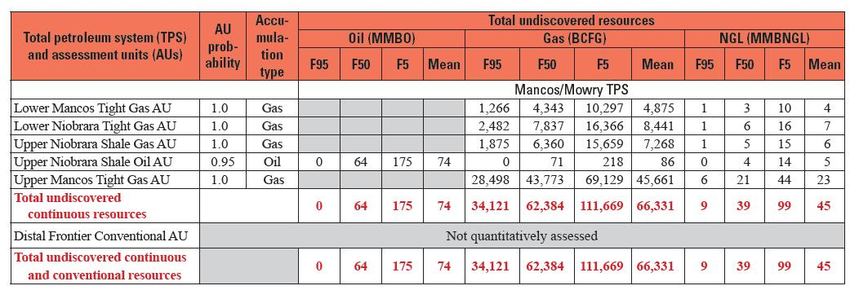

Niobrara/Mancos Play Potential

In 2016, the potential of the economic exploitation of this resource was given in a presentation to the Garfield County Energy Advisory Board. ¹⁸ Figure 13 presents a well in the play, essentially a 8000' horizontal well at 8300' drilling depth, as an example. Its ultimate gas recovery was estimated at 16 BCF, an excellent well by nearly any standards. At the time, it was thought that development of 20% of the basin (520,000 acres) would require:

- 13,000 new wells (7000’ laterals, 880’ lateral spacing, 4 stacks)
- Well capex of ~ $130 Billion ($10 Million/well)
- Infrastructure capex of ~ $25 Billion
- At 5 acres/48-well pad, about 1350 acres of well surface space

- With 40 rigs drilling and 30 days/rig, would require >25 years to drill
- Would generate ~ 130 TCF of reserves (assuming 10 BCF/well),
- Sales revenue of $390 Billion @ $3/MCF

- Would increase production to > 5 BCFD, 2.5X current pipeline capacity

However, since 2016, this play never fully materialized. As we shall see in the following paragraphs, the example well cited is actually a best case scenario. Most wells in the play are nowhere near as good. To this point, Eleson in 2020 observed that the play remained “underexplored” and that the well results were “mixed”. Why? To answer this question, we must examine the economics of the play, and a more robust look at actual well results. ¹⁹

Economics

In 2014 Wright examined the economics of the Niobrara/Mancos play. ⁸ To do this, he used data from the key wells drilled up to that time. Figure 14 shows the decline curves for gas production from the 32 wells producing at that time. Note the following:

- The great variability in both initial production and their subsequent decline. This is typical for wells in fractured reservoirs, whether naturally fractured or artificially fractured [fracked].
- Initial production rates vary from a high in excess of 12 mmcfd to a low of less than 2 mmcfd.
- Indeed, an average decline curve has an initial production rate of just over 5 mmcfd, about half of the example well.
- The curves are hyperbolic, again typical for fractured reservoirs. These wells decline at a very fast rate initially, eventually leveling out at a low sustained rate. Typically, it takes several years of production to accurately measure this decline curve and accurately determine an Estimated Ultimate Return [EUR].
- Ultimate recoveries were calculated on these 32 horizontal wells. Note that some of the wells are expected to recover a large amount of gas (in excess of 6 BCF) while 50% of the wells are expected to recover less than 4 BCF. This is typical of the ranges in recovery seen in resource plays. The vast majority of wells never get close to the previously estimated 10 BCF.

Well costs were not known to any degree of detail at that time. However, Wright did have access to well costs for similar wells in Weld County as well as comments from operators in the Piceance Basin. His final conclusion was an average well cost could be $7 million. He considered this to be highly optimistic, which as we shall see below, was prescient.

Submitting this data to an industry standard Monte Carlo economic simulation, which took into account the full range of potential outcomes evidenced by the 32 wells, he concluded was that the play was essentially uneconomic.

Using the same data, MHA Petroleum Consultants found: “No correlation was evident between any reservoir characteristics and/or completion techniques to the actual performance of the wells. For the
present, there is no reliable method to predict how a Mancos well, either vertical or horizontal,
will behave.” ⁹

I updated the Wright analysis using wells drilled up to the present, but restricted it to wells from the area adjacent to the Thompson acreage. See Figure 15. ²⁰ Since many of these wells were drilled after 2014, one might expect better results, as operators climb the learning curve. In actual fact, this did not fully materialize.

These wells are:

Decline curves ²⁰ for these wells were collected and presented in the same fashion as Wright. See Figure 16. Note the following:

- The same variability is present in this data. In fact, it looks remarkably like the earlier Wright data, which used the entire basin. These wells again range in initial production from just below 12 mmcfd to wells below 4 mmcfd.
- Wright's 2014 average curve is shown in blue for comparison purposes. It appears that this remains a likely average curve for this dataset.
- Thus we can conclude that estimated ultimate recoveries for these wells will likely be similar to the Wright data.

Well costs are considered to be proprietary to the operator, therefore, like Wright, well cost data must be obtained from other sources. In this case, we have data from Niobrara/Mancos horizontal wells from nearby New Mexico. David Deckelbaum, an energy analyst at Keybanc Capital Markets in New York, stated, “Typical Mancos well tests have cost $13 million to $15 million.” ²¹

Closer to home, we have public data for the Trail Gulch Unit 1090 #30-H2, the well with the highest initial production in my dataset [see Figure 16]. In an analysis performed in December of 2022, ²² two EUR's are provided, 15.337 BCF from the operator, and 16.614 BCF from the BLM. Well cost is $11,186,647. The economic analysis yields a rate of return of 20% and a net present value of $13,672,969. Although these numbers are positive, there are concerns:

- The well is far and away the best well in the basin and not representative of an average case. It is much closer to the Mancos 'type' well on Figure 13.
- Even as such, the economics are positive, but not overwhelmingly so.
- Using the decline curves from either Wright or myself, EUR for an 'average' well are more likely to be less than half of these numbers.
- On the other hand, this well had considerable problems during drilling, resulting on two sidetracks which may have inflated the well costs. It must be noted that the EUR's calculated for the Trail Gulch well are based on the very short production history of this well [about 1 year]. It is speculative, and may prove to be very misleading. Fitting a curve to this data in order to predict future performance is a non-unique solution. Where this hyperbolic curve flattens is essentially unknowable at this time, as is the resultant EUR.
- In addition, as shown on Figure 12, this well is within the area more favorable for Mancos potential. The bulk of the Thompson acreage is not.

At this time, the future for Niobrara/Mancos drilling in the Piceance Basin remains unclear for the following reasons:

- Economics of the play remain questionable. Wright determined the play was likely uneconomic. My additional analysis of decline curves seems to confirm this, as wells drilled after his analysis do not show any substantial change.
- Industry seems to agree, as drilling activity in the basin remains low. There has not been any real increase in drilling to date for the Niobrara/Mancos.

Concerning the prospects for Niobrara/Mancos drilling in the future, there is scant evidence there is any prospect for additional drilling on the Thompson acreage. The reasons are:

- Much of the acreage is not in the prime source rock interval, making the drilling of economic wells even less likely.
- Niobrara/Mancos wells, which are more expensive to drill in the first place, will be much more expensive to drill due to the much more difficult terrain.
- There are numerous, much superior well locations available in the more central Piceance Basin, given the better terrain, readily available infrastructure, better outlook for source rock, and so on.
- Only three new Mancos horizontal wells are listed in the Colorado Oil and Gas Commission database from 2020 to 2023.

Coal Bed Methane Potential

Coal gas and coal bed methane is produced from the Piceance Basin. See Figure 17. Coal mines ring the basin, reflecting where the coal beds which underlie the basin reach the near surface where mining becomes historically economic. It also shows several Coal Bed Methane fields scattered throughout the basin. Two small coal bed accumulations are seen near the south central portion of the Thompson acreage. However, these small fields located in Gunnison County currently contribute only a small portion [0.003% of statewide production in Colorado:
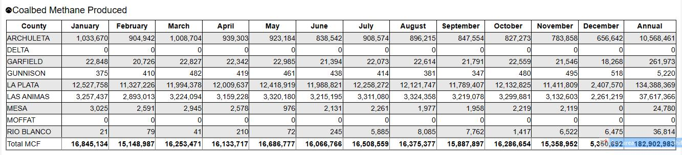

There is also coal gas production from Divide Creek field which lies several miles west of the Thompson acreage. Here the Cameo coal is one of many producing formations including the Mesaverde, Cozzette, Corcoran and others.

Similarly further south, Ragged Mountain, Bull Mountain South, West Muddy Creek, Oil Well Mountain and other small fields have produced, or are producing from, the Cameo coal, Cozzette, Corcoran, Mesaverde and others. In addition, as we have seen, several wells produce from the Mancos.

Previously, I have established that seeking to extend this production to the east on the Thompson acreage is extremely risky and unlikely to be successful. In addition, there has been no drilling activity in or near the acreage for many years.

Ten years ago, SG sought to permit a well near the Wolf Creek storage unit, but this well was never permitted or drilled. Wright ⁸ was pessimistic about the potential for developing this resource, which helps explain why the well was never drilled:

“SG is attempting to permit a well to the Cozzette, Corcoran, and Cameo just to the east of the Wolf Creek gas storage unit. The odds are extremely low that SG will discover producible natural gas at this location. If SG finds gas it will most likely be storage gas and they will not be allowed to produce it. If they don’t “discover” storage gas they will be below the gas-water contact associated with the gas storage facility and will encounter only water. The Cameo coal produces some natural gas in the deeper Piceance Basin but it also produces large amounts of water. Coal bed methane reservoirs
produce vast amounts of water – much of which must be produced before any significant gas production is obtained. They also require wells to be drilled on 40 to 80 acre spacing in order to dewater the coal. The water often has dissolved solids which requires subsurface disposal. Even where it produces, the gas production rates from the Cameo coal are relatively low and the water rates are quite high. It is necessary to have continuous water production during the first few years of production in order to produce gas from a CBM play. That is difficult under the best of circumstances.”

These same conditions apply to the rest of the Thompson acreage. He goes on:

“The combination of low gas rates, high water rates, large number of wells, difficult operating conditions, necessity of reinjecting or trucking the water, high drilling costs, high operating costs, and low gas prices make the odds of developing a commercial CBM play on the Thompson Divide vanishingly small.”

Wright’s logic and his conclusions remain sound today. The likelihood of developing a commercially viable play from coal gas and coal bed methane in the Thompson Divide is not likely.

The lack of any recent significant activity reveals industry is not pursuing this play.

Summary

There is no scenario for the reasonable and foreseeable economic development of hydrocarbon resources existing under the Thompson Divide. The key points are:

- The Mesaverde, the main gas producer in the basin, and virtually the only formation that is currently being developed, is not prospective here.
- The Niobrara/Mancos, the largest gas resource in the basin, has still unproven economics, and is not being actively pursued currently in the basin. Moreover, the most prospective area for development lies in the basin center, far from this acreage.
- Current rates of drilling in the basin have been at a low rate for many years. There is no indication of this situation improving in the near term.
- The Thompson Divide acreage, by virtue of its difficult terrain, its lack of infrastructure, and its position at the basin's steep edge, is at a distinct competitive disadvantage compared with the deeper basin center. Any revival of interest in the drilling for gas in the Piceance Basin is not likely to occur here.

References

- Stanford School of Earth, Energy and Environmental Sciences; Piceance Basin, Colorado;
https://bpsm.stanford.edu/piceance-basin-colorado [link now inactive]
- Piceance Basin wiki | TheReaderWiki graphic from Yattahey; Mesaverde Structure: Uinta-Piceance Basins
- Johnson et al; Geologic history and hydrocarbon potential of late cretaceous-age, low-permeability reservoirs, Piceance Basin, western Colorado: Final report. [118 references - unconventional gas accumulations]
- Aschoff, Jennifer et al; Stratigraphic Controls on Tight-gas Sandstone: Insight from a Regional Outcrop-to-Subsurface Sequence- stratigraphic Framework of the Upper Williams Fork Stratigraphic Controls on Higher-than-average Permeability Zones in Tight-gas Sandstones; RPSEA, 2013
- Hood, Kenneth et al; Assessing the Mesaverde basin center gas play, Piceance Basin, Colorado; in S. P. Cumella, K. W. Shanley, and W. K.Camp, eds., Understanding, exploring g, and developing tight-gas sand s — 2005 Vail Hedberg Conference: AAPG Hedberg Series, no. 3, p. 87 – 104
- Author's work; data from the Colorado Oil & Gas Conservation Commission
- Author's work; data from Arc-GIS website
- Wright, Dr John D; ECONOMIC ANALYSIS OF THE POTENTIAL FOR OIL AND GAS DEVELOPMENT IN THE THOMPSON DIVIDE AREA; prepared for BOARD OF COUNTY COMMISSIONERS PITKIN COUNTY, COLORADO; 2014
- MHA Petroleum Consultants LLC; Thompson Divide Area Geological & Economic Assessment;Prepared for Thompson Divide Coalition; January 2014
- NGI's Shale Daily; Piceance Basin;
https://www.naturalgasintel.com/piceanceinfo
- USGS, Assessment of Undiscovered Continuous Tight-Gas Resources in the Mesaverde Group and Wasatch Formation, Uinta-Piceance Province, Utah and Colorado, 2018
- Graphic and data from the Colorado Oil & Gas Conservation Commission
- Author's work; data from the Colorado Oil & Gas Conservation Commission
- Cumella, Steve; Geology of the Piceance Mesaverde Gas Accumulation In book: Unconventional Energy Resources: Making the Unconventional Conventional: 29th Annual (pp.459-482)
- Piceance Basin Drilling Activity 2023 (shaleexperts.com)
- Author's work; data from the Colorado Oil & Gas Conservation Commission
- USGS; Assessment of Continuous (Unconventional) Oil and Gas Resources in the Late Cretaceous Mancos Shale of the Piceance Basin, Uinta-Piceance Province, Colorado and Utah, 2016
- Downey, Robert [Gunnison] The Mancos Shale is an Emerging Giant; presented at the Garfield County Energy Advisory Board Meeting; December 1, 2016
- Eleson, Jason; The Past, Present and Future of Niobrara/Mancos B Horizontal Development in the Piceance Basin; GeoIntegra Consulting, LLC; September 15-18,2019–AAPG Rocky Mountain Section Meeting, Cheyenne, Wyoming
- Author's work; data from the Colorado Oil & Gas Conservation Commission
- Collins Ryan; From a Little-known Shale Play in New Mexico, BP Gets a Gusher; Industry Week [Bloomberg] Rigzone; Aug. 8, 2017
- Kemba Anderson; UNIT Paying Well Determination for the TGU 1090 #30-H2 well; BLM; Letter Dec 12, 2022;
- Roberts, Laura; Structure Contour Map of the Top of the Dakota Sandstone, Uinta-Piceance Province, Utah and Colorado; Chapter 16 of Petroleum Systems and Geologic Assessment of Oil and Gas in theUinta-Piceance Province, Utah and Colorado; USGS

Figures

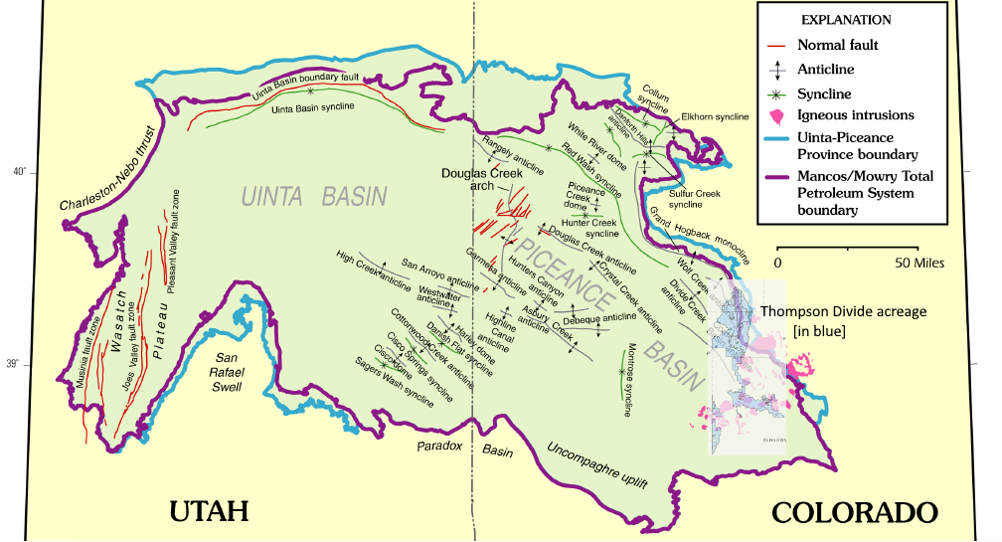Figure 1 Piceance Basin showing major structures and igneous activity

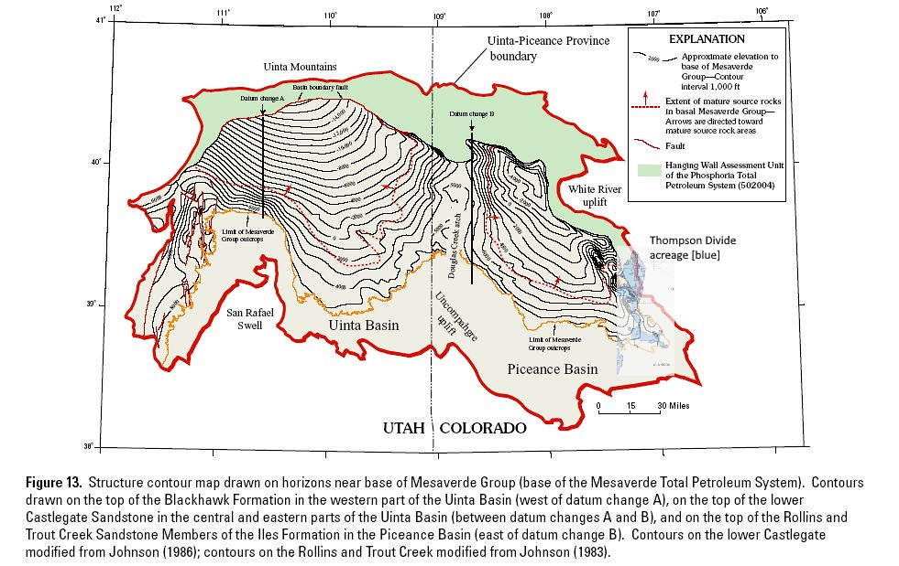
Figure 2 Mesaverde structure map. Note the tighter contours near the Thompson acreage indicating steeper dips in the area

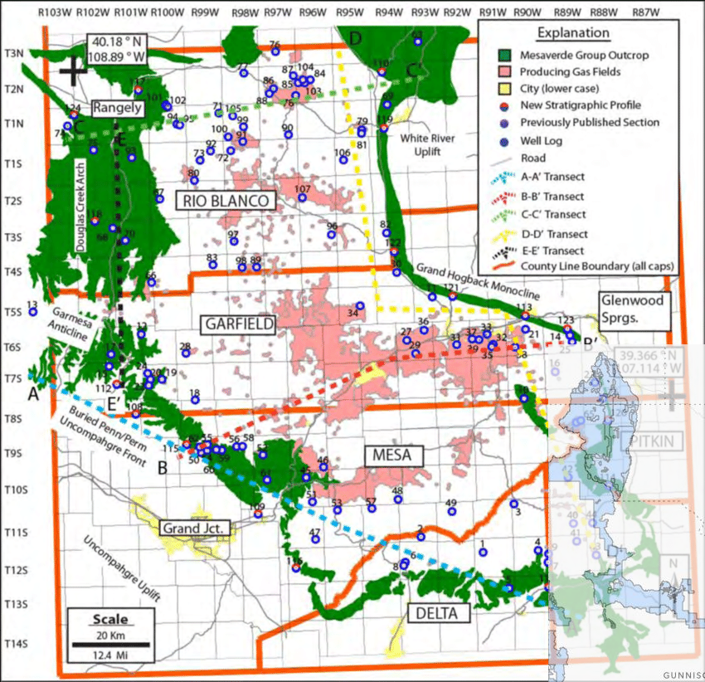
Figure 3: Piceance Basin with Mesaverde outcrops. Note the Thompson acreage is coincident with these outcrops, making Mesaverde gas production very unlikely.

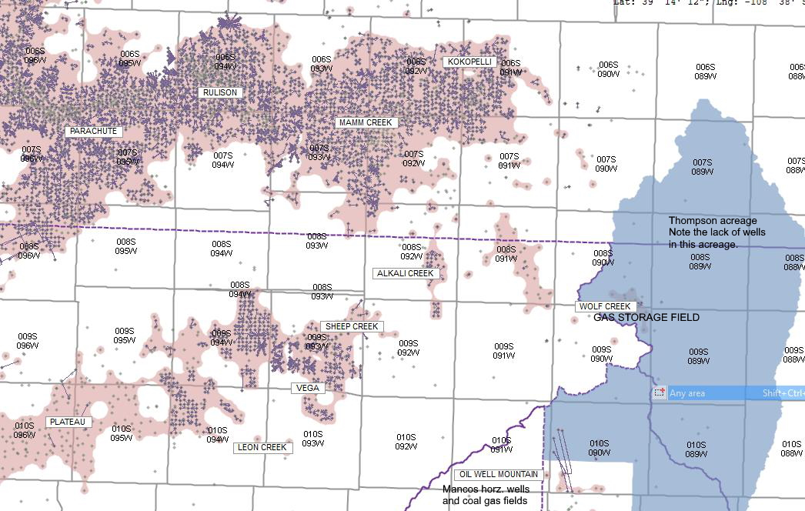Figure 4 Major gas fields and wells in the Eastern Piceance Basin. Major fields such as Rulison, Mamm Creek and Parachute are depicted.

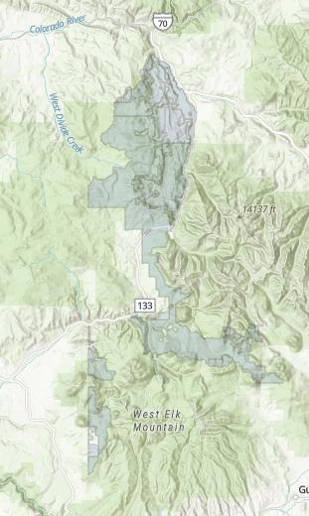Figure 5 Thompson Divide acreage on a terrain map. Note the rugged terrain.

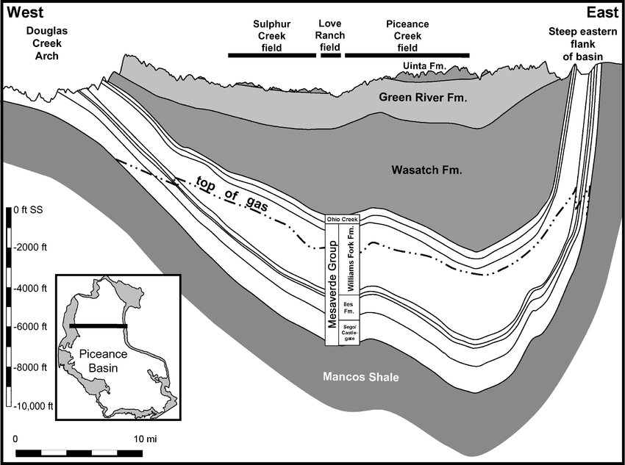Figure 6 West to East cross section across the basin. Note the steep dips on the eastern flank as well as the 'top of gas' line within the Mesaverde group. Much of the Thompson Divide acreage lies within the area of steep dip. The Mesaverde in this area is above the top of gas, thereby making this area non prospective for Mesaverde gas production.

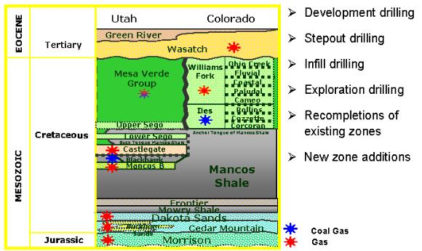

Figure 7 Producing formations in the Piceance. The Mesa Verde group provides the majority of production in the basin.

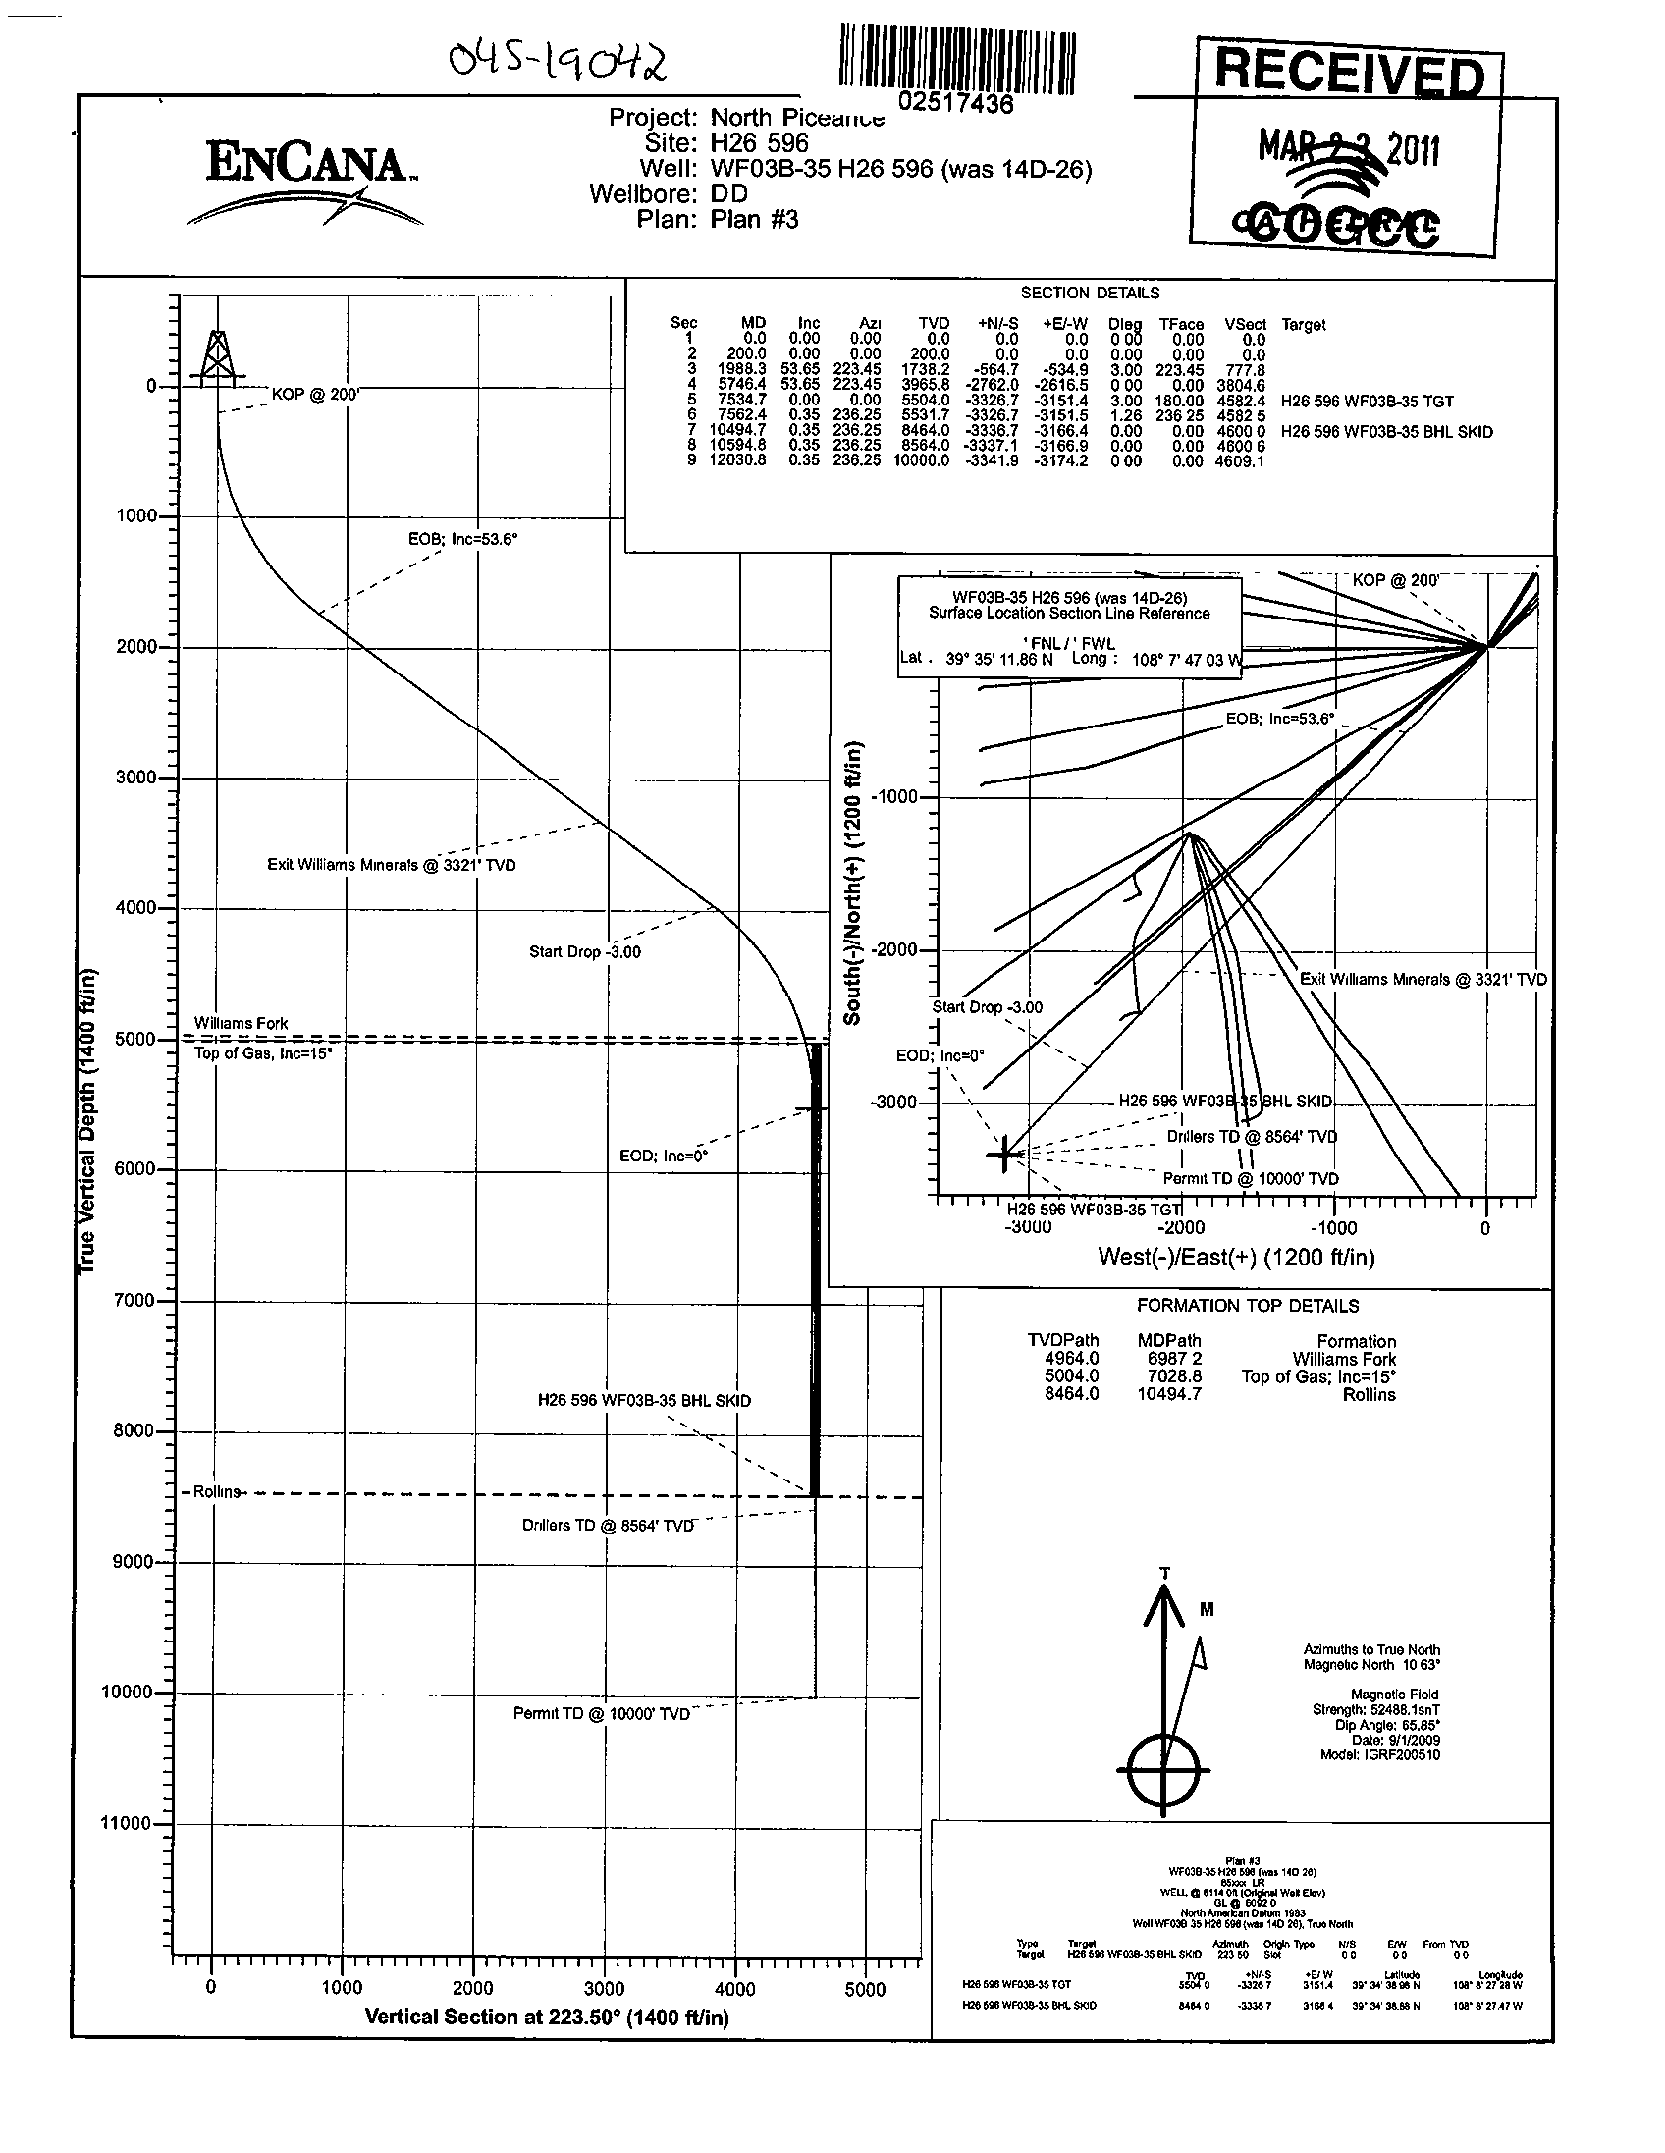

Figure 8 Typical S-curve well. Note the bottom vertical portion of the hole is located about 4600' from the surface location.

Figure 5: Close-up of section 21, T6N, R92W showing the 16 wells drilled from one surface location. Note there are 64 wells draining 640 acres, or a 10-acre spacing.
Figure 5: Close-up of section 21, T6N, R92W showing the 16 wells drilled from one surface location. Note there are 64 wells draining 640 acres, or a 10-acre spacing.

Figure 9 Close-up of section 21, T6N, R92W showing the 16 wells drilled from one surface location. Note there are 64 wells draining 640 acres, or a 10-acre spacing.

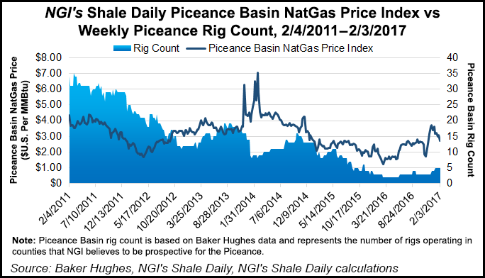Figure 10 Weekly Rig Count and Natural Gas Price 2011-2017. Note drilling declined to 3 to 5 rigs by 2017. Current rig count in the Piceance is 3.

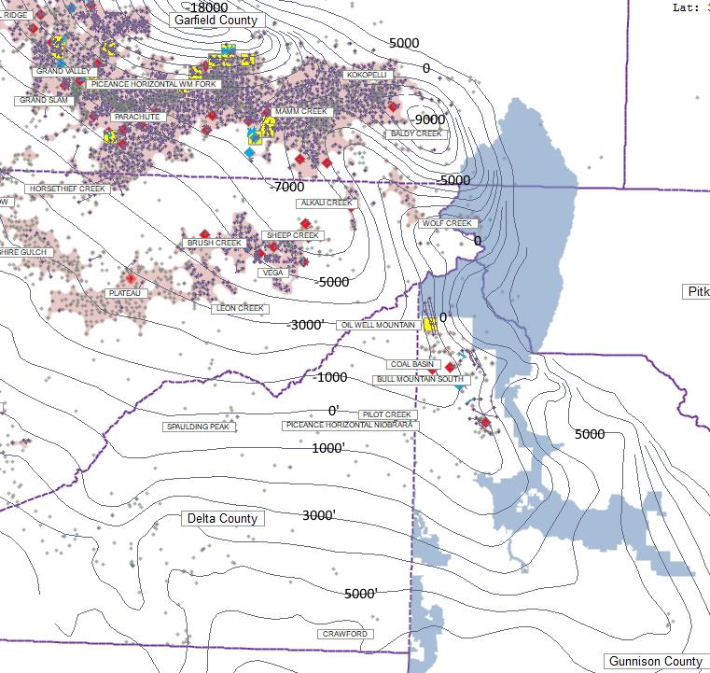Figure 11 Eastern Piceance showing wells drilled from 2016 to 2019 in red, wells from 2020 to the present in yellow, and permitted wells in blue. Contours are on the base of Dakota structure. ²³ Note the major Mesaverde fields and recent drilling activity occurs in the -5000' to -10000 interval. The Mesaverde outcrops approximately at the +1000' Dakota contour. Note the drilling activity in the Bull Mountain area is either very shallow Mesaverde or deeper Mancos.

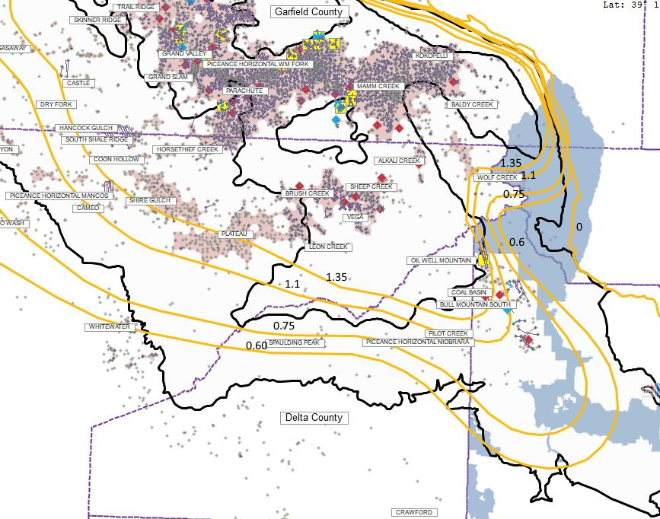

Figure 12. Hydrocarbon potential from Vitrinite Reflectance values obtained in the Mancos. The richest source rock, and therefore the areas of the most potential for producing oil and gas lies above the 1.35 line.

Figure 12. Hydrocarbon potential from Vitrinite Reflectance values obtained in the Mancos. The richest source rock, and therefore the areas of the most potential for producing oil and gas lies above the 1.35 line.

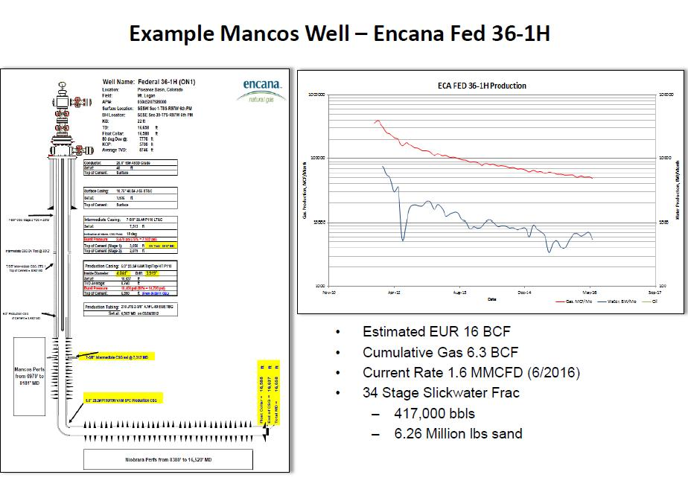Figure 13 'Type' well illustrating the potential of the Niobrara/Mancos play as envisioned in 2016

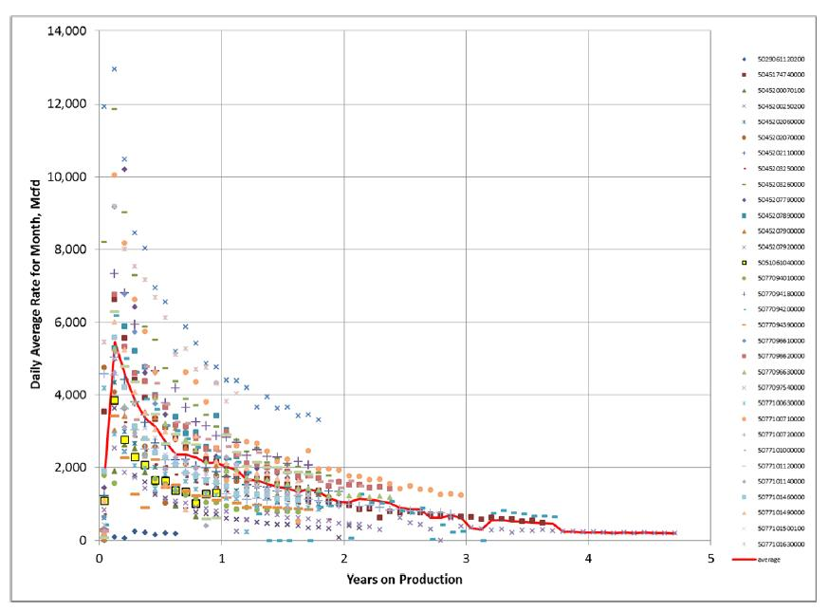Figure 14 Decline curves for Niobrara/Mancos horizontal wells drilled prior to 2015. Note the large scatter in the data as well as the average decline in red.

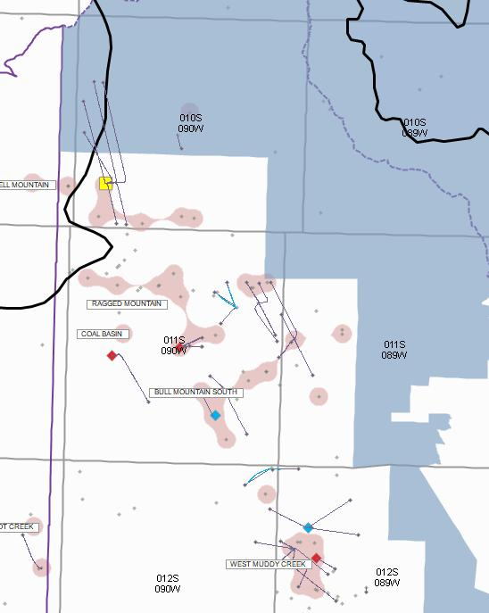Figure 15 Niobrara/Mancos wells adjacent to the Thompson Divide acreage. The gas fields shown also produce gas from the Cameo Coal, Cozzette, Corcoran and Williams Fork.

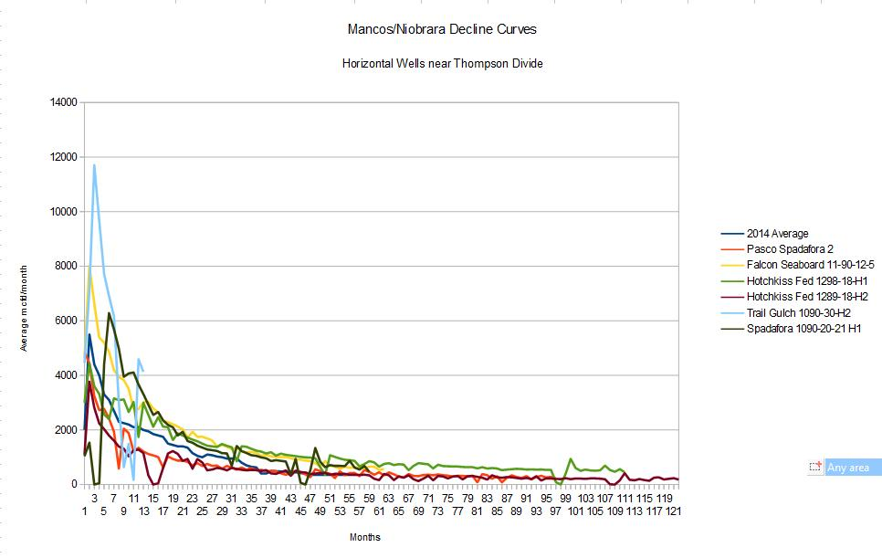Figure 16 Decline curves for the horizontal wells adjacent to the Thompson Divide acreage. Note the similarity to Wright's curves on Figure 13.

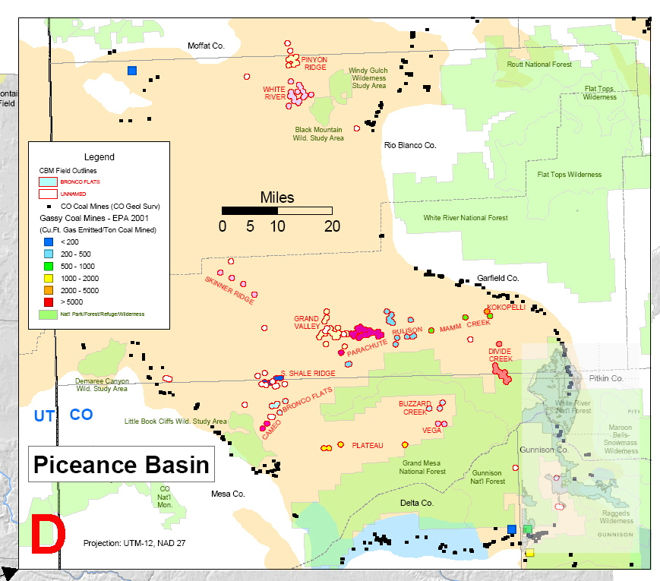Figure 17 Coal and Coaled Methane [CBM] in the Piceance Basin. Note small CBM accumulations near the lower portions of the Thompson acreage.

Kenneth Kreckel
5848 New Crossings PT
Colorado Springs, Colorado 80918
307 251 1370
E-mail: kreckel1@yahoo.com

HIGHLIGHTS:

Geo-scientist with over forty years’ experience in the exploration and development of oil and gas reserves throughout the U.S. and Europe. Career highlights are:

- Proven oil & gas finder, with several hundred MMBOE discovered. Led the initiation, discovery and subsequent development of the Cotton Valley Reef play in east Texas during the 1990’s.
- Recent extensive experience in developing and teaching an oil and gas focused associates degree program
- Eight years’ experience as Exploitation Manager responsible for the development of multiple fields, especially in tight gas formations, as well as exploration throughout the southern region of the U.S.
- Expertise in horizontal drilling, especially in the Austin Chalk
- Many years’ experience in developing tight gas sands
- Many years’ experience in exploration and development in the Rocky Mountain region.
- Confirmed judgment in prospect evaluations
- Many years’ experience managing multidisciplinary teams in successful exploration and development projects.
- Proficient at partner and contractor negotiations. Experienced with contracts.
- Performed numerous evaluations of company exploration assets.
- Many years as on-campus recruiter. Skilled in interviews and new employee evaluations.
- Particular ability with office relocations, and the establishment of new exploration offices.
- Experience in managing an exploration workstation support team.
- Personally designed and carried out numerous 3-D surveys. Particular expertise in cost-effective, suited-to-purpose surveys.
- Excellent at supervising seismic acquisition, processing and interpretation projects.
- Interpretation experience with several interpretation packages, most recently with SMT Kingdom
- Recent experience with Environmental Impact Statements and Assessments
- Recent experience in an international offshore geophysical and geological project
- Superior communication skills, especially written. [published author]

EXPERIENCE

2001-Current Geo-science Consultant

Bahamas Petroleum Company [2011-17] Long term major project in charge of the geophysical effort. Supervised PSTM and PSDM processing of the 80 km² Pearl 3D survey at CGG Veritas. Interpreted and mapped several prospects on both of the above versions of the survey, using Kingdom software. Reviewed inversion work, gravity and mag interpretations and so on. De-risked the prospects and brought them to a drillable stage. Presented results to management and numerous potential partners, as well as facilitating partner technical evaluations.

Rocky Mountain region drilling and environmental evaluations [2001-current] Performed analysis of over sixty small to mid-size oil & gas projects in the Rocky Mountain region, with an emphasis on current gas development concerns. Analyze and comment on environmental impact statements, assessments, etc. Championed the use of directional drilling from multi-well pads. Extensive work with the Southern Utah Wildlife Alliance.

Casper College
125 College Drive
Casper, WY 82601

2007-2016 Department Head and Instructor
Head of Extractive Resources Department charged with building the program. Developed and taught courses in petroleum geology, well logging, geophysics, seismic interpretation, GPS and mapping, drilling, production, and refining. Acquired and installed several state-of-the-art software packages for instructor and student use.

Marathon Oil Company
P O Box 3128
5555 San Felipe Road
Houston, Texas 77056
713 629 6600

1998-2001 London, England Manager of Exploration Support
Responsible for the technical quality of interpretations of several geophysicists working throughout NW Europe. Managed UNIX workstation support department. Directly supervised geologic and geophysical support staff. Designed, contracted, and carried out several large 3D surveys. Supervised acquisition and processing of large multi-client surveys. Company representative with partners, research groups, NGO’s, etc.

1990-1998 Tyler, Texas Exploitation Manager
Directed over thirty geo-science, engineering and land professionals engaged in exploration and development in East Texas, Gulf Coast onshore and Louisiana. Responsible for the initiation and successful development of the Cotton Valley Reef Play, discovering several fields totaling in excess of 200BCF, largely through the application of custom designed 3D technology. Drilled over 50 successful horizontal wells in the Austin Chalk. Also active in tight gas sand development in numerous fields. Initiated, presented, and secured $50MM annual budgets.

1988-1990 Midland, Texas Region Geophysicist
Responsible for the technical excellence of seismic interpretations in West Texas, the Mid-Continent, and Michigan Basin. Designed and carried out numerous seismic projects, from acquisition through interpretation.

1978-1988 Cody & Casper, Wyoming Geophysicist, Exploration Supervisor, Region Geophysicist
Interpreted and acquired seismic data throughout the Rocky Mountain Region, particularly the Thrust Belt, Paradox and Powder River Basins. Directly led the company effort in the Utah-Wyoming Thrust Belt, eventually rising to supervise several exploration teams working all of Utah. Involved in the discoveries in the Paradox Basin. Generated and drilled numerous wells in several plays. Ultimately worked as Region Geophysicist responsible for all technical work performed by several geophysicists working throughout the Rocky Mountain Region.

Texaco, Inc.

1974-1978 Bellaire, Texas Geophysicist & Geologist
As a geologist, developed fields in the Vicksburg of South Texas. As a geophysicist, explored in the Atlantic margin, Illinois Basin, and offshore Gulf of Mexico. Directly worked in seismic processing, interpretation and velocity mapping.

EDUCATION

Michigan Technological University, Houghton, Michigan B.S. Geology with Honor 1974

Extensive list of professional and technical courses.

Graduate of Marathon Management courses, including the Marathon Advanced Management Program at Indiana University

RECENT CIVIC POSITIONS

Member, City of Casper Optional One-cent #12 Sales Tax Committee, 2002
Commissioner, Casper Planning & Zoning Commission, 2003-2007

OTHER RELEVANT EXPERIENCE

Wrote feature articles for the Historical Novel Society publications, as well as a large number of book reviews. Conducted and published interviews with numerous successful authors.

Published several historical novels.

