1 Dec 2023

TO: Ochoco National Forest
VIA: https://cara.fs2c.usda.gov/Public//CommentInput?Project=61651

Subject: North Fork Crooked River Forest Resilience Project— comments

Please accept the following comments from Oregon Wild concerning the North Fork Crooked River Forest Resilience Project, https://www.fs.usda.gov/project/?project=61651. Oregon Wild represents 20,000 members and supporters who share our mission to protect and restore Oregon’s wildlands, wildlife, and water as an enduring legacy. Our goal is to protect areas that remain intact while striving to restore areas that have been degraded. This can be accomplished by moving over-represented ecosystem elements (such as logged and roaded areas) toward characteristics that are currently under-represented (such as roadless areas and complex old forest).

Proposed Action Alt 2 involves silvicultural treatments and fuels reduction across 11,065 acres, including over 5,800 acres of commercial logging that will produce approximately 24.5 mmbf, enough to fill approximately 5,000 log trucks, that would stretch over 50 miles if parked end-to-end.
- Logging large trees over 21” dbh
- 259 acres of commercial logging in RHCA
- Commercial logging in Wild and Scenic River corridor
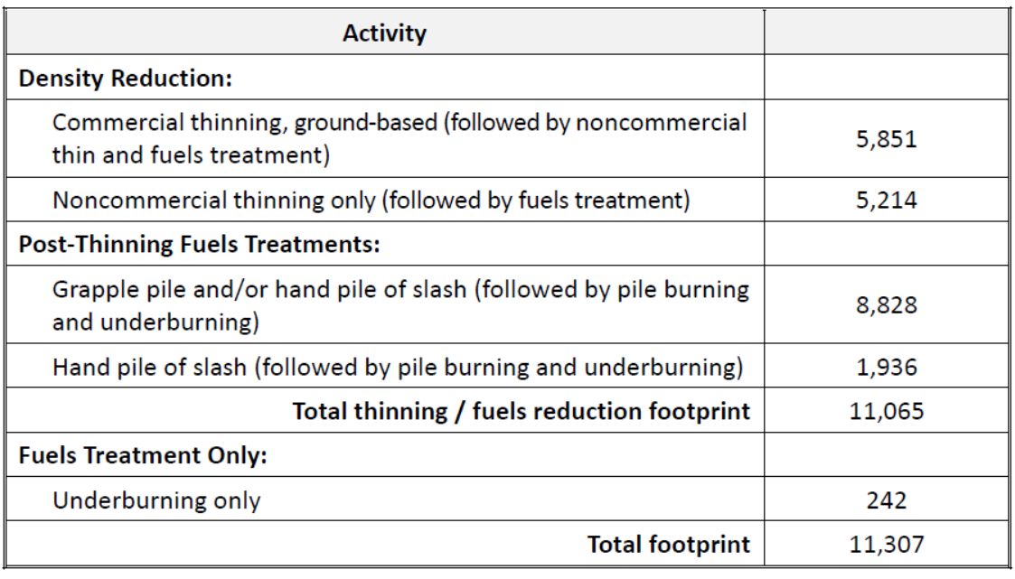

The EA failed to address key issues raised in our scoping comments including:
- The need to harmonize climate change adaptation (such as density reduction to alleviate drought stress) and climate change mitigation (carbon storage). Logging, especially large tree logging, will transfer carbon from the forest to the atmosphere, which will exacerbate global climate change and its effects on forests including those in the project area. The FS failed to consider alternatives that would more modestly reduce stand density, while retaining basal area, and retaining the large trees that store disproportionate carbon if retained, and emit disproportionate carbon if logged. Focus exclusively on climate change adaptation, to the exclusion of climate change mitigation and carbon storage, is irrational and arbitrary and capricious.
- The purpose and need should address the unmet need to manage forests for carbon storage and climate mitigation. We are in the midst of a global climate crisis. All federal activities that affect the global carbon cycle, and potentially transfer carbon to the atmosphere must be carefully considered in light of carbon budgets and climate goals. This is clearly articulated in Presidential Executive Orders and CEQ Guidance, set forth below.
- The need to follow the Eastside Screens including the requirement to retain large trees both inside and outside Late Old Structure forests, as clearly articulated in numerous interpretive memos put out by the regional forest in the 1990s. Recent court actions also undermine the legal validity of the 2021 regional amendment of the Eastside Screens to allow removal of large grand fir trees. The EA fails to weigh and consider all the trade-offs from large tree logging, including loss of large tree habitat, loss of large snag habitat, greenhouse gas emissions, and low canopy cover that stimulates hazardous surface and ladder fuels.
- The EA fails to consider alternatives that would modify grazing to help meet the purpose and need of this project. Livestock grazing has a direct influence on the vegetation structure that this project is designed to address. The agency must analyze the effect of past and future grazing which will tend to reduce palatable fine fuels like grasses and shift the plant community toward less palatable shrubs and trees which are more hazardous as ladder fuels that contribute to more severe fire effects on forests. Livestock grazing probably contributed to the development of plant communities where grass and forbs are underrepresented and small conifers are over-represented. Grazing also likely contributes to the spread of juniper. Future livestock grazing will tend to cause these same trends, so the NEPA analysis must consider the connected and cumulative impacts of livestock grazing.
- The EA failed to document fulfillment of the connectivity requirements of the Eastside Screens. The explicit intent of the Screens which is “to insure that blocks of habitat maintain a high degree of connectivity between them,...” 1995 Eastside Screens, Scenario A, INTENT STATEMENT for connectivity (emphasis added). The connectivity requirements of the screens are detailed and mandatory. Connectivity corridors:
  - Must link all late old structure stands in at least 2 directions;
  - Must be at least 400 feet wide at their narrowest spot;
  - Must be maintained as dense as possible with medium and large trees, or in the top third of site-potential and at least 50% canopy cover;
See more on connectivity below.
- The EA analysis of wildfire is biased and misleading. The needs to consider the many ecosystem services provided by wildfire. Wildfires are still burning with a mostly characteristic mix of low and moderate severity, even some high severity fire is part of the pattern in forests like these. When wildfire fire occurs (including under the no action alternative) it thins the forest, increases resource available to surviving plants, creates habitat diversity, etc.
- Our scoping comments explained that large intact expanses of habitat disproportionately provide a wide range of important ecosystem services. Such area were once quite common but are now rare. Species evolved in the context of the large habitat patches that result from the natural disturbance regime. As just one important example, big game need large patches of security cover which is best provided by large unroaded areas. New science confirms that roads and logging tend to be contagious on the landscape (managed areas beget more management until little remains unmanaged), so to conserve the habitat values associated with wild places we have to prevent the first intrusions. The purpose and need for this project (and the NEPA alternatives) should include protecting and restoring large unroaded areas consistent with the natural range of variability. The analysis revealed the presence of 7 polygons within the project area ranging in size from 1,187 acres to 4,436 acres that meets the criteria for undeveloped lands, but the Forest Service treated these lands as if they were just like other more developed lands in the area. The analysis failed to disclose the disproportionate ecosystem services that flow from undeveloped lands under the influence of natural processes, and the adverse effects of conducting logging and building roads in such areas. The FS should consider alternatives that conserve and restore large blocks of habitat without commercial logging. Roadlessness is an important and under-represented landscape feature that wildlife evolved within and the FS should conserve and restore. The map below shows existing unroaded areas in pale purple polygons.
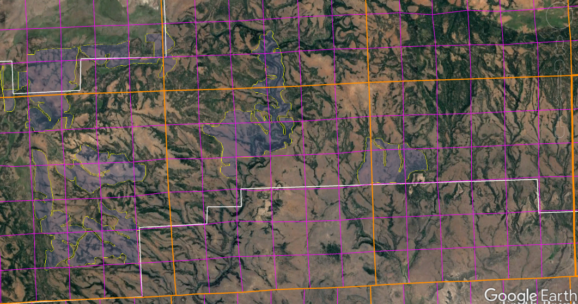

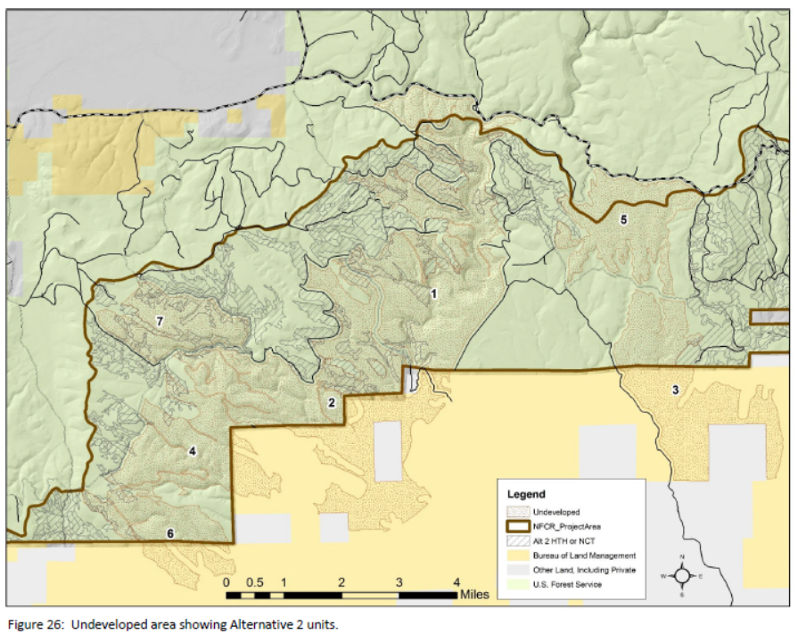

Follow the Screens
The NEPA analysis must disclose how the project will comply with all the requirements of the Eastside Screens.

The Eastside Screens say “2) Outside of LOS, many types of timber sale activities are allowed. The intent is still to maintain and/or enhance LOS components in stands subject to timber harvest … Manipulate vegetative structure that does not meet late and old structural (LOS) conditions, … in a manner that moves it towards these conditions as appropriate to meet HRV. … Manipulate vegetation in a manner to encourage the development and maintenance of large diameter, open canopy structure.” 1995 Regional Forester’s Forest Plan Amendment #2. http://www.fs.usda.gov/Internet/FSE_DOCUMENTS/stelprdb5288660.pdf

Looking at the old-growth definition from ICBEMP (http://www.icbemp.gov/pdfs/sdeis/Volume2/Appendix17a.pdf:
“old growth is typically distinguished from younger growth by several of the following attributes: 1. Large trees for species and site. 2. Wide variation in tree sizes and spacing. 3. Accumulations of large-size dead standing and fallen trees that are high relative to earlier stages. 4. Decadence in the form of broken or deformed tops or bole and root decay. 5. Multiple canopy layers. 6. Canopy gaps and understory patchiness.”
(emphasis added) It is clear that LOS “components” such as abundant snags must be retained and recruited, and many small and medium sized trees are needed grow into large trees. Thinning dense understory trees might help move stands toward LOS, but any action that would remove snags or reduce recruitment of medium trees into large tree classes would not be consistent with the Eastside Screens.

The Eastside Screens also state “To reduce fragmentation of LOS stands, or at least not increase it from current levels, stands that do not currently meet LOS that are located within, or surrounded by, blocks of LOS stands should not be considered for even-aged regeneration, or group selection at this time.” Any action that would build roads or establish young even-aged stands would not meet the Eastside Screens. Heavy thinning for fuel reduction should also be evaluated under this connectivity standard.

Make sure that any treatments in wildlife corridors comply with the expectations of the Eastside Screens, i.e. "medium diameter or larger trees are common, and canopy closures are within the top one-third of site potential. Stand widths should be at least 400 ft. wide at their narrowest point.... some amount of understory (if any occurs) is left in patches or scattered to assist in supporting stand density and cover."

Recognizing the fact that past logging practices have greatly reduced the abundance of large trees and snags, the Eastside Screens also require that projects use the best available science to meet the intent of 100% potential populations of primary cavity excavators. While the potential population methodology has been discredited the Forest Service must still meet the intent by not taking any action that could reduce populations of primary cavity excavators.

If any exceptions to the Eastside Screens will be considered, such as removing white fir larger than 21” dbh, please recognize that compelling ecologic justification for removal of large trees are lacking. As shown in the table below from the 2020 Amendment to the Eastside Screens, there is still a shortage of large trees across the eastside landscape.
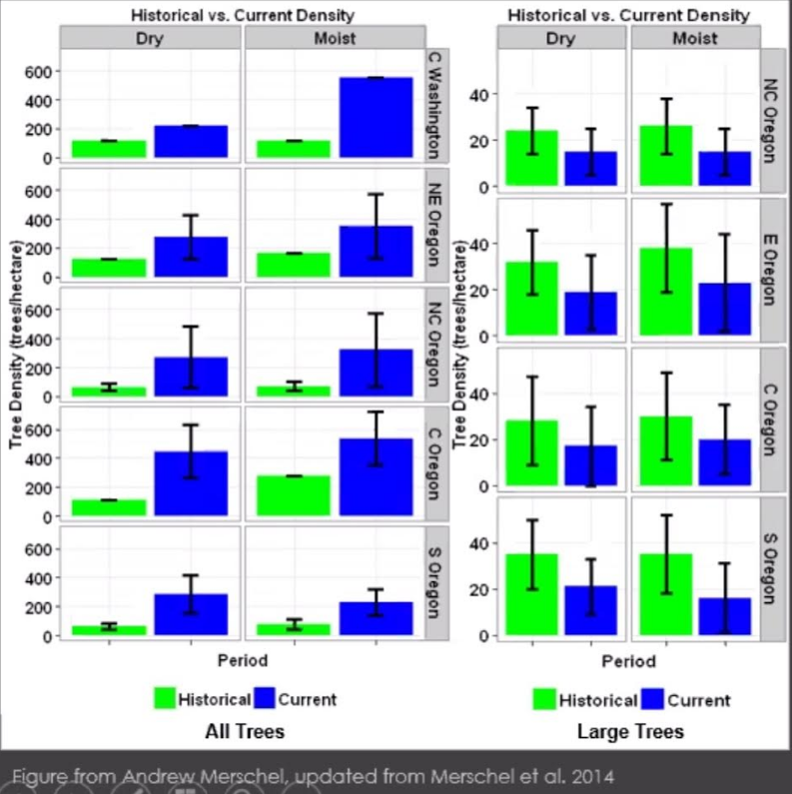

Significantly, large white fir contribute positively to biodiversity associated with large trees and large snags, climate mitigation and adaptation, and fire resistance/resilience. The problem of large white fir co-mingling and adversely competing with large pine is overstated, and does not justify sweeping exemptions to the well-supported standards requiring protection of all large trees in eastside National Forests.

Where large trees appear to be abundant, they are helping to compensate for large areas lacking large trees. The agency is not helping when they propose to remove large trees when they exceed the historic average, because large trees populations exhibited a range of conditions often exceeding the average.

Furthermore, where large trees appear to be in competition and at risk of mortality, they are just furthering the natural processes that help tree populations develop adaptive traits such as when less fit individuals die and allow more fit individuals to survive and reproduce, thus increasing population resilience to drought. Mortality also helps recruit valuable large snags and dead wood. It is unavoidable that logging large trees has net negative ecological effects and cannot be justified on ecological grounds. The agency must consider all the trade-offs carefully.

Hessburg et al 2015 recommend: “To improve the longevity of larger early seral trees, restorative activities would include thinning and removing neighboring shade-tolerant trees to reduce competition for water and nutrients, and removing nearby surface and ladder fuels to reduce fire intensities that would threaten their long-term survival.” Paul F. Hessburg . Derek J. Churchill . Andrew J. Larson . Ryan D. Haugo . Carol Miller. Thomas A. Spies . Malcolm P. North . Nicholas A. Povak . R. Travis Belote . Peter H. Singleton. William L. Gaines . Robert E. Keane . Gregory H. Aplet . Scott L. Stephens . Penelope Morgan, Peter A. Bisson . Bruce E. Rieman . R. Brion Salter . Gordon H. Reeves. 2015. Restoring fire-prone Inland Pacific landscapes: seven core principles. Landscape Ecology, May 2015. DOI 10.1007/s10980-015-0218-0 http://link.springer.com/content/pdf/10.1007%2Fs10980-015-0218-0.pdf.

However, the co-mingling of large Ponderosa pine and large white fir is not a significant problem. Mildrexler et al (2023) looked at the FIA data and found –
Large ponderosa pine co-mingle with large grand fir about 14% of the time (259 plots), leaving 86% of plots with large ponderosa pine without large grand fir (1616 plots). Similarly, large western larch co-mingle with large grand fir about 56% of the time. Large ponderosa pine and grand fir are found together on only 8% of all plots in the region, while large larch and grand fir are found together on only 4% of all plots in the region. In other words, large ponderosa pine are by far the most common tree species found in these six National Forests and infrequently co-mingle with large grand fir at the FIA plot scale, whereas large western larch are far less common and co-mingle with large grand fir about half the time, which is expected since these species occupy similar environmental settings …
David J. Mildrexler, Logan T. Berner, Beverly E. Law, Richard A. Birdsey, William R. Moomaw 2023. Protect large trees for climate mitigation, biodiversity, and forest resilience. Conservation Science and Practice. 2023;e12944. https://doi.org/10.1111/csp2.12944. This paper also notes that large trees are more resilient to drought stress than small trees, and “a trait-based approach to assess fire resistance found that the grand fir forest type had the second highest fire resistance score, and one of the lowest fire severity values among forest types of the Inland Northwest USA (Moris et al., 2022).” Citing Moris, J. V., Reilly, M. J., Yang, Z., Cohen, W. B., Motta, R., & Ascoli, D. (2022). Using a trait-based approach to asses fire resistance in forest landscapes of the inland northwest, USA. Landscape Ecology, 37, 2149–2164. https://doi.org/10.1007/s10980-022-01478-w.

Shifting species composition has become a popular rationale for removing large trees. The agency needs to recognize that the shift toward shade-tolerant tree species is a natural process. The PNW Region’s Eastside Screens Plan Amendment draft EA (p 23) says:
3.1.4.2 Forest Succession Assumptions: All Alternatives
Species composition will continue to shift toward fire intolerant species like grand fir and white fir. Less fire tolerant trees like white fir and grand fir will be the most abundant young trees as they can flourish in shady understories in the absence of periodic fire. Large fires with uncharacteristically large patch sizes will favor species with light windborne seeds that are capable of reseeding areas much farther away from reproducing survivors instead of the fire adapted species with heavy seeds (e.g. ponderosa pine) which do not travel far from the reproducing individual (Kemp et al. 2016, Westerling 2016, Owen et al. 2017, Coop et al. 2019, Downing et al. 2019, Hessburg et al. 2019). The increasing representation of these fire intolerant trees in dry and moist forest landscapes creates a feedback loop that perpetuates conditions more conducive to severe large-scale disturbances with increased risk of a future altered or unique vegetation conditions (Walker et al. 2018, Davis et al. 2019).
USDA 2020. Eastside Screens Plan Amendment draft EA. https://www.fs.usda.gov/Internet/FSE_DOCUMENTS/fseprd779174.pdf. Retaining large grand fir and white fir that did not grow up under intense competition is better than removing them, especially when the expectation is for lots more small trees and greater challenges growing large trees of any species.

Johnson & Franklin (2013) review several considerations that the agency should make:
Shift Tree Composition towards More Fire- and Drought-Tolerant Species
Restoring the dominance of fire- and drought-tolerant species in Dry Forests is fundamental to increasing resilience. ….
The desired proportion of fire-tolerant to fire-intolerant species will vary by PAG. On sites historically dominated by ponderosa pine, meeting wildlife, fire and fuels, and resilience objectives may involve leaving almost 100% of a stand’s post-treatment basal area in pines. In the more productive Dry Mixed-Conifer stands, some Douglas-fir or grand/white fir may need to be left to achieve residual basal area objectives.
Restoring species composition towards historical levels can often mean removing large but younger (<150 year) grand/white fir and Douglas-fir to favor pines and western larch. Hard diameter limits, such as a 21-inch dbh limit, can make it difficult or impossible to achieve desired composition in many Mixed-Conifer Forests, which would compromise their future resilience. At the same time, large, young fir trees provide important wildlife habitat in their live, standing dead and down states, so some often should be retained (Box 5).
…
Box 5: Deciding Which Larger Grand/White Fir to Retain or Remove During Restoration
Deciding how many and which larger grand or white fir to retain and which to remove can be a challenging question for managers, stakeholders, and marking crews, particularly when there are no diameter limits (e.g., trees >21" dbh) or where diameter limits have been suspended. Large grand/white firs are often abundant on sites where they are poorly adapted or unwanted as potential fuel or a continuing source of grand/white fir seed. On the other hand, larger grand/white firs often make up a large percentage of the basal area and provide important wildlife habitat. So, what to do? Let’s begin by looking at some attributes of grand/white firs and then examine factors favoring retention or removal. Do remember that all older (e.g., greater than approximately 150 year old) grand/white firs should generally be retained along with older trees of other species.
Grand/white firs have the potential to grow fast and to larger sizes relatively quickly on sites that are environmentally favorable, such as Moist Mixed-Conifer sites. They are aggressive regenerators, producing large seed crops at frequent intervals. Grand/white firs are highly shade tolerant and typically retain lower branches as they grow into saplings and poles, creating potential fuel ladders. While growth during the first century is often rapid, grand/white firs are relatively short-lived species with low resistance to trunk, butt, and root rots, insect defoliators (especially spruce budworm), and bark beetles, among other afflictions (Table 1). Hence, mature (e.g., approximately 100 year old) stands dominated by white or grand fir can be expected to fall apart during their second century because of high levels of tree mortality, although individual trees may survive for 200 years or more. Grand/white firs are decay prone in the dead as well as the live state, so persistence as a snag or down log is short. Grand/white firs are also highly vulnerable to damage or death by wildfire or drought.
Why would we retain larger young grand/white firs in restoration treatments, given their vulnerability to disease, insects, fire, and drought? One major reason might be the desire to retain some larger diameter trees as part of the residual stand, and a second may be that retaining grand/white fir could help achieve the target residual stand structure (e.g., basal area or tpa) where this species is a major component. Grand/ white firs may be a good choice for retention where rapid growth in wood volume is a major objective in the restored stand, however wildlife habitat is more likely to be a reason for retaining larger grand/white firs. Larger grand/white firs often have decadent features, like cavities, decay pockets, and brooms, which are useful to wildlife. Furthermore, many of these trees are important sources of snags and logs, since most will die in the near future (e.g., 50 years). For example, grand/white firs hollowed by Indian paint fungus may be opened up by pileated woodpeckers and later used by Vaux swifts. Finally, grand/white firs produce seed crops that are valuable to some wildlife, including Douglas squirrels.
Why should many or most of the larger grand/white firs be removed during restoration treatments? First, they compete aggressively with ponderosa pine and other fire- and drought-resistant species and may provide significant fuel ladders. Hence, the location of larger grand/white firs relative to pines and larches or even Douglas-fir may be an important factor in deciding which ones to retain. Grand/white firs are also relatively short-lived and highly susceptible to fires and defoliators; they are not likely to make a long-term contribution to the live basal area of the stand or to contribute to its resilience. There are many examples where larger grand/white firs were retained to maintain the basal area of restored stands but died within the next decade. Of course, this is fine if an objective is to generate short-lived snags and down logs for wildlife. Finally, removal of larger grand/white fir will substantially reduce the amount of grand/white fir seed source present on the site and, potentially, its abundance in regeneration.
So, what are the most appropriate larger grand/white firs to retain in restoration treatments? First, retain any grand/white fir older than approximately 150 years of age. Guides for visual identification of these older trees are under development and initial results are reported above. With larger grand/white firs that are less than 150 years of age, consider retaining individuals that are not threatening older pines or western larches either as fuel ladders or competitors, especially in Moist mixed-Conifer Stands. Further, where a choice is between trees with significant defects, such as cavities and stem rots, and sound trees of comparable size, retaining defective trees is generally the better choice ecologically and economically. Trees with defects generally will have the greatest wildlife value both in the short- and long-term.
Franklin, J.F., Johnson, K.N., et al 2013. Restoration of Dry Forests in Eastern Oregon – A Field Guide. The Nature Conservancy, Portland, OR. 202 pp. http://nature.ly/dryforests.
Reliance on site-specific forest plan amendments to waive the diameter limits in the Eastside Screens violates NFMA’s requirement that forest plans “form one integrated plan for each unit of the National Forest System, incorporating in one document or one set of documents, available to the public at convenient locations, all of the features required by this section.” 16 U.S.C. § 1604(f)(1).

Before considering any amendment to the diameter limit in the Eastside Screens the Forest Service must document its consideration of, and consistency with, the available guidance about when such amendments might be appropriate. In this case, the most recent guidance is Regional Forester James Peña’s September 10, 2015 guidance to Forest Supervisors regarding site-specific amendments to the Eastside Screens. This guidance says “The Eastside Screens were intended to conserve old forest abundance and wildlife habitat in late and old structural stages. I emphasize these intentions remain in place. The direction in this letter and its enclosure, which provides additional information regarding the importance of maintaining Screens …” (emphasis added).

Peña’s 2015 memo is a revision of the 2003 Goodman memo. The bulk of Peña’s guidance regards the site-specificity of plan amendments. Other important considerations regarding plan amendments for removal of large trees are addressed in Regional Forester Linda Goodman's June 11, 2003 memo to eastside Forest Supervisors. The NEPA analysis for this project needs to provide a clear explanation of how this project meets the requirements of the 2003 guidance memo which says -
"science findings ... reinforce the importance of retaining and recruiting large, old trees in the eastside landscape. ... The objective of increasing the number of large trees and LOS stands on the landscape remains. Economic considerations are important but are not considered adequate justification alone for conducting harvest activities in LOS stands. I encourage you to coordinate with the Regional screens team and Regional planning staff as site-specific Forest Plan amendments are developed."
The memo does not recommend changing the underlying restoration goal of the screens, but rather "to consider site-specific Forest plan amendments where this will better meet LOS objectives by moving the landscape towards HRV, and providing LOS for the habitat needs of associated wildlife species." Amendments calling for removal of large trees, especially those not in direct competition with legacy trees, ARE changing the goals of the Eastside Screens to emphasize restoring species composition, and de-emphasize large tree conservation. There is no compelling ecological support for this change.

The enclosure to the 2003 Goodman memo says "These findings reinforce the importance of retaining and recruiting large, old trees in the eastside landscape, .... It is critical that silvicultural prescriptions provide for large snags in adequate numbers (as indicated by DecAID and other tools) through time to provide habitat for these species." This indicates not only that retention of large trees continues to be important, but also indicates that the FS must use quantitative methods (such as DecAID) to determine when adequate numbers of large snags and large green recruitment trees are available.

The enclosure to the RF’s memo specifically mentions five wildlife species that need adequate numbers of large trees that turn into large snags,
Pygmy nuthatch: 18-34 inches or larger
White-headed woodpecker: 18-36 inches or larger
Pileated woodpecker (an MIS): 20-35 inches or larger
Flammulated owl: 6-53 inches or larger [and]
Fisher ... Data from DecAID indicate that 70 percent of fishers use snags between 27 and 47 inches DBH. Radio telemetry studies indicate that snag densities in telemetry locations of fishers are significantly greater than those of random sites.
Many additional species are also intended to benefit from the LOS restoration standards in the Eastside Screens, and DecAID provides a long list of key ecological functions of snags in Ppine/Doug fir forests. https://apps.fs.usda.gov/r6_decaid/legacy/decaid/queries/emcf-e-cscds-bmt/lrgr-trs/narrative.html#ECOLOGICAL%20FUNCTIONS%20AND%20PROCESSES%20OF%20DECAYED%20WOOD%20ELEMENTS Any amendments proposed for removal of large trees must disclose whether and how the needs of these species will be met over time.

Past guidance makes clear that snag habitat is one of the most important things to consider before adopting a site-specific amendment to allow logging of large trees, but this EA provides virtually no analysis of snag habitat. The Wildlife Appendix adds some context but still fails to analyze the effects of large tree logging on snag habitat recruitment.

Removing large grand fir/white fir comes with an ecological cost. The NEPA analysis needs to recognize that pileated woodpeckers are large birds that need large snags and dead wood which tends to become scarce in managed landscapes. The NEPA analysis needs to consider that the majority (62%) of roost trees for pileated woodpecker are in grand fir, both live and dead, especially trees infected by Indian paint fungus (Echinodontium tinctorium). Roost stands tended to be >60% canopy cover with little or no logging history. Evelyn L. Bull, Richard S. Holthausen and Mark G. Henjum. 1992. Roost Trees Used by Pileated Woodpeckers in Northeastern Oregon. The Journal of Wildlife Management. Vol. 56, No. 4 (Oct., 1992), pp. 786-793. Published by: Wiley on behalf of the Wildlife Society. DOI: 10.2307/3809474. https://www.jstor.org/stable/3809474.
Retention of large shade-tolerant (especially grand fir) trees is also important for maintaining resting and denning sites for American marten. Evelyn L. Bull and Thad W. Heater 2000. Resting and Denning Sites of American Martens in Northeastern Oregon. Northwest Science. Vol. 74, No. 3, 2000. https://research.libraries.wsu.edu/xmlui/bitstream/handle/2376/1018/v74%20p179%20Bull%20and%20Heater.PDF?sequence=1. (“Most of the [resting] trees (92%) were living, and the average dbh was 52 cm (Table 2). Trees typically had branches along the entire length of the bole. … Trees with cavities were used as rest sites all year although April and December had the greatest use (Figure 2). The majority of cavities were in grand fir and western larch (Table 2). Sixty-seven percent of the trees were dead, and the rest living. Most of the trees with cavities used by martens were hollow, based on the presence of fruiting bodies of Indian paint fungus (Echinodontium tinctorium) on grand fir … . Martens entered these hollow trees through broken tops, holes excavated by pileated woodpeckers (Dryocopus pileatus), or through natural cavities usually created when a branch broke off. Cavities occurred in large diameter trees … [T]rees with cavities used as dens were grand fir (84%), western larch (8%), and subalpine fir (8%) … The dens in grand fir and western larch were entered through pileated woodpecker holes or broken off tops. … Hollow logs used for dens were grand fir (55 %), western larch (27%), Engelmann spruce (9%), and subalpine fir (9%). The logs averaged 73 cm in diameter at the large end and 24 m long. … Typically, only large-diameter trees contain a hollow chamber large enough for a marten to use because the chamber forms only when the former heartwood has decayed and slumped downward (Bull et al. 1997). The high use of living trees occurred because hollow chambers caused by heartrot fungi are created while the tee is still alive (Bull et al. 1997). This decay process can take decades to develop, and trees may be several hundred years old. Typically, these hollow trees occur in forest stands of grand fir in late-successional stages, which now occupy only about 3% of the landscape in northeastern Oregon (Bull et al. 1997). The use of cavities in large-diameter trees that we observed has been reported by Steventon and Major (1982), Spencer (1987). Marlin and Barrett (1991), Buskirk and Ruggiero (1991), and Raphael and Jones (1997); … The findings in our study can be used by managers to retain the appropriate structures to provide martens with rest sites and dens. Large-diameter hollow trees and logs, accumulations of coarse woody debris, and trees with brooms provided important habitat for resting sites. The silvicultural practices of removing trees with brooms, removing hollow trees, and reducing fuels (coarse woody debris) to lower the risk of or damage by wildfire may negatively alter marten habitat”).
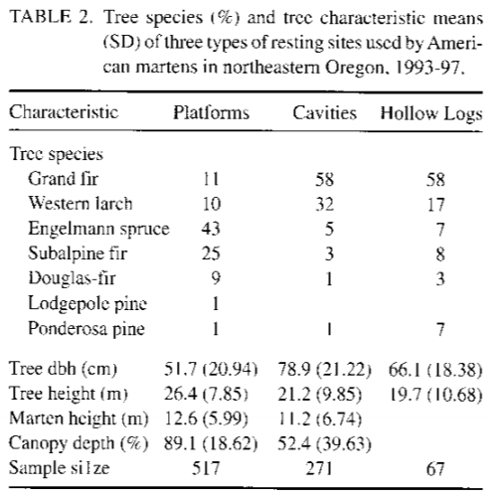

The NEPA analysis must take a hard look at the habitat needs of primary cavity excavators over the long term. It is not enough to meet the needs of woodpeckers for a few years after harvest. Maintaining viable populations of primary cavity excavators will require retention of virtually all the overstory trees so that there is a long-term supply of snags and dead wood.

Removal of large trees is ill-advised because large trees store a disproportionate amount of the carbon in eastside forests and logging will transfer a significant portion of that carbon to the atmosphere, making global climate change (and ocean acidification) worse. Mildrexler David J., Berner Logan T., Law Beverly E., Birdsey Richard A., Moomaw William R. 2020. Large Trees Dominate Carbon Storage in Forests East of the Cascade Crest in the United States Pacific Northwest. Frontiers in Forests and Global Change. Vol 3, Pp 127. https://www.frontiersin.org/articles/10.3389/ffgc.2020.594274/pdf (“ABSTRACT: Large-diameter trees store disproportionally massive amounts of carbon and are a major driver of carbon cycle dynamics in forests worldwide. In the temperate forests of the western United States, proposed changes to Forest Plans would significantly weaken protections for a large portion of trees greater than 53 cm (21 inches) in diameter (herein referred to as “large-diameter trees”) across 11.5 million acres (∼4.7 million ha) of National Forest lands. This study is among the first to report how carbon storage in large trees and forest ecosystems would be affected by a proposed policy. We examined the proportion of large-diameter trees on National Forest lands east of the Cascade Mountains crest in Oregon and Washington, their contribution to overall aboveground carbon (AGC) storage, and the potential reduction in carbon stocks resulting from widespread harvest. We analyzed forest inventory data collected on 3,335 plots and found that large trees play a major role in the accumulated carbon stock of these forests. Tree AGC (kg) increases sharply with tree diameter at breast height (DBH; cm) among five dominant tree species. Large trees accounted for 2.0 to 3.7% of all stems (DBH ≥ 1” or 2.54 cm) among five tree species; but held 33 to 46% of the total AGC stored by each species. Pooled across the five dominant species, large trees accounted for 3% of the 636,520 trees occurring on the inventory plots but stored 42% of the total AGC. A recently proposed large-scale vegetation management project that involved widespread harvest of large trees, mostly grand fir, would have removed ∼44% of the AGC stored in these large-diameter trees, and released a large amount of carbon dioxide to the atmosphere. Given the urgency of keeping additional carbon out of the atmosphere and continuing carbon accumulation from the atmosphere to protect the climate system, it would be prudent to continue protecting ecosystems with large trees for their carbon stores, and also for their co-benefits of habitat for biodiversity, resilience to drought and fire, and microclimate buffering under future climate extremes.”).

The Forest Service Must Conserve Mature & Old-growth Forests, Including All Large Trees.
This project proposes logging large trees in violation of the Eastside Screens and Biden admin policy.

On April 22, 2022 President Biden issued an executive order declaring a policy to conserve mature & old-growth forests on federal land and to manage forests to retain and enhance carbon storage. The agencies should immediately implement these policies.
Sec. 1. Policy.
Strengthening America’s forests, which are home to cherished expanses of mature and old-growth forests on Federal lands, is critical to the health, prosperity, and resilience of our communities …. Forests provide clean air and water, sustain the plant and animal life fundamental to combating the global climate and biodiversity crises, and hold special importance to Tribal Nations. … Conserving old-growth and mature forests on Federal lands … is critical to protecting these and other ecosystem services provided by those forests. … We can and must take action to conserve, restore, reforest, and manage our magnificent forests … It is the policy of my Administration, … to … conserve America’s mature and old-growth forests on Federal lands …
…
Sec. 2. Restoring and Conserving the Nation’s Forests, Including Mature and Old-Growth Forests.
My Administration will manage forests on Federal lands, which include many mature and old-growth forests, to promote their continued health and resilience; retain and enhance carbon storage; conserve biodiversity …
Biden, J. 2022. Executive Order on Strengthening the Nation’s Forests, Communities, and Local Economies. APRIL 22, 2022. PRESIDENTIAL ACTIONS https://www.whitehouse.gov/briefing-room/presidential-actions/2022/04/22/executive-order-on-strengthening-the-nations-forests-communities-and-local-economies/ (emphasis added). The E.O. also calls for an inventory of mature & old-growth on federal land, an analysis of threats to mature & old-growth forests, and development of policies to address those threats. The agencies do not need to wait for these steps. The official policy of the federal government is to conserve mature & old-growth forests on federal land and that policy should be implemented here and now.

As you are aware, Judge Hallman of the District of Oregon recently ruled that the Forest Service's 2021 Amendment to the Eastside Screens which eliminated the 21-inch rule was unlawful under the National Forest Management Act, the Endangered Species Act, and the National Environmental Policy Act, and that the Screens Amendment should be vacated. See Greater Hells Canyon Council v. Wilkes, Findings & Recommendation of Judge Hallman. Case No. 2:22-cv-00859-HL, ECF 97 (August 31, 2023) https://pdf.wildearthguardians.org/support_docs/eastside-screens-08-31-2023-decision-97%20F%20and%20R.pdf. Vacatur of the Screens Amendment results in the reinstatement of the 21-inch rule as the controlling Forest Plan standard with which this project must be consistent. 16 U.S.C. § 1604(i). We must also remind the Forest Service that the Snow Basin court decision ruled that the Forest Service could not use a project-specific amendment to address a forest-wide or region-wide problem. LOWD v Connaughton, D.C. No. 3:12-cv-02271- HZ (D. Or. Dec 2014) https://web.archive.org/web/20221001014147/http://climatecasechart.com/wp-content/uploads/sites/16/case-documents/2014/20141209_docket-312-cv-02271_opinion-and-order.pdf. (“… [T]he repeated use of site-specific amendments allows the Forest Service to bypass any public consideration of the regional or forest-wide management implications of the amendments, and is inconsistent with NFMA’s requirements for integrated forest plans. … [T]here must be at least some characteristics unique to a site to support a site-specific amendment. …”).

==
The FS should use a scientific definition of large trees which is 20” dbh. And the NEPA analysis should clearly disclose the effects of removal of large trees 20-30” dbh under the Trump Screens Amendment, as well as large trees removed for safety and operational purposes. The NEPA analysis should be clear about any proposed removal of large trees, including location, extent, and tree species.

The National Forest Management Act and its implementing regulations require the Forest Service to follow the requirements of the LRMP, as amended. The Eastside Screens adopted in 1994 and 1995 are valid amendments of the LRMP. The Jan 2021 Amendment of the Screens was not adopted pursuant to proper NFMA and NEPA and ESA procedures and so the Forest Service cannot rely on that amendment to authorize the removal of large trees >21” dbh.

In the event the Forest Service decides to ignore the clear trajectory of court proceedings and rely on the Trump administration’s last-minute decision to approve the regional Screens Amendment allowing removal of large trees, we object. The Forest Service must consider that the Trump Screens Amendment is unlawful for a variety of reason, including but not limited to:
- The Screens Amendment was a public involvement nightmare. The FS failed to provide a scoping period and failed to provide an objection period even though one was promised from the beginning. The FS failed to meaningfully respond to public comment. The decision was approved at the last minute by a corrupt, lame duck administration.
- The decision to amend the Screens and allow removal of large numbers of large trees across a large region is likely to have significant effects on the environment and therefore requires preparation of an Environmental Impact Statement.
- The Screens EA violated NEPA in numerous ways, including an inadequate analysis of cumulative effects, failed to take a hard look at effects on carbon and climate, habitat for viable populations of species that depend on large and old trees, dense/unmanaged forest, snags and dead wood, riparian and aquatic habitats, etc.
- The Screens EA failed to consider reasonable alternatives to meet the purpose and need such as retaining old trees regardless of size, and allowing the large-young trees within the dripline of legacy trees to be converted to snags, using prescribed fire to control encroachment of shade-tolerant tree species, and adopting a quantitative, science-based standard for conservation and restoration of large snags and green recruitment trees to meet population goals for snag-associated species.
- The Screens Amendment also adopted a standardless approach to managing snags and green replacement trees, calling for the provision of some snags and green trees to meet the needs of some species, but without any assurances that logging will maintain population viability for the species which are most sensitive to the absence of abundant snags.
- Approval of the Screens amendment violates the procedural and substantive requirements of the NFMA and its implementing regulations.
- The FS failed to consult with NMFS and FWS regarding ESA-listed species.
- There is significant new information that natural mortality processes are self-correcting the species composition, and getting the job done better than logging because natural processes kills the trees that are least fit to survive, and natural processes create and retain snags, and dead wood habitat. In 2022, forest scientists reported a “Firmageddon” event, where true firs such as white fir and grand fir and noble fir were dying across large areas of eastern Oregon, apparently from drought stress. See Nathan Gilles 2022. Massive die-off hits fir trees across Pacific Northwest | Columbia Insight (AP) Updated: Nov 27, 2022. https://www.mailtribune.com/top-stories/2022/11/27/massive-die-off-hits-fir-trees-across-pacific-northwest/.
- There is new information indicating that Grand fir may be more fire resistant than assumed in the NEPA analysis supporting the Screens Amendment. "The grand fir forest type had severity values at the same level of forest types dominated by fire-resister species despite grand fir was classified as a fire-avoider species. … In many ponderosa pine forests maintained historically by a high frequency, low-severity fire regime, the transition towards denser forests dominated by Douglas-fir and grand fir would explain why ponderosa pine and Douglas-fir still compose a significant proportion of basal area in the grand fir forest type, and many maintain large, old, fire-resistant ponderosa pine trees (Johnston et al. 2021; Merschel et al. 2021). Therefore, the particular structure and composition of these “recent” grand fir forests (e.g., Merschel et al. 2014), with an important presence of large-diameter trees of fire-resistant species, may provide latent fire resistance (Larson et al. 2013)." Jose V. Moris, Matthew J. Reilly, Zhiqiang Yang, Warren B. Cohen, Renzo Motta, Davide Ascoli 2022. Using a trait‑based approach to asses fire resistance in forest landscapes of the Inland Northwest, USA. Landsc Ecol (2022) 37:2149–2164. energyhttps://doi.org/10.1007/s10980-022-01478-w, https://www.fs.usda.gov/rm/pubs_journals/2022/rmrs_2022_moris_j001.pdf.
We incorporate by reference our scoping comments and comments on the Large Tree Amendment EA and preserve all legal claims related to the issues raised in our NEPA comments. https://cara.fs2c.usda.gov/Public//ReadingRoom?Project=58050

The Trump Administration’s last minute amendment of the Eastside Screens is now under litigation, and if the plaintiffs prevail, the Screens amendment will likely be set aside, and the FS will be required to modify projects to retain trees >21” dbh. The Forest Service should avoid the complications associated with post-decisional changes to this project, by adopting a 21” dbh limit for this project while the litigation proceeds.

The FS should not try to exploit ambiguities in the Screens to cut large trees inside LOS. For 25 years, the Eastside Screens have prohibited logging trees >21’ dbh both outside AND inside LOS stands. This is made clear in a 1995 interpretive memorandum from the Regional Forester, where John Lowe states:
“… the intent of the screens is to maintain, in the short-term, all features of late and old structure, whether the stand is actually LOS or not. … For additional clarification, the screen direction under Scenario A of the wildlife standard is intended to maintain all live trees >21 inches regardless of tree species and regardless of whether a stand is LOS or not. The existing wording in Scenario A could be erroneously interpreted to mean that large trees >21 inches "could" be cut in LOS in some instances. We regret the ambiguous wording used in writing Amendment #2. The intent of Scenario A is as stated above.”
John Lowe, Nov 14, 1995, File Code: 2430, USDA Pacific NW Region; “Subject: Regional Forester Amendment #2 Implementation -Umatilla NF Trip”

This point is consistently repeated in several other similar memos, including:
John Lowe, 10-31-95 memo to eastside forest supervisors on implementation of the Screens:
One question here was: Can trees greater than 21 inches dbh be harvested during a treatment to move multi-story to single story LOS? The team responded that, although the standards and guidelines (S&Gs) are not clear in this case, harvest of 21"-plus trees is not permitted within non-LOS stands whenever either LOS structural stage (single of multi-layer) is below the historic range of variability (HRV) (Scenario A). The intent is that the same standard should apply to LOS stands as well.

John Lowe, 11-14-95 memo to eastside forest supervisors regarding Regional Forester Amendment #2 Implementation - Wallowa-Whitman NF:
The review team would like to clarify that trees 21” and over cannot be cut in Scenario A. The existing wording in Scenario A could be erroneously interpreted to read that large trees can be cut in the course of converting a surplus LOS type (e.g., multi-strata with large trees) to a deficit type (e.g., single stratum with large trees) as long as enough large trees remain for the stand to qualify as LOS. This was an error in the way the Regional Forester's Amendment 2 was written. The intent of the screens, as evidenced by the restriction on cutting large trees in non-LOS under Scenario A, is to leave large all trees 21" and greater in Scenario A.

John Lowe, 11-14-95 memo to eastside forest supervisors regarding Regional Forester Amendment #2 Implementation - Umatilla NF Trip
For additional clarification, the screen direction under Scenario A of the wildlife standard is intended to maintain all live trees >21 inches regardless of tree species and regardless of whether a stand is LOS or not. The existing wording in Scenario A could be erroneously interpreted to mean that large trees >21 inches “could” be cut in LOS in some instances. We regret the ambiguous wording used in writing Amendment #2. The intent of Scenario A is as stated above.

Robert Devlin, 9-10-98 memo to eastside forest supervisors regarding Screens Review, Winema and Fremont NF's
the principles stressed by the review team included:
1. Trees twenty-one inches and larger cannot be harvested in late- or old-structure (LOS) stands with the intent of reducing the probability of mortality over the long term.
…
Notes from 7/21-23/98 Screens trip to Winema and Fremont NFs
…
Issue: Can some trees over 21" be cut to reduce competition among large trees in LOS stands. There are clumps and patches which are currently too dense in large trees to avoid significant mortality over the next several years to decade. These stands may actually drop below the number of trees required for LOS over the next few years. The Screens have been in place so long that "interim” protection may be resulting in loss through mortality (m LOS) in the next few years.
Answer: The Screens will result in some tree mortality. The screens were designed to maintain LOS and keep, if not increase, levels of large dead or dying structure to insure LOS-related species viability. This short term need currently out weighs likely mortality losses in the longer term, at least until Forest Plans are revised. The Team advised the Forest and RD not to process Forest Plan amendments to cut trees over 21” for this reason.

Before logging mature & old-growth forest, please review and consider Heiken, D. 2009. “The Case for Protecting Mature & Old-Growth Forests” https://www.dropbox.com/s/4s0825a7t6fq7zu/Mature%20Forests%2C%20Heiken%2C%20v%201.8.pdf?dl=0.

Connectivity Analysis
Agencies have a duty to consider connectivity in their NEPA analyses. In 2023 CEQ issued guidance saying
“… agencies should consider and be transparent about the positive or negative impacts of proposed actions and alternatives on connectivity and corridors. Through the NEPA review process, Federal agencies can consider measures to advance corridors and connectivity as components of proposed actions, alternatives to proposed actions, or mitigation for proposed actions’ effects.”

“Connectivity is the degree to which landscapes, waterscapes, and seascapes allow species to move freely and ecological processes to function unimpeded. Corridors are distinct components of a landscape, waterscape, or seascape that provide connectivity. Corridors have policy relevance because they facilitate movement of species between blocks of intact habitat, notably during seasonal migrations or in response to changing conditions… Increasing connectivity is one of the most frequently recommended climate adaptation strategies for biodiversity management.”

“To the maximum extent practicable, Federal agencies are expected to advance the objectives of this guidance by developing policies, through regulations, guidance, or other means, to consider how to conserve, enhance, protect, and restore corridors and connectivity during planning and decision-making, and to encourage collaborative processes across management and ownership boundaries. Any existing corridor and connectivity policies or related policies should be updated as needed to align with the objectives in this guidance. Federal agencies should have new or updated policies ready to implement by the first quarter of 2024 and make their policies publicly available. Federal agencies should also actively identify and prioritize actions that advance the objectives set forth in this guidance.”

“Federal agencies should not limit engagement in restoration activities only to circumstances when restoration serves as a mitigation strategy to compensate for adverse impacts from projects or actions. Instead, Federal agencies should consider where there are opportunities in their programs and policies to carry out restoration with the objective of promoting greater connectivity.”
Mallory, B. 2023. CEQ Guidance for Federal Departments and Agencies on Ecological Connectivity and Wildlife Corridors. https://www.whitehouse.gov/wp-content/uploads/2023/03/230318-Corridors-connectivity-guidance-memo-final-draft-formatted.pdf.

The agency’s analysis of connectivity should consider the State of Oregon’s Priority Wildlife Connectivity Areas (PWCAs) developed by ODFW’s Oregon Connectivity Assessment and Mapping Project (OCAMP) described here: https://oregonconservationstrategy.org/success-story/priority-wildlife-connectivity-areas-pwcas/; and displayed here: https://experience.arcgis.com/experience/6979b6598f904951bd0af1821e1595f1/
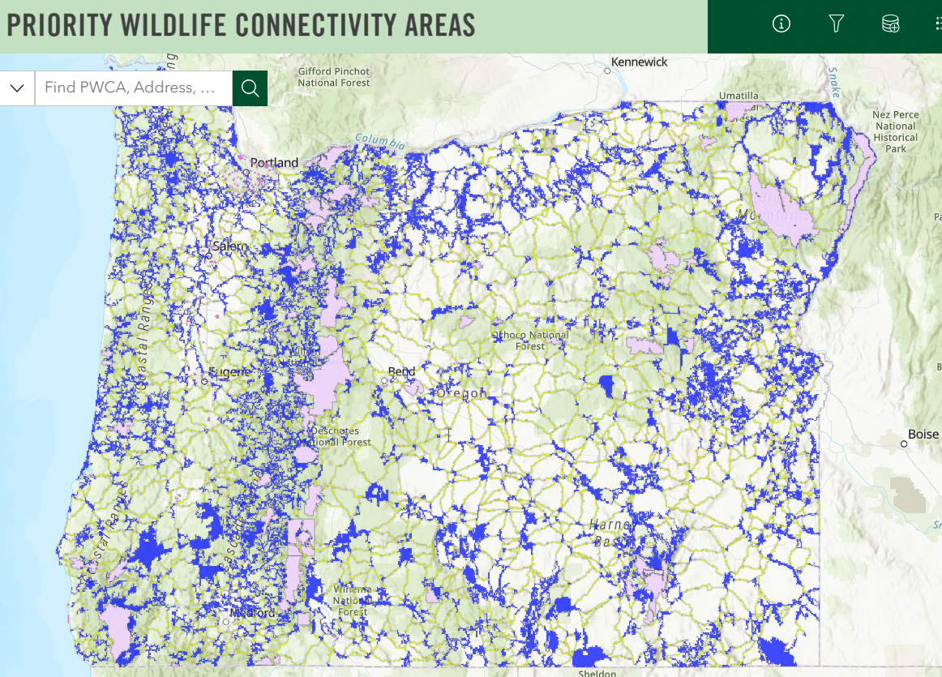

CEQ issued a connectivity policy talks about “movement of species between blocks of intact habitat.” This is crucial. Connectivity requires not only connections but also high quality habitat source habitats. The NEPA analysis should address how the proposed project affects both the connective functions and the integrity of blocks of intact habitat that are being connected.

The CEQ connectivity policy mentions free movement of wildlife, as well as “unimpeded … ecological processes.” This is important. For instance, forest management should be designed to facilitate fire as a natural process, not to stop fire and exacerbate the serious problems of fuel building, and disrupted of natural fire regimes. Roads also disrupt connectivity, not only making it harder for wildlife to cross, roads, but also natural hillslope processes such as the natural movement of water, wood, and substrate downslope and downstream. This is especially true where roads cross streams or roads located in floodplains or midslope where lots of dynamics happens.

Commercial Logging in RHCAs
We are concerned that logging in RHCAs will violate INFISH by retarding attainment of aquatic objectives such as abundant wood. Commercial logging removes functional wood from the near-stream environment. Such trees provide several important values including shade, microclimate, and future wood recruitment. Logging can reduce shade and increase stream temperature. Logging is also known to cause a long-term reduction in wood recruitment to streams.

The Forest Service should avoid commercial logging in the Wild and Scenic River corridor. The “do not retard” standard in INFISH can be compared to the duty to protect and restore the outstandingly remarkable values of the Wild and Scenic River corridor. Removing trees, especially large trees, will degrade habitat and scenic values.

Removing trees near streams will degrade water quality. Riparian vegetation is important in several ways: (a) it shades the water surface from direct solar insolation, (b) it shades soils and shallow groundwater before it is discharged to surface streams; (c) it reduces wind penetration and air mass mixing over the water surface, insulating the stream from summer daytime warming or winter night time cooling, and (d) it stabilizes streambanks and floodplain surfaces and provides a supply of downed wood that helps keep channels narrow and establishes and maintains internal hydrologic complexity (vertical and lateral flow exchange between surface water and hyporheic waters) that buffers stream temperature against the effects of solar insolation and airmass mixing.

Thinning in riparian reserves does in fact raise ambient air temperatures that the microclimate effects must be accounted for. Anderson, Paul D.; Larson, David J.; Chan, Samuel S. 2007. Riparian Buffer and Density Management Influences on Microclimate of Young Headwater Forests of Western Oregon. Forest Science, Volume 53, Number 2, April 2007 , pp. 254-269(16). http://www.ingentaconnect.com/content/saf/fs/2007/00000053/00000002/art00012.

... concern about cumulative effects of thinning, which involves an understanding of the spatial and temporal dimensions of the issue in whole-stream networks. To address these cumulative effects we are studying experimental riparian thinning treatments in adjacent stream networks and forests managed by the Green Diamond Resource Company and the National Park Service (Redwood National Park) in northern California. Thinning was implemented in multiple locations, allowing us to evaluate effects of these local treatments in the context of larger stream networks. To track local treatments, we followed a before-after-control-impact approach to quantify spatial and temporal patterns of riparian shade, light, and stream temperatures as possible responses to riparian thinning. To evaluate how the potential effects of these local treatments resonate at broader extents, we have quantified shade, light, and stream temperatures across entire networks. Spatial statistical models were applied to these data to determine the spatial extent to which localized thinning propagated through stream networks. Preliminary results from tracking local treatments indicate an immediate response in stream temperature associated with the reductions in shade and increases in light associated with riparian thinning. At the network extent this resulted in variable downstream propagation of the effects of upstream thinning.
David Roon, Jason Dunham. 2018. Spatial Patterns of Riparian Shade, Light, and Stream Temperature in Response to Riparian Thinning in Redwood Headwater Streams. Speed Talks. 2018 Oregon Chapter of the American Fisheries Society 54th Annual Meeting.
http://orafs.org/wp-content/uploads/2017/10/2018-Annual-Meeting-Abstracts.pdf

Climate change is expected to increase stream temperatures and reduce fish habitat quality and quantity. “Riparian vegetation can potentially off-set future increases in water temperature [related to global climate change].” Gordy Reeves, 4-22-2020 Presentation to the Oregon Board of Forestry. https://www.oregon.gov/odf/Board/Documents/BOF/20200422/B_Item%20Two_Presentation.pdf (p 63/66).

Dead wood is important to meeting many aquatic and terrestrial wildlife habitat values. Dead wood is also important for ecological services such as the capture, storage and release of water, sediment, and nutrients including, carbon. Most riparian reserves are short of dead wood due to past and ongoing logging, roads, fire suppression, etc. Natural processes of stand growth and mortality will correct this shortage, whereas logging will capture and export mortality and reduce and delay recruitment of wood to both streams and uplands within riparian reserves. This is not a minor short-term effect, but rather a significant long-term effect. Such effects are inconsistent with the Aquatic Conservation Strategy which prohibits logging in riparian reserves unless it is needed to meet objectives, and requires that management actions “maintain” and "not retard" ACS objectives, including dead wood. Any proposal to log riparian reserves must address these factors, develop clear goals, provide clear linkages between proposed actions and desired outcomes. Any alleged benefits of logging must be weighed against likely adverse effects on dead wood recruitment.

Large wood in streams—preferably whole trees with root wads and all—provides the randomness and dynamic environment that fish absolutely need to survive in the ever-changing waters they occupy. Wood breaks up the current and spreads water sideways across its natural floodplain, creating wonderful, dynamic and necessary diversity while also absorbing energy that could cause serious damage downstream otherwise, such as flooding or unnatural erosion. It sorts gravels during high flows, creating those beautiful spawning gravel beds laid out like blankets among bigger rock. It makes those current breaks downstream of log jams. It provides cooling shade and cover, and slow pools and edge habitat that baby fish need after emerging from those gorgeous gravels to ride out high flows, find food and hide from prying eyes. Decomposing wood and the nutrients it produces jumpstarts that the natural processes critical to insect, animal, amphibian and plant life.
Alan Moore, Why Fish Love ‘Large Woody Debris.’ Trout Unlimited. 2-4-2013. http://troutunlimitedblog.com/large-woody-debris-makes-for-fishy-rivers/

The presence of LWM within a stream channel is critical to maintaining the integrity of the system, in fact, there cannot be an overabundance of LWM. … Riparian Reserves provide important wildlife habitat, which justifies the heavy loading of LWM in the creeks and the floodplains. … In the Riparian Reserves … it is desirable to maintain healthy forest stands over the long-term while maintaining high snag densities and green tree replacements. … It is recognized that Riparian Reserves constitute an area where higher risks are taken (including reduced fire suppression efforts) in order to allow natural processes to occur and continue without human intervention.
Deschutes NF 1999. Crescent-Odell Watershed Analysis, pages 164-165.
In an undisturbed forest ecosystem, wood is naturally “recruited” to streams in various ways. Riparian trees growing along the channel fall into the channel when they are undercut by the stream, toppled by beavers, burned by fire or blown down during storms. Upslope trees can be transported into the channel by events such as avalanches or landslides . Flooding can wash trees into the channel and during highwater they may be pushed downstream.
In-stream woody debris has been drastically reduced in some streams by historical forest management practices. Logging near rivers and streams limited the number of trees that could fall into streams. Road building that channeled streams through culverts prevented downstream wood recruitment. “Stream cleaning” was sometimes conducted to remove fallen trees from streams, for beautification, to prevent damage to infrastructure downstream, or in a misguided attempt to assist fish migration.
Scientists have now come to understand that in-stream LWM [large woody material] is ecologically important for a number of reasons:
- LWM can help spawning gravels accumulate , by stopping the gravel from moving downstream;
- Pools can form behind LWM, which provide important juvenile rearing habitat, as well as habitat for all fish during periods of low-flows;
- LWM can help slow stream speed , which helps adult fish as they move upstream and shelters rearing juveniles from using too much energy fighting currents;
- LWM provide shade , offering pockets of cooler water, and can help to lower the temperature of an entire stream;
- LWM provides fish with refuge from predators ;
- LWM can help to stabilize banks, prevent erosion and decrease sediment movement that can harm downstream fish habitat;
- LWM is important to the aquatic food chain, because it traps organic matter and provides habitat for insects and invertebrates, which are both food for fish.
All of these elements add “complexity” to a stream. When it comes to fish habitat, complexity is a good thing. And one of the best ways to make a stream complex is to simply add wood.
Hannah Ettema 2014. Seven Reasons Why Fish Need Wood. https://www.nationalforests.org/blog/seven-reasons-why-fish-need-wood

Abundant dead wood is not just important for fish and other aquatic species, but we are learning that it is also useful for a wide variety of terrestrial wildlife. OSU researchers say
… little is known about how large wood in streams impacts birds and land-based animals.
Oregon State University scientists Ezmie Trevarrow and Ivan Arismendi are beginning to change that with a just-published paper in Biodiversity and Conservation that outlines what they observed from one year of footage from motion-triggered video cameras they set up near multiple large log jams in a creek just west of Corvallis.

“This study reveals a hidden role of large wood in streams,” said Trevarrow, who conducted the research as an undergraduate in the Honors College at Oregon State and is now a research associate at the University of Georgia. “The findings are valuable for land managers because they demonstrate additional value of restoration projects that involve wood placement into streams.”
In the paper, Trevarrow and Arismendi focused their attention on what species they saw, the most common observed activities and the seasonality of the detections. Among their findings:
- Forty species were observed during the study period. The most common species included mule deer, raccoon belted kingfisher, Townsend’s chipmunk, deer mouse western grey squirrel, Virginia opossum and American robin.
- The most common animal activities around the log jams included movement (68%), rest (18%), and food handling/eating (9%), suggesting that large wood in streams acts as lateral corridors, or highways as Trevarrow put it, connecting land habitats year-round for wildlife.
- A strong seasonality in detections and species richness with the highest values occurring in summer and spring, and the lowest values in winter. For example, the most species were seen in summer (27), followed by spring (23), fall (22) and winter (16).
…
While the benefits of large wood in streams for fish, particularly salmon, have been well studied, few studies have focused on the impact on land-based animals, the Oregon State researchers said.
For their study, they set up 13 cameras between June 2020 and June 2021 along Rock Creek, about 15 miles west of Corvallis. They collected 1,921 videos containing at least one animal detection, …
KTVZ News 6-21-2022. OSU research looks at importance of large wood in streams for land-based animals. https://ktvz.com/news/environment/2022/06/21/osu-research-looks-at-importance-of-large-wood-in-streams-for-land-based-animals/ citing Trevarrow, E., Arismendi, I. The role of large wood in streams as ecological corridors for wildlife biodiversity. Biodivers Conserv (2022). https://doi.org/10.1007/s10531-022-02437-2 https://link.springer.com/article/10.1007/s10531-022-02437-2.

The agency should not manage for minimum levels of dead wood because optimal levels of dead wood are much higher than minimums. In fact, there may not be any maximum. “The presence of LWM within a stream channel is critical to maintaining integrity of the system, in fact, there cannot be an overabundance of LWM.” Deschutes NF, 1997. Big Marsh Watershed Analysis.

In order to retain options for recruitment of large wood in degraded stream systems, scientific recommendations include retention of trees >12” dbh.
Removal of trees from riparian zones may delay the recovery of fish habitat. At a minimum, the largest trees (that is, those > 12 inches in diameter at breast height) should be left in riparian areas for future sources of in-stream wood. This would apply to all streams, as recommended by Anderson and others (1992). Smaller trees could be removed as part of a program for riparian vegetation restoration.
Gordon H. Reeves and Fred H. Everest. 1994. REDUCING HAZARD FOR ENDANGERED SALMON STOCKS, in Eastside Forest Ecosystem Health Assessment; Volume IV. Everett, Richard L., comp. 1994. Restoration of Stressed Sites, and Processes. Gen. Tech. Rep. PNW-GTR-330. Portland, OR: USDA, Forest Service, Pacific Northwest Research Station. https://www.fs.fed.us/pnw/pubs/pnw_gtr330.pdf.
(p 23).

In small streams, even small wood provides valuable ecological functions. “The effect that wood has on [fish] habitat is related to the size of the piece of wood relative to the channel size and gradient.” East Alsea Landscape Management Project – EA Appendix H - Fish BE, 4-18-2011. The NEPA analysis should therefore disclose the effects of logging not only on absolute size of wood but on the size of wood relative to stream size and gradient. Dead wood of all sizes is important to streams and riparian function. In small streams, small wood can even perform the ecological and hydrological functions normally thought to require large wood. If the goal of logging is to create large trees faster, the NEPA analysis should document the size, gradient, and other characteristics of streams adjacent to each logging area and determine the size of wood that can serve key ecological and hydrological functions, then disclose the effects of logging relative to those relevant wood sizes.

"Available research (et al., Beechie and Sibley 1997, Bilby and Ward 1989) indicates that trees as small as 5-6 inches in diameter can form pools in small streams. Thinning along small streams with wood deficits can significantly reduce recruitment of wood to streams (Beechie et al. 2000), and the risks of this happening appear to be significantly increased by the above management actions. [i.e. "thinning in riparian areas for all stream sizes"]
...
Alternatives 2 and 3 will substantially decrease the large wood contribution to fish bearing streams relative to the No-Action Alternative, and the decreases will be long-term. This is because thinning will remove wood large enough to form pools from the riparian zone (if the term large wood is defined by its ability to form pools rather than the arbitrary value of >20 inches diameter) (Beechie et al. 2000)."
NMFS, Comments on DEIS for the WOPR dated 01-11-2008. pp 8-9, 21. http://www.blm.gov/or/plans/wopr/files/NOAA_comments.pdf. See also Roni, Philip, Timothy J. Beechie, Robert E. Bilby, Frank E. Leonetti, Michael M. Pollock, And George R. Pess. 2002. A Review of Stream Restoration Techniques and a Hierarchical Strategy for Prioritizing Restoration in Pacific Northwest Watersheds. North American Journal of Fisheries Management 22:1–20, 2002 American Fisheries Society 2002 http://www.crab.wa.gov/LibraryData/RESEARCH_and_REFERENCE_MATERIAL/Environmental/020923StreamRestoreTechPNW.pdf.

See also, Frissell, Christopher A., Baker, Rowan. J., DellaSala, Dominick A., Hughes, Robert M., Karr, James R., McCullough, Dale A., Nawa, Richard. K., Rhodes, Jon, Scurlock, Mary C., Wissmar, Robert C. 2014. CONSERVATION OF AQUATIC AND FISHERY RESOURCES IN THE PACIFIC NORTHWEST: Implications of New Science for the Aquatic Conservation Strategy of the Northwest Forest Plan, FINAL REPORT, July 30, 2014. http://coastrange.org/documents/ACS-Finalreport-44pp-0808.pdf This report summarizes the available information and concludes that non-commercial thinning in very young stands might advance aquatic objectives, but that commercial logging is unlikely to provide net benefits due to wood removal, road requirements, soil impacts, etc.

New information on Snags and Dead Wood.
The EA provides almost no analysis of effects to snag habitat. LRMP standards are based on outdated science and standards about dead wood ecology and the effects of logging. The snag analysis in the wildlife appendix also fails to disclose whether logging, especially large tree logging will push the ecosystem toward or away from the natural range of variability.

Comparing current and reference conditions, without also projecting future snag conditions with and without logging is arbitrary and capricious and fails to provide an effects analysis. Here is an example of the kind of analysis that the public needs to provide informed comment and the decision-maker needs to make an informed decision:
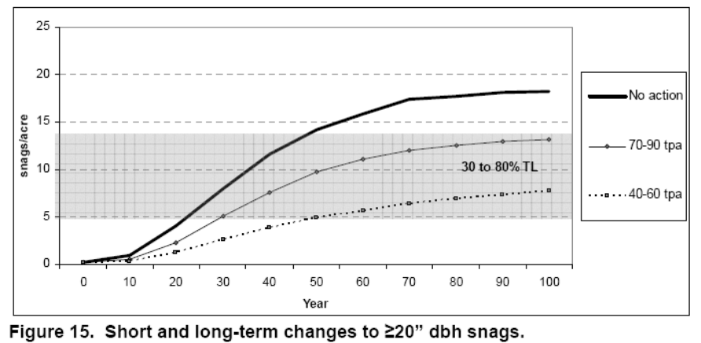http://a123.g.akamai.net/7/123/11558/abc123/forestservic.download.akamai.com/11558/www/nepa/32805_FSPLT2_053506.pdf. The graph above is from the Curran Junetta Thin EA (on the Cottage Grove Ranger District) which shows that thinning delays by more than 60 years the attainment of habitat objectives for large snags (i.e. mid-point of the gray band representing 30-80% tolerance level). The EA uses misleading statements such as “The large old snags utilized for nesting by this species are not targeted by activities.” Which ignores that removal of green trees has a significant indirect effect on snag habitat by removing trees before they ever have a chance to become snags. Remember, in a natural forest virtually every tree eventually becomes a snag. Every tree that is removed from the forest is a snag that can never be recruited. When large trees are removed this effect is significant. The EA needs to account for this.
Dynamic ecosystems historically included large-scale mortality events both pulsed and continuous. Mortality and biomass accumulation are natural and desirable ecological processes that forest management has been working for decades to capture, suppress, and avoid. Large snags are severely under-represented in our forests and logging will capture, reduce and delay recruitment of future large snags. Korol et al (2002) estimated that even if we apply enlightened forest management on federal lands in the Interior Columbia Basin for the next 100 years, we will still reach only 75% of the historic large snag abundance, and most of the increase in large snags will occur in roadless and wilderness areas. Jerome J. Korol, Miles A. Hemstrom, Wendel J. Hann, and Rebecca A. Gravenmier. 2002. Snags and Down Wood in the Interior Columbia Basin Ecosystem Management Project. PNW-GTR-181. http://www.fs.fed.us/psw/publications/documents/gtr-181/049_Korol.pdf. Wisdom et al (2008) found that snag abundance in the Pacific northwest forests is inversely related to past harvest and proximity to roads. Wisdom, M.J., and Bate, L.J. 2008. Snag density varies with intensity of timber harvest and human access. For. Ecol. Manage. 255: 2085–2093. doi:10.1016/j.foreco.2007.12.027. http://www.fs.fed.us/pnw/pubs/journals/pnw_2008_wisdom001.pdf (“Our highest snag density … occurred in unharvested stands that had no adjacent roads. … Stands with no history of timber harvest had 3 times the density of snags as stands selectively harvested, and 19 times the density as stands having undergone complete harvest. Stands not adjacent to roads had almost 3 times the density of snags as stands adjacent to roads.”) Salem BLM’s Bottleneck LSR Enhancement Project EA (http://www.blm.gov/or/districts/salem/plans/files/sdo_080-07-16_eafonsi.pdf ) includes Table 9 which clearly shows that thinning will adversely affect mortality processes. Mortality would be 70 tpa without treatment, or 0.10 tpa with thinning, thus sacrificing 69.9 trees per acre averaging 20.3" dbh that would be recruited to the large snag and down wood pool over the next 30 years except that they will instead be cut and taken to the mill.

Snags have been severely depleted across the eastside forests. The federal agencies need to compensate for the severe lack of snags on intensively managed forest lands, but unfortunately snags are lacking on federal lands as well. Snag depletion in eastside forests is described in the ICBEMP Scientific Analysis Group which found that “Across the [interior Columbia River] basin (all lands) large snags have declined more than 30 percent. This was most likely a reflection of the loss of late-seral forests, particularly in the dry and moist PVGs.” Miles A. Hemstrom, Wendel J. Hann, Rebecca A. Gravenmier, Jerome J. Korol. 2000. [SAG] Landscape Effects Analysis of the [ICBEMP] SDEIS Alternatives. USDA/USDI, draft March 2000.
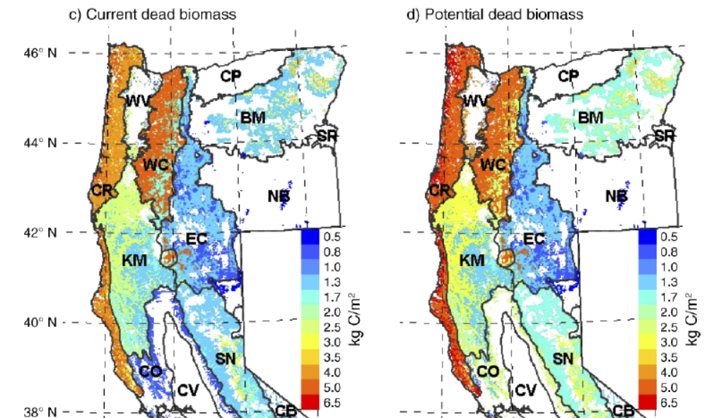
Tara Hudiburg, Beverly Law, David P. Turner, John Campbell, Dan Donato, And Maureen Duane 2009. Carbon dynamics of Oregon and Northern California forests and potential land-based carbon storage. Ecological Applications, 19(1), 2009, pp. 163–180
http://terraweb.forestry.oregonstate.edu/pubs2/Hudiburg2009EA.pdf.

“In general, wildlife species that use dead wood for nesting, roosting, or foraging prefer larger diameter logs and snags (>20 inches). Although we tallied dead wood in this size class throughout Oregon, the estimated density may not be sufficient for some wildlife species. For example, inventory results show a mean of almost 3 snags per acre in this size class in western Oregon and 1 per acre in eastern Oregon. This may indicate that large-diameter snags are currently uncommon in Oregon habitat and that management may be necessary to produce a greater density of large snags.”
Donnegan, Joseph; Campbell, Sally; Azuma, Dave, tech. eds. 2008. Oregon’s forest resources, 2001–2005: five-year Forest Inventory and Analysis report. Gen. Tech. Rep. PNW-GTR-765. Portland, OR: U.S. Forest Service, Pacific Northwest Research Station. 186 p. http://www.fs.fed.us/pnw/publications/gtr765/pnw-gtr765b.pdf.

The 9th Circuit recently reiterated that “species viability may be met by estimating and preserving habitat ‘only where both the Forest Service’s knowledge of what quality and quantity of habitat is necessary to support the species and the Forest Service’s method for measuring the existing amount of that habitat are reasonably reliable and accurate.’ Earth Island Inst. v. U.S. Forest Serv., 442 F.3d 1147, 1175-76 (9th Cir. 2006) (quoting Native Ecosystems Council v. U.S. Forest Serv., 428 F.3d 1233, 1250 (9th Cir. 2005))” ONRC v. Goodman (Mt Ashland case, 9th Circuit Sept 24, 2007) (emphasis added).
http://caselaw.findlaw.com/us-9th-circuit/1151013.html
and http://caselaw.findlaw.com/us-9th-circuit/1094367.html.

The Forest Service cannot provide any assurance that its plans and projects will assure viable populations of native wildlife that depend on dead trees. The Forest Service does not know how many snags are necessary to support viable populations of cavity associated species. The Forest Service has provided no credible link between DecAID tolerance levels, potential population levels, and/or viable populations. The Forest Service has also failed to reliably quantify existing and projected habitat for snag associated species.

The Forest Service cannot provide any assurance that its plans and projects will assure viable populations of native wildlife that depend on dead trees. The recently amended Eastside Screens changed the requirements for snag habitat in a way that offers no assurances of population viability. The new snag standards basically requires some snags for some wildlife, while failing to ensure there are enough snags for wildlife that are most sensitive to logging and the resulting absence of abundant snags.

An unavoidable impact of all commercial logging is to “capture mortality” which reduces valuable snag habitat in the short-term (via hazard tree felling) and in the long-term (via delayed recruitment and reduced overall recruitment). For example, in a thinning project on the Siuslaw National Forest “modeling stand #502073 over a 100-year cycle [using ORGANON] predicts a total stand mortality of 202 trees (>10 inches dbh) for the unthinned stand, while mortality for the thinned stand was two trees. Therefore, thinning will reduce density-dependent mortality within the stand by 99%.” NOAA April 4, 2006 Magnuson Act consultation on Essential Fish Habitat and Response to Siuslaw NF Lobster Project BA. There is no reason to think that thinning in densely stocked forests elsewhere would be any different.

Dead wood in forests is thought to follow a U-shaped pattern over time “from the combined and lagged effects of legacy wood decay and the recruitment of new dead wood,” (Harmon 1986, Hudiburg 2009) resulting in abundant dead wood legacies from the previous stand in young forests, less dead wood in middle-aged stands as the legacies decay, and more again in older stands as natural mortality processes manifest. If the goal is to restore high quality old forest habitat, the agencies must respect this dynamic by recognizing that dead wood recruitment requires (1) “surplus” biomass and (2) it’s a process that takes time, so managers should ensure that middle-aged stands accumulate biomass and begin to recruit and accumulate snags and dead wood. The low of dead wood in middle aged stands is not universal or necessarily desirable, and since many young stands were deprived of the legacies they normally enjoy, it would be advisable to start accumulating snags and dead wood as soon as possible, not wait for mature stages.

The federal forest agencies now recognize that current methods and assumptions concerning snag habitat standards are outdated, and the old snag standards do not ensure enough snags to meet the intent of the standard, yet the agencies have not adjusted their management plans to account for this new information nor have they developed new standards that are consistent with the latest scientific information.

As explained on the DecAID website:
Why is DecAID needed?
National Forest LRMP standards and guidelines for management of snags and down wood in the Pacific Northwest were based on wildlife species models and tools that were developed in the 1970s and 1980s (Thomas et al. 1979, Neitro et al. 1985, Marcot 1992, Raphael 1983). New information about the ecology, dynamics, and management of decayed wood has been published since then, and the state of the knowledge continues to change. Rose et al. (2001) report that results of monitoring indicate that the biological potential models are a flawed technique (page 602). There has been an evolution from thinking of large woody material as habitat structures, to thinking of decaying wood as an integral part of complex ecosystems and ecological processes.

This paradigm shift has made the management of dead wood a much more complex task. We can no longer expect to go to our LRMPs or the biological potential model to get one number for the amount or size of snags and down wood that we can apply to all projects and to all acres. We are directed to use the best available science to manage ecosystems, and the best available science simply will not support business as usual for managing dead wood.
Region 6 - USDA Forest Service. A Guide to the Interpretation and Use of the DecAID Advisor. June, 2006. http://www.fs.fed.us/r6/nr/wildlife/decaid-guide/

A few of the problems with the old standards are:
- They failed to account for the fact that the number of snags needed for roosting, escape, and foraging can exceed the number of snags needed for nesting;
- They failed to recognize that the number of snags needed to support viable populations of secondary cavity users may exceed the needs of primary cavity excavators;
- The old standard failed to account for the size height of snags favored by some species;
- In applying the old standards the agencies often fail to account for rates of snag fall and recruitment;
- The old standards fail to recognize non-equilibrium conditions in our forests, i.e. some species rely on the natural large pulses of snags associated with large disturbances;
- The old standards fail to account for the differential use of space and population density of different species;
- The old standards ignore other important habitat features of dead wood, e.g. loose bark, hollow trees, broken tops, etc.

The Forest Service recognizes that
Forest Plan standards were based on a model that did not account for snags required for foraging (EA p. 68 and Appendix K p. 45). There is general consensus in the scientific and professional community that using the biological potential model (which was used in developing the Forest Plan standard) is flawed and does not provide adequate nesting, roosting, or foraging structure for cavity excavating birds …
North Fork John Day RD, Umatilla NF. 2011. Mirage Vegetation Management Project DN. http://a123.g.akamai.net/7/123/11558/abc123/forestservic.download.akamai.com/11558/www/nepa/53012_FSPLT2_055455.pdf.

Bull et al. states that the current direction for providing wildlife habitat on public forest lands does not reflect the new information that is available which suggests that to fully meet the needs of wildlife, additional snags and habitat are required for foraging, denning, nesting, and roosting (1997). Johnson and O’Neil (2001) and Rose et al. (2001) also state that several major lessons have been learned in the period 1979 to 1999 that have tested critical assumptions of earlier management advisory models (2001), including some of the assumptions used to develop the current recommendations in the LRMP Standards and Guidelines, as amended by the Regional Forester’s Amendment #2. Some assumptions include:
• calculation of numbers of snags required by woodpeckers based on assessing their “biological (population) potential” is a flawed technique (Johnson and O’Neil 2001). Empirical studies are suggesting that snag numbers in areas used and selected by some wildlife species are far higher than those calculated by this technique (Johnson and O’Neil 2001).
• numbers and sizes (dbh) of snags used and selected by secondary cavity nesters often exceed those of primary excavators (Johnson and O’Neil 2001).
This suggests the current direction of managing for 100 percent population potential levels of primary excavators may not represent the most meaningful measure of managing for cavity-nesters and that these snag levels, under certain conditions, may not be adequate for some species.
Fremont-Winema NF. Barnes Valley-Long Branch Restoration and Enhancement Project EA Appendix B – DecAID Information. http://www.fs.fed.us/r6/frewin/projects/analyses/barneslong/ea/appb.pdf (Broken 8/10/2012).
http://www.fs.fed.us/outernet/r6/winema/management/analyses/barneslong/prelimea.pdf.

The authors of DecAID describe some of the limitations of the old methods of managing snag habitat.
Limitations of Existing Approaches for Assessing Wildlife-Dead Wood Relations.
Models of relationships between wildlife species and snags in the Pacific Northwest typically are based on calculating potential densities of bird species and expected number of snags used per pair. This approach was first used by Thomas et al. (1979). Marcot expanded this approach in Neitro et al. (1985) and in the Snag Recruitment Simulator (Marcot 1992) by using published estimates of bird population densities instead of calculating population densities from pair home range sizes. This approach has been criticized because the numbers of snags suggested by the models seem far lower than are now being observed in field studies (Lundquist and Mariani 1991, Bull et al. 1997). In addition, the models provided only deterministic point values of snag sizes or densities and of population response ("population potential") instead of probabilistic estimates that are more amenable to a risk analysis and risk management framework.
In addition, existing models have focused on terrestrial vertebrate species that are primary cavity excavators. Thomas et al. (1979) and Marcot (1992) assumed that secondary snag-using species would be fully provided for if needs of primary snag-excavating species were met. However, McComb et al. (1992) and Schreiber (1987) suggested that secondary cavity nesting birds may be even more sensitive to snag density than are primary cavity excavators.
Furthermore, existing models do not address relationships between wildlife and down wood, nor do they account for species that use different types of snags and partially dead trees, such as hollow live and dead trees used by bats (Ormsbee and McComb 1998, Vonhof and Gwilliam 2007), Vaux's swift (Chaetura vauxi) (Bull and Hohmann 1993), American marten (Martes americana) (Bull et al. 2005), and fisher (Martes pennanti) (Zielinski et al. 2004).
Bruce G. Marcot , Janet L. Ohmann, Kim L. Mellen-McLean, and Karen L. Waddell. Synthesis of Regional Wildlife and Vegetation Field Studies to Guide Management of Standing and Down Dead Trees. Forest Science 56(4) 2010. http://www.fs.fed.us/pnw/pubs/journals/pnw_2010_marcot002.pdf

The agencies need to prepare a EIS to consider a replacement methodology for maintaining species and other values associated with dead wood. This is especially critical because adequate dead wood is recognized as an essential feature of healthy forests and the Forest Service has identified lots of “management indicator species” associated with dead wood habitat.

Back in the early 1990s the Forest Service recognized the their forest plans were not adequate to maintain populations of spotted owls and they tried to develop plans to conserve spotted owl without following NEPA and NFMA procedures. The courts said they had to stop cutting owl habitat until they had complied with environmental laws. This is the same situation we find ourselves in today with dead-wood associated species. The agencies should stop harming dead wood habitat until they have a legal plan to conserve associated species over the long-term. Seattle Audubon Society v. Epsy, 998 F.2d 699, 704 (9th Cir. 1998) (an agency must re-examine its decision when the EIS "rests on stale scientific evidence and false assumptions").

Lessons Learned During the Last Fifteen Years
…
Several major lessons have been learned in the period 1979-1999 that have tested critical assumptions of these earlier management advisory models:
- Calculations of numbers of snags required by woodpeckers based on assessing their ‘biological potential’ (that is, summing numbers of snags used per pair, accounting for unused snags, and extrapolating snag numbers based on population density) is a flawed technique. Empirical studies are suggesting that snag numbers in areas used and selected by some wildlife species are far higher than those calculated by this technique.²²⁶
- Setting a goal of 40% of habitat capability for primary excavators, mainly woodpeckers,³⁶⁹ is likely to be insufficient for maintaining viable populations.
- Numbers and sizes (dbh) of snags used and selected by secondary cavity-nesters often exceed those of primary cavity excavators.
- Clumping of snags and down wood may be a natural pattern, and clumps may be selected by some species, so that providing only even distributions may be insufficient to meet all species needs.
- Other forms of decaying wood, including hollow trees, natural tree cavities, peeling bark, and dead parts of live trees, as well as fungi and mistletoe associated with wood decay, all provide resources for wildlife, and should be considered along with snags and down wood in management guidelines.
- The ecological roles played by wildlife associated with decaying wood extend well beyond those structures per se, and can be significant factors influencing community diversity and ecosystem processes.
Rose, C.L., Marcot, B.G., Mellen, T.K., Ohmann, J.L., Waddell, K.L., Lindely, D.L., and B. Schrieber. 2001. Decaying Wood in Pacific Northwest Forests: Concepts and Tools for Habitat Management, Chapter 24 in Wildlife-Habitat Relationships in Oregon and Washington (Johnson, D. H. and T. A. O'Neil. OSU Press. 2001) http://web.archive.org/web/20060708035905/http://www.nwhi.org/inc/data/GISdata/docs/chapter24.pdf

The potential population models are based on the number of trees needed for nesting cavity-excavator birds, however, “[t]he high value of large, thick-barked snags in severely burned forests has as much to do with feeding opportunities as it does with nesting opportunities they provide birds.” (Hutto. ConBio 20(4). 2006. http://web.archive.org/web/20060904175645/http://avianscience.dbs.umt.edu/documents/hutto_conbio_2006.pdf. The number of snags needed to support bird feeding, escape from predators, and other life functions, is different than, and likely higher than, the number of snags needed to support nesting, so the agencies’ existing “potential population” snag standards are arbitrary and capricious.

New science indicates that meeting the needs of cavity excavators requires retaining far more snags than managers realize.
… at-risk species, namely the black-backed and the white-headed woodpeckers, were nesting within burns that contained 86 to 96 percent of trees with unsuitably hard wood. This suggests that past studies that did not measure wood hardness counted many sites as available to cavity-excavating birds when actually they were unsuitable. “By not accounting for wood hardness, managers may be overestimating the amount of suitable habitat for cavity-excavating bird species, some of which are at risk,” Lorenz says.
In their study plots, the researchers did not find reliable visual cues to distinguish
between suitable and unsuitable trees. Snag decay class was a poor indicator of internal wood properties—and this was not the first study to demonstrate that fact, although it was the first study to do so in ornithology (past studies had been done by foresters and published in forestry journals).
“Currently, the best solution we can recommend is to provide large numbers of snags for the birds, which can be difficult without fire,” Lorenz says. According to the researchers’ calculations, if one of every 20 snags (approximately 4 percent) has suitable wood, and there are five to seven species of woodpeckers
nesting in a given patch, approximately 100 snags may be needed each year for nesting sites alone. This does not account for other nuances, like the fact that most species are territorial and will not tolerate close neighbors while nesting, or the fact that species like the black-backed woodpecker need more foraging
options. Overall, more snags are needed than other studies have previously recommended.
Vizcarra, Natasha 2017. Woodpecker Woes: The Right Tree Can Be Hard to Find. PNW Science Findings, Issue 199, August 2017. https://www.fs.fed.us/pnw/sciencef/scifi199.pdf. citing Lorenz, T.J.; Vierling, K.T.; Johnson, T.R.; Fischer, P.C. 2015. The role of wood hardness in limiting nest site selection in avian cavity excavators. Ecological Applications. 25: 1 016–1033. https://www.treesearch.fs.fed.us/pubs/49102.

There is evidence that retaining more than the minimum number of snags has significant benefits for cavity dependent species. Comparing two sites in Northern California, Blacks Mountain Experimental Forest (BMEF) with little past logging and lots of snags, and Goosenest Adaptive Management Area (GAMA) with lots of logging and fewer snags, the author’s found “… three times as many snags (6.38/acre vs. 2.04/acre, respectively) … The use of snags by cavity-nesting bird species was dramatically different between the sites. Thirty-one cavity-nesting pairs from 10 species were detected at BMEF, while only one pair each of two species were detected at GAMA…. This fifteenfold difference is much greater than any measure of snags or cavities reported. …”
We feel that forest managers may well be asking a misleading question. “Snags per acre” requirements implicitly assume an equilibrium condition and reflect only one ecological requirement for a given cavity-nesting species. … [C]onsideration of foraging habitat and other ecological requirements must be part of the “snags per acre” management considerations. This is an important, but somewhat daunting proposition, as potential cavity-nesting species are diverse, and each species likely has very different foraging ecologies, as well as other differences in habitat requirements. … [C]avity nesters at BMEF used larger snags on average … [T]he loss of large trees due to logging in eastside pine and other forests, over the past century has major implications for cavity-nesting birds. … [F]orest managers must have a sense of snag recruitment in relationship to snag fall, and the patterns and processes that underlie them, when addressing wildlife needs. … We view the understanding of these complexities to be of primary importance in forest management for wildlife.
Steve Zack, T. Luke George, and William F. Laudenslayer, Jr. 2002. Are There Snags in the System? Comparing Cavity Use among Nesting Birds in “Snag-rich” and “Snag-poor” Eastside Pine Forests. USDA Forest Service Gen. Tech. Rep. PSW-GTR-181. http://www.fs.fed.us/psw/publications/documents/gtr-181/017_Zack.pdf.

The bottom line is that current management at both the plan and project level does not reflect all this new information about the value of abundant snags and down wood. The agency must avoid any reduction of existing or future large snags and logs (including as part of this project) until the applicable management plans are rewritten to update the snag retention standards. See also PNW Research Station, “Dead and Dying Trees: Essential for Life in the Forest,” Science Findings, Nov. 1999 (http://www.fs.fed.us/pnw/sciencef/scifi20.pdf ) (“Management implications: Current direction for providing wildlife habitat on public forest lands does not reflect findings from research since 1979; more snags and dead wood structures are required for foraging, denning, nesting, and roosting than previously thought.”) and Jennifer M. Weikel and John P. Hayes, HABITAT USE BY SNAG-ASSOCIATED SPECIES: A BIBLIOGRAPHY FOR SPECIES OCCURRING IN OREGON AND WASHINGTON, Research Contribution 33 April 2001, http://www.fsl.orst.edu/cfer/snags/bibliography.pdf.

Another important ecological function provided by mortality is that it promotes evolutionary adaptation which is critical right now in the face of climate change.
[R]esearchers were surprised to find that the mortality of established trees considerably promotes the adaptation of forests to the changing environment. … Evolution is promoted by the mortality of established trees. The researchers assumed that demographic characteristics of the trees would have a notable impact on their adaptability. Tree species differ for example so that birch matures at a considerably younger age than pine, and birch seeds spread more effectively than pine seeds. However, the results showed that these differences had only minor impacts. Instead, the mortality of established trees played a large role in the evolutionary adaptation.
Northern forests do not benefit from lengthening growing season. UNIVERSITY OF HELSINKI. PUBLIC RELEASE: 12-JAN-2010. http://www.eurekalert.org/pub_releases/2010-01/uoh-nfd011210.php. Importantly, for natural selection to occur, mortality must be caused by natural events like drought, insects, and fire, rather than through human choices about which trees will live and which will die.

The effects of the “no action” alternative must be accurately portrayed.
The agency is not permitted to present a biased description of the no action alternative. The agency is not permitted to saddle the no action alternative with a worst-case-scenario in terms of future fire. The NEPA document describes the no-action alternative in terms of its inherent high risk of intense future fire, but the NEPA document lacks any recognition: (a) the probability of high severity fire is far less than certain, (b) if a high severity fire does occur during hot-dry-windy conditions, the environmental effects will be similar whether the area is treated or not, and (c) that during favorable conditions of weather and fuel moisture a low-severity or mixed-severity fire could occur in the project area and such as fire would likely accomplish much of what this project is attempting to accomplish without all the adverse consequences from ground disturbance. This shows a strong bias against the no-action alternative.

Wildfire effects are often more ecologically beneficial than logging. The 2017 Fuels Report for the 130,000 acre East Hills Project on this Fremont-Winema NF admits that wildfires are expected to have beneficial effects even under the no action alternative - “Overall expected value of fire effects is moderately beneficial. This assumes that fires burn throughout the range of conditions – actual current practice is to suppress fires that are most likely to be beneficial.” https://www.fs.usda.gov/nfs/11558/www/nepa/101283_FSPLT3_4264365.pdf. This would indicate a need to modify fire suppression practices and work with fire when weather conditions are favorable.

Leaving forests unlogged allows natural successional processes to flourish. This typically results in higher-quality combination of habitat features with fewer trade-offs. For instance, allowing trees to grow unharvested, results in natural tree mortality which not only frees up resources (light, moisture, nutrients, growing space) for residual trees to be grow larger, but also creates valuable snags and down wood habitat, and opens small canopy gaps that stimulate understory development and new tree cohorts. The benefits of allowing natural succession to occur in older stands is summarized by Eugene BLM:

As dominant trees continue to grow, they would gain late-successional habitat features like large diameters, deeply fissured bark, deep crowns, large branches, broken tops, and cavities. As individual dominant trees die, they would become large snags or down wood. As large trees or snags fall, they would knock over other trees and branches, creating growing space. This growing space would release understory conifers and hardwoods, allowing them to grow into dominant trees, and stimulate growth of shrubs and herbaceous vegetation. The overall effect of these successional processes would create a mosaic of tree ages, species composition, and latesuccessional habitat features in the stands. Additionally, patches of overstory trees would continue to suffer mortality from sporadic processes such as root rot or other disturbance such as windthrow. This would create larger areas of growing space for surviving overstory trees, hardwoods, conifer regeneration, shrubs, and herbs to occupy. Therefore, habitat in the project area would primarily develop late-successional characteristics, with patches of early- or mid-successional habitat throughout.
McKenzie Landscape EA, No. DOI-BLM- OR060-2013-0005-EA. https://eplanning.blm.gov/epl-front-office/projects/nepa/69610/91093/109561/2016_11_23_McKenzie_Landscape_EA__and_Preliminary_FONSI.pdf

See also, Lutz. J.A. 2005. The Contribution of Mortality to Early Coniferous Forest Development. MS Thesis. University of Washington. http://faculty.washington.edu/chalpern/Lutz_2005.pdf. This MS Thesis looked at long-term transect data from young forests in Western Oregon and found that non-competitive mortality and gap forming processes are very much in operation in dense young planted stands. This indicates that in young stands the homogenizing influence of stand growth and competitive mortality is significantly counter-balanced by non-competitive mortality that tends toward heterogeneity and structural diversification. This means that if young stand management is to effectively mimic natural patterns and processes, that variable density treatments must be the rule, and the scale of the mosaic must be very fine scale. Note: The study sites were located in the HJ Andrews Experimental Forest and were not naturally regenerated, so it is likely that in young stands that are naturally regenerating after disturbance such as fire, the heterogeneity and gap-forming processes would be even more pronounced. See also Lutz & Halpern 2006. Tree Mortality During Early Forest Development: A Long-Term Study Of Rates, Causes, And Consequences. Ecological Monographs, 76(2), 2006, pp. 257–275. http://cfr501.jamesalutz.com/Lutz_Halpern_Mortality_EM_2006.pdf and Franklin, J. F., T. A. Spies, R. Van Pelt, A. B. Carey, D. A. Thornburgh, D. R. Berg, D. B. Lindenmayer, M. E. Harmon, W. S. Keeton, D. S. Shaw, K. Bible, and J. Chen. 2002. Disturbances and structural development of natural forest ecosystems with silvicultural implications, using Douglas-fir as an example. Forest Ecology and Management 155:399-423. http://www.fs.fed.us/pnw/pubs/journals/pnw_2002_franklin001.pdf; Franklin, Jerry F.; Mitchell, Robert J.; Palik, Brian J. 2007. Natural disturbance and stand development principles for ecological forestry. Gen. Tech. Rep. NRS-19. Newtown Square, PA: U.S. Department of Agriculture, Forest Service, Northern Research Station. 44 p. https://www.nrs.fs.fed.us/pubs/gtr/gtr_nrs19.pdf.

Among the benefits of not logging is growth of strong wood that may eventually create more persistent snags.
Slower diameter growth develops stronger wood with a higher proportion of heartwood compared to faster growth, …. Heartwood is generally stronger and more decay resistant than sapwood, so a higher percentage of heartwood with smaller growth rings tends to result in … more durable dead wood which persists longer in the forest stand.
NW Oregon BLM. 2016. Hole-in-the-Road EA. https://eplanning.blm.gov/epl-front-office/projects/nepa/53390/91260/110166/HTR_EA_final_Nov282016_508.pdf

Biden Admin Climate Policy Requires Harmonizing Climate Adaptation and Mitigation
The agency should develop alternatives that harmonize potentially competing objectives of climate change mitigation, and climate change adaptation. Climate change mitigation involves keeping carbon in the forest and avoiding GHG emissions to the atmosphere from logging. Climate change adaptation may involve a variety of actions that range from reducing stand density to reduce water stress in a warming world to providing habitat redundancy and connectivity, and maintaining cool/moist habitat refugia for wildlife that thrive in dense forests.

The Biden Administration has adopted a policy to both mitigate AND prepare for global climate change.
“It is, therefore, the policy of [the Biden] Administration to listen to the science; to improve public health and protect our environment; to ensure access to clean air and water; … to reduce greenhouse gas emissions; to bolster resilience to the impacts of climate change; … To that end, this order directs all executive departments and agencies (agencies) to immediately review and, as appropriate and consistent with applicable law, take action to address the promulgation of Federal regulations and other actions during the last 4 years that conflict with these important national objectives, and to immediately commence work to confront the climate crisis.”
Executive Order on Protecting Public Health and the Environment and Restoring Science to Tackle the Climate Crisis. JANUARY 20, 2021 https://www.whitehouse.gov/briefing-room/presidential-actions/2021/01/20/executive-order-protecting-public-health-and-environment-and-restoring-science-to-tackle-climate-crisis/. This requires careful balancing of sometimes competing objectives, such as retaining trees to store carbon, and thinning to reduce climate stresses. The best harmony among these objectives is to retain medium and large trees that store the most carbon and provide the greatest ecosystem services, while thinning small trees removal of which will reduce climate stresses on the larger trees while emitting less carbon.

Biden Climate Policy Requires Quantifying and Disclosing the Social Cost of Carbon Dioxide as a proxy for the impacts of GHG emissions.
The social, economic, and environmental costs of unmitigated climate change are astronomical. With a recognition that nature-based carbon storage can help mitigate those costs, it is becoming clear that conservation of nature, especially forests, creates far more value than natural resource extraction. Bradbury, R.B., Butchart, S.H.M., Fisher, B. et al. The economic consequences of conserving or restoring sites for nature. Nat Sustain (2021). https://doi.org/10.1038/s41893-021-00692-9. https://rdcu.be/cgpdK (“At $31/tonne [of carbon] the nature-focused state NPV was greater than the alternative state NPV at 100% of forest sites. … [W]hile these patterns hold for all goods combined and for non-excludable goods, the alternative state was often more valuable when only excludable goods were considered. Our findings thus provide a strong economic justification for incentives to encourage private landowners towards decisions that favour nature-focused land management to enhance overall social value.”).

It is important to quantify the total carbon emissions from logging then use proxies such as the social cost of carbon dioxide emissions to help explain the effects of those emissions. Another powerful proxy is provided by Bressler (2021) which shows that 4,434 tonnes of CO2e emissions is estimated to result in 1 premature human death. Bressler, R.D. The mortality cost of carbon. Nat Commun 12, 4467 (2021). https://doi.org/10.1038/s41467-021-24487-w. https://www.nature.com/articles/s41467-021-24487-w.pdf. The agency should calculate and disclose how many people they are killing with their logging plans.

The Biden Administration says it is essential that federal decision-making consider the full cost of agency actions that may harm the climate:
Sec. 5. Accounting for the Benefits of Reducing Climate Pollution. (a) It is essential that agencies capture the full costs of greenhouse gas emissions as accurately as possible, including by taking global damages into account. Doing so facilitates sound decision-making, recognizes the breadth of climate impacts, and supports the international leadership of the United States on climate issues. The “social cost of carbon” (SCC), “social cost of nitrous oxide” (SCN), and “social cost of methane” (SCM) are estimates of the monetized damages associated with incremental increases in greenhouse gas emissions. They are intended to include changes in net agricultural productivity, human health, property damage from increased flood risk, and the value of ecosystem services. An accurate social cost is essential for agencies to accurately determine the social benefits of reducing greenhouse gas emissions when conducting cost-benefit analyses of regulatory and other actions. …
(b) There is hereby established an Interagency Working Group on the Social Cost of Greenhouse Gases …
(ii) Mission and Work. The Working Group shall, as appropriate and consistent with applicable law:
(A) publish an interim SCC, SCN, and SCM within 30 days of the date of this order, which agencies shall use when monetizing the value of changes in greenhouse gas emissions resulting from regulations and other relevant agency actions until final values are published;
(B) publish a final SCC, SCN, and SCM by no later than January 2022;
Biden Executive Order on Protecting Public Health and the Environment and Restoring Science to Tackle the Climate Crisis; JANUARY 20, 2021. https://www.whitehouse.gov/briefing-room/presidential-actions/2021/01/20/executive-order-protecting-public-health-and-environment-and-restoring-science-to-tackle-climate-crisis/. Experts offered 8 steps to restating the social cost of carbon dioxide emissions. Gernot Wagner, David Anthoff, Maureen Cropper, Simon Dietz, Kenneth T. Gillingham, Ben Groom, J. Paul Kelleher, Frances C. Moore & James H. Stock. 2021. Eight priorities for calculating the social cost of carbon. Nature | Vol 590 | pp 548-550 | 25 February 2021. https://media.nature.com/original/magazine-assets/d41586-021-00441-0/d41586-021-00441-0.pdf. (1. Reverse Trump’s changes. 2. Seek broad input. 3. Update damage functions. 4. Reappraise climate risks. 5. Address equity. 6. Review discount rates. 7. Update socio-economic pathways. 8. Clarify limitations.). See also, Wagner, Gernot. “Recalculate the social cost of carbon,” Nature Climate Change (29 March 2021). doi:10.1038/s41558-021-01018-5.

Gifford Pinchot said "Where conflicting interests must be reconciled, the question shall always be answered from the standpoint of the greatest good of the greatest number in the long run." The social cost of carbon dioxide emissions is a useful yardstick for measuring “the greatest good to the greatest number” because it allows the agency to compare the centralized economic value of timber to the decentralized economic costs of greenhouse gases emissions from logging.

GHG emissions from fossil fuels, logging, and other land management activities impose significant costs on society, such as the cost of damage caused by climate change and the costs of adapting to climate change and the cost of sequestering carbon to mitigate emissions. The Social Cost of Carbon Dioxide could be referred to as the “climate misery index” related to the human impacts of greenhouse gas emissions. CEQ’s draft guidance on NEPA and Climate Change recognizes that the Social Cost of Carbon Dioxide (SCC) is a “harmonized, interagency metric that can provide decision-makers and the public with some context for meaningful NEPA review.” 79 Fed. Reg. 77802, 77827. “The SCC estimates the benefit to be achieved, expressed in monetary value, by avoiding the damage caused by each additional metric ton (tonne) of carbon dioxide (CO2) put into the atmosphere.” Ruth Greenspan and Dianne Callan 2011. More than Meets the Eye: The Social Cost of Carbon in U.S Climate Policy, in Plain English (World Resources Institute, July 2011) at 1, http://pdf.wri.org/more_than_meets_the_eye_social_cost_of_carbon.pdf; Wentz, J. 2016. EPA’s Use of the Social Cost of Carbon is Not Arbitrary or Capricious http://blogs.law.columbia.edu/climatechange/2016/03/07/epas-use-of-the-social-cost-of-carbon-is-not-arbitrary-or-capricious/. The NEPA analysis should carefully disclose these social costs. The express purpose of SCC analysis is to provide an apples-to-apples basis for comparing a project’s economic benefits with GHG pollution impacts (costs). Where SCC is not analyzed and disclosed, these impacts (costs) are hidden from the public and, in fact, often “paid for” by the broader environment and public in the form of degraded ecological resiliency, public health impacts, and more.

CEQ Guidance: Take a Hard Look at the Effects of, and Alternatives to, GHG Emissions from Logging.
The agency should follow the latest (2023) CEQ guidance for analysis of global climate change in federal NEPA analyses, including quantification of GHG emissions, quantification of the social cost of GHG emissions, disclosure whether the project makes progress toward or away from climate goals, comparison of effects with-and-without the project, and development of alternatives that avoid, minimize, and mitigate effects of emissions.

Quantifying, Disclosing, and Contextualizing Climate Impacts, and
Addressing the Potential Climate Change Effects of Proposed Federal
Actions
Consistent with section 102(2)(C) of NEPA, Federal agencies must disclose and consider the reasonably foreseeable effects of their proposed actions including the extent to which a proposed action and its reasonable alternatives (including the no action alternative) would result in reasonably foreseeable GHG emissions that contribute to climate change. Federal agencies also should consider the ways in which a changing climate may impact the proposed action and its reasonable alternatives, and change the action’s environmental effects over the lifetime of those effects.
…
Some resource management activities, such as a prescribed burn or certain non-commercial thinning of forests or grasslands conducted to reduce wildfire risk or insect infestations, might result in short-term GHG emissions or loss of stored carbon but greater long-term ecosystem health, including an overall net increase in carbon sequestration and storage. However, other types of land-use changes, such as permanent deforestation, can adversely alter ecosystem long-term carbon dynamics, resulting in net emissions. Agencies can use relevant tools to analyze the anticipated long-term GHG emissions implications from proposed ecosystem restoration actions.
This guidance is intended to assist agencies in disclosing and considering the effects of GHG emissions and climate change. This guidance does not establish any particular quantity of GHG emissions as “significantly” affecting the quality of the human environment. However, quantifying a proposed action’s reasonably foreseeable GHG emissions whenever possible, and placing those emissions in appropriate context are important components of analyzing a proposed action’s reasonably foreseeable climate change effects.
This section of the guidance identifies and explains the following steps agencies should take when analyzing a proposed action’s climate change effects under NEPA:
1) Quantify the reasonably foreseeable GHG emissions (including direct and indirect emissions) of a proposed action, the no action alternative, and any reasonable alternatives as discussed in Section IV(A) below.
2) Disclose and provide context for the GHG emissions and climate impacts associated with a proposed action and alternatives, including by, as relevant, monetizing climate damages using estimates of the SC-GHG, placing emissions in the context of relevant climate action goals and commitments, and providing common equivalents, as described below in Section IV(B).
3) Analyze reasonable alternatives, including those that would reduce GHG emissions relative to baseline conditions, and identify available mitigation measures to avoid, minimize, or compensate for climate effects.
…
NEPA requires more than a statement that emissions from a proposed Federal action or its alternatives represent only a small fraction of global or domestic emissions. Such a statement merely notes the nature of the climate change challenge, and is not a useful basis for deciding whether or to what extent to consider climate change effects under NEPA. Moreover, such comparisons and fractions also are not an appropriate method for characterizing the extent of a proposed action’s and its alternatives’ contributions to climate change because this approach does not reveal anything beyond the nature of the climate change challenge itself—the fact that diverse individual sources of emissions each make a relatively small addition to global atmospheric GHG concentrations that collectively have a large effect.
Therefore, when considering GHG emissions and their significance, agencies should use appropriate tools and methodologies to quantify GHG emissions, compare GHG emission quantities across alternative scenarios (including the no action alternative), and place emissions in relevant context, including how they relate to climate action commitments and goals. This approach allows an agency to present the environmental and public health effects of a proposed action in clear terms and with sufficient information to make a reasoned choice between no action and other alternatives and appropriate mitigation measures. This approach will also ensure the professional and scientific integrity of the NEPA review.48
As part of the NEPA documents they prepare, agencies should quantify the reasonably foreseeable gross GHG emissions increases and gross GHG emission reductions49 for the proposed action, no action alternative, and any reasonable alternatives over their projected lifetime, using reasonably available information and data.50
…
Quantification and assessment tools are widely available and are already in broad use in the Federal Government and private sector, by state and local governments, and globally. CEQ maintains a GHG Accounting Tools website listing many such tools.56 …
…
[A]gencies should use the following best practices, as relevant: (1) In most circumstances, once agencies have quantified GHG emissions, they should apply the best available estimates of the SC-GHG [Social Cost of Greenhouse Gases] 61 to the incremental metric tons of each individual type of GHG emissions62 expected from a proposed action and its alternatives. 63 SC-GHG estimates allow monetization (presented in U.S. dollars) of the climate change effects from the marginal or incremental emission of GHG emissions, …
…
SC-GHG estimates can help describe the net social costs of increasing GHG emissions as well as the net social benefits of reducing such emissions. Given NEPA’s mandates to consider worldwide and long-range environmental problems,68 it is most appropriate for agencies to focus on SCGHG estimates that capture global climate damages and, consistent with the best available science, reflect a timespan covering the vast majority of effects and discount future effects at rates that consider future generations. It is often also worth affirming that SC-GHG estimates, including those available at the publication of this guidance, may be conservative underestimates because various damage categories (like ocean acidification) are not currently included.
… [A]gencies should explain how the proposed action and alternatives would help meet or detract from achieving relevant climate action goals and commitments, including Federal goals, international agreements, state or regional goals, Tribal goals, agency-specific goals, or others as appropriate.69 However, as explained above, NEPA requires more than a statement that emissions from a proposed Federal action or its alternatives represent only a small fraction of global or domestic emissions.
…
Reasonable Alternatives
Considering reasonable alternatives, including alternatives that avoid or mitigate GHG emissions, is fundamental to the NEPA process and accords with Sections 102(2)(C) and 102(2)(E) of NEPA, which independently require the consideration of alternatives in environmental documents.74 NEPA calls upon agencies to use the NEPA process to identify and assess the reasonable alternatives to proposed actions that will avoid or minimize adverse effects on the human environment.75
Consideration of alternatives provides an agency decision maker the information needed to examine other possible approaches to a particular proposed action (including the no action alternative) that could alter environmental effects or the balance of factors considered in making the decision. Agencies make better informed decisions by comparing relevant GHG emissions, GHG emission reductions, and carbon sequestration potential across reasonable alternatives, assessing trade-offs with other environmental values, and evaluating the risks from or resilience to climate change inherent in a proposed action and its design.
Agencies must consider a range of reasonable alternatives, as well as reasonable mitigation measures if not already included in the proposed action or alternatives, consistent with the level of NEPA review (e.g., EA or EIS) and the purpose and need for the proposed action.76
…
Mitigation
Identifying and analyzing potential mitigation measures is an important component of the NEPA process.105 Evaluating potential mitigation measures generally involves first determining whether impacts from a proposed action or alternatives can be avoided, then considering whether adverse impacts can be minimized, then, when impacts are unavoidable, rectifying them and, if appropriate, requiring compensation for residual impacts.106 Mitigation plays a particularly important role in how agencies should assess the potential climate change effects of proposed actions and reasonable alternatives. Agencies should consider mitigation measures that will avoid or reduce GHG emissions. Given the urgency of the climate crisis, CEQ encourages agencies to mitigate GHG emissions to the greatest extent possible.
…
Special Considerations for Biological GHG Sources and Sinks
…
In NEPA reviews, for actions involving potential changes to biological GHG sources and sinks, agencies should include a comparison of net GHG emissions and carbon stock117 changes that are anticipated to occur, with and without implementation of the proposed action and reasonable alternatives. The analysis should consider the estimated GHG emissions (from biogenic and fossil-fuel sources), carbon sequestration potential, and the net change in relevant carbon stocks in light of the proposed actions and timeframes under consideration, and explain the basis for the analysis.
Some actions that involve ecosystem restoration118 can generate short-term biogenic emissions while resulting in overall long-term net reductions of atmospheric GHG concentrations through increases in carbon stocks or reduced risks of future emissions. One example is certain vegetation management practices that affect the risk of wildfire, insect and disease outbreak, or other disturbance. Some resource management activities, such as a prescribed burn or certain non-commercial thinning of forests or grasslands conducted to reduce wildfire risk or insect infestations, might result in short-term GHG emissions or loss of stored carbon but greater long-term ecosystem health, including an overall net increase in carbon sequestration and storage. However, other types of land-use changes, such as permanent deforestation, can adversely alter ecosystem long-term carbon dynamics, resulting in net emissions. Agencies can use relevant tools to analyze the anticipated long-term GHG emissions implications from proposed ecosystem restoration actions.
Federal land and resource management agencies should consider developing and maintaining agency-specific principles and guidance for considering biological carbon in management and planning decisions. fn/119. Such guidance can help address the importance of considering biogenic carbon fluxes and storage within the context of other management objectives and ecosystem service goals, …
Council on Environmental Quality 2023. National Environmental Policy Act Guidance on Consideration of Greenhouse Gas Emissions and Climate Change https://www.federalregister.gov/documents/2023/01/09/2023-00158/national-environmental-policy-act-guidance-on-consideration-of-greenhouse-gas-emissions-and-climate. fn/119: See, e.g., USDA Forest Service, Considering Forest and Grassland Carbon in Land Management (2017), https://www.fs.usda.gov/research/treesearch/54316... (aka, Janowiak, et al 2017. Considering Forest and Grassland Carbon in Land Management. Gen. Tech. Rep. WO-95. Washington, D.C.: United States Department of Agriculture, Forest Service. 68 p. https://www.fs.usda.gov/research/publications/gtr/gtr_wo95.pdf.)

The Jan. 9, 2023 Federal Register notice says “This interim guidance is effective immediately. … This interim [15] GHG guidance, effective upon publication, builds upon and updates CEQ's 2016 Final Guidance for Federal Departments and Agencies on Consideration of Greenhouse Gas Emissions and the Effects of Climate Change in National Environmental Policy Act Reviews … This guidance applies longstanding NEPA principles to the analysis of climate change effects, which are a well-recognized category of effects on the human environment requiring consideration under NEPA … Agencies should use this guidance to inform the NEPA review for all new proposed actions. Agencies should exercise judgment when considering whether to apply this guidance to the extent practicable to an on-going NEPA process …” https://www.federalregister.gov/documents/2023/01/09/2023-00158/national-environmental-policy-act-guidance-on-consideration-of-greenhouse-gas-emissions-and-climate.

Each substantive issue discussed in these comments should be (i) incorporated into the purpose and need for the project, (ii) used to develop NEPA alternatives that balance tradeoffs in different ways, (iii) carefully analyzed and documented as part of the effects analysis, and (iv) considered for mitigation.

Please post to the project website, links to all relevant ESA and EFH consultation documents, RMPs, watershed analyses, and other supporting documents relied on in the NEPA analysis.

Please post to the project website before the public comment period, georeferenced maps of the proposed activity units that can be used to navigate in the field using apps such as Avenza.

Note: If any of these web links in this document are dead, they may be resurrected using the Wayback Machine at Archive.org. http://wayback.archive.org/web/

Sincerely,
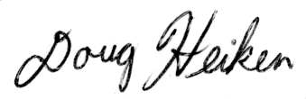
Doug Heiken
dh@oregonwild.org

