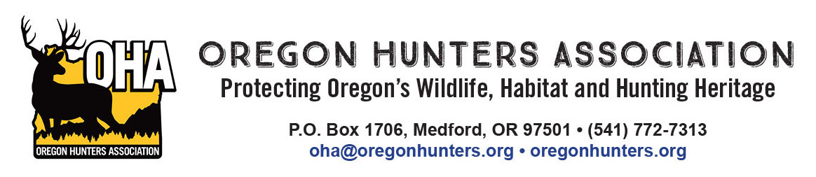

November 30, 2023

RE: Oregon Hunters Association comments on the North Fork Crooked River Forest Resilience Project

The Oregon Hunters Association (OHA) is a sportsmen’s conservation organization with over 11,000
members in 26 chapters across Oregon. OHA values our National Forests as a public place to hunt and recreate, and as a valuable asset providing habitat for the wildlife we care about. As such, the management and access of these lands are of critical importance to OHA. We have been engaged in numerous projects to improve and protect habitat conditions, and we value our partnership with the U.S. Forest Service (USFS). We are providing comments and input on the North Fork Crooked River Forest Resilience Project.

The project proposes to improve forest resiliency in the event of future wildfire or insect and disease outbreaks by reducing forest fuels and thinning. OHA’s primary interest lies with potential effects and benefits to Rocky Mountain elk and mule deer. Impacts of both Alternatives 2 and 3 in the environmental assessment appear to closely mirror one another for these two species. Thus, OHA could support either alternative, but would prefer Alternative 2 for the increased economic support of the local communities.

Specifically, OHA is in support of the Core Habitat area(s) in the proposed action. OHA is also in support of using a distance band approach to evaluate effects of roads on elk instead of using the open road density that current Forest Plan standards are based on. We feel this moves the forest in the direction of using the best available science.

OHA would like to emphasize two other points to consider with project planning and implementation. First, the use of seasonal operational restrictions to avoid disturbance when operating in fawning and calving areas. Second, OHA wants to emphasize the need for project design features that minimize the introduction and spread of noxious weeds across the forest by strictly enforcing decontamination of equipment used in all phases of the project and additional restoration work.

Access of our public lands, including those in this proposal, are a priority to OHA. Managing and balancing this access with wildlife needs should always be considered.

We appreciate the opportunity to comment on the project.

Mike Totey
Conservation Director
Oregon Hunters Association

