4 September 2020
Custer Gallatin Land Management Plan Revision Objection
Objector: David J. Mattson, Ph.D. (see signature at end)
Address: P.O. Box 2406, Livingston, Montana 59047
Email: davidjmattson@gmail.com
Issues Addressed: Provisions for conserving and protecting grizzly bears
The reasons for this objection are listed below, with each objection identified by number. I conclude with a concise statement of proposed solutions. My objections reference numerous documents and publications that necessitated hand delivery of electronic versions on a disc at the USDA Forest Service Northern Region Office in Missoula. This disc was accompanied by a cover letter that clearly associates the contained documents with this objection.
My Background, Credentials, and Standing
- I am a scientist and retired wildlife management professional with extensive experience in grizzly bear research and conservation spanning four decades. My educational attainments include a B.S. in Forest Resource Management, an M.S. in Plant Ecology, and a Ph.D. in Wildlife Resource Management. My professional positions prior to retirement from the U.S. Geological Survey (USGS) in 2013 included: Research Wildlife Biologist, Leader of the Colorado Plateau Research Station, and Acting Center Director for the Southwest Biological Science Center, all with the USGS; Western Field Director of the Massachusetts Institute of Technology-USGS Science Impact Collaborative; Visiting Scholar at the Massachusetts Institute of Technology; and Lecturer and Visiting Senior Scientist at the Yale School of Forestry & Environmental Studies. Throughout my career I have been consulted by brown/grizzly bear managers and researchers worldwide, including from Russia, Japan, France, Spain, Greece, Italy, and, most notably, Canada. I have also given numerous public presentations on grizzly bear ecology and conservation, including talks, nationally, at the Smithsonian (Washington, DC) and American Museum of Natural History (New York, NY), and, regionally, at the Denver Museum of Natural History (Denver, CO), the Museum of Wildlife Art (Jackson, WY), and the Museum of the Rockies (Bozeman, MT).

- My credentials of direct relevance to the following objections arise from (1) having been a lead investigator of grizzly bear research in the Yellowstone Ecosystem during 1983-1993, preceded by involvement as a research technician during 1979-1982; (2) publications arising from this research during 1985-2011; (3) close involvement with development of the Yellowstone Grizzly Bear Cumulative Effects Model (CEM) during 1984-2004; and (4) being a resident of occupied grizzly bear habitat since 2010 as well as a close follower of published grizzly bear research during the last 41 years. Of relevance to item (3), I developed core elements of the CEM, reported in Weaver et al. (1986), Mattson et al. (1986), Mattson & Knight (1991), Mattson & Knight (1993), Mattson et al. (2004), and elsewhere, and drew the boundaries of current Bear Management Units (BMUs) and derivative Subunits in 1985 with the help of Drs. John Weaver and Donald Despain.

- I am submitting the objections below, expressed as a critique in narrative form, expanding on and with explicit connection to comments on the Custer Gallatin National Forest Revised Land Management Plan (hereafter CGNFPlan) that I submitted on 6 June 2019, assigned the ID of 50185-2788-8835 (Mattson 2019a). My objections are also of direct relevance to grizzly bear-related issues raised by others during the comment period.

- First and foremost I object to the fact that virtually all of my comments as well as those submitted by others of relevance to grizzly bear conservation and protection were arbitrarily dismissed in formulation of the current version of the CGNFPlan. My more specific objections follow.
Provisions of the Custer Gallatin National Forest Revised Plan
- The CGNFPlan relies solely on habitat recovery criteria described in a 2007 Supplement to the US Fish & Wildlife Service (Service) Grizzly Bear Recovery Plan to specify standards for protecting grizzly bears. The CGNFPlan at the same time disregards an enormous amount of research and information relevant to assessing and mitigating human impacts on grizzlies, most of which is not accounted for in the Recovery Plan 2007 Supplement. Aside from this substantive problem, a recovery criterion is not a standard, nor does a recovery criterion serve the purpose of guiding concrete on-the-ground actions to remedy harm.

- Barring the invocation of a food storage order designed to secure human foods within the Demographic Monitoring Area (DMA), the only standard in the CGNFPlan that explicitly protects grizzly bears or grizzly bear habitat is limited to the Primary Conservation Area (PCA). This standard defines areas >10 acres (4 hectares) in size and 500-m distant from developed areas or open and temporarily closed roads as being “secure” for grizzly bears. Relevant conditions are specified on the basis of Bear Management Unit Subunits, with an aspirational goal of maintaining secure habitat at levels that existed during 1998. Given that developed areas on CGNF jurisdictions are invariably along roads and comparatively small in size, fulfillment of this standard is, in effect, driven almost wholly by roads. Conditions during 1998 are invoked as a baseline because this year is when demographic recovery criteria specified in the Grizzly Bear Recovery Plan were first met.

- In the following points I elaborate on why the pattern of disregard for science, substitution of monitoring for standards, and conflation of recovery criteria with standards in the CGNFPlan translates into substantial problems that foreseeably harm to grizzly bears.

Secure Areas as Defined in the CGNFPlan are Inadequate
- The first of many problems with the standard used in the CGNFPlan for defining “secure” habitat is the indefensibly small size of areas required to meet the threshold for ensuring security from humans while at the same time providing bears with adequate space for life-sustaining activities. The CGNFPlan assumes, first, that 500-m buffers along roads and developments are sufficient to mitigate mortality risk and displacement and, second, that an area as small as 4 ha within a network of buffers is sufficient for grizzly bears to safely forage and rest for significant periods of time.

- Four hectares is far smaller than any research has shown bears to use for periods even as short as a day. The few available studies of movements at this scale have, in fact, shown grizzly bears to use areas 290-900 ha (720-2,220 acres) in size during 1-2 day periods (Mattson 1993, Gibeau et al. 2001)—areas roughly 70-220 times larger than 4 ha. The upshot is that, despite being defined as “secure” according to the CGNFPlan standard, isolated areas much smaller than roughly 290-900 ha would require bears to spend significant periods of time <500 m from roads and developments to meet daily needs and thus defeat the standard’s presumed purpose.
Amendment 19 and Its Implementation are Inadequate
- The CGNFPlan invokes Amendment 19 as a basis for monitoring road densities within the PCA, specifically areas impacted by >1 mile/mile² of open roads and >2 miles/mile² of roads both closed and open, but without offering any authoritative guidance or prescriptive response for when Amendment 19 standards are exceeded. Aside from lacking any substantive guidance, the Plan’s disregard for impacts attributable to open road densities in excess of 1 miles/mile² ignores a substantial body of research showing that human impacts on grizzly bears increase exponentially with increasing road densities (e.g., Mace et al. 1996, Johnson et al. 2004, Suring et al. 2006, Schwartz et al. 2010, Boulanger & Stenhouse 2014, Lamb et al. 2020). This nonlinear relationship is not captured in a simple buffering of roads that assumes impacts on bears within a fixed buffer are equal regardless of larger-scale juxtapose with other roads, or in an approach that categorizes impacts on grizzly bears simply according to whether open road densities are greater or less than 1 mile/mile².

- A recent federal court opinion (Alliance for the Wild Rockies vs. Cheryl Probert) is of further relevance to implementing Amendment 19 on CGNF lands, even for the simple purposes of monitoring. The Federal Judge in this case made clear that simply calling a road “closed” is not sufficient, but rather barriers used to close roads must demonstrably stop human traffic. This consideration is not only of legal but also practical importance given the low threshold of vehicle traffic (roughly 10 vehicles per day) at which impacts on grizzly bears have been demonstrated (see points 17 and 18 below).

The CGNFPlan Fails to Directly Address the Reasons Why Grizzly Bears Die
- These fundamental failings are rooted in an untenable assumption: that the road infrastructure—essentially the physical road prism—encapsulates all of the ways that humans impact grizzly bear reproduction and survival. Yet roads, as such, clearly do not kill grizzly bears. It is the people on roads that are the direct and indirect arbiters of impacts. At most, grizzly bears react to the physical presence of roads based on past histories with people on roads. Emphasizing this point, some research has shown that, absent people, grizzly bears will travel along roads and consume foods that proliferate along road margins (Roever et al. 2008a, 2008b). Even more important, people are not confined to roads, but also travel on trails as well as cross-country.

- Focusing solely on roads, as does the CGNFPlan, misses the fact that people—not road grades, prisms, or surfaces—kill 80-90% of adolescent and adult grizzlies (Mattson 1998, McLellan et al. 1999, Mattson et al. 1996, Schwartz et al. 2006), and create a dynamic that results in avoidance, displacement, and alienation by bears. Moreover, people with guns and associated with attractants such as animal carcasses are demonstrably more lethal to grizzly bears compared to people without guns traveling along a road (Mattson et al. 1996a, 1996b).

- The CGNFPlan does not directly address the reasons why grizzly bears die from human causes in any goals or standards. This a major deficiency, first, because human-caused mortality is a severe threat to grizzly bears (U.S. Fish & Wildlife Service 1993) and, second, because physical distance from roadbeds does not, in fact, address the main reason why grizzly bears die on the CGNF.
Hunters Are the Main Cause of Grizzly Bear Deaths on the CGNF
- Reports and databases published by the Interagency Grizzly Bear Study Team (U.S. Geological Survey, Interagency Grizzly Bear Study Team, Data and Tools; Knight et al. 1989-1993, 1997; Knight & Blanchard 1994, 1995; Haroldson et al. 1998; Schwartz & Haroldson 1999-2003; Schwartz et al. 2004-2010) highlight this last problem. Between 1998 and 2019, 50-58% of all grizzly bears killed by humans on the CGNF died because of encounters with hunters (Figure 1; this is for known and probable deaths, with the range dependent upon how deaths currently under investigation are treated). The second most common cause is conflicts related to human attractants in developed areas, followed by collisions with vehicles on highways—neither of which account for more than 15-20% of deaths (Figure 1).

- Deaths attributable to hunters have moreover increased proportionally over time from 47% during 1988-1997 to 59% during 2009-2019 (Figure 2a), and, in absolute terms, from roughly 0.7 to 1.5-1.8 per year during the same time period (Figure 2b). In other words, the threat posed by conflicts with hunters has gotten more rather than less severe, including a near tripling of absolute numbers of hunter-caused bear deaths since 2009. Notably, this increase far exceeds any increase in bear distribution or numbers within the CGNF portion of the DMA (Van Manen et al. 2019).

- The problems intrinsic to relying on a fixed buffer along roads and around developed areas to define the geospatial extent of human threats to grizzly bears are thrown into sharp relief by the prevalence of hunter-caused deaths. Virtually none of the close threatening encounters between bears and hunters occur on or near roads (Haroldson et al. 2004, Servheen et al. 2009). Rather, almost all occur on trails, at backcountry campsites, or in off-trail areas. Moreover, most close encounters between and grizzlies and hunters on foot occur in areas >500 m from mapped roads used to calculate habitat security.
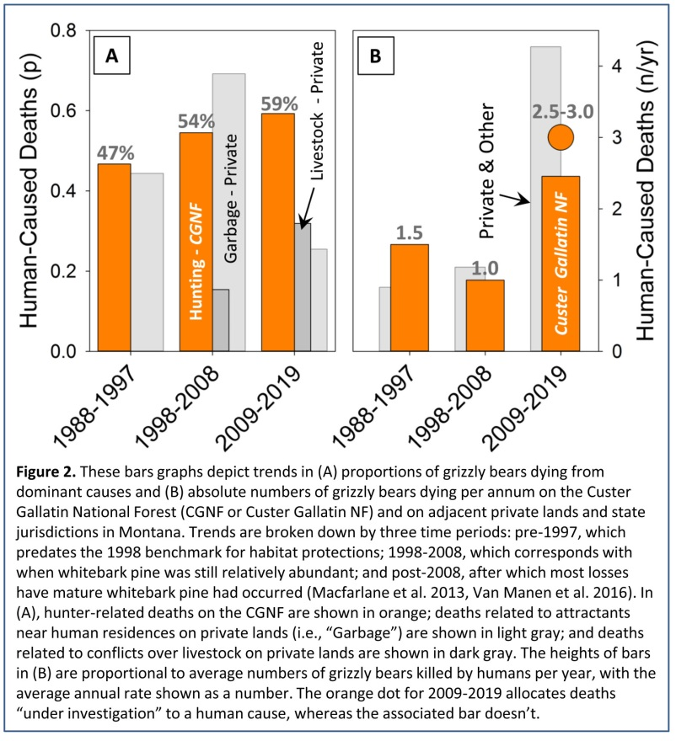
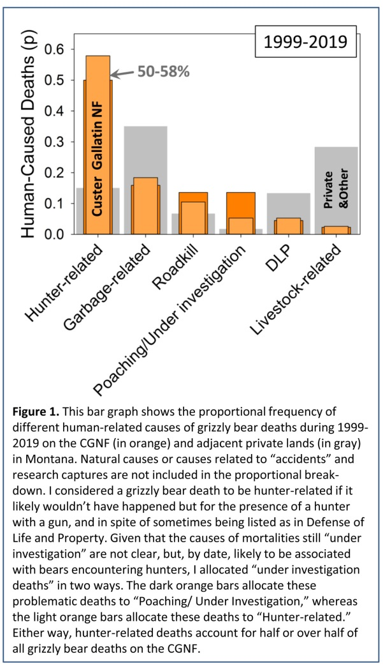

- More important yet, managing roads, as such, does not address the proximal factors contributing to fatal encounters of grizzly bears with hunters, including, for example: failure of hunters to carry pepper spray; failure of hunters to keep a clean camp; killing big game late in the day without retrieval of the carcass before nightfall; hunting alone; and stealthily hunting as an archer (Servheen et al. 2009). The common response by the US Forest Service to these sorts of problematic activities on Forest Service lands is to claim lack of authority. Even so, there are cogent arguments for why this claim is not valid (Nie et al. 2017, Nie 2020).
The CGNFPlan’s Assumption That All Roads are Equal is Indefensible
- Another problem with how the CGNFPlan treats roads arises from the fact that grizzly bears respond differently to a roadbed or road prism depending on levels of traffic. The Plan currently treats all roads as equal insofar as impacts on bears are concerned, whether reckoned in terms of avoidance, habitat alienation, or risk of mortality. This treatment is not defensible. Ample research has shown that avoidance of roads by bears increases as traffic volume increases, at first inducing a shift to greater nocturnality (Martin et al. 2010; Ordiz et al. 2014, 2016) although, at some point, spatial impacts are no longer being offset by this diel shift in activity (Mace et al. 1999, Chruszoz et al. 2003, Northrup et al. 2012a, Roever et al. 2010, Ladle et al. 2019, Van der Marel et al. 2020).

- Thresholds of response by grizzly bears to vehicle traffic are relatively low. Avoidance is evident at traffic levels of around 10 vehicles per day, with major impacts evident at around 100-200 vehicles/day barring situations such as in National Parks where habituation to contact with humans can mitigate such impacts (Mattson et al. 1987, Mace et al. 1999, Roever et al. 2010, Northrup et al. 2012a). Not surprisingly, when traffic exceeds roughly 100 vehicles per hour, as occurs during daylight hours along Highways 191, 89, and even 212, highways can become impenetrable barriers for grizzly bears (Waller & Servheen 2005). These high-speed, high-traffic volume highways also account for most grizzly bear deaths from vehicle strikes within CGNF jurisdictions (U.S. Geological Survey, Interagency Grizzly Bear Study Team, Data and Tools).
The CGNFPlan Does Not Address Impacts of Non-Motorized Human Activities
- Neglect of impacts by people involved in non-motorized off-road activities is also a critical shortcoming of the CGNGPlan, especially given the substantial body of research showing that impacts on grizzly bears can be substantial. Mattson (2019b) provides a comprehensive summary of relevant scientific literature and interpretation of impacts by hikers, photographers, wildlife watchers, hunting, and mountain bikers on grizzly bears, with an emphasis on displacement and avoidance.

- For example, grizzly bears take flight from pedestrians during roughly 72% of encounters, with flight initiated at around 83 m from the involved person and covering an average distance of around 2 km. This distance notably spans nearly twice the diameter of areas deemed to be “secure” by the CGNFPlan, even when 500-m buffers along roads are included. Longer-term impacts on movements and activity patterns can last 1-3 days (Mattson 2019b: Section 3).

- Aside from reactions to specific encounters with people, ample research has shown that histories of trail and campsite use by people can have major effects on grizzly bear movements, activity patterns, and habitat selection, manifest in displacement and avoidance. One near-universal impact is an increase in nocturnal behavior. Related to this, reduced foraging efficiencies have been commonly documented, with declines in the range of 20-50% (Mattson 2019b: Section 5). Avoidance of trails averages 270 m, whereas avoidance of campsites averages 550 m (Mattson 2019b: Section 6).

- These impacts on bear behaviors are clearly of a magnitude comparable to the impacts of people on secondary roads typical of the CGNF, and need to be accounted for with implementation of meaningful standards. The assertion made in the 2006 Gallatin National Forest Travel Management Plan ROD that “impacts of non-motorized summer travel…were not significant issues” is patently indefensible in light of the best available science.
The CGNFPlan Does Not Address the Disproportionate Impacts of Mountain Biking
- The impacts of mountain bikers on grizzly bears are noteworthy (Mattson 2019b: Section 8a). Encounters between grizzly bears and mountain bikers are at closer average distances compared to encounters involving people on foot; far more often involve females with dependent young; and far more often result in aggressive responses from the involved bears (Mattson 2019b: Section 8a). These aspects of bear-biker encounters are not surprising given that mountain bikers travel silently and at comparatively high speeds which, combined, increase the odds of close-range encounters that elicit a high degree of reactivity from the involved bears.

- The weight of available evidence indisputably shows that impacts of mountain bikers on grizzly bears are disproportionately severe compared to the impacts of other people involved in non-motorized activities, with attendant disproportionate risks for people on bikes (Mattson 2019b: Section 8a). Numbers of people using mountain bikes have, moreover, increased substantially since 2000 (e.g., Corporate Research Associates 2010). Of particular relevance to the CGNFPlan, mountain bikers have access to the majority (>50%) of the CGNF (i.e., semi-primitive motorized and non-motorized areas within which “mountain bikes and other mechanized equipment” are “often” or “sometimes also” present). This creates a mandate for the CGNF to address the threat posed by mountain bikes with meaningful monitoring and standards.
The CGNFPlan Fails to Consider Habitat Productivity and Attractiveness
- Neglect of habitat productivity and attractiveness is yet another failing in the approach taken by the CGNFPlan to addressing impacts of human activities on grizzly bears. This neglect is problematic even when adopting the untenable assumption that human impacts are confined to areas within 500 m of roads and developed areas. The reason is straight-forward. Ample research in the Yellowstone Ecosystem as well as throughout the Northern Hemisphere has shown that grizzly bears—like virtually all other mammalian species—select for areas where high-quality foods are abundant, even when controlling for human impacts (e.g., among many others: Mattson 1997, Mattson et al. 2004, Costello et al. 2014).

- In other words, it matters whether a road or development is located in unproductive unattractive habitat versus productive attractive habitat. Compared to lower quality habitats transected by roads, bears will more often be attracted to areas near roads located in high quality habitat, where they will then incur the direct and indirect risks associated with encountering humans. This basic fact was well-recognized in pre-2000 formulations of the Yellowstone Ecosystem Grizzly Bear Cumulative Effects Model (Weaver et al. 1986; Mattson et al. 1986, 2004), and has been more recently emphasized in research reported by Canadian researchers from Alberta and southeastern British Columbia (Apps et al. 2004, 2016; Nielsen et al. 2010; Proctor et al. 2017; Lamb et al. 2017, 2020), which recommends setting road density thresholds at lower levels (e.g., 0.6 miles/mile²) to protect productive attractive habitats (Van der Marel et al. 2020).

- Extreme instances where attractive habitats associated with human facilities create problematic even lethal dynamics for grizzly bears are called ecological traps or attractive sinks. Attractants can be in the form of either natural or anthropogenic foods. Heightened human-bear conflicts and associated levels of grizzly bear mortality are characteristic features of traps and sinks, which have been well-documented for grizzly bears, notably by Berland et al. (2008), Northrop et al. (2012b), Boulanger et al. (2018), Periteriani et al. (2018), and Lamb et al. (2020). In the Yellowstone Ecosystem, sinks have long been a feature of areas near towns such as Cooke City, Gardiner, West Yellowstone, and Big Sky (Knight et al. 1988), but new traps are emerging organized around livestock grazing on both public and private lands. The most striking examples are on grazing allotments in the Owl Creek Mountains and Upper Green River areas of the Shoshone National Forest as well as the Gravelly Mountains on the Beaverhead-Deerlodge National Forest (Wells 2017, Wells et al. 2019).

- Even though ecological traps centered on livestock are not yet evident on the CGNF, similar dynamics have emerged on adjacent private lands (Figures 1 and 2a). The main point here is that traps and sinks are extremely problematic, with spatial expression beyond the immediate locale of attractants. Sinks and traps are also almost certain to emerge on CGNF grazing allotments, especially given the persisting reliance of grizzly bears on anthropogenic meat sources sink 2009 (Orozco & Miles 2013, Middleton et al. 2013, Schwartz et al. 2014, Ebinger et al. 2016), which necessitates meaningful and proactive measures in the CGNFPlan.
The CGNFPlan Fails to Protect Grizzly Bears and Grizzly Bear Habitat Outside the PCA
- The issue of grazing allotments highlights yet another serious short-coming with the CGNFPlan. As inadequate as the Plan’s grizzly bear-related standards are, they apply only to the PCA and not the DMA. Specific to grazing allotments, provisions for monitoring livestock occupancy and stocking also only pertain to the PCA. This limited scope of protections, such as they are, is important simply because roughly 56% of the DMA on the CGNF is outside the PCA (Figure 3). Even more dramatically, roughly 79% of all grazing allotments in the DMA are outside the PCA (Reid 2016). In other words, much if not most of the area occupied by grizzly bears on the CGNF has no explicit provisions for protecting habitat or providing security.

- Designated Wilderness provides de facto protections for grizzly bears on the CGNF. Even so, fully 33% of the DMA is both outside of Wilderness Areas and outside the bounds of minimal protections offered by standards applied only to the PCA. As important, the numerous serious short-comings of CGNFPlan standards described above makes Wilderness Areas all the more important given that they alone provide grizzly bears with meaningful de facto protections. Notably, roughly 52% of the PCA and 59% of the DMA are outside of Wilderness Areas, in areas where meaningful protections are absent.
- The discrepancy between areas covered by the DMA and PCA also highlights a fundamental short-coming in the assumptions upon which the CGNFPlan rests. Bears within the DMA are counted towards reaching demography recovery criteria, yet habitat protections—albeit nominal in the case of the CGNFPlan—apply only to the PCA. As was made clear in mid-1990s litigation of the 1993 Grizzly Bear Recovery Plan (The Fund for Animals vs. Bruce Babbitt) and subsequent settlement agreement, it is not sufficient to protect bears, as such, being counted toward reaching recovery goals. The habitats upon which bears depend also need to be protected. This simple fact makes the absence of habitat standards on 56% of habitat deemed to be suitable for grizzly bears on the CGNF all the more glaring.
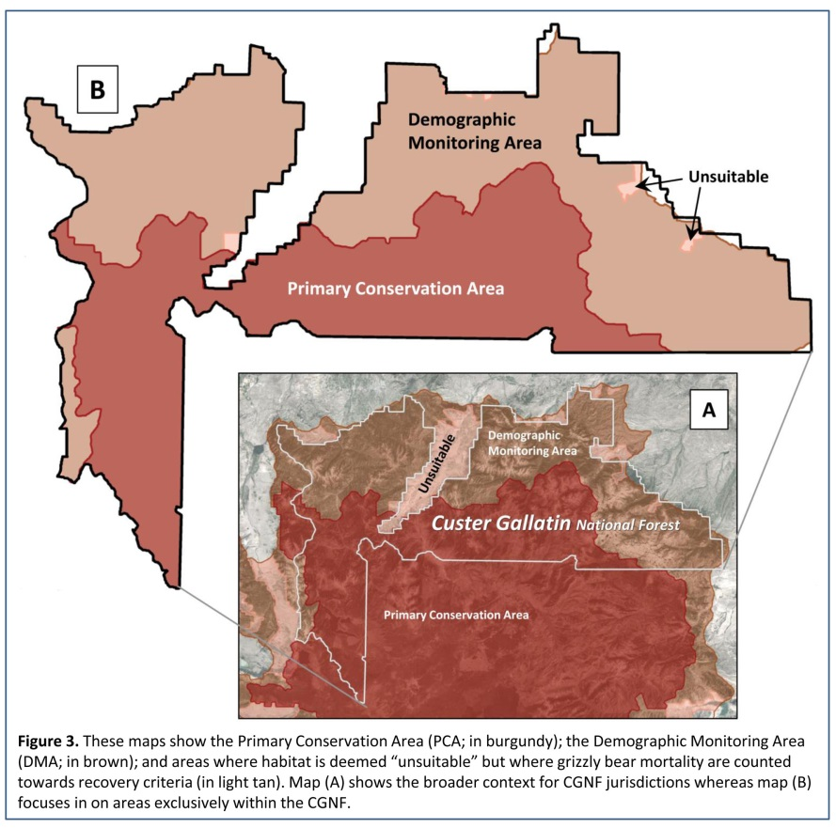

The CGNFPlan Fails to Address Impacts of Changes Since 1998
- A final major problem with the CGNFPlan that I address here is the untenable assumption that simple and largely static geospatial measures of human infrastructure capture all of the changes since 1998 that have affected and will continue to affect interactions between grizzly bears and humans. In other words, the CGNFPlan assumes that mapped roadbeds and physical features of human developments capture changing levels, types, and distributions of human activity, regardless of whether on or off roads or inside or outside of developed areas. This reliance on a few static measures of infrastructure also assumes that there have been no changes in bear habitats and foods leading to changes in bear distributions and behaviors, with implications for exposure of bears to people and conflict situation. All these assumptions are prima facie untenable, if not absurd. I elaborate in the four following points.

- Numbers of people living and recreating in or near the Greater Yellowstone DMA have increased dramatically, especially during the last decade. Numbers of people residing in Gallatin County, Montana, Teton County, Wyoming, and Teton County, Idaho have increased at an astounding 2.4% per annum rate since 2010. Even in less rapidly growing rural counties of the Greater Yellowstone Ecosystem (GYE), populations have increased at a steady 0.2% per annum rate (Figure 4a & e; U.S. Census Bureau: County Population Totals 2010-2019). On top of this, annual visitation to Yellowstone National Parks increased from an average near 3 million during the 2000s to nearer 3.7 million during the 2010s, with visitation surpassing 4 million each year 2015-2019 (Gunther 2019). Trends in Grand Teton National Park were comparable (Wilmot 2019).
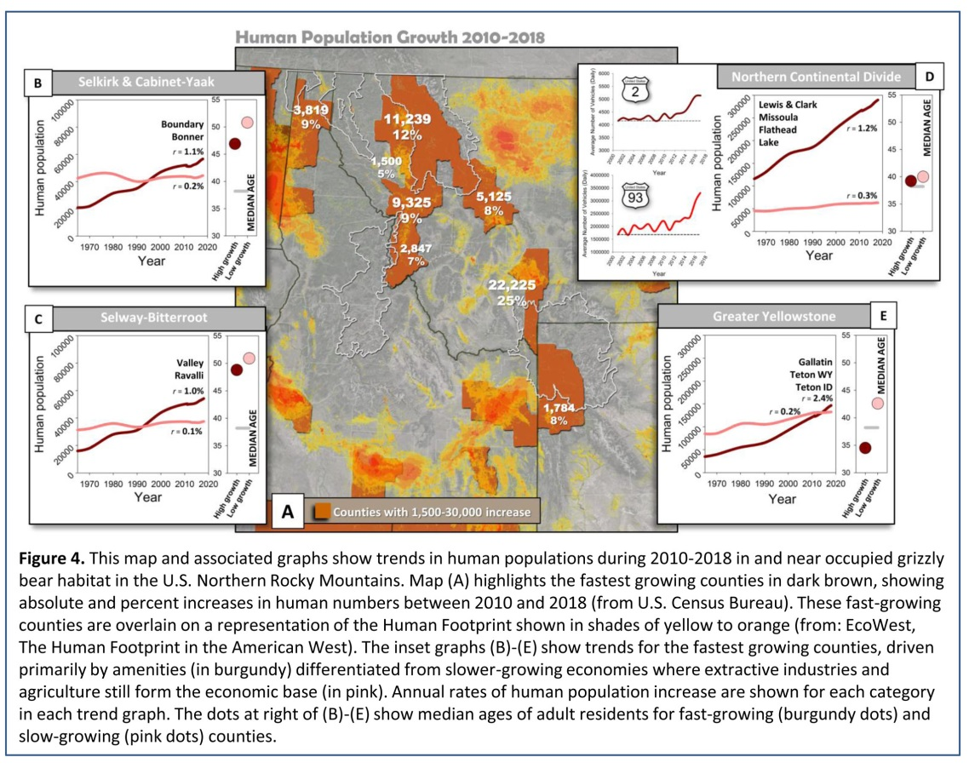

- Although information on backcountry human use in the GYE is less readily available, permitted overnight use in Grand Teton National Park increased from roughly 30,000 per year during 2009-2014 to roughly 40,000 per year during 2017-2019 (Wilmot 2019), although permitted overnight use in Yellowstone National Park during the same period remained relatively constant (Gunther 2020). Importantly, none of this information pertains to day use, and all was collected in National Parks where visitors are limited to designated backcountry campsites and required to obtain permits. Of more direct relevance to the CGNF, levels of dispersed recreation increased by a staggering 76% between 2008/2009 and 2013/2014, with 41% of surveyed people describing hiking/walking as their primary activity (Oswald 2017). Bicycling was the second most popular summer activity at around 8% (Oswald 2017). All this makes the CGNFPlan’s deficient provisions for managing and monitoring off-road human activities in the DMA all the more indefensible.

- There have been major changes in grizzly bear habitat on the Custer Gallatin National Forest since 1998. Most importantly, there have been major losses of mature cone-producing whitebark pine trees, especially in western portions of the CGNF (Figure 5; Macfarlane et al. 2013). An estimated 70% of mature trees have died ecosystem-wide (Macfarlane et al. 2013; Van Manen et al. 2016, 2019), with little likelihood of replacement as a functional bear food given the projected effects of climate change (e.g., Chang et al. 2014, Hansen & Phillips 2015, Case & Lawler 2016, Wong & Daniels 2017). Areas burned by wildfires have also continued to mount since 2000 (Figure 5; ArcGIS US Historical Fire Perimeters from 2000-2018), with implications for both habitat selection by grizzly bears (Blanchard & Knight 1990, Mattson 1997, Mattson et al. 2004) and the related abundance of food sources such as fruit-bearing shrubs (e.g., Martin 1979, 1983; Anderson 1994; Hamer 1996; Doyle et al. 1998, Souliere et al. 2020). Populations of elk on and near the Bozeman, Gardiner, and Yellowstone Ranger Districts plummeted between the mid-1990s and 2010 (Hamlin et al. 2009, MacNulty et al. 2016, Northern Yellowstone Cooperative Wildlife Working Group). Compounding these changes, summer temperatures have steadily mounted, punctuated by increasingly frequent drought conditions (e.g., Figure 6, based on NOAA National Centers for Environmental Information, Yellowstone Basin weather data).

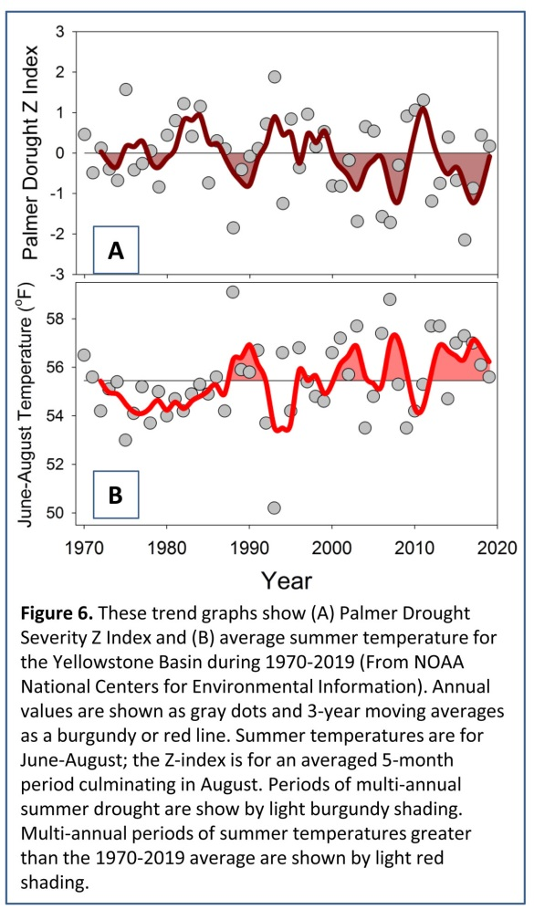
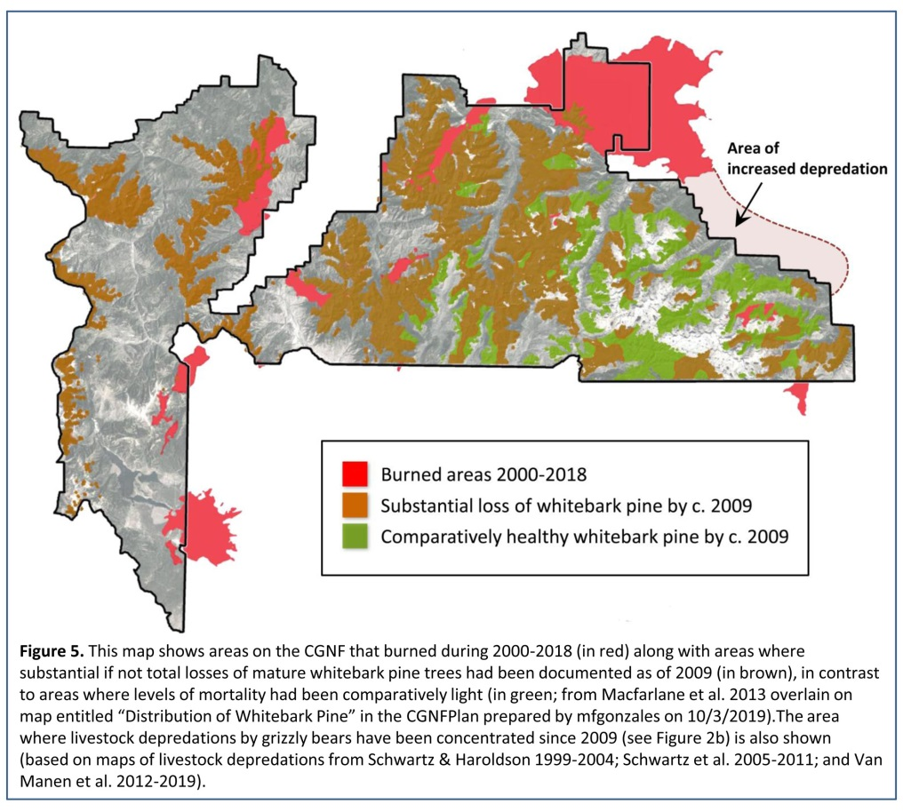

- All of these changes have had substantial implications for diets and habitat use of grizzly bears given the historical reliance of especially female grizzly bears on whitebark pine seeds (Mattson et al. 1991, 1994; Mattson 2000; Mattson et al. 2004), the prospective future importance of fleshy fruit to grizzly bears in the Yellowstone Ecosystem (Ripple et al. 2014), and the demonstrable effects of drought on grizzly bear diets in the Yellowstone Ecosystem (e.g., Mattson 2000, 2001, 2002).

- Grizzly bears have responded to habitat changes with dietary shifts and related changes in habitat selection (e.g., Costello et al. 2014). Most notably, consumption of meat from large herbivores by grizzly bears has increased substantially since the mid-2000s (e.g., Orozco & Miles 2013, Middleton et al. 2013, Schwartz et al. 2014, Ebinger et al. 2016). Conflicts with big game hunters and depredations of livestock have correspondingly mounted on lands inside the PCA and DMA, with a sharp increase beginning after 2009 (Schwartz & Haroldson 1999-2004; Schwartz et al. 2005-2011; Van Manen et al. 2012-2019; Wells 2017; Wells et al. 2019). These trends are clearly manifest in the prevalence and increasing incidence of hunter-caused grizzly bear mortality on the CGNF (Figure 1a), as well the burgeoning of livestock-related conflicts and bears deaths on nearby private lands (Figure 1b).
Conclusions
- The CGNFPlan’s sole grizzly-bear related standard, applied only to the PCA, neglects a host of human-related factors that research has shown to negatively impact grizzly bears wherever grizzly bears may roam. This standard also does not directly reflect the reasons why humans kill grizzly bears, the conflicts that often lead to human-caused grizzly bear deaths, or the spatial distributions of deaths. Nor does this standard account for the considerable extent to which habitat productivity and attractiveness mediate impacts of humans and human infrastructure on bears, the considerable impacts of off-road human activities, or the considerable changes in habitats and foods that have driven changes in grizzly bear distributions and diets in the Yellowstone Ecosystem since the mid-1990s.

- As a result, the CGNFPlan, as currently written, depends on numerous unwarranted assumptions. (1) The Plan assumes that non-motorized human activities, mountain biking in particular, have no impacts on grizzly bears. (2) The Plan assumes that all roads are equal, regardless of the level or speed of traffic. (3) The Plan assumes that habitat productivity and attractiveness have no effect on distributions or behaviors of grizzly bears. (4) The Plan assumes that levels of human activity and configurations and quality of habitats have not changed since 1998. (5) The Plan assumes that grizzly bear habitat needs no protections outside the PCA in places occupied by grizzly bears used to count towards demographic recovery goals. (6) The Plan assumes that grizzly bears die solely for reasons somehow—directly—associated with mapped developed areas and roadbeds. (7) The Plan assumes that densities of open roads in excess of 1 mile/mile² have no additional impacts on grizzly bears. (8) The Plan assumes that areas as small as 4 hectares provide sufficient space for grizzly bears to meet life needs without being displaced or exposed to risks of human-caused mortality.

- All of these assumptions have been repeatedly falsified by scientific research or rendered indefensible by the best available information. Protections for grizzly bears and grizzly bear habitats in the CGNFPlan currently are at odds with virtually all of the available evidence. The Plan’s reliance on outdated and unsubstantiated standards described in a Supplement to the Grizzly Bear Recovery Plan does not obviate this fact.

- For these and other reasons, the Custer Gallatin National Forest’s Revised Land Management Plan fails to conserve grizzly bears on the CGNF and fails to include the plan components or ecological conditions necessary to contribute to the legal fulfillment of grizzly bear recovery. The Custer Gallatin National Forest’s Environmental Impact Statement fails to fulfill NEPA requirements to adequately evaluate and analyze the direct, indirect, and cumulative impacts of the Custer Gallatin National Forest Revised Land Management Plan on grizzly bears, grizzly bear habitat, and grizzly bear recovery in the CGNF and larger Greater Yellowstone region. The related Endangered Species Act Section 7 consultation documents also fail this requirement.
Proposed Solutions
- Given these factual patterns and resulting conclusions, the Custer Gallatin National Forest Revised Plan, as written, needs to be further revised to: (1) Apply all standards developed to protect grizzly bears in the PCA to the DMA as well; (2) Develop and apply standards that adequately address impacts of non-motorized activities on grizzly bears, notably the impacts of mountain biking; (3) Develop and apply standards that adequately address the impacts of backcountry trail and campsite infrastructure on grizzly bears; (4) Develop and apply standards as well as related procedures for integrating habitat productivity and attractiveness into delineations of secure grizzly bear habitat; (5) Revise definitions and delineations of secure grizzly bear habitat so as to require that inclusions within 500-m buffers around roads and developed areas are a minimum of 290 hectares in size; (6) Develop and apply standards for defining secure grizzly bear habitat that account for non-linear increases in human impacts at road densities >1 mile/mile²; (7) Of relevance to (6), explicitly include road densities in definitions of grizzly bear habitat security that are also codified in related standards; (8) Develop and apply standards for defining secure grizzly bear habitat that account for different levels of traffic on roads and highways; (9) Promulgate rules, regulations, procedures, and related standards that adequately address and remedy hazards posed by big game hunters to grizzly bears on CGNF jurisdictions; (10) Promulgate rules, regulations, procedures, and related standards that adequately address and remedy existing and foreseeable hazards to grizzly bears posed by livestock operations on CGNF grazing allotments; and (11) Modify all standards for defining secure grizzly bear habitat so as to account for the many substantial changes in levels and types of human activities as well as distributions and productivity of grizzly bear habitats that have occurred since 1998.

These objections are respectfully submitted by:
David J. Mattson, Ph.D.

Referenced Documents
With a very few exceptions, the urls associated with the references and documents below allow for direct download of documents. At a minimum, all of these links provide a view of document abstracts. Electronic versions of these documents and publications were also delivered on a disc to the USDA Forest Service Northern Region Office in Missoula. This disc was accompanied by a cover letter that clearly associates the contained documents with this objection.
Apps, C. D., McLellan, B. N., Woods, J. G., & Proctor, M. F. (2004). Estimating grizzly bear distribution and abundance relative to habitat and human influence. Journal of Wildlife Management, 68(1), 138-152. https://wildlife.onlinelibrary.wiley.com/doi/abs/10.2193/0022-541X(2004)068[0138:EGBDAA]2.0.CO;2
Apps, C. D., McLellan, B. N., Proctor, M. F., Stenhouse, G. B., & Servheen, C. (2016). Predicting spatial variation in grizzly bear abundance to inform conservation. Journal of Wildlife Management, 80(3), 396-413. https://wildlife.onlinelibrary.wiley.com/doi/abs/10.1002/jwmg.1037
Anderson, N.J. (1994) Grizzly bear food production on clearcuts within the western and northwestern Yellowstone ecosystem. M.S. Thesis, Montana State University, Bozeman, Montana. https://scholarworks.montana.edu/xmlui/bitstream/handle/1/7659/31762102666680.pdf?sequence=1
ArcGIS US Historical Fire Perimeters from 2000-2018. https://www.arcgis.com/home/item.html?id=9c407d9f46624e98aa4fca1520a3a8f7
Berland, A., Nelson, T., Stenhouse, G., Graham, K., & Cranston, J. (2008). The impact of landscape disturbance on grizzly bear habitat use in the Foothills Model Forest, Alberta, Canada. Forest Ecology & Management, 256(11), 1875-1883. https://www.sciencedirect.com/science/article/abs/pii/S0378112708005719
Bischof, R., Steyaert, S. M., & Kindberg, J. (2017). Caught in the mesh: Roads and their network‐scale impediment to animal movement. Ecography, 40(12), 1369-1380. https://onlinelibrary.wiley.com/doi/full/10.1111/ecog.02801
Blanchard, B. M., & Knight, R. R. (1990). Effects of the 1988 wildfires on Yellowstone grizzly bears. Pages 14-18 in Knight, R. R., Blanchard, B. M., & Mattson, D. J. Yellowstone grizzly bear investigations: annual report of the Interagency Study Team, 1989. U.S. National Park Service, Bozeman, Montana. https://www.usgs.gov/centers/norock/science/igbst-annual-reports?qt-science_center_objects=7#qt-science_center_objects
Boulanger, J., & Stenhouse, G. B. (2014). The impact of roads on the demography of grizzly bears in Alberta. PLOS One, 9(12), e115535. https://journals.plos.org/plosone/article?id=10.1371/journal.pone.0115535
Boulanger, J., Nielsen, S. E., & Stenhouse, G. B. (2018). Using spatial mark-recapture for conservation monitoring of grizzly bear populations in Alberta. Scientific Reports, 8(1), 1-15. https://www.nature.com/articles/s41598-018-23502-3/
Case, M. J., & Lawler, J. J. (2016). Relative vulnerability to climate change of trees in western North America. Climatic Change, 136(2), 367-379. https://link.springer.com/article/10.1007/s10584-016-1608-2
Chang, T., Hansen, A. J., & Piekielek, N. (2014). Patterns and variability of projected bioclimatic habitat for Pinus albicaulis in the Greater Yellowstone Area. PLoS One, 9(11). https://journals.plos.org/plosone/article?id=10.1371/journal.pone.0111669
Chruszcz, B., Clevenger, A. P., Gunson, K. E., & Gibeau, M. L. (2003). Relationships among grizzly bears, highways, and habitat in the Banff-Bow Valley, Alberta, Canada. Canadian Journal of Zoology, 81(8), 1378-1391. https://www.nrcresearchpress.com/doi/abs/10.1139/z03-123#.X0-9ilVKiUk
Corporate Research Associates (2010). Secondary research—mountain biking market profiles: Final report. Corporate Research Associates. Accessed via: https://www.nemba.org/science-economics-trails-and-mountain-biking
Costello, C. M., van Manen, F. T., Haroldson, M. A., Ebinger, M. R., Cain, S. L., Gunther, K. A., & Bjornlie, D. D. (2014). Influence of whitebark pine decline on fall habitat use and movements of grizzly bears in the Greater Yellowstone Ecosystem. Ecology & Evolution, 4(10), 2004-2018. https://onlinelibrary.wiley.com/doi/full/10.1002/ece3.1082
District Judge, Paul L. Friedman. (29 September 1995). OPINION, 903 F. Supp. 96 (D.D.C. 1995); The Fund for Animals, et al., Plaintiffs vs. Bruce Babbitt, et al. Defendents; The National Audubon Society, et al., Plaintiffs vs. Bruce Babbitt, et al., Defendants. Nos. 94-1021, 94-1106. https://law.justia.com/cases/federal/district-courts/FSupp/903/96/1361144/
District Judge Donald W. Malloy. (3 October 2019). OPINION and ORDER, CV 18-67-M-DWM; Alliance for the Wild Rockies, Plaintiff, vs. Cheryl Probert, Kootenai National Forest Supervisor, et al. Defendants. https://casetext.com/case/all-for-wild-rockies-v-probert
Doyle, K. M., Knight, D. H., Taylor, D. L., Barmore, W. J., Jr., & Benedict, J. M. (1998). Seventeen years of forest succession following the Waterfalls Canyon fire in Grand Teton National Park, Wyoming. International Journal of Wildland Fire, 8(1), 45-55. https://ecoshare.info/uploads/ccamp/synthesis_paper_tools/huckleberry/Doyle_et_al._1998.pdf
Ebinger, M. R., Haroldson, M. A., van Manen, F. T., Costello, C. M., Bjornlie, D. D., Thompson, D. J., ... & White, P. J. (2016). Detecting grizzly bear use of ungulate carcasses using global positioning system telemetry and activity data. Oecologia, 181(3), 695-708. https://link.springer.com/article/10.1007/s00442-016-3594-5
EcoWest, The Human Footprint in the American West. http://ecowest.org/2013/05/01/human-footprint-in-west/
Gallatin National Forest (2006). Gallatin National Forest Travel Management Plan: Record of Decision. USDA Forest Service, Gallatin National Forest, Bozeman, Montana.
Gibeau, M. L., Herrero, S., McLellan, B. N., & Woods, J. G. (2001). Managing for grizzly bear security areas in Banff National Park and the Central Canadian Rocky Mountains. Ursus, 12, 121-129. https://www.bearbiology.org/publications/ursus-archive/managing-for-grizzly-bear-security-areas-in-banff-national-park-and-the-central-canadian-rocky-mountains/
Graham, K., Boulanger, J., Duval, J., & Stenhouse, G. (2010). Spatial and temporal use of roads by grizzly bears in west-central Alberta. Ursus, 21(1), 43-56. https://www.researchgate.net/profile/John_Boulanger/publication/232692391_Spatial_and_temporal_use_of_roads_by_grizzly_bears_in_west-central_Alberta/links/0c960522f3f07dbb97000000.pdf
Gunther, K. (2019). Yellowstone National Park recreational use. Pages 58-61 in Van Manen, F. T., Haroldson, M. A., & Karabensh, B. E. (eds). Yellowstone grizzly bear investigations: Annual Report of the Interagency Grizzly Bear Study Team: 2018. U.S. Geological Survey, Bozeman, Montana. https://www.usgs.gov/centers/norock/science/igbst-annual-reports?qt-science_center_objects=7#qt-science_center_objects
Hamer, D. (1996). Buffaloberry [Shepherdia canadensis (L.) Nutt.] fruit production in fire-successional bear feeding sites. Journal of Range Management, 49(6), 520-529. https://journals.uair.arizona.edu/index.php/jrm/article/viewFile/9162/8774
Hamlin, K. L., & Cunningham, J. A. (2009). Monitoring and assessment of wolf-ungulate interactions and population trends within the Greater Yellowstone Area, southwestern Montana, and Montana statewide: Final Report. Montana Department of Fish, Wildlife, and Parks, Wildlife Division, Helena, Montana, USA. https://digitalcommons.unl.edu/cgi/viewcontent.cgi?article=1027&context=wolfrecovery
Hansen, A. J., & Phillips, L. B. (2015). Which tree species and biome types are most vulnerable to climate change in the US Northern Rocky Mountains?. Forest Ecology & Management, 338, 68-83. https://scholarworks.montana.edu/xmlui/bitstream/handle/1/8935/HansenandPhillips_FEM_%202015_POSTPRINT.pdf?sequence=1&isAllowed=y
Haroldson, M. S. Tement, M., Holm, G., Swalley, R. A., Podruzny, S., Moody, D., & Schwartz. C. C. (1998). Yellowstone grizzly bear investigations: annual report of the Interagency Grizzly Bear Study Team, 1997. U.S. Geological Survey, Bozeman, Montana. https://www.usgs.gov/centers/norock/science/igbst-annual-reports?qt-science_center_objects=7#qt-science_center_objects
Haroldson, M. A., Schwartz, C. C., Cherry, S., & Moody, D. S. (2004). Possible effects of elk harvest on fall distribution of grizzly bears in the Greater Yellowstone Ecosystem. Journal of Wildlife Management, 68(1), 129-137. https://wildlife.onlinelibrary.wiley.com/doi/abs/10.2193/0022-541X(2004)068[0129:PEOEHO]2.0.CO;2
Johnson, C. J., Boyce, M. S., Schwartz, C. C., & Haroldson, M. A. (2004). Modeling survival: application of the Andersen-Gill model to Yellowstone grizzly bears. Journal of Wildlife Management, 68(4), 966-978. https://wildlife.onlinelibrary.wiley.com/doi/abs/10.2193/0022-541X(2004)068[0966:MSAOTA]2.0.CO;2
Kearney, S. P., Coops, N. C., Stenhouse, G. B., Nielsen, S. E., Hermosilla, T., White, J. C., & Wulder, M. A. (2019). Grizzly bear selection of recently harvested forests is dependent on forest recovery rate and landscape composition. Forest Ecology & Management, 449, 117459. https://www.ars.usda.gov/ARSUserFiles/30123025/Kearney/10.%20Kearney_et_al_2019_Grizzly_bear_selection_of_recently_harvested_forests.pdf
Knight, R. R., Blanchard, B. M., & Eberhardt, L. L. (1988). Mortality patterns and population sinks for Yellowstone grizzly bears, 1973-1985. Wildlife Society Bulletin, 16(2), 121-125. https://www.jstor.org/stable/3782177
Knight, R. R., Blanchard, B. M., & Mattson, D. J. (1989). Yellowstone grizzly bear investigations: annual report of the Interagency Study Team, 1988. National Park Service, Bozeman, Montana. https://www.usgs.gov/centers/norock/science/igbst-annual-reports?qt-science_center_objects=7#qt-science_center_objects
Knight, R. R., Blanchard, B. M., & Mattson, D. J. (1990). Yellowstone grizzly bear investigations: annual report of the Interagency Study Team, 1989. National Park Service, Bozeman, Montana. https://www.usgs.gov/centers/norock/science/igbst-annual-reports?qt-science_center_objects=7#qt-science_center_objects
Knight, R. R., Blanchard, B. M., & Mattson, D. J. (1991). Yellowstone grizzly bear investigations: annual report of the Interagency Study Team, 1990. National Park Service, Bozeman, Montana. https://www.usgs.gov/centers/norock/science/igbst-annual-reports?qt-science_center_objects=7#qt-science_center_objects
Knight, R. R., Blanchard, B. M., & Mattson, D. J. (1992). Yellowstone grizzly bear investigations: annual report of the Interagency Study Team, 1991. National Park Service, Bozeman, Montana. https://www.usgs.gov/centers/norock/science/igbst-annual-reports?qt-science_center_objects=7#qt-science_center_objects
Knight, R. R., Blanchard, B. M., & Mattson, D. J. (1993). Yellowstone grizzly bear investigations: annual report of the Interagency Study Team, 1992. National Park Service, Bozeman, Montana. https://www.usgs.gov/centers/norock/science/igbst-annual-reports?qt-science_center_objects=7#qt-science_center_objects
Knight, R. R., & Blanchard, B. M. (1994). Yellowstone grizzly bear investigations: annual report of the Interagency Study Team, 1993. National Biological Service, Bozeman, Montana. https://www.usgs.gov/centers/norock/science/igbst-annual-reports?qt-science_center_objects=7#qt-science_center_objects
Knight, R. R., & Blanchard, B. M. (1995). Yellowstone grizzly bear investigations: annual report of the Interagency Study Team, 1994. National Biological Service, Bozeman, Montana. https://www.usgs.gov/centers/norock/science/igbst-annual-reports?qt-science_center_objects=7#qt-science_center_objects
Knight, R. R., & Blanchard, B. M. (1996). Yellowstone grizzly bear investigations: annual report of the Interagency Study Team, 1995. National Biological Service, Bozeman, Montana. https://www.usgs.gov/centers/norock/science/igbst-annual-reports?qt-science_center_objects=7#qt-science_center_objects
Knight, R. R., Blanchard, B. M., & Haroldson, M. A. (1997). Yellowstone grizzly bear investigations: annual report of the Interagency Grizzly Bear Study Team, 1996. U.S. Geological Survey, Bozeman, Montana. https://www.usgs.gov/centers/norock/science/igbst-annual-reports?qt-science_center_objects=7#qt-science_center_objects
Ladle, A., Avgar, T., Wheatley, M., Stenhouse, G. B., Nielsen, S. E., & Boyce, M. S. (2019). Grizzly bear response to spatio‐temporal variability in human recreational activity. Journal of Applied Ecology, 56(2), 375-386. http://www.ace-lab.ca/assets_b/Ladle_et_al-2019-Journal_of_Applied_Ecology.pdf
Lamb, C. T., Mowat, G., McLellan, B. N., Nielsen, S. E., & Boutin, S. (2017). Forbidden fruit: human settlement and abundant fruit create an ecological trap for an apex omnivore. Journal of Animal Ecology, 86(1), 55-65. https://besjournals.onlinelibrary.wiley.com/doi/full/10.1111/1365-2656.12589
Lamb, C. T., Mowat, G., Reid, A., Smit, L., Proctor, M., McLellan, B. N., ... & Boutin, S. (2018). Effects of habitat quality and access management on the density of a recovering grizzly bear population. Journal of Applied Ecology, 55(3), 1406-1417. https://besjournals.onlinelibrary.wiley.com/doi/full/10.1111/1365-2664.13056
Lamb, C. T., Ford, A. T., McLellan, B. N., Proctor, M. F., Mowat, G., Ciarniello, L., ... & Boutin, S. (2020). The ecology of human–carnivore coexistence. Proceedings of the National Academy of Sciences, 117(30), 17876-17883. https://www.pnas.org/content/117/30/17876.short
Linke, J., McDermid, G. J., Fortin, M. J., & Stenhouse, G. B. (2013). Relationships between grizzly bears and human disturbances in a rapidly changing multi-use forest landscape. Biological Conservation, 166, 54-63. https://www.sciencedirect.com/science/article/abs/pii/S0006320713001948
Mace, R. D., Waller, J. S., Manley, T. L., Lyon, L. J., & Zuuring, H. (1996). Relationships among grizzly bears, roads and habitat in the Swan Mountains Montana. Journal of Applied Ecology, 33(6), 1395-1404. ftp://nris.mt.gov/public/Maxell/Models/Predictive_Modeling_for_DSS_Lincoln_NE_121510/Modeling_Literature/Mace%20et%20al_Grizzly%20bear%20habitat%20relationships.pdf
Mace, R. D., Waller, J. S., Manley, T. L., Ake, K., & Wittinger, W. T. (1999). Landscape evaluation of grizzly bear habitat in western Montana. Conservation Biology, 13(2), 367-377. https://conbio.onlinelibrary.wiley.com/doi/abs/10.1046/j.1523-1739.1999.013002367.x
Macfarlane, W. W., Logan, J. A., & Kern, W. R. (2013). An innovative aerial assessment of Greater Yellowstone Ecosystem mountain pine beetle-caused whitebark pine mortality. Ecological Applications, 23(2), 421-437. https://esajournals.onlinelibrary.wiley.com/doi/full/10.1890/11-1982.1
MacNulty, D. R., Stahler, D. R., Wyman, C. T., Ruprecht, J., & Smith, D. W. (2016). The challenge of understanding northern Yellowstone elk dynamics after wolf reintroduction. Yellowstone Science, 24(1), 25-33. https://qcnr.usu.edu/labs/macnulty_lab/files/MacNulty%20et%20al%202016a.pdf
Martin, J., Basille, M., Van Moorter, B., Kindberg, J., Allaine, D., & Swenson, J. E. (2010). Coping with human disturbance: spatial and temporal tactics of the brown bear (Ursus arctos). Canadian Journal of Zoology, 88(9), 875-883. https://www.nrcresearchpress.com/doi/abs/10.1139/z10-053#.X0-64lVKiUk
Martin, P. A. (1979). Productivity and taxonomy of the Vaccinium globulare V. membranaceum complex in western Montana. M.S. Thesis, University of Montana, Missoula, Montana. https://scholarworks.umt.edu/etd/7398/
Martin, P. (1983). Factors influencing globe huckleberry fruit production in northwestern Montana. International Conference of Bear Research & Management, 5, 159-165. https://www.bearbiology.org/publications/ursus-archive/factors-influencing-globe-huckleberry-fruit-production-in-northwestern-montana/
Mattson, D. J., Knight, R. R., & Blanchard, B. M. (1986). Derivation of habitat component values for the Yellowstone grizzly bear. Pages 222-229 in Contreras, G. P., & Evans, K. E. (eds). Proceedings—Grizzly Bear Habitat Symposium. U.S. Forest Service, Intermountain Research Station, General Technical Report INT-207. https://www.researchgate.net/publication/294229361_Derivation_of_habitat_component_values_for_the_Yellowstone_grizzly_bear
Mattson, D. J., Knight, R. R., & Blanchard, B. M. (1987). The effects of developments and primary roads on grizzly bear habitat use in Yellowstone National Park, Wyoming. International Conference on Bear Research & Management, 7, 259-273. https://www.researchgate.net/publication/271786012_The_Effects_of_Developments_and_Primary_Roads_on_Grizzly_Bear_Habitat_Use_in_Yellowstone_National_Park_Wyoming
Mattson, D. J., & Knight, R. R. (1991). Application of cumulative effects analysis to the Yellowstone grizzly bear population. Interagency Grizzly Bear Study Team Report, 1991C, Interagency Grizzly Bear Study Team, Bozeman, Montana. https://www.researchgate.net/publication/344047295_Application_of_Cumulative_Effects_Analysis_to_the_Yellowstone_Grizzly_Bear_Population
Mattson, D. J., Blanchard, B. M., & Knight, R. R. (1991). Food habits of Yellowstone grizzly bears, 1977–1987. Canadian Journal of Zoology, 69(6), 1619-1629. https://www.researchgate.net/publication/238023842_Food_habits_of_Yellowstone_grizzly_bears_1977-1987
Mattson, D. J. (1993). Background and proposed standards for managing grizzly bear habitat security in the Yellowstone Ecosystem. Cooperative Park Studies Unit, College of Forestry, Wildlife & Range Sciences, University of Idaho, Moscow, Idaho. https://www.researchgate.net/publication/332448739_BACKGROUND_AND_PROPOSED_STANDARDS_FOR_MANAGING_GRIZZLY_BEAR_HABITAT_SECURITY_IN_THE_YELLOWSTONE_ECOSYSTEM
Mattson, D. J., Reinhart, D. P., & Blanchard, B. M. (1994). Variation in production and bear use of whitebark pine seeds in the Yellowstone area. Pages 205-220 in Despain, D. G. (ed). Plants and their environments: proceedings of the First Biennial Scientific Conference on the Greater Yellowstone Ecosystem. U.S. National Park Service, Denver, Colorado.
https://www.researchgate.net/publication/344047278_Variation_in_Production_and_Bear_Use_of_Whitebark_Pine_Seeds_in_the_Yellowstone_Area
Mattson, D. J., Herrero, S., Wright, R. G., & Pease, C. M. (1996a). Designing and managing protected areas for grizzly bears: how much is enough?. Pages 133-164 in Wright, R. G., & Lemons, J. (eds). National parks and protected areas: their role in environmental protection. Blackwell Science, Cambridge, Massachusetts. https://www.researchgate.net/publication/344047516_Designing_and_Managing_Protected_Areas_for_Grizzly_Bears_How_Much_Is_Enough
Mattson, D. J., Herrero, S., Wright, R. G., & Pease, C. M. (1996b). Science and management of Rocky Mountain grizzly bears. Conservation Biology, 10(4), 1013-1025. https://www.researchgate.net/publication/229720316_Science_and_Management_of_Rocky_Mountain_Grizzly_Bears
Mattson, D. J. (1997). Use of lodgepole pine cover types by Yellowstone grizzly bears. Journal of Wildlife Management, 61(2), 480-496. https://www.jstor.org/stable/3802606
Mattson, D. J. (1998). Changes in mortality of Yellowstone's grizzly bears. Ursus, 10, 129-138. https://www.researchgate.net/publication/255657926_Changes_in_mortality_of_Yellowstone's_grizzly_bears
Mattson, D.J. (2000). Causes and consequences of dietary differences among Yellowstone grizzly bears (Ursus arctos). Ph.D. Dissertation, University of Idaho, Moscow, ID. 173 pp. https://www.researchgate.net/publication/327868803_Causes_and_Consequences_of_Dietary_Differences_among_Yellowstone_Grizzly_Bears_Ursus_arctos
Mattson, D. J. (2001). Myrmecophagy by Yellowstone grizzly bears. Canadian Journal of Zoology, 79(5), 779-793. https://www.researchgate.net/publication/249542433_Myrmecophagy_by_Yellowstone_grizzly_bear
Mattson, D. J. (2002). Consumption of wasps and bees by Yellowstone grizzly bears. Northwest Science, 76(2), 166-172. https://research.libraries.wsu.edu/xmlui/handle/2376/951
Mattson, D.J., K. Barber, R. Maw & R. Renkin (2004). Coefficients of Productivity for Yellowstone’s Grizzly Bear Habitat. U.S. Geological Survey, Biological Resources Discipline Biological Science Report USGS/BRD/BSR-2002-0007. https://citeseerx.ist.psu.edu/viewdoc/download?doi=10.1.1.359.9202&rep=rep1&type=pdf
Mattson, D. J. (June 6 2019a). Comments on the Draft Revised Plan (Publication No. R1-19-07) and associated Draft Environmental Impact Statement (Publication No. R1-19-08) for the Custer Gallatin National Forest. ID 50185-2788-8835.
Mattson, D. J. (2019b). Effects of pedestrians on grizzly bears: an evaluation of the effects of hikers, hunters, photographers, campers, and watchers. Grizzly Bear Recovery Project Report GBRP-2019-3. https://www.researchgate.net/publication/335383762_Effects_of_Pedestrians_on_Grizzly_Bears_2019
McLellan, B. N., Hovey, F. W., Mace, R. D., Woods, J. G., Carney, D. W., Gibeau, M. L., ... & Kasworm, W. F. (1999). Rates and causes of grizzly bear mortality in the interior mountains of British Columbia, Alberta, Montana, Washington, and Idaho. Journal of Wildlife Management, 63(3), 911-920. https://www.jstor.org/stable/3802805
Middleton, A. D., Morrison, T. A., Fortin, J. K., Robbins, C. T., Proffitt, K. M., White, P. J., ... & Kauffman, M. J. (2013). Grizzly bear predation links the loss of native trout to the demography of migratory elk in Yellowstone. Proceedings of the Royal Society of London B: Biological Sciences, 280(1762), 20130870. https://royalsocietypublishing.org/doi/full/10.1098/rspb.2013.0870
Nielsen, S. E., McDermid, G., Stenhouse, G. B., & Boyce, M. S. (2010). Dynamic wildlife habitat models: seasonal foods and mortality risk predict occupancy-abundance and habitat selection in grizzly bears. Biological Conservation, 143(7), 1623-1634. https://www.sciencedirect.com/science/article/abs/pii/S0006320710001503
Northern Yellowstone Cooperative Wildlife Working Group (2016-2019). Winter surveys of Northern Yellowstone elk. e.g.: https://www.nps.gov/yell/learn/news/2019-late-winter-survey-of-northern-yellowstone-elk.htm
Montana Department of Transportation, Traffic Data. https://mdt.mt.gov/publications/datastats/traffic_maps.shtml
Nie, M., Barns, C., Haber, J., Joly, J., Pitt, K., & Zellmer, S. (2017). Fish and wildlife management on federal lands: debunking state supremacy. Environmental Law, 47, 797-932. https://heinonline.org/HOL/LandingPage?handle=hein.journals/envlnw47&div=31&id=&page=
Nie, M. (2020). Reclaiming the national interest in federal public lands and wildlife conservation. Bolle Center for People & Forests, W.A. Franke College of Forestry & Conservation, University of Montana, Missoula, Montana. https://www.cfc.umt.edu/bolle/national-interest-public-lands/default.php
NOAA National Centers for Environmental Information. https://www.ncdc.noaa.gov/cag/divisional/time-series
Northrup, J. M., Pitt, J., Muhly, T. B., Stenhouse, G. B., Musiani, M., & Boyce, M. S. (2012a). Vehicle traffic shapes grizzly bear behaviour on a multiple‐use landscape. Journal of Applied Ecology, 49(5), 1159-1167. https://besjournals.onlinelibrary.wiley.com/doi/full/10.1111/j.1365-2664.2012.02180.x
Northrup, J. M., Stenhouse, G. B., & Boyce, M. S. (2012b). Agricultural lands as ecological traps for grizzly bears. Animal Conservation, 15(4), 369-377. http://sci-northern.ab.ca/wp-content/uploads/2010/12/AgriculturalLandsEcologicalTrapsForGrizzlyBears.pdf
Ordiz, A., Kindberg, J., Sæbø, S., Swenson, J. E., & Støen, O. G. (2014). Brown bear circadian behavior reveals human environmental encroachment. Biological Conservation, 173, 1-9. http://bearproject.info/wp-content/uploads/2016/03/2014-A161_161-Ordiz-Brown-bear-circadian-behavior-BiolConserv.pdf
Ordiz, A., Sæbø, S., Kindberg, J., Swenson, J. E., & Støen, O. G. (2017). Seasonality and human disturbance alter brown bear activity patterns: implications for circumpolar carnivore conservation?. Animal Conservation, 20(1), 51-60. http://globeproject.pl/images/pdf/2016_Ordiz-et-al_Bear-Seasonality-Human-Disturbance-Alter-Activity-Patterns_AnimalCons.pdf
Orozco, K. & Miles, N. (2013) Use of diminished whitebark pine resources by adult female grizzly bears in Togwotee Pass, Spread Creek, and Mount Leidy in the Bridger-Teton National Forest, Wyoming, 2012. Pages 45-47 in F.T. Van Manen, M.A. Haroldson, & K. West (eds.). Yellowstone grizzly bear investigations: Annual report of the Interagency Grizzly Bear Study Team, 2012. U.S. Geological Survey, Bozeman, Montana. https://www.usgs.gov/centers/norock/science/igbst-annual-reports?qt-science_center_objects=7#qt-science_center_objects
Oswald, L. (16 February 2017). Assessment Forest Plan Revision: Final Recreation Settings, Opportunities, and Access Report. USDA Custer Gallatin National Forest, Bozeman, Montana.
Penteriani, V., Delgado, M. D. M., Krofel, M., Jerina, K., Ordiz, A., Dalerum, F., ... & Bombieri, G. (2018). Evolutionary and ecological traps for brown bears Ursus arctos in human‐modified landscapes. Mammal Review, 48(3), 180-193. http://www.cantabrianbrownbear.org/wp-content/uploads/2018/06/Mammal_Review.pdf
Proctor, M. F., Paetkau, D., McLellan, B. N., Stenhouse, G. B., Kendall, K. C., Mace, R. D., ... & Wakkinen, W. L. (2012). Population fragmentation and inter‐ecosystem movements of grizzly bears in western Canada and the northern United States. Wildlife Monographs, 180(1), 1-46. https://wildlife.onlinelibrary.wiley.com/doi/abs/10.1002/wmon.6
Proctor, M. F., Lamb, C. T., & MacHutchon, A. G. (2017). The grizzly dance between berries and bullets: relationships among bottom-up food resources and top-down mortality risk on grizzly bear populations in southeast British Columbia. Trans-border Grizzly Bear Project, Kaslo, British Columbia, Canada. http://transbordergrizzlybearproject.ca/pdf/Proctor%20et%20al%202017.pdf
Proctor, M. F., McLellan, B. N., Stenhouse, G. B., Mowat, G., Lamb, C. T., & Boyce, M. S. (2019). Effects of roads and motorized human access on grizzly bear populations in British Columbia and Alberta, Canada. Ursus, 30, 16-39. https://bioone.org/journals/ursus/volume-2019/issue-30e2/URSUS-D-18-00016.2/Effects-of-roads-and-motorized-human-access-on-grizzly-bear/10.2192/URSUS-D-18-00016.2.full
Reid, K. (29 November 2016). Assessment Forest Plan Revision: Draft Permitted Livestock Grazing Report. Figure 1. Map of Custer Gallatin National Forest grazing allotments—montane units. USDA Custer Gallatin National Forest, Bozeman, Montana.
Ripple, W. J., Beschta, R. L., Fortin, J. K., & Robbins, C. T. (2014). Trophic cascades from wolves to grizzly bears in Yellowstone. Journal of Animal Ecology, 83(1), 223-233. https://besjournals.onlinelibrary.wiley.com/doi/full/10.1111/1365-2656.12123
Roever, C. L., Boyce, M. S., & Stenhouse, G. B. (2008a). Grizzly bears and forestry: I: Road vegetation and placement as an attractant to grizzly bears. Forest Ecology & Management, 256(6), 1253-1261. https://www.sciencedirect.com/science/article/abs/pii/S0378112708004891
Roever, C. L., Boyce, M. S., & Stenhouse, G. B. (2008b). Grizzly bears and forestry: II: grizzly bear habitat selection and conflicts with road placement. Forest Ecology & Management, 256(6), 1262-1269. https://www.researchgate.net/profile/Mark_Boyce2/publication/222542562_Grizzly_bears_and_forestry_II_Grizzly_bear_habitat_selection_and_conflicts_with_road_placement/links/5c1c0657458515a4c7eda95b/Grizzly-bears-and-forestry-II-Grizzly-bear-habitat-selection-and-conflicts-with-road-placement.pdf
Roever, C. L., Boyce, M. S., & Stenhouse, G. B. (2010). Grizzly bear movements relative to roads: application of step selection functions. Ecography, 33(6), 1113-1122. https://onlinelibrary.wiley.com/doi/full/10.1111/j.1600-0587.2010.06077.x
Schwartz, C. C., & Haroldson, M. A., eds. (1999). Yellowstone grizzly bear investigations: Annual Report of the Interagency Grizzly Bear Study Team: 1998. U.S. Geological Survey, Bozeman, Montana. https://www.usgs.gov/centers/norock/science/igbst-annual-reports?qt-science_center_objects=7#qt-science_center_objects
Schwartz, C. C., & Haroldson, M. A., eds. (2000). Yellowstone grizzly bear investigations: Annual Report of the Interagency Grizzly Bear Study Team: 1999. U.S. Geological Survey, Bozeman, Montana. https://www.usgs.gov/centers/norock/science/igbst-annual-reports?qt-science_center_objects=7#qt-science_center_objects
Schwartz, C. C., & Haroldson, M. A., eds. (2001). Yellowstone grizzly bear investigations: Annual Report of the Interagency Grizzly Bear Study Team: 2000. U.S. Geological Survey, Bozeman, Montana. https://www.usgs.gov/centers/norock/science/igbst-annual-reports?qt-science_center_objects=7#qt-science_center_objects
Schwartz, C. C., & Haroldson, M. A., eds. (2002). Yellowstone grizzly bear investigations: Annual Report of the Interagency Grizzly Bear Study Team: 2001. U.S. Geological Survey, Bozeman, Montana. https://www.usgs.gov/centers/norock/science/igbst-annual-reports?qt-science_center_objects=7#qt-science_center_objects
Schwartz, C. C., & Haroldson, M. A., eds. (2003). Yellowstone grizzly bear investigations: Annual Report of the Interagency Grizzly Bear Study Team: 2002. U.S. Geological Survey, Bozeman, Montana. https://www.usgs.gov/centers/norock/science/igbst-annual-reports?qt-science_center_objects=7#qt-science_center_objects
Schwartz, C. C., & Haroldson, M. A., & West, K., eds. (2004). Yellowstone grizzly bear investigations: Annual Report of the Interagency Grizzly Bear Study Team: 2003. U.S. Geological Survey, Bozeman, Montana. https://www.usgs.gov/centers/norock/science/igbst-annual-reports?qt-science_center_objects=7#qt-science_center_objects
Schwartz, C. C., & Haroldson, M. A., & West, K., eds. (2005). Yellowstone grizzly bear investigations: Annual Report of the Interagency Grizzly Bear Study Team: 2004. U.S. Geological Survey, Bozeman, Montana. https://www.usgs.gov/centers/norock/science/igbst-annual-reports?qt-science_center_objects=7#qt-science_center_objects
Schwartz, C. C., & Haroldson, M. A., & West, K., eds. (2006). Yellowstone grizzly bear investigations: Annual Report of the Interagency Grizzly Bear Study Team: 2005. U.S. Geological Survey, Bozeman, Montana. https://www.usgs.gov/centers/norock/science/igbst-annual-reports?qt-science_center_objects=7#qt-science_center_objects
Schwartz, C. C., & Haroldson, M. A., & West, K., eds. (2007). Yellowstone grizzly bear investigations: Annual Report of the Interagency Grizzly Bear Study Team: 2006. U.S. Geological Survey, Bozeman, Montana. https://www.usgs.gov/centers/norock/science/igbst-annual-reports?qt-science_center_objects=7#qt-science_center_objects
Schwartz, C. C., & Haroldson, M. A., & West, K., eds. (2008). Yellowstone grizzly bear investigations: Annual Report of the Interagency Grizzly Bear Study Team: 2007. U.S. Geological Survey, Bozeman, Montana. https://www.usgs.gov/centers/norock/science/igbst-annual-reports?qt-science_center_objects=7#qt-science_center_objects
Schwartz, C. C., & Haroldson, M. A., & West, K., eds. (2009). Yellowstone grizzly bear investigations: Annual Report of the Interagency Grizzly Bear Study Team: 2008. U.S. Geological Survey, Bozeman, Montana. https://www.usgs.gov/centers/norock/science/igbst-annual-reports?qt-science_center_objects=7#qt-science_center_objects
Schwartz, C. C., & Haroldson, M. A., & West, K., eds. (2010). Yellowstone grizzly bear investigations: Annual Report of the Interagency Grizzly Bear Study Team: 2009. U.S. Geological Survey, Bozeman, Montana. https://www.usgs.gov/centers/norock/science/igbst-annual-reports?qt-science_center_objects=7#qt-science_center_objects
Schwartz, C. C., & Haroldson, M. A., & West, K., eds. (2011). Yellowstone grizzly bear investigations: Annual Report of the Interagency Grizzly Bear Study Team: 2010. U.S. Geological Survey, Bozeman, Montana. https://www.usgs.gov/centers/norock/science/igbst-annual-reports?qt-science_center_objects=7#qt-science_center_objects
Schwartz, C. C., Haroldson, M. A., White, G. C., Harris, R. B., Cherry, S., Keating, K. A., ... & Servheen, C. (2006). Temporal, spatial, and environmental influences on the demographics of grizzly bears in the Greater Yellowstone Ecosystem. Wildlife Monographs, 161(1). http://www.buffalofieldcampaign.org/legal/grizzlybears/AWR_exhibit2.pdf
Schwartz, C. C., Haroldson, M. A., & White, G. C. (2010). Hazards affecting grizzly bear survival in the Greater Yellowstone Ecosystem. Journal of Wildlife Management, 74(4), 654-667. https://wildlife.onlinelibrary.wiley.com/doi/abs/10.2193/2009-206
Schwartz, C. C., Fortin, J. K., Teisberg, J. E., Haroldson, M. A., Servheen, C., Robbins, C. T., & Van Manen, F. T. (2014). Body and diet composition of sympatric black and grizzly bears in the Greater Yellowstone Ecosystem. Journal of Wildlife Management, 78(1), 68-78. https://wildlife.onlinelibrary.wiley.com/doi/abs/10.1002/jwmg.633
Servheen, C., Haroldson, M., Schwartz, C., Bruscino, M., Cain, S., Frey, K., Losinski, G., Barber, K., Cherry, M., Gunther, K., Aber, B., & Claar, J. (2009). Yellowstone grizzly bear mortality and conflict reduction report. Interagency Grizzly Bear Study Team, Bozeman, Montana.
Souliere, C. M., Coogan, S. C., Stenhouse, G. B., & Nielsen, S. E. (2020). Harvested forests as a surrogate to wildfires in relation to grizzly bear food-supply in west-central Alberta. Forest Ecology & Management, 456, 117685. https://www.ace-lab.org/assets_b/Souliere%20et%20al.%20(2020)%20For%20Ecol%20Mngmt.pdf
Suring, L. H., Farley, S. D., Hilderbrand, G. V., Goldstein, M. I., Howlin, S., & Erickson, W. P. (2006). Patterns of landscape use by female brown bears on the Kenai Peninsula, Alaska. Journal of Wildlife Management, 70(6), 1580-1587. https://wildlife.onlinelibrary.wiley.com/doi/abs/10.2193/0022-541X(2006)70[1580:POLUBF]2.0.CO;2
U.S. Census Bureau, County Population Totals: 2010-2019. https://www.census.gov/data/tables/time-series/demo/popest/2010s-counties-total.html
U.S. Fish & Wildlife Service (1993). Grizzly Bear Recovery Plan. U.S. Fish & Wildlife Service, Missoula, Montana. https://www.fws.gov/montanafieldoffice/Endangered_Species/Recovery_and_Mgmt_Plans/Grizzly_Bear_Recovery_Plan.pdf
U.S. Fish & Wildlife Service (2007). Supplement: Habitat-based Recovery Criteria for the Yellowstone Ecosystem. U.S. Fish & Wildlife Service, Missoula, Montana. https://ecos.fws.gov/docs/recovery_plan/070313_1.pdf
USDA Forest Service, Custer Gallatin National Forest; Beartooth, Bozeman, Gardiner, Hebgen Lake, and Yellowstone Ranger Districts; Occupancy and Use Order #01-14-11-00-02.
U.S. Geological Survey, Interagency Grizzly Bear Study Team, Data and Tools. https://www.usgs.gov/science/interagency-grizzly-bear-study-team?qt-science_center_objects=4#qt-science_center_objects
Van der Marel, R. C., Holroyd, P. C., & Duinker, P. N. (2020). Managing human footprint to achieve large-landscape conservation outcomes: Establishing density limits on motorized route-user networks in Alberta’s Eastern Slopes. Global Ecology & Conservation, 22, e00901. https://www.sciencedirect.com/science/article/pii/S2351989419309497
Van Manen, F. T., Haroldson, M. A., & West, K., eds. (2012). Yellowstone grizzly bear investigations: Annual Report of the Interagency Grizzly Bear Study Team: 2011. U.S. Geological Survey, Bozeman, Montana. https://www.usgs.gov/centers/norock/science/igbst-annual-reports?qt-science_center_objects=7#qt-science_center_objects
Van Manen, F. T., Haroldson, M. A., & West, K., eds. (2013). Yellowstone grizzly bear investigations: Annual Report of the Interagency Grizzly Bear Study Team: 2012. U.S. Geological Survey, Bozeman, Montana. https://www.usgs.gov/centers/norock/science/igbst-annual-reports?qt-science_center_objects=7#qt-science_center_objects
Van Manen, F. T., Haroldson, M. A., West, K., & Soileau, S. C., eds. (2014). Yellowstone grizzly bear investigations: Annual Report of the Interagency Grizzly Bear Study Team: 2013. U.S. Geological Survey, Bozeman, Montana. https://www.usgs.gov/centers/norock/science/igbst-annual-reports?qt-science_center_objects=7#qt-science_center_objects
Van Manen, F. T., Haroldson, M. A., & Soileau, S. C., eds. (2015). Yellowstone grizzly bear investigations: Annual Report of the Interagency Grizzly Bear Study Team: 2014. U.S. Geological Survey, Bozeman, Montana. https://www.usgs.gov/centers/norock/science/igbst-annual-reports?qt-science_center_objects=7#qt-science_center_objects
Van Manen, F. T., Haroldson, M. A., & Karabensh, B. E., eds. (2016). Yellowstone grizzly bear investigations: Annual Report of the Interagency Grizzly Bear Study Team: 2015. U.S. Geological Survey, Bozeman, Montana. https://www.usgs.gov/centers/norock/science/igbst-annual-reports?qt-science_center_objects=7#qt-science_center_objects
Van Manen, F. T., Haroldson, M. A., Bjornlie, D. D., Ebinger, M. R., Thompson, D. J., Costello, C. M., & White, G. C. (2016). Density dependence, whitebark pine, and vital rates of grizzly bears. Journal of Wildlife Management, 80(2), 300-313. https://wildlife.onlinelibrary.wiley.com/doi/abs/10.1002/jwmg.1005
Van Manen, F. T., Haroldson, M. A., & Karabensh, B. E., eds. (2017). Yellowstone grizzly bear investigations: Annual Report of the Interagency Grizzly Bear Study Team: 2016. U.S. Geological Survey, Bozeman, Montana. https://www.usgs.gov/centers/norock/science/igbst-annual-reports?qt-science_center_objects=7#qt-science_center_objects
Van Manen, F. T., Haroldson, M. A., & Karabensh, B. E., eds. (2018). Yellowstone grizzly bear investigations: Annual Report of the Interagency Grizzly Bear Study Team: 2017. U.S. Geological Survey, Bozeman, Montana. https://www.usgs.gov/centers/norock/science/igbst-annual-reports?qt-science_center_objects=7#qt-science_center_objects
Van Manen, F. T., Haroldson, M. A., & Karabensh, B. E., eds. (2019). Yellowstone grizzly bear investigations: Annual Report of the Interagency Grizzly Bear Study Team: 2018. U.S. Geological Survey, Bozeman, Montana. https://www.usgs.gov/centers/norock/science/igbst-annual-reports?qt-science_center_objects=7#qt-science_center_objects
Waller, J. S., & Servheen, C. (2005). Effects of transportation infrastructure on grizzly bears in northwestern Montana. Journal of Wildlife Management, 69(3), 985-1000. https://wildlife.onlinelibrary.wiley.com/doi/abs/10.2193/0022-541X(2005)069[0985:EOTIOG]2.0.CO;2
Weaver, J., Escano, R., Mattson, D., Puchlerz, T., & Despain, D. (1986). A cumulative effects model for grizzly bear management in the Yellowstone Ecosystem. Pages 234-246 in Contreras, G. P., & Evans, K. E. (eds). Proceedings—Grizzly Bear Habitat Symposium. U.S. Forest Service, Intermountain Research Station, General Technical Report INT-207. https://www.researchgate.net/publication/344058766_A_Cumulative_Effects_Model_for_Grizzly_Bear_Management_in_the_Yellowstone_Ecosystem
Wells, S. L. (2017). Livestock depredation by grizzly bears on Forest Service grazing allotments in the Greater Yellowstone Ecosystem. M.S. Thesis, Montana State University, Bozeman, Montana. https://scholarworks.montana.edu/xmlui/bitstream/handle/1/15061/WellsS0817.pdf?sequence=4
Wells, S. L., McNew, L. B., Tyers, D. B., Van Manen, F. T., & Thompson, D. J. (2019). Grizzly bear depredation on grazing allotments in the Yellowstone Ecosystem. The Journal of Wildlife Management, 83(3), 556-566. https://wildlife.onlinelibrary.wiley.com/doi/abs/10.1002/jwmg.21618
Wilmot, K. R. (2019). Grand Teton Park recreational use. Page 57 in Van Manen, F. T., Haroldson, M. A., & Karabensh, B. E. (eds). Yellowstone grizzly bear investigations: Annual Report of the Interagency Grizzly Bear Study Team: 2018. U.S. Geological Survey, Bozeman, Montana. https://www.usgs.gov/centers/norock/science/igbst-annual-reports?qt-science_center_objects=7#qt-science_center_objects
Wong, C. M., & Daniels, L. D. (2017). Novel forest decline triggered by multiple interactions among climate, an introduced pathogen and bark beetles. Global change biology, 23(5), 1926-1941. https://digitalcommons.usu.edu/cgi/viewcontent.cgi?article=1448&context=barkbeetles

