Immediate Office of Chief Economist
1400 Independence Ave. S.W., Room 112-A
Whitten Federal Building (mail stop: 3810)
Washington, DC 20250

Comments sent via email: CCPOOCE@usda.gov
Copy of comments and supporting science sent via US Mail

April 29, 2021

Dear US Department of Agriculture.
At a virtual Earth Day summit last week, President Biden committed the United States to cutting emissions in half by 2030. The times call for such bold action, and the undersigned groups applaud it. Just as important as cutting carbon emissions, however, is preserving the natural processes that currently mitigate the remaining emissions, sequestering carbon out of the atmosphere.
Protecting national forests can significantly contribute to tackling the climate crisis.
Logging releases the most carbon associated with our national forests. Cutting down a tree eliminates that tree’s potential to sequester carbon out of the atmosphere. Bigger trees sequester more carbon, so when a bigger tree is logged, we lose its greater potential to sequester carbon. Not only does logging eliminate carbon sequestration processes and release stored carbon, but logging activities themselves emit carbon. Machinery used to build roads to access trees, cut those trees down, and haul the logs away burn fossil fuels. Processing those trees often burn more fossil fuels. Whatever final wood product that results stores a fraction of the carbon that the tree would have if it remained in the forest, living or dead. Finally, trees slated to enter the biofuels market become wood pellets, intended to be completely consumed for energy, which emits more carbon into the atmosphere than the same unit of energy generated from burning coal. Logging our national forests costs the United States an outsized amount of carbon emissions.
Logging leaves detrimental legacies on our public lands Logging compacts and damages soils, which hinder vegetative regrowth. Roads built to log areas and those cleared areas fragment landscapes and contribute sediment to streams, which impact the movement and survival of animals and fish. These legacies, combined with warming temperatures, contribute additional biological hurdles for the ecosystem to recover.
Logging to “thin the forest” or “reduce fuels” is not only ineffective, but emits more carbon than the fire it was purportedly meant to avoid. Reducing fuels is not going to halt a high-severity fire because it is the climate and weather—not fuels—that drive high-severity fires. Even severe fires don’t consume a tree’s entire carbon store and still emit far less carbon on the whole than logging. Fires burn in mosaic patterns of low, moderate, and high severity, so the low and moderate burns emit even less carbon. Wildfires do not significantly contribute to greenhouse gases, but logging does. And the United States is currently a world leader in logging and deforestation of our own lands.
We expand upon all of these points in the comment that follows, with references to the science. Any USDA policy that involves our national forests—the public land owned by our citizens and managed by the US Forest Service—should substantially increase protections of standing forests and eliminate most logging. Science suggests that ecosystems and the atmosphere are far better off leaving trees in the forest than having taxpayers subsidize logging—the current situation. Protect forests, reject any US contribution that supports burning wood to generate electricity, and help citizens living next to national forests coexist with fire by educating them on how to make their properties fire-wise and having evacuation plans.
Thank you in advance for using the science to develop your policy.

Sincerely,

CC: John Kerry, Special Presidential Envoy for Climate
Gina McCarthy, White House National Climate Advisor

Protecting National Forests as a Climate-Smart Strategy
Protecting our forests—which include drastically reducing logging and roadbuilding, and retiring grazing on public lands, will cheaply and easily contribute to the Administration’s commitment to halving greenhouse gas emissions by 2030.
The undersigned submit our comments on the USDA’s invitation to collect stakeholder input on climate-smart forestry strategies as directed by President Biden’s January 27, 2021 Executive Order. Our comment focuses on public forestlands managed by the US Forest Service, an agency under the direction of the USDA. Stakeholders—people with an interest or concern in something—in America’s national forests are their owners: the American public. Your largest stakeholder group includes those concerned about their land in the National Forest System and the unscientific management policies that currently drive them.

Much of the public—even the world’s scientific community—is thirsty for a U.S. recommitment to scientific integrity. We found hope in the President’s executive order, stating, “Together, we must listen science and meet the moment.”
In terms of strategies to mitigate global warming, the USDA’s guiding principle should be clear:
Pay attention to the science and let science drive the policy.
Data-driven policy decisions are inherently rational. Those who have paid attention to the science will quickly notice that some of the assumptions embedded into the executive order and embedded into questions that the USDA posed in this invitation for public comment are explicitly or implicitly premised on unscientific assumptions. This comment aims to arm you with the data and the science that should drive the policy. Forming a climate-smart strategy begins with abandoning some of the unscientific assumptions embedded in your starting point. Let the data below set your starting point to then drive rational policy directions.
Our Earth and future generations depend upon rational policy directions.
Climate-smart forestry: Carbon Sinks v. Carbon Emissions, and the Additional Benefits of Protected Forest Systems

A climate-smart strategy for the public’s forests—our national forests—starts by protecting them to maximize sequestration and reduce carbon emissions.
Climate-smart care for public forests include proforestation—protecting standing forests. And the benefits to the public are non-monetary. The USDA worded questions under this section so as not to distinguish between forestry practices on private land and those on public land. But, it should, because public forestlands are under the management jurisdiction of the US Forest Service, and thus the USDA. When the USDA wants “climate-smart...forestry practices” where “benefits accrue to producers,” the monetary bottom line, and not science, is the driving assumption, and this is certainly does not appear to consider the public, who are the stakeholders of their national forests. An ever-increasing body of science enumerates that, to mitigate climate change now, we need to maintain all of the mature and standing trees that exist.
Because some of the below have found that subdivisions of the US Forest Service regularly omit and disregard much of the science we’ve provided here, using this science to inform policy actually falls under a *new* strategy for the Forest Service and the USDA.
In caring for public forests, the USDA must understand science and data behind the carbon-sequestering role that intact forests, meadows, and soils contribute, and the USDA must understand the carbon-emitting role of active forest management. Because words matter, and words like “resilience” and “health” have been coopted by the timber industry, we clarify what we mean by “intact forests” and “active management.”
An “intact” forest means current intrusions by the Forest Service have been minimal and the agency has not tried to restructure vegetation. Intact means where mature trees exist, where soils are undisturbed or has had at least a decade on the road to recovering, and where ecosystem governs itself through its own processes.
Active management means when the agency conducts or has recently conducted activities in an attempt to influence the ecosystem by substituting itself for ecosystem-disturbance processes. These activities include what the undersigned groups and individuals call “cutting down trees” or “logging,” and what the Forest Service, when not calling the same activities “timber harvest” like a crop, euphemistically uses scientifically unsupportable terms such as “restoration” or “resilience.” Most of the time the Forest Service’s “restoration” efforts are inseparable with logging projects.
Climate-smart stewardship of the public’s forests begins with an understanding as to how these forests are carbon sinks, and how the Forest Service’s active management and current direction critically undermines that potential.
Forests are carbon sinks
Trees sequester carbon continually throughout their lives. While live trees store that carbon, dead trees also store carbon. And this carbon storage exists throughout forested areas in the United States.

Above: McKinley et al. 2011. “Average statewide forest carbon stocks [in Megagrams of Carbon per hectare] in live and dead trees in the conterminous United States.” While the dark green represents the greatest carbon stocks and gain, note how much carbon storage and carbon stocks of forests in the entire United States, when added together, can contribute. All forest lands have the potential to mitigate for global warming in various regions across the United States in both the soils and the vegetation.
While forest lands are carbon sinks, more intact forest lands can be more efficient carbon sinks. For example, larger trees more efficiently store carbon. All parts of the tree—the trunk, the bark, the branches, the leaves or needles, and the roots, is biomass. And scientists have found that the largest one percent of trees in mature and older forests comprised 50 percent of forest biomass worldwide. Lutz, J.A. et al. 2018. Furthermore, larger trees of a species accumulate more carbon on a rate greater than their younger and smaller counterparts; in one year, a large tree species can store carbon equal to a mid-sized tree. Stephenson, N.L. et al. 2014. Large-diameter trees store outsized amounts of above-ground carbon when compared to other trees because the growing up, so to speak, is largely done: “Once trees attain large stature, each additional [diameter at breast height] increment results in a significant addition to the tree’s total carbon stores, whereas small-diameter trees must effectively ramp up to size before the relationship between [diameter at breast height] and [above-ground carbon] results in significant gains.” Mildrexler et al. 2020. This potential is impressive: in eastern Oregon, for example scientists found that, while large trees were only three percent of what they inventoried, those same trees stored forty-two percent of the above-ground carbon in the areas inventoried. Mildrexler et al. 2020. While all forests have biomass, Pacific Northwest forests can hold live tree biomass equivalent to or larger than tropical forests. Law and Waring 2015.

Trees are not the only component that stores carbon in forests. In addition to the living biomass that stores carbon, soils, meadows, and dead trees all store carbon as well. Behind living biomass, soils are the next remarkable carbon sinks in the forest. Pan et al. 2011. And soils are more insulated from the weather extremes that can impact above-ground biomass. Achat et al. 2015. Dead trees not removed from a forest also store carbon, McKinley et al. 2011, emitting it on a more favorable time-delay than human activities that more immediately launch carbon into the atmosphere (discussed below).
Finally, even mountain meadows have the potential to be a carbon sink. Researchers at the University of Nevada Reno found that wet montane meadows, particularly the plants that grow in wetlands and the dense roots that accompany those plants, removed carbon from the atmosphere at a rate comparable to tropical rain forests. They stored carbon in the ground, which again can be less vulnerable to natural ecosystem disturbances. See Reed et al. 2020; Wharton 2020.
Livestock grazing, permitted on national forest lands, contribute to greenhouse gases and make the land where they are physically present more vulnerable to the impacts of climate change. See (Beschta et al., 2012). Livestock grazing spreads invasive weeds and corresponds with increased instances of cheatgrass. (Williamson et al., 2019). These grasses can be highly flammable and contribute increased fire risk. Changing livestock policy, especially where it concerns public lands, can reduce greenhouse gases. Ripple et al. 2014. Because livestock grazing on public lands also impairs ecosystems to the point they are more vulnerable to climate change through reducing an areas ability to retain moisture, erodes soils, and contributes sediment and pathogens to streams, which cause stream temperatures to increase. Given the negatives of livestock grazing, and given the taxpayer heavily subsidizes this activity, the USDA should retire grazing on public lands. See Beschta et al. 2012, Sankey and others 2009, BLM and FS 1994; WSWC 1989; EPA 2009.
While standing trees, dead trees, soil, and meadows can store carbon, disrupting these areas with active management, including logging, roadbuilding, and grazing, can do just the opposite and emit carbon, contributing to global warming.
Cutting down trees, removing dead wood, and disturbing soils reduce carbon sequestration and also emit carbon
Climate science suggests that cutting down trees and manipulating forest stands does not benefit the climate. Instead, cutting trees and manipulating vegetation by killing and removing it decreases carbon sequestered, decreases carbon stored, and increases carbon emitted.
Carbon is lost to the atmosphere several different ways from harvesting wood. First, cutting down trees reduces a forest’s potential to sequester carbon from the atmosphere. If living trees continually store carbon through the process of sequestration, then it logically follows that killing and removing each tree arrests each tree’s sequestration process, resulting in a net reduction how much carbon a forest sequesters. Even planting new trees cannot fully replace lost sequestration: “[I]f the starting point is a mature forest with large carbon stocks (Cooper 1983, Harmon et al. 1990), then harvesting this forest and converting it to a young forest will reduce carbon stocks and result in a net increase in atmospheric [CO2] for some time (Fig. 8B; Harmon and Marks 2002).” McKinley et al. 2011. Planting replacement trees cannot fully replace the lost carbon sequestration because mature forests with larger trees sequester more carbon than newly planted seedlings. Cutting down trees not only reduces sequestration, but reduces carbon storage.
Not only does cutting down trees reduce the rate of carbon sequestration, but harvesting wood actively emits carbon. Disturbing soil, including road construction to logging units and soil disturbance within those units by wheels of machinery and dragging felled trees to where they can be loaded, releases the carbon that soil held into the atmosphere. See Pan et al. 2011; Achat et al. 2015. While 100 percent of standing trees store carbon, processing wood does not have this same efficiency. 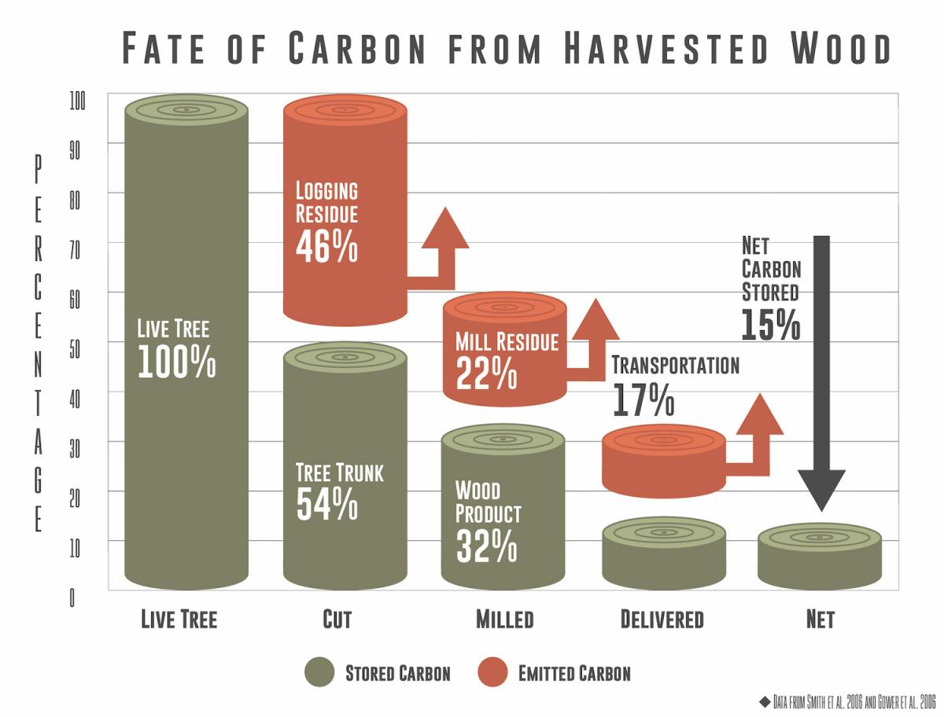
Above: Josephine County Democrats, “Forest Defense is Climate Defense,” at https://josephinedemocrats.org/forest-defense-is-climate-defense/ (last visited Apr. 5, 2021), based on data from Gower 2003 and Smith et al. 2006.
Harris et al. 2016 had higher estimates than the above chart: “[Sixty-four] percent of these losses were from logging residues [both above (19%) and below-ground (23%) and mill residues (22%). “The actual carbon stored long-term in harvested wood products represents less than 10 percent of that originally stored in standing trees or biomass.” Moomaw and Smith 2017.

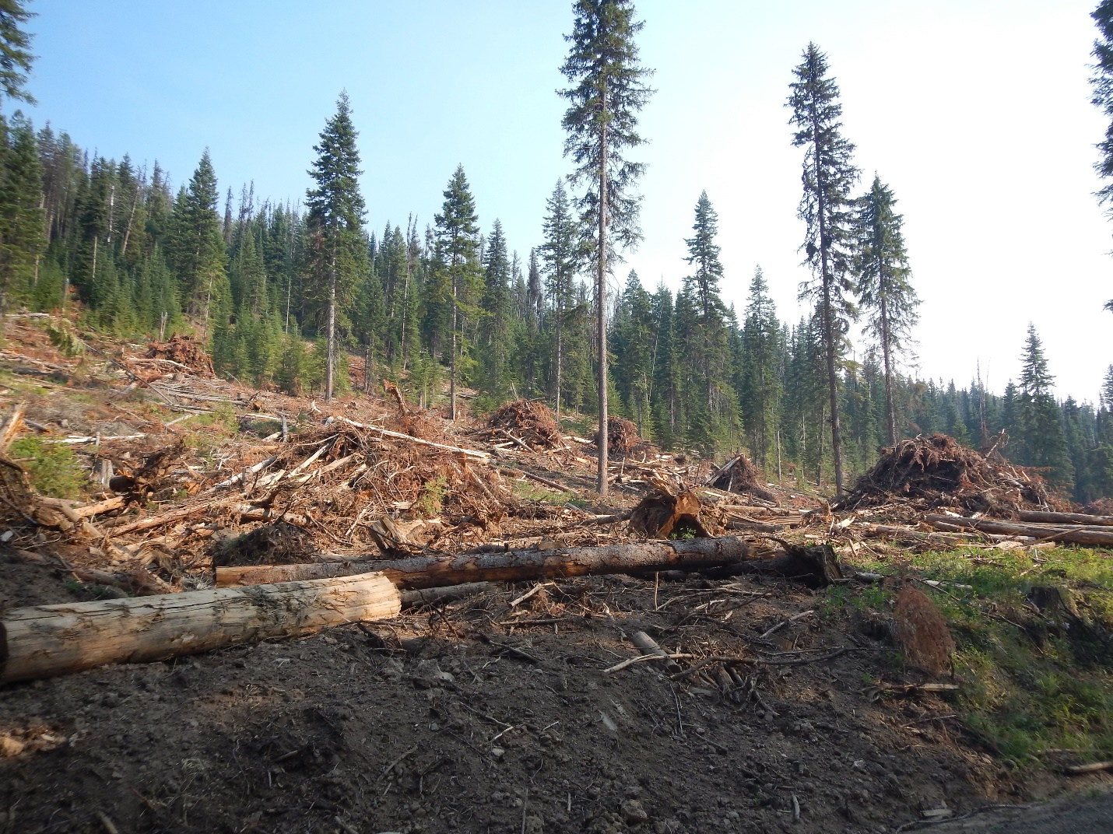
Photo: Example of logging residue. Piles are burned when logging operations are complete. Nez Perce-Clearwater National Forests, courtesy of Friends of the Clearwater.
To calculate carbon emissions from logging residue, Harris et al. 2016 used mill surveys, so these concerning percentages do not appear to account for the fossil fuels burned for the power to process the wood.
Logging operations burn fossil fuels. Cutting down trees, dragging logs to trucks, and hauling those logs to mills burn fossil fuels. Below are some examples of the machinery that burn fossil fuels, and all of them are generally involved with logging.
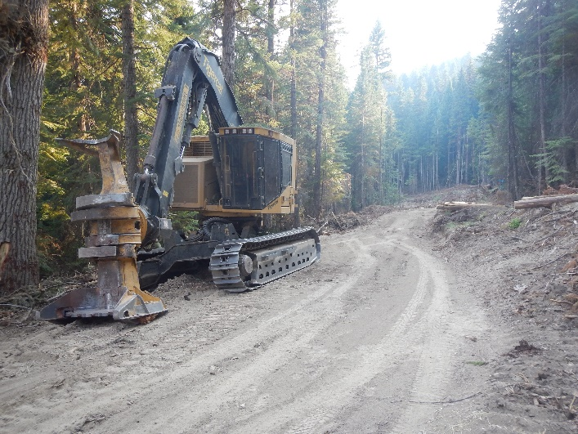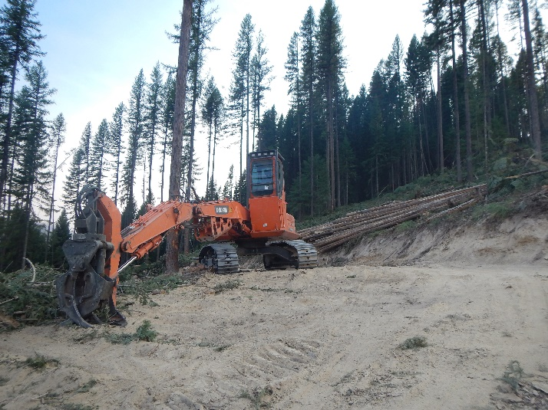
Upper left: feller-buncher; Upper right: swing machine. Photos courtesy of Friends of the Clearwater. This machinery burns fossil fuels and need to be transported to logging sites by trucks that also burn fossil fuels.
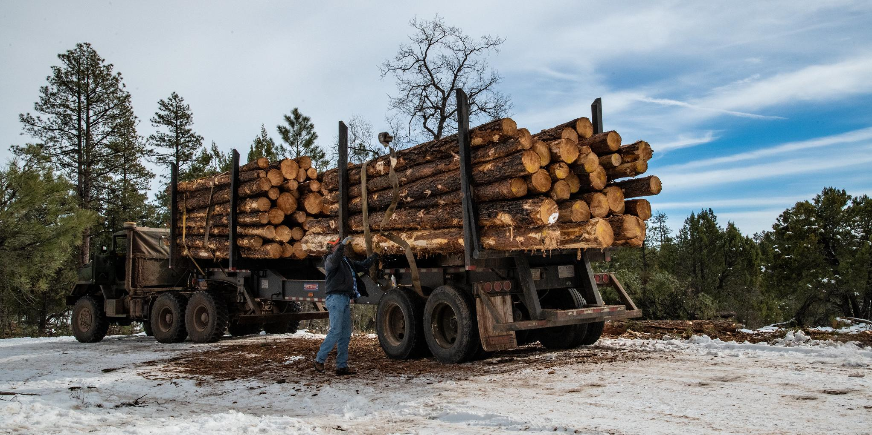
Logging truck. Photo Courtesy US Forest Service. https://www.fs.usda.gov/. Logging trucks can haul anywhere from three thousand to six thousand board feet of timber. In 2020, the Nez Perce-Clearwater sold over eighty-four million board feet of timber. It will take over 14,000 truckloads to haul away the timber sold in 2020 once it is cut down.
The most carbon lost in the public’s forests is from logging. Even logging to purportedly “reduce fuel” (a strategy largely debunked by science and discussed in further detail below) can emit three times more carbon into the atmosphere than the logging purportedly accomplished to avoid it. Harris et a. 2016. And the true emissions associated with logging are sometimes underestimated and not accurately accounted for. See Hudiburg et al. 2019.

Even for the emissions we have accounted for, the most carbon lost from forests in the United States is from logging:
Above: USDA Forest Service 2016. Future of America’s Forests and Rangelands. Update tot he Forest Service 2010 Resources Planning Act Assessment. “Figure 8-4. Carbon accumulation rates (kilogram per hactare per year) resulting from disturbances in the Eastern United States, based on the most recent remeasured Forest Inventory and Analysis data (about a 6-year time step).
Eastern forests of the US are not the only net sinks. Western US forests are, too.

Figure 1, Buotte et al. 2019. While this figure ranks carbon priority, we point out that all of these forests are carbon sinks. Also, this map does not include Alaskan forests.
The sequestration potential is national.
In addition to logging, disturbing other ecosystems with activities like grazing can also emit carbon. For example, the same researchers who found mountain meadows as a potential carbon sink found that disturbing those meadows can be a carbon source. Human activity, like grazing livestock on public lands, has transformed some wet meadows to drier soils with sparser grasses and shrubs, which transforms these same areas to potential sources of carbon emission. See Reed et al. 2020; Wharton 2020.
Other benefits of protecting national forests instead of cutting down trees
Intact forests provide benefits to wildlife and biodiversity as well as sequestering carbon for us. Structural diversity begets biodiversity. See Moomaw et al. 2019, Buotte et al. 2019. Forest canopies in general can promote cooler microclimates, which buffer warming environments for other living organisms, providing a climate refugia. Intact forests, after a fire, also contain swaths of fire refugia, which are areas that fires miss and provide refugia for animals as well as a source of seed for vegetative regrowth after fire. Meddens et al. 2018. Older forests, including old growth, which is the product of hundreds of years of ecosystem work, are among those cooler microclimates. See Davis et al. 2019a; Frey et al. 2016. If we see forests as more than just out tree crop to chop, these public lands can provide excellent habitat, coast to coast, for species that are struggling in the face of ever-expanding human development and increasing temperatures. See Buotte et al. 2019; Moomaw et al. 2019.

Biofuels
The questions that the USDA asked about biofuels are loaded in assumptions that they are green and that storing wood in houses/building materials is green. Please see above for the science and chart to compare the efficient carbon storage of leaving a tree standing in the forest versus cutting it down for wood building materials.
When the Kyoto Protocol was created, it counted burning biofuels as carbon neutral. Burning biofuels to generate electricity is not carbon neutral; it is not sustainable and it is not climate-smart.
“[B]urning wood emits more carbon pollution per unit of energy than coal.” Booth 2021. On top of emitting more carbon per unit of energy, the additional cost is the carbon emitted from 1) eliminating carbon sequestering trees; 2) fossil fuels to log and haul those trees to processing plants; 3) Processing them into wood pellets; and 4) transporting them to their final destination so they can then emit more carbon than coal when they are burned.
Currently, the biofuels industry is hitting forests in the southeastern United States. This industry adds more air pollution in the logging and transporting of carbon sequestering trees, which impact rural and disadvantaged communities to a greater degree. The long-term impact will stay with these communities far longer than the time it takes to cut down a tree. Environmental justice means not supporting biofuels.

Addressing “Catastrophic” Wildfire
Before discussing global warming and the role of wildfire on national forests, we first response to the loaded word “catastrophic” that the USDA has chosen to use in the questions it has asked the public. “Catastrophic” is a holdover term from before a body of science that recognized there is an important role that natural high-severity wildfire plays on wild landscapes. High-severity fire on wildlands begets biodiversity.
Fire has varying levels of severity and exists in different regions differently. Forests in the Northern Rockies, for example, have existed for millenia with mixed-severity fire, which includes stand-replacing fires. Mixed severity fire is important for our public forests in this region, and that includes high-severity fire. Mixed severity fire includes patches of natural high-severity fire in addition to low severity fire and unburned pockets. When we say “high-intensity fire,” we mean stands with over 75 percent tree mortality. High-severity fire in public forests are ecologically important, too—many species evolved with high-severity fire. See Bond et al. 2012a, Hanson 2010; and Hutto, “Fire Ecology Stories” https://www.youtube.com/watch?v=5EpTncRMbXs. Snag forest habitat “is one of the most ecologically important and biodiverse forest habitat types in western U.S. conifer forests (Lindenmayer and Franklin 2002, Noss et al. 2006, Hutto 2008).” Hanson 2010. “Many plant and animal species are adapted to post-fire conditions, and populations of some (e.g. many bird species; Figure 1) decline after fire exclusion or post-fire logging.” Noss et al. 2006. For example, Hutto 2008 found that the black-backed woodpecker is a specialized species on severely burned forests. Hutto found a distribution of black-backed woodpeckers, which “suggests that conditions created by severe fires probably represent the historical backdrop against which this species evolved.” And, “[t]he desire to rid our forests of severe fire beyond the urban interface is, for many forest types, not well grounded in ecological science.” Hutto 2008. Please also see LeQuire 2009 and Odion et al. 2014.
Climate and weather—not fuels—drive fire severity. Global warming is driving the climate and weather that drive the severe wildfires, in part due to more droughts and longer periods of hotter temperatures. See, e.g.,. Pechony and Shindell 2010; Pierre-Louis and Popovich 2018: Lesmeister 2019. Logging exacerbates the situation driving severe fires because logging contributes up to three times the carbon emissions that logging purports to save by altering fire behavior. Campbell et al. 2012. A later study, Harris et al. 2016, found that where some disturbances like insects, disease and fire kill trees and lower carbon sequestration, logging has the greater impact—up to ten times the carbon from forest fires and bark beetles together. So, logging and contributing to carbon emissions will neither make forests more resilient nor mitigate our contribution to a warming world—logging conversely contributes to climate change. It is increasingly understood and accepted that reducing fuels does not consistently prevent large fires and does not reduce the outcome of these fires. See Lydersen et al. 2014.
Fire severity is not greater where fire has been absent. In a large study across the west, Bradley et al. 2016 found that areas that tend to be more protected had less instances of high-severity wildfire than areas where the Forest Service has “managed” through logging. See also Odion et al. 2004. Science suggests that logging tends to exacerbate fire behavior as opposed to an unlogged state. Zald & Dunn 2018 found that plantation forestry with young forests and spatially homogenized fuels were more significant in predicting wildfire severity than pre-fire biomass. And this makes more sense. Below are two pictures, taken by FOC staff, from the Nez Perce National Forest approximately 15-20 years after clearcutting swaths of forest:
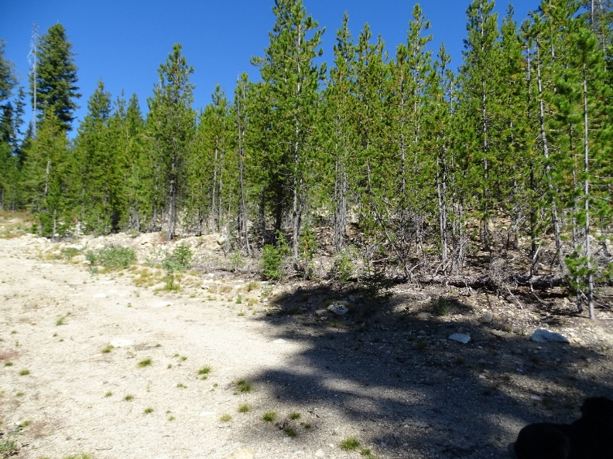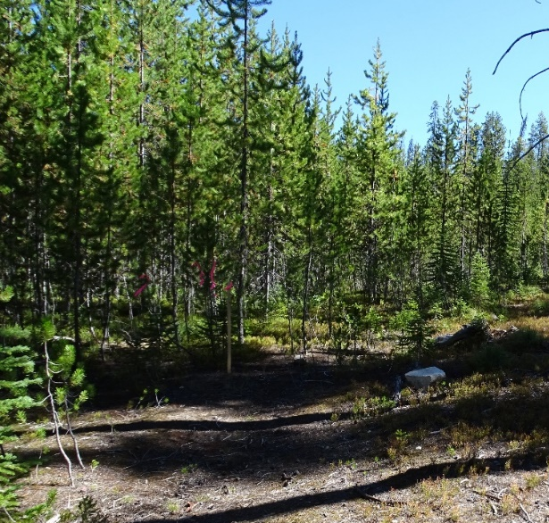
Clearcutting creates a homogenous forest structure, where all trees are the same height. The branches, which become ladder fuels, are on top of each other. Partly for this reason, intensive regeneration logging can make areas not previous susceptible to high-severity fires more susceptible to them. This science suggests that if there is any change in the frequency of fire-severity on the landscape, it is likely due to the Forest Service’s own silvicultural practices.
The old and mature forests we can protect play a positive role in countering impacts from high-severity fire. Lesmeister et al. 2019, in looking at fires in southwestern Oregon, mapped northern spotted owl habitat with the 2013 fires in that region. Northern spotted owls are an old-growth-obligate species, meaning they generally only occur in these mature types of forests. Lesmeister et al. 2019 found that the areas of forests that had high habitat suitability for northern spotted owls burned more often at low or moderate severity, while the forests that have been logged were more likely to burn at moderate to high severity. Bradley et al. 2016 had similar findings—protected areas, i.e., older forests, were less likely to burn at high severity. Protecting older, mature forests not only provide increased carbon sequestration, but offer a buffer to high-severity fire. Some even may serve as fire refugia, which are areas disturbed less frequently or severely by wildfire—these areas provide safe havens for wildlife during a fire, and help post-fire recovery of surrounding areas by providing the seed for new vegetation. Meddens et al. 2018. These areas are not always predictable, as some are created by happenstance. “Treating” areas by logging or prescribed burning can eliminate what would have been natural fire refugia. Protecting old mature forests are the solution, not a problem to be logged.
Protecting people and structures from any wildfire starts with smart zoning and continues with defensible space where it matters the most: right around the house. The Forest Service’s own scientist found that the measures taken within the first 130 feet of the house to reduce home ignitability have the most influence on whether a home is lost in a subsequent wildfire. Home ignitions depend upon whether the structure is built with fire-resistant materials and whether there are flammable items on or around the structure. For this reason, “[h]omes with low ignitability can survive high-intensity wildland fires, whereas highly ignitable homes can be destroyed during lower-intensity fires.” Cohen 2000. Because home ignitability drive whether a structure is lost, the “fire loss problem can be defined as a home ignitibility issue largely independent of wildland fuel management issues.” Cohen 2000. The issue is how people manage the first 130 feet surrounding their structure, not how the US Forest Service manages public lands miles away from houses that are highly ignitable. Beyond that, ensuring the roads that our evacuation routes are in good condition and having an evacuation plan that doesn’t delay departure. Zoning can help risky development in wildland-urban interfaces.
Many of the solutions to protect people from wildfire, like zoning, evacuation routes, and reducing the ignitability of the house and its surrounding 130 feet, simply don’t directly involve the federal government. But, the federal government could provide education. One additional strategy the federal government could consider, however, is acquiring private land next to national forests in places the government believes are risky to inhabit because of wildfire. A Friends of the Clearwater staff member was out on a field trip where the Forest Service was showing a recent “fuels reduction” project, where the Forest Service approved logging in an inventoried roadless area in the middle of the forest to ostensibly “reduce fuels” next to a community of about 20 structures far into the forest. In the environmental assessment of the project, the Forest Service noted that most of those structures were summer homes, and these private lands were mostly inholdings surrounded by national forest on all sides. On this field trip, the district ranger said it would have been cheaper to buy out the landowners than it would have been to do the project in the first place. Perhaps buying out the private inholdings in national forests is both the safest and most economical thing to do.

Opportunities Based on Current conditions
Currently, a lot of opportunity exists for the USDA, through the US Forest Service, to tackle the climate crisis through protecting our forests and drastically reducing logging, and completely eliminating the felling of large trees. Only a small fraction of national forests are left intact, and the US Forest Service is still logging irresponsible amounts. And while the US was the forefront timber products in 2015, Prestemon 2015, several groups that have signed onto this letter have noticed an upward creep of timber sales and proposed logging on some forests in the past five years in particular. In the face of the science that discusses the carbon that large trees sequester and what logging emits, the US Forest Service has increased logging. For Friends of the Clearwater, we’ve noticed this upward creep of timber sales on the Nez Perce and Clearwater National Forests for over a decade now.

Above is a chart of the timber sold off the Nez Perce-Clearwater National Forests. The information is from US Forest Service Region 1’s annual reports on what this agency has sold based on logging projects on the Nez Perce and Clearwater National Forests. The units are “thousand board feet,” so 84,000 thousand board feet = 84,000,000 board feet = 84 million board feet sold in 2020. In five of the past six years, this national forest has sold more of the public’s trees than any other year since 2000. The previous administration emphasized increasing logging, so Forest Service’s increase in logging projects is not unique to this forest. And on forests like the the Nez Perce-Clearwater National Forests, the Forest Service has continued to take bites of out of old growth and mature forests in just about every logging project it approves. Every time the Forest Service “resets” an area that is mature forest or would have become old growth, it eliminates the benefits described above for the rest of the lives of folks living. Living and future generations cannot afford this trend.
Scientists have discussed the opportunities of mitigating global warming and preserving biodiversity by protecting our forests. “Alterations in forest management can contribute to increasing the land sink and decreasing emissions by keeping carbon in high biomass forests, extending harvest cycles, reforestation, and afforestation.” Law et al., 2018. Scientists have proposed proforestation, which optimizes the trees that currently exists and allows them to grow intact with their natural ecosystems as opposed to disturbing them by logging: “Growing existing forests to their biological carbon sequestration potential optimizes [carbon dioxide removal] while limiting climate change and protecting biodiversity, air, land, and water. Natural forests are by far the most effective.” Moomaw, W.R., Masino, S.A., and Faison, E.K. 2019. Intact forests in the United States: Proforestation mitigates climate change and serves the greatest good. Frontiers in Global Change 2(27): pp. 1-10. (internal citations omitted). We must stop logging what exists and start protecting it: “Given the urgency of keeping additional carbon out of the atmosphere and continuing carbon accumulation from the atmosphere to protect the climate system, it would be prudent to continue protecting ecosystems with large trees for their carbon stores, and also for their co-benefits of habitat for biodiversity, resilience to drought and fire, and microclimate buffering under future climate extremes.” Mildrexler 2020.
The present situation reveals the value the US Forest Service still places on logging and industrial exploitation, to the detriment of carbon storage, carbon sequestration, and our future. The current state of things are contributing to the climate crises. But, the USDA can contribute significantly to tackling the climate crisis by protecting—not logging—the nation’s public forestlands, and retiring grazing in national forests.
We hope you consider these comments as you move forward.

Works cited

Whether one chooses the term “logging” (the business of felling trees, and cutting and preparing timber) or its whitewashed and euphemistic term, tree “harvest” (the process of gathering a crop of something), the substantive action is the same: cutting down trees and hauling them away.
See also McKinley et al. 2011: “[I]f the starting point is a mature forest with large carbon stocks [], then harvesting this forest and converting it to a young forest will reduce carbon stocks and result in a net increase in atmospheric [CO2] for some time.

