13 Sept 2023

TO: Kendall Cikanek, Whitman District Ranger, Wallowa-Whitman National Forest
VIA: https://cara.fs2c.usda.gov/Public//CommentInput?Project=64450

Subject: Clarks IVM Fuels Project — scoping comments

Please accept the following comments from Oregon Wild concerning the Clarks IVM Fuels Project, https://www.fs.usda.gov/project/?project=64450. Oregon Wild represents 20,000 members and supporters who share our mission to protect and restore Oregon’s wildlands, wildlife, and water as an enduring legacy. Our goal is to protect areas that remain intact while striving to restore areas that have been degraded. This can be accomplished by moving over-represented ecosystem elements (such as logged and roaded areas) toward characteristics that are currently under-represented (such as roadless areas and complex old forest).

This proposal involves:
- 18819 acres of commercial logging
- 76 million board feet (15,200+ log truck loads)
- 12238 ac individual tree selection
- 4909 ac thinning form below
- 1533 ac regeneration harvest
- 876 ac riparian logging
- 17773 ac non-commercial thinning (mostly within commercial units)
- 309 acres of logging in MA15 old growth stands (requires plan amendment)
- 880 acres of RHCA (75’ buffer on redband trout streams, 25’ buffer on perennial streams that flow into RBT streams, no buffer on intermittent streams, undisclosed buffer on perennial streams that don’t flow into RBT streams)
- Relying on Trump Screens Amendment allowing removal of large trees
- Defensible Fuel Profile Zones + maintenance
- Tethered logging of steep slopes
- 1010 acres of non-commercial thinning
- Prescribed fire
- Road maintenance + “daylighting” blind corners)
- Temporary road construction [undisclosed quantity and location]

Treat Moist and Cold Forests Differently
Be sure to treat moist forests different than dry forests. Many dry forests are mixed with moist/mixed forests. These stands do not typically need to be commercially logged. Moist stands naturally have dense, multi-layered canopies, and greater abundance of dead wood, and a more mixed fire regime, including patches of stand replacing fire. Natural processes will continue to operate in these stands and create desired conditions. Non-commercial thinning of some small trees may be appropriate if there is significant in-growth of small conifers that threaten legacy trees.

RHCA Logging
Logging in RHCAs is ill advised and likely violates PCFISH/INFISH prohibition on activities that will retard attainment of aquatic objectives, especially including recruitment of abundant dead wood. Commercial logging in RHCAs directly removes trees that would otherwise be recruited to serve aquatic objectives, and logging adjacent to RHCAs removes trees that would do “work” to help recruit wood to RHCAs. See Lutz. J.A. 2005. The Contribution of Mortality to Early Coniferous Forest Development. MS Thesis. University of Washington. http://faculty.washington.edu/chalpern/Lutz_2005.pdf. See also, Rhodes, J. 2022. Expert Report Regarding Aquatic Effects of Trump Screens Amendment, for Oliver Stiefel, Crag Law Center. (“The loss of larger trees in and near RHCAs also contributes to long-term LWD losses from adjacent trees in RHCAs. This is because, when larger trees fall, they often knock down other trees that provide LWD to streams and riparian areas. Thus, logging of larger trees is likely to ultimately reduce instream LWD in perennial streams via several means.”)

Logging and stream temperature
Removing trees near streams will degrade water quality. Riparian vegetation is important in several ways: (a) it shades the water surface from direct solar insolation, (b) it shades soils and shallow groundwater before it is discharged to surface streams; (c) it reduces wind penetration and air mass mixing over the water surface, insulating the stream from summer daytime warming or winter night time cooling, and (d) it stabilizes streambanks and floodplain surfaces and provides a supply of downed wood that helps keep channels narrow and establishes and maintains internal hydrologic complexity (vertical and lateral flow exchange between surface water and hyporheic waters) that buffers stream temperature against the effects of solar insolation and airmass mixing.

Thinning in riparian reserves does in fact raise ambient air temperatures that the microclimate effects must be accounted for. Anderson, Paul D.; Larson, David J.; Chan, Samuel S. 2007. Riparian Buffer and Density Management Influences on Microclimate of Young Headwater Forests of Western Oregon. Forest Science, Volume 53, Number 2, April 2007 , pp. 254-269(16). http://www.ingentaconnect.com/content/saf/fs/2007/00000053/00000002/art00012.

... concern about cumulative effects of thinning, which involves an understanding of the spatial and temporal dimensions of the issue in whole-stream networks. To address these cumulative effects we are studying experimental riparian thinning treatments in adjacent stream networks and forests managed by the Green Diamond Resource Company and the National Park Service (Redwood National Park) in northern California. Thinning was implemented in multiple locations, allowing us to evaluate effects of these local treatments in the context of larger stream networks. To track local treatments, we followed a before-after-control-impact approach to quantify spatial and temporal patterns of riparian shade, light, and stream temperatures as possible responses to riparian thinning. To evaluate how the potential effects of these local treatments resonate at broader extents, we have quantified shade, light, and stream temperatures across entire networks. Spatial statistical models were applied to these data to determine the spatial extent to which localized thinning propagated through stream networks. Preliminary results from tracking local treatments indicate an immediate response in stream temperature associated with the reductions in shade and increases in light associated with riparian thinning. At the network extent this resulted in variable downstream propagation of the effects of upstream thinning.
David Roon, Jason Dunham. 2018. Spatial Patterns of Riparian Shade, Light, and Stream Temperature in Response to Riparian Thinning in Redwood Headwater Streams. Speed Talks. 2018 Oregon Chapter of the American Fisheries Society 54th Annual Meeting.
http://orafs.org/wp-content/uploads/2017/10/2018-Annual-Meeting-Abstracts.pdf

Climate change is expected to increase stream temperatures and reduce fish habitat quality and quantity. “Riparian vegetation can potentially off-set future increases in water temperature [related to global climate change].” Gordy Reeves, 4-22-2020 Presentation to the Oregon Board of Forestry. https://www.oregon.gov/odf/Board/Documents/BOF/20200422/B_Item%20Two_Presentation.pdf (p 63/66).

Weigh the trade-offs associated with logging in riparian reserves.
There is a lack of good monitoring of the short- and long-term effects of logging RHCAs, but there is tremendous evidence from the westside indicating that the Forest Service should be very cautious here and carefully analyze trade-offs. Monitoring of the Aquatic Conservation Strategy shows that the natural abundance of large wood (>24” dbh) is still declining. This is because too many large and old trees were removed before the Northwest Forest Plan, large wood has a finite residence time, and tress grow slowly, so it will take a very long time to restore the conditions necessary to recruit natural levels of large wood necessary to support riparian and aquatic biodiversity.
Across the sampled sites in the AREMP area, overall survey results indicate that the density of wood pieces per length of stream consistently declined for the large size category, but they remained relatively constant for the intermediate and in some cases increased for the small size Across the AREMP area, the overall trend in wood piece density was -24.9 percent per decade (95-percent credibility intervals from -32.6 to -16.4 percent), and 83 percent of subwatershed-level trends were negative (95-percent credibility intervals from 71 to 95 percent) for the largest size class D. … All aquatic provinces experienced declines in density of the largest pieces of wood (class D) … Declines in density of larger sizes of wood (class D) were consistent across LUAs, with a 24-percent per decade decrease in LSRs, a 27-percent decrease in matrix, and a 29-percent decrease in congressional reserves. … Overall, trends indicating losses of larger instream wood are consistent with the concept of slow attrition of pieces derived from older, larger trees recruited to streams prior to widespread forest harvest in the region and subsequent protections imposed in accordance with the NWFP.
… For instream wood, we also observed declines in the quantity of the largest size class, presumably as recruitment of these largest pieces mainly occurred prior to the extensive removal of old-growth forests preceding the NWFP. Recovery of larger wood recruitment from older trees occurs on time scales that far exceed the 25-year period of this report.
Dunham, Jason; Hirsch, Christine; Gordon, Sean; Flitcroft, Rebecca; Chelgren, Nathan; Snyder, Marcia; Hockman-Wert, David; Reeves, Gordon; Andersen, Heidi; Anderson, Scott; Battaglin, William; Black, Tom; Brown, Jason; Claeson, Shannon; Hay, Lauren; Heaston, Emily; Luce, Charles; Nelson, Nathan; Penn, Colin; Raggon, Mark. 2023. Northwest Forest Plan the first 25 years (1994 2018): watershed condition status and trends. Gen. Tech. Rep. PNW-GTR-1010. Portland, OR: U.S. Department of Agriculture, Forest Service, Pacific Northwest Research Station. 163 p. https://doi.org/10.2737/PNW-GTR-1010. [Notably, the data also show a decline in wood 18-24” dbh in the Western Cascades Provinces]. The long-lasting adverse effect of past mismanagement can be mitigated or made worse depending on how riparian forests are managed going forward. More riparian logging will remove trees that would othersie grow and be recruited as riparian wood, thus making a bad situation worse. While strict conservation of riparian forests will allow those trees to grow and be recruited. Keep in mind that where there is a shortage of large wood, the presence of abundant small wood can partially mitigate that shortage.

Logging is a subtractive endeavor that is adverse to recruitment of dead wood. So, the agency often claims that logging in riparian reserves is necessary to improve attributes other than large wood. However, these benefits are often minor and transitory, and do not outweigh the significant long-term adverse effect of logging on recruitment of dead wood. The agency must focus on the most significant contributions of vegetation toward ACS objectives and the most significant effects of logging on the ACS objectives.

If the agency intends to log in riparian reserves to increase some nebulous goal like “vegetation diversity and complexity,” then please explain why the biophysical indicators for the ACS objectives (set forth below) do not include any mention of vegetation diversity or complexity. See the Jazz Thinning Preliminary Analysis, 2011. http://bark-out.org/sites/default/files/bark-docs/Jazz_PA_0.pdf.
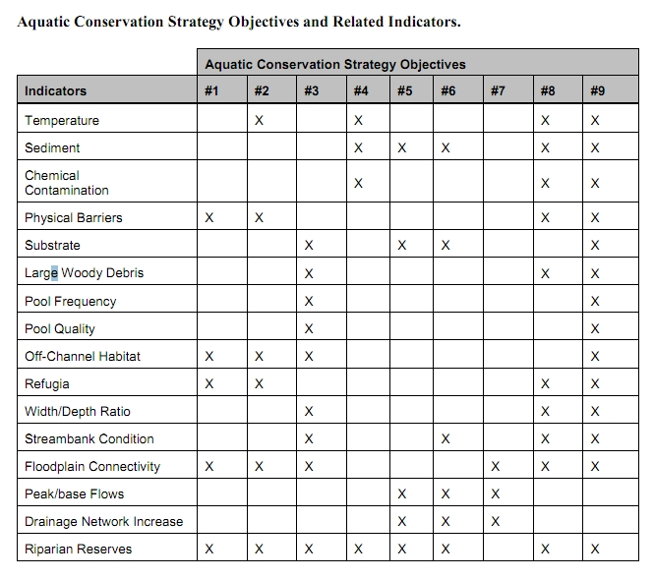
These ACS objectives and biophysical indicators are consistent throughout the Pacific Northwest and are not unique to the Mt Hood NF.

The Northwest Forest Plan and its supporting documentation make clear that the primary value of riparian vegetation is as a source of large wood and shade, not vegetation diversity and canopy layering, as often asserted by the agency to justify logging in riparian reserves. BLM admits “The primary function of Riparian Reserves is to provide shade and a source of large wood inputs to stream channels.” Medford BLM 2013. Pilot Thompson EA, p 3-76. http://www.blm.gov/or/districts/medford/plans/files/PT_EA_ForWeb.pdf

NEPA requires consideration of trade-offs. California v. Block, 690 F.2d 753, 771 (9th Cir. 1982) (NEPA was designed to “ensure that an agency is cognizant of all the environmental trade-offs that are implicit in a decision”). Stan Gregory notes the following trade-offs associated with logging riparian reserves to enhance early seral vegetation:
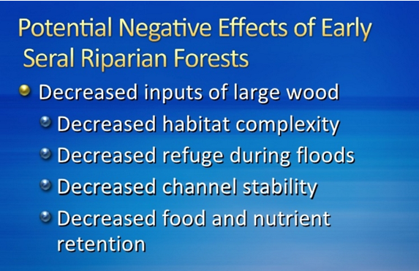
Gregory, Stan 2010. What About Riparian Systems: Who Benefits From an Early Seral Forest Condition. Workshop - Early Seral Forest - We know we need it -- How do we get it? Presentation sponsored by the Central Cascades Adaptive Management Partnership and NW Oregon Ecology Group http://ecoshare.info/2010/07/06/what-about-riparian-systems-who-benefits-from-an-early-seral-forest-condition-gregory/

The Northwest Forest Plan Aquatic Conservation Strategy Objectives (1994 ROD p B-11) enumerates specific purposes for “Maintain[ing] and restor[ing] the species composition and structural diversity of plant communities in riparian areas and wetlands” that is -
“to provide adequate summer and winter thermal regulation, nutrient filtering, appropriate rates of surface erosion, bank erosion, and channel migration and to supply amounts and distributions of coarse woody debris sufficient to sustain physical complexity and stability.”
All these values are provided as well or better by unthinned riparian stands.

The effects of logging on dead wood are significant and long term, adversely affecting a core function of the reserves, while the purported benefits to vegetation diversity are minor and transitory, and affect secondary purposes of the reserves.

Large Wood
Large quantities of downed trees are a functionally important component of many streams (Swanson et al. 1976; Sedell and Luchessa, 1982; Sedell and Froggat, 1984; Harmon et al. 1986; Bisson et al. 1987; Maser et al. 1988; Naiman et al. 1992). Large woody debris influences channel morphology by affecting longitudinal profile, pool formation, channel pattern and position, and channel geometry (Bisson et al. 1987). Downstream transport rates of sediment and organic matter are controlled in part by storage of this material behind large wood (Betscha 1979). Large wood affects the formation and distribution of habitat units, provides cover and complexity, and acts as a substrate for biological activity (Swanson et al. 1982; Bisson et al. 1987). Wood enters streams inhabited by fish either directly from the adjacent riparian zone from tributaries that may not be inhabited by fish, or hillslopes (Naiman et al. 1992).
Large wood in streams has been reduced due to a variety of past and present timber harvesting practices and associated activities. Many riparian management areas on federal lands are inadequate as long term sources of wood.
…
Riparian Ecosystem Components
…
Riparian vegetation regulates the exchange of nutrients and material from upland forests to streams (Swanson et al. 1982; Gregory et al. 1991). Fully functional riparian ecosystems have a suite of characteristics which are summarized below. Large conifers or a mixture of large conifers and hardwoods are found in riparian zones along all streams in the watershed, including those not inhabited by fish (Naiman et al. 1992). Riparian zone-stream interactions are a major determinant of large woody debris loading (House and Boehne 1987; Bisson et al. 1987; Sullivan et al. 1987). Stream temperatures and light levels that influence ecological processes are moderated by riparian vegetation (Agee 1988; Gregory et al. 1991). Streambanks are vegetated with shrubs and other low-growing woody vegetation. Root systems in streambanks of the active channel stabilize banks, allow development and maintenance of undercut banks, and protect banks during large storm flows (Sedell and Beschta 1991). Riparian vegetation contributes leaves, twigs, and other forms of fine litter that are an important component of the aquatic ecosystem food base (Vannote et al. 1980).
1993 FEMAT Report, pp V-13, V-25.

The effects of thinning on crown development are not very significant.

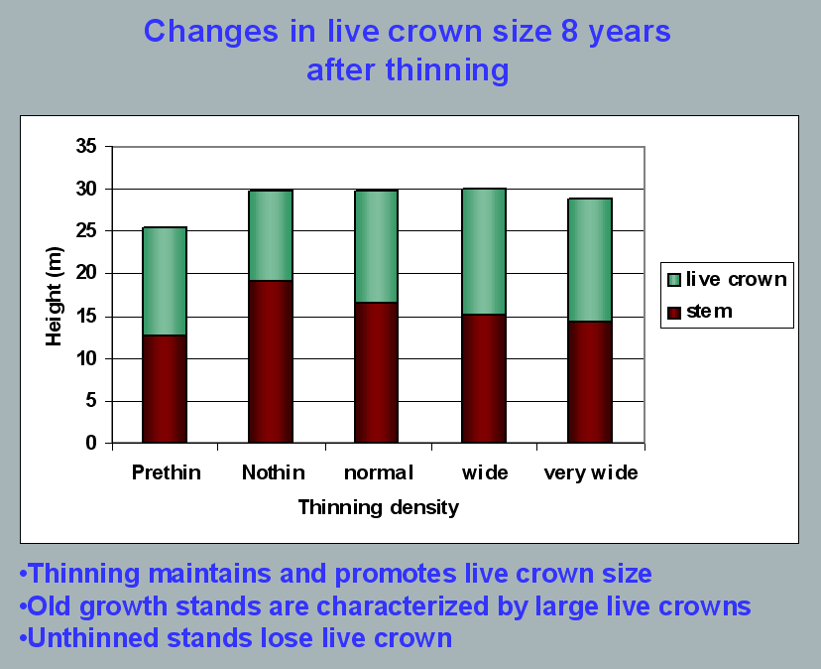
Aquatic/Riparian Ecosystem Dynamics and Associated Management Implications - Recent Findings. Powerpoint, 32.6M. This topic was presented at the Regional Interagency Executive Committee meeting on January 7, 2003. https://web.archive.org/web/20161221100307/http://www.reo.gov/library/presentations/Szaro_present_Aquatic_Rip_Final.ppt.

Stimulating the development of a diverse understory is often used as a justification for thinning, but this may not be justified in stands older than about 40 years. A systematic review of 917 Forest Inventory and Analysis (FIA) plots in western Oregon (mostly on non-federal lands) found,
Contrary to expectations of canopy closure, mean canopy cover by age class rarely exceeded 85 percent, even in unthinned productive young conifer forests. Possibly as a result, effects of stand age on understory vegetation were minimal, except for low levels of forbs found in 20- to 40-year-old wet conifer stands. … Although heavily thinned stands had lower total cover, canopy structure did not differ dramatically between thinned and unthinned stands. Our findings suggest potential limitations of simple stand succession models that may not account for the range of forest types, site conditions, and developmental mechanisms found across western Oregon.
McIntosh, Anne C.S.; Gray, Andrew N.; Garman, Steven L. 2009. Canopy structure on forest lands in western Oregon: differences among forest types and stand ages. Gen. Tech. Rep. PNW-GTR-794. Portland, OR: U.S. Department of Agriculture, Forest Service, Pacific Northwest Research Station. 35 p. http://www.fs.fed.us/pnw/pubs/pnw_gtr794.pdf. This seems to indicate that the benefits of thinning may be best realized in dense stands younger than 40 years old. This study also showed that in wet conifer stands the mean Canopy Height Diversity Index and the mean Simpson’s Diversity Index of tree heights leveled off at about age 65. This study also looked at canopy conditions after three levels of thinning intensities (heavy, light, and none). “Mean cover of the lower canopy layer was nominal for all three thinning intensities. … There were no evident trends between understory cover and thinning history; both shrub and forb cover were fairly similar among the three thinning intensities. … The lack of a strong effect of crown closure on understory cover may be related to our finding that mean crown cover did not exceed 85 percent. … We expected greater cover of understory vegetation in thinned than in unthinned stands but did not detect significant differences in this analysis.”

While one can generalize that vegetation diversity is more likely to flourish when conifer density is lower, there are data showing a wide range of conifer density can support a wide range of deciduous shrub cover. Thinning is not always necessary. The NEPA analysis should carefully document the site-specific “need” for thinning.
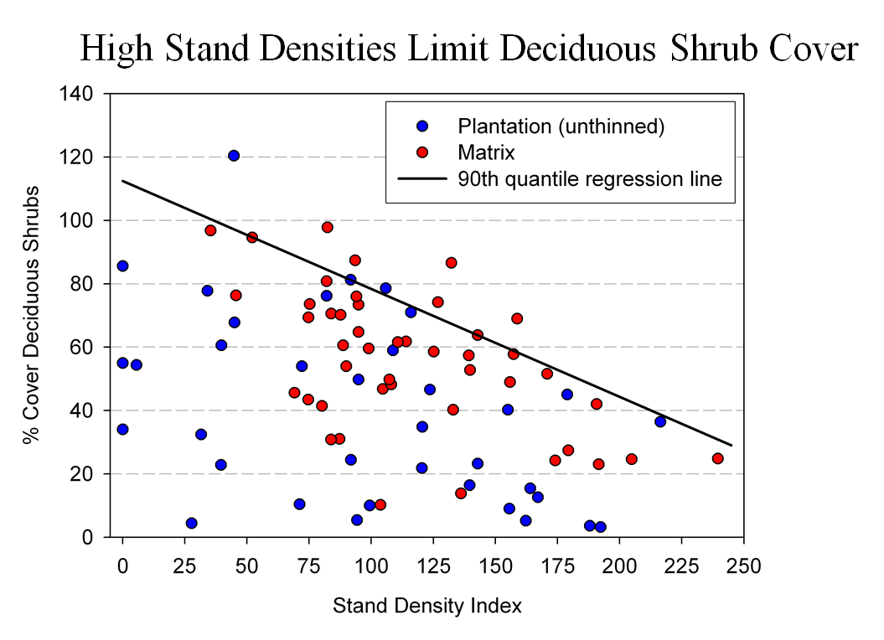
Spies, T. 2008. Powerpoint: Assumptions behind thinning young stands to create late successional riparian habitat. Presented at Riparian Thinning: Logic Paths for Silvicultural Prescriptions -- March 20, 2008. https://ecoshare.info/projects/central-cascade-adaptive-management-partnership/workshops/riparian-thinning-logic-paths/

It is also worth noting that where understories are well-stocked, midstory development can be enhanced by focusing on treating the understory itself rather than killing canopy trees.
[R]esults show that individual understory trees can be selectively favored for increased growth into the midstory by being released from competing saplings in the understory cohort. …Our results suggest that understory release treatments can be used to target individual saplings for increased growth, thereby recruiting a shade tolerant midstory cohort and accelerating the development of vertical foliar connectivity and a multi-layered stand structure. Abundance of non-coniferous understory vegetation is also augmented by this treatment. … [Note] The extent to which released understory trees collectively form a cohesive midstory canopy stratum is dependent on the density and horizontal arrangement of those released individuals. … . Inducing spatial variability within the midstory tree cohort would emulate the finescale disturbances of natural stands that create gaps and patches.
Taylor, Andrew 2016. : Understory Vegetation Dynamics and Midstory Development Following Understory Release Treatments in Northwest Oregon Thinned Douglas-fir Stands. OSU MS Professional Paper.

Anderson (2007) looked at the effects of thinning in young Douglas fir forests and found –
[T]hinning treatments … had little impact on the abundance, size, or diversity of understory vegetation. Disturbance resulted in short-term decreases in understory vegetation cover, particularly tall shrubs. However, within five years of treatment, understory vegetation abundance returned to approximate pretreatment condition. … The general lack of understory vegetation response to the thinning treatments was likely due to the inherent resistance and resilience of the plant communities to disturbance, as well as the low intensity of disturbance attributable to the treatments.
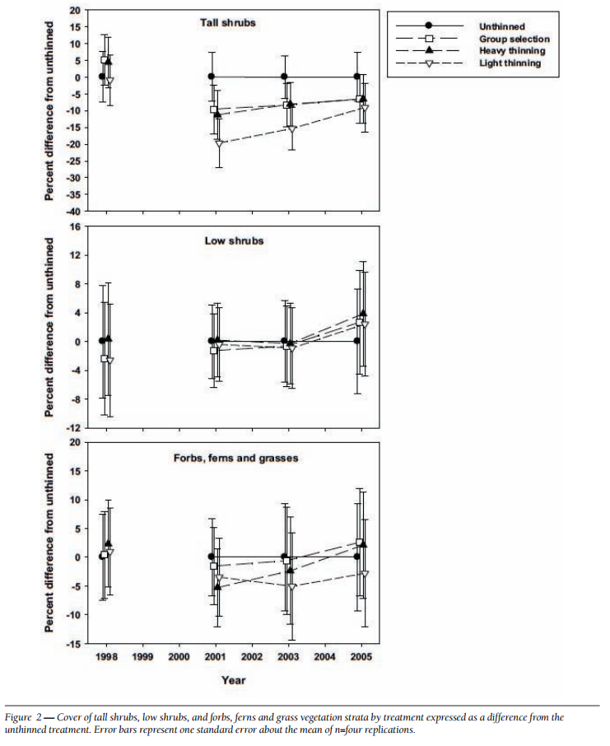
[Four years after thinning] tall shrub cover that was approximately four to nine percent less than the unthinned treatment … [C]over by low shrub species was unchanged by the harvest activity … Forbs, ferns, and grasses [experienced] little difference in cover between thinned and unthinned stands. … [F]ollowing treatment, the mean number of species declined somewhat, [then] return[ed] to pretreatment levels… [T]he evenness component of diversity did not differ among treatments or vary over time …. [T]here was little evidence of substantial alterations of understory shrub and herbaceous vegetation. This lack of strong understory vegetation response in terms of composition, abundance, or size is consistent with several studies of thinning in Douglas-fir. In a recent review of seven operational-scale silviculture experiments, Wilson and Puettmann (2007) report that percent cover by shrubs and percent cover by herbs, one to seven years following thinning showed little difference across a wide range of residual basal area.
Paul D. Anderson 2007. Understory Vegetation Responses to Initial Thinning of Douglas-fir Plantations Undergoing Conversion to Uneven-Age Management. Proceedings of the 2007 National Silviculture Workshop. http://www.fs.fed.us/pnw/publications/gtr733/PNW_GTR_733_4.pdf This paper was published in: Deal, R.L., tech. ed. 2008. Integrated restoration of forested ecosystems to achieve multi-resource benefits: proceedings of the 2007 national silviculture workshop. Gen. Tech. Rep. PNW-GTR-733. Portland, OR: U.S. Department of Agriculture, Forest Service, Pacific Northwest Research Station. 306 p.

[W]hile specific structural attributes of forest ecosystems have been correlated with certain species, it is uncertain how such species will respond to treatments designed to recreate these features. There is always the possibility that in our attempt to create a structural attribute we think is important, we eliminate another attribute that is equally important, but unrecognized. One example is that attempts to restore spotted owl habitat by heavily thinning to accelerate the development of large diameter nesting trees could actually delay spotted owl recovery by reducing production of the large down wood utilized by the species it preys upon (Forsman et al., 1984; Carey, 1995; North et al., 1999). Similarly, heavily thinning stands to accelerate the development of marbled murrelet nesting trees also create open stands with a dense understory that is ideal habitat for a number of corvid species that prey on marbled murrelet nest eggs (USFWS, 2010). Riparian thinning efforts to create long-term supplies of very large diameter instream wood that can initiate complex wood jam formation (e.g., key pieces) are also likely to reduce the supply of large diameter wood that will create pools (Beechie and Sibley, 1997; Beechie et al., 2000; Fox and Bolton, 2007). Thus, we suggest that any efforts to actively restore riparian forests for the benefit of certain species should be treated as scientific experiments and proceed cautiously, skeptically, and with robust pre- and post-treatment data collection efforts. Hypothesized effects of thinning on riparian forest structure and the use of that structure by targeted species should be tested against empirical data.
Pollock, Michael M. and Timothy J. Beechie, 2014. Does Riparian Forest Restoration Thinning Enhance Biodiversity? The Ecological Importance of Large Wood. Journal of the American Water Resources Association (JAWRA) 50(3): 543-559. DOI: 10.1111/jawr.12206. http://oregon-stream-protection-coalition.com/wp-content/uploads/2014/07/Pollock-and-Beechie.-2014.-Riparian-thinning-and-biodiversity.pdf.

Climate change highlights an additional trade-off related to logging riparian buffers. New science shows that more frequent drought makes upland habitats less suitable, so increasing numbers of upland birds flock to riparian corridors, which become more crowded, with negative effects on riparian-dependent species. The agency should do more to increase space for wildlife that need moist streamside habitat during droughts. Gabrielsen, Paul 2021. In dry years, rivers become birds’ crowded corridors. University of Utah @THEU.
https://attheu.utah.edu/uncategorized/in-dry-years-rivers-become-birds-crowded-corridors/ (“New research from the University of Utah and the Utah Division of Wildlife Resources (UDWR) finds that in dry years, birds funnel into the relative greenness of riparian (adjacent to river) environments. That increased diversity is accompanied by overcrowding that may cause increased competition for habitat and resources, the study finds, and an overall decrease in populations of birds who call the river home. … Neate-Clegg and his colleagues noticed that during particularly dry years they were finding more birds than usual in the mist nets near rivers. … The multi-year data showed that total bird captures and total species were higher in hotter and drier years, El Niño years, and less green years. The effect was strongest for non-riparian species, suggesting that in harsh conditions, birds from all over the landscape found their way to the rivers. “This suggests that the wider landscape is unable to support migrants and so they are forced to use greener areas,” Neate-Clegg says. But just as an influx of tourists can crowd out locals, the uptick in birds may have taken its toll on typically riparian species, especially those that breed on river banks…. In warmer years, population growth rates slowed for 47% of riparian bird species. The slowing, the researchers found, wasn’t due to more birds deaths, but rather to fewer new birds joining the population. There could be several reasons that bird breeding goes down in hotter years, but the authors suspect that more species in riparian habitats can mean more competition and fewer resources to go around. ‘This study shows how native bird populations utilize these habitats,’ Norvell says. ‘As droughts intensify, this becomes increasingly the refuge that everything’s relying on. And I don’t think humans are all that different in this case. We’re all increasingly relying on these very same areas.’ Neate-Clegg says that rivers provide connections for birds across the landscape, enabling them to transport nutrients or disperse seeds. A hotter, drier climate could affect those important functions that birds provide, called ‘ecosystem services.’”)

Eastside Screens and MA-15 logging

Please confirm that this project will not authorize cutting of any trees over 21 inches dbh, consistent with the original 1995 Eastside Screens.

Judge Hallman of the District of Oregon recently ruled that the Forest Service's 2021 Amendment to the Eastside Screens which eliminated the 21-inch rule was unlawful under National Forest Management Act, the Endangered Species Act, and the National Environmental Policy Act, and that the Screens Amendment should be vacated. See Greater Hells Canyon Council v. Wilkes, Findings & Recommendation of Judge Hallman. Case No. 2:22-cv-00859-HL, ECF 97 (August 31, 2023) https://pdf.wildearthguardians.org/support_docs/eastside-screens-08-31-2023-decision-97%20F%20and%20R.pdf. Vacatur of the Screens Amendment results in the reinstatement of the 21-inch rule as the controlling Forest Plan standard with which this project must be consistent. 16 U.S.C. § 1604(i).

The Eastside Screens also prohibit regeneration harvest on eastside forests. All forest treatments must move stands toward Late Old Structure (LOS), that means retaining canopy cover, retaining enough green trees to recruit snags and down wood throughout the life of the stand, retaining all large trees, and if there are too few large trees, then medium and smaller trees must be retained.

The NEPA analysis must address significant new information showing that that natural mortality processes are self-correcting the species composition, and getting the job done better than logging because natural processes kills the trees that are least fit to survive, and natural processes create and retain snags, and dead wood habitat. In 2022, forest scientists reported a “Firmageddon” event, where true firs such as white fir and grand fir and noble fir were dying across large areas of eastern Oregon, apparently from drought stress. See Nathan Gilles 2022. Massive die-off hits fir trees across Pacific Northwest | Columbia Insight (AP) Updated: Nov 27, 2022. https://www.mailtribune.com/top-stories/2022/11/27/massive-die-off-hits-fir-trees-across-pacific-northwest/.

There is also new information indicating that Grand fir may be more fire resistant than often assumed. "The grand fir forest type had severity values at the same level of forest types dominated by fire-resister species despite grand fir was classified as a fire-avoider species. … In many ponderosa pine forests maintained historically by a high frequency, low-severity fire regime, the transition towards denser forests dominated by Douglas-fir and grand fir would explain why ponderosa pine and Douglas-fir still compose a significant proportion of basal area in the grand fir forest type, and many maintain large, old, fire-resistant ponderosa pine trees (Johnston et al. 2021; Merschel et al. 2021). Therefore, the particular structure and composition of these “recent” grand fir forests (e.g., Merschel et al. 2014), with an important presence of large-diameter trees of fire-resistant species, may provide latent fire resistance (Larson et al. 2013)." Jose V. Moris, Matthew J. Reilly, Zhiqiang Yang, Warren B. Cohen, Renzo Motta, Davide Ascoli 2022. Using a trait‑based approach to asses fire resistance in forest landscapes of the Inland Northwest, USA. Landsc Ecol (2022) 37:2149–2164. energyhttps://doi.org/10.1007/s10980-022-01478-w, https://www.fs.usda.gov/rm/pubs_journals/2022/rmrs_2022_moris_j001.pdf.

Logging in MA-15 old growth is not needed or desired. There is still a severe shortage of mature & old-growth forests on the eastside. The adverse trade-offs from logging far outweigh any alleged benefits. Natural process are active and working to develop high quality old growth habitat. The agency must view these forests from an ecological perspective, where native insects, disease, and mortality are natural and desired. These natural processes just enrich the habitat for a greater diversity of species. Non-commercial thinning of small trees without heavy equipment might make sense.
The NEPA analysis must disclose how the project will comply with all the requirements of the Eastside Screens.

The Eastside Screens say “2) Outside of LOS, many types of timber sale activities are allowed. The intent is still to maintain and/or enhance LOS components in stands subject to timber harvest … Manipulate vegetative structure that does not meet late and old structural (LOS) conditions, … in a manner that moves it towards these conditions as appropriate to meet HRV. … Manipulate vegetation in a manner to encourage the development and maintenance of large diameter, open canopy structure.” 1995 Regional Forester’s Forest Plan Amendment #2. http://www.fs.usda.gov/Internet/FSE_DOCUMENTS/stelprdb5288660.pdf

Looking at the old-growth definition from ICBEMP (http://www.icbemp.gov/pdfs/sdeis/Volume2/Appendix17a.pdf:
“old growth is typically distinguished from younger growth by several of the following attributes: 1. Large trees for species and site. 2. Wide variation in tree sizes and spacing. 3. Accumulations of large-size dead standing and fallen trees that are high relative to earlier stages. 4. Decadence in the form of broken or deformed tops or bole and root decay. 5. Multiple canopy layers. 6. Canopy gaps and understory patchiness.”
(emphasis added) It is clear that LOS “components” such as abundant snags must be retained and recruited, and many small and medium sized trees are needed grow into large trees. Thinning dense understory trees might help move stands toward LOS, but any action that would remove snags or reduce recruitment of medium trees into large tree classes would not be consistent with the Eastside Screens.

The Eastside Screens also state “To reduce fragmentation of LOS stands, or at least not increase it from current levels, stands that do not currently meet LOS that are located within, or surrounded by, blocks of LOS stands should not be considered for even-aged regeneration, or group selection at this time.” Any action that would build roads or establish young even-aged stands would not meet the Eastside Screens. Heavy thinning for fuel reduction should also be evaluated under this connectivity standard.

Make sure that any treatments in wildlife corridors comply with the expectations of the Eastside Screens, i.e. "medium diameter or larger trees are common, and canopy closures are within the top one-third of site potential. Stand widths should be at least 400 ft. wide at their narrowest point.... some amount of understory (if any occurs) is left in patches or scattered to assist in supporting stand density and cover."

Recognizing the fact that past logging practices have greatly reduced the abundance of large trees and snags, the Eastside Screens also require that projects use the best available science to meet the intent of 100% potential populations of primary cavity excavators. While the potential population methodology has been discredited the Forest Service must still meet the intent by not taking any action that could reduce populations of primary cavity excavators.

If any exceptions to the Eastside Screens will be considered, such as removing white fir larger than 21” dbh, please recognize that compelling ecologic justification for removal of large trees are lacking. As shown in the table below from the 2020 Amendment to the Eastside Screens, there is still a shortage of large trees across the eastside landscape.
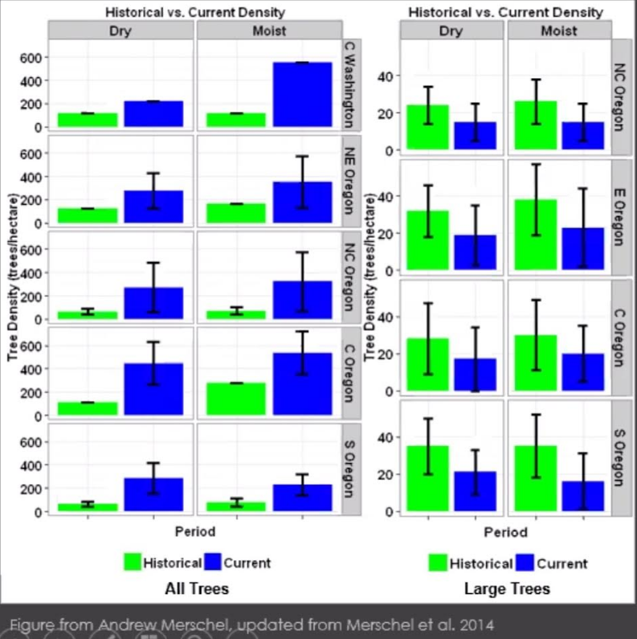

Significantly, large white fir contribute positively to biodiversity associated with large trees and large snags, climate mitigation and adaptation, and fire resistance/resilience. The problem of large white fir co-mingling and adversely competing with large pine is overstated, and does not justify sweeping exemptions to the well-supported standards requiring protection of all large trees in eastside National Forests.

Where large trees appear to be abundant, they are helping to compensate for large areas lacking large trees. The agency is not helping when they propose to remove large trees when they exceed the historic average, because large trees populations exhibited a range of conditions often exceeding the average.

Furthermore, where large trees appear to be in competition and at risk of mortality, they are just furthering the natural processes that help tree populations develop adaptive traits such as when less fit individuals die and allow more fit individuals to survive and reproduce, thus increasing population resilience to drought. Mortality also helps recruit valuable large snags and dead wood. It is unavoidable that logging large trees has net negative ecological effects and cannot be justified on ecological grounds. The agency must consider all the trade-offs carefully.

Connectivity Requirements of the Eastside Screens

The explicit intent of the Screens which is “to insure that blocks of habitat maintain a high degree of connectivity between them,...” 1995 Eastside Screens, Scenario A, INTENT STATEMENT for connectivity (emphasis added).

The connectivity requirements of the screens are detailed and mandatory. Connectivity corridors:
- Must link all late old structure stands in at least 2 directions;
- Must be at least 400 feet wide at their narrowest spot;
- Must be maintained as dense as possible with medium and large trees, or in the top third of site-potential and at least 50% canopy cover;

The Eastside Screens provide ...
... it is important to insure that blocks of habitat maintain a high degree of connectivity between them, and that blocks of habitat do not become fragmented in the short-term.
a) Maintain or enhance the current level of connectivity between LOS stands and between all Forest Plan designated “old growth/MR” habitats by maintaining stands between them that serve the purpose of connection as described below:
(1) Network pattern – LOS stands and MR/Old Growth habitats need to be connected with each other inside the watershed as well as to like stands in adjacent watersheds in a contiguous network pattern by at least 2 different directions.
(2) Connectivity Corridor Stand Description – Stands in which medium diameter or larger trees are common, and canopy closures are within the top one-third of site potential. Stand widths should be at least 400 ft. wide at their narrowest point. The only exception to stand width is when it is impossible to meet 400 ft with current vegetative structure, AND these “narrower stands” are the only connections available (use them as last resorts). In the case of lodgepole pine, consider medium to large trees as appropriate diameters for this stand type.
If stands meeting this description are not available in order to provide at least 2 different connections for a particular LOS stand or MR/Old Growth habitat, leave the next best stands for connections. Again, each LOS and MR/Old Growth habitat must be connected at least 2 different ways.
(3) Length of Connection Corridors – The length of corridors between LOS stands and MR habitats depends on the distance between such stands. Length of corridors should be as short as possible.
(4) Harvesting within connectivity corridors is permitted if all the criteria in (2) above can be met, and if some amount of understory (if any occurs) is left in patches or scattered to assist in supporting stand density and cover. Some understory removal, stocking control, or salvage may be possible activities, depending on the site.
We would like to emphasize that the screens anticipated the possibility of logging in connectivity areas, but there are minimum requirements for that. The screens provide: “Harvesting within connectivity corridors is permitted if all the criteria in (2) above can be met ...” and some patches of understory are retained.

The 1995 EA for the Eastside Screens identifies the following process for analyzing connectivity:
c) To insure connectivity as described above is maintained, use the following process:
(l) Do suitable network linkages between old and late structural stands and MR-designated habitats occur, according to the previous description? If so, will the proposed project isolate any area or group of areas by reducing any one of the parameters below acceptable levels? If not, the project can continue. If so, the project must be deferred or re-designed to meet connectivity parameters described above.
(2) Do suitable network linkages between old and late structural stands and MR-designated habitats NOT OCCUR under current conditions, as described above? If areas are already isolated, or partially isolated by not meeting the connectivity description above, will the proposed prescription promote linkage sooner than if left alone? If so, the project should continue. If the project is designed in a manner that would further increase isolation, the project must be deferred or re-designed to enhance connectivity parameters.

The NEPA analysis must disclose how much of the project area will maintain >50% canopy closure (or in the top third of site potential) after this project is implemented. The 1995 EA supporting the Eastside Screens says “The intent is to maintain canopy closure as dense as possible.” The Response to Comment asks “where the >50% canopy closure number came from.” The >50% canopy closure number comes from the 1995 EA for the Eastside Screens which included some clarifying text about connectivity on page 17 of Appendix C. Violation of the Eastside Screens, is a violation of NFMA which requires compliance with the LRMP as amended by the Screens.

Agencies have a duty to consider connectivity in their NEPA analyses. In 2023 CEQ issued guidance saying “… agencies should consider and be transparent about the positive or negative impacts of proposed actions and alternatives on connectivity and corridors. Through the NEPA review process, Federal agencies can consider measures to advance corridors and connectivity as components of proposed actions, alternatives to proposed actions, or mitigation for proposed actions’ effects.” Mallory, B. 2023. CEQ Guidance for Federal Departments and Agencies on Ecological Connectivity and Wildlife Corridors. https://www.whitehouse.gov/wp-content/uploads/2023/03/230318-Corridors-connectivity-guidance-memo-final-draft-formatted.pdf.

The agency’s analysis of connectivity should consider the State of Oregon’s Priority Wildlife Connectivity Areas (PWCAs) developed by ODFW’s Oregon Connectivity Assessment and Mapping Project (OCAMP) described here: https://oregonconservationstrategy.org/success-story/priority-wildlife-connectivity-areas-pwcas/; and displayed here: https://experience.arcgis.com/experience/6979b6598f904951bd0af1821e1595f1/
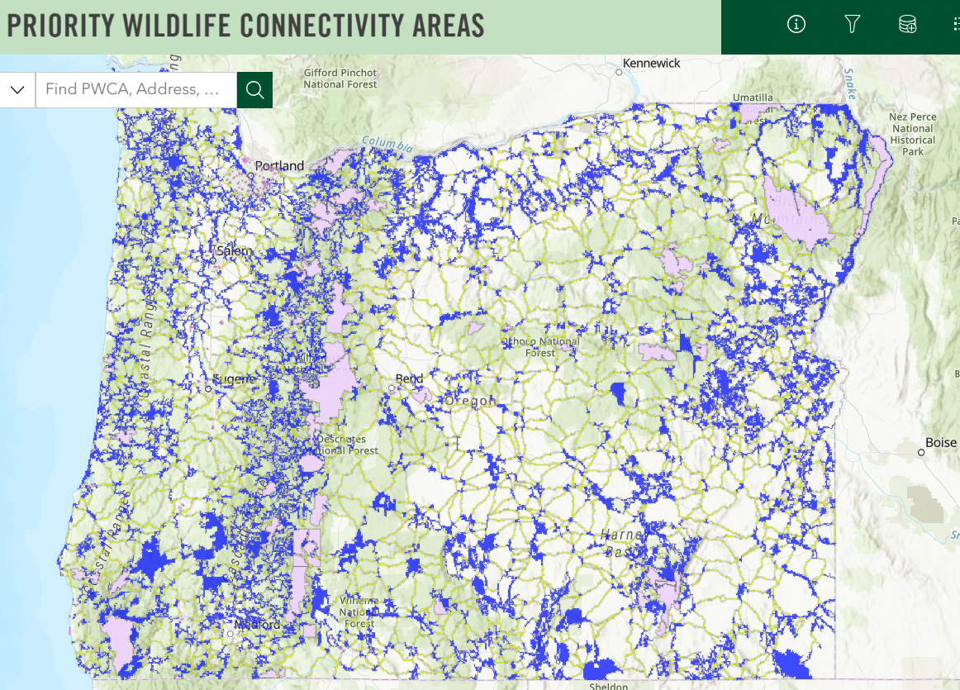

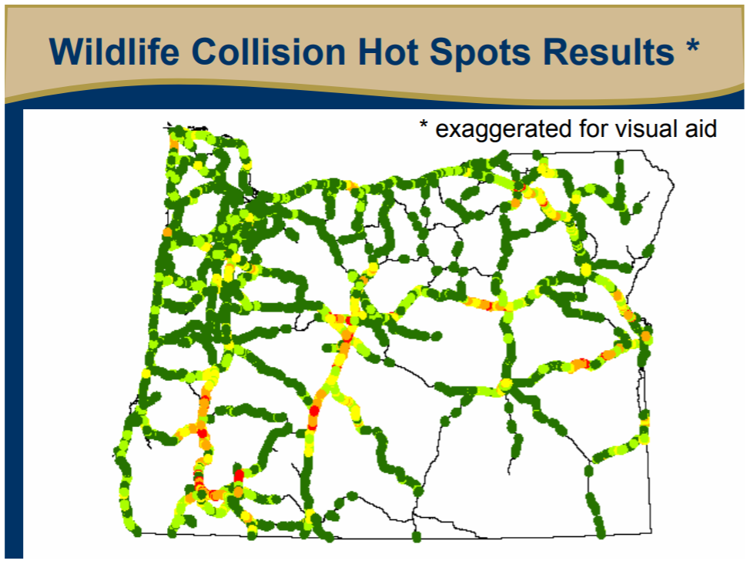
https://www.dfw.state.or.us/conservationstrategy/docs/pac_nw_wl_connections_ws_102008/Oregon%20Wildlife%20Movement%20Strategy.pdf

Hennings and Soll (2010) Wildlife corridors and permeability - A literature review METRO. April 2010
https://www.oregonmetro.gov/sites/default/files/2019/08/22/wildlife-corridors-and-permeability-report-April-2010.pdf

Connectivity corridors must be carefully considered, in part because a lot of species disperse randomly. Narrow corridors are better than nothing; wider corridors are better than narrow corridors; but the best approach to connectivity is to create a "permeable landscapes."

The CEQ connectivity policy talks about “movement of species between blocks of intact habitat.” This is crucial. Connectivity requires not only connections but also high quality habitat source habitats. The NEPA analysis should address how the proposed project affects both the connective functions and the integrity of blocks of intact habitat that are being connected.

The CEQ connectivity policy mentions free movement of wildlife, as well as “unimpeded … ecological processes.” This is important. For instance, fuel breaks should be designed to facilitate fire as a natural process, not to stop fire and exacerbate the serious problems of fuel building, and disrupted of natural fire regimes. Roads also disrupt connectivity, not only making it harder for wildlife to cross, roads, but also natural hillslope processes such as the natural movement of water, wood, and substrate downslope and downstream. This is especially true where roads cross streams or roads located in floodplains or midslope where lots of dynamics happens.

Agencies have a duty to consider connectivity in their NEPA analyses. In 2023 CEQ issued guidance saying “… agencies should consider and be transparent about the positive or negative impacts of proposed actions and alternatives on connectivity and corridors. Through the NEPA review process, Federal agencies can consider measures to advance corridors and connectivity as components of proposed actions, alternatives to proposed actions, or mitigation for proposed actions’ effects.”

“Connectivity is the degree to which landscapes, waterscapes, and seascapes allow species to move freely and ecological processes to function unimpeded. Corridors are distinct components of a landscape, waterscape, or seascape that provide connectivity. Corridors have policy relevance because they facilitate movement of species between blocks of intact habitat, notably during seasonal migrations or in response to changing conditions… Increasing connectivity is one of the most frequently recommended climate adaptation strategies for biodiversity management.”

“To the maximum extent practicable, Federal agencies are expected to advance the objectives of this guidance by developing policies, through regulations, guidance, or other means, to consider how to conserve, enhance, protect, and restore corridors and connectivity during planning and decision-making, and to encourage collaborative processes across management and ownership boundaries. Any existing corridor and connectivity policies or related policies should be updated as needed to align with the objectives in this guidance. Federal agencies should have new or updated policies ready to implement by the first quarter of 2024 and make their policies publicly available. Federal agencies should also actively identify and prioritize actions that advance the objectives set forth in this guidance.”

“Federal agencies should not limit engagement in restoration activities only to circumstances when restoration serves as a mitigation strategy to compensate for adverse impacts from projects or actions. Instead, Federal agencies should consider where there are opportunities in their programs and policies to carry out restoration with the objective of promoting greater connectivity.”
Mallory, B. 2023. CEQ Guidance for Federal Departments and Agencies on Ecological Connectivity and Wildlife Corridors. https://www.whitehouse.gov/wp-content/uploads/2023/03/230318-Corridors-connectivity-guidance-memo-final-draft-formatted.pdf.

Conserve Roadless Areas and Consider New information on Unroaded Areas >1,000 acres

Large intact expanses of unfragmented habitat were once quite common but are now rare. Species evolved in the context of the large habitat patches that result from the natural disturbance regime. As just one important example, big game need large patches of security cover which is best provided by large unroaded areas. New science confirms that roads and logging tend to be contagious on the landscape (managed areas beget more management until little remains unmanaged), so to conserve the habitat values associated with wild places we have to prevent the first intrusions. The purpose and need for this project should include protecting and restoring large unroaded areas consistent with the natural range of variability. This goal is just as important as goals related to tree density or species composition that the agency too often relies on to justify logging and road building.

The Forest Service defines unroaded areas as any area without the presence of classified roads, and of a size and configuration sufficient to protect the inherent characteristics associated with its roadless condition. http://web.archive.org/web/20010729111100/http://roadless.fs.fed.us/documents/feis/glossary.shtml. Unroaded areas greater than about 1,000 acres, whether they have been inventoried or not provide valuable natural resource attributes that must be protected. These include: water quality; healthy soils; fish and wildlife refugia; centers for dispersal, recolonization, and restoration of adjacent disturbed sites; reference sites for research; non-motorized, low-impact recreation; carbon sequestration; refugia that are relatively less at-risk from noxious weeds and other invasive non-native species, and many other significant values. See Forest Service Roadless Area Conservation FEIS, November 2000.

Secretary of Agriculture Tom Vilsack recognizes the value of National Forest roadless areas: “Roadless areas preserve essential watersheds and help ensure an abundant supply of clean drinking water. These large areas of undisturbed forests provide diverse habitats for sensitive and endangered wildlife. In addition, roadless areas provide other critical ecological services, such as carbon storage, and operate as effective barriers to invasive species, while also providing social values such as scenic landscapes and a host of recreational opportunities. Let me assure you that USDA and the Forest Service will move forward to conserve and protect these lands and meet all legal obligations.” March 11, 2009 letter to Oregon Governor Ted Kulongoski.

Before logging roadless areas the agency should consider the impacts to all the values of roadless areas, including:
(1) High quality or undisturbed soil, water, and air;
(2) Sources of public drinking water;
(3) Diversity of plant and animal communities;
(4) Habitat for threatened, endangered, proposed, candidate, and sensitive species and for those species dependent on large, undisturbed areas of land;
(5) Primitive, semi-primitive non-motorized and semi-primitive motorized classes of dispersed recreation;
(6) Reference landscapes;
(7) Natural appearing landscapes with high scenic quality;
(8) Traditional cultural properties and sacred sites; and
(9) Other locally identified unique characteristics.
36 CFR §294.11 (2001). https://www.fs.usda.gov/Internet/FSE_DOCUMENTS/stelprdb5050459.pdf

We are aware that the PNW Regional office issued a directive relative to uninventoried roadless areas, aka “undeveloped areas”. This 11-24-04 memo from Lisa Freedman wisely instructs the Forest Service to give consideration to “special” features of undeveloped areas regardless of size. However, this memo also has some troubling instructions that deserve mention. First, the memo instructs Forests not to "establish a permanent identity or inventory for these areas" which not only interferes with efficient management of information and natural resources but also violates the NFMA mandate to maintain an accurate and up-to-date inventory of the renewable resources of the National Forests. See 16 U.S.C. 1603 which says "the Secretary of Agriculture shall develop and maintain on a continuing basis a comprehensive and appropriately detailed inventory of all National Forest System lands and renewable resources. This inventory shall be kept current so as to reflect changes in conditions and identify new and emerging resources and values." Second, Forests are instructed to focus their analysis on the "effects of the proposed activity where the effects occur rather than on identification or inventory of the undeveloped area." How can the effects of management be adequately disclosed “where they occur” or anywhere else for that matter, UNLESS the qualities of the area are fully understood through identification and inventory. This memo essentially instructs the Forest Service to (i) routinely destroy factual information about resources under its management, and (ii) provide uninformed disclosure of the effects of proposed management action without collecting and considering contextual information about roadless/undeveloped areas that could be affected. If the Forest Service follows these instructions they will be violating NEPA, so don’t do it.

The Forest Service adopted new guidance concerning ecological restoration and resilience which urges managers to “Identify opportunities to sustain ecological refugia that may serve as vital sources of ecological diversity.” FSM 2020.3 – Policy. http://web.archive.org/web/20090511091720/http://www.fs.fed.us/im/directives/fsm/2000/id_2020-2008-1.doc. This is an opportunity to look at uninventoried roadless areas in a fresh new light.

“It is well established in this [9th] Circuit that logging in an unroaded area is an ‘irreversible and irretrievable’ commitment of resources and ‘could have serious environmental consequences.’” and therefore requires an EIS. Sierra Club v. Austin No 03-35419; DC No. CV-03- 00022 DWM (9th Circ. 2003), citing Smith v. Forest Service 33 F.3d 1072, 1078 (9th Circ. 1994). This project involves activities in such unroaded areas. The NEPA analysis for this project does not adequately discuss the impacts of proposed activities on all the many significant values of roadless/unroaded areas.

The 9th Circuit has held that the agencies have a NEPA obligation to consider the potential for future wilderness designation before conducting management activities in areas that may be eligible for wilderness, even if they are not inventoried roadless areas. The Lands Council v. Martin, (9th Circ, June 25, 2008). http://www.ca9.uscourts.gov/datastore/opinions/2008/06/24/0735804.pdf (The court enjoined salvage logging that would have affected uninventoried roadless areas less than 5,000 acres in size that were located adjacent and contiguous with an inventoried roadless area.)

The agency can develop a preliminary map of roadless/unroaded areas >1,000 acres by simply querying your GIS database for polygons between roads that are >1,000 acres. This preliminary map can be made more accurate by subtracting regen harvest units younger than 50 years.

Oregon Wild conducted such an inventory as follows:
Oregon Wild’s Citizen Roadless Inventory is shown on interactive statewide map available at http://www.oregonwild.org/explore-oregon/oregon-wild-map-gallery by following the link for “All Potential Forest Wilderness.” We generally define these areas as those that meet the criteria for inventoried roadless areas set forth by the USFS but based on new science showing the significant ecological values of unroaded areas >1,000 acres, we applied the criteria to federal land areas over 1,000 acres. They are generally in fairly good shape with no substantial/obvious logging, development, or roads.

These areas have wilderness qualities and may qualify for Wilderness protection. There are many other significant values that make these areas worthy of special attention including (but not limited to) their value as places where natural processes can do the ecological work and as a control to experiments (intentional and otherwise) being done across a landscape dominated by human activities including commercial logging, mining, grazing, road building, and other development.

The Forest Service defines unroaded areas as any area without the presence of classified roads, and of a size and configuration sufficient to protect the inherent characteristics associated with its roadless condition. http://web.archive.org/web/20010729111100/http://roadless.fs.fed.us/documents/feis/glossary.shtml. While we refer to Forest Service guidelines in identifying these areas, FS inventories such as RARE II are not the final word. In addition to errors made during the inventory, there are a number of exclusionary biases in defining potential wilderness area's and the roadless inventory. Furthermore, science has evolved since that time to recognize significant ecological value in areas smaller than 5,000 acres.
To identify these areas, Oregon Wild started with a GIS query. Using the most current data layers available for existing roads, we identified all polygons >1,000 acres bounded by those roads. Using GIS layers, we excluded non-federal lands, clearcuts, and heavy thins. We then used aerial images to further refine boundaries based on obvious developments, roads, quarries, and other logging areas not previously identified. We then recruited volunteers to “adopt” candidate unroaded areas and ground-truth them to the extent possible by adding and subtracting areas based on ground reconnaissance. While not every area has been ground-truthed, we update the inventory as we receive information from individuals and agencies during project planning and at other times. Our inventory of unroaded areas is a work-in-progress with a fairly high level of accuracy.

This project appears to propose logging in inventoried roadless areas and adjacent de facto roadless areas that are not inventoried yet provide the same values. The map below shows roadless and unroaded areas as polygons filled with green and outlined in red. The roadless rule prohibits logging in IRAs, and the NEPA analysis must carefully disclose the impacts of logging in the uninventoried roadless areas, especially in light of the new information about the immense ecological value (and carbon value) of these areas.
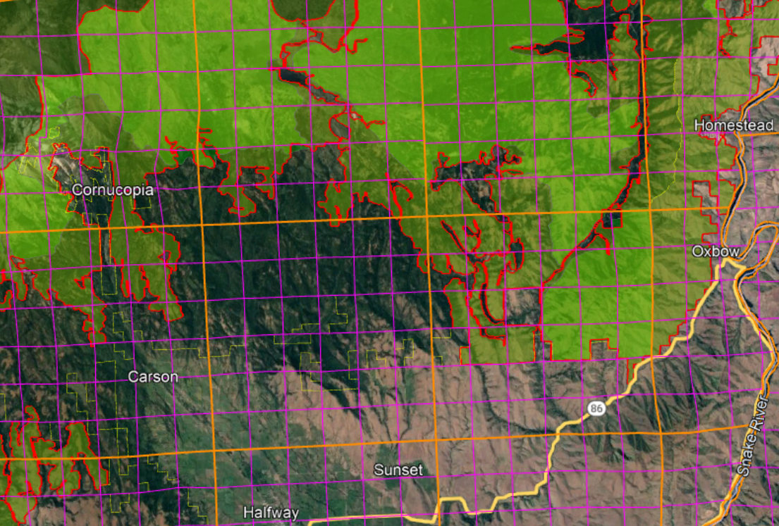

The NEPA analysis should discuss whether the project will push the landscape toward or away from the natural range of variability for large-scale habitat patches. Landscape analysis based on historic disturbance patterns suggests that historically the majority of old forest occurred in large patches. See Wimberly, M. 2002. Spatial simulation of historical landscape patterns in coastal forests of the Pacific Northwest. Can. J. For. Res. 32:13-16-1328 (2002) http://andrewsforest.oregonstate.edu/pubs/pdf/pub2859.pdf (72% of the total mature forest in the Oregon Coast Range was concentrated in patches >1,000 ha). These large patches of older forests that native fish and wildlife species evolved with are now severely underrepresented on the forest landscape and must be protected and restored.

The agency cannot limit its analysis of roadless areas to inventoried areas >5,000 acres, because smaller roadless areas that were not inventoried are ecologically relevant and potentially significant. The NEPA analysis must reflect the growing scientific evidence (cited below) indicating the significant value of roadless areas smaller than 5,000 acres and larger than 1,000 acres. Recent scientific literature emphasizes the importance of unroaded areas greater than 1,000 acres as strongholds for the production of fish and other aquatic and terrestrial species, as well as sources of high quality water. Commercial logging and/or road building within large unroaded areas threatens these significant ecological values.

First, it is important to recognize that about 30% of inventoried roadless areas (IRA) nationwide are smaller than 5,000 acres. It is therefore likely that the diverse and significant values of IRAs can be found within many other unroaded areas between 1,000 and 5,000 acres that were simply not inventoried. NEPA requires that these values be recognized and the effects of logging and roads be carefully disclosed and considered. Martin, DeVelice, Brown. 2001. Landscape Analysis and Biodiversity Specialist Report. Forest Service Roadless Area Conservation FEIS. November 2000. http://www.fs.usda.gov/Internet/FSE_DOCUMENTS/fsm8_035781.pdf
Small areas are important for conserving biodiversity of species with small home ranges, species with special habitat needs, or for providing linkages between larger areas. … Of the more than 2,800 named inventoried roadless areas, about 70% of these areas are larger than 5,000 acres (USDA Forest Service 2000a).

Large unroaded areas are important simply due to the fact that they better represent the historic condition that species evolved with but they are now rare on the landscape due to human activities that have degraded and fragmented the majority of the landscape. The Northwest Forest Plan LSOG Effectiveness Monitoring Plan says that “perhaps 80 percent or more [of the historic late-successional old-growth forest] would probably have occurred as relatively large (greater than 1,000 acres) areas of connected forest.” Miles Hemstrom, Thomas Spies, Craig Palmer, Ross Kiester, John Teply, Phil McDonald, and Ralph Warbington; Late-Successional and Old-Growth Forest Effectiveness Monitoring Plan for the Northwest Forest Plan, USFS General Technical Report PNW-GTR-438; December 1998; http://www.fs.fed.us/pnw/pubs/gtr_438.pdf. Currently, these 1,000 acre and larger patches are rare on the landscape.

Boakes et al (2009) explained why it is important to retain large unroaded areas.
Abstract: Habitat clearance remains the major cause of biodiversity loss, with consequences for ecosystem services and for people. In response to this, many global conservation schemes direct funds to regions with high rates of recent habitat destruction, though some also emphasize the conservation of remaining large tracts of intact habitat. If the pattern of habitat clearance is highly contagious, the latter approach will help prevent destructive processes gaining a foothold in areas of contiguous intact habitat. Here, we test the strength of spatial contagion in the pattern of habitat clearance. Using a global dataset of land-cover change at 50x50 km resolution, we discover that intact habitat areas in grid cells are refractory to clearance only when all neighbouring cells are also intact. The likelihood of loss increases dramatically as soon as habitat is cleared in just one neighbouring cell, and remains high thereafter. This effect is consistent for forests and grassland, across biogeographic realms and over centuries, constituting a coherent global pattern. Our results show that landscapes become vulnerable to wholesale clearance as soon as threatening processes begin to penetrate, so actions to prevent any incursions into large, intact blocks of natural habitat are key to their long-term persistence.
Elizabeth H. Boakes, Georgina M. Mace, Philip J. K. McGowan and Richard A. Fuller 2009. Extreme contagion in global habitat clearance. Proceedings of the Royal Society B: Biological Sciences. November 25, 2009. doi: 10.1098/rspb.2009.1771

World Wildlife Fund and the Conservation Biology Institute summarized the important attributes of small roadless areas (1,000-5,000 acres).
Small roadless areas share many of attributes in common with larger ones, including:
• Essential habitat for species key to the recovery of forests following disturbance such as herbaceous plants, lichens, and mycorrhizal fungi
• Habitat refugia for threatened species and those with restricted distributions (endemics)
• Aquatic strongholds for salmonids
• Undisturbed habitats for mollusks and amphibians
• Remaining pockets of old-growth forests
• Overwintering habitat for resident birds and ungulates
• Dispersal “stepping stones” for wildlife movement across fragmented landscapes
DellaSala, Dominick and James Strittholt. 2002. Scientific Basis For Roadless Area Conservation. World Wildlife Fund. Ashland, OR; Conservation Biology Institute. (June 2002 - Updated October 2003) https://d2k78bk4kdhbpr.cloudfront.net/media/reports/files/Scientific_Basis_For_Roadless_Area_Conservation.pdf.

In a 1997 letter to President Clinton, 136 scientists said:
There is a growing consensus among academic and agency scientists that existing roadless areas–irrespective of size–contribute substantially to maintaining biodiversity and ecological integrity on the national forests. The Eastside Forests Scientific Societies Panel, including representatives from the American Fisheries Society, American Ornithologists’ Union, Ecological Society of America, Society for Conservation Biology, and The Wildlife Society, recommended a prohibition on the construction of new roads and logging within existing (1) roadless regions larger than 1,000 acres, and (2) roadless regions smaller than 1,000 acres that are biologically significant…. Other scientists have also recommended protection of all roadless areas greater than 1,000 acres, at least until landscapes degraded by past management have recovered…. As you have acknowledged, a national policy prohibiting road building and other forms of development in roadless areas represents a major step towards balancing sustainable forest management with conserving environmental values on federal lands. In our view, a scientifically based policy for roadless areas on public lands should, at a minimum, protect from development all roadless areas larger than 1,000 acres and those smaller areas that have special ecological significance because of their contributions to regional landscapes.
Letter to President Clinton from 136 scientists (Dec. 10, 1997).
https://drive.google.com/file/d/0B4L_-RD-MJwrRzhFcm5QcFR0MHM/view?usp=sharing&resourcekey=0-2-sbGMN3bOUBQGGMDBQM1Q

To the list of special values found within unroaded areas must be added carbon storage. European policy leaders consider roadless areas effective for carbon storage and climate mitigation:
[T]he European Parliament has agreed to raise the issue of roadbuilding in intact forests at the UN Climate Change Conference to be held next month in Warsaw (Poland); it calls on parties to use the existence of roads in forest areas as an early negative performance indicator of REDD+ projects, and to prioritise the allocation of REDD+ funds towards road free forests.
Oct 24, 2013 Press release: EUROPEAN PARLIAMENT BACKS THE PROTECTION OF ROADFREE AREAS. http://kritonarsenis.gr/eng/actions/view/european-parliament-backs-the-protection. Federal land managers should recognize the tremendous carbon values in unroaded/unmanaged forests and avoid actions that would threaten these values. See also, William R. Moomaw, Susan A. Masino, and Edward K. Faison. 2019. Intact Forests in the United States: Proforestation Mitigates Climate Change and Serves the Greatest Good Front. For. Glob. Change, 11 June 2019 | https://doi.org/10.3389/ffgc.2019.00027; https://www.frontiersin.org/articles/10.3389/ffgc.2019.00027/full. See also, Kun, Z., DellaSala, D., Keith, H., Kormos, C., Mercer, B., Moomaw, W.R. and Wiezik, M. (2020), Recognising the importance of unmanaged forests to mitigate climate change. GCB Bioenergy. Accepted Author Manuscript. doi:10.1111/gcbb.12714 https://onlinelibrary.wiley.com/doi/pdfdirect/10.1111/gcbb.12714. (“The most effective means for keeping carbon out of the atmosphere to meet climate goals is to protect primary forests (Mackey et al. 2020) and continue growing secondary forests to accumulate additional carbon (proforestation) (Moomaw et al. 2019) while reducing emissions from all sources including bioenergy. … The importance of primary (unlogged) forests lies in the magnitude and longevity of their carbon stock. In order to reverse the decreasing forest carbon stocks in Europe (EEA, 2019), the largest forest carbon stores must be protected and additional forests must be allowed to continue accumulating carbon (proforestation).”).

Road reconstruction and Road improvement

The NEPA analysis should describe when road improvement and road reconstruction are really more like road construction. Road beds that are revegetated and stabilized often do not need any intervention, so re-establishing a road in those locations just reopens old wounds that are well on their way to healing. Such road work often causes more significant impacts than indicated by the term road “improvement” and the agency has a responsibility to be clear in its descriptions and analysis.

Avoid unnecessary construction of temporary roads

Temporary roads still cause serious adverse impacts to soil, water and wildlife, and spread weeds. Decommissioning such roads is not entirely successful and the soil compaction effects can last for decades. The agency should consider avoiding building spurs by treating some areas non-commercially (e.g. thin lightly, create lots of snags, and leave the material on site).

We urge the agency to avoid road construction, including temporary road construction. The ecological costs of road construction almost always outweigh any benefits of the associated commercial logging activity. Since an optimal landscape restoration plan includes a mix of treated and untreated areas, the agency can easily avoid road construction by co-locating untreated areas and inaccessible areas.

Temporary roads have many of the same impacts as permanent roads, including complete vegetation removal, severe soil disturbance and compaction, severe modification of the flow of water and air through the soil, impairment of soil biological activity, wildlife habitat fragmentation (especially for microfauna), and wildlife cover loss. In spite of the fact that some roads may only be used by heavy equipment on a temporary basis, the biophysical effects of temporary roads can be long-lasting. The FS may even come back and use these temporary roads for future vegetation management or fire management. The temporal effects of temp roads can also be extended by legal or illegal use by off highway vehicles, woodcutters, hunters, mushroom collectors, etc.

The November 2000 National Forest Roadless Area Conservation FEIS p 3-30 says that temporary roads are not designed and constructed to the same standard as classified roads and therefore result in a “higher risk of environmental impacts.” The NEPA analysis must account for this increased risk of temporary roads compared to permanent roads.

The Roadless FEIS also says:
Temporary roads present most of the same risks posed by permanent roads, although some may be of shorter duration. Many of these roads are designed to lower standards than permanent roads, are typically not maintained to the same standards, and are associated with additional ground disturbance during their removal. Also, use of temporary roads in a watershed to support timber harvest or other activities often involves construction of multiple roads over time, providing a more continuous disturbance to the watershed than a single, well-designed, maintained, and use-regulated road. While temporary roads may be used temporarily, for periods ranging up to 10 years before decommissioning, their short- and long-term effects on aquatic species and habitats can be extensive. [The FEIS has similar disclosures citing extensive impacts to terrestrial species and habitats, and rare plant populations.]
Roadless Area Conservation FEIS — Specialist Report for Terrestrial and Aquatic Habitats and Species prepared by Seona Brown and Ron Archuleta, EIS Team Biologists http://web.archive.org/web/20040515020554/http://roadless.fs.fed.us/documents/feis/specrep/xbio_spec_rpt.pdf.

"Temporary roads are constructed with no engineering specifications since they are targeted to be used for a short time (ideally a single season), and then obliterated. This lack of construction design makes it particularly important to follow Project Design Criteria for avoiding potentially unstable slopes, even with potentially short time frame of use. That is because even temporary roads which are constructed with road cuts in steep, unstable terrain can trigger debris avalanches and slope failures by removing downslope support and interfering with surface and subsurface water flows that can weaken slopes."
USDA 2020. Stella Landscape Restoration Project Draft Environmental Impact Statement. Page III-30. Rogue River Siskiyou National Forest. https://www.fs.usda.gov/project/?project=53241.

Please consider George Wuerthner’s summary of the many problems with so-called temporary roads. George Wuerthner 2009. Temporary Roads Are Like Low Fat Ice Cream, NewWest. 3-17-09. http://www.newwest.net/topic/article/temporary_roads_are_like_low_fat_ice_cream/C564/L564/ (“The problem is that temporary roads have most of the same environmental impacts as regular roads.”). See also, Wuerthner’s April 2020 blog post showing the persistent impacts of temporary roads. http://www.thewildlifenews.com/2020/04/22/are-temporarily-roads-ecologically-invisible/.

The agency typically assumes that temporary roads will have little or no effect because they are temporary. The agency has shown no scientific evidence to support this assumption. In fact, scientific research has shown exactly the opposite. Research results, published in Restoration Ecology, shows there is nothing temporary about temporary roads, and that ripping out a road is NOT equal to never building a road to begin with.
The saturated hydraulic conductivity of a ripped road following three rainfall events was significantly greater than that of the road surface before ripping... most saturated hydraulic conductivities after the third rainfall event on a ripped road were in the range of 22 to 35 mm/hr for the belt series and 7 to 25 mm/hr for the granitics. These conductivities are modest compared to the saturated hydraulic conductivity of a lightly disturbed forest soil of 60 to 80 mm/hr.” id. Even this poor showing of restoring pre-road hydrologic effects worsened with repeated rainfall. “Hydraulic conductivity values for the ripped treatment on the granitic soil decreased about 50% with added rainfall (p(K1=K2)=0.0015). This corresponded to field observations of soil settlement and large clods of soil created by the fracture of the road surface dissolving under the rainfall... The saturated hydraulic conductivity of the ripped belt series soils also dropped from its initial value. Initially, and for much of the first event, the ripped plots on the belt series soil showed no runoff. During these periods, run-off from higher areas flowed to low areas and into macropores.... Erosion of fine sediment and small gravel eventually clogged these macropores... Anecdotal observations of roads ripped in earlier years revealed that after one winter, the surfaces were nearly as solid and dense as the original road surfaces.” Id. Even though ripped roads increase water infiltration over un-ripped roads, it does not restore the forest to a pre-road condition. “These increases do not represent ‘hydrologic recovery’ for the treated areas, however, and a risk of erosion and concentration of water into unstable areas still exists.
Luce, C.H., 1997. Effectiveness of Road Ripping in Restoring Infiltration Capacity of Forest Roads, Restoration Ecology; 5(3):265-270. http://library.eri.nau.edu/gsdl/collect/erilibra/import/Luce.1997.EffectivenessOfRoadRippingIn.pdf.

The Rogue River-Siskiyou National Forest’s Rustler EA (2010) says:
Temporary roads are also expected to have an irretrievable reduction in soil productivity since they are bladed (soil is mixed and displaced) and compacted. Even once rehabilitated, the soil profile is modified to a degree that may take many years to return to the productive state of the undisturbed forest soils adjacent to it.

To help weigh trade-offs, the agency should do an analysis that illuminates how many acres of accessed by each road segment so that we can distinguish between short segments of spur that allow access to large areas (large accomplishment of goals, with small cost/trade-off) and long spurs that access small areas (small accomplishment, large cost/trade-off). This can help inform the decision-maker’s balancing of the costs and benefits of logging and roading.

EIS required
This large logging project is likely to have significant effects on soil, water, fish & wildlife habitat, climate, recreation, fire hazard, and quality of life and therefore requires an EIS.

Adding to the significant effects of this project includes overlap of mature & old-growth logging, riparian logging, steep slope logging (using untested tethered logging technology), roadless area logging, and/or logging over and near sensitive plants and fish & wildlife.

Basal Area Retention

We urge the agency to retain greater basal area. This will help mitigate several adverse trade-offs caused by commercial logging, including greenhouse gas emissions, wildlife cover and connectivity, long-term snag recruitment, and slash production and disposal.

Basal Area retention is an important ecological consideration that must be disclosed quantitatively in the NEPA analysis. The NEPA analysis should consider alternative levels of basal area retention that resolve trade-offs in different ways. The NEPA document should disclose how recommended basal area retention levels will provide assurance that enough trees are being retained to meet ecological needs for live and dead trees now and in the future.

Where there are lots of small trees we recommend variable density thinning to 60-80 sq ft/acre basal area, retaining the largest trees that will become the next generation of old growth. Since larger trees have a higher ratio of basal area to leaf area, sites with abundant large trees can sustain higher basal areas, and we recommend retaining 100-140+ sq ft/acre.

Basal area retention should be variable but not be too low in any one unit. Enough trees need to be retained to retain and recruit large and old trees and snags now and in the future. Basal area targets should be adjusted higher to account for the following actors:
- Prescribed basal area retention should be weighted to accommodate relatively greater retention in stands with large trees and desirable clumps of trees that contribute to LOS structural conditions.
- All things being equal, large and old trees are more sustainable and resilient than small trees, so where large and old trees are abundant, the site can sustain higher basal area and the mature and old trees do not need to be thinned.
- Retention patches should be excluded from the basal area calculation. Basal area should not be averaged across the stand, but rather across the treated portion of the stand. We recommended 3-4 clumps per acre of 2-10 individual trees as well as the skips to emulate natural historic stand structures.
- Basal area can be higher in riparian areas, area with higher water table, north slopes, etc...

The agency should avoid reducing stand density lower than is appropriate to meet the full suite of ecological objectives, including wildlife cover, perpetuating mortality processes that create and sustain valuable habitat features, etc. The goals should be to create a wide diversity of niches for different species, including those that thrive in dense, complex, forests with abundant snags and dead wood, instead of thinning to low basal area that tends to create one ideal niche for healthy, vigorous conifer trees.

We are concerned that the agencies’ stocking guides were created and intended to be used as a tool to avoid mortality which is clearly inconsistent with ecosystem management. (“To preclude serious tree mortality from mountain pine beetle, western dwarf mistletoe and perhaps western pine beetle, stand densities should be maintained below the upper limit of the management zone” Powell 1999, https://fs.usda.gov/Internet/FSE_DOCUMENTS/fsbdev7_016034.pdf) Healthy forests require dead trees, sometimes in abundance, in order to meet the needs of diverse wildlife and provide full suite of ecosystem functions. Rose, C.L., Marcot, B.G., Mellen, T.K., Ohmann, J.L., Waddell, K.L., Lindely, D.L., and B. Schrieber. 2001. Decaying Wood in Pacific Northwest Forests: Concepts and Tools for Habitat Management, Chapter 24 in Wildlife-Habitat Relationships in Oregon and Washington (Johnson, D. H. and T. A. O’Neil. OSU Press. 2001) http://web.archive.org/web/20060708035905/http://www.nwhi.org/inc/data/GISdata/docs/chapter24.pdf

A comprehensive restoration approach requires focusing not just on live trees, but also on the full suite of ecological processes including density dependent mortality processes that create and recruit snags and dead trees as a valuable feature of eastside forests. We urge the agency not to manage for tree vigor and minimum stocking levels because it will not provide enough green trees for recruitment of snags through time. This is a critical issue given that the current standards for snag habitat are outdated and fail to provide adequate levels of snags and dead wood, and adequate levels of green trees needed to recruit those snags through time.

This graphic from the Microsoft Teams public meeting held Feb 1, 2023 to discuss the draft report of the “2nd Annual Adaptive Management Workgroup: Management Direction for Large Diameter Trees” clearly shows the close association between the abundance of large live trees and large snags. This makes perfect sense because all snags are a product of large live trees. The NEPA analysis must provide an honest and accurate disclosure of the adverse effects of thinning to low basal area through commercial removal of medium and large trees on the future recruitment of large snags.

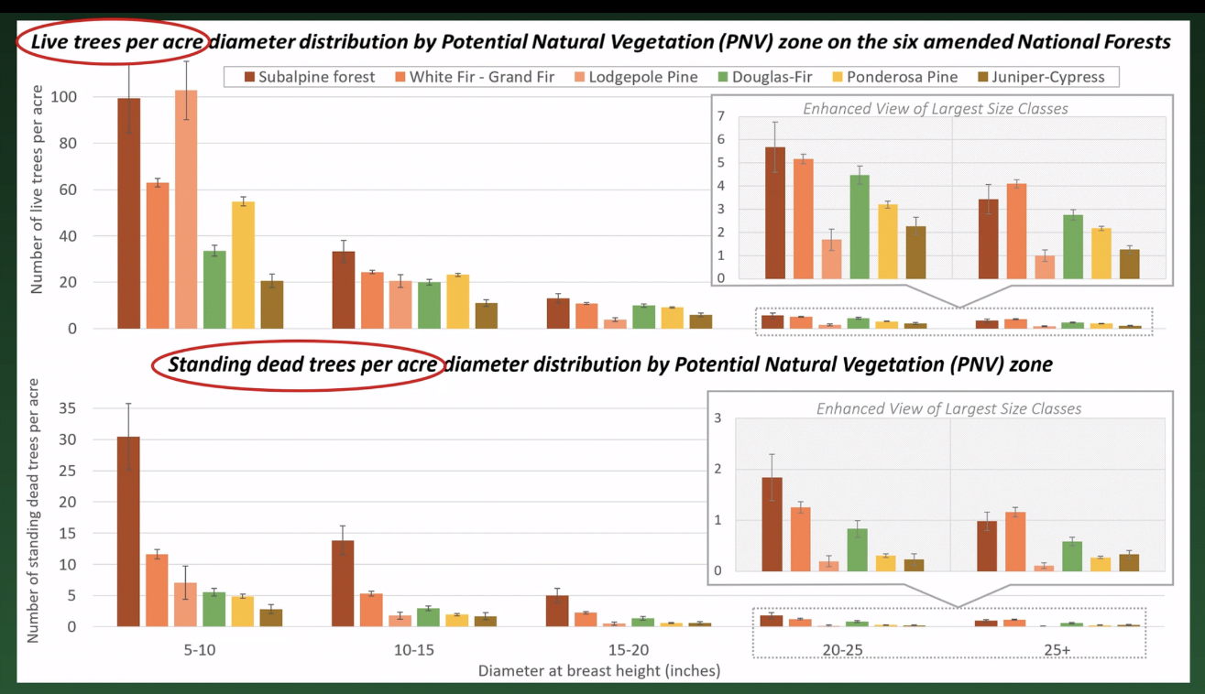
https://www.fs.usda.gov/project/?project=58050

Cutting basal area down to 30-40 ft²/acre is too low. We urge the agency to retain at least 60-120 ft²/acre of basal area. 30-40 ft2/acre might be OK in small patches within units as part of a variable prescription, but the average over a unit must be much higher than that in order to ensure adequate cover for wildlife, and adequate dead wood recruitment through time.

Fire is Mostly Climate Driven
The NEPA analysis must address the fact that agency is trying to use fuel modification to control a system that is driven by weater and climate.

Annual wildfire area burned in coming decades is likely to be highly geographically heterogeneous, reflecting interacting regional and seasonal climate drivers of fire occurrence and spread.
...
Weather conditions at local and regional scales during the fire season are dominant factors influencing fuel flammability and annual area burned [17–20]. Warmer temperatures in concert with drought decrease fuel moisture, increase lightning ignitions, and lengthen the period over which fires occur [21], [22]. At regional scales, the occurrence of severe fire weather is regulated strongly by seasonal climatology as reflected in synoptic-scale atmospheric circulation [23–26]. As a consequence, the potential impacts of seasonal weather on fire behavior and extent are spatially heterogeneous, for several reasons. Growing season temperature influences water balance deficits (PET-AET)–an important variable controlling annual area burned by regulating biomass and fuel moisture–variably across climates and ecosystems [22], [26–28]. ... In addition to fire-season weather, antecedent temperature and precipitation over prior months and years regulate fire frequency and extent to varying degrees across ecosystem types. These effects are especially strong where winter and spring moisture are limiting to growth and conditioning of fine fuels prior to fire season [26], [33], [34]. Ecosystems will thus generate differential responses in vegetation growth in response to warming and changes in precipitation, resulting in significant differences in fuel types and loads under altered climate [7], [35]. For example, although warming may increase area burned under extreme warming/drying conditions in more productive, less fire-prone ecosystems due to increased fuel desiccation, it may produce only modest changes or even decreased area burned in less productive, fuel limited ecosystems by restricting fuel production [3], [6], [15].
...
Seasonal climate variation exerts a primary control on the length, location, and intensity of fire seasons in western North America and worldwide. The amount of area burned by wildfires represents a complex integration of productivity, ignition patterns, landscape configuration (i.e., fuel connectivity), synoptic and local weather, and seasonal climatic conditions that condition fuels and influence fire spread and the length of fire season, along with the important role of anthropogenic ignitions [18], [20], [32].
...
Wildfire is a global Earth system process that both integrates and influences many other interactions between ecosystem and the climate system. Fire mediates other ecosystem responses to changing climate, for example by modulating forest density and composition, and thus providing a mechanism by which ecosystems adapt to changing climate conditions. Uncertainties in key elements of climate projections could be compounded by nonlinear responses of fire to climate variability. Fires may also act as triggers for abrupt and irreversible change to novel configurations under Direct and indirect controls on annual wildfire area burned future climate [44], [83]. As climate change progresses, the projected changes in the area affected annually by fire may be an important multiplier of these effects in coming decades.
Kitzberger T, Falk DA, Westerling AL, Swetnam TW (2017) Direct and indirect climate controls predict heterogeneous early-mid 21st century wildfire burned area across western and boreal North America. PLoS ONE 12(12): e0188486. https://doi.org/10.1371/journal.pone.0188486

The most disastrous fires in terms of loss of human lives and property are less tied to anomalous fuel loads than they are to extreme wind events. Management responses to these different fire types are radically different.
...
[Those responses include] the five “P”s. First, recognition that this is not so much a fuel problem as it is a People problem. The primary means of heading off these catastrophic fires is not with fuel treatments, but with the Prevention of human ignitions, particularly during severe wind events. Failing to do this, there is need for greater attention to Planning placement of developments with a strategic plan that puts fewer people at risk. For those homes at the WUI), Protection of homes from fires is critical. And lastly, agencies would benefit from increased capacity for Prediction of extreme wind patterns in real time and communicating that information to fire agencies and homeowners.
Keeley, J.E., Syphard, A.D. Twenty-first century California, USA, wildfires: fuel-dominated vs. wind-dominated fires. fire ecol 15, 24 (2019) doi:10.1186/s42408-019-0041-0. https://pubs.er.usgs.gov/publication/70205950. https://fireecology.springeropen.com/track/pdf/10.1186/s42408-019-0041-0

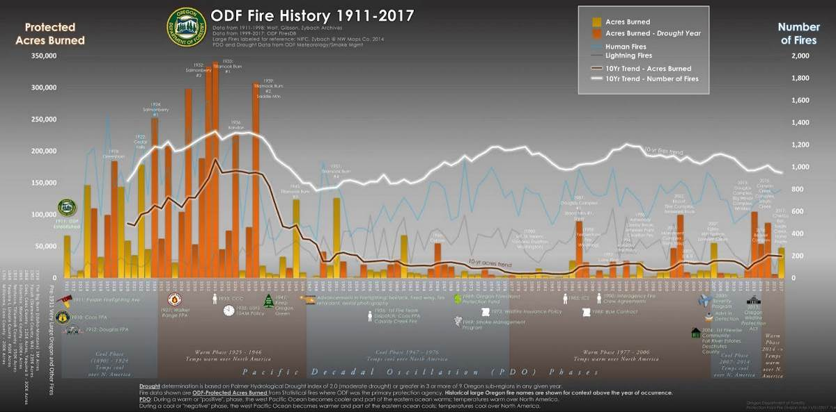

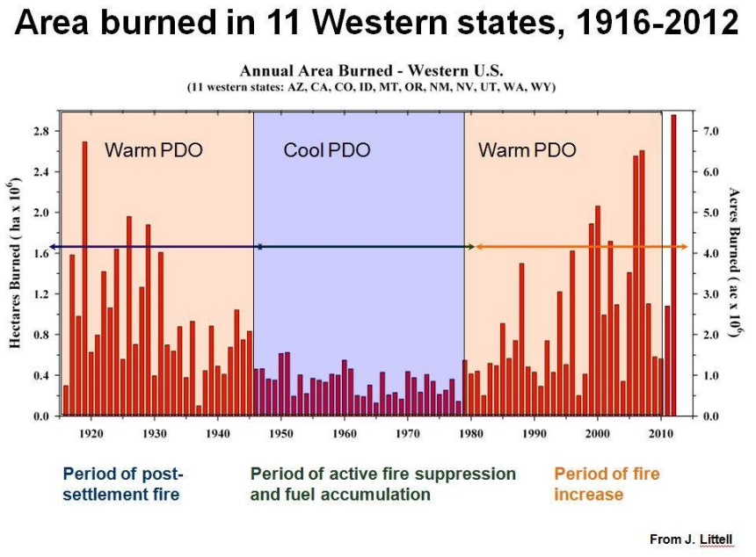
http://forestpolicypub.com/wp-content/uploads/2015/09/photo.jpg (data from Littell)

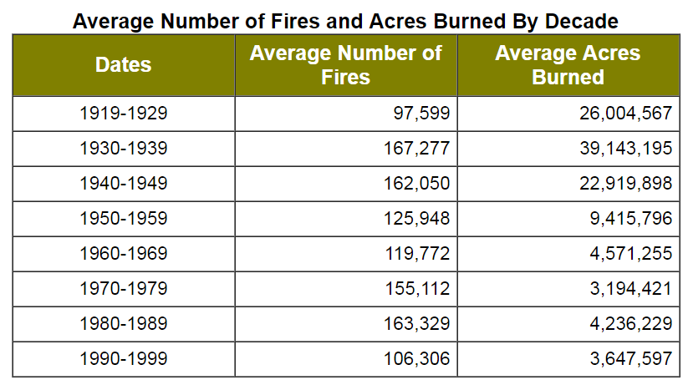
http://web.archive.org/web/20030417010742/www.nifc.gov/stats/wildlandfirestats.html

Set realistic goals and expectations for fuel reduction.

The NEPA analysis must reflect that limited effectiveness of fuel management.

First of all, it is important to recognize the real source of hazard from wildfire. Climate factors (not fuel levels) explain most of the variability in fires across the west.
Climate explains most of the multidecadal to century-scale variations of biomass burning (R2 ¼ 0.85; F ¼ 47.0; p < 0.001). Temperature alone can account for half of the total variance of biomass burning (R2 ¼ 0.53; F ¼ 51.2; p < 0.001), while drought area can explain about one-third of the overall variance (R2 ¼ 0.34;
F ¼ 24.4; p < 0.001).
Jennifer R. Marlon, Patrick J. Bartlein, Daniel G. Gavin, Colin J. Long, R. Scott Anderson, Christy E. Briles, Kendrick J. Brown, Daniele Colombaroli, Douglas J. Hallett, Mitchell J. Power, Elizabeth A. Scharf, and Megan K. Walsh. Long-term perspective on wildfires in the western USA. PNAS, February 14, 2012 DOI: 10.1073/pnas.1112839109. http://www.pnas.org/content/early/2012/02/09/1112839109.full.pdf

Furthermore, the fuels that are the problem are small, generally not commercial-sized wood. Mature forests on federal lands are not the biggest source of fire hazard. Much more significant hazards include (in rough order of priority):
- Drought and climate change.
- Landowners who fail to establish defensible space around their buildings;
- Landowners neighbors who fail to establish defensible space around their buildings;
- Dense young forests on nearby non-federal lands;
- Increased ignition risks from areas with high road density and high rates of human activity.
Downing, W.M., Dunn, C.J., Thompson, M.P. et al. Human ignitions on private lands drive USFS cross-boundary wildfire transmission and community impacts in the western US. Sci Rep 12, 2624 (2022). https://doi.org/10.1038/s41598-022-06002-3, https://www.nature.com/articles/s41598-022-06002-3.pdf. (“A common narrative used to describe CB [cross-boundary] fire is as follows: a wildfire ignites on remote public lands (e.g., US Forest Service), spreads to a community, showers homes with embers, and results in structure loss and fatalities23,25,28. In this framing, public land management agencies bear the primary responsibility for managing and mitigating CB fire risk, with effort focused on prevention, hazardous fuel reduction, and suppression—largely reinforcing the dominant management paradigm of fire exclusion29,30. An alternative risk management framing of this challenge has emerged, starting with the axiom that CB fire transmission is inevitable in fire-prone mixed ownership landscapes and that private landowners and homeowners are the actors best positioned to reduce fire risk to homes and other high-value assets regardless of where the fire starts31. In the absence of a broad-scale empirical assessment of CB fire transmission, it is difficult to determine which of these narratives more accurately reflects the nature of the problem, and whether CB fire risk management is best framed in terms of reducing fire transmission from public lands or decreasing the exposure and vulnerability of high-value developed assets on private lands. … [F]uel treatments are not ecologically appropriate in many fire-prone ecosystems and their effectiveness at landscape scales is limited2,31. Wildfires rarely interact with treatments before fuels recover to hazardous levels53,54,55, and treatments are generally not designed to be effective during the extreme weather and fire behavior conditions associated with the small number of large, destructive fires that escape initial containment … Approximately 11% of all fires on national forest lands burned across USFS boundaries. Most [cross-boundary] ignitions were human-caused (e.g., debris burning, equipment use, escaped campfires) and originated on private lands (Table 1). … A systematic inventory of fire-induced structure loss from ICS-209 and ancillary spatial datasets resulted in a list of 91 fires that destroyed more than 50 buildings between 2000 and 2018 (Fig. 6). Fires starting on USFS lands represent (24%) of destructive fires, and these fires were responsible for 14.7% (5077) of the total structures destroyed (34,493). … We observed a strong positive association between private ignitions and road density, and a weak positive association with average temperature. For the USFS ignitions model, road density was the most important variable and demonstrated a strong positive association with ignitions.”)

“We agree with the authors who have concluded that fuel management is most likely to be effective, and fire suppression more likely to have an influence on fire regimes in ecosystems (e.g. ponderosa pine) where fire occurrence is fuel-driven, which are typically characterized by relatively low-severity surface fire. More purely climate-driven fire regimes are typified by high or mixed severity fires which often burn with an intensity that does not make them amenable to control.” William T. Sommers, Stanley G. Coloff, Susan G. Conard 2011. Synthesis of Knowledge: Fire History and Climate Change. JFSP Project 09-02-1-09 Fire History and Climate Change, Chapter 6. http://www.firescience.gov/JFSP_fire_history.cfm.

“Most fires burn < 1 hectare (Pyne 1984). 1% of largest fires burn 80-96% of total area burned (Strauss et al. 1989).” R. E. Gresswell, Bateman, M. Heck, Heck, G. L. Larson, W. J. Liss, B. Deimling, D. McIntire, and R. Hoffman. Influence Post--fire Environments On Aquatic Ecosystems. http://www.fsl.orst.edu/cfer/products/WorkshopPdfs/Gresswell_Fire.pdf. Did the NEPA analysis consider whether we can do much to influence those large fires that burn during extreme weather conditions?

The NEPA analysis must set realistic expectations about the efficacy of fuel reduction treatments. First of all, the timber industry and some in the agencies like to think that all logging is created equal. (i.e., It's all good.) In fact, logging could make things better or they could make things worse. Even thinning can increase fire hazard instead of decrease it because it makes the forest hotter, drier, and windier and stimulates the growth of future ladder fuels. Amy E.M. Waltz, Peter Z. Fulé, W. Wallace Covington, and Margaret M. Moore. 2003. Diversity in Ponderosa Pine Forest Structure Following Ecological Restoration Treatments. Forest Science 49(6) 2003. http://www.globalrestorationnetwork.org/uploads/files/LiteratureAttachments/91_diversity-in-ponderosa-pine-forest-structure-following-ecological-restoration-treatments.pdf (“Following treatment, total tree regeneration was significantly higher in restored units than control … The thinning component of restoration treatments adds sound fuel through slash, often resulting in increases in larger woody fuels, represented by 100 hr and 1000 hr fuels."). A meta-analysis of the effects of partial cutting showed that understory growth was stimulated in all cases. D. Zhou, S. Q. Zhao, S. Liu, and J. Oeding. 2013. A meta-analysis on the impacts of partial cutting on forest structure and carbon storage. Biogeosciences, 10, 3691–3703, 2013. https://www.biogeosciences.net/10/3691/2013/bg-10-3691-2013.pdf. (“Understory C was stimulated significantly by partial cutting in all of the studies. This stimulation can be mostly attributed to an increase in the availability of light, water, and nutrients to the understory because of tree removal (Aussenac, 2000; Kleintjes et al., 2004; Deal, 2007)”).
Another problem is that the effectiveness of even the best treatments is often grossly overstated because (a) most of the acres that burn do so in severe fires where weather instead of fuels is the controlling factor (i.e. thinning won't help control severe fires which dominate the system), and (b) there is a relatively low probability (e.g. <10%) that any given treated area will be affected by severe fire during the ~20 year period that fire hazard might be reduced.
Third, all logging has impacts that must be factored in and if we are going to treat anywhere near the acres needed to affect landscape level fire patters, then the number of acres treated will be very significant and the cumulative impacts will be tremendous. This has yet to be accounted for in the NEPA analysis here or anywhere else.
We are not arguing that we should do nothing, only that we need to move forward carefully and not accept the mistaken view that logging equals restoration. We have yet to see the safeguards or sideboards that would be needed to ensure that this project program would do more good than harm.

See Finney and Cohen. Expectation and Evaluation of Fuel Management Objectives. USDA Forest Service Proceedings RMRS-P-29. 2003. http://www.fs.fed.us/rm/pubs/rmrs_p029/rmrs_p029_351_366.pdf. Table 1—Expectations of fire and fuel management compared to more realistic performance.
Expectation | Reality
Wildland fuel management prevents structure loss. | Wildland fuel management changes wildland fire behavior. Structure loss (i.e., homes burning) is dependent on local properties of the structure and its immediate surroundings. This means that the proximate responsibility for structure loss from fire primarily resides with the private owners of the structure and immediate property, not with public land management agencies.
Fuel treatments will stop wildland fires. | Fuel treatments change fire behavior within limitations of their prescription. That is, the design criteria or prescription of fuel treatments (see below) allows them to perform alterations in fire behavior up to a limit of weather conditions (primarily fuel moisture and winds). This change in behavior includes reduced intensities and spread rates, but does not prevent combustion. The changes in fire behavior and fuel conditions may enhance the effectiveness of fire suppression tactics, but it is impossible for fuel treatments alone to stop fires from burning or spreading.
Fuel management can be equally successful for all  vegetation and fire regimes. | Fuel management can alter fire behavior but the longevity of these alterations and the ecological appropriateness of the treatment are specific to a given vegetation type. The most common fuel treatments today are concomitant with forest restoration of low-elevation pine and mixed-conifer forests. The same ecological justification and desired changes in fire behavior are inappropriate models for fuel hazard reduction in grasslands that recover following a single growing season or to high-elevation forest characterized by stand-destroying fire regimes. Fuel management strategies and ecological rationale are required for each fire regime and vegetation community.

The paper makes clear that if the goal is protection of structures then the fuel reduction activity must focus on the immediate environment around the structures, not on fuels far removed from the threatened structure.

Surface fuels removed by prescribed burning or canopy fuels removed by thinning change fire behavior within the local domain of the treatment unit. Many studies have shown that fire behavior responds at this local scale to fuel management measures (Helms 1982; Martin et al. 1989; Deeming 1988; Pollet and Omi 2002). This scale, and only this scale, corresponds to the physics of home ignition, whether from firebrands or flames impinging upon home construction materials (Cohen 2000b). The physical properties of the home and its immediate surroundings determine ignition potential and are restricted to the structure and material in very close proximity as determined by principles of radiation and convective heat transfer.

Fuel breaks also fall outside the realm of reasonable expectations because --
…fuel break performance and benefit is based on the questionable expectation that fire suppression will be capable of “stopping” fires after initial attack fails (see Expectations above). Large fires escape initial attack for many reasons that include resource scarcity due to high numbers of ignitions, and spotting and crown fire behaviors that make holding a pre-defined position by firefighters untenable and perhaps dangerous. Furthermore, the only firefighting tactics supported by fuel breaks are categorized as “indirect” (Brown and Davis 1973). This means that the rest of firefighting tactics (direct attack and parallel attack) are not enhanced regardless of the current fire behavior or fire position on the landscape relative to the location of the fuel break. A large fire that slows before reaching a fuel break (because of a change in weather conditions, nighttime, etc.) must be attacked (by direct or parallel tactics) with no benefit of the fuel break. Utilizing fuel breaks involves a large burnout operation, which may be of a size equal to the original wildfire, take place regardless of the fire behavior at its current location, and produce negative effects on wildland vegetation greater than the original wildfire. Maintenance costs of fuel breaks are often ignored by proponents but maintenance is a perpetual burden that is likely to divert efforts from managing fuels and vegetation on the remaining majority of the landscape.
…
Evidence that fuel breaks surrounding urban zones are sufficient to reduce threats to urban values is lacking. Because of their location on the periphery of wildlands, fuel breaks cannot reduce losses of wildland values associated with a community. Although it is commonly argued that fuel breaks will reduce wildfire intensities adjacent to residential development and thereby allows firefighters to protect homes, wildland-urban fire disasters tend to occur during severe fire conditions when fire behavior characteristics often overwhelm fire protection resources.
Finney and Cohen. 2003. Expectation and Evaluation of Fuel Management Objectives. USDA Forest Service Proceedings RMRS-P-29. http://www.fs.fed.us/rm/pubs/rmrs_p029/rmrs_p029_351_366.pdf

The agency must also recognize that the effects of logging projects on fire behavior are often determined by future weather events that are beyond their control. The consequences of land management in the event of bad weather must be disclosed and considered.
[T]he local climate and weather conditions during and after the human activities... are major determinants of the impact on aquatic systems,...
[T]he actual weather conditions that occur at any specific place and time are much less predictable, and inevitably include extreme conditions that are hidden within the long-term average conditions....
[T]he impact of any forest management action on aquatic systems is partially a
matter of chance. With the bad luck of a severe rainstorm, even an action that follows best management practices can have a strong negative effect on aquatic resources, while a poorly conducted action can have little or no negative effect because of the good fortune of moderate precipitation.
Michael Huston, Enrique Gomezdelcampo, Rachel Sewell Nesteruk. Linking Topography, Hydrology, and Biodiversity to Understand Terrestrial Impacts on Aquatic Systems. NCSSF. http://web.archive.org/web/20050323202717/http://www.ncseonline.org/ewebeditpro/items/O62F3298.pdf.

Don’t focus on reducing canopy fuels.

This project is justified primarily as a fuels reduction project, but not all fuels reduction is the same. Reducing surface and ladder fuels is a much higher priority. Reducing canopy fuels is a double-edged sword that can make fire hazard worse instead of better. Canopy fuel reduction comes with significant trade-offs, not only with respect to fire hazard, but also carbon and habitat values. It’s much better to focus on protecting the structure ignition zone and reducing small fuels close to the ground.

Before embarking on an aggressive strategy of crown fuel reduction, the agency must address the responsible opposing viewpoints regarding the manifold values of retaining more canopy to retain cooler temperatures and moisture. Responsible opposing experts say that reducing ground fuels and ladder fuels should be the first priority and reducing canopy fuels a lesser priority.

An implicit assumption of many logging proponents is that less fuels means less fire. This is not supported by the evidence. Less fuel does NOT mean less fire. Some fuel can actually help reduce fire, such as deciduous hardwoods that act as heat sinks (under some conditions), and dense canopy fuels that keep the forest cool and moist and help suppress the growth of surface and ladder fuels, and those canopy fuels are connected to large tree boles with thick bark that do not readily burn.

The Conifer-dominated forest type we are actively encouraging, is highly flammable, while the Broadleaf Aspen forest type we are actively eliminating, is incredibly fire resistant. ... [W]ith leaves, the absence of pitch and high moisture content gives aspen and the other broadleaves serious fire suppressing power. That’s why its standard procedure for firefighters to tie their firebreaks into deciduous stands.
James Steidle 2019. B.C. forest fires would be less severe if we didn't kill off the broadleaf trees. Vancouver Sun. 1-22-2019. https://vancouversun.com/opinion/op-ed/james-steidle-b-c-forest-fires-would-be-less-severe-if-we-didnt-kill-off-the-broadleaf-trees. Also, “stands of deciduous forests acted as brakes on many fires ...” Stockdale, C. A., N. McLoughlin, M. Flannigan, and S. E. Macdonald. 2019. Could restoration of a landscape to a pre-European historical vegetation condition reduce burn probability? Ecosphere 10(2):e02584. 10.1002/ecs2.2584. https://esajournals.onlinelibrary.wiley.com/doi/pdf/10.1002/ecs2.2584

Omi and Martinson (2012) prepared a review of the literature for managers and concluded —
That no relationship (r²<0.06) was found between canopy fuel variables and the effectiveness of either surface reduction treatments without thinning or thinning treatments without subsequent slash treatment supports the assertion that surface fuel reduction is of primary importance in influencing treatment effectiveness.
Omi & Martinson 2012. Effectiveness of Fuel Treatments for Mitigating Wildfire Severity: A Manager-Focused Review and Synthesis. Joint Fire Science Program. Final Report. JFSP Project Number 08-2-1-09 http://www.firescience.gov/projects/08-2-1-09/project/08-2-1-09_finalreport08-2-1-09.pdf

Opening up the stand significantly will dry surface fuels due to increased light levels, surface winds and temperatures. This may increase surface fire intensity and rate of spread unless total surface fuel loading is reduced. In addition, thinning that allows significant light to reach the forest floor may result in the regrowth of small trees and shrubs, which over time become new ladder fuels.
Stephen Fitzgerald and Max Bennett. 2013. A Land Manager’s Guide for Creating Fire-Resistant Forests. EM 9087. OSU Extension. http://www.nwfirescience.org/sites/default/files/publications/A%20Land%20Managers%20Guide%20for%20Creating%20Fire-resistant%20Forests%20.pdf

The agencies must also recognize that most large fires are climate driven, not fuel driven. “Within forests, annual burned area correlated at least as strongly with spring–summer vapour pressure deficit (VPD) as with 14 other drought-related metrics, including more complex metrics that explicitly represent fuel moisture. Particularly strong correlations with VPD arise partly because this term dictates the atmospheric moisture demand.” A. Park Williams, Richard Seager al 2014. Correlations between components of the water balance and burned area reveal new insights for predicting forest fire area in the southwest United States. International Journal of Wildland Fire 24(1) 14-26 http://dx.doi.org/10.1071/WF14023 http://www.publish.csiro.au/?paper=WF14023

“Our analyses indicate that year-of-fire climate is the strongest influence on area burned in forested ecosystems, but fire size may be limited secondarily by fuel continuity between or within forest stands (Rollins et al. 2002). For example, continuity may be less limiting for fire regimes in which crown fires are the dominant mechanism than in lower-elevation forests characterized by surface fires,...” Jeremy S. Littell, Donald Mckenzie, David L. Peterson, And Anthony L. Westerling. 2009. Climate and wildfire area burned in western U.S. ecoprovinces, 1916–2003. Ecological Applications, 19(4), 2009, pp. 1003–1021. https://www.fs.fed.us/pnw/pubs/journals/pnw_2009_littell001.pdf.

[R]elationships described in Westerling et al. (2006) hold for more of the 20th century than previously shown.... These relationships all support our claim that drying of fuels is the primary mechanism for large WFAB [Wild fire area burned] in the higher-elevation and northern mountainous ecoprovinces. Wild fire area burned in these ecoprovinces thus appears to be limited by climate rather than fuel availability, …
…
Our analyses indicate that year-of-fire climate is the strongest influence on area burned in forested ecosystems, but fire size may be limited secondarily by fuel continuity between or within forest stands (Rollins et al. 2002). For example, continuity may be less limiting for fire regimes in which crown fires are the dominant mechanism than in lower-elevation forests characterized by surface fires, …
…
Climate controls on the area burned by wildfire in the western United States are strong, even during the dominant period of fire suppression and exclusion in the last two-thirds of the 20th century. Roughly 39% (1916–2003) to 64% (1977–2003) of the fire area burned can be related directly to climate. The variance explained by climate implies that fuel treatments, for example, might be tailored to specific ecosystems and climate–fire relationships. Recognizing that most ecoprovinces have significant ecological variability, climate-limited ecoprovinces may be less influenced by fuel treatment than fuel-limited ecoprovinces (at least for area burned, if not fire severity).
Jeremy S. Littell, Donald McKenzie, David L. Peterson, Anthony L. Westerling (2009) Climate and wildfire area burned in western U.S. ecoprovinces, 1916–2003. Ecological Applications: Vol. 19, No. 4, pp. 1003-1021. http://naldc.nal.usda.gov/download/34676/PDF.

“[P]otential shrub responses to reduction in stand densities must be considered. Some dry mixed-conifer plant associations have the potential to develop dense shrubby understories when light and moisture are made available by tree thinning; … Such understories can provide significant ground fuels for wildfires, thereby negating some of the positive effects of thinning on fire behavior. The potential for development of shrubby understories can initially be assessed on the basis of plant association; i.e., plant associations vary significantly in potential understory responses. Current stand conditions provide another important measure. Hence, the potential for developing undesirable levels of understory fuels needs to be assessed on a stand-by-stand basis and prescriptions adjusted so as to reduce the risk of undesirable understory responses. Indeed, in some cases it may be desirable to maintain essentially full overstory cover, treating only ladder fuels, and leaving all dominant and co-dominant canopy trees in place rather than risk enhancing ground fuels (e.g., grasses or shrubs). … The Tanoak plant associations of the Siskiyou Mountains have a robust shrub understory that may quickly develop when stands are opened up, potentially defeating the use of thinning to reduce fuel accumulation… ”
Johnson K.N., Franklin, J.F. 2009. Restoration of Federal Forests in the Pacific Northwest: Strategies and Management Implications.

Crown fire is usually a passive crown fire which relies on the preheating of canopy fuels by burning from below. When surface and ladder fuels are adequately treated active crown fire becomes an unlikely outcome except on very steep slopes where preheating is driven by the other crowns burning below. Active crown fire is such a rare event that it should not drive forest management objectives, and the agencies should instead focus on reducing surface and ladder fuels and retaining canopy to help create a cool moist microclimate and to help suppress the growth of surface and ladder fuels.

Removing canopy fuels creates canopy gaps and thus “radiation reaching the forest floor and air movement beneath the residual live tree canopy are increased, and both contribute to fuel drying. More open canopies also contribute to greater understory vegetation growth. The consequences of these changes on fire behavior are not fully understood, but such conditions may favor ignition and spread of fire more readily than in forests having few canopy gaps …” Kaufmann M.R., G.H. Aplet, M. Babler, W.L. Baker, B. Bentz, M. Harrington, B.C. Hawkes, L. Stroh Huckaby, M.J. Jenkins, D.M. Kashian, R.E. Keane, D. Kulakowski, C. McHugh, J. Negron, J. Popp, W.H. Romme, T. Schoennagel, W. Shepperd, F.W. Smith, E. Kennedy Sutherland, D. Tinker, and T.T. Veblen. 2008. The status of our scientific understanding of lodgepole pine and mountain pine beetles – a focus on forest ecology and fire behavior. The Nature Conservancy, Arlington, VA. GFI technical report 2008-2. http://csfs.colostate.edu/pdfs/LPP_scientific-LS-www.pdf.

“Thinning is most effective when it removes understory trees, because larger overstory trees are more resistant to heat injury (Agee and Skinner 2005). In addition, shade and competition from larger trees slows the recruitment of younger trees in the understory.” Keeley, J.E.; Aplet, G.H.; Christensen, N.L.; Conard, S.C.; Johnson, E.A.; Omi, P.N.; Peterson, D.L.; Swetnam, T.W. 2009. Ecological foundations for fire management in North American forest and shrubland ecosystems. Gen. Tech. Rep. PNW-GTR-779. Portland, OR: U.S. Department of Agriculture, Forest Service, Pacific Northwest Research Station. 92 p. http://www.fs.fed.us/pnw/pubs/pnw_gtr779.pdf.

“Removing approximately half of the basal area of a mature stand of lodgepole pine in southeastern British Columbia, by thinning from below to uniform 4 m inter-tree spacing, resulted in decreased canopy interception of rainfall and increased within-stand solar radiation, windspeed, and nearsurface air temperature.” Whitehead, R.J. G. Russo, B.C. Hawkes, S.W. Taylor, B.N. Brown, H.J. Barclay, and R.A. Benton. 2006. Effect of a spaced thinning in mature lodgepole pine on within-stand microclimate and fine fuel moisture content. In P.L. Andrews and B.W. Butler (compilers). Fuels Management - How to Measure Success. USDA Forest Service, Rocky Mountain Research Station, Fort Collins, Colorado, Proceedings RMRS-P-41. Pp. 523-536. http://www.fs.fed.us/rm/pubs/rmrs_p041.html.

A recent study of crown damage related to the Biscuit fire showed that
The most important predictors of total crown damage were the percentage of pre-fire shrub-stratum vegetation cover and average daily temperature. … The median level of damage was 32% within large conifer cover and 62% within small conifer cover. Open tree canopies with high levels of shrub-stratum cover were associated with the highest levels of tree crown damage, while closed canopy forests with high levels of large conifer cover were associated with the lowest levels of tree crown damage.
…
[Random forest analysis] RFA explained 45% of variation in total crown damage. Shrubstratum cover was, by far, the most important predictor variable (Fig. 4); increasing shrub-stratum cover was associated with increasing crown damage (Fig. 5). Average temperature and burn period were similarly important and were ranked second and third, respectively. Large conifer cover was ranked fourth and was associated with decreasing total damage.
…
Furthermore, the ability of conifers to resist fire damage increases with age, as the height to the base of the crown rises and the insulating capacity of the bark increases. This is consistent with the fact that, within the Biscuit Fire, median crown damage within large conifer cover was 32%, compared to 62% within small conifer cover.
…
In addition, mixed-sized conifer cover experienced levels of damage that were intermediate between small and large (median = 52%), which suggests that multi-storied conifer stands did not increase the level of damage by increasing vertical fuel continuity. Instead, it seems likely that the small tree component of the mixed-sized stands was damaged, while the large tree component was not.
Jonathan R. Thompson, Thomas A. Spies 2009. Vegetation and weather explain variation in crown damage within a large mixed-severity wildfire. Forest Ecology and Management 258 (2009) 1684–1694. See also, Jonathan R. Thompson. 2008. Patterns of Crown Damage within a Large Wildfire in the Klamath-Siskiyou Bioregion. PhD dissertation. http://ir.library.oregonstate.edu/xmlui/bitstream/handle/1957/9025/Thompson_Dissertation_FINAL.pdf.
In areas with relatively high productivity that can support shrubs, canopy removal via thinning is very likely to stimulate the proliferation of shrubs and create the very conditions that favor more severe crown damage during fire. This study also challenges the very popular notion that dense forests are a fire hazard. A meta-analysis of the effects of partial cutting showed that understory growth was stimulated in all cases. D. Zhou, S. Q. Zhao, S. Liu, and J. Oeding. 2013. A meta-analysis on the impacts of partial cutting on forest structure and carbon storage. Biogeosciences, 10, 3691–3703, 2013. https://www.biogeosciences.net/10/3691/2013/bg-10-3691-2013.pdf. (“Understory C was stimulated significantly by partial cutting in all of the studies. This stimulation can be mostly attributed to an increase in the availability of light, water, and nutrients to the understory because of tree removal (Aussenac, 2000; Kleintjes et al., 2004; Deal, 2007)”)

Johnson et al (2009) simulated thinning in a densely stocked stand of Ponderosa pine with an understory of Douglas-fir and grand fir.
The predicted fire type after treatment is surface fire for all thinning options, but the more open stands are characterized predominantly by fuel model 2, so flame lengths increase and potential BA mortality remains above 20 percent regardless of surface fuel treatment. The 200 and 300 TPA... treatments have a more closed canopy and fire behavior is influenced less by grass fuels, so flame lengths and potential BA mortality are lower than the more open stands.
...
The 200 TPA treatment has the greatest long-term effect on crown fire potential, with a predicted surface fire type for 50 years with pile-and burn or no surface fuel treatment and 40 years with prescribed fire treatment. The 50 TPA (124 TPH) treatment had the most short-lived effect on crown fire potential, with regeneration causing a drop in canopy base height in 30 years regardless of surface fuel treatment.
Morris Johnson, David L. Peterson, and Crystal Raymond 2009. Fuel treatment guidebook: illustrating treatment effects on Fire hazard. Fire Management Today 69(2)
http://www.fs.fed.us/fire/fmt/fmt_pdfs/FMT69-2.pdf p 32-33.
Models show that maintaining canopy cover is a useful way to reduce fire hazard, while removing canopy increases fire hazard.
Compared with the original conditions, a closed canopy would result in a 10 percent reduction in the area of high or extreme fireline intensity. In contrast, an open canopy has the opposite effect, increasing the area exposed to high or extreme fireline intensity by 36 percent. Though it may appear counterintuitive, when all else is equal open canopies lead to reduced fuel moisture and increased midflame windspeed, which increase potential fireline intensity.
Rutherford V. Platt, Thomas T. Veblen, and Rosemary L. Sherriff. 2006. Are Wildfire Mitigation and Restoration of Historic Forest Structure Compatible? A Spatial Modeling Assessment. Annals of the Association of American Geographers, 96(3), 2006, pp. 455–470. http://www.colorado.edu/geography/class_homepages/geog_4430_f10/Platt%20et%20al_Wildfire%20Mitigatnion_AnAAG_2006.PDF. See also, Jim Agee. Risk Assessment for Decision-making Related to Uncharacteristic Wildfire, Conference Portland, Oregon Nov 17-20, 2003 http://www.docstoc.com/docs/37210605/Risk-Assessment-for-Decision-Making-Related-to-Uncharacteristic. (“Reduce Crown Density • Important to address once surface fire and torching are addressed. • DON’T START HERE!!!!! … Treatments that reduced surface fuels, treated ladder fuels, and kept the big trees fared best.”) An EIS is needed to respond to opposing viewpoints and consider the consequences of alternative approaches to fuel reduction. http://www.fws.gov/oregonfwo/ExternalAffairs/Topics/DryForestWorkshop/Documents/2005/PowerPoints/Agee%20NSO-Bend-Agee.ppt.

New Information on Goshawk Habitat Selection

Project Design Criteria should retain a 30 acre no-touch buffer around goshawk nests, and should focus on non-commercial treatment (rather than commercial logging) within 400 acre post-fledging areas around goshawk sites.

The Eastside Screens provide,
… the following standards are to be met as a minimum. Forest Plan standards and guidelines that EXCEED the levels described below should be used instead of, or in addition to, the following:
(1) Protect every known active and historically used goshawk nest-site from disturbance. “Historical” refers to known nesting activity occurring at the site in the last 5 years. Seasonal restrictions on activities near nest sites will be required for activity types that may disturb or harass pair while bonding and nesting.
(2) 30 acres of the most suitable nesting habitat surrounding all active and historical nest tree(s) will be deferred from harvest.
(3) A 400-acre “Post Fledging Area” (PFA) will be established around every known active nest site. While harvest activities can occur within this area, retain the LOS stands and enhance younger stands towards LOS condition, as possible.
“Disturbance” is an inclusive term. Is does not mean to prohibit just commercial logging, but all cutting of vegetation.

A 2015 science review focused on the southern Blue Mountains of Oregon highlights several key points about goshawks:
- New goshawk science calls for protecting more habitat - e.g., recruitment habitat AND active nest cores; mid-AND-late seral forest;
- New science indicates that the Eastside Screens can be improved if FS would identify and protect more and larger reserve areas for goshawks AND other wildlife;
- Science affirms that goshawk require closed canopy forest, raising questions about increasing the pace and scale of density reduction;
- The Eastside Screens have slowed logging rates and successfully averted a conservation crisis for the goshawk. Increasing the pace and scale of logging could undermine this success story;
Goodell, J. M. and Seager, ST. 2015. The Northern Goshawk on the Southern Blue
Mountains and Malheur National Forest: A Technical Review of its Status, Ecology
and Management. The Nature Conservancy, Portland, OR. 93 p. http://hdl.handle.net/1957/57413; http://ir.library.oregonstate.edu/xmlui/bitstream/handle/1957/57413/Goshawk%20on%20Southern%20Blue%20Mountains_Goodell%20and%20Seager%202015.pdf

Blakey et al (2020) found that although “Effects of timber harvest, including thinning, on goshawks are debated, ... avoidance of open areas and low canopy cover by goshawks in our study indicate that harvesting activities that result in these conditions may detrimentally impact Northern Goshawks.” Blakey, R.V., Siegel, R.B., Webb, E.B., Dillingham, C.P., Johnson, M., Kesler, D.C. 2020 Multi-scale habitat selection by Northern Goshawks (Accipiter gentilis) in a fire-prone landscape. Biological Conservation Volume 241, 2020, 108348, ISSN 0006-3207, https://doi.org/10.1016/j.biocon.2019.108348. https://www.sciencedirect.com/science/article/pii/S0006320719305567

Rodriguez et al (2016) conducted a meta-analysis and found that “Site occupancy by goshawks was reduced near timber harvest and small trees.” S.A. Rodriguez, P.L. Kennedy, T.H. Parker 2016. Timber harvest and tree size near nests explains variation in nest site occupancy but not productivity in northern goshawks (Accipiter gentilis). For. Ecol. Manag., 374 (2016), pp. 220-229. https://doi.org/10.1016/j.foreco.2016.04.052. (“Evidence from across the breeding distribution of the northern goshawk suggests that timber harvest as represented in these studies (Table 2) is associated with lower nest-site occupancy. However, if goshawk pairs do nest at timber-harvest sites, their reproduction appears unaffected by this harvest. ... Our results support conclusions of other reviews (e.g., Squires and Kennedy, 2006) that, regardless of forest type, goshawks prefer patches of more mature trees, relative to availability, for situating nests. ... [R]educed goshawk occupancy of sites near timber harvest or sites with smaller trees need not result from changes in food availability. It is plausible that such patterns may result from goshawks selecting nests in areas that are shielded from predators or protected from inclement weather. When a nest tree is surrounded by small trees, or if surrounding trees are removed, the nest itself may become more visible to predators and less protected from inclement weather. If goshawks respond to greater nest exposure with nest abandonment, that could explain our occupancy results. There is no empirical support for this type of nest site selection in goshawks, but it is plausible given that in some other birds species individuals may adjust nest placement to enhance concealment and reduce predation risk (Lima, 2009). ... Thus we have not shown that stand characteristics and timber harvest do
not influence goshawk reproduction. Instead we have found only a lack of evidence that stand characteristics and timber harvest influence the success of nesting attempts that occur in the presence of timber harvest. In other words, the relationships we detected with site occupancy could well be effects on nest initiation, and thus potentially lifetime reproduction and ultimately fitness.”).

Rickabaugh (201x) conducted extensive surveys of goshawks in eastern Oregon and found that density reduction treatments were not favorable.
FOREST MANAGEMENT OF TERRITORIES
In 1993, the USFS wisely began implementation of goshawk guidelines in their planning process, based on work by Reynolds et al (1992). On this forest the attempted directions for management (as specifically stated in the “East Side Forest Plan Amendment 2”) is to protect every known active and historically used goshawk nest site from disturbance; and that 30 acres of the most suitable nesting habitat surrounding all active and historical nest trees will be deferred from harvest. A 400-acre PFA has been established around a majority of the known nests sites but not all.
…
Most of the management activities (timber harvest, thinning, etc.) on this study area at the nest stand level have proven to be deleterious to occupancy of those nest stands. Even though the directives in the “East Side Forest Plan Amendment 2” (C. Kranich, pers. com.) is to defer from harvest 30 acres of the most suitable nesting habitat surrounding all active and historical nest trees, this has not been implemented (for various reasons deemed by forest managers at the time) in all cases. In these cases (for examples see Burntcabin Creek, Dipping Vat, LP Dog, Steagall Springs), nesting goshawks moved to adjacent areas or were seemingly extirpated from that nest stand. Though the harvest prescriptions may change in the future, I have observed that the overall management activities in the goshawk nest stands and surrounding areas have had the effect of reducing the canopy layer and opening up the forest structure. Goshawks are more likely to be found in areas with a high percentage of mid-aged to late succession forest in closed canopy conditions. A reduction in large trees and canopy cover, either through short-term high volume logging or repeated entry into stands over time, reduced the suitability of those stands for occupancy by breeding goshawks (DeStefano et al. 2006). There is a need for long-term monitoring of the results of these management procedures; however, funding and personnel will probably continue to be deficient for this forest, particularly in the current budget climate. In the 32 core territories with the longest monitored record, only 13 have remained relatively unaltered by any timber activity or disturbance other than natural
occurrences (e.g., wind throw, deadfall). Seventeen have been altered by cuts in or around the nest clusters, and two have been burned …
SKYLAR J. RICKABAUGH with THEODORE J. FREMD. NORTHERN GOSHAWKS
IN THE MALHEUR NATIONAL FOREST EASTERN OREGON 1992 TO 2011. p 429-430
https://scholarsbank.uoregon.edu/xmlui/bitstream/handle/1794/12197/A_Final_Goshawk_doc_May_10.pdf

A 2005 review of the most accurate information on goshawk habitat selection confirms that goshawks select stands with complex forest structure (e.g. high canopy closure, large tree for forest type, canopy layering, abundant course woody debris). However, protecting just late successional forest and just the active nest sites may not be enough. The agency should be protecting more mid-and late seral forests and should be protecting both recruitment habitat and active nest cores, i.e., the agencies should be managing for a landscape that is suitable for goshawks and other late successional wildlife to thrive and move around in.

This review also does not find support for a few of the assumptions underlying Reynolds’ 1992 management recommendations.
- Goshawks are habitat generalists only in the sense of using forests with a variety of tree species, but they are not habitat generalists in terms of selecting forest structure. They disproportionately select for late successional forest.
- Goshawks are not opportunistic foragers. Rather they appear to select for prey availability as determined by late successional forest structure.
- Goshawk are not limited by prey abundance. They select for prey availability, with absolute prey abundance being only a component of availability, late successional forest structure being an important determining factor.

Some relevant excerpts from this review include:
Boal et al (2001) found that stands used by goshawks contained 1.6 to 2.4 km of down woody debris per hectare with an average diameter of 17-19 cm, depending on forest type, and Bloxton (2002) documented that goshawk kill sites has greater numbers of snags >12.5 cm dbh/ha (u=77) than random sites.
…
… the consistency of results in demonstrates goshawk selection for late successional forest structures (e.g. high canopy closure, large tree for forest type, canopy layering, abundant course woody debris) when using areas within their studies home ranges. …
…
A majority of studies found selection for stands with >40% canopy closure and greater densities of trees over 40 cm dbh. …
… goshawks may be broad habitat generalists in terms of tree species but are habitat specialists with respect to forest structure. …
… prey abundance is not the most important factor is selecting foraging sites...
Several studies determined that goshawks select foraging habitat based not on prey abundance but rather prey availability as determined by habitat structure. … [R]ecommendations focusing on increasing prey abundance at the expense of forest structure within occupied home ranges are not likely to improve goshawk occupancy rates.
…
goshawks avoided open areas, particularly logged open areas, and none found selection for openings. … current information does not conclusively support a contention that creating openings through logging will benefit the goshawk. Given the history of clearcutting in much of the western United States range of the goshawk, we very much doubt that forest clearing are a limiting factor for the species.
…
Occupancy rates were reduced by removing forest cover in the home range…
…
We have no way of knowing assessing whether 40% of the landscape in mature and old-growth forests is sufficient to sustain goshawks. … we recommend protecting existing mature and old-growth forest characteristics and ensuring that such forests are allowed to develop in proportions similar to pre-settlement conditions. This can be accomplished by restricting cutting to small trees and prohibiting large reductions in canopy closure. A similar proposal was recently adopted by Region 5 of the United States Forest Service for the Sierra Nevada.
Greenwald, Crocker-Bedford, Broberg, Suckling, and Tibbitts. 2005. A review of Northern goshawk habitat selection in the home range and implications for forest management in the western United States. Wildlife Society Bulletin 33(1):120-129. http://www.fs.usda.gov/Internet/FSE_DOCUMENTS/fsbdev3_021122.pdf.

This comprehensive review of telemetry studies does not find support for the hypothesis that thinning improves goshawk foraging habitat. Absent clear scientific support, the agency should clearly label the statement as an unsupported hypothesis.

Even though the speculations in Reynolds (1992) about the benefits of logging have been discredited by subsequent science we still see the agencies inappropriately relying on Wisdom (2000) which in turn relies on Reynolds (1992). (e.g. Jackson Vegetation Management Project FIES. Ochoco NF. 2012).

Beier et al (2008) looked at the efficacy goshawk management recommendations used by the FS in the SW and found
The strongest pattern was that, contrary to our hypothesis, production of ﬂedglings decreased as the breeding area’s similarity to the goshawk guidelines increased. Why did goshawk reproduction not increase with similarity to the goshawk guidelines? One possibility is that Reynolds et al. (1992) estimated inaccurately forest conditions that maximize prey abundance. … Another possibility is that Reynolds et al. (1992) erred in their fundamental assumption that goshawks are habitat generalists and prey specialists that thrive best in a landscape with abundant prey. … [W]e found a moderate negative correlation between goshawk productivity and the forest structure prescribed by the guidelines. This calls into question the purported benefit to goshawks.
Beier, P., E. C. Rogan, M. F. Ingraldi, and S. S. Rosenstock. 2008. Does forest structure affect reproduction of northern goshawks in ponderosa pine forests? Journal of Applied Ecology 45:342–350. http://oak.ucc.nau.edu/pb1/vitae/Beier_etal.2008.Goshawk.JAE.pdf and see Beier, P., E. C., and M. F. Ingraldi 2012. Commentary: There Is No Evidence That the Forest Service’s Goshawk Recommendations Improve Goshawk Nest Productivity. Wildlife Society Bulletin; DOI: 10.1002/wsb.122. (“we tested whether goshawk (accipiter genitilis) productivity increased with increasing similarity of goshawk breeding areas to Forest Service recommendations for the northern goshawk in the southwestern United States. Surprisingly, we found that nest productivity declined as similarity to the recommendations increased from 21% to 57% (Beier et al. 2008).”

Timber sales that emphasize removal of shade tolerant trees will likely adversely affect goshawk habitat. Minta et al (1993) found that goshawk territories in NE Oregon tend to be located in stands dominated by Grand fir, while they prefer to nest in large Douglas fir trees. Minta, Steven, Ralph Anderson and Tracy Fleming. 1993(fall). Trends in historic goshawk data, Wallowa (Whitman) National Forest, Oregon. Unpublished 2 page typescript summary. Report on file at National Council of the Paper Industry for Air and Stream Improvement. (“The dominant trees in the nest stand were grand fir (38.4%, n=159), Douglas Fir (22.6%), Ponderosa pine (14.5%), western larch (12%), and lodgepole pine (10.7%). Secondarily dominant trees included Douglas fir (46.6%, n=131), western larch (16.8%), Ponderosa pine (14.5%), and grand fir (10.7%). The USFS plant community designation was most frequently grand fir/twinflower (35.9%, n=117), grand fir/big huckleberry (27.4%), Douglas fir/common snowberry (13.7%), …”)

The agency sometimes argues that logging helps create flying space for goshawks. This generally not necessary or beneficial. Goshawks prefer relatively dense, complex forest and they have the ability to fly through complex forests, as shown in the following videos: https://youtu.be/_bXHLznnQmY?t=37s;
https://youtu.be/7WurNq4q0K0?t=2m46s;
https://www.facebook.com/atmacaalemi.sparrowhawkworld/videos/121267271547623/

New information on Snags and Dead Wood.
There is a shortage of large snags and down wood in our eastside forests. The NEPA analysis must address the fact that commercial logging makes a bad situation worse in terms of snags and dead wood. The FS lacks scientifically credible standards for managing snags and green replacement trees. The old standards are outdated (as explained below). The amended snags and green tree standards in the Trump Screens Amendment cannot be relied upon because the NEPA analysis has been rejected by the courts. The amended standards are also improper fro all the reasons we described in our comments on the Trump Screens Amendment. We incorporate by reference our scoping comments and comments on the Large Tree Amendment EA and preserve all legal claims related to the issues raised in our Screens NEPA comments. https://cara.fs2c.usda.gov/Public//ReadingRoom?Project=58050.

Dynamic ecosystems historically included large-scale mortality events both pulsed and continuous. Mortality and biomass accumulation are natural and desirable ecological processes that forest management has been working for decades to capture, suppress, and avoid. Large snags are severely under-represented in our forests and logging will capture, reduce and delay recruitment of future large snags. Korol et al (2002) estimated that even if we apply enlightened forest management on federal lands in the Interior Columbia Basin for the next 100 years, we will still reach only 75% of the historic large snag abundance, and most of the increase in large snags will occur in roadless and wilderness areas. Jerome J. Korol, Miles A. Hemstrom, Wendel J. Hann, and Rebecca A. Gravenmier. 2002. Snags and Down Wood in the Interior Columbia Basin Ecosystem Management Project. PNW-GTR-181. http://www.fs.fed.us/psw/publications/documents/gtr-181/049_Korol.pdf. Wisdom et al (2008) found that snag abundance in the Pacific northwest forests is inversely related to past harvest and proximity to roads. Wisdom, M.J., and Bate, L.J. 2008. Snag density varies with intensity of timber harvest and human access. For. Ecol. Manage. 255: 2085–2093. doi:10.1016/j.foreco.2007.12.027. http://www.fs.fed.us/pnw/pubs/journals/pnw_2008_wisdom001.pdf (“Our highest snag density … occurred in unharvested stands that had no adjacent roads. … Stands with no history of timber harvest had 3 times the density of snags as stands selectively harvested, and 19 times the density as stands having undergone complete harvest. Stands not adjacent to roads had almost 3 times the density of snags as stands adjacent to roads.”) Salem BLM’s Bottleneck LSR Enhancement Project EA (http://www.blm.gov/or/districts/salem/plans/files/sdo_080-07-16_eafonsi.pdf ) includes Table 9 which clearly shows that thinning will adversely affect mortality processes. Mortality would be 70 tpa without treatment, or 0.10 tpa with thinning, thus sacrificing 69.9 trees per acre averaging 20.3" dbh that would be recruited to the large snag and down wood pool over the next 30 years except that they will instead be cut and taken to the mill.

Most managers under-estimate how many snags a healthy forest is supposed to have. For instance, recent descriptions of native forests in the Coast Range show that >30% of the basal area is standing dead trees. Gray, Andrew N.; Monleon, Vicente J.; Spies, Thomas A. 2009. Characteristics of remnant old-growth forests in the northern Coast Range of Oregon and comparison to surrounding landscapes. Gen. Tech. Rep. PNW-GTR-790. Portland, OR: U.S. Department of Agriculture, Forest Service, Pacific Northwest Research Station. 45 p. http://www.fs.fed.us/pnw/pubs/pnw_gtr790.pdf (derived from Table 2, page 13.) Also, the old-growth Douglas-fir/western hemlock forest at the site of the Wind River Canopy Crane has 59.5 snags/hectare larger than 51 cm dbh. Shaw, David C.; Franklin, Jerry F.; Bible, Ken; Klopatek, Jeffrey; Freeman, Elizabeth; Greene, Sarah; Parker, Geoffrey G. 2004. Ecological setting of the Wind River old-growth forest. Ecosystems. 7: 427-439. http://www.fs.fed.us/pnw/pubs/journals/pnw_2004_shaw001.pdf. Where are we intentionally managing for this outcome?

Snags have been severely depleted across the eastside and westside forests. On industrial forest lands “The density of large snags [under an industrial forest regime] was projected to be less than 1% that found in unmanaged stands.” Wilhere, G.F. 2003. Simulations of snag dynamics in an industrial Douglas-fir forest. Forest Ecology and Management. Volume 174, Issues 1-3, 17 February 2003, Pages 521-539. http://www.sciencedirect.com/science?_ob=ArticleURL&_udi=B6T6X-47P120B-3&_user=10&_rdoc=1&_fmt=&_orig=search&_sort=d&view=c&_acct=C000050221&_version=1&_urlVersion=0&_userid=10&md5=54598041b1147ba33dab125d9058d7b2.
The federal agencies need to compensate for the severe lack of snags on intensively managed forest lands, but unfortunately snags are lacking on federal lands as well. For snag depletion in westside forests, see Nonaka, E, Spies, TA, Wimberly, MC, and Ohmann, JL. 2007. Historical range of variability (HRV) in live and deadwood biomass: a simulation study in the Coast Range of Oregon, USA. Can. J. For. Res. 37:2349-2364. http://ddr.nal.usda.gov/bitstream/10113/9953/1/IND44013619.pdf , and Jerome J. Korol, Miles A. Hemstrom, Wendel J. Hann, and Rebecca A. Gravenmier. 2002. Snags and Down Wood in the Interior Columbia Basin Ecosystem Management Project. PNW-GTR-181. http://www.fs.fed.us/psw/publications/documents/gtr-181/049_Korol.pdf. For snag depletion in eastside forests, see the ICBEMP Scientific Analysis Group which found that “Across the [interior Columbia River] basin (all lands) large snags have declined more than 30 percent. This was most likely a reflection of the loss of late-seral forests, particularly in the dry and moist PVGs.” Miles A. Hemstrom, Wendel J. Hann, Rebecca A. Gravenmier, Jerome J. Korol. 2000. [SAG] Landscape Effects Analysis of the [ICBEMP] SDEIS Alternatives. USDA/USDI, draft March 2000.
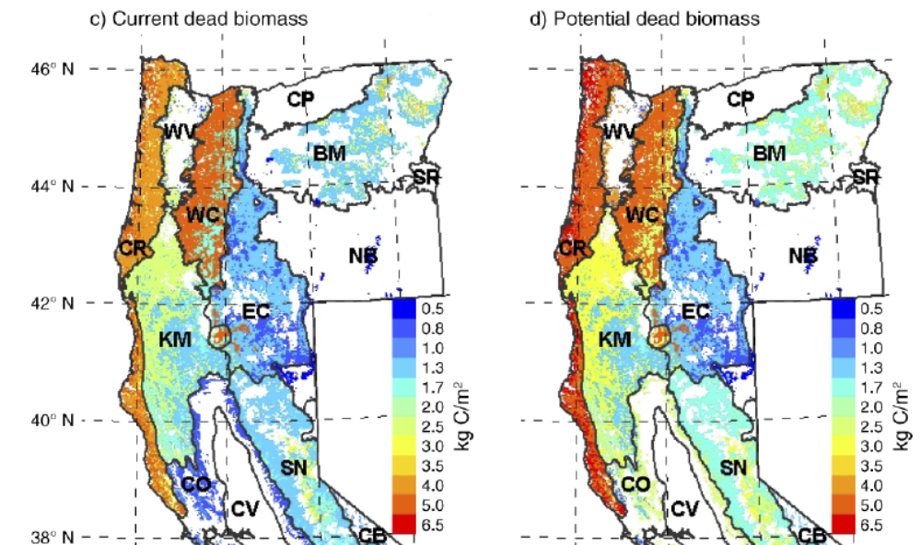
Tara Hudiburg, Beverly Law, David P. Turner, John Campbell, Dan Donato, And Maureen Duane 2009. Carbon dynamics of Oregon and Northern California forests and potential land-based carbon storage. Ecological Applications, 19(1), 2009, pp. 163–180
http://terraweb.forestry.oregonstate.edu/pubs2/Hudiburg2009EA.pdf.

“In general, wildlife species that use dead wood for nesting, roosting, or foraging prefer larger diameter logs and snags (>20 inches). Although we tallied dead wood in this size class throughout Oregon, the estimated density may not be sufficient for some wildlife species. For example, inventory results show a mean of almost 3 snags per acre in this size class in western Oregon and 1 per acre in eastern Oregon. This may indicate that large-diameter snags are currently uncommon in Oregon habitat and that management may be necessary to produce a greater density of large snags.”
Donnegan, Joseph; Campbell, Sally; Azuma, Dave, tech. eds. 2008. Oregon’s forest resources, 2001–2005: five-year Forest Inventory and Analysis report. Gen. Tech. Rep. PNW-GTR-765. Portland, OR: U.S. Forest Service, Pacific Northwest Research Station. 186 p. http://www.fs.fed.us/pnw/publications/gtr765/pnw-gtr765b.pdf.

The 9th Circuit recently reiterated that “species viability may be met by estimating and preserving habitat ‘only where both the Forest Service’s knowledge of what quality and quantity of habitat is necessary to support the species and the Forest Service’s method for measuring the existing amount of that habitat are reasonably reliable and accurate.’ Earth Island Inst. v. U.S. Forest Serv., 442 F.3d 1147, 1175-76 (9th Cir. 2006) (quoting Native Ecosystems Council v. U.S. Forest Serv., 428 F.3d 1233, 1250 (9th Cir. 2005))” ONRC v. Goodman (Mt Ashland case, 9th Circuit Sept 24, 2007) (emphasis added).
http://caselaw.findlaw.com/us-9th-circuit/1151013.html
and http://caselaw.findlaw.com/us-9th-circuit/1094367.html.

The Forest Service cannot provide any assurance that its plans and projects will assure viable populations of native wildlife that depend on dead trees. The Forest Service does not know how many snags are necessary to support viable populations of cavity associated species. The Forest Service has provided no credible link between DecAID tolerance levels, potential population levels, and/or viable populations. The Forest Service has also failed to reliably quantify existing and projected habitat for snag associated species.

The Forest Service cannot provide any assurance that its plans and projects will assure viable populations of native wildlife that depend on dead trees. The recently amended Eastside Screens changed the requirements for snag habitat in a way that offers no assurances of population viability. The new snag standards basically requires some snags for some wildlife, while failing to ensure there are enough snags for wildlife that are most sensitive to logging and the resulting absence of abundant snags.

An unavoidable impact of all commercial logging is to “capture mortality” which reduces valuable snag habitat in the short-term (via hazard tree felling) and in the long-term (via delayed recruitment and reduced overall recruitment). For example, in a thinning project on the Siuslaw National Forest “modeling stand #502073 over a 100-year cycle [using ORGANON] predicts a total stand mortality of 202 trees (>10 inches dbh) for the unthinned stand, while mortality for the thinned stand was two trees. Therefore, thinning will reduce density-dependent mortality within the stand by 99%.” NOAA April 4, 2006 Magnuson Act consultation on Essential Fish Habitat and Response to Siuslaw NF Lobster Project BA. There is no reason to think that thinning in densely stocked forests elsewhere would be any different.

Dead wood in forests is thought to follow a U-shaped pattern over time “from the combined and lagged effects of legacy wood decay and the recruitment of new dead wood,” (Harmon 1986, Hudiburg 2009) resulting in abundant dead wood legacies from the previous stand in young forests, less dead wood in middle-aged stands as the legacies decay, and more again in older stands as natural mortality processes manifest. If the goal is to restore high quality old forest habitat, the agencies must respect this dynamic by recognizing that dead wood recruitment requires (1) “surplus” biomass and (2) it’s a process that takes time, so managers should ensure that middle-aged stands accumulate biomass and begin to recruit and accumulate snags and dead wood. The low of dead wood in middle aged stands is not universal or necessarily desirable, and since many young stands were deprived of the legacies they normally enjoy, it would be advisable to start accumulating snags and dead wood as soon as possible, not wait for mature stages.

The federal forest agencies now recognize that current methods and assumptions concerning snag habitat standards are outdated, and the old snag standards do not ensure enough snags to meet the intent of the standard, yet the agencies have not adjusted their management plans to account for this new information nor have they developed new standards that are consistent with the latest scientific information.

As explained on the DecAID website:
Why is DecAID needed?
National Forest LRMP standards and guidelines for management of snags and down wood in the Pacific Northwest were based on wildlife species models and tools that were developed in the 1970s and 1980s (Thomas et al. 1979, Neitro et al. 1985, Marcot 1992, Raphael 1983). New information about the ecology, dynamics, and management of decayed wood has been published since then, and the state of the knowledge continues to change. Rose et al. (2001) report that results of monitoring indicate that the biological potential models are a flawed technique (page 602). There has been an evolution from thinking of large woody material as habitat structures, to thinking of decaying wood as an integral part of complex ecosystems and ecological processes.

This paradigm shift has made the management of dead wood a much more complex task. We can no longer expect to go to our LRMPs or the biological potential model to get one number for the amount or size of snags and down wood that we can apply to all projects and to all acres. We are directed to use the best available science to manage ecosystems, and the best available science simply will not support business as usual for managing dead wood.
Region 6 - USDA Forest Service. A Guide to the Interpretation and Use of the DecAID Advisor. June, 2006. http://www.fs.fed.us/r6/nr/wildlife/decaid-guide/

A few of the problems with the old standards are:
- They failed to account for the fact that the number of snags needed for roosting, escape, and foraging can exceed the number of snags needed for nesting;
- They failed to recognize that the number of snags needed to support viable populations of secondary cavity users may exceed the needs of primary cavity excavators;
- The old standard failed to account for the size height of snags favored by some species;
- In applying the old standards the agencies often fail to account for rates of snag fall and recruitment;
- The old standards fail to recognize non-equilibrium conditions in our forests, i.e. some species rely on the natural large pulses of snags associated with large disturbances;
- The old standards fail to account for the differential use of space and population density of different species;
- The old standards ignore other important habitat features of dead wood, e.g. loose bark, hollow trees, broken tops, etc.

The Forest Service recognizes that
Forest Plan standards were based on a model that did not account for snags required for foraging (EA p. 68 and Appendix K p. 45). There is general consensus in the scientific and professional community that using the biological potential model (which was used in developing the Forest Plan standard) is flawed and does not provide adequate nesting, roosting, or foraging structure for cavity excavating birds …
North Fork John Day RD, Umatilla NF. 2011. Mirage Vegetation Management Project DN. http://a123.g.akamai.net/7/123/11558/abc123/forestservic.download.akamai.com/11558/www/nepa/53012_FSPLT2_055455.pdf.

Logging Does More to Reduce Resilience Than Increase It

Proposed commercial logging is known to decrease resilience because:
- Logging slash greatly increases fire risk;
- Logging replaces large fire resistant larger trees with fire prone small trees;
- Logging causes “shock” to residual trees and increases the risk of blowdown of residual large trees;
- Logging increases the risk of disease such as root disease;
- Logging make fish and other aquatic organisms more vulnerable to increased sediment;
- Logging increases distribution of harmful invasive plants and reduces the prevalence of native plants;
- Logging reduces forest productivity through soil damage (compaction) and reduced soil carbon;
- Logging causes long lasting reduction in snag densities needed by diverse wildlife that need abundant snags and dead wood, and cavity nesting birds that prey on forest “pest” insects;
- Logging attracts OHV users that damage soils;
- Logging and logging roads increases risk of human caused fire ignitions; and
- Logging makes forests less resilient by removing trees that may be more genetically adapted to survive in a dynamic environment.

Studies show that slower growing Ponderosa pine trees may be better adapted to survive drought. This might mean that logging prescriptions that favor removal of smaller trees might be making Ponderosa pine forests less resilient. University of Montana. June 18, 2019. Cell structure linked to longevity of slow-growing Ponderosa Pines. https://www.sciencedaily.com/releases/2019/06/190618174358.htm (“Slow-growing ponderosa pines may have a better chance of surviving longer than fast-growing ones, especially as climate change increases the frequency and intensity of drought, according to new research from the University of Montana. ... [A] key difference between fast and slow growers resides in a microscopic valve-like structure between the cells that transport water in the wood, called the pit membrane. The unique shape of this valve in slow-growing trees provides greater safety against drought, but it slows down water transport, limiting growth rate.”). citing Beth Roskilly, Eric Keeling, Sharon Hood, Arnaud Giuggiola, Anna Sala. Conflicting functional effects of xylem pit structure relate to the growth-longevity trade-off in a conifer species. Proceedings of the National Academy of Sciences, 2019; 201900734 DOI: 10.1073/pnas.1900734116.

Weak Relationship Between Stand Density and Forest Health or Resilience

Pre-fire nesting/roosting habitat had lower probability of burning at moderate or high severity compared to other forest types under high burning conditions. Our results indicate that northern spotted owl habitat can buffer the negative effects of climate change by enhancing biodiversity and resistance to high-severity fires, which are predicted to increase in frequency and extent with climate change. Within this region, protecting large blocks of old forests could be an integral component of management plans that successfully maintain variability of forests in this mixed-ownership and mixed-severity fire regime landscape and enhance conservation of many species.
Lesmeister, D. B., S. G. Sovern, R. J. Davis, D. M. Bell, M. J. Gregory, and J. C. Vogeler. 2019. Mixed-severity wildfire and habitat of an old-forest obligate. Ecosphere 10(4):e02696. 10.1002/ecs2.2696. https://esajournals.onlinelibrary.wiley.com/doi/pdf/10.1002/ecs2.2696.

Lesmeister et al (2021)--
We examined the relationship between fire severity and suitable nesting forest in 472 large wildfires (> 200 ha) that occurred in the northern spotted owl range during 1987–2017. … Averaged over all fires, the interior nesting forest burned at lower severity than edge or non-nesting forest. These relationships were consistent within the low severity, very frequent, and mixed severity, frequent fire regime areas. … Over the 30-year study, we found a strong positive trend in the proportion of wildfires that burned at high severity in the non-nesting forests, but not in the suitable nesting forest types. Conclusions: Under most wildfire conditions, the microclimate of interior patches of suitable nesting forests likely mitigated fire severity and thus functioned as fire refugia (i.e., burning at lower severity than the surrounding landscape). With changing climate, the future of interior forest as fire refugia is unknown, but trends suggest older forests can dampen the effect of increased wildfire activity and be an important component of landscapes with fire resiliency.
Lesmeister, D.B., Davis, R.J., Sovern, S.G. et al. Northern spotted owl nesting forests as fire refugia: a 30-year synthesis of large wildfires. fire ecol 17, 32 (2021). https://doi.org/10.1186/s42408-021-00118-z; https://fireecology.springeropen.com/counter/pdf/10.1186/s42408-021-00118-z.pdf.

The relationship between stand density and mortality may be intuitively appealing but is not well-supported by the evidence. Recent comments from the Center for Biological Diversity to the California Department of Forestry explained --
A study in the Douglas fir forests of northeastern Washington found that competition [i.e., higher density] did not affect tree responses to extreme drought. Importantly, trees with more competition from neighbors appeared to have higher drought resistance (i.e., a significantly higher proportion of sapwood area in latewood, which is a trait associated with drought resistance). The authors suggested that “a tree’s ability to cope with environmental variability is driven not just by the proximate effects of neighbours on resource availability, but also by phenotypic plasticity and long-term adaptations to competitive stress.”

A study that directly investigated the lack of fire on the physiological status of oldgrowth ponderosa pine trees in unlogged forests in Idaho found that, contrary to predictions, oldgrowth trees in stands that were unburned for at least 70 years showed no significant differences in multiple stress indicators compared to non-fire-suppressed stands, indicating that these trees may be “more resilient to increased stand density associated with the lack of fire than previously thought.”
Center for Biological Diversity et al., March 17, 2017 comments on the California Forest Carbon Plan (January 20, 2017 Draft). http://www.biologicaldiversity.org/campaigns/debunking_the_biomass_myth/pdfs/Forest_Carbon_Plan_Comments.pdf citing Carnwath, G.C. and C.R. Nelson. 2016. The effect of competition on response to drought and interannual climate variability of a dominant conifer tree of western North America. Journal of Ecology 104: 1421-1431, and Keeling, E.G. et al. 2011. Lack of fire has limited physiological impact on old-growth ponderosa pine in dry montane forests of north-central Idaho. Ecological Applications 21: 3227-3237.

There is evidence that tree mortality is controlled more by low humidity than soil water availability, so thinning to increase soil water availability won’t do much good. Karla M. Jarecke, Linnia R. Hawkins, Kevin D. Bladon, Steven M. Wondzell 2023. Carbon uptake by Douglas-fir is more sensitive to increased temperature and vapor pressure deficit than reduced rainfall in the western Cascade Mountains, Oregon, USA. Agricultural and Forest Meteorology, Volume 329, 15 February 2023, 109267. https://www.sciencedirect.com/science/article/abs/pii/S0168192322004543.

The CBD comments cited above provided several useful excerpts from the literature--
Recent studies of epidemic forest mortality events have not found stand density to be a significant contributor to tree death and instead, have attributed forest declines to the effects of top-down drivers such as moisture stress and drought, and associated spread and proliferation of bark beetle populations (Ganey and Vojta, 2011; Lines et al., 2010; Sánchez-Martínez and Wagner, 2002; van Mantgem and Stephenson, 2007). During episodic forest mortality events, the role of site environment, spatial proximity and landscape configuration can become more important than stand characteristics for predicting mortality patterns (MacQuarrie and Cooke, 2011; Powers et al., 1999; Simard et al., 2012). Differences in the importance of tree vigor and spatial aggregation may help explain why hazard ratings based on stand characteristics have little predictive power when applied to landscapes (Logan et al., 1998; Nelson et al., 2007). A comprehensive understanding of the role of density dependence during both epidemic and non-epidemic (‘‘background”) mortality periods remains elusive (Stamp, 2003).
Van Gunst, K.J. et al. 2016. Do denser forests have greater risk of tree mortality: a remote sensing analysis of density-dependent forest mortality. Forest Ecology and Management 359: 19-32.

Recent findings that stands with higher density do not necessarily exhibit greater physiological stress (Keeling, Sala & DeLuca 2011) or experience lower tree mortality in extreme drought events (e.g. Floyd et al. 2009; van Mantgem et al. 2009; Ganey & Vojita 2011) lend support to this idea but other studies have shown the opposite relationship between density and mortality (Negron et al. 2009; Kane & Kolb 2014) or that this relationship is inconsistent and context dependent (Meddens et al. 2015; Van Gunst et al. 2016).
Carnwath, G.C. and C.R. Nelson. 2016. The effect of competition on response to drought and interannual climate variability of a dominant conifer tree of western North America. Journal of Ecology 104: 1421-1431.

However, the available evidence suggests that density-dependent mortality is not as typical of old and large tree subpopulations in conifer forests (Acker et al., 1996; Das et al., 2011; Aakala et al., 2012; Silver et al., 2013; Larson et al., 2015) as it is in the smaller size classes (Das et al., 2011; Lutz et al., 2014).
Clyatt, K.A. et al. 2016. Historical spatial patterns and contemporary tree mortality in dry mixed-conifer forests. Forest Ecology and Management 361: 23-37.

New evidence indicates that forests continue to grow vigorously even when they have some signs indicating otherwise. Allan Baumann (2018) looked closely at the well-researched old growth stand on the Umpqua National Forest and found that many trees with poor form and fungal infections were still growing well, so logging to increase tree vigor may not be needed.
Conventional young-growth thinking is that key crown structural form is important for adequate tree development; e.g. having crown ratios greater than 40% for Douglas-fir and not having a one-sided form. In testing these hypothesis against the Lynx old-growth some interesting results were found. These might influence future forest management for improving the resilience, health and sustainability of these valued genetic-legacy trees of the forest.

An in-depth look at one-sided crown trees found that while 24% did have poor growth rates, 76% had moderate or fast growth rates. Testing trees with less than 20% crown form found only 13% growing poorly, while 87% grew moderate-fast over the 40-year period. Testing trees with both poor crowns and one-sided structure, found that 23% had poor growth and 77% had moderate-fast growth rates.

Further analysis was done on trees with visible conk indicators. Fifty-one (51) trees with Phellinus pini were measured and while 26% had poor growth rates, 74% had moderate-fast growth rates. Six (6) trees with Phaeolus Schweinitzii were measured and 33% had poor growth rates and 66% were unexpectedly growing moderate-fast. Implications for this additional growth are not normally considered.
Baumann, A. 2018. Lynx #1 White paper.

Sohn et al (2016) conducted a meta-analysis which showed that thinning conifers does have an effect on trees’ resistance and resilience to drought, but that effect is not large and diminishes over time:
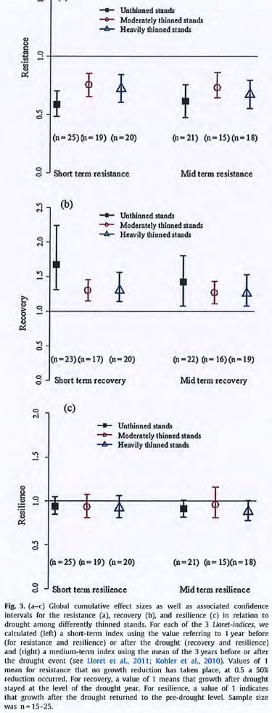
Sohn, J. A., S. Saha, and J. Bauhus. 2016. Potential of forest thinning to mitigate drought stress: a meta-analysis. Forest Ecology and Management 380:261–273. https://www.researchgate.net/profile/Somidh_Saha/publication/308097759_Potential_of_forest_thinning_to_mitigate_drought_stress_A_meta-analysis/links/59cc0becaca272bb050c64ea/Potential-of-forest-thinning-to-mitigate-drought-stress-A-meta-analysis.pdf?origin=publication_detail. This analysis also showed that heavy thinning was less effective on more arid sites. Thinning in water-limited sites that exposes individual large trees to more sunlight may actually increase certain stress factors, causing “greater vulnerability to hydraulic stress and to higher radiation and evaporative demand of the more exposed crowns” when compared to smaller trees in crowded stands.

Forest scientists in Europe found that fungal relationships may have more to do with tree growth than previously understood, suggesting that other resource constraints, e.g., from competition, are less important:
Studying five species of the most common European forest trees, the researchers show that differences in fungal communities are linked to even greater variation in tree growth than local climate conditions and anthropogenic nitrogen inputs.

‘Differences in ectomycorrhizal fungal communities correspond to a three-fold increase in tree growth rates. These fungi also provide a clearer ecological explanation for differences in tree growth compared to other factors such as temperature and rainfall,’ says Mark Anthony, a postdoc at ETH Zurich and lead author of the new study in the journal ISME.
…
There was slower growth in forest trees where local ectomycorrhizal fungal communities are adapted to supply trees with nitrogen from organic sources. This type of nitrogen is found in dead, decaying biomass in the ground. To release it, the fungi must first generate special enzymes to depolymerize and break down the biomass. Doing this costs the fungi more energy than directly tapping inorganic nitrogen from the soil and in turn it also costs trees more. Since fungi that tap organic nitrogen draw their required energy from tree partners, the trees themselves are left with less energy to devote to their own growth.
…
‘In the future, fungal communities that utilize organic nitrogen could be advantageous for many species of tree,’ Anthony says. This is because rising temperatures and CO2 concentrations promote plant growth. To grow faster, trees draw on easily obtainable inorganic nitrogen. In doing so, they deplete stores of this kind of nitrogen more quickly, which in turn could slow long-term growth. This is in contrast to the fungal communities that utilize organic nitrogen, which is more abundant in the soil albeit harder to access. The right fungi could ensure that their tree partner grow steadily into the future by capturing this organic nitrogen over the long term.
Peter Rüegg-Eth Zurich 2022. Fungi, Not Weather, May Explain Tree Growth Secrets. Futurity. January 11th, 2022. https://www.futurity.org/trees-growth-fungi-symbiosis-2681232-2/ citing Anthony, M.A., Crowther, T.W., van der Linde, S. et al. Forest tree growth is linked to mycorrhizal fungal composition and function across Europe. ISME J (2022). https://doi.org/10.1038/s41396-021-01159-7.

Well-intentioned logging has impacts that make ecosystems less resilient to climate change. For instance, roads and soil degradation make watershed less resilient to the expected effects of the amplified hydrologic cycle; reduction of complex forest structure and dense forest conditions makes certain species populations less resilient to climate change, including species associated with relatively dense forests and species associated with snags and dead wood. These species are already stressed by the cumulative effects of non-federal land management and fragmentation caused by past and ongoing management on federal lands.

Also, “High overstory density can be resilient” when ladder fuel are absent and there is a gap between surface and canopy fuels. Terrie Jain (2009) Logic Paths for Approaching Restoration: A Scientist's Perspective, from Workshop: Restoring Westside Dry Forests - Planning and Analysis for Restoring Westside Cascade Dry Forest Ecosystems: A focus on Systems Dominated by Douglas-fir, Ponderosa Pine, Incense Cedar, and so on. May 28, 2009. http://ecoshare.info/projects/central-cascade-adaptive-management-partnership/workshops/restoring-westside-dry-forests/

A bet-hedging strategy should retain trees of all sizes and stands of various densities. “Removal of most small trees to reduce wildfire risk may compromise the bet-hedging resilience, provided by small trees and diverse tree sizes and species, against a broad array of unpredictable future disturbances.” William L. Baker and Mark A. Williams. 2015. Bet-hedging dry-forest resilience to climate-change threats in the western USA based on historical forest structure. Front. Ecol. Evol., 13 January 2015 | doi: 10.3389/fevo.2014.00088.http://journal.frontiersin.org/Journal/10.3389/fevo.2014.00088/full

Retain and Restore Genetic Diversity of Trees

There are significant unacknowledged risks involved when humans decide which trees live and which trees die. Natural mortality from drought, insects, and fire have shaped the genetic make-up of the forest for millennia, favoring more fit individuals and increasing the resilience of forest stands. Logging is a novel cause of mortality that does not favor the fittest individuals. The agency must carefully consider the consequences of logging that decouples mortality from fitness, survival and resilience. This is especially important in light of climate change. Conserving genetic and phenotypic diversity is important for climate adaptation. Halofsky, J.E.; Peterson, D.L., eds. 2016. Climate change vulnerability and adaptation in the Blue Mountains. Gen. Tech. Rep. PNW-GTR-xxx. Portland, OR: U.S. Department of Agriculture, Forest Service, Pacific Northwest Research Station. (Table 6.8e) http://adaptationpartners.org/bmap/docs/BMAP_final.pdf. Also, Matthew Reilly, 2018. Chapter 2: Climate, Disturbance, and Vulnerability to Vegetation Change in the Northwest Forest Plan Area. Northwest Forest Plan Science Synthesis – Science Forum | Tuesday, June 26, 2018 | Portland, Oregon.
https://docs.wixstatic.com/ugd/8f8000_08456f0927cb4aa88b18f341b3c7c435.pdf. A strategy to conserve genetic diversity would do two things: First, protect all old trees that have survived previous climate extremes. These legacy trees have already shown their fitness for survival. Protecting such trees might involve careful actions to reduce competition and ladder fuels in the immediate vicinity of those legacy trees. Second, let natural processes determine which of the younger trees are most fit to survive. Genetic fitness is not obvious even to the trained forester. Logging might inadvertently let the least fit survive and kill the trees with the most fit genes.

Old trees that are alive today are survivors. In the least 50 years, they have survived one of the wettest 20 year periods in more than 1,000 years, and one of the driest periods, now referred to as a megadrought. These survivors may be hard to replace and they deserve to be retained. “The 2000–2018 drought was preceded by the wettest 19-year period (1980–1998) in at
least 1200 years. … [T]he 2000–2018 drought was on a megadrought-like trajectory throughout its development …” A. Park Williams, et al. 2020. Large contribution from anthropogenic warming to an emerging North American megadrought. Science 368, 314–318 (2020). https://science.sciencemag.org/content/368/6488/314.

The agency must recognize that natural mortality provides an important ecological function – that is, it promotes evolutionary adaptation which is critical right now in the face of climate change.

[R]esearchers were surprised to find that the mortality of established trees considerably promotes the adaptation of forests to the changing environment. … Evolution is promoted by the mortality of established trees. The researchers assumed that demographic characteristics of the trees would have a notable impact on their adaptability. Tree species differ for example so that birch matures at a considerably younger age than pine, and birch seeds spread more effectively than pine seeds. However, the results showed that these differences had only minor impacts. Instead, the mortality of established trees played a large role in the evolutionary adaptation.
Northern forests do not benefit from lengthening growing season. UNIVERSITY OF HELSINKI. PUBLIC RELEASE: 12-JAN-2010. http://www.eurekalert.org/pub_releases/2010-01/uoh-nfd011210.php.

Importantly, for natural selection to occur, mortality must be caused by natural events like drought, insects, and fire, rather than through human choices about which trees will live and which will die. There is already evidence that this is happening. Trugman et al (2020) found “evidence for coordinated shifts toward communities with more drought-tolerant traits driven by tree mortality…” Anna T. Trugman, Leander D. L. Anderegg, John D. Shaw, William R. L. Anderegg 2020. Trait velocities reveal that mortality has driven widespread coordinated shifts in forest hydraulic trait composition. Proceedings of the National Academy of Sciences. Mar 2020, 201917521; DOI: 10.1073/pnas.1917521117. https://www.pnas.org/content/early/2020/03/24/1917521117.

Biologist Derek Lee points out that
… logging schemes are the latest in a series of Forest Service attempts to chainsaw their way out of a perceived problem. However, forests in the western United States have evolved to naturally self-thin uncompetitive trees through forest fires, insects, or disease. Forest fires and other disturbances are natural elements of healthy, dynamic forest ecosystems, and have been for millennia. These processes cull the weak and make room for the continued growth and reproduction of stronger, climate-adapted trees. Remaining live trees are genetically adapted to survive the new climate conditions and their offspring are also more climate-adapted, resistant, and resilient than the trees that perished. Without genetic testing of every tree in the forest, indiscriminate thinning will remove many of the trees that are intrinsically the best-adapted to naturally survive drought, fire, and insects.
Derek Lee. January 14, 2017. Blog post: Proposed Forest Thinning Will Sabotage Natural Forest Climate Adaptation and Resistance to Drought, Fire, and Insect Outbreaks. http://dereklee.scienceblog.com/34/proposed-forest-thinning-will-sabotage-natural-forest-climate-adaptation-and-resistance-to-drought-fire-and-insect-outbreaks/

Another study shows that slower growing Ponderosa pine trees may be better adapted to survive drought. This might mean that logging prescriptions that favor removal of smaller trees might be making Ponderosa pine forests less resilient. University of Montana. June 18, 2019. Cell structure linked to longevity of slow-growing Ponderosa Pines. https://www.sciencedaily.com/releases/2019/06/190618174358.htm (“Slow-growing ponderosa pines may have a better chance of surviving longer than fast-growing ones, especially as climate change increases the frequency and intensity of drought, according to new research from the University of Montana. ... [A] key difference between fast and slow growers resides in a microscopic valve-like structure between the cells that transport water in the wood, called the pit membrane. The unique shape of this valve in slow-growing trees provides greater safety against drought, but it slows down water transport, limiting growth rate.”). citing Beth Roskilly, Eric Keeling, Sharon Hood, Arnaud Giuggiola, Anna Sala. Conflicting functional effects of xylem pit structure relate to the growth-longevity trade-off in a conifer species. Proceedings of the National Academy of Sciences, 2019; 201900734 DOI: 10.1073/pnas.1900734116.

The bottom line is that nature does a good job of picking trees that are fit for survival in a stressful world. Foresters cannot predict which trees will survive drought and insects, so they will kill some trees that are relatively more fit and retain trees that are relatively less fit. This indicates that natural mortality will lead to greater forest resilience, while logging will lead to reduced forest resilience.

e360: So by trying to fix the problem, we sometimes only make it worse.
Six: As humans, we have this feeling that if something goes awry, we need to fix it, and that somehow we can. I don’t think that we necessarily always know what needs to be done, or that when we do apply management that we are always actually doing the right thing. Sometimes we just need to realize that nature can sort itself out perhaps better than we can.
…
[M]odels assume that the forest is genetically homogenous, that everything is the same. And they are not. I suspect that there is a lot more genetic variability out there that will allow for more adaptation and greater persistence than we currently anticipate.

e360: You are suggesting that evolution will kick in and help to a degree?
Six: If we let it. If we don’t go out and replant with stock that may not be genetically correct, if we don’t thin or cut down trees that may have been selected by beetles or drought to survive. We have to get smart about how we are treating our forest if we’re going to help nature’s process of adaptation to proceed.
Richard Shiffman interview with Diana Six. 04 JAN 2016: INTERVIEW- How Science Can Help to Halt The Western Bark Beetle Plague http://e360.yale.edu/content/feature.msp?id=2944

A press release from the University of Montana says:
A University of Montana researcher has discovered that mountain pine beetles may avoid certain trees within a population they normally would kill due to genetics in the trees.

UM Professor Diana Six made the discovery after studying mature whitebark and lodgepole trees that were the age and size that mountain pine beetle prefer, but had somehow escaped attack during the recent outbreak.

After DNA screening, survivor trees all contained a similar genetic makeup that was distinctly different from the general population that were mostly susceptible to the beetle.

“Our findings suggest that survivorship is genetically based and, thus, heritable,” Six said, “which is what gives us hope.”
...
"Our results suggest that surviving trees possess a wealth of information that can be used to inform our understanding of the genetic and phenotypic bases for resistance and to develop management approaches that support forest adaptation," Six said.
PUBLIC RELEASE: 16-AUG-2018. UM Researcher discovers genetic differences in trees untouched by mountain pine beetles. THE UNIVERSITY OF MONTANA https://www.eurekalert.org/pub_releases/2018-08/tuom-urd081618.php citing Six, Diana L.; Vergobbi, Clare; Cutter Mitchell. 2018. Are Survivors Different? Genetic-Based Selection of Trees by Mountain Pine Beetle During a Climate Change-Driven Outbreak in a High-Elevation Pine Forest. Frontiers in Plant Science 9(993). https://doi.org/10.3389/fpls.2018.00993; https://www.frontiersin.org/articles/10.3389/fpls.2018.00993/full. (“We found that surviving mature trees in a high elevation forest of whitebark and lodgepole pine were genetically distinct from “general population” trees that were assumed to represent the genetic structure of the population pre-outbreak and without selection by the beetle. In line with our hypothesis, a low percentage (<10%) of “survivor” genotypes were identified within the general population. ... We found surprisingly high levels of differentiation between survivor and general population trees in both species of pine. ... With climate change supporting the invasion of aggressive bark beetles into naïve forests, and predictions of more frequent and severe outbreaks, it is increasingly important to understand the capacity of trees to adapt and persist (Millar et al., 2007; Ramsfield et al., 2016). ... While the massive mortality of pines in western North America in recent years is cause for concern, we should also look at these hard-hit forests as opportunities to learn. In almost all cases, affected forests are not completely dead–they retain many living large diameter trees. If these trees are genetically different than those selected and killed by the beetles as our study suggests, these trees may aid in in situ adaptation and persistence. They may also be key to developing management and trajectories that allow for forest adaptation. For example, retaining surviving trees as a primary seed source, rather than removing them during salvage operations could support in situ adaptation. In contrast, the effects of natural selection in these stands could be instantly negated by clearcutting or replanting with general seed stock. Supporting forest adaptation is critical in this time of rapid change (Millar et al., 2007). Given the great expanses of forest that are being affected by climate change and the fact that most will need to adapt in situ, it is imperative we begin to move past structural approaches to consider the genetic capacity of forest trees to adapt. The high degree of standing genetic variation found in most forest trees indicates many will have considerable ability to adapt. We need to be cognizant of adaptation that is occurring so that our management approaches act to support rather than hinder natural selection for traits needed under future conditions.”)

George Wuerthner often reminds public land managers that
… there is significant genetic variation in individual trees, and thinning the forest can reduce the genetic diversity of the remaining stand, in effect, reducing its "resilience" and the ability of the forest ecosystem to adapt to changing conditions.
[Studies] show that ponderosa pine seedlings have tremendous variation in their adaptation to drought and mature trees ability to fend off bark beetles. Under natural conditions, the beetles and drought would [selectively] eliminate the trees without these adaptations. But the average forester with his or her paint gun marking trees has no idea of the genetic makeup of the trees they are logging. Yet I do not even hear any sense of caution from the collaborative about this matter. They are of the belief that logging creates resilience. In fact, it impoverishes the forest ecosystem.
Wuerthner, George. 3-28-2017 Email to Deschutes Collaborative via Vernita Ediger, citing Kolb, T.E., Grady, K.C., McEttrick, M.P., and A. Herrero 2017. Local-Scale Drought Adaptation of Ponderosa Pine Seedlings at Habitat Ecotones. For. Sci. 62(6), pp.641-651. http://dx.doi.org/10.5849/forsci.16-049 (“The large amount of phenotypic variation within populations suggests the potential for future evolution of stress tolerance…”) and Pinnell, Sean, 2016. MS Thesis: "Resin Duct Defenses In Ponderosa Pine During A Mountain Pine Beetle Outbreak: Genetic Effects, Mortality, And Relationships With Growth" (2016). Paper 10709. http://scholarworks.umt.edu/cgi/viewcontent.cgi?article=11753&context=etd. (“Analyses at both the phenotypic and genetic levels indicated that drought significantly predisposed some trees and families to mortality …”).

Studies show that forests have a natural ability to weed out trees that are less likely to survive and retain trees that are more likely to survive, so that forests become progressively more resilient to stress over time. Logging can interfere with this process by choosing the wrong trees for removal and retention. Katherine Kornei 2023. Surviving a drought may help forests weather future dry spells - After a drought, California’s forests withstood a second one surprisingly well. ScienceNews. JUNE 9, 2023 https://www.sciencenews.org/article/drought-forests-trees-weather-future (“Some forests take one-two punches surprisingly well. Researchers have shown that certain California forests exposed to two successive droughts weathered the second one much better than forests only hit by the later dry period. Given that the frequency and severity of droughts is increasing with climate change, the findings suggest that forested regions might fare better than predicted in the future… Norlen and Goulden speculate that the first drought eliminated trees weakened by pests like bark beetles, or perhaps that the dry conditions prompted trees to protect themselves by growing deeper roots. Those changes would have helped protect the remaining trees from future droughts, Goulden says. ‘You effectively have a stronger population.’”) citing C.A. Norlen and M.L. Goulden. Recent Tree Mortality Dampens Semi-Arid Forest Die-Off During Subsequent Drought. AGU Advances. Published online May 17, 2023. doi: 10.1029/2022AV000810, https://agupubs.onlinelibrary.wiley.com/doi/full/10.1029/2022AV000810; and X. Jiang et al. Projected Future Changes in Vegetation in Western North America in the Twenty-First Century. Journal of Climate. 2013. doi: 10.1175/JCLI-D-12-00430.1, https://journals.ametsoc.org/view/journals/clim/26/11/jcli-d-12-00430.1.xml.

Note also, Pinnell (2016) found that fast growing trees are not necessarily more fit to survive drought and insects. (“I found no evidence of a resin duct defense-growth tradeoff. … [F]aster growing families did not suffer lower mortality.”) Foresters often identify stands for thinning based on their growth rate as measured by annual growth rings/inch, and they identify trees for retention based on observed vigor and form. This study indicates that these factors may not be associated with resistance to mortality. Again, foresters think they are improving forest resilience, but they may be removing trees that are more fit, and retaining trees that are less fit, leaving more ill-fitting genes in the stand to reproduce and leaving the stand less resilient over the long term.

Generally speaking, outbreaks of beetles can facilitate the development of a forest that is structurally, genetically and compositionally more diverse (Axelson et al., 2009) and therefore perhaps less prone to subsequent beetle attack (Amman, 1977). Thus, despite causing mortality of many individual trees, outbreaks can also play a critical role in ecosystem processes (Berryman, 1982).
Black, S. H., D. Kulakowski, B.R. Noon, and D. DellaSala. 2010. Insects and Roadless Forests: A Scientific Review of Causes, Consequences and Management Alternatives. National Center for Conservation Science & Policy, Ashland OR. http://www.geosinstitute.org/images/stories/pdfs/Publications/RoadlessAreas/FireandBugReport.pdf.
http://www.xerces.org/wp-content/uploads/2010/03/insects-and-roadless-forests1.pdf

Epidemics of forest insects and pathogens have always occurred, and the selective killing of susceptible trees tends to increase overall stand fitness (Haack and Byler 1993). Spruce budworm, for example, may help maintain ecosystem health by selectively killing weaker, genetically inferior trees and thus increasing resistance to future outbreaks (Alfaro et al. 1982).
...
Mountain pine beetle epidemics are part of a natural boom-and-bust cycle (Amman 1977). Large populations of beetles selectively kill large numbers of the most susceptible trees. Killing these trees facilitates the development of a forest that is structurally, genetically, and compositionally more diverse and therefore less prone to beetle attack in the long run (Amman 1977).
Black, S.H. 2005. Logging to Control Insects: The Science and Myths Behind Managing Forest Insect “Pests.” A Synthesis of Independently Reviewed Research. The Xerces Society for Invertebrate Conservation, Portland, OR. http://www.xerces.org/wp-content/uploads/2008/10/logging_to_control_insects1.pdf citing Amman, G.D. 1977. The role of the mountain pine beetle in lodge pole pine ecosystems: Impact of succession.
In The Role of Arthropods in Forest Ecosystems: Proceedings in the Life Sciences, W.J. Mattson, ed. Pp. 3–18. New York: Springer–Verlag. https://digitalcommons.usu.edu/cgi/viewcontent.cgi?article=1110&context=barkbeetles

Climate change is driving natural selection, but we will interfere in that process by choosing the winners and losers instead of letting natural mortality do it.
From 2012 to 2016, drought and bark beetles killed more than 129 million trees in California, most of them conifers in the Sierra Nevada. On the drier, south-facing slopes on this basin’s north side, sugar pines were hit especially hard as mountain pine beetles attacked the water-starved trees, tunneling through their bark until many of them died.

“You had literally side-by-side sugar pines, one alive, one dead,” said UC Davis forest biologist Patricia Maloney.

But it’s not the dead trees that interested Maloney. It’s the survivors.

She wanted to know how they managed to stay healthy and green despite experiencing the same parched conditions that killed their neighbors. She thinks it has to do with innate characteristics that gave them a selective advantage over their peers.

Maloney is now leading an effort to plant thousands of seedlings descended from drought-surviving sugar pines from around Lake Tahoe, hoping they carry genes that make them more resilient to drought, waning snowpack and other effects of global warming.

... [S]he sees hope in the genetic variation in local populations that allows some trees to survive while others succumb to drought and other environmental threats.

“I think what we’re witnessing is contemporary natural selection. Species have been evolving for millions of years, we’ve just hastened the pace with climatic change and drought,” Maloney explained. “Let nature and evolution in some way run its course, but we can assist in its regeneration. There is promise in these survivors. So let’s work with what we have.”

... Sally Aitken, a professor of forest genetics at the University of British Columbia [said] “The raw material of natural selection is genetic diversity. Increase diversity and you increase the chances of survival. It’s a way of hedging your bets.”
...
After the drought ended, in 2017, [Maloney] and her team selected 100 of these surviving sugar pines to be mothers to a new generation. They studied, cored and examined the rings of a portion of those trees and learned they all had at least one thing in common: They used water more efficiently than their deceased neighbors.

That ability can be passed along to the next generation, Maloney said. But they probably have other advantageous traits that she wants to study, such as when they time their spring growth, how massive their roots are and what chemicals they send out from their resin that might attract or repel beetles.
...
The 1859 discovery of the Comstock Lode in Virginia City, Nev., sparked a silver rush and a logging boom, with trees felled and ferried by raft, water flume and rail to supply lumber to the mines. Loggers cut down so many sugar pines, Maloney’s research has found, that in some locations their genetic diversity suffers to this day.
TONY BARBOZA 2019. In the Sierra, scientists bet on ‘survivor’ trees to withstand drought and climate change. LA Times 11-18-2019. https://www.latimes.com/california/story/2019-11-18/sierra-trees-climate-change-adaptation-lake-tahoe.
Foresters are more likely to choose retention trees based on size than on cryptic features such as the size of resin ducts, but Zhao & Erbilgin (2019) showed that lodgepole pine fitness to survive mountain pine beetle attack is more closely associated with large resin ducts rather than radial growth rates.
In this study, we compared the resin duct-based anatomical defenses and radial growth between beetle-killed and live residual lodgepole pine trees... We found that tree radial growth was not associated with tree survival. The best two predictors of tree survival were resin duct size and production (number per year). Trees having larger but fewer resin ducts showed higher survival probability compared to those with smaller but more abundant resin ducts annually. ... Healthy trees had consistently larger resin ducts than declining trees in the past 20 years in post-outbreak stands. Survival trees ranked between healthy and declining trees. Overall, these results demonstrate that resin duct size of lodgepole pine trees can be an important component of tree defenses against mountain pine beetle attacks and suggest that lodgepole pine trees with large resin ducts are likely to show resistance to future bark beetle attacks. ... By increasing the volume of resin flow, larger resin ducts likely substantially reduced the probability of successful beetle colonization on residual trees by providing sticky physical barriers, sealing beetle entry wounds, and releasing toxic compounds (Franceschi et al., 2005; Erbilgin et al., 2017; Erbilgin, 2019; Mason et al., 2019). Thus, these results are in agreement with earlier studies emphasizing the importance of anatomic defenses in the survival of conifers against tree-killing bark beetle species in North America (Kane and Kolb, 2010; Ferrenberg et al., 2014; Gaylord et al., 2015; Hood and Sala, 2015; Mason et al., 2019). .... Among the anatomical characteristics measured, the number of resin ducts did not seem to be as important as their size; lodgepole pine trees with relatively smaller but more resin ducts were killed during MPB outbreak, and trees with larger but fewer resin ducts had a higher probability of survival during outbreak, suggesting a possible trade-off between size and number of resin ducts in pine trees (Herms and Mattson, 1992). ... We provided four possible explanations to support our results.

First, larger resin ducts likely result in the storage and biosynthesis of a higher volume of resin, thereby increasing resin accumulation within the tree (Hood and Sala, 2015). Consequently, such trees could form a stronger constitutive defense line against bark beetles. Second, larger resin ducts could rapidly deploy a much higher amount of resin flow to the beetle attack points, which would increase the likelihood of the entrapment of beetles at the host entrance during initial host colonization (Schopmeyer et al., 1954; Hood and Sala, 2015; Cale et al., 2017; Erbilgin et al., 2017). Using the Poiseuille’s Law, one unit increasing in the radius of resin ducts can result in resin flow increasing by a fourth power. Third, larger resin ducts can transport higher viscosity resin within trees (Tyree and Zimmermann, 2002). With higher viscosity, resin can carry higher amounts of terpenes and be more effective during beetle attack (Franceschi et al., 2005). Finally, the resin duct size of residual trees in the healthy and survived categories either remained the same or increased after MPB outbreak, suggesting possible effects of tree genetics and genetics–environment interaction on resin duct size. While some resin duct characteristics (density and production) are influenced by tree genetics in some pine species (Moreira et al., 2015; Westbrook et al., 2015), the heritability of resin duct size remains unclear in lodgepole pine and requires further investigations. Nevertheless, the survival of pine trees with larger resin ducts suggests that bark beetle outbreaks likely drive selection for better-defended lodgepole pine phenotypes. ... We consistently found enhanced anatomical defense structures in residual pine trees during post-outbreak as compared to pre-outbreak periods. This is the first report of enhanced anatomical defenses in pines after bark beetle outbreaks. Two possible post-outbreak stand conditions may explain these results. First, these stands may not provide optimal conditions for tree growth following MPB outbreaks (Cigan et al., 2015; Karst et al., 2015; Pec et al., 2017). In fact, the reduced growth in residual trees right after an outbreak in the current study may reflect less optimal growing conditions in these stands and a possible trade-off between anatomical defense and tree growth. This is expected as the growth-differentiation balance hypothesis predicts that plants favor defense over growth when resources are limited (Herms and Mattson, 1992). Second, it has been widely documented that plants, including lodgepole pine, under attack from herbivory insects can release volatile organic compounds that can alarm neighboring trees (Baldwin and Schultz, 1983; Engelberth et al., 2004; Hussain et al., 2019), which might have led to the production of additional resin ducts in the healthy trees. This explanation warrants further studies in the field.
Shiyang Zhao and Nadir Erbilgin. 2019. Larger Resin Ducts Are Linked to the Survival of Lodgepole Pine Trees During Mountain Pine Beetle Outbreak. Front. Plant Sci., 26 November 2019 | https://doi.org/10.3389/fpls.2019.01459. https://www.frontiersin.org/articles/10.3389/fpls.2019.01459/full.

General recommendations for dry forest thinning/restoration
Please consider the following recommendations to improve the ecological benefits of restoring dry forests and to mitigate the adverse impacts.
  - Oregon Wild will do its best to maintain the torch that was carried for so long by the late Tim Lillebo who worked to protect and restore eastside forests for almost four decades. In Tim’s office, we found the following concise summary of his recommendations for thinning dry forests containing old growth trees.
Old Growth stand thinning
My recommendation for thinning in OG stands is the same prescription we used for the Glaze Project where we thinned OG stands.
Basically,
-retain all OG trees of all species
-retain historic mix of species
-retain all snags and down logs, with safety exceptions
-retain 15-20% in wildlife leave patches from 1/4 - 5 acres
-In small trees thin in variable density 60-80 sq ft basal area, retaining the largest trees that will become the next generation of old growth. Larger trees carry higher basal areas of 100-140+.
-thin leaving clumps of 2-10 trees with 3-4 clumps per acre
-doughnut thin around old growth trees, but if available retain 1-2 good sized trees in the doughnut to become replacement old growth
A more detailed description of Tim’s restoration concepts, vision, priorities, recommended prescriptions for eastside forests can be found in Oregon Wild’s “Practical Guide for Ecological Restoration of Eastern Oregon's Dry Forests,” http://www.oregonwild.org/sites/default/files/pdf-files/Eastside_Restoration_Handbook.pdf. In appropriate dry forest type please consider applying Tim’s recommendations, including lessons for successful restoration, and recommendations for minimizing unintended consequences.
  - Additional dry forest restoration concepts can be found here: Franklin, J.F., Johnson, K.N., et al 2013. Restoration of Dry Forests in Eastern Oregon – A Field Guide. The Nature Conservancy, Portland, OR. 202 pp. http://nature.ly/dryforests (We have not had a chance to carefully review all of the recommendations in this field guide, but it does appear to have some good ideas. We are concerned about the proposed allowance to remove some old trees to make restoration economically viable. There are no clear criteria to ensure that the ecological benefits exceed the ecological costs.)
  - Use an integrated multi-objective planning process. “An integrated planning process focuses on multiple-objective planning rather than single-objective planning from the beginning of the project. It favors a transparent and interactive process that offers opportunities for understanding ecosystem complexity, stakeholder positions, and clear articulation of decision trade-offs and benefits.” Jain, Theresa B.; Battaglia, Mike A.; Han, Han-Sup; Graham, Russell T.; Keyes, Christopher R.; Fried, Jeremy S.; Sandquist, Jonathan E. 2012. A comprehensive guide to fuel management practices for dry mixed conifer forests in the northwestern United States. USDA Forest Service Gen. Tech. Rep. RMRS-GTR-292. 2012 http://www.firescience.gov/projects/09-2-01-16/project/09-2-01-16_09-2-01-16_rmrs_gtr292web.pdf.
For example, the agencies too often assume that ecological restoration and fuel reduction are perfectly aligned. The analysis needs to recognize that fuel reduction and ecological restoration are often in conflict (e.g. thinning reduces habitat for wildlife that prefer dense, snag-rich forests). While it may be acceptable to sacrifice ecological goals INSIDE the structure ignition zone, there is no compelling rationale to sacrifice ecological restoration goals OUTSIDE the structure ignition zone. This conclusion becomes apparent when the analysis fully accounts for (i) the fact that only a small fraction of fuel treatments can be expected to interact with wildfire, (ii) the complex effects of logging as a tool for fuel management (e.g. removing canopy stimulates growth of surface ladder fuel and makes fire hazard worse) and (iii) logging for fuel reduction has many trade-offs (ecological, climate, and economic).
  - Be sure to treat moist forests different than dry forests. Many dry forests are mixed with moist/mixed forests. These stands do not typically need to be commercially logged. Moist stands naturally have dense, multi-layered canopies, and greater abundance of dead wood, and a more mixed fire regime, including patches of stand replacing fire. Natural processes will continue to operate in these stands and create desired conditions. Non-commercial thinning of some small trees may be appropriate if there is significant in-growth of small conifers that threaten legacy trees.
  - When conducting commercial thinning projects take the opportunity to implement other critical aspects of watershed restoration especially reducing the impacts of the road system and livestock grazing and establishing the ecological processes that foster recovery of hydrologic systems and fire regimes. See FEMAT 1993. Appendix V-J: Guidelines for Restoration Projects (unnumbered pages between V-96 and VI-1). Bradbury, Nehlsen et al 1995. Handbook for Prioritizing Salmon & Watershed Restoration. http://pacificrivers.org/science-research/resources-publications/handbook-for-prioritizing-watershed-protection-and-restoration-to-aid-recovery-of-native-salmon.
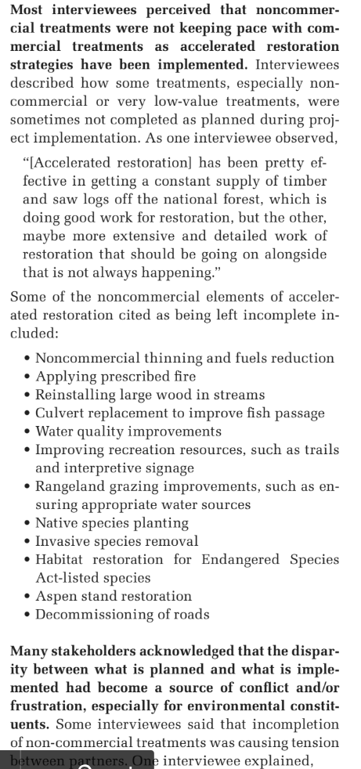
Anna Santo, Emily Jane Davis, Heidi Huber-Stearns, and Autumn Ellison 2018. Successes, Challenges, and Opportunities for Collaborative Accelerated Restoration in Oregon’s Blue Mountains. ECOSYSTEM WORKFORCE PROGRAM WORKING PAPER NUMBER 88, SUMMER 2018. http://ewp.uoregon.edu/
  - Don’t waste too much effort restoring forest structure when doing so will require continuous expenditure of money and effort to maintain. Use scarce resources efficiently by striving to restore ecological processes that can be self-sustaining. Recognize that insects and disease are natural ecological processes that actually help improve landscape diversity. Recognize that tree mortality recruits valuable habitat structures and makes resources available which increase the vigor of surviving trees, thus accomplishing many of the objectives of mechanical density reduction projects. Don't focus too much on tree health, but think instead about forest ecosystem health. Use natural processes where it makes sense to do so. Fettig et al 2013 review draft. The Ecology and Management of Moist Mixed-Conifer Forests in Eastern Oregon and Washington; a Synthesis of the Relevant Science and Implications for Future Management (“[R]estoration should aim to re-establish the self-organizing, self-maintaining, and adaptive capacities of ecosystems. This is done by restoring ecological patterns and processes. In doing so, we can address the goal of ‘healthier, more resistant, more resilient ecosystems, even if they are not exactly the same systems as before (USDA Forest Service).’ The application of ad hoc, narrowly focused ‘engineering’ solutions (e.g., managing forest structure and composition to recover a specific stable state) is expensive, logistically challenging, and often incapable of achieving restoration goals. Engineered solutions can still have limited roles for particular sites, but creating healthy and resilient landscapes requires a more dynamic and process-based perspective.”)
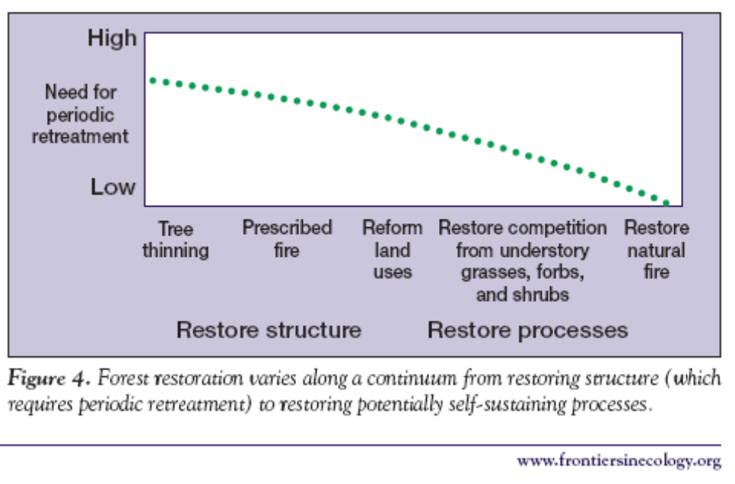
Reed F Noss, Jerry F Franklin, William L Baker, Tania Schoennagel, and Peter B Moyle. 2006. Managing fire-prone forests in the western United States. Front Ecol Environ 2006; 4(9): 481–487. http://spot.colorado.edu/~schoenna/images/Nossetal2006Frontiers.pdf. Crist, M.R., T.H. DeLuca, B. Wilmer, and G.H. Aplet. 2009 Restoration of Low-Elevation Dry Forests of the Northern Rocky Mountains: A Holistic Approach. Washington, D.C.: The Wilderness Society. http://fedgycc.org/documents/WldrnsSociety_Restoration-Low-Elev-Dry-Forests-Rocky-Mtns.pdf.
  - Use projects as an opportunity to conduct monitoring and research on the effects of thinning. There are many information gaps that need filling. Every project should generate useful information to inform future projects.
  - There are a lot of people calling for an increase in the “pace and scale” of restoration of eastside forests. The large size of recent projects raises concerns about cumulative effects. Also, if the agency moves too fast, then the “restoration” task may be complete, but the agency will still have a timber target. If the agency proceeds at a more measured and sustainable pace, they can continue to harmonize restoration and timber goals for longer. This should be considered in the NEPA analysis.
  - Treated stands do not exist in isolation, so be sure to consider the effects of thinning on adjacent areas which may provide habitat for species of concern. Prepare a “risk map” based on proximity to different habitat types from high quality to non-habitat. Agencies have a duty to consider habitat connectivity in their NEPA analyses. CEQ issued guidance saying “… agencies should consider and be transparent about the positive or negative impacts of proposed actions and alternatives on connectivity and corridors. Through the NEPA review process, Federal agencies can consider measures to advance corridors and connectivity as components of proposed actions, alternatives to proposed actions, or mitigation for proposed actions’ effects.” Mallory, B. 2023. CEQ Guidance for Federal Departments and Agencies on Ecological Connectivity and Wildlife Corridors. March 21, 2023. https://www.whitehouse.gov/wp-content/uploads/2023/03/230318-Corridors-connectivity-guidance-memo-final-draft-formatted.pdf.
  - Only a small subset of needed restoration activities are “profitable,” so we can’t let logging economics determine restoration priorities. If we restore primarily those areas that have commercial-sized logs and fail to treat the thousands of acres of areas that need restoration but lack economic return, we will not be accomplishing real restoration which requires carefully and strategically choosing the subset of the landscape that can be treated to provide the greatest gain (both ecological and fire hazard reduction) for the least ecological “cost” in terms of soil, water, wildlife, carbon, and weeds. “Hoping to boost their economies and also restore these forests, local leaders are interested in the economic value of timber that might be available from thinning treatments on these lands. … [W]e found that on lands where active forestry is allowable, thinning of most densely stocked stands would not be economically viable.” Rainville, Robert; White, Rachel; Barbour, Jamie, tech. eds. 2008. Assessment of timber availability from forest restoration within the Blue Mountains of Oregon. Gen. Tech. Rep. PNW-GTR-752. Portland, OR: U.S. Department of Agriculture, Forest Service, Pacific Northwest Research Station. 65 p. http://www.fs.fed.us/pnw/pubs/pnw_gtr752.pdf. Allowing economics to drive these choices will result in greater ecological impacts and lower ecological gains. The NEPA analysis must honestly disclose what optimum restoration treatments would look like versus what is actually being proposed, so the public can see what’s being sacrificed.
  - Protect soil and water quality by avoiding ground-based logging and log hauling during the wet season.
  - Thinning should focus on areas accessible from existing roads. Building new roads will cause degradation that typically erases any alleged benefit of treatments. Inaccessible areas can be treated non-commercially or become part of the landscape mosaic that is untreated and serve important ecological values such as dense forest cover, carbon storage, and natural rates of snag recruitment.
  - Where road building is necessary, ensure that the realized restoration benefits far outweigh the adverse impacts of the road. Carefully consider the effects of roads on connectivity, especially at road/stream crossings, across ridge tops, and midslope hydrological processes (such as large wood delivery routes). The NEPA analysis should rank new road segments according to their relative costs (e.g. length, slope position, soil type, ease of rehabilitation, weed risk, native vegetation impacts, etc.) and benefits (e.g. acres of restoration facilitated), then use that ranking to consider dropping the roads with the lowest ratio of benefits to costs. Once the relative acres accessed per mile of road is determined, take the analysis one step further and determine the “effective road density” of each segment. In other words, extrapolate as if that much road were required to reach each acre of the planning area, then compare the resulting road density to RMP objectives for big game, fish conservation, cumulative hydrological impact, etc.? For example, if a new spur road accesses thinning opportunities at a rate of 200 acres of forest per mile of road, then divide 640 acres per section by 200 acres per mile to determine the effective road density of 3.2 mi/mi².
  - Use the historic range of variability as a guide, but don’t just focus on seral stage. The NEPA description of historic “forest stand structure” is often generalized as stand initiation, stem exclusion, understory reinitiation, etc. These are not very good generalizations because after natural disturbance stand conditions would include abundant legacies that are created by natural disturbance and often persist for long periods after disturbance. However, these same terms are used to describe stand structures created by timber harvest that are NOT like natural stand structures, because logged stands lack the abundant legacy structures. The NEPA analysis should adjust the analytical methods to describe the historic abundance (and current shortage) of live and dead legacy structures. Restoring and maintaining legacies should be a major focus of restoration. Consider also the historic abundance of ecological attributes like large trees, large snags, the scale and distribution of patches of dense forest, low road density, roadless areas, etc., all of which have been severely reduced from historic norms. Also, consider the natural range of variability, which is the historic range of variability as modified by future climate change and fire suppression. James A. Harris, Richard J. Hobbs, Eric Higgs, and James Aronson. 2006. Ecological Restoration and Global Climate Change. Restoration Ecology Vol. 14, No. 2, pp. 170–176 JUNE 2006. http://www.globalrestorationnetwork.org/uploads/files/LiteratureAttachments/353_underlying-principles-of-restoration.pdf.
  - Develop restoration treatments appropriate to each forest type or plant association group (PAG). Dry Ponderosa pine forests that have significant ingrowth due to fire exclusion are good candidates for thinning. Mixed-conifer forest types often included some dense forest patches, so they should be retained at appropriate scales. Lodgepole pine and subalpine forests have stand replacing fire regimes and generally do not need to be thinned or regenerated.
  - Prioritize treating stands that are already degraded by past logging, and place less priority on treating previously unlogged forests. See Naficy, Cameron, Anna Sala, Eric G. Keeling, Jon Hagmann, and Thomas H. DeLuca. 2010. Interactive effects of historical logging and fire exclusion on ponderosa pine forest structure in the northern Rockies. Ecological Applications 20:1851-1864. http://rintintin.colorado.edu/~cana4848/papers/Naficy_et_al_2010_Ecol_App.pdf (“We document that fire-excluded ponderosa pine forests of the northern Rocky Mountains logged prior to 1960 have much higher average stand density, greater homogeneity of stand structure, more standing dead trees and increased abundance of fire-intolerant trees than paired fire-excluded, unlogged counterparts. Notably, the magnitude of the interactive effect of fire exclusion and historical logging substantially exceeds the effects of fire exclusion alone. These differences suggest that historically logged sites are more prone to severe wildfires and insect outbreaks than unlogged, fire-excluded forests and should be considered a high priority for fuels reduction treatments.”)
  - Recognize the value of untreated areas to provide benefits like dense forest cover, snags recruitment, soil/water quality, etc. Recognize that forests are naturally adaptive and natural processes will accomplish many of the benefits attributed to thinning. “Counter to many regional studies, our results indicated that treated and long-unaltered, untreated areas may be moving in a similar direction. Treated and untreated areas experienced declines in tree density, increases in the size of the average individual, and losses of surface fuels in most size classes. The number of large trees increased in untreated areas, but decreased in treated areas. Our results suggested that untreated areas may be naturally recovering from the large disturbances associated with resource extraction and development in the late 1800s, and that natural recovery processes, including self thinning, are taking hold. ... In a study of forest restoration need across eastern Washington and Oregon, over 25% of required restoration could be achieved through transition to later stages of forest stand development through successional processes as western landscapes recover from widespread historic degradation (Haugo et al., 2015).” Zachmann, L. J., D. W. Shaw, and B. G. Dickson. 2018. Prescribed fire and natural recovery produce similar long-term patterns of change in forest structure in the Lake Tahoe basin, California. Forest Ecology and Management 409:276–287. http://www.csp-inc.org/wp-content/uploads/2017/11/Zachmann_et_al_2017.pdf.
  - Experts makes the following recommendation for wildlife friendly fuel reduction:
An evenly spaced stand, with much of the understory shrubs and small diameter trees removed, results in reduced cover and available forage. Habitat complexity elements in the mid to understory are critical for many forest wildlife species. For example, small clumps of trees provide a place for deer and elk to hide from predators, and provide shelter from inclement weather. Shrub clumps provide nesting and hiding cover for ground nesting birds and many small mammals that rely on that shrub layer. Deer and elk forage routinely on these same shrubs and hide their fawns in dense shrub thickets.
…
Remember, you don’t need to eradicate all fuels on your property to reduce your risk of high intensity fire; you do need to break up the continuity of fuels …
Summary of Recommendations:
Snags and Logs: Strive for 6 foraging snags/acre and 1 - 2 cavity nesting snags/acre. Strive for snags and logs greater than 15 ft. long/tall and greater than 12” in diameter.
Legacy: Keep any old growth trees, including defective trees. Strive for 2 - 3 per acre.
Openings: Openings can vary from 1/10 to 5 acres in size. They can comprise 5 - 15% of the landscape and aim for irregular shapes.
Patches: Patches can be 30 - 50 ft. across and preferably 100 - 300 ft. in length. Aim for 10 - 20% of the landscape.
Piles: Build habitat piles of 5 layers with larger material on bottom. Piles should be 20 ft. in diameter, 6 ft. high and 1 - 3 per acre.
Shrubs: Maintain the best species on the site, keep them in clumps, and beyond any adjacent tree’s overhanging limbs (dripline).
Nicole Strong, Ken Bevis, Gretchen Bracher 2016. Wildlife-Friendly Fuels Reduction in Dry Forests of the Pacific Northwest. Woodland Fish & Wildlife Project of the Western Forestry and Conservation Association. https://woodlandfishandwildlife.com/wp-content/uploads/2019/12/Wildlife-Friendly-Fuels-Reduction-in-Dry-Forests-of-the-Pacific-Northwest_reduced.pdf.
  - Some people describe dry forest thinning as "cutting trees that would likely not be there." But don't forget the biomass in those trees we are removing would likely have accumulated on other trees in the stand, (e.g., the idealized park like stand of low density very large trees) so thinning might get back to the right number of stems per acre but not the right amount of biomass per acre. Removing trees deprives the stand of live and dead biomass over the long term.
  - Prioritize treating dry forest types at low elevation and on south slopes. Treatments in forests with naturally mixed-severity fire regimes should be carefully scrutinized to ensure those areas (i) are in fact outside of the HRV, and (ii) treatment will not remove scarce habitat for focal species that depend on dense forests, and (iii) treatments are in fact needed and (iv) proposed treatments will be effective. Treatments in mixed severity fire regimes should be more patchy and leave behind more structure, more snags and large dead wood.
  - Removing large numbers of small trees and forest understory across large areas may not be consistent with historic forest conditions. New evidence indicates that small trees were more common in dry forests than previously recognized. Historically, more than 60% of trees in the Blue Mountains and eastern Cascades were “small” (<40 cm or <16” dbh). William L. Baker and Mark A. Williams. 2015. Bet-hedging dry-forest resilience to climate-change threats in the western USA based on historical forest structure. Front. Ecol. Evol., 13 January 2015 | doi: 10.3389/fevo.2014.00088. http://journal.frontiersin.org/Journal/10.3389/fevo.2014.00088/full
  - New evidence indicates that far more of the “dry” forests, rather than being typified low severity fire regimes, were in fact dominated by mixed severity fire regimes (including significant areas of stand replacing fire), so mixed severity fire is an important part of the historic range of variability that should be restored. The goal should not be a uniform low severity fire regime, but rather a wide mix of tree densities in patches of varying sizes. This objective can often be met by allowing natural fire regimes to operate, or by leaving significant areas untreated when planning fuel reduction projects. Hessburg, Paul. Evidence for the Extent of Mixed Severity Fires in Pre-Management Era Dry Forests of the Inland Northwest. Proceedings: Mixed Severity Fire Regimes: Ecology and Management. November 17–19, 2004. Spokane, Washington. http://web.archive.org/web/20100713232718/http://www.sustainablenorthwest.org/bmfp/hessburg__salter__james_paper_11.pdf; Baker, W.L., T.T. Veblen and R.L. Sherriff (2006). Fire, fuels, and restoration of ponderosa pine-Douglas-fir forests in the Rocky Mountains, USA. Journal of Biogeography. 2006. http://www.humboldt.edu/geography/documents/BakerEtAl_FireFuelsPipo_JBiog2007.pdf; Odion, D.C. et al 2014. Examining Historical and Current Mixed-Severity Fire Regimes in Ponderosa Pine and Mixed-Conifer Forests of Western North America. PLOS One. February 2014 | Volume 9 | Issue 2 http://www.californiachaparral.org/images/Odion_et_al_Historical_Current_Fire_Regimes_mixed_conifer_2014.pdf. (“We compiled landscape-scale evidence of historical fire severity patterns in the ponderosa pine and mixed-conifer forests from published literature sources and stand ages available from the Forest Inventory and Analysis program in the USA. The consensus from this evidence is that the traditional reference conditions of low-severity fire regimes are inaccurate for most forests of western North America. Instead, most forests appear to have been characterized by mixed-severity fire that included ecologically significant amounts of weather-driven, high-severity fire.”). William L. Baker 2017. Restoring and managing low-severity fire in dry-forest landscapes of the western USA. http://journals.plos.org/plosone/article?id=10.1371/journal.pone.0172288 (“Frequent fire (PMFI/FR < 25 years) was found across only about 14% of historical dry-forest area, with 86% having multidecadal rates of low-severity fire. Historical fuels (e.g., understory shrubs and small trees) could fully recover between multidecadal fires, allowing some denser forests and some ecosystem processes and wildlife habitat to be less limited by fire. Lower historical rates mean less restoration treatment is needed before beginning managed fire for resource benefits, where feasible.”)
  - “The wildfire crisis generally and structure loss specifically are largely driven by extreme events, highlighted clearly in recent years ... The overwhelming majority of wildfires that result in structure loss are started by human-related ignitions, and they are occurring in regions with increasingly high structure density within flammable vegetation. Consequently, the number of structures destroyed by wildfire in the West in any single year was well explained by the total area burned from human-related ignitions; and, total structure loss in a state over the past two decades was well explained by the number of structures in flammable vegetation” Philip E Higuera, Maxwell C Cook, Jennifer K Balch, E Natasha Stavros, Adam L Mahood, Lise A St. Denis, Shifting social-ecological fire regimes explain increasing structure loss from Western wildfires, PNAS Nexus, 2023; https://doi.org/10.1093/pnasnexus/pgad005. “We have learned that forest thinning is rarely effective under extreme burning conditions, and the severity of fire in adjacent forests has little to do with whether a home burns," said Tania Schoennagel, who is affiliated with CU-Boulder's geography department. "Solely relying on public forest management to prevent homes burning by wildfire is simply barking up the wrong tree. We need more integrated solutions that cross the public-private land boundary to help us coexist with inevitable wildfire." CU Boulder Press Release, New global wildfire analysis indicates humans need to coexist and adapt. November 5, 2014. http://www.colorado.edu/news/releases/2014/11/05/new-global-wildfire-analysis-indicates-humans-need-coexist-and-adapt. And Coexist or perish, new wildfire analysis says (2014, November 5) retrieved 6 November 2014 http://phys.org/news/2014-11-coexist-perish-wildfire-analysis.html Fuel treatments in the WUI should be coupled with efforts to make communities fire resilient, not just to facilitate fire suppression. We urge the agency to bifurcate the landscape along the area defining the “structure ignition zone” within 100 feet of homes and built structures. Inside the structure ignition zone, ecological restoration goals can be compromised so that vegetation treatments can focus on modifying fuels to protect infrastructure. Outside the structure ignition zone, treatments should focus on ecological restoration, while expecting some fuel reduction benefits as a byproduct. Do not define the wildland urban interface too broadly, because fire hazard can be reduced by treating the area immediately adjacent to structures and this “structure ignition zone” is usually on non-federal lands. Fire is an important ecological process that needs to be restored on public lands, so the WUI fire problem should be framed as a structure-ignition problem and the solution for that generally lies with the private property owners. Joe H. Scott, Matthew P. Thompson, Julie W. Gilbertson-Day 2016. Examining alternative fuel management strategies and the relative contribution of National Forest System land to wildfire risk to adjacent homes – A pilot assessment on the Sierra National Forest, California, USA. Forest Ecology and Management 362 (2016) 29–37. http://www.fs.fed.us/rm/pubs_journals/2016/rmrs_2016_scott_j001.pdf (“A treatment scenario that focused on treating defensible space near homes was by far the most efficient at reducing WUI exposure, including exposure transmitted from USFS lands. … [T]he Defensible Space fuelscape was by far the most efficient at reducing home exposure. … In terms of feasible treatment scenarios, treating USFS land near where people live (Five-percent Solution) was not nearly as effective as treating the same amount of area where people live with a focus on land closest to the national forest (Defensible Space). … [T]he analysis suggests that mitigation of wildfire risk to homes through fuel treatment on some landscapes could be best accomplished by treating where the homes are, not on federal land further away. ”) Cohen 2008. The Wildland-Urban Interface Fire Problem – A Consequence Of The Fire Exclusion Paradigm. Forest History Today. Fall 2008. http://www.foresthistory.org/Publications/FHT/FHTFall2008/Cohen.pdf. Much more info here: http://www.fusee.org/community-fire-preparedness. See also, Gibbons P, van Bommel L, Gill AM, Cary GJ, Driscoll DA, et al. (2012) Land Management Practices Associated with House Loss in Wildfires. PLoS ONE 7(1): e29212. doi:10.1371/journal.pone.0029212. http://nature.berkeley.edu/moritzlab/docs/Gibbons_etal_2012_PLoS.pdf (“The typical response to destructive wildfires is to increase the total area of land that is fuel-reduced [10,13]. Our results instead indicate that a shift in emphasis from broad-scale fuel-reduction treatments to intensive fuel treatments close to houses will more effectively mitigate impacts from wildfires on houses. This result is consistent with observations that the density of airborne embers and amount of radiant heat (the principal causes of house loss during wildfires) are greatest closer to the fuel source. This suggests that the actions of private landholders, who manage fuel close to houses, are extremely important when reducing risks to houses posed by fuel.”). Alexandra D. Syphard, Teresa J. Brennan, and Jon E. Keeley. 2014. The role of defensible space for residential structure protection during wildfires. International Journal of Wildland Fire - http://dx.doi.org/10.1071/WF13158, https://d2k78bk4kdhbpr.cloudfront.net/media/publications/files/Syphard_defensibleSpace.pdf (“Structures were more likely to survive a fire with defensible space immediately adjacent to them. The most effective treatment distance varied between 5 and 20 m (16–58 ft) from the structure, but distances larger than 30 m (100 ft) did not provide additional protection, even for structures located on steep slopes. The most effective actions were reducing woody cover up to 40% immediately adjacent to structures and ensuring that vegetation does not overhang or touch the structure.”) The need for density reduction treatment in the immediate vicinity of homes complements WUI homeowners preferences. See Factsheet: Forest Density Preferences of WUI Homebuyers. https://docs.wixstatic.com/ugd/5fc209_6f3c53750fb84fbfb6d86a40625f3d1f.pdf; and https://docs.wixstatic.com/ugd/5fc209_57cff23959e24668a1863dda2aa3b2b2.pdf (“In the more immediate forest surrounding WUI houses (100-meter (109-yard) radius level), WUI homebuyers have a preference for lower forest density. In the larger surrounding vicinity of WUI houses (500-meter (547-yard) radius level), higher forest density was preferred.”)
  - Prioritize treatment of the dense young stands that are most "plastic" and amenable to restoration. Another priority is to carefully plan and narrowly target treatments to protect specific groves of fire-resistant, old-growth trees that are threatened by ingrowth of small fuels, but don’t focus on rigid density reduction targets. Leave all medium and large trees that show old-growth characteristics.
  - Thin from below, retaining the largest trees, or use “free thinning” with a diameter cap so that some trees of all size classes are retained. Retain all large trees and most medium sized trees so they can recruit into the larger classes of trees and snags. In the face of uncertainty that is exacerbated by climate change, a bet-hedging strategy should retain trees of all sizes and stands of various densities. “Removal of most small trees to reduce wildfire risk may compromise the bet-hedging resilience, provided by small trees and diverse tree sizes and species, against a broad array of unpredictable future disturbances.” William L. Baker and Mark A. Williams. 2015. Bet-hedging dry-forest resilience to climate-change threats in the western USA based on historical forest structure. Front. Ecol. Evol., 13 January 2015 | doi: 10.3389/fevo.2014.00088. http://journal.frontiersin.org/Journal/10.3389/fevo.2014.00088/full
  - Identify and retain all trees with old-growth characteristics even if they are less than 21” dbh. Some refer to these small-old trees as "Tillebo trees" because the late Tim Lillebo was a big advocate for protection of old trees regardless of size. Old growth characteristics include thick bark, colored bark, flat top, asymmetric crown, broken top, forked top, relatively large branches, etc. These trees have important habitat value and human values regardless whether they are 21” dbh. Allow natural processes of succession and mortality to turn some of these medium and large trees into ecologically valuable snags and down wood. The agencies often use this technique to identify and retain old-growth juniper trees and the same can be used to protect old growth pine, larch, Douglas fir and other species. Van Pelt, R. 2008. Identifying Old Trees and Forests In Eastern Washington. Washington DNR. http://www.dnr.wa.gov/Publications/lm_hcp_east_old_growth_hires_part01.pdf. We are generally comfortable with the use of the Van Pelt guidelines to identify tree age, but as science improves, we urge the agency to use the best available information and err on the side of caution to ensure that trees older than 150 years (regardless of size) are not inadvertently cut. A recent study supports the retention of slow growing old trees because they are relatively more resilient. The study found that slower-growing older trees tend to channel their energy into structural support and defense compounds to “maximize durability while minimizing … damage”. Black, Colbert, & Pederson. 2008. Relationship between radial growth rates and lifespan within North American tree species. Ecoscience 15(3), 349-357 (2008). http://fate.nmfs.noaa.gov/documents/Publications/Black_et_al_2008_Ecoscience.pdf. See also. Box 8 of Franklin, J.F., Johnson, K.N., et al 2013. Restoration of Dry Forests in Eastern Oregon – A Field Guide. The Nature Conservancy, Portland, OR. 202 pp. http://nature.ly/dryforests; and Tobias Züst, Bindu Joseph, Kentaro K. Shimizu, Daniel J. Kliebenstein and Lindsay A. Turnbull, Using knockout mutants to reveal the growth costs of defensive traits, in: Proceedings of the Royal Society B, 2011, Jan. 26, doi:10.1098/rspb.2010.2475. See also, University of Montana. June 18, 2019. Cell structure linked to longevity of slow-growing Ponderosa Pines. https://www.sciencedaily.com/releases/2019/06/190618174358.htm (“Slow-growing ponderosa pines may have a better chance of surviving longer than fast-growing ones, especially as climate change increases the frequency and intensity of drought, according to new research from the University of Montana. ... [A] key difference between fast and slow growers resides in a microscopic valve-like structure between the cells that transport water in the wood, called the pit membrane. The unique shape of this valve in slow-growing trees provides greater safety against drought, but it slows down water transport, limiting growth rate.”) citing Beth Roskilly, Eric Keeling, Sharon Hood, Arnaud Giuggiola, Anna Sala. Conflicting functional effects of xylem pit structure relate to the growth-longevity trade-off in a conifer species. Proceedings of the National Academy of Sciences, 2019; 201900734 DOI: 10.1073/pnas.1900734116.
  - Use diameter limits as a management tool because it provides a useful means to prevent economic values from trumping ecological values. The public supports the use of diameter limits because it provides a means to prevent economic values from trumping ecological values. It is often appropriate to use smaller diameter limits for fire tolerant species like Ponderosa pine and Douglas fir, while using somewhat larger limits for fire intolerant species like grand fir/white fir. The exceptional circumstances in which diameter limits allegedly don’t work, are more rare than the circumstances in which refusing to use diameter limits will lead to unintended consequences, including removal of ecologically valuable trees and lack of public trust.
  - While the agency embarks on an ambitious effort to reduce fuels and reduce forest density, the agency must also conserve habitat for diverse wildlife that depend on dense forest canopy cover, complex understories, and dead wood. Carbon storage and watershed values are also enhanced when forest cover is maintained. We urge the agency to carefully consider whether there is enough habitat provided for these species, including goshawk, marten, fisher, and pileated woodpecker. The current distribution of recognized and protected habitat areas may be inadequate, especially considering the need for redundancy to account for expected habitat loss from fire, logging, fuel reduction, and natural forest succession. The fact that big game cover requirements need to be amended to accommodate many projects like this raises concerns not just for big game, but for the wide variety of other species that depend on canopy cover, complex understory, and dead wood. Before conducting large-scale density reduction efforts or amending big game cover standards, the agency should carefully consider all the other wildlife that were intended to be sheltered by the "umbrella" of big game cover standards in the RMP. The cover and forage requirements of big game is another lens through which to think about optimizing the mix of treated and untreated stands, as well as the scale and extent of skips and heavily-thinned “gaps” within treated stands. The NEPA analysis should consider alternatives with different mixes of treated and untreated areas for this purpose. The agency should use a state-and-transition model to project future dense forest habitat recruitment under a reasonable set of assumptions about disturbance and succession.
  - Recognize that thinning affects fire hazard in complex ways, including some tendencies to make fire hazard worse. The agency must address the fact that thinning creates slash; moves fine fuels from the canopy to the ground (increasing their availability for combustion); thinning increases ignition risk (by increasing human access and human activities, including spark-generating machinery); thinning makes the forest hotter-drier-windier; and makes site resources available to stimulate the growth of future surface and ladder fuels. Amy E.M. Waltz, Peter Z. Fulé, W. Wallace Covington, and Margaret M. Moore. 2003. Diversity in Ponderosa Pine Forest Structure Following Ecological Restoration Treatments. Forest Science 49(6) 2003. http://www.globalrestorationnetwork.org/uploads/files/LiteratureAttachments/91_diversity-in-ponderosa-pine-forest-structure-following-ecological-restoration-treatments.pdf (Kaufmann M.R., G.H. Aplet, M. Babler, W.L. Baker, B. Bentz, M. Harrington, B.C. Hawkes, L. Stroh Huckaby, M.J. Jenkins, D.M. Kashian, R.E. Keane, D. Kulakowski, C. McHugh, J. Negron, J. Popp, W.H. Romme, T. Schoennagel, W. Shepperd, F.W. Smith, E. Kennedy Sutherland, D. Tinker, and T.T. Veblen. 2008. The status of our scientific understanding of lodgepole pine and mountain pine beetles – a focus on forest ecology and fire behavior. The Nature Conservancy, Arlington, VA. GFI technical report 2008-2. http://csfs.colostate.edu/pdfs/LPP_scientific-LS-www.pdf. A meta-analysis of the effects of partial cutting showed that understory growth was stimulated in all cases. D. Zhou, S. Q. Zhao, S. Liu, and J. Oeding. 2013. A meta-analysis on the impacts of partial cutting on forest structure and carbon storage. Biogeosciences, 10, 3691–3703, 2013. https://www.biogeosciences.net/10/3691/2013/bg-10-3691-2013.pdf. (“Understory C was stimulated significantly by partial cutting in all of the studies. This stimulation can be mostly attributed to an increase in the availability of light, water, and nutrients to the understory because of tree removal (Aussenac, 2000; Kleintjes et al., 2004; Deal, 2007)”). Fuel reduction must find the “sweet spot,” by removing enough of the small surface and ladder fuels while retaining enough of the medium and large trees to maintain canopy cover for purposes of microclimate, habitat, hydrology, suppression of ingrowth, etc. The agency should consider alternative canopy treatments that are small and patchy, instead of extensive and continuous. Selective pruning of lower branches should also be considered as a viable canopy treatment.
  - Not all ladder fuels are hazardous. Studies after the Biscuit fire showed that “Mid-story hardwoods dampened fire and reduced mortality of dominant conifers—consider leaving them when thinning. … Why did controls burn less intensely than thinned stands as predicted by fire models? Evidence to consider: … * Controls retained mid-story hardwoods (madrone, tanoak, chinkapin) and they did not act as fuel ladder as predicted, and rather appeared to dampen the fire (much lower char heights). * Still much to be learned about fire behavior.” Bernard Bormann 2009. From B&B to Biscuit: What We Have Learned from Recent Westside Dry Forest Fires, from Workshop: Restoring Westside Dry Forests - Planning and Analysis for Restoring Westside Cascade Dry Forest Ecosystems: A focus on Systems Dominated by Douglas-fir, Ponderosa Pine, Incense Cedar, and so on. May 28, 2009. http://ecoshare.info/projects/central-cascade-adaptive-management-partnership/workshops/restoring-westside-dry-forests/
  - Fire-regime condition-class may not be an accurate predictor of fire hazard, because it assumes incorrectly that time-since-fire is an accurate indicator of fire hazard. There is compelling evidence that time-since-fire has exactly the opposite of the assumed effect, that is, fires may burn more severely in early seral vegetation, and burn less severely in closed canopy forests. This may be related to the fact that closed canopy forests maintain a cool-moist microclimate that helps retain higher fuel moisture and more favorable fire behavior. Odion, D.C., E.J. Frost, J.R. Strittholt, H. Jiang, D.A. DellaSala and M.A. Moritz. 2004. Patterns of fire severity and forest conditions in the western Klamath Mountains, California. Conservation Biology 18(4): 927-936. http://nature.berkeley.edu/moritzlab/docs/Odion_etal_2004.pdf. Canopy cover also helps suppress the growth of ladder fuels. The practical significance of this is that thinning projects should retain more canopy variability across the stand, and need not focus on treatment of canopy fuels except to provide some well-distributed “escape hatches” for hot gases generated by surface fires. Credible models of post-thinning fire behavior, must account for both fuel structure and microclimate effects of thinning.
  - There is growing evidence that in order to be effective, mechanical treatments must be followed by prescribed fire. But the effects of such fires must also be carefully considered. Fuel treatments without regular follow-up treatments might be worse than doing nothing at all because thinning can be expected to stimulate the growth of future surface and ladder fuels. Crystal L. Raymond. 2004. The Effects of Fuel Treatments on Fire Severity in a Mixed-Evergreen Forest of Southwestern Oregon. MS Thesis. http://depts.washington.edu/nwfire/publication/Raymond_2004.pdf ; Jonathan R. Thompson, Thomas A. Spies 2009. Vegetation and weather explain variation in crown damage within a large mixed-severity wildfire. Forest Ecology and Management 258 (2009) 1684–1694. Therefore retain plenty of canopy cover to suppress the growth of those future fuels and as insurance against the very real possibility that follow-up fuel treatments may not be adequately funded and implemented.
  - Don’t thin to uniform spacing. Use variable density thinning techniques to establish a variety of microhabitats, break up fuel continuity, create discontinuities to disrupt the spread of other contagious disturbances such as disease, bugs, weeds, fire, etc. Retain patchy clumps of trees which is the natural pattern for many species.
  - Be creative in establishing diversity and complexity both within and between stands. “Patchy, gappy, and clumpy” is often use to describe the distribution of trees in dry forests. Use skips and gaps within units to help achieve diversity. Gaps should be small, while skips should be a little larger. Landings do not make good gaps because they are clearcut, highly compacted and disturbed, more likely subject to repeated disturbance, and directly associated with roads. Gaps should be located away from roads and should not be clearcut but rather should retain some residual structure in the form of live or dead trees. Methods of implementing spatial variability in restoration treatments are described by Churchill, D.J., M.C. Dalhgreen, A.J. Larson, and J.F. Franklin. 2013. The ICO approach to restoring spatial pattern in dry forests: Implementation guide. Version 1.0. Stewardship Forestry, Vashon, Washington, USA. https://web.archive.org/web/20130330181038/http://www.cfc.umt.edu/ForestEcology/files/ICO_Manager_Guide.pdf and Derek J. Churchill, Andrew J. Larson, Matthew C. Dahlgreen, Jerry F. Franklin, Paul F. Hessburg, and James A. Lutz. 2013. Restoring forest resilience: From reference spatial patterns to silvicultural prescriptions and monitoring. Forest Ecology and Management 291 (2013) 442–457. http://www.fs.usda.gov/Internet/FSE_DOCUMENTS/stelprdb5428873.pdf
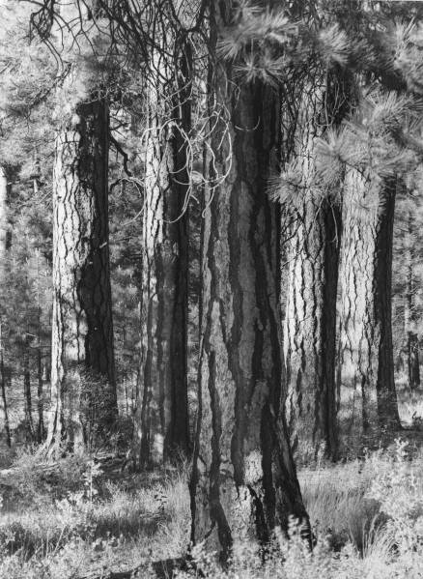
Figure 1. An example of naturally clumped large pines.
A historical reconstruction of forests in the Blue Mountains of Oregon, showed that more than 2/3 of plots had large clumps of between 10-30 trees and 50-90% of individual trees were within 6 meters of other trees (i.e., few were isolated individuals). Churchill, Derek J.; Carnwath, Gunnar C.; Larson, Andrew J.; Jeronimo, Sean A. 2017. Historical forest structure, composition, and spatial pattern in dry conifer forests of the western Blue Mountains, Oregon. Gen. Tech. Rep. PNWGTR-956. Portland, OR: U.S. Department of Agriculture, Forest Service, Pacific Northwest Research Station. 93 p. https://www.fs.fed.us/pnw/pubs/pnw_gtr956.pdf. See also Churchill, D.J., S T. Seager, A.J. Larson, E.E. Schneider, K.B. Kemp and C. Bienz. Ecological Functions of Spatial Patterns in Dry Forests: Implications for Forest Restoration. The Nature Conservancy, Portland, OR. 7 p. https://www.conservationgateway.org/ConservationByGeography/NorthAmerica/UnitedStates/oregon/forests/Documents/WOC_9_ICO.pdf.
  - Thin heavy enough to stimulate development of some patches of understory vegetation, but don’t thin so heavy that future development of a uniform understory of ladder fuels becomes a more significant problem than the one being addressed by the current project. 15-20 years after thinning and prescribed fire, the Umpqua NF found “considerable development of less fire tolerant understory vegetation …. Continued stand development … will result in increased understory density and fuel laddering into the dominant fire tolerant overstory…” Umpqua NF, Diamond Lake RD, Lemolo Pine Health Maintenance Burn Project, June 1, 2010 scoping notice.
  - The scale of patches in variable density thinning regimes is important. Ideally variability should be implemented at numerous scales ranging from small to large, including: the scale of tree fall events; pockets of variably contagious disturbance from insects, disease, and mixed-severity fire; soil-property heterogeneity; topographic discontinuities; the imprint of natural historical events; etc.
  - Retain and protect under-represented species of conifer and non-conifer trees and shrubs. Retain patches of dense young stands as wildlife cover and pools for recruitment of future forests.
  - View native insects and disease in an ecological context. They are part of the natural processes that diversify and enrich our forests. They are best viewed as solutions, rather than problems. In particular, mistletoe brooms and seeds (and the large trees that mistletoe often live on) provide many ecological benefits, and treatment efforts are typically ineffective. So mistletoe, insect, and disease treatments have many costs and few benefits.
  - Recognize that thinning captures mortality and that most stands (especially plantations) are already lacking critical values from dead wood due to the unnatural stand history of logging, planting, and disrupted natural processes. To inform the decision, please conduct a stand simulation model showing that long term snag recruitment (after logging) will still meet DecAID 50-80% tolerance levels.
  - We are concerned that the agencies’ stocking guides were created and intended to be used as a tool to avoid mortality which is clearly inconsistent with ecosystem management. (“To preclude serious tree mortality from mountain pine beetle, western dwarf mistletoe and perhaps western pine beetle, stand densities should be maintained below the upper limit of the management zone” Powell 1999, Suggested Stocking Levels for Forest Stands in Northeastern Oregon and Southeastern Washington: An Implementation Guide for the Umatilla National Forest, F14-SO-TP-03-99, https://fs.usda.gov/Internet/FSE_DOCUMENTS/fsbdev7_016034.pdf) Healthy forests require dead trees, sometimes in abundance, in order to meet the needs of diverse wildlife and provide full suite of ecosystem functions. A comprehensive restoration approach requires focusing not just on live trees, but also on the full suite of ecological processes including density dependent mortality processes that create and recruit snags and dead trees as a valuable feature of eastside forests. We urge the agency not to manage for tree vigor and minimum stocking levels because it will not provide enough green trees for recruitment of snags through time. This is a critical issue given that the current standards for snag habitat are outdated and fail to provide adequate levels of snags and dead wood, and adequate levels of green trees needed to recruit those snags through time.
  - Retain abundant snags and course wood and green trees for future recruitment of snags and wood. Retention should be both distributed and in clumps so that thinning mimics natural disturbance. Retention of dead wood should generally be proportional to the intensity of the thinning, e.g., heavy thinning should leave behind more snags not less. Retain wildlife trees such as hollows, forked tops, broken tops, leaning trees, etc. Think not only about existing snags but more importantly about the processes the recruit snags, including: a large pool of green trees from which to recruit snags and the existence of competition and other mortality processes. Logging will significantly harm both of these snag recruitment factors. Recognize that thinning captures mortality. To inform the NEPA decision, please conduct a stand simulation model to fully disclose the adverse effects of logging on dead wood, especially long-term recruitment of large snags >20” dbh, and then mitigate for these adverse effects by identifying areas within treated stands and across the landscape that will remain permanently untreated so they can recruit adequate large snags and dead wood to meet DecAID 50-80% tolerance levels as soon as possible and over the long-term.
  - If using techniques such as whole-tree yarding or yarding with tops attached to control fuels, the agency should top a portion of the trees and leave the greens in the forest in order to retain nutrients on site. Achat, Deleuze, et al 2015. Quantifying consequences of removing harvesting residues on forest soils and tree growth – A meta-analysis. Forest Ecology and Management Volume 348, 15 July 2015, Pages 124–141. http://www.sciencedirect.com/science/article/pii/S0378112715001814 (“Our study showed that, compared with conventional stem-only harvest, removing the stem plus the harvesting residues generally increases nutrient outputs thereby leading to reduced amounts of total and available nutrients in soils and soil acidification, particularly when foliage is harvested along with the branches. … Soil fertility losses were shown to have consequences for the subsequent forest ecosystem: tree growth was reduced by 3-7% in the short or medium term (up to 33 years after harvest) in the most intensive harvests (e.g. when branches are exported with foliage). Combining all the results showed that, overall, whole-tree harvesting has negative impacts on soil properties and trees that may have an impact on the functioning of forest ecosystems.”)
  - Thinning creates activity fuels that can be treated (or not treated) in a variety of ways. Strive to treat fuels in ways that provide public benefits such as wildlife habitat (e.g., complex woody structure) and charcoal production (e.g., enhanced soil carbon storage), and reduce detrimental soil impacts from machine piling and hot burn piles. Deborah S. Page-Dumroese et al. 2017. Methods to Reduce Forest Residue Volume after Timber Harvesting and Produce Black Carbon. Scientifica. Volume 2017 (2017), Article ID 2745764, https://doi.org/10.1155/2017/2745764; https://www.hindawi.com/journals/scientifica/2017/2745764/; Jon Cox, Ken Bevis, Fran Cafferata, and Susan Barnes 2023. Habitat Piles Tools for Family Forestland Owners. Woodland Fish & Wildlife Project of the Western Forestry and Conservation Association. https://woodlandfishandwildlife.com/wp-content/uploads/2023/05/WFW-2023-Habitat-Piles-final_reduced.pdf.
  - Avoid impacts to raptor nests and enhance habitat for diverse prey species. Train marking crews and cutting crews to look up and avoid cutting trees with nests of any sort and trees with defects.
  - Take proactive steps to avoid the spread of weeds. Avoid and minimize soil disturbance. Retain canopy cover and native ground cover to suppress weeds.
  - Buffer streams from the effects of heavy equipment and loss of bank trees and trees that shade streams. Mitigate for the loss of LWD input by retaining extra snags and wood in riparian areas. Recognize that thinning captures mortality that is not necessarily compensated by future growth.
  - Protect soils by avoiding road construction, minimizing ground-based logging, and avoiding numerous large burn piles. Mitigate the adverse soil impacts from burn piles by inoculating affected sites after burning (with living soil and native plant seeds, Julie E. Korb, Nancy C. Johnson, and W. W. Covington. 2004. Slash Pile Burning Effects on Soil Biotic and Chemical Properties and Plant Establishment: Recommendations for Amelioration. Restoration Ecology Vol. 12 No. 1, pp. 52-62 March 2004). Where road building is deemed necessary, ensure that the realized restoration benefits far outweigh the adverse impacts of the road, build the roads to the absolute minimum standard necessary to accomplish the job, and remove the road as soon as possible to avoid firewood theft, OHV trespass, and certainly before the next rainy season to avoid stormwater pollution. Do not allow log hauling during the wet season.
  - Adopt a purpose and need (and develop NEPA alternatives) that maintains and increases carbon storage in forest ecosystems. There is a carbon cost associated with thinning that must be disclosed and considered. As stands develop from young to mature to old, they continuously recruit carbon-rich material from the live tree pool to the dead wood pool. Some of that wood gets incorporated into the soil or falls in fire refugia where it can accumulate. Logging, even thinning, can dramatically affect the accumulation of carbon in the dead wood pool by capturing mortality, diverting it from the forest, and accelerating the transfer of carbon to the atmosphere. Carbon stays out of the atmosphere much longer if it remains in the forest as live and/or dead trees, instead of being converted to wood products and industrial and consumer waste.
  - If this project involves biomass utilization, the impacts need to be clearly disclosed. How will the biomass be moved from the remote corners of the treatment areas to the landings? Will there be extra passes made by heavy equipment? Will the landings be enlarged to make room for grinders, chip vans, and other equipment? Can the local forest roads accommodate chip vans? Will the roads be modified to make them passable by chip vans? What are the impacts of that? What are the direct, indirect, and cumulative impacts on soil, water, wildlife, and weeds?
  - Provide clear and detailed rationale that connects proposed actions to desired conditions. Test the rationale for actions and effects analysis against the scientific evidence, including the full range of evidence, reasonable opposing viewpoints, and the evidence presented in these comments. For each treatment unit, provide clear descriptions of silvicultural prescriptions and marking guides in the NEPA document.
  - Recognize that federal fuel reduction efforts likely have adverse unintended effects on human behavior and land use and fire hazard. “This project has explored the hypothesis that public fire suppression in fire-prone areas acts as a subsidy to landowners, incentivizing conversion of land to residential and commercial development. Landowners do not bear the full cost of their choice to build on land in fire-prone areas, since they do not pay for suppression, though they reap all of the benefits, potentially resulting in economically inefficient levels of development. … Results suggest that when federal suppression efforts intensify on public lands, private development accelerates nearby. The main paper produced by the funded research thus shows that public investment in reducing the damages from fire in the short run causes unintended long-run behavioral responses, which may increase future hazard exposure.” Sheila Olmstead (PI), Carolyn Kousky (co-PI), Roger Sedjo (co-PI) 2013. Final Report to the Joint Fire Science Program Wildland Fire Suppression and Land Development in the Wildland/Urban Interface. http://www.firescience.gov/projects/10-3-01-33/project/10-3-01-33_final_report.pdf. Rasker, R. 2016. Why do we keep putting people in the way of wildfire? The wrong carrots and sticks. LA Times Op-Ed. http://www.latimes.com/opinion/op-ed/la-oe-rasker-wildfire-preparation-incentives-20160901-snap-story.html. (“Wildfire presents a classic case of a moral hazard, which is what occurs when someone takes a risk knowing someone else will bear a great deal of the cost if things go wrong. Typically, the wildfire version plays out in the West like this: Local governments, eager to reap increased property taxes, willingly approve new home construction, even on or near the most flammable of lands. When fire comes, federal and state agencies send in crews and air tankers to defend private homes. Most of the cost is borne by taxpayers… [T]he hard and unpleasant reality is that we will never solve the wildfire problem unless local governments are forced to bear a higher proportion of the firefighting costs. Keeping more of the costs local would create a strong incentive for continually improving land-use planning and other wildfire preparation policies. It may also provide elected officials the political cover they need to require stricter fire-safe standards for existing as well as new developments because it would make land-use planning a fiscal necessity.”)
  - Acknowledge and consider the following potentially significant issues in the NEPA analysis:
- Removing commercial sized logs, and associated roads and slash disposal, often conflicts with other resource values such as soil, water, weeds, wildlife habitat, fire hazard, and carbon storage;
- Removal of commercial sized logs can make the stand hotter, drier, and windier, making fire hazard worse instead of better;
- Commercial logging tends to present significant risks of weed infestations because of soil disturbance and canopy reduction;
- Removal of commercial logs necessitates road related impacts on soil and water resources. Machine piling and pile burning tend to cause significant adverse impacts on soil and water, especially when combined with road impacts and other logging disturbances.
- “Capturing mortality” reduces future snag habitat that is already deficient. Increasing vigor via thinning delays recruitment of snag habitat that is already deficient;
- The unavoidable adverse impacts of logging and roads must be balanced against the rather uncertain benefits of fuel reduction. Fuel reduction has little or no beneficial effect on low severity fires (controlled by favorable weather conditions) or on high severity fires (controlled by unfavorable weather conditions). There is actually a very low probability that moderate intensity fire will affect any given stand during the relatively brief time period that fuel hazard is alleged to be reduced. Please disclose the realistic probability that desired outcomes will occur based on (1) whether fire is likely to occur when the fuel treatments are likely to be effective, and (2) if fire does occur, whether there will be a good match between (A) the actual forest type and fuel treatment type, and (B) the actual probability of favorable weather conditions and fire conditions for that forest type and treatment type. Depending on these variables, fuel treatments may have little influence on both low intensity fire and extreme high intensity fire, leaving only a small subset of well-matched fuel treatments and fires, and a low probability that the proposed treatments will have ecological benefits that exceed ecological impacts.
- The effects of forest health thinning are very complex with many feedback loops. There is still a fair amount of scientific uncertainty about several critical factors relevant to a decision about fuel reduction, including: (A) uncertain rates of tree mortality and how many young trees need to be retained to ensure proper recruitment of future stands of old trees and large snags; (B) uncertainty about how much the canopy can be reduced without making the stand hotter, drier, and windier (and exacerbating fire hazard); (C) uncertainty whether logging has any significant beneficial effect on controlling insects and diseases like mistletoe.
- The agency must test the assumption that fire (and insect) risk reduction is compatible with ecological restoration objectives. This test must be spatial, probabilistic, and use reasonable assumptions about weather, fire frequency, fire suppression, and historic conditions in areas with variable-severity fire regimes. Sensitivity analysis should test the robustness of assumptions and conclusions. Example analyses can be found in the literature, e.g. Rutherford V. Platt, Thomas T. Veblen, and Rosemary L. Sherriff. 2006. Are Wildfire Mitigation and Restoration of Historic Forest Structure Compatible? A Spatial Modeling Assessment. Annals of the Association of American Geographers, 96(3), 2006, pp. 455–470. http://www.colorado.edu/geography/class_homepages/geog_4430_f10/Platt%20et%20al_Wildfire%20Mitigatnion_AnAAG_2006.PDF , and R. V. Platt, T. T. Veblen, and R. L. Sherriff. 2008. Spatial Model of Forest Management Strategies and Outcomes in the Wildland–Urban Interface Natural Hazards Review, Vol. 9, No. 4, November 1, 2008. DOI:10.1061/(ASCE)1527-6988(2008)9:4(199) http://public.gettysburg.edu/~rplatt/Platt%20et%20al._NatHazReview08.pdf (“The results point toward several ways to guide current management practices in the study area. First, prioritizing land at the lowest elevations leads to the selection of the most land where both wildfire mitigation and restoration of historical forest conditions are needed. When thinning is restricted to Forest Service land, less land is selected where both goals are needed under all parameter scenarios. This is because Forest Service land tends to be at higher elevations and comprises forest types that are within the HRV. … Prioritizing the stands with the highest canopy cover decreases the percentage of selected land where both outcomes are needed…. Many of the stands where restoration of historical forest conditions is needed are open canopy and located on south facing slopes and at lower elevations. In contrast, many closed canopy stands are often located at higher elevations and on north-facing slopes where restoration of historical forest conditions is not needed.”)
- Focus the analysis on “trade-offs” related to logging. All logging, including thinning, includes some adverse impacts and trade-offs. Some impacts of logging are unavoidable, so there is no such thing as a logging operation that is 100% beneficial. Depending on how thinning is done, it can have adverse impacts such as soil disturbance, habitat disturbance, carbon removal, spreading weeds, reduced recruitment of snags; road-related impacts on soil, water, site productivity, and habitat; moving fuels from the canopy to the ground, hotter-drier-windier microclimate that is favorable to greater flame lengths and rate of fire spread, etc. Some of these negative effects are fundamentally unavoidable, therefore all thinning has negative effects that must be compensated by beneficial effects such as reducing competition between trees so that some can grow larger faster, increased resistance drought stress and insects, possible increasing species and structural diversity, possible fire hazard reduction, etc. The NEPA analysis should elucidate and weigh these trade-offs and attempt to display net ecological effects.

Unresolved questions about forest restoration may require an EIS.

Forest restoration is still a work-in-progress and the agencies need to approach every project as an opportunity to learn and improve practices and ensure achievement of restoration objectives. It is important to recognize that logging has complex effects some of which might be considered restorative and some detrimental to ecological values, so all the effects (both beneficial and adverse) must be carefully described and weighed. Over-simplification of the complexities of forest restoration treatments can lead to unintended consequences. NEPA’s mandates for full-disclosure and informed-decision-making require that these unintended consequences be daylighted and avoided as much as possible.

“[F]uel-reduction activities may have undesirable environmental effects (e.g., the need for periodic treatments, introduction of weeds, soil disturbance, or maintenance of some roads).” Spies, Thomas A.; Hemstrom, Miles A.; Youngblood, Andrew; Hummel, Susan. 2006. Conserving old-growth forest diversity in disturbance-prone landscapes. Conservation Biology. 20(2): 351-362. http://www.fs.fed.us/pnw/pubs/journals/pnw_2006_spies001.pdf.

The NEPA analysis should address the following unresolved questions that seem to come up again and again, especially when considering so-called “dry” forests:
- Sharon Friedman questions several assumptions about historic range of variability and restoration of fire regimes:
(1) The idea that there is one past “historic fire regime” for millennia conceivably there were glaciers and warm periods, cool periods, and so on. Then there were humans* actively engaged, strangely absent from this narrative. Unless we know for sure that they were not burning forests.
(2) Then there is an idea that “ecosystems are adapted” . Adaptation is something that we usually consider to be a property of species. Exactly what is an “ecosystem” in this context, and how does it “adapt” since ” an ecosystem” is an idea about real physical things, and not a thing in itself?
(3) That you need to reenact the past for things to be OK ...
Sharon Friedman 4-30-2019 commenting on The Missing (PNW) Fires at The Smokey Wire blog. http://forestpolicypub.com/2019/04/30/the-missing-pnw-fires/#comment-453153. See also, The scientific controversy described in Baker, William L., Chad T. Hanson, Mark A. Williams, and Dominick A. DellaSala. 2023. "Countering Omitted Evidence of Variable Historical Forests and Fire Regime in Western USA Dry Forests: The Low-Severity-Fire Model Rejected" Fire 6, no. 4: 146. https://doi.org/10.3390/fire6040146; https://www.mdpi.com/2571-6255/6/4/146 citing Hagmann, R.K.; Hessburg, P.F.; Prichard, S.J.; Povak, N.A.; Brown, P.M.; Ful, P.Z.; Keane, R.E.; Knapp, E.E.; Lydersen, J.M.; Metlen, K.L. Evidence for widespread changes in the structure, composition, and fire regimes of western North American forests. Ecol. Appl. 2021, 31, e02431. And see Odion DC, Hanson CT, Arsenault A, Baker WL, DellaSala DA, et al. (2014) Examining Historical and Current Mixed-Severity Fire Regimes in Ponderosa Pine and Mixed-Conifer Forests of Western North America. PLoS ONE 9(2): e87852. doi:10.1371/journal.pone.0087852.
- Firescience.Gov reported the management implications of Martinson & Omi (2013): “Until residual activity fuels are disposed, they largely offset much of the hazard reduction benefit achieved from opening the canopy. While follow-up slash treatment may be generally intended, untreated slash seems to be encountered by large wildfires with surprising frequency.” Firescience.Gov News. Fuel Treatments and Fire Severity: A Meta-Analysis. Issue 58 | June 7, 2013. http://us2.campaign-archive1.com/?u=5f6de7b069a57255f980944b4&id=97915ceb5e&e=47edde4b58 citing Martinson, E.J.; Omi, P.N. 2013. Fuel treatments and fire severity: A meta-analysis. Res. Pap. RMRS-RP-103WWW. Fort Collins, CO: U.S. Department of Agriculture, Forest Service, Rocky Mountain Research Station. 35 pp https://www.firescience.gov/projects/08-2-1-09/project/08-2-1-09_RMRS-RP-103WWW.pdf. Martison & Omi (2013) make the point that treatments are only effective for a short-time (5-15 years) and will require periodic retreatment, essentially in perpetuity. This raises a serious conundrum. If the initial fuel treatment in a stand is funded by removal of “excess” small trees, follow-up treatments are either (a) unlikely to occur because there are no more excess trees to pay for them, or (b) if follow-up treatments are funded with more tree-removals, such treatments will be removing ever more ecologically valuable trees and undermining any ecological benefit of the initial treatment. From an ecological perspective, the "excess" trees were removed in the first treatment. After that, all the trees belong and need to be retained so they can grow large and old in order to rebuild the severely depleted population of old growth.
- There is a critical need to consider the trade-offs and cumulative effects of a fuel treatment program. Another important point that ties together several of the findings of Martinson & Omi (2013) (above):
- Treating fuels in individual stands is unlikely to be effective in altering landscape fire behavior because stand-scale treatments are unlikely to encounter fire during the relatively brief period that treatments is "effective;"
- In order to increase the probability that treatments will encounter fire and actually modify fire behavior, treatments must be implemented across the landscape;
- The cumulative effects of landscape-scale treatments (plus the REQUIRED follow-up treatments) comes with significant trade-offs in terms of water quality, wildlife habitat, carbon, roads, soil, weeds, cost, etc.
Any attempt to reduce fuels should address these cumulative effects and unresolved trade-offs.
- Removing the understory across large areas may not be consistent with historic forest conditions. New evidence indicates that small trees were more common in dry forests than previously recognized. Historically, more than 60% of trees in the Blue Mountains and eastern Cascades were “small” (<40 cm or <16” dbh). William L. Baker and Mark A. Williams. 2015. Bet-hedging dry-forest resilience to climate-change threats in the western USA based on historical forest structure. Front. Ecol. Evol., 13 January 2015 | doi: 10.3389/fevo.2014.00088. http://journal.frontiersin.org/Journal/10.3389/fevo.2014.00088/full
- How can we balance the need to thin overly dense forests in order to grow more big trees and the need to provide habitat for species that depend on dead wood and dense canopy cover? This is a particular concern in terms of species associated with dead wood and those associated with complex riparian areas. There is evidence that capturing mortality has adverse consequences for these species that have not been fully integrated into our management approaches. Some might argue that our forests are suffering more from a lack of management, but we would strenuously argue that our forests are still more threatened by too much of the wrong forms of management, past, present and future (roading, logging, grazing, mining, fire suppression) and there is still too little recognition of this.
- How can we balance the competing effects of canopy removal that both reduces fire hazard by reducing canopy bulk density and increases fire hazard by making the stand hotter, drier, and windier? Canopy reduction has competing effects on fuels and microclimate that need to be more carefully examined. Recognizing that “The fire environment is thus an integration of the effects of all of its components” (Countryman 1972) the agencies lack a comprehensive model that integrates the effects of logging on both fuel structure (rearranging fuels, moving the canopy to the ground) and microclimate (making the stand hotter, drier, windier). “The evaluation of biomass removal alternatives on fire potential is complex and many-faceted. … Treatments can alter many aspects of a stand and thus of fire potential. … In fact, fuels and fire potential change dynamically and continuously— and not always consistently. The relative success of treatments in reducing fire potential may change as stands and fuels develop. … In the long run, opening a stand and removing biomass alters stand dynamics and fuel dynamics. Effects on potential fire behavior may vary with time since treatment …” Reinhardt, Elizabeth D.; Holsinger, Lisa; Keane, Robert 2010. Effects of biomass removal treatments on stand-level fire characteristics in major forest types of the northern Rocky Mountains. Western Journal of Applied Forestry. 25(1): 34-41. http://www.fs.fed.us/rm/pubs_other/rmrs_2010_reinhardt_e001.pdf.
- How do we integrate and balance terrestrial and aquatic restoration objectives which can sometime be in conflict. Terrestrial restoration often involve manipulation of vegetation, while aquatic restoration more often benefits from minimal anthropogenic ground disturbance. Terrestrial restoration often requires road systems which are almost universally harmful to aquatic systems.
- Is fire-regime condition-class (FRCC) a sound basis for describing and prioritizing fuel treatments. FRCC is a widely used tool which assumes that “time since fire” is an accurate indicator of fire hazard, but there is conflicting evidence showing that closed canopy forests that develop in the absence of fire can help suppress the growth of surface and ladder fuels and maintain a cool, moist microclimate that helps reduce fire hazard. Dense canopy cover might actually help suppress fire rather than spread it. See Odion, D.C., E.J. Frost, J.R. Strittholt, H. Jiang, D.A. DellaSala and M.A. Moritz. 2004. Patterns of fire severity and forest conditions in the western Klamath Mountains, California. Conservation Biology 18(4): 927-936. http://nature.berkeley.edu/moritzlab/docs/Odion_etal_2004.pdf.
- How much dead wood habitat should we be leaving, and how do we ensure that enough is provided through time? The current forest plan standards for snag-associated wildlife (based on “biological potential”) are scientifically outdated and need to be updated. DecAID is a start, but it has its own limitations and DecAID has not been officially adopted as a management standard with appropriate tolerance levels clearly specified for each land allocation. See
- Franklin, J.F., Lindenmayer, D., MacMahon, J.A., McKee, A., Magnuson, J., Perry, D.A., Waide, R., and Foster, D. 2000. Threads of Continuity. Conservation Biology in Practice. [Malden, MA] Blackwell Science, Inc. 1(1) pp9-16. https://andrewsforest.oregonstate.edu/sites/default/files/lter/pubs/pdf/pub2815.pdf.
- William F. Laudenslayer, Jr., Patrick J. Shea, Bradley E. Valentine, C. Phillip Weatherspoon, and Thomas E. Lisle Technical Coordinators. Proceedings of the Symposium on the Ecology and Management of Dead Wood in Western Forests. PSW-GTR-181. http://www.fs.fed.us/psw/publications/documents/gtr-181/.
- Lofroth, Eric. 1998. The dead wood cycle. In: Conservation biology principles for forested landscapes. Edited by J. Voller and S. Harrison. UBC Press, Vancouver, B.C. pp. 185-214. 243 p. http://www.for.gov.bc.ca/hre/deadwood/DTrol.htm.
- Rose, C.L., Marcot, B.G., Mellen, T.K., Ohmann, J.L., Waddell, K.L., Lindely, D.L., and B. Schrieber. 2001. Decaying Wood in Pacific Northwest Forests: Concepts and Tools for Habitat Management, Chapter 24 in Wildlife-Habitat Relationships in Oregon and Washington (Johnson, D. H. and T. A. O'Neil. OSU Press. 2001) http://web.archive.org/web/20060708035905/http://www.nwhi.org/inc/data/GISdata/docs/chapter24.pdf.
- Stevens, Victoria. 1997. The ecological role of coarse woody debris: an overview of the ecological importance of CWD in B.C. forests. Res. Br., B.C. Min. For., Victoria, B.C. Work. Pap. 30/1997. http://www.for.gov.bc.ca/hfd/pubs/docs/Wp/Wp30.pdf.
- Hagar, Joan, 2007, Assessment and management of dead-wood habitat: USGS Administrative Report 2007-1054, pp. 1-32. http://pubs.usgs.gov/of/2007/1054/pdf/ofr20071054.pdf.
- Bruce G. Marcot 2017. Ecosystem Processes Related to Wood Decay. PNW Research Note 576. https://www.fs.fed.us/pnw/pubs/pnw_rn576.pdf
- Our understanding of mortality processes in eastside forests is still limited, so as we switch from human-dominated disturbance regimes back to more natural disturbance regimes, how many medium-sized trees do we need to retain in order to achieve desired levels of future old growth structure? The final recovery plan for the spotted owl recommends retention of large populations of medium-sized trees for recruitment as future large trees, both live and dead. See
- USFWS. 2008 Final Recovery Plan for the Northern Spotted Owl. http://www.fws.gov/pacific/ecoservices/endangered/recovery/NSORecoveryplanning.htm.
- K. Norm Johnson, Jerry Franklin, Debora Johnson. The Klamath Tribes’ Forest Management Plan. May 2008. http://www.klamathtribes.org/background/documents/Klamath_Plan_Final_May_2008.pdf.
- What are the full benefits of variability both within and between stands? Variability is not only good for habitat, but is also an under-appreciated way to moderate fire behavior.
- Kevin W. Zobrist. 2005. A literature review of management practices to support increased biodiversity in intensively managed Douglas-fir plantations. Final Technical Report to the National Commission on Science for Sustainable Forestry (NCSSF). http://www.ruraltech.org/pubs/working/ncssf/tech_a/tech_report_a.pdf.
- Poage, Nathan, J. 2005, Variability in Older Forest Structure in Western Oregon. U.S. Geological Survey, Open-file Report 2005-1385, 28 p.
- SÁNDOR BARTHA et al. 2004. On the Importance of Fine-Scale Spatial Complexity in Vegetation Restoration Studies. International Journal of Ecology and Environmental Sciences 30: 101-116, 2004
http://www.zpok.hu/img_upload/cb39111eba7a31c9c0e48686fa8e3c87/IJEES2004.pdf.
- Franklin J.F.; Van Pelt R. 2004. Spatial Aspects of Structural Complexity in Old-Growth Forests. Journal of Forestry, Volume 102, Number 3, April/May 2004, pp. 22-28(7).
- Lutz. J.A. 2005. The Contribution of Mortality to Early Coniferous Forest Development. MS Thesis. University of Washington. http://faculty.washington.edu/chalpern/Lutz_2005.pdf and See also Lutz & Halpern 2006. Tree Mortality During Early Forest Development: A Long-Term Study Of Rates, Causes, And Consequences. Ecological Monographs, 76(2), 2006, pp. 257–275. http://cfr501.jamesalutz.com/Lutz_Halpern_Mortality_EM_2006.pdf.
- Carey, Andrew B., Janet Kershner, Brian Biswell, and Laura Dominguez de Toledo. 1999. Ecological Scale and Forest Development: Squirrels, Dietary Fungi, and Vascular Plants in Managed and Unmanaged Forests. Wildlife Monographs, No 142, Supplement to the Journal of Wildlife Management, Vol. 63 No. 1, January 1999. http://www.fs.fed.us/pnw/pubs/journals/pnw_1999_carey003.pdf.
- Andrew B. Carey, Constance A. Harrington; Small mammals in young forests: implications for management for sustainability; Forest Ecology and Management (2001) 154(1-2): 289-309; http://www.fs.fed.us/pnw/pubs/journals/pnw_2001_carey003.pdf.
- Kevin Shear Mccann, The diversity–stability debate. Nature 405, 228 - 233 (11 May 2000). http://www.iterations.com/protected/dwnload_files/diversity_stability_debate.pdf.
- USFWS. 2008 Final Recovery Plan for the Northern Spotted Owl. http://www.fws.gov/pacific/ecoservices/endangered/recovery/NSORecoveryplanning.htm
- How can we balance the unavoidable adverse impacts of logging, roads, activity fuels, weeds, etc. versus the rather uncertain benefits of fuel reduction? Fuel reduction may have little or no beneficial effect on low severity fires (which are largely controlled by favorable weather conditions) or high severity fires (which are largely controlled by unfavorable weather conditions). What is the actual likelihood that favorable fire will occur any given stand during the relatively brief time period that fuel hazard is reduced by treatments? And, if fire does occur, will there be a good match between the actual forest type, the actual fuel treatment, and the actual weather conditions? See William L. Baker, Jonathan J. Rhodes. 2008. Fire Probability, Fuel Treatment Effectiveness and Ecological Tradeoffs in Western U.S. Public Forests. pp.1-7 (7). The Open Forest Science Journal, Volume 1. 2008. ftp://ftp2.fs.fed.us/incoming/r5/Science/Rhodes%20&%20Baker%20(2008).pdf.
- How effective will restoration treatments be in the long run unless we address the underlying causes of forest health problems, such as fire suppression, livestock grazing, roads, as well as top-down influences such as CO2 enrichment and climate change. For instance, “[s]hadetolerant trees show greater growth responses to CO2 than do shade-intolerant species because of more efficient use of light, water, and nutrients.” John Aber, Ronald P. Neilson, Steve Mcnulty, James M. Lenihan, Dominique Bachelet, And Raymond J. Drapek. 2001. Forest Processes and Global Environmental Change: Predicting the Effects of Individual and Multiple Stressors. BioScience vol 51, no. 9, pp735-751. http://www.usgcrp.gov/usgcrp/Library/nationalassessment/forests/bioone3.pdf This could account in part for the proliferation of shade tolerant ladder fuels in our forests.
- How do we determine the appropriate mix of park-like stands and denser stands? How do we merge limited snapshot views of historic conditions into an accurate picture of the full range of historic conditions? Could low density forest conditions be at least partially a lingering artifact of native American burning practices? Is the current densification of forests partly related to climate change and CO2 enrichment? What is the “future range of variability” in light of climate change? How do we manage eastside forests to be both resilient to disturbance and to store lots of carbon in order to help mitigate climate change? See William T. Sommers, Stanley G. Coloff, Susan G. Conard 2011. Synthesis of Knowledge: Fire History and Climate Change. JFSP Project 09-02-1-09 Fire History and Climate Change, Chapter 6. http://www.firescience.gov/JFSP_fire_history.cfm (“When researchers and managers talk about “historic” fire regimes, they are generally referring to fire regimes during the period before extensive European settlement. Because Native American populations were widespread in much of the western US for over 10,000 years, on a broad scale it is generally impossible to separate the effect that they had on vegetation and fire regimes from the effects of fire ignited by lightning and other sources.”) See also Baker, W.L., T.T. Veblen and R.L. Sherriff (2006). Fire, fuels, and restoration of ponderosa pine-Douglas-fir forests in the Rocky Mountains, USA. Journal of Biogeography. 2006.
- When commercial logging is used as a tool to accomplish restoration, how can we ensure that we don’t remove the very building blocks of forest health? There is evidence that commercial logging objectives can conflict with the attainment of objectives for both habitat and fire hazard. Are there other ways to pay for restoration that relies less on removing structure from the forest? See USDA PNW Research. Science Findings, Issue 85. http://www.fs.fed.us/pnw/sciencef/scifi85.pdf.
- What scales and pace of restoration is needed to maintain viable populations of native wildlife, or conversely, what do we have to do on federal lands to compensate for what is occurring on non-federal forest lands? What scales and pace of treatment can be tolerated across the landscape while still maintaining viable populations of native fish & wildlife?
- How to appropriately integrate management before, during, and after disturbance. Right now our efforts are very dis-integrated. We try to restore forests to be more fire adapted, while we continue to aggressively suppress fire and remove valuable structural legacies after fire. This makes no sense.
- The agency often claims that fuel reduction logging improves habitat for species dependent on old growth forests, such as pileated woodpeckers and goshawks. The claim is that by reducing fire hazard logging improves forest conditions over the long term, but recent research shows that fuel reduction logging has a significant cost in terms of reduced carbon storage. Even if logging reduces fire hazard there is less carbon stored in the logged forest than is stored in a burned forest. See Mitchell, Harmon, O'Connell. 2009. Forest fuel reduction alters fire severity and long-term carbon storage in three Pacific Northwest ecosystems. Ecological Applications. 19(3), 2009, pp. 643–655 http://www.fs.fed.us/pnw/pubs/journals/pnw_2009_mitchell001.pdf. Although thinning can affect fire, the agencies are likely to remove more carbon by logging than will be saved by avoiding fire. Forest carbon biomass is a rough proxy for wildlife habitat, soil quality, and other forest values, maybe even water quality. This brings into question the agency’s frequent claims that they are saving the forest by logging it. The agency especially must recognize that carbon biomass is a meaningful proxy for wildlife habitat, especially for species associated with structurally complex mature and old-growth forest, so the NEPA analysis needs to disclose the likely adverse consequences of logging in terms of loss of complex wood structure in these forests.
- “[T]reatments that create more open stands in areas where user-created trails already exist invite development of more user-created trails, even when the project design leaves buffers along trails.” This can have a significant effect on soil, water, wildlife, recreation, and weeds. Unfortunately, this problem is not well understood because “a proliferation of user-created trails that made the GIS layers an unreliable data source for tracking these metrics.” Deschutes Collaborative Forest Project 2022. A Decade of Learning 10-Year Monitoring Report. Mamut Consulting, 6-30-2020. http://deschutescollaborativeforest.org/ The NEPA analysis needs to carefully consider these issues.
- Modern forestry does not account for the complex effects of both competition and cooperation among the trees in a stand. Forest science tends to assume that competition dominates, but in reality the trees in a stand often share resources and provides benefits to their neighbors. Logging interferes with natural forest community dynamics.
Wohlleben: We all learn in school that evolution advances by pitting each individual against every other in the struggle for survival. As a forester, I learned that trees are competitors that struggle against each other for light, for space. But we are now learning that individuals of a species are actually working together, they are cooperating with one another.
e360: How exactly do trees cooperate with one another?
Wohlleben: One thing is that mother trees suckle their children, they feed the young tree just enough sugars produced by its own photosynthesis to keep it from dying. Trees in a forest of the same species are connected by the roots, which grow together like a network. Their root tips have highly sensitive brain-like structures that can distinguish whether the root that it encounters in the soil is its own root, the root of another species, or the roots of its own species. If it encounters its own kind, I don’t know if scientists yet know how this happens, but we have measured with radioactive-marked sugar molecules that there is a flow from healthy trees to sick trees so that they will have an equal measure of food and energy available.
e360: How do the healthy trees that feed their sick companions benefit? Parts of the forest that grew naturally were 3 degrees C cooler than those managed by humans."
Wohlleben: If sick trees die, they fall, which open gaps in the canopy. The climate becomes hotter and drier and the environment becomes worse for the trees that remain. In the forest I manage, students from Aachen University did a study that shows that the parts of the forest that grew naturally were 3 degrees C cooler than those that are managed and disturbed by humans.
The world is trying to limit warming from climate change to 2 degrees, but undisturbed forests can do even better than that. Forests create their own microclimate. When we thin forests, the temperature rises, the humidity goes down, evaporation increases, and all the trees begin to suffer. So trees have a stake in supporting one another to keep all members of the community healthy.
Richard Schiffman, e360 INTERVIEW: Are Trees Sentient Beings? Certainly, Says German Forester. In his bestselling book, The Hidden Life of Trees, Peter Wohlleben argues that to save the world’s forests we must first recognize that trees are “wonderful beings” with innate adaptability, intelligence, and the capacity to communicate with — and heal — other trees. 16 NOV 2016. http://e360.yale.edu/feature/are_trees_sentient_peter_wohlleben/3055/. (Another view, Henriksson, N., Marshall, J., Högberg, M.N., Högberg, P., Polle, A., Franklin, O. and Näsholm, T. (2023), Re-examining the evidence for the mother tree hypothesis – resource sharing among trees via ectomycorrhizal networks. New Phytol. https://doi.org/10.1111/nph.18935 (“We conclude that evidence of a significant net [tre-to-tree] C transfer via common mycorrhizal networks that benefits the recipients is still lacking. Furthermore, a role for fungi as a C pipeline between trees is difficult to reconcile with any adaptive advantages for the fungi.”)). Similarly, Forests with more mature trees and more fungal connections may be more resilient than forests with fewer trees and fewer connections. Betkowski, B. 2020. Soil fungi act like a support network for trees, study shows – [University of Alberta] research is first to show that growth rate of adult trees is linked to fungal networks colonizing their roots. Folio Oct 22, 2020. https://www.folio.ca/soil-fungi-act-like-a-support-network-for-trees-study-shows/ citing Birch, JD, Simard, SW, Beiler, KJ, Karst, J. Beyond seedlings: Ectomycorrhizal fungal networks and growth of mature Pseudotsuga menziesii. J Ecol. 2020; 00: 1– 13. https://doi.org/10.1111/1365-2745.13507
These questions are not intended to doubt the need for restoration but rather to refine the focus of restoration and improve methods. Hand thinning of small trees might still makes sense but building roads and commercial removal of established trees may not. The NEPA analysis should consider a full range of NEPA alternatives to illuminate and explore these unresolved issues.

This project presents a number of trade-offs that must be considered in an EIS, such as:
- Commercial logging and road construction versus unroaded/undeveloped values. Large unroaded/unmanaged areas provide disproportionate ecosystem services such as clean abundant water, high quality habitat, carbon storage / climate change mitigation, soil conservation, scenic values, quality of life, intact plant communities with fewer weeds, etc. Unroaded areas are rare and under-represented across the landscape and need to be restored, not further degraded. Building more roads and treating such a large fraction of the landscape move this landscape in the wrong direction;
- Commercial logging and road construction versus carbon storage. Climate change is a significant issue facing humanity. Our forests are an important part of the global carbon cycle. Logging will make climate change worse, while forest conservation will help store more carbon across the landscape and over time. This project is part of the cumulative global problem of carbon emissions. The global carbon cycle is globally distributed. There is no single place, or single activity that can fix the climate problem. All agencies must take steps to reduce GHG emissions. We can’t point the blame and solution elsewhere;
- Commercial logging and road construction versus long-term recruitment of snags and dead wood habitat. Snags and dead wood habitat are critically important to forest ecosystems. Dead wood serves a wide variety of ecosystem services, not just habitat. Snags and dead wood habitat has been significantly reduced and degraded by decades of forest management on public and private lands. Logging kills trees and exports the wood unavoidably reducing dead wood values. This is a particular concern when such a large fraction of the landscape will be treated. The RMP and Eastside Screens are based on outdated “potential population” methodology. New science indicates that wildlife need more snags and dead wood for a wider variety of life functions and more green trees are needed to serve as a recruitment pool for continuous snag recruitment through the life of the stand. The agency has not (but needs to prepare an EIS and plan amendment to) adopt new standards to replace the outdated standards. The agency should use DecAID as the best available science but should use this tool appropriately: prepare a stand simulation that project snag recruitment under the action and no action alternatives, not just rely on the reference stand conditions, but instead compares future snag conditions to the DecAID tolerance levels for individual species who’s viability depends on high snag abundance;
- Commercial logging and road construction versus habitat for wildlife that prefer complex forest and dense forest cover. Many wildlife, including goshawk, marten, pileated woodpecker, marten, three-toed woodpecker, black-backed woodpecker, and fish that need well-shaded streams and abundant dead wood, etc. Logging across such a large fraction of this landscape will remove and degrade habitat for these fish & wildlife. The NEPA analysis needs to carefully disclose and weigh these impacts and provide mitigation to ensure species viability;
- Commercial logging and road construction versus fire hazard. Logging has complex effects on fire and fuels with some effects tending to reduce hazard, and other effects tending to increase hazard. When forest “restoration” treatments involve significant reduction of canopy cover it can have complex effects on fire hazard with potential to increase fire hazard by making the stand hotter/drier/windier, generating more hazardous slash, stimulating the growth of future surface and ladder fuels, and additional roads increase human ignition risks. These trade-offs require an EIS.

The Purpose and Need Should Address The Unmet Need for Carbon Storage

The Forest Service cannot meet its legal obligations unless it works to reduce climate change. Those legal obligation emanate from the Forest Service Organic Act, the National Forest Management Act, the Endangered Species Act, Multiple-Use Sustained-Yield Act, and the applicable Land and Resources Management Plan.

“Public forest reservations are established to protect and improve the forests for the purpose of securing a permanent supply of timber for the people and insuring conditions favorable to continuous water flow.” 1897 FS Organic Act. https://winapps.umt.edu/winapps/media2/wilderness/NWPS/documents/publiclaws/ORGANIC-ACT-OF-1897.pdf. Climate change is expected to disrupt forest ecosystems and hydrologic systems to an extent that threatens to violate the very foundations of the agency’s Organic Act. The FS should make every effort to reduce GHG emissions that exacerbate global climate change.
The agency is required by law to faithfully implement its Resource Management Plan. Meeting resource management objectives set forth in the RMP requires properly functioning ecosystems with biophysical conditions and disturbance regimes within the historic range of variability. Global climate change is a clear and present threat to forest ecosystems and watersheds and is preventing the agency from meeting the goals and standards & guidelines described in the applicable Resource Management Plan, and other core legal requirements for management of federal lands. The agency cannot meet the RMP without bringing climate change under control, which requires reducing emissions, including emissions from logging. The agency cannot say that carbon storage is outside the scope of this project or not part of the purpose and need. The agency must include carbon storage as part of the purpose and need for this project.
The agency typically says one of the purposes of this project is to provide a supply of wood products to the public. The agency should reconsider timber targets in light of the fact that the public needs carbon storage to reduce global climate change much more than they need wood products. The NEPA analysis also needs to account for the fact that managing forests for water quality, water quantity, quality of life, and carbon storage for a stable climate will contribute far more to community stability than propping up the timber boom-bust industry with subsidized logging.

The agency must recognize that wood products are already underpriced and over-supplied due to “externalities” (costs that are not included in the price of wood, so those costs are shifted from wood product producers and consumers to the general public who suffer the consequences of climate change without compensation from those who profit from logging related externalities). Ecosystem carbon storage on the other hand is under-supplied because there is not a functioning market for carbon storage and climate services. The agency is in a position to address these market imperfections by focusing on unmet demand for carbon storage instead of offering wood products that are already oversupplied.

Land protection, both public and private, provides substantial ecological benefits by avoiding conversion of natural systems to intensive, developed uses. These benefits include carbon sequestration, watershed functioning, soil conservation, and the preservation of diverse habitat types (e.g., Daily 1997, Brauman et al. 2007, Kumar 2012, Watson et al. 2014). Land protection also solves a key market failure: private markets tend to underprovide socially beneficial land uses such as natural forests, agricultural lands, or managed timberlands. The reason for this failure is that many of the benefits of these lands go to the public in general, not individual landowners. When private values and market transactions determine land uses, less land will be devoted to socially beneficial uses than if citizens could collectively determine use on the basis of social values (e.g., Angelsen 2010, Tietenberg and Lewis 2016).
Katharine R.E. Sims, Jonathan R. Thompson, Spencer R. Meyer, Christoph Nolte, Joshua S. Plisinski. 2019. Assessing the local economic impacts of land protection. Conservation Biology. 26 March 2019 https://doi.org/10.1111/cobi.13318, https://harvardforest.fas.harvard.edu/sites/default/files/Sims_et_al-2019-Conservation_Biology.pdf.

Maintaining and increasing carbon storage in ecosystems on public lands is also required to meet LRMP desired future conditions and standards & guidelines. Carbon emissions from logging and other land management activities exacerbate global climate change and drive ecosystem changes that diverge from desired future conditions, such as uncharacteristic drought, fire, insect outbreaks, vegetation and wildlife mortality, species range shifts, low summer stream flows, unfavorable stream temperatures, extreme precipitation and peak flows and erosion, uncertainty related to vegetation recovery post-disturbance, uncertainty about the ability to provide a predictable, sustainable supply of forest products, etc. The agency should identify a purpose and need that recognizes the necessity of avoiding carbon emissions from logging and optimizing carbon storage to fulfill the promises in the LRMP.

Do not rely on the flawed boilerplate climate analyses

As explained below, the Forest Service’s standardized NEPA language handed down from the regional office regarding carbon and climate change fails to take a hard look that NEPA requires. The analysis makes several highly misleading statements about managing forests for carbon storage, climate resilience, and the effects on climate change. The analysis inappropriately mischaracterizes the role of individual logging projects in the cumulative problem of global GHG emissions. The analysis misstates the effects of logging related carbon emissions that are not related to “deforestation.” The analysis grossly misstates the climate effects of logging intended to reduce disturbance. The analysis misleadingly implies that logging benefits the climate by increasing forest productivity.

The NEPA analysis should consider the adverse climate consequences of GHG emissions caused directly and indirectly by logging. The NEPA analysis should estimate the quantity of GHG emitted by logging and associated activities throughout the wood products supply chain, and describe the contribution of this project to cumulative impacts of excess GHG in the atmosphere. The NEPA analysis should use a proxy such as the social cost of carbon dioxide emissions to describe effects.

The Forest Service should not rely on the boilerplate NEPA language from the regional office which is flawed in many ways. Instead the Forest Service:
- Must recognize the cumulative nature of the GHG emissions and climate problems. It does not matter that this project is small in the global scheme because all emissions matter when the causation (and effects) of climate change are global and cumulative;
- Cannot credibly assert that this project is harmless because it’s not causing deforestation. This is immaterial. All GHG emissions, regardless of the source or how it is labelled, are part of the problem and cause the same climate impacts.
- Cannot credibly assert that thinning for forest health justifies or mitigates emissions from logging. Logging does not increase the capacity for growing trees. To the contrary, logging harms soil and reduces site productivity. Storing carbon in wood products is not preferable to storing carbon in forests. Evidence shows that forests are a more secure way of storing carbon. If this forest is not logged, or if more green tree are retained in situ, the agency cannot conclude that natural mortality will be greater than logging mortality. In fact, it is quite easy to predict that logging causes significantly more mortality than natural processes.
- Must not compare carbon before and after logging. That is an improper framework for NEPA analysis. The proper NEPA framework is to compare the effects of different alternatives (over time), so the agency must describe the carbon emissions and carbon storage in the forest over time with logging and without logging.
- Logging to reduce fire effects does not result in a net increase in forest carbon storage. The agency cannot predict the location, timing, or severity of future wildfires, so most fuel treatments will cause carbon emissions without any offsetting benefits from modified fire behavior. Studies clearly show that the total carbon emissions from logging (plus unavoidable wildfire) are greater than carbon emissions from wildfire alone.
- Cannot credibly assert that carbon storage in wood products is a useful climate strategy. Logging kills trees, stops photosynthesis, and initiates decay and combustion, with the end result being a significant transfer of carbon from the forest to the atmosphere. In stark contrast, an unlogged forest continues to grow and transfer more carbon from the atmosphere to the forest. Carbon emissions caused by logging far exceed the small fraction of carbon transferred to wood products. Carbon accounting methods that attempt to account for substitution of wood for other high-carbon building materials are fraught with uncertainty and too often represent maximum potential substitution effects rather than lower realistic estimates.
The FS website links to a 2009 document explaining how to incorporate “Climate Change Considerations in Project Level NEPA Analysis.” Since then the agency has regressed to a misleading and incomplete non-quantitative analysis of how carbon emissions from logging contribute to global climate change. The FS should now be following the latest 2023 CEQ guidance on fulfilling NEPA requirements for projects that affect the carbon cycle and emit GHG.

CEQ Guidance: Take a Hard Look at the Effects of, and Alternatives to, GHG Emissions from Logging.

The agency should follow the latest (2023) CEQ guidance for analysis of global climate change in federal NEPA analyses, including quantification of GHG emissions, quantification of the social cost of GHG emissions, disclosure whether the project makes progress toward or away from climate goals, comparison of effects with-and-without the project, and development of alternatives that avoid, minimize, and mitigate effects of emissions.

Quantifying, Disclosing, and Contextualizing Climate Impacts, and
Addressing the Potential Climate Change Effects of Proposed Federal
Actions
Consistent with section 102(2)(C) of NEPA, Federal agencies must disclose and consider the reasonably foreseeable effects of their proposed actions including the extent to which a proposed action and its reasonable alternatives (including the no action alternative) would result in reasonably foreseeable GHG emissions that contribute to climate change. Federal agencies also should consider the ways in which a changing climate may impact the proposed action and its reasonable alternatives, and change the action’s environmental effects over the lifetime of those effects.
…
Some resource management activities, such as a prescribed burn or certain non-commercial thinning of forests or grasslands conducted to reduce wildfire risk or insect infestations, might result in short-term GHG emissions or loss of stored carbon but greater long-term ecosystem health, including an overall net increase in carbon sequestration and storage. However, other types of land-use changes, such as permanent deforestation, can adversely alter ecosystem long-term carbon dynamics, resulting in net emissions. Agencies can use relevant tools to analyze the anticipated long-term GHG emissions implications from proposed ecosystem restoration actions.
This guidance is intended to assist agencies in disclosing and considering the effects of GHG emissions and climate change. This guidance does not establish any particular quantity of GHG emissions as “significantly” affecting the quality of the human environment. However, quantifying a proposed action’s reasonably foreseeable GHG emissions whenever possible, and placing those emissions in appropriate context are important components of analyzing a proposed action’s reasonably foreseeable climate change effects.
This section of the guidance identifies and explains the following steps agencies should take when analyzing a proposed action’s climate change effects under NEPA:
1) Quantify the reasonably foreseeable GHG emissions (including direct and indirect emissions) of a proposed action, the no action alternative, and any reasonable alternatives as discussed in Section IV(A) below.
2) Disclose and provide context for the GHG emissions and climate impacts associated with a proposed action and alternatives, including by, as relevant, monetizing climate damages using estimates of the SC-GHG, placing emissions in the context of relevant climate action goals and commitments, and providing common equivalents, as described below in Section IV(B).
3) Analyze reasonable alternatives, including those that would reduce GHG emissions relative to baseline conditions, and identify available mitigation measures to avoid, minimize, or compensate for climate effects.
…
NEPA requires more than a statement that emissions from a proposed Federal action or its alternatives represent only a small fraction of global or domestic emissions. Such a statement merely notes the nature of the climate change challenge, and is not a useful basis for deciding whether or to what extent to consider climate change effects under NEPA. Moreover, such comparisons and fractions also are not an appropriate method for characterizing the extent of a proposed action’s and its alternatives’ contributions to climate change because this approach does not reveal anything beyond the nature of the climate change challenge itself—the fact that diverse individual sources of emissions each make a relatively small addition to global atmospheric GHG concentrations that collectively have a large effect.
Therefore, when considering GHG emissions and their significance, agencies should use appropriate tools and methodologies to quantify GHG emissions, compare GHG emission quantities across alternative scenarios (including the no action alternative), and place emissions in relevant context, including how they relate to climate action commitments and goals. This approach allows an agency to present the environmental and public health effects of a proposed action in clear terms and with sufficient information to make a reasoned choice between no action and other alternatives and appropriate mitigation measures. This approach will also ensure the professional and scientific integrity of the NEPA review.48
As part of the NEPA documents they prepare, agencies should quantify the reasonably foreseeable gross GHG emissions increases and gross GHG emission reductions49 for the proposed action, no action alternative, and any reasonable alternatives over their projected lifetime, using reasonably available information and data.50
…
Quantification and assessment tools are widely available and are already in broad use in the Federal Government and private sector, by state and local governments, and globally. CEQ maintains a GHG Accounting Tools website listing many such tools.56 …
…
[A]gencies should use the following best practices, as relevant: (1) In most circumstances, once agencies have quantified GHG emissions, they should apply the best available estimates of the SC-GHG [Social Cost of Greenhouse Gases] 61 to the incremental metric tons of each individual type of GHG emissions62 expected from a proposed action and its alternatives. 63 SC-GHG estimates allow monetization (presented in U.S. dollars) of the climate change effects from the marginal or incremental emission of GHG emissions, …
…
SC-GHG estimates can help describe the net social costs of increasing GHG emissions as well as the net social benefits of reducing such emissions. Given NEPA’s mandates to consider worldwide and long-range environmental problems,68 it is most appropriate for agencies to focus on SCGHG estimates that capture global climate damages and, consistent with the best available science, reflect a timespan covering the vast majority of effects and discount future effects at rates that consider future generations. It is often also worth affirming that SC-GHG estimates, including those available at the publication of this guidance, may be conservative underestimates because various damage categories (like ocean acidification) are not currently included.
… [A]gencies should explain how the proposed action and alternatives would help meet or detract from achieving relevant climate action goals and commitments, including Federal goals, international agreements, state or regional goals, Tribal goals, agency-specific goals, or others as appropriate.69 However, as explained above, NEPA requires more than a statement that emissions from a proposed Federal action or its alternatives represent only a small fraction of global or domestic emissions.
…
Reasonable Alternatives
Considering reasonable alternatives, including alternatives that avoid or mitigate GHG emissions, is fundamental to the NEPA process and accords with Sections 102(2)(C) and 102(2)(E) of NEPA, which independently require the consideration of alternatives in environmental documents.74 NEPA calls upon agencies to use the NEPA process to identify and assess the reasonable alternatives to proposed actions that will avoid or minimize adverse effects on the human environment.75
Consideration of alternatives provides an agency decision maker the information needed to examine other possible approaches to a particular proposed action (including the no action alternative) that could alter environmental effects or the balance of factors considered in making the decision. Agencies make better informed decisions by comparing relevant GHG emissions, GHG emission reductions, and carbon sequestration potential across reasonable alternatives, assessing trade-offs with other environmental values, and evaluating the risks from or resilience to climate change inherent in a proposed action and its design.
Agencies must consider a range of reasonable alternatives, as well as reasonable mitigation measures if not already included in the proposed action or alternatives, consistent with the level of NEPA review (e.g., EA or EIS) and the purpose and need for the proposed action.76
…
Mitigation
Identifying and analyzing potential mitigation measures is an important component of the NEPA process.105 Evaluating potential mitigation measures generally involves first determining whether impacts from a proposed action or alternatives can be avoided, then considering whether adverse impacts can be minimized, then, when impacts are unavoidable, rectifying them and, if appropriate, requiring compensation for residual impacts.106 Mitigation plays a particularly important role in how agencies should assess the potential climate change effects of proposed actions and reasonable alternatives. Agencies should consider mitigation measures that will avoid or reduce GHG emissions. Given the urgency of the climate crisis, CEQ encourages agencies to mitigate GHG emissions to the greatest extent possible.
…
Special Considerations for Biological GHG Sources and Sinks
…
In NEPA reviews, for actions involving potential changes to biological GHG sources and sinks, agencies should include a comparison of net GHG emissions and carbon stock117 changes that are anticipated to occur, with and without implementation of the proposed action and reasonable alternatives. The analysis should consider the estimated GHG emissions (from biogenic and fossil-fuel sources), carbon sequestration potential, and the net change in relevant carbon stocks in light of the proposed actions and timeframes under consideration, and explain the basis for the analysis.
Some actions that involve ecosystem restoration118 can generate short-term biogenic emissions while resulting in overall long-term net reductions of atmospheric GHG concentrations through increases in carbon stocks or reduced risks of future emissions. One example is certain vegetation management practices that affect the risk of wildfire, insect and disease outbreak, or other disturbance. Some resource management activities, such as a prescribed burn or certain non-commercial thinning of forests or grasslands conducted to reduce wildfire risk or insect infestations, might result in short-term GHG emissions or loss of stored carbon but greater long-term ecosystem health, including an overall net increase in carbon sequestration and storage. However, other types of land-use changes, such as permanent deforestation, can adversely alter ecosystem long-term carbon dynamics, resulting in net emissions. Agencies can use relevant tools to analyze the anticipated long-term GHG emissions implications from proposed ecosystem restoration actions.
Federal land and resource management agencies should consider developing and maintaining agency-specific principles and guidance for considering biological carbon in management and planning decisions. fn/119. Such guidance can help address the importance of considering biogenic carbon fluxes and storage within the context of other management objectives and ecosystem service goals, …
Council on Environmental Quality 2023. National Environmental Policy Act Guidance on Consideration of Greenhouse Gas Emissions and Climate Change https://www.federalregister.gov/documents/2023/01/09/2023-00158/national-environmental-policy-act-guidance-on-consideration-of-greenhouse-gas-emissions-and-climate. fn/119: See, e.g., USDA Forest Service, Considering Forest and Grassland Carbon in Land Management (2017), https://www.fs.usda.gov/research/treesearch/54316... (aka, Janowiak, et al 2017. Considering Forest and Grassland Carbon in Land Management. Gen. Tech. Rep. WO-95. Washington, D.C.: United States Department of Agriculture, Forest Service. 68 p. https://www.fs.usda.gov/research/publications/gtr/gtr_wo95.pdf.)

The Jan. 9, 2023 Federal Register notice says “This interim guidance is effective immediately. … This interim [15] GHG guidance, effective upon publication, builds upon and updates CEQ's 2016 Final Guidance for Federal Departments and Agencies on Consideration of Greenhouse Gas Emissions and the Effects of Climate Change in National Environmental Policy Act Reviews … This guidance applies longstanding NEPA principles to the analysis of climate change effects, which are a well-recognized category of effects on the human environment requiring consideration under NEPA … Agencies should use this guidance to inform the NEPA review for all new proposed actions. Agencies should exercise judgment when considering whether to apply this guidance to the extent practicable to an on-going NEPA process …” https://www.federalregister.gov/documents/2023/01/09/2023-00158/national-environmental-policy-act-guidance-on-consideration-of-greenhouse-gas-emissions-and-climate.

===

Each substantive issue discussed in these comments should be (i) incorporated into the purpose and need for the project, (ii) used to develop NEPA alternatives that balance tradeoffs in different ways, (iii) carefully analyzed and documented as part of the effects analysis, and (iv) considered for mitigation.

Please post to the project website, links to all relevant ESA and EFH consultation documents, RMPs, watershed analyses, and other supporting documents relied on in the NEPA analysis.

Please post to the project website before the public comment period, georeferenced maps of the proposed activity units that can be used to navigate in the field using apps such as Avenza.

Note: If any of these web links in this document are dead, they may be resurrected using the Wayback Machine at Archive.org. http://wayback.archive.org/web/

Sincerely,

Doug Heiken
dh@oregonwild.org

The Deschutes National Forest used a sensible approach on the Lava Cast Project using a 21” diameter cap for lodgepole, 18” diameter cap for white fir, a 16” diameter cap for Ponderosa pine where the average diameter is the stand is below 12”, and 18” diameter cap for Ponderosa pine where the average diameter of the stand is larger than 12 inches. Lava Cast DN. Feb 2007.
Tom Spies made some useful observations in the Northwest Forest Plan Monitoring Synthesis Report: “Certainly, the growth of trees into larger diameter classes will increase as stand density declines (Tappeiner and others 1997). At some point, however, the effect of thinning on tree diameter growth levels off and, if thinning is too heavy, the density of large trees later in succession may be eventually be lower than what is observed in current old-growth stands. In some cases, opening the stand up too much can also create a dense layer of regeneration that could become a relatively homogenous and dominating stratum in the stand. Furthermore, if residual densities are too low, the production of dead trees may be reduced (Garman and others 2003). Thinning should allow for future mortality in the canopy trees.” http://web.archive.org/web/20070808101639/http://www.reo.gov/monitoring/10yr-report/documents/synthesis-reports/index.html
“[T]he data have not supported early expectations of ‘bonus’ volume from thinned stands compared with unthinned. … [T]hinnings that are late or heavy can actually decrease harvest volume considerably.” Talbert and Marshall. 2005. Plantation Productivity in the Douglas-fir Region Under Intensive Silvicultural Practices: Results From Research And Operations. Journal of Forestry. March 2005. pp 65-70. citing Curtis and Marshall. 1997. LOGS: A Pioneering Example of Silvicultural Research in Coastal Douglas-fir. Journal of Forestry 95(7):19-25.

