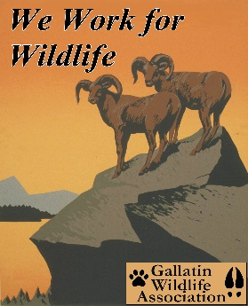

GALLATIN WILDLIFE
ASSOCIATION

P. O. Box 5317

Bozeman, MT 59717
(406) 586-1729
www.gallatinwildlife.org

September 9, 2023

Attn: Goose Creek Fuel Break #64730

Corey Lewellen, District Ranger
Bozeman District Office
3710 Fallon St, Suite C
Bozeman, MT. 59718

Dear Mr. Lewellen:

On August 31, 2023, Custer Gallatin National Forest released a 14-day public scoping notice for a fuel break project known as Goose Creek. The Forest Service claims the buildup of hazardous fuels in and around Chestnut Mountain justifies this necessary action to protect homes and structures in the wildland urban interface (WUI), specifically those homes and structures in the Bear Canyon and Goose Creek communities. The intent according to the scoping notice is:

“…to reduce wildfire spread and intensity and to reduce the risk of uncharacteristic wildfire on Federal land or catastrophic wildfire for nearby communities.”

The comments below represent those of the Gallatin Wildlife Association and their membership. GWA is a local, all volunteer wildlife conservation organization dedicated to the preservation and restoration of wildlife, fisheries, habitat and migration corridors in Southwest Montana and the Greater Yellowstone Ecosystem, using science-based decision making. We are a nonprofit 501(c)(3) organization founded in 1976. GWA recognizes the intense pressures on our wildlife from habitat loss and climate change, and we advocate for science-based management of public lands for diverse public values, including but not limited to hunting and angling.

The Misapplication of Categorical Exclusion:

Before we get into actual specifics of utilizing fuel breaks, GWA would like to comment on the process by which this and other fuel break projects have been released upon the public domain. These projects are possible and funded because of the recent passage of the Bipartisan Infrastructure Law signed into law on November 5, 2021. Within that law is a section known as Sec. 40806 – Establishment of Fuel Breaks in Forests and Other Wildland Vegetation. This section establishes a categorical exclusion (CE) for fuel breaks up to 1,000 feet in width and not more than 3,000 acres of treatments located primarily in – the wildland-urban interface or a public drinking water source area. If that is the only criteria used in CE determination, then the Goose Creek project area qualifies under this criterion.

But as usual, laws can be manipulated by politics and special interests. GWA believes that is the case here. There is a political and national push to fight climate change across our country, as there should be. Our national forests have a direct role to play in that effort. In fact, GWA has been advocating for that role to be played out. Unfortunately, the massive push to utilize fuel breaks has not been the effort we’ve been seeking. GWA believes fuel breaks have been misconstrued to their effectiveness. This is a clear example of some projects having good intentions but falling short in their implementation. Even though these projects are supposedly limited in scope and are designed to be implemented under the CE clause of NEPA, they can still cause significant impact and ecological damage upon the landscape such as we will see here in the Goose Creek Project.

Because of the ecological damage that would result from this project, GWA believes the use of CE has been misappropriated in this case. CE(s) should be based upon more than the size and scope of any one individual project. They should be based upon the scope and likelihood of ecological damage being done to the landscape. In fact, in Section 40806, this law states the following in paragraphs (c)(3)(D). It states listing excludes the use of categorical exclusions on lands whereby the activity “would be inconsistent with the applicable land management plan or resource management plan.” GWA contends that is the case here.

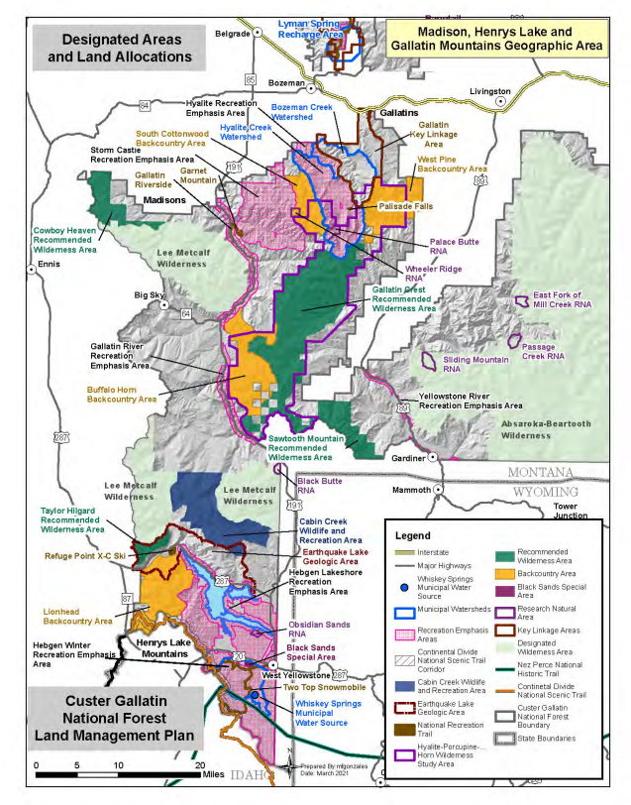

The map above highlights the Land Management Plan from the newly revised 2020 Forest Plan. Hard to see in this map, but toward upper center right, is the Gallatin Key Linkage Area, an area of land set aside for the purpose of wildlife connectivity. Here wildlife can move north to south or vice-versa from the Gallatin Range to the Bridger Range. This linkage has ecological significance as this stretch of landscape has long-been proven to be historically critical in the overall migration corridor between the Greater Yellowstone Ecosystem to the south and the Northern Continental Divide Ecosystem to the north.

In today’s world, this narrow stretch of forested land is a natural link for wildlife as they try to cross the formidable challenge of I-90. Wildlife are plentiful in this region, a region that GWA has long been advocating for the restoration and establishment of a wildlife corridor.

We were pleased to see the Custer Gallatin National Forest (CGNF) set aside lands to enable this connection to take place and evolve over time. But problems quickly ensued when the Forest Service also declared lands directly south of that declaration as a recreation emphasis area, and not to mention, adjoining lands as watershed management areas where timber harvest could ensue. Other lands adjoining the Key Linkage Area could also be set aside for mechanical and motorized usage, basically fragmenting an already severe fragmented landscape. The Goose Creek Project includes lands in the heart of that Gallatin Key Linkage Area.

GWA believes those lands set aside for fuel break designation in the Goose Creek Project run contrary to the original intent and purpose as laid out in NEPA. GWA also believes they are contrary to the land-use management and allocation set aside by the CGNF themselves. Therefore, the use of CEs in this case should be null and void for there will obviously be negative impacts upon the environmental condition on the ground. The use of a CE will severely hinder the movement and habitat of wildlife.

The fuel breaks as orchestrated currently split the landscape of the Key Linkage Area. It will cause further fragmentation and/or deepen already existing fragmentation, severely compromising the landscape making it more incompatible for wildlife, let alone allowing them to fulfill their migratory behavior patterns. Species such as elk, moose, bear, grizzly bear, wolves, wolverine, and many others are just some that could be impacted. Some of these species are already listed as threatened or are being considered as threatened as we speak under the ESA of 1973.

For this reason alone, GWA believes the liberal use of categorical exclusion to sensitive lands is a breach of NEPA and violates the intent of NEPA despite the recent application of the Bipartisan Infrastructure Act of 2021.

Another problem with this approach is the minimalist practice of importing a 2-week public comment period. This disenfranchises the public in the most flagrant way possible by restricting the comment period to two weeks. By the time people become aware of this project, the time to respond and/or comment could easily pass denying them their right to register their opinion on a matter that impacts the ecological integrity of their national forests.

The Loss of Ecological Integrity at Bear and Goose Creek:

GWA has researched what little science there has been done on the success of utilizing fuel breaks in wildfire mitigation. Their use is controversial, but there is no real science on the efficacy of fuel breaks either. Fuel breaks are not homogenous. They may vary in size, slope, vegetative terrain, etc. And the success or lack thereof depends upon climatic or local weather conditions at the time of the fire. If fuel breaks are completed for the purpose of cessation of wildfire, then this is the wrong approach to employ.

They can offer an opportunity to help suppress wildfires, and they may alter a fire’s behavior, but these are not guarantees. Fuel breaks may have their time and place and may have some successes, but they are dependent upon variables. While success is dependent on variables, ecological damage is a guarantee leaving a permanent scar upon the landscape.

GWA challenges the use of this CE at this location for this purpose. The vicinity of Chestnut Mountain on the Custer Gallatin National Forest southeast of Bozeman, Montana lies in the WUI and in that regard meets one of the criteria of Section 40806. However, the lands projected for fuel breaks are in uninhabited lands and are valuable and sensitive for a variety of wildlife.

As stated, these lands are already impacted by people, mostly recreationists either hiking, or riding on mechanized or motorized toys. Because of the amount of accessibility this part of the forest receives, GWA believes portions especially those portions in the Gallatin Key Linkage Area should be restricted at certain times and seasons to human activity. There is an obvious fear these fuel breaks will allow more accessibility impacting these already imperiled lands for wildlife.

The amount of material describing the use of fuel breaks is plentiful. GWA could flood this comment platform with information on the pros and cons on the matter, but nearly all say the same in one regard, there is not enough study to determine if they are truly effective. But nearly all of them state the detrimental impact upon the environment. The quote below is from one of the more pro-favored articles in using fuel breaks. From Forest Ecology and Management, an article entitled “Quantifying the effectiveness of shaded fuel breaks from ground-based, aerial, and spaceborne observations” by Baijnath-Rodino, Janine A¹., et al., is the following statement.

“Some short-term studies indicate fuel reduction and treatments can be detrimental to biodiversity and ecosystem function. Furthermore, long-term ecological trajectories and fuel hazard outcomes of fuel treatments are still poorly understood (Wilkin et al., 2017).”

The map below highlights the project area. This map also depicts the most northern portion of the Gallatin Key Linkage Area. One can easily see the potential damage this project imposes upon wildlife and their migration pattern to the north. This is especially
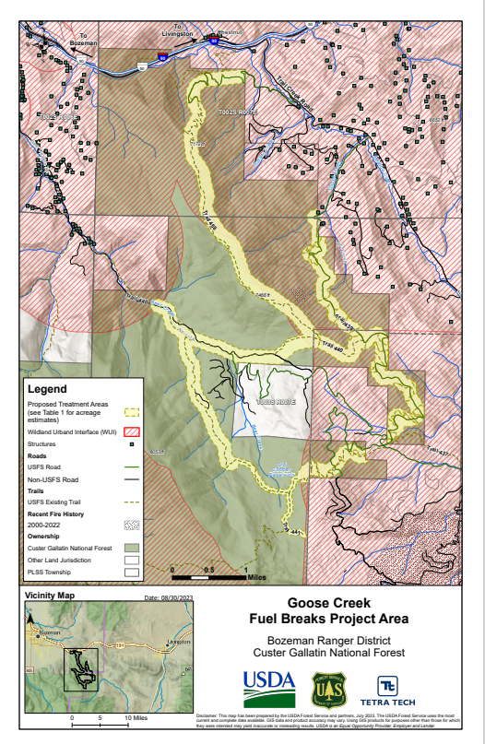
true when discussing the potential migration patterns of grizzly bears. Historical and scientific evidence indicates grizzly bear migration has been and still is possible to reconvene to the north. Many NGOs and government agencies have propagated this theory revisioning the connectivity from the Greater Yellowstone Ecosystem to that of the Northern Continental Divide. The terrain is mountainous with dense, lush vegetation in places, the kind of vegetation that provides excellent cover for wildlife. Not only will this fuel break add to the fragmentation of wildlife habitat, but as one can see there is a linear function to the trail system that is unnatural across the landscape. These are features that may alter the movement of wildlife and disrupt corridor patterns by creating unnatural edges or boundaries. All of this adds to the dysfunctional character of the landscape impacting the natural movements of wildlife.

In addition to fuel breaks adding to the dysfunction of wildlife movement, they also add to the dysfunction of soil and grass regimes at the forest floor. In an old college textbook by Smith, Robert L²., Ecology and Field Biology, the following summation has never been more true.

“A close relationship exists between litter and humus, and the environmental conditions in the forest community – the internal microclimate of the soil, the moisture regime, its chemical composition, and its biological activity. The forest floor plays a dominant role in the life and distribution of many forest plants and animals, in maintenance of soil fertility, and in many of the soil-forming processes. The nature and quality of the forest organic layer depend in part on the kind and quality of forest litter and fate of that litter and the development of the humus layer is conditioned by the activity of microflora and soil animals.”

Again, it is the small intricate relationships, even those invisible to the naked eye, that affect the overall health in an ecosystem. This is where the disturbance begins, at the most micro level in forest dynamics. In the Introduction of a scientific article “Forest disturbance and arthropods: small-scale canopy and understory disturbances alter movement of mobile arthropods”, by Perry, Kayla I³., et al., the following excerpt is quoted.

“Disturbances shape patterns of environmental heterogeneity, community dynamics, and ecosystem processes on varying spatial and temporal scales and are integral to the maintenance of species diversity (White and Pickett 1985, Petraitis et al. 1989, Frelich 2002).

For example, arthropods can respond to changes in soil moisture levels (Verhoef and van Selm 1983, Levings and Windsor 1984), amount and decay stage of downed woody debris (Ulyshen and Hanula 2009, Perry and Herms 2017), and leaf litter depth (Koivula et al.”

It is obvious that forest thinning, trampling, machinery, cutting and burning disrupts all these activities beneath the forest litter and including soil biota. Of course, fire is a natural ingredient in a forest, the other actions are not. We will be changing the integrity of the smallest biome, but there is more.

Another issue with fuel break projects is the intrusion of non-native invasive plants. On this subject, we refer to the Executive Summary found in a scientific journal by the U.S. Geological Survey entitled, The Role of Fuel Breaks in the Invasion of Nonnative Plants by Merriam, Kyle E⁴., et al.

“Fuel reduction projects have become an increasingly important component of state and federal fuels management programs. However, an unintended result of some pre-fire fuel manipulation projects may be the introduction of nonnative invasive plants. The establishment of nonnative plants within fuel breaks is a serious concern because the presence of invasive species in areas treated to reduce fuels could make adjacent wildland areas more susceptible to invasion, particularly following widespread disturbances such as fires. could make adjacent wildland areas more susceptible to invasion, particularly following widespread disturbances such as fires.”

Many scientific journals or research done on fuel breaks are based on studies in California, primarily because of California’s long experience with wildfires and the approaches they have used to mitigate them. One such study entitled “Fuel Breaks Affect NonNative Species Abundance in California Plant Communities”, by Merriam, Kyle E.⁵, et al., states a surprising statistic early on in the Abstract.

“We evaluated the abundance of nonnative plants on fuel breaks and in adjacent untreated areas to determine if fuel treatments promote the invasion of nonnative plant species. Understanding the relationship between fuel treatments and nonnative plants is becoming increasingly important as federal and state agencies are currently implementing large fuel treatment programs throughout the United States to reduce the threat of wildland fire. Our study included 24 fuel breaks located across the State of California. We found that nonnative plant abundance was over 200% higher on fuel breaks than in adjacent wildland areas. Relative nonnative cover was greater on fuel breaks constructed by bulldozers (28%) than on fuel breaks constructed by other methods (7%). Canopy cover, litter cover, and duff depth also were significantly lower on fuel breaks constructed by bulldozers, and these fuel breaks had significantly more exposed bare ground than other types of fuel breaks. There was a significant decline in relative nonnative cover with increasing distance from the fuel break, particularly in areas that had experienced more numerous fires during the past 50 years, and in areas that had been grazed. These data suggest that fuel breaks could provide establishment sites for nonnative plants, and that nonnatives may invade surrounding areas, especially after disturbances such as fire or grazing. Fuel break construction and maintenance methods that leave some overstory canopy and minimize exposure of bare ground may be less likely to promote nonnative plants.”

This is a surprising statistic and one that needs to be adhered to in the practice of using fuel breaks across this country. Realizing that not all fuel breaks are the same, and not all construction of fuel breaks is the same, the point is made that the heavier construction utilized, the more disturbance, the greater the likelihood of an invasion on nonnative plants upon the landscape. This would be a disaster to think that we are sacrificing our ecosystem for something that might happen over an event that most likely will happen should we adhere to a political whim of Congress.

But this is still not all. Problems such as erosion, soil compaction, and aesthetics of construction are all issues that need attention and are all issues that get disregarded the most. Opening the canopy to allow more sunlight to the forest floor increases temperature, reduces humidity, exposes lower levels to more wind and an increase in dryness. All of these changes may accelerate fires rather than help to mitigate them.

Picture below showcases the vegetation and terrain that is projected to be turned into a fuel break in the Goose Creek Project. This picture was recently taken by Nancy Schultz and Glenn Monahan, board members of GWA. It is unthinkable to imagine what a fuel break would do to this forested setting as seen below. The disruptive nature would for years to come alter the natural setting for wildlife, disrupt their pattern of migration, not to mention the richness of the biodiversity we see at the lower levels of the forest and the aesthetics of that biodiversity. The forest’s integrity would be harmed for generations.

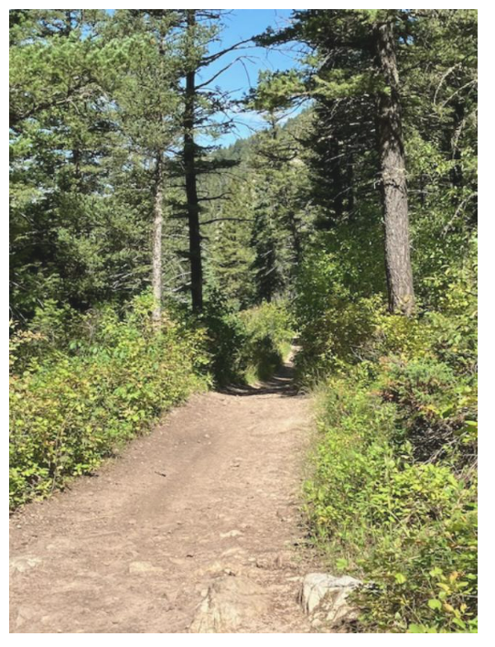

This scene would be lost and the continuity of this portion of the forest would be lost as well.

Sacrificing Public Land for Private Interests:

GWA presented a film called “Elemental⁶” back on July 26 of this year. The Forest Service attended that film. They participated in the panel after that film. They said they understood the message the film was trying to convey. That message was simply this. If we want to really get serious about mitigating damage done from wildfires, we need to focus on the homes themselves rather than trying to fight mother nature in the wildlands. It is much cheaper, more scientific, and more efficient, as well as more safe for fire fighters. Yet here we are again, the Forest Service is trying to promote the practice of fighting fires in the wild instead of spending time and money on where it would pay the greatest dividends, the homes.

It is widely known embers from wildfires can travel much further than 1,000 feet, the maximum length authorized under Section 40806 of the Infrastructure Bill. According to the Orange County Fire Authority⁷ of California, embers have been shown to travel as far as 5 miles in front of a fast-moving wildfire. So, what are we really trying to do here, other than make ourselves feel good.

The movement of embers and the behavior of wildfire is something that is beyond human control. Yes, we can perhaps alter the behavior of wildfire to a certain degree depending upon conditions on the ground and weather conditions in the air and after spending millions of dollars, but we ought to realize our shortcomings. We should spend our limited resources and do something where it is more effective, use the tools and knowledge that has the greatest efficacy, fire hardening people’s homes of those who decide to live within the fire-prone communities.

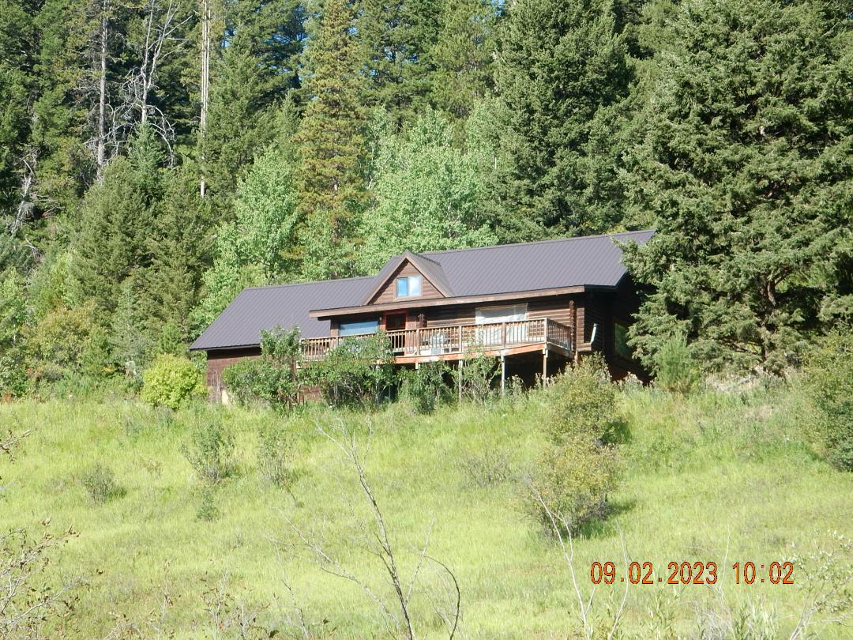

Pictured here is a home within the wildland urban interface, supposedly the type of structures this project is supposed to protect. Picture taken by GWA board member Paul Griffin. But as we can see this home has apparently done little in hardening their home in the face of wildfire. Unfortunately, this example of a home in the WUI is rather commonplace of so many others in and around Gallatin County. Has education failed or perhaps there has not been enough? But this was the rationale of GWA to bring the film Elemental to Bozeman. Instead, Congress, the National Forest Service, and yes, this administration seems to wallow in old forest management remedies that will cost millions upon millions of dollars and still not get the intended result.

In the meantime, we are sacrificing our national treasure, our forests, and our wildlife in the process. A more sobering way to state this is that we are sacrificing our biological diversity and our ecological integrity for the private sector. This is not ethical, and it is not justifiable, and it must be stopped for the future of our forests.

Concluding Remarks:

The landscape within the Goose Creek Project Area contains Chestnut Mountain, the heart of the Gallatin Key Linkage Area. The project area traverses a well-established wildlife corridor between the Gallatin Range to the south and the Bridger Range to the north. This landscape also contains lands between Bear Creek to the west and Goose Creek to the east, an area widely known to many as containing many species of wildlife. This landscape was so designated for the purpose of allowing a connectivity corridor to be established for wildlife, a corridor that has long been thought necessary for the free movement of grizzly bears northward.

The use of a simple CE on lands so sensitive and critical to the biological integrity of the Custer Gallatin National Forest violates the intentions of NEPA. It provides a disservice to the ecological integrity of the Goose Creek Project Area landscape despite the wording or phrasing within Section 40806 of the Infrastructure Bill itself. The use of a CE in this scenario minimizes the severity of environmental damage done and serves as a misapplication of the CE clause.

The analysis of fuel breaks upon the landscape is not a proven science. Our research was conclusive as to the “hard to determine nature” the study of fuel break efficacy truly is. Success depends upon the type of terrain, vegetative cover, and the type of fire and weather conditions that exist at the time. We must not use fuel breaks as a remedy for all fire mitigation solutions because the ecological damage can outweigh the benefits.

In the meantime, we are destroying and sacrificing the ecological integrity of our forest for something that might happen, or for something that might prove successful. But in doing that, we are risking success against a 100% chance of environmental degradation. Is this the purpose of the National Forest Service? Is this proper management of public lands? GWA believes this is not the wisest use of public land. The U.S. Forest Service should be engaged in protecting forest resources not sacrificing them. Therefore, we urge the Custer Gallatin National Forest to deny funds for this project.

The chances of harming wildlife migration are real. The chances of increasing habitat fragmentation are real. The chances of causing ecological damage to the integrity of the forest are real. The chances of embers being blown over 1,000 feet during the midst of a wildfire and undermining the total purpose and intention of this project are real. So, we ask again, why are we doing this?

Science has shown it is better to refocus our challenge in fighting wildfires by hardening people’s homes. Using fire protectant materials and new technologies, clearing brush and flammable materials around homes and structures is cheaper, more efficient, and more safe than fighting wildfires in the back country or wild landscapes. This would be the proper application of science in the 21st century. It is inappropriate to use public land as a defense mechanism for private property. That is not the role of the U.S. Forest Service.

Finally, as we close our comments, we will add one more reference, a reference that specifically pertains to the Bipartisan Infrastructure Bill that began this country-wide excuse to utilize fuel breaks on our public lands. GWA backs and supports those provisions as stated in the attached letter by the John Muir Project⁸ and the Partnership for Policy Integrity. It is a summation of a letter addressed to Congress entitled; “A Statement on the Bipartisan Infrastructure Bill”.

It is time to address climate change based upon science rather than utilizing the same old remedies of the 19th century. This is the paradigm change that GWA has been talking about in the press and to the U.S. Forest Service. Let’s utilize our best science and save taxpayer dollars the easy and safe way and not force firefighters into a fray of fuel breaks that could be death traps.

We wholeheartedly urge the Custer Gallatin National Forest to abandon this fuel break project in the heart of the Gallatin Key Linkage Area. We are carving up our precious forests out of fear, not science. How long will this excuse need to play out before we, as a society, wake up? And by doing so, what will our forest look like, what wildlife will be left, and what will we have to show for it?

Sincerely,

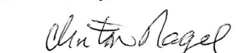

Clinton Nagel, President
Gallatin Wildlife Association

References:

- Baijnath-Rodino, Janine A, et al., Quantifying the effectiveness of shaded fuel breaks from ground-based, aerial, and spaceborne observations, Forest Ecology and Management, 2023.
https://escholarship.org/content/qt5br7r07k/qt5br7r07k.pdf

- Smith, Robert L²., Ecology and Field Biology

3.) Perry, Kayla I., et al., Forest disturbance and arthropods: small-scale canopy and understory disturbances alter movement of mobile arthropods, ESA Journals, 2021.
https://esajournals.onlinelibrary.wiley.com/doi/full/10.1002/ecs2.3771

4.) Merriam, Kyle E., et al., The Role of Fuel Breaks in the Invasion of Nonnative Plants, U.S. Geological Survey, 2007.
https://pubs.usgs.gov/sir/2006/5185/pdf/sir_2006-5185.pdf

5.) Merriam, Kyle E., Fuel Breaks Affect NonNative Species Abundance in California Plant Communities, Ecological Society of America, 2006.
https://www.fs.usda.gov/psw/publications/beyers/psw_2006_beyers001_merriam.pdf

6.) Ready, Set, Go! Be Ember Aware, Orange County Fire Authority,
https://www.ocfa.org/Uploads/SafetyPrograms/OCFA%20RSG%20-%20Be%20Ember%20Aware.pdf

7.) Elemental: Reimagine Wildfire, Green Oregon, GO Alliance,
https://www.elementalfilm.com/

8.) A Statement on the Bipartisan Infrastructure Bill, John Muir Project, and Partnership for Policy Integrity.
https://johnmuirproject.org/wp-content/uploads/2021/08/JMPPFPIStatementOnInfrastructure.pdf

