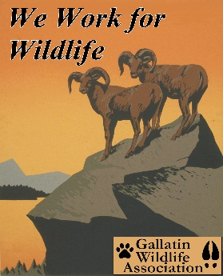

GALLATIN WILDLIFE
ASSOCIATION

P. O. Box 5317

Bozeman, MT 59717
(406) 586-1729
www.gallatinwildlife.org

August 15, 2023

David Whittekiend
Forest Supervisor
Uinta-Wasatch-Cache National Forest
857 West South Jordan Parkway
South Jordan, UT 84095

Susan Eickhoff,
Forest Supervisor
Ashley National Forest
355 N. Vernal Ave.
Vernal, UT 84078

EIS No. 20230085, Draft Supplement, USFS, UT, High Uintas Wilderness Domestic Sheep Analysis

Dear Supervisors of the Uinta-Wasatch-Cache and Ashley National Forests:

In June of 2023, the U.S. Forest Service through the auspices of the Uinta-Wasatch-Cache and the Ashley National Forests publicly announced the release of their Supplemental Draft Environmental Impact Statement (SDEIS), a SDEIS to update the High Uintas Wilderness Domestic Sheep Analysis. According to the U.S. Forest Service, they have received new information that warranted a supplemental release of the document.

“In August 2019, the official comment period for the Draft Environmental Impact Statement (DEIS) closed. Since then, the two Forests have been responding to comments and working with our cooperating agencies to find the best path forward. As a result of some of the comments we received on the DEIS, we added new information to the analysis and have prepared a Supplemental Draft Environmental Impact Statement (SDEIS).”

The following comments are in response to that release of new information and represent those of the Gallatin Wildlife Association of Bozeman, Montana. Gallatin Wildlife Association (GWA) is a local, all volunteer wildlife conservation organization dedicated to the preservation and restoration of wildlife, fisheries, habitat and migration corridors in Southwest Montana and the Greater Yellowstone Ecosystem, using science-based decision making. We are a nonprofit 501 (c) (3) organization founded in 1976. GWA recognizes the intense pressures on our wildlife from habitat loss and climate change, and we advocate for science-based management of public lands for diverse public values, including but not limited to hunting and angling.

GWA has long been involved in the status of bighorn sheep in the Uintas and has provided comments in that regard since our Dec. 21, 2015, letter. The U.S. Forest Service Scoping Letter of 2016 prompted GWA to submit additional comments on March 11 of that year. Since then, GWA along with other signatories, signed on to a combined letter effort campaign regarding the June 25, 2019, release of the Draft Environmental Impact Statement (DEIS) for the High Uintas Wilderness Domestic Sheep Analysis Project. Our interest in the bighorn sheep of Utah has been longstanding and the rationale as to why will hopefully be made apparent throughout these set of comments.

Acknowledgement of Indigenous Bighorn Sheep in the Uintas

GWA’s president at the time, Glenn Hockett, stated the obvious in our 2016 letter¹.

“Bighorn sheep were once abundant in Utah and across the west in large herds with connected habitat (Dubay et al. 2003, Singer et al. 2001, Singer et al. 2001(a), Smith et al. 1991, Toweill and Geist 1999, Utah DWR 2013). Historically, bighorn numbers were estimated to be between 1.5 to 2 million across the west (Toweill and Geist 1999). However, only about 35,000 Rocky Mountain bighorn sheep are found in North America now (Toweill and Geist 1999). This represents a loss of over 98% of the historic bighorn population with only 1.75% of historic numbers remaining across the West (Toweill and Geist 1999).

While we could not find historic bighorn estimates specifically for Utah, bighorns were considered abundant across the State (Toweill and Geist 1999, Utah DWR 2013). However, Rocky Mountain bighorn sheep declined dramatically in Utah and native populations were nearly extirpated following pioneer settlement (Toweill and Geist 1999, Utah DWR 2013). Currently there are only about 2,000 Rocky Mountain bighorn sheep in seven different populations and about the same number of Desert bighorn sheep left in Utah (Utah DWR 2013, page 15&16).”

GWA wants to challenge the U.S. Forest Service contention that bighorn sheep are not native to the Uintas. This is a basic premise that needs to be exposed because it is key to the argument of bighorn sheep protection. We are not suggesting for a moment that the U.S. Forest Service actually believes otherwise, but it does suggest that perhaps the U.S. Forest Service is trying to downplay the obvious in the public’s perception. It should be self-evident that bighorns are a native species to the landscape of the Unitas. The SDEIS comes close to stating this on page 151, whereas it states bighorn sheep were recorded in the Uintas as early as 1849, but this document never does state that bighorn sheep are indigenous to the region. This alternate universe the U.S. Forest Service is trying to portray is just contrary to the facts. On page 180 of the SDEIS, there is this statement:

“In evaluating effects to the NS Uintas BHS from domestic sheep grazing these allotments, consideration needs to be given to these herds being introduced and manipulated by UDWR management. The NS Uintas BHS herds are not native herds, but rather are introduced herds which are the result of the UDWR conducting as many as 13 periodic releases of BHS in the Uintas from 1983 to 2014 from seven different sources (UDWR 2018d, USDA Forest Service 2021).”

Several statements like this are scattered throughout the SDEIS. Do you think this will relieve you from obligation to protect the species? The SDEIS seems to propagate this theory even further by stating the existing herds are manipulated by the state. It seems as if the U.S. Forest Service is trying to downplay their natural significance in the ecosystem. While it is true these specific herds were reintroduced and therefore have no historical link to the native herds of the past, they do have a genetic link. This fact does not diminish the viability of these herds and the critical role they play in the ecological niche of the Uintas.

A Memorandum of Understanding² signed by multiple parties (state and federal) in May of 2019, was to coincide efforts and programs for the management of bighorn sheep in the state of Utah. Signatories were the State of Utah, Utah Division of Wildlife Resources, Utah Department of Agriculture and Food, and the United States Department of Agriculture, Forest Service Intermountain Region. On page 2 of the Bighorn Sheep Management Plan for the Uinta Mountains, North Slope/South Slope WMUs # 8 & 9 dated August 2019³, there are these statements.

“Bighorn sheep were historically abundant and found across all of the Uinta Mountains. Bighorn habitat is located within the steep rocky canyons and hillsides as well as the high alpine habitat above timberline in the High Uintas. Native bighorn sheep were abundant on the Uintas in the 1800's but by 1915 they had become less common. Bighorn were documented in 1946 near Granddaddy Basin and a bighorn was photographed in Dry Fork Canyon as late as 1967.”

“Bighorns were reintroduced in the Uintas starting in 1983 near Flaming Gorge. Numerous transplants have occurred since then (Table 1). The most recent transplant occurred in Jan. 2014 to Goslin Mountain in the Three Corners subunit. Five sites have received transplants and despite challenges and several disease related set-backs, bighorn have persisted across the Uinta Mountains since these restoration efforts began. The current population is estimated at 150 to 200 sheep (Table 1). A map of current known and potential distribution is depicted in Figure 1.”

At least the Division of Wildlife Resources is using the correct terminology and phraseology by using the phrase reintroduction. The SDEIS needs to be more inclusive by relaying the facts as they are; bighorn sheep were on the landscape prior to any domestic sheep grazing. The only reason the original herds are not present today is obviously through no fault of their own or the ecological conditions of the Uintas, but through actions (directly or indirectly) resulting from settlement of the West during the Westward Expansion.

Shame on the U.S. Forest Service for seemingly trying to lessen the intrinsic value of bighorn reintroduction and shame on us (humankind) for allowing viable herds of bighorn sheep to become extirpated throughout the region. For as goes the population of bighorn sheep across the west, so they will also go here in Montana.

The Purpose of the MOU as stated on paragraph 1 of the MOU is clear.

“The purpose of this MOU is to document the cooperative efforts of the parties to manage bighorn sheep herds and their habitats on NFS lands in the State of Utah, to the extent consistent with federal law and regulation.”

Need we remind the U.S. Forest Service, they have an ethical, legal, and scientific obligation to protect bighorn sheep and other species upon the landscape to the best of their ability.

Acknowledgement of Climate Change and Cumulative Effects

In reviewing the document, reference to climate change occurred only 6 times in the SDEIS. A third of those were in the title and in a reference. The following sentence on page 21 states the position of the U.S. Forest Service.

“During the 2019 comment period on the original DEIS, we received some comments on climate change. We evaluated climate change in a separate report (USDA Forest Service 2020). This issue was dismissed from detailed analysis in the DEIS since it was not deemed a driving issue in the analysis. However, the separate report does provide a detailed evaluation. The referenced report is available in the project record.”

Everyone should know by now that climate change will most likely affect nearly every aspect of life, especially those pertaining to the natural condition. The question in this SDEIS, is how was the analysis of climate change taken into consideration? How were those analyses incorporated into this document? To say that the analysis was done in a separate report with a detailed evaluation does not help the public understand the impact even if it is available in the project record. How did that evaluation guide the analysis in this document? That is the question.

On top of that, the statement above says:

“This issue was dismissed from detailed analysis in the DEIS since it was not deemed a driving issue in the analysis.”

With this statement, one could ascertain, climate change was not even a serious consideration. With what we know about climate change and how it affects the landscape, how is this even possible? Beginning on page 182 of the SDEIS, there are several paragraph discussions on cumulative impacts. The conclusions found in these cumulative discussions discuss events such as timber harvest, fire, etc., but conclude impacts are negligible because plant communities meet desired conditions, so forage competition is not a problem. With the advent of climate change, the effects of fire could be severe on the landscape, and plant communities are likely to be heavily impacted. While grasses may grow back after wildfire, other cumulative effects like drought and higher temperatures are likely to create impacts we have not seen to-date. Again, forage competition is a concern based on evidence seen in photographs of the degraded project area. More discussion on that to come.

The following statement found on page 183:

“Cumulative effects will not cause a trend toward federal listing or loss of viability of sensitive species.”

This statement is not supported by the facts presented. Climate change will have cumulative impacts upon the landscape and they will be unforeseen. This SDEIS needs a serious evaluation of those consequences, not just a dismissal of the impacts.

The Alternatives?

Page 25 of the SDEIS describes only two alternatives in detail: Alternative 1, the No Action, No Grazing Alternative and Alternative 2, the Proposed Action, Continued Management option. Analyzing two alternatives under NEPA’s Environmental Impact Statement criteria seems to be the new thinking by Federal Agencies. Even though two alternatives seems to be the minimum required, it does little to improve the understanding of the public. We think it is safe to say the only reason the No Action Alternative option is presented here is due to the requirements of NEPA. Under the No Action Alternative, there would be no grazing option and the existing term grazing permits would be cancelled as stated on page 25. As also stated, the use of the sheep driveway south of the East Fork-West Fork junction of the Blacks Fork would be discontinued. Under Alternative 2, the Proposed Action, there would be 5 grazing allotments on the Uinta-Wasatch-Cache National Forests and 5 grazing allotments on the Ashley National Forest. Here in this alternative as stated on page 25, Alternative 2, the U.S. Forest Service Proposed Alternative, they once again seem to try to rationalize themselves out of the responsibility of proper bighorn sheep management.

“After working through the species data for bighorn sheep, as well as looking at the current range and how they intermix with one another, we determined that a project-specific amendment would be required. We recognize that for bighorn sheep, a sensitive species, this subgoal cannot be met at the planning area level given the current distribution of bighorn sheep. The WCNF can make efforts to maintain bighorn sheep, but viability in the planning area alone is not possible as this population extends across two forests, two states, and includes multiple jurisdictions including the Forest Service, state, private and Bureau of Land Management managed lands. This would be the case whether continued domestic sheep grazing is authorized in the project area or not.”

According to statements found on page xiii, both alternatives were designed to be viable and ensure consistency between the project and the 2003 Wasatch-Cache Land and Resource Management Plan (Wasatch-Cache Forest Plan). In order to accomplish this, a forest plan amendment would be needed. Wording from the SDEIS on page xiii:

“Neither alternative analyzed in detail would be consistent with one of the forestwide subgoals for biodiversity and viability in relation to bighorn sheep. A project specific plan amendment would be necessary to exempt the project from this specific Forest Plan direction.”

What would this forest plan amendment do? Page xiv answers that question.

“The project-specific amendment would exempt authorizations under the High Uintas Wilderness Domestic Sheep Analysis from the following Forest Plan direction:

Forestwide Subgoal – Biodiversity and Viability, Subgoal 3i:
“Maintain viability of species-at-risk (including endangered, threatened and sensitive species and unique communities)” (Forest Plan, p. 4-19).

The core herd home range for this metapopulation of bighorn sheep extends across two forests, two states, and includes multiple jurisdictions including Forest Service, state, private, and Bureau of Land Management managed lands. Based on its current distribution, the viability of the bighorn sheep metapopulation affected by the Project cannot be maintained on the Wasatch-Cache plan area independent of the other lands associated with the population.

Achievement of this subgoal for bighorn sheep in the Wasatch-Cache portion of the project area is not possible whether or not domestic sheep grazing is occurring in the area. Therefore, this proposed amendment is applicable to the no action alternative as well.”

In other words, there seems to be an attempt once again to release the U.S. Forest Service from making hard, perhaps unpopular decisions. GWA objects to the proposal as written because the existence of domestic sheep on non-Forest Service lands in the vicinity can be independently addressed by actions by the BLM and/or private operators. The U.S. Forest Service can and should still honor its obligations to the best of their ability by ensuring the viability of the bighorn sheep meta population within its jurisdiction. They should not relinquish their obligation just because others make it difficult to achieve the goal. The U.S. Forest Service can show some leadership amid this focus of debate and advocate for bighorn sheep for a change. The agriculture community seems to have dominated the debate over generations on the management of grazing permits on public land. The National Forests and bighorn sheep have paid the price. It is time to turn the attention toward wildlife, and conditions on the landscape.

Another point on this matter. Is the U.S. Forest Service actually saying they are prepared to exempt species in the project area, (in this case, lands within a wilderness area (no less)) from their Forestwide Subgoal – Biodiversity and Viability, Subgoal 3i which says “Maintain viability of species-at-risk (including endangered, threatened and sensitive species and unique communities)”? Does the U.S. Forest Service really believe that grazing allotments are more critical to the management of the forest than the adherence to the Endangered Species Act of 1973? GWA philosophically and fundamentally has a problem with that decision if that be the case.

We want to be clear, GWA is in support of Alternative 1, the No Action Alternative. GWA will return to statements found on page 25 of the SDEIS. First Alternative 1, the No Action Alternative, as stated directly responds to the issue of pathogen transfer from domestic sheep to Rocky Mountain bighorn sheep. As stated in the paratheses, it is also known as the environmentally preferred alternative. And we want to be clear as stated on page 25, that the permitting of sheep grazing is a discretionary action that must be evaluated under NEPA. The existence, administration and management of wilderness areas are Congressionally approved and signed into law by the President of the United States.

Even though grazing is permitted in wilderness areas by law, here in this case, 35% of the lands within the High Uintas Wilderness Area is subject to grazing. That is a massive number of grazing permits to allow in a wilderness area knowing the effect grazing can have on riparian areas and forage, not to mention those areas that are sensitive to grazing. This must affect the quality of the wilderness experience, not to mention the availability and quality of forage for wildlife. See Figure 2 copied from the SDEIS below. As can be seen, the majority of the sheep allotments are contained in High Uintas Wilderness Area.

In addition to the grazing allotments, the project area also uses a system known as sheep driveways. Page XV begins to discuss this use of land and what it details.

“The Forests are also proposing to continue to use the sheep driveway that allows sheep to access the allotments from their winter range on private lands. There are a total of approximately 52.2 miles of sheep driveway that are used to access these allotments; of this, 13 miles occur outside of the allotments, while 39.2 miles are within the allotments.”

This driveway system is not shown below in the map, but it adds to the amount of landscape that is in scrutiny all due to grazing in the Uintas.
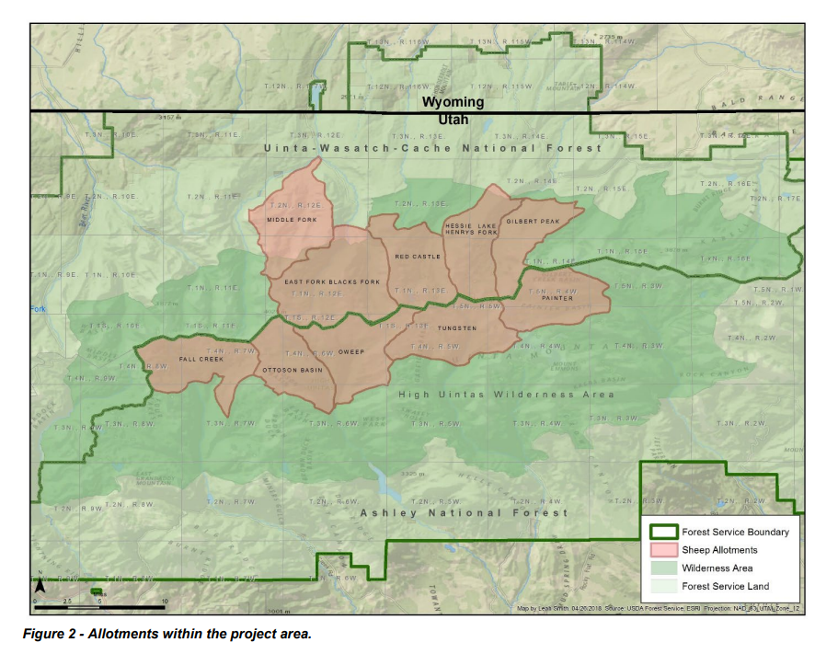

Forestwide Subgoal – Biodiversity and Viability, Subgoal 3i:

This forestwide subgoal is to maintain the viability of species-at-risk including endangered, threatened, and sensitive species and unique communities. We want to re-emphasize that this subgoal is to be implemented across the entirety of the forest. However, the U.S. Forest Service seems to be washing their hands of the responsibility to maintain viability for bighorn sheep saying they (the U.S. Forest Service) cannot meet standards required, due to the management of domestic sheep beyond their control, on lands outside the jurisdiction of the U.S. Forest Service. They say whether the project moves forward or not, they have given up on trying to meet the goals under this standard for bighorn sheep. This is truly unacceptable.

As stated on page 142 of the SDEIS, there are 15 terrestrial wildlife species that are classified as sensitive species in the project area. Only three species have habitat in the project area, one of those being bighorn sheep. The Great Gray Owl and the Northern Goshawk are unaffected by this project for various reasons, primarily due to lack of availability in the project area. But bighorn sheep on the other hand, a species well established in the project area, won’t be affected because the viability of bighorn sheep can’t be maintained with or without the project. The standard answer in the SDEIS is the following.

“The core herd home range for this metapopulation of bighorn sheep extends across two forests, two states, and includes multiple jurisdictions including Forest Service, state, private, and Bureau of Land Management managed lands. Based on its current distribution, the viability of the bighorn sheep metapopulation affected by the Project cannot be maintained on the Wasatch-Cache plan area independent of the other lands associated with the population.”

GWA simply asks what kind of logic is this? Is this the kind of decision we get to expect from our Nation’s land management agency? There still is a federal commitment to be upheld and a legal obligation to be fulfilled. Our organization cannot buy this as a legitimate response.

Disease: The Driving Force

As to the U.S. Forest Service responsibility to mitigate threats to the sensitive species of Bighorn Sheep, the SDEIS seems to once again be masterful in diverting attention from the key issue. That key issue is the ease of which disease is transmitted when bighorn sheep are exposed to domestic sheep. According to the U.S. Geological Survey⁴, the lethality to bighorn sheep from pneumonia is estimated to range from 50-80%. By citing other sources of disease such as stated on page 150, it minimizes the overriding truth in the matter as shown here.

“There are counter-arguments from some scientists, who question the transfer of respiratory pathogens from domestic sheep to BHS and/or question the study design/methods of studies that conclude disease transmission or deleterious effects to BHS after contact with domestic sheep, and argue that other factors (environmental and anthropogenic) may have a larger factor in triggering respiratory disease in BHS than the presence of domestic sheep (Thurmond 2016, USDA Forest Service 2021).”

Citing contrary opinions may be necessary in the overall presentation of all the facts, but they must be stated in a way that does not diminish the overall truth of the matter. That contrarian view was immediately contrasted by the following scientific fact.

“However, there is increasing evidence that show pathogens (known to cause or that are associated with bacterial pneumonia in BHS) such as Mycoplasma ovipneumonia can be transmitted between domestic sheep and bighorn sheep and between individual BHS (Besser et al. 2014, Cassirer et al. 2018, USDA Forest Service 2021).”

Further down on that same page (page 150), there is a diversion once again proclaiming the fact that other species may be to blame. It is highly possible that other species would be carriers of disease or pathogens. But who is to say that those species didn’t also obtain the disease from domestic sheep? Science is key in helping wildlife managers in understanding how domestic animals impact wildlife. We should listen to science and act accordingly. But science should be the deciding measure not politics when implementing wildlife policy. Policies and practices should be put in place that incorporate that science into the public sphere.

It has been stated several times in the SDEIS, the state considers the taking of rams as viable evidence there is no concern about the disease threat (page 181, 187). This is just one statement that seems to minimize the threat of disease on the landscape. Another is found on page 153 with this statement.

“However, since bighorn sheep restoration efforts were initiated in Utah ~50 years ago, no BHS population that reached at least 125 animals has gone extinct even after experiencing disease related die-offs (UDWR 2016b, USDA Forest Service 2021). For example, the NS Uintas bighorn sheep herds have persisted (since they were first introduced into the Uintas) concurrent with domestic sheep on the allotments for 35+ years and have done so with periodic disease outbreaks.”

Again, statements such as this almost seem to minimize the effect of disease and indicate the U.S. Forest Service is willing to accept restoration efforts as is, basically sacrificing individual animals as long as reintroduction takes place, all in order to maintain a minimum herd size of 125 individuals. Five herds of bighorn sheep have been introduced and manipulated (as the SDEIS states) during the years of 1996-2020. But the SDEIS fails to realize, these efforts are likely ineffective because of the disease threat posed by domestic livestock grazing.

Risk of Contact (ROC) The U.S. Forest Service has put a lot of time and effort into what they call a “risk of contact” model. As described in the SDEIS, this is a framework that was developed “in 2015 to provide a quantitative approach to assist in assessing bighorn sheep risk of contact to domestic sheep allotments.” Basically, it is a model to determine the frequency or likelihood of frequency that domestics and bighorn sheep comingle in a way that increases the likelihood disease transmission to native bighorn sheep.

In our understanding of models, models are only as good as the data you put into them and the assumptions made. In that regard, we also know that models can be somewhat limited and if not careful, they can be biased. The SDEIS actually describes one of the weak links in this model program on page 153 and 154 by admitting the difficulty in gaining private information of domestic sheep on private lands. In this case scenario, the SDEIS admits it used the worst-case scenario for ROC to private lands with domestic sheep use.

This model is used primarily to prevent the contact of domestics and bighorn sheep to prevent the spread of Bighorn Pneumonia, a disease caused by the bacteria Mycoplasma ovipneumoniae. The belief is this disease spreads by either direct or close contact. The goal is to keep the distinct species from comingling, but if the domestic sheep are habituating in suitable habitat, where then are bighorn sheep supposed to go?

The U.S. Forest Service seems to rely heavily on this model. According to the SDEIS on page 169, overlap of Forest Service domestic sheep allotments and the Core Herd Home Range (CHHR) only occurs on the western edge of the CHHR, thus allowing nearly all of the CHHR with no overlap with U.S. Forest Service domestic sheep allotments. The statement in the SDEIS states the following.

“Likewise the vast majority of Uintas bighorn sheep (Bare Top herd, Goslin herd, Red Canyon herd, and nearly all of the Sheep Creek herd) are located toward the eastern side of the CHHR and do not foray to the west where the overlapping Forest Service domestic sheep allotments are located. Thus, the high ROC to the two overlapping Forest Service allotments “only occurs on the very western edge of the CHHR with a limited number of BHS.”

The map (Figure 33 from the SDEIS) highlights this fact seen below.
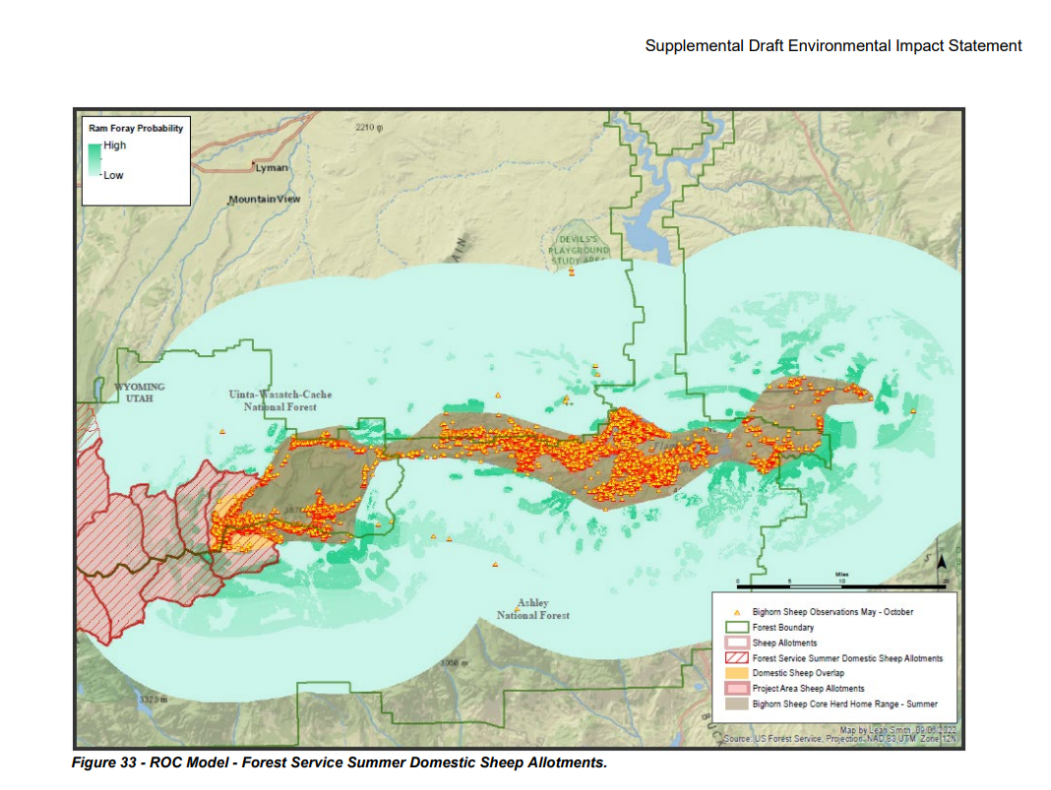

But this conclusion presupposes that Bighorn Sheep remain in certain locations and ‘do not foray’ elsewhere, a limitation that is artificially imposed on a sensitive species struggling to repopulate suitable lands. Another problem with this analysis as presented in the SDEIS, is once again the U.S. Forest Service seems to minimize the contact risk. For on page 169 again there is this statement.

“Although the overlap on the western edge of the CHHR does pose a “high” ROC of BHS with two Forest Service domestic sheep allotments, it is unknown how many times a BHS would need to contact a domestic sheep allotment (or lands with domestic sheep use) for interspecies contact to occur. But when interspecies contact does occur, it is likely to result in pathogen transfer to BHS (USDA Forest Service 2021).”

Once again, there appears to be an attempt to question the risk by placing doubt in the minds of viewers as to the frequency necessary to transmit the disease of pneumonia from domestic sheep to bighorn sheep. However, immediately following that moment of doubt, the SDEIS comes back and states the likelihood that transmission would occur. All of this on again/off again scenario leaves doubt and misunderstanding with the public.

The passage above introduces speculative uncertainty about a fact that is central to the issue. “But when interspecies contact does occur, it is likely to result in pathogen transfer to BHS (USDA Forest Service 2021).” Transfer is likely, and to say that it is unknown how many times a contact is required is beyond the point. “Likely” means transfer will probably occur on the first contact. Secondly, to say the severity of disease outbreak is uncertain, when the likely result of infection is herd die-off, is specious.

Degree of Separation: Buffer Zones We find it interesting; there wasn’t any mention of “buffer zones” in the SDEIS and the option of using “separation” was mentioned only once as it described actions of Utah Department of Wildlife Resources. If there was more discussion than this, we apologize for not finding it. But this is a viable option, one worth considering and one which should have been discussed in much more detail in the SDEIS than it was, so we will touch on it here.

First, we will state according to the scientific record, specifically to the report published in the Wildlife Society Bulletin⁵ published July 22, 2022, a paper entitled “Cost distance models to predict contact between bighorn sheep and domestic sheep” by Anderson, Kathleen, et al., the following statement.

“At present, there is no consensus on minimum spatial separation distances needed to prevent contact between bighorn sheep and domestic sheep. Recommended minimum distances range from 13.5 km to 35 km (Desert Bighorn Council 1990, Singer et al.”

The Wildlife News⁶ publication dated November 9, 2011 by Ken Cole, stated the following in his article entitled “Here are the Facts: Bighorn Sheep vs Domestic Sheep.”

“The Western Association of Fish and Wildlife Agencies (WAFWA) recommends a 9-mile separation between bighorn and domestic sheep to prevent the transmission of deadly domestic sheep diseases. Some question this recommendation but even this is a compromise.”

Finally, there is this as we researched further policies on this issue. The American Sheep Industry Association⁷ had this in their on-line article dated April 2016 questioning the science of transmission of pneumonia from domestic to bighorn sheep. They reported the fact that according to them, the Montana Bighorn Report has serious flaws because the Montana Wildlife Federation, the National Wildlife Federation and the Wild Sheep Foundation propose a 20-mile buffer of separation between bighorn sheep and domestic sheep.

But we were disappointed that this SDEIS and the Utah Bighorn Sheep Statewide Management Plan, both don’t mention the option of using buffer zones to maintain species separation. To be truthful, the latter does mention that separation would be advisable. Page 15 of the following states this.

Strategies: Reduce Risk of Pathogen Transmission
a. Strive for spatial separation between bighorn sheep and domestic sheep and goats that does not negatively impact livestock grazing by utilizing natural barriers (e.g. rivers or expanses of unsuitable habitat) and man-made barriers (e.g. fences or roads).
b. Strive for temporal separation between bighorn sheep and domestic sheep and goats by coordinating with livestock operators and federal land management agencies on active grazing allotments and private lands.

But discussion in the SDEIS was minimal at best and an example of not utilizing the best available science at worst. The following map below provided to us from the good people at Yellowstone to Uintas Connection⁸ showcases the nine (9) mile buffer zone if one would have been installed based upon the bighorn sheep western most observed points of travel within the CHHR.

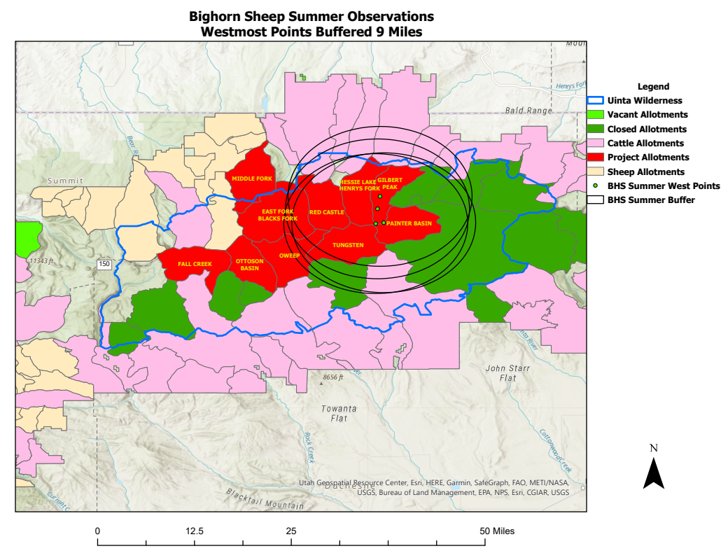

Perhaps the reason buffer zones or degrees of separation was not discussed as an option was because it would eliminate nearly half of the project’s domestic sheep grazing allotments. None-the-less, this should have been presented to the public as a viable option. And scientifically, this should have been presented to other scientists for debate. But this is what science and methodology looks like in the real world. You look at all options and discuss the best way to proceed to reach the overall objectives at hand. Which makes us ask, what is the real objective in this case?

At first glance, there appears to be a too close a connection between state and federal land and wildlife managers with the agricultural community. We understand the necessity of civil discourse and willingness to get along with neighbors, but at what point does wildlife have priority? We ask because it sure seems the agricultural community has had the upper hand in wildlife policy for generations.

As we conclude this section on ROC, GWA would like to bring to the attention of the U.S. Forest Service one more reference that should be considered. This reference is from Tristin Howard⁹, an individual who studied the efficacy of wild-domestic sheep interaction policies in bighorn disease outbreak locations in the western United States as part of his thesis from the University of Montana. In Tristin’s on-line report, there is this paragraph about Buffer Zones. The DBC mentioned below refers the Desert Bighorn Council.

“Buffer zones are one of the most effective ways separation can be accomplished (DBC Technical Staff 1990). The DBC’s technical staff states that: “No domestic sheep grazing should be authorized or allowed within buffer strips ≥13.5 km (8.4 mi) wide surrounding desert bighorn habitat, except where topographic features or other barriers prevent any interaction” (1990, 34). Aside from considering the problem of wandering young rams, the DBC’s technical staff justifies this recommendation by stating: “Bighorn and domestic sheep separation distances cited in the literature range from 3.2 to 32 km [(2 to 20 mi)]” (1990, 34). Bighorn reintroduction recommendations from 2001 indicate the necessity of a 23 km (14 mi) buffer (Shannon et al. 2008).”

Having read this on-line report, we thought we would verify these statements with conclusions from the written text. That, as you will see, is below. As done previously, we highlighted those passages that are pertinent to this discussion and without a detailed analysis of each one, we think they speak for themselves. The entirety of the whole document¹⁰ can be found here.

https://scholarworks.umt.edu/cgi/viewcontent.cgi?article=1248&context=etd

Page 205:
“As Schommer emphasized, buffers are not always effective because of the sometimes unpredictable and wide-ranging movement patterns of wild and domestic sheep and the rugged terrain both species often inhabit (USFS 2010b). Also, though biologists have since learned that buffer zones of about 13.5 km (roughly 9 mi) wide are inadequate, that has not stopped the BLM from using the 13.5 km figure in its resource management planning processes (Tanner 2012a; BLM 1999). The ODFW, MFWP, and the U.S. Fish and Wildlife Service (USFWS) have also used the 9-mile buffer value (Foster 2012; MFWP 2010a; USFWS 2000). Regardless of their inefficacy, the lack of attempts at establishing buffers may have been a key policy weakness that contributed to disease striking all case study locations.”

Page 210:
“Nonetheless, Curtis M. Mack (Bighorn Sheep Recovery Project Leader for the Nez Perce tribe) criticizes the efficacy of the removal policy and indicates that sometimes “the need to remove bighorn sheep because of interactions with domestic sheep or goats should be viewed as a management failure triggering implementation of more effective separation strategies to prevent contact and preclude the need for further removal of wild sheep” (2008, 215).”

Page 220:
“Wildlife veterinarian Deana L. Clifford et al. aptly share some of these same conclusions in their assessment of wild-domestic sheep disease risk in the Sierra: To eliminate all risk of contact and potential disease transmission, domestic sheep cannot be grazed on allotments that overlap with areas utilized by Sierra Nevada bighorn sheep. Where wildlife and domestic animal populations share limited habitat, and there is documented evidence of a substantial disease threat and extinction risk, stakeholders must recognize that the only way to eliminate contact and risk of disease transmission is to give priority to one species or the other. If conservation is the priority, difficult decisions will need to be made to balance trade-offs between economic livelihoods and species conservation. (2009, 2559)”

Page 220:
“While complete removal of domestic sheep is a clear way to reduce bighorn health risks, issues of economics and social justice should not be dismissed. Federal agencies should make domestic sheep removal agreeable to livestock producers through 221 reasonable, fair means. Aside from the obvious incentive of direct payment, agencies could implement efforts to perform land swaps with ranchers in regions with checkerboard private/government ownership patterns. Such swaps might compensate sheep ranchers for lost range and better consolidate portions of bighorn habitat in the public domain. Agencies could also take advantage of the fact that bighorns may often have more economic value in particular areas than domestic sheep. Bighorns are popular enough to have become the state mammal in Nevada and Colorado, and bighorn hunting permits have been auctioned for hundreds of thousands of dollars (BLM 1995b; ODFW 2003).”

Page 221:
Wild sheep biologist Wayne E. Heimer ends his 2002 analysis of the bighorn-domestic sheep disease issue by remarking: My recommendation for wildlife biologists would be to leave the bacterial adventures and vaccine development to specialists in those fields, and to concentrate on doing the best we can to humanely separate bighorns from domestics. It’s not sexy, and it’s not new; but it will probably do more for bighorns than the excursions into DNA, diseases, and parasites that have occupied us for the last 50 years. (2002, 164)

We believe these statements are probably the most scientific and the most common-sense approach we have studied and researched so far. The absence of buffer zones in this SDEIS is a serious flaw. The ROC model is a tool, but it is only that, a tool; one that may or may not be appropriate under current conditions. In fact, we at GWA wonder if it is even workable knowing that there is a current overlap between domestic sheep and bighorn sheep.

We believe the U.S. Forest Service is fooling itself if they think the ROC model can serve them well in this process. Even though opinions exist that buffer zones may not be foolproof, there is consensus that they are better than not according to the scientist in the field. But we must realize there is no absolute method to get the desired result other than complete separation. And as said, there must be a realization that bighorn sheep is the species natural habitat, domestic sheep is the foreign visitor on the landscape.

One More Thing: We place ourselves in trouble if we only focus bighorn sheep die-offs to just one bacterium, but that seems to be what is occurring with the ROC Model. One, we know there are many diseases upon a landscape that can be transmitted from one species to another without the presence of direct contact. Many diseases that can be lethal. Therefore, it is naïve to focus just on one specific disease. While Mycoplasma ovipneumoniae may be the most reported cause for die-offs, there are others, just as deadly. Other diseases that can either kill or weaken individual animals to the point they may die of other causes, weakened immune system, etc.

Before we get into the other disease or parasite factors that can cause lethality in bighorn sheep, let us just briefly mention a few other factors that play a role in population dynamics upon the landscape. There are the obvious factors, predation and hunting. We will refer to a scientific journal published on the National Center of Biotechnology Information website, National Library of Medicine¹¹, published online on Mar. 29, 2012. Entitled “A Review of Hypothesized Determinants Associated with Bighorn Sheep Die-offs”, this scientific paper discusses diseases and other factors that affect bighorn sheep populations.

In section 2.2. Environmental Determinants, there is this statement which places into perspective the environmental affects upon bighorn sheep.

Environmental determinants are known to directly or indirectly affect the susceptibility of animals to disease and have been proposed to be limiting factors for bighorn sheep populations. Combinations of extreme cold, heavy snow, or other adverse conditions may sporadically compromise bighorn sheep health and predispose to infectious disease die-offs, but are rare direct causes of mortality. Escape terrain is a temporally stable feature that probably characterizes where bighorn sheep can avoid predation and persist, but is unlikely to vary in space and time.

We recommend the U.S. Forest Service, Ashley National Forest, and the Unita-Wasatch-Cache National Forest study the science in this journal. The analysis goes into quite detail, much beyond the scope of these comments, but they are relatable to the question at hand. The discussions on Host Determinants and Agent Determinants are worthy of consideration. But the discussion under 2.4.1 Parasites, 2.4.2 Bacteria, 2.4.3 Virus, 2.5 Mixed Infections, and the Summary in section 3.0 underscores the numerous possibilities to exposure of disease and parasites on the landscape. Below are a handful of segments pertaining to the potential disease affecting bighorn sheep.

2.4.1 Parasites - “Bighorn sheep harbor a number of ecto- and endo-parasites. Based on general animal models, these agents may act as primary pathogens or increase susceptibility to disease from other agents. Sheep scab (Psoroptes spp.) is an ectoparasite that has been reported range-wide and was first associated with bighorn sheep die-offs during 19th century settlement of bighorn sheep range. While early reports are consistent with the hypothesis that these outbreaks resulted from the introduction of novel parasites to bighorn sheep, probably from domestic sheep, the ecology, reservoirs, and taxonomy of bighorn sheep Psoroptes spp. have not been fully resolved.

An outbreak, where high animal densities and drought were described, illustrates the challenge in distinguishing between compromised animal health due to competition for nutrition, density-dependent “stress” responses of the host, density-dependent transmission of an agent, and other factors. However, in sum, these observations suggest that multiple environmental, host, and agent determinants may determine the clinical course of bighorn sheep Psoroptes spp. infestations. While it may be speculated that these determinants may also render bighorn sheep vulnerable to respiratory disease, a link between these two has not been established. Nevertheless, the potential for range-wide impacts and disease to be favored by changing conditions illustrates the importance of understanding how combinations of environmental, host, and agent factors may favor the transition from subclinical and/or low-prevalence disease to outbreaks.”

“Muellerius capillaris, a lungworm of domestic sheep that has become established in some bighorn sheep populations, may cause disease under some conditions. Similar historic introductions in other settings have been recognized to be responsible for a mosaic landscape of native and introduced parasite species.”

2.4.2 Bacteria - “The similarity of Pasteurellaceae among bighorn and domestic sheep may represent the historic introduction and establishment of novel strains in populations, and it is conceivable that this could predispose animals to disease. Thus, there is a need to identify Pasteurellaceae that are associated more with pneumonic bighorn sheep than with apparently healthy animals. Alternatively, it is possible that pasteurellosis is an opportunistic infection that results when favored by other host, environmental, or agent determinants.”

“Domestic livestock, and possibly bighorn sheep, can experience a range of clinical severity to Pasteurellaceae. This includes self-resolution of infections. Histopathological evidence for resolution of bronchopneumonia suggests that bighorn sheep may experience a similar range of clinical severity and self-resolution. There is also evidence that pasteurellosis can cause chronic, sporadic disease that can negatively impact bighorn sheep populations, as opposed to acute outbreak impacts.
Multiple bacterial species have been associated with respiratory disease in bighorn sheep, much as has been documented for other species. Outbreaks of bacterial ocular disease in bighorn sheep illustrate the potential for bacterial pathogens to be transmissible, and for livestock to be a reservoir for transmissible bacterial pathogens. However, the degree to which endogenous versus transmissible bacteria generally contribute to disease is unclear, reservoirs are uncertain, factors affecting the dynamics of transmissible agents are undetermined, and the degree to which specific bacteria contribute to specific outbreaks in free-ranging populations or in general needs clarification. This uncertainty is due to constraints in methodology and study designs (predominantly case reports and cross-sectional studies) that limit the inference possible from historic data.

We close by selecting the following thought as it was discussed in the paragraph of Pasteurellaceae.

Alternatively, 14.5 km buffers between bighorn and domestic sheep have been employed as a quarantine strategy to minimize interspecies transmission of Pasteurellaceae, although long-distance movements by both species can undermine this approach. Nevertheless, in principle, buffers are useful for multiple reasons, such as minimizing interspecies transmission of multiple agents, minimizing competition for forage, mitigating against potential stress responses of bighorn sheep to domestic animals, and potentially for other reasons, particularly for small-, high-risk bighorn populations.

We bring these other options up for discussion only to show that there are other diseases and parasites out on the landscape that bring mortality to bighorn sheep. These threats are on the landscape whether or not domestic sheep and bighorn sheep come into direct contact with each other. These other occurrences of die-offs, although not as frequent as the more prevalent die-offs form Mycoplasma ovipneumoniae, undermine the intent of the ROC Model. Mortality and outbreaks of disease don’t always have to come from nose-to-nose contact by comingling. Hosts and parasites have a role to play in the advancement of disease. And as stated in this section of the scientific journal, so do events such as drought, environmental factors, forage conditions, etc.

The Condition of the Habitat:

The SDEIS makes the following claim several times throughout the document.

“Vegetative monitoring studies indicate plant composition, structure and ground cover is in satisfactory condition consistent with desired conditions for grazing.”

However, the photographs provided throughout this project show a very different reality, and in fact demonstrate that vegetation is badly degraded. Pictures shown on pages 121 and 122 tell a different story. Pictures shown on pages 47-51 indicate variable conditions.

On page 175, the following statement is made.

“Intensive grazing of grasses and forbs by livestock can cause forage competition between livestock and big game, including bighorn sheep (Lindzey et. al. 1997). These conflicts can displace big game and/or deplete forage resources, causing big game to move to other areas in order to meet their forage needs (Lindzey et. al. 1997). However, bighorn sheep generally use the ridge tops and steep slopes for foraging, whereas domestic sheep generally use the valley bottoms. Thus, foraging competition between domestic sheep and the Uintas BHS is likely relatively limited.”

If there were always such a difference in grazing habits between the species, then no disease transfer ever would have happened. The facts prove otherwise, and it makes sense that there may be overlap in grazing ranges. The following argument is repeated.

“the vegetation is in satisfactory condition. Bighorn sheep habitat is found to be in good condition, so habitat is not a limiting factor.”

Also,

“Desired conditions are likely to be maintained in the future concurrent with grazing.”

These simple assumptions belie the more observable conditions visible on photographs of the degraded landscape. There is another statement in the SDEIS found on page 175 which states the following.

“Since the desired conditions were developed with consideration of wildlife habitat needs, maintaining desired conditions would likely maintain or improve vegetative conditions that would be favorable to BHS (USDA Forest Service 1986, USDA Forest Service 2003b, Cameron and Huber 2018, USDA Forest Service 2021).”

These two highlighted passages in cyan are not very reassuring because they are based upon assumptions without any scientific fact. Once again there seems to be an absence of concern over cumulative effects of climate change or drought. As we have learned above, the conditions of the range are also critical to the health of the overall population of bighorn sheep. Malnutrition or lack of quality forage can be a precursor to the spread of disease.

The following pictures below were caught via snapshot from, once again, our friends at Yellowstone to Uintas Connection and The Wild Utah Project show a more troubling story of habitat conditions on the High Uinta Range.

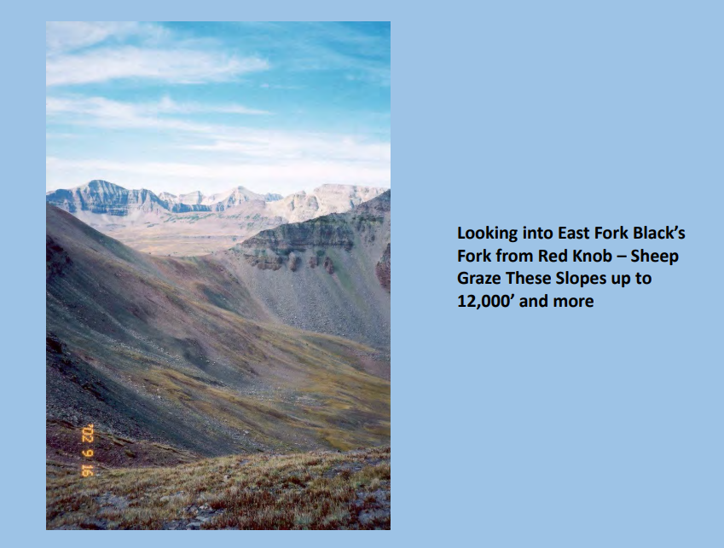

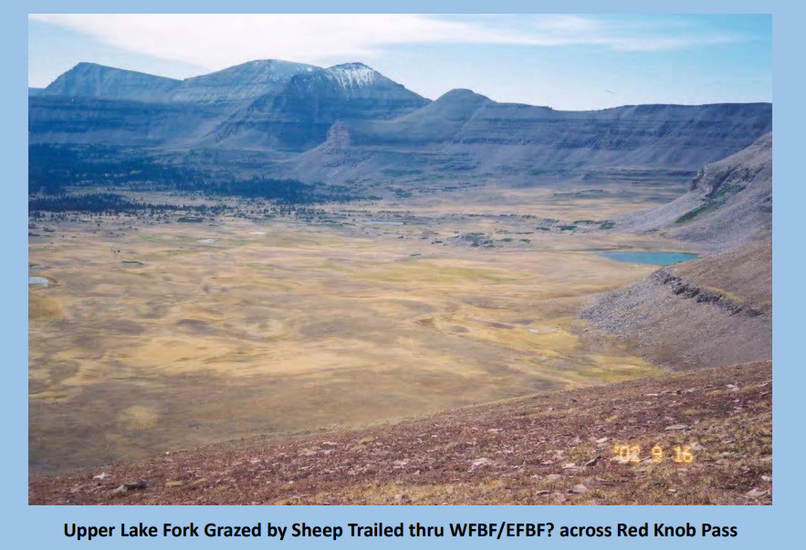

Pictures were from document “A Forage Capacity and Stocking Rate Determination for the High Uintas Wilderness Domestic Sheep Analysis by Emanuel Vasquez, John Carter, and Allison Jones, published in September 2018.

Looking at these pictures, it should remind us of Ecology 101, whereby soil and vegetation of alpine tundra regions are perhaps the most fragile ecosystem, if not one of the few most fragile ecosystems on this planet. Whereby we ask this question, why in the world is the U.S. Forest Service allowing grazing in this ecosystem? Alpine tundra ecosystems as described in Montana’s Field Guide¹² states the following.

“This system is fragile due to its extremely limited growing season and soil development. Species in these systems are generally slow growing and decrease in cover and vigor in areas of trampling or grazing.

Generally, grazing and human disturbances are very limited in this system due to inaccessibility or low forage cover.”

So again, we ask the question: Why in the world is the U.S. Forest Service allowing grazing in this ecosystem? Utilizing another reference, that of a description of Alpine Soils found at this link below.

https://horizon.documentation.ird.fr/exl-doc/pleins_textes/divers15-08/010033761.pdf

Jerome Poulenard¹³ from the University of Savoie, Le Bourget du Lac, France and Pascal Podwojewski of the L’ Institut de Recherche pour le Developpement (IRD), Hanoi, Vietnam makes the following statements.

“The alpine soils are fragile and currently submitted to severe environmental threats, such as overgrazing, acid deposition, and climate change.

“High mountain ecosystems are generally considered to be particularly sensitive to climate warming. Therefore, they appear to be useful " ecological indicators" and extensive work has been done to study climate changes in alpine ecosystems. Overall warming and associated change in precipitation patterns and snow cover will drastically influence alpine vegetation with change in diversity and abundance of certain species. The possible impact of projected climate change on Alpine soils is then firstly linked with the alpine vegetation change.”

Back to the analysis of The Wild Utah Project and Yellowstone to Uintas Connection, GWA will jump to the conclusions of their write up in order to save time.

The analysis we have conducted for the Uinta Wasatch Cache and Ashley National Forests’ High Uintas Domestic Sheep Analysis indicates that only a small fraction of these allotments are capable for domestic sheep grazing. Even under the most optimistic scenario only about a quarter of the lands of these High Uintas Wilderness allotments are capable of supporting domestic sheep grazing. This is with a conservative forage capability model and stocking rate analysis that included forage samples collected in wetland areas along with predicted weights of sheep that are likely lighter than most sheep today. Our analysis was further conservative in the utilization rate used in all alternatives of the model.

With our knowledge of alpine tundra and the sensitivity this landscape has to compaction, grazing, erosion, and other environmental events exacerbated by climate change, and other anthropogenic actions, we don’t see the High Uinta Wilderness Area as a resource for grazing, sheep, or cattle. It is not the best use of the resource; in fact, it is more detrimental to the landscape than a benefit for the public good.

The Utah Bighorn Sheep Statewide Management Plan may be honest, but it Doesn’t Work Well for Bighorn Sheep

In the preparation of these comments, GWA searched out the document entitled Utah Bighorn Sheep Statewide Management Plan¹⁴, a document referred to many times in the SDEIS. On page 2 of that statewide plan, 3rd paragraph describing the purpose, there was this paragraph.

“The ability to successfully manage current populations of bighorn sheep and to restore bighorns to historical habitat is highly dependent on public tolerance for those existing and new populations. There are very few areas in Utah with suitable bighorn habitat that are not impacted by human development or are not in proximity to domestic sheep or domestic sheep grazing. Remaining areas of unoccupied suitable habitat have domestic sheep in the vicinity that create a moderate risk of comingling. Broad-based public support for new bighorn populations cannot be achieved if it comes at the expense of local domestic sheep operations. That public support, particularly with the agriculture industry, is critical to UDWR’s ability to successfully maintain and expand bighorn sheep and other wildlife populations throughout the state. That public support is more vital to the successful conservation of bighorn sheep than abating the moderate risk of comingling and disease presented by domestic sheep. If UDWR adopts a zero sum game approach in abating comingling through involuntary grazing restrictions, conversions, and terminations, it will create a divide between agriculture and wildlife management detrimental not only to bighorn sheep conservation, but wildlife in general.”

No doubt there is truth to this statement. On the other hand, wildlife management agencies need to start being advocates for wildlife and not acquiesce to the agricultural community. We understand the agricultural community votes and has power in local, state and federal governments. Wildlife don’t. Wildlife has no voice unless groups like ours provide them with one. But agriculture has overstepped. Agriculture and wildlife should be able to coexist and there are programs that do that work effectively. But so many times when it comes to land management, wildlife has always, almost always taken the back seat of priorities. That needs to change.

We understand that in this case as the U.S. Forest Service makes a statement such as outside influences have hindered their ability to manage wildlife to the extent necessary, there is some truth in that. But it is also true that the U.S. Forest Service needs to educate the public and fight back and advocate for the other aspects of the multiple use concept, like wildlife. Agriculture has gained more than their fair share of attention in the agency’s multiple use concept. When species become listed on an agency’s endangered, threatened, or sensitive species list, it is time to change course.

Conclusion:

There are many faults we find with this action. The lack of serious alternatives, the perpetuation of politics in wildlife management, the reliance on a model that overlooks the ecological and anthropogenic events that undermine that model, and an SDEIS that tries to propagate or minimize the history of a species upon its native and habitual landscape are to name a few. We cannot unlearn what we know. But perhaps the greatest fault we find is the continuation of bad practice, on a landscape that shouldn’t have experienced the grazing of domestic livestock in the first place. This we cannot minimize.

With that said. the Gallatin Wildlife Association cannot approve this SDEIS as written. We must be true to ourselves as a wildlife advocacy organization. With all that we know, with all that we believe, and with all the science that we have researched, we cannot overlook the science or common sense that is guiding us. It is time for the U.S. Forest Service to renew their roots to the mission that was given to them and authorized by Congress.

“The mission of the USDA Forest Service is to sustain the health, diversity, and productivity of the Nation's forests and grasslands to meet the needs of present and future generations.”

That mission is not being met by this proposed action. This action is not sustainable. This action does not sustain the health or diversity of our Nation’s forests or grasslands. We understand the desire and political pressure to be all things to all people. This is part of the problem with the Multiple Use Sustained Yield Act of 1960. It should be to apply the best land-use practices to the appropriate landscape, to discern which landscape has the best sustainable use for each purpose. Science as we know can help guide our efforts in implementing the best land-use management practices. That is not what is happening here.

This Proposed Action, the Continued Management Action is basically a status quo of bad policy. The U.S. Forest Service needs to break the habit. It needs to be proactive and bold. We realize that is going to be hard to do in this political climate. But this is why there really needs to be a strong educational program for the public and even for our politicians because many of them don’t know anything different other than what they hear from people with the loudest voices or the most money.

Please stop and think about this. There is something inherently wrong with a concept where we as a society spend millions of dollars over years to reintroduce a species to its native landscape, while at the same time, continuing a practice that basically undermines that effort. In the meantime, we allow individual animals to die, knowing that a certain percentage of them will die, just to maintain a minimum population and we call it a success.

We cannot minimize or ignore the fact that bighorn sheep were on the landscape long before the European settlers settled the intermountain west of Utah. We can’t continue to practice a model that we know has not prevented the problem at hand and ignore what science and common sense tells us. The only way to prevent bighorn sheep die-offs is to use some method of spatial and temporal separation. And we cannot ignore the eventuality of climate change on one of the most fragile ecosystems on earth and hope that everything will work out for the best. Therefore, GWA proposes that the U.S. Forest Service phase out all high topography, alpine tundra, grazing allotments within the High Uinta Wilderness Area as soon as possible, including those of this project. Allow the natural condition to restore and heal itself back to a time before grazing allotments interfered with normal progression of life on the landscape.

What happens in the High Uinta Wilderness Area of Utah affects, could and most likely will happen across the Intermountain West. Whether it be from bad policy, bad precedent, or proliferation of pandemics among wildlife across the West, it is time to make wise proactive decisions. We began our comments quoting from GWA’s former president Glenn Hockett when he wrote back in 2016 the following.

Historically, bighorn numbers were estimated to be between 1.5 to 2 million across the west (Toweill and Geist 1999). However, only about 35,000 Rocky Mountain bighorn sheep are found in North America now (Toweill and Geist 1999). This represents a loss of over 98% of the historic bighorn population with only 1.75% of historic numbers remaining across the West (Toweill and Geist 1999).

This is what we have lost. There is no excuse for this other than man himself. It is time to correct our mistakes. We implore the U.S. Forest Service to begin the process of practicing a new paradigm. A paradigm of proper wildlife and land-use management. Bighorn sheep should be an indicator species, let’s listen to what they are telling us.

Sincerely,

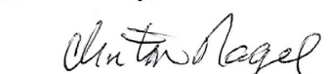

Clinton Nagel, President
Gallatin Wildlife Association

References:

- Hockett, Glenn, “Comments on the High Uintas Wilderness Domestic Sheep Grazing Project”, Gallatin Wildlife Association, March 11, 2016.

- Bighorn Sheep Unit Management Plan Uinta Mountains, North Slope / South Slope, WMUs #8 & 9 August 2019, Page 18, Appendix A. Memorandum of Understanding between the State of Utah, Utah Division of Wildife Resources, Utah Department of Agriculture and Food, and the United States Department of Agriculture, Forest Service Intermountain Region. 2019.

- Bighorn Sheep Unit Management Plan Uinta Mountains, North Slope / South Slope, WMUs #8 & 9 August 2019, Page 2.

- U.S. Geological Survey, Diseases of Terrestrial Wildlife, Bighorn Sheep Pneumonia, National Wildlife Health Center Newsletter.
https://www.usgs.gov/diseases-of-terrestrial-wildlife/bighorn-sheep-pneumonia#:~:text=Pneumonia%20in%20bighorn%20sheep%20is,of%20individuals%20within%20affected%20herds.

- Anderson, Kathleen, et al, Cost distance models to predict contact between bighorn sheep and domestic sheep, Wildlife Society Bulletin, July 22, 2022.
https://wildlife.onlinelibrary.wiley.com/doi/full/10.1002/wsb.1329

- Cole, Ken, Here are the Facts: Bighorn Sheep vs Domestic Sheep, The Wildlife News, November 9, 2011.
https://www.thewildlifenews.com/2011/11/09/here-are-the-facts-bighorn-sheep-vs-domestic-sheep/

- Johnson, Theodora, Science of Bighorn Report Questioned, American Sheep Industry, April 2016.
https://www.sheepusa.org/blog/newsmedia-sheepindustrynews-pastissues-2016-april2016-scienceofbighornreportquestioned

- Vasquez, Emanuel, Carter, John, Jones, Allison, “A Forage Capacity and Stocking Rate Determination for the High Unitas Wilderness Domestic Sheep Analysis”, September 2018.

- Howard, Tristin, online article, Disease Transmission from Domestic Sheep to Bighorn Sheep.
http://bighorndiseaseinfo.altervista.org/about_this_site.html

- Howard, Tristin, “Comparison of Wild-Domestic Sheep Interaction Policies in Bighorn Disease Outbreak Locations in the Continental U.S., 1990-2010”, University of Montana, May 2013.
https://scholarworks.umt.edu/cgi/viewcontent.cgi?article=1248&context=etd

- Miller, David S., et al., A Review of Hypothesized Determinants Associated with Bighorn Sheep Die-offs, National Library of Medicine, National Center for Biotechnology Information, March 29, 2012.
https://www.ncbi.nlm.nih.gov/pmc/articles/PMC3329887/#:~:text=Causes%20of%20direct%20mortality%20to,early%2020th%20centuries%20%5B7%5D.

- Montana Natural Heritage Program, Montana Field Guide,
https://fieldguide.mt.gov/displayES_Detail.aspx?ES=7116

- Poulenard, Jerome, Podwojewski, Pascal, Alpine Soils,
https://horizon.documentation.ird.fr/exl-doc/pleins_textes/divers15-08/010033761.pdf

- Utah Bighorn Sheep Statewide Management Plan, Utah Division of Wildlife Resources, Department of Natural Resources,
https://wildlife.utah.gov/pdf/bg/bighorn-plan.pdf

