Dear Dean Schlichting, Emily Long, Nick Grant, Dirk Rogers, and District Ranger Allen Hambrick,

My name is Drew Simrin, my address is redacted Eugene, Oregon redacted, and my telephone number is +1- redacted.

Please redact the above personal information as practicable.

I will be providing comments on “2023 Delta EA”,”2023 Fire Prevention signs”, and “2023 Developed Recreation Site Improvements”, specifically regarding the installation of light poles at the “Terwilliger/Cougar Hot Springs” site.

My name is Drew and I have lived and recreated in the area my entire life. The McKenzie River Ranger District is a special place in the Willamette National Forest. I understand that it can be hard to balance the needs of the forest for, ecosystems, wildlife, recreationists, workers, and the community.

I am glad to see progress being made regarding “2023 Delta EA” by restoring the floodplain for the benefit of ESA protected salmon. This is an important measure to mitigate the impacts to ESA protected salmon that the USACE/dam impoundment have caused. Decommissioning and removal of the road is a way to allow the area to restore/recover, and is a good idea for the delta/confluence.

I support the placement of fire prevention signs communicating fire danger (re:“2023 Fire Prevention signs”). We need to do what we can to reduce human caused wildfires, including those sourced by equipment, especially given the recent and historical fires in the district.

I have concerns about the “2023 Developed Recreation Site Improvements”, specifically regarding the installation of light poles at the “Terwilliger/Cougar Hot Springs” site.

This reason for the light poles being designated as a categorical exclusion, 36 CFR 220.6(e)(3) "Approval, modification, or
continuation of special uses that require less than 20 acres of NFS lands.”, is not appropriate for the change being proposed as the special use of the area/site/permit is not being modified.

I disagree that this action be categorically excluded from environmental review for many reasons, such as the cumulative effects of having artificial lights added to the area and the “human environment” with little light pollution are not being considered.

Additionally, ESA protected salmon are affected by artificial light and they become more susceptible to predation at night as a result. Coho salmon are known to be in the adjacent South Fork McKenzie River/Cougar Reservoir. (https://www.usgs.gov/centers/western-fisheries-research-center/news/shedding-some-light-issue-investigating-how)

Northern Spotted Owl also reside in the area and would be impacted by the artificial light at night, and this should be addressed.

The site and proposed lights is close to the Three Sisters Wilderness, and even closer to inventoried roadless areas, impacting the rugged/undeveloped area(s) with sights of light. This is another reason why consideration for an EA must be made.

Adding two independently powered light systems increases the risk for human caused wildfires in a popular area already impacted by human caused wildfire recently (2018 https://www.statesmanjournal.com/story/news/2020/07/11/terwilliger-fire-hot-springs-burned-reopened-human-caused-cougar-reservoir/5404850002/)

I am also concerned that by adding two light posts will increase operational expenses at the site that may be used to justify a fee increase at an already expensive day use fee charged by American Land and Leisure, even though AL&L is not providing any funding for the project. Also, I fear that the light posts may be a target of vandalism after discussing this proposal with others that enjoy the hot springs site, and hearing the dissatisfaction with the proposal, which would further strain available USFS and local law enforcement resources. I don’t believe that adding lights will improve the safety or security of the site, certainly not enough to waive an environmental review.

Many people I have spoken to in the area around the Terwilliger site love to view the night sky because by the reservoir you can get a good clear view of the Milky Way and escape the lights of the city. In the picture below, you can clearly see the big dipper and the “defunct” existing light pole in the foreground, taken with a mobile phone camera, which would not be able to be done with an operational light in the area.

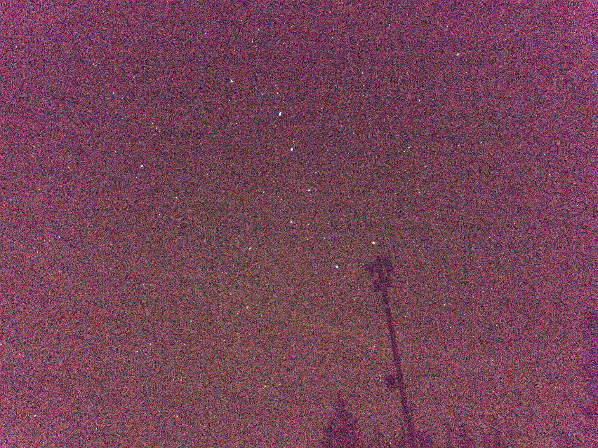

Due to the many reasons and concerns regarding the light poles that have not been considered, I urge the Forest Service to drop the proposal to install light poles at the Terwilliger Hot Springs site. If the agency insists with proceeding, the many concerns need to be studied and addressed in an Environmental Assessment (EA) and mitigated.

Thank you for the opportunity to provide comments.

