8 June 2023

TO: Kendall Cikanek,(kendall.cikanek@usda.gov), Whitman District Ranger
ATTN: Adrian Cuzick (adrian.cuzick@usda.gov)
VIA: https://cara.fs2c.usda.gov/Public//CommentInput?Project=59524

Subject: Bonnanza Big Hole Placer Mining and Reclamation Project —comments

Please accept the following comments from Oregon Wild concerning the Bonnanza Big Hole Placer Mining and Reclamation Project, https://www.fs.usda.gov/project/?project=59524. Oregon Wild represents 20,000 members and supporters who share our mission to protect and restore Oregon’s wildlands, wildlife, and water as an enduring legacy. Our goal is to protect areas that remain intact while striving to restore areas that have been degraded. This can be accomplished by moving over-represented ecosystem elements (such as logged and roaded areas) toward characteristics that are currently under-represented (such as roadless areas and complex old forest).

Thank you for working with Rob Klavins to clarify the goals of this project and the anticipated means of accomplishing them. We generally find mining on public lands to be contrary to the public interest because of the severe environmental effects and outdated mining laws. If this proposal involves bringing this kind of extreme disturbance to pubic land adjacent to public streams, we are not going to support it.
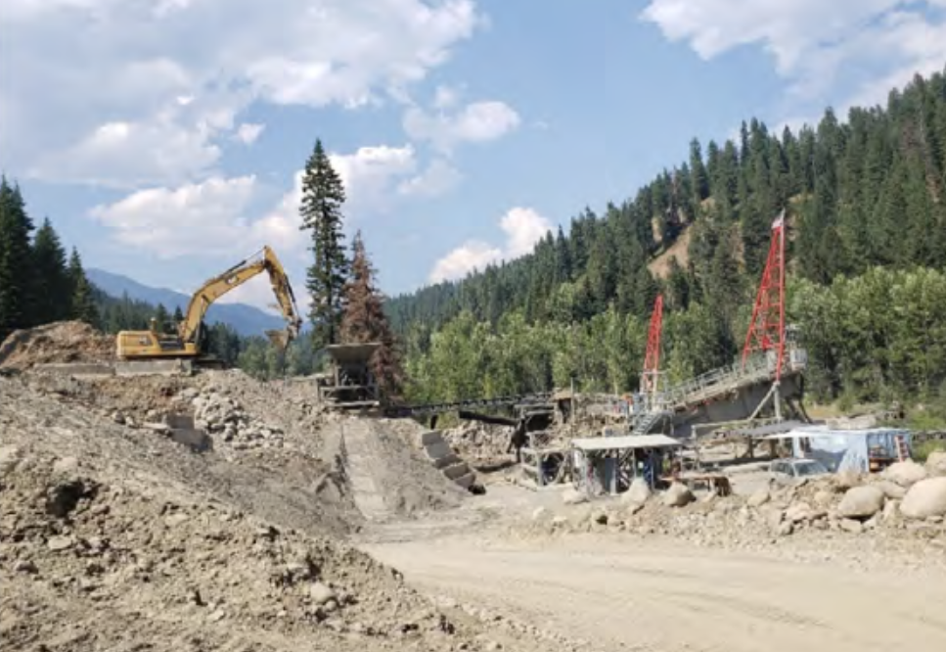

We understand that past mining has left the area in an undesirable state, but we are reluctant to accept that the federal government is unable or unwilling to correct that situation without allowing a significant expansion of mining activity onto public land. We encourage the agency to be extremely diligent about monitoring and enforcement of all requirements. Please make clear in the final NEPA decision all the mitigations, bonding, and other assurances necessary to ensure this project meets reclamation goals.

It was difficult to use the FS-rendered .pdf of the EA because it was saved in a way that made the text difficult to work with. Please use text recognition and save pdfs in a user-friendly form.

It is hard to get a clear picture of the proposed action from reading the EA. The “proposed action” section of the EA should have a clear summary of the mining/reclamation proposal up front. The rest of the proposed action section provides a lot of detail but is a bit hard to follow.

This proposal involves expansion onto National Forest land of ongoing mining activity on adjacent private with total NFS surface disturbance of approximately 37 acres in a narrow canyon of Pine Creek, which includes 21 acres of mining disturbance plus approximately one mile of constructed haul road 20 to 35 feet in width. Mining would start downstream and move upstream (south to north) in approximately five-acre parcels with the main haul ramp extending from the pit floor northward to a one-way haulage road along the west side of the pit. Six wetlands and four waters located on NFS land that would be impacted by mining. Greater than 10,000 cubic yards (cy) would be processed annually, therefore, an Individual CWA Permit is required. On-site mineral processing would include using wash water drawn from Pine Creek (and groundwater) and gravity separation in a closed loop system that does not utilize settling ponds. The mobile processing plant would be moved as needed as each panel is mined. Most of the overburden stripped material would be directly hauled and backfilled into mined-out areas. Limited amounts of overburden may be temporarily stockpiled on a backfilled cell. Alternate temporary storage sites would be along the boundaries of the active five-acre pit as it progresses north. The reclamation goal is for the reclaimed area to match the surrounding topography as much as is possible. Following recontouring, the areas would be reseeded with a USFS approved weed-free seed mix to minimize soil erosion and water runoff sediment issues and protect fish and wildlife habitat. The historic channel and wetland complex would be restored in order to decrease the effects of 100-year flooding. The original Pine Creek drainage would be restored to its natural pre-mining contours.

The EA should provide a more detailed explanation of how LRMP requirements are met. This analysis leaves a lot to be desired.
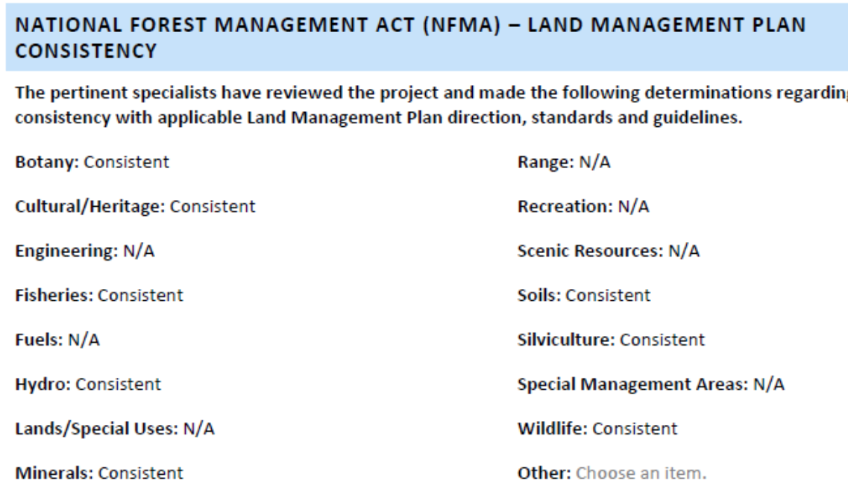

The Forest Service NEPA Handbook also requires that Decision Notices explain complete[ly] and comprehensive[ly]” how the NEPA decision complies with applicable legal requirements including the LRMP land allocations and Standards & Guidelines.
FSH 1909.15 Chapter 40, 43.21 - Format and Content
Decision notices document the conclusions drawn and the decision(s) made based on the analysis in the EA. Decision notices should conform to the following format and content. While sections may be combined or rearranged in the interest of clarity and brevity, the information needs to be complete and comprehensive.
…
6. Findings required by other laws and regulations. Include any findings required by any other laws which apply to the decision being made. Cite the project record or environmental analysis document that contains the information being used to support the findings. Describe how the decision is consistent with applicable laws and regulations. For example, findings regarding consistency with the forest plan (allocation, and standards and guidelines), suitability for timber production, and vegetation management criteria required by the National Forest Management Act and 36 CFR part 219. (emphasis added)
http://web.archive.org/web/20090118192937/http://www.fs.fed.us/im/directives/fsh/1909.15/1909.15_40.doc. See also Judge Hogan’s ruling in Klamath Siskiyou Wildlands Center v. Boody (D. Or. #03-3124-CO. May 18, 2004) where he held “plaintiffs have raised a serious question as to whether BLM violated NEPA in failing to disclose sufficient information in the EA to confirm compliance with … the RMP.” (Order at page 18). The EA includes Table 3 showing supporting project documentation. Those documents, especially the specialists reports, watershed analysis and the biological assessment, should be included in the project website to help inform public comments. The project website has two of the specialists reports, but many are missing.

Design criteria include following all requirements of the relevant LRMP as amended by IFISH. This is good, but those requirements should be spelled out. It would seem difficult to achieve the goals of INFISH if mining includes significant disturbance of RHCAs up to 50 feet from streams. As noted in our scoping comments, those INFISH goals include:
RIPARIAN GOALS (GOALS)
The goals establish an expectation of the characteristics of healthy, functioning watersheds, riparian areas, and associated fish habitats. Since the quality of water and fish habitat in aquatic systems is inseparably related to the integrity of upland and riparian areas within the watersheds, Alternatives 3 and 4 articulate several goals for watershed, riparian, and stream channel conditions, The goals are to maintain or restore:
(1) water quality to a degree that provides for stable and productive riparian and aquatic ecosystems;
(2) stream channel integrity, channel processes, and the sediment regime (including the elements of timing, volume, and character of sediment input and transport) under which the riparian and aquatic ecosystems developed;
(3) instream flows to support healthy riparian and aquatic habitats, the stability and effective function of stream channels, and the ability to route flood discharges;
(4) natural timing and variability of the water table elevation in meadows and wetlands;
(5) diversity and productivity of native and desired non-native plant communities in riparian zones;
(6) riparian vegetation to:
(a) provide an amount and distribution of large woody debris characteristic of natural aquatic ·and riparian ecosystems;
(b) provide adequate summer and winter thermal regulation within the riparian and aquatic zones; and
(c) help achieve rates of surface erosion, bank erosion, and channel migration characteristic of those under which the communities developed.
(7) riparian and aquatic habitats necessary to foster the unique genetic fish stocks that evolved within the specific geo-climatic region; and
(8) habitat to support populations of well-distributed native and desired non-native plant, vertebrate, and invertebrate populations that contribute to the viability of riparian-dependent communities.

We urge the reclamation plans include addition of wood, and planting of diverse native trees to ensure long-term recruitment of sufficient woody structure and nutrient inputs.

The EA basically conducts no meaningful environmental analysis. EA (p 38) says “Although a number of concerns were noted during scoping and the analysis, no issues were identified. As documented in this EA and this Project’s planning record, the Proposed Action would not result in unacceptable impacts on any given resource and the Proposed Action would be consistent with applicable laws, rules, regulations, and Forest Plan.” We disagree and think a more detailed analysis of INFISH compliance is warranted.

The EA should consider alternatives that better mitigate adverse effects, and an analysis that compares and contrasts the effects of the projects with more or less mitigation.

The EA says that ESA-threatened bull trout and its critical habitat may be adversely affected, but the EA provides little to no explanation of those effects or how they are mitigated. Bull trout are kind of a big deal, but you wouldn’t know it from reading the EA. The specialists report says “migratory behavior by bull trout is limited” based on evidence from the Pine Creek Basin, but this conclusion may be a product of poor habitat, not the species preferences. The report acknowledges that “bull trout populations display a spectrum of migratory behaviors.” There is evidence that bull trout can be a highly mobile species. They often move from headwaters to larger downstream waters to feed. This project area may be an important migratory route, which is supported by the fact that a bull trout was captured in the project area in 2013. Even if the 50 foot buffer between the creek and mining is effective (which is doubtful) there are later stages of reclamation that may have more significant direct impacts on the stream and bull trout. Even if these effects are beneficial overall, they deserve more careful disclosure and consideration in the NEPA analysis.

In the end it’s kind of amazing that this EA is 62 pages long but provides little in the way of NEPA analysis of alternatives and environmental effects that can inform commenters and the decision-maker. The conversations that the Forest Service had with Oregon Wild staff are appreciated, but they do not replace careful and competent NEPA analysis.

Each substantive issue discussed in these comments should be (i) incorporated into the purpose and need for the project, (ii) used to develop NEPA alternatives that balance tradeoffs in different ways, (iii) carefully analyzed and documented as part of the effects analysis, and (iv) considered for mitigation.

Please post to the project website, links to all relevant ESA and EFH consultation documents, RMPs, watershed analyses, and other supporting documents relied on in the NEPA analysis.

Sincerely,
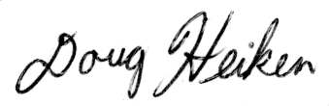
Doug Heiken
dh@oregonwild.org

