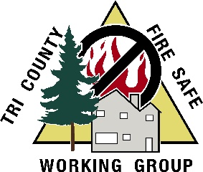
www.tcfswg.org

Forest Supervisor:

Thank you for the opportunity to comment on the Forestwide Prescribed Fire Project #63783. TCFSWG has a long and cooperative working relationship with the Helena-Lewis and Clark National Forest on fuel mitigation projects, including cross-boundary projects. We support the proposal and the objectives of this project. In addition we would request that you consider analyzing cross-boundary treatments on private land adjacent to National Forest System lands in the WUI. We believe this is a most effective approach to managing fuels and protecting values at risk.

We also support the approach of using Geographic Area Groups for planning and the priorities within those groups.

On behalf of the Board of Directors,

Lois Olsen

President

