The Vatican repudiates 'Doctrine of Discovery,' which was used to justify colonialism
March 30, 20231:38 PM ET
By
Bill Chappell
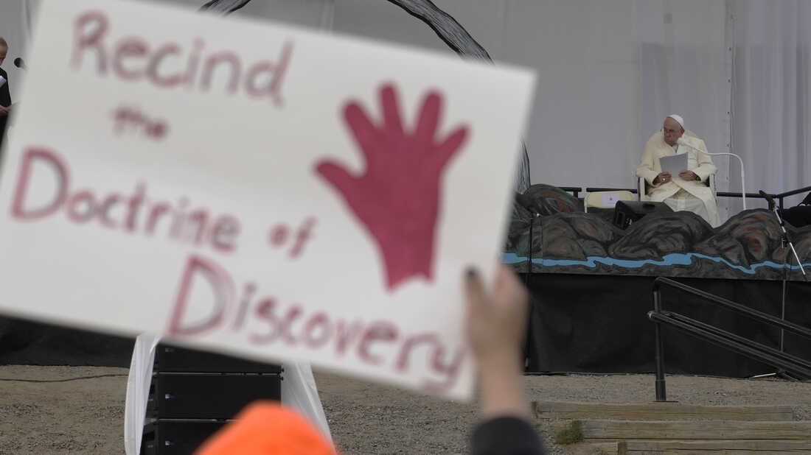
People protest as Pope Francis meets young people and elders at Nakasuk Elementary School Square in Iqaluit, Canada, last July. The Vatican on Thursday formally repudiated the "Doctrine of Discovery." The theory is backed by 15th century papal decrees that legitimized the colonial-era seizure of Native lands and form the basis of some property laws today.
Gregorio Borgia/AP
Nearly 500 years after papal decrees were used to rationalize Europe's colonial conquests, the Vatican repudiated those decrees on Thursday, saying the "Doctrine of Discovery" that was used to justify snuffing out Indigenous people's culture and livelihoods is not part of the Catholic faith.
The doctrine was invoked as a legal and religious standing by Europeans who "discovered" new lands and violently seized it from people who had been living there for generations. It has been cited in different arenas for centuries, including by the U.S. Supreme Court — as early as 1823 and as recently as 2005.
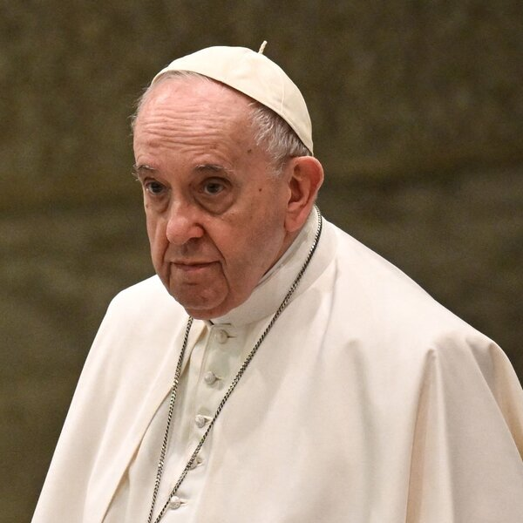

NATIONAL

An Indigenous youth delegate met with the pope. Here's what she wants him to do next
"The statement repudiates the very mindsets and worldview that gave rise to the original papal bulls," the Rev. David McCallum, executive director of the Program for Discerning Leadership based in Rome, told NPR.
"It renounces the mindset of cultural or racial superiority which allowed for that objectification or subjection of people, and strongly condemns any attitudes or actions that threaten or damage the dignity of the human person."
Here's a brief guide to the Discovery Doctrine, and why the Vatican's move is historic:
Sponsor Message

The doctrine came from papal "bulls" in the 15th century
The doctrine was laid out in a series of papal "bulls," or decrees; the first one was issued in 1452. They authorized colonial powers such as Spain and Portugal to seize lands and subjugate people in Africa and the "New World," as long as people on the lands were not Christians.
Scholars widely note three bulls: Pope Nicholas V's Dum diversas (1452) and Romanus Pontifex (1455); and Pope Alexander VI's Inter caetera (1493).

Later popes revoked the decrees, but the damage was done
The papal bulls "were not considered valid just 30 to 40 years after they were first issued. They were in fact abrogated legally and nullified by the Vatican by the late 1530s," McCallum told NPR.
The Vatican's nullification was too late to stop the destructive impact of colonialism, McCallum said, noting that European expansion was fueled by a "sort of missionary sense that the Western monarchies had a right to go to these new lands and to take from them their resources and if necessary to put down people, including enslaving them."

The doctrine made its way into the U.S. legal system
"Back in the in the 19th century, it was used as a precedent which gave people a sense of title to land that had not been owned with an official title in deed," McCallum said.
Sponsor Message
So what began as a religious decree in the 1400s then became the basis for a legal concept in the U.S., when the Doctrine of Discovery was invoked in an 1823 U.S. Supreme Court ruling that Indigenous people had only rights of "occupancy," not ownership, over lands they had long lived on. The land, then, was open for the taking.


BOOK REVIEWS

'Our History Is The Future' Puts Standing Rock In Broader Native American Story
"As a result of this being written into the American property law, it was actually considered a precedent," McCallum said, including citations as recent as a 2005 case in upstate New York, involving the Oneida Indian Nation.

Indigenous groups have long sought the repudiation
Indigenous advocates have previously called on the Catholic Church to issue a formal repudiation of the doctrine, saying personal apologies fell short, given the magnitude of the policy's effects.
Last year, the pope stunned observers when he personally apologized to Taylor Behn-Tsakoza, a youth delegate with the Assembly of First Nations who lives in British Columbia, for the Catholic Church's role contributing to years of suffering.
Behn-Tsakoza welcomed the pope's action. But she also noted the irreparable harm done to her culture by centuries of subjugation and to families like her own by decades of forced assimilation — and she called on Francis to renounce the Doctrine of Discovery.
Months later, the pope apologized to Indigenous peoples for the systemic abuse inflicted upon Native children at Catholic-run residential schools. But he stopped short of formally rescinding the doctrine.

What did the Vatican say about the doctrine?
Invoking the Christian mandate to respect the dignity of every human being, the Vatican said on Thursday, "The Catholic Church therefore repudiates those concepts that fail to recognize the inherent human rights of indigenous peoples, including what has become known as the legal and political 'doctrine of discovery.' "
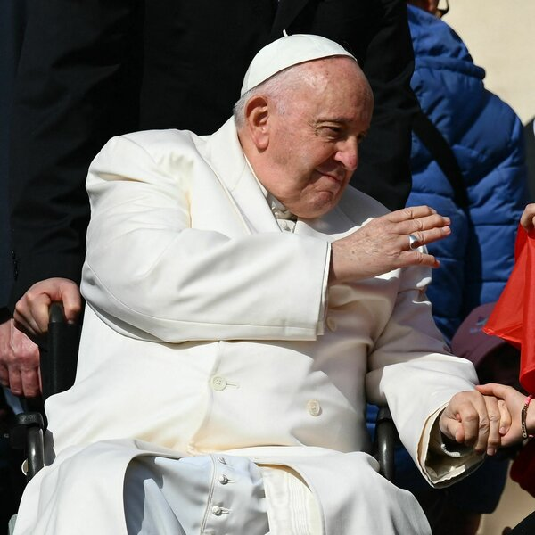

WORLD

Pope Francis has been hospitalized after having breathing trouble, the Vatican says
The Church also said it stands with Indigenous peoples now and strongly supports the U.N. Declaration on the Rights of Indigenous Peoples, which it says can help protect Indigenous rights as well as improving living conditions and development "in a way that respects their identity, language and culture."
The Vatican also invoked the pope's words from his visit to Canada last year: "Never again can the Christian community allow itself to be infected by the idea that one culture is superior to others, or that it is legitimate to employ ways of coercing others."
Sponsor Message

Priests welcome the Vatican statement
"What was significant today is the way that the statement repudiates the very mindsets and worldview that gave rise to the original papal bulls," McCallum said. "It renounces the mindset of cultural or racial superiority which allowed for that objectification or subjection of people, and strongly condemns any attitudes or actions that threaten or damage the dignity of the human person."
Bishop Douglas Lucia of the Diocese of Syracuse, N.Y., said he believes the statement will lead to more dialogue.
"The call 'to walk side by side' is especially poignant in this land of the Onondaga and Haudenosaunee where there exists the 'Two Row Wampum,' " Lucia told NPR via email. "It is a 1613 agreement of how the Haudenosaunee would treat the new settlers on their land based on friendship, peace, and forever."
With the Vatican taking a formal stance, Lucia added, the Christian community can acknowledge its own failings and work with Indigenous peoples to embody that 1613 agreement.

