6 April 2023

TO: Wallowa-Whitman National Forest
VIA: https://cara.fs2c.usda.gov/Public//CommentInput?Project=58961
ATTN: Brian Anderson, Wallowa Valley District Ranger
CC: Alison Arnold, Environmental Coordinator alison.arnold@usda.gov
Subject: Morgan Nesbit Project — scoping comments

Please accept the following scoping comments from Oregon Wild, Central Oregon Bitterbrush Broadband / Great Old Broads for Wilderness, Juniper Group / Oregon Chapter Sierra Club, Western Watersheds Project, and WildEarth Guardians concerning the Morgan Nesbit Project, https://www.fs.usda.gov/project/?project=58961.
- Oregon Wild represents 20,000 members and supporters who share our mission to protect and restore Oregon’s wildlands, wildlife, and water as an enduring legacy. Our goal is to protect areas that remain intact while striving to restore areas that have been degraded. This can be accomplished by moving over-represented ecosystem elements (such as logged and roaded areas) toward characteristics that are currently under-represented (such as roadless areas and complex old forest). Oregon Wild’s contact for this project is Rob Klavins | Northeast Oregon Field Coordinator | PO Box 48, Enterprise OR 97828 541.886.0212 | rk@oregonwild.org | | www.oregonwild.org.
- Central Oregon Bitterbrush Broadband / Great Old Broads for Wilderness focus areas include: Wild Lands Protection—We work to protect the wild nature that is the intrinsic value of our public lands through stewardship, education and advocacy. We work on overuse issues in the Three Sisters Wilderness and the Ochoco National Forest. We host conferences on public lands to teach awareness and the values of public lands, along with taking input on how to expand our work. Issues we work on include off-highway vehicles, fish and wildlife species and their habitats, livestock grazing, roads, habitat fragmentation, and general mismanagement. Wildlife Issues—We create habitat for monarch butterflies and pollinators, and work to increase habitat connectivity for all fish and wildlife in Oregon. We educate each other and the public about the importance of beaver, large trees, and top predators. We pull invasive weeds. Bitterbrush Broadband’s contact for this project is co-leader Amy Stuart, 13501 NW Grizzly Mountain Road, Prineville, OR 97754, 541-233-8215, amystuart63@gmail.com.

- Juniper Group / Oregon Chapter Sierra Club is dedicated to preserving Central and Eastern Oregon's environment, natural resources, and quality of life. The Juniper Group is composed of Sierra Club members from Baker, Crook, Deschutes, Grant, Harney, Jefferson, Malheur, Morrow, Umatilla, Union, Wallowa, and Wheeler counties. Juniper Group’s contact for this project is Mathieu Federspiel, the Group Vice Chair and Federal Projects Review Coordinator. The Juniper Group’s address is 16 NW Kansas Ave., Bend, OR 97703, juniper.group@oregon.sierraclub.org.
- Western Watersheds Project (WWP) is a non-profit environmental conservation group that works to influence and improve public lands management throughout the western United States in order to protect native species and conserve and restore the habitats they depend on. WWP mission is to protect and restore western watersheds and wildlife through education, public policy initiatives, and legal advocacy. Western Watersheds Project’s contact for this project is Adam Bronstein, Oregon/Nevada Director, (541) 595-8034, adam@westernwatersheds.org.

- WildEarth Guardians is a non-profit conservation organization that uses advocacy and education to protect and restore the wildlife, wild places, wild rivers, and health of the American West. WildEarth Guardians’ contact for this project is Chris Krupp, ckrupp@wildearthguardians.org, 10015 Lake City Way NE #414, Seattle, WA 98125, (206) 417-6363.

The Morgan Nesbit proposal involves:
- 14,097 acres of commercial thinning
- 2320 acres of thinning with patch cuts
- 708 acres of shelterwood
- 460 acres of commercial logging in RHCA
- 1894 acres of non-commercial thinning in RHCA
- 307 acres of non-commercial aspen enhancement
- 3131 acres of non-commercial TSI thinning
- 136 acres of non-commercial wet meadow enhancement
- 6448 acres of non-commercial shaded fuel breaks 100-1,000 feet wide
- ?? acres of prescribed fire
- 23.3 miles of temporary road construction
- 367 miles of road maintenance
- 11 culvert replacements
- ? road closure
- ? road removal/decommissioning
- ? culvert removal

Note: These comments are the result of a group effort among the signatory organizations. They are lengthy and there will be some redundancy, but they are organized by topic for easier review by the interdisciplinary team.
Table of Contents
Introduction 6
Fundamental Concern: Over-Reliance on Timber Sales as a Restoration Tool 6
Preferred Alternative 9
General 10
Late Scoping 10
This project is controversial. It is unnecessary. We encourage you to reconsider. 10
Empower Specialists and Encourage Continuity. 12
This Landscape is Tremendously Complex, Unique, Wild, and Valuable. 13
Hells Canyon NRA and Wallowa-Whitman LRMP 14
Wilderness, Wild and Scenic Rivers, and values deserving of protection 16
Consider more holistic/comprehensive restoration. 21
Do not give special dispensation to some stakeholders over others. 23
Reconsider the arbitrarily narrow scope of the Purpose & Need and the flawed assumptions in the Scoping Notice. 25
The agency must do more to rebuild trust 26
Infrastructure Money Facilitates Non-commercial Treatments 29
Natural Disturbance and Mortality Should be Viewed as Solutions, Not Problems 29
Conserve and Restore Roadless/Unroaded Areas 35
Analysis of Potential Wilderness and Other Roadless Values Must be Distinct 46
Allow Natural Processes to Flourish in Unroaded Areas 50
Economics 54
Logging prescriptions 56
Basal Area Retention 56
Do not log on steep slopes 59
Previously Logged vs Unlogged 59
Moist vs Dry Forest Types 60
Large & Old Trees / Eastside Screens 60
The current Screens amendment allowing discretion to cut large trees should not be used. 63
Regen Logging: Patch Cuts and Shelterwood 68
Aspen Enhancement 71
Carbon and Climate 72
The Purpose and Need Should Address Climate Protection and The Unmet Need for Carbon Storage 73
Harmonize climate change mitigation and adaptation 75
Do not rely on flawed boilerplate climate analyses 81
CEQ Guidance: Take a Hard Look at the Effects of, and Alternatives to, GHG Emissions from Logging. 83
On Managing to Achieve HRV 88
Clarification 88
Problems with Using HRV 88
HRV Data Weaknesses 88
HRV Inappropriate for Management Direction 89
How HRV is Silviculturally Used is Inappropriate 90
Future Range of Variability Needs Consideration 91
Riparian and Aquatic Issues 91
Impacts of Timber Harvest on Streams, Riparian Areas, Aquatic Habitats and Native Fish 91
Impacts of Roads on Streams, Riparian Areas, Aquatic Habitats and Native Fish 95
Impacts to Riparian Areas and Aquatic Habitats from Timber Harvest/Roads 97
The Importance of Streamside Buffers - INFISH and PACFISH 100
Native Fish in the Project Area 102
Impacts of Riparian Harvest to Wildlife 103
RHCA Logging 104
Water quality is impaired throughout this landscape and must not be made worse. 111
Aquatic Riparian Conclusion 111
ESA Consultation for Fish and Wildlife 112
Wildlife 112
Protect habitat for all native wildlife. 112
Give more serious consideration to impacts on birds 113
Protect Goshawk Habitat 114
Identify and protect Great Gray Owl habitat 115
Snag Habitat 116
New information on Snags. 121
Connectivity Requirements of the Eastside Screens and CEQ Guidance 125
Significantly scale back roadside logging / PODs 127
Road Issues 129
Avoid Road Construction and its Undesired Trade-offs 129
Avoid unnecessary construction of temporary roads 135
Road construction is controversial, causes significant cumulative impacts and requires an EIS. 137
Road Closure and Decommissioning 140
Fire and Fuels 141
PODs / Shaded Fuel Breaks 141
Fuel Management 143
Avoid excessive slash and unnecessary burning 145
Wildfires and Prescribed Fires 149
Analysis 152
Disclose all analysis 152
Further explain (disclose? justify?) soils analysis 152
HRV is a flawed basis for restoration projects. If used, it must be used in a more comprehensive manner. 153
Consider secondary impacts 155
Include fire use planning 156
Analyze likely scenarios during implementation, create adaptive implementation plans, and ensure active monitoring and adjustment. 157
Conduct thorough botanical surveys looking for known and potential rare, sensitive, threatened, endangered, and endemic species. 163
Conduct a thorough survey for cultural values. 163
Include analysis that extends beyond the project borders. 163
Some fundamental assumptions are flawed or, at least, far more complex and controversial than the agency acknowledges. Among the many examples: 163
Disclose and Mitigate Cumulative Effects 168
Significant Effects Require an EIS 171
Unresolved Questions About Forest Science Require an EIS. 175
Literature Cited (in the Aquatic/Riparian Section) 185

Introduction

Fundamental Concern: Over-Reliance on Timber Sales as a Restoration Tool
Yet again, the agency is putting forth a nominal restoration project that will aggressively log and build roads in one of the wildest and most globally-important unprotected landscapes in the Continental United States. Rather than focus on the primary restoration needs or the underlying causes of that need, the project – which has largely been developed prior to scoping and with far too little field work and data – is another series of backcountry timber sales with some non-commercial activities included.
This is right on the heels of a series of similarly packaged and ongoing “restoration”, “safety”, “collaborative”, and similar projects that have been controversial and destructive. In those projects we have seen the commercial logging occur, but many of the legitimate restoration activities dropped.
The project is silent on the biodiversity crisis and, while it acknowledges the reality of climate change, it uses that crisis to justify logging that will undoubtedly make climate change worse.
Additionally, this landscape spans many types of demarcated land management types including those designated for timber and grazing but also old growth areas, Wild and Scenic Rivers, and a National Recreation Area full of Indigenous history. There are many undesignated and undeveloped areas with no less value. Much of the project area has been proposed for additional protections from Wilderness to National Park status. The landscape is mind-bogglingly diverse and complex. It includes Canyonlands hosting cacti, grasslands, and dry, wet, and subalpine forests…and everything in between. However, in analyzing the project, specious assumptions have been made that lump all these landscapes together into the categories that best justify aggressive logging.

/ / /

/ / /

/ / /

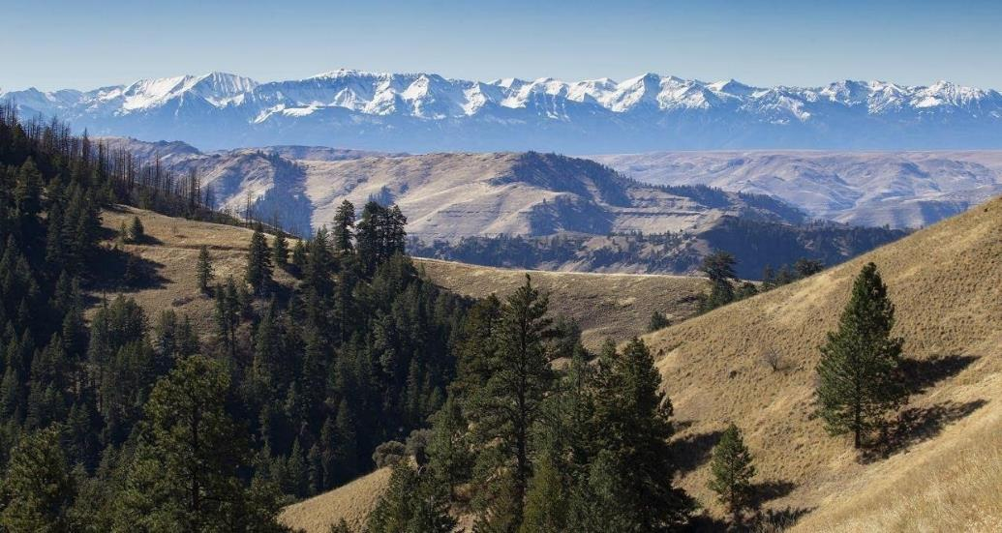
A view of the Morgan Nesbit Project area.

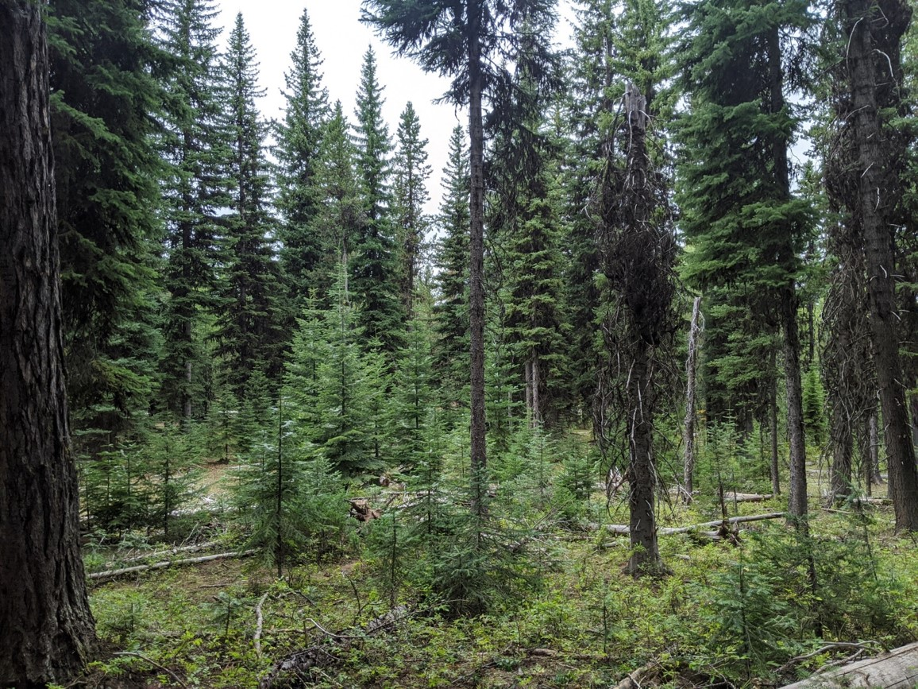
A stand of moist-mixed conifer forest that has been targeted for aggressive regeneration harvest and large tree removal. It currently provides invaluable habitat for many species of wildlife.
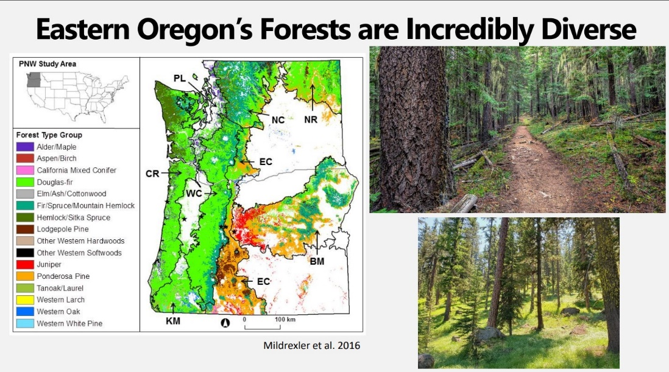
This slide from a presentation by Dr. David Mildrexler shows that while many of the forests in Eastern Oregon are dry, the forests in the Morgan Nesbit project area are wetter, more diverse, and more complex. Treating them with principles from central Oregon and the Southern blues is inappropriate.

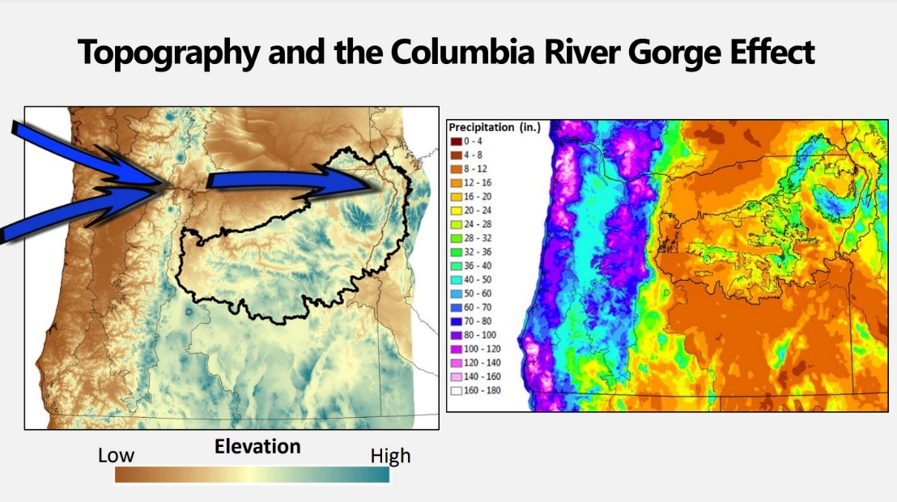
This slide from a presentation by Dr. David Mildrexler shows that the forests in the Morgan Nesbit Area are far wetter than most in Eastern Oregon and therefore support a different forest type. This is largely a result of topography and climate.

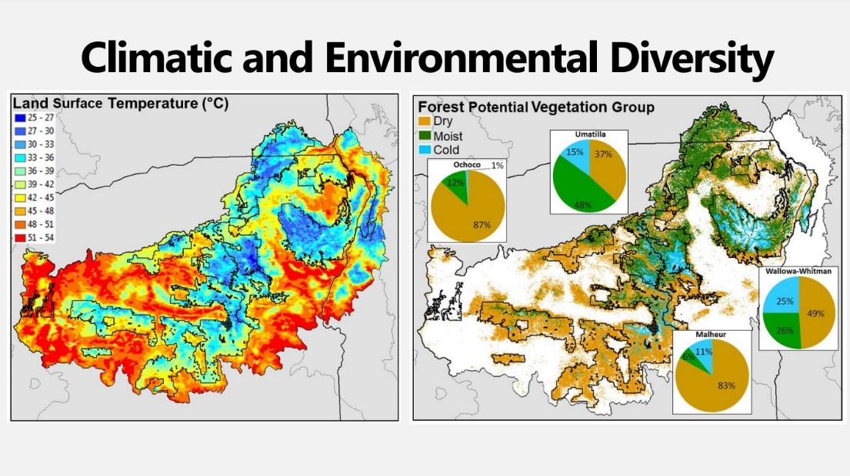
While many of the forests in Eastern Oregon are dry, the Morgan Nesbit Project area is dominated by moist forests. While parts of the project do include dry forests, that is not the case here. In its descriptions and plans, however, the agency has treated the area like it is much more homogenous and erred toward lumping it together with dry forests found elsewhere.

Preferred Alternative
If the Forest Service insists upon going forward with this project, the agency can minimize and mitigate the adverse impacts and avoid unnecessary conflict if the preferred alternative focuses on areas where there is broad public agreement. Specifically:
- consider and implement of a broad suite of non-commercial restoration activities, instead of emphasizing log extraction with all its trade-offs;
- complete a robust analysis, data collection, field work, and monitoring that is in line with the complexity, diversity, and importance of this landscape;
- retain all large trees (>21” dbh) regardless of age and all old large trees regardless of size;
- avoid commercial logging in unroaded areas >1,000 acres, RHCAs, and steep slopes;
- avoid regen logging (shelterwood and patch cuts);
- avoid road construction, including temporary roads, except very short spur roads;
- strategically close roads to restore the natural range of variability of large blocks of habitat;
- avoid log hauling during wet weather;
- limit fuel breaks to non-commercial thinning of small fuels within 150 feet from roads; retain canopy trees to moderate the microclimate, retain fuel moisture, reduce slash production, suppress growth of future surface and ladder fuels, and reduce maintenance costs;
- retain and recruit abundant snags and dead wood for the diverse wildlife and ecological functions that benefit from abundant dead wood; and
- retain enough basal area of medium and large trees to perpetuate natural processes, including the mortality processes associated with insects and disease, competition, etc.

General

Late Scoping
The extent to which this project has been developed prior to scoping is inappropriate and unprecedented for a project of this size and complexity. As a result, our scoping comments will be more detailed. There is no rush. We encourage the agency to slow down.
Normally, in scoping comments, we would limit our comments to the Purpose and Need. However, we are dismayed to learn that the project has already been largely developed, and in great detail. In fact, over a year ago, the agency spoke at public meetings talking about developing implementation details before they’d even collected data. We’ve also heard the agency provide startling levels of detail in various venues that are not included in the Scoping Notice. This is troubling, and we encourage the agency to take a big step back before continuing to push forward. This information also causes us to provide far more detailed comment than we might otherwise at this stage.
Given how much far the agency has gone in developing this project, please immediately disclose that information to the public. Doing so will help us all engage in a more effective manner and build public trust. Further, with field season coming, this summer, may be our only opportunity to ground truth the proposal.
Given the complexity and importance of this landscape and project, we will need more than 30-days in the next comment period to fully digest the agency analysis and proposals and refine our comments in response.

This project is controversial. It is unnecessary. We encourage you to reconsider.
This project, and project area was chosen as a priority under intense political pressure and as part of the failed leadership of former Forest Supervisor Tom Montoya and District Ranger Kris Stein. Their legacy is one of failed projects, litigation, unnecessary conflict, and the devolution of collaboration in the region. Now Morgan Nesbit seems to be moving forward simply because time and resources have been expended, and doing something different would be unpopular with local power brokers. Rather than throw good resources after bad, we strongly encourage the agency to find something less controversial, ecologically justifiable, and economically viable to work on. That would be a place where legitimate restoration goals do not have to be undermined to achieve implementation, and/or the agency has to obfuscate the real motivations to make the project palatable.
Rather than learn from past controversial projects such as Lostine, Lower Joseph, Puderbaugh, and Divide WUI that are taking place on this district, many aspects of this project repeat or even double down on past mistakes.
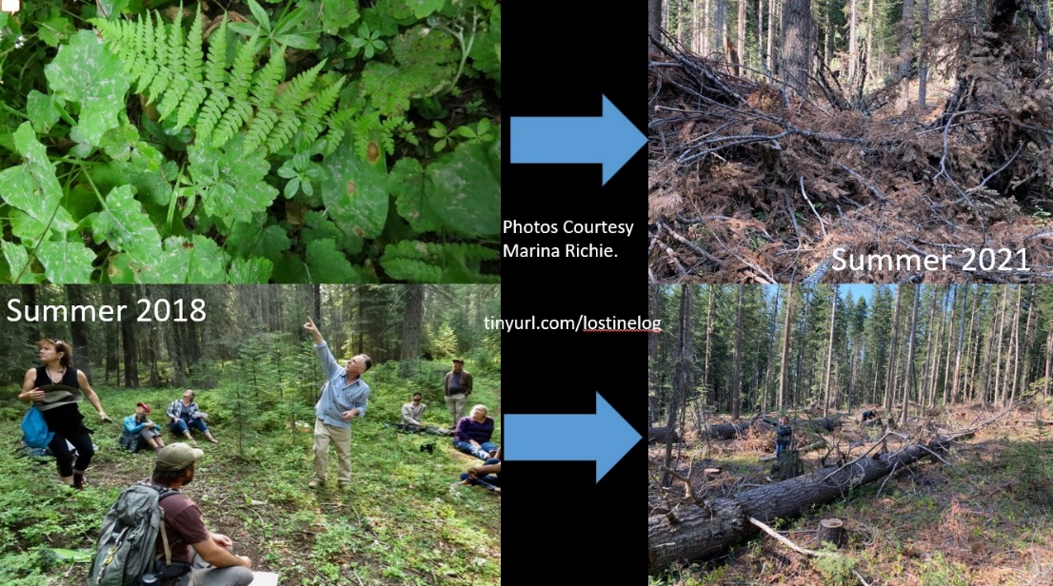
Photos by Marina Richie show how the Lostine Project created hotter, drier conditions that increased, rather than decreased, fire risk.
While we understand the agency is under tremendous pressure, and has timber targets to meet, the agency is understaffed and overworked. Rather than continue to plan huge new controversial projects, there are plenty of NEPA decisions, projects, acres, and volume ready to be implemented.
In choosing this landscape, the Forest Service has already provoked unnecessary controversy. It includes tremendously important, fragile, and irreplaceable ecological and cultural values. There is a great deal of good work that can be done in less controversial and complex landscapes. We encourage the agency to focus on previously managed forests near homes and communities and work their way out from there. Instead, this project proposes to “restore” forests, some of which have never seen a chainsaw, miles from the nearest paved roads.
We have been told that after this project, the agency may begin to apply aspects to more front country projects. However, it is ecologically, socially, economically, and ethically backwards to go from the backcountry to the front country with such aggressive and controversial activities. That is especially true given the failure of ongoing projects on this very district like Lower Joseph and Puderbaugh.
The Forest Service must do a better job explaining why this landscape, above others, is the right place to focus. We believe strongly that there are greater restoration (and resilience) needs, places where fuels reductions are far more likely to interact with fire that threatens people and structures, where logging is more economical, where it will be less controversial, etc. Even at the district level, we believe there is sufficient need on the landscape (and on the NEPA shelf) that would allow the agency to focus on more urgent, appropriate, and feasible opportunities for a long time to come.
We believe there is legitimate, non-controversial, and beneficial restoration work that can be done within this project area. However, what the Forest Service is proposing here is far too narrowly focused on logging as restoration, and on far too large and special a landscape. If a restoration project is to take place on this landscape, it must reduce the dependence on logging and roadbuilding and consider other restoration activities.

Empower Specialists and Encourage Continuity.
So far, we have been pleased with the new and growing relationships with Ranger Brian Anderson and Supervisor Shaun McKinney. We also have a good working relationship with silviculturist Lucas Glick, soil scientist Mary Young, botanist Jerry Hustafa, wildlife biologist Julia Boland, and NEPA Coordinator Andrea Holmquist. We also have and had valued relationships with people who previously worked on the project including retired fisheries biologist Alan Miller, wildlife biologist Laura Navarette, and silviculturist Clint Foster. We encourage as much continuity as possible. Since, by the agency’s own admission, so much of the project has already been developed, we would encourage the agency not to change planning staff unless necessary.
We understand the agency is woefully understaffed. That’s especially true for specialists like wildlife biologists, botanists, and hydrologists. While silviculture and fuels have important roles to play, specialists with those interests often propose activities that undermine legitimate restoration, ecological, and forest health needs. Vigorous trees are only a small part of what makes a forest healthy. In fact, a lack of dead, dying, diseased, malformed, and other trees and conditions often maligned by agency staff are under-represented on the forest. Further, our forests are facing a fire deficit. Wildfire – even stand replacing fire – is a natural part of this landscape, and an important function that should be allowed to occur. In developing “restoration” and “resilience” projects, the agency must empower specialists whose areas of expertise and concern do not lend themselves as well to meeting arbitrary targets for board feet produced and acres treated.

/ / /
/ / /
/ / /

This Landscape is Tremendously Complex, Unique, Wild, and Valuable.
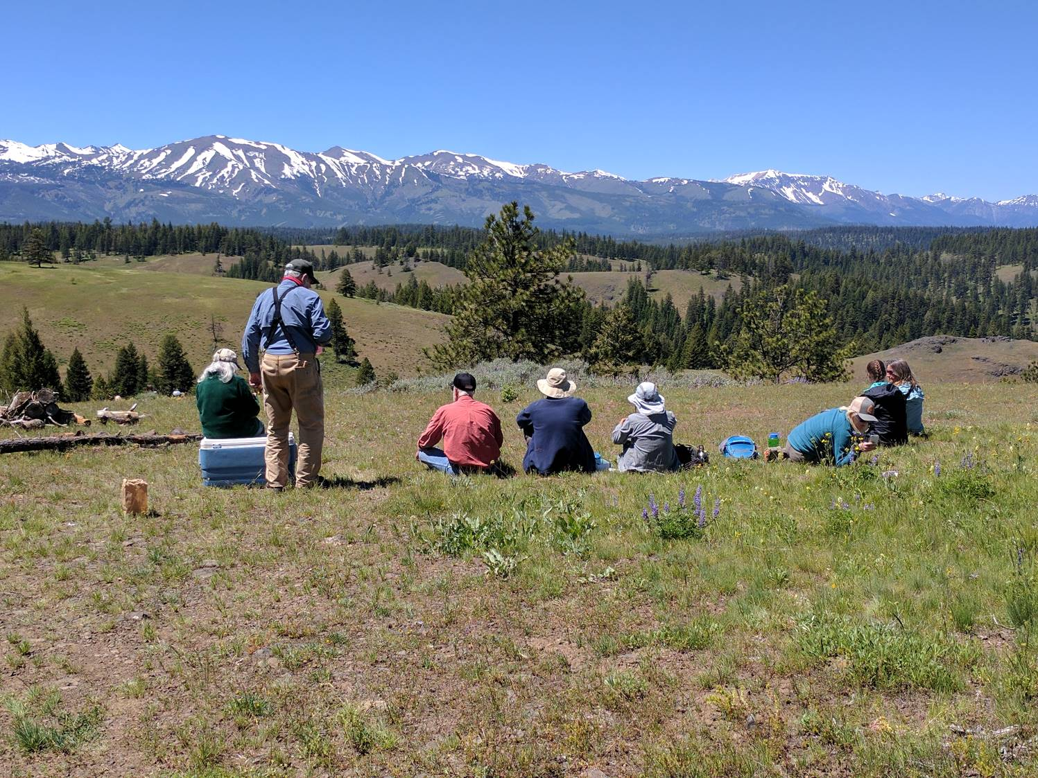
A group of wildlife watchers from across the country on the edge of Big Sheep Breaks looking towards the Eagle Cap Wilderness and over much of the project area.

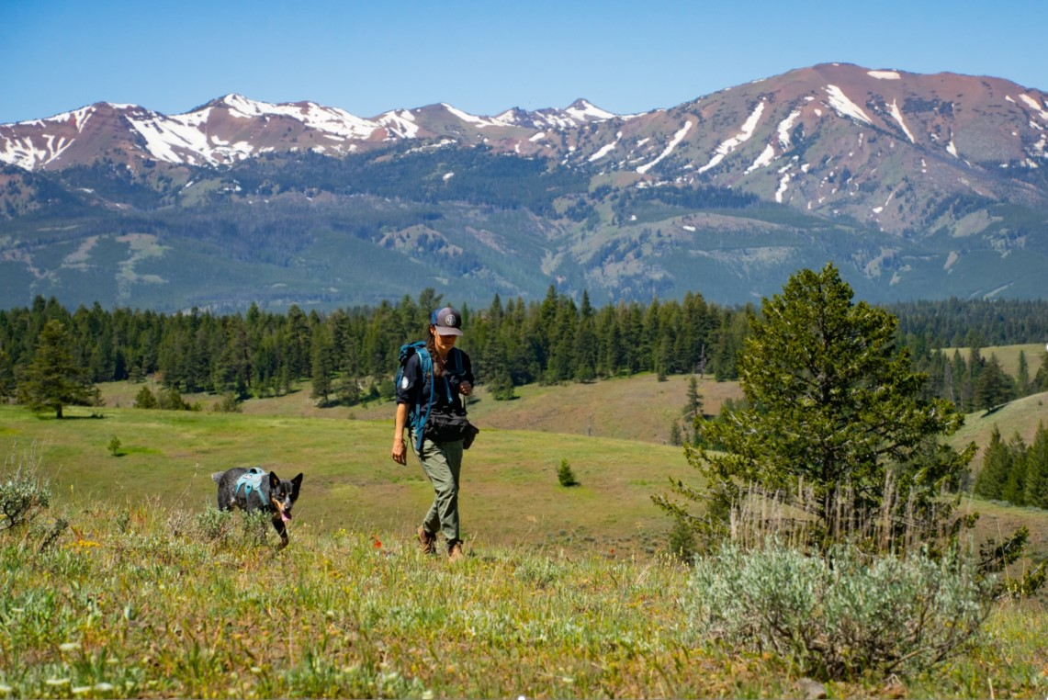
A scat dog team searches for evidence of rare wildlife in the project area in an effort funded by conservationists. Photo by Daniel Howland

For good reason, congress determined the Hells Canyon National Recreation Area to be deserving of a more protective designation than surrounding Forest Service lands. It must be managed differently as well. As we have said since the beginning, it is inappropriate for the HCNRA to be included in this project. If the agency continues to insist upon carrying this logging project into the HCNRA, the analysis and activities proposed should be more protective of natural systems and considerate of non-extractive values. If the analysis and proposed actions are the same on both sides of the line, they must adhere to the more stringent, cautious, and protective guidelines of the HCNRA rather than the other way around.

Hells Canyon NRA and Wallowa-Whitman LRMP
Approximately half of the commercial logging (>9,000 acres) is located within the Hells Canyon National Recreation Area. The Forest Service should fully explain how any proposed activities are consistent with all provisions of the HCNRA Comprehensive Management Plan, the HCNRA legislation, and all other relevant management direction, such as the Wallowa-Whitman National Forest LRMP, and provide any such documents as part of a publicly-accessible project file available on the project website.

NEPA requires disclosure of information necessary to determine compliance with legal requirements such as the Endangered Species Act, Clean Water Act, National Forest Management Act, and applicable Forest Plan Standards & Guidelines. See 40 CFR 15087.27(b)(10) and NW Indian Cemetery Protective Association v. Peterson, 795 F2d 688 (9th Circ. 1986). In this G-O Road case, the NEPA document described water quality changes resulting from a road project in terms of 7-day average changes, whereas the applicable WQ standard was defined by daily peak changes. The court found this to be a NEPA violation.
The USDA Office of General Counsel agrees that project level analysis must document “Project Compliance With Other Laws.”
In addition to consistency with the LRMP each project must be in compliance with NEPA, CWA, CAA and other laws. Simply being consistent with the LRMP does not fulfill the site-specific requirements of Federal law. Project level analysis is to "determine findings for NFMA, to ensure compliance with NEPA, and to meet other appropriate laws and regulations." Forest Service Land and Resource Management Planning, FSM 1920 and Forest Service Handbook 1909.12, 5.31. 53 Fed. Reg. 26807, 26836 (July 15, 1988).
The CEQ NEPA regulations also require an analysis of legal requirements in order to determine whether an action may cause significant impacts on the environment. 40 CFR §1508.27(b)(10) (“Significantly, as used in NEPA, requires considerations of both context and intensity: … The following should be considered in evaluating intensity: … Whether the action threatens a violation of Federal, State, or local law or requirements imposed for the protection of the environment.” Emphasis added.) (“The FEIS has thus mentioned what appears to be a major consequence of the plan jeopardy to other species that live in the old growth forests without explaining the magnitude of the risk or attempting to justify a potential abandonment of conservation duties imposed by law. An EIS devoid of this information does not meet the requirements of NEPA.” Emphasis added.)

The Forest Service NEPA Handbook also requires that Decision Notices explain complete[ly] and comprehensive[ly]” how the NEPA decision complies with applicable legal requirements including the LRMP land allocations and Standards & Guidelines.

FSH 1909.15 Chapter 40, 43.21 - Format and Content
Decision notices document the conclusions drawn and the decision(s) made based on the analysis in the EA. Decision notices should conform to the following format and content. While sections may be combined or rearranged in the interest of clarity and brevity, the information needs to be complete and comprehensive.
…
6. Findings required by other laws and regulations. Include any findings required by any other laws which apply to the decision being made. Cite the project record or environmental analysis document that contains the information being used to support the findings. Describe how the decision is consistent with applicable laws and regulations. For example, findings regarding consistency with the forest plan (allocation, and standards and guidelines), suitability for timber production, and vegetation management criteria required by the National Forest Management Act and 36 CFR part 219. (emphasis added)

See also, Judge King's October 2003 Decision in ONRC Action v. U.S. Forest Service, CV. 03-613-KI:
“The underlying EAs for the timber sales at issue did not properly frame the Forest Service’s survey and manage duties, they did not analyze a range of alternatives based upon these duties, they did not evaluate completed surveys, they did not demonstrate that the Forest Service had all of the proper information before it before allowing logging, and they did not provide for public influence over the decisions. For all of these reasons, the underlying EAs are legally deficient.” Emphasis added.)

And also Judge Hogan’s ruling in Klamath Siskiyou Wildlands Center v. Boody (D. Or. #03-3124-CO. May 18, 2004) where he held
“plaintiffs have raised a serious question as to whether BLM violated NEPA in failing to disclose sufficient information in the EA to confirm compliance with … the RMP.” (Order at page 18).

The 9th Circuit has explicitly found that an EIS violates NEPA when it has an inaccurate or misleading description of forest plan requirements.
The Forest Service’s use of a hiding cover denominator in the EIS other than that allowed by the HNF Plan arbitrarily and capriciously skewed the EIS’s elk herd hiding cover percentage. Consequently, the Elkhorn project EIS did not provide a “full and fair” discussion of the potential effects of the project on elk hiding cover and did not “inform[ ] decision-makers and the public of the reasonable alternatives which would avoid or minimize adverse impacts” on the Sheep Creek elk herd. Klamath-Siskiyou Wildlands Ctr., 387 F.3d at 993 (quoting 40 C.F.R. § 1502.1); see also Animal Def. Council v. Hodel, 840 F.2d 1432, 1439 (9th Cir. 1988) (“Where the information in the initial EIS was so incomplete or misleading that the decisionmaker and the public could not make an informed comparison of the alternatives, revision of an EIS may be necessary to provide a reasonable, good faith, and objective presentation of the subjects required by NEPA.”) (internal quotation marks omitted), amended by 867 F.2d 1244 (9th Cir. 1989).
…
The Elkhorn project EIS is inadequate under NEPA because, by using a hiding cover calculation denominator that is inconsistent with that required by the HNF plan, the agency did not take a “hard look” at the project’s true effect and failed to inform the public of the project’s environmental impact.

Wilderness, Wild and Scenic Rivers, and values deserving of protection
The Forest Service should develop an alternative that avoids commercial logging in Wild and Scenic River corridors and protects and restores outstandingly remarkable river values by doing non-commercial restoration treatments where appropriate. This is a relatively small part of the project proposal attached to a potentially significant point of conflict. The NEPA analysis should also take a hard look at the trade-offs related to logging, especially as they relate to the outstandingly remarkable values associated with existing and proposed Wild and Scenic Rivers.

As evidenced by destructive and controversial projects like the Lostine and Lower Joseph, the Wallowa Whitman has a real and recent history of treating its forests as though they are dry. Doing so has often led to unintended results including making forest hotter, drier, and more fire prone, decreasing habitat and thermal refugia, releasing trees causing water to be a limiting factor, increased windthrow, etc. (See photos). Indeed, many people think of all forests in Eastern Oregon as dry. However, that simply is not the case. Operating under that assumption, the agency has done “restoration” logging that might make sense for dry ponderosa pine forests. However, the landscape of this project is incredibly complex and diverse at all scales. “Treatments” must be appropriate at the stand level which also requires recent and detailed stand exams.
The Snake River Watershed is home to the oldest known evidence of human habitation in North America at approximately 16,000 years. The Nimiipuu or Nez Perce Tribe have lived here since time immemorial. They are a sovereign nation, retain treaty rights in the area, and this project is being proposed on the reservation promised to them in the Treaty of 1855. This area is full of cultural sites. As evidenced by current litigation, the Forest Service has a very poor recent record working with the Nez Perce and must do better both in their direct work with the Tribe, and also in doing much more rigorous analysis of cultural values and taking a much more cautious and humble approach to the landscape.
These forests have been proposed as climate/bio reserves in recent scientific papers by internationally respected scientists (here and here and elsewhere). They have also been proposed in whole or part as National Parks, Wild & Scenic Rivers, and Wilderness. As seen in the illustrations below, they are also recognized as a chokepoint in a connectivity corridor of global significance.

/ / /

/ / /

/ / /
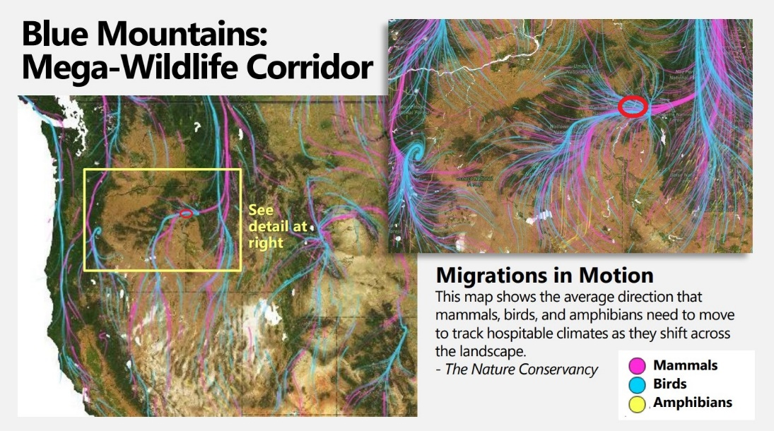
This image from the Nature Conservancy shows the importance of this very narrow connectivity corridor on a continental scale. In a time of climate change, increasing development, and a biodiversity crisis, these corridors have become even more important. The Morgan Nesbit Project area is circled in red.

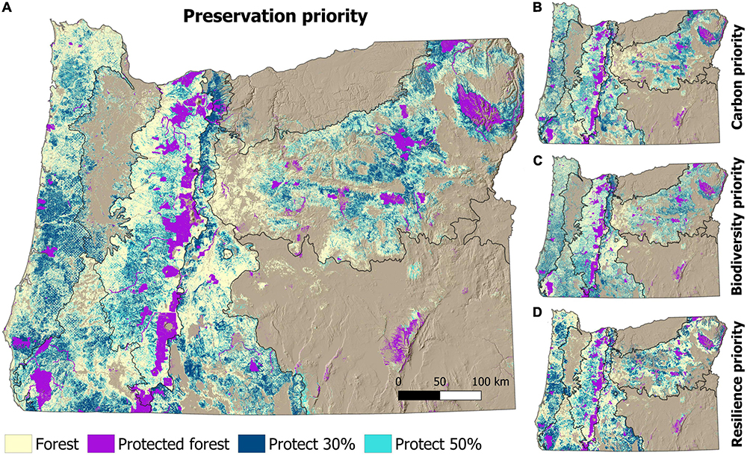
Forestlands prioritized to meet preservation targets across Oregon. Preservation targets include protecting 30 and 50% of each ecoregion’s forestlands. To identify preservation targets, the current extent of forest protection was determined for each ecoregion and then the highest ranked unprotected forestlands were sequentially added to the protected area network until each preservation target was met. (A) Forest preservation priority targets are shown, as are the (B) carbon, (C) biodiversity, and (D) climate resilience priority targets.
Figure 3 and caption above from: Law, B. et. Al (2022) Strategic Reserves in Oregon’s forests for biodiversity, water, and carbon to mitigate and adapt to climate change. Frontiers in Forests and Global Change Vol. 5 www.frontiersin.org/articles/10.3389/ffgc.2022.1028401/full.

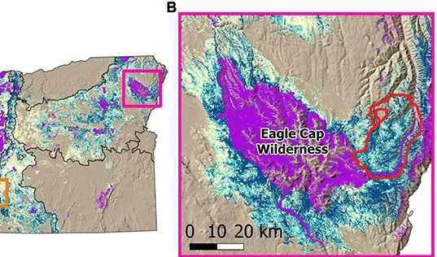
From the same paper, a cropped image of Figure 4 shows a closeup of Northeast Oregon with the Morgan Nesbit project area outlined in red.

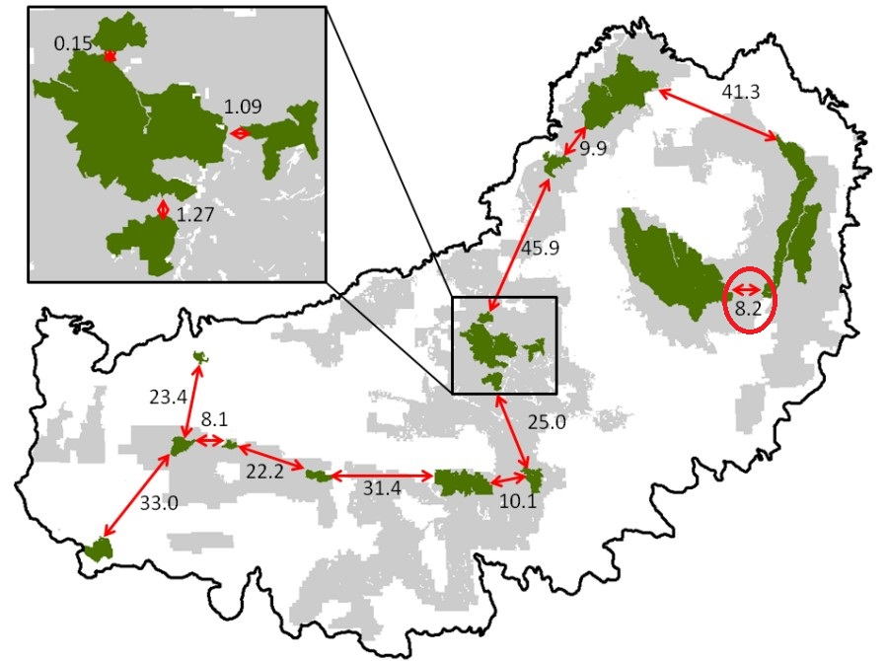
Only 4% of Oregon is protected as Wilderness. This is far less than neighboring states including Idaho. Much of what is protected is “rock and ice”. It is far less than scientists say is necessary to achieve widely embraced climate, biodiversity, and cultural goals. Scientists (and the Biden Administration) have argued for protecting 30% of our land by 2030. In this image of the Blue Mountain Ecoregion, protected Wilderness is depicted in dark green with distances (in miles) between these reserves depicted by red arrows. The area circled in red is the Morgan Nesbit Project Area. Given all the forested corridors between the Rockies, blues, and Cascades south of the Columbia River are included in this image, and coupled with the TNC connectivity map, it is easy to see the global importance of this landscape.

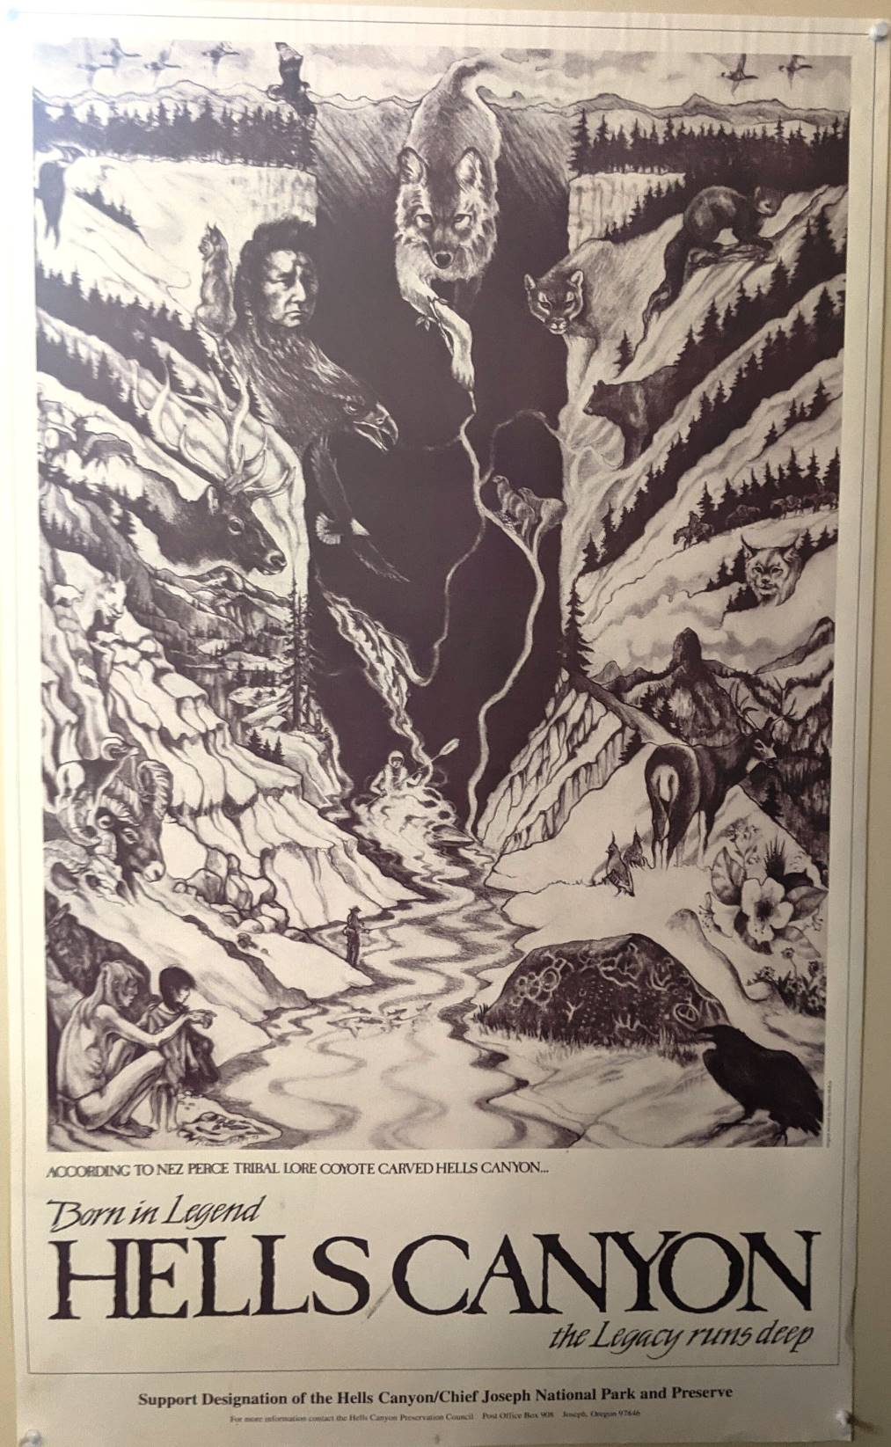
Much of the Morgan Nesbit Project Area has already been designated as a National Recreation Area and Wild and Scenic River Corridor. It is immediately adjacent to Wilderness and Inventoried Roadless Areas. Parts of the project area have been proposed for various designations including Wilderness, Wild & Scenic Rivers, and as a National Park as evidenced by this poster.
In public presentations on the project, the USFS has acknowledged that there is not a consensus on the science of management of the Moist Mixed Conifer forests that make up much of the project area. In fact, when diverse stakeholder are welcomed into public discussions and field trips, the conversations have focused on the intense scientific and values-based debate about fundamental questions including whether thinning and other “treatments” increases or decreases fire risk, whether or not stands will get hotter and drier, and whether projects like this are necessary at all.
The agency has conducted Wilderness and Wild & Scenic River analyses on some of the waterways and landscapes at the core of, and surrounding this project area. Given the lack of field work done for this project, the relative recent arrival of staff, and other factors, this document (and others linked elsewhere) should be consulted to determine what other values are present. Among other things, it includes attention to the importance of quiet recreation, relatively wild and unmanaged parts of the landscape, scenery, water quality, wetlands, cultural resources, songbirds, wildlife habitat connectivity, the importance of riparian habitat connectivity, chinook salmon, steelhead, native rainbow trout, and bull trout.

Consider more holistic/comprehensive restoration.
The Forest Service is calling this a “restoration” and “resilience” project. There are many restoration activities that can lead to increased resilience. Please explain which of the following activities the agency has chosen to undertake in this project, and why. Please also explain which have been excluded from consideration in this project, and why.
- Road decommissioning and physical closures
- Culvert replacements and repair
- Streambank restoration and stabilization including through activities like plantings of riparian vegetation, exclusion of livestock, and exclusion of OHV’s.
- Fish passage barrier removal
- Reintroduction of extirpated species
- Beaver dam analogs
- Habitat improvement and other measures to improve habitat for keystone species like beaver and wolves.
- Grazing changes including reduction in riparian areas and other sensitive habitats. (Notably, the WWNF has more AUM’s than any other forest in Region 6).
- Livestock exclusion and retirement of grazing allotments in environmentally sensitive and important areas.
- Fencing for livestock and native ungulates
- Monitoring, maintenance, and replacement of infrastructure including fences. There are many areas in the project area where fences have fallen into disrepair, have been taken down, gates opened, etc.
- Fence removal
- Fence improvements including replacing barbed wire with smooth wire.
- Invasive species control
- Prescribed fire
- Fire use planning
- Restoration of cultural burning if it occurred here
- Enhancement of tribal rights and a full suite of first foods
- Adjusting forest/tree structure, density, and composition
- Non-commercial thinking
- Inducing on-site tree mortality
- Increasing downed wood habitat
- Snag creation
- Restore the biophysical function of dead wood in the capture/storage/release of water, sediment, nutrients, and energy
- Enhance recruitment of future large snags, standing dead wood, and downed woody habitat
- Tree tipping
- Limbing and pruning
- Conversion of roads to trails
- Travel management
- Signage for forest users
- Trail repair
- Sanitation improvements
- Erosion control, especially from roads, trails, and management activities
- A full suite of aspen restoration including fencing (with a plan for long-term maintenance), reduced herbivory, planting, encouragement of native carnivores, fire use, and changes to livestock grazing. (Simply cutting conifers and one-time fence building are very limited temporally and spatially. Also, conifer thinning should leave the trees on site to reduce subsequent herbivory.)
- Increasing presence of law enforcement
- Increasing wildlife security, protecting core habitat, and increasing connectivity at all scales
- Designation of, and advocacy for protective designations such as NRA’s, WSR’s Wilderness, etc.
- Passive restoration through natural processes
- Enhancement of natural disturbance processes like fire, beetle, and disease.
- Conduct a limiting function analysis and restore those functions that are of greatest concern.
- Restore and enhance biological potential for carbon storage
- Monitor wildlife and botanical presence, diversity, richness, and abundance as well as trends.
- Monitor stream temperatures, sediment, bank undercut, flows, macroinvertebrates, etc.
- Monitor soil temperature and moisture
- Conduct and encourage research
Commercial logging is not inherently restoration. Thinning is not inherently restoration.

The project area includes old clearcuts and plantations. There is a good deal of agreement about some thinning in those stands as demonstrated by successful projects in the Walla Walla District of the Umatilla National Forest. These may provide opportunities for legitimate restoration coupled with economic outputs and lack of controversy. These opportunities should be identified. Even if some of them are not “ready” economically, some work now could speed that process up and provide both short- and long-term ecological and economic outcomes.

Do not give special dispensation to some stakeholders over others.
The agency has been giving a great degree of deference to a number of formal and informal “collaborative” groups. These groups are necessarily exclusive. Especially locally, they do not represent the majority of the mainstream conservation community. In some cases, they have become extremely secretive, undemocratic, unscientific, discriminatory, and disreputable. All the ones we know of who are engaged in this project are dominated by a narrow set of interests (most of which who have economic interests) that tend to focus on and primarily support extractive activities on our public lands. While we acknowledge these groups – and their members – have standing, they should not be given any more deference, access, information, or power than any other members of the non-Indigenous public.

To the extent our National Forests are owned by anyone, they are owned by all members of the public equally (notwithstanding the special status of Indigenous people discussed elsewhere). Our National Forests were created in part to reduce the impact of provincial influence. While local politicians and citizens may have greater access to and power over the agency, equal consideration must be given to the broad public values this area provides and the voices of those who may not have the time, resources, expertise, or awareness of this project proposal.
Please recall the strong feedback from citizens who participated in a field trip stating:
Aggressive logging felt like “a gut punch” and likened pre-logged stands to a “cathedral” (notably, these were all from local citizens).
Since stand initiation is easy and quick to create and the chance of stand-replacing fire is high, there is no need to create it with chainsaws and bulldozers. It can be achieved more cheaply and in a more ecologically sound manner through natural disturbance like fire.

Share the results of the public survey conducted by the agency on this project including demographics of those who participated.
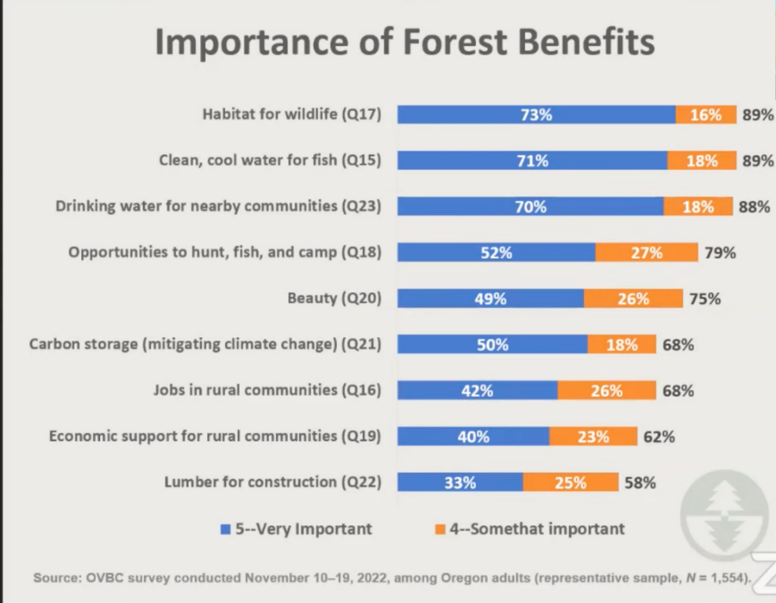

/ / /

/ / /

/ / /
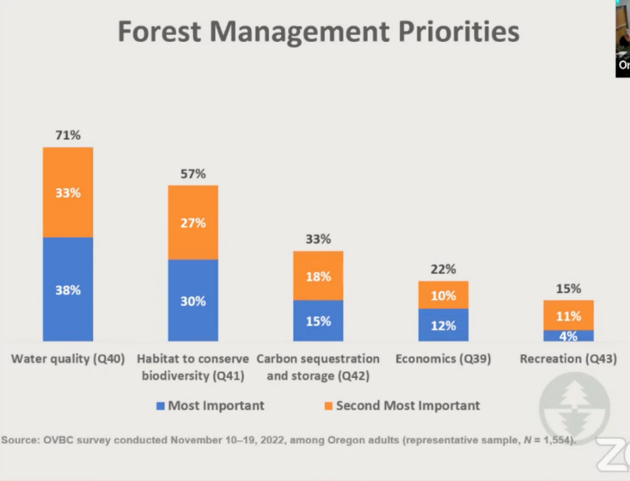
A recent survey by the Oregon Values and Beliefs Center surveyed Oregonians about the relative importance of various forest benefits. The results in these two slides, taken from a public presentation, by the Sightline Institute speak for themselves.

People from many backgrounds find solitude, scientific, spiritual, economic, and recreational values here that are difficult to find elsewhere. However, The Nimiipuu, or Nez Perce, have lived on this landscape since time immemorial.

In fact, the oldest currently known evidence of human habitation in North America is found just miles away in the Snake River Watershed. It dates back to nearly 16,000 years. The project area is entirely within the reservation that was promised to the Nimiipuu in the Treaty of 1855. Indigenous people remain on the land and frequent this landscape. They retain their rights and sovereignty. However, the Forest Service has often done little more than “box-checking” exercises to ensure legal requirements are met in designing projects on these lands. The agency needs to do far better in listening to, and meaningfully incorporating input from the Nez Perce Tribe.

Reconsider the arbitrarily narrow scope of the Purpose & Need and the flawed assumptions in the Scoping Notice.
As described in greater detail elsewhere, the P&N of this project is unnecessarily narrow. As so often seems to be the case, the agency has determined that logging is the answer. The goal of the NEPA process becomes the process of developing questions and language to justify that while proposing a few additional non-extractive restoration activities.

Doing so excludes a number of legitimate restoration activities and/or activities that will lead to greater resilience on this landscape than what is being proposed
We appreciate that the agency is considering some non-commercial activities. But, far too often, while those are considered in the analysis, alternatives, and even decision, they are not carried out. The cost of their implementation is then often used to justify aggressive logging to make the project “economically feasible”. That has happened across the country for decades, and has continued to be the case on this district.
Agency leadership has said “the worst thing we can do is nothing”. We disagree. There are a lot of “somethings” that are worse than “nothing’.
As described elsewhere, the Scoping Notice misrepresents the historic fire regime of this landscape. It may describe small portions of the landscape, but it is disingenuous to ignore the diversity and complexity within these 87,000 acres.
While we have supported landscape scale level planning in the past, the agency either needs to choose a smaller, less complex subpart of the landscape or undertake a far more robust and complicated analysis and planning effort that matches the landscape.
The Scoping Notice highlights aggressive suppression of wildfire as a primary cause of the restoration need here. “Setting the landscape up so it can receive fire” is specious, and even if done, without assurances in writing that the landscape will receive fire and suppression of wildfire will become less aggressive/reflexive, this is not addressing that root cause or meeting the real needs of this landscape.

We appreciate that the agency has recently “let some fires go”, and stand ready to continue to support those decisions. However, the Forest Service has a long way to go. Those fires have either been in Wilderness or on extremely small footprints.

The agency must do more to rebuild trust
Forest Service leadership have repeatedly asked the conservation community to take a leap of faith and trust them. This is a big ask. There are recent, real, and ongoing examples of the agency proposing very similar activities to what is being proposed on Morgan Nesbit. These projects have led to very poor outcomes including human conflict, increased fire risk, degraded wildlife habitat, and hotter, drier forests.

The underlying causes of the stated restoration need on this project is past and ongoing mismanagement by the Forest Service. Throughout that time, as leadership has changed, each new leader has asked for trust. This project has already seen tremendous staff turnover. It is very likely that those implementing the project will not be those who design it. While we embrace and appreciate the promises being made, those that are not in writing, clear, and enforceable, are not real. We welcome efforts by the agency to rebuild trust, and we commit to doing our part. However, until trust is truly rebuilt and earned, we encourage such leaps of faith to be asked for on landscapes that are not as special, fragile, and irreplaceable as this.
While we do trust many of the staff involved in this project, it is simply shocking how little time many of them have spent on this landscape.
We welcome verbal assurances that controversial parts of the project will be implemented in a “boutique way”, based on science, or “not your grandfathers regen harvest [clearcut]”, etc. We have been told that areas of aggressive logging, clearcuts, and large tree logging will be selected for specific reasons. However, we have heard this before, and on ongoing projects, only to see very different outcomes.

On ongoing projects like Lower Joseph, the agency did not mark trees. That has led to controversy from all sides. Leaving the mark in the hands of those who did not design the project means they are likely to be wrong. Left in the hands of the lowest bidder, they are likely to be sloppy. Left in the hands of those with economic interest in more aggressive logging incentivizes overly aggressive marks.

Further, the agency has not sufficiently monitored this or other projects or adjusted implementation in ecologically driven ways. That is even when the agency has acknowledged that the project has fallen short of or undermined desired outcomes. Rather, we have seen the agency entertain re-opening roads, dropping non-commercial restoration activities, using new systems to log steep slopes, etc. As one of many examples, in the ongoing Lower Joseph Project, the agency promised to replace two culverts. That has not occurred, and we have been told it will not. In fact, we have seen culverts blocked by logging activity.

/ / /

/ / /

/ / /
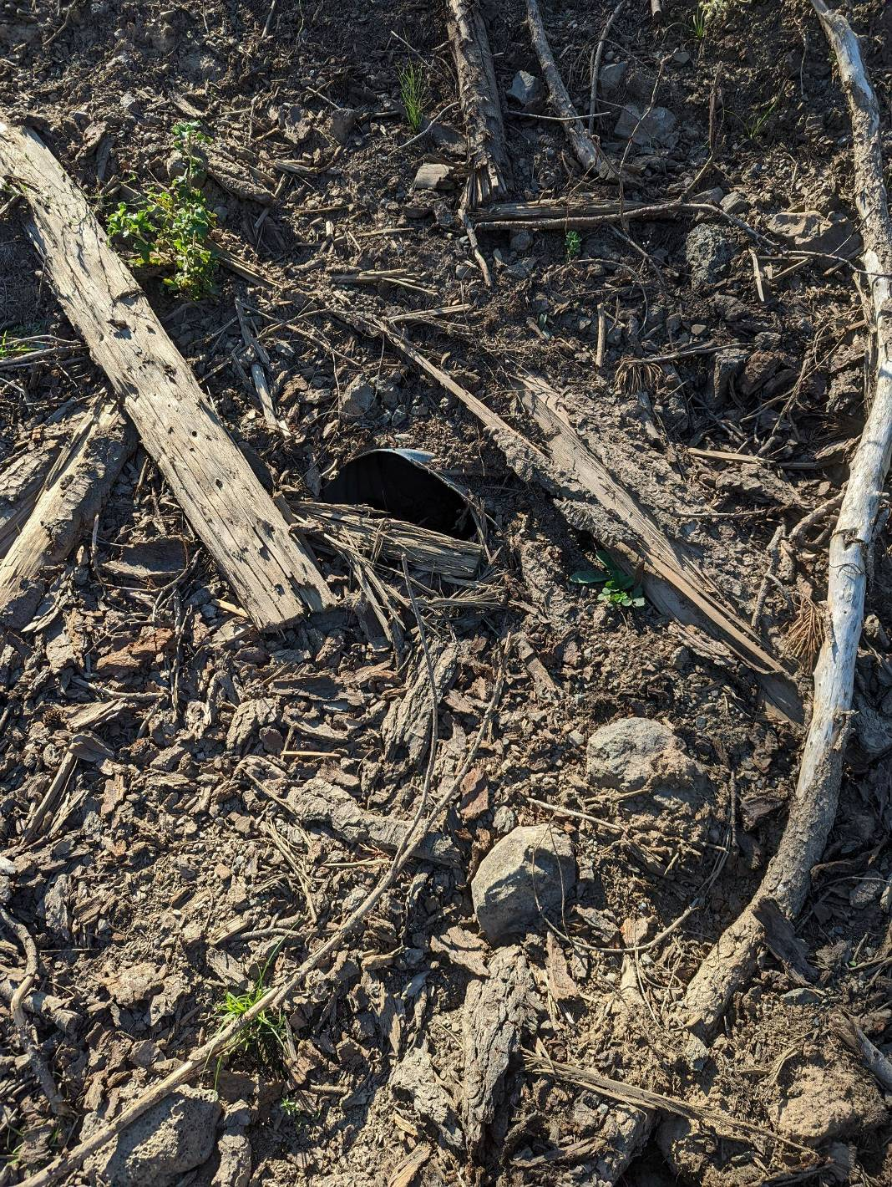
This culvert, center, about 2/3rds of the way to the top, was blocked by deep logging debris in the Lower Joseph Project. That project and its proponents regularly pointed to the planned replacement of two culverts in the 97,000-acre project area to showcase the restoration components of that controversial project. They have not been replaced, and now that the project is underway, agency staff have told us they will almost certainly not be due to local opposition.
In a 2021 public meeting, agency staff said clearcuts (or patches) would be limited to 2-acres. The bigger the acreage of aggressive logging (clearcuts, shelterwood, patches, regen cuts, etc), the more controversial they are. We are disappointed to understand proposals for clearcuts have more than doubled in size.
Over a year before scoping, at a public meeting, agency staff divulged that the agency was already working up prescriptions and preferred alternatives before data had been collected, much less analyzed. Now we understand the agency has preferred and proposed alternatives and even know how many timber sales will be involved, board feet produced, etc. Some stakeholders have been given far more information than others. This has all occurred before scoping and is of great concern. It does not help build trust.
The agency has a long history of proposing “treatments” and activities that offset the damage and concerns from the conservation community and then not implementing them. To the extent that some of these activities are carried out, the agency often justifies more aggressive logging “to pay for” it or “make it pencil”. The agency must give greater assurance that the non-commercial activities will in fact occur. Further, with a glut of millions of dollars coming to the agency, the excuse of needing these projects to “pay for themselves” no longer hold water. As former District Ranger Bill Gamble often pointed out, after decades of taking from our forests, we can only work with what we have left. It is time to invest in our forests, not continue taking from them and repeating past mistakes with new rhetoric. Like most National Forests, the Wallowa Whitman is wildly behind in approved activities that have not happened. We encourage consideration and implementation of more non-commercial, non-extractive activities in this project.

Infrastructure Money Facilitates Non-commercial Treatments
We expect that the significant infusion of money from the Infrastructure Investment and Jobs Act and other sources will allow the Forest Service to create alternatives that rely less on commercial logging (which too often compromises restoration goals) and place more emphasis on non-commercial restoration that yields closer to optimal restoration outcomes and reduces conflict.

Natural Disturbance and Mortality Should be Viewed as Solutions, Not Problems
Fire, insects, disease, root rot, competitive mortality are all natural processes that help forests develop into complex ecosystems. The scoping notice appears to adopt an outdated agricultural model of forests that portrays these natural processes as problems that reduce “tree vigor” and need to be solved with logging.

Natural disturbance processes, including fire, insects, disease, and competitive stress should be viewed as solutions instead of problems. They represent natural processes that help create valuable habitat for a wide variety of species that thrive with diverse age-classes, a variety of seral stages, abundant snags and dead wood, and the increased light, water, and nutrients that are made available through natural disturbance processes.

Foresters are taught to suppress natural mortality processes, but that is an outdated approach to forests that needs to be replaced by true ecosystem management. Commercial logging to suppress insects and disease does not mimic natural processes; it interrupts those natural processes and diminishes the benefits of natural disturbance and recruitment of biological structures form the live pool to the dead pool. All that, and it also comes with significant adverse environmental trade-offs noted above.

The agencies need to stop thinking about forests as an agricultural crop and start thinking about forests as complex, self-organizing systems. When forests become dense, natural mortality processes, like insects, disease, competitive mortality, and fire, are not a problem, rather they are part of the solution. Natural mortality increases the diversity and complexity of the forest. Mortality creates opportunities for new organisms, thus enhancing biodiversity.

As reported in the Durango Herald, beetle-kill zones are surprisingly rich in biodiversity:
Forests “scarred by the spruce beetle outbreak, can elicit strong emotions in the nature lover. Several logging sales may be on the way, but new research suggests ravaged trees can create an ecologically vital habitat worth saving. … The Forest Service has long maintained such timber sales benefit the health of the ecosystem as it transitions from an old-growth to new-growth forest, but research from the University of Montana, as well as several conservation groups, challenges that idea. … After the beetle moves on, woodpeckers feed on the larvae left behind, which creates nest cavities in dead trees for other species – such as bluebirds, chickadees and even squirrels – who are unable to make the safe havens themselves. Then come the wildflowers, which thrive on the exposed understory of the forest, typically covered in shade. Flies and other insects arrive to feed on the flowers, and in turn bring birds, bats and other small mammals, which attract larger predators.

“What you end up with is a very rich and biodiverse ecosystem,” Hanson said.

Clark University associate professor Dominik Kulakowski agreed. He said the result, a “snag forest,” is a favorable habitat for many invertebrates and vertebrates because of the creation of canopy gaps and enhanced growth of understory plants. “Outbreaks create snags that may be used by various birds and mammals, including woodpeckers, owls, hawks, wrens, warblers, bats, squirrels, American marten and lynx,” Kulakowski said.” By removing the trees, you remove this process, both Hanson and Kulakowski said.

The following quote from Oregon State University demonstrates a more modern ecological view of forest insects and disease:
The massive insect epidemics that have plagued Pacific Northwest forests in recent years are mostly a reflection of poor forest health conditions, overcrowding, overuse of chemicals, fire suppression and introduction of monocultures or non-native species, a new report concludes.

Beyond that, these insect attacks are actually nature's mechanism to help restore forest health on a long-term basis and in many cases should be allowed to run their course, according to Oregon State University scientists in a new study published this week in the journal Conservation Biology In Practice.

Native insects work to thin trees, control crowding, reduce stress and lessen competition for water and nutrients, the researchers found. Some levels of insect herbivory, or plant-eating, may even be good for trees and forests, and in the long run produce as much or more tree growth.

"There is now evidence that in many cases forests are more healthy after an insect outbreak," said Tim Schowalter, an OSU professor of entomology. "The traditional view still is that forest insects are destructive, but we need a revolution in this way of thinking. The fact is we will never resolve our problems with catastrophic fires or insect epidemics until we restore forest health, and in this battle insects may well be our ally, not our enemy."

Historically, Schowalter said, destructive forest insects such as the mountain pine beetle or tussock moth were native to Pacific Northwest forests and served an essential role in keeping them healthy. When trees became too crowded the insects would eliminate weaker trees and reduce competition. But since the beetles' reproductive pheromones only carried effectively about 15-20 feet, naturally open stands of mature pines were protected against widespread outbreaks.

In these same forests today, fire suppression has allowed shade-tolerant, fire-intolerant species to crowd the understory, create an entire forest stressed for water and nutrients, and beetles can skip from one weak tree to another across entire stands. But the solution in cases such as this, Schowalter said, is to address the fundamental issue of overcrowding through forest thinning, controlled fire and insect attack, allowing the pine beetles to actually help in the long-term process of restoring forest health.
It now appears that insects, which are the most abundant and diverse animals on Earth, are anything but destructive pests. Rather, they are major architects of the plant world in both structure and function, and in natural balance help to maintain healthy and productive forest ecosystems.

According to the new report, insects can influence their environment in five key ways:
• Insects aid decomposition, stimulate the breakdown of organic materials, enhance soil fertility and plant growth, burrow in soils and increase its porosity and water-holding capacity.
• Insects are herbivores that eat plants, influencing where they can grow. Sometimes they kill trees and other plants to reduce competition, and many times feed on trees without killing them in ways that actually improve the health and long-term growth of trees and forests.
• Insects are a key food source for vertebrates and other animals, and play a major role in the food chain.
• Insect are dispersal agents to carry seeds, fungal spores, and even other invertebrates from one place to another.
• Insects are pollinators, and in this role also help control the movement of plant species.

Through this multiplicity of roles, forest insects can help to control plant succession, dictate which plants will be allowed to grow or thrive in particular areas, and generally invigorate plant communities, the report said. Studies suggest herbivory levels as high as 40-50 percent make little or no difference to plant growth and survival, and this type of moderate herbivory clearly should not be "fought" with costly controls. Wood production in western U.S. pine forests reached or exceeded pre-attack levels 10-15 years following mountain pine beetle outbreaks, research has shown, and the more an individual Douglas-fir tree is defoliated by the tussock moth, the more it compensates afterwards with increased growth, given sufficient resources. The herbivory may alleviate drought stress by reducing a tree's demand for water, and also encourage more competitive interactions between plant species that ultimately work to the benefit of the tree.

Insects may be so important to soil fertility that they may be a better barometer of forest ecosystem health than the larger trees or animals which live there, researchers say. In natural forest communities there are more than 200 species of arthropods and more than 200,000 individuals in a square meter of soil, and the numbers of these arthropods can tell more than chemical tests about soil concerns such as compaction and nutrient cycling.

A study by another OSU researcher showed residual impacts on soil invertebrate populations from a site that had been clearcut and slash burned 40 years earlier.

In their natural role, insects are usually helpful to the forest and rarely cause large epidemics.

"When you have a highly destructive insect epidemic, what that really should be telling us is not that we have an insect problem, but that we have a forest health problem," Schowalter said. "It's monocultures and fire suppression that cause insects to become nuisances. The pests that plague us are all too often of our own making."

As these systems become more fully understood, Schowalter said, it should be possible to work with insects, rather than against them, to produce new solutions to maximize the yield of forest commodities while achieving conservation goals and healthier ecosystems.

"It's really simple on one level," Schowalter said. "We have to pay more than lip service to the balance of nature."

This project is based on the idea that treating insects and disease will help make forests more resilient. This may not be well supported. Several recent studies suggest that beetles may in fact help forests adapt to changing climate conditions.
• Peter T. Soul, Paul A. Knapp & Justin T. Maxwell (2013) "Mountain Pine Beetle Selectivity in Old-Growth Ponderosa Pine Forests, Montana, USA" Ecology and Evolution Volume 3 Issue 5 pp.1141-1148. https://libres.uncg.edu/ir/asu/f/Soule_Peter_2013_Mountain%20Pine%20Beetle_orig.pdf;
• Millar, C.I. et al. 2007. Response of high-elevation limber pine (Pinus flexilis) to multiyear droughts and 20th-century warming, Sierra Nevada, California, USA. Canadian Journal of Forest Research 37: 2508-2520. https://www.fs.fed.us/psw/publications/millar/psw_2007_millar031.pdf;
• Millar, C.I. et al. 2012. Forest mortality in high-elevation whitebark pine (Pinus albicaulis) forests of eastern California, USA; influence of environmental context, bark beetles, climatic water deficit, and warming. Canadian Journal of Forest Research 41: 749-765. https://www.fs.fed.us/psw/publications/millar/psw_2012_millar001.pdf;

Insects and disease may increase rather than decrease stand resilience to fire. Meigs et al (2015) made a careful review of the evidence and found beetle-kill/fire interactions to be relatively rare and concluded that it is better to view insects as part of the solution, not part of the problem:
Abstract. Although there is acute concern that insect-caused tree mortality increases the likelihood or severity of subsequent wildfire, previous studies have been mixed, with findings typically based on stand-scale simulations or individual events. This study investigates landscape- and regional-scale wildfire likelihood following outbreaks of the two most prevalent native insect pests in the US Pacific Northwest (PNW): mountain pine beetle (MPB; Dendroctonus ponderosae) and western spruce budworm (WSB; Choristoneura freemani). We leverage seamless census data across numerous insect and fire events to (1) summarize the interannual dynamics of insects (1970–2012) and wildfires (1984–2012) across forested ecoregions of the PNW; (2) identify potential linked disturbance interactions with an empirical wildfire likelihood index; (3) quantify this insect-fire likelihood across different insect agents, time lags, ecoregions, and fire sizes. All three disturbance agents have occurred primarily in the drier, interior conifer forests east of the Cascade Range. In general, WSB extent exceeds MPB extent, which in turn exceeds wildfire extent, and each disturbance typically affects less than 2% annually of a given ecoregion. In recent decades across the PNW, wildfire likelihood does not consistently increase or decrease following insect outbreaks. There is evidence, however, of linked interactions that vary across insect agent (MPB, WSB), space (ecoregion), and time (interval since insect onset). Specifically, in most cases following MPB activity, fire likelihood is neither higher nor lower than in non-MPB-affected forests. In contrast, fire likelihood is lower following WSB activity across multiple ecoregions and time lags. In addition, insect-fire likelihood is not consistently associated with interannual fire extent, suggesting that other factors (e.g., climate) control the disproportionately large fire years accounting for regional fire dynamics. Thus, although both bark beetles and defoliators alter fuels and associated fire potential, the windows of opportunity for increased or decreased fire likelihood are too narrow—or the phenomena themselves too rare—for a consistent signal to emerge across PNW conifer forests. These findings suggest that strategic plans should recognize (1) the relative rarity of insect-fire interactions and (2) the potential ecosystem restoration benefits of native insect outbreaks, when they do occur.

See also:
• Insect Ecology - An Ecosystem Approach Edited by Timothy D. Schowalter Academic Press. 2000. and Schowalter, TD and J. Withgott. 2001.
• Rethinking insects: What would an ecosystem approach look like? Conservation Biology In Practice 2(4): 11-16.
• Waldbruaer, Gilbert. 2003. What Good are Bugs? Insects in the Web of Life. Harvard University Press. Cambridge, MA. 316 pp.
• Maddie Oatman 2015. Bark Beetles Are Decimating Our Forests. That Might Actually Be a Good Thing. They gobble up trees and send politicians into a frenzy. But do the bugs know more about climate change than we do? Mother Jones, May/June 2015 http://m.motherjones.com/environment/2015/03/bark-pine-beetles-climate-change-diana-six

Conserve and Restore Roadless/Unroaded Areas
This project area includes extensive roadless and unroaded areas that serve important functions as intact watersheds, high quality water, stable stream flows, fish & wildlife refugia, connective habitat corridors, carbon storehouses, reference landscapes, recreation, scenic beauty, cultural significance, places where natural processes can operate unfettered, remnant large trees/large snags/mature & old-growth forest, etc. In recognition of the many significant values of unroaded areas and the potentially significant effects of logging and roads in unroaded areas, we request that the Forest Service develop NEPA alternatives that conserves these areas without commercial logging or roads to maintain and enhance the diverse roadless values listed in these comments. In addition, we request that the FS take a hard look at significant benefits of conserving roadless values, and the significant impacts of logging and roading them.

/ / /

/ / /

/ / /

The map below shows the unroaded areas >1,000 acres outlined in red and filled with partially-transparent green:

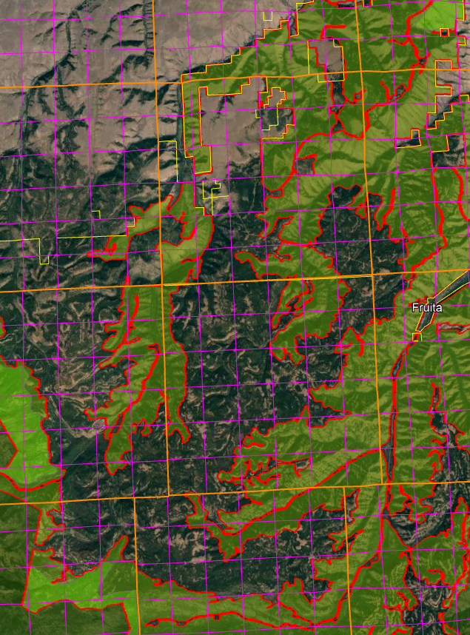

Large intact expanses of unfragmented habitat were once quite common but are now rare.

Species evolved in the context of the large habitat patches that result from the natural disturbance regime. As just one important example, big game need large patches of security cover which is best provided by large unroaded areas.

New science confirms that roads and logging tend to be contagious on the landscape (managed areas beget more management until little remains unmanaged), so to conserve the habitat values associated with wild places we have to prevent the first intrusions. The purpose and need for this project should include protecting and restoring large unroaded areas consistent with the natural range of variability.

This goal is just as, if not more, important as goals related to tree density or species composition that the agency too often relies on to justify logging and road building. The NEPA analysis should discuss whether the project will push the landscape toward or away from the natural range of variability for large-scale habitat patches. Landscape analysis based on historic disturbance patterns suggests that historically the majority of old forest occurred in large patches.

Our National Forests are home to more roads than the entirety of the US Highway System, and the Wallowa Whitman is one of the most heavily roaded forests in the country. It is also one of only two National Forests in the nation that does not have a Travel Management Plan, and is therefore operating in violation of the law.
The USFS must abide by the letter and spirit of the 2001 Roadless Area Conservation Rule. It was wise to leave Inventoried Roadless Areas outside the project area.
Whether inventoried or not, unroaded landscapes are precious, rare, and important everywhere. They are especially important in this narrow connectivity corridor of global importance.
Large patches of unroaded lands were not included in the RARE II inventory, but have been documented – and ground-truthed – by Oregon Wild and others. In most cases those are areas over 1,000 acres, but ecologists have been documenting important and unique values for unroaded blocks of 500 acres and larger.

Over the years, the agency has, at times, rightly analyzed and treated these areas differently using terms like “Other Unroaded Lands”, “Other Undeveloped Lands”, “OUL’s”, and other names. These places provide rare and important values. Many have been proposed for Wilderness and Wild & Scenic River Protections. While there may be cases where hand-thinning and prescribed fire might be appropriate, these areas should generally not be “treated”, and certainly should not be commercially logged.
Unroaded parcels of land are usually not “isolated polygons” as the Forest Service has characterized them. In many cases, they are immediately adjacent to other unroaded polygons, IRAs, and Wilderness. Retired Forest Service personnel have recounted that, not long ago, the agency (and this district in particular) had a practice of intentionally “punching holes” and “creating gaps” between undeveloped landscapes so they would be less likely to enjoy future protection. Rather than further degrade and fragment these landscapes, efforts should be made to close roads and other developments that may separate them. Doing so would be real restoration.
Many of these unroaded areas have been proposed as Wilderness and/or have wilderness characteristics. Where the agency insists upon management activities in them, conservation concerns can be assuaged by explicitly stating that doing so does not change their long-term viability as Wilderness. To be clear, such a statement would not put the agency on record as saying whether or not a designation is – or ever would be – appropriate, but rather that the proposed activities do not have any long-term effect.
The Forest Service defines unroaded areas as any area without the presence of classified roads, and of a size and configuration sufficient to protect the inherent characteristics associated with its roadless condition.

Unroaded areas greater than about 1,000 acres, whether they have been inventoried or not provide valuable natural resource attributes that must be protected. These include: water quality; healthy soils; fish and wildlife refugia; centers for dispersal, recolonization, and restoration of adjacent disturbed sites; reference sites for research; non-motorized, low-impact recreation; carbon sequestration; refugia that are relatively less at-risk from noxious weeds and other invasive non-native species, and many other significant values.

Secretary of Agriculture Tom Vilsack recognizes the value of National Forest roadless areas:
“Roadless areas preserve essential watersheds and help ensure an abundant supply of clean drinking water. These large areas of undisturbed forests provide diverse habitats for sensitive and endangered wildlife. In addition, roadless areas provide other critical ecological services, such as carbon storage, and operate as effective barriers to invasive species, while also providing social values such as scenic landscapes and a host of recreational opportunities. Let me assure you that USDA and the Forest Service will move forward to conserve and protect these lands and meet all legal obligations.”

Before logging roadless areas the agency should consider the impacts to all the values of roadless areas, including:
(1) High quality or undisturbed soil, water, and air;
(2) Sources of public drinking water;
(3) Diversity of plant and animal communities;
(4) Habitat for threatened, endangered, proposed, candidate, and sensitive species and for those species dependent on large, undisturbed areas of land;
(5) Primitive, semi-primitive non-motorized and semi-primitive motorized classes of dispersed recreation;
(6) Reference landscapes;
(7) Natural appearing landscapes with high scenic quality;
(8) Traditional cultural properties and sacred sites; and
(9) Other locally identified unique characteristics.

We are aware that the PNW Regional office issued a directive relative to uninventoried roadless areas, aka “undeveloped areas”. This 11-24-04 memo from Lisa Freedman wisely instructs the Forest Service to give consideration to “special” features of undeveloped areas regardless of size. However, this memo also has some troubling instructions that deserve mention.

First, the memo instructs Forests not to "establish a permanent identity or inventory for these areas" which not only interferes with efficient management of information and natural resources but also violates the NFMA mandate to maintain an accurate and up-to-date inventory of the renewable resources of the National Forests. See 16 U.S.C. 1603 which says "the Secretary of Agriculture shall develop and maintain on a continuing basis a comprehensive and appropriately detailed inventory of all National Forest System lands and renewable resources. This inventory shall be kept current so as to reflect changes in conditions and identify new and emerging resources and values."

Second, Forests are instructed to focus their analysis on the "effects of the proposed activity where the effects occur rather than on identification or inventory of the undeveloped area." How can the effects of management be adequately disclosed “where they occur” or anywhere else for that matter, UNLESS the qualities of the area are fully understood through identification and inventory. This memo essentially instructs the Forest Service to (i) routinely destroy factual information about resources under its management, and (ii) provide uninformed disclosure of the effects of proposed management action without collecting and considering contextual information about roadless/undeveloped areas that could be affected. If the Forest Service follows these instructions they will be violating NEPA, so don’t do it.

The Forest Service adopted new guidance concerning ecological restoration and resilience which urges managers to “Identify opportunities to sustain ecological refugia that may serve as vital sources of ecological diversity.” This is an opportunity to look at uninventoried roadless areas in a fresh new light.

“It is well established in this [9th] Circuit that logging in an unroaded area is an ‘irreversible and irretrievable’ commitment of resources and ‘could have serious environmental consequences.’” and therefore requires an EIS. This project involves activities in such unroaded areas. The NEPA analysis for this project does not adequately discuss the impacts of proposed activities on all the many significant values of roadless/unroaded areas.

The 9th Circuit has held that the agencies have a NEPA obligation to consider the potential for future wilderness designation before conducting management activities in areas that may be eligible for wilderness, even if they are not inventoried roadless areas. (The court enjoined salvage logging that would have affected uninventoried roadless areas less than 5,000 acres in size that were located adjacent and contiguous with an inventoried roadless area.)

The agency cannot limit its analysis of roadless areas to inventoried areas >5,000 acres, because smaller roadless areas that were not inventoried are ecologically relevant and potentially significant. The NEPA analysis must reflect the growing scientific evidence (cited below) indicating the significant value of roadless areas smaller than 5,000 acres and larger than 1,000 acres. Recent scientific literature emphasizes the importance of unroaded areas greater than 1,000 acres as strongholds for the production of fish and other aquatic and terrestrial species, as well as sources of high quality water. Commercial logging and/or road building within large unroaded areas threatens these significant ecological values.

World Wildlife Fund and the Conservation Biology Institute summarized the important attributes of small roadless areas (1,000-5,000 acres). Small roadless areas share many of attributes in common with larger ones, including:
• Essential habitat for species key to the recovery of forests following disturbance such as herbaceous plants, lichens, and mycorrhizal fungi
• Habitat refugia for threatened species and those with restricted distributions (endemics)
• Aquatic strongholds for salmonids
• Undisturbed habitats for mollusks and amphibians
• Remaining pockets of old-growth forests
• Overwintering habitat for resident birds and ungulates
• Dispersal “stepping stones” for wildlife movement across fragmented landscapes.

In a 1997 letter to President Clinton, 136 scientists said:
There is a growing consensus among academic and agency scientists that existing roadless areas–irrespective of size–contribute substantially to maintaining biodiversity and ecological integrity on the national forests. The Eastside Forests Scientific Societies Panel, including representatives from the American Fisheries Society, American Ornithologists’ Union, Ecological Society of America, Society for Conservation Biology, and The Wildlife Society, recommended a prohibition on the construction of new roads and logging within existing (1) roadless regions larger than 1,000 acres, and (2) roadless regions smaller than 1,000 acres that are biologically significant…. Other scientists have also recommended protection of all roadless areas greater than 1,000 acres, at least until landscapes degraded by past management have recovered…. As you have acknowledged, a national policy prohibiting road building and other forms of development in roadless areas represents a major step towards balancing sustainable forest management with conserving environmental values on federal lands. In our view, a scientifically based policy for roadless areas on public lands should, at a minimum, protect from development all roadless areas larger than 1,000 acres and those smaller areas that have special ecological significance because of their contributions to regional landscapes.

International policy bodies like IUCN recognize the value of intact unroaded areas:
While primary forests of all extents have conservation value, areas of greater extent warrant particular attention where they persist, as they support more biodiversity, contain larger carbon stocks, provide more ecosystem services, encompass larger-scaled natural processes, and are more resilient to external stresses. The significance of large areas of primary forests has been highlighted by the global mapping of Intact Forest Landscapes (IFL) greater than 500 km2 in extent. While suitable for many purposes, other thresholds may be more suitable at regional and national levels that reflect local ecological factors.

There are tremendous co-benefits from conserving large blocks of unmanaged forests, such as climate mitigation and biodiversity conservation. As noted by Roberts et al (2020):
Based on the species–area relationship, regarded as one of ecology’s few universal laws, protection of [too] little habitat will condemn thousands of species to extinction if habitat outside them is converted, degraded or lost. It is this logic that underpins calls for ‘Nature Needs Half’ [26], together with an understanding that ecosystem processes and services of the scale needed to sustain the well-being of life on Earth require large wildlife populations and huge expanses of intact and restored habitat. ... Climate change adds a new dimension to the question of how much protected area coverage is needed to assure conservation of wild nature.

Climate change is already reducing wildlife population sizes and forcing range shifts as conditions alter [28,29]. Protected areas counter such stresses by building up populations, and connectivity of populations and habitats is emerging as a key property in securing species persistence and resilience to rapid change [5]. Hence networked protected areas, especially where embedded within well-managed land or seascapes, provide crucial stepping stones to accommodate range shifts and, where no further movements are possible, refuges of last resort [5]. Analyses suggest that adequate levels of population viability and connectivity can be achieved only with marine protected area coverages of 30% or more [27]. ... [G]iven that many ecosystems are already degraded, ensuring continued provision of ecosystem services requires not only the precautionary protection of currently intact habitats, but also large-scale habitat restoration.

Providing greater space for recovery of intact, vibrant nature is not altruistic conservation, but is, we argue, an indispensable act of self- preservation, producing a cascade of benefits that will help maintain the habitability of the biosphere as the climate changes, thereby securing the well-being of generations to come.

Law et al (2022) make a strong case that conservation of intact forests advances the twin goals of protecting the climate and biodiversity, and that broad-scale thinning to reduce fire severity conflicts with climate and biodiversity goals:
Instead of regularly harvesting on all of the 70% of U.S. forest land designated as “timberlands” by the U.S. Forest Service, setting aside sufficient areas as Strategic Reserves would significantly increase the amount of carbon accumulated between now, 2050 and 2100, and reestablish greater ecosystem integrity, helping to slow climate change and restore biodiversity. The 2022 IPCC AR6 report stated that “Recent analyses, drawing on a range of lines of evidence, suggest that maintaining the resilience of biodiversity and ecosystem services at a global scale depends on effective and equitable conservation of approximately 30% to 50% of Earth’s land, freshwater and ocean areas, including currently near-natural ecosystems (high confidence).” Continuing commercial timber harvest on a portion of the remaining public lands and tens of millions of hectares of private lands would continue to adequately supply a sustainable forestry sector.
Preserving and protecting mature and old forests would not only increase carbon stocks and growing carbon accumulation, they would slow and potentially reverse accelerating species loss and ecosystem deterioration, and provide greater resilience to increasingly severe weather events such as intense precipitation and flooding.
…
Many of the existing forest management practices allegedly protect forests and homes from wildfire and are having severe adverse effects on forest ecosystem integrity and resilience, and are worsening climate change and diminishing biodiversity.
…
To summarize, harvest-related emissions from thinning are much higher than potential reduction in fire emissions. In west coast states, overall harvest-related emissions were about 5 times fire emissions …
Law et al (2022) describe a strategic reserve approach to protect water, biodiversity, and carbon in Oregon’s forests. Existing unroaded areas could make a significant contribution to such an approach.
Our study demonstrated that Oregon has high carbon density forests that also have high biodiversity and connectivity for species movement. When these characteristics were prioritized within each ecoregion, it identified sufficient forestland to meet both the 30% protection by 2030 and 50% by 2050 targets that are important nationally and internationally. … the climate resilience rank highlights large areas within the ecoregions with larger landscape features that are important for resilience (Figure 2D), such as the topography of mountain ranges in southwest Oregon, the Coast Range, Cascades, and Blue Mountains in the northeast. … Meeting the forest preservation targets would substantially increase protection of tree carbon stocks, animal and tree species’ habitat, and surface drinking water source areas. … Meeting these forest preservation targets would substantially increase forest habitat protection for threatened and endangered (T&E) species and other species of interest … Mitigation strategies need to explicitly protect existing oldgrowth forests, and allow mature secondary forests to regrow to their carbon capacity. For climate mitigation using natural climate solutions, effectiveness is based on the time that a unit of biomass carbon is resident in a forest ecosystem stock and thus kept out of the atmosphere (Körner, 2017; Mackey et al., 2020). … We also found that limiting harvest to half of current levels on public lands and doubling harvest cycles to 80 years on private lands was three times more effective as a land use strategy than replanting and reforestation after cutting within current forest boundaries in Oregon (Law et al., 2018). … There is concern that protecting areas that are vulnerable to increased drought and fire will be ineffective, however, species diversity, and threatened and endangered species still need habitat, refugia and connectivity with other protected areas. Wildfires tend to be patchy, and a majority of trees survive low to mixed-severity fires (Halofsky et al., 2011) that can be critical habitat, and burned forests still retain the vast majority of their carbon (Hudiburg et al., 2009; Law et al., 2018). … Older forests in Oregon’s watersheds exhibit greater water retention and improved late summer stream flows compared to managed plantations (Segura et al., 2020). Intact forests also tend to harbor more large and old trees, bolstering carbon stores and biodiversity services that large trees provide (Lutz et al., 2018; Plumtre et al., 2021). … The most important action Oregon can take to mitigate climate change, reduce biodiversity losses, and protect watersheds for drinking water is to set aside existing forests.

In 1994, several scientific societies submitted a report to Congress and the President recommending conservation of roadless areas larger than 1,000 acres. This report is described by the Interior Columbia Ecosystem Management Project as a “Major Stud[y] of Eastside Ecosystems and Management”:
Because roads crisscross so many forested areas on the Eastside, existing roadless regions have enormous ecological value. … Although roads were intended as innocuous corridors to ease the movement of humans and commodities across the landscape, they harm the water, soils, plants, and animals in those landscapes. [p 6]
…
4. Do not construct new roads or log within existing (1) roadless regions larger than 1000 acres or (2) roadless regions smaller than 1000 acres that are biologically significant.
Roadless regions constitute the least-human-disturbed forest and stream systems, the last reservoirs of ecological diversity, and the primary benchmarks for restoring ecological health and integrity. Roads fragment habitat; alter the hydrological properties of watersheds; discharge excessive sediment to streams; increase human access and thus disturbance to forest animals; and influence the dispersal of plants and animals, especially exotic species, across the landscape. Because many forested areas in eastern Oregon and Washington are heavily dissected by roads, the ecological value of existing roadless regions is especially high. [pp 8, 202]
…
Our analysis defined a roadless region as any region where all points within an LS/OG stand were at least 100 meters from a road or trail.
…
What remains of ponderosa pine and Douglas fir LS/OG is the least protected today. In the four national forests within the Blue Mountains, 48% of the land base above 6000 feet lies in wilderness areas, whereas only 10% of the land below 6000 feet, where ponderosa pine occurs, receives such protection … [p 110]

… Fifth, roads, whose impact on aquatic and terrestrial resources is well documented, are widely distributed in eastside forests. Road densities in western Colville, Winema, and Ochoco National Forests average 2.5, 3.5, and 3.7 miles per square mile, respectively. Densities reach 8.8 and 11.9 miles per square mile in some watersheds. In the national forests of Oregon's Blue Mountains (Table 5.2), less than 10% of roadless regions on slopes steeper than 60% are now protected, less than 15% on slopes of 30-60%. Moreover, roadless regions, like LS/OG patches, are extensively fragmented. In northern Ochoco National Forest, nearly one-third (38,882 acres) of 128,140 acres of roadless region consists of patches smaller than 1000 acres. (RARE II surveys underestimated total roadless area in this region [45,700 acres] because they considered only areas larger than 5000 acres.) [p 110]
…
CONCLUSIONS
Watersheds outside wilderness and roadless regions in eastern Oregon and Washington are highly degraded. Without an intensive restoration effort on federal and private lands, many native aquatic stocks and species risk extinction. [p 160]
…
Because the distribution of many native fishes in Oregon's national forests has receded into steep headwater areas, USPS has a vital role in protecting the few remaining watershed refugia and preventing further damage to already degraded habitats downstream. Critical to securing eastside [aquatic diversity areas] ADAs as aquatic refugia are the remaining roadless regions, sources of large wood from LS/OG forests, and the integrity of riparian corridors on national forestlands. [p 168]
…
7. High road densities harm many forms of wildlife.
The ecological integrity of existing LS/OG patches and other roadless regions can only be maintained if these sites are not disturbed by the construction of roads. Roadless regions serve as critical refuges for terrestrial wildlife sensitive to human disturbance. Road densities in LS/OG patches that already have roads should be reduced to less than 1 mi/mi². Achieving this goal is vital to rehabilitation of eastside fisheries and terrestrial resources. [p 197]

Analysis of Potential Wilderness and Other Roadless Values Must be Distinct
It is important for the NEPA analysis to recognize and disclose impacts to wilderness values AS WELL AS other unique values provided disproportionately by large unroaded/unmanaged areas. The analysis of effects to wilderness values must not be blurred with effects on other roadless values, and the analysis of effects on roadless values must not be blurred with effects on the degraded values provide on previously managed areas.

An international group of scientists has identified a diverse array of important values provided by roadless areas, including:
ROADLESS AREAS - biodiversity conservation
- Preservation of native biodiversity
- Barrier against invasive species
- Preservation of genetic resources
- Maintenance of ecosystem connectivity and integrity
- Ensure habitat for viability of populations
- Provide migration corridors and stopovers

ROADLESS AREAS - ecosystem services
- Water regulation and supply
- Erosion control
- Air quality
- Climate regulation
- Disease control (e.g. Lyme disease)
- Pollination of crops
- High resilience to pest outbreak
- Recreation
- Education and scientific value

ROADLESS AREAS - climate change
- High resilience and buffering capacity
- Protection against catastrophic events (e.g. fires, landslides, floods)
- Carbon sequestration and decrease of greenhouse gases effects
- Support species adaptation
Conserving roadless areas is an efficient and economical way to meet many of these goals.

Impacts to these values should be carefully evaluated before logging, road building, or using heavy equipment in roadless areas.

The FS often says that inventorying wilderness lands is a forest planning requirement, not a project planning requirement. This may be partially true but this only applies to the FS obligation to make wilderness recommendations during forest planning, it does not absolve the Forest Service of their NEPA duties with respect to description of the affected environment and the disclosure of effects to unique environmental values. The agency has a clear responsibility to accurately described the character of the landscape as part of the “affected environment” section of the NEPA analysis. This includes the existence of unroaded areas >1,000 acres and the significant ecological values provided by such unroaded. areas. The agency also has a responsibility to accurately disclose the potentially significant environmental effects of building roads and logging in those unroaded areas.

Note: even though the Forest Service does not have to make a wilderness recommendation during project planning, they do have to disclose the effects of logging on the wilderness character of the land. The wilderness character of the land is a discernable fact that is relevant to the NEPA analysis and the effects of logging on those wilderness values are an important consideration for the decision-maker.

Wilderness is just one among many reasons to protect unroaded areas. The FS needs to recognize that unroaded areas provide disproportionate public values such as clean water, biodiversity, carbon storage, resilience to climate change, recreation, and scenery. Watson et al (2018) –
… summarize published evidence that intact forests support an exceptional confluence of globally significant environmental values relative to forests that have experienced those damaging human actions. We show that intact forests are indispensable not only for addressing rapid anthropogenic climate change, but also for confronting the planet’s biodiversity crisis, providing critical ecosystem services and supporting the maintenance of human health. We then show that the relative value of intact forests is likely to become magnified as already-degraded forests experience further intensified pressures (including anthropogenic climate change).
… [I]ntact forest protection can typically secure very high environmental values with often relatively low implementation and opportunity costs, which serves to reinforce the need for their direct inclusion in global environmental accords. …
… The increasing significance of intact forests
The differences in important environmental and social values of intact forests relative to degraded forests are likely to become magnified in the future due to two negative processes in degraded areas: progressive anthropogenic damage and reduced resilience to environmental change.
…
Retaining the integrity of intact forest ecosystems should be a central component of proactive global and national environmental strategies, alongside current efforts aimed at halting deforestation and promoting reforestation.
… An essential first step towards greater success is achieving widespread recognition that rapid loss of forest intactness represents a major threat to sustainable development and human well-being. Policymakers need to understand the challenge that the loss of forest intactness represents for achieving strategic goals outlined in key multilateral environmental agreements, including the Convention of Biological Diversity, the UNFCCC and the UN Sustainable Development Goals139,143, and this recognition needs to be translated into meaningful changes on the ground.
A fundamental constraint to progress is the fact that international definitions of forests have not differentiated among types of forest and, in most policy settings, they treat all forests, regardless of their condition, as equivalent1,144. As such, international policy processes seldom acknowledge the special qualities and benefits that flow from intact ecosystems as compared with those that are
degraded.
… There is evidence that the designation of ‘roadless areas’ in the USA, for example, has led to an effective expansion in the degree of ecoregional representation under protection and increases in the number of areas big enough to provide refugia for species needing large tracts relatively undisturbed by people.
…
Conclusion
There are still significant tracts of forest that are free from the damaging impacts of large-scale human activities. These intact forests typically provide more environmental and social values than forests that have been degraded by human activities. … The practical tools required to address this challenge are generally well understood and include well-located and managed protected areas, indigenous territories that exemplify sound stewardship regulatory controls and responsible behaviour by logging, mining, and agricultural companies and consumers, and targeted restoration. Currently these tools are insufficiently applied, and inadequately supported by governance, policy and financial arrangements designed to incentivize conservation. Losing the remaining intact forests would exacerbate climate change effects through huge carbon emissions and the decline of a crucial, under-appreciated carbon sink. It would also result in the extinction of many species, harm communities worldwide by disrupting regional weather and hydrology, and devastate the cultures of many indigenous communities. Increased awareness of the scale and urgency of this problem is a necessary pre-condition for more effective conservation efforts across a wide range of spatial scales.

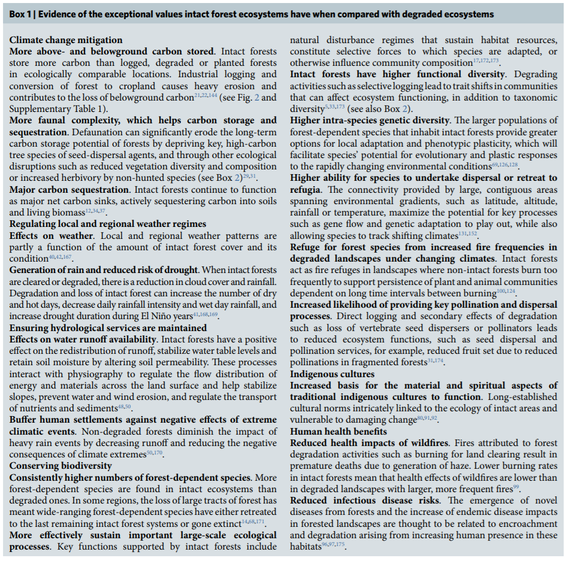
Watson et al (2018).

The NEPA analysis must not blur the distinction between the effect of logging on roaded areas and unroaded areas. The effects of logging unroaded areas are qualitatively different and more significant than logging areas previously affected by roads and logging. The NEPA analysis must clearly disclose the fact that water quality, habitat, scenic values, soil quality, and carbon storage are all better in unroaded areas than roaded areas, and logging will have disproportionately adverse effects on those values.

Allow Natural Processes to Flourish in Unroaded Areas
Unroaded/undeveloped areas are an important feature of the historic range of variability that needs to be restored. Such areas provide high quality water, soil, fish & wildlife habitat, carbon storage, recreation and scenic values, etc. The purpose and need should include restoration of unroaded/undeveloped areas (consistent with the natural range of variability) where natural processes can flourish.

Unroaded areas are rare on the landscape and they are one of the places where human influence has been limited and the ecological building blocks remain in place, so it is reasonably possible to achieve restoration of desired ecological conditions by relying on natural self-correcting mechanisms. Natural processes have operated successfully for millennia to achieve dynamic balance between forest growth and mortality. Within unroaded areas the agency should focus on eliminating unnatural stressors (such as livestock and weeds) while reintroducing natural processes such as fire. There may be an opportunity to manually pre-treat fuels before reintroducing fire, but building miles of new roads and removing significant habitat structures would not be appropriate.

Unroaded areas often have mature forests which are developing and diversifying naturally.
“Mature Seral Stage - This stage typically occurs between ages 81 and 195. Stand diversity is gradually increasing in response to openings in the canopy created by wind-throw, disease, insects, and stand mortality”.

Even when forests in roadless areas seem more uniform than desired, it is not always necessary to mechanically thin forests to increase diversity and complexity. Natural processes can do the job. Spies et al (2002) enumerate a variety of disturbance agents that can help diversify forest stands without logging.
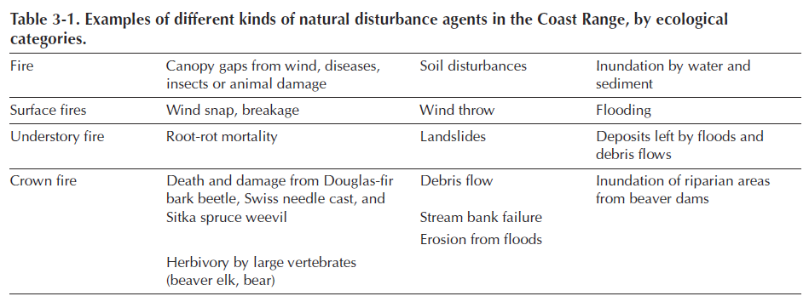

One of the important but under-appreciated values of unroaded areas is the long-term creation and maintenance of dead wood habitat due to the fact that unmanaged areas are where natural processes are allowed to flourish.

Unroaded areas are one of the few places where trees are allowed to fulfill their entire “lifecycle” (including their life-giving role as snags, dead wood, and soil builders) in the forest. Korol et al (2002) found that large snag habitat is below historic range of variability across the Interior Columbia Basin and they estimated that even if the agencies apply enlightened forest management on federal lands in the Interior Columbia Basin for the next 100 years, we will still reach only 75% of the historic large snag abundance, and most of the increase in large snags will occur in roadless and wilderness areas.

Since wilderness and unmanaged areas are the only place that a healthy population of snags is likely to be recruited and maintained over the long term, they represent invaluable and irreplaceable mitigation for all the places where snags are in short supply due to logging, hazard tree removal, and other management efforts designed to control and capture mortality.

The map below shows the strong correlation between snag abundance and unmanaged forest lands such as wilderness and roadless areas.
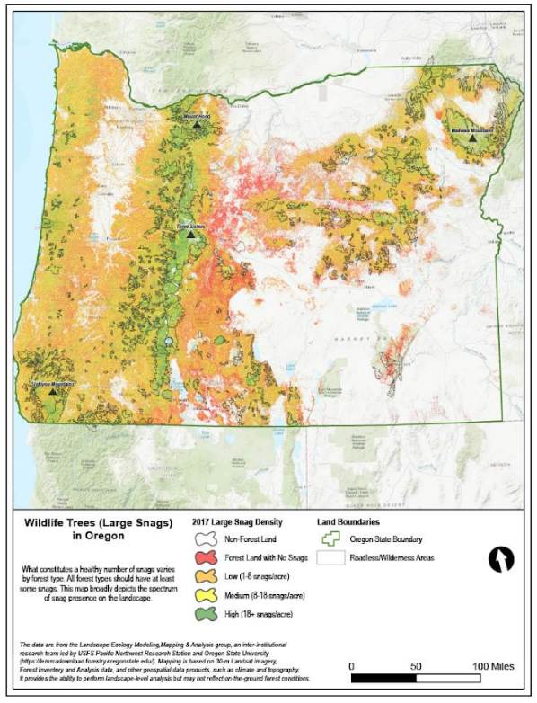

Wisdom et al (2008) found that snag abundance in the Pacific northwest forests is inversely related to past harvest and proximity to roads:
“Our highest snag density … occurred in unharvested stands that had no adjacent roads. … Stands with no history of timber harvest had 3 times the density of snags as stands selectively harvested, and 19 times the density as stands having undergone complete harvest. Stands not adjacent to roads had almost 3 times the density of snags as stands adjacent to roads.”

Low-impact restoration activities, including but not limited to prescribed fire, mowing, non-commercial thinning, and weed removal may be appropriate in roadless/unroaded areas as long as they will be substantially unnoticeable to the casual observer and leave the area suitable for future wilderness designation. The NEPA document should describe the roadless/unroaded area, the undeveloped values present, and the need for, and impacts of, the proposed restoration activities.

Commercial logging prescriptions are typically designed to exert significant control over fire behavior and tree mortality, and similar prescriptions have been and are being applied across quite a large area of our federal forests. By limiting treatments to low-impact, non-commercial activities in undeveloped areas we are still treating them, and still getting benefits in terms of fire and "forest heath," but we are relaxing our control just a bit and letting natural processes play a bigger role in that subset of the landscape.

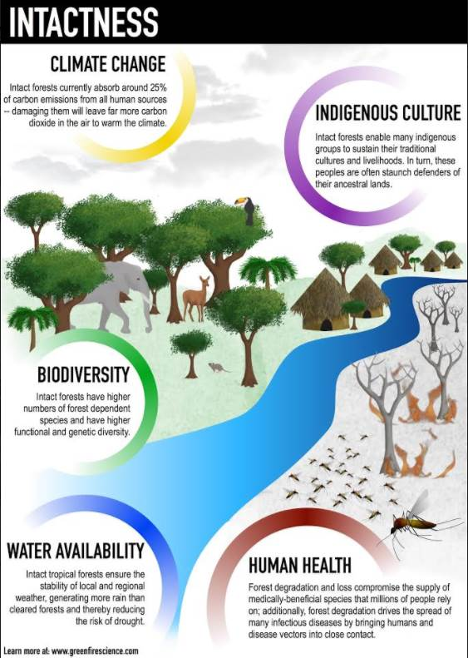
Watson et al 2018.

Economics
The NEPA analysis should include a balanced analysis of the economic costs and benefits of this project (including the social cost of carbon dioxide emissions required by the CEQ), and the analysis should highlight the economic impacts of commercial logging and other restoration actions, such as prescribed fire and non-commercial thinning.

The Forest Service continues to produce economic analysis that are incomplete, full of specious assumptions, and biased towards extractive interests. While incomplete, the list of problems include:
- The agency undervalues non-extractive jobs, and does not give serious consideration to where dollars go. Some activities like prescribed fire, fencing, hand-thinning and road maintenance are likely to support local family-wage jobs. Meanwhile when large companies buy contracts (or even buy them from original local purchasers as occurred in the Lostine), many of the dollars that the agency points to end up in distant communities where industry executives live such as Boise and suburban Portland.
- The agency continues to equate board feet to jobs. In an increasingly mechanized and mature industry, those equivalencies are no longer valid. More board feet to mills does not necessarily mean more jobs, or that those jobs would not be supported from other sources.
- The agency undervalues what are often referred to as ecosystem services like clean water, carbon sequestration, fish, wildlife, and clean air. The agency doesn’t even attempt to quantify other important values such as spiritual, cultural, public health, and lifestyle.
- After decades of taking from our forests and considering them as “natural resources” for us, it is time to reconsider our relationships. Our forests, and “restoration projects” do not need to “pay for themselves”. In fact, after generations of taking, it is time to invest in them. With so much money coming into the agency, the need to offset good restoration work with broad support against more aggressive logging is unnecessary.

/ / /

/ / /

/ / /
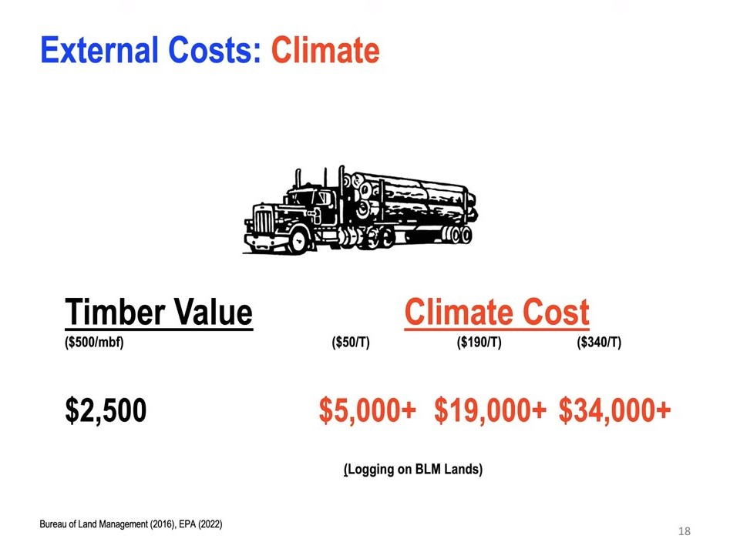
A slide from a public presentation of the Sightline institute demonstrates costs of logging to our climate from logging. Agencies like BLM and the Forest Service tend to quantify and share the timber value of extraction (which tends to benefit a few) while ignoring the climate costs (which are born by the public).
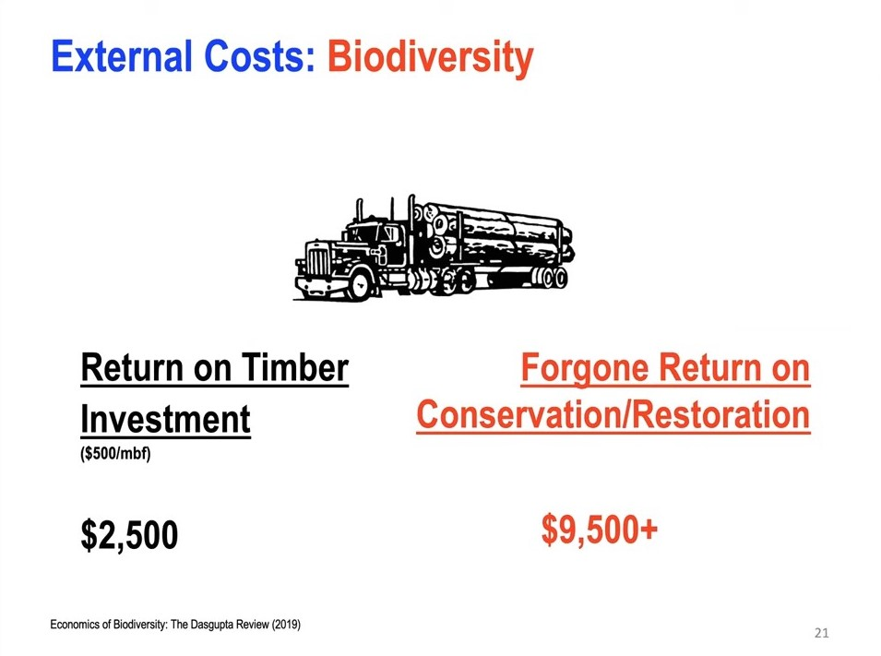
A slide from a public presentation of the Sightline institute demonstrates costs of logging to other conservation values from logging. Agencies like BLM and the Forest Service tend to quantify and share the timber value of extraction while ignoring costs shared by the public.

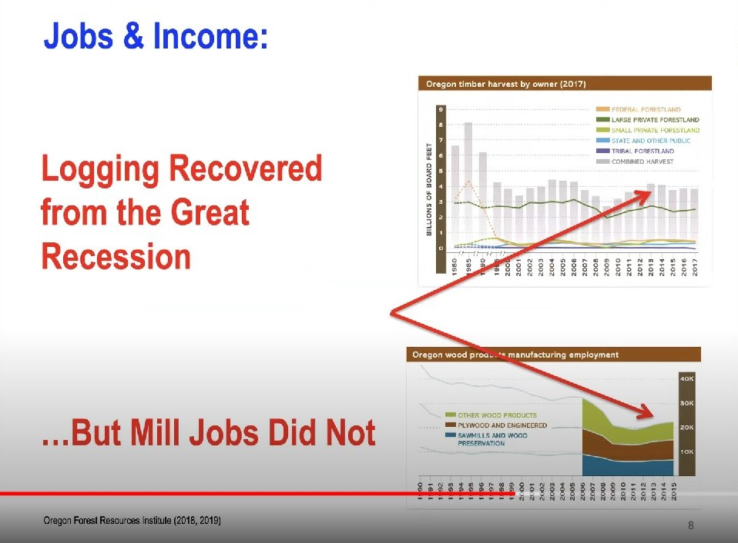
Even as board feet increased in recent years, the number of jobs did not. As shown by OFRI (a quasi-government institute with ties to the logging industry), more board feet to mills does not necessarily mean more jobs as the Forest Service often assumes.

Logging prescriptions

Basal Area Retention
We urge the agency to develop alternatives that retain greater basal area to help mitigate several adverse trade-offs caused by commercial logging, including greenhouse gas emissions, wildlife cover and connectivity, long-term snag recruitment, and slash production and disposal.

Basal Area retention is an important ecological consideration that must be disclosed quantitatively in the NEPA analysis. The NEPA analysis should consider alternative levels of basal area retention that resolve trade-offs in different ways. The NEPA document should disclose how recommended basal area retention levels will provide assurance that enough trees are being retained to meet ecological needs for live and dead trees now and in the future.

Where there are lots of small trees we recommend variable density thinning to 60-80 sq ft/acre basal area, retaining the largest trees that will become the next generation of old growth. Since larger trees have a higher ratio of basal area to leaf area, sites with abundant large trees can sustain higher basal areas, and we recommend retaining 100-140+ sq ft/acre.

Basal area retention should be variable but not be too low in any one unit. Enough trees need to be retained to retain and recruit large and old trees and snags now and in the future. Basal area targets should be adjusted higher to account for the following actors:
- Prescribed basal area retention should be weighted to accommodate relatively greater retention in stands with large trees and desirable clumps of trees that contribute to LOS structural conditions.
- All things being equal, large and old trees are more sustainable and resilient than small trees, so where large and old trees are abundant, the site can sustain higher basal area and the mature and old trees do not need to be thinned.
- Retention patches should be excluded from the basal area calculation. Basal area should not be averaged across the stand, but rather across the treated portion of the stand. We recommended 3-4 clumps per acre of 2-10 individual trees as well as the skips to emulate natural historic stand structures.
- Basal area can be higher in riparian areas, area with higher water table, north slopes, etc...

The agency should avoid reducing stand density lower than is appropriate to meet the full suite of ecological objectives, including wildlife cover, perpetuating mortality processes that create and sustain valuable habitat features, etc. The goals should be to create a wide diversity of niches for different species, including those that thrive in dense, complex, forests with abundant snags and dead wood, instead of thinning to low basal area that tends to create one ideal niche for healthy, vigorous conifer trees.

We are concerned that the agencies’ stocking guides were created and intended to be used as a tool to avoid mortality which is clearly inconsistent with ecosystem management. To justify density reduction, the agency often relies on Powell (1999) which says: “To preclude serious tree mortality from mountain pine beetle, western dwarf mistletoe and perhaps western pine beetle, stand densities should be maintained below the upper limit of the management zone”

Healthy forests require dead trees, sometimes in abundance, in order to meet the needs of diverse wildlife and provide full suite of ecosystem functions.

A comprehensive restoration approach requires focusing not just on live trees, but also on the full suite of ecological processes including density dependent mortality processes that create and recruit snags and dead trees as a valuable feature of eastside forests. We urge the agency not to manage for tree vigor and minimum stocking levels because it will not provide enough green trees for recruitment of snags through time. This is a critical issue given that the current standards for snag habitat are outdated and fail to provide adequate levels of snags and dead wood, and adequate levels of green trees needed to recruit those snags through time.

This graphic from the Microsoft Teams public meeting held Feb 1, 2023 to discuss the draft report of the “2nd Annual Adaptive Management Workgroup: Management Direction for Large Diameter Trees” clearly shows the close association between the abundance of large live trees and large snags. This makes perfect sense because all snags are a product of large live trees. The NEPA analysis must provide an honest and accurate disclosure of the adverse effects of thinning to low basal area through commercial removal of medium and large trees on the future recruitment of large snags.

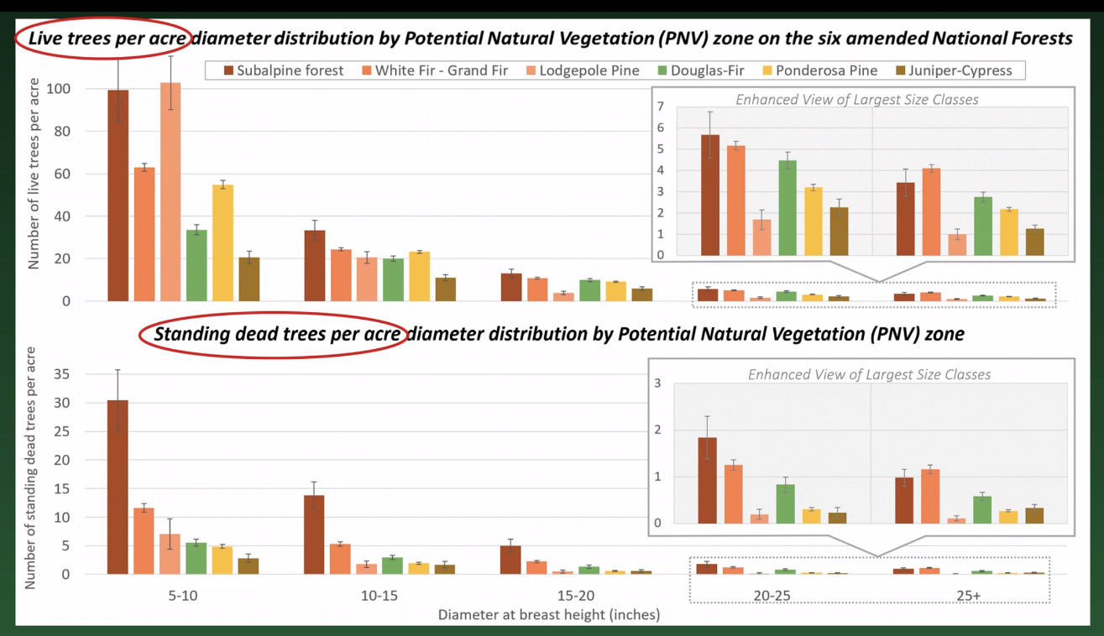

Cutting basal area down to 30-40 ft²/acre is too low. We urge the agency to retain at least 60-120 ft²/acre of basal area. 30-40 ft2/acre might be OK in small patches within units as part of a variable prescription, but the average over a unit must be much higher than that in order to ensure adequate cover for wildlife, and adequate dead wood recruitment through time.
/ / /

/ / /

/ / /

Do not log on steep slopes
Steep slopes logging is destructive and rightly controversial. Tethered logging technology did not exist when the forest plan was approved. The FS should not allow this destructive ground-based logging method without careful review in a plan amendment.

While it has largely been limited due to economic concerns of industry, and, to a lesser extent concerns about soils, the concerns extend far beyond that. Among other things, the limitation of steep slopes logging has created refugia in landscapes that are otherwise heavily manipulated and logged both during and after planned operations.

Where economic concerns may be assuaged by new technologies, any and all subsidies that make such logging more economically feasible should be disclosed. Experimental and expensive new technologies like tethered logging are generating great excitement from industry and those whose values align with industry. However, it is an experimental technology. The agency’s stated desire to experiment with tethered steep slopes logging are demonstrated by the experimental activities taking place in Baker County. Given the value of this landscape, the agency should complete this experiment, conduct a thorough analysis, and get buy-in from the scientific and conservation communities before applying it here.
As seen in the controversial Big Mosquito Project, steep slopes logging equipment (cable, tethered, etc.) is likely to increase the number of large and old trees likely to be cut to create corridors and a sense of safety for loggers. If such systems are put in place, the agency must analyze this eventuality, and provide off-ramps to drop units or adjust treatments so that any laudable project goals are not undermined.
Wildlife don’t just need linear connectivity. Many species also require vertical cover connectivity. That is especially true in this landscape where a small horizontal distance may include a tremendous amount of elevation gain and loss.

Previously Logged vs Unlogged
The FS should develop NEPA alternatives that focus restoration on stands that are degraded by previous logging, especially stands that were clearcut or high graded. This is where the benefits of restoration are most needed and the adverse trade-offs are least likely. The NEPA analysis should also take a hard look at the relative costs, benefits, and trade-offs related to logging of previously logged vs unlogged stands.

There are very few forests left in North America that have not been logged at some point. That is also true in the Wallowa Whitman. However, previous proposals shared with the public have included aggressive industrial logging of forests that have managed to escape chainsaws since time immemorial. These forests provide many values – including as a control to the experiments being done on a massive scale. In 2023, any forests that have never been logged should be off limits logging and thinning – especially commercial logging.
Previously unlogged stands are less likely to need intervention because the stands are more fully occupied by trees and less likely to be invaded by ingrowth. Unlogged stands are also more likely to be harmed by a logging intervention because their soils and watershed functions are more intact. Unlogged stands are also providing important ecosystem services and mitigation for extensive logging elsewhere in the project area, such as watershed functions, snag recruitment, wildlife refugia, carbon storage, etc.

Careful thinning may be appropriate in some unlogged stands to help improve the chances that legacy trees can persist, but such thinning should be done non-commercially to avoid heavy equipment, roads, and adverse trade-offs on large trees, snags, habitat, soil, water, carbon, etc.

Moist vs Dry Forest Types
The FS should develop alternatives that focus fuel reduction and density reduction on dry forests, especially those on south facing slopes. Moist sites can accommodate forest densification and there are many benefits from such processes, including carbon storage, habitat values, natural processes that recruit snags, replacement of large trees, even fire hazard reduction (via microclimate moderation and canopy suppression of surface and ladder fuels), etc.

Large & Old Trees / Eastside Screens
To best achieve goals related to restoration, fire hazard, climate mitigation, wildlife habitat etc. the FS should retain all large trees regardless of age, and all old trees regardless of size.

The FS should retain all large trees (>21” dbh) as required by the only valid version of the Eastside Screens. The proposed “doughnut thins” that contemplate the removal of some large trees around large-old legacy trees might be a commendable attempt at compromise, but the FS should not rely on the illegal Trump Screens Amendment, and the agency is prohibited by the Snow Basin court decision from adopting site-specific plan amendments to address general forest issues.

The FS should use a scientific definition of large trees which is 20” dbh. And the NEPA analysis should clearly disclose the effects of removal of large trees 20-30” dbh under the Trump Screens Amendment, as well as large trees removed for safety and operational purposes. The NEPA analysis should be clear about any proposed removal of large trees, including location, extent, and tree species.

On Earth Day, 2022, President Biden travelled to the Pacific Northwest and issued an Executive Order calling on the USFS and BLM to inventory all mature and old-growth trees and forests as a prelude to more formal protections. Many – including in agency leadership - have interpreted that to mean trees and stands over 80-years old. At a minimum, to comply with potential protections that may be in place at the time of implementation, the Forest Service should develop an alternative that only logs trees and/or stands under 80-years old. Not doing so in projects like Flat Country have created tremendous conflict. The agency can avoid that here by protecting mature & old-growth stands and trees >21” dbh.
In all stands, Oregon Wild’s Tim Lillebo rightly encouraged the agency to protect the largest trees regardless of age, and the oldest trees regardless of size. We encourage the agency to do so here.
In a number of recent instances, the Forest Service has wisely chosen alternatives to projects that do not have to log large trees to accomplish restoration, fuels, and other goals. In the Sno-Basin Project, after courts struck the project down, the Wallowa Whitman found that they were better able to achieve their goals by avoiding the logging of trees over 21”. We encourage the agency to review, and replicate, that analysis. If the agency decides to make different decisions, that warrants a robust explanation of why the circumstances are different here.
Logging is a primary driver of major declines in large live and dead trees alike.
The National Forest Management Act and its implementing regulations require the Forest Service to follow the requirements of the LRMP, as amended. The Eastside Screens adopted in 1994 and 1995 are valid amendments of the LRMP. The Jan 2021 Amendment of the Screens was not adopted pursuant to proper NFMA and NEPA and ESA procedures and so the Forest Service cannot rely on that amendment to authorize the removal of large trees >21” dbh.

The FS should develop an alternative that does not rely on the Trump Screens Amendment, which was improperly developed and approved.

If the Forest Service intends to rely on the Trump administration’s last-minute decision to approve the regional Screens Amendment allowing removal of large trees, we strongly object.

The Trump Screens Amendment is unlawful for a variety of reason, including but not limited to:
- The Screens Amendment was a public involvement nightmare. The FS failed to provide a scoping period and failed to provide an objection period even though one was promised from the beginning. The FS failed to meaningfully respond to public comment. The decision was approved at the last minute by a corrupt, lame duck administration.
- The decision to amend the Screens and allow removal of large numbers of large trees across a large region is likely to have significant effects on the environment and therefore requires preparation of an Environmental Impact Statement.

- The Screens EA violated NEPA in numerous ways, including an inadequate analysis of cumulative effects, failed to take a hard look at effects on carbon and climate, habitat for viable populations of species that depend on large and old trees, dense/unmanaged forest, snags and dead wood, riparian and aquatic habitats, etc.
- The Screens EA failed to consider reasonable alternatives to meet the purpose and need such as retaining old trees regardless of size, and allowing the large-young trees within the dripline of legacy trees to be converted to snags, using prescribed fire to control encroachment of shade-tolerant tree species, and adopting a quantitative, science-based standard for conservation and restoration of large snags and green recruitment trees to meet population goals for snag-associated species.
- The Screens Amendment also adopted a standardless approach to managing snags and green replacement trees, calling for the provision of some snags and green trees to meet the needs of some species, but without any assurances that logging will maintain population viability for the species which are most sensitive to the absence of abundant snags.
- Approval of the Screens amendment violates the procedural and substantive requirements of the NFMA and its implementing regulations.
- The FS failed to consult with NMFS and FWS regarding ESA-listed species.
- There is significant new information that natural mortality processes are self-correcting the species composition, and getting the job done better than logging because natural processes kills the trees that are least fit to survive, and natural processes create and retain snags, and dead wood habitat. In 2022, forest scientists reported a “Firmageddon” event, where true firs such as white fir and grand fir and noble fir were dying across large areas of eastern Oregon, apparently from drought stress.

- The is significant new information indicating that Grand fir may be more fire resistant than assumed in the NEPA analysis supporting the Screens Amendment. "The grand fir forest type had severity values at the same level of forest types dominated by fire-resister species despite grand fir was classified as a fire-avoider species. … In many ponderosa pine forests maintained historically by a high frequency, low-severity fire regime, the transition towards denser forests dominated by Douglas-fir and grand fir would explain why ponderosa pine and Douglas-fir still compose a significant proportion of basal area in the grand fir forest type, and many maintain large, old, fire-resistant ponderosa pine trees. Therefore, the particular structure and composition of these “recent” grand fir forests (e.g., Merschel et al. 2014), with an important presence of large-diameter trees of fire-resistant species, may provide latent fire resistance (Larson et al. 2013)."
We incorporate by reference our scoping comments and comments on the Large Tree Amendment EA and preserve all legal claims related to the issues raised in our NEPA comments.

The Trump Administration’s last minute amendment of the Eastside Screens is now under litigation, by numerous conservation organizations and the Nez Perce Tribe. If the plaintiffs prevail, the Screens amendment will likely be set aside, and the FS will be required to modify projects to retain trees >21” dbh. The Forest Service should avoid the complications associated with post-decisional changes to this project, by adopting a 21” dbh limit for this project while the litigation proceeds.

The current Screens amendment allowing discretion to cut large trees should not be used.
The Trump Administration amended the 21” rule in a politically-motivated, rushed, controversial, and undemocratic process. While the agency pushed back on that characterization, FOIA documents and independent journalism demonstrated that to be the case. It was further laid bare when the decision was signed by a political appointee days before the inauguration of a new president. As a result, the agency failed to follow up on promised public process. Over half a dozen conservation groups and the Nez Perce Tribe have since filed multiple legal challenges. Conflict around the amendment was a key factor in the conservation community withdrawing from the Northern Blues Forest Collaborative and subsequently being excluded by the Forest Service from full participation in other public and quasi-public processes.
The initial Screens protections were scientifically defensible as evidenced by the 1994 full report and summary.
The 21” rule remained scientifically defensible as evidenced by a recent, comprehensive scientific report and the objection to the amendment from 115 independent scientists.
The amendment was opposed by dozens of climate, conservation, indigenous, public health, and other organizations. Tribes also expressed clear opposition along with former USFS leadership.
Even the weakened guidelines require protections for trees over 150 years old. As USFS marking shows, trees under 30” are likely to be well over 150 years old. In other cases, trees as big as 22” were found to be less than 50 years old. As these examples and Van Pelt guidelines make clear, grand fir is an extremely site-sensitive species, and visual characteristics are not good indicators of age.

Given that, the agency must find other ways of verifying tree age before tree rings can be counted on stumps. Given the agency stating an intent to only cut a limited number of these trees, it is not an onerous burden to request that large trees be cored before marking. Further, there has been support in the agency for protections of trees over 80 years old, and by the time implementation of this project occurs, such protections may be enshrined in administrative rules flowing from the 2022 Earth Day Executive Order. Trees over 21” are very likely to be well above this threshold (see photo).

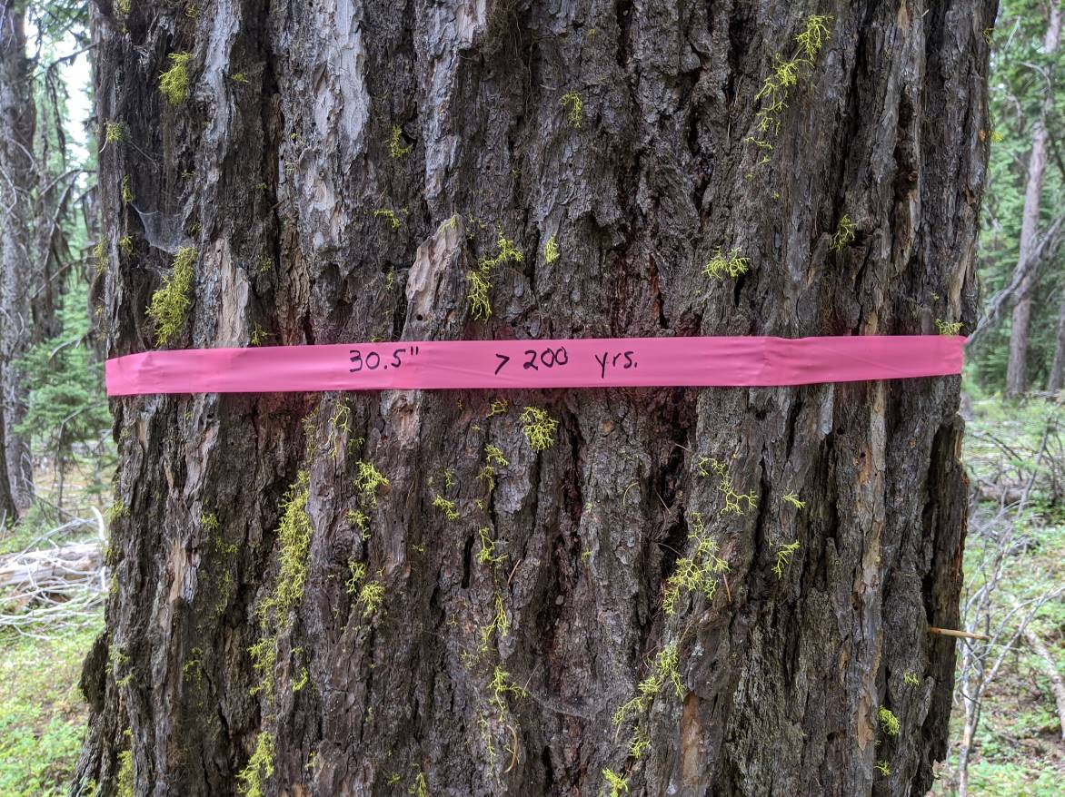
Marking and aging of a grand fir in the Morgan Nesbit Project Area.

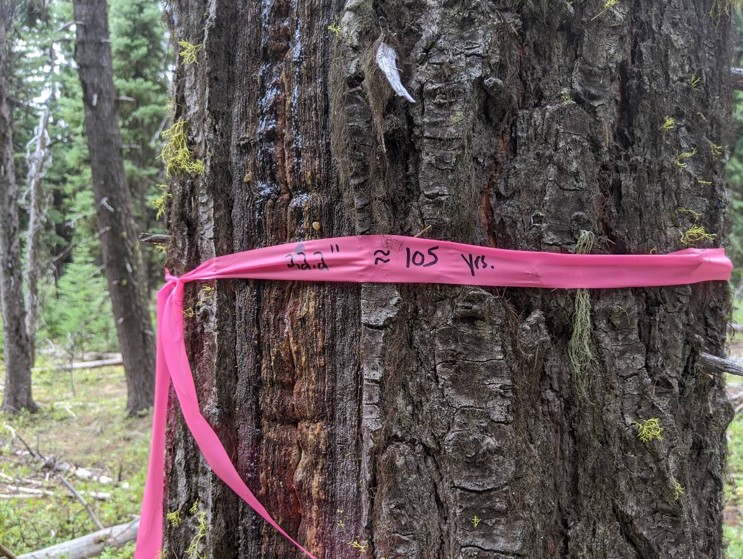
Marking and aging of a grand fir in the Morgan Nesbit Project area.

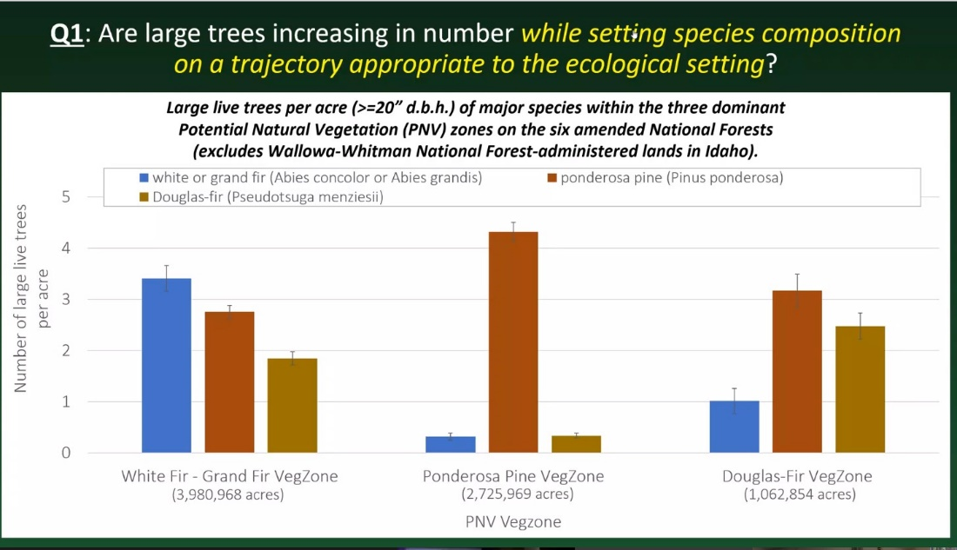
In its own analysis, the Forest Service showed that grand fir are not overrepresented in forests where they do not “belong”. While there may be a coherent argument for trying to reduce grand fir numbers and densities, it should be the exception, not the rule.
Previous marking shown on a public field trip made clear that the agency did not understand its new discretion by marking large old growth Douglas-fir in demonstration marks.
Over the last several years, this, and other National Forests in Eastern Oregon, have considered and rejected logging of large trees. In several cases, including the judicially required re-working of the Snow-Basin Project, the agency was able to better meet its goals by not cutting these large trees. The agency should look at those decisions and either make similar decisions or explain what is different here.

For these and many other reasons, including legal uncertainty and the fact that even the Trump amendment still favors retention of large and old tress, the Forest Service should, at a minimum analyze an alternative that does not include large tree logging.
As we saw in the ongoing Lower Joseph Project, thinning around legacy trees in hopes of helping them can lead to their death. In that project, after losing the protection of the dense forest around them, centuries old trees fell down in the next windstorm (see below). Conservationists and tribes raised that issue during project development and were summarily dismissed. Based on this occurring just a few miles away, the agency must consider this very likely outcome.
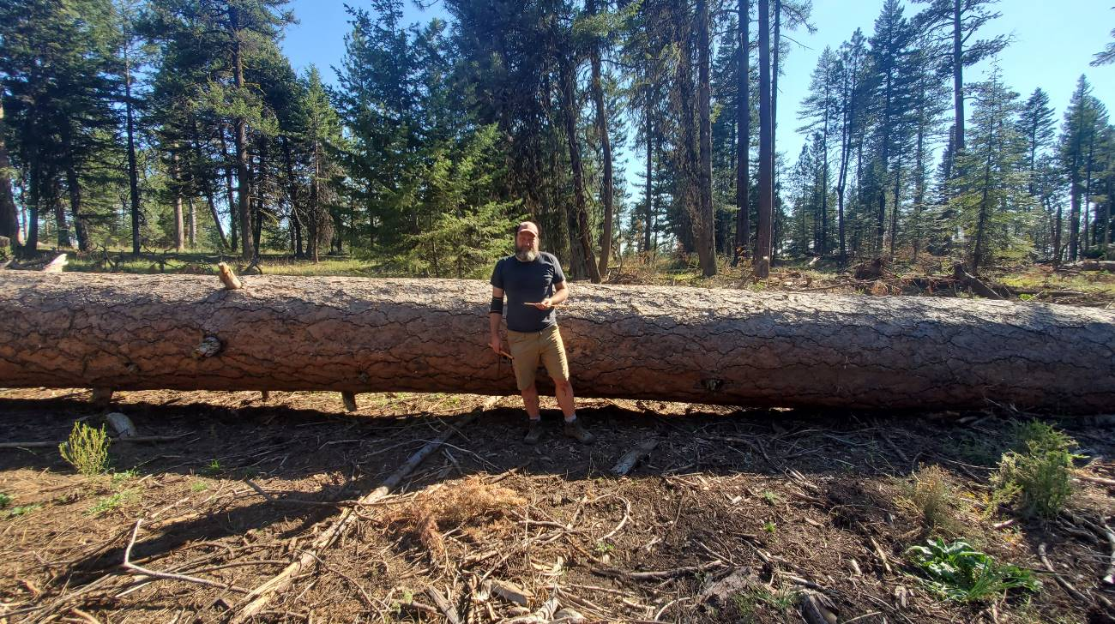

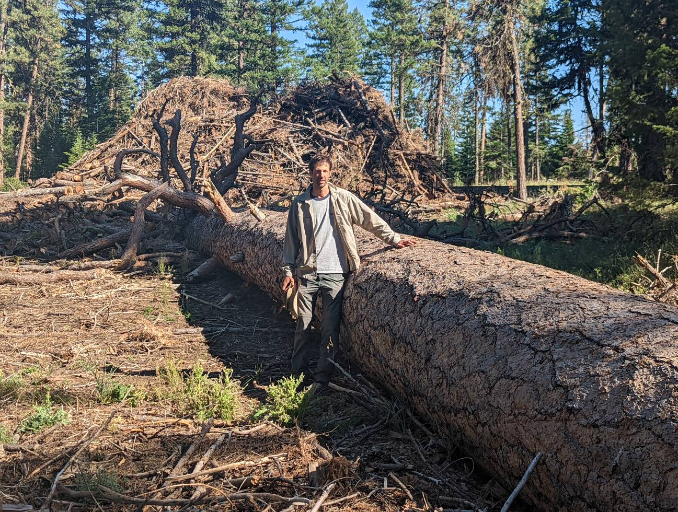

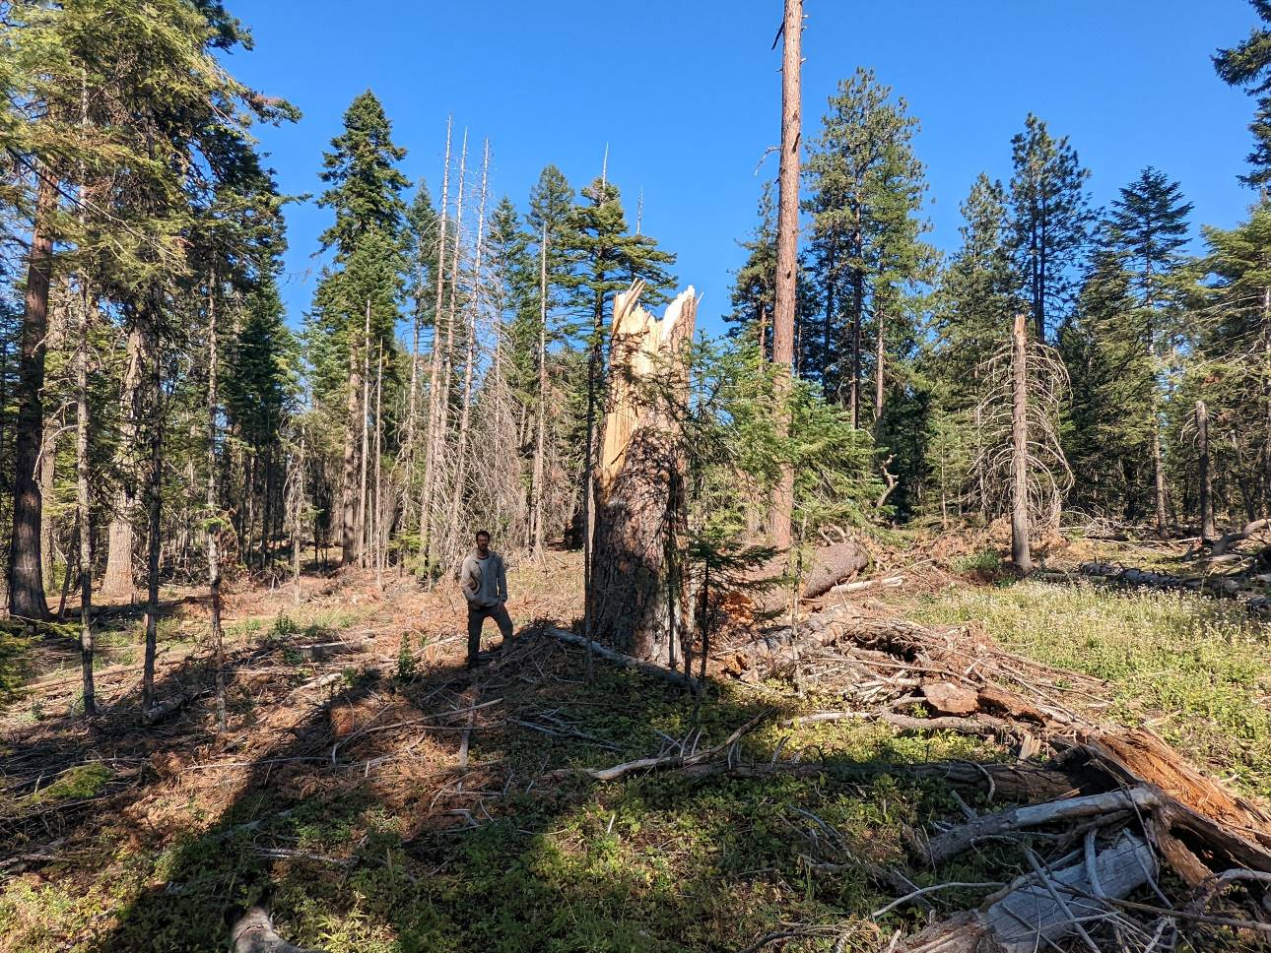

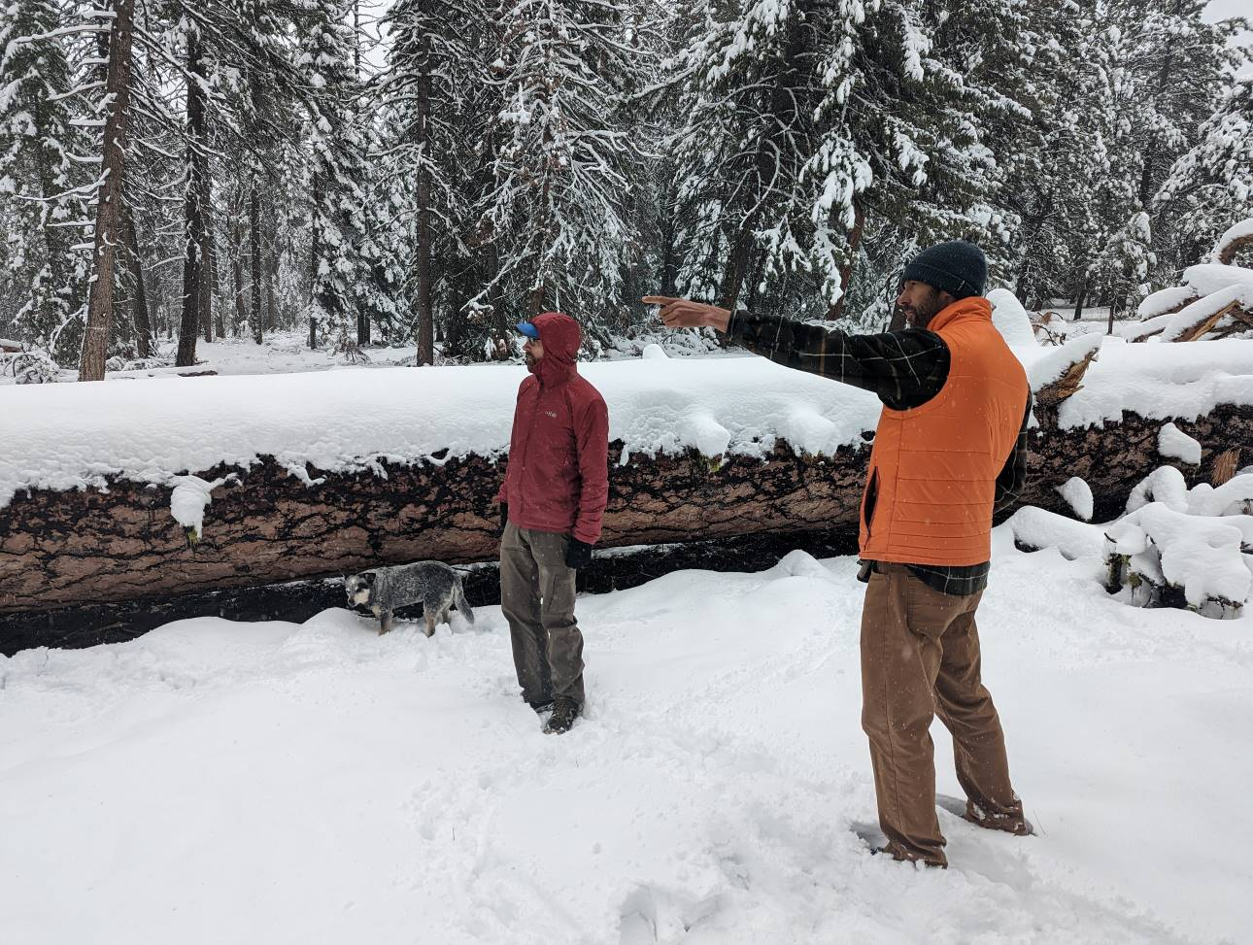

/ / /

/ / /

/ / /
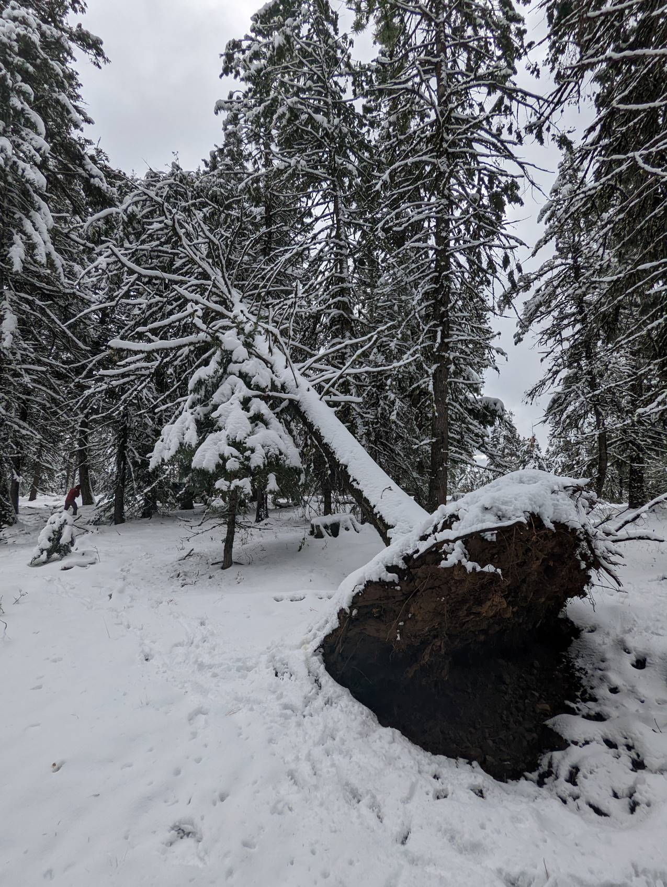
If the agency insists upon logging large trees, this is another area where it is critical that the agency honor its verbal promises. Relatively careful, site-specific logging of large trees can not be accomplished if marking is done by contractors. In fact, we’d encourage the agency to learn from the Puderbaugh objection resolution and allow members of the public to participate in the process. Marking procedures for any large tree logging should be done by agency staff in a collaborative manner, and explicitly explained in the EA (EIS, really).
The NEPA should disclose how many trees over 21” are there in proposed harvest units and disclose how many may be removed versus retained.

Regen Logging: Patch Cuts and Shelterwood
Despite previous public assurances that patch cuts would be limited to 2-acres, proposed patch cutting will now allow clearcuts up to 5 acres. This will have significant effects much worse than thinning (or no action/ conservation) in terms of: habitat destruction and fragmentation, soil erosion, soil compaction, degraded soil foodweb, degraded water quality, future snag recruitment, edge effects including blowdown, rain-on-snow effects including peak flows/low flows, degraded scenic values, release of sequestered carbon pools, lost wilderness potential, and increased fire hazard. The NEPA analysis must make these distinctions crystal clear to the public and the decision maker.

Regen based on forest health reasons is outdated. From an ecosystem perspective, patches of unhealthy trees are make perfectly healthy forest habitat for diverse species that thrive with abundant dead wood, and diverse non-conifer vegetation that thrives in openings.

The Eastside Screens require managing toward Late Old Structure (LOS) conditions. Both shelterwood and patch cuts remove valuable components of LOS (medium and large trees and snags) which moves the stand move away from (not toward) LOS conditions.

Since this project is justified in part of fuel and fire concerns. Regen logging makes little sense because openings stimulate dense conifer reprod which represents a very hazardous fuel condition. Stone et al (2008) reviewed the conditions before and after the 2003 Cooney Ridge fire in Montana and found that ...
Much more private land burned severely compared to public land [See Figures 3 and 4 below]. Heavily logged areas and tree plantations have been known to burn more extensively than intact forests (Brown 2002). Much of the private land within the fire perimeter had been recently heavily logged for timber extraction, not for the purpose of fire hazard reduction. ... Private lands in this area were recently harvested with large clear cuts.... A much lower proportion of the public land had been recently harvested.

/ / /

/ / /

/ / /
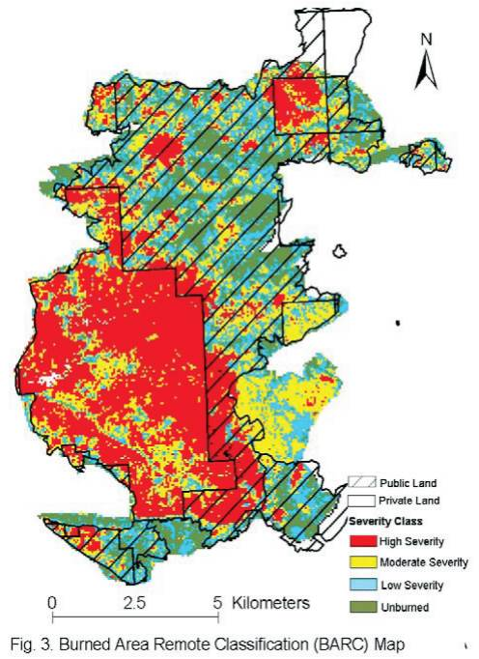

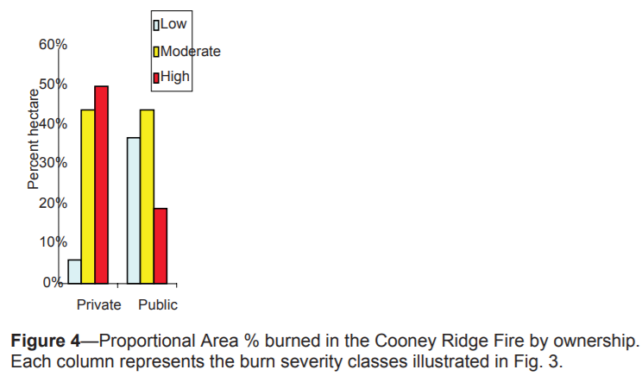

More research is needed to understand the relationship between ownership
practices and severity. At the Cooney Ridge fire, patches of unburned vegetation and low severity remained after the fire, while much more of the private land burned uniformly with high severity. These results indicate that more diversified public lands management helped produce a much more diverse fire mosaic, thus better protecting this forested landscape. By comparison most private forested land burned with moderate to high severity, under likely similar weather conditions as on the public land. Our results show that, perhaps counter intuitively, heavy harvest can increase subsequent fire severity.

Judge Clarke said about the Lower Grave timber sale:
BLM's proposed regeneration harvest would leave only 6-8 trees per acre and would, in the short-term, increase fire hazard. AR 2697 ("As the stand develops it would represent a shrub fuel model with an increased fire behavior potential as vegetation occupies the site.")

See also, Steel et al (2022):
Areas with high initial canopy cover and without tall trees were most vulnerable to canopy cover declines [due to wildfire] … The effect of large tree height on relative canopy cover decline was negative … indicating the presence of large, tall trees had a moderating effect on disturbance. …

And Bigelow & North (2012):
Group-selection openings [0.7–0.8 ha, 12% canopy cover, Sierra mixed-conifer] … greatly increased wind speeds and higher surface temperatures mean that they are at risk for more severe fire behavior. This should be of particular concern when group selection openings are embedded within fuels-reduction thinned stands that form part of a network for rapid access by fire-fighting personnel.

Aspen Enhancement
The agency should develop NEPA alternatives that harmonize aspen restoration with restoration of large and old conifer habitat and meadow/riparian habitat, as appropriate.

Do not sacrifice large and old conifers in the name of aspen restoration. Recognize that old growth conifers and aspen are often found co-existing together. Killing small conifers and leaving the large conifers mixed in with the aspen is fine. It will benefit aspen while retaining valuable large conifer habitat (and future large snag habitat) as well. If a compelling case can be made for limited large conifer removal, those trees should be left as snags or down habitat.

Please emphasize non-commercial treatments where possible. This will enhance ecological outcomes by the significant ecological trade-offs associated with roads and skid trails. Retaining conifers also enhances dead wood habitat, and provides material for jackstraw barriers that help deter grazers and browsers.

Consider felling conifers in a jackstraw fashion around the perimeter to protect emerging young aspen and avoid building fences that may not be properly maintained over time. Consider retaining some small conifers for future use as “replacement jackstraw.”

Always try to factor livestock into the equation. Protect aspen by reducing or eliminating livestock that over-indulge in aspen.

Minimize use of heavy equipment in and around aspen and the moist soils they thrive in.

If the agency is conservative and follows this advice, it will alleviate concerns about treating beyond large buffers around aspen trees/stands. If the agency gets too aggressive about removal of large conifers or removing conifers far from valuable aspen stands, then we will need ask for more tight/conservative answers to questions like "what is an aspen stand?" and "how far out from the aspen tree can we treat?"

Evidence indicates that aspen benefits from fire, especially high severity fire, more than it benefits from logging, so if the goal is to enhance aspen, the agency should adjust fire policies accordingly.

Carbon and Climate

Climate change is real. It is happening now. And it is primarily driven by human activity. It is accompanied and intertwined with a biodiversity crisis as well as social unrest. The Forest Service, industry, and logging collaboratives selectively agree to parts of this and acknowledge that our forests will be affected by some of these factors. However, it is important to note that our forests can contribute to them in positive and negative ways as well. Projects like Morgan Nesbit make climate change worse. Proforestation helps the climate, biodiversity, and social crises we face.
Scientists have made clear that we must radically change course if we wish to avert the worst outcomes, and that we can’t afford any missteps. No amount of superlative language is too much. Over 15,000 scientists from over 180 countries reminded us of this in their “Warning to Humanity: A Second Notice”. Following a 1992 statement that “a great change in our stewardship of the Earth and the life on it is required, if vast human misery is to be avoided”, they said “humanity has failed to make sufficient progress in generally solving these foreseen environmental challenges, and alarmingly, most of them are getting far worse”. This project is not insignificant. On several fronts, it decidedly moves us in the wrong direction.

Researchers have warned that even if well intentioned, an over-reliance on climate change mitigation and adaptation over addressing the root causes of climate change (which is to say treating for the symptoms rather than cause) is leading to a “doom loop” that undermines humanity’s capacity to tackle the crisis.

The Purpose and Need Should Address Climate Protection and The Unmet Need for Carbon Storage
The Forest Service cannot meet its legal or moral obligations unless it works to reduce climate change. Those legal obligation emanate from the Forest Service Organic Act, the National Forest Management Act, Multiple-Use Sustained-Yield Act, and the applicable Land and Resources Management Plan.

“Public forest reservations are established to protect and improve the forests for the purpose of securing a permanent supply of timber for the people and insuring conditions favorable to continuous water flow.”

Climate change is expected to disrupt forest ecosystems and hydrologic systems to an extent that threatens to violate the agency’s foundational Organic Act. The Forest Service should make every effort to reduce GHG emissions that exacerbate global climate change.
The agency is required by law to faithfully implement its Resource Management Plan. Meeting resource management objectives set forth in the RMP requires properly functioning ecosystems with biophysical conditions and disturbance regimes within the historic range of variability.
Global climate change is a clear and present threat to forest ecosystems and watersheds and is preventing the agency from meeting the goals and standards & guidelines described in the applicable Resource Management Plan, and other core legal requirements for management of federal lands. The agency cannot meet the RMP without bringing climate change under control, which requires reducing emissions, including emissions from logging. The agency cannot say that carbon storage is outside the scope of this project or not part of the purpose and need. The agency must include carbon storage as part of the purpose and need for this project.
The agency typically says one of the purposes of this project is to provide a supply of wood products to the public. The agency should reconsider timber targets in light of the fact that the public needs carbon storage to reduce global climate change much more than they need wood products. The NEPA analysis also needs to account for the fact that managing forests for water quality, water quantity, quality of life, and carbon storage for a stable climate will contribute far more to community stability than propping up the timber boom-bust industry with subsidized logging.

The agency must recognize that wood products are already underpriced and over-supplied due to “externalities” (costs that are not included in the price of wood, so those costs are shifted from wood product producers and consumers to the general public who suffer the consequences of climate change without compensation from those who profit from logging related externalities). Ecosystem carbon storage on the other hand is under-supplied because there is not a functioning market for carbon storage and climate services. The agency is in a position to address these market imperfections by focusing on unmet demand for carbon storage instead of offering wood products that are already oversupplied.

Sim et al (2019) said:
Land protection, both public and private, provides substantial ecological benefits by avoiding conversion of natural systems to intensive, developed uses. These benefits include carbon sequestration, watershed functioning, soil conservation, and the preservation of diverse habitat types (e.g., Daily 1997, Brauman et al. 2007, Kumar 2012, Watson et al. 2014). Land protection also solves a key market failure: private markets tend to underprovide socially beneficial land uses such as natural forests, agricultural lands, or managed timberlands. The reason for this failure is that many of the benefits of these lands go to the public in general, not individual landowners. When private values and market transactions determine land uses, less land will be devoted to socially beneficial uses than if citizens could collectively determine use on the basis of social values (e.g., Angelsen 2010, Tietenberg and Lewis 2016).

Maintaining and increasing carbon storage in ecosystems on public lands is also required to meet LRMP desired future conditions and standards & guidelines.

Carbon emissions from logging and other land management activities exacerbate global climate change and drive ecosystem changes that diverge from desired future conditions, such as uncharacteristic drought, fire, insect outbreaks, vegetation and wildlife mortality, species range shifts, low summer stream flows, unfavorable stream temperatures, extreme precipitation and peak flows and erosion, uncertainty related to vegetation recovery post-disturbance, uncertainty about the ability to provide a predictable, sustainable supply of forest products, etc.

The agency should identify a purpose and need that recognizes the necessity of avoiding carbon emissions from logging and optimizing carbon storage to fulfill the promises in the LRMP.

Harmonize climate change mitigation and adaptation
The NEPA analysis should develop alternatives that harmonize the competing objectives of climate change mitigation and adaptation. The effects analysis should explicitly account for the trade-offs of logging, e.g., increased GHG emissions that exacerbate climate stresses.

The Biden Administration has adopted a policy to both mitigate AND prepare for global climate change:
“It is, therefore, the policy of [the Biden] Administration to listen to the science; to improve public health and protect our environment; to ensure access to clean air and water; … to reduce greenhouse gas emissions; to bolster resilience to the impacts of climate change; … To that end, this order directs all executive departments and agencies (agencies) to immediately review and, as appropriate and consistent with applicable law, take action to address the promulgation of Federal regulations and other actions during the last 4 years that conflict with these important national objectives, and to immediately commence work to confront the climate crisis.”

This requires careful balancing of sometimes competing objectives, such as retaining trees to store carbon, and thinning to reduce climate stresses. The best harmony among these objectives is to retain medium and large trees that store the most carbon and provide the greatest ecosystem services, while thinning small trees removal of which will reduce climate stresses on the larger trees while emitting less carbon.

Stein et al (2014) make the distinction between climate change mitigation and adaptation and the potential conflict between the two:
Climate change adaptation is the discipline that focuses on addressing these impacts. In contrast, climate change mitigation addresses the underlying causes of climate change, through a focus on reductions in greenhouse gas concentrations in the atmosphere. Confronting the climate crisis requires that we both address the underlying causes of climate change and simultaneously prepare for and adapt to current and future impacts. Accordingly, adaptation and mitigation must be viewed as essential complements, rather than as alternative approaches. Because greenhouse gas emissions and concentrations will dictate the type and magnitude of impacts to which we will need to adapt, the ability to successfully accomplish adaptation over the long term will be linked to the success of climate mitigation efforts (Warren et al. 2013).
…
Climate-smart conservation strategies must also take climate mitigation considerations into account. Although adaptation is about addressing the impacts of rapid climate change, adaptation actions should not aggravate the underlying problem of global warming. Indeed, minimizing the carbon footprint of adaptation actions can help society avoid the “worst-case” scenarios for climate change, which would make successful adaptation in human and natural systems difficult, if not impossible, to achieve. Ideally, adaptation efforts should contribute to meeting climate mitigation goals both by minimizing or reducing the greenhouse gas emissions from project operations, including from any construction and ongoing maintenance, as well as by managing natural systems in ways that sustain or enhance their ability to cycle, sequester, and store carbon.
…
Some of the most obvious synergies between adaptation and mitigation are those aimed at enhancing carbon stocks in natural forests, … Strategies for increasing the capture and storage of forest carbon include: avoiding deforestation; afforestation (i.e., establishment of trees in areas have not been forests or where forests have not been present for some time); decreasing forest harvest; and increasing forest growth (McKinley et al. 2011). Managing natural systems to provide carbon benefits must be carefully balanced, however, with other conservation and adaptation goals. … Recent research, however, indicates that old trees “do not act simply as senescent carbon reservoirs” but actively fix larger amounts of carbon than smaller trees (Stephensen et al. 2014). This recognition highlights the important role that biodiversity-rich old-growth forests can play in sequestering carbon.
…
It is not always obvious, however, when conservation and climate mitigation efforts might be in alignment or in conflict. … Although there are clear synergies between adaptation and mitigation focused activities, managers will also need to carefully consider any trade-offs.

Sometimes climate change mitigation and adaptation are in complete harmony, such as protecting riparian forests that both store carbon and buffer streams from hydrological extremes caused by climate change.

However, there are also times when efforts directed at climate change adaptation conflict with climate change mitigation goals. For instance, some people argue that we should reduce the density of federal forests so they are more resilient to soil-water stress caused by global warming. However, forest density reduction will accelerate the transfer of carbon from the forest to the atmosphere where it will contribute to global climate change.

Federal agencies must strive to harmonize climate change mitigation (carbon storage or avoided emissions) and climate change adaptation (making ecosystems more resilient to climate change). For example, if the agency uses climate change adaptation as a rationale for forest thinning, they must not only fully disclose the increased GHG emissions caused by their proposal, they must also consider alternatives that harmonize these competing goals, such as by thinning very lightly and retaining all of the medium and large trees that store most of the carbon.

There may be climate benefits from thinning but there will also be climate trade-offs in the form of carbon emissions, unless thinning is done very early in stand development. Schaedel et al (2017) said --
Thinning in second growth forests is often suggested as a climate change adaptation strategy (Bradford and D’Amato, 2012; Churchill et al., 2013), because thinning can be used to promote the development of complex stand structures resilient to disturbances and drought. However, these climate change adaptation outcomes attainable with thinning generally require a tradeoff with climate change mitigation objectives: most studies have shown decreased forest C storage in thinned stands (Bradford and D’Amato, 2012).
...
We found that: (1) fifty-four years after PCT total aboveground C is similar across treatments, due primarily to the increase in mean tree C of trees grown at lower stand densities; (2) deadwood legacies from the pre-disturbance forest still play an important role in long-term C storage 62 years after current stand initiation, accounting for approximately 20–25% of aboveground C stores; and (3) given enough time since early thinning, there is no trade-off between managing stands to promote individual tree growth and development of understory vegetation, and maximizing stand level accumulation of aboveground C over the long term. We infer that early PCT can be used to simultaneously achieve climate change mitigation and adaptation objectives, provided treatments are implemented early in stand development before canopy closure and the onset of intense intertree competition.

This is important because, even if thinning provides climate benefits in future decades, short-term carbon emissions conflict with climate policy priorities. The next few decades are critical to achieving goals related to decarbonizing our economy. Delayed climate benefits should be strongly discounted because we should have decarbonized our economy by then, so future effects are not nearly as important as near-term effects. If thinning causes a short-term pulse of GHG emissions, that’s a problem.

The Oregon Global Warming Commission’s Roadmap to 2020 (https://www.keeporegoncool.org/roadmap-to-2020/) guides the state’s efforts to meet its legislatively mandated GHG emissions reduction goals, including broad objectives for increasing carbon storage in Oregon forests.
The Roadmap also set out general strategies for dry forests east of the Cascade Mountains versus moist west of the Cascades. Based on improved understanding of the carbon storage capacity of the state’s forests, the 2017 Global Warming Commission Report explained that, “The Roadmap sees ‘Eastside forests . . . managed primarily for ecosystem restoration, safety and climate adaptation with a minimum of incurred carbon (loss). West-side forests (are) managed . . . to increase carbon storage . . . private forestlands (are) managed primarily for production of timber and wood products . . . ’ with carbon stores remaining stable or increasing”.
Following this strategy will require the agencies to retain all medium and large trees that store carbon and that do not pose a substantial fire hazard.

The agencies often claim that density reduction treatments are expected to increase the resiliency of treated stands to the projected effects of climate change. But this small increase in resiliency comes at a tremendous cost. The NEPA analysis needs to disclose and consider the fact that logging will result in greenhouse gas emissions that make climate change worse. Think about that trade-off. Logging might make a small area more resilient to climate change while making climate conditions (and ocean acidification) worse for ecosystems all over the rest of the world. This significant trade-off needs to be carefully evaluated in the NEPA document.

There is evidence that tree mortality is controlled more by low humidity than soil water availability, so thinning to increase soil water availability and drought resilience won’t do much good. This undercuts the idea that logging is useful to increase forest resilience and adaptation to climate change. Such logging just emits a lot of carbon and exacerbates climate change without actually increasing forests resilience. This is a highly unfavorable trade-off.

Even well-intentioned logging also has impacts that make ecosystems less resilient to climate change. For instance, (i) roads and soil degradation make watershed less resilient to the expected effects of the amplified hydrologic cycle; (ii) reduction of complex forest structure and dense forest conditions makes certain species populations less resilient to climate change, including species associated with relatively dense forests and species associated with snags and dead wood. These species are already stressed by the cumulative effects of non-federal land management and fragmentation caused by past and ongoing management on federal lands; (iii) Also, “High overstory density can be resilient” when ladder fuel are absent and there is a gap between surface and canopy fuels.

New information indicates that El Ninos will likely become stronger even if we are able to limited warming to 1.5 degrees C. A bet-hedging strategy should retain trees of all sizes and stands of various densities. “Removal of most small trees to reduce wildfire risk may compromise the bet-hedging resilience, provided by small trees and diverse tree sizes and species, against a broad array of unpredictable future disturbances.”

When all these trade-offs are considered, we feel that climate change mitigation should receive emphasis over climate adaptation on federal land management (especially when adaptation efforts come with significant trade-offs). When climate change mitigation and adaptation may be in conflict, the agency needs to focus on reducing GHG emissions (or maintaining carbon stores). These mitigation actions are more important because (i) mitigation is shown to be more challenging (institutionally) and it is perennially under-achieved, (ii) mitigation has global benefits, and (iii) mitigation ultimately reduces the need for adaptation. An emphasis on mitigation is in accord with international law, e.g. the European Convention on Human Rights:
The court emphasises that the [State’s duty of care] first and foremost should concern mitigation measures, as adaptation measures will only allow the State to protect its citizens from the consequences of climate change to a limited level. If the current greenhouse gas emissions continue in the same manner, global warming will take such a form that the costs of adaptation will become disproportionately high. Adaptation measures will therefore not be sufficient to protect citizens against the aforementioned consequences in the long term. The only effective remedy against hazardous climate change is to reduce the emission of greenhouse gases.

Stenzel et al (2021) highlighted the complex nature of the trade-offs between climate adaptation (density reduction/drought tolerance) and climate mitigation (maintaining carbon storage/reducing carbon emissions) in the context of thinning:
Carbon balance tradeoffs between reduced biomass density and increased forest resilience to disturbance are uncertain in large part due to the uncertainty of future natural disturbances occurring in treated areas. Our simulated mass mortality scenarios indicated that 2050 thinning emissions approximately equaled the 2050 emissions from stand mortality events greater than 75% and occurring after 2035. In these experiments, the gradual decomposition of large pools of killed biomass remaining on site highlighted that the emissions consequences of near-term natural disturbances will in part be realized beyond current GHG reduction timelines (e.g., 2035 or 2050, IPCC, 2018). Thus, when managing for forest carbon storage, the timing and magnitude of potential carbon gains or losses, which may be offset in time from disturbance events, must be considered. In our simulations, the near-parity in carbon emissions from thinning and high natural disturbance late in the simulation period occurred at the stand level. However, at the landscape level, the encounter rates between treatments and disturbance are typically low (J. L. Campbell et al., 2012). Greater areas of forest must therefore be treated than will encounter a disturbance, in turn increasing any carbon cost to benefit ratio estimated at the stand scale.

Due to the infeasibility of landscape level treatment experiments, landscape level predictions of disturbance impacts are generally simulated with earth systems models (Buotte, Levis, et al., 2020), which remain limited in their ability to represent stochastic disturbance such as wildfire
The agency needs to take a hard look at these trade-offs and develop alternatives that harmonize divergent climate goals in light of the evidence for (and against) benefits on both sides of the adaptation/mitigation ledger. Janowiak et al (2017) say:
CARBON AS ONE OF MANY MANAGEMENT OBJECTIVES
Management objectives dictate the decisions land managers make. These objectives vary widely based on the landowner as well as the conditions of the ecosystem in question, and objectives may include any number of desired ecosystem benefits: water protection, wood production, wildlife, specific recreational opportunities, aesthetics, privacy, and more. Greenhouse gas mitigation is thus part of a wider array of management aims for forests and grasslands. Managers may choose to incorporate greenhouse gas mitigation as a management objective for a number of reasons, including increasing forest productivity or deriving benefits from participating in carbon markets. However, focusing solely on carbon could lead to non-optimal management decisions, and, in some situations, managing for carbon benefits may be at odds with other goals.

The tradeoffs inherent in balancing multiple management goals necessitate the recognition that it may not be possible to meet all goals, including those for carbon, in a single stand or at a single point in time (Ryan et al. 2010). Consideration of the effects of management actions on carbon require thinking broadly across large spatial scales and long timeframes to determine the true effects on atmospheric greenhouse gases (Harmon 2001).

Do not rely on flawed boilerplate climate analyses
As explained below, the Forest Service’s standardized NEPA language handed down from the regional office regarding carbon and climate change fails to take a hard look that NEPA requires. The analysis makes several highly misleading statements about managing forests for carbon storage, climate resilience, and the effects on climate change. The analysis inappropriately mischaracterizes the role of individual logging projects in the cumulative problem of global GHG emissions. The analysis misstates the effects of logging related carbon emissions that are not related to “deforestation.” The analysis grossly misstates the climate effects of logging intended to reduce disturbance. The analysis misleadingly implies that logging benefits the climate by increasing forest productivity.

The NEPA analysis should consider the adverse climate consequences of GHG emissions caused directly and indirectly by logging. The NEPA analysis should estimate the quantity of GHG emitted by logging and associated activities throughout the wood products supply chain, and describe the contribution of this project to cumulative impacts of excess GHG in the atmosphere. The NEPA analysis should use a proxy such as the social cost of carbon dioxide emissions to describe effects.

The Forest Service should not rely on the boilerplate NEPA language from the regional office which is flawed in many ways. Instead the Forest Service:
- Must recognize the cumulative nature of the GHG emissions and climate problems. It does not matter that this project is small in the global scheme because all emissions matter when the causation (and effects) of climate change are global and cumulative;
- Cannot credibly assert that this project is harmless because it’s not causing deforestation. This is immaterial. All GHG emissions, regardless of the source or how it is labelled, are part of the problem and cause the same climate impacts.
- Cannot credibly assert that thinning for forest health justifies or mitigates emissions from logging. Logging does not increase the capacity for growing trees. To the contrary, logging harms soil and reduces site productivity. Storing carbon in wood products is not preferable to storing carbon in forests. Evidence shows that forests are a more secure way of storing carbon. If this forest is not logged, or if more green tree are retained in situ, the agency cannot conclude that natural mortality will be greater than logging mortality. In fact, it is quite easy to predict that logging causes significantly more mortality than natural processes.
- Must not compare carbon before and after logging. That is an improper framework for NEPA analysis. The proper NEPA framework is to compare the effects of different alternatives (over time), so the agency must describe the carbon emissions and carbon storage in the forest over time with logging and without logging.
- Logging to reduce fire effects does not result in a net increase in forest carbon storage. The agency cannot predict the location, timing, or severity of future wildfires, so most fuel treatments will cause carbon emissions without any offsetting benefits from modified fire behavior. Studies clearly show that the total carbon emissions from logging (plus unavoidable wildfire) are greater than carbon emissions from wildfire alone.
- Cannot credibly assert that carbon storage in wood products is a useful climate strategy. Logging kills trees, stops photosynthesis, and initiates decay and combustion, with the end result being a significant transfer of carbon from the forest to the atmosphere. In stark contrast, an unlogged forest continues to grow and transfer more carbon from the atmosphere to the forest. Carbon emissions caused by logging far exceed the small fraction of carbon transferred to wood products. Carbon accounting methods that attempt to account for substitution of wood for other high-carbon building materials are fraught with uncertainty and too often represent maximum potential substitution effects rather than lower realistic estimates.
The FS website links to a 2009 document explaining how to incorporate “Climate Change Considerations in Project Level NEPA Analysis.” Since then, even though the climate crisis has only become more apparent, the agency has regressed to a misleading and incomplete non-quantitative analysis of how carbon emissions from logging contribute to global climate change. The Forest Service should now be following the latest 2023 CEQ guidance on fulfilling NEPA requirements for projects that affect the carbon cycle and emit GHG.

CEQ Guidance: Take a Hard Look at the Effects of, and Alternatives to, GHG Emissions from Logging.
The agency should follow the latest (2023) CEQ guidance for analysis of global climate change in federal NEPA analyses, including quantification of GHG emissions, quantification of the social cost of GHG emissions, disclosure whether the project makes progress toward or away from climate goals, comparison of effects with-and-without the project, and development of alternatives that avoid, minimize, and mitigate effects of emissions. The CEQ guidance provides:

Quantifying, Disclosing, and Contextualizing Climate Impacts, and
Addressing the Potential Climate Change Effects of Proposed Federal
Actions
Consistent with section 102(2)(C) of NEPA, Federal agencies must disclose and consider the reasonably foreseeable effects of their proposed actions including the extent to which a proposed action and its reasonable alternatives (including the no action alternative) would result in reasonably foreseeable GHG emissions that contribute to climate change. Federal agencies also should consider the ways in which a changing climate may impact the proposed action and its reasonable alternatives, and change the action’s environmental effects over the lifetime of those effects.
…
Some resource management activities, such as a prescribed burn or certain non-commercial thinning of forests or grasslands conducted to reduce wildfire risk or insect infestations, might result in short-term GHG emissions or loss of stored carbon but greater long-term ecosystem health, including an overall net increase in carbon sequestration and storage. However, other types of land-use changes, such as permanent deforestation, can adversely alter ecosystem long-term carbon dynamics, resulting in net emissions. Agencies can use relevant tools to analyze the anticipated long-term GHG emissions implications from proposed ecosystem restoration actions.
This guidance is intended to assist agencies in disclosing and considering the effects of GHG emissions and climate change. This guidance does not establish any particular quantity of GHG emissions as “significantly” affecting the quality of the human environment. However, quantifying a proposed action’s reasonably foreseeable GHG emissions whenever possible, and placing those emissions in appropriate context are important components of analyzing a proposed action’s reasonably foreseeable climate change effects.
This section of the guidance identifies and explains the following steps agencies should take when analyzing a proposed action’s climate change effects under NEPA:
1) Quantify the reasonably foreseeable GHG emissions (including direct and indirect emissions) of a proposed action, the no action alternative, and any reasonable alternatives as discussed in Section IV(A) below.
2) Disclose and provide context for the GHG emissions and climate impacts associated with a proposed action and alternatives, including by, as relevant, monetizing climate damages using estimates of the SC-GHG, placing emissions in the context of relevant climate action goals and commitments, and providing common equivalents, as described below in Section IV(B).
3) Analyze reasonable alternatives, including those that would reduce GHG emissions relative to baseline conditions, and identify available mitigation measures to avoid, minimize, or compensate for climate effects.
…
NEPA requires more than a statement that emissions from a proposed Federal action or its alternatives represent only a small fraction of global or domestic emissions. Such a statement merely notes the nature of the climate change challenge, and is not a useful basis for deciding whether or to what extent to consider climate change effects under NEPA. Moreover, such comparisons and fractions also are not an appropriate method for characterizing the extent of a proposed action’s and its alternatives’ contributions to climate change because this approach does not reveal anything beyond the nature of the climate change challenge itself—the fact that diverse individual sources of emissions each make a relatively small addition to global atmospheric GHG concentrations that collectively have a large effect.
Therefore, when considering GHG emissions and their significance, agencies should use appropriate tools and methodologies to quantify GHG emissions, compare GHG emission quantities across alternative scenarios (including the no action alternative), and place emissions in relevant context, including how they relate to climate action commitments and goals. This approach allows an agency to present the environmental and public health effects of a proposed action in clear terms and with sufficient information to make a reasoned choice between no action and other alternatives and appropriate mitigation measures. This approach will also ensure the professional and scientific integrity of the NEPA review.48
As part of the NEPA documents they prepare, agencies should quantify the reasonably foreseeable gross GHG emissions increases and gross GHG emission reductions49 for the proposed action, no action alternative, and any reasonable alternatives over their projected lifetime, using reasonably available information and data.50
…
Quantification and assessment tools are widely available and are already in broad use in the Federal Government and private sector, by state and local governments, and globally. CEQ maintains a GHG Accounting Tools website listing many such tools.56 …
…
[A]gencies should use the following best practices, as relevant: (1) In most circumstances, once agencies have quantified GHG emissions, they should apply the best available estimates of the SC-GHG [Social Cost of Greenhouse Gases] 61 to the incremental metric tons of each individual type of GHG emissions62 expected from a proposed action and its alternatives. 63 SC-GHG estimates allow monetization (presented in U.S. dollars) of the climate change effects from the marginal or incremental emission of GHG emissions, …
…
SC-GHG estimates can help describe the net social costs of increasing GHG emissions as well as the net social benefits of reducing such emissions. Given NEPA’s mandates to consider worldwide and long-range environmental problems,68 it is most appropriate for agencies to focus on SCGHG estimates that capture global climate damages and, consistent with the best available science, reflect a timespan covering the vast majority of effects and discount future effects at rates that consider future generations. It is often also worth affirming that SC-GHG estimates, including those available at the publication of this guidance, may be conservative underestimates because various damage categories (like ocean acidification) are not currently included.
… [A]gencies should explain how the proposed action and alternatives would help meet or detract from achieving relevant climate action goals and commitments, including Federal goals, international agreements, state or regional goals, Tribal goals, agency-specific goals, or others as appropriate.69 However, as explained above, NEPA requires more than a statement that emissions from a proposed Federal action or its alternatives represent only a small fraction of global or domestic emissions.
…
Reasonable Alternatives
Considering reasonable alternatives, including alternatives that avoid or mitigate GHG emissions, is fundamental to the NEPA process and accords with Sections 102(2)(C) and 102(2)(E) of NEPA, which independently require the consideration of alternatives in environmental documents.74 NEPA calls upon agencies to use the NEPA process to identify and assess the reasonable alternatives to proposed actions that will avoid or minimize adverse effects on the human environment.75
Consideration of alternatives provides an agency decision maker the information needed to examine other possible approaches to a particular proposed action (including the no action alternative) that could alter environmental effects or the balance of factors considered in making the decision. Agencies make better informed decisions by comparing relevant GHG emissions, GHG emission reductions, and carbon sequestration potential across reasonable alternatives, assessing trade-offs with other environmental values, and evaluating the risks from or resilience to climate change inherent in a proposed action and its design.
Agencies must consider a range of reasonable alternatives, as well as reasonable mitigation measures if not already included in the proposed action or alternatives, consistent with the level of NEPA review (e.g., EA or EIS) and the purpose and need for the proposed action.76
…
Mitigation
Identifying and analyzing potential mitigation measures is an important component of the NEPA process.105 Evaluating potential mitigation measures generally involves first determining whether impacts from a proposed action or alternatives can be avoided, then considering whether adverse impacts can be minimized, then, when impacts are unavoidable, rectifying them and, if appropriate, requiring compensation for residual impacts.106 Mitigation plays a particularly important role in how agencies should assess the potential climate change effects of proposed actions and reasonable alternatives. Agencies should consider mitigation measures that will avoid or reduce GHG emissions. Given the urgency of the climate crisis, CEQ encourages agencies to mitigate GHG emissions to the greatest extent possible.
…
Special Considerations for Biological GHG Sources and Sinks
…
In NEPA reviews, for actions involving potential changes to biological GHG sources and sinks, agencies should include a comparison of net GHG emissions and carbon stock117 changes that are anticipated to occur, with and without implementation of the proposed action and reasonable alternatives. The analysis should consider the estimated GHG emissions (from biogenic and fossil-fuel sources), carbon sequestration potential, and the net change in relevant carbon stocks in light of the proposed actions and timeframes under consideration, and explain the basis for the analysis.
Some actions that involve ecosystem restoration118 can generate short-term biogenic emissions while resulting in overall long-term net reductions of atmospheric GHG concentrations through increases in carbon stocks or reduced risks of future emissions.
One example is certain vegetation management practices that affect the risk of wildfire, insect and disease outbreak, or other disturbance. Some resource management activities, such as a prescribed burn or certain non-commercial thinning of forests or grasslands conducted to reduce wildfire risk or insect infestations, might result in short-term GHG emissions or loss of stored carbon but greater long-term ecosystem health, including an overall net increase in carbon sequestration and storage. However, other types of land-use changes, such as permanent deforestation, can adversely alter ecosystem long-term carbon dynamics, resulting in net emissions. Agencies can use relevant tools to analyze the anticipated long-term GHG emissions implications from proposed ecosystem restoration actions.
Federal land and resource management agencies should consider developing and maintaining agency-specific principles and guidance for considering biological carbon in management and planning decisions.119. Such guidance can help address the importance of considering biogenic carbon fluxes and storage within the context of other management objectives and ecosystem service goals, …

On Managing to Achieve HRV

Clarification
The scoping document uses the terms “historic reference conditions” and “historic range of variability” (HRV) to lead up to Table 2 on page 3 where the “historic range percentage” is identified as the “desired condition.” In this comment we will proceed from this point by clearly stating that we believe the management direction of this project is to move forest conditions in the direction of a desired condition of HRV, where HRV includes the range of tree species, tree density, and forest structure as determined to be the conditions from about the year 1900 (pre-European settlement).

The scoping document does not reference the analysis document that lead up to the determination of HRV for this landscape. We request that this document be included in the EA for this project.

We will continue with this comment assuming that the HRV used by the Wallowa-Whitman NF used the same or similar data sources and analysis as other PNW National Forests used.

Problems with Using HRV
There are many peer reviewed published papers that document the problems with using HRV for forest management direction. Some of these problems and references are provided next.

HRV Data Weaknesses
Data from 100 years ago is sparse; that is, small sample size. For example, General Land Office Surveys from 1812 to 1946 include information about the vegetation at each section corner. A section is a square mile. Thus, this data has a sample point for every square mile. A forest varies a lot over a mile due to disturbance (fire, wind, etc.), water availability, soil conditions, slope, aspect, and disease, to name a few causes.

The interpretation of photos and journals from individuals similarly suffers from human quirks which result in data being recorded from places that are easy to get to, and recording conditions that are unique or that differ from the conditions the individual was used to or expected to see. Individuals also travel mostly along known routes which have seen influences from other travelers, such as grazing from stock animals and firewood harvesting and other modification by travelers and European settlers.

Historic data is just a snap-shot of forest conditions. Forests vary over time and over the landscape. Large wildfires can change large landscapes and have done so for centuries (see The Big Burn by Timothy Egan); smaller wildfires are more frequent and make more localized changes. Droughts, landslides, severe storms (especially with high winds or heavy ice and snow), and floods are all examples of more localized disturbances that affect forest variability. Native Americans also affected forest conditions with fire, harvesting, and just living in the forest. The snap-shot extrapolated from historic records will likely show different conditions for a given location with every sample over time.

The analysis of historical data that concludes forests were predominantly sparse, large trees, may be wrong. Researchers like Baker and Williams (https://www.frontiersin.org/articles/10.3389/fevo.2014.00088/full) conclude that “small trees dominated (52–92% of total trees) dry forests”.

HRV Inappropriate for Management Direction
The use of HRV for management decisions was first promoted in the 1990’s. In 2009, Keane et. al. pointed out weaknesses and pitfalls in using HRV (some described above) while still holding it as a viable tool, with limitations. (https://www.fs.usda.gov/pnw/publications/use-historical-range-and-variability-hrv-landscape-management) The authors do state (p. 1034):
To use HRV in an operational context, it must be assumed that
the record of historical conditions more or less reflects the range of
possible conditions for future landscapes; an assumption that we
now know is overly simplistic because of documented climate
change, exotic introductions, and human land use.

This view is emphasized by Millar (https://srs.fs.usda.gov/pubs/47361), who states (p. S28):
...historic reconstructions are best used to improve understanding of
ecological response to a wide range of forcing factors, and thereby
to inform (rather than prescribe) management strategies.

Thus, if the stated purpose of this project is (p. 2):
The purpose of this project is to move forest conditions, including structure, density, and species composition towards the historic range of variability and desired conditions. The goal is to promote forest conditions that support sustainable ecological functions and processes and maintain and enhance wildlife habitat diversity and quality.
This purpose is invalid if HRV is the management objective, given the current, best available science as presented above. As stated by Keane et. al. (p. 1035):
If expected biotic responses to climate change come true, tomorrow’s landscapes will be so altered by human actions that current management philosophies and policies of managing for healthy ecosystems, wilderness conditions, or historical analogs will no longer be feasible because these objectives will be impossible to achieve in the future.

As these two USDA scientific papers state, the goal of this project cannot be met by using HRV in the fashion described in this scoping document. Many other scientists concur with this analysis of HRV usage in forest management. For example: Trees in Trouble, by Daniel Mathews; The Treeline, by Ben Rawlence; and http://www.fsl.orst.edu/clams/download/pubs/2005EA_nonaka_spies.pdf.

How HRV is Silviculturally Used is Inappropriate
As described in the scoping document, silvicultural treatments will be applied over large areas to move the forest vegetation to HRV conditions. Such implementation does not mimic the natural conditions that allowed the forest reach those historic conditions. Natural plant succession takes time, and that time allows plants, fungi, and animals to adapt to new vegetative conditions.
The proposed treatments to achieve the desired potential vegetation groups (p. 6) are a massive disturbance to the ecosystem. In addition to changing the microclimates of most areas, the treatments largely describe removing biomass from the lands which affects the soil building capability, as well as surface winds, and surface drying from winds and sun.

In his book The Good Rain Timothy Egan said:
It takes up to a thousand years for a natural forest to become the rich rot of diversity known as the climax phase of the tree growing cycle. ...Less than a tenth remains of the original 30 million acres of virgin forest in Oregon. [p. 164]

HRV is being used only for the range of tree species, tree density, and forest structure. It does not address the forest ecosystem processes that are all important to forest resilience. For example, the mycorrhizal network is extremely important to tree health and drought tolerance, and is harmed by the actions of heavy machinery and tree harvesting. [See: Finding the Mother Tree by Suzanne Simard] Other natural processes develop along with natural plant succession and the interactions of flora and fauna, along with geologic conditions of each site. Accurate management control of this is unlikely.

We, as well as the courts, demand an honest account of HRV and how it is used in the decision-making process:
… Although treatment may be designed to restore old growth to “historic conditions,” [plaintiff] points out this can be a misleading concept: for example, information regarding historic conditions is incomplete; altering particular sections of forest in order to achieve “historic” conditions may not make sense when the forest as a whole has already been fundamentally changed; many variables can affect treatment outcomes; and the treatment process is qualitatively different from the “natural” or “historic” processes it is intended to mimic.
…Here, the Service is not simply maintaining the amount of old-growth habitat necessary to support old-growth dependent species — it is altering the composition of old-growth habitat through an invasive process.

Future Range of Variability Needs Consideration
The agency should consider the possibility that the future range of variability is different than the historic range of variability. In other words, we raise the significant possibility that CO2 enrichment, plus cessation of native burning and continuation of fire suppression, plus climate change (different spatial and temporal patterns of wet/dry and warm/cold) has resulted in a different range of future possibilities relative to the past. The historic range of variability is still a useful point of reference but is an unattainable goal. We suggest that the agency needs to tolerate more dense stands while maintaining enough variability so that disturbances are controlled by discontinuities (e.g., disturbance is not overly contagious), then make sure that post-disturbance landscapes retain structural legacies and are allowed to recover their complexity.

Many report that global warming warrants new approaches to ecosystem restoration (http://www.sciencedaily.com/releases/2006/06/060615082745.htm), and modeling for future range of variability as well as species ranges moving North are some example.

We recognize that mature forests have ecological inertia that will help them persistent through small ranges of climate variability but that large scale climate variation is here and over long time frames stand replacing disturbance is inevitable. Such stand replacing disturbances may bring on a phase transition that may divert the trajectory of the vegetation into a new attractor basin (e.g. hardwoods or shrub fields).

Over time scales longer than just a couple hundred years, it is noted by Susan J. Prichard et. al. 2009: Climate appears to be a key driver in vegetation and fire regimes over millennial time scales. (https://www.fs.usda.gov/research/treesearch/34506)

Riparian and Aquatic Issues
(See literature cited at the end of this document)

Impacts of Timber Harvest on Streams, Riparian Areas, Aquatic Habitats and Native Fish
One of the major objectives of amending planning documents in the 1990s with PACFISH and INFISH was to implement new management systems that would support viable native salmonids (Ratner et al. 1997; McHugh et al. 2017). Many native anadromous salmonids had been listed under the Endangered Species Act (ESA) and other species, such as resident redband trout, were experiencing severe declines.

The primary approach to improve stream conditions to support native aquatic life with PACFISH and INFISH was to limit activities such as timber harvest, road construction, livestock grazing, and other activities near streams that caused the degradation of streams and riparian areas (Boisjolie et al. 2017; Roper et al. 2018). In addition, there were new policy guidelines to minimize sediment runoff from roads, requirements to conduct watershed scale analyses, identify priority watersheds where aquatic species would have greater protection, and implement stream restoration projects. Simultaneous with changes in management policies that were expected to improve streams and riparian areas was a 70% reduction in the quantity of timber harvested from public lands in the Pacific Northwest region (Adams et al. 2006).

Those protections, however, were not in place long enough to restore riparian areas, wetlands, and streams and the crucial fish and wildlife habitat they provided for recovery from the past century of logging, road construction and livestock grazing in eastern Oregon. Most eastern Oregon streams remain severely degraded streams, with a large deficit of large live and dead trees on the landscape in eastern Oregon as well as a depleted abundance of the native fish and wildlife species that the rules were designed to protect and maintain.

Beschta et al. (1995) reported that “Land management practices in the interior Columbia… have profoundly impacted forest, grassland, and aquatic ecosystems. Watersheds and forests have been degraded (e.g., ecosystems fragmented, habitats simplified or lost, disturbance regimes altered). At every level of biological organization -- within populations, within assemblages, within species, and across the landscape -- the integrity of biological systems has been severely degraded. This is best seen in the marked reduction in the biological diversity in the region.” The authors further stated that “By narrowly concentrating on forest health (often a euphemism for tree health, recently referring to carbon cycling), federal land managers have embarked on an ambitious attempt to address forest management in ways that risk neglecting watershed health and the ecology of aquatic ecosystems.”

Large trees in riparian areas are particularly important, either live or dead, standing or fallen onto the forest floor or into the stream, and are critical to forest and watershed function. In streams, they are referred to as large woody debris (LWD). There is abundant literature on the importance of LWD to the structure, function, and biodiversity of forests and particularly in aquatic ecosystems.

The focus of the Morgan Nesbit project is to “restore the forest” and move stand conditions toward HRV. But every project in eastern Oregon that has been implemented to “restore” forests has failed to restore the other natural resources including riparian areas, seeps and springs, streams, and fish and wildlife including native aquatic species and riparian dependent wildlife. These other resources take a back seat again and again to silvicultural treatments and promises for mitigation of the other resources rarely, if ever, occur.

It is well confirmed by a prolific number of studies that timber harvest and thinning near streams and in riparian areas can harm water quality and fish habitat. An established and growing body of science has documented the negative effects associated with the removal of large, commercial-sized trees. While non-commercial thinning and prescribed burning of fine fuels may cause a short-term loss of habitat (e.g., a few months or a few years), the removal and loss of large trees and their canopies, snags and down wood takes decades or longer to recover.
Effects on fish habitat from loss of trees in the riparian area and floodplain include increased stream temperature, loss of cover, increased erosion, a widening and shallowing of the stream channel, and reduction or loss of perennial flow. Degraded habitat is characterized by increased sediment, increased water temperatures, a decline in pool depth, quality, and frequency, reduced LWD, increased cutbanks and bank instability, and high width/depth ratios. Water quantity and quality problems, primarily flow reduction or loss, temperature, sedimentation, and turbidity, limit fish distribution and production (Bottom et al. 1985).

Yonce et al. (2021) observed that “The effects of timber harvest on the thermal regime of streams have been observed globally”. The authors stated that “Reduction in baseflow, which can occur due to soil compaction during harvest, may also reduce the capacity to absorb increased thermal inputs. Preventing these adverse effects was a motivating factor in the development of riparian buffer management practices for forestry. Riparian buffers influence water temperature through shading that reduces direct insolation to streams, and secondary effects on microclimate (air temperature and wind) within the buffer are also important. Additional benefits of buffers include reducing peak storm runoff, maintaining stable baseflow, and potentially filtering out sediment, nutrients, and other pollutant loads from the surrounding area”.

Studies have shown that logging, even selective logging, has increased instream fine sediments (Kreutzweiser et al. 2005, Miserendino and Masi 2010) and increased instream water temperatures (Guenther et al. 2012) and these changes in habitats are found decades after logging.

Logging in riparian areas can increase nutrient loads, stream temperature, and sediment to the stream, compromising fish habitat and water quality. Any active management in stream corridors and riparian areas causes a risk of harm to stream ecosystems (Frissell 2017) via the release of nutrients and increases in sediment and stream temperatures.

For native salmonids, Lee et al. (1998) reported that the “composition, distribution, and status of fishes within the [Interior Columbia] basin are very different now than historically. The overall changes are dramatic and extensive and, in many cases, irreversible.” The authors noted that “A statistical analysis of relationships among habitat features, landscape features, and disturbance variables suggested that streams within the assessment area have been significantly affected by human activities. Most notably, pool frequency was inversely correlated with road density and land management emphasis.” The authors also state that “Streams in wilderness or roadless areas either retained or improved pool habitat during the last 55 to 60 years” while managed lands were “inversely correlated with road density and land management emphasis.” Further, Lee et al. (1998) reported that for native anadromous fish, some forms are extinct while others have been extirpated from large portions of their historical range. Remaining species have experienced declines in abundance, the loss of important life histories, extirpation, and fragmentation and isolation of high-quality habitats.

Yet, despite these extensive observations on the importance of trees to riparian areas, aquatic ecosystems, and their importance for supporting native fish and other aquatic species, the Forest Service proposes to cut trees in riparian habitat conservation areas (RHCAs) in the Morgan Nesbit project. Numerous projects have shown that thinning and commercial harvest treatments in RHCAs has increased livestock use and caused further degradation to riparian areas and streams along with loss of wood recruitment and soil compaction. Any thinning done in RHCAs should be extremely limited, only be done by hand, and all trees felled must be placed and retained in riparian areas and floodplains to limit livestock and mechanized access to streams. All trees cut should be retained in the RHCA for all four classes of RHCAs. Retaining any thinned trees instream and in the floodplain will protect riparian areas from entry by mechanized equipment (e.g., off highway vehicles) and livestock.

This proposed project uses flawed assumptions and analyses to justify timber harvest and associated road construction and reconstruction for “restoration” and “resiliency from wildfire”. These activities pose great risks to numerous fish and wildlife species and the ecological integrity of the forest. If HRV and wildfire resiliency is the justification for silvicultural prescriptions, then HRV should similarly be applied using the road densities and livestock grazing that occurred prior to Euromericans occupying this landscape (zero to no roads or domestic livestock). To simply use silvicultural treatments as the only measure of “restoration” is a false narrative and creates the potential for continued and ongoing irreparable harm to many fish and wildlife species and their habitats including riparian areas, wetlands, streams, and aquatic habitats. The project should require protection and restoration of the full range of and ecological benefits of natural disturbances patterns and native fish and wildlife whenever possible.

Impacts of Roads on Streams, Riparian Areas, Aquatic Habitats and Native Fish
The bulk of the National Forest System roads were built in the last 50-60 years, and with a few exceptions, most were constructed for access to timber harvest, particularly along streams and in riparian areas. Given the depletion of large trees over the past century from high grading timber harvest practices, the remaining trees, and especially large trees, in riparian areas are all the more important to retain. Large trees provide a far greater benefit than smaller trees since they are critical to form and retain high quality pools, they last longer than smaller trees, and are more effective at providing instream habitat and reducing bank erosion.

The project is justified using a “historic condition reference” which is typically the time period when authors use the late 1800s as a “reference” period for HRV as a goal for managing vegetation (Churchill et al. 2017). However, there were zero to very few roads at the time on the landscape. We recommend that HRV be applied to road densities as well, meaning that there should be no new roads on the landscape. No new temporary roads should be constructed for any reason, as there are too many roads already causing degradation to fish and wildlife and their habitats. All closed, decommissioned and user created roads should be physically blocked to eliminate illegal use.

The Wallowa Whitman National Forest (WWNF), like many forests in eastern Oregon, has a long history of not closing roads once they are constructed. In fact, the WWNF is one of only two forests in the entire United States that has violated the Travel Management Rule and failed to complete and implement a required Travel Management Plan. How can the public that cares about impacts of management activities on fish and wildlife populations and their habitats trust an agency that has failed to meet the legal requirements of the 2005 Travel Management Rule? The WWF has had 18 years to produce and implement a Travel Management Plan but has failed to do so. Sadly, many of our conservation community members have experienced countless areas on the forest and the district where we have encountered motorized vehicles traveling on the innumerable roads and overland travel across country that were created by “management activities.”

Lee et al. (1998) reported that “fish distributional changes on lands under federal management reflect the intensity of management activity” and the “best indicator of management intensity was predicted road density”. They further state that “statistical analyses demonstrated that increasing road densities and their attendant effects are significantly associated with declines in the status of the resident key salmonids. These fish are less likely to use streams in moderate to highly roaded areas for spawning and rearing, and if found there, they are less likely to be at strong population levels. This is a consistent and unmistakable pattern based on an empirical analysis limited primarily to forested lands managed by the Forest Service and the Bureau of Land Management”.

Carnefix and Frissell (2009) found that there is not a truly “safe” threshold road density for aquatic species, but instead negative impacts begin with the first road segment in a watershed, and highly significant impacts began at road densities as low as 1 mi/mi². Since much of the area is already compromised with high road densities well beyond these road densities, there should be no new temporary roads, and other existing roads (closed, decommissioned, user created) should be physically blocked to stop public access.

Closed and Decommissioned Roads. The project area analyses of road densities should assess the amount of closed and decommissioned roads that are currently being driven by the public to show the rea amount of roads, not just the ones designated as open or on a map. Wherever they are found, these should be physically blocked to disallow public use or decommissioned so that they will not tempt bad actors to recreate them and cause further harm.

Temporary Roads. The Proposed Action proposes 23.3 miles of temporary roads. Will these roads be located on the footprint of old skid roads or other previously disturbed ground, or will they be located on ground never disturbed by mechanized equipment? Of particular concern are roads that may be proposed across fragile non-forest soils to access steep slope forest stringers. We recommend that the Forest Service develop an Alternative in the EA with no temporary roads.

User-Created Roads. The project area has many miles of user-created roads. When the project is analyzed, all user-created roads as well as closed and decommissioned roads that are currently being driven by the public, must be counted in the analysis of road densities to give a true picture of road impacts. Wherever they are found, these should be decommissioned so that they cannot be used again and cause further harm.

Importance of Roadless Areas. All roadless areas should have zero management activities including timber harvest and roads. DellaSala et al. (2011) states that “the roaded, intensively managed landscapes of the other national forest lands have been closely correlated with heavily sediment-laden streams and dramatic changes in flow regimes”. Other authors have reported that roadless areas, that have been left “unmanaged”, with a lack of logging and roads, are critical to maintaining high-quality water and protecting aquatic ecosystems. The clean water from remnant roadless areas is important to maintain healthy coldwater salmonid fisheries, sustain viable aquatic ecosystems, and help protect threatened species and ecosystems (Abell et al. 2000; Trout Unlimited 2004). DellaSala et al. (2011) explain that roadless areas (which have generally not been harvested) provide the best examples of clean water and biodiversity that are most closely linked to undisturbed natural ecosystems. Roadless areas are also important refugia for many salmon and trout populations, as well as for a diversity of endangered freshwater species. The authors report that “restoration of native salmonids in areas with high road densities will likely fail without the pivotal role provided by roadless areas as fishery strongholds. For many major drainages and entire watersheds of major rivers such as the Columbia River Basin, roadless areas and other wilderness areas represent the last few percentages (usually 1% to 5%) of the landscape with a minimally disturbed, or near natural, hydrology”.

Impacts to Riparian Areas and Aquatic Habitats from Timber Harvest/Roads
As stated above, timber harvest and road construction and use cause long term impacts to riparian areas, aquatic habitats and native fish and wildlife species. Studies have shown that even selective logging in riparian areas and along streams has increased instream fine sediments (Kreutzweiser et al. 2005, Miserendino and Masi 2010) and increased instream water temperatures (Guenther et al. 2012) which changes habitats for decades after logging. Lee et al. (1998) observed a direct and significant relationship between road density and surface fines, corroborating a link between forest management practices and channel sediment characteristics.
Hicks et al. (1991) describe the numerous effects that timber harvest has on stream morphology, channel stability, habitat conditions and water quality and the largely negative impacts to native salmonids. Streamside and upslope timber harvest results in 1) increased solar radiation, leading to higher stream temperatures, 2) decreased large woody debris, resulting in reduced cover, pool habitat, storage of gravel and hydraulic connectivity, 3) erosion of streambanks leading to loss of cover, wider channel and reduced depth, 4) altered streamflow regimes and hydraulics resulting in altered peak and base flows, 5) accelerated surface erosion, resulting in increased sediment and loss of instream cover, 6) increased nutrient runoff, and 7) increased number of road crossings resulting in increased sediment. The authors further describe how this impacts spawning, rearing, and migration life history needs of salmonids. For example, higher stream temperature impacts aquatic species by raising stream temperatures above the tolerable range for rearing, and increases vulnerability to disease, reduces metabolic efficiency, shifts fish species assemblages, and inhibits upstream migration.

Sediment. Elliot et al. (2011) reported that sediment is the greatest pollutant of forest streams, and forest road networks are the main annual source of sediment in forest watersheds. Foltz et al. (2009) reported that roads can become overgrown if not used, but if cleared and used for logging traffic, erosion rates can increase 100-fold. A major factor that increases erosion is traffic. Roads with heavy traffic generate 4 to 5 times the sediment generated by roads with light traffic (Elliot et al. 2010).

Motorized use of unpaved roads is a direct factor in sediment production (Furniss et al. 1991). Some studies have documented that heavily used roads increase sediment production 130 times greater than abandoned roads (Reid and Dunne 1984). Other studies have documented that sediment production for roads with traffic deliver from 2 to 30 times the sediment production from unused roads (Luce and Black 2001). Foltz et al. (2009) reported that after Forest Service roads were reopened from being closed or decommissioned, sediment concentrations were significantly higher due to decreased vegetative cover. The authors found that 30 years of no traffic and vegetation regrowth was not sufficient to allow recovery of soil infiltration to values similar to an undisturbed forest. In other words, the years of compaction by vehicles effectively and permanently compacted soils and caused increased runoff and sedimentation from lack of infiltration.

Stream crossings along with roads are also a major source of sediment to streams (Furniss et al. 1991). Williams (1999) summarized how roads impact aquatic habitat: “Increased sediment in streams connected with roads causes increased aggradation of stream beds, filling of pools, enlarged channel width and widening width-to-depth ratios” (Jackson and Beschta 1984; Lisle 1982). Lee et al. (1997) reported that as road density increases, there is a clear decline in pool frequency and frequency of large pools, both of which are essential requirements for high-quality fish habitat. The authors reported that increasing road densities are correlated with declines in the four non-anadromous salmonid species including bull trout, Westslope cutthroat trout, Yellowstone cutthroat trout, and redband trout. All species are less likely to use streams in highly roaded areas for spawning and rearing, and if present, are less likely to be at strong population levels. As pools are filled in by sediment, they support fewer fish, and they suffer higher mortality. Elevated levels of fine sediment also adversely affect salmonid embryo survival (Bjornn and Reiser 1991) and cause decreased fry emergence and juvenile densities, loss of winter carrying capacity, and increased predation (Chapman 1988; Everest et al. 1987; Scrivener and Brownlee 1989; Magee et al. 1996). Furthermore, higher fine sediment load reduces intragravel dissolved oxygen, increases metabolic waste concentrations, decreases intergravel space for aquatic life, and restricts movements of alevins (young fry) (Bjornn and Reiser 1991; Chapman 1988; Everest et al. 1987; Baird et al. 2012).

Water Quality. Most streams on National Forest lands in Eastern Oregon, including streams in the Morgan Nesbit project area, already have high stream temperatures and violate state water quality standards for temperature. These high temperatures are a severe and long-term threat to water quality and continue to be a problem due to both past and current land management practices of timber harvest, high road densities and livestock grazing. High stream temperatures, especially in violation of state and Forest Plan stream temperature standards, create chronic and acute lethal conditions for native fish and limit their productivity and survival in areas where they are already stressed by high loads of fine sediments. Even local increases of water temperatures and sediment at the subwatershed or reach scale can cause local extinctions which cannot be recovered (Frissell 2017).

Stream temperature can be impacted by roads and trails. Increases in stream temperature are strongly correlated with roads constructed along valley bottoms and next to stream channels, and from loss of riparian vegetation and canopy cover. Higher stream temperature impacts aquatic species by raising stream temperatures above the tolerable range for rearing, increases vulnerability to disease, reduces metabolic efficiency, shifts fish species assemblages, and inhibits upstream migration (Beschta et al. 1987; Hicks et al. 1991).

The numerous streams in the Project area are already in violation of water quality standards for temperature, and minimal increases in stream temperatures pose severe threats to fish population viability.

Large Woody Debris (LWD). Large trees in riparian areas provide stream-side shading and, when they fall into streams, hiding cover for aquatic species. Large mature trees accrue soil depth, cycle nutrients, mitigate pollution, purify water, release oxygen, and provide habitat for wildlife at levels far superior to logged forests (Mackey et al. 2013, Mackey 2014, Mackey et al. 2014, Brandt et al. 2014).

Forest Service research scientists have repeatedly acknowledged the importance of trees for aquatic ecosystems. Hessburg et al. (2020) reported that “Larger stems with root wads are more effective at creating deep plunge pools and side channels than smaller wood pieces because they can deflect greater hydraulic power and they last longer in streams. Smaller stems are often removed by spring flood and other channel reorganizing events...Large trees play a vital role in creating instream structure by adding complexity to stream channels and providing shade, and they are essential to creating high-quality, durable fish habitats…Across a continuum of habitats from the headwaters to the mouth, large wood plays a functional role in the creation of complex habitats for native fish (Fauschet al. 2002, Vannote et al. 1980).” The authors further stated that “Highly complex habitat mosaics reflect a combination of dead trees, log and debris jams, sediment, varying hydraulic power, and stream width”.

Habitat in headwater areas is often characterized by high-gradient streams. In such environments, large wood moderates flow, providing cold water and micro refugia for fish, salamanders, and other aquatic species (Vannote et al. 1980). Farther downstream, large wood contributes to the complexity of floodplain habitats by slowing water, depositing sediment, and facilitating seasonal flooding. These floodplain environments are highly productive for native fish and are enhanced by the presence of embedded large wood (Jeffres et al. 2008). Large trees contribute to the complexity of aquatic habitats (Reeves et al. 2018). Large wood slows water, resulting in the deposition of sediment that is then sorted into microhabitats by the water column (Montgomery and Buffington 1997).

Instream cover provided by large wood offers critical refuge from predation, particularly for rearing juvenile fishes (Dolloff and Warren 2003). Large wood is also important to the life histories of dozens of species of fish that associate with large wood for cover, spawning, and feeding. Other aquatic organisms such as crayfish freshwater mussels, and turtles also use large wood during part of their life cycles (Dolloff and Warren 2003). Further, large wood with root wads tends to survive longer in the stream channel, providing cover and moderating sediment and flow dynamics more effectively than small wood, which tends to be washed downstream. Shading of stream channels by large riparian trees provides critical thermal regulation and cooling (Poole and Berman 2001), particularly for cold-water dependent fish such as bull trout (Salvelinus confluentus) (Dunham et al. 2011). As climate changes, anticipated thermal stress will further reduce habitat available to native coldwater fish (Falke et al. 2016, Isaak et al. 2017, Rieman et al. 2007). Large trees throughout the river network are important regulators of thermal condition.

Lee et al. (1998) stated that “the abundance of instream wood is important in controlling pool frequency. Woody debris forms pools by causing hydraulic obstructions and forcing local scour, especially for larger, low-gradient channels. Wood frequency was correlated with pool frequency throughout the [Interior Columbia] basin; the correlation between large woody debris and large pools was most notable on low-gradient streams. Wood effectively stabilizes channels, influences sediment routing, provides a major component of the instream organic matter, provides cover for fish and habitat for invertebrates, and increases overall channel complexity. These factors highlight the need to protect sources of instream wood.”

Essentially large wood is critically important to forested streams for a variety of ecological reasons that benefit both the stream and its aquatic life. Any removal of wood by timber harvest from the RHCAs poses long term reductions in LWD recruitment and long-term risks to aquatic species.

The Importance of Streamside Buffers - INFISH and PACFISH
PACFISH was adopted in 1995 as an interagency ecosystem management approach to maintain and restore healthy, functioning watersheds, riparian areas, and aquatic habitats within the range of Pacific anadromous fish on Forest Service and BLM lands. It amended fifteen forest plans in the inland Pacific Northwest and seven BLM land management plans. PACFISH was implemented to reverse declining habitat conditions and anadromous fish populations on federally managed lands. For example, a Forest Service study found that 80% of the Upper Grande Ronde River Basin in the Wallowa-Whitman National Forest failed to meet forest plan standards for water temperature, sediment levels, and riparian conditions. PACFISH includes riparian management objectives (RMOs) that were established to quantitatively assess 1) pool frequency, 2) water temperature, 3) large woody debris, 4) bank stability, 5) lower bank angle and 6) width depth ratio. RHCAs were established and require the federal agencies to manage buffers where riparian-dependent resources (streams and lakes in anadromous fish watersheds) receive primary emphasis. Standards were established to set buffers for protection with riparian widths of 300 feet on each side for Category 1 streams (fish bearing perennial streams), 150 feet on each side for Category 2 (perennial non-fish bearing streams) and Category 3 (ponds, lakes, and wetlands greater than 1 acre), and 100 feet for Category 4 (seasonal streams and wetlands less than 1 acre). PACFISH incorporated standards and guidelines for forest management activities within RHCAs with timber harvest prohibited and road construction projects modified to minimize sedimentation to streams. PACFISH defines "fish-bearing streams" to include any fish, not just anadromous fish, and, if any anadromous fish are present in a watershed, then the entire watershed is considered an anadromous watershed to be managed under the purview of PACFISH.

INFISH was also adopted and applies to the non-anadromous watersheds on 22 national forests in the general area covered by PACFISH, including, eastern Oregon and Washington, Idaho, western Montana, and portions of Nevada. Like PACFISH, INFISH established management direction to protect inland native fish habitat by reducing the risk of loss of populations and reducing potential negative impacts to aquatic habitat. Similar to PACFISH, INFISH set the same size buffer widths and placed constraints on management activities in riparian areas/wetlands/streams/ponds and lakes including timber harvest and road construction and requires the Forest Service to “maintain and restore” water quality to the degree necessary to provide stable and productive riparian and aquatic habitats. INFISH also has RMOs which are quantifiable measures of stream and streamside conditions that define good fish habitat and serve as indicators against which attainment or progress toward attainment of goals will be measured. INFISH has the same RMOs as PACFISH. Actions that reduce habitat quality, regardless of whether existing conditions are better or worse than RMOs, conflict with the purpose of INFISH.

RHCAs include traditional riparian corridors, wetlands, intermittent streams, springs and seeps, and other areas to help maintain the integrity of the aquatic ecosystems. The protection of these areas helps maintain or improve the integrity of aquatic ecosystems by (1) influencing the delivery of coarse sediment, organic matter, and woody debris to streams, (2) providing root strength for channel stability, (3) shading the stream, and (4) protecting water quality. These buffers are crucial for protecting and restoring riparian areas and streams to support the numerous aquatic and wildlife species that depend on these habitats.

Riparian areas provide very important ecosystem functions for their aquatic environments. Riparian areas, wetlands, seeps, and springs are among the most critical fish and wildlife habitats and provide habitat for over 80% of the native fish and wildlife species in western landscapes. However, riparian areas typically comprise less than 5% and sometimes as little as 1-2% of National Forest lands.

Even though riparian buffers were established in PACFISH and INFISH to protect riparian areas, streams, wetlands, and lakes and ponds, the Forest Service has increasingly pursued cutting in RHCAs. The Forest Service has been using silvicultural prescriptions and modifying buffers to eliminate protections for and allow the cutting of trees that provide critical shade for the streams, either as commercial harvest or disguised as thinning trees up to 20-inch dbh. The impact of cutting trees, especially large trees in riparian areas, will significantly and directly impact many important functions that trees provide.

Historically, river systems provided highly complex habitat conditions for diverse native salmonids including spring, summer and fall Chinook salmon, steelhead, bull trout, cutthroat trout, and redband trout populations. Historically, the large tracts of old growth and large mature forests buffered river and stream systems and provided large quantities of wood to stream channels, forming pools and creating hiding and feeding cover for adult and juvenile fish (DellaSala and Baker 2020). Mature trees shaded streams, connected floodplains and stream channels, and kept water cool for fish production. Many scientific reports including PACFISH and INFISH have affirmed that 200–300-foot riparian buffers along streams are needed to protect aquatic habitats. A review of numerous authors in INFISH reported that “non-channelized sediment flow rarely travels more than 300 feet and that 200–300-foot riparian 'filter strips' are generally effective at protecting streams from sediment from non-channelized flow.
The EA and decision document that removed the protections of Eastside Screens failed to provide any numerical data on stream conditions and parameters for meeting or violating RMOs from PACFISH and INFISH. All six forests that were covered under the EA to remove the protection of the Eastside Screens have highly degraded watershed function, and streams and riparian conditions throughout all actively managed areas. The few areas that meet RMOs are typically found in wilderness and roadless areas.

We note that the Morgan Nesbit Scoping Notice proposes extensive timber harvest, thinning and prescribed fire in RHCAs from Class I to Class 4 areas. The conservation groups are opposed to timber harvest and associated management activities of road construction, reopening closed roads, haul routes and temporary roads in RHCAs because of the well-known degradation and long-term effects to water quality and riparian habitats. We are concerned that the WWNF is increasing logging in scarce but ecologically sensitive riparian areas. Scientific research has well documented impacts of timber harvest and road activities including stream temperature increases, changes to hydrology, increased fine sediment, stream bank instability, increased width depth ratios and other parameters that show degraded aquatic habitat. The WWNF has either ignored or minimized these impacts and the ecological risks of proposed treatments in RHCAs.

Native Fish in the Project Area
Native species in the proposed project area include ESA-listed spring, summer and fall Chinook salmon, steelhead, and bull trout, and another species that is identified as sensitive or a species of concern, redband trout. All of these species are fragmented, occur in relatively low abundance, and are limited by high stream temperatures, and poor watershed and riparian conditions that create severe ecological risks to these species.

Ecovista (2004a) described the status of native anadromous fish species in the Imnaha basin which includes the entire proposed project area. Ecovista (2004a) reports that “The listed ESU includes all natural populations of fall- and spring-run chinook salmon and summer steelhead in the mainstem Snake River and any of the following subbasins: Tucannon River, Grande Ronde River, Imnaha River, Salmon River, Asotin Creek, and Clearwater River.” The USFWS published the final rule listing bull trout in the Columbia River distinct population segment (DPS) as a threatened species under ESA in July 1998. Snake River spring/summer chinook were listed as threatened species in 1992 with the ESU including all natural populations of spring/summer-run chinook in the mainstem Snake River downstream of Hells Canyon Dam and the subbasins of the Tucannon, Grande Ronde, Imnaha, and Salmon rivers. Snake River fall chinook were also listed as a threatened species under the ESA in 1992 and includes all natural populations of fall-run chinook in the mainstem Snake River and the subbasins of the Tucannon, Grande Ronde, Imnaha, Salmon, and Clearwater rivers. Snake River steelhead was listed as a threatened species in 1997 and includes all naturally spawned populations of steelhead in streams in the Snake River Basin of southeast Washington, northeast Oregon, and Idaho, downstream of Hells Canyon Dam with major tributary subbasins of the Tucannon, Clearwater, Grande Ronde, Imnaha, and Salmon rivers.

Ecovista (2004b) further describe the factors impacting native fish. These include elevated stream temperatures in impacted riparian zones. For example, bull trout have narrow thermal tolerance limits with a year-round temperature criterion for bull trout spawning, rearing, and adult of 10.0 °C (50.0 °F), that applies portions of the mainstem Imnaha River, Big Sheep Creek, and Little Sheep Creek watersheds. These streams are 303(d)-listed in the mainstem Imnaha River and Big and Little Sheep Creek watersheds for violations of the numeric criteria for water temperature. In addition, livestock grazing and overutilization of riparian areas occur throughout the subbasin and are a primary contributing factor to temperature and habitat problems. Other impacts are from fires, grazing, pathogens, wind throw, agricultural clearing, roads, and timber harvest which have contributed to the deterioration of riparian areas.

Impacts of Riparian Harvest to Wildlife
From a wildlife perspective, RHCAs are unsuitable for conducting land management experiments due to their importance for fish and wildlife populations, importance for water quality, and connectivity for terrestrial and aquatic resources. Most target basal areas for forest stand density are based on silvicultural prescriptions rather than addressing the needs of wildlife species. Some research authors have expressed concerns about harvest and other treatments in riparian areas. Authors Allen et al. (2002) and Carey and Schumann (2003) reported that large-scale prescribed fires and thinning are still experimental tools in ecological restoration with unanticipated effects on biodiversity, and wildlife and invertebrate populations. Additionally, while some habitat loss from thinning and burning may be short term for a few months or a few years, other components such as the loss of large-diameter snags and down wood may take decades to recover. The loss of recruitment for future snags and downed wood is another concern from such harvest treatments.

Riparian areas are also very important components for reproductive habitats of big game species and provide important thermal and hiding cover. For example, elk habitat needs to be of adequate size and arrangement on the landscape to meet an animal’s requirement for any particular season, such as breeding, wintering, calving, lactating/rearing, summering, and migration. Elk calving structural components are typically aspen stands and wet meadow complexes interspersed in coniferous cover and riparian woodlands that serve as calving grounds. This type of elk security habitat is preferred by cow elk to birth their calves. Elk habitat also needs to be relatively free of disturbances such as noise from motor vehicles that can cause diminished or negated habitat effectiveness.

Elk calving and wallow habitat are important to ensure the reproductive viability of the local elk populations (Oregon Forest Resources Institute (OFRI) 2013; Washington Department of Fish and Wildlife (WDFW) 2005). Elk calving (and deer fawning) areas with low disturbance are needed for birthing to ensure population recruitment. Lehman et al. (2015) found that “At the fine scale in forests and grasslands, female elk selected sites in areas with intermediate slope (19%), closer to water (355–610 meters), and far from roads (541–791 meters).” Likewise, bull elk create and use wallows (wet muddy areas near seeps, springs, wetlands, and riparian areas) with low disturbance, to cover themselves in mud laced with their urine and feces (their perfume) to attract and breed with cow elk in the fall of the year. Both life history functions for breeding and reproduction are essential to the health, productivity, and vitality of an elk herd, and require proximity to riparian areas, wetlands, springs, and seeps. From the above description of the importance of riparian habitat for big game breeding, and dropping and rearing young, any treatments in RHCAs need to be minimal and dispersed.

RHCA Logging
The Forest Service should develop alternatives that avoid commercial logging and thinning in RHCAs set aside for aquatic and riparian values. The NEPA analysis should also clearly disclose how aquatic and riparian values are adversely affected by commercial removal of any sized logs that serve as valuable structural material that meet current and future Riparian Management Objectives (RMOs). RMOs are enhanced by abundant recruitment of dead wood. RMOs are retarded by removal of green trees that would otherwise serve aquatic and riparian values.

The agency, logging collaboratives, industry, and others, continue to push for more and more riparian logging. We believe that some careful restoration work can be done in these areas, and we have seen some success. However, we have also seen examples of problematic results (especially when logging/thinning is not accompanied by things like grazing reform).

As the agency continues to push the envelope and the boundaries of trust, we encourage you to scale back to those places where there is broad support. An example is what we saw on the Little Dean Project where:
There were meaningful promises of robust and transparent monitoring
Large and old trees were protected
Wildlife corridors were built in up front.
Specialists were heavily involved and transparent with the public
Mechanical entry was limited.
Soils helped guide treatments, however, as with this project, the current analysis seems to be model-heavy and data-light
There were no listed fish
The project area was heavily used front country.
Significant portions of the RHCA were left alone.
A variety of slash and other residuals of various sizes were retained to prevent erosion, intercept precipitation, and reduce grazing.
Riparian values beyond fish, water, and sediment were give serious consideration.
Fencing was placed in areas where ungulates might have deleterious effects.
Buffers were variable and always above the minimums required.
Big Sheep and other creeks in the project area have very broad channel migration zones. This is a very good thing, and relatively rare in many of the manipulated landscapes of the Blues. In addition to arguing for less mechanized treatment in RHCAs, it is also a good reason to consider RHCA buffers from the edge of the channel migration zone rather than the current river path.
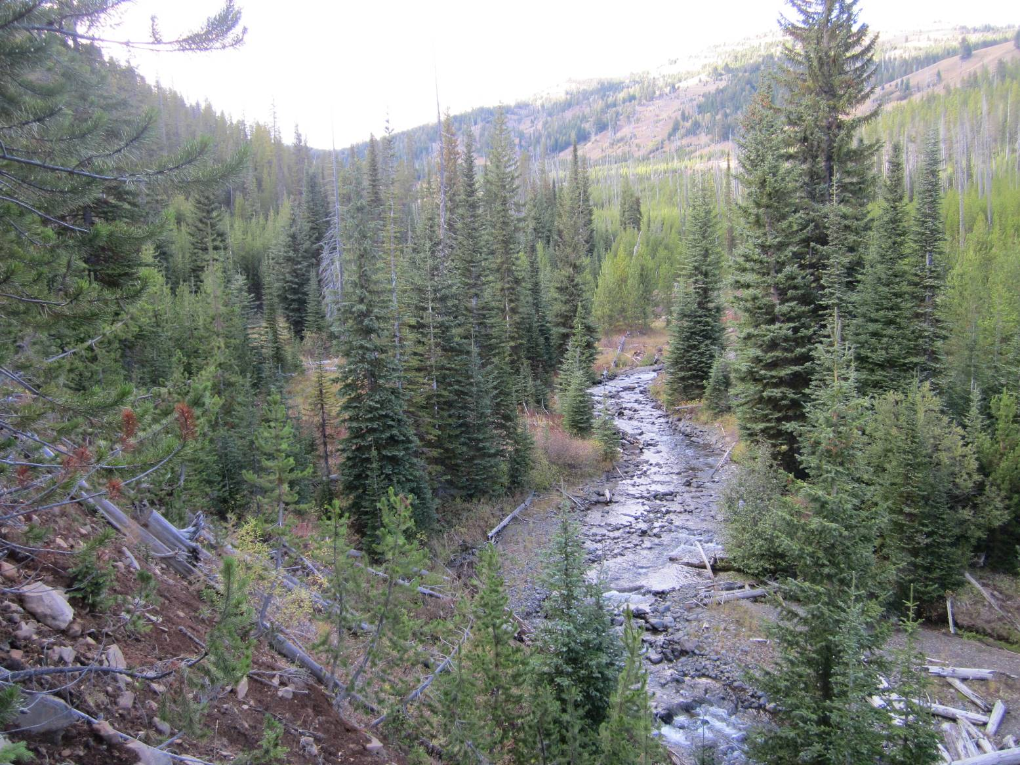
The upper portion of Big Sheep Creek

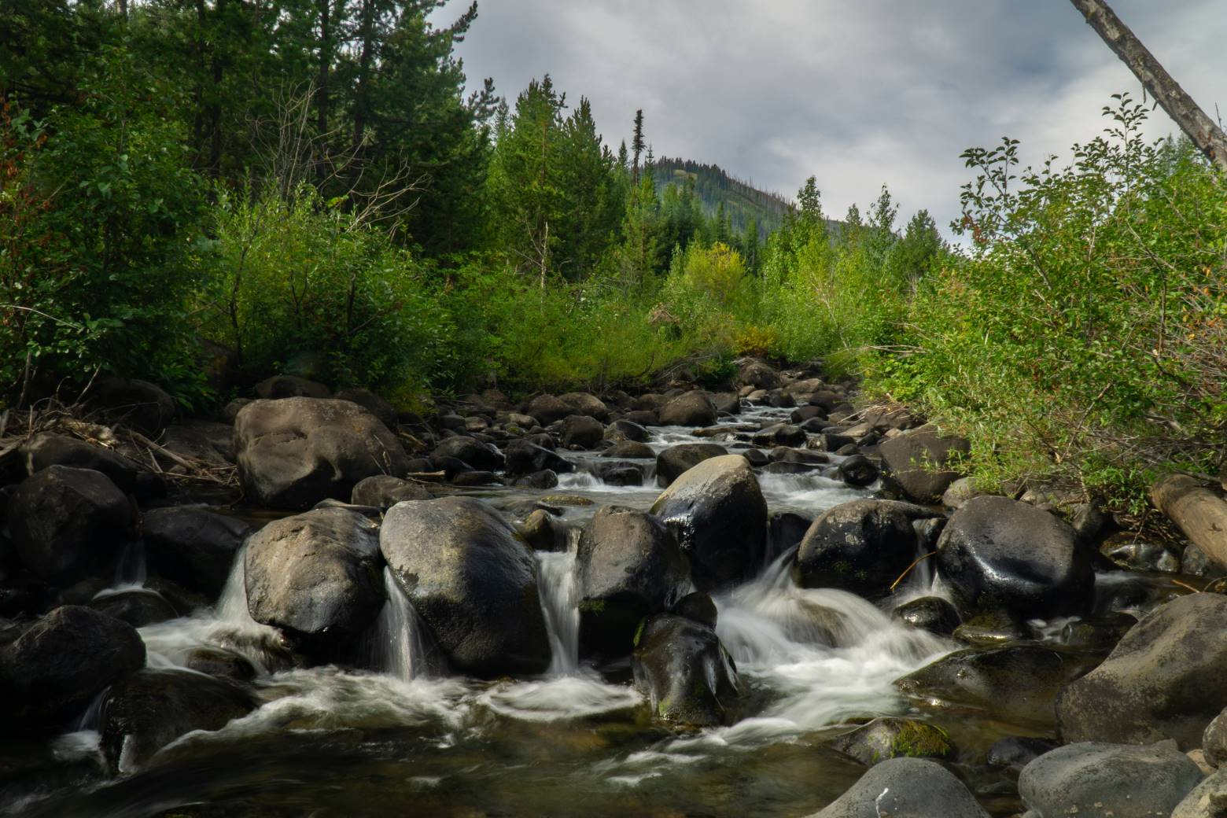
Big Sheep photo by Daniel Howland

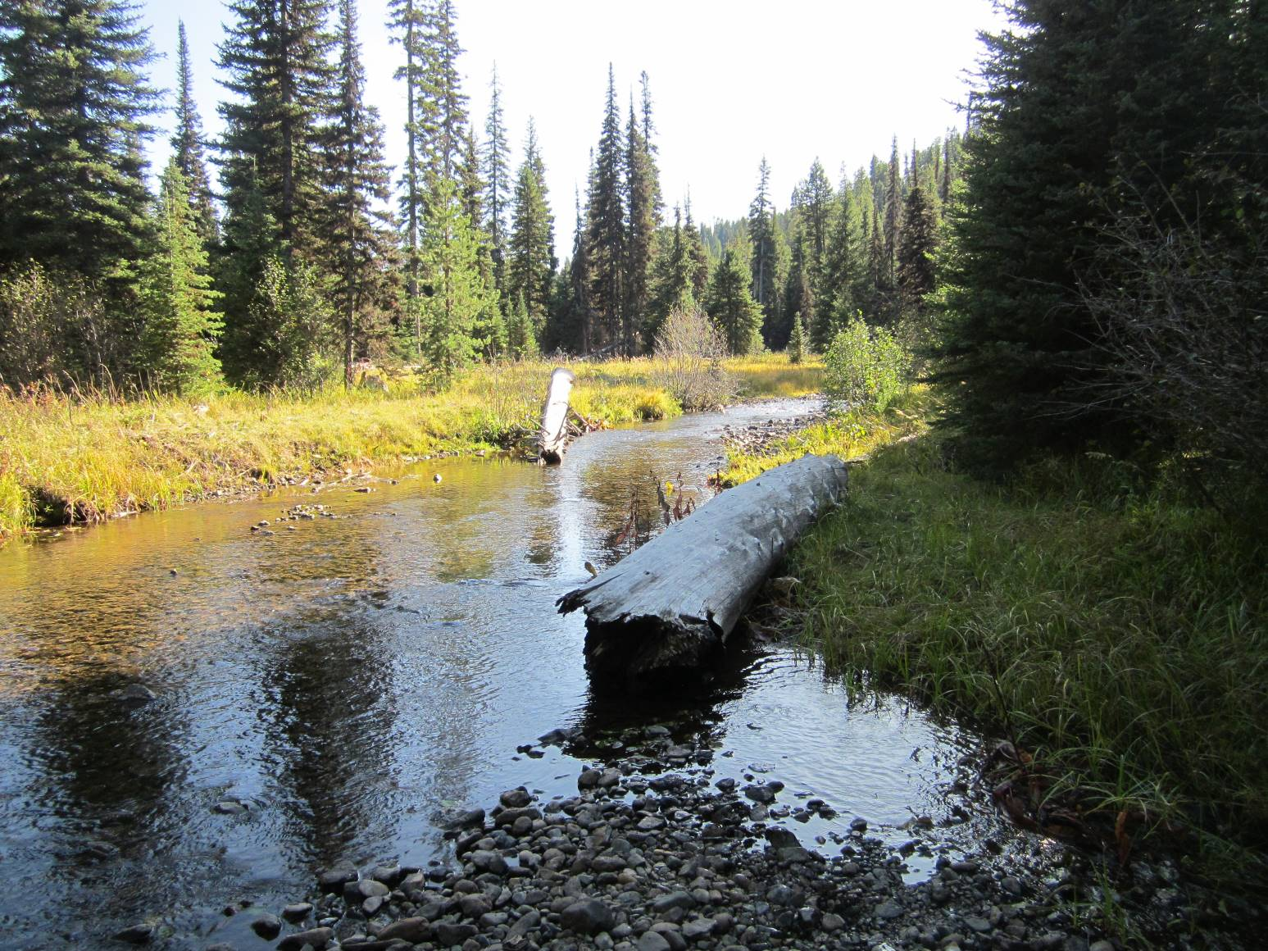
Lick Creek photo from Wally Sykes

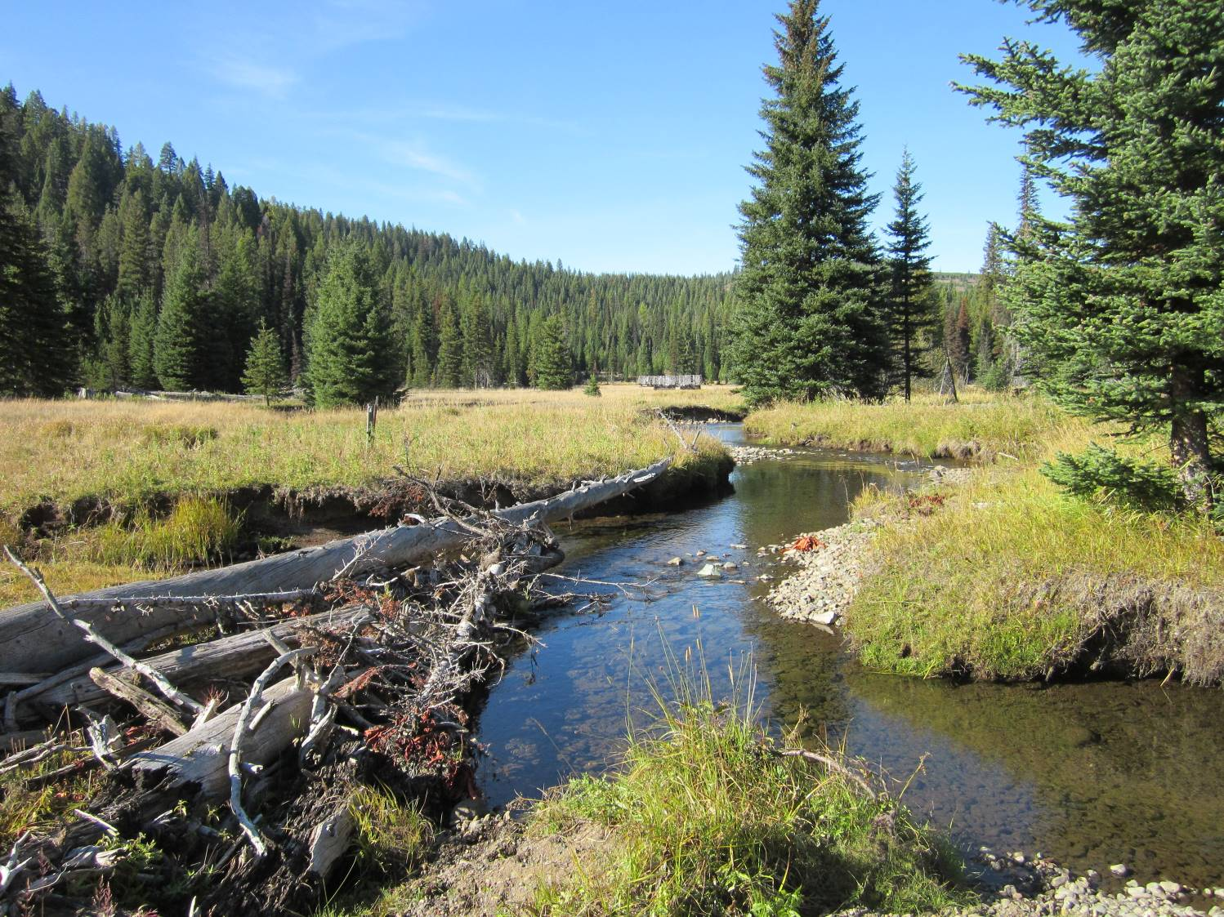
Lick Creek Photo – Wally Sykes
One of the most significant effects of commercial logging in RHCAs is reduced long-term recruitment of dead wood which is critical for aquatic and riparian function. This issue requires careful scrutiny in the NEPA analysis.

The Forest Service should not manage for minimum levels of dead wood because optimal levels of dead wood are much higher than minimums. In fact, there may not be any maximum. “The presence of LWM within a stream channel is critical to maintaining integrity of the system, in fact, there cannot be an overabundance of LWM.” Deschutes NF, 1997. Big Marsh Watershed Analysis.

Where streams are degraded, management of riparian forests should strive to meet the high end of the natural range for large wood, not the central tendency. This brings into question the minimum requirements that pervade current standards. Fox & Bolton (2007) recommend -
In degraded streams, where management is needed to restore favorable conditions, wood loads are often no longer found in the upper distribution of these ranges, or the distribution is centered around a lower mean. In these cases, merely managing for the mean or median will not restore the natural ranges of heterogeneity. Thus, for management purposes intending to restore natural wood-loading conditions, establishing instream wood targets based on the upper portion of the distribution observed in natural systems (i.e., the 75th percentile) rather than the lower portion of the distribution are reasonable as well as prudent to restore natural ranges.
In order to retain options for recruitment of large wood in degraded stream systems, scientific recommendations include retention of trees >12” dbh. Reeves & Everest (1994) said:
Removal of trees from riparian zones may delay the recovery of fish habitat. At a minimum, the largest trees (that is, those > 12 inches in diameter at breast height) should be left in riparian areas for future sources of in-stream wood. This would apply to all streams, as recommended by Anderson and others (1992). Smaller trees could be removed as part of a program for riparian vegetation restoration.

Dead wood is important to meeting many aquatic and terrestrial wildlife habitat values. Dead wood is also important for ecological services such as the capture, storage and release of water, sediment, and nutrients including, carbon. Most riparian reserves are short of dead wood due to past and ongoing logging, roads, fire suppression, etc. Natural processes of stand growth and mortality will correct this shortage, whereas logging will capture and export mortality and reduce and delay recruitment of wood to both streams and uplands within riparian reserves. This is not a minor short-term effect, but rather a significant long-term effect. Such effects are inconsistent with the Aquatic Conservation Strategy which prohibits logging in riparian reserves unless it is needed to meet objectives, and requires that management actions “maintain” and "not retard" ACS objectives, including dead wood. Any proposal to log riparian reserves must address these factors, develop clear goals, provide clear linkages between proposed actions and desired outcomes. Any alleged benefits of logging must be weighed against likely adverse effects on dead wood recruitment.

Trout Unlimited explains:
Large wood in streams—preferably whole trees with root wads and all—provides the randomness and dynamic environment that fish absolutely need to survive in the ever-changing waters they occupy. Wood breaks up the current and spreads water sideways across its natural floodplain, creating wonderful, dynamic and necessary diversity while also absorbing energy that could cause serious damage downstream otherwise, such as flooding or unnatural erosion. It sorts gravels during high flows, creating those beautiful spawning gravel beds laid out like blankets among bigger rock. It makes those current breaks downstream of log jams. It provides cooling shade and cover, and slow pools and edge habitat that baby fish need after emerging from those gorgeous gravels to ride out high flows, find food and hide from prying eyes. Decomposing wood and the nutrients it produces jumpstarts that the natural processes critical to insect, animal, amphibian and plant life.

The Deschutes NF’s Crescent-Odell Watershed Analysis says:
The presence of LWM within a stream channel is critical to maintaining the integrity of the system, in fact, there cannot be an overabundance of LWM. … Riparian Reserves provide important wildlife habitat, which justifies the heavy loading of LWM in the creeks and the floodplains. … In the Riparian Reserves … it is desirable to maintain healthy forest stands over the long-term while maintaining high snag densities and green tree replacements. … It is recognized that Riparian Reserves constitute an area where higher risks are taken (including reduced fire suppression efforts) in order to allow natural processes to occur and continue without human intervention.

Ettema (2014) said:
In an undisturbed forest ecosystem, wood is naturally “recruited” to streams in various ways. Riparian trees growing along the channel fall into the channel when they are undercut by the stream, toppled by beavers, burned by fire or blown down during storms. Upslope trees can be transported into the channel by events such as avalanches or landslides . Flooding can wash trees into the channel and during highwater they may be pushed downstream.
In-stream woody debris has been drastically reduced in some streams by historical forest management practices. Logging near rivers and streams limited the number of trees that could fall into streams. Road building that channeled streams through culverts prevented downstream wood recruitment. “Stream cleaning” was sometimes conducted to remove fallen trees from streams, for beautification, to prevent damage to infrastructure downstream, or in a misguided attempt to assist fish migration.
Scientists have now come to understand that in-stream LWM [large woody material] is ecologically important for a number of reasons:
- LWM can help spawning gravels accumulate , by stopping the gravel from moving downstream;
- Pools can form behind LWM, which provide important juvenile rearing habitat, as well as habitat for all fish during periods of low-flows;
- LWM can help slow stream speed , which helps adult fish as they move upstream and shelters rearing juveniles from using too much energy fighting currents;
- LWM provide shade , offering pockets of cooler water, and can help to lower the temperature of an entire stream;
- LWM provides fish with refuge from predators ;
- LWM can help to stabilize banks, prevent erosion and decrease sediment movement that can harm downstream fish habitat;
- LWM is important to the aquatic food chain, because it traps organic matter and provides habitat for insects and invertebrates, which are both food for fish.
All of these elements add “complexity” to a stream. When it comes to fish habitat, complexity is a good thing. And one of the best ways to make a stream complex is to simply add wood.
Thinning in stands of trees that are not yet of "pool forming" size may be beneficial, but after trees are of pool-forming size, thinning just captures and removes the mortality that should end up in the stream. (In simplistic terms, a pool-forming tree is one big enough to fall all the way across the stream, so it varies by stream size, but in general it only takes a small tree to form a pool in a small stream).

It is important to retain medium and large trees, not just those that can reach the stream when they fall, but also trees that could fall and knock other trees into the stream.

The NEPA analysis should take a hard look at the effects of logging in and near RHCAs. The NEPA analysis should reflect the fact that regen and density reduction logging adjacent to a riparian buffers will create “edge effects” that change the microclimate in the buffer and reduce the recruitment of wood to the buffer. The Forest Service should address this problem by adopting a buffer-on-the-buffer approach so that at least the inner portion of the riparian reserves would have near-natural microclimate and wood recruitment processes.

Water quality is impaired throughout this landscape and must not be made worse.
The agency has done a very poor job monitoring conditions in these forests. Therefore, in establishing a baseline, to a certain extent, we have to take it where we can get it. That includes water quality. The Oregon Department of Environmental Quality published an Integrated Report with EPA and found that all of the tested streams in the project area had some level of impairment. That included
- Big Sheep Creek showing impaired conditions for fish and aquatic life, habitat modification, year-round temperature, and spawning temperature. None of the parameters were meeting goals.
- On Lick Creek, no parameters were meeting goals, and it was found to be impaired for year-round temperature and fish and aquatic life.
- Grouse Creek met no goals and was impaired for fish and aquatic life, year round temperature, and spawning temperature.
- Gumboot Creek failed on all measurements and was impaired for temperature and fish and aquatic life. Same for the Imnaha River, Dry Creek, and Summit Creek.
- Lower stretches of the Imnaha in the project area were also found to be impaired for dissolved oxygen, pH, and ammonia.
The report can be found here. The agency must explain how this project will improve these parameters and, at a minimum demonstrate they will not make them worse.

Aquatic Riparian Conclusion
The conservation groups believe that commercial logging, extensive thinning, widespread prescribed burning, and high road densities pose a greater risk to aquatic species than wildfire, even high-severity wildfire. The combination of lack of adequate data and understanding of RHCAs and the species that occupy these habitats, the lack of information on the trends of baseline or existing conditions, and the huge assumptions that restoration using upland silvicultural prescriptions in riparian areas will improve stream conditions, make restoration activities highly risky. The management actions proposed in RHCAs are more likely to cause or perpetuate long term degradation and irreparable harm to streams and riparian areas and the multitude of species that depend on them. We recommend that no timber harvest occur in any RHCA buffer areas, that many of the roads along streams and RHCAs be closed and relocated upslope, and that any thinning or burning only be done carefully in experimental areas that are extensively monitored post treatment. Natural events such as wildfire or windstorms can alter these forests, but they recover quickly. However, it can take centuries for old-growth forests to recover from human activities such as timber harvest and high road densities.

The continued entry into riparian areas along with associated roads to harvest trees will further compact and disturb soils, remove trees that are important for shade, sediment retention, nutrient cycling, and water quality, and further harm ESA-listed fish species. Yet the Forest Service is proposing to allow removal of large trees under the guise of restoration and wildfire resiliency contrary to the best available science and facts about large trees. One has only to look and compare wilderness and roadless areas to highly managed forested areas to see the last best chinook, steelhead and trout habitat is in the largely untrammeled areas. The quality of fish habitat and the abundance of ESA species are highly impacted by managed habitats due to the removal of large wood and extensive road systems to remove timber.

ESA Consultation for Fish and Wildlife
The Forest Service should initiate consultation regarding impacts to listed species. This is another reason to do an EIS, because it will provide a more informed basis for consultation with the regulatory agencies, and help advance NEPAs goals for informed commenting and informed public comments.

During ESA Section 7 consultation, the agency “shall use the best scientific and commercial data available.” 16 U.S.C. § 1536(a)(2). “[T]he Federal agency requesting formal consultation,” “shall provide the Service with the best scientific and commercial data available or which can be obtained during the consultation,” to serve as the basis for the Fish and Wildlife Service’s subsequent BO. 50 C.F.R. 402.14(d).

Wildlife

Protect habitat for all native wildlife.
The agency has a responsibility to protect habitat for all native wildlife. That means keeping common species (flying squirrels, elk, deer, snowshoe hare, bobcats, etc. ) common, as well as helping recover species that are sensitive, threatened, endangered, rare, or declining (marten, wolves, goshawk, great gray owls, beaver, tanagers, etc.). The agency must also give more serious consideration to maintaining habitat for species that may be extirpated or extremely rare. That includes species like wolverine, fisher, lynx, and grizzly bear.
Wolverine have been documented in the Eagle Cap Wilderness and this project area. Wolverine are extremely sensitive to human presence. Increases in roads and human activity will reduce its value to this important species. Given that this is the only connectivity corridor between Oregon’s very small population, and existing populations in the Northern Rockies, this must be given serious consideration.
The last confirmed Oregon grizzly bear was killed in Wallowa County. Since that time there have been credible sightings here, and recent confirmation of bears just a few miles to the east, in Idaho. If this project has detrimental impacts on grizzly habitat and the ability to move across the landscape, the Forest Service may be stalling or precluding the recovery of the species in Oregon.
Lynx populations and range can be quite variable over time. There is no doubt that this has historically been lynx habitat, and therefore, even a current absence would not mean it no longer is. Lynx can disperse as much as 500 miles or more, and lynx are well known within that range. Further, there have been numerous credible and confirmed lynx in the region. Examples include:
- a lynx shot by APHIS trapper, Wendell Weaver on an island in the Imnaha River near the mouth of Fence Creek. That was confirmed by Ron Bartells at the ODFW officers in Enterprise, and documented by Vic Coggins in the 1974 Journal of Mammology.
- USFS staff saw a lynx in 1992 on the Tollgate Road and was documented by District Biologist, Rod Johnson. Additional staff reported lynx in the same location over the next 4 to 6 years. The Ukiah District Ranger subsequently reported a lynx in the same location.
- Wallowa County bounty records and those kept by Rod Johnson contain over 60 occurrences.

Recent agency assessments of this and immediately adjacent areas surrounding the project area highlight this as lynx habitat.
Snowshoe hare habitat is lynx habitat. Therefore, snowshoe hare habitat and habitat components should be protected as a surrogate.
Minimums for things like wildlife connectivity corridors are just that, minimums. We encourage a cautionary approach, which is to say protect more corridors, and keep them wide, buffered, diverse, and redundant.
Past agency assessments of this and immediately adjacent areas surrounding the project area note the value as a connectivity corridor and/or habitat for lynx and wolverine as well as marten, fisher, ptarmigan, numerous bats (including spotted bats) and Wallowa Rosy Finch. It also notes good habitat for snakes and lizards in rock rims and riparian areas.
Among the many important values of big trees, they provide habitat for Vaux’s swifts, over 50% of bear hibernacula in the Blues, bat maternity colonies, habitat for pileated woodpeckers and flammulated owls, and winter roosting for grouse and other birds. According to Dr. Evelyn Bull’s thesis, 25% of great grays, >80% of long-eared owls, and 15-25% of coopers hawks are found in trees with dwarf mistletoe.

Give more serious consideration to impacts on birds
The proposed project area goes from the edge of the Eagle Cap Wilderness down into the Hells Canyon National Recreation Area. That makes it relevant that the Audubon Society identified the Wallowa Mountains as an important bird area. The group highlights a number of species including “the entire range of Spruce Grouse in Oregon”, “the only area with regular confirmed breeding of Pine Grosbeak in Oregon”, “the entire breeding range of an Oregon endemic taxon, the Wallowa Rosy Finch”, and black swifts.
We were pleased to support and organize funding for the Klamath Bird Observatory to do monitoring in this project area. We encourage the agency to take advantage of this resource in the development of this project and for future monitoring. We were particularly pleased by the Observatory’s interest in documenting all species through point counts and acoustic monitoring.
We believe the agency has regularly violated the Migratory Bird Treaty Act. To comply, the agency must avoid adverse impacts on migratory bird resources (not just populations), identify where unintentional take may affect populations, develop and use USFWS conservation measures, and inventory and monitor habitat and populations. The USFS and USFWS MOU does not remove these legal requirements and it does not allow take – even incidental take.
The agency is required by law to schedule all activities to occur outside peak bird breeding season. If that is unavoidable, the agency must conduct surveys prior to activities to determine presence, and buffer nesting locations.
Agency documents show that prairie falcons and peregrine have been found in the area.
Vaux’s swifts are present. Like bats, bears, and many other species, they benefit from the presence of large white or grand fir.
There are reports of boreal owls in the area. There are also good areas of potential restoration for white-headed woodpeckers and flammulated owls.
Canopy warblers require depth and complexity of canopy and thermal refugia for nesting. Many warblers, and thrushes depend on mid-elevation multi-canopy forests.
Opening and simplifying canopy structure is likely to increase predation of many species.
Despite a reduction in numbers, this is a stronghold for Spruce grouse. Spruce grouse depend on mistletoe trees. Also, while spruce grouse can physically cross openings. Simply put, they don’t. Even small gaps could be disastrous for the species.

Protect Goshawk Habitat
The agency must be far more protective of known goshawk and all potential goshawk habitat.
Lack of evidence is not evidence of lack. Given that the agency has not regularly surveyed for goshawk, and an active nest is defined as one that has not been occupied for the past 5 years, all past goshawk nests should be considered active, and a comprehensive survey should be conducted. We have historical USFS goshawk data going back decades, if the agency does not have it, please let us know. Given its sensitive nature, we are not including it here in a public facing document.
If past goshawk nests are unoccupied, one of two things is occurring. The goshawk are elsewhere in the territory and the currently occupied nest should be found, or the goshawk are no longer present in the territory, the population is in decline, and that must be addressed.
Simply buffering known occupied goshawk nests is insufficient for other reasons. Protecting goshawk habitat in postage stamps around current occupancy as minimum requirements provide, means the species is no longer acting as an indicator species for other values, but, rather, is only representing the efforts to protect goshawk with no known benefit to other values that are meant to be indicated. Further, the values that benefit goshawk are in high demand by other species. Some of those species may be able to outcompete goshawk. By eliminating those habitat values elsewhere on the landscape, the agency increases competition where goshawk are currently present by lowering supply on the landscape. That leads to detrimental impacts to goshawk and the other species that their protections are meant to ensure.

Identify and protect Great Gray Owl habitat
The area is home to several known great gray owl colonies. The bird is still seen and reported in the area. Great Gray Owl surveys should be conducted with colonies given generous buffers. If they cannot be found, habitat should be modeled and protected. Given the sensitive nature of the data, we will not note it here, but have oral accounts from retired USFS staff about where colonies have existed in the past.
Notably, great gray owls like goshawk nests and habitat. This is another reason why goshawk nests (historic, occupied, potential, and abandoned) should be protected. These birds don’t share well with others.
Great Grays are among many species who benefit from mistletoe trees.
Great Grays are also among many species who benefit from large contiguous patches of complex “messy” forests that isn’t “steep and deep”.

Snag Habitat
Snags are an essential feature of LOS forests that the Eastside Screens require the FS to be managing toward. Snags are also is short supply across the eastside primarily due to past logging that removes snags directly or removes green trees before they can fulfill their complete life-cycle in the forest as a dead tree. Continued logging of will make a bad situation worse in terms of snag recruitment, and these adverse effects are long-lasting because it takes a long time to grow a tree to replace the ones being removed. Commercial logging across large areas such as this project will cause log-term significant cumulative effects on snag recruitment. Any removal of large trees >20” dbh will have significant adverse effects on rare large snag habitat.

The NEPA analysis should use the best available science, such as the DecAID Advisor to consider the effects of logging on those species most sensitive to the lack of abundant snags, and develop mitigation alternatives, such as no-commercial-logging of roadless/unroaded areas, RHCAs, etc. The alternatives comparison should project snag recruitment over time under alternatives that log relatively more or fewer acres and remove/retain relatively more or fewer green trees.

Snags and dead down wood are limiting factors for many species. They also serve other purposes including refuge during fire, water retention, and reducing erosion. Like most of Eastern Oregon, logging, firewood cutting, “fuel reduction’ efforts, fire suppression, and other activities have reduced the abundance of snags and dead down habitat. The agency can no longer consider snag reductions as a cost of doing business. It undermines laudable restoration and resilience goals.

Landings, skid trails, roads (temporary or otherwise), logging units, and other areas of activity must not result in the loss of snags. If they cannot be located in such places, those activities should be curtailed or dropped. Further, the agency must retain enough mature trees to serve as the next generation of snags and dead down habitat so the problem is not carried into the future.
Snags are not just nice to have, they are an essential feature of old forests. A stand of big trees without snags is not a healthy forest. The ICBEMP Scientific Analysis Group (SAG) review of selected terrestrial vertebrate populations used “large snag density as a proxy for the structural quality of old-forest habitats.” and the SAG found that --
Key model factors contributing most strongly to low environmental index values and low population outcomes—

Families 1 and 2 (Old-forest families)—
• Low recruitment of large snags composed of shade-intolerant tree species, such as ponderosa pine, western larch, and western white pine, as indexed by moderate and high HRV (Lewis’ woodpecker (migrant), pygmy nuthatch, flammulated owl), are the key factors contributing to low environmental index and low population outcomes.
• Low quality of old-forest structural conditions (lack of diversity of size and decadence of large trees, large snags, and large logs), as indexed by declining large snag and/or large log trends (northern goshawk [summer], American marten, hoary bat), are the key factors. …
Long-eared myotis (Family 7)—
• … decreasing snag trends (indexing low availability of roost sites) contribute to low environmental index and low population outcomes. …
Western bluebird (Family 8)—
• High HRV departure and declining large snag density (indexing a lack of shade-intolerant tree species recruited as snags) contribute to the low environmental index and low population outcomes.

In a dynamic ecosystem life may be fleeting but the snags and logs that survive disturbance provide very critical temporal links from one stand to the next. Under natural conditions, a forest hands down a large legacy of living and dead material from one stand to another even after an intense disturbance. Even non-stand-replacing disturbance creates pulses of dead material that are critical for forest ecosystems. See for instance:
- Franklin, J.F., Lindenmayer, D., MacMahon, J.A., McKee, A., Magnuson, J., Perry, D.A., Waide, R., and Foster, D. 2000. Threads of Continuity. Conservation Biology in Practice. [Malden, MA] Blackwell Science, Inc. 1(1) pp9-16. https://andrewsforest.oregonstate.edu/sites/default/files/lter/pubs/pdf/pub2815.pdf;
- William F. Laudenslayer, Jr., Patrick J. Shea, Bradley E. Valentine, C. Phillip Weatherspoon, and Thomas E. Lisle Technical Coordinators. Proceedings of the Symposium on the Ecology and Management of Dead Wood in Western Forests. PSW-GTR-181. http://www.fs.fed.us/psw/publications/documents/gtr-181/.
- Lofroth, Eric. 1998. The dead wood cycle. In: Conservation biology principles for forested landscapes. Edited by J. Voller and S. Harrison. UBC Press, Vancouver, B.C. pp. 185-214. 243 p. http://www.for.gov.bc.ca/hre/deadwood/DTrol.htm.
- Rose, C.L., Marcot, B.G., Mellen, T.K., Ohmann, J.L., Waddell, K.L., Lindely, D.L., and B. Schrieber. 2001. Decaying Wood in Pacific Northwest Forests: Concepts and Tools for Habitat Management, Chapter 24 in Wildlife-Habitat Relationships in Oregon and Washington (Johnson, D. H. and T. A. O'Neil. OSU Press. 2001) http://www.fs.fed.us/wildecology/decaid/decaid_background/chapter24cwb.pdf
- Stevens, Victoria. 1997. The ecological role of coarse woody debris: an overview of the ecological importance of CWD in B.C. forests. Res. Br., B.C. Min. For., Victoria, B.C. Work. Pap. 30/1997. http://www.for.gov.bc.ca/hfd/pubs/docs/Wp/Wp30.pdf.
- Hagar, Joan, 2007, Assessment and management of dead-wood habitat: USGS Administrative Report 20071054, pp. 1-32. http://pubs.usgs.gov/of/2007/1054/pdf/ofr20071054.pdf
- Bruce G. Marcot; 2002. An Ecological Functional Basis for Managing Wood Decay Elements for Wildlife; USDA Forest Service Gen. Tech. Rep. PSW-GTR-181.
- http://www.fs.fed.us/psw/publications/documents/gtr-181/068_Marcot.pdf.
- Bruce G. Marcot 2017. Ecosystem Processes Related to Wood Decay. PNW Research Note 576. https://www.fs.fed.us/pnw/pubs/pnw_rn576.pdf
- Jennie Sandström et al. 2019. Impacts of dead wood manipulation on the biodiversity of temperate and boreal forests. A systematic review, Journal of Applied Ecology (2019). DOI: 10.1111/1365-2664.13395. https://besjournals.onlinelibrary.wiley.com/doi/pdf/10.1111/1365-2664.13395.
- Blue Mountain Native Forest Alliance. 199x. Problems Related to the Loss of Dead Wood. http://www.subtleenergies.com/ormus/bmnfa/DEADWOOD.HTM.

An important and under-appreciated ecological process is the cycle of biomass accumulation (e.g., large snag and dead wood are vastly under-represented on the landscape because management is so focused on controlling and preventing mortality.) The full life-cycle of a tree starts with photosynthesis that captures carbon from the air to build a magnificent tree but it includes decades to centuries of "life" as a snag, down wood, and soil enhancement before it returns to the atmosphere to begin the cycle again. The dead wood portion of this cycle needs to be re-established to enhance biodiversity, hydrology, soil productivity, and carbon storage. The NEPA analysis needs to recognize the full life-cycle of forests including the ecological, hydrological and carbon-cycle value of both live and dead trees.

Felling and removal of large trees, whether they are alive or dead, removes large material that is normally handed down from one stand to the next. The loss of this material has serious adverse consequences for wildlife, hydrology, soil, etc. These legacies are often described as “lifeboats” that allow species to persist in post-disturbance forests and/or return more rapidly to post-disturbance forests. Given cumulative loss of habitat and ecological functions over the last century, how many lifeboats can we take off the ship when threatened and endangered species and sensitive species are at stake? The NEPA analysis must account for all the values provided by snags and down wood and the effect of removing these legacy structures.

The NEPA analysis must recognize that mechanical treatments unavoidably reduce snag habit, if for no other reason than the habitual removal of snags for safety reasons, but the most significant effect of commercial logging on snag habitat is the long-term reduction in the recruitment pool of green-trees available for future snags. Even restoration thinning intended to accelerate development of large trees reduces mortality that is another key attribute of late successional forests.

The 2017 Science Synthesis for the NW Forest Plan says partial cutting in older forests will “strongly impact dead wood amounts, and the accompanying road and harvest system will add additional impacts.” In the Windjammer EA, the Siuslaw NF noted that at least six times more coarse wood carries over from old-growth forests after wildfire compared to timber harvest, and the CWD left after logging is smaller and decays faster (citing Spies & Cline 1988). Ohmann et al (1994) found that non-federal forestlands do not retain enough snags to support viable wildlife populations, so federal managers likely need to retain more snags on federal lands to compensate.

Even when snag removal is not an intentional design feature of a project, hazard tree felling normally occurs in all treatment areas, plus a safety buffer around all treatment areas, plus a safety corridor along roads, and other work areas. Furthermore, non-federal lands are not managed for snag habitat. These are some of the reasons why Korol et al (2002) found that large snag habitat is below historic range of variability, and in the future would attain historic levels only in roadless and wilderness areas. Wisdom et al (2008) found that snag abundance in the Pacific northwest forests is inversely related to past harvest and proximity to roads.

Wisdom (2008) found:
“Our highest snag density … occurred in unharvested stands that had no adjacent roads. … Stands with no history of timber harvest had 3 times the density of snags as stands selectively harvested, and 19 times the density as stands having undergone complete harvest. Stands not adjacent to roads had almost 3 times the density of snags as stands adjacent to roads.”

Given the current extent of the road network and the historic extent of logging, the cumulative effects analysis must recognize the inherent conflict between “forest management” (past, present and future) and snags and all their values.

Federal forest management also needs to mitigate for conditions on non-federal lands where dead wood is highly under-represented. PNW Research reported that “Large snags and logs decreased on forest industry lands as legacy dead wood derived from historical natural disturbance events was not replaced through management. Conservation oriented policies designed to maintain or increase dead wood may have strong positive influence on large dead wood abundance and related biodiversity in parts of a region also under intensive management.”

Almost all of the agencies’ focal species use dead wood for important aspects of their life cycle. Pileated woodpeckers and cavity excavators use dead wood for nesting, foraging, and possibly communication. Goshawks, owls, and other raptors use dead wood for nesting, roosting, and to support a healthy prey base. Pacific fisher and American marten for denning, travel, cover, foraging, and prey base. Deer and elk use dead wood for cover and protection of bedding and fawning areas. Salmon, trout, and other aquatic species use dead wood for shade and stream cooling, hiding cover, spatial partitioning of habitat, energy dissipation, capture-storage-release of sediment and nutrients, and substrate and energy input for the food web that provides their food.

Secondary cavity nesters include numerous species of conservation concern including the Pacific fisher, American marten, bufflehead, flammulated owl, western bluebird, Vaux’s swift, northern flying squirrel, and several bat species, plus bears, amphibians, invertebrates, and many others. Approximately 31% of the total bird fauna of this region use snags for nesting and denning, foraging, roosting, communicating, and as hunting and resting perches. (Raphael and White 1984), so the importance of dead wood as a habitat element cannot be over-stated. Snags and down wood also serve several crucial ecosystem functions related to site productivity, nutrient storage & cycling, hydrology, geomorphology, disturbance, and habitat (terrestrial, riparian and aquatic).

Current plan direction for protecting and providing snags and down wood tends to be focused on a small subset of the full spectrum of values provided by dead wood and does not ensure the continued operation of these ecosystem functions or meet the complete lifecycle needs of the many species associated with this unique and valuable habitat component. Please consider all the many values of snags and down wood presented in Rose et al (2001).

New information on Snags.
The NEPA analysis needs to account for significant new information about snag habitat and the effects of logging. Dynamic ecosystems historically included large-scale mortality events both pulsed and continuous. Mortality and biomass accumulation are natural and desirable ecological processes that forest management has been working for decades to capture, suppress, and avoid. Large snags are severely under-represented in our forests and logging will capture, reduce and delay recruitment of future large snags. Korol et al (2002) estimated that even if we apply enlightened forest management on federal lands in the Interior Columbia Basin for the next 100 years, we will still reach only 75% of the historic large snag abundance, and most of the increase in large snags will occur in roadless and wilderness areas.

Wisdom et al (2008) found that snag abundance in the Pacific northwest forests is inversely related to past harvest and proximity to roads.
“Our highest snag density … occurred in unharvested stands that had no adjacent roads. … Stands with no history of timber harvest had 3 times the density of snags as stands selectively harvested, and 19 times the density as stands having undergone complete harvest. Stands not adjacent to roads had almost 3 times the density of snags as stands adjacent to roads.”)

Salem BLM’s Bottleneck LSR Enhancement Project EA includes Table 9 which clearly shows that thinning will adversely affect mortality processes. Mortality would be 70 tpa without treatment, or 0.10 tpa with thinning, thus sacrificing 69.9 trees per acre averaging 20.3" dbh that would be recruited to the large snag and down wood pool over the next 30 years except that they will instead be cut and taken to the mill.

The federal agencies need to compensate for the severe lack of snags on intensively managed forest lands, but unfortunately snags are lacking on federal lands as well. For snag depletion in eastside forests, see the ICBEMP Scientific Analysis Group which found that “Across the [interior Columbia River] basin (all lands) large snags have declined more than 30 percent. This was most likely a reflection of the loss of late-seral forests, particularly in the dry and moist PVGs.”

The 2008 FIA Report for Oregon found:
“In general, wildlife species that use dead wood for nesting, roosting, or foraging prefer larger diameter logs and snags (>20 inches). Although we tallied dead wood in this size class throughout Oregon, the estimated density may not be sufficient for some wildlife species. For example, inventory results show a mean of almost 3 snags per acre in this size class in western Oregon and 1 per acre in eastern Oregon. This may indicate that large-diameter snags are currently uncommon in Oregon habitat and that management may be necessary to produce a greater density of large snags.”

The Forest Service cannot provide any assurance that its plans and projects will assure viable populations of native wildlife that depend on dead trees. The recently amended Eastside Screens changed the requirements for snag habitat in a way that offers no assurances of population viability. The new snag standards basically requires some snags for some wildlife, while failing to ensure there are enough snags for wildlife that are most sensitive to logging and the resulting absence of abundant snags.

The Forest Service does not know how many snags are necessary to support viable populations of cavity associated species. The Forest Service has provided no credible link between DecAID tolerance levels, potential population levels, and/or viable populations. The Forest Service has also failed to reliably quantify existing and projected habitat for snag associated species.

An unavoidable impact of all commercial logging is to “capture mortality” which reduces valuable snag habitat in the short-term (via hazard tree felling) and in the long-term (via delayed recruitment and reduced overall recruitment). For example, in a thinning project on the Siuslaw National Forest “modeling stand #502073 over a 100-year cycle [using ORGANON] predicts a total stand mortality of 202 trees (>10 inches dbh) for the unthinned stand, while mortality for the thinned stand was two trees. Therefore, thinning will reduce density-dependent mortality within the stand by 99%.” There is no reason to think that thinning in densely stocked forests elsewhere would be any different.

Dead wood in forests is thought to follow a U-shaped pattern over time “from the combined and lagged effects of legacy wood decay and the recruitment of new dead wood,” (Harmon 1986, Hudiburg 2009) resulting in abundant dead wood legacies from the previous stand in young forests, less dead wood in middle-aged stands as the legacies decay, and more again in older stands as natural mortality processes manifest. If the goal is to restore high quality old forest habitat, the agencies must respect this dynamic by recognizing that dead wood recruitment requires (1) “surplus” biomass and (2) it’s a process that takes time, so managers should ensure that middle-aged stands accumulate biomass and begin to recruit and accumulate snags and dead wood. The low of dead wood in middle aged stands is not universal or necessarily desirable, and since many young stands were deprived of the legacies they normally enjoy, it would be advisable to start accumulating snags and dead wood as soon as possible, not wait for mature stages.

The federal forest agencies now recognize that current methods and assumptions concerning snag habitat standards are outdated, and the old snag standards do not ensure enough snags to meet the intent of the standard, yet the agencies have not adjusted their management plans to account for this new information nor have they developed new standards that are consistent with the latest scientific information.

As explained on the DecAID website:
Why is DecAID needed?
National Forest LRMP standards and guidelines for management of snags and down wood in the Pacific Northwest were based on wildlife species models and tools that were developed in the 1970s and 1980s (Thomas et al. 1979, Neitro et al. 1985, Marcot 1992, Raphael 1983). New information about the ecology, dynamics, and management of decayed wood has been published since then, and the state of the knowledge continues to change. Rose et al. (2001) report that results of monitoring indicate that the biological potential models are a flawed technique (page 602). There has been an evolution from thinking of large woody material as habitat structures, to thinking of decaying wood as an integral part of complex ecosystems and ecological processes.

This paradigm shift has made the management of dead wood a much more complex task. We can no longer expect to go to our LRMPs or the biological potential model to get one number for the amount or size of snags and down wood that we can apply to all projects and to all acres. We are directed to use the best available science to manage ecosystems, and the best available science simply will not support business as usual for managing dead wood.

A few of the problems with the old standards are:
- They failed to account for the fact that the number of snags needed for roosting, escape, and foraging can exceed the number of snags needed for nesting;
- They failed to recognize that the number of snags needed to support viable populations of secondary cavity users may exceed the needs of primary cavity excavators;
- The old standard failed to account for the size height of snags favored by some species;
- In applying the old standards the agencies often fail to account for rates of snag fall and recruitment;
- The old standards fail to recognize non-equilibrium conditions in our forests, i.e. some species rely on the natural large pulses of snags associated with large disturbances;
- The old standards fail to account for the differential use of space and population density of different species;
- The old standards ignore other important habitat features of dead wood, e.g. loose bark, hollow trees, broken tops, etc.

Back in the early 1990s the Forest Service recognized their forest plans were not adequate to maintain populations of spotted owls and they tried to develop plans to conserve spotted owl without following NEPA and NFMA procedures. The courts said they had to stop cutting owl habitat until they had complied with environmental laws. This is the same situation we find ourselves in today with dead-wood associated species. The agencies should stop harming dead wood habitat until they have a legal plan to conserve associated species over the long-term.

Rose et al (2001) said:
Lessons Learned During the Last Fifteen Years
…
Several major lessons have been learned in the period 1979-1999 that have tested critical assumptions of these earlier management advisory models:
- Calculations of numbers of snags required by woodpeckers based on assessing their ‘biological potential’ (that is, summing numbers of snags used per pair, accounting for unused snags, and extrapolating snag numbers based on population density) is a flawed technique. Empirical studies are suggesting that snag numbers in areas used and selected by some wildlife species are far higher than those calculated by this technique.²²⁶
- Setting a goal of 40% of habitat capability for primary excavators, mainly woodpeckers,³⁶⁹ is likely to be insufficient for maintaining viable populations.
- Numbers and sizes (dbh) of snags used and selected by secondary cavity-nesters often exceed those of primary cavity excavators.
- Clumping of snags and down wood may be a natural pattern, and clumps may be selected by some species, so that providing only even distributions may be insufficient to meet all species needs.
- Other forms of decaying wood, including hollow trees, natural tree cavities, peeling bark, and dead parts of live trees, as well as fungi and mistletoe associated with wood decay, all provide resources for wildlife, and should be considered along with snags and down wood in management guidelines.
- The ecological roles played by wildlife associated with decaying wood extend well beyond those structures per se, and can be significant factors influencing community diversity and ecosystem processes.

Connectivity Requirements of the Eastside Screens and CEQ Guidance
The Forest Service has duties with respect to connectivity that are both procedural and substantive. Agencies have a duty to consider connectivity in their NEPA analyses. Just this year, CEQ issued guidance saying “… agencies should consider and be transparent about the positive or negative impacts of proposed actions and alternatives on connectivity and corridors. Through the NEPA review process, Federal agencies can consider measures to advance corridors and connectivity as components of proposed actions, alternatives to proposed actions, or mitigation for proposed actions’ effects.”

The explicit intent of the Eastside Screens is “to insure that blocks of habitat maintain a high degree of connectivity between them,...” 1995 Eastside Screens, Scenario A, INTENT STATEMENT for connectivity (emphasis added).

The connectivity requirements of the screens are detailed and mandatory. Connectivity corridors:
- Must link all late old structure stands in at least 2 directions;
- Must be at least 400 feet wide at their narrowest spot;
- Must be maintained as dense as possible with medium and large trees, or in the top third of site-potential and at least 50% canopy cover;

The Eastside Screens provide ...
... it is important to insure that blocks of habitat maintain a high degree of connectivity between them, and that blocks of habitat do not become fragmented in the short-term.
a) Maintain or enhance the current level of connectivity between LOS stands and between all Forest Plan designated “old growth/MR” habitats by maintaining stands between them that serve the purpose of connection as described below:
(1) Network pattern – LOS stands and MR/Old Growth habitats need to be connected with each other inside the watershed as well as to like stands in adjacent watersheds in a contiguous network pattern by at least 2 different directions.
(2) Connectivity Corridor Stand Description – Stands in which medium diameter or larger trees are common, and canopy closures are within the top one-third of site potential. Stand widths should be at least 400 ft. wide at their narrowest point. The only exception to stand width is when it is impossible to meet 400 ft with current vegetative structure, AND these “narrower stands” are the only connections available (use them as last resorts). In the case of lodgepole pine, consider medium to large trees as appropriate diameters for this stand type.
If stands meeting this description are not available in order to provide at least 2 different connections for a particular LOS stand or MR/Old Growth habitat, leave the next best stands for connections. Again, each LOS and MR/Old Growth habitat must be connected at least 2 different ways.
(3) Length of Connection Corridors – The length of corridors between LOS stands and MR habitats depends on the distance between such stands. Length of corridors should be as short as possible.
(4) Harvesting within connectivity corridors is permitted if all the criteria in (2) above can be met, and if some amount of understory (if any occurs) is left in patches or scattered to assist in supporting stand density and cover. Some understory removal, stocking control, or salvage may be possible activities, depending on the site.
We would like to emphasize that the screens anticipated the possibility of logging in connectivity areas, but there are minimum requirements for that. The screens provide: “Harvesting within connectivity corridors is permitted if all the criteria in (2) above can be met ...” and some patches of understory are retained.

The 1995 EA for the Eastside Screens describes the following process for analyzing connectivity:
c) To insure connectivity as described above is maintained, use the following process:
(l) Do suitable network linkages between old and late structural stands and MR-designated habitats occur, according to the previous description? If so, will the proposed project isolate any area or group of areas by reducing any one of the parameters below acceptable levels? If not, the project can continue. If so, the project must be deferred or re-designed to meet connectivity parameters described above.
(2) Do suitable network linkages between old and late structural stands and MR-designated habitats NOT OCCUR under current conditions, as described above? If areas are already isolated, or partially isolated by not meeting the connectivity description above, will the proposed prescription promote linkage sooner than if left alone? If so, the project should continue. If the project is designed in a manner that would further increase isolation, the project must be deferred or re-designed to enhance connectivity parameters.

The NEPA analysis must disclose how much of the project area will maintain >50% canopy closure (or in the top third of site potential) after this project is implemented. The 1995 EA supporting the Eastside Screens says “The intent is to maintain canopy closure as dense as possible.” The Response to Comment asks “where the >50% canopy closure number came from.” The >50% canopy closure number comes from the 1995 EA for the Eastside Screens which included some clarifying text about connectivity on page 17 of Appendix C. Violation of the Eastside Screens, is a violation of NFMA which requires compliance with the LRMP as amended by the Screens.

Significantly scale back roadside logging / PODs
We appreciate the idea behind roadside thinning or PODs or other ways of describing efforts to create fire containers that may allow for more fire use. However, this is yet another place where the conservation community has given an inch and the Forest Service has taken a mile.
Please share where these “treatments” have been implemented before, how they were monitored, what was learned, and how they were – or were not – maintained.
Please disclose maintenance and treatment backlogs.
It seems that the development (and potential future implementation) of this project is taking resources from current maintenance backlogs around the forest. What assurances do we have that won’t happen here? Will the forest stop developing new projects after this one to make sure maintenance occurs here and elsewhere?
Roads have many negative impacts, and thinning alongside them only exacerbates and extends those impacts. They must be analyzed, disclosed, and minimized. They include increased fire risk, increase in invasives, increased (legal and illegal) firewood cutting, increased poaching, increased off-road traffic, increase legal killing of wildlife, decreased connectivity, soil impacts, increased sediment and runoff, higher water and air temperatures, increased evaporation, and – critically – decreased security for elk and wildlife species that are far less studied and more vulnerable.
If they are not maintained, such fuel breaks may have a benefit for a short period of time. Then they may actually be counterproductive. A plan for their maintenance must be created with the agency demonstrating it has the resources and resolve to carry that out. That maintenance plan must also be analyzed, as it is sure to have many of the same impacts as the rest of the project, just over a longer period of time. If no such plan is documented, funded, and analyzed, the agency must analyze the effect of a one-time treatment over time.
Much of this landscape is not forested. There is no need to put in PODs where a forested road is very close to grasslands, scree fields, rims, tops, or other features that can serve the same purpose. While it may make sense in some places to “tie into” such features, in places where they provide redundant protection, the roadside thinning should be dropped.
We appreciated the suggestion at the public open house by agency staff to leave as much material on site as possible in roadside thinning (lop, drop, scatter). Doing so reduces economic incentives to be too aggressive, retains moisture, reduces the likelihood of destructive offroad activity, and mitigates other negative impacts of these treatments.

Road Issues

Avoid Road Construction and its Undesired Trade-offs
The NEPA analysis should develop an alternative that avoids road construction by focusing commercial logging on areas that are accessible from existing roads. Areas not accessible from existing roads may be more appropriate for non-commercial restoration treatments. The NEPA analysis should take a hard look at the adverse trade-offs associated with road construction, and the how those impacts can be avoided by accomplishing needed restoration non-commercial treatments funded by the Infrastructure bill.

With more than twice as many miles of roads as in the entire US Highway System, our National Forests are already heavily roaded. At 70,952 miles, Oregon has more miles of Forest Service Roads than any other state by a wide margin. The Wallowa Whitman is among the worst offenders and one of only two National Forests in the nation without a required travel management plan. This project area is already heavily-roaded with official and user-created roads. Any project must result in a net reduction in roads.
Given the high road density in the area, there is no need for the agency to extend the already extensive road system. Any speculative gains from logging and thinning that require new roads is reduced by the certain negative effects of new roads.
There is no such thing as a temporary road. The ecological effects are not temporary. Without a Travel Management Plan, any road footprint is likely to remain and lead to the well documented deleterious road effects of increased fire risk, poaching, soil compaction, legal & illegal firewood harvest, disturbance to wildlife, increased invasives, etc. Around the world, it has been demonstrated that even minor road development can decrease important natural values (one of many examples is here).
While we believe the agency should develop and choose an alternative with no temporary roads, any temp roads should be restricted to existing road templates and then closed in a manner that they cannot and will not be reused.
Please disclose the mileage of administrative use and other closed roads that will be re-opened or used.

Roads have many ecological and hydrological impacts including:
- Soil disturbance, erosion, compaction, loss of forest productivity
- Pollution: sedimentation, thermal loading
- Hydrologic modification: flow interception, accelerated run-off, peak flows
- Impaired floodplain function
- Barrier to movement of wood and spawning gravel
- Habitat removal
- Reduced recruitment of snags and down wood habitat
- Fragmentation: wildlife dispersal barrier
- Human disturbance, weed vector, hunting pressure, loss of snags, litter, marbled murrelet nest predation, human fire ignition, etc.
- Reduced carbon storage in adjacent and nearby forests

Road building, often associated with logging, always has unavoidable adverse impacts on soil, water, weeds, and wildlife, and carbon stores. In order to support the assertion that logging is really restoration and not just timber production under a new name, these adverse impacts must be mitigated with clear conservation benefits. Road building has many adverse and long-lasting impacts on soil, water, weeds, wildlife and carbon. When roads building is a part of a restoration logging project, it becomes much more difficult for the benefits to clearly off-set the additional adverse impacts.

Noted ecologist Reed Noss says this about the effects of roads:
Nothing is worse for sensitive wildlife than a road. Over the last few decades, studies in a variety of terrestrial and aquatic ecosystems have demonstrated that many of the most pervasive threats to biological diversity - habitat destruction and fragmentation, edge effects, exotic species invasions, pollution, and overhunting - are aggravated by roads. Roads have been implicated as mortality sinks for animals ranging from snakes to wolves; as displacement factors affecting animal distribution and movement patterns; as population fragmenting factors; as sources of sediments that clog streams and destroy fisheries; as sources of deleterious edge effects; and as access corridors that encourage development, logging and poaching of rare plants and animals. Road-building in National Forests and other public lands threatens the existence of de facto wilderness and the species that depend on wilderness.

Especially in light of climate change and its interactions with the transportation system, the NEPA analysis should review and consider the information and recommendations made in the scientific literature. The Wilderness Society prepared a literature review that is illuminating:
The following literature review summarizes the most recent thinking related to the
environmental impacts of forest roads and motorized routes and ways to address them. The literature review is divided into three sections that address the environmental effects of transportation infrastructure on forests, climate change and infrastructure, and creating sustainable forest transportation systems.
I. Impacts of Transportation Infrastructure and Access to the Ecological Integrity of Terrestrial and Aquatic Ecosystems and Watersheds
II. Climate Change and Transportation Infrastructure Including the Value of Roadless Areas for Climate Change Adaptation
III. Sustainable Transportation Management in National Forests as Part of Ecological Restoration
...
As climate change impacts grow more profound, forest managers must consider the impacts on the transportation system as well as from the transportation system. In terms of the former, changes in precipitation and hydrologic patterns will strain infrastructure at times to the breaking point resulting in damage to streams, fish habitat, and water quality as well as threats to public safety. In terms of the latter, the fragmenting effect of roads on habitat will impede the movement of species which is a fundamental element of adaptation.
...
Transportation infrastructure and carbon sequestration
The topic of the relationship of road restoration and carbon has only recently been explored. There is the potential for large amounts of carbon (C) to be sequestered by reclaiming roads. When roads are decompacted during reclamation, vegetation and soils can develop more rapidly and sequester large amounts of carbon. A recent study estimated total soil C storage increased 6 fold to 6.5 x 107g C/km (to 25 cm depth) in the northwestern US compared to untreated abandoned roads (Lloyd et al. 2013). Another recent study concluded that reclaiming 425 km of logging roads over the last 30 years in Redwood National Park in Northern California resulted in net carbon savings of 49,000 Mg carbon to date (Madej et al. 2013, Table 5).

Road networks are also associated with reduced carbon storage in adjacent and nearby forests.

Science indicates that the erosion from roads is far worse than that from severe fire.

The ICBEMP analysis found that roads have a disproportionate impacts on aquatic and terrestrial systems:
A good example of combined departures [from historic range of variability] is roads on BLM- and FS-administered lands. Road surface area in itself only accounts for 2 percent of the BLM- and FS-administered lands. However, because of the linear pattern across the contour and connected effects on aquatic and terrestrial systems the affected area is approximately 65 percent. … Road density was found to be indirectly correlated with: (1) the distribution and spread of exotic plants, (2) many forest composition and structural changes, (3) efficacy of fire suppression activities, and (4) the probability of fire occurrence due to human caused ignitions. In forest systems, roads were associated with timber-management practices and thus correlated with the transition of shade-intolerant to shade-tolerant species, the loss of late-seral structures, reduced densities of large trees and snags, and increased fuel loadings. In rangeland systems, roads appear to function as vectors for dispersing exotic species. Regardless of the biophysical setting, roads appear to increase the efficacy of fire-suppression activities. … Subbasins having the highest forest integrity values were largely unroaded … Conversely, subbasins … that had been intensively roaded, typically had the lowest forest integrity …
…
Major decreases in pool habitat have been caused by two factors: the loss of riparian vegetation, and road and highway construction accompanying human activities (such as timber harvest, grazing, and farming). Most notably, pool frequency (large pools and all pools) is inversely correlated with road density and management intensity. … The amount of fine sediment (sediment less than 6 mm) on channel beds is another important aspect of habitat quality that apparently is influenced by management. The results of our analysis indicate road density significantly affects surface fines and corroborates the link between forest management practices and channel sediment characteristics. … [T]he proportion [of strong salmonid populations] declines with road density. …

Roads and Associated Activity
Roads contribute to the disruption of hydrologic function and increase sediment delivery to streams. Roads also provide access, and the activities that accompany access magnify their negative effects on aquatic habitats. Activities associated with roads include fishing, recreation, timber harvest, livestock grazing, and agriculture. Roads also provide avenues for stocking non-native fishes. Unfortunately, we do not have adequate broad-scale information on many of these attendant effects to accurately identify their component contributions. Thus we are forced to use roads as a catch-all indicator of human disturbance.

The discussion of the relationship of roads to fishes often centers around three themes: 1) the belief that road-building practices have improved enough in the last decade that we should not worry about their effects on aquatic systems; 2) the legacy of past road building is so vast and road maintenance budgets so low that the problems will be with us for a long time; and 3) the belief that there is not a strong correlation between road density and fish habitat and population.

From an intensive review of the literature, we conclude that increases in sedimentation are unavoidable even using the most cautious reading methods. Roads combined with wildfires accentuate the risk from sedimentation. The amount of sediment or hydrologic alteration from roads that streams can tolerate before there is a negative response is not well known. It is not fully known which causes greater risk to aquatic systems: building roads to reduce fire risk or realizing the potential risk of fire. More research is needed in this area.

The ability of the Forest Service and Bureau of Land Management to conduct road maintenance has been sharply reduced because of declining budgets. This is resulting in progressive degradation of road drainage structures and a potential increase in erosion. Most problems are with older roads that are located in sensitive terrain and roads that have been essentially abandoned, but are not adequately configured for long-term drainage. Given the magnitude of the area of federal forests with moderate to high road densities, the job of road maintenance will be expensive. Most road networks have not been inventoried to determine influence on riparian or aquatic resource goals and objectives.

We conducted two analyses examining the correlation of roads to habitat and fish population status. Each of these analyses support the general conclusion that increasing road density correlates with declining aquatic habitat conditions and aquatic integrity. Our results clearly show that increasing road densities (combined with the activities associated with roads) and their attendant effects are associated with declines in the status of four nonanadromous salmonid species. Those species are less likely to use moderate to highly roaded areas for spawning and rearing, and if found are less likely to be at strong population levels. There is a consistent and unmistakable pattern based on empirical analysis of thousands of combinations of known species status and subwatershed conditions. The analysis is limited primarily to forested lands managed by the Forest Service and Bureau of Land Management.
…
Designated wilderness and potentially unroaded areas are important anchors for [salmonid] strongholds throughout the Basin. More than 8 million hectares (27%) of Forest Service and BLM lands in the Basin contain strongholds (40% of Forest Service and 4% of BLM). These stronghold subwatersheds contain large areas of unroaded land (about 4.7 million hectares), averaging 58 percent of the area of an individual subwatershed).

We would be kidding ourselves to think that “modern road practices” avoid these problems, because the described effects seem to be mostly inherent and unavoidable outcomes of roads.

EPA describes the impacts of roads as follows:
Stormwater discharges from logging roads, especially improperly constructed or maintained roads, may introduce significant amounts of sediment and other pollutants into surface waters and, consequently, cause a variety of water quality impacts. … [S]ilviculture sources contributed to impairment of 19,444 miles of rivers and streams [nationwide]. … forest roads can degrade aquatic ecosystems by increasing levels of fine sediment input to streams and by altering natural streamflow patterns. Forest road runoff from improperly designed or maintained forest roads can detrimentally affect stream health and aquatic habitat by increasing sediment delivery and stream turbidity. This can adversely affect the survival of dozens of sensitive aquatic biota (salmon, trout, other native fishes, amphibians and macroinvertebrates) where these species are located.
Increased fine sediment deposition in streams and altered streamflows and channel morphology can result in increased adult and juvenile salmonid mortality where present (e.g., in the Northwest and parts of the East), a decrease in aquatic amphibian and invertebrate abundance or diversity, and decreased habitat complexity.

The physical impacts of forest roads on streams, rivers, downstream water bodies and watershed integrity have been well documented but vary depending on site-specific factors. Improperly designed or maintained forest roads can affect watershed integrity through three primary mechanisms: they can intercept, concentrate, and divert water (Williams, 1999).

NRDC (1999) also reports several significant harms from road construction and use:
1. Harm Wildlife
2. Spread Tree Diseases and Bark Beetles
3. Promote Insect Infestations
4. Cause Invasion by Harmful Non-native Plant and Animal Species
5. Damage Soil Resources and Tree Growth
6. Adversely Impact Aquatic Ecosystems

Avoid unnecessary construction of temporary roads
Temporary roads still cause serious adverse impacts to soil, water and wildlife, and spread weeds. Decommissioning such roads is not entirely successful and the soil compaction effects can last for decades. The agency should consider an alternative that avoids building spurs by treating some areas non-commercially (e.g. thin lightly, create lots of snags, and leave the material on site).

We urge the agency to avoid road construction, including temporary road construction. The ecological costs of road construction almost always outweigh any benefits of the associated commercial logging activity. Since an optimal landscape restoration plan includes a mix of treated and untreated areas, the agency can easily avoid road construction by co-locating untreated areas and inaccessible areas.

Temporary roads have many of the same impacts as permanent roads, including complete vegetation removal, severe soil disturbance and compaction, severe modification of the flow of water and air through the soil, impairment of soil biological activity, wildlife habitat fragmentation (especially for microfauna), and wildlife cover loss. In spite of the fact that some roads may only be used by heavy equipment on a temporary basis, the biophysical effects of temporary roads can be long-lasting. The FS may even come back and use these temporary roads for future vegetation management or fire management. The temporal effects of temp roads can also be extended by legal or illegal use by off highway vehicles, woodcutters, hunters, mushroom collectors, etc.

The November 2000 National Forest Roadless Area Conservation FEIS p 3-30 says that temporary roads are not designed and constructed to the same standard as classified roads and therefore result in a “higher risk of environmental impacts.” The NEPA analysis must account for this increased risk of temporary roads compared to permanent roads.

The Roadless FEIS also says:
Temporary roads present most of the same risks posed by permanent roads, although some may be of shorter duration. Many of these roads are designed to lower standards than permanent roads, are typically not maintained to the same standards, and are associated with additional ground disturbance during their removal. Also, use of temporary roads in a watershed to support timber harvest or other activities often involves construction of multiple roads over time, providing a more continuous disturbance to the watershed than a single, well-designed, maintained, and use-regulated road. While temporary roads may be used temporarily, for periods ranging up to 10 years before decommissioning, their short- and long-term effects on aquatic species and habitats can be extensive. [The FEIS has similar disclosures citing extensive impacts to terrestrial species and habitats, and rare plant populations.]

"Temporary roads are constructed with no engineering specifications since they are targeted to be used for a short time (ideally a single season), and then obliterated. This lack of construction design makes it particularly important to follow Project Design Criteria for avoiding potentially unstable slopes, even with potentially short time frame of use. That is because even temporary roads which are constructed with road cuts in steep, unstable terrain can trigger debris avalanches and slope failures by removing downslope support and interfering with surface and subsurface water flows that can weaken slopes."

The agency typically assumes that temporary roads will have little or no effect because they are temporary. The agency has shown no scientific evidence to support this assumption. In fact, scientific research has shown exactly the opposite. Research results, published by Luce et al in Restoration Ecology, shows there is nothing temporary about temporary roads, and that ripping out a road is NOT equal to never building a road to begin with.
The saturated hydraulic conductivity of a ripped road following three rainfall events was significantly greater than that of the road surface before ripping... most saturated hydraulic conductivities after the third rainfall event on a ripped road were in the range of 22 to 35 mm/hr for the belt series and 7 to 25 mm/hr for the granitics. These conductivities are modest compared to the saturated hydraulic conductivity of a lightly disturbed forest soil of 60 to 80 mm/hr.

Even this poor showing of restoring pre-road hydrologic effects worsened with repeated rainfall. “Hydraulic conductivity values for the ripped treatment on the granitic soil decreased about 50% with added rainfall (p(K1=K2)=0.0015). This corresponded to field observations of soil settlement and large clods of soil created by the fracture of the road surface dissolving under the rainfall... The saturated hydraulic conductivity of the ripped belt series soils also dropped from its initial value. Initially, and for much of the first event, the ripped plots on the belt series soil showed no runoff. During these periods, run-off from higher areas flowed to low areas and into macropores.... Erosion of fine sediment and small gravel eventually clogged these macropores...

Anecdotal observations of roads ripped in earlier years revealed that after one winter, the surfaces were nearly as solid and dense as the original road surfaces.” Id. Even though ripped roads increase water infiltration over un-ripped roads, it does not restore the forest to a pre-road condition. “These increases do not represent ‘hydrologic recovery’ for the treated areas, however, and a risk of erosion and concentration of water into unstable areas still exists.”

The Rogue River-Siskiyou National Forest’s Rustler EA (2010) says:
Temporary roads are also expected to have an irretrievable reduction in soil productivity since they are bladed (soil is mixed and displaced) and compacted. Even once rehabilitated, the soil profile is modified to a degree that may take many years to return to the productive state of the undisturbed forest soils adjacent to it.

Please consider George Wuerthner’s summary of the many problems with so-called temporary roads. “The problem is that temporary roads have most of the same environmental impacts as regular roads.”

To help weigh trade-offs, the agency should do an analysis that illuminates how many acres of accessed by each road segment so that we can distinguish between short segments of spur that allow access to large areas (large accomplishment of goals, with small cost/trade-off) and long spurs that access small areas (small accomplishment, large cost/trade-off). This can help inform the decision-maker’s balancing of the costs and benefits of logging and roading.

Road construction is controversial, causes significant cumulative impacts and requires an EIS.
Rowland et al (2004) explain that there are significant trade-offs involved in road planning and management:
Road management inevitably involves tradeoffs between the benefits of increased access that roads provide versus the ecological and economic costs associated with roads (Gucinski et al. 2001, Forman et al. 2003). Because the U.S. Department of Agriculture, Forest Service manages about 10 percent of the public road system in the United States (Forman et al. 2003), road-management decisions made by that agency strongly influence current road systems. Forest Service policy regarding road closures and construction continues to engender controversy, exemplified by the multi-year debate over the national Roadless Rule. The rule, first published in the Federal Register in January 2001 (U.S. Government 2001), has been challenged by at least nine lawsuits in federal district courts.

Decisions about roads, including construction, reconstruction, closure, obliteration, or decommissioning, are complex because they affect a multitude of resources, not just wildlife. All resource values in a watershed must be evaluated when making decisions about roads; these may include human safety (e.g., access to combat wildfires), soils, recreation, commercial timber harvest, and restoration activities. In addition, decisions about roads are closely tied to available funding. Expenses are involved both in constructing and maintaining roads and in decommissioning roads and enforcing road closures (Forman et al. 2003). Complicating the issue of evaluating effects of roads is that roads in forested ecosystems currently are not well inventoried (Gucinski et al. 2001).

The NEPA analysis must address the significant cumulative watershed effects caused by past, present and foreseeable future road construction. Roads are “exotic structures” that have no equivalent in the historic record, yet they have strong influence on watershed processes by rerouting water in various ways. Since roads are nearly ubiquitous across the landscape, they often have significant cumulative impacts that must be considered.

Roads may act directly or indirectly on wildlife population viability and/or ecosystem process as follows:
- Dispersal bottlenecks for fragmentation sensitive species (well documented and summarized below)
- Conduits for the dispersal of invasive species (e.g., roads and associated vehicular traffic are a major contributor to the spread of root rot fungus Phytophoris lateralis into Port Orford cedar forest-- well documented. Road maintenance can accelerate the spread of weeds.
- Impediments to hydrological properties and processes, particularly changes in drainage patterns and stream morphology (e.g., higher peak flows of streams and rivers, more localized flooding events, floodplain alterations -- see Eaglin and Hubert 1993, Roth et al. 1996, Haskins and Mayhood 1997-- also on moist slopes inadequate culvert size, location, or number causes a higher and lower water table upslope and downslope, respectively (Stoeckeler 1965)
- Degradation of fish habitat (well documented -- also minimizing road impacts is a major component of salmonid recovery plans in the west and the Northwest Forest Plan)
- “Predictor variables indicative of land management, cattle density, and road density were negatively associated with peak spawner densities in many of our models. These results are consistent with a rich literature documenting the types of effects and pathways by which livestock grazing (e.g. Platta 1991; Belsky et al. 1999) and roads (e.g. Everest et al. 1987; Beechie et al. 1994; Paulsen and Fisher 2001) may degrade salmonid freshwater habitats” p. 451);
- Mass wasting events and slope instability (particularly road building on steep slopes)
- Poaching, over-hunting, and trapping of wildlife (well documented)
- Collisions with wildlife (Lalo (1997) estimates more than 1 million vertebrates nation-wide are killed by collisions with vehicles -- roadkill is the leading cause of death of the endangered Florida panther and key deer; Harris and Gallagher 1989)
- Alteration of fire patterns (e.g., increased risk of arson due to human access exacerbated by roads -- according to the Forest Service national fire statistics in 1995, human-caused fires (arson or accidental) accounted for up to 90% of all forest fires nation-wide; DellaSala et al. 1995) Between 1986 and 2003, there have been an average of 1098 fires per year in Oregon. Of those, more than twice as many are human caused versus lightning caused.
- Soil and water pollution, air pollution, particularly a buildup of nitrous oxides in soils and streams that has been associated with the spread of exotics (Schowalter 1988, Tyser and Worley 1992), erosion, sedimentation of streams, edge effects, over collecting of rare plants and animals (e.g., cacti and reptiles), elimination of snags for firewood or road safety, and a number of indirect and cumulative effects (Bennett 1991, Noss and Cooperrider 1994).
- “[T]reatments that create more open stands in areas where user-created trails already exist invite development of more user-created trails.” Unfortunately, this problem is not well understood because “a proliferation of user-created trails that made the GIS layers an unreliable data source for tracking these metrics.”

The NEPA analysis needs to carefully consider these issues.
The cumulative effect of all these impacts is significant.

In forested ecosystems, roads can contribute to cumulative impacts that when combined with other anthropogenic disturbances reduce habitat suitability for a number of taxa, including ungulates (moose: Crete et al. 1981, Timmermann and Gallath 1982, white-tailed deer: Sage et al. 1983, and Rocky Mountain elk: Rost and Bailey 1979, Lyon 1983), large carnivores (see Conservation Biology Vol 10 No. 4, 1996), mountain goats (citations below), small mammals (citations below), carabid beetles (Niemela et al. 1993), breeding birds (increased predation and cowbird parasitism along edges of roads-- see Burkey 1993 -- also noise impacts within 656-984 feet of roads (even during low vehicle traffic) has been associated with loss of forest interior species see Reijnen 1995), and reptiles (see Rosen and Lowe 1994).

Roads and Habitat Fragmentation - in a recent study of forest fragmentation, Wilcove (BioScience 1998) states “roads are the single greatest impact to the movement of sensitive species.” While collectively only two percent of the conterminous United States is covered by roads, the ecological effect is much larger than the area cleared for roads (Forman 1996). The bottleneck effect of roads on wildlife has been well documented by Wilcove, Forman, and many other researchers.

Road Closure and Decommissioning
The Forest Service should develop alternatives that mitigate the adverse effects of existing roads and help restore soils, watersheds, and fish & wildlife, by strategically reducing road density in the project area.

In addition to not creating new roads, the USFS must reduce the number of roads on this landscape. While the negative effects of roads to water, plant communities, cultural resources, and other values are important, the impact of roads on wildlife in this connectivity corridor of global importance at a time of a biodiversity and climate crisis are especially notable.

The Ellis Project in the Umatilla National Forest has rightly proposed closing many roads to increase elk security based on the world-class research from the Starkey Experimental Forest and other research. Road closures should focus on those that are redundant and, especially those that “go to nowhere” and otherwise break up big blocks of habitat.

It is also worth reiterating that “treatments” including fuel breaks along roads increase the deleterious effects of roads.

The project area is home to many miles of user-created roads. Wherever they are found, these should be “treated” such that they will not tempt re-creation of them. That can include a combination of obliteration, subsoiling (where appropriate), barriers, leaving large slash at strategic locations, etc.

Implementing previously decided, but unfinished road closures, etc. on the project area should be a non-controversial way to make progress on the need to reduce overall road densities.

Fire and Fuels

PODs / Shaded Fuel Breaks
Fuel breaks are a largely untested with potentially uncertain ecological effects.
Shinneman et al. (2019) reported that there is little scientific information available regarding their [fuel breaks] ecological effects. They report that fuel breaks can: (1) directly alter ecosystems; (2) create edges and edge effects; (3) serve as vectors for wildlife movement and plant invasions; and (4) preemptively fragment otherwise contiguous sagebrush landscapes.

We think some of the trade-offs of shaded fuel breaks can be minimized by following some guidelines, such as:
- Focus on treating plantations and previously logged stands. Avoid/minimize treating mature & old-growth, riparian areas, and roadless/unroaded areas.
- Treatments in reserves should be avoided/minimized and modified to retain more large wood and diverse vegetation to meet objectives for the land allocation.
- We prefer shaded fuel breaks, not clearings. Maintaining a reasonably dense canopy will mitigation habitat fragmentation effects, as well as lower maintenance costs by suppressing growth of surface and ladder fuels. Focus on small (<9” dbh) surface and ladder fuels within 150 feet of roads;
- Use manual treatments (hand felling, lop-and-scatter, burning small piles) instead of heavy equipment;
- Retain dense, mid-to-high canopy to help maintain a cool, moist microclimate, retain fuel moisture, and help suppress the growth of surface and ladder fuels (which also minimizes maintenance costs);
- Retain deciduous hardwoods which can serve as heat sinks during fires;
- Retain important elements of diversity, such as Pacific yew, and some patches of shrubs that produce berries, nuts, nectar, etc. (food for wildlife);
- Consider and minimize the effects on wildlife large and small that need to cross roads. Opening the forest reduces cover and increases barriers to safe movement of wildlife;
- Treat a well-planned network of roads that create polygons with a high area/perimeter ratio. Too much redundancy will create cumulative impacts. Larger PODs have a more favorable ratio of area/perimeter, which reduces cumulative effects. Consider smaller PODs within the WUI, and larger PODs further out.
- Reduce cumulative effects by avoiding redundant fuel breaks, e.g. nearby parallel roads.
- Plan and account for recurring maintenance costs, e.g., manual thinning, prescribed fire, weed control, etc. Avoid commercial logging in the first instance because log values will not be a recurring feature to POD maintenance. The fuels removed should be smaller over time, not larger.
- PODs planning must be truly interdisciplinary, not just in name only.
- NEPA analysis of PODs should be both programmatic and site-specific.
- PODs should be explicitly planned and designed to facilitate the return of fire to the landscape, not the failed policy of continued suppression of wildfire.

Please develop a NEPA alternative that follows these guidelines.

Consider the role fuel breaks play in increasing the presence, abundance, and spread of invasive plants. For example, Merriam et al (2007) …
"found that 19 of the 24 fuel breaks had significantly higher relative nonnative cover than the adjacent wildland areas.... Time since construction was strongly associated with nonnative abundance when we evaluated all of the fuel breaks together.... A number of different species assumed dominance... suggesting that many nonnative species may be well adapted to take advantage of the conditions provided by fuel treatments.... [F]uel breaks with more canopy and ground cover may be less likely to be invaded.... We found that nonnative cover decreased with distance from the fuel break, suggesting that fuel breaks act as sources of nonnative plant seeds during the invasion of adjacent areas."

Fuel Management
Fuels in the project area is naturally heterogeneous because of variable plant associations, such as grasslands that break up the forest patches. This means that fuel reduction is not such a high priority here.

Fuels work should focus on surface and ladder fuels, NOT canopy fuels. The vast majority f fires move along the ground, not in the canopy. When fires do get into the canopy is generally because of highly unfavorable fire weather (hot dry wind) in which case fuel conditions are virtually immaterial.

Thinning canopy trees is just a thinly veiled excuse for commercial logging. Medium and large trees often targeted for logging have thick, fire-resistant bark and high canopies that hold fuels high above the flames. Retaining canopy fuels actually helps reduce fuel hazard, by maintaining a relatively cool/moist/less windy microclimate, reducing the production of hazardous slash, and suppressing the growth of surface and ladder fuels. Canopy thinning can make fuel/fire hazard worse by making the stand relatively hotter/drier/winder, moves more hazardous fine fuels form the canopy to the ground where they are more available for combustion, and stimulate the growth of surface and ladder fuels. This narrative likely explains why more and more evidence (random samples, as opposed to anecdotes) is revealing that forests with relatively dense canopies actually fare better during wildfire than forests with low canopy density. Forests with dense canopy are LESS prone to crown scorch. High biomass forests are likely to be fire refugia.

If non-commercial thinning of shaded fuel breaks is effective as a means of fuel management along roads, why is commercial logging of canopy trees required further from roads? This needs careful analysis and explanation.

The graphics below from Evers et al (2022) show that tall canopies (i.e., mature forest) significantly reduces the probability of high burn severity (vertical axis) in both extreme (red line) and moderate (blue line) fire weather conditions, but especially in moderate fire weather conditions. In addition, higher canopy cover also reduced the probability of high burn severity, especially during moderate fire weather. This finding directly contradicts the rationale often used to justify fuel reduction logging.
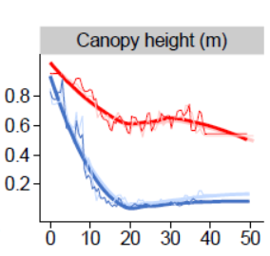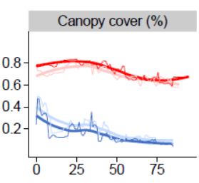

Reviewing the 2020 Labor Day fires in the Western Cascades, the Evers et al (2022) found:
… both vegetation structure and topography significantly affect burn severity patterns even under extreme fuel aridity and winds. Early-seral forests primarily concentrated on private lands, burned more severely than their older and taller counterparts, over the entire megafire event regardless of topography. Meanwhile, mature stands burned severely only under extreme winds and especially on steeper slopes. … The most important factors explaining high burn severity across all five megafires combined (both burn periods) were canopy height, followed by weather period (i.e., winds), …

Vegetation structure (especially canopy height) was the strongest predictor of high burn severity and was strongly related to two important thresholds. First, the likelihood of high burn severity increased markedly in stands shorter than 20 m and was particularly high below 10 m for P1 [severe fire weather] and especially P2 [moderate fire weather] (Figure 2B). The likelihood of short-stature vegetation (ca. 5 m) burning at high severity compared to 30 m in P1 was ca. 40% higher and 750% higher in P2. Second, open canopy vegetation, especially below 40% cover, was at substantially higher risk of burning at high severity during both periods, and particularly so for P2. … Canopy height and canopy cover had one of the most pronounced interactions both within and across periods, both of which had a notable and compounding effect on severity below specific thresholds (e.g., canopy heights < 10 m; canopy cover < 40%; Figure 3A). These compounding effects were pervasive and had an overriding effect on other variables. For instance, the effect of slope on severity in P1 was overwhelmed in stands lower than 10 m in canopy height (Figure 3C,G). … The probability of high-severity burn remained elevated for low-stature forests while mature stands were likely protected by thicker bark, shadier conditions [37], increased canopy–base height [79], and lower canopy bulk density [80,81]. Early successional vegetation (<40% canopy cover) burned more severely than closed-canopy forests. Streams and the moist, deep soils of the canyon bottom [20,82,83] lowered the likelihood of high severity fire during P2 … Inconsistent with hypothesis H1, forest structure (particularly canopy height) was the single most important predictor of high-burn severity during P1, … ”

Models show that maintaining canopy cover is a useful way to reduced fire hazard, while removing canopy increases fire hazard. Platt et al (2006) found:
Compared with the original conditions, a closed canopy would result in a 10 percent reduction in the area of high or extreme fireline intensity. In contrast, an open canopy has the opposite effect, increasing the area exposed to high or extreme fireline intensity by 36 percent. Though it may appear counterintuitive, when all else is equal open canopies lead to reduced fuel moisture and increased midflame windspeed, which increase potential fireline intensity.

Avoid excessive slash and unnecessary burning
Another failure of the ongoing Lower Joseph and Lostine projects is the waste of habitat, nutrients, and wood from trees that are cut but rejected by mills, burned in piles, etc. Also excessively large burn piles convert habitat into carbon dioxide (far more than if they burned in a wildfire) and likely create mortality in nearby trees. (See photos below of both projects). That “debris” can instead be kept as standing trees and snags, dead down debris, etc. It can also potentially be put to use through things like firewood, lopped and scattered to reduce ungulate browsing, in-stream restoration, blocking closed roads, reducing runoff, etc. There are many benefits to leaving trees onsite and unburned.
The following photo series shows …
Enormous slash piles in the Lower Joseph project will kill leave trees and sterilize soils when they burn. Rather than provide habitat, sequester (and slowly release) carbon, and retain moisture, they are converted into climate-destroying carbon dioxide. Many logs were also left to rot on site by timber companies because they were not desirable to mill managers. Slash piles in the Lostine project undermine the argument that these will be economically utilized. They are placed in ways that will kill leave trees, and include toxins like plastic tarps that are burned along with the slash.
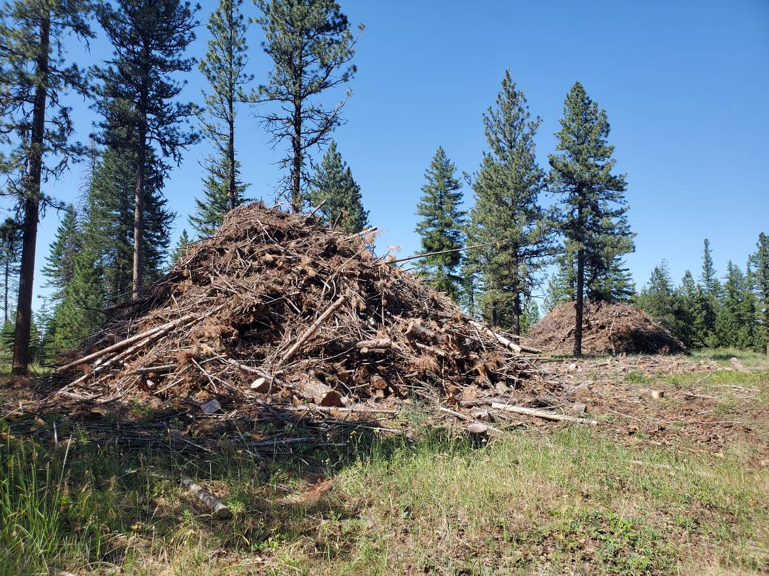

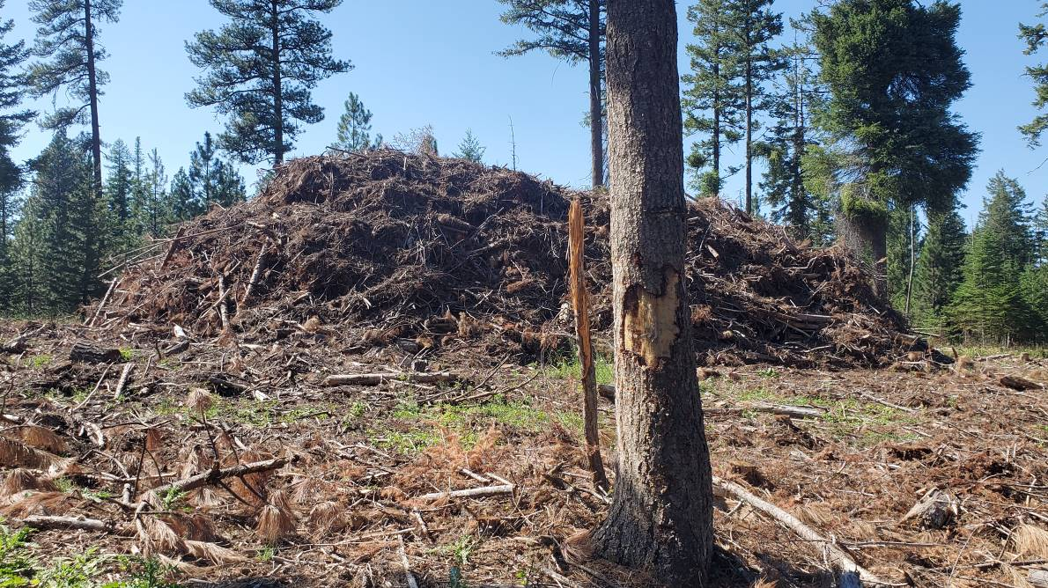

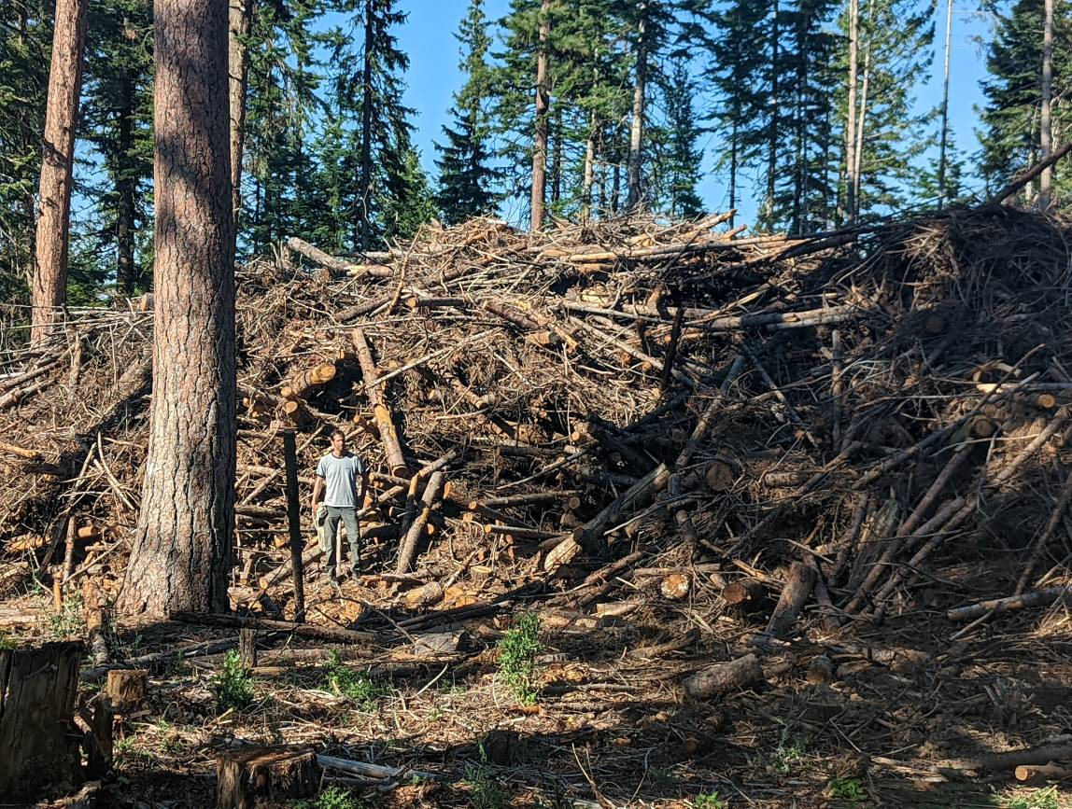

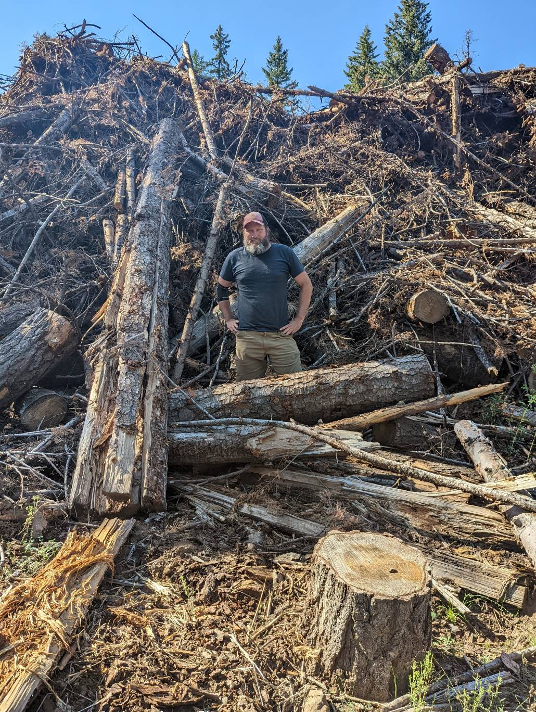

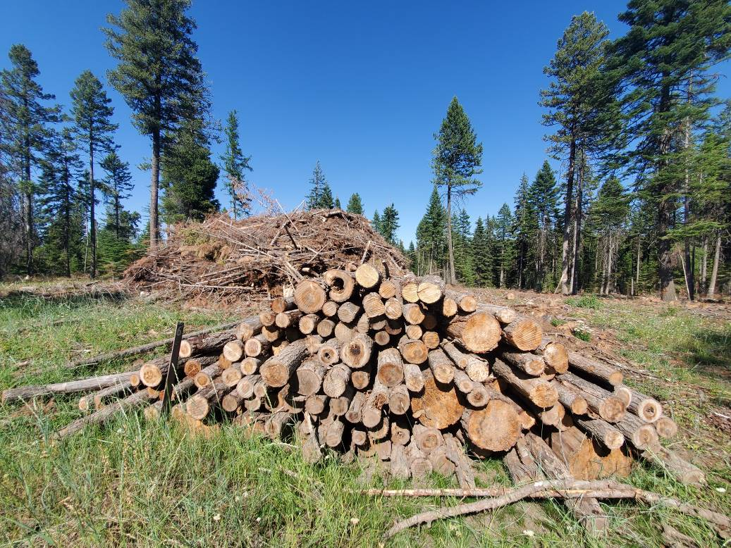
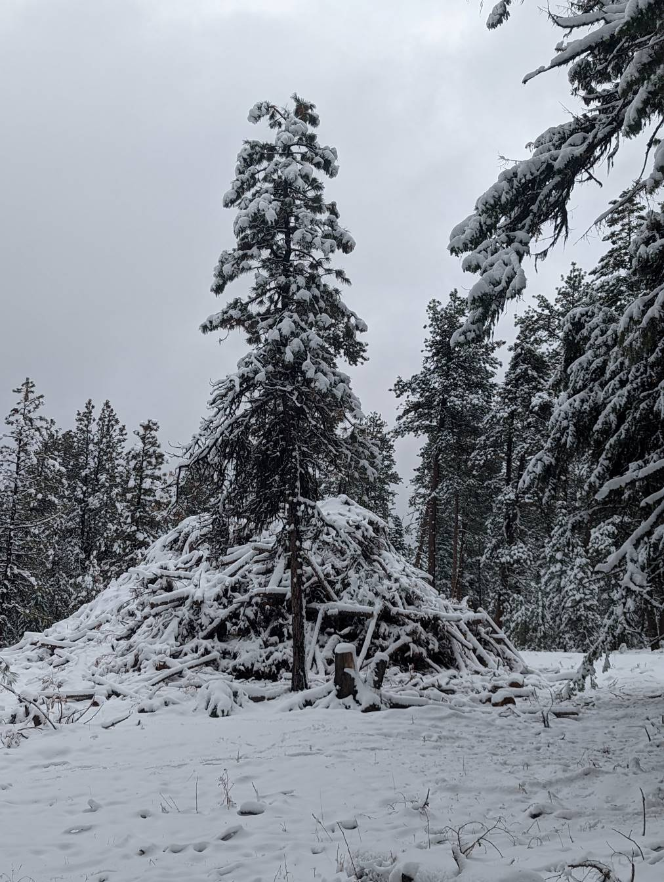

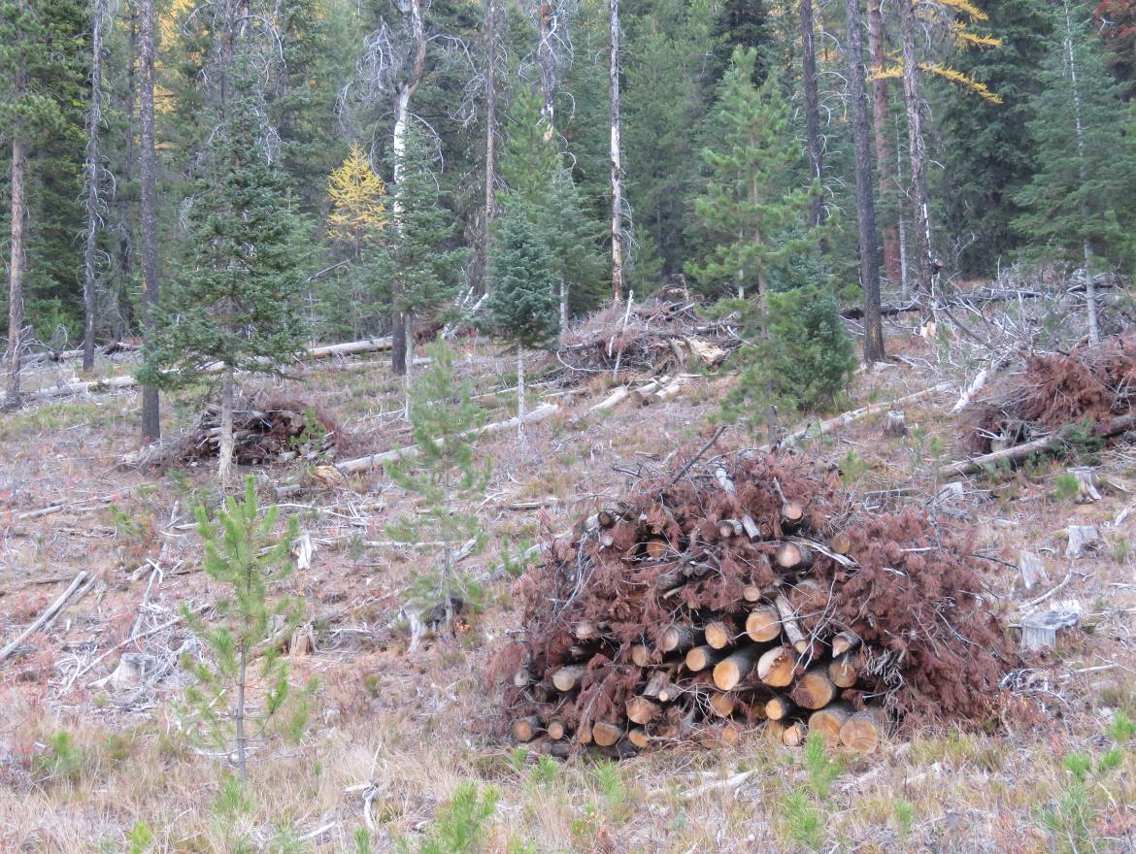

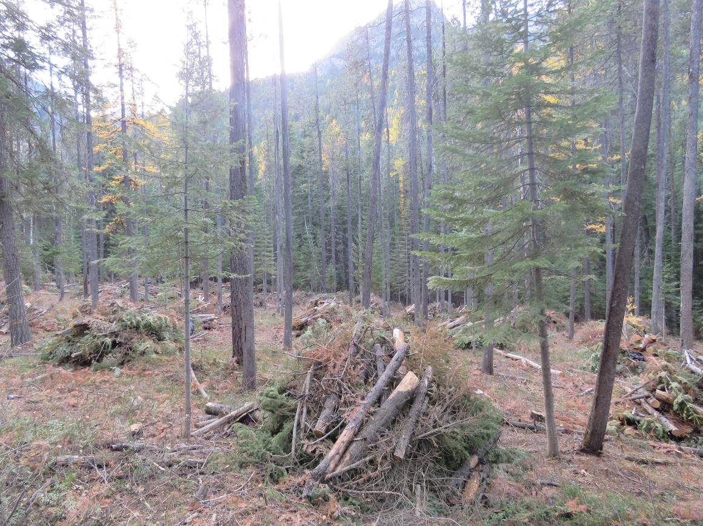

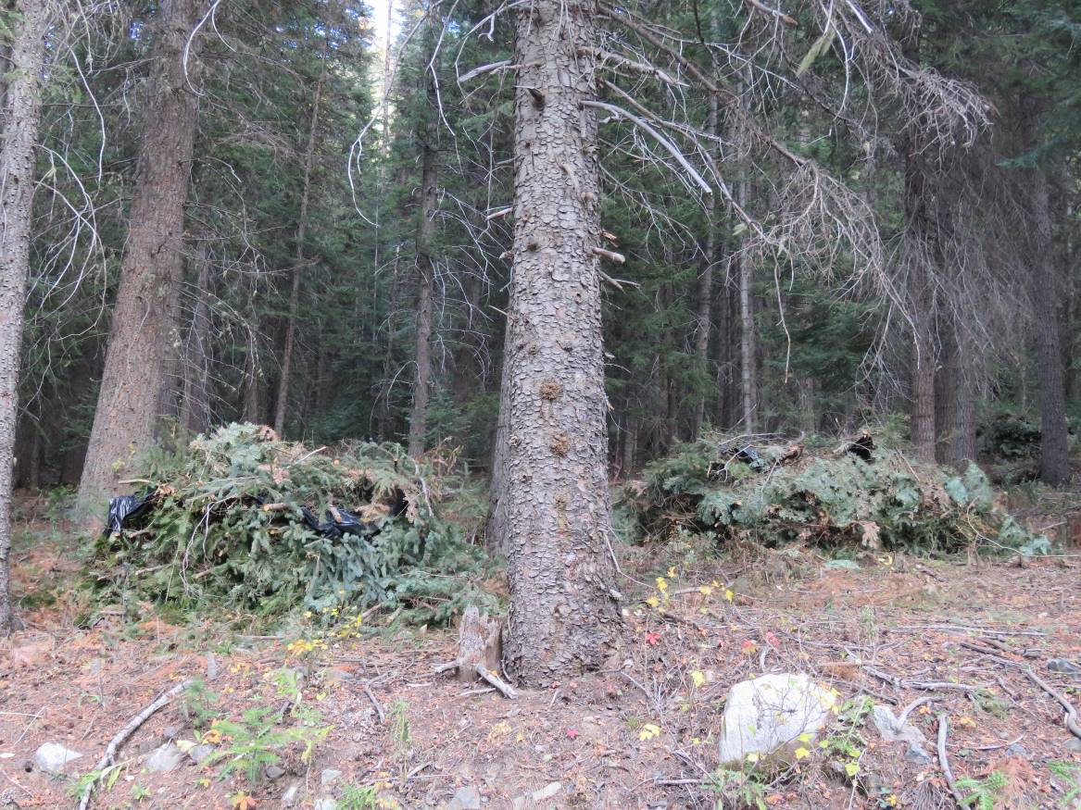

Wildfires and Prescribed Fires
Like prescribed fires, not all medium and high intensity wildfires are “bad” as portrayed by the Forest Service and the alleged need to restore forest health using timber harvest. There are benefits of high-intensity wildfire because they can create large patches that are biodiverse, ecologically important, and spatially rare and unique habitats. Areas impacted by wildfires often have higher species richness and diversity than an unburned old forest. Many wildlife species use this forest habitat type and old forest species select it for foraging.

Some of the more rare and imperiled species, such as the Black-backed Woodpecker and Buff-breasted Flycatcher, depend on forests that have been burned by wildfires. Other benefits from wildfires are examples of ponderosa pine and Douglas-fir forests in Idaho at 5-10 years post-fire where aquatic insects emerging from streams were two and a half times greater in abundance in high-intensity fire areas than in unburned mature/old forest, while bats were nearly 5 times more abundant in riparian areas with high-intensity fire than in unburned mature/old forest (Malison and Baxter 2010).

Many authors conclude that the risk of logging and road building are far greater and have long term impacts versus the risk of wildfire and prescribed fire and the possibly acute but short-term impacts. Native aquatic species like salmon, steelhead, and bull and redband trout evolved with wildfires but did not evolve with timber harvest, high road densities and livestock grazing, that cause long term degraded streams that have failed to recover under current forest management practices.

Beschta et al. (1995) reported that fires reset historical patterns and processes and when allowed to occur without additional human impacts, provide dynamic and biologically critical contributions to ecosystems over the long term. In fact, the "patchiness" of wildfire is an important characteristic that many fish, wildlife, and plant species depend on for their life cycles.
Gedalof et al. (2005) commented that “fuels treatments alone may not be effective at reducing area burned under extreme climatic conditions and furthermore that anthropogenic climate change may have important implications for forest management.” He reported that widespread fuel treatments do nothing to stop the warming trend and do little to reduce the extent or severity of weather-driven fires. Therefore, vegetation treatments intended to reduce wildfires will ultimately fail because a warming climate and wind events are the major drivers of large wildfires.

Buotte et al. (2019) reported that the greater frequency and intensity of extreme events such as wildfires have adversely affected ecosystems, and although climate change impacts forests in many regions, other regions have low vulnerability to fires, insects and drought in the future. The authors report that preserving temperate forests in the western United States that have medium to high potential carbon sequestration and low future climate vulnerability could account for about a third of the global mitigation potential previously identified for temperate and boreal forests. Maps in the report included abundant areas in the Blue Mountains that qualified as high potential for carbon sequestration and low climate vulnerability. Ultimately, smart public lands management is an opportunity to mitigate the effects of climate-induced ecosystem changes to biodiversity and watersheds. That includes making smart decisions to store carbon in large trees and retain those large trees in “vegetation management” projects rather than sending these scarce large trees to mills.

Rhodes and Baker (2008) assessed fuel treatment effectiveness and non-treatment risks from records of the probability of fire occurring in some stand types, particularly ponderosa pine. The authors estimated that fuel treatments have a mean probability of 2.0-7.9% of encountering moderate- or high-severity fire during a 20-year period of reduced fuels. In the remaining treated areas, adverse treatment effects on watersheds are not balanced by benefits from reduced fire severity. In ponderosa pine forests, fuel treatments reduce fire severity on a small fraction of treated areas. Their results indicate that higher-severity fire benefits watersheds and aquatic ecosystems in several ways, including increased recruitment of large wood and pulsed sediment supplies that can rejuvenate aquatic habitats and increase their productivity. High severity fire is also a key process for restoration of structural heterogeneity in forests, which is important for biodiversity. Other research compared the erosional effects of fuel treatments with high-severity fire under the explicit assumption that high-severity fire was inevitable without treatment and the implied assumption that treatments always reduce or eliminate the potential for high severity fire. Their analysis indicates that these assumptions are unwarranted and mischaracterize the outcomes and impacts of treatment options. Their results also indicate that high-severity fire is far from inevitable in untreated areas and affects only a small fraction of such areas at the broad scale. Further, the results indicate that even if fuel treatments were effective when encountering fire, treatments are unlikely to substantially reduce effects of high-severity fire.

Schoennagel et al. (2004) reported that while decades of fire suppression have promoted unnatural fuel accumulation and subsequent large, severe wildfires across western forests, vegetation “treatments” have been developed primarily from studies of dry ponderosa pine forests and then applied uncritically across western forests (such as the Healthy Forests Restoration Act). Their research showed that a “one size fits all” approach to reducing wildfire hazards via “treatments” in the west is unlikely to be effective and may cause collateral damage. Their conclusions are 1) historic fire regimes are complex, including both low-severity surface fires and infrequent high-severity crown fires, 2) both fuels and climate have major influences on the frequency, severity, and size of fires, 3) fire suppression has had variable effects on fuel densities in mixed-severity fire regimes, with the greatest impacts on sites that formerly had open woodlands, 4) the occurrence of high-severity crown fires is within the historical range of variability, although their size and frequency may be increasing, and 5) extreme climate and weather conditions can override the influence of stand structure and fuels on fire behavior.

Analysis

Disclose all analysis
We understand many decisions were made based on initial modelling of the project area that was later found to be flawed. Please disclose what the differences were in the model and real data as well as how it affected proposals and decisions.
It is not clear if the agency will use more accurate and more recent data from LIDAR and other sources or instead rely on older modeling. Using debunked modelling should be an absolute non-starter. Please disclose.

While the LIDAR may be an improvement upon models, it does not capture all the complexity of the forest. We encourage the agency to take a more comprehensive look and err on the side of protecting more connectivity corridors, etc.
We understand that the last time stand exams were done was in the 1990’s (and those were primarily concentrated in the Southwest portion of the project area). New stand exams are necessary given that the premise of this project is that conditions have changed greatly since that time, LIDAR gives an incomplete picture but demonstrated flawed assumptions, FSVeg uses old stand exams, and this landscape is incredibly complex and diverse. Please disclose how many stand exams have been done, where, when, and the results of those exams.
Please share specialists reports as soon as possible.
The agency is relying on dramatically colored fire models that many will find compelling and scary. The Nebo Fire (and perhaps Double Creek) burned many of these acres. This provides an easy opportunity to validate the model. We encourage the agency to run the analysis, disclose the results, and adjust the model as necessary.
The agency conducted a public survey. Please disclose the full results of that.
Since the agency is clearly expediting this process and has only promised a 30-day comment period on the draft decision, we encourage the agency to proactively share analysis prior to the promulgation of the draft so we, and other members of the interested public, can give it due consideration. We also encourage a longer comment period.

Further explain (disclose? justify?) soils analysis
Soils are an underappreciated part of forest systems. Since we understand the agency is justifying many of its activities on soils, we appreciate hearing that a more thorough soil analysis is being conducted. So, at a post-scoping-notice public meeting, we were surprised to see the agency posting a soils map that showed results of a model. We are concerned that model may be flawed. What are the uncertainties of that model? How has it been validated? At what scale? What is the appropriate scale of application, especially given that it is based on a regional scale?
We encourage the agency to test the model against the real-world field data and disclose any and all differences. If the model is found to be flawed, the assumptions, and resulting activities must be adjusted. The real-world data should be more influential than the model.
The soils map displayed at the meeting also raised our eyebrows as they did not reflect the diversity we see across this landscape and region. Soils may indeed be informative, but are not definitive. Forests are part of a biogeoaltitudinal climatic continuum that is extremely complex. Aspect, exposure, and elevation are major drivers of forest patterns in this topographically and climatically complex area. Further, soils have been dramatically altered in the last 170 or so years of post-colonial management. For example, on many ridgetops in this landscape, early grazing practices led to soils being completely eliminated. They simply don’t come back in this time frame and represent mismanagement and use, not historic conditions.
Where soils are “droughty” the agency seems to be taking the approach that more aggressive logging can take place. Perhaps. However, given that logging, thinning, and clearcutting can dry areas more, these areas might become even more vulnerable in a hotter drier world and should instead be left alone so that they are cooler, shaded, and wetter, and, if a fire comes through, there will be more residual wood that holds water and creates soil.
Further, as with the narrow view of HRV the agency continues to use, soils are just a small part of the picture. Among other things, there may be many species that depend on the more dense complex forests that nature has created even if it may not have always existed on that particular acre. The impact of trying to convert, revert, or restore that acre to something else may now have serious negative impacts. That is especially true in a changing climate and developing world, and when zooming out to put this project area into a broader context.
Of particular note, ash soils are have high water-holding capacity and are very susceptible to compaction.

HRV is a flawed basis for restoration projects. If used, it must be used in a more comprehensive manner.
HRV is overused by the agency and suffers from many flaws. That is especially true given radically changing conditions on many fronts (climate, fire exclusion, biodiversity loss, increased development, etc.).
HRV tends to view forests as static leading to a desire to “restore” to arbitrary conditions and states rather than important functions.

Forests are not static. They are infinitely complex and dynamic systems. The climate, human activities, and other forces have changed dramatically over the last 150 years and appear set to continue to change at an accelerating rate. If the agency is going to use HRV and future conditions/RV, then the agency must do a better job explaining how those very different contexts can be harmonized and justified in the present. Otherwise it is simply speculation.
The concept of HRV is rightly being subject to increased scrutiny from the scientific and conservation communities. The agency must justify its otherwise arbitrary choice of time frame to consider the baseline and give careful consideration to what conditions may have been present at that time.
Developing projects based on HRV of tree species, density, and composition, is often used with an assumption that doing so will lead to a number of particular outcomes. Using habitat (especially using extremely limited and disconnected measures such as forest structure and tree species composition) as proxy for actual results must be validated. To date, it has not. Further, there are many other values subject to HRV. If HRV is being used, please conduct a consistent HRV analysis for the following:
- Water temperature and quantity
- Cows and other livestock
- Roads
- Motorized vehicles
- Nutrient cycles
- Tree species composition
- Snags
- Forest Complexity
- Water table
- Forest structure
- Fencing
- Salmon
- Native fish and wildlife – specific species presence and abundance, species diversity, and richness
- Botanical species presence and abundance, species diversity and richness.
- Snags
- Mycorrhizal networks
- Soil temperature and moisture
- Down woody habitat
- Solar penetration
- Fire, insects, disease, and other natural disturbance
- Down woody habitat
- Human presence and use patterns
- In-stream complexity
- Carbon sequestration (active and currently stored)
- Soil health including compaction.
- Carbon emissions and flow
- Blocks of contiguous unroaded habitat
HRV also misses a great deal of nuance. The agency must do a better job identifying winners and losers in trying to change forest structure and justifying why one is preferable to another. For instance, “canopy closure” misses many things when it is considered binary. Dense forests with complex layers of canopy may not be desirable to silviculturists and fuels specialists. However these provide thermal cover, moisture retention, cover from predators, auditory refuge, and more.

Consider secondary impacts
Thinning forests will create many secondary impacts. The agency must consider increased windthrow (as seen in the nearby Lower Joseph project), increased grazing (especially given the agency entertaining repopulation of vacant and closed allotments. It is notable that that the agency is considering a Title II allocation that specifically references the Morgan Nesbit Project and data collection on vacant allotments in the project area. The agency must also consider increased poaching, increased firewood harvest (legal and illegal), increased invasives, increased off-road motorized use, etc.
Specifically to grazing, if the agency insists upon not addressing grazing and considers it an existing condition, the agency must also recognize that the impacts of grazing will change after implementation. The agency must analyze that and include mitigation measures at all scales.
While we recognize that Wallowa Chieftain writer Bill Bradshaw has a history of misquoting people, we were dismayed to read an article quoting District Ranger Brian Anderson saying that livestock grazing can help the overall health of the forest and reduce fire risk. That is simply untrue. This area is actively being absolutely trashed by livestock grazing – and it is well-known to all Forest Service staff. Livestock damage in this project area has been highlighted in the Bend Bulletin, Oregonian, High Country News, and on OPB. We have been monitoring wildlife with remote cameras on this landscape for over a decade. In many places, cows outnumber native wildlife in our photos by a ratio >9:1.
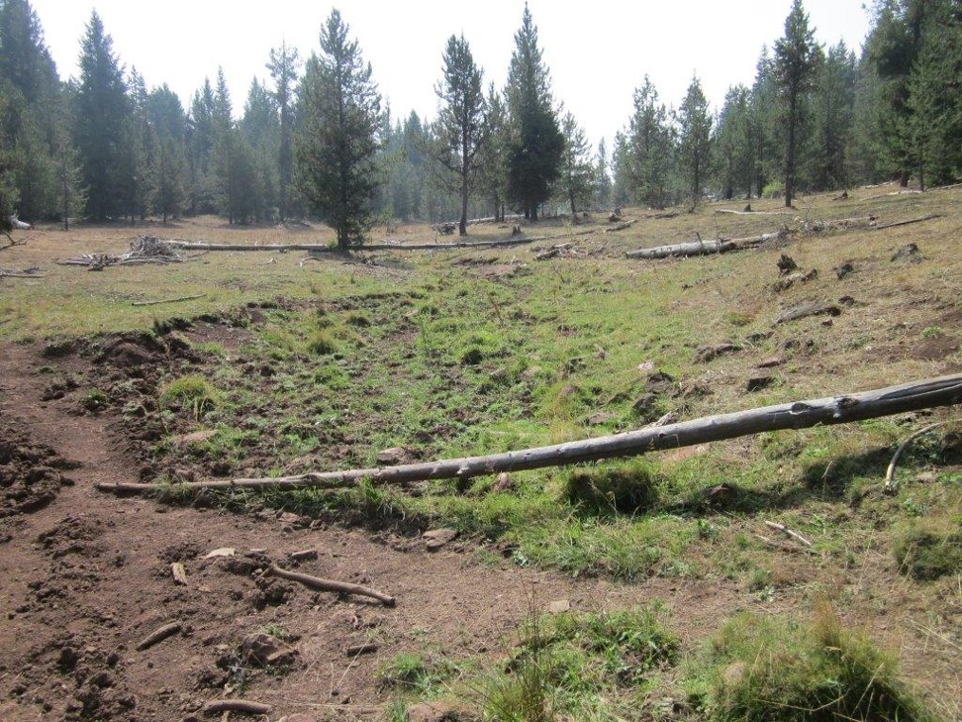
A typical “wet meadow” in the Morgan Nesbit Project Area. While cutting and dropping some conifers could be beneficial, the obvious restoration needed here is to adjust grazing practices. This photo is taken during a wet time of year. Among less obvious impacts, the water table has been reduced from livestock use.
Opening up and/or simplifying canopies has many deleterious effects and – trade-offs. It can harden snowpack making it harder for owls and other plunge predators to hunt. It can increase forb flush changing the composition of the prey base for birds of prey and mesopredators.
Please fully explain the benefits of OFMS vs. OFSS and vice versa. Who/what are the winners and losers in each?
How will stands react? Immediately? In 10 years, 20, and 50? Will larch actually come back where that is the intention? Especially with stands of lodgepole in abundance, might they and grand fir be released in greater abundance? Will that only intensify the current situation?

Include fire use planning
The agency has a long history of selling projects like this as “setting up the landscape for fire” but then continuing a relentless policy of fire suppression. Doing so only continues the cycle of restoration need and undermines the credibility of the agency. It simply becomes logging and “restoration” for its own sake, which is not restoration at all. While we appreciate that the agency has begun to talk about fire use, and has even allowed some wildfires to burn, that has so far only occurred here on very small fires and in designated Wilderness. Until the agency begins using wildfire in other landscapes, or develops a real fire use plan on this project, we – and the agency analysis – must assume that fire will not be allowed to burn here in the future. To be clear, fire use planning includes prescribed fire and wild fire.
While often beneficial, prescribed fire does not replicate wildfire and the agency has a tremendous backlog of prescribed fire.

Analyze likely scenarios during implementation, create adaptive implementation plans, and ensure active monitoring and adjustment.
In the Big Mosquito Restoration Project, large and old pine were meant to be protected and retained. However, once the project began being implemented, many of the old growth trees were considered dangerous. Many were cut and sent to mills, which undermined the goals of the project. There was no meaningful monitoring, oversight, or accountability from the local CFLR Program. This is not an isolated incident. The agency must analyze the likelihood of such outcomes and create adaptive implementation plans that allow off-ramps or changes to contracts, logging systems, and prescriptions to ensure that project goals are not undermined and public trust is not broken. Sufficient dollars for monitoring and enforcement must be identified before logging occurs.

The following photo series shows … Photos from Blue Mountain Biodiversity Project and Daniel Howland show old growth logging in the Big Mosquito Project.

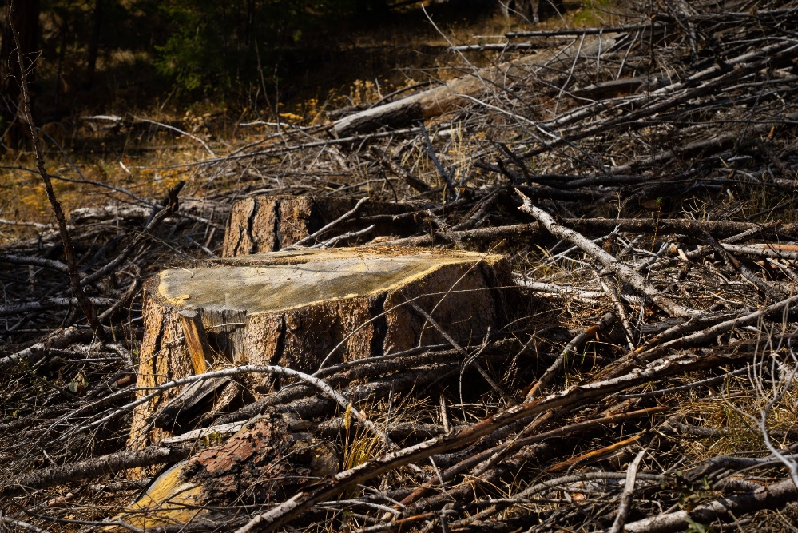

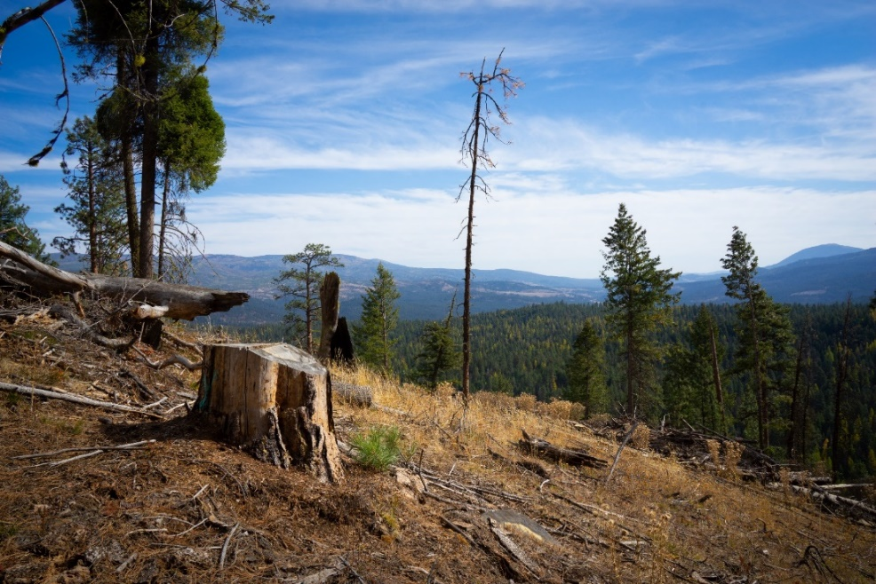

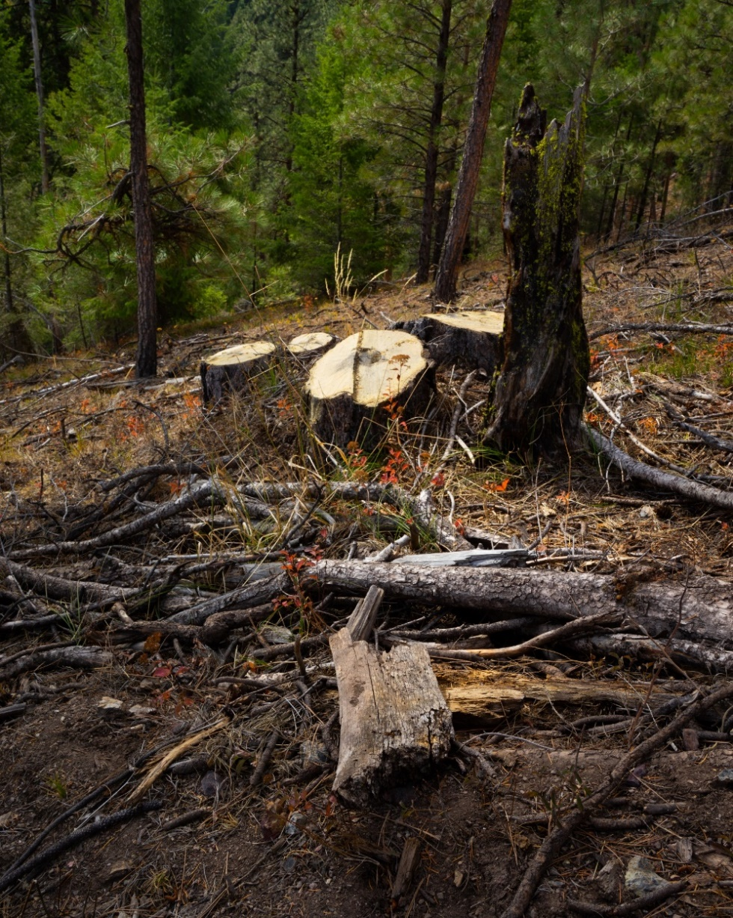

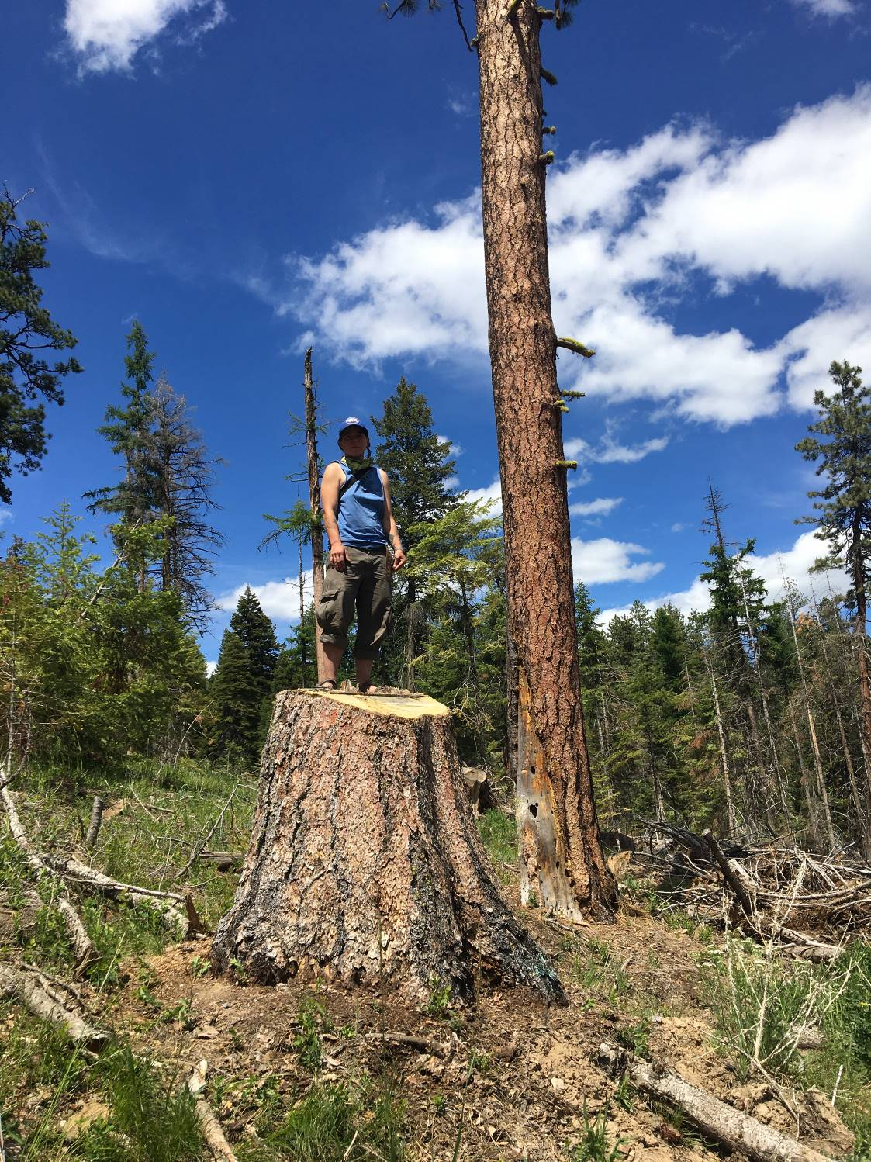

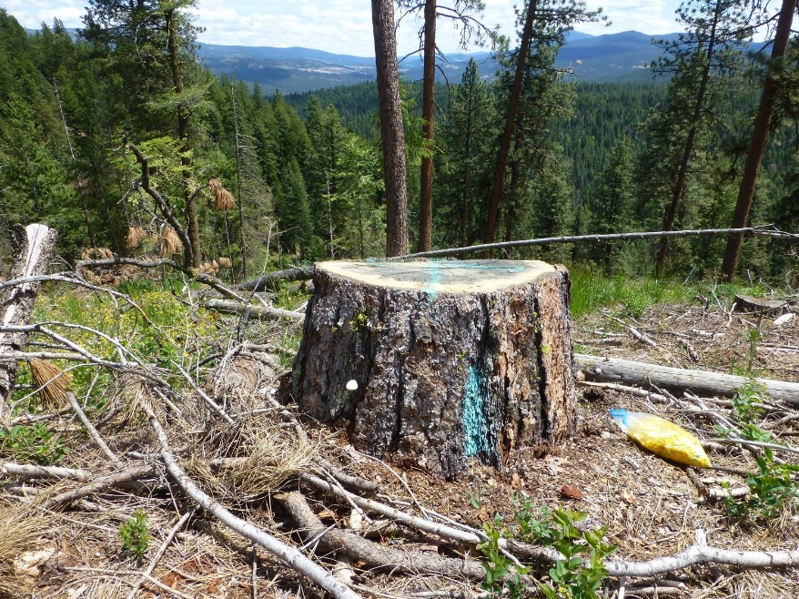

In the Lower Joseph Project, which is currently being implemented by this district, logging operations resulted in a shocking amount of damage to trees that were meant to be left. In the past, bumping “undesirable” leave trees has been a purposeful act by contractors, with the Forest Service not objecting. Damaging leave trees, especially grand fir, can undermine the goals of the proposed project. The scale of the damage on Lower Joseph is sloppy and unprofessional at best. It is hard to come to a conclusion that it was not purposeful and systematic. We are aware of no corrective action. Given that this is ongoing, on the same district, and the result of likely operators of this project, the agency must either assume similar rates of damage in its analysis, and/or ensure active monitoring with consequences for sloppy operators or changes in activities.

Photos below show examples from the Lower Joseph Project:
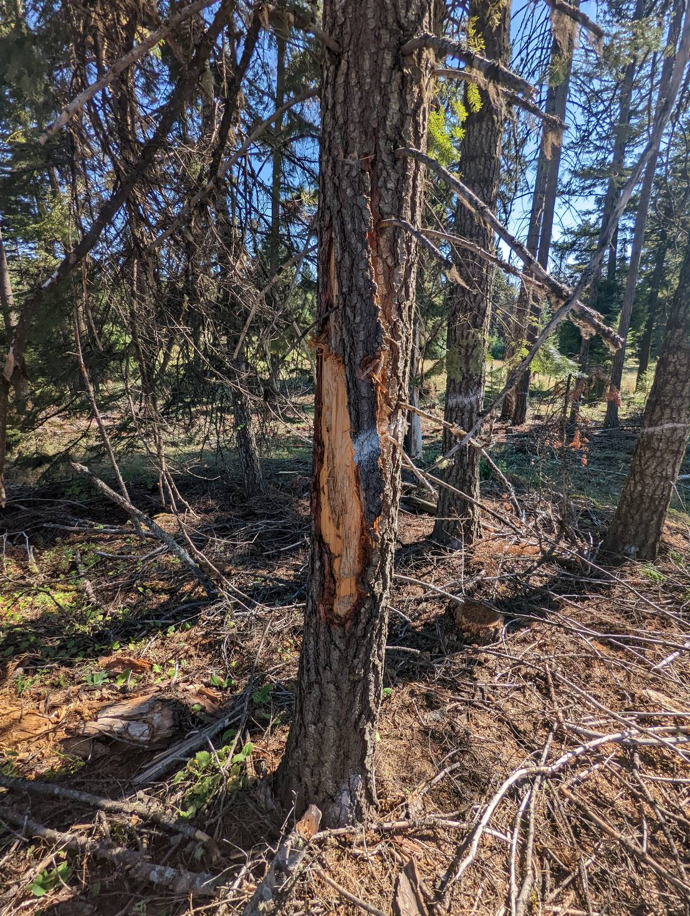
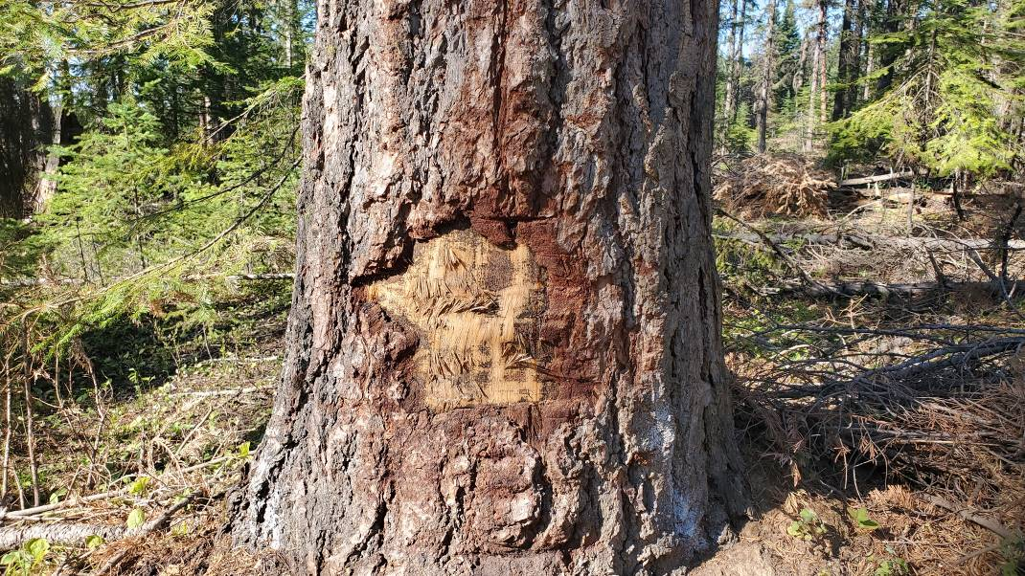

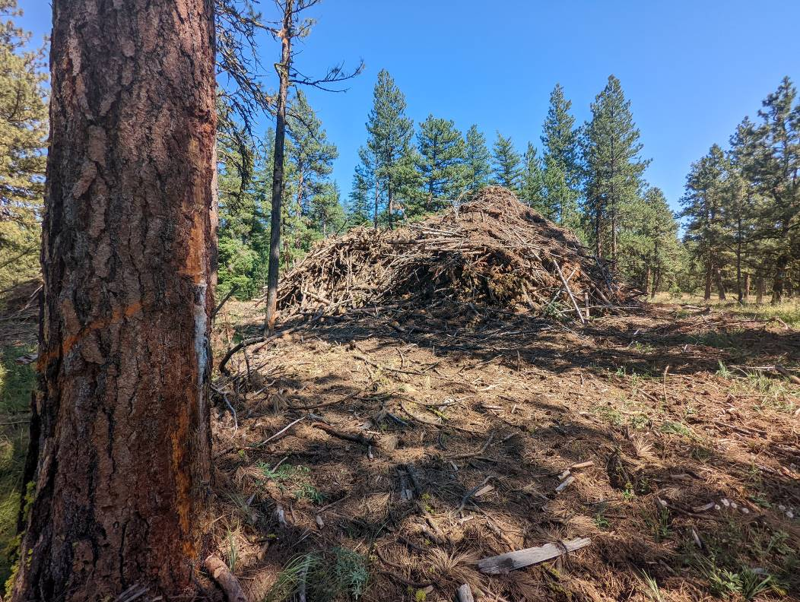

/ / /

/ / /

/ / /

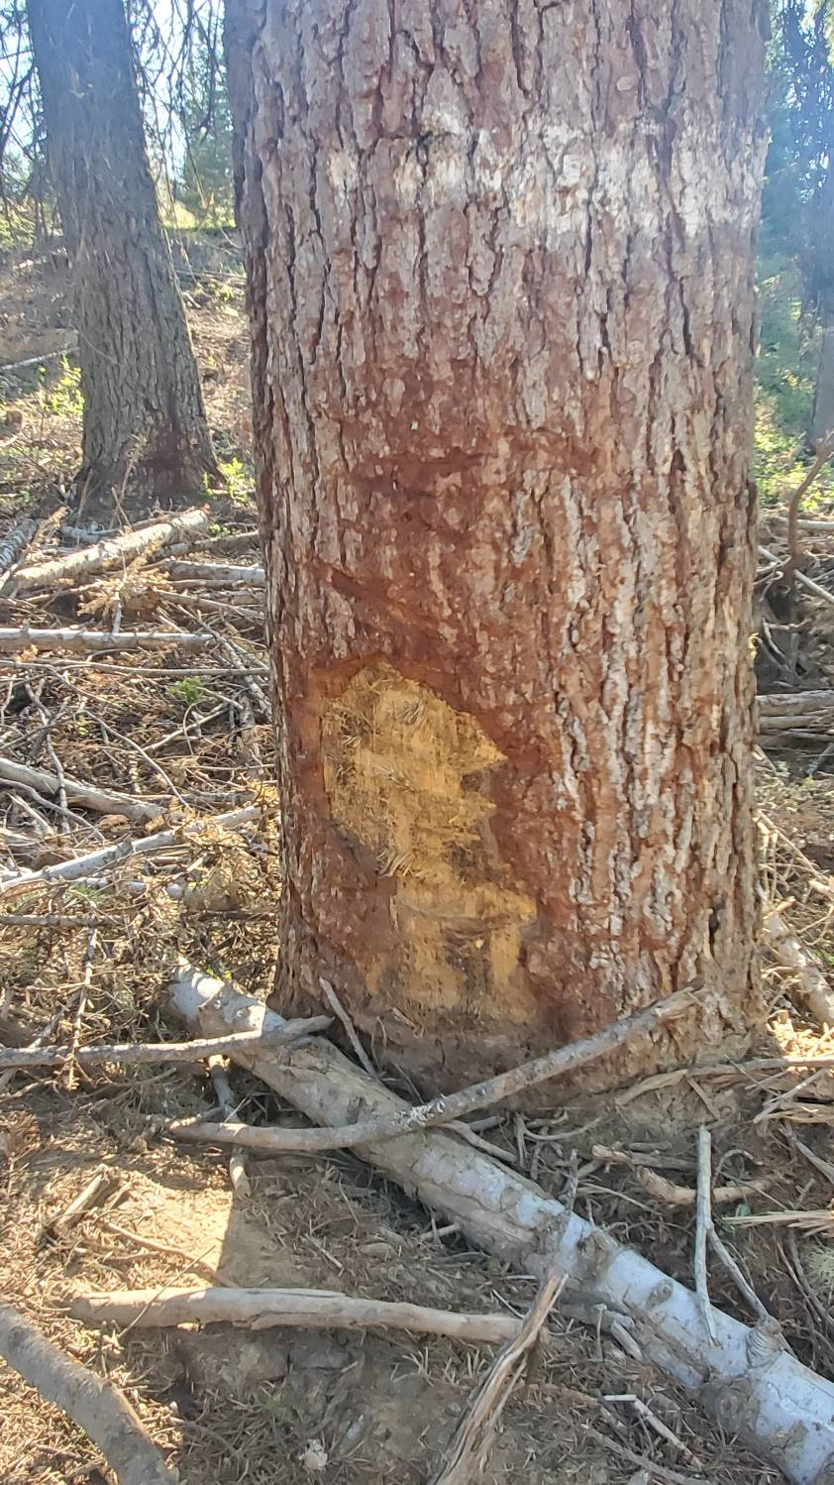

Conduct thorough botanical surveys looking for known and potential rare, sensitive, threatened, endangered, and endemic species.
There are numerous sensitive plant species here including Botrychium minganenese, Lomatioum greenmanii, Bolandra oregano, Mimulus patulus, Wallowa Primrose, and Primula Cusickiana. Past USFS analysis has noted that there is a great deal of potential habitat for additional rare plants as well as unique plant communities and associations including the potential for a great many endemic species.

Conduct a thorough survey for cultural values.
Due to the sensitive nature of these values, we are not going to go into detail in this public facing document. However, we are aware of numerous significant cultural sites and artifacts in this project area. By the agency’s own acknowledgement, surveys have been inadequate and there are likely many unknown cultural resources that occur. The agency must look before it logs.

Include analysis that extends beyond the project borders.
Please explain the justification for the project boundaries?
There is a lot of recent fire just outside the border of the project boundaries (and even some within the boundaries). An (HRV and other) analysis that include adjacent lands might find that stand initiation, single story, open forest, and other states that are described as “overrepresented” in the project area are actually underrepresented in the broader landscape. In particular, adjacent private lands and private inholdings are very different and some have been recently heavily logged. These conditions and recent activities mean that the values of complex and less heavily managed forests found within the project boundaries may have additional value than assumed when looked at in arbitrary isolation.

Some fundamental assumptions are flawed or, at least, far more complex and controversial than the agency acknowledges. Among the many examples:
It is assumed that water is the limiting factor on this landscape, that “opening stands up” will reduce competition, and therefore remaining trees/forests will be more resilient. However, dense, complex forests, including those with grand fir – even in dry regions – are often limited by sun due to their density. Opening up stands may release trees in the short term, but as a result, may actually make them more susceptible to drought and dry conditions in the long-term.
The agency continues to look at fire and other natural disturbance as a negative. However, fire, even stand-replacing fire at large scales is a necessary part of the cycle of these forests. Logging and thinning and post-colonial human management is not. The agency and logging collaboratives also continue to assume that logging and thinning will reduce fuel, and therefore fire risk. Even if fire is views as destructive, and more likely to occur in this age of climate change, thinning is likely to actually increase fire risk. In high fire risk scenarios, fuel is not the limiting factor. High winds and dry conditions are likely to overwhelm any fuel reduction treatments. Over time fuels come back, and will come back as finer fuels. And further, opening up stands is likely to make them hotter and drier, and more fire prone for longer periods of time. We have already seen this on ongoing projects on this district like Lower Joseph and Lostine.

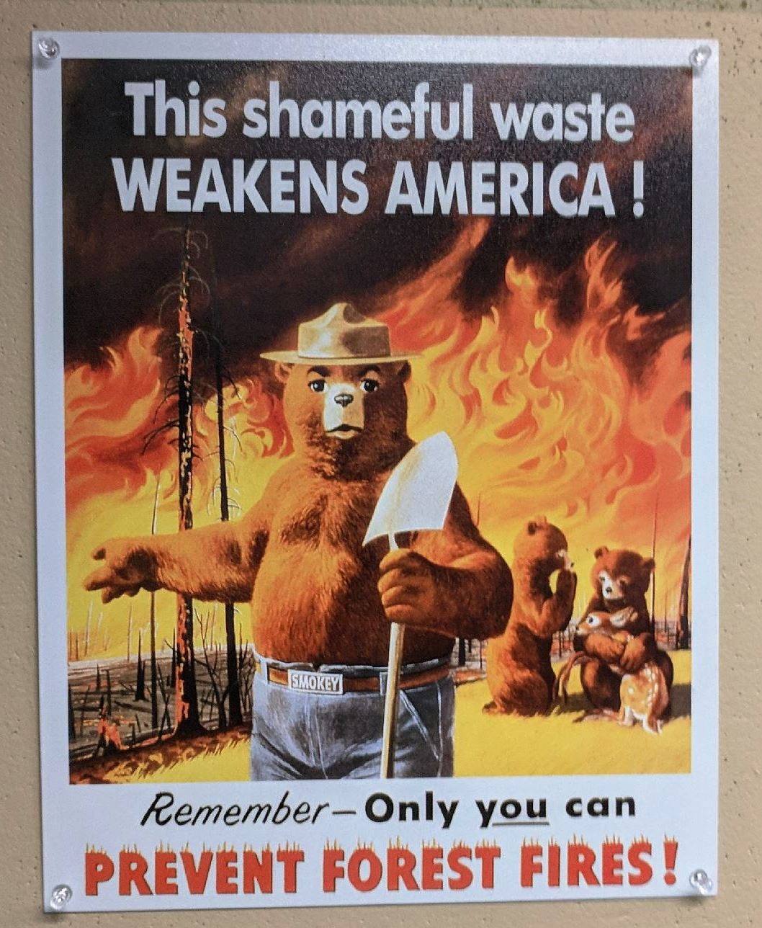
This poster hangs in the Wallowa Mountains Office of the Wallowa Whitman National Forest and shows a flawed and unhelpful, but widely held view of natural disturbance.
This is a fire-dependent landscape that is currently facing a fire deficit after decades of fire suppression. That history includes large, stand-replacing fires on vast landscapes. To the extent that fire can be “catastrophic”, it is a home ignition and climate problem. It is not a fuels problem, and certainly not a backcountry fuels problem. Home ignition issues are best addressed within the ignition zone of those structures. Logging and thinning more than a few hundred feet from those values has no effect. Further, the logging, thinning, and other activities proposed by this project will make climate change worse.
Despite the claims made in the Scoping Notice “frequent low-intensity fires maintained forest health and wildlife habitat…”Past USFS analysis of this area notes that there is a wide variety of fire regimes. Much of the area is dominated by a historic fire regime that is described as “infrequent, high-intensity, and extensive,” especially when they occur in >90th percentile conditions. This has been validated by fires such as the Canal Fire. Further, past analysis assumed future trends would be “expected to exhibit similar fire regime patterns”. This is not unexpected, novel, or an emergency that needs to be solved through human intervention. Rather, in many parts of the landscape it is what these forests have evolved with.
Logging does not replicate fire. Fire – even stand replacing fire – leaves behind the vast majority of carbon (to be reincorporated or very slowly released), snags, downed material, and other unique habitat, nutrients, etc. Logging leaves behind compacted soils, roads, invasive species, etc. Where the agency insists upon killing trees, they do not need to be taken offsite. They can be dropped on site, cut by hand, killed by girdling, blowing out tops, etc.

Foresters like to think that logging mimics natural processes like fire, but this is far from the case, because logging removes so much more biomass than fire. Fire leaves abundant legacies that offer some late successional habitat value, even in the young stands that dominate in the decades after fire. This is not the case with regen logging which removes much more biomass and disproportionally removes the large legacy components. This causes a much more abrupt spatial and temporal transition/ fragmentation between young and old forests. Logging also causes much more significant soil disturbance, especially compaction and displacement, from roads, landings, skidding and yarding logs, and unusually hot slash fires. This spreads weeds, harms the below-ground ecosystem, degrades site productivity, and causes erosion. Regen combined with replanting and roads also causes very atypical hydrologic disruption, including artificial peak flows immediately after the first several storms following logging, and artificial low flows during summer for several decades following establishment of dense tree plantations.

Logging does not mimic natural disturbance because it removes the vast majority of the habitat structure, such as snags and large down wood, that early seral wildlife depend on. Eighty five percent of vertebrates tied to edges and early seral forest in the western Cascades need dead wood.

Natural disturbance recruits large amounts of dead wood that provide valuable habitat for diverse wildlife. Of the many wildlife species that use early seral forest, 85% use dead wood at some life stage. Unfortunately, regen harvest removes virtually all of the most valuable large wood depriving wildlife of the rich structural complexity they would normally enjoy after a natural disturbance.

McCrae et al (2001) highlight some of the differences between logging and natural disturbance:
The presence of coarse woody debris is critical for biodiversity conservation. … In general, post-fire forest ecosystems include the presence of large numbers of snags and downed woody debris. This dead material provides important habitat elements for many species of plants and animals, while also storing a great deal of carbon (MacDonald 1993; Fleming and Freedman 1998; Freedman et al. 1996).
Clearcut harvesting of natural forests results in the removal of most of the aboveground woody biomass from the site because trees are the commodity being harvested. … Because clearcut harvesting concentrates on the removal of biomass, it fails to produce large-dimension snags and coarse-woody debris in intensively managed forests, … Although both harvesting and wildfire kills trees, only fire leaves them as dead standing biomass. … The fire-killed snags and woody debris cast partial shade, which ameliorates the surface microclimate and may enhance the survival of pine seedlings (Fraser and Farrar 1953; Cayford and McRae 1983; Carleton and MacLellan 1994).
… Some studies have suggested that the cover and richness of the understorey vegetation of a natural forest may never fully recover from clearcutting. … Wildfires reduce the presence of some hosts that assist the spread of pests and pathogens while clearcutting may promote them. … [E]xclusion of fire from such ecosystems, along with forestry practices that leaves young infected trees in the residual stand, leads to increased abundance of this parasite. In contrast, fire eliminates Dwarf mistletoe. … Numerous studies have determined the potential removals of nutrients with conventional and whole-tree clearcuts … The data show that clearcutting removes large amounts of biomass and nutrients from the site, and that these are equivalent to a substantial fraction of the site capita of these materials.
… During a wildfire, biomass capital of the stand is lost by combustion, as is that of nitrogen through the oxidation of organic compounds and the release of gaseous NO and NH3. In intense wildfires these losses of biomass and nitrogen can be comparable in magnitude to what would be removed by the clearcutting of comparable stands. Unlike wildfire, however, clearcutting also removes large amounts of phosphorus, potassium, calcium, and magnesium contained in the tree biomass; these materials are mostly conserved in situ during a wildfire.
… Clearcut harvesting with heavy equipment can cause severe soil compaction along skidding lanes and it can also disrupt soil profiles by churning … Permanent roads are not generally associated with wildfire management or suppression (although temporary access routes may be constructed while fighting some wildfires). An extensive road network is, however, necessary for timber harvesting and subsequent stand management. Roads affect biodiversity in many ways. Roads directly remove natural habitat, alter drainage and stream dynamics, cause erosion, introduce edge effects, fragment contiguous ecosystems, alter species movements, and act as corridors for the introduction of non-native species …. Road density is a useful indicator of ecological threat … [I]t is erroneous to assume that forest harvesting plays the same ecological role as wildfire.

Modelling by Harris (2000) suggests that since snags are ephemeral and need to be continually replaced, 12 or more green trees need to be retained for every snag we want to maintain over the life of the stand. This paper also highlights the concern that without numerical guides, managers could erroneously assume that they are maintaining adequate numbers of snags across the landscape even though they are retaining too few green trees to achieve that goal.

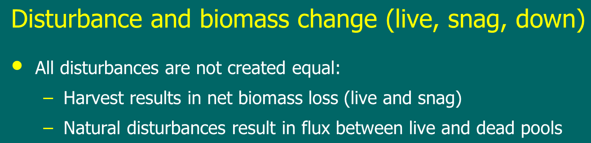

The agency and collaborators often assume that leave trees will be healthier after logging. That is often not true, and we’ve seen it for various reasons on this district and neighboring forests. On Lower Joseph, centuries old trees were left vulnerable to winds and toppled after the “restoration” project. In Big Mosquito, huge numbers of old-growth pine meant to be saved were cut as hazard trees. In Lower Joseph, many leave trees were damaged by logging equipment and are likely to die. Leave trees on many projects are killed (on purpose and by accident) from burning immense piles of slash. Further, logging and other activities have impacts from compacted soils, nutrient removal, and mycorrhizal networks.
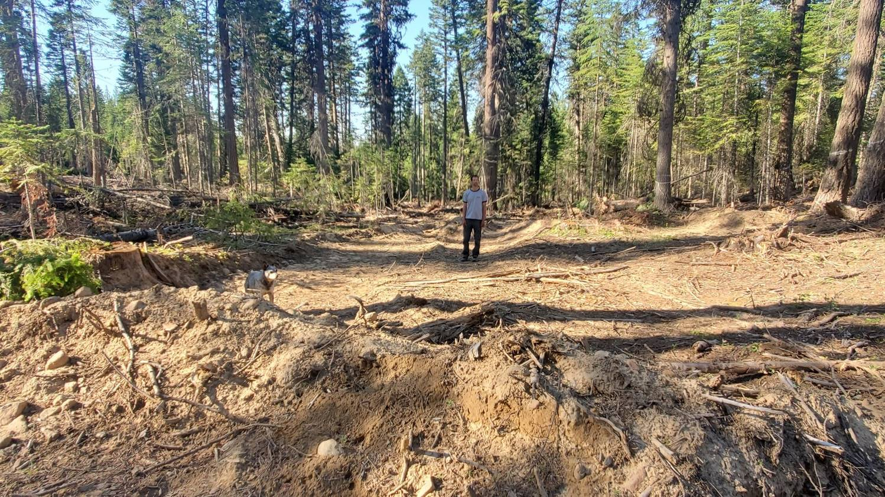
Compacted soils from the nearby and ongoing Lower Joseph Project. They will likely soon flush with invasive plants.
The agency, industry, and logging collaboratives often argue some protective management designations like Old Growth should be managed more flexibly. On the other hand, they simultaneously argue that we must rigidly consider logging for areas like MA-1. The latter may have some validity if this is a volume sale. However, this is supposed to be a restoration/resilience project. Simply being in a timber management zone is not sufficient justification to log it.
Prior to project initiation, we expressed concern about the agency doing a single HRV analysis for 87,000 diverse and complex acres. There are no less than three distinct conditions, and arguable far more. HRV analysis does not take very long. In addition to our other HRV comments, the agency must conduct more than one HRV analysis for the project area.
Grand fir may be less fire resistant than ponderosa pine and larch. However, large grand fir are often fire resistant – certainly more than small ones. Cutting large grand fir that are likely to be replaced by smaller grand fir is likely to increase fire risk. Where large grand fir may be considered ladder fuel, lower branches could be limbed or mortality could be induced through means other than chainsaws.

Disclose and Mitigate Cumulative Effects
Multiple projects have been recently proposed and may still be in implementation that overlap, are immediately adjacent to, and near this project area. They include, but may not be limited to Cold Canal, Puderbaugh, Divide WUI, and numerous private lands projects.
The NEPA document must fully disclose the cumulative effects of past, present, and foreseeable future livestock grazing, timber harvest, prescribed fire, and road developments on water quality, forest health, wildlife habitat, noxious weeds, cultural resources, and other resources.

The agency cannot look at each category of environmental effect in isolation. Many effects interact resulting in compound risks that are greater than the sum of each effect viewed individually. Disclosure of cumulative impacts should include a description of the compounding effects of multiple factors that influence environmental values. These include the interaction of the likely effects of global climate change (e.g. intensified drought, fire, precipitation, increased stream temperature, increased flooding in the wet season, reduced flows in the dry season, ocean acidification, sea level rise, etc.) and existing natural processes (e.g., fire and storms), and ongoing environmental stresses caused by human activities (e.g., edge effects, habitat loss, artificial peak and low stream flow, etc.).

The cumulative effects analysis should include a map of the planning area showing all past harvest, including thinning and regen displayed in different colors.

The NEPA analysis must address the cumulative watershed effects caused by past, present and foreseeable future road construction. Roads are “exotic structures” that have no equivalent in the historic record, yet they have strong influence on watershed processes by rerouting water in various ways. Since roads are nearly ubiquitous across the landscape, they often have significant cumulative impacts that must be considered.

The 9th Circuit decision in Lands Council v Powell makes clear that NEPA are not met with a mere listing of other projects, but requires careful disclosure of impacts of other projects and adding up of impacts so they can be compared to management thresholds. This court said:
Cumulative effects analysis requires the Final Environmental Impact Statement to analyze the impact of a proposed project in light of that project’s interaction with the effects of past, current, and reasonably foreseeable future projects. See 40 C.F.R. §1508.7. … there is no discussion of the connection between individual harvests and the prior environmental harms from those harvests that the Forest Service now acknowledges. Instead, the Final Environmental Impact Statement contains only vague discussion of the general impact of prior timber harvesting, and no discussion of the environmental impact from past projects on an individual basis, which might have informed analysis about alternatives presented for the current project. … Muckleshoot Indian Tribe v. United States Forest Serv., 177 F.3d 800, 809-10 (9th Cir. 1999) (“[A]n EIS must catalogue adequately the relevant past projects in the area.... Detail is therefore required in describing the cumulative effects of a proposed action with other proposed actions.” (internal citation and quotation marks omitted)). Stated differently, the general rule under NEPA is that, in assessing cumulative effects, the Environmental Impact Statement must give a sufficiently detailed catalogue of past, present, and future projects, and provide adequate analysis about how these projects, and differences between the projects, are thought to have impacted the environment. See Neighbors of Cuddy Mountain v. United States Forest Serv., 137 F.3d 1372, 1379-80 (9th Cir. 1998); City of Caramel-By-The-Sea v. United States Dept. of Transp., 123 F.3d 1142, 1160-61 (9th Cir. 1997). … For the public and agency personnel to adequately evaluate the cumulative effects of past timber harvests, the Final Environmental Impact Statement should have provided adequate data of the time, type, place, and scale of past timber harvests and should have explained in sufficient detail how different project plans and harvest methods affected the environment. The Forest Service did not do this, and NEPA requires otherwise.7 Muckleshoot, 177 F.3d at 809-10.

The 9th Circuit’s legal requirement for adequate discussion of the cumulative effects of timber harvest and other projects requires the agency to disclose, analyze, and consider:
- a “detailed catalog of past present and future projects”
- “the time, type, place, and scale of past timber harvests”
- “how these projects, and differences between the projects, are thought to have impacted the environment” and ”explain[] in sufficient detail how different project plans and harvest methods affected the environment”
- “analyze the impact of a proposed project in light of that project’s interaction with the effects of past, current, and reasonably foreseeable future projects”

Consider the cumulative impacts of forest practices in Oregon. "Cumulative Effects of Forest Practices..." by Beschta et al.

The agency must consider and disclose cumulative impacts even when using Categorical Exclusions. In Wildwest Institute v. Austin. (District of Montana. #CV 05 37 M DWM. Sept 25, 2006) Judge Molloy held that the Forest Service violated NEPA when it approved a CE without considering cumulative impacts on soil and management indicator species.
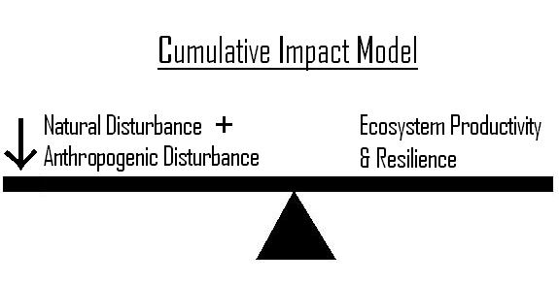

The agency must analyze the cumulative impacts of modifying habitat for special status species that depend upon under-represented habitats.

The cumulative impacts analysis must describe the cumulative impacts at relevant scales. For cumulative impacts on species, the relevant scale is the range of the species. Impacts on species must be done at the range-wide level (like the 1994 NW Forest Plan EIS that described the cumulative impacts of all federal management throughout the range of the spotted owl and the marbled murrelet, as well as several salmon ESUs), not at the project level.

Each special status species was designated because of some level of concern for persistence or special relevance to land management. Even though some habitat type may be relatively abundant at the project- or watershed-scale, but the agency cannot ignore the facts that (1) many habitat types (especially old forest, young complex forest with abundant legacies, park-like stands on the eastside, functional aquatic habitats) are far below the historic range of variability across the range of many special status species, and (2) the long-term viability of various species that live in the project area is dependent upon the management of habitat across the range of the species. The agency must clearly describe (in a NEPA document) the condition of habitat for sensitive species (especially those dependent upon under-represented habitats such as old forest, unsalvaged disturbances, and aquatic habitats) and describe the impacts of federal land management on the species as a whole. The ICBEMP EIS was a partial attempt to do this but it was never completed, so the agency cannot tier to it.

Significant Effects Require an EIS
There are likely significant effects and significant controversy over several aspects of this proposal, including but not limited to:
- The need for and wisdom of logging large trees 20-30” dbh, given concerns about carbon, climate, snags, etc;
- The need for and wisdom of regen logging (patch cutting and shelterwood), given the conflict with the requirement to manage for LOS conditions and the likely vigorous vegetation response that represents increase in fuel hazard;
- The need for and wisdom of aggressive density reduction of moist mixed conifer forests, given concerns about wildlife, carbon, climate, fire hazard, snag recruitment, classification uncertainties, etc, and the complex trade-offs between climate change mitigation (retaining trees to avoid emissions and store carbon, with global benefits) and climate change adaptation (thinning to reduce drought stress, with local benefits);
- The need for and wisdom of commercial logging in roadless, unroaded, RHCAs, given concerns about carbon, climate, refugia, connectivity, reference landscapes, snag habitat, etc;
- The need for and wisdom of road construction, given concerns about soil, water quality, weeds, wildlife habitat, connectivity, watershed effects, etc;
- The need for and wisdom of logging steep slopes using untested methods such as tethered logging, given concerns about soil, slope stability, watershed effects, LRMP compliance, etc;
- The long-term cumulative effects of landscape scale logging on snag recruitment, given the existing shortage of snags on the landscape, the further loss of snag recruitment due to logging, and the lack of meaningful forest plan standards to assure maintenance of viable populations of wildlife associated with abundant snags;

“A threshold question in a NEPA case is whether a proposed project will ‘significantly affect’ the environment, thereby triggering the requirement for an EIS.” Blue Mountains Biodiversity Project v. Blackwood, 161 F.3d 1208, 1212 (9th Cir. 1998), citing 42 U.S.C. § 4332(2)(C). The Ninth Circuit has established a “relatively low threshold for preparation of an EIS,” and an EIS must be prepared if a plaintiff raises substantial questions about whether a project will have significant effects. NRDC v. Duvall, 777 F. Supp. 1533, 1537 (E.D. Cal. 1991); Blue Mountains, 161 F.3d at 1212. The NEPA regulations outline factors that an agency must consider in determining whether an action may significantly affect the environment. Sierra Club v. U.S. Forest Serv., 843 F.2d 1190, 1193 (9th Cir. 1988); 40 C.F.R. § 1508.27; see also Blue Mountains, 161 F.3d at 1212. Any of these factors may be sufficient to require preparation of an EIS. Public Citizen v. Dep’t of Transp., 316 F.3d 1002, 1023 (9th Cir. 2003) (holding that the presence of one NEPA significance factor required the preparation of an EIS); Anderson v. Evans, 314 F.3d 1006, 1021 (9th Cir. 2002) (same).

If the agency decides not to prepare an EIS, the agency must supply a “convincing statement of reasons” to explain why the action will not have a significant impact on the environment. Blue Mountains, 161 F.3d at 1212; see also 40 C.F.R. § 1501.4(e); 40 C.F.R. § 1508.13. “The statement of reasons is crucial to determining whether the agency took a hard look at the potential environmental impact of a project.” Blue Mountains, 161 F.3d at 1212 (internal quotations omitted). The Court is to defer to the agency’s decision not to prepare an EIS only when that decision is “fully informed and well considered.” Jones v. Gordon, 792 F.2d 821, 828 (9th Cir. 1986).

The scale of this project is large and will cause significant effects including long-lasting detrimental changes to soil and water quality, degradation of the unique values represented by large unroaded areas or areas with low road density, killing of mature and old-growth forests, felling snags and reducing future snag recruitment, loss of wildlife habitat, exacerbating the project area’s deviation from the historic range of variability, etc.

This project also has many conflicting and competing objectives and outcomes that complicate the analysis and require an EIS. These include:
- the soil effects, water quality effects, and invasive weed effects of the combination of road decommissioning and road construction.
- The complex positive and negative effects of logging and roads and fire on soil, weeds, water, wildlife habitat, fire hazard, site productivity, and forest insects/disease/pathogens.
- Related activities such as off-road vehicles, livestock grazing and firewood poaching will also conflict with the proposed action and may be exacerbated by new roads which open access to poachers (reducing snag and down wood habitat) and off-road vehicles (causes erosion and spreads weeds), canopy removal which promotes growth of forage and modifies livestock use (modify fuel and fire behavior).

The leaders of the U.S. Forest Service, the U.S. Geological Survey and the National Oceanic and Atmospheric Administration, appeared at the annual meeting of the 8,000-member Ecological Society of America and admitted to the complexity of land management and the uncertainty of outcomes. These are indicators of NEPA significance:
Forest Service Chief Dale Bosworth said his agency no longer focuses on a particular tree or animal species as it did 40 years ago, but now takes a more complicated landscape-wide approach to managing federal forests.
"That ecological complexity has humbled us as land managers," he said. "It means that we're not going to be 100 percent sure about management prescriptions, and we're not going to be 100 percent sure about the outcomes of what we do on the land."
Bosworth, who was appointed the agency's chief in 2001, said mistakes will be made in managing forests. "But through science maybe we can do a much better job of learning through those mistakes and help us improve our future management."

Federal agencies have previously recognized the complexities and uncertainties of forest management:
The management of large forest landscapes is a complex and developing discipline. There is less than complete information about many of the relationships and conditions of fire ecology, wildlife and plant species, forest habitats, the economy, and conditions in rural communities.”

Similar complexities have been recognized in the peer-reviewed literature:
Climate change, fire policy, and fuel-treatment strategies are complex biosocial issues, and integrating them with wildlife conservation objectives is challenging. Conservation of taxa that live in late-seral forest and riparian habitat has been a dominant management paradigm for the past two decades, but this emphasis is often incompatible with increased use of fire and mechanical thinning for ecosystem restoration (Cissel et al. 1999). For example, fuel treatments and natural fires that remove a portion of the overstory, understory, and surface fuels reduce the risk of subsequent crown fire but also preclude habitats required for some plant and animal species.

The complexity and uncertainty of modern forest management, especially multiple-objective projects like this, require careful consideration in an EIS.

This project proposes a wide variety of actions that can have both positive and negative effects over a variety of temporal and geographic scales. The NEPA document does not adequately consider these significant complexities and an EIS is needed to properly consider, analyze, and disclose these complex issues.

If this project were simplified to remove the commercial logging and road building, these conflicting and complicating factors would be greatly reduced and an EA might be more appropriate.

This project is also controversial which indicates its significance.

This project will have significant effects because it will adversely affect listed species. The “no jeopardy” finding by FWS does not eliminate the probability that this projects will in fact be significant. In Malama MAKUA v. RUMSFELD the court said:
The … "no jeopardy" opinion by FWS under the ESA is not equivalent to a finding of no potential impact under NEPA. The "no jeopardy" opinion says that routine training would not likely jeopardize the continued existence of endangered species, provided certain safeguards are implemented. A FONSI, by contrast, must be based on a review of the potential for significant impact, including impact short of extinction. Clearly, there can be a significant impact on a species even if its existence is not jeopardized. …

In Anderson v. Evans, the 9th Circuit said:
To prevail on the claim that the federal agencies were required to prepare an EIS, the plaintiffs need not demonstrate that significant effects will occur. A showing that there are “ ‘substantial questions whether a project may have a significant effect’ on the environment” is sufficient. Blue Mountains, 161 F.3d at 1212 (quoting Idaho Sporting Cong. v. Thomas, 137 F.3d 1146, 1150 (9th Cir. 1998)) (emphasis added).

The court in Save the Yaak said: "An agency's decision not to prepare an EIS will be considered unreasonable if the agency fails to supply a convincing statement of reasons why potential effects are insignificant. … The statement of reasons is crucial to determining whether the agency took a ‘hard look’ at the potential environmental impact of a project."

An EIS must be prepared if "substantial questions are raised as to whether a project... may cause significant degradation of some human environmental factor."

Unresolved Questions About Forest Science Require an EIS.
Forest restoration is still a work-in-progress and the agencies need to approach every project as an opportunity to learn and improve practices and ensure achievement of restoration objectives. It is important to recognize that logging has complex effects some of which might be considered restorative and some detrimental to ecological values, so all the effects (both beneficial and adverse) must be carefully described and weighed. Over-simplification of the complexities of forest restoration treatments can lead to unintended consequences. NEPA’s mandates for full-disclosure and informed-decision-making require that these unintended consequences be day-lighted and avoided as much as possible.

“[F]uel-reduction activities may have undesirable environmental effects (e.g., the need for periodic treatments, introduction of weeds, soil disturbance, or maintenance of some roads).”

The NEPA analysis should address the following unresolved questions that seem to come up again and again, especially when considering so-called “dry” forests:
- Forest Service official Sharon Friedman questions several assumptions about historic range of variability and restoration of fire regimes:
(1) The idea that there is one past “historic fire regime” for millennia conceivably there were glaciers and warm periods, cool periods, and so on. Then there were humans* actively engaged, strangely absent from this narrative. Unless we know for sure that they were not burning forests.
(2) Then there is an idea that “ecosystems are adapted” . Adaptation is something that we usually consider to be a property of species. Exactly what is an “ecosystem” in this context, and how does it “adapt” since ” an ecosystem” is an idea about real physical things, and not a thing in itself?
(3) That you need to reenact the past for things to be OK ...

- Firescience.Gov reported the management implications of Martinson & Omi (2013): “Until residual activity fuels are disposed, they largely offset much of the hazard reduction benefit achieved from opening the canopy. While follow-up slash treatment may be generally intended, untreated slash seems to be encountered by large wildfires with surprising frequency.” Martison & Omi (2013) make the point that treatments are only effective for a short-time (5-15 years) and will require periodic retreatment, essentially in perpetuity. This raises a serious conundrum. If the initial fuel treatment in a stand is funded by removal of “excess” small trees, follow-up treatments are either (a) unlikely to occur because there are no more excess trees to pay for them, or (b) if follow-up treatments are funded with more tree-removals, such treatments will be removing ever more ecologically valuable trees and undermining any ecological benefit of the initial treatment. From an ecological perspective, the "excess" trees were removed in the first treatment. After that, all the trees belong and need to be retained so they can grow large and old in order to rebuild the severely depleted population of old growth.

- There is a critical need to consider the trade-offs and cumulative effects of a fuel treatment program. Another important point that ties together several of the findings of Martinson & Omi (2013) (above):
- Treating fuels in individual stands is unlikely to be effective in altering landscape fire behavior because stand-scale treatments are unlikely to encounter fire during the relatively brief period that treatments is "effective;"
- In order to increase the probability that treatments will encounter fire and actually modify fire behavior, treatments must be implemented across the landscape;
- The cumulative effects of landscape-scale treatments (plus the REQUIRED follow-up treatments) comes with significant trade-offs in terms of water quality, wildlife habitat, carbon, roads, soil, weeds, cost, etc.
Any attempt to reduce fuels should address these cumulative effects and unresolved trade-offs.

- Removing the understory across large areas may not be consistent with historic forest conditions. New evidence indicates that small trees were more common in dry forests than previously recognized. Historically, more than 60% of trees in the Blue Mountains and eastern Cascades were “small” (<40 cm or <16” dbh).

- How can we balance the need to thin overly dense forests in order to grow more big trees and the need to provide habitat for species that depend on dead wood and dense canopy cover? This is a particular concern in terms of species associated with dead wood and those associated with complex riparian areas. There is evidence that capturing mortality has adverse consequences for these species that have not been fully integrated into our management approaches. Some might argue that our forests are suffering more from a lack of management, but we would strenuously argue that our forests are still more threatened by too much of the wrong forms of management, past, present and future (roading, logging, grazing, mining, fire suppression) and there is still too little recognition of this.

- How can we balance the competing effects of canopy removal that both reduces fire hazard by reducing canopy bulk density and increases fire hazard by making the stand hotter, drier, and windier? Canopy reduction has competing effects on fuels and microclimate that need to be more carefully examined. Recognizing that “The fire environment is thus an integration of the effects of all of its components” (Countryman 1972) the agencies lack a comprehensive model that integrates the effects of logging on both fuel structure (rearranging fuels, moving the canopy to the ground) and microclimate (making the stand hotter, drier, windier). “The evaluation of biomass removal alternatives on fire potential is complex and many-faceted. … Treatments can alter many aspects of a stand and thus of fire potential. … In fact, fuels and fire potential change dynamically and continuously— and not always consistently. The relative success of treatments in reducing fire potential may change as stands and fuels develop. … In the long run, opening a stand and removing biomass alters stand dynamics and fuel dynamics. Effects on potential fire behavior may vary with time since treatment …”

- How do we integrate and balance terrestrial and aquatic restoration objectives which can sometime be in conflict. Terrestrial restoration often involve manipulation of vegetation, while aquatic restoration more often benefits from minimal anthropogenic ground disturbance. Terrestrial restoration often requires road systems which are almost universally harmful to aquatic systems.

- Is fire-regime condition-class (FRCC) a sound basis for describing and prioritizing fuel treatments. FRCC is a widely used tool which assumes that “time since fire” is an accurate indicator of fire hazard, but there is conflicting evidence showing that closed canopy forests that develop in the absence of fire can help suppress the growth of surface and ladder fuels and maintain a cool, moist microclimate that helps reduce fire hazard. Dense canopy cover might actually help suppress fire rather than spread it.

- How much dead wood habitat should we be leaving, and how do we ensure that enough is provided through time? The current forest plan standards for snag-associated wildlife (based on “biological potential”) are scientifically outdated and need to be updated. DecAID is a start, but it has its own limitations and DecAID has not been officially adopted as a management standard with appropriate tolerance levels clearly specified for each land allocation.

- Our understanding of mortality processes in eastside forests is still limited, so as we switch from human-dominated disturbance regimes back to more natural disturbance regimes, how many medium-sized trees do we need to retain in order to achieve desired levels of future old growth structure? The final recovery plan for the spotted owl recommends retention of large populations of medium-sized trees for recruitment as future large trees, both live and dead.

- What are the full benefits of variability both within and between stands? Variability is not only good for habitat, but is also an under-appreciated way to moderate fire behavior.
- How can we balance the unavoidable adverse impacts of logging, roads, activity fuels, weeds, etc. versus the rather uncertain benefits of fuel reduction? Fuel reduction may have little or no beneficial effect on low severity fires (which are largely controlled by favorable weather conditions) or high severity fires (which are largely controlled by unfavorable weather conditions). What is the actual likelihood that favorable fire will occur any given stand during the relatively brief time period that fuel hazard is reduced by treatments? And, if fire does occur, will there be a good match between the actual forest type, the actual fuel treatment, and the actual weather conditions?

- How effective will restoration treatments be in the long run unless we address the underlying causes of forest health problems, such as fire suppression, livestock grazing, roads, as well as top-down influences such as CO2 enrichment and climate change. For instance, “[s]hadetolerant trees show greater growth responses to CO2 than do shade-intolerant species because of more efficient use of light, water, and nutrients.” This could account in part for the proliferation of shade tolerant ladder fuels in our forests.

- How do we determine the appropriate mix of park-like stands and denser stands? How do we merge limited snapshot views of historic conditions into an accurate picture of the full range of historic conditions? Could low density forest conditions be at least partially a lingering artifact of native American burning practices? Is the current densification of forests partly related to climate change and CO2 enrichment? What is the “future range of variability” in light of climate change? How do we manage eastside forests to be both resilient to disturbance and to store lots of carbon in order to help mitigate climate change?

- When commercial logging is used as a tool to accomplish restoration, how can we ensure that we don’t remove the very building blocks of forest health? There is evidence that commercial logging objectives can conflict with the attainment of objectives for both habitat and fire hazard. Are there other ways to pay for restoration that relies less on removing structure from the forest?

- What scales and pace of restoration is needed to maintain viable populations of native wildlife, or conversely, what do we have to do on federal lands to compensate for what is occurring on non-federal forest lands? What scales and pace of treatment can be tolerated across the landscape while still maintaining viable populations of native fish & wildlife?

- How to appropriately integrate management before, during, and after disturbance. Right now our efforts are very dis-integrated. We try to restore forests to be more fire adapted, while we continue to aggressively suppress fire and remove valuable structural legacies after fire. This makes no sense.

- The agency often claims that fuel reduction logging improves habitat for species dependent on old growth forests, such as pileated woodpeckers and goshawks. The claim is that by reducing fire hazard logging improves forest conditions over the long term, but recent research shows that fuel reduction logging has a significant cost in terms of reduced carbon storage. Even if logging reduces fire hazard there is less carbon stored in the logged forest than is stored in a burned forest. Although thinning can affect fire, the agencies are likely to remove more carbon by logging than will be saved by avoiding fire. Forest carbon biomass is a rough proxy for wildlife habitat, soil quality, and other forest values, maybe even water quality. This brings into question the agency’s frequent claims that they are saving the forest by logging it. The agency especially must recognize that carbon biomass is a meaningful proxy for wildlife habitat, especially for species associated with structurally complex mature and old-growth forest, so the NEPA analysis needs to disclose the likely adverse consequences of logging in terms of loss of complex wood structure in these forests.

- “[T]reatments that create more open stands in areas where user-created trails already exist invite development of more user-created trails, even when the project design leaves buffers along trails.” This can have a significant effect on soil, water, wildlife, recreation, and weeds. Unfortunately, this problem is not well understood because “a proliferation of user-created trails that made the GIS layers an unreliable data source for tracking these metrics.” The NEPA analysis needs to carefully consider these issues.

- Modern forestry does not account for the complex effects of both competition and cooperation among the trees in a stand. Forest science tends to assume that competition dominates, but in reality the trees in a stand often share resources and provides benefits to their neighbors. Logging interferes with natural forest community dynamics.
Wohlleben: We all learn in school that evolution advances by pitting each individual against every other in the struggle for survival. As a forester, I learned that trees are competitors that struggle against each other for light, for space. But we are now learning that individuals of a species are actually working together, they are cooperating with one another.
e360: How exactly do trees cooperate with one another?
Wohlleben: One thing is that mother trees suckle their children, they feed the young tree just enough sugars produced by its own photosynthesis to keep it from dying. Trees in a forest of the same species are connected by the roots, which grow together like a network. Their root tips have highly sensitive brain-like structures that can distinguish whether the root that it encounters in the soil is its own root, the root of another species, or the roots of its own species. If it encounters its own kind, I don’t know if scientists yet know how this happens, but we have measured with radioactive-marked sugar molecules that there is a flow from healthy trees to sick trees so that they will have an equal measure of food and energy available.
e360: How do the healthy trees that feed their sick companions benefit? Parts of the forest that grew naturally were 3 degrees C cooler than those managed by humans."
Wohlleben: If sick trees die, they fall, which open gaps in the canopy. The climate becomes hotter and drier and the environment becomes worse for the trees that remain. In the forest I manage, students from Aachen University did a study that shows that the parts of the forest that grew naturally were 3 degrees C cooler than those that are managed and disturbed by humans.
The world is trying to limit warming from climate change to 2 degrees, but undisturbed forests can do even better than that. Forests create their own microclimate. When we thin forests, the temperature rises, the humidity goes down, evaporation increases, and all the trees begin to suffer. So trees have a stake in supporting one another to keep all members of the community healthy.
Similarly, Forests with more mature trees and more fungal connections may be more resilient than forests with fewer trees and fewer connections.

These questions are not intended to doubt the need for restoration but rather to refine the focus of restoration and improve methods. Hand thinning of small trees might still makes sense but building roads and commercial removal of established trees may not. The NEPA analysis should consider a full range of NEPA alternatives to illuminate and explore these unresolved issues.

This project presents a number of trade-offs that must be considered in an EIS, such as:
- Commercial logging and road construction versus unroaded/undeveloped values. Large unroaded/unmanaged areas provide disproportionate ecosystem services such as clean abundant water, high quality habitat, carbon storage / climate change mitigation, soil conservation, scenic values, quality of life, intact plant communities with fewer weeds, etc. Unroaded areas are rare and under-represented across the landscape and need to be restored, not further degraded. Building more roads and treating such a large fraction of the landscape move this landscape in the wrong direction;
- Commercial logging and road construction versus carbon storage. Climate change is a significant issue facing humanity. Our forests are an important part of the global carbon cycle. Logging will make climate change worse, while forest conservation will help store more carbon across the landscape and over time. This project is part of the cumulative global problem of carbon emissions. The global carbon cycle is globally distributed. There is no single place, or single activity that can fix the climate problem. All agencies must take steps to reduce GHG emissions. We can’t point the blame and solution elsewhere;
- Commercial logging and road construction versus long-term recruitment of snags and dead wood habitat. Snags and dead wood habitat are critically important to forest ecosystems. Dead wood serves a wide variety of ecosystem services, not just habitat. Snags and dead wood habitat has been significantly reduced and degraded by decades of forest management on public and private lands. Logging kills trees and exports the wood unavoidably reducing dead wood values. This is a particular concern when such a large fraction of the landscape will be treated. The RMP and Eastside Screens are based on outdated “potential population” methodology. New science indicates that wildlife need more snags and dead wood for a wider variety of life functions and more green trees are needed to serve as a recruitment pool for continuous snag recruitment through the life of the stand. The agency has not (but needs to prepare an EIS and plan amendment to) adopt new standards to replace the outdated standards. The agency should use DecAID as the best available science but should use this tool appropriately: prepare a stand simulation that project snag recruitment under the action and no action alternatives, not just rely on the reference stand conditions, but instead compares future snag conditions to the DecAID tolerance levels for individual species who’s viability depends on high snag abundance;
- Commercial logging and road construction versus habitat for wildlife that prefer complex forest and dense forest cover. Many wildlife, including goshawk, marten, pileated woodpecker, marten, three-toed woodpecker, black-backed woodpecker, and fish that need well-shaded streams and abundant dead wood, etc. Logging across such a large fraction of this landscape will remove and degrade habitat for these fish & wildlife. The NEPA analysis needs to carefully disclose and weigh these impacts and provide mitigation to ensure species viability;
- Commercial logging and road construction versus fire hazard. Logging has complex effects on fire and fuels with some effects tending to reduce hazard, and other effects tending to increase hazard. When forest “restoration” treatments involve significant reduction of canopy cover it can have complex effects on fire hazard with potential to increase fire hazard by making the stand hotter/drier/windier, generating more hazardous slash, stimulating the growth of future surface and ladder fuels, and additional roads increase human ignition risks. These trade-offs require an EIS.

Each substantive issue discussed in these comments should be (i) incorporated into the purpose and need for the project, (ii) used to develop NEPA alternatives that balance tradeoffs in different ways, (iii) carefully analyzed and documented as part of the effects analysis, and (iv) considered for mitigation.

Please post to the project website, links to all relevant ESA and EFH consultation documents, RMPs, watershed analyses, and other supporting documents relied on in the NEPA analysis.

Please post to the project website before the public comment period, georeferenced maps of the proposed activity units that can be used to navigate in the field using apps such as Avenza.

Note: If any of these web links in this document are dead, they may be resurrected using the Wayback Machine at Archive.org. http://wayback.archive.org/web/

Sincerely,
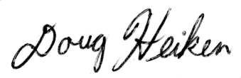 /s/ Rob Klavins
Doug Heiken
dh@oregonwild.org & rk@oregonwild.org

/s/ Amy Stuart
Central Oregon Bitterbrush Broadband / Great Old Broads for Wilderness

/s/ Mathieu Federspiel
Juniper Group / Oregon Chapter Sierra Club

/s/ Adam Bronstein
Western Watersheds Project

/s/ Chris Krupp
WildEarth Guardians

Literature Cited (in the Aquatic/Riparian Section)

Abell R.A., et al. 2000. Freshwater Ecoregions of North America: A Conservation Assessment. Washington (DC): Island Press.

Adams, D.M., R.W. Haynes, and A.J. Daigneault. 2006. Estimated timber harvest by U.S. region and ownership, 1950-2002. Gen. Tech. Rep. PNW-GTR-659. Pacific Northwest Research Station. 72 pp.

Allen, C. D., M. Savage, D. A. Falk, K. F. Suckling, T. W. Swetnam, T. Schulke, P. B. Stacey, P. Morgan, M. Hoffman, and J. T. Klingel. 2002. Ecological restoration of southwestern ponderosa pine ecosystems: a broad perspective. Ecological Applications 12:1418–1433.

Baird, E.J., W. Floyd, I. Van Meerveld and A.E. Anderson. 2012. Road surface erosion. Part 1: Summary of Effects, Processes, and Assessment Procedures. Streamline Watershed Management Bulletin 15. 9 pp.

Beschta, R.L., C.A. Frissell, R. Gresswell, R. Hauer, J.R. Karr, G. W. D.A. Perry, and J.J. Rhodes. 1995. Wildfire and salvage logging: Recommendations for ecologically sound post-fire salvage management and other post-fire treatments on federal lands in the west. 14 pp.

Bjornn, T.C. and D.W. Reiser. 1991. Habitat requirements of salmonids in streams. In Meehan, W. (Ed). Influences of forest and rangeland management on salmonid fishes and their habitats. American Fisheries Society Special Publication 19.

Boisjolie, B.A., M.V. Santelmann, R.L. Flitcroft, and S.L. Duncan. 2017. Legal ecotones: A comparative analysis of riparian policy protection in the Oregon Coast Range, USA. Journal of Environmental Management 197 (2017) 206-220.

Bottom, D.L., P.J. Howell, and J.D. Rodgers. 1985. The effects of stream alterations on salmon and trout habitat in Oregon. Oregon Department of Fish and Wildlife, Portland. 70 pp.

Brandt, P., D. J. Abson, D. A. DellaSala, R. Feller, and H. von Wehrden. 2014. Multifunctionality and biodiversity: ecosystem services in temperate rainforests of the Pacific Northwest, USA. Biological Conservation 169:362–371.

Buotte, P.C., B.E. Law, W.J. Ripple, and L.T. Berner. 2019. Carbon sequestration and biodiversity co‐benefits of preserving forests in the western USA. Ecological Applications, 2019; DOI: 10.1002/eap.2039.

Carey, H. and M. Schumann. 2003. Modifying wildfire behavior – the effectiveness of fuel treatments, the status of our knowledge. National Community Forestry Center, Southwest Region Working Paper. 26 pp.

Carnefix, G. and C. Frissell. 2009. Aquatic and other environmental impacts of roads: the case for road density as indicator or human disturbance and road-density reduction as restoration target; a concise review. Pacific Rivers Council Science Publication 09-001. 9 pp.

Chapman, D.W. 1988. Critical review of variables used to define effects of fines in redds of large salmonids. Transactions of the American Fisheries Society 117(1): 1-21.

Churchill, D.J., G.C. Carnwath, A.J. Larson and S.A. Jeronimo. 2017. Historical forest structure, composition, and spatial pattern in dry conifer forests of the western Blue Mountains, Oregon. Gen. Tech. Rep. PNWGTR-956. USDA Forest Service, Pacific Northwest Research Station, Portland, Oregon.

DellaSala, D.A. and W.L. Baker 2020. Large trees: Oregon's bio-cultural legacy essential to wildlife, clean water, and carbon storage.

DellaSala, D.; J. Karr, and D. Olson. 2011. Roadless areas and clean water. Journal of Soil and Water Conservation, 66(3): 78A-84A. Accessed at: http://.jswconline.org/content/66/3/78A.full.pdf.

Dolloff, C.A. and M.L. Warren. 2003. Fish relationships with large wood in small streams. American Fisheries Society Symposium 37:179-193.

Dunham, J.B., M.K. Young, R.E. Gresswell and B.E. Rieman. 2003. Effects of fire on fish populations: landscape perspectives on persistence of native fishes and nonnative fish invasions. Forest Ecology and Management 178 (2003) 183–196.

Ecovista. 2004a. Imnaha subbasin assessment. Written for Nez Perce Tribe and Wallowa County Natural Resources Advisory Committee. 272 pp.

Ecovista. 2004b. Supplement to the Imnaha subbasin plan. Written for Nez Perce Tribe and Wallowa County Natural Resources Advisory Committee. 20 pp.

Elliot, W. J., I. S. Miller, and L. Audin (eds.). 2010. Cumulative watershed effects of fuel management in the western United States. Gen. Tech. Rep. RMRS-GTR-231. Fort Collins, CO: U.S. Department of Agriculture, Forest Service, Rocky Mountain Research Station. 299 p.

Elliot, W.J., P.R. Robichaud, and R.B. Foltz. 2011. Erosion processes and prediction n NW US forests. International Symposium on Erosion and Landscape Evolution. September 18-21, 2011. Anchorage, Alaska. 8 pp.

Everest, F.H., R.L. Beschta, J.S. Scrivener, K.V. Koski, J.R. Sedell and C.J. Cedarholm. 1987. Fine sediment and salmonid production: a paradox. Pp. 98-142, In: J. Colt and R.J. White, eds. Streamside management: forestry and fishery interactions. Contrib. No. 57. Seattle, WA. Institute of For. Res., Univ. WA.

Falke, J.A., R.L. Flitcroft, J.B. Dunham, K.M. McNyset, P.F. Hessburg and G. H. Reeves. 2015. Climate change and vulnerability of bull trout (Salvelinus confluentus) in a fire-prone landscape. Can. J. Fish. Aquat. Sci. 72: 304–318. dx.doi.org/10.1139/cjfas-2014-0098.

Fausch, K.D., C.E. Torgersen, C.V. Baxter, and H.W. Li. 2002. Landscapes to riverscapes: bridging the gap between research and conservation of stream fishes. Bioscience 52(6): 483-498.

Foltz, R.B., N.S. Copeland, and W.J. Elliot. 2009. Reopening abandoned forest roads in northern Idaho, USA: quantification of runoff, sediment concentration, infiltration, and interrill erosion parameters. J. Environmental Management (Impact Factor: 3.06). 04/2009; 90(8):2542-50.

Frissell, C. 2017. Panel on logging in streamside corridors. John Day, Oregon. https://bluemountainsbiodiversityproject.org/panel-on-logging-in-streamside-corridors-john-day-oregon-2017/.

Furniss, M.J., T.D. Roelofs, and C.S. Yee. 1991. Road construction and maintenance in Influences of Forest and Rangeland Management on Salmonid Fishes and Their Habitats. American Fisheries Society Special Publication 19:297-323.

Gedalof, Z., D.L. Peterson and N.J. Mantua. 2005. Atmospheric, climatic, and ecological controls on extreme wildfire years in the Northwestern United States. Ecological Applications 15(1). DOI:10.1890/03-5116.

Guenther, S., T. Gomi, and R. Moore, R. 2012. Stream and bed temperature variability in a coastal headwater catchment: influences of surface-subsurface interactions and partial-retention forest harvesting. Hydrological Processes, 28: 1238–1249.

Hessburg, P.F., S. Charnley, K.L. Wendel, E.M. White, P.H. Singleton, D.W. Peterson, J.E. Halofsky, A.N. Gray, T.A. Spies, R.L. Flitcroft, and R. White. 2020. The 1994 Eastside screens large tree harvest limit: Review of science relevant to forest planning 25 Years later. Gen. Tech. Rep. PNW-GTR-990. Portland, OR: U.S. Department of Agriculture, Forest Service, Pacific Northwest Research Station. 114 p.

Hicks, B.J., J.D. Hall, P.A. Bisson and J.R. Sedell. 1991. Responses of salmonids to habitat changes. Pp. 483-518, In: W.R. Meehan, ed. Influences of forest and rangeland management on salmonid fishes and their habitat. American Fisheries Society Sp. Publ. 19. Bethesda, MD.

Isaak, D. J., Wenger, S. J., Peterson, E. E.,Ver Hoef, J. M., Nagel, D. E., Luce, C. H., Parkes-Payne, S. 2017. The NorWeST summer stream temperature model and scenarios for the western U.S.: A crowd-sourced database and new geospatial tools foster a user community and predict broad climate warming of rivers and streams. Water Resources Research, 53, 9181–9205. https://doi.org/10.1002/2017WR020969.

Jackson, W.L. and R. L. Beschta. 1984. Influences of sand delivery on the morphology of sand and gravel channels. Water Resources Bulletin 20(4): 527-533.

Jeffres, C.A., J.J. Opperman and P.B. Moyle. 2008. Ephemeral floodplain habitats provide best growth conditions for juvenile Chinook salmon in a California river. Environ Biol Fish (2008) 83:449–458. DOI 10.1007/s10641-008-9367-1.

Kreutzweiser, D.P., S.S. Capell, and K.P. Good. 2005. Effects of fine sediment inputs from a logging road on stream insect communities: A large-scale experimental approach in a Canadian headwater stream. Aquatic Ecology 39(1):55-66. DOI:10.1007/s10452-004-5066-y.

Lee, D.C., J.R. Sedell, B.E. Rieman, R.F. Thurow, J.E. Williams, D. Burns, J.L. Clayton, L. Decker, R. Gresswell, R. House, P. Howell, K.M. Lee, K. Macdonald, J. McIntyre, S. McKinney, T. Noel, J.E. O'Connor, C.K. Overton, D. Perkinson, K. Tu. and P. Van Eimeren. 1997. Broadscale Assessment of Aquatic Species and Habitats. In: An Assessment of Ecosystem Components in the Interior Columbia Basin and Portions of the Klamath and Great Basins, T. M. Quigley and S. J. Arbelbide (Editors). USDA Forest Service Gen. Tech. Rep. PNW-GTR-405, Vol. III, Portland, Oregon, pp. 1057-1713.

Lee, D.C., J.R. Sedell, B.E. Reiman, R.F. Thurow, and J.E. Williams. 1998. Aquatic Species and Habitats. Journal of Forestry 96(10):16-21.

Lehman, Chadwick P.; Rumble, Mark A.; Rota, Christopher T.; Bird, Benjamin J.; Fogarty, Dillon T.; Millspaugh, Joshua J. 2015. Elk resource selection at parturition sites, Black Hills, South Dakota. Journal of Wildlife Management. 80(3): 465-478.

Lisle, T.E. 1982. Effects of aggradation and degradation on riffle-pool morphology in natural gravel channels, northwestern California. Water Resources Research. 18:1643-1651.

Luce, B.H. and T.A. Black. 2001. Effects of traffic and ditch maintenance of forest road sediment production. Effects of Traffic and Ditch Maintenance on Forest Road Sediment Production. In Proceedings of the Seventh Federal Interagency Sedimentation Conference, March 25-29, 2001, Reno, Nevada. pp. V67–V74.

Mackey, B., I. Colin Prentice, W. Stelen, J.I. House, D. Lindenmayer, H. Keith and S. Berry. 2013. Untangling the confusion around land carbon science and climate change mitigation policy. Nature Climate Change. Vol. 3:552-557.

Mackey, B. 2014. Counting trees, carbon and climate change. Significance 11, no. 1: 19–23. https://doi.org/10.1111/j.1740-9713.2014.00720.x.

Mackey, B., D.A. DellaSala, C. Kormos, D. Lindenmayer, D, N. Kumpel, B. Zimmerman, S. Hugh, V. Young, S. Foley, K. Arsenis, and J.E.M. Watson. 2014. Policy Options for the World’s Primary Forests in Multilateral Environmental Agreements. Cons. Let. doi: 10.1111/conl.12120.

Magee, J.P., T.E. McMahon, and R.F. Thurow. 1996. Variation in spawning habitat of cutthroat trout in a sediment-rich stream basin. Transactions of the American Fisheries Society 125 :768-779.

Malison, R., and Baxter, C., 2010. The fire pulse: wildfire stimulates flux of aquatic prey to terrestrial habitats driving increases in riparian consumers. Canadian Journal of Fisheries and Aquatic Sciences 67: 570-579.

McHugh et al. 2017. Linking models across scales to assess the viability and restoration potential of a threatened population of steelhead (Oncorhynchus mykiss) in the Middle Fork John Day River, Oregon, USA. Ecological Modelling. 355:24-38.

Miserendino, L. and Masi, C. 2010. The effects of land use on environmental features and functional organization of macroinvertebrate communities in Patagonian low order streams. Ecological Indicators, 10(2): 311-319.

Montgomery, D.R. and J.M. Buffington. 1997. Channel-reach morphology in mountain drainage basins. Geological Society of America Bulletin 109(5):596-611.

Oregon Forest Resources Institute. 2013. Wildlife in managed forests: deer and elk. Portland, Oregon. 32 pp.

Poole, G. and C. Berman. 2001. An ecological perspective on in-stream temperature: natural heat dynamics and mechanisms of human-caused thermal degradation. Environmental Management 27:787–802. https://doi.org/10.1007/s002670010188.

Ratner, S., R. Lande, and B. B. Roper. 1997. Population viability analysis of spring chinook salmon in the South Umpqua River, Oregon. Conserv. Biol. 11: 879-889.

Reeves, G.H.; Olson, D.H.; Wondzell, S.M. 2018. The aquatic conservation strategy of the Northwest Forest Plan—a review of the relevant science after 23 years. In: Spies, T.A.; Stine, P.A.; Gravenmier, R.; Long, J.W.; Reilly, M.J., tech. coords. 2018. Synthesis of science to inform land management within the Northwest Forest Plan area. Gen. Tech. Rep. PNW-GTR-966. Pacific Northwest Research Station.

Rhodes, J.J., and W.L. Baker.2008. Fire probability, fuel treatment effectiveness and ecological tradeoffs in western U.S. Public Forests. Open Forest Science Journal. 2008, 1–7.
Rieman, B.E., D. Isaak, S. Adams, D. Horan, D. Nagel. C. Luce, and D. Myers. 2007. Anticipated climate warming effects on bull trout habitats and populations across the Interior Columbia River Basin. Transactions of the American Fisheries Society 136(6): 1552-1565.

Roper, B.B., J.M. Capurso, Y. Peroz, and M.K. Young. 2018. Aquatic biodiversity conservation in the context of multiple use management of National Forest System lands. Fisheries, 43, 396–405.

Schoennagel, T., T.T. Veblen, and W.H. Romme. 2004.The interaction of fire, fuels, and climate across Rocky Mountain forests. BioScience 54(7):661-676.

Scrivener, J.C. and M.J. Brownlee. 1989. Effects of forest harvesting on spawning and incubation survival of chum and Coho salmon in Carnation Creek, British Columbia. Canadian Journal of Fisheries and Aquatic Sciences. 46:681-696.

Trout Unlimited (Public Lands Initiative). 2004. Where the Wild Lands are: Oregon; the Importance of Roadless Areas to Oregon’s Fish, Wildlife, Hunting and Angling Accessed at: http://www.tu.org/sites/default/files/OR- Where-the-wildands-are.pdf.

USDA, Forest Service. 1995. Inland Native Fish Strategy Environmental Assessment, Decision Notice and Finding of No Significant Impact, Intermountain, Northern and Pacific Northwest Regions. USDA Forest Service. 2006.

USDA Forest Service and USDI Bureau of Land Management. 1995. Decision notice/decision record for the interim strategies for managing anadromous fish-producing watersheds in eastern Oregon and Washington, Idaho, and portions of California. Washington, DC. PACFISH.

Vannote, R. L., G. W. Minshall, K. W. Cummins, J. R. Sedell, and C.E. Cushing. 1980. The river continuum concept. Can. J. Fish. Aquat. Sci. 37: 130-137.

Washington Department of Fish and Wildlife (WDFW) 2005. Living with elk. Adapted from “Living with wildlife in the Pacific Northwest. Russell Link, Wildlife Biologist. 8 pp.

Williams, C.D. 1999. Summary of Scientific Findings on Roads and Aquatic Ecosystems. Primary Research and Analysis. Environmental Consultants, Medford, Or. 17 pp.
Yonce, H.N., S. Saumya, J.B. Butcher, T.E. Johnson, S.H. Julius and S.D. LeDuc. 2021. Forest riparian buffers reduce timber harvesting effects on stream temperature, but additional climate adaptation strategies are likely needed under future conditions. Journal of Water and Climate Change 12 (5): 1404–1419.https://doi.org/10.2166/wcc.2020.031.

OGC, “Forest Plan and Project Level Decisionmaking— Overview of Forest Planning and Project Level Decisionmaking,” http://web.archive.org/web/20030111060230/http://www.fs.fed.us/forum/nepa/decisionm/p4.html, http://web.archive.org/web/20060829000705/http://www.fs.fed.us/emc/nfma/includes/overview.pdf.
SAS v. Mosely 798 F.Supp. 1473 (W.D. Wash. May 1992)
FSH 1909.15 Chapter 40 http://web.archive.org/web/20090118192937/http://www.fs.fed.us/im/directives/fsh/1909.15/1909.15_40.doc
ONRC Action v. U.S. Forest Service, CV. 03-613-KI http://web.archive.org/web/20041105214752/http://www.onrc.org/press/ONRCv.USFS.pdf
Native Ecosystems Council v. USFS. (9th Circuit August 11, 2005) http://www.ntc.blm.gov/krc/uploads/194/2h%20-%20Native%20Ecosystems%20Council%20v%20US%20Forest%20Service%20--%20Jimtown.pdf.
Jonathan Romeo 2016. Beetle Kill Zones Surprisingly Rich in Biodiversity. Durango Herald. March 3, 2016. http://www.durangoherald.com/article/20160302/NEWS06/160309880/0/SEARCH/Beetle-kill-zones-surprisingly-rich-in-biodiversity
Oregon State University. "View Of Forest Insects Changing From Pests To Partners." ScienceDaily, 31 October 2001. http://www.sciencedaily.com/releases/2001/10/011030230203.htm.
Meigs, G. W., J. L. Campbell, H. S. J. Zald, J. D. Bailey, D. C. Shaw, and R. E. Kennedy. 2015. Does wildfire likelihood increase following insect outbreaks in conifer forests? Ecosphere 6(7):118. http://dx.doi.org/10.1890/ES15-00037.1; http://www.esajournals.org/doi/pdf/10.1890/ES15-00037.1. See also, Garrett W Meigs, Harold S J Zald, John L Campbell, William S Keeton, and Robert E Kennedy. 2016. Do insect outbreaks reduce the severity of subsequent forest fires? Environmental Research Letters, Volume 11, Number 4. http://iopscience.iop.org/article/10.1088/1748-9326/11/4/045008/meta & http://iopscience.iop.org/article/10.1088/1748-9326/11/4/045008/pdf (“In contrast to common assumptions of positive feedbacks, we find that insects generally reduce the severity of subsequent wildfires. Specific effects vary with insect type and timing, but both insects decrease the abundance of live vegetation susceptible to wildfire at multiple time lags. By dampening subsequent burn severity, native insects could buffer rather than exacerbate fire regime changes expected due to land use and climate change. … In the case of [mountain pine beetle], this forest thinning effect results in a lasting reduction of fire impacts on residual vegetation (figure 3(a)). Moreover, the continuing decline in post-beetle burn severity indicates that the thinning effect may persist until vegetation and fuel distributions recover to pre-insect conditions. … Our core finding that insect outbreaks actually dampen wildfire severity across numerous large insect–fire events has direct applications to natural resources management. Specifically, policies based on the assumption that recent insect outbreaks increase the hazard of subsequent wildfires might be unjustified (Hart et al 2015). Furthermore, given that insects also can reduce wildfire likelihood (Lynch and Moorcroft 2008, Meigs et al 2015a), these findings illustrate the role that a biotic disturbance (i.e., insect outbreak) can play in limiting both the occurrence and impacts of an abiotic disturbance (i.e., wildfire).”)
See Wimberly, M. 2002. Spatial simulation of historical landscape patterns in coastal forests of the Pacific Northwest. Can. J. For. Res. 32:13-16-1328 (2002) http://andrewsforest.oregonstate.edu/pubs/pdf/pub2859.pdf
Forest Service Roadless Area Conservation FEIS, November 2000. http://web.archive.org/web/20010729111100/http://roadless.fs.fed.us/documents/feis/glossary.shtml.
Secretary of Agriculture Tom Vilsack March 11, 2009 letter to Oregon Governor Ted Kulongoski.
36 CFR §294.11 (2001). https://www.fs.usda.gov/Internet/FSE_DOCUMENTS/stelprdb5050459.pdf
FSM 2020.3. http://web.archive.org/web/20090511091720/http://www.fs.fed.us/im/directives/fsm/2000/id_2020-2008-1.doc.
Sierra Club v. Austin No 03-35419; DC No. CV-03- 00022 DWM (9th Circ. 2003), citing Smith v. Forest Service 33 F.3d 1072, 1078 (9th Circ. 1994).
The Lands Council v. Martin, (9th Circ, June 25, 2008). http://www.ca9.uscourts.gov/datastore/opinions/2008/06/24/0735804.pdf
DellaSala, Dominick and James Strittholt. 2002. Scientific Basis For Roadless Area Conservation. World Wildlife Fund. Ashland, OR; Conservation Biology Institute. (June 2002 - Updated October 2003) https://d2k78bk4kdhbpr.cloudfront.net/media/reports/files/Scientific_Basis_For_Roadless_Area_Conservation.pdf.
Letter to President Clinton from 136 scientists (Dec. 10, 1997). https://drive.google.com/file/d/0B4L_-RD-MJwrRzhFcm5QcFR0MHM/view?usp=sharing&resourcekey=0-2-sbGMN3bOUBQGGMDBQM1Q
IUCN Policy Statement on Primary Forests, https://www.iucn.org/sites/dev/files/content/documents/iucn_pf-ifl_policy_2020_approved_version.pdf , accessed on 22 April 2020
Roberts CM, O’Leary BC, Hawkins JP. 2020 Climate change mitigation and nature conservation both require higher protected area targets. Phil. Trans. R. Soc. B 375: 20190121. http://dx.doi.org/10.1098/rstb.2019.0121. See also, Soto-Navarro C et al. 2020 Mapping co-benefits for carbon storage and biodiversity to inform conservation policy and action. Phil. Trans. R. Soc. B 375: 20190128. http://dx.doi.org/10.1098/rstb.2019.0128 showing the congruence of high carbon value and high biodiversity value in PNW forests.
Law, Beverly E., William R. Moomaw, Tara W. Hudiburg, William H. Schlesinger, John D. Sterman, and George M. Woodwell. 2022. Creating Strategic Reserves to Protect Forest Carbon and Reduce Biodiversity Losses in the United States. Land Vol. 11, no. 5: 721. https://doi.org/10.3390/land11050721, https://www.mdpi.com/2073-445X/11/5/721/htm.
Law BE, Berner LT, Mildrexler DJ, Bloemers RO and Ripple WJ (2022) Strategic reserves in Oregon’s forests for biodiversity, water, and carbon to mitigate and adapt to climate change. Front. For. Glob. Change 5:1028401. doi: 10.3389/ffgc.2022.1028401. https://www.frontiersin.org/articles/10.3389/ffgc.2022.1028401/pdf.
Henjum, M.G., J.R. Karr, D.L. Bottom, D.A. Perry, J.C. Bednarz, S.G. Wright, S.A. Beckwitt and E. Beckwitt. 1994. Interim Protection for Late-Successional Forests, Fisheries, and Watersheds: National Forests East of the Cascade Crest, Oregon and Washington. A Report to the Congress and President of the United States. Eastside Forests Scientific Society Panel.
2016 Roadless Initiative / Centre for Economics and Ecosystem Management. http://www.roadless.online/roadless-areas/.
PRESS RELEASE, Hyderabad, India, 18 October 2012, Protecting Roadless Areas: Meeting the Nagoya targets in a cost efficient and effective way http://www.roadless.online/wp-content/download/docs/Press%20Release%20Protecting%20Roadless%20Areas%20COP11%20CBD.pdf.
Watson, Evans, Venter et al 2018. The exceptional value of intact forest ecosystems. Nature Ecology & Evolution (2018) https://www.nature.com/articles/s41559-018-0490-x
Eugene BLM, 1995. Mohawk/McGowan Watershed Analysis. https://www.blm.gov/or/districts/eugene/plans/files/mcgowan.pdf
Thomas A. Spies, David E. Hibbs, Janet L. Ohmann, Gordon H. Reeves, Robert J. Pabst, Frederick J. Swanson, Cathy Whitlock, Julia A. Jones, Beverly C. Wemple, Laurie A. Parendes, and Barbara A. Schrader. 2002. The Ecological Basis of Forest Ecosystem Management in the Oregon Coast Range. http://www.fsl.orst.edu/rna/Documents/publications/Flynn%20Creek%20spies_etal_2002_ecological_basis.pdf in Hobbs, S. D. et al (2002). Forest and stream management in the Oregon coast range. Corvallis, Or: Oregon State University Press. https://osupress.oregonstate.edu/book/forest-and-stream-management-in-oregon-coast-range
Jerome J. Korol, Miles A. Hemstrom, Wendel J. Hann, and Rebecca A. Gravenmier. 2002. Snags and Down Wood in the Interior Columbia Basin Ecosystem Management Project. PNW-GTR-181. http://www.fs.fed.us/psw/publications/documents/gtr-181/049_Korol.pdf
Wisdom, M.J., and Bate, L.J. 2008. Snag density varies with intensity of timber harvest and human access. For. Ecol. Manage. 255: 2085–2093. doi:10.1016/j.foreco.2007.12.027. http://www.fs.fed.us/pnw/pubs/journals/pnw_2008_wisdom001.pdf
Watson et al 2018. The exceptional value of intact forest ecosystems. Nature Ecology & Evolution. https://www.nature.com/articles/s41559-018-0490-x
Powell DC 1999. Suggested Stocking Levels for Forest Stands in Northeastern Oregon and Southeastern Washington: An Implementation Guide for the Umatilla National Forest. F14-SO-TP-03-99. April 1999. https://fs.usda.gov/Internet/FSE_DOCUMENTS/fsbdev7_016034.pdf
Rose, C.L., Marcot, B.G., Mellen, T.K., Ohmann, J.L., Waddell, K.L., Lindely, D.L., and B. Schrieber. 2001. Decaying Wood in Pacific Northwest Forests: Concepts and Tools for Habitat Management, Chapter 24 in Wildlife-Habitat Relationships in Oregon and Washington (Johnson, D. H. and T. A. O’Neil. OSU Press. 2001) http://web.archive.org/web/20060708035905/http://www.nwhi.org/inc/data/GISdata/docs/chapter24.pdf
USFS 2021. Amending Forest Management Direction for Large Diameter Trees in Eastern Oregon https://www.fs.usda.gov/project/?project=58050
See Nathan Gilles 2022. Massive die-off hits fir trees across Pacific Northwest | Columbia Insight (AP) Updated: Nov 27, 2022. https://www.mailtribune.com/top-stories/2022/11/27/massive-die-off-hits-fir-trees-across-pacific-northwest/
Johnston et al. 2021; Merschel et al. 2021
Jose V. Moris, Matthew J. Reilly, Zhiqiang Yang, Warren B. Cohen, Renzo Motta, Davide Ascoli 2022. Using a trait‑based approach to asses fire resistance in forest landscapes of the Inland Northwest, USA. Landsc Ecol (2022) 37:2149–2164. Energy https://doi.org/10.1007/s10980-022-01478-w and https://www.fs.usda.gov/rm/pubs_journals/2022/rmrs_2022_moris_j001.pdf
USFS 2021. Amending Forest Management Direction for Large Diameter Trees in Eastern Oregon. Comment Reading Room https://cara.fs2c.usda.gov/Public//ReadingRoom?Project=58050
Oregon Wild. Trump Screens Information. https://oregonwild.org/trump-screens-information
Carter Stone, Andrew Hudak, Panelope Morgan 2008. Forest Harvest Can Increase Subsequent Forest Fire Severity. PSW-GTR-208, pp 525-534. https://www.fs.fed.us/psw/publications/documents/psw_gtr208en/psw_gtr208en_525-534_stone.pdf, In González-Cabán, Armando, tech. coord. 2008. Proceedings of the second international symposium on fire economics, planning, and policy: a global view. Gen. Tech. Rep. PSW-GTR-208, Albany, CA: Pacific Southwest Research Station, Forest Service, U.S. Department of Agriculture. 720 p. https://www.fs.fed.us/psw/publications/documents/psw_gtr208en/
KS Wild v BLM. (D. Or 2019) Case No.: 1:17-cv-997-CL. Judge Mark Clarke, Findings & Recommendations, Feb 20, 2019.
Steel, Z.L., Jones, G.M., Collins, B.M., Green, R., Koltunov, A., Purcell, K.L., Sawyer, S.C., Slaton, M.R., Stephens, S.L., Stine, P. and Thompson, C. (2022), Mega-disturbances cause rapid decline of mature conifer forest habitat in California. Ecological Applications. Accepted Author Manuscript e2763. https://doi.org/10.1002/eap.2763
Bigelow & North 2012. Microclimate effects of fuels-reduction and group-selection silviculture: Implications for fire behavior in Sierran mixed-conifer forests. Forest Ecology and Management 264 (2012) 51–59. https://northlab.faculty.ucdavis.edu/wp-content/uploads/sites/195/2016/02/Microclimate-Effects-Of-Fuels-reduction-And-Group-selection-Silviculture-Implications-For-FIre-Behavior-In-Sierran-Mixed-conifer-Forests-North-2011-1.pdf
Krasnow, K. D., and S. L. Stephens. 2015. Evolving paradigms of aspen ecology and management: impacts of stand condition and fire severity on vegetation dynamics. Ecosphere 6(1):12. http://dx.doi.org/10.1890/ES14-00354.1; http://www.esajournals.org/doi/pdf/10.1890/ES14-00354.1
https://www.ippr.org/research/publications/1-5c-dead-or-alive and reported on here: https://www.washingtonpost.com/climate-environment/2023/02/16/doom-loop-earth-climate-change/
1897 Forest Service Organic Act. https://winapps.umt.edu/winapps/media2/wilderness/NWPS/documents/publiclaws/ORGANIC-ACT-OF-1897.pdf
Katharine R.E. Sims, Jonathan R. Thompson, Spencer R. Meyer, Christoph Nolte, Joshua S. Plisinski. 2019. Assessing the local economic impacts of land protection. Conservation Biology. 26 March 2019 https://doi.org/10.1111/cobi.13318, https://harvardforest.fas.harvard.edu/sites/default/files/Sims_et_al-2019-Conservation_Biology.pdf
Executive Order on Protecting Public Health and the Environment and Restoring Science to Tackle the Climate Crisis. JANUARY 20, 2021 https://www.whitehouse.gov/briefing-room/presidential-actions/2021/01/20/executive-order-protecting-public-health-and-environment-and-restoring-science-to-tackle-climate-crisis/
Stein, B.A., P. Glick, N. Edelson, and A. Staudt (eds.). 2014. Climate-Smart Conservation: Putting Adaptation Principles into Practice. National Wildlife Federation, Washington, D.C. https://www.nwf.org/~/media/PDFs/Global-Warming/2014/Climate-Smart-Conservation-Final_06-06-2014.pdf.
Justice et al. 2017. Can stream and riparian restoration offset climate change impacts to salmon populations? Journal of Environmental Management 188 (2017) 212e227 https://www.critfc.org/wp-content/uploads/2017/01/JournalPost_Justice_etal2017.pdf
Michael S. Schaedel, Andrew J. Larson, David L.R. Affleck, R. Travis Belote, John M. Goodburn, Deborah S. Page-Dumroese. 2017. Early forest thinning changes aboveground carbon distribution among pools, but not total amount. Forest Ecology and Management 389 (2017) 187–198. https://www.fs.fed.us/rm/pubs_journals/2017/rmrs_2017_schaedel_m001.pdf (“There are actually conflicting results on pre-commercial thinning. “... precommercial thinning (PCT) when the thinned trees have no commercial value, show inconsistent results. Some PCT studies of this type found that decreasing stand density decreased total forest C stores (Skovsgaard et al., 2006; Jiménez et al., 2011), while others noted that the increased growth rate of trees grown at lower densities can maintain or increase live tree C (Hoover and Stout, 2007; Dwyer et al., 2010), especially in the case of longer-term responses to thinning (Horner et al., 2010). Short-term studies of PCT effects on aboveground C have shown consistent decreases in aboveground C (Campbell et al., 2009; De las Heras et al., 2013; Jiménez et al., 2011; Dwyer et al., 2010), indicating that low densities of small trees do not fully occupy the site (Turner et al., 2016). Given these conflicting results, it is still unclear whether PCT is compatible with the climate change mitigation goal of forest C storage (Jiménez et al., 2011).””)
Fain, S.J.; Kittler, B.; Chowyuk, A. Managing Moist Forests of the Pacific Northwest United States for Climate Positive Outcomes. Forests 2018; 9(10):618. https://www.mdpi.com/1999-4907/9/10/618
Karla M. Jarecke, Linnia R. Hawkins, Kevin D. Bladon, Steven M. Wondzell 2023. Carbon uptake by Douglas-fir is more sensitive to increased temperature and vapor pressure deficit than reduced rainfall in the western Cascade Mountains, Oregon, USA. Agricultural and Forest Meteorology, Volume 329, 15 February 2023, 109267. https://www.sciencedirect.com/science/article/abs/pii/S0168192322004543.
Terrie Jain (2009) Logic Paths for Approaching Restoration: A Scientist’s Perspective, from Workshop: Restoring Westside Dry Forests - Planning and Analysis for Restoring Westside Cascade Dry Forest Ecosystems: A focus on Systems Dominated by Douglas-fir, Ponderosa Pine, Incense Cedar, and so on. May 28, 2009. http://ecoshare.info/projects/central-cascade- adaptive-management-partnership/workshops/restoring-westside- dry-forests/.
Guojian Wang, et al. 2016. Continued increase of extreme El Niño frequency long after 1.5 °C warming stabilization. Nature Climate Change (2017). doi:10.1038/nclimate3351. https://www.nature.com/nclimate/journal/vaop/ncurrent/full/nclimate3351.html.
William L. Baker and Mark A. Williams. 2015. Bet-hedging dry-forest resilience to climate-change threats in the western USA based on historical forest structure. Front. Ecol. Evol., 13 January 2015 | doi: 10.3389/fevo.2014.00088. http://journal.frontiersin.org/Journal/10.3389/fevo.2014.00088/full
Urgenda Foundation v. The State of the Netherlands. Hague Court of Appeal. October 9, 2018. https://uitspraken.rechtspraak.nl/inziendocument?id=ECLI:NL:RBDHA:2015:7196
Stenzel, J. E., Berardi, D. B., Walsh, E. S., & Hudiburg, T. W. (2021). Restoration thinning in a drought-prone Idaho forest creates a persistent carbon deficit. Journal of Geophysical Research: Biogeosciences, 126, e2020JG005815. https://doi.org/10.1029/2020JG005815
Janowiak, M.; Connelly, W.J.; Dante-Wood, K.; Domke, G.M.; Giardina, C.; Kayler, Z.; Marcinkowski, K.; Ontl, T.; Rodriguez-Franco, C.; Swanston, C.; Woodall, C.W.; Buford, M. 2017. Considering Forest and Grassland Carbon in Land Management. Gen. Tech. Rep. WO-95. Washington, D.C.: United States Department of Agriculture, Forest Service. 68 p. https://www.fs.usda.gov/research/publications/gtr/gtr_wo95.pdf.
Council on Environmental Quality 2023. National Environmental Policy Act Guidance on Consideration of Greenhouse Gas Emissions and Climate Change https://www.federalregister.gov/documents/2023/01/09/2023-00158/national-environmental-policy-act-guidance-on-consideration-of-greenhouse-gas-emissions-and-climate. fn/119: See, e.g., USDA Forest Service, Considering Forest and Grassland Carbon in Land Management (2017), https://www.fs.usda.gov/research/treesearch/54316... (aka, Janowiak, et al 2017. Considering Forest and Grassland Carbon in Land Management. Gen. Tech. Rep. WO-95. Washington, D.C.: United States Department of Agriculture, Forest Service. 68 p. https://www.fs.usda.gov/research/publications/gtr/gtr_wo95.pdf
Ecology Center v. Austin (9th Circ. 2005) http://www.sierraforestlegacy.org/Resources/Conservation/LawsPoliciesRegulation/RecentImportantCaseLaw/EcologyCentev,Austin.pdf.
Martin Fox & Susan Bolton (2007) A Regional and Geomorphic Reference for Quantities and Volumes of Instream Wood in Unmanaged Forested Basins of Washington State, North American Journal of Fisheries Management, 27:1, 342-359, DOI: 10.1577/M05-024.1. http://dx.doi.org/10.1577/M05-024.1
Gordon H. Reeves and Fred H. Everest. 1994. REDUCING HAZARD FOR ENDANGERED SALMON STOCKS, in Eastside Forest Ecosystem Health Assessment; Volume IV. Everett, Richard L., comp. 1994. Restoration of Stressed Sites, and Processes. Gen. Tech. Rep. PNW-GTR-330. Portland, OR: USDA, Forest Service, Pacific Northwest Research Station. https://www.fs.fed.us/pnw/pubs/pnw_gtr330.pdf. (p 23)
Alan Moore, Why Fish Love ‘Large Woody Debris.’ Trout Unlimited. 2-4-2013. http://troutunlimitedblog.com/large-woody-debris-makes-for-fishy-rivers/ Joshua J. Roering, professor of geological sciences at the University of Oregon studies the processes that create fish habitat and concluded: “[Coho salmon] seem to respond to the heterogeneity that is so inherent in most real landscapes. Nature is messy, and the fish have adapted to that." University of Oregon (2013, February 11). Large, ancient landslides delivered preferred upstream habitats for coho salmon. ScienceDaily. Retrieved from http://www.sciencedaily.com/releases/2013/02/130211135045.htm.
Deschutes NF 1999. Crescent-Odell Watershed Analysis, pages 164-165.
Hannah Ettema 2014. Seven Reasons Why Fish Need Wood. https://www.nationalforests.org/blog/seven-reasons-why-fish-need-wood
Roni, Philip, Timothy J. Beechie, Robert E. Bilby, Frank E. Leonetti, Michael M. Pollock, And George R. Pess. 2002. A Review of Stream Restoration Techniques and a Hierarchical Strategy for Prioritizing Restoration in Pacific Northwest Watersheds. North American Journal of Fisheries Management 22:1–20, 2002 American Fisheries Society 2002 http://www.crab.wa.gov/LibraryData/RESEARCH_and_REFERENCE_MATERIAL/Environmental/020923StreamRestoreTechPNW.pdf
Lutz. J.A. 2005. The Contribution of Mortality to Early Coniferous Forest Development. MS Thesis. University of Washington. http://faculty.washington.edu/chalpern/Lutz_2005.pdf. See also, Rhodes, J. 2022. Expert Report Regarding Aquatic Effects of Trump Screens Amendment, for Oliver Stiefel, Crag Law Center. (“The loss of larger trees in and near RHCAs also contributes to long-term LWD losses from adjacent trees in RHCAs. This is because, when larger trees fall, they often knock down other trees that provide LWD to streams and riparian areas. Thus, logging of larger trees is likely to ultimately reduce instream LWD in perennial streams via several means.”)
Martin G. Raphael, Richard S. Holthausen, Bruce G. Marcot, Terrell D. Rich, Mary M. Rowland, Barbara C. Wales, Michael J. Wisdom, 2000. DRAFT Effects of SDEIS Alternatives on Selected Terrestrial Vertebrates of Conservation Concern within the Interior Columbia River Basin Ecosystem Management Project, March 2000, revised June 23 , 2000 and November 14, 2000.
Mortality of Douglas-fir and hardwoods was higher in controls than in thinned units. Liane R. Davis, and Klaus J. Puettmann, Gabriel F. Tucker. 2007. Overstory Response to Alternative Thinning Treatments in Young Douglas-fir Forests of Western Oregon. Northwest Science 81(1). 2007.
Spies, T. A., and S. P. Cline. 1988. Coarse woody debris in forests and plantations of coastal Oregon. Pp. 5-23 in: C. Maser, R. F. Tarrant, J. M. Trappe, and J. F. Franklin, ed. From the forest to the sea: a story of fallen trees. Gen. Tech. Rpt. PNW- GTR-229. USDA Forest Service, Portland OR. http://www.fs.fed.us/pnw/pubs/229chpt1.pdf
Ohmann, McComb, & Zumrawi; SNAG ABUNDANCE FOR PRIMARY CAVITY-NESTING BIRDS ON NONFEDERAL FOREST LANDS IN OREGON AND WASHINGTON; Wildl. Soc. Bull. 22:607-620, 1994 http://web.archive.org/web/20041107222037/http://www.fs.fed.us/pnw/pubs/journals/ohmann-snagabundance.pdf
Wisdom, M.J., and Bate, L.J. 2008. Snag density varies with intensity of timber harvest and human access. For. Ecol. Manage. 255: 2085–2093. doi:10.1016/j.foreco.2007.12.027. http://www.fs.fed.us/pnw/pubs/journals/pnw_2008_wisdom001.pdf
Kennedy, R. 2010. Large dead wood in coastal forests projected to increase on federal land, decrease on private. In Mazza, Rhonda 2010. 2010 Science Accomplishments Report of the Pacific Northwest Research Station. Portland, OR: U.S. Department of Agriculture, Forest Service, Pacific Northwest Research Station. 88 p. http://www.treesearch.fs.fed.us/pubs/37383.
Rose, C.L., Marcot, B.G., Mellen, T.K., Ohmann, J.L., Waddell, K.L., Lindely, D.L., and B. Schrieber. 2001. Decaying Wood in Pacific Northwest Forests: Concepts and Tools for Habitat Management, Chapter 24 in Wildlife-Habitat Relationships in Oregon and Washington (Johnson, D. H. and T. A. O'Neil. OSU Press. 2001). http://web.archive.org/web/20060708035905/http://www.nwhi.org/inc/data/GISdata/docs/chapter24.pdf.
Jerome J. Korol, Miles A. Hemstrom, Wendel J. Hann, and Rebecca A. Gravenmier. 2002. Snags and Down Wood in the Interior Columbia Basin Ecosystem Management Project. PNW-GTR-181. http://www.fs.fed.us/psw/publications/documents/gtr-181/049_Korol.pdf.
Wisdom, M.J., and Bate, L.J. 2008. Snag density varies with intensity of timber harvest and human access. For. Ecol. Manage. 255: 2085–2093. doi:10.1016/j.foreco.2007.12.027. http://www.fs.fed.us/pnw/pubs/journals/pnw_2008_wisdom001.pdf
http://www.blm.gov/or/districts/salem/plans/files/sdo_080-07-16_eafonsi.pdf.
Miles A. Hemstrom, Wendel J. Hann, Rebecca A. Gravenmier, Jerome J. Korol. 2000. [SAG] Landscape Effects Analysis of the [ICBEMP] SDEIS Alternatives. USDA/USDI, draft March 2000.
Tara Hudiburg, Beverly Law, David P. Turner, John Campbell, Dan Donato, And Maureen Duane 2009. Carbon dynamics of Oregon and Northern California forests and potential land-based carbon storage. Ecological Applications, 19(1), 2009, pp. 163–180. http://terraweb.forestry.oregonstate.edu/pubs2/Hudiburg2009EA.pdf
Donnegan, Joseph; Campbell, Sally; Azuma, Dave, tech. eds. 2008. Oregon’s forest resources, 2001–2005: five-year Forest Inventory and Analysis report. Gen. Tech. Rep. PNW-GTR-765. Portland, OR: U.S. Forest Service, Pacific Northwest Research Station. 186 p. http://www.fs.fed.us/pnw/publications/gtr765/pnw-gtr765b.pdf
NOAA April 4, 2006 Magnuson Act consultation on Essential Fish Habitat and Response to Siuslaw NF Lobster Project BA.
Region 6 - USDA Forest Service. A Guide to the Interpretation and Use of the DecAID Advisor. June, 2006. http://www.fs.fed.us/r6/nr/wildlife/decaid-guide/
Seattle Audubon Society v. Epsy, 998 F.2d 699, 704 (9th Cir. 1998) (an agency must re-examine its decision when the EIS "rests on stale scientific evidence and false assumptions")
Rose, C.L., Marcot, B.G., Mellen, T.K., Ohmann, J.L., Waddell, K.L., Lindely, D.L., and B. Schrieber. 2001. Decaying Wood in Pacific Northwest Forests: Concepts and Tools for Habitat Management, Chapter 24 in Wildlife-Habitat Relationships in Oregon and Washington (Johnson, D. H. and T. A. O'Neil. OSU Press. 2001) http://web.archive.org/web/20060708035905/http://www.nwhi.org/inc/data/GISdata/docs/chapter24.pdf
Mallory, B. 2023. CEQ Guidance for Federal Departments and Agencies on Ecological Connectivity and Wildlife Corridors. https://www.whitehouse.gov/wp-content/uploads/2023/03/230318-Corridors-connectivity-guidance-memo-final-draft-formatted.pdf
Noss, Reed; The Ecological Effects of Roads; http://www.wildlandscpr.org/ecological-effects-roads; http://www.eco-action.org/dt/roads.html
The Wilderness Society. 2014. Transportation Infrastructure and Access on National Forests and Grasslands - A Literature Review. May 2014. https://www.fs.usda.gov/nfs/11558/www/nepa/96158_FSPLT3_3989888.pdf, https://www.sierraforestlegacy.org/Resources/Conservation/ProjectsPlans/ForestPlanRevisions/SFL%20et%20al.%20FPR%20comments%20part%205%20of%205.pdf.
Hu, X., Zhang, L., Ye, L., Lin, Y. & Qiu, R. Locating spatial variation in the association between road network and forest biomass carbon accumulation. Ecol. Indic. 73, 214–223 (2017). https://www.sciencedirect.com/science/article/abs/pii/S1470160X16305738.
Colombaroli, D. and D.G. Gavin. 2010. Highly episodic fire and erosion regime over the past 2000 years in the Siskiyou Mountains, Oregon Proceedings of the National Academy of Sciences of the United States of America 107: 18909-18914. http://www.pnas.org/content/early/2010/10/13/1007692107.full.pdf
Quigley, Thomas M.; Arbelbide, Sylvia J., tech. eds. 1997. An assessment of ecosystem components in the interior Columbia basin and portions of the Klamath and Great Basins: volume 1. Gen. Tech. Rep. PNW-GTR-405. Portland, OR. http://www.fs.fed.us/pnw/publications/pnw_gtr405/pnw_gtr405_06.pdf http://www.fs.fed.us/pnw/publications/pnw_gtr405/pnw_gtr405_07.pdf.
EPA 2012. Notice of Intent To Revise Stormwater Regulations … Federal Register. May 23, 2012. http://www.gpo.gov/fdsys/pkg/FR-2012-05-23/pdf/2012-12524.pdf
NRDC Report: “End of the Road: The Adverse Ecological Impacts of Roads and Logging: A Compilation of Independently Reviewed Research” (1999) https://web.archive.org/web/20081024112126/http://www.nrdc.org/land/forests/roads/eotrinx.asp
Roadless Area Conservation FEIS — Specialist Report for Terrestrial and Aquatic Habitats and Species prepared by Seona Brown and Ron Archuleta, EIS Team Biologists http://web.archive.org/web/20040515020554/http://roadless.fs.fed.us/documents/feis/specrep/xbio_spec_rpt.pdf
USDA 2020. Stella Landscape Restoration Project Draft Environmental Impact Statement. Page III-30. Rogue River Siskiyou National Forest. https://www.fs.usda.gov/project/?project=53241
Luce, C.H., 1997. Effectiveness of Road Ripping in Restoring Infiltration Capacity of Forest Roads, Restoration Ecology; 5(3):265-270. http://library.eri.nau.edu/gsdl/collect/erilibra/import/Luce.1997.EffectivenessOfRoadRippingIn.pdf
George Wuerthner 2009. Temporary Roads Are Like Low Fat Ice Cream, NewWest. 3-17-09. http://www.newwest.net/topic/article/temporary_roads_are_like_low_fat_ice_cream/C564/L564/ See also, Wuerthner’s April 2020 blog post showing the persistent impacts of temporary roads. http://www.thewildlifenews.com/2020/04/22/are-temporarily-roads-ecologically-invisible/
Rowland, M. M., M. J. Wisdom, B. K. Johnson, and M. A. Penninger. 2004. Effects of Roads on Elk: Implications for Management in Forested Ecosystems. Transactions of the North American Wildlife and Natural Resource Conference 69: in press. http://www.fs.fed.us/pnw/lagrande/starkey_na/PDFs_Preprints/ms-04_Rowland.pdf.
Rural Road Maintenance May Accidentally Push Spread of Invasive Plants. ScienceDaily (Aug. 15, 2011) http://www.sciencedaily.com/releases/2011/08/110809144513.htm.
See e.g., Firman, Julie C., Steel, E. Ashley, Jensen, David W., Burnett, Kelly M., Christiansen, Kelly, Feist, Blake E., Larsen, David P., and Anlauf, Kara (2011) “Landscape Models of Adult Coho Salmon Density Examined at Four Spatial Extents,” Transactions of the American Fisheries Society, 140: 2,440 - 455, First published on: 13 April 2011. URL: http://dx.doi.org/lO.l080!00028487.2011.567854; http://noaa.academia.edu/BlakeFeist/Papers/580465/Landscape_models_of_adult_coho_salmon_density_examined_at_four_spatial_extents.
Gary Carnefix and Chris Frissell. Aquatic and Other Environmental Impacts of Roads: The Case for Road Density as Indicator of Human Disturbance and Road-Density Reduction as Restoration Target; A Concise Review. Pacific Rivers Council. http://pacificrivers.org/science-research/resources-publications/road-density-as-indicator/?searchterm=road%20density
http://web.archive.org/web/20030312161211/http://www.odf.state.or.us/DIVISIONS/protection/fire_protection/stats/firecharts.asp?id=3070105
Deschutes Collaborative Forest Project 2022. A Decade of Learning 10-Year Monitoring Report. Mamut Consulting, 6-30-2020. http://deschutescollaborativeforest.org/.
Kauffman, Beschta et al 2020. Comments on Boise BLM’s Tri-State Fuel Break Project. 22 Dec 2020. https://drive.google.com/open?id=1AEA3PTs31Sv_-RZZnMsduhHCb1hniZ_e citing Shinneman, Douglas J.; Germino, Matthew J.; Pilliod, David S.; Aldridge, Cameron L.; Vaillant, Nicole M.; Coates, Peter S. 2019. The ecological uncertainty of wildfire fuel breaks: examples from the sagebrush steppe. Frontiers in Ecology and the Environment 17(5):279-288. https://doi.org/10.1002/fee.2045 (“Fuel breaks are increasingly being implemented at broad scales (100s to 10,000s of square kilometers) in fire‐prone landscapes globally, yet there is little scientific information available regarding their ecological effects (e.g. habitat fragmentation). … Given uncertain outcomes, we examine how implementation of fuel breaks might (1) directly alter ecosystems, (2) create edges and edge effects, (3) serve as vectors for wildlife movement and plant invasions, (4) fragment otherwise contiguous sagebrush landscapes, and (5) benefit from scientific investigation intended to disentangle their ecological costs and benefits.”) See also Shinneman, D.J., Aldridge, C.L., Coates, P.S., Germino, M.J., Pilliod, D.S., and Vaillant, N.M., 2018, A conservation paradox in the Great Basin—Altering sagebrush landscapes with fuel breaks to reduce habitat loss from wildfire: U.S. Geological Survey Open-File Report 2018–1034, 70 p., https://doi.org/10.3133/ofr20181034.
Timothy Ingalsbee 2005. Fuelbreaks for Wildland Fire Management: A Moat or a Drawbridge for Ecosystem Fire Restoration? Journal of Fire Ecology, Pages: 85-99. DOI:10.4996/fireecology.0101085. http://fireecology.org/docs/Journal/pdf/Volume01/Issue01/085.pdf
Merriam, K.E., Keeley, J.E., and Beyers, J.L., 2007, The role of fuel breaks in the invasion of nonnative plants: U.S. Geological Survey Scientific Investigations Report 2006-5185, 69 p. http://pubs.usgs.gov/sir/2006/5185/pdf/sir_2006-5185.pdf.
Evers C, Holz A, Busby S, Nielsen-Pincus M. Extreme Winds Alter Influence of Fuels and Topography on Megafire Burn Severity in Seasonal Temperate Rainforests under Record Fuel Aridity. Fire. 2022; 5(2):41. https://doi.org/10.3390/fire5020041, https://www.mdpi.com/2571-6255/5/2/41/pdf.
Rutherford V. Platt, Thomas T. Veblen, and Rosemary L. Sherriff. 2006. Are Wildfire Mitigation and Restoration of Historic Forest Structure Compatible? A Spatial Modeling Assessment. Annals of the Association of American Geographers, 96(3), 2006, pp. 455–470. http://www.colorado.edu/geography/class_homepages/geog_4430_f10/Platt%20et%20al_Wildfire%20Mitigatnion_AnAAG_2006.PDF
C. Friesen 2010. Early Seral Forests – A Conservation Conundrum. http://www.ecoshare.info/uploads/ccamp/Early-Seral-Forest-Friesen.ppt; http://ecoshare.info/projects/central-cascade-adaptive-management-partnership/synthesis-papers-tools/
Friesen, C.A. 2007. Early Seral Forest: A conservation Conundrum. http://www.ecoshare.info/uploads/ccamp/Early-Seral-Forest-Friesen.ppt
D.J. McRae, L.C. Duchesne, B. Freedman, T.J. Lynham, and S. Woodley, 2001. Comparisons between wildfire and forest harvesting and their implications in forest management. Environ. Rev. 9. 223-260 (2001); DOI: 10.1139/er-9-4-223
Harris, R.B. 2000. Estimating large snag recruitment needs in regeneration timber harvests. Western Journal of Applied Forestry. 15: 140-146. http://www.cas.umt.edu/facultydatabase/FILES_Faculty/1152/Harris%202000%20LargeSnagRecruitment%20Western%20J.%20Appl.%20For.pdf.
Ohmann, JL, MJ Gregory, HM Roberts, RE Kennedy, Z Yang, J Braaten, SL Powell, WB Cohen, V Kane, J Lutz. 2012. Mapping change in live and dead forest biomass with Landsat time-series, remeasured plots, and nearest-neighbor imputation. ForestSat 2012: Corvallis, OR; September 2012. http://lemma.forestry.oregonstate.edu/export/presentations/ohmann_etal_2012_forestsat.pps
The Lands Council v. Powell (2004 WL 1801880 (--- F.3d --- 9th Circuit, August 2004, amended Jan 2005)http://web.archive.org/web/20061006152330/http://www.ca9.uscourts.gov/ca9/newopinions.nsf/EAF838C83126F73D88256F930058E338/$file/0335640.pdf?openelement
Beschta et al "Cumulative Effects of Forest Practices..." http://www.forestry.oregonstate.edu/cof/fr/facultypages/CumulativeEffectsofForestPractices.pdf
Medford BLM, South Deer EA, July 2005.
Donald Mckenzie, Ze’ev Gedalof, David L. Peterson, and Philip Mote. Climatic Change, Wildfire, and Conservation. Conservation Biology 18(4), Aug 2004. http://www.uoguelph.ca/cedar/Pubs/McKenzie_et_al_ConsBio.pdf
Public Citizen v. Dept. of Transportation, 316 F.3d 1002, 1027 (9th Cir. 2003). http://bulk.resource.org/courts.gov/c/F3/316/316.F3d.1002.02-71249.02-70986.html
Malama MAKUA v. RUMSFELD, 163 F.Supp2d 1202. (D. Hawai'i). July 16, 2001.
Anderson v. Evans, (9th Circuit 2002, amended 2003, 2004).
Save the Yaak, 840 F.2d at 717.
Idaho Sporting Congress, 137 F.3d at 1149. A "plaintiff need not show that significant effects will in fact occur." It is enough for the plaintiff to raise "substantial questions whether a project may have a significant effect" on the environment. Id. at 1150. See also Blue Mountains Biodiversity Project v. Blackwood, (9th Circ, Dec 1998) https://caselaw.findlaw.com/us-9th-circuit/1180061.html
Spies, Thomas A.; Hemstrom, Miles A.; Youngblood, Andrew; Hummel, Susan. 2006. Conserving old-growth forest diversity in disturbance-prone landscapes. Conservation Biology. 20(2): 351-362. http://www.fs.fed.us/pnw/pubs/journals/pnw_2006_spies001.pdf
Sharon Friedman 4-30-2019 commenting on The Missing (PNW) Fires at The Smokey Wire blog. http://forestpolicypub.com/2019/04/30/the-missing-pnw-fires/#comment-453153. See also, The scientific controversy described in Baker, William L., Chad T. Hanson, Mark A. Williams, and Dominick A. DellaSala. 2023. "Countering Omitted Evidence of Variable Historical Forests and Fire Regime in Western USA Dry Forests: The Low-Severity-Fire Model Rejected" Fire 6, no. 4: 146. https://doi.org/10.3390/fire6040146; https://www.mdpi.com/2571-6255/6/4/146 citing Hagmann, R.K.; Hessburg, P.F.; Prichard, S.J.; Povak, N.A.; Brown, P.M.; Ful, P.Z.; Keane, R.E.; Knapp, E.E.; Lydersen, J.M.; Metlen, K.L. Evidence for widespread changes in the structure, composition, and fire regimes of western North American forests. Ecol. Appl. 2021, 31, e02431. And see Odion DC, Hanson CT, Arsenault A, Baker WL, DellaSala DA, et al. (2014) Examining Historical and Current Mixed-Severity Fire Regimes in Ponderosa Pine and Mixed-Conifer Forests of Western North America. PLoS ONE 9(2): e87852. doi:10.1371/journal.pone.0087852.
Firescience.Gov News. Fuel Treatments and Fire Severity: A Meta-Analysis. Issue 58 | June 7, 2013. http://us2.campaign-archive1.com/?u=5f6de7b069a57255f980944b4&id=97915ceb5e&e=47edde4b58 citing Martinson, E.J.; Omi, P.N. 2013. Fuel treatments and fire severity: A meta-analysis. Res. Pap. RMRS-RP-103WWW. Fort Collins, CO: U.S. Department of Agriculture, Forest Service, Rocky Mountain Research Station. 35 pp https://www.firescience.gov/projects/08-2-1-09/project/08-2-1-09_RMRS-RP-103WWW.pdf.
William L. Baker and Mark A. Williams. 2015. Bet-hedging dry-forest resilience to climate-change threats in the western USA based on historical forest structure. Front. Ecol. Evol., 13 January 2015 | doi: 10.3389/fevo.2014.00088. http://journal.frontiersin.org/Journal/10.3389/fevo.2014.00088/full
Reinhardt, Elizabeth D.; Holsinger, Lisa; Keane, Robert 2010. Effects of biomass removal treatments on stand-level fire characteristics in major forest types of the northern Rocky Mountains. Western Journal of Applied Forestry. 25(1): 34-41. http://www.fs.fed.us/rm/pubs_other/rmrs_2010_reinhardt_e001.pdf.
See Odion, D.C., E.J. Frost, J.R. Strittholt, H. Jiang, D.A. DellaSala and M.A. Moritz. 2004. Patterns of fire severity and forest conditions in the western Klamath Mountains, California. Conservation Biology 18(4): 927-936. http://nature.berkeley.edu/moritzlab/docs/Odion_etal_2004.pdf
See for instance, • Franklin, J.F., Lindenmayer, D., MacMahon, J.A., McKee, A., Magnuson, J., Perry, D.A., Waide, R., and Foster, D. 2000. Threads of Continuity. Conservation Biology in Practice. [Malden, MA] Blackwell Science, Inc. 1(1) pp9-16. https://andrewsforest.oregonstate.edu/sites/default/files/lter/pubs/pdf/pub2815.pdf. • William F. Laudenslayer, Jr., Patrick J. Shea, Bradley E. Valentine, C. Phillip Weatherspoon, and Thomas E. Lisle Technical Coordinators. Proceedings of the Symposium on the Ecology and Management of Dead Wood in Western Forests. PSW-GTR-181. http://www.fs.fed.us/psw/publications/documents/gtr-181/. • Lofroth, Eric. 1998. The dead wood cycle. In: Conservation biology principles for forested landscapes. Edited by J. Voller and S. Harrison. UBC Press, Vancouver, B.C. pp. 185-214. 243 p. http://www.for.gov.bc.ca/hre/deadwood/DTrol.htm. • Rose, C.L., Marcot, B.G., Mellen, T.K., Ohmann, J.L., Waddell, K.L., Lindely, D.L., and B. Schrieber. 2001. Decaying Wood in Pacific Northwest Forests: Concepts and Tools for Habitat Management, Chapter 24 in Wildlife-Habitat Relationships in Oregon and Washington (Johnson, D. H. and T. A. O'Neil. OSU Press. 2001) http://web.archive.org/web/20060708035905/http://www.nwhi.org/inc/data/GISdata/docs/chapter24.pdf. • Stevens, Victoria. 1997. The ecological role of coarse woody debris: an overview of the ecological importance of CWD in B.C. forests. Res. Br., B.C. Min. For., Victoria, B.C. Work. Pap. 30/1997. http://www.for.gov.bc.ca/hfd/pubs/docs/Wp/Wp30.pdf. • Hagar, Joan, 2007, Assessment and management of dead-wood habitat: USGS Administrative Report 2007-1054, pp. 1-32. http://pubs.usgs.gov/of/2007/1054/pdf/ofr20071054.pdf. • Bruce G. Marcot 2017. Ecosystem Processes Related to Wood Decay. PNW Research Note 576. https://www.fs.fed.us/pnw/pubs/pnw_rn576.pdf
See USFWS. 2008 Final Recovery Plan for the Northern Spotted Owl. http://www.fws.gov/pacific/ecoservices/endangered/recovery/NSORecoveryplanning.htm. And see, K. Norm Johnson, Jerry Franklin, Debora Johnson. The Klamath Tribes’ Forest Management Plan. May 2008. http://www.klamathtribes.org/background/documents/Klamath_Plan_Final_May_2008.pdf
See for instance, • Kevin W. Zobrist. 2005. A literature review of management practices to support increased biodiversity in intensively managed Douglas-fir plantations. Final Technical Report to the National Commission on Science for Sustainable Forestry (NCSSF). http://www.ruraltech.org/pubs/working/ncssf/tech_a/tech_report_a.pdf. • Poage, Nathan, J. 2005, Variability in Older Forest Structure in Western Oregon. U.S. Geological Survey, Open-file Report 2005-1385, 28 p. • SÁNDOR BARTHA et al. 2004. On the Importance of Fine-Scale Spatial Complexity in Vegetation Restoration Studies. International Journal of Ecology and Environmental Sciences 30: 101-116, 2004 http://www.zpok.hu/img_upload/cb39111eba7a31c9c0e48686fa8e3c87/IJEES2004.pdf. • Franklin J.F.; Van Pelt R. 2004. Spatial Aspects of Structural Complexity in Old-Growth Forests. Journal of Forestry, Volume 102, Number 3, April/May 2004, pp. 22-28(7). • Lutz. J.A. 2005. The Contribution of Mortality to Early Coniferous Forest Development. MS Thesis. University of Washington. http://faculty.washington.edu/chalpern/Lutz_2005.pdf and See also Lutz & Halpern 2006. Tree Mortality During Early Forest Development: A Long-Term Study Of Rates, Causes, And Consequences. Ecological Monographs, 76(2), 2006, pp. 257–275. http://cfr501.jamesalutz.com/Lutz_Halpern_Mortality_EM_2006.pdf. • Carey, Andrew B., Janet Kershner, Brian Biswell, and Laura Dominguez de Toledo. 1999. Ecological Scale and Forest Development: Squirrels, Dietary Fungi, and Vascular Plants in Managed and Unmanaged Forests. Wildlife Monographs, No 142, Supplement to the Journal of Wildlife Management, Vol. 63 No. 1, January 1999. http://www.fs.fed.us/pnw/pubs/journals/pnw_1999_carey003.pdf. • Andrew B. Carey, Constance A. Harrington; Small mammals in young forests: implications for management for sustainability; Forest Ecology and Management (2001) 154(1-2): 289-309; http://www.fs.fed.us/pnw/pubs/journals/pnw_2001_carey003.pdf. • Kevin Shear Mccann, The diversity–stability debate. Nature 405, 228 - 233 (11 May 2000). http://www.iterations.com/protected/dwnload_files/diversity_stability_debate.pdf. • USFWS. 2008 Final Recovery Plan for the Northern Spotted Owl. http://www.fws.gov/pacific/ecoservices/endangered/recovery/NSORecoveryplanning.htm
See William L. Baker, Jonathan J. Rhodes. 2008. Fire Probability, Fuel Treatment Effectiveness and Ecological Tradeoffs in Western U.S. Public Forests. pp.1-7 (7). The Open Forest Science Journal, Volume 1. 2008. ftp://ftp2.fs.fed.us/incoming/r5/Science/Rhodes%20&%20Baker%20(2008).pdf.
John Aber, Ronald P. Neilson, Steve Mcnulty, James M. Lenihan, Dominique Bachelet, And Raymond J. Drapek. 2001. Forest Processes and Global Environmental Change: Predicting the Effects of Individual and Multiple Stressors. BioScience vol 51, no. 9, pp735-751. http://www.usgcrp.gov/usgcrp/Library/nationalassessment/forests/bioone3.pdf.
See William T. Sommers, Stanley G. Coloff, Susan G. Conard 2011. Synthesis of Knowledge: Fire History and Climate Change. JFSP Project 09-02-1-09 Fire History and Climate Change, Chapter 6. http://www.firescience.gov/JFSP_fire_history.cfm (“When researchers and managers talk about “historic” fire regimes, they are generally referring to fire regimes during the period before extensive European settlement. Because Native American populations were widespread in much of the western US for over 10,000 years, on a broad scale it is generally impossible to separate the effect that they had on vegetation and fire regimes from the effects of fire ignited by lightning and other sources.”) See also Baker, W.L., T.T. Veblen and R.L. Sherriff (2006). Fire, fuels, and restoration of ponderosa pine-Douglas-fir forests in the Rocky Mountains, USA. Journal of Biogeography. 2006.
See USDA PNW Research. Science Findings, Issue 85. http://www.fs.fed.us/pnw/sciencef/scifi85.pdf.
See Mitchell, Harmon, O'Connell. 2009. Forest fuel reduction alters fire severity and long-term carbon storage in three Pacific Northwest ecosystems. Ecological Applications. 19(3), 2009, pp. 643–655 http://www.fs.fed.us/pnw/pubs/journals/pnw_2009_mitchell001.pdf.
Deschutes Collaborative Forest Project 2022. A Decade of Learning 10-Year Monitoring Report. Mamut Consulting, 6-30-2020. http://deschutescollaborativeforest.org/.
Richard Schiffman, e360 INTERVIEW: Are Trees Sentient Beings? Certainly, Says German Forester. In his bestselling book, The Hidden Life of Trees, Peter Wohlleben argues that to save the world’s forests we must first recognize that trees are “wonderful beings” with innate adaptability, intelligence, and the capacity to communicate with — and heal — other trees. 16 NOV 2016. http://e360.yale.edu/feature/are_trees_sentient_peter_wohlleben/3055/ .
Betkowski, B. 2020. Soil fungi act like a support network for trees, study shows – [University of Alberta] research is first to show that growth rate of adult trees is linked to fungal networks colonizing their roots. Folio Oct 22, 2020. https://www.folio.ca/soil-fungi-act-like-a-support-network-for-trees-study-shows/ citing Birch, JD, Simard, SW, Beiler, KJ, Karst, J. Beyond seedlings: Ectomycorrhizal fungal networks and growth of mature Pseudotsuga menziesii. J Ecol. 2020; 00: 1– 13. https://doi.org/10.1111/1365-2745.13507

