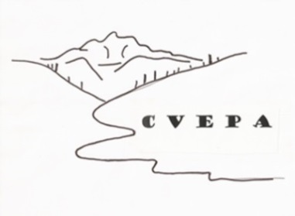
The Crystal Valley Environmental Protection Association
PO 921 Carbondale CO 81623 www.cvepa.org
EIN 84-1048136

The purpose of the Crystal Valley Environmental Protection Association is the protection and preservation of the natural environment, its scenic and historic resources, and to encourage conduct, that will sustain those resources.

Dear Reviewing Officer:

This letter is on behalf of the Crystal Valley Environmental Protection Association (CVEPA) Board of Directors (listed below) regarding the Redstone to McClure Pass Trail Project #56913 Environmental Assessment; this proposed project is within the White River National Forest’s Sopris Ranger District.

During the Draft EA (Scoping) Process CVEPA submitted comments (see Feb. 20, 2022 letter,
available in the Public Comment Reading Room). The USFS responded to several of our comments in the EA. CVEPA supports the Proposed Action but offers the following clarification and suggestions for how the proposed decision may be improved.

Draft EA comment: “Usage of the trails in the Bear Creek Basin will increase as a result of this
action. Vigilant education, patrol and enforcement to deter social trail development and develop an attitude of stewardship is essential. Dog regulation is of great concern to us as mitigation of wildlife disturbance is a priority. We support science-based seasonal regulations to close the area for wildlife protection.”

The Draft Decision proposes a closure season of the Rock Creek Wagon Road, as well as the Old McClure Road, from December 1st through April 30th, with further monitoring to determine if the season should be extended to June 30th. We propose that the more conservative, longer closure occur first, then determining if the closure can be shortened. We know those who recreate in the Crystal River Valley well, and it is much harder to get this community to accept increased closure times after a couple of years than it is to decrease them.

Draft EA comment: “CVEPA adamantly recommends prohibition of commercial use on the trail. This should not preclude bicycle rentals in Redstone or the surrounding area but should disallow outfitters from bringing riders to the top (or bottom) of McClure Pass to ride the trail. Additional, profit motivated uses will bring more pressure to the trails system and the Bear Creek Basin.”

USFS Response (page 100): “The Proposed Action specifies that special uses by private entities would be considered on a case-by-case basis, consistent with Forest Service regulations.”

If possible with Forest Service regulations, CVEPA adamantly recommends the prohibition of commercial use on the entire length of the trail upon it’s construction. We do not support special uses by private entities nor do we support case-by-case decision-making regarding potential commercial development along the trail. With increased recreational opportunities, we do not want to see increased commercial ventures.

Thank you for the chance to provide additional comments.

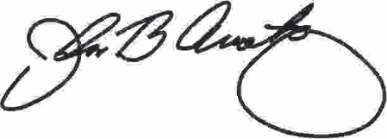

John Armstrong, CVEPA Board President

CVEPA Board Members
John Armstrong, President
Suzy Meredith-Orr, Vice President
Dale Will, Vice President
John Hoffman, Treasurer
Tait Andersen
Jay Engstrom
Grant Stevens

