31 Oct 2022

TO: Central Coast Ranger District, Siuslaw NF
VIA: comments-pacificnorthwest-siuslaw-centralcoast@usda.gov

Subject: North Fork Smith Restoration — scoping comments

Please accept the following scoping comments from Oregon Wild concerning the North Fork Smith Restoration Project, https://www.fs.usda.gov/project/?project=59122. Oregon Wild represents 20,000 members and supporters who share our mission to protect and restore Oregon’s wildlands, wildlife, and water as an enduring legacy. Our goal is to protect areas that remain intact while striving to restore areas that have been degraded. This can be accomplished by moving over-represented ecosystem elements (such as logged and roaded areas) toward characteristics that are currently under-represented (such as roadless areas and complex old forest).

The pre-scoping does not give us much of an idea of what is being proposed, but we have seen enough Siuslaw restoration thinning projects to make some assumptions. We urge the Forest Service to stay within the parameters of what has been working over the last 20 years. Carefully thinning dense young plantations and rationalizing the road system to restore late successional habitat and aquatic habitat, with appropriate analysis and mitigation of unavoidable trade-offs.

Project Setting:
- Landform is mostly steeply incised valleys, forming a dense stream network. 83% of the project area is riparian reserves. Unstable areas need to be included in the riparian reserves.
- Many streams are bedrock dominated, somewhat flashy. Abundant dead wood is needed to help capture and store gravel.
- A majority of project area was affected by fire >120 years ago.
- Only 2% of the project area is privately owned.
- Significant areas of mature forest, some fragmented, some interior. 70% of federal lands are native forest.
- Project area has a history of road building, clearcutting and plantation establishment, 1950-1994. 30% of federal lands are previously clearcut plantations.
- Several significant large roadless and unroaded areas are within the project area, representing anchors for interior mature forest, intact watershed functions, high carbon storage, etc.
- ESA listed spotted owls, marbled murrelet and coho salmon are present.
- The project area is 94.5% LSR + riparian reserves, and 5.5 % matrix + riparian reserves. Very little of the matrix is plantations.
- The Kentucky Falls Special Interest Area is within the project area.
- North Fork Smith River and Fiddle Creek identified as Key Watersheds with high restoration potential. Senator Wyden’s River Democracy Act includes Kentucky Creek and the North Fork Smith River as proposed Wild & Scenic Rivers. The FS should strive to manage compatibly.
- The western portion of the project area contains a portion of the South Coast Water District municipal drinking supply watershed.

Please use this project as an opportunity to develop a preferred alternative that advances the goals for each land allocation and address trade-offs, such as:
- Make restoration of biological potential carbon storage part of the purpose and need. Strive to minimize and mitigate carbon emissions associated with logging. Do not rely on the misleading analysis of carbon and climate put forth by the regional office;
- Conserve and restore the historic range of variability of large blocks of habitat such as unroaded areas >1,000 acres (described below) and LSRs. Where possible, strategically close roads to “grow” unroaded areas;
- Maintain and enhance connections between existing late successional habitat, especially between large blocks such as the Kentucky Falls SIA, Devils Staircase Wilderness, and the uninventoried roadless areas.
- Avoid hard edges adjacent to suitable marbled murrelet habitat. Consider alternatives that retain various levels of unthinned buffers adjacent to suitable murrelet habitat to reduce nest predation on murrelets;
- Retain unthinned “skips” to ensure long-term recruitment of dead wood which is depleted by extensive thinning;
- Retain generous no-cut buffers along streams to retain long-term wood recruitment, which is especially important to build up gravel deposits in bedrock dominated streams;
- Recognize that riparian reserves are intended to benefit both aquatic and terrestrial species, and many upland species depend on abundant snags and dead wood. Retaining and recruiting dead wood is also important for late successional habitat development as a substrate for regenerating hemlock and other species in the understory. Develop alternatives that recruit abundant dead wood throughout the entire extent of riparian reserves, not just instream;
- Plan strategic road decommissioning and road storage, and minimize road construction. Focus on removing poorly located roads in riparian areas and midslope roads that interfere with hillslope processes, such as the natural movement of water, sediment and wood. If possible, try to focus on thinning dense young stands that are accessible from existing roads in order to avoid the significant adverse effects of road construction in steep terrain like this;
- Consider alternatives that retain various levels of residual basal area to achieve several objectives, recognizing that greater green tree retention will advance carbon capture and storage to mitigate climate change, and provision of habitat for spotted owl prey species, such as flying squirrels, red tree vole, and red-backed voles, and to mitigate adverse effects of thinning on wood recruitment;
- Develop a preferred alternative that implements highly variable tree spacing, including clumps and small structure-rich gaps, and retain under-represented species, such as hemlock, cedar, yew hardwoods, deciduous shrubs, etc. to help diversify wildlife food sources and complex late successional habitat conditions. Make sure these living elements of diversity are not killed by post-harvest fuel reduction;
- The pre-scoping materials indicate an interest in thinning to below 40% canopy cover to stimulate understory and mid-story and provide “occlusion” for flying squirrels. This will have significant trade-offs.
  - Wilson and Forsman have shown that that flying squirrel populations are adversely affected by thinning and take a long time to recover, probably because fewer stems provide less occlusion in the near term;
  - Heavy thinning exposes spotted owls to predators and territorial competitors;
  - Heavy thinning also causes long term reduction in dead wood recruitment which is important for late successional habitat development; and
  - Heavy thinning reduces carbon storage and increases carbon emissions.
  - Heavy thinning may also weaken the network of tree roots that stabilize slopes;
The alleged benefits of heavy thinning can be expected to occur naturally over time through the action of natural processes, such as wind, snow/ice, insects, disease, fire, tree fall events. And, these natural created canopy gaps are better for wildlife because they retain more dead and down woody structure. To minimize and mitigate these trade-offs heavy thinning should be limited to small patches representing small subset of thinned areas. And significant unthinned patches should be retained to ensure dense cover for wildlife and adequate wood recruitment. The FS should conduct a quantitative analysis to find the optimal landscape mix of lightly thinning thinned, heavily thinned, and unthinned areas.
- The NEPA analysis should quantify and compare the projected snag habitat with light thinning, heavy thinning, and no thinning and compare to 80% tolerance levels for those species most sensitive to the absence of abundant snags;
- Strive to find ways to enhance habitat for foothill yellow-legged frogs that does not cause significant loss of dead wood recruitment in riparian reserves.
- Early seral habitat creation is not a good ecological goal here because natural processes are still creating early seral habitat. In fact, climate driven fire is creating lots of early seral across the region, while making it harder to retain mature & old-growth. Also, early seral habitat created by logging is not very high quality habitat compared to early seral created by natural processes, because logging (unlike natural disturbances) removes virtually all the dead wood.

Conserve Unroaded Areas

Oregon Wild has identified several large (>1,000 acre) areas without roads and without significant evidence of past logging. These areas are ecologically significant and deserve to be protected. Large blocks of habitat are a restoration goals of the Northwest Forest Plan. Large blocks of habitat are an important part of the historic range of variability that wildlife evolved with and the FS should strive to restore those conditions.

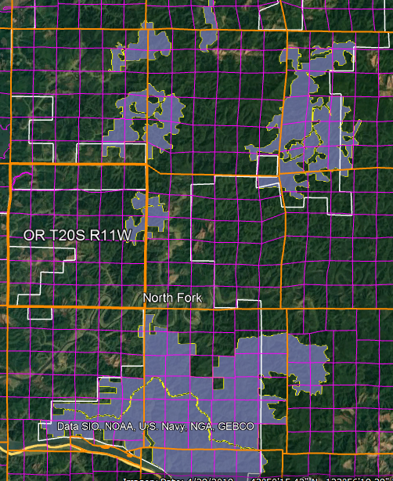
Overview of roadless areas >1,000 acres in the North Fork Project Area, including the Devils Staircase Wilderness/Wassen Creek Roadless Area immediately south of this project.

/ / /

/ / /

/ / /
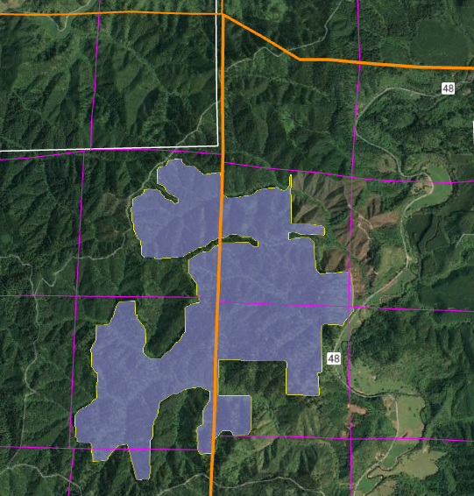
McKinney Creek Unroaded Area, 1426 acres

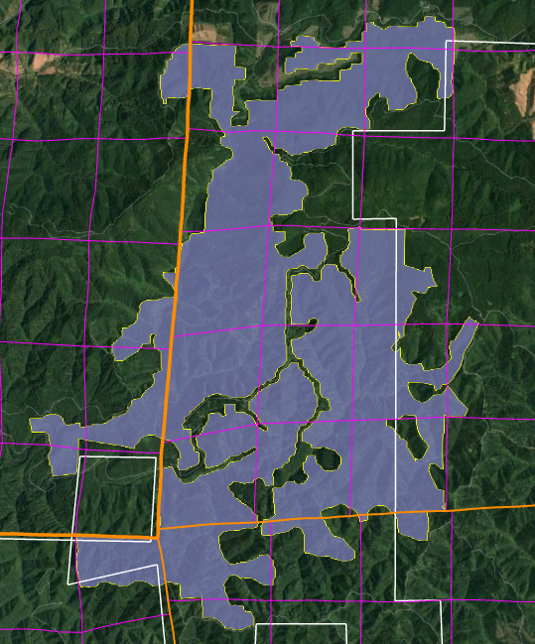
North Fork Smith Unroaded Area, 4347 acres
Middle Fork of the North Fork Smith, Lesley Headwaters Unroaded Area, 2767 acres
Lind Peak Unroaded Area, 1737 acres

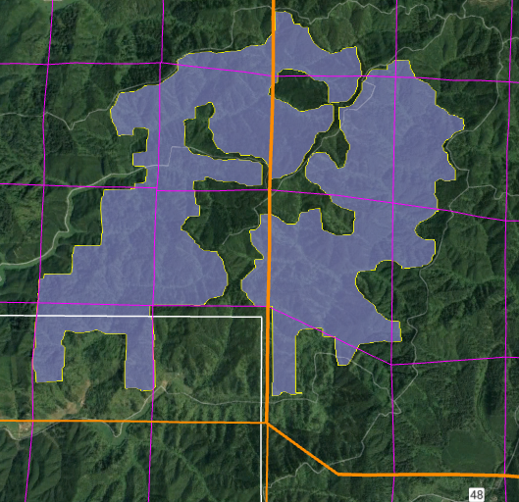
Fiddle Creek Unroaded Area, 1501 acres
Mount Popocatepei Unroaded Area, 2037 acres

Allow Natural Processes to Flourish in Unroaded Areas
Unroaded/undeveloped areas are an important feature of the historic range of variability that needs to be restored. Such areas provide high quality water, soil, fish & wildlife habitat, carbon storage, recreation and scenic values, etc. The purpose and need should include restoration of unroaded/undeveloped areas (consistent with the natural range of variability) where natural processes can flourish.

Unroaded areas are rare on the landscape and they are one of the places where human influence has been limited and the ecological building blocks remain in place, so it is reasonably possible to achieve restoration of desired ecological conditions by relying on natural self-correcting mechanisms. Natural processes have operated successfully for millennia to achieve dynamic balance between forest growth and mortality. Within unroaded areas the agency should focus on eliminating unnatural stressors (such as livestock and weeds) while reintroducing natural processes such as fire. There may be an opportunity to manually pre-treat fuels before reintroducing fire, but building miles of new roads and removing significant habitat structures would not be appropriate.

Unroaded areas often have mature forests which are developing and diversifying naturally. “Mature Seral Stage - This stage typically occurs between ages 81 and 195. Stand diversity is gradually increasing in response to openings in the canopy created by wind-throw, disease, insects, and stand mortality” Eugene BLM, 1995. Mohawk/McGowan Watershed Analysis.

Even when forests in roadless areas seem more uniform than desired, it is not always necessary to mechanically thin forests to increase diversity and complexity. Natural processes can do the job. Spies et al (2002) enumerate a variety of disturbance agents that can help diversify forest stands without logging.
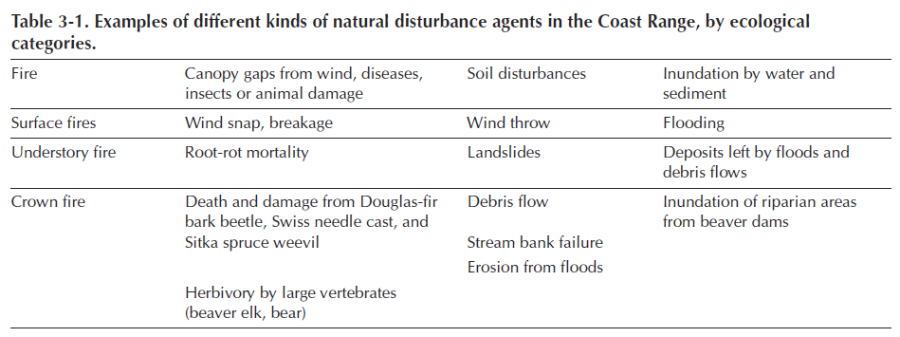
Thomas A. Spies, David E. Hibbs, Janet L. Ohmann, Gordon H. Reeves, Robert J. Pabst,
Frederick J. Swanson, Cathy Whitlock, Julia A. Jones, Beverly C. Wemple,
Laurie A. Parendes, and Barbara A. Schrader. 2002. The Ecological Basis of Forest Ecosystem Management in the Oregon Coast Range. http://www.fsl.orst.edu/rna/Documents/publications/Flynn%20Creek%20spies_etal_2002_ecological_basis.pdf in Hobbs, S. D. et al (2002). Forest and stream management in the Oregon coast range. Corvallis, Or: Oregon State University Press. https://osupress.oregonstate.edu/book/forest-and-stream-management-in-oregon-coast-range

One of the important but under-appreciated values of unroaded areas is the long-term creation and maintenance of dead wood habitat due to the fact that unmanaged areas are where natural processes are allowed to flourish. Unroaded areas are one of the few places where trees are allowed to fulfill their entire “lifecycle” (including their life-giving role as snags, dead wood, and soil builders) in the forest. Korol et al (2002) found that large snag habitat is below historic range of variability across the Interior Columbia Basin and they estimated that even if the agencies apply enlightened forest management on federal lands in the Interior Columbia Basin for the next 100 years, we will still reach only 75% of the historic large snag abundance, and most of the increase in large snags will occur in roadless and wilderness areas. Jerome J. Korol, Miles A. Hemstrom, Wendel J. Hann, and Rebecca A. Gravenmier. 2002. Snags and Down Wood in the Interior Columbia Basin Ecosystem Management Project. PNW-GTR-181. http://www.fs.fed.us/psw/publications/documents/gtr-181/049_Korol.pdf. Since wilderness and unmanaged areas are the only place that a healthy population of snags is likely to be recruited and maintained over the long term, they represent invaluable and irreplaceable mitigation for all the places where snags are in short supply due to logging, hazard tree removal, and other management efforts designed to control and capture mortality.

The map below shows the strong correlation between snag abundance and unmanaged forest lands such as wilderness and roadless areas.

/ / /

/ / /

/ / /
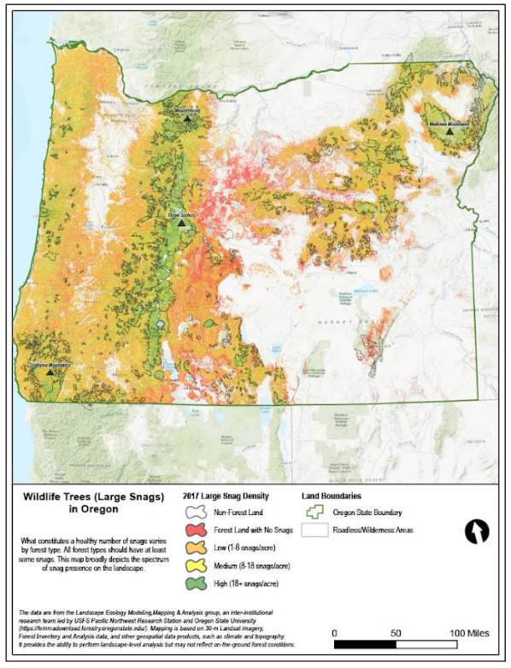

Wisdom et al (2008) found that snag abundance in the Pacific northwest forests is inversely related to past harvest and proximity to roads. Wisdom, M.J., and Bate, L.J. 2008. Snag density varies with intensity of timber harvest and human access. For. Ecol. Manage. 255: 2085–2093. doi:10.1016/j.foreco.2007.12.027. http://www.fs.fed.us/pnw/pubs/journals/pnw_2008_wisdom001.pdf (“Our highest snag density … occurred in unharvested stands that had no adjacent roads. … Stands with no history of timber harvest had 3 times the density of snags as stands selectively harvested, and 19 times the density as stands having undergone complete harvest. Stands not adjacent to roads had almost 3 times the density of snags as stands adjacent to roads.”)

Low-impact restoration activities, including but not limited to prescribed fire, mowing, non-commercial thinning, and weed removal may be appropriate in roadless/unroaded areas as long as they will be substantially unnoticeable to the casual observer and leave the area suitable for future wilderness designation. The NEPA document should describe the roadless/unroaded area, the undeveloped values present, and the need for, and impacts of, the proposed restoration activities.

Commercial logging prescriptions are typically designed to exert significant control over fire behavior and tree mortality, and similar prescriptions have been and are being applied across quite a large area of our federal forests. By limiting treatments to low-impact, non-commercial activities in undeveloped areas we are still treating them, and still getting benefits in terms of fire and "forest heath," but we are relaxing our control just a bit and letting natural processes play a bigger role in that subset of the landscape.

/ / /

/ / /

/ / /
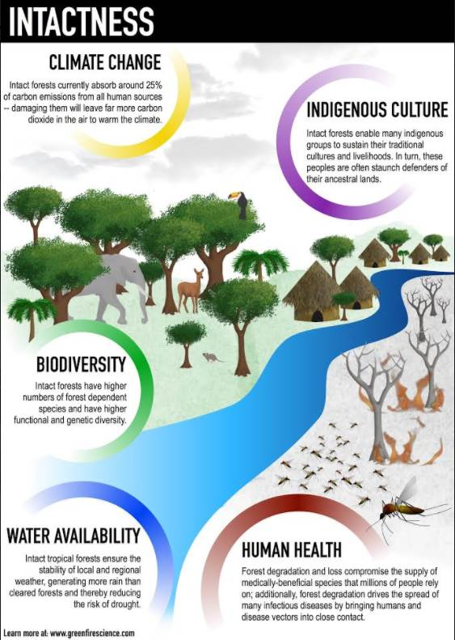
Watson et al 2018. The exceptional value of intact forest ecosystems. Nature Ecology & Evolution (2018) https://www.nature.com/articles/s41559-018-0490-x

New information on Unroaded Areas >1,000 acres
The agency cannot limit its analysis of roadless areas to inventoried areas >5,000 acres, because smaller roadless areas that were not inventoried are ecologically relevant and potentially significant. The NEPA analysis must reflect the growing scientific evidence (cited below) indicating the significant value of roadless areas smaller than 5,000 acres and larger than 1,000 acres. Recent scientific literature emphasizes the importance of unroaded areas greater than 1,000 acres as strongholds for the production of fish and other aquatic and terrestrial species, as well as sources of high quality water. Commercial logging and/or road building within large unroaded areas threatens these significant ecological values.

First, it is important to recognize that about 30% of inventoried roadless areas (IRA) nationwide are smaller than 5,000 acres. It is therefore likely that the diverse and significant values of IRAs can be found within many other unroaded areas between 1,000 and 5,000 acres that were simply not inventoried. NEPA requires that these values be recognized and the effects of logging and roads be carefully disclosed and considered. Martin, DeVelice, Brown. 2001. Landscape Analysis and Biodiversity Specialist Report. Forest Service Roadless Area Conservation FEIS. November 2000. http://www.fs.usda.gov/Internet/FSE_DOCUMENTS/fsm8_035781.pdf
Small areas are important for conserving biodiversity of species with small home ranges, species with special habitat needs, or for providing linkages between larger areas. … Of the more than 2,800 named inventoried roadless areas, about 70% of these areas are larger than 5,000 acres (USDA Forest Service 2000a).

Large unroaded areas are important simply due to the fact that they better represent the historic condition that species evolved with but they are now rare on the landscape due to human activities that have degraded and fragmented the majority of the landscape. The Northwest Forest Plan LSOG Effectiveness Monitoring Plan says that “perhaps 80 percent or more [of the historic late-successional old-growth forest] would probably have occurred as relatively large (greater than 1,000 acres) areas of connected forest.” Miles Hemstrom, Thomas Spies, Craig Palmer, Ross Kiester, John Teply, Phil McDonald, and Ralph Warbington; Late-Successional and Old-Growth Forest Effectiveness Monitoring Plan for the Northwest Forest Plan, USFS General Technical Report PNW-GTR-438; December 1998; http://www.fs.fed.us/pnw/pubs/gtr_438.pdf. Currently, these 1,000 acre and larger patches are rare on the landscape.

Boakes et al (2009) explained why it is important to retain large unroaded areas.
Abstract: Habitat clearance remains the major cause of biodiversity loss, with consequences for ecosystem services and for people. In response to this, many global conservation schemes direct funds to regions with high rates of recent habitat destruction, though some also emphasize the conservation of remaining large tracts of intact habitat. If the pattern of habitat clearance is highly contagious, the latter approach will help prevent destructive processes gaining a foothold in areas of contiguous intact habitat. Here, we test the strength of spatial contagion in the pattern of habitat clearance. Using a global dataset of land-cover change at 50x50 km resolution, we discover that intact habitat areas in grid cells are refractory to clearance only when all neighbouring cells are also intact. The likelihood of loss increases dramatically as soon as habitat is cleared in just one neighbouring cell, and remains high thereafter. This effect is consistent for forests and grassland, across biogeographic realms and over centuries, constituting a coherent global pattern. Our results show that landscapes become vulnerable to wholesale clearance as soon as threatening processes begin to penetrate, so actions to prevent any incursions into large, intact blocks of natural habitat are key to their long-term persistence.
Elizabeth H. Boakes, Georgina M. Mace, Philip J. K. McGowan and Richard A. Fuller 2009. Extreme contagion in global habitat clearance. Proceedings of the Royal Society B: Biological Sciences. November 25, 2009. doi: 10.1098/rspb.2009.1771

World Wildlife Fund and the Conservation Biology Institute summarized the important attributes of small roadless areas (1,000-5,000 acres).
Small roadless areas share many of attributes in common with larger ones, including:
• Essential habitat for species key to the recovery of forests following disturbance such as herbaceous plants, lichens, and mycorrhizal fungi
• Habitat refugia for threatened species and those with restricted distributions (endemics)
• Aquatic strongholds for salmonids
• Undisturbed habitats for mollusks and amphibians
• Remaining pockets of old-growth forests
• Overwintering habitat for resident birds and ungulates
• Dispersal “stepping stones” for wildlife movement across fragmented landscapes
DellaSala, Dominick and James Strittholt. 2002. Scientific Basis For Roadless Area Conservation. World Wildlife Fund. Ashland, OR; Conservation Biology Institute. (June 2002 - Updated October 2003) https://d2k78bk4kdhbpr.cloudfront.net/media/reports/files/Scientific_Basis_For_Roadless_Area_Conservation.pdf.

In a 1997 letter to President Clinton, 136 scientists said:
There is a growing consensus among academic and agency scientists that existing roadless areas–irrespective of size–contribute substantially to maintaining biodiversity and ecological integrity on the national forests. The Eastside Forests Scientific Societies Panel, including representatives from the American Fisheries Society, American Ornithologists’ Union, Ecological Society of America, Society for Conservation Biology, and The Wildlife Society, recommended a prohibition on the construction of new roads and logging within existing (1) roadless regions larger than 1,000 acres, and (2) roadless regions smaller than 1,000 acres that are biologically significant…. Other scientists have also recommended protection of all roadless areas greater than 1,000 acres, at least until landscapes degraded by past management have recovered…. As you have acknowledged, a national policy prohibiting road building and other forms of development in roadless areas represents a major step towards balancing sustainable forest management with conserving environmental values on federal lands. In our view, a scientifically based policy for roadless areas on public lands should, at a minimum, protect from development all roadless areas larger than 1,000 acres and those smaller areas that have special ecological significance because of their contributions to regional landscapes.
Letter to President Clinton from 136 scientists (Dec. 10, 1997).
https://drive.google.com/file/d/0B4L_-RD-MJwrRzhFcm5QcFR0MHM/view?usp=sharing&resourcekey=0-2-sbGMN3bOUBQGGMDBQM1Q

To the list of special values found within unroaded areas must be added carbon storage. European policy leaders consider roadless areas effective for carbon storage and climate mitigation:
[T]he European Parliament has agreed to raise the issue of roadbuilding in intact forests at the UN Climate Change Conference to be held next month in Warsaw (Poland); it calls on parties to use the existence of roads in forest areas as an early negative performance indicator of REDD+ projects, and to prioritise the allocation of REDD+ funds towards road free forests.
Oct 24, 2013 Press release: EUROPEAN PARLIAMENT BACKS THE PROTECTION OF ROADFREE AREAS. http://kritonarsenis.gr/eng/actions/view/european-parliament-backs-the-protection. Federal land managers should recognize the tremendous carbon values in unroaded/unmanaged forests and avoid actions that would threaten these values. See also, William R. Moomaw, Susan A. Masino, and Edward K. Faison. 2019. Intact Forests in the United States: Proforestation Mitigates Climate Change and Serves the Greatest Good Front. For. Glob. Change, 11 June 2019 | https://doi.org/10.3389/ffgc.2019.00027; https://www.frontiersin.org/articles/10.3389/ffgc.2019.00027/full. See also, Kun, Z., DellaSala, D., Keith, H., Kormos, C., Mercer, B., Moomaw, W.R. and Wiezik, M. (2020), Recognising the importance of unmanaged forests to mitigate climate change. GCB Bioenergy. Accepted Author Manuscript. doi:10.1111/gcbb.12714 https://onlinelibrary.wiley.com/doi/pdfdirect/10.1111/gcbb.12714. (“The most effective means for keeping carbon out of the atmosphere to meet climate goals is to protect primary forests (Mackey et al. 2020) and continue growing secondary forests to accumulate additional carbon (proforestation) (Moomaw et al. 2019) while reducing emissions from all sources including bioenergy. … The importance of primary (unlogged) forests lies in the magnitude and longevity of their carbon stock. In order to reverse the decreasing forest carbon stocks in Europe (EEA, 2019), the largest forest carbon stores must be protected and additional forests must be allowed to continue accumulating carbon (proforestation).”).

Optimal Mix of Treated and Untreated

Oregon Wild supports thinning of young planted stands when such projects are well planned and designed to accomplish comprehensive restoration objectives and carefully implemented to avoid unintended consequences. One of the key considerations is to find the optimal mix of treated and untreated patches within and between stands. This is because thinning benefits some aspects of late successional forest conditions such as large trees and vegetation diversity, but thinning also has adverse effects on other aspects of late successional forests such as dead wood recruitment, biomass accumulation, wildlife cover, soil quality, and microclimate conditions. In order to achieve all the objectives for optimal late successional forest conditions, restoration projects must contain both thinned and unthinned patches. Finding the right mix should not be an accident based mostly on operational feasibility and site constraints, but should be a conscious decision based on quantitative analysis showing how best to achieve optimal late successional conditions. Since thinning has a long-term negative effect on reducing recruitment of dead wood, it should be treated as a limiting factor and used to drive the search for an alternative with the most appropriate mix of treated and untreated stands.
It is useful to apply the concept of “habitat complementation” based on proximity of different stand types and different needs of wildlife. Some stand types provide shelter from predators and weather, while other stand types provide foraging opportunities. Recognize that the thoughtful juxtaposition of thinned and unthinned areas can provide habitat benefits greater than large homogeneous areas of either thinned or unthinned. There is a synergy to creation of a mosaic of thinned and unthinned stands that is greater than the sum of its parts. With this recognition, an important purpose of the NEPA document and the ultimate decision is to seek and find the most optimal mix of treated and untreated areas. Instead of an 80/20 mix of treated/untreated areas, consider a variety of combinations such as 60/40, 50/50, 40/60, and 20/80. Note that both the absolute proportion and the spatial pattern of treated and untreated must be considered.
Consider the ecological costs and benefits of both thinned areas and unthinned areas. Thinned areas grow big trees (but fewer of them), while unthinned areas recruit more dead wood habitat structure in the short and long-term. In order to accomplish real ecological restoration in young stands we need to plan for and implement both thinned areas and unthinned areas.
Determining the appropriate scale of thinned and unthinned areas is a critical decision which requires clear objectives and quantitative analysis. One necessary component of such an analysis is to determine how many green trees are needed at what density in order to recruit sufficient snags over time (both short and long-term) to achieve 50-80% DecAID tolerance levels across the project area.
It is important to integrate the analysis of road access and the optimal mix of treated and untreated areas. Since road construction has serious adverse impacts on soil, water, weeds, and wildlife, and because some areas will contribute to ecological goals while not being thinned, the agency should just allocate inaccessible areas to the untreated portion of the mix. This will lead to complementary benefits - avoided road impacts, and ecological benefits associated with dense forest and long-term dead wood recruitment.

Big game cover and forage requirements, and dead wood habitat recruitment represent good tools to help optimize the mix of treated and untreated stands and the scale and extent of untreated skips and heavily-thinned “gaps” within treated stands. Thinned areas may provide better forage opportunities for big game, while untreated skips offer essential hiding cover for big game and other wildlife. Thinned and regenerated areas are not expected to recruit adequate numbers of snags and dead wood habitat over time, while untreated areas will recruit near-natural levels of dead wood habitat. The need for well-distributed patches of relatively dense forest where snags are continuously recruited is a good lens through which to think about optimizing the mix of treated and untreated stands, as well as the scale and extent of skips and heavily-thinned “gaps” within treated stands. The agency should consider alternatives with different mixes of treated and untreated areas for this purpose.

When confronted with trade-offs, the agency must find a rational basis for emphasizing one set of benefits versus another. The agency has a NEPA obligation to consider all reasonable alternatives. When there may exist a NEPA alternative that minimizes the trade-offs and offers an optimal mix of benefits from treated and untreated areas, the agency must disclose the existence of that alternative and compare the effects of the optimal mix, to other alternatives with sub-optimal mixes of treatments.

The Council on Environmental Quality (CEQ) regulations for implementing the National Environmental Policy Act (NEPA) call on agencies to “Use the NEPA process to identify and assess the reasonable alternatives to proposed actions that will avoid or minimize adverse effects of these actions upon the quality of the human environment.” 40 CFR 1502, 1500.2 (e). The CEQ regulations require that agencies specify “the alternative or alternatives which were considered to be environmentally preferable” (40 CFR § 1505.2(b)). “Environmentally preferable” is interpreted to mean the alternative(s) that would cause the least damage to the biological and physical components of the environment, and which best protects, preserves, and enhances, historic, cultural, and natural resources (CEQ, 40 Most Asked Questions Concerning CEQs National Environmental Policy Act Regulations, 46 Federal Register 18026).” NEPA mandates that an agency “shall to the fullest extent possible: use the NEPA process to identify and assess the reasonable alternatives to proposed actions that will avoid or minimize adverse effects of these action upon the quality of the human environment.” 40 C.F.R. § 1500.2(e). NEPA also requires the agency to “study, develop, and describe appropriate alternatives to the recommended courses of action in any proposal which involves unresolved conflicts concerning alternative uses of available resources...” Taken together, this means the agency is required to identify an alternative that provides an optimal mix of treated and untreated areas.

The NEPA analysis must recognize the value of untreated areas to provide benefits like dense forest cover, snag recruitment, soil/water quality, carbon storage, etc. Recognize that forests are naturally adaptive and natural processes will accomplish many of the benefits attributed to thinning. “Counter to many regional studies, our results indicated that treated and long-unaltered, untreated areas may be moving in a similar direction. Treated and untreated areas experienced declines in tree density, increases in the size of the average individual, and losses of surface fuels in most size classes. The number of large trees increased in untreated areas, but decreased in treated areas. Our results suggested that untreated areas may be naturally recovering from the large disturbances associated with resource extraction and development in the late 1800s, and that natural recovery processes, including self thinning, are taking hold. ... In a study of forest restoration need across eastern Washington and Oregon, over 25% of required restoration could be achieved through transition to later stages of forest stand development through successional processes as western landscapes recover from widespread historic degradation (Haugo et al., 2015).” Zachmann, L. J., D. W. Shaw, and B. G. Dickson. 2018. Prescribed fire and natural recovery produce similar long-term patterns of change in forest structure in the Lake Tahoe basin, California. Forest Ecology and Management 409:276–287. http://www.csp-inc.org/wp-content/uploads/2017/11/Zachmann_et_al_2017.pdf

Many restoration goals can be met by simply letting forests grow and proceed through the natural stages of succession, or by working with natural or prescribed fire and then letting forests grow. Haugo et al (2017) looked at forest restoration needs across the dry forests of Oregon and Washington and found -
... that approximately 41% (4,742,000 ha) of all coniferous forest in eastern Washington and eastern and southwestern Oregon was in need of a transition to a different s-class [successional/structural stages] in order to restore forest structure to a NRV reference condition. Across these regions Disturbance then Succession was the most common restoration need category (20% of all forests, 5,678,000 ha) followed by Disturbance Only (14%, 3,920,000 ha) and Succession Only (7%, 2,120,000 ha; Table 3). On the largest individual ownership, the US Forest Service, approximately 38% (2,412,000 ha) of coniferous forests was in need of transition to a different s-class. ... Overall restoration need was higher on Bureau of Land Management, State, and Private forests (52%, 45%, and 45% of forests per respective ownership) with Disturbance then Succession, the most common restoration need category on these ownerships (Table 3).
...
Within the vast majority of the watersheds we evaluated, disturbance alone cannot restore NRV forest structure. Deficits in late development forest structure were clearly evident; succession into later development s-classes was required in over half (66%) of the total restoration needs across the region.
...
We found that time to transition into later development structural classes through successional processes was required on approximately 3.2 million ha (over 25% of all coniferous forests). On an estimated 2.3 million ha we identified that disturbance followed by succession was required to restore NRV forest structure.
Haugo, R., Zanger, C., DeMeo, T., Ringo, C., Shlisky, A., Blankenship, K., Simpson, M., Mellen-McLean, K., Kertis, J., Stern, M., 2015. A new approach to evaluate forest structure restoration needs across Oregon and Washington, USA. For. Ecol. Manage. 335, 37–50. https://doi.org/10.1016/j.foreco.2014.09.014.

Disclose and Mitigate Trade-offs

Land management inevitably involves trade-offs among competing uses of the public lands. Alternatives should be developed to resolve trade-offs in different ways.

The agency must avoid portraying the effects of the proposed action in uniformly positive terms, while describing the effects of no action in uniformly negative terms.

If the agency purpose and need includes a mix of restoration goals and timber production, the NEPA analysis needs to clearly disclose to what extent optimal restoration outcomes are being sacrificed in order to produce timber volume. It is often the case that optimal restoration calls for retention of more trees, especially commercial-sized trees, that serve a variety of ecosystem services. Retaining optimal levels of medium and large trees –
- Provides habitat for wildlife that depend on (i) relatively dense forests and/or (ii) abundant snags and dead wood;
- Stores carbon that helps moderate global climate change;
- Enhances recreational/scenic values;
- Suppresses the growth of hazardous ladder fuels and reduces future maintenance costs associated with removing non-commercial in-growth; and
- Provides cool/moist microclimate buffering that benefits wildlife, recreation, and moderates fire hazard;
Removing trees to meet timber objectives sacrifices all these values. The agency needs to carefully disclose the extent to which these public values are sacrificed in order to achieve timber volume objectives. Clearly disclosing such trade-offs helps the public provide informed comment, and helps achieve the informd decision-making requirements of NEPA. It also furthers the requirements of NEPA related to:
- “Study, develop, and describe appropriate alternatives to recommended courses of action in any proposal which involves unresolved conflicts concerning alternative uses of available resources.” 40 CFR §§1501.2(c), 1507.2(d), 42 USC § 4332(2)(E).
- “… the relationship between short-term uses of man’s environment and the maintenance and enhancement of long-term productivity, …”40 CFR §1502.16, 42 USC § 4332(2)(C). https://www.energy.gov/sites/prod/files/NEPA-40CFR1500_1508.pdf

NEPA requires disclosure of the trade-offs among competing uses.
Project-level planning and implementation pursues management activities in accordance with forest plans to enhance flows of particular ecosystem services—to improve a specific fish or wildlife population, for example, or reduce the likelihood that natural disturbance (e.g., wildfire) might adversely affect flows of ecosystem services. However, many ecosystem services and the associated landscape conditions from which they derive are interrelated in either conflicting or synergistic ways such that changes in one service necessarily involve changes in another service. In some cases, increased flows of one service may only be possible by accepting decreased flows of another service. Evaluating and communicating expected management outcomes necessarily must account for these interrelationships and the tradeoffs—the exchange of one level of service for another—made necessary when implementing a project that will affect multiple ecosystem service flows.
Conceptually, tradeoffs among ecosystem services are best illustrated by using the economic concept of “production possibility frontiers” (e.g., Bowes and Krutilla 1989: 49, Stevens and Montgomery 2002). Production possibility frontiers show the combinations and levels of ecosystem services that can be produced on a landscape given that landscape’s capacity to produce those services (e.g., its size and biophysical features) and management inputs (e.g., labor) and capital improvements (e.g., roads, trails, culverts).
…
Understanding the production possibilities for a given landscape enables managers to identify and weigh the possible output combinations that might be expected on a given landscape, and may make it more feasible to avoid unnecessary tradeoffs.
…
Another important step in evaluating forest management tradeoffs is characterizing how valued ecosystem services are likely to change in response to management activities under consideration. … Ideally, analysis of the likely outcomes of landscape management would be based on credible scientific information linking expected changes in ecosystem services to specific changes in landscape conditions and processes resulting from proposed plans and projects. The quantity and quality of scientific information available for evaluating management effects in this way can differ depending on how well particular ecosystem processes are understood and how well they can be described by ecologists and biophysical scientists as changes in ecosystem services.
… [M]any economists refer to a need for ecological production functions (e.g., Polasky 2008) that link the production of a given ecosystem service in space and time to landscape conditions and processes necessary to its production. …
Whether dealing with empirical data and models or qualitative data and narratives, evaluating and communicating expected management outcomes calls for managers to (1) identify key landscape conditions that affect the quantity and quality of valued ecosystem services; (2) characterize key relations between those landscape conditions and the levels of ecosystem services produced; and (3) describe the degree of uncertainty in the data and models used to predict management outcomes. This process includes describing the spatial and temporal aspects of expected outcomes.
Kline, Jeffrey D.; Mazzotta, Marisa J. 2012. Evaluating trade-offs among ecosystem services in the management of public lands. Gen. Tech. Rep. PNW-GTR-865. Portland, R: U.S. Department of Agriculture, Forest Service, Pacific Northwest Research Station. 48 p. http://www.fs.fed.us/pnw/pubs/pnw_gtr865.pdf.

[W]hile specific structural attributes of forest ecosystems have been correlated with certain species, it is uncertain how such species will respond to treatments designed to recreate these features. There is always the possibility that in our attempt to create a structural attribute we think is important, we eliminate another attribute that is equally important, but unrecognized. One example is that attempts to restore spotted owl habitat by heavily thinning to accelerate the development of large diameter nesting trees could actually delay spotted owl recovery by reducing production of the large down wood utilized by the species it preys upon (Forsman et al., 1984; Carey, 1995; North et al., 1999). Similarly, heavily thinning stands to accelerate the development of marbled murrelet nesting trees also create open stands with a dense understory that is ideal habitat for a number of corvid species that prey on marbled murrelet nest eggs (USFWS, 2010). Riparian thinning efforts to create long-term supplies of very large diameter instream wood that can initiate complex wood jam formation (e.g., key pieces) are also likely to reduce the supply of large diameter wood that will create pools (Beechie and Sibley, 1997; Beechie et al., 2000; Fox and Bolton, 2007). Thus, we suggest that any efforts to actively restore riparian forests for the benefit of certain species should be treated as scientific experiments and proceed cautiously, skeptically, and with robust pre- and post-treatment data collection efforts. Hypothesized effects of thinning on riparian forest structure and the use of that structure by targeted species should be tested against empirical data.
Pollock, Michael M. and Timothy J. Beechie, 2014. Does Riparian Forest Restoration Thinning Enhance Biodiversity? The Ecological Importance of Large Wood. Journal of the American Water Resources Association (JAWRA) 50(3): 543-559. DOI: 10.1111/jawr.12206. http://oregon-stream-protection-coalition.com/wp-content/uploads/2014/07/Pollock-and-Beechie.-2014.-Riparian-thinning-and-biodiversity.pdf

The agency should look for tools to help illuminate and transparently resolve trade-offs. “An integrated planning process focuses on multiple-objective planning rather than single-objective planning from the beginning of the project. It favors a transparent and interactive process that offers opportunities for understanding ecosystem complexity, stakeholder positions, and clear articulation of decision trade-offs and benefits.” Jain, Theresa B.; Battaglia, Mike A.; Han, Han-Sup; Graham, Russell T.; Keyes, Christopher R.; Fried, Jeremy S.; Sandquist, Jonathan E. 2012. A comprehensive guide to fuel management practices for dry mixed conifer forests in the northwestern United States. USDA Forest Service Gen. Tech. Rep. RMRS-GTR-292. 2012 http://www.firescience.gov/projects/09-2-01-16/project/09-2-01-16_09-2-01-16_rmrs_gtr292web.pdf Chapter 7 of this document highlights the importance of clearly articulated project objectives, quantitative metrics defining success across multiple objectives, “a format to display the benefits and trade-offs among the metrics...,” and a clearly articulated rationale linking treatment prescriptions to desired objectives.

“[F]uel-reduction activities may have undesirable environmental effects (e.g., the need for periodic treatments, introduction of weeds, soil disturbance, or maintenance of some roads).” Spies, Thomas A.; Hemstrom, Miles A.; Youngblood, Andrew; Hummel, Susan. 2006. Conserving old-growth forest diversity in disturbance-prone landscapes. Conservation Biology. 20(2): 351-362. http://www.fs.fed.us/pnw/pubs/journals/pnw_2006_spies001.pdf.

Another potentially useful framework for weighing trade-offs among ecosystem services (such as timber production and biodiversity) is presented here: Cavender-Bares, J., S. Polasky, E. King, and P. Balvanera. 2015. A sustainability framework for assessing trade-offs in ecosystem services. Ecology and Society 20(1): 17. http://dx.doi.org/10.5751/ES-06917-200117; http://www.ecologyandsociety.org/vol20/iss1/art17/ (“Similar to Bator’s 1957 article, ‘The simple analytics of welfare maximization,’ which sought to provide a coherent unified treatment of welfare economics that was widely accessible, we sought to provide a coherent unified and clear treatment of ecosystem service trade-offs in the context of sustainability. We did so in a series of steps that (1) defined the biophysical constraints of the system in the form of an efficiency frontier, (2) combined the values of stakeholders and the efficiency frontier, (3) examined temporal lags and intergenerational inequalities, and (4) incorporated thresholds and nonlinear system dynamics. … Our sustainability framework emphasizes the ecological processes underlying the production of ecosystem services that contribute to human well-being. This emphasis complements the work of economists on “inclusive wealth ” (Hamilton and Clemens 1999, Dasgupta and Mäler 2000, Heal 2000, Arrow et al. 2004, 2012). Inclusive wealth is a measure of the value of all capital assets, i.e., manufactured, human, social, and natural capital, with value reflecting the contribution of the asset to providing benefits both now and in the future. To be sustainable, inclusive wealth should be nondeclining, so that future generations have bundles of assets that are of equal or greater value than the value of current assets. The advantage of the inclusive wealth approach is that it offers a clear and simple criterion for sustainability with a comprehensive and global scope (Cavender-Bares et al. 2013). … The process of developing a study in the context of the sustainability framework as we have outlined it is a valuable exercise (cf. Ewing and Runck 2015, Grossman 2015, Mastrangelo and Laterra 2015; P. Balvanera, F. Mora, A. Castillo, and J. Trilleras, unpublished manuscript, M. ). It untangles the known from the perceived, makes transparent disparate viewpoints and underlying assumptions of stakeholders, and clarifies the information base that stakeholders rely on for informing themselves about the system. Moreover, it identifies the data gaps so that stakeholders can make more informed decisions about the most appropriate intervention for an area, given social and biophysical constraints (Grossman 2015; P. Balvanera, F. Mora, A. Castillo, and J. Trilleras, unpublished manuscript). The process itself, however, may be more valuable than any immediate outcome of the analysis. As such, the framework has the potential to contribute to a participatory approach (E. G. King, J. Cavender-Bares, T. Mwampamba, P. Balvanera, and S. Polasky, unpublished manuscript) that builds trust, common ground, and the working environment needed to address ecological problems in a way that can secure long-term commitment to resolving them, which is a necessary building block for sustainability. Ultimately, an integrated social-ecological analysis of the trade-offs among ecosystem services and their dynamics through time is necessary to assess how close or far we are from attaining sustainability.”)

Yang et al (2015) created a framework linking ecosystem services to human welling being. They “used net benefits rather than gross benefits to allow the indices to capture both [ecosystem services] and disservices, account for costs associated with provision of [ecosystem services], consider trade-offs and synergies between different [ecosystem services], and facilitate cross-context comparisons (Yang et al. 2013b).” Yang, W., T. Dietz, D. B. Kramer, Z. Ouyang, and J. Liu. 2015. An integrated approach to understanding the linkages between ecosystem services and human well-being. Ecosystem Health and Sustainability 1(5):19. http://dx.doi.org/10.1890/EHS15-0001.1; http://onlinelibrary.wiley.com/doi/10.1890/EHS15-0001.1/epdf. In this framework, the benefits of ecosystem services provided by wood products would be adjusted to reflect the costs of water pollution, loss of biodiversity, and carbon emissions , and other values associated with logging.

See also:
- Maass, M., P. Balvanera, P. Bourgeron, M. Equihua, J. Baudry, J. Dick, M. Forsius, L. Halada, K. Krauze, M. Nakaoka, D. E. Orenstein, T. W. Parr, C. L. Redman, R. Rozzi, M. Santos-Reis, A. M. Swemmer, and A. Vădineanu. 2016. Changes in biodiversity and trade-offs among ecosystem services, stakeholders, and components of well-being: the contribution of the International LongTerm Ecological Research network (ILTER) to Programme on Ecosystem Change and Society (PECS). Ecology and Society 21(3):31. http://dx.doi.org/10.5751/ES-08587-210331; https://www.ecologyandsociety.org/vol21/iss3/art31/ES-2016-8587.pdf
- Deng, X., Li, Z. & Gibson, J. J. 2016. A review on trade-off analysis of ecosystem services for sustainable land-use management. Geogr. Sci. (2016) 26: 953. https://doi.org/10.1007/s11442-016-1309-9
- Cordingley JE, Newton AC, Rose RJ, Clarke RT, Bullock JM (2015) Habitat Fragmentation Intensifies Trade-Offs between Biodiversity and Ecosystem Services in a Heathland Ecosystem in Southern England. PLoS ONE 10(6): e0130004. https://doi.org/10.1371/journal.pone.0130004; http://journals.plos.org/plosone/article/file?id=10.1371/journal.pone.0130004&type=printable
- Turkelboom F., Thoonen M., Jacobs S., García-Llorente M., Martín-López B. and Berry P. (2016): Ecosystem services trade-offs and synergies. In: Potschin, M. and K. Jax (eds): OpenNESS Ecosystem Services Reference Book. EC FP7 Grant Agreement no. 308428. http://www.openness-project.eu/sites/default/files/SP-Trade-offs-and-synergies.pdf
- Bennett E.M. et al. (2009): Understanding relationships among multiple ecosystem services. Ecology letters12(12): 1394-1404.
- Howe C. et al. (2014): Creating win-wins from trade-offs? Ecosystem services for human well-being: A meta-analysis of ecosystem service trade-offs and synergies in the real world. Global Environmental Change28: 263-275. https://www.sciencedirect.com/science/article/pii/S0959378014001320
- Mouchet M. et al. (2014): An interdisciplinary methodological guide for quantifying associations between ecosystem services. Global Environmental Change 28: 298-308.
- Lydia Olander, Robert J. Johnston, Heather Tallis, Jimmy Kagan, Lynn Maguire, Steve Polasky, Dean Urban, James Boyd, Lisa Wainger, and Margaret Palmer. 2015. “Best Practices for Integrating Ecosystem Services into Federal Decision Making.” Durham: National Ecosystem Services Partnership, Duke University. doi:10.13016/M2CH07. https://nicholasinstitute.duke.edu/sites/default/files/publications/es_best_practices_fullpdf_0.pdf (There’s also a guidebook: https://nespguidebook.com/ )

Tree tipping does not fully mitigate for loss of functional wood caused by logging

If tree-tipping is considered as a mitigation for commercial removal of functional wood from riparian areas, recognize that tree tipping by itself (without logging) might provide some aquatic restoration benefits by accelerating recruitment of wood and creating growing space for residual trees, but tree tipping as mitigation for the adverse effects of logging is not well supported.

Chris Frissel says—
Benda et al. (2016) recently proposed “tree tipping” as a means of mitigating the effects of thinning on depletion of large wood recruitment. This idea rests on the premise that setting aside a portion of logged trees within the riparian area for direct felling into stream channels can offset the medium and long-term reduction of wood recruitment to streams when natural mortality is reduced by riparian forest thinning, by increasing the directional efficiency and speed of debris delivery. While Benda et al.’s successional modeling of wood recruitment effects through a century of post-treatment forest succession produces results similar to Pollock and Beechie (2014) with regard to thinning’s depletion of woody debris sources to streams, we find the utility of this model in justifying management practices is limited due to its simplification and non-specificity of key parameters known to govern natural wood dynamics in riparian areas. For example, the model appears to represent only riparian areas dominated by stands of high-density post-clearcut Douglas-fir, but this is not a prevalent condition in many riparian areas in the Pacific Northwest, where even within extensive second-growth forest plantations, diverse species of conifer and hardwood trees naturally regenerate within most riparian areas.
Moreover, a variety of natural gap-creating disturbance processes (Everest & Reeves 2007), including windthrow, flood, fluvial erosion, slope erosion and deposition, herbivory, and pathogens often operate at substantially greater frequency in riparian areas than in adjacent uplands, but this is not acknowledged by Benda et al., nor apparently represented in their model. Further, Benda et al.’s modeling does not appear to account for accelerated windthrow from increased wind sheer stress in riparian areas that is known to follow logging of adjacent uplands (Liquori 2006, MacDonald et al. 2003, Huggard et al. 1999). Episodes of windthrow following thinning commonly result in mature live tree and standing snag densities and shade much lower than pre-disturbance conditions, and much lower than predicted by successional models that do not account for change in windthrow vulnerability (C.A. Frissell and M. Pollock, unpublished data). Moreover post-logging windthrow in riparian areas either replaces, or greatly magnifies the desired effect of tree tipping—that is, increasing wood recruitment in the near term by reducing the supply of large wood to support recruitment to streams in future decades (Liquori 2006).
Benda et al. justify thinning in riparian areas on the basis of increasing the growth and eventual size of trees that are left uncut, but they do not detail the conditions under which tree size is ecologically critical; more smaller pieces that are well-distributed and recruit frequently may convey more habitat benefit over time to some species and functions than do fewer, far more scattered larger pieces, except in very large streams where channel width exceeds the length of tree boles (Pollock and Beechie 2014, Collins et al. 2002) Consideration of windthrow effects likely renders tree tipping redundant or undesirable—for example, beyond the depletion effect on future wood recruitment of hastened tree mortality, the cumulative shade losses associated with thinning, tree tipping, and subsequent windthrow (MacDonald et al. 2003, Burton et al. 2016) are likely to often produce stream warming that is harmful to coldwater fishes, amphibians, and other biota.
Another major concern is feasibility of implementation. According to the findings of Benda et al., tree tipping could only reach the ideal levels of sustainable debris recruitment sufficient to offset the wood-depleting effects of thinning if an unlogged buffer of 10-30 m is left along streams (to support future natural wood recruitment to the stream), and thinning and tree tipping are implemented along both sides of thestream. This means extensive mechanized equipment operations alongside both streambanks, in near-stream areas that often include highly erodible soils and erosion-prone slopes. Skid trails and soil disturbance by logging equipment within about 60-220 m of steams can produce rilling or gully erosion that delivers sediment to channels (Rashin et al. 2006, Litschert and MacDonald 2009). Because much logging within the Pacific Northwest occurs in rainfall-dominated rather than snow-dominated areas, there is limited opportunity to mitigate erosion by operating logging equipment over snow and frozen ground. Therefore the primary mitigation measure for reducing sediment delivery to streams from logging disturbances is to exclude ground-based equipment operations within a zone from 60-200 m of surface waters. Such an exclusion greatly limits capability to access riparian forests for aggressive management measures like tree tipping. Finally, directional felling of trees from an outer riparian zone through an unlogged inner riparian stand of 10-30 m width is a difficult proposition. Many felled trees are certain to “hang up” on standing trees under this condition, and are unlikely to reach the intended stream channel. As a result many more trees would have to be cut than acknowledged in the Benda et al. analysis to attain the in-channel tree tipping targets specified as necessary to mitigate thinning-related debris losses—causing further ancillary harms as outlined above.

Weigh the trade-offs associated with logging in riparian reserves.

The agency often claims that logging in riparian reserves is necessary to improve attributes other than large wood. However, these benefits are often minor and transitory, and do not outweigh the significant long-term adverse effect of logging on recruitment of dead wood. The agency must focus on the most significant contributions of vegetation toward ACS objectives and the most significant effects of logging on the ACS objectives.

If the agency intends to log in riparian reserves to increase some nebulous goal like “vegetation diversity and complexity,” then please explain why the biophysical indicators for the ACS objectives (set forth below) do not include any mention of vegetation diversity or complexity. See the Jazz Thinning Preliminary Analysis, 2011. http://bark-out.org/sites/default/files/bark-docs/Jazz_PA_0.pdf.

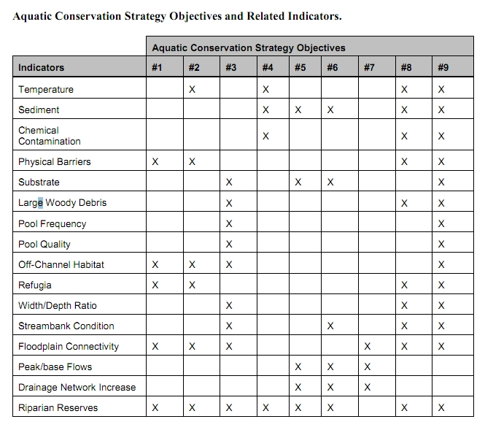

The Northwest Forest Plan and its supporting documentation make clear that the primary value of riparian vegetation is as a source of large wood and shade, not vegetation diversity and canopy layering, as often asserted by the agency to justify logging in riparian reserves. BLM admits “The primary function of Riparian Reserves is to provide shade and a source of large wood inputs to stream channels.” Medford BLM 2013. Pilot Thompson EA, p 3-76. http://www.blm.gov/or/districts/medford/plans/files/PT_EA_ForWeb.pdf

Stan Gregory notes the following trade-offs associated with logging riparian reserves to enhance early seral vegetation:
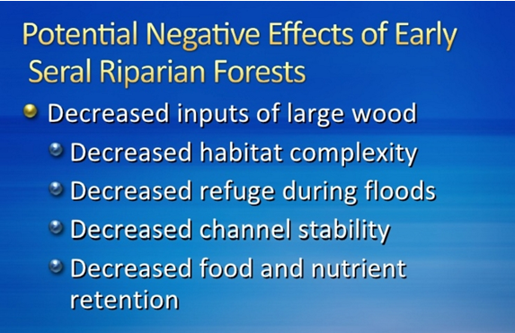
Gregory, Stan 2010. What About Riparian Systems: Who Benefits From an Early Seral Forest Condition. Workshop - Early Seral Forest - We know we need it -- How do we get it? Presentation sponsored by the Central Cascades Adaptive Management Partnership and NW Oregon Ecology Group http://ecoshare.info/2010/07/06/what-about-riparian-systems-who-benefits-from-an-early-seral-forest-condition-gregory/

The Northwest Forest Plan Aquatic Conservation Strategy Objectives (1994 ROD p B-11) enumerates specific purposes for “Maintain[ing] and restor[ing] the species composition and structural diversity of plant communities in riparian areas and wetlands” that is -
“to provide adequate summer and winter thermal regulation, nutrient filtering, appropriate rates of surface erosion, bank erosion, and channel migration and to supply amounts and distributions of coarse woody debris sufficient to sustain physical complexity and stability.”
All these values are provided as well or better by unthinned riparian stands.

The effects of logging on dead wood are significant and long term, adversely affecting a core function of the reserves, while the purported benefits to vegetation diversity are minor and transitory, and affect secondary purposes of the reserves.

Large Wood
Large quantities of downed trees are a functionally important component of many streams (Swanson et al. 1976; Sedell and Luchessa, 1982; Sedell and Froggat, 1984; Harmon et al. 1986; Bisson et al. 1987; Maser et al. 1988; Naiman et al. 1992). Large woody debris influences channel morphology by affecting longitudinal profile, pool formation, channel pattern and position, and channel geometry (Bisson et al. 1987). Downstream transport rates of sediment and organic matter are controlled in part by storage of this material behind large wood (Betscha 1979). Large wood affects the formation and distribution of habitat units, provides cover and complexity, and acts as a substrate for biological activity (Swanson et al. 1982; Bisson et al. 1987). Wood enters streams inhabited by fish either directly from the adjacent riparian zone from tributaries that may not be inhabited by fish, or hillslopes (Naiman et al. 1992).
Large wood in streams has been reduced due to a variety of past and present timber harvesting practices and associated activities. Many riparian management areas on federal lands are inadequate as long term sources of wood.
…
Riparian Ecosystem Components
…
Riparian vegetation regulates the exchange of nutrients and material from upland forests to streams (Swanson et al. 1982; Gregory et al. 1991). Fully functional riparian ecosystems have a suite of characteristics which are summarized below. Large conifers or a mixture of large conifers and hardwoods are found in riparian zones along all streams in the watershed, including those not inhabited by fish (Naiman et al. 1992). Riparian zone-stream interactions are a major determinant of large woody debris loading (House and Boehne 1987; Bisson et al. 1987; Sullivan et al. 1987). Stream temperatures and light levels that influence ecological processes are moderated by riparian vegetation (Agee 1988; Gregory et al. 1991). Streambanks are vegetated with shrubs and other low-growing woody vegetation. Root systems in streambanks of the active channel stabilize banks, allow development and maintenance of undercut banks, and protect banks during large storm flows (Sedell and Beschta 1991). Riparian vegetation contributes leaves, twigs, and other forms of fine litter that are an important component of the aquatic ecosystem food base (Vannote et al. 1980).
1993 FEMAT Report, pp V-13, V-25.

/ / /

/ / /

/ / /

The effects of thinning on crown development are not very significant.

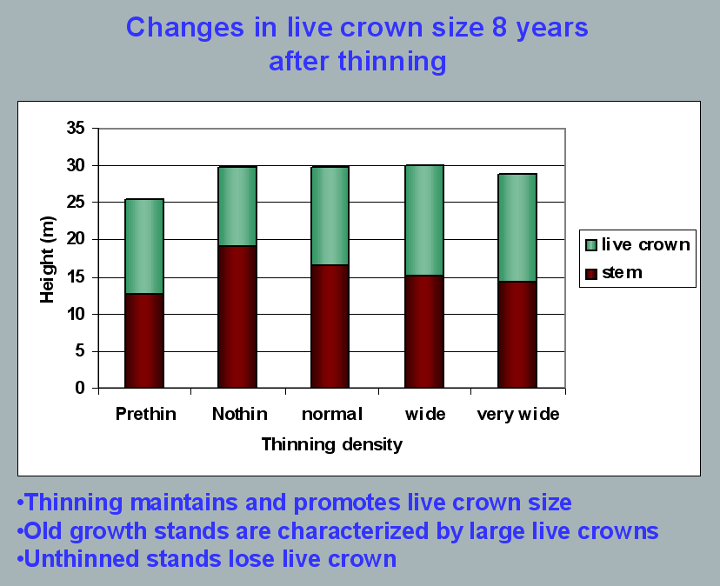
Aquatic/Riparian Ecosystem Dynamics and Associated Management Implications - Recent Findings. Powerpoint, 32.6M. This topic was presented at the Regional Interagency Executive Committee meeting on January 7, 2003. https://web.archive.org/web/20161221100307/http://www.reo.gov/library/presentations/Szaro_present_Aquatic_Rip_Final.ppt.

Stimulating the development of a diverse understory is often used as a justification for thinning, but this may not be justified in stands older than about 40 years. A systematic review of 917 Forest Inventory and Analysis (FIA) plots in western Oregon (mostly on non-federal lands) found,
Contrary to expectations of canopy closure, mean canopy cover by age class rarely exceeded 85 percent, even in unthinned productive young conifer forests. Possibly as a result, effects of stand age on understory vegetation were minimal, except for low levels of forbs found in 20- to 40-year-old wet conifer stands. … Although heavily thinned stands had lower total cover, canopy structure did not differ dramatically between thinned and unthinned stands. Our findings suggest potential limitations of simple stand succession models that may not account for the range of forest types, site conditions, and developmental mechanisms found across western Oregon.
McIntosh, Anne C.S.; Gray, Andrew N.; Garman, Steven L. 2009. Canopy structure on forest lands in western Oregon: differences among forest types and stand ages. Gen. Tech. Rep. PNW-GTR-794. Portland, OR: U.S. Department of Agriculture, Forest Service, Pacific Northwest Research Station. 35 p. http://www.fs.fed.us/pnw/pubs/pnw_gtr794.pdf. This seems to indicate that the benefits of thinning may be best realized in dense stands younger than 40 years old. This study also showed that in wet conifer stands the mean Canopy Height Diversity Index and the mean Simpson’s Diversity Index of tree heights leveled off at about age 65. This study also looked at canopy conditions after three levels of thinning intensities (heavy, light, and none). “Mean cover of the lower canopy layer was nominal for all three thinning intensities. … There were no evident trends between understory cover and thinning history; both shrub and forb cover were fairly similar among the three thinning intensities. … The lack of a strong effect of crown closure on understory cover may be related to our finding that mean crown cover did not exceed 85 percent. … We expected greater cover of understory vegetation in thinned than in unthinned stands but did not detect significant differences in this analysis.”

While one can generalize that vegetation diversity is more likely to flourish when conifer density is lower, there are data showing a wide range of conifer density can support a wide range of deciduous shrub cover. Thinning is not always necessary. The NEPA analysis should carefully document the site-specific “need” for thinning.
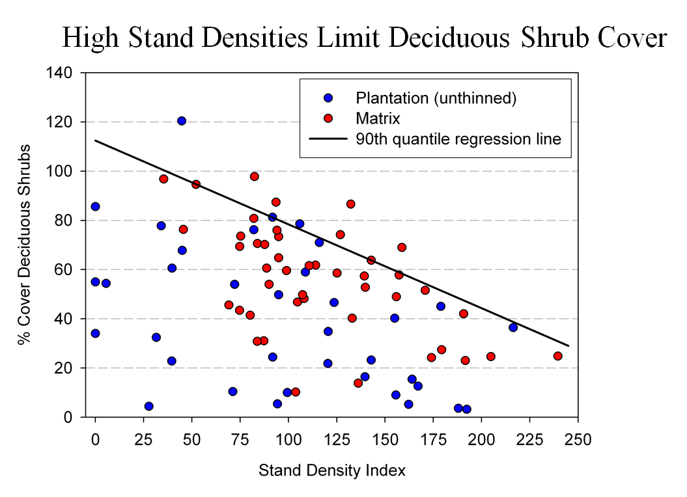
Spies, T. 2008. Powerpoint: Assumptions behind thinning young stands to create late successional riparian habitat. Presented at Riparian Thinning: Logic Paths for Silvicultural Prescriptions -- March 20, 2008. https://ecoshare.info/projects/central-cascade-adaptive-management-partnership/workshops/riparian-thinning-logic-paths/

It is also worth noting that where understories are well-stocked, midstory development can be enhanced by focusing on treating the understory itself rather than killing canopy trees.
[R]esults show that individual understory trees can be selectively favored for increased growth into the midstory by being released from competing saplings in the understory cohort. …Our results suggest that understory release treatments can be used to target individual saplings for increased growth, thereby recruiting a shade tolerant midstory cohort and accelerating the development of vertical foliar connectivity and a multi-layered stand structure. Abundance of non-coniferous understory vegetation is also augmented by this treatment. … [Note] The extent to which released understory trees collectively form a cohesive midstory canopy stratum is dependent on the density and horizontal arrangement of those released individuals. … . Inducing spatial variability within the midstory tree cohort would emulate the finescale disturbances of natural stands that create gaps and patches.
Taylor, Andrew 2016. : Understory Vegetation Dynamics and Midstory Development Following Understory Release Treatments in Northwest Oregon Thinned Douglas-fir Stands. OSU MS Professional Paper.

Anderson (2007) looked at the effects of thinning in young Douglas fir forests and found -
[T]hinning treatments … had little impact on the abundance, size, or diversity of understory vegetation. Disturbance resulted in short-term decreases in understory vegetation cover, particularly tall shrubs. However, within five years of treatment, understory vegetation abundance returned to approximate pretreatment condition. … The general lack of understory vegetation response to the thinning treatments was likely due to the inherent resistance and resilience of the plant communities to disturbance, as well as the low intensity of disturbance attributable to the treatments.

/ / /

/ / /

/ / /
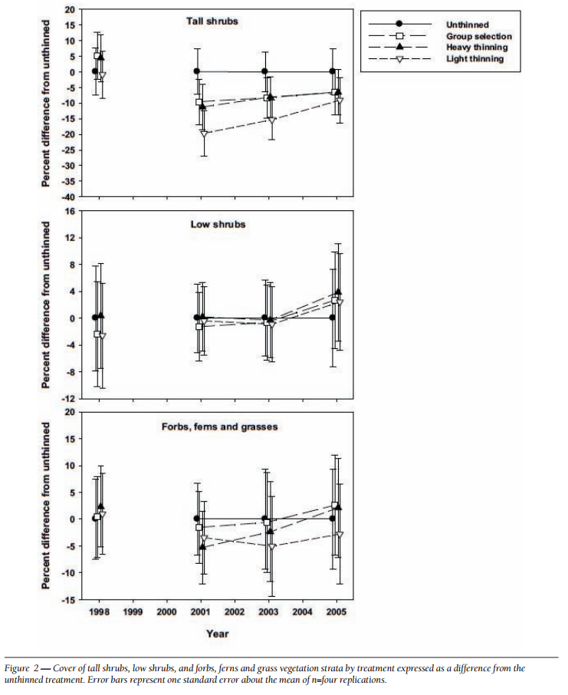
[Four years after thinning] tall shrub cover that was approximately four to nine percent less than the unthinned treatment … [C]over by low shrub species was unchanged by the harvest activity … Forbs, ferns, and grasses [experienced] little difference in cover between thinned and unthinned stands. … [F]ollowing treatment, the mean number of species declined somewhat, [then] return[ed] to pretreatment levels… [T]he evenness component of diversity did not differ among treatments or vary over time …. [T]here was little evidence of substantial alterations of understory shrub and herbaceous vegetation. This lack of strong understory vegetation response in terms of composition, abundance, or size is consistent with several studies of thinning in Douglas-fir. In a recent review of seven operational-scale silviculture experiments, Wilson and Puettmann (2007) report that percent cover by shrubs and percent cover by herbs, one to seven years following thinning showed little difference across a wide range of residual basal area.
Paul D. Anderson 2007. Understory Vegetation Responses to Initial Thinning of Douglas-fir Plantations Undergoing Conversion to Uneven-Age Management. Proceedings of the 2007 National Silviculture Workshop. http://www.fs.fed.us/pnw/publications/gtr733/PNW_GTR_733_4.pdf This paper was published in: Deal, R.L., tech. ed. 2008. Integrated restoration of forested ecosystems to achieve multi-resource benefits: proceedings of the 2007 national silviculture workshop. Gen. Tech. Rep. PNW-GTR-733. Portland, OR: U.S. Department of Agriculture, Forest Service, Pacific Northwest Research Station. 306 p.

[W]hile specific structural attributes of forest ecosystems have been correlated with certain species, it is uncertain how such species will respond to treatments designed to recreate these features. There is always the possibility that in our attempt to create a structural attribute we think is important, we eliminate another attribute that is equally important, but unrecognized. One example is that attempts to restore spotted owl habitat by heavily thinning to accelerate the development of large diameter nesting trees could actually delay spotted owl recovery by reducing production of the large down wood utilized by the species it preys upon (Forsman et al., 1984; Carey, 1995; North et al., 1999). Similarly, heavily thinning stands to accelerate the development of marbled murrelet nesting trees also create open stands with a dense understory that is ideal habitat for a number of corvid species that prey on marbled murrelet nest eggs (USFWS, 2010). Riparian thinning efforts to create long-term supplies of very large diameter instream wood that can initiate complex wood jam formation (e.g., key pieces) are also likely to reduce the supply of large diameter wood that will create pools (Beechie and Sibley, 1997; Beechie et al., 2000; Fox and Bolton, 2007). Thus, we suggest that any efforts to actively restore riparian forests for the benefit of certain species should be treated as scientific experiments and proceed cautiously, skeptically, and with robust pre- and post-treatment data collection efforts. Hypothesized effects of thinning on riparian forest structure and the use of that structure by targeted species should be tested against empirical data.
Pollock, Michael M. and Timothy J. Beechie, 2014. Does Riparian Forest Restoration Thinning Enhance Biodiversity? The Ecological Importance of Large Wood. Journal of the American Water Resources Association (JAWRA) 50(3): 543-559. DOI: 10.1111/jawr.12206. http://oregon-stream-protection-coalition.com/wp-content/uploads/2014/07/Pollock-and-Beechie.-2014.-Riparian-thinning-and-biodiversity.pdf

Plan and implement road systems with big storms in mind.

Big storms are the driving force behind many large geomorphologic events such as floods, landslides, etc, that shape underlying forest hydrology. Project design must look beyond the 2-5 year storms that are typically considered.

Roads and their artificial water drainage structures are long-lasting alien features in the forest landscape and the effects of big storms are particularly important to consider in the decision whether, where and how to build roads and how to drain them.

Road-stream crossings can be high dynamic during large storms, so they must consider large events, and not just rosy scenarios where culverts remain unblocked.

Avoid Roads in Reserves

“An extensive road system is in conflict with LSR objectives. The road network creates contrasting edges of forest habitat, fragments connecting habitat, creates barriers to species movement, and provides access and opportunities for humans to extract natural resources.” Hehe LSR Thin Decision Notice. Willamette National Forest. October 31, 2007. http://www.fs.usda.gov/Internet/FSE_DOCUMENTS/stelprdb5050106.pdf

Temporary Roads

We urge the agency to avoid road construction, including temporary road construction. The ecological costs of road construction almost always outweigh any benefits of the associated commercial logging activity. Since an optimal landscape restoration plan includes a mix of treated and untreated areas, the agency can easily avoid road construction by co-locating untreated areas and inaccessible areas.

Temporary roads have many of the same impacts as permanent roads, including complete vegetation removal, severe soil disturbance and compaction, severe modification of the flow of water and air through the soil, impairment of soil biological activity, wildlife habitat fragmentation (especially for microfauna), and wildlife cover loss. In spite of the fact that some roads may only be used by heavy equipment on a temporary basis, the biophysical effects of temporary roads can be long-lasting. The FS may even come back and use these temporary roads for future vegetation management or fire management. The temporal effects of temp roads can also be extended by legal or illegal use by off highway vehicles, woodcutters, hunters, mushroom collectors, etc.

The November 2000 National Forest Roadless Area Conservation FEIS p 3-30 says that temporary roads are not designed and constructed to the same standard as classified roads and therefore result in a “higher risk of environmental impacts.” The NEPA analysis must account for this increased risk of temporary roads compared to permanent roads.

If young stand thinning requires construction of temporary roads, the agency should do an analysis that illuminates how many acres of thinning are reached by each road segment so that we can distinguish between short segments of spur that allow access to large areas (big benefit, small cost) and long spurs that access small areas (small benefit, big cost). This can help inform the decision-maker’s balancing of the costs and benefits of thinning and roading.

The 1994 NWFP ROD (p 68) says “Standards and guidelines for Alternative 9 require that new road construction be substantially limited. Any road construction associated with silvicultural treatments inside late-successional reserve would be subject to the overall ‘beneficial’ requirement for such activities. That is, if the value of a thinning was negated by the habitat lost through road construction to the thinning, the activity should not proceed.”

The Coos Bay BLM’s Brummit Creek Density Management EA (2005) includes a useful table showing the length of each road (new, renovated, improved), the unit acres that are accessed by each road, and the acres of unit per mile of road. This is a useful way to evaluate and prioritize road work relative the expected benefits of thinning.

Temporary roads still cause serious adverse impacts to soil, water and wildlife, and spread weeds. Decommissioning such roads is not entirely successful and the soil compaction effects can last for decades. The agency should consider avoiding building spurs by treating some areas non-commercially (e.g. thin lightly, create lots of snags, and leave the material on site).

Protect habitat for raptors, like northern spotted owl.

Logging disrupts behavior of nesting birds and could harm other aspects of their life needs. BLM has acknowledged that —

Current research has shown that spotted owls are likely to increase the size of their home ranges to utilize untreated stands in preference to newly treated stands both during and after harvest. Factors that reduce the quality of habitat within a home range or cause increased movement by owls in order to meet prey requirements may decrease the survival and reproductive fitness of owls at that site (Meiman et al., 2003).
Roseburg BLM 2010. Third Elk EA. http://www.blm.gov/or/districts/roseburg/plans/files/ThirdElkEA.pdf.

A radio-telemetry study in the north Coast Range of Oregon showed that thinning in 40-65 year old stands near a spotted owl pair resulted in the owl: (1) shifting habitat use patterns to avoid thinned areas, especially heavily thinned areas, (2) enlarging its home range requiring the owl to expend more energy to fulfill its life functions. Before harvest the study made 23 owl locations in the areas to be thinned, only one owl location was made in the thinned area during the harvest period, and only 8 locations were made in the thinned area after harvest. The area added to the home range after harvest was larger than the area harvest. Recognize that this study looked at only one bird and only looked at short-term effects in the first few years after thinning. Long term effects might be different, but because the effects of thinning could affect survival and reproductive success over the course of several breeding seasons, this could be significant for a Threatened species. Based on these preliminary findings, the authors said—
We therefore recommend that thinning operations not be conducted within core use areas in this region until further research on this topic is conducted. … [W]e recommend that land managers identify the best spotted owl habitat (old conifer with multi-layered canopy and abundant snags) around the nest site and designate an area where no timber harvest activities will occur. The mean (100-ha) and maximum (250-ha) size of core use areas in the North Coast Range … should be used as guidelines for delineating reserve areas. Where forest stands are homogenous and/or the best habitat cannot be identified, an area with 600 –m radius (~115-ha) around the nest should be used.
Meiman, S., R. Anthony, E. Glenn, T. Bayless, A. Ellingson, M.C. Hansen, and C. Smith. 2003. Effects of commercial thinning on home-range and habitat-use patterns of a male spotted owl: a case study. Wildlife Society Bulletin. 2003. 31(4):1254-1262.

Salem BLM’s Turner Creek EA made an honest disclosure about thinning that should be acknowledged in other projects. “Overall the No Action alternative would result in much more coarse wood in the next several decades as compared to the Proposed Action which would provide better overall habitat for small mammals which in turn may benefit the spotted owl.” http://www.blm.gov/or/districts/salem/plans/files/TC_EA.pdf.

“Snag and down woody debris are important components of spotted owl habitat … [If stands are not thinned] [e]ventually the stands would start to differentiate to varying degrees and show a substantial increase in the levels of snags, down wood and understory development. Where these developments occurred, they would improve the dispersal habitat characteristics ….” Mt Hood NF 2011. Huckleberry Thin EA. http://a123.g.akamai.net/7/123/11558/abc123/forestservic.download.akamai.com/11558/www/nepa/59590_FSPLT2_034896.pdf.

Courtney (2004) summarized spotted owl habitat use studies and found positive relationships between spotted owl habitat use and several forest attributes that are detrimentally affected by thinning, including: canopy volume, canopy closure, snag basal area or volume, and log volume. Importantly, these relationships appear to hold true whether the owl sites were old growth or non-old growth forest. See Jim Thrailkill 2006. “Effects of Habitat Thinning on Northern Spotted Owls? Literature Summarized Through 2005.” Appendix F of Interagency Level 1 Team, North Coast Province. 2010. Biological Assessment of Habitat Modification Projects Proposed During Fiscal Years 2011 and 2012 in the North Coast Planning Province, Oregon, that are Not Likely to Adversely Affect (NLAA) Northern Spotted Owl and Marbled Murrelets and Their Critical Habitats, April 13, 2010 (page 101). citing Courtney et al 2004, Scientific Evaluation of the Status of the Northern Spotted Owl, SEI, Sept 2004.

Other relevant findings from this Thrailkill white-paper include:
- “Snag volume is correlated with increased [spotted owl] foraging use (North 1999). (p 102)
- “Snag volume is important to owl foraging sites because it influences local prey abundance (Carey 1995).” (p 102)
- “[S]tudies (Carey et al 1999) conducted in the Oregon and Washington Cascades and Coast Ranges have demonstrated a direct relationship between increasing levels of coarse wood debris (CWD) in a stand and the abundance of small mammals (e.g. northern flying squirrel) in those stands.” (p 102)
- “[T]hinning prescriptions should take advantage of creating conditions where coarse wood debris recruitment can be hastened.” (p 102)
Note: This white paper does not address new information since 2005 showing longer-term (multi-decade) adverse effects of thinning on flying squirrels and dead wood recruitment.

It is important to retain unthinned patches as source areas for spotted owl prey.
Sakai and Noon found the highest number of woodrats in sapling and brushy pole timber (20 – 30 year old) although these stands are seldom used by spotted owls (Forsman) probably because woodrats are inaccessible to the owls. Still these areas are a good source of woodrats dispersing out into older stands more frequented by foraging spotted owls and accessible to owls hunting along the edges where old forest meets young.
Heaney, J. 2012. Workshop on spotted owl prey. Ecology of and Habitat Management for the Dusky-Footed and Bushy-Tailed Woodrat. http://ecoshare.info/wp-content/uploads/2012/08/Ecology-of-and-Habitat-Management-for-the-Dusky-Footed-woodrat.ppt

Thinning effects on flying squirrels
Flying squirrels are an important prey item for Northern Spotted Owls in all parts of the owl’s range. Even in SW Oregon where wood rats represent a large part of the owls diet, flying squirrels are still critically important. See Forsman, Anthony, Meslow, Zabel. 2004. Diets And Foraging Behavior Of Northern Spotted Owls In Oregon. Journal of Raptor Research 38(3):214-230. http://elibrary.unm.edu/sora/jrr/v038n03/p00214-p00230.pdf. Given the importance of flying squirrels to the diet of the spotted owl, managers must ensure that thinning does not significantly reduce the flying squirrel population, but recent evidence shows that thinning does in fact lead to a multi-decade decline in the number of flying squirrels. The agencies must leave significant untreated skips in order to mitigate for this significant adverse effect.

The findings of this study raise questions that the Forest Service has already posed to itself: “If thinning is a treatment to promote late successional forest for spotted owls, but it reduces their primary prey base for a substantial amount of time, we may want to think differently about how we manage for flying squirrel populations across a landscape.” Central Cascades Adaptive Management Partnership - Administrative Study Portfolio - Status and Funding Needs, November 2014. (p 3) http://ecoshare.info/projects/central-cascade-adaptive-management-partnership/study-portfolio/ Project purposes and project alternatives need to account for this new information. The finding that thinning reduces, for a couple decades at least, populations of flying squirrels, an important prey for spotted owls throughout their range, reinforces the importance of finding the optimal mix of thinned and unthinned areas within stands and across the landscape (not just for flying squirrels but also for dead wood recruitment and other ecological values). The agencies’ current approach does provide a mix, but NEPA analyses fail to seek or find the optimum mix.

Manning et al (2012) found that the thinning is adverse to both flying squirrels and snags, and these effects may be related.
- Flying squirrel density positively associated with snag density
- Snags rare in thinned stands
- Thinning causes decrease in density-dependent mortality
…
- Canopy gaps = exposure to predators
- Tree trunks = safety
Tom Manning, Joan Hagar, Brenda McComb 2012 spotted owl prey workshop. Flying Squirrel Response to Thinning in the Oregon Cascades. http://ecoshare.info/wp-content/uploads/2012/08/Commercial-thinning_flying-squirrels.ppt; http://ecoshare.info/projects/central-cascade-adaptive-management-partnership/workshops/spotted-owl/.

Wilson & Forsman 2013 state (“thinning reduces the abundance of some tree-dwelling rodents, especially Northern Flying Squirrels (Glaucomys sabrinus) and Red Tree Voles (Arborimus longicaudus), that are important prey species for Northern Spotted Owls (Strix occidentalis caurina).” Wilson, Todd M.; Forsman, Eric D. 2013. Thinning effects on spotted owl prey and other forest-dwelling small mammals. In: Anderson, Paul D.; Ronnenberg, Kathryn L., eds. Density management for the 21st Century: west side story. Gen. Tech. Rep. PNW-GTR-880. Portland, OR: U.S. Department of Agriculture, Forest Service, Pacific Northwest Research Station: 79–90.

“Management strategies that involve tree removal, even ones designed to have positive long-term ecological effects, almost always result in reduced squirrel populations. A squirrel-predation connection explains this phenomena …” Wilson, T. 2010. Forest structure is a good indicator of flying squirrel habitat. In Mazza, Rhonda 2010. 2010 Science Accomplishments Report of the Pacific Northwest Research Station. Portland, OR: U.S. Department of Agriculture, Forest Service, Pacific Northwest Research Station. 88 p. http://www.treesearch.fs.fed.us/pubs/37383.

Twenty years after the spotted owl was listed, there remains an unfortunate dearth of information about the effects of thinning and fuel reduction logging on spotted owls and their prey. There is however, some new information from Andy Carey & Todd Wilson's long-term study of the effects of thinning on flying squirrels at Fort Lewis. On Jan 19, 2011 Todd Wilson gave a presentation in Corvallis on flying squirrels. http://calendar.oregonstate.edu/event/49175/ and the effects of thinning.
When collecting baseline data in among the young stands in the Fort Lewis study, Andy Carey and Wilson found that stands which had been previously thinned had fewer flying squirrels than those that had not been thinned. After another round of thinning, preliminary results from a few years post-thinning indicated that flying squirrel populations initially declined after thinning, but at the time (a few years ago) they seemed to be rebounding. Now the longer data set shows that the rebound was part of a temporary fluctuation, and the long-term trend shows that the squirrel population continued to decline and remains at very low levels almost two decades after thinning.

Manage for Decadence – retain untreated “skips” for recruitment of mortality

“Two common consequences of conventional thinning practices have been increased uniformity of forest structure and composition, and removal or delay in the development of dead wood as snags or down wood to meet decadence and habitat functions. … Over the past several decades our ecological understanding of decadence and its importance to habitat and biogeochemical processes has increased substantially, but translation of the fundamental knowledge into coherent goals is lagging.”
Paul D. Anderson 2013. Two Decades of Learning about Thinning in the Ecosystem Management Era. http://www.fs.fed.us/pnw/pubs/pnw_gtr880/pnw_gtr880_001.pdf in Density Management in the 21st Century: West Side Story PNW-GTR-880. http://www.treesearch.fs.fed.us/pubs/44695

“Many species in the Pacific Northwest evolved to use large snags and logs that were historically abundant in the landscape. If snags and logs are lost, biodiversity can be affected and potentially cause a loss of some function in the landscape such as control of forest insects.”
Mt Hood NF 2011. Huckleberry Thin EA. http://a123.g.akamai.net/7/123/11558/abc123/forestservic.download.akamai.com/11558/www/nepa/59590_FSPLT2_034896.pdf.

Many animals in Douglas fir forests are strongly associated with habitat features that are best developed in natural forest, such as large trees, snags, and downed logs. The diversity and density of cavity-nesting birds, for example, are positively correlated with the abundance of snags, especially tall and/or large-diameter snags (Nelson 1988, Zarnowitz and Manuwal 1985).
…
It is the cycle of structural development through plant growth, and the retention of structural complexity via legacy, that characterizes natural forests in the Coastal Northwest. Intensive wood production practices may alter this cycle both by truncating succession before large structures develop and by removing most existing structures during harvest. Planting and thinning may further promote uniformity in tree species, size, and spacing.
…
Studies in unmanaged forests teach us that natural disturbance maintains structural complexity within stands and that this complexity promotes plant and animal diversity.
…
Until it is clear that forests managed for wood production can be made suitable for native species, managers should consider retaining within managed forests representative tracts of all natural forest stages, not just old growth.
Hansen, A. J.; Spies, T. A.; Swanson, F. J.; Ohmann, T. L. 1991. Conserving biodiversity in managed forests - Lessons from natural forests. BioScience 41(6):382- 392. http://www.montana.edu/hansen/documents/downloadables/hansenetal1991.pdf.

“Dead wood in the form of snags and downed logs is generally common or abundant. Although a notable part of old-growth stands, such material is actually common in unmanaged stands in all successional stages in the Douglas-fir region.” Franklin & Spies 1983. CHARACTERISTICS OF OLD-GROWTH DOUGLAS-FIR FORESTS. Reprinted New Forests for a Changing World. Proceedings of the 1983 SAF National Convention http://andrewsforest.oregonstate.edu/pubs/pdf/pub120.pdf

Many natural young and mature stands have some of the attributes of old-growth stands that may not be present in young, managed stands. Perhaps the greatest difference between natural and managed stands is the lower number and volume of large snags and logs in managed plantations (Spies and Cline 1988). Many young natural forests less than 80 years old have high amounts of carry-over of woody debris...
Thomas A. Spies and Jerry F. Franklin 1991. The Structure of Natural Young, Mature, and Old-Growth Douglas-Fir Forests in Oregon and Washington in Leonard F. Ruggiero, Keith B. Aubry, Andrew B. Carey, and Mark H. Huff, technical editors 1991. Wildlife and Vegetation of Unmanaged Douglas-Fir Forests. General Technical Report PNW-GTR-285. http://www.fs.fed.us/pnw/pubs/gtr285/.

The NEPA analysis should help illuminate trade-off between snag quality (snag size) and snag quantity (number of snags) that follows from the choice between thinning and not thinning. This critically important trade-off may be amenable to quantitative analysis if the agency would conduct a stand simulation model. This is one of the key functions of NEPA to illuminate the consequences of alternative management approaches. With respect to dead wood habitat, what mix of treated and untreated areas will result in the best mix of thinned areas with later-fewer-larger snags, and unlogged areas where dead wood recruitment is more rapid, more abundant, only slightly smaller?

Thinning is often presumed to accelerate attainment of multiple attributes of mature & old-growth forests. This is partially true. Thinning does accelerate the growth rate of the trees that are retained, but thinning has limited effects on canopy structure and generally has adverse effects on snags and dead wood. The NWFP ROD highlighted the importance of dead wood accumulation as young forests develop into mature & old-growth: “Desired late-successional and old-growth characteristics that will be created as younger stands change through successional development include: (1) multispecies and multilayered assemblages of trees, (2) moderate-to-high accumulations of large logs and snags, (3) moderate-to-high canopy closure, (4) moderate-to-high numbers of trees with physical imperfections such as cavities, broken tops, and large deformed limbs, and (5) moderate-to-high accumulations of fungi, lichens, and bryophytes.” 1994 ROD p B-5. Thinning will truncate this important ecological process and degrade the quality of future late-successional habitat. When the logs are removed from the site, this adverse effect can be long-lasting.

“Natural processes and disturbances such as windthrow fire and the effects of pathogens and insects are also part of old forest development that thinning does not mimic.” http://www.fsl.orst.edu/Oldgrowthworkshop/statements/Tappeiner.pdf.

Mid-seral stands that result from past clearcutting leave few if any legacies from the previous stand. Natural young stands tend to have abundant snags and dead wood, but clearcut stands are artificially deprived of dead wood several decades. At the age of thinning, such stands are starting to experience suppression mortality and will tend to accumulate snags and dead wood over time if left unthinned. However, thinning will perpetuate the artificial shortage of snags and dead wood for another several decades. This is a long-term cumulative impacts that needs to be addressed in the NEPA analysis.

There is a widely held belief that growing big trees faster by thinning, also benefits snag associated wildlife and fish because if there are bigger trees, there must also be bigger snags faster. This assumption does not hold up under scrutiny. Thinning captures mortality and removes it from the forest to the mill. It also increases the vigor of trees and delays mortality. BLM says “Thinning ‘captures’ much of the snag recruitment that results from inter-tree competition and very little density mortality … is expected to occur for 25 years after treatment.” Salem BLM, South Scapoose EA. http://www.blm.gov/or/districts/salem/plans/files/SSC_EA.pdf. See this online slideshow which shows the modeled effects of thinning on dead wood habitat. http://www.slideshare.net/dougoh/effects-of-logging-on-dead-wood-habitat. Stand simulation models clearly show that we need to count the effects of thinning on dead wood as a “cost” instead of the “benefit”, so we need to consider appropriate methods to avoid and mitigate impacts. Avoidance is just to leave stands unthinned and let them naturally grow and recruit mortality over time. Mitigation can come in several forms. Here are a few ideas:
a) truly mimic natural disturbance by thinning with prescribed fire that creates a pulse of dead trees and does not build roads. This could be combined with light thinning;
b) retain abundant untreated areas such as riparian areas and other “skips” within thinning areas where natural mortality can proceed without interference, and make sure these areas do not get salvaged or thinned in subsequent entries so that mortality gets recruited to the stands, not to the mill;
c) identify which portions of the landscape will remain unthinned in perpetuity and keep the loggers out. Use tools like DecAID determine the appropriate portion of the landscape must be managed to meet the each different tolerance levels in order to attain desired objectives over time for viable populations, carbon storage, soil stability/sediment storage and routing, nutrient cycling, site productivity, water storage, and other ecological services.
NOTE: simply protecting existing snags or artificially creating a few snags during logging has a very short-term effect that does not address the more fundamental issue of continuous snag recruitment over time.

One of the big challenges of any restoration thinning regime, is that virtually all logging tends to “capture mortality,” yet the trees that are removed represent future snags and down logs and are valuable (even essential) components of any complex forest. “Carey et al. (1999) found that coarse woody debris amounts declined significantly as a result of variable density thinning, especially the higher decay classes, despite the intent of the treatment to leave all existing debris in place.” The agency cannot use “average” snag levels as a management objective within treatment areas, because treatments are essentially displacing natural disturbance events which would normally create and retain large numbers of snags, so disturbance areas should have abundant snags, not average levels of snags. Managing for decadence in young stands is not a trivial issue because among the many other valuable attributes of dead wood, it is strongly associated with healthy populations of many small animals species that in turn help support populations of at-risk predators such as spotted owls, goshawk, fisher, marten, etc.

Small logs provide escape cover or shelter for small species. … Tallmon and Mills (1994) have shown that red-backed voles, a primary prey species for the spotted owl, are highly associated with large down material in more advanced decay stages. Truffles, a dietary staple of the northern flying squirrel, have also been loosely associated with down material.
Gregg, M. 2013. Wildlife Report for Management Indicator Species, Species of Concern from the Northwest Forest Plan, and Landbirds - Pole Creek Fire Timber Salvage. http://a123.g.akamai.net/7/123/11558/abc123/forestservic.download.akamai.com/11558/www/nepa/94141_FSPLT3_1451590.pdf

The snag dynamics white paper on the DecAID website indicates that timber harvest typically results in the loss of a majority of the standing snags (62% of snags within a variety of timber harvest areas were cut down.) http://web.archive.org/web/20060520051245/http://wwwnotes.fs.fed.us:81/pnw/DecAID/DecAID.nsf/HomePageLinks/863EEA66F39752C088256C02007DF2C0?OpenDocument. Also, in the Windjammer EA the Siuslaw NF noted that at least six times more coarse wood carries over from old-growth forests after wildfire compared to after timber harvest, and the CWD left after logging is smaller and decays faster (citing Spies & Cline 1988) so young stands are already deprived of dead wood. This is very troubling. The agency must start by carefully designing the project to keep workers away from existing snags. The agency must then consciously and very deliberately manage for decadence in the design of all thinning efforts. One way to think of this is to figure out how many trees the agency thinks they want to kill and remove a small portion of those while leaving the remainder as standing snags or down wood.

Harmon (1999) said:
Linking Live and Dead Trees - Although developing a viable morticulture will require new knowledge, in many cases it will require that we apply what we already know. For example, we already know that live trees eventually form dead trees, but it is amazing that this dynamic is often missing from current forest management thinking. … Forest management in the past century has focused on how to lower mortality rates via thinning, fire protection, etc. Ironically, the next century of forest management may be occupied with how to increase mortality when and where we want it. … [H]ow might this new paradigm of morticulture work? It would probably start by answering the question of which species or processes are to be maintained, restored, or otherwise managed (fig. 5). Then the target levels for these functions should be determined. Before assessing the amount of woody detritus to be maintained or added to meet this functional target, the landscape context for the management action should be assessed. Are there limitations of populations or processes that would limit the desired response? If not, a plan to add wood would be designed to maintain the desired level. But if there are landscape limitations, then these should be addressed before planning at the stand-level proceeds.”)
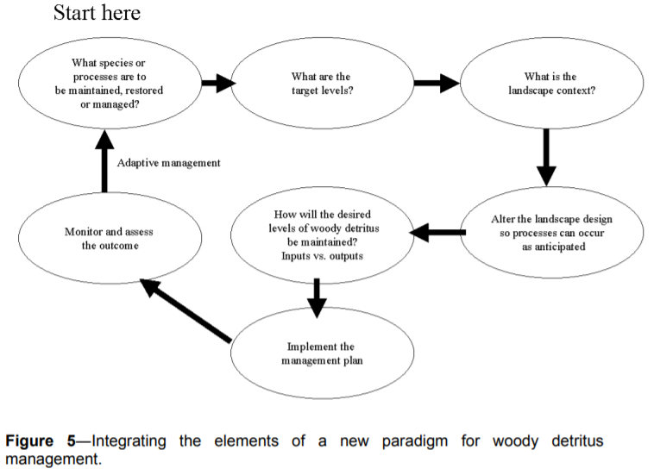
See Harmon, Mark 1999. Moving towards a New Paradigm for Woody Detritus Management. in Proceedings of the Symposium on the Ecology and Management of Dead Wood in Western Forests. PSW-GTR-181. http://www.fs.fed.us/psw/publications/documents/gtr-181/
https://www.fs.fed.us/psw/publications/documents/gtr-181/071_Harm.pdf. Using DecAID or other tools, the agency needs to identify appropriate goals for snags and dead wood habitat based on the needs of wildlife that are most sensitive to the absence of such habitat features. The agency needs to analyze how to achieve those goals by retaining an adequate population of green trees and maintaining natural mortality processes that can act on those trees.

The agency should recognize the long-term effects of captured mortality on the habitat needs of small mammals and spotted owls.
Several small mammals, such as the northern flying squirrel form the prey base for the Endangered Species Act (ESA) listed spotted owl and are among the species associated with abundant large dead standing and down wood. This presumably, is why spotted owls prefer to forage in stands with abundant standing and fallen dead wood (Table 2, North et al. 1999). The fruiting bodies of hypogeous fungi are a food source of northern flying squirrels and are also associated with down logs, suggesting that there are complex, indirect paths through which dead wood supports spotted owls (Amaranthus et al. 1994, Carey 2000).
Thomas Spies, Michael Pollock, Gordon Reeves, and Tim Beechie 2013. Effects of Riparian Thinning on Wood Recruitment: A Scientific Synthesis - Science Review Team Wood Recruitment Subgroup. Jan 28, 2013, p 36. http://www.mediate.com/DSConsulting/docs/FINAL%20wood%20recruitment%20document.pdf

North et al. (1999) noted in a study of foraging habitat selection by northern spotted owls, “In our study area, stands with high use by owls typically included many ‘legacies’ (large trees and snags) that survived a fire or windstorm that destroyed much of the previous stand. They found that “stands with 142 m³/ha of intact snags and a high diversity of tree heights had medium or high foraging use by spotted owls. In these old-growth stands, biological legacies (e.g., large trees and snags) produced by past disturbance provide important forest structures associated with spotted owl foraging.” North, Franklin, Carey, Forsman, Hamer. 1999. Forest Stand Structure of the Northern Spotted Owl’s Foraging Habitat. For. Sci. 45(4):520-527.

Artificial snag creation is often proposed as a mitigation, but this has very short-term benefits. Since logging has long-term adverse effects on snag recruitment, it is necessary to adopt mitigation with long-term effects, such as retaining untreated skips embedded within treatments areas where natural mortality processes can flourish.

The Purpose and Need Should Address The Unmet Need for Carbon Storage
Meeting resource management objectives set fr the in the RMP requires properly functioning ecosystems with biophysical conditions and disturbance regimes within the historic range of variability. Global climate change is a clear and present threat to forest ecosystems and watersheds and is preventing the agency from meeting the goals and standards & guidelines described in the applicable Resource Management Plan. The agency cannot meet the RMP without bringing climate change under control, which requires reducing emissions, including emissions from logging. The agency cannot say that carbon storage is outside the scope of this project or not part of the purpose and need. The agency must include carbon storage as part of the purpose and need for this project.

The agency typically says one of the purposes of this project is to provide a supply of wood products to the public. The agency should reconsider timber targets in light of the fact that the public needs carbon storage to reduce global climate change much more than they need wood products. The NEPA analysis also needs to account for the fact that managing forests for water quality, water quantity, quality of life, and carbon storage for a stable climate will contribute far more to community stability than propping up the timber boom-bust industry with subsidized logging.

The agency must recognize that wood products are already under-priced and over-supplied due to “externalities” (costs that are not included in the price of wood, so those costs are shifted from wood product producers and consumers to the general public who suffer the consequences of climate change without compensation from those who profit from logging related externalities). Ecosystem carbon storage on the other hand is under-supplied because there is not a functioning market for carbon storage and climate services. The agency is in a position to address these market imperfections by focusing on unmet demand for carbon storage instead of offering wood products that are already oversupplied.

Land protection, both public and private, provides substantial ecological benefits by avoiding conversion of natural systems to intensive, developed uses. These benefits include carbon sequestration, watershed functioning, soil conservation, and the preservation of diverse habitat types (e.g., Daily 1997, Brauman et al. 2007, Kumar 2012, Watson et al. 2014). Land protection also solves a key market failure: private markets tend to underprovide socially beneficial land uses such as natural forests, agricultural lands, or managed timberlands. The reason for this failure is that many of the benefits of these lands go to the public in general, not individual landowners. When private values and market transactions determine land uses, less land will be devoted to socially beneficial uses than if citizens could collectively determine use on the basis of social values (e.g., Angelsen 2010, Tietenberg and Lewis 2016).
Katharine R.E. Sims, Jonathan R. Thompson, Spencer R. Meyer, Christoph Nolte, Joshua S. Plisinski. 2019. Assessing the local economic impacts of land protection. Conservation Biology. 26 March 2019 https://doi.org/10.1111/cobi.13318, https://harvardforest.fas.harvard.edu/sites/default/files/Sims_et_al-2019-Conservation_Biology.pdf.

Maintaining and increasing carbon storage in ecosystems on public lands is also required to meet LRMP desired future conditions and standards & guidelines. Carbon emissions from logging and other land management activities exacerbate global climate change and drive ecosystem changes that diverge from desired future conditions, such as uncharacteristic drought, fire, insect outbreaks, vegetation and wildlife mortality, species range shifts, low summer stream flows, unfavorable stream temperatures, extreme precipitation and peak flows and erosion, uncertainty related to vegetation recovery post-disturbance, uncertainty about the ability to provide a predictable, sustainable supply of forest products, etc. The agency should identify a purpose and need that recognizes the necessity of avoiding carbon emissions from logging and optimizing carbon storage to fulfill the promises in the LRMP.

Do not rely on the flawed boilerplate climate analyses

As explained below, the Forest Service’s standardized NEPA language regarding carbon and climate change fails to take a hard look that NEPA requires. The analysis makes several highly misleading statements about managing forests for carbon storage, climate resilience, and the effects on climate change. The analysis inappropriately mischaracterizes the role of individual logging projects in the cumulative problem of global GHG emissions. The analysis misstates the effects of logging related carbon emissions that are not related to “deforestation.” The analysis grossly misstates the climate effects of logging intended to reduce disturbance. The analysis misleadingly implies that logging benefits the climate by increasing forest productivity.

The NEPA analysis should consider the adverse climate consequences of GHG emissions caused directly and indirectly by logging. The NEPA analysis should estimate the quantity of GHG emitted by logging and associated activities throughout the wood products supply chain, and describe the contribution of this project to cumulative impacts of excess GHG in the atmosphere. The NEPA analysis should use a proxy such as the social cost of carbon dioxide emissions to describe effects.

The Forest Service should not rely on the boilerplate NEPA language from the regional office which is flawed in many ways. Instead the Forest Service:
- Must recognize the cumulative nature of the GHG emissions and climate problems. It does not matter that this project is small in the global scheme because all emissions matter when the causation is global and cumulative;
- Cannot credibly assert that this project is harmless because it’s not causing deforestation. This is immaterial. All GHG emissions, regardless of the source or how it is labelled, are part of the problem and cause the same climate impacts.
- Cannot credibly assert that thinning for forest health justifies or mitigates emissions from logging. Logging does not increase the capacity for growing trees. To the contrary, logging harms soil and reduces site productivity. Storing carbon in wood products is not preferable to storing carbon in forests. Evidence shows that forests are a more secure way of storing carbon. If this forest is not logged, or if more green tree are retained in situ, the agency cannot conclude that natural mortality will be greater than logging mortality. In fact, it is quite easy to predict that logging causes significantly more mortality than natural processes.
- Must not compare carbon before and after logging. That is an improper framework for NEPA analysis. The proper NEPA framework is to compare the effects of different alternatives (over time), so the agency must describe the carbon emissions and carbon storage in the forest over time with logging and without logging.
- Logging to reduce fire effects does not result in a net increase in forest carbon storage. The agency cannot predict the location, timing, or severity of future wildfires, so most fuel treatments will cause carbon emissions without any offsetting benefits from modified fire behavior. Studies clearly show that the total carbon emissions from logging (plus unavoidable wildfire) are greater than carbon emissions from wildfire alone.
- Cannot credibly assert that carbon storage in wood products is a useful climate strategy. Logging kills trees, stops photosynthesis, and initiates decay and combustion, with the end result being a significant transfer of carbon from the forest to the atmosphere. In stark contrast, an unlogged forest continues to grow and transfer more carbon from the atmosphere to the forest. Carbon emissions caused by logging far exceed the small fraction of carbon transferred to wood products. Carbon accounting methods that attempt to account for substitution of wood for other high-carbon building materials are fraught with uncertainty and too often represent maximum potential substitution effects rather than lower realistic estimates.

Plantation thinning recommendations

Oregon Wild makes the following recommendations to enhance the restoration benefits of young stand thinning prescriptions:
- When conducting commercial thinning projects take the opportunity to implement other critical aspects of watershed restoration especially pre-commercial thinning, restoring fish passage, reducing the impacts of the road system, and treating invasive weeds.
- Use projects as an opportunity to learn by conducting monitoring and research on the effects of thinning. There are many information gaps that need filling. Every project should generate useful information to inform future projects.
- Young stands do not exist in isolation, so be sure to consider the effects of thinning on adjacent mature & old-growth habitat which may provide habitat for spotted owls, marbled murrelets, and other species. Spotted owls may use young stands for dispersal, foraging, and security from predators. It may be helpful to create a “risk map” that identifies areas that are more or less suitable for thinning based on criteria such as: existing habitat characteristics, proximity to occupied habitat or activity centers, proximity to suitable habitat, and proximity to recently thinned areas, non-habitat, and roads. The agency should also consider adjusting both the location and timing of thinning to minimize the cumulative effects of widespread thinning on the sensitive and listed species.
- Focus on treating the youngest stands that are most "plastic" and amenable to restoration.
- Generally retain all the largest trees, and some of the smaller trees in all age-size classes. This can be accomplished in part by retaining untreated “skips” embedded within the stand.
- Retain and protect under-represented conifer and non-conifer trees. Protect shrubs as much as possible, especially deciduous and tall shrubs, and those that produce insects, berries and mast. "Although usually classified as a shrub and not considered in discussions of forest composition or structure, A. circinatum [vine maple] dominated the angiosperm component, and although comprising only 0.9% of the basal area, it was the most abundant woody species in terms of stem count. This is important because A. circinatum makes a disproportionate contribution to biodiversity in this evergreen conifer forest, for example by providing food for folivore geometrid larvae that feed Neotropical migrant birds [26] and by providing substrate for epiphytic lichens and bryophytes [27]." Lutz JA, Larson AJ, Freund JA, Swanson ME, Bible KJ (2013) The Importance of Large-Diameter Trees to Forest Structural Heterogeneity. PLoS ONE 8(12): e82784. doi:10.1371/journal.pone.0082784. http://ctfs.arnarb.harvard.edu/Public/pdfs/LutzEtAl_PLoS2013.pdf
- Strive for a variable density outcome. Be creative in establishing diversity and complexity both within and between stands. Use skips and gaps within units to help achieve diversity. Gaps should be small, while skips should be a little larger, but even small clumps and patches of trees are desirable. Gaps should not be clearcut but rather should retain some residual structure in the form of live or dead trees. Landings do not make good gaps because they are clearcut, highly compacted and disturbed, more likely subject to repeated disturbance, and directly associated with roads. Using “designation by description” results in a small amount of within stand variability, but it is a significant compromise compared to the amount of variability that is ecologically desired both within and between stands and that could reasonably be accomplished with a little more effort.
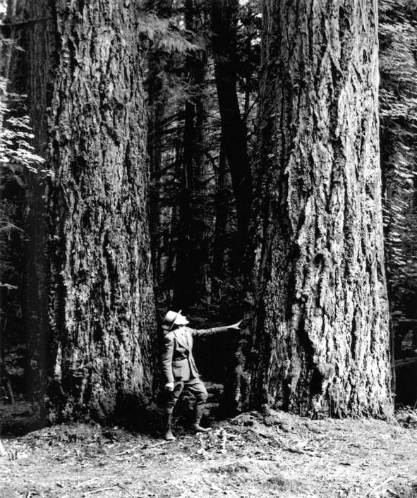
An example showing that old growth trees are not widely or evenly spaced, highlighting the need for variability and retaining clumps of trees.
- The scale of patches in variable density thinning regimes is important. Ideally variability should be implemented at numerous scales ranging from small to large, including: the scale of tree fall events; pockets of variably contagious disturbance from insects, disease, and mixed-severity fire; soil-property heterogeneity; topographic discontinuities; the imprint of natural historical events; etc.
- Retain abundant snags and course wood both distributed and in clumps so that thinning mimics natural disturbance. Retention of dead wood should generally be proportional to the intensity of the thinning, e.g., heavy thinning should leave behind more snags not less. Retain wildlife trees such as hollows, forked tops, broken tops, leaning trees, etc.
- Thinning does not always accelerate development of late successional forests, in particular commercial thinning has an adverse effect on snags and dead wood that are defining characteristics of late successional habitat. Thinning might produce the first large trees, but those trees would be vigorous and less likely to experience mortality, so developing large snags is not direct and immediate result of growing large trees. Thinning also dramatically reduces the pool from which future mortality can be recruited so thinning actually retards development of some attributes of late successional forest and spotted owl habitat including snags and down wood. NEPA analyses often assert that "As a result of thinning, growth of retained live trees would be accelerated, so larger trees would be available sooner for recruitment as snags and CWD than without thinning." This is only half the story and it is very misleading. The agency is not being fully honest about the effects of logging unless statements like this are followed by a loud and clear acknowledgement that accelerating development of a few larger live trees (that might become snags if a few of them happen to die) comes at the cost of a significant reduction in the number of medium and large snags over time. From an ecological perspective, the net result of commercial logging is undeniably adverse to snag habitat. The agency cannot present logging as a benefit to snag habitat when it is really a cost that needs to be mitigated.
- Continuous recruitment of snags is critical to development of old growth forest habitat. We urge the agency to adopt a process-based approach to snag habitat. Instead of focusing on how many snags there are now and immediately after logging, it is better to focus on (i) whether the project will retain an adequate pool of green trees from which to recruit snags and (ii) whether the project will retain the ecological processes that cause mortality, including density dependent mortality and other mechanisms. Commercial logging will significantly harm both of these snag recruitment factors, so mitigation measures are needed. Green tree retention, including generous unthinned “skips” where density dependent mortality will play out, is necessary to support this process. This is especially critical in previously logged uplands that are already short of snags and in riparian areas where recruitment of large wood is important to stream structure. It is often asserted that thinning grows big trees faster and therefore results in more rapid recruitment of large snags, but FVS and other tools show this NOT to be true. In fact, thinning both reduces and delays recruitment of snags, first by removing trees that would otherwise suffer suppression mortality, and second by increasing stand vigor and postponing overall mortality. See this online slideshow which shows the modeled effects of thinning on dead wood habitat. Heiken, D. 2010. Dead Wood Response to Thinning: Some Examples from Modeling Work. https://www.dropbox.com/s/m4671mhsstg61ss/dead_wood_slides_2.pdf?dl=0. The implications are that heavy thinning should be used sparingly and generous unthinned patches should be retained WITHIN thinned stands in order to continue the snag recruitment process and mitigate for captured mortality. To inform the decision, please conduct a stand simulation model to fully disclose the adverse effects of logging on dead wood, especially large snags >20” dbh, and then mitigate for these adverse effects by identifying areas within treated stands and across the landscape that will remain permanently untreated so they can recruit adequate large snags and dead wood to meet DecAID 50-80% tolerance levels as soon as possible and over the long-term.
- Artificial snag creation is often proposed as mitigation for the loss of snags during logging, but snags fall down and dead wood decays, so a one-time snag creation effort provides very short-term benefits. Since logging has long-term adverse effects on snag recruitment, it is necessary to adopt mitigation with long-term effects, such as retaining generous untreated “skips” embedded within treatments areas where natural mortality processes can flourish.
- Recognize that dead wood values are sacrificed in thinned areas due to the effect of “captured mortality,” while other late successional values, such as rapid development of large trees and understory diversity may be delayed in unthinned areas, so an important step in the restoration process is to identify the most optimal mix of treated (thinned) and untreated (unthinned) areas. We think this should be a conscious and well-documented part of the NEPA analysis, not just an accidental byproduct of what’s economically thinnable. Tools like DecAID might be used to identify goals for large and small snags that need to be met over time and at the geographic scale of home-ranges of focal species. This can help identify the scale and distribution of untreated “skips.”
- Thin heavy enough to stimulate development of understory vegetation, but don’t thin too heavy. Recognize that thinning captures mortality and that plantation stands are already lacking critical values from dead wood due to the unnatural stand history of all clearcut and planted stands. Tom Spies made some useful observations in the Northwest Forest Plan Monitoring Synthesis Report: “Certainly, the growth of trees into larger diameter classes will increase as stand density declines (Tappeiner and others 1997). At some point, however, the effect of thinning on tree diameter growth levels off and, if thinning is too heavy, the density of large trees later in succession may be eventually be lower than what is observed in current old-growth stands. In some cases, opening the stand up too much can also create a dense layer of regeneration that could become a relatively homogeneous and dominating stratum in the stand. Furthermore, if residual densities are too low, the production of dead trees may be reduced (Garman and others 2003). Thinning should allow for future mortality in the canopy trees.” http://web.archive.org/web/20070808101639/http://www.reo.gov/monitoring/10yr-report/documents/synthesis-reports/index.html.
- If using techniques such as whole-tree yarding or yarding with tops attached to control fuels, the agency should top a portion of the trees and leave the greens in the forest in order to retain nutrients on site. Achat, Deleuze, et al 2015. Quantifying consequences of removing harvesting residues on forest soils and tree growth – A meta-analysis. Forest Ecology and Management Volume 348, 15 July 2015, Pages 124–141. http://www.sciencedirect.com/science/article/pii/S0378112715001814 (“Our study showed that, compared with conventional stem-only harvest, removing the stem plus the harvesting residues generally increases nutrient outputs thereby leading to reduced amounts of total and available nutrients in soils and soil acidification, particularly when foliage is harvested along with the branches. … Soil fertility losses were shown to have consequences for the subsequent forest ecosystem: tree growth was reduced by 3-7% in the short or medium term (up to 33 years after harvest) in the most intensive harvests (e.g. when branches are exported with foliage). Combining all the results showed that, overall, whole-tree harvesting has negative impacts on soil properties and trees that may have an impact on the functioning of forest ecosystems.”)
- Thinning creates activity fuels that can be treated (or not treated) in a variety of ways. Strive to treat fuels in ways that provide public benefits such as wildlife habitat (e.g., complex woody structure) and charcoal production (e.g., enhanced soil carbon storage), and reduce detrimental soil impacts from machine piling and hot burn piles. Deborah S. Page-Dumroese et al. 2017. Methods to Reduce Forest Residue Volume after Timber Harvesting and Produce Black Carbon. Scientifica. Volume 2017 (2017), Article ID 2745764, https://doi.org/10.1155/2017/2745764; https://www.hindawi.com/journals/scientifica/2017/2745764/
- Recognize and mitigate adverse effects of thinning on spotted owl prey such as flying squirrels, red tree voles, and chipmunks. Avoid impacts to raptor nests and enhance habitat for diverse prey species. Train marking crews and cutting crews to look up and avoid cutting trees with nests of any sort and retain trees with defects such as forks, broken tops, etc...
- Take proactive steps to avoid the spread of weeds. Use canopy cover to suppress weeds. Avoid soil disturbance and road construction. Scarifying landings and tempera roads and planting with native seeds is a good idea but please take steps to ensure that it is effective.
- Buffer streams from the effects of heavy equipment and loss of bank trees and trees that shade streams. Mitigate for the loss of LWD input by retaining extra snags and wood (and green trees for recruitment) in riparian areas. Recognize that thinning “captures mortality” and results in a long-term reduction in recruitment of functional down wood, and that effect is not mitigated by future growth.
- Avoid road construction. Building new roads will cause degradation that typically erases any alleged benefit of treatments. Roads have a variety of long-lasting adverse impacts on soil, water, and wildlife. Focus treatments on areas accessible from existing roads. Inaccessible areas can be treated non-commercially or become part of the landscape mosaic that is untreated and serve important ecological values such as dense forest cover, carbon storage, and natural rates of snag recruitment.
- Where road building is necessary, ensure that the realized restoration benefits far outweigh the adverse impacts of the road. Carefully consider the effects of roads on connectivity, especially at road/stream crossings, across ridge tops, and midslope hydrological processes (such as large wood delivery routes). The NEPA analysis should rank new road segments according to their relative costs (e.g. length, slope position, soil type, ease of rehabilitation, weed risk, native vegetation impacts, etc.) and benefits (e.g. acres of restoration facilitated), then use that ranking to consider dropping the roads with the lowest ratio of benefits to costs. Avoid log hauling during the wet season. Once the relative acres accessed per mile of road is determined, take the analysis one step further and determine the “effective road density” of each segment. In other words, extrapolate as if that much road were required to reach each acre of the planning area, then compare the resulting road density to standards for big game, cumulative hydrological impact, etc? For example, if a new spur road accesses thinning opportunities at a rate of 200 acres of forest per mile of road, then divide 640 acres per section by 200 acres per mile to determine the effective road density of 3.2 mi/mi².
- If this project involves biomass utilization, the impacts need to be clearly disclosed. How will the biomass be moved from the remote corners of the treatment areas to the landings? Will there be extra passes made by heavy equipment? Will the landings be enlarged to make room for grinders, chip vans, and other equipment? Can the local forest roads accommodate chip vans? Will the roads be modified to make them passable by chip vans? What are the impacts of that? What are the direct, indirect, and cumulative impacts on soil, water, wildlife, and weeds?
- Adopt a purpose and need to maintain and increase carbon storage in forest ecosystems. Develop an alternative that addresses carbon and climate by (a) deferring harvest of older forests to store carbon and provide biodiversity and connectivity and (b) thin younger stands to increase forest resilience and diversity and connectivity. Recognize that there is a carbon cost associated with thinning. As stands develop from young to mature to old, they recruit large amounts of material from the live tree pool to the dead wood pool and this pool continues to accumulate large amounts of carbon for centuries. Logging, even thinning, can dramatically affect the accumulation of carbon in the dead wood pool by capturing mortality, diverting it from the forest, and accelerating the transfer of carbon to the atmosphere. Carbon stays out of the atmosphere much longer if it remains in the forest as live and/or dead trees, instead of being converted to wood products and industrial and consumer waste.
- If the stands to be thinned are younger than 80 years, the agency may rely on the Pechman exemption and not complete surveys for rare and uncommon species. However, this exemption is intended to apply to even-aged stands. If there are distinguishable legacy trees (more than 2 per acre) those areas are not part of the younger stand, and not eligible for the Pechman exemption, therefore the agency must survey for red tree voles and other survey and manage species.
- Descriptions of the effect of NOT thinning dense young stands should incorporate the information presented in Lutz. J.A. 2005. The Contribution of Mortality to Early Coniferous Forest Development. MS Thesis. University of Washington. http://faculty.washington.edu/chalpern/Lutz_2005.pdf. This MS Thesis looked at long-term transect data from young forests in Western Oregon and found that non-competitive mortality and gap forming processes are very much in operation in dense young planted stands. This indicates that in young stands the homogenizing influence of stand growth and competitive mortality is significantly counter-balanced by non-competitive mortality that tends toward heterogeneity and structural diversification. This means that if young stand management is to effectively mimic natural patterns and processes, that variable density treatments must be the rule, and the scale of the mosaic must be very fine scale. Note: The study sites were located in the HJ Andrews Experimental Forest and were not naturally regenerated, so it is likely that in young stands that are naturally regenerating after disturbance such as fire, the heterogeneity and gap-forming processes would be even more pronounced. See also Lutz & Halpern 2006. Tree Mortality During Early Forest Development: A Long-Term Study Of Rates, Causes, And Consequences. Ecological Monographs, 76(2), 2006, pp. 257–275. http://cfr501.jamesalutz.com/Lutz_Halpern_Mortality_EM_2006.pdf and Franklin, J. F., T. A. Spies, R. Van Pelt, A. B. Carey, D. A. Thornburgh, D. R. Berg, D. B. Lindenmayer, M. E. Harmon, W. S. Keeton, D. S. Shaw, K. Bible, and J. Chen. 2002. Disturbances and structural development of natural forest ecosystems with silvicultural implications, using Douglas-fir as an example. Forest Ecology and Management 155:399-423. http://www.fs.fed.us/pnw/pubs/journals/pnw_2002_franklin001.pdf
- Focus the analysis on “trade-offs” related to logging. All logging, including thinning stands of any age, include some adverse impacts and trade-offs. Some impacts of logging are unavoidable, so there is no such thing as a logging operation that is 100% beneficial. Depending on how thinning is done, it can have adverse impacts such as soil disturbance; habitat disturbance; damage to the shrub layer; carbon removal; spreading weeds; reduced populations of prey for carnivorous species; reduced recruitment of snags; road-related impacts on soil, water, site productivity, and habitat; moving fuels from the canopy to the ground, hotter-drier-windier microclimate that is favorable to greater flame lengths and rate of fire spread, etc. Some of these negative effects are fundamentally unavoidable, therefore all thinning has negative effects that must be compensated by beneficial effects such as reducing competition between trees so that some can grow larger faster, increased resistance drought stress and insects, possible increasing species and structural diversity, possible fire hazard reduction, etc. It is generally accepted that when thinning very young stands, the benefits outweigh the adverse impacts and net benefits are likely. It is also widely understood that thinning older stands tends to have greater impacts on soil, water, weeds, carbon, dead wood recruitment so the impacts very often outweigh the benefits, resulting in net negative outcome on the balance sheet. Thus, as we move from young forest to older forests, the net benefits turn into net negative impacts. See Klaus J. Puettmann, Adrian Ares, and Erich Dodson. 2011. Over- and understory vegetation responses to thinning treatments: Can we accelerate late successional stand structures? Symposium: Density Management In The 21st Century: West Side Story. http://oregonstate.edu/conferences/event/densitymanagement2011/agenda.pdf (“growth of large trees was less responsive to thinning and low mortality rates for larger trees resulted in little recruitment of large snags or coarse woody debris (down wood). In general, thinning increased abundance and diversity of early-seral understory species, with little effect on late-seral species. On sites where shrub cover was already high harvesting initially reduced the cover, but shrubs recovered over time. Exotic species slightly increased in response to treatment …”); and Erich K. Dodson, Adrian Ares, and Klaus J. Puettmann. 2011. Thinning effects on tree mortality and snag recruitment. Symposium: Density Management In The 21st Century: West Side Story. http://oregonstate.edu/conferences/event/densitymanagement2011/agenda.pdf (“…thinning did little to accelerate the development of large snags and coarse downed wood that provide critical wildlife habitat…”) These are some of the trade-offs that must be disclosed and weighed in the NEPA document.
- Provide clear and detailed descriptions of silvicultural prescriptions and marking guides in the NEPA document.
- Make the NEPA analysis thorough, explicit, and transparent on all these issues.

Each substantive issue discussed in these comments should be (i) incorporated into the purpose and need for the project, (ii) used to develop NEPA alternatives that balance tradeoffs in different ways, (iii) carefully analyzed and documented as part of the effects analysis, and (iv) considered for mitigation.

Note: If any of these web links in this document are dead, they may be resurrected using the Wayback Machine at Archive.org. http://wayback.archive.org/web/

Sincerely,

Doug Heiken
dh@oregonwild.org

In young Douglas-fir stands “canopy structure did not differ dramatically between thinned and unthinned stands. … There were no evident trends between understory cover and thinning history; both shrub and forb cover were fairly similar among the three thinning intensities [including the unthinned control stands]. The difference in mean shade-tolerant canopy cover was not significantly lower in LT [light thin] and HT [heavy thin] than in ND [undisturbed] stands … We expected greater cover of understory vegetation in thinned than in unthinned stands but did not detect significant differences in this analysis.” McIntosh, Anne C.S.; Gray, Andrew N.; Garman, Steven L. 2009. Canopy structure on forest lands in western Oregon: differences among forest types and stand ages. Gen. Tech. Rep. PNW-GTR-794. Portland, OR: U.S. Department of Agriculture, Forest Service, Pacific Northwest Research Station. 35 p. http://www.fs.fed.us/pnw/pubs/pnw_gtr794.pdf
Jan 2004 SEIS for Removing Survey and Manage Mitigation, page 189. citing Carey, A.B., D.R. Thysell, and A. Brodie. 1999. The forest ecosystem study: background, rationale, implementation, baseline conditions, and silvicultural assessment. USDA Forest Service. General Technical Report PNW-GTR-457. Pacific Northwest Research Station. Portland, Oregon. http://www.treesearch.fs.fed.us/pubs/2984
Spies, T. A., and S. P. Cline. 1988. Coarse woody debris in forests and plantations of coastal Oregon. Pp. 5-23 in: C. Maser, R. F. Tarrant, J. M. Trappe, and J. F. Franklin, ed. From the forest to the sea: a story of fallen trees. Gen. Tech. Rpt. PNW- GTR-229. USDA Forest Service, Portland OR. http://www.fs.fed.us/pnw/pubs/229chpt1.pdf.

