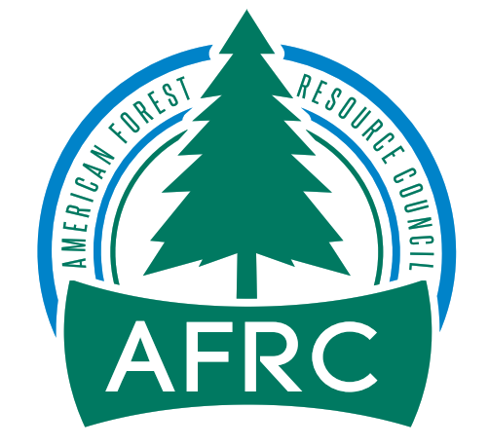
VIA Link: www.fs.usda.gov/project/?project=63393

February 9, 2023

Daniel Pliley
District Ranger
West Fork Ranger District
6735 West Fork Road
Darby, MT. 59829

Dear Daniel:

On behalf of the American Forest Resource Council (AFRC) and its members, thank you for the opportunity to comment on the Thunder Mountain Project.

AFRC is a regional trade association whose purpose is to advocate for sustained yield timber harvests on public timberlands throughout the West to enhance forest health and resistance to fire, insects, and disease. We do this by promoting active management to attain productive public forests, protect adjoining private forests, and assure community stability. We work to improve federal and state laws, regulations, policies, and decisions regarding access to and management of public forest lands and protection of all forest lands. Many of our members have their operations in communities within and adjacent to the Bitterroot National Forest and management on these lands ultimately dictates not only the viability of their businesses, but also the economic health of the communities themselves.

AFRC would like the Forest to know that we support this Project and it should accomplish to some degree the purpose of the Project which is:
- Reduce he likelihood of crown fires within the WUI by altering fuels.
- Provide for firefighter and public safety in the event of a wildfire.
- Promote insect and disease resiliency and increase the health and vigor of early seral species (ponderosa pine).

I would just suggest that with all of the fire risk in your area, that you consider making the Project larger and include more commercial thinning. I would especially ask that you consider more thinning in the mixed conifer Douglas-fir and ponderosa pine stands. Unit 1 is going to be difficult economically with harvesting young ponderosa pine. There is not a good market for that material and most likely it will take some extra Forest Service funding to get the work done. Units 2-4 are all non-commercial thus another economic drain, but could possibly add a larger tree component to target some merchantable size material and assist the Project economically.

I assume this will be an IRSC contract so the Forest can add some money to get the work completed?

I just think that it would make sense to increase the size of the area you are treating, and possibly use other NEPA tools or CE’s to expedite the planning and produce a Project that is economically feasible and might provide more commercial material for our sawmills that depend on the National Forests for their raw materials.

In closing, AFRC supports the work, but it seems like a small chunk of what really needs to be done on your District. Other avenues might be or might have been available.

Sincerely,
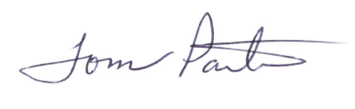

Tom Partin
AFRC Consultant
921 SW Cheltenham Street
Portland, Oregon 97239

