PRESERVE MONROE

February 3, 2023

To: Dr. Homer Wilkes, Under Secretary, U.S. Department of Agriculture. George Washington & Jefferson National Forests

Dear Mr. Wilkes and To Whom It May Concern:
On behalf of Preserve Monroe and the citizens who have fought to protect the valuable and irreplaceable resources of the Jefferson National Forest we ask that the United States Forest Service (USFS) extend the Comment Period for the permit, requested by Mountain Valley Pipeline (MVP) to cross the Jefferson National Forest, by 30 Days: 45 days is unfair and insufficient, especially when it spans the holiday season at the end of December and the beginning of January. Some organizations that want to make substantive comments were actually out of the office for eleven of those 45 days. Since MVP has had two years to prepare its case and the agencies have had application materials since at least last summer, it is only fair that an additional 30 days be granted to review all the material in MVP’s permit request.
As you know, MVP is, once again, attempting to construct their pipeline through our sacred Jefferson National Forest. They are poised not only to irreparably damage the pristine forest but also the critical water resources and fragile ecosystem found within the forest that harbors many unique and even endangered species in WV and VA.
The Mountain Valley Pipeline and Equitrans Expansion Project Draft Supplemental Environmental Impact Statement #50036 proposes amendments to 11 crucial standards that are essential for protecting the Jefferson National Forest. The company’s newly submitted documents do not provide sufficient assessment, monitoring, modeling, or real-world analyses to support changes to the Forest Plan.
As a coalition of citizens whose homes and environment are most directly impacted by the proposed path of the MVP and by the proposed changes to standards for soil health, old-growth forest, forest edge, species competition and scenic viewshed, we can attest to the fact that these changes would bring significant harm to the Jefferson National Forest and to our citizens. The proposed changes serve only as conveniences for the developer of one fossil fuel project, to the detriment of lands held in the public trust. To give in to 'private gain' by deviating from fundamental principles would weaken the authority of the USFS.
Many of our members have been residents of the area since the 1970’s and 80’s when the Federal Government proposed to extend the Jefferson National Forest into Monroe County, WV and into the nearby counties of Giles, Craig and Montgomery in VA. Their arguments for acquiring this land from citizens, even threatening the use of eminent domain and even exercising that right in certain instances was to “Protect Critical Habit and Water Resources” and to “Protect the Appalachian National Scenic Trail Corridor”. (Attachment # 1)
For the Forest Service to be in collusion with allowing 11 of its own rules to be broken as per the directives of a for-profit corporation - Mountain Valley Pipeline, LLC, - would set an alarming precedent for similar rule-breaking on national forests across the country. The MVP is an LLC but what liability would the USFS incur for knowingly degrading a forest that is owned collectively by the American people? These exceptions would run counter to the Forest Service’s own motto 'Caring for the Land and Serving People' and to its own mandate to “sustain healthy, diverse and productive forests and grasslands for present and future generations.” These exceptions run counter to the reasons that were given to extend the Jefferson National Forest into this pristine area. They also allow the Mountain Valley Pipeline to destroy some of the AT’s most scenic views, including but not limited to the view from Peters Mountain in Monroe County, where you can see the MVP coming right at you from Keeney’s Knob in Summers County and across both counties for over 30 miles. Particularly egregious is the view crossing nearby Little Mountain in Monroe County, just before crossing the Wilson Mill Valley and then up Peters Mountain.
There are many more impacts to the AT across the region, as noted by the Appalachian Trail Conservancy in a letter to FERC in 2016: “... as many as 19 prominent AT vistas may be severely impacted from this project, many of them viewing impacts as they occur on USFS land. --As a result, the assessment of cumulative impacts to the AT is drastically insufficient. The scope of cumulative impact must be based on the nature of the impacted resource, not the proposed project. In ascribing an arbitrary geographic scope for this DEIS of 100 miles….”
Picture below taken by Andrew Downs ATC Central& Southwestern VA Regional Director of the Appalachian Trail Conservancy prior to MVP Construction across Monroe and Summers County, WV. This is the iconic viewshed that has been impacted by the MVP Construction and would be permanently and severely scared by the further construction of the MVP. 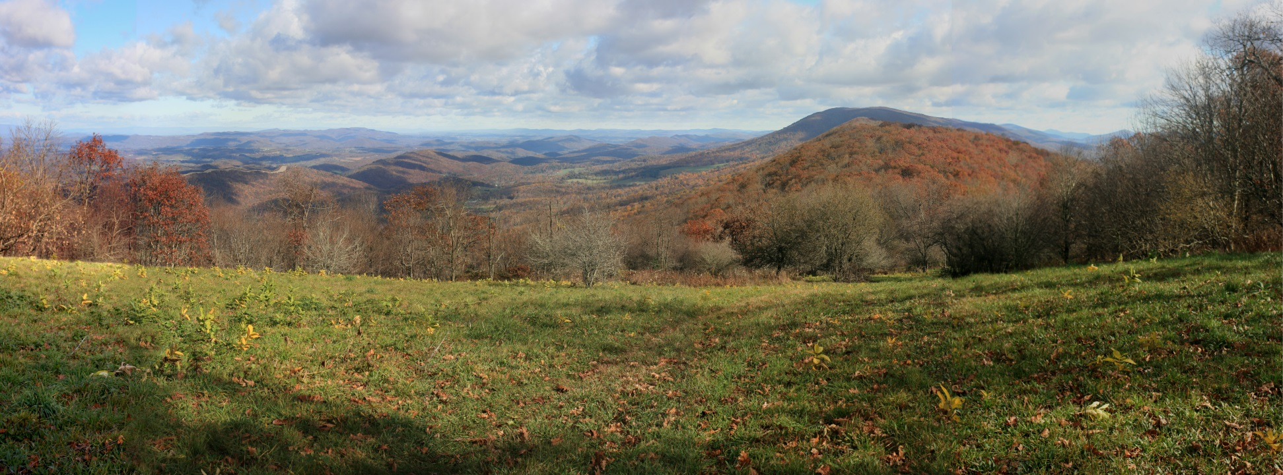
We have attached two letters from the Appalachian Trail Conservancy filed in 2016 that outline their concerns and detail how the MVP would impact the AT. Just because MVP gave a multi-million dollar “settlement” to the ATC does not change the fact that these concerns are real and every bit as relevant today as they were in 2016 when the MVP proposed to cross the Jefferson National Forest. What we do know now that we did not know in 2016 is exactly how severe the visual impacts to the view across Monroe and Summers County from Symms Gap in Monroe County are really going to be. We also know that similar impacts to the AT from other areas along the Trail in this WV and VA region are just as severe. (Attachment # 2 & # 3)
The applicant has had a demonstrated history of improper and inadequate sediment and erosion control practices during construction, leading to more than 500 violations of permit conditions and environmental standards in Virginia and West Virginia. Members of Preserve Monroe have filed over 300 Erosion & Sediment Control Complaints and Concerns with the West Virginia Department of Environmental Protection over the past 5 years. These complaints continue even as recently as this past month. Many of these Complaints resulted in Notices of Violations being issued by the WV DEP to MVP and many more resulted in a request for corrective action by WV DEP. It is reasonable to expect that new construction would cause additional adverse impacts to riparian zones, which serve an important role as buffers for holding back sedimentation from waterways both in and out of the Jefferson National Forest.
The SEIS continues to minimize the severity of impacts on vulnerable forest ecosystems. The loss of old-growth forest, which plays a crucial role in creating topsoil, cannot be mitigated and would impair biodiversity. America's national forests are held in the public trust as special lands — they harbor headwaters for drinking water supplies, habitat for rare animals and plants, scenic beauty and recreational spots where we rejuvenate our spirits. They should not be destroyed by the fossil fuel industry for private gain.
Additionally, the alleged need for the Mountain Valley Pipeline is speculative and unproven, given existing supply alternatives and market shifts towards non-fossil fuel alternatives. It is inaccurate for the agency to attempt to 'balance off' the damage done to treasured national forest land by professing “economic benefit.”
For the reasons stated above, we respectfully ask that the U.S. Forest Service select the 'No Action' Alternative and reject the Forest Plan Amendments and MVP’s request to cross the Jefferson National Forest. The Mountain Valley Pipeline project as proposed is inconsistent with the Forest Plan. It cannot meet the Plan’s standards for environmental protection, which should not under any circumstances be weakened.
Sincerely,

Roseanna Sacco, Chairman
Paula Mann, Treasurer
Robin Wright, Board Member
Joe Chasnoff, Board Member
Jill Fischer, Board Member
Jon McLaughlin, Board Member
Patricia Ann “Cookie” Cole Member
Preserve Monroe

