10 Nov 2022

TO: Michelle King, Acting Sweet Home District Ranger
ATTN: Chris Mushrush, Fire Planner, Sweet Home Ranger Station
VIA: https://cara.fs2c.usda.gov/Public/CommentInput?Project=63008

Subject: Sweet Home 2022 Roadside Fuels Breaks CE — comments

Please accept the following comments from Oregon Wild and Cascadia Wildlands concerning the Sweet Home 2022 Roadside Fuel Breaks CE, https://www.fs.usda.gov/project/?project=63008. Oregon Wild represents 20,000 members and supporters who share our mission to protect and restore Oregon’s wildlands, wildlife, and water as an enduring legacy. Our goal is to protect areas that remain intact while striving to restore areas that have been degraded. Cascadia Wildlands is part of a movement to protect and restore wild ecosystems of the Cascadia Bioregion, including vast old-growth forests, rivers full of wild salmon, wolves howling in the backcountry, and vibrant communities sustained by the unique landscapes. Cascadia Wildlands’ contact information is: P.O. Box 10455, Eugene, OR 97440 | Eugene, OR 97401 | 541-434-1463 | info@cascwild.org.

This project involves reducing fuels along [undisclosed] miles of roads in the vicinity of the Middle Santiam Wilderness, focusing on removal of trees <7” dbh and down wood <10” diameter (especially within 15 feet of larger trees) on 620 acres within 150 feet of roads. Yew trees and sugar pine would be retained. Riparian reserves would have 70% canopy retention.

The draft decision memo mischaracterizes the fire risk of mature native forest. The best evidence shows that unmanaged forests, especially mature forests, are relatively more resilient to severe fire compared to managed forests, especially dense plantations.
- Jerry Franklin, David Perry, Reed Noss, David Montgomery, Christopher Frissell. Simplified Forest Management To Achieve Watershed And Forest Health: A Critique. National Wildlife Federation. https://web.archive.org/web/20061008082841/http://www.coastrange.org/documents/forestreport.pdf (“Large blocks of old-growth forests – rather than large contiguous blocks of young growth or highly simplified forests – are the best scenario for reducing catastrophic wildfire.”).
- Steel, Z.L., Jones, G.M., Collins, B.M., Green, R., Koltunov, A., Purcell, K.L., Sawyer, S.C., Slaton, M.R., Stephens, S.L., Stine, P. and Thompson, C. (2022), Mega-disturbances cause rapid decline of mature conifer forest habitat in California. Ecological Applications. Accepted Author Manuscript e2763. https://doi.org/10.1002/eap.2763 (“Areas with high initial canopy cover and without tall trees were most vulnerable to canopy cover declines [due to wildfire] … The effect of large tree height on relative canopy cover decline was negative … indicating the presence of large, tall trees had a moderating effect on disturbance. …”).
- Harold S. J. Zald, Christopher J. Dunn. 2018. Severe fire weather and intensive forest management increase fire severity in a multi‐ownership landscape. Ecological Applications. Online Version of Record before inclusion in an issue. 26 April 2018. https://doi.org/10.1002/eap.1710. Also, https://phys.org/news/2018-04-high-wildfire-severity-young-plantation.html (“… RdNBR was consistently higher in young forests on both ownerships. RdNBR declined rapidly on BLM forests between stand ages of 20 and 80 yr old, and remained roughly level in older forests. In contrast, RdNBR in private forests declined linearly with age across its range, although private lands had few forests greater than 100 yr old. …[W]e believe our results have implications across a much broader geographic area. First, it brings into question the conventional view that fire exclusion in older forests is the dominant driver of fire severity across landscapes. … [I]n the landscape we studied, intensive plantation forestry appears to have a greater impact on fire severity than decades of fire exclusion. Second, higher fire severity in plantations potentially flips the perceived risk and hazard in multi-owner landscapes, because higher severity fire on intensively managed private lands implies they are the greater source of risk than older forests on federal lands. These older forests likely now experience higher fire severity than historically due to decades of fire exclusion, yet in comparison to intensively managed plantations, the effects of decades of fire exclusion in older forests appear to be less important than increased severity in young intensively managed plantations on private industrial lands.”).
- Lesmeister, D. B., S. G. Sovern, R. J. Davis, D. M. Bell, M. J. Gregory, and J. C. Vogeler. 2019. Mixed-severity wildfire and habitat of an old-forest obligate. Ecosphere 10(4):e02696. 10.1002/ecs2.2696. https://esajournals.onlinelibrary.wiley.com/doi/pdf/10.1002/ecs2.2696. (“Pre-fire nesting/roosting habitat had lower probability of burning at moderate or high severity compared to other forest types under high burning conditions. Our results indicate that northern spotted owl habitat can buffer the negative effects of climate change by enhancing biodiversity and resistance to high-severity fires, which are predicted to increase in frequency and extent with climate change. Within this region, protecting large blocks of old forests could be an integral component of management plans that successfully maintain variability of forests in this mixed-ownership and mixed-severity fire regime landscape and enhance conservation of many species.”).
Maybe the FS should reconsider the priority for treating this areas versus areas with more plantations and more roads (which pose an increased risk of fire ignitions).

We support the shaded fuel break prescription which focuses on non-commercial removal of small fuels, and the retention of Pacific yew and sugar pine, and protection of riparian reserves. We urge the agency to consider retaining deciduous trees such as hazel and vine maple, because the foliage of these trees can hold a lot of water and act as heat sinks during a fire.

We urge the agency to skip treatment of areas within 50 feet of streams. Removing understory trees and shrubs up to 15 feet from streams will remove vegetation that contributes to attainment of ACS objectives. This is not allowed especially for a project with speculative benefits and uncertain future maintenance.

The project map appears to show excessive redundancy in the roads being treated. Since this project is speculative to start with, and will require significant investment in maintenance treatments, maybe the agency should focus on creating one line of defense instead of redundant control lines that are in close proximity.

Categorical Exclusions are not the good way to ensure meaningful public involvement. The public is getting only one chance to review this proposal and that is occurring after the design has been completed.

This project occurs in an areas with significant roadless values (shown below in blue polygons).
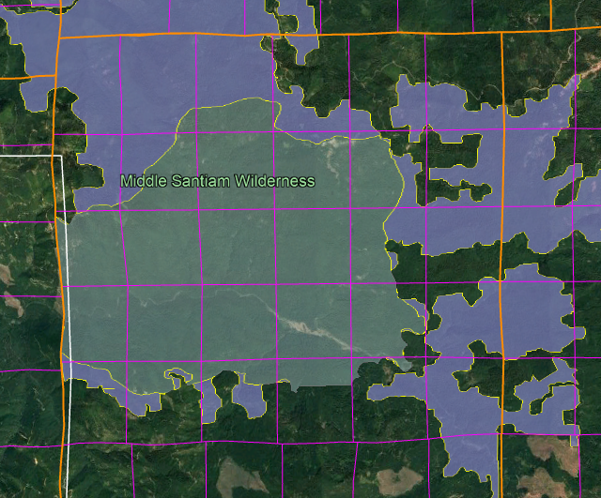
We urge the agency to minimize impacts to roadless values, by retaining all large trees and large snags (keep workers out of the danger zone), retain vegetation diversity, avoid spreading weeds, avoid heavy equipment off the road, etc. We are concerned that opening the understory and reducing cover values in this area could create a barrier to wildlife movement across the affected roads. We urge the FS to carefully consider whether the impacts to unroaded characteristics of the affected lands represents extraordinary circumstances.

Sincerely,

Doug Heiken

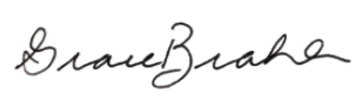
Grace Brahler
Cascadia Wildlands

