Steering Committee
Randy Smith- Chair
Rancher - Middle Big Hole
Jim Hagenbarth- Vice Chair
Rancher - Middle Big Hole
Roy Morris- Secretary
George Grant Trout Unlimited
Steve Luebeck- Treasurer
Sportsman

Governing Board
Dave Ashcraft
Rancher- Lower Big Hole
Sean Claffey
The Nature Conservancy
Peter Frick
Rancher- Upper Big Hole
Jim Dennehy
Butte-Silver Bow Water Dept.
Eric Thorson
Fishing Guide & Outfitter
John Jackson
Beaverhead County
Rancher- Upper Big Hole
Diane Hutton
Landowner- Middle Big Hole
Liz Jones
Rancher- Middle Big Hole
Mark Kambich
Rancher- Middle Big Hole
Brian Wheeler
Big Hole River Foundation
Erik Kalsta
Rancher- Lower Big Hole
Dean Peterson
Rancher- Upper Big Hole

Phil Ralston
Rancher- Middle Big Hole
John Reinhardt
Rancher- Middle Big Hole
Bill Kemph
Fishing Guide
Paul Cleary
Resident
Andy Suenram
Resident and Sportsman
Mark Raffety
Rancher- Lower Big Hole

1/13/2023

Re: Basin Creek-Butte Watershed Project #63295

Dear Tim Lahey
Butte District Ranger
1820 Meadowlark Ln
Butte, MT 59701

The Big Hole Watershed Committee (BHWC) is a collaborative conservation organization in Southwest Montana that has, since 1995, brought together stakeholders to achieve meaningful solutions for water management that provide for all water uses and users. Butte-Silver Bow’s water supply team has been a member of our Governing Board for decades, given the importance of the Big Hole River to municipal water supplies.
The ability of the Basin Creek water treatment facility to supply water to the growing city of Butte has huge implications on water withdrawals from the Big Hole River. The proposed project, by mitigating against the potentially catastrophic effects of a wildlife in the watershed, is well worth the effort. The project will avoid downstream costs of cleanup, will reduce the probability of increased withdrawals from the Big Hole, and will lead to a more resilient and diversified forest above the Basin Creek Reservoir.
Every effort should be made to approve and implement this project with the sense of urgency it deserves. Our river simply cannot afford a major fire in this watershed. We support the fuels reduction activities as written. Thank you,

Sincerely,
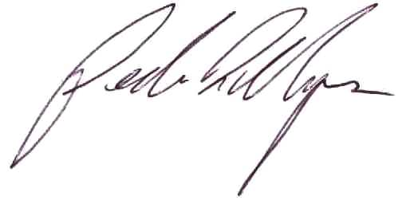

Pedro Marques
Executive Director
Big Hole Watershed Committee
pmarques@bhwc.org

