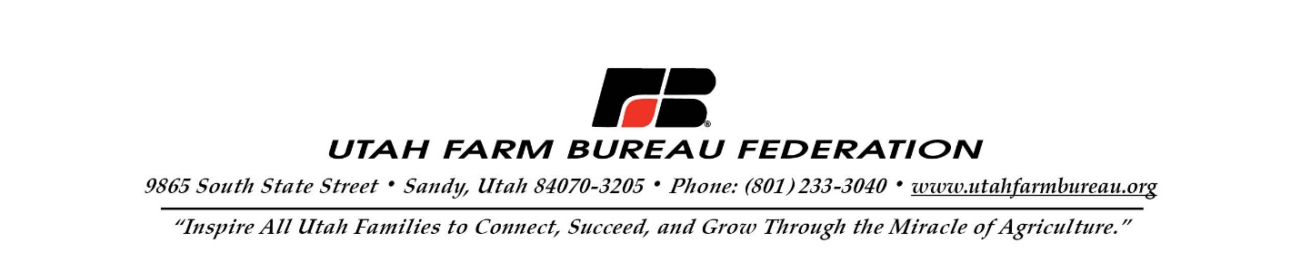
December 21, 2022

Kevin Wright
Forest Supervisor
Dixie National Forest
820 N Main St.
Cedar City, UT 84721

Re: Dixie National Forest Prescribed Fire Landscape Resiliency Project

Forest Supervisor Wright:

We appreciate the opportunity to provide comments on the Dixie National Forest’s Prescribed Fire Landscape Resiliency Project. The Utah Farm Bureau Federation supports the overarching goals of the project. Decades of passive Forest Service management combined with artificial suppression of fire and severe drought in the West has resulted in overgrown and fire prone forests. Currently, over 63 million acres of U.S. Forest Service land are at high or very high risk of wildfire. We appreciate the Forest Service’s commitment to reduce the risk of catastrophic wildfire on the Dixie National Forest.

We understand the need to conduct a large-scale environmental assessment (EA) to consider impacts for conducting prescribed burning throughout the Dixie National Forest. This action will save the Forest Service time and money and will provide enhanced flexibility to conduct prescribed fire operations when conditions allow. In addition to this project, we encourage you to utilize all the tools you have been provided, including mechanical thinning. Expanded mechanical thinning is consistent with the Forest Service’s own findings in the “Confronting the Wildfire Crisis” strategy, which stated: “Using fire and thinning together, however, provides the best opportunity for reducing risk and moderating fire behavior. With a risk-informed approach, a forest thinning is often needed first to reduce the number of trees to something approaching the historical level a century ago. Then a low-intensity surface fire can follow—what professionals call a prescribed fire.”

Although we support this project, we would like to share a few items of concern. First, following completion of the EA process, we urge you to continue actively communicating and coordinating with the local governments and communities in Southern Utah regarding prescribed burning projects. Local leaders and landowners have specialized knowledge of their area and current conditions that is vital to ensuring public safety. Recent examples in New Mexico of prescribed burns escaping highlight the need to coordinate with local officials to understand on-the-ground conditions.

Second, we noted that while the EA discusses procedures that will be taken to protect livestock and range improvements within burn areas, the EA fails to provide a solution for restoring damaged livestock fencing, pipelines, or other improvements. Prescribed fire sometimes moves beyond designated areas and has, in the past, resulted in damages to livestock improvements. We request that the Forest Service consider setting aside funding for potential damages in burn plans and that the Forest Service take responsibility for the replacement of range improvements should damage occur.

Third, we ask that you carefully consider the interests of livestock producers. We understand that prescribed burns sometimes result in temporary displacement of livestock, temporary suspension of head months, and temporary institution of more intensive management techniques. We noted on page eight of the EA under the heading “Post-treatment Actions,” one of the bullet points states: “Resting burned or treated areas from livestock grazing for two full growing seasons (spring through fall).” While resting certain burned or treated areas may be necessary in some instances, in many cases, allotments may not need to be rested at all, or for a shorter period. We request that you revise this language to allow for more flexibility.

Thank you for taking the time to read our comments. We are grateful for your efforts to actively manage the Dixie National Forest. We support the use of prescribed fire and other active management tools provided to the Forest Service.

Feel free to contact us any time if you have any questions about our comments.

Terry Camp
VP, Public Policy
Utah Farm Bureau Federation
Terry.Camp@FBFS.com

Trevor Barnson
Board Member, District 6
Utah Farm Bureau Federation
President, Piute County Farm Bureau
TrevorBarnson@Gmail.com

Allen Henrie
President, Garfield County Farm Bureau
AllenHenrie@Yahoo.com

Congressional Research Service, “Federal Wildfire Management: Ten-Year Funding Trends and Issues (FY2011-FY2020)”, Katie Hoover, October 28, 2020, https://crsreports.congress.gov/product/pdf/R/R46583
U.S. Department of Agriculture Forest Service, “Confronting the Wildfire Crisis A Strategy for Protecting Communities and Improving Resilience in America’s Forests,” January 2022, FS-1187a, https://www.fs.usda.gov/sites/default/files/Confronting-Wildfire-Crisis.pdf.

